MATHEMATICAL MODELLING OF EDM FOR METAL REMOVAL RATE ON ALLOY STEEL (EN31) USING
COPPER ELECTRODE

A Major Project thesis Submitted in partial fulfillment for the requirement for the award of the degree of
Masters of Engineering
in

Production and Industrial Engineering

Submitted By:

Bibhu dutta Jethy

University Roll No. 12654
College Roll No.018/Pro/05

Under the guidance of

Dr. VIPIN
Asstt. Prof.



DEPARTMENT OF MECHANICAL ENGINEERING
DELHI COLLEGE OF ENGINEERING
DELHI UNIVERSITY, DELHI-110042

June, 2009

Candidate’s declaration

I, BIBHU DUTTA JETHY hereby certify that the work which is being presented in this thesis entitled “MATHEMATICAL MODELLING OF EDM FOR METAL REMOVAL RATE ON ALLOY STEEL (EN31) USING COPPER ELECTRODE” in the partial fulfillment of requirement for the award of degree of Masters of Engineering submitted in the Department of Mechanical Engineering at Delhi College Of Engineering, is an authentic record of my own work carried out during a period from July 2005 to June 2009, under the supervision of Dr. VIPIN, Asstt. Prof. Department of Mechanical Engineering, Delhi College of Engineering, Delhi. The matter presented in this thesis has not been submitted in any other University/ Institute for the award of M.E. Degree.

(Bibhu Dutta Jethy)

CERTIFICATE
This is to certify that the above statement made by the candidate is correct to best of my knowledge.

(Dr. VIPIN)
ACKNOWLEDGEMENT

It is a matter of great pleasure for me to present my dissertation report on “MATHEMATICAL MODELLING OF EDM FOR METAL REMOVAL RATE ON ALLOY STEEL (EN31) USING COPPER ELECTRODE”. First and foremost, I am profoundly grateful to my guide Dr. VIPIN, Asst. Prof, Mechanical Engineering Department for his expert guidance and continuous encouragement during all stages of thesis. I feel lucky to get an opportunity to work with him. Not only understanding the subject, but also interpreting the results drawn thereon from the graphs was very thought provoking. I am thankful to the kindness and generosity shown by him towards me, as it helped me morally complete the project before actually starting it.
I would like to thank Prof. C.K. Dutta (Production Engineering Department) and Prof. S Maji (HOD Mechanical and Production DCE) and Sh. Pradeep Kashyap (Workshop In charge of DCE) and thank all staff of Production Engineering Department at DCE without their support it would be almost impossible to complete my thesis work in time.
Last, but not the least, I would like to thank my family members for their help, encouragement and prayers through all these months. I dedicate my work to them.

Date:
Place:
Bibhu Dutta Jethy

CONTENTS

CANDIDATE’S DECLARATION 2
ACKNOWLEDGEMENT 3
ABSTRACT 8

Chapter 1: INTRODUCTION 9-26

1.1 Non Traditional Machining 10

1.2 Need of Non Traditional Machining 12
1.3 EDM Process and Principles 12
1.3.1 History of Electro Discharge Machining 13
1.3.2 EDM Principle 13
1.3.3 EDM controller 18
1.3.4 Design Adaptation system for EDM machining 20
1.3.5 Electrode Material 25
1.3.6. Applications of EDM 25
1.3.7. Advantages of EDM 26
1.3.8. Disadvantages of EDM 26

Chapter 2: LITERATURE REVIEW 27-35

Chapter 3: REGRESSION AND DESIGN OF EXPERIMENTS 36-61

  - Regression Analysis 36
    - Linear Regression 36
    - Non-Linear Regression 37
    - Analysis Technique 38
      - Least Square analysis 38
      - Model Assumptions 42
      - Model Validity 43
  - Design Of Experiments 46
    - Concept of DOE 46
    - Problem Identification 49
    - Taguchi’s Parameter Design Method 50
      - Objectives of Taguchi’s Method 50
      - Orthogonal Array 50
    - Brainstorming 51
    - Types of Optimization Problems 53
      - Static Problems 53
      - Dynamic Problems 54
    - Batch Process Optimization 55
      - Smaller the Better 55
      - Larger the Better 55
      - Nominal the Best 55
    - Steps in Taguchi Methodology 56
    - Advantages of Taguchi Design of Experiment 58
    - Limitations of Taguchi Design of Experiment 58

Chapter 4: EXPERIMENTAL SET UP 62-78

  - EDM Machine 62
  - Process Description 66
  - Controller Description 67
  - Electrode material 69
  - Setting of W/p for spark erosion 70
  - Electrode Clamping 70
  - Work piece material 78

Chapter 5: ANALYSIS OF MACHINING DATA 79-89

5.1 Mathematical Models Formulation of Machining Data 81
    - Non-Linear Model 81
    - Metal Removal Equation 89

Chapter 5: RESULTS AND CONCLUSION 90-91

REFERENCES 92-97

GLOSSARY 98-104

List of Tables

Table No Table Description Page

4.1 EDM Machine specifications 63
4.2 Chemical Composition of Work Piece 78
5.1 Data Collection for Model 83
5.2 Result of Regression Analysis 83

ABSTRACT

Electro-discharge machining (EDM) appears as an alternative to grinding and hard turning for the machining of tool steels because EDM allows the machining of any type of conducting material, regardless of its hardness. Nevertheless, other factors must be taken into account in the selection of machining processes, especially in the case of responsibility parts. These factors are related with surface integrity: residual stresses, hardness and structural changes generated by the machining processes. Electrical Discharge Machining (or EDM) is a machining method primarily used for hard metals or those that would be impossible to machine with traditional techniques. One critical limitation, however, is that EDM only works with materials that are electrically conductive, and generally those materials are ferrous alloys. EDM is a non-traditional method of removing material by a series of rapidly recurring electric arcing discharges between an electrode (the cutting tool) and the work-piece, in the presence of an energetic electric field. The EDM cutting tool is guided along the desired path very close to the work but it does not touch the piece. Consecutive sparks produce a series of micro-craters on the work piece and remove material along the cutting path by melting and vaporization. The particles are washed away by the continuously flushing dielectric fluid. It is also important to note that a similar micro-crater is formed on the surface of the electrode, the debris from which must also be flushed away. This work provides the information on the Electro discharge machining and the related parameters and latest developments in this field for the cutting of work piece EN31 using electrolytic copper electrodes of different dias. Also a design is developed and employed for improved Metal removal Rate. Also the application and advantages of the process are discussed showing the versatility of the process. Equations are developed for the data collected for machining of EN31 work-piece regarding the MRR by varying the values of Dia. Of Electrode , Current & Pulse duration.
Linear Multiple Regression Software is used to solve the equations of the dependent and independent variables.

Chapter 1
INTRODUCTION

Electrical discharge machining (EDM) is a non-conventional process of machining. the development of the EDM technology started in the forties. Since then, it is the most important machining process in tool engineering. General advantages to other machining processes are: accuracy, surface quality and the fact that hardness and stiffness of a work-piece material is not important for the material removal. The EDM has become mature technology but the researches and improvements of the process are still going on. The main reason why, is that there still does not exist a machining process, which could successfully replace the EDM.
This work aims to show the prospects of electrical discharge machining (EDM) technology by interrelating the effects variation of parameters like current , dia. Of electrode and pulse duration on metal removal rate of work piece. Although gap phenomena in EDM are very complicated and hence not yet very well understood, recent improvements in computers and electronic measuring instruments are contributing to new discoveries and inventions in EDM technology. EDM processes once believed to be impossible or unrealistic are now becoming practical. Before discussing the detail study of the findings lets discuss the various machining processes and advantages of EDM process.
Types of Manufacturing Processes
Manufacturing processes can be broadly divided into two groups and they are primary manufacturing processes and secondary manufacturing processes. The former ones provide basic shape and size to the material as per designer’s requirement. Casting, forming, powder metallurgy are such processes to name a few. Secondary manufacturing processes provide the final shape and size with tighter control on dimension, surface characteristics etc. Material removal processes are mainly the secondary manufacturing processes.

1.1 Non Traditional Machining – Classification
Material removal processes once again can be divided into mainly two groups and they are “Conventional Machining Processes” and “Non-Traditional Manufacturing Processes”. Examples of conventional machining processes are turning, boring, milling, shaping, broaching, slotting, grinding etc. Similarly, Abrasive Jet Machining (AJM), Ultrasonic Machining (USM), Water Jet and Abrasive Water Jet Machining (WJM and AWJM), Electro-discharge Machining (EDM) are some of the Non Traditional Machining (NTM) Processes. To classify Non Traditional Machining Processes (NTM), one needs to understand and analyze the differences and similar characteristics between conventional machining processes and NTM processes.
Conventional Machining Processes mostly remove material in the form of chips by applying forces on the work material with a wedge shaped cutting tool that is harder than the work material under machining condition. Such forces induce plastic deformation within the work piece leading to shear deformation along the shear plane and chip formation.
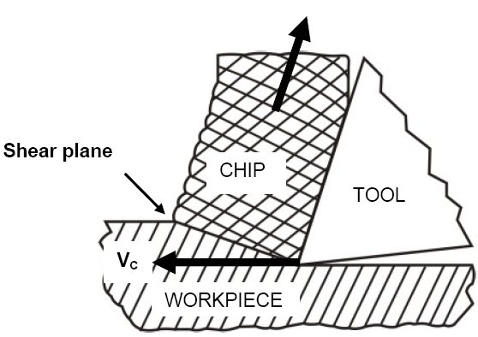
Fig. 1.1 Mechanism of material removal
Thus the major characteristics of conventional machining are:
*Generally macroscopic chip formation by shear deformation
- Material removal takes place due to application of cutting forces – energy domain can be classified as mechanical
- Cutting tool is harder than work piece at room temperature as well as under machining conditions
Non Traditional Machining (NTM) Processes on the other hand are characterized as follows:
- Material removal may occur with chip formation or even no chip formation may take place. For example in AJM, chips are of microscopic size and in case of Electrochemical machining material removal occurs due to electrochemical dissolution at atomic level
- In NTM, there may not be a physical tool present. For example in laser jet machining, machining is carried out by laser beam. However in Electrochemical Machining there is a physical tool that is very much required for machining
- In NTM, the tool need not be harder than the work piece material. For example, in EDM, copper is used as the tool material to machine hardened steels.
- Mostly NTM processes do not necessarily use mechanical energy to provide material removal. They use different energy domains to provide machining. For example, in USM, AJM, WJM mechanical energy is used to machine material, whereas in ECM electrochemical dissolution constitutes material removal.

Thus classification of NTM processes is carried out depending on the nature of energy used for material removal. The broad classification is given as follows:
- Mechanical Processes
  - Abrasive Jet Machining (AJM)
  - Ultrasonic Machining (USM)
  - Water Jet Machining (WJM)
  - Abrasive Water Jet Machining (AWJM)
- Electrochemical Processes
  - Electrochemical Machining (ECM)
  - Electro Chemical Grinding (ECG)
  - Electro Jet Drilling (EJD)
- Electro-Thermal Processes
  - Electro-discharge Machining (EDM)
Laser Jet Machining (LJM)
  - Electron Beam Machining (EBM)
- Chemical Processes
  - Chemical Milling (CHM)
  - Photochemical Milling (PCM) etc.

1.2 Need for Non Traditional Machining

Conventional machining sufficed the requirement of the industries over the decades. But new exotic work materials as well as innovative geometric design of products and components were putting lot of pressure on capabilities of conventional machining processes to manufacture the components with desired tolerances economically. This led to the development and establishment of NTM processes in the industry as efficient and economic alternatives to conventional ones. With development in the NTM processes, currently there are often the first choice and not an alternative to conventional processes for certain technical requirements. The following examples are provided where NTM processes are preferred over the conventional machining process
- Intricate shaped blind hole – e.g. square hole of 15 mmx15 mm with a depth of 30 mm
- Difficult to machine material – e.g. same example as above in Inconel, Ti-alloys or carbides.
- Low Stress Grinding – Electrochemical Grinding is preferred as compared to conventional grinding
- Deep hole with small hole diameter – e.g. 1.5 mm hole with l/d = 20
- Machining of composites

1.3 Electro Discharge Machining (EDM) Process Requirement Principle

Electro-discharge machining (EDM) appears as an alternative to grinding and hard turning for the machining of tool steels because EDM allows the machining of any type of conducting material, regardless of its hardness. Nevertheless, other factors must be taken into account in the selection of machining processes, especially in the case of responsibility parts. These factors are related with surface integrity: residual stresses, hardness and structural changes generated by the machining processes. Production grinding generates compressive stresses at the surface, and a slight tensile peak, accompanied by a decrease in hardness beneath it. No structural changes are noticeable. Hard turning generates slight tensile stresses in the surface, accompanied by an increase in hardness and in the amount of retained austenite. Just below the surface compressive stresses are obtained, as well as a decrease in hardness and in the volume fraction of retained austenite .
1.3.1. The History of EDM Machining
The history of EDM Machining techniques goes as far back as the 1770s when it was discovered by an English Scientist. However, Electrical Discharge Machining was not fully taken advantage of until 1943 when Russian scientists learned how the erosive effects of the technique could be controlled and used for machining purposes.
When it was originally observed by Joseph Priestly in 1770, EDM Machining was very imprecise and riddled with failures. Commercially developed in the mid 1970s, wire EDM began to be a viable technique that helped shape the metalworking industry we see today.
In the mid 1980s, the EDM techniques were transferred to a machine tool. This migration made EDM more widely available and appealing over traditional machining processes.
Today, Wire EDM makes it possible to work with harder materials and metals while keeping the exactness of precision cutting.
1.3.2. Electro Discharge Machining (EDM) Principle
Electrical Discharge Machining (or EDM) is a machining method primarily used for hard metals or those that would be impossible to machine with traditional techniques. One critical limitation, however, is that EDM only works with materials that are electrically conductive, and generally those materials are ferrous alloys. EDM can cut small or odd-shaped angles, intricate contours or cavities in pre-hardened steel without the need for heat treatment to soften and re-harden them as well as exotic metals such as titanium, hastelloy, kovar, and inconel.
Sometimes referred to as spark machining or spark eroding, EDM is a non-traditional method of removing material by a series of rapidly recurring electric arcing discharges between an electrode (the cutting tool) and the work-piece, in the presence of an energetic electric field. The EDM cutting tool is guided along the desired path very close to the work but it does not touch the piece. Consecutive sparks produce a series of micro-craters on the work piece and remove material along the cutting path by melting and vaporization. The particles are washed away by the continuously flushing dielectric fluid. It is also important to note that a similar micro-crater is formed on the surface of the electrode, the debris from which must also be flushed away. These micro-craters result in the gradual erosion of the electrode, many times necessitating several different electrodes of varying tolerances to be used, or, in the case of wire EDM machining, constant replacement of the wire by feeding from a spool.
Two metal parts submerged in an insulating liquid are connected to a source of current which is switched on and off automatically depending on the parameters set on the controller. When the current is switched on, an electric tension is created between the two metal parts.
If the two parts are brought together to within a fraction of an inch, the electrical tension is discharged and a spark jumps across. Where it strikes, the metal is heated up so much that it melts.
Innumerable such sparks spray, one after the other (never simultaneously) and gradually shape the desired form in the piece of metal, according to the shape of the electrode. Several hundred thousand sparks must fly per second before erosion takes place.
There are two main types of EDM machines: Sinker EDM (also called Conventional EDM and Ram EDM) and Wire EDM.
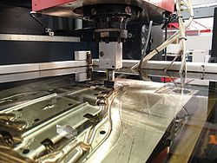
Figure:1.2. Electro Discharge Machining
EDM is a machining method primarily used for hard metals or those that would be impossible to machine with traditional techniques. One critical limitation, however, is that EDM only works with materials that are electrically conductive. EDM or Electrical Discharge Machining , is especially well-suited for cutting intricate contours or delicate cavities that would be difficult to produce with a grinder, an end mill or other cutting tools. Metals that can be machined with EDM include hast-alloy, hardened tool-steel, titanium, carbide, inconel and kovar.
EDM is sometimes called "spark machining" because it removes metal by producing a rapid series of repetitive electrical discharges. These electrical discharges are passed between an electrode and the piece of metal being machined. The small amount of material that is removed from the work piece is flushed away with a continuously flowing fluid. The repetitive discharges create a set of successively deeper craters in the work piece until the final shape is produced.
The EDM process uses electrical discharges to remove material from the work piece, with each spark producing a temperature of between 10,000-20,000°C. Consequently, the work piece is subjected to a heat affected zone (HAZ) the top layer of which comprises recast material. The thickness, composition and condition of this layer depend on the discharge energy and the make-up of the work piece, tool electrode and dielectric fluid, and both hard and soft surface layers can be produced despite perceived wisdom that the recast layer is always hard. With ferrous work piece materials, the recast layer typically appears white and amorphous when viewed under a microscope, and is prone to tensile stress, micro cracking and porosity.
There are two primary EDM methods: ram EDM and wire EDM. The primary difference between the two involves the electrode that is used to perform the machining. In a typical ram EDM application, a graphite electrode is machined with traditional tools. The now specially-shaped electrode is connected to the power source, attached to a ram, and slowly fed into the work piece. The entire machining operation is usually performed while submerged in a fluid bath. The fluid serves the following three purposes:
- Flushes material away.
- Serves as a coolant to minimize the heat affected zone (thereby
preventing potential damage to the work piece).
- Acts as a conductor for the current to pass.
In wire EDM a very thin wire serves as the electrode. Special brass wires are typically used; the wire is slowly fed through the material and the electrical discharges actually cut the work piece. Wire EDM is usually performed in a bath of water.
If you were to observe the wire EDM process under a microscope, you would discover that the wire itself does not actually touch the metal to be cut; the electrical discharges actually remove small amounts of material and allow the wire to be moved through the workpiece. The path of the wire is typically controlled by a computer, which allows extremely complex shapes to be produced.
Perhaps the best way to explain wire EDM is to use an analogy. Imagine stretching a thin metal wire between your hands and sliding it though a block of cheese cutting any shape you want. You can alter the positions of your hands on either side of the cheese to define complex and curved shapes. Wire EDM works in a similar fashion, except electrical discharge machining can handle some of the hardest materials used in industry. Also note, that in dragging a wire through cheese, the wire is actually displacing the cheese as it cuts, but in EDM a thin kerf is created by removing tiny particles of metal.
Electrical discharge machining is frequently used to make dies and molds. It has recently become a standard method of producing prototypes and some production parts, particularly in low volume applications. For more details regarding a typical application, you can read about a custom bronze branding-iron that was made with EDM.
Crater to pulse classification
By research on basic principles for material removal in EDM process we try to improve effectiveness of the process. A single discharge - an unit event of EDM process was researched (Fig. 1). The correlation between electrical parameters and surface give us important information about process.
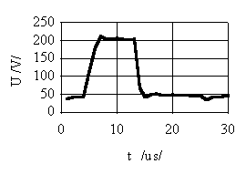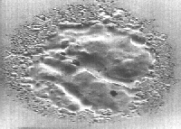
Figure 1.3 : Time dependence and surface crater of single discharge made by EDM machining
Source: http://www.fs.uni-lj.si/lat/dfm
EDM small hole machining
The use of EDM process is in parallel to development of new technologies. One of these new technologies is small hole drilling by EDM.
Small hole drilling (d < 1 mm, h/d > 10) is a huge technological problem (Fig.). By drilling problems arise with chip transport and heat deviating. Drilling tough and rigid materials on depth is also a problem. By other non-conventional processes like laser and electron beam small holes can also be made, but these processes are still to expensive for common use. EDM is the best choice for machining electric conductive materials, especially for holes of uncommon shapes.
Technological problems arise:
- precision of electrode machining
- electrode positioning
- high dielectric liquid pressure
- electrical parameters selecting
- electrode guide

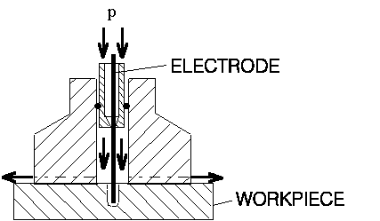
Figure: 1.4. EDM small hole sinking design

1.3.3. EDM controller
EDM process is very unstable, especially when working in fine regime. Often surface damage occurs by arc discharging. Unstable working is unavoidable, so the process is forced to work in liable, but effective region of working. The process is run by operator who overlook it and make a feedback control. Automation of process is the final goal of our research.
A strategy of controlling is a very important part of stable EDM action. It is complex and operator can master it after a long period of learning and collecting his own experience. Operator's knowledge and technological knowledge together with technological receipts can be added to adaptive controller which must be able to accept both of them. We are working on development of such a controller. All basic function of controller (identification, reasoning and control) are computer made. Identification of process is well done by computer. The same is with reasoning, based on qualitative and probability assessment, which is usually reserved for human. Operator-to-computer communication is possible and controller can be improved. While the split between human way of reasoning and reasoning algorithms, a strategy of controller is developed by artificial intelligence (learning by example). Method FORS (First Order Regression System) is used. Rules IF-THEN-ELSE can be obtain by human demonstration of process leading. By this method, operator knowledge is transformed to algorithm used by computer. Rules IF-THEN-ELSE are human understandable, too.
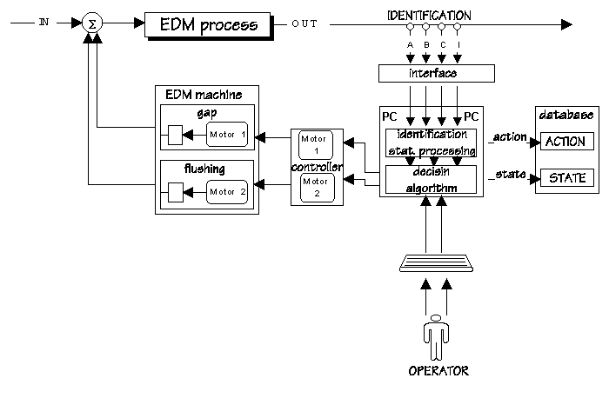 Figure:1.5.Adaptive control system for EDM process control Source: http://www.fs.uni-lj.si/lat/dfm

1.3.4 Design adaptation system for machining by EDM process
The EDM is still very often used, especially in tool engineering where tools for mass production are produced. The shape of the tool is a negative image of the product and it has to be easily and cheaply made. To adapt tool design, and at the same time also product design, for easier manufacture of the tool we distinguish two levels: design and manufacturing level. On the manufacturing level a manufacturing technology for tool machining is determined. There is always feedback information from manufacturing to design level to change the tool and the product design according to easier (cheaper) manufacture of the tool. The designer considers the suggestions of the technologist and together they find the best design by taking into account also the demands for the product and the tool.
A system for segmentation and determination of a proper machining process for machining each segment of the tool separately has already been developed at the Faculty of mechanical engineering. A high speed milling (HSM) and the EDM process are considered as two machining processes for making each segment of the tool. In our work the system for adaptation of the product to easier tool manufacture with EDM process was developed. It is designed for designers to establish critical parts of the product from the point of view of machining the tool with EDM process. With these information the designer can adapt the critical parts of the product design without the tool engineer. By using the system it is possible to reduce number of information from manufacturing to design level and to reduce the time necessary to manufacture tools. In reality it is impossible to eliminate all information from manufacturing to design level or to replace the tool engineer with an expert system.
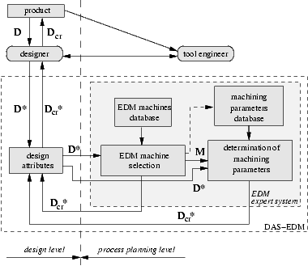
Figure :1.6. Scheme of the design adaptation system for EDM.
Source: http://www.fs.uni-lj.si/lat/dfm

On-line selection of the rough machining parameters upon the eroding surface size
The material removal rate and the surface roughness increase with increased power in the gap. In this way, rough and fine machining is distinguished. When rough machining is performed, the material removal rate should be as high as possible, while the achieved surface roughness does not play an important role.
The EDM process stability is determined by the proportion of harmful discharges in the gap between a work-piece and an electrode, i.e. arc and short-circuit discharges, which not only lower the material removal rate, but also increase the electrode wear. The process is more stable in the case of lower proportion of the harmful discharges. The main cause for unstable EDM process is the contamination of the gap with discharge products. But the surface power density in the gap also affects the process stability. To achieve the highest material removal rate, the roughing setup parameters should be tuned to the eroding surface size. The eroding surface is a projection of the engaged surface of the electrode to the plane perpendicular to the machining direction as shown in Figure. This was analytically proved in general, the engaged surface is not plane and the eroding surface size changes with the depth of machining. To select the appropriate roughing setup parameters at any machining depth, the eroding surface size has to be determined on-line.
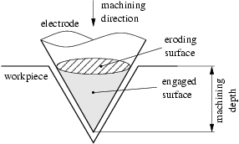
Figure 1.7. The eroding surface is a projection of the engaged surface of the electrode to the plane perpendicular to the machining direction.
Voltage and current in the gap define electric power in the gap (P=UI). There exists the optimal set of the setup parameters' values to obtain the certain power in the gap and the discharge voltage is nearly constant at all machining regimes, thus the power in the gap depends only on the current in the gap. In the literature, the boundary surface current density is given rather than boundary surface power density and it is stated that stable EDM process is achieved when the surface current density is less than 0.1 A. The relation between the surface current density and the material removal rate Vw is presented in Figure . At constant eroding surface size A1, the material removal rate increases with increased surface current density until the boundary surface current density is reached. Higher surface current density causes unstable machining process and the material removal rate decreases. When greater eroding surface is employed (A2), the higher current is needed to reach the boundary surface current density, thus the material removal rate is higher compared to the material removal rate at eroding surface A1.
To select the appropriate roughing setup parameters when eroding surface size varies during the machining, the eroding surface size has to be determined on-line.

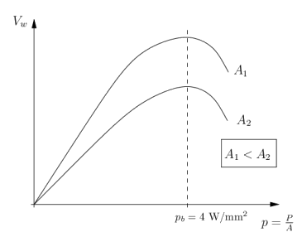
Figure 1.8. Material removal rate versus the surface current density
For on-line detection of the eroding surface size, it is necessary to monitor the appropriate process quantities z. Proper evaluation of the process quantities is the key to gain suitable process attributes x for the determination of the eroding surface size. The process attributes are the inputs into the model for the selection of the optimal rough machining parameters.
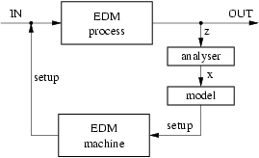
Figure 1.9. On-line selection of the roughing setup parameters of the EDM process

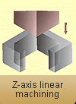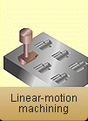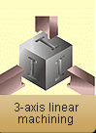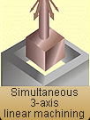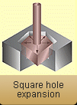

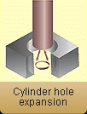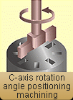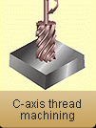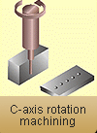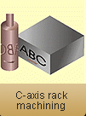

Figure1.10. Figures showing the machining in EDM Process

1.3.5. Electrode Materials
Very little surface alloying occurs when using ‘conventional’ tool electrodes under standard polarity compared to partially sintered PM electrodes, where the binding energy between grains is considerably lower. Negative tool polarity is usually employed and PM electrode materials used include Al, Cr, Cr/Ni, Cu/Co, Cu/Mn, Cu/Sn, Cu/W, Ni, Ni/Co, Ni/Fe, Ni/Mn, Ni/Si, Ti, Ti/A1, TiC/Ni, W/CrC/Cu and WC/Co. Figure 1 shows a schematic of the process. This approach to surface alloying is relatively new and there is little information on aspects such as preferred particle size, sintering temperatures and pressures. However, powder sizes of less then 50 µm are quoted with temperatures of ~900-1300°C and pressures of ~100-550 MPa.

1.3.6. Applications Of EDM
Electrical discharge machining (EDM) is a thermal process that involves melting and vaporisation of the work piece electrode. It is widely used in the aerospace, mould making and die casting industries for manufacturing plastics moulds, forging dies and die casting dies made from hardened tool steels, together with engine components, such as compressor blades made from titanium alloys and nickel-based super alloys. In addition to the more well known EDM operations of die sinking, scanning/milling with a simple electrode and wire cutting, other operations and machine configurations exist, one of which allows the surface of hardened steel rolls used in the production of steel and aluminium sheet to be textured.

1.3.6.1. The Recast Surface Layer
To increase the life of the tool or product, the recast layer is generally removed, particularly for applications in which the part is subjected to cyclical stress (aero engine components) or fluctuating loads (forging and punching tools/dies). This is achieved either by hand polishing, etching or heat treatment. Alternatively, burnishing or shot penning is employed in order to impose a compressive residual stress regime. However, such processes are supplementary and may increase cost and time. With operations in which repeated high levels of mechanical impact are not a factor, such as plastics injection moulding, the EDM recast layer can be beneficial in providing increased abrasion and corrosion resistance.

1.3.6.2. Surface Alloying During Electrical Discharge Machining
Another way of improving the surface integrity and wear resistance of an EDM work-piece is by applying surface alloying during sparking, using either partially sintered powder metallurgy (PM) tool electrodes, or by dispersing metallic powders in the dielectric. Several published papers detail the use of powders suspended in the dielectric as a means of producing surface alloying. This is an extension of work where powders, typically graphite, aluminium (Al) or silicon (Si), varying in size from 1-100 µm, are used to produce mirror-like EDM surfaces with minimal micro cracking. Although deionised water can been used, the majority of current work uses hydrocarbon oil dielectrics (kerosene/paraffin), which produce carbides through carburisation with pyrolytic carbon.
1.3.7. Advantages of EDM: Some of the advantages of EDM include machining of:
- complex shapes that would otherwise be difficult to produce with conventional cutting tools
- extremely hard material to very close tolerances
- very small work pieces where conventional cutting tools may damage the part from excess cutting tool pressure.
1.3.8. Disadvantages of EDM:Some of the disadvantages of EDM include:
- The inability to machine non-conductive materials.
- The slow rate of material removal.
- The additional time and cost used for creating electrodes for ram / Sinker EDM.
- Reproducing sharp corners on the work-piece is difficult due to electrode wear.
Chapter 2
LITERATURE REVIEW

A considerable number of studies have investigated the general effects of the current, pulse duration , electrode dia., dielectric fluid , Work piece material and others on the Material removal rate. These studies have been briefly discussed for the variations observed experimentally.
1.EDM parameters optimization: S. Bigot, J. Valentinči , O. Blatnik , M. Junkar
Electrical discharge machining (EDM) is an important process in the field of micro machining. However, a number of issues remain to be solved in order to successfully implement it in an industrial environment. One of these issues is the processing time. This paper investigates the optimization of machining parameters for rough and fine machining in micro EDM. In one case, the parameters are selected to achieve the highest material removal rate (MRR). The study focuses on a specific combination of electrode and work piece material and proposes a typical method for micro EDM process optimization.

2. Electro-discharge machining (EDM):V. Garc´ıa Navasa, I. Ferreresb, J.A. Marano (2007)
Electro-discharge machining (EDM) appears as an alternative to grinding and hard turning for the machining of tool steels because EDM allows the machining of any type of conducting material, regardless of its hardness. Nevertheless, other factors must be taken into account in the selection of machining processes, especially in the case of responsibility parts. These factors are related with surface integrity: residual stresses, hardness and structural changes generated by the machining processes.

3. Advancing EDM through Fundamental Insight into the Process M. Kunieda, B. Lauwers, K. P. Rajurkar, B. M. Schumacher

This paper aims to show the prospects of electrical discharge machining (EDM) technology by interrelating recent achievements in fundamental studies on EDM with newly developed advanced application technologies. Although gap phenomena in EDM are very complicated and hence not yet very well understood, recent improvements in computers and electronic measuring instruments are contributing to new discoveries and inventions in EDM technology. Such newly acquired insight sometimes raises questions on the validity of the established theories of EDM phenomena, and EDM processes once believed to be impossible or unrealistic are now becoming practical.

4.Electrode wear ratio in electrical discharge machining (EDM): J. Marafona (2007)

This article gives a new proposal about the electrode wear ratio (EWR) in the die-sinking electrical discharge machining (EDM) process. During the machining of a work piece (BS 4695 D2), a black layer is produced on the tool surface (W/Cu). The black colour is due to the migrated carbon from the dielectric during the electrical discharge. This article shows that a bi-dimensional laminate of carbon crystals with random phases forms the black layer, which is strongly attached to the tool. Moreover, it demonstrates that there is not only carbon in the black layer composition but also other elements such as iron, chromium, vanadium and molybdenum. The most of these elements forms the equivalent carbon, which is the main cause of wear decrease in the tool according to the set of EDM input parameters used. An association between the equivalent carbon value of the black layer and EWR was done, proving that the equivalent carbon has a direct effect on tool wear. Thus, the equivalent carbon increases on the tool surface from the beginning until the end of the work piece machining leading to the decrease of the EWR. This study confirms that there is a EWR decrease by selecting in the beginning of machining a predetermined set of EDM input parameters.

5. Norliana Mohd Abbas_, Darius G. Solomon, Md. Fuad Bahari: research trends in electrical discharge machining. (2007)

Electrical discharge machining (EDM) is one of the earliest non-traditional machining processes. EDM process is based on thermoelectric energy between the work piece and an electrode. A pulse discharge occurs in a small gap between the work piece and the electrode and removes the unwanted material from the parent metal through melting and vaporizing. The electrode and the work piece must have electrical conductivity in order to generate the spark. There are various types of products which can be produced using EDM such as dies and moulds. Parts of aerospace, automotive industry and surgical components can be finished by EDM. This paper reviews the research trends in EDM on ultrasonic vibration, dry EDM machining, EDM with powder additives, EDM in water and modeling technique in predicting EDM performances.

6. Masanori Kunieda, Teruki Kobayashi: Clarifying mechanism of determining tool electrode wear ratio in EDM.(2004)

This paper clarifies the mechanism of determining tool electrode wear ratio in electrical discharge machining (EDM) by spectroscopic measurement of the vapor density of the tool electrode material. The relative density of copper vapor in EDM arc plasma was obtained from radiant fluxes emitted from the arc plasma and the temperature of the arc plasma obtained from the radiant fluxes of two different wavelengths using the line pair method. Longer pulse duration is known to result in lower tool electrode wear ratio and deposition of a thicker carbon layer on the tool electrode surface. On the other hand, the density of copper vapor evaporated from the tool electrode surface was found to be lower when the carbon layer was thicker, indicating that tool electrode wear is prevented by the protective effects of the carbon layer.

7. Kai Egashira , Akihiro Matsugasako, Hachiro Tsuchiya, Makoto Miyazaki: Electrical discharge machining with ultralow discharge energy.(2006)
The possibility of electrical discharge machining (EDM) with ultralow discharge energy has been investigated. EDM using an RC discharge circuit was performed at low open-circuit voltages and a capacitance of approximately 30 pF. Work-pieces were ultrasonically vibrated to remove debris and bubbles from the discharge gap, thus preventing short-circuiting. The machining proceeded at voltages lower than 15V at a vibration amplitude of 0.4 _m. The maximum discharge energy per pulse is as small as approximately 3 nJ under these conditions. The volumetric electrode wear ratio can be 0.2% at voltages lower than 40V, while it is normally more than 1% for EDM using an RC discharge circuit. Work-piece surfaces processed at voltages of 20V or lower are smooth and free of observable discharge craters, and show no typical features of surfaces machined by EDM.

8. H.C. Tsai, B.H. Yan , F.Y. Huang: EDM performance of Cr/Cu-based composite electrodes.(2003)
Electrode materials for electrical discharge machining (EDM) are usually graphite, copper and copper alloys because these materials have high melting temperature, and excellent electrical and thermal conductivity. The electrodes made by using powder metallurgy technology from special powders have been used to modify EDM surfaces in recent years, to improve wear and corrosion resistance. However, electrodes are normally fabricated at high temperatures and pressures, such that fabrication is expensive. This paper proposes a new method of blending the copper powders contained resin with chromium powders to form tool electrodes. Such electrodes are made at low pressure (20 MPa) and temperature (200 °C) in a hot mounting machine. The results showed that using such electrodes facilitated the formation of a modified surface layer on the work piece after EDM, with remarkable corrosion resistant properties. The optimal mixing ratio, appropriate pressure, and proper machining parameters (such as polarity, peak current, and pulse duration) were used to investigate the effect of the material removal rate (MRR), electrode wear rate (EWR), surface roughness, and thickness of the recast layer on the usability of these electrodes. According to the experimental results, a mixing ratio of Cu–0wt%Cr and a sinter pressure of 20 MPa obtained an excellent MRR. Moreover, this work also reveals that the composite electrodes obtained a higher MRR than Cu metal electrodes; the recast layer was thinner and fewer cracks were present on the machined surface. Furthermore, the Cr elements in the composite electrode migrated to the work piece, resulting in good corrosion resistance of the machined surface after EDM.

9. Biing Hwa Yan, Hsien Chung Tsai, Fuang Yuan Huang: The effect in EDM of a dielectric of a urea solution in water (2005)
This study investigates the influence of the machining characteristics on pure titanium metals using an electrical discharge machining (EDM) with the addition of urea into distilled water. Additionally, the effects of urea addition on surface modification are also discussed. In the experiments, machining parameters such as the dielectric type, peak current and pulse duration were changed to explore their effects on machining performance, including the material removal rate, electrode wear rate and surface roughness. Moreover, the elemental distribution of nitrogen on the machined surface was qualitatively determined by EPMA to assess the effects on surface modification. Micro hardness and wear resistance tests were performed to evaluate the effects of the reinforced surface. Experimental results indicate that the nitrogen element decomposed from the dielectric that contained urea, migrated to the work piece, forming a TiN hard layer, resulting in good wear resistance of the machined surface after EDM.

10. Yan-Cherng Lin, Lih-Ren Hwang, Chao-Hsu Cheng, Pao-Lin Su: Effects of electrical discharge energy on machining performance.(2008)

This work elucidates the effect of electrical discharge energy on surface crack and bending strength of cemented tungsten carbide by electrical discharge machining (EDM). Cemented tungsten carbides graded K10 and P10were used as work-piece materials , and the machining parameters of EDM were varied to study the effects of electrical discharge energy on material removal rate (MRR) and surface roughness.

11. Y.S. Wong , L.C. Lim , and L.C. Lee(1995):
Although the influence of flushing on the efficiency and stability of machining conditions in EDM has been extensively investigated, including the effects of the flushing configuration on the wear of the tool and the profile of the work piece, little has been reported concerning the effects of flushing on the integrity of the electro discharge machined (EDMed) surfaces. This paper presents the effects of flushing rates on the types and distribution of recast layers in commercially pure iron, 0.5% C steel and AISI 01 tool steel after EDM. There exists an optimal dielectric flushing rate where cracks and average thickness of the recast layer are at a minimum for all three materials. The trends for the crack density and recast thickness are similar, being higher at flushing rates below and above a basically similar optimum rate. The distributions of the crack density at the sides, bottoms and corners of the machined cavities under different flushing conditions are presented. Based on the results obtained, the effects of the quenching property and debris removal ability of the dielectric flow conditions on the recast layers of the three types of EDMed specimens are discussed.

12. P. Narender Singh , K. Raghukandan , M. Rathinasabapathi , B.C. Pai (2004):

The use of unconventional machining techniques in shaping aluminum metal matrix composites (Al-MMC) has generated considerable interest as the manufacturing of complicated die contours in these hard materials to a high degree of accuracy and surface finish is difficult. Electrical discharge machining (EDM) is an important process for machining difficult-to-machine materials like metal matrix composites. Among the many unconventional processing techniques, EDM has proved itself to be one among the effective tool in shaping such difficult-to-machine materials. The objective of this work is to investigate the effect of current (C), Pulse ON-time (P) and flushing pressure (F) on metal removal rate (MRR), tool wear rate (TWR), taper (T), radial overcut (ROC), and surface roughness (SR) on machining as-cast Al-MMC with 10% SiCP reinforcement. ELEKTRAPULS spark erosion machine was used for the purpose and jet flushing of the dielectric fluid, kerosene, was employed. Brass tool of 2.7mm was chosen to drill the specimens. An L27 orthogonal array (OA), for the three machining parameters at three levels each, was opted to conduct the experiments. The experiments were performed in a random order with three successive trials. Analysis of variance (ANOVA) was performed and the optimal levels for maximizing the responses were established. Scanning electron microscope (SEM) analysis was done to study the surface characteristics.

13. I. Puertas, C.J. Luis (2004):

Here a comparative study of the electrical discharge machining (EDM) of three different conductive ceramics were carried out. The ceramics used in the experiments were cobalt-bonded tungsten carbide (WC–Co), hot-pressed boron carbide (B4C) and reaction-bonded silicon carbide (SiSiC). This study has been done only for the finishing stages and the selection of the above-mentioned conductive ceramics was motivated by their wide range of applications: machining and mining for WC–Co, thermal-neutron absorber and nozzles for B4C and wear parts and heat exchangers for SiSiC, among others. The comparative study has been carried out on the influence of the design factors of intensity (I), pulse time (ti) and duty cycle (η) over response variables such as surface roughness (evaluated through the Ra parameter), volumetric electrode wear (EW) and material removal rate (MRR). This was accomplished through the technique of design of experiments (DOE), along with multiple linear regression techniques, which allowed us to carry out the analysis with only a small number of experiments.

14. Yih-fong Tzeng(2004):

The study used Taguchi dynamic approach coupled with a proposed ideal function model to optimize a high-speed EDM process for high geometrical machining precision and accuracy. The designed tool electrode including two basic geometries of square and circle as the distinct characteristics of work piece is employed to help develop a versatile process for wider industrial applications. To enhance the speed and stability of EDM process, large discharge current is applied and aluminum (Al) powder added into the working fluid throughout the experiments. For robust design of the process parameters, noise factors causing process variation are also included into the experimental design. The experimental error through the analysis of variance (ANOVA) accounted for about 0.521% of the total process variation, indicating a successful experimental design and highly reliable results. It is noted that the energy-related factors, such as pulse duration, duty cycle, and pulsed peak current are responsible for 83.148% of the variation. Additionally, ANOVA reveals that the powder-related factors contribute slightly to the functional variation in the high-speed EDM process. Once the process parameters are optimized, the geometrical variation of the ED machined product is reduced to be 28.48% of the initial conditions and the geometrical accuracy of the product could be adjusted to an ideal value.

15. Yan-Cherng Lin , Ho-Shiun Lee (2007) :

The gap conditions of electrical discharge machining (EDM) would significantly affect the stability of machining progress. Thus, the machining performance would be improved by expelling debris from the machining gap fast and easily. In this investigation, magnetic force was added to a conventional EDM machine to form a novel process of magnetic force-assisted EDM. The beneficial effects of this process were evaluated. The main machining parameters such as peak current and pulse duration were chosen to determine the effects on the machining characteristics in terms of material removal rate (MRR), electrode wear rate (EWR), and surface roughness. The surface integrity was also explored by a scanning electron microscope (SEM) to evaluate the effects of the magnetic force-assisted EDM. As the experimental results suggested that the magnetic force-assisted EDM facilitated the process stability. Moreover, a pertinent EDM process with high efficiency and high quality of machined surface could be accomplished to satisfy modern industrial applications.

16. Yan-Cherng Lin, Yuan-Feng Chen, Der-An Wang, Ho-Shiun Lee (2008) :

A versatile process of electrical discharge machining (EDM) using magnetic force assisted standard EDM machine has been developed. The effects of magnetic force on EDM machining characteristics were explored. Moreover, this work adopted an L18 orthogonal array based on Taguchi method to conduct a series of experiments, and statistically evaluated the experimental data by analysis of variance (ANOVA). The main machining parameters such as machining polarity (P), peak current (Ip), pulse duration (_p), high-voltage auxiliary
current (IH), no-load voltage (V) and servo reference voltage (Sv) were chosen to determine the EDM machining characteristics such as material removal rate (MRR) and surface roughness (SR). The benefits of magnetic force assisted EDM were confirmed from the analysis of discharge waveforms and from the micrograph observation of surface integrity. The experimental results show that the magnetic force assisted EDM has a higher MRR, a lower relative electrode wear ratio (REWR), and a smaller SR as compared with standard EDM. In addition, the significant machining parameters, and the optimal combination levels of machining parameters associated with MRR as well as SR were also drawn. Moreover, the contribution for expelling machining debris using the magnetic force assisted EDM would be proven to attain a high efficiency and high quality of surface integrity to meet the demand of modern industrial applications.

17. K.H. Ho, S.T. Newman (2003):

Electrical discharge machining (EDM) is a well-established machining option for manufacturing geometrically complex or hard material parts that are extremely difficult-to-machine by conventional machining processes. The non-contact machining technique has been continuously evolving from a mere tool and die making process to a micro-scale application machining alternative attracting a significant amount of research interests. In recent years, EDM researchers have explored a number of ways to improve the sparking efficiency including some unique experimental concepts that depart from the EDM traditional sparking phenomenon. Despite a range of different approaches, this new research shares the same objectives of achieving more efficient metal removal coupled with a reduction in tool wear and improved surface quality. This paper reviews the research work carried out from the inception to the development of die-sinking EDM within the past decade. It reports on the EDM research relating to improving performance measures, optimising the process variables, monitoring and control the sparking process, simplifying the electrode design and manufacture. A range of EDM applications are highlighted together with the development of hybrid machining processes. The final part of the paper discusses these developments and outlines the trends for future EDM research.
Chapter 3
REGRESSION ANALYSIS & DESIGN OF EXPERIMENT

In this chapter, regression analysis and design of experimental has been discussed for experiment design and analysis of the machining data.

3.1 Regression Analyses
Regression Analysis is a statistical forecasting model, that is concerned with describing and evaluating the relationship between a given variable (usually called the dependent variable) and one or more other variables (usually called the independent variables).
3.1.1. Linear Regression
In statistics, linear regression is a regression method that allows the relationship between the dependent variable Y and the p independent variables X and a random term ε. The model can be written as
Y = β₁ + β₂ X₂ +………. + β_{p}X_{p} + ε
Where β₁ is the intercept ("constant" term), the β_{I} are the respective parameters of independent variables, and p is the number of parameters to be estimated in the linear regression.
This method is called "linear" because the relation of the response to the explanatory variables is assumed to be a linear function of the parameters. It is often erroneously thought that the reason the technique is called "linear regression" is that the graph of Y = β₀ + βX is a straight line or that Y is a linear function of the X variables. But if the model is (for example)
Y = α + βX + γX ²
The problem is still one of linear regression, that is, linear in x and x² respectively, even though the graph on x by itself is not a straight line.
There are many different approaches to solving the regression problem that is, determining suitable estimates for the parameters.
3.1.2 Nonlinear Regression
In statistics, nonlinear regression is the problem of inference for a model
y = f (x, θ) + ε
Based on multidimensional x,y data, where f is some nonlinear function with respect to unknown parameters θ. At a minimum, we may like to obtain the parameter values associated with the best fitting curve (usually, least squares).Also, statistical inference may be needed, such as confidence intervals for parameters, or a test of whether of not the fitted model agrees well with the data.
The scope of nonlinear regression is clarified by considering the case of polynomial regression, which actually is best not treated as a case of nonlinear regression. When f takes a form such as
F(x) = ax² + bx + c
Our function f is nonlinear as a function of x but it is linear as a function of unknown parameters a, b, and c. The latter is the sense of "linear" in the context of statistical regression modeling. The appropriate computational procedures for polynomial regression are procedures of (multiple) linear regression with two predictor variables x and x² say. However, on occasion it is suggested that nonlinear regression is needed for fitting polynomials. Practical consequences of the misunderstanding include that a nonlinear optimization procedure may be used when the solution is actually available in closed form. Also, capabilities for linear regression are likely to be more comprehensive in some software than capabilities related to nonlinear regression.
3.1.3 Analysis Technique
3.1.3.1 Least-squares analysis
Least-squares analysis was developed by Carl Friedrich Gauss in the 1820s. This method uses the following Gauss-Markov assumptions:
- The random errors ε_{i} have expected value 0.
- The random errors ε_{i} are uncorrelated (this is weaker than an assumption of probabilistic independence).
- The random errors ε_{i} are homoscedastic, i.e., they all have the same variance.
These assumptions imply that least-squares estimates of the parameters are optimal in a certain sense.
A linear regression with p parameters (including the regression intercept β₁) and n data points (sample size), with n >= (p + 1) allows construction of the following vectors and matrix with associated standard errors:
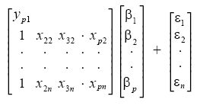
or, from vector-matrix notation above,
Y = Xβ + ε
Each data point can be given as , i = 1,2,3………..n. For n = p, standard errors of the parameter estimates could not be calculated. For n less than p, parameters could not be calculated.
The estimated values of the parameters can be given as
= (X^{T}X)⁻¹ X^{T}

Using the assumptions provided by the Gauss-Markov Theorem, it is possible to analyze the results and determine whether or not the model determined using least-squares is valid. The number of degrees of freedom is given by m − n.
The residuals, representing 'observed' minus 'calculated' quantities, are useful to analyze the regression. They are determined from
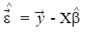
The standard deviation, for the model is determined from
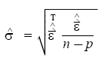
The variance in the errors can be described using the Chi-square distribution:
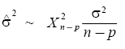
The 100(1 − α) % confidence interval for the parameter, β_{i}, is computed as follows:
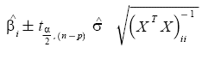
where t follows the Student's t-distribution with m − n degrees of freedom and (X^{T}X)_{ii} ⁻¹ denotes the value located in the i^{th} row and column of the matrix.
The 100(1 − α) % mean response confidence interval for a prediction (interpolation or extrapolation) for a value is given by:
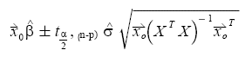
Where, 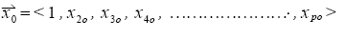
The 100(1 − α) % predicted response confidence intervals for the data are given by:
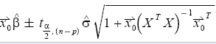
The regression sum of squares SSR is given by:
SSR = ∑ (_{i} - ) ²
Where is an n by 1 unit vector.
The error sum of squares ESS is given by:
ESS = ∑ (y_{i - i)} ²
The total sum of squares TSS' is given by
TSS = ESS + SSR
Pearson's co-efficient of regression, R² is then given as:
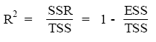
Assessing the least-squares model
Once the above values have been corrected, the model should be checked for 2 different things:
- Whether the assumptions of least-squares are fulfilled and
- Whether the model is valid
3.1.3.2 Model assumptions
The model assumptions are checked by calculating the residuals and plotting them. The residuals are calculated as follows:
The following plots can be constructed to test the validity of the assumptions:
- Plotting a normal probability plot of the residuals to test normality. The points should lie along a straight line.
- Plotting a time series plot of the residuals, that is, plotting the residuals as a function of time.
- Plotting the residuals as a function of the explanatory variables, X.
- Plotting the residuals against the fitted values,.
- Plotting the residuals against the previous residual.
In all, but the first case, there should not be any noticeable pattern to the data.

3.1.3.3 Model validity
The validity of the model can be checked using any of the following methods:
- Using the confidence interval for each of the parameters, β_{i}. If the confidence interval includes 0, then the parameter can be removed from the model. Ideally, a new regression analysis excluding that parameter would need to be performed and continued until there are no more parameters to remove.
- Calculate Pearson’s co-efficient of regression. The closer the value is to 1; the better the regression is. This co-efficient gives what fraction of the observed behavior can be explained by the given variables.
- Examining the observational and prediction confidence intervals. The smaller they are the better.
- Computing the F-statistic.
Confidence or prediction interval of a regression line
If you check the option box, Prism will calculate and graph either the 95% confidence interval or 95% prediction interval of the regression line. Two curves surrounding the best-fit line define the confidence interval.
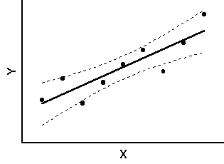
Fig. 3.1
The dashed lines that demarcate the confidence interval are curved. This does not mean that the confidence interval includes the possibility of curves as well as straight lines. Rather, the curved lines are the boundaries of all possible straight lines. The fig. below shows four possible linear regression lines (solid) that lie within the confidence interval (dashed).
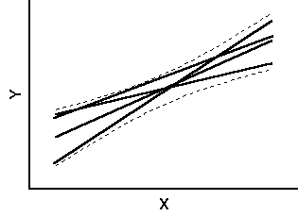
Fig. 3.2
Given the assumptions of linear regression, you can be 95% confident that the two curved confidence bands enclose the true best-fit linear regression line, leaving a 5% chance that the true line is outside those boundaries.
Many data points will be outside the 95% confidence interval boundary. The confidence interval is 95% sure to contain the best-fit regression line. This is not the same as saying it will contain 95% of the data points.
The 95% prediction interval is the area in which you expect 95% of all data points to fall. In contrast, the 95% confidence interval is the area that has a 95% chance of containing the true regression line. This graph shows both prediction and confidence intervals (the curves defining the prediction intervals are further from the regression line).
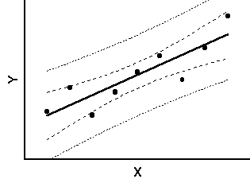
Fig. 3.3
The analysis of Experimental results obtained of surface roughness was analyzed. The data for speed, feed, depth of cut and surface roughness was recorded and analyzed in terms of obtaining best fit curve equations.
3.2. Parameter Design Optimization of EDM Machining Using DOE
This chapter is all about the steps and procedures used to optimize EDM parameters using Taguchi’s design of experiment. In this chapter objectives of the study were set and according to the objectives of the study different factors were selected. After that experimental work was carried out on EDM machine according to L₂₇ orthogonal array. The values of response factor i.e. metal removal are then recorded according to orthogonal array.

3.2.1 Concept of DOE
Design of Experiment (DOE) is a structured, organized method that is used to determine the relationship between the different factors (Xs) affecting a process and the output of that process (Y). Sir Ronald A. Fisher, the renowned mathematician and geneticist first developed this method in the 1920s and 1930.
Design of experiment (DOE) is to understand the impact of specific changes to the inputs of the process, and then to maximize, minimize or normalize the outcome by manipulating the input.
DOE is a scientific approach which allows the researchers to gain knowledge in order to better understand a process and to determine how the impacts (attribute effect the output response).
It is usually used when it is unclear what impact a specific set of inputs may have either individually or collectively on process or product. A designed experiment is the simultaneous evaluation of two or more factors (parameters) for their ability to affect the resultant average or variability of a particular product or process characteristic. To accomplish this in an effective and statically proper fashion, the level of factors are varied in a strategic manner, the results of particular test combination are observed, and the complete set of results is analyzed to determine the influential factors and preferred levels, and whether increase or decrease of those levels will potentially lead to further improvement. It is important to note that this is an iterative process; the first round through the DOE process will many times lead to subsequent rounds of experimentation. The beginning round, often referred to as screenings experiment, is used to find the few important influential factors out of the many possible factors involved with the process or product design. The experiment is typically a small experiment with many factors at two levels. Later rounds of experiments typically involve few factors at more than two levels to determine conditions of further improvement.
- DOE is the most cost effective and efficient method for identifying the key input factors and in understanding the relationship between input factors and response.
- DOE investigate a number of input factors with relatively small number of tests.
- DOE helps to identify important/ critical attributes of a process improvement effort, as they can be characteristics to be examined and the desired effect.
The DOE process is divided is divided into three main phases, which encompasses all experimental approaches. These three phases are:
  - The Planning Phase
  - The Conducting Phase
  - The analyzing phase.
The planning phase is when factors and levels are selected and, therefore the most important stage of experimentation. Also the correct selection factors and levels is non statistical in nature and more dependent upon product or process expertise.
The second most important phase is the conducting phase, when the test results are actually collected. If experiments are well planned and conducted, the analysis is actually much easier and more likely to yield positive information about factors and levels.
The analysis phase is when the positive or negative information concerning the selected factors and levels is generated based on the previous two phases. This phase is statistical in nature.
The major steps to complete an effective designed experiment are listed in the following 12 steps. The planning phase includes steps 1 through 9, the conducting step 10, and the analysis phase include steps 11 and 12.
- State the problem(s) or areas(s) of concern.
- State the objective(s) of the experiment.
- State the quality characteristic(s) and measurement system(s).
- Select the factors that may influence the selected quality characteristics.
- Identify control and noise factors.
- Select levels of factor.
- Select the appropriate orthogonal array (OA) or Ors.
- Select interactions that may influence the selected quality characteristics or go back to step 4(iterative steps).
- Assign factors to OA(s) and locate interactions.
- Conduct tests described by trials in OAs.
- Analyze and interpret results of the experimental trials.
- Conduct confirmation experiment.

3.2.2 Problem Identification
Set-up parameters play the most important role to get the desired results. The main objectives of this research are to carry out the experiments by selecting different variables and their levels, applying Taguchi design of experiment and then analyzing the results obtained. The machining characteristics considered were:
- Metal Removal Rate
The set-up parameters, which were used to get the expected results, are
- Current
- Dia. Of electrode
- Pulse On time
The experiments were conducted according to the Taguchi design of experiment i.e. the number of experiments were done as suggested by the Taguchi design of experiment according to number of factors, their levels and their interactions.
3.2.3 Taguchi's Parameter Design Method
3.2.3.1 Objective of Taguchi's Method
Taguchi's parameter design can be used to make a process robust against sources of variation and hence improve field performance. If we can design a process that has the robustness to noise factors that largely affects the variance of performance characteristics at a developing stage, it will very possible for the process to have robustness against other noise factors that could not be considered at the development stage. The aim of a parameter design experiment is, then, to identify settings of the design parameters that maximize the chosen performance measure and are insensitive to noise factors. (Feng. Chang-Xue (Jack) 2001)

3.2.3.2 Orthogonal Array
The goal of a Taguchi's experimental design is to identify optimal settings for all the design parameter, not to build the model fitting of process. Taguchi has achieved substantial payoffs just by conducting many main-effect-only-experiments and checking the results by confirmation experiments. If it can be proved that the system could be described well by even only main effects, the optimal condition determined by only main effect analysis can be very efficient and simple method for optimization. Orthogonal array has been used to minimize the number of test runs while keeping the pair-wise balancing property in Taguchi's method for that purpose. These basic principles serve as a screening filter, which allows the examination of the effects of many process variables, identifying those factors, which have a major effect on process characteristics using a single trial with a few reactions. For example, optimization experiment would normally require each variable to be tested independently. Thus, a trial run investigating the effects and interactions of four reaction variables each at three concentration levels, would require an experiment with 81 (i.e. 3⁴) separate reactions. Using an orthogonal array, however, an estimate of the effect of each variable can be carried out using only nine experiments. Providing that three level are used for each variable tested, the number of experiments required (E) is calculated from the equation E= 2k +1, where k is the number of factors to be tested. If the calculated number is not a multiple of three, then the required number of variables to be tested is the next multiple. Hence, as the number of components to be tested is increased, the reduction in the number of experiments required becomes more marked; e.g. to test 9 factors would require 3⁹ = 19683 experiments to analyze fully, whereas using Taguchi's methods this could be reduced to just 21(2 x 9 + 1 = 19), 19 is not a multiple of three and then next integer divisible by three is 21).
3.2.4 Brainstorming
When physical experiments are used, it is sometimes impossible or very expensive to carry out an experiment according to the set-up. Thus it becomes necessary to first study and discuss about the process and process parameters. A good knowledge about the work to be done, process and optimization technique may be very helpful to get expected results. Important steps that are to be considered are as follows:
- Objectives of Study and Evaluation Criteria
- What are the criteria of evaluation?
- How are each of these criteria measured?
- How are these criteria combined into a single number?
- What is the common characteristic of these criteria?
- What is the relative influence these criteria exhibit?
- Design Factors
- What are the factors that influence the performance criteria?
- Which factors are more important than others?
- Noise Factors
- Which factors can't be controlled in real life?
- Is the performance dependent on the application environment?
- Factor Levels
- What are the ranges of values the factors can assume within practical limits?
- How many levels of each factor should be used for the study?
- What is the tradeoff for a higher level?
- Interaction between Factors
- Which factors are most likely to interact?
- How many interactions can be studied?
- Scopes of Studies
- How many experiments can we run?
- When do we need the results?
- How much does each experiment cost?
- Additional Items
- What do we do with factors that are not included in the study?
- In what order do we run these experiments?
- Who will do these experiments?

Use of Orthogonal Arrays (OAs) and Signal-to-Noise (S/N) Ratios
OAs is used to minimize the number of runs (or combinations) needed for the experiment. Many people are of the opinion that the application of OA is TM, but the application of OAs is only a part of TM. S/N ratios are used as a measure of the functionality of the system. S/N ratios capture the magnitude of real effects (signals) after making some adjustment to uncontrollable variation (noise).
Two-Step Optimization
After conducting the experiment, the factor–level combination for the optimal design is selected with the help of two step optimization. The first step is to minimize the variability (maximize S/N ratios). In the second step, the sensitivity (mean) is adjusted to the desired level since it is easier to adjust the mean after minimizing the variability.
3.2.5 Types of Optimization Problems
3.2.5.1 Static Problems
Generally, a process to be optimized has several control factors, which directly decide the target or desired value of the output. The optimization then involves determining the best control factor levels so that the output is at the target value. Such a problem is called as a "STATIC PROBLEM".
This is best explained using a P-Diagram, which is shown below ("P" stands for Process or Product). Noise is shown to be present in the process but should have no effect on the output. The primary aim of the Taguchi experiments is to minimize variations in output even though noise is present in the process. The process is then said to have become robust.
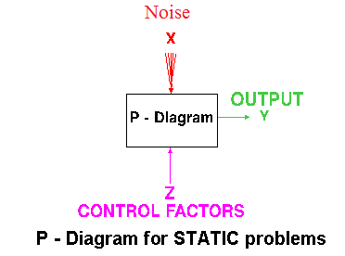
Fig. 3.4 P-Diagram for Static Problems
3.2.5.2 Dynamic Problems
If the product to be optimized has a signal input that directly decides the output, the optimization involves determining the best control factor levels so that the "input signal / output" ratio is closest to the desired relationship. Such a problem is called as a "DYNAMIC PROBLEM". The difference between dynamic and static problem is that in dynamic problems we study the effects on output due to noise also which are not considered in static problems. This is best explained by a P-Diagram, which is shown below. Again, the primary aim of the Taguchi experiments - to minimize variations in output even though noise is present in the process- is achieved by getting improved linearity in the input/output relationship.
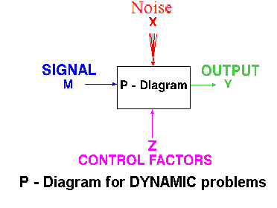
Fig. 3.5 P-Diagram for Dynamic Problems
3.2.6 Batch Process Optimization
There are 3 Signal-to-Noise ratios of common interest for the purpose of optimization;
3.2.6.1 Smaller-The-Better
n = -10 Log₁₀ [mean of sum of squares of measured data]
This is usually the chosen S/N ratio for all undesirable characteristics like "defects, surface roughness" etc. for which the ideal value is zero. Also, when an ideal value is finite and its maximum or minimum value is defined (like maximum purity is 100% or minimum time for making a telephone connection is 1 sec) then the difference between measured data and ideal value is expected to be as small as possible. The generic form of S/N ratio then becomes,
n = -10 Log₁₀ [mean of sum of squares of {measured - ideal}]
3.2.6.2 Larger-The-Better
n = -10 Log₁₀ [mean of sum squares of reciprocal of measured data]
This case has been converted to SMALLER-THE-BETTER by taking the reciprocals of measured data and then taking the S/N ratio as in the smaller-the-better case.
3.2.6.3 Nominal-The-Best
Square of mean
n = 10 Log₁₀ -----------------
variance
This case arises when a specified value is MOST desired, meaning that neither a smaller nor a larger value is desirable.
3.2.7 Steps in Taguchi Methodology
Taguchi method is a scientifically disciplined mechanism for evaluating and implementing improvements in products, processes, materials, equipment, and facilities. These improvements are aimed at improving the desired characteristics and simultaneously reducing the number of defects by studying the key variables controlling the process and optimizing the procedures or design to yield the best results.
The method is applicable over a wide range of engineering [35] fields that include processes that manufacture raw materials, sub systems, products for professional and consumer markets. In fact, the method can be applied to any process be it engineering fabrication, computer-aided-design, banking and service sectors etc. Taguchi method is useful for 'tuning' a given process for 'best' results.
Taguchi proposed a standard 8-step procedure for applying his method for optimizing any process. These are:

Step1: formulation of the problem – the success of any experiment is dependent on a full understanding of the nature of the problem. It is important to establish just what the experiment is aiming to solve.
Step2: Determine the objective:-Identify the output characteristics (responses) to be studied and eventually optimized and determine the method of measurement. To establish measurement reliability, a separate experiment may be required
Step 3: Identification of control factors, noise factors and signal factors (if any). Control factors are those which can be controlled under normal production conditions. Noise factors are those which are either too difficult or too expensive to control under normal production conditions. Signal factors are those which affect the mean performance of the process. Taguchi believes that it is generally preferable to consider as many factors (rather than many interactions) as it is economically feasible for the initial screening.
Step 4: selection of factor levels, possible interactions and the degrees of freedom associated with each factor and the interaction effects. Assign the controllable factors and their interactions to the columns of the inner array, and the noise factors to the columns f the outer array.
Step 5: Conduct the experiment: Perform the experimental trials and collect the experimental data.
Step 6: Analyze the data: Evaluate the performance measures (TPM and NPM) for each trial run of the inner array and analyze them using the appropriate statistical analysis technique
Step 7: Interpret the results: Identify the variability control factors (VCF) and target control factors (TCF) and select their optimal levels. For the VCF’s the optimal levels are those, which maximize the NPM (minimize variability in the response), and for the TCF’s they are those, which bring the mean response nearest to the target value.
Step 8: Run a confirmatory Experiment: It is necessary to confirm, by some follow up experimental trials. A successful confirmation can alleviate concerns about the possibilities of a wrong choice for factor levels and experimental design.
If predicted results are not confirmed, or otherwise unsatisfactory, additional experiments may be required and a repetition of step no. 3 to 8 may be necessary.
3.2.8 Advantages of Taguchi Design of Experiment
- It changes the timing of the application of quality control from on line to offline, so that we can easily rely on inspection, can build quality into the product and the process and thus ‘do it right first time’.
- It changes the experiment procedure from varying one factor at a time to varying many factors at a time, through statistical experimental design techniques.
- It changes the objective of experiments and the definition of quality from ‘achieving conformance to specification’ to ‘achieving the target and minimizing the variability’.
- It changes the attitude for dealing with uncontrollable factors: remove the effect not the cause, by appropriately turning the controllable factors.
3.2.9 Limitations of Taguchi Design of Experiment
Sometimes it is claimed that, Dr. Taguchi, “has advocated some novel methods of statistical analysis and some approaches to the design of experiments that are unnecessarily complicated, inefficient, and sometimes ineffective”.
- Some of Taguchi’s experiment designs may lead to an incorrect answer when large two factor interactions appear.
- Taguchi method uses one array for control variables and one array for the noise variables and then a crossed array experiment is conducted, this makes the process difficult to understand.
- Several considerations favour the separate analysis of mean value and standard deviation instead of using Taguchi’s S/N ratio.
- There is only selected number of experiments to be done in Taguchi’s design of experiment that’s why it cannot be guaranteed that picking optimum level will provide optimum results.
- This process is limited to a certain number of designs.
- It will be useful only when it is implemented in early stages of design.
Central composite designs
There are Central Composite designs for any number of factors, but we will focus on the three factor case. The graphic shows the design as a pattern of points in a coded three-dimensional factor space. The design will be shown as a table on the next page.
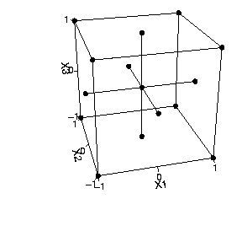
The design is called composite because it can be thought of as the union of three separate pieces:
- the eight corners of the cube, which form a two level full factorial
- the six points in the centres of each face, known as the axial points or the star points
- the centre point.
It is called central to distinguish it from non-central designs in which the centroid of the star is displaced relative to the centre of the cube. For brevity we will call it a CC design.

Central Composite Designs
These types of experimental design are frequently used together with response models of the second order. The design consists of three types of points:
axial points The axial points are created by a Screening Analysis
cube points The 2^{n} cube points come from a Full Factorial design
center point A single point in the center is created by a Nominal design
For the further description of the designs, the ranges -- minimum and maximum values -- of the control parameters are scaled to [-1,+1]. A graphic of a three dimensional Central Composite Circumscribed (CCC) design is shown in Figure . Here the axial points are located on a hyper-cube with the radius b_{i}. The cube build by the cube points has side-length of 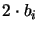.
Figure : The example points of a Central Composite Circumscribed design with three input parameters.
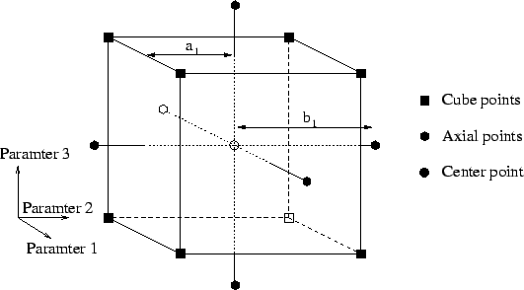
All three types of Central Composite designs, (Central Composite Circumscribed (CCC), Central Composite Inscribed (CCI), and Central Composite Face-centered (CCF)), have the same structure shown in Figure but with other values for a_{i} and b_{i}. These values of the three Central Composite designs are listed in Table

Table : Factors a and b for Central Composite designs with full factorial cube points.
 |  | range_{i}
CCC |  | 2 a_{i}
CCI |  | 2 b_{i}
CCF | 1 | 2 a_{i} = 2 b_{i}

Two of these designs -- CCC and CCI -- have a special characteristic; they are rotatable. A design is said to be rotatable, if upon rotating the design points about the center point the moments of the distribution of the design remain unchanged. For rotatable Central Composite designs the factor must be .
This table is only valid for a single center point. This is not a big restriction for numerical simulation because the the results of two simulations with the same input data have to be the same.
Chapter 4
EXPERIMENTAL SET UP
In this chapter, we would discuss the experimental set up, machine used its limitations, advantages, measuring instrument, tooling used on the machine.
4.1 EDM Machine
The following figure shows EDM Machine consists of the machine unit with servo gap control system , dielectric system and pulse generator system.
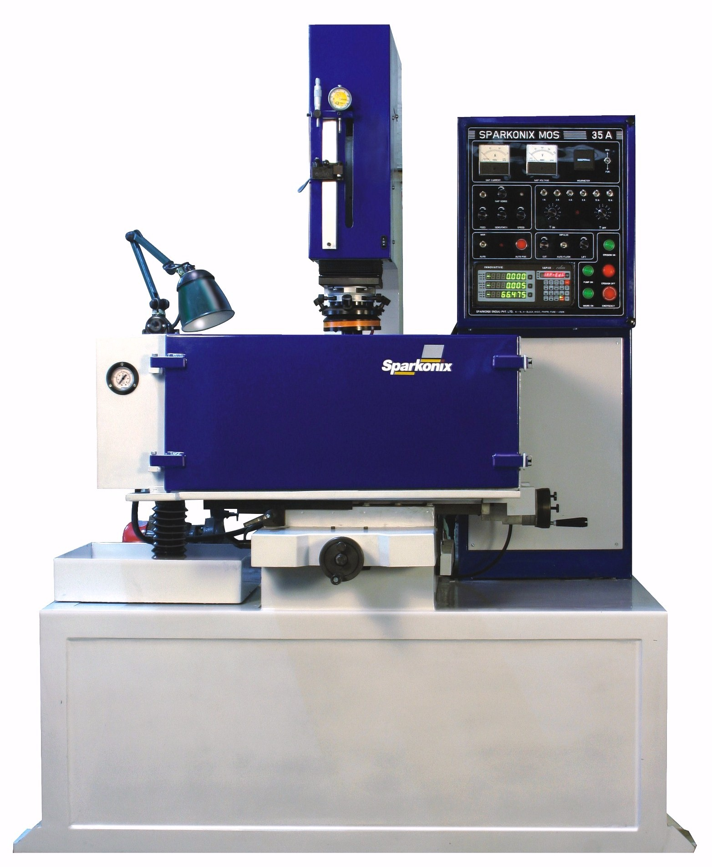
Fig.: 4.1 EDM Machine
EDM Machine made Sparkonix , PUNE was available for the experimental purpose.
System configuration
Sparkonix Pune make EDM Machine has following configurations.
- Electrical:
Controller : 35A
Optimum Working Current: 35
Power Connection: 4 KVA (415V,3 phase , 50Hz)
- Mechanical:
Model | SN35
Tank Size | 775 mmx 450mm x 325mm
Table Size | 550mm x 350mm
Long Cross Travel | 200mm x 200mm
Quill | 200mm
Max. Height of Work Piece | 300mm
Max.Weight of Work Piece | 400kg
Max. Electrode Weight | 35Kg
Parallelism of table surface with travel | 0.02
Squareness of electrode travel | 0.02 / 300
Capacity of dielectric | 260 lts
Motor for Pump | 1 HP
Table 4.1. EDM machine Desciption
DIELECTRIC SYSTEM
It will be seen from description of Spark Erosion process that the efficiency of the erosion and surface finish obtained depends on the presence of any foreign particles in the dielectric finish obtained on the presence of any foreign particles in the dielectric medium. It is also a must that the carbon particles produced during erosion should be cleared from the sparking zone, hence various flushing techniques like injecting the filtered dielectric into the sparking zone. The system consists of pump. Valves filters and drain. A well-designed dielectric system to give trouble free circulation of the dielectric system to give trouble free circulation to the dielectric to the work tank tank has been provided.
A welded sheet metal tank is provided with the sheet metal cover placed near the machine tool. It consists of a 3 phase, 415 volts AC Monbloc pump, Filter unit, Dielectric distributor consisting of a manifold with Flushing points at regular intervals suitable to flush out carbon particles throughout the job. It is connected to a 1 inch T with a Flexible pipe, which is connected to main inlet pipe. The other end of 1 inch T is connected to 1 inch Gate valve for flow of the dielectric into the work tank. Pump is fixed on mild steel plate and placed on the top of the dielectric system.
Filter Cartridges are mounted on a metal box. Metal pipe from the box is connected to the inlet of pump using flange with rubber gasket and fitted with nut and bolts. The kerosene is filled in to the tank. The amount of kerosene required depends upon the capacity of the filter tank. Flexible pipe coming from the 1 inch T from working tank has flange connected to it at one end. This flange is connected to the outlet of pump with nut and bolts along with rubber gaskets, which are provided. The Gate valve provides inlet of the dielectric (Kerosene) in to the work tank. Operating the Gate valve can control the flow of the dielectric. The excess flow can be passed back to the filter tank by ;operating the other Gate valve provided near the pump.
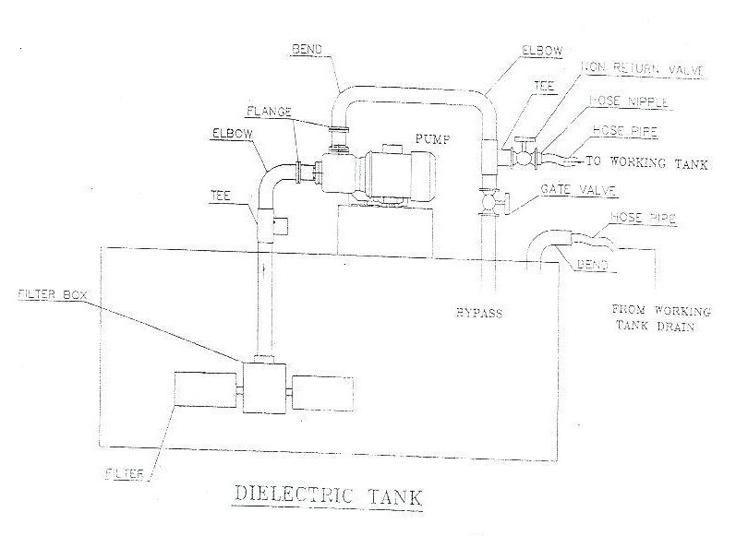
Figure 4.2 Dielectric System of EDM machine
Operating the gate valves provided on the work tank can control the flushing pressure. Pressure gauge is provided to indicate the respective flushing pressure. A solenoid valve can also mount on the working tank (optional) and it serves for quick drain of to dielectric after the fob is over. Pipeline for drain is provided from the working tank.
The filters cartridges should be replaced after every 200-working hour of the machine to achieve the best results. Priming of the pump is to be done before the pump is put into operation.
PRESSUE GAUGE
The flushing pressure can be read on separate gauge fitted on the left side of the working tank.
VACUUM GAUGE
The suction pressure (vacuum) can be read on the gauge provided on the left side of working tank.
4.2. PROCESS DESCRIPTION
Spark Erosion Machining is a process based on the disintegration of the dielectric and current conduction between the job and Work piece by an electrical discharge occurring between them. This process is also called as Electro Discharge Machining/Elector Erosion Process/Electro Spark Machining. In this method the job and the Work piece (which act as electrodes) are separated by a certain gap filled with a dielectric medium. A preset pulse is applied across the fob and Work piece. Depending upon the micro irregularities of Tool and Work piece surfaces, and presence of carbon and metal particles, the dielectric is broken down at several points producing, the dielectric is broken down at several points producing ionized columns which allow a focused stream of electrons to flow and produces compression shock waves and there is and there is an intense increase in the local temperature. Due to the combined effect of these two, particles of metal are thrown out. Very much similar to the boiling out of water. As erosion progresses the gap changes and that gap is continuously maintained by the servomechanism.
This process incorporates two unique features viz.
- Absence of any cutting force between tool and work piece.
- Absence of any effect of hardness of hardness of work piece and on cutting action. These features allow this process to be used in producing fine slots of micro drills in thin delicate parts like electrical and electronic components. The spark erosion process is effective in machining electrically conductive but extremely brittle material, in machining super hard material like cemented carbide, in removing broken drills, taps etc. besides being unique in above application this process can replace the conventional extra laborious die cavity producing methods. Since the shape of cavity being eroded corresponds to the shape of tool, this process is very convenient and economical for various die-sinking applications.

As the Erosion is carried out in Dielectric the eroded particles get contaminated in dielectric. Due to the presence of these carbon particles the process gets affected. Hence it is necessary that such particles should be removed from dielectric continuously.
This necessitates use of filtration system. For this Spark Erosion Machines are provided with a combination of filter pumps system to control dielectric circulation. Various methods like injection of dielectric in to sparking zone through electrode of work piece of from sides in to the sparking zone. This is called as FLUSHING. It has been proved beyond doubt tat flushing of dielectric improves the efficiency, accuracy and surface finish.
4.3.CONTROLLER DESCRIPTION
The controller supplies electrical energy to the Spark gap in the form of Square wave pulses. Precision timing and control of the pulses in the Spark controller results in stable sparking (machining)
Features:
- Based on MOSFET, which ensures reliable consistent sparking in low and high frequency operations.
- Auto lift/cut of the electrode at adjustable timing.
- DC stepper drive on quill movement for rapid movement for rapid movement in manual mode and controlled speed in sparking made.
- Gap sense (Anti-Arc) facility to prevent arcing and possibility of damages to electrode and job
- Different selectable settings.
- Autopos and Zero setting facility with Audio/visual signal device for positioning of electrode and precise depth setting.
- EPROM input by crystal controlled oscillator.
All components in the controller are assembled in standard cabinet. Opening respective panels can easily access the sub assemblies in the controller. All controls are easily assessable to avoid the overheating by an efficient cooling system with circular fan. The controller works on 415VAC, 3Phase + /-10%, 50Hz power supply. Sparkman MOS consists of EPROM based pulse generator for roughing as well fine finishing operations.
EPROM based pulse cum fine generator
The discharge current in spark gap is selected by means of current selector switches.
The working current can be selected depending upon sparking are. Different values
of current can be switched ON individually.
The generator consists of T ON and T off switches provided on the control panel. According to the abjustment of T ON time and T off time the machining mean current can be below maximum peak current. The values are at a working voltage of approximately 45 to 50volts. The ON time duration for which the pulse is switched ON and OFF time is the duration for which the pulse is switched off. This ix fixed by means of an electronic time base and chose by setting 11-position pulse time selector to maximize the efficiency in roughing and finishing operations.
The pulse ON time determines the energy of each discharge for given power. The longer the duration of the pulse. The greater the energy per discharge, the craters produced being deeper and the surface finish rougher. On the other hand the longer the pulse ON time, the less will be the wear of the electrode. The duration of the pulses for a given power (Current) determines the surface finish and the rater of wear and Material Removal Rate (M.R.R.).
The pulse off time determines the spacing of the pulses i.e. the frequency of the succession of the pulses. It is thus possible to modify the speed of sparking for a given pulse ON time. Modification of pulse OFF time has no effect on the surface finish .this selector is adjusted so that both speed and stability of sparking are obtained. The T ON time should always be more than T off time by one of two divisions. Finishing con be achieved at very low current with very low T On and T off timings.
OPTIONAL:
The operator has to set important parameters on the from panel or control panel which influences considerably the material removal rate (M.R.R.) electrode wear, surface finish and over cut.
They are-
- Sparking on generator with variable pulse duration i.e. T On and T off timing.
- Sparking Current.
- Feed and Sensitivity control along with the speed control.
- Mode of flushing.

4.4 ELECTRODE MATERIAL ELECTROLYIC COPPER
Electrolytic copper is generally used as an electrode material. It can be extruded of drawn and then machined to required size and shape. It has low wear under both Roughing and Finishing operations and has the capacity to remover larg amounts of material. This material is advisable for spark eroding cavities in Tungsten Carbide particularly of small sizes and intricate shapes.
For eroding all types of die cavities this material is recommended. Its alloys like Copper Chromium, Copper Cadmium are also used for Electrode making.
Composition of Electrolytic Copper:
CU (Min) 99.99%
(SI/ppm) 0.3 (Fe/ppm) 2 (CO/ppm) 0.2gy76 O2 (2/ppm) nil (BI/ppm) 0.1
(AG/ppm) 10 (MN/ppm) 0.1 (PB/ppm) 0.2 (TE/ppm) 0.05 (NI /ppm) 0.2
(AL/ppm) 0.5 (SE/ppm) 0.3 (MG/ppm) 0.4 (SB/ppm) 0.1
4.5 SETTING OF WORKPIECE FOR SPARK EROSIN
The procedure for setting the JOB in spark erosion is similar to other conventional machines except for certain precautions regarding limitations of the process.
MOUNTING OF WORKPIECE
The work piece con be located at the desired place on the T slot table by opening the door to the tank, then clamp the work piece which are provided of on magnetic block, magnetic vice etc. lf any reference edge is to be checked then the gauge of marking block should be held in the electrode holder and checked with the help of X-Y coordinate movement.
After clamping the job and setting it properly hold the electrode firmly in the V block. Use a rectangular or a square shank instead of a round one to check whether Electrode is perpendicular of not.
BY X-Y coordinate and Servo slide movements the Electrode should be located over the desired cavity. Then adjust the float switch so that the dielectric level is at least 5cm.above the topmost sparking point. Then close the door firmly with the clamps. The job is now set and we may proceed for operating the machine as per instructions given in the manual.
4.6 ELECTRODE CLAMPING
- In order to make round or square cavity an Electrode of that shape should be clamped directly on the V-block as shown in the adjoining figure.
2. If there is a big electrode than one has to make use of other shanks. The shank is
lightly screwed on to the Electrode first and is then clamped on the V=Block Shank with an internal hole is to used for suction of injection flushing system.
3. Special electrode holder and rotary mechanism for fine drilling of holes is provided and that it can be clamped on the V-block holder.
4. For gang drilling the special jigs and fixture are available.
RELOCATING OF ELECTRODE
In most of the operations relocating of the electrode is required and con be obtained by following ways:
- By using a relocating shank which has a tight angle which fits in the V-block holder (as shown in the figure) so that after removing and clamping again it will retain the position.
- After removing the electrode mark its position by scriber on the job and relocate the shank in such a position that the marking on the job and electrode coincide.
- But the most practical method of relocating is by starting the controller on very low power of pulse generator, please see to it that dielectric is not present on the job as well as in the tank while observing sparking.
- Autopos function can also be used for relocating of electrode. e.g. entering of the job and electrode.
ALIGNMENT OF ELECTRODE
- Roughly it is checked by master try square.
- it is also checked by dial guage as follows,
its alignment is checked at two places which should be perpendicular to each other as shown in the figure. It should be within 0.02 mm for a length of 100mm. the dial gauge is held over by a magnetic block and the electrode is moved up and down manually by Quill motor.
SWIVELLING MECHANISM
Electrode can be made perpendicular to the work piece surface by swiveling of electrode with the help of 4 bolts shown in the figure. The electrode can be swiveled maximum 7 degrees kin the vertical plain. The dial guage of metal try square can be used to check the perpendicularity.
GUIDELINES FOR ROUGHING OPERATIONS
Generally current applied depends upon the sparking area which leads to optimum results related to cutting speed (M.R.R) electrode wear, spark gap (over size) and surface finish.
For 100 sq. mm. sparking area-4 Amps for copper to steel
For roughing operations please follow as given below-
Current T ON T OFF Remarks
1 Amps to 6Amps 6 6 For single OR two cavities
with depth 10 mm (Max)
7Amps to 12 Amps 7 6 for multi cavities
7Amps to 12 Amps 7 6 General
12 Amps and above 8 6/7 Genera
FOR CARBIDE TO STEEL
Current TON TOFF
4Amps to 10 Amps 4 4
11Amps to 20 Amps 4 4/5
Note: The cutting speed, electrode wear, surface finish depends upon the grade of carbide polarity selection and mode of flushing/suction which varies abruptly for
various grades of carbide.

GENERAL STEPS FROM ROUGHING TO FINISHING .
Sr. No. TON Time TOFF Time Power (current) Time
1. 8 6 12Amps …….
2. 7 6 10Amps …….
3. 6 5 8Amps ……..
4. 5 4 6Amps 5Mins
5. 4 3 4Amps 5Mins
6. 3 2 3Amps 5Mins
7. 2 1 2Amps 5Mins
8. 1 0 1Amps 5Mins
9. 0 0 1Amps 10Mins
FLUSHING TECHINQUES
FLUSHING: The eroded products: i.e.
  - Gases involved in the splitting of the dielectric fluid.
  - Carbon particles (swarf) removed from the electrode & work piece are removed from the spark gap by appropriate devices.

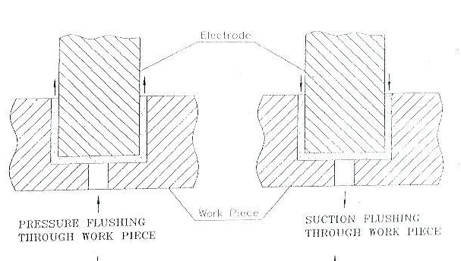
Figure 4.3. Flushing technique
The gases escape through the workgap in the form of bubbles while the particles removed form the electrode and work piece vary in size & shape, are washed away by flushing, hence there is always fresh between the spark gap. Care should be taken to avoid the flushing of kerosene opposite to each other. In case of jobs which have to be deeper than 10mm use the Autoflush. For deeper erosion process shorter should be the selection f CUT time. It is also advised to use flushing through the electrode/job wherever possible.

Various types of flushing techniques have been shown in the figure. The basic type of flushing i.e. pressure flushing and suction are differentiated in the figures, through the electrode/job wherever possible.
Various types of flushing techniques have been shown in the figure. The basic type of flushing i.e. pressure flushing and suction are differentiated in the figures, which are self explanatory. If the work piece is having a through hole then the flushing pot is used as shown in the figure.
If the electrode is of large size then we have to provide holes for flushing at more than one point .g. for connecting rod electrode (conrod) three holes for flushing are provided as shown in the figure. A electrode holding shank with central hole for flushing/suction is connected to flushing point/suction point using flexible pipe.
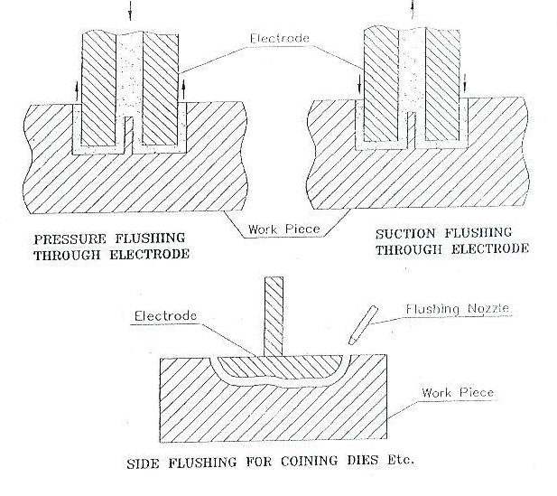
Figure 4.4 Flushing techniques
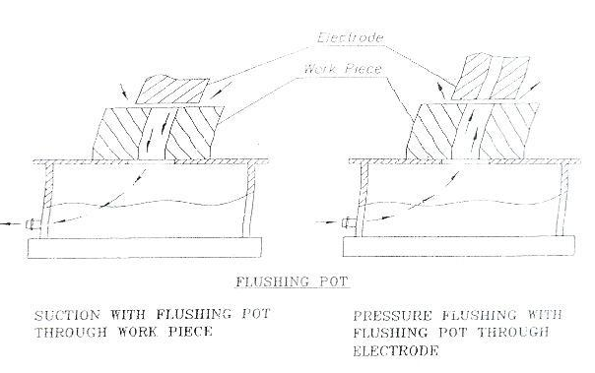

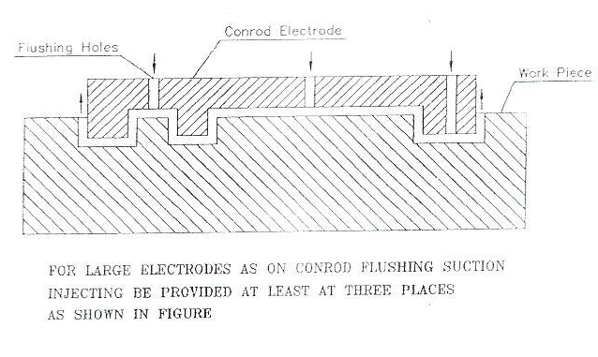

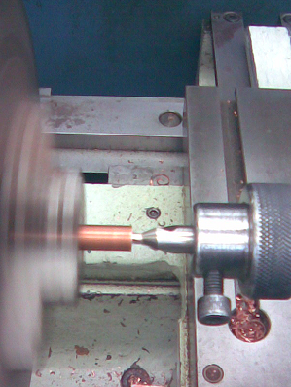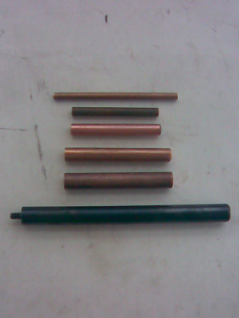
Figure 4.4. Figure showing machining of electrode and electrodes of different sizes
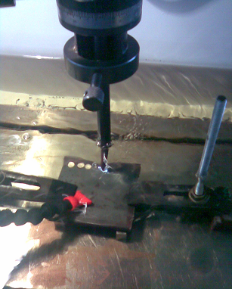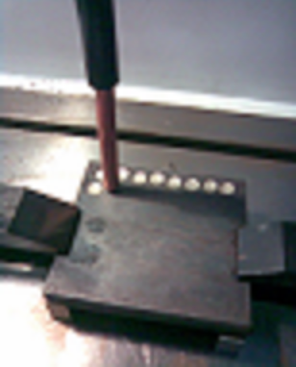
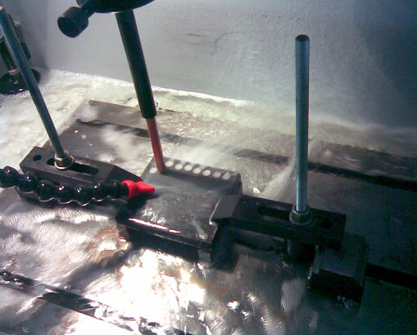
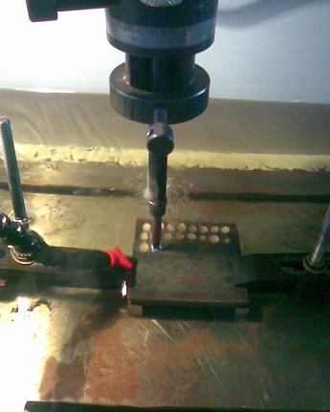
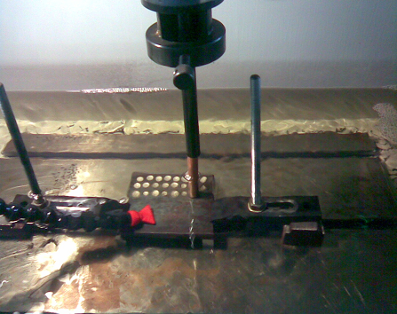
Figure4.5. Experimental set up and machining work piece
4.7.Work piece material.
Standardized material was selected to ensure consistency of the alloy, which is an EN31 used in industry thus, EN31 made in the form of plate of 20mm thickness. High carbon alloy steel achieves a high degree of hardness with compressive strength and abrasion resistance. The work piece material was EN31 alloy with the chemical composition as under:
TABLE 4.2 (Chemical Composition of Work Piece)
Element | Weight %
C. | 0.90%
Si | 0.25%
Mn | 0.80%
S | 0.05%
Cr | 1.0%
P | 0.05%

Chapter 5
ANALYSIS OF MACHINING DATA

Regression analysis is one of the most widely used techniques for analyzing multifactor data. Its broad appeal and usefulness result from the conceptually logical process of using an equation to express the relationship between a variable of interest (the response) and a set of related predictor variables. So regression analysis was used to develop the parametric equations. The following factors are used in the present analysis:
Regression sum of squares:
${\text{SS}}_{R}=\sum_{i=1}^{n}{{\left({\hat{y}}_{i}−\bar{y}\right)}^{2}}$ (5.1)
Where $\bar{y}$= sum of dependent variable
${\hat{y}}_{i}$= fitted value of i^{th} dependent variable
Residual sum of squares:
${\text{SS}}_{\text{Res}}=\sum_{i=1}^{n}{{\left(y_{i}−{\hat{y}}_{i}\right)}^{2}}$ (5.2)
y_{i} = observed value of i^{th} dependent variable
Total sum of squares: It is the total variability in the observations of the data.
${\text{SS}}_{T}={\text{SS}}_{R}+{\text{SS}}_{\text{Res}}$ (5.3)
Predictor variables
$k={\text{SS}}_{R} / σ^{2}$ (5.4)
This has the same number of degree of freedom as number of regressor or predictor variables in the model.
σ² = variance
Regression mean squares
${\text{MS}}_{R}=\frac{{\text{SS}}_{R}}{k}$ (5.5)
Residual mean squares
${\text{MS}}_{\text{Res}}=\frac{{\text{SS}}_{\text{Res}}}{n−p}$ (5.6)
p = k +1 = parameter in the regression model
n = number of observations
Test of statistic
$F=\frac{{\text{MS}}_{R}}{{\text{MS}}_{\text{Res}}}$ (5.7)
Coefficient of determination
$R^{2}=\frac{{\text{SS}}_{R}}{{\text{SS}}_{T}}=1−\frac{{\text{SS}}_{\text{Res}}}{{\text{SS}}_{T}}$ (5.8)
Adjusted coefficient of determination
$\text{Adjusted} R^{2}=1−\frac{{{\text{SS}}_{\text{Res}}}/{\left(n−p\right)}}{{{\text{SS}}_{T}}/{\left(n−1\right)}}$ (5.9)
Standard error of regression: $\text{SE}=\sqrt{{\text{MS}}_{\text{Res}}}$ (5.10)
5.1 Mathematical Models Formulation of Machining Data
The purpose of developing the mathematical models relating the machining responses and their machining factors was to facilitate the optimization of the machining process. Using these mathematical models, the objective function and process constraints were formulated, and the optimization problem was then solved by using regression analysis.
The mathematical models commonly used are represented by:
$Y=φ\left(\text{D, CU , P}\right)$ (5.11)
Where Y is the machining response,
$ϕ$ is the response function,
and D,CU,P are machining variables.
5.1.1 Non-Linear Model
When expressed in the non- linear form, equation 5.11 becomes
$Y=C D^{n1} {\text{CU}}^{n2} P^{n3}$ (5.12)
The model was formulated as:
$\text{MR}=C D^{n1} {\text{CU}}^{n2} P^{n3}$ (5.13)
Logarithms taken on both sides of the equation 5.13
$\text{log}\text{MR}=\text{log}C+n1 \text{log} D+n2 \text{log} \text{CU}+n3 \text{log} P$ (5.14)
Using these mathematical models, the objective function and process constraints were formulated, and the optimization problem was then solved by using regression analysis as shown in Fig. 5.1.
Material Removal Rate
Current
Dia. Of Electrode
Pulse rate
Logarithmic transformation
Data set
Procedure
Output
Raw mach inability data
Fig. 5.1 Flow Chart for processing Non-Linear Model in regression analysis
[Yeo et al, 1989].
The setup developed is used to machine EN31 work piece with copper electrode. The machining is done by varying different parameters to obtain material removal as an output. The three parameters varied were Current ,Dia. Of electrode and Pulse rate. The variation was done by setting different values for different levels and then data considering MRR as an output was collected corresponding to a particular set of variation of the parameters.
Table 5.1 Data Collection for Model
Level | Low | Medium | High
Coding | -1 | 0 | 1
Current | 6 | 8 | 10
Dia. Of electrode (mm) | 8 | 10 | 12
Pulse on time | 6 | 7 | 8

Table no. 5.2 Values of metal removed for different set of parameters
DIA CURRENT PULSE MR LogD Log CU Log P Log MR
8 6 6 0.756 0.90309 0.77815 0.778151 -0.121478
12 6 6 0.432 1.07918 0.77815 0.778151 -0.364516
8 10 6 0.845 0.90309 1.00000 0.778151 -0.073143
12 10 6 0.823 1.07918 1.00000 0.778151 -0.084600
8 6 8 0.344 0.90309 0.77815 0.903090 -0.463442
12 6 8 0.587 1.07918 0.77815 0.903090 -0.231362
8 10 8 0.645 0.90309 1.00000 0.903090 -0.190440
12 10 8 0.623 1.07918 1.00000 0.903090 -0.205512
10 8 7 0.582 1.00000 0.90309 0.845098 -0.235077
10 8 7 0.620 1.00000 0.90309 0.845098 -0.207608
10 8 7 0.612 1.00000 0.90309 0.845098 -0.213249
10 8 7 0.621 1.00000 0.90309 0.845098 -0.206908
8 8 7 0.635 0.90309 0.90309 0.845098 -0.197226
12 8 7 0.611 1.07918 0.90309 0.845098 -0.213959
10 6 7 0.388 1.00000 0.77815 0.845098 -0.411168
10 10 7 0.890 1.00000 1.00000 0.845098 -0.050610
10 8 6 0.685 1.00000 0.90309 0.778151 -0.164309
10 8 8 0.621 1.00000 0.90309 0.903090 -0.206908
8 8 7 0.688 0.90309 0.90309 0.845098 -0.162412
12 8 7 0.632 1.07918 0.90309 0.845098 -0.199283
10 6 7 0.390 1.00000 0.77815 0.845098 -0.408935
10 10 7 0.895 1.00000 1.00000 0.845098 -0.048177
10 8 6 0.690 1.00000 0.90309 0.778151 -0.161151
10 8 8 0.615 1.00000 0.90309 0.903090 -0.211125

D - DIA OF ELECTRODE IN MM.

CU - CURENT IN AMPS.

P - PULSE RATE

MR - METAL REMOVAL IN gram.

Table 5.3 Result of Regression Analysis
Regression Analysis: Log MR versus LogD, Log CU, Log P

The regression equation is

Log MR = - 0.424 - 0.089 LogD + 1.02 Log CU - 0.724 Log P

Predictor Coef SE Coef T P
Constant -0.4238 0.3761 -1.13 0.273
LogD -0.0887 0.2206 -0.40 0.692
Log CU 1.0187 0.1749 5.83 0.000
Log P -0.7242 0.3113 -2.33 0.031

S = 0.0674591 R-Sq = 66.4% R-Sq(adj) = 61.3%

Analysis of Variance

Source DF SS MS F P
Regression 3 0.179575 0.059858 13.15 0.000
Residual Error 20 0.091015 0.004551
Total 23 0.270589

Source DF Seq SS
LogD 1 0.000702
Log CU 1 0.154251
Log P 1 0.024623
Obs LogD Log MR Fit SE Fit Residual St Resid
1 0.90 -0.1215 -0.2748 0.0379 0.1533 2.75R
2 1.08 -0.3645 -0.2904 0.0369 -0.0741 -1.31
3 0.90 -0.0731 -0.0488 0.0367 -0.0244 -0.43
4 1.08 -0.0846 -0.0644 0.0356 -0.0202 -0.35
5 0.90 -0.4634 -0.3652 0.0372 -0.0982 -1.74
6 1.08 -0.2314 -0.3809 0.0362 0.1495 2.63R
7 0.90 -0.1904 -0.1392 0.0359 -0.0512 -0.90
8 1.08 -0.2055 -0.1549 0.0348 -0.0506 -0.88
9 1.00 -0.2351 -0.2046 0.0139 -0.0305 -0.46
10 1.00 -0.2076 -0.2046 0.0139 -0.0030 -0.05
11 1.00 -0.2132 -0.2046 0.0139 -0.0087 -0.13
12 1.00 -0.2069 -0.2046 0.0139 -0.0023 -0.04
13 0.90 -0.1972 -0.1960 0.0247 -0.0013 -0.02
14 1.08 -0.2140 -0.2116 0.0231 -0.0024 -0.04
15 1.00 -0.4112 -0.3318 0.0248 -0.0793 -1.26
16 1.00 -0.0506 -0.1058 0.0228 0.0552 0.87
17 1.00 -0.1643 -0.1561 0.0245 -0.0082 -0.13
18 1.00 -0.2069 -0.2466 0.0233 0.0397 0.63
19 0.90 -0.1624 -0.1960 0.0247 0.0336 0.53
20 1.08 -0.1993 -0.2116 0.0231 0.0123 0.19
21 1.00 -0.4089 -0.3318 0.0248 -0.0771 -1.23
22 1.00 -0.0482 -0.1058 0.0228 0.0577 0.91
23 1.00 -0.1612 -0.1561 0.0245 -0.0051 -0.08
24 1.00 -0.2111 -0.2466 0.0233 0.0354 0.56

R denotes an observation with a large standardized residual.

Fitted Line: Log MR versus LogD

Fitted Line: Log MR versus Log CU

Fitted Line: Log MR versus Log P

Metal Removal Equation
The data of analysis of variance of the metal removal model shown in table 5.2 the metal removal model developed as:
Log MR = - 0.424 - 0.089 LogD + 1.02 Log CU - 0.724 Log P (5.15)

Equation formulated from the above model is:
$\text{MR}=0\text{.}\text{3767}D^{−0\text{.}\text{089}} {\text{CU}}^{1\text{.}\text{02}} P^{−0\text{.}\text{724}}$ (5.16)
The R-square value of 66.4% indicated the variability in the metal removal was explained by the model with factors D, CU and P. based on the mathematical model, it can be concluded that the current is a dominant factor in the metal removal model of EDM operation.
Chapter 6
RESULTS AND CONCLUSION

This work presented an experimentation approach to studying the impact of machining parameters on metal removal rate in EDM process. Strong interactions were observed among the machining parameters. Most significant interactions were found between current , pulse rate and electrode size. A systematic approach was provided to design and analyze the experiments, which is able to reduce the cost and time of experiments and to utilize the data obtained to the maximum extend.
From the data collection we have observed that the increase in current tends to improve the metal removal rate. The increase in dia. Of electrode influences the MRR slightly,
We have developed the regression models for the non-linear case.
The present study can be concluded in the following steps:
- For regression equation relationship with the R-square value of 66.4% indicate that the variability in the MRR in EDM process was explained by the model with factors current (CU), Pulse rate (P) and siza of electrode (D).
- This can be observed from the analysis that with increase in current MRR improves and optimum result can be observed from contour plot.
- Simultaneous effect of current , size of electrode and pulse rate affects the MRR. Increase in current , pulse rate and decrease in size of electrode improves MRR.
- A methodology for the prediction of MRR in EDM process using Regression Analysis has been developed. A good number of experiments have been conducted on EN31 work-piece metal using copper electrode by design of experiment. The optimum network architecture has been found out based on the mean square error and the convergence rate.
Scope for future work
The machining variables are divided into three main categories. These are electrode variables, work piece variables and set-up variables. Electrode variables includes material, wear rate, geometry, etc. Work piece variables include work piece material, hardness etc. Set-up variables include current rating , flushing pressure , dielectric fluid pulse rate etc. In the present work only three variables are considered. Elctrode variables and work piece variables can also be optimized by using Taguchi design of experiment There is also scope for considering more factors levels, interactions to optimize a selected set of parameters. A comparison between different optimization techniques can also be studied to check which optimization technique is better.

REFERENCES

A review on current research trends in electrical discharge machining------- Norliana Mohd Abbas , Darius G. Solomon, Md. Fuad Bahari
International Journal of Machine Tools & Manufacture 47 (2007) 1214–1228

A new approach on the determination of ease of machining by EDM processes------------Muslim Mahardikaa, , Takayuki Tsujimotoa, Kimiyuki Mitsui
International Journal of Machine Tools & Manufacture 48 (2008) 746–760

Advancing EDM through Fundamental Insight into the Process------------------------------
Journal of Materials Processing Technology 142 (2003) 434–451

Effects of Flushing on Electro-Discharge Machined Surfaces-------------------------------------
Y.S. Wong , L.C. Lim , and L.C. Lee
Journal of Materials Processing Technology 48 (1995) 299--305

Machining parameters selection for varying surface in EDM-------------------------------------
JozÏe ValentincÏicÏ , D. KusÏ er, S. Smrkolj, Oki Blatnik* and Mihael Junkar
Int. J. Materials and Product Technology, Vol. 29, Nos. 1/2/3/4, 2007

State of the art electrical discharge machining (EDM)--------------K.H. Ho, S.T. Newman
International Journal of Machine Tools & Manufacture 43 (2003) 1287–1300

Surface modification by electrical discharge machining: A review------------------------------Sanjeev Kumar, Rupinder Singh, T.P. Singh, B.L. Sethi
Journal of Materials Processing Technology xxx (2008) xxx–xxx

Development of a flexible high-speed EDM technology with geometrical transform optimization------------------------------------------------Yih-fong Tzeng
journal of materials processing technology 2 0 3 ( 2 0 0 8 ) 355–364

Black layer characterisation and electrode wear ratio in electrical discharge machining (EDM)------------- J. Marafona
Journal of Materials Processing Technology 184 (2007) 27–31
Validation of electrical discharge machining electrodes made with rapid tooling technologies----------------------------------------------------M. Monz´ona, A.N. Benı´tez , M.D. Marrero, N. Herna´ ndez, P. Herna´ ndez, J. Aisa
journal of materials processing technology 1 9 6 ( 2 0 0 8 ) 109–114

Clarifying mechanism of determining tool electrode wear ratio in EDM using spectroscopic measurement of vapor density-----------------------------Masanori Kunieda, Teruki Kobayashi
Journal of Materials Processing Technology 149 (2004) 284–288

Three-dimensional shaping by dot-matrix electrical discharge machining-------------------
Katsushi Furutani,*Toshio Enami and Naotake Mohri
Precision Engineering 21:65-71, 1997 1997 Elsevier Science Inc.

Electric discharge machining of Al–10%SiCP as-cast metal matrix composites--------------P. Narender Singh , K. Raghukandan , M. Rathinasabapathi , B.C. Pai
Journal of Materials Processing Technology 155–156 (2004) 1653–1657

Electrical discharge machining with ultralow discharge energy----------------------------------Kai Egashira, Akihiro Matsugasako, Hachiro Tsuchiya, Makoto Miyazaki
Precision Engineering 30 (2006) 414–420

The role of voltage pulse off-time in the electro discharge machined AISI T1 high-speed steel----------O.A. Abu Zeid
Journal of Materials Processing Technology 61 (1996) 287 291

The study of EDM hole-drilling method for measuring residual stress in SKD11 tool steel---Hwa-Teng Lee Werner P. Rehbach b, Fu-Chuan Hsua, Tzu-Yao Tai a, Edward Hsua
Journal of Materials Processing Technology 149 (2004) 88–93

Hybrid High Speed Machining (HSM): System Design and Experimental Results for Grinding / HSM and EDM / HSM-----------D.K. Aspinwall’, R.C. Dewes’, J.M. Burrows’, M.A. Paul

EDM performance of Cr/Cu-based composite electrodes---------------------------------------H.C. Tsai, B.H. Yan, F.Y. Huang
International Journal of Machine Tools & Manufacture 43 (2003) 245–252

EDM simulation: finite element-based calculation of deformation, microstructure and residual stresses--------------------------------------------Shuvra Dasa, Mathias Klotz, F. Klocke
Journal of Materials Processing Technology 142 (2003) 434–451

The effect in EDM of a dielectric of a urea solution in water on modifying the surface of titanium------------------------------Biing Hwa Yan, Hsien Chung Tsai, Fuang Yuan Huang
International Journal of Machine Tools & Manufacture 45 (2005) 194–200

Effect of machining fluid on the process performance of electric discharge milling of insulating Al2O3 ceramic------------------Y.H. Liu , R.J. Ji, X.P. Li, L.L. Yu, H.F. Zhang, Q.Y. Li
International Journal of Machine Tools & Manufacture 48 (2008) 1030–1035

EDM and ECM for mass production Philips DAP-------------------------Harmen S.J. Altena
Journal of Materials Processing Technology 149 (2004) 18–21

EDM Dressing of Fine Grain Super abrasive Grinding Wheel-------------------------------------Xiankui WANG, Baoge YING, Weigang LIU
Journal of Materials Processing Technology 62 (1996) 299-302

EDM-Lathe for Micromachining---------------------------------------------------------------------------T. Masuzawal , K. Okajimal, T. Taguchil, M. Fujinol
International Journal of Machine Tools & Manufacture 45 (2005) 194–200

Electric discharge milling of silicon carbide ceramic with high electrical resistivity--------Yonghong Liu , Renjie Ji, Qingyun Li, Lili Yu, Xiaopeng Li
International Journal of Machine Tools & Manufacture 48 (2008) 1504– 1508

A study on the electrical discharge machining of conductive ceramics------------------------I. Puertas, C.J. Luis
Journal of Materials Processing Technology 153–154 (2004) 1033–1038

Electrical discharge machining using simple and powder-mixed dielectric: The effect of the electrode area in the surface roughness and topography------------------------------------
P. Pec¸, E. Henriques
journal of materials processing technology 2 0 0 ( 2 0 0 8 ) 250–258

Electrical discharge surface alloying-------------------------------------------------------------------
H.G. Lee a, J. Simao , D.K. Aspinwall , R.C. Dewesa, W. Voice
Journal of Materials Processing Technology 149 (2004) 334–340

The effects of powder suspended dielectrics on the thermal influenced zone by electrodischarge machining with small discharge energies---------------------------------------F. Klocke, D. Lung, G. Antonoglou, D. Thomaidis
Journal of Materials Processing Technology 149 (2004) 191–197

A study on wear mechanism and wear reduction strategies in grinding wheels used for ELID grinding-----------------------------K. Fathima, A. Senthil Kumar∗, M. Rahman, H.S. Lim
Wear 254 (2003) 1247–1255 Elsevier Science

The effect of electrode material on machinaNfity in wire electro-discharge machining--J. Prohaszka A.G. Mamalis , N.M. Vaxevanidis
Journal of Materials Processing Technology 69 (19971 233-237

The dependence of interspace discharge transitivity upon the gap debris in precision electro discharge machining---------------------------------------------------------------------Y.F. Luo
Journal of Materials Processing Technology 68 (1997~ J 2 ! - n 31

Study on mechanical pulse electric discharge machining----------------------------------------
Jia Zhixin, Ai Xing, and Zhang Jianhua
Precision Engineering 17:89-93, 1995

Semi-empirical model of surface finish on electrical discharge machining-------------------Kuo-Ming Tsai, Pei-Jen Wang
International Journal of Machine Tools & Manufacture 41 (2001) 1455–1477

A semi-empirical approach for residual stresses in electric discharge machining (EDM)-Bu¨lent Ekmekci, A. Erman Tekkaya, Abdulkadir Erden
International Journal of Machine Tools & Manufacture 46 (2006) 858–868
Workpiece surface modification using electrical discharge machining------------------------
J. Simao, H.G. Lee, D.K. Aspinwall, R.C. Dewes, E.M. Aspinwall
International Journal of Machine Tools & Manufacture 43 (2003) 121–128

Relationship between EDM parameters and surface crack formation---------------------
H.T. Lee, T.Y. Tai
Journal of Materials Processing Technology 142 (2003) 676–683

Parametric optimization and surface characterization of wire electrical discharge machining process--------------------------------------------------T. A. Spedding and Z. Q. Wang
Precision Engineering 20:5-15, 1997

Multi-objective optimisation of high-speed electrical discharge machining process using a Taguchi fuzzy-based approach------------------------------------------------------------------Yih-fong Tzeng , Fu-chen Chen
Materials and Design 28 (2007) 1159–1168

On the effect of electrodischarge machining parameters on the fatigue life of AISI D6 tool steel-------------------------------------------------------------O.A. Abu Zeid
Journal of Materials Processing Technology.~ 6~ < 1997 27 -32

A numerical model of the EDM process considering the effect of multiple discharges----B. Izquierdo , J.A.Sa´nchez,S.Plaza,I.Pombo,N.Ortega
International Journal of MachineTools&Manufacture49(2009)220–229

New possibilities of machining and electro discharge alloying of free-form surfaces-----Bogdan Nowickia, Robert Pierzynowski, Søawomir Spad
Journal of Materials Processing Technology 109 (2001) 371-376

Investigation on the influence of machining parameters when machining tool steel using EDM-----------------------------------------------------------------------------------C H Che Heron
Journal of Material priocessing technology 116 (2001) 84 - 87

Influence of steel type on electrical discharge machined surface integrity-------------------F. Ghanem, C. Brahamb, H. Sidhom
Journal of Materials Processing Technology 142 (2003) 163–173
Oxidation and Fatigue-life of an AISI D3 steel machined by electrodischarge---------------M.A.Bejar , J. Gallardo , W.Schnake
Journal of Materials Processing Technology 65 (1997) 179–182

Experimental study of wire electrical discharge machining of AISI D5 tool steel------------Ahmet Hasçalýk, Ula¸s Çaydas
Journal of Materials Processing Technology 148 (2004) 362–367

Electric discharge machining of Al–10%SiCP as-cast metal matrix composites--------------P. Narender Singh , K. Raghukandan , M. Rathinasabapathi , B.C. Pai
Journal of Materials Processing Technology 155–156 (2004) 1653–1657

Electro-discharge machining (EDM) versus hard turning and grinding—Comparison of residual stresses and surfaceintegrity generated in AISI O1 tool steel
journal of materials processing technology 1 9 5 ( 2 0 0 8 ) 186–194

An investigation into the actual EDM off-time in SEA machining- ----- --------Y.F. Luo
Journal of Materials Processing Technology 74 (1998) 61–68

A STUDY ON THE ANALYSIS OF GRINDING MECHANISM AND DEVELOPMENT OF DRESSING SYSTEM BY USING OPTIMUM IN-PROCESS ELECTROLYTIC DRESSING-- -----EUN-SANG LEE and JEONG-DU KIM
Int. J. Mach. Tools Manufact, Vol, 37, No. 12, pp. 1673-1689, 1997, Elsevier Science Ltd

Analysis of three-dimensional transient heat conduction for predicting wire erosion in the wire electrical disc machining process-------------- ----------------------------------------------S. Banerjee , B.V.S.S.S. Prasad , P.K. Mishra
Journal of Materials Processing Technology 65 (1997) 134- 142

GLOSSARY
Amperage (A) | The current that actually machines material in EDM.
Angstrofine | An advanced grade of EDM graphite characterized by a particle size of less than 1 micron (0.000039") and having very high tensile strength, isotropy, and uniform structure.
Anisotropic | Exhibiting properties whose values change when measured along differing axes.
Anode | Often used to describe the cutting tool (electrode) in the EDM process. The positive terminal of an electrolytic cell or battery.
Arc | A continuous flow of electrical current, visually recognizable as a yellow flash, between an electrode and workplace. An arc will damage both the electrode and workpiece.
Arc guard | Same as arc suppressor.
Arc suppressor | A circuit in the EDM power supply that reduces that Guards or Suppresses an arc from occurring.
Automatic Tool (Electrode) Changer (ATC) | A device used with computer numerically controlled machine tools (EDM) to change tools automatically to provide automatic operation.
Average current | The average value of all the minimum and maximum peaks of amperage in the spark gap, as read on the ammeter.
Blind hole | Any hole or cavity cut into a solid shape which does not connect with other holes.
Capacitor | An electrical component that stores current and discharges when they be come full. Traditionally used for EDM'ing tough to machine and exotic material. In some EDM power supplies, a bank of capacitors are connected across the machining gap.
Carbon | An abundant, naturally occurring element. Often used in place of the word graphite. Graphite is a form of the element carbon. There are four forms of carbon.
Catalyst | A material that causes an increase in the rate of a reaction due to its presence, but is unchanged at the end of the reaction. In EDM, catalyst refers to particulates of that aid in establishing a current path in the dielectric fluid.
Cathode | In EDM, a term to denote the workpiece, or the negative terminal of a battery.
Center Flushing | A method of flushing dielectric through a center hole in an electrode or workpiece.
Circuit | A continuous path of electrical current.
Coarse | A class of graphite characterized by a particle size of more than 100 µm large pores and voids, a non-uniform structure, and low strength. Not recommended as an EDM electrode material.
Collet | A device used to hold round shank electrodes.
Colloidal Suspension | Tiny particles produced during EDM'ing form a colloidal suspension in the dielectric fluid.
Common Metals | The first group of metallic electrode materials. Includes copper, brass, and zinc.
Composite | In EDM, copper tungsten is an example of a metallic composite. The copper and tungsten do not alloy, but are simply combined together. Copper graphite is a metallic/carbon composite.
Condenser | Same as capacitor.
Conductor | Any material that will carry electrical current is a conductor.
Contamination | The accumulation of debris in the dielectric fluid, which can cause instability and a decrease in the fluid's dielectric strength.
Copper Graphite | Graphite electrode material that is infiltrated with copper. Use for very fine detail EDM'ing, but will also wear faster than standard graphite.
Copper tungsten | A porous tungsten material infiltrated with cooper.
Core | The slug that remains after EDMing with an electrode that has a flush hole in it.
Coreless Machining | Refers to the Wire EDM'ing all the material from a shape by stepping from the center instead of producing a "slug". Similar to a pocketing routine in milling.
Corner Wear | In EDM, the comers of the electrode wear the most. Comer wear is the distance up the electrode comers that show signs of wear.
Crater | The small circular impressions that are formed by each individual spark as material is removed that creates the random EDM'd surface on the workpiece.
Inches Cube/Hour (in3/hr) | The units of measure used to describe the rate of metal removal from the workpiece.
DC Arcing | Same as arc.
DC (Direct Current) | Constant polarity current, as opposed to Alternating Current (AC), which changes polarity from negative to positive in cycles.
DDM | Is the Makino "Process" that produces HQSF (High Quality Surface Finishes).
Deionization | A return of the condition of the dielectric to a non-conductive state. Failure to accomplish Deionization during the off-time of the spark is responsible for DC arcing.
Depth of Craters | The distance from the peaks to valleys on an EDM'd surface.
Depth-to-diameter ratio | In small hole EDMing, the ratio of the depth of a blind hole compared to the diameter of the electrode used to make the hole.
Dielectric Fluid | In EDM, a liquid medium that fills the gap between the electrode and workpiece and acts as an insulator until a specific gap and voltage are achieved. Used to remove chips and cool the electrode/wire and workpiece. It It then ionizes and becomes an electrical conductor, allowing a current (spark) to flow through it to the workpiece. It also serves to cool the work and to flush away the particles generated by the spark.
Dielectric Strength | The voltage at which the insulating qualities of a material break down. In EDM, a specification applied to dielectric fluid.
Discharge | The EDM spark.
Discharge Channel | The conductive pathway formed by ionized dielectric and vapor between the electrode and workpiece.
Discharge Dressing | The process used to dress worn electrodes prior to finishing. The machine is programmed to move the worn electrode to a dressing block in the work tank. After dressing, the electrode is returned to the cavity for the finishing cut. Often used for forming micro diameter electrodes for small hole applications.
Disintegrator | An EDM technology used for removing taps and other broken tools for salvage purposes. The original EDM application.
Dither | A slight motion in the machining axis (Z) used to improve cutting stability on manual EDM machines.
Dressing | The re-machining of the face of an electrode to sharpen its detail after it has been used to produce a cavity. Electrodes used to make a through-hole are often dressed at the worn end.
Duty Cycle | The percentage of the on-time relative to the sum of the on-time and off-time setting for a particular cut.
Edge finder | An electrically activated device on an EDM machine to aid in the accurate location of the workpiece with respect to the electrode.
EDM | See Electrical Discharge Milling or Machining.
Efficiency | A measure of EDM performance which varies with the on and off time settings for an EDM cut. Duty cycle.
Electrical Discharge Grinding (EDG) | An EDM machine resembling a surface grinder but Using a wheel made from electrode material. Can also be done with a horizontal spindle attachment (mounted on the quill of a conventional EDM machine) which has a built-in motor drive for the electrode wheel.
Electrical Discharge Machining (EDM) | A metal removal process using a series of electric sparks to erode material from a workpiece under carefully controlled conditions.
Electrical Resistance | The resistance of the flow of electricity through material. Measured in ohms.
Electrode | The tool in the EDM process. It must be made from an electrically conductive material. Its form, or shape, is a mirror image of the finished form or shape desired in the workpiece, with its dimensions adjusted to take into account the amount of over "burn" that occurs.
Electrode Growth | A plating action occurring at certain low wear settings which causes workplace material to build up on the electrode, causing it to increase in size.
Electrode Management Technology (EMT) | Automatic management of electrodes for replenishment in flexible manufacturing environment.
Electroforming | An electroplating process used to make metal EDM electrodes.
Electrolyte | A normally conductive liquid or gas.
End Wear | A reduction in the length of an EDM electrode occurring during EDM'ing. Can be given as a dimension, or as a percentage of the original usable length of the electrode.
Eroding | Material removal by the EDM process.
Exit point | The point at which the electrode pieces the workpiece in through hole EDM.
Exotics | The third group of metallic electrode material types used in EDM. Includes all rarely used metals such as tantalum, nickel, molybdenum, silver and even gold.
Farad | The unit of electrical capacitance. Used to rate the energy storing capacity of a capacitor and usually rated in microfarads. One farad = the capacitance between whose plates there appears a potential of one volt when charged by one amp/second.
Filtering | Removal of chips and other debris from the dielectric fluid before re-circulating it back into the Work Zone and Spark Gap.
Fine | A class of EDM graphite characterized by a grain size from 11µ to 20 µ.
Finish | The surface texture produced by EDM'ing. Usually given in µin Aa or Ra (U.S.).
Finish or Skim Cut | The final cut made with EDM on the workpiece. Therefore, roughing cuts, done with conventional equipment or with EDM, should be planned to leave only enough material to be removed by the finish cut to gain final size and surface finish desired.
Fire Extinguisher | Used in today's advanced EDM Sinking systems to allow for safer unattended operation.
Flashpoint | The temperature at which any flammable material will burst into flame an important factor in selecting a dielectric fluid.
Flexural Strength | A property of a solid material that indicates its ability to withstand a flexural or transverse load.
Float Switch | An adjustable float switch that monitors the depth of the dielectric fluid in the tank.
Flush Pot | A multipurpose box-like fixture which is clamped to the machine worktable. Primarily used when EDM'ing through-holes. The work- piece is clamped to its top, usually over an opening that will permit an electrode to pass through the work-piece without interference from the tank's top plate. It is connected to the dielectric system and can be used for either suction flushing or pressure flushing.
Flushing | Describes the dielectric movement through the spark gap that is necessary in EDM to cool the electrode/wire and work-piece and remove machining chips and debris caused by the ED machining process.
Flushing Hole | A hole through the work-piece or electrode used to introduce dielectric fluid to the gap for flushing purpose.
Flushing Pressure | The pressure supplied by pumps in the dielectric system supply fluid to the spark gap.
Gap (Spark Gap) | The distance between the electrode and work-piece when the spark occurs.
Gap voltage | This can be measured as two different values during one complete cycle. The voltage, which can be read across the electrode/work-piece gap before the spark current begins to flow, is called the open gap voltage. The voltage that can be read across the gap during the spark current discharge is the working gap voltage.
Generator | Another term for EDM power supply.
Glazed Finish | A Makino term that refers to a mirror or reflective EDM'd surface finish < 6 µinch Ra (1µmRmax) that is produced when charged particles in the gap are used with orbital motion to electro-mechanically polish the surface. Extreme accuracy and rigidity is required in order to maintain a precise spark gap.
Grain | In manufactured carbon and graphite product technology, a region in a carbon or graphite body that is identifiable as being derived from a particle or filler.
Graphite | One of the four forms of carbon. In EDM, a material used for electrodes which has high heat resistance and transfers electric current very efficiently. It is the most popular electrode material and probably the easiest to machine.
Head | That part of the EDM machine tool in which the quill or Ram (Z Axis) travels.
Heat-Affected Zone (HAZ) | The layer below the recast layer. This layer has been d subjected to elevated temperatures that have altered the properties of the material.
Hertz (Hz) | The international term for one complete electrical cycle or frequency.
HQSF™ | Is Makino's High Quality Surface Finish that uses Diffused Discharge Machining (DDM) technology.
Hunting | Erratic movement of the EDM quill during a cut that can be caused by poor flushing conditions in the gap, servo response set for too much sensitivity, and build-up of carbon deposits on the bottom of the cavity being EDM'd.
Intelligent Expert System(IES) | Intelligent Expert System is Makino's software driven adaptive control system designed to automatically correct machining variables during machining. Some EDM builders for their adaptive control system use "Fuzzy Logic". One weakness is that Fuzzy Systems are hardware dependant and become obsolete.
Injection | The introduction of dielectric fluid to the gap under pressure.
Injection flushing | An external flushing method, also known as jet flushing. Fluid is directed into the gap by means of a flexible tube.
Initiation voltage | Same as open gap voltage.
Insulator | A substance which blocks the flow of electric current.
Ion | An atom or group of atoms that carries a positive or negative charge as a result of having lost or gained one or more electrons. It is ionization of the dielectric fluid that provides the conductive path for the EDM spark.
Ionization | The process by which the dielectric fluid become electrically conductive between the electrode and work-piece.
Ionization Delay Time | The inconsistent delay between ionization start and completion times and is affected by changing Gap conditions.
Ionization Time | The time from the application of voltage until current begins to flow.
Ionization Voltage | The voltage at which current flow begins across the gap.
Ionized Path | The path of electrically conductive dielectric molecules between the two points on the electrode and workpiece through which the spark current will flow.
Isotropic | Exhibiting properties with the same values when measured along axes in all directions. Opposite of anisotropic.
Jump | Exhibiting properties with the same values when measured along axes in all directions. Opposite of anisotropic.
Lateral Flushing | Same as surface or splash flushing. Directing the flow of dielectric fluid through a hose pointed at the electrode in order to remove chips and swarf in a [shallow] blind cavity.
Low Wear | The result of certain settings for EDM machining which produces a very low degree of wear by plating the electrode with melted work material. In some cases less than 1%, which is also known as no-wear.
Machine Tool | It performs the purely mechanical functions and, along with the dielectric system and the power supply, makes up the complete EDM.
Machining Rate | Same as Metal Removal Rate. The rate at which material is removed from the workpiece by EDM.
Mean Overcut | The average of top and bottom Overcut.
Medium Grade | A class of EDM graphite materials characterized by a particle size from 21m to 100m, anisotropy, non-uniform performance, and high porosity.
Metal Removal Rate (MRR) | The rate at which material is removed from the work-piece by EDM. In the U.S., usually expressed in cubic inches/hour (in/hr).
Metallic Composite | A non-alloyed combination of metals, such as copper tungsten.
MG CNC Control | Makino Graphic CNC Controls. First with GUI style operator interface and simplified macro driven software.
Micro-farad | One-millionth of a farad.
Micron Machining | Makino term for precision EDM machining.
Micron, Micrometer (µm) | A unit of length equal to one-millionth of a meter or 0.00003973" Micro inch (µinch) One-millionth of an inch (0.000001"). Micro Processor A computer-on-a-chip.
Micro second (µs) | One-millionth of a second (0.000001 sec.) used to control each EDM spark from the generator µs of On & Off-Times
Millisecond (ms) | One thousandth of a second (0.001 sec.).
Miss | A pulse that does not produce machining due to too great a gap.
Model Data | Provides the programmer the ability to pre-select from 1 to 15 burning conditions (roughing and finishing) based on electrode size and surface finish with ONLY two inputs.
Model Plan | Canned Cycles (Macros) that simplify EDM Programming through the use of commonly used Machining Positioning and Measuring Models (or Functions) that can be programmed easily using Makino's Graphic User Interface.
Monitor | In EDM, any mechanical or electrical device which is used to indicate various operating conditions, i.e., ammeters, indicators, lights, pressure gages.
Multiple electrodes | The simultaneous use of electrodes to produce multiple cavities in one or more work-pieces. A standard power supply usually has one wire lead connected to the electrode or work-piece and through which the total power available.
No-Wear | Defined by POCO as a condition under which 1 unit or less of electrode is eroded to every 100 units of work-piece. (one percent or less)
No-Load Voltage | Same as open gap voltage.
Non-Directional Finish | An EDM finish is non-directional and has no specific direction to its surface pattern.
Off-Time | The time between sparks, measured in microseconds. Too short an off-time may result in unstable machining or worse, DC arcing.
Ohm | A unit of electrical resistance equal to that of a conductor in which a current of one ampere is produced by a potential of one volt.
Oil-through-chuck | A sealed holder for tubular electrodes through which dielectric fluid can be pumped or sucked for center hole flushing.
On-Time | The duration time of the EDM spark measured in microseconds.
Open Circuit | An electrical circuit which is not complete.
Open Gap Voltage | The voltage that can be read across the electrode/work-piece gap before the spark begins to flow. See gap voltage.
Operating Current | Same as average current.
Output | The voltage and current of an EDM power supply.
Overburn | Same as overcut.
Overcut | An EDM cavity is always larger than the electrode used to machine it. The difference between the size of the electrode and the size of the cavity is called the overcut. When discussing or calculating overcut, be sure to specify whether you are referring to total overcut (Diametral overcut) or overcut per side. Diametral overcut is most often used.
Overcut, per side | One-half of the Diametral overcut value. It is important to follow this procedure in designing electrodes: (1) Select surface finish settings to determine finishing cut overcut. (2) Design finishing electrode size with overcut allowance. (3) Design roughing electrode providing for overlap which will leave proper allowance for the finish machining cut to clean up the surface left by the rough cut.
Overlap | (1) The area by which the electrode for the next cut exceeds the workpiece cavity. (2) The difference between the rough machined hole or cavity size and the size of the electrode to be used for the next cut.
Particle Size | The average cross section of the solid graphite particles in a graphite system. The carbonaceous material from which the graphite is produced and the method of manufacturing determine the particle size. Also referred to as grain size.
Pause | The absence of electrical energy for a preset time following a discharge of electrical energy (pulse).
Pause Duration (time) | Same as off-time.
Peak Current | The maximum current available from each pulse from the power supply/generator.
Percent Electrode Wear | The volume of electrode worn away as compared to the volume of work-piece worn away.
Pieced Electrode | (1) An EDM electrode made using lower quality graphite as a base material with a higher quality material as the cutting surface. Such electrodes require careful mating to insure conductivity and correct positioning. (2) An electrode that has been repaired by replacing a broken part. All cutting surfaces must be of the same material for uniform performance. (3) An electrode made from several pieces of the same quality material to obtain a bigger electrode.
Plasma | A superheated, ionized gas that forms in the discharged channel due to the action of the thermoelectric force.
Platen | A large flat mounting surface affixed to the end of the quill or the ram of an EDM machine, and on which the electrodes or various electrode-holding devices can be mounted. It usually has tapped holes or machined T-slots for convenience in clamping electrodes or holders.
Polarity | In EDM, the designation of positive or negative electrical polarity of the electrode. Positive polarity of the electrode (in CNC EDM) is considered to be Normal and produces the least amount of electrode wear.
Potential | The difference in voltage between two points of an electrical circuit.
Power Supply | Or Generator. The part of the EDM system that supplies the voltage and current that causes the sparks or discharges between the electrode and workpiece.
Premium Graphite | A material with a particle size of 5 microns or less.
Pressure Flush | The forcing of dielectric up through flush holes in the work-piece or down through flush holes in the electrode.
Pretensioned Axis Screws | The practice of stretching a ball lead screw by several tenths (0.0001"), between two supports in order to provide added rigidity, alignment and accuracy.
Pulsator | A unit on the EDM machine which periodically causes the electrode to retract for a short period of time to aid in flushing a deep or blind cavity. Also commonly called a RAM cycler or jump control.
Pulse | The discharge of a single spark of electrical current having preset time.
Pulse duration (time) | Same as on-time.
Quench | The rapid cooling of the EDM'd surface by the dielectric fluid. Partially responsible for the metallurgical changes forming the recast layer and the heat-affected zone.
Quill | The moving member of an EDM machine on which the electrode or electrode holder is mounted. A cylinder working in a bearing or bushing.
Ram | The moving member of an EDM machine on which the electrode or electrode holder is mounted. A dovetail guided arrangement.
Ram Cycler | Same as pulses.
RC or Relaxation Circuit | An EDM powers supply (circa 1962) that used capacitors to produce a spark. This early EDM power system is seldom used in advanced machines.
Recast layer | A layer created by molten metal solidifying on the workmetal surface.
Reverse Burning | The technique of mounting the electrode on the machine table or flush tank and the work-piece on the quill. Used in EDMing a blanking punch with female electrode.
Rotating Spindle | Either an accessory mounted on the quill or ram, or a built-in machine spindle used to rotate the electrode to achieve more uniform wear and to improve flushing conditions. Its use is limited to round electrodes. Another use for the rotating spindle is in trimming the work-piece with an indicator, as you would on a jig borer, for setting locations.
Roughing | The mode of EDM that removes the most material in the shortest time.
Secondary Discharge | A discharge that occurs as conductive particles are carried up the side of the electrode by the dielectric e fluid.
Servo Mechanism | The device that drives and controls the movement of the quill or Ram.
Servo Reaction Time | The time between a signal to the servo and its physical response to the signal.
Side wear | In EDM, the wear along the sidewalls of the electrode.
Silicone | A dielectric fluid for special situations consisting mostly of the chemical polymer silicone.
Silver tungsten | A porous tungsten material which is infiltrated with silver.
Solid state power supply | Transistorized circuitry. See transistor.
Spark | An electrical discharge between two conductors.
Spark Erosion | Another name for EDM.
Spark gap | The distance between the electrode and the workpiece when discharges are occurring.
Spark intensity | The amount of energy in the spark.
Spindle | An upper rotating member of an EDM machine to which the electrode or electrode holder is mounted.
Split electrode | Multiple electrodes on a single machine electrically insulated from each other. Used with multiple lead power supplies.
Split lead power supply | Same as multiple lead power supply.
Square wave | A term for an electrical wave shape generated by a solid state power supply.
Stability | Refers to the steadiness of EDM cut. The opposite of hunting.
Staged Electrode | A multiple electrode set designed to produce a single cavity. From rougher to finisher, each electrode must have dimensions that take into account leaving sufficient metal for the last electrode to produce the required dimensions.
Stepped Electrode | An electrode constructed in such a manner as to allow the roughing and finishing of a through-hole cavity in a single set up. The smaller front section is used to rough out the cavity and the larger rear portion is used for finishing.
Stroke | The distance the ram/quill travels under servo control.
Sublime | To pass directly from a solid state to a gaseous state. Graphite does not melt when heated at normal pressures, but passes directly into a gaseous state.
Suction Flushing | Using a vacuum to draw the contaminated dielectric away from the gap as opposed to forcing it out with pressure.
Superfine | A class of EDM electrode materials with a particle size from 6m to 10m characterized by moderately high strengths, usually isotropic.
Surface Finish | The surface roughness of a machined surface.  µinRa in the U.S.  µmRmax or µmRy in Asia  µmRa or VDI in Europe.
Surface Integrity | The quality of the machined surface and subsurface and has little to do with surface finish.
Surface Flushing | The use of nozzles or hoses to direct jets of dielectric at the cutting area to flush away the debris. Usually employed while pulsating the electrode.
Surface Roughness | Surface irregularities on a machined surface. See finish, surface finish.
Swarf | The eroded particles or residue.
Synthetic Dielectric | Newer types of dielectric oils that are safer than mineral seal oils used.
Taper | The dimensional difference between the entrance and exit opening of a cavity, or between the entrance and bottom of a blind hole.
Tellurium Copper | An alloy of copper and tellurium.
Thermal Convectiona | Temperature Cut-Off A circuit that shuts down a system at a preset temperature. Used on EDM dielectric systems.
Time Controlled Machining | Through-Hole Flushing The use of a pre-drilled hole in the workplace to inject dielectric fluid up toward the gap by injection flushing or down from the gap by suction flushing.
Total Form Machining (TFM) | An abrasive machining device capable of copying complete graphite electrodes.
Tramming Attachment | A mechanical accessory used in EDM to check the accuracy of the setup and to aid in the precise location of the work-piece in respect to the electrode.
Transistor | An electronic component used as a switch to open and close with extreme speed. Replaced the vacuum tube due to its reliability, long life, and much higher switching speed.
Trepanning Electrode | A hollowed out or tubular electrode which is used in through-hole machining to remove a large amount of material from the solid so as to avoid pre-machining by conventional means.
Tungsten | A metal used in pure or near pure state as an electrode material, Melting point is 3380ºC.
Ultrafine | A class of EDM graphite characterized by a particle size from 1µ to 5µ isotropy, uniform structure, and high strength.
Unstable | Erratic or intermittent EDMing.
Vacuum Flushing | Same as suction flushing.
Vacuum Tube Power Supply | An EDM power supply which uses vacuum tubes to switch the electrical machining pulses (sparks) on and off.
Vibrator | An accessory used on an EDM machine to move the work-piece or electrode back and forth rapidly. Employed primarily for improving flushing in blind cavities.
Viscosity | The tendency of a fluid to resist flow. High viscosity liquids are thicker.
Voltmeter | An instrument that measures the Average voltage across the spark gap on an EDM machine during machining.
Volumetric Wear | The total wear of the electrode expressed in cubic inches.
Wave Form | A geometric shape that represents the output of a power supply as seen on an oscilloscope.
Wear | The erosion of the electrode during the EDM process.
Wear Ratio | The ratio of electrode material volume worn away as compared to the volume of workpiece material removed by EDM.
Wire EDM | The electrode is a continuously spooling conducting wire that moves in preset patterns around the workpiece.
Working Gap Voltage | See gap voltage.
Work-piece | The part being (EDM) machined by a machine tool.

