Mathematical Modelling of Abrasive Jet Machining for Metal removal rate on Fiber Glass using

Abrasive silicon carbide

A Major Project thesis Submitted in partial fulfillment for the requirement for the award of the degree of
Masters of Engineering
In
Production Engineering
Submitted By:
Ankur Sagar
University Roll No. 12321

Under the guidance of
Dr. VIPIN
Assistant Professor

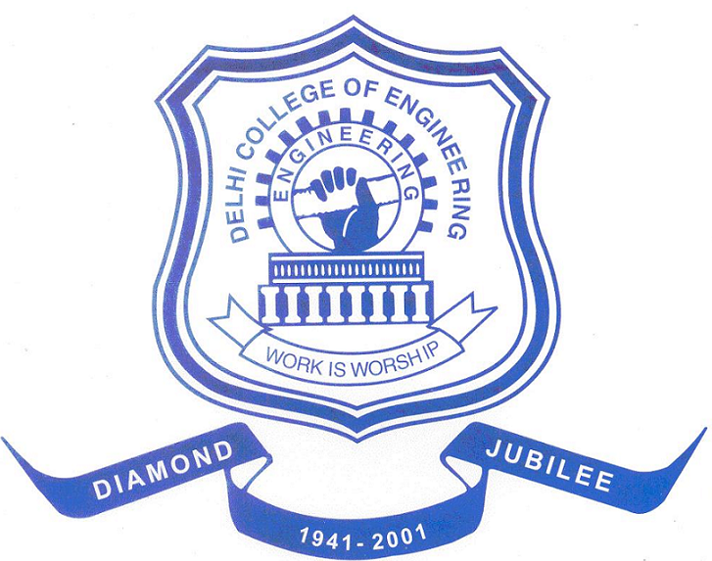

Delhi College of Engineering, New Campus, Bawana Road, New Delhi
DELHI UNIVERSITY

CANDIDATE’S DECLARATION

I hereby declare that the work done in this project entitled “Mathematical Modelling of Abrasive Jet Machining for Metal removal rate on Fiber Glass using Abrasive silicon carbide ” in the partial fulfillment for the award of degree of “MASTER OF ENGINEERING” with specialization in “PRODUCTION ENGINEERING” submitted to Delhi College of Engineering, University of Delhi, is an authentic record of my own work carried out under the supervision of Dr. Vipin, Assistant Professor, Department of Mechanical Engineering, Delhi College of Engineering, University of Delhi. I have not submitted the matter in this dissertation for the award of any other Degree or Diploma or any other purpose whatsoever.

(ANKUR SAGAR)
University Roll No: 12321
College Roll No.: 01/PRO/07

CERTIFICATE

This is to certify that dissertation entitled “Mathematical Modelling of Abrasive Jet Machining for Metal removal rate on Fiber Glass using Abrasive silicon carbide” being submitted by ANKUR SAGAR in the partial fulfillment for the award of degree of “MASTER OF ENGINEERING” with specialization in “PRODUCTION ENGINEERING” submitted to Delhi College of Engineering, University of Delhi, is a bonafide work carried out by him under my guidance and supervision.
The matter in this dissertation has not been submitted to any other university or institute for the award of any degree.

Dr. Vipin,
Assistant Professor
Department of Mechanical Engineering
Delhi College of Engineering, Delhi-110042

ACKNOWLEDGEMENT
It is distinct pleasure to express my deep sense of gratitude and indebtedness to my guide Dr. Vipin, Assistant Professor in the Department of Mechanical Engineering, Delhi College of Engineering, for his invaluable guidance, encouragement and patient review. His continuous inspiration has enabled me to complete this project.
I am also grateful to Prof C.K. Dutta, (Production Engineering Deptt.), University of Delhi, Prof S. Maji, HOD (Mechanical and Production Engineering), Delhi College of Engineering, all other faculty members for providing necessary help and support from the department.
I am also thankful to Mr. Pradeep (Metal forming lab, Mech. Engg. Deptt.) and Mr. vinay (Welding Lab, Mech. Engg. Deptt.). And all other peoples from the department who provided there invaluable guidance help to complete this project.
I am thankful to my friends and classmates for their unconditional support and motivation for this project.

(ANKUR SAGAR)

