CHAPTER 1
Sheet metal Design

  - Introduction

In today’s practical and cost conscious world, sheet metal parts have already replaced many expensive cast, forged and machined products. The reason is obviously the relative cheapness of stamped, mass produced parts as well as greater control of their technical and aesthetic parameters. Metal stamping is an indispensable, pervasive part of the contemporary industrialized society. An examination of most machines and products would disclose metal stampings in the assembly. Currently stampings are widely used in machines, tools vehicles of all kinds, household appliances, hardware, office equipments, electrical and electronic equipments, containers, etc.Application of metal stamping in various fields are listed in table given below.
Machine and Tools | Material handling equipment, Lawn movers,Fans,Agricultural components,etc.
Household Appliances | Furniture, Washing machine, TV sets, radiators, heaters refrigerators, cooking utensils etc.
Clothing | Buttons, Buckles etc.
Vehicles | Aero industries, Automobile industry, Rail coaches etc.
Hardware | Building hardware, Door Knobs,Locks,Pipe coupling, Hinges etc.
Office | Computers,Calulators,Typewriters etc.
Containers | Cans,inboxes,Drum,Caps,Buckets,Containerforfood, Medicines etc.
Table (1) application of sheet metal design
Sheet metal operations are also called stampings. Word stamping is used as verb-operations performed sheet metal and as noun-part produced. The work piece obtained after one or more press operation is called a metal stamping. Due to its low cost and generally good strength and formability characteristics, low carbon steel is the most commonly used sheet metal. Metal stamping range in size from tiny instrument part to freight cars ends. The starting material for press working is sheet metal in the form of strips from 0.2mm to about 6 to 8 mm thick. During stamping process the wall thickness of the part remains almost constant. There are number of advantages of metal stamping like:
- High productivity of labour.
- High efficiency.
- Highly accurate size and accuracy.
- High volume- Low Production cost
- Uniformity of parts.
- Low cost material.
- Less labour consuming

All the Above advantages have made sheet stamping very attractive to a host of industries, particularly to automotive, Aircraft, Electronic industries etc.
Fifty to seventy % of the cost of a stamping is for material .therefore the method employed for laying out the scrap strip directly influences the financial success or failure of any press operation .the blank must be positioned so a maximum area of the strip is utilized in production of the stamping. This blank layout is drawn before any work is done on the die design it self. In fact the scrap strip layout will govern the shapes and sizes of many of the die members.

1.2 Sheet Metal Characteristics
In sheet metal forming operations certain characteristics of sheet metal play very important role in getting good quality desirable products.

Elongation: Because the material is usually being stretched in sheet forming, high uniform elongation is desirable for good formability. The true strain at which necking begins is numerically equal to the strain-hardening exponent n*, thus a high value of n indicates large uniform elongation. Necking may be localized or it may be diffuse, depending on the strain rate sensitivity m** of the material. The higher the value of m, the more diffuse the neck becomes; diffuseness is desirable in sheet metal operations. In addition to uniform elongation and necking, the total elongation of the specimen is also a significant factor in the formability of sheet metals. Obviously, the total elongation of the material increases with increasing values of both n and m.
*{σ = K έ n} ** {σ = C έ m}

Yield Point Elongation: Low carbon steels exhibit a behavior called yield point elongation, one having upper and lower yield points. This behavior indicates that, after the material yields the sheet stretches farther in certain regions without any increase in the lower yield point, while other regions in the sheet have not yet yielded. Aluminum –magnesium alloys also exhibit this behavior. This behavior produces Lueder’s bands (stretcher strain marks or worms) on the sheet. They are elongated depressions on the surface of the sheet, can be found on the bottom of the cans used for common household products. They may be objectionable in the final product, because coarseness in the surface degrades appearance and causes difficulties in subsequent coating and painting operations.

Anisotropy: An important factor that influences sheet metal forming is anisotropy (directionality) of the sheet. There are two types of anisotropy: crystallographic anisotropy (preferred orientation of the grains) and mechanical fibering (alignment of impurities, inclusions, and voids through out the thickness of the sheet).

Grain size: The coarser the grain, the rougher is the surface appearance. An ASTM grain size of 7 or finer is preferred for general sheet metal forming operations.

Residual stresses: This is caused by non uniform deformation during forming. It causes part distortion when sectioned and can lead to stress corrosion cracking. This is reduced or eliminated by stress relieving operations.

Spring back: This is caused by elastic recovery of the plastically deformed sheet after unloading. Due to this distortion of part and loss of dimensional accuracy happened. It can be controlled by techniques such as over bending and bottoming of the punch.

Wrinkling: This happened due to circumferential compressive stresses in the plane of the sheet and is controlled by proper tool and die design.
Quality of sheared edges: The edges can be rough, not square, and may contain cracks, residual stresses, and a work hardened layer all of which are detrimental to the formability of the sheet. The quality can be improved by control of clearance, tool and die design, fine blanking, shaving, and lubrication.

Surface condition of sheet: It depends on rolling practices. This is important in sheet forming as it can cause tearing and poor surface quality.

  - Strip Layout

Material economy is of paramount importance in press work. Blanking being the first operation, raw material economy can be affected by using the most economical strip layout which can give the highest material utilization. Experienced press tool designers generally draw at least three strip layouts and compute and compare their material utilizations before commencing the design of the blanked tool
Figure 1. Processed sheet of sheet metal
In stamping, operating costs are dominated by raw material costs, which can typically reach 75% of total costs in a stamping facility [1]. Not all of this material is used in the parts, however, due to the need to trim scrap material from around irregularly-shaped parts. The amount of scrap produced is directly related to the efficiency of the stamping strip. Optimal strip layout is crucial to a stamping firm’s competitiveness. The degree of this trim loss is determined at the tooling design stage when the strip layout is created. As a part or parts are laid out on the strip, the designer chooses the orientation of the part(s), width of the strip, and, in the case of multiple parts blanked together, their relative positions. The stamping process is one of the earliest technical developments in the manufacturing industry. The process has been improved continuously, and stamping products can be found everywhere. Blank layout is one of the most important processes in stamping die design, and it can be defined as fitting together of stamping blanks to occupy the maximum amount of surface area on a coiled strip or a metal sheet. The purpose of blank layout is to increase the material utilization and minimize the amount of scrap to meet the requirements of the stamping technology. As the major cost in sheet metal stamping is the material cost, any efforts to minimize the scrap which is in accordance with the stamping technology may result in substantial savings not only in strip material, but in the overall production cost as well. In addition, the result of blank layout is the basis of strip layout design and die structure design such as the design of the die plate and stripper. In the past, blank layout was a manual operation which was highly dependent on the skill and experience of the designer [2]. However, it took a long time to accumulate experience, and to answer the many problems in the practical design process, the answers to which cannot be obtained from books or manuals. The development of computer-aided design software was necessary for practical designers to improve the design quality and shorten the required design time. In stamping, sheet metal parts of various levels of complexity are produced rapidly, often in very high volumes; using hard tooling ideally, the material utilization is maximized. The value of even tiny improvements in material utilization can be great; for example, in a stamping operation running at 200 strokes per minute, a savings of just 10 grams of material per part will accumulate into a savings of more than a tonne of raw material per eight-hour shift. The material utilization is set during the tooling design stage, and remains fixed for the (usually long) life of the tool. Thus, there is significant value in determining the optimal strip layout before tooling is built.

CHAPTER 2

Literature Review
Originally, strip layout problems were solved manually, for example, by cutting blanks from cardboard and manipulating them to obtain a good layout, V. Vamanu & T. J. Nye [3]. The introduction of computers into the design process led to algorithmic approaches. With the approach to fit blanks into rectangles, then fit the rectangles along the strip, M. Adamowicz and A. Albano, [4]. Algorithms for blank layout, which describe the mathematical modeling of the blank layout, have been proposed by many workers to achieve potential savings through maximum material utilizations. Variations of this approach have involved fitting blanks into non-overlapping composites of rectangles, W. Qu and J. L. Sanders [5], convex polygons D. Dori and M. Ben-Bassat [6] and known interlocking shapes, Chow, W. W [8].
Adamowicz and Albano [4], Dori and Ben-Bassat [6], and Qu and Sanders [5] proposed a two-stage approach in which irregular shapes were initially converted into an approximated standard manageable shape, such as a rectangle or a convex polygon, which was then nested.
Chow [8] proposed three approaches for nesting a single pattern arranged in a single row or double row on a strip of raw material.
A fundamental limitation exists with this approach, however, in that the enclosing shape adds material to the blank that cannot be removed later during the layout process. This added material may prevent optimal layouts from being found.
Exact optimization algorithms have been developed for fitting a single part on a strip where the strip width is predetermined, Nee, A. Y. C., [9] and where it is determined during the layout process, Joshi, S. and Sudit, M., [10].These algorithms are based on a geometric construction in which one shape is ‘grown’ by another shape. The use of this construction, efficient algorithms can be created that find the globally optimal strip layout.
Dagli and Tatoglu [11] proposed a heuristic approach which used various priority rules of allocation depending on the pattern shapes.
Nee [12,13] and Nee and Foong [14] have developed an experimental package, which involves algorithms and evaluation functions. The algorithm developed was designed to perform pairwise clustering based on an exhaustive search in which shapes were rotated in increments of 180° until all possible sides were paired. The algorithm includes routines to execute coordinate rotational and translational transformation whilst detecting any overlapping of the shapes.
Ismail and Hon [15] proposed an algorithm based on extracting the edge information in the form of edge arrays, which are used to recognize the possible direction and obtain better pairing.
Lin and Hsu [16] introduced an optimal layout method to obtain the dual-row optimal blank layout, and displayed the blank layout graphics on the screen using Auto Lisp.
Singh and Sekhon [17] presented a method which is based on a computerized diagraph and matrix approach.
all the algorithms developed are expected to increase the ability for automation in blank layout, but few are concerned with how to build a practical optimization system for blank layout in which not only a reasonable algorithm, but also the practical manufacturing requirements will be fully considered. In this project the conventional approach for blank layout is discussed first that involves case study of blank optimization in an industry then basic principles of blank layout optimization are introduced, later manual optimization method is discussed and then the general structure of a practical blank layout system using some cad features is proposed. Finally, some key steps for the calculation of layout parameters are discussed.

CHAPTER 3
Problem Identification
3.1 Problem Identification: Most of the large scale sheet metal component industries in area like, Automobile sector, home appliances, electronic parts industries etc. are manufacturing only class A parts at their own station i.e. those parts required aesthetic look a lot. Most of the other parts that remain underside of these surfaces are manufactured at their vendor end. Here we observe the tool development procedure for AGRO ENGINEERING WORKS (at faribabad) a vendor of Maruti udyog limited manufacturing the sheet metal component for various segments of cars, for eg. Steering support for wagon R, U-clamp bracket for Zen, Roof panel for omni van, Center pillar for 800 cc, Dust cover for 800 cc, brake-clutch pedal set for 8oo cc, Brake clutch pedal set for omni van, Rear gate assembly for gypsy, fuel tank for escort tractor Etc.These are few name of component that are very important from functional point of view but their aesthetic look does not matter a lot. During tool development procedure various steps involved are as:
1. Number of operations required for completing the component.
2. Calulation of tonnage and press capacity required for individual operations.
3. Actual manufacturing of tools except blanking tool.
4. Blank development and cutting using snips and shearing machine for sample
development of component.
5. After sample approval development of blanking tool.
6. Trial for optimizing the strip layout to reduce the scrap.

3.2 Method for scrap reduction:
The process of strip layout with conventional methodology was very time consuming, uneconomical, wastage of material, extensive machine and labor involvement. For strip layout the procedure adopted is almost hit & trial method and precision depends upon experience of tool developer and production in charge of press shop. Many people and things are involved for such experimental work like tool room in charge, tool developer, shop manager, power press, shearing machine, machine operator, work material, Also Possibility of accident increases that may result in loss of hand or fingers that can spoil carrier of related person etc.
There are large number of these type of industries in N.C.R. zone those are making huge quantity of such parts. These industries for strip layout are still using conventional hit & trial method. Before starting strip layout optimization on any component various crucial action must be consider. Various steps for prepare the base for conventional strip layout process are as

- Consideration for number of component required to stamp depends upon the order from customer.
- Consideration of size limitation of shearing machine for cutting of strip for blanking operation.
- Consideration of number of blank required to produce in one shift.
- Consideration of handling length of strip for operator i.e. gap between two rows of press line.
After getting the following information conventional method for strip layout is preceding that involves the following steps.
- Blank development and cutting for sample production and approval.
- After sample approval development of blanking tool.
- Calculation of tonnage and space required on bolster plate for loading of tool.
- Cutting of strips in different sizes at shearing machine. Consider various amount of clearance between two consecutive blank.
- Blanking operation after loading the tool on press for various positions by rotation of strip.
- Find the material utilization or number of blanks for different positions.
- For optimum position set the gauge and pilots w.r.t. to die location on die plate and punch plate.
- Now the blanking tool is ready for production run.
This is all based on experience of tool developer. If he is expert the optimum result can be obtain soon otherwise it will take time. Reason behind popularity of these techniques is that most of tool developers are not enough qualified to understand various algorithms, mathematical solutions or typical software for strip optimization. They found tough to understand them but they have enough experience to complete their jobs. but today’s short time dead line for tool development and growing competition among various vendors to obtain the order of manufacturing from mother units make sure that there is definitely need to change scene. They are definitely looking for such techniques that are easy to implement and easy to understand by their tool room professionals. In this project I try to shift all this work from shop floor to desktop in easy and user friendly way by using the soft skills of cad software.

3.3 Non destructive Manual Technique:
How ever to avoid this destructive technique for strip optimization there one method explained by xyz in his book of dies design. Before switching to soft ware based approach for optimum blank lay out we discuss the various steps involved in this approach where on a paper blank print are created then using transparent sheet over it check for various positions by rotation of sheet and draw the blank position over it. After first blank again rotate the sheet for next blank at sufficient gap. This process continues till optimum strip lay out is obtained.

3.4 Proposed Methodology
Material Optimization using CAD Software: Here all the steps that involved for optimization in manual technique are shifted to computer screen using 3d cad software for generating layout to reducing scrap in sheet metal operations. Steps involved in this technique are as:
1. CAD- Creation of drawing of component using various 2d and 3d features of cad software.
2. Nesting/ Optimization - Using various software features develops the nested layouts for various feasible blank positions. Calculate the material utilization for various blank positions and able to take decision regarding best layout for material utilization.

CHAPTER 4
General Information about Blanks and Layouts
4.1 Basic blank shapes
The shape of most blanks will fall in to one of the classification shown below in figure (2 a, b, c, d, e). Accompanying scrap strip design for these standard part outlines provide a basis for establishing the correct material layout for any similar part to be blanked.
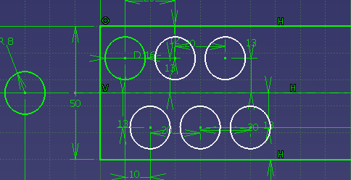
Fig (2a) Basic Blanks Shapes (Circular)
the scrap strip for a circular blank is laid out for a double row .this is more economical than a single row layout and it is usually specified for such dies except those for large blanks and for low production.
Many blanks have elaborate contours that cannot be readily classified. But these will be found to be made up of two or more of the basic forms shown in fig.(2a,b,c,d,e) and scrap strips for these must take in to consideration the particular shape combination.

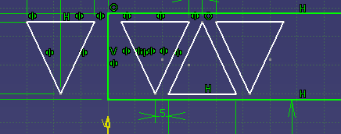
Fig(2b) Basic Blanks Shapes(Triangular)

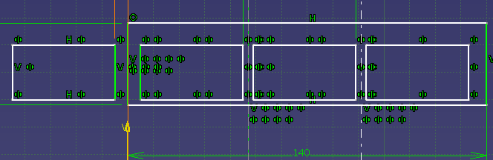
Fig(2c) Basic Blanks Shapes(Rectangular)

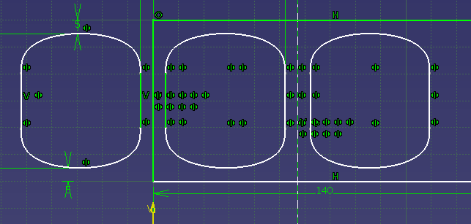
Fig(2d)Basic Blanks Shapes(Partial Ring)

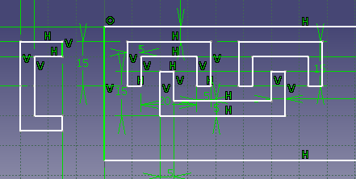
Fig (2e) Basic Blanks Shapes (U-Shape)

4.2 Basic Principles of Blank Layout Optimization

A blank can be described simply as the outer contour of the piece-part which requires a piercing or blanking process, but if the piece-part requires drawing, or bending on the edge, it means that the outer contour of the unfolded part always includes. The material utilization ratio for strip can be expressed as follows:_
Material utilization = Area of the strip before blanking/Area of blanks from strip

M.U.R.= (Νumber of blanks*Area of Blank) / (feed Pitch*strip width ) ∗ 100%
Where P is the feed pitch, W is the strip width, n is the number of blanks in one feed pitch, and A is the area of one blank.
The percentage utilization should not less than 70 % for economical working. However, for complicated shapes of blanks, it can be less than 70 %.The strip layout with maximum material saving may not be the best strip layout, as the die construction may become more complex which would offset the savings due to material economy unless a large number of parts are to be produced. Another important consideration in strip layout is the distance between the nearest points of the blanks and between the blanks and the edges of the strip. To prevent the scrap from twisting and wedging between the punch and the die, this distance must increase with metal thickness. A general rule of thumb is to keep this distance called web at least 1.5 times the material thickness. Other factors such as strip thickness, hardness, type of operation, shape of blanks etc. may allow web to be thinner. Terminology involved with strip layout is shown in figure 3.
Fig. (3) Nomenclature of strip layout
The following principles [16], which may affect the correct blank layout in a metal stamping operation, should be satisfied:
1. Obtain a higher material utilization ratio. This is one of the most important factors to be considered, especially when the required quality of the blanks to be produced is high or the material is expensive.
2. For a part with bending, the bending line should be preferably constrained in a certain angle range relative to the grain flow direction in the strip. The reason for this is that in the process of cold rolling, the sheet metal will undergo plastic deformation, causing the grains to elongate and align parallel to the rolling direction. Cracking at the bending edge might occur if the bending line is parallel to the grain flow direction.
3. Consider the constraint of strip width (maximal or minimal value is given) or feed pitch (maximal or minimal value is given) to satisfy certain strip width or feed pitch demands of the customer.
4. Consider the appropriateness of the die structure design.
5. Calculate the feed pitch and strip width to meet the requirement of calculating the tolerance accurately and efficiently.
6. A uniform bridge width (web) should be ensured throughout the layout. Bridge width (web) is the minimum permissible spacing between consecutive blanks or from the blank to the edge of the strip.
4.3Blank Positioning
Blanks can be positioned different ways in the strip. Choice of the correct method depends upon part shape, production requirements, and any bends that must be applied. In the stamping process, many types of layout for positioning of blank are possible.
Such as 1-row, 2-row, 3-row, and multiple rows. The most commonly used layout types are normal 1-row, opposite 1-row, normal 2-row, and opposite 2-row. Normal layout means that all blanks are arranged with the same rotation angle in the strip; whereas opposite layout means that the adjacent blanks always have a difference of 180° in rotation angle. The figure (4a, b, c, d) shows the single row, one pass and single row two pass methods.

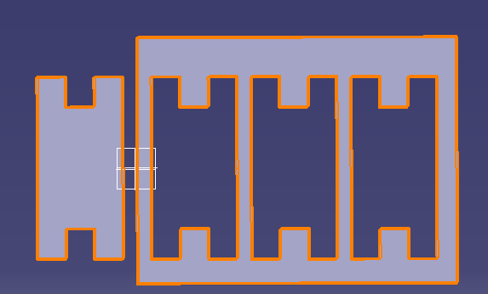
Fig (4a). Blank positions for one pass (wide)
In the first case the blanks are arranged in a single row and the strip is passed through the die once to cut all blanks from it. At 3a the parts are located in a vertical position in the strip. This is the preferred method because the maximum numbers of blanks can be cut from one strip and fewer strips must be handled.


Fig (4b). Blank positions for one pass (narrow)

When serve bends are required in subsequent operations, method (4b) must be used. This procedure involves handling more strips to produce the same number of blanks.


Fig (4c). Blank positions for two pass
Material can be saved by the single run; two pass method (4c, 4d) when employed for certain part shapes. In this case the blanks are positioned in the strip in a single row. Alternate blanks are turned upside down as shown, and the strip must be passed through the die twice to remove all blanks from it, As the strip goes through the first time the blanks in the upper row are cut .the strip is then turned over and run through the die again removing the rest of the blanks.
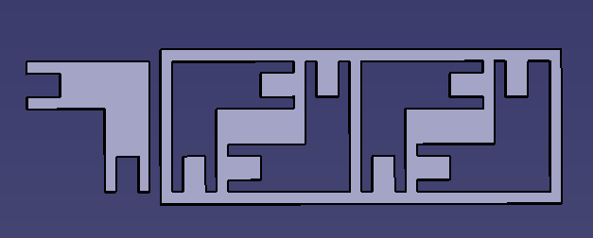
Fig (4d). Blank positions for two pass
A ten to fifteen % higher labor cost will occur in double run layouts. The operator must pass the strip through the die twice and employ greater care in gaging it. Extra labor cost is offset by the saving in material when blanks are large and waste is considerable.
Vertical positioning is shown at (4a) and horizontal positioning at (4b). Some times the shape of the part will often lend itself to angular positioning. For some contours, this method is economical of material. Also it has the further advantage of allowing bends to be made without possible fracture.
4.3.1 Double Row Layouts
The material can be saved from wastage by use of double row two pass layouts as shown in figure (5a) . The strip is run through the die twice as in two pass layouts, but blanking centers are closer together, giving greater operating speed.

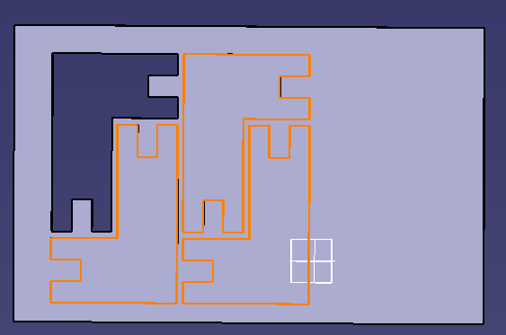
Fig (5a) Double-row blanks layouts for two pass

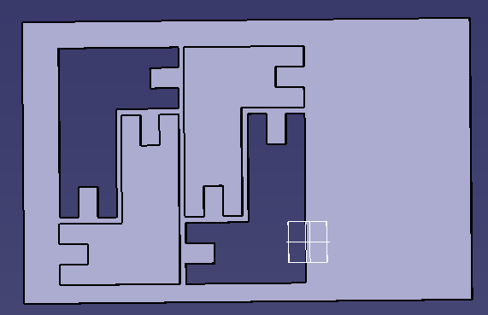
Fig (5b) Double-row blanks layouts for one pass

The same positioning method may be used for double row gang dies .where an extra punch and die opening is applied to the die, cutting two blanks with each stroke and the strip is run through only once.

4.3.2 Triple Row layout
Some times triple row gang dies of the progressive type can be used for blanking as shown in fig 6.this is the layout for a die used to produce washers at high speed. these dies may have more than three rows; the numbers is limited only by press size and production requirements.
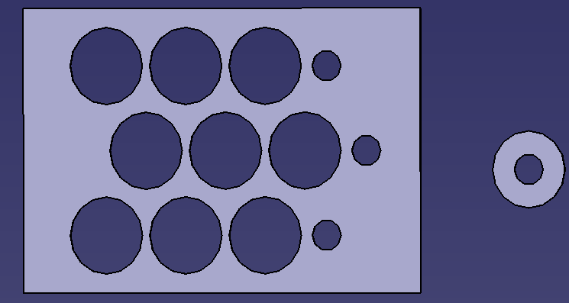
Fig (6) Triple-row blanks layouts of washer

4.4 Scrap strip allowances
It is important that correct bridge allowances be applied between blanks and between blanks and edges of the strip. Excessive allowance is wasteful of material. Insufficient allowance result in a weak scrap strip subject to possible breakage with consequent slowdowns on the press line. In addition a weak scrap area around the blank can cause dishing of the part.

4.4.1 Scrap strip allowances – one pass layouts
Scrap strip allowance for one pass layout is given below .here we consider the possible Outer shapes of blanks that may be classified in four distinct outline shapes.

1. Curved outlines- For these, dimensions between edge of strip and blank periphery i.e. A as shown in fig (7 a) are given a minimum allowance 70 % of the strip thickness T.

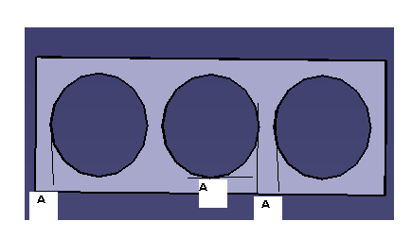
Fig (7a) scrap strip allowance for one pass layout

2. Straight edge- for these, dimensions between edge of strip along lengthwise and periphery of blank i.e. B and dimensions between edge of strip along width and periphery of blank i.e. B’ depend upon the length of the bridge, dimensions L and L’ i.e. Continuous length along length and continuous length along width respectively, as shown in fig (7 b).
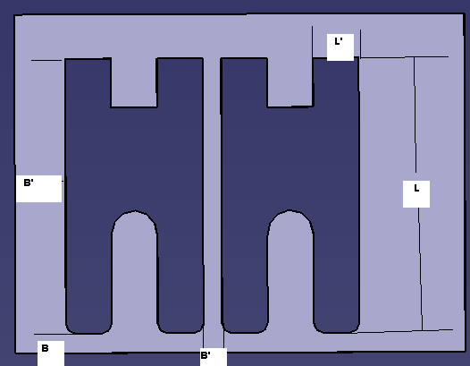
Fig (7b) scrap strip allowance for one pass layout
When L and L’ is less then 64mm, then B and B’ =1 T, respectively
When L and L’ is 64 to 200 mm, then B and B’ =1.25 T, respectively
When L and L’ over 200mm, then B and B’ =1.5 T, respectively
3. Parallel curves - for work with parallel curves the same rules apply as for straight edges .as shown in fig (7c).
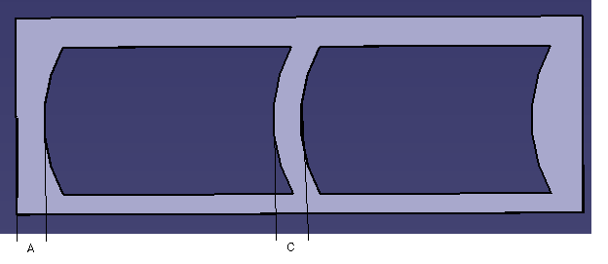
Fig (7c) scrap strip allowance for one pass layout

Where L is less then 64mm, C =1 T, respectively
Where L is 64 to200mm, C =1.25 T, respectively
Where L is over 200mm , C =1.5 T, respectively

4.4.2 Scrap strip allowance two pass layouts
When the strip is to be run through the die twice in order to remove all the blanks from it, more allowance must be provided than is required for one pass layouts this illustration lists minimum scrap bridge allowance which should be applied under given conditions. For single row layouts are given more allowance than is required for double row layouts .this is because the wider double row strips do not distort as much in cutting the first row and less allowance is required. Because of this for minimum strip distortion, double row layout is preferred.

4.5 Minimum allowance
The table given below list minimum scrap bridge allowances for both one pass and two pass lay outs. These values apply for thin gages of stock (less then 3/64inch) of stock where use of the previous rules would give such small allowances as to be impractical .Select the value for space A opposite the appropriate strip width. Fig 8a and 8b shows the positions of space where allowance must be add. Table 2 shows the appropriate value of space A for various widths of strips.

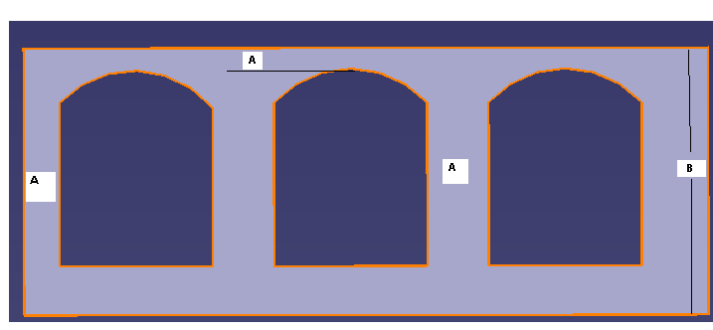
Fig (8a) Minimum strip allowances for one pass

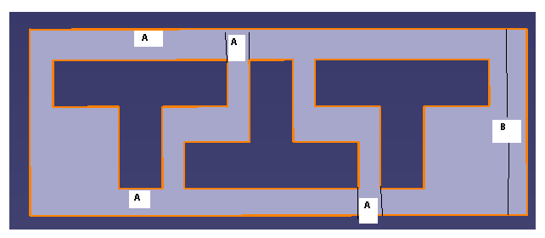
Fig (8b) Minimum strip allowance for two pass

Minimum Scrap strip allowances
One-Pass Layout |  | Two-Pass Layout
Strip Width (B | Space(A) | Strip Width(A) | Space(B)
0-75mm | 0.8mm | 0-75mm | 1.6mm
75-150mm | 1.6mm | 75-150mm | 2.5mm
150-300mm | 2.5mm | 150-300mm | 3.2mm
Over300mm | 3.2mm | Over300mm | 4mm

Table (2) Minimum Scrap-Strip allowances

4.6 Blank Area calculations
When it is possible to position blanks in two or more ways in the strip, the blanks area for each method is found and the one most economical of material is selected for the die. The blank area for single row one pass positioning (the area of the strip which is used for one part) is found by the following formula:
Blank area = A * B
Where A = width of strip
Where B = length of blanks + distance between two consecutive blanks.
Single row blanks which must pass through the die twice have their blank area determined by the formula:
Blank area = (A x B)/2
This formula applies to the blank layout for single row two pass and double row one or two pass.
4.7 Number of blanks per strip
For large blanks it is often necessary to determine the number of blanks in each strip to establish the extent of the waste end. this has an influence on the blank layout, because too great a waste end is uneconomical. The number of blanks per strip for a single pass layout is found by the formula:
Blanks per strip A = {S-[X + Y+2E]}/B + 1
Waste end D = S- [B (A – 1) + X+Y+2E]
When strips must make two passes through the die, the following formulas determine the number of blanks per strip and the extent of the waste end:
Blanks per strip = (S – [X + Y + 2E]) /0.5 B + 1
Waste end D = S – [0.5 B (A-1) + X + Y +2E]
Where S=Length of strip (mm)
B = Blank length from centre of one blank to centre of another blank.(mm)
A= no of blanks.
E = strip allowance at initial end of strip.(mm)
X= Beginning of one blank to beginning of second blank.
D=material left at the end of strip
Y = distance from end of last blank to the distance where B for that blank completed.

CHAPTER 5
Manual Optimization

5.1 Nesting:
Various stages that are involved for tool development are shown in table (3 ) below. the figure shows that nesting is need to done at very raw stage.

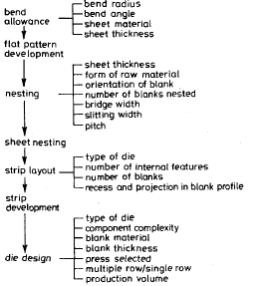

Table (3) factor affecting the die design for sheet metal blanks

The term nesting has been used to describe a wide variety of two dimensional cutting problems. This involves a non overlapping placement of given set of shapes and width; minimize the length of a rectangular region with width W such that all shapes are contained in the region.
Following are the causes that result in requirement of nesting technique for optimization. :
A. the side by side layouts, except for some rectangular or round parts are wasteful of material.

B. Double run layouts can be a source of trouble and they are seldom used for small parts. Only for very large blanks are the saving in material great enough to justify their use.

C. Double die layouts are quite expensive except for extremely large quantities

5.2 Manual Optimization:
Due to number of reasons that result in economic loss by conventional strip optimization process a nesting technique on drawing board was introduced, J.R.Paquin [18].various steps for this technique are discussed below. While designing a press tool, there is always in mind how the material strip will appear exactly after all operations have been performed on it. It is then called a scrap strip. For successful scrap strip layout one must follow a definite procedure that will ensure that nothing has been left to chance.
Most blanks with irregular contours will nest when placed side by side in the correct position .the best nesting position for the particular part must be found before proceeding with the strip layout. Since fifty to seventy % of the cost of a stamping is of material. There fore optimization of scrap strip directly influences the financial success or failure of any press operation. While optimizing, the blank must be positioned so a maximum area of the strip is utilized in production.
Before this manual method for material saving all the strip layout process were done on machine using actual cutting of material. But In this technique most of the operations are done manually on drafting table. Various terms and steps involved in designing of scrap strip.
5.2.1. Generation of blank Part layout
The first step is to layout the part accurately on paper (fig.9). Check all dimensions as any mistake will result in considerable useless work over drawing sheet. Over the part layout place a sheet of thin, translucent paper and trace the part outline.
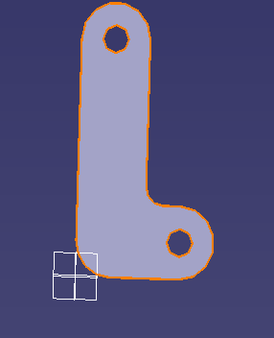
Fig (9) Part layout on sheet

5.2.2. Nesting position
Now rotate or move the transparent sheet over the blank layout until the best nesting position is found. Correct Scrap Bridge allowances must be allowed between blanks. This is all depending upon the previous experience of tool developer.

5.2.3. Correcting the layout
Now Fasten this layout to the drafting table straighten inaccurate lines and check dimensions. Draw guide lines surrounding the blank and leaving the correct scrap bridge allowance part line, of the next blank to help in positioning the paper for tracing it.
5.2.4. Drawing of Second Blank Now again move the sheet over blank layout and match the profile for best fit with drawn part line. Remove the sheet and over drawing board correct the profile of second blank Again consider the sufficient bridge gap between two consecutive blanks.
5.2.5. Drawing the third Blank
Now Place the sheet back over the part layout and draw the third blank as accurately as possible and continues till end of requirement. How ever this process is better then conventional cutting but still demand good drafting and analytical skills.
5.2.6. Completed lay out
After drawing the desire number of blanks over sheet the layout is complete and accurate. Here it appears that task is finished.
5.2.7 Running the strip
Now this optimized strip can be run in various ways that depend upon location of gauge and pilot pin to locate the strip.

Now a days number of cad software’s are available with excellent 3d capability that include all the features that required for shifting manual optimization operation from drafting table to desktop that result in to reduce number of problems related with manual optimization. More over to perform this operation we need to club the experience of tool developer with key soft computing skill that is all being done in this report. So here we club such manual activity with features of available cad software.

CHAPTER 6
Optimization using CAD Software

6.1 Nesting Using Cad Software:
Here we use CATIA V5 (Computer aided three dimensional interactive applications) [19] software for replacing the manual method of strip optimization with computer aided optimization skills. Various features of this cad tool that help for optimization are as.
Part design work shop- In this work shop 3d image of any component can be generated with parametric or non parametric design features.
Sketcher Workshop – here we generate the desire profile using various commands.
Drafting workshop –Here we can create drawing of the component directly from 3d to 2d with aiding all desire features need to read a drawing. In table (3 ) below there are some standard commands of various workshops that are used for nesting.

Workshop | Command | Symbol
Part Design | Pad | 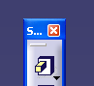
Part Design | Reference Element | 
Part Design | Sketch | 
Sketcher | Profile | 
Sketcher | Axis
Sketcher | Circle | 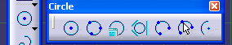
Sketcher | Constraint | 
Sketcher | Corner | 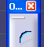
Sketcher | Trim
Sketcher | Rotate
Sketcher | Translation
Sketcher | Project | 

Table (4) List of Commands Used for layout with CATIA V5-R-19

All the features named in table (4) are very helpful for analysis of strip layout. Here very precise rotation of component or sheet is possible (up to one degree) over blank. This rotation features help to locate the exact position die over die plate then stoppers are located to ensure the optimum blank bridge allowance.

6.2 Steps for nesting using Cad software:
6.2.1. Part Print (Off Set Hinge)
Here we are designing a scrap strip for producing small elbow shaped parts called offset Hinge. This is child part of gutter plate assembly used in one of car model of MUL Using cad software first we generate it’s 3d view and then drawing of the component called part print as shown in figure(10) and. Study of the part print shows that both a two station progressive die and a compound tool can be used. In progressive dies the holes are pierced at one station and the part is blanked out at the succeeding station. While in compound tool both operation are carried out at single station.
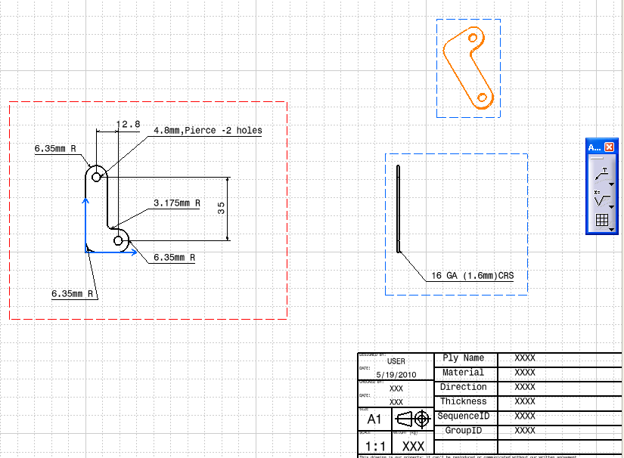
Fig (10) Part print-Offset Hinge

6.2.2. Normal running of the component (Offset Hinge):
(A) Wide Run
At very beginning to run a strip for blanking operation we think about easy and convenient method. Normal method that come to mind to lay out the hinge is side by side with wide run as shown at fig (11 a,b,c,d).Blanks arranged in this manner can be run through the die in any of four different ways, shown below. But this method results in large wastage of material.
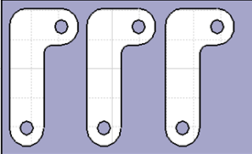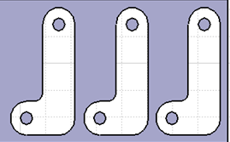
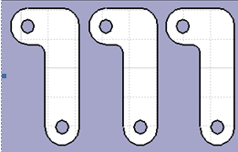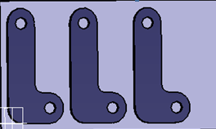
Fig (11a, b, c, and d) Parts positioned for wide run

(B) Narrow Run:
If a bend is to be applied on the long arm of this part the first thought would be to lay it out the narrow way, as shown in fig(12 a,b,c,d), because bends should be made across the grain preferably .how ever this layout is also wasteful of material. Here again it is possible to run the strip in four ways as shown below.

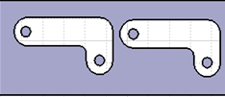
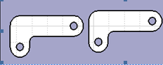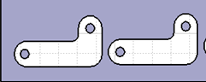
Fig (12a, b, c, d) Part Positioned for narrow run

(C) Double row and Double Die Run
Double row layout are economical of material but they may create problem for the designer as it is difficult to locate the stopper for double row and tooling cost increase for double die. In fig (13a) this part is shown in a wide run, double row layout. With first run at the upper side, the strip would be run through for punching all holes in the upper portion of the strip then it would be reversed and run through the die for blanking with locating the side of strip towards lower part gauge for a second time.
While running the strip for the first row it becomes curved and distorted and this can cause it to stick and bind when running the second time. There is a ten to fifteen % increase in labor cost for double row dies.

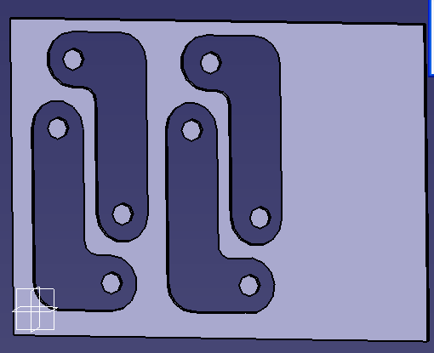
Fig (13a) Double row layouts Wide run

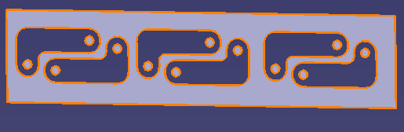
Fig (13b) Double row layouts narrow run

Double die layout in which both upper and lower punch would be blanking stations present fewer difficulties. But few parts have the high production requirements which should justify the expense of providing two blanking punches and die opening and an extra set of piercing punches.
Double row narrow run layout is shown in fig (13b). This can be either a two pass layout in which the strip is run through the die twice to extract all blanks or it can be a double die layout, with both upper and lower punch would be the blanking stations.

6.3 Optimization of Scrap Strip using CATIA V5:

6.3.1 Creation of 3d view: here we use the work done earlier for generating the part print and create the three dimensional view of the component that is need to be nested using any cad software( CATIA V5).figure (14) shows the three dimensional view of the component. This is all done using sketcher and part design workshop.

Figure (14) 3d view –OFFSET-HINGE

    - Nesting Position: this step involves the work related with optimum positioning of blank. Various steps that are used for positioning are explained below.

- Reference Element :
- Creation of reference plane 1, vertical to the plane in which component is drawn. This generation of new plane helps to work independently without disturbing the identity of original shape. Now draw the rectangle in this plane that behave like a rectangular sheet to cover the blank of the component.
- Creation of Reference plane 2 and draw projection of rectangle drawn on plane one using projection command of sketcher workshop.
(b) Rotation: On reference plane 2 using rotation command Rotate the sheet for various angular position to view the possible position of blank over sheet and done analysis to find out the optimum angle of rotation where die must be set one die plate for blanking or piercing. Minimum angle that can be rotated using rotate command of sketcher workshop is one degree. However for practical we rotate the sheet in different steps for angles of 5 degree ,20 degree,25 degree,30 degree,35 degree,45 degree rotation. Figures (15 a, b, c, d) below show the various position of sheet over blank.

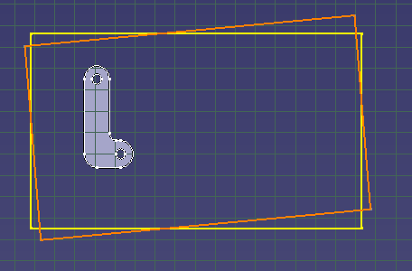

Figure (15 a) rotation of five degree.

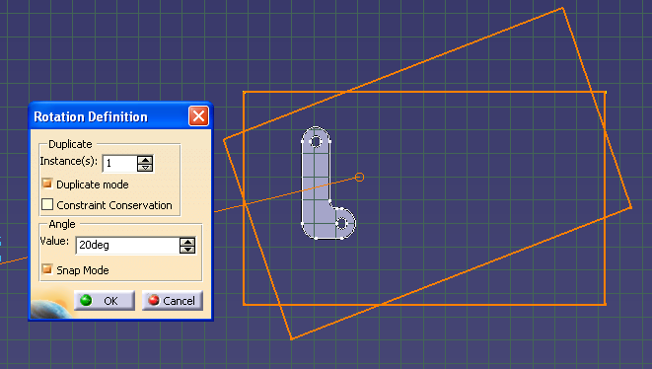

Figure (15b) rotation of 20 degree

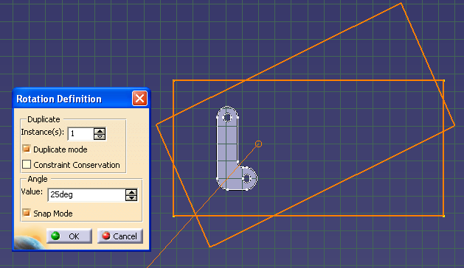
Figure (15c) rotation of 25 degree

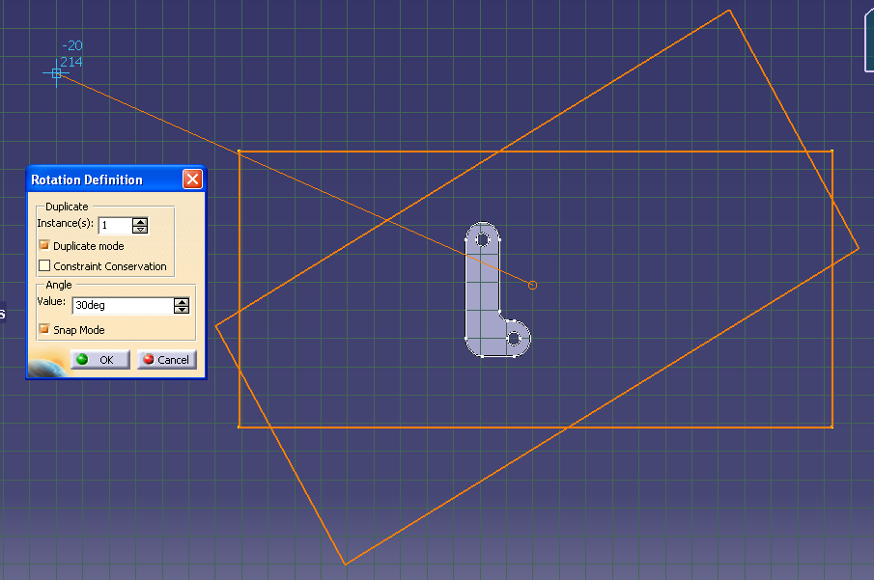

Figure (15d) rotation of 30 degree

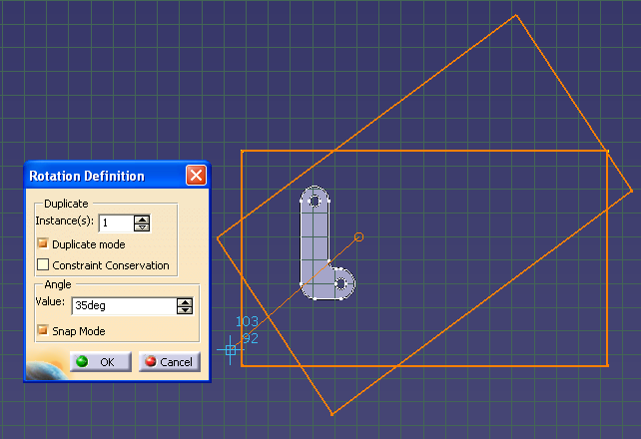

Figure (15e) rotation of 35 degree

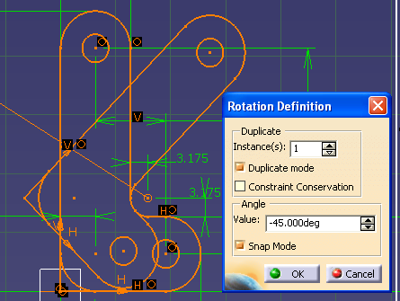

Figure (15f) rotation of 45 degree

(c) Translation & Rotation:
Now for various angular positions of blank generate the second blank using translation command as shown below, while translating the component must consider the minimum bridge allowance i.e. the gap between two consecutive blanks that depends upon the sheet thickness of the sheet metal used for strip layout. Thus the position for second blank will be located as shown in figure (16). Then rotate both the sheet and blank simultaneously back to linear position so that we can obtain the optimum position of blanks over strip for further analysis.
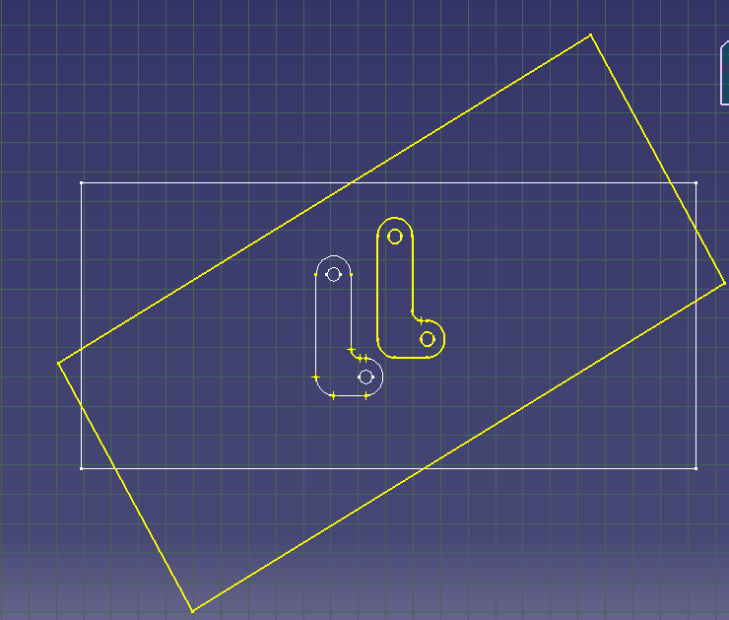

Figure (16) Translation of blank

(d) Return Back to Previous Position:

Now using Rotation command rotate the sheet back to its previous position and add the correct bridge allowance for next blank as shown in figure (17)

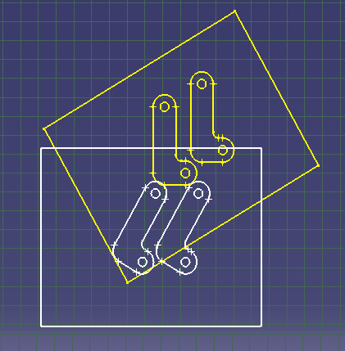

Figure (17) rotation for previous position.

(e) Generation of Third Blank: Now above steps will repeat for next blank and continue this, thus we get the optimized strip layout. As shown in figure (18) below.

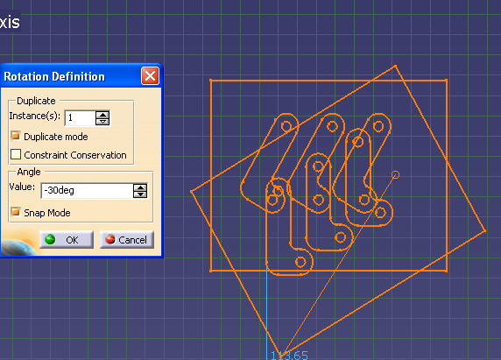

Figure (18) generation of third blank

(f) Completed Layout: thus repeating the steps mention above for number of times the blank required on one strip the layout for scrap strip will be completed for offset hinge as shown in figure (19) below.

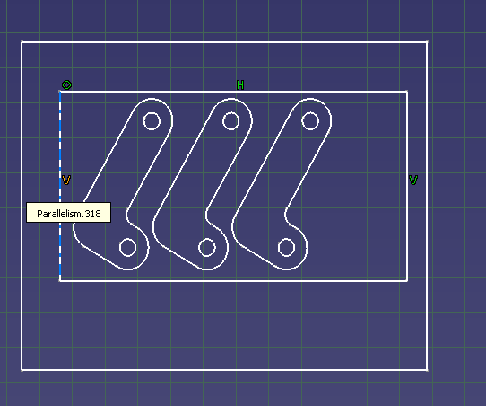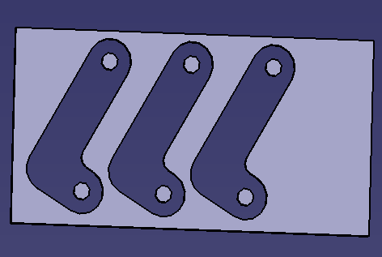

Figure (19) optimized strip layout

(g) Running the strip: this optimized strip can be run in to the die through four ways, using the layout just completed as shown in figure (20a, b, and c, d). One of these will be the best method for a given part, depending on its contour. Practically all this will be done by changing the location of die on die plate for each trial .this trial is required to check the feasibility of running of strip by operator.

Figure (20a) Running of strip

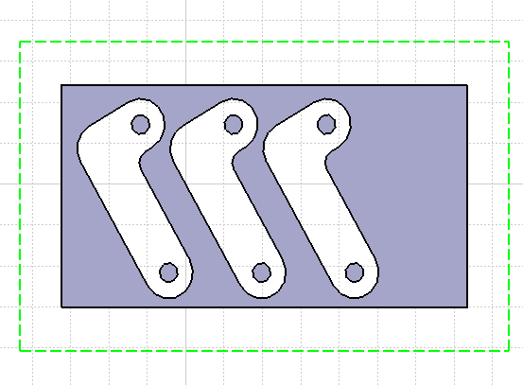
Figure (20b) Running of strip

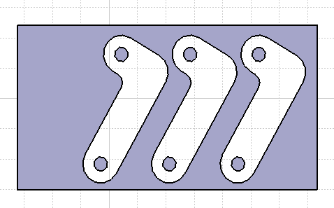
Figure (20c) Running of strip

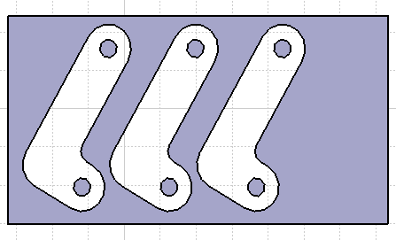
Figure (20d) Running of strip

CHAPTER 7
Result and Discussion
7.1Result and Discussion:

Optimized Strip for blank can run side by side in wide or narrow position, double row and double die run or at position by optimize rotation. All this approach is discussed below with their advantages and limitation .here we find out the material utilization in every possible situation and comparatively find out the best method.
- Side by side wide run & Narrow run: the side by side layouts are generally used for rectangular or round parts other then these shapes this kind of layout is found just the wastage material. Such type of layout is shown in figure below.
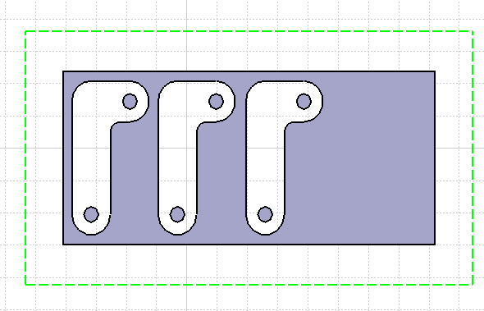

Figure (21) Wide Run with side by side location

- Double run layouts :
In Double run layouts sheet passes through the die set twice to remove all the blanks from strip. But there is problem associated with this method that is distortion of strip like bending or twisting during first run that causes a source of trouble for second run result in excessive labor time, distortion of blanks and higher production time. So they are seldom used for small parts. But no doubt there is considerable saving of material in case of very large blanks. Such types of layout for narrow and wide run are shown in figure (22) below.

Figure (22) Wide Run with Double row lay out

- Double die layouts: to overcome the problem of double run layout there is possibility to provide Double die layouts i.e. two set of punch and die in a one tool .however these kind of tool are quite expensive so they are avoided except for extremely large quantity.

- Nesting: Above mention limitation of various layout results in necessity of optimization of strip layout before running the actual production at shop floor and in this project this technique is shifted from thin translucent paper on drawing board to soft computing technique that is user friendly. Such type of optimized strip layout is shown in figure (23).

Figure (23) Nested strip using Catia v5

7.2 Analysis of strip layout for various methods of layout for material Utilization.
Analysis of strip layout required to find the optimum material utilization by calculating the material utilization for every possible layout. To calculate the required size of strip (width and length) and material utilization for one blank of various strip layout. Following sequence of step followed.

CALCULATION Procedure:
Stage 1
Step1. Calculate Blank Area of the component.
Step2. Calculate strip area per blank including the minimum scrap allowance.
Step3. Calculate the material wastage for each layout.
Step4. Calculate material utilization for the component with every possible layout.
Stage 2
Step.5 Comparison of the optimum material utilization for different positions Further we adopt the above sequence for side by side wide run and narrow run, double row wide run and narrow run, Nested wide and narrow run. Thus we find out the comparative result of material utilization and strip size.

7.2.1 Side by Side Wide Run and Narrow Run:
Step 1: Calculate blank area : Using Measure feature of software we can calculate the area of blank. As shown in figure (24) below. 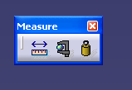
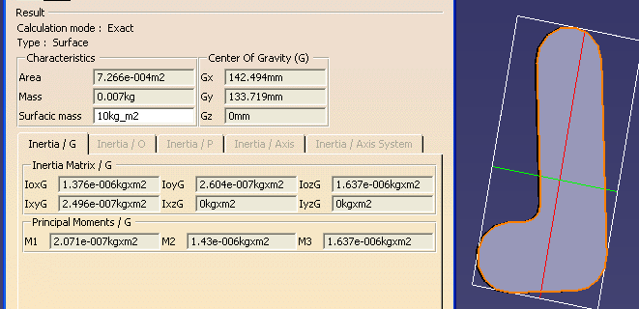
Figure (24) various characteristics of offset hinge.
Blank area = 726mm²

Step2. Calculate strip area per blank including the minimum scrap allowance.
Allowance for straight side=Sheet thickness =1.6mm (Using recommendation from table)
Allowance for Curved side=Sheet thick ness=1.6mm (Using recommendation from table)
Strip area per blank = 1394.66mm² (Calculated directly from the rectangle surrounding the blank using measure command as shown in figure 24.

Step3. Calculate the material wastage for wide run side by side layout.
Material used for strip=1394.66mm²
Material used for Blank=726mm²
Material remain with Strip as scrap = 1394.66-726 = 668.66mm²

Step4. Calculate material utilization for the given component with every layout
% Material Utilization = (Blank Area /Strip Area) * 100
= 726/1394.66
= approx. 52. %
% Material Wastage = 48 %

7.2.2 Double Row Wide and Narrow Run layouts:
Step1: Calculate blank Area: Using Measure feature of software we can calculate the area of blank. As shown in figure (24).

Blank area = 726mm²

Step2. Calculate strip area per blank including the minimum scrap allowance.
Allowance for straight side= 1.25 times of Sheet thickness= 2mm (Using recommendation from table)
Allowance for Curved side=1.25 times of sheet thick ness = 2mm (Using recommendation from table)
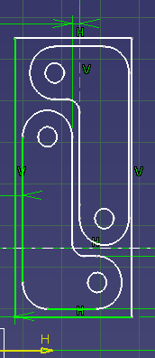
Figure (25) strip layout for double row

Strip area for Two blank = 2262.95 mm² (directly from rectangle surrounding the pair of blank).
Strip Area per Blank = 1133.975 mm²

Step3. Calculate the material wastage for wide run side by side layout.
Material used for strip= 1133.97mm²
Material used for Blank=726mm²
Material remain with Strip as scrap = 1133.97-726 = 407.97mm²

Step4. Calculate material utilization for the given component with every layout
% Material Utilization = (Blank Area /Strip Area) * 100
= 726/1133.97
= 64.2%
% Material Wastage = 35.8 %

There is good saving of material using double row layout then the earlier method but there is some technical problem of running the strip for second run. Thus process become laborious and time consuming result in low production.

7.2.3 Optimized layout at 20degree (wide and narrow run):
Step 1: Calculate blank Area: Using Measure feature of software we can calculate the area of blank. As shown in figure (24).
Blank area = 726mm²

Step 2. Calculate strip area per blank including the minimum scrap allowance.
Allowance for straight side= Sheet thickness = 1.6mm (Using recommendation from table)
Allowance for Curved side= sheet thickness = 1.6mm (Using recommendation from table)
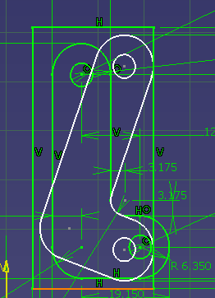
Figure (26) strip rotation at 20 degree.
Strip Area per blank = 53.15*26.283= 1396.94mm²(width and length of strip for one blank including the allowances)

Step3. Calculate the material wastage.
Material used for strip=1396.94mm²
Material used for Blank=726mm²
Material remain with Strip as scrap = 1396.94-726 =670.94 mm²

Step4. Calculate material utilization for the given component with every layout
% Material Utilization = (Blank Area /Strip Area) * 100
= 726/1396.94 =51.97
= 51.97%
% Material Wastage = 48.03

7.2.4. Optimized layout at 35degree (wide and narrow run):
Step 1: Calculate blank Area: Using Measure feature of software we can calculate the area of blank. As shown in figure (24).

Blank area = 726mm²

Step2. Calculate strip area per blank including the minimum scrap allowance.
Allowance for straight side= Sheet thickness = 1.6mm (Using recommendation from table)
Allowance for Curved side= sheet thickness = 1.6mm (Using recommendation from table)
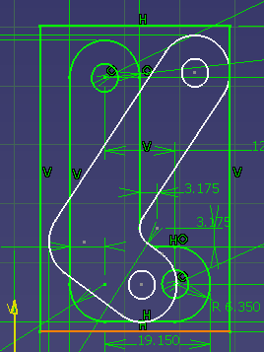
Figure (27) rotation at 35 degree.
Strip Area per blank = 51.853*34.341 =1780.68mm²(width and length of strip for one blank including the allowances)

Step3. Calculate the material wastage.
Material used for strip=1780.68mm²
Material used for Blank=726mm²
Material remain with Strip as scrap = 1780.68-726 = 1054.68mm²

Step4. Calculate material utilization for the given component with every layout
% Material Utilization = (Blank Area /Strip Area) * 100
= 726/1780.68=40.77
= 40.77%
% Material Wastage = 59.22 %

    - Optimized layout at 45degree ( wide and narrow run ):
Step 1: Calculate blank Area: Using Measure feature of software we can calculate the area of blank. As shown in figure (24).
Blank area = 726mm²

Step2. Calculate strip area per blank including the minimum scrap allowance.
Allowance for straight side= Sheet thickness = 1.6mm (Using recommendation from table)
Allowance for Curved side= sheet thickness = 1.6mm (Using recommendation from table)

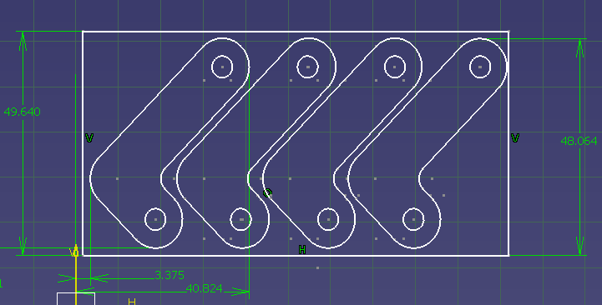
Figure (28) strip rotation at 45 degree.

Strip Area for four Blank = 49.64 * 100.343= 4977.9mm² (width and length of strip for four blanks including the allowances)

Strip Area per blank = 4977.9/4 =1244.47mm²

Step3. Calculate the material wastage.
Material used for strip=1244.47mm²
Material used for Blank=726mm²
Material remain with Strip as scrap = 1244.47-726 = 518.47mm²

Step4. Calculate material utilization for the given component with every layout
% Material Utilization = (Blank Area /Strip Area) * 100
= 726/1244.47 =58.33
= 58.33 %
% Material Wastage = 41.67 %

Stage 2
Step 5: Comparison of the optimum material utilization for different positions.

Sr.No. | Lay out | Material Utilization | Material Wastage
1 | Side By side Run | 52 % | 48 %
2 | Double Row Run | 64.2% | 35.8 %
3 | Side by side run At 20 degree | 51.97% | 48.03%
4 | Side by side run At 35 degree | 40.77% | 59.23%
5 | Side by side run At 45 degree | 58.33 % | 41.67%

Table (5) Comparative result for various layouts
From the above shown results in table (5), it clear that strip layout with double row run for hinge offset is best material utilization method. But there is limitation associated with it i.e. running of strip for second run is very difficult due to distortion in first run and if we provide extra punch and die to cut in single run will increase the complexity for design of tool and also causes extra cost for tool this will be done only when there is good amount of order for pieces. More over possibility for breaking of punch in gang die increases then single punch. so the next better option for running the strip is 45 degree which offer maximum material utilization than any other positons.how ever our aim is not to show the best method that was obtained earlier also but we are trying to show that all of process is done very fast without wasting material, without using extra man power, with out using power press i.e. this technique is good combination of shop floor experience and software skills.

7.3 Advantages of Nesting using Cad Software:
The optimization is done with the help of cad software CATIA V5, with applying the features required for strip layout after identification of those features on available software. This helps to optimize the strip using skill of tool room persons with aid of cad software. There are number of advantages using this technique explained below as:
1. This result in saving of excessive machine utilization for trial run.
2. This result in saving of labor (Mental and Physical) that used for trial run.
3. This result in saving of material wastage that occurs due to hit and trial run method.
4. This result in saving of shop floor production time.
5. This reduces the possibility of accident that may occur due to long run of trial and fatigue.
6. Manual optimization is good for optimization over conventional method but involves lot of repetitive job work that causes physical and mental fatigue.
7. Nesting helps to locate the die on die plate at optimum angle with exact setting of dowel and guide gauge for strip. While conventional method is very time consuming.
8. The labor required for die setting over die plate, location of stopper and guide plate reduce to large extent and almost done in one setting.
Since Software based optimization have lot of advantages but only limitation is that how to make it popular among such persons who are technically strong but academically poor. So this can be done by making training module that includes only those features that required for nesting that will be common to almost every software like translation, rotation, scaling.profile generation etc. so this program will be user friendly and can be customize as per the trainee requirement. So they don’t need to learn the entire software workshops and modules.

7.4 Benefits of CAD software for Nesting
Optimization
Sr.No. | Feature | Benefit
1 | Nesting | Material Saving
2 | Simplicity | Demands minimum skills from the user
3 | Objective | Standardization
4 | Immediate Results | Estimation can be made in advance
5 | Rapid nesting trials | Material Saving potential

7.5 Conclusions:
Traditional strip layout method requires lot of experience, shop floor movement, material wastage that affect the cost of tool development and running production cost. From the above mention techniques no doubt that number of problems related to traditional method may over come i.e. there is no need to engage the machine, operator until optimum results obtain. All work related to strip lay out can be done on computer .Skill requirement are knowledge of sheet metal operation and cad tool. This technique can be readily accepted by vendors of various big industries. But only thing required is that development of training module or manual to trained their tool room professional.
CHAPTER 8
References:

1. Industry Canada, 1998 “Industry Overview Reports: SIC-E 3253 - Motor Vehicle
Stampings Industry,” Ottawa, Canada, November 22, 1998.
2. Z. Zhao and Y. Peng “Development of a Practical Blank Layout Optimization System
For Stamping Die Design” Int J Adv Manu Techno (2002) 20:357–362.
3. V. Vamanu, T. J. Nye “Stamping Die Strip Optimization for Paired Parts” October 30, 2000.
4. M. Adamowicz and A. Albano, “Nesting of two-dimensional shapes in rectangular modules”, Computer-Aided Design, 8(1),pp. 27–33, 1976.
5. W. Qu and J. L. Sanders, “A nesting algorithm for irregular parts and factors affecting trim losses”, International Journal of Production Research, 25(3), pp. 381–397, 1987.
6. D. Dori and M. Ben-Bassat, “Efficient nesting of congruent convex figures”, Communications of the ACM, 27(3), pp. 228–235, 1984
7. Karoupi, F. and Loftus, M., 1991, “Accommodating Diverse Shapes within Hexagonal
Pavers,” International Journal of Production Research, Vol. 29, pp. 1507 – 1519.
8. Chow, W. W., 1979, “Nesting of a Single Shape on a Strip,” International Journal of
Production Research, Vol. 17, pp. 305 – 322.
9. Nee, A. Y. C., 1984, “A Heuristic Algorithm for Optimum Layout of Metal Stamping
Blanks,” Annals of the CIRP, Vol. 33, pp. 317 – 320.
10. Joshi, S. and Sudit, M., 1994, “Procedures for Solving Single-Pass Strip Layout
Problems,” IIE Transactions, Vol. 26, pp. 27 – 37.
11. C. H. Dagli and M. Y. Tatoglu, “An approach to two-dimensional cutting stock problems”, International Journal of Production Research, 25(2), pp. 175–190, 1987.
12. A. Y. C. Nee, “A heuristic algorithm for optimum layout of metal stamping blanks”, Annals CIRP, 33, pp. 317–320, 1984.
13. A. Y. C. Nee, “PC-based computer aids in sheet-metal working”, Journal of Mechanical Working Technology, 19, pp. 11–21, 1989.
14. A. Y. C. Nee and K. Y. Foong, “Some considerations in the design and automatic staging of progressive dies”, International Journal of Materials Processing Technology, 29, pp. 147–158,1992.
15. H. S. Ismail and K. K. B. Hon, “New approaches for the nesting of two-dimensional shapes for press tool design”, International Journal of Production Research, 30(4), pp. 825–837, 1992.
16. Z -C. Lin and C -Y. Hsu, “An investigation of an expert system for shearing cut progressive die design”, International Journal of Advanced Manufacturing Technology, 11, pp. 1–11, 1996.
17. R. Singh and G. S. Sekhon, “A computerized diagraph and matrix approach for evaluation of metal stamping layouts”, Journal of Materials Processing Technology, 59, pp. 285–293, 1996.

18. J.R.Paquin “Die design fundamentals” industrial press Inc, Newyork, N.Y.

19. CAD software “CATIA V5-R19”

