Chapter 1
Introduction and Literature Review
1.1 Introduction
Today as the demand for power is increasing day by day Load Flow solution plays an important role as it gives solution of the network under steady state condition subject to certain inequality constraints under which the system operates. It also gives nodal voltages and phase angles and hence the power injection at all the buses and power flows through interconnecting transmission lines. In this work we have used genetic algorithm (GA) technique and Matlab programming to solve load flow problem for IEEE 5 Bus System. Genetic algorithms are search algorithms based on the mechanics of natural selection and natural genetics they combine survival of the fittest among structures with a structured yet randomized information exchange to form a search algorithm with some of the innovative flair of human search.
1.2 Objectives and Methodology
Our objective in this work is to solve load flow problem using genetic algorithm. For this IEEE 5 system has been considered. GA is based on the technique of natural selection. It helps to get the global optimum solutions. For calculating active powers, reactive powers and losses Matlab programming has been applied. The work has been carried out in the following order:
1.2.1 Exploring and Analyzing the Tools of Genetic Algorithm in Matlab
In Matlab GA operations are explored in many ways to get the global optimal points like, running the GA from the Command prompt for constrained, unconstrained and parameterized functions. GAtool is executed by opening it in a separate window for solving constrained and unconstrained problems. We have varied different parameters in Genetic Algorithm to understand its influence in getting the accuracy and Final Generation. Here Final Generation stands for the generation where we get the global optimal points. Different parameters like Population Size, Initial range, Initial Population, Stopping conditions etc are varied and the corresponding graphs are drawn between these parameters and the (accuracy of the optimal points and final generation) for predicting the results.
1.2.2 Performing Constrained & Unconstrained Minimization:
We have taken various problems regarding constrained and unconstrained minimization of functions both single variable and Multi variable. Results have been analyzed and accuracy has been checked by varying the various stopping criterion.
1.3 Survey Of Literature
Jumeau and Chiang (1993) presented a technique to solve the convergence problem at singular or near-singular roots of the system. They gave a basis stemming from bifurcation theory for the proposed technique. Special attention is given to saddle-node bifurcations points which are generally found in power systems applications. Bifurcation is the qualitative change in system’s response with quantative change in input quantity. This paper develops an efficient computational procedure to solve ill-conditioning load flow solutions with the following features:
(1) It locally removes the singularity of the corresponding Jacobian
(2) It only requires a simple identification of the standard load flow equations, with no added dimension
(3) It adds just a few non-zero elements to the sparse Jacobian matrix of the load flow equations
(4) It enlarges the region of convergence around singular solutions. This work results are conforming that the solution of a non linear system lies within a specific bound of singular point region.
Zeng, et al. (1993) presented a computationally efficient and simple approach to estimate maximum loading conditions in the load flow problem. They found that the operating points are known to result in a number of undesirable phenomena such as the singularity of the Jacobian, solution bifurcations, and voltage collapse. The approach presented here generates precise estimates of the maximum possible amount of load increase that the system can tolerate along a specified path, as well as the corresponding voltage vector.
Weimin and Thorp (1993) proposed a numerically efficient algorithm to find all the solutions to load flow equations. This algorithm is based on the analysis of the topological structures of the solution set defined by the parameterized load flow equation. They found that the load flow solutions are connected by one-dimension manifolds (curves) to form a connected graph. All the load flow solutions can be found by tracing these curves. The significance of this algorithm is that it can be guaranteed to find all the solutions while reducing the amount of computations to the point. This task can be attempted on real power systems. The algorithm is based on theoretical analysis of the topological structures of the manifolds (smooth curves), and guarantees that all the solutions are found. The significance of this method is that its computational complexity is proportional to the product of the system size (N) and the number of solutions (s) the system actually has, thus it greatly reduces the amount of computations required.
NGUYEN (1997) presented a new algorithm that is the extensive NEWTON-RAPSHON algorithm, which is used for the solution of three phase power flow analysis of both transmission or distribution systems under unsymmetrical operating conditions and power quality problems. This is a new and robust technique, and is developed on the extension of Newton-Raphson method and its Jacobian in complex form. It gives the solutions in whole phasor format.
Wanliang and Ngan (1997) proposed a method to calculate the load flow of power system in which Unified Power Flow Controllers (UPFCs) are embedded. The Unified Power Flow Controller is a combination of shunt and series controller. It has three controllable parameters as the magnitude of the boosting injected voltage, phase of this voltage and the exciting transformer reactive current. So UPFCs can provide controlled voltage, phase and current in a system. First the load flow equations of power system including the UPFCs are derived and then the algorithm is developed based on the Newton Raphson Load Flow (NRLF) technique. The method inherits the basic properties of the NRLF approach. Numerical computation using the proposed method on standard testing programs indicates that this algorithm is reliable and efficient. This work has proposed a method to extend the NRLF technique to calculate the load flow of complex power systems with multi-UPFCs. Both the theoretical analysis and numerical computation show that the algorithm is effective in terms of computational speed, accuracy, computing resources and its quadratic convergence characteristics. The case studies demonstrate that the approach posed by this work is novel, systematic, efficient and reliable. It can be easily integrated to the conventional NRLF programme and provides a useful tool for the study of UPFC. Since the modification formulas presented in this work are all analyzable function of parameters of UPFC, they have potential for adoption on other areas of studies relating to power systems with UPFC.
Wong, et al. (1997) proposed genetic-algorithm for load-flow. The methods proposed by them satisfy the power balance requirement and the voltage magnitude constraint. Then they developed and incorporated the genetic-algorithm method to form a constrained genetic-algorithm for solution of the load-flow problem. It is based on the concept of genetic algorithms and the methods of constraint satisfaction. The methods developed in this work satisfy the specified powers of the PQ nodes and the specified voltage magnitudes of the PV nodes. Three mechanisms, the dynamic population technique, the solution acceleration technique and the sequencing method for nodal voltage updating, had also been developed and incorporated in Constrained Genetic Algorithm Load Flow to enhance its performance and computational speed. But when the loading condition is such that the load-flow equation set is unsolvable, the insolvability is indicated by CGALF in the form of voltage magnitude violation at the PV nodes.
Wong, et al. (1999) proposed an efficient and reliable constrained genetic algorithm based load flow. The components and the constraint satisfaction methods in the algorithm are presented. A nodal voltage differential technique and a gradient method are developed to accelerate the solution process in the algorithm. A method for dealing with generator reactive power limits is also developed. This algorithm can determine multiple load flow solutions and can be used to determine the loadability limits of transmission systems. It is particularly useful for determining the load flow solutions of highly stressed systems where the conventional NEWTON-RAPSHON approach fails. The concept of virtual population, the techniques of acceleration and their integration into the framework of the genetic algorithm in this work is very useful for solving other power system optimisation problems.

Liu and Song (2000) developed a Power Injection Model based UPFC (Unified Power Flow Controller) control approach to consider a number of internal limits imposed on the UPFC, including series injection voltage magnitude, line current through the series inverter, real power transfer between the shunt inverter and series inverter, shunt side current and shunt injection voltage magnitude. The proposed constrained control strategies can coordinate the available control freedom to achieve an efficient usage of the UPFC when constrained by the internal limits.
Zebleh, et al. (2000) proposed a new constructive method for electric system reconfiguration. Their work addressed an ant colony optimization method to solve a combinational problem of total investment-cost minimization, subject to power constraints. Due to the variation of demand, the reconfiguration may be considered in two different situations i.e. in the system planning or in system design stage. The proposed method determines the minimal investment-cost system configuration during the considered study period to satisfy power transit constraints. The algorithm of ant colony approach (ACA) is required to identify the optimal combination of adding or cut off feeders with different parameters for the new topology design. This algorithm differs from most others, by constructing the system from scratch, rather than performing switch exchanges or sequential switch openings. An approximate loss formula helps to quickly screen candidate switch closings, but this method still performs more load flow calculations than other methods. Most of the load flow calculations only work with a subset of the system. This algorithm can solve load flow either restoration or loss minimization problems.

Teng (2003) proposed a direct approach for unbalanced three-phase distribution load flow solutions. They fully utilized the special topological characteristics of distribution networks to make the direct solution possible. Two developed matrices the bus-injection to branch-current matrix and the branch-current to bus-voltage matrix and a simple matrix multiplication are used to obtain load flow solutions. Due to the distinctive solution techniques, the proposed method is robust and time-efficient. The proposed method shows great potential to be used in distribution automation applications.
Dimitrovski (2004) proposed a new concept for finding accurate boundary load flow solutions given fuzzy/interval numbers is presented. Based on extending an idea from probabilistic load flow, an optimization procedure for implicitly defined functions is introduced. This work presents a new concept for finding accurate boundary values of load flow solutions. The concept is based on an optimization procedure for implicitly defined vector functions. A simple algorithm is developed that is easy to implement and performs well, in the sense that it provides a solution whenever the associated deterministic load flow (DLF) converges. Finding the accurate boundary values enables us, for the first time, to obtain accurate solutions from a fuzzy/interval load flow in which the uncertain generation and load powers are modelled with fuzzy/interval numbers. It also enables us to establish a reference for other methods that solve the same problem approximately.
Phu, et al. (2004) presented a genetic algorithm based distributed generator placement technique in a distributions system for minimizing the total real power losses in the system. Both the optimal size and location are obtained as outputs from the genetic algorithm toolbox. The results are verified using some popular power flow analytical as Guass-Siedel, Newton-Rapshon and Fast Decoupled methods for distribution system load flow. But due to more accuracy N-R method is used. The paper also emphasizes the importance of selecting the correct size and suitable location for minimizing the system losses.

Sahoo, et al. (2007) proposed dynamic load balancing algorithm for heterogeneous distributed systems. In a heterogeneous distributed computing system, processing loads arrive from many users at random time instants. A proper scheduling policy was attempted to assign these loads to be available at computing nodes so as to complete the processing of all loads in the shortest possible time. Their algorithm for load distributing is based on genetic algorithm and has four components as (i) a transfer policy that determines whether a node is in a suitable state to participate in a task transfer (ii) a selection policy that determines which task should be transferred (iii) a location policy that determines to which node a task selected for transfer should be sent, and (iv) an information policy which is responsible for triggering the collection of system state information. They found that GA based algorithm works better when the numbers of tasks are large.

Zechun and Wang (2008) introduced a new method for obtaining the maximum loading point (MLP) of electric power systems based on the load flow method with optimal multiplier in rectangular coordinates. The proposed method starts from an infeasible point beyond power system maximum loadability and approaches the MLP iteratively. The method approximates the MLP from the infeasible region of the load flow equations and is simple to implement since it is based primarily on widely used Newton Raphson load flow technique.

Chapter 2
Genetic Algorithm
This Chapter will present the general principles of Biological Genetic Algorithms including the fundamental concept of Natural Selection. Once the concept of Natural Selection has been presented, this Chapter will then explain the basic process that any Genetic Algorithm would follow if applied to a real-world problem. In order to understand the capabilities and limitations of applying a Genetic Algorithm to an engineering optimization problem, the Chapter concludes with a brief discussion on the main advantages and disadvantages associated with Genetic Algorithms.

2.1 Introduction

Genetic algorithms are search algorithms based on the mechanics of natural selection and natural genetics. They combine survival of the fittest among string structures with a structured yet randomized information exchange to form a search algorithm with some of the innovative flair of human search. In every generation, a new set of artificial strings is created using bits and pieces of the fittest of the old; an occasional new part as tried for good measure.

GA have been developed by John Holland his colleagues and his students at the university of Michigan.The goals of their search have been twofold
- To abstract and rigorously explain the adaptive processes of natural systems
- To design artificial systems software that retains the important mechanisms of natural systems.
Genetic Algorithms (GA’s) are adaptive heuristic search algorithm premised on the evolutionary ideas of natural selection and genetic. The basic concept of GA’s is designed to simulate processes in natural system necessary for evolution, specifically those that follow the principles first laid down by Charles Darwin of survival of the fittest. As such they represent an intelligent exploitation of a random search within a defined search space to solve a problem.
First pioneered by John Holland in the 60’s, Genetic Algorithms has been widely studied, experimented and applied in many fields in engineering worlds. Not only does GA’s provide alternative methods to solving problem, it consistently outperforms other traditional methods in most of the problems link. Many of the real world problems involved finding optimal parameters, which might prove difficult for traditional methods but ideal for GA’s. However, because of its outstanding performance in optimization, GA’s have been wrongly regarded as a function optimizer. In fact, there are many ways to view genetic algorithms. Perhaps most users come to GA’s looking for a problem solver, but this is a restrictive view [De Jong, 1993].
Herein, we can examine GA’s as a number of different things
  - GA’s as problem solvers
  - GA’s as challenging technical puzzle
  - GA’s as basis for competent machine learning
  - GA’s as computational model of innovation and creativity
  - GA’s as computational model of other innovating systems
  - GA’s as guiding philosophy
However, due to various constraints, we would only be looking at GA’s as problem solvers and competent machine learning here. We would also examine how GA’s is applied to completely different fields.
Many scientists have tried to create living programs. These programs do not merely simulate life but try to exhibit the behaviors and characteristics of real organisms in an attempt to exist as a form of life. Suggestions have been made that a life would eventually evolve into real life. Such suggestion may sound absurd at the moment but certainly not implausible if technology continues to progress at present rates. Therefore it is worth, in our opinion, taking a paragraph out to discuss how A life is connected with GA’s and see if such a prediction is farfetched and groundless.

2.2 Brief Overview
GA’s were introduced as a computational analogy of adaptive systems. They are modeled loosely on the principles of the evolution via natural selection, employing a population of individuals that undergo selection in the presence of variation-inducing operators such as mutation and recombination (crossover). A fitness function is used to evaluate individuals, and reproductive success varies with fitness.
The Algorithms
- Randomly generate an initial population M(0)
- Compute and save the fitness u(m) for each individual m in the current population M(t)
- Define selection probabilities p(m) for each individual m in M(t) so that p(m) is proportional to u(m)
- Generate M(t+1) by probabilistically selecting individuals from M(t) to produce offspring via genetic operators
- Repeat step 2 until satisfying solution is obtained.
The paradigm of GA’s described above is usually the one applied to solving most of the problems presented to GA’s. Though, it might not find the best solution more often than not, it would come up with a partially optimal solution.
2.3 History
Computer simulations of evolution started as early as in 1954 with the work of Nils Aall Barricelli, who was using the computer at the Institute for Advanced Study in Princeton, New Jersey. His 1954 publication was not widely noticed. Starting in 1957, the Australian quantitative geneticist Alex Fraser published a series of papers on simulation of artificial selection of organisms with multiple loci controlling a measurable trait. From these beginnings, computer simulation of evolution by biologists became more common in the early 1960s, and the methods were described in books by Fraser and Burnell (1970) and Crosby (1973). Fraser's simulations included all of the essential elements of modern genetic algorithms. In addition, Hans Bremermann published a series of papers in the 1960s that also adopted a population of solution to optimization problems, undergoing recombination, mutation, and selection. Bremermann's research also included the elements of modern genetic algorithms. Other noteworthy early pioneers include Richard Friedberg, George Friedman, and Michael Conrad. Many early papers are reprinted by Fogel (1998).
Although Barricelli, in work he reported in 1963, had simulated the evolution of ability to play a simple game, artificial evolution became a widely recognized optimization method as a result of the work of Ingo Rechenberg and Hans-Paul Schwefel in the 1960s and early 1970s - his group was able to solve complex engineering problems through evolution strategies. Another approach was the evolutionary programming technique of Lawrence J. Fogel, which was proposed for generating artificial intelligence. Evolutionary programming originally used finite state machines for predicting environments, and used variation and selection to optimize the predictive logics. Genetic algorithms in particular became popular through the work of John Holland in the early 1970s, and particularly his book Adaptation in Natural and Artificial Systems (1975). His work originated with studies of cellular automata, conducted by Holland and his students at the University of Michigan. Holland introduced a formalized framework for predicting the quality of the next generation, known as Holland's Schema Theorem. Research in GA’s remained largely theoretical until the mid-1980s, when The First International Conference on Genetic Algorithms was held in Pittsburgh, Pennsylvania.

As academic interest grew, the dramatic increase in desktop computational power allowed for practical application of the new technique. In the late 1980s, General Electric started selling the world's first genetic algorithm product, a mainframe-based toolkit designed for industrial processes. In 1989, Axcelis, Inc. released Evolver, the world's second GA product and the first for desktop computers. The New York Times technology writer John Markoff wrote about Evolver in 1990.
2.4 Advantages and Disadvantages
As already eluded to, Genetic Algorithms have numerous inherent advantages over classical numerical optimization techniques. Haupt & Haupt (2005) attest that some of the advantages of Genetic Algorithms are that they:
- Can handle discrete and continuous variables; Don’t require the calculation of function derivates (not calculus based);
- PID Controller Optimization Using Genetic Algorithms
- Are suited to parallel computing (still the current means from which personal computers are attempting to gain significant increases in processing power);
- Can provide a list of optimal variables;
- Can handle complex cost surfaces (local minima/maxima do not fault the method); and
- Can handle large numbers of variables.

However, despite the many advantages over classical analytical optimization techniques, the Genetic Algorithms own process of searching a large solution space results in a significant disadvantage. That disadvantage being a high computational cost associated with processing and searching a large solution space. Such a computational cost is normally manifested by a slow computational process and a high demand for memory. Hence, classical analytical optimization techniques still remain the best for complex analytical functions with few variables.
2.5 Comparison with other nontraditional techniques

Classical Algorithm | Genetic Algorithm
Generates a single point at each iteration. The sequence of points approaches an optimal solution. | Generates a population of points at each iteration. The best point in the population approaches an optimal solution.
Selects the next point in the sequence by a deterministic computation | GA work with a coding of the parameter set not the parameter themselves
 | GA use payoff (objective function) information, not derivatives or other auxiliary knowledge.
 | GA use probabilistic transition rules not deterministic rules.

It is important to understand that the functioning of such an algorithm does not guarantee success. We are in a stochastic system and a genetic pool may be too far from the solution, or for example, a too fast convergence may halt the process of evolution. These algorithms are nevertheless extremely efficient, and are used in fields as diverse as stock exchange, production scheduling or programming of assembly robots in the automotive industry.
2.6 Understanding Genetic Algorithm
2.6.1 Biological rules
The genetic algorithm is a method for solving optimization problems that is based on natural selection, the process that drives biological evolution. The genetic algorithm repeatedly modifies a population of individual solutions. At each step, the genetic algorithm selects individuals at random from the current population to be parents and uses them produce the children for the next generation. Over successive generations, the population "evolves" toward an optimal solution. You can apply the genetic algorithm to solve a variety of optimization problems that are not well suited for standard optimization algorithms, including problems in which the objective function is discontinuous, non differentiable, stochastic, or highly nonlinear.

The genetic algorithm uses three main types of rules at each step to create the next generation from the current population:
- Selection rules select the individuals, called parents that contribute to the population at the next generation.
- Crossover rules combine two parents to form children for the next generation.
- Mutation rules apply random changes to individual parents to form children.
- Before we go further we must understand the terminology associated with GA

2.6.2 Genetic Algorithm Terminology
This section explains some basic terminology for the genetic algorithm, including Fitness Functions Individuals Populations and Generations Fitness Values and Best Fitness Values Parents and Children.

Fitness Functions
The fitness function is the function you want to optimize. For standard optimization algorithms, this is known as the objective function. The genetic algorithm tries to find the minimum of the fitness function.

Individuals
An individual is any point to which you can apply the fitness function. The value of the fitness function for an individual is its score.

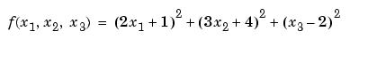
For example, if the fitness function is the vector (2, 3, 1), whose length is the number of variables in the problem, is an individual. The score of the individual (2, 3, 1) is
f (2, -3, 1) = 51. An individual is sometimes referred to as a genome and the vector entries of an individual as genes.

Populations and Generations
A population is an array of individuals. For example, if the size of the population is 100 and the number of variables in the fitness function is 3, you represent the population by a 100-by-3 matrix. The same individual can appear more than once in the population. For example, the individual (2, 3, 1) can appear in more than one row of the array. At each iteration, the genetic algorithm performs a series of computations on the current population to produce a new population. Each successive population is called a new generation.

Diversity
Diversity refers to the average distance between individuals in a population. A population has high diversity if the average distance is large; otherwise it has low diversity. In the following figure, the population on the left has high diversity, while the population on the right has low diversity. Diversity is essential to the genetic algorithm because it enables the algorithm to search a larger region of the space.

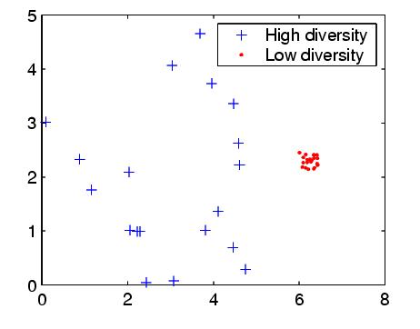

Fitness Values and Best Fitness Values
The fitness value of an individual is the value of the fitness function for that individual. Because the toolbox finds the minimum of the fitness function, the best fitness value for a population is the smallest fitness value for any individual in the population. Parents and Children to create the next generation, the genetic algorithm selects certain individuals in the current population, called parents, and uses them to create individuals in the next generation, called children. Typically, the algorithm is more likely to select parents that have better fitness values.


2.7 Working of Genetic Algorithm

Outline of the Algorithm:
1. This section provides an overview of how the genetic algorithm works.
2. This section covers the following topics: Outline of the Algorithm Initial Population Creating the Next Generation Plots of Later Generations Stopping Conditions for the Algorithm

The following outline summarizes how the genetic algorithm works: The algorithm begins by creating a random initial population. The algorithm then creates a sequence of new populations, or generations. At each step, the algorithm uses the individuals in the current generation to create the next generation. To create the new generation, the algorithm performs the following steps: Scores each member of the current population by computing its fitness value. Scales the raw fitness scores to convert them into a more usable range of values. Selects parents based on their fitness. Produces children from the parents. Children are produced either by making random changes to a single parent -- mutation or by combining the vector entries of a pair of parents -- crossover. Replaces the current population with the children to form the next generation. The algorithm stops when one of the stopping criteria is met.

Before you can use a genetic algorithm to solve a problem, a way must be found of encoding any potential solution to the problem. This could be as a string of real numbers or, as is more typically the case, a binary bit string. I will refer to this bit string from now on as the chromosome. A typical chromosome may look like this:

10010101110101001010011101101110111111101

At the beginning of a run of a genetic algorithm a large population of random chromosomes is created. Each one, when decoded will represent a different solution to the problem at hand. Let's say there are N chromosomes in the initial population. Then, the following steps are repeated until a solution is found.
- Test each chromosome to see how good it is at solving the problem at hand and assign a fitness score accordingly. The fitness score is a measure of how good that chromosome is at solving the problem to hand.
- Select two members from the current population. The chance of being selected is proportional to the chromosomes fitness. Roulette wheel selection is a commonly used method.
- Dependent on the crossover rate crossover the bits from each chosen chromosome at a randomly chosen point.
- Step through the chosen chromosomes bits and flip dependent on the mutation rate. Repeat step 2, 3, 4 until a new population of N members has been created

2.7.1 Creating a random initial population
Initially many individual solutions are randomly generated to form an initial population. The population size depends on the nature of the problem, but typically contains several hundreds or thousands of possible solutions. Traditionally, the population is generated randomly, covering the entire range of possible solutions (the search space). Occasionally, the solutions may be "seeded" in areas where optimal solutions are likely to be found.
The algorithm begins by creating a random initial population, as shown in the following figure.
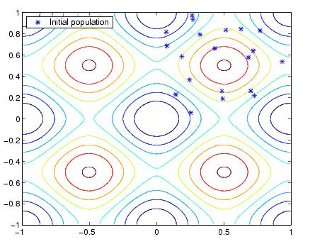
In this example, the initial population contains 20 individuals, which is the default value of Population size in the Population options.
Note: that all the individuals in the initial population lie in the upper-right quadrant of the picture, that is, their coordinates lie between 0 and 1, because the default value of Initial range in the Population options is [0;1].
If you know approximately where the minimal point for a function lies, you should set Initial range so that the point lies near the middle of that range.

2.7.2 Creating the Next Generation

After choosing the initial population the GA uses its four operators to produce the next population

GA OPERATORS
- Mate selection
- Reproduction
- Crossover (Recombination)
- Mutation

2.7.3 Mate selection operator
- Making marriages is like Mate selection.
- This operators selects good strings in a random population and forms a mating pool.
- The selection function chooses parents for the next generation based on their scaled values from the fitness scaling function.
- An individual can be selected more than once as a parent , in which case it contributes its genes to more than one child. The default selection option , stochastic uniform, lays at a line in which each parent corresponds to a section of the line of length proportional to its scaled value. The algorithm moves along the line in steps of equal size. At each step, the algorithm allocates a parent from the selection it lands on.
- Using the mate selection operator, individual chromosomes are selected according to their fitness, which is evaluated using an objective function. This means that a chromosome with a higher fitness value will have a higher probability of contributing one or more chromosomes in the next generation. There are many ways this operator can be implemented.
- A basic method calls for using a weighted Roulette wheel with slots sized according to fitness. Thus on the Roulette wheel the individual with highest fitness will have a larger slot than the other individuals in the population.
- Consequently when the wheel is spun the best individual will have a higher chance of being selected to contribute to the next generation.
- Individuals thus selected are further operated on with other GA operators such as crossover and mutation.
- In reproduction, good strings in a population are probabilistically assigned a larger number of copies and mating pool is formed.
- It is important to note that no new strings are formed in reproduction phase.

2.7.4 Reproduction
The next step is to generate a second generation population of solutions from those selected through genetic operators: crossover (also called recombination), and/or mutation.
For each new solution to be produced, a pair of "parent" solutions is selected for breeding from the pool selected previously. By producing a "child" solution using the above methods of crossover and mutation, a new solution is created which typically shares many of the characteristics of its "parents". New parents are selected for each child, and the process continues until a new population of solutions of appropriate size is generated.
These processes ultimately result in the next generation population of chromosomes that is different from the initial generation. Generally the average fitness will have increased by this procedure for the population, since only the best organisms from the first generation are selected for breeding, along with a small proportion of less fit solutions, for reasons already mentioned above.
2.7.5 Mutation and Crossover

It explains how to specify the number of children of each type that the algorithm generates and the functions it uses to perform crossover and mutation. The following sections explain how the algorithm creates crossover and mutation children. Crossover Children the algorithm creates crossover children by combining pairs of parents in the current population. At each coordinate of the child vector, the default crossover function randomly selects an entry, or gene, at the same coordinate from one of the two parents and assigns it to the child. Mutation Children the algorithm creates mutation children by randomly changing the genes of individual parents. The following figure shows the children of the initial population, that is, the population at the second generation, and indicates whether they are elite, crossover, or mutation children.

2.7.6 Crossover Operator
At each step, the genetic algorithm uses the current population to create the children that make up the next generation. The algorithm selects a group of individuals in the current population, called parents, who contribute their genes -- the entries of their vectors -- to their children. The algorithm usually selects individuals that have better fitness values as parents. You can specify the function that the algorithm uses to select the parents in the Selection function field in the Selection options. The genetic algorithm creates three types of children for the next generation: Elite children are the individuals in the current generation with the best fitness values. These individuals automatically survive to the next generation. Crossover children are created by combining the vectors of a pair of parents. Mutation children are created by introducing random changes, or mutations, to a single parent. The following schematic diagram illustrates the three types of children.
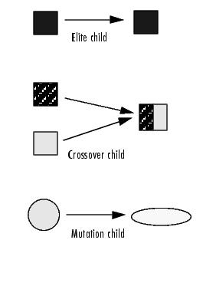
- The purpose of crossover operator is to produce new chromosomes that are distinctly different from their parents, yet retain some of their parent characteristics.
- New strings are created by exchanging information among strings of the mating pool.
- There are two important crossover techniques called one point crossover and two point crossover.
- In One point crossover two parent chromosomes are interchanged at a randomly selected point thus creating two children.
- In two point crossover, two crossover points are selected instead of just one crossover point. The part of the chromosome string between these two points is then swapped to generate two children. Empirical studies have shown that Two point crossover usually provides better randomization than One point crossover.

Crossover demonstration
- One point crossover:
- Let us take two strings. (i) 0 1 1 0 1 (ii) 1 1 0 0 0
- Crossover position is randomly selected as 4
- | is the crossover symbol
- Before crossover
- 0 1 1 0 | 1
- 1 1 0 0 | 0
- After crossover
- String (i) becomes 0 1 1 0 0
- String (ii) becomes 1 1 0 0 1

- Two point crossover
- Let us take two strings (i) 0 1 1 0 1 (ii) 1 1 0 0 0
- Two crossover positions are randomly selected as 2 and 4.
- | is the crossover symbol
- Before crossover
- 0 1 | 1 0 | 1
- 1 1 | 0 0 | 0
- After crossover
- String (i) becomes 0 1 0 0 1
- String (ii) becomes 1 1 1 0 0

2.7.7 Mutation operator
- Some of the individuals in the new generation produced by Mate selection and Crossover are mutated using the Mutation operator. The most common form of mutation is to take a bit from chromosome and alter it with some predetermined probability.
- As mutation rates are very small in natural evolution, the probability with which the mutation operator is applied is set to a very low value and is generally experimented with before this value is fixed.
- Practical aspect of mutation is to include the member from outside having different gene to create the next generation. The purpose of this is to widen the search space.

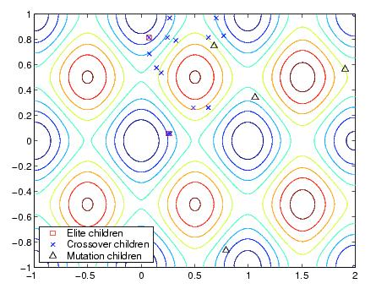

Plots of later generations the following figure shows the populations at iterations 60, 80, 95, and 100.
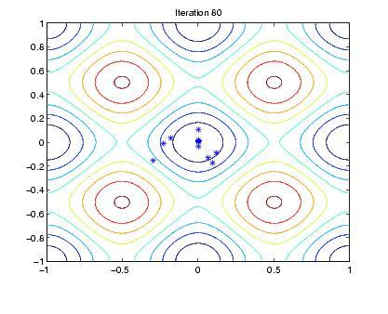

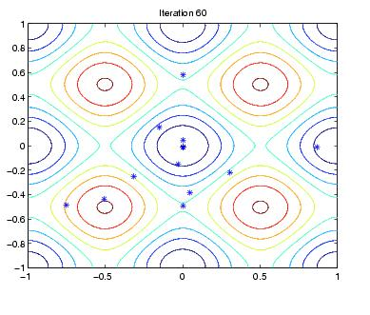

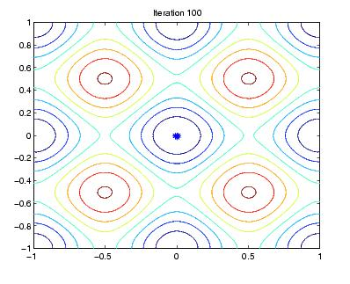
As the number of generations increases, the individuals in the population get closer together and approach the minimum point

2.8 Termination
Stopping Conditions for the Algorithm:

The genetic algorithm uses the following five conditions to determine when to stop:

1. Generations -- The algorithm stops when the number of generations reaches the value of Generations.

2. Time limit -- The algorithm stops after running for an amount of time in seconds equal to Time limit.

3. Fitness limit -- The algorithm stops when the value of the fitness function for the best point in the current population is less than or equal to Fitness limit.

4. Stall generations -- The algorithm stops if there is no improvement in the objective function for a sequence of consecutive generations of length Stall generations.

5. Stall time limit -- The algorithm stops if there is no improvement in the objective function during an interval of time in seconds equal to Stall time limit.

The algorithm stops as soon as any one of these five conditions is met. You can specify the values of these criteria in the Stopping criteria options in the Genetic Algorithm Tool. The default values are shown in the figure below.
When you run the genetic algorithm, the Status panel displays the criterion that caused the algorithm to stop. The options Stall time limit and Time limit prevent the algorithm from running too long. If the algorithm stops due to one of these conditions, you might improve your results by increasing the values of Stall time limit and Time limit. This generational process is repeated until a termination condition has been reached. Common terminating conditions are:
- A solution is found that satisfies minimum criteria
- Fixed number of generations reached
- Allocated budget (computation time/money) reached
- The highest ranking solution's fitness is reaching or has reached a plateau such that successive iterations no longer produce better results
- Manual inspection

2.9 Applications of Genetic Algorithms
- Automated design of mechatronic systems using bond graphs and genetic programming (NSF).
- Automated design of industrial equipment using catalogs of exemplar lever patterns.
- Automated design of sophisticated trading systems in the financial sector.
- Building phylogenetic trees.
- Calculation of Bound states and Local-density approximations.
- Chemical kinetics (GA’s and solid phases)
- Configuration applications, particularly physics applications of optimal molecule configurations for particular systems like C60 (buckyballs).
- Container loading optimization.
- Code-breaking, using the GA to search large solution spaces of ciphers for the one correct decryption.^{[citation needed]}
- Design of water distribution systems.
- Distributed computer network topologies.
- Electronic circuit design, known as Evolvable hardware.
- File allocation for a distributed system.
- Parallelization of GA’s/GPs including use of hierarchical decomposition of problem domains and design spaces nesting of irregular shapes using feature matching and GA’s.
- Game Theory Equilibrium Resolution.
- Gene expression profiling analysis.
- Learning Robot behavior using Genetic Algorithms.
- Learning fuzzy rule base using genetic algorithms.
- Linguistic analysis, including Grammar Induction and other aspects of Natural Language Processing (NLP) such as word sense disambiguation.
- Marketing Mix Analysis
- Mobile communications infrastructure optimization.
- Molecular Structure Optimization (Chemistry).
- Multiple criteria production scheduling.
- Multiple population topologies and interchange méthodologies.
- Multiple sequence alignment.
- Operon prediction.
- Optimisation of data compression systems, for example using wavelets.
- Protein folding and protein/ligand docking.
- Plant floor layout.
- Representing rational agents in economic models such as the cobweb model.
- RNA structure prediction.
- Scheduling applications, including job-shop scheduling. The objective being to schedule jobs in a sequence dependent or non-sequence dependent setup environment in order to maximize the volume of production while minimizing penalties such as tardiness.
- Selection of optimal mathematical model to describe biological systems.
- Software engineering
- Solving the machine-component grouping problem required for cellular manufacturing systems.
- Tactical asset allocation and international equity strategies.
- Timetabling problems, such as designing a non-conflicting class timetable for a large university.
- Training artificial neural networks when pre-classified training examples are not readily obtainable (neuroevolution).
- Traveling Salesman Problem.
- Finding hardware bugs.

2.10 Failure of Standard Genetic Algorithm
When GA’s applied to very large problems, they fail in two aspects:
1. They scale rather poorly (in terms of time complexity) as the number of cities increases.
2. The solution quality degrades rapidly.

Chapter 3

EXPLORING THE TOOLS OF GENETIC ALGORITHM IN MATLAB
3.1 RUNNING GA FROM COMMAND PROMPT
To run the GA with the default options we have to call the GA with the syntax [x fval] = ga(@fitness function, nvars) where fitness function stands for the function which we want to optimize, nvars is the no. of variables of the fitness function. The fitness function must be written in a separate M-file. It should be imported at the command prompt when we use the GA from the command line.

The fitness function used here is a two variable function named as minfunc. The M-file for minfunc function is saved in a MATLAB path. It is imported for running GA as and when required.
The M-file for minfunc Function is as follows

function y=minfunc(x)

y=((x(1))^2+x(2)-11)^2+(x(1)+(x(2))^2-7)^2;

This is demonstrated by running the GA from the command line

>> [ x fval ] = ga(@minfunc,2 )

Optimization terminated: average change in the fitness value less

than options.TolFun.

x =3.0240 1.9833

fval = 0.0182

Additional Output Arguments
To get more information about the performance of the genetic algorithm,
We can call GA with the syntax [x fval reason output population scores] = ga(@fitnessfcn, nvars)
Besides the optimal values, and the objective function values it can return the following as follows
Reason – Reason the algorithm is terminated.
Output – It gives the total no. of generations GA took to get the optimal point.
Scores – This gives fitnessfunction values for the final population.
Population – It gives the population of the final generation.

This is demonstrated for the two variable function
[ x fval reason output population ] = ga(@minfunc ,2)
Optimization terminated: average change in the fitness value less than options.TolFun.

x = 3.0019 1.9974

fval = 1.4564e-004

reason = 1

output = randstate: [625x1 uint32]
randnstate: [2x1 double]
generations: 64
funccount: 1300
message: 'Optimization terminated: average change in the fitness value less than options.TolFun.'
problemtype: 'unconstrained'

population = 3.0019 1.9974
3.0019 1.9974
3.0972 1.4451
3.0019 1.9974
3.0019 1.9974
3.0019 1.9974
3.0972 2.2776
3.0019 1.9974
3.0019 1.5743
2.4790 1.7785
3.0019 1.9974
3.0019 1.9974
3.0019 1.9974
1.8300 2.6615
3.0019 1.9974
2.6747 1.6538
2.9707 1.8944
2.8774 2.3525
3.2334 3.0486
2.5524 2.0540

3.2 SETTING OPTIONS FOR GA AT COMMAND LINE
You can specify any of the options that are available in the Genetic Algorithm Tool by passing an options structure as an input argument to GA using the syntax:
[x fval] = ga(@fitnessfun, nvars, [],[],[],[],[],[],[],options)
This syntax does not specify any linear equality, linear inequality or nonlinear constraints.
It can create the options structure using the function gaoptimset.
options = gaoptimset
This returns the structure options with the default values for its fields.
options = PopulationType: 'doubleVector'
PopInitRange: [2x1 double]
PopulationSize: 20
EliteCount: 2
CrossoverFraction: 0.8000
MigrationDirection: 'forward'
MigrationInterval: 20
MigrationFraction: 0.2000
Generations: 100
TimeLimit: Inf
FitnessLimit: -Inf
StallGenLimit: 50
StallTimeLimit: 20
TolFun: 1.0000e-006
TolCon: 1.0000e-006
InitialPopulation: []
InitialScores: []
InitialPenalty: 10
PenaltyFactor: 100
PlotInterval: 1
CreationFcn: @gacreationuniform
FitnessScalingFcn: @fitscalingrank
SelectionFcn: @selectionstochunif
CrossoverFcn: @crossoverscattered
MutationFcn: @mutationgaussian
HybridFcn: []
Display: 'final'
PlotFcns: []
OutputFcns: []
Vectorized: 'off'

3.3 HOW TO CHANGE THE OPTIONS

The function GA uses these default values if you do not pass in options as an input argument. The value of each option is stored in a field of the options structure, such as options.PopulationSize. You can display any of these values by entering options followed by the name of the field. For example, to display the size of the population for the genetic algorithm,
enter options.PopulationSize
ans = 20
To create an options structure with a field value that is different from the default — for example to set PopulationSize to 100 instead
of its default value 20 — enter
options = gaoptimset ('PopulationSize', 100)
This creates the options structure with all values set to their defaults except for PopulationSize, which is set to 100. If you now enter,
ga(@fitnessfun,nvars,[],[],[],[],[],[],[],options)
GA runs the genetic algorithm with a population size of 100.

3.4 REPRODUCING YOUR RESULTS
Because the genetic algorithm is stochastic, that is, it makes random choices, we get slightly different results each time when we run the genetic algorithm. The algorithm uses the MATLAB uniform and normal random number generators, such as rand and randn, to make random choices at each iteration. Each time GA calls rand and randn, their states are changed, so that the next time when they are called, they return different random numbers. That is why the output of GA differs each time when we run it.
If you need to reproduce your results exactly, you can call GA with an output argument that contains the current states of rand and randn and then reset the states to these values before running GA again.
For example to reproduce the output of GA applied to two variable functions, call GA with the syntax
[x fval reason output]=ga(@minfunc,2)
Optimization terminated: average change in the fitness value less than options.TolFun.

x = 2.9973 1.9949

fval = 9.7874e-004

reason =1

output = randstate: [625x1 uint32]
randnstate: [2x1 double]
generations: 51
funccount: 1040
message: 'Optimization terminated: average change in the fitness value less than options.TolFun.'
problemtype: 'unconstrained'

Then, reset the states, by entering
rand('state', output.randstate);
randn('state', output.randnstate);
If you now run GA a second time, you get the same results.
[ x fval ] = ga(@minfunc,2)

Optimization terminated: average change in the fitness value less than options.TolFun.

x = 2.9973 1.9949

fval = 9.7874e-004

Hence, the results obtained were same as obtained earlier.

3.5 RESUMING GA FROM FINAL POPULATION OF PREVIOUS RUN
By default, GA creates a new initial population each time you run it. However, you might get better results by using the final population from a previous run as the initial population for a new run. To do so, you must have saved the final population from the previous run by calling GA with the syntax
[x, fval, reason, output, final_pop] = ga(@fitnessfcn, nvars);

Resuming GA from the Final Population of a Previous Run - continued
The last output argument is the final population. To run GA using final_pop as the initial population, enter

options = gaoptimset('InitialPop', final_pop);

[x, fval, reason, output, final_pop2] = ...
ga(@fitnessfcn, nvars,[],[],[],[],[],[],[],options);

Then use final_pop2, the final population from the second run, as the initial population for a third run.

Resuming GA from the Final Population of a Previous Run – Demonstration

[ x fval reason output final_pop ] = ga(@minfunc,2)

Optimization terminated: average change in the fitness value less than options.TolFun.
x = 2.9978 2.0096
fval = 0.0013

reason =1
output = randstate: [625x1 uint32]
randnstate: [2x1 double]
generations: 68
funccount: 1380
message: 'Optimization terminated: average change in the fitness value less than options.TolFun.'
problemtype: 'unconstrained'

final_pop = 2.9978 2.0096
2.9978 2.0096
2.9978 2.0096
2.9446 2.1310
2.9978 2.0096
2.9978 1.2363
2.9978 2.0096
2.9978 2.0096
2.9978 1.4147
2.9978 2.0096
2.9978 2.0180
2.9978 2.0096
3.5443 2.0096
2.9978 2.0096
2.9446 2.0096
3.3255 1.7993
2.9785 1.8566
2.6437 2.8720
2.9773 1.6690
2.8753 2.0506

Resuming GA from the Final Population of a Previous Run – Demonstration continued
options = gaoptimset('Initialpop',final_pop);
[x fval reason output final_pop2] = ga(@minfunc, 2,[],[],[],[],[],[],[],options)
Optimization terminated: average change in the fitness value less than options.TolFun.
x = 2.9978 2.0096

fval =0.0013

So, the results obtained by setting the final population of the previous run is same as obtained earlier.

3.6 ANALYZING THE ACCURACY BY CHANGING THE PARAMETERS:
Now we will change the various options or parameters in GA so as to analyze the accuracy and would see if the results are changed and if yes then by what extent.
Results obtained with default options:
[ x fval reason output] = ga(@minfunc,2)
Optimization terminated: average change in the fitness value less than options.TolFun.
x = 2.9919 2.0185

fval = 0.0053

reason = 1

output =

randstate: [625x1 uint32]
randnstate: [2x1 double]
generations: 51
funccount: 1040
message: 'Optimization terminated: average change in the fitness value less than options.TolFun.'
problemtype: 'unconstrained'

On changing the options:
(i) Changing population size from default 20 to 100
(ii) Changing number of generations from 100 to 200
(iii) Changing stall generation limit from 50 to 100
(iv) Changing stall time limit from 20 to 10

The result obtained is:
>> options=gaoptimset('PopulationSize',100)
>> options=gaoptimset(options,'Generations',200)
>> options=gaoptimset(options,'StallGenLimit',100)
>> options=gaoptimset(options,'StallTimeLimit',100)
options =

PopulationType: 'doubleVector'
PopInitRange: [2x1 double]
PopulationSize: 100
EliteCount: 2
CrossoverFraction: 0.8000
MigrationDirection: 'forward'
MigrationInterval: 20
MigrationFraction: 0.2000
Generations: 200
TimeLimit: Inf
FitnessLimit: -Inf
StallGenLimit: 100
StallTimeLimit: 100
TolFun: 1.0000e-006
TolCon: 1.0000e-006
InitialPopulation: []
InitialScores: []
InitialPenalty: 10
PenaltyFactor: 100
PlotInterval: 1
CreationFcn: @gacreationuniform
FitnessScalingFcn: @fitscalingrank
SelectionFcn: @selectionstochunif
CrossoverFcn: @crossoverscattered
MutationFcn: @mutationgaussian
HybridFcn: []
Display: 'final'
PlotFcns: []
OutputFcns: []
Vectorized: 'off'
>> [x fval reason output]=ga(@minfunc,2,[],[],[],[],[],[],[],options)
Optimization terminated: average change in the fitness value less than options.TolFun.

x = 2.9973 2.0027

fval = 2.4535e-004 = 0.044

reason = 1

output = randstate: [625x1 uint32]
randnstate: [2x1 double]
generations: 101
funccount: 10200
message: 'Optimization terminated: average change in the fitness value less than options.TolFun.'
problemtype: 'unconstrained'

Now we change the function tolerance from 1.000e-006 to 1.000e-004. Results obtained are:
>> options=gaoptimset(options,'Tolfun',1.0000e-004)

options = PopulationType: 'doubleVector'
PopInitRange: [2x1 double]
PopulationSize: 100
EliteCount: 2
CrossoverFraction: 0.8000
MigrationDirection: 'forward'
MigrationInterval: 20
MigrationFraction: 0.2000
Generations: 200
TimeLimit: Inf
FitnessLimit: -Inf
StallGenLimit: 100
StallTimeLimit: 100
TolFun: 1.0000e-004
TolCon: 1.0000e-006
InitialPopulation: []
InitialScores: []
InitialPenalty: 10
PenaltyFactor: 100
PlotInterval: 1
CreationFcn: @gacreationuniform
FitnessScalingFcn: @fitscalingrank
SelectionFcn: @selectionstochunif
CrossoverFcn: @crossoverscattered
MutationFcn: @mutationgaussian
HybridFcn: []
Display: 'final'
PlotFcns: []
OutputFcns: []
Vectorized: 'off'
>> [x fval reason output]=ga(@minfunc,2,[],[],[],[],[],[],[],options)
Optimization terminated: average change in the fitness value less than options.TolFun.

x = 3.0023 1.9964

fval = 2.5005e-004 =0.0457

reason =1

output = randstate: [625x1 uint32]
randnstate: [2x1 double]
generations: 101
funccount: 10200
message: 'Optimization terminated: average change in the fitness value less than options.TolFun.'
problemtype: 'unconstrained'
Based on the changes done following results have been obtained which are shown in the tabulated form:

Options | X(1) | X(2) | Fitness Value | No. of Generation
With default options | 2.9919 | 2.0185 | 0.0053 | 51
Changing population size from 20 to 100 | 3.0011 | 2.0113 | 0.0025 | 51
Changing maximum number of generations from 100 to 200 | 2.9966 | 1.9979 | 0.1197 | 51
Changing stall generation limit from 50 to 100 | 2.9995 | 2.0035 | 0.034 | 101
Changing stall time limit from 20 to 100 | 2.9965 | 2.0014 | 0.071 | 101
With function tolerance 1.00e-006 | 2.9973 | 2.0027 | 0.0449 | 101
Changing function tolerance from 1.00e-006 to 1.00e-004 | 3.0003 | 2.0004 | 0.0457 | 101

It is found that after changing the above mentioned parameters the best fitness value of the function has increased from 0.0053 to 0.0449 & total number of generations taken by GA to obtain the final answer has also changed from 51 to 101.
It is seen that on changing the function tolerance there is not much change in the best fitness value. It has changed from 0.0449 to 0.0457

3.7 CONSTRAINED MINIMIZATION USING GA
The GA function assumes the constrainted function will take one input x, where x has as many elements as the number of variables in the problem. The constrainted function computes the values of all the inequality and equality constraints and returns two vectors, c and ceq, respectively.
To minimize the fitness function, you need to pass a function handle to the fitness function as the first argument to the GA function, as well as specifying the number of variables as the second argument. Lower and upper bounds are provided as LB and UB respectively. In addition, a function should be passed handle to the nonlinear constraint function.

The syntax to implement the constraint minimization is as follows:
[x,fval] = ga(@ObjectiveFunction, nvars,[],[],[],[],[LB],[UB],@ConstraintFunction)
Suppose you want to minimize the simple fitness function of two variables x₁ and x₂,

min f(x) = 100*(x₁^2 – x₂)^2 + ( 1 – x ₁)^2.

subject to the following nonlinear inequality constraints and bounds

x₁.x₂ + x₁ – x₂ + 1.5 <= 0
10 – x₁.x₂ <= 0
0 <= x₁ <= 1
0 <= x₂ <= 13

First, create an M-file named simple_fitness.m as follows:

function y = simple_fitness(x)
y = 100 * (x(1)^2 - x(2)) ^2 + (1 - x(1))^2;
The genetic algorithm function, GA, assumes the fitness function will take one input x, where x has as many elements as the number of variables in the problem. The fitness function computes the value of the function and returns that scalar value in its one return argument, y.

Create an M-file, simple_constraint.m, containing the constraints

function [c, ceq] = simple_constraint(x)
c = [1.5 + x(1)*x(2) + x(1) - x(2); -x(1)*x(2) + 10;x(1)-1;x(2)-13];
ceq = [];

For the constrained minimization problem, the GA function changed the mutation function to @mutationadaptfeasible. The default mutation function, @mutationgaussian, is only appropriate for unconstrained minimization problems.
Specify mutationadaptfeasible as the mutation function for the minimization problem by using the gaoptimset function.
options = gaoptimset('MutationFcn',@mutationadaptfeasible);
ObjectiveFunction = @simple_fitness;
nvars = 2; % Number of variables
LB = [0 0]; % Lower bound
UB = [1 13]; % Upper bound
ConstraintFunction = @simple_constraint;
Next run the GA solver.
[x,fval] = ga(@ObjectiveFunction,nvars,[],[],[],[],[LB],[ UB],@ConstraintFunction, options)
Optimization terminated: current tolerance on f(x) 1e-007 is less than options.TolFun and constraint violation is less than options.TolCon.

x = 0.8122 12.3122
fval = 1.3578e+004

3.8 PARAMETRIZING FUNCTIONS CALLED BY GA

Sometimes you might want to write functions that are called by GA that have additional parameters to the independent variable. For example, consider the following function for minimization:

f(x) = ( a – bx₁^2 + x₁^4/3)*x₁^2 + x₁.x₂ + ( -c + cx₃^2)*x₃^2

for different values of a, b, and c. Because GA accepts a fitness function that depends only on x, the additional parameters a, b, and c must be provided to the function before calling GA.

Parameterzing Functions Using Anonymous Functions with GA

To parameterize a function, first write an M-file containing the following code:

function y = parameterfun(x,a,b,c)
y = (a - b*x(1)^2 + x(1)^4/3)*x(1)^2 + x(1)*x(2)+(-c + c*x(3)^2)*x(3)^2);
Save the M- file as parameterfun.m in a directory on the MATLAB path.

Now, suppose the function is to be minimized for the parameter values a = 4, b =2.1, and c = 4. To do so, define a function handle to an anonymous function by entering the following commands at the MATLAB prompt:

>> a = 4; b = 2.1; c = 4; % Define parameter values
fitfun = @(x) parameterfun(x,a,b,c);
nvar = 3;
>> [x fval] = ga(fitfun , 3)
Optimization terminated: average change in the fitness value less than options.TolFun.
x = -0.1302 0.7170 0.2272
fval = -1.0254

3.9 GA TOOL

GA TOOL is one of the features available in the MATLAB. It performs the same functions as the GA from the command line. But the difference between them is GATOOL is not operated in the command prompt.
Instead , once if we type the GATOOL at the command prompt, a new window is opened , where we can adjust the options and we can get the optimal points.

Fig 3.1 GA Tool Sheet in MATLAB Basic Operation of GA tool

Write a simple M-file which computes the objective function value, and import it in the GATOOL as follows @filename in the fitness function column.
Specify the no. of variables in the nvars column .
Then click the start button to get the output in the same window.

Possible Outputs to be Obtained in the GA tool
Linear equalities of the form A*x = b are specified by the matrix A and the vector b.
Linear equalities of the form Aeq*x = beq are specified by the matrix Aeq and the vector beq.
Bounds are lower and upper bounds on the variables.
Lower = specifies lower bounds as a vector.
Upper = specifies upper bounds as a vector.
Nonlinear constraint function defines the nonlinear constraints. Specify the function as an anonymous function or as a function handle of the form @nonlcon, where nonlcon.m is an M-file that returns the vectors c and ceq. The nonlinear equalities are of the form ceq = 0, and the nonlinear inequalities are of the form c = 0.

3.10 DEMONSTRATION OF CONSTRAINTS IN GA

M-file of constraints
function [c, ceq] = nonlcon(x)
c = [1.5 + x(1)*x(2) + x(1) - x(2); -x(1)*x(2) + 10];
ceq = [];
Import it in the nonlinear constraint column by writing @noncolon

Then start running the GATOOL as same as the basic operation of the GATOOL.

Rosenbrok eqn is solved with the nonlinear constraints specified in the M-file

We got the output as follows

Fitness function value: 13578.18005695581

Optimization terminated: average change in the fitness value less than options.TolFun. And constraint violation is less than options.TolCon.

X = 0.8122 12.3122

3.11 PLOT FUNCTION IN GA TOOL

Plot functions enable to plot various aspects of the genetic algorithm as it is executing. Each one will draw in a separate axis on the display window. The Stop button is used on the window to interrupt a running process.
Plot interval specifies the number of generations between successive updates of the plot.
Best fitness plots the best function value in each generation versus iteration number.
Score diversity plots a histogram of the scores at each generation.
Stopping plots stopping criteria levels.
Best individual plots the vector entries of the individual with the best fitness function value in each generation.
Genealogy plots the genealogy of individuals. Lines from one generation to the next are color-coded as follows:
Red lines indicate mutation children.
Blue lines indicate crossover children.
Black lines indicate elite individuals.
Max constraint plots the maximum nonlinear constraint violation.
Distance plots the average distance between individuals at each generation.
Range plots the minimum, maximum, and mean fitness function values in each generation.
Selection plots a histogram of the parents. This shows which parents are contributing to each generation.

Run Solver in GA tool
To run the solver, click Start under Run solver. When the algorithm terminates, the Status and results pane displays the reason the algorithm terminated. The Final point updates to show the coordinates of the final point.
Options in GA tool #
Populations
Fitness scaling
Selection
Reproduction
Mutation
Crossover
Stopping criteria
Output functions
Display to the command window
Vectorize

3.12 POPULATION OPTION IN GA TOOL
Population options specify options for the population of the genetic algorithm.
Population type specifies the type of the input to the fitness function. Population type can be set double vector, or Bit string, or Custom type. If we select Custom, we have to write our own creation, mutation, and crossover functions that work with our population type, and specify these functions in the fields Creation function, Mutation function, and Crossover function, respectively.
Important Note: MATLAB uses the default population type as double vector.
Population size specifies how many individuals are there in each generation. If Population size is to be a double vector of length greater than 1, the algorithm creates multiple subpopulations. Each entry of the vector specifies the size of a subpopulation.
Creation function specifies the function that creates the initial population. The default creation function is Uniform type. It creates a random initial population with a uniform distribution. Custom is specified to provide your own creation function, which must generate data of the type that you specify in Population type.
Initial population enables you to specify an initial population for the genetic algorithm. If it is not specified, the algorithm creates one using the Creation function.
Initial scores enable you to specify scores for initial population. If it is not specified, the algorithm computes the scores using the fitness function.
Initial range specifies lower and upper bounds for the entries of the vectors in the initial population. Initial range can be specified as a matrix with 2 rows and Initial length columns. The first row contains lower bounds for the entries of the vectors in the initial population, while the second row contains upper bounds. If you specify Initial range as a 2-by-1 matrix, the two scalars are expanded to constant vectors of length Initial length.

3.13 FITNESS SCALING OPTION IN GA TOOL
The scaling function converts raw fitness scores returned by the fitness function to values in a range that is suitable for the selection function.
Scaling function specifies the function that performs the scaling. The function can be chosen as rank scales.
Rank scales the raw scores based on the rank of each individual, rather than its score. The rank of an individual is its position in the sorted scores. The rank of the fittest individual is 1, the next fittest is 2, and so on. Rank fitness scaling removes the effect of the spread of the raw scores.

3.14 SELECTION OPTION IN GA TOOL
The selection function chooses parents for the next generation based on their scaled values from the fitness scaling function.
You can specify the function that performs the selection in the Selection function field.
The Roulette wheel selection is explained below
Roulette simulates a roulette wheel with the area of each segment proportional to its expectation. The algorithm then uses a random number to select one of the sections with a probability equal to its area..

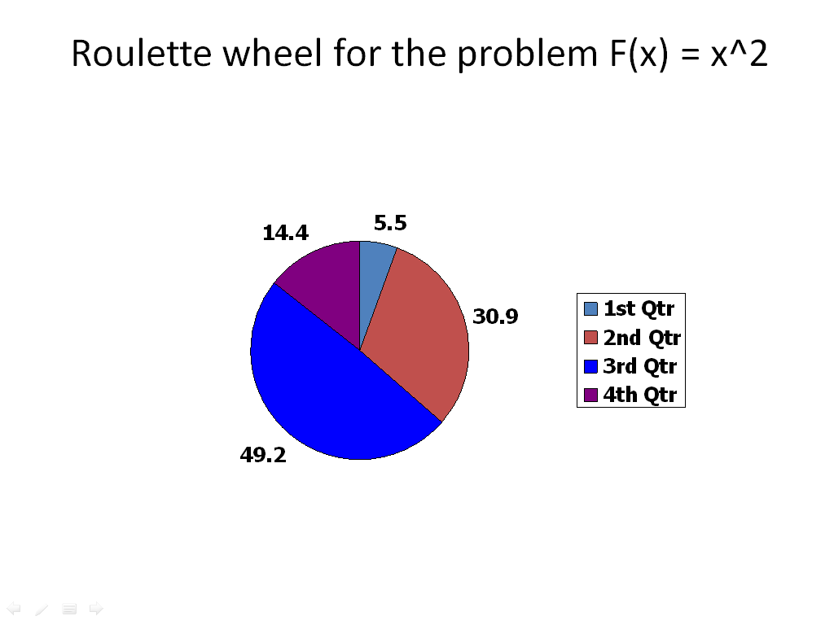
Fig 3.2 Roulette Wheel

3.15 REPRODUCTION OPTION IN GA TOOL
Reproduction options determine how the genetic algorithm creates children at each new generation.
Elite count specifies the number of individuals that are guaranteed to survive to the next generation. Set Elite count to be a positive integer less than or equal to Population size.
Crossover fraction specifies the fraction of the next generation, other than elite individuals, that are produced by crossover.
Set Crossover fraction to be a fraction between 0 and 1, either by entering the fraction in the text box or moving the slider.

3.16 MUTATION OPTION IN GA TOOL
Mutation functions make small random changes in the individuals in the population, which provide genetic diversity and enable the Genetic Algorithm to search a broader space. You can specify the function that performs the mutation in the Mutation function field. The default option in Mutation function field is Gaussian. Gaussian is normally used for unconstrained problems. For constrained problems adapt feasible option is used.

3.17 STOPPING CRITERION OPTION IN GA TOOL
Stopping criteria determines what causes the algorithm to terminate. Following are the causes to terminate the genetic algorithm.
Generations:
Specifies the maximum number of iterations the genetic algorithm performs.
Time limit:
Specifies the maximum time in seconds the genetic algorithm runs before stopping.
Fitness limit:
If the best fitness value is less than or equal to the value of Fitness limit, the algorithm stops.
Stall generations:
If the weighted average change in the fitness function value over Stall generations is less than Function tolerance, the algorithm stops.

Stall time limit:
If there is no improvement in the best fitness value for an interval of time in seconds specified by Stall time limit, the algorithm stops.
Function tolerance:
If the cumulative change in the fitness function value over Stall generations is less than Function tolerance, the algorithm stops.
Nonlinear constraint tolerance:
Specifies the termination tolerance for the maximum nonlinear constraint violation.

3.18 OUTPUT FUNCTION OPTION IN GA TOOL
History to new window outputs the iterative history of the algorithm to a separate window.
Interval:
Specifies the number of generations between successive outputs.
Custom:
Enables to write one’s own output function.

Display option in GATOOL
Level of display specifies the amount of information displayed in the MATLAB Command Window when you run the algorithm. Choose from the following:
Off: Display no output.
Iterative: Display information at each iteration of the algorithm.
Diagnose: Information is displayed at each iteration. In addition, the diagnostic lists some problem information and the options that are changed from the defaults.
Final: Display only the reason for stopping at the end of the run.

Vectorize Option in GAtool
The vectorize option specifies whether the computation of the fitness function is vectorized.
Set Objective function is vectorized to On to indicate that the fitness function is vectorized.
When Objective function is vectorized is Off, the algorithm calls the fitness function on one individual at a time as it loops through the population.

3.19 MINIMIZATION PROBLEMS:

3.19.1 CONSTRAINED PROBLEMS:

PROBLEM I: Find the minimum of the function f = 2*x(1)+x(2)-5*x(3)

Subject to
x(1)-2*x(2)+x(3)≤8
-3*x(1)+2*x(2)≤18
2*x(1)+x(2)-2*x(3)≤-4
x(1)≥0,x(2)≥1,x(3)≥5
x(1)≤6,x(2)≤9,x(3)≤20

OBJECTIVE FUNCTION M-file:

function z = problemii(x)

z=2*x(1)+x(2)-5*x(3);

CONSTRAINT FUNCTION M-file:

function [c,ceq] = constraintproblemii(x)

c=[x(1)-2*x(2)+x(3)-8;-3*x(1)+2*x(2)-18;2*x(1)+x(2)-2*x(3)+4];

ceq=[];

Solution on Command Window:

>> [x fvalue]=ga(@problemii,3,[],[],[],[],[0 1 5],[ 6 9 20],@constraintproblemii)

Optimization terminated: average change in the fitness value less than options.TolFun
and constraint violation is less than options.TolCon.

x = 0.0000 6.0002 20.0000

fvalue = -93.9998

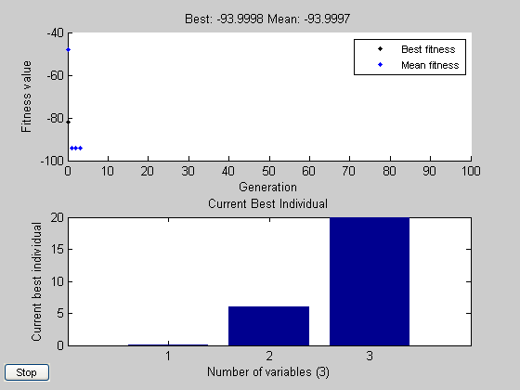

Fig 3.3 Plot between Fitness value and Generation for constrained Problem I

PROBLEM II: Minimize the function f = -3*(x(1))-2*(x(2)

Subject to constraint

x(1)-x(2)≤1
3*x(1)-2*x(2)≤6
x(1)≥1,x(2)≥2
x(1)≤5,x(2)≤6

OBJECTIVE FUNCTION M-file:

function z=problemvi(x)
z=-3*(x(1))-2*(x(2);

CONSTRAINT FUNCTION M-file:

c=[x(1)-x(2)-1;3*x(1)-2*x(2)-6];
ceq=[];

Solution on Command Window:

>> [x fvalue] = ga(@problemvi,2,[],[],[],[],[1 2],[5 6],@constraintproblemvi)

Optimization terminated: average change in the fitness value less than options.TolFun
and constraint violation is less than options.TolCon.

x = 5.0000 6.0000

fvalue = -27.0000

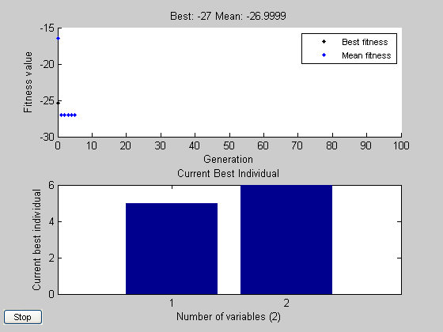

Fig 3.4 Plot between Fitness value and Generation for constrained Problem II

PROBLEM III: Minimize the function f = 2*x(1)+3*x(2)+2*x(3)-x(4)+x(5)

Subject to constraint

3*x(1)-3*x(2)+4*x(3)+2*x(4)-x(5)=0
x(1)+x(2)+x(3)+3*x(4)+x(5)=0
x(1)≥0, x(2)≥0, x(3)≥3, x(4)≥2, x(5)≥5
x(1)≤4, x(2)≤6, x(3)≤5, x(4)≤7, x(5)≤9

OBJECTIVE FUNCTION M-file:

function z= problemvii(x)

z==2*x(1)+3*x(2)+2*x(3)-x(4)+x(5);

CONSTRAINT FUNCTION M-file:

c=[];
ceq=[3*x(1)-3*x(2)+4*x(3)+2*x(4)-*x(5);x(1)+x(2)+3*x(4)+x(5)];

Solution on Command Window:

[x fvalue reason output population]=ga(@problemvii,5,[],[],[],[],[0 0 3 2 5],[4 6 5 7 9],@constraintproblemvii)

Optimization terminated: average change in the fitness value less than options.TolFun
and constraint violation is less than options.TolCon.

x = 0.1603 1.6673 3.9888 3.0298 8.7468

fvalue = 19.0171

reason = 1

output = problemtype: 'nonlinearconstr'
rngstate: [1x1 struct
generations: 7
funccount: 8060
message: [1x140 char]
maxconstraint: 8.1136e-008

population = 0.1603 1.6673 3.9888 3.0298 8.7468
0.1603 1.6673 3.9888 3.0298 8.7468
0.1603 1.6673 3.9888 3.0298 8.7468
0.1603 1.6673 3.9888 3.0298 8.7468
0.1603 1.6673 3.9888 3.0298 8.7468
0.1603 1.6673 3.9888 3.0298 8.7468
0.1603 1.6674 3.9888 3.0298 8.7468
0.1603 1.6674 3.9888 3.0298 8.7468
0.1603 1.6673 3.9888 3.0298 8.7468
0.1603 1.6673 3.9889 3.0298 8.7468
0.1603 1.6674 3.9888 3.0296 8.7468
0.1603 1.6673 3.9888 3.0298 8.7468
0.1603 1.6673 3.9888 3.0298 8.7468
0.1603 1.6673 3.9888 3.0298 8.7468
0.1602 1.6675 3.9890 3.0298 8.7469
0.1603 1.6673 3.9888 3.0298 8.7468
0.1604 1.6673 3.9888 3.0298 8.7467
0.1603 1.6674 3.9888 3.0296 8.7468
0.1603 1.6674 3.9888 3.0298 8.7468
0.1604 1.6673 3.9888 3.0298 8.7467

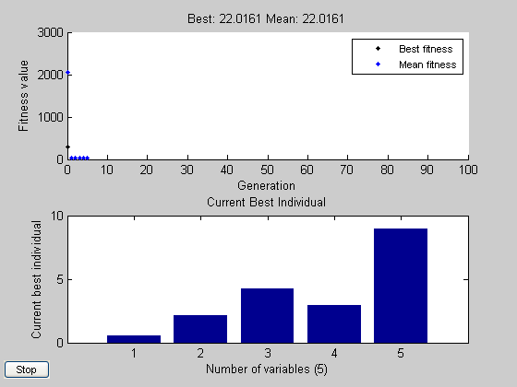

Fig 3.5 Plot between Fitness value and Generation for constrained Problem III

PROBLEM IV: Maximize the function f = x(1)-2*(x(2))-x(3)

Subject to condition

0≤x(1)≤6
0≤x(2)≤1
0≤x(3)≤8
x(1)≥0,x(2)≥0,x(3)≥0
x(1)≤6,x(2)≤1,x(3)≤8

OBJECTIVE FUNCTION M-file:

Function y=simplex(x)
y= - (x(1)-2*(x(2))-x(3));

Solution on Command Window:

[x fvalue] = ga(@simplexfunc,3,[],[],[],[],[0 0 0],[6 1 8])

Optimization terminated: average change in the fitness value less than options.TolFun.

x = 5.9999 1.0000 7.8564

fvalue = -15.8562

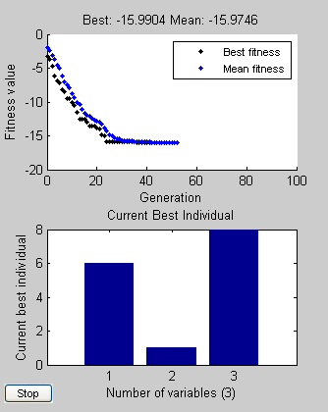

Fig 3.6 Plot between Fitness value and Generation for constrained Problem IV

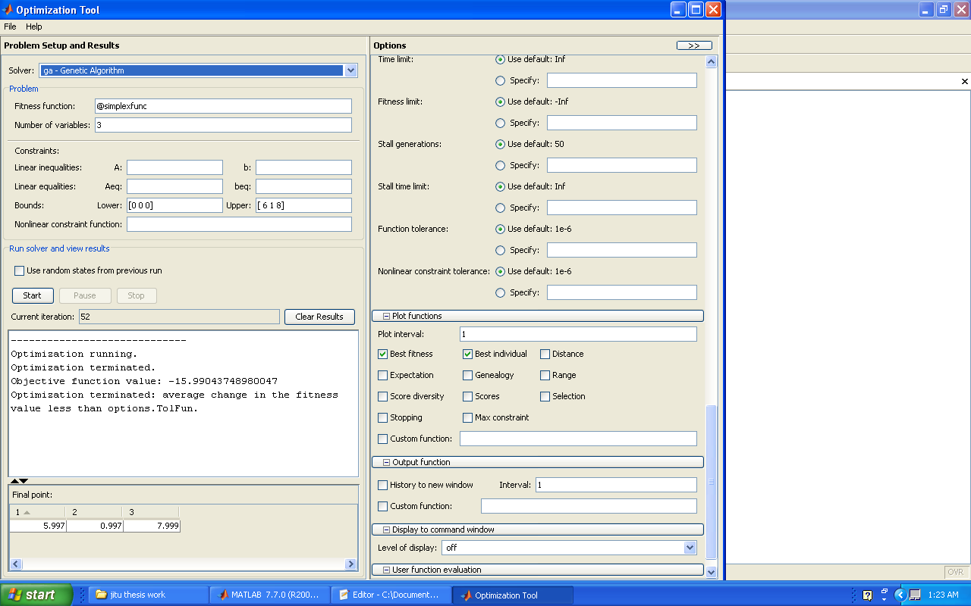

Fig 3.7 Command Window Results for constrained Problem IV

Chapter 4

LOAD FLOW
4.1 INTRODUCTION
Load flow solution is a solution of the network under steady state condition subject to certain inequality constraints under which the system operates. These constraints can be in the form of load nodal voltages, reactive power generation of the generator, the tap settings of a tap changing under load transformer.
The load flow solution gives the nodal voltages and phase angles and hence the power injection at all the buses and power flow through interconnecting power channels. Load flow solution is essential for designing a new power system and for planning extension of the exiting one for increased load demand.
These analyses require the calculation of numerous load flows under both normal and abnormal operating conditions. Load flow solution also gives the initial conditions of the system when the transient behavior of the system is to be studied. Load flow solution for power network can be worked out in both ways according as it is operating under balanced or unbalanced conditions.
A load flow solution of a power system requires the following steps:
(i) Formation of the network equations.
(ii) Suitable mathematical technique for solution of the equations.
Since we are studying the system under steady state conditions the network equations will be in the form of simple algebraic equations. The load and hence generations are continually changing in a real power system. We will assume here that the loads are fixed at a particular value over a suitable period of time.
4.2 BUS CLASSIFICATION:
In a power system each bus is associated with four quantities, real and reactive powers, bus voltage magnitude and its phase angle. In a load flow solution two out of the four quantities are specified and the remaining two are required to be obtained through the solution of the equations. Depending upon which quantities have been specified, the buses are classified in the following three categories:
- Load Bus: At this bus the real and reactive components of power are specified. It is desired to find out the voltage magnitude and phase angle through the load flow solution.
- Generator Bus: Here the voltage magnitude corresponding to the generation voltage and real power corresponding to its ratings are specified. It is required to find out the reactive power generation and the phase angle of the bus voltage.
- Slack Bus or Reference Bus: In a power system there are mainly two types of buses: load and generator buses. For these buses we have specified the real power injections which are taken as positive for generator and negative for load buses. The losses remain unknown until the load flow solution is complete. It is for this reason that generally one of the generator buses is made to take the additional real and reactive power to supply transmission losses. At this bus voltage magnitude and phase angle are specified whereas real and reactive powers are to be obtained through load flow solution.
The phase angle of the voltage at slack bus is usually taken as the reference. In the following analysis the real and reactive components of the voltage at a bus are taken as the independent variables for the load flow equations i.e.
V_{i} δ_{i} =e_{i} +j.f_{i}
Where e_{i} and f_{i} are the real and reactive components of voltage at the i^{th} bus.
4.3 Nodal Admittance Matrix:
If the interconnection between various nodes for a given system and the admittance value for each interconnecting circuit are known the admittance matrix may be assembled as follows:

- The diagonal elements of each node are the sum of the admittances connected to it.

- The off-diagonal is the negated admittance between the nodes.

The load flow equation using nodal admittance for n buses is:
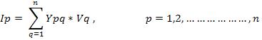

In matrix form:

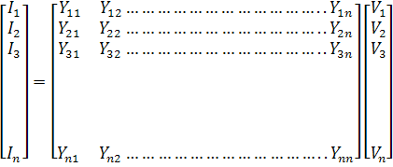

4.4 Formulation Of Load Flow Equations:
The nodal current equation for n bus system is
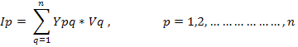

Now Vp*Ip = Pp - jQp

Or Ip = (Pp – jQp) / Vp*

Vp=1/Ypp[Pp-jQp/Vp* -],

p = 1,2,…………………,n

4.5 Iterative Methods For Load Flow Solutions:
As load flow equations are non linear and they can be solved by an iterative method. The iterative methods are
(i) Gauss’s method.
(ii) Gauss-Seidel method.
(iii) Newton-Raphson method.
Gauss-Siedel method is superior than Gauss method as in the former method the new calculated voltages in the iterations, immediately replaces the previous ones and are used in solution of the subsequent equations. So the comparison is between Gauss-Siedel method and Newton-Raphson method from the real point computer memory requirement, polar coordinates are preferred for solution based on Newton- Raphson method and rectangular coordinates for Gauss-Siedel method.
The time taken to perform one iteration of the computation is relatively smaller in case of G-S method as compared to N-R method but the number of iterations required by G-S method for a particular system is greater as compared to N-R method and they increase with the increase in the size of the system. In case of N-R method the no. of iterations are more or less independent of the size of the system and varies between 3-5 iterations. The convergence characteristics of N-R method are not affected by the selection of a slack bus whereas that of G-S method is sometimes very seriously affected and the solution of a particular bus may result in poor convergence. For large power system N-R method is found to be more efficient and practical from the view point of computational time and convergence characteristics.

The sequence of steps for the solution of load flow problem using NEWTON-RAPHSON method is as follows:
- Assume a suitable solution for all buses except the slack bus. Let Vp=1+j0 , for p=1,2,…………………n, p≠s, Vs=a+j0

- Set convergence criterion =Є i.e. if the largest of absolute of the residues exceeds Є the process is repeated, otherwise it is terminated.
- Set iteration count K = 0
- Set bus count p = 1
- Check if p is a slack bus. If yes, go to step 10.

- Calculate the real and reactive powers P_{p} and Q_{p} respectively using:

P_{p}=

Q_{p}=

- Evaluate ∆P_{p} ^{k} = P_{sp} - P_{p}^{k}

- Check if the bus in question is a generator bus. If yes compares Q_{p}^{k} with the limits. If it exceeds the limit, fix the reactive power generation to the corresponding limit and treat the bus as a load bus for that iteration and go to next step. If the lower limit is violated set Q_{psp}= Q_{pmin} . If the limit is not violated evaluate the voltage residue ∆V_{p}²=V_{p}²_{spec} - V_{p}² and go to step 10.

- Evaluate ∆Q_{p}^{k} = Q_{sp} – Q_{p}^{k}.

- Advance the bus count by 1 i.e. p=p+1 and check if all the buses have been accounted. If not go to step 5.

- Determine the largest absolute value of the residue.

- If the largest of the absolute value is less than Є go to step 17.

- Evaluate elements for Jacobian matrix.

- Calculate voltage increments ∆e_{p}^{k} and ∆f_{p}^{k} .

- Calculate new bus voltages e_{p}^{k+1}=e_{p}^{k} +∆e_{p}^{k} and f_{p}^{k+1}=f_{p}^{k} +∆f_{p}^{k}
- Advance the iteration count k=k+1 and go to step 4.

- Evaluate bus and line powers and print the results.

Assume bus voltages as Vp=1+j*0, for p=1,2,….n, p‡s and Vs=a+j*0
h
Start
T

Read in system data and formulate nodal admittance matrix
Set convergence criterion=€

K=0

Set bus count p=1

Check for slack bus
no
Calculate P_{p} and Q _{p}

Evaluate ∆P_{pk} = P _{psp}- P _{pk}

Check for generator bus
Is Q_{p}<Q_{pmin}
Is Q_{p}>Q_{pmax}
Set Q_{p}= Q_{pmax}
Evaluate ∆Q _{pk}=Q _{sp} – Q _{pk}
Advance bus count p = p+1
no

yes

yes
Set Q _{p} = Q _{pmin}

no

yes no
Evaluate |V_{p}|^2=|V _{sp}|^2-|V_{p}|^2

no
if p>n Check

yes
Determine the largest of the absolute of the residue

Check if the residue‡€€
Calculate the line flows and slack bus power

End
Evaluate elements of Jacobian matrix

Calculate voltage increments ∆e_{p}^{k} and ∆f_{p}^{k}

Calculate new bus voltages e_{p}^{k+1}=e_{p}^{k} +∆e_{p}^{k} and f_{p}^{k+1}=f_{p}^{k} +∆f_{p}^{k}

Fig 4.1 Flow Chart for NEWTON-RAPSHON Method

Chapter 5
Experiments with Load Flow Studies
5.1 Load Flow Using Newton-Raphson In Matlab Programming
Here, Newton-Rapshon method is used for solving load flow problem of standard IEEE 5- bus system. The MATLAB program is given below:

% clear all;
% clc;
datafor5bus;
% N = input('Enter the number of bus = ');
%the following loop will give us admittance matrix.
for i=1:N
for k=1:N
% r(i,k) = input(sprintf('Enter the value of R(%d,%d)+jX(%d,%d) = ',i,k,i,k));
if(r(i,k)==0)
y(i,k)=0;
else
y(i,k)=inv(r(i,k));
end;
end
end

for i=1:N
for j=1:N
if (i==j)
Y(i,j)=0;
for k=1:N
Y(i,j)=Y(i,j)+y(i,k);
end;
else
Y(i,j)= -y(i,j);
end;
end;
end;

Gpq = real(Y);
Bpq = -1*imag(Y);
%
% PS = input('Prespecified Value = ');
%
% E(1) = input('Magnitude of Slack Bus Voltage = ');
% F(1) = input('Angle of Slack Bus Voltage = ');
e(1) = E(1)*cos(pi*F(1)/180);
f(1) = E(1)*sin(pi*F(1)/180);

for i = 2:N
% E(i) = input('Magnitude of Next Bus Voltage = ');
% F(i) = input('Angle of Next Bus Voltage = ');
e(i) = E(i)*cos(pi*F(i)/180);
f(i) = E(i)*sin(pi*F(i)/180);
end;
%
% for i=2:N
% Psp(i) = input('Specified value of Real Power = ');
% Qsp(i) = input('Specified value of Reactive Power = ');
% end;

Dm = 10;
K=0;
while(Dm>=PS)
% it will provide us voltage magnitude and angle of each bus.
for i=1:N
V(i)=sqrt((e(i)^2) + (f(i)^2));
angle(i)=atan(f(i)/e(i))*180/pi;
end;

losses=0;
for i = 1:N

P(i) = 0;
Q(i) = 0;
% the following loop provides us calculated values of P(active power) and Q(reactive power)
for j = 1:N
temp1 = e(i)*((e(j)*Gpq(i,j))+(f(j)*Bpq(i,j))) + f(i)*((f(j)*Gpq(i,j))-e(j)*Bpq(i,j));
temp2 = f(i)*((e(j)*Gpq(i,j))+(f(j)*Bpq(i,j))) - e(i)*((f(j)*Gpq(i,j))-e(j)*Bpq(i,j));
P(i) = P(i) + temp1;
Q(i) = Q(i) + temp2;

end;
losses=losses+P(i);

end;
% condition for generator bus having upper & lower limits.
if (Q(3)<=LR)
Qsp(3)=LR;
elseif(Q(3)>=UR)
Qsp(3)=UR;
else
Qsp(3)=abs(Vsp^2-V(3)^2);
end
% following loop gives difference b/w specified powers & calculated powers.
for i=2:N
dP(i)=Psp(i)-P(i);
dQ(i)=Qsp(i)-Q(i);
end;

% elements of jacobian matrix.
for i=2:N
dPpep(i)= 2*e(i)*Gpq(i,i);
for j=1:N
if(i==j)
else
temp = (e(j)*Gpq(i,j))+(f(j)*Bpq(i,j));
dPpep(i)=dPpep(i)+temp;
end;
end;
end;

for i=2:N
dPpfp(i)= 2*f(i)*Gpq(i,i);
for j=1:N
if(i==j)
else
temp = (f(j)*Gpq(i,j))-(e(j)*Bpq(i,j));
dPpfp(i)=dPpfp(i)+temp;
end;
end;
end;

for i=2:N
for j=2:N
if(i==j)
else
dPpeq(i,j)= (e(i)*Gpq(i,j))-(f(i)*Bpq(i,j));
end;
end;
end;

for i=2:N
for j=2:N
if(i==j)
else
dPpfq(i,j)= (e(i)*Bpq(i,j))+(f(i)*Gpq(i,j));
end;
end;
end;

for i=2:N
dQpep(i)= 2*e(i)*Bpq(i,i);
for j=1:N
if(i==j)
else
temp = (f(j)*Gpq(i,j))-(e(j)*Bpq(i,j));
dQpep(i)=dQpep(i)-temp;
end;
end;
end;

for i=2:N
dQpfp(i)= 2*f(i)*Bpq(i,i);
for j=1:N
if(i==j)
else
temp = (e(j)*Gpq(i,j))+(f(j)*Bpq(i,j));
dQpfp(i)=dQpfp(i)+temp;
end;
end;
end;

for i=2:N
for j=2:N
if(i==j)
else
dQpeq(i,j)= (e(i)*Bpq(i,j))+(f(i)*Gpq(i,j));
end;
end;
end;

for i=2:N
for j=2:N
if(i==j)
else
dQpfq(i,j)= -(e(i)*Gpq(i,j))+(f(i)*Bpq(i,j));
end;
end;
end;

%J1
for i=1:(N-1)
for j=1:(N-1)
if(i==j)
J(i,j)=dPpep(i+1);
else
J(i,j)=dPpeq(i+1,j+1);
end;
end;
end;

%J2
for i=1:(N-1)
for j=1:(N-1)
if(i==j)
J(i,j+N-1)=dPpfp(i+1);
else
J(i,j+N-1)=dPpfq(i+1,j+1);
end;
end;
end;

%J3
for i=1:(N-1)
for j=1:(N-1)
if(i==j)
J(i+N-1,j)=dQpep(i+1);
else
J(i+N-1,j)=dQpeq(i+1,j+1);
end;
end;
end;

%J4
for i=1:(N-1)
for j=1:(N-1)
if(i==j)
J(i+N-1,j+N-1)=dQpfp(i+1);
else
J(i+N-1,j+N-1)=dQpfq(i+1,j+1);
end;
end;
end;

for i=1:(N-1)
D(1,i)= dP(i+1);
end;
for i=1:(N-1)
D(1,i+N-1)= dQ(i+1);
end;

IJ=inv(J);
EF=D*IJ;

Dm = D(1);
for i=1:2*(N-1)
if(Dm<D(i))
Dm = D(i);
end;
end;

for i=2:N
e(i)=e(i) + EF(i-1);
f(i)=f(i) + EF(N-1+i-1);
end;
K=K+1;

for i=1:N
V(i)=sqrt((e(i)^2) + (f(i)^2));
angle(i)=atan(f(i)/e(i))*180/pi;
end;

Y
e
f
V
angle
K
P
Q
losses

end;

5.2 The data for IEEE 5 bus system is given below
clear all
clc;
N=5; % specified no. of buses
r(1,1)=0; % specified impedance data
r(1,2)=.10+j*.4;
r(1,3)=0;
r(1,4)=.15+j*.6;
r(1,5)=.05+j*.2;
r(2,1)=.10+j*.4;
r(2,2)=0;
r(2,3)=.05+j*.2;
r(2,4)=.10+j*.4;
r(2,5)=0;
r(3,1)=0;
r(3,2)=.05+j*.2;
r(3,3)=0;
r(3,4)=0;
r(3,5)=.05+j*.2;
r(4,1)=.15+j*.6;
r(4,2)=.10+j*.4;
r(4,3)=0;
r(4,4)=0;
r(4,5)=0;
r(5,1)=.05+j*.2;
r(5,2)=0;
r(5,3)=.05+j*.2;
r(5,4)=0;
r(5,5)=0;

PS=.01; % specified value of €
E(1)=1.02; % voltage magnitude of slack bus
F(1)=0; % angle of slack bus
E(2)=1; % voltage magnitude of load bus 2
F(2)=0; % angle of load bus 2
E(3)=1.04; % voltage magnitude of generator bus 3
F(3)=0; % angle of generator bus 3
E(4)=1; % voltage magnitude of load bus 4
F(4)=0; % angle of load bus 4
E(5)=1; % voltage magnitude of load bus 5
F(5)=0; % angle of load bus 5
Psp(2)=-.6; % specified active power of load bus 2
Qsp(2)=-.3; % specified active power of load bus 2
Psp(3)=1; % specified active power of generator bus 3
Psp(4)=-.4; % specified active power of load bus 4
Psp(5)=-.6; % specified active power of load bus 5
Qsp(3)=0; % specified reactive power of generator bus 3
Qsp(4)=-.1; % specified reactive power of load bus 4
Qsp(5)=-.2; % specified reactive power of load bus 5
Vsp=1.04; % specified voltage of generator bus 3
UR=0.6; % specified upper limit of reactive power of generator bus 3
LR=0; % specified lower limit of reactive power of generator bus 3

5.2.1 The results of load flow for IEEE 5 bus system are as follows

Y = 2.1569 - 8.6275i -0.5882 + 2.3529i 0 -0.3922 + 1.5686i -1.1765 + 4.7059i
-0.5882 + 2.3529i 2.3529 - 9.4118i -1.1765 + 4.7059i -0.5882 + 2.3529i 0
0 -1.1765 + 4.7059i 2.3529 - 9.4118i 0 -1.1765 + 4.7059i
-0.3922 + 1.5686i -0.5882 + 2.3529i 0 0.9804 - 3.9216i 0
-1.1765 + 4.7059i 0 -1.1765 + 4.7059i 0 2.3529 - 9.4118i

e = 1.0200 0.9151 0.9566 0.9092 0.9525

f = 0 -0.0580 0.0544 -0.1260 -0.0281

V = 1.0200 1.0000 1.0400 1.0000 1.0000

angle = 0 0 0 0 0

K = 1

P = 0.0440 -0.0588 0.0979 -0.0078 -0.0706

Q = 0.1760 -0.2353 0.3915 -0.0314 -0.2824

losses = 0.0046

e = 1.0200 0.9103 0.9706 0.8884 0.9570

f = 0 -0.0586 0.0576 -0.1272 -0.0281

V = 1.0200 0.9169 0.9581 0.9179 0.9529

angle = 0 -3.6255 3.2564 -7.8910 -1.6907

K = 2

P = 0.6640 -0.5778 0.9296 -0.3803 -0.5820

Q = 0.6342 -0.2406 0.0384 -0.0382 -0.1800

losses =0.0534

e = 1.0200 0.9047 0.9621 0.8842 0.9532

f = 0 -0.0540 0.0623 -0.1243 -0.0250

V = 1.0200 0.9122 0.9723 0.8975 0.9574

angle = 0 -3.6835 3.3969 -8.1462 -1.6817
K = 3

P = 0.6730 -0.6091 1.0003 -0.3992 -0.6051

Q = 0.6564 -0.2894 0.1665 -0.0948 -0.1991

losses = 0.0599

5.3 Results obtained after changing value of € from 0.01 to 0.001 are as follows

Y = 2.1569 - 8.6275i -0.5882 + 2.3529i 0 -0.3922 + 1.5686i -1.1765 + 4.7059i
-0.5882 + 2.3529i 2.3529 - 9.4118i -1.1765 + 4.7059i -0.5882 + 2.3529i 0
0 -1.1765 + 4.7059i 2.3529 - 9.4118i 0 -1.1765 + 4.7059i
-0.3922 + 1.5686i -0.5882 + 2.3529i 0 0.9804 - 3.9216i 0
-1.1765 + 4.7059i 0 -1.1765 + 4.7059i 0 2.3529 - 9.4118i

e = 1.0200 0.9151 0.9566 0.9092 0.9525

f = 0 -0.0580 0.0544 -0.1260 -0.0281

V = 1.0200 1.0000 1.0400 1.0000 1.0000

angle = 0 0 0 0 0

K = 1

P = 0.0440 -0.0588 0.0979 -0.0078 -0.0706

Q = 0.1760 -0.2353 0.3915 -0.0314 -0.2824

losses = 0.0046

e = 1.0200 0.9103 0.9706 0.8884 0.9570

f = 0 -0.0586 0.0576 -0.1272 -0.0281

V = 1.0200 0.9169 0.9581 0.9179 0.9529

angle = 0 -3.6255 3.2564 -7.8910 -1.6907

K = 2

P = 0.6640 -0.5778 0.9296 -0.3803 -0.5820

Q = 0.6342 -0.2406 0.0384 -0.0382 -0.1800

losses = 0.0534

e = 1.0200 0.9047 0.9621 0.8842 0.9532

f = 0 -0.0540 0.0623 -0.1243 -0.0250

V = 1.0200 0.9122 0.9723 0.8975 0.9574

angle = 0 -3.6835 3.3969 -8.1462 -1.6817

K = 3

P = 0.6730 -0.6091 1.0003 -0.3992 -0.6051

Q = 0.6564 -0.2894 0.1665 -0.0948 -0.1991

losses = 0.0599

e = 1.0200 0.9053 0.9653 0.8836 0.9543

f = 0 -0.0563 0.0607 -0.1263 -0.0264

V = 1.0200 0.9063 0.9641 0.8929 0.9536

angle = 0 -3.4140 3.7062 -8.0027 -1.5044

K = 4

P = 0.6522 -0.5916 0.9925 -0.3978 -0.5946

Q = 0.7025 -0.2972 0.1343 -0.0984 -0.1978

losses = 0.0608

e = 1.0200 0.9047 0.9636 0.8835 0.9537

f = 0 -0.0550 0.0617 -0.1252 -0.0257
V = 1.0200 0.9071 0.9672 0.8925 0.9546

angle = 0 -3.5614 3.5968 -8.1327 -1.5873

K = 5

P = 0.6664 -0.6039 1.0022 -0.4010 -0.6022

Q = 0.6930 -0.2996 0.1539 -0.1001 -0.2007

losses = 0.0616
e = 1.0200 0.9049 0.9644 0.8835 0.9539

f = 0 -0.0557 0.0612 -0.1257 -0.0260

V = 1.0200 0.9064 0.9656 0.8923 0.9540

angle = 0 -3.4797 3.6650 -8.0645 -1.5420

K = 6

P = 0.6589 -0.5979 0.9986 -0.3994 -0.5988

Q = 0.6995 -0.2999 0.1453 -0.0998 -0.1996

losses = 0.0614

e = 1.0200 0.9048 0.9640 0.8835 0.9538

f = 0 -0.0553 0.0615 -0.1255 -0.0259

V = 1.0200 0.9067 0.9664 0.8924 0.9543

angle = 0 -3.5210 3.6329 -8.1009 -1.5641

K = 7

P = 0.6628 -0.6010 1.0006 -0.4003 -0.6006

Q = 0.6968 -0.3000 0.1497 -0.1001 -0.2002

losses = 0.0616

e = 1.0200 0.9049 0.9642 0.8835 0.9539

f = 0 -0.0555 0.0614 -0.1256 -0.0260

V = 1.0200 0.9065 0.9660 0.8923 0.9542

angle = 0 -3.5002 3.6494 -8.0827 -1.5530

K = 8

P = 0.6609 -0.5995 0.9997 -0.3999 -0.5997

Q = 0.6982 -0.3000 0.1475 -0.1000 -0.1999

losses = 0.0615

5.4 Load Flow Using Genetic Algorithm:
Here GA is used for load flow solution of a standard IEEE 5- bus system. The data of IEEE 5-bus is as follows:

5.4.1 IEEE 5-BUS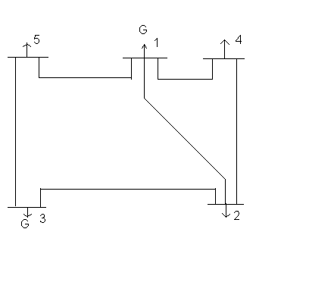
Fig. 5.1 Bus-Code Diagram 5 Bus System

TABLE 1
LINE DATA or IMPEDANCE DATA (5 Bus System)

LINE DESIGNATION | *R (p.u.) | *X (p.u.) | LINE CHARGING
1-2 | 0.10 | 0.4 | 0.0
1-4 | 0.15 | 0.6 | 0.0
1-5 | 0.05 | 0.2 | 0.0
2-3 | 0.05 | 0.2 | 0.0
2-4 | 0.10 | 0.4 | 0.0
3-5 | 0.05 | 0.2 | 0.0
* The impedances are based on MVA as 100.
TABLE 2
BUS DATA or OPERATING CONDITIONS (5 Bus System)

 | GENERATION | GENERATION | LOAD | LOAD
BUS NO. | MW | VOLTAGE MAGNITUDE | MW | MVAR
1* | ------- | 1.02 | ------- | -------
2 | ------- | ------- | 60 | 30
3 | 100 | 1.04 | ------- | -------
4 | ------- | ------- | 40 | 10
5 | ------- | ------- | 60 | 20
*Slack Bus

TABLE 3
REGULATED BUS DATA (5 Bus System)

BUS NO. | VOLTAGE MAGNITUDE | MINIMUM MVAR CAPABILITY | MAXIMUM MVAR CAPABILITY | MINIMUM MW CAPABILITY | MAXIMUM MW CAPABILITY
1 | 1.02 | 0.0 | 60 | 30 | 120
3 | 1.04 | 0.0 | 60 | 30 | 120

The nodal load voltage inequality constraints are 0.9<= V_{i} <=1.05

Cost Characteristics

C₁ = 50 P₁^2 + 351 P₁ + 44.4 $/hr
C₃ = 50 P₃^2 + 389 P₃ + 40.6 $/hr

Here for the 5 bus system we have taken, the total load demand of the system is 160 MW. Maximum and minimum active power constraint on the generator bus for the given system is 120 MW and 30 MW respectively. Voltage magnitude constraint for generator bus 3 is 1.04

5.4.2 Load Flow Problem formulation in GA:
The Load Flow problem has been formulated as a non linear function and GA has been used to solve this optimization problem. The objective function has been taken as the sum of squares of powers mismatch and voltage mismatch. The load flow solution is obtained when the objective function tends to be minimum(ideally zero). The objective function is as follows:

F =
Where N= Total no. of buses.
NG= No. of Generator buses.

5.4.3 Problem formulation for IEEE 5-bus system
Minimize F(x) = - ( ∆P^2 + ∆Q^2 + ΔV^2 )
Such that
inequality constraints:
0.3≤ P1 ≤ 1.2 0≤Q1≤0.6 0.3≤ P3≤ 1.2 0≤Q3≤0.6
0.9≤Vi≤1.1 -20≤Ѳi≤20
&
equality constraint:
V3=1.04
Where ∆P = P_{sp -} P_{cal}
∆Q = Q_{sp} – Q_{cal}
P_{cal} =
Q_{cal}=
P_{sp}= Specified value of active powers.
Q_{sp}= Specified value of reactive powers.
5.4.4 Based on this data the Objective Function M-file:
function y = load5(x)
y=-(((-0.6-(x(1)*((1.02*-.5882)+(0*-2.3529)) + x(5)*((0*-.5882)-(1.02*-2.3529))+ x(1)*((x(1)*2.3529)+(x(5)*9.4118)) + x(5)*((x(5)*2.3529)-(x(1)*9.4118))+ x(1)*((x(2)*-1.1765)+(x(6)*-4.7059)) + x(5)*((x(6)*-1.1765)-(x(2)*-4.7059))+x(1)*((x(3)*-2.3529)+(x(7)*-2.3529))+x(5)*((x(7)*-2.3529)-(x(3)*-2.3529))+ x(1)*((x(4)*0)+(x(8)*0))+ x(5)*((x(8)*0)-(x(4)*0))))+ (1-(x(2)*((1.02*0)+(0*0)) + x(6)*((0*0)-(1.02*0))+ x(2)*((x(1)*-1.1765)+(x(5)*-4.7059)) + x(6)*((x(5)*-1.1765)-(x(1)*-4.7059))+ x(2)*((x(2)*2.3529)+(x(6)*9.4118)) + x(6)*((x(6)*2.3529)-(x(2)*9.4118))+x(2)*((x(3)*0)+(x(7)*0))+ x(6)*((x(7)*0)-(x(3)*0))+ x(2)*((x(4)*-1.1765)+(x(8)*-4.7059))+ x(6)*((x(8)*-1.1765)-(x(4)*-4.7059))))+ (-.40-(x(3)*((1.02*-0.3922)+(0*-1.5686)) + x(7)*((0*-0.3922)-(1.02*-1.5686))+ x(3)*((x(1)*-2.3529)+(x(5)*-2.3529)) + x(7)*((x(5)*-2.3529)-(x(1)*-2.3529))+ x(3)*((x(2)*0)+(x(6)*0)) + x(7)*((x(6)*0)-(x(2)*0))+ x(3)*((x(3)*.9804)+(x(7)*3.9216))+ x(7)*((x(7)*.9804)-(x(3)*3.9216))+ x(3)*((x(4)*0)+(x(8)*0))+ x(7)*((x(8)*0)-(x(4)*0)))) + (-.60-(x(4)*((1.02*-1.1765)+(0*-4.7059)) + x(8)*((0*-1.1765)-(1.02*-4.7059))+ x(4)*((x(1)*0)+(x(5)*0)) + x(8)*((x(5)*0)-(x(1)*0))+ x(4)*((x(2)*-1.1765)+(x(6)*-4.7059)) + x(8)*((x(6)*-1.1765)-(x(2)*-4.7059))+ x(4)*((x(3)*0)+(x(7)*0))+ x(8)*((x(7)*0)-(x(3)*0))+ x(4)*((x(4)*2.3529)+(x(8)*9.4118))+ x(8)*((x(8)*2.3529)-(x(4)*9.4118)))))^2) + (((-0.3-(x(5)*((1.02*-.5882)+(0*-2.3529)) -x(1)*((0*-.5882)-(1.02*-2.3529))+ x(5)*((x(1)*2.3529)+(x(5)*9.4118)) - x(1)*((x(5)*2.3529)-(x(1)*9.4118))+ x(5)*((x(2)*-1.1765)+(x(6)*-4.7059)) - x(4)*((x(6)*-1.1765)-(x(2)*-4.7059))+ x(5)*((x(3)*-2.3529)+(x(7)*-2.3529)) -x(1)*((x(7)*-2.3529)-(x(3)*-2.3529))+ x(5)*((x(4)*0)+(x(8)*0))- x(1)*((x(8)*0-x(4)*0))))+(0-(x(6)*((1.02*0)+(0*0)) - x(2)*((0*0)-(1.02*0))+ x(6)*((x(1)*-1.1765)+(x(5)*-4.7059)) - x(2)*((x(5)*-1.1765)-(x(1)*-4.7059))+ x(6)*((x(2)*2.3529)+(x(6)*9.4118)) - x(2)*((x(6)*2.3529)-(x(2)*9.4118))+ x(6)*((x(3)*0)+(x(7)*0))- x(2)*((x(7)*0)-(x(3)*0))+ x(6)*((x(4)*-1.1765)+(x(8)*-4.7059))- x(2)*((x(8)*-1.1765)-(x(4)*-4.7059))))+(-.10-(x(7)*((1.02*-0.3922)+(0*-1.5686)) - x(3)*((0*-0.3922)-(1.02*-1.5686))+ x(7)*((x(1)*-2.3529)+(x(5)*-2.3529)) - x(3)*((x(5)*-2.3529)-(x(1)*-2.3529))+ x(7)*((x(2)*0)+(x(6)*0)) - x(3)*((x(6)*0)-(x(2)*0))+ x(7)*((x(3)*.9804)+(x(7)*3.9216))- x(3)*((x(7)*.9804)-(x(3)*3.9216))+ x(7)*((x(4)*0)+(x(8)*0))- x(3)*((x(8)*0)-(x(4)*0))))+ (-.20-(x(8)*((1.02*-1.1765)+(0*-4.7059)) - x(4)*((0*-1.1765)-(1.02*-4.7059))+ x(8)*((x(1)*0)+(x(5)*0)) - x(4)*((x(5)*0)-(x(1)*0))+ x(8)*((x(2)*-1.1765)+(x(6)*-4.7059)) - x(4)*((x(6)*-1.1765)-(x(2)*-4.7059))+ x(8)*((x(3)*0)+(x(7)*0))- x(4)*((x(7)*0)-(x(3)*0))+ x(8)*((x(4)*2.3529)+(x(8)*9.4118))- x(4)*((x(8)*2.3529)-(x(4)*9.4118)))))^2);

5.5.5 Constraint Function M-file:
function [c,ceq]=constraintload5(x)
c = [atand(x(5)/x(1))-20;-1*(atand(x(5)/x(1))+20);atand(x(6)/x(2))-20;-1*(atand(x(6)/x(2))+20);atand(x(7)/x(3))-20;-1*(atand(x(7)/x(3))+20);atand(x(8)/x(4))-20;-1*(atand(x(8)/x(4))+20);sqrt(x(1)^2+x(5)^2)-1.1;-1*(sqrt(x(1)^2+x(5)^2))+.9;sqrt(x(3)^2+x(7)^2)-1.1;-1*(sqrt(x(3)^2+x(7)^2))+.9; sqrt(x(4)^2+x(8)^2)-1.1;-1*(sqrt(x(4)^2+ x(8)^2))+.9; 1.02*((1.02*2.1569)+(0*8.627)) + 0*((0*2.1569)-(1.02*8.6274))+ 1.02*((x(1)*-0.5882)+(x(5)*-2.3529))+ 0*((x(5)*-0.5882)-(x(1)*-2.3529)) +1.02*((x(2)*0)+(x(6)*0)) + 0*((x(6)*0)-(x(2)*0))+1.02*((x(3)*-.3922)+(x(7)*-1.5686)) + 0*((x(7)*-0.3922)-(x(3)*-1.5686))+1.02*((x(4)*-1.1765)+(x(8)*-4.7059)) + 0*((x(8)*-1.1765)-(x(4)*-4.7059))-1.2;
-1*(1.02*((1.02*2.1569)+(0*8.627)) + 0*((0*2.1569)-(1.02*8.6274))+ 1.02*((x(1)*-0.5882)+(x(5)*-2.3529)) + 0*((x(5)*-0.5882)-(x(1)*-2.3529))+1.02*((x(2)*0)+(x(6)*0)) + 0*((x(6)*0)-(x(2)*0))+1.02*((x(3)*-.3922)+(x(7)*-1.5686)) + 0*((x(7)*-0.3922)-(x(3)*-1.5686))+1.02*((x(4)*-1.1765)+(x(8)*-4.7059)) + 0*((x(8)*-1.1765)-(x(4)*-4.7059)))+.3;
x(2)*((1.02*0)+(0*0)) + x(6)*((0*0)-(1.02*0))+ x(2)*((x(1)*-1.1765)+(x(5)*-4.7059)) + x(6)*((x(5)*-1.1765)-(x(1)*-4.7059))+ x(2)*((x(2)*2.3529)+(x(6)*9.4118)) + x(6)*((x(6)*2.3529)-(x(2)*9.4118))+x(2)*((x(3)*0)+(x(7)*0))+ x(6)*((x(7)*0)-(x(3)*0))+ x(2)*((x(4)*-1.1765)+(x(8)*-4.7059))+ x(6)*((x(8)*-1.1765)-(x(4)*-4.7059))-120;-1*(x(2)*((1.02*0)+(0*0)) + x(6)*((0*0)-(1.02*0))+ x(2)*((x(1)*-1.1765)+(x(5)*-4.7059)) + x(6)*((x(5)*-1.1765)-(x(1)*-4.7059))+ x(2)*((x(2)*2.3529)+(x(6)*9.4118)) + x(6)*((x(6)*2.3529)-(x(2)*9.4118))+x(2)*((x(3)*0)+(x(7)*0))+ x(6)*((x(7)*0)-(x(3)*0))+ x(2)*((x(4)*-1.1765)+(x(8)*-4.7059))+ x(6)*((x(8)*-1.1765)-(x(4)*-4.7059)))+.3;x(6)*((1.02*0)+(0*0)) - x(2)*((0*0)-(1.02*0))+ x(6)*((x(1)*-1.1765)+(x(5)*-4.7059)) - x(2)*((x(5)*-1.1765)-(x(1)*-4.7059))+ x(6)*((x(2)*2.3529)+(x(6)*9.4118)) - x(2)*((x(6)*2.3529)-(x(2)*9.4118))+ x(6)*((x(3)*0)+(x(7)*0))- x(2)*((x(7)*0)-(x(3)*0))+ x(6)*((x(4)*-1.1765)+(x(8)*-4.7059))- x(2)*((x(8)*-1.1765)-(x(4)*-4.7059))- .6;
-1*(x(6)*((1.02*0)+(0*0)) - x(2)*((0*0)-(1.02*0))+ x(6)*((x(1)*-1.1765)+(x(5)*-4.7059)) - x(2)*((x(5)*-1.1765)-(x(1)*-4.7059))+ x(6)*((x(2)*2.3529)+(x(6)*9.4118)) - x(2)*((x(6)*2.3529)-(x(2)*9.4118))+ x(6)*((x(3)*0)+(x(7)*0))- x(2)*((x(7)*0)-(x(3)*0))+ x(6)*((x(4)*-1.1765)+(x(8)*-4.7059))- x(2)*((x(8)*-1.1765)-(x(4)*-4.7059)))+ 0];

ceq =[sqrt(x(2)^2+x(6)^2)-1.04; 0];

5.5.6 Results from command window:
[x fvalue reason output population] = ga(@load5,8,[],[],[],[],[],[],@constraintload5)
Optimization terminated: average change in the fitness value less than options.TolFun
and constraint violation is less than options.TolCon.
x = -1.0654 -1.0257 0.9993 -0.9040 0.1380 0.1720 0.3145 0.3263
fvalue = -630.2365
reason = 1
output = problemtype: 'nonlinearconstr'
rngstate: [1x1 struct]
generations: 5
funccount: 5310
message: [1x140 char]
maxconstraint: 0
population = -1.0654 -1.0257 0.9993 -0.9040 0.1380 0.1720 0.3145 0.3263
-1.0654 -1.0257 0.9993 -0.9040 0.1380 0.1720 0.3145 0.3263
-1.0654 -0.5803 0.9993 -0.9040 0.1380 0.1720 0.3145 0.7801
-1.0654 -1.0257 0.9993 -1.0192 0.1380 0.8638 -0.4610 0.3263
-1.7215 -2.5529 -1.0271 -1.4699 0.1380 0.1720 0.3145 0.3263
-1.0654 -1.0257 0.9993 -0.9040 0.1380 0.1720 0.3145 0.3263
-1.0654 -1.1294 0.9993 -0.9040 1.1367 0.1720 0.3145 0.3263
-1.2906 -0.7986 0.9162 -0.7131 0.2751 0.2532 -0.4334 -0.1317
-1.0654 -1.0257 0.9993 -0.9040 1.1938 0.1720 0.3145 0.3263
-1.0654 -1.0257 0.9993 -0.9040 0.1380 0.1720 0.3145 0.3263
-0.0112 -1.0257 0.9993 -0.9040 1.1367 0.1720 0.5654 0.3263
-1.0654 -1.0257 0.9993 -0.9040 0.1380 0.1720 0.3145 0.3263
-1.0654 -1.0257 0.7177 -0.9040 0.1380 0.1720 0.3145 0.3263
-1.0654 -1.0257 0.9993 -0.9040 0.2537 0.1720 0.3145 0.3263
-1.0654 -1.0257 0.9993 -0.9040 0.1380 0.1720 0.3145 0.3263
-1.0654 -1.0257 0.9993 -0.9040 0.1380 0.1720 0.3145 0.3263
-0.6918 -0.6553 1.4715 -0.2048 0.1116 -0.1019 0.8886 0.0458
-1.4661 -1.1938 1.5242 -1.1546 0.6429 -0.6412 0.2914 -0.3012
-1.4558 -0.9271 1.0779 -0.2185 0.4740 0.2935 -0.0780 0.5275
-0.4972 -1.3942 1.2649 -0.1489 -0.1739 -0.5386 0.8831 -0.3403

5.5.7 Results from GA Sheet with Default Setting:

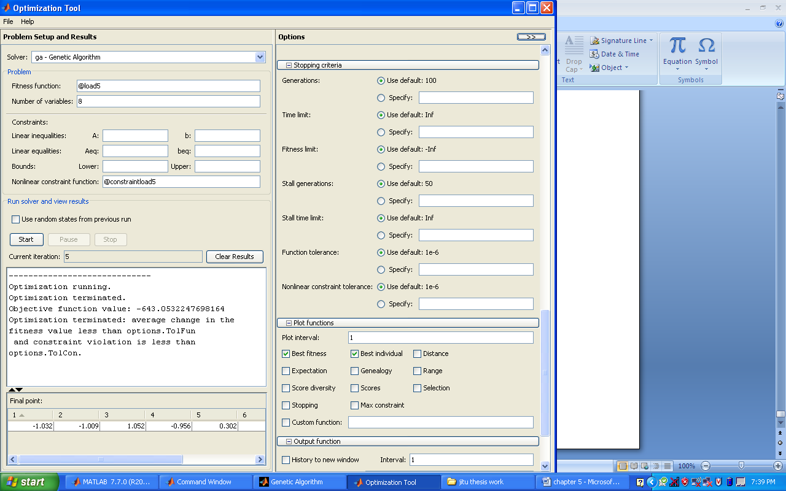
Fig. 5.2 GA Sheet

No. of generations=100
Stall generations=50
Function tolerance limit=1e-006
Non linear constraint limit=1e-006
Current generations=5
Objective function value= -643.05322
Optimization terminated: average change in the fitness value is less than options.Tolfun and constraint voilation is less than options.Tolcon.

x= -1.032 -1.009 1.052 -0.952 0.302 0.254 0.318 0.216

Table 4
Voltage and Angle of load flow solution
V∟Ѳ | V₂ ∟Ѳ₂ | V₃ ∟ Ѳ₃ | V₄ ∟ Ѳ₄ | V₅ ∟Ѳ ₅
Voltage magnitude | 1.075 | 1.040 | 1.099 | 0.980
Angle (in degrees) | -16.13 | -14.12 | 16.81 | -12.73

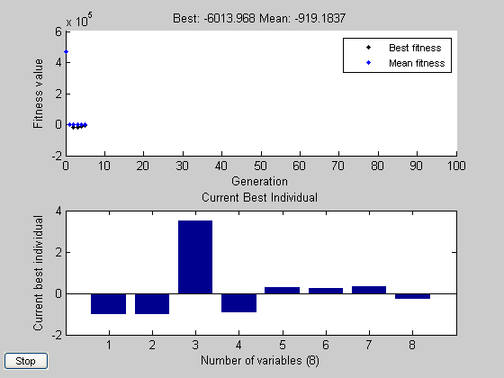

Fig. 5.3 Plot between fitness value, current best individual versus number of variables

5.5.8 Results from GA Sheet By Changing The Options:
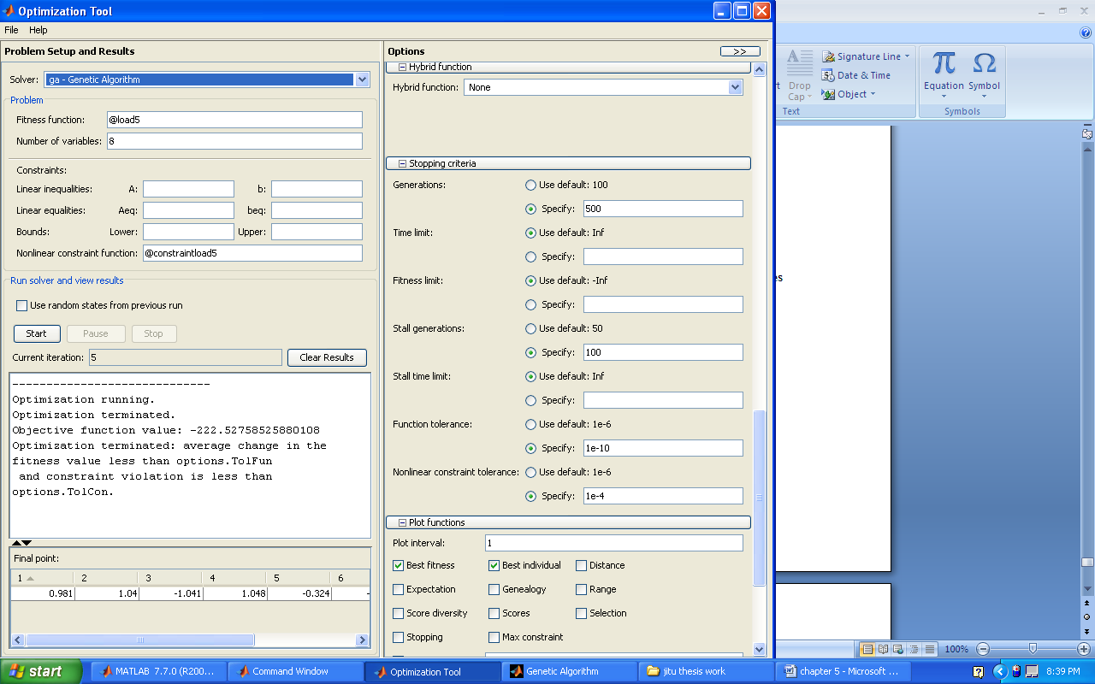
Fig. 5.4 GA Sheet

No. of generations=500
Stall generations=100
Function tolerance limit=1e-010
Non linear constraint limit=1e-004
Current generations=5
Objective function value= -222.527
Optimization terminated: average change in the fitness value is less than options.Tolfun and constraint voilation is less than options.Tolcon.

x= 0.981 1.04 -1.041 1.048 -0.324 -0.001 0.151 0.217

Table 5
Voltage and Angle of load flow solution
V∟Ѳ | V₂ ∟Ѳ₂ | V₃ ∟ Ѳ₃ | V₄ ∟ Ѳ₄ | V₅ ∟Ѳ ₅
Voltage magnitude | 1.033 | 1.040 | 1.051 | 1.07
Angle (in degrees) | -18.27 | -0.05 | -8.25 | 11.69

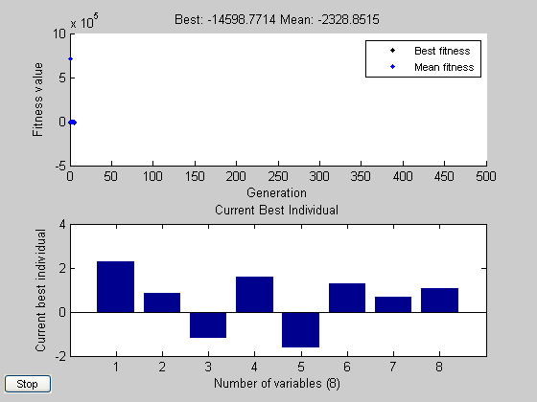

Fig. 5.5 Plot between fitness value, current best individual versus number of variables

Chapter 6
CONCLUSIONS & FUTURE SCOPE OF WORK
6.1 CONCLUSIONS
Based on the work carried out in this thesis following conclusion can be made:
1. In this work Genetic Algorithm has been studied and analyzed its parameters like population size, Initial population, Initial Range, Stopping conditions etc in getting the optimal points and final generation calculated for plotting the graphs. We had also noticed that we are not been able to obtain the results of all the population after each generation or iteration. We were only being able to get best fitness value after every generation.
2. Minimization of both constrained and unconstrained functions has been done using Genetic Algorithm to find global optimum point.
3. Genetic Algorithm has been used to solve the load flow problem
The effectiveness of the developed program is tested for IEEE 5-BUS system but it is found that the GA is not accepting the reactive power constraint effectively which causes power mismatch at the nodes.
6.2 FUTURE SCOPE OF WORK:
The Scope of further work in this field is identified as:
- In this work we have optimized the Load Flow problem while considering constraints which satisfy the nodal voltages magnitude and angle only. However, an attempt should be made to propose an algorithm so that the matched power injections at each node is obtained and the losses can be effectively minimized.
- Effort should be done to find the population after each iteration or generation so that more detailed analysis of the results could be done.
- Neural networks can be used to predict the load demand and to identify the feasible solutions.

REFERENCES
[1] Renk Jean- Jumeau , Hsiao-Dong Chiang, “Parameterizations of the Load-Flow Equations for Eliminating Ill-conditioning Load Flow Solutions” IEEE Transactions on Power Systems, Vol. 8, No. 3. August 1993.
[2] Hieu Le NGUYEN, “NEWTON-RAPHSON METHOD IN COMPLEX FORM” IEEE Transactions on Power Systems, Vol,, 12, No. 3, August 1997.
[3] Jun-Yong Liu, Yong-Hua Song, “Strategies for Handling UPFC Constraints in Steady-State Power Flow and Voltage Control,” IEEE TRANSACTIONS ON POWER SYSTEMS, VOL. 15, NO. 2, MAY 2000
[4 ZC. Zeng, F.D. Galiana, B.T.Ooi, N. Yorino, “A SIMPLIFIED APPROACH TO ESTIMATE MAXIMUM LOADING CONDITIONS IN THE LOAD FLOW PROBLEM,” IEEE Transactions on Power Systems, Vol. 8, No. 2, May 1993.
[5] Ray D. Zimmerman Hsiao-Dong Chiang, " Fast Decoupled Power Flow for Unbalanced Radial Distribution Systems" IEEE Transactions on Power System, Vol. 10, No. 4, November 1995.
[6] Zechun Hu and Xifan Wang, “Efficient Computation of Maximum Loading Point by Load Flow Method With Optimal Multiplier,” IEEE TRANSACTIONS ON POWER SYSTEMS, VOL. 23, NO. 2, MAY 2008.
[7] Fang Wanliang H.W.Ngan, “Extension of Newton Raphson Load Flow Techniques to Cover Multi Unified Power Flow Controllers” Proceedings of the 4th International Conference on Advances in Power System Control, Operation and Management, APSCOM-97, Hong Kong, November 1997.
[8] K.P.Wong A. Li M .Y. Law, “Development of constrained-genetic-algorithm loadflow method,” IEE Proc.-Gener. Transm. Distrib., Vol. 144, No. 2, March 1997.
[9] KPWong, A.Li and T.M.Y.Law, “Extension of Newton Raphson Load Flow Techniques to Cover Multi Unified Power Flow Controllers,” IEE Proc.-Gener. Transm. Distrib., Vol. 146, No. 6, November 1999.
[10]Genetic Algorithms by David E. Goldberg
[11]Electrical Power System by C.L.Wadhwa
[12]Power System Optimization by D.P Kothari and J.S Dhillon.
[13]Matlab 2007b documentation regarding Genetic Algorithm.
[14]Optimization Theory and Application by S.S.Rao.
[15]Multi-objective Programming and Planning by Jared L. Cohon.

