A
Major Report
On

A WAVELET DOMAIN IMPLEMENTATION OF DIGITAL WATER MARKING

Submitted in Partial fulfillment of the requirement
For the award of the degree of

MASTER OF ENGINEERING
(Electronics and Communication)

Submitted by
Nirmal Kumar
(University Roll No. 10275)

Under the Guidance of
JEEBANANDA PANDA
(LECTURER)
Department of Electronics and Communication



DEPARTMENT OF ELECTRONICS & COMMUNICATION ENGINEERING
DELHI COLLEGE OF ENGINEERING
BAWANA ROAD, DELHI -110042
(UNIVERSITY OF DELHI)

2006-2008

CERTIFICATE
This is to certify that the MAJOR REPORT titled as “A WAVELET DOMAIN IMPLEMENTATION OF DIGITAL WATER MARKING” is being submitted by NIRMAL KUMAR Class Roll No. 06/E&C/06, University Roll No. 10275, in partial fulfillment for the award of “Master of Engineering Degree in Electronics & Communication” in Delhi College of Engineering, (Delhi University), Delhi; is the bonafide work carried out by him under my guidance and supervision.

PROJECT GUIDE
MR. JEEBANANDA PANDA
SENIOR LECTURER
DEPARTMENT OF ELECTRONICS AND COMMUNICATION ENGINEERING
DELHI COLLEGE OF ENGINEERING
BAWANA ROAD ,DELHI-42

ACKNOWLEDGEMENT

Firstly, I would like to express my hearty gratitude and thanks to my project guide Mr. Jeebananda Panda Lecturer in Deptt. of Electronics and Communication Engg; D.C.E. Delhi, for continuous inspiration, encouragement and guidance in every stage of preparation of this major project report.

I am also extremely thankful to Assistant Prof. P.R. Chaddha, Head of the Deptt. of Electronics and Communication Engineering, D.C.E. Delhi, for the support provided by him during the entire duration of degree course and especially in this thesis.
I am also thankful to all teaching and non-teaching staff at DCE, and my fellows, who have helped me directly or indirectly in completion of this thesis report.

NIRMAL KUMAR
(M.E. ELECTRONICS AND COMMUNICATION ENGG.)
COLLEGE ROLL NO. 06/E&C/06
DELHI UNIVERSITY ROLL NO. 10275

ABSTRACT

Watermarking is an approach to address the problem of authority of multi-media data. The concept of digital watermarking is associated with data hiding technique, known as stenography. This technique has been proposed as a way to identify the source, creator, owner or authorized distributer of multi media data. Digital watermarking has been presented in recent literatures as a technique to protect the copyright of multimedia data. Digital water marking proposes the unified approach to watermark the image or video based on two or three dimensional discreet wavelet transform. The hierarchical nature of wavelet representation allows multi resolution detection of digital watermark, which is Gaussian distributed random vector added to the entire high pass band in wavelet domain.

In this major project a watermarking on image is implemented using wavelet. After watermarking, the watermarked image will be tested against common image processing operation such as blurring, rotating, scaling and cross correlation between original and watermarked image will be calculated. The properties of watermark include robustness and unobtrusiveness. The robustness and imperceptibility are two different issue in digital watermarking in which we have to make a compromise in making robustness or imperceptible technique.

CONTENTS

CHAPTER # 1…………………..........................................9

INTORDUCTION TO DIGITAL WATERMARKING AND TYPES OF WATERMARKING…………………………………….………………........9
1.1 Introduction………...................................................................................10
1.2. Cryptography……......................................................................................10
1.3. Stenography………....................................................................................10
1.4. Digital water marking….............................................................................11
1.5. Application of Digital water marking………………….............................12
1.5.1. Image Water marking..............................................................................12
1.5.2. Video watermarking................................................................................13
1.5.3. Audio watermarking................................................................................13
1.5.4. Text watermarking...................................................................................13
1.5.5. Authentication.........................................................................................13
1.5.6. Signaling..................................................................................................14
1.5.7. Finger printing ........................................................................................14
1.6 Type of watermarking…………………………………………………......15
1.7 Type of watermarks……………………………………………………......15

CHAPTER # 2………………………………….................17

CHARACTERISTIC OF WATERMARKS
2.1 Robustness………………............................................................................17
2.2 Real time processing……….........................................................................17
2.3 Imperceptibility………….............................................................................17
2.4 Tamper resistance………..............................................................................18
2.5 Watermark extraction …………...................................................................19

DISTORTION AND ATTACKS

2.6.1. Additive Noise………………...................................................................19
2.6.2. Filtering…………......................................................................................19
2.6.3. Cropping………….....................................................................................19
2.6.4. Compression…………...............................................................................20
2.6.5. Rotation and scaling…...............................................................................20
2.6.6. Statistical averaging………........................................................................20
2.6.7. Least significant bit attack……..................................................................20

CHAPTER # 3 …………………………………………......21
INTRODUCTION TO WAVELET AND PROPERTIES….....................…......21

3.1 Introduction to wavelet…………………………………………………….......22
3.2. Wavelet definition…………………………………………….........................23
3.3. Wavelet characteristic……………………………............................................24
3.4. Wavelet analysis………………...........................................................…..........24
3.5 Evolution of Wavelet transform……………………….…….............................24
3.5.1 Fourier transform..............................................................................................25
3.5.2 Short term fourier analysis…………………....................................................25
3.6 Continuous Wavelet transform…………………………….…...........................26
3.7 Discreet wavelet transform…………………………………………..................28
3.8 Comparative visualization………………............................................ ..............30
3.9 Wavelet properties………………………………………………..……….........32
3.10 Band pass filter………………………………………………….……….........34
3.11 The scaling function……………………………………………..………........35
3.12 Sub band coding …………………………………………………..…….........37
3.13 Orthogonal wavelet……………………………………………………….......38
3.14 Bi orthogonal wavelet…………………………………………………...........39
3.15 Generating scaling function and wavelets from filter coefficients……….......39
3.16 Wavelet transform and data compression ………………………………........41
3.17 Audio compression………………………………………………………........42
3.18 Application of wavelet transform…………………………………..…….......42
3.19 Types of wavelet……………………………………………………..….........43
(a). Daubechies……………………………………………………………..….......43
(b) Coiflets………………………………………………………………….….......44
(c) Biorthogonal……………………………………………………………….......44
(d) Symlets……………………………………………………………………........46
(e) Morlets…………………………………………………………………….........46
(f) Mexican hat………………………………………………………………..........47
(g) Meyer……………………………………………………………………….......47
3.20 Similarties between fourier and wavelet transform……………………….......48
3.21 Dissimilarties between fourier and wavelet transform…………………..........48

CHAPTER # 4………………………………..........................49

WAVELET DOMAIN DIGITAL WATER MARKING TECHNIQUE.................49

4.1 Introduction ………………………………………………………………….....50
4.2 Capacity Issue in digital water marking………………………………………...51
4.3 Multi resolution watermarking framework for images……………………….....52
4.4 Detection technique of watermark……………………………………………....54
4.5 Experimental result……………………………………………………………...55
4.6 Multi resolution wavelet transform technique for watermarking…………….....57
4.7 A wavelet transform of images……………………………………………….....58
4.8 Water marking in DWT domain………………………………………………...60
4.9 Watermark extracting method…………………………………………………..62
4.10(a).On the robustness against image processing operation………………..........65
4.10(b).On the robustness against JPEG loss compression and mixed image processing…………………………………………………………………………....65
4.10(c). On the robustness compared to other approaches…………………………..65
4.11 A flow chart method for implementing wavelet domain digital
Watermarking………………………………………………………………………..66
4.12 A flow chart for extracting the watermark from level 1 frequency sub
Band………………………………………………………………………………....67
4.13 A flow chart for extracting the watermark from level 2 frequency sub
Band………………………………………………………………………………....68
4.14 A flow chart for implementing attack on watermarked image………………………………………………………………………………...69

CHAPTER # 5………………………………………………...70

RESULTS AND DISCUSSION……………………………………………………70
List of generated figures in MATLAB
Fig 5.1………………………………………………………………………………..71
Fig 5.2………………………………………………………………………………..72
Fig 5.3………………………………………………………………………………..73
Fig 5.4………………………………………………………………………………..74
Fig 5.5………………………………………………………………………………..75
Fig 5.6………………………………………………………………………………..76
Fig 5.7………………………………………………………………………………..77
Fig 5.8………………………………………………………………………………..78
Fig 5.9………………………………………………………………………………..79
Fig 5.10………………………………………………………………………………80
Fig 5.11………………………………………………………………………………81
Fig 5.12(a,b).…………………………………………………………………………82
Fig5 13(a)……………….……………………………………………………………83
Fig 5.13(b)..…………………………………………………………………………..84
Fig 5.14(a,b).…………………………………………………………………………85
Fig 5.14(c)……………………………………………………………………………86
Fig 5.15(a,b).…………………………………………………………………………87
Fig 5.16(a,b)………………………………………………………………………….88
Fig5.16(c)…………………………………………………………………………….89
Fig 5.17(a,b)………………………………………………………………………….90
Fig 5.17(c )…………………………………………………………………………...91
Fig 5.18(a,b)………………………………………………………………………….92
5.19 Calculation of normalized cross correlation coefficient between original and extracted watermark in level 1 from LH frequency sub band……………………….93
5.20 Calculation of normalized cross correlation coefficient between original and extracted watermark in level 1 from HL frequency sub band……………………….93
5.21 Calculation of normalized cross correlation coefficient between original and extracted watermark in level 1 from HH frequency sub band……………………….94
5.22 Normalized correlation coefficient calculation in various attacks on watermarked image……………………..……………………………………….………………….95
5.23 Normalized correlation coefficient calculation in scaling attack on watermarked image…………………………………………………………………………………95
5.24 Normalized correlation coefficient calculation in rotating attack on watermarked image …………………………………….…………………………………………..96
5.25 Normalized correlation coefficient calculation in average filtering attack on watermarked image……………………………..……………………………………97
5.26 Normalized correlation coefficient calculation in median filtering attack on watermarked image…………………….…………………………………………….97
5.27 Normalized correlation coefficient calculation in wiener filtering attack on watermarked image…………………………………………………………………..98
5.28 Effect of increasing scaling factor on correlation coefficient calculation from different attacks………………………….…………………………………………99
5.29 Effect of increasing attack strength on correlation coefficient calculation from different attacks at fixed scaling factor……………………………………………..99
(a) In case of blurr attack…………………..……………………………………….100
(b) In case of scaling attack…...................................................................................100
( c) In case of rotating attack.....................................................................................101
(d) In case of average filtering attack........................................................................101
(e) In case of median filtering attack.........................................................................102
(f) In case of wiener attack........................................................................................102

LIST OF TABLES
Table 1.......................................................................................................................99
Table 2.......................................................................................................................100
Table 3.......................................................................................................................100
Table 4.......................................................................................................................101
Table 5.......................................................................................................................101
Table 6.......................................................................................................................102
Table 7.......................................................................................................................103
CONCLUSION ………………………....................................................................104
FUTURE WORK…..................................................................................................105
REFERENCE............................................................................................................106

CHAPTER # 1

INTRODUCTION TO DIGITAL WATER
MARKING & TYPES OF WATERMARKS

[1.1] INTRODUCTION:
In recent times, internet is being increasingly used as the platform for distribution of digital multimedia content. The inherent flexibility of Internet facilitates users to transact with one another to create, distribute, store, peruse, subscribe, enhance, modify and trade digital content in various forms like text documents, databases, e-books, still images, audio, video, computer software and games.
The use of an open medium like Internet gives rise to concerns about protection and enforcement of intellectual property rights of the digital content involved in the transaction. In addition, unauthorized replication and manipulation of digital content is relatively trivial and can be done using inexpensive tools, unlike the traditional analog multimedia content. The protection and enforcement of intellectual property rights for digital media has become an important issue. In recent years, the research community has seen much activity in the area of digital watermarking as an additional tool in protecting digital content.
[1.2] CRYPTOGRAPHY:
Literally, Cryptography is the art of writing in ‘ciphers’; or it is a method of secret communication. In cryptography, the contents of secret message are concealed and only the sender and the receiver of the secret message know the process of extracting the concealed information. Apparently, others can’t easily detect what message is being conveyed. Cryptography is an effective solution to the distribution problem, but in most instances has to be tied to specialized and costly hardware to create tamper-proof devices that avoid direct access to data in digital format. Moreover, most cryptographic protocols are concerned with secured communications instead of ulterior copyright infringements. For instance, access control in set-top-boxes used for digital television demodulation and decoding succeed in avoiding unauthorized access to programs that are being broadcast in scrambled form but fail in precluding further storage and illegal dissemination actions.
[1.3] STEGANOGRAPHY:
Stenography is a technique for concealed communication. In contrast to cryptography where the content of a communicated message is secret, in steganography the very existence of the message that is communicated is a secret and its presence is known only by parties involved in the communication. Steganography is technique where a secret message is hidden within another unrelated message and then communicated to the other party. Some of the techniques of steganography like use of invisible ink, word spacing patterns in printed documents, coding messages in music compositions, etc., have been used by military intelligence since the times of ancient Greek civilization. In steganography, usually the message itself is of value and must be protected through clever hiding techniques and the “vessel” for hiding the message is not of value. In watermarking, the effective coupling of message to the “vessel”, which is the digital content, is of value and the protection of the content is crucial.
[1.4] Digital Watermarking
Watermarking is descendent of steganography which has been in existence for at least a few hundred years. Watermarking is a special technique of steganography where one message is embedded in another and the two messages are related to each other in some way. The most common examples of watermarking are the presence of specific patterns in currency notes which are visible only when the note is held to light and logos in the background of printed text documents. The watermarking techniques prevent forgery and unauthorized replication of physical objects.
Digital watermarking is similar to watermarking physical objects except that the watermarking technique is used for digital content instead of physical objects. In digital watermarking a low-energy signal is imperceptibly embedded in another signal. The low-energy signal is called watermark and it depicts some metadata, like security or rights information about the main signal. The main signal in which the watermark is embedded is referred to as cover signal since it covers the watermark. The cover signal is generally a still image, audio clip, video sequence or a text document in digital format.
Unlike encryption, which does not provide a way to examine the original data in its protected form, the watermark remains in the content in its original form and does not prevent a user from listening to, viewing, examining, or manipulating the content. Also, unlike the idea of steganography, where the method of hiding the message may be secret and the message itself is secret, in watermarking, typically the watermark embedding process is known and the message (except for the use of an optional secret key) does not have to be secret.
Watermarking is the direct embedding of additional information into the original content or host signal. Ideally, there should be no perceptible difference between the watermarked and original signal and the watermark should be difficult to remove or alter without damaging the host signal. In some instances, the amount of information that can be hidden and detected reliably is important. It is easy to see that the requirements of imperceptibility, robustness, and capacity conflict with each other. For instance, a straightforward way to provide an imperceptible watermark is to embed the watermark signal into the perceptually insignificant portion of the host data. However, this makes the watermark vulnerable to attack because it is fairly easy to remove or alter the watermark without affecting the host signal.
Visible watermarks which do not interfere with the intelligibility of the host signal have also been developed; while transparent watermarking techniques can be fragile, robust, or semi fragile. Fragile watermarks do not survive lossy transformations to the original host signal and their purpose is tamper detection of the original signal.
There are many effective ways to insert a fragile watermark into digital content while preserving the imperceptibility requirement. Placing the watermark information into the perceptually insignificant portions of the data guarantees imperceptibility and provides fragile marking capabilities. For instance, early watermark techniques for still image data propose inserting watermark information into the least significant bits of the pixel values. This result in an imperceptible mark which can detect lossy transformations performed on the watermarked content. For security applications and copyright protection, robust watermarking techniques have been developed. Here the technical challenge is to provide transparency and robustness which are conflicting requirements.
[1.5] APPLICATIONS OF DIGITAL WATERMARKING
Let us look upon some of the scenarios where watermarking is being already used as well as other potential applications. The list given here is by no means complete and intends to give a perspective of the broad range of possibilities that digital watermarking opens.
1.5.1 Image Watermarking
Many techniques have been developed for the watermarking of still image data. For grey-level or color-image watermarking, watermark embedding techniques are designed to insert the watermark directly into the original image data, such as the luminance or color components or into some transformed version of the original data to take advantage of perceptual properties or robustness to particular signal manipulations. compression (such as JPEG), filtering, rescaling, cropping, A/D and D/A conversion, geometric distortions, and additive noise. Capacity refers to the amount of information (or payload) that can be hidden in the host image and detected reliably under normal operating conditions. Many of the watermarking techniques are additive, where the watermark signal is added directly to the host signal or transformed host signal. The watermark may be scaled appropriately to minimize noticeable distortions to the host. Perceptual models may be used to determine and adapt the watermark scale factor appropriately to the host data. The watermark itself is a function of the watermark information, a secret or public key and perhaps the original host data.
1.5.2 Video Watermarking
In this case most considerations made in previous sections hold. However, now the temporal axis can be exploited to increase the redundancy of the watermark. As in the still images case, watermarks can be created either in the spatial or in the DCT domains. In the latter, the results can be directly extrapolated to MPEG-2 sequences, although different actions must +3.be taken for I, P and B frames. Note that perhaps the set of attacks that can be performed intentionally is not smaller but definitely more expensive than for still images.
1.5.3 Audio Watermarking
Again, previous considerations are valid. In this case, time and frequency masking properties of the human ear are used to conceal the watermark and make it inaudible. The greatest difficulty lies in synchronizing the watermark and the watermarked audio file, but techniques that overcome this problem have been proposed.
1.5.4 Text Watermarking
This problem, which in fact was one of the first that was studied within the information hiding area can be solved at two levels. At the printout level, information can be encoded in the way the text lines or words are separated (this facilitates the survival of the watermark even to photocopying).
1.5.5 Authentication
This is a variant of the previous application, in an area where cryptographic techniques have already made their way. However, there are two significant benefits that arise from using watermarking: first, as in the previous case, the signature becomes embedded in the message, second, it is possible to create ‘soft authentication’ algorithms that offer a multi-valued ‘perceptual closeness’ measure that accounts for different unintentional transformations that the data may have suffered (an example is image compression with different levels), instead of the classical yes/no answer given by cryptography-based authentication. Unfortunately, the major drawback of watermarking-based authentication is the lack of public key algorithms that force either to put secret keys in risk or to resort to trusted parties.
1.5.6 Signaling
The imperceptibility constraint is helpful when transmitting signaling information in the hidden channel. The advantage of using this channel is that no bandwidth increase is required. An interesting application in broadcasting consists in watermarking commercials with signaling information that permits an automatic counting device to assess the number of times that the commercial has been broadcast during a certain period. An alternative to this would require complex recognition software.

1.5.7 Fingerprinting
This is similar to the previous application and allows acquisition devices (such as video cameras, audio recorders, etc) to insert information about the specific device (e.g., an ID number) and date of creation. This can also be done with conventional digital signature techniques but with watermarking it becomes considerably more difficult to excise or alter the signature. Some digital cameras already include this feature.

[1.6] Type of watermarking:
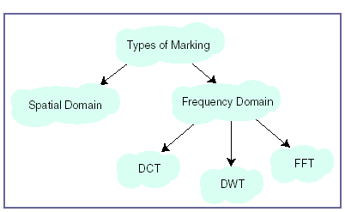
Fig 1 Types of watermarking

[1.7] Type of watermark:
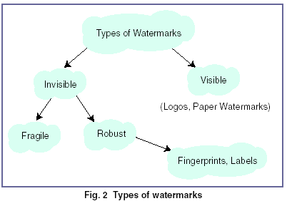

CHAPTER # 2

CHARACTERISTICS OF WATER MARK
DISTORTION AND ATTACK

CHARECTERISTIC OF WATERMARKS:- There are different characteristic which the water mark must have:
2.1 ROBUSTNESS:-
A water mark must robust to transformation that includes common signal distortion. The watermark must survive different image processing operation such cropping, filtering, JPEG attack. The robustness can only be achieved if the data to be watermarked has been placed in the perceptually significant portion of image.
It should be noted that watermark robustness actually comprises two separate issues:
→ Whether or not the watermark is still present in data after distortion and
→ Whether the watermark detector can detect it.
2.2 REAL TIME PROCESSING:-
The watermark scheme should guarantee the real time embedding extraction process when considering property of the real time processing for moving picture.
2.3 IMPERCEPTIBILITY:-
The invisible watermark should not be noticeable to the viewers nor should the watermark degrade the quality of content ideally. It should be imperceptible. However if a signal is truly imperceptible, then perceptual based loss compression algorithm
Should in principle, remove such signal. Of course a just noticeable difference (JND) is usually observed by comparing two signal, e.g. Compressed and uncompressed or watermark and original.
2.4 TAMPER RESISTANCE:-
Watermark should be robust to legitimate signal distortion. Watermark may also be subjected to signal processing that is solely intended to remove the watermark .It is important that a watermark be resistant to such tampering. There are number of possible ways in which this can be achieved.

PRIVATE WATERMARK:
A private watermark whether either the decoder requires knowledge of un watermarked content or the pseudo random noise sequence that constitute the watermark is only known to sender and receiver are inherently more tamper resistant than public watermark in which every body is free to decode the watermark.
ASYMMETRIC ENCODER/DECODER:
If removal of a public watermark requires inverting the encoding, then it is highly desirable to make the encoder as complex as possible, especially if the watermark is only applied to once. However if decoder must run in real time when it is necessary for the decoding process to simpler than encoding.
BIT RATE:
The bit rate of watermark refers to them amount of information a watermark can encode a signal. This is important for public watermark. Low bit rate watermark are robust.
UNABIGUOUS:
Retrieval of watermark should unambiguously identify the owner. The watermark should not need any interpretation as looking into the data base of codes to interpret the watermark unless a standard body maintains it internationally.
UNIVERSAL:
The same watermark should apply to all media under consideration .this is potentially helpful in watermarking of multimedia products .also this feature is conducive to implementation of audio /image/video watermarking also on common hardware.
2.5 WATERMARK EXTRACTION:-
The embedded watermark should be extracted without using the original video when considering large amount of video data.
DISTORTION AND ATTACKS:
In practice a watermarked object may be altered either on purpose accidently, so the watermarking system should still be able to detect and extract the watermark. Obviously the distortion is limited to those that do not produce excessive degradation, since otherwise the transform object would be unusable. These distortions also introduce degradation on the performance of system. For intentional attack the goal of attacker is to maximize the reduce in these probabilities while minimizing the impact that his transform produces on the object
Following are some of the best known attacks .some of may be intentional /unintentional, depending on application.
2.6.1 ADDITIVE NOISE:-
This may stem in certain application from the use of D/A or A/D converters or from transmission errors. However an attacker may introduce perceptually shaped noise with max unnoticeable power. This will typically force to increase the threshold at which the correlation detector works.
2.6.2 FILTERING: -
Low pass filtering for instance does not introduce considerable degradation in watermarked images or audio but can dramatically affect the performance, since spread spectrum like watermark have non negligible HF spectral contents.
2.6.3 CROPPING: -
This is a very common attack since in many cases the attacker is interested in small portion of watermarked object, such as part of certain picture or frames of a video sequences. With this in mind in order to survive the watermark needs to be spread over the dimensions where the attacks take place.
2.6.4 COMPRESSION:-
This is generally a unintentional attack which appears very often in multimedia application. Practically all the video, audio and images that are currently being distributed via internet have been compressed. if it is usually advisable to perform the watermark insertion task in the same domain where the insertion takes place. For instance DCT domain image watermarking is more robust to JPEG compression than spatial domain watermarking.
2.6.5 ROTATION AND SCALING:
This has been the true battle horse of digital water marking, especially because of its success with still images. Correlation based detection and extraction fail when rotation and scaling is per formed on the watermarked image because the embedded watermark and the locally generated version do not share the same spatial pattern anymore. Obviously it would be possible to do exhaustive search on different rotation angles and scaling factors until a correlation peak is found but it is prohibitively complex.
2.6.6 STATISTICAL AVERAGING:
An attacker may try to estimate the watermark and then un watermarked the object by subtracting the estimate. This is dangerous if the watermark does not depend substantially on the data. Note that with different watermarked objects it would be possible to improve the estimate by simple averaging. This is a good reason for using perceptual masks to create the watermark.
2.6.7 LEAST SIGNIFICANT BIT ATTACK:-
An illegal user destroys the lsb of the original image to remove embedded watermark. Since water mark is not embedded in LSB of image, destroying the LSB of image will not destroy the embedded water mark.

CHAPTER # 3

INTODUCTION TO WAVELT
AND IT’S PROPERTIES

[3.1] INTRODUCTION TO WAVELET:

The wavelet transform has been perhaps the most exciting development in the last decade to bring together , researchers in several different fields such as signal processing , image processing ,communications ,computer sciences and mathematics etc., It is well known form Fourier theory that a signal can be expressed as the sum of a , possibly infinite, series of sine’s and cosines. This sum is also referred to as a Fourier expansion. The big dis advantage of a Fourier expansion however is that, it has only frequency resolution and no time resolution. This means that although we might be able to determine all the frequencies present in a signal, we do not know when they are present. To overcome this problem in the past decades several solutions have been developed which are more or less able to represent a signal in the time and frequency domain at the same time.
The idea behind these time-frequency joint representations is to cut the signal of interest into several parts and then analyze the parts separately. It is clear that analyzing a signal this way will give more information about the when and where of different frequency components, but it leads to a fundamental problem as well: how to cut the signal? Suppose that we want to know exactly all the frequency components present at a certain moment in time, we cut out only this very short time window using dirac pulse transform it to the frequency domain and something is very wrong.
The problem here is that cutting the signal corresponds to a convolution between the signal and the cutting window. Since convolution in the time domain is identical to multiplication in the frequency domain and since the Fourier transform of a dirac pulse contains all possible frequencies the frequency components of the signal will be smeared out all over the frequency axis. In fact this situation is the opposite of the standard Fourier transform since we now have time resolution but no frequency resolution whats over.
The underlying principle of the phenomenon just described is Heisenberg’s uncertainty principle e, which in signal processing terms, states that it is impossible to know the exact frequency and the exact time of occurrences of this frequency in a signal. In other words a signal can simply not be represented as a point in the time-frequency space. The uncertainty principle shows that it is very important now one cuts the signal.
The wavelet transform or wavelet analysis is probably the most recent solution to overcome the shortcomings of the Fourier transform. In wavelet analysis the use of a fully scalable modulated window solves the signal-cutting problem. The window is shifted along the signal and for every position the spectrum is calculated. Then this process is repeated many times with slightly shorter (or longer) window for every new cycle. In the end the result will be a collection of time and frequency representations of the signal, all with different resolutions. Because of this collection of representations we can speak multi-resolution analysis. In this case of wavelets we normally speaks about time-frequency representations but about time-scale representations, scale being in a way the opposite of frequency , because the term frequency is reserved for the Fourier transform.
[3.2] WAVELET DEFINATION:-
A wavelet is a small wave which has its energy concentrated in time. It has oscillating wave like characteristic but also has the ability to allow simultaneous time and frequency analysis and it is a suitable tool for transient, non-stationary or time-varying phenomena.

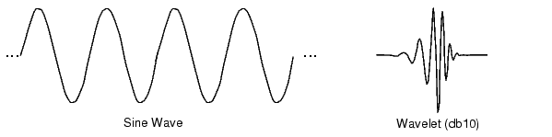

Fig 1

[3.3] WAVELET CHARACTERISTICS:-
The difference between wave and wavelet is shown in the above fig. waves are smooth, predictable and everlasting, whereas wavelets are limited duration, irregular and may be asymmetric. Waves are used as deterministic basis functions in Fourier analysis for the expansion of functions (signals), which are time-invariant, or stationary. The important characteristic of wavelets is that they can serve as deterministic or non-deterministic basis for generation and analysis of the most natural signals to provide better time-frequency representation, which is not possible with waves using conventional Fourier analysis.
[3.4] WAVELET ANALYSIS:
The wavelet analysis procedure is to adopt a wavelet prototype function, called an ‘analyzing wavelet’ or ‘mother wavelet’ .Temporal analysis is performed with a contracted , high frequency version of the prototype wavelet , while frequency analysis is performed with a dilated, low frequency version of the same wavelet. Mathematical formulation of signal expansion using wavelets gives wavelet transform (WT) pair, which is an analogue to the Fourier transform (FT) pair. Discrete-time and discrete-parameter version of WT is termed as discrete wavelet transforms (DWT). DWT can be viewed in a similar framework of discrete Fourier transform (DFT). DWT can be viewed in a similar framework of discrete Fourier transform (DFT) with its efficient implementation through fast filter bank algorithms similar to fast Fourier transform algorithms.
[3.5] EVOLUTION OF WAVELET TRANSFORMS:
The need of simultaneous representation and localization of both time and frequency for non-stationary signals (e.g. music, speech, images) led toward the evolution of wavelet transform form the popular Fourier transform. Different ‘time-frequency representations’ (TFR) are very informative in understanding and modeling of wavelet transform.
[3.5.1] FOURIER TRANSFORM
Fourier transform is used to find the frequency content of a signal. It allows going back and forwarding between the raw and processed (transformed) signals. However, only either of them is available at any given time. That is, no frequency information is available in the time-domain signal, and no time information is available in the Fourier transformed signal. Fourier transform of a time domain signal X(t) and inverse Fourier transform (IFT) of a frequency domain signal X(f) are given below.
1
2
Though FT has a great ability to capture signal’s frequency content as long as X(t) is composed of few stationary components (e.g. sine waves) .However , any abrupt change in time for non-stationary signal X(t) is spread out over the whole frequency axis in X(f). Hence the time-domain signal sampled with dirac-delta function is highly localized in time but spills over entire frequency band and vice versa. The limitation of FT is that it cannot offer both time and frequency localization of a signal at the same time. To overcome the limitations of the standard FT, Gabor introduced the initial concept of short time Fourier transform (STFT).
[3.5.2] SHORT TERM FOURIER ANALYSIS:
This is the revised version of the Fourier transform. There is only a minor difference between short term Fourier analysis (STFT) and FT. In STFT, the signal is divided into small enough segments, where these segments (portions) of the signal can be assumed to be stationary. For this purpose, a window function “w” is chosen. The width of this window must be equal to the segment of the signal where its stationary is valid.
This window function is the first located to the very beginning of the signal. That is, the window function is located at t=0. Let’s suppose that the width of the windows is “T” s. At this time instant (t=0), the window function will overlap with the first T/2 seconds. The window functions and the signal are then multiplied. By doing this , only the first T/2 seconds of the signal is being chosen, with the appropriate weighting of the window (if the window is a rectangle, with amplitude “I” , then the product will be equal to the signal) Assuming the product just as another signal, FT is taken.
The result of this transformation is the FT of the first T/2 seconds of the signal. If this
Portion of the signal is stationary, as it is assumed, the obtained result will be as true frequency representation of the first T/2 seconds of the signal. The next step would be shifting this window (for some t1 seconds) to a new location, multiplying with the signal and taking the FT of the product. This procedure is followed until the end of the signal is reached by shifting the window with “t1” seconds intervals. The following definition of the STFT summarizes all the above explanations in one line:

In the above equation X(t) is the signal , w(t) is the window function, and * is the complex conjugate. As you can see from the equation, the STFT of the signal is nothing but the FT of the signal multiplied by a window function. Using STFT one cannot know the exact time-frequency representation of a signal, i.e., one cannot know what spectral components exist at what instances of times. What one can know are the time intervals in which certain band of frequencies exists, which is a resolution problem. This problem occurs because of width of window function used.
Narrow window ➔ good time resolution, poor frequency resolution
Wide window ➔ good frequency resolution, poor time resolution and violates the condition of stationary.
The selection of proper window is application dependent. Once a window has been chosen for STFT, the time-frequency resolution is fixed over the entire time-frequency plane because the same window is used at all frequencies. There is always a trade off between time resolution and frequency resolution in STFT.
[3.6] CONTINUOUS WAVELET TRANSFORM:
The continuous wavelet transform was developed as alternative approach to the short time Fourier transforms to overcome the resolution problem. The wavelet analysis is done in a similar way to the STFT analysis, in the sense that the signal is multiplied with a function (i.e. the wavelet) , similar to the window function in the STFT, and the transform is computed separately for different segments of the time-domain signal, however, there are two main differences between the STFT and the CWT.
- The Fourier transforms of the windowed signals are not taken, and therefore are not computed.
- The width of the window is changed as the transform is computed for every single spectral component, which is probably the most significant characteristic of the wavelet transform.
The wavelet transform (WT) in its continuous (CWT) form provides a flexible time-frequency window, which narrows when observing high frequency phenomena and widens when analyzing low frequency behavior. Thus time resolution becomes arbitrarily good at low frequencies. This kind of analysis is suitable for signals composed of high frequency components with short duration and low frequency components with long duration, which is often the case in practical situation.
The continuous wavelet transform is defined as follows
As seen in the above equation, the transformed signal is a function of two variables, and s, the translation and scale parameters, respectively. Ψ (t) is the transforming function, and it is called the mother wavelet.
The mother wavelet is a prototype for generating the other window functions. The term translation is related to the location of window, as the window is shifted through the signal. This term corresponds to the time information in transform. The scale parameter is defined as the inverse of frequency. High scales (low frequencies) correspond to global information of a signal (that usually spans the entire signal) whereas low scales (high frequencies) do not last for entire duration of signal but usually appear from time to time as short bursts and high scales (low frequencies) usually last for the entire duration of the signal.
The CWT is the correlation between a wavelet at different scales and the signal with the scale (or the frequency) being used as a measure of similarity. The continuous wavelet transform was computed by changing the scale of the analysis window, shifting the window in time, multiplying by the signal, and integrating over all times.

[3.7] DESCRETE WAVELET TRANSFORM:
The CWT has the drawbacks of redundancy and impracticability with digital computers. The discrete wavelet transform (DWT) provides sufficient information both for analysis and synthesis of the original signal, with a significant reduction in the computation time. The DWT is considerably easier to implement when compared to the CWT.
The DWT analyzes the signal at different frequency bands with different resolutions by decomposing the signal into a coarse approximation and detail information. DWT employs two sets of functions, called scaling functions and wavelet functions, which are associated with low pass and high pass filters, respectively. The original signal x[n] is first passed through a half-band high pass filter g[n] and a low pass filter h[n]. After the filtering, half of the samples can be eliminated according to the nyquist’s rule. The signal can therefore be sub sampled by 2, simply by discarding every other sample. This constitutes one level of decomposition and can mathematically be expressed as follows:

and are the outputs of the high pass and low pass filters, respectively after sub sampling by 2. This decomposition halves the time resolution since only half the number of samples now characterizes the entire signal. However, this operation doubles the frequency resolution, since the frequency band of the signal now spans only half the previous frequency band, effectively reducing the uncertainty in the frequency by half. The above procedure, which is also known as the sub-band coding can be repeated for further decomposition. At every level, the filtering and sub sampling will result in half the number of samples (and hence half the time resolution) and half the frequency band spanned (and hence half the frequency resolution). Hence the fig. illustrates this procedure, where x[n] is the original signal to be decomposed, and h[n] and g[n] are low pass and high pass filters, respectively. The bandwidth of the signal at every level is marked on the figure as “ f “.

The frequencies that are most prominent in the original signal will appear as high amplitudes in that region of the DWT signal that includes those particular frequencies. The frequency bands that are not very prominent in the original signal will have very low amplitudes , and that part of the DWT signal can be discarded without any major loss of information , allowing data reduction. The difference of this transform from the Fourier transform is that the time localization of these frequencies will not be lost.

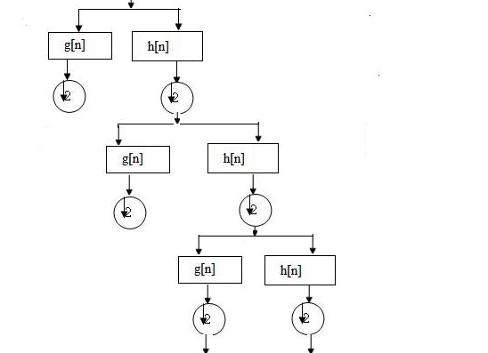
Fig 2
Four resulting sets of wavelet coefficients,, and are conventionally named according to the filtering types along rows and columns respectively (H: high pass filtering, L: for low pass filtering). These sets are also called wavelet sub bands (LL, LH, HL, and HH). The perfect reconstruction is also obtained by applying the
ID synthesis scheme on rows and columns successively.

It is worth pointing out that the order in which rows and columns are processed at the analysis and synthesis sides has no importance since the global transformation is linear.
An advantage of wavelet transform is that the windows vary. In order to isolate signal discontinuities, one would like to have some very short basis functions. At the same time, in order to obtain detailed frequency analysis, one would like to have some very long basis functions. A way to achieve this is to have short high-frequency basis functions and long low-frequency ones. This happy medium is exactly what you get with wavelet transforms. One thing to remember is that wavelet transforms do not have a single set of basis functions like the Fourier transform, which utilizes just the sine and cosine functions. Instead, wavelet transforms have an infinite set of possible basis functions. Thus wavelet analysis provides immediate access to information that can be obscured by other time-frequency methods such as Fourier analysis.

[3.8] COMPARATIVE VISUALIZATION:
A comprehensive visualization of various time-frequency representations, shown in figure, demonstrates the time-frequency resolution for a given signal in various transform domains with their corresponding basis functions.
Figure describes the time and frequency responses in different domains.
Here
x axis denotes -> time
y axis denotes -> frequency

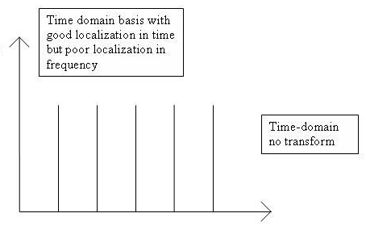
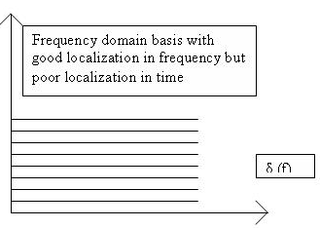
Fig 3.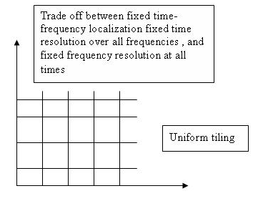
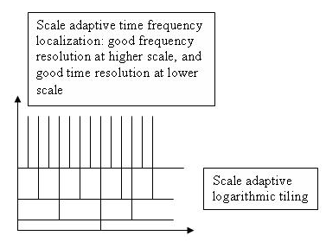
Fig 4

[3.9] WAVELET PROPERTIES:
The most important properties of wavelets are the admissibility and the regularity conditions and these are the properties which gave wavelets their name. It can be shown that square integrable functions satisfies the admissibility condition
˂ +
Can be used to first analyze and then reconstruct a signal without loss of information.
Stands for the Fourier transform of . The admissibility condition implies that the Fourier transform of vanishes at the zero frequency.
i.e.,
This means that wavelets must have a band-pass like spectrum. This is a very important observation, which we will use later on to build an efficient wavelet transform.
A zero at the zero frequency also means that the average value of the wavelet in the time domain must be zero.
And therefore it must be oscillatory. In other words must be a wave. As from the above knowledge the wavelet transform of one dimensional function is two dimensional; the wavelet transform of two-dimensional function is four-dimensional. The time-bandwidth product of the wavelet transform is the square of the input signal and for most practical applications this is not a desirable property. Therefore one imposes some additional conditions on the wavelet functions in order to make the wavelet transform decrease quickly with decreasing scale s. These are the regularity conditions and they state that the wavelet function should have some smoothness and concentration in both time and frequency domains.
If we expand the wavelet transform into the Taylor series at t=0 until order n (let τ=0 for simplicity) we get
Hence f^{(p)} stands for the p^{th} derivative of f and O(n+1) means the rest of the expansion. Now, if we define the moments of the wavelet by M_{p} ,
M_{p} =
Then we can get the finite development
From the admissibility condition we already have that the 0th moment M₀= 0 so that the first term in the right-hand side of above equation is zero. If we now manage to make the other moments up to M_{n} zero as well, then the wavelet transform coefficients will decay as fast as s^{n+2} for a smooth signal f(t). This is known in literature as the vanishing moments or approximation order. If a wavelet has N vanishing moments, then the approximation order of the wavelet transform is also N. The moments do not have to be exactly zero , a small value is often good enough. In fact experimental research suggests that the number of vanishing moments required depends heavily on the applications.
The admissibility condition gave us the wave, regularity and vanishing moments gave us the fast decay or the let, and put together they give us the wavelet.

[3.10] A BAND-PASS FILTER:
With the redundancy removed, we still have two hurdles to take before we have the wavelet transform in a practical form. We continue by trying to reduce the number of wavelets needed in the wavelet transform and save the problem of the difficult analytical solutions for the end.
Even with discrete wavelets we still needed an infinite number of scaling and translations to calculate the wavelet transform. The easiest way to tackle this problem is simply not to use an infinite number of discrete wavelets. Of course this poses the question of the quality of the transform. Is it possible to reduce the number of wavelets to analyze a signal and still have a useful result?

The translation of the wavelets is of course limited by the duration of the signal under investigation so that we have an upper boundary for the wavelets. This leaves us with the question of dilation how many scales do we need to analyze our signal?
How do we get the lower bond? it turns out that we can answer this question by looking at the wavelet transform in a different way.
The wavelet has a band-pass like spectrum. From Fourier theory we know that compression in time is equivalent to stretching the spectrum and shifting it upwards
This means that a time compression of the wavelet by a factor of 2 will stretch the frequency spectrum of the wavelet by a factor of 2 and also shift all frequency components up by a factor of 2. Using this insight we can cover the finite spectrum of our signal with the spectrum of dilated wavelets in the same way as that we covered our signal in the time domain with translated wavelets. To get a good coverage of the signal spectrum the stretched wavelet spectra should touch each other, as if they were standing hand in had. This can be arranged by correctly designing the wavelets.

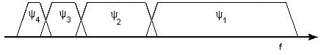
Fig 5.
If one wavelet can be seen as a band-pass filter, then a series of dilated wavelets can be seen as a band-pass filter bank. If we look at the ratio between the center frequency of a wavelet spectrum and the width of this spectrum we will see that it is the same for all wavelets. This ratio is normally referred to as the fidelity factor Q of a filter and in the case of wavelets one speaks therefore of a constant-Q filter bank.

A CONSTRAINT:
As a constraint we will now take a look at an important constraint on our signal, which has sneaked in during the last section the signal to analyze must have finite energy. When the signal has infinite energy it will be impossible to cover its frequency spectrum and its time duration with wavelets. Usually this constraint is formally stated as
And it is equivalent to stating that the L² norm of our signal f(t) should be finite. This is where Hilbert spaces come in so we end our constraint by stating that natural signals normally have finite energy.

[3.11] THE SCALING FUNCTION:
The question arises how to cover the spectrum all the way down to zero? Because every time we stretch the wavelet in time domain with a factor of 2, its bandwidth is halved. In other words, with every wavelet stretch we cover only half of the remaining spectrum, which means that we will need an infinite number of wavelets to get the job done.
The solution of this problem is simply not to try to cover the spectrum all the way down to zero with wavelet spectra, but to use a cork to plug the hole when it is small enough. This cork then is a low-pass spectrum and it belongs to the so-called scaling function. The scaling function was introduced by mallet. Because of the low-pass nature of he scaling function spectrum it is sometimes referred to as the averaging filter.

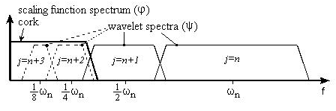
Fig 6
Figure shows scaling function of wavelet.
If we look at the scaling function as being just a signal with a low-pass spectrum, then we can decompose it in wavelet components and express it as
Since we selected the scaling function in such a way that its spectrum neatly fitted in the space left open by the wavelets, the expression uses an infinite number of wavelets up to certain scale j. This means that if we analyze a signal using the combination of scaling function and wavelets, the scaling function by itself takes care of the spectrum otherwise covered by all the wavelets up to scale j, while the rest is done by the wavelets. In this way we have limited the number of wavelets form an infinite number to a finite number.
By introducing the scaling function we have circumvented the problem of the infinite number of wavelets and set a lower bound for the wavelet. Of course when we use a scaling function instead of wavelets we lose information. That is to say, from a signal representation view we do not loose any information, since it will still be possible to reconstruct the original signal but from a wavelet-analysis point of view we discard possible valuable scale information. The width of the scaling function spectrum is therefore an important parameter in the wavelet transform design. The shorter its spectrum the more wavelet coefficients, we will have and more scale information. But , as on , in the discrete wavelet transform this problem is more or less automatically solved.
The low-pass spectrum of the scaling function allows us to state some sort of admissibility condition similar to
Which shows that the 0th moment of the scaling function can not vanish?
If one wavelet can be seen as a band-pass filter and scaling function is a low pass filter, then a series of dilated wavelets together with a scaling function can be seen as a filter bank.

[3.12] SUBBAND CODING:
If we regard the wavelet transform as a filter bank, and then we can consider wavelet transforming a signal as passing the signal through this filter bank. The outputs of the different filter stages are the wavelet-and scaling function transform coefficient. Analyzing a signal by passing it through a filter bank is not a new idea and has been around for many years under the name sub-band coding. It is used for instance in computer vision applications.
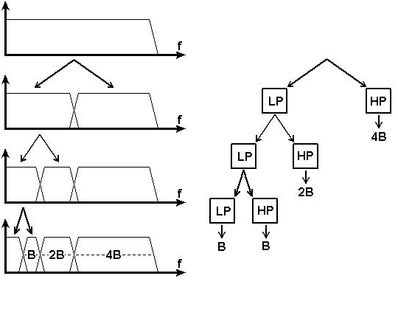
Fig 7.
The filter bank needed in sub band coding can be built in several ways. One way is to build many band-pass filters to split the spectrum into frequency bands. The advantages are that the width of every band can be chosen freely, in such a way that the spectrum of the signal to analyze is covered in the places where it might be interesting. The disadvantage is that we will have to design every filter separately and this can be a time consuming process. Another way is to split the signal spectrum in two parts a low-pass and a high-pass part. The high-pass part contains the smallest details we are interested in and we could stop here. We now have two bands. However the low-pass part still contains some details and therefore we can split it again. And again, until we are satisfied with the number of bands we have created. In this way we have created an iterated filter bank. Usually the number of bands is limited by for instance the amount of data or computation power available. The process of splitting the spectrum is graphically delayed in fig. The advantage of this scheme is that we have to design only two filters , the disadvantage is that the signal spectrum coverage is fixed.
Looking in above fig. we see that what we are left with after the repeated spectrum splitting is a series of band-pass bands with doubling bandwidth and one low-pass band. (Although in first split gave us a high-pass band and a low-pass band, in reality the high-pass band is a band-pass band due to te limited bandwidth of the signal.) .The same can be done in another way by feeding the signal into a bank of band-pass filters of which each filter has a bandwidth twice as wide as his left neighbor (the frequency axis runs to the right here) and a low-pass filter. This is same as applying a wavelet transform to the signal. The wavelet gives us the band-pass bands with doubling bandwidth and scaling function provides us with the low-pass band. So we can conclude that a wavelet transform is the same thing as a sub-band coding scheme using a constant-Q filter bank. This analysis is referred to as a multi-resolution analysis.

[3.13] ORTHOGONAL WAVELET:
An orthogonal wavelet is a Wavelet where the associated wavelet transform is orthogonal. That is the inverse wavelet transform is the ad joint of the wavelet transform. If this condition is weakened you may end up with bi-orthogonal wavelet.
The scaling function is a re-definable function. That is, it is a fractal functional equation, called refinement equation:
,
Where the sequence of real numbers is called scaling sequence or scaling mask. The wavelet proper is obtained by a similar linear combination,
Where the sequence of real numbers is called wavelet sequence or wavelet mask.
A necessary condition for the orthogonality of the wavelets is, that the scaling sequence is orthogonal to any shifts of it by an even number of coefficients:
In this case there is the same number M=N of coefficients in the scaling as in the wavelet sequence, the wavelet sequence can be determined asb_{n}=(-1)^{n}a_{N-1-n} . In some cases the opposite sign is chosen.
[3.14] BI-ORTHOGONAL WAVELET:
A bi-orthogonal wavelet is a wavelet where the associated wavelet transform is invertible but not necessarily orthogonal. Designing bi-orthogonal wavelets allows more degrees of freedoms than orthogonal wavelets. One additional degree of freedom is the possibility to construct symmetric wavelet functions.
In the bi-orthogonal case, there are two scaling functions, which may generate different multi-resolution analyses, and accordingly two different wavelet functions . So the numbers M,N of coefficients in the scaling sequences may differ. The scaling sequences must satisfy the following bi orthogonality condition
. Then the wavelet sequences can be determined as, , n=0,…,M-1 and ,n=0,…,N-1.
[3.15] GENERATING SCALING FUNCTIONS AND WAVELETS FROM FILTER COEFFICIENTS:
The following equation represents as
is the frequency response of H.
Rewriting this above equation as
Where we have set Φ(0)=1, we have the coefficients of the impulse response of a discrete-time filter h(n) satisfy the par unitary conditions. The sequence 2h(n) can serve as the set of coefficients for the dilation equation to generate a potential scaling function ϕ(t) for an orthonormal decomposition. If substitution of the frequency response H(ω) in the right-hand side of the equation leads to a function of Φ(ω), then its inverse Fourier transform is such a scaling function. There is a simple time-domain iteration method based on this result.
The steps of the algorithm are
- Set c(n)=2h(n).
- Let the initial scaling function be the haar scaling function
_{otherwise 0} ^{0≤t<1}
- At iteration n set
- Iterate until either divergence is established or the desired convergence is obtained. If there is convergence, the scaling function is given by
Transforming the iteration to the frequency domain, at the end of the first iteration,
Where denotes the Fourier transform of the scaling function at the n^{th} iteration. The function is the Fourier transform of the Haar scaling function.
Thus the scaling function become
[3.16] WAVELET TRANSFORM AND DATA COMPRESSION:
The most wide spread application of the wavelet transform so far has been for data compression. This is related to the fact that the DWT is tied closely to sub band decomposition, and the latter was already being used for compression by the time the connection between the two was established by mallet.
Compression in the context of speech compression, image compression, and so forth, connotes the process of starting with a source of such data in digital form and creating a representation for it that uses fewer bits than the original. The aim is to reduce storage requirements or transmission time when such information is communicated over a distance. Ideally we want the compression process to be reversible. That is given the compressed data; we would like to get the original data. When it is possible to do so then compression is said to be lossless; otherwise we have lossy compression
The error signal is represented as
For lossless compression, e (n) is identically zero. For lossy compression, an objective measure of distortion or figure of merit for the quality of the reproduction signal or image is the mean squared value of the e(n) . One might use the related measures of signal to noise ratio (SNR) or peak signal to noise ratio (PSNR) defined as

[3.17] AUDIO COMPRESSION:
The DTWT or sub band decomposition techniques are used for the compression of audio and wideband speech signals. There seems to be a perceptual basis in audio perception for using such decomposition. The frequency range for human hearing extends to 20 kHz. When an analog audio signal is sampled, the sampling frequency has to be greater than 40 kHz. In applications such as audio recording on conventional compact disk (CD), the sampling rate is 44.1 kHz. Since the sampled data are stored in digital form, only a finite number of levels, determined by the number of bits allotted per sample, can be used to represent the signal. In audio CDs, 16 bits per sample are used. This allows 65,536 levels. Then this levels are decoded is called pulse code modulation.
[3.18] APPLICATIONS OF WAVELET TRANSFORMS:
Finally, applications of widely used standard DWT implementations, utilizing its Multi-scale and Multi-resolution capabilities with fast filter bank algorithms are numerous to describe. Depending upon the application, extensions of standard DWT namely WP and SWT are also employed for improved performance at the cost of higher redundancy and computational complexity.
A few of such applications in data compression, de noising, source and channel coding , biomedical, non-destructive evolution, numerical solutions of PDE , study of distant universe, zero-crossing, fractals, turbulence, speckle removal, edge detection and object isolation, image fusion, scaling functions as signaling pulses, and finance are comprehensively covered in. wavelet applications in may diverse fields such as physics , medicine, and biology, computer graphics, communications and multimedia etc. can be found in various books on wavelets.

[3.19] TYPES OF WAVELETS:
Any discussion of wavelets begins with Haar wavelet, the first and simplest. Haar wavelet is discontinuous, and resembles a step function. It represents the same wavelet as Daubechies I.

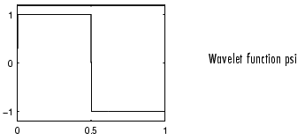
Fig 8

(a).DAUBECHIES
Ingrid Daubechies, one of the brightest stars in the world of wavelet research, invented what are called compactly supported orthonormal wavelets thus making discrete wavelet analysis practicable.
The names of the Daubechies family wavelets are written dbN, where N is the order, and db the "surname" of the wavelet. The db1 wavelet, as mentioned above, is the same as Haar wavelet. Here is the wavelet functions psi of the next nine members of the family:

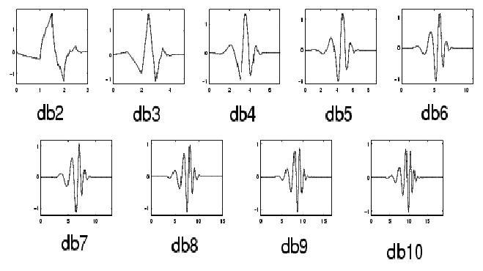
Fig 9.
(b).Coiflets:
Built by I. Daubechies at the request of R. Coifman. The wavelet function has 2N moments equal to 0 and the scaling function has 2N-1 moments equal to 0. The two functions have a support of length 6N-1. You can obtain a survey of the main properties of this family by typing from the MATLAB command line.

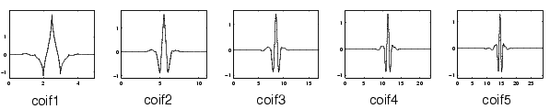
Fig 10
(c) Biorthogonal:
This family of wavelets exhibits the property of linear phase, which is needed for signal and image reconstruction. By using two wavelets, one for decomposition (on the left side) and the other for reconstruction (on the right side) instead of the same single one, interesting properties are derived.

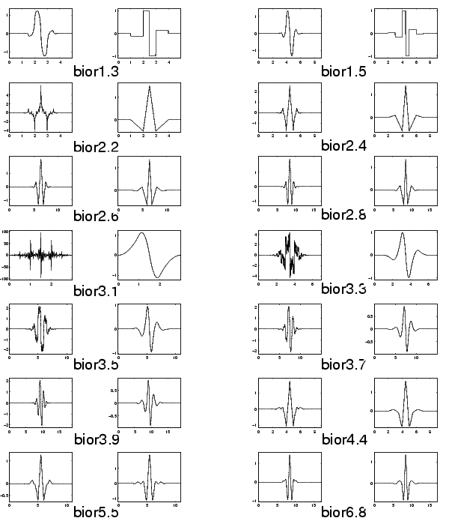

Fig 11

(d) Symlets:
The symlets are nearly symmetrical wavelets proposed by Daubechies as modifications to the db family. The properties of the two wavelet families are similar. Here is the wavelet functions psi.
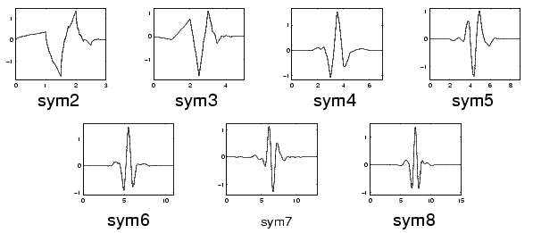

Fig 12
(e) Morlet:
This wavelet has no scaling function, but is explicit.
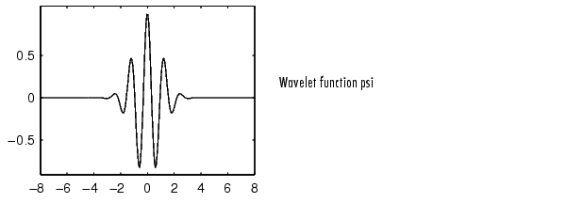

Fig 13

[f].Mexican Hat:
This wavelet has no scaling function and is derived from a function that is proportional to the second derivative function of the Gaussian probability density function.

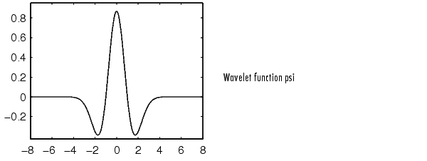
Fig 14
[g] Meyer:
The Meyer wavelet and scaling function are defined in the frequency domain.
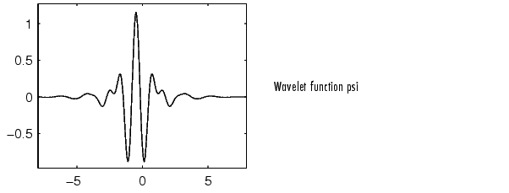
Fig 15

[3.20] SIMILARTIES BETWEEN FOURIER AND WAVELET TRANSFORM:
The fast Fourier transform (FFT) and the discrete wavelet transform (DWT) are both linear operations that generate a data structure that contains segments of various lengths, usually filling and transforming it into a different data vector of length .
The mathematical properties of the matrices involved in the transforms are similar as well. The inverse transform matrix for both the FFT and the DWT is the transpose of the original. As a result, both transforms can be viewed as a rotation in function space to a different domain. For the FFT, this new domain contains basis functions that are sine and cosines. For the wavelet transform, this new domain contains more complicated basis functions called wavelets, mother wavelets, or analyzing wavelets.
Both transforms have another similarity. The basis functions are localized in frequency, making mathematical tools such as power spectra (how much power is contained in a frequency interval) and scale grams (to be defined later) useful at picking out frequencies and calculating power distributions.

[3.21] DISSIMILARTIES BETWEEN FOURIER AND WAVELET TRANSFORM:
The most interesting dissimilarity between these two kinds of transforms is that individual wavelet functions are localized in space. Fourier sine and cosine functions are not. This localization feature, along with wavelets' localization of frequency, makes many functions and operators using wavelets "sparse" when transformed into the wavelet domain. This sparseness, in turn, results in a number of useful applications such as data compression, detecting features in images, and removing noise from time series.

CHAPTER # 4

WAVELET DOMAIN DIGITALWATER
MARKING TECHNIQUE:

[4.1] INTRODUCTION:-
With the rapid growth of network distributions of images and video, there is an urgent need for copy-right protection against pirating. Different digital watermarking schemes have been proposed to address this issue of ownership identiﬁcation. Early work on digital watermarking focused on information hiding in the spatial domain. For example, Schyndel et al. proposed to insert a watermark by changing the least signiﬁcant bit of some pixels in an image. Bender et al. described a watermarking approach by modifying a statistical property of an image. Recent efforts are mostly based on frequency-domain techniques for still images. In particular, Cox et al. described a method where the watermark is embedded in large discrete cosine transform (DCT) coefficients using ideas borrowed from spread spectrum in communications. For digital watermarking of video sequences, Hartung and Girod [6] proposed a watermarking technique for MPEG-2 encoded video in the bit stream domain. Swanson et al. also considered MPEG-2 compressed domain video watermarking [7] and a wavelet-based multi resolution video watermarking method [8], in which the multi resolution wavelet transform is performed in the temporal domain only. Although different transforms (e.g., discrete Fourier transform, discrete cosine transform, and discrete wavelet transform) have been used in digital watermarking schemes reported in the literature, there is no common framework for multi resolution digital watermarking of both images and video. In this paper, we propose a united app2-D) and three-dimensional (3-D) discrete wavelet transforms [9]. Our wavelet-based watermarking framework is motivated by the fact that most network-based images and video are in compressed form and that wavelets are playing an important role in upcoming compression standards such as JPEG2000 and MPEG-4. We ﬁrst experimentally show that a watermark signal [e.g., an independently identically distributed (i.i.d.) Gaussian random vector] can be embedded in every high-pass wavelet coefficient without any impact on the visual ﬁdelity.This is different from the approach in [3], where the watermark is only placed into a small number of the perceptually most important coefficients (e.g., 1000 largest coefficients). Our results indicate that the capacity or the amount of information in an invisible watermark can be quite large. We then describe the proposed framework where an i.i.d.Gaussian random vector is added to all the high-pass bands in the wavelet domain as a multi resolution digital watermark. The watermark added to a lower resolution can be thought of as a nested version of the one corresponding to a higher resolution.

.
[4.2] CAPACITY ISSUES IN DIGITAL IMAGE WATERMARKING:
Portions, roi or
Digital watermarking is a process of hiding a watermark (or signature) signal in image or video media by making small changes in the media content. Properties of watermarks include unobstructiveness and robustness. The former indicates that a watermark should be perceptually invisible; the later means that the watermark should be difficult to remove or destroy before resulting in severe degradation in visual ﬁdelity. To make the watermark invisible, one would intuitively pick a watermark signal with small energy and hide it in the perceptually insigniﬁcant regions. However, the main thrust of [4] is
the placement of the watermark in the perceptually signiﬁcant regions of an image for robustness. It is argued that visual ﬁdelity is only preserved if the perceptually signiﬁcant regions remain intact. Otherwise, a watermark placed in perceptually insigniﬁcant regions can be easily removed.
The question, therefore, is how much extra watermark information we can add to the perceptually signiﬁcant regions without any impact on the visual ﬁdelity. This raises the capacity issues in digital image watermarking. For a ﬁxed watermarking procedure, the length of the watermark serves as a measure of the capacity, and it is upper bounded by the number of coefficients in the perceptually signiﬁcant regions. A longer watermark signal means that more coefficients need to be modiﬁed .

To determine the perceptual capacity of each frequency, one could use models for the human visual system or simple experiments. Using the watermarking procedure described in, we experimentally vary the length of the watermark signal and compute the peak signal-to-noise ratio (PSNR) between the original and watermarked images. Two cases are considered. First, the watermark is placed on the 1000 largest high-pass wavelet coefficients. Second, the watermark is hidden in all high-pass wavelet coefficients. The results are tabulated for three popular 512 512 images. We see that in all cases, the PSNR’s of the watermarked images are quite high, making them visually indistinguishable from the originals even when a watermark (the longest) is placed
in all high-pass wavelet coefficients.

[4.3] MULTI RESULATION WATER MARKING FRAME WORK FOR IMAGES:-

We describe our multi resolution watermarking scheme for images assuming that a two dimensional DWT is applied to main original image. Our proposed framework can easily extend to video sequences after applying 3-D DWT to a GOP. Multiresolution watermarking is described as the watermarking done at more than one level. I have done first at one level decomposition then at second level decomposition.
The algorithm is as follows.

1. Assume image to be a size of N×N and there are in total R+1 resolution in wavelet image representation. The size of image is taken as 256*256 images. The level is second for my decomposition. First I have decomposed the original image into level 1 by using
Daubechies wavelet.

2. Then from first level the decomposition into second level is done. The watermark is inserted into both the first and second level of decomposed image.

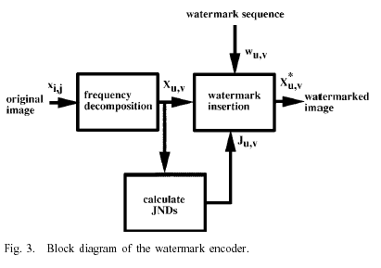
3. let the watermark vector be
X=(x₁…x_{n1,…} xn2,..., x_{nr})
The watermark vector is normally distributed random number of standard deviatation .6 and means .4. The size of the watermark is 132*132.
4. Then the watermark corresponding to resolution r (1≤r ≤R) is Xr = {x₁,…., xnR}
With n_{r} = N²/ 2^{2(R-r)} – N²/ 2 ^{2R}

5. To insert the watermark X into the high pass wavelet coefficient, we collect them in vector V, and insert watermark X into V to obtain V according to formula
V_{i}  = Vi (1+α_{i}, xi)
αi = scaling factor

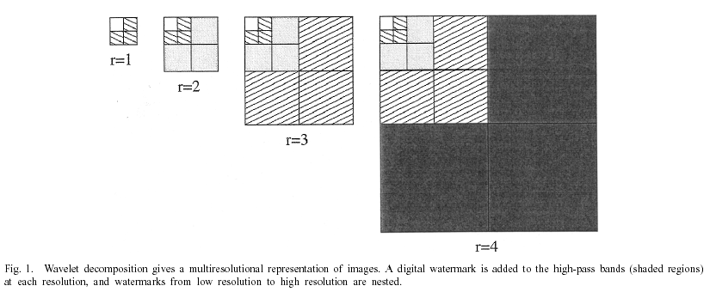

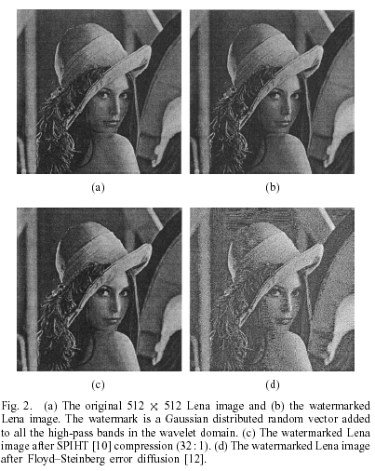
This nonlinear insertion procedure adapts the watermark to the energy preset in each wavelet coefficient. It draws an analogy to spread spectrum in communication.
[4.4]. DETECTION TECHNIQUE OF WATERMARK:
1. The watermark is detected from each level from all the frequency decomposition in which it is inserted.
2. First the watermark is removed from all the high pass band of first level. In the detection of the watermark from the first level it is found that from the entire band
The exact value of watermark is detected.
3. Again the same procedure is repeated for detecting the watermark from the second level. From the second level the exact value of watermark is also detected.
4. To verify the detection the correlation coefficient between the original and extracted watermark is done.
5. The value of correlation coefficient is found to 1 as it leads to true value of watermark detection.
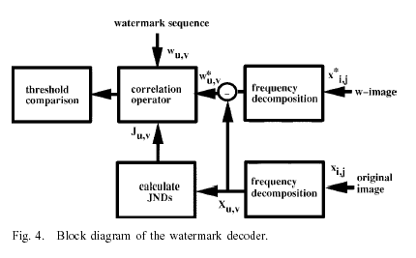
6. To verify the detection I have made a plot which is similar to the plot shown below,
The mat lab plot is shown in the result part of the project.
7. In my project I have made the fix value of scaling factor ai = .3
[4.5] .EXPERIMENTAL RESULT:
1. After performing the watermarking operation we have gone through the certain image processing operation like scaling attack, rotating, cropping, average filtering etc.
2. In different attack the correlation value of watermark is calculated. In some attack the value is found is to be greater than one. But in some attack it is found to be less than one.
3. Median filtering does not distort the watermark picture to much. Average filtering also does not affect the watermark picture.
4. Blurring and scaling attack is more towards the watermark image. In these cases the value of correlation coeff is found to be less the one.

For still images (e.g., the 512 512 Lena image), we consider set partitioning in hierarchical trees (SPIHT) compression[10] and error diffusion [12] of the watermarked Lena image and test the effectiveness of our proposed multiresolution watermarking scheme. Fig. 2(a)–(c) shows the original Lena image, the watermarked Lena image with a PSNR of 42.77 dB, and the watermarked Lena image after SPIHT compression
(32: 1) with a PSNR of 33.48 dB, respectively. We choose a medium compression ratio of 32: 1, as the visual quality for images is usually high in Web applications. Fig. 2(d) is the watermarked Lena image after Floyd–Steinberg error diffusion in four resolutions [12]. Detector responses of watermarks (64 to 512512) of the compressed Lena and 100 randomly generated watermarks are shown in Fig. 3.
The single peak values of similar resolutions are 23.30, 37.97, 49.70, and 52.17. We can easily identify the watermark we added at each resolution
SIMILARTY OF WATERMARK:--
It is highly unlikely that the extracted mark X* will be identical to the original mark. Even the act of requantization the watermark document for delivery will cause X* to deviate from X.
We measure the similarity between X and X* by
Sim (X, X*) = X*. X/√ X*.X*

[4.6] MULTIRESOLUTION WAVELET TRANSFORM TECHNIQUE FOR WATER
MARKING:
Several digital watermarking algorithms have been proposed with different contributions [1]–[15]. Roughly speaking, these contributions can be categorized according to their casting/processing domain, signal type of the watermark, and hiding position. Two processing-domain categories, the spatial-domain and the frequency-domain watermarking, have been proposed. The earlier watermarking techniques are almost spatial-based approaches the simplest example is to embed the watermark in the least significant bits (LSBs) of image pixels A variety of improvements were proposed against image compression and filtering . However, these techniques still have relative low-bit capacity and are not resistant enough to lossy image compression and other image processing. For example, a simple image cropping operation may eliminate the watermark.
In contrast to the spatial-domain-based watermarking, frequency-domain-based techniques can embed more bits of watermark and are more robust to attack; thus, they are more attractive than the spatial-domain-based methods. Cox et al. [7] used the spread spectrum communication for multimedia watermarking. They embedded sequences of
Independent and identical distributed random number drawn from a Gaussian distribution into the perceptually most significant frequency components of an image.

In most previously proposed wavelet-based watermarking techniques [7], [10]–[12], [17]–[21], the watermark is a random sequence of bits, and can only be detected by employing detection theory. Detection involves retrieving the watermark by subtracting the original image from the watermarked image. There fore, an experimental threshold value is chosen and compared to a sharp peak in the cross-correlation coefficient to determine whether the image is watermarked. In this paper, we propose a wavelet-based watermarking approach by adding visually recognizable images to the large coefficients at the high and middle frequency bands of the DWT of an image. The proposed approach has the following advantages: 1) the extracted watermark is visually recognizable to claim one’s ownership; 2) the approach is hierarchical and has multi resolution characteristics; 3) the embedded watermark is hard to detect by human visual perceptivity; and 3) the approach matches the upcoming image/video compression standards. Our experimental results show that the proposed watermarking approaches is very robust to image compression and complicated image distortions. The remaining sections of this paper are organized as follows. Watermarking in the DWT domain is described below. Next paragraph describes the watermark embedding approach and the extraction method.

[4.7] A WAVELET TRANSFORM OF IMAGES:
The wavelet transform is identical to a hierarchical sub band system, where the sub bands are logarithmically spaced in frequency. The basic idea of the DWT for a two dimensional images described as follows. An image is first decomposed into four parts of high, middle, and low frequencies (i.e., LL1, HL1, LH1, HH1 sub bands) by critically sub sampling horizontal and vertical channels using sub band filters. The sub bands labeled HL1, LH1, and HH1 represent the finest scale wavelet coefficients. To obtain the next coarser scaled wavelet coefficients, the sub-band LL1 is further decomposed and critically sub sampled. This process is repeated several times, which is determined by the application at hand. An example of an image being decomposed into ten sub bands for three levels is shown in Fig. Each level has various bands information such as low–low, low–high, high low, and high–high frequency bands.

Fig. 5. DWT decomposition of an image. Note that the arrow points from the parent sub band to its children sub band. The lowest frequency sub band is at the top left and the highest frequency sub band is at the bottom right. A wavelet tree consisting of all Descendants of a single coefficient in the sub band LH3 is also given.

Fig 6. A real case of DWT decomposition. (a) The original 512_512 Lena image (b) Its DWT decomposition

Furthermore, from these DWT coefficients, the original image can be reconstructed. This reconstruction process is called the inverse DWT (IDWT). If I(m,n) represents an image, the DWT and IDWT for I(m,n) can be similarly defined by implementing the DWT and IDWT on each m and n dimension and separately. An original 512 * 512 Lena image and its DWT decomposition are shown in Fig. 2.
[4.8] WATERMARKING IN THE DWT DOMAIN:
The proposed embedded digital watermarking can hide visually recognizable patterns in images. The goal of digital watermarking is invisible to human eyes but also robust under different attacks. In the proposed method, watermarks are redundantly embedded in the host image by modifying them in the location of QSWT coefficients. Note that we construct a QSWT for one of three pairs of sub bands (LH3, LH2), (HL3, HL2), and (HH3, HH2). The visually recognizable watermark is the image of binary, gray image, or color image. Watermarking in the DWT domain includes two parts: embedding and extracting.
The algorithm to embed a watermark in the host image is shown at the bottom of the next page. The encoding method is illustrated in Fig. 3.
Step 1:
In the embedding part, we first decompose an image into three levels with ten sub bands of a pyramid structure as shown in Fig. 2. Suppose the size of host image and watermark image are of size p×q and r × s, respectively.
Step 2:
Sub band (LH3, LH2) is selected to be cast, [(HL3, HL2) is alternative], the threshold value of each sub band is chosen by
T1=1/n {x_{p} Median(x₁,x₂,……..x_{i},……x_{n})),x_{i}€ LH3} ,
T2=1/m {x_{r} Median(x₁,x₂,……..x_{i}…….x_{m})),x_{i}€ LH2},
Next, QSWT is found by the algorithm, Finding QSWT as follows.
Algorithm Finding QSWT
K=0
QSWT[k] =Φ
For i=1 to n
For j = 1 to m
If x₃(i ,j) ≥ T1 ; x₃(i ,j) € LH3
If x₂(2*I -1, 2*j -1) ≥ T2 and x₂(2*i-1,2*j)≥ T2 and x₂(2*i,2*j -1)≥ T2 and
X₂(2*i, 2*j) ≥ T2; x2(p, q) € LH2
QSWT[k] ={x3(i, j), x₂(2*I -1, 2*j -1), x₂(2*i-1, 2*j), x₂(2*i, 2*j -1), x₂(2*i, 2*j)}
K = K+1
End If
End If
End for j
End for i
Step 3: Next, we calculate the summation of coefficients of QSWT[i], for i= 1 to k , and
Choose top r×s of the summation of coefficients of QSWT[i].
Step 4:
Sort the gray level of watermarks W in descending order.
Step 5:
In the casting stage, watermarks W are redundantly embedded into sub bands of LH3 and LH2 for robustness. For I 1 to r×s , the watermarks are embedded as follows:
x ₃’(i, j) = x₃(i, j)+a W(k, l)
Where x₃(i, j) is a coefficient of LH3 sub band of host image, w(k,l) is a gray level of digital watermark, a is a scaling parameter, and x ₃’(i, j) is a coefficient of LH3 sub band of watermarked image. Scaling parameter a is to alter to alter x₃(i, j) the perceptual quality of the host image. A large a means that one can perceptually get away with altering x₃(i, j) by a large factor without degrading the host image.
x ₂’(i, j) = x₂(i, j)+aW(k, l)
Where x₂(i, j) = max{x2(i, j), x₂(2*I -1, 2*j -1), x₂(2*i-1, 2*j), x₂(2*i, 2*j -1), x₂(2*i, 2*j)}
Step 6:
Save the embedded position, sub band label, then, we take the two-dimensional IDWT of the modified DWT coefficients and the unchanged DWT coefficients to form watermarked image.

Fig 7.Watermark embedding procedure

[4.9] Watermark Extracting Method:-
On the other hand, the watermarks are detected by using the embedded position and scaling parameter after the wavelet decomposition of the watermarked image and the original image, as follows.

Step 1.
We first decompose a watermarked image X’ and the original image X with DWT into three levels of ten sub bands, respectively,
Y = DWT(X)
Y’=DWT (X’)
Step 2.
We subtract the same index of coefficients of subbandLH3 (or LH2) of Y by the coefficients of sub band LH3 (or LH2) of Y’for the length of watermark. Then, we average and scale down the watermarks
For i 1 to r×s
W_{i}³ = Y_{i}’ (LH3) – Y_{i} (LH3)
W_{i}² = Y_{i}’ (LH2) – Y_{i} (LH2)
Averaging and scaling down the watermark
W_{i =} (W_{i}³ +W_{i}²)/ 2a
Step 3.
After arranging the index of watermarks, we have the extracted watermarks W’.
Step 4.
In our scheme, the extracted watermarks are a visually recognizable image. However, the subjective measurement is dependent on factors such as views. Therefore, we measure the similarity of original watermarks W and extracted watermarks by the standard correlation coefficient as W’.

Fig. 8. Watermark extracting procedure

[4.10 a] On the Robustness against Image Procession Operation:
Sharpen operations are used to enhance the subjective quality. The extracted results are highly similar to the original watermark. Smoothing operations such as median filter are used to decrease spurious effects that may be present in images from a poor transmission channel. The extracted watermark is still visually recognizable.
[b] On the Robustness against JPEG Loss Compression and Mixed Image Processing:
Sharpen and blur operations are used on a watermarked image. Table IV shows that the watermarked image still maintains good quality, and the peak signal-to-noise ratio (PSNR) value of the watermarked image is 35.6. The extracted results are still highly similar to the original watermark.
The PSNR is defined as PSNR = 10 log₁₀ 255²/MSE
Where MSE is the mean-square error between a watermarked (or an attacked watermarked) image and its original image.

[c] On the Robustness Compared to Other Approaches:
As mentioned in Section I, in most previous wavelet-based approaches, for example, [7], [10]–[12], and [17]–[21], the watermark is a random sequence of bits, and can only be detected by employing the detection theory. Such kinds of patterns are less intuitive for representing an organization’s logo. The proposed approach is a wavelet-based watermarking scheme by adding visually recognizable image to the large coefficients at the high and middle frequency bands of the DWT of an image. Hsu and Wu [13] embedded a visually recognizable watermark into an image using DWT.
Both the watermark and the host image are composed of multi resolution representation with different structures and decompressed watermarks of different resolution embedded into the corresponding resolution of decomposed images. The measurement of the similarity of original watermarks and extracted watermarks used in [13] is the normalized correlation (NC) coefficient.

[4.11] A FLOW CHART METHOD OF IMPLEMENTING WAVELET DOMAIN DIGITAL WATERMARKING:
In my project i have implemented the wavelet domain digital watermarking using daubechies filter. The random vector which is added as a watermark is normal distributed random number. A flow chart is given below which shows a quick review of the algorithm.
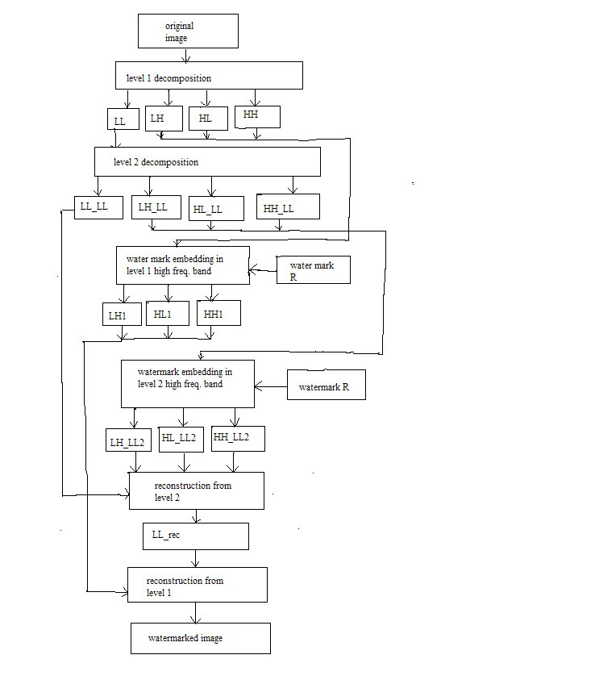

[4.12] A FLOW CHART FOR EXTRACTING THE WATERMARK FROM LEVEL1
FREQUENCY SUB BAND:

LH1, HL1, HH1 are the watermark embedded frequency sub band. In the flow chart the watermark is detected from all the frequency band and its correlation value is found with the original watermark.
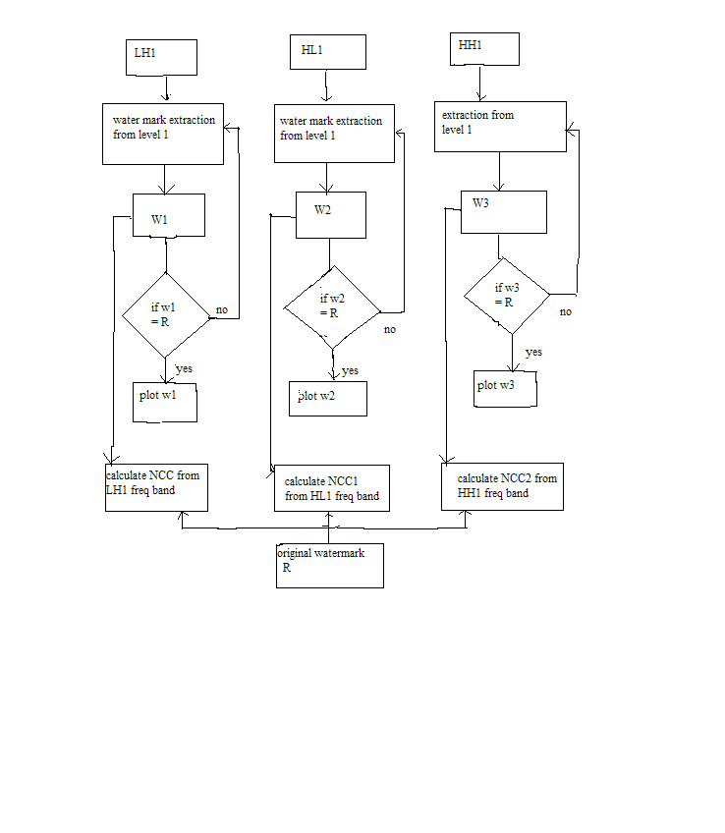

[4.13] A FLOW CHART FOR EXTRACTING THE WATERMRK FROM LEVEL 2
FREQUENCY SUB BAND:
LH_LL2, HL_LL2, HH_LL2 are the watermark embedded frequency sub band. In the flow chart the watermark is detected from all the frequency band from level 2 and its correlation value is found with the original watermark.
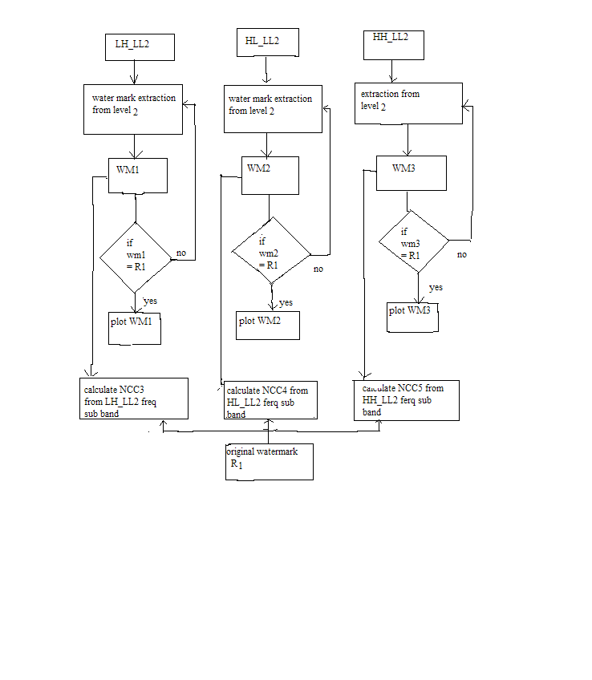

[4.14] A FLOW CHART FOR IMPLEMENTING ATTACK ON THE WATERMARK
IMAGE:

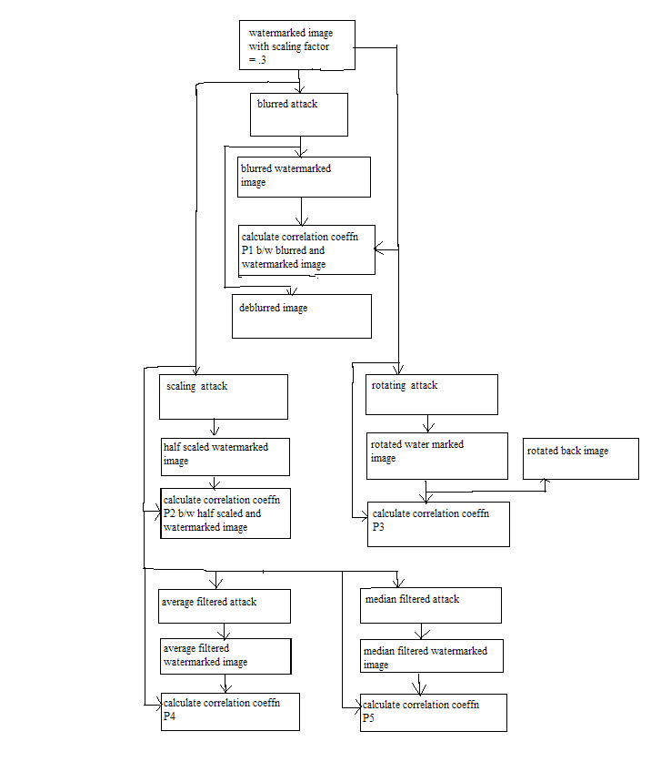

CHAPTER # 5

RESULTS
& DISCUSSION

Fig 5.1 original lena image of size 256 * 256.

Fig 5.2. First level decomposition of original image using daubechies wavelet. The four parts shows the decomposition of image into LL, LH, HL, and HH.

Fig 5.3 the second level decomposed part of the original image using the LL (low low) part of the first level.

Fig 5.4 The above figure shows that watermark is embedded into all the high pass band of first level decomposition. The scaling factor is a_{i} = .3.

Fig 5.5 The above figure shows that watermark is embedded into all the high pass band of second level (l =2) decomposition. The scaling factor is a_{i} = .3.

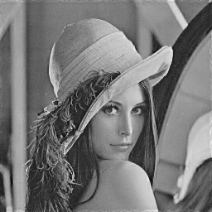
reconstructed image

Fig 5.6 The above figure shows the watermarked image. The watermarking is done at scaling factor value of a_{i} = .3.

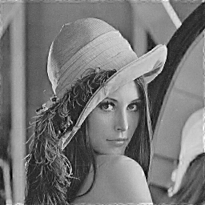
reconstructed image

Fig 5.7 The above figure shows the watermarked image. The watermarking is done at scaling factor value of a_{i} = .5

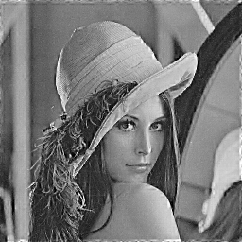
reconstructed image

Fig 5.8 The above figure shows the watermarked image. The watermarking is done at scaling factor value of a_{i} = .7

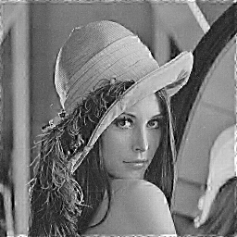
reconstructed image

Fig 5.9 the above figure shows the watermarked image. The watermarking is done at scaling factor value of a_{i} = .9

Fig 5.10 the above figure shows the original watermark which is embedded in the original image. The watermarks R is set of normalized random number standard deviation .6 and mean .4.

Fig 5.11 the above figure shows the extracted watermarked at (level 1) from each frequency sub band in which it is embedded. From the fig 5.10 and fig 5.11 it is clear that the original and extracted water mark are same. Normalized cross correlation values are calculated between original and extracted watermark from each frequency sub band. They are shown in tabulated form in later.

reconstructed image
Fig 5.12(a) watermarked image
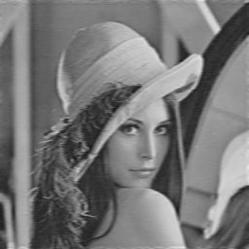
blurred image

Fig 5.12(b) blurred watermarked image at scaling factor = .3

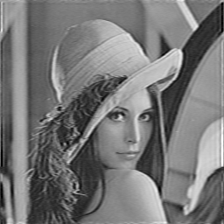
deblurred,true PSF

Fig 5.13(a) The above figure shows the deblurred watermarked image. The deblurring attack is done at scaling factor value a_{i} = .3

Fig 5.13(b) The above figure shows the graph between different random generated watermark and watermark detector response in case of blurring attack. A high peak shows that only a unique watermark can be detected by the watermark detector in each resolution. The value of detector response is 81.38 at scaling factor = .3

Fig 5.14(a) watermarked image at scaling factor value of a_{i} = .3

Fig 5.14(b) Half scaled watermarked image at scaling factor value of a_{i} = .3

Fig 5.14(c) The above figure shows the graph between different random generated watermark and watermark detector response in case of scaling attack. A high peak shows that only a unique watermark can be detected by the watermark detector in each resolution. The value of detector response is 23.84 at scaling factor = .3

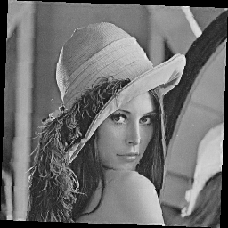
rotated watermarked image
Fig 5.15(a) The above figure shows the rotated watermarked image by 2 degree in counter clockwise direction .The rotating attack is done at scaling factor value a_{i} = .3
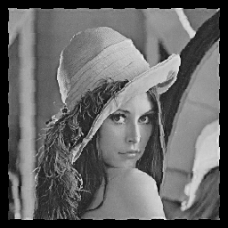
rotated back image

Fig 5.15(b) The above figure shows the rotated back watermarked image. The rotating attack is done at scaling factor value a_{i} = .3

Fig 5.16(a) watermarked image at scaling factor = .3

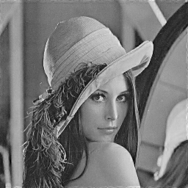
average filtered watermark image

Fig 5.16(b) average filtered watermarked image at scaling factor = .3

Fig 5.16(c) The above figure shows the graph between different random generated watermark and watermark detector response in case of average filtering attack. A high peak shows that only a unique watermark can be detected by the watermark detector in each resolution. The value of detector response is 14.99 at scaling factor = .3

Fig 5.17(a) watermarked image at a_{i} = .3

Fig 5.17(b) median filtered watermarked image at a_{i} = .3

Fig 5.17(c) The above figure shows the graph between different random generated watermark and watermark detector response in case of median filtering attack. A high peak shows that only a unique watermark can be detected by the watermark detector in each resolution. The value of detector response is 131.1 at scaling factor = .3

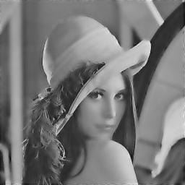
wiener atk image
Fig 5.18(a) wiener attacked watermarked image at a_{i} = .3
Fig 5.18(b) The above figure shows the graph between different random generated watermark and watermark detector response in case of wiener attack. The watermark detector response is 60.93.
[5.19] CALCULATION OF NORMALISED CROSS CORRELATION BETWEEN ORIGINAL WATERMARK ‘R’ AND EXTRACTED WATERMARK ‘W1’ FROM LH SUB BAND OF LEVEL 1:
(i) To calculate the normalized cross correlation coefficient between the original and extracted watermark we use the concept of mathematical formula.
(ii) First we take the multiplication between the original and extracted value for each element in the matrix.
(iii) Then we normalize these values by dividing the value of (R*R) . Where R is the original watermark.
Mathematically
r = r + (R*W1)
c = c + (R*R)
NCC = r/c
Where r = 0; initially
c = 0; initially
R = original watermark
W1 = extracted watermark from LH frequency sub band in resolution level
( l =1).
As the same watermark is extracted from level 1 in LH frequency sub band so the value obtained is NCC = 1.
[5.20] CALCULATION OF NORMALISED CROSS CORRELATION BETWEEN ORIGINAL WATERMARK ‘R’ AND EXTRACTED WATERMARK ‘W2’ FROM HL SUB BAND OF LEVEL 1 :
(i) To calculate the normalized cross correlation coefficient between the original and extracted watermark we use the same procedure as above.
(ii) First we take the multiplication between the original and extracted value for each element in the matrix.
(iii) Then we normalize these values by dividing the value of (R*R) . Where R is the original watermark.
Mathematically
r 1 = r1 + (R*W2)
c1 = c1 + (R*R)
NCC1 = r1/c1
Where r1 = 0; initially
c 1 = 0; initially
R = original watermark
W2 = extracted watermark from HL frequency sub band in resolution level
( l =1).
As the same watermark is extracted from level 1 in HL frequency sub band so the value obtained is NCC1 = 1.
[5.21] CALCULATION OF NORMALISED CROSS CORRELATION BETWEEN ORIGINAL WATERMARK ‘R’ AND EXTRACTED WATERMARK ‘W3’ FROM HH SUB BAND OF LEVEL 1 :
(i) To calculate the normalized cross correlation coefficient between the original and extracted watermark we use the same procedure as above.
(ii) First we take the multiplication between the original and extracted value for each element in the matrix.
(iii) Then we normalize these values by dividing the value of (R*R) . Where R is the original watermark.
Mathematically
r 2 = r2 + (R*W2)
c2 = c2 + (R*R)
NCC2 = r2/c2
Where r2 = 0; initially
c 2 = 0; initially
R = original watermark
W3 = extracted watermark from HH frequency sub band in resolution level
( l =1).
As the same watermark is extracted from level 1 in HL frequency sub band so the value obtained is NCC2 = 1.
Similarly the watermark is extracted from second resolution level in the entire high frequency sub band. The normalized correlation coefficient value is found to be 1 in all the cases as exact watermark is detected. From LH_LL, HL_LL, HH_LL ferquency sub band the value of correlation coefficient is 1.

[5.22] NORMALISED CROSS CORRELATION COEFFICIENT CALCULATION IN VARIOUS ATTACKS ON WATERMARKED IMAGE:
(i) Blurring attack is performed on watermarked image by creating a filter of length l and angle theta .
(ii) The similarity between the watermarked image and attacked watermarked image is found by calculating the correlation over entire dimension of the image.
(iii) The same procedure is obtained as above.
Taking x1 = x1 + (R * Wa)
y1 = y1 + (R * R)
P1 = (x1/y1)
Where x1 = 0; initially
y1 = 0; initially
P1 = correlation coefficient
R = original watermark
Wa = watermark extracted from blurred image
The value of correlation coefficient found in this case is P1 = .69546 for scaling factor a_{i}= .3. The watermarking scheme is robust in this case. For different value of scaling factor different sets of correlation value is found and summarized in the table1 later.

[5.23] NORMALISED CROSS CORRELATION COEFFICIENT CALCULATION IN CASE OF SCALING ATTACK ON WATERMARKED IMAGE:
(i) Scaling attack is performed on watermarked image by resizing the watermarked image to half its original size.
(ii) The similarity between the watermarked image and attacked watermarked image is found by calculating the correlation over entire dimension of the attacked image.
(iii) The same procedure is applied as above.
Taking x2 = x2 + (R * Ws)
y2 = y2 + (R * R)
P2 = (x2/y2)
Where x2 = 0; initially
y2 = 0; initially
P2 = correlation coefficient
R = original watermark
Ws = watermark extracted from half scaled image
The value of correlation coefficient found in this case is P2 = .29206 for scaling factor a_{i}= .3. the correlation value is less which shows that the watermarking scheme is not more robust for scaling attack.

[5.24] NORMALISED CROSS CORRELATION COEFFICIENT CALCULATION IN CASE OF ROTATING ATTACK ON WATERMARKED IMAGE:
(i) Rotating attack is performed on watermarked image by rotating the watermarked image to 2 degree in anticlockwise direction.
(ii) The similarity between the watermarked image and attacked watermarked image is found by calculating the correlation over entire dimension of the attacked image.
(iii) The same procedure is applied as above.
Taking x3 = x3 + (R * Wr)
y3 = y3 + (R * R)
P3 = (x3/y3)
Where x3 = 0; initially
y3 = 0; initially
P3 = correlation coefficient
R = original watermark
Wr = watermark extracted from rotated image
The value of correlation coefficient found in this case is P3 = .23855 for scaling factor a_{i}= .3 the correlation value is less which shows that the watermarking scheme is not more robust for rotating attack also.

[5.25] NORMALISED CROSS CORRELATION COEFFICIENT CALCULATION
IN CASE OF AVERAGE FILTERING ATTACK ON WATER MARKED IMAGE:
(i) Average filtering attack is performed on watermarked image by creating a filter.
(ii) The similarity between the watermarked image and attacked watermarked image is found by calculating the correlation over entire dimension of the attacked image.
(iii) The same procedure is applied as above.
Taking x4 = x4 + (R * Wvg)
y4 = y4 + (R * R)
P4 = (x4/y4)
Where x4 = 0; initially
y4 = 0; initially
P4 = correlation coefficient
R = original watermark
Wvg = watermark extracted from average filtered image
The value of correlation coefficient found in this case is P4 = .0036435 for scaling factor a_{i}= .3 the value of correlation factor is very less,which shows that exact watermark can not be detected in this case.

[5.26] NORMALISED CROSS CORRELATION COEFFICIENT CALCULATION IN CASE OF MEDIAN FILTERING ATTACK ON WATER MARKED IMAGE:
(i) Median filtering attack is performed on watermarked image by creating a filter.
(ii) The similarity between the watermarked image and attacked watermarked image is found by calculating the correlation over entire dimension of the attacked image.
(iii) The same procedure is applied as above.
Taking x5 = x5 + (R * Wmf)
y5 = y5 + (R * R)
P5 = (x5/y5)
Where x5 = 0; initially
y5 = 0; initially
P5 = correlation coefficient
R = original watermark
Wmf =watermark extracted from median filtered image
The value of correlation coefficient found in this case is P5 = .54988 for scaling factor a_{i}= .3 The correlation value is high which shows that the scheme is robust for this attack.

[5.27] NORMALISED CROSS CORRELATION COEFFICIENT CALCULATION IN CASE OF WIENER ATTACK ON WATER MARKED IMAGE:
(i) Wiener attack is performed on watermarked image by creating a filter.
(ii) The similarity between the watermarked image and attacked watermarked image is found by calculating the correlation over entire dimension of the attacked image.
(iii) The same procedure is applied as above.
Taking x6 = x6 + (R * Wnr)
y6 = y6 + (R * R)
P6 = (x6/y6)
Where x6 = 0; initially
y6= 0; initially
P6 = correlation coefficient
R = original watermark
Wnr =watermark extracted from wiener attacked image
The value of correlation coefficient found in this case is P6 = .88038 for scaling factor a_{i}= .3
The above discussion reveals that the watermark is not robust in the case of average filtering and rotating attack. But in blurring attack, median filtering, wiener attack our watermark is more robust. It is some robust for scaling attack. Again for different value of scaling factor the various results are obtained.

[5.28] EFFECT OF INCREASING SCALING FACTOR ON CORRELATION COEFFICIENT CALCULATION FROM DIFFERENT ATTACKS.

Scaling factor a_{i} | Correlation  Coeff.(P1)  In Blurring attack | Correlation  Coeff (P2) in scaling  Attack | Correlation  Coeff (P3) in rotating  Attack | Corr.Coeff (P4)in avg.  Filtering  attack | Correlation  Coeff (P5) in median  Filt.attack | Corr. Coeff(P6)  In wiener  attack
.25 | .64509 | .17708 | .24241 | .0019716 | .51104 | .8377
.30 | .69546 | .29206 | .23855 | .0036435 | .54988 | .88038
.35 | .75073 | .43938 | .23901 | .0074542 | .59561 | .93165
.40 | .81167 | .59436 | .23935 | .014382 | .64536 | .99058

Table1. Relation between the increasing value of scaling factor and correlation coefficient
The table shows that as the value of scaling factor is increased the correlation between the original watermark and the extracted watermark from different attacked images increases. In my project I have fixed the value of scaling factor = .3 . Higher value of scaling factor increases the energy of the watermark. At the scaling factor value above .45 the watermarked picture quality becomes poor and it can be easily determined by anyone that picture has some degraded perceptual quality. I have increased the scaling factor from .25 to .40 at interval of .5 .

[5.29] EFFECT OF INCREASING VALUE OF ATTACK STRENGTH ON CORRELATION COEFFICIENT AT FIXED VALUE OF SCALING FACTOR:
We have analyzed the effect of increasing scaling factor on the correlation. Here i am giving the value of correlation coefficient at different value of attack strength and fixed value of scaling factor.

[5.29 a] IN BLURRING ATTACK CASE:
In this case I have changed the value of length of filter which creates the PSF. By changing the value of length, the input watermarked images have different effect by passing it through filter. For doing filtering this attack requires a special filter design. So we design special filter in MATLAB with fspecial command.

Length ,theta | Scaling factor | Correlation P1
(3,1) | .3 | .69546
(4,1) | .3 | .9542
(5,1) | .3 | 1.193

Table2. Shows that at different value of attack strength the correlation value is increasing.
In the table the scaling factor is same throughout. So we conclude that high value of attack strength makes watermarking robust in the case of blurring attack.
[5.29 b] IN SCALING ATTACK CASE:
In this case I have scaled the watermarked image for .5, .25, .125 size of original image. In each case I have calculated the value of correlation coefficient P1 between the original watermark and the watermark extracted from the scaled image.

Scaling factor of image | Scaling factor | Correlation  P2
.5 | .3 | .29206
.25 | .3 | .17381
.125 | .3 | .17041

Table3. Shows that at different value of attack strength the correlation value is decreasing.
In the above table the correlation value is decreasing. It shows that for higher value of scaling of image the similarity decreases between the original and extracted watermark.

[5.29 c] IN ROTATING ATTACK CASE:
In rotating attack case I rotated the image for different value of angle in counter clockwise direction and for each value I have calculated the correlation between the original and extracted watermark from the rotated image.

Angle theta | Scaling factor | Correlation P3
-1 | .3 | .37349
-2 | .3 | .23855
-3 | .3 | .18261

Table4. Shows that at different value of attack strength the correlation value is decreasing.
In this case when we are increasing the value of angle theta in counter clockwise direction and taking the correlation between the extracted and original watermark, the value of correlation P3 is decreasing. So this attack is not feasible for higher attack strength.
[5.29 d] IN AVERAGE FILTERING CASE:
In average filtering we average filter the watermark image by a multidimensional filter. As I have increased the strength of filter the correlation value is determined and shown below in the table.

Filter F_h | Scaling factor | Correlation P4
(1,1)/1.17 | .3 | .0036435
(2,2)/5 | .3 | .22127
(3,3)9 | .3 | .7875

Table5. Shows that at different value of attack strength the correlation value is increasing.
F_h is a multidimensional filter which filters the input image passed through it. The output pixels are average filtered in neighbor hood of the filter coefficient. The correlation value found is increasing as we are increasing the value of attack strength. So we conclude that the scheme can be robust for higher attack strength.
[5.29 e] IN MEDIAN FILTERING CASE:
In median filtering we median filter the watermark image by a two dimensional filter. As I have increased the strength of filter the correlation value is determined and shown below in the table.

Filter of size  M by N | Scaling factor | Correlation P5
(1,3) | .3 | .54988
(2,3) | .3 | .73347
(4,3) | .3 | .80144

Table6. Shows that at different value of attack strength the correlation value is increasing.
M by N is a two dimensional filter which filter the input image passed through it. The output pixel are median filtered in neighbor hood of M by N of the input image value. The correlation value found is increasing as we are increasing the value of attack strength. So we conclude that the scheme can be robust for higher attack strength.
[5.29 f] IN WIENER FILTERING CASE:
In wiener filter we do the adaptive low pass filtering of the watermarked image. The wiener filter attack removes the noise added to the image. In case we do not include noise the Gaussian noise is added. In this case I have changed the filter dimension and extracted the watermark for each case. The correlation value is given in the next table.

Wiener filter of size M by N | Scaling factor | Correlation P6
(3,3) | .3 | .55025
(5,5) | .3 | .66329
(6,6) | .3 | .88038

Table7. Shows that at different value of attack strength the correlation value is increasing.
M by N is a two dimensional wiener filter which adaptively low pass filter the input image passed through it. The correlation value found is increasing as we are increasing the value of attack strength. So we conclude that the scheme can be robust for higher attack strength.

CONCLUSION:-
In my project work the technique which I have implemented is in image domain. The spatial domain watermarking technique has good embedding and extracting feature on the watermarked image. But main disadvantage of spatial domain technique is that many images processing operation such as cropping and filtering may eliminate the watermark. So frequency domain technique is more robust against ordinary image processing operation and lossy compression. Image adaptive scheme are more robust, as they exploit properties of human visual system in order to provide extremely high quality Original content while providing an effective means of protecting robustness to attacks. As wavelet has hierarchical nature so its multi resolution analysis helps to embed the watermark in n no. of levels. The watermarking scheme is robust against towards blurring, wiener and median filtering attack. As same watermark is retrieved from the entire frequency band so the value of NCC is 1 in all cases. At higher value of scaling factor the correlation coefficient value is high. This shows that robustness increases with increasing scaling factor but with not degrading the perceptual quality of image.

FUTURE WORK:
In this project I have done the decomposition of original image at second level. After second level decomposition the embedding is done in all the high pass band of frequency.
The future work of this project is to embedding the watermark and extracting the watermark at higher level. At more than one level the wavelet multi resolution structure gives better result in comparison to lower level. In embedding I have generated the normalized random number vector sequence of standard deviation .6 and mean .4. The future work of this is to take different value of standard deviation and mean and do the watermarking for all those values. Different values will give the different watermarked image. We should compare each watermarked image for which the value of mean and deviation gives the better result. Also other attack should be done on the watermarked image so that the effect of each attack will be analyzed correlation values will be calculated. In future the new multi wavelet could be better than the wavelet in case of watermarking application. Multi wavelets are the more modified form of wavelet in which the number of scaling and wavelet function is more than the wavelet case. But the problem with the wavelet is that we will have to design a pre and post filter for the multi wavelet.

REFERENCE:-
[1]. Samuel cheng, Qiang Wu, “Non ubiquitous watermarking for record indexing and integrity protection of medical images”.
[2]. Xia-mu, Shang-he sun, “Adaptive gray level digital watermarking”. Proceedings of
ICSP 2000
[3].Wenwu zhu, Ya-Qin zhang, “Multiresolution watermarking for image and video” IEEE transaction on circuit and system for video technology vol-9, No.4
[4].Chin-chen chang, kuo- Fen Hwang, “ A watermarking technique based on one way hash function” IEEE transaction on consumer electronics vol-45 ,No.2
[5]. an overview of image watermarking algorithm.
[6]. Christine I.podilchuk, Wenjun zeng, “Image adaptive watermarking using visual model” IEEE journal on selected areas in communication vol-16, No.4
[7]. Raymond B. Wolfgang, Edward J.DELP, “Perceptual watermarking for digital image and video” Proceedings of IEEE vol-87, N0.7 July 1999
[8] .J.zhang, Anthony T.S. Ho, “An efficient digital image in image watermarking algorithm using the integer DCT” ICICS-PCM 2003 15 -18 dec-2003
[9]. I.J.Cox, J.killan,Thomson Leighton, “ Secure spread spectrum watermarking for multimedia” IEEE transaction on image processing vol-6,No-12
[10]. Xia-mu Nlu, sheng ho sun, “Digital watermarking of still images with gray level digital watermark”.
[11]. Pei Min chen,”A robust DWM based on statistic approach”.
[[12].chuan-Fu, Wu, Wen-shyong Hsiesh,” DWM using zero tree of DCT”.
[13] Christopher. Fleming, Bijan J. Mobasseri, “Rotationally robust data hiding in JPEG images using a tunable spreading function”.
[14]. Arun Kajriwal, “Watermarking”
[15]. Giuseppe caccia, Rosa Lancini , “Data hiding in MPEG2 bit stream domain”.
[16]. Mohd.A Suhail, Mohd. S.Qbaidat, “DWM based DCT and JPEG Model”. IEEE transaction on instruments and measurement vol 52,No. 5
[17]. Z.H.nel, Y.Q.Fu, “Perceptual DWM of images using wavelet transform”.
[18]. Taehun, Chung, Min-suk Hong, “DWM for copy right protection of MPEG 2 compressed video”.
[19]. Xia-mu, Nlu, “Multiresolution watermarking for still images”.
[20]. Young cong Chen, Long, wen cheng, “A secure and robust DWM tech by block cipher RC6 and secure hash algorithm”.
[21]. Jana Dittaman, “Interactive watermarking environment”
[22].Ionians Pitas, “A method for watermark casting on digital images”. IEEE transaction on ckt and system for video tech vol 8 No.6
[23]. Gwo-chin Tai, “A novel public watermarking for still images based on encryption algorithm”.
[24]. Yoonki choi, “DWM using inter block correlation: Extension to JPEG coded domain”
[25]. M Barni , F . Bartolini ,”A DCT domain system for robust image watermarking”
[26]. R. G. Schyndel, A. Z. Tirkel, and C. F. Osborne, “A digital watermarking,” in Proc. ICIP94, 1994, vol. 2,
[27] W. Bender, D. Gruhl, and N. Morimoto, “Techniques for data hiding,”in Proc. SPIE, vol. 2420, 1995.
[28] I. Cox and M. L. Miller, “A review of watermarking and the importance of perceptual modeling,” in Proc. SPIE, 1997, vol. 3016,
[29] X.-G. Xia, C. G. Boncelet, and G. R. Arce, “A multiresolution watermark for digital images,” in Proc. ICIP97, Santa Barbara, CA, 1997,vol. I,
[30] F. Hartung and B. Girod, “Digital watermarking of MPEG-2 coded video in the bitstream domain,” in Proc. ICASSP97, 1997, vol. 4,
[31] M. Swanson, B. Zhu, B. Chau, and A. Tewﬁk, “Object-based transparent video watermarks,” in Proc. IEEE Workshop Multimedia Signal Processing, Princeton, NJ, June 1997
[32] A. Said and W. A. Pearlman, “A new, fast, and efﬁcient image codec based on set partitioning in hierarchical trees,” IEEE Trans. Circuits Syst. Video Technol., vol. 6, June 1996.
[33] W. A. Pearlman, B.-J. Kim, and Z. Xiong, “Embedded video subband coding with 3D SPIHT,” in Wavelet Image and Video Compression, P.Topiwala, Ed. Norwell, MA: Kluwer, 1998.
[34] R. A. Ulichney, Digital Halftoning. Cambridge, MA: MIT Press, 1987.
[35] I. Pitas, “A method for watermark casting on digital images,”IEEE Trans. Circuits Syst. Video Technol., vol. 8, Oct.1998.
[36] J. Li and S. Lei, “Arbitrary shape wavelet transform with phase alignment,” in Proc. ICIP’98, Chicago, IL, Oct. 1998.
[37] S. Li, W. Li, H. Sun, and Z. Wu, “Shape adaptive wavelet coding,” in Proc. IEEE ISCAS’98, 1998,

www.google.com
www.ieeexplore.ieee.org

