VOLTAGE AND FREQUENCY CONTROL OF WIND GENERATION SYSTEM

A MAJOR PROJECT
SUBMITTED IN PARTIAL FULFILLMENT OF REQUIREMENTS
FOR THE AWARD OF THE DEGREE OF
MASTER OF ENGINEERING
(CONTROL & INSTRUMENTATION)

Submitted by
Deepali Rane
University Roll No. 10213

Under supervision of

Prof. Madhusudan Singh
Electrical Engineering Department



Delhi College of Engineering
University of Delhi
Delhi-110007
2008

CERTIFICATE

This is to certify that the major project titled, “VOLTAGE AND FREQUENCY CONTROL OF WIND GENERATION SYSTEM”, submitted by Deepali Rane in the partial fulfillment of requirements for the award of the degree of Master of Engineering (Control and Instrumentation) of the Electrical Engineering Department, Delhi College of Engineering, Delhi-110042, is a bonafide record of work that she has carried out under my guidance and supervision.

Dr. Madhusudan Singh.
Professor,
Electrical Engineering Department,
Delhi College of Engineering,
Delhi-110042.

ACKNOWLEDGEMENTS

I take this opportunity to express my sincere thanks and heartful gratitude to my project supervisor Prof. Madhusudan Singh. It was his repeated encouragement, supervision, and invaluable guidance that helped me in completing this project. I am deeply indebted to him for giving clarity of vision and thought which enabled me to complete the project.

I would also like to extend my sincere thanks to Prof. Parmod Kumar, H.O.D, Electrical Engg. Department, for his continous encouragement through out my M.E. course at DCE, Delhi.

I am deeply grateful to my husband, Abhay, for his patience, understanding, and for being a constant source of motivation throughout the year.

Lastly, my heartfelt appreciation goes to all those who directly or indirectly helped me to make this project a success, especially my friends Qateef and Ajayta.

Deepali Rane
M.E. (C& I)
University Roll No: 10213

VOLTAGE AND FREQUENCY CONTROL OF WIND GENERATION SYSTEM

CONTENTS

ABSTRACT
CHAPTER I: INTRODUCTION 1-15
1.0 General 1
1.1 Wind Generation System 1
1.1.1 Wind Turbine 2
1.1.2 Induction Generator 6
i) Grid connected induction generator 7
ii) Self-excited induction generator 12
1.1.3 Static Synchronous Compensator 13
1.2 Outline of Chapters 14
CHAPTER II: LITERATURE SURVEY 16-28
2.0 General 16
2.1 Literature Survey 16
2.1.1 Development in Wind Energy System 16
2.1.2 Wind Energy Integration with Hydro 19
2.1.3 Development in Induction Generator Technology 22
2.1.4 Solid State Reactive Power Controllers 25
2.2 Scope of present work 28
CHAPTER III: MODELING OF WIND GENERATION SYSTEM 29-49
3.0 General 29
3.1 Description of a Wind Generation System 29
3.2 Mathematical Modeling of Wind Generation System 30
3.2.1 Terms related to Wind Turbine 30
3.2.2 Wind Turbine Model 32
3.2.3 Wind Turbine Pitch Angle Control 35
3.3 Mathematical Model of Induction Generator 37
3.3.1 Process of Self-Excitation 37
3.3.2 Effect of external capacitance and load impedance 39
3.3.3 Effect of speed variation on performance of IG 40
3.3.4 Dynamic d-q axis model of SEIG 41
3.4 Model of STATCOM 44
3.5 Conclusion 49
CHAPTER IV: MATLAB SIMULATION OF WIND GENERATION SYSTEM
4.0 General 50
4.1 MATLAB Model of Wind Turbine 51
4.2 MATLAB Model of Induction Generator 52
4.3 MATLAB Model of STATCOM 54
4.4 MATLAB Model of Wind Generation System 59
4.5 Conclusion 60
CHAPTER V: RESULTS AND DISCUSSION 61-65
5.0 Simulation 61
5.1 Performance of Wind Generation System with Wind Speed 61
5.2 Performance of Wind Generation System along with a SG 63
5.3 Performance of Wind Generation System along with STATCOM 64
5.4 Conclusion 65
CHAPTER VI: CONCLUSION AND FUTURE SCOPE OF WORK 66
6.0 Conclusion
6.1 Future Scope of Work
REFERENCES 67-69
APPENDIX 70

ABSTRACT

In this project a strategy for controlling the voltage and frequency of a wind generation system is presented. A mathematical model of wind generation system and synchronous generator has been developed and MATLAB model of the integrated system is developed for simulation studies under varying load conditions. It is found that a wind generation system along with a synchronous generator and STATCOM is able to maintain the voltage and frequency of the system constant. The synchronous generator helps in reducing the reactive power supplied by STATCOM and hence a reduced capacity STATCOM could be used for the purpose. Induction generators are increasingly being used in non-conventional energy systems such as wind, micro/mini hydro systems. Major advantages of induction generator are reduced unit cost and size, ruggedness, brushless, absence of separate dc source, ease of maintenance, self-protection against severe overloads and short-circuits, etc.
In the proposed scheme, the induction generator is connected in parallel with a synchronous generator. The synchronous generator has an exciter, which provides a fixed excitation to produce normal rated terminal voltage at full resistive load. On the other hand, the induction generator is driven by a wind turbine. A static compensator (STATCOM) is connected to the common bus for terminal voltage and frequency control. In the absence of STATCOM, the synchronous generator is required to generate the reactive power demanded by the load as well as induction generator. The STATCOM supplies the reactive power demanded by the load so that the reactive power generation of the synchronous generator does not exceed its capability limit. The synchronous generator is driven by constant mechanical power input of 1 pu. When the consumers load changes, the chopper on the dc side of the STATCOM controls the active power consumed by the dump load so that the total load on the generator remains constant and equal to its full load capacity thus by resulting in constant speed and constant frequency operation.

CHAPTER I
INTRODUCTION

- GENERAL
The wind is a free, clean, and inexhaustible energy source. It has served mankind well for many centuries by propelling ships and driving wind turbines to grind grain and pump water. Many people think there is enough coal for several centuries. But the rapidly increasing demand for electrical energy and the consequent depletion of fossil fuels namely oil and coal has led to the worldwide interest in developing wind power plants.
Nuclear power generation was once treated with great optimism, but with the knowledge of the environmental hazard associated with possible leakage from nuclear power plants, most countries have decided not to install them any more.
Moreover, some countries like Denmark, lacked adequate fuel and water-power resources, which led them to look for alternative ways of generating electricity. The growing awareness of these problems led to heightened research efforts for developing alternative sources of energy for generation of electricity.
Traditionally, wind generation systems used variable pitch constant speed wind turbines (horizontal or vertical axis) that were coupled to cage type induction generators or wound-field synchronous generators, and fed power directly to utility grids. Recently, variable speed wind turbine (VSWT) system that processes power through power electronic converters has found more acceptance.

  - WIND GENERATION SYSTEM
Wind power uses the force of the wind to drive a turbine which drives a generator to produce electricity. Wind power is renewable because it is created by the energy from the sun that drives the earth's weather patterns. Typically, turbines are clustered in "wind farms" scattered throughout reliably windy areas and often share space with productive agricultural lands. These large installations supply electricity to regional power grids for sale to homes and businesses. Smaller installations to meet specific needs are also common where grid electricity is not available. Wind farms, like other large scale electricity generation facilities, are connected to the electricity grid. It is delivered to homes and businesses just like other sources of electricity.

1.1.1 WIND TURBINES
A wind turbine is a rotating machine which enables the conversion of kinetic energy in wind into mechanical energy. If the mechanical energy is used directly by machinery, such as a pump or grinding stones, the machine is usually called a windmill. If the mechanical energy is then converted to electricity, the machine is called a wind generator, wind turbine, wind power unit (WPU), or wind energy converter (WEC).
Virtually all modern wind turbines convert wind energy to electricity for energy distribution. The turbine can be divided into three components. The rotor component, which is approximately 20% of the wind turbine cost, includes the blades for converting wind energy to low speed rotational energy. The generator component, which is approximately 34% of the wind turbine cost, includes the electrical generator, the control electronics, and most likely a gearbox component for converting the low speed incoming rotation to high speed rotation suitable for generating electricity. The structural support component, which is approximately 15% of the wind turbine cost, includes the tower and rotor pointing mechanism
For a given temperature and pressure, the power contained in the wind at a particular site is proportional to the cube of the wind speed. Ideally, the maximum power that a turbine can extract is 0.593, the Betz coefficient, times the power contained in the wind. However, the maximum extractable power from a practical turbine is limited to 35 – 40 % of the wind power. For a given turbine, this limit is achievable for a specific ratio of the turbine’s rotational speed to the wind speed. At other ratios, the turbine output reduces. So, with constant change in wind speed, a natural occurrence, it is desirable for the turbine speed to be adjustable to the wind speed in order to maximize the output.

Classification of Schemes:
Broadly, four different systems are used for generation of electricity from wind power.

- Constant-Speed Constant-Frequency Generation
The generation scheme in this category is based on fixed-speed technology. The horizontal-axis wind turbine, whose speed can be controlled by using a pitch-control mechanism, operates at a constant speed and drives, through a gear-box, a synchronous or an induction generator that is connected to the power network.
A constant-speed wind turbine can achieve maximum efficiency at the speed that gives the tip speed ratio the value corresponding to the maximum power coefficient C_{p,opt}. Its main weakness lies in its poor energy capture from the available wind power at other wind speeds. Moreover, a pitch control mechanism adds considerably to the cost of the machines and stresses the operating mechanism and the machines.
- Near-Constant-Speed Constant-Frequency Generation
In this scheme, induction generators feed power to the utility network at variable slip. Here, also the generators are driven by horizontal-axis wind turbines but with a less stringent pitch angle controller, which can maintain small values of slip.
- Variable-Speed Variable-Frequency Generation
This scheme employs capacitor self-excited three-phase or single-phase induction generators for small-scale power generation as a source of isolated supply to feed frequency-insensitive loads.
- Variable-Speed Constant-Frequency Generation
Wind turbines are basically variable speed prime movers. This category implies a wide and continuous range of variable-speed operation of the turbine and the processing of power ultimately at the synchronous frequency of the utility system. Variable-speed operation of wind turbines offers several benefits. So there is a general trend now towards generation schemes employing variable-speed turbines. There are many reasons for such a choice, which may be briefly summarized as follows.
- Continuous operation of wind turbines at the optimum tip speed to wind ratio by changing the rotor speed with the wind velocity. This increases energy capture even under low wind conditions.
- Reduction in noise emission from wind turbine at low wind speeds.
- Reduction in the size and weight of the gear box, or its total elimination, together with the associated noise.
- The possibility of power smoothing due to the inertial energy storage in the turbine rotor as the wind gusts above the average level. With reduction in the wind speed, the power flow level in the network can be maintained by deriving additional energy from the inertia of the system. The time trace of the power output of a constant speed wind turbine is characterized by high frequency fluctuations superimposed on power variations owing to the short-term wind fluctuations and inherent time lag in the wind turbine control system. On the other hand, the time trace of the power output of a variable speed system is considerably smoother due to the rotor flywheel effect.
The variable shaft speed leads to variable voltage, variable frequency output from the generator, in general. However, in certain systems, the output voltage magnitude can be maintained constant, or within a range, by a voltage regulating system.
The variable-voltage, variable-frequency system requires efficient power electronic ac/dc/ac converters for interfacing with the utility system. Converters using power electronic devices have good dynamic performance, and can provide high quality sine wave current in the generator and the power network. They can also help to control the real as well as the reactive power of the system.
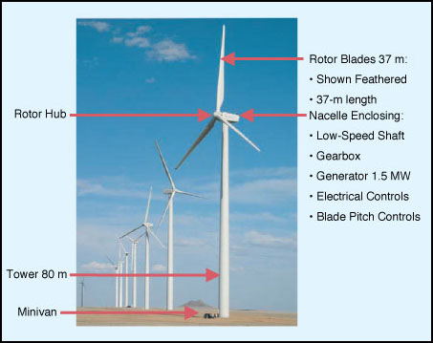

Fig.1.1, A modern wind turbine installed in a wind farm.
Fig.1.1, shows a schematic diagram of a wind turbine along with a nacelle is installed over a tall tower of height 60 – 80m. Modern wind turbines deployed throughout the world today have three-bladed rotors with diameters of 70m to 80m. The turbine power output is controlled by rotating the blades about their long axis to change the angle of attack with respect to the relative wind as the blades spin about the rotor hub, which is referred to as “ controlling the blade pitch “. The turbine is pointed into the wind by rotating the nacelle about the tower, which is called “yaw control“. Almost all modern turbines operate with the rotor positioned on the windward side of the tower, which is referred to as an “upwind rotor”. Wind sensors on the nacelle tell the yaw controller where to point the turbine, and, when combined with sensors on the generator and drive train, tell the blade pitch controller to regulate the power output and rotor speed and to prevent overloading structural components.
The fig. 1.2, shows the power curve for a typical modern turbine and illustrates the different control regions for the turbine. Typically, a turbine will cut in and begin to produce power at a wind speed of about 12 mph. It will reach its rated power at about 28 to 30 mph, where the pitch control system begins to limit power output and prevent overloading the generator and drive train. At around 50 mph, the control system pitches the blades to stop rotation (which is referred to as feathering the blades) to prevent overloads and damage to the turbines components.

Fig. 1.2, A typical power output versus wind speed curve.
1.1.2 WIND GENERATORS
In the early days, dc generators were used, which still find application in low-voltage, low-capacity wind power systems charging storage batteries to operate lights and small appliances. For larger machines, dc machines have been phased out, mainly due to the problems associated with commutators. Ac generators, namely, induction and synchronous generators are used by all major wind turbine manufacturers. Hence it is necessary to study ac generators in detail to understand their operation with wind turbines.
There are two ways of exciting an induction generator. Based on the method of excitation, induction generators are classified into two basic categories, namely,
- Constant-voltage, constant-frequency generators and
- Variable-voltage, variable-frequency generators.
There are other ways of classifying induction generators, but these are generally related to the method of operation of the machine, based on certain control schemes.

Fig. 1.3, Induction generator feeding to a utility grid with exciting capacitor.
In the constant-voltage, constant-frequency category, the generator derives its excitation from the utility bus as shown in fig. 1.3. Such induction generators are called as “Grid Connected Induction Generators (GCIG) “. The generated power is fed to the supply system when the rotor is driven above the synchronous speed. Machines with a cage-type rotor feed only through the stator and generally operate at low negative slip. But wound rotor machines can feed power through the stator as well as the rotor to the bus over a wide speed range.

Fig. 1.4, Self-excited induction generator feeding a load.
The fig. 1.4, presents the second type, which is analogous to a self-excited dc generator. A capacitor, when connected across the induction machine, helps build up the terminal voltage. Such induction generators are called as “Self-Excited Induction Generators (SEIG)”. But the build-up of voltage also depends on factors such as speed, capacitor value, and load. The squirrel cage machine is generally used as a self-excited induction generator.
With the stator winding remaining connected to the utility gird, if the rotor is driven by a prime mover above the synchronous speed in the direction of the air-gap field, the mechanical power of the prime mover is converted into electrical power.

i) Grid Connected Induction Generators (GCIG)
The grid connected induction generators can be divided into two types, i.e., single output system and double outputs system.
- Single Output System
The system in general sense implies the use of the squirrel cage induction generator, which provides the power output only through the stator winding. The generator always draws reactive power from the network. Capacitors are used to compensate this lagging VAR. These capacitors may cause the induction machine to self-excite, leading to over voltages at the time of the disconnection of the wind turbine from the electrical system if proper protective measures are not taken.
a) Fixed-speed System: As the induction generator is coupled to the grid, its speed varies over a very small range above the synchronous speed, usually around 1%. As the speed variation is small, the system is commonly known as a fixed-speed system. For such a system the tip speed ratio varies over a wide range, making the rotor efficiency suffer at wind speeds other than the rated wind speed. The gear box ratio is selected for optimal value of power coefficient for the most frequent wind speed. In a well-designed system, fixed-speed operation can extract about 80% of the energy available from a fully variable speed system over a year. Fixed speed wind turbines employing either blade pitch regulation or stall regulation to limit the power at high wind speeds are used. It is necessary to do so because if the input mechanical power is more than the power corresponding to the pull-out torque, the system becomes unstable.
In a pitch regulated system the electrical output power is regulated by a control system, which alters the blade pitch angle to extract the maximum energy at wind speeds below the rated wind speed; the power output is governed towards a limiting value at wind speeds above the rated speed. With stall regulation the blades are set at a constant pitch angle and the turbine enters the stall mode at high wind speed, thereby limiting the output power. Stall control is commonly applied in fixed-speed generators.
Appreciable generation at low wind speeds require reduced rotor speed. To achieve this, one can use a two-speed cage-type induction generator with a stator winding arrangement for two different number of poles. The large number of poles is for low wind speed and small number of poles is for high wind speed. An appropriately designed two speed system can extract as high as 90% of the energy obtainable from a 100% variable-speed system over a year. With a two-speed system, the audible noise at lower wind speeds is reduced.
Usually, the turbine accelerates the induction machine to synchronous speed using wind power; the machine is then connected to the grid. The direct connection of an induction machine to the supply produces high inrush current, which is undesirable, particularly in the case of electrical networks with low fault tolerance levels. Such a connection can also cause torque pulsations, leading to gear box damage. In order to reduce the magnetizing current surge, soft-starter circuits utilizing phase-controlled anti parallel thyristors are frequently employed to control the applied stator voltage when the induction machine is connected to the network. A few seconds later when the normal current is established, these starting devices are bypassed.
b) Semi-Variable-Speed Operation: The advantages of a grid connected fixed-speed squirrel cage generator are its lower capital cost, simple system configuration and robust mechanical design. As the rotor speed is nearly constant, fluctuations in wind speed result in torque excursions, which may lead to unwanted grid voltage fluctuation and strains on the turbine components. Wind gusts in particular lead to large torque variations.
Limited variable-speed operation in this single-output system can bring down the pulsations in grid power and mechanical stress. If some of the generator shaft input can be dissipated in the rotor, the grid input power can be levelled under fluctuating wind speed conditions. The rotor electrical power is proportional to the slip. It then becomes possible to achieve speed control of energy dissipated in the rotor resistor. The variation of rotor resistance with speed keeps both the rotor current and the air-gap power constant. Hence the main aim of the control strategy will be to keep the rotor current at a set value, irrespective of the speed variation within a range, for constant power output from the stator.
- Double-Output System
With a slip-ring induction machine, power can be fed into the supply system over a wide speed range by appropriately controlling the rotor power from a variable-frequency source. The provision for bidirectional flow of power through the rotor circuit can be achieved by the use of a slip-ring induction motor with an ac/dc/ac converter connected between the slip-ring terminals and the utility grid. The basic configuration of the system is shown in the fig. 1.5. The system is known as as a double output induction generator (DOIG) because power can be tapped both from the stator and from the rotor.

Fig. 1.5, Double-output induction generator system.

Fig. 1.6, Double-output system with direct current link.
a) Double-Output System with a Current Converter Fig. 1.6, presents the main components of the solid-state system for the controlled flow of slip power at variable speed through current converters. The intermediate smoothing reactor is needed to maintain current continuity and reduce ripples in the link circuit. For the transfer of electrical power from the rotor circuit to the supply, converters I and II are operated, respectively, in the rectification and inversion modes. On the other hand, for power flow in the reverse direction, converter II acts as a rectifier and converter I as an inverter. The step-down transformer between converter II and supply extends the control range of the firing delay angle of converter II.
The firing delay angle of converter I on the rotor side controls the phase difference between the injected rotor phase voltage and the rotor current, while the delay angle of converter II on the line side dictates the injected voltage into the rotor circuit.
b) Double-Output System with a Voltage Source Inverter The drawbacks of naturally commutated or line-commutated converters and low-frequency forced-commutated converters can be overcome by the use of dual PWM voltage-fed, current-regulated converters, connected back to back, in the rotor circuit, as shown in the fig. 1.7.
Fig. 1.7, Power flow in slip power control scheme with dc link voltage.
PWM converters with dc voltage link offer the following characteristics:
i) Realization of the field-oriented control principle for decoupled control of the generators active and reactive power.
ii) Low distortion in stator, rotor, and supply currents, owing to the shift of the harmonic spectra from lower to higher order, requiring a small-sized filter for attenuation of higher harmonics.
iii) Improvement in the overall system power factor through the control of the displacement factor between the voltage and current of the supply-side converter II.
iv) Operation at synchronous speed with direct current injected into the rotor from the dc voltage link circuit.

ii) Self-Excited Induction Generator (SEIG)
Self-excited induction generators are good candidates for wind-powered electricity generation especially in remote areas, because they do not need an external power supply to produce the excitation magnetic field. Furthermore, the SEIG has a self-protection mechanism because the voltage collapses when there is a short circuit at its terminals.
Initiation of the voltage build up and its sustenance depend on several parameters, such as the load resistance, the capacitance, the speed, and the residual flux this is how a self-excited induction generator is obtained. The self-excited induction generator is also of two types i.e., squirrel cage type and wound rotor type.

Doubly-fed Induction Generator
The wound rotor induction machine, commonly known as the doubly fed induction generator, is finding increasing application, particularly in the megawatt range, in variable-speed wind energy conversion systems. When compared with motoring operation, the power handling capability of a wound rotor induction machine as a generator theoretically becomes nearly double. The rotor of the generator is coupled to the turbine shaft through a gear box so that a standard (1500/1800 rpm) wound rotor induction machine can be used. The gear ratio is so chosen that the machine’s synchronous speed falls nearly in the middle of the allowable speed range of the turbine (nearly 60 – 110 %). Above the rated wind speed, power is limited to the rated value by pitching the blades. The stator is directly connected to the fixed-frequency utility grid while the rotor collector rings are connected via back-to-back PWM voltage source inverters and a transformer / filter to the same utility grid. As the rotor power is a fraction of the total power of the generator, a rotor converter rating of nearly 35 % of the rated turbine power is sufficient. The rotor-side PWM converter is a stator flux based controller that provides independent control of the induction machine’s active and reactive powers. The grid-side converter is the dc link voltage regulator that enables power flow to the grid, keeping the dc link voltage level constant.

1.1.3 Static Compensator (STATCOM)
The possibility of generating controllable reactive power directly, without the use of ac capacitors or reactors, by various switching power converters was disclosed by Gyugyi in 1976. These (dc to ac or ac to ac) converters are operated as voltage and current sources and they produce reactive power essentially without reactive energy storage components by circulating alternating current among the phases of the ac system. Functionally, from the standpoint of reactive power generation, their operation is similar to that of an ideal synchronous machine whose reactive power output is varied by excitation control. Like the mechanically powered machine, they can also exchange real power with the ac system if supplied from an appropriate, usually dc energy source. Because of these similarities with a rotating synchronous generator, they are termed Static Synchronous Generators (SSG). When an SSG is operated without an energy source, and with appropriate controls to function as a shunt-connected reactive compensator, it is termed, analogously to the rotating synchronous compensator (condenser), a Static Synchronous Compensator (Condenser) or STATCOM (STATCON).
A STATCOM consists of an array of solid-state switches which connect the input terminals to the output terminals. Consequently, a switching power converter has no internal energy storage and therefore the instantaneous input power must be equal to the instantaneous output power. Also, the termination of the input and output must be complementary, that is, if the input is terminated by a voltage source (which can be an active voltage source like a battery or a passive one like a capacitor) then the output must be terminated by a current source (which in practice would always mean a voltage source with an inductive source impedance or a passive inductive impedance) and vice-versa. In the case of dc to ac converters the dc terminals are usually considered as “input” and therefore voltage-sourced and current-sourced converters are distinguished according to whether these are shunted by a voltage source (capacitor) or by a current source (inductor).

1.2 OUTLINE OF THE CHAPTERS
Chapter 1: It gives a general introduction of a wind generation system. The main components of a wind plant are wind turbine, induction generator and the power electronics devices. This chapter introduces all these components in detail. This chapter addresses grid-connected induction generator and self-excited induction generator operation. The first deals with constant-voltage, constant-frequency output from both squirrel cage and wound rotor induction machines, whose stator windings are directly connected to the grid. The near-synchronous-speed squirrel cage induction generator, driven by a wind turbine via a gear box, prevails dominantly (more than 80 %) over the other types of generators in the wind power market. Their manufacturing range extends up to 1.5 MW. Both classical stall and active stall are used with these fixed-speed turbines to limit the power generation at high wind speeds. This system is cheap and simple, but it draws the least amount of energy from wind compared to other technologies for same wind speed values.
For variable-speed operation, the wound rotor induction machine is used. The stator is directly connected to the grid. The rotor also feeds power to the grid via converters. The system, known as double-output induction generator, is the favored choice for variable-speed, high-capacity turbines in the range 1 - 4.5 MW. Above the rated wind-speed, the output is restricted to rated power by pitching the blades. The system offers good power factor, good speed variation, and low converter rating. The principle of operation of such a system is presented.
Chapter 2: This chapter deals with the literature survey that was carried out. There has been rapid developments in the area on wind power generation, and much of the useful information is available in research papers and conference proceedings. The induction generator is finding lot of scope in wind generation as compared to synchronous generator. The only drawback of induction generator is its poor voltage and frequency regulation. Power electronic circuits can easily improve the power factor as well as the voltage and frequency of the wind generation system.
Chapter 3: This chapter contains the principle of operation and mathematical analysis of the various components of wind generation system to the extent required for their application in the conversion of wind energy to electricity. The important mechanical characteristics of a wind turbine such as power-speed characteristics and torque-speed characteristics are presented. The concept of vector control is introduced and the dynamic d-q axis model of the induction machine is presented to facilitate the understanding of the induction generators operation with a variable-speed turbine. Also the operation of isolated wind turbine generator where variable-voltage, variable-frequency power is generated by a self-excited induction generator is presented. The self-excitation process, the excitation requirements, and the circuit model for SEIG are also presented and discussed.
Chapter 4: This chapter gives the MATLAB simulation of the wind generation system. MATLAB / Simulink have emerged as an important simulation tool for distributed energy sources such as wind, hydro, etc. These values can easily used for the practical application. Simulation can be very useful in many scientific studies that proceed as: observing the physical system, formulating a hypothesis or mathematical model to explain the observations, predicting the behaviour of the system from solutions or properties of the mathematical model, and testing the validity of the hypothesis or mathematical model.
Chapter 5: This chapter deals with the results and discussions of the scheme which was simulated using simulink.

CHAPTER II
LITERATURE SURVEY

2.0 GENERAL
Power generation from wind has emerged as one of the most successful programmes in the renewable energy sector, and has started making meaningful contributions to the overall power requirements of some States. Energy is a major input for overall socio-economic development. Use of fossil fuels is expected to fuel the economic development process of a majority of the world population during the next two decades. However, at some time during the period 2020-2050, fossil fuels are likely to reach their maximum potential, and their price will become higher than other renewable energy options on account of increasingly constrained production and availability. Therefore, renewables are expected to play a key role in accelerating development and sustainable growth in the second half of the next century, accounting then to 50 to 60% of the total global energy supply.

2.1 LITERATURE SURVEY
A proper knowledge base of each and every components of the schematic is necessary for the successful completion of any project. Moreover, the subject of wind electric power conversion is multi-disciplinary in nature. It requires the knowledge of aerodynamics, wind turbines, electrical machines, power electronics, interfacing with solar/diesel power, etc. An extensive literature survey was carried out on wind energy system and brief description is summarized as;

2.1.1 Development in Wind Energy System
A phased programme to develop wind energy in India started as early as 1985, and today the total installed capacity has reached 1650 MW, saving about 9,35,000 metric tons of coal. So wind energy system is day by day gaining importance in the field of research and development as well as trained manpower is required to drive such systems.
S. N. Bhadra, et.al. [1], first introduces the basics of wind energy conversion, and then concentrates on the issues of the conversion of wind energy into electrical energy, wind energy integration with local grid, stand-alone generation and consumption, and hybrid power systems, where wind energy is integrated with other energy sources such as solar energy or diesel generators to provide reliable and continuous energy supply. The power that can be extracted from the wind is proportional to the cube of the wind speed, thus if proper type of wind turbine consisting of modern control systems and aerodynamic designs, then maximum energy can be easily extracted from low speed winds. Wind turbines convert wind energy into mechanical energy, which then needs to be converted into the electrical form using generators. In conventional generating stations, synchronous machines are used, while the variable-speed nature of wind energy necessitates a different strategy, wherein induction machines are used in conjunction with
power electronic converters.
Wind power generation, as it stands today, is dominated by induction generators, of both the squirrel cage type and the wound rotor type. About 85 % of the wind generators today are induction generators. Hence the study of the operation of constant-speed and variable-speed induction generators with grid-connected stator windings and self-excited induction generators is presented. Reactive power compensation and the effect of wind generators on a utility are briefly presented. The variable-speed operation of wind turbines has a lot of benefits, the most important being the possibility of maximizing the power output. However, the resulting variation of voltage and frequency with the variation of wind speed necessitates the use of power electronic converters. The book also introduces power semiconductor devices, converters and inverters, including pulse width modulation and power factor correction techniques.
Wind being variable in nature, wind power alone cannot supply any utility continuously over a whole day and throughout the year. However, wind generators in conjunction with other sources such as solar and diesel generators, and storage devices such as batteries, can overcome this drawback.
The article by Robert Thresher, et al.[2], provides a look at the wind resource, the history, and the technology behind the modern wind turbine and the R &D opportunities available to continue to increase the capacity factor and reduce the overall cost of wind energy.
The article by Robert Zavadil, et al. [3], provides a report on the status of the industry regarding the task of interconnecting this new form of generation into the power system. One of the areas of great interest to power system engineers is the dynamic models necessary to carry out short circuit and system stability studies with this new form of generation, particularly when the machine architecture includes a power electronic interface. This article explores the collector system design within the wind plant as well as connection to the external world.
The article by Edgar DeMeo, et al.[4], provides a nice update on the status of utility wind integration studies going on around the country. A broader range of utilities is involved in the studies, and the range of systems explored has been expanded to include those with high levels of hydro capacity. The study of 33% RPS in California by 2020 is particularly interesting, being the highest level of renewables penetration yet studied in the United States. The Minnesota study is quite interesting for the insights it provides into the benefits of well-functioning markets operating across broad geographical regions, as is the Avista work for the insights gained through parametric investigations.
Richard Piwko, et.al.[5], says that, as higher levels of wind penetration are being studied around the country, it is becoming increasingly clear that a robust transmission system will be necessary to interconnect these often remote resources to the transmission grid and deliver the energy to the load. Some novel approaches to transmission expansion are being investigated to break the logjam in the development cycle between wind development and transmission availability. There is a growing recognition of the importance of market design in the ability to incorporate large amounts of variable output renewables into the generation mix.
The article by Bernhard Ernst et al,[6], brings out the most recent experience with wind forecasting from Europe and United States. Recent insights on the increased levels of accuracy in both the hour-ahead and the day-ahead time frames are provided. The importance of the size of the area for which the forecast is being provided on both the forecast accuracy and the reduction in wind plant variability is remarkable. Some very exciting developments in the use of ensemble techniques to continue to improve the accuracy of wind plant output forecasts in the future are described. Progress being made in integrating the forecasts into the utility operations planning and real-time operations time frame is also discussed.
In the article by Thomas Ackermann et al,[7], highlights the challenges that are being met with the increasing penetration of wind power on the European power systems. The European Commission has recently announced a goal of providing 20% of Europe’s total energy from renewable. That goal is being translated into individual national goals, and it appears that wind will continue to play an ever increasing role.

2.1.2 Wind Energy Integration with Hydro
I. Tamrakar et al, [8], presents the parallel operation of synchronous and induction generators in micro hydro scheme. The synchronous generator has an exciter, which provides a fixed excitation to produce normal rated terminal voltage at full resistive load. On the other hand, the induction generator has neither exciter nor speed controller. Static compensator (STATCOM) is connected to the common bus for terminal voltage and frequency control. A resistive dump load is connected across the DC link capacitor of STATCOM through a chopper control to control active power. It is found that the connection of a synchronous generator in parallel with induction generator is much simpler than connecting two synchronous generators in parallel.
C.H. Lee et al, [20], proposes a novel approach to find the minimum start value of capacitance required for self-excitation of parallel operated induction generators feeding an induction motor. The proposed scheme is eigen value method instead of solving a non-linear polynomial. Both sensitivity analysis of capacitance values concerning system limit and transient analysis of the studied generator under various loading conditions are performed. A direct and simple method based on eigen value and eigen value sensitivity analyses has been proposed to predict the minimum value of capacitance required for parallel operated self-excited induction generators (SEIGs) feeding an induction motor load. The maximum value of capacitance for self-excitation can also be found by the same method without any difficulty. Steady-state and sensitivity analyses of different capacitance values with respect to different system parameters have been investigated. The proposed approach can be employed easier, better, and faster than the one proposed by other existing papers, and it can go directly to transient analysis. The transient responses of the output voltage can be easily investigated. The responses of the output voltage of parallel operated generators during suddenly switched on and off an induction motor load have been performed.
Nonlinear model simulations of the studied parallel operated SEIGs under different loading conditions are carried out. The popular technique employed in this paper for dynamic response simulations is Runge-Kutta integration method. All system nonlinearities are included to have detailed simulations. When the induction motor is suddenly switched on the phase voltage drops drastically and abruptly from its phase value to a certain value and then gradually rises to a value lower than peak value. Also there is a very small drop in frequency. Similarly, when the induction motor is suddenly switched off, the phase voltage rises very fast to its no load value. Regarding the frequency, there is a very small rise in frequency when the motor is suddenly switched off.
C. Chakraborty et al, [21], says that with the availability of controlled static VAR sources, a number of induction generators can be operated satisfactorily in parallel dispensing with the need of synchronous sources to provide the SEIGs with their VAR requirements. Elimination of the need for synchronization and of the associated problems with hunting, reliability of operation, reduced overall cost, utilization of the full potential of energy sources are some of the obvious advantages with parallel operation of induction generators. Derived equations contain expressions (piece-wise linear approximation) for saturation characteristics, and if these section-wise representations for different machines do not match at the start of the iterative process, convergence will be delayed. Even misleading results might be the consequences. This paper is addressed to the study of certain aspects of parallel operated self-excited induction generators in respect of voltage regulation for given excitation capacitances, load sharing as influenced by machine parameters and speed, VAR requirements for given loads and speed etc. Steady state equations under balanced operating conditions are solved by successive approximation to fix the terminal voltage and/or the operating frequency. With the suggested initial guess and the proposed algorithm, the convergence is a certainty. For the study, two separate cases have been considered. In the first case, capacitance requirement and comparative load sharing are studied considering load voltage to be constant, whereas in the second case, voltage regulation and comparative current and load distribution are investigated, keeping the excitation capacitance constant.
Load voltage constant: When two or more induction generators are connected in parallel to supply a load, it is desirable that the voltage remains constant with load variation at constant/varying speed conditions. As the change in voltage is due to the stator impedance drop and subsequent demagnetization, hence it is expected that a boost in magnetization in the form of capacitive VAR injection can restore the voltage. In practice this may occur when a controlled static VAR source is connected in parallel to the generators to maintain the voltage level. It is evident that output power capability of the system, compared to the aggregate rating is reduced. When two identical machines are operated at two different speeds (1 pu and 1.02 pu) the power output reduces. The reduction in the power output is due to the difference in parameters and magnetizing characteristics. The differences in parameters are inherent when two different machines are operated, however, when two identical machines are run at different speeds the imbalances in load sharing and reduced net power output arise because of their differences in magnetizing reactances. The above study recommends operation of identical machines or different types of machines at same or near the same speeds.
C constant: If a simultaneous change in capacitance with the change in speed and load is not carried out, the load voltage exhibits a variation.
The analysis is very simple needing solution of only three equations. Because of the inherent non-linearity, the solution procedure is iterative by nature. The convergence of the iterative process is a certainty if solution exists. If any machine is motoring then the real part of its stator current will become negative. So the range of speed for which any of the machines will work as generator may be studied before the generators are installed.
G. Bortolotto et al, [25], proposes the strategies for controlling both voltage and frequency based on variable structure control theory (VSC) with sliding mode. This theory has been widely applied in recent years to control electric drives. Sliding mode control offers interesting characteristics such as robustness to parametric uncertainties and external perturbations, system reduction, fast dynamic response, easy controller design for nonlinear systems, and it turns to be very appropriate for the on-off behavior of power switches. A dynamic model of the generator is used to design the controller and to analyze the transient response of the system upon sudden load changes. A detailed analysis on the behavior of the electrical variables at the switching instants is performed by,. A new strategy based on variable structure control is used to regulate the frequency. Computer simulations are presented to show the transient behavior.

2.1.3 Development in Induction Generator Technology
R.C. Bansal [10], presents an overview of three-phase self-excited induction generator (SEIG) and the process of self-excitation and voltage buildup, modeling, steady-state, and transient analysis, reactive power control methods, and their parallel operation. To buildup voltage across the generator terminals, excitations must be provided by some means; therefore the induction generator can work in two modes (i.e., grid connected and isolated mode). In case of a grid connected mode, the induction generator can draw reactive power either from the grid but it will place a burden on the grid or by connecting a capacitor bank across the generator terminals. For an isolated mode, there must be a suitable capacitor bank connected across the generator terminals. This phenomenon is known as capacitor self-excitation and the induction generator is called SEIG. Amongst the various model of induction generators available, the d-q reference frame model is commonly used.
D.S. Henderson et. al, [9], due to combined pressures of the inherent low cost of induction generators, and the relatively high unit cost ( cost / kW ) of small scale generation projects, there is a tendency to automatically specify induction generators. It is true that the induction generator offers a number of distinct technical advantages over the synchronous generator. These include simpler excitation, simpler starting and control requirements, robust construction and a relatively low contribution to fault levels. However, their selection must be carefully considered, particularly to avoid potential problems with self excitation. This paper offers a timely review of the different operating characteristics of induction and synchronous generators and highlights the various different technical and economic factors which must be considered when specifying and choosing the type of generators for small scale generation system.
There is usually a straight choice between the induction type and synchronous type of generator specified for these installations. For an electrically isolated system, the synchronous generator is the only machine which is inherently suitable, as the induction machine requires a supply of excitation current. This requirement means that the induction machine must be connected to a system which is known to be capable of providing that current.
When this condition has been satisfied, the induction generators offers several advantages over the synchronous machine; a simpler excitation system, a simpler starting and control system and a lower fault level contribution. These accrue to produce a system which is more rugged and usually has a lower capital cost than that for a synchronous machine. Warning must however be made in respect of potential problems for the induction generator associated with voltage-drop on starting and self-excitation on loss-of-grid.
G.K. Singh, [11], has provided a complete survey on induction generator technology. The research has been underway for the last three decades to investigate the various issues related to the use of induction generator as potential alternative to the synchronous generator to utilize the small hydro and wind energy to accomplish the future energy requirement, and to feed the power to remote locations and far flung areas, where extension of grid is economically not feasible. This paper, therefore, reviews the progress made in induction generator particularly, the self-excited induction generator (SEIG) research and development since its inception. Attempts are made to highlight the current and future issues involved in the development of induction generator technology for its large-scale future applications.
M. Godoy Simoes et al, [12], presents the wind power integration by induction generator and its investment considerations and optimization of control actions. The integration of renewable sources of energy, such as wind energy, poses a challenge because their output is intermittent and variable and must be stored for use when there is demand. If only one renewable energy source is considered, the electric power system is simple where the source can be connected to a storage system.
T.F. Chan, [13], presents a simple method for computing the minimum value of capacitance required for initiating voltage build-up in a three-phase self-excited induction generator. Based on the steady-state equivalent circuit model, a consideration of the circuit conductances yields a 6th-degree polynomial in the per-unit frequency. The polynomial can be solved for real roots, which enables the value of C_{min}, to be calculated. Critical values of load impedance and speed, below which the machine fails to self-excite irrespective of the capacitance used, are found to exist. Closed form solutions for C_{min}, are derived for no-load and inductive loads. Using the same numerical approach, an iterative procedure is also developed for predicting the capacitance required for maintaining the terminal voltage at a preset value when the generator is supplying load.
N.H. Malik et al, [15], examines the influence of the excitation capacitor on the steady state performance characteristics of an isolated self-excited induction generator feeding a balanced load. It is shown that the terminal capacitor must have its value within a certain range to sustain self-excitation. If the value of the excitation capacitor is outside this range, self-excitation will not be possible. Moreover, if the load impedance is below a certain value, self-excitation will not be achieved irrespective of the value of the excitation capacitor. In the capacitance range where self-excitation is possible, it’s value strongly influences the induction generator performance characteristics. The value of capacitance can be selected so that the terminal voltage is constant, regardless of the generator output power. It is further shown that under such condition, the value of capacitance is influenced by the load as well as by the load power factor. The generator performance is however independent of the load power factor and is only affected by the magnitude of the load impedance.
As the load resistance is gradually reduced, the range of capacitor which can maintain self-excitation under steady state conditions decreases progressively. Ultimately for some value of load, both extreme values of capacitor will be equal. If load is further reduced, the magnetizing reactance will always be greater than its maximum limiting value and self-excitation is not possible. This determines the minimum value of load which can be connected to the generator to maintain self-excitation.
S.S. Murthy et al, [17], illustrates the suitability of using a normal three-phase induction motor as a capacitor self-excited induction generator (SEIG). The thermal limit of the stator windings being the limiting factor, the capacity of the SEIG is determined. The steady-state performance of such induction generators, maintaining a constant terminal voltage is analyzed under resistive and reactive loads. Typical experimental results are also presented. An analytical method employing Newton-Raphson technique is used to obtain the desired performance. Certain performance indices are defined which would provide guidelines in the development of induction generator systems including the voltage regulator. It has been found that for normal low power motors, the maximum power that can be extracted as generators is 148% to 160% of the motor rating for resistive loads and 118% t o 128% of the motor rating for 0.8 lagging power factor (PF) loads. Capacitive reactive volt-ampere (var) required to maintain constant voltage at 1.0 pu speed is in the range 85% to 140% of the power rating of the motor with resistive loads and 100% to 140% with lagging resistive loads.

2.1.4 Solid State Reactive Power Controllers
N. Hingorani et. al, [23], provides a comparison study of shunt capacitor, SVC, and STACOM used for static voltage stability margin enhancement. Various merits and demerits of the shunt compensation devices are discussed in detail. The importance of selecting an adequate size SVC and STATCOM is also discussed; this is an important issue as far as voltage stability is concerned, as these devices suffer voltage control problems at the limits. The shunt capacitor, SVC, and STATCOM increase the static voltage stability margin and power transfer capability, however, SVC and STATCOM provide better behaviour in terms of loss reduction and voltage profile. The increase in losses with a shunt capacitor under lightly loaded conditions is due to poor voltage profile. A remote control scheme can be implemented to solve the voltage control problem at the shunt capacitor bus.
Static voltage instability is mainly associated with reactive power imbalance. Thus, the loadability of a bus in a system depends on the reactive power support that the bus can receive from the system. As the system approaches the maximum loading point or voltage collapse point, both real and reactive power losses increase rapidly. Therefore the reactive power supports have to be locally adequate. With static voltage stability, slowly developing changes in the power system occur that eventually lead to a shortage of reactive power and declining voltage. As power transfer increases, the voltage at the receiving end decreases. Eventually a critical point, the point at which the system reactive power is out of usage, is reached where any further increase in active power transfer will lead to very rapid decrease in voltage magnitude. Before reaching the critical point, a large voltage drop due to heavy reactive power losses is observed. The only way to save the system from voltage collapse is to reduce the reactive power load or add additional reactive power prior to reaching the point of voltage collapse.
Shunt capacitors are relatively inexpensive to install and maintain. These increase the voltage stability, however, they have a problem of poor voltage regulation and beyond a certain level of compensation, a stable operating point is unattainable. SVC is a shunt connected static VAR generator/load whose output is adjusted to exchange capacitive or inductive current. STATCOM is a voltage source converter based device, which converts a dc input voltage into an ac output voltage. The STATCOM exhibits constant current characteristics when the voltage is low under the limit.
All the devices improve the static voltage stability margin of the system; however, the voltage level of the weakest bus with shunt capacitor at the lightly loaded condition is unacceptably high. For SVC and STATCOM, the voltage profile is within the acceptable range, even at high loading as expected. Shunt capacitors can be used to increase the voltage stability of the system. However, due to very rapid drop in voltage near the nose point, the best warning signal of a gradual decline in system voltage is last. A shunt capacitor cannot be connected gradually because there is no warning to the system operator about the coming collapse point. Using SVC and STACOM gives a warning voltage decline before reaching the collapse point. SVC and STATCOM significantly affect the shape of the P-V curve, improving the critical point without masking the nose point. The use of shunt capacitor may lead to an acceptable voltage magnitude in normal operation, and the amount of reactive power delivered is mostly dependent on the voltage magnitude. Hence, it may increase the power transfer capability but will not improve voltage stability, compared to SVC and STATCOM. The SVC and STATCOM can do much better job, improving voltage stability while keeping the voltage magnitude in the acceptable range.
K.K. Sen, [24], has modeled a STATCOM which is connected to a simple transmission line, using an Electromagnetic Transients Program (EMTP) simulation package. Flexible Alternating Current Transmission Systems ( FACTS ) devices, namely STATic synchronous COMpensator (STATCOM), Static Synchronous Series Compensator (SSSC) and Unified Power Flow Controller (UPFC), are used to control the power flow through an electrical transmission line connecting various generators and loads at its sending and receiving ends. FACTS devices consist of a solid-state voltage source inverter with several Gate Turn Off (GTO) thyristor switch-based valves and a DC link capacitor, a magnetic circuit, and a controller. The number of valves and the various configurations of the magnetic circuit depend on the desired quality of AC waveforms generated by the FACTS devices. The inverter configuration described in this paper is one of many different possible configurations that can be used to build a voltage source inverter. In this paper, The STATCOM, a solid-state voltage source inverter coupled with a transformer, is tied to a transmission line. A STATCOM injects an almost sinusoidal current, of variable magnitude, at the point of connection. This injected current is almost in quadrature with the line voltage, thereby emulating an inductive or a capacitive reactance at the point of connection with the transmission line. The functionality of the STATCOM model is verified by regulating the reactive current flow through it. This is useful for regulating the line voltage. The controller of a STATCOM is used to operate the inverter in such a way that the phase angle between the inverter voltage and the line voltage is dynamically adjusted so that the STATCOM generates or absorbs desired VAR at the point of connection. When the inverter voltage is higher than the system voltage, the STATCOM ‘‘sees” an inductive reactance connected at its terminal. Hence, the system “sees” the STATCOM as a capacitive reactance and the STATCOM is considered to be operating in a capacitive mode. Similarly, when the system voltage is higher than the inverter voltage, the system “sees” an inductive reactance connected at its terminal. Hence, the STATCOM “sees” the system as a capacitive reactance and the STATCOM is considered to be operating in an inductive mode.

2.2 SCOPE OF PRESENT WORK
Renewal energy is expected to create maximum impact in the production of electricity. Projections indicate that by the end of the first decade of the new century, it would be cost effective to generate and supply renewable electricity, aggregating to several thousand megawatts, as it's efficiencies and costs are decreasing, while the costs of conventional electricity are increasing. Besides grid supply augmentation, renewable electric technologies offer possibilities of distributed generation at or near points of use, which can reduce peaking loads and save on costly up-gradation and maintenance of transmission and distribution networks growing demand. No other renewable energy based electricity producing technology has attained the same level of maturity as wind power. There are no major technical barriers to large scale penetration of wind power.
From the literature survey carried out, it is clear that in most cases, induction generators are used, driven by wind or hydraulic turbines. This is mainly due to their high reliability, low price and reduced maintenance costs. Induction generators can operate connected to a power network or as autonomous generators. When the induction generator is connected to an infinite power net, the analysis becomes simple, since the voltage and frequency are determined by the driving network. However, an autonomous induction machine is able to generate electric power only if self excitation occurs. The self-excitation can be provided by connecting a bank of capacitor across the generator terminals. There are various methods for computing the minimum value of capacitance required for initiating voltage build-up in a three-phase self-excited induction generator. Thus once an approximate value of excitation capacitance is known the exact value can be found out by trial and error using MATLAB/Simulink. In the present scheme, a mathematical model of wind generation system using MATLAB/Simulink has been developed. Initially the wind generator is operated in stand alone mode. A synchronous generator is connected to supply the reactive power demand of the generator. The wind generation system along with synchronous generator and a STATCOM provides better voltage and frequency regulation.

CHAPTER III
MATHEMATICAL MODELING OF WIND GENERATION SYSTEM

3.0 GENERAL
Mathematical models are necessary to represent physical system for their detailed analysis. A model must be realistic and yet simple to understand and easy to manipulate. These are conflicting requirements, realistic models are seldom simple and simple models are seldom realistic. Often, the scope of a model is defined by what is considered relevant. Features or behavior that are pertinent must be included in the model and those that are not can be ignored. Modeling here refers to the process of analysis and synthesis to arrive at a suitable mathematical description that encompasses the relevant dynamic characteristics of system components, preferably in terms of parameters that can be easily determined in practice.

3.1 DESCRIPTION OF WIND GENERATION SYSTEM

Fig. 3.1, A typical wind generation system.
Fig. 3.1, shows a wind generation system. The main objective in wind energy conversion is to transform the wind energy into the rotation of a shaft. It consists of a wind turbine and a generator connected by means of a gear box.
As shown the wind turbine converts wind energy into mechanical energy, which then needs to be converted into the electrical form using generators. The electrical generator may be a synchronous or an induction generator. This electrical energy is transmitted to the grid by the stator winding of the induction generator. The pitch angle is controlled in order to limit the generator output power to its nominal value for high winds. In order to generate power the induction generators speed must be slightly above the synchronous speed. But the speed variation is typically so small that the WTIG is considered to be a fixed speed wind generator. The reactive power absorbed by the induction generator is provided by the grid or by some devices like capacitor banks, SVC, STATCOM or synchronous condenser.
The present trend is to adopt variable-speed operation of the wind turbines, because it has lots of benefits, the most important being the possibility of maximizing the power output. However, the resulting variation of voltage and frequency with the variation of wind speed necessitates the use of power electronics converters in order to obtain good quality power output.

3.2 MATHEMATICAL MODELING OF WIND GENERATION SYSTEM
3.2.1 Terms related to Wind Turbine
Wind turbines are designed to exploit the wind energy that exists at a location. Aerodynamic modeling is used to determine the optimum tower height, control systems, number of blades, and blade shape.
Few important terms related to wind turbine are:
- Solidity: The solidity of a wind rotor is the ratio of the projected blade area to the area of the wind intercepted. The projected blade area does not mean the actual blade area; it is the blade area met by the wind or projected in the direction of the wind. Solidity has a direct relationship with torque and speed. High solidity rotors have high torque and low speed, and are suitable for pumping water. Low-solidity rotors, on the other hand, have high speed and low torque, and are typically suited for electrical power generation.
- Tip Speed Ratio: The tip speed ratio of a wind turbine is defined as;
$λ=\frac{2π\text{RN}}{V_{∞}}$ (3.1)
where,
is the TSR ( non-dimensional ),
R is the radius of the swept area (m),
N is the rotational speed in revolutions per second,
is the wind speed without rotor interruption ( m/s).
- Power Coefficient: The power coefficient of a wind energy converter is given by;
(3.2)
The power coefficient differs from the efficiency of a wind machine in the sense that the latter includes the losses in mechanical transmission, electrical generation, etc., whereas the former is just the efficiency of conversion of wind energy into mechanical energy of the shaft.
- Pitch Angle: The angle α between the chord of the aerofoil section at r and the plane of rotation, also called the setting angle.
- Angle of incidence: The angle of incidence is the angle between the relative velocity vector and the chord line of the aerofoil, denoted by i. It is also called angle of attack.
- Lift Force: The lift force is the component of the aerodynamic force in the direction perpendicular to the relative wind. It is given by;
$F_{L}={ρA}_{b}ω^{2}C_{L}/2$ (3.3)
where, is lift coefficient and is blade area in m²
- Drag Force: The component of the aerodynamic force in the direction of the relative wind; it is given by
$F_{D}={ρA}_{b}ω^{2}C_{D}/2$ (3.4)
where, is the drag coefficient.
3.2.2 Wind Turbine Model
The wind turbine power curves as shown in fig. 3.2, illustrate how the mechanical power that can be extracted from the wind depends on the rotor speed. For each wind speed there is an optimum turbine speed at which the extracted wind power at the shaft reaches its maximum value. Such a family of wind turbine power curves can be represented by a single dimensionless characteristic curve, namely, the C_{p} – λ curve, as shown in fig. 3.3, where the power coefficient is plotted against the TSR.
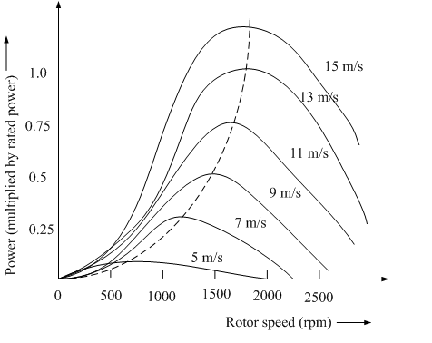
Fig. 3.2, A typical power versus speed characteristics of a wind turbine.
Fig. 3.3, Typical curves of power coefficient versus tip speed ratio for various values of the pitch angle α.
For a given turbine, the power coefficient depends not only on the TSR but also on the blade pitch angle. The fig. 3.3, shows the typical variation of the power coefficient with respect to the TSR λ with blade pitch control.
From the following equations,
$P_{o}=\frac{1}{2}ρ{\text{AV}}_{∞}^{3}$ and
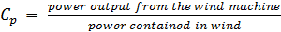
the mechanical power transmitted to the shaft is
$P_{m}=\frac{1}{2}{ρC}_{p}{\text{AV}}_{∞}^{3}$ (3.5)
where C_{p} is a function of the TSR λ and the pitch angle α.
For a wind turbine with radius R, the above equation can be expressed as
$P_{m}=\frac{1}{2}{ρC}_{p}{πR}^{2}V_{∞}^{3}$ (3.6)
For a given wind speed, the power extracted from the wind is maximized if C_{p} is maximized. The optimum value of C_{p}, say C_{p,opt}, always occurs at a definite value of λ say λ_{opt}. This means that for varying wind speed, the rotor speed should be adjusted proportionally to adhere always to this value of λ ( = λ_{opt} ) for maximum mechanical power output from the turbine. Using the relation $λ=ωR/V_{∞}$ in above equation, the maximum value of the shaft mechanical power for wind speed can be expressed as
$P_{\text{max}}=\frac{1}{2}{ρC}_{p,\text{opt}}π\left(\frac{R^{5}}{λ_{\text{opt}}^{3}}\right)ω^{3}$ (3.7)
Thus the maximum mechanical power that can be extracted from wind is proportional to the cube of the rotor speed, i.e.,
$P_{\text{max}}∝ω^{3}$ (3.8)
Studying the torque versus speed characteristics of any prime mover is very important for properly matching the load and ensuring stable operation of the electrical generator. The torque and power are related as
$T_{m}=\frac{P_{m}}{ω}$ (3.9)
From equation (3.3), at the optimum operating point ( C_{p,opt}, λ_{opt} ), the relation between aerodynamic torque and rotational speed is
$T_{m}=\frac{1}{2}{ρC}_{p,\text{opt}}π\left(\frac{R^{5}}{λ_{\text{opt}}^{3}}\right)ω^{2}$ (3.10)
It is seen that at the optimum operating point on the C_{p} – λ curve, the torque is quadratically related to the rotational speed.
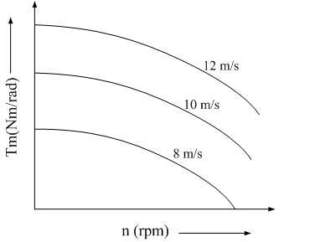
(a)
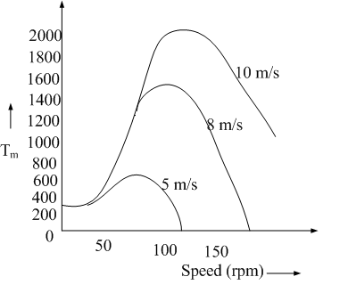
(b) (c)
Fig. 3.4, Torque-speed characteristics of (a) Savonious type, (b) Darrieus type and (c) Propeller type wind turbines.
The curves in fig. 3.4, show that for the propeller turbine and the Darrieus turbine, for any wind speed, the torque reaches a maximum value at a specific rotational speed, and this maximum shaft torque varies approximately as the square of the rotational speed. In the case of electricity production, the load torque depends on the electrical loading, and by properly choosing the load, the torque can be made to vary as the square of the rotational speed.
The choice of constant of proportionality of load is very important. At the optimal value, the load curve follows the maximum shaft power. But at a higher value, the load torque may exceed the turbine torque for most speeds. Consequently, the machine would fail to speed up above a very low value. If the constant K is lower than the optimum value, the machine may over speed at the rated wind speed, activating the speed-limiting mechanism. Thus the proportionality constant of the load needs to be selected from a rather narrow range, about 10-20% of the optimum power curve. Note that the point of maximum torque is not the same as that for maximum power.
As the power output is a product of torque and speed, it also has maxima that vary as the cube of the rotational speed, The matching characteristics of the load can make the load curve pass through the maximum power points at all wind speeds. For generators that feed power to the grid, the torque-speed characteristics are tuned using power electronics controls.
In terms of power coefficient C_{p}(λ,α), the aerodynamic torque becomes
$T_{m}=\frac{1}{2}{ρC}_{T}{πR}^{3}V_{∞}^{3}$ (3.11)
where $C_{T}=C_{p}/λ$ is called the torque coefficient.

3.2.3 Pitch Angle Control
With pitch control it is possible to achieve a high efficiency by continuously aligning the blade in the direction of the relative wind.
On a pitch-controlled machine, as the wind speed exceeds its rated speed, the blades are gradually turned about the longitudinal axis and out of the wind to increase the pitch angle. This reduces the aerodynamic efficiency of the rotor, and the safe limit for the system, the pitch angle is so changed that the power output reduces to zero and the machine shifts to the ‘stall’ mode. After the gust passes, the pitch angle is reset to the normal position and the turbine is restarted. At normal wind speeds, the blade pitch angle should ideally settle to a value at which the output power equals the rated power.

Fig. 3.5 The feedback loop for pitch angle control.
The pitch angle control is shown in the fig. 3.5. The input variable to the pitch controller is the error signal arising from the difference between the output electrical power and the reference power. The pitch controller operates the blade actuator to alter the pitch angle. During operation below the rated speed, the control system endeavors to pitch the blade at an angle that maximizes the rotor efficiency. The generator must be able to absorb the mechanical power output and deliver to the load. Hence, the generator output power needs to be simultaneously adjusted.
Continuous pitch control is relatively expensive to incorporate, and the cost-benefit trade-off does not justify its use in small wind machines. However, the stalling mechanism must be incorporated to prevent damage of the turbine during turbulent weather conditions.
The pitch angle is given by
$α=I−i$ (3.12)
where, I is angle of inclination,
i is angle of incidence.
As I varies along the length of the blade, α should also vary to ensure an optimal angle of incidence at all points of the blade. Thus the desirable twist along the blade can be calculated easily.
The pitch angle should be such that tanε or C_{D}/C_{L} is minimum at all points of the rotor. It is more convenient to plot the curve for C_{D}/C_{L} versus i. Its minimum point will then represent the optimal value of the incidence angle. This method yields a twisted blade, that is, one that has different pitch angles at different distances from the axis. If the constraints in the production methods do not permit a twist, the optimal value of α can be chosen for a suitable point on the blade, say r = 0.8R, and the same pitch angle maintained throughout the blade.

3.3 MATHEMATICAL MODEL OF INDUCTION GENERATOR
Wind power generation, as it stands today, is dominated by induction generators, of both the squirrel cage type and wound rotor type. About 80% of the wind generators today are induction generators.

3.3.1 Process of Self-Excitation
For the self-excitation process to initiate, a capacitor bank of suitable size must be connected across the machine terminals, the magnetic circuits of machine must retain some residual flux. In order to understand the self-excitation process, let us refer to the simplified circuit model of the self-excited induction generator under no-load condition as shown in fig. 3.6.
Fig. 3.6, Modified circuit model of induction generator with speed emf in the rotor circuit.
For any speed of the rotor, the residual flux generates a small synchronous emf E_{r}. The steady state magnitude of the current through the L_{m}C circuit is such that the difference between the synchronous saturation curve and the capacitor load line, as shown in fig. 3.7, at this value of the stator current equals E_{r}.
Fig. 3.7, Building up of voltage in a self-excited induction generator: (a) the capacitor load line and the saturation curve, (b) the difference between them
At this stage, the slip s being zero for no speed difference between the rotor and the air-gap flux, no induced rotor current flows and the machine operates as a synchronous generator.
If E_{r} is less than E_{r1}, the machine operates in the stable steady state in the synchronous mode over the region oa. An increase in I in the region demands more synchronous voltage than the residual emf E_{r}. Consequently, the increased I is not sustained and the current comes back to its original value. By the same reasoning, if E_{r} is between E_{r1} and E_{r2}, a stable synchronous mode operation is observed over the region cd. For E_{r} ≥ E_{r2}, stable synchronous operation takes place from the point f onward. The regions ac and df are unstable, where, for the residual emf equal to E_{r1}, or E_{r2}, the machine terminal voltage rises owing to synchronous self-excitation, before entering the next stable region. In the stable regions, the machine operates as a self-excited synchronous generator.
The possibility of a changeover from synchronous generator operation to the self-excited asynchronous generator mode occurs in the region where the saturation curve emf is greater than the capacitor voltage. While the machine operates in the synchronous mode, any disturbance initiates an oscillation in the LC resonance circuit formed by the machine terminal capacitance and the magnetizing inductance at the natural angular frequency $ω_{n}=1/\sqrt{L_{m}C}$. Only at the points b and e does $ω_{n}$ equal the synchronous frequency $ω_{1}$. Between the points b and e, the synchronous inductive reactance is greater than the capacitive reactance. Hence the natural frequency $ω_{n}$ of oscillation is lower than the rotational frequency $ω_{1}$. The air-gap flux associated with the oscillating current rotates at a speed lower than that of the rotor, implying a negative value of the slip. The corresponding rotational emf E(1-s), which exceeds E, drives a current into the stator circuit, building up the terminal voltage.
The machine now enters the asynchronous generating mode. An unstable oscillatory condition between the capacitor and the magnetizing reactance still persists owing to a continuous fall in the effective value of the magnetizing reactance as the terminal voltage rises. The natural frequency of oscillation progressively increases, and sustained oscillation is reached when the capacitive reactance is close to, but still less than, magnetizing reactance near the point e. The small negative slip compensates the losses in the stator circuit. With a resistive load connected across the capacitor, the circuit must be under damped to initiate the asynchronous generating mode.

3.3.2 Effect of External Capacitance and Load Impedance on performance of Induction Generator
Fig. 3.8, Voltage regulation for different values of the excitation capacitance at constant speed.
The fig. 3.8, shows the typical variation of terminal voltage for resistive load with the output power at a fixed speed for different values of the excitation capacitance. The curves suggest that, for a given speed and capacitance, an optimal load impedance exists for maximum power output. In these respects, the curves are similar to the output characteristics of a dc shunt generator with different field circuit resistances. The frequency decreases with the load, but this variation is not significantly affected by the capacitance.
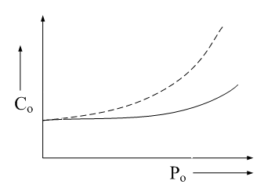
Fig. 3.9, Capacitance requirement for maintaining a constant voltage at the generator terminals for different power factors.
Fig. 3.9, exhibits the manner in which the capacitance requirement changes with load and the power factor for constant terminal voltage at a fixed speed. The figure also indicates an increase in the VAR demand with decreasing load power factor.

3.3.3 Effect of Speed variation on performance of Induction Generator
For power generation using wind energy, the speed of the prime mover varies over a wide range. For self-excitation, as indicated by the capacitance reactance value$X_{\text{cb}}/F^{2}$, the capacitor size is approximately proportional to the inverse of the square of the speed. The group of curves in fig. 3.10, shows some typical output characteristics for different speeds under the constraint $X_{\text{cb}}/v^{2}$= constant.
Fig. 3.10, Effect of speed on the output characteristics for constant capacitance.
The terminal voltage and the output frequency increase almost linearly with speed for the same power output over the working range. Fig. 3.11, shows the output power versus speed curves for a given capacitance and load impedances. From the figure it is clear that there exists a certain speed that maximizes the output power.
Fig. 3.11, Output power and frequency variation with speed.

3.3.4 Dynamic d-q axis model for Self-Excited Induction Generator
The fig. 3.12 and 3.13 shows the equivalent d and q axis circuit diagram for a induction generator.
Fig. 3.12, d – axis equivalent circuit of a induction machine.
Fig. 3.13, q – axis equivalent circuit of a induction machine.
In the synchronously rotating reference frame defined by the d^{e} – q^{e} axis, the dynamic voltage equations of a three-phase symmetrical induction machine in terms of the equivalent two-phase system, are given by (refer above figures 3.12 and 3.13)
$v_{\text{ds}}^{e}=R_{s}i_{\text{ds}}^{e}+{pλ}_{\text{ds}}^{e}−ω_{e}λ_{\text{qs}}^{e}$ (3.13)
$v_{\text{qs}}^{e}=R_{s}i_{\text{qs}}^{e}+{pλ}_{\text{qs}}^{e}+ω_{e}λ_{\text{ds}}^{e}$ (3.14)
$v_{\text{dr}}^{e}=R_{r}i_{\text{dr}}^{e}+{pλ}_{\text{dr}}^{e}−\left(ω_{e}−ω_{r}\right)λ_{\text{qr}}^{e}$ (3.15)
$v_{\text{qr}}^{e}=R_{r}i_{\text{qr}}^{e}+{pλ}_{\text{qr}}^{e}+\left(ω_{e}−ω_{r}\right)λ_{\text{dr}}^{e}$ (3.16)
Where,
R_{s} is the stator resistance
R_{r} is the rotor resistance
$λ$is the flux linkage and
p is the derivative.
The flux linkage equations are
$λ_{\text{ds}}^{e}=L_{s}i_{\text{ds}}^{e}+{\text{Mi}}_{\text{dr}}^{e}$
$λ_{\text{qs}}^{e}=L_{s}i_{\text{qs}}^{e}+{\text{Mi}}_{\text{qr}}^{e}$ (3.17)
$λ_{\text{dr}}^{e}=L_{r}i_{\text{dr}}^{e}+{\text{Mi}}_{\text{ds}}^{e}$
$λ_{\text{qr}}^{e}=L_{r}i_{\text{qr}}^{e}+{\text{Mi}}_{\text{qs}}^{e}$ (3.18)
where L_{s} and L_{r} are the self-inductances of the stator and the rotor windings, respectively, and M is the mutual inductance between a stator and a rotor winding.
The expression for electromagnetic torque in terms of the currents is
$T_{e}=M\frac{P}{2}\left(i_{\text{qs}}^{e}i_{\text{dr}}^{e}−i_{\text{ds}}^{e}i_{\text{qr}}^{e}\right)$ (3.19)
using equations (3.17) and (3.18) in equation (3.19), gives the following equations
$T_{e}=P/2\left(λ_{\text{ds}}^{e}i_{\text{qs}}^{e}−λ_{\text{qs}}^{e}i_{\text{ds}}^{e}\right)$ (3.20)
$T_{e}=P/2\left(λ_{\text{qr}}^{e}i_{\text{dr}}^{e}−λ_{\text{dr}}^{e}i_{\text{qr}}^{e}\right)$ (3.21)
Induction machines are generally operated under balanced conditions. If the terminal voltages form a balanced set, the steady-state currents will also form a balanced set in a symmetrical induction machine. Let the stator terminal voltages be
$v_{a}=\sqrt{2}V\text{cos}\left(ωt−α\right)$
$v_{b}=\sqrt{2}V\text{cos}\left(ωt−α−\frac{2π}{3}\right)$
$v_{c}=\sqrt{2}V\text{cos}\left(ωt−α+\frac{2π}{3}\right)$ (3.22) where $ω$is the angular supply frequency. Similarly,
$i_{a}=\sqrt{2}I\text{cos}\left(ωt−β\right)$
$i_{b}=\sqrt{2}I\text{cos}\left(ωt−β−2π/3\right)$
$i_{c}=\sqrt{2}I\text{cos}\left(ωt−β+2π/3\right)$ (3.23)
Carrying out the trigonometrical operations on the products $v_{\text{ds}}^{e}i_{\text{ds}}^{e}$, $v_{\text{ds}}^{e}i_{\text{qs}}^{e}$, $v_{\text{qs}}^{e}i_{\text{qs}}^{e}$ and $v_{\text{qs}}^{e}i_{\text{ds}}^{e}$, we get
Active power $P=v_{\text{ds}}^{e}i_{\text{ds}}^{e}+v_{\text{qs}}^{e}i_{\text{qs}}^{e}$
$P=3\text{VI}\text{cos}\left(β−α\right)$ (3.24)
Reactive power $Q=v_{\text{qs}}^{e}i_{\text{ds}}^{e}−v_{\text{ds}}^{e}i_{\text{qs}}^{e}$
$Q=3\text{VI}\text{sin}\left(β−α\right)$ (3.25)
and
${\left(v_{\text{ds}}^{e}\right)}^{2}+{\left(v_{\text{qs}}^{e}\right)}^{2}=3V^{2}$ (3.26)
For balanced sets, v_{o} and i_{o} will be zero. Whether balanced or not, the relations given below always hold good:
$P=v_{\text{ds}}^{e}i_{\text{ds}}^{e}+v_{\text{qs}}^{e}i_{\text{qs}}^{e}+v_{\text{os}}^{e}i_{\text{os}}^{e}$ (3.27)
$P=v_{a}i_{a}+v_{b}i_{b}+v_{c}i_{c}$ (3.28)
and ${\left(v_{\text{ds}}^{e}\right)}^{2}+{\left(v_{\text{qs}}^{e}\right)}^{2}+{\left(v_{\text{os}}^{e}\right)}^{2}=v_{\text{as}}^{2}+v_{\text{bs}}^{2}+v_{\text{cs}}^{2}$ (3.29)

3.4 MODEL OF STATCOM
Basically, STATCOM is an inverter connected to the system bus and controlled to draw leading current in order to compensate the lagging current drawn by the load from the bus. STATCOM proposed in the scheme also draws the in-phase component of the current and the active power flow through the STATCOM branch is dissipated into the heat energy through the dump load. The volt– amp capacity of this type of STATCOM is equal to the sum of active power to be dissipated in the dump load and the reactive power to be injected to the bus. Simulink model of STATCOM is developed as a current-controlled inverter with the hysteresis band current control principle. Fig. 3.14, shows the basic circuit diagram and control strategy of the STATCOM with hysteresis band current control pulse width modulation (PWM) inverter which can control reactive power as well as active power.

Fig. 3.14, STATCOM with hyteresis band current control PWM converter
The bus voltage is sensed and compared with the reference value and the error thus obtained is passed through a proportional integral (PI) controller to obtain the magnitude of the q-axis component of the reference current i_{abc} (ref). The frequency is sensed and compared with the reference frequency and the error thus obtained is passed through a PI controller to obtain the duty cycle of the chopper to control the power dissipation in the dump load. Similarly, the magnitude of the d-axis component of the reference current is determined by comparing the actual DC-link voltage with the reference value. The d–q axes reference currents are then transformed to stationary a-b-c reference frame to obtain the three-phase reference current i_{abc} (ref).

Fig. 3.15, Simulink model of hyteresis band current controller
The hysteresis band current controller as shown in fig. 3.15, compares the actual currents through the STATCOM branch with the reference currents and generates the gate signals to turn on and off the switch pairs T1-T2, T3-T4 and T5-T6 several times in a cycle so that the actual inverter current i₀ (actual) tracks the reference current i_{abc} (ref ) within a limited hysteresis band. The actual current through the STATCOM branch current is given by the following equation;
$i_{0a}=−\frac{R_{0}}{L_{0}}\int{i_{0a}}\text{dt}−\frac{1}{L_{0}}\int{\left(V_{\text{sa}}−V_{0a}\right)}\text{dt}$ (3.30)
$i_{0b}=−\frac{R_{0}}{L_{0}}\int{i_{0b}}\text{dt}−\frac{1}{L_{0}}\int{\left(V_{\text{sb}}−V_{0b}\right)}\text{dt}$ (3.31)
$i_{0c}=−\frac{R_{0}}{L_{0}}\int{i_{0c}}\text{dt}−\frac{1}{L_{0}}\int{\left(V_{\text{sc}}−V_{0c}\right)}\text{dt}$ (3.32)

Fig. 3.15, shows the Simulink model developed to simulate the hysteresis band current controller, which generates gate signals S_{a}, S_{b} and S_{c}. The inverter model shown in fig.3.16, computes the phase voltages of inverter output as follows;
$V_{0a}=\frac{V_{\text{dc}}}{3}\left(2S_{a}−S_{b}−S_{c}\right)$ (3.33)
$V_{0b}=\frac{V_{\text{dc}}}{3}\left(2S_{b}−S_{a}−S_{c}\right)$ (3.34)
$V_{0c}=\frac{V_{\text{dc}}}{3}\left(2S_{c}−S_{b}−S_{a}\right)$ (3.35)
Where,
S_{a}, S_{b} and S_{c} are the switching functions of switch pairs T1-T2, T3-T4 and T5-T6, respectively.

Fig. 3.16, Simulink model of inverter

The switching function takes the value of 1 if the upper switch of the inverter leg is on and lower switch is off. It is 0 if the lower switch in the same leg is on and upper switch is off. The modeling of DC side of the inverter is based on the instantaneous power balance between AC side and DC side of the inverter and the following equations;
$v_{\text{DC}}i_{\text{DC}}=v_{a}i_{a}+v_{b}i_{b}+v_{c}i_{c}$ (3.36)
$i_{\text{DC}}=\frac{v_{a}i_{a}+v_{b}i_{b}+v_{c}i_{c}}{v_{\text{DC}}}$ (3.37)
$v_{\text{DC}}=\frac{1}{C}\int{i_{\text{DC}}}\text{dt}$ (3.38)
$i_{\text{cap}}=i_{\text{DC}}−i_{d}$ (3.39)
$i_{d}=\frac{S_{d}×V_{\text{DC}}}{R_{d}}$ (3.40)
where, S_{d} is the switching function of the chopper.
Fig. 3.17, shows the single line diagram and control block diagram of a STATCOM.

Fig. 3.17, Single line diagram of a STACOM and its control block diagram
The control system consists of:
- A phase-locked loop (PLL) which synchronizes on the positive-sequence component of the three-phase primary voltage V₁. The output of the PLL (angle θ = ωt) is used to compute the direct-axis and quadrature-axis components of the ac three-phase voltage and currents (labeled as V_{d}, V_{q} or I_{d}, I_{q} on the diagram).
- Measurement systems measuring the d and q components of ac positive-sequence voltage and currents to be controlled as well as the dc voltage V_{dc}.
- An outer regulation loop consisting of an AC voltage regulator and a DC voltage regulator. The output of the AC voltage regulator is the reference current I_{qref} for the current regulator (I_{q} = current in quadrature with voltage which controls reactive power flow). The output of the DC voltage regulator is the reference current I_{dref} for the current regulator (I_{d} = current in phase with voltage which controls active power flow).
- An inner current regulation loop consisting of a current regulator. The current regulator controls the magnitude and phase of the voltage generated by the PWM converter (V_{2d} V_{2q}) from the I_{dref} and I_{qref} reference currents produced respectively by the DC voltage regulator and the AC voltage regulator (in voltage control mode). The current regulator is assisted by a feed forward type regulator which predicts the V₂ voltage output (V_{2d} V_{2q}) from the V₁ measurement (V_{1d} V_{1q}) and the transformer leakage reactance.

3.5 CONCLUSION
Thus if a wind turbine pitch angle controlled then it is possible to have high efficiency. When the wind speed exceeds the safe limit the pitch angle controller changes the pitch angle such that the power output reduces to zero and the machine enters stall mode. To operate an induction motor as a generator, capacitive excitation is required. A dynamic d-q axis model of the induction generator is also developed. This model simplifies the model of the machine and its analysis can be done easily. The voltage, current and power equations of induction generator with reference to d-axis and q-axis are also derived. For improving voltage regulation of induction generator a continuously variable capacitive VAR is necessary. A STATCOM system is integrated with wind energy system to provide continuously variable VARs.

CHAPTER IV
MATLAB SIMULATION OF WIND GENERATION SYSTEM

4.0 GENERAL
Actual experimentation on bulky power components can be expensive and time-consuming. Simulation offers a fast and economical means to learn more about system before its prototype is developed.
Power components should be designed to withstand expected stresses caused by temporary over-voltages, surges, and faults. Since extreme stresses usually occur during abnormal operation and transient conditions, the design of these components is often dictated by transient considerations. Some examples are: persistent over-voltages which can affect insulation coordination; surges caused by lightning and switching; undesirable interactions such as ferro-resonance between nonlinear magnetizing inductance and circuit capacitance; and sub-synchronous resonance between the torsional modes of the turbine shaft and natural frequency of the network.
Modeling and simulation have appropriate uses. They are especially beneficial in situations where the actual system does not exist or is too expensive, time-consuming, or hazardous to build, or when experimenting with an actual system can cause unacceptable disruptions. Changing the value of parameters, or exploring a new concept or operating strategy, can often be done more quickly in a simulation than by conducting a series of experimental studies on an actual system. Simulation can also be a very useful training aid; it is a technique by which students can learn more and gain greater insight and better understanding about the system they are studying.
A frequent question about simulation is its validity. Do the simulation results reflect those of the actual system for the condition simulated? Even with valid component models the use of them in a larger simulation must be done carefully with consistency and a well-defined goal in mind; otherwise, the results could be meaningless. Finally, in interpreting the results, we should not overlook the simplifications and assumptions made in devising the model.

4.1 MATLAB Model of Wind Turbine
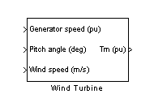
Fig. 4.1, MATLAB model of wind turbine
The model is based on the steady-state power characteristics of the turbine. The stiffness of the drive train is infinite and the friction factor and the inertia of the turbine must be combined with those of the generator coupled to the turbine. The output power of the turbine is given by the following equation:
$P_{m}=\frac{1}{2}{ρC}_{p}{\text{AV}}_{∞}^{3}$ (4.1)
The generator speed, pitch angle, and wind speed are the inputs to the MATLAB wind turbine block and the T_{m} is the output variable.
Generator speed (pu): Simulink input of the generator speed in pu based on the nominal speed of the generator.
Pitch angle (deg): Simulink input of the pitch angle.
Wind speed (m/s): Simulink input of the wind speed in m/s.
T_{m} (pu): Simulink output of the mechanical torque of the wind turbine, in pu of the nominal generator torque. The nominal torque of the generator is based on the nominal generator power and speed.
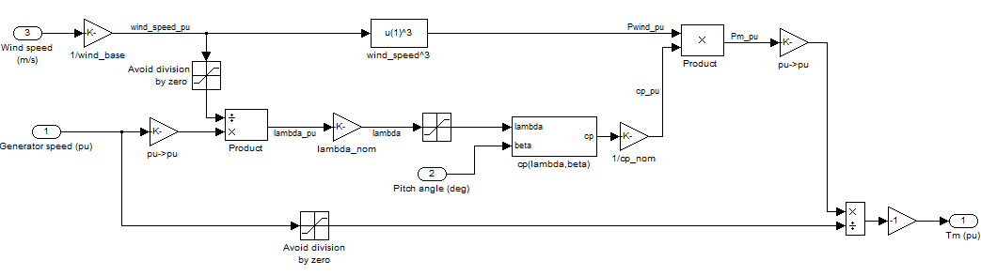
Fig. 4.2, Simulink model of wind turbine
The Simulink model of the turbine is illustrated in the fig. 4.2. The three inputs are the generator speed ω_{r} in pu of the nominal speed of the generator, the pitch angle in degrees and the wind speed in m/s. The tip speed ratio λ in pu of λ_nom is obtained by the division of the rational speed in pu of the base rotational speed and the wind speed in pu of the base wind speed. The output is the torque applied to the generator shaft.

4.2 MATLAB Model of Induction Generator
Fig. 4.3, shows the MATLAB block of induction generator.
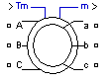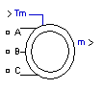
Fig. 4.3, MATLAB model of induction generator
The Asynchronous Machine block operates in either generator or motor mode. The mode of operation is dictated by the sign of the mechanical torque:
- If Tm is positive, the machine acts as a motor.
- If Tm is negative, the machine acts as a generator.
The electrical part of the machine is represented by a fourth-order state-space model and the mechanical part by a second-order system. All electrical variables and parameters are referred to the stator. All stator and rotor quantities are in the arbitrary two-axis reference frame (dq frame).
Input and Output parameters in MATLAB block
T_{m}: The Simulink input of the block is the mechanical torque at the machine's shaft. When the input is a positive Simulink signal, the asynchronous machine behaves as a motor. When the input is a negative signal, the asynchronous machine behaves as a generator. When you use the SI parameters mask, the input is a signal in N.m, otherwise it is in pu.
m: The Simulink output of the block is a vector containing 21 signals. One can demultiplex these signals by using the Bus Selector block provided in the Simulink library. Depending on the type of mask you use, the units are in SI, or in pu.

Signal | Definition | Units
1 | Rotor Current ir_a | A or pu
2 | Rotor Current Ir_b | A or pu
3 | Rotor Current Ir_c | A or pu
4 | Rotor Current iq | A or pu
5 | Rotor Current id | A or pu
6 | Rotor Flux phir_q | V.s or pu
7 | Rotor Flux phir_d | V.s or pu
8 | Rotor Voltage Vr_q | V or pu
9 | Rotor Voltage Vr_d | V or pu
10 | Stator Current is_a | A or pu
11 | Stator Current is_b | A or pu
12 | Stator Current is_c | A or pu
13 | Stator Current is_q | A or pu
14 | Stator Current is_d | A or pu
15 | Stator Flux phis_q | V.s or pu
16 | Stator Flux phis_d | V.s or pu
17 | Stator Voltage vs_q | V or pu
18 | Stator Voltage vs_d | V or pu
19 | Rotor Speed | Rad/s
20 | Electromagnetic  Torque Te | Nm or pu
21 | Rotor Angle thetam | rad

The stator terminals of the Asynchronous Machine block are identified by the A, B, and C letters. The rotor terminals are identified by the a, b, and c letters. Note that the neutral connections of the stator and rotor windings are not available; three-wire Y connections are assumed.
Limitations:
- The Asynchronous Machine block does not include a representation of the saturation of leakage fluxes. If one choose to supply the stator via a three-phase Y-connected infinite voltage source, then the three sources are connected in Y. However, if one choose to simulate a delta source connection, he must use only two sources connected in series.
- When Asynchronous Machine blocks in discrete systems is used, a small parasitic resistive load is to be used, connected at the machine terminals, in order to avoid numerical oscillations. Large sample times require larger loads. The minimum resistive load is proportional to the sample time. As a rule of thumb, remember that with a 25 ms time step on a 60 Hz system, the minimum load is approximately 2.5% of the machine nominal power. For example, a 200 MVA asynchronous machine in a power system discretized with a 50 ms sample time requires approximately 5% of resistive load or 10 MW. If the sample time is reduced to 20 ms, a resistive load of 4 MW should be sufficient.

4.3 MATLAB Model of STATCOM:
Fig. 4.4, represents a MATLAB block of Static Compensator.
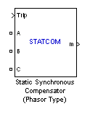
Fig. 4.4, MATLAB block of STATCOM
The Static Synchronous Compensator (STATCOM) is a shunt device of the Flexible AC Transmission Systems (FACTS) family using power electronics to control power flow and improve transient stability on power grids. The STATCOM regulates voltage at its terminal by controlling the amount of reactive power injected into or absorbed from the power system. When system voltage is low, the STATCOM generates reactive power (STATCOM capacitive). When system voltage is high, it absorbs reactive power (STATCOM inductive).
The variation of reactive power is performed by means of a Voltage-Sourced Converter (VSC) connected on the secondary side of a coupling transformer. The VSC uses forced-commutated power electronic devices (GTOs, IGBTs or IGCTs) to synthesize a voltage V2 from a DC voltage source.
Input and Output parameters of MATLAB model of STATCOM
A B C: The three AC terminals of the STATCOM.
Trip: Apply a simulink logical signal (0 or 1) to this input. When this input is high the STATCOM is disconnected and its control system is disabled. Use this input to implement a simplified version of the protection system.
V_{ref} : Simulink input of the external reference voltage signal. This input is visible only the External control of reference voltage V_{ref} parameter is checked.
m: Simulink output vector containing 16 STATCOM internal signals. These signals are either voltage and current phasors (complex signals) or control signals. They can be individually accessed by using the Bus Selector block.
The various simulink models of STATCOM are as shown in fig. 4.5,

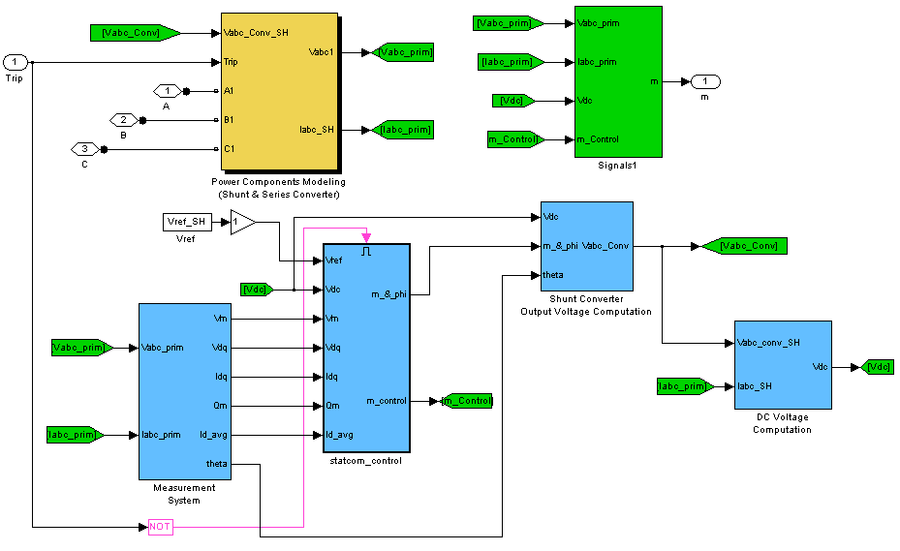
Fig. 4.5, Controller block of MATLAB model of STATCOM
The power components modeling block is shown in fig. 4.6 and 4.7, which shows a current source controlled converter. This block measures the three phase voltage on the converter side as well as on the supply line side.
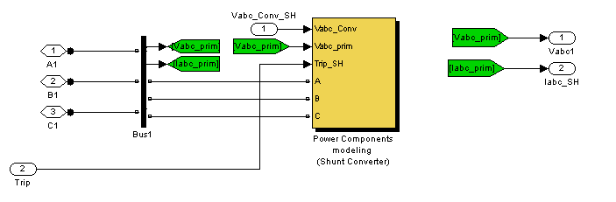
Fig. 4.6, STATCOM power circuit model
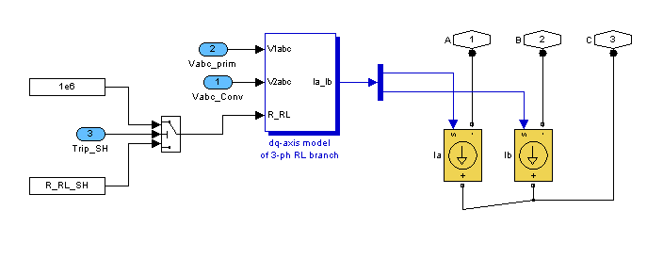
Fig.4.7, STATCOM dq-axis model of three-phase RL branch
The STATCOM controller is shown in fig. 4.8. It basically consists of a ac voltage regulator, a dc voltage regulator and current regulator. . The output of the AC voltage regulator is the reference current I_{qref} for the current regulator (I_{q} = current in quadrature
with voltage which controls reactive power flow). The output of the DC voltage regulator is the reference current I_{dref} for the current regulator (I_{d} = current in phase with voltage which controls active power flow). The current regulator controls the magnitude and phase of the voltage generated by the PWM converter (V_{2d} V_{2q}) from the I_{dref} and I_{qref} reference currents produced respectively by the DC voltage regulator and the AC voltage regulator (in voltage control mode). The current regulator is assisted by a feed forward type regulator which predicts the V₂ voltage output (V_{2d} V_{2q}) from the V₁ measurement (V_{1d} V_{1q}) and the transformer leakage reactance.

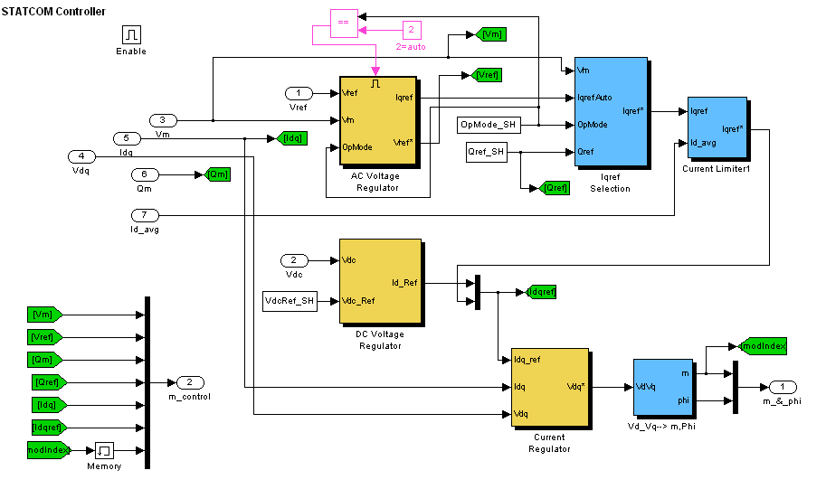

Fig. 4.8, MATLAB model of STATCOM control for AC side and DC link voltage control

The I_{qref} selection block consists of:
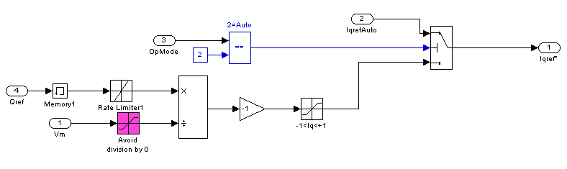
Fig. 4.9, MATLAB model of STATCOM I_{qref} selection block.

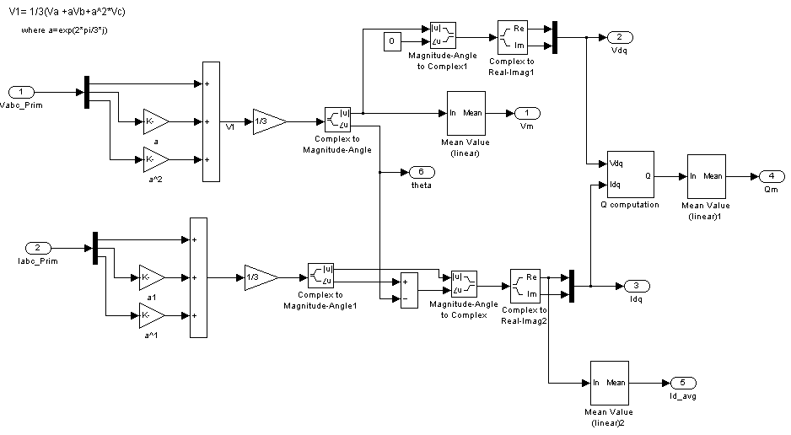

Fig. 4.10, Sub-system of AC voltage control
The sub-system for AC voltage regulator is shown if fig. 4.10. The inputs to this block are the measured three-phase voltages and currents. These three-phase voltages and currents are transformed into their equivalent d-q axis to get V_{dq} and I_{dq}.
The dc voltage block as shown below.
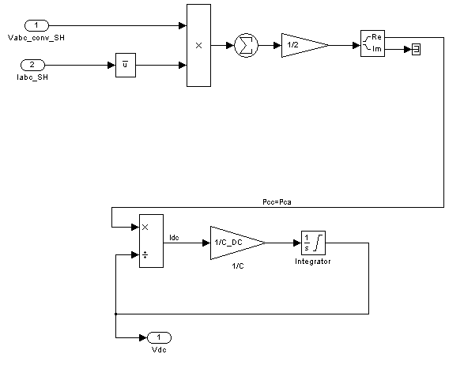
Fig. 4.11, Sub-system for DC voltage control of STATCOM

4.4 MATLAB Model of Wind Generation System

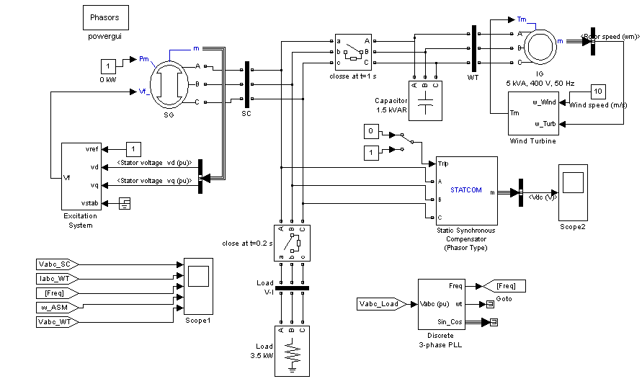
Fig. 4.12, MATLAB model of wind generation system
Fig. 4.12, shows a complete MATLAB model of integrated wind generation system. It consists of an induction generator of 5 kVA, 400 V, 50 Hz, 1500 rpm, driven by a wind turbine with a wind speed of 10 m/s. The excitation requirements of induction generator is furnished by a three-phase capacitor bank of 1.5 kVAR, to generate rated terminal voltage of 380 V. to provide additional reactive VAR for maintaining the constant terminal voltage a STATCOM of V_{DC} = 600 V, C = 600 μF and R_{r} = 2.5 , L_{r} = 0.008 H is selected.
The proposed wind generation system is operated in conjunction with a synchronous generator of rating 16 kVA, 400 V, 50 Hz, driven through a constant prime mover (diesel engine). Initially the induction generator is made to generate rated volateg of 380 V at a constant wind speed of 10 m/s and subsequently at t = 1s a synchronous generator is connected in parallel to the induction generator through a closing breaker. The transient performance of this wind generation system is studied. It is assumed that the generator terminal voltage remains fixed due to presence of STATCOM. The frequency of the wind generation system is also kept almost constant by keeping the total load on generator constant.

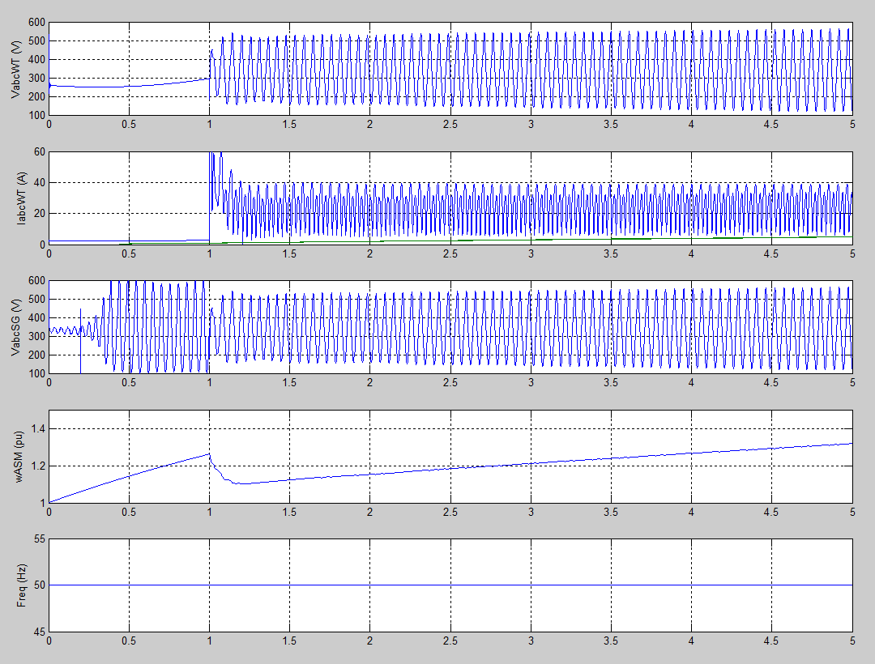

Fig. 4.13, Performance of wind generation system

4.5 Conclusion
This chapter presents a complete mathematical modeling and MATLAB simulation of a wind generation system operating along with a synchronous generator. A wind generator along with a synchronous generator has an increased output from capture and also posses scope of keeping the system power quality reasonably good.

CHAPTER V
RESULTS AND DISCUSSIONS:

5.0 Simulation
The operation of a wind generation system is studied with a constant speed of 10 m/s. The wind generation system is also operated along with synchronous generator and STATCOM and the performances are summarized as follows.

5.1 PERFORMANCE OF WIND GENERATION SYSTEM WITH WIND SPEED
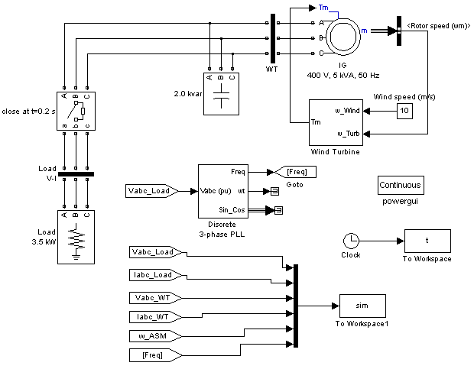

Fig. 5.1, Performance of wind generation system with wind speed
Fig. 5.1, shows the performance characteristics of wind generator in a stand alone mode. The rating of the wind generator is 5 kVA, 400 V, 50 Hz, 1500 rpm, driven by a wind turbine with pitch angle control running with a wind speed of 10 m/s. It is observered that when a load of 3.5 kW is switched on at t = 0.2 s. the terminal voltage of wind generator falls to 360 V. Also, due to variations in real power its frequency changes.

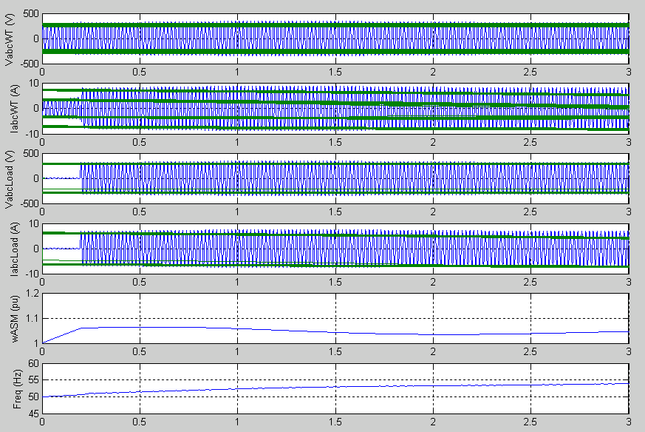

Fig. 5.2, Performance of wind generator in stand alone mode

5.2 PERFORMANCE OF WIND GENERATION SYSTEM ALONG WITH A SYNCHRONOUS GENERATOR

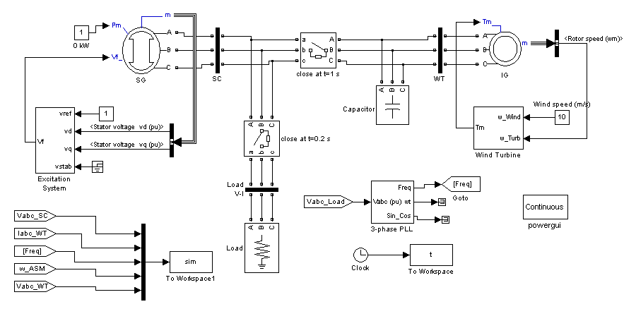

Fig. 5.3, Performance of wind generator along with synchronous generator
Fig. 5.3, shows the performance of a wind generator along with a synchronous generator of rating 16 kVA, 400 V, 50 Hz. The synchronous generator is driven by a constant source. It is observed that when the synchronous generator is switched on at t = 1s, the voltage if wind generator improves.

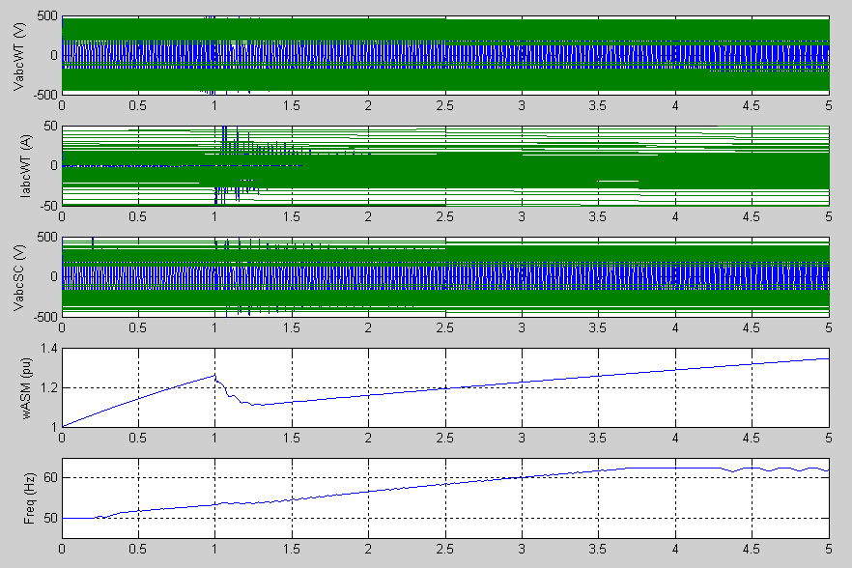

Fig. 5.4, Performance of wind generator along with synchronous generator

5.3 PERFORMANCE OF WIND GENERATION SYSTEM ALONG WITH STATCOM
The complete simulation model of parallel operation of synchronous and induction generators with STATCOM is shown in the above fig. 4.12. The scheme consists of a 16 kVA synchronous generator and 4 kW induction generator. The STATCOM is responsible for generating the reactive power demanded by the load. A fixed excitation capacitor of 1.5 kVar is connected across the induction generator terminals. It is the minimum capacitance required for self-excitation of the induction generator at no-load. The ratings and parameters of the synchronous generator, induction generator and STATCOM are given in the Appendix.
Fig. 4.13, shows the waveforms of wind generation system, while operating with STATCOM. A STATCOM with 400 V ac, 600 V at dc link and capacitor of 600 μF is used. It is observed that the voltage and frequency are well regulated. A spike transient appeared in the stator current of synchronous generator, because the STATCOM, synchronous generator and the excitation capacitor cannot instantly generate the additional reactive power demanded by the induction generator. These transients die out in a short span of time and the terminal voltage and speed settles down to 1 pu each.

CHAPTER VI
CONCLUSION AND FUTURE SCOPE OF WORK

6.0 CONCLUSION
The voltage and frequency of a wind generation system has been controlled using a STATCOM. The simulation results show that when an induction generator is driven by a wind turbine alone it has poor voltage and frequency regulation. The turbine should also be pitch controlled to have constant speed. The minimum capacitance required for the induction generator self-excitation is selected. The STATCOM shows the perfect control of the voltage and frequency. The transients in the stator terminal voltage, stator current of synchronous generator and induction generator are found to be acceptable for practical implementation. However, the realization of STATCOM for small wind generation unit may not be always economically viable. If cost of the controller is not a major constraint, a STATCOM with a real power controller at its DC link is able to ensure constant voltage and constant frequency operation.

6.1 FUTURE SCOPE OF WORK
There are various methods for the control of voltage and frequency of wind generation system, like by the use of Fuzzy logic controllers. The fuzzy logic control in combination with power electronic devices like PWM converter may found better control. The voltage and frequency of a wind turbine driven induction generator can be further improved by replacing the PI controllers used in STATCOM by fuzzy logic controllers.

REFERENCES

- Bhadra S.N., Kastha D., Banerjee S., “Wind Electrical Systems”, Oxford University, 2005.
- Robert Thresher, “To Capture the Wind”. IEEE Power and Energy Magazine, vol., 5, no., 6, Nov/Dec2007.
- Robert Zavadil, “Queuing Up”. IEEE Power and Energy Magazine, vol., 5, no., 6, Nov/Dec2007.
- Edgar DeMeo, “Accommodating Wind’s Natural Behavior”. IEEE Power and Energy Magazine, vol., 5, no., 6, Nov/Dec2007.
- Richard Piwko, “What Comes First?”. IEEE Power and Energy Magazine, vol., 5, no., 6, Nov/Dec2007.
- Bernhard Ernst, “Predicting the Wind”. IEEE Power and Energy Magazine, vol., 5, no., 6, Nov/Dec2007.
- Thomas Ackermann, “European Balancing Act”. IEEE Power and Energy Magazine, vol., 5, no., 6, Nov/Dec2007.
- Tamrakar, L. B. Shilpakar, B. G. Fernandes and R. Nilsen, “Voltage and frequency control of parallel operated synchronous generator and induction generator with STATCOM in micro hydro scheme.” IET Gener. Transm. Distrib., 2007, 1, (5), pp. 743-750.
- Henderson, D.S.: “Synchronous or induction generators? – The choice for small scale generation”. Opportunities and Advances in Int. Power Generation, IEE Conf., March 1996, (Publication No. 419), pp. 146-149.
- R.C.Bansal, “Three-phase self-excited induction generators: An overview”, IEEE Trans. Energy Conversion, vol 20. no.2, June 2005.
- Singh G. K., “Self-excited induction generators research – a survey”. Science direct.
- Simoes M.G., Chakraborty S., Wood R., “Induction generators for small wind energy systems”. IEEE Power Electronics Society NEWSLETTER 19. Third quarter 2006.
- Chan, T.F., “Capacitance requirements of self-excited induction generators”, IEEE Transactions on Energy Conversion, 1992, vol.8, pp. 304-11.
- Al-Bahrani, A.H., and Malik, N.H.: “Steady state analysis and performance characteristics of a three phase induction generator self excited with a single capacitor”, IEEE Trans. Energy Conversion, 1990, 5, (4), pp 725-732.
- N.H. Malik and A.H. Al-Bahrani, “Influence of the terminal capacitor on the performance characteristics of a self-excited induction generator,” Proc. Inst. Elect. Eng., pt. C, vol. 137, no.2, pp. 168-173, Mar.1990.
- Seyoum, D., Grantham, C. and Rahman, F.M., “The dynamic characteristics of an isolated self-excited induction generator driven by a wind turbine.” IEEE Transactions on Industry App. vol.39, no.4, July/August 2003.
- S. S. Murthy, B. P. Singh, C. Nagamani, and K. V. V. Satyanarayana, “ Studies on the use of conventional induction motors as self-excited induction generators”, IEEE Trans. Energy Conversion, vol. 3, pp. 842-848, Dec. 1998.
- Wang, L., Yang, Y-F., and Kuo, S.C.: “Analysis of grid connected induction generators under three phase balanced conditions.” Proc. of the Int. Conf. on Energy Conversion, 2002, 2002, pp. 413-416.
- Murthy, S.S., Jha, C.S., Ghorashi, A.H., and P.S. Nagendra Rao: “Performance analysis of grid connected induction generators driven by hydro/wind turbines including grid abnormalities”. Proc. of the 24th Int. Conf. on Energy Conversion, 1998, vol. 4, pp. 2045-2050.
- Wang, L., and Lee, C.H.: “Dynamic analyses of parallel operated self-excited induction generators feeding an induction motor load”. IEEE Trans. Energy Conversion, 1999, 14, (3), pp. 479-485.
- Chakraborty, C., Das, S.P., and Bhadra, S.N.: “Some studies on the parallel operation of self-excited induction generators”. Proc. of the Int. Conf. on Energy Conversion, 1993, pp. 361-366.
- Tamrakar, I., and Malik, O.P.,: “Power factor correction of induction motors using PWM inverter fed auxiliary stator winding”, IEEE Trans. Energy Conversion, 1999, 14, (3), pp. 426-432.
- N. G. Hingorani, and L. Gyugyi, “Understanding FACTS”, IEEE Press Book.
- Kalyan K. Sen: “STATCOM – STATic synchronous COMpensator: Theory, modeling, and applications.” IEEE PES 1999 Winter Meeting Proceedings, pp. 1177-1183.
- E. Suarez, G. Bortolotto,: “Voltage – Frequency Control of a SEIG”, IEEE Trans. Energy Conversion, vol. 14, no.3, September1999.
- G. Raina, O.P. Malik,: “Variable – Speed Wind Energy Conversion Using Synchronous Machine”, IEEE Trans. On Aerospace and Electronic Systems, vol., AES-21. no., 1, Jan 1985.
- htpp://www.mathwork.com

APPENDIX

Ratings and parameters of synchronous generator, induction generator and STATCOM used in the simulation are as follows:
Synchronous Generator:
16 kVA, 400 V, 50 Hz, 1500 rpm.
$X_{d}=\text{10734}\text{pu}$, $X_{d}^{'}=0\text{.}\text{177}\text{pu}$, $X_{d}^{\text{''}}=0\text{.}\text{112}\text{pu}$
$X_{q}=0\text{.}\text{861}\text{pu}$, $X_{q}^{\text{''}}=0\text{.}\text{199}\text{pu}$, $X_{l}=0\text{.}\text{07}\text{pu}$,
$T_{d}^{'}=0\text{.}\text{018}s$, $T_{d}^{\text{''}}=0\text{.}\text{0045}s$, $T_{q}^{\text{''}}=0\text{.}\text{0045}s$,
$R_{s}=0\text{.}\text{02}\text{pu}$, $H=6s$.
Induction Generator:
4 kW, 400 V, 50 Hz,
$R_{s}=0\text{.}\text{0035}\text{pu},$$L_{\text{ls}}=0\text{.}\text{045}\text{pu},$$R_{r}=0\text{.}\text{034}\text{pu},$
$L_{\text{lr}}=0\text{.}\text{045}\text{pu},$$L_{m}=2\text{.}8\text{pu},$$H=1\text{.}2\text{pu},$$P=4$
Excitation Capacitor = 1.5 kVAR, 400 V.
Static Compensator:
25 kVAR, 400 V, V_{DC} = 600 V, DC capacitor C = 600 μF.

