Time Varying Channel Estimation Using Kalman Filter

A MAJOR THESIS

SUBMITTED IN PARTIAL FULFILLMENT OF THE REQUIREMENTS FOR AWARD OF THE DEGREE OF

MASTER OF ENGINEERING
IN
ELECTRONICS AND COMMUNICATION
ENGINEERING

BY

JAVED AHMAD
College Roll No. 14 /E & C/05
University Roll No.2808

UNDER THE ESTEEMED GUIDANCE OF

DR. Asok Bhattacharyya
Prof & Head
Department of Electronics & Communication Engineering
Delhi College of Engineering
University Of Delhi
Delhi


DEPARTMENT OF ELECTRONICS AND COMMUNICATION ENGINEERING
DELHI COLLEGE OF ENGINEERING
(UNIVERSITY OF DELHI), DELHI

CERTIFICATE

This is to certify that the thesis entitled “Time Varying Channel Estimation Using Kalman Filter ” being submitted by Javed Ahmad in the partial fulfillment of the requirement for the degree of Master of Engineering in Electronics & Communication in the Department of Electronics & Communication, Delhi College of Engineering. University of Delhi is a record of bonafide work done by him under my supervision and guidance. It is also certified that the dissertation has not been submitted elsewhere for any other degree.

(Prof. Asok Bhattacharyya)
Prof & Head
Department of Electronics & Communication Engineering
Delhi College of Engineering
University Of Delhi
Delhi

ACKNOWLEDGEMENT

I take this opportunity to express my gratitude to my Project Guide & head of department Dr. Asok Bhattacharyya for his unwavering encouragement and support throughout this endeavor. His insight and expertise in this field
Have deeply influenced me and my work recorded herein. Without his constructive direction and invaluable advice, this work would not have been completed.

My gratitude is also extended to Mr. Rajesh Rohilla & Mrs.Rajeshwari Panday for their unwavering encouragement and support in my pursuit for academics.
I would be failing in my duty if I don’t express my sincere thanks to all the Lab. Assistants and supporting staff here for their co-operation.
I wish to express my deepest love for my parents & family, whose endless love,
Understanding, and support during all these years have been the greatest assets in my life.

(JAVED AHMAD)
University Roll No.-2808
College Roll No. - 14/E&C/05
Delhi College of Engineering,
(University of Delhi), Delhi

Notation and Symbols:

AMN: M-row N-column matrix
A¡1: Inverse of A
Tr(A): Trace of A, Tr(A)=
P
iAii
AT : Transpose of A
A¤: Complex conjugate transpose of A
IN: Identity matrix of size N £ N
?: Linear convolution
Quan(¢): Quantization operation
E[¢]: Expectation
Var[¢]: Variance

List of Acronyms:

- Minimum mean squared error (MMSE)
- Bayes estimators(BE)
- Wiener filter(WF)
- Kalman filter(KF)
- Maximum likelihood estimators(MLE)
- Method of moments estimators
- Cramer-Rao Lower bound (CRLB)
- Maximum a posteriori (MAP)
- Minimum variance unbiased estimator (MVUE)
- Best linear unbiased estimator (BLUE)

TABLE OF CONTENT

TABLE OF CONTENT

Certificate
Acknowledgement
Notation and Symbols
List of Acronyms
1. Introduction
2. Review of various Channel Estimation Techniques
2.1 General Terms
2.2 Channel estimation
2.3 Signal Multipath
2.4 Estimation theory
2.5 Estimation Procedure
2.6 Estimators
2.7 Choosing an Estimator
3. Kalman Filter
3.1 SCALAR KALMAN FILTER
- Gauss Markov Signal model
- Prediction
- Minimum Prediction MSE
- Kalman gain
- Correction
- Minimum MSE
- Dynamic Model

3.2 VECTOR KALMAN FILTER
- Theorem
- Prediction
- Minimum Prediction MSE matrix
- Kalman gain
- Correction
- Minimum MSE Matrix

4. Channel Estimation Using Kalman Filter
4.1Multipath and Fading Channel
4.2Tapped Delay Line Channel Model
4.3Example
5. Simulation and Results
5.1Simulation and results
5.2Conclusions
5.3 Scope of future work
6.References & Bibliography
7. Appendix

Preface
This project is based on a comprehensive coverage of channel estimation and Kalman filter. The contents of the project have been logically organized and spread over five chapters. Each chapter includes brief discussion of the chapter objectives and contents. The study has been motivated by the study of some concepts from the various books during study. I have attempted to give a balanced blend of theoretical and practical aspects in the present text.
Chapter 1 deals with the basic concept of channel estimations, its meaning & also establishes the need of channel estimation. This chapter embarks upon the utility of MATLAB, which is a powerful technical computing tool. The 2nd chapter deals with the different types of estimators, applications and techniques which are used to choose the optimal estimator .The platform of this project on Kaman filter and its functioning has been discussed in the 3rd chapter. The next chapter explains multipath and fading signals and the behind Kalman Filter using an example of a signal embedded in noise. Finally the simulation has been envisaged in MATLAB environment in last chapter & the results discussed .The coding used in the process has been attached in the Appendix.

Chapter-1
INTRODUCTION

1. INTRODUCTION
Many transmission channels can be characterized as being linear but not time invariant. These are referred as fading dispersive channels or fading multi path channels. They arise in communication problems in which the troposphere is used as a medium or in sonar in which the ocean is used. In either case, an impulse input to the system appear as a continuous waveform at the output through the dispersive or multi path where medium acts as a linear filter which delays & attenuates the signal. Additionally, however, a sinusoid at the input will appear as a narrow band signal at the output or one whose amplitude is modulated (the fading nature). This effect is due to the changing character of the medium, for example, the movement of the scatterers. Thus behavior of the channel can be estimated as a linear time-varying filter In this project, we have explored the possibilities how better the channel estimation can be made using Kalman filter.

Channel estimation & its importance
In its most General sense, a channel can describe everything from the source to the sink of the radio signal. This includes the physical medium (free space, fiber waveguides etc.) between the transmitter and receiver through which the signal propagates. An essential feature of any physical medium is, that the transmitted signals is received at the receiver, corrupted in a variety of ways by frequency and phase distortion, inter symbol interference and thermal noise. A channel model on the other hand can be thought of as a mathematical representation of the transfer characteristics of this physical medium. This model could be based on some known underlying physical phenomenon or it could be formed by fitting the best mathematical/statistical model on the observed Channel behavior. Most channel models are formulated by observing the characteristics of the received signal for each specific environment. Different mathematical models that explain the received signal are then fit over the accumulated data. Usually the one that best explains the behavior of the received signal is used to model the given physical channel.
Channel estimation is simply defined as the process of characterizing the effect of the physical channel on the input sequence .If the channel is assumed to be linear; the channel estimate is simply the estimate of the impulse response of the system. It must be stressed once more that channel estimation is only a mathematical representation of what is truly happening. A “good” channel estimate is one where some sort of error minimization criteria is satisfied (e.g. Minimum Mean Square Error (MMSE)).
Why Channel estimation
Channel estimation algorithms allow the receiver to approximate the impulse response of the channel and explain the behavior of the channel. This knowledge of the channel behavior is well utilized in modern radio communications. Adaptive channel equalizers utilize channel estimates to over come the effects of intersymbol interference. Diversity techniques (for e.g. the IS -95 Rake receiver) utilize the channel estimate to implement the matched filter such that the receiver is optimally matched to the received signal instead of the transmitted one .Maximum likelihood detectors utilize channel estimates to minimize the error probability .One of the most important benefits of channel estimation is that it allows the implementation of coherent demodulation .Coherent demodulation requires the knowledge of the phase of the signal .This can be accomplished by using channel estimation techniques.
Simulation: We have presented MATLAB simulation results of time varying channel estimation using Kalman filter .The name MATLAB stands for MATrix LABoratory. MATLAB is a high performance language for technical computing .It integrates computation, visualization and programming in an easy-to-use environment where problems and solutions are expressed in familiar mathematical notation. MATLAB has extensive facilities for displaying vectors and matrices as graphs, as well as annotating and printing these graphs .It includes high –level functions for two-dimensional and three-dimensional data visualization, image processing, animation and presenting graphics.

Chapter-2
REVIEW OF VARIOUS
CHANNEL
ESTIMATION TECHNIQUES

2.1 Terms associated with channel estimation:

Channel: In its most General sense can describe everything from the source to the sink of the radio signal including the physical medium. In this work “Channel” refers to the physical medium.
Channel Model: It is a mathematical representation of the transfer characteristics of the physical medium. Channel models are formulated by observing the characteristics of the received signal. The one that best explains the received signal behavior is used to model the channel.
Channel Estimation: The process of characterizing the effect of the physical medium on the input sequence.

Aim of any channel estimation procedure:
- Minimize some sort of criteria, e.g. MSE.
- Utilize as little computational resources as possible allowing easier implementation.
- A channel estimate is only a mathematical estimation of what is truly happening in nature.
Why Channel Estimation?
- Allows the receiver to approximate the effect of the channel on the signal.
- The channel estimate is essential for removing inter symbol interference, noise rejection techniques etc.
- Also used in diversity combining, ML detection, angle of arrival estimation etc.

3.2 General Channel Estimation
Error
Signal
e
(n)
Actual
Received Signal
Channel
Estimated
Channel

Model
Estimation Algorithm
+
Estimated
Signal
(n)
ˆ
Y
Y(n)
Transmitted sequence
x(n)
+
-

2.3 SIGNAL MULTIPATH

Base Station
Tall Buildings
Mobile Terminal
Path 2
Path 3
Direct Path
Building

- Signal multipath occurs when the transmitted signal arrives at the receiver via multiple propagation paths.

- Each path can have a separate phase, attenuation, delay and Doppler shift associated with it.

- Due to signal multipath the received signal has certain undesirable properties like Signal Fading, Inter-Symbol-Interference, distortion etc.

Two types of Multipath:

Discrete: When the signal arrives at the receiver from a limited number of paths.

Diffuse: The received signal is better modeled as being received from a very large number of scatterers.

2.4 Estimation Theory :
A branch of probability and statistics concerned with deriving information about properties of random variables, stochastic processes, and systems based on observed samples. Some of the important applications of estimation theory are found in control and communication systems, where it is used to estimate the unknown states and parameters of the system. The estimation problem for dynamic systems may be divided into two parts: parameter estimation and state estimation.
The basic difference between a parameter and the state is that the former either does not change at all or changes slowly in time, whereas the latter continuously evolves in time. For example, the state of a satellite is a six-dimensional vector consisting of three position variables and three velocity variables along the axes of an orthogonal coordinate system. The parameters of the satellite are its mass, inertia, and so on. In many control and communication problems, some of the system parameters are not known with desired accuracy. The problem of estimating these parameters from observed data is called parameter identification, though it is basically a problem of estimation. The more general problem of developing a mathematical model of the system from observed data is called system identification. On the other hand, the problem of state estimation is described by names such as signal processing, filtering, and smoothing. The problem belongs to the theory of stochastic processes and is also commonly known as time series analysis.
Three basic approaches used for estimation are least-squares, maximum-likelihood, and Bayesian.
An estimator is defined as a function of the observations possessing certain desirable properties such as unbiased ness, consistency, and minimum variance. A Kalman filter provides estimates that are optimal in the least-squares, maximum-likelihood and Bayesian sense for a Gauss-Markov model. (A stochastic process is Markov if, given its present state, its future is independent of its past.)
Since their introduction in 1960, Kalman filters and their extensions have found numerous applications. Initially, these filters were developed for space applications such as satellite orbit determination, inertial navigation, Apollo lunar landing module guidance, and so on. The applications to power systems and industrial processes were developed shortly there after. Kalman filters have been used for forecasting, water quality prediction, hurricane tracking, aircraft landing systems, a stochastic control, Flight controls; Guidance systems; Process control; Statistics; Systems engineering.

2.5 Estimation process:
The entire purpose of estimation theory is to arrive at an estimator, and preferably an implementable one that could actually be used. The estimator takes the measured data as input and produces an estimate of the parameters.
It is also preferable to derive an estimator that exhibits optimality. An optimal estimator would indicate that all available information in the measured data has been extracted, for if there was unused information in the data then the estimator would not be optimal. For example, it is desired to estimate the proportion of a population of voters who will vote for a particular candidate. That proportion is the unobservable parameter; the estimate is based on a small random sample of voters.
Or, for example, in radar the goal is to estimate the location of objects (airplanes, boats, etc.) by analyzing the received echo and a possible question to be posed is "where are the airplanes?" To answer where the airplanes are, it is necessary to estimate the distance the airplanes are at from the radar station, which can provide an absolute location if the absolute location of the radar station is known.

In estimation theory, it is assumed that the desired information is embedded into a noisy signal. Noise adds uncertainty and if there was no uncertainty then there would be no need for estimation.

In summary, the estimator estimates the parameters of a physical model based on measured data.

Fields that use estimation theory:
There are numerous fields that require the use of estimation theory. Some of these fields include:
- Interpretation of scientific experiments
- Signal processing
- Clinical trials
- Opinion polls
- Quality control
- Telecommunications
- Control theory
  - Kalman filter
  - Actuator changes with time
- Network intrusion detection system
The measured data is likely to be subject to noise or uncertainty and it is through statistical probability that optimal solutions are sought to extract as much information from the data.

2.6 Estimators
This list is some of the more common estimators used:
- Minimum mean squared error (MMSE)
- Bayes estimators
- Wiener filter
- Kalman filter
- Maximum likelihood estimators(MLE)
- Method of moments estimators
- Cramer-Rao Lower bound (CRLB)
- Maximum a posteriori (MAP)
- Minimum variance unbiased estimator (MVUE)
- Best linear unbiased estimator (BLUE)
MINIMUM MEAN SQUARE ERROR (MMSE)

One common estimator is the minimum mean squared error (MMSE) estimator, which utilizes the error between the estimated parameters and the actual value of the parameters
℮ ═ $\overset{}{θ}−θ$
as the basis for optimality. This error term is then squared and minimized for the MMSE estimator
After the model is formed, the goal is to estimate the parameters, commonly denoted, $\overset{}{θ}$ where the "hat" indicates the estimate.

BayesIAN estimators:
Bayesian theory are named after Thomas Bayes (1702 — 1761), who proved a special case of what is now called Bayes' theorem. The term Bayesian, however, came into use only around 1950, and it is not clear that Bayes would have endorsed the very broad interpretation of Estimation that is associated with his name. Laplace proved a more general version of Bayes' theorem and used it to solve problems in celestial mechanics, medical statistics and, by some accounts, even jurisprudence.Bayesian theory also suggests that Bayes' theorem can be used as a rule to infer or update the degree of belief in light of new information.

Bayesian estimation theory is a general tool for estimating the Parameters of a source distribution given:

(a) The transfer function between source and observation;

(b) Observations of the system, and estimates of the noise on those observations;

and (c) some prior probability distribution for the parameter values.

Bayesian analysis yields both the parameter values and an estimate of the errors on the values. The evidence provides a quantitative estimate of the probability attached to a particular set of values, which thus allows direct comparison between different feasible solutions. There is a huge variety of applications for such a methodology. One of the best-known is the area of image processing, where we want to estimate the pixel values of the true, or underlying, image, given only some observed data which have been convolved with some instrumental point spread function (PSF).

Simple Example (Initialize – Predict – Observe)
The example shows how two classes are built. The first is the prediction model, the second the observation model. In this example they represent a simple linear problem with only one state variable and constant model noises. The example then constructs a filter. The Unscented filter scheme is chosen to illustrate how this works, even on a simple linear problem. After construction the filter is given the problem’s initial conditions. A prediction using the predefine prediction model is then made. This prediction is then fused with an external observation given by the example and the defined observation model. At each stage, the filter’s state estimate and variance estimate are printed.

WIENER filter:

The Wiener filter is a filter proposed by Norbert Wiener during the 1940s and published in 1949.

Description

The goal of the Wiener filter is to filter out noise that has corrupted a signal. It is based on a statistical approach. Typical filters are designed for a desired frequency response. The Wiener filter approaches filtering from a different angle. One is assumed to have knowledge of the spectral properties of the original signal and the noise, and one seeks the LTI filter whose output would come as close to the original signal as possible. Wiener filters are characterized by the following
Assumption: signal and (additive) noise are stationary linear stochastic processes with known spectral characteristics or known autocorrelation and cross-correlation
Requirement: The filter must be physically realizable, i.e. causal (this requirement can be dropped, resulting in a non-causal solution).
Performance criteria: minimum mean-square error.
This filter is frequently used in the process of deconvolution;

Model/problem setup
The input to the Wiener filter is assumed to be a signal, s(t), corrupted by additive noise, n(t). The output, x(t), is calculated by means of a filter, g(t), using the following convolution:
x(t) = g(t) * (s(t) + n(t))

Where
- s(t) is the original signal (to be estimated)
- n(t) is the noise
- x(t) is the estimated signal (which we hope will equal s(t))
- g(t) is the Wiener filter

The error is e(t) = s(t + α) − x(t) and the squared error is e²(t) = s²(t + α) − 2s(t + α)x(t) + x²(t) where
- s(t + α) is the desired output of the filter
- e(t) is the error

Depending on the value of α the problem name can be changed:
- If α > 0 then the problem is that of prediction
- If α = 0 then the problem is that of filtering
- If α < 0 then the problem is that of smoothing
Writing x(t) as a convolution integral:
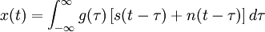
Taking the expected value of the squared error results in

Where
- R_{s} is the autocorrelation function of s(t)
- R_{x} is the autocorrelation function of x(t)
- R_{xs} is the cross-correlation function of x(t) and s(t)
If the signal s(t) and the noise n(t) are uncorrelated (i.e., the cross-correlation is zero) then note the following
- R_{xs} = R_{s}
- R_{x} = R_{s} + R_{n}
The goal is to then minimize E(e²) by finding the optimal g(t).
The Wiener filter has solutions for two possible cases: the case where a causal filter is desired, and the one where a non-causal filter is acceptable. The latter is simpler but is not suited for real-time applications. Wiener's main accomplishment was solving the case where the causality requirement is in effect.

Non causal solution:
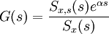
Provided that g(t) is optimal then the MMSE equation reduces to 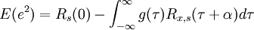
And the solution, g(t) is the inverse two-sided Laplace transform of G(s).

Causal solution:
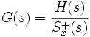
Where
- H(s) consists of the causal part of 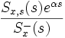(that is, that part of this fraction having a positive time solution under the inverse Laplace transform)
- is the causal component of S_{x}(s) (i.e. the inverse Laplace transform of is non-zero only for )
- is the anti-causal component of S_{x}(s) (i.e. the inverse Laplace transform of is non-zero only for negative t)
This general formula is complicated and deserves a more detailed explanation. To write down the solution G(s) in a specific case, one should follow these steps
1. Start with the spectrum S_{x}(s) in rational form and factor it into causal and anti-causal components:
Where S ⁺ contains all the zeros and poles in the left hand plane (LHP) and S ⁻ contains the zeroes and poles in the RHP.
2. Divide S_{x,s}(s)e^{αs} by and write out the result as a partial fraction expansion.
3. Select only those terms in this expansion having poles in the LHP. Call these terms H(s).
4. Divide H(s) by . The result is the desired filter transfer function G(s)

We now discuss an important generalization of the wiener filter. The significance of the extension is in its ability to accommodate vector signals and noises which additionally may be non stationary. This is in contrast to the wiener filter, which is restricted to stationary scalar signals and noises. This generalization is termed the kalman filter. It may be thought of as a sequential MMSE estimator of a signal embedded in noise, where the signal is characterized by a dynamical or state model. It generalizes the sequential MMSE estimator to allow the unknown parameters to evolve in time according to a dynamical model. If the signal and noise are jointly Gaussian, then the kalman filter is an optimal MMSE estimator, and if not, it is optimal LMMSE estimator.
2.7 Choosing an Estimator

The choice of an estimator that will perform well for a particular application depends upon many considerations. Of primary concern is the selection of a good data model. It should be complex enough to describe the principle features of the data, but at the same time, simple enough to allow an estimator that is optimal and easily implemented. We have seen that at times we were unable to determine the existence of an optimal estimator, an example being the search for the MVU estimator in classical estimation. In other instances, even though the optimal estimator could easily be found. It could not be implemented, an example being the MMSE estimator in Bayesian estimation. For a particular problem we are neither assured of finding an optimal estimator or, even if we are fortunate enough to do so, of being able to implement it. Therefore it becomes critical to have at one’s disposal knowledge of the estimators that are optimal and easily implemented, and further more, to understand under what conditions we may justify their use. To this end we now summarize the approaches, assumptions, and for the linear data model, the explicit estimators obtained. Then, we will illustrate the decision making process that one must go through in order to choose a good estimator.
We now illustrate the decision making process involved in choosing an estimator. In doing so, our goal is always to find the optimal estimator for a given data model. If this is not possible, we consider sub optimal estimation approaches. Consider an equation
x[n] = A[n] +w[n] n = 0,1,2……N-1

Where the unknown parameters are {A[0],A[1]…… A[N-1]}. We have allowed the parameter A to change with time, as most parameters normally change to some extent in real world problems. Depending on our assumptions on A[n] & w[n], the data may have the form of the classical or Bayesian linear model. If this is the case, the optimal estimator is easily found. However, even if the estimator is optimal for the assumed data model, its performance may not be adequate. Thus, the data model may need to be modified, as we now discuss. We will refer to the flow chart given below as we describe the considerations in the selection of a estimator. Since we are attempting to estimate as many parameters as data points, we can expect poor estimation performance due a lack of averaging. The classical approaches to estimation in which the unknown px1 parameter vector $θ$ is assumed to be a deterministic constant, followed by the Bayesian approach in which $θ$ is assumed to be the realization of the random vector. In the classical approaches the data information is summarized by the probability density function (PDF) p(x;$θ$), where the PDF is functionally dependent on$θ$.In contrast to this modeling the Bayesian approach augments the data information with a prior PDF p($θ$) which describe our knowledge about $θ$ (before any data are observed).This is summarized by the joint PDF p(x,$θ$) or, equivalently, by the conditional PDF and the prior PDF p($θ$) (prior information).

BAYESIAN APPROACH

PDF known
Compute mean of posterior PDF
MAP estimator
MMSE estimator
First two moments known
Yes
No
Yes
No
Yes
Yes
No
LMMSE estimator

Maximize posterior PDF
No
With prior knowledge such as the PDF of $θ$ = [A[0],A[1]…… A[N-1]]^{T} we could use a Bayesian approach as given in figure below. Based on the PDF p(x,$θ$), we can in theory find the MMSE estimator. This will involve a multidimensional integration and may not in a practice be possible. Failing to determine the MMSE estimator we could attempt to maximize the posterior PDF to produce the MAP estimator, either analytically or at least numerically. As a last resort if the first two joint moment of x and $θ$ are available, we could determine the LMMSE estimator in explicit form even if dimensionality is not a problem as for example, If A[n] = A, the use of prior knowledge embodied by the prior PDF will improve the estimation accuracy in the Bayesian sense, that is to say the Bayesian MSE will be reduced. If no prior knowledge is available, we will be forced to reevaluate all data model or else obtain more data for example, we might suppose that, A(n) = A or even A[n] = A+Bn reducing the dimensionality of the problem. This may result in bias error due to modeling inaccuracies but at least the variability of any resultant estimator would be reduced. Then we resort to a classical approach given in figure below. If the PDF is known we first compute the equality condition for the CRLB, and if satisfied, an efficient and hence MVU estimator will be found, if not we could attempt to find a sufficient statistics, make it unbiased and if complete, this would produce the MVU estimator. If this approach fails, a maximum likelihood approach could be tried if the likelihood function (PDF with x replaced by the observed data values) can be maximized analytically or at least numerically. Finally the moments could be found and the method moment estimator tried. Note that the entire PDF need not to be known for a method of moments estimator. If the PDF is unknown but the problem is one of a signal in noise, then either a BLUE or LS approach could be tried. If the signal is linear in $θ$ and the two moments of the noise are known, a BLUE can be found. Otherwise a LS and a possibly a non linear LS estimator must be employed. In general, the choice of an appropriate estimator for a signal processing problem should begin with the search for an optimal estimator, which is computationally feasible. If the search proves to be futile, then sub optimal estimators should be investigated.

CLASSICAL APPROACH

PDF Known

CRLB Satisfied
Complete sufficient statistic exist
Evaluate MLE
Evaluate method of moments estimator
Signal in noise
Signal linear
First two noise moments known
No
Yes
No
Yes
Make it unbiased
Yes
No
No
Yes
MLE
No
Yes
No
Moments estimator
MVU estimator
Yes
MVU
Yes
No
Yes
Yes
BLUE
No
LSE
No

CLASSICAL VS BAYESIAN
Dimensionality a problem
Signal processing problem
No
Yes
Prior knowledge
Prior knowledge
New data model or take more data
No
Yes

No

No
Yes
Bayesian approach
Bayesian approach

Classical approach

Chapter-3
KALMAN FILTER

3. KALMAN FILTER

The Kalman filter is a recursive estimator. This means that only the estimated state from the previous time step and the current measurement are needed to compute the estimate for the current state. In contrast to batch estimation techniques, no history of observations and/or estimates is required. It is unusual in being purely a time domain filter; most filters (for example, a low-pass filter) are formulated in the frequency domain and then transformed back to the time domain for implementation. The Kalman filter is an efficient recursive filter which estimates the state of a dynamic system from a series of incomplete and noisy measurements.The Kalman filter is widely used in navigational and guidance systems, radar tracking, sonar ranging, and satellite orbit determination (for the Ranger, Apollo, and Mariner missions, for instance), as well as in fields as diverse as seismic data processing, nuclear power plant instrumentation, and econometrics. Kalman filter may be thought of a sequential MMSE estimator of a signal embedded in noise, where the signal is characterized by a dynamic or state model .It generalizes the sequential MMSE estimator, to allow the unknown parameters to evolve in time according to a dynamic model. If the signal and noise are jointly Gaussian, then the Kalman filter is an optional MMSE estimator, and if not, it is the optional LMMSE estimator.
X[n] = A + w[n]
Where A is the parameter to be estimated and w[n] is WGN with variance σ². A could be time varying, hence more accurate measurement model would be
x[n] = A[n] + w[n]
Where A[n] is the true signal at time n. However, with this model our estimation problem becomes considerably more complicated since we will need to estimate A[n] for n = 0,1,…..N-1 instead of just a single parameter A. Successive samples of A[n] will not be too different, leading us to conclude that they display a high degree of “correlation”.
In wiener filtering the signal to be estimated was termed s[n], and it was assumed to be zero mean. Once we specify the signal model for zero mean s[n], it is easily modified to accommodate nonzero mean process by adding E(s[n]) to it. We will always assume that the mean is known.
A simple model for s[n] which allows us to specify the correlation between samples is the first order Gauss-Markov process
s[n] = as[n-1] + u[n] n≥0
Where u[n] is WGN with variance σ_{u}² , s[-1] ~ N(µ_{s,} σ_{s}²), and s[-1] is independent of u[n] for all n≥0.The noise u[n] is termed the driving or excitation noise since s[n] my be viewed as the output of a linear time invariant system driven by u[n].The above model is also called the dynamical or state model. We will refer to above equation as the Gauss-Markov model, where it is understood to be first order.
First, we express s[n] as a function of the initial condition, and the inputs as
s[0] = as[-1] + u[0]
s[1] = as[0] + u[1]
= a²s[-1] + au[0] + u[1]
etc.

In general, we have
n
s[n] = a^{n+1}s[-1] + ∑a^{k}u[n-k]
k=0
So the mean follows as
E(s[n]) = a^{n+1} E(s[-1])
= a^{n+1} µ_{s}
Thus, the covariance between samples s[m] and s[n] for m>n

m
C_{s}[m,n] = a^{m+n+2} σ_{s}² + σ_{u}²∑a^{2k+n-m}
k=m-n

n
∑a^{2k} = a^{m+n+2} σ_{s}² + σ_{u}² a^{m-n}
k=m-n
And of course C_{s}[m,n] = C_{s}[n,m] for m<n.
Thus variance is,
Var(s[n]) = C_{s}[n,n]

3.1 SCALAR KALMAN
GAUSS MARKOV SIGNAL MODEL: The Gauss-Markov signal model discussed had the form
s[n] = as[n-1] + u[n] n≥0
We now describe a sequential MMSE estimator which will allow us to estimate s[n] based on the data {x[0],x[1]…..x[n]} as n increases. Such an operation is referred to as filtering. The approach computes the estimator s[n] based on the estimator for the previous time sample s[n-1] and so is recursive in nature. This is so called Kalman Filter. The versatility of the Kalman filter accounts for its widespread use. It can be applied to estimation of a scalar Gauss-Markov signal as well as to its vector extension.
Furthermore, the data which previously in all our discussions consisted of a scalar sequence such as {x[0],x[1]…..x[n]}, can be extended to vector observations or {x[0],x[1]…..x[n]}.
Consider the scalar state equation and the scalar observation equation
s[n] = as[n-1] + u[n]
x[n] = s[n] + w[n]
Where u[n] is zero mean Gaussian noise with independent samples and
E (u² [n]) = σ_{u}², w[n] is zero mean Gaussian noise with independent samples and E (w² [n]) = σ_{n}². We finally assume that s [-1], u[n], and w[n] are all independent. Finally we assume s [-1] ~ N (µ_{s,} σ_{s}²). The noise process w[n] differs from WGN only in that its variance is allowed to change with time. We wish to estimate s[n] based on the observations {x[0],x[1]…..x[n]} or to filter x[n] to produce ŝ[n].
More generally, the estimator of s[n] based on the observations {x[0],x[1]…..x[m]} will be denoted by ŝ[n|m]. Our criterion of optimality will be the minimum Bayesian MSE or
E[(s[n]-ŝ[n|n])²
where the expectation is with respect to p(x[0],x[1]…..x[n], s[n]). But the MMSE estimator is just the mean of posterior PDF or
ŝ[n|n] = E(s[n]|x[0],x[1,……,x[n]])
with zero means this becomes
ŝ[n|n] = C_{θx}C⁻¹_{xx} x
where θ = s[n] and x = [x[0],x[1]…..x[n]]^{T} are jointly Gaussian. We are assuming Gaussian statistics for the signal and noise, the MMSE estimator is linear and is identical in algebraic form to the LMMSE estimator. The implicit linear constraint does not detract from the generality since we already know that the optimal estimator is linear.
Further from above equations and the orthogonality principle we will have
ŝ[n|n] = E(s[n]|x[0],x[1,……,x[n-1]) + E(s[n]|x[n])
= ŝ[n|n-1] + E(s[n]|x[n])
Which has the desired sequential form.
Let X[n] = [x[0]x[1]…..x[n]]^{T} and x~[n] denote the innovation. The innovation is the part of x[n] that is uncorrelated with the {x[0],x[1]…..x[n-1]} or
x~[n] = x[n] - x~[n|n-1]
Further to determine E(s[n]| x~[n]) we note that it is the MMSE estimator of s[n] based on x~[n]. As such it is linear, and because of the zero mean assumption of s[n], it takes the form

E(s[n]| x~[n]) = K[n] x~[n]
= K[n](x[n] - x~[n|n-1])

Where, K[n] = E(s[n] x~[n])
E(x^{~2}[n])

Hence,
K[n] = E[s[n](x[n] – ŝ[n|n-1])]
E[(x[n] - ŝ[n|n-1])²]

or K[n] = E[(s[n] – ŝ[n|n-1])(x[n] - ŝ[n|n-1])]
E[(s[n] - ŝ[n|n-1] + w[n])²]

= E[(s[n] – ŝ[n|n-1])²]
σ_{n}² + E[(s[n] - ŝ[n|n-1])²]

The numerator is just the minimum MSE incurred when s[n] is estimated based on the minimum one step prediction error. We denote this by M[n|n-1], so that

K[n] = M[n|n-1]______
σ_{n}² +M[n|n-1]

Hence, we can summarize it below for n≥0 as

Prediction:
ŝ[n|n-1] = aŝ[n-1|n-1]
Minimum Prediction MSE:
M[n|n-1] = a²M[n-1|n-1] + σ_{u}²

Kalman Gain:
K[n] = M[n|n-1]______
σ_{n}² + M[n|n-1]
Correction:
ŝ[n|n] = ŝ[n|n-1] + K[n](x[n] - ŝ[n|n-1])

Minimum MSE:
M[n|n] = (1 – K[n])M[n|n-1]

Although derived for µ_{s} = 0, the same equations result for µ_{s} ≠ 0. Hence, to initialize the equations we use ŝ[-1|-1] = E(s[-1]) = µ_{s}, and M[-1|-1] = σ², since this amounts to the estimation of s[-1] without any data.

Scalar state-scalar observation Kalman filter and relationship to dynamic model

az⁻¹
u[n]
∑
s[n]
+
+
a. Dynamic model
A block diagram of Kalman filter is shown. It is interesting to note that the dynamic model for the signal is an integral part of the estimator. Furthermore, we may view the output of the gain block as an estimator of u[n].

∑
ŝ[n|n]
+…
+

Dynamic model
K[n]
∑

+
-
x[n]
Û[n]

ŝ[n|n-1]
x[n]
+
az⁻¹

b. Kalman filter

3.2 VECTOR KALMAN

The scalar state-scalar observation Kalman filter is easily generalized. The two generalizations are to replace s[n] by s[n], and to replace the scalar observation x[n] by the vector observation x[n],The first generalization will produce the vector state scale observation Kalman filter, while the second leads to the most general form, the vector state vector observation Kalman filter. In either case the state model is,

s[n] = As[n-1] + Bu[n] n ≥ 0
Where A,B are known p×p and p×r matrices, u[n] is vector WGN with u[n] ~ Ν (0,Q), s[-1] ~ Ν (µ_{s ,} C_{s}) , and s[n-1] is independent of the u[n]’s. The vector state –scalar observation Kalman filter assumes that the observations follow the Bayesian linear model with the added assumption that the noise covariance matrix is diagonal. Thus for nth data sample we have
x[n] = h^{T}[n]s[n] + w[n]
Where h[n] is known p×1 vector and w[n] is zero mean Gaussian noise with uncorrelated samples, with variance σ_{n}² and also independent of s[-1] and u[n].The above data model is called the observation or measurement equation.

Theorem (Vector Kalman Filter):
The p×1 signal vector s[n] evolves in time according to the Gauss- Markov model
s[n] = As[n-1] + Bu[n] ; n ≥ 0
Where A,B are known p×p and p×r matrices, respectively. The driving noise vector u[n] has the PDF u[n] ~ Ν (0,Q) and is independent from sample to sample, so that E(u[m]u^{T}[n]) =0 for m ≠ n (u[n] is vector WGN).The initial state vector s[-1] has PDF s[-1] ~ Ν (µ_{s ,} C_{s}) and is independent of u[n].
The M × p observation matrix (which may be time varying) and w[n] is an M × 1 observation noise vector with PDF w[n] ~ Ν (0,C[n]) and is independent from sample to sample, so that E(w[n]w^{T}[n]) = 0 for m ≠ n.

The MMSE estimator s[n] based on {x[0] , x[1], ….., x[n] } or
ŝ[n|n] = E(s[n]| x[0] , x[1], ….., x[n] )
Can be computed easily on basis of previously described recursions.
The vector state set up for kalman filter is described in the same manner as the scalar state. Following that we have

Prediction:
ŝ[n|n-1] = Aŝ[n-1|n-1] .

Minimum Prediction MSE Matrix (p×p):
M[n|n-1] = AM[n-1|n-1]A^{T} + BQB^{T}

Kalman Gain Vector (p×1):
K[n] = M[n|n-1]h[n]
σ_{n}²+ h^{T}[n]M[n|n-1]h[n]

Correction:
ŝ[n|n] = ŝ[n|n-1] + K[n] (x[n]- h^{T}[n] ŝ [n|n-1])
Minimum MSE Matrix (p×p):
M[n|n] =(I- K[n] h^{T}[n]) M[n|n-1]

Where the mean square matrices are defined as
M[n|n] = E[( s[n] -ŝ[n|n] )( s[n] - ŝ[n|n])^{T}]
M[n|n-1] = E[( s[n] -ŝ[n|n-1] )( s[n] - ŝ[n|n-1])^{T}]

We now require the inversion of an M×M matrix to find the Kalman gain. If the dimension of the observation vector M, a more efficient implementation of the Kalman filter can be obtained.
Extensions can be made by letting the matrices A, B, and Q be time varying. Fortuitously, the equations that result are identical to those of the previous theorem when we replace A by A[n], B by B[n], Q by Q[n]. Also it is possible to extend the results to colored observation noise and to signal models with deterministic inputs (in addition to the driving noise).

NOTES:

Many of the filters use classical linear estimation techniques, such as the Kalman filter. To make them useful they are applied in modified forms to cope with linearized models of some kind. Commonly a gradient linearized model is used to update uncertainty, while the state is directly propagated through the non-linear model. This is the extended form used by the Extended Kalman Filter. However, some numerical schemes cannot be modified using the extended form. In particular, it is not always possible to use the extended form with correlated noises. Where this is the case, the linearized model is used for uncertainty and state.
There are also many Bayesian filters that work with non-Gaussian noise and non-linear models - such as the SIR filter. The SIR scheme has been built so it works with Likelihood model.

Chapter-4
CHANNEL ESTIMATION
USING
KALMAN FILTER

4.1 CHANNEL ESTIMATION USING KALMAN FILTER

Many transmission channels can be characterized as being linear but not time invariant. These are referred to by various names such as fading dispersive channels or fading multi path channels. They arise in communication problems in which the troposphere is used as a medium or in sonar in which the ocean is used. In either case medium acts as a linear filter causing an impulse to appear as a continuous waveform at the output as shown in the figure below. This effect is a result of a continuum of propagation paths, i.e. multi path, each of which delays and attenuates the input signal. Additionally, however, a sinusoid at the input will appear as a narrow band signal at the or one whose amplitude is modulated (the fading nature). This effect is due to the changing character of the medium, for example, the movement of the scatterers. A little thought will convince that the channel is acting as a linear time varying filter. If we sample the output of the channel, then it can be shown that a good model is the low-pass tap delay line model as shown in next figure. This input-output description of this system is

p-1
y[n] = ∑ h_{n}[k]v[n-k]
k=0

and the curves depicting the input output relationship is shown in the figures below

Input
t
t

Output

(a) Multipath channel
Input
Output
t
t
(b) Fading channel

h_{n}[1]

h_{n}[p-1]

y[n]
z⁻¹
z⁻¹

z⁻¹

×
∑
×
h_{n}[0]
. . . . . .
×
Tapped delay line channel model

x [n]

This is really nothing more than a FIR filter with time varying coefficients. To design effective communication or sonar systems it is necessary to have knowledge of these coefficients. Hence the problem becomes one of estimating h_{n}[k] based on the noise corrupted output of the channel
p-1
x[n] = ∑ h_{n}[k]v[n-k] + w[n]
k=0

Where w[n] is the observation noise.
From above equation the observations for p=2 and assuming that v[n]=0 for n<0, are
x[0] = h₀[0]v[0] + h₀[1]v[-1] + w[0] = h₀[0]v[0] + w[0]
x[1] = h₀[0]v[1] + h_{1[1]v[0] + w[1]}
x[2] = h2[0]v[2] + h2[1]v[1] + w[2]
_{etc.}
It is seen that for n ≥ 1 we have two new parameters for each new data sample. Even without corrupting noise we cannot determine the tapped delay line weights. A way out of this problem is to realize that the weights will not change rapidly from sample to sample. The use of Gauss-Markov model allows us to fix the correlation between the successive values of a given tap weight in time. Hence, we suppose that the state vector is
h[n] = Ah[n-1] + u[n]
where h[n] = [h_{n}[0] h_{n}[1]…… h_{n}[p-1]]^{T} , A is a known p×p matrix and u[n] is a vector WGN with covariance matrix Q. A standard assumption that is made to simplify the modeling is that of uncorrelated scattering. It assumes that the tap weights are uncorrelated to each other and hence independent due to jointly Gaussian assumption. As a result, we can let A, Q, and Ch, the covariance matrix of h[-1], be diagonal matrices. The vector Gauss-Markov model then becomes p independent scalar models.
The measurement model is

Where w[n] is assumed to be WGN with variance σ² and the v[n] sequence is assumed known (since we provide the input to the channel). We can now from the MMSE estimator for the tapped delay line weights recursively in time using the kalman filter equations for a vector state and scalar observations. With obvious changes in notation we have
x[n] = [ v[n] v[n-1] …….v[n-p+1]] h[n] + w[n]
v^{T}[n]

ĥ[n|n-1] = A ĥ[n-1|n-1]
M[n|n-1] = AM[n-1|n-1]A^{T} + Q

K[n] = M[n|n-1] v[n]
σ² + v^{T}[n] M[n|n-1] v[n]

ĥ[n|n] = ĥ[n|n-1] + K[n] (x[n]- v^{T}[n] ĥ[n|n-1] )

M[n|n-1] = ( I - K[n] v^{T}[n] ) M[n|n-1]

And is initialized by ĥ[-1|-1] = µ_{h}, M[-1|-1] = C_{h}.

4.2 Example:
An example of an application would be to provide accurate continuously-updated information about the position and velocity of an object given only a sequence of observations about its position, each of which includes some error. It is used in a wide range of engineering applications from radar to computer vision. Kalman filtering is an important topic in control theory and control systems engineering.
For example, in a radar application, where one is interested in tracking a target, information about the location, speed, and acceleration of the target is measured with a great deal of corruption by noise at any time instant. The Kalman filter exploits the dynamics of the target, which govern its time evolution, to remove the effects of the noise and get a good estimate of the location of the target at the present time (filtering), at a future time (prediction), or at a time in the past (interpolation or smoothing).
As an example implementing the kalman filter estimator for a tap delay line having p=2 weights, we assume a state model with

A particular realization is shown in figure below in which h_{n}[0] is decaying to zero while h_{n}[1] is fairly constant. This is because the mean of the weights will be zero in steady state. Due to smaller values of [A]₁₁, h_{n}[0]
0.99 0

0 0.999

A =

Q =

0.0001 0

0 0.0001

will decay more rapidly. Also the eigen values of A are just the diagonal elements and they are less than one in magnitude.

Realization of TDL coefficients
10 20 30 40 50 60 70 80 90

1.2

1.0

0.8

0.6

0.4

0.2

0.0
Sample number, n

Tap weight, h_{n}[0]

For this tap weight realization and the input shown in figure, the output is shown in next figure as determined from above equations.

10 20 30 40 50 60 70 80 90

1.2

1.0

0.8

0.6

0.4

0.2

0.0
Tap weight,h_{n}[1]

Sample number, n

1.0

0.5

0.0

-0.5

-1.0
0 10 20 30 40 50 60 70
Ch. i/p
Sample number, n

0 10 20 30 40 50 60 70

Sample number, n

1.5

1.0

0.5

0.0

-0.5

-1.0

Ch. o/p

When observation noise is added with σ² = 0.1, we have the channel output as shown in figure below

0 10 20 30 40 50 60 70

Sample number, n

2.5

2.0

1.5

1.0

0.0

-0.5

-1.0

Ch o/p,x[n]

We next apply the Kalman filter with ĥ[-1|-1] = 0 and M[-1|-1] = 100I, which are chosen to reflect little knowledge about the initial state. In the theoretical development of the Kalman filter the initial state estimate is given by the mean of S[-1]. In practice this is seldom known, so that we usually just choose an arbitrary initial state estimate with a large initial MSE matrix to avoid “biasing” the Kalman filter towards that assumed state. The estimated tap weights are shown in figure below.

0 10 20 30 40 50 60 70

Sample number, n

1.2

1.0

0.8

0.6

0.4

0.2

0.0

True

Estimate

Tap weights, h_{n}[0]

0 10 20 30 40 50 60 70

Sample number, n

1.2

1.0
0.8
0.6
0.4
0.2
0.0

Tap weights, h_{n}[1]

True
Estimate

0 10 20 30 40 50 60 70
Sample number, n

1.2

1.0

0.8

0.0

-0.2

-0.4

-0.6

Kalman gain, k₁[n]

0 10 20 30 40 50 60 70

Sample number, n

1.2

1.0
0.8
0.6
0.4
-0.2
-0.4

Kalman gain, k₂[n]

After an initial transient the Kalman filter “locks on” to the true weights and tracks them closely. The Kalman filter gains are shown above
The kalman appear to attain a periodic steady state but because v[n] varies with time, true steady state is never obtained. Also at times gain is zero as for example
In [K]1 = K1[n] for 0 ≤ n ≤ 4. This is because at these times v[n] is zero due to zero input and thus observations contain only noise. The Kalman filter ignores these data samples by forcing the gain to be zero.
Finally minimum MSEs are shown below and are seen to decrease monotonically.

2.00

1.75

1.50
1.25

1.00
0.75

0.50
0.00

0 10 20 30 40 50 60 70

Sample number, n

Minimum MSE, M₁₁[n]

2.00

1.75

1.50
1.25

1.00
0.75

0.50
0.00

0 10 20 30 40 50 60 70

Sample number, n

Minimum MSE, M₂₂[n]

Chapter-5
SIMULATION AND RESULTS

5.1 SIMULATION AND RESULTS

As we had studied about the time varying channel estimation using Kalman filter, we implemented the Kalman filter estimator for a tapped delay line having p=2 weights using MATLAB. For the implementation part we assumed
0

0 0.999

A =

Q =

0.0001 0

0 0.0001

ĥ [-1|-1] = 0
M [-1|-1] = 100I
σ² = 0.1
We obtained the following graphs for channel input, output, estimated tap weights, Kalman gain and mean square error which are depicted serially.

Tap and estimated tap weight

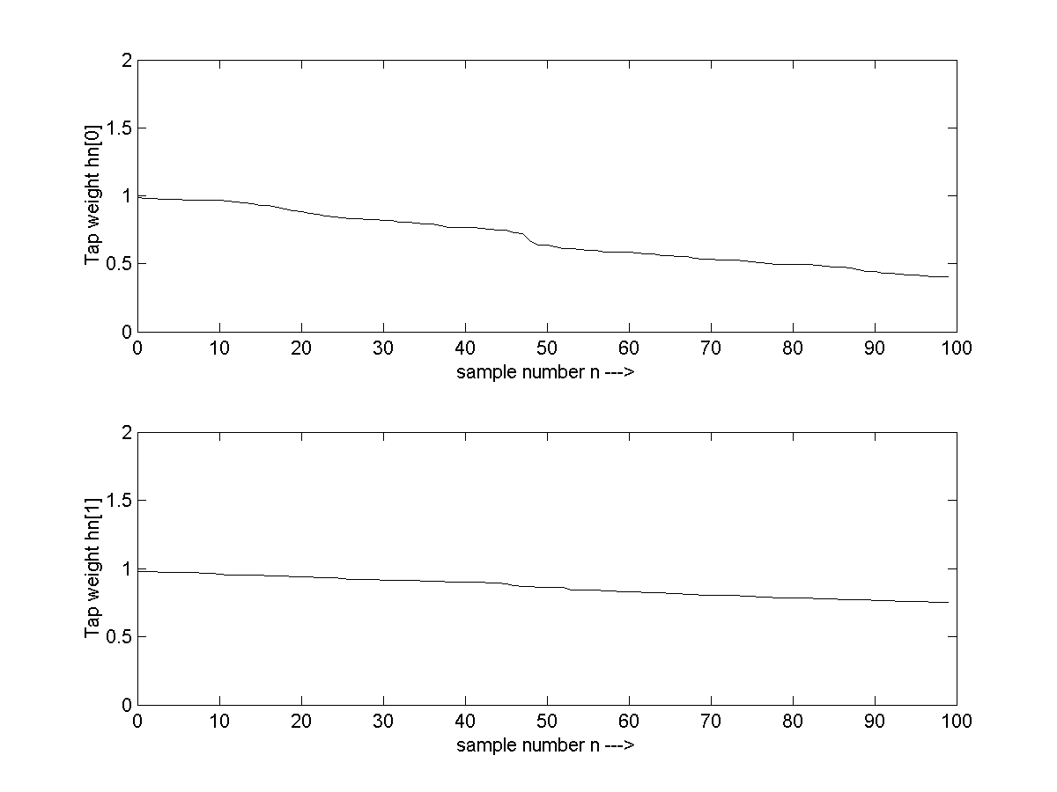

X-axis - Sample number, n
Y-axis - Tap weights

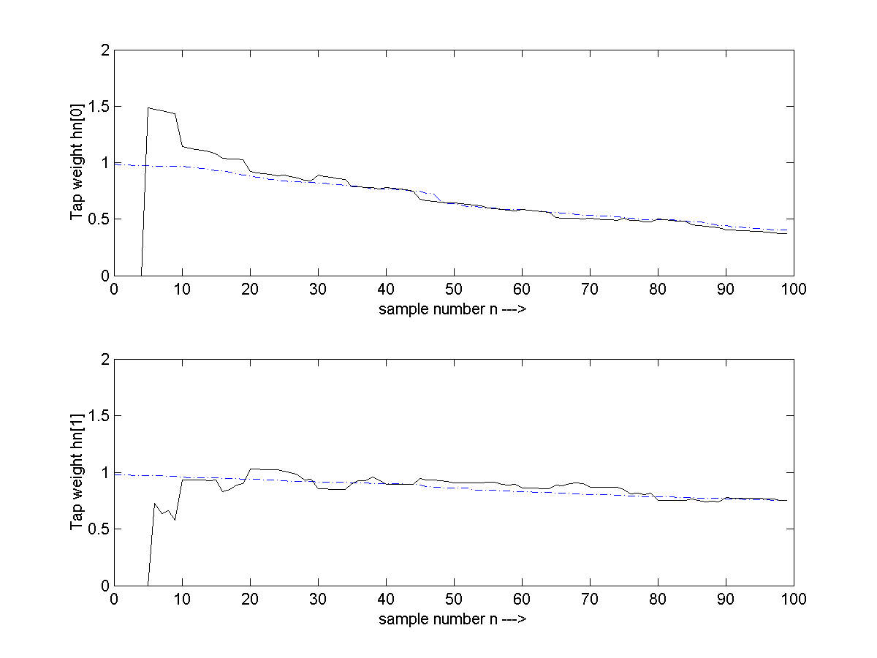

Channel Input V(n)

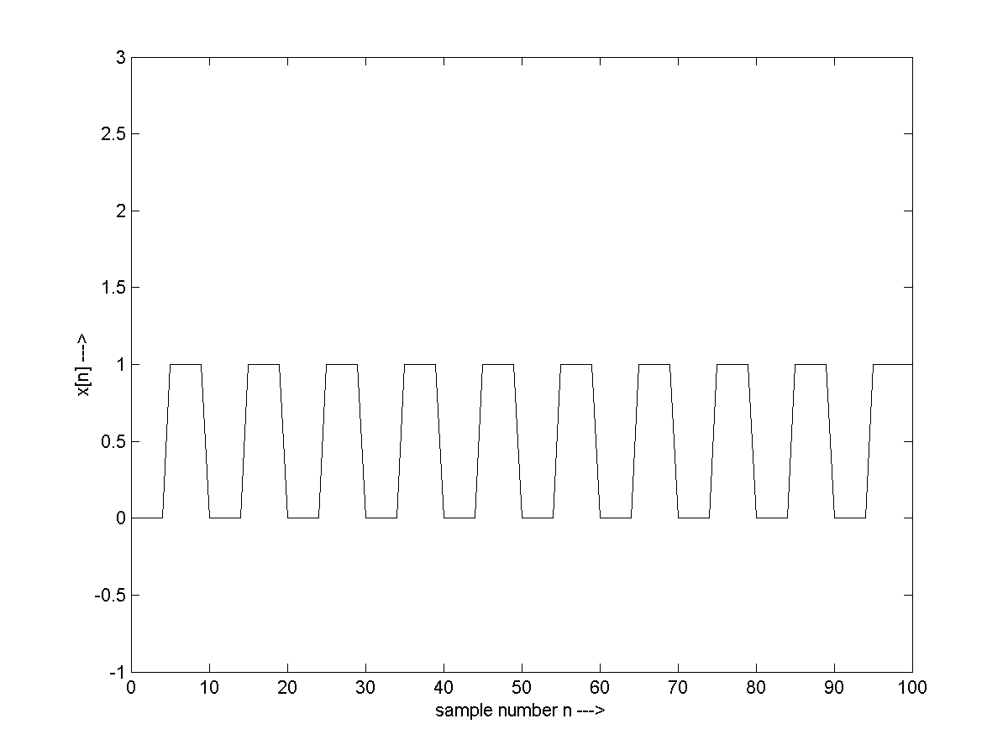

X-axis - Sample number, n
Y-axis - Channel input

Channel output X(n)

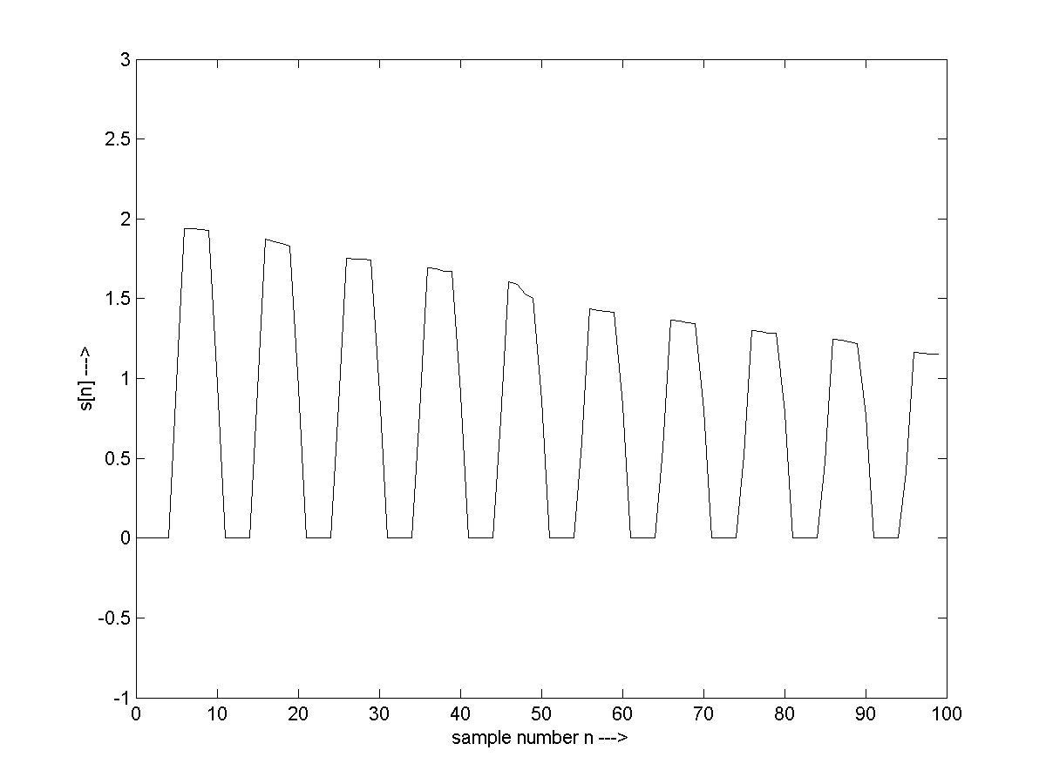

X-axis - Sample number, n
Y-axis - Channel output

Noiseless Channel output y[n]
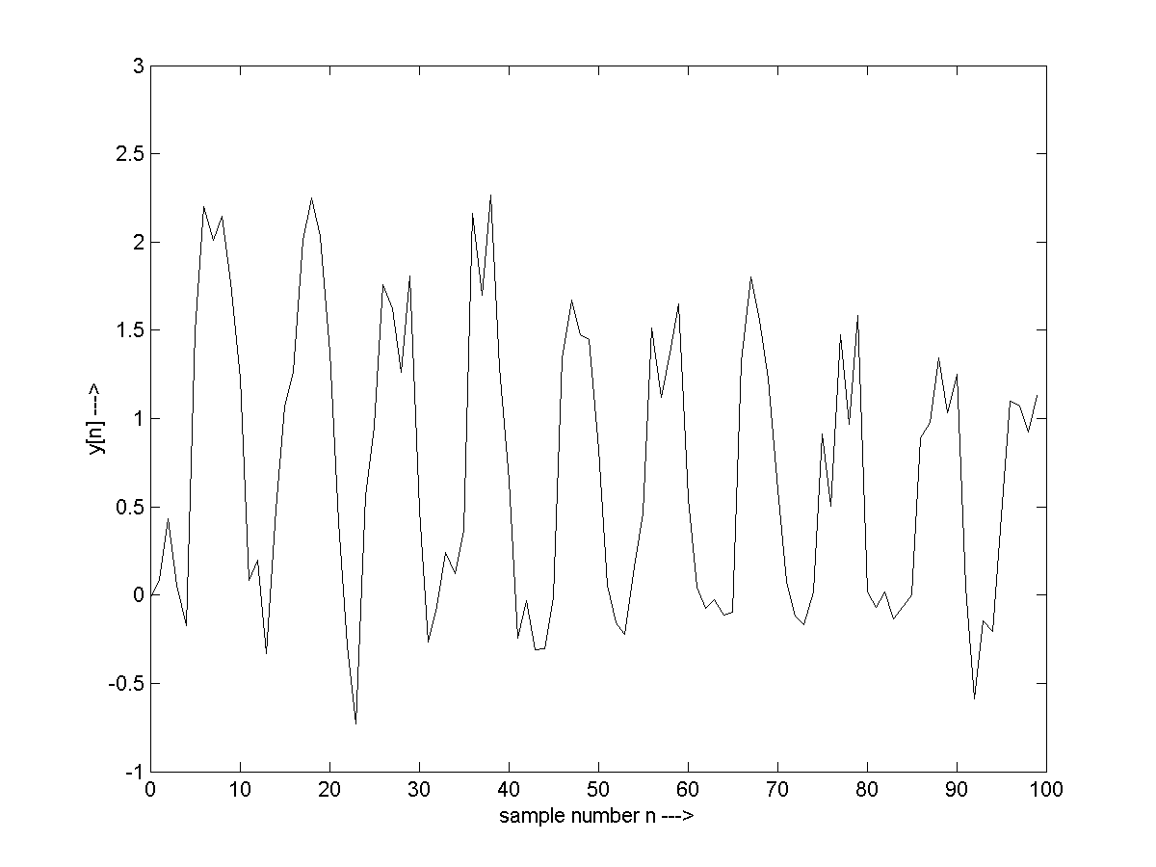

X-axis - Sample number, n
Y-axis - Noiseless Channel output

Kalman gain

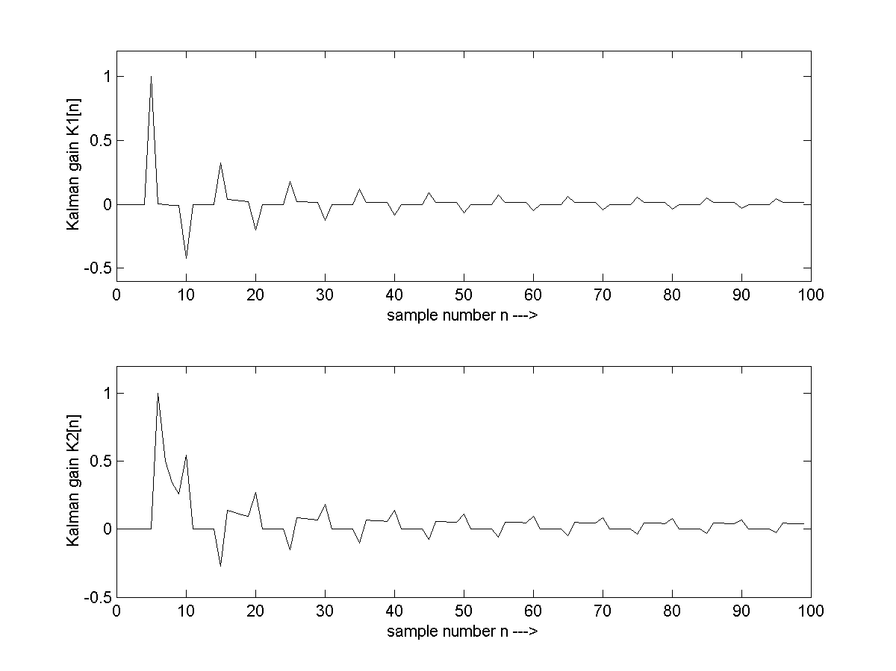

X-axis - Sample number, n
Y-axis - Kalman gain

Minimum MSE

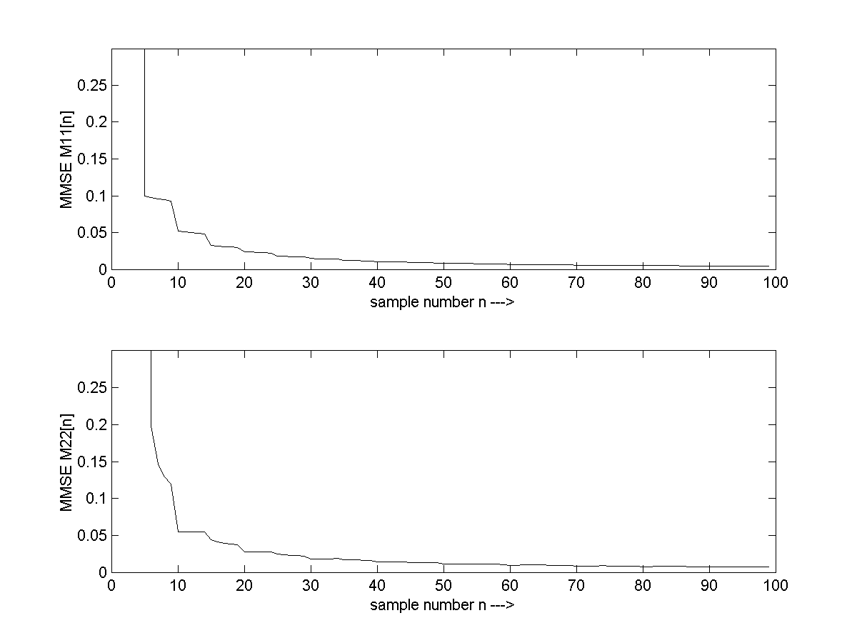

X-axis - Sample number, n
Y-axis - Kalman filter minimum MSE

5.2CONCLUSIONS

In this project we modeled the time varying channel as a low pass tapped delay line filter (FIR filter with time varying coefficient).The observation model is assumed to be Gauss-Markov for tap weight. And the kalman filter is used to estimate the time varying coefficient of the channel.

7. BIBLIOGRAPHY

- J. G. Proakis, "Digital Communications", 3rd edition, McGraw-Hill, 1995, 929 p.

- S. M. Kay, "Fundamentals of Statistical Signal Processing: Estimation Theory", Prentice-Hall, 1998, 595 p.

- S. Haykin, "Adaptive Filter Theory", Prentice-Hall, 3rd Ed., 1996, 989 p.

- L. Lindbom, A. Ahl´en, M. Sternad, and M. Falkenstr¨om, “Tracking of time-varying mobile radio channels-part II: A case study,” IEEE Trans. Commun.,vol. 50, no. 1, pp. 156–167, January 2002.

- Brown R G, Hwang P Y C 1997 Introduction to random signals and applied Kalman Filtering(New York: John Wiley and Sons)

- M. C. Jeruchim, P. Balaban, and K. S. Shanmugan, "Simulation of Communication Systems”, Plenum Press, 1992, 731 p.

- M. Pukkila, "Channel Estimation of Multiple Channel Signals", Master’s Thesis, HUT, 1997.

- Grewal M. S., and Andrews A. P., “Kalman filtering, theory and practice,” Prentice-Hall, 1993.

- Omidi M. J., Pasupathy S., Gulak P.G.,“Joint data and Kalman estimation of fading channel,” International Conference on Communications (ICC’96), pp. 1198-1203, 1996.

- Golub G. H., Van Loan C. E, “Matrix computations,” Johns Hopkins University Press, 2nd edition, pp. 137, 1991.

- Jover M., and Kailath T., “A parallel architecture for Kalman filter measurement update and parameter estimation,”Automatica, vol. 22, No. 1, pp. 43-57, 1986.

8. APPENDIX

MATLAB CODE:

clc;
clear all;
close all;

v1 = ones(1,20);
v2=2*ones(1,20);
v=cat(2,v1,v2,v1,v2,v1,v2);
%axis([1 100 0.5 4])
plot(v)
n=2;
uh0=1;
uh1=.9;

h2 = [uh0;uh1];
Ch=0.4;% final
M2 = [Ch,0;0,Ch];
A=[.99,0;0,.999];
Q=[.0001,0;0,.0001];
sig = 0.01;
I=[1,0;0,1];
w = sqrt(sig)*randn(1,120);

for i=2:120
h=A*h2;
M= A*M2*A'+Q;
vtemp=[v(n);v(n-1)];
K = (M*vtemp)/(((vtemp')*M*vtemp)+sig);
x(n) = (vtemp')*h + w(n);
h2 = h + K*(x(n)-((vtemp')*h)) ;
M2 = (I-(K*(vtemp')))*M;
H(1,n)=h(1);
H(2,n)=h(2);
Kal(1,n)=K(1);
Kal(2,n)=K(2);
MSE(1,n)=M(1,1);
MSE(2,n)=M(2,2);
n=n+1;
end

figure;
plot(x)
figure;
plot(v)
figure;
v=cat(2,v1,v2,v1,v2,v1,v2);
%axis([1 100 0.5 4])
%plot(v)

n=2;
uh0=1;
uh1=1;
h2 = [uh0;uh1];
Ch=0.2;
M2 = [Ch,0;0,Ch];
A=[.99,0;0,.999];
Q=[.0001,0;0,.0001];
sig = 0.01;
I=[1,0;0,1];
w = sqrt(sig)*randn(1,120);

for i=2:120
h=A*h2;
M= A*M2*A'+Q;
vtemp=[v(n);v(n-1)];
% K = (M*vtemp)/(((vtemp')*M*vtemp)+sig);
K = (M*vtemp)/(((vtemp')*M*vtemp));
% x(n) = (vtemp')*h + w(n);
x(n) = (vtemp')*h ;
h2 = h + K*(x(n)-((vtemp')*h)) ;
M2 = (I-(K*(vtemp')))*M;
Hd(1,n)=h(1);
Hd(2,n)=h(2);
Kal(1,n)=K(1);
Kal(2,n)=K(2);
MSE(1,n)=M(1,1);
MSE(2,n)=M(2,2);
n=n+1;
end

plot(Hd(2,:))
figure;
plot(H(1,:))
hold;
plot(Hd(1,:))
figure;
plot(x)

