THEORETCAL AND EXPERIMENTAL INVESTIGATION OF SI ENGINE USING GASOLINE AND ALTERNATIVE GASEOUS FUELS

A Major Dissertation Submitted in partial fulfillment of the
requirements for the award of the degree of
Master of Engineering
In
Thermal Engineering

By

RUDRA NARAYAN ROY
(University Roll No. 8556)
Session 2008-10
Under the Supervision of

MR. AMIT. PAL PROF. S. MAJI



Department of Mechanical Engineering
Faculty of Technology, University of Delhi
Delhi-110007, INDIA
2010
STUDENTS’ DECLERATION

I, hereby declare that the dissertation entitled “THEORETICAL AND EXPERIMENTAL INVESTIGATION OF SI ENGINE USING GASOLINE AND OTHER GASEOUS FUELS” being presented here in the partial fulfillment for the award of the Degree of Master of Engineering (Thermal Engineering), is an authentic record of own work carried out by me under the guidance and supervision of Mr. Amit Pal, Sr Lecturer, Department of Mechanical Engineering and Dr S. Maji, Professor, Department of Mechanical Engineering, Delhi College of Engineering, Delhi.
I, further declare that the dissertation has not been submitted to any other Institute/University for the award of any degree or diploma or any other purpose whatsoever.

June, 2010 Rudra Narayan Roy
University Roll no. 8556
Master of Engineering
(Thermal Engineering)

CERTIFICATE

Date: ___________

This is to certify that the dissertation entitled “THEORETICAL AND EXPERIMENTAL INVESTIGATION OF S I ENGINE USING GASOLINE AND OTHER GASEOUS FUELS” submitted by Mr. Rudra Narayan Roy, 10/THR/08, (University Roll. No.8556) in partial fulfillment of the requirements for the award of the Degree of Master of Engineering in Thermal Engineering, is an authentic record of student’s own work carried out by him under our guidance and supervision.
This is also certified that this dissertation has not been submitted to any other Institute/University for the award of any degree or diploma.

Prof. Amit Pal Dr. S. Maji
Sr. Lecturer Professor

Department of Mechanical Engineering
Faculty of Technology
University of Delhi, Delhi, India

ACKNOWLEDGEMENT

It is distinct pleasure to express my deep sense of gratitude and indebtedness to my learned supervisor Dr. S. Maji, Professor and Mr. Amit Pal, Sr. Lecturer in the Department of Mechanical Engineering, at Delhi College of Engineering, for his invaluable guidance, encouragement and patient review. His continuous inspiration only has made me complete this major dissertation. I am also very much thankful to Dr. S.S. Kachhwaha, Asst. Professor for reviewing drafts and giving valuable suggestions in the preparation of this dissertation.
I am thankful to Dr. P.B. Sharma, Director and Dr. B.D. Pathak, HOD of Mechanical Engineering Department at Delhi College of Engineering for their approval for the equipment and infrastructure required for completion of this project.
I would like to thank Sh. Manmohan, Sh. Lalit Kumar & Sh. Vijay Hingorani Ji of I.C Engine laboratory for extending their kind support and sharing their valuable time for the completion of the project.
I am thankful to my all teachers, classmates and friends for their unconditional support and motivation during this project. It is a great opportunity for me to extend my heartiest felt gratitude to everybody who helped me throughout the course of this dissertation in anyway.

Rudra Narayan Roy
ME (Thermal)
Univ. roll no.-8556

ABSTRACT

Computer simulations of internal combustion engine cycles are desirable because of the aid they provide in design studies to predicting trends serve as investigation tools for providing more data that are normally inaccessible from experiments and help to understand the complex process that occur inside combustion chamber. In the present work a two zone zero-dimensional model has been developed. The governing ODE equations contain cylinder pressure (p), burned temperature (T_{b}) and unburned temperature (T_{u}) as main parameters which are solved by using 4th order Runge-Kutta method. For a prescribed fuel the initial conditions required for simulation are equivalence ratio, ignition timing, manifold absolute pressure and engine speed. The model predicts the variation in pressure (p), burned gas temperature (T_{b}) and unburned gas temperature (T_{u}) for compression, combustion and expansion phases w.r.t crank angle. The developed model has been validated with the experimental data for gasoline, CNG and HCNG18. The predicted results match reasonably well with the available experimental data.

Performance and emission studies are also carried out on 4 stroke Wagon R engine. The variation of performance parameters (BSFC, BTE, BSEC) and emissions (CO and HC) for CNG and HCNG18 were compared with gasoline for a wide range of power output. The results show that gasoline is having higher BSFC as compared to CNG and HCNG18 whereas BTE is lower for HCNG18 as compared CNG and gasoline. CO and HC emissions of HCNG18 are lower as compared to CNG and gasoline. CNG and HCNG18 can be successfully used as an alternative gaseous fuel in SI engine.

 | CONTENTS
Page
No.
 | Students’ Declaration
 | Certificate
 | Acknowledgement |  |  |  |  |  |  |  |  | I
 | Abstract |  |  |  |  |  |  |  |  | II
 | Contents |  |  |  |  |  |  |  |  | III
 | List of Figures |  |  |  |  |  |  |  |  | V
 | List of Tables |  |  |  |  |  |  |  |  | IX
 | Nomenclature |  |  |  |  |  |  |  |  | X
Chapter 1 | INTRODUCTION |  |  |  |  |  |  |  |  | 1
 | 1.1 | Overview |  |  |  |  |  |  |  | 1
 |  | 1.1.1 |  |  |  |  |  |  | CNG | 2
 |  | 1.1.2 |  |  |  |  |  |  | Hydrogen | 3
 |  | 1.1.3 |  |  |  |  |  |  | Hydrogen-CNG blend (HCNG) | 6
 | 1.2 | Motivation |  |  |  |  |  |  |  | 7
 | 1.3 | Organisation of the report |  |  |  |  |  |  |  | 8
Chapter 2 | LITERATURE REVIEW |  |  |  |  |  |  |  |  | 9
 | 2.1 | Classification of literature review |  |  |  |  |  |  |  | 9
 |  | 2.1.1 |  |  |  |  |  | Model formulation of spark ignition engine |  | 9
 |  | 2.1.2 |  |  |  |  |  | Performance and emission characteristics of spark ignition engine with alternative fuels |  | 16
 | 2.2 | Important findings from literature review |  |  |  |  |  |  |  | 23
 | 2.3 | Objectives of present work |  |  |  |  |  |  |  | 24
Chapter 3 | THERMODYNAMIC FORMULATION OF SPARK IGNITION ENGINE |  |  |  |  |  |  |  |  | 25
 | 3.1 | Classification of models |  |  |  |  |  |  |  | 25
 | 3.2 | Zero-dimensional model formulation |  |  |  |  |  |  |  | 25
 |  | 3.2.1 |  |  |  |  |  | Mass and energy balance |  | 26
 |  | 3.2.2 |  |  |  |  |  | Property data calculation of air and combustions products |  | 27
 |  | 3.2.3 |  |  |  |  |  | Thermal Properties |  | 33
 |  | 3.2.4 |  |  |  |  |  | Trapped mass in control volume |  | 35
 |  | 3.2.5 |  |  |  |  |  | Fuel Burning Rate Model |  | 35
 |  | 3.2.6 |  |  |  |  |  | Heat transfer model |  | 36
 |  | 3.2.7 |  |  |  |  |  | Heat transfer Correlation |  | 36
 |  | 3.2.8 |  |  |  |  |  | Principle Governing Equations |  | 37
 | 3.3 | Quasi dimensional Model Formulation |  |  |  |  |  |  |  | 40
 |  | 3.3.1 |  |  |  |  | Property data calculation of air and combustions products |  |  | 40
 |  | 3.3.2 |  |  |  |  | Principal governing equations in the model |  |  | 40
Chapter 4 | RESULTS AND DISCUSSION |  |  |  |  |  |  |  |  | 44
 | 4.1 |  | Solution methodology |  |  |  |  |  |  | 44
 | 4.2 |  | Collection of experimental data |  |  |  |  |  |  | 47
 | 4.3 |  | Model Validation |  |  |  |  |  |  | 48
 | 4.4 |  | Results and discussion |  |  |  |  |  |  | 48
 |  |  | 4.4.1 |  |  | Gasoline |  |  |  | 48
 |  |  | 4.4.2 |  |  | CNG |  |  |  | 55
 |  |  | 4.4.3 |  |  | HCNG18 |  |  |  | 61
 |  |  | 4.4.4 |  |  | Comparison of P- diagrams |  |  |  | 68
 | 4.5 |  | Performance studies |  |  |  |  |  |  | 73
 |  |  | 4.5.1 |  | Experimental setup |  |  |  |  | 73
 |  |  | 4.5.2 |  | Results and discussion |  |  |  |  | 77
Chapter 5 | CONCLUSIONS AND RECOMMENDATIONS FOR FUTURE WORK |  |  |  |  |  |  |  |  | 91
 | 5.1 |  |  | Conclusion |  |  |  |  |  | 91
 | 5.2 |  |  | Recommendations for future work |  |  |  |  |  | 91
Chapter 6 | REFERENCES |  |  |  |  |  |  |  |  | 92
 | APPENDIX |  |  |  |  |  |  |  |  | 96
 | A |  |  | Thermodynamic properties |  |  |  |  |  | 96
 | B |  |  | Simulated data |  |  |  |  |  | 99
 | C |  |  | Experimental data |  |  |  |  |  | 100

LIST OF FIGURES
S.No. | Title | Page No.
Figure 4.1 | Solution procedure of the zero-dimensional combustion model | 46
Figure 4.2 | Input and output variables | 47
Figure 4.3(a) | Cylinder pressure variation v/s crank angle for gasoline at 3000rpm, = 0.95 | 49
Figure 4.3(b) | Temperature variation v/s crank angle for gasoline at 3000rpm, = 0.95 | 50
Figure 4.4(a) | Cylinder pressure variation v/s crank angle for gasoline at 3000rpm, = 0.79 | 51
Figure 4.4(b) | Temperature variation v/s crank angle for gasoline at 3500rpm, = 0.79 | 51
Figure 4.5(a) | Cylinder pressure variation v/s crank angle for gasoline at 4000rpm, = 1.14 | 52
Figure 4.5(b) | Temperature variation v/s crank angle for gasoline at 4000rpm, = 1.14 | 53
Figure 4.6(a) | Cylinder pressure variation v/s crank angle for gasoline at 4500rpm, = 1.28 | 54
Figure 4.6(b) | Temperature variation v/s crank angle for gasoline at 4500rpm, = 1.28 | 54
Figure 4.7(a) | Cylinder pressure variation v/s crank angle for CNG at 3000rpm, = 0.78 | 56
Figure 4.7(b) | Temperature variation v/s crank angle for CNG at 3000rpm, = 0.78 | 56
Figure 4.8(a) | Cylinder pressure variation v/s crank angle for CNG at 3500rpm, = 0.82 | 57
Figure 4.8(b) | Temperature variation v/s crank angle for CNG at 3500rpm, = 0.82 | 58
Figure 4.9(a) | Cylinder pressure variation v/s crank angle for CNG at 4000rpm, = 0.794 | 59
Figure 4.9(b) | Temperature variation v/s crank angle for CNG at 4000rpm, = 0.794 | 59
Figure 4.10(a) | Cylinder pressure variation v/s crank angle for CNG at 4500rpm, = 1.26 | 60
Figure 4.10(b) | Temperature variation v/s crank angle for CNG at 4500rpm, = 1.26 | 61
Figure 4.11(a) | Cylinder pressure variation v/s crank angle for HCNG18 at 3000rpm, = 0.673 | 62
Figure 4.11(b) | Temperature variation v/s crank angle for HCNG18 at 3000rpm, = 0.673 | 63
Figure 4.12(a) | Cylinder pressure variation v/s crank angle for HCNG18 at 3500rpm, = 0.77 | 64
Figure 4.12(b) | Temperature variation v/s crank angle for HCNG18 at 3500rpm, = 0.77 | 64
Figure 4.13(a) | Cylinder pressure variation v/s crank angle for HCNG18 at 4000rpm, = 0.78 | 65
Figure 4.13(b) | Temperature variation v/s crank angle for HCNG18 at 4000rpm, = 0.78 | 66
Figure 4.14(a) | Cylinder pressure variation v/s crank angle for HCNG18 at 4500rpm, = 1.12 | 67
Figure 4.14(b) | Temperature variation v/s crank angle for HCNG18 at 4500rpm, = 1.12 | 67
Figure 4.15(a) | Cylinder pressure variation v/s crank angle for three fuels at speed 3000 rpm | 69
Figure 4.15(b) | Cylinder pressure variation v/s crank angle for three fuels at speed 3500 rpm | 70
Figure 4.15(c) | Cylinder pressure variation v/s crank angle for three fuels at speed 4000 rpm | 70
Figure 4.15(d) | Cylinder pressure variation v/s crank angle for three fuels at speed 4500 rpm | 71
Figure 4.16(a) | Cylinder pressure variation v/s crank angle for gasoline at four different speeds | 72
Figure 4.16(b) | Cylinder pressure variation v/s crank angle for CNG at four different speeds | 72
Figure 4.16(c) | Cylinder pressure variation v/s crank angle for HCNG18 at four different speeds | 72
Figure 4.17 | Experimental setup | 74
Figure 4.18 | Schematic diagram of engine setup | 74
Figure 4.19 | Gas Analyser | 75
Figure 4.20(a) | BSFC v/s power (3000 rpm) | 78
Figure 4.20(b) | % change in BSFC | 78
Figure 4.21(a) | BSFC v/s power (3500 rpm) | 79
Figure 4.21(b) | % change in BSFC | 79
Figure 4.22(a) | BSFC v/s power (4000 rpm) | 79
Figure 4.22(b) | % change in BSFC | 79
Figure 4.23(a) | BSFC v/s power (4500 rpm) | 80
Figure 4.23(b) | % change in BSFC | 80
Figure 4.24(a) | BTE v/s power at (3000 rpm) | 81
Figure 4.24 (b) | % change in BTE | 81
Figure 4.25(a) | BTE v/s power at (3500 rpm) | 82
Figure 4.25 (b) | % change in BTE | 82
Figure 4.26(a) | BTE v/s power at (4000 rpm) | 82
Figure 4.26 (b) | % change in BTE | 82
Figure 4.27(a) | BTE v/s power at (4500 rpm) | 83
Figure 4.27 (b) | % change in BTE | 83
Figure 4.28(a) | BSEC v/s power at (3000 rpm) | 84
Figure 4.28 (b) | % change in BSEC | 84
Figure 4.29(a) | BSEC v/s power at (3500 rpm) | 84
Figure 4.29(b) | % change in BSEC | 84
Figure 4.30(a) | BSEC v/s power at (4000 rpm) | 85
Figure 4.30(b) | % change in BSEC | 85
Figure 4.31(a) | BSEC v/s power at (4500 rpm) | 85
Figure 4.31(b) | % change in BSEC | 85
Figure 4.32(a) | CO emissions v/s power at (3000 rpm) | 86
Figure 4.32(b) | % change in CO emissions | 86
Figure 4.33(a) | CO emissions v/s power at (3500 rpm) | 87
Figure 4.33(b) | % change in CO emissions | 87
Figure 4.34(a) | CO emissions v/s power at (4000 rpm) | 87
Figure 4.34(b) | % change in CO emissions | 87
Figure 4.35(a) | CO emissions v/s power at (4500 rpm) | 88
Figure 4.35(b) | % change in CO emissions | 88
Figure 4.36(a) | HC emissions v/s power at (3000 rpm) | 89
Figure 4.36(b) | % change in HC | 89
Figure 4.37(a) | HC emissions v/s power at (3500 rpm) | 89
Figure 4.37(b) | % change in HC | 89
Figure 4.38(a) | HC emissions v/s power at (4000 rpm) | 90
Figure 4.38(b) | % change in HC | 90
Figure 4.39(a) | HC emissions v/s power at (4500 rpm) | 90
Figure 4.39(b) | % change in HC | 90

LIST OF TABLES

S.No. | Title | Page No.
Table 1 | Properties of Gasoline, CNG and Hydrogen | 7
Table 3.1 | Atomic composition of fuels | 28
Table 3.2 | Burned gas composition under 1700 K | 30
Table 3.3 | Gas phase equilibrium reactions | 32
Table 3.4 | Governing equations for different processes in an engine cycle | 39
Table 4.1 | Test engine specifications | 45
Table 4.2 | Operating Conditions | 47

NOMENCLATURE

Symbols
 |  | area exposed to heat transfer
 |  | hemispherical cylinder head area
 |  | Flat piston crown area
 |  | mean flame front surface area
 | m | cylinder bore
 | - | blowby co-efficient.
 | kJ/kg K | specific heat at constant pressure
 | kJ/kg K | specific heat at constant volume
 | - | residual fraction
 | - | hydrogen fraction
 | kJ/kg,  W/m²K | specific enthalpy,  heat transfer coefficient
K(T) | - | equilibrium constant
M | kg/kmol | molecular weight
 | kg | mass of the gas
 | kg | burned mass
 | kg | entrained mass
 | m | maximum inlet valve lift
 | m | turbulent length scale
 | kmol | total mole
 | kmol | mole of species
 | kJ | heat transfer
 | kPa | pressure
 | kPa | working fluid pressure
 | kPa | motoring cylinder pressure
 | kJ/kg K | gas constant
 | - | compression ratio
 | m | spherical radius of the flame
 | m/s | laminar burning velocity
 | kJ/kg K | specific entropy
T | K | temperature
 | K | working fluid temperature
 | m/s | turbulent entrainment velocity
 | kJ/kg | internal energy
 | m³ | Volume
 | m³ | clearance volume
 | m³ | displaced volume
 | m³ | working fluid volume
V | m³/kg | specific volume
 | m/s | average cylinder gas velocity
 | - | mass burned fraction
Y | - | mole fraction

Greek Symbols
 | ˚CA | crank angle
 | ˚CA | start of combustion
 | ˚CA | total combustion duration
Α | - | number of C atoms in fuel molecules
Β | - | number of H atoms in fuel molecules
Γ | - | number of O atoms in fuel molecules
Δ | - | number of N atoms in fuel molecules
 | - | equivalence ratio
 | kg/ m³ | density of gas
 | rad/sec | angular velocity
 | sec | time constant
0 | - | reference value

Subscripts
Fuel
fuel and air
unburned gas
burned gas
Wall

Abbreviations

A/F |  | air fuel ratio
BMEP |  | brake mean effective pressure
BSEC |  | brake specific enrgy consumption
BSFC |  | brake specific fuel consumption
BTDC |  | before top dead center
BTE |  | brake thermal efficiency
CA |  | crank angle
MAP |  | manifold absolute pressure
MBT |  | maximum brake torque
TDC |  | top dead center

1. INTRODUCTION

1.1 Overview
Automobiles have become critically indispensable to our modern life style. On the other hand, future of automobiles, built on the internal combustion engines, has been badly hit by the twin problems due to diminishing fuel supplies and environmental degradation. Thus, it is very important to identify some clean-burning, renewable, alternative fuels to ensure the safe survival of internal combustion engines. However, it is not possible to have a common alternative fuel for universal application in the existing engines that have been designed to operate on petroleum-based fuels. Considering the energy crises and pollution problems today, investigations have concentrated on decreasing fuel consumption by using alternative fuels and on lowering the concentration of toxic components in combustion products. LPG, CNG, ethanol and hydrogen can be very good substitute for conventional fuel used in spark ignition engine.

The use of hydrogen as an automotive fuel, as a primary or supplementary fuel, appears to promise a significant improvement in the performance of a spark ignition engine. Besides being the cleanest burning chemical fuel, hydrogen can be produced from water (using non-fossil energy) and, conversely, on combustion forms water again by closed cycle. A small amount of hydrogen mixed with gasoline and air produces a combustible mixture, which can be burned in a conventional spark ignition engine at an equivalence ratio below the lean flammability limit of a gasoline/air mixture. The resulting ultra-lean combustion produces a low flame temperature and leads directly to lower heat transfer to the walls, higher engine efficiency and lower exhaust of CO and NOx. Ethanol is a likely alternative automotive fuel in that it has properties that would allow its use in present engines with minor modifications.

One of the major areas of development in the internal combustion engine is the development of computer simulations of various types of engines. Their economic value is in the reduction in time and costs for the development of new engines and their technical value is in the identification of areas that require specific attention as the design study evolves. Computer simulations of internal combustion engine cycles are desirable because of the aid they provide in design studies, in predicting trends, in serving as diagnostic tools, in giving more data than are normally obtainable from experiments, and in helping one to understand the complex processes that occur in the combustion chamber. Some of the important properties of CNG, hydrogen and their blends as a fuel in spark ignition engine are described below.

1.1.1 CNG
Natural gas was first used as fuel in China. The gas obtained from shallow wells near seepages and was distributed locally through piping made of hollowed-out bamboos. Since then, there are no records on usage of natural gas until the early 17th century in Northern Italy, where it was used as a fuel to provide lighting and heating. As the time moves on the usage of natural gas spread to North America, Canada, New Zealand and Europe. The usage was limited to domestic and industry heating.

When the world turned into the 20th century, the usage of natural gas expanded to most part of Western Europe and USA. Exploration of natural gas source was more active after the post-war years. It became a commercial item in the form of liquefied natural gas for exports and imports. The gas fields or the natural gas resource are mainly found in Asia and Middle East countries. These include Malaysia, Brunei, Algeria, Libya, Saudi Arabia, Kuwait and Iran. By 1980s, these countries became the main exporters of natural gas.

Natural gas consists mostly of methane and is drawn from wells or in conjunction of crude oil production. Since natural gas is colourless, odourless and tasteless, an odorant is normally added to CNG for safety reasons. Liquefied natural gas (LNG) vehicles store natural gas as a cryogenics liquid.

CNG as an alternative automotive fuel is gaining wide acceptance all over the world and especially in India where in Delhi it has helped in significantly reducing the pollution levels. To use natural gas as fuel in vehicles, it has to be compressed at a high pressure of about 18-20MPa at normal temperature in vessels before it can be supplied to the engine combustion chamber. Generally natural gas is lighter than air with a vapour density of 0.68 relative to air. Therefore, if leaking happens, it will not cause explosion but instead it will disperse to the atmosphere.

Natural gas has a high auto-ignition temperature compared to gasoline or diesel, which is the lowest temperature for it to ignite through heat alone and without any spark or flame. Higher ignition temperature means that natural gas is more difficult to ignite. This can significant reduce fire hazard, and constitute anti-knocking ability especially when it is compressed in a very high pressure in the combustion chamber. The ignition temperature of natural gas is about 900 K.
1.1.2 Hydrogen
Hydrogen can be produced from a variety of feed stocks. These include fossil resources, such as natural gas and coal, as well as renewable resources, such as biomass and water with input from renewable energy sources (e.g. sunlight, wind, wave or hydro-power). A variety of process technologies can be used, including chemical, biological, electrolytic, photolytic and thermo-chemical.
Some of the hydrogen production activities that are going on are as follows:
- H₂ from fossil fuels.
- H₂ from splitting of water.
- H₂ from biomass.

Hydrogen as a fuel for internal combustion engine is best suited for spark ignition due to its high self-ignition temperature. Hydrogen needs very low ignition energy, which ensures prompt ignition. Further on, because of the wide flammability limits and the high flame propagation speed of hydrogen, a hydrogen fuelled engine is capable of very lean combustion. The wide flammability limits of hydrogen make it possible to use an ultra- lean mixture for engine operation. Use of lean mixture in an engine leads to high thermal efficiency. A wide range of flammability limit (lower limit 4% and the upper limit 75% by volume) is a very important property for engine application as it enables the engine to adopt quality regulation to control the power output by way of regulating the fuel-flow rate and keeping the air un-throttled. As a matter of comparison, it is observed that methane has a flammability limit ranging from 5% to 15% by volume. Lean operation is very useful both from the operational point of view as well as from the point of low emission. It restricts the combustion temperature and the NOx level. Stoichiometric combustion, on the other hand, needs the mixture strength to be controlled very accurately and maintained around the chemically correct value. The wide flammability range of hydrogen air mixture makes it possible to adopt internal mixture formation as well as external mixture formation techniques for engine system configuration.
It is appropriate to emphasize here that some combustion properties of hydrogen fuel are unique in the sense that they prove to be extremely advantageous if properly utilized. On the other hand, if inappropriately used, they could prove disastrous. The minimum ignition energy of hydrogen is one such property. Hydrogen possesses a minimum ignition energy which is about 1/15 that of methane. This can be a very useful property for engines as it enables the system to respond to a very low spark. At the same time, it increases the chances of unintentional ignition resulting in backfire. In view of its low quenching distance, hydrogen combustion (which can be initiated with a low spark) is difficult to quench. There is another property that needs to be observed from the engine’s point of view. The hydrogen molecule is the smallest and lightest in nature with specific gravity 0.0695 at 20˚C and 101.3 kPa. Therefore, hydrogen diffuses rapidly. Radiations emitted by hydrogen are at a lower wavelength that is readily absorbed by the atmosphere. Hydrogen being light, any leakage out of the hydrogen-operated engine rises rapidly through air. In contrast, spilled gasoline spreads very rapidly to a larger area. As far as utilization of hydrogen in engines is concerned, this property could be very helpful that in the event of an accident, the threat of fire remains for a longer period in a gasoline-fuelled engine, whereas in a hydrogen engine, the leaked hydrogen disperses much sooner.
A hydrogen engine develops lower power mainly due to its low volumetric energy density. Under stoichiometric conditions, hydrogen occupies 29.6% by volume, whereas gasoline–air mixture occupies only about 2% by volume. The limitation of power output by a hydrogen engine very often masks some of the extremely important merits of the system such as efficiency and range of operation. Hydrogen fuel possesses a very low density and low energy content per unit volume. The flame speed and auto-ignition temperatures, on the other hand, are comparatively higher. These are some of the properties that are extremely important and must be critically assessed in the context of hydrogen operation.
Choice of the appropriate lubricant for the hydrogen engine is also a very important factor. Sometimes particulate matter resulting from the pyrolysis of lubricating oil vapors could be the cause of hot-spot-induced backfire. Hydrogen has special properties so the combustion characteristics of hydrogen are very different from gasoline. The laminar flame speed of a hydrogen air mixture at stoichiometric condition is about 10 times that of gasoline. The octane rating of hydrogen of 106 RON allows increasing compression ratio. Hydrogen does not experience problems associated with liquid fuels, such as vapour lock, cold wall quenching, inadequate vaporization, poor mixing and so forth.

Hydrogen combustion does not produce any of the major pollutants such as CO, HCs, SOx, smoke, lead or other toxic metals. Sulphuric acid deposition, benzene and other carcinogenic compounds, ozone and other oxidants are intrinsically absent in a well-designed neat hydrogen engine. Oxides of nitrogen are the single pollutant which needs to be closely monitored. In addition to the above mentioned pollutants, a very small amount of hydrogen peroxide is also given out by a hydrogen engine under specific operating conditions. There is a possibility of some amount of unburned hydrogen also being emitted by the system, but hydrogen itself is basically non-toxic and non-polluting and hence is of practically no concern in the overall context of environmental degradation.
As hydrogen is a gaseous fuel like CNG it also needs an entirely different approach from that of liquid fuelling. The intensity and frequency of backfire were substantially lower with CNG operation, whereas this tendency of backfire was severe and uncontrollable with hydrogen fuelling. Some of the properties which are responsible for causing the undesirable combustion in hydrogen operated engine are higher flame propagation, minimum ignition energy and wide ignition limits are some such properties which explain these phenomena. Higher flame propagation rate effectively reduces the periods of combustion during expansion stroke and also reduces losses during combustion particularly under high engine speed condition. Lower ignition energy is favourable to ignition in Otto-cycle engines, but it is the main cause of preignition and backfire.

1.1.3 Hydrogen-CNG blend (HCNG)
When hydrogen used in an internal combustion engine, even the addition of small amount of hydrogen to natural gas (5-30% by volume, that means- 1.5-10% by energy) leads to many advantages, because of some particular physical and chemical properties of the two fuels Methane has a slow flame speed while hydrogen has a flame speed about eight times higher, therefore when the equivalence ratio much higher than for the stoichiometric condition, the combustion of methane is not as stable as with HCNG. Thus, the addition of hydrogen to natural gas can increase the flame propagation speed and stabilize the combustion process, especially under lean mixture combustion. As a consequence of the addition of hydrogen to natural gas an overall better combustion leads to higher efficiency and lower CO₂ production and emissions.

Hydrogen is an excellent additive to natural gas due to its unique characteristics. It has a much better lean burn capability, high flame propagation speed, small quenching distance, and so forth. An increase in the amount of premixed hydrogen could stabilize the combustion process and reduced hydrocarbon (HC) and CO emissions but increase the NOx emissions in a methane stratified charge spark ignition engine with hydrogen premixing under the same excess air ratio operation. The quenching distance of hydrogen is one-third that of natural gas, and this is beneficial to reducing the unburned HC near the wall and the top-land crevices.

Although the mass heating value of hydrogen is larger than that of natural gas, the volumetric heating value of hydrogen has a lower value than that of natural gas. In HCNG, despite its higher LHV per kg has a lower LHV per m³ depending on the hydrogen content. Therefore, a natural gas engine, when fuelled with HCNG, shows a lower power output, while maintaining its better efficiency. Moreover, the volumetric fraction of hydrogen at stoichiometric air-fuel ratio is greater than that of natural gas and hydrogen occupies a large proportion of volume at the stoichiometric air-fuel ratio. A stoichiometric hydrogen-air mixture contains less energy than a stoichiometric natural gas-air mixture., the addition of hydrogen into CNG will increase the excess air ratio (mixture dilution effect) of the mixture and this decreases the burning speed of the mixture. On the other hand, the addition of hydrogen in to natural gas leads to enrichment of fuel mixture and this increases the burning speed of the mixture. This indicates that there exists an optimum percentage range of hydrogen at which HCNG blend give best results of fuel efficiency. Various properties of gasoline, CNG and hydrogen is given in Table 1

Table 1 Properties of Gasoline, CNG and Hydrogen
Properties | Gasoline | CNG | Hydrogen
Minimum Ignition Energy(mJ) | 0.24 | 0.29 | 0.02
Flame speed (cm/s) | 41.5 | 42 | 237
Quench Gap (cm) | 0.2 | 0.2 | 0.06
Diffusion coefficient | 0.05 | 0.16 | 0.61
Higher Heating Value (MJ/kg) | 47.3 | 55.5 | 142.0
Lower Heating Value (MJ/kg) | 44 | 50 | 120
Octane number (Research) | 90-98 | 120 | 106
Stoic. A/F ratio mass | 14.6 | 17.23 | 34.3
Flammability in air vol. % | 1.4-7.6 | 5.3-15 | 5-75
Adiabatic Flame Temperature(K) (at stoichmetric ratio) | 2266 | 2227 | 2383
Auto ignition temperature (K) | 743 | 853 | 858

1.2 Motivation
With decrease in petroleum based resource demand of alternative fuel which can substitute the petroleum product is increasing. Also the time of finding suitable fuel and their cost effectiveness are the natural constraints.
So there is a need of identification of alternative fuels that can suitably substitute the conventional fuels which can give high performance and can also reduce the emissions. Also the development of mathematical models which can predict the performance of SI engine is quiet effective and less time consuming. Therefore attention is to be provided in these areas.

1.3 Organisation of the report
- Chapter 1 includes the properties of CNG, hydrogen and HCNG as an alternative fuels for S.I engine.
- Chapter 2 includes literature survey.
- Chapter 3 includes the formulation of thermodynamic model for two zone zero-dimensional model and quasi-dimensional model in details.
- Chapter 4 includes validation of the developed zero-dimensional model with experimental results for gasoline, CNG and HCNG18 fuels. It also includes the performance studies of the above mentioned fuels.
- Chapter 5 includes conclusion obtained by the work and recommendation for the future work.

2. LITERATURE REVIEW

2.1Classification of literature review

The literature survey is classified into two main parts

1 Model formulation for spark ignition engine
2 Performance and emission characteristics of spark ignition engine with alternative fuels
2.1.1 Model formulation for spark ignition engine
Model formulation of internal combustion engine cycles and its computer simulation are desirable because of the aid they provide in design studies, in predicting trends, in serving as diagnostic tools, in giving more data than are normally obtainable from experiments, and in helping one to understand the complex processes that occur in the combustion chamber.

Abd Alla [1] introduced the preliminary simulation of a four stroke spark ignition engine. In this study an arbitrary heat release formula has been used to predict the cylinder pressure, to find the indicated work done. The heat transfer from the cylinder, friction and pumping losses also were taken into account to predict the brake mean effective pressure, brake thermal efficiency and brake specific fuel consumption in this work. Most of the parameters that can affect the performance of four stroke spark ignition engines, such as equivalence ratio, spark timing, heat release rate, compression ratio, compression index and expansion index are studied. The use of a real combustion curve has a profound influence on the similarity of the pressure–volume profile to that seen for the real engine.

Baghdadi [3] presented a simulative model for establishing the performance parameters of spark ignition engines fuelled with a range of fuels (gasoline, ethanol, or hydrogen) and their mixture. A two-zone procedure for deriving an estimate of the effective duration of combustion and the associated mass burning rate for various operating conditions and fuels was described. A system of first-order ordinary differential equations was obtained for the pressure, mass, volume, temperature of the burned and unburned gases, heat transfer from the burned and unburned zone, mass flow into and out of crevices, and the composition of combustion products. The mathematical and simulation model which was developed was tested, and verified against the experimental data to simulate a 4-stroke cycle of a spark ignition engine fuelled with gasoline, ethanol, or hydrogen as a single fuel or their mixture. The results obtained from this study have shown the capability of the model to predict satisfactorily the performance and emissions including the incidence of pre-ignition at various engine-operating conditions.

Bayraktar and Durgun [4] presented the development of an empirical correlation for combustion duration. For this purpose, the effects of variations in compression ratio engine speed, fuel/air equivalence ratio and spark advance on combustion duration have been determined by means of a quasi-dimensional SI engine cycle model previously developed by them. Burn durations at several engine operating conditions were calculated from the turbulent combustion model. Variations of combustion duration with each operating parameter obtained from the theoretical results were expressed by second degree polynomial functions. By using these functions, a general empirical correlation for the burn duration was developed. In this correlation, the effects of engine operating parameters on combustion duration were taken into account.

Bayraktar [5] investigated experimentally and theoretically the effects of ethanol addition to gasoline on an SI engine performance and exhaust emissions. In the theoretical study, a quasi-dimensional SI engine cycle model, which was firstly developed for gasoline-fueled SI engines by the author, has been adapted for SI engines running on gasoline–ethanol blends. Experimental applications have been carried out with the blends containing 1.5, 3, 4.5, 6, 7.5, 9, 10.5 and 12 vol% ethanol. Numerical applications have been performed up to 21 vol% ethanol. Engine was operated with each blend at 1500 rpm for compression ratios of 7.75 and 8.25 and at full throttle setting. Experimental results have shown that among the various blends, the blend of 7.5% ethanol was the most suitable one from the engine performance and CO emissions points of view. However, theoretical comparisons have shown that the blend containing 16.5% ethanol was the most suited blend for SI engines. Furthermore, it was demonstrated that the proposed SI engine cycle model has an ability of computing SI engine cycles when using ethanol and ethanol–gasoline blends and it can be used for further extensive parametric studies.
Bayraktar [6] investigated theoretically the turbulent flame propagation process in a spark-ignition (SI) engine fueling with gasoline, ethanol and different gasoline–ethanol blends. A quasi dimensional SI engine cycle model previously developed by him is used to predict the thermodynamic state of the cylinder charge during the cycle. The flame is assumed to be spherical in shape and centered at the spark plug. Computations are carried out for an automobile SI engine having a disc-shaped combustion chamber, for which the compression ratio and the nominal speed are 9.2 and 5800 rpm, respectively. Geometrical features (flame radius, flame front area and enflamed volume) of the flame, combustion characteristics (mass fraction burned and burn duration), and cylinder pressure and temperature are predicted as a function of the crank angle. It was concluded that ethanol addition to gasoline up to 25 vol% accelerated the flame propagation process.

Benson et al. [7] presented a comprehensive simulation model for a spark ignition engine including intake and exhaust systems. The model combines a full power cycle simulation with the prediction of NO emissions with a comprehensive gas dynamic model for the cylinder and ducts allowing for chemical reactions in the exhaust pipe. The predicted NO results were compared with test results from a single cylinder engine. It was found that good agreement between the predicted and measured NO over an equivalence range of 0.8-1.1 when the flame speed is corrected at the equivalence (0.9) corresponding to the peak NO was obtained. The NO emission is sensitive to the residuals and the exhaust back pressure both of which are automatically included in this simulation model. The program which was written for the model simulation can be used to assist in the design of intake and exhaust manifolds as well as to study many problems such as location of thermal reactors, catalytic devices, exhaust gas recirculating valves, effects of misfire and maldistribution of fuel-air mixture.

Chan and Zhu [11] presented paper on modelling of an engine in cylinder thermodynamics under high values of ignition retard with an objective of improving exhaust gas availability for heating so that rapid catalyst light off can be achieved at engine cold-start. Emphases were given on improving the predictive capability of the engine model under extreme spark retard where commonly used Wiebe function describing the fuel burning rate is not suitable. Modified Wiebe function was used in conjunction with an empirical correlation for cylinder pressure variation during the mass blow down process, which occurs between the exhaust valve opened and bottom dead-centre. In addition, the complicated mass blow down process across the exhaust valves was simplified by two processes: (i) isentropic expansion from the cylinder pressure to the constant exhaust manifold pressure, and (ii) constant pressure throttling which gives rise to increased exhaust gas temperature due to the recovery of kinetic energy.

Hosseini et al. [20] developed a model which concern to the combustion of a four-stroke, single cylinder, Ricardo E6 research engine. Work has been carried out in development of a comprehensive program aimed at accurately simulating spark ignition engine combustion over a wide range of operating conditions. The accuracy determinations are considered with regard to speed, spark timing, compression ratio, and equivalence ratio in cylinder pressure versus crank angle diagrams. After model adjustment for matching the simulated pressure data with experimental data it was found that heat transfer model of Annand was found better influence on matching experimental data than models of Woshni [51], intake gas pressure was found around 95% of atmospheric pressure.

Ma et al. [27] presented a predictive model which is used to simulate the working cycle of HCNG engines which is applicable for variable hydrogen blending ratios. The fundamentals of the thermodynamic model, the turbulent flame propagation model and related equation were introduced in this paper. The most important factor influencing the applicability of the model for variable hydrogen blending ratio, is the laminar flame speed, then the methods of how to deal with the laminar burning velocity in this model were described. After the determination of model constants by calibration, simulated results were compared with experimental cylinder pressure data for various hydrogen blending ratios, spark timings and equivalence ratios. It was found that simulation and experimental results match quite well except for extremely fuel lean conditions where problems of incomplete combustion become severe.

Perini et al. [29] showed the development of a predictive two-zone, quasi-dimensional model for the simulation of the combustion process in spark ignited engines fueled with hydrogen, methane, or hydrogen–methane blends. The code is based on a general-purpose thermodynamic framework for the simulation of the power cycle of internal combustion engines. Quasi-dimensional modelling in this paper describes the flame front development assuming a simplified spherical geometry, as well as infinitesimal thickness. The flame front subdivides the in-cylinder volume into a zone of unburned mixture, and a second zone of burned gases. As far as the combustion process is concerned, the attention was paid in describing the physical and chemical phenomena controlling the flame development and the formation of combustion products. First of all, in this model an empirical correlation for estimating the laminar burning velocity was developed. The equation, tailored for arbitrary fuel blendings and equivalence ratios, has been validated against detailed experimental data. Furthermore, the influence of turbulence on flame evolution according to a fractal-based model was implemented. Then, work was carried out in developing a physical and chemical computing environment for evaluating both gaseous mixtures thermodynamic properties, and equilibrium species concentrations of combustion products and coupled to the code. The validation has been performed by comparing numerical pressure traces against literature experimental data, on a standard CFR single-cylinder engine. A unique set-up of the model parameters has been obtained, suitable for both pure hydrogen and pure methane fuelling; finally, it was found that the predictive capabilities of the model have been applied to analyze different fuel blends and equivalence ratios: the comparison against experimental pollutant emissions (NO and CO) shows a reasonable accuracy.

Ramachandran [30] developed a thermodynamic model for the simulation of a spark ignition engine running on alternate hydrocarbon fuel. The model is based on the classical two-zone approach, wherein parameters like heat transfer from the cylinder, blowby energy loss and heat release rate are also considered. Having formulated the mathematical framework, pressure, temperature, work and heat transfer is simulated for an single cylinder, four stroke SI engine running on ethanol (CH₃CH₂OH). Cylinder geometry consists of bore of 0.1m, stroke of 0.08 m and compression ratio of 10. The engine is assumed to operate at 2000 rpm, with an equivalence ratio of 0.8.

Salimi et al. [33] investigated the role of mixture richness, spark and valve timing in hydrogen-fuelled engine performance and emission. In this paper, development of a quasi-dimensional two-zone thermodynamic model of an SI hydrogen ICE and validation by experimental data was carried out. The model used as an engine simulator. Spark advance (SA), air to fuel ratio and valve timing are selected as the main effective and controllable parameters on engine emissions and performance characteristics. Valve timing parameter is defined as the intake and exhaust valves’ lift, opening time and duration. The model illustrated the effects of variation of the mentioned three parameters on emission and performance characteristics of the engine. Finally, the reasons of the engine behaviour and characteristics under variations of these parameters were fully described.

Sher and Hacohena [39] studied the effect of the amount of hydrogen addition on engine performance. A detailed model to simulate a four-stroke cycle of a SI engine fueled with hydrogen-enriched gasoline was used to predict the optimal amount of hydrogen supplement and the corresponding MBT. Dynamometer test results were used to calibrate the proposed model. It was found that there is a significant reduction in the bsfc, of the order of 10 to 20% is achieved with hydrogen-enriched gasoline for a hydrogen to fuel mass ratio of 2 to 6%. The energy conversion gain is prominent at partial loads and depends only to a limited extent on the engine speed. An increase in the amount of hydrogen enrichment improves the bsfc at a declining rate, depending mainly engine load. Above 6% of hydrogen enrichment, the decrease in the bsfc seems to be marginal throughout the experimental range. In order to achieve good correlation between predictions and experiments, the combustion efficiency (which is the parameter that takes into account the cycle to cycle variation in the model) had to be increased by 3%, when 10% of hydrogen was introduced by them. The increase of the combustion efficiency was assumed to depend linearily on the amount of hydrogen enrichment, and was found to be practically independent of the engine speed and intake pressure. Although at wide open throttle, pumping work is significantly reduced, a larger amount of hydrogen is needed to produce a lean mixture whose burning velocity is greater than that of a gasoline/air mixture in a conventional engine.

The main objective of Sitthiracha et al. [41] was to develop a mathematical model of spark ignition engine using cylinder-by-cylinder model approach in order to predict the performances; torque and power. The method is based on ideal Otto cycle and modified by equations which affect the performances. The model which was developed consists of set of tuning parameters such as engine physical geometries, ignition advance, air/fuel ratio, etc. It is also developed under Matlab/Simulink. The results from simulation were verified with the data from commercial engines. The volumetric efficiency has great influences on the performance curve. It is results of combining of many effects. However, their model does not include tuning and ram effects which introduce the errors at mid and high engine speed.

Verhelst and Sierens [44] developed a simulation code for the power cycle of hydrogen-fuelled engines, using a quasi-dimensional model with standard modelling assumptions. A combustion model consisting of two differential equations was used, one for the entrainment mass burning rate and one for the fully burned mass burning rate, to account for the finite turbulent flame thickness (affecting the end of combustion). A number of turbulent burning velocity models were evaluated in his work. It was found that the use of an existing correlation for the laminar burning velocity of hydrogen/air mixtures resulted in a faulty pressure development, whereas the use of the correlation constructed by them gave consistent results. After calibration to a single reference condition, simulations were run for different conditions, where ignition timing, compression ratio and equivalence ratio were varied compared to the reference condition. All turbulent burning velocity models considered were able to qualitatively as well as quantitatively predict the effects of changes in ignition timing and compression ratio. The ability to predict the effects of changes in equivalence ratio clearly is the benchmark to distinguish between models, with the Gülder, Leeds, Zimont and ‘Fractals’ model predictions corresponding well with experiments and the ‘Damköhler’ and Peters models failing.

Yusaf et al. [47] discussed analytically and provides data on effects of compression ratio, equivalence ratio and spark timing of a hydrogen fuelled engine A modified version of Olikara and Borman method was presented to track the mole fraction of the equilibrium state of combustion products for hydrogen fuel. The equilibrium values of each species were used to predict the NOx formation, which is the main concern of study for hydrogen-fuelled engine. A mathematical simulation model has been developed in FORTRAN programming language in order to investigate the cycle analysis.

2.1.2 Performance and emission characteristics of spark ignition engine with alternative fuels
The literature survey includes various alternative fuels such as CNG, hydrogen and HCNG.
(a) CNG
Natural gas is produced from gas wells or tied in with crude oil production. Natural gas (NG) is primarily made of methane (CH₄) but frequently contains trace amounts of ethane, propane, nitrogen, helium, carbon dioxide, hydrogen sulfide and water vapour. Compressed natural gas is a largely available from of fossil energy and therefore non-renewable.

In the study of Bhandari et al [10] a comprehensive review of various operating parameters have been prepared for better understanding of operating conditions (spark and compression ignition engines) for natural gas fuelled internal combustion engine. It was estimated that a CNG with range and power equivalent to the gasoline model would be less efficient (25%). The study finally concluded that CNG duel fuel retrofitted vehicle could provide very large CO reduction (80-95%) compared to current gasoline vehicles. The NMHC and NOx emission impacts depended upon conversion techniques. Emission benefits in CNG engine would be greater in dedicated vehicle. The maximum level of CO emission was 0.325 percent. The results showed that an improvement in the performance emission characteristics of CNG fuelled SI engines using specially designed Electro Mechanical fuel systems would be obtained.

Fleming and Allsup [17] investigated on single cylinder and a multi cylinder engines and showed light-load, lean-limit misfire region of NG begins at an air fuel ratio between 140-150% of stoichiometric value. Changes in ignition timing significantly influenced emission of NOx and HC but had little effect on CO emissions. Lower emissions can be achieved in current design engines but with heavy penalty to engine performance. Emissions from vehicle fueled with NG are virtually unaffected between 6 to 38˚C. NG exhausts are estimated to be 22-25% as reactive as gasoline exhaust. The CNG fueled engines showed improved efficiency (3-5%) depending on the CR and air index and emitted less CO but slightly higher amount of NOx.
How et al. [21] investigated the performance of the engine with respect to brake torque, brake power, brake mean effective pressure (BMEP), brake specific fuel consumption (BSFC), fuel conversion efficiency and exhaust emissions for gasoline and CNG fuels under various steady state operations. Reduction of 8-16% brake torque and brake power with CNG operation over a speed range of 1500 to 5000 rpm was obtained. It was found that the maximum brake torque obtained were 115 Nm at 3500 rpm for gasoline and 100 Nm at 3000 rpm for CNG. The BMEP of CNG is 8-16% less than gasoline. In addition, the displacement of air by CNG in the cylinder reduces the volumetric efficiency and consequently causes the BMEP loss. Volumetric efficiency is an important factor in internal combustion engine because lower volumetric efficiency reduces the heating value of cylinder charge, thus decreasing the potential of output power. On average, CNG operation yields 22% improvement in BSFC and 13% higher fuel conversion efficiency (FCE) compared to gasoline. It was also found that CNG operation with sequential port injection achieved lower BSFC and better fuel conversion efficiency compared to mixer type of CNG operation in carburetor system of the same engine where 17-18% less BSFC and 2.90% higher FCE. CNG produces steadily lower unburned hydrocarbon emission throughout the speed range as compared to gasoline. The emission of HC is significantly reduced by 40-87% with CNG operation due to a more complete combustion of CNG as compared to gasoline. In addition, CNG operation shows significantly lower of CO and CO₂ emission. It was found that CNG produced less 20-98% and 8-20% of CO and CO₂ respectively.
Kumarappa and Prabhukumar [23] found that two stroke spark ignition engines have high exhaust emissions and low brake thermal efficiency due to the short circuiting losses and incomplete combustion which occur during idling and at part load operating conditions. To eliminate the short circuiting losses, direct injection has been developed. Electronic CNG injection system was developed for better fuel economy and reduced emissions. Experiments were carried out at the constant speed of 3500 rpm with a compression ratio of 12:1. This indicates the improvement in brake thermal efficiency from 15.2% to 24.3%. This mainly due to significant reduction in short circuit loss of fresh charge and precise control of air fuel ratio. The pollution levels of HC and CO were reduced by 79% and 94% respectively compared to a conventional carburetted engine.
Semin et al. [35] investigated results of the combustion temperature in the engine cylinder of four stroke direct injection diesel engine converted to sequential or multi point injection dedicated CNG engine. It was found that the engine conversion can decrease the maximum combustion temperature in the engine cylinder. For the diesel engine, the increasing engine speed will be increase the maximum combustion temperature in the engine cylinder. For the CNG engine, the increasing engine speed will be decrease the maximum combustion temperature in the engine cylinder. The highest maximum combustion temperature in the engine cylinder for the diesel engine is declared in the 3500 rpm engine speed. The highest maximum combustion temperature in the engine cylinder for the CNG engine is declared in the 1500 rpm engine speed. So, based on the increasing engine speed, the conversion of diesel engine to CNG engine will be reduce the maximum temperature in cylinder.

Semin et al. [36] investigate the cylinder pressure of CNG engine by converting the diesel engine to multi point injection dedicated CNG engine. Based on the investigation they found that the conversion can decrease the cylinder pressure. Both of diesel engine and CNG engine, the increasing engine speed will decrease the cylinder pressure. The higher cylinder pressure is declared in low engine speed and the lower cylinder pressure is declared in high engine speed.

Semin et al. [37] investigated the fluid characteristic effect in the engine cylinder of four-stroke direct injection diesel engine converted to port injection dedicated compressed natural gas (CNG) engine spark ignition. It was found that with increasing engine speed in port injected CNG engine will decrease the air-fuel characteristics such as cumulative mass fuel injected, cylinder volumetric efficiency, fuel flow past intake valve to cylinder, total fuel consumption per cycle and total fuel energy entering cylinder. Also with increasing engine speed in port injected CNG engine will increase the air-fuel characteristics such as mass flow rate from intake valve, percent burned mass at cycle start and fuel/air ratio in cylinder. The air-fuel performance characteristics in cylinder of port injection CNG engine commonly is lower than the base diesel engine, but the percent burned mass at cycle start is higher than diesel engine. It means that conversion of diesel engine to port injection CNG engine commonly will reduce the air-fuel characteristics in cylinder and increase the percent burned mass at cycle start.
According to Srinivasan [42] natural gas contains more than 98% methane. Natural gas can be compressed, so it can be stored and used as Compressed Natural Gas (CNG). NG requires a much larger volume to store while at high pressure, about 200 bar the same mass of natural gas can be stored in a smaller volume in the form of Compressed Natural Gas (CNG). CNG is safer than gasoline in many respects and ignition temperature for natural gas is higher than gasoline and diesel fuel. Additionally, natural gas is lighter than air and will dissipated upward rapidly if a rupture occurs. Gasoline and diesel will pool on the ground, increasing the danger of fire. Compressed natural gas is non-toxic and do not contaminate groundwater if spilled. Advanced CNG engines guarantee considerable advantages over conventional gasoline and diesel engines.

(b) Hydrogen

According to Das [13] hydrogen can be used in both the spark ignition as well as compression ignition engines without any major modification in the existing systems. An appropriately designed timed manifold injection system can get rid of any undesirable combustion phenomena such as backfire and rapid rate of pressure rise. It is perhaps better to adopt hydrogen supplementation for automotive applications and compression ignition engines that can be operated on duel fuel mode. Such systems can be very suitable for application as decentralized energy units.

Das [14] investigated that it is possible to use hydrogen-operated spark ignition engines in existing automobiles. However, some specific steps are to be adopted for the fuelling system and safety considerations. CNG-operated systems can have modest amounts of hydrogen added to them. This hydrogen to CNG blending can be pre-blended for fuelling an automobile. As far as an effective introduction of hydrogen to the existing small horsepower diesel engines are concerned, it is also possible to attain this objective in agricultural applications with 66% hydrogen-energy substitution to the diesel fuel.

Das [15] investigated the exhaust emissions from hydrogen operated engine. The minimum HC emission in hydrogen-enriched gasoline engine occurred at an equivalence ratio of about 0.8 and leaning further beyond this value did result in an increased HC emission. It was observed that the CO level decreased with an equivalence ratio of 0.55 and was increased with further leaning in a hydrogen operated engine. NOx emission largely depends upon the injection timing and found to reach a maximum value when injection started at 30-40 ̊ CA BTC. Apart from equivalence ratio and injection timing, spark advance has been found to play a critical role in determining NOx emissions. It was experientally evaluated that a slight retardation of the spark value to 11 ̊ BTDC results in the NOx reduction level to the tune of 40 %. The MBT spark timing for hydrogen engines has considerably less advance than for corresponding gasoline engine. As the mixture leaned beyond an equivalence ratio 0.8 and more oxygen became available, NOx emission still showed a decreasing trend because of lower combustion temperatures. Thus with leaner operation allowed by hydrogen addition to gasoline will reduce NOx emissions.
In case of hydrogen fuelled port injection engine Rahaman et al. [31] investigated that there is decrease of BMEP with increase of AFR and speed, but here decrease is of non linear nature only for range of speeds. The maximum power of BMEP is 1.2775 bar at a lower speed 2500 rpm compared with the power of BMEP =0.18 bar at speed of 4500 rpm. He observed that the maximum BTE of 31.8% at speed of 2500 rpm compared to 26.8% at speed of 4500 rpm. In this type of injection system a BSFC of 144.563 g/kW-h was observed for the speed of 2500 rpm while 1038.85g/kW-h for speed of 4500 rpm. The value BSFC at speed of 2500 rpm was doubled around 2 times at speed of 4000 rpm; however the same value was doubled around 7 times at speed of 4500 rpm.
Rahaman et al. [32] investigated the effect of air/fuel ratio on direct injection of hydrogen. It was found that there is decrease of BMEP with increase of AFR (equivalence ratio = 1.2 to 0.2) and speed (2500 rpm to 4500 rpm). For rich mixtures, BMEP decreases almost linearly, then BMEP falls with a non-linear behavior. The total drop of BMEP is more in lower speed than in higher speed. At lean operating conditions (equivalence ratio = 0.2) the engine gives maximum power at lower speed 2500 rpm compared with the power at speed 4500 rpm. There is increase in brake thermal efficiency when operating nearby the richest condition (AFR=35) and then decreases with increases of AFR and speed. There is an optimum minimum value of BSFC occurred within a range of AFR from 38.144 for the selected range of speed. At very lean conditions, higher fuel consumption can be noticed.
Sierens and Verhelst [38] studied the use of hydrogen in V-8 engine and tried to optimize engine parameters such as ignition timing, the injection pressure, injection timing and injection duration. It was found that the optimum ignition timing is early, up to 50° BTDC (power cycle) for lean mixtures (low loads and speeds). For high loads and speeds (maximum power output) the optimum ignition timing is about 20° BTDC. When the injection pressure is raised, the power output will rise due to the higher amount of hydrogen in the engine (if injection durations are fixed). The injection duration (in degrees crank angle) is proportional to the engine load. Thus, in idling conditions, injection durations of about 3 ms are applied, corresponding to 13.5 degrees c.a. with an engine speed of 750 rpm. Under high load conditions, injection durations of up to 14 ms and more are applied, corresponding to 315 degrees c.a. with an engine speed of 3750 rpm. All optimum injections start at or before TDC, and should be advanced with speed increase. For example, during idling conditions (low speed) the injection starts at TDC and in high speed conditions the injection timing is advanced up to 105° c.a. BTDC (thus before the inlet valve opens, because of the time needed for the fuel to travel from the injector to the inlet valve, as a consequence the injection ends well before the inlet valve closes). All injections should end before the inlet valve closes (95° c.a. after BDC). The properties of the oil have strongly changed with a serious decrease of the lubricating qualities. The concentration of various additives (both lubricating and wear-resisting, e.g. zincdialkyldithiophosphate) is greatly decreased; esters appearing in the unused oil have almost completely disappeared in the used oil. This is understandable when one knows that hydrogen is used in the industry to harden oils to fats (breaking open the double C-C bonds). The viscosity of the oil in atmospheric conditions has increased (causing more friction during starting) and decreased more quickly when the temperature rose (causing poor lubrication when the engine is at operating temperature). The kinematic viscosity at 40°C of the used oil is 141.9 mm²/s, as compared to the value for the unused oil of 111.8 mm²/s. At 100°C these values are respectively 14.33 mm²/s versus 17.25 mm²/s. The viscosity index of the used oil thus amounts to 99, substantially lower than that of the unused oil which is 163. This means that all changes of the oil characteristics are to be ascribed to the influence of the blow down gases.

(c) Hydrogen-CNG (HCNG) blends

Andrew et al. [2] carried out test by hydrogen-CNG blend in standard CNG 3-wheeler. The ratio of hydrogen varied from 1.1 wt% (12-48 vol%). The blends are 1.1 wt% (12 vol%), 2.2 wt% (22.5 vol%), 3.7 wt% (33.5 vol%) and 6.6 wt% (48 vol%). The engine did start easily and run smooth on H-CNG blends without any incidence of backfire. The vehicle performed somewhat better than CNG alone operation. The medium range blend of hydrogen-CNG has shown superior performance and when compared in terms kilometer per kg CNG equivalent, a thermal efficiency improvement of about 20-25 %. The intake of fresh air is invariable at fixed engine speed. This optimum percentage of hydrogen varies between 2-4 wt% (20-35 vol%). The acceleration performance of the vehicle has improved to some extent with blending of hydrogen in CNG. The enhancement in acceleration was clearly evident in the case of the medium range (3.7 wt% H₂) H-CNG blend and the magnitude of enhancement is about 15%.The improvement in acceleration is attained due to efficient propagation of combustion flame inside the combustion chamber resulting in fast heat release and completeness of combustion. For specific induction duration, the total combustion duration has decreased with increase in hydrogen fraction due to burning velocity enhancement by hydrogen addition. But the acceleration performance seems to diminish at higher proportions of hydrogen in H-CNG due to power loss arising from lower energy density of hydrogen rich CNG mixture. Power produced is maximum near stoichiometric equivalence ratio. A lean burn engine, when full power is needed, such as during acceleration or hill climbing, reverts to a stoichiometric (14.7:1) ratio or richer than its normal air/fuel ratio (about 22:1). Hydrogen addition may reduce the power due to lower volumetric LHV but at the same time increase the power due to improvement in combustion efficiency. Thus it maintains an optimum power output at a particular range of concentration of hydrogen in H-CNG. Power produced is maximum near stoichiometric equivalence ratio. A lean burn engine, when full power is needed, such as during acceleration or hill climbing, reverts to a stoichiometric (14.7:1) ratio or richer than its normal air/fuel ratio (about 22:1). There exist an optimum percentage of hydrogen; 2-4 wt% (20-35 vol%) at which H-CNG blend shows best performance in a vehicle. Fuel efficiency of the H-CNG fueled engine is about 20-25% higher than that of CNG engine.
Liu et al. [25] studied the emission characteristics of five natural gas-hydrogen blends. The volumetric fractions of hydrogen in the natural gas-hydrogen blends were 0, 12, 23, 30, and 40%, respectively The engine was operated at a speed of 3000 rpm and a brake mean effective pressure (bmep) of 0.16 and 0.32 MPa. He found that the variation of HC versus excess air ratio shows a similar trend at various hydrogen fractions. HC gets its lowest value at excess air ratios between 1.1 and 1.2 in the case of both natural gas-air mixture combustion and natural gas-hydrogen-air mixture combustion. Increasing the hydrogen fraction can extend the mixture lean burn limit and causes low HC concentrations at even large excess air ratios. When the excess air ratio is larger than 1.5, the HC concentration decreases with the increase of the hydrogen fraction in the blends. When the excess air ratio is smaller than 1.5, the HC concentration maintains an almost constant low value regardless of the hydrogen fraction in the blends. This suggests that hydrogen addition can contribute to HC reduction at leaner mixture combustion. The NOx concentration reaches it peak value at an excess ratio of 1.1. For rich mixture combustion, the insufficient oxygen in the cylinder decreases the NOx concentration. When the excess air ratio is larger than 1.1, the NOx concentration decreases remarkably with the increase of excess air ratio due to the decrease in combustion temperature. When the excess air ratio is larger than 1.6, a very low NOx concentration is presented. It can be seen that NOx concentration is less than 20 ppm when the excess air ratio is larger than 1.7 for the blend with 40% hydrogen and 60% natural gas. This indicates that the lean limit can be extended while introducing hydrogen into natural gas and lower NOx can be obtained for the lean mixtures even if no post catalyst is used. At excess air ratios larger than 1, CO remains at a very low value regardless of the mixture concentration and hydrogen fraction. The CO concentration increases remarkably with increasing excess air ratio at excess air ratios smaller than 1. The insufficient oxygen is responsible for this increasing behavior.

2.2 Important findings from literature review
- Commonly applied thermodynamic model of spark ignition are of two types which reduces the computation time are zero dimensional and quasi dimensional.
- Zero dimensional model which requires Webe function in order to determine burned mass fraction can be modified in order to determine high value of ignition retards. The disadvantage of using zero dimensional is not predicting flame velocity can be fulfilled by quasi dimensional model.
- The diesel engine volumetric efficiency and the total fuel consumption per cycle is higher than the port injection dedicated compressed natural gas (CNG) spark ignition engine.
- There is the reductions of 8-16% brake torque and brake power with CNG operation over a speed range of 1500 to 5000 rpm and there is 4-30% higher FCE throughout CNG operation.
- Hydrogen can be used in both the spark ignition as well as compression ignition engines without any major modification in the existing systems.
- BTE obtained in the hydrogen operated engine is higher than that achieved from CNG over its entire range of operation.
- Increasing the hydrogen fraction in CNG can extend the mixture lean burn limit and causes low HC concentrations at even large excess air ratios. The NOx concentration increases with the increase of hydrogen fraction in the blends. CO remains at a very low value regardless of the mixture concentration and hydrogen fraction.
- The medium range blend of hydrogen-CNG has shown superior performance and when compared in terms kilometer per kg CNG equivalent
- Hydrogen addition may reduce the power due to lower volumetric LHV but at the same time increase the power due to improvement in combustion efficiency.

2.3 Objective of present work
- Development of a zero dimensional two zone model which can predict the cylinder pressure, burned and unburned gas temperature for spark ignition engine with conventional (gasoline) and alternative fuels (CNG and HCNG18).
- Experimentally determining the performance and emission characteristics CNG and HCNG18.

3. THERMODYNAMIC FORMULATION OF SPARK IGNITION ENGINE
In this chapter various thermodynamic model of S.I engines are classified and discussed in detail.
3.1 Classification of models
Several model frameworks are used for the simulation of the spark ignition engine cycle, these can be classified in zero, quasi and multidimensional models. The first two are thermodynamic models, where the equations constituting the basic structure of the model are based on conservation of energy and are only dependent on the time (ordinary differential equations). Multidimensional models are also termed fluid mechanical/dynamic models, where the governing equations are the Navier-Stokes equations in addition to conservation of mass and energy (the equations are also dependent on the spatial coordinate, so they are partial differential equations). Quasi-dimensional models are distinguished from zero-dimensional models by the inclusion of certain geometrical parameters in the basic thermodynamic approach. This is mostly a radius of a thin interface (the flame) separating burned from unburned gases, resulting in a ‘two-zone’ model. Zero-dimensional models are also termed single-zone models, and use a predefined mass burning rate, the Wiebe law is the best known example. This mass burning rate has to be defined for every operating point, is not expressed in terms of physical quantities and hence extrapolation to other operating conditions is not possible. In quasi- and multidimensional models, the mass burning rate is modelled. Again, several approaches exist: a turbulent burning velocity model can be used, detailed chemistry can be included, a progress variable can be tracked, a flame sheet density calculated, etc. Here in this work a zero-dimensional is developed and is simulated with gasoline, CNG and HCNG18 blend in SI engine. The formulations of these models are described below.

3.2 Zero-dimensional model formulation
The combustion chamber is divided into two zones consisting of unburned gas (mixture of fuel, air and residuals) and burned gas (mixture of 10 product species), each under uniform composition. Following assumption are consider while developing the model [7], [30]:
- The pressure at any instant is assumed to be uniform throughout the cylinder.
- At any instant of time during combustion, the cylinder volume is divided into burned and unburned zones by an infinitesimally thin flame-front with a spherical shape.
- There is no heat transfer between burned and unburned zones.
- The burned gases are assumed to be in chemical equilibrium during combustion and for the main expansion stroke
- While the end of expansion stroke the mixture is assumed to be frozen.
The zero-dimensional model includes the formulation of mass and energy balance.
3.2.1 Mass and Energy Balance
The equation of state for an ideal gas is
where
; ; .
For a control volume enclosing the fuel-air mixture, the rate of change of total mass of an open system is equal to the sum of mass flowing into and out of the system:
Applying the first law of thermodynamics to an open thermodynamic system, the energy equation is
Prescribing the conservation of mass and energy equations as function of crank angle, equations (3.2.2) and (3.2.3) can be written as
Equation (3.2.5) neglects changes of kinetic and potential energy in control volume.

3.2.2 Property data calculation of air and combustions products
Regarding basic thermodynamic properties at low temperature) and high temperature, By [18] the following curve fitted expressions are used.
Values of the curve-fit constants to given in Table A-1 over two different temperature range and for the 10 species given below. Similarly curve-fit coefficients for some fuels are given in Table A-2.The most complete models are based on the assumption that the unburned mixture is frozen in composition and the burned mixture is in equilibrium. The whole combustion process is divided into two temperature range, low temperature range and high temperature range. The following species that are of interested in the product list are listed as [16]:
CO_{2,} H₂O, N₂, O₂, CO, H₂, H, O, OH and NO.
Mole fractions of those species at low and higher temperature range are describe in next section.

(a) Mole fraction of species at low temperature range (T<1000K)
At low temperature range (T<1000K), chemical dissociation effects on the properties are small, only the water gas reaction will be considered. For hydrocarbon and hydrogen fuel blends combustion process can be described as
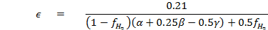
where
Moles of species i
The number of C atoms in fuel molecules.
The number of H atoms in fuel molecules.
The number of O atoms in fuel molecules.
The number of N atoms in fuel molecules.
Equivalence ratio.
Hydrogen fraction.
When is set equal to zero Equation (3.2.9) will be applicable for pure hydrocarbon fuels. Some examples of atomic composition of different fuels are given in Table 3.1 below.
Table 3.1 Atomic composition of fuels
Fuel | Atoms | Hydrogen fraction () |  | First term of Equation (3.2.6)
Gasoline(C₇H₁₇) | = 7; =17;  =0; =0. | 0 | 0.1867 | 0.1867(C₇H₁₇)
CNG(CH₄) | = 1; =4;  =0; =0. | 0 | 0.105 | 0.105(CH₄)
Hydrogen(H₂) | = 0; =0;  =0; =0. | 1 | 0.42 | 0.42(H₂)
Blend of 18% hydrogen and 82%  CNG (HCNG18) | = 1; =4;  =0; =0. | 0.18 | 0.1214 | 0.1214(0.82 x CH₄+0.18 x H₂)

The n_{i} can be determined using the following assumptions
- For lean and stoichiometric mixtures ( and can be neglected. In this case atom balance equations are sufficient to determine the product composition since there are four equations and four unknowns.
- For rich and stoichiometric mixtures ( can be neglected. In this case there are five unknowns, so we need an additional equation to supplement the four atom balance equations. We assume equilibrium considerations between the product species to determine the product composition. This reaction is termed the water-gas reaction:
with the equilibrium constant provide the fifth equation [16] given below:
The equilibrium constant equation is a curve fit of JANAF table data [16]:
The obtained from the element balance and the above assumption are shown in Table 3.2. The value of is obtained by solving the quadratic:

Table 3.2 Burned gas composition under 1700 K
Species
 | - | -
 | 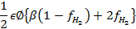
 | 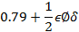

Total mole of the residual gas is given by
Mole fractions of each species is then given by
Molecular weight of the residual gas is given by
Mole fractions of fuel and air are given by
Molecular weight of fuel and air is given by
Residual gas mole fraction is given by
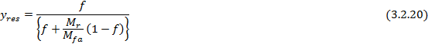
The unburned mixture (fuel, air and residual gas fraction), in the mixture can be written as
Thermodynamic properties of the unburned mixture are described below.
Gas Constant
where kJ/kmol K
Enthalpy
Internal Energy
Entropy
(b) Mole fractions of species at high temperature range(T>1000 K)
At high temperature (T>1000 K), chemical dissociation effects have to be taken into account. The basic approach is based on the method developed by Olikara and Borman [28] where an equilibrium constant method is applied. Use of equilibrium constant method is based on the minimization of the Gibbs free energy of the gas. Under the assumption of atmospheric air composition and provided , the only species that are important because of dissociation are O, H, OH and NO. The combustion reaction thus becomes
(3.2.36)
Atom balance yields the following four equations
C:
H:
O:
N:
where is the total number of moles. The mole fractions of all products are added up to unity.
Six gas phase equilibrium reactions has been introduced and given in Table 3.3. These reactions include dissociation of hydrogen, oxygen, water, carbon dioxide, and equilibrium OH and NO formation:
Table 3.3 Gas phase equilibrium reactions [16]
Equation | Equilibrium | Equation Number
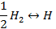 | 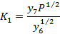
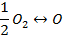 | 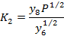
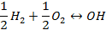 | 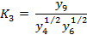
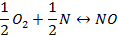 | 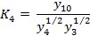
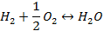 | 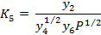
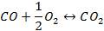 | 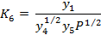
Equation | Equilibrium | Equation Number

The unit of pressure in the six equations is the atmosphere. Olikara and Borman [28] have curve fitted the equilibrium constants to JANAF Table data for Their expressions are of the form
where T is in Kelvin. The equilibrium constant curve-fit coefficients are given Table A-2.
Equation (3.2.27) to (3.2.30) can be written in the form given below
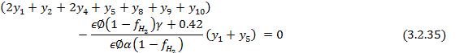
Substituting Equations (3.2.32a) to (3.2.32f) in Equations (3.2.34) to (3.2.37) which is then solved by Newton Raphson iteration scheme. In order to start the iteration the initial guess is estimated from low temperature range.
3.2.3 Thermal Properties
In a two-zone burnt/unburned model, the unburned mixture zones are each treated as separate open systems. Hence, the specific internal energy and specific volume is expressed as
subscripts and refers to burnt gas and unburned gas respectively.
Going by our assumption that the pressures of burnt and unburned gases are equal, and are functions of , and . Hence
The thermodynamic properties of a complex chemical equilibrium composition existing in any fuel-air reaction are obtained using the method proposed by Olikara and Borman [28] which is an equilibrium constant based method for solving chemical equilibrium compositions, specific heats, internal energies, enthalpies, entropies, and other partial derivatives useful in thermodynamic analysis.
By substituting logarithmic derivatives Equations (3.2.40) and (3.2.41) can be rewritten as
Similarly, the internal energies of both the burned and unburned gases, under the same pressure condition and including the logarithmic derivatives can be written as

3.2.4 Trapped mass in control volume
The trapped mass in the control volume is defined at various periods [11].

The volume of cylinder at any crank angle instant is given by [11]
where
= Clearance volume; = Compression ratio.
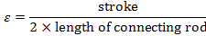
3.2.5 Fuel Burning Rate Model
The burning rate depends mostly on the combustion chamber shape and the position of the spark plug. The Wiebe function represents the mass fraction burned, versus crank angle and defined as [18]
where
a =5; m=2; = Crank Angle (degree); = Start of Combustion (degree); = Total Combustion duration.

3.2.6 Heat transfer model
Heat transfer into a thermodynamic system is expressed in terms of heat loss
where
Here and are the areas of burnt and unburned gases in contact with the combustion chamber component at temperature and subscripts refers to cylinder head, piston crown and liner, respectively. We have the following relations [33]
subscript i refers to intake.
3.2.7 Heat transfer Correlation
In (3.2.53) and (3.2.54), is the instantaneous heat transfer coefficient. Woschni [46] proposed a correlation given below:
where is Nusselt number and is Reynolds number.
where
For the compression period [18]: =2.28, =0
For the combustion and expansion period [18]: =2.28, =3.24*10⁻³
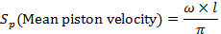
= Displaced volume = instantaneous cylinder pressure; = working fluid temperature; = working fluid pressure; = working fluid volume; = motored cylinder pressure at the same crank angle as .
3.2.8 Principle governing equations in the model
Differentiating Equations (49) and (51) and incorporating with Equations (4), (38) - (39), (42)-(45) and (52)-(62) into Equation (5) ,we have the following sets of equations [11]
For Compression phase
where
For Combustion phase
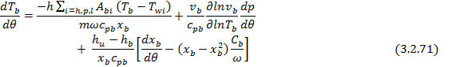
where
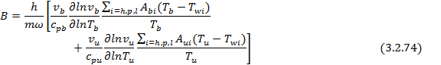
For Expansion phase
where
The above equations are function of and solved by Runge-Kutta method. The above sets of equations are summarized in Table 3.4 below for the different processes in the engine cycle.
Table 3.4 Governing equations for different processes in an engine cycle

 | Compression  ( = 0) | Combustion | Expansion  ( = 1)
 | Equation (3.2.70) | Equation (3.2.70) | Equation (3.2.70)
 | N.A | Equation (3.2.71) | Equation (3.2.71)
 | Equation (3.2.72) | Equation (3.2.72) | N.A
 | Equation (3.2.73) | Equation (3.2.73) | Equation (3.2.73)
 | Equation (3.2.74) | Equation (3.2.74) | Equation (3.2.74)
 | 0 | Equation (3.2.75) | 0
 | 0 | Equation (3.2.76) | Equation (3.2.76)
 | Equation (3.2.77) | Equation (3.2.77) | 0

3.3 Quasi-dimensional Model Formulation
In the zero-dimensional model the mass burned fraction is represented by Wiebe correlation, which does not give the detail information of velocity profile of the burned gases. This difficulty can be overcome in quasi-dimensional model by incorporating turbulent entrainment submodel.
3.3.1 Air and Combustion Products data
The submodel of composition of burned gas and unburned gas is determined from the chemical equilibrium at a given temperature and pressure of 10 species. The calculation of the composition is similar as described in the section 3.2.2.
3.3.2 Principal governing equations in the model
The basic equation for the engine model is derived from the conservation of energy applied
to the cylinder volume
Here, is the internal energy of the cylinder gas mixture, the heat exchange of the cylinder contents with the environment (walls) where for heat loss from gas to wall, W the work where for work delivered by the cylinder charge, h_{i} the specific enthalpy of in- or outflowing gas, and the mass flow into (+) or out of (−) the cylinder. The work can be expressed as , where p is the pressure and V the cylinder volume.

The first term on the right hand side of Equation (3.3.1) expresses the heat loss of the cylinder contents to the surroundings, the modelling of which is described in later section. The second term expresses the work delivered, the third term is the total energy flowing into or out of the cylinder. Here, we are only considering the power cycle so the change in cylinder mass is solely through blowby. During the power cycle we assume there is only leakage from the cylinder volume to the crankcase (no inflow) and take the blowby composition to be the cylinder gas composition.

(a) Compression and expansion
During compression and expansion, using the assumptions stated above, Equation (3.3.1) can be simplified to
with the rate of pressure change from the ideal gas state equation:
where is the mixture gas constant and is the cylinder mass leakage rate (due to blowby).
(b) Combustion
The rate of change of cylinder pressureand unburned and burned gas temperature and are given by following equations, using conservation of mass and energy and the ideal gas equation
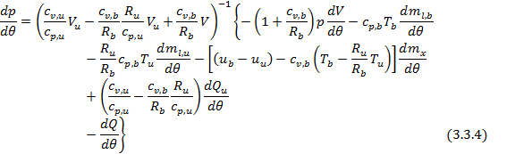
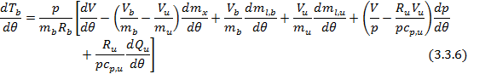
where the subscripts u and b denote unburned and burned properties, respectively is the specific heat at constant pressure and is the mass burning rate, which in the case of quasi-dimensional models is derived from a turbulent combustion model.

(b) Submodels
In order to close the above differential equations we need some submodels which can determine the heat transfer rate (), turbulent entrainment combustion model which can determine mass burned rate (). The heat transfer rate can be determine as described in section 3.2.6. In this section the turbulent entrainment combustion model is described. The model used in this work is based on the entrainment framework, where the rate of entrainment of unburned gas into the flame front is given by:
here, is the entrained mass, is a mean flame front surface area and is the turbulent entrainment velocity. The mass entrained into the flame front is then supposed to burn with a rate proportional to the amount of entrained unburned gas, with a time constant :
with
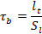
where is a turbulent length scale and is the laminar burning velocity.
The burning Equations (3.3.7) and (3.3.8) contain four parameter ,, and that should be determined simultaneously. The flame surface area is obtained from the geometric model of a spherical flame front in a disc shaped combustion chamber. At any crank angle, the enflamed volume is determined using the known values of , and the corresponding density.
Given the volume of the burned zone , the equivalent spherical radius of the flame , is calculated from:
where is the cylinder bore and and are defined in the manner that accounts for the portion of equivalent sphere which falls outside the combustion chamber
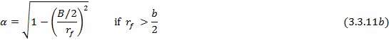
Given the flame radius the flame area is calculated by following equation
Laminar flame speed is a critical parameter in model results, so using an accurate formulation is essential. Almost all of the turbulent combustion models assumed to happens in flamelet regime. It is then assumed to travel locally at laminar flame speed therefore it is necessary to know the laminar flame speed [18].
where
Turbulent flame speed is given by Now is defined as follows
where
is the maximum inlet valve lift.
is the mean inlet gas speed.

. RESULTS AND DISCUSSION

This chapter includes the solution methodology of the formulated model and followed by validation with experimental results and performance studies on S.I engine using gasoline, CNG and HCNG18.
4.1 Solution Methodology
Section 3.2 consists of formulation of zero dimensional model consisting of equations [(3.2.63) to (3.2.84)]. The variables are functions of the . The equations are in the ODE form and the solution technique is described below.
A Matlab code has been developed in order to solve the model. In order to execute the code, first of all engine configuration which is given in Table 4.1 is initialized. Then the value for equivalence ratio, ignition timing, engine speed, absolute manifold pressure, inlet temperature and fuel type as an input has to be set. The thermodynamic properties and mole fraction for the species described in section (3.2.2) are calculated thereafter. Using these initial conditions calculation of pressure and unburned temperature in the compression phase are performed. In the compression phase there are two differential equations (3.2.63) and (3.2.64) which are solved by Range-Kutta method. The initial value of the pressure and unburned temperature in the compression phase are set to be equal to the inlet pressure (manifold absolute pressure) and inlet temperature. The initial value of is equal to 180˚. The pressure and temperature change with respect to crank angle () can be calculated in the first step After that calculation of new variable at the next crank angle step is done by the Range-Kutta method using the general expression
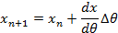
where is any variable, the suffix ( is the new crank angle step and is the increment in crank angle. In this method the crank angle increment is the parameter which decides the accuracy of solution and the computational time. If the increment is large results will be inaccurate and if it is too small computational time will be higher. So an appropriate value of the increment has to be set. In the present simulation the value of increment is 1˚ CA and the accuracy is kept upto 0.0001.

Table 4.1 Test engine specifications

Parameters | Value
Bore | 69 mm
Stroke | 72 mm
Connecting rod length | 112.5 mm
Compression ratio | 9.4:1
Cylinder | Four

The duration of compression phase is 180˚ CA to ignition timing. The values of ignition timing at different speeds are given in Table 4.2. After completion of compression phase the adiabatic flame temperature is calculated by equating the enthalpy of product and enthalpy of reactant. Now to solve for combustion phase the pressure and unburned temperature obtained from compression phase are consider as the initial values for equations (3.2.70) and (3.2.72), and the adiabatic flame temperature as an initial values for equation (3.2.71). The initial value of is the time at which ignition occurs. The combustion duration is taken to 60˚ CA.
The process is also repeated for expansion phase using equations (3.2.78) and (3.2.79). In the expansion phase the initial value of is the time at which combustion ends. The expansion phase completes at 540˚ CA. The computational steps are summarized in Figure 4.1. Figure 4.2 gives the input and output variables of the zero-dimensional model.

Start

Initialize the engine configuration, set value for equivalence ratio, engine speed, spark timing, inlet pressure and temperature.

Calculate the thermodynamic properties and mole fraction for the species

Start of Compression (Solve the governing equation for the single zone by 4th order Runge Kutta to obtain temperature(,𝑇-𝑢.), pressure ( at step i)

Calculate the adiabatic flame temperature

Start of Combustion(Solve the governing equations for the two zone to obtain temperature (,𝑇-𝑏.and ,𝑇-𝑢.), pressure () at step i)

Start of Expansion (Solve the governing equations for the single zone to obtain temperature (), pressure () at step i)

Results for compression ( ,𝑇-𝑢.and 𝑝 ), combustion, expansion ( ,𝑇-𝑏.and 𝑝 ) and their graphical representations

Stop

Figure 4.1- Solution procedure of the zero-dimensional combustion model

Input Variables Output Variables
Fuel Type
Equivalence ratio ()
Ignition Timing
Speed (RPM)
Manifold absolute pressure (MAP)

Pressure
Unburned Gas Temperature
Burned Gas Temperature (,𝑇-𝑏.)

M
O
D
E
L

Figure 4.2 Input and output variables

4.2 Collection of experimental data

In order to validate the predictive zero-dimensional model, experiments were conducted with S.I engine running on gasoline, CNG and HCNG18. The experiments were carried out on a four-cylinder, four stroke Wagon R engine. The experimental data obtained are shown in Table 4.2. It shows the 12 operating conditions in which speed, manifold absolute pressure (MAP), equivalence ratio, and ignition timing are all changed widely for gasoline, CNG and HCNG18 blend. The experimental data of P- curve on the following operating conditions are obtained by ‘engine soft’ software.
4.3 Model Validation
Experimental data that are given in Table 4.2 are used to simulate the model As intake pressure measurement facility is not available the model is simulated with three range of manifold absolute pressure. The optimum pressure on which the predicted and experimental results are in good agreement is given Table 4.2. The range is taken to be 10 from the optimum value. The same procedure is carried out for other two fuels (CNG and HCNG18). The results obtained are discussed in following section.

4.4 Results and discussion
4.4.1 Gasoline
Figure 4.3(a) to 4.6(a) represents the comparison of simulated and experimental results for in-cylinder pressure variation, and simulated results for burned and unburned gas temperature. Simulation haven performed for 50, 60 and 70kPa.For all the cases simulation for 60kPa matches reasonably with the experimental P- curve. Model under predicts for the values of between 180˚ CA to 314˚ CA in compression stroke and 412˚ CA to 540˚ CA in expansion stroke. The reasons for under prediction may be to inaccuracy in pressure measuring device. For the sake of clarity, comparison of simulated results at 60kPa with experimental data is shown separately in Figure 4.3(a) (ii) to 4.6(a) (ii). The zero-dimensional model matches accurately between the crank angle 314˚ CA to 385˚ CA for the combustion stroke and properly predicts the peak pressure.
Simulated results of unburned and burned gas temperature are shown in Figure 4.3(b) to 4.6(b). The unburned gas temperature increases upto some degree after TDC and afterwards it starts decaying. Burned gas temperature rises sharply and after achieving maximum value it reduces in expansion stroke. The trend matches with the results available in the literature.

(i)

(contd…)

(ii)
Figure 4.3(a) Cylinder pressure variation v/s crank angle for gasoline at 3000rpm, = 0.95

Figure 4.3(b) Temperature variation v/s crank angle for gasoline at 3000rpm, = 0.95

(i)

(ii)
Figure 4.4(a) Cylinder pressure variation v/s crank angle for gasoline at 3000rpm, = 0.79

Figure 4.4(b) Temperature variation v/s crank angle for gasoline at 3500rpm, = 0.79

(i)

(contd…)

Figure 4.5(a) Cylinder pressure variation v/s crank angle for gasoline at 4000rpm, = 1.14

Figure 4.5(b) Temperature variation v/s crank angle for gasoline at 4000rpm, = 1.14

(i)

(ii)
Figure 4.6(a) Cylinder pressure variation v/s crank angle for gasoline at 4500rpm, = 1.28

Figure 4.6(b) Temperature variation v/s crank angle for gasoline at 4500rpm, = 1.28

4.4.2 CNG

Figure 4.7(a) to 4.10(a) represents the comparison of simulated and experimental results for in-cylinder pressure variation, and simulated results for burned and unburned gas temperature. Simulation haven performed for 40, 50 and 60kPa. For all the cases simulation for 50kPa matches reasonably with the experimental P- curve. Model under predicts for the values of between 180˚ CA to 314˚ CA in compression stroke and the predicted results are close to experimental results in expansion stroke. The reasons for under prediction may be due to inaccuracy in pressure measuring device. For the sake of clarity, comparison of simulated results at 50kPa with experimental data is shown separately in Figure 4.7(a) (ii) to 4.10(a) (ii). The zero-dimensional model matches accurately between the crank angle 314˚ CA to 385˚ CA for the combustion stroke and properly predicts the peak pressure.
Simulated results of unburned and burned gas temperature are shown in Figure 4.7(b) to 4.10(b). The unburned gas temperature increases upto some degree after TDC and afterwards it starts decaying. Burned gas temperature rises sharply and after achieving maximum value it reduces in expansion stroke. The trend matches with the results available in the literature.

(i)

(ii)
Figure 4.7(a) Cylinder pressure variation v/s crank angle for CNG at 3000rpm, = 0.78

Figure 4.7(b) Temperature variation v/s crank angle for CNG at 3000rpm, = 0.78

(i)

(ii)
Figure 4.8(a) Cylinder pressure variation v/s crank angle for CNG at 3500rpm, = 0.82

Figure 4.8(b) Temperature variation v/s crank angle for CNG at 3500rpm, = 0.82

(i)

(ii)
Figure 4.9(a) Cylinder pressure variation v/s crank angle for CNG at 4000rpm, = 0.794

Figure 4.9(b) Temperature variation v/s crank angle for CNG at 4000rpm, = 0.794

(i)

(contd…)

(ii)
Figure 4.10(a) Cylinder pressure variation v/s crank angle for CNG at 4500rpm, = 1.26

Figure 4.10(b) Temperature variation v/s crank angle for CNG at 4500rpm, = 1.26

4.4.3 HCNG18

Figure 4.11(a) to 4.14(a) represents the comparison of simulated and experimental results for in-cylinder pressure variation, and simulated results for burned and unburned gas temperature. Simulation haven performed for 38, 48 and 58kPa.For all the cases simulation for 48kPa matches reasonably with the experimental P- curve. Model under predicts for the values of between 180˚ CA to 321˚ CA in compression stroke and there slight variation of predicted and experimental results in expansion stroke. The reasons for under prediction may be .For the sake of clarity, comparison of simulated results at 48kPa with experimental data are shown separately in Figure 4.11(a) (ii) to 4.14(a) (ii). The zero-dimentional model matches accurately between the crank angle 321˚ CA to 385 ˚ CA for the combustion stroke and properly predicts the peak pressure.
Simulated results of unburned and burned gas temperature are shown in Figure 4.11(b) to 4.14(b). The unburned gas temperature increases upto some degree after TDC and afterwards it starts decaying. Burned gas temperature rises sharply and after achieving maximum value it reduces in expansion stroke. The trend matches with the results available in the literature.

(i)
(contd…)

(ii)
Figure 4.11(a) Cylinder pressure variation v/s crank angle for HCNG18 at 3000rpm, = 0.673

Figure 4.11(b) Temperature variation v/s crank angle for HCNG18 at 3000rpm, = 0.673

(i)

(ii)
Figure 4.12(a) Cylinder pressure variation v/s crank angle for HCNG18 at 3500rpm, = 0.77

Figure 4.12(b) Temperature variation v/s crank angle for HCNG18 at 3500rpm, = 0.77

(i)

(contd…)

Figure 4.13(a) Cylinder pressure variation v/s crank angle for HCNG18 at 4000rpm, = 0.78

Figure 4.13(b) Temperature variation v/s crank angle for HCNG18 at 4000rpm, = 0.78

(i)

(ii)
Figure 4.14(a) Cylinder pressure variation v/s crank angle for HCNG18 at 4500rpm, = 1.12

Figure 4.14(b) Temperature variation v/s crank angle for HCNG18 at 4500rpm, = 1.12

4.4.4 Comparison of P- diagrams

Figures 4.15(a) to 4.15(d) shows the cylinder pressure variation for three fuels (gasoline, CNG and HCNG18) at 3000, 3500, 4000 and 4500 rpm. Figures 4.16(a) to 4.16(c) shows the cylinder pressure variation for four engine speeds using gasoline, CNG and HCNG18 respectively.
As shown in the Figures 4.15(a) to 4.15(d) of the P- diagram peak pressure is relatively high for gasoline as compared to CNG and HCNG18. The area of the P- diagram almost coincides for CNG and HCNG18 except the peak pressure. Peak pressure for CNG is slightly higher as compared to HCNG18. Similarly it can be seen in the Figures 4.16(a) to 4.16(c) that the peak pressure rises with increase in speed. Factors that contribute to the rise in peak cylinder temperature are inlet pressure, compression ratio, equivalence ratio ignition timing, speed. Considering the first factor the inlet pressure of HCNG18 is slightly less that CNG and gasoline, which results in the lower pressure, as with higher inlet pressure the cylinder pressure rises. Since the compression ratio was kept constant throughout the engine operation, therefore it does not contribute much in cylinder pressure variation.
Equivalence ratio are having a strong influence on rise of cylinder pressure and temperature. Peak cylinder pressure and temperature increase with increasing equivalence ratio towards the richer side. As more fuel is available combustion rate increase and complete combustion of fuel takes place. This results in high cylinder pressure and high burned gas temperature. This effect can be vividly seen in Figures 4.15(a) to 4.15(d). By operating condition 1 to 12 in Table 4.2 gasoline is operated with richer mixture as compared to CNG and HCNG18, CNG is slightly richer than HCNG18 which results in higher cylinder pressure of gasoline and CNG compared to HCNG18.
One important factor that influence the results is ignition timing. With advancing ignition (spark advance) the peak cylinder pressure will rise because the compression charge is ignited and the rising piston in the compression phase compress the burned charge resulting in high peak pressure and temperature. For the gaseous fuel ignition timing is required to be in advance. But the engine where test has been performed is designed for the conventional fuel (gasoline). When operating the engine by CNG and HCNG18 the peak cylinder pressure will be low as compared to the result obtained by gasoline. Therefore in Figures 4.15(a) to 4.15(d) at different speeds we get the above results.
Speed also influences the rise of cylinder pressure and temperature. With increase in speed cylinder pressure and temperature increases which can be seen by Figure 4.16(a) to Figure 4.16(c). Figure 4.16(a) shows that for the case of gasoline at speed 3000 rpm peak cylinder pressure is higher compared at 3500 rpm , because in this case the mixture is richer (see Table 4.2 Operating condition 2 and 5) . The effect of equivalence ratio is previously discussed.
The tabulated data for peak cylinder pressure and temperature is given in Appendix B

Figure 4.15(a) Cylinder pressure variation v/s crank angle for three fuels at speed 3000 rpm

Figure 4.15(b) Cylinder pressure variation v/s crank angle for three fuels at speed 3500 rpm

Figure 4.15(c) Cylinder pressure variation v/s crank angle for three fuels at speed 4000 rpm

Figure 4.15(d) Cylinder pressure variation v/s crank angle for three fuels at speed 4500 rpm

Figure 4.16(a) Cylinder pressure variation v/s crank angle for gasoline at four different speeds

Figure 4.16(b) Cylinder pressure variation v/s crank angle for CNG at four different speeds

Figure 4.16(c) Cylinder pressure variation v/s crank angle for HCNG18 at four different speeds

4.5 Performance studies
4.5.1 Experimental setup
The setup consists of four cylinder, four stroke, Petrol (MPFI) engine connected to eddy current type dynamometer for loading. It is provided with necessary instruments for measurements of combustion pressure and crank-angle. These signals are interfaced to computer through engine indicator for P-θ & PV diagrams. Provision is also made for interfacing airflow, fuel flow, temperatures and load measurement. The set up has stand-alone panel box consisting of air box, fuel tank, manometer, fuel measuring unit, transmitters for air and fuel flow measurements, process indicator and engine indicator. Rotameters are provided for cooling water and calorimeter water flow measurement. Photograph of engine setup, schematic diagram of engine and photograph of gas analyser is shown in Figure 4.17, 4.18 and 4.19 respectively.
The setup enables study of engine performance for brake power, indicated power, frictional power, BMEP, IMEP, brake thermal efficiency, indicated thermal efficiency, Mechanical efficiency, volumetric efficiency, specific fuel consumption, A/F ratio and heat balance. Windows based Engine Performance Analysis software package “Engine soft” is provided for on line performance evaluation. Gas analyser is used for emission measurements.
The main aim of this experiment is to investigate the effects on performance of gasoline, CNG and HCNG18 in four cylinder Wagon R engine.

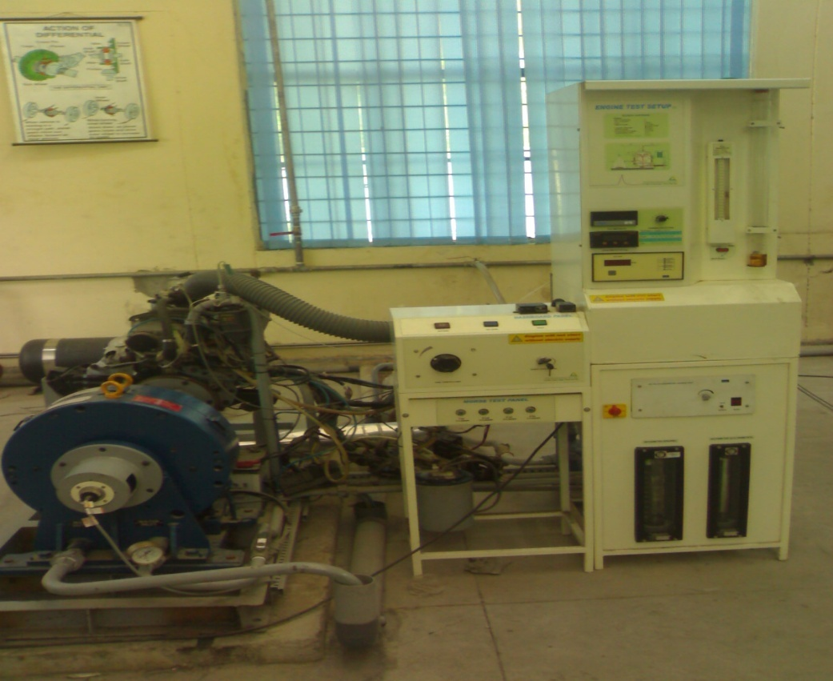
Engine rotameter
Calorimeter rotameter

Load nob
Throttle nob
Speed indicator
Load indicator
Fuel level indicator
Engine
Dynamometer

Figure 4.17 Experimental setup

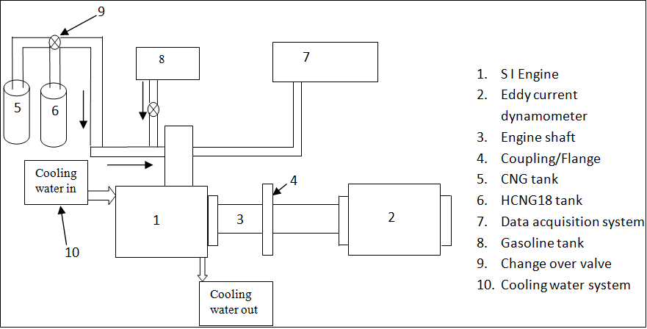
Figure 4.18 Schematic diagram of engine setup

Figure 4.19 Gas Analyser
Engine specifications
Engine Make-Maruti, Model Wagon-R MPFI, Type 4 Cylinder, 4 Stroke, Petrol (MPFI), Water cooled, Power 44.5 KW at 6000 rpm, Torque 59 NM at 2500 rpm, Stroke 72 mm, bore 69 mm, 1100 CC, CR 9.4:1
Dynamometer Type eddy current, Water cooled, With loading unit, Make – Saj test plant Pvt Ltd, Model AG80.
Propeller shaft With universal joints, Make Hindustan Hardy Spicer.
Air Box M S fabricated with orifice meter and manometer (Orifice Dia 40 mm).
Fuel tank Capacity 15 lit with glass fuel metering column
Calorimeter Type Pipe in pipe, 25-250 LPH.
Rotameter Make-Eureka Model PG 5, Range 25-250 lph, Connection ¾ `` BSP vertical screwed, packing Neoprene.
Rotameter Make-Eureka Model PG 9, Range 100-1000 lph, Connection 1`` BSP vertical screwed, packing Neoprene.
Piezo sensor Make-PCB Piezotronics, Model HSM111A22, Range 5000 psi, Diaphragm stainless steel type & Hermetic Sealed.
Crank angle sensor Make-Kubler-Germany Model 8.3700.1321.0360, Dia: 37 mm shaft size: size 6mm x length 12.5mm, Supply Voltage 5-30 V DC, Output Push Pull (AA,BB,OO), PPR:360, Outlet cable type axial with flange 37mm to 58mm.
Load Indicator Make-Selectron, Model PIC 152-B2, 85 to 270 V AC, Retransmission output 4-20 mA.
Battery Make-Exide, Model MHD 350 06687, 12 V DC.
Engine Indicator Input Piezo sensor, Crank angle sensor, No. of channels 2, Communication RS232.
Digital millivoltmeter Range 0-200mV, Panel mounted.
Temperature sensor Make-Radix Type K, Ungrounded, Sheath Dia 6mmX110mmL, SS316, Connection ¼`` BSP (M), Adjustable compression fitting.
Fuel measuring unit Make-Apex, Glass Model FF0.090.
Temperature Make-Wika, model T19.10.3K0-4NK-Z,Input thermocouple
Transmitter (type K), Output 4-20 mA, Supply 24 V DC, Calibration 0-1200 deg C.
Load Indicator Digital, Range 0-50 Kg, Supply 230 V AC.
Load Sensor Make-Sensotronics Sanmar Ltd, Model 60001, Type S beam , Universal Capacity 0-50 kg.
Fuel flow transmitter DP transmitter, Range 0-500 mm WC.
Air flow transmitter Pressure transmitter, Range (-) 250 mm WC.
CNG Conversion Kit Make-Tomasetto Achilles.
Gas Analyser Make- AVL, (AVL for DIGAS) for emission measurement.

Performance Evaluation
A four cylinder Petrol engine was used for the experimental analysis. Fuel was supplied to the engine from an outside tank. The data measured during the tests included engine speed, brake power, torque, and fuel consumption, SFC. During the test engine load was varied while maintaining a constant engine speed. The tests were performed with four different speed range 3000,3500, 4000, and 4500 rpm. Fuels that have been used are gasoline, CNG and HCNG18. Formulation used for calculation of various parameters are described below
Torque (kg m) = Load × Arm length
Brake power (kW) = (2 × π × Speed × Torque × 9.81) / (60 × 1000)
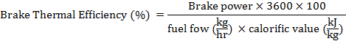
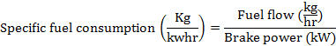

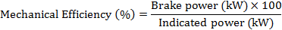
4.5.2 Results and discussion
The performance characteristics of the engine operated by gasoline, CNG and HCNG18 obtained are given below
Brake specific fuel consumption
Brake specific fuel consumption (BSFC) and % variation w.r.t to gasoline versus power for speed values 3000, 3500, 4000 and 4500 rpm are shown in the Figures 4.20 to 4.23 respectively for gasoline, CNG and HCNG18. The trends shown in the graph indicate that maximum BSFC values lies between 4 to 6 kW power range. The peak values of BSFC, for all the fuels are existing at same power output at a prescribed engine speed. As the peak increases (for 3500 rpm) the peak values shift towards lower side. With further increase in engine speed, peak values shift toward higher power output values. The maximum BSFC for range of speed are for gasoline

followed by CNG and HCNG18. The maximum BSFC for all fuels decrease sharply with increase in power output and remain constant after 8 to 20 kW power output range . Since the combustion in the gaseous fuels are relatively better, the BSFC values for entire range is lower for CNG and HCNG18 as compared to gasoline. The BSFC of gasoline is higher as compared to CNG and HCNG18. This is because of the fact that with CNG and HCNG18 the lean limit of operation gets extended. Also BSFC of engine when operated with HCNG18 is less than CNG because of the addition of hydrogen with CNG which can further extend the lean limit of operation. The increase of BSFC with increase of speed at constant load is primarily due to the increasing friction mep at higher speed which decreases the mechanical efficiency. The experimental data are tabulated in Table C-1 to C-19.
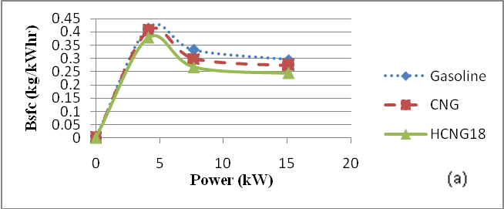

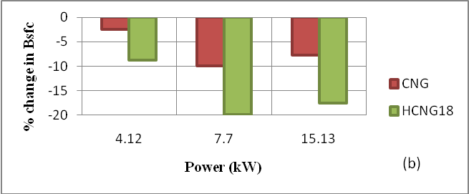

Figure 4.20(a) BSFC v/s power (3000 rpm) & (b) % change in BSFC.

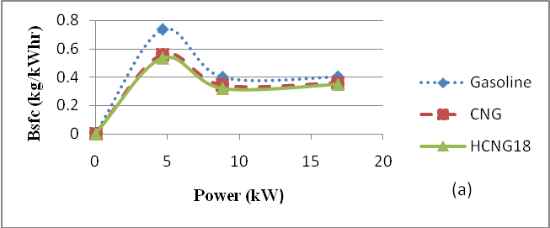

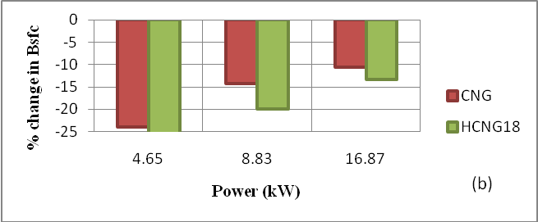

Figure 4.21(a) BSFC v/s power (3500 rpm) & (b) % change in BSFC
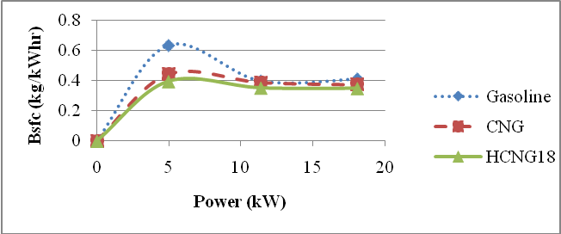

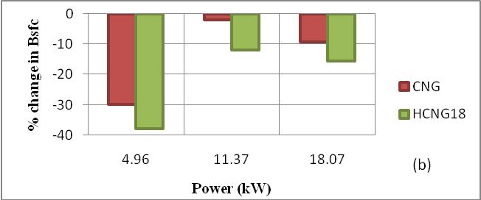

Figure 4.22(a) BSFC v/s power (4000 rpm) & (b) % change in BSFC
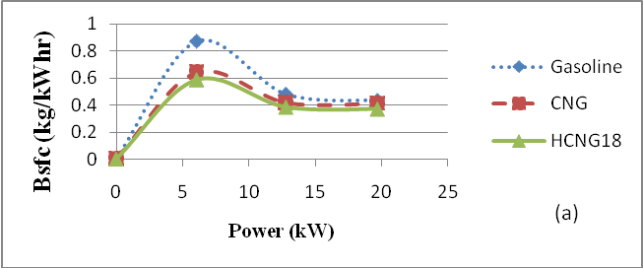

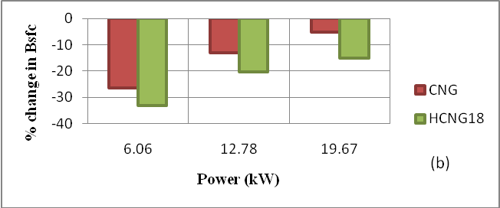

Figure 4.23(a) BSFC v/s power (4500 rpm) & (b) % change in BSFC
Brake thermal efficiency

Brake thermal efficiency (BTE) and % variation w.r.t gasoline versus power for speed values 3000, 3500, 4000 and 4500 rpm are shown in the Figures 4.24 to 4.27 respectively for gasoline, CNG and HCNG18. The trends shown in the graphs indicate that the maximum BTE lies between 14 to 20 kW power range. The peak values of BTE, for all the fuels exist at same power output at a prescribed engine speed. The maximum BTE decreases sharply with decrease in power output. The maximum BTE for gasoline and CNG are almost same, whereas it is lower for HCNG18. HCNG18 is having higher heating value. Brake thermal efficiency depends on brake power. This in turn depends on spark advance. So with advancing the spark upto MBT maximum efficiency can be obtained. Also the brake specific energy consumption of HCNG18 is higher as compared to CNG and gasoline (will be discussed later on). So the energy contained with HCNG18 is not fully used at a specified power which results in lower thermal efficiency. As the BSFC decreases with increase in load so there is increase of brake thermal efficiency with load, as BTE is inversely proportion to the BSFC.

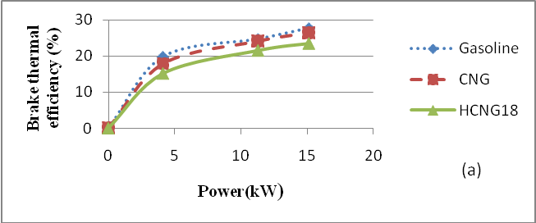

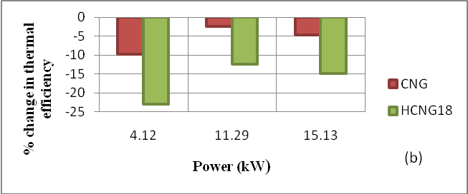

Figure 4.24(a) BTE v/s power at (3000 rpm) & (b) % change in BTE
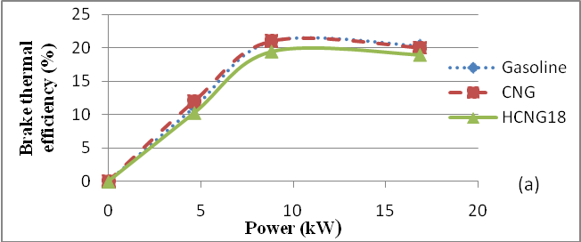

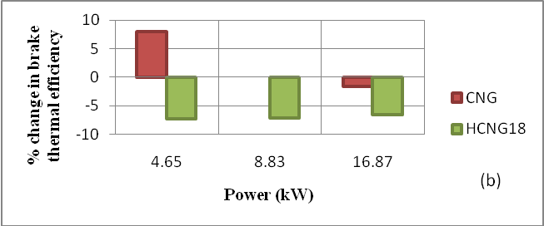

Figure 4.25(a) BTE v/s power at (3500 rpm) & (b) % change in BTE

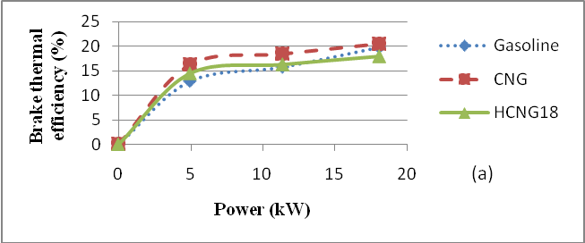

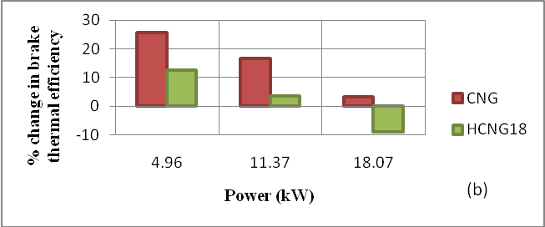

Figure 4.26(a) BTE v/s power at (4000 rpm) & (b) % change in BTE

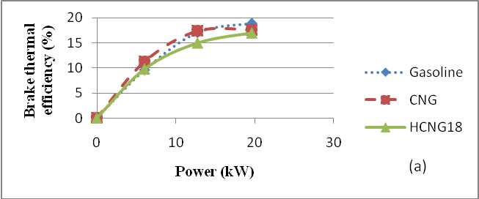

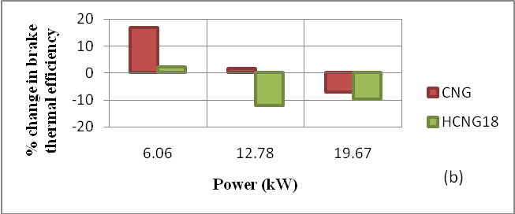

Figure 4.27(a) BTE v/s power at (4000 rpm) & (b) % change in BTE

Brake specific energy consumption

Brake specific energy consumption (BTE) and % variation w.r.t gasoline versus power for speed values 3000, 3500, 4000 and 4500 rpm are shown in the Figures 4.28 to 4.31 respectively for gasoline, CNG and HCNG18. The trends shown in the graphs indicate that the maximum BSEC lies between 4 to 6 kW power range. The peak values of BSEC, for all the fuels are existing at same pressure output. As the speed increases the peak value shifts toward higher power output values. The maximum BSEC decreases sharply with increase in power output and remains constant after 8 to 20 kW power output range. BSEC is inversely proportional to the BSFC, so the trend of the graph with respect to power the will be opposite. HCNG18 are having high heating value compared to CNG and gasoline, it is having so higher BSEC.

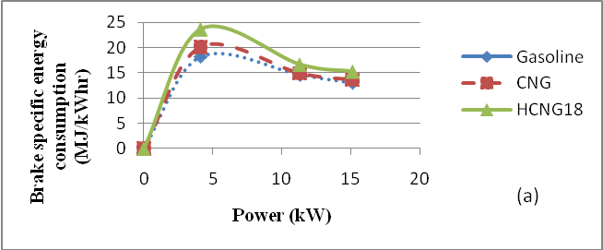

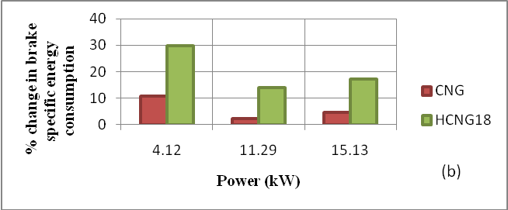

Figure 4.28(a) BSEC v/s power at (3000 rpm) & (b) % change in BSEC

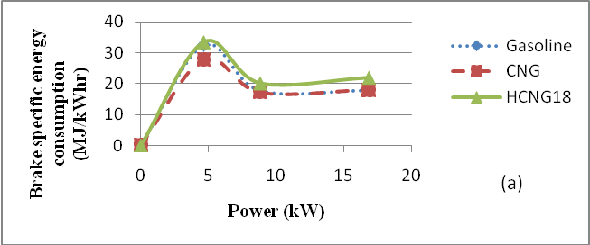

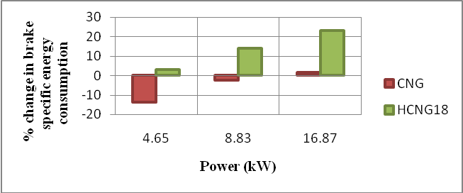

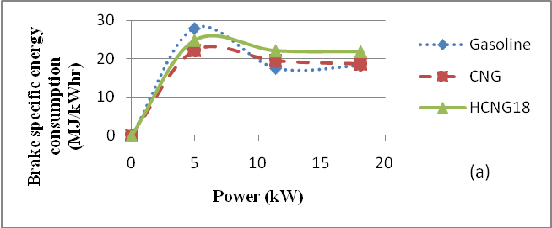
Figure 4.29(a) BSEC v/s power at (3500 rpm) & (b) % change in BSEC

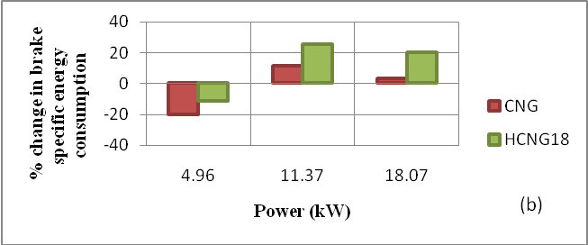

Figure 4.31(a) BSEC v/s power at (4500 rpm) & (b) % change in BSEC

CO emissions
CO emissions versus and % variation w.r.t gasoline power for speed values 3000, 3500, 4000 and 4500rpm are shown in the Figures 4.32 to 4.35 respectively for gasoline, CNG and HCNG18. CO emission is lower with HCNG18 as compared to CNG and gasoline. CNG are also having lower CO emission than gasoline because it easily forms more homogenous mixture with air and can run leaner than gasoline engines. With HCNG18 carbon content percentage is much lower compare to CNG.

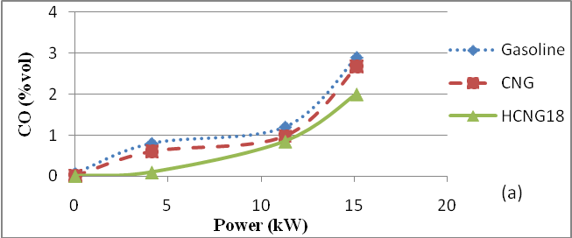

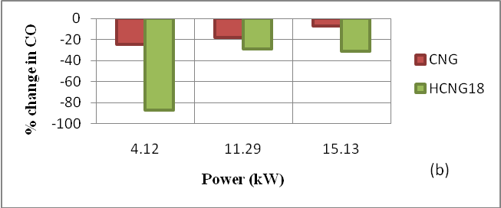

Figure 4.32(a) CO emissions v/s power at (3000 rpm) & (b) % change in CO emissions

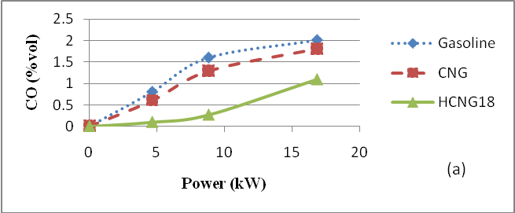

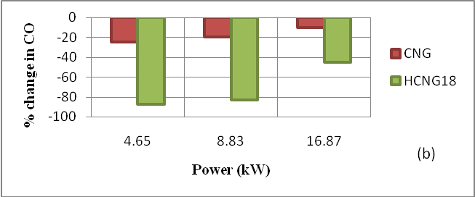

Figure 4.33(a) CO emissions v/s power at (3500 rpm) & (b) % change in CO emissions

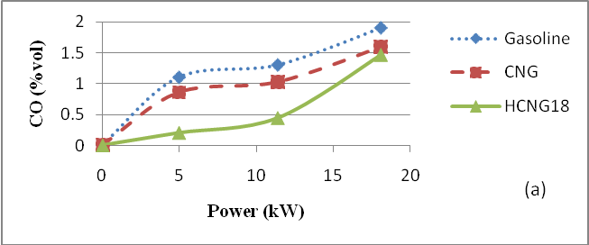

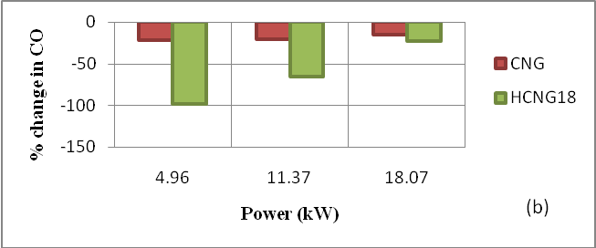

Figure 4.34(a) CO emissions v/s power at (4000 rpm) & (b) % change in CO emissions
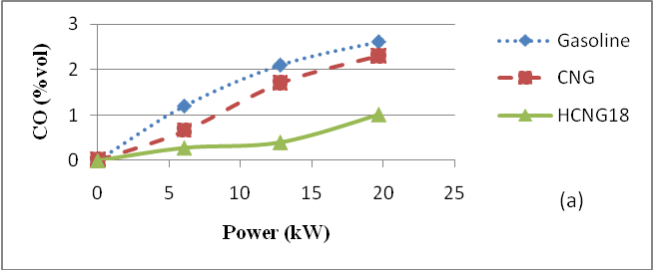

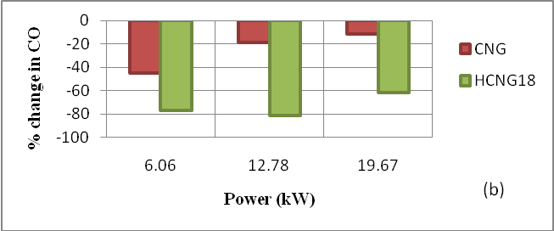

Figure 4.35(a) CO emissions v/s power at (4500 rpm) & (b) % change in CO emissions

HC emissions
HC emissions and % variation w.r.t gasoline versus power for speed range 3000, 3500, 4000 and 4500rpm are shown in the Figure 4.36 to 4.39 respectively for gasoline, CNG and HCNG18. The trend shown in the figure is that at the maximum load the HC concentration is lower. At higher power, expansion and exhaust stroke temperature is higher and the in-cylinder oxidation rate, if oxygen available will be higher. However, as the exhaust gas flow rate increases, the residence time in critical sections of the exhaust system decreases and a reduction in exhaust port HC oxidation occurs. The net trend is for HC concentration to decrease modestly as power is increased.

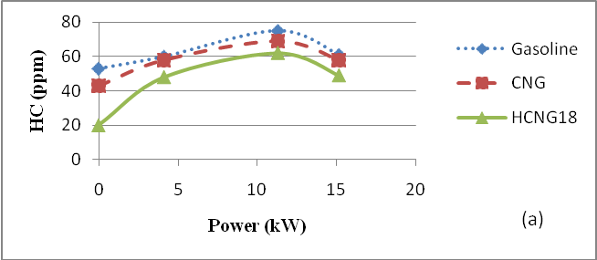

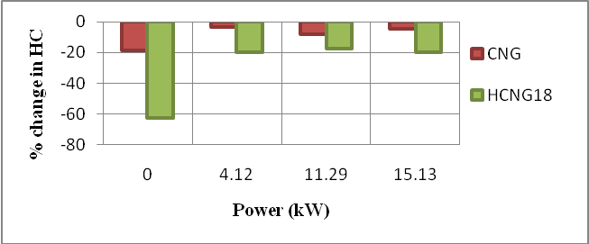

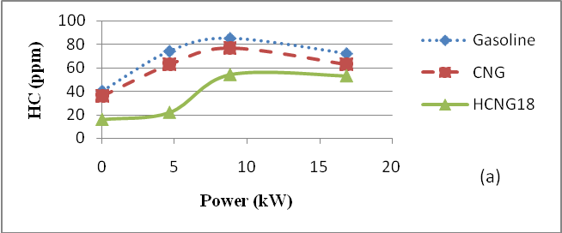
Figure 4.36(a) HC emissions v/s power at (3000 rpm) & (b) % change in HC emissions

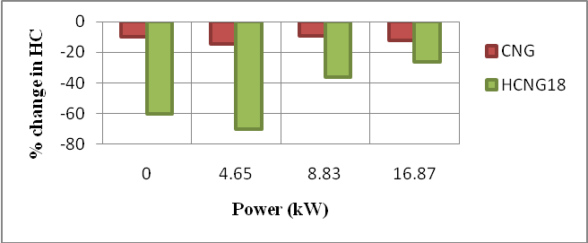

Figure 4.37(a) HC emissions v/s power at (3500 rpm) & (b) % change in HC emissions
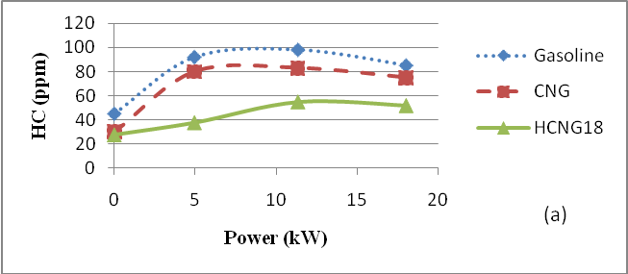

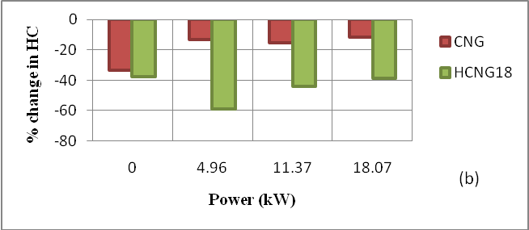

Figure 4.38(a) HC emissions v/s power at (4000 rpm) & (b) % change in HC emissions
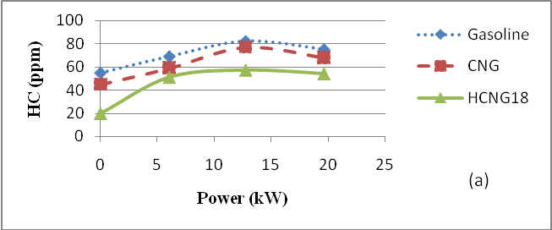

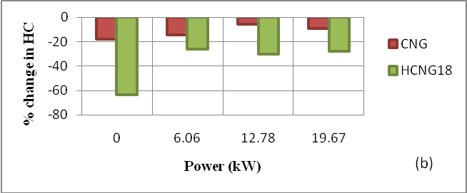

Figure 4.39(a) HC emissions v/s power at (4500 rpm) & (b) % change in HC emissions
5. CONCLUSIONS AND RECOMMENDATIONS FOR FUTURE WORK

5.1 Conclusion
The following conclusions are drawn from the present research work:
- A thermodynamic two zone zero dimensional model has been developed which predicts the variation in cylinder pressure in good agreement with experimental data obtained for gasoline, CNG and HCNG18.
- The trends of predicted variation in unburned and burned gas temperature with crank angle matches with the results available in the literature.
- P- curve is a strong functions of speed, equivalence ratio, ignition timing and manifold absolute pressure.
- The peak cylinder pressure and the area of P- curve HCNG18 is lower as compared to gasoline and CNG.
- The performance parameter such as BSFC is higher for wide range of power output for gasoline as compared to CNG and HCNG18.
- The BSEC of HCNG18 is higher as compared to CNG and gasoline.
- The BTE of HCNG18 is lower as compared to CNG and gasoline..
- CO and HC emissions of HCNG18 are much lower as compared to CNG and gasoline.

5.2 Recommendations for future work
- The present model can be extended for design and analysis of S.I engines using alternative fuels and emission predictions.
- Work can also be carried out to develop quasi-dimensional model to predict turbulent flow characteristic of the charge inside the cylinder.
- Experiments should be carried out for wide range of advance spark timing and HCNG blends in S.I engine.

6. REFERENCES

- Abd Alla G.H. Computer Simulation of a Four Stroke Ignition Engine, Energy Conservation and Management 43(8) May (2002) 1043-1061.
- Andrew R, Sharma J. Hydrogen-CNG blend performance in a three wheeler SAE Number 2008-28-0119 (2008)
- Baghdadi M. A Simulation Model for a Single Cylinder Four-Stroke Spark Ignition Engine Fuelled with Alternative Fuels, Turkish J. Eng. Env. Sci 30 (2006) 331-350.
- Bayraktar H, Durgun O. Development of an Empirical Correlation for Combustion Durations in Spark Ignition Engines, Energy Conservation and Managment 45(9) June (2004) 1419-1431.
- Bayraktar H. Experimental and theoretical investigation of using gasoline–ethanol blends in spark-ignition engines, Renewable Energy 30(11) September(2005) 1733-1747.
- Bayraktar H. Theoretical investigation of flame propagation process in an SI engine running on gasoline–ethanol blends, Renewable Energy 32(5) April (2007) 758-771.
- Benson RS, Annand WJD and Baruatt P C. A simulation model including intake and exhaust systems for a single cylinder four-stroke cycle spark ignition engine, Int. J. Mech. Sci 17(2) February(1975) 97-124.
- Beretta GP, Rashidi M, Keck JC. Turbulent Flame Propagation and Combustion in Spark Ignition Engines, Combustion and Flame 52 (1983) 217-245.
- Buttsworth DR. Spark Ignition Internal Combustion Engine Modelling using Matlab, Faculty of Engineering & Surveying Technical Reports, University of Southern Queensland (2002).
- Bhandari K, Bansal A, Shukla A and Khare M. Performance and emissions of natural gas fueled internal combustion engine, J of Scientific & Industrial Research 64(5) May(2005) 333-338.
- Chan S H and Zhu J. Modelling of engine in-cylinder thermodynamics under high values of ignition retard, Int. J. Therm. Sci 40 (1999) 94-103.
- Chin YW, Matthews RD, Nichols SP and Kiehne TM. Use of fractal geometry to model turbulent combustion in SI engines, Combustion Sci and Tech 86 (1992) 1-30
- Das LM, Gulati R, Gupta PK. A comparative evaluation of the performance characteristics of a spark ignition engine using hydrogen and compressed natural gas as alternative fuel, Int. J. Hydrogen Energy 25(8) August(2000) 783-793.
- Das LM. Near-term introduction of hydrogen engines for automotive and agriculture, Int. J. Hydrogen Energy 27(5) May(2002) 479-487.
- Das LM. Exhaust emission characteristics of hydrogen-operated engine system: nature of pollutants and their control techniques, Int. J. Hydrogen Energy 16(11) (1991) 765-775.
- Ferguson CR. Internal Combustion Engines, Applied Thermosciences, New York: John Wiley and Sons (1986)
- Fleming RD and Allsup JR. Emission characteristics of natural gas as an alternative fuel, SAE 710833 (1971).
- Heywood JB. Internal Combustion Engine Fundamentals, McGraw-Hill New York (1988).
- Heywood JB. Combustion and its Modelling in Spark Ignition Engines, International Symposium COMODIA (1994).
- Hosseini S, Abdolah R, and Khani A. A Developed Quasi-Dimensional Combustion Model in Spark-Ignition Engines, Proceedings of the World Congress on Engineering London(2008).
- How HG, Taib IM, Shahrir A, Yusoff A, Azhari S, Elvis A. Experimental Investigation of Performance and Emission of a Sequential Port Injection Natural Gas Engine, European J. Scientific Research 30(2) (2009) 204-214.
- JANAF Thermochemical Tables, United States National Bureau of Standards Publications NSRDS-NBS 37 (1971).
- Kumarappa S and Prabhukumar GP. Improving the Performance of Two Stroke Spark Ignition Engine by Direct Electronic CNG Injection, Jordan J. Mechanical and Industrial Engineering 2 December (2008) 169-174
- Kumar RH and Antony AJ. New empirical correlations for simulation the influence of compression ratio on ignition delay and overall combustion duration in SI engines, Proceedings of the World Congress on Engineering London July(2009).
- Liu B, Huang Z, Zeng K, Chen H, Wang X, Miao H and Jing D. Experimental study on emissions of a spark ignition engine fueled with natural gas-hydrogen blends, Energy & Fuels 22 (2008) 273-277
- Mathur HB, Khajuria PR. A computer simulation of hydrogen fueled spark ignition engine, Int. J. Hydrogen Energy 11(6) (1986) 409-417.
- Ma F, Wang Y, Wang M, Liu H, Wang J, Ding S, Zhao S. Development and Validation of a Quasi-Dimensional Combustion Model for SI Engines Fuelled by HCNG with Variable Hydrogen Fractions, Int. J. Hydrogen Energy 33(18) September(2008) 4863-4875.
- Olikara C. and Borman G L. Calculating Properties of Equilibrium Combustion Products with Some Application to I.C. Engines, SAE Paper 750468 (1975).
- Perini F, Patrinieri F, Mattarelli E. A Quasi-dimensional Combustion Model for Performance and Emissions of SI Engines Running on Hydrogen-Methane Blends, Int. J Hydrogen Energy 35(10) (2010) 4687-4701.
- Ramachandran S. Rapid Thermodynamic Simulation Model of an Internal Combustion Engine on Alternative Fuels, Proceedings of the International Multiconference of Engineers and Computer Scientist Hong Kong (2009).
- Rahaman MM, Mohammad MK, Bakar RA. Effect of air-fuel ratio and engine speed on performance of hydrogen fueled port injection engine, American journal of Scientific Research (1) (2009) 23-33.
- Rahaman MM, Mohammad MK, Bakar RA. Study of air-fuel ratio on engine performance of direct injection hydrogen fueled engine, American journal of Scientific Research 34(4) (2009) 506-513.
- Salimi F, Shamekhi AH, Pourkhesalian AM. Role of Mixture Richness, Spark and Valve Timing in Hydrogen-Fuelled Engine Performance and Emission, Int. J. Hydrogen Energy 34(9) May(2009) 3922-3929.
- Sekmen P and Sekmen Y. Mathametical Modeling of a SI Engine Cycle with Actual Air-Fuel Cycle Analysis, Mathematical and Computational Application 12(3) (2007) 161-171.
- Semin, Ismail AR, Bakar RA. Combustion Temperature Effect of Diesel Engine Convert to Compressed Natural Gas Engine, American J. of Engineering and Applied Science 2(1) (2009) 212-216.
- Semin, Ismail AR, Bakar RA. Effect of Diesel Engine Converted to Sequential Port Injection Compressed Natural Gas Engine on the Cylinder Pressure vs Crank Angle in Variation Engine Speeds, American J. of Engineering and Applied Science 2(1) (2009) 443-452.
- Semin, Ismail AR, Bakar RA. Engine Cylinder Fluid Characteristics of Diesel Engine Converted to CNG Engine, American J. of Engineering and Applied Science 2(1) (2009) 154-159.
- Sierens R and Verhelst S. A Hydrogen Fuelled V-8 Engine For City-Bus Application, Int. J. of Automotive Technology 2(2) (2001) 39-45
- Sher E and Hacohen F. On the modeling of a SI 4-stroke cycle engine fueled with hydrogen-enriched gasoline, Int. J. Hydrogen Energy 12(II) (1987) 773-781,
- Shudo T, Shimamura K, Nakajima Y. Combustion and emissions in a methane stratified charge engine with hydrogen pre-mixing, JSAE ReV 21 (1) (2000) 3–7.
- Sitthiracha S, Patumsawad S and Koetniyom S. An analytical model of spark ignition engine for performance prediction, The 20th conference of mechanical Engineering Network of Thailand (2006).
- Srinivasan KK. The Advanced Injection Low Pilot Ignited Natural Gas Engine: A Combustion Analysis, J. Eng. Gas Turbines Power 128(1) (2006) 213-218.
- United States Environmental Protection Agency(US-EPA). Clean Alternative Fuels: Compressed Natural Gas, EPA420-F-00-033 March (2002).
- Verhelst S and Sierens R. A Quasi-dimensional Model for the Power Cycle of a Hydrogen-Fuelled ICE, Int. J. Hydrogen Energy 32(15) October (2007) 3545-3554.
- Verhelst S and Sheppard CGW. Multi- zone thermodynamic modelling of spark –ignition engine combustion-an overview, Energy conversion and management 50(5) May (2009) 1326-1335.
- Woschni G. A Universally Applicable Equation for the Instantaneous Heat Transfer Coefficient in the Internal Combustion Engine, SAE Paper 670931 (1967).
- Yusaf T. F, Yusoff M.Z, Hussein I, Fong and Sye H. A Quasi One-dimensional Simulation of a 4 Stroke Spark Ignition Hydrogen Fuelled Engine, American Journal of Applied Sciences 8 (2005) 1206-1212.
- Yusaf TF, Sye H, Fong, Yusoff MZ and Hussein I. Modelling of Transient Heat Flux in Spark Ignition Engine Duration Combustion and Comparisons with Experimental, American Journal of Applied Sciences, 10(2) (2005) 1438-1444.

The equilibrium constant curve -fit coefficients for equation 3.2.36 are given Table A-3.

Table A-3 Equilibrium constant curve –fit coefficients [16]

1 | 0.432168E+00 | -0.112464E+05 | 0.267269E+01 | -0.745744E-04 | 0.242484E-08
2 | 0.310805E+00 | -0.129540E+05 | 0.321779E+01 | -0.738336E-04 | 0.344645E-08
3 | -0.141784E+00 | -0.213308E+04 | 0.853461E+00 | 0.355015E-04 | -0.310227E-08
4 | 0.150879E-01 | -0.470959E+04 | 0.646096E+00 | 0.272805E-05 | -0.154444E-08
5 | -0.752364E+00 | 0.124210E+05 | -0.260286E+01 | 0.259556E-03 | -0.162687E-07
6 | -0.415302E-02 | 0.148627E+05 | -0.475746E+01 | 0.124699E-03 | -0.900227E-08

APPENDIX B: Simulated data

Table B-1 Simulated and experimental results of cylinder pressure at specified operating conditions

Operating  Condition | Peak Cylinder Pressure (MPa)
Operating  Condition | Gasoline |  | CNG |  | HCNG18
Operating  Condition | Simulated | Experimental | Simulated | Experimental | Simulated | Experimental
1 | 3.0982 | 3.61 | 2.1577 | 2.56 | 1.9309 | 2.14
2 | 3. 7395 | 3.61 | 2.7210 | 2.56 | 2.4632 | 2.14
3 | 4.3817 | 3.61 | 3.2845 | 2.56 | 2.9954 | 2.14
4 | 2.6680 | 3.24 | 2.2921 | 2.85 | 2.1277 | 2.55
5 | 3.2801 | 3.24 | 2.8872 | 2.85 | 2.7103 | 2.55
6 | 3.8926 | 3.24 | 3.4827 | 2.85 | 3.2931 | 2.55
7 | 3.3837 | 4.15 | 2.3083 | 2.79 | 2.1821 | 2.69
8 | 4.1163 | 4.15 | 2.9051 | 2.79 | 2.7770 | 2.69
9 | 4.8190 | 4.15 | 3.5022 | 2.79 | 3.3722 | 2.69
10 | 3.4633 | 3.96 | 2.8934 | 3.49 | 2.4592 | 3.19
11 | 4.1718 | 3.96 | 3.5541 | 3.49 | 3.1288 | 3.19
12 | 4.8805 | 3.96 | 4.2151 | 3.49 | 3.7995 | 3.19

Table B-2 Simulated results of burned gas temperature at specified operating conditions

Operating  Condition | Maximum Burned Gas Temperature (K)
Operating  Condition | Gasoline | CNG | Hythane
1 | 2639 | 2404 | 2251
2 | 2654 | 2424 | 2272
3 | 2666 | 2438 | 2286
4 | 2479 | 2485 | 2425
5 | 2493 | 2503 | 2413
6 | 2503 | 2516 | 2458
7 | 2716 | 2468 | 2457
8 | 2729 | 2484 | 2475
9 | 2738 | 2490 | 2487
10 | 2650 | 2621 | 2696
11 | 2660 | 2634 | 2715
12 | 2667 | 2643 | 2729

APPENDIX C: Experimental data
Experimental data obtained are given in Table C-1 to C-19
Table C-1 Performance parameters for gasoline at 3000rpm
Power  (kW) | Bsfc  (kg/kW hr) | Brake thermal efficiency (%) | Bsec  (MJ/kW hr) | CO  (%vol) | HC (ppm)
0 | 0 | 0 | 0 | 0.07 | 53
4.12 | 0.414 | 19.74 | 18.216 | 0.8 | 60
7.7 | 0.332 | 24.66 | 14.608 | 1.2 | 75
15.13 | 0.296 | 27.67 | 13.024 | 2.9 | 61

Table C-2 Performance parameters for CNG at 3000rpm
Power  (kW) | Bsfc  (kg/kW hr) | Brake thermal efficiency (%) | Bsec  (MJ/kW hr) | CO  (%vol) | HC (ppm)
0 | 0 | 0 | 0 | 0 | 43
4.12 | 0.404 | 17.82 | 20.2 | 0.6 | 58
7.7 | 0.299 | 24.08 | 14.95 | 0.98 | 69
15.13 | 0.273 | 26.38 | 13.65 | 2.68 | 58

Table C-3 Performance parameters for HCNG18 at 3000rpm
Power  (kW) | Bsfc  (kg/kW hr) | Brake thermal efficiency (%) | Bsec  (MJ/kW hr) | CO  (%vol) | HC (ppm)
0 | 0 | 0 | 0 | 0.01 | 20
4.12 | 0.378 | 15.21 | 23.66 | 0.1 | 48
7.7 | 0.266 | 21.62 | 16.65 | 0.85 | 62
15.13 | 0.244 | 23.56 | 15.27 | 2 | 49

Table C-4 % change of the performance parameters for CNG with respect to gasoline at 3000rpm
Power  (kW) | Bsfc  (kg/kW hr) | Brake thermal efficiency (%) | Bsec  (MJ/kW hr) | CO  (%vol) | HC (ppm)
0 | 0 | 0 | 0 | 0 | -18.8679
4.12 | -2.4155 | -9.2764 | 10.8915 | -25 | -3.3333
7.7 | -9.9398 | -2.3520 | 2.3412 | -18.3333 | -8
15.13 | -7.7703 | -4.6621 | 4.8065 | -7.5862 | -4.9180

Table C-5 % change of the performance parameters for HCNG18 with respect to gasoline at 3000rpm
Power  (kW) | Bsfc  (kg/kW hr) | Brake thermal efficiency (%) | Bsec  (MJ/kW hr) | CO  (%vol) | HC (ppm)
0 | 0 | 0 | 0 | 0 | -62.2642
4.12 | -8.6957 | -22.9483 | 29.8858 | -87.5 | -20
7.7 | -19.8795 | -12.3277 | 13.9786 | -29.1667 | -17.3333
15.13 | -17.5676 | -14.8536 | 17.2451 | -31.0345 | -19.6721

Table C-6 Performance parameters for gasoline at 3500rpm
Power  (kW) | Bsfc  (kg/kW hr) | Brake thermal efficiency (%) | Bsec  (MJ/kW hr) | CO  (%vol) | HC (ppm)
0 | 0 | 0 | 0 | 0 | 40
4.65 | 0.736 | 11.11 | 32.384 | 0.8 | 74
8.83 | 0.4 | 21 | 17.6 | 1.6 | 85
16.87 | 0.403 | 20.31 | 17.732 | 2.01 | 72

Table C-7 Performance parameters for CNG at 3500rpm
Power  (kW) | Bsfc  (kg/kW hr) | Brake thermal efficiency (%) | Bsec  (MJ/kW hr) | CO  (%vol) | HC (ppm)
0 | 0 | 0 | 0 | 0 | 36
4.65 | 0.559 | 12 | 27.95 | 0.6 | 63
8.83 | 0.343 | 21 | 17.15 | 1.29 | 77
16.87 | 0.36 | 20 | 18 | 1.81 | 63

Table C-8 Performance parameters for HCNG18 at 3500rpm
Power  (kW) | Bsfc  (kg/kW hr) | Brake thermal efficiency (%) | Bsec  (MJ/kW hr) | CO  (%vol) | HC (ppm)
0 | 0 | 0 | 0 | 0 | 16
4.65 | 0.533 | 10.3 | 33.366 | 0.1 | 22
8.83 | 0.32 | 19.5 | 20.032 | 0.27 | 54
16.87 | 0.349 | 19 | 21.847 | 1.1 | 53

Table C-9 % change of the performance parameters for CNG with respect to gasoline at 3500rpm
Power  (kW) | Bsfc  (kg/kW hr) | Brake thermal efficiency (%) | Bsec  (MJ/kW hr) | CO  (%vol) | HC (ppm)
0 | 0 | 0 | 0 | 0 | -10
4.65 | -24.0489 | 8.0108 | -13.6919 | -25 | -15.8649
8.83 | -14.25 | 0 | -2.5568 | -19.375 | -9.4118
16.87 | -10.67 | -1.5263 | 1.5114 | -9.9502 | -12.5

Table C-9 % change of the performance parameters for HCNG18 with respect to gasoline at 3500rpm
Power  (kW) | Bsfc  (kg/kW hr) | Brake thermal efficiency (%) | Bsec  (MJ/kW hr) | CO  (%vol) | HC (ppm)
0 | 0 | 0 | 0 | 0 | -60
4.65 | -27.5815 | -7.2907 | 3.0324 | -87.5 | -70.2703
8.83 | -20 | -7.1429 | 13.8182 | -83.125 | -36.4706
16.87 | -13.4 | -6.45 | 23.2066 | -45.2736 | -26.3889

Table C-10 Performance parameters for gasoline at 4000rpm
Power  (kW) | Bsfc  (kg/kW hr) | Brake thermal efficiency (%) | Bsec  (MJ/kW hr) | CO  (%vol) | HC (ppm)
0 | 0 | 0 | 0 | 0 | 45
4.95 | 0.635 | 12.89 | 27.94 | 1.1 | 92
11.37 | 0.399 | 15.78 | 17.556 | 1.3 | 98
18.07 | 0.413 | 19.8 | 18.172 | 1.9 | 85

Table C-11 Performance parameters for CNG at 4000rpm
Power  (kW) | Bsfc  (kg/kW hr) | Brake thermal efficiency (%) | Bsec  (MJ/kW hr) | CO  (%vol) | HC (ppm)
0 | 0 | 0 | 0 | 0 | 30
4.95 | 0.445 | 16.2 | 22.25 | 0.86 | 80
11.37 | 0.391 | 18.4 | 19.55 | 1.03 | 83
18.07 | 0.375 | 20.45 | 18.75 | 1.6 | 75

Table C-12 Performance parameters for HCNG18 at 4000rpm
Power  (kW) | Bsfc  (kg/kW hr) | Brake thermal efficiency (%) | Bsec  (MJ/kW hr) | CO  (%vol) | HC (ppm)
0 | 0 | 0 | 0 | 0 | 28
4.96 | 0.4155 | 14.5 | 24.727 | 0.02 | 38
11.37 | 0.352 | 16.34 | 22.035 | 0.44 | 55
18.07 | 0.349 | 18 | 21.847 | 1.46 | 52

Table C-13 % change of the performance parameters for CNG with respect to gasoline at 4000rpm
Power  (kW) | Bsfc  (kg/kW hr) | Brake thermal efficiency (%) | Bsec  (MJ/kW hr) | CO  (%vol) | HC (ppm)
0 | 0 | 0 | 0 | 0 | -33.3333
4.96 | -29.9213 | 25.6788 | -20.3651 | -21.8182 | -13.0435
11.37 | -2.0050 | 16.6033 | 11.35794 | -20.7692 | -15.3061
18.07 | -9.2010 | 3.2828 | 3.1807 | -15.7895 | -11.7647

Table C-14 % change of the performance parameters for HCNG18 with respect to gasoline at 4000rpm
Power  (kW) | Bsfc  (kg/kW hr) | Brake thermal efficiency (%) | Bsec  (MJ/kW hr) | CO  (%vol) | HC (ppm)
0 | 0 | 0 | 0 | 0 | -37.7778
4.96 | -37.7953 | 12.4903 | -11.4996 | -98.1818 | -58.6957
11.37 | -11.7794 | 3.5488 | 25.5126 | -68.1538 | -43.8776
18.07 | -15.4964 | -9.0909 | 20.2234 | -23.1579 | -38.8235

Table C-15 Performance parameters for gasoline at 4500rpm
Power  (kW) | Bsfc  (kg/kW hr) | Brake thermal efficiency (%) | Bsec  (MJ/kW hr) | CO  (%vol) | HC (ppm)
0 | 0 | 0 | 0 | 0 | 55
6.06 | 0.872 | 9.58 | 38.368 | 1.2 | 69
12.78 | 0.48 | 17.04 | 21.12 | 2.1 | 82
19.67 | 0.434 | 18.85 | 19.096 | 2.61 | 75

Table C-16 Performance parameters for CNG at 4500rpm
Power  (kW) | Bsfc  (kg/kW hr) | Brake thermal efficiency (%) | Bsec  (MJ/kW hr) | CO  (%vol) | HC (ppm)
0 | 0 | 0 | 0 | 0.01 | 45
6.06 | 0.642 | 11.2 | 32.1 | 0.66 | 59
12.78 | 0.417 | 17.3 | 20.85 | 1.71 | 77
19.67 | 0.411 | 17.5 | 20.55 | 2.31 | 68

Table C-17 Performance parameters for HCNG18 at 4500rpm
Power  (kW) | Bsfc  (kg/kW hr) | Brake thermal efficiency (%) | Bsec  (MJ/kW hr) | CO  (%vol) | HC (ppm)
0 | 0 | 0 | 0 | 0 | 20
6.06 | 0.585 | 9.8 | 36.621 | 0.28 | 51
12.78 | 0.383 | 15 | 23.976 | 0.4 | 57
19.67 | 0.369 | 17 | 23.699 | 1.01 | 54
Table C-18 % change of the performance parameters for CNG with respect to gasoline at 4500rpm
Power  (kW) | Bsfc  (kg/kW hr) | Brake thermal efficiency (%) | Bsec  (MJ/kW hr) | CO  (%vol) | HC (ppm)
0 | 0 | 0 | 0 | 0 | -18.1818
6.06 | -26.3761 | 16.9102 | -16.3365 | -45 | -14.4928
12.78 | -13.125 | 1.5258 | -1.2784 | -18.5714 | -6.0976
19.67 | -5.2995 | -7.1618 | 7.6142 | -11.4943 | -9.3333

Table C-19 % change of the performance parameters for HCNG18 with respect to gasoline at 4500rpm
Power  (kW) | Bsfc  (kg/kW hr) | Brake thermal efficiency (%) | Bsec  (MJ/kW hr) | CO  (%vol) | HC (ppm)
0 | 0 | 0 | 0 | 0 | -63.6364
6.06 | -32.9128 | 2.2964 | -4.5533 | -76.6667 | -26.087
12.78 | -20.2083 | -11.9718 | 13.5227 | -80.9524 | -30.4878
19.67 | -14.977 | -9.8143 | 24.1045 | -61.3027 | -28

