STUDY OF SOME PROPERTIES OF DIESEL
By
EKTA BANGA
Dissertation submitted in partial
Fulfillment of the degree of
MASTER OF SCIENCE
In
APPLIED PHYSICS
DEPARTMENT OF APPLIED PHYSICS
DELHI COLLEGE OF ENGINEERING


(Faculty of Technology)
University of Delhi
Delhi - 110042.

CERTIFICATE
The project entitled "Study of Some Properties of Diesel" represents the work done by Ekta Banga in partial fulfillment of the requirements for the award of degree of Master of Science in Applied Physics at Delhi College of Engineering, Bawana Road, Delhi.
The project has been carried out under my supervision and guidance. I approve it for the submission to the college for the award of Master of Science degree in Applied Physics.

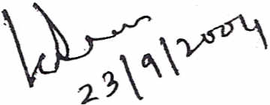
Prof. K. L. Deori
Department of Applied Physics Delhi College of Engineering Bawana Road
Delhi - 110042.

ACKNOLEDGEMENT

In is my privilege to record my deep, sense of gratitude and unbound reverence to Prof. K. L. Deori, Head of Department, Applied Physics for her constant encouragement and inspiration throughout the project. I am greatly indebted to Dr. G. L. Verma, Head of Department, Applied Chemistry for valuable advices.
I would like to thank Mr. Mahindra Pal of Oil and Natural Gas Cooperation, who guided and helped me throughout the project, without whose help the project would not have been completed. I would also like to thank all the departmental laboratory staff particularly Shri 1. D. Kapoor, Shri Oharamchand Bhatia, Mr. Manoj, Md. Ekramul Haque for their cooperation.
Finally, I want to express my heart-felt gratitude to my father, mother, sister, and brother for their cheerful encouragement, immeasurable patience, and inspiration.

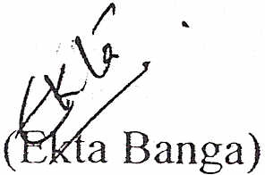
CONTENTS
CHAPTER-01 PAGE
1.1 Introduction 02
1.2 Definition of Diesel 04
1.3 Production of Diesel 05
1.4 Properties of Diesel 07
1.5 Properties Regulated by Govt. 10
1.6 Uses of Diesel 12
1.7 Diesel Engine 12

CHAPTER-02
2.1 Introduction 18
2.2 Theory 19
2.3 Description of Weighing Balance 20
2.4 Diagram 21
2.5 Experimental 22
2.6 Results 23

CHAPTER-03
3.1 Introduction 25
3.2 Theory 26
3.3 Diagram 28
3.4 Experimental 29
3.5 Results 31
CHAPTER-04 PAGE
4.1 Introduction 33
4.2 Theory 35
4.3 Diagram 35
4.4 Description of Viscometer 38
4.5 Experimental 39
4.6 Results 40

CHAPTER-05
5.1 Introduction 42
5.2 Theory 43
5.3 Diagram 45
5.4 Experimental 46
5.5 Results 47

CHAPTER-06
Conclusion 49
References 51

CHAPTER-01
DIESEL

  - INTRODUCTION
  - DEFINITION OF DIESEL
  - PRODUCTIN OF DIESEL
  - PROPERTIES OF DIESEL
  - PROPERTIES REGULATED BY GOVT
  - USES OF DIESEL
  - DIESEL ENGINE

1.1 INTRODUCTION
Diesel is a petroleum-based fuel, which is burned in engines ignited by compression, rather than sparks; commonly used for heavy-duty engines including buses and trucks. The molecular composition of diesel oil is from C₁₃ to CIS hydrocarbons. The boiling range of diesel is 250°C to 350°C.
SAMPLES COLLECTION
Samples of Diesel were collected from various petrol pumps in Delhi.
The samples are from two petrol pumps i.e. Bharat Petroleum and HP. The samples are eight in number, as one sample from each petrol pump from different parts of Delhi has been collected. The various parts of Delhi from where samples have been collected are East Delhi, West Delhi, North Delhi and South Delhi.
Various properties of diesel, which are covered in my project, are:
Density
Density is a measure of the fuel's mass per unit volume. Variations in fuel density can result in variations in the energy content of the fuel injected into an engine. Hence, engine power, emissions and fuel consumption may be affected. A narrower density range allows more efficient fuel consumption, better engine performance and reduced emissions. Reducing the maximum allowable density reduces the quantity of some of the heavier components in the diesel, giving cleaner burning and fewer smoke emissions.

Viscosity
Viscosity is a measure of the fuel's resistance to flow. High viscosity can reduce fuel flow rates resulting in insufficient fuel flow. Low viscosity will increase leakage from fuel pumps, can increase engine wear and may result in hot starting difficulties. Therefore, good control of viscosity is critical to the optimum performance of diesel fuel pumps and fuel injection systems.
Surface Tension
The force acting perpendicular to each centimeter of the imaginary line in the plane of the surface is called Surface Tension. Surface tension, is the property of the liquid by virtue of which free surface of liquid at rest tends to have minimum area and as such it behaves as if covered with a stretched membrane. Surface tension is caused by the inward attraction on the molecules in the surface.
Bulk Modulus & Compressibility
Bulk Modulus is defined as the ratio of normal stress· to the volumetric strain. K denotes Bulk Modulus. Mathematically, K can be defined as
K = normal stress / volumetric strain
Compressibility of a material is the reciprocal of its bulk modulus. C denotes compressibility. Mathematically, it is expressed as
C = 1 / K
1.2 DEFINATION OF DIESEL
A petroleum-based fuel which is, burned in engines ignited by compression rather than spark commonly used for heavy-duty engines including buses and trucks. A type of fuel oil used to power diesel engines. Heavier, less-refined fuel used primarily for large trucks and other heavy equipment. Diesel bums more slowly than gasoline, providing a more prolonged explosion in an engine's combustion chambers.
BIO-DIESEL
Bio-diesel is a renewable, biodegradable, alternative fuel or fuel additive for diesel engines. It can be used in its pure form or it can be mixed with a petroleum-based diesel. Bio-diesel can be made from a variety of products, including animal fats and virgin and recycled vegetable oils derived from crops such as soybeans, canola, corn, and sunflowers. Bio-diesel is through transesterification, a process in which organically-derived oils are combined with alcohol (ethanol or methanol) in the presence of a catalyst to form ethyl or methyl ester. The biomass-derived ethyl or methyl esters can be blended with conventional diesel fuel or used as a neat fuel (100% bio-diesel). Bio-diesel can be made from soybean or rapeseed oils, animal fats, waste vegetable oils or microalgae oils.

1.3 PRODUCTION OF DIESEL
Diesel is a petroleum fraction, obtained from crude oil by:
- Separation e.g. distillation.
- Upgrading e.g. hydrotrating .
- Conversion e.g. catalytic cracking.
Distillation
Distillation is the process used to separate crude oil or other wide boiling range mixtures into products with narrower boiling ranges based on the differences in boiling point of the compounds.
Diesel Oil
Diesel is obtained by fractional distillation of petroleum. The process of separating crude petroleum oil into more useful fractions is called refining. The refining of petroleum or separation of petroleum into different components is based. On the fact that the different components of crude oil have different 'boiling point' range.

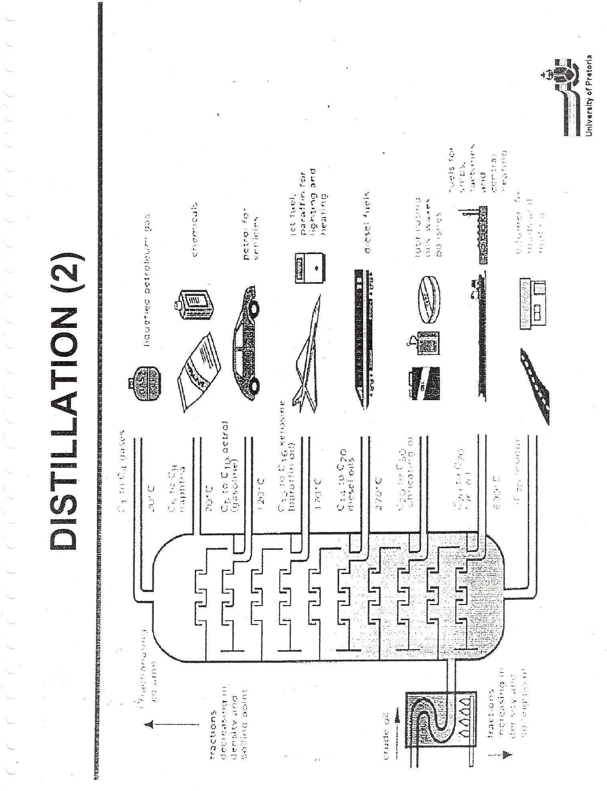

The fractional distillation of petroleum is done by using a tall fractional column or fractionating tower. The various fractions obtained by the fractional distillation f crude petroleum oil are: Petroleum gas, Petroleum ether, Gasoline or Petrol, Kerosene oil, Diesel oil, Fuel oil, Lubricating oil, Paraffin wax, Asphalt, and Petroleum coke.

1.4 PROPERTIES OF DIESEL
- Cetane Number
Cetane number is a measure of how easily diesel fuel ignites in an engine. The higher the cetane number the shorter is the delay period from the start f fuel injection to the start of combustion. Cetane number is the property that controls performance.
- Viscosity
Viscosity is a measure of the fuel’s resistance to flow. High viscosity can reduce fuel flow rates resulting in insufficient fuel flow. Low viscosity will increase leakage from fuel pumps can increase engine wear and may result in hot starting difficulties. Therefore, god control f viscosity is critical to the optimum performance of diesel fuel pumps and fuel injection systems.
- Distillation
Distillation is related to density as heavier fuel components tend to evaporate at high temperatures. Heavy components have more potential for incomplete combustion than higher components and may increase smoke or sot emissions.
- Flash Point
Flash pint is the lowest temperature at which enough vapour has combined in the air above a liquid that it will ignite when exposed to a flame. Flash point is a measure of both volatility and flammability.
- Cloud Point
Cloud point is the temperature at which wax crystals start to form and the fuel becomes cloudy. Cloud point is a useful measure of base fuel quality, while cold filter plugging point is an indication of how diesel will perform in an engine.
- Lubricity
Lubricity is a measure of the ability of diesel fuel to reduce wears on contacting metal surfaces found in fuel pumps and injectors.
- Density
Density is a measure of the fuel’s mass per unit volume. Variation in the fuel density can result in variations in the energy content of the fuel injected into an engine.
- Ash
Ash refers to the small amount of non-combustible ash-forming compounds that occur in crude oil and petroleum products. These compounds can contribute to fuel system wear and plugging of fuel filters and injector nozzles.
- Color
Color is useful indicators of contamination, as fuel contaminated with water can appear hazy. The tests involve a visual inspection of the fuel. Color is compared against a standard chart.
- Sulphur
Sulphur occurs naturally in crude oils and must be removed to an acceptable level during the refining process. Sulphur in diesel contributes to the formation f particulate matter, a component of engine exhaust that is linked to health problems. Sulphur also degrades the performance of vehicle emissions-control equipment.
Characteristics of Ideal Diesel Fuel:
- Ease of start.
- Low wear (lubricity).
- Sufficient power.
- Low temperature operability.
- Low noise.
- Low emission.
- Good fuel economy.

1.5 PROPERTIES OF DIESEL REGULATED BY GOVT.
Density
Progressively narrowing the allowable density range will enable improved engine performance.
Density is a measure of the fuel’s mass per unit volume. Variations in fuel density can result in variations in the energy content of the fuel injected into an engine. Consequently, engine power emissions and fuel consumption may be affected. A narrower density range allows more efficient fuel consumptions, better engine performance and reduced emissions.

Changes Proposed to the Regulations

Current Regulations | Proposed changes
Density at 15ºC: 810 kg/m³ minimum; 860 kg/m³ maximum | Immediate increase to 820 kg/m³ minimum  Stage 1 reduction to 850 kg/m³ maximum  Stage 2 reduction to 845 kg/m³ maximum

Reducing the maximum allowable density reduces the quantity of some of the heavier components in the diesel, giving cleaner burning and fewer smoke emissions. The proposed changes will progressively align the specifications with those of Europe. New vehicle engine technology is being designed n the basis of the European fuel specifications.

Viscosity
Viscosity is a measure of the fuel’s resistance to flow. High viscosity can reduce fuel flow rates resulting in insufficient fuel flow. Low viscosity will increase leakage from fuel pumps, can increase engine wear and may result in starting difficulties. Therefore, good control of viscosity is critical to the optimum performance of diesel fuel pumps and fuel injection systems.

Changes Proposed to the Regulations
Current Regulations | Proposed changes
Density at 40ºC: 1.5mm/s minimum; 5.0 mm/s maximum | Immediate reduction to 4.5 mm/s maximum  Stage 1 increase to 2.0 mm/s minimum

USES OF DIESEL
The various uses of Diesel are:
- Diesel is used a fuel for vehicles like car, buses, trucks, railway engines, and ships.
- Diesel is used to run water pump, which are used in irrigation.
- Diesel is used to produce electricity on small scale in diesel generators.

DIESEL ENGINE
Rudolf Diesel developed the idea for the diesel engine and obtained the German patent for it in 1982. His goal was to create an engine with high efficiency. Gasoline engines had been invented in 1876 and especially at that time were not efficient.
The diesel vapours and air from petrol tank enters cylinder through the intake valve. The engine has four strokes, which are cyclically repeated. Figure 1.2 and 1.3 shows the diagram of diesel engine and the four strokes of diesel engine respectively, which are repeated in cyclic order.
- The intake stroke:
In this stroke, a stream of air passes through the nozzle of the carburetor with high velocity which reduces the pressure. The diesel vapour from the carburetor jet is sprayed into the air stream. This mixture of diesel vapour and air is explosive mixture. As the piston moves downwards the intake valve opens and the explosive mixture is inserted into the cylinder through the intake valve.

- The compression stroke:
In this stroke the intake valve is closed and the piston moves upwards with great force, which compresses the explosive mixture. The exhaust valve is also closed. Explosive mixture is heated to a very high temperature. The efficiency of the engine increases if the explosive mixture is compressed excessively.

- The power stroke:
When explosive mixture is compressed to its maximum value an electrical spark produced in the spark plug ignites the mixture causing combustion, which produces a chemical reaction. This chemical reaction converts chemical energy to heat energy. A large pressure is created by combustion and explosion, which causes the piston to move downward.

- Exhaust:
In the upper stroke the gases have fully expanded. The exhaust valve opens. The spent combustion gases are driven out of the cylinder through the exhaust valve into the atmosphere. The pressure decreases up to atmospheric pressure. Now the piston moves up so the burnt gases are driven out. When the piston reaches at the top the exhaust valve closes.

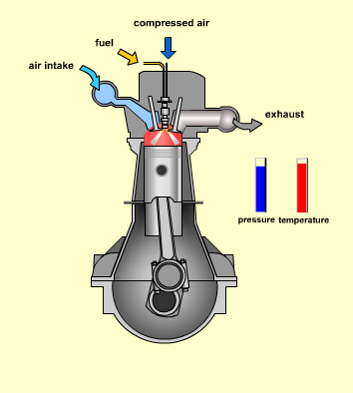
Figure 1.2 Diesel Engine

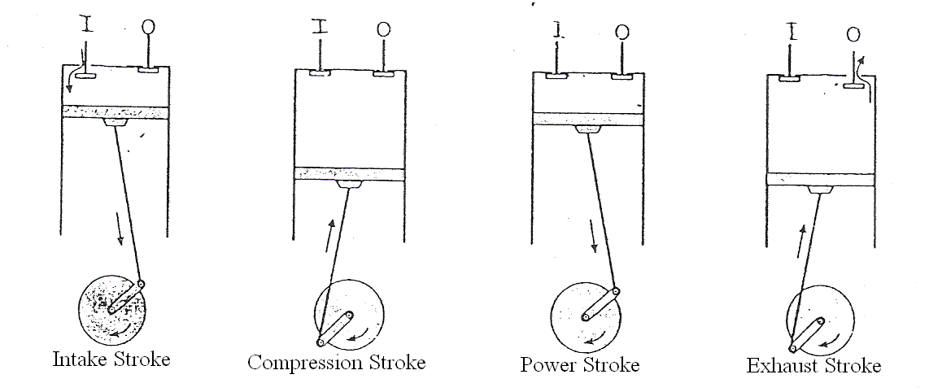
Figure 1.3 Four Strokes of a Diesel Engine

The main differences between the gasoline engine and the diesel engine are:
- A gasoline engine intakes a mixture of gas and air, compresses it and ignites the mixture with a spark. A diesel engine takes in just air, compresses it, and then injects fuel into the compressed air. The heat of the compressed air lights the fuel spontaneously.
- A gasoline engine compresses at a ratio of 8:1 to 12:1, while a diesel engine compresses at a ratio of 14:1 to as high as 25:1. The higher the compression ratio of the diesel engine leads to better efficiency.
The diesel engine has no spark plug, that it intakes air and compresses it, and that it then injects the fuel directly into the combustion chamber (direct injection). It is the heat of the compressed air that lights the fuel in a diesel engine.

CHAPTER-02
MEASUREMENT OF MASS AND DENSITY

2.1 INTRODUCTION
  - THEORY
  - DESCRIPTION OF WEIGHING BALANCE
  - DIAGRAM
  - EXPERIMENTAL
  - RESULTS

2.1 INTRODUCTION

Mass: it is the amount of matter contained in a substance. Mass is the measure of inertia or gravitation. Mass is a scalar quantity. Mass is never zero for any material body. It is not affected by the pressure of other bodies. It is a constant quantity. It is an essential property of material bodies.

The SI units of mass are kilogram and in cgs system units are gram.

Depending upon the manner in which mass of a body is measured, it is of two types:

- Inertial Mass:
When a body is in translational motion under the effect of an external force other than gravity, the mass of the body measured is called its inertial mass.
If a given force produces an acceleration a₁ in a body of mass m₁ and acceleration a₂ in a body of mass m₂,
Then m₁ / m₂ = a₁ / a₂
To measure the inertial mass of a body inertial balance is used.

- Gravitational Mass:
When a body is under the effect of gravity but without motion, the mass of the body measured is called gravitational mass.
The gravitational mass of a body is measured by making use of a physical balance.

Density:
Density is an important fundamental property of liquids and gases. Density is a useful means of displaying the mass in a liquid. The density of any substance is the mass of the material divided by the volume it occupies. This is summarized in Equation 1.
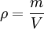
where,
ρ (rho) is the density of the substance, measured in kg·m-3
m is the mass of the substance, measured in kg
V is the volume of the substance, measured in m3
Density has a direct effect on the power required for pumps. Liquids with low levels of suspended solids such as city water (low densities) have little effect on the pump power requirements. Increasing the amount of suspended solids (higher densities) will generally increase the horsepower required to pump the liquid.

  - THEORY

Mass
Mass is defined as the amount of matter contained in a substance. Mass is the measure of inertia or gravitation. Mass is a scalar quantity. Mass is never zero for any material body. SI unit of mass is kg.
Density
Density is defined by the equation:
D = M / V.
The SI units of density are kg/l. The density of a sample is usually found by dividing the mass by a volume of the sample. Most often, the most complicated part of the procedure is determining the exact volume of an irregularly shaped solid. It is also difficult to determine the volume of liquids and gases because they have no specific shape.
  - DESCRIPTION OF WEIGHING BALANCE
Weighing balance used for measuring mass of various samples of diesel was an analytical balance. It is of Precisa make. The weighing range of the balance is from 0.01 gram to 120 grams. The accuracy given by the balance is 0.1 milligram. The balance is provided with Windshield cover, this cover helps in measuring the accurate weight as it prevents atmospheric air creeping inside. The voltage which is desired for its operation is 230 Volts ± 15 %, 50 Hz and the operating temperature range is from 10ºC to 50ºC. The linearity of balance is 0.2 milligram. Internal calibration of the balance has been done.

  - DIAGRAM
Precisa make Weighing Balance used for measuring mass and density
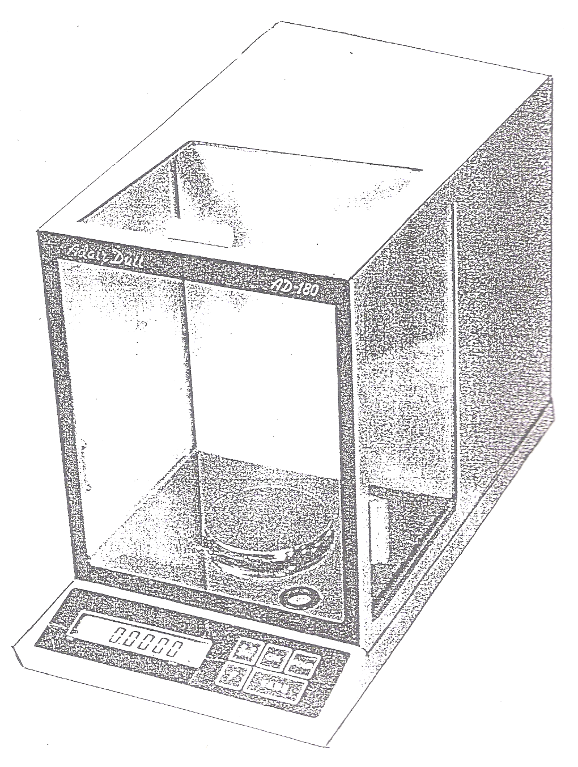

  - EXPERIMENTAL
The balance is switched on and is observed if it is showing any reading. If any weight is shown it is made zero with the help of Taring button. The door of the balance is opened and the empty specific gravity bottle is put on the pan of the balance. The door is closed, so that no air can get inside the balance. The mass of the empty specific gravity bottle is noted down. This specific gravity bottle which is of fixed volume is then taken out and filled with the diesel sample till the neck of the bottle, so that when cap is placed on the bottle diesel shots out from the capillary which is inside the cap. The specific gravity bottle is then cleaned with a filter paper so that there is no diesel, which is adhering to the outer surface of the specific gravity bottle. Now the mass of the specific gravity bottle and diesel is measure and is noted down.
The specific gravity bottle is taken out of the balance; it is emptied till the last drop of diesel is out. The specific gravity bottle is made to dry for 1 minute to 3 minutes. This is done so as the bottle is now again empty and there is no diesel inside it. The mass of the empty bottle (which was filled and then emptied and dried) is again taken from the balance.
The difference in the mass of the empty specific gravity bottle and weighted with the sample, gives the weight of the sample diesel. Density is calculated from the mass and volume of the specific gravity bottle. Mass of the sample diesel has been calculated with the help of specific gravity bottle and balance. The volume of diesel is 50ml, as the specific gravity bottle is of constant volume. Thus, we calculate the density by dividing mass with volume.

  - RESULT

The mass and density of various samples comes out to be:

Samples | Mass (kg) | Density (kg/l)
A | 0.04280 | 49.8
B | 0.04270 | 49.7
C | 0.04257 | 49.0
D | 0.04259 | 49.5
E | 0.04262 | 49.6
F | 0.04280 | 50.0
G | 0.04258 | 49.2
H | 0.04272 | 49.5

CHAPTER-03
MEASUREMENT OF SURFACE TENSION

  - INTRODUCTION
  - THEORY
  - DIAGRAM
  - EXPERIMENTAL
  - RESULTS

3.1 INTRODUCTION
The molecules in the surface of a liquid possess potential energy of every system tends to a minimum value, the liquid tries to have the least possible number of molecules in its surface, by reducing the surface area. The surface film is thus in a state of tension. If a straight line be imagined drawn on the surface the molecules on the one side of this line try to pull themselves away from the molecules lying to the other side of the line (in their attempt to reduce surface area). The rupture of the surface is however, prevented by cohesive forces between molecules. The force acting perpendicular to each centimeter of the imaginary line in the plane of the surface is called Surface Tension.

Surface tension, is the property of the liquid by virtue of which free surface of liquid at rest tends to have minimum area and as such it behaves as if covered with a stretched membrane. Surface tension is caused by the inward attraction on the molecules in the surface. The attraction produces curvature in free liquid surfaces and causes a pressure difference to exist at the curved boundary.
Factors on which surface tension of liquid depends:
- On the nature of the liquid.
- On the nature of surfaces in contact
Surface tension of mercury in contact with air is different from that when it is in contact with water.
- On the temperature of the liquid.
As temperature increase, surface tension of liquid decreases. The surface tension of liquid is zero at its boiling point and it vanishes at critical temperature.
  - THEORY:
When a capillary tube is set up in a liquid so that its lower end dips in the liquid, the liquid rises up the tube through a height, h. The surface tension, T acts upwards along the tangent to the meniscus. The component of the tension acting vertically upwards is T cos θ, where θ is the angle of contact. It is the angle between the tangent plane to the liquid surface and the tangent plane to the solid-surface in the liquid at any point on the line of contact of the liquid and solid. It is generally less than 90º, but for mercury it is 135º.
The total force acting upwards on the meniscus is T cos θ 2 π r, where r = internal radius of the capillary. This upward force supports the weight of the liquid column. The volume of the liquid is π r² h + 1/3 π r³ and its weight = π r² (h + 1/3 r) ρ g, where ρ = density of liquid. For equilibrium,
T cos θ 2 π r = π r² (h + 1/3 r) ρ g
T = r h ρ g / 2 cos θ, neglecting 1/3 r.
For liquids that wet glass, θ is very small and hence cos θ is practically unity and
T = h r ρ g / 2 dynes/cm.

  - DIAGRAM

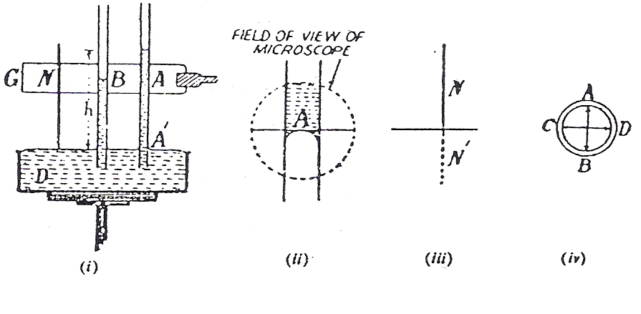
Figure 3.1 Experimental Setup for measuring Surface Tension
(i) Experimental Setup (ii) Field of View
(iii) Needle Index (iv) Diameter measurement
Figure Index:-
A and B - Capillary Tube D – Dish
G – Stand N – Needle

  - Experimental

A flat-bottomed dish is placed with vertical sides, on a table whose height can be adjusted. It is filled with diesel so that the diesel stands slightly below the edge of the dish. A glass plate is hooded in a clamp and attaches two capillary tubes A and B and a needle N to it with wax or rubber bands. The position of the plate is adjusted such that the capillary tubes are exactly vertical and their ends dip well in the diesel. Diesel automatically rises in the tubes. The diesel meniscus is viewed first in A, through a microscope and adjusts the height of the microscope so that it’s horizontal cross-wire just touches the lower diesel meniscus (it will look inverted) and read the microscope scale. The position of the needle is adjusted such that it is just above the surface of diesel in the dish.
If the needle dips, diesel will rise up along its sides. The space between the tip of the needle and its image in diesel is so small that when the cross-wire of the microscope is adjusted in between the needle and its image, it just fills the gap. The microscope reading is noted again. The difference gives the height h, of diesel above its level in the dish. We measure the height. The lower tip of needle should be just above the diesel surface but should not touch it. The surface of diesel should be free from grease. For this the dish is first being washed in acid and only then diesel is poured into it.
The capillary tubes should be set up vertically. The horizontal cross-wire should touch the lower meniscus before the microscope is read. The tube at the level of the meniscus is broken and holds it horizontally. The inner diameter AB of the capillary is calculated. The capillary is rotated and we calculate the diameter CD. Calculate the mean diameter and hence the mean radius r. Experiment is repeated with other capillary tubes of different bores.

  - Result
The surface tension of various samples of diesel at 30.8ºC is as follows:

Samples | Surface Tension (N/m)
A | 1.334
B | 1.236
C | 1.328
D | 1.229
E | 1.278
F | 1.269
G | 1.315
H | 1.295

CHAPTER-04
MEASUREMENT OF VISCOSITY

  - INTRODUCTION
  - THEORY
  - DIAGRAM
  - DESCRIPTION OF VISCOMETER
  - EXPERIMENTAL
  - RESULTS

  - INTRODUCTION

Viscosity is the property of a liquid by virtue of which an internal frictional force comes into play when the fluid is in motion and opposes the relative motion of its different layers. It is also called as fluid friction. Or, it is the property of liquids (or gases) by virtue of which a backward dragging force a viscous drag acts tangentially on the layers of the liquid in the motion and it tries to stop the motion is called viscosity.
Viscosity is due to the intermolecular forces, which are effective when the different layers of the liquid are moving with different velocities. These forces are of Vander Waal type and vary inversely as the seventh power of intermolecular distance. Due to these forces, every fast moving liquid layer tends to accelerate the adjoining slow moving layer and every slow moving layer tends to retard the adjoining fast moving layer of liquid. As a result, a backward dragging force called viscous drag comes into play, which accounts for viscosity of liquid.
Viscosity of liquid depends on various factors such as:
- Area of the layers.
- Distance between two layers.
- Temperature
With increase in temperature the viscosity of liquid decreases.
When liquid flows slowly over a fixed horizontal surface, the liquid layer in contact with the fixed surface remains at rest. The velocity of flow, however, increases steadily as we move upwards from the bottom. If u be the velocity at a distance x above and u+du the velocity at a distance x+dx, the change in velocity for a distance dx is du.
The du/dx is called the velocity gradient.
Newton has showed that the viscous force F, acting on a layer is proportional to the area A, of the layer and to the velocity gradient du/dx, thus:
F = - η.A.du/dx
where, η is a constant known as coefficient of viscosity and depends on the nature of the fluids.
The SI units of η is Nsm⁻² or kgm⁻¹s⁻¹ and is called decapoise. In the cgs system, the unit is dynscm⁻² or gcm⁻¹s⁻¹ and is called poise.

STOKES’ LAW
According to Stokes, when the spherical body falls through the fluid, layer in immediate contact with it, sticks to it and moves along with the body with the same velocity. The layer next to it has lesser velocity, the next still lesser and so on, while the layer at a considerable distance from the body remains at rest. As a result of this relative motion, a backward dragging force is set up which opposes the motion of the body. This backward force, called the viscous force, is given by:
F = -6 π η r π υ

  - THEORY
The absolute viscosity of fluid oil can be determined by measuring the rate of flow of the oil through a capillary tube kept at a uniform temperature. But in case of lubricating oils specific viscosity is generally determined by measuring the time taken for a given quantity of oil to flow through an orifice or jet of standard dimension under standard conditions. Three types of viscometer namely Redwood, Engler, and Saybolt viscometers are in common use.

  - DIAGRAM
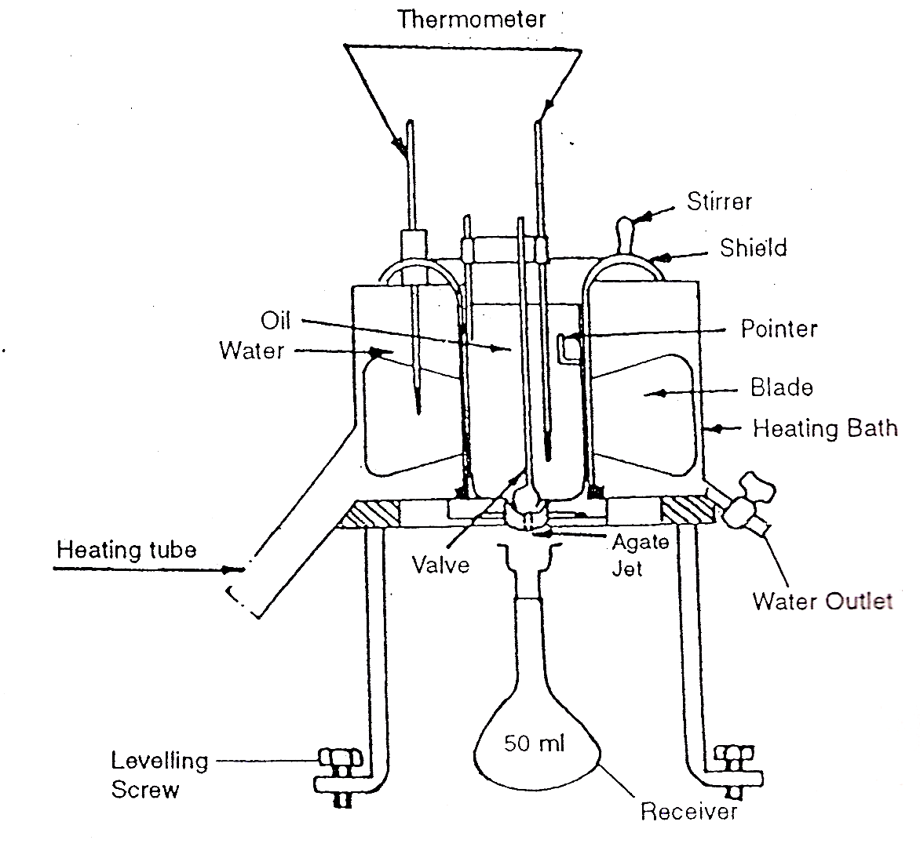
Figure 4.1 Redwood Viscometer used for measuring viscosity

  - DESCRIPTION OF VISCOMETER
The redwood apparatus measures viscosity in empirical units and not in absolute unit such as centistokes. There are two types of redwood viscometers i.e. Redwood No.1 and No.2. The redwood No.1 will correctly indicate the viscosity for a liquid having flow time between 30 seconds to 2000 seconds. If the flow time measured with this apparatus for any oil exceeds 2000 seconds, the test should be repeated with Redwood viscometer No.2 that will give correct value of viscosity for such highly viscous oil. The two viscometers RW1 and RW2 are identical in principle, shape, and mode of testing. They differ only in dimensions of orifice.

Viscometer | Diameter | Length of the jet
RW 1 | 1.62 mm | 10 mm
RW 2 | 3.8 mm | 50 mm

RW 1 is commonly used for light or thin oil(kerosene, mustard oil etc.)
RW 2 is used for high viscous liquids (fuel oil, mobile oil, glycerol etc.)

The redwood viscometer consists of the standard oil cup, which is opened at the upper end. It is fitted with an agate jet in the base. The diameter of the orifice is different for the Redwood viscometer I and II. The jet can be kept closed or opened by a ball valve, which thus permits the flow of oil being stopped or started. The cup is provided with a pointer, which indicates the level up to which the oil should be filled in the cup. The lid of the cup is provided with an arrangement to fix a thermometer to indicate the oil temperature. The cup is surrounded by a cylindrical copper vessel containing water, which serves as a water bath for maintaining the desired oil temperature with the help of electrical heating coils. A stirrer with four blades is provided in the water bath to maintain uniform temperature in the bath and hence enabling uniform heating of the oil. A thermometer is also provided in the bath to know the temperature of the water. The water bath is provided with an outlet for removing water as and when needed. A spirit level is used for leveling the apparatus and a 50ml flask for receiving the oil from the jet outlet is also provided.

  - EXPERIMENTAL

Cleaning of the viscometer cup can be done with the help of a suitable solvent e.g. CCl₄ether, Benzene, or petroleum spirit so as to remove any trace of the solvent. Further, it is dried also. Leveling screws help in leveling the instrument on the tripod. For higher temperature fill the bath with diesel having suitable viscosity at the test temperature. The diesel is filtered through a 100 mesh wire sieve before testing for its viscosity.
The brass ball is kept in a position so as to seal the orifice. Diesel is poured carefully into the oil cup to the tip of the indicator. 50 ml flask is kept below the jet. Ball valves are lifted and with that instantly stopwatch is started, till the flask reads up to 50 ml mark of the diesel, which is pouring down. Receiving flask should be place in such a way that the oil jet touches inside layer of the flask and does not cause foaming.
Stopwatch is stopped and the reading of the time, in seconds is noted. Ball valve is replaced in position so as to seal the cup to prevent over flow of the diesel. The oil is refilled in the cup up to indicator tip of the oil cup. Experiment is repeated so as to minimize the error. Taking mean of these values, the viscosity is reported at room temperature, TºC. After each reading, diesel should be completely drained out of the receiving flask. The flask should preferably be washed with xylol and dried before repeating the procedure.

  - RESULTS

The viscosity of diesel with the help of Redwood viscometer at room temperature 28.8ºC for various samples comes out to be as:

Samples | Viscosity (Redwood seconds)
A | 34.98
B | 35.66
C | 35.74
D | 36.80
E | 34.80
F | 35.89
G | 35.90
H | 34.85

CHAPTER-05
MEASUREMENT OF BULK MODULUS AND COMPRESSIBILITY

  - INTRODUCTION
  - THEORY
  - DIAGRAM
  - EXPERIMENTAL
  - RESULTS

  - INTRODUCTION
Bulk Modulus
Bulk Modulus is defined as the ratio of normal stress to the volumetric strain. K denotes Bulk Modulus. Mathematically, K can be defined as
K = normal stress / volumetric strain

Consider a sphere of volume V and a surface area a. Suppose that a force F which acts uniformly over the whole surface of the sphere, decreases its volume by ΔV. Then,
Normal stress = F / a.
and, the volumetric strain = - ΔV / V

The negative sign indicates that on increasing the stress, volume of the sphere decreases.
K = - F V / a ΔV
Now, F / a = p, the pressure applied over the surface. Hence,
K = p V / ΔV
The SI units of bulk modulus are Nm⁻² and the dimensions are [ML⁻¹T⁻²].
Compressibility
Compressibility of a material is the reciprocal of its bulk modulus. C denotes compressibility. Mathematically, it is expressed as
C = 1 / K
The SI units of compressibility are N⁻¹m² and the dimensions are [M⁻¹LT²].

  - THEORY
The ultrasonic wave passing through a liquid is an elastic wave in which compressions and rarefactions travel one behind the other regularly spaced equally apart. The distance between two successive compressions or rarefactions is the wavelength λ1 of ultrasonic wave in the liquid.
If a wave train is subjected to reflection by placing an obstacle in its path on both sides, stationary wave pattern is obtained with nodes and antinodes formed, which are spaced equally. In such case the liquid serves as an acoustic diffraction grating to the light incident normally on it and produces diffraction of light according to the grating rule.
If λ is the wavelength of ultrasonic wave in air, let λ₁ denotes the wavelength of sound in the liquid, and n is the angle of diffraction of nth order, then we have
(a + b) sin θ_{n} = n λ

where, a + b is the grating element. In the present case, a + b = λ₁ therefore,
λ₁ sin θ = n λ
If υ is the frequency of the ultrasonic wave and ν its velocity in the liquid, then
ν = υ λ₁

Thus, knowing λ and n and measuring the angle of diffraction, the wavelength of ultrasonic wave in the liquid can be determined by above equation. Also, knowing the frequency υ of the ultrasonic wave and having calculated λ₁ we can determine its velocity ν in the liquid.
The velocity of sound wave in a liquid is related to its bulk elasticity E as:
I ν = (E / ρ)^{/2}
where, ρ is the density of the liquid. Thus, knowing ν we can calculate the bulk elasticity of the liquid. The reciprocalof this bulk elasticity E is known as compressibility K of the liquid, i.e. K = 1 /E.

  - DIAGRAM

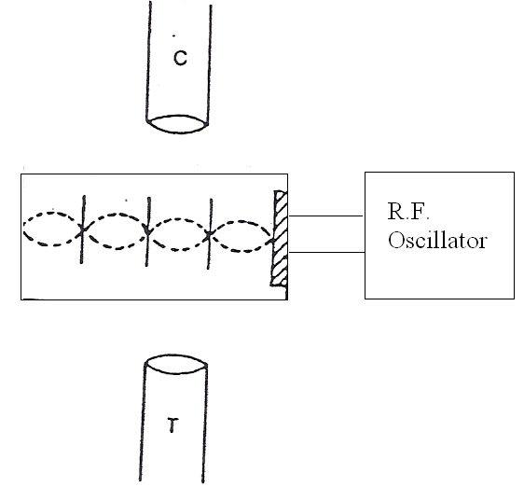
Figure 5.1 Experimental Setup for measuring Bulk Modulus and Compressibility
Figure Index:
R.F. Oscillator - Radio Frequency Oscillator T - Telescope
C – Spectrometer D – Wave pattern

  - EXPERIMENTAL

Square glass can is taken in which a hole is cut and the piezo-electric crystal is placed in the hole, such that there is no leakage when diesel is poured in it.
Normal spectrometer is taken and is adjusted, so that a well collimated beam of light is obtained from the collimator. Leveling of the prism table with the help of spirit level and then by optical method. Glass can is placed on the prism table. The can is filled with the sample diesel up to ¾ of the height of the can, such that the piezoelectric crystal is well inside the sample diesel. Prism table is turned till the front and back faces of the cell, which is fitted on one of the sides of the glass can, are exactly to the incident light. Prism table is rotated till situation is such that ultrasonic waves generated by it travel in direction perpendicular to the direction of light.
Radio Frequency Oscillator, which is of “D Lab Product” make and operates on voltage of 220V, 50Hz. Radio Frequency Oscillator is now switched on and its frequency is adjusted to match with the natural frequency of the crystal. At this instant, resonance occurs and pattern is observed in the spectrometer telescope. The angle 2 θ, is measured between the first order spectrum lines and then 2θ₂, 2θ₃, etc. are measured. The frequency is obtained by using Radio Frequency Oscillator frequency counter built in the oscillator. This is also the frequency of vibration of piezoelectric crystal.

  - RESULTS

The bulk modulus and compressibility for various samples of diesel comes out to be:

Samples | Bulk Modulus (Nm⁻²) | Compressibility (N⁻¹m²)
A | 2.4038 | 0.4160
B | 2.4479 | 0.4085
C | 2.0605 | 0.4853
D | 2.5125 | 0.3980
E | 2.3081 | 0.4325
F | 205947 | 0.3854
G | 2.5641 | 0.3900
H | 2.8636 | 0.3492

CHAPTER-06

CONCLUSION

In this project, I collected diesel samples from two major petrol pumps in India. These are Bharat Petroleum and Hindustan Petroleum. The samples were collected from various parts of Delhi i.e. North Delhi, South Delhi, West Delhi, and East Delhi. These samples have been marked as A to D for Hindustan Petroleum and E to H for Bharat Petroleum samples. Different properties studies on these samples are Mass, Density, Surface Tension, Viscosity, Bulk Modulus, and Compressibility. The method used to study mass and density was weighing technique. In this weighing of diesel was done with help of weighing balance, which has an accuracy of 0.1 milligram. Viscosity of diesel samples was measured with the help of Redwood viscometer. For calculating the surface tension of diesel I used capillary rise method. In this method the samples of diesel were made to rise in capillary and their height were noted. Bulk modulus and compressibility were calculated using Radio Frequency Oscillator and piezo-electric crystal.

A comparison is made between the values of different properties i.e. mass, density, viscosity, surface tension, bulk modulus, and compressibility of the samples collected across different parts of Delhi from different petrol pumps.

Samples | From | Mass  (kg) | Density  (kg/l) | Surface Tension (N/m) | Viscosity (Redwood seconds) | Bulk Modulus (N/m²) | Compressibility (N⁻¹/m²)
A | HP (N) | 0.04280 | 49.8 | 1.334 | 34.98 | 2.4038 | 0.4160
B | HP (E) | 0.04270 | 49.7 | 1.236 | 35.66 | 2.4479 | 0.4085
C | HP (W) | 0.04257 | 49.0 | 1.328 | 35.74 | 2.0605 | 0.4856
D | HP (S) | 0.04259 | 49.5 | 1.229 | 36.80 | 2.5125 | 0.3980
E | BP (N) | 0.04262 | 49.6 | 1.278 | 34.80 | 2.3081 | 0.4325
F | BP (E) | 0.04280 | 50.0 | 1.269 | 35.89 | 2.5947 | 0.3854
G | BP (W) | 0.04258 | 49.2 | 1.315 | 35.90 | 2.5641 | 0.3900
H | BP (S) | 0.04272 | 49.5 | 1.295 | 34.85 | 2.8636 | 0.3892

REFERENCES

- Diesel and its Properties by Philip de Vaal of University of Pretoria.
- Laboratory Manual by V.P.Bhatnager.
- Properties of Matter by Charles.
- Chemical Engg. by P.C.Jain
- Encyclopedia of Main Technology 2003
- Howstuffworks.com

