STUDY OF SOFT HANDOVER IN THIRD GENERATION

CELLULAR NETWORK

A

Dissertation

Submitted in Partial fulfilment of the requirements for the award of the degree of
MASTER OF ENGINEERING

In

(Computer Technology & Application)

Submitted By:

RAJARSHI HASDAH
College Roll No: 12/CTA/08

University Roll No. 8410

Under the Guidance of:

Mr. Vinod Kumar

Dept. of Computer Engineering

Delhi College of Engineering, Delhi



DEPARTMENT OF COMPUTER ENGINEERING
DELHI COLLEGE OF ENGINEERING

DELHI UNIVERSITY
2010

CERTIFICATE


DELHI COLLEGE OF ENGINEERING

DELHI UNIVERSITY 2009-2010

This is to certify that the work contained in this dissertation entitled “study of soft handover in third generation celullar network” submitted by Rajarshi Hasdah, University Roll No-8410 in the requirement for the partial fulfilment for the major project in Master of Engineering in Computer Technology & Application, Delhi College of Engineering is an account of his work carried out under my guidance and supervision in the academic year 2009-2010.

Mr. Vinod Kumar

Assistant Professor

Project Guide

Dept. Of Computer Engineering

Delhi College of Engineering, Delhi

ACKNOWLEDGEMENT

It is a great pleasure to have the opportunity to extend my heartiest felt gratitude to everybody who helped me throughout the course of this project.

It is distinct pleasure to express my deep sense of gratitude and indebtedness to my learned supervisor Mr. Vinod Kumar for his valuable guidance, encouragement and patient reviews. With his continuous inspiration only, it becomes possible to complete this dissertation.

I would also like to take this opportunity to present my sincere regards to all the faculty members of the Department for their support and encouragement.

I am grateful to my parents for their moral support all the time; they have been always around to cheer me up, in the odd times of this work. I am also thankful to my classmates for their unconditional support and motivation during this work. Last but not the least, special thanks to the people who are active in the field of cellular netwok.

RAJARSHI HASDAH

Master in Engineering

(Computer Technology & Application) College Roll No. 12/CTA/08
University Roll No. 8410

Dept. of Computer Engineering
Delhi College of Engineering,
Bawana Road, Delhi-110042

CONTENTS
 | Title | Page No.

 | Certificate
 | Acknowledgement
 | Contents
 | List Of Figures
 | List Of Tables
 | Abstract
Chapter 1 | INTRODUCTION
 | 1.1 Introduction | 1
 | 1.2 Cellular Networks | 1
 | 1.2.1 First Generation Mobile Networks | 2
 | 1.2.2 Second Generation Mobile Networks | 2
 | 1.2.2.1 2g-Mobile Networks’ Capacity | 3
 | 1.2.2.2 Some Primary Advantages | 3
 | 1.2.2.3 Drawbacks | 3
 | 1.4 Third Generation Mobile Networks | 3
 | 1.5 Beyond 3g(4g) Technology | 4
 | 1.6 Organisation Of Thesis | 5
Chapter 2 | UNIVERSAL MOBILE TELECOMMUNICATION SYSTEM | 6
 | 2.2 Hierarchical Cell Structure | 6
 | 2.3 Multiple Access | 7
 | 2.3.1 Wcdma | 8
 | 2.4 Umts Architecture | 10
 | 2.4.1 User Equipment(Ue) | 11
 | 2.4.2 Umts Terrestrial Radio Access Network (Utran) | 12
 | 2.4.2.1 Radio Network Controller Rnc | 12
 | 2.4.2.2 Node B | 13
 | 2.4.3 Core Network(Cn) | 14
 | 2.4.3.1 Interfaces Of The Umts | 15
 | 2.5 Umts Features And Some Functionality | 16
 | 2.5.1 Power Control | 16
 | 2.5.2 Cell Breathing | 17
 | 2.5.3 Channel Type Switching | 18
 | 2.5.4 Congestion Control | 18
 | 2.5.5 Synchronnization | 19
Chapter 3 | SOFT HANDOVER
 | 3.1 Overview Of Handover In Mobile Networks | 20
 | 3.2 Objectives Of Handover | 21
 | 3.3 Handover Measurements And Procedures | 22
 | 3.4 Soft Handover (Sho) | 23
 | 3.4.1 Principles Of Soft Handover | 24
 | 3.4.2 Algorithm Of Soft Handover | 27
 | 3.4.3 Features Of Soft Handover | 29
Chapter 4 | NETWORK MODELLING
 | 4.1 Introduction | 31
 | 4.2 Opnet Modeler | 31
 | 4.2.1 Network Layer | 32
 | 4.2.2 Node Laye | 32
 | 4.2.3 Process Layer | 33
 | 4.2.4 Opnet Umts Model | 34
Chapter 5 | SIMULATION
 | 5.1 Comparison Between Hard Handover And Soft Handover | 36
 | 5.2 Simulation For Different Threshold Values | 40
Chapter 6 | CONCLUSION AND FUTURE WORK
 | 6.1 Conclusion | 44
 | 6.2 Future Work | 44
 | REFRENCES
LIST OF FIGURES

Serial no. | Title | Page no.
Figure 1.1: | Evolution of cellular network |  | 2
Figure 2.1: | Umts cell structure |  | 6
Figure 2.2: | Multiple access technology |  | 7
Figure 2.3: | Principle of spread-spectrum multiple access |  | 8
Figure2.4: | Umts architecture |  | 11
Figure 3.5: | Utran network. |  | 12
Figure 3.1: | Scenarios of different types of handover. |  | 21
Figure3.2: | Handover procedure |  | 23
Figure 3.3: | Shows the basic process of hard and soft handover |  | 24
Figure 3.4: | Principles of soft handover (2-way case) |  | 26
Figure 3.5: | Is-95a soft handover algorithm |  | 27
Figure 3.6: | Wcdma soft handover algorithm |  | 28
Figure 3.7: | Interference-reduction by sho in ul |  | 29
Figure 4.1: | Screenshot of the network editor |  | 32
Figure 4.2: | Node representation of umts workstation |  | 33
Figure 4.3: | State transition diagram (std) of umts_gmm process in ue gmm layer |  | 34
Figure 4.4: | Opnet umts architecture representation |  | 34
Figure 5.1: | Simulation scenario |  | 36
Figure 5.2: | Uplink transmission power for hard handover |  | 37
Figure 5.3: | Uplink transmission power for soft handover |  | 37
Figure 5.4: | Comparison of uplink transmission power between hard handover and soft handover |  | 38
Figure 5.5: | Comparison of end to end delay between hard handover and soft handover |  | 39
Figure 5.6: | Simulation scenario for different threshold value |  | 40
Figure 5.7: | Uplink transmission power for threshold value 0.1 dB |  | 40
Figure 5.8: | Uplink transmission power for threshold value 1 dB |  | 41
Figure 5.9: | Uplink transmission power for threshold value 5 dB |  | 41
Figure 5.10 : | Uplink transmission power for threshold value 10 dB |  | 42
Figure 5.11 : | Uplink transmission power for threshold value 14 dB |  | 42
Figure 5.12 : | Soft handover probability |  | 43
LIST OF TABLES

Serial no. | Title | Page no.
Table 2.1 : | Main wcdma parameters | 9

ABSTRACT

UMTS is an emerging cell phone technology and it is basically another name for 3G mobile communication systems. It provides an enhanced range of multimedia services like video conferencing and high speed internet access.

Sometimes UMTS is marketed as 3GSM emphasizing the both 3G nature and GSM standards which it was designed to succeed. UMTS is also European term for wireless systems based on the IMT-2000 standards. To utilize various merits in mobile telecommunication system which consist of various radio access networks, UMTS as Third Generation wireless technology utilizes a wideband CDMA or TD/CDMA transceiver and also cover large area. Handover is basically a function which continues the communication between users without any gaps when the hardware goes to a place where it finds no network coverage. When we talk in terms of cellular communications systems, handover is a process which is referred to the transfer of a connection from one cell to another. Handover time is generally between 200 and 1,200 milliseconds (ms), which accounts for the delay. In this thesis we are going to find the reasons for these factors which affect the Quality of service of handover.

The main focus of this research is to study the some factors which really affect the handover phenomenon in UMTS that basically affect the overall quality of mobile network. For this we intend to find the solution for problems which born during the handover. Handover provides the mobility to users which are the main theme of wireless technology and it is also make the interoperability between different network technologies.

CHAPTER 1: INTRODUCTION

1.1 INTRODUCTION
Cellular technology has acquired over three generations since 1979, when the first national cellular network was congenital in Japan. Each generation uses spectrum more competently, therefore adding more subscribers who can generate more cash flow for a carrier. The first generation (1G) cellular was only analog and used completely for voice calls. The second generation (2G) is a digital network and also provides some data services. The third generation (3G) cellular network allows high-speed data with voice. One generation doesn't clean off the previous generation; somewhat, a 2G tower operates next to a 1G tower operating at an altered part of the spectrum. But it takes time to install new hardware, cellular devices has been made to fall back to use the old generation network. The service features in almost all networks include air interface standards, and spectrum allocated. However, 3G network features involve packet switched data, transparent roaming services, broadcast quality sound/video .

1.2 CELLULAR NETWORKS
The latest and more valuable form for human communication is the wireless communication. Wireless network means that every network which is wireless comes in this category. The cellular system is essentially designed such that to use the raise of frequency spectrum proficiently. The cellular architecture is designed such that at low power used a more numbers of transmitters, thus it becomes easy to reuse the frequencies[8], this is totally different from old communication system, because in old system of communication only one transmitter was used at very high power at a limited channels. In this system re use of frequencies was complicated .

In wireless communication GSM technology is playing very important role. GSM use the narrow band TDMA which allows eight calls at the same radio frequency in digital cellular system. To achieve speedy web contact and good quality of videos and images and high data rate services, Third Generation Mobile systems are used. This research will focus on UMTS (Universal Mobile Telecommunications Network) thus 3rd generation networks are considered as UMTS. WCDMA (wide band code division multiple access) is the most important air interface which is being used in third generation and it works at 2GHz. Soft handover have been applied with WCDMA air interface to get the high quality of services and high data rate and it also provides the flexibility in the network.
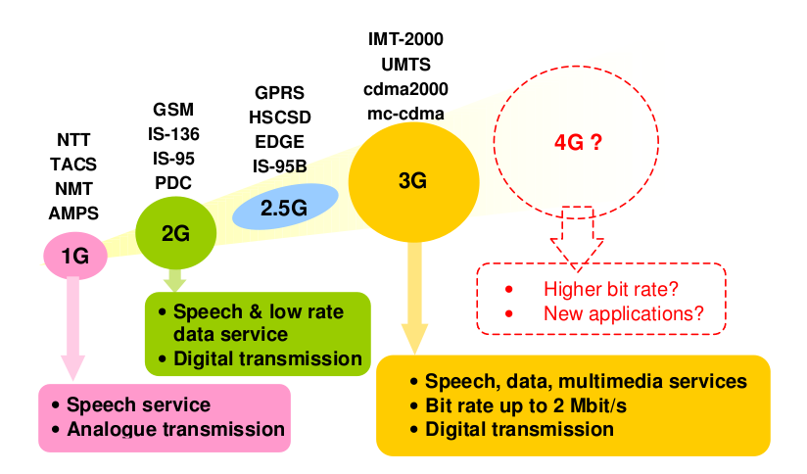
Figure 1.1 Evolutions of Cellular Networks

1.2.1 FIRST GENERATION MOBILE NETWORKS
AMPS (Analog mobile phone system) are the 1st generation technology this technology was found on analog signals. These analog signals travel like a waveform. These waves are generated by mobile device from transmitting ends in mobile networks which means from one base station where it proceeds to decide the next target of the signal. At the last when the signal has reached its final target then base station again restore the signal most likely try to reconstruct in its original shape for further proceeding.

1.2.2 SECOND GENERATION MOBILE NETWORKS
The main Advantages of 2G (2nd Generation) Mobile networks over their previous sections were:
- Mobile phone conversations were digitally encrypted
- 2G mobile systems were more reliable & efficient on the spectrum allowing for far
greater mobile phone penetration levels & signals.
- 2G also introduced Value added services & data services for mobile to make a start with SMS text messages.

1.2.2.1 2G-MOBILE NETWORKS’ CAPACITY
It uses digital technology between the Mobile station (handsets) and the tower to bust-up the system capacity & performance in two ways:
- Digital signal & voice data can be multiplexed, encrypted & compressed much more effectively than analog voice data; it allows more calls to be handled in the same radio bandwidth.
- Digital systems were designed in such a way to consume less radio power from the MS, which means cells could be smaller in size.

1.2.2.2 SOME PRIMARY ADVANTAGES
Following are advantages of digital system due to most consumers like it.
- Lower powered digital radio signals needs less battery power due to phones last much longer and batteries can be smaller in size.
- Digital voice encoding system allowed handling digital error checking which could boost-up sound quality by reducing the noise in transmission system.
- The lower power consumption helped to meet health standards.Digital systems introduced digital data services, such as SMS, GPRS, EDGE, MMS and Email.
- Digital system is most secure and reliable for consumer to handle calls according to their desires.
- We can trace and locate very easily any person through his mobile number. This is one of major advantage of Digital systems.

1.2.2.3 DRAWBACKS
The typical disadvantages of digital systems are:
- In less populated areas, the weaker digital signal may not be enough to reach a mobile cell tower. But this is a very rare problem as 2G is deployed on very high frequency & low power.
As digital calls are tend to be free of stagnant and background noise, the poor compression used by the codec takes a toll due to which the range of the sound that they can convey is reduced. You'll hear less of the tonality of someone's voice talking on a digital cell phone, but you will hear it more clearly.

1.4 THIRD GENERATION MOBILE NETWORKS
2G systems are limited in terms of maximum data rate. This makes 2G systems practically useless for the increased requirements of future mobile data applications.In order to provide for efficient support of new services, work on the Third Generation of cellular systems was initiated by the International Telecommunication (ITU) in 1992[3]. The outcome of the standardization effort, called International Mobile Telecommunications 2000 (IMT-2000)[3], comprises a number of different 3G standards. The European proposal for IMT-2000 prepared by ETSI (European Tele-communications Standards Institute) is called UMTS (Universal Mobile Telecommunications System). IMT-2000 standards are:
Past communication was mostly depending only on 2G but as technology is going to be advance, there was an introduction of latest technology such as Wireless Internet access (Wi-Fi and video telephony which require universal standards at higher user bit rates. Most of the new services require bit rates up to 2 M bit/s.

The broad objectives of 3G systems are:
- Support 2 Mbps for handheld devices, 384 kbps for walking mobile devices, and 144 kbps for car-borne mobile devices.
- Support for global roaming
- The 3G systems should work in all radio environments: urban areas, suburban areas, hilly and mountainous regions, and indoor environments. To achieve this, the cell size may vary considerably.
- Asymmetric and symmetric services should be supported, i.e., the uplink (from handset to base station) data rates can be lower than the downlink data rate.

The following services should be supported:

- Computer data with Internet access, e-mail transfer, mobile computing
- Telecom services, such as telephony, video telephony, video and audio conferencing
- Audio/video on demand, tele-shopping, TV and radio broadcast

1.5 BEYOND 3G(4G) TECHNOLOGY
The 4G mobile technology has many advantage over 3G networks, 4G networks can give us data rates of about 100 Mega bits per seconds (Mbps) and an efficient use of spectrum then the normal 3G networks, low latency and low cost, 4G mobile technology provides ever new and better way of providing higher level of graphic user interface and it provides high level of online gaming and more better video quality.

Long Term Evolution (LTE) which is also known as super G or 3.9G has been developed by the 3GPP project as an improvement to the UMTS system. LTE uses Orthogonal Frequency Division Multiple Access (OFDMA) and LTE will provide us download data dates of about 150 Mbps for multi antenna (2×2) multiple-input multiple-output (MIMO) which are for the highest terminal category and for upload it will be 50 Mbps. LTE make very efficient use of the spectrum with the available bandwidth of 1.25 MHz to 200 MHz.
According to the working groups which will use this technology, the infrastructure and terminals that will be used in 4G network will use all the standards from 2G to 4G but the legacy system will be placed to adopt users in the existing infrastructure but the 4G network will all be based on
packets i.e. it will be all IP based .

1.6 ORGANISATION OF THESIS
The rest of the thesis is organized as follows:

chapter 2 We deals with the architecture of the UMTS.we discuss the architecture of the universal mobile telecommunication system.

Chapter 3 we deal with the process of handover .we discuss the various types of handover processes
that are applied in the umts network.

Chapter 4 we deal with the simulator . We discribe in brief about the OPNET simulator .the focus is mainly on the umts models of OPNET.

Chapter 5 we deal with the siimulation process.we present the simulation result .

Chapter 6 we deal with the conclusion of the thesis and discuss the possibility of future work in this area.

Finally, we give the Bibliography, containing the details of the papers related to the subject.

CHAPTER 2:UNIVERSAL MOBILE
TELECOMMUNICATION SYSTEM

2.1 INTRODUCTION
The third generation mobile communication system UMTS (Universal Mobile telecommunications System) is successor of GSM (Global System for Mobile Communications). UMTS networks can be divided in two parts. One part that is responsible for the circuit switched services (CS-domain) and one part that manages packet switched services . The CS-domain manages voice calls and on the other hand the PS-domain is responsible for data connections like connections from a mobile device (called user equipment (UE) in UMTS) to the internet.

2.2 HIERARCHICAL CELL STRUCTURE
UMTS is designed to provide global access and world-wide roaming. To support this the URAN (UMTS Radio Access Network) will be build in different hierarchical levels .
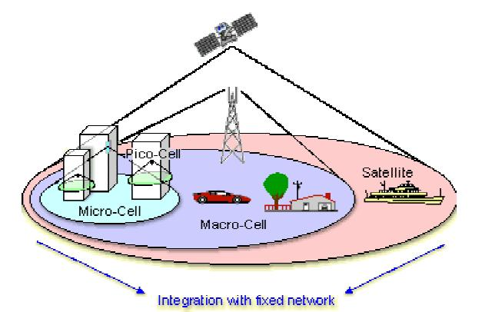

Figure 2.1: umts cell structure

Higher levels cover larger geographical areas.Lower levels cover only little areas but they can handle a higher density of devices that want to access the network in this little areas. They also provide faster wireless links to the network than larger levels. The whole system is connected and integrated with PTSN (Public Telephone Switched Network) and PDN (Public Data Network) like internet etc[2]. The following levels are planned:

Satellite system:
This covers the whole planet. Even on seas and in uninhabited regions access to the network is possible via satellites.

UTRAN (UMTS Terrestrial Radio Access Network):
The UTRAN infrastructure is terrestrial and consists also of different levels and cells:

Macro layer:
This cells cover large areas with regions where only few devices access the network.

Micro layer:
In regions with a high density of devices that want access to the network, like bigger cities, micro cells are used. They cover only quite little areas to provide enough capacity for all devices in this area.

Pico layer:
A pico cell is normally located in bigger buildings to provide fast and good access to the network. For example hot spots are made out of pico cells in buildings.

2.3 MULTIPLE ACCESS
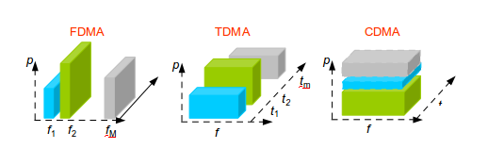
A mobile communication network is a multi-user system, in which a large number of users share a common physical resource to transmit and receive information. Multiple access capability is one of the fundamental components. The spectral spreading of the transmitted signal gives the feasibility of multiple access to CDMA systems [5].

Figure 2.2 Multiple access technologies
Figure 2.2 shows three different multiple access technologies:TDMA,FDMA and CDMA.
In FDMA, (Frequency Division Multiple Access), signals for different users are transmitted in different channels each with a different modulating frequency; in TDMA, (Time Division Multiple Access), signals for different users are transmitted in different time slots. With these two technologies, the maximum number of users who can share the physical channels simultaneously is fixed. However, in CDMA, signals for different users are transmitted in the same frequency band at the same time. Each user’s signal acts as interference to other user’s signals and hence the capacity of the CDMA system is related closely to the interference level: there is no fixed maximum number, so the term soft capacity is used. Figure 2.3 shows an example of how 3 users can have simultaneous access in a CDMA system.
At the receiver, user 2 de-spreads its information signal back to the narrow band signal, but nobody else’s. This is because that the cross-correlations between the code of the desired user and the codes of other users are small: coherent detection will only put the power of the desired signal and a small part of the signal from other users into the information bandwidth.
The processing gain, together with the wideband nature of the process, gives benefits to CDMA systems, such as high spectral efficiency and soft capacity.
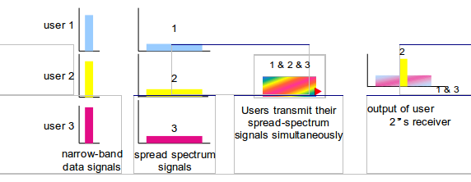
However, all these benefits require the use of tight power control and soft handover to avoid one user’s signal cloaking the communication of others.

Figure 2.3 Principle of spread-spectrum multiple access

2.3.1 WCDMA
Wideband-CDMA (WCDMA) has been adopted by UMTS as the multiple access technology and it is also referred to as UMTS terrestrial radio access (UTRA)[4]. This section introduces the principles of the WCDMA air interface. Special attention is drawn to those features by which WCDMA differs from GSM and IS-95.
Table 2.1 summarises the main parameters related to the WCDMA air interface. Some of the items that characterise WCDMA are:
WCDMA is a wideband CDMA system. User information bits are spread over a wide bandwidth (5 MHz) by multiplying with spreading codes before transmission and are recovered by decoding in the receiver .
The chip rate of 3.84 Mchip/s used leads to a carrier bandwidth of approximately 5 MHz. In GSM, carrier bandwidth is only 2OO kHz. Even in narrowband CDMA systems, such as IS-95, the carrier bandwidth is only 1.25 Mhz.
The inherently wide carrier bandwidth of WCDMA supports high user data rates and also has certain performance benefits, such as increased multipath diversity .
WCDMA supports highly variable user data rates; in other words the concept of obtaining Bandwidth on Demand (BoD) is well supported. Each user is allocated frames of 1O ms duration, during which the user data rate is kept constant. However, the data capacity among the users can change from frame to frame.
WCDMA supports two basic modes of operation: Frequency Division Duplex (FDD) and Time Division Duplex (TDD). In FDD mode, separate 5MHz carriers are used for the uplink and downlink respectively, whereas in TDD only one 5 MHz is time-shared between uplink and downlink.
WCDMA supports the operation of asynchronous base stations. Unlike the synchronous IS-95 system, there is no need for a global time reference, such as a GPS, so making deployment of indoor and micro base stations easier.
Multiple access method | DS-CDMA
Duplexing method | FDD/TDD
Base station synchronisation | Asynchronous operation
Chip rate | 3.84 Mcps
Frame length | 10 ms
Service multiplexing | Multiple services with different quality of service requirements multiplexed on one connection
Multirate concept | Variable spreading factor and multicode
Detection | Coherent using pilot symbols or common pilot
Multiuser detection,smart antennas | Supported by the standard, optional in the implementation

Table 2.1 : Main WCDMA parameters

WCDMA employs coherent detection on uplink and downlink based on the use of pilot signals or common pilot. In IS-95 coherent detection is only used on the downlink. The use of coherent detection on uplink will result in an overall increase of coverage and capacity on the uplink. This makes the downlink more likely to be the bottleneck of the whole system.
The WCDMA air interface has been crafted in such a way that advanced CDMA receiver concepts, such as multiuser detection and smart adaptive antennas , can be deployed by the network operator as a system option to increase capacity and/or coverage. In most second generation systems no provision has been made for such concepts.

WCDMA is designed to be deployed in conjunction with GSM. Therefore,handovers between GSM and WCDMA are supported.

2.4 UMTS ARCHITECTURE
The UMTS network can be divided into tree parts :

User Equipment (UE):
he UE connects to the UTRAN via wireless radio link to one or more cells. Unlike in GSM
it is possible to have a link to many cells at the same time.

UMTS Terrestrial Radio Access Network (UTRAN):
The UTRAN consists of Node Bs (BTS in GSM) that are connected to Radio Network Controllers (RNCs – BSC in GSM). The RNCs are connected to each other and to the core networks via ATM.

Core Network (CN):
The core network is connected to other networks like PTSN (Public Telephone Switched Network), Internet, other mobile networks etc. It is responsible for routing, authentication, location tracking, etc. The core networks is divided into two domains, the circuit switched (CS) and the packet switched (PS) domain . This work will further focus on the PS- domain.

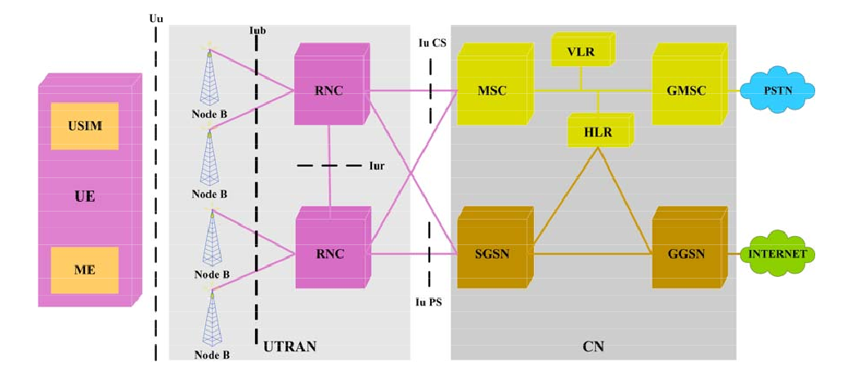
Figure:2. Figure2.4 umts architecture

2.4.1 USER EQUIPMENT(UE)
UE is a synonym for device here. For example an UE may be a mobile phone, a personal digital assistant (PDA) or a notebook. UE connects via the radio interface Uu based on the W-CDMA technology to the UTRAN. A device can be connected to more than one cell simultaneously. The UE consists of two parts :

Mobile Equipment:
That is the hardware device itself. The device alone can not use any UMTS services.

USIM-Card:
All necessary data for authentication and getting access to the UMTS network to use services is stored on an USIM-Card (UMTS Subscriber Identity Module-Card). This card is equivalent to the SIM-Card in GSM. The USIM-Card is issued by the common carrier and is unlike GSM SIM-Cards able to save some MB of personal data. GSM SIM-Cards only have between 8kB and 32kB of memory.

2.4.2 UMTS TERRESTRIAL RADIO ACCESS NETWORK (UTRAN)
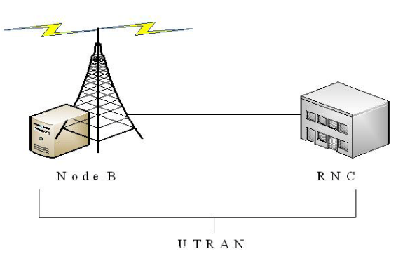
Among other things the UTRAN is responsible for the radio resource management. This includes the responsibility for power control, support for the different handover types and also controlling and managing handovers.
Figure 2.5 : UTRAN Network.

The UTRAN consists of Node Bs and RNCs.

2.4.2.1 RADIO NETWORK CONTROLLER RNC
In the radio access network the RNC is the main node. Between the mobile equipment and the radio access network a number of the protocols are applied in the radio network controller through the lur interface with the other RNC’s of the core network. The function of the RNC is same as the function of the BSc in the GSM network. The radio resource management is controlled in more than one Node-B by the RNC. The following are tasks of the RNC .

- Through the radio interface it performs all the data transmission tasks.
- The radio resources are managed by this entity.
- The connection and the releasement of the radio bearers.
- The admission of the call control through the Call admission control.
- The allocation of the code is also the duty of this entity.
- The control of power.
- Helps in handovers and the scheduling of the packet.
- The relocation of the SRNS and the conversion of the protocol.
- The data coming from other networks are ciphered in the RNC’s.

There are three types of RNC’s.
- Serving RNC
- Controlling RNC
- Drift RNC

Serving RNC
This RNC serves the user equipment because the user equipment is connected to this
RNC. That is why this RNC is called as the serving RNC.

Controlling RNC
It works with reference to the Node – B.

Drift RNC
It works in the process of handover.

2.4.2.2 NODE B
Its functions are similar to the BTS in the GSM network. The Node-B’s are also called as the radio network controller. The following are functions of the Node-B.
- Many cells are managed by the Node-B.
- The tasks which are attached to the radio interface is manage in the Node-B.
- The data splitting and the combination is also the duty of this entity.
- It helps in the process of handovers too.

Node-B’s has three types which include the following
- UTRA-TDD Node B
- UTRA-FDD Node B
- Dual Node B

Most of the Node Bs manage three cells. A group of Node Bs are connected with the Iub interface to one RNC via an ATM network. The RNC, a Node B is connected to, is called Controlling RNC (CRNC) (of this Node B). One RNC with all connected Node Bs is called Radio Network Subsystem (RNS).

A Node B operates at physical and network layer and passes the data to the CRNC. It also measures the quality and power of the radio links to the UEs and reports it to the CRNC. The CRNC can react on basis of this information, for example to reduce or increase the power of the radio signal at the Node B and/or UE. The RNC also assigns a W- CDMA code for the radio link between UE and Node B so that the data from the specific UE can be extracted from the whole data sent by all UEs and Node Bs around . It is also responsible for handovers between different RNS, radio resource control, etc. To provide a soft handover the RNCs are connected to each other with the Iur interface via an ATM network. They are also connected to the CN via the Iu-CS interface for circuit switched services and via the Iu-PS interface for packet switched services .

2.4.3 CORE NETWORK(CN)
The core network is divided into two parts . One for circuit switched services (CS- domain) and one for packet switched services (PS-domain). The CS-domain contains the following parts:

Mobile Switching Center (MSC):
The MSC is a switching node that routes data of CS-services within and out of the own network via the Gateway Mobile Switching Center (GMSC). A MSC manages many RNCs that are connected via the Iu-CS interface. The MSC is also connected to different databases for example to the Home Location Register (HLR) and manages the mobility for the CS-services. Depending on the size of the network there is normally more than one MSC in an UMTS network.

Gateway Mobile Switching Center (GMSC):
The GMSC is connected to the MSC and interconnects the own UMTS network to other CS-switched networks like PTSN (Public Telephone Switched Network) or ISDN (Integrated Services Digital Network). In an UMTS network can be more than one GMSC.

Visitor Location Register (VLR):
One VLR is normally assigned to every MSC. The VLR saves temporarily security, authentication and identification data of all participants that are currently managed by the MSC. Some of the data are copied from the Home Location Register (HLR, see below).

Transcoder Rate Adapter Unit (TRAU):
The TRAU is a gateway between the RNC and the MSC that is responsible for the conversion of the format (Adaptive Multi Rate (AMR) to Pulse Code Modulation 30 (PCM30) and vice versa) of speech data. This is necessary because UTRAN and CN use different formats . In an UMTS network can be more than one TRAU.

The PS-domain consists of the following parts:

Serving GPRS Support Node (SGSN):
The SGSN in the PS-domain is similar to the MSC in the CS- domain. It routes data of PS- services in the own UMTS networks and outside via the Gateway GPRS Support Node (GGSN). It also manages many RNCs that are connected via the Iu-PS interface and is connected to databases like the Home Location Register (HLR, see below). The SGSN is also responsible for authentication and mobility management. Depending on the size there is normally more than one SGSN in an UMTS network.

Gateway GPRS Support Node(GGSN):
The GGSN again is very similar to the GMSC in the CS-domain.It interconnects the UMTS
network with other PS networks like the Internet or X.25 networks and is connected to the SGSN. In an UMTS network there can be more than one GGSN.There are also some elements that are used by both domains. One important component of them is the following:

Home Location Register (HLR)/Authentication Center (AuC):
The HLR/AuC is a database that saves data of participants that rarely change like security and encryption information, phone number, services that a user is allowed to access by contract etc.

2.4.3.1 INTERFACES OF THE UMTS
The following are the different interfaces in the UMTS.

Lub Interface:
The RNC and the Node-B’s are connected through the Lub interface. There are many functionalities of this interface which include the management of the information system, the validation of the message on the user side, management of the traffic on different channels like in control and the dedicated channel and timings and the management of the link status.

Lur Interface:
Two RNC’s are connected to the interface known as Lur interface. The functionalities of this interface include management of the traffic in different channels like dedicated and common transport channel.

Uu Interface:
The RNC and the mobile equipment through the Node –B’s are connected to this interface. The main functionalities of this interface include paging and the management of the security, MAC/RLC reconfiguration and configuration and the handling of priority and the selection of the TFC.

Iu Interface:
The core network and the RNC’s are connected through the Iu interface. The main functionalities of the Iu Interface include establishment of the radio access bearers, its maintenance and the releasement is also the responsibility of this interface.
Iu-CS:
The RNC’s connected to the circuit switched domain of the core network through this interface.

Iu-PS:
The RNC’s connected to the packet switched domain of the core network through this interface.

2.5 UMTS FEATURES AND SOME FUNCTIONALITY
Here are some special UMTS features and functionalities

2.5.1 POWER CONTROL
Power control normalizes the transmission power of the mobile equipment and the RNC. It is very important to cope with the fading and the path loss.Greater capacity is gain by the regulation of the power transmission. To beaten the near far effects the received power equalization is very important. Also to minimize the interference level and the nosie in the cell power control is very important. There are three power control mechanisms used in the WCDMA.

Closed Loop Power Control
From the mobile equipment the RNC measures the uplink signal and sends a command to the user’s equipment. The down link signal is monitor by the mobile equipment and the data is forwarded to the RNC. To accommodate the near far problem in uplink this algorithm is used. The main function of the closed loop power control is that the power equalization at the users equipment all time.

Open Loop Power control
This mechanism is the property of the user’s equipment for arranging a required power for the required receiver. The mobile equipment measures the pilot signal from the base station and sets the power of the signal according to the power of the receiver signal.

Inner Loop Power Control:
This power control is also called as the closed loop power control. The power received is kept constant in fading channel due to this power control. The near far terminal problem is reduced due to this power control mechanism.

Outer Loop Power Control:
This type of the power control is related to the long term fluctuations of the channels. This type of power control is also called as the slow closed loop power control

2.5.2 CELL BREATHING
Cell breathing phenomenon gets higher from power control. The cell size varies because it depends upon the traffic load. This is the exchange between coverage and capacity. Good quality can be gained though from a long distance from base station when there is low load in the cell means number of users will be less in the cell. On the other hand, when the number of users in the cell is high, the large number of subscribers generates a high interference level and subscribers have to get closer to the base station to achieve good quality. If the number of users is higher in the cell then to get the good quality the users should get closer to the base station and in case of more users, far away from base station there will involve more interference.

2.5.3 CHANNEL TYPE SWITCHING
In order to maximize the total traffic throughput, different types of channels are used to transmit the data in WCDMA. To move the subscribers between the two channels like between common channels and dedicated channels, depending upon the information that subscribers need to transmit, Channel type switching functionality will be used.

The two most basic ones are:

Dedicated Channels:
When there is enough information for transmission, for example downloading, voice conversation then dedicated channel is used. It efficiently utilizes the radio resources because it provide supports for power control and soft handover.

Common Channels:
The common channel, in contrast, is smaller quantity spectrums efficient. As many subscribers can share the same resource, the common channel reduces the delays. This is one of the advantages of common channel. Thus for the transfer of limited information common channel is a preferable channel.

Admission Control:
To avoid system overload and for providing planned coverage, Admission control functionality is used. This functionality is used because in WCDMA there is very clear exchange between coverage and capacity. When a new subscriber looks access to the network, the admission control functionality estimates the network load on the base of newly coming load, then subscriber is either allowed to enter in the network or being blocked. According to the services of subscriber’s demand the operator can expand the network usage within a set of network quality levels.

2.5.4 CONGESTION CONTROL
Overload may also occur even in case of using efficient admission control. The main cause of this is due to the movement of subscribers from one area to another one. In case of overload four different actions can be taken.
- To resolve the overload issue congestion control becomes activated and it decreases the bit rate of non real time applications.
- If overload issue is not fully solved by reducing bit rate then inter or intra frequency handover becomes active by congestion control, which moves some of the subscribers to the less loaded frequencies.
- Some subscribers are being handover to GSM
- The action of discontinue is taken to keep the quality of the remaining connections.

2.5.5 SYNCHRONNIZATION
For accurate synchronization of base stations, when WCDMA system was standardized, should not depend on external systems and this is the basic requirement for synchronization. This has achieved by a method, where the handset, when needed, measures the synchronization of offset between the different cells and then reports this to the network .Moreover, there is also another option for the use of an external source, for example GPS, for node synchronization, i.e. to always give the top solution for both asynchronous and synchronous nodes are supported.

CHAPTER 3: SOFT HANDOVER

3.1 OVERVIEW OF HANDOVER IN MOBILE NETWORKS
Mobile networks allow users to access services while on the move so giving end users “freedom”in terms of mobility. However, this freedom does bring uncertainties to mobile systems. The mobility of the end users causes dynamic variations both in the link quality and the interference level, sometimes requiring that a particular user change its serving base station. This process is known as handover (HO). Handover is the essential component for dealing with the mobility of end users. It guarantees the continuity of the wireless services when the mobile user moves across cellular boundaries.
In first-generation cellular systems like AMPS, handovers were relatively simple. Second-generation systems like GSM are superior to 1G systems in many ways, including the handover algorithms used. More sophisticated signal processing and handover decision procedures have been incorporated in these systems and the handover decision delay has been substantially reduced. Since the introduction of CDMA technology, another idea that has been proposed for improving the handover process is soft handover and this is the focus of the work in this thesis.

Types of handover in 3G WCDMA systems
There are four different types of handovers in WCDMA mobile networks. They are:

Intra-system handover:
Intra-system handover occurs within one system. It can be further divided into Intra- frequency handover and Inter-frequency handover. Intra-frequency occurs between cells belonging to the same WCDMA carrier, while Inter-frequency occurs between cells operate on different WCDMA carriers.

Inter-system handover:
Inter-system handover takes places between cells belonging to two different Radio Access Technologies (RAT) or different Radio Access Modes (RAM). The most frequent case for the first type is expected between WCDMA and GSM systems. Handover between two different CDMA systems also belongs to this type.

Hard Handover:
Hard handover is a category of handover procedures in which all the old radio links of a mobile are released before the new radio links are established. For real-time bearers it means a short disconnection of the bearer; for non-real-time bearers hard handover is lossless. Hard handover can take place as intra or inter-frequency handover.

Soft Handover and Softer handover:
During soft handover, a mobile simultaneously communicates with two (2-way soft handover) or more cells belonging to different BSs of the same RNC (intra-RNC) or different RNCs (inter-RNC). In the downlink (DL), the mobile receives both signals for maximal ratio combining: in the uplink (UL), the mobile code channel is detected by both BSs (2-way soft handover), and is routed to the RNC for selection combining. Two active power control loops participate in soft handover: one for each BS. In the softer handover situation, a mobile is controlled by at least two sectors under one BS, the RNC is not involved and there is only one active power control loop. Soft handover and softer handover are only possible within one carrier frequency and therefore, they are intra-frequency handover processes. Figure 3.1 shows some scenarios of different types of handover.

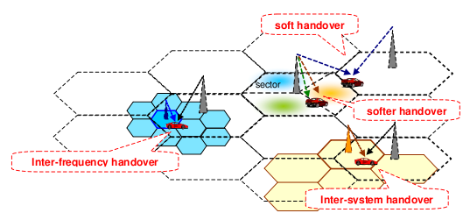

Figure 3.1 Scenarios of different types of handover.

3.2 OBJECTIVES OF HANDOVER
Handover can be initiated in three different ways: mobile initiated, network initiated and mobile assisted[7].

Mobile Initiated:
The Mobile makes quality measurements, picks the best BS, and switches,with the network’s cooperation. This type of handover is generally triggered by the poor link quality measured by the mobile.
Network Initiated:
The BS makes the measurements and reports to the RNC, which makes the decision whether to handover or not. Network initiated handover is executed for reasons other than radio link control, e.g. to control traffic distribution between cells. An example of this is the BS-controlled Traffic Reason Handover (TRHO). TRHO is a load-based algorithm that changes the handover threshold for one or more outgoing adjacencies for a given source cell depending on its load. If the load of the source cell exceeds a given level, and the load in a neighbouring cell is below another given level, then the source cell will shrink its coverage, handing over some traffic to the neighbouring cell. Therefore, the overall blocking rate can be reduced, leading to a greater utilisation of the cell resource.

Mobile Assisted:
Here the network and the mobile both make measurements. The mobile reports the measurement results from nearby BSs and the network makes the decision of handing over or not.

The objectives of handover can be summarised as follows:
- Guaranteeing the continuity of wireless services when the mobile user moves across the cellular boundaries
- Keep required QoS
- Minimising interference level of the whole system by keeping the mobile linked to the strongest BS or BSs.
- Roaming between different networks
- Distributing load from hot spot areas (load balancing)

The triggers that can be used for the initiation of a handover process could be the link quality (UL or DL), the changing of service, the changing of speed, traffic reasons or O&M (Operation & Maintenance) intervention.

3.3 HANDOVER MEASUREMENTS AND PROCEDURES
The handover procedure can be divided into three phases: measurement, decision and execution phases as illustrated in Figure 3.2. In the handover measurement phase, the necessary information needed to make the handover decision is measured. Typical downlink measurements performed by the mobile are the Ec/Io of the Common Pilot Channel (CPICH) of its serving cell and neighbouring cells. For certain types of handover, other measurements are needed as well. For example, in an asynchronous network like UTRA FDD (WCDMA), the relative timing information between the cells needs to be measured in order to adjust the transmission timing in soft handover to allow coherent combining in the Rake receiver. Otherwise, the transmissions from the different BSs would be difficult to combine and especially the power control operation in soft handover would suffer additional delay.
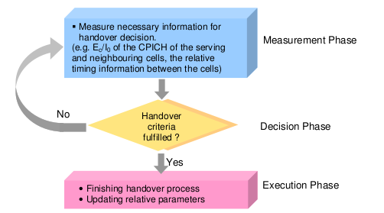

Figure3.2: Handover Procedure

In the handover decision phase, the measurement results are compared against the predefined thresholds and then it is decided whether to initiate the handover or not. Different handover algorithms have different trigger conditions. In the execution phase, the handover process is completed and the relative parameters are changed according to the different types of handover. For example, in the execution phase of the soft handover, the mobile enters or leaves the soft handover state, a new BS is added or released, the active set is updated and the power of each channel involved in soft handover is adjusted.

3.4 SOFT HANDOVER (SHO)
Soft handover was introduced by CDMA technology. Compared to the conventional hard handover, soft handover has quite a few inherent advantages. However, it also has the disadvantages of complexity and extra resource consumption. Planning of soft handover overhead is one of the fundamental components of the radio network planning and optimisation . In this section, the basic principles of soft handover are presented.

3.4.1 PRINCIPLES OF SOFT HANDOVER
Soft handover is different from the traditional hard handover process. With hard handover, a definite decision is made on whether to handover or not and the mobile only communicates with one BS at a time. With soft handover, a conditional decision is made on whether to handover or not. Depending on the changes in pilot signal strength from the two or more BSs involved, a hard decision will eventually be made to communicate with only one. This normally happens after it is clear that the signal coming from one BS is considerably stronger than those come from the others. In the interim period of soft handover, the mobile communicates simultaneously with all the BSs in the active set. The difference between hard and soft handover is like the difference between a swimming relay and track-and-field relay events. Hard handover happens on a time point; while, soft handover lasts for a period of time.

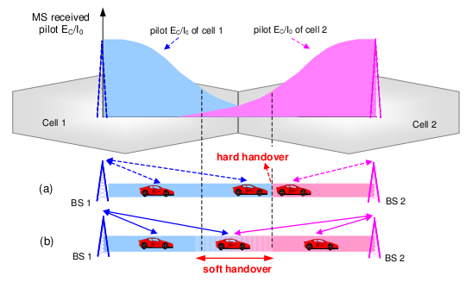

Figure 3.3 shows the basic process of hard and soft handover

Figure 3.3 shows the basic process of hard and soft handover (2-way case). Assuming there is a mobile terminal inside the car moving from cell 1 to cell 2, BS1 is the mobile’ original serving BS. While moving, the mobile continuously measures the pilot signal strength received from the nearby BSs. With hard handover shown as (a) in Figure 3.3, the trigger of the handover can be simply described as:
If (pilot_Ec/Io)2 - (pilot_Ec/Io)1 > D and BS1 is the serving BS
Handover to BS2 ;
else
do not handover ;
end

Where (pilot_ Ec/Io)1 and (pilot_ Ec/Io)2 are the received pilot Ec/Io from BS1 and BS2 respectively; D is the hysteresis margin.

The reason for introducing the hysteresis margin in the hard handover algorithm is to avoid a “ping-pong effect” the phenomenon that when a mobile moves in and out of , cell’ boundary, frequent hard handover occurs. Apart from the mobility of the mobile, fading effects of the radio channel can also make the “ ping-pong”effect more serious. By introducing the hysteresis margin, the “ ping-pong”effect is mitigated because the mobile does not handover immediately to the better BS. The bigger the margin, the less the “ ping-pong”effect. However, a big margin, means more delay. Moreover, the mobile causes extra interference to neighbouring cells due to the poor quality link during the delay. Therefore, to hard handover, the value of the hysteresis margin is fairly important. When hard handover occurs, the original traffic link with BS1 is dropped before the setting up of the new link with BS2 so hard handover is a process of “break before make” .

In the case of soft handover, shown as (b) in Figure 3.3, before (pilot_ Ec/Io)2 goes beyond (pilot_ Ec/Io)1, as long as the soft handover trigger condition is fulfilled, the mobile enters the soft handover state and a new link is set up. Before BS1 is dropped (handover dropping condition is fulfilled), the mobile communicates with both BS1 and BS2 simultaneously. Therefore, unlike hard handover, soft handover is a process of “make before break” So far, several algorithms have been proposed to support soft handover and different criteria are used in different algorithms.
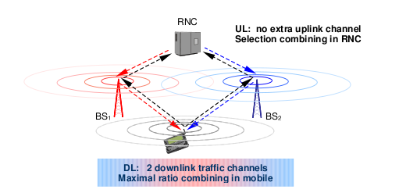

Figure 3.4 Principles of soft handover (2-way case)

The soft handover process is not the same in the different transmission directions. Figure 3.4 illustrates this. In the uplink, the mobile transmits the signals to the air through its omnidirectional antenna. The two BSs in the active set can receive the ignals simultaneously because of the frequency reuse factor of one in CDMA systems. Then, the signals are passed forward to the RNC for selection combining. The better frame is selected and the other is discarded. Therefore, in the uplink, there is no extra channel needed to support soft handover.

In the downlink, the same signals are transmitted through both BSs and the mobile can coherently combine the signals from different BSs since it sees them as just additional multipath components. Normally maximum ratio combining strategy is used, which provides an additional benefit called macrodiversity. However, to support soft handover in the downlink, at least one extra downlink channel (2-way SHO) is needed. This extra downlink channel acts to other users acts like additional interference in the air interface. Thus, to support soft handover in the downlink, more resource is required. As a result, in the downlink direction, the performance of the soft handover depends on the trade-off between the macrodiversity gain and the extra resource consumption.

3.4.2 ALGORITHM OF SOFT HANDOVER
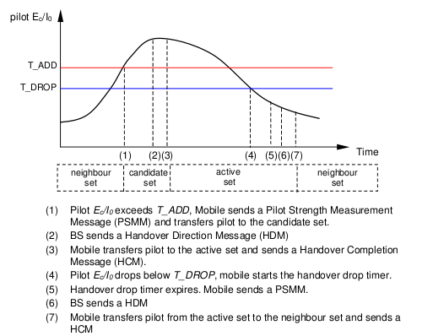
The performance of soft handover is related closely to the algorithm. Figure 3.5 shows the IS-95A soft handover algorithm (also called basic cdmaOne algorithm)[1] .

Figure 3.5 IS-95A soft handover algorithm

The active set is the list of cells that currently have connections to the mobile; the candidate set is the list of cells that are not presently used in the soft handover connection, but whose pilot Ec/Io values are strong enough to be added to the active set; the neighbouring set (monitored set) is the list of cells that the mobile continuously measures, but whose pilot Ec/Io values are not strong enough to be added to the active set.
In IS-95A, the handover threshold is a fixed value of received pilot Ec/Io. It is easy to implement, but has difficulty in dealing with dynamic load changes. Based on the IS-95A algorithm, several modified cdmaOne algorithms were proposed for IS-95B and cdma2000 systems with dynamic rather than fixed thresholds.
In WCDMA, more compliated algorithm is used, as illustrated in Figure 3.6 .
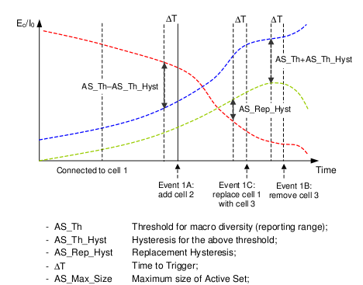

Figure 3.6 WCDMA soft handover algorithm

The WCDMA soft handover algorithm can be described as follows:
• If pilot_Ec/Io > Best_ pilot_Ec/Io–(AS_Th –AS_Th_Hyst) for a period of ∆T and the active set is not full, the cell is added to the active set. This is called Event 1A or Radio Link Addition.

• If pilot_Ec/Io < Best_ pilot_Ec/Io – (AS_Th + AS_Th_Hyst) for a period of ∆T, then the cell is removed from the active set. This is called Event 1B or Radio Link Removal.

• If the active set is full and Best_ candidate_pilot_Ec/Io >Worst_Old_pilot_Ec/Io + AS_Rep_Hyst for a period of ∆T, then the weakest cell in the active set is replaced by the strongest candidate cell. This is called Event 1C or Combined Radio Link Addition and Removal. The maximum size of the active set in Figure 3.6 is assumed to be two.

Where pilot_Ec/Io is the measured and filtered quantity of Ec/Io of CPICH; Best_ pilot_Ec/Io is the strongest measured cell in the active set; Best_ candidate_pilot_Ec/Io is the strongest measured cell in the monitored set; Worst_Old_pilot_Ec/Io is the weakest measured cell in the active set. In the WCDMA algorithm, relative thresholds rather than absolute threshold are used. Compare to IS-5A, the greatest benefit of this algorithm is its easy parameterisation with no parameter tuning being required for high and low interference areas due to the relative thresholds. Most of the work in this thesis is based on the WCDMA soft handover algorithm.

3.4.3 FEATURES OF SOFT HANDOVER
Compared to the traditional hard handover, soft handover shows some obvious advantages, such as eliminating the “ ping-pong”effect, and smoothing the transmission (there is no break point in soft handover). No “ ping- pong”effect means lower load on the network signalling and with soft handover, there is no data loss due to the momentary transmission break that happens in hard handover.
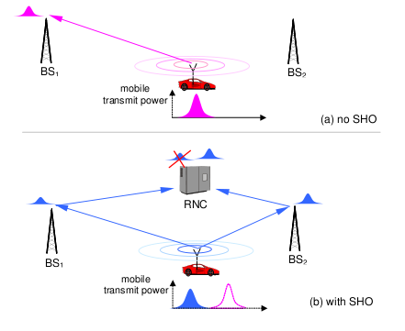
Apart from handling mobility, there is another reason for implementing soft handover in CDMA; together with power control, soft handover is also used as an interference-reduction mechanism.
Figure 3.7 Interference-reduction by SHO in UL

Figure 3.7 shows two scenarios. In the top one, shown as (a), only power control is applied; in the lower one, shown as (b), power control and soft handover are both supported. Assume that the mobile is moving from BS1 towards BS2. At the current position, the pilot signal received from BS2 is already stronger than that from BS1. This means BS2 is “ better”than BS1.

In (a), the power control loop increases the mobile transmit power to guarantee the QoS in the uplink when the mobile moves away from its serving BS, BS1. In (b), the mobile is in soft handover status: BS1 and BS2 both listen to the mobile simultaneously. The received signals, then, are passed forward to the RNC for combining. In the uplink direction, selection combining is used in soft handover. The stronger frame is selected and the weaker one is discarded. Because BS2 is “ better”than BS1, to meet the same QoS target, the required transmit power (shown in blue) from the mobile is lower compared to the power (shown in pink) needed in scenario (a). Therefore, the
interference contributed by this mobile in the uplink is lower under soft handover because soft handover always keeps the mobile linked to the best BS. In the downlink direction, the situation is more complicated. Although the maximum ratio combining gives macrodiversity gain, extra downlink channels are needed to support soft handover.

Summarising the features of soft handover:

Advantages
- Less the “ ping-pong”effect, leading to reduced load on the network signalling and overhead.
- Smoother transmission with no momentary stop during handover.
- No hysteresis margin, leading to lower delay being equivalent to “instantaneous” macroscopic selection diversity.
- Reduced overall uplink interference, leading to:
- Better communication quality for a given number of users
- More users (greater capacity) for the same required QoS
- Fewer time constraints on the network. There is a longer mean queuing time to get a new channel from the target BS, this helps to reduce the blocking probability and dropping probability of calls.

Disadvantages
- More complexity in implementation than hard handover
- Additional network resources are consumed in the downlink direction (code resource and power resource)

CHAPTER 4 :NETWORK MODELLING

4.1 INTRODUCTION
The previous chapter introduced the UMTS system technology described in the 3GPP specifications as also the soft handover process and its implications on the system performance. The goal of this research is to analyse the soft handover process with simulations, draw some conclusions on the probability a user is in soft handover and the impact of soft handover on issues as network capacity and coverage. In order to draw valuable conclusions, efficient network modelling is a vital aspect of this project.

The first part of this chapter gives a walkthrough of the opnet netwok optmizer software[9] that was used for these simulations. This software package enables network modelling on different levels of detail; the logical network configuration can be edited in the network editor, the node level provides facilities to define the structure and internal configuration of the network elements and the process layer enables configuration of processes inside the node and direct implementation of communication protocols. Another advantage of OPNET is that it has a specific UMTS model built in, based on the 3GPP specifications.

4.2 OPNET MODELER
OPNET Modeler provides a graphical user interface, which enables modelling and simulating networks. The modelling environment consists of different hierarchical layers for developing communication structures.OPNET provides the flexibility to build verydetailed customized models as well to perform general system analysis[10]. Systems are built up in an object oriented way, compiling the models automatically generates discrete event simulations in C language . After simulation it is possible to gather and analyze results with some of the built-in performance statistics features provided by this package.

4.2.1 NETWORK LAYER
The network layer enables to define the network topology on a logical or geographical map. It is possible to place network elements — called nodes — and interconnect them with different types of links; both fixed and radio links. Users having a radio link connection can be assigned trajectories to simulate their mobility. This being particularly useful in this context where it is necessary to be able to simulate mobile UMTS users and their effect on the network resources used.
In the network layer it is possible to nest subnetworks to configure complex hierarchical networks. Imagine a pan-European network, consisting of different national networks, formed by interconnection of different ring networks, which can in turn be connected to LAN entities…

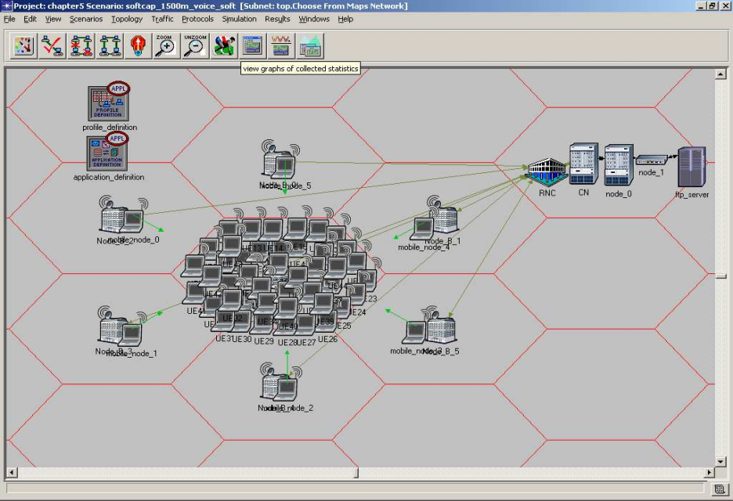
Figure 4.1 screenshot of the network editor
A network project can be built up using the network editor. OPNET contains an extensive library of node models of different technologies ranging from Ethernet, ATM, UMTS, wireless and IP networks as also equipment models of specific manufacturers as Cisco, 3Com and others.

4.2.2 NODE LAYER
The node layer provides functionality to build node — or network element — models to be used and interconnected on network level. In the node editor the nodes are built up out of processors, queues, transmitters and receivers. These building blocks called modules allow implementing node specific characteristics. Different modules are interconnected with packet streams, statistic wires or logical associations between them. Modules act as information sources and sinks or simply process the packets sent between them.
The picture below shows the node level implementation of a UMTS workstation (umts_wkstn_adv) as included in the OPNET UMTS model. Notice the presence of the full TCP/IP stack.
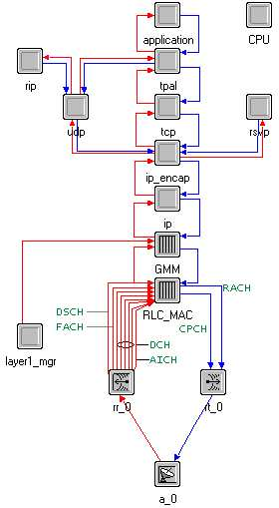
Figure 4.2 node representation of UMTS workstation

4.2.3 PROCESS LAYER
To further increase the level of detail used in the network model, the process layer makes it possible to program the different modules used in the node layer in order to implement specific protocols or desired behavior of the nodes. The processes carried out by the nodes are very similar to procedures commonly used in communication networks but it is also possible to include user specific functions by writing C++ code. The process editor makes use of a programming language called proto-C, which combines graphical State Transition Diagrams (STD) and C/C++ programming language. A STD consists of states with transitions between them. Both forced and unforced states exist. Whereas a system can wait in an unforced state, it has to leave the forced state immediately after executing the executives of that state. The state executives are actions to be performed right after entering — enter executives — or right before leaving a state — exit executives. Whether a transition should be traversed or not is decided by the transition conditions. These statements expressed in C/C++ language respond to interrupts or combinations of state variables.
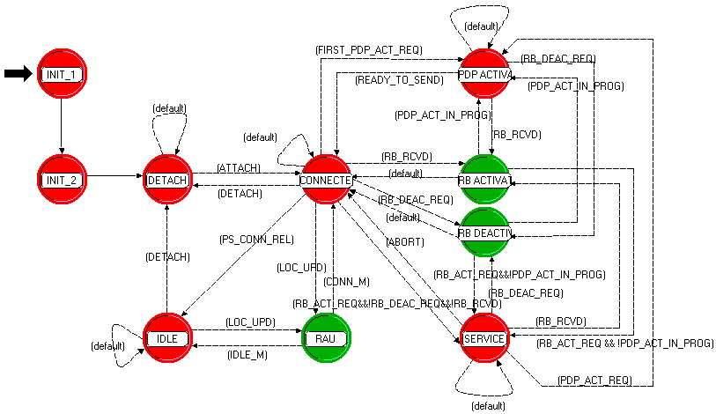

Figure 4.3 : State Transition Diagram (STD) of umts_gmm process in UE GMM layer

4.2.4 OPNET UMTS MODEL
OPNET modeler offers specialized models that address thr specific needs for modeling and simulating networks focused on a certain area of technology. One of those specialized models is the UMTS model based on the 3GPP specifications. This model follows closely the UE-UTRAN-CN system architecture as described in the previous chapter. The UE model offers functionality related to terminal equipment and mobile termination, responsible for terminating the radio link. The UTRAN part consists of models for the Node B and the RNC. The Core Network architecture is not fully implemented. The SGSN and the GGSN are implemented but the MSC/VLR and the HLR are currently not included in the UMTS model. The graphical representation of the architecture is shown on the picture below.

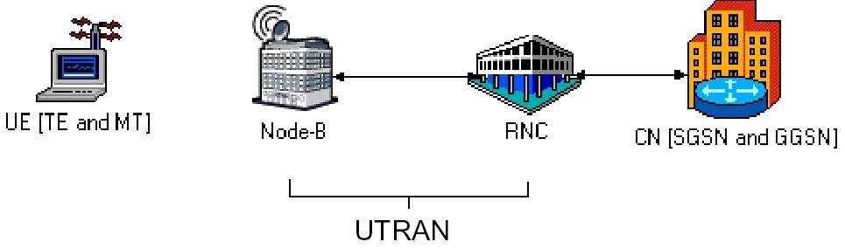
Figure 4.4 OPNET UMTS architecture representation
Below an overview of the features of the UMTS model as used for the modelling, will be given beside a discussion of the implementation of the different node models.
The UMTS specialised model supports a wide range of features resembling real network characteristics. Four different traffic classes have been defined: streaming, conversational, interactive and background. With each traffic class a QoS profile has been associated. This allows studying the effect of error or delay sensitive traffic in the system.
Also the following channels are supported in the model: DCH, DSCH and FACH&RACH. Hence also the Cell DCH and the Cell FACH state as mentioned in the previous chapter are supported. To simulate soft handovers it is essential to model users in the Cell DCH state as only dedicated transport channels support soft handovers.Additional features of the UMTS model are the supported mobility of users, power control and TCP/IP functionality.Although the UMTS model is very extended and reflects real networks to high detail it has significant limitations. One limitation is that only the UMTS FDD mode is supported. As initially pointed out not to evaluate the TDD mode this shortcoming is not limiting. Several other limitations are related to attaching procedures between the mobile device and the network. GMM idle mode and the GPRS detach procedure are not included. Also mobility of the mobile terminal prior to the attachment to the network is impossible. These aspects of the model are not limiting the simulation work done, as the aim is to evaluate the effect of handovers on the network performance rather than to study the specific signalling procedures preceding communications. In the following paragraph some of the primary modelling choices made during this research are presented and motivated.

CHAPTER 5:SIMULATION

We conducted a series of simulations. we can categorize the simulations into two parts. The first part deals with the comparison between the soft handover and the hard handover. And the second part deals with the threshold value for handover.

5.1 COMPARISON BETWEEN HARD HANDOVER AND SOFT HANDOVER

The comparison is based on the basis of the following parameters

- Uplink transmission
- End to end delay

The scenario for this simulation is shown in figure 5.1.

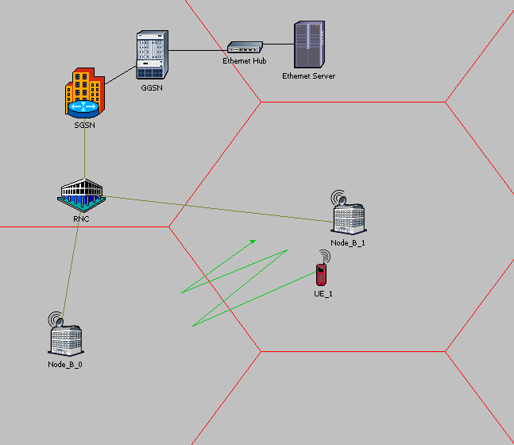

Figure 5.1 : simulation scenario

First the uplink transmission power for soft handover and hard handover is considered seperately and then both are compared on the same graph to get the clear picture.
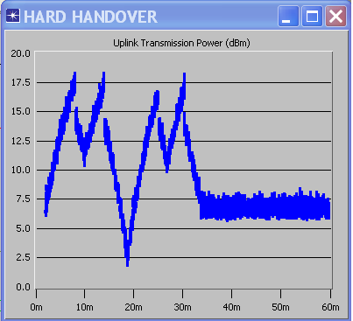

Figure 5.2 : uplink transmission power for hard handover

In the figure 5.2 it is clear that in hard handover first the previous connection is disconnected and then the new conection is made,this is more commonly known as “break before make” connection.this disconnection is for a fraction of a second and the user does not notices this. This normally happens after it is clear that the signal coming from one BS is considerably stronger than those come from the others. As we can see the new signal is is always srtonger than the old signal.

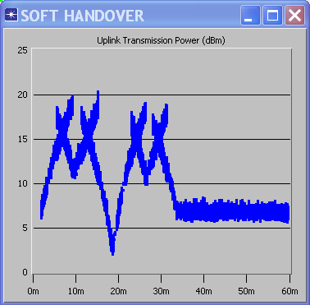

Figure 5.3 : uplink transmission power for soft handover

In the figure 5.3 it is clear that in soft handover first the new connection is made and then the previous conection is disconnected,this is more commonly known as “make before break” connection.we will focus on this issue in the following simulations.

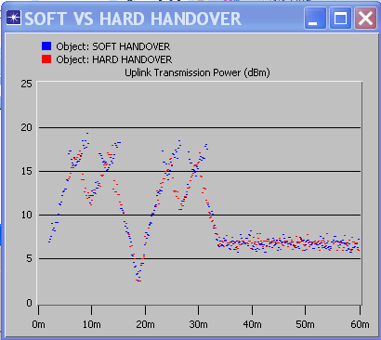

Figure 5.4 : comparison of uplink transmission power between hard handover and soft handover

In figure 5.4 comparison of uplink transmission power between hard handover and soft handover is done.The graph is plotted against time (sec) and transmission power in dbm. It can be observed from figure 5.4 the variation in uplink transmission power .The maximum value of uplink transmission power is 18.3 dBm for hard handover and 20.3 dBm for soft handover . In case of soft handover less variation in the value of uplink transmission power is observed. The reason for fluctuation in values of uplink transmission power in hard hand over is when the strength of the signal coming from one base station is faded the more uplink transmission power is required in order to maintain the quality of the service .After the execution of hard handover the strength of the signal improves and the lesser transmission power is required. In soft handover the signal strength of the two base stations are monitored simultaneously. When the strength of one base station goes beyond the minimum level then the soft handover is performed Thus minimum uplink transmission power is required.

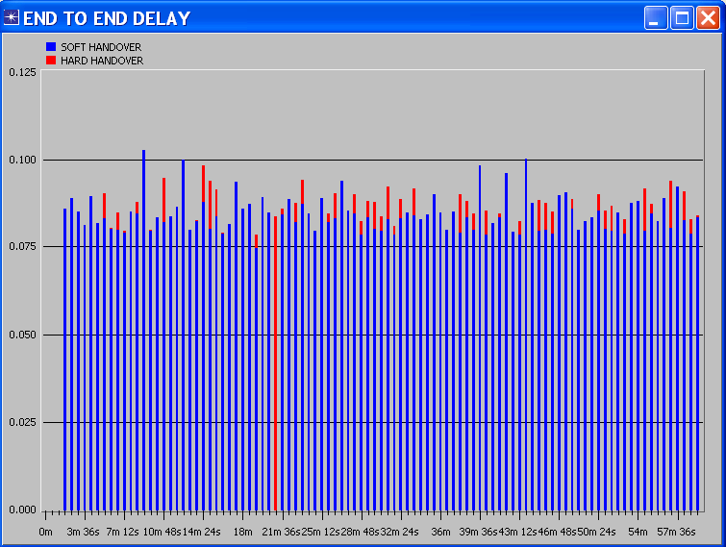

Figure 5.5 : comparison of end to end delay between hard handover and soft handover

In figure 5.5 end to end delay is represented. The graph is plotted against time (sec) and end- to- end delay (sec). The blue bar shows the information regarding soft handover and red bar show the data of hard hand over. By observing the graph it can be seen that more delay is recorded in soft handover than in hard handover. The maximum value of delay recoded in hard handover is 0.0982 second at 14m24s. In soft handover the maximum value of delay is observed at time instance 9m and value is 0.102 second. The reason for more end to end delay in soft handover is that the receiving RNC routes the data towards the base station of new RNC from same source for some time period that causes delay until the handover is performed.

5.2 SIMULATION FOR DIFFERENT THRESHOLD VALUES
We performed a series of simulations at different threshold values for soft handover. Figure 5.6 shows the simulation scenario.
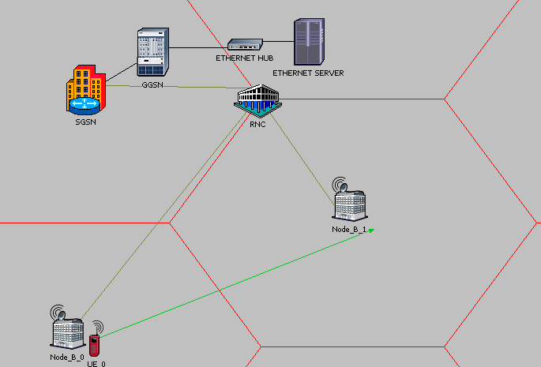

Figure 5.6 : simulation scenario for different threshold value

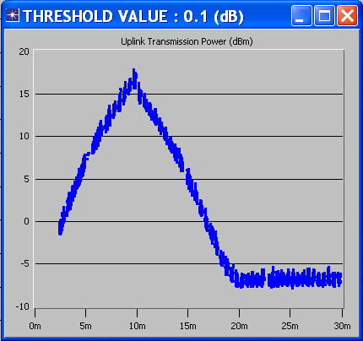
Figure 5.7 : uplink transmission power for threshold value 0.1 dB

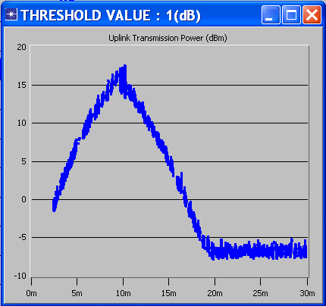
Figure 5.8 : uplink transmission power for threshold value 1 dB

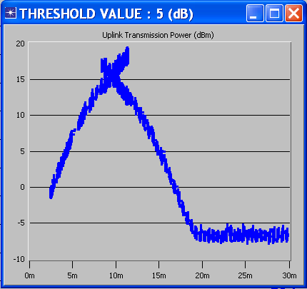
Figure 5.9 : uplink transmission power for threshold value 5 dB

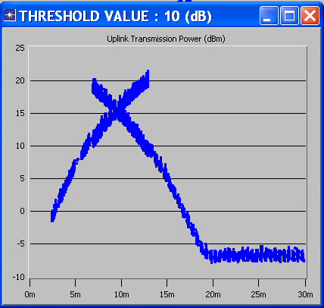
Figure 5.10 : uplink transmission power for threshold value 10 dB

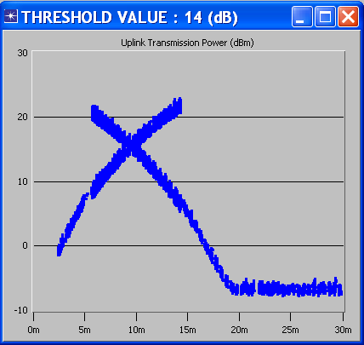
Figure 5.11 : uplink transmission power for threshold value 14 dB

From the study of graphs above from figure 5.7 to figure 5.11 we conclude that as we increase the threshold value the larger is the soft handover window.which means the user equpment remains in soft handover region for a longer time.
We also see that for a smaller value of threshold the soft handover is violated i.e the mobile equipment is not connected to two different base stations as we can see this in figure 5.7. In this case it is more or less similar to hard handover. So there increase a chance of call drop.
The most suitable threshold value is around 5 dB.

We now calculate the soft handover probability which is defined as the ratio of spent during handover to the total time in transition. We have calculated soft handover probability for threshold values from 2 dB to 14 dB taking step of 1 dB . which is represented in figure 5.12.

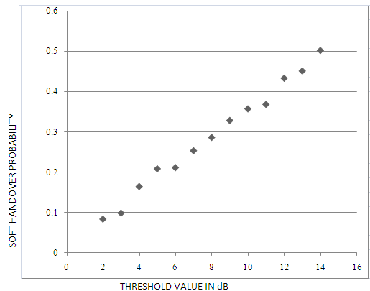

Figure 5.12 : soft handover probability

We see from from figure 5.12 that as we increase the threshold value the soft handover probability increases gradually . soft handover probability has a great impact on the system performence . As we know that higher the soft handover probability higher is the system capacity usage. Keeping a user equipment in soft handover region may result in over use of the resource which is not necessary . so we should keep the threshold value such that overall system performance can be optimized.

CHAPTER 6: CONCLUSION AND FUTURE WORK

6.1 CONCLUSION

In this research the main focus has been on soft handover . First we have compared the hard handover and soft handover. First we compare their uplink transmission signal and found that soft handover has higher uplink transmission value than soft handover.we also compared the end to end delay for both types of handover and found that soft handover has higher end to end delay as compared to the hard handover

Then we conducted a series of simulations for uplink transmission signal at different threshold values .The handoff window is the area over which the received strengths of the pilot signal differ less than the handover threshold. The simulations carried out show that for higher threshold values the handoff window becomes wider.

We also made conclusion about the soft handover probability distribution inside on cell. We see that near the cell centre very few users are in soft handover. In the cell edge area a soft handover probability of 100% is achieved. Concerning the effect of the handover threshold it is shown that the lower the value of this parameter, the slower the transition from 0% to 100% is made.

Soft handovers in the system also influence the capacity by increasing the traffic load due to the overhead in connections made during soft handovers Also the total amount of interference present in the system is minimal for networks with soft handovers enabled when considerably low threshold values are used.

6.2 FUTURE WORK

Although this research tried to show how threshold value effects the soft handover and thus effecting the overall network capacity, many aspects have not been covered in this report. For future research more attention has to be drawn to quality of service requirements in the system. As the implementation of QoS is essential for offering for example real time services, this is a vital aspect of the UMTS system. Studying the effect of soft handovers on parameters as the end-to-end delay for a given connection or the block error rate could provide interesting results on the system performance for each of the four UMTS QoS classes.

Although most of the results obtained from the simulations are useful to illustrate mechanisms influencing the network performance parameters, it has not always been possible to generate figures and values generally applicable for real systems. This has various reasons. Limitations of the OPNET® tool and assumptions and approximations made when building the models affect the degree to which the reality is reflected.

In order to obtain results applicable to real networks more simulations with more variable parameters have to be carried out. Also testing on the emerging commercial UMTS networks and knowledge gathered from operation and management of these real networks could provide a rich source of information for future research. In future research also more attention could be drawn to the aspects of different channels in the system and the way in which their characteristics affect the capacity of the system.

Finally it should be studied in which way the different handover and power control algorithms present in the system can be further optimised.

REFRENCES
[ 1] 3rd Generation Partnership Project, Technical Specification Group RAN, Working Group
2 (TSG RAN WG2), “Radio Resource Management Strategies”, 3G TR 25.922, V2.0.0,
December 1999

[ 2] V. Cauwenberge, “study of soft handover in UMTS”,Master’s thesis,technical universiy of denmark,2003.

[ 3] Y. Chen,”Soft Handover Issues in Radio Resource Management for 3G WCDMA Networks” Ph.D thesis, Queen Mary University of London, 2003

[ 4] Mubeen, T. Tasadduq, I. A. Zubairi, J. Ahmed “Hand Off Issues in 3G UMTS Networks” International Bhurban Conference on Applied Sciences & Technology Islamabad pp. 44 – 48 Jan. 2007
[ 5] R. A. Cheema, M.J. Irshad, “Issues and Optimization of UMTS Handover”, Marter’s thesis, Blekinge Institute of Technology,February 2008

[ 6] Ciubotaru,B.Muntean, “SHSHA-A Quality-Oriented Handover Algorithm for Multimedia content Delivery to Mobile Users” IEEE transaction on broadcasting, vol. 55, issue:2, pp.437-450, june2009.

[ 7] M. M. Khan,M.S. Khan, “investigation of handover in 3G UMTS traffic classes”,Master’s thesis,Blekinge institute of technology,2010.

[ 8] http://www.umtsworld.com

[ 9] http://www.opnet.com

[10] OPNET® modeller online documentation, “Modelling Concepts – Chapter 1:Modelling Overview”

