A
Dissertation
On
Study of Particle & Kalman Filter for Image Tracking
Submitted in Partial fulfillment of the requirement
for the award of Degree of

MASTER OF ENGINEERING
(Computer Technology & Application)

Submitted By:
Sanjay Kumar
College Roll No: 17/CTA/06
University Roll No. 10196

Under the Guidance of:
Dr. Rajiv Kapoor

Dept. of Electronics & Communication
Delhi College of Engineering, Delhi

DEPARTMENT OF COMPUTER ENGINEERING
DELHI COLLEGE OF ENGINEERING
DELHI UNIVERSITY
2006-2008

CERTIFICATE

This is to certify that the work contained in this dissertation entitled “Study of Particle, Kalman Filter for Image Tracking” submitted by Sanjay Kumar, University Roll No- 10196 in the requirement for the partial fulfillment for the award of the degree of Master of Engineering in Computer Technology & Application, Delhi College of Engineering is an account of his work carried out under our guidance and supervision in the academic year 2007-2008.

The work embodied in this major project has not been submitted for the award of any other degree to the best of my knowledge

Dr. RAJIV KAPOOR
Assistant Professor
Project Guide
Dept. of Electronics and Communication
Delhi College of Engineering, Delhi

ACKNOWLEDGEMENT

It is a great pleasure to have the opportunity to extend my heartiest felt gratitude to everybody who helped me throughout the course of this project.

It is distinct pleasure to express my deep sense of gratitude and indebtedness to my learned supervisor Dr. Rajiv Kapoor for their invaluable guidance, encouragement and patient reviews. I am very thankful to Dr. Daya Gupta H.O.D Computer Department who allows me to do project under the Guidance of Dr. Rajiv Kapoor on Image Processing. With their continuous inspiration only, it becomes possible to complete this dissertation and both of them kept on boosting me with time, to put an extra ounce of effort to realize this work.

I would also like to take this opportunity to present my sincere regards to my teachers Mrs. Rajni Jindal, Dr. S.K.Saxena and Mr. Manoj Sethi, Mr. Manish Kumar and Mr. Vinod Khera for their support and encouragement.

I would also like to take this opportunity to present my sincere regards to all the faculty members of the Department for their support and encouragement.

I am grateful to my parents for their moral support all the time; they have been
always around to cheer me up, in the odd times of this work. I am also thankful to my classmates for their unconditional support and motivation during this work.

Sanjay Kumar
M.E. (Computer Technology & Application)
College Roll No. 17/CTA/06
University Roll No. 10196
Department of Computer Engineering
Delhi College of Engineering, Delhi-110042

ABSTRACT

An unscented Kalman filter (UKF) has been extensively used for tracking problems. UKF has been used earlier to generate proposal distributions to turn a generic particle filter to a high-performance unscented Particle filter (UPF). This thesis uses the unscented Kalman filter to generate sophisticated proposal distributions that seamlessly integrate the current observation, thus greatly improving the tracking performance. The Unscented Particle Filter, those that the reduce the size of the space explored by the particles or those that perform a local exploration of the likelihood surface before predicting new particles. The use of the generic particle filter (PF) algorithm is well known for target tracking, but it can not overcome degeneracy of particles and cumulation of estimation errors. In this paper, we propose an improved PF algorithm called PF-RBF. Radial- basis function network (RBFN) is used in the sampling step for dynamically constructing the process model from observations and updating the value of each particle. PF-RBF can give an accurate proposal distribution and maintain the convergence of the Tracking system. Simulation results verify that PF-RBF performs better then the Unscented Kalman Filter (UKF), PF and Unscented Particle Filter (UPF) in both robustness and accuracy whether the observation model used for the sensor system is linear or nonlinear for the tracking application.

Keyword :- unscented Particle Filter, unscented Kalman filter, Radial Basic function

Table of Contents

CERTIFICATE i
ACKNOWLEDGEMENT ii
ABSTRACT iii
1 Introduction 1
1.1 Tracking: A Brief Review 1
1.2 Components of Visual Tracking system: 2
1.2.1 Target Representation and Localization. 2
1.2.2 Filtering and Data Association. 2
1.3 Tracking: Possible Issues and Applications 2
1.4 Optimization Methods For Tracking: 3
1.4.1 Direct optimization. 3
1.4.2 Probabilistic inference. 4
1.4.3 Particle Filters 7
1.5 Literature Survey 7
2 Kalman Filter 9
2.1 Introduction: 9
2.2 The Filtering Problem: 10
2.3 The Kalman filter 13
2.3.1 The System model for Kalman Filter 14
2.3.2 Derivations 17
2.3.3 Kalman gain derivation 18
2.4 Types of Kalman Filters 19
2.4.1 Extended Kalman filter 19
2.4.2 Unscented Kalman filter 20
3 Graphical Model Building Blocks 25
3.1 Exponential Family 25
3.2 Gaussian Distribution and Properties 26
3.2.1 Product of Gaussian distributions 27
3.2.2 Conditional Gaussian distribution 27
3.3 Bayesian Networks 28
3.4 Markov Chains 29
4 Particle Filter 31
4.1 Monte Carlo approximation 31
4.2 Model 32
4.3 Importance Sampling 32
4.4 Efficient Sampling 33
4.5 Sampling Importance Resampling (SIR) 34
4.6 Particle Filtering Issues 37
4.6.1 Controlled Resampling 38
4.6.2 Regularization 39
4.6.3 Weight Update Lower Bounds 40
4.7 The Unscented Particle Filter 40
5 Radial Basis Function 42
5.1 Introduction 42
5.1.1 Estimating the weights 42
5.2 A Radial Basis Function Network 43
5.2.1 Normalized architecture 44
5.2.2 Local linear models 45
5.3 Training 46
5.3.1 Interpolation 47
5.3.2 Function approximation 48
5.3.3 Logistic map 50
5.3.4 Function approximation 50
5.3.5 Time series prediction 52
5.3.6 Control of a chaotic time series 53
6 Work Done 54
6.1 IMPLEMENTATION 54
6.1.1 Design of Kalman Filter. 54
6.1.2 Design of Particle Filter. 54
6.1.3 Comparison of Results of Kalman and Particle Filter. 54
6.1.4 Design Of Rbf Algorithm is In Progress. 54
7 Results 55
7.1 Comparison to Kalman Filter vs. Particle Filter 55
8 Conclusion & Future Work 58
9 References 59

TABLE OF FIGURES

Figure 2.1 Typical application of the Kalman Filter 10
Figure 2.2 General Conditional Filter 13
Figure 2 3 Model underlying the Kalman filter. 14
Figure 3.1 Graphical model families. 25
Figure 3.2 Bayesian Networks. Example of Bayesian network graphical model. The joint distribution factors into the product of conditional distributions as illustrated above. All the conditional independences imposed by the graph itself are also listed. Notice that even though there seems to be a loop in the graph, there are no directed cycles. 28
Figure 3.3 Graphical model corresponding to a first-order Markov Chain. 28
Figure 3.4 Hidden Markov Models. Directed graphical model representation of the temporal Hidden Markov Model (HMM) with T = 5 observations and hidden variables are shown. Models that illustrate first-order and second-order Markov dynamics are shown in (a) and (b) respectively. 29
Figure 4.1 Example of efficient sampling of a distribution 34
Figure4.2 Activities performed on the particles in one time step. 36
Figure 4.3 The UKF proposal distribution allows us to move the samples in the prior to regions oh high likelihood. This is of paramount importance if the likelihood happens to lie in one of the tails of the prior distribution or if it is too narrow (low measurement error). In figure shows the estimates of the state covariance generated by a stand-alone EKF and UKF. 41
Figure 4.4 EKF and UKF Estimates of states covariance 41
Figure 5.1 Two unnormalized Gaussian radial basis functions in one input dimension. The basis function centers are located at c₁=0.75 and c₂=3 43
Figure 5.2 Architecture of a radial basis function network. An input vector x is used as input to all radial basis functions, each with different parameters. The output of the network is a linear combination of the outputs from radial basis functions. 43
Figure 5.3 Two normalized radial basis functions in one input dimension. The basis function centers are located at c₁ = 0.75 and c₂ = 3.25. 45
Figure 5.4 Unnormalized basis functions. The Logistic map (blue) and the approximation to the logistic map (red) after one pass through the training set. 51
Figure 5.5 Normalized basis functions. The Logistic map (blue) and the approximation to the logistic map (red) after one pass through the training set. Note the improvement over the unnormalized case. 51
Figure 5.6 Normalized basis functions. The Logistic map (blue) and the approximation to the logistic map (red) as a function of time. Note that the approximation is good for only a few time steps. This is a general characteristic of chaotic time series. 53
Figure 7.1 Variation of center of ball with green color & radius due to compression when it strik to target in red by kalman filter 55
Figure 7.2 These picture shows the how new weight varies according to new frame particle when ball is in motion from Bays algo. 56
Figure 7.3 These picture shows the how particle varies from frame to frame when ball is in motion through filter. 57

LIST OF ABBREVIATIONS

EKF……………………..Extended Kalman Filter
LPF……………………..Low Pass Filter
MCMC…………………Markov Chain Monte Carlo
MLP……………………...Multi Layer Perceptron
MMSE……………….....Measured Mean Square Error
MSE……………………Mean Square Error
PDF………………….…Probability Density Function
PF………………………Particle Filter
RBF…………………….Radial Basis Function
SMC……………………Monte Carlo Methods
SIR……………………. Sampling Importance Resampling
UKF……………………Unscented Kalman Filter

Introduction

Tracking: A Brief Review

In day to day life, there has been an increasing interest in image tracking and activity recognition systems; due to the large amount of applications there those features can be used. Standard algorithms are not practical to employ for image tracking due to the computational cost that arises from the high number of degrees of freedom of moving objects and from the ambiguity of the images obtained from a single camera. Constraints in the configuration of the moving objects can be used to reduce its complexity. The constraints can be deduced from demonstration, based on different activities. An image tracking system is developed using this kind of constraints and then evaluated. The fact that the constraints are based on activities allows, while doing the tracking, the inference of the activity the object is performing.

Image tracking and activity recognition are receiving increasing attention among computer scientists due to the wide spectrum of applications where they can be used, ranging from athletic performance analysis to video surveillance. By image tracking we refer to the ability of a computer to recover the position and orientation of the object from a sequence of images. There have been several different approaches to allow computers to derive automatically the kinematics pose and activity from image sequences.
Video tracking is the process of locating a moving object (or several ones) in time using a camera. An algorithm analyses the video frames and outputs the location of moving targets within the video frame. The main difficulty in video tracking is to associate target locations in consecutive video frames, especially when the objects are moving fast relative to the frame rate. Here, video tracking systems usually employ a motion model which describes how the image of the target might change for different possible motions of the object to track. The role of the tracking algorithm is to analyse the video frames in order to estimate the motion parameters. These parameters characterize the location of the target.

Components of Visual Tracking system:

Target Representation and Localization.

Target Representation and Localization is mostly a bottom-up process. Typically the computational complexity for these algorithms is low. The following are some common Target Representation and Localization algorithms:
- Blob tracking: Segmentation of object interior (for example blob detection, block-based correlation or optical flow).
- Kernel-based tracking (Mean-shift tracking): An iterative localization procedure based on the maximization of a similarity measure (Bhattacharyya coefficient).
- Contour tracking: Detection of object boundary (e.g. active contours or Condensation algorithm).
- Visual feature matching: Registration

Filtering and Data Association.

Filtering and Data Association is mostly a top-down process, which involves incorporating prior information about the scene or object, dealing with object dynamics, and evaluation of different hypotheses. The computational complexity for these algorithms is usually much higher. The following are some common Filtering and Data Association algorithms:
- Kalman filter: An optimal recursive Bayesian filter for linear functions and Gaussian noise.
- Particle filter: Useful for sampling the underlying state-space distribution of non-linear and non-Gaussian processes.

Tracking: Possible Issues and Applications

One approach to reduce the problem space and to make the problem computationally tractable is to provide constraints on the positions of the object. Constraints can be based on temporal information, camera configuration, or any combination of these. Camera configuration constraints are usually expressed by making assumptions on the relative positioning of the subject with respect to the camera.

Temporal constraints refer to the fact that an object can only move up to a certain speed, therefore given a certain configuration, the object can only reach a subset of all the possible configurations in the next time step. There are certain constraints in tracking the object motion, for example Joint angles constraints are the constraints that deal with the restrictions on the configurations of the human body due to its nature or to any other fact (i.e. activity performed, domain of the application, etc.). The set of constraints that produce the most accurate tracking is the one that describes better the action performed. Activity recognition systems are based on the concept of human tracking. These can be employed in numerous applications, ranging from robotics, computer animation, and video surveillance, etc. to video indexing and even athletics.

Optimization Methods For Tracking:

Most human motion and pose estimation approaches propose some sort of optimization method, direct or probabilistic, to optimize the pose (and/or body model) subject to the image features observed. This section will give an non-exhaustive overview of the methods employed.

Direct optimization.

Direct optimization methods often formulate a continuous objective function F(Xt, It), where Xt is the pose of the body at time t and It is the corresponding observed image, and then optimize it using some standard optimization technique. Since F(Xt, It) is highly non-linear and non-convex there is almost never a guarantee that a global optimum can be reached. However, by iteratively linearizing F(Xt, It) and following the gradient with respect to the parameters a local optimum can be reached. If a good estimate from the previous time step is available, and the pose changes slowly over time, then initializing the search with the previous pose often leads to a reasonable solution.

Probabilistic inference.

It is often convenient and natural to formulate tracking and pose estimation as probabilistic inference. A probabilistic framework has two advantages over the direct optimization methods:

- it can encode the confidence of any given articulated interpretation of the image.
- it allows one to maintain multi-modal predictions both spatially and over time. Multi-modality arises naturally in human motion estimation, since the body in different postures can look very similar (if not identical) in the image.

The number of valid interpretations of the image depend significantly on the features used, imaging conditions and the temporal history. By maintaining a multi-modal pose hypothesis over time, approaches can often benefit by resolving the ambiguities as more information becomes available.

Let us assume that the pose of the body, Xt, at time t is generated by a dynamic process. In general, for articulated motion estimation we are interested in the joint posterior distribution p(X0,X1, ...Xt|I0, I1, ..., It), where I_{i} is a (possibly multiocular) sequence of image observations over time i [0, ..., t]. Since dealing with the joint distribution over many high-dimensional variables is hard approximations are often made that only infer the marginals of the joint. The marginal equations are significantly simplified my introducing Markov assumption over the hidden states. The 1-st order Markov assumption4 states that pose, Xt, at time t depends only on the pose at t . 1. This model is also known as Hidden Markov Model (HMM) and will be discussed at length in the next chapter.

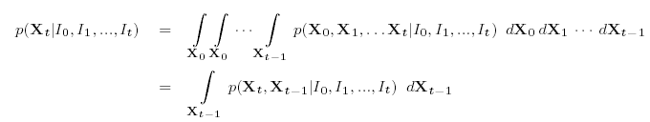

Using first Bayes’ rule from above Eq and then assuming the independence of observations, in particular, that It is conditionally independent of [I₀, ..., I_{t}.1] given X_{t}, we can re-write the above expression as follows,
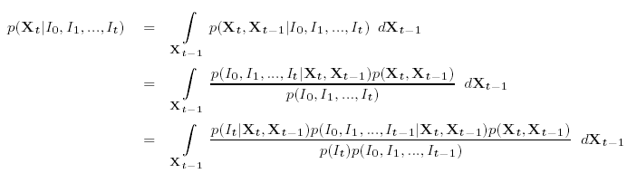

Since the observation, It, at time t is assumed conditionally independent of all hidden states (past or future) given the state, X_{t} at time t, we can further simplifyabove Eqs.. Then using conditional probability rules (Eq. 2.7), re-arranging terms (Eq. 2.8) and applying Bayes’ rule again to the right-most term is obtain the final recursive expression for Baysian filtering ,
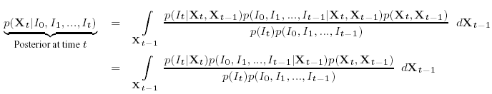
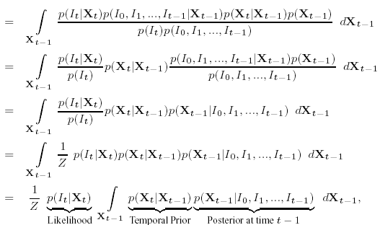
where Z is a normalizing constant. The integral portion of the above equation is referred to as the prediction and the term before the integral, p(It|Xt), as the likelihood. Furthermore, the first term in the integral, is also known as the temporal prior that defines the dynamics or the state evolution process. It is worth noting that the above recursion terminates at p(X0|I0) = p(X0), where it is assumed that the distribution over the initial starting pose X0 is known. In the case of the pose estimation p(X0|I0) 6= p(X0) and itself needs to be inferred.

If the likelihood is Gaussian, p(It|Xt) = N(It ;AoXt,_o), the initial distribution, p(X0), is Gaussian and temporal prior is linear with normally distributed noise, p(Xt|Xt.1) = N(Xt;AdXt.1,_d), the integral in above Eq. can be dealt with analytically. This model is commonly called the Kalman Filter and has been used successfully for articulated tracking in some cases . While the Kalman filter provides a probabilistic solution to tracking, this model is only capable of dealing with uni-modal Gaussian predictions of the posterior. Hence, most state of the art probabilistic methods tend to avoid Kalman Filtering in favor of other models that make weaker assumptions on dynamics and observations (e.g. particle filtering). It is worth mentioning that there is significant evidence that the posterior over pose is indeed non-Gaussian and is hard to model using simple parametric distributions. This arises due to non-linear dynamics of the human body and an often non-Gaussian observation model. For example, when a leg hits the ground during the walking cycle, the result is an inelastic collision between the foot and the ground plane that is highly non-linear

. In such cases a common solution is to approximate the integral using numerical (e.g. Monte Carlo) integration. This leads to a family of methods that are commonly known as Particle Filters. Particle filters will be covered in more detail in chapter 4. Particle filters have been extensively used for both rigid and articulated object tracking. Unlike the Kalman Filter, Particle Filters are able to deal with complex and multimodal posterior distributions. Particle Filters tend to represent the posterior at time t using a weighted set of N samples (particles) where s_{t}^{i} is an i-th sample and w_{t}^{i} is the corresponding weight, such that . The most notable disadvantage of these methods is that they require sampling in high-dimensional spaces to represent the posterior. Since the number of samples required grows exponentially with the dimensionality, (a.k.a. curse of dimensionality), most methods rely on some heuristic function that designates the most plausible portion of the space to sample. Consequently, the efficiency of particle filters is greatly effected by the choice of this function.

Particle Filters

Standard Particle Filters assume that the integral in the Baysian filtering equation cannot be computed analytically, in some cases however integrating analytically over part of the state space may be easy (e.g. a subset of variables in X_{t} may be Gaussian). Particle Filters make use of this fact by integrating analytically over the part of the state-space that can be integrated, and sampling the rest. As a result it can be shown that Particle Filters provide a better estimate for the posterior distribution. While RBPF inference has been successfully used in various applications, few approaches have thus far attempted to use it for articulate human motion estimation.

Literature Survey

I studied many papers related to Object Tracking by Particle & Kalman filter. In those papers, author used different techniques for the analysis of the object in different Application as a slightly changed in algorithm.

This thesis studies the use of Particle Filtering as a tool for approximate inference in Dynamic Bayesian Networks. The objective is to estimate the state of a object sequential observations, where the mappings between states and observations are not linear. While the conditions are similar to traditional Kalman Filtering problems, the fundamental difference is that the nonlinear mapping of states to observations can result in multi-modal posterior state distributions. Multi-modal distributions are not handled by traditional Kalman Filtering Techniques nor extensions of these techniques.

The objective is to evaluate the performance of Particle Filtering for the estimation and classification of unknown objects. The main advantage expected from this stochastic sampling technique, is that multi-modal probability spaces can be modeled. However, disadvantages must arise from the inexact nature of the algorithms well as the computational costs of sampling. As a result, we investigate several techniques to increase the efficiency of the algorithm, including regularization and controlled resampling.

- Chapter 1 covers the introduction to tracking, types of tracking and issues related to tracking and optimization techniques.

- Chapter 2 discusses Kalman filter and types of Kalman filter and inference using a sequence of observations.

- Chapter 3 discusses the Graphical model distributions types and Baysian and Markov chain process.

- Chapter 4 5 discusses the motivations behind the Particle Filtering technique as well as the basic algorithm. Main issues of Particle Filtering, including sample degeneracy and sampling depletion. The section goes on to describe commonly used techniques to mitigate these problems.

- Chapter 5 discusses the radial basis function network to apply on tracking.

- Chapter 6 discuss the work done in Matlab for coding of algorithm.

- Chapter 7 the results of tests on various object tracking this section demonstrates discrimination between more challenging nonlinear patterns and evaluates the Kalman filter, Particle filter’s performance as a classifier.

- Chapter 6 will discuss Conclusion and ideas for future work.

Kalman Filter

Introduction:

The Kalman filter is an efficient recursive filter that estimates the state of a dynamic system from a series of incomplete and noisy measurements. It was developed by Rudolf Kalman. The Kalman filter is a set of mathematical equations that provides an efficient computational (recursive) means to estimate the state of a process, in a way that minimizes the mean of the squared error. The filter is very powerful in several aspects: it supports estimations of past, present, and even future states, and it can do so even when the precise nature of the modeled system is unknown.

The Kalman filter dynamics results from the consecutive cycles of prediction and filtering. The dynamics of these cycles is derived and interpreted in the framework of Gaussian probability density functions. Under additional conditions on the system dynamics, the Kalman filter dynamics converges to a steady-state filter and the steady-state gain is derived. The innovation process associated with the filter, that represents the novel information conveyed to the state estimate by the last system measurement, is introduced.

When either the system state dynamics or the observation dynamics is nonlinear, the conditional probability density functions that provide the minimum mean-square estimate are no longer Gaussian. The optimal non-linear filter propagates these non-Gaussian functions and evaluate their mean, which represents a high computational burden. A non optimal approach to solve the problem, in the frame of linear filters, is the Extended Kalman filter (EKF). The EKF implements a Kalman filter for a system dynamics that results from the linearization of the original non-linear filter dynamics around the previous state estimates.

This section formulates the general filtering problem and explains the conditions under which the general filter simplifies to a Kalman filter (KF).

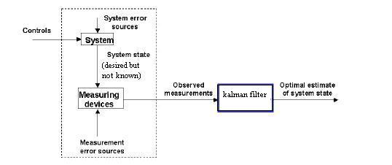
Figure 2.1 Typical application of the Kalman Filter

Figure 2.1 illustrate the application context in which the Kalman Filter is used. A physical system, (e.g. a mobile robot, a chemical process, a satellite) is driven by a set of external inputs or controls and its outputs are evaluated by measuring devices or sensors, such that the knowledge on the system’s behavior is solely given by the inputs and the observed outputs. The observations convey the errors and uncertainties in the process, namely the sensor noise and the system errors. Based on the available information (control inputs and observations) it is required to obtain an estimate of the system’s state that optimizes a given criteria. This is the role played by a filter. In particular situations, explained in the following sections, this filter is a Kalman Filter.

The Filtering Problem:

The general filtering problem may formulated along the following lines.
x (k + 1) = f(x(k), u(k),w(k)) (2.1)
y (k) = h(x(k), v(k)) (2.2)

Let be the state dynamics of a general non-linear time-varying system, where
- x € R^{n} is the system state vector.
- f (., ., .) defines the system’s dynamics.
- u € R^{m} is the control vector.
- w is the vector that conveys the system error sources.
- y € R^{r} is the observation vector.
- h (., ., .) is the measurement function.
- v is the vector that represents the measurement error sources.

Given

- f, h, the noise characterization, the initial conditions.
- The set of controls, u(0), u(1), . . . , u(k - 1).
- The set of measurements, y(1), y(1), y(2), . . . , y(k).

Obtain
- The best estimate of x (k).

Any type of filter tries to obtain an optimal estimate of the desired quantities (the system’s state) from data provided by a noisy environment. The concept of optimality expressed by the words best estimate corresponds to the minimization of the state estimation error in some respect.

Taking a Bayesian viewpoint, the filter propagates the conditional probability density function of the desired quantities, conditioned on the knowledge of the actual data coming from the measuring devices, i.e., the filter evaluates and propagates the conditional pdf.

p(x(k)|y(1), . . . , y(k), u(0), . . . , u(k - 1)) (2.3)

for increasing values of k. This pdf conveys the amount of certainty on the knowledge of the value of x(k).
Consider that, for a given time instant k, the sequence of past inputs and the sequence of past measurements are denoted by
,, ..…… } (2.4)
} (2.5)

The entire system evolution and filtering process, aiming at obtaining the best state estimate, the filter propagates the conditional pdf for increasing values of k, and for each k, it obtains the estimate that optimizes a chosen criteria, as represented in the following figure 2.2.

Different optimization criteria may be chosen, leading to different estimates of the system’s state vector. The estimate can be

- The mean, i.e., the center of the probability mass, corresponding to the minimum mean-square error criteria.
- The mode that corresponds to the value of x that has the highest probability, corresponding to the Maximum a Posterior (MAP) criteria.
- The median, where the estimate is the value of x such that half the probability weight lies to the left and half to the right of it.

For the conditional pdf represented in Figure 2.2 these criteria leads to different state estimates. So far, we formulated the general filtering problem. Under a set of particular conditions related with the linearity of the system (state and observation) dynamics and the normality of the random vectors involved (e.g., initial condition, state and measurement noise), the conditional probability density functions propagated by the filter are Gaussian for every k.
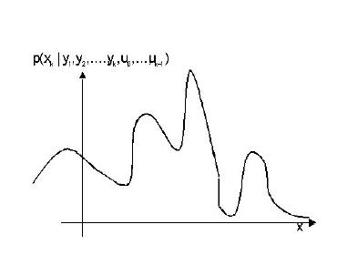
Figure 2.2 General Conditional Filter

The involved pdf are thus completely characterized by the mean vector and the covariance matrix. Rather than propagating the entire pdf, the filter only propagates (recursively) the first and second moments of the conditional pdf. The general filter simplifies to what is known as the Kalman filter, whose dynamics is be derived further.

The Kalman filter dynamics will be derived as general random parameter vector estimation. The KF filter evaluates the minimum mean-square error estimate of the random vector that is the system’s state. Results on the estimation of a general random parameter vector are represented.

The Kalman filter

The Kalman filter is a recursive estimator. This means that only the estimated state from the previous time step and the current measurement are needed to compute the estimate for the current state. In contrast to batch estimation techniques, no history of observations and/or estimates is required. It is unusual in being purely a time domain filter; most filters(example, a low-pass filter) are formulated in the frequency domain and then transformed back to the time domain for implementation. In what follows, the notation represents the estimate of at time n given observations up to, and including time m.

The System model for Kalman Filter

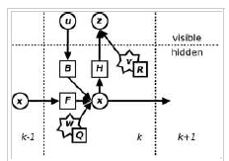

Figure 2 3 Model underlying the Kalman filter.
- circles are vectors, squares are matrices
- stars represents Gaussian noise and the associated covariance matrix at the lower right
The Kalman filter model assumes the true state at time k is evolved from the state at (k - 1) according to
x_{k} = F_{k} x_{k-1} + B_{k} u_{k-1} + w_{k-1}
Where
- F_{k} is the state transition model which is applied to the previous state x_{k-1};
- B_{k} is the control-input model which is applied to the control vector u_{k};
- wk is the process noise which is assumed to be drawn from a zero mean multivariate normal distribution with covariance Q_{k.}
w_{k} ~ N(0,Q_{k})
At time k an observation (or measurement) zk of the true state xk is made according to

z_{k} = H_{k}x_{k} + v_{k}

where H_{k} is the observation model which maps the true state space into the observed space and v_{k} is the observation noise which is assumed to be zero mean Gaussian white noise with covariance R_{k}.

v_{k} ~ N(0,R_{k})
The initial state, and the noise vectors at each step {x0, w1, ..., wk, v1 ... vk} are all assumed to be mutually independent. Many real dynamical systems do not exactly fit this model; however, because the Kalman filter is designed to operate in the presence of noise, an approximate fit is often good enough for the filter to be very useful. Variations on the Kalman filter described below allow richer and more sophisticated models.

The state of the filter is represented by two variables:
- the estimate of the state at time k.
- ,the error covariance matrix (a measure of the estimated accuracy of the state estimate).

The Kalman filter has two distinct phases: Predict and Update. The predict phase uses the state estimate from the previous timestep to produce an estimate of the state at the current timestep. In the update phase, measurement information at the current timestep is used to refine this prediction to arrive at a new, (hopefully) more accurate state estimate, again for the current timestep.

- Predict

Predicted state

Predicted estimate covariance

- Update

Innovation or measurement residual
Innovation (or residual) covariance
Optimal Kalman gain
Updated state estimate
Updated estimate covariance

The formula for the updated estimate covariance above is only valid for the optimal Kalman gain. Usages of other gain values require a more complex formula found in the derivations section.

Invariants

If the model is accurate, and the values for and accurately reflect the distribution of the initial state values, then the following invariants are preserved: all estimates have mean error zero

where E[ξ] is the expected value of ξ, and covariance matrices accurately reflect the covariance of estimates.

Derivations

Deriving the posterior estimate covariance matrix

Starting with our invariant on the error covariance as above

Substitute in the definition of

Substitute

And

And by collecting the error vectors we get

Since the measurement error is uncorrelated with the other terms, this becomes

By the properties of vector covariance this becomes

Which, using our invariant on and the definition of becomes

This formula (sometimes known as the "Joseph form" of the covariance update equation) is valid no matter what the value of Kk. It turns out that if Kk is the optimal Kalman gain, this can be simplified further as shown below.

Kalman gain derivation

The Kalman filter is a minimum mean-square error estimator. The error in the posterior state estimation is
.
We seek to minimize the expected value of the square of the magnitude of this vector, . This is equivalent to minimizing the trace of the posterior estimate covariance matrix. By expanding out the terms in the equation above and collecting, we get:

The trace is minimized when the matrix derivative is zero:

- 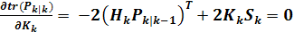

Solving this for yields the Kalman gain:

This gain, which is known as the optimal Kalman gain, is the one that yields MMSE estimates when used.

Types of Kalman Filters

The basic Kalman filter is limited to a linear assumption. However, most non-trivial systems are non-linear. The non-linearity can be associated either with the process model or with the observation model or with both.

Extended Kalman filter

In the extended Kalman filter, (EKF) the state transition and observation models need not be linear functions of the state but may instead be (differentiable) functions.

The function f can be used to compute the predicted state from the previous estimate and similarly the function h can be used to compute the predicted measurement from the predicted state. However, f and h cannot be applied to the covariance directly. Instead a matrix of partial derivatives (the Jacobian) is computed.

At each timestep the Jacobian is evaluated with current predicted states. These matrices can be used in the Kalman filter equations. This process essentially linearizes the non-linear function around the current estimate. This results in the following extended Kalman filter equations:

Predict

Update

Where the state transition and observation matrices are defined to be the following Jacobians
- 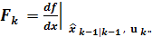
- 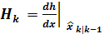
Criticism of the extended Kalman filter

Unlike its linear counterpart, the extended Kalman filter is not an optimal estimator. In addition, if the initial estimate of the state is wrong, or if the process is modeled incorrectly, the filter may quickly diverge, owing to its linearization. Another problem with the extended Kalman filter is that the estimated covariance matrix tends to underestimate the true covariance matrix and therefore risks becoming inconsistent in the statistical sense without the addition of "stabilising noise".
Having stated this, the extended Kalman filter can give reasonable performance, and is arguably the de facto standard in navigation systems and GPS.

Unscented Kalman filter

When the state transition and observation models – that is, the predict and update functions f and h are highly non-linear, the extended Kalman filter can give particularly poor performance [JU97]. This is because only the mean is propagated through the non-linearity. The unscented Kalman filter (UKF) [JU97] uses a deterministic sampling technique known as the unscented transform to pick a minimal set of sample points (called sigma points) around the mean. These sigma points are then propagated through the non-linear functions and the covariance of the estimate is then recovered. The result is a filter which more accurately captures the true mean and covariance. (This can be verified using Monte Carlo sampling or through a Taylor series expansion of the posterior statistics.) In addition, this technique removes the requirement to analytically calculate Jacobians, which for complex functions can be a difficult task in itself.

Predict

As with the EKF, the UKF prediction can be used independently from the UKF update, in combination with a linear (or indeed EKF) update, or vice versa.
The estimated state and covariance are augmented with the mean and covariance of the process noise.
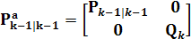

A set of 2L+1 sigma points is derived from the augmented state and covariance where L is the dimension of the augmented state.

Where

is the i^{th} column of the matrix square root of

Using the definition: square root A of matrix B satisfies

The matrix square root should be calculated using numerically efficient and stable methods such as the Cholesky decomposition.

The sigma points are propagated through the transition function f.

The weighted sigma points are recombined to produce the predicted state and covariance.
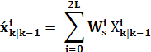

Where the weights for the state and covariance are given by:
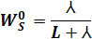
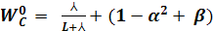
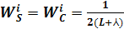

Typical values for α, β, and k are 10⁻³, 2 and 0 respectively.

Update

The predicted state and covariance are augmented as before, except now with the mean and covariance of the measurement noise.

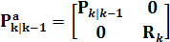
As before, a set of 2L + 1 sigma points is derived from the augmented state and covariance where L is the dimension of the augmented state.

Alternatively if the UKF prediction has been used the sigma points themselves can be augmented along the following lines

Where
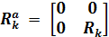

The sigma points are projected through the observation function h.

The weighted sigma points are recombined to produce the predicted measurement and predicted measurement covariance.

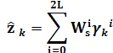

The state-measurement cross-covariance matrix,

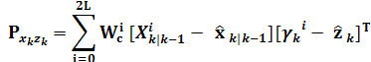

Is used to compute the UKF Kalman gain.

As with the Kalman filter, the updated state is the predicted state plus the innovation weighted by the Kalman gain,

And the updated covariance is the predicted covariance, minus the predicted measurement covariance, weighted by the Kalman gain.

Graphical Model Building Blocks

In this section we will introduce the set of distributions commonly refereed to in this thesis and their properties. These distributions will play a key role in constructing more complex models used throughout this thesis, and in doing inference in these models.
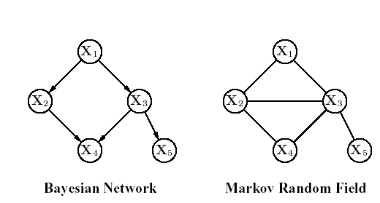
Figure 3.4 Graphical model families.
Three families of graphical models that will be discussed in this chapter are illustrated. All three graphs can encode the same underlying joint distribution, p (X1,X2,X3,X4,X5), given the proper choice of parameters. Different choices of parameters would lead to different encoded joint distributions.

Exponential Family
The exponential family of distributions is a class of distributions that serve as building blocks in graphical models, and give rise to rich probabilistic models used throughout the thesis. The distribution p(X|θ), where X is a random variable and θ is a set of parameters, is said to be part of the exponential family if it can be written in the following form:
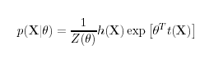
- θ is a vector of parameters (a.k.a. natural or canonical parameters)
- t(X) is a function referred to as sufficient statistics
- Z(θ) is a normalizing constant (a.k.a. partition function) defined as
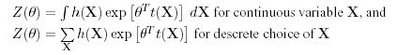
- h(X) is a function of X.
Many distributions can be written in this form, including Bernoulli, Poisson, Gaussian, Beta and Gamma densities. While the exponential family has many convenient properties, one that is worth mentioning is that the joint probability of N samples from the distribution can be written in the following form,

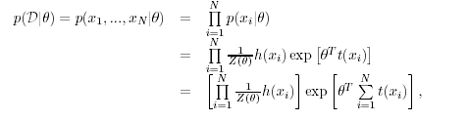
hich suggests that the dimensionality of the sufficient statistic remains the same with the number of samples. This, in turn means that in order to characterize a distribution in the exponential family, it is sufficient to compute the sufficient statistics. Once we have sufficient statistics for the distribution the samples themselves give no additional information about the distribution that generated them. This gives a convenient compact form for representing distributions in this family.

Gaussian Distribution and Properties

In this section we will review a Gaussian (or Normal) distribution, which is a prime example of the exponential family. A univariate Gaussian distribution with mean μ and variance σ2 on random variable X R can be written as,

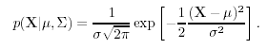

Alternatively we can also introduce the shorthand notation N(X|μ,_∑) or N(X; μ,∑). It is easy to see that a univariate Gaussian is an exponential family distribution with the following parameterization,
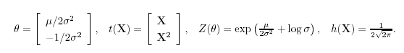

If X is multivariate random variable, X Rd, then the distribution can be written in the more general form,
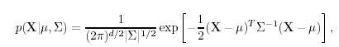
Where ∑ is now a covariance matrix and μ a multivariate mean. The Gaussian distribution has a number of convenient properties that make it very useful for modeling and inference tasks. The two most important properties that relate to the product of Gaussian distributions and conditional distribution of jointly Gaussian variables are stated bellow.

Product of Gaussian distributions

Product of two or more Gaussian distributions is also a Gaussian distribution. For example, product of M Gaussian distributions p(Xi) = N(X_{i}|μ_{i}, ∑_{i}), i [1, ...,M] is
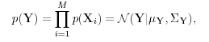

Conditional Gaussian distribution
A conditional distribution of two or more jointly Gaussian variables is also a Gaussian Consider a case of two jointly Gaussian variables X and Y,

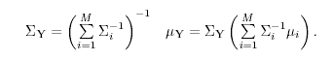

We can write conditional distribution p(X|Y) as a normal distribution with the following parameters for mean and covariance respectively:

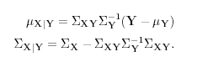

Bayesian Networks

Bayesian Networks is a family of graphical models that characterize how the joint distribution over a set of N variables, p(X1,X2, ...,XN), factors into a set of conditional relationships imposed by the structure of the graph G = {V, E}. By the product rule, it can be shown that the joint distribution defined by the graph can be written as the product of conditional distributions for each node, where the variable associated with the node is conditioned on all the parents of that node in the graph. Hence, for a general directed graph with N = |V| variables, the joint distribution can be written as:
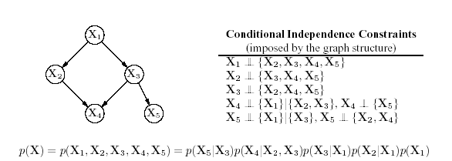
Figure 3.5 Bayesian Networks. Example of Bayesian network graphical model. The joint distribution factors into the product of conditional distributions as illustrated above. All the conditional independences imposed by the graph itself are also listed. Notice that even though there seems to be a loop in the graph, there are no directed cycles.
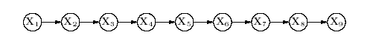
Figure 3.6 Graphical model corresponding to a first-order Markov Chain.

First-order Markov assumption encoded in the model presumes that the state, X_{t}, at time t is only a function of the state at t . 1 for all t [2, ..., T], where in the example above T = 9.
` 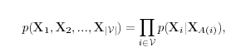 Y_{i} V
where A(i) V is defined as a function that returns all parents of the node i V in a graph; X_{A(i)} is then the set of associated variables {X_{k}|k A(i)}. The equation above expresses the factorization properties of the joint distribution and holds for all joint distributions and all definitions of variables X_{i}, i V. In order to ensure that factorization holds, an important restriction on the graph topology must be maintained.

In particular, graph G = {V, E} cannot contain cycles, (i.e. it must be a directed acyclic graph (DAG)). In other words, there cannot exist a path from any node in the graph along the directed edges that leads back to the node itself. Example of the directed graphical model and the factorization of the joint distribution over all the variables is given in Figure.

Markov Chains

Markov Chains are among the simplest directed graphical models. A first-order Markov Chain is defined on a series of random variables {X1,X2, ...,XN} such that the following conditional independence holds for
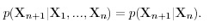
This conditional independence can be encoded in the graphical model as is shown on Figure 3.3. The Markov Chain can then be specified by the initial distribution p(X1) and the conditional distribution for the subsequent variables (a.k.a. transition probabilities). A Markov Chain is called homogenous if the conditional
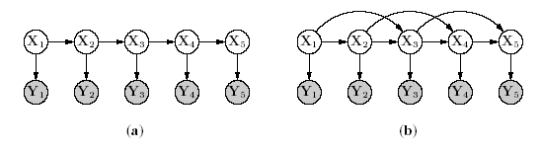

Figure 3.7 Hidden Markov Models. Directed graphical model representation of the temporal Hidden Markov Model (HMM) with T = 5 observations and hidden variables are shown. Models that illustrate first-order and second-order Markov dynamics are shown in (a) and (b) respectively.

Distributions are the same for all variables in the model. Marginal probability of a particular variable in the chain can be computed recursively using the following,
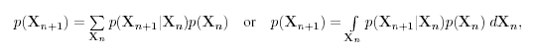
depending on whether the variables are discrete or continuous respectively. The distribution p(X) is said to be stationary if the following condition holds,

Markov Chains are extremely useful for inference of other more complex models. In particular, one can design a Markov Chain in such a way as to facilitate sampling from an
arbitrary complex distribution. To this end another property of Markov Chains must be introduced, ergodicity. Ergodicity ensures that for a given choice of the stationary distribution p(X), p(Xn) will converge to p(X) as n → ∞ irrespective of initial choice of distribution p(X1). Such a stationary distribution is also called an equilibrium distribution. It is worth mentioning that while a Markov Chain may have a number of stationary distributions, an ergodic Markov Chain will have only one equilibrium distribution.

Particle Filter

Particle filters, also known as sequential Monte Carlo methods (SMC), are sophisticated model estimation techniques based on simulation. They are usually used to estimate Bayesian models and are the sequential ('on-line') analogue of Markov chain Monte Carlo (MCMC) batch methods and are often similar to importance sampling methods. If well-designed, particle filters can be much faster than MCMC. They are often an alternative to the Extended Kalman filter (EKF) or Unscented Kalman filter (UKF) with the advantage that, with sufficient samples, they approach the Bayesian optimal estimate, so they can be made more accurate than either the EKF or UKF. The approaches can also be combined by using a version of the Kalman filter as a proposal distribution for the particle filter.
The goal of Particle Filtering is to sample the posterior distribution, Particle Filtering embodies two main sampling ideas, which are importance sampling and efficient sampling.

Monte Carlo approximation

Particle methods, like all sampling-based approaches (e.g., MCMC), generate a set of samples that approximate the filtering distribution So, with P samples, expectations with respect to the filtering distribution are approximated by
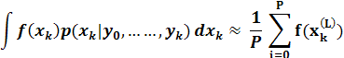
and f(.), in the usual way for Monte Carlo, can give all the moments etc. of the distribution up to some degree of approximation.

Generally, the algorithm is repeated iteratively for a specific number of k values (call this N). Initializing x_{k} = 0 |k = 0 for all particles provides a starting place to generate x1, which can then be used to generate x2, which can be used to generate x3 and so on up to k = N. When done, the mean of x_{k} over all the particles (or) is approximately the actual value of x_{k}.

Model

Particle methods assume x_{k} and the observations y_{k} can be modeled in this form:

- is a first order Markov process such that

and with an initial distribution p(x0).

- The observations are conditionally independent provided that are known

In other words, each y_{k} only depends on x_{k}

Form such of this scenario is

where both vk and wk are mutually independent and identically distributed sequences with known probability density functions and f(.) and h(.) are known functions. These two equations can be viewed as state space equations and look similar to the state space equations for the Kalman filter. If the functions f(.) and h(.) were linear, and if both vk and wk were Gaussian, the Kalman filter finds the exact Bayesian filtering distribution. If not, Kalman filter based methods are a first-order approximation. Particle filters are also an approximation, but with enough particles can be much more accurate.

Importance Sampling

Importance sampling is one of the fundamental ideas of Particle Filtering. The idea is to model a desired distribution by re-weighting samples from another distribution, called the proposal distribution. The proposal distribution can be chosen to be anything, but should bear as much similarity to the desired distribution as possible. The prior distribution is often used as the proposal distribution in particle filtering.
After samples are generated according to the proposal distribution, a particle filtering algorithm re-weights those samples by the probability of the observations given each sample, . After renormalization, the re-weighted samples will have relative weights according to the posterior distribution we wish to model, P(X|Y ). Let the proposal distribution be P(X), the prior, for the purposes of illustration.

Importance Sampling

- Initial samples are sampled according to P(X)
- Weights are calculated by multiplying each original weight by P(Y |X_{s})
- The new weights, w = P(Y )|P(X_{s}) = P(X_{s}|Y )P(Y ), by Bayes Rule
- Renormalize the re-weighted samples since all contain the same P(Y ) term, and we have weighted samples of the posterior distribution, P(X|Y ).

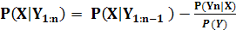
For a sequence of observations, the weights of each sample can be updated sequentially. At each time-step the weight is multiplied by the probability of the new observation given the state. When renormalized, the weights represent the probability of each state given all the observations, Y_{1: n} . The reason why we can update the weights at each time-step is that this is a Markov process, so the observations are conditionally independent given the state.

Efficient Sampling

The second main idea of Particle Filtering is that the whole distribution need not be sampled. Usually we are most interested in the regions of highest probability. Therefore it is more efficient to concentrate our samples in those regions.
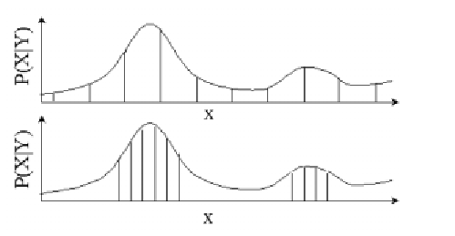
Figure 4.8 Example of efficient sampling of a distribution

Figure demonstrates the idea of efficiency of sampling. The top graph shows relatively uniform sampling, while the bottom shows samples concentrated near areas of high probability. If we sampled the distribution in the figure more finely, and then resampled from those those samples, each of whose probability would be determined by the distribution, we could create the lower graph with more samples in the high probability areas. The method of resampling from the distribution created by importance sampling concentrates samples near the peaks of the distribution. Importance sampling when combined with resampling can be shown to converge on the posterior distribution.[4] Importance sampling allows the algorithm to model the posterior distribution with samples from another distribution, while resampling helps to model just the highest probability areas of the posterior distribution.

Sampling Importance Resampling (SIR)

Sampling importance resempling (SIR) is a very commonly used particle filtering algorithm, which approximates the filtering distribution by a weighted set of particles

The importance weights are approximations to the relative posterior probabilities (or densities) of the particles such that
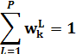

SIR is a sequential (i.e., recursive) version of importance sampling. As in importance sampling, the expectation of a function f(.)can be approximated as a weighted average
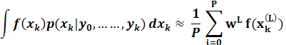
For a finite set of particles, the algorithm performance is dependent on the choice of the proposal distribution
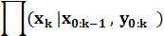

The optimal proposal distribution is given as the target distribution

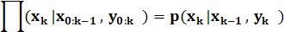
However, the transition prior is often used as importance function, since it is easier to draw particles (or samples) and perform subsequent importance weight calculations:

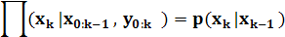

Sampling Importance Resampling (SIR) filters with transition prior as importance function are commonly known as bootstrap filter and condensation algorithm. Resampling is used to avoid the problem of degeneracy of the algorithm, that is, avoiding the situation that all but one of the importance weights are close to zero. The performance of the algorithm can be also affected by proper choice of resampling method. The stratified resampling proposed by Kitagawa (1996) is optimal in terms of variance.

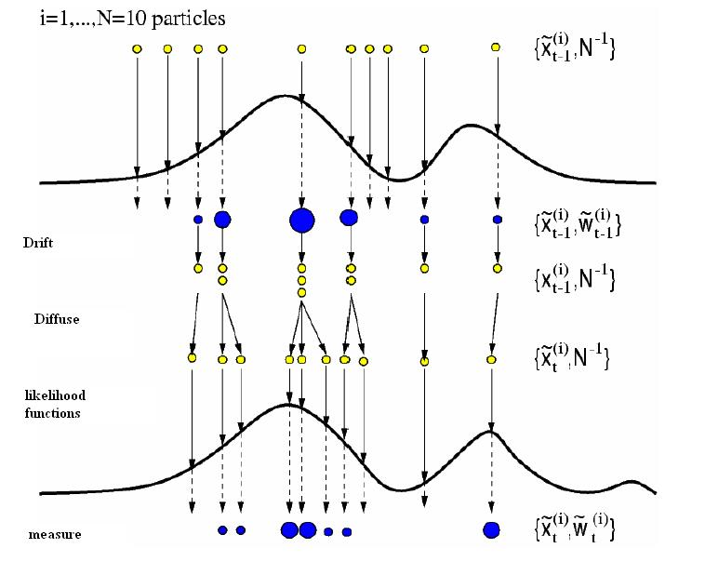
Figure4.9 Activities performed on the particles in one time step.

A single step of sequential importance resampling is as follows:

- For L = 1,…….P draw samples from the proposal distribution
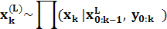

- For L = 1,…….P update the importance weights up to a normalizing constant:
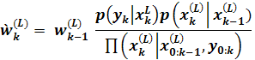
- For L = 1,…….P compute the normalized importance weights:

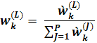

- Compute an estimate of the effective number of particles as
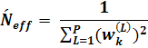
- If the effective number of particles is less than a given threshold , then perform resampling:

- Draw P particles from the current particle set with probabilities proportional to their weights. Replace the current particle set with this new one.
- For L= 1,….P set 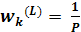.

The term Sequential Importance Resampling is also sometimes used when referring to SIR filters.

Particle Filtering Issues

With an infinite number of samples, the particle .filtering algorithm theoretically approaches the optimal Bayesian estimate of the posterior probability distribution. However, practical implementations of this algorithm must limit the number of samples depending on how quickly the algorithm must perform inference. As a result, there are limitations created by the approximations of finite sampling.

The two main sampling considerations of particle .filtering are referred to as sample degeneracy and sampling depletion. Both are concerned with modeling the higher probability areas of the posterior distribution.

Sample degeneracy signifies the efficiency with which the samples model the desired distribution. If there are many particles with very low probability weights, those low-weight samples do not accurately model the high probability areas of the distribution. Usually the process of resampling will rid us of many low probability samples, since the low probability samples will be resampled infrequently.
Sample depletion, however, refers to the case when there are no samples in the high probability areas we wish to model. Once samples have been depleted from that area, it is very difficult to gain an accurate representation of the distribution. Due to the inaccuracy of sampling, a posterior distribution with sharp peaks will be difficult to model since the probability of choosing samples on those peaks, using a more uniform proposal distribution, is very low. Hence, for sharp posterior probability distributions too frequent resampling and sample depletion are major concerns.

Particle filtering techniques will have most difficulty when the likelihood of the newly observed evidence is low, since the likelihood that we have sampled the regions that could result in those observations will also be low. However, this deficiency is being traded for the efficiency of the many cases where the observations will be likely according to our prior beliefs. In order to improve our particle filter as a robust technique for inference, there are some methods to help combat sample depletion while attempting to keep sample degeneracy to a minimum.

Controlled Resampling

It is clear that sample depletion and degeneracy are closely linked to the frequency with which we resample our particles. If we resample too often, samples in less likely probability areas will be lost and we increase the possibility that future observations cannot be explained by our remaining samples. However, resampling too infrequently will result in many samples with negligible probability weights; particles which could better be used to sample higher probability regions of the distribution.

One idea for controlling the frequency of resampling is to link the frequency to the variance of the particle weights. An approximate measure of the number of effective particles, Neff, where N is the number of particles and wi represents the weight of particle i, is below.
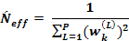

When Neff, the approximate number of particles, falls below a chosen threshold, one should resample the particles. The effect is to resample only when there are too many samples of very low weight and not in situations where the reasonably probable particles are likely to be depleted. However, choosing the threshold for resampling is not an easy task. This tuning parameter can have a major effect on the performance of the filter because of the serious consequences of sample depletion.

Regularization

Another method for combatting errors due to sampling is often referred to as regularization. This technique involves perturbing samples using a Gaussian distribution after resampling. In the particle filtering algorithm shown in Figure 3.2, this step is represented by the slight shifting of resampled particles in the fourth group of samples from the top.

The problem with particle filtering without regularization is that in systems where
is continuous, after each resampling event, our samples of x can only estimate x’s value with precision limited by the locations of the original samples. Without Gaussian perturbations, even if the samples narrow themselves down to one region with little uncertainty, the region cannot be a more precise estimate of x than any of the original samples.

These random perturbations are necessary in order to allow finer exploration of the continuous space. In situations where the number of samples used do not cover the state space with the precision desired, this technique is very useful in countering the natural inaccuracies due to under-sampling.

However, in highly peaked posterior densities, this technique will not help to find
sharp peaks since samples must have weights large enough to be resampled in the first place before the regularization process can perturb them. As a result, particle filters will be more likely to converge on local minima in these rapidly changing, peaked distributions.
In addition the Gaussian perturbations should remain relatively small in order to allow eventual convergence to peaks and not shift samples too far away from the desired areas. Regularization, or Gaussian resampling is a useful measure to increase the precision and resolution of a particle filter, but its ability to combat sample depletion is limited.

Weight Update Lower Bounds

Another technique to combat sample depletion is to place a limit on how small the weight update, P(y_{t}|x_{t}), can be. For the Gaussian additive noise we are concerned with in this study, this is similar to using a truncated Gaussian to re-weight samples given the new evidence.

The results of placing a lower bound on new probability weights can help to combat the effects of outlier observations. A particularly noisy observation may cause sample depletion in the true posterior distribution if the weights of particles are allowed to fall too quickly. Generally this technique is not needed when there are many samples to cover the sample space.

The Unscented Particle Filter

Using the transition prior as proposal distribution can be inefficient as illustrated in figure, if we fail to use the latest available information to propose new values for the states, only a few particles might survive it is therefore of paramount importance to move the particle towards the region of high likelihood. To achieve this we used the unscented particle filter as proposal distribution. This simply requires that we propagate the sufficient statistics of the UKF for each particle.

Figure 4.10 The UKF proposal distribution allows us to move the samples in the prior to regions oh high likelihood. This is of paramount importance if the likelihood happens to lie in one of the tails of the prior distribution or if it is too narrow (low measurement error). In figure shows the estimates of the state covariance generated by a stand-alone EKF and UKF.

Figure 4.11 EKF and UKF Estimates of states covariance

Radial Basis Function

Introduction
A radial basis function (RBF) is a real-valued function whose value depends only on the distance from the origin, so that ; or alternatively on the distance from some other point c, called a center, so that . Any function φ that satisfies the property φ(x)= φ(||x||) is a radial function. The norm is usually Euclidean distance.
Radial basis functions are typically used to build up function approximations of the form
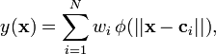
where the approximating function y(x) is represented as a sum of N radial basis functions, each associated with a different center c_{i}, and weighted by an appropriate coefficient w_{i}. Approximation schemes of this kind have been particularly used in time series prediction and control of non linear systems exhibiting sufficiently simple chaotic behavior.
The sum can also be interpreted as a rather simple single-layer type of artificial neural network called a radial basis function network, with the radial basis functions taking on the role of the activation functions of the network. It can be shown that any continuous function on a compact interval can in principle be interpolated with arbitrary accuracy by a sum of this form, if a sufficiently large number N of radial basis functions are used.

Estimating the weights

The approximant y(x) is differentiable with respect to the weights w_{i}. The weights could thus be learned using any of the standard iterative methods for neural networks. But such iterative schemes are not in fact necessary: because the approximating function is linear in the weights w_{i}, the w_{i} can simply be estimated directly, using the matrix methods of linear least squares.
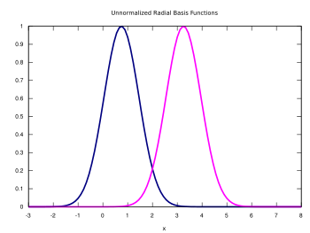
Figure 5.12 Two unnormalized Gaussian radial basis functions in one input dimension. The basis function centers are located at c₁=0.75 and c₂=3

A Radial Basis Function Network

A radial basis function network is an artificial neural network that uses radial basis functions as activation functions. They are used in function approximation, time series prediction, and control.
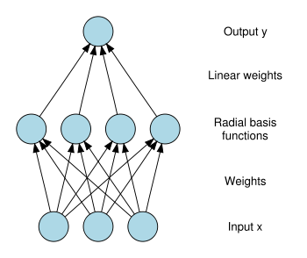

Figure 5.13 Architecture of a radial basis function network. An input vector x is used as input to all radial basis functions, each with different parameters. The output of the network is a linear combination of the outputs from radial basis functions.
Radial basis function (RBF) networks typically have three layers: an input layer, a hidden layer with a non-linear RBF activation function and a linear output layer. The output, , of the network is thus
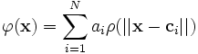
where N is the number of neurons in the hidden layer, c_{i} is the center vector for neuron i, and a_{i} are the weights of the linear output neuron. In the basic form all inputs are connected to each hidden neuron. The norm is typically taken to be the Euclidean distance and the basis function is taken to be Gaussian
.
The Gaussian basis functions are local in the sense that
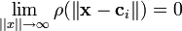
i.e. changing parameters of one neuron has only a small effect for input values that are far away from the center of that neuron. RBF networks are universal approximators on a compact subset of . This means that a RBF network with enough hidden neurons can approximate any continuous function with arbitrary precision. The weights a_{i}, , and β are determined in a manner that optimizes the fit between and the data.

Normalized architecture

In addition to the above unnormalized architecture, RBF networks can be normalized. In this case the mapping is
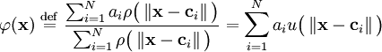

where
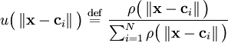

is known as a "normalized radial basis function".
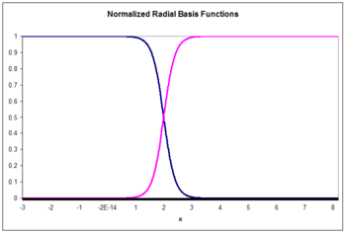

Figure 5.14 Two normalized radial basis functions in one input dimension. The basis function centers are located at c₁ = 0.75 and c₂ = 3.25.

Local linear models

It is sometimes convenient to expand the architecture to include local linear models. In that case the architectures become, to first order,
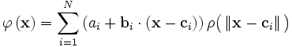
and
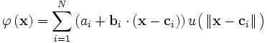
in the unnormalized and normalized cases, respectively. Here are weights to be determined. Higher order linear terms are also possible.
This result can be written
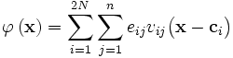
where
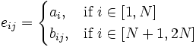

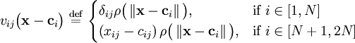
in the unnormalized case and
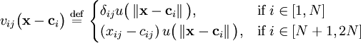
in the normalized case.
Here δ_{ij} is a Kronecker delta function defined as
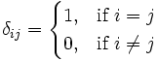.

Training

In a RBF network there are three types of parameters that need to be chosen to adapt the network for a particular task: the center vectors c_{i}, the output weights w_{i}, and the RBF width parameters β_{i}. In the sequential training of the weights are updated at each time step as data streams in.
For some tasks it makes sense to define an objective function and select the parameter values that minimize its value. The most common objective function is the least squares function
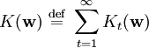
where
.

We have explicitly included the dependence on the weights. Minimization of the least squares objective function by optimal choice of weights optimizes accuracy of fit. There are occasions in which multiple objectives, such as smoothness as well as accuracy, must be optimized. In that case it is useful to optimize a regularized objective function such as
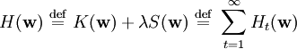

where
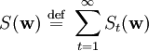
and
where optimization of S maximizes smoothness and λ is known as a regularization parameter.

Interpolation

RBF networks can be used to interpolate a function when the values of that function are known on finite number of points: . Taking the known points x_{i} to be the centers of the radial basis functions and evaluating the values of the basis functions at the same points g_{ij} = ρ( | | x_{j} − x_{i} | | ) the weights can be solved from the equation

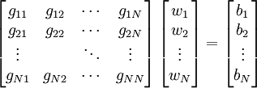

It can be shown that the interpolation matrix in the above equation is non-singular, if the points x_i are distinct, and thus the weights w can be solved by simple linear algebra:

Function approximation

If the purpose is not to perform strict interpolation but instead more general function approximation or classification the optimization is somewhat more complex because there is no obvious choice for the centers. The training is typically done in two phases first fixing the width and centers and then the weights. This can be justified by considering the different nature of the non-linear hidden neurons versus the linear output neuron.

Training the basis function centers
Basis function centers can be randomly sampled among the input instances or obtained by Orthogonal Least Square Learning Algorithm or found by clustering the samples and choosing the cluster means as the centers.
The RBF widths are usually all fixed to same value which is proportional to the maximum distance between the chosen centers.

Pseudo inverse solution for the linear weights
After the centers c_{i} have been fixed, the weights that minimize the error at the output are computed with a linear pseudo inverse solution:
,
where the entries of G are the values of the radial basis functions evaluated at the points x_{i}: g_{ji} = ρ( | | x_{j} − c_{i} | | ). The existence of this linear solution means that unlike Multi-Layer Perceptron (MLP) networks the RBF networks have a unique local minimum (when the centers are fixed).

Gradient descent training of the linear weights
Another possible training algorithm is gradient descent. In gradient descent training, the weights are adjusted at each time step by moving them in a direction opposite from the gradient of the objective function
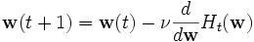
- where ν is a "learning parameter."

For the case of training the linear weights, a_{i}, the algorithm becomes
in the unnormalized case and
in the normalized case.
For local-linear-architectures gradient-descent training is

Projection operator training of the linear weights

For the case of training the linear weights, a_{i} and e_{ij}, the algorithm becomes
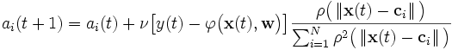
in the unnormalized case and
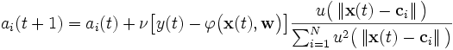
in the normalized case and

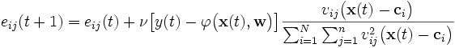

in the local-linear case.

Logistic map

The basic properties of radial basis functions can be illustrated with a simple mathematical map, the logistic map, which maps the unit interval onto itself. It can be used to generate a convenient prototype data stream. The logistic map can be used to explore function approximation, time series prediction, and control theory. The map originated from the field of population dynamics and became the prototype chaotic time series. The map, in the fully chaotic regime, is given by
where t is a time index. The value of x at time t+1 is a parabolic function of x at time t. This equation represents the underlying geometry of the chaotic time series generated by the logistic map.
Generation of the time series from this equation is the forward problem. The examples here illustrate the inverse problem; identification of the underlying dynamics, or fundamental equation, of the logistic map from exemplars of the time series. The goal is to find an estimate
for f.

Function approximation

Unnormalized radial basis functions
The architecture is
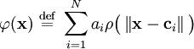
where
.
Since the input is a scalar rather than a vector, the input dimension is one. We choose the number of basis functions as N=5 and the size of the training set to be 100 exemplars generated by the chaotic time series. The weight β is taken to be a constant equal to 5. The weights c_{i} are five exemplars from the time series. The weights a_{i} are trained with projection operator training:
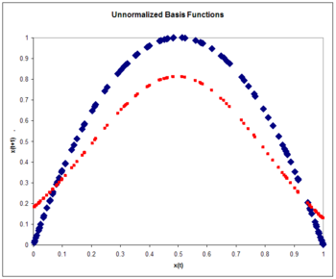
Figure 5.15 Unnormalized basis functions. The Logistic map (blue) and the approximation to the logistic map (red) after one pass through the training set.

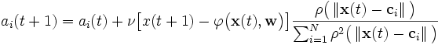
where the learning rate ν is taken to be 0.3. The training is performed with one pass through the 100 training points. The rms error is 0.15.
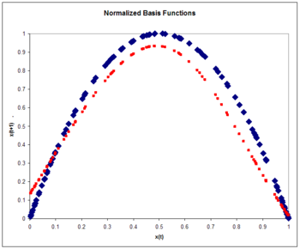

Figure 5.16 Normalized basis functions. The Logistic map (blue) and the approximation to the logistic map (red) after one pass through the training set. Note the improvement over the unnormalized case.

Normalized radial basis functions

The normalized RBF architecture is
where
.
Again:
.

Again, we choose the number of basis functions as five and the size of the training set to be 100 exemplars generated by the chaotic time series. The weight β is taken to be a constant equal to 6. The weights c_{i} are five exemplars from the time series. The weights a_{i} are trained with projection operator training:
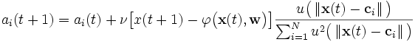

where the learning rate ν is again taken to be 0.3. The training is performed with one pass through the 100 training points. The rms error on a test set of 100 exemplars is 0.084, smaller than the unnormalized error. Normalization yields accuracy improvement. Typically accuracy with normalized basis functions increases even more over unnormalized functions as input dimensionality increases.

Time series prediction
Once the underlying geometry of the time series is estimated as in the previous examples, a prediction for the time series can be made by iteration:
.
A comparison of the actual and estimated time series is displayed in the figure. The estimated times series starts out at time zero with an exact knowledge of x(0). It then uses the estimate of the dynamics to update the time series estimate for several time steps.
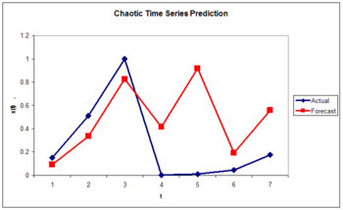
Figure 5.17 Normalized basis functions. The Logistic map (blue) and the approximation to the logistic map (red) as a function of time. Note that the approximation is good for only a few time steps. This is a general characteristic of chaotic time series.

Control of a chaotic time series
We assume the output of the logistic map can be manipulated through a control parameter c[x(t),t] such that
.
The goal is to choose the control parameter in such a way as to drive the time series to a desired output d(t). This can be done if we choose the control parameter to be
where

is an approximation to the underlying natural dynamics of the system. The learning algorithm is given by
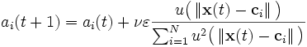

Work Done

IMPLEMENTATION

Design of Kalman Filter.

Design of Particle Filter.

Comparison of Results of Kalman and Particle Filter.

Design Of Rbf Algorithm is In Progress.

Results

This chapter presents the results of Kalman and Particle Filter on the motion of a ball (object). The first section, 7.1, compares the (240 * 320) samples of a ball (object) image on particle Filter and the Kalman Filter. Since the Kalman Filter is already the least squares solution, the First section is a validation of the ability of the Particle Filter to deal with linear filtering and estimation problems. It also provides a clear comparison of the performance of the two Filters that demonstrates the sensitivity of the Particle Filter to its various parameters and the possible limitations of particle Filtering.

Comparison to Kalman Filter vs. Particle Filter

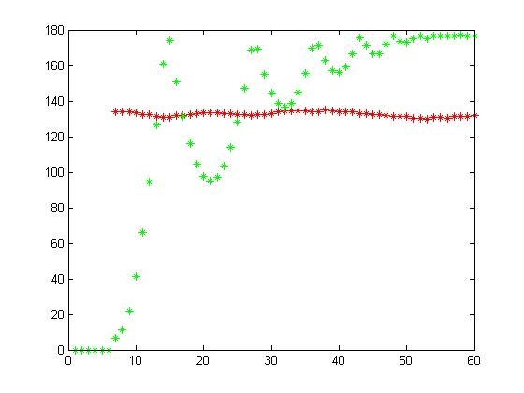

Figure 7.18 Variation of center of ball with green color & radius due to compression when it strik to target in red by kalman filter

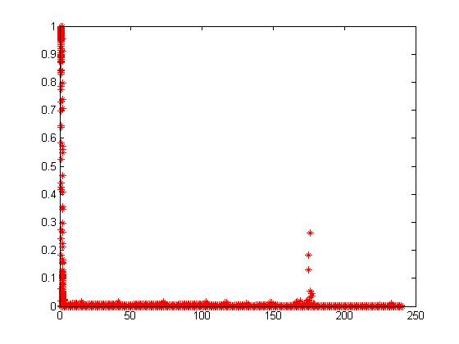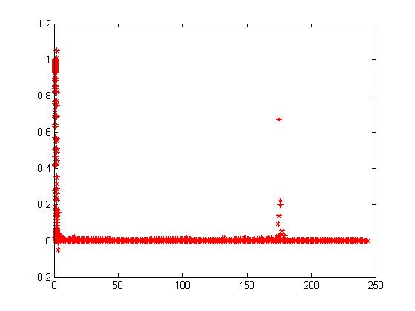
- (2)

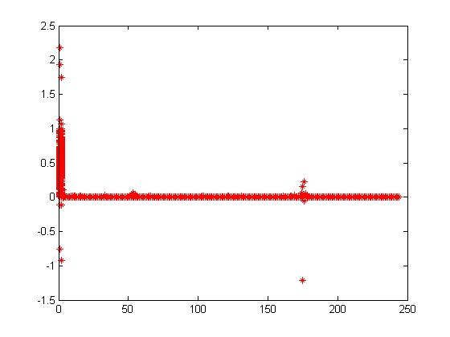
(3) (4)

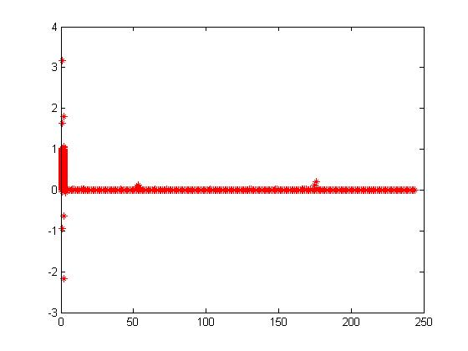
(5) (6)

Figure 7.19 These picture shows the how new weight varies according to new frame particle when ball is in motion from Bays algo.

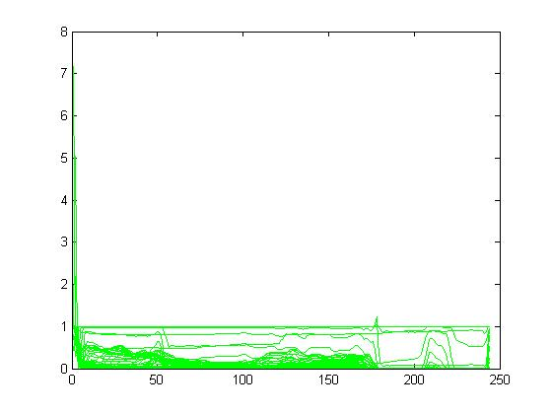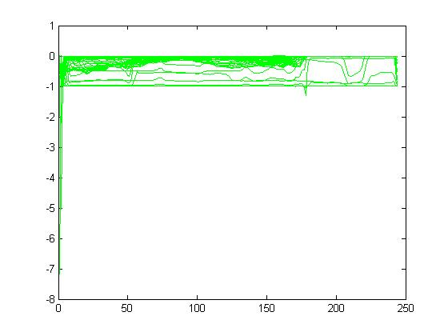

(1) (2)

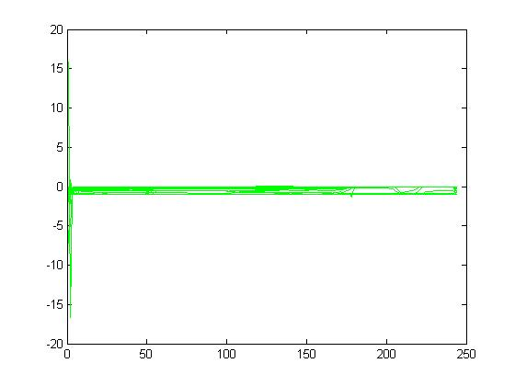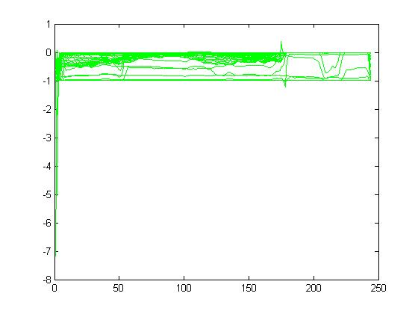
(3) (4)

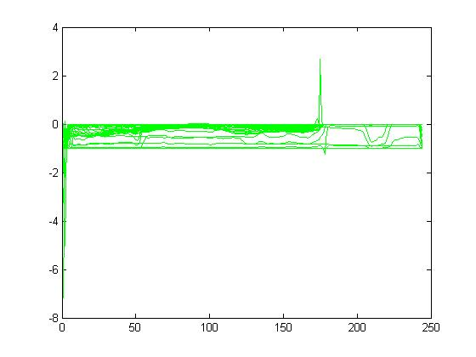

(5) (6)

Figure 7.20 These picture shows the how particle varies from frame to frame when ball is in motion through filter.

Conclusion & Future Work

In this thesis I have analyzed the Kalman and Particle filter on sequence of Image of object for tracking. We used Kalman and Particle filter for prediction of future state of object and want to show how Particle filter is better than Kalman for random motion of object. Randomness is better analyzed with probability density function and conditional probability. We show the results of comparison of Kalman and Particle filter. Here I have presented a new approach for object tracking using Kalman Particle filter using RBF algorithm. After analyzing we used a RBF algorithm to get better results of object tracking. We have discussed and reserved some for our discussion latter pursuits and we hope to carry that in our next work.

At this stage my work should be considered as a preliminary as it has plenty of scope for future investigation and analysis. Major work can be carry in the field of image processing and signal processing. The next challenge is take the methods introduced in this thesis and extend them for use with generic and possibly different types of tracking of objects like radar tracking. Among the challenges one would have to address, the most predominant are the unsupervised or semi-supervised learning of object through RBF algo.

References

[1] Ajeesh P. Kurian and Sadasivan Puthusserypady “Unscented Kalman Filter and Particle Filter for Chaotic Synchronization”, IEEE Semiannual Volume 4, Issue, January 2006
[2] Sanjeev Arulampalam, Simon Maskell, Neil Gordon, and Tim Clapp. “A Tutorial
on Particle Filters for on-line Non-linear/Non-Gaussian Bayesian Tracking” IEEE Transactions On Signal Processing, 50(2):174–189, February 2002.

[3] Yaakov Bar-Shalom, X.-Rong Li, and Thiagalingam Kirbarajan.”Estimation with Applications To Tracking and Navigation” John Wiley & Sons, Inc., New York, 2001.
[4] T. M. Cover and J. A. Thomas.”Elements of Information Theory” Wiley, New York, 1991.
[5] Dan Crisan and Arnaud Doucet ”A survey of convergence results on particle Filtering methods for practitioners” IEEE Transactions On Signal Processing,
50(3):736–746, March 2002.
[6] Arnaund Doucet, Nando de Freitas, and Neil Gordon, editors” Sequential Monte Carlo Methods in Practice” Statistics for Engineering and Information Science. Springer, New York, 2001.
[7] Dieter Fox. Kld-sampling: Adaptive particle Filters ”In Advances in Neural Information Processing Systems 14” MIT Press, 2001.
[8] A.H. Jazwinski. Stochastic Processes and Filtering Theory. Academic Press, London, England, 1970.87
[9] S. Julier, J. Uhlmann, and H. Durrant-Whyte”A new approach for Filtering nonlinear systems” Proceedings of the American Control Conference,pages 1628–
1632, 1995.
[10] S. J. Julier and J. H. Uhlmann. A new extension of the Kalman Filter to nonlinear systems. Proceedings of the AeroSense: The 11th Int. Symp. On Aerospace/Defence Sensing, Simulation and Controls, 1997.
[11] R.E. Kalman. A new approach to linear Filtering and prediction problems. Transactions of the ASME Journal of Basic Engineering (Series D.), 82:35–45, 1960.
[12] R.E. Kalman and R.S. Bucy. New results in linear Filtering and prediction theory. Transactions of the ASME Journal of Basic Engineering (Series D.), 83:95–108, 1961.
[13] Peter S. Maybeck. Stochastic models, estimation and control. Academic Press, New York, 1982.
[14] Peter S. Maybeck ”Kalman filtering : concepts, design and extensions ; a tutorial” presented at the 51st MORS, Air Force Institute of Technology, September 27 and 28, 1983. Wright-Patterson Air Force Base, OH : Institute of Technology, 1983.
[15] Stuart Russell and Peter Norvig Editors.”Artificial Intelligence A Modern Approach”Prentice Hall Series in Artificial Intelligence. Pearson Education, Inc, Upper Saddle River, New Jersey, second edition, 2003.
[17] Rudolf van der Merwe and Eric Wan.”The unscented Kalman Filter for nonlinear estimation”Proceedings of Symposium 200 on Adaptive Systems for Signal Processing, Communication and Control(AS-SPCC), 2000.
88
[18] Rudolf van der Merwe and Eric Wan”Sigma-point Kalman Filters for probabilistic inference in dynamic state-space models”. Proceedings of the Workshop on Advances in Machine Learning, June 2003.
[19] Henry Stark, John W. Woods,”Probability and Random Processes with Application to Signal Processing”, Third Edition, Pearson Publication
[20] Dimitris G. Manolakis, Vinay K. Ingle, Stephon M. Kogon “Statistical and Adaptive Signal Processing”
[21] Rafael C. Gonzales, Richard Eugene Woods “ Digital Image Processing” Second Edition, Pearson Publication

