CHAPTER 1

INTRODUCTION

1.1 General:
For the developing countries like India, development is causing a lot of side effects. So to meet the goal of sustainable development Environmental Impact Assessment is being used as tool for effective Environmental Management. Since the first notification in 1994 till 2006 the process of EIA has been made more and more effective for the safeguard of environment.

Environment Impact Assessment or EIA can be defined as the study to predict the effect of a proposed activity/project on the environment. As a decision making tool, EIA compares various alternatives for a project and seeks to identify the one which represents the best combination of economic and environmental costs and benefits.

EIA systematically examines both beneficial and adverse consequences of the project and ensures that these effects are taken into account during project design. It helps to identify possible environmental effects of the proposed project, proposes measures to mitigate adverse effects and predicts whether there will be significant adverse environmental effects, even after the mitigation is implemented.

1.2 History of EIA in India
The Indian experience with Environmental Impact Assessment began over 20 years back. It started in 1976-77 when the Planning Commission asked the Department of Science and Technology to examine the river-valley projects from environmental angle. This was subsequently extended to cover those projects, which required approval of the Public Investment Board. Till 1994, environmental clearance from the central government was an administrative decision and lacked the legislative support.

1.2.1 EIA Notification, 1994
The environment impact process was integrated into the Indian legal system in 1994 when Environment Impact Assessment (EIA) Notification came into existence. The objective of the Notification was to push for more sustainable industrialisation process in the country after giving due consideration to environmental and social impacts. For doing so, the notification imposed restrictions on setting up, modernising or expanding any new project or proposal without getting an environmental clearance from the government.
The notification specified the type of project/proposal that needed environmental clearance and thus would have to conduct the EIA. The Act made it mandatory for all projects listed in schedule 1 to get an environmental clearance from the Central government, be it, for setting or expanding any plant anywhere in the country. It also listed a number of projects/proposals, which have been exempted from the environment clearance process or public hearing.
The notification also made provisions for formation of an Impact Assessment Agency (IAA), which essentially consisted of experts for review of the documents submitted to the MoEF for clearance. It defined the roles and responsibilities of the IAA and has fixed time frame for various stages of the environmental clearance process. The notification also made the provision for the proponent to reapply in case it was rejected due to lack of data. It, however, placed a penalty of automatic rejection in case of misrepresentation and concealing of factual data.
1.2.2 Amendmends in the notification:
Several changes were made to the original notification. The first amendment came within a few months of the notification on July 4, 2005. Many more were to follow. The EIA notification 1994 was amended 12 times in 11 years. Some of the key amendments are discussed as follows:
- Amendment on April 10, 1997: The process of environmental public hearing (EPH) was introduced in the environmental clearance process. The SPCBs were entrusted to conduct public hearing to get the views and concerns of the affected community and interested parties for the proposed project.
- Amendment on June 13, 2002: This amendment diluted the purpose of the notification exempting many industries from the EIA process or from the entire environment clearance process on the basis of level of investment.
  - It exempted pipeline and highway projects from preparing the EIA report, but these projects would have to conduct public hearings in all the districts through which the pipeline or highway passes.
  - A number of projects were totally exempted from the Notification if the investment was less than Rs 100 crore for new projects and less than Rs. 50 crore for expansion/modernisation projects.
  - Most of the industries exempted from the clearance process had a very high social and environmental impact even if the investment was less than Rs 100 crore. For example, in case of hydel power projects, irrespective of the investment, there will be social impacts due to displacement.
  - No EIA was required for modernisation projects in irrigation sector if additional command area was less than 10,000 hectares or project cost was less than Rs. 100 crore.
- Amendment on 28th February, 2003: This amendment added a little tooth to the notification. It took into consideration location-sensitivity into the environment clearance process. This amendment prohibited certain processes and operations in specified areas of the Aravalli range.
- Amendment on 7th May 2003: The notification was amended to expand the lists of activities involving risk or hazard. In this list, river valley projects including hydel power projects, major irrigation projects and their combination including flood control project except projects relating to improvement work including widening and strengthening of existing canals with land acquisition up to a maximum of 20 metres, (both sides put together) along the existing alignments, provided such canals does not pass through ecologically sensitive areas such as national parks, sanctuaries, tiger reserves and reserve forests.
- Amendment on August 4th 2003: This amendment was similar to the one in February 2003 that tried bringing in location-sensitivity in the entire environmental clearance process. Any project located in a critically polluted area, within a radius of 15 km of the boundary of reserved forests, ecologically sensitive areas, which include national parks, sanctuaries, biosphere reserves; and any State, had to obtain environmental clearance from the Central Government.
- Amendment on September 2003: Site clearance was made mandatory for green field airport, petrochemical complexes and refineries. Moreover, the amendment added that no public hearing was required for offshore exploration activities, beyond 10 km from the nearest habitation, village boundary, goothans and ecologically sensitive areas such as, mangroves (with a minimum area of 1,000 sq.m), corals, coral reefs, national parks, marine parks, sanctuaries, reserve forests and breeding and spawning grounds of fish and other marine life.
- Amendment on July 7th, 2004: It made EIA mandatory for construction and industrial estate.
- Amendment on 4th July 2005: The amendment provided that projects related to expansion or modernisation of nuclear power and related project, river valley project, ports, harbours and airports, thermal power plants and mining projects with a lease area of more than 5 hectares could be taken up without prior environmental clearance. The Central Government in the Ministry of Environment and Forests may, on case to case basis, in public interest, relax the requirement of obtaining prior environmental clearance and may, after satisfying itself, grant temporary working permission on receipt of application in the prescribed format for a period not exceeding two years, during which the proponent shall obtain the requisite environmental clearance as per the procedure laid down in the notification. The grant of temporary working permission would not necessarily imply that the environmental clearance would be granted for the said project.
There was a wide spread opinion that the EIA notification was not able to address all the concerns and had several weaknesses which was making the entire clearance process weak. This was the reason why Union Ministry of Environment and Forest (MEF) initiated the process of bringing in some significant modifications in the environment clearance process. A draft notification was published on September 15, 2005. This was put up for public comment for a year and has recently been notified in September 2006.

1.2.3 Environmental Impact Assessment Notification, 2006
The Union Ministry of Environment and Forest (MEF) notified the new EIA Notification in September 2006 after putting up the draft notification for public comment for a year.
The objective of EIA Notification 2006 is to address the limitations in the old EIA Notification (1994). Therefore, various modifications have been incorporated in the old Notification, which the ministry claims have been done after taking into account the feedback from the different stakeholders. Some of the key differences in the New Notification and the old one are listed in table - 1.
Table 1.1: Major differences in New EIA notification 2006 and old notification (1994)
Sl No | EIA Notification 2006 | EIA Notification 1994 (including amendments)
1 | All the Projects in Schedule-1 have been divided into two categories, Category A and B.  Category A project will require clearance from Central Government (MoEF). Category B will require clearance from State Government. | Any project listed in Schedule-1 had to obtain clearance from the Central Government.
2 | The screening process with projects divided into two categories:  Category A: All projects and activities require EIA study and clearance from central government.  Category B: Application reviewed by the State Level Expert Appraisal Committee into two categories - B1 (which will require EIA study) and B2, which does not require EIA study. | In screening, the project proponent assesses if the proposed activity/project falls under the purview of environmental clearance, than the proponent conducts an EIA study either directly or through a consultant
3 | Scoping has been defined, however, the entire responsibility of determining the terms of reference (ToR) will depend on the Expert Appraisal Committee. This will be done in case of Category A and Category B1 projects. However, the finalisation of ToR by the EACs will depend on the information provided by the project proponent.  The final ToR shall be displayed on the website of the Ministry of Environment and Forests and concerned State / Union Territory Environment Impact Assessment Authority (SEIAA). | Scoping was not applicable.
4 | Public Consultation- All Category A and Category B1 projects or activities have to undertake public consultation except for 6 activities for which public consultation has been exempted.  The Notification makes provision that Ministry of Environment and Forest shall promptly display the Summary of the draft Environment Impact Assessment report on its website, and also make the full draft EIA available in Ministry’s Library at New Delhi for reference.  No postponement of the time, venue of the public hearing shall be undertaken, unless some untoward emergence situation occurs and only on the recommendation of the concerned District Magistrate. This was not a part of the earlier Notification.  The SPCBs or Union Territory Pollution Control Committee shall arrange to video film the entire proceedings. | The project proponent has to write to State Pollution Control Board to conduct public hearing.  It was the responsibility of the State Boards to publish notice for environmental public hearing in at least two newspaper widely circulated in the region around the project, one of which shall be in the vernacular language of the locality concerned.

1.3 EIA process in India:
The EIA process in India consists of following stages:
Scoping and consideration of alternatives: Scoping is a process of detailing the terms of reference of EIA. It has to be done by the consultant with the project proponent and guidance, if need be, from Impact Assessment Agency.
Base line data collection: Base line data describes the existing environmental status of the identified study area. The site-specific primary data should be monitored for the identified parameters and supplemented by secondary data if available.
Impact prediction: Impact prediction is a way of ‘mapping’ the environmental consequences of the significant aspects of the project and its alternatives.
Assessment of alternatives, delineations of mitigation measures and environmental impact statement: For every project, possible alternatives should be identified and environmental attributes compared. Alternatives should cover both project location and process technologies. Alternatives should consider ‘no project’ option also. Alternatives should then be ranked for selection of the best environmental optimum economic benefits to the community at large.
Public hearing: After the completion of EIA report the law requires that the public must be informed and consulted on a proposed development after the completion of EIA report.
Decision-making: Decision making process involve consultation between the project proponent and the impact assessment authority.
Monitoring the clearance conditions: Monitoring should be done during both construction and operation phases of a project. This is not only to ensure that the commitments made are complied with but also to observe whether the predictions made in the EIA reports were correct or not.
The following projects or activities shall require prior environmental clearance from the concerned regulatory authority, which shall hereinafter referred to be as the Central Government in the Ministry of Environment and Forests for matters falling under Category ‘A’ in the Schedule and at State level the State Environment Impact Assessment Authority (SEIAA) for matters falling under Category ‘B’ in the said Schedule, before any construction work, or preparation of land by the project management except for securing the land, is started on the project or activity:
(i) All new projects or activities listed in the Schedule to this notification;
(ii) Expansion and modernization of existing projects or activities listed in the Schedule to this notification with addition of capacity beyond the limits specified for the concerned sector, that is, projects or activities which cross the threshold limits given in the Schedule, after expansion or modernization;
(iii) Any change in product - mix in an existing manufacturing unit included in Schedule beyond the specified range.
Figure-1.1 shows the process diagram for EIA in India.

Fig 1.1: Environmental clearance process in India
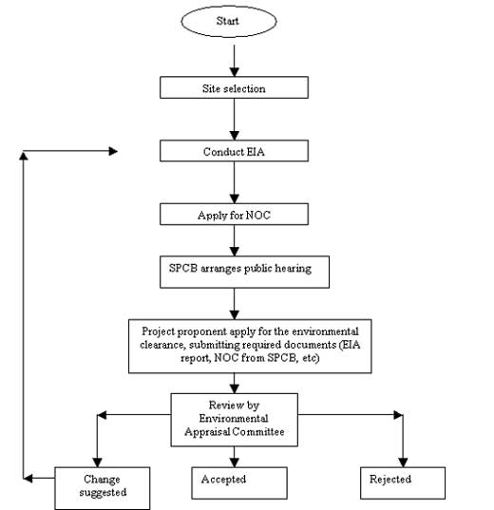

Source: EIA notification, Ministry of Environment & Forest, 2006
When we talk about the Hydroelectric Power Projects, it falls under the category 1(c)-River Valley projects of the schedule as per the latest EIA notification of 2006. The categorisation for River Valley Projects is given in Table-2 as under:
Table-1.2 Project Categorisation For Prior Environmental Clearance
(RIVER VALLEY PROJECTS)
Project or Activity |  | Category with threshold limit |  | Conditions if any
 |  | A | B | Conditions if any
1. |  | Mining, extraction of natural resources and power generation (for a specified production capacity)
(1) | (2) | (3) | (4) | (5)
1(c) | River Valley  projects | (i) ≥ 50 MW hydroelectric  power generation;  (ii) ≥ 10,000 ha. of culturable  command area | (i) < 50 MW ≥ 25 MW hydroelectric power generation;  (ii) < 10,000 ha. of  culturable command  area | General Condition shall  apply

The applicable General Condition (GC):
Any project or activity specified in Category ‘B’ will be treated as Category A, if located in whole or in part within 10 km from the boundary of: (i) Protected Areas notified under the Wild Life (Protection) Act, 1972, (ii) Critically Polluted areas as notified by the Central Pollution Control Board from time to time, (iii) Notified Eco-sensitive areas, (iv) inter-State boundaries and international boundaries.

1.4 Power Scenario Of India
Energy utilization has become a symbol of growth and instrument for development. Electric power particularly the hydropower is among the cleanest and renewable energy input for economic activities. The ministry of Power has set the objective of providing “Power for all by 2012”. This will entail electrification of all villages by 2007 and of all households by 2012. The infrastructure would need the availability of assured and quality power at affordable price through reliable and adequate generation, transmission and distribution facilities.
Power generation in India began more than a century ago in 1898 when the first hydropower unit was set up in Darjeeling. When India achieved freedom in 1947, the country had an installed capacity of 1360 MW. The present installed capacity of the country is 1,07,973 MW. The share of hydro with 26,910 MW capacity is about 25%. Thermal accounts for maximum share of 71% with 76,607 MW. The share of nuclear is about 2.5% with 2,720 MW while wind accounts for the balance 1,736 MW. The attainment is significant. However what we achieved in over 50 years will need be attained now in nearly 10 years. The present annual energy requirement in 2002-03 was 5,45,674 MU, of which only 4,97,589 MU were available, leaving a shortfall of 8.8%. While the peaking requirement was 81,492 MW in 2002-03, a peak of 71,547 MW only could be met, leaving a shortage of 12.2%. The 16th Electric Power Survey (EPS) carried out by the Central Electricity Authority (CEA) has projected a peak demand of 1,57,107 MW and an energy requirement of 9,75,222 MU by the end of 11th Plan.
The Indian power system requirement had been assessed to need a hydropower and thermal/nuclear powers mix in the ratio of 40:60 for flexibility in system operation depending on typical load pattern. The present ratio is 25:75 which needs be corrected immediately to meet peak load requirements as well as system and frequency stability. The estimated hydro potential in the country is 1,50,000 MW out of which only 26,910 MW amounting to 18% of the total potential has been harnessed (all the above figures have been taken from the website of Ministry of Power, GoI).
Hydroelectric power is a renewable and non-polluting source of energy, which can be developed on a large scale and for which well-proven technology is available. Further, hydroelectric generation provides a number of economic, operational and social advantages over other modes of energy generation. It is cheaper at the time of initial installation and, with the escalation of fuel costs over the passage of time for other modes of generation, it grows much more economical. Hydroelectric plants have longer life.

Table- 1.3 Hydropower Projects Under Construction In Ganga Valley
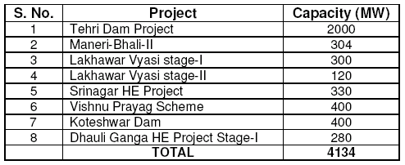
Uttarakhand Jal Vidyut Nigam Limited (UJVNL) is responsible for development of hydropower in Uttarakhand for state’s share allotted projects..

1.5 Objectives Of Present Study
The main objective of the study is to:
- Study different Notification by Government of India regarding the Environment Impact Assessment.
- Study different EIA methodologies
- Study the EIA of Pala Maneri Hydroelectric project
CHAPTER 2

LITERATURE SURVEY

2.1 General:
Electricity is one of the important factors under the Infrastructural development of nation. It is well established fact that hydro power is a clean energy using the water as fuel for generation in place of fossil fuel or nuclear energy. The hydro power projects are categorized as Reservoir Based Projects or Run of the River (RoR) Project. As per the National Policy on R&R, 2003 the issue of rehabilitation and environmental degradation has discouraged the reservoir based projects and all the projects that are being constructed presently in the Himalayan region are RoR schemes of reservoir with little submergence.
Hydroelectric power is a renewable and non-polluting source of energy, which can be developed on a large scale and for which well-proven technology is available. Further, hydroelectric generation provides a number of economic, operational and social advantages over other modes of energy generation. It is cheaper at the time of initial installation and, with the escalation of fuel costs over the passage of time for other modes of generation, it grows much more economical. Hydroelectric plants have longer life. Central Water Commission and Ministry of Environment and Forests have set the environmental guidelines for River Valley Projects. These guidelines have been adopted for the DPR preparation of the Pala Maneri HEP that has been referred for the study.
While examining the case of 4x120 MW Pala Maneri Hydroelectric Project to be constructed by UJVNL, the environmental parameters like Ambient Air quality, Noise Level, Tolerance limit of effluents and the socio-economic aspects will be studied in comparison to the project construction and operation stages.

2.1.1 Ambient Air Quality Standards
Ambient Air Quality Standards have been notified by the CPCB vide Gazette Notification dated 11th April 1994. Table-2.1 details the Ambient Air Quality Standards.

2.1.2 Ambient Noise Standards
Ambient Noise level standards have been notified by the MoEF vide Gazette Notification dated 26th December 1989 and also in the Schedule III of the Environmental (Protection) Rules 1986. It is based on the ‘A’ weighted equivalent noise level (Leq). These are presented in Table-2.2

Table-2.1 National Ambient Air Quality Standards
Pollutants | Time-weighted average | Concentration in ambient air
Pollutants | Time-weighted average | Industrial Areas | Residential, Rural & other Areas | Sensitive Areas
SulphurDioxide (SO₂) | Annual Average* | 80 µg/m³ | 60 µg/m³ | 15 µg/m³
SulphurDioxide (SO₂) | 24 hours** | 120 µg/m³ | 80 µg/m³ | 30 µg/m³
Oxides of Nitrogen as  (NOx) | Annual Average* | 80 µg/m³ | 60 µg/m³ | 15 µg/m³
Oxides of Nitrogen as  (NOx) | 24 hours** | 120 µg/m³ | 80 µg/m³ | 30 µg/m³
Suspended Particulate Matter (SPM) | Annual Average* | 360 µg/m³ | 140 µg/m³ | 70 µg/m³
Suspended Particulate Matter (SPM) | 24 hours** | 500 µg/m³ | 200 µg/m³ | 100 µg/m³
RespirableParticulate Matter (RPM) (size less than 10 microns) | Annual Average* | 120 µg/m³ | 60 µg/m³ | 50 µg/m³
 | 24 hours** | 150 µg/m³ | 100 µg/m³ | 75 µg/m³
Lead (Pb) | Annual Average* | 1.0 µg/m³ | 0.75 µg/m³ | 0.50 µg/m³
Lead (Pb) | 24 hours** | 1.5 µg/m³ | 1.00 µg/m³ | 0.75 µg/m³
Ammonia1 | Annual Average* | 0.1 mg/ m³ | 0.1 mg/ m³ | 0.1 mg/m³
 | 24 hours** | 0.4 mg/ m³ | 0.4 mg/m³ | 0.4 mg/m³
CarbonMonoxide (CO) | 8 hours** | 5.0 mg/m³ | 2.0 mg/m³ | 1.0 mg/ m³
CarbonMonoxide (CO) | 1 hour | 10.0 mg/m³ | 4.0 mg/m³ | 2.0 mg/m³
* | Annual Arithmetic mean of minimum 104 measurements in a year taken twice a week 24 hourly at uniform interval.
** | 24 hourly/8 hourly values should be met 98% of the time in a year. However, 2% of the time, it may exceed but not on two consecutive days.

Source: Central Pollution Control Board available at web site

Table-2.2 National Ambient Noise Standards
Zone | Limits (dB)
Zone | Day  (6.00 to 21.11hrs) | Night
Industrial | 75 | 70
Commercial | 65 | 55
Residential | 55 | 45
Silence  (Area at 100m radial distance from Courts, Hospitals, Educational Institutions etc.) | 50 | 40

Source: Central Pollution Control Board available at web site

2.1.3 Water Quality Criteria
For the purpose of protecting and improving the quality of the environment and preventing the environmental pollution, the standards for discharge of environmental pollutants from industries, operations or processes are stipulated under “Environmental Protection Rules (1993)”. Table-2.3 summarizes the standards for water quality criteria in Inland Surface Water Bodies.

2.2 Important Environmental Legislations
The regulation of environmental acts, legislation, guidelines and standards is the responsibility of different government agencies. The principal environmental regulatory agency in India is the Ministry of Environment and Forests (MoEF), New Delhi. MoEF formulates environmental policies and accords environmental clearances for different projects. As per the notification from the MoEF dated 27th January 1994 and amendment dated 4th May 1994 and latest amendment dated 14th Sept 2006, expansion or modernization of any activity shall not be undertaken in any part of India, unless it has been accorded environmental clearance by the Central/State Government in accordance with the procedures specified in this notification. As per the procedure, anybody who desires to undertake any project in any part of the country or expansion or modernization of any existing project, a detailed project report, which shall inter alia include an Environmental Impact Assessment (EIA) report, needs to be submitted. The MoEF as we know is vested with overall responsibility to set policy and standards for the protection of environment along with Central Pollution Control Board (CPCB). The air, noise and water quality standards are significant for preparation of Environmental Impact Assessment (EIA) Statement of any Developmental Project.
The important environmental legislation referred, are as per Table-2.4.

TABLE-2.3: Criteria For Inland Surface Water Quality
Designated-Best-Use | Class of water | Criteria
Drinking Water Source without  conventional treatment but after disinfection | A | - Total Coliforms OrganismMPN/100ml shall be 50 or less  - pH between 6.5 and 8.5  - Dissolved Oxygen 6mg/l or more  - Biochemical Oxygen Demand 5 days 20oC 2mg/l or less
Outdoor bathing (Organised) | B | - Total Coliforms Organism MPN/100ml shall be 500 or less  - pH between 6.5 and 8.5  - Dissolved Oxygen 5mg/l or more  - Biochemical Oxygen Demand 5 days 20oC 3mg/l or less
Drinking water source after conventional treatment and disinfection | C | - Total Coliforms Organism MPN/100ml shall be 5000 or less  - pH between 6 to 9  - Dissolved Oxygen 4mg/l or more  - Biochemical Oxygen Demand 5 days 20oC 3mg/l or less
Propagation of Wild life and Fisheries | D | - pH between 6.5 to 8.5  - Dissolved Oxygen 4mg/l or more  - Free Ammonia (as N) 1.2 mg/l or less
Irrigation, Industrial Cooling, Controlled Waste disposal | E | - pH betwwn 6.0 to 8.5  - Electrical Conductivity at 25oC micro mhos/cm Max.2250  - Sodium absorption Ratio Max. 26  - Boron Max. 2mg/l
 | Below-E | Not Meeting A, B, C, D & E Criteria

Source: Central Pollution Control Board available at web site

Table-2.4 Important Environmental legislations
Act/Notification | Purpose
Water (Prevention and Control of Pollution) Act,  1974,1988. | For the prevention and control of water pollution and  maintaining the quality of water
Air (Prevention and Control of Pollution) Act 1981,1987. | For the prevention and control of air pollution
Forest conservation Act, 1980,1988. | For acquisition of common property such  as forests; prevent rapid deforestation and degradation of forests
Wildlife Protection Act, 1972, 1993 | For the protection of wildlife
Environment Protection Act, 1986. | For the protection and improvement of Environment
National Policy on Rehabilitation and Resettlement  2004 | For the Rehabilitation and Resettlement of project affected people
Environmental clearance Notification 1994,1997 and 2006. | Guidelines and procedure for Environmental Impact Assessment of projects

CHAPTER 3

PALA MANERI HYDRO-ELECTRIC PROJECT DESCRIPTION

3.1 Project Background
The state of Uttarakhand has got tremendous potential of developing hydroelectric power, which is estimated to about 15,000 MW (excluding the 5000 MW Pancheshwar project which is pending due to the sharing dispute with Nepal). The existing installed generating capacity of the state is 2686 MW (2003 census), which means that about 82.5% of its hydropower potential remains to be developed. Ganga and Yamuna are the main rivers of Uttarakhand. The major rivers in Ganga Valley including the Bhagirathi River have got considerable perennial flow and steep bed slopes. The nature of terrain also provides good storages sites without any considerable disturbance to the human settlements. As such the rivers of Uttarakhand can play a key role in the economic growth of this newly formed state.

Hydropower schemes are being planned and executed in the state of Uttarakhand ever since its inception to bridge the gap between the demand for power and its availability. The major hydropower schemes under construction in the Ganga valley are reported in Table-3. Other than these, Loharinag-Pala (600 MW) and Pala-Maneri (480 MW) are in advance stage of planning. Loharinag-Pala is being developed by National Thermal Power Corporation (NTPC) and Pala-Maneri by UJVNL.

3.2 The Project and Its Location
The Pala-Maneri hydroelectric project is proposed on river Bhagirathi, which is the main tributary of the Ganga. The project envisages an installed capacity of 480 MW and a total average annual energy production of 2083 GWh or Million Units. The project will be constructed as a peaking power plant. It will comprise of a reservoir, a concrete gravity dam, an intake structure, sedimentation chamber, a headrace tunnel, a valve chamber, pressure shaft, an underground powerhouse and an outdoor switchyard. The maximum gross head of the scheme is 358 meter and the nominal discharge is 124 cum/s. The proposed hydroelectric project is located between Pala and Maneri villages of Tehsil Bhatwari in Uttarkashi District of Uttarakhand State. Location of the project is shown in Figure 2. The project site is approachable by National Highway-94 up to Dharasu and thereafter on National Highway 108 to Bhatwari. The nearest airport is at Dehradun, approximately 236 km from the project site. The nearest railhead is Rishikesh about 180 km from the project site. The project area is located between Latitude 30o 46’ 25” N to 30o 44’ 36” N and Longitude 78o 35’ 15” E to 78o 30’ 00” E.

Figure 3.1 The Project location

3.3 Project Salient Features
Most of the project structures, whether permanent or temporary in nature, shall be located between the dam site and the tailrace works. The constructions activities will also be concentrated accordingly.
Salient features of the project are given as under in table3.1 below.

Salient Features Of Pala Maneri Hep

I. PROJECT LOCATION
a) Latitude 30º 46’25” to 30º 44’ 36”
b) Longitude 78º 35’ 15” to 78º 30’ 00”
c) Tehsil Bhatwari
d) District Uttarkashi
e) State Uttaranchal
f) Name of river Bhagirathi
g) Name of the basin Ganga

II. HYDROLOGY FOR PALA INTAKE
a) Catchment area 3,667 sq. km.
b) Snow bound catchment area at dam site
included in (a) above 1,802 sq.km.
c) Average annual inflow 3,859x106 cum
d) Average discharge 124 cum/s
e) Specific average discharge 0.034 cum/s/sq.km.
f) Minimum ecological water release 2 cum/s
g) Flood discharge for river diversion (~Q50) dry 450 cum/s
h) Design discharge for spillway arrangement 9,200 cum/s

III. RESERVOIR
a) Maximum normal reservoir level 1665.00 m above m.s.l.
b) Average normal reservoir level (0.5 active) 1660.50 m above m.s.l.
c) Minimum normal reservoir level 1655.00 m above m.s.l.
d) Extreme maximum reservoir level (max. flood) 1669.00 m above m.s.l.
e) Total storage volume 4.7 Mm3
f) Active storage volume 2.25 Mm3
g) Dead storage volume 2.45 Mm3

IV. DAM AND APPURTENANT STRUCTURES
a) Dam type Gravity
b) Crest level 1670.00 m above m.s.l.
c) Stream bed level 1611.00 m above m.s.l.
d) Dam foundation level 1592.00 m above m.s.l.
e) Dam height from foundation level 78.0 m
f) Crest length 175.0 m
g) Maximum length of grout curtain 52 m
h) Diversion facilities:
Upstream cofferdam
- Crest elevation 1624.90 m above m.s.l.
- Length 58 m
Downstream cofferdam
- Crest elevation 1619.30 m above m.s.l.
- Length 74 m
Gated Submerged Spillway
- Crest elevation 1631.53 m above m.s.l.
- Type incorporated into dam
- Gate type and size (HxW) Radial, 11.9x10.5 m
- Number 4
- Max. head 38.17 m
- Discharge capacity 9200 m3/s
Relocation length of national highway-108 2500 m

V. INTAKE (RIGHT ABUTMENT)
a) Number of openings 3
b) Water inlet elevation 1640.0 m above m.s.l.
c) Nominal discharge 156 cum/sec
d) Dimension of trash rack opening (HxW) 7.0x11.5
e) Gate number and type at the tunnel entrance 3, vertical sliding
- Sill elevation 1640.0 m above m.s.l.
- Dimensions (HxW) 4.70x5.50 m
- Maximum head 29.70 m

VI. DESILTING CHAMBERS
a) Number 3
b) Type Underground
c) Nominal discharge for each 52 cum/s
d) Size of particle to be removed >0.2 mm
e) Size (HxW) 19.62x12.6 m

VII. HEADRACE TUNNEL
a) Tunnel:
- Finished Shape Circular
- Length 12,646 m
- Excavation diameter 7.8 m
- Internal diameter 7.2 m
- Velocity for nominal discharge 3.83 m/s
- Slope 0.63 %
- Nominal discharge 156 cum/s
- Number of adits 2
- Lining type and thickness 0.3 m, circular
b) Adits:
- Number and Total length 2, 1293 m
- Excavation (HxW, D shaped) 6.5x6.5 m

VIII. SURGE SHAFT
a) Vertical shaft:
- Top elevation 1725 m above m.s.l.
- Bottom elevation 1555 m above m.s.l.
-Total height 170 m
- Maximum water level in upper chamber 1720.7
- Minimum water level in lower chamber 1597.2 m above m.s.l.
- Lining 100 % concrete
b) Upper chamber:
- Invert elevation 1714.24 m above m.s.l.
- Internal diameter 10.0 m
- Length 80.0 m
c) Riser shaft between upper and lower chamber:
- Height 130.5 m
- Internal diameter 15.0 m
d) Lower chamber:
- Bottom elevation 1594.0 m above m.s.l.
- Internal diameter 10.0 m
- Length 125.0 m
e) Shaft between lower chamber and HRT:
- Height 39.0 m
- Internal diameter 8.0 m

IX VALVE CHAMBER
a) Type Underground
b) Dimensions (LxHxW) 18.5x16.10x18.10 m
c) Butterfly valves:
- Number 2
- Diameter 3.5 m
d) Access road Length (approx.) 2820 m

X. PRESSURE SHAFT
a) Length 350 m
b) Internal diameter 4.4 m
c) Velocity for nominal discharge 5.13 m/s
d) Nominal discharge each 78 cum/s

XI. POWER HOUSE
a) Type Underground
b) Dimensions (LxHxW) 100x38x21
c) Turbine type Francis
- Number of units 4
- Turbine setting elevation 1277.32 m above m.s.l.
- Rated discharge per unit 39 cum/s
- Turbine speed 272.73 rpm
- Max./ Min. gross head 357.86/347.87 m
-Rated head 352.86 m
- Installed capacity per unit 120 MW
d) Inlet valve type Spherical
- Number 4
- Axis elevation 1277.32 m above m.s.l.
- Diameter 2.5 m
- Max. Head 357.86 m
e) Generator Type 3 phase
- Number 4
- Nominal Speed 272.73 rpm
- Voltage/ Frequency 13.8/50 kV/Hz
- Load factor 0.9 cos ϕ
f) Transformer type Single phase
- Location Underground
- Number 13
- Unit capacity 50 MVA
- Voltage ratio 13.8/4003 kV/kV

XII. EXPANSION CHAMBER
a) Type Rectangular
b) Dimensions (L x H x W) 50x51x10 m
c) Maximum upsurge 1308.90 m above m.s.l.
d) Maximum Down surge 1275.6 m above m.s.l.

XIII TAILRACE CHANNEL
a) Number One
b) Length 1378.43 m
c) Diameter 7.2 m
d) Slope 0.89 %
e) Nominal Discharge 156 cum/sec
Outlet sill elevation 1278.11 m above m.s.l.

XIV SWITCHYARD
Type Outdoor
Area (L x W) 90x32 m

XV ESTIMATED COST (crore rupees)
Civil works 1329.22
E&M works 730.12
Total basic cost (excl. transmission line) 2059.34
Escalated cost for Civil and E&M Works 236.25
Interest during construction & Financing 150.50
Total (Generation works) 2446.09
Cost Cr Rs per MW Installed 5.09

XVI POWER BENEFITS
Energy generation in 50% dependable Year 2083.0 GWh
Energy Generation in 90% dependable Year 1880.1 GWh

XXII COST OF GENERATION Rupees 1.97

XVIIICONSTRUCTION PERIOD 4.41 years
Source: Pala Maneri Hydroelectric Detailed Project Report- March 2005

3.4 Construction Material
The construction of Pala-Maneri H.E. Project would involve handling of large quantities of construction materials. Arrangement for their procurement and safe storage will be made. Estimated quantities required for construction are summarized in Table-3.1. These quantities will be used during construction period of about 52 months.

3.5 Project Costs And Economic Evaluation
The project cost has been estimated as Rs2446 Crores taking into account of civil, electrical and mechanical works, which includes the cost of dam, intake works, desilting tank, headrace tunnel, generators, and transmission lines up to bus bar. It also includes escalation during construction and interest etc., but does not include the cost of transmission for distribution of power. The economic evaluation of project is presented in Table-3.2 below:

TABLE-3.1: QUANTITIES OF CONSTRUCTION MATERIAL
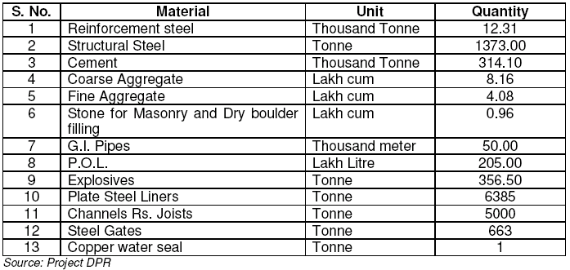

TABLE -3.2 ECONOMIC EVALUATION OF THE PROJECT
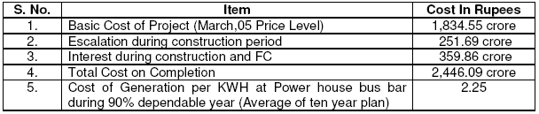
Source: Project DPR

CHAPTER 4

EIA METHODOLOGY

4.1 General:
A number of methodologies have been developed after the inception of the NEPA – USA for evaluation and assessment of environmental impacts. Most of the methods suffer from excessive dependence on subjective judgements and are weak in predicting and quantifying the impact of the project on the environment, but the development of computer-based modelling techniques shows promise of bridging the existing gap (Banerjee, Rathore 1994). Some of the important methods developed over the period are discussed below.

4.1.1 Adhoc approach
This is the oldest and perhaps the crudest approach to EIA. The method provides very little guidance for assessing impacts on specific parameters beyond suggesting impacts on broad areas like impact on land, forests, population, water, wildlife, etc. It does not address secondary impacts.

4.1.2 Checklist Method
It is the updated version of the ad hoc approach in which specific areas of potential impacts are listed. Checklists are the lists of environmental attributes. The evaluator needs to tick against each environmental parameter for adverse, beneficial, or no effects due to proposed project activities. The method defines the parameters to be evaluated, but it is usually very large, very subjective, and provides little guidance that can aid in the decision-making process.

4.1.3 Matrix method
The method is attributed to Leopold et al. (1971). The method uses a matrix format to relate project actions and environmental components. The column of the matrix consists of 100 project actions (can be shortlisted as per requirement) against rows of the matrix of 88 environmental components (also can be shortlisted as per the project). If a project action is likely to make an impact on environmental components, the appropriate cell is scored for magnitude and importance of the impact (on an arbitrary scale). A +ve or –ve sign is provided for harmful or beneficial nature of the impact. Row totals of the matrix reflect the total impact of all project actions on one environmental component, while the column totals reflect the impact of one project action on all components of the environment. The matrix total gives the total environmental impact.
One of the drawbacks of matrix approach is that it generally does not include secondary impacts. Also, the Leopold matrix is a non-mathematical matrix where true algebraic operations cannot be performed. A number of mathematical matrix methods have also been developed, namely, the Peterson’s matrix, the component interaction matrix, etc., that try to address inclusion of secondary impacts and allow true algebraic operations.

4.1.4 Mathematical matrices
The matrix was developed by Peterson, Gemmell, Schofer (1974) and called the Peterson’s Matrix. First, a matrix is formed to evaluate the effects of environmental action on the various physical components of the environment on a scale of +3 to –3. Another matrix is constructed to evaluate effects of the impacted physical components on human environment. Matrices are then multiplied to give a third matrix that brings out the effect of actions on the human environment. The production matrix is operated by a vector of relative weight of human impacts to result in a weighted vector of human impacts. The weighted vector is then summed up to result in a total value of the project impact.
The approach has been criticized for too much of mathematical operations. It is also difficult to carry out the multiplication of matrices manually, and basic inputs to the matrix are still subjective.

4.1.5 Network approach
This approach links the project and its impacts in an easily understandable format. The network method aims at working from a list of project activities and establishes cause, condition, and effect relationships. Since the environmental system is dynamic and action-impacting, certain environmental parameters can lead to a series of impacts on other environmental parameters. The network method primarily addresses the need by defining a set of possible networks and allowing the user to identify impacts by selecting and tracing appropriate project actions. This approach has been identified as one of the best approaches for assessing higher-order impacts, although quantification of impacts is still subjective in nature.

4.1.6 Battlelle environmental evaluation system
This method has been identified as one of the most quantitative methods. In the Battlelle environmental evaluation system (BEES), 78 measurable environmental parameters are divided into four major categories of ecology, environmental pollution, aesthetics, and human interest. The first step includes the conversion of parametric estimates into an environmental quality (EQ) scale that ranges between 0 and 1, where 0 denotes extremely bad quality and 1 denotes very good quality. It is done using value function curves. The next step includes multiplication of EQ values with the respective parameter importance unit (PIU) values to obtain environmental impact units (EIU) for each parameter. Addition of EIU values provides a composite score. Total environmental impact is calculated by evaluating the expected future condition of the environmental quality with and without the project.

4.1.7 Computer-aided EIA
A number of computer-aided EIA methods have been developed in recent times. These basically link the multi-tasking software in a user-friendly manner to come up with an overall assessment system. A trendsetting computer system for EIA has been developed by the US Army Construction Engineering Research Laboratory for predicting environmental impacts for army construction activities. The system integrates three subsystems, namely:
(1) the environmental impact computer system (EICS) to identify potential environmental impacts by relating army activities to environmental attributes,
(2) the economic impact forecast system (EIFS) which provides quantitative estimates of regional economic impact of army actions based upon an extensive, diverse, interactive database, and
(3) the computer aided environmental legislative data system (CELDS) which stores abstracts of pertinent environmental legislation.
In India, the National Environmental Engineering Research Institute (NEERI) has developed a computer aided rapid EIA system using predictive models for a number of environmental parameters. The method divides the environment into various environmental components, namely, air, water, land, noise, biological, and socioeconomic. Each environmental component is further divided into associated risks and each risk is further divided into measurable environmental parameters and predictors. Value function curves have been developed to convert measured values of environmental parameters into environmental quality on a scale between 0 and 1 like the BEES.
The highlight of the method is the use of air, water, and noise models for prediction of environmental parameters. In recent times, Geographic Information Systems (GIS) has emerged as a very effective spatial analysis and presentation tool, enabling the identification of the impacted zones by using the overlay technique. Computer-based systems, however, are very expensive to run and maintain, and are, therefore, less frequently encountered in spite of all their merits.

4.1.8 Modelling approaches

A large number of mathematical models have been developed for the assessment and simulation of a number of environmental attributes like air quality, water quality, noise, and behaviour of biological systems. The approaches aim at modelling the environmental parameters for future prediction of impacts in quantitative terms. Key features of this approach include the ability to give the non-mathematical experts the capacity to model complex, and non-linear feedback systems. A major problem in the modelling approach to decision making is the scaling of judgement. Modelling the environment as a whole is a resource-intensive and time-consuming procedure, which requires a significant level of expertise.

4.1.9 Methodology adopted for the EIA of Pala Maneri Project:
For the EIA of Pala Maneri Hydroelectric project, a matrix was formulated to identify the attributes, likely to be affected due to proposed project activity and presented as Table-4.1. Environmental baseline data includes inventory of physical, ecological and socio-economic parameters. Covering these aspects, data has been compiled for:
- Land Environment
- Water Environment
- Air Environment
- Noise Environment
- Ecological Environment
- Socio-Economic Environment
Based on matrix and project setting the attributes likely to be affected were identified for baseline data generation. The information was collected from various sources. Majority of data was collected from field studies, carried out in three different seasons e.g. winter, summer and postmonsoon to generate primary data on water, noise, soil, air quality, ecology and socioeconomics at the project site. Discussions were held with the local people, project affected people and local government/non-government organisations, which have provided very useful information for preparation of EIA report. Information on project facilities, size, magnitude and cost of the construction activities, geology and, seismology of the project site was been taken from the draft DPR (March 2005). Literature, books, maps and reports provided useful secondary data on the project. The frequency of data collection has been as per Table-4.2.
TABLE-4.1: MATRIX FOR THE PROJECT

ASPECT OF ENVIRONMENT | LIKELY IMPACTS
A. LAND ENVIRONMENT
Construction Phase | - land for worker colonies  - muck disposal  - Solid waste from site camps and hutments  - soil erosion  - construction spoils
B. WATER RESOURCES & WATER QUALITY
Construction Phase | - turbidity of nearby receiving water bodies  - disposal of wastes from worker colony and construction sites.
Operation Phase | - Eutrophicatio  - reduction in D.O. due to increased residence time in reservoir  - Disruption of hydraulic regime  - Sedimentation and siltation n
C. AQUATIC ECOLOGY
Construction Phase | - fishing.  - Reduced productivity due to increase in turbidity
Operation Phase | - migratory fish species  - spawning and breeding grounds  - Degradation of riverine ecology  - Increased potential for reservoir fisheries
D. TERRESTRIAL ECOLOGY
Construction Phase | - Increased pressure on nearby forests due to work force to meet their fuel wood and timber requirements  - Adverse impacts due to migration of worker population  - Loss of forest  - Impacts on nature reserves due to various project appurtenances  - Impacts on wildlife movement  - Impacts on diversity and productivity of flora  - Impacts on economically/ genetically/ biologically important plant species
E. SOCIO-ECONOMICS
Construction Phase | - Acquisition of land and private properties  - Impacts on archaeological & cultural monuments  - Impacts on mineral reserves  - Improved employment potential during project construction phase  - Development of allied sectors leading to greater employment.  - Pressure on existing infrastructure facilities  - Friction between guest and host community
Operation Phase | - Increased revenue from power generation
F. AIR POLLUTION
Construction Phase | - Impacts due to emissions generated by crushers and other  equipment  - Impacts due to increased vehicular movement  - Fugitive emissions from various sources.
G. NOISE POLLUTION
Construction Phase | - Noise due to operation of various equipment  - Noise due to increased vehicular movement
H. PUBLIC HEALTH
Construction Phase | -Increased incidence of water related diseases  - Transmission of diseases by immigrant labour population
Operation Phase | Phase - Increased incidences of vector borne diseases
Source EIA Report Pala Maneri
4.2 LAND ENVIRONMENT
The dam site is located about 15 km NE of Uttarkashi town near Pala village, at a height of about 1650 m above MSL. Parameters involved in land environment are physiography, geology, minerals, soils, land use pattern and seismicity.

4.2.1 Land Use Pattern of District Uttarkashi and Affected Villages
Land use and land cover patterns are important in environmental impact assessment study from the point of view that land use describes the present use such as agriculture, settlement, etc and land cover, describes the material on it such as forest, vegetation, rocks or building etc. Land use details of the project-affected villages have been presented in Table-4.3. The land use pattern of Uttarkashi district presented in Table-4.4 indicates that forests are spread over 88.53% of the district area, cultivable area occupies 4.36% and cultivable waste area including settlements, roads etc. is 7.11%.

Table-4.2: Frequency Of Monitoring the Attributes 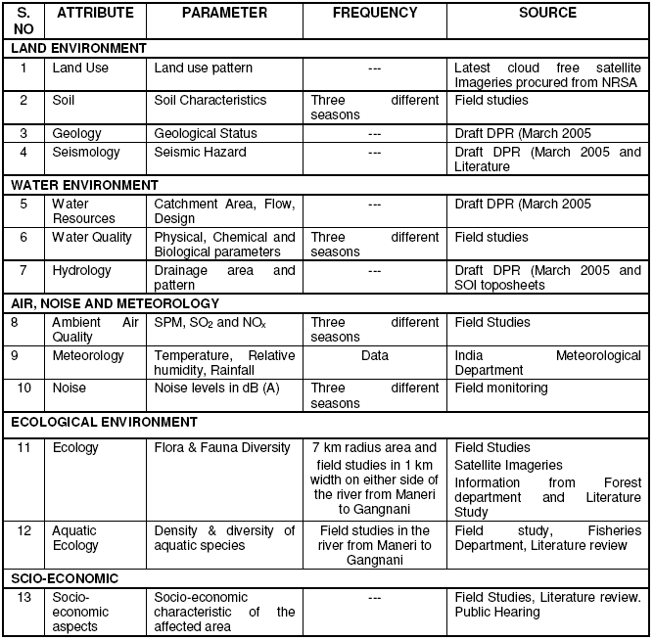
Source: EIA Report of Pala Maneri

Table-4.3: Land Use DETAILS Of Affected Villages
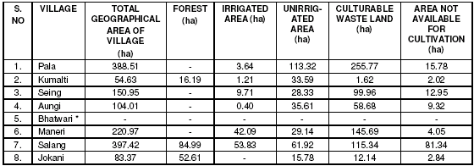
Source: Bhatwari Tehsil

Table 4.4: Land Use Pattern Of Uttarkashi District
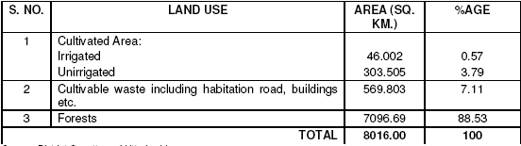
Source: District Gazetteer Uttarkashi

4.2.2 Land Cover of 10 km Radius Study Area
Detail of land cover of the study area is indicated in Table-4.5. There are three types of vegetation cover; dense vegetation, medium vegetation and light vegetation. It is seen from the details that 86.51% of the area is coved with vegetation out of which 66.5 % is dense type. Agricultural land makes 7.72 % and scrubs/bushes 5.53 % of the area. Settlement makes only 0.25% of the study area.

TABLE-4.5 : LAND COVER OF 10 km RADIUS STUDY AREA
S.NO. | LAND COVER CATAGORY | AREA (ha) | AREA (%)
1 | Dense Vegetation (Crown cover density >40%) | 20,971.3 | 66.75
2 | Medium Vegetation (Crown cover density 10 - 40%) | 5,130.0 | 16.33
3 | Light Vegetation (Crown cover density <10%) | 10,78.9 | 3.43
4 | Agricultural land | 2,300.0 | 7.32
5 | Scrubs/Bushes | 1,736.1 | 5.53
6 | Barren area | 23.5 | 0.08
7 | Water body | 70.6 | 0.23
8 | Settlement/Built-up | 80.9 | 0.25
9 | Snow covered area | 24.7 | 0.08
 | TOTAL | 31,416.0 | 100.00
Source Forest Division Uttarkashi

4.3 Physiography
Lying in the upper Himalayas, Uttarkashi contains within itself varying geographical environments ranging from snow free valleys and outer hills to the high peaks with perpetual snow and glaciers. The terrain runs into series of ridges and valleys. Most of the terrain is mountainous consisting of high-rise ridges, hills, valleys and deep gorges in which flat pieces of land are rare. Land surface is largely occupied by boulders and gravel outcrops. On the sloping hillsides lies a chain of sparsely populated settlements interspersed with terrace cultivation.
Geographical area of district Uttarkashi is 8,016.20 sq. km, which is mainly divided into the Ganga and Yamuna sub-basins. River Bhagirathi, a major tributary of river Ganga, rises up in the Gangotri glacier at Gaumukh and traverses 128 km in Uttarkashi. The river has a very steep bed-slope and a considerable quantity of perennial flow, which provides enormous potential for hydropower development. Axis of the proposed dam is along NW-SE direction, across the river, which flows from NE to SW direction. The river valley upstream of the dam site is so deep and narrow that it provides a live storage of 2.25 M cum with a submergence of only about 20 hectare area. Location of the powerhouse is proposed about 15 km downstream of the dam site under Right Bank hill slope. The Physical map of Uttarakhandshowing project location is given as Figure-4.1.

Figure-4.1: Physical Map Of The Project Area, Pala –Maneri Dam Site
Source: Internet

4.4 Geology

4.4.1 General Geology of Uttarakhand:
Geology of the Himalayan area in Uttarakhand in general and that of the project specific area is described in the following paragraphs.
Geological map of a portion of Uttarakhand is given in Figure-4.2, which shows the general geology of the project area. Uttarakhand Himalayas occurring in the central part of the Himalayan folded belt has the rock types varying in age from Proterozoic to Late Tertiary period, disposed in four major tectonic belts designates as Foothill Siwalik belt, Lesser Himalayan belt, Central Crystalline and Tethyan belt. Two heterogeneous tectonic divisions, one representing the epigeosynclinal orogeny and the other indicating an epiplatform or extra geosynclinal orogeny are possibly juxtaposed. Various geologists have studied the magnitude of the crystalline thrust sheets of Kumaon Himalaya and introduced the concept of large scale overthrusting to explain structural disposition of parts of Himalayan belt. The foothills consist entirely of a narrow belt of Lower Siwalik sediments consisting of sandstone, siltstone, shales and conglomerates. Middle and upper Siwaliks are subordinate with contact often marked by strike faults. The individual Siwalik sections are mostly normal and are demarcated on the north by an important geotectonic feature named as the Main boundary fault/thrust.
Crystalline belt consists of a complex of mylonite gneisses, phyllite, garnetiferous schist and kyanite bearing schist, calc silicate rock and quartzite with associated, migmatite syntectonic granite gneisses and late to post – tectonic tourmaline bearing granite including the famous Badrinath and Gangotri granite.

4.4.2 Geology of the project area
The project is located in a succession of metamorphic rocks of Proterozoic age, which have been folded, faulted, fractured and sheared by intense tectonic deformations during the Quaternary. One major active thrust is identified along the project alignment, namely the Munsiari Thrust which is located along the tunnel alignment in the Kumalti Gad near the village of Sainj and separates the Lower and Upper Lesser Himalayas sequences of low to medium grade metamorphic rocks. This thrust is also known as the MCT1 and runs parallel to the Vaikrata Thrust or MCT which is located 13 km to the north of the project. Current opinion suggests that the Munsiari Thrust is an active tectonic feature of major significance in the current orogenic process and has replaced the MCT as the primary source of movement in this region of the Himalayas. It is also the main and closest source of seismic activity and is a source of geothermal activity.
The dam, intake works, de-silting structure and approximately 8km of the headrace tunnel will be located in fresh foliated jointed gneisses, schists and amphibolites of the Upper Lesser Himalayan Series. The headrace tunnel will cross the active Munsiari Thrust Shear Zone, which is a highly complex zone of about 300m length sheared and highly deformed gneisses schists and quartzites and amphibolites. The remaining 4 Km of headrace tunnel, surge shaft, powerhouse complex and tailrace tunnel are all located in predominantly quartzite and semi pelitic or meta-volcanics of the Lower Lesser Himalayan Series. All lithologies are pervaded by a strong foliation dipping to the NE at about 30°-40° as well 3 or 4 major joint sets. Shearing is observed along the foliation and a later high angle phase. Geothermal waters are present in the lower half of the project especially in the vicinity of the powerhouse complex near Aungi.

Figure-4.2 Geological Map of Project Area
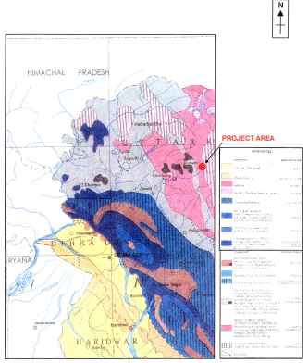
Source: EIA Report Pala Maneri

4. 5 Soils and Minerals
Mainly Submontane soils occur in district Uttarkashi, and the project area as well. The nature and type of soil is quite inconsistent. Mild hill slopes are covered with a layer of fragmented rocks and gravel mixed with soil, whereas top-cover has scoured from steeper slopes. The soils in the valley are alluvial of red and brown colour, being thin on the hillsides. The soil on the shady side of a hill, especially if it is bordered by forests, retains moisture better than if it has a southern aspect and is usually thicker and richer. At places the quality of the soil, if it is not alluvial, is determined by the kind of rocks in the sub-soil.

4. 5.1 Soil Test Results
Soil samples were collected from five different locations, one each at dam site, colony site and power house site plus two locations on dam upstream side namely Gangnani and Harsil to represent the project area. The soil samples were collected in three different seasons and were analysed for NPK, organic matter, pH value, Calcium, and Magnesium content. Soil test results presented at Table-4.6 indicate that soil in the project area is sandy by and large. Low organic content and the levels of NPK indicate that productivity of soil is moderate. It does not indicate extensive use of fertilizers. The sodium levels do not indicate any potential for soil salinization or adverse impact on soil productivity. In general the pH value is around 7, which indicates neutral characteristics of the soil.

Table-4.6,Physio-Chemical Characteristics Of Soils

PARAMETER | HARSIL |  |  | GANGNANI |  |  | PALA |  |  | AUNGI |  |  | BHATWARI
 | I | II | III | I | II | III | I | II | III | I | II | III | I | II | III
pH value | 6.99 | 7.56 | 7.24 | 7.20 | 6.80 | 6.5 | 7.13 | 7.52 | 7.52 | 6.2 | 8.09 | 7.23 | 7.24 | 7.36 | 7.56
Organic Matter | 1.24 | 0.4 | 0.45 | 3.64 | 16.75 | 13.64 | 3.37 | 2.04 | 0.14 | 3.08 | 0.15 | 1.62 | 1.82 | 2.12 | 1.71
Sodium Content  (Meq/100gm) | 0.13 | 0.905 | 0.605 | 0.26 | 1.17 | 1.26 | 0.13 | 1.12 | 0.21 | 0.26 | 1.47 | 0.15 | 0.14 | 0.12 | 0.16
Potassium Content (Meq/100gm) | 0.20 | 0.0508 | 0.308 | 0.61 | 0.64 | 0.63 | 0.59 | 0.18 | 0.025 | 0.49 | 0.05 | 0.26 | 0.18 | 0.16 | 0.13
Calcium Content  (Meq/100gm) | 2.47 | 2.34 | 2.14 | 8.04 | 23.27 | 18.41 | 5.70 | 6.35 | 0.39 | 10.69 | 3.19 | 4.04 | 3.45 | 3.58 | 4.5
Magnesium Content  (Meq/100gm) | 1.83 | 2.61 | 2.41 | 3.43 | 8.25 | 4.35 | 2.36 | 5.22 | 0.2 | 1.20 | 2.17 | 1.64 | 1.62 | 1.54 | 1.5
Phosphate (as P₂0₅)  (Kg/hectare) | 1198 | 99.59 | 110.59 | 151.85 | 443.75 | 245.62 | 1059.3 | 395.77 | 87.71 | 147.59 | 315.8 | 151.67 | 110.4 | 112.12 | 114.3
Nitrogen Content  (Kg/hectare) | 2502 | 824.06 | 858.86 | 5227.4 | 12095. | 8265.2 | 3059.5 | 1782.5 | 578.1 | 3306.3 | 473.68 | 1895.8 | 1885 | 1920 | 1993
Texture:
Sand (%)  Silt (%)  Clay (%) | 93.99  5.99  0.02 | 84.09  11.55  4.36 | 88.14  7.52  2.54 | 82.29  13.14  4.57 | 78.76  9.63  11.6 | 80.35  12.42  5.82 | 74.48  12.32  13.20 | 88.02  6.12  5.06 | 91.14  2.16  6.7 | 87.97  7.73  4.30 | 97.88  0.52  1.60 | 83.8  7.12  9.08 | 88.12  6.52  8.36 | 86.15  5.62  8.92 | 84.99  5.79  9.22
Source: EIA Report pala maneri
I- First Season Study (Summer)
II- Second Season Study (Post Monsoon)
III- Third Season Study (Winter)

4. 5.2 Minerals
Scattered presence of some minerals such as Copper, Graphite, Limestone, Mica, Iron, Kyanite and Soapstone has been reported in Uttarkashi. Copper occurs at various places in the district. There are widespread outcrops of limestone in the district but most of them are dolomitic and hence of little industrial use. Abundant mica schist’s occur between Lohari-Nag and Suki but economic exploitation of the deposits in this area is not practicable as the quality of mica is very poor. Poor mineralisation of iron is known for the schists and the quartzite from area near Bhatwari. Small scattered occurrences of soapstone are found near Dharasu. Generally in hydropower projects, no significant impact is anticipated except soil pollution at disposal site of construction waste.

4.6 Seismicity
Based on the tectonic features and records of earthquake, Seismic Zoning map of the country has been developed by Bureau of Indian Standard. Seismic Zoning Map of India is placed as Figure-4.3. The project area falls in zone-IV of this map. The Himalayan frontal area including the Garhwal Himalaya has been a site of devastating earthquakes. Although historical records are not very good yet there are reports as well as information about dozens of damaging earthquakes which have occurred in this region. From the Garhwal sector of this area, Oldham (1883) has reported five events, which had caused damages in this region. The most damaging one being of 1st September 1803 which is assessed to have occurred near Barakot (now known as Uttarkashi) with an intensity of IX or Magnitude of +7. This event caused 200-300 deaths in Uttarkashi. The 1809 earthquake in Joshimath had intensity VIII that caused landslides to block the Vishnu Ganga river. Two events of intensity VI occurred during 1842 and 1843 in vicinity of Mussorie. The effect of the 4th April 1905 Kangra earthquake with magnitude of 8 caused considerable damage in Garhwal Himalaya. The lower part of Tehri was just one side the Ross Fordisoseismal VIII drawn around Dehradun while the project area was included in the isoseist VII. Middlemiss (1910) Chandra (1988) modified the fault rupture for this event and concluded that the causative fault of this event was a low angle thrust plane dipping northeast and having a dip slip motion. The north eastern edge of this rupture lay in the Garhwal Seismic Belt and the above slip extension of this lay about 17 km from the MCT trace.

4.7 Water Environment
Water environment consists of water resources such as streams, lakes, estuaries, water use, and quality. Understanding the water quality is essential in preparation of EIA and to identify critical issues with a view to suggest appropriate mitigation measures for implementation. Water quality parameters of the surface water, which is the main source of water in the project area, have been studied for assessing the water environment and to evaluate its suitability for drinking purpose along with anticipated impacts of the proposed project on water environment.

4.7.1 Water Resources
The water regimes of Uttarakhand comprise mainly three basins. The first type of water basin includes the rivers originating from glacial regions of the Higher Himalayas like the Ganga, Yamuna and Kali rivers. The second and third regimes are the non-glacial rivers originating from ground water sources in lesser Himalayas like Ramganga, Kosi etc. and the seasonal rivers in the Siwaliks. The two great and reverent rivers of India, the Bhagirathi called the Ganga in the plains and the Yamuna originates from District Uttarkashi.
Figure-4.3
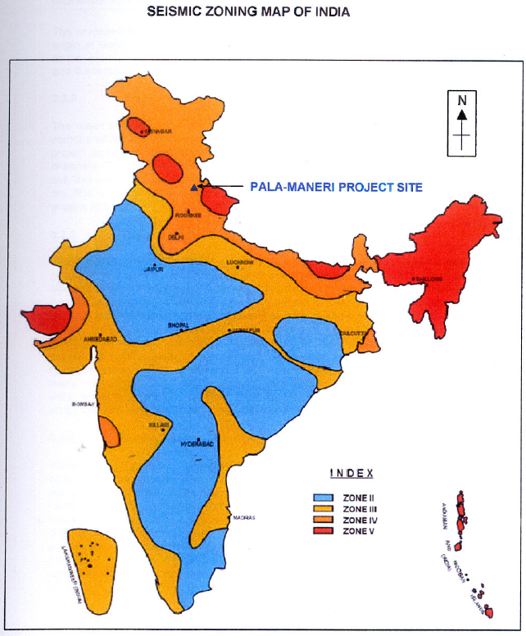
Source: Geological Survey of India

At Pala Dam Site the total catchment area is 3,667 sq.km, out of which 1,802 sq. km is snow fed and above the elevation of 4,900 m.

4.7.2 Water Use
The major uses of water are for agriculture, drinking and domestic purpose. The main sources of water are rivers and nallahs. These are used to meet the requirements in project as well as in study area. The water is conveyed to the consumer through open channels. The area has rainfed agriculture. Rainwater and snow are absorbed within the soil; this water percolates through soil and reappears in the form of spring. These springs are also used for water consumption. The flow of these springs increases during rainy season and decreases during winter and summer.

4.7.3 Ground Water
Groundwater regimes in Uttarakhand from Gangatic planes to Higher Himalayas are governed by varied meteorological and atmospheric cycles, earth’s three-dimensional features and its evolutionary factors (geological setup, geomorphologic evolution and its dynamics). Sources include recharge from rainfall, snowmelt in Lesser Himalayas, snow, ice and glacial melts in Greater Himalayas and influent surface waters (rivers, lakes, canals, man-made reservoirs etc.). On an average percolation of 15 to 25% of the precipitation into the ground is expected, while the remaining water flows overland depending upon slopes, nature of soil, vegetation and anthropogenic activities. The interconnectivity of the porosity patterns allows water to migrate from a few meters to many kilometers in depth in the direction of gravity and rock inclinations. The percolating water tends to be trapped or accumulated in natural reservoirs or aquifers and may flow along fractures, joints, cleavage, schistose and dislocating planes in rocks.

4.7.4 Water Quality
Water quality can be expressed in terms of physical, chemical and biological characterization of water. Essential characteristics like pH, total hardness, Iron, Chlorides are covered in physical analysis. Dissolved solids, Calcium, Magnesium, Sulphates, Nitrate and Fluoride are chemical parameters to be analysed as per BIS. In order to collect baseline data on the existing water quality, raw water samples were collected from 6 different locations on the river (five samples upstream of the dam and one near the powerhouse location) representing the complete catchment area and analyzed as per the procedure specified in standard methods for examination of water and wastewater. The results of the physio-chemical analysis are summarized in the Table-4.7. The test results when compared with Table-2.3 “Tolerance Limits for Inland Surface Water Quality” show that water in the river is suitable for all kinds of its designated use namely; (A): drinking water source without conventional treatment but after disinfection, (B): outdoor bathing, (C): drinking water source with conventional treatment followed by disinfection, (D): propagation of wildlife and fisheries and (E): irrigation, industrial cooling and controlled waste disposal.
It is observed from the test results that BOD of all the samples is well within permissible limits of drinking water, which indicates the absence of organic pollution loading. This is mainly due to low population density and absence of industrial activities in the catchment. The iron content of all the samples is above the permissible limits (i.e. 0.3 mg/l). This may be due to the soils rich in iron or dissolution of ferrous minerals. The higher presence of DO is due to the cascading effect of the river and less polluting organic matter. From the above results it could be concluded that surface water at the site is fit for human consumption after preliminary treatment like chlorination and sedimentation. Central Pollution Central Board has established one water quality monitoring station near Gangotri on river Bhagirathi. The results so obtained are summarized in Table-4.8. The coliform counts are high and indicates the contamination of river water from fecal sources.

4.8 METEOROLOGY AND AIR ENVIRONMENT
Meteorology is an important parameter in environmental impact assessment exercise. It is responsible for the movement of air and air pollutants. The main parameters are: temperature, humidity, rainfall, winds and cloud cover. The meteorology and air environment of the area are discussed in subsequent sections.

4.8.1 Meteorology
There is wide variation in altitude in District Uttarkashi and so are the meteorological conditions, which determine the weather. There exist three distinct types of climate zones in the district. Southwest portion of the district has Tropical Sub-Mountain type climate, in which the months of May and June are quite hot. The northern and northeastern regions of the district have perpetual snow. The remaining intervening area (between altitude of 2000 m to 4000 m) has a climate of typical temperate zone, having pleasant summers and extremely cold winters. The climate of the project area is generally temperate and varies with elevation. It is warm in summer, humid in monsoon and cold in winter months. The winter season starts from November and lasts till end of March. The months of May and June are normally the hottest part of the year. Mean maximum and minimum temperatures in the area have been observed about 32oC and –2oC respectively. December and January are coldest in which the temperature falls below freezing point.
Rainfall. Average annual rainfall in the area is reported 1238 mm. The rainfall during the months of July and August constitute nearly 50% of the annual rainfall. Humidity: Humidity is generally low throughout the year, which is around 40% except monsoon, when it touches 90%. Cloud cover: The sky is generally cloudy during monsoon. Short spells of winter months are also clouded when the area comes under the influence of western disturbances. Winds: The winds are mostly light and changes with altitudes and location due to hilly topography.

4.8.2 Air Quality
Sampling Stations; the ambient air quality within the study area of 10 Kms radius from the barrage site forms the baseline information. The study area is rural in nature and there is no industry or urban settlements. The primary sources of air pollution in the area are vehicular emissions, domestic fuel burning and dust from roads/ fields. The prime objective of collecting baseline air quality data is to assess the air quality of the area during preproject conditions. The ambient status of three major air pollutants viz. suspended particulate matter (SPM); sulphur dioxide (SO2) and oxides of nitrogen (NOx) representing the quality of pollution level have been assessed. Three Ambient Air Quality Monitoring (AAQM) stations at following locations were selected for sampling. These locations are
- Near dam site at Pala
- Colony site at Bhatwari
- Powerhouse site at Aungi

Frequency; The ambient air quality monitoring has been carried out for three seasons namely; summer, winter and post-monsoon season, in each season for four consecutive weeks and two samples in a week.

Methodology; Respirable Dust Sampler APM – 451 of Enviro-Tech Instruments have been used for sampling and analyzing suspended particulate matter (SPM), Sulphur Dioxide (SO2) and Nitrogen Oxides (NOx). The SPM are collected through filter paper. A nozzle is fitted on suction side of the blower to pass the gas through impengers used to absorb SO2 and NOx. The SPM have been estimated by gravimetric method. Modified West and Galke Method (IS-5182 Part II, 1962) have been used for SO2 analysis while Jacobs Hochheiser Method (IS-5182 Part II, 1975) has been adopted for NOx analysis. Results; The summary of results of monitoring are tabulated in Table-4.9. The air quality monitoring results show that concentration of any of the three pollutant, at any of the three locations, during any time (among three different seasons) have not exceeded the concentration limits of these pollutants specified by CPCB for residential area. Further the presence of gaseous pollutants is either below detectable limits or very low which shows existence of very good quality air in the project area. The ambient air quality criteria laid down by CPCB has been given in Table-4.10.

Table-4.7 Surface Water Quality In Project Area
Parameter | Harsil |  |  | D/s of Sonagad junction |  |  | Gangnani |  |  | Pala |  |  | Aungi |  |  | Bhatwari
 | I | II | III | I | II | III | I | II | III | I | II | III | I | II | III | I | II | III
pH Value | 8.01 | 7.5 | 7.54 | 7.80 | 7.45 | 7.42 | 7.98 | 7.47 | 7.24 | 7.95 | 7.36 | 6.75 | 8.00 | 7.25 | 7.32 | 7.54 | 7.47 | 6.86
Chlorides (as Cl) (mg/l) | 4.00 | 4.0 | 3.89 | 4.00 | 3.99 | 3.84 | 4.00 | 3.99 | 3.98 | 4.00 | 3.99 | 3.9 | 4.00 | 3.99 | 3.99 | 3.45 | 3.99 | 3.99
Sulphates (as SO4) (mg/l) | 21.9 | 29.4 | 28.14 | 27.59 | 6 | 6.5 | 19.71 | 21.42 | 20.86 | 23.00 | 18.62 | 6.9 | 13.03 | 18.02 | 24.33 | 18.02 | 18.32 | 1.8
Phosphates (as PO4) (mg/l) | 0.19 | <0.003 | <0.003 | 0.21 | <0.003 | <0.003 | 0.29 | <0.003 | <0.003 | 0.32 | <0.003 | <0.003 | 0.21 | <0.003 | <0.003 | <0.003 | <0.003 | <0.003
Total Iron (as Fe) (mg/l) | 0.97 | 0.46 | 0.54 | 0.71 | 0.1 | 0.15 | 0.86 | 0.31 | 0.35 | 0.74 | 0.023 | 0.078 | 0.71 | 0.023 | 2.3 | 0.385 | 0.312 | 0.19
Dissolved Oxygen (mg/l) | 7.60 | 7.2 | 7.23 | 7.20 | 7.1 | 7.32 | 7.40 | 7.3 | 6.85 | 7.85 | 7.5 | 9.1 | 7.60 | 7.6 | 8 | 8.24 | 7.3 | 9
Total Suspended Solids (mg/l) | 40.0 | 15.49 | 18.23 | 27.00 | 12.3 | 14.56 | 63.60 | 5.6 | 6.23 | 65.20 | 8.29 | 0.59 | 59.00 | 4.9 | 26.6 | 6.2 | 7.1 | 0.89
Total Dissolved Solids (mg/l) | 72.8 | 125.19 | 99.19 | 82.39 | 67.97 | 69.52 | 75.15 | 112.6 | 110.65 | 74.69 | 102 | 78.2 | 65.32 | 107.8 | 93.23 | 158.2 | 108.4 | 45.01
Calcium (as Ca) (mg/l) | 14.5 | 55.94 | 44.52 | 14.41 | 35.96 | 34.56 | 14.41 | 35.96 | 34.54 | 14.41 | 43.95 | 35.96 | 14.41 | 51.94 | 31.97 | 53.12 | 51.94 | 15.98
Magnesium (as Mg) (mg/l) | 5.9 | 51.94 | 48.26 | 7.77 | 27.97 | 25.86 | 5.80 | 43.95 | 44.32 | 4.90 | 31.96 | 42.24 | 4.86 | 27.97 | 31.97 | 20.14 | 15.98 | 23.98
Total Alkalinity (mg/l) | 16.0 | 35.96 | 35.96 | 39.96 | 35.96 | 36.12 | 39.96 | 35.96 | 36.45 | 35.96 | 39.96 | 35.96 | 35.96 | 43.95 | 35.96 | 35.62 | 43.95 | 19.98
Nitrates (as NO3) (mg/l) | 2.10 | 0.05 | 0.15 | 4.00 | 0.1 | 0.15 | 3.13 | 0.05 | 0.056 | 2.30 | 0.16 | 1.64 | 2.90 | 0.98 | 1.64 | 0.198 | 0.218 | 1.09
BOD 3 days at 27°C (mg/l) | 0.90 | <2 | <2 | 1.80 | <2 | <2 | 1.95 | <2 | <2 | 2.00 | <2 | <2 | 1.10 | <2 | <2 | <2 | <2 | <2
Fluorides (as F) (mg/l) | 0.55 | 0.24 | 0.26 | 0.29 | 0.5 | 0.56 | 0.20 | 0.28 | 0.25 | 0.22 | 0.279 | 0.87 | 0.36 | 0.31 | 0.45 | 0.154 | 0.167 | 0.15
Source : EIA report of Project
I pertains to summer season study
II pertains to post-monsoon season study
III pertains to winter season

Table-4.8 Water Quality In Bhagirathi Near Gangotri

S. NO. | PARAMETER | VALUE
1 | pH | 7.8
2 | Total dissolved Solids (mg/l) | 54
3 | Hardness (mg/l) | 30
4 | Dissolved Oxygen (mg/l | 10.2
5 | Biological Oxygen Demand(mg/l) | 1.0
6 | Chemical Oxygen Demand (mg/l) | 4.0
7 | Nitrites + Nitrates (mg/l) | 0.013
8 | Sodium (mg/l) | 4.0
9 | Total Kjeldahe Nitrogen (mg/l) | 1.6
10 | Total Alkalinity (mg/l) | 8
11 | Sulphates (mg/l) | 1.6
12 | Calcium (mg/l) | 5
13 | Magnesium (mg/l) | 30
14 | Chlorides (mg/l) | 10
15 | Fecal Coliforms (MPH/ 100ml) | 377
16 | Total Coliforms (MPH/ 100 ml) | 17,500
Source: MINARS/21/2002-03. CPCB

Table-4.9 Summary Of Ambient Air Quality
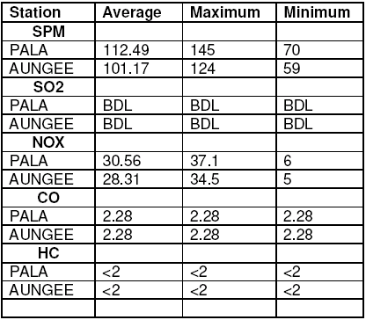
Source: EIA Report pala Maneri

Table-4.10 Ambient Status of Air Quality
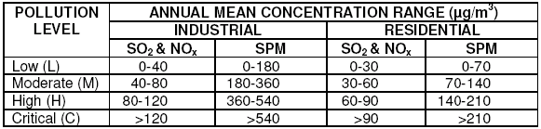
Source: CPCB

4.9 NOISE ENVIRONMENT
Noise levels have been measured at dam site, powerhouse site and colony site during three different seasons. The observations were recorded in the morning (8:00hrs to 10:15 hrs), afternoon (12:00 hrs to 14:15 hrs) and evening (16:00 hrs to 18:15 hrs). The results of observations indicate that noise levels at all the three sites exceeded the limit prescribed for residential area (55 dBA) only 10 percent of the time, otherwise it remained below 55 dBA. During site visits it is noticed that the main source of noise in the project area (10 km radius) is due to the flow of water in the river and the noise level at any point in the area is inversely proportional to its distance from the river. The other secondary sources of noise are occasional movement of vehicle on the road along the riverside and wind blowing. The area is otherwise calm and quite.

4.10 ECOLOGY

4.10.1 Vegetation
The major vegetation of the project area is forest. The major forest category observed in the project area is Western Himalayan Mixed Coniferous forest. The elevation within the study area ranges from 1400 m to 1800 m. The major vegetation of the project area i.e. from Aungi to Gangnani could be classified into various groups as given in Table-4.12.

Table-4.11 Vegetation Types In The Project Area And Its Surroundings
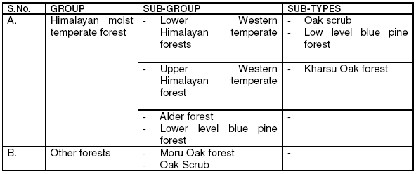
Source: EIA Report Pala Maneri

4.10.2 Aquatic Ecology
The phytoplankton and zooplankton populations determine the productivity of a water body. Primary productivity is an important indicator of pollution level in any aquatic ecosystem. Fish production is dependent on production of zooplanktons which in turn is dependent on the phytoplankton production or primary productivity.
Planktons The occurrence of planktonic population in river Bhagirathi, like any other river, depends on local conditions, e.g. season, flow pattern, water quality, etc. The planktonic community in river Bhagirathi river water was studied by collecting the water samples from the three sites in June 2005 at village Pala, Bhatwari and Aungi. A total of 14 phytoplankton species were reported at the above three sampling locations.

4.11. SOCIO-ECONOMIC ASSESSMENT

4.11.1 GENERAL
The project shall involve mega construction activities for various components of the project like dam, silting chambers, headrace and tailrace tunnels, underground power house, project township and offices, and other infrastructure works. These activities shall necessitate acquisition of 82.002 ha land, out of which 21.239 ha is private agricultural, 21.883 ha is reserve forest, 31.648 ha is civil forest and the remaining 7.232 ha is owned by PWD. It is also observed that the project does not require acquisition of any built-up or homestead land. A part of the land required for the project has already been acquired by the then UP Irrigation department, whereas the remaining part need be acquired by UJVNL.
Expropriation of lands from current owners/users (private owners) may lead to loss of livelihood and economic loss for the project-affected families/people This land acquisition needs to be handled with utmost care and fore thought for issues relating to Resettlement and Rehabilitation of Project Affected Families. Such approach is more sensitive since the project area is remote, where majority of community comprises of marginal farmers and women. For successful implementation of the project it is necessary to cultivate a productive relationship between the project offices and the affected families. Besides the economic and social disturbance due to the land acquisition, the construction activities shall also mobilize construction agencies together with staff in the area, which may displace present economic activities within the area of impact of the project. The demographic changes during the construction period would stress, temporarily, the local environment and population. Finally operational staff shall settle down in the area to operate the project. In brief the project during construction as well as during operational period shall have a lasting impact over the demography and socio-economic structure of the persons in the project area. It shall bring positive and quantitative change in the habitat after commencing, but shall raise some stress during construction. This has raised voices of concern by public representatives at various platforms.
While implementing the project, there is a need to take into account these disturbances and losses due to the project, their impact on socio-economic condition of the people and plan for their mitigation measures to minimize any negative impacts. Governed by this consideration, an effort has been made in this chapter to; understand the socio-economic condition of the project area (Uttarkashi district) in general, and that of the project affected people in specific through a well-designed sample survey; get the opinion of project affected people/public through discussions and public hearing; analyze the impacts of the project; and finally to prepare a Resettlement, Rehabilitation Plan and Social Response Program.

4.11.2 SOCIO-ECONOMIC SURVEY
A Socio-Economic Survey (SES) was undertaken to study and understand the socio economic conditions of project-affected families/people and to examine the impact of the proposed project thereupon. For the purpose of Socio-Economic survey of the project affected people, these seven villages have been included. RITES carried out a sample socio-economic survey from 22nd to 27th April 2003 and from 9th to 11th February 2005. Village wise sample size of the socioeconomic survey is presented in Table-4.12. A sample of 56 households spread over seven villages was randomly selected for survey. As seen from the table, 45 households out of the total 142 (31.69%), whose land has been/is to be acquired for the project were surveyed. Other details about the project affected villages and families can be found in table no 4.13 to 4.20.

Table-4.12 Caste Wise Distribution Of Project Affected Families
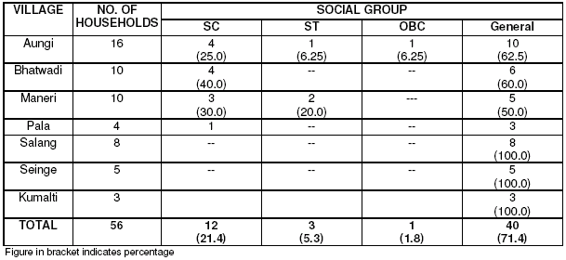
Source: EIA Report Pala Maneri
Table-4.13 Project Affected Families According To Occupation
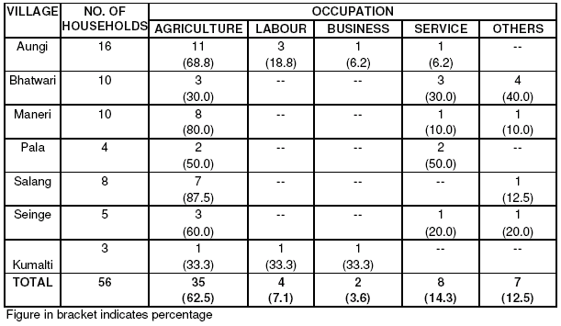
Source: EIA Report Pala Maneri

Table-4.14 Family Income Of Project Affected Families (Rs. Per Annum)
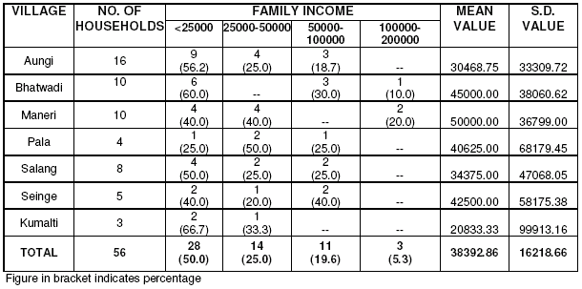
Source: EIA Report Pala Maneri

Table-4.15 Marital Status Of Project Affected People
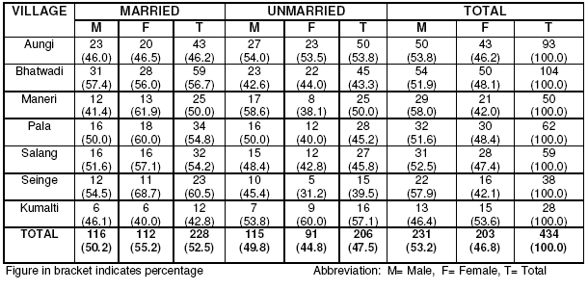
Source: EIA Report Pala Maneri

Table-4.16 Family Pattern Of Project Affected Families
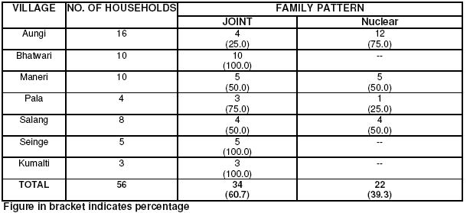
Source: EIA Report Pala Maneri

Table-4.17 Family Size Of Project Affected Families

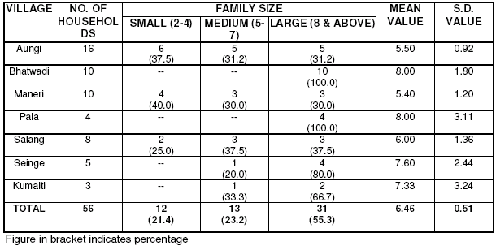
Source: EIA Report Pala Maneri

Table-4.18 Village Wise Distribution Of Land Holdings
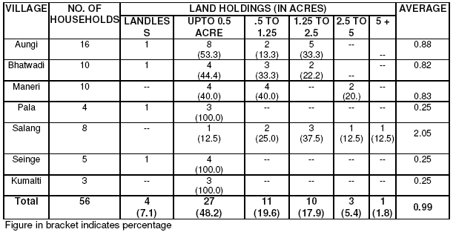
Source: EIA Report Pala Maneri
Table-4.19 Type Of House Of Project Affected Families
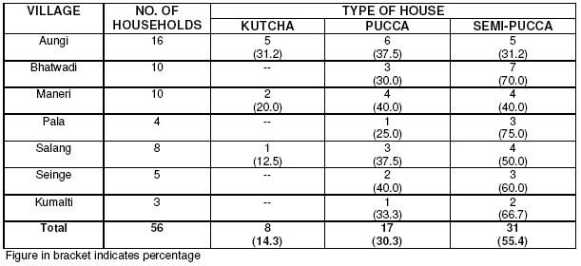
Source: EIA Report Pala Maneri

Table-4.20 Infrastructure Facilities In Project Affected Villages
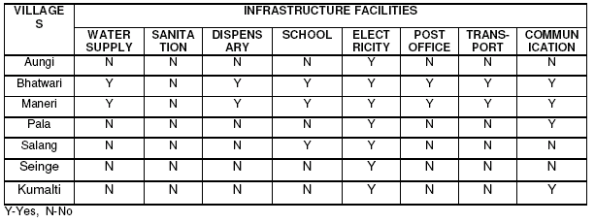

Source: EIA Report Pala Maneri

CHAPTER 5

ENVIRONMENTAL IMPACTS OF PALA MANERI HYDROELECTRIC PROJECT

5.1 GENERAL
In the process of development there has been intensive use of natural resources, very often leading to ecological imbalance. With rapid strides in economic development, the need for rationalizing the development has become imperative. In pursuance of the global goals of nature conservation and protection of environment, the union and state governments have initiated plans, schemes and actions to implement various legislation, the latest being the Environment (Protection) Act, 1986 with it’s amendments. In May 1994, MoEF had issued a notification on EIA for developmental projects. Schedule-I of this notification has a list of the projects, which need environmental clearance from MoEF. River valley projects (including hydropower) are included in this list.

5.2 IMPACT IDENTIFICATION
The environmental impact assessment process begins by identifying the development and operational activities resulting from the proposed project. Potential impacts due to the proposed hydroelectric project on the environment in different phases of the project cycle namely location, construction and operation have been identified. The type and magnitude of the impacts however, depend on the specific attributes of the given environment. As far as possible, attempts have been made to quantitatively predict the impacts due to the project. For non-quantitative impacts, qualitative assessment has been done. Potential impacts on environmental components due to the proposed
hydroelectric project activities have been summarized in Table-5.1. The impacts due to project location are generally irreversible and could be mitigated through environmental enhancement measures. Impacts related to construction are normally short term, which can be set-off by observing a simple set of precautionary measures.

Table-5.1 Potential Environmental Impacts Of The Project

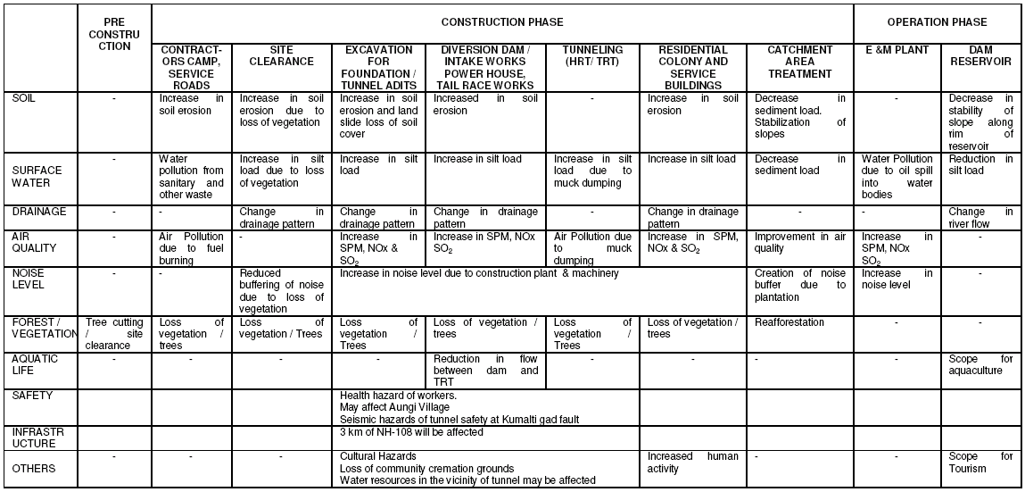
Source: EIA Report Pala Maneri

5.3 ENVIRONMENTAL IMPACTS
This section identifies and appraises various negative impacts likely to result from the proposed development, on environmental baseline conditions as reported in Chapter-4. Negative impacts likely to result from the proposed development on land, water, air, noise ecology and socio-economics have been listed under various phases of project cycle under the following headings:
- Impacts due to project location
- Impacts due to construction works, and
- Impacts due to project operation

5.3.1 IMPACTS DUE TO PROJECT LOCATION
The environmental impacts, which may take place due to location of the project, are as under:
- Loss of land / Change in land use,
- Encroachment into forest land/loss of forest produce,
- Encroachment into wildlife habitat/corridor,
- Loss of historical, cultural and religious monuments/structures,
- Loss of Infrastructure,
- Sediments,
- Disruption of hydrological balance,
- Risk due to earthquake,
- Risk due to geological fault and
- Environmental risks due to future developments.
- The impacts due to acquisition of land.

5.3.1.1 Loss of Land / Change in Land use
Permanent change in land use shall be due to construction/creation of various permanent features of the project on ground like; reservoir, dam structure, colony, office and other ancillary structures. However, some of the permanent features to be constructed underground like; powerhouse, headrace tunnel, tailrace tunnel etc would not affect any change in land use. Table -5.2 reports the land requirement along with its category for various facilities of the project. It is observed that out of the total 82.002 hectare permanent land requirement of the project, 53.53 ha is forest (21.883 ha reserve forest+ 31.648 ha civil forest), 21.239 ha is private land and the balance 7.232 ha pertains to PWD department. The project, however, does not require any built-up area.

Table-5.2 Permanent Land Requirement For The Project
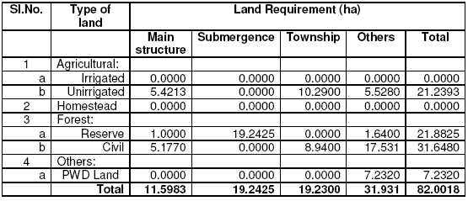
Source: land acquisition details of Pala Maneri project

5.3.1.2 Encroachment into Forest Land
The proposed project envisages acquisition of 53.53 hectares of forestland, out of which 19.243 hectare (in reserve forest area) would be submerged in the reservoir. Side slopes of the river valley from riverbed up to the submergence level (1,665m), at the proposed reservoir site are very steep as observed at site. Most of the area under
submergence on right bank of the river is barren having a few scattered trees, however, the number of trees on the left bank is comparatively more. In addition, during construction and operation of the project, there may be efforts to collect wood from nearby forest for various purposes legally or illegally, which can affect the forest.

5.3.1.3 Encroachment into Wildlife Habitat/Corridor
The project area of 10 km radius with barrage site as its center does not encroach into any wildlife sanctuary or any other type of nature reserve. No rare or endangered species of wildlife have been reported within the 10 km radius area. The project components i.e. dam, powerhouse, HRT etc. are located along the Rishi kesh-Gangotri Road, which has already pushed the wildlife for away from the project area. Villagers reported stray incidences of sighting wild animals like leopard, black bear, wild boar etc. in the area, which otherwise infest in deep jungles. There is no indication that the project area functions as a corridor for movement of wildlife. It could, therefore, be concluded that the project would not have any impact on the wildlife.

5.3.1.4 Loss of Historical, Cultural and Religious Monuments/Structures
No historical, religious or cultural monuments will be lost due to the project location or its activities. People residing in the Bhagirathi valley normally have their community cremation grounds located on the banks of this holy river. Cremation grounds of village Pala, Salang, and Thrang are likely to be affected due to the dam construction and creation of the reservoir.

5.3.1.5 Loss of Infrastructure
Infrastructure comprises of schools, hospitals, establishments, communication, post offices, community resources, etc. There is no house or structure coming under submergence. However about 2.5 km length of national highway no. 108 (Rishikesh – Gangotri road) would be affected due to the project location.

5.3.1.6 Sediments
Sediments carried by the catchment runoff into the reservoir if not settled down before entering the HRT, may damage the parts of the turbine coming into contact with the flow of water. The sediments, which settle down in the reservoir, reduce the capacity of the reservoir gradually and finally determine the useful life of the project. Sedimentation is a function of the soil erosion rates and delivery ratio of the catchment area.

5.3.1.7 Disruption of Hydrological Balance
The flow of water in about 16 km long stretch of the river, downstream of the dam site, would be affected due to the construction of dam. Minimum discharge (90% availability) in the river at dam site has been reported as 18 cumec in the winters. It is observed during site inspection that water is not drawn from the affected portion of the river (between dam site and tailrace tunnel) for irrigation or any kind of industrial use. The people residing in the nearby locality rarely use it for washing, bathing etc. Its use for drinking is seldom as other more convenient sources of water in the form of springs/perennial streams having better quality (with lesser sediment load) is available to the people and animals.
The first major perennial stream named Papar Gad joins the river about two km downstream of the dam site, another two big perennial streams named Nahar Gad and Jalang Gad joins the river within next two kilometer. The most affected stretch of the river thus, will be from downstream of dam up to the confluence of Papar Gad. Reduction of flow in this particular stretch of the river is not going to cause any disruption of water supply for any purpose because water is not drawn from this stretch of river for any kind of use. Mitigation measures has, however, been proposed to maintain minimum flow in the river to sustain the aquatic life.

5.3.1.8 Risk due to Earthquake
The project area falls in zone IV of the Indian Standard Seismic Map and quite sensitive from seismic point of view. For safety of the structures, necessary factors and appropriate co-efficient have to be incorporated in designing the structures under worst combination of forces. Provided with the appropriate design of the dam, tunnel and other structures of the scheme, the risk due to earthquake can be minimized to desired limits. With the available experience, it has been scientifically established that dams, using modern methods of design and construction can safely withstand high intensity earthquakes. The experience of tunneling in Maneri-Bhali stage I & II schemes and other Himalayan region projects of similar nature would provide important data in this aspect.

5.3.1.9 Risk due to Geological Fault
The headrace tunnel alignment crosses one major geological fault at Kumalti Gad, which poses potential risk to the headrace tunnel during construction as well as operation. Earthquakes will cause displacement- horizontal, vertical, or combined- at the causative fault, with the result that the use of the tunnel may be impaired or lost. A tunnel that crosses an active fault is almost liable to be ruptured along the fault plane and part of the fault zone for any major earthquake on the fault. In addition any lining probably will be heavily damaged for certain length adjacent to the rupture. The design objectives in this area therefore, must be to accommodate as much movement as practical to minimize the risk of damage

5.3.1.10 Environmental Risks due to Future Developments
The projects on its completion would create conditions favorable for setting up of new industries in the surrounding areas, which could accelerate the process of deforestation and have other negative impacts on the environment.

5.3.2 IMPACTS DUE TO PROJECT CONSTRUCTION
Although environmental hazards related to construction works are mostly temporary in nature, this does not mean that these should be given less importance. Appropriate measures need to be included in the work plan and budgeted for. The most likely hazards related to the construction works are:
- Increased Soil Erosion at Construction Sites,
- Muck Generation from Tunneling Operation
- Transportation of Construction Material,
- Health Risks,
- Cultural Hazards,
- Air and Noise Pollution,
- Water Pollution,
- Quarry Operations on Ground and in Riverbed,
- Impact of Tunneling on Surface and Groundwater Sources,
- Vibrations due to blasting for Underground Powerhouse Construction Below Village Aungi, and
- Safety Hazards of Tunnel Construction.

5.3.2.1 Increased Soil Erosion at Construction Sites
Any groundbreaking activity for construction works, whether permanent or temporary, would require removal of vegetation cover from ground. Runoff from unprotected excavated areas, muck disposal sites, quarry sites, etc., would result in increased soil erosion. Excavations on slopes would also decrease its stability. Given with the topography of the area, unprotected excavations on sloping grounds will make landslide prone sites, especially during the rainy season. Excessive soil erosion and mass movement of soil is likely to disrupt the natural drainage, which can lead to impounding of runoff in dangerous preposition.

5.3.2.2 Muck Generation from Tunneling Operation
About 2.33 million cum of muck would be generated from tunneling operation, which need be disposed in nearby area. Muck disposal sites shall present large surfaces with loose soil liable to erosion. Availability of flat area having suitable approach for muck disposal is very limited due to the topography, which means that the muck disposal sites will have to be located on sloping grounds. The disposal sites, if not designed properly may cause mass movement of soil blocking the natural drainage and causing other sequential problems.

5.3.2.3 Transportation of Muck and Construction Material
As mentioned in previous paragraph, 2.33 million cum of muck will have to be transported from tunnels to the dumping site. Considering that one dumper trip carries 6 cum muck and the tunnel excavation is completed in four years, each having 250 working days, there would be about 388 dumper trips every working day. The project construction would require about 4.08 lakh cum of fine aggregate, 8.16 lakh cum of coarse aggregate and 0.96 lakh cum of stone for which stone would have to be transported from quarry site/source to the stone crusher and further from crusher to various construction sites. Transportation of this material would add SPM and other vehicular pollutants to the local air shed. In addition, about 3.141-lakh tone of cement, 25,730 tone of steel, 205 lakh litre of P.O.L ,and electrical /mechanical equipment will have to be transported from the nearest railhead at Rishikesh. Transportation of the construction material from Rishikesh to the project site would put immense pressure on the Rishikesh-Gangotri road and reduce its service life. The increased traffic on this road would also increase air pollutions though; the same would disperse in the vast volumes of available clean background air not having any noticeable impact on the air quality along this route.

5.3.2.4 Health Risk
Health risk during construction phase of the dam and other works, include disease hazards due to lack of sanitation (water supply and human waste disposal), vector borne disease and hazards due to local carriers. Therefore, mitigation measure must include the proper sanitation, health care and human waste disposal facilities. Sanitation facilities are included in the project estimate to take care of cost towards human waste disposal facility.

5.3.2.5 Cultural Hazards
The district of Uttarakhandhas its unique culture. People of this area have distinct habits of food and clothing. They have deep religious faiths and celebrate their festivals with great enthusiasm. During construction phase of the dam and other works, problems could arise due to difference in customs of outside workers and local residents. These can be avoided by providing adequate facilities in workers camp and by employing the local labour.

5.3.2.6 Air Pollution
Consumption of fuel in construction activities and movement of construction vehicles will be the principal cause of increase in air pollution. Diesel powered trucks used for the haulage of construction material and running of construction machinery at the construction sites are the sources of air pollution. The data on fuel utilization rates of the units expected to be in operation during the construction are provided in Table-5.3.

Table-5.3 Fuel Consumption Rates For Construction Machinery
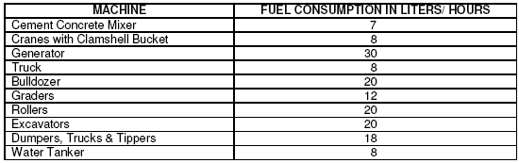
Source: EIA Repoer Pala Maneri

About 8.16 lakh cum of coarse aggregate would have to be produced by crushing the rock/boulders, which would require three crusher working for 10-12 hours a day during the peak construction period. Operation of the stone crushers would add noise and air pollution to the local air shed. Background concentration of air pollutants, as reported in Chapter – 4, is very low. The increase in concentration of air pollutants during construction would be of temporary nature and would remain well within the prescribed limits. The project is unlikely to cause any kind of air pollution during operation. It is, therefore, considered that the project will not cause any air pollution of significance. With the background concentrations of SPM, SO2 and NOx, the pollutant concentration in ambient air is anticipated as 58.40μg/m3, 1.60 μg/m3 and 6.20μg/m3 respectively. The scenario for air pollution without project and with project during construction period (for mobile & stationary sources) is modeled for winter season and is given in Table-5.4. During operation phase, there is no activity contributing to air pollution.

Table-5.4 Expected Air Pollution During Construction Period
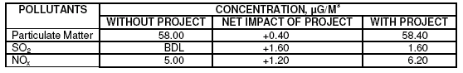
Source: EIA Report Pala maneri

5.3.2.7 Noise Pollution
The major sources of noise pollution during construction are movement of vehicles for transportation of construction material to the construction yard and the noise generating activity at the yard itself. The primary noise generating activities at construction yards can be:
- Blasting & Drilling,
- Concreting & Mixing,
- Casting and Material movement.
Expected noise levels due to operation of various construction machinery at site are indicated in Table-5.5

Table-36 Typical Noise Levels Of Construction Equipments
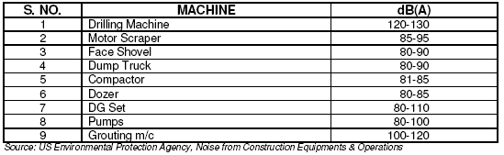

As seen from the above table, construction activities are expected to produce noise levels at source in the range of 80-130 dB (A), which will decrease with increase in distance. The construction works will be carried out during the day time. The impact of noise produced during the construction will, however, be limited to a distance of about 50 to 200 meters at which the noise level of various equipment will come down below 55 dB (A). It could therefore be concluded that the construction activities would not have a significant impact on existing ambient noise levels. Due to the high noise levels of construction machinery, the personnel operating the machines and the workers stationed close to the machines are prone to exposure of high levels of noise.

5.3.2.8 Water Pollution and Quality
The major sources of water pollution during construction phase are due to discharge of sewage from labour camps/ colonies. The duration of construction will be about 4.41 years. In all about 2,000 people will be staying at site during peak period of construction. The water supply will be about 70 liters per capita per day. The total sewage production will be about 0.80 x 70x2000 = 112 m3/ day. The BOD load contributed by the domestic sewage will be about 34-kg/ day. The sewage from workers camp and other establishments need be treated before its final disposal.

5.3.2.9 Quarry Operation on Ground and in River Bed
The project would require about 9.12 lakh cum of stone/river boulder to fulfill the requirement of coarse aggregate and stone for construction, which shall be met from stone quarries, selected rocks from excavation material and boulders from riverbed. In addition, about 4.08 lakh cum of sand from riverbed shall be collected and used as fine aggregate. Excavation on hill slope shall have its impact on the stability of slope, whereas excavation in riverbed shall increase the turbidity if water temporarily.

5.3.2.10 Impact of Tunneling on Surface and Groundwater Resources
Tunneling work could result in ruptures in the overburden layers, through which water may leak into the tunnel during construction. The water leakage could result in drying of the groundwater source i.e. springs falling in the tunnel influence zone and channels crossing the tunnel alignment. The leakage may also result in lowering down of the ground water table in the tunnel influence zone. Water resources of Pala, Siri, Raithal, Doari, Gorsali, Jokani, Jakhol, Manjgaon and Aungi, which fall in the vicinity of the tunnel alignment, may be affected. It would be pertinent to mention here that water leakage into the tunnel from overburden can occur only during the construction period until the lining is done. However, after concrete lining there would not be any chances of leakage into the tunnel and hence on ground water resources.

5.3.2.11 Vibrations due to Blasting for Underground Powerhouse Construction below Aungi Village
The powerhouse of the project is proposed to be located underground right below Aungi village at a depth of about 250 to 300 meters. Underground blasting operation for the construction of the powerhouse would generate vibrations, which shall travel towards the ground surface and may have its impact on the house/structures. The past experience has shown that these vibrations are observed up to 100 m in case of controlled blasting. People are concerned about the safety of structures in Aungi village. Stability analysis is recommended to avoid the problem.

5.3.2.12 Safety Hazards of Tunnel Construction
At one time, tunnel accidents claimed one life for every half mile of tunnel constructed. Increased concern over tunnel construction safety has led to improvements in the miner’s working conditions, with a subsequent reduction in the frequency of death and disabling accidents. However, accidents still occur at more than twice the frequency for underground workers compared with other construction workers, and three times the rate for manufacturing workers. Approximately the same ratio applies to fatalities. Obviously there is a need for more care in the underground works. The major causes of these accidents are; Uncontrolled contact between personnel and material or equipment; Failure of temporary structure; Inherent construction hazard such as use of explosives and unsafe practices or carelessness by individual workers.

5.3.3 IMPACTS DUE TO PROJECT OPERATION
The impacts due to project operation shall be long term and can be both positive and negative in nature. The positive impacts are discussed in para 5.7. The negative impacts could be:
- Reservoir Evaporation Losses,
- Deforestation,
- Change in Water Quality and Risk of Eutrophication,
- Increased Incidence of Water Borne Diseases,
- Impact on Aquatic Life and Fish Migration and
- Public Health Facilities
- Impact due to Dam Break (Failure)

5.3.3.1 Reservoir Evaporation Losses
Reservoir evaporation losses are worked out using Pan Evaporation equation for the available data of site nearest to the project site. Average Pan Evaporation loss is calculated from this data and converted into monthly evaporation losses. Maximum monthly evaporation is considered in each season and total evaporation loss over the year is calculated per unit area. Evaporation losses from the submergence area are computed by using the mean surface area between FRL and MDDL and multiplying it by evaporation loss/unit area calculated. Based on above, the evaporation loss at project site is computed about 4mm/day (average). The total evaporation losses will be about 0.20 M m3/ year, which is equal to 4.2% of the total storage capacity of the reservoir. In this particular case, keeping in view the very small area of reservoir, evaporation losses become insignificant.

5.3.3.2 Deforestation
The improved access to the project sites will open an avenue to encroachers for illegally entering in to the forests, which are currently pristine. Increased human activity in the area will increase the biotic pressure on the forest.

5.3.3.3 Change in Water Quality and Risk of Eutrophication
Eutrophication results from excessive levels of nutrients (Phosphorous and nitrogen compounds). It may lead to excessive algal growth, including that of blue green algae, which are obnoxious. Most of the mathematical models use Phosphorous as the limited parameter for impact prediction. When nitrogen compounds are the limiting factor, blue green algae, which can fix nitrogen from the atmosphere could be dominating. The change in water quality due to leached soil nutrient and runoff sediment may lead to eutrophication of surface waters. The eutrophication is mainly due to the presence of nutrients such as nitrate and phosphate. Phosphate concentrations above 0.1 mg/l give
rise to eutrophication. Analysis of water samples shows phosphate concentration lower than 0.1 mg/l hence, possibility of eutrophication is not envisaged in the reservoir.

5.3.3.4 Increased Incidence of Water Related Diseases
The factors enhancing the proliferation of water related diseases are vectors and pathogens. Stagnant water and vegetation provide favorable breeding places for vector life such as mosquito and snails. Regular testing of reservoir water for these factors would be required for prevention & control of water borne diseases. Additional health facilities will improve the future status. However, field survey showed that the typical vector borne diseases are not common in the project area.

5.3.3.5 Impact on Aquatic Life and Fish Migration
A very small population of fish has been reported in the river water. The construction of dam will create a barrier in the natural flow of water and movement of river fish species. Since the upstream and downstream dams of the proposed dam have no provision of fish ladder, provision of a fish ladder in the dam structure would not be of much help. Instead, alternative measures would have to be adopted. Fish spawning in flowing water depends on the velocity of water as under (Table 5.6):

Table-5.6: Spawning Features
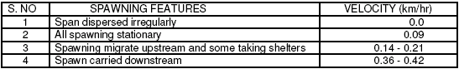
Source: EIA Pala Maneri
Due to very steep bed slope, velocity of flow in river Bhagirathi is higher than 0.42 km/hr in all the seasons hence no spawning habitat for fish is found in the river. Other aquatic life available in the river water is likely to flourish in the reservoir.

5.3.3.6 Public Health Facilities
Public health facilities, such as water supply and sanitation are much needed at colony, powerhouse and dam site. In all about 70 residential quarters are likely to be constructed for operation of the project/ in the colony. Domestic water requirements @ 135 liters/capita/day: assuming 4 persons per family for 70 units works out to 37,800 lpd say, 38 cum per day. Adding the water requirement for 70 person in office @ 70liter/person, the total requirement of water during operation works out to about 0.043 mld, which could be met with the water from springs and the river using pumping arrangements. However, the water need be treated for removal of iron and magnesium and disinfected before use.

5.3.3.7 Impact due to Dam Break
Dam break is partial or catastrophic failure of a dam leading to the uncontrolled release of water causing severe damages to the lives and properties situated downstream. The effect of such a flood disaster can be mitigated to a great extent, if the resultant magnitude of flood peak and its time of arrival at different locations downstream of the
dam can be estimated, facilitating planning of the emergency action measures. This warrants dam break modeling, which assesses the flood hydrograph of discharge from the dam breach and maximum water level at different locations of the river downstream of the dam due to propagation of flood waves along with their time of occurrence. Appreciating the need for evolving an effective and efficient disaster management plan in the unlikely event of failure of the dam, a dam break analysis has been carried out by the project proponent and submitted in a separate volume.

5.4 POSITIVE IMPACTS
The proposed hydropower project has both positive and negative impacts. The positive impacts have been listed under the following headings:
- Employment Opportunities,
- Recreation and Tourism Potential,
- Better Water Supply,
- Additional Habitat for Aquatic Life,
- Fisheries and Aqua-Culture Potential,
- Benefits to Economy
- Reduction in Air Pollution, and
- Reduction in Greenhouse Gas (Carbon Dioxide) Emission.

5.4.1 Employment Opportunities
The project will provide short and long term employment opportunities. Construction of the project is likely to be completed in 54 months, during which manpower will be needed to take part in various project activities. About 2000 persons are likely to work during peak construction period. In operation phase, about 70 persons will be deployed for operation and maintenance of the project. This employment will be at all levels starting from unskilled worker to plant operator and administrator. The project construction would also require indirectly related support services, which shall accelerate business and commercial activities in and around the project area and provide substantial indirect employment to the people. Thus the project would provide substantial direct as well as indirect employment in general and to the local people in specific.

5.4.2 Recreation and Tourism Potential
Tourism has the potential of contributing significantly to the economy of any region. Therefore, development projects ought to be scanned for the possibility of recreation and tourism, which needs to be exploited to the fullest extent possible. The proposed dam will be located by the side of the road from Uttrarkashi to Gangotri. Tourist places like Gangotri, Gaumukh, Harsil, Gangnani and Uttarkashi are all along the valley of river Bhagirathi in district Uttarkashi. Location of the project reservoir is ideally suited for development of a recreational center for the tourists/pilgrims enroute to Gangotri, which should be given due consideration.

5.4.3 Better Water Supply
Water contributes directly or indirectly to all aspects of development. Beyond meeting the basic needs, water contributes to human welfare through its role as a basic element of social and economic infrastructure. The construction of the dam will enhance the water supply prospects of the area and enhance better personal hygiene and other domestic purposes ultimately leading to better human welfare. Expansion of industrial and agricultural activity will receive a boost as a result of this project. Improvement in water supply and sanitary condition will help in controlling diseases and improving living conditions.

5.4.4 Additional Habitat for Aquatic Wildlife
Increase in the area covered with water surface will create additional habitat for aquatic wildlife especially in or near the reservoir. This will also provide breading habitat for resident species.

5.4.5 Fisheries and Aquaculture Potential
Fisheries are subjected to a wide variety of positive environmental impacts. The reservoir of dam will create potential for fisheries. Fish production in reservoir depends upon several parameters such as dissolved oxygen, nutrients and average water depth. The average fish production would be about 21 kg/ha or 380 kg/year. Economically, this small fish production will not be viable for commercial exploitation.

5.4.6 Less Fuel Consumption
The project capacity is 480MW and it would generate 1860.1GWh power annually on 90% dependability. In no project scenario, in order to generate this power by thermal power plant, about 1.97milion tones of coal would be utilized. With the implementation of this project equal amount of coal is saved. Specific fuel consumption has been taken as 1.06Kg/ Kwh. This will directly benefit to the tune of Rs.3,940 million per year.

5.4.7 Reduction in Air Pollution
The major pollutants that define the ambient air quality are: Suspended Particulate matter, Sulphur dioxide, and Nitrogen oxides. In addition to the above pollution, unburnt products like aldehydes, acetaldehyde and smoke are byproducts of emissions. With the existing system of no hydropower scenario, the total estimated pollution load to install 480MW thermal power plant is 13800 tones per year. The details are reported in Table-5.7. Due to excess air there is no emission of Carbon monoxide however carbon dioxide is emitted from the stack.

Table 5.7 Estimated Pollution Load (Tones/Year)
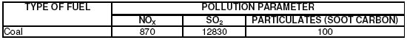

5.4.8 Reduction in Greenhouse Gas (Carbon Dioxide) Emission
The emissions of carbon dioxide depend on quality of coal, combustion characteristics and excess air available in the combustion. The CO2 production varies from 2800 ton/MW/year to 6000 ton/MW/year. We have assumed about 997gm/kwh emission factor for CO2 generation (based on CPCB study). About 1.854 million ton of CO2 will be emitted from 480MW coal fired thermal power plant. With the construction of proposed hydropower plant equal amount will be eliminated. This will reduce 1.854 million tones of green house gas contribution to the global environment every year. The cumulative reduction in Green House gas (CO2) in the taking 70 years lifetime of the project thus works out to 129.78 million tones. The other indirect benefits of a hydropower project over thermal one are reduction in water pollution, noise pollution, thermal, fly-ash and health effects in and around the area.

5.5 CHECKLIST OF IMPACTS
Based on negative and positive impacts a screening checklist of environmental impacts has been prepared and presented in Table-5.8. Environmental impacts at various stages of the project e.g. location, construction and operation are listed and the degree of environmental impact is shown. The terms none, minor, medium and major are used in the checklist to classify the magnitude of impact. In the checklist, the location, construction and operation phases have been considered separately in order to distinguish the short term and long term impacts. It should be noted that identification given in the checklist relates to the level of impact, assuming that no negative impact mitigation measure or benefit enhancement are adopted.

Table-5.8 Checklist Of Impacts Due To The Project
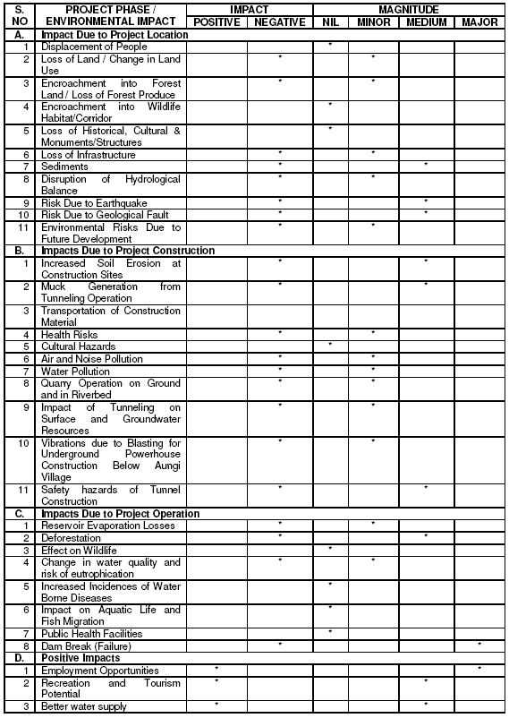
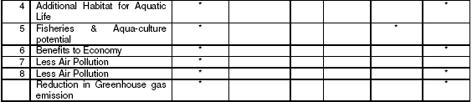

Source: EIA Pala Maneri

CHAPTER 6

MITIGATION MEASURES

6.1 GENERAL:
Based on planned project activities, environmental baseline conditions and the impacts assessed, a set of measures to be taken during implementation and operation, to eliminate or avoid/ offset adverse environmental impacts or to reduce them to acceptable levels, together with the action which need be taken to implement them. A disaster management plan in case of the dam failure also makes part of this chapter. The Pala-Maneri Hydroelectric power project will provide cheap and clean power, direct and indirect employment opportunities, economic benefits at local, state and national level, additional water resource, reduction in green house gas emissions, habitat for aquatic life and tourism potential on one hand and problems of deforestation, increased soil erosion, muck disposal, potential risk due to earthquake, air and water pollution and safety hazards on the other hand. The issues likely to develop at various stages of the project e.g. pre-construction, construction and operation could be addressed by preparing a compatible Environmental Management Plan (EMP) and its effective implementation.
In EMP the important actions during the pre-construction stage would be/have been; site selection to minimize the submergence and in turn to minimize the loss of terrestrial ecology and displacement of people; adequate design provisions for safety of project structures in general and the HRT in specific against seismological hazards. Construction time mitigation measures include; control of soil erosion/mass movement at excavation sites and muck disposal area; control of air, noise and water pollution as a result of various construction activities; good housekeeping practice at workers camp and close monitoring of any impact on water resources, houses and infrastructure facilities of the local villagers in the close proximity of tunneling and powerhouse construction. The effectiveness of these environmental considerations will, however, depend on appropriate inclusion of these in the work contracts.
Operation period mitigation would involve good house keeping practice, wastewater disposal and maintenance/upbringing of green area/plantation. The operation unit will also be required to confirm, receipt of the construction period mitigation report and prepare a follow on timetable of actions.
The most reliable way to ensure, that the plan will be integrated into the overall project planning and implementation is to establish the plan as a component of the project. This ensures that it will receive funding and supervision along with the other investment components. For optimal integration of the EMP into the project, it should be linked for:
- Proper Funding,
- Effective Management and Training,
- Proper Monitoring.
The purpose of the first link is to ensure that proposed actions are adequately financed. The second link helps in imparting training, technical assistance, staffing and other institutional strengthening items needed to implement the mitigation measures in the overall management plan. The third link is necessary to provide a critical path for implementation and, to enable sponsors and the funding agency to evaluate the success of mitigation as part of project supervision and as a means to improve future projects.

6.2 Various Mitigating measures
Mitigation measures required to be taken during various stages of the project, and as mentioned in the EMP have been listed and described below.

6.2.1 PRE-CONSTRUCTION STAGE

6.2.1.1 Compensation for Loss of Land
Compensation for private land acquired for the project has already been paid/would be paid to the affected people as per government norms. Over and above the cash compensation, social welfare and poverty alleviation of the project affected people have been planned and addressed under Social Response Program (SRP) of the project, which includes technical and financial support for self employment of the PAP.
6.6.2.1.2 Compensatory Afforestation
The forest area affected by the project falls under Uttarkashi Forest Division. The Forest Conservation Act of 1980 stipulates strict forest protection measures and outlines procedures (Guideline 1/08-1 (ii)) for compensatory afforestation if the department accepts conversion of forestlands for other purposes:
- If non-forest land is not available, compensatory forest plantation is to be raised on degraded forest land to the extent of twice the affected or lost forest area;
- If non-forest land is available, compensatory afforestation is to be raised over an area equivalent to the affected/lost area of the forest.
The afforestation work shall be carried out through Uttarkashi Forest Division. The cost of compensatory afforestation @ Rs. 30,000/ha works out to Rs. 32,10,000. This cost, however, does not include the supplementary works such as nursery development, engineering works, establishment cost, maintenance etc., which has been taken care in the CAT works estimate.

6.2.1.3 Compensation for Loss of Community Cremation Grounds
It is proposed to provide alternative facility for community cremation for three villages e.g. Pala, Salang and Thrang for which provision has been made in the estimate. Exact location and the structure shall be finalized by the PIU in consultation with the representatives of these villages. A provision of Rs. 2,50,000x3=Rs. 0.75 million has been made for this.

6.2.1.4 Sedimentation Control
A comprehensive Catchment Area Treatment (CAT) plan has been presented in chapter-7 of the report, which would help in reducing the sedimentation load in the water reaching the reservoir. The project design, envisages removal of suspended particles of size greater than 0.20 mm from water entering the HRT through sedimentation tanks, which takes care of any possible damage to the turbine by suspended particles. Sedimentation tanks will be flushed out at regular interval to remove the accumulated sediments. The collected sediments will again be put into the river.

6.2.1.5 Compensation for Loss of Infrastructure
Construction of alternative new road in lieu of the portion of Rishikesh-Gangotri road likely to be affected due to the project has been planned by UJVNL. Construction of the alternative should be so scheduled so that it is put to use before the use of existing road is impaired in any way due to the project. The cost of construction of new road has been included into project costs.

6.2.1.6 Safety towards Geological Fault and Earthquake Risk
The headrace tunnel (HRT) design/alignment has been modified in such a way that it crosses the Kumalti gad with open-air steel lined crossing. The Main Central Thrust (MCT) at Kumalti gad shall be excavated initially by means of an investigation drift and various monitoring instruments will be installed in the drift to study its behavior. Based
on the data acquired from the drift, excavation of HRT through the MCT will be designed and executed to take care of all the risks and hazards involved. For safety of structures against possibility of an earthquake, necessary factors and appropriate co-efficient will have to be incorporated in designing the structures under worst combination of forces.

6.2.1.7 Minimum Sacrificial Flow
A perennial stream having considerable flow joins the river about 2 km down stream of the proposed dam. Neither water is drawn for any purpose nor any effluent is discharged in this critical 2 km length of the river. A minimum sacrificial flow of 2 cumec has been provided to sustain the aquatic life and any other down stream use of the river water. Provision to maintain this flow shall be made in the dam structure.

6.2.2 CONSTRUCTION STAGE
The construction period mitigation would include the following measures;
- Soil Erosion Control,
- Muck Disposal,
- Measures for Road Construction,
- Quarry slope stabilization,
- Measures to Control Indiscriminate Felling of Trees,
- Air Pollution Control,
- Noise Control Measures,
- Water Supply and Wastewater Treatment Facility for Workers Camps,
- Solid Waste (Domestic) Management for Labour Camps,
- Health Facilities,
- Precautions Towards Safety of Houses/Structures in Aungi Village,
- Precautions Towards Depletion of Water Resources in the Vicinity of Tunnel,
- Safety Precautions in Tunnel Construction,
- Catchment Area Treatment,
- Cultural Upliftment and Education Assistance,
- Fishery Management and
- Training and Extension

6.2.2.1 Soil Erosion Control
Careful planning & selection of borrow pits, timing of cut and fill operations and re-vegetation are required to mitigate the soil erosion. A general guideline to control soil erosion shall be to stop all the earthwork activities during rainy season so that surfaces having loose earth are not exposed to rains. The cutting and filling area, on completion of the work shall be dressed well, compacted and covered with plantation. Measures specific to works like muck disposal, road construction have been discussed in subsequent paragraphs.

6.2.2.2 Muck Disposal
The project authorities, after careful consideration of various locations, have identified seven sites on the basis of their merits for safe disposal of the muck from tunneling. Considerations for selection of these sites have been its accessibility, storage capacity, intensity of ground slope, cost implication towards development of site and requirement of protection works like retaining wall etc.. The total area required for the purpose is 49.85 ha as.
The muck shall be filled in these areas in layers and compacted mechanically. Dumping sites on sloping ground shall be protected adequately against any possible slide/slope failure through engineering measures. The entire muck disposal area on completion of the filling operation shall be provided with a layer of good earth on the top, dressed neatly and covered with vegetation. A provision of Rs 9.8 million towards development of muck disposal site as green patches has been made.

6.2.2.3 Measure for Road Construction
The proposed project would require construction of approach roads for various construction sites, camps and material yards etc. Following guidelines need to be followed during road construction:
- The cleaning shall be kept minimum as per technical requirement of the road.
- The clearing area shall be demarcated to save trees and to keep tree cutting to minimum,
- The cut and fill shall be done at the same time to avoid large accumulation of earth/soil,
- The slopes shall be stabilized and retaining wall shall be provided wherever required,
- In case of rock blasting, controlled blasting techniques shall be followed,
- Excavated material shall be stored properly for reuse/ refill of for disposal and
- The diversion drains during construction shall be connected with natural drains.

6.2.2.4 Side Slope Stabilization of Excavation and Quarry Sites
To control erosion from and collapsing of side slopes of excavations and quarries, following measures need be taken.
- The quarrying operation should be controlled and permitted in specified area earmarked for such purpose.
- Design of excavations i.e. side slope, benching depth of excavation shall be approved by the construction supervision engineer before starting the work. No unauthorized excavation should be allowed. Engineering measures like application of boulder crates at critical locations would be applied to stabilize the slope of excavation. A provision of Rs 1.4 million ( 2000 cum @ Rs.700/cum) has been kept for this head.
- On completion of the excavations the excavated surface shall be dressed neatly and covered with plantation, wherever possible.

6.2.2.5 Measures to Control Indiscriminate Felling of Trees
Efforts would be made to minimize the cutting of trees for various construction activities. An inventory of trees required to be cut shall be prepared showing the details of each tree to obtain necessary prior approval. Construction of the proposed project would increase human activities during construction and operation of the project, which would increase pressure on local natural resources if no adequate measures are provided for. Encroachment on nearby forest reserves and subsequent forest degradation can be avoided by arranging adequate supply of alternative fuels. Requirement of fuel for workers camp will have to be met through supply of fossil fuel to avoid encroachment on forest area during construction phase. It is estimated that on an average about 2000 people will be working during the construction. Generally 1 LPG cylinder is required per month for four people for cooking. The requirement of LPG thus works out to 6,000 cylinders per annum and approximately 27,000 cylinders during the entire construction period. Considering that one cylinder costs Rs.400 at site, the cost involvement is Rs. 10.8 million. It is proposed to provide 50 % subsidy for compulsory provision of LPG in workers camp. The users and the contractor can share the balance cost. A provision of Rs. 5.4 million has been kept for this head.

6.2.2.6 Air Pollution Control
During construction period the impact on air quality will be mainly due to increase in SPM along haul roads and emission from vehicles and construction machinery. Though the predictions of air quality during construction shows insignificant impact on ambient air quality, nevertheless certain mitigation measures which shall be adopted to reduce the air pollution are presented below:
- Every day the haul road at the construction site shall be inspected and the debris left by the tractor - trolleys shall be removed as early as possible.
- As the vehicular movement may lead to fugitive dust in the area, hence provisions shall be made for sprinkling of water on the roads at least once a day during the entire construction period. Idling of delivery trucks / tractors and other construction equipment’s should not be permitted during the periods when they are unloaded or are not in active use.
- Stone crushers, which have installed pollution control device and have taken a certificate to that effect from the state pollution control board, shall only be allowed to operate.
- Concrete batching plant should be located at or near the project site so that the requirement of transit mixers/ delivery trucks is minimized.
- Proper care should be taken for storage of furnace oil, LDO, etc.
- Operation time of each construction machinery should be optimized through modifications in the work schedule.
- As soon as the construction activity is over the surplus earth should be utilized to fill up the low-lying areas, if any.
- All stationary machines / DG sets emitting the pollutants shall be inspected weekly for maintenance and should be fitted with exhaust pollution control devices.

6.2.2.7 Noise Control
During the construction phase, there would be a temporary increase in ambient noise levels due to construction machinery operation and movement of construction vehicles. Though the industrial countries have specified limits for occupational noise exposure, the permissible noise exposure limit for industrial workers is primarily concerned with harmful effects of noise and its objective is to protect the hearing of majority of working people. Exposure to continuous and intermittent noise levels louder than 115 dB(A) should not be permitted. Following mitigation / management measures shall be adopted during construction period:
- Special acoustic enclosures should be provided for individual noise generating construction equipment like DG sets. The Special acoustic enclosures may be provided by way of noise shields.
- For protection of construction workers, earplugs should be provided to those workers who will be working very close to noise generation source.
- Acoustic material and other protection device should conform to the user guidelines specified by MoEF. Noise control measures to be adopted for various construction machinery/sites shall be provided in the conditions of particular application of work contracts.

6.2.2.8 Water Supply and Wastewater Treatment Facility for Workers Camps
About 2000 people are likely to work at site during the peak construction period, which will create significant stress on different facts of environment. Following issues need to be addressed:
- Water Supply and Sewage Disposal, and
- Solid Waste Management
It is estimated that 0.15 MLD (2000x75) water will be required daily for the camps, which will be collected from nearby stream and treated for removal of Fe and Mg before disinfection. About 80% of the water supply will be generated as sewage/ wastewater, which need be treated before disposal. One community latrine could be provided per 20 people. The sewage from community latrine would be treated through septic tank and disposed off through soak pits. The drinking water facilities and sewage disposal sites should be located away from each other. About Rs 5.08 million will be required for these facilities.

6.2.2.9 Solid Waste Management for Labour Camps
The past experience of such projects indicates that about 0.35 kg/ person/ day of solid waste is generated from the labour camps, which means that the total solid waste generation will be about 2000 x 0.35 kg = 700 kg/ day, for which adequate collection, conveyance and disposal facilities shall be provided. One garbage collection bins of about 20 litre capacity with handle and cover would be provided among eight workers every two and a half years, in addition four community bins at different locations would be provided for effective collection of the waste. The cost of these facilities including maintenance for 4.41 years works out to about Rs. 6.33 million.

6.2.2.10 Health Delivery System
Health centre facility would be provided for the workers during construction period. According to the criteria of Ministry of Health and World Health Organisation, two Health Centre (HC) with one doctor and minimum of five health personnel, (nurses, compounders etc.) for each HC would be required. Cost of the health facilities works out
to Rs. 9.0 million.
Up gradation of PHC at Bhatwari and health facilities in project affected villages as mentioned in the SRP under chapter 4 would further add to the health delivery system in the project area, since all the facilities would be available for the workers and the local people as well.

6.2.2.11 Precautions Towards Safety of Houses/Structures in Aungi Village
A vibration velocity limit of 5 cm /sec adjacent to building foundation is commonly specified when there is concern over any form of damage. Plaster cracking does not ordinarily occur below 7.5 cm/sec, and structural damage is unlikely below about 15 cm/sec. The age, type of construction, and general building conditions affect the ability of a structure to withstand vibrations; the poorer the overall condition, the more susceptible it is to damage. Velocity is used for vibration control, rather than acceleration or displacement, because it relates most closely to structural damage. If the velocity criterion is satisfied, other criteria will be normally also. The general constraint has been set at 2.5 cm/sec, which can be traced back to considerable published material on mining. It is proposed to install micro seismograph capable of measuring the velocity of surface vibrations (SSU Microsies type, which can measure the velocity up to 13cm/sec with a resolution of 0.25mm/sec would be suitable for this purpose) at village Aungi, just at the starting of excavation for the underground powerhouse. The project authorities should make efforts to ensure that the velocity of vibration when they reaches ground surface does not exceed 2.5cm/sec and design the charge of blasting accordingly, if so required. In case the vibration velocity exceeds the limit of 2.5cm/sec for technical reasons, the actual impact on structures/houses will have to be observed closely. In case there are any signs of damage to the structure/houses, arrangements should be made to relocate the affected structure or if required rehabilitate Aungi village at a suitable location and in due consultation with the affected person/villagers.
In view of the above mentioned measures, it is necessary that the project authorities, in consultation with the local administration and the villagers, prepares a status report of village Aungi taking due note of the number, type of structure, present structural condition (soundness) and ownership etc. To avoid any complications in future, such report should be prepared well before the start of powerhouse construction activities.

6.2.2.12 Precautions Towards Depletion of Water Resources in the Vicinity of Tunnel
It is proposed to use double shield tunnel boring machine for tunneling, which will minimize the chances of water leakage in to the tunnel during construction. It is also proposed to measure the minimum discharge of the streams crossing the tunnel alignment and depth of ground water table in the above-mentioned villages before starting the tunnel excavation work. The observations will be used to see the impact of tunneling on the water sources. In case, there is any indication of adverse impact on the water resources, the project authorities should take immediate action for alternative arrangement of water for the affected population.

6.2.2.13 Safety Precautions in of Tunnel Construction
The project authorities must recognize the causes of safety hazards in tunnel construction and establish programs, rules, regulations, guidelines and whatever else might be necessary to reduce accidents. Measures, which can provide guidelines for preparation of a comprehensive safety program achieving better safety performance for underground works are; deployment of a full time safety engineer, who will also prepare a safety program tailored to the project; emergency measures should include tunnel evacuation plan and procedures independent of the tunnel power supply; tunnel personnel should wear protective headgear, footwear and any other special garments that applicable code requires; specific working areas in underground construction can have their own unique hazards that personnel should be made aware of; weatherproof first aid kits should be provided at appropriate locations; tunnels should be provided with mechanically induced reversible flow primary ventilation for all work areas and there should be detailed guidelines for handling and storage of explosives.

6.2.2.14 Catchment Area Treatment
Details of a comprehensive catchment area treatment plan, which includes biological and engineering measures, have already been presented in previous chapters..

6.2.2.15 Cultural Upliftment and Education Assistance
The region has rich cultural heritage. During the construction and operation period of this project, construction workers / labour force and staff personnel will be staying at project site. The project will serve as a platform for cultural exchanges. The project will bring diverse cultural events and will lead to cultural upliftment of the area. To maintain the cultural heritage/events and promote awareness a provision of Rs. 0.5 million has been provided in the estimate to be appropriately utilized by cultural department of local administration.

6.2.2.16 Training and Extension
The training and extension programmes need be conducted for UJVNL officers. These programmes should also be extended for the local population for their active participation in the project implementation. Apart from training, such programmes should include guidelines for safety, measures of disaster prevention, action required in case of emergency, fire protection, environmental risk analysis etc. The cost involved for such a programme is Rs 0.77 million.

6.2.3 OPERATION PERIOD MITIGATION

6.2.3.1 Deforestation (Mitigation)
There is local movement of residents of nearby villages, who collect the forest produce for domestic use and graze their cattle in nearby area. The requirements of fuel wood for heating and cooking can be replaced by cheap electricity generated by hydropower projects, ultimately reducing deforestation. Provision of dedicated grazing lands will also help in reducing pressure on forests.

6.2.3.2 Fishery Management
As a result of the dam construction, there will be a reduction in the flow due to diversion for power generation between Dam and Tailrace, which will adversely affect the benthic communities and fish. Trout are likely to be affected as a result of obstruction in their migration by the dam. A minimum flow of 2 cumec will be released to sustain the aquatic ecology. The dam will acts as a barrier for free movement of the fish species. There are no satisfactory fish passes. As the reservoir area is small and has deep depth, stocking of fish is not recommended. However it is proposed to stock the river for a length of 10 km upstream and downstream off the dam. The stocking rates shall be 100 fingerlings of about 30 mm per kilometre, which shall be done by the State Fishery Department, for which budgetary provisions has been made.

6.2.2.3 Water Supply and Sanitation in Colony
The public health facilities, such as water supply, sanitation and toilets are much needed at project location. Central Public Health and Environmental Engineering Organisation (CPHEEO) has recommended 70 litres of water per day per person for office accommodation. Water should be treated before use upto statutory drinking water standards. It is estimated that 70 officials will be working for the project during operation. Water demand of about 4,900 litres per day is estimated during project operation for offices. There would be approximately 70 permanent residential units in the project area for the operation of the facility. Assuming four occupants per dwelling unit the water demand (considering 135 lpd/capita) shall be 37,800 liters/day. Hence the total demand will be about 0.043 MLD.
The surface water test results indicate that it exceeds the acceptable limits of Fe and Mg for class-A water. It is proposed to treat the drinking water for removal of Fe and Mg before disinfection. Aeration followed by alum-lime dosing shall remove Fe and Mg respectively. Flow diagram for the treatment of drinking water is placed at Figure-6.1. The wastewater from staff colony and office accommodation (about 0.034 mld) would be treated in oxidation pond to achieve the effluent standards for application on land. The effluent after treatment can be used for horticulture within the colony and powerhouse area. Process diagram of proposed oxidation pond for wastewater treatment is placed at Figure-6.2 Cost of water treatment as well as wastewater treatment shall make part of the engineering estimate.

Figure-6.1 Water Treatment Plant Flow Diagram

6.2.2.4 Refuse Disposal for Colony
Refuse includes many different substances such as garbage, rubbish, sweepings and ash. Health problem may arise since some of the refuse is attractive to insects and rodents. Refuse disposal programme should include storage, collection and disposal. The power generation process does not generate any solid waste however; about 250 kg/day of solid waste would be generated from residential colony and office accommodation. The solid waste first needs to be collected in properly designed collection containers equipped with side handles to facilitate handling. The containers used for garbage storage should not exceed 50 litres capacity and should preferably be equipped with lockable cover. To avoid odour and accumulation of fly-supporting materials, garbage containers should be washed at frequent intervals. The solid waste could be finally converted to compost and reused for horticulture. Cost of these works shall make part of the engineering estimate.

Figure-6.2 Waste Water treatment Flow diagram
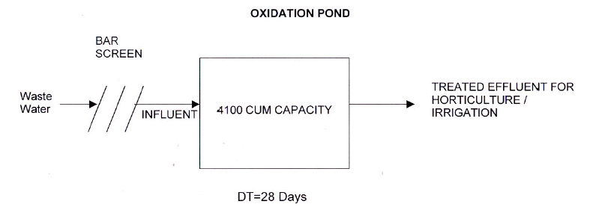

6.3 Plan For Clamity Management

6.3.1 General:
Needless to mention that a lot of care needs to be taken during the design and construction stages of dams to reduce the probability of their failure, however, we can only reduce the possibility of failure but cannot eliminate it. Therefore, it is important that a “Disaster Management Plan” (DMP) should be in place to reduce the damage to the minimum in case of any eventuality. The purpose of the DMP is primarily to safeguard lives and secondarily to reduce property damage of residents, who live downstream of proposed dam, in the event of flooding caused by a large volume of runoff from failure of the dam. The crucial aspects of disaster management plan would be:
- To establish an effective Dam Safety Surveillance and Monitoring programme including rapid analysis and interpretation of instrumentation and observation data, periodic inspection and safety reviews/ evaluation by an independent panel of experts.
- To formulate and implement an Emergency Action Plan to minimize the loss of life and damage to property in the event of dam failure.
As observed at site, the following structures shall be inundated in case of dam failure.
- Cable stayed bridge near Bhatwari
- Green Hut owned by village panchayat, Bhatwari
- Water mill owned by private person
All these structures are located at Bhatwari and fall between 3 to 5 km d/s of the dam. Water shall reach these structures with in 3 to 5 minutes of the failure. No other habitation or structure is likely to be inundated up to the reservoir of Maneri-Bhali stage-I scheme.

6.3.2 Pre-Emergency Preparedness and Planning Functions
Implementation of accident prevention measures for any dam is an important exercise and should form a part of regular operation. There are various activities that go into planning and preparedness to effectively counter the impacts of dam break emergency. For effectively handling such situations, the response agencies need to be in a good state of operational readiness and this requires meticulous planning on their part. Following paragraphs discuss the pre emergency planning and preparedness activities, which would not only help in reducing the chances of disaster but also improve the preparedness to manage disasters effectively for minimum damage to life and health, in case such a situation arises.

6.3.2.1 Surveillance
Surveillance activity, which is an important part of any Dam Safety Program, is generally limited to post fill monitoring of performance and aging process of most of the dams. This would encompass rapid analysis and interpretation of instrumentation and observation data along with periodic inspection, safety reviews and evaluation are suggested. Such programs will have to be implemented during design and investigation phase, construction phase, first reservoir filling, early operation period, operation and maintenance phases during the life cycle of dam.
Evaluation of the structural environment response includes assessment of the hazards specific to the site. Many factors must be deducted indirectly. Such assessment should be assigned to professionals who understand potential problems.

6.3.2.2 Preparation of a customized Emergency Action Plan (EAP)
Emergency Action Plan (EMP) should be a crisp document covering all the important aspects of Emergency Management during a disaster. It should essentially identify all the personnel responsible for emergency management as an emergency management team, give their contact numbers during working and non-working hours and define each ones responsibility during emergency situation (who will do what). In addition, it should have list of authorities such as district administration, state administration etc. required to be notified during emergency along with their names and contact numbers. It should clearly define warning and notification procedures to be followed in case of failure or potential failure of the dam. Emergency Action Plan should also include all potential indicators of likely failure of the dam, since the primary concern is for timely and reliable identification and evaluation of existing or potential emergency.
Rescue Team: will comprise of following official/ Representative:
- Divisional Commissioner/ his nominated officer (to relocate the people to safe places at higher elevation) with the help of state administration.
- Engineer in charge of the Project (EAP Coordinator)
- Superintendent of Police/ his nominated officer (to maintain law & order)
- Chief Medical Officer of the area (to tackle health problems of affected people)
- Sarpanch/ Affected Village Representative to execute the resettlement operation with the aid of state machinery & project management.
- Sub committees at village level

Notification Procedures: are integral parts of any emergency action plan. Separate procedures should be established for slowly and rapidly developing situations and failure. Notifications would include communication of either an alert situation or an alert situation followed by a warning situation. An alert situation would indicate that although failure or flooding is nor imminent, a more serious situation could occur unless conditions improve. A warning situation would indicate that flooding is imminent as a result of an impending failure of the dam. It would normally include an order for evacuation of delineated inundation areas. Again depending upon the local situation such procedures are to be developed by clearly defining flow of information, communication and linked to roles and responsibilities of individuals of name/ rank. Such procedures are to be communicated to all concerned and rehearsed regularly to avoid any confusion at the time of actual emergency.

Technical aspects: of the EAP consist of preventive action to be taken with regards to the structural safety of the dam. For this purpose, providing an adequate and easy access to the dam site is a necessity. The dam, its sluices, and non-overflow sections should be properly illuminated for effective operations during nighttime.

Evacuation Plan: and procedures for implementation based on local needs. These could be:
- Demarcation/ prioritization of areas to be evacuated
- Notification procedures and evacuation instructions
- Safe routes, transport and traffic control
- Functions and responsibilities of members of evacuation team

Communication System: An efficient communication system and a downstream warning system are absolutely essential for the success of an emergency preparedness plan. Details of the communication systems to be used during emergency should form part of the EAP.

6.3.2.3 Periodic Training, Review, Updating and Testing
The EAP coordinator’s duties during pre-emergency situation include the following:
- Training EAP participants to handle an emergency situation
- Annually reviewing the EAP with EAP participants for any required changes and distributing copies of the revised plan to participants.
- Testing the EAP
- Submitting EAP revisions and testing reports to the concerned authorities.

Review and Updating: Annually the EAP Coordinator shall review the plan with EAP participants to explain the procedures to follow in the event of an emergency, address any changes that need to be made in the plan, answer questions regarding the procedures, and test their understanding of the plan. The EAP participants review the plan for possible changes, including:
- Changes in personnel
- Changes in telephone numbers
- New conditions that would affect flood flows or the extent of damage due to a dam failure
- The EAP coordinator promptly makes the needed changes in the EAP and distributes a revised plan to all participants. If changes are made in the EAP at any other time, the
- EAP Coordinator also verbally reviews these changes with the participants and distributes a revised plan.

Testing: The EAP Coordinator is responsible for conducting a test simulating a dam failure. Testing the plan amiliarizes the EAP participants with the plan, helps estimate the time needed for notification, and helps reveal any plan deficiencies. EAP participants must perform their required actions as if in a real emergency. When executing the test, each participant states their name and position and indicates that this is only a test. To assess the degree of success of the test, the EAP Coordinator requests that each participant comment about the execution of the notification procedures, discuss any problems encountered, and suggest any changes that would improve the EAP. The EAP Coordinator keeps this information on file for comparison with future tests and revises the EAP if needed.

Approval: Key EAP participants need to approve the EAP by signing and dating the approval form. By signing the approval form, they agree to their responsibilities to review the EAP process and carry out the plan.

6.3.2.4 Public Awareness for Disaster Mitigation
Public participation in the process of execution of the EAP may further help in amelioration the adverse impacts of the likely disaster and for this, it is necessary that the public should be aware of its responsibilities. Copies of the EAP including the inundation map should be displayed at prominent locations, in the rooms and locations of the personnel named in the notification chart. In additions, guidelines that have to be followed by the inhabitants of flood prone areas, in the event of a flood resulting from dam failure, which form part of public awareness for disaster mitigation may also include following.
- To listen to the radio for advance information and advice
- To disconnect all electrical appliances and move all valuable personnel and household goods beyond the reach of floodwater, if one is warned or if one suspect that floodwaters may enter the house,
- To move vehicles, farm animals and movable goods to the higher place nearby
- To keep sources of water pollution i.e. insecticides out of the reach of water
- To turn off electricity and gas when one has to leave the house
- To lock all outside doors and windows if one has to leave the house
- Not to enter flood waters
- Not to wander around a flood area

6.3.3 ACTION PLAN FOR EMERGENCY MANAGEMENT

6.3.3.1 Initial Notification
Whenever sinkholes, boils, increased leakages, movement of masonry rock, gate failure, rapid rise or fall of the level in the reservoir, rise in the level of reservoir beyond the maximum water level, or wave overrun of the dam crest are observed, the personnel on patrol is required to immediately inform EAP coordinator, explaining that the failure is imminent or a potential emergency conditions is developing. EAP Coordinator (as defined in the customized EAP-Engineer-in-Charge is usually EAP coordinator), who is responsible for making decision on actions to be taken based on the developing situation and liaison with Civil Administration viz. Divisional Commissioner. He will be responsible for taking the crucial decision of informing the downstream inhabitants using pre-defined methods, so as to make them aware of the imminent danger and start of evacuation.

6.3.3.2 Preventive Action
Once the likelihood of an emergency situation is suspected, however the failure is not imminent, immediate action would be required to prevent a failure. Critical points where situations reach an emergency level shall be identified and at that stage the vigilance and surveillance shall be upgraded both in respect of time and level. A thorough inspection of the dam should be carried out to locate any visible sign (s). During an alert condition or warning condition, specific preventive actions may help to prevent or delay dam failure. Because the feasibility and effectiveness of a preventive action will depend on the specific situation, engineer in charge can take the decision on type of preventive action to be taken. Preventive actions could include:
- Cleaning the inlet of intake works
- Placing riprap in pipe outlet plunge pool if scour is occurring
- Placing sandbags on the crest of the embankment
Because of uncertainties about their effectiveness, these preventive actions should be carried out simultaneously with appropriate notification of an alert condition or warning condition. Engineers responsible for preventive action should identify well in advance sources of equipment needed for repair-materials, labour and expertise for use during an emergency. The amount and type of material required for emergency repairs should be determined for each dam, depending upon its characteristics, design, and construction history and past behavior. It is desirable to stockpile suitable construction materials at an appropriate site. The anticipated need of equipment should be evaluated and if these are not available at the dam site, the exact location and availability of this equipment should be determined and recorded. The sources/ agencies must have necessary instructions for assistance during emergency. Due to the inherent uncertainties about their effectiveness, preventive actions should usually be carried out simultaneously with appropriate notification on alert situation or a warning situation.

6.3.3.3 Evacuation
If the dam failure and flooding situation is becoming serious, it is appropriate to order evacuation as per the EAP guidelines, even if the preventive action is under progress. Preventive action may help in delay the failure and it is better to take advantage of that time and evacuate as many as possible. The Engineer-in-charge will be responsible for the entire operation including prompt determination of the flood situation time to time. Once the red alert is declared the whole state machinery will come into swing and will start evacuating people in the inundation areas delineated in the inundation maps. For successful execution, annually mock trials should be undertaken. Divisional Commissioner is to monitor the entire operation.

6.3.4 POST EMERGENCY ACTIVITIES
It is to be accepted that in the event of dam breaks, even with maximum efforts, the loss of human lives, livestock and property would be inevitable. Under such a scenario, a massive effort would be used by various government agencies to provide various relief measures to the evacuees. Project authorities could take up formulation of a plan delineating such measures separately. However, some of the measures which need to be implemented are listed as below:
- Provision of various food items & shutter to the evacuees
- Provision of fuel for various evacuees
- Provision of adequate fodder supply
- Arrangements for potable water supply
- Commissioning of low cost sewerage treatment & sanitation facilities, and disposal of treatment sewerage
- Approximate disposal of dead bodies human & livestock
- Immunization programs for prevention of outbreak of epidemics of various water related disease
- Adequate stocks of medicines of various diseases, especially water-related disease
- Assessing the inundated areas, clean-ups and declare them safe for re-entry.

6.4. ENVIRONMENTAL MONITORING PLAN
The environmental monitoring programme is a vital process in the Management Plan for a water resources / river valley project. This helps in signalling the potential problems that would result from the proposed project and will allow for prompt implementation of corrective measures. The environmental monitoring will be required during construction and operational phases. The following parameters need to be monitored:
- Land Compensation and Social Welfare,
- Water Quality and Public Health,
- Catchment Area Treatment Measures; and
- Air Quality and Noise Level.

6.4.1 LAND COMPENSATION AND SOCIAL WELFARE
A part of the land required for the project was acquired by the then UP Irrigation department and the remaining part would have to be acquired. Compensation has been /would be paid as decided by the revenue department in accordance with the prevailing norms of the state for such acquisitions. In addition to the com pensation for land acquired, a number of social welfare measures have been proposed under the Social Response Program (SRP) of the project as outlined in Chapter-4 of the report. These include technical and financial assistance for employment generation, poverty alleviation, education assistance, infrastructure development, healthcare and medical facilities etc. An active participation of project-affected people, local administration and other relevant institutions has been envisaged in implementation of the SRP. A separate SRP cell under the control of the general manager of the project would be responsible for implementation of the program. Measurable for each of the schemes need be specified for monitoring purpose. A separate body comprising of representatives from project management & public representatives shall be responsible for monitoring and concerted evaluation of the SRP.

6.4.2 WATER QUALITY AND PUBLIC HEALTH
Since water contamination leads to various water related diseases, the project authorities shall establish a procedure for water quality surveillance and ensure safe water for the consumers. A detailed epidemiological study related to water borne diseases shall be carried out and the data shall be compiled for every year in the project area. This data
would help the authority in finding out the trends for incidence of water related diseases prevalent in the area, which would help them to take suitable remedial measures for reducing or eradicating the occurrence of these diseases in future. Water quality parameters shall be monitored for one year before and for at least three years after the completion of the project. Monitoring shall be carried out on monthly basis (environment background) and two other assistants (miscellaneous works). The task of the division would be to supervise and co-ordinate studies, monitoring and implementation of environmental mitigation measures, and it shall report directly to the General Manager of the Project. An Environmental Advisor shall review progress of the division every year. The Environmental Advisor would be an experienced Ecologist or Environmentalist familiar with environmental planning of water resources projects. Cost of such a Division has been estimated as Rs.83.35 lakh.

6.4.3 SEDIMENTATION AND CAT WORKS MONITORING
Soil erosion rates and slope stability of reservoir rim and filled up sites, including sediment load shall be ontinuously monitored to establish effectiveness of the soil conservation measures undertaken through CAT plan. The sediment load monitoring shall be carried out through the environmental division of the project. Monitoring of afforestation schemes shall be required to measure the change in forest cover of the catchment area. It shall allow for validation of the assessment made in the present study and will give timely signal against potential problems, which could result from the proposed project, thus allowing for prompt implementation of corrective measures. The project authorised need to monitor the vegetation cover through remote sensing techniques for this purpose. A provision of Rs. 10,00,000 is kept for monitoring the progress of CAT works (plantation) through GIS.

6.4.4 AIR AND NOISE QUALITY MONITORING
Though there is no significant air or noise pollution by the proposed project, however, to assess the effectiveness of air pollution control measures suggested towards maintenance of approach roads, stone crushers, muck disposal sites and quarry sites and noise control measures suggested towards operation of various construction machinery, it would be required to monitor these parameters at regular interval. The environmental division of the project would carry this out.

6.5 ENVIRONMENTAL COST
All costs involved in Environmental Mitigating measures and Management to be put on theaccount Pala-Maneri Hydroelectric project works out to Rs. 2305.85 lakh as summarized in Table-6.1.

Table-6.1 Environmental Cost

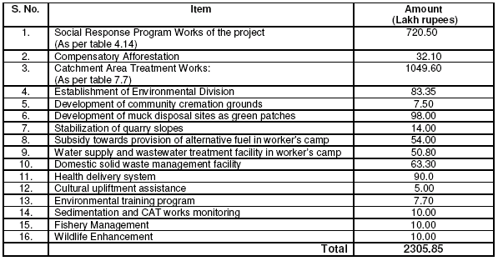
Source: EIA report Pala Maneri

CHAPTER 7

C0NCLUSIONS AND RECOMMENDATIONS

From the study of Environmental Impacts of Pala Maneri Hydeo-electric Project, following conclusions are drawn:
- The latest EIA notification of 2006 is sufficient to assess the impacts of developmental projects, it is an optimization between time saving for environmental clearance and stringent-ness of law.
- The prevailing environmental laws are sufficient to tackle the environmental hazards, only its proper implementation is required.
- The Pala Maneri Hydro-electric Project is proposed to be constructed in river Bhagirathi in District Uttarkashi of Uttarakhand State. It will generate 480 MW of power and its completion time is 52 months and the Estimated cost is Rs 2350.00 Crores.
- The Checklist method is very useful for Hydroelectric Projects and is best suitable method for the Socio-economic Survey, whereas the Matrix method is very useful for the survey of other attributes.
- The proposed project would have an overall positive impact, because the positive impacts of social upliftment and local development have prevailed upon the negative impacts of low magnitude like air, noise and water pollution.
- To mitigate and minimize the negative impacts arising during various stages of this project, a management plan have been prepared along with the Social Response Programme.
- After incorporation of environmental management plans, the environmental sustainability will be improved.
- Impacts, as discussed on natural resources, terrestrial and aquatic ecology of the area could be mitigated with available know-how in technology. The key issue is that the project would cause social upliftment in addition to the economic gains with minor negative impacts on the ecological environment.

Based on the study following recommendations are being forwarded:
- Public involvement and participation should be done right from the initiation of the Impact study inspite of doing it in the end of the process.
- As the amount of Rs 23.06 Crores proposed to be spent on Environmental management Plan is approximately 1 % of the total project cost of Plala Maneri Hydro Electric Project, it can be increase upto 2% with increasing the land compensation packages as per the R&R policy of ADB which provides the compensation for land encroachers also.
- As we know hydro Power is a clean energy and the project being the Run-of-the-river type with two hours of peaking storage with submergence without any rehabilitation, this can easily be termed as Sustainable development. So little amount from the regular income by the Power Plant, should be spent on the local environment on long term basis along with the initial investment as per the EMP.
- Various mitigation measures as suggested in the study should be adopted religiously and with proper attention. The proper implementation and monitoring will fully justify this report during construction and during operation on the Power Plant.

REFERENCES

- Air (Prevention and control of Pollution) Act 1981 amended in 1988, Ministry of Environment and Forest, Government of India.
- Air (Prevention and Control of Pollution) Act 1981, amended in 1987, Ministry of Environment and Forest, Government of India.
- Ambuhl H (1959), The importance of flow as an ecological factor, Schweiz Zeitschr F, Hydrol 21, 133-264, Germany.
- Bachfisher R (1978), The ecological risk assessment: a method for integration of environmental factors into regional planning), dissertation, Technical Univ. munich, germany.
- BfG (1996), environmental impact studies of federal waterways, material for evaluation of the effects upon the environment, Fedral Institute of Hydrology, konlenz, Germany.
- Deswal S and Deswal A, Environmental Studies,, Dhanpat Rai & Co ltd, Delhi, 2004.
- Environmental (Protection) Act 1986, amended in 1991.
- EIA Training Resource Manual, United Nations Environment Programme, 2002.
- Environmental Impact Assessment for Developing Countries in Asia; Asian Developmental Bank, 2000.
- Environmental Impact Assessment Report of Pala Maneri Hydro-electric Power Project, Uttarakhand Jal Vidyut Nigam Ltd. Dehradun, 2005.
- Environmental Standards for Ambient Air, Automobiles, Fuels, Industries and Noise, Pollution Control Law Series: PCLS/4/2000-01, Central pollution Control Board, Delhi, 2000.
- Forest (Conservation) Act, 1980 amended in 1988.
- Ferda K (1994) Model based environmental information and decision support systems, 8 Symposium Hamburg-1994, Vol 1, 37-58, Marburg, Germany.
- Forest (Conservation) Act 1980, amended in 1988.
- Freistuhler Elke, Giers Antje, Gert A Schultz & Bauer J H (2001), A technique to predict the hydro-ecological effects in an ecological assessment of water projects, IAHS Publ No 266, UK.
- Guidelines for River Valley Projects, Ministry of Environment & Forests, Government of India, 1981.
- Garg S K; Water Engineering, Khanna Publications, New Delhi, 2004.
- Garg S K, Waste Water Engineering, Khanna Publications, New Delhi, 2004.
- Garg S K, Ecological and Environmental Studies, Khanna publishers, Delhi,2006.
- Giers Antje, Freistuhler & Gert A Schultz (1998), Methodology for assessment of ecohydrological effects of dam construction in a head water region, Head Water Conference-98, Merano, Italy.
- Guidelines for EIA of River Valley Projects, Ministry of Environment and Forest, GoI, 1994.
- Guidelines for DPR preparation of River Valley Projects, Ministry of Water Resources, GoI, 1997.
- Indian Standard Drinking Water – Specification (BIS 10500: 1991).
- Larry Canter, Environmental Impact Assessment, Mc Graw Hill Publication, New York, 2003
- Land Acquisition Details of Pala-Maneri Hydroelectric Project, 2005, UJVNL.
- LWA (1993) map of structural quality of rivers, mapping instructions (temporary version 1993) Westfalen, Germany.
- Metcalf & Eddy; Waste Water Engineering: Treatment And Reuse, Tata Mc Graw-Hill, Delhi, (2003).
- National Forest Policy, 1988, Ministry of Environment & Forests, Government of India, 1981.
- National Environmental Policy, 2006, Ministry of Environment & Forests, Government of India, 1981.
- National Water Policy, 2002, Ministry of Water Resources, Government of India, 1981.
- Notification on EIA, Ministry of Environment & Forests, 1994 and 2006.
- Noise Pollution (Regulation and Control) Rules, Ministry of Environment & Forests, 2000.
- National Policy on Resettlement & Rehabilitation for Project Affected Families, Ministry of Rural Development, 2004.
- National Ambient Air Quality Standards (NAAQS); Central Pollution Control Board (CPCB), New Delhi (1994).
- Pala-Maneri Hydroelectric Detail Project Report, Uttarakhand Jal Vidyut Nigam Ltd, Dehradun, 2005.
- Rao C S, Environmental Pollution Control Engineering, New Age International Publishers, Delhi, 2001.
- Rajagopalan R, Environmental Studies- From Crisis to Cure,Oxford University press, New Delhi, 2005.
- Sander U (1981) Classification concept for the determination of ecological intream flow requirements), Arch Hydrobiol, Suppl 53, 409-461, Germany.
- Schmedlje U (1995), Ecological foundations for the assessment of diverted streams, Schweiz Zeitschr F, Hydrol 25, Germany
- Statistical Handbook, District Uttarkashi, 2003.
- Statzner B & Muller R (1989) Standard hemispheres as indicators of flow characteristics in lotic benthos research, Freshwat boil, 21. 445-459, Germany.
- Susan L Cutter, Environmental Risks and Hazards, Prentice hall India, Delhi1, 1999.
- Subramanian V, Environmental Science, Narosa Publishing House, Delhi, 2002.
- The Environmental Clearance Notification, 1994.
- Tiwari-Khulbe-Tiwari, Environmental Studies, I K International publishing House, Delhi, 2007.
- The National Environmental Appellate Authority Act, 1997.
- The Wildlife (Protection) Act, 1972, amended in 1993.
- Tripathi R P and Singh H P, Soil erosion and Conservation, New Age international Publishers, Delhi, 1998.
- UNEP/ICC/FIDIC, Environmental Management Systems - Training Resource Kit. 1996.
- UNEP-EEU, Environmental Impact Assessment : Issues, Trends and Practice. Nairobi : September, 1996.
- UNEP-EEU, EIA Training Resource Manual. Nairobi: June 1996.
- UNEP-IE, Environmental Management Tools, Industry and Environment. Vol. 18 No. 2-3, Paris, April-September, 1995.
- Vyasulu Vinod and Chary S N, Macmillan India Ltd, Delhi, 2000.
- Water (Prevention and Control of Pollution) Act 1974, amended in 1978 & 1988.
- Water (Prevention and Control of Pollution) Act 1974, amended in 1988.
- Zhu-Motley-Qasim, Water Works Engineering-Planning, Design and Operation, Prentice Hall India, Delhi, 2002.

Internet

- Ministry of Environment and Forest, www.envifro.nic.in.
- Ministry of Water resources, www.watermin.nic.in.
- Ministry of Power, www.watermin.nic.in.
- Central Pollution Control Board. www.cpcb.nic.in.
- Centre for Science and Environment. www.cseindia.org.
- United Nations Environment Programme, www.unep.org.
- United Nations Development Programme, www.undp.org.
- World Bank, www.worldbank.org.
- Asian Development Bank, www.adb.org.
- United States Environmental Protection Agency Energy, www.epa.gov/
- Guidelines For Confirmation Of Environmental And Social Considerations, Japan Bank For International Cooperation, www.jbic.org.
- International Sustainable Energy Organisation for Renewable Energy and Energy Efficiency available at www.uniseo.org
- The Australian Government official website, www.environment.gov.au.
- www.iaia.org, (database of EA training courses).

