CHAPTER 1

1.1 WORKABILITY
Workability or consistency of fresh concrete indicates its dryness or wetness. A dry concrete may not flow freely around corners and between the reinforcing bars. A wet mix may easily segregate . the consistency of the mix should be such that the concrete can be mixed, transported, placed and finished easily without segregation. Slump test and compacting factor test are normally used for determining the workability of fresh concrete .
The slump test is irregular but cheap and easy to carry out on the work site. It is hence used universally to keep a check on the water content of different batches of concrete. The compacting factor apparatus is bulky and is generally used in the laboratory for designing the mix only.

1.2 CLASSIFICATION OF CONCRETE
Concrete is most used building material invented in last century. With increase in its use continued research is being done to have desired results. It has very good compressive strength. But it is poor in tension. In latest IS/456-2000 code concrete is designated by its compressive strength of 150 mm cubes at 28 days in N/mm2.

The classification of grades has been done as M 10 to M 20 ordinary concrete;
M 25 to M 55 standard concrete; M 60 to M 80 High performance concrete;
And now new grade has also been developed as ultra high performance concrete
High Performance Concrete is often called durable concrete because its strength and impermeability to chloride penetration makes it last much longer than conventional PCC. The concrete mix is engineered with the typical elements of water, portland cement, and fine and coarse aggregates, but with admixtures which enhance performance. High-performance concrete is not just about high-strength mix, but also enhanced durability.
HPC mix designs were developed in the 1980s to protect reinforced concrete high-rise buildings and bridges from chlorides, sulfates, and alkali-silica reactivity and to quell concrete shrinkage and creep.
In HPC, materials and admixtures are carefully selected and proportioned (optimised) to form high early strengths, high ultimate strengths and high durability beyond conventional concrete.
Some industrial waste materials of a few decades ago now are integral elements of this new-engineered concrete. These admixtures, such as coal fly ash, silica fume, and ground granulated blast furnace slag, add both strength and durability to the concrete, and enhance its marketability as an environmentally friendly product.
Providentially, these materials also produce a lower heat of hydration, which can minimize shrinkage cracking produced by higher temperatures. minimizing shrinkage cracks can limit ingress of chlorides.
HPC provides enhanced mechanical properties in precast concrete structural elements, including higher tensile and compressive strengths, and heightened modulus of elasticity (stiffness). In frost-prone regions the benefits of HPC are great. The enhanced durability of HPC helps it resist penetration of chloride-laden snow and ice melt water. This results in longer life for the reinforcing steel within, and a reduction in spalling, cracking, and associated repairs.
The proportions in which fundamental components are mixed, and the admixtures that are used, constitute the main difference between conventional PCC and HPC. A high-range water-reducing admixture may provide a required low water/cement ratio, perhaps as low as 0:35.
When strength of concrete is more than M 80 it is called ultra high performance concrete. It is also called as reactive powder concrete (RPC). It is a high strength ductile material formulated by combining Portland cement, silica fumes, quartz flour, fine silica sand, high water reducing agent, water, and steel or organics fibers. The material provides compressive strength up to 200 Mpa and flexural strength up to 50 Mpa.

1.3 THE NEED FOR SUFFIENT WORKABILITY
Workability is a vital property as far as the finished product is concerned because concrete must have a workability such that compaction to maximum density is possible with a reasonable amount of work .
The need for compaction becomes apparent from a study of the relation between the degree of compaction and the resulting strength . it is convenient to express the former as a density ratio, i.e. a ratio of the actual density of the given concrete to the density of the same mix when fully compacted. Likewise, the ratio of the strength of concrete is actually (partially) compacted to the strength of the same mix when fully compacted can be called the strength ratio. The presence of voids in concrete greatly reduces its strength: 5% voids can lower strength by as much as 30 %, as shown in figure
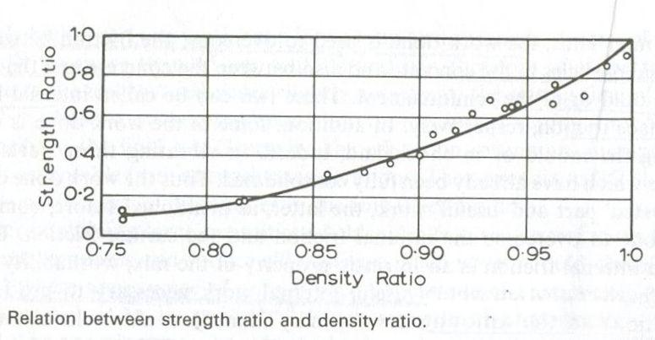
FIGURE 1.1

1.4 EFFECT OF TIME AND TEMPERATURE ON WORKABILITY
Freshly mixed concrete stiffens with time . this should not be confused with setting of cement . it is simply that some water from the mix is absorbed by the aggregate if not saturated, some is lost by evaporation .
The exact value of the loss in workability depends on several factors. First, the higher the initial workability the greater the slump loss. Second, the rate of loss of slump is higher in rich mixes. Furthermore, the rate of loss depends on the properties of the cement used: the rate is higher when the alkali content is high and when the sulfate content is too low. A typical loss of slump is shown in figure
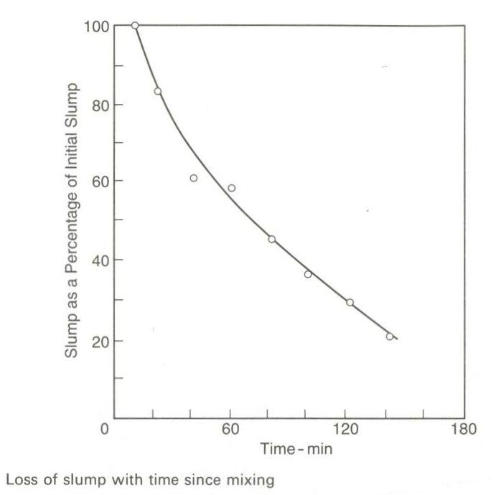
FIGURE 1.2
The change in workability with time depends also on the moisture condition of aggregate: the loss is greater with dry aggregates due to the absorption of water by aggregate.
The workability of a mix is also affected by the ambient temperature as shown in figure and . it is apparent that on a hot day the water content of the mix would have to be increased for a constant early workability to be maintained. The loss of slump in stiff mixes is less influenced by temperature because such mixes are less affected by changes in water content.
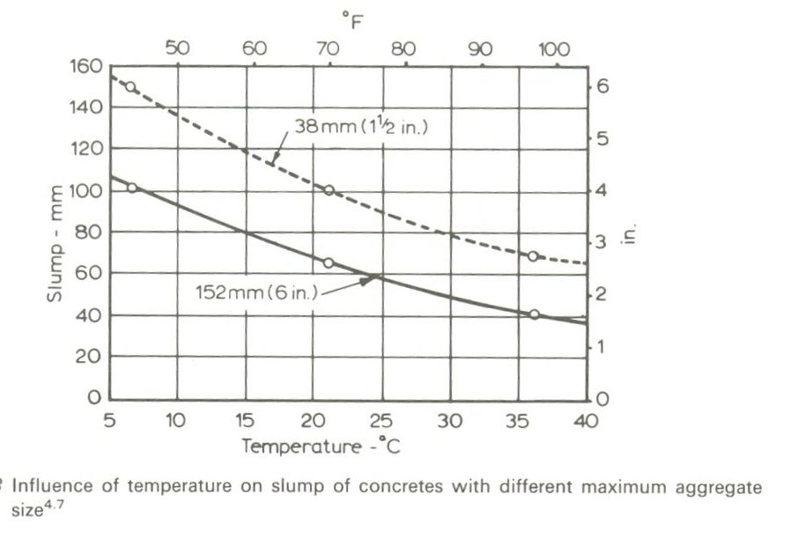
FIGURE 1.3

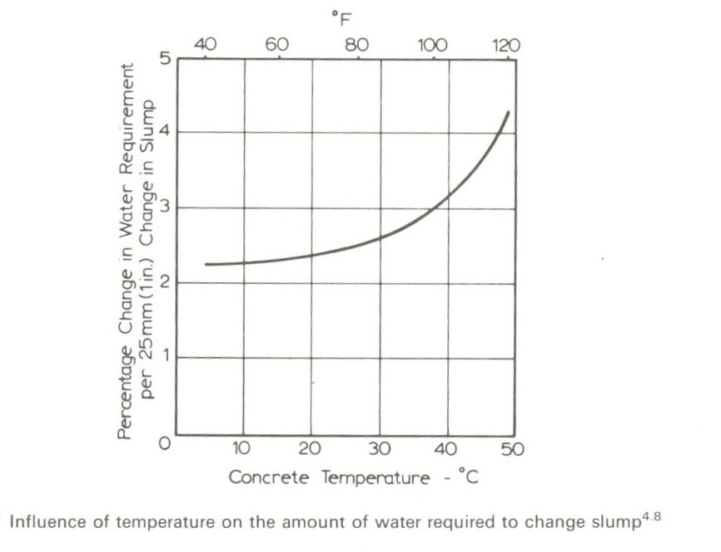
FIGURE 1.4
Because workability decreases with time , it is important to measure , say, slump after a predetermined time lapse since mixing . there is value in determining slump immediately after the discharge of the concrete from the mixer for the purpose of control of batching. There is also value in determining slump at the time of placing the concrete in the formwork for the purpose of ensuring that the workability is appropriate for the means of compaction to be used .

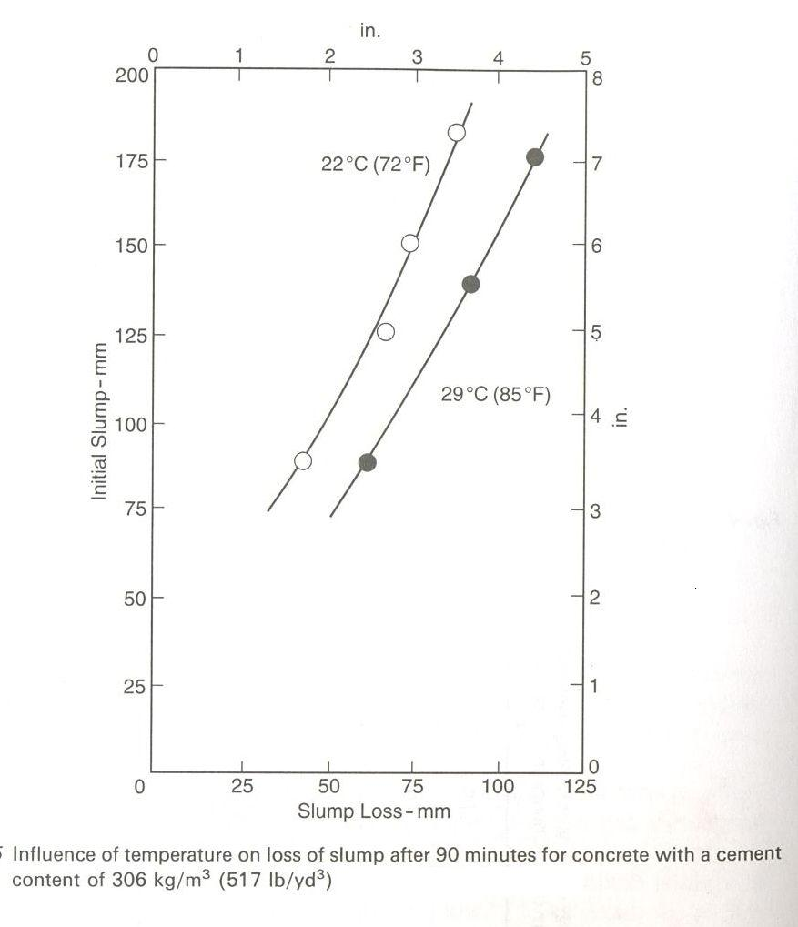
FIGURE- 1.5
1.5 Pumped concrete
Pumping of concrete thorough steel pipelines is one of the successful methods of transporting concrete . pumped concrete has largely been used in construction of multi storey buildings, tunnels, and bridges. Powered by diesel engine, an older version of a concrete pump is a heavy duty, simple two-stroke mechanical reciprocating pump consisting of a receiving hopper, inlet valves, a piston and a cylinder.
A modern concrete pump, on the other hand , basically consists of three parts: a concrete receiving hopper, a controlling valve system and concrete transmission system. In the commonly used pump called squeeze pump , the concrete placed in the receiving hopper is fed by rotating blades into the flexible pipe connected to the pumping chamber, which is under vacuum of about 600mm of mercury. Two rotating rollers progressively squeeze the flexible pipes and force the concrete to move through the delivery pipe in a continuous flow.
The pipe line of transmission system carrying concrete at high pressure should have correct diameter with adequate wall thickness for a given operating pressure, and well designed coupling system for trouble free functioning and safety. The diameter of the pipe depends on the pumping pressure and the size of aggregate. For longitudinal horizontal distance involving high pumping pressure, a larger diameter pipe would be suitable for reduced resistance to flow. On the other hand for pumping concrete to heights, smallest possible diameter pipelines should be used from gravity consideration. The pipe diameter should be between 3 to 4 times the maximum size of aggregate . as a guide, a pump with an output of 30m3/h and with length of pipeline not exceeding 200meter may have a diameter of 100mm, but for lengths in excess of 500m, a 150 mm diameter could be considered. Generally, 125mm diameter pipes are used. The pipe line should be carefully laid and well anchored when bends are introduced for travel free pumping operation. The pump should not be kept very close to the vertical pipe. There must be starting distance of about 10 to 15 percent of the vertical distance.
1.6 READY MIXED CONCRETE
A concrete whose constituents are weight-batched at a central batching plant, mixed either at the plant itself or in truck mixers, and then transported to the construction site and delivered in a condition ready to use, is termed ready mixed concrete (RMC). This enables the places of manufacture and use of concrete being separated and linked by suitable transport operation. The technique is useful in congested sites or at diverse work places and saves the consumer from the botheration of procurement, storage and handling of concrete materials. Ready made concrete is produced under factory conditions and permits a close control of all operations of manufacture and transportation of fresh concrete . due to its durability, low cost and its ability to be customized for different applications, ready-mixed concrete is one of the most versatile and popular building materials.
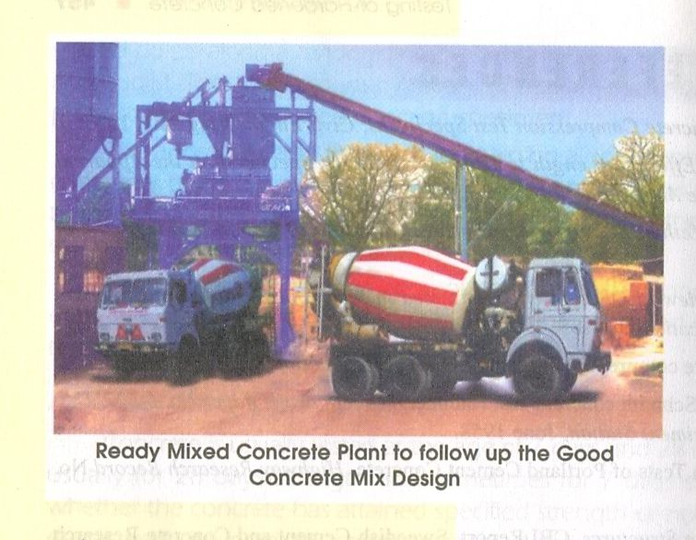
READY MIX CONCRETE PLANT
FIGURE – 1.6
1.7 SHOTCRETE OR GUNITING
Shotcrete is mortar or very fine concrete deposited by jetting it with high velocity (pneumatically projected or sprayed) on to a prepared surface. The system has different proprietory names in different countries such as blastcrete, blowcrete, guncrete, jet-crete, nucrete, pneukrete, spraycrete, torkrete, etc. though the principle is essentially the same. Shotcrete offers advantages over conventional concrete is frequently more economical than conventional concrete because of less formwork requirements, requiring only a small portable plant for manufacture and placement. It is capable of excellent bonding with a number of materials and this may be an important consideration.
Shot Crete has wide applications in different constructions , such as thin overhead vertical or horizontal surfaces, particularly the curved and folded sections, canal, reservoir and tunnel lining , swimming pools and other water- retaining structures and prestressed tanks . shot crete is very useful for the restoration and repair of concrete structures ,fire damaged structures And waterproofing of walls.
Shotcrete has been successfully used in the stabilization of rock slopes and temporary protection of freshly excavated rock surfaces. Its utility has been proved for protection against long term corrosion of piling, coal bunkers, oil tanks, steel building frames and other structures, as well as in encasing structural steel for fire proofing.
Special shotcrete has been developed for high temperature applications, such as refractory lining of kilns, chimneys, furnaces, ladles, etc.

1.8 ADVANTAGES OF USING HIGH STRENGTH CONCRETE
The main advantages of using high-strength concrete are the following:
- Reduction in member size , resulting in an increase in the usable floor space, a reduction in the quantity of concrete , and a consequent reduction in construction time.
- Reduction in self weight and a consequent reduction in the foundation cost .
- Reduction in the area of the formwork and the time required for stripping forms.
- The ability to withstand large column loads with reasonable sizes of columns .
- Provision of large spans , or elimination of a few columns or smaller beams for comparable spans , leading to a reduction in the storey height from headroom considerations.
- Reduction in axial shortening effects in columns.
- Reduction in floor thickness and beam height.
- Elimination of a few footings because of adoption of large spans.
- Superior durability and long term performance .
- Lower creep and shrinkage .
- Larger stiffness as a result of a larger value of young’s modulus of concrete.
- Higher resistance to crack propagation, chemical attack, etc.
- Reduced maintenance costs.

CHAPTER 2

2.1 WORKABILITY

Workability is that property of freshly mixed concrete or mortar which determines the ease and homogeneity with which it can be mixed , placed compacted and finished. As per IS: 6461 (Part vii ) -1973 .

2.2 MEASUREMENT OF WORKABILITY

A number of different empirical tests are available for measuring the workability of fresh concrete , but non of them is wholly satisfactory . each test measures only a particular aspect of it and there is really no unique method which measures the workability of concrete in its totality . however, by checking and controlling the uniformity of the workability, it is easier to ensure a uniform quality of concrete and hence uniform strength for a particular job . the empirical tests widely used are :

i) the slump test

ii) the compacting factor test

iii )the vee-bee consistency test

iv) the flow table test

2.3 COMPRESSIVE STRENGTH

of the various strengths of concrete the determination of compressive strength has received a large amount of attention because the concrete is primarily meant to withstand compressive strength . the cubes are usually 150mm side, the specimens are cast, cured and tested as per standards prescribed for such tests.

The compressive strengths given by different specimens for the same concrete are different .the cylinders and prisms of a ratio of height or length to the lateral dimension of 2 may give a strength of about 75 to 85 percent of the cube strength of normal-strength concrete.

2.4 PROPERTIES OF MATERIALS USED

CEMENT:

Name of cement used in research work with their specific gravities.
Name of cement | Specific gravity
1 ) 53 grade ACC cement  2 ) 53 grade j k cement  3 ) 53 grade Birla cement  4 ) 53shri ultra cement | 3.15  3.16  3.20  3.20

2.5 ADMIXTURE ( SUPER PLASTICIZER ) : name of high range water reducing agents used in research work with their recommended dosages and redosages work are as follows
NAME OF HIGH RANGE WATER REDUCING ADMIXTURE | RECOMMENDED DOSAGE | DOSAGE AND REDOSAGE USED
CEMWET SP 3000  RHEOBUILD 1100 | 0.3 TO 3.0%  0.8% TO 3 .0 % | 15ML/KG,5 ml /kg, 5ml / kg, 5ml /kg  15ML /KG, 5ml / kg, 5ml /kg , 5ml /kg

2.6 RHEOBUILD 1100
Description
The basic components of RHEOBUILD 1100 are synthetic polymers which allow mixing water to be reduced considerably and concrete strength to be enhanced significantly, particularly at early ages. RHEOBUILD 1100 is a chloride free product.
Primary uses
- Production of rheoplastic self compacting concrete.
- Precast concrete.
- Low water/cement ratio concrete.
- In complicated formwork or with congested reinforcement.
Advantages
RHEOBUILD 1100 allows the production of very flowable concrete, with a low water / cement ratio. Table 1 shows some typical examples of reductions in w/c ratio. Concrete with RHEOBUILD 1100 shows strengths higher than concrete without admixture having the same workability. The increase in strength, specially evident at early ages remains at later ages, both in air cured and steam cured processes. Initial and final sets do not change significantly with respect to concrete without admixture. Therefore, whenever longer transport and finishing times are needed, the use of retarding superplasticisers, such as RHEOBUILD 561M or RHEOBUILD MICRAFLOW are recommended.
Due to the reduction in the water / cement ratio, all other properties of hardened concrete improve significantly, namely; lowered permeability, shrinkage and creep, increased workability and modulus of elasticity.
For more detailed information on the influence of superplasticisers on hardened concrete properties, consult your local BASF-ME representative.
Compatibility
RHEOBUILD 1100 is compatible with all cements and admixtures meeting ASTM standards.
The use of RHEOBUILD 1100 and MICRO-AIR 100 air entraining agent is recommended whenever concrete is required to withstand freeze / thaw cycling.

Packaging
RHEOBUILD 1100 is available in bulk or 210 litre drums.
Typical properties
Colour: | Brown free flowing liquid.
Specific gravity: | 1.185 - 1.205 at 25°C.
Air entrainment: | Maximum 1%.
Chloride content: | Nil to BS 5075.
Nitrate content: | Nil.
Freezing point: | 0°C. Can be reconstituted if stirred after thawing.
Standards
ASTM C-494 Types A and F
BS 5075 Part 1 & 3
Dosage
RHEOBUILD 1100 is normally dispensed at a rate of 0.8 - 1.2 Iitres per 100kg of cement. Other dosages may be used, depending on the materials and conditions.
Directions for use
RHEOBUILD 1100 should be added to the mix with the gauging water.
No extension to the mixing time is necessary. Never add RHEOBUILD 1100 to dry cement.
Alternatively, when using RHEOBUILD 1100 to produce flowing concrete at site using ready mix trucks, it can be added to the concrete via the feed hopper at the rear of the truck. Mix before discharge for 3 minutes at 10rpm to produce a fully homogenous mix.
When using RHEOBUILD 1100 to obtain very high early strengths, advantage must be taken of its water reducing properties.

Effects of over dosage
A severe over-dosage of RHEOBUILD 1100 will result in the following:
- Retardation of initial and final set.
- Slight increase in air entrainment.
- Increase in workability.
Dispensing
RHEOBUILD 1100 is introduced into the mixer together with mixing water. The plasticising effect or water reduction is higher if the admixture is added to the concrete after 50-70% of the mixing water has been added. The addition of RHEOBUILD 1100 to dry aggregate or cement is not recommended.
Storage
Store under cover, out of direct sunlight and protect from extremes of temperature. Shelf life is at least 2 years when stored as above. Failure to comply with the recommended storage conditions may result in premature deterioration of the product or packaging. For specific storage advice consult BASF's Technical Services Department.
Safety precautions
RHEOBUILD 1100 contains no hazardous substances requiring labelling. For further information refer to the material safety data sheet.
Note
Field service, where provided, does not constitute supervisory responsibility. For additional information contact your local BASF representative.
BASF reserves the right to have the true cause of any difficulty determined by accepted test methods.
Quality and care
All products originating from BASF's Dubai, UAE facility are manufactured under a management system independently certified to conform to the requirements of the quality, environmental and occupational health & safety standards ISO 9000, ISO 14001 and OHSAS 18001.

2.7 CEMWET SP - 3000
CEMWET SP - 3000
HIGH RANGE WATER REDUCING SUPERPLASTICISING ADMIXTURE FOR THE PRODUCTION OF SELF-COMPACTING PLASTIC CONCRETE
DESCRIPTION
The basic components of CEMWET SP-3000 are synthetic polymers which allow mixing water to be reduced considerably and concrete strength to be enhanced significantly, particularly at early ages. CEMWET SP-3000 is a chloride free product.
PRIMARY USES
- Production of plastic self compacting concrete.
- Precast concrete, Readymix concrete.
- Low water/cement ratio concrete.
- In complicated formwork where reinforcement is conjusted.
ADVANTAGES
CEMWET SP-3000 makes the concrete highly 'owable, with a low water /cement ratio. Table 1 shows some typical examples of reductions in the w/c ratio. The concrete treated with CEMWET SP-3000 shows strengths higher than concrete without admixture having the same workability.
The increase in strength, specially evidently at early ages remains at later ages, both in air cured and steam cured processes. Initial and final sets do not change significantly with respect to concrete without admixture.
Due to the reduction in the water / cement ratio, all the other properties of hardened concrete improve significant, namely, permeability, shrinkage, creep, workability and modulus of elasticity.
COMPATIBILITY : CEMWET SP-3000 is compatible with all cements and admixtures particularly CEMWET - SRA, CEMWET - ACC, CEMWET-AEA.
PACKAING : 210 litre drums. Bulk deliveries in tankers available upon request.
TYPICAL PROPERTIES
Colour: | Brown free flowing liquid.
Specific gravity: | 1.20 ±0.035.
Chloride content: | Nil to BS 5075, to I.S.: 456-78
Nitrate content: | Nil
Freezing point: | 0 C. Can be reconstituted if stirred after thawing.
Airentrainment: | MaximumO#5%#
DOSAGE
CEMWET SP- 3000 is normally dispensed at a rate of 0.8 -1.2 litres per 100 kg of cement. Other dosages may be used, depending on the materials and conditions. Trial mixes are recommended prior to production of concrete outside these normal ranges.
DIRECTION FOR USE
CEMWET SP-3000 should be added to the mix with the gauging water.
No extension to the mixing time is necessary. Never add CEMWET SP-3000 to dry cement.
Alternatively, when using CEMWET SP-3000 to produce flowing concrete at site using ready mix trucks, it can be added to the concrete via the feed hopper at the rear of the truck. Mix before discharge for 3 minutes at 10rpm to produce a fully homogeneous mix.
When using CEMWET SP-3000 to obtain very high early strengths, advantage must be taken of its water reducing properties.
EFFECTS OF OVER DOSAGE
A severe over- dosage of CEMWET SP-3000 v\
result in the following:
- Retardation of initial and final set.
- Slight increase in air entrainment.
- Increase in workability.
DISPENSING
CEMWET SP-3000 is introduced into the mixer together with mixing water. The plastici-sing effect or water reduction is higher if the admixture is added to the concrete after 50-70% of the mixing water has been added. The addition of CEMWET SP-3000 to dry aggregate or cement is not recommended.
SAFETY PRECAUTIONS : CEMWET SP-3000 contains no hazardous substances.
STORAGE : CEMWET SP-3000. in tightly closed origins containers, has a shelf life of at least 2 years. The product must be stored in a place where temperatures do not drop below + 5 C. If the product has frozen, thaw and agitate until completely reconstituted.

2.8 CLASSIFICATION OF AGGREGATES :
The size of aggregates used in concrete range from few centimeters or more , down to a few microns . the maximum size of the aggregate may very , but in each case it is to so graded that the particles of different size fractions are incorporated in the mix in appropriate proportions . the particle size distribution is called the grading of the aggregates .
2.9 FINE AGGREGATES
It is the aggregate most of which passes through a 4.75 mm IS sieve and contains only that much coarser materials as is permitted by the specifications . sand is generally considered to have a lower size limit of about 0.07mm. material between 0.06mm and 0.002 mm is classified as silt, and still smaller particles are called clay . the fine aggregate may be one of the following types:
I) natural sand, i.e. the fine aggregate resulting from natural disintegration of rock which have been deposited by stream and glacial agencies .
ii) crushed stone sand , i.e. the fine aggregate produced by crushing hard stone .
iii) crushed gravel sand , i.e. the fine aggregate produced by crushing natural gravel.
2.10 COARSE AGGREGATES
The aggregates most of which are retained on the 4.75mm IS sieve and contain only that much of fine material as is permitted by the specifications are termed as coarse aggregates. The coarse aggregates may be one of the following types :
i)crushed gravel or stone obtained by the crushing of gravel or hard stone .
ii) uncrushed gravel or stone resulting from the natural disintegration of rock, or
iii) partially crushed gravel or stone obtained as a product of the blending of the above two types .
the graded coarse aggregate is described by its nominal size , i.e., 40mm, 20mm, 16mm , and 12.5 mm. for example , a graded aggregate of nominal size 12.5mm means an aggregate most of which passes the 12.5mm IS sieve.
2.11 WATER
Water is the most important and least expensive ingredient of concrete . a part of mixing water is utilized in the hydration of cement to form the binding matrix in which the inert aggregates are held in suspension until the matrix has hardened . the remaining water serves as a lubricant between the fine and coarse aggregates and makes concrete workable , readily placeable in forms.
2.12 QUALITY OF MIXING WATER
The water used for the mixing and curing of concrete should be free from injurious amounts of deleterious materials. The unwanted situations , leading to the distress of concrete, have been found to be a result of , among others, the mixing and curing water being of in appropriate quality . potable water is generally considered satisfactory for mixing concrete.
2.13 CURING OF CONC RETE
The physical properties of concrete depend largely on the extent of hydration of cement and the resultant microstructure of the hydrated cement . upon coming in contact with water , the hydration of cement proceeds both inwards and outwards in the sense that the hydration products get deposited on the outer periphery of cement grains , and the nucleus of unhydrated cement inside gets gradually diminished in volume. At any stage of hydration the cement paste consists of hydration ( called gel because of its large area ), the remnant of unreacted cement, ca(oh)2 and water.
The development of the strength of concrete , which starts immediately after setting is completed , continues for an indefinite period, though at a rate gradually diminishing with time. Eighty to eighty five per cent of the eventual strength is attained in the first 28 days and hence this 28 days strength is considered to be the criterion for the design and is called characteristic strength .
The curing increases compressive strength , improves durability , impermeability and abrasion resistance .
2.14 CURING PERIODS
To develop design strength , the concrete has to be cured for up to 28 days . as the rate of hydration , and hence the rate of development of strength , reduces with time it is not worthwhile to cure for the full period of 28 days.
IS 456-2000 stipulates a minimum of 7 days moist curing , while IS: 7861 (PART-I ) -1975 stipulates a minimum of 1o days under hot weather conditions .
2.15 APPLICATIONS OF HIGH STRENGTH CONCRETE
In the context of tall buildings and large span bridges, it is clear that use of high strength concrete leads to reduced column sizes and beam depths. In addition , it results in improved performance in terms of creep, shrinkage, and other elastic properties that yield a more favorable deformation pattern for tall buildings. The improved elastic properties also limit the sway and reduced elastic shortening and other secondary effects. hence high strength concrete has found applications in various structures used by various industries.
Applications of high strength concrete in different industries

Industries design strength(Mpa) technique used for achieving high __________________________________strength_______________________
Railways 50- 80 super plasticizer + high early cement
Highway bridges 60- 70 super plasticizer + high early cement
Diaphragm walls 50-55 super plasticizer + low heat cement
Oil drilling rigs 60-65 super plasticizer + silica fume
Abrasion resistant
Concret 40-80 super plasticizer + silica fume or anhydrous gypsum additive
High rise reinforced
conc (RC) buildings 40-80 super plasticizer + silica fume +ultra fine particles
RC piles 50 super plasticizer + silica fume
Prestressed conc pile 80 super plasticizer + silica fume
Spun piles 85 super plasticizer + silica fume+ autoclave curing
Steel conc composite pile 80 super plasticizer + silica fume
Centifugered RC piles 50-80 super plasticizer + silica fume
Railway sleepers 40-50 super plasticizer
Machine foundations 80-120 super plasticizer
High strength concrete has been used in bridges, oil drilling rigs, diaphragm walls and tall buildings as also in prestressed concrete piles.
2.16 Example
One of the worlds tallest reinforced concrete buildings is in Chicago , Illinois. At 293m high, with 70 floors, it changed the Chicago skyline . elkem micro silica concrete at 83MPa was specified in the major columns , which meant a saving of steel reinforcement and concrete volume .
Introduction
311 south wacker drive , Chicago,Illinois, one of the worlds tallest reinforced concrete buildings, was completed in 1990. it is a 70 storey, 121,000m2 office tower, owned by Lincoln property company. There are approximately 420,000m2 of office space on the site , which is just a block south of the sears tower . the construction company was j.a. jones construction co , Chicago. The construction time was 32 months ,using approximately 84,000 of concrete .
Mix design and results
The concrete was produced by prairie materials sales corporation of Chicago. 83 MPa concrete was used for the major columns in the first 14 floors . even though lower strengths were required in the columns above , (ranging from 69 to 52 MPa ) . the concrete still contained Elkem micro silica for improved performance .
The high strength concrete mix gave savings not only in the tonnage of reinforcing steel , but also in the quantity of concrete placed. The savings added up to about 3,000 tones of rebar and 7650m3 of concrete . another saving was obtained through being able to use the same column size for the whole project.
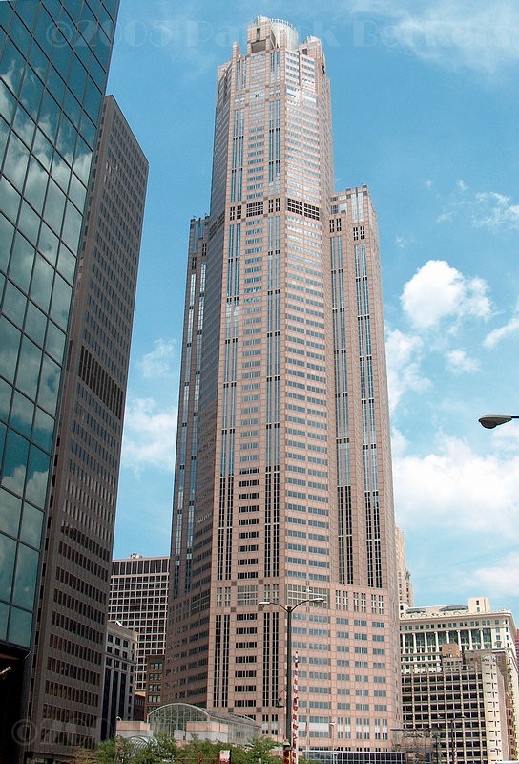
  - SOUTH WACKER DRIVE ,CHICAG0
  - (high performance concrete used in columns)
FIGURE – 2.1
Chapter 3

3.1 Superplasticizers
The use of superplasticizers (high range water reducer) has become a quite common practice. This class of water reducers were originally developed in Japan and Germany in the early 1960s; they were introduced in the United States in the mid-1970s.
Superplasticizers are linear polymers containing sulfonic acid groups attached to the polymer backbone at regular intervals (Verbeck 1968). Most of the commercial formulations belong to one of four families:
- Sulfonated melamine-formaldehyde condensates (SMF)
- Sulfonated naphthalene-formaldehyde condensates (SNF)
- Modified lignosulfonates (MLS) .
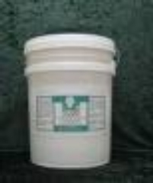
- FIGURE 3.1 super plasticize
Polycarboxylate derivatives
The sulfonic acid groups are responsible for neutralizing the surface charges on the cement particles and causing dispersion, thus releasing the water tied up in the cement particle agglomerations and thereafter reducing the viscosity of the paste and concrete (Mindess and Young 1981).
ASTM C 494 was modified to include high-range water-reducing admixtures in the edition published in July 1980. The admixtures were designated Type F water-reducing, high range admixtures and Type G water-reducing, high-range, and retarding admixtures (Mielenz 1984).
Effect of Super plasticizers on Concrete Properties. The main purpose of using super plasticizers is to produce flowing concrete with very high slump in the range of 7-9 inches (175-225 mm) to be used in heavily reinforced structures and in placements where adequate consolidation by vibration cannot be readily achieved. The other major application is the production of high-strength concrete at w/c's ranging from 0.3 to 0.4 (Ramachandran and Malhotra 1984).
The ability of super plasticizers to increase the slump of concrete depends on such factors as the type, dosage, and time of addition of super plasticizer; w/c; and the nature or amount of cement. It has been found that for most types of cement, super plasticizer improves the workability of concrete. For example, incorporation of
1.5% SMF to a concrete containing Type I, II and V cements increases the initial slump of 3 inches (76 mm) to 8.7, 8.5, and 9 inches (222, 216, and 229 mm), respectively.

3.2 TESTING OF SUPERPLASTICIZERS
Several methods have been proposed for studying cement /super plasticizer interaction. An initial attempt consisted of extending the standards on water reducing agents to the case of super plasticizers , only to ultimately realize that such an undertaking did not always meet with success. A number of standard bodies decided to designate particular cement as a reference, whereas other bodies proposed using a mix of several cements . both of these methods are acceptable for the purposes of testing a specific super plasticizer, they can not However resolve the problems of a concrete manufacturer using cement other than the reference cement

3.3 DOSAGE OF SUPERPLASTIZERS:
For increasing the workability of the mix , the normal dosage of super plasticizers is between 1 to 3 liters per cubic meters of concrete, the liquid plasticizers containing about 40 percent active material . when super plasticizers are used to reduced the water content of the mix, their dosage is much higher 5 to 20 liters per cubic meters of concrete. In the calculation of the water/cement ratio and of mix proportions in general, the volume of the liquid superplasticizer must be taken into account.

3.4 COMPATABILITY
Until the present time , both compatible and incompatible expressions had always been used for describing the interaction between cements and super plasticizers. A cement/superplasticizer combination is said to be incompatible when a superplasticizer concrete loses its initial slump very quickly . some concretes lose their initial slump in less than 15 minutes, while others retain a slump of greater than 200mm for 60 or even 90 minutes, without the presence of either bleeding or segregation and with any loss in strength at an age of 24 hours.
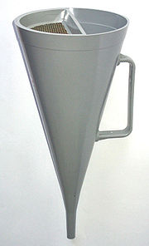
A modern plastic Marsh Funnel
FIGURE – 3.2

3.5 SILICA FUME
Silica fume is a byproduct resulting from reduction of high purity quartz with coal in an electric arc furnance in the manufacture of silicon or ferrosilicon alloy. Silica fume rises as an oxidized vapors. It cools, condenses and is collected in cloth bags. The shape of silica fume particle is spherical with particle size less than 1 micron. It has an average diameter of about 0.1micron. silica fume has specific surface area of about 20,000 m2/kg.
Silica fume by itself do not contribute to the strength dramatically although it does contribute to the strength property by its being very fine pozzolanic material and also creating dense packing and pore filler of cement paste. Due to very small particle size the rate of reaction of silica fume is considerably high and thus silica fume starts to contribute to strength development as early as one day after mixing of concrete .addition of silica fume to high slag cement concrete had no effect on compressive strength till the age of 91 days but the same increased significantly at the age of 1 year. The use of silica fume in conjunction with super plasticizer is the back bone of the modern high performance concrete .
Micro silica is much more reactive then fly ash or any other natural pozzolana. The reactivity of pozzolana can be quantified by measuring the amount of Ca(OH)2 , in the cement paste at different times.
Water demand increases by about 1 percent for every one percent of cement substitute by micro silica .. with the 20mm maximum size aggregate concrete containing 10 percent micro silica will have an increased water content of about 20litres/ m3 . by adjusting the aggregate grading and using super plasticizers this increase can be avoided. The addition of micro silica will lead to lower slump but more cohesive mix and this is in agreement with the findings of khatri and sirivivatnanon. The addition of micro silica , helps in reduction of bleeding and concrete could be handled without segregation . concrete containing micro silica is vulnerable to plastic shrinkage cracking and there fore sheet or mat curing should be considered.
Concrete containing silica fume show good strength development of the order of 60 80Mpa relatively easily at all ages . early curing by way of membrane curing is essential to keep off plastic shrinkage due to rate of evaporation at the surface being faster than the rate of migration of water from the interior to the surface.
The compressive strength of silica fume concrete at 8 percent replacement level having total cementitious material content of 500kg/m3 has shown that the compressive strength of silica fume concrete was consistently higher than OPC concrete when cured in the standard condition at the end of 28 days. For the same silica fume concrete compressive strength at the end of 1 year was approximately 10 percent more than OPC concrete.
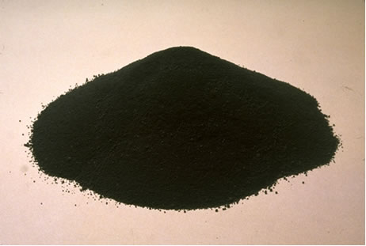

SILICA FUME
FIGURE – 3.3

3.6 Water cement ratio:
The compressive strength of high performance concrete at a given age and under normal temperature , depends primarily on the water cement ratio , lower the water cement ratio , greater the compressive strength and vice versa, duff Abrams first found the water cement ratio and compressive strength relation ship as:
S= k1/k2
S- compressive strength,
w/c-- water cement ratio of a fully compacted high performance concrete
K1 $ K2 – empirical constants .
The general form of strength verses water cement ratio curve is shown in fig 3.5
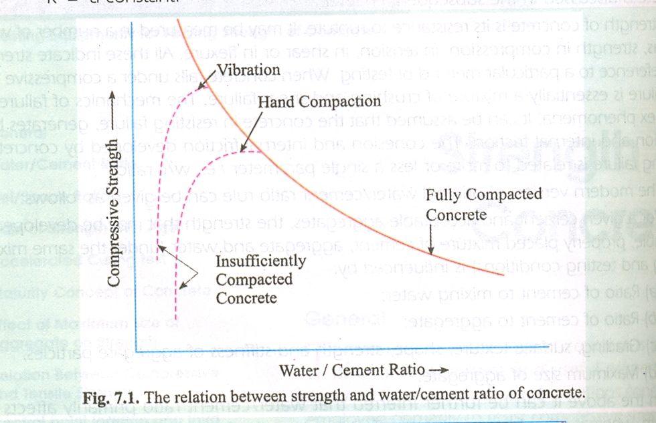
FIGURE – 3.4
Based on various researches the result showing relationship between free water cement ratio and compressive strength of concrete is shown in the figure . the water cement ratio has significant influence on permeability , the reduction in permeability with reducing water cement ratio has already been established as a fact by Glanville.

3.7 SLUMP TEST:
Slump test is the most commonly used method of measuring consistency of concrete which can be employed either in laboratory or at site of work . it is not a suitable method for very wet or very dry concrete . it does not measure all factors contributing to workability , nor is it always representative of the applicability of the concrete .
The apparatus for conducting the slump test essentially consists of a metallic mould in the form of a frustum of a cone having the internal dimensions as under .
Bottom diameter : 20cm
Top diameter :10cm
Height 30cm
The thickness of the metallic sheet for the mould should not be thinner than 1.6mm . for tamping concrete , a steel tamping rod 16mm diameter, 60cm long with bullet end used .
The mould is then filled in three layers , each approximately one third (1/3) of the height of the mould . each layer is tamped 25 times by the tamping rod taking care to distribute the strokes evenly over the cross section . after the top layer has been rodded , the conctere is struck off level with a trowel and tamping rod . the mould is removed from the concrete immediately by raising it slowly and carefully in a vertical direction. this allows the concrete subside . this subside is referred as slump concrete .
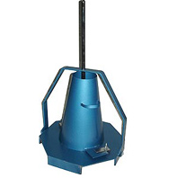
FIGURE – 3.5 SLUMP TEST
3.8 GEL/ SPACE RATIO
The water cement ratio propounded by duff Abrams has certain limitations like the strength at any water cement ratio depends upon the degree of hydration of cement and its physical / chemical properties , temperature at which hydration takes place, air content in case of air entrained concrete , change of effective water cement ratio and the formation of fissures and cracks due to shrinkage. The strength of concrete can be more correctly related to the solid products of hydration of cement to the space available for formation of this product.
Gel space ratio is defined as the ratio of the volume of the hydrated cement paste to the sum of the volumes of the hydrated cement and capillary pores. Experiments have shown that the strength of high performance concrete bears a specific relation ship with gel / space ratio given by 240x3, where x ions the gel/ space ratio. Figure shows the relation ship between strength and gel / space ratio . this relation ship is independent of age where as water cement ratio holds good primarily for 28 daysstrength for fully compacted concrete

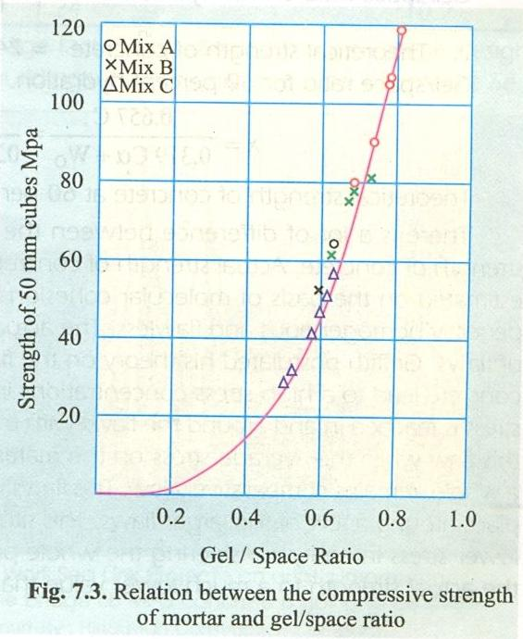

FIGURE – 3.6

3.9 Mix Design
Introduction
The process of selecting suitable ingredients of concrete and determining their relative amounts with the objective of producing a concrete of the required, strength, durability, and workability as economically as possible, is termed the concrete mix design. The proportioning of ingredient of concrete is governed by the required performance of concrete in 2 states, namely the plastic and the hardened states. If the plastic concrete is not workable, it cannot be properly placed and compacted. The property of workability, therefore, becomes of vital importance.
The compressive strength of hardened concrete which is generally considered to be an index of its other properties, depends upon many factors, e.g. quality and quantity of cement, water and aggregates; batching and mixing; placing, compaction and curing. The cost of concrete is made up of the cost of materials, plant and labour. The variations in the cost of materials arise from the fact that the cement is several times costly than the aggregate, thus the aim is to produce as lean a mix as possible. From technical point of view the rich mixes may lead to high shrinkage and cracking in the structural concrete, and to evolution of high heat of hydration in mass concrete which may cause cracking.
The actual cost of concrete is related to the cost of materials required for producing a minimum mean strength called characteristic strength that is specified by the designer of the structure. This depends on the quality control measures, but there is no doubt that the quality control adds to the cost of concrete. The extent of quality control is often an economic compromise, and depends on the size and type of job. The cost of labour depends on the workability of mix, e.g., a concrete mix of inadequate workability may result in a high cost of labour to obtain a degree of compaction with available equipment.
Requirements of concrete mix design
The requirements which form the basis of selection and proportioning of mix ingredients are :
a ) The minimum compressive strength required from structural consideration
b) The adequate workability necessary for full compaction with the compacting equipment available.
c) Maximum water-cement ratio and/or maximum cement content to give adequate durability for the particular site conditions
d) Maximum cement content to avoid shrinkage cracking due to temperature cycle in mass concrete.
Types of Mixes
1. Nominal Mixes
In the past the specifications for concrete prescribed the proportions of cement, fine and coarse aggregates. These mixes of fixed cement-aggregate ratio which ensures adequate strength are termed nominal mixes. These offer simplicity and under normal circumstances, have a margin of strength above that specified. However, due to the variability of mix ingredients the nominal concrete for a given workability varies widely in strength.
2. Standard mixes
The nominal mixes of fixed cement-aggregate ratio (by volume) vary widely in strength and may result in under- or over-rich mixes. For this reason, the minimum compressive strength has been included in many specifications. These mixes are termed standard mixes.
IS 456-2000 has designated the concrete mixes into a number of grades as M10, M15, M20, M25, M30, M35 and M40. In this designation the letter M refers to the mix and the number to the specified 28 day cube strength of mix in N/mm². The mixes of grades M10, M15, M20 and M25 correspond approximately to the mix proportions (1:3:6), (1:2:4), (1:1.5:3) and (1:1:2) respectively.
3. Designed Mixes
In these mixes the performance of the concrete is specified by the designer but the mix proportions are determined by the producer of concrete, except that the minimum cement content can be laid down. This is most rational approach to the selection of mix proportions with specific materials in mind possessing more or less unique characteristics. The approach results in the production of concrete with the appropriate properties most economically. However, the designed mix does not serve as a guide since this does not guarantee the correct mix proportions for the prescribed performance.
For the concrete with undemanding performance nominal or standard mixes (prescribed in the codes by quantities of dry ingredients per cubic meter and by slump) may be used only for very small jobs, when the 28-day strength of concrete does not exceed 30 N/mm². No control testing is necessary reliance being placed on the masses of the ingredients.
Factors affecting the choice of mix proportions
The various factors affecting the mix design are:
1. Compressive strength
It is one of the most important properties of concrete and influences many other describable properties of the hardened concrete. The mean compressive strength required at a specific age, usually 28 days, determines the nominal water-cement ratio of the mix. The other factor affecting the strength of concrete at a given age and cured at a prescribed temperature is the degree of compaction. According to Abraham’s law the strength of fully compacted concrete is inversely proportional to the water-cement ratio.

2. Workability
The degree of workability required depends on three factors. These are the size of the section to be concreted, the amount of reinforcement, and the method of compaction to be used. For the narrow and complicated section with numerous corners or inaccessible parts, the concrete must have a high workability so that full compaction can be achieved with a reasonable amount of effort. This also applies to the embedded steel sections. The desired workability depends on the compacting equipment available at the site.
3. Durability
The durability of concrete is its resistance to the aggressive environmental conditions. High strength concrete is generally more durable than low strength concrete. In the situations when the high strength is not necessary but the conditions of exposure are such that high durability is vital, the durability requirement will determine the water-cement ratio to be used.
4. Maximum nominal size of aggregate
In general, larger the maximum size of aggregate, smaller is the cement requirement for a particular water-cement ratio, because the workability of concrete increases with increase in maximum size of the aggregate. However, the compressive strength tends to increase with the decrease in size of aggregate.
IS 456:2000 and IS 1343:1980 recommend that the nominal size of the aggregate should be as large as possible.
5. Grading and type of aggregate
The grading of aggregate influences the mix proportions for a specified workability and water-cement ratio. Coarser the grading leaner will be mix which can be used. Very lean mix is not desirable since it does not contain enough finer material to make the concrete cohesive.
The type of aggregate influences strongly the aggregate-cement ratio for the desired workability and stipulated water cement ratio. An important feature of a satisfactory aggregate is the uniformity of the grading which can be achieved by mixing different size fractions.
6. Quality Control
The degree of control can be estimated statistically by the variations in test results. The variation in strength results from the variations in the properties of the mix ingredients and lack of control of accuracy in batching, mixing, placing, curing and testing. The lower the difference between the mean and minimum strengths of the mix lower will be the cement-content required. The factor controlling this difference is termed as quality control.
Mix Proportion designations
The common method of expressing the proportions of ingredients of a concrete mix is in the terms of parts or ratios of cement, fine and coarse aggregates. For e.g., a concrete mix of proportions 1:2:4 means that cement, fine and coarse aggregate are in the ratio 1:2:4 or the mix contains one part of cement, two parts of fine aggregate and four parts of coarse aggregate. The proportions are either by volume or by mass. The water-cement ratio is usually expressed in mass
Factors to be considered for mix design
⇨ The grade designation giving the characteristic strength requirement of concrete.
⇨ The type of cement influences the rate of development of compressive strength of concrete.
⇨ Maximum nominal size of aggregates to be used in concrete may be as large as possible within the limits prescribed by IS 456:2000.
⇨ The cement content is to be limited from shrinkage, cracking and creep.
⇨ The workability of concrete for satisfactory placing and compaction is related to the size and shape of section, quantity and spacing of reinforcement and technique used for transportation, placing and compaction.
Procedure
1. Determine the mean target strength f_{t} from the specified characteristic compressive strength at 28-day f_{ck} and the level of quality control.
f_{t} = f_{ck} + 1.65 S
where S is the standard deviation obtained from the Table of approximate contents given after the design mix.
2. Obtain the water cement ratio for the desired mean target using the emperical relationship between compressive strength and water cement ratio so chosen is checked against the limiting water cement ratio. The water cement ratio so chosen is checked against the limiting water cement ratio for the requirements of durability given in table and adopts the lower of the two values.
3. Estimate the amount of entrapped air for maximum nominal size of the aggregate from the table.
4. Select the water content, for the required workability and maximum size of aggregates (for aggregates in saturated surface dry condition) from table.
5. Determine the percentage of fine aggregate in total aggregate by absolute volume from table for the concrete using crushed coarse aggregate.
6. Adjust the values of water content and percentage of sand as provided in the table for any difference in workability, water cement ratio, grading of fine aggregate and for rounded aggregate the values are given in table.
7. Calculate the cement content form the water-cement ratio and the final water content as arrived after adjustment. Check the cement against the minimum cement content from the requirements of the durability, and greater of the two values is adopted.
8. From the quantities of water and cement per unit volume of concrete and the percentage of sand already determined in steps 6 and 7 above, calculate the content of coarse and fine aggregates per unit volume of concrete from the following relations:
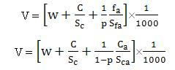
where V = absolute volume of concrete
= gross volume (1m³) minus the volume of entrapped air
S_{c} = specific gravity of cement
W = Mass of water per cubic metre of concrete, kg
C = mass of cement per cubic metre of concrete, kg
p = ratio of fine aggregate to total aggregate by absolute volume
f_{a}, C_{a} = total masses of fine and coarse aggregates, per cubic metre of concrete, respectively, kg, and
S_{fa}, S_{ca} = specific gravities of saturated surface dry fine and coarse aggregates, respectively
9. Determine the concrete mix proportions for the first trial mix.
10. Prepare the concrete using the calculated proportions and cast three cubes of 150 mm size and test them wet after 28-days moist curing and check for the strength.
11. Prepare trial mixes with suitable adjustments till the final mix proportions are arrived at.

3.10 High performance concrete mix design
Mix proportions for high-performance concrete (HPC) are influenced by many factors, including specified performance properties, locally available materials, local experience, personal preferences, and cost. With today's technology, there are many products available for use in concrete to enhance its properties. Consequently, there are many alternatives for mix proportions that will result in concrete with the desired properties. Here, Technical Talk briefly addresses selection of mix proportions for high-strength and low permeability concretes.
High-strength concrete High-strength concrete is defined by the American Concrete Institute (ACI) as concrete with a specified compressive strength of 6,000 psi (41 MPa) or greater. Although concretes with compressive strengths greater than 6,000 psi (41 MPa) can be produced using only cement as the binding material, it is likely that these concretes will also contain a mineral admixture such as fly ash, silica fume, or ground granulated blast furnace slag (GGBFS). For mix proportions of high-strength concrete containing cement and fly ash, the reader is referred to ACI 211.4R(1) entitled "Guide for Selecting Proportions for High-Strength Concrete with Portland Cement and Fly Ash." At the present time, similar guides are in preparation for high-strength concretes containing silica fume or GGBFS. However, many of the guidelines that apply to concrete containing fly ash also apply to concrete containing silica fume or GGBFS. Some of these are summarized below:
Testing age. Concrete tested at an age of 56 or 90 days generally has a higher compressive strength than concrete tested at 28 days. This is more noticeable with concrete containing fly ash and less noticeable with concrete containing silica fume. The use of a later age makes it easier and more economical to achieve the higher strengths. Proportions of cementitious materials are usually selected to produce the desired strength at the selected test age.
Water-cementitious materials ratio. According to ACI 211.4R,(1) many researchers have concluded that the most important variable in achieving high-strength concrete is the water-cement ratio. However, most high-strength concretes contain binding materials other than cement. Consequently, the water-cementitious materials ratio must be considered instead of the water-cement ratio where the cementitious materials include cement, fly ash, silica fume, and GGBFS as appropriate. In general, as the water-cementitious materials ratio decreases, the concrete compressive strength increases.
Portland cement. Proper selection of the type and source of cement is one of the most important steps in the production of high-strength concrete. Variation in the chemical composition and physical properties of the cement affect the concrete compressive strength more than variations in any other single material. There is also an optimum cement content beyond which little or no additional increase in strength is achieved by increasing the cement content.(1) To achieve higher strengths, it is necessary to include other materials such as fly ash, silica fume, GGBFS, or combinations of these materials
Coarse aggregate. For each concrete strength level, there is an optimum size for the coarse aggregate that will yield the greatest compressive strength per unit mass of cement. In general, a smaller size aggregate will result in a higher compressive strength concrete. On the other hand, the use of the largest possible coarse aggregate size is important in increasing the modulus of elasticity or reducing creep and shrinkage
Fine aggregate. According to ACI 211.4R,(1) fine aggregates with a fineness modulus in the range of 2.5 to 3.2 are preferable for high-strength concrete. Concretes with a fineness modulus less than 2.5 may be sticky and result in poor workability and high water requirement.
Chemical admixtures. Water-reducers or high-range water-reducers are essential in high-strength concrete to ensure adequate workability while achieving a low water-cementitious materials ratio. Retarding admixtures may also be used. The optimum dosage of an admixture or combination of admixtures should be determined by trial mixtures using varying amounts of each additive. It is also important to be sure that admixtures are compatible when used in combination.
Sample mixes. Table 1 lists a selection of concrete mix proportions for commercially available high-strength concretes from various sources. These data show a range of materials and quantities that can be used to produce high-strength concrete. Hence, there is no standard mix to produce a high-strength concrete. Trial mixes are needed to obtain the optimum use of each locally available constituent material.
Low permeability concrete Whereas guidelines are available for mix proportions of high-strength concrete, the same is not true for low permeability concretes. Most specifications address the requirements for low permeability by specifying a maximum water-cementitious materials ratio of 0.40 and a maximum permeability per ASTM C 1202.(4)
According to the Portland Cement Association publication EB001,(5) fly ash and GGBFS generally reduce the permeability of concrete even when the cement content is relatively low, and silica fume is especially effective in this regard. Tests show that the permeability of concrete decreases as the quantity of hydrated cementitious materials increases and the water-cementitious materials ratio decreases. Values of permeability less than 2,000 coulombs may be achieved with concretes containing fly ash, silica fume, or GGBFS. Values of permeability less than 1,000 coulombs may require the use of silica fume.
Table 2 lists a selection of concrete mix proportions used to achieve low permeability concretes. It demonstrates that a variety of materials may be used to achieved lower permeability.
Conclusions For HPC, mix proportions must be selected to meet the specified performance criteria at a reasonable cost while using locally available materials. This will require more trial mix batches and testing than are necessary with conventional concretes.

CHAPTER 4
4.1 MATERIALS TECHNOLOGY OF HIGH PERFORMANCE CONCRETE
In order to achieve high compressive strength . it is important to understand the factors that governs the strength of concrete :
- The properties of the cement paste.
- The properties of the transition zone between the paste and the aggregate.
- Properties of the aggregate.
- The relative proportions of the constituent materials.
All these factors must be optimized in order to make significant increases in compressive strength.
4.2 PASTE PROPERTIES
A reduction in water/cement ratio will produce a paste in which the cementitious particles are initially closer together in the freshly mixed concrete. This results in less capillary porosity in the hardened paste and hence a greater strength .this reduced capillary porosity also favors the formation of fine textured hydration products that have a higher strength than coarser equivalents. The capillary porosity can also be reduced by optimizing the particle size distribution of the cmentitious materials in order to increase the potential packing density. Special high strength cements are available and the inclusion of finely divided reactive materials such as silica fume will also contribute to an increase in packing density and reduced capillary porosity.
The role of super plasticizer in enabling workable concretes to be produced at very low water/cement ratio (and without the need for excessively high cement contents ) is critical . further more the effect of super plasticizer in preventing the flocculation of Portland cement particles and distributing material such as silica fume homogenously through the freshly mixed concrete leads to a reduction in inhomogenieties within the paste and hence improved paste strength . the strength of the paste will be limited by the flows that form the weakest link , be they inhomogenieties or capillary pores . in order to improve the strength of the paste as a whole , all such flows must be minimized.

4.3 TRANSITION ZONE PROPERTIES
If the transition zone to the aggregate is weak , the strength of the concrete will not increase commensurately . in conventional ( say ,40Mpa) concretes , this transition zone is quite large and is characterized by a high porosity and large crystalline hydration products(such as porlandite ca(oh)2. reducing the water /paste ratio and the incorporation of silica fume into the concrete both contribute to reducing the width and improving the strength of the transition zone (mindess 1994). The rapid conversion of ca(oh)2 to CSH by silica fume is thought to be of particular importance . reduced bleeding with in the paste also reduced the potential for accumulation of water around aggregate particles.
4.4 AGGREGATE PROPERTIES
Crushed rock aggregates are generally preferred to smooth gravels as there is some evidence that the strength of transition zone is weakened by smooth aggregates ( Aitkin and Mehta 1990). The aggregate should have a high intrinsic strength and granites, basalts, and limestone’s have been used successfully, as have crushed glacial gravels .
During the crushing process , aggregate particles may be severely micro cracked. The number of micro cracks will be greater in larger particles , consequently it is common practice to use smaller particles (10mm -14mm nominal size) for high strength concrete ( Mehta and aitcin,1990a).
It is assumed that small aggregate particles will contain less internal flaws and hence produce a higher concrete strength . it must be stressed that the selection of appropriate sources of aggregate is much more critical for high strength concrete than for conventional concretes.
4.5 MATERIALS SELECTION
It should be recognized that there is no single or unique composition for high performance concrete . high performance concrete can be made with a range of materials and mix designs which will produce slightly differing properties.
4.6 CEMENT
High performance concrete can be produced with most available Portland cements, but those cements that are particularly coarsely ground are usually unsuitable(Mehta and aitcin,1990a). special cements have been developed for high performance concrete in norway which are more finely ground and with lower tricalcium aluminate (C3A)CONTENT (HELLAND,1996) but elsewhere normal commercial products are generally employed .
Silica fume is almost ubiquitous in high performance concrete as it has approximately three times the cementing efficiency (on a weight for weight basis) as Portland cement . this facilitates the achievements of high strength concretes without excessive cement contents. Silica fume is available in Europe (and elsewhere)both in the form of a water based slurry and a dandified power (concrete society 1993). To be effective it should always be used in conjunction with a super plasticizer. It is usually incorporated into concrete at b5-15 percent by weight of total binder.
PFA and GGBS have also been used successfully together with Portland cement and silica fume (burg and ost, 1992) , albeit at lower levels than in conventional structural concrete . the reasons for use include improvements in pumping performance and reducing in heat evolution . The use of met kaolin ( a highly reactive pozzolan) HAS ALSO BEEN PROPOSEDFOR HIGH PERFORMANCE CONCRETE (CALDERONE ET AL ,1994, RYLE,2000) although not yet used very extensively. As different sources of cementitious materials may interact with different efficiency , trials to establish the optimum combination and sources of materials may often be required .
All cements should comply with appropriate national or international standards.
FIGURE - 4.1 Portland cement
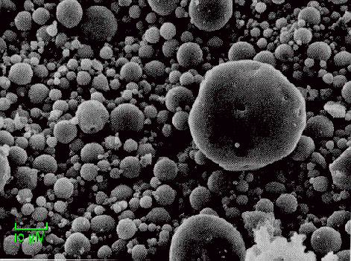
FIGURE 4.2 , FLY ASH
4.7 ADMIXTURES
The role of admixture is much more significant in high performance concrete than for more conventional concretes. To produce workable concretes at very low levels of water/cement ratios (typically below .30), without needing unacceptably high cement content , requires the use of super plasticizers . melamine based , naphthalene –based and polycarboxilate ether –based super plasticizers have been used successfully, either individually or in combination .the dosage rates of super plasticizers can be very high (upto 3 percent by weight of cement ) in order to achieve the required workability. It should be noted that there is generally a saturation dosage of super plasticizers above which no further increase in workability will occur . this can easily be determined by the use of a flow cone (Aitkin et al 1994) this efflux time is measured at the same free water/cement ratio for a series of admixture dose rates . this enable the maximum effective level of admixture addition (minimum efflux time ) to be identified. (see figure)
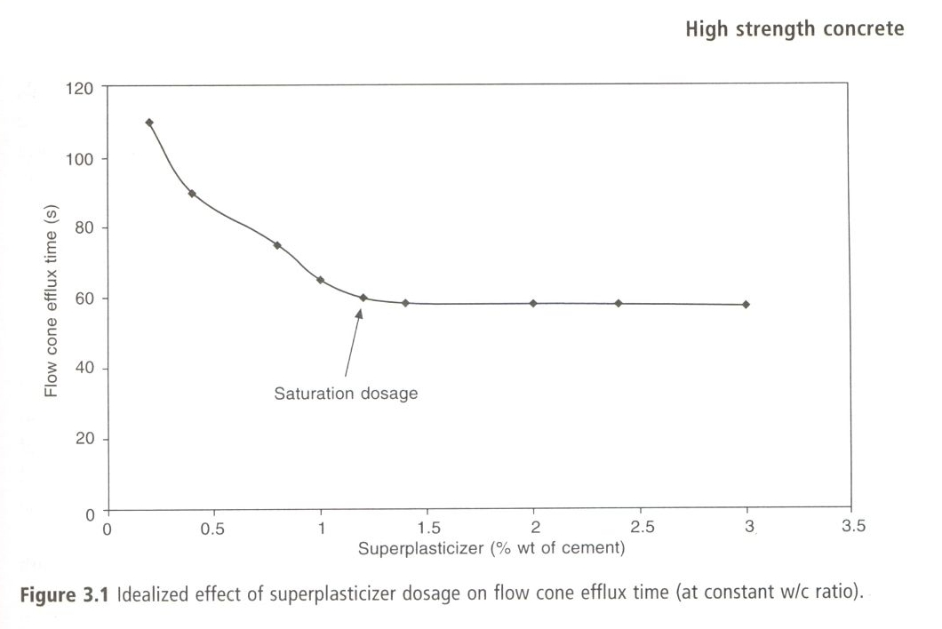

FIGURE – 4.3
Lignosulphnate based plasticizers may also be combined with melamine super plasticizers in order to extent their workability retention . compatibility between admixtures and different cement types , must be considered when materials are selected ( again flow cone tests may be useful).
4.8 AGGREGATES
Fine aggregates for high performance concrete should be selected to reduced the water demand . rounded particles are thus preferred to crushed rock fines where possible . the silt, clay and dust content of both fine and coarse aggregates should be kept as low as possible.
As most high performance concrete contain a large amount of fine material in the cement (often greater than 500 kg/m3), it is accepted practice to utilized slightly coarser grading of fine aggregate than is normal for conventional structural concrete (aitcin , 1998). The finest fractions of the fine aggregate are no longer essential to increase workability or prevent segregation, a coarser grading (fineness modulus 2.7 to 3.0 or BS 882 class C ),(British standard institution , 1992) is there fore appropriate . the grading curve of the fine aggregate should ,however , generally be smooth and free gap grading to optimize the water demand.
The requirements of coarse aggregates have been examined earlier. However , the particle shape should ideally be equidimensional (i.e not elongated or flaky) and the grading should once again be smooth with no gaps in the grading between coarse and fine fractions . a maximum size of 10- 14mm is usually selected (Mehta and aictin,1990a) although aggregates upto 20mm may be used if they are strong and free of internal flows or fractures . this can , however, only be evaluated from trial
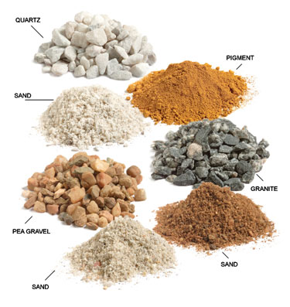

FIGURE 4.4 , AGGREGATES

CHAPTER 5

DESIGN OF CONCRETE MIXES

5.1 CONCRETE MIX DESIGN ( M50 GRADE )

(a ) design stipulations :

1  2  3  4  5 | Characteristic compressive strength required in the field at 28 days  Maximum size of aggregate  Degree of workability  Degree of quality control  Type of exposure | 50Mpa  20mm (angular)  0.90 (compaction factor )  Good  severe

( b) test data for materials:

1  2  3  4  5  6  7 | Cement used, ordinary portland cement satisfying the requirements of IS 12269 -1999  Specific gravity of cement (53 grade)  I Specific gravity of coarse aggregate  Ii specific gravity of fine aggregate  Water absorption  I coarse aggregate  Ii fine aggregate  Free surface moisture  Fine aggregate  Coarse aggregate  Sieve analysis  Fine aggregate  Fine ness modulus ( FM) | 53 Grade  3.20  2.85  2.78  0.80%  1.68%  0.80%  0.40%  Confirming to grading zone ii of table 4 of IS 383-1997  2.62

( c ) target mean strength of concrete

Ft = fck+ ks

Ft=50+1.65x5= 58.25 N/mm2

Where ft = target mean compressive strength at 28 days.

Fck=50, characteristic compressive strength at 28 days

S= 5, standard deviations ( from table 8 of IS 456-2000)

K = 1.65 ( Tolerance factor)

  - selection of water cement ratio :
from figure 47 of sp: 23 -1982, the water cement ratio required for the target mean strength of 58.25 N/mm2 is o.33. this is lower than maximum value of 0.45 prescribed for severe exposure ( from table 23 of sp23- 1982 )

(e ) selection of water and sand content:

From table 43, for 20mm nominal maximum size of aggregate and sand confirming to grading zone ii , water content /m3 of concrete is equal to 180 kg and sand content as a percentage of total aggregate by absolute volume is equal to 25% . for change in values in water cement ratio , compacting factor , the following adjustment is required.

Adjustment required in
Change in condition (from table 44 of sp: 23) | Water content% | % sand in total aggregate
For decrease in water cement ratio by ( o.45- 0.33 )  For increase in compacting factor (0.90-0.80), that is ,0.01 | 0  +3.0 | -3.5
Total | + 3.0 | - 3.5

There fore required sand content as % of total aggregate by absolute volume = 25-3.5 =21.5 %
Required water content=180+180x3.5/100 =186.30 kg/m3
(f ) determination of cement content:

Water cement ratio = 0.33

Water= 186.3kg

Cement =186.3/0.33 =564.54kg

Limit=450 kg

Water = 450x0.33=148.5kg

(g) determination of coarse and fine aggregate content

From table 41, for the specified maximum size of aggregate of 20mm, the amount of entrapped air in the wet concrete is 2 % . taking this into account and applying equation ,

V = ( w +c/Sc +1/p xfa/sfa) x1/1000

V = ( w + c/Sc + 1/(1-p) x ca /Sca) x 1/1000

V = absolute volume of fresh concrete
= gross volume (1m3) minus the volume of entrapped air ,

Sc = specific gravity of cement

W mass of water (kg) per m3 of concrete ,

C = mass of cement ( kg) per m3 of concrete

P = ratio of fine aggregate to total aggregate by absolute volume

Fa, Ca =total masses of fine aggregate and coarse aggregate kg per m3 of concrete respectively,

Sfa, Sca= specific gravity of saturated surface dry fine and coarse aggregate, respectively.

0.98m3= ( 148.5+ 450/3.2+1/0.215 xfa/2.78)x1/1000

Fa = 412.94=413 kg

980= (148.5 + 450/3.2 +1/0.785x1/2.85)

1545.66=1546 kg/m3

The mix proportions then becomes:

Water(kg) | Cement(kg) | Fine aggregate(Kg) | Coarse aggregate(kg) | Admixture  (kg)
148.5  0.33 | 450  1 | 413  0.9177 | 1546  3.436 | 9 or 13.5

( h ) actual quantities required for the mix per bag of cement :

The mix is o.33:1:0.9177:3.436 (by mass )

For 50 kg of cement the quantity of materials are worked out as under

(i) cement= 50 kg

(ii) sand = 45.885 kg

(iii) coarse aggregate = 171.8 kg admixture=@ 2% , or 3% by weight of cement.

5.2 CONCRETE MIX DESIGN M50 ( Mix proportions with micro silica or silica fume )
IS 456 – 2000 recommends silica fume as replacement of cement in the proportion of 5 to 10 percent of the cementitious materials .
Considering a cementing efficiency factor of silica fumes as 3.0
Silica fume content @ 8 % = 8x 450/100=36 kg
Reduction in cement content = 3 x 36 = 108 kg
Quantity of cement = 450- 108 = 342 kg

From yield point of view , sand content
[1- 342/(3.20 x 1000) – 36/ (2.2x 1000 )- 1546/ (2.85x 1000) -186.3/1000 – 3/100)]
= 0.159m3
=0.20m3 (say )
Weight of sand = 0.20 x 1000 x 2.78= 556 kg
High range water reducing admixture @ 3 % =3x (342+36)/100 = 11.34 kg
Net weight of water excluding that in high range water reducing admixture
186.3 – 11.34 174.96 kg
Percentage of silica fume= 36 x 100 /(342+36 ) = 9.52 % , which is with in the optimum range of 5 to 10 percent .
The mix proportions using silica fume are
Ingredients weight /m3 of concrete , kg
Cement 342 kg
Sand 556 kg
Coarse aggregate 1546 kg
Water 174.96 kg
Super plasticizer 11.34 kg

5.3 CONCRETE MIX DESIGN (M60 GRADE)

(a) design stipulations :
1 | Characteristic compressive strength required in the field at 28 days | 60N/mm2
2  3  4  5 | Maximum size of aggregate  Degree of workability  Degree of quality control  Type of exposure | 20mmor 12.5mm  0.90(compaction factor)  Good  severe

(b) test data for materials
1  2  3i  ii  4  i  ii  5  6  7 | Cement used ordinary port land cement(opc) satisfying the requirements of I S 12269-1999  Specific gravity of cement  Specific gravity of coarse aggregate  Specific gravity of fine aggregate  Water absorption  Coarse aggregate  Fine aggregate  Free surface moisture  I coarse aggregate  Ii fine aggregate  Sieve analysis (fine aggregate)  Fine ness modulus | 53 grade  3.15  2.60  2.46  0.5  1.65  0.2  0.5  Confirming to grading zone ii of table 4 of IS 383-1997  2.67

( C ) Target mean compressive strength at 28 days.
Fck = fck + k.s
= 60 + 1.65x 7
71.55 N/mm2
Where ft = target mean compressive strength at 28 days
Fck = 60, characteristic compressive strength at 28 days,
S= 7 , standard deviations ( from table 1 IS 10262 1982)
K= tolerance factor

( d ) selection of water cement ratio from figure 47 of SP 23 1982, the water cement ratio required for the target mean strength of 71.55 N/mm2 is 0.31 =0.31
This is lower than the maximum value of 0.65 prescribed for “ severe “exposure ( from table 23 of SP 23-1982).
( e ) selection of water and sand content.
From table 43 of SP 23- 1982 , for 20mm nominal maximum size aggregate and sand confirming to grading zone ii , water content/m3 of concrete is equal to 180 kg and sand content as percentage of total aggregate by absolute volume is equal to 25 percent. For change in values in the water content ratio ,compacting factor , the following adjustment is required.

Change in condition ( from table 44 of SP 23). Adjustment required in
Water content % % sand in total aggregate
For decrease in water cement ratio by (0.65- 0.31)= 0.34  For increase in compacting factor (0.90- 0.80 ) that is ,0.1  Total = | 0  + 3.0  + 3.0 | - 3.5  -3.5
There fore required sand content s as % of total aggregates by absolute volume = 25- 3.5 = 21.5 %
Required water content + 180+ ( 180 x3.5/100)
=186.30 kg .
( f ) determination of cement content :
Water cement ratio = 0.31
Water = 186.30 kg
Cement = 186.30/0.31 = 600.961 kg
Limit =450 kg actual water = 450x 0.31 139.5 kg
Cement = 139.5/0.31 = 450 kg/m3
( g ) determination of coarse and fine aggregate content :
From table 41 , for the maximum size of aggregate of 20mm , the amount of entrapped air in the wet concrete is 2% . taking this into account and applying equation ,
V = ( W + C/Sc + 1/P x fa/Sfa ) 1/1000
Where , V= absolute volume of fresh concrete
= gross volume ( 1 m3) minus the volume of entrapped air.
Sc = specific gravity of cement
W = mass of water (kg) per m3 of concrete
P = ratio of fine aggregate to total aggregate by absolute volume.
fa , Ca = total masses of fine and and coarse aggregate, 9 KG 0 /m3 of concrete respectively and ,
Sfa, Sca = specific gravities of saturated surface dry fine aggregate and coarse aggregate respectively.
0.98 = ( 139.5 + 450/3.15 + 1/0.215 x fa/2.46) x 1/1000
Fa = 369 kg/ m3
  - = ( 139.5 + 450/3.15 +1/0.785 x ca/2.60 ) x1/1000
Ca = 1423.88 kg

Admixture @ 2% to 3% by weight of cement
2x450/100 = 9 kg/m3 , or , 3x 450 /100 = 13.5 kg /m3

The mix proportions becomes :
Water  139.50 kg  0.31 | Cement  450 kg  1 | Fine aggregate  369 kg  0.82 | Coarse aggregate  1424 kg  3.164 | Admixture (kg)  9 or 13.5
( h) actual quantities required for the mix per bag of cement :
The mix is ,
0.31:1:0.82:3.164 ( by mass)
For 50 kg of cement the quantity of materials are worked out as follows,
( 1 ) cement = 50 kg
( 2 ) sand = 41 kg
(3) coarse aggregate = 158.21 kg
(4 ) water for water cement ratio 0.31 , water = 15.5 liters.
Extra water to be absorbed in case of coarse aggregate at (0.8- 0.3 ) = 0.25 liters.
Extra water to be added for absorption in sand at ( 1.65 – 0.5) by mass = 0.575 liters
Actual water to be added = 15.5 + 0.25 + 0.575
= 16.325 liters.
(5 ) actual quantity of sand required after allowing for mass of pre moisture
41- 0.575 = 40.425 liters
= 40.425 kg
( 6 ) actual quantity of coarse aggregate required = 158.2 – 0.25 = 157.95 kg
= 157.95 kg
There fore , the actual quantities of different constituents required for the mix are
Water = 16.325 lit/kg
Sand = 40.425 kg
Cement = 50 kg
Coarse aggregate = 157 .25 kg

5.4 CONCRETE MIX DESIGN M60 GRADE (MIX PROPORTIONS WITH MICRO SILICA OR SILICA FUME )
IS 456 – 2000 recommends silica fume as replacement of cement in the proportion of replacement of cement in the proportion of 5 to 10 percent of cementitious materials .
Assuming 8 % addition of silica fume in the concrete = 450 x 8/100
= 36 kg
Reduction in the cement content = 36 x 3 = 108 kg
Cement = 450-108 = 342 kg
From the yield point of view [ 1 – 342/(3.15x 1000) -36/(2.2x 1000) -1424/(2.6 x1000)- 186.3/1000 – 3/100 ]
= 1- 0.87 = 0.13 m3
0.20m3
Weight of sand = .2x 2.6 1000 = 520 kg
High range water reducing admixture @ 3 % = 3(342+36) = 11.34 kg
Net weight of water excluding that in the high range water reducing admixture
186.30- 11.34 = 174.96kg
Percentage of silica fume = 36x 100 / (342+36) = 9.523, which is with in the optimum range of 5% to 10 %
The mix proportions using silica fume are :
Ingredients weight /m3 of concrete (kg)
Cement 342
Micro silica (silica fume ) 36 kg
Sand 520 kg
Coarse aggregate 1424 kg
Water 174.96 kg
High range water reducing admixture 11.34 kg

5.5 CONCRETE MIX DESIGN M70 GRADE
( a ) Design stipulation :
1  2  3  4  5 | Characteristic compressive strength required in the field at 28 days  Maximum size of aggregate  Degree of workability  Degree of quality control  Type of exposure | 70 N/mm2  20mm or 12.5mm (angular)  0.9 (C. F.)  Good  Severe

( b ) test data for materials
1  2  3  4  5  6  7 | Cement used – ordinary portland cement satisfying the requirements of IS 12269  Specific gravity of cement ( 53 grade )  I Specific gravity of coarse aggregate  Ii specific gravity of fine aggregate  Water absorption, I coarse aggregate  Ii fine aggregate  Free surface moisture, I coarse aggregate  Ii fine aggregate  Sieve analysis  Fine aggregate , confirming to grading zone ii of table 4 of IS 383 1997  Fine ness modulus | 53M pa  3.16  2.75  2.60  0.8%  1.68%  0.4%  0.8%  2.51

( c ) target mean strength of concrete
Ft = fck + ks
Ft = 70 +1.65x 7 ( S=7 , as per IS 10262)
= 81.55N/mm2
Where ft = target mean compressive strength at 28 days.
S= 7 , standard deviation
K= 1.65 tolerance factor.
(d ) selection of water cement ratio from figure 47 of SP 23- 1982 , the water cement ratio required for the target mean strength of 81.55 N/mm2 is 0.30. this is lower than the maximum value of 0.65 prescribed for severe exposure ( from table 23 of sp 23- 1982).
(e) selection of water and sand content:
From table 43, for 20mm or 125 mm , nominal maximum size aggregate and confirming to grading zone II , water content /m3 of concrete is equal to 180 kg and sand content as percentage of total aggregate by absolute volume is equal to 25 percent . for change in values of water cement ratio , compacting factor, the following adjustment is required .

Change in condition ( from table table 44 of SP 23) | Adjustment required  Water content % | in  % sand in total aggregate.
For decrease in water cement ratio by ( 0.60-0.30) =0.30  For increase in compacting factor (0.90-0.80) that is 0.01  Total = | 0  + 3.0  + 3.0 | -3.0  0  -3.0
There required sand content as % of total aggregate by absolute volume,
Volume = 25- 3.0 =22 %
Required water content = 180+ 180x3/100
180+ 5.4 = 185.4 kg.
(f ) determination of cement content
Water- cement ratio = 0.30
Water 185.4kg
Cement = 185.4/0.30 618kg
Limit= 530 kg /m3
Water = 530x 0.30 = 159 kg
(g ) determination of coarse and fine aggregate content:
For the specified maximum size of aggregate of 20mm, the amount of entrapped air in the wet concrete is 2% . taking this into account and applying equation
V=( w + c/Sc + 1/p x fa/Sfa)x1/1000
V= (w+ c/Sc + 1/(1-p) x Ca/Sca) x1/1000
Where, v =absolute volume of fresh concrete
=gross volume (1m3) minus the volume of entrapped air,
Sc = specific gravity of cement
W = mass of water ( kg) per m3 of concrete
C = mass of cement ( kg) per m3 of concrete.
P = ratio of fine aggregate to total aggregate by absolute volume.
Fa , Ca , = total masses of fine aggregate and coarse aggregate ( kg) per cubic meter of concrete respectively,
0.98m3 = n(159+530/3.16 + 1/0.22 xfa/2.60) 1/1000
Fa = 373.67kg/m3
0.98 = ( 159+ 530/3.16 + 1/0.78 xCa/2.75) x 1/1000
Ca = 1401.3 kg/m3
Admixture = @ 2% to 3% by weight of cement
2x 530/100,=10.6 kg, or
3x 530/100 = 15.9 kg/m3
The mix proportions then becomes :
Water(kg) | Cement (kg) | Fine aggregate(kg) | Coarse aggr (kg) | Admixture(kg)
159  0.30 | 530  1 | 374  0.706 | 1401.3  2.644 | 10.6 or 15.9
(h) actual quantities required for the mix per bag of cement :
The mix is, 0.30:1:0.706:2.644 .
For 50 kg of cement the quantities of materials are worked out as below.
- cement = 50 kg
- sand =35.3 kg
- coarse aggregate = 132.2 kg
- water , for water cement ratio 0.30,
water = 15.0 kg
extra water to be added for absorption in case of coarse aggregate at (0.8-0.4)by mass=0.54 liters.
Extra water to be added for absorption in sand at (1.68% - 0.8%)=0.49 liters.
Actual water to be added = 15.0+0.54 +0.49 =16.3 litres.
(5)actual quantity of sand required after allowing for mass of pre moisture 35.3-0.49=34.81kg
(6) actual quantity of coarse aggregate required=132.2-0.54= 131.66kg
Therefore, the actual quantities of different constituents required for the mix are:
Water= 16.03kg
Cement=50kg
Sand =34.81kg
Coarse aggregate = 131.66 kg

5.6 CONCRETE MIX DESIGN M70 GRADE ( MIX PROPORTIONS WITRH MICRO SILICA OR SILICA FUME ) :
IS : 456 – 2000 recommends silica fume as replacement of cement in the proportion of 5 to 10 percent of the cementitious materials . cementing efficiency factor of silica fume as 3.0 .
Silica fume content @ 7.5 5 = 530 x 7.5 /100 =39.75kg = 40 kg
Reduction in cement content = 40x 3 = 120 kg
Cement content = 530- 120 =410 kg
From the yield point of view
[ 1- 410/(3.16 x 1000 ) – 40/(2.2x1000) – 1401/(2.75x1000)-159/1000 -3/100 ]
= 0.154m3 = 0.200m3
Weight of sand 0.20x 1000 x 2.6
=520 kg
High range water reducing admixture @ 3 % =0.03x (410+40)
13.5kg= 13.5litres
Water = 159-13.5 = 145.5 kg
Percentage of micro silica = 40 100/ (410+40) = 8.88,
Which is with in the optimum range of 5 to 10 percent .

The mix proportions using the silica fume are
Ingredients weight /m3 of concrete , kg
Cement 410 kg
Micro silica 40 kg
Sand 520 kg
Coarse aggregate 1401 kg
Water 145.5 kg
High range water reducing admixture 13.5 kg

5.7 CONCRETE MIX DESIGN (M 80 GRADE)

(a ) Design stipulations
1  2  3  4  5 | Characteristic compressive strength required in the field at 28 days  Maximum size of aggregate  Degree of workability  Degree of quality control  Type of exposure | 80N/mm2  20mm or  12.5mm (angular)  0.90(compaction factor)  good  severe

(b)test data for materials
1  2  3  4  5  6  7 | Cement used ,ordinary portland cement confirming to IS 12269 -1999)  Specific gravity of cement (53 grade )  I specific gravity of coarse aggregate  Ii specific gravity of fine aggregate  Water absorption  I coarse aggregate  Ii fine aggregate  Free surface moisture  I coarse aggregate  Ii fine aggregate  Sieve analysis  I fine aggregate  Fine ness modulus | 53 grade  3.20  2.87  2.73  0.8%  2.0%  0.4%  0.8%  Confirming to grading zone ii of table 4 of IS : 383-1997  2.52

(c) Target mean strength of concrete

ft = fck + k.s

= 80+ 1.65x8 (s 8 as per is 10262)

= 93.2 N/mm2

Where ft = target mean compressive strength at 28 days

Fck = 80N/mm2, characteristic compressive strength at 28 days

S =8 ( standard deviation from IS 10262 ,assumed )

K = tolerance factor

( d ) selection of water cement ratio:

From figure 47 of SP 23- 1982, the water cement ratio required for the target mean strength of 93.2 N/mm2 is 0.28 . this is lower than the maximum value of 0.45 prescribed for severe exposure( from table 23 of SP 23 – 1982)

( e ) selection of water and sand content :
From table 43, for 20mm nominal maximum size aggregate and sand confirming to grading zone ii , water content /m3 of concrete is equal to 180 kg and sand content as percentage of total aggregate by absolute volume is equal to 25 percent . for change in values in water cement ratio , adjustment is required .

Adjustment required in
Change in condition (from table 44 of sp: 23) | Water content % | % sand in total aggregate
For decrease in water cement ratio (0.6-0.41)=0.25  For increase in compacting factor (0.9- 0.8 ) that is 0.01 | 0  + 3.0 | -3.0  0
total | +3.0 | -3.0
There fore required sand contents as % of total aggregate by absolute volume= 25- 3.0 =22%
Required water content = 180+ 3x180/100 =185.4 kg

( f ) determination of cement content

Water cement ratio =0.28

Water content = 185.4 liters ,or kg

Cement = 185.4/0.28 =662.14 kg

Limit = 530 kg /m3

Water content =530x0.28

= 148.4kg

This cement content is adequate for severe exposure conditions table 23, page 65, SP 23-,1982 )

(G) Determination of coarse and fine aggregate content:

From table 41, for the specified maximum size of aggregate 20mm, the amount of entrapped air in the wet concrete is 2 % . taking this into account and applying equation.

V = ( w+c/Sc +1/p x fa /sfa )x1/1000

V = ( w + c/Sc +1/(1-p) xCa/Sca)x1/1000

Where, v =absolute volume of fresh concrete
= gross volume (1m3) minus the volume of entrapped air.

Sc = specific gravity of cement

W =mass of water (kg) per m3 of concrete

C = mass of cement (kg) /m3 of concrete

P = ratio of fine aggregate to total aggregate by absolute volume.

fa, ca= total masses of fine aggregate and coarse aggregate kg/m3 of concrete respectively, and
Sfa and Sca = specific gravity of saturated surface dry fine aggregate and coarse aggregate respectively.

0.98m3= (148.4 + 530/3.20)+1/0.22 x fa/2.73)x1/1000

fa=399.98kg = 400 kg/m3

0.98m3=( 148.4 + 530/3.20+ 1/0.78 xca/2.87 ) x1/1000

Ca= 1490.85 kg/m3= 1491kg/m3

Admixture @ 2% by weight of cement
2x530/100 =10.6 kg, or
3x530/100 = 125.9 kg

The mix proportions then becomes

Water(kg) | Cement(kg) | Fine aggregate(kg) | Coarse aggregate(kg) | Admixture  (kg)
148.4  0.28 | 530  1 | 400  0.754 | 1491  2.813 | 10.6,or,15.9

(h) actual quantities required for the mix per bag of cement :
The mix is 0.28:1:0.754:2.813 (by mass ) , for 50 kg of cement the quantities of materials are worked out as below:

1 Cement = 50 kg
2 sand =37.7kg
3 coarse aggregate
4 water

For water cement ratio of 0.28
Water = 0.28x50
Extra water to be added for absorption in case of coarse aggregate at (0.8 – 0.4 )% =by mass = 0.55 kg
Extra water to be added for absorption in sand at(1.68- 0.8 )%by mass= 0.49 kg
Actual water to be added
= 14+0.55+0.49 = 15.04 kg

( 5 ) actual quantity of sand required after allowing for mass of pre moisture = 37.7- 0.49 +37.21 kg.
- actual quantity of coarse aggregate required = 140.65-0.55 =140.1 kg

there fore , the actual quantity of different materials required for the mix are :
water= 15.04 kg

cement = 50 kg

sand = 37.21 kg

coarse aggregate =140.1 kg.

5.8 CONCRETE MIX DESIGN M80 GRADE CONCRETE (Mix proportions with silica fume or micro silica )
IS: 456 – 2000 recommends silica fume as replacement of cement in the proportion of 5 % to 10 % of the cementitious materials.
Assuming efficiency factor of silica fume = 3
Silica fume content @ 7.5 %
= 530 x 7.5 / 100 = 39.75kg = 40 kg
Reduction in cement content = 3 x 40= 120 kg
Cement= 530-120 =410 kg
Sand content ,
[ 1- 410/ (3.20x 1000) -40 / (2.2x 1000) – 1491/(2.87 x 1000) – 148.4 /1000 – 3/100 ]
= 0.171m3 = 0.20 m3 (say)
Weight of dry sand = 0.20x 2.73x 1000 = 546 kg
High range water reducing admixture @ 3 % = 3x (410+40 ) /100 = 13.5 kg
Weight of water 185.40-13.5 = 171.9 kg
Percentage of silica fume = (40 x 100 0 / (410 +40 ) = 8.88 , which is with in the optimum range 5 to 10 percent .
The mix proportions using silica fume are :
Ingredients weight /m3 of concrete , kg
Cement 410 kg
Silica fume 40 kg
Sand 546 kg
Coarse aggregate 1491kg
Water 171.9 kg
Super plasticizer 13.5 kg

CHAPTER – 6

PHOTO GRAPHS OF RESEARCH WORK

FIGURE – 6.1

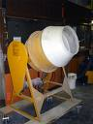

DRUM TYPE CONCRETE MIXER

FIGURE 6.2

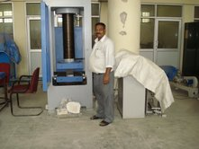

COMPRESSIVE STRENGTH MEASURING MACHINE
FIGURE – 6.3
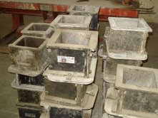

EMPTY CUBE MOULDS (SIZE 15CMX 15CM X 15 CM )

FIGURE – 6.4

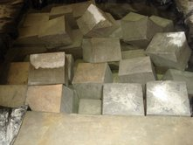

CURING TANK FOR CONCRETE CUBES
FIGURE 6.5

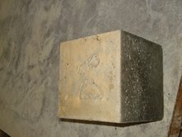

CUBES ON THE VIBRATING TABLE
FIGURE - 6.6

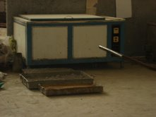

FIGURE - 6.7 , WARM WATER CURING TANK

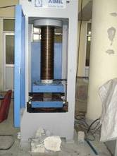

FIGURE – 6.8 , CUBE IN THE COMPRESSION TESTING MACHINE

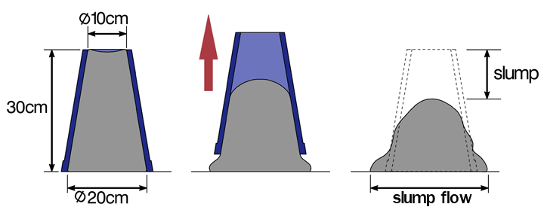

FIGURE – 6.9 – MEASUREMENT OF SLUMP

FIGURE 6.10- SLUMP TEST APPARATUS

CHAPTER- 7

  - GRAPHS – VARIATION OF WORKABILITY WITH TIME

FIGURE 1 VARIATION OF WORKABILITY WITH TIME FOR M50 GRADE

FIGURE 2 VARIATION OF WORKABILITY WITH TIME FOR M50 GRADE CONCRETE

FIGURE 3 VARIATION OF WORKABILITY WITH TIME M50 GRADE

FIGURE 4 VARIATION OF WORKABILITY WITH TIME M 50 GRADE

FIGURE 5 VARIATION OF WORKABILITY WITH TIME FOR M60 CONCRETE

FIGURE 6 VARIATION OF WORKABILITY WITH TIME FOR M60 CONCRETE

FIGURE 7 VARIATION OF WORKABILITY WITH TIMEFOR M60 CONCRETE

FIGURE 8 VARIATION OF WORKABILITY WITH TIME FOR M60 CONCRETE

FIGURE 9 VARIATION OF WORKABILITY WITH TIME FOR M 70 CONCRETE

FIGURE 10 VARIATION OF WORKABILITY WITH TIME FOR M70 CONCRETE

FIGURE 11 VARIATION OF WORKABILITY WITH TIME FOR M70 CONCRETE

FIGURE 12 VARIATION OF WORKABILITY WITH TIME FOR M70 CONCRETE

FIGURE 13 VARIATION OF WORKABILITY WITH TIME FOR M80 GRADE

FIGURE 14 VARIATION OF WORKABILITY WITH TIME FOR M80 GRADE

FIGURE 15 VARIATION OF WORKABILITY WITH TIME FOR M80 GRADE CONCRETE

FIGURE 16 VARIATION OF WORKABILITY FOR M80 GRADE CONCRETE

FIGURE 17 VARIATION OF WORKABILITY WITH TIME FOR M 50 GRADE CONCRETE

FIGURE 18 VARIATION OF WORKABILITY WITH TIME FOR M 60 GRADE CONCRETE

FIGURE 19 VARIATION OF WORKABILITY WITH TIME FOR M 70 GRADE CONCRETE

FIGURE 20 VARIATION OF WORKABILITY WITH TIME FOR M80 GRADE CONCRETE

FIGURE 21 VARIATION OF WORKABILITY WITH TIME FOR M80 GRADE

FIGURE 22 VARIATION OF WORKABILITY WITH TIME FOR M80 GRADE

FIGURE 23 VARIATION OF WORKABILITY WITH TIME FOR M80 GRADE CONCRETE

FIGURE24 VARIATION OF WORKABILITY WITH TIME FOR M80 GRADE CONCRETE

FIGURE 25 VARIATION OF WORKABILITY WITH TIME FOR M70 GRADE CONCRETE

FIGURE 26 VARIATION OF WORKABILITY WITH TIME FOR M70 GRADE CONCRETE

FIGURE 27 VARIATION OF WORKABILITY WITH TIME FOR M70 GRADE CONCRETE

FIGURE 28 VARIATION OF WORKABILITY WITH TIME FOR M70 GRADE CONCRETE

7.2 GRAPHS – VARIATION OF COMPRESSIVE STRENGTH WITH SUPERPLASTICIZER

FIGURE 1 VARIATION OF COMPRESSIVE STRENGTH WITH SUPER PLASTICIZER

FIGURE 2 VARIATION OF COMPRESSIVE STRENGTH WITHSUPER PLASTICIZER / M50 GRADE

FIGURE 3 VARIATION OF COMPRESSIVE STRENGTH WITH SUPER PLASTICIZER / M50 GRADE

FIGURE 4 VARIATION OF COMPRESSIVE STRENGTH WITH SUPER PLASTICIZER / M50 GRADE

FIGURE 5 VARIATION OF COMPRESSIVE STRENGTH WITH SUPER PLASTICIZER / M 60 GRADE

FIGURE 6 VARIATION OF COMPRESSIVE STRENGTH WITHSUPER PLASTICIZER /M60 GRADE

FIGURE 7 VARIATION OF COMPRESSIVE STRENGTH WITHSUPER PLASTICIZER / M60 GRADE

FIGURE 8 VARIATION OF COMPRESSIVE STRENGTH WITH SUPER PLASTICIZER / M60 GRADE

FIGURE 9 VARIATION OF COMPRESSIVE STRENGTH WITHSUPER PLASTICIZER / M70 GRADE

FIGURE 10 VARIATION OF COMPRESSIVE STRENGTH WITHSUPER PLASTICIZER / M70 GRADE

FIGURE 11 VARIATION OF COMPRESSIVE STRENGTH WITH SUPER PLASTICIZER / M70 GRADE

FIGURE 12 VARIATION OF COMPRESSIVE STRENGTH WITH SUPER PLASTICIZER /M70 GRADE

FIGURE 13 VARIATION OF COMPRESSIVE STRENGTH WITH SUPER PLASTICIZER / M80 GRADE

FIGURE 14 VARIATION OF COMPRESSIVE STRENGTH WITH SUPER PLASTICIZER / M80 GRADE

FIGURE 15 VARIATION OF COMPRESSIVE STRENGTH WITH SUPER PLASTICIZER / M80 GRADE

FIGURE 16 VARIATION OF COMPRESSIVE STRENGTH WITH SUPER PLASTICIZER / M80 GRADE

FIGURE 17 VARIATION OF COMPRESSIVE STRENGTH WITH SUPER PLASTICIZER / M50 GRADE

FIGURE 18 VARIATION OF COMPRESSIVE STRENGTHN WITH SUPER PLASTICIZER /M50 GRADE

FIGURE 19 VARIATION OF COMPRESSIVE STRENGTH WITH SUPER PLASTICIZER / M50 GRADE

FIGURE 20 VARIATION OF COMPRESSIVE STRENGTH WITH SUPER PLASTICIZER/M 50 GRADE

FIGURE 21 VARIATION OF COMPRESSIVE STRENGTH WITH SUPER PLASTICIZER /M60 GRADE

FIGURE 22 VARIATION OF COMPRESSIVE STRENGTH WITH SUPER PLASTICIZER/ M 60 GRADE

FIGURE 23 VARIATION OF COMPRESSIVE STRENGTH WITH SUPER PLASTICIZER / M60 GRADE

FIGURE 24 VARIATION OF COMPRESSIVE STRENGTH WITH SUPER PLASTICIZER /M 60 GRADE

FIGURE 25 VARIATION OF COMPRESSIVE STRENGTH WITH DOSAGE / | /M70 GRADE

FIGURE 26 VARIATION OF COMPRESSIVE STRENGTH WITH SUPER PLASTICIZER / M70 GRADE

FIGURE 27 VARIATION OF COMPRESSIVE STRENGTH WITH SUPER PLASTICIZER / M70 GRADE

FIGURE 28 VARIATION OF COMPRESSIVE STRENGTH WITH SUPER PLASTICIZER / M70 GRADE

FIGURE 29 VARIATION OF COMPRESSIVE STRENGTH WITH SUPER PLASTICIZER / M80 GRADE

FIGURE 30 VARIATION OF COMPRESSIVE STRENGTH WITH SUPER PLASTICIZER / M80 GRADE

FIGURE 31 VARIATION OF COMPRESSIVE STRENGTH WITH SUPER PLASTICIZER / M80 GRADE

FIGURE 32 VARIATION OF COMPRESSIVE STRENGTH WITH SUPER PLASTICIZER / M80 GRADE

7.3 BAR CHARTS – VARIATION OF COMPRESSIVE STRENGTH WITH SUPERPLASTICIZER

FIGURE 1 VARIATION OF COMPRESSIVE STRENGTH WITH SUPER PLASTICIZER /M50 GRADE

FIGURE 2 VARIATIONOF COMPRESSIVE STRENGTH WITH SUPER PLASTICIZER FOR M60 GRADE CONCRETE

FIGURE 3 VARIATION OF COMPRESSIVE STRENGTH WITH SUPER PLASTICIZER FOR M70 GRADE CONCRETE

FIGURE 4 VARIATION OF COMPRESSIVE STRENGTH WITH SUPER PLASTICIZER FOR M80 GRADE CONCRETE

FIGURE 5 VARIATION OF COMPRESSIVE STRENGTH WITHSUPER PLASTICIZER FOR M50 GRADE CONCRETE

FIGURE 6 VARIATION OF COMPRESSIVE STRENGTH WITH SUPER PLASTICIZER FOR M 60 GRADE

FIGURE 7 VARIATION OF COMPRESSIVE STRENGTH WITH SUPER PLASTICIZER FOR M70 GRADE CONCRETE

FIGURE 8 VARIATION OF COMPRESSIVE STRENGTH WITHSUPER PLASTICIZER FOR M80 GRADE CONCRETE

FIGURE 9 MAXIMUM COMPRESSIVE STRENGTH ACHIEVED IN N/mm2

FIGURE 10 MAXIMUM COMPRESSIVE STRENGTH ACHIEVED IN N/mm2

7.4 GRAPHS – VARIATION OF COMPRESSIVE STRENGTH WITH SUPERPLASTICIZER (MIX DESIGN BASED ON MICRO SILICA)

FIGURE 1 VAR4IATION OF COMPRESSIVE STRENGTH WITH SUPER PLASTICIZER / M50 GRADE CONCRETE /MICRO SILICA

FIGURE 2 VARIATION OF COMPRESSIVE STRENGTH WITH SUPER PLASTICIZER /M50 GRADE ( MICRO SILICA )

FIGURE 3 VARIATION OF COMPRESSIVE STRENGTH WITH SUPER PLASTICIZER / M50 GRADE ( MICRO SILICA )

FIGURE 4 VARIATION OF COMPRESSIVE STRENGTH WITH SUPER PLASTICIZER /M50 GRADE (MICRO SILICA )

FIGURE 5 VARIATION OF COMPRESSIVE STRENGTH WITH SUPER PLASTICIZER / M60 GRADE (MICRO SILICA )

FIGURE 6 VARIATION OF COMPRESSIVE STRENGTH WITH SUPER PLASTICIZER / M60 GRADE ( MICRO SILICA )

FIGURE 7 VARIATION OF COMPRESSIVE STRENGTH WITH SUPER PLASTICIZER / M60 GRADE ( MICRO SILICA )

FIGURE 8 VARIATION OF COMPRESSIVE STRENGTH WITH SUPER PLASTICIZER /M 60 GRADE ( MICRO SILICA )

FIGURE 9 VARIATION OF COMPRESSIVE STRENGTH WITH SUPER PLASTICIZER /M70 GRADE (MICRO SILICA )

FIGURE 10 VARIATION OF COMPRESSIVE STRENGTH WITH SUPER PLASTICIZER /M 70 GRADE (MICRO SILICA)

FIGURE 11 VARIATION OF COMPRESSIVE STRENGTH WITH SUPER PLASTICIZER / 70 GRADE ( MICRO SILICA)

FIGURE 12 VARIATION OF COMPRESIVE STRENGTH WITH SUPER PLASTICIZER / M70 GRADE (MICRO SILICA )

FIGURE 13 VARIATION OF COMPRESSIVE STRENGTH WITH SUPER PLASTICIZER /M 80 GRADE (MICRO SILICA )

FIGURE 14 VARIATION OF COMPRESSIVE STRENGTH WITH SUPER PLASTICIZER / M80GRADE (MICRO SILICA )

FIGURE 15 VARIATION OF COMPRESSIVE STRENGTH WITH SUPER PLASTICIZER /M80 GRADE(MICRO SILICA )

FIGURE 16 VARIATION OF COMPRESSIVE STRENGTH WITH SUPER PLASTICIZER / M80 GRADE (MICRO SILICA )

FIGURE 17 VARIATION OF COMPRESSIVE STRENGTH WITH SUPER PLASTICIZER /M50 GRADE (MICRO SILICA )

FIGURE 18 VARIATION OF COMPRESSIVE STRENGTH WITH SUPER PLASTICIZER /M50 GRADE (MICRO SILICA )

FIGURE 19 VARIATION OF COMPRESSIVE STRENGTH WITH SUPER PLASTICIZER /M50 GRADE (MICRO SILICA )

FIGURE 20 VARIATION OF COMPRESSIVE STRENGTH WITH SUPER PLASTICIZER /M 50 GRADE (MICRO SILICA )

FIGURE 21 VARIATION OF COMPRESSIVE STRENGTH WITH SUPER PLASTICIZER /M50 GRADE (MICRO SILICA ) | M60 GRADE

FIGURE 22 VARIATION OF COMPRESSIVE STRENGTH WITH SUPER PLASTICIZER /M60 GRADE (MICRO SILICA )

FIGURE 23 VARIATION OF COMPRESSIVE STRENGTH WITH SUPER PLASTICIZER /M60 GRADE ( MICRO SILICA)

FIGURE 24 VARIATION OF COMPRESSIVE STRENGTH WITH SUPER PLASTICIZER /M60 GRADE( MICRO SILICA )

FIGURE 25 VARIATION OF COMPRESSIVE STRENGTH WITH SUPER PLASTICIZER /M70 GRADE (MICRO SILICA)

FIGURE 26 VARIATION OF COMPRESSIVE STRENGTH WITH SUPER PLASTICIZER /M70 GRADE (MICRO SILICA )

FIGURE 27 VARIATION OF COMPRESSIVE STRENGTH WITH SUPER PLASTICIZER / M70 GRADE(MICRO SILICA )

FIGURE 28 VARIATION OF COMPRESSIVE STRENGTH WITH SUPER PLASTICIZER /M70 GRADE (MICRO SILICA )

FIGURE 29 VARIATION OF COMPRESSIVE STRENGTH WITH SUPER PLASTICIZER /M80 GRADE (MICRO SILICA )

FIGURE 30 VARIATION OF COMPRESSIVE STRENGTH WITH SUPER PLASTICIZER / M80 GRADE (MICRO SILICA )

FIGURE 31 VARIATION OF COMPRESSIVE STRENGTH WITH SUPER PLASTICIZER /M80 GRADE (MICRO SILICA )

FIGURE 32 VARIATION OF COMPRESSIVE STRENGTH WITH SUPER PLASTICIZER / M80 GRADE (MICRO SILICA )

7.5 BAR CHARTS – VARIATION OF COMPRESSIVE STRENGTH WITH SUPERPLASTICIZER

FIGURE 1 VARIATION OF COMPRESSIVE STRENGTH WITH SUPER PLASTICIZER/ M50 GRADE (MICRO SILICA )

FIGURE 2 VARIATION OF COMPRESSIVE STRENGTH WITH SUPER PLASTICIZER /M 60 GRADE (MICRO SILICA)

FIGURE 3 VARIATION OF COMPRESSIVE STRENGTH WITH SUPER PLASTICIZER /M 70 GRADE (MICRO SILICA )

FIGURE 4 VARIATION OF COMPRESSIVE STRENGTH WITH SUPER PLASTICIZER / M80 GRADE

FIGURE 5 VARIATION OF COMPRESSIVE STRENGTH WITH SUPER PLASTICIZER /50 GRADE (MICRO SILICA )

FIGURE 6 VARIATION OF COMPRESSIVE STRENGTH WITH SUPER PLASTICIZER /M 60 GRADE (MICRO SILICA )

FIGURE 7 VARIATION OF COMPRESSIVE STRENGTH WITH SUPER PLASTICIZER /M 70 GRADE (MICRO SILICA )

FIGURE 8 VARIATION OF COMPRESSIVE STRENGTH WITH SUPER PLASTICIZER / M80 GRADE(MICRO SILICA )

FIGURE 9 MAXIMUM COMPRESSIVE STRENGTH ACHIEVED IN (Mpa ) /MICRO SILICA

FIGURE 10 MAXIMUM COMPRESSIVE STRENGTH ACHIEVED IN Mpa / MICRO SILICA

CHAPTER – 8
EXPERIMENTAL WORK

TABLE 1 VARIATION OF COMPRESSIVE STRENGTH WITH DOSAGE
GRADE OF CONCRETE | FOR CEMWET SP 3000/ ACC CEMENT
M 50  M 60  M 70  M 80 | DOSAGE (HRWR) | FIRST REDOSAGE | SECOND REDOSAGE | THIRD REDOSAGE
M 50  M 60  M 70  M 80 | 52  63  71  81.5 | 54  64  71.5  82 | 56  64.5  72  82.3 | 57.3  65  72.4  82.8

TABLE 2 VARIATION OF COMPRESSIVE STRENGTH WITH DOSAGE
GRADE OF CONCRETE | FOR CEMWET SP 3000 / JK CEMENT
M 50  M 60  M70  M80 | DOSAGE (HRWR) | FIRST REDOSAGE | SECOND REDOSAGE | THIRD REDOSAGE
M 50  M 60  M70  M80 | 51  62  72  81 | 52.5  64.5  74.5  81.4 | 54  65  75  82.1 | 54.5  66.5  75.5  82.3

TABLE 3 VARIATION OF COMPRESSIVE STRENGTH WITH DOSAGE
GRADE OF CONCRETE | FOR CEMWET SP 3000 / BIRLA CEMENT
M 50  M 60  M 70  M 80 | DOSAGE (HRWR) | FIRST REDOSAGE | SECOND REDOSAGE | THIRD REDOSAGE
M 50  M 60  M 70  M 80 | 51  60.5  71.4  81.7 | 52.3  63  72.3  82.4 | 54  63.5  73.8  83.1 | 55.3  64.7  74.1  83.9

TABLE 4 VARIATION OF COMPRESSIVE STRENGTH WITH DOSAGE

GRADE OF CONCRETE | FOR CEMWET SP 3000 /SHRI ULTRA CEMENT
M 50  M 60  M 70  M 80 | DOSAGE ( HRWR ) | FIRST REDOSAGE | SECOND REDOSAGE | THIRD REDOSAGE
M 50  M 60  M 70  M 80 | 51  62  70.4  80.2 | 54.5  64.1  73.1  80.6 | 55.2  65.2  74.5  83.4 | 57.1  66.3  76.1  84.7

TABLE 5 VARIATION OF COMPRESSIVE STRENGTH WITH DOSAGE
GRADE OF CONCRETE | FOR RHEOBUILD 11OO /ACC CEMENT
M 50  M 60  M 70  M80 | DOSAGE (HRWR ) | FIRST REDOSAGE | SECOND REDOSAGE | THIRD REDOSAGE
M 50  M 60  M 70  M80 | 51.4  60.5  71.4  80.9 | 52.3  62.5  71.7  81.3 | 52.7  62.7  73.2  81.6 | 53.7  63.2  73.7  82.4

TABLE 6 VARIATION OF COMPRESSIVE STRENGTH WITH DOSAGE
GRADE OF CONCRETE | FOR RHEOBUILD 1100 / J K CEMENT
M 50  M 60  M70  M 80 | DOSAGE (HRWR) | FIRST REDOSAGE | SECOND REDOSAGE | THIRD REDOSAGE
M 50  M 60  M70  M 80 | 52  60.2  71.5  80.4 | 54.3  61.4  72.3  80.7 | 55.7  63.3  72.7  82.0 | 56.2  64.2  74.3  82.3

TABLE 7 VARIATION OF COMPRESSIVE STRENGTH WITH DOSAGE
GRADE OF CONCRETE | FOR RHEOBUILD 1100 / BIRLA CEMENT
M 50  M 60  M 70  M 80 | DOSAGE (HRWR) | FIRST REDOSAGE | SECOND REDOSAGE | THIRD REDOSAGE
M 50  M 60  M 70  M 80 | 50.4  60.5  71.3  80.1 | 52.3  62.3  74.0  80.7 | 52.7  63.3  74.70  81.3 | 53.4  63.7  75.3  81.7

TABLE 8 VARIATION OF COMPRESSIVE STRENGTH WITH DOSAGE
GRADE OF CONCRETE | FOR RHEOBUILD 1100 /SHRI ULTRA CEMENT
M 50  M 60  M 70  M 80 | DOSAGE(HRWR) | FIRST REDOSAGE | SECOND REDOSAGE | THIRD REDOSAGE
M 50  M 60  M 70  M 80 | 52.1  60.7  71  82 | 54.7  63.2  72.3  83.3 | 55.3  64.7  75.2  83.7 | 57.4  66.7  77.7  86.3

TABLE 9 CEMENT CONTENT FOR DIFFERENT GRADES OF CONCRETE
GRADE OF CONCRETE | CEMENT CONTENT ( KG /M3)
M 50 | 450
M 60 | 450
M 70 | 530
M 80 | 530

CEMWET SP 3000

TABLE 10 MAXIMUM COMPRESSIVE STRENGTH ACHIEVED IN N/mm2
GRADE OF CONCRETE | ACC | JK | BIRLA | SHRI ULTRA CEMENT
M 50  M 60  M 70  M 80 | 57.3  65.0  72.4  82.8 | 55.3  64.7  74.1  83.9 | 54.5  66.5  75.5  82.3 | 57.1  66.3  76.1  84.7

RHEOBUILD 1100
TABLE 11 MAXIMUM COMPRESSIVE STRENGTH ACHIEVED IN N /mm2
GRADE OF CONCRETE | ACC | BIRLA | JK | SHRI ULTRA CEMENT
M 50  M 60  M 70  M 80 | 53.7  63.2  73.7  82.4 | 53.4  63.7  75.3  81.7 | 56.2  64.2  74.3  82.3 | 57.4  66.7  77.7  86.3

TABLE 12 VARIATION OF COMPRESSIVE STRENGTH WITH SUPER PLASTICIZER / ACC CEMENT/ MICRO SILICA
GRADE OF CONCRETE | FOR CEMWET SP 3000 / ACC CEMENT
M 50  M60  M70  M80 | DOSAGE | FIRST REDOSAGE | SECOND REDOSAGE | THIRD REDOSAGE
M 50  M60  M70  M80 | 54.2  63.5  70.5  80.7 | 57.5  66.7  73.2  82.5 | 58.3  67.3  74.5  84.4 | 58.7  67.8  75.4  84.7

TABLE 13 VARIATION OF COMPRESSIVE STRENGTH WITH SUPER PLASTICIZER/ J K CEMENT / MICRO SILICA
GRADE OF CONCRETE | FOR CEMWET SP 3000 /J K CEMENT
M 50  M 60  M 70  M 80 | DOSAGE | FIRST REDOSAGE | SECOND REDOSAGE | THIRD REDOSAGE
M 50  M 60  M 70  M 80 | 54  65.1  73  82 | 55.7  65.3  74.2  83.5 | 56.3  66.4  75.3  83.7 | 57  66.7  76  84.3

TABLE 14 VARIATION OF COMPRESSIVE STRENGTH WITH SUPER PLASTICIZER/BIRLA CEMENT / MICRO SILICA
GRADE OF CONCRETE | FOR CEMWET SP 3000 / BIRLA CEMENT
M 50  M 60  M 70  M 80 | DOSAGE | FIRST REDOSAGE | SECOND REDOSAGE | THIRD REDOSAGE
M 50  M 60  M 70  M 80 | 55.1  63.2  72.2  80.1 | 55.7  64.4  73.3  83.2 | 56.2  65.3  74.1  84.5 | 56.5  66  74.5  85.3

TABLE 15 VARIATION OF COMPRESSIVE STRENGTH WITH SUPER PLASTICIZER / SHRI ULTRA CEMENT / MICRO SILICA

GRADE OF CONCRETE | FOR CEMWET SP 3000 / SHRI ULTRA CEMENT
M50  M60  M 70  M80 | DOSAGE | FIRST REDOSAGE | SECOND REDOSAGE | THIRD REDOSAGE
M50  M60  M 70  M80 | 55.3  63.7  74.2  84.4 | 56.7  64.3  75.3  84.9 | 58  66.7  76.2  85.7 | 59.5  68.2  77.7  86.3

TABLE 16 VARIATION OF COMPRESSIVE STRENGTH WITH SUPER PLASTICIZER /ACC CEMENT / MICRO SILICA
GRADE OF CONCRETE | FOR RHEOBUILD 1100 /ACC CEMENT
M50  M60  M70  M80 | DOSAGE | FIRST REDOSAGE | SECOND REDOSAGE | THIRD REDOSAGE
M50  M60  M70  M80 | 50.5  60.2  73  80.7 | 53.2  63.5  74.5  83.5 | 54.7  65.2  74.7  84.2 | 55.2  65.7  75.3  84.7

TABLE 17 VARIATION OF COMPRESSIVE STRENGTH WITH SUPER PLASTICIZER/ J K CEMENT / MICRO SILICA
GRADE OF CONCRETE | RHEOBUILD 1100 / J K CEMENT
M 50  M 60  M70  M 80 | DOSAGE | FIRST REDOSAGE | SECOND REDOSAGE | THIRD REDOSAGE
M 50  M 60  M70  M 80 | 53.2  62.3  73.5  83.1 | 54.2  63.2  74.5  84.5 | 55.7  64.2  74.7  85.2 | 56  64.5  75.3  85.7

TABLE 18 VARIATION OF COMPRESSIVE STRENGTH WITH SUPER PLASTICIZER / BIRLA CEMENT / MICRO SILICA
GRADE OF CONCRETE | RHEOBUILD 1100 / BIRLA CEMENT
M 50  M 60  M 70  M 80 | DOSAGE | FIRST REDOSAGE | SECOND REDOSAGE | THIRD REDOSAGE
M 50  M 60  M 70  M 80 | 53.2  64.1  73.2  81.7 | 54.5  64.3  73.5  82.7 | 54.7  64.7  74.5  83.2 | 55  65.2  74.7  83.4

TABLE 19 VARIATION OF COMPRESSIVE STRENGTHWITH SUPER PLASTICUIZER/SHRI ULTRA CEMENT /MICRO SILICA
GRADE OF CONCRETE | FOR RHEOBUILD 1100 / SHRI ULTRA CEMENT
M 50  M60  M70  M80 | DOSAGE | FIRST REDOSAGE | SECOND REDOSAGE | THIRD REDOSAGE
M 50  M60  M70  M80 | 54.7  63.5  73.2  83.2 | 55.2  64.7  74.5  84.7 | 56.7  66.7  76.2  85.7 | 58  68.3  77.8  87.5

TABLE 20 MAXIMUM COMPRESSIVE STRENGTH ACHIEVED (N/mm2 )
GRADE OF CONCRETE | CEMWET SP 3000
M 50  M60  M70  M80 | ACC CEMENT | J K CEMENT | BIRLA CEMENT | SHRI ULTRA CEMENT
M 50  M60  M70  M80 | 58.7  67.8  75.4  84.7 | 57  66.7  76  84.3 | 56.5  66  74.5  85.3 | 59.5  68.2  77.7  86.3

TABLE 21 MAXIMUM COMPRESSIVE STRENGTH ACHIEVED IN N/ /mm2
Grade of concrete | RHEOBUILD 1100
M 50  M60  M 70  M80 | ACC CEMENT | J K CEMENT | BIRLA CEMENT | SHRI ULTRA CEMENT
M 50  M60  M 70  M80 | 55.2  65.7  75.3  84.7 | 56  64.5  75.3  85.7 | 55  65.2  74.7  83.4 | 58  68.3  77.8  87.5

CEMWET SP 3000
TABLE 22 SLUMP RETAINMENT TIME (MIN )
GRADE OF CONCRETE | ACC | BIRLA | J K | SHRI ULTRA CEMENT
M 50  M60  M70  M 80 | 120  120  105  95 | 105  90  60  45 | 150  45  45  30 | 120  45  30  15

RHEOBUILD 1100
TABLE 23 SLUMP ERTAINMENT TIME( MINIMUM )
GRADE OF CONCRETE | ACC | BIRLA | JK | SHRI ULTRA
M 70  M 80 | 255  240 | 270  210 | 210  210 | 240  210

CHAPTER- 9

CONCLUSIONS OF HIGH STRENGTH CONCRETE MIX DESIGNS AND WORKABILITY, EFFECTS OF SUPERPLASTICIZER ON HIGH STRENGTH CONCRETE.
- There are wide spread applications of high strength concretes in India in Delhi metro rail corporation ,Bangalore metro rail corporation , precast segments and girders.
- High performance concrete with very high compressive strength generally called high strength concrete has been used in bridges , oil drilling rigs , diaphragm walls in deep underground tanks etc.
- For special applications such as industrial flooring and repair of dams , high performance concrete has been used due to its superior abrasion resistance property.
- For high rise construction , the higher compressive strength of high performance concrete has been utilized in columns to maximum the resistance capacity without sacrificing the available floor space.
- High strength concrete have also been used for prestressed concrete piles .
Other applications of high strength concrete in India include hume pipes for sewerage or agricultural canals , prestressed concrete sleepers , concrete shield segments as lining in shield tunneling , beds for machine tools.
- It is observed that the compressive strength of high strength concrete increases with increase in the percentage of superplasticizer ( upto 3% by weight of cement ) for the use of cemwet sp 3000 , Rheobuild 1100.
- superplasticizer of 3 % by weight of cement in the high strength concrete Rheobuild 1100 , cemwet SP 3000 resulted in very good workability, between 150mm to 200mm slump, for all cements used .
- there fore it is concluded that the optimum dosage of superplasticizer for any cement can be determined through a compatibility study conducted in the laboratory.
- the compatibility of various cements , as tested with Cemwet SP 3000 superplasticizer showed that the best workability is achieved for 2.5% by weight of j.k.cement , 3.0 % by weight of cement , Shri ultra and Birla cement , the workability achieved at these percentages was 155- 225 mm slump.

CHAPTER - 10

REFERENCES

- Neville A.M. and Brooks J . J . Addition Wesley Longman Limited, concrete technology. Reprinted 1997.
- Shetty M. S. S. Chand and company limited , new delhi . concrete technology .fifth revision 2008.
- Naville A.M . pearson education ( Singapore ) pvt ltd . properties of concrete . fourth Indian reprint. 2008.
4. Gambhir M. L TATA Mc Graw Hill Publishing company limited new delhi Concrete technology . eight reprint 2007.
- BUREAU OF INDIAN STANDARD , NEW DELHI , SP 23: 1982: Hand book on concrete mixes second reprint December 1990.
- BUREAU OF INDIOAN STANDARDS IS 383:1970: Specifications of coarse and fine aggregates from natural sources for concrete (second revision ).
- BUREAU OF INDIAN STANDARDS IS 456 – 2000 .code of practice for plain and reinforced concrete (fourth revision ).
- BUREAU OF INDIAN STANDARDS IS 516 : 1959. Method of test for strength of concrete .
- BUREAU OF INDIAN STANDARDS IS 2386 (PART 1 ):1963.method of test of aggregates for concrete for part 1 particle size and shape .
- BUREAU OF INDIAN STANDARDS IS : 2386 ( part 3 ) : 1963 . method of test for aggregates for concrete part 3 specific gravity , density , voids , absorption and bulking .
- BUREAU OF INDIAN STANDARDS IS 2386 (PART 4 ) : 1963, Methods of test for aggregates for concrete part 4 mechanical properties .
- BUREAU OF INDIAN STANDARDS IS 3812:1981 specification of fly ash for use as pozzolana and admixture (first revision ).
- BUREAU OF INDIAN STANDARDS IS 4031 (PART 1 ): 1996. Methods of physical tests for hydraulic cement part 1 Determination of fine ness by7 dry sieving (second revision ).
- BUREAU OF INDIAN STANDARDS IS 4031 (PART 4): 1988. methods of physical tests forhydraulic cement part 4 Determination of consistency of standard cement paste ( first revision ).
- BUREAU OF INDIAN STANDARDS IS 4031 (PART 5): 1988 . Methods of physical tests for hydraulic cement part 5 . Determination of initial and final setting times (first revision ).
- BUREAU OF INDIAN STANDARDS IS 8112: 1989 : Specifications for 43 grade ordinary Portland cement (first revision ).
- BUREAU OF INDIAN STANDARDS IS 9013: 1978 . Methods of making , curing and determining compressive strength of cured concrete test specimen.
- BUREAU OF INDIAN STANDARDS IS 9103: 1999. , specification for admixtures for concrete ( first revision ).
- BUREAU OF INDIAN STANDARDS IS 12269-:1987. Specification for 53 grade ordinary Portland cement .
- Aitcin , P. C. (1988) , high performance concrete , E $ FN Spoon , London , p 199.
- Mehta , P . K. and P.C. 1990b , principles under lying production of high performance concrete .
- American concrete institute 1998 guide to quality control and testing of high strength concrete . Farmington hills , ACI 363 -2R 98.
- MEYER A, experience in the use of super plasticizers in Germany , ACI SP 62, 1978, PP 21 TO 36.
- S.P SHAH and S.H AHMAD high performance concrete :properties and applications .
- American concrete institute (ACI ) manual of concrete part 1 : materials and general properties of concrete. Detroit.ACI. 1997.

