STUDIES ON POLYACRYLAMIDE/POLYANILINE NANOFIBRE
COMPOSITE HYDROGELS

A major project report submitted for partial fulfillment of the
requirements for the award of the degree of

MASTER OF ENGINEERING

IN

POLYMER TECHNOLOGY

By

NEELAM KUMARI
06 /Poly /08

Under the guidance of

Dr. D. KUMAR



DEPARTMENT OF APPLIED CHEMISTRY & POLYMER TECHNOLOGY,
Delhi COLLEGE OF ENGINEERING,
SHAHBAD DAULATPUR, BAWANA ROAD,
DELHI – 110042

2010
Department of Applied Chemistry & Polymer Technology
Delhi College of Engineering
(Govt. of National Capital Territory of Delhi)
Main Bawana Road, Delhi - 110042

Certificate

This is to certify that the major project work that is being presented in this dissertation entitled “Studies on Polyacrylamide / Polyaniline Nanofibre Composite Hydrogels” has been carried out by Neelam Kumari (Roll No. 06/poly/08), a student of Delhi College of Engineering, University of Delhi. This work was completed and carried out under my supervision and forms a part of the Master of Engineering (Polymer Technology) course and curriculum. She has completed her work with utmost sincerity.

(Prof. G. L. Verma) (Dr. D. Kumar)
Head Asstt. Professor,
Department of Applied Chemistry, Department of Applied Chemistry,
Delhi College of Engineering Delhi College of Engineering

Acknowledgement
I would like to avail this opportunity to humbly thank and appreciate the contribution and support, which various individuals have provided for the successful completion of this dissertation. My heartfelt thanks to my mentor and guide Dr. D. Kumar, Asstt. Professor, Department of Applied Chemistry & Polymer Technology, Delhi College of Engineering, who provided me an opportunity to work under his able guidance. His valuable guidance and motivation has helped me to complete my project successfully.
I also express my grateful thanks to Professor G. L. Verma, Head, Department of Applied Chemistry & Polymer Technology, Delhi College of Engineering, and all the faculty members of the department for their valuable suggestions and help, wherever needed.
I wish to express my deep sense of gratitude to Mr. Irfan Ahmad Mir, research scholar, Department of Applied Chemistry & Polymer Technology, for his valuable comments & kind discussion. I am also thankful to Mrs. Tarushee Ahuja, Ms. Sapna jain, Ms. Sudha, and Ms. Reetu Prabhakar, research Scholars, Department of Applied Chemistry & Polymer Technology, Delhi College of Engineering for their enthusiastic support throughout the study. Their keen interest and suggestions were the source of inspiration for the successful completion of the project.
I am also grateful to Mr. Gopal, research scholar, for his help to carryout FTIR of my samples. I am also grateful to Mr. Vinod kumar, Lab Assistant, Instrumentation centre, DCE, for his kind cooperation in performing SEM & XRD studies.
Thanks is too small a word to acknowledge the contribution of my friends, Vikas, Shri Krishana, Bhan Prakash, Baijnath, Manas, and Abhay in my dissertation.

(Neelam Kumari)
Roll No. 06/poly/08,
M.E. (Polymer Technology),
Department of Applied Chemistry & Polymer Technology,
Delhi College of Engineering,
University of Delhi,
Delhi-110042.

CONTENTS

ABSTRACT 1

CHAPTER-1 Introduction 2-41
1.1. Hydrogels 3
1.2. Types of hydrogels 4
1.3. Preparation of hydrogels 8
1.4. Electrical conductive hydrogels 10
1.5. Swelling mechanism 13
1.6. Applications of hydrogels 14
1.7. Conducting polymers 18
1.8. Classification of conducting polymers 22
1.9. Polyaniline 26
1.10. Doping of polymers 28
1.11. Dopants 30
1.12. Different types of doping 31
1.13. Types of doping agent 33
1.14. Charge appearing on the polymer chain 34
1.15. Properties and applications 36
1.16. Conducting nano fibres 38
1.16.1. Polyaniline nanofibres: Synthesis and growth mechanism 39
1.16.2. Enhanced processibility of polyaniline nanofibres 40
1.17. Interpenetrating network 41

CHAPTER-2 Experimental work & Techniques of characterization 43-53
2.1. Chemicals used 44
2.2. Chemical synthesis of polyaniline powder 44
2.3. Synthesis of polyaniline nanofibres 45
2.4. Preparation of polyacrylamide hydrogels 46
2.5. Preparation of polyacrylamide/polyaniline nanofibre composite hydrogels 46
2.6. Equilibrium water content 47
2.7. Dehydration & rehydration Studies 47
2.8. Fourier transform infrared spectroscopy 48
2.9. Thermogravimetric analysis 49
2.10. Cyclic voltametry 50
2.11. X-ray differaction pattern 52
2.12. Scanning electron microscopy 53

CHAPTER-3 Results & Discussion 56-72
3.1. Dehydration studies 57
3.2. Rehydration studies 60
3.3. Equilibrium water content 65
3.4. Fourier transform infrared spectroscopy 65
3.5. Thermogravimetric analysis 67
3.6. Cyclic voltammetry 69
3.7. X-ray differaction pattern 71
3.8. Scanning electron microscopy 72

CHAPTER-4 Conclusion & Future prospects 74-76

REFRENCES 77-81

ABSTRACT
Conducting polymer composite hydrogels have received a lot of attention from researchers worldwide. Although, a number of approaches have been reported to electropolymerize conducting polymers inside hydrogels, yet a simple procedure for chemical synthesis has not been outlined. This study attempts to address the problem and involves the chemical synthesis of polyacrylamide/polyaniline nanofibre composite hydrogels and their characterization. The main advantage is that the process is very simple and does not require specialized instruments for synthesis and can be carried out easily in any lab with an added feature of being very economic. Polyacrylamide hydrogel and polyacrylamide/polyaniline nanofibre composite hydrogels were characterized by using FTIR spectroscopy. The electroactivity of polyaniline in the composite hydrogels was shown using cyclic voltammetry. Thermal degradation studies of hydrogels were carried out using TGA and crystallinity was studied by using X-ray diffractometer. The morphological studies of hydrogels were shown by using scanning electron microscopy. Studies of the rehydration and dehydration characteristics of the polyacrylamide hydrogels as well as that of polyacrylamide/polyaniline nanofibre composite hydrogels were also a part of the project. Such composites can find application in electrochemically controlled drug delivery devices.

CHAPTER -1

INTRODUCTION

1.1 HYDROGELS
Hydrogels are three-dimensional water swollen structures composed mainly of hydrophilic homopolymers or copolymers. They absorb large quantities of water while remaining insoluble in aqueous solutions due to chemical or physical crosslinking of individual polymer chains. Crosslink’s provide the network structure and physical integrity. They are colloidal gel in which water is a dispersion medium and are able to absorb a large amount of water compared with general water absorbing material to form a stable hydrogel in which the absorbed water is hardly removed under some pressure.
In a chemical hydrogel, all polymer chains are crosslinked to each other by covalent bonds, and thus, the hydrogel is one molecule regardless of its size. Hydrogels are superabsorbent because they have large capacity of absorbing water or biological fluids. They are generally hydrophilic in nature and absorb water to swell in the presence of abundant water. Their ability of hydrogels to absorb water arises from hydrophilic functional groups such as OH, -CONH-, -CONH2, -COOH, and –SO3H [1] attached between network chains. Many materials, both naturally occurring and synthetic, fit the defination of hydrogels. Cross-linked dextrans and collagens are examples of natural polymers that are modified to produce hydrogels. Classes of synthetic hydrogels include poly(hydroxyalkylmethacrylates), poly(acrylamide), poly(N-vinyl pyrrolidone), poly(acrylic acid), and poly(vinyl alcohol).
Hydrogels have solid like and liquid like properties and also have high biocompatibility and lack toxicity. The water contents in the hydrogels affect different properties like permeability, mechanical properties, surface properties, and biocompatibility. Hydrogels have similar physical properties as that of living tissue, and this similarity is due to the high water content, soft and rubbery consistency, and low interfacial tension with water or biological fluids. Due to these characteristic properties, hydrogels have been utilized in wide range of biological, medical, pharmaceutical and environmental application. Among the most important properties of hydrogels are their swelling capacity and swelling behaviour, their mechanical properties and also dehydration behaviour. These properties affect hydrogel usability in various applications. The ability of molecules of different size to diffuse into (drug loading), and out (release drug) of hydrogels, permit the use of hydrogels as delivery systems. Since, hydrogels have high permeability for water soluble drugs and proteins, the most common mechanism of drug release in the hydrogel system, is diffusion. Factors like polymer composition, water content, crosslinking density, and crystallinity, can be used to control the drug release rate and mechanism from hydrogels [2].

1.2 TYPES OF HYDROGELS
Hydrogels are one of the most promising types of polymers being used for new material development. They are stimuli responsive materials whose dynamic characteristics are reasonably well understood. Hydrogels undergo phase transitions (volume changes) in response to changing environmental conditions such as temperature, pH, solvent composition, and electrical stimuli. In the case of hydrogels electrical stimuli are not readily transmitted throughout the structure due to the low electronic conductivity of the supporting polymer network. Conducting polymers also undergo chemical and physical changes in response to electrical stimuli. Ion exchange capacity, protein affinity, or enzyme bioactivity, tensile strength, conductivity and optical properties, all change in response to the imposition of appropriate electrical potentials. Hydrogels, based on their nature, can be classified as
- pH sensitive,
- temperature sensitive,
- enzyme sensitive, and
- Current or charge sensitive [3].
pH sensitive hydrogels can be neutral or ionic in nature. The anionic hydrogels contain negatively charged moieties, cationic networks contain positively charged moieties, and neutral networks contain both positive and negatively charged moieties. In neutral hydrogels, the driving force for swelling arises from the water-polymer thermodynamic mixing contributions, and elastic polymer contributions. In ionic hydrogels, the swelling is due to the previous two contributions, as well as ionic interactions between charged polymer and free ion [4].
In the case of anionic polymeric network containing carboxylic or sulphonic acid groups, ionization takes place, as the pH of the external swelling medium rises above the pKa of that ionizable moiety. The change in the pH of the external environment will act as a stimulus, and the response to the stimulus is the change in swelling properties of the hydrogels,
The cationic hydrogels show swelling at pH values below pKa of the cationic group. The amine groups are protonated at pH lower than pKa, and become hydrophilic and absorb water. At pH greater than pKa, the polymers are hydrophobic, and exclude water.
Electric current can also be used as an environmental signal to induce responses of hydrogels. Hydrogels, sensitive to electric current, are usually made of polyelectrolytes. An electric field as an external stimulus has advantages, such as the availability of equipment, which allows precise control with regards to the magnitude of current, duration of electric pulses, intervals between pulses, etc. It has been demonstrated that, four distinct electrochemical and electromechanical mechanisms exists for selective controlled transport of proteins and neutral solutes across hydrogel membranes: (1) electrically and chemically induced swelling of a membrane to alter the effective pore size and permeability; (2) electrophoretic augmentation of solute flux within a membrane; (3) electroosmotic augmentation of solute flux within the membrane; and (4) electrostatic partitioning of charged solutes into charged membranes [5].
Thermosensitive hydrogels are one of the widely studied responsive polymer systems. The thermosensitive polymers are characterized by the presence of hydrophobic groups, such as methyl, ethyl, and propyl groups.
Temperature sensitive hydrogels are classified into negatively thermosensitive, positively thermosensitive, and thermally reversible gels [6]. Certain hydrogels formed by IPNs show swelling at high temperature, and shrinking at low temperature. IPNs of poly(acrylic acid) and polyacrylamide (PAM) or poly(acrylamide-co-butyl methacrylate), have positive temperature dependence of swelling. Such types of hydrogels are called positively thermosensitive hydrogels. The negatively thermosensitive hydrogels include P(NIPAAm-co-BMA) hydrogels [7], and inter-penetrating polymer networks (IPNs) of P(NIPAAm) and poly(tetramethyleneether glycol) (PTMEG). These type of hydrogels swell when the temperature is decreased, and deswell when the temperature is increased. Thermoreversible gels that are widely studied, are copolymers of poly(ethylene oxide) (PEO) and poly(propylene oxide) (PPO).
Enzyme sensitive hydrogels are mainly used in the targeting of drugs to colon. The colon-specificity is achieved due to the presence of pH-sensitive monomers and azo cross-linking agents in the hydrogel structure. When the hydrogels pass through the gastro-intestinal tract, the swelling capacity of the hydrogels increases as the pH increases, due to presence of pH sensitive polymers, with the swelling being highest around pH 7.4. Upon arrival in the colon, the hydrogels have reached a degree of swelling, that makes the cross-links accessible to the enzymes (azoreductase) or mediators.

1.3 Preparation of hydrogels
Several techniques have been reported for the synthesis of hydrogels. The first approach involves copolymerization/crosslinking of co-monomers using multifunctional co-monomer, which acts as crosslinking agent. The polymerization reaction is initiated by chemical initiator. The polymerization reaction can be carried out in bulk, in solution, or in suspension. The second method involves crosslinking of linear polymers by irradiation, or by chemical compounds [1]. The monomers used in the preparation of the ionic polymer network contain an ionizable group, a group that can be ionized, or a group that can undergo a substitution reaction after the polymerization is completed. As a result, hydrogels synthesized contain weakly acidic groups like carboxylic acids, or a weakly basic group like substituted amines, or a strong acidic and basic group like sulfonic acids, and quaternary ammonium compounds. Some of the commonly used crosslinking agents include N, N'-methylenebisacrylamide, divinyl benzene, and ethylene glycol dimethacrylate.
SOLUTION POLYMERIZATION / CROSSLINKING:
In solution, co-polymerization/crosslinking reactions, and ionic or neutral monomers are mixed with the multifunctional crosslinking agent. The polymerization is initiated thermally, by UV-light, or by redox initiator system. The presence of solvent serves as heat sink, and minimizes temperature control problems. The prepared hydrogels need to be washed with distilled water to remove the unreacted monomers, crosslinking agent, and the initiator. The hydrogels can be made pH-sensitive or temperature-sensitive by incorporating methacrylic acid [8] or N-isopropylacrylamide [9] as monomers.
SUSPENSION POLYMERIZATION
This method is employed to prepare spherical hydrogel microparticles with size range of 1 µm to 1mm. In suspension polymerization, the monomer solution is dispersed in the non-solvent forming fine droplets, which are stabilized by the addition of stabilizer. The polymerization is initiated by thermal decomposition of free radicals. The prepared microparticles are then washed to remove unreacted monomers, crosslinking agent, and initiator.
POLMERIZATION BY IRRADIATION
High energy radiation like gamma and electron beam, have been used to prepare the hydrogels of unsaturated compounds. The irradiation of aqueous polymer solution results in the formation of radicals on the polymer chains. Also, radiolysis of water molecules results in the formation of hydroxyl radicals, which also attack the polymer chains, resulting in the formation of macroradicals. Recombination of the macroradicals on different chains results in the formation of covalent bonds, and finally a crosslinked structure is formed. During radiation, polymerization macroradicals can interact with oxygen, and as a result, radiation is performed in an inert atmosphere using nitrogen or argon gas. The major advantage over chemical initiation is the production of relatively pure, residue-free hydrogels.
CHEMICALLY CROSSLINKED HYDROGELS
Polymers containing functional groups like OH, COOH, NH₂ are soluble in water. The presence of these functional groups on the polymer chain can be used to prepare hydrogels by forming covalent linkages between the polymer chains and complementary reactivity, such as amine-carboxylic acid, isocyanate-(OH/NH₂) or by Schiff base formation [10].

1.4 ELECTRICALLY CONDUCTIVE HYDROGELS
Electroconductive hydrogels (ECHs) are polymeric blends or co-networks that combine inherently conductive electroactive polymers (CEPs) with highly hydrated hydrogels. First described by Guiseppi-Elie [11-13] in 1995 and later by Wallace et al [14] and Guiseppi-Elie et al [15], these polymeric materials show the combination of the unique and enduring properties of their constituents. For the hydrogel component this implies a high degree of hydration, swellability, in vitro and in vivo biocompatibility and the high diffusivity of small molecules. For the inherently conductive electroactive polymer component this implies high electrical conductivity, ON–OFF electrical and optical switching and electrochemical redox properties. Electroconductive hydrogels belong to the general class of multifunctional smart materials conceptually illustrated in Fig 1.1.

Fig 1.1 Illustration of the generalized concept of multi-functional smart materials
that combine the properties of constituent materials to yield technologically
relevant devices and systems of increasing complicatedness and possible
complexity

The reactive monomer, which may be a combination of both hydrogel precursors and CEP precursors, may be combined, along with photo or thermally labile free radical initiators, into a single cocktail or pre-polymer cocktail. The cocktail may be cast into film, prepared as microspheres, spun as fibers or spun-applied to electrodes and other solid-state electronic device substrates. Chemical oxidative polymerization does not require a substrate and can proceed when the hydrogel form (fibre, film or microsphere) is immersed within a suitable solution containing the initializing oxidant such as FeCl₃ or peroxysulfate. Electrochemical polymerization requires that the hydrogel form be applied to a metallic or semiconducting electrode to which a suitable potential may be impressed relative to a reference electrode and the ensuing current supported by a counter electrode. In both cases the bathing solution may also contain additional free monomer that may or may not be equilibrated with the electroactive monomer trapped within the hydrogel. A schematic illustration of the generalized synthetic routes to electroconductive hydrogels is shown in Fig. 1.2.

Fig 1.2 Schematic illustration of the generalized synthetic routes to
electroconductive hydrogels

These electroconductive hydrogels are based on 2-hydroxyethylmethacryate (HEMA), a water soluble monomer that may be UV polymerized at low temperature (-20 to 10⁰C) and may be readily copolymerized with other acrylate, methacrylate and acrylamide monomers e.g., poly(ethylene glycol) methacrylate (PEGMA) and N-[tris(hydroxymethyl)methyl]-acrylamide (HMMA) to yield hydrogels of varying physical and chemical properties [16]. The presence of PEGMA and HMMA confers the anti-protein fouling properties of the pendant polyethylene glycol (PEG) chains and the temperature responsive properties of the acrylamide to the characteristics of the [p(HEMA-co-PEGMA-co-HMMA) hydrogels. The polypyrrole component is synthesized by electropolymerization to yield a homopolymer of pyrrole or a copolymer of pyrrole and 4-(3-pyrrolyl) butyric acid monomer that were physically entrapped within the p(HEMA)-based hydrogel while supplemented by pyrrole monomer that was in the bathing solution. In this system, the 3-sulfopropyl methacrylate potassium salt (SPMA) of the hydrogel component serves as the counter anion to the positively charged, oxidized form of the conductive electroactive polypyrrole.

1.5 SWELLING MECHANISM
The hydrophilic-hydrophobic interactions of hydrogels play an important role in structure and swelling properties of hydrogels. Upon preparation the hydrophilic gel is brought in contact with water to yield the final solvated network structure. The polymer chains that make up the network do not dissolve because they are connected to each other through covalant or non-covalant bonds. The swollen equilibrated states results from a balance between the osmotic driving forces that cause the water to enter the hydrophilic polymer. The other major force is the electrostatic repulsion between the like charges present in hydrophilic ionizable polymers. The gel system comes in contact with the water it produces ions of like charges, which further experience a force of repulsion leading to the expansion of the network. The retractive force of the cross-linked structure counter balances the thermodynamically driven swelling forces. Two forces become equal at some point and equilibrium is reached.
Determination of the equilibrium swelling degree- The equilibrium swelling degree (S_{Deq}), defined as the difference between the weight of the swollen hydrogel sample at equilibrium (W_{S}) and the weight of dry hydrogel sample (W_{d}) divided by the weight of the swollen sample at equilibrium (W_{S}), i.e., the hydrogel sample which attained a constant weight [17], is calculated according to following equation:-
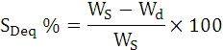

1.6 APPLICATIONS OF HYDROGELS
The polyaniline-polyacrylamide IPNs can be used for a number of applications like controlled drug release. Controlled drug release is typically achieved by encapsulating drugs in either biodegradable or non-biodegradable polymers, which can control the release of the drug to the body over specific duration ranging from a day to several years. Drug delivery technology could be brought to the next level by designing ‘smart’ polymers or devices that are ‘responsive’ to the patient’s therapeutic requirements and deliver certain amount of a drug in response to a biological stimulus [18].
Hydrogel’s high water content could contribute to their biocompatibility and their rubbery nature could ensure minimal mechanical irritation to surrounding tissue while the low interfacial tension between the gel surface and surrounding fluids would minimize protein adsorption and cell adhesion on to the gel [19]. Hydrogels also offer the possibility of fabrication in a variety of different shapes, e.g., rods, disks, films, depending on the intended applications and sites of administration and easily be washed, to remove any undesired molecules such as unreacted initiators, monomers, etc.
Precise control of drug levels in the body can be achieved if the drug carrier responds in a reproducible and predictable fashion to an internal or external chemical, physical or biological stimulus. The magnitude of the response must be dependent on the magnitude of the stimulus [20]. The presence of electroactive polymer inside the hydrogel gives it an advantage of swelling and contacting by oxidation and reduction of the conducting polymer. Hence a precise and reproducible stimulus can be provided.
Hydrogels are used in formation of silver nano particles. A study by Saravanan et al has shown that poly(acrylamide) hydrogels are effective for the production of nano-sized silver particles. A few studies that deal with metal nanoparticles, especially silver, gold and copper have exhibited antibacterial activity on microorganisms [21, 22]. Among these nanoparticles, nanosilver displays reasonable antimicrobial activity [23-25]. Silver nanoparticles are non toxic and environment friendly antibacterial materials, but due to their poor binding characteristic with surfaces, their utility has been restricted. Therefore, polymer stabilized nanoparticles and nanoparticles embedded in hydrogel networks are outstanding approaches for antibacterial applications.
Hydrogels also help with moisture retention and water conservation by helping soil increase water holding capacity, allowing plants to survive during droughts. Erosion control, soil management, and environmental clean-ups are also ways hydrogels can help the environment. .They has been extensively used in waste water treatment. They efficiently remove many impurities like phosphorus, nitrogen, sulphur, nitrate, nitrite anions etc. from the waste water. Hydrogels selectively bind the pollutant anions into the polymer matrix and remove from the contaminated system.
In moisture treatment applications, cross-linked polyacrylamide (hydrogel) expands upon contact with water to form a pliable gel that in a growing medium constitutes a reservoir of moisture available for uptake by plants. Trials with seedlings of three crop species (Lactuca sativa L, Raphanus sativus L, Triticum aestivum L) using measurements of yield and evapo-transpiration ratio show that gel-stored moisture is utilised with a greater efficiency than conventional forms of water. Moreover, gel storage of water provides a buffer against temporary drought stress and the potential for reducing the risk of failure of certain crops at establishment.
Superabsorbent polymers have a network structure with a suitable degree of crosslinking. Not only it is able to absorb a large amount of water to form a stable hydrogel, but also the absorbed water is hardly removed under some pressure. About three decades ago, superabsorbent polymers were introduced into the agriculture and diaper industries, and then their applications were extended to other industries where an excellent water holding property was of prime importance. Recently, many researchers focus their attentions on the superabsorbent polymer for developing new applications, such as conducting materials, biomaterials, sensors and release materials, wave-absorbing materials. Over all superabsorbent used in candles, composites & laminates, controlled release of insecticides & herbicides, diapers and incontinence garments, drown-free water source for feeder insects, filtration applications, fire-retardant gel, fragrance carrier, frog tape (high tech masking tape designed for use with latex paint), grow-In-water toys, hot & cold therapy packs, medical waste solidification [26], mortuary pads, motionless waterbeds, spill control, surgical pads, potting soil, waste stabilization & environmental remediation, water retention for supplying water to plants, wire & cable water blocking, wound dressings, fuel monitor systems in aviation, fuel monitor systems in vehicles etc.

1.7 CONDUCTING POLYMERS
Electrically conducting polymers appear to be ideal candidates for various applications, including corrosion, weight, matrix incompatibility and environmental integrity [27]. In addition to being corrosion resistant and light weight, many critical properties of conducting polymers may be tailored for various applications.
Conducting polymers represent a relatively new class of materials with promising properties. This special class of polymers often referred to as synthetic metals possess the unique electronic, magnetic, & optical properties of a metal along with known advantages of conventional polymers.
In 1958, polyacetylene was first synthesized by Natta et al as a black powder. Polyacetylene was already known as a black powder when in 1974 it was prepared as a silvery film by Shirakawa and co-workers from acetylene, using Ziegler-Natta catalyst. But despite its metallic appearance it was not a conductor. In 1977, however, Shirakawa, MacDiarmid and Heeger discovered that oxidation with chlorine, bromine or iodine vapour made polyacetylene films 10⁹ times more conductive than they were originally. Treatment with halogen was called doping by analogy with the doping of semiconductors. The doped form of polyacetylene had a conductivity of 10⁵ S/cm, which was higher than that of any previously known polymer. As a comparison, Teflon has a conductivity of 10⁻¹⁶ S/cm and silver and copper 10⁶ S/cm.
In 1980’s polyheterocycles were first developed. They were found to be much more air stable than polyacetylene, although their conductivities were not so high, typically about 10³ S/cm. By adding various side groups to the polymer backbone, derivatives which were soluble in various solvents were prepared. Other side groups affected properties such as their color and their reactivity to oxidizing and reducing agents.
Since then it has been found that about a dozen different polymers and polymer derivatives undergo this transition when doped with a weak oxidation agent or reducing agent. They are all various conjugated polymers. All have a highly conjugated electronic state. This also causes the main problems with the use of these system, that of processibility and stability. Most early conjugated polymers were unstable in air and were not capable of being processed. A logrthimic conductivity ladder of some these polymers as shown in Fig 1.3.
Fig1.3 Logarithmic conductivity ladder locating some metals and conducting polymers
A key property of a conductive polymer is the presence of conjugated double bonds along the backbone of the polymer. In conjugation, the bonds between the carbon atoms are alternately single and double. Every bond contains a localised σ bond which forms a strong chemical bond. In addition, every double bond also contains a less strongly localised π bond which is weaker, made up of overlap of singly occupied p-orbital in the backbone of the polymer chain. However, conjugation is not enough to make the polymer material conductive. Although conducting polymers possess a relatively large number of delocalized π electrons, a fairly large energy gap exists between the valence band and the conducting band greater than 1 eV), thus these polymers are considered to be semi-conducting, at best (figure 1.4).
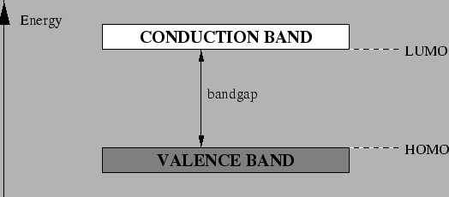
Figure 1.4 Band structure in an electronically conducting polymer

In addition charge carriers in the form of extra electrons or holes have to be injected into the material. A hole is a position where an electron is missing. When such a hole is filled by an electron jumping in from a neighbouring position, a new hole is created and so on, allowing charge to migrate a long distance.
This electronic delocalization provides the highway for charge mobility along the backbone of the polymer chain. Therefore, the electronic structure in conducting polymers is determined by the chain symmetry, i.e., the number and kind of atoms within the repeat unit, with the result that such polymers can exhibit semiconducting or even metallic properties.
Polyacetylene was the first conducting polymer to be reported. This conjugated organic polymer, could attain high levels of electronic conductivity when oxidized by suitable reagents initiated a significant research. Doping the polymers creates new states (donor or acceptor states), which exist within the band gap, and are energetically accessible to the π electrons, resulting in significant increase in conductivity. In fact, the conductivity of doped polymers may be up to 10 orders of magnitude greater than that of the neutral polymers. The concept of conductivity and electronegativity of conjugated polymers was quickly broadened from polyacetylene to include a conjugated hydrocarbon and aromatic heterocyclic polymers, such as poly(p-phenylene), polypyrrole and polythiophene. The conductivity of various doped and undoped polymers, some common semiconductors, and metals is presented in Table 1.1. As the conducting polymers may be doped to various degrees, there is an element of control in doping level, hence the conductivity. This ability to tailor the polymer’s electrical properties exemplifies the versatility of conducting polymers.

MATERIALS | CONDUCTIVITY (S/cm)
Gold, Silver, Copper | ̴ 10⁶
Doped trans-polyacetylene | ̴ 10⁵
Doped Polyaniline | ̴ 10¹
Germanium | ̴ 10⁻²
Silicon | ̴ 10⁻⁴
Undoped trans-Polyacetylene | ̴ 10⁻⁵
Undoped Polyaniline | ̴ 10⁻¹⁰
Glass | ̴ 10⁻¹⁰
Quartz | ̴ 10⁻¹⁶

Table 1.1 Conductivities of various conducting polymers, semi- and
metals conductors

1.8 CLASSIFICATION OF CONDUCTING POLYMERS
Conducting polymers can be classified in different types on the basis of conduction mechanism that renders electrical conductivity to polymers [28].
- Conducting polymer composites
- Organometallic polymeric conductors
- Polymeric charge transfer complexes
- Inherently conducting polymers

(1) CONDUCTING POLYMER COMPOSITES
Conducting polymer composites are mixture or blends of conductive particles and polymers. Various conductors have been used in different forms together with large number of conducting and engineering plastics. Various conductive fillers have been tried such as carbon black, graphite flakes, fibers, and metal powders etc. The electrical conductivity of the materials is decided by the volume fraction of the filler. A transition from insulating to non-insulating behavior is generally observed when volume fraction of conductive filler in the mixture reaches a threshold of about 25%. Various polymers which have been used as main matrix, are typically PP, Nylon, and PVC etc.

(2) ORGANOMETALLIC POLYMERIC CONDUCTORS
This type of conducting materials is obtained by adding organometallic groups to polymer molecules. In this type of materials the d-orbital of metal may overlap with orbitals of the organic structure and thereby increases the electron delocalization. The d-orbital may also bridge adjacent layers in crystalline polymers to give conducting property to it, e.g., metallopthalocyanines and their polymers fall in this class of polymeric material. These polymers have extensively conjugated structures. The bridge transition metal complexes form one of the stable systems exhibiting intrinsic electrical conductivities, without external oxidative doping. Polyferrocenylene is also an example of this type of polymer. These materials possess strong potential for future application such as molecular wires, antistatic foils and in fibers etc.

(3) POLYMERIC CHARGE TRANSFER COMPLEXES
Polymeric charge transfer complexes are formed when acceptor like molecules are added to the insulating polymers. There are many charge transfer complexes, e.g., tetrathiafulvalene (TTF) with bromine, chlorine, TCNQ etc. is a good conductor. The reason for high conductivity in polymeric charge transfer complexes and radical ion salts are still somewhat obscure. It is likely that in polymeric materials, the donor-acceptor interaction promotes orbital overlap, which contributes to alter molecular arrangements and enhanced electron delocalization.

(4) INHERENTLY CONDUCTING POLYMERS
Many small conjugated molecules were found to polymerize, producing conjugated polymers, which were either insulating or semiconducting in the oxidized or doped state. The electronic properties of conjugated polymers are due to the presence of electrons. The conjugated polymers are studied as the intrinsically conductive polymers. The conductivity in such polymers arises due to a special type of metallic bonding in which valence electrons are completely delocalized and move almost freely through the crystal lattice. It is therefore necessary for the polymer backbone to behave as an electrical conductor. This delocalization of electrons may occur through the interaction of n-bonded electrons in a highly conjugated chain or by a similar interaction of n-electrons with non-bonded electrons of electron rich hetero-atoms (e.g., S, N, etc.) in the backbone. For this reason, the molecular structure of the backbone should be planar. There should be no torsion at the bonds, which would decrease the delocalization of the electron system. Some of the examples of inherently conjugated polymers are shown in Figure 1.5.

Figure 1.5 Inherently conducting polymers
The electrical and optical properties of these kinds of materials depend on the chemical nature of the repeated units. The electronic conductivity is proportional to both density and drift mobility of the charge carrier, Drift mobility is defined as the ratio of the drift velocity to the electric field and reflects the ease with which carriers are propagated. To enhance the electrical conductivity of polymers, an increase in the carrier mobility and the density of the charge carriers is required.

1.9 POLYANILINE
Among conducting polymers, polyaniline (PANI) is of high interest due to its outstanding properties. It is one of the so called doped polymers in which conductivity results from a process of partial oxidation or reduction. Polyaniline is a conducting polymer of the semi-flexible rod polymer family. Although it was discovered over 150 years ago, only recently has polyaniline captured the attention of the scientific community due to the discovery of its high electrical conductivity. Amongst the family of conducting polymers, PANI is unique due to its ease of synthesis, environmental stability, and simple doping/dedoping chemistry. Although the synthetic methods to produce polyaniline are quite simple, its mechanism of polymerization and the exact nature of its oxidation chemistry are quite complex. Because of its rich chemistry, polyaniline has been one of the most studied conducting polymers of the past 20 years.
Polyaniline compounds can be designed to achieve the required conductivity for a given application. The resultant blends can be as conductive as silicon and germanium or as insulating as glass. Another advantage is that the compound can be simply mixed with conventional polymers and it is easy to fabricate PANI products into specific shapes. The conductivity of polyaniline makes it an ideal shield against static electricity discharges and thus polyaniline compounds have been used in the packaging of electronics products. Polyaniline compounds are being tested for use as protection against electromagnetic radiation. Further, scientists hope that one day printed circuit boards, electrochromic windows in houses and cars, conductive fabrics will contain polyaniline compounds. It is well known that polyaniline compounds provide protection against corrosion.
Polyaniline exists in a variety of forms that differ in chemical and physical properties. The most common green protonated emeraldine has conductivity on a semiconductor level of the order of 100 S/cm, many orders of magnitude higher than that of common polymers (<10⁻⁹ S/cm) but lower than that of typical metals (>10⁴ S/cm). Protonated PANI, (e.g., PANI hydrochloride) converts to a non-conducting blue emeraldine base when treated with ammonium hydroxide. Polyaniline mainly occurs in four different forms like leucoemeraldine (fully reduced), pernigraniline (fully oxidized), nigraniline (75% oxidized), and emeraldine (50% oxidized).

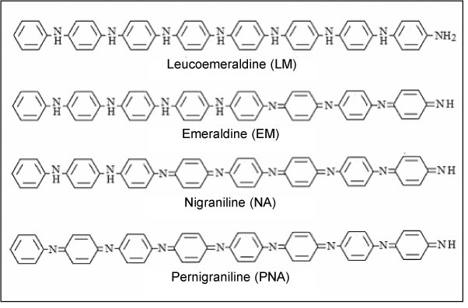
Figure 1.6 Different oxidation states of polyaniline

There is particular interest in employing the protonated polyaniline or the emeraldine salt, their derivatives, or polyaniline metal composites as sensing materials. The preference for a conductive polymer over a conventional metal as a sensing material is mainly because conductive part is light and less expensive in processing, it can be operated at lower applied voltages and temperatures, and it interacts more favorably with organic compounds.

1.10 DOPING OF POLYMERS
Conductive polymers generally exhibit poor electrical conductivity (σ ≤ 10⁻¹² S/cm) in the virgin state and behave as insulators. These virgin polymers need to be treated with a suitable oxidizing or reducing agents to remarkably enhance their conductivities to the metallic region. This phenomenon has been termed as doping. It can be simply regarded as the insertion or ejection of electrons. Doping process has result in dramatic changes in the electronic, electrical, magnetic, optical, and structural properties of the polymer. Doping of polymeric semiconductors is different from that in inorganic or conventional semiconductors. Inorganic semiconductors have three-dimensional crystal lattice and on incorporation of specific dopant, n-type or p-type in ppm level, the lattice becomes only highly distorted. The dopant is distributed along specific crystal orientations in specific sites on a repetitive basis. Whereas, doping of conducting polymer involves random dispersion or aggregation of dopants in molar concentrations in the disordered structure of entangled chains and fibrils. The dopant concentration may be as high as 50%. Also incorporation of the dopant molecules in the quasi one dimensional polymer systems considerably disturbs the chain order leading to reorganization of the polymer. Doping process is reversible, and it produces the original polymer with little or no degradation of the polymer backbone. Both doping and undoping processes, involving dopant counterions which stabilize the doped state, may be carried out chemically or electrochemically. Doping of inorganic semiconductors generates either holes in the valence band or electrons in the conduction band. On the other hand, doping of polymer leads to the formation of conjugation defects,viz. solitons, polarons or bipolarons in the polymer chain. The ultimate conductivity in polymeric semiconductors depends on many factors, viz., nature and concentration of dopants, homogeneity of doping, carrier mobility, crystallinity and morphology of polymers. By controllably adjusting the doping level, conductivity anywhere between that of the non-doped (insulating or semiconducting) and that of the fully doped (highly conducting) form of the polymer can be easily obtained. Generally in conducting polymers p-type doping is conducted with an electron acceptor, such as p-type and n-type doping is conducted with donor specie, such as Li. In the doped state, the backbone of a conducting polymer consists of a delocalized system. In the undoped state, the polymer may have a conjugated backbone such as in trans- (CH)x which is retained in a modified form after doping, or it may have a non conjugated backbone, as in polyaniline (leucoemeraldine base form), which becomes truly conjugated only after p-doping, or a non-conjugated structure as in the emeraldine base form of polyaniline which becomes conjugated only after protonic acid doping.
1.11 Dopants
Dopants are either strong oxidizing or reducing agents. On doping, either positive or negative charge carriers are created in polymers.
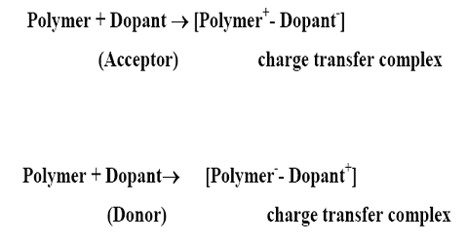
Figure 1.7 Effect of dopant on polymer
1.12 Different types of doping
The expression doping is ambiguous and refers to an uptake into pure material of some other material. This uptake may be diffusion of dopants in to the fibers, a chemical reaction with internal or surface chains or simple adsorption on the surface. Doping is accomplished by chemical methods of direct exposure of the conjugated polymer to a charge transfer agent in the gas or solution phase, or by electrochemical oxidation or reduction. The dopant concentration can be determined by chemical or spectroscopic analysis, or simple weight uptake. Doping of polymers may be done by the following methods [29].
Redox doping
Redox doping is the most common method of doping. This is also known as oxidative doping and accomplished by removing π-electrons from the conjugated π-systems. All conducting polymers, e.g., polypyrrole, polythiophene, PANI etc undergo p or n redox doping by chemical or electrochemical processes during which the number of electrons associated with the polymer backbone changes. p-doping is accompanied by partial oxidation of the backbone of the polymer. It was first discovered by treating trans-(CH)x with an oxidizing agents such as iodine. p-doping can also be done by electrochemical anodic oxidation by immersing a trans-(CH)x film in a solution of LiClO₄ and attaching it to the positive terminal of a DC power source, the negative terminal being attached to an electrode also immersed in the solution. n-doping, i.e., partial reduction of the backbone system of an organic polymer, was also discovered using trans-(CH)x by treating it with a reducing agents such as sodium naphthalide.
Photo-doping
When trans (CH)x is exposed to radiation of energy greater than its band gap, electrons are promoted across the gap and polymer undergoes photo-doping.
Charge injection doping
Charge injection doping is most conveniently carried out using a metal/insulator/semiconductor (MIS) configuration involving a metal and a conducting polymer separated by a thin layer of a high dielectric strength insulator. Application of an appropriate potential across the structure can give rise to a surface charge layer. The resulting charges in the polymer, for example, (CH)x or poly (3-hexylthiophene) are present without any associated dopant ion.
Non redox doping
Although oxidative doping is used for polyaniline, a more common method of producing doped polyaniline is known as acid-doping (or proton doping). This type of doping differs from redox doping is that the number of electrons associated with the polymer backbone does not change during the doping process. As with the oxidative doping process, doped polyaniline may be produced in one step. The presence of the acid results in the protonation of nitrogen atoms. Once protonated, the polymer chain is now positively charged, and has associated counter anions. The degree of protonation depends on the oxidation state of the polymer and the pH of the acid solution [30]. The energy levels are rearranged during doping. The emeraldine base form of PANI was the first example of the doping of an organic polymer to a highly conductive regime by non redox type doping.
Neutral (or undoped) polyaniline exhibits conductivity of the order of 10⁻¹⁰ S/cm as with oxidative doping, protonic, or acid, doping can result in a significant increase in conductivity [31].

1.13 Types of doping agents
Dopants may be classified as:
A) Neutral dopants: I₂, Br₂, AsF₂, Na, K, H₂SO₄, FeCl₃ etc.
B) Ionic dopants: LiClO₄, FeClO₄, CF₃SO₃Na, etc.
C) Organic dopants: CF₃COOH, CF₃SO₃Na, p-CH₃C₆H₄SO₃H
D) Polymeric dopants: PVS, PPS
Neutral dopants are converted into negative or positive ions with or without chemical modifications during the process of doping. Ionic dopants are either oxidized or reduced by an electron transfer with the polymer and the counter ion remains with the polymer to make the system neutral. Organic dopants are anionic dopants, generally incorporated into polymers from aqueous electrolytes during anodic deposition of the polymer.

1.14 Charge appearing on the polymer chains upon doping
In a polymer, just as in a crystal, the interaction of a polymer unit cell with all its neighbours leads to the formation of electronic bands. The highest occupied electronic levels constitute the valence band (VB) and the lowest unoccupied levels, the conduction band (CB, the width of the forbidden band, or band gap (E_{g}), between the VB and CB determines the intrinsic electrical properties of the material. In organic molecule, it is usually the case that equilibrium geometry in the ionized state is different from the ground state. On ionization of an organic molecule the geometry of the molecule is first distorted in the ground state in such a way that the molecule adopts the equilibrium geometry of the ionized state. This costs distortion energy E_{dis}. Then the reduction in the ionization energy i.e. E_{IP-V} - E_{IP-d} upon distortion is larger than the energy E_{dis} required to make that distortion .The whole procedure is shown in Figures 1.8 and 1.9.
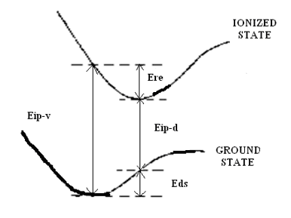
Figure 1.8 Molecular ionization process in conducting polymers

However in an organic polymer chain, it can be energetically favorable to localize the charge that appears on the chain and to have, around the charge, a local distortion (relaxation) of the lattice. This process causes the presence of a localized electronic state in the band gap. Considering the case of oxidation that is the removal of an electron from the chain. This causes the formation of radical ion on the polymer chain and around that charge or cation localization occurs. This radical cation which is formed is having more energy than that of the energy of the valance band. This radical cation associated with the lattice distortion is known as polaron and the presence of localized electronic state in the gap referred to as polaron state. It is having half (1/2) spin [32].
A bipolaron is defined as a pair of like charges associated with a strong local distortion. It is spinless. The bipolaron charge carrier is of relatively high energy, and thus is short-lived. Redistribution of charge and spin yields a polaron as the more stable charge carrier [33]. A radical, cation, or anion defect on a polyacetylene backbone divides the polymer into sections which are mirror images to each other. The defect can move in either direction without affecting the energy of the backbone. The movement of the defect can be described as a solitary wave or soliton. The radical defect is referred to as soliton, the anion and cation defects are charged solitons.The neutral soliton is having spin whereas the anion and cation defects are spinless.
Figure 1.9 Charge transport Mechanism

1.15 PROPERTIES AND APPLICATIONS
The highest advantage of conducting polymers is their processability. Conductive polymers are also plastics (which are organic polymers) and therefore can combine the mechanical properties (flexibility, toughness, malleability, elasticity, etc.) of plastics with the high electrical conductivities of a doped conjugated polymer. They have been known to have promise in antistatic materials and they have been incorporated into commercial displays and batteries, but there have had limitations due to the manufacturing costs, material inconsistencies, toxicity, poor solubility in solvents, and inability to directly melt process. Literature suggests they are also promising in organic solar cells, organic light-emitting diodes, actuators, electrochromism, supercapacitors, biosensors, flexible transparent displays, electromagnetic shielding and possibly replacement for the popular transparent conductor indium tin oxide. Conducting polymers are rapidly gaining attraction in new applications with increasingly processable materials with better electrical and physical properties and lower costs.
The extended p-systems of conjugated polymer are highly susceptible to chemical or electrochemical oxidation or reduction. These alter the electrical and optical properties of the polymer, and by controlling this oxidation and reduction, it is possible to precisely control these properties. Since these reactions are often reversible, it is possible to systematically control the electrical and optical properties with a great deal of precision. It is even possible to switch from a conducting state to an insulating state.
There are two main groups of applications for these polymers. The first group utilizes their conductivity as its main property. The second group utilizes the electroactivity. These applications are shown in table (1.2).

GROUP 1 | GROUP 2
Electrostatic materials | Molecular electronics
Conducting adhesives | Electrical display
Electromagnetic shilding | Chemical biomechanical and thermal sensors
Printed circuit board | Rechargeable batteries and solid electrolytes
Artificial nerves | Drug release systems
Antistatic clothing | Optical computers
Piezo ceramics | Ion exchange membrane
Active elactronics (diodes, transistors) | Electromechanical activators
Aircraft structures | ‘Smart’ structures
Switches

Table 1.2 Various application of conducting polymers

1.16 CONDUCTING NANO FIBRES
In recent years, there has been growing interest in research on conducting polymer nanostructures (i.e., nano-rods, -tubes, -wires, and -fibres) since they combine the advantages of organic conductors with low-dimensional systems and therefore create interesting physicochemical properties and potentially useful applications. Traditionally, an advantage of polymeric materials is that they can be synthesized and processed on a large scale at relatively low cost and many of the applications (sensors, functional coatings, catalysts, etc.) of conducting polymers indeed need bulk quantity materials.
Polyaniline is used as a model material to systematically investigate the synthesis, properties, and applications of nanofibres of conjugated polymers. It has been found that the nanofibres significantly improve the processibility of polyaniline and its performance in many conventional applications involving polymer interactions with its environment.

1.16.1 POLYANILINE NANOFIBRES: SYNTHESIS & GROWTH MECHANISM
Among the family of conjugated polymers, polyaniline is one of the most useful since it is stable in air and moisture in both its doped, conducting form and in its de-doped, insulating form [34-36]. Polyaniline is also unique among conducting polymers in that it has a very simple acid/base doping/dedoping chemistry [37]. Conventional polyaniline synthesis is known to produce particulate products with irregular shapes. Therefore, many methods have been developed to synthesize nanostructures of polyaniline [34, 38, 39]. Some recent work indicates that uniform polyaniline nanofibres can be obtained without the need for any template simply by controlling the electrochemical polymerization kinetics [40-42]. The basic morphological unit for chemically synthesized polyaniline also appears to be nanofibres with diameters of tens of nanometers by introducing structural directing agents during the chemical polymerizing reaction [43]. First, through careful electron microscopy observations, a small amount of nanofibres can be found among the irregularly shaped particulates in conventionally synthesized polyaniline [44, 45]. This suggests the possibility of obtaining polyaniline nanofibres without any external structural directing agents. A transition from pure, well-defined nanofibres, to irregularly shaped, micron-scale particulates was observed. Two basic approaches to separate nanofibres formation from overgrowth in conventional aniline polymerization reactions have been discovered. In the first approach, the reaction is placed in a heterogeneous biphasic system, where the polymerization occurs primarily at the interface [44, 46]. Since the as-made polyaniline product is synthesized in its hydrophilic emeraldine salt form, it diffuses away from the reactive interface into the water layer. This makes more reaction sites available at the interface and avoids further overgrowth. In this way, the nanofibres formed at the interface are collected in the water layer without severe secondary overgrowth.

1.16.2 Enhanced processibility of polyaniline nanofibrEs
The solution processibility and film-forming capability are of critical importance for the applications of a polymer. Polyaniline is insoluble in water and it has been known to have poor water processibility, likely due to the irregularly shaped micron-sized morphology. However, polyaniline synthesized by either interfacial polymerization or rapidly mixed reactions exhibit excellent water dispersibility due to its uniform nanofibrillar morphology. For example, when purified by dialysis or centrifugation, polyaniline nanofibres readily disperse in water without any adduct. Casting such a dispersion onto a substrate, a mat of a random nanofibre network is obtained. Most interestingly, when the pH value of the solution is around 2.6, the nanofibres can form a stable colloidal dispersion by themselves [47].

1.17 INTER PENETRATING NETWORK
An interpenetrating polymer network (IPN) is any material containing two polymers, each in network form. The three conditions for eligibility as an IPN are:
(1) Two types of polymers are synthesized and/or crosslinked in the presence of the other, (2) both polymers have similar kinetics and (3) both are not dramatically phase separated.
IPNs that have only one polymer crosslinked (where the polymers are synthesized separately) or where the polymers have vastly different kinetics are still considered, and graft copolymers in two ways : (1) an IPN swells but does not dissolve in solvents, and (2) creep and flow are suppressed.
These systems differ mainly because of the number and types of crosslinks that exist in the system. A non-covalant semi IPN is one in which only one of the polymer systems is crosslinked. A non-covalent full IPN is one in which the two separate polymers are independently crosslinked. A covalent semi-IPN contains two separate polymer systems that are crosslinked to form a single polymer network. This covalent semi-IPN is similar to a non-covalent IPN because one of the polymer systems can be crosslinked without networking with the second linear system. However, the two systems tend to be networked for better property development. These covalent semi-IPNs are developed with organic-inorganic composite materials.
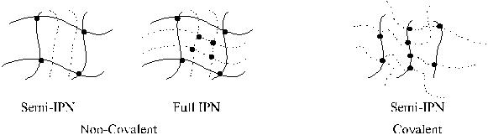
Figure 1.10 Different types of IPNs
There are four types of IPNs, including sequential IPNs, simultaneous IPNs, semi-IPNs and homo-IPNs
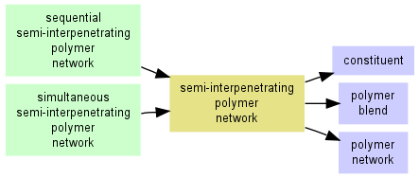
Figure 1.11 Different types of interpenetrating network

CHAPTER – 2

EXPERIMENTAL WORK
&
TECHNIQUES
OF
CHARACTERIZATION

2.1 CHEMICALS USED

The chemicals used in the present study along with the sources are given in Table 2.1. The chemicals as obtained were used for synthesis purpose except aniline which was distilled before use.

CHEMICALS | ACRONYM | SOURCES
Aniline | Ani | Central drug house (P) ltd. New Delhi, India
Ammonium per oxo  Disulphate | APS | Merck specialities private ltd. Mumbai, India
Hydrochloric acid | HCl | Central drug house (P) ltd. New Delhi, India
Xylene | Xylene | Merck specialities private ltd. Mumbai, India
Acrylamide | AAm | Central drug house (P) ltd. New Delhi, India
Potassium per sulphate | KPS | s.d.fine-chem ltd. Mumbai, India
N,N-methylenebisacrylamide | MBA | Sisco research lab private ltd. Mumbai, India
N,N,N’,N’-tetramethylethylenediamine | TEMED | Sisco research lab private ltd. Mumbai, India

Table 2.1 Chemicals used for synthesis

2.2 CHEMICAL Synthesis of polyaniline POWDER
The most common synthesis of polyaniline involves single step oxidative polymerization. Chemical polymerization of aniline was carried out using ammonium per sulphate as an oxidizing agent. The temperature during the reaction was maintained low because the reaction is exothermic.
The solution of aniline (0.2M) was added in diluted (1M) HCl and maintained at low temperature. 0.2M solution of ammonium per sulphate solution was added to above solution drop by drop. A constant stirring for about 4-5 h resulted the formation of dark green precipitate. The precipitate so obtained was filtered and then washed repeatedly with distilled water until the disappearance of colour of the filtrate. The precipitate was dried in an air oven.

2.3 SYNTHESIS OF POLYANILINE NANOFIBRES
The above method produces simple PANI powder (particles) with irregular shapes, therefore a number of methods have evolved to produce nano structured PANI. Here, we used interfacial polymerization. It occurs at the interface of an organic and aqueous layer, produces excellent nanofibres of PANI with relatively uniform diameters. It is simple and does not involve any template, special solvent, or dopant.
PANI nano-fibres were synthesized using interfacial polymerization by the process reported by Huang et al [48]. Aniline (3.2 mmol) was dissolved in 10 ml of xylene while ammonium persulphate (0.8 mmol) was dissolved in 10 ml of 1M hydrochloric acid solution. Both the solutions were kept at low temperature (~4 °C). The aniline solution was transferred to a 50 ml glass vial and then APS solution was carefully pored over to obtain an interface between the two layers. The polymerization reaction was allowed to proceed for 24 h at room temperature. PANI obtained was filtered and washed several times with de-ionised Millipore water and ethanol, then dried in an air oven.

2.4 PREPARATION OF POLYACRYLAMIDE HYDROGEL
In a typical procedure, a mixed solution of acrylamide monomer and crosslinker (MBA) was made by agitating acrylamide monomer (0.5g) and N, N’-methylene bisacrylamide (0.026g), dissolved in 10ml of distilled water at ambient temperature. Under a nitrogen atmosphere, the mixture solution was stirred for 10 min., then potassium persulphate (KPS,0.01g) and N, N, N’, N’-tetramethylethylene diamine (TEMED, 100µl) were added with vigorous stirring. KPS was used to initiate the reaction and TEMED was employed to provide a more stable media for the free radical polymerization of acrylamide. Before gelification, this pre-gel solution was injected in premarked (500µl) tube. After the polyacrylamide (PAM) hydrogel formation the hydrogel was extracted by breaking the tube and was placed in distilled water.

2.5 PREPARATION OF POLYACRYLAMIDE/POLYANILINE NANOFIBRES COMPOSITE HYDROGELS
Different quantities of PANI nanofibres (2, 4, 6, 8, and 10%) were dispersed in 10 ml distilled water using an Ultrasonicator (Accumax India, Delhi, Model USB-2.25) for 15 minutes. Acrylamide monomer (0.5g) and crosslinker MBA (0.026g) were added to aqueous dispersion of nanofibres. Under N₂ atmosphere, the mixture solution was stirred for 10 minutes. KPS (0.01g) and TEMED (100µl) were added to the solution under stirring. Before gelification, this pre gel solution was injected in premarked (500µl) tubes. The conducting hydrogels were extracted by breaking the tubes and placed in distilled water for extracting any impurities.

2.6 EQUILIBRIUM WATER CONTENT
The equilibrium water content (EWC) was determined using the following procedure. Hydrogel composites were dried at room temperature. The dried samples were weighed to constant weight (W_{d}). The samples were then immersed in a large amount of distilled water and allowed to reach equilibrium before weighing (W_{S}). The EWC (S_{Deq}) of the hydrogel composites was determined from following equation-

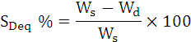

W_{S} is the weight of the swollen gel at time t (equilibrium) and W_{d} is the initial weight of the dry gel.

2.7 DEHYDRATION AND REHYDRATION STUDIES
The swollen samples were allowed to dehydrate (weight loss) completely. The weight of the samples during drying was measured after 30 min. (W_{dt}) and the water content calculated using following equation :-

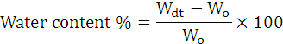

Where W_{o} is the initial weight of hydrogel.
Upon completion of the dehydration measurement, PAM/PANI nanofibre composite hydrogels were immersed in distilled water to observe the rehydration behaviour. The weight of the samples during rehydration increased and was measured half hourly (W_{rt}). The water content during rehydration was obtained from the equation given below:-

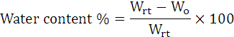

2.8 FOURIER TRANSFORM INFRARED SPECTROSCOPY
Fourier Transform Infra Red (FTIR) is preferred method of infrared spectroscopy. In infrared spectroscopy, IR radiation is passed through a sample. Some of the infrared radiation is absorbed by the sample and some of it is passed through (transmitted). The resulting spectrum represents the molecular absorption and transmission, creating a molecular fingerprint of the sample. Like a fingerprint no two unique molecular structures produce the same infrared spectrum. This makes infrared spectroscopy useful for several types of analysis.

Fig 2.1 A simple layout of FTIR instrument

2.9 THERMOGRAVIMETRIC ANALYSIS
Thermogravimetric analysis (TGA) is a thermal analysis technique used to measure weight (mass) changes of a sample as a function of temperature (time) under a controlled atmosphere. TGA is commonly used to determine polymer degradation temperatures, residual solvent levels, absorbed moisture content, and the amount of inorganic (non-combustible) filler in polymer or composite material compositions.
The analyzer usually consists of a high-precision balance with a pan (generally platinum) loaded with the sample. The pan is placed in a small electrically heated oven with a thermocouple to accurately measure the temperature. The atmosphere may be purged with an inert gas to prevent oxidation or other undesired reactions. A computer is used to control the instrument. Analysis is carried out by raising the temperature gradually and plotting weight against temperature. The temperature in many testing methods routinely reaches 1000ºC or greater, but the oven is so greatly insulated that an operator would not be aware of any change in temperature even if standing directly in front of the device. After the data is obtained, curve smoothing and other operations may be done such as to find the exact points of inflection.
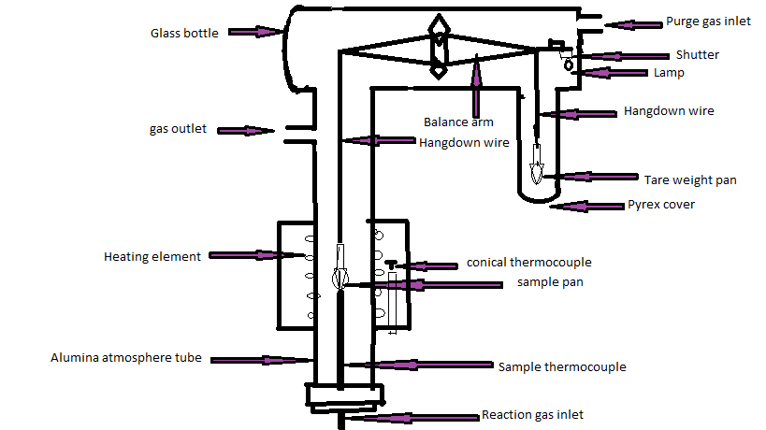
Figure 2.2 A Layout of TGA instrument

2.10 CYCLIC VOLTAMMETRY
Cyclic voltammetry (CV) is the most widely used technique for acquiring qualitative information about electrochemical reactions. The power of cyclic voltammetry from its ability to rapidly provide considerable information on the thermodynamics results of redox processes and the kinetics of heterogeneous electron-transfer reactions, and on coupled chemical reactions or adsorption processes.
This method uses a reference electrode, working electrode, and counter electrode (auxiliary electrode) which in combination are sometimes referred to as a three-electrode setup. Electrolyte is usually added to the test solution to ensure sufficient conductivity. The combination of the solvent, electrolyte and specific working electrode material determines the range of the potential. Electrodes are static and sit in unstirred solutions during voltammetry. This solution method results in cyclic voltammetry’s characteristic diffusion controlled peaks. This method also allows a portion of the analyte to remain after reduction or oxidation where it may display further redox activity. Stirring the solution between cyclic voltammetry traces is important as to supply the electrode surface with fresh analyte for each new experiment. The solubility of an analyte can change drastically with its overall charge. Since, cyclic voltammetry usually alters the charge of the analyte, it is common for reduced or oxidized analyte to precipitate out onto the electrode. This layering of analyte can insulate the electrode surface, display its own redox activity in subsequent scans, or at the very least alter the electrode surface.
Common working electrode is generally encased in a rod of inert insulator with a disk exposed at one end. The counter electrode, also known as the auxiliary or second electrode, can be any material which conducts easily and won't react with the bulk solution.
Figure 2.3 Cyclic voltammetry circuit layout. AE, RE and WE refer to
the auxiliary, reference and working electrodes.

2.11 X-RAY DIFFRACTION PATTERN
X-ray diffraction (XRD) techniques give information about the structure of solids, that is, the arrangement of the atoms that compose the solid.
X-ray diffraction has been in use in two main areas, for the fingerprint characterization of crystalline materials and the determination of their structure.
The X-ray diffraction experiment requires an X-ray source, the sample under investigation and a detector to pick up the diffracted X-rays. Below Figure (2.7) is a schematic diagram of a powder X-ray diffractometer.
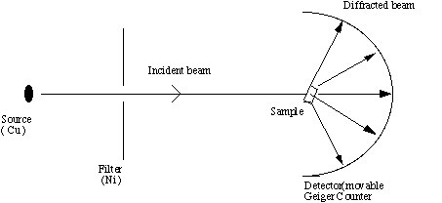
Figure 2.4 Schematic of an X-ray powder diffractometer
The X-ray radiation most commonly used is that emitted by copper, whose characteristic wavelength for the K radiation is =1.5418Å. When the incident beam strikes a powder sample, diffraction occurs in every possible orientation of 2θ. The diffracted beam may be detected by using a moveable detector such as a Geiger counter, which is connected to a chart recorder. In normal use, the counter is set to scan over a range of 2θ values at a constant angular velocity. Routinely, a 2θ range of 5 to 70 degrees is sufficient to cover the most useful part of the powder pattern. The scanning speed of the counter is usually 2θ of 2 degree min⁻¹ and therefore, about 30 min. are needed to obtain a trace.

2.12 SCANNING ELECTRON MICROSCOPE
A scanning electron microscope (SEM) is a type of microscope that uses a particle beam of electrons to illuminate a specimen and create a highly-magnified image. Scanning electron microscopes have much greater resolving power. The resolution increases with increasing frequency of the light beam.The interaction of the electron beam with the specimen gives information concerning its morphology, topography, crystallographic arrangement and elemental composition. Their major applications are in the fields of health sciences, molecular and cellular biology, biotechnology, structural biology and engineering.
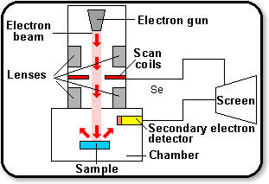
Figure 2.5 Scanning electron microscope
In the SEM, a set of scan coils moves the electron beam across the specimen in a two dimensional grid fashion. When the electron beam scans across the specimens, different interactions take place. These interactions are decoded with various detectors situated in the chamber above the specimen. Some electrons from the surface material are knocked out of their orbitals by the electron beam, and are called Secondary electrons. These electrons are detected by the secondary electron detector. Different interactions give images based on topography, elemental composition or density of the sample. A SEM can magnify up to about 1,00,000x.

CHAPTER – 3

RESULTS
&
DISCUSSION

3.1 DEHYDRATION STUDIES
Polyacrylamide/PANI nanofibre composite hydrogels and PAM hydrogel were dried and the % water content of the PAM/PANI nanofibre composite hydrogels and PAM hydrogel are reported in table 3.1. The % water content decreased with increased compositions of PANI nanofibres.
The initial dehydration rate for PAM hydrogel was slightly higher in comparision to the nano-composite hydrogels. For the composite hydrogels, there may be retardation in the diffusion of water though the three dimensional network due to the presence of PANI nanofibres formed in the porous hydrogel network. Also, water may be retained by PANI nanofibres through surface interaction or binding of water molecules to free PANI nano fibres. It may be observed that maximum weight loss occurs in first 2-3 h indicating that water is totally free to leave without any appreciable bonding or interaction.

Figure 3.1 Dehydration studies of PAM/PANI nanofibre composite
hydrogels and PAM hydrogel

Table 3.1 Dehydration studies of PAM/PANI nanofibre composite
hydrogels and PAM hydrogel

Time  (h) | Percentage of water content
Time  (h) | 2% | 4% | 6% | 8% | 10% | PAM
0.5 | -22.82 | -23.95 | -24.53 | -31.14 | -29.87 | -23.53
1 | -39.45 | -41.72 | -41.12 | -49.42 | -50 | -33.4
1.5 | -59.57 | -61.48 | -58.87 | -68 | -72.64 | -42.25
2 | -80.46 | -78.02 | -78.27 | -84.85 | -87.73 | -53.27
2.5 | -85.49 | -87.4 | -86.21 | -85.71 | -95.28 | -65.78
3 | -87.62 | -89.38 | -93.22 | -92.28 | -95.91 | -69.23
3.5 | -92.45 | -93.82 | -95.32 | -94.57 | -96.22 | -77.49
4 | -94.97 | -94.81 | -95.56 | -94.85 | -96.22 | -81.74
4.5 | -95.35 | -95.06 | -95.56 | -94.85 | -96.22 | -85.53
5 | -95.35 | -95.06 | -95.56 | -94.85 | -96.22 | -91.27
5.5 | -95.35 | -95.06 | -95.56 | -94.85 | -96.22 | -94.71
6 | -95.35 | -95.06 | -95.56 | -94.85 | -96.22 | -96.9
6.5 | -95.35 | -95.06 | -95.56 | -94.85 | -96.22 | -97.35
7 | -95.35 | -95.06 | -95.56 | -94.85 | -96.22 | -97.93
7.5 | -95.35 | -95.06 | -95.56 | -94.85 | -96.22 | -97.93
8 | -95.35 | -95.06 | -95.56 | -94.85 | -96.22 | -97.93
8.5 | -95.35 | -95.06 | -95.56 | -94.85 | -96.22 | -97.93
9 | -95.35 | -95.06 | -95.56 | -94.85 | -96.22 | -97.93
9.5 | -95.35 | -95.06 | -95.56 | -94.85 | -96.22 | -97.93
10 | -95.35 | -95.06 | -95.56 | -94.85 | -96.22 | -97.93
10.5 | -95.35 | -95.06 | -95.56 | -94.85 | -96.22 | -97.93
11 | -95.35 | -95.06 | -95.56 | -94.85 | -96.22 | -97.93

3.2 REHYDRATION STUDIES
Rehydration tests were carried out in distilled water as described earlier. The degree of rehydration for the PAM/PANI nanofibre composite hydrogels and PAM hydrogel are summarized in graph (Fig 3.2). The water holding capacity of hydrogels is reduced by the incorporation of PANI nanofibres inside acrylamide network. Since, the voids or spaces in the network are occupied by PANI nanofibres, there is less space available. Also, the network junction movement is retarded by the presence of rigid PANI network inside the hydrogels. It is concluded that although the water uptake or swelling capacity of hydrogels decreases with the incorporation of PANI nanofibres, yet the decrease is small and not phenomenal. Such a phenomenon is very important for the composites. The basic swelling property of the matrix is retained to maximum. Hence, it is clear that nanofibres have impended minimum hindrance to the network properties of hydrogel matrix.

Figure 3.2 Rehydration studies of PAM/PANI nanofibre composite
hydrogels and PAM hydrogel

Table 3.2 Rehydration studies of PAM/PANI nanofibre composite
hydrogels and PAM hydrogel
Time (h) | Percentage of water content
Time (h) | 2% | 4% | 6% | 8% | 10% | PAM
0.5 | 29.2 | 30.1 | 29 | 30.9 | 28.6 | 31.1
1 | 33.9 | 38.2 | 34.8 | 33.4 | 30.1 | 34.7
1.5 | 38.6 | 39.4 | 36.4 | 34.5 | 32.8 | 38.4
2 | 40.1 | 39.9 | 38.1 | 37.9 | 33.5 | 41.7
2.5 | 41.9 | 40.3 | 39.4 | 38.7 | 35.9 | 46.3
3 | 45.6 | 41.7 | 40.3 | 39.9 | 37.2 | 49.8
3.5 | 49.6 | 44.2 | 42.1 | 41.6 | 39.6 | 53.6
4 | 51.7 | 46.9 | 44.8 | 42.1 | 40.9 | 55.8
4.5 | 58.6 | 50.8 | 45.2 | 43.6 | 41.6 | 57.9
5 | 60.2 | 54.3 | 50.5 | 45.1 | 43.8 | 60.1
5.5 | 63.4 | 56.1 | 52.9 | 48.3 | 46.3 | 63.3
6 | 67.5 | 58.6 | 56.4 | 50.3 | 48.8 | 65.9
6.5 | 69.8 | 61.3 | 59.1 | 54.9 | 49.7 | 67.3
7 | 70.1 | 66.2 | 60.7 | 55.5 | 51.1 | 69.7
7.5 | 72.2 | 68.9 | 63.8 | 58.7 | 53.8 | 73.3
8 | 73.9 | 70.4 | 67.5 | 60.2 | 55.9 | 75.7
8.5 | 74.1 | 71.2 | 69.3 | 63.4 | 57.5 | 78.9
9 | 75.3 | 72.4 | 70.3 | 68.3 | 59.3 | 80.3
9.5 | 77.5 | 74.5 | 72.6 | 69.1 | 60.1 | 81.2
10 | 78.6 | 76.3 | 73.8 | 70.8 | 63.6 | 83.7
10.5 | 79.9 | 77.4 | 75.1 | 74.2 | 67.7 | 86.5
11 | 80.6 | 79.8 | 77.3 | 75.3 | 69.6 | 88.2
11.5 | 81.4 | 80.2 | 78.4 | 76.5 | 71.9 | 89.5
12 | 82.7 | 81.4 | 79.5 | 77.1 | 74.4 | 90.3
12.5 | 83.65 | 82.3 | 80.7 | 78.7 | 75.2 | 91.5
13 | 85.5 | 83.2 | 82.3 | 79.4 | 76.8 | 92.9
13.5 | 87.2 | 85.1 | 83.8 | 80.1 | 77.3 | 93.7
14 | 89.1 | 87.2 | 84.9 | 82.3 | 79.2 | 94.4
14.5 | 90.2 | 89.1 | 86.4 | 84.5 | 80.7 | 94.8
15 | 92.4 | 90.9 | 88.6 | 85.7 | 82.7 | 95
15.5 | 93.2 | 91.5 | 89.4 | 87.3 | 83.3 | 95.5
16 | 94.3 | 92.7 | 90.1 | 89.2 | 84.5 | 96.3
16.5 | 95.3 | 93.3 | 91.3 | 89.9 | 85.9 | 97.2
17 | 95.5 | 93.8 | 92.2 | 90.7 | 86.3 | 97.2
17.5 | 95.8 | 93.8 | 92.9 | 91.6 | 87.3 | 97.2
18 | 95.9 | 93.8 | 92.9 | 91.7 | 88.3 | 97.2
18.5 | 96.1 | 94.7 | 93.8 | 92.1 | 89.3 | 97.2
19 | 96.3 | 94.7 | 93.8 | 92.9 | 90.6 | 97.2
19.5 | 96.4 | 94.7 | 93.8 | 92.9 | 92.1 | 97.2
20 | 96.4 | 94.7 | 93.8 | 92.9 | 92.1 | 97.2
20.5 | 96.4 | 94.7 | 93.8 | 92.9 | 92.1 | 97.2
21 | 96.4 | 94.7 | 93.8 | 92.9 | 92.1 | 97.2
21.5 | 96.4 | 94.7 | 93.8 | 92.9 | 92.1 | 97.2
22 | 96.4 | 94.7 | 93.8 | 92.9 | 92.1 | 97.2

The specific weight change corresponding to different time periods was studied and presented in Fig 3.3. This figure clearly shows that the rehydration occurs faster than dehydration. This is attributed to strong diffusion forces that act across the surface barrier of the hydrogels. As soon as water seeps into the network it opens up the pores for further water intake, hence the hindrance to water flow inside the hyrogel is reduced. While as in dehydration pores may get clogged due to drying and water entrapped inside the network takes more time to evaporate and reach the surface. While rehydration takes place along strong concentration gradient, dehydration occurs across the surface barrier created by closure of surface pores due to drying.
Fig 3.3 A comparison between dehydration & rehydration rate of composite hydrogel
3.3 Equilibrium Water Content
Equilibrium water content measurements were carried out as described in the experimental section. The results show that incorporation of PANI nanofibres into the hydrogels has little effect on the water content of the hydrogel. This reflects that relatively small amont of PANI nanofibres have been incorporated. The EWC is decreased with increasing concentration of PANI nanofibres in hydrogel composites, as the hindrance of PANI nanofibres increases. Although due to small size & morphology of nanofibres, the network formed of hydrogel is highly efficient.
Table 3.3 Equilibrium water content of PAM/PANI nanofibre composite
hydrogels & PAM hydrogel
Samples | Equlibrium Water Content (%)
PAM Hydrogel | 97.2
PAM/PANI nanofibre composite hydrogel (2%) | 96.4
(4%) | 94.8
(6%) | 93.8
(8%) | 92.9
(10%) | 92.1

3.4 Fourier Transform Infrared Spectrometry
The IR spectra of the compounds were recorded on thermo Nicolet 380, Fourier transform infrared spectrometry. FTIR studies were carried out on PAM hydrogel and PAM/PANI nanofibre composite hydrogels by pressing pellets of powdered material in KBr. The absorbtion peaks are ascribed to the N-H bending at 3166-3336 cm⁻¹ and 2921 cm⁻¹ for the –CH₂ stretching can be observed in FTIR graph of composite hydrogels, i.e, Fig (3.4a), 1669 cm⁻¹ is due C=O bending for polyacrylamide and 1608 cm⁻¹ is attributed to N-H in plane bending in –CONH₂ group, the peak at 1425 cm⁻¹ is corresponding to C-N stretching. The band at 1194 cm⁻¹ can be interpreted as a C-N-C stretching vibration in the polaron structure and the band at 1135 cm⁻¹ is assigned to a vibration mode of the –NH⁺= structure, which is formed during protonation. Out of plane deformations of C-H on 1, 4-disubstituted rings are located at 838 cm⁻¹, and the absorption at 656 cm⁻¹ is caused by the deformation of the benzene ring. The 1278 cm⁻¹ band is assigned to the C-N stretching of a secondary aromatic amine. Fig (3.4b) shows FTIR of PAM hydrogel in which 1651 cm⁻¹ band is interpreted for C=O stretching vibration of –CONH₂ group and 2924 cm⁻¹ for CH₂ stretching.
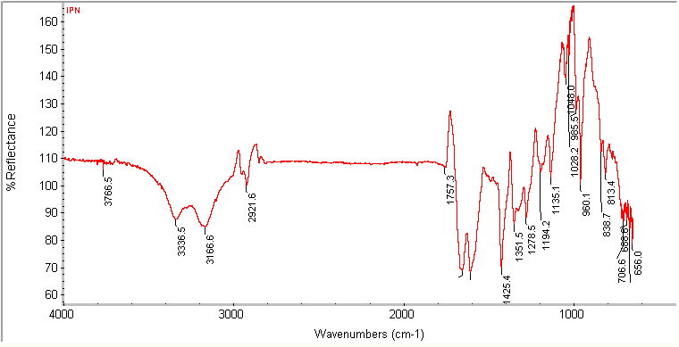
Figure 3.4(a) FTIR spectra of PAM/PANI nanofibre composite hydrogel
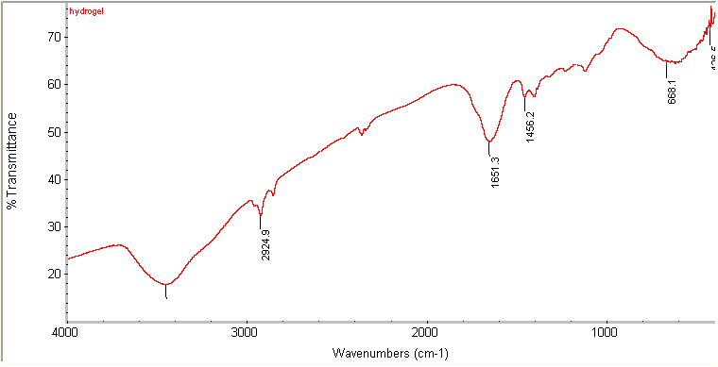
Figure 3.4(b) FTIR spectra of PAM hydrogel

3.5 THERMOGRAVIMETRIC ANALYSIS
The thermal stabilities of the polyacrylamide hydrogel and PAM/PANI nanofibre composite hydrogels were evaluated by using thermogravimetric analyser model Q50 from TA instruments at a heating rate of 10⁰C/min under nitrogen atmosphere (flow rate, 100ml/min) from room temperature to 600⁰C.
A clear variation between PAM hydrogel and PAM/PANI nanofibre composite hydrogels has been observed in TGA thermograms (Fig 3.5). Both samples were completely dry and followed two step transition. Polyacrylamide/PANI nano-composite hydrogel exhibit good thermal stability than PAM hydrogel. Both the samples show good stability till 200⁰C with only small weight loss. After that PAM/PANI nanofibre composite hydrogel shows some significant weight loss, while in PAM hydrogel weight loss starts only after 250⁰C. Both the samples begin to degrade after 350⁰C but nano-composite hydrogel retains more weight and hence it appears that thermal stability of hydrogel increased by incorporation of PANI nanofibres. This may be due to resistance to heat by PANI present insides the acrylamide network.

Figure 3.5 A TGA graph of PAM/PANI nanofibre composite
hydrogel and PAM hydrogel

3.6 CYCLIC VOLTAMMETRY
Electrochemical characterization of PAM hydrogel and PAM/PANI nanofibre composite hydrogels was carried out using cyclic voltammetry in 0.1M HCl solution. A sterile needle was inserted in the centre of swollen cylindrical hydrogel carefully and was used as a working electrode. Cyclic voltammetry was done in a conventional three electrode cell with standard Ag/AgCl and platinum electrode as reference and counter electrodes, respectively using potentiostat/galvanostat. Cyclic voltammograms of the hydrogels were recorded under the scan rate of 0.05 V/s and applied potential was varied from -0.25 to 1.25.
Cyclic Voltammetry of the composite hydrogel show the characteristic redox response commonly observed for conventional conducting polymer films at electrode surface. Figures (3.6a) and (3.6b) show a comparison between the cyclic voltammograms of PAM hydrogel and PAM/PANI nano-composite hydrogel under standard conditions. However, the cyclic voltammograms of composite hydrogel is not well defined with a general blurring of redox responses. Such behaviour is indicative of increased resistance or sluggish electron transfer as the conducting polymer phase lies inside the PAM network. Cyclic voltammetric responses indicated that ion transport in and out of entire composite hydrogel was significantly more difficult than for compact films.

Figure 3.6 (a) Cyclic voltammogram of PAM hydrogel

Figure 3.6 (b) Cyclic voltammogram of PAM/PANI nanofibre composite hydrogel

3.7 X-RAY DIFFRACTION PATTERN
The X-Ray diffraction spectra were recorded using a D-8 Advanced X-ray diffractometer, BRUKER Co., Germany. The dried gels were placed on the glass slide specimen holder and exposed to XRD assembly. The scan was taken between 10 to 80⁰ and running at 40 kV and 40 mA.
The X-ray pattern of PAM/PANI nanofibre composite hydrogel exhibit sharp diffraction peak at 2θ = 23.13⁰, 29.82⁰, 36.24⁰, 39.93⁰. The peak centered at 2θ = 29.82⁰ is ascribed to PANI nanofibres which shows its highly ordered crystallinity (Fig.3.7a). Fig 3.7 (b) shows a typical non crystalline pattern of pure PAM hydrogel.

Fig 3.7(a) XRD pattern of PAM/PANI nanofibre composite hydrogel

Fig 3.7(b) XRD pattern of PAM hydrogel

3.8 SCANNING ELECTRON MICROSCOPY
The surface morphologies of PAM hydrogel and PAM/PANI nanofibre composite hydrogels were observed by using Hitachi, S-3700N, scanning electron microscope.
The SEM micrographs of PAM/PANI nanofibre composite hydrogel and PAM hydrogel are shown in Fig. 3.8 (a & b). The Figure 3.8 (a & b) show similar surface morphologies of PAM/PANI nanofibre composite hydrogel and PAM hydrogel. It is clear that the surfaces of the both hydrogels are homogenous and shows no cracks, voids and unevenness. There is no phase segregation or agglomeration of nanofibres evident, the distribution of nanofibres seems to be uniform.

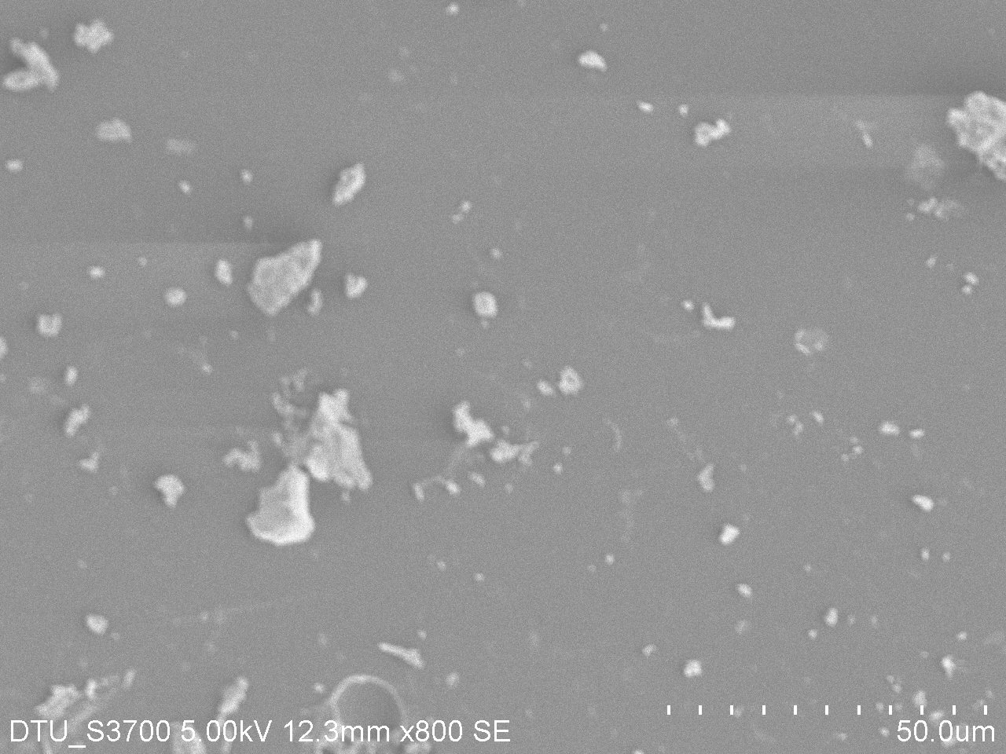
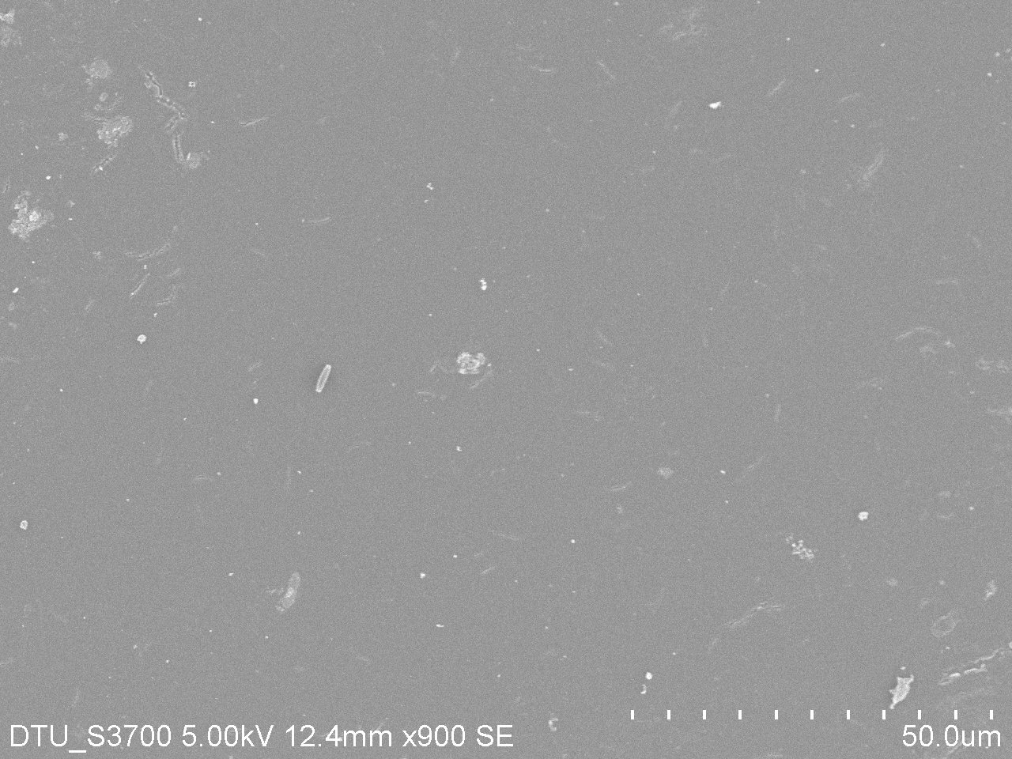
(a) (b)

Figure 3.8 SEM micrographs of (a) PAM/PANI nanofibre composite hydrogel and (b) PAM hydrogel

CHAPTER – 4

CONCLUSION
&
FUTURE PROSPECTS

CONCLUSION
- Polyacrylamide/PANI nanofibre composite hydrogels were synthesized by free radical polymerization. PANI nanofibres were incorporated in PAM hydrogel network to during polymerization render them conducting.
- The dehydration and rehydration studies show that PAM/PANI nanofibre composite hydrogels have good water holding and releasing capacity. However, dehydration and rehydration rates of composite hydrogels are slightly slower than that of PAM hydrogel.
- It is observed that the basic swelling property of composite hydrogels is retained to maximum. There is a negligible impact of PANI phase on water retention capacity as evidenced by EWC studies. However, the EWC decreases with increase in PANI nanofibre content due to filling of intra-network spaces by nanofibres.
- By the FTIR, the presence of PANI inside hydrogels was confirmed.
- XRD results indicated that orderness and crystallinity appears in otherwise amorphous PAM matrix.
- The morphological characteristics of PAM network are almost unaffected by the incorporation of PANI nanofibres as evidenced by SEM studies. There is no distinct phase separation indicative of highly efficient composite systems.
- Due to incorporation of PANI, electroactivity is produced in composite hydrogels. These composite hydrogels show a prospect of being used for timed drug release.

FUTURE PROSPECTS
Since, the electroactive nature of polyaniline has been established. The polyacrylamide/PANI nano composite hydrogels developed can be used for controlled drug delivery. The controlled release studies may be undertaken by subjecting the composite hydrogels to oxidation and reduction potentials of polyaniline and observing the release of a model dye like safranine or a drug like tetracycline. Furthermore, the electroactivity can also be increased by using more electroactive conducting polymers as network.

REFRENCES
[1] Peppas N.A., and Khare A.R., Preparation, structure and diffusional behavior of hydrogels in controlled release. Advance Drug Delivery Review, 11 (1993) 1.
[2] Andrianov A.K., Payne L.G., Polymeric carriers for oral uptake of micro particulates. Advance drug Delivery Review, 34 (1998) 155.
[3] Kost J., Langer R., Responsive polymeric delivery system. Advance Drug Delivery Review, 46 (2001) 125.
[4] Kudela V., In: Mark H.F., and Kroschwitz J.I., Eds., Encyclopedia of Polymer Science and Technology, Wiley, New York, 7 (1985) 783.
[5] Murdan S., Electro-responsive drug delivery from hydrogels. Journal of Control Release, 92 (2003) 1.
[6] Qui Y., Park K., Environment-sensitive hydrogels for drug delivery. Advance drug delivery Review, 53 (2001) 321.
[7] Gutowska A., Bae Y.H., Feijen J., Kim S.W., Heparin release from thermosensitive hydrogels. Journal of Control Release, 22 (1992) 95.
[8] Morishita M., Lowman A.M., Takayama K., Nagai T., Peppas N.A., Elucidation of the mechanism of incorporation of insulin in controlled release systems based on complexation polymers. Journal of Control Release, 81 (2002) 25.
[9] Zhang K., Wu X.Y., Modulated insulin permeation across a glucose-sensitive polymeric composite membrane. Journal of Control Release, 80 (2002) 169.
[10] Hennink W.E., Nostrum C.F., Novel crosslinking methods to design hydrogels. Advance Drug Delivery Review, 54 (2002) 13.
[11] Guiseppi-Elie A., Sheppard Jr. N.F., editors, Conferring biospecificity to electroconductive polymer-based biosensor devices. ACS Northeast Regional Meeting (NERM): Rochester, NY, (1995) 22.
[12] Guiseppi-Elie A., Wilson A.M., Sujdak A.R., Brown K.E.., Electroconductive hydrogels: novel materials for the controlled electrorelease of bioactive peptides. Polymer Preprints, 38 (1997) 608.
[13] Guiseppi-Elie A., Sujdak A., Wilson A.M., editors, Electroconductive hydrogels: Electrical, electrochemical and impedance properties. Fall MRS Meeting Symposium J. Boston: Materials Research Society, (1997) 1.
[14] Small C.J., Too C.O., Wallace G.G., Responsive conducting polymer–hydrogel composites. Polymers Gels and Networks, 5 (1997) 251.
[15] Guiseppi-Elie A., Wilson A.M., Sudjak A.S., Electroconductive gels for controlled electrorelease of bioactive peptides. Washington, DC: ACS Symposium Series, (1998) 185.
[16] Brahim S., Narinesingh D., Guiseppi-Elie A., Synthesis and hydration properties of pH-sensitive, p(HEMA)-based hydrogels containing 3-(trimethoxysilyl) propyl methacrylate. Biomacromolecules, 4 (2003) 497.
[17] Jovanovic J., Adnadjevic B., Influence of poly (acrylic acid) xerogel structure on swelling kinetics in distilled water. Polymer Bulletin, 58 (2007) 243..
[18] Low L.M, Seetharaman S., He K.Q., Mark J., Microactuators toward microvalves for responsive controlled drug delivery. Sensors and Actuators, 67 (2000) 149.
[19] Kim S.W., Bae Y.H., Okano T., Hydrogels: Swelling, Drug Loading, and Release. Pharmaceutical Research, 9 (1992) 283.
[20] Murdan S., Electro-responsive drug delivery from hydrogels. Journal of Controlled Release, 92 (2003) 1.
[21] ] Feng Q.L., Kim T.N., Kim J.W., Cui F.Z., Ag-Substituted HA Coatings with both antimicrobial Effects and Cell-Compatibility. Journal of Materials Science Letters, 18 (1999) 559.
[22] Silver S., Bacterial silver resistance: molecular biology and uses and misuses of silver compounds. FEMS Microbiology Reviews, 27 (2003) 341.
[23] Margaret I., Lui S.L., Poon V.K.M., Lung I., Burd A., Med J., Antimicrobial activities of silver dressings: an in vitro comparison. Microbiology, 55 (2006) 59.
[24] Maki D.J., Tambyah P.A., Engineering out the risk for infection with urinary catheters.
Emerging Infectious Diseases, 7 (2001) 342.
[25] Curtin J.J., Donlan R.M., Using Bacteriophages to reduce formation of catheter-associated biofilms by Staphylococcus epidermidis. Antimicrobial Agents and Chemotherapy, 50 (2006) 1268.
[26] Kabiri K., Synthesis of fast-swelling superabsorbent hydrogels: effect of crosslinker type and concentration on porosity and absorption rate. European Polymer Journal 39 (2003) 1341.
[27] Faez R., Martin I.M., De Paoli M.A., Rezedene M.C., Microwave properties of EPDM/PANI-DBSA blends. Synthetic Metals, 119 (2001) 435.
[28] Nalwa H.S., (Ed), Handbook of organic conductive materials and polymers, Wiley New York (1997) 4.
[29] Mazur M., Tagowska M., Palys B., Jackowska K., Template synthesis of polyaniline and poly(2-methoxyaniline) nanotubes: comparison of the formation mechanisms. Electrochemistry Communication, 5 (2003) 403.
[30] Bredas J.L., Bryan Street G., polarons, bipolarons and solitons in conducting polymers. Accounts of Chemical Research, 18 (1985) 309.
[31] Heeger A.J., Semiconducting and Metallic Polymers: The Fourth Generation of Polymeric Materials. Angewandte Chemie International Edition, 40 (2001) 2591.
[32] Baughmann R.H., Conducting polymer artificial muscles. Synthetic Metals, 78 (1996) 339.
[33] Shirakawa H., and Ikeda S., Infra red structure of Polyacetylene. Polymer Journal, 2 (1971) 231.
[34] Huang W.S., Humphrey B.D., MacDiarmid A.G., Effects of polymer doping upon the Langmuir film formation. Journal of Chemical Society, Faraday Transaction 1, 82 (1986) 2385.
[35] MacDiarmid A.G., Polyaniline and polypyrrole: Where are we headed?. Synthetic Metals, 84 (1997) 27.
[36] MacDiarmid A.G., Chiang J.C., Halpern M., Huang W.S., Mu S.L., Somasiri N.L., Wu W.Q., Yaniger S.I., “Polyaniline”: Interconversion of Metallic and Insulating Forms. Molecular Crystals and Liquid Crystals, 121 (1985) 173.
[37] Huang J., Synthesis and applications of conducting polymer polyaniline nanofibers. Pure and Applied Chemistry, 78 (2006) 15.
[38] Mantovani J.G., Warmack R.J., Annis B.K., MacDiarmid A.G., Scherr E., Investigation of surface morphology of emeraldine hydrochloride by scanning tunneling microscopy. Journal of Applied Polymer Science, 40 (1990) 1693.
[39] Wei Y., Sun Y., Jang G.W., Tang X., Effects of p-aminodiphenylamine on electrochemical polymerization of aniline. Journal of Polymer Science Part C: Polymer Letters, 28 (1990) 81.
[40] Choi S.J., Park S.M., Conducting polymer: a new era in electrochemistry. G. Inzelt, Editor F. Scholz, Journal of Electrochemical Society, 149 (2002) E26.
[41] Liu J., Lin Y.H., Liang L., Voigt J.A., Huber D.L., Tian Z.R., Coker E., Mckenzie B., Mcdermott M.J., Templateless Assembly of Molecularly Aligned Conductive Polymer Nanowires: A New Approach for Oriented Nanostructures. Chemistry - A European Journal, 9 (2003) 605.
[42] Liang L., Liu J., Windisch C.F., Exarhos G.J., Lin Y.H., Direct Assembly of Large Arrays of Oriented Conducting Polymer Nanowires. Angewandte Chemie International Edition, 41 (2002) 3665.
[43] Huang J.X., Kaner R.B., Nanofiber Formation in the Chemical Polymerization of Aniline: A Mechanistic Study. Angewandte Chemie International Edition, 43 (2004) 5817.
[44] Huang J.X., Kaner R.B., A journal chemical route to polyaniline nanofibre. Journal of the American Chemical Socity, 126 (2004) 851.
[45] Chao D., Chen J., Lu X., Chen L., Zhang W., Wei Y., SEM study of the morphology of high molecular weight polyaniline. Synthetic Metals, 150 (2005) 47.
[46] Huang J.X., Virji S., Weiller B.H., Kaner R.B., Polyaniline nanofibres : facile synthesis and chemical sensors. Journal of the American Chemical Socity, 125 (2003) 314.
[47] Li D., Kaner R.B., Processable stabilizer – free polyaniline nanofibre stable colloids. Chemical Communication, (26) (2005) 3286.
[48] Huang J., Kaner R.B., A general chemical route to polyaniline nanofibres. Journal of
American Chemical Society, 126 (2004) 851.

