STUDIES ON

MODIFIED POLYALKENOATE

CEMENT

A Major Project Submitted for the Fulfillment

of the Requirement for the Degree of

MASTER OF ENGINEERING

in

POLYMER TECHNOLOGY

In the faculty of technology,
University of Delhi, Delhi.

By
PAWAN KUMAR PUNIANI

Under the Guidance of
Dr. A. P. Gupta

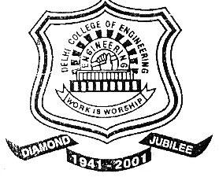

DEPARTMENT OF APPLIED CHEMISTRY
AND POLYMER TECHNOLOGY
DELHI COLLEGE OF ENGINEERING
DELHI-110042

