CHAPTER 1

INTRODUCTION AND LITRATURE SURVEY

1.1 INTRODUCTION

Now a days the developments in material science and medical science have made it possible to rebuild human body parts. The biocompatible materials used for such rebuilding are called biomaterials. Biomaterials are broadly of two kinds-natural and synthetic. Natural biomaterials include purified collagen, protein fibers (silk, wool& hair); and polysaccharides. These materials are complex, heterogeneous and difficult to characterize.
Synthetic biomaterials like ceramics and polymers are often called biomedical material to differentiate them from natural biomaterials.
Polymeric materials have a wide variety of applications for implantation since they can be easily fabricated into many forms: fibers, textiles, films, and rods and viscous liquids. Polymers bear a close resemblance to natural soft tissue components such as collagen. In some cases it is possible to achieve a bond between synthetic polymers and natural tissue polymers. Polymeric biomaterials have almost similar properties as natural tissues have.
Biomedical polymers are finding more and more applications. So the research on these materials is also getting more attention. These materials are being used in artificial limbs, bone repairs, controlled release drugs, dental fillings, dentures, external ear repairs sutures etc, different applications of materials have different properties requirements. So a single material cannot be useful for all applications. Particularly in dentistry where polymeric biomaterials are used in denture base, artificial teeth, cavity restorations, resilient linings, crown and bridge materials, dental cements, root canals and impression materials; many materials are in use.
Materials used for dental application must meet the physical, chemical, biological and aesthetic requirements including adequate strength resilience. Abrasion resistance dimensional stability in processing, translucency, color, and stability resistance to oral fluid, food or other substances with which the dental material may come in contact. Only a few materials fulfill most of these requirements.
Polymers also play an important role in operative dentistry as ingredients of composite restorative materials, cements and adhesives, cavity liners and protective sealant for pits and fissures.

Cement is commonly conceived as a substance that holds two surfaces together. In dentistry, however cement is defined as “an agent that not only serves as an luting (cementing) agent but also as an aesthetic restorative material, thermal insulator temporary restorative material and medicament for pulpal protection under large restoration. The other definition quite common is a paste that hardens to a solid mass. Dental cements are used in approximately 50% of all dental restorations as cementing agent for fixed restorations and orthodontic appliances, as base under permanent restorations etc.

The requirements for an ideal dental restorative material are:
- Good adhesive properties to dentine and enamel
- Dimensionally stable
- Resistant to degradation
- Good mechanical properties, such as good compressive strength, fracture,
toughness and wear resistance
- Cariostatic
- Easy to handle
- Aesthetically pleasing
- Biocompatible

In view of the varying demands in manipulative properties such as setting time resistance to mechanical breakdown and dissolution in oral fluids, It is practically not possible to have one type of material to perform satisfactory under all conditions. In 1920, cement based on zinc oxide eugenol remained almost unchanged for 50 years. Subsequently several cements such as zinc phosphate, silicophosphate, zinc oxide eugenol (ZOE), resin cement, and ployalkeneoid or polyelectrolyte cements such as poly-alkenoate and glass ionomer cements were reported.

1.2 LITERATURE SURVEY

1.2.1 Types Of Dental Cements

Three International Standards Organization (ISO) classifications have been specified for the use of dental cements: I) luting applications; II) restorative applications; and III) liner or base applications. Some types of cements are supplied in more than one of these three classifications. The following are examples of the use of various types of cement.

Cement Systems Principally Used For Luting Comprise: Zinc Phosphate, Zinc Polycarboxylate, Polyalkenoate (Glass Ionomer) Resin Cement, (especially orthodontic appliances) Resin Filled cement, Resin Ionomer Cement (resin modified ionomer).

Cement Used For Temporary Luting Or Temporary Restoration: Zinc oxide-eugenol, Zinc Oxide EBA (ethoxy benzoic acid).

Pulp Capping and Thermal-Insulating Base: Calcium hydroxide, Zinc oxide-eugenol.

Cavity Liners and Bases: Glass ionomer and resin-modified glass ionomer, Polycarboxylate, Zinc oxide-eugenol.

Cementing Veneers and Composite Inlays: Resin cements. Root Canal Sealants and Periodontal Dressing: Zinc oxide-eugenol.

Core Buildup Under a Crown Or Bridge Preparation: Metal-modified glass-ionomer.

1.2.1.1 Inorganic Cements

Inorganic Cements are two-component system, an organic powder and an acid. These are zinc phosphate, silicate, silicophosphate and zinc oxide eugenol (ZOE) cements.

Zinc Phosphate Cement

Zinc phosphate is the oldest of luting cement and us has the longest record. It serves as the standard for the newer systems developed. It is two-component systems namely zinc oxide powder and an aqueous solution of ortho phosphoric acid. In addition, the powder may contain small amount of other oxides such as magnesium oxide as modifier, aluminum and zinc are also present as resolved phosphates in the liquid. When the zinc oxide powder is mixed with aqueous solution of phosphoric acid, a solid substance is rapidly formed accompanied by considerable evolution of heat

ZnO+H3PO4---------------→ amorphous zinc phosphate

The amorphous zinc phosphate formed binds together the unreacted zinc oxide and other components of cement. The set cement consists of cured structure of the residual zinc oxide particles in a phosphate matrix.

Zinc phosphate cement has the widest range of applications from fixations of inlays, crowns, bridges, facing and orthodontic bends to their use as cavity liners or basis. Zinc phosphate has long served as universal luting cement it has good handling characteristics and proved longevity in the oral cavity when it is used for the cementing of the well feting restoration. The disadvantage of zinc phosphate cement is that, this is highly acidic (pH ranging between 1-2) and can cause pulpal injury, when placed directly on fresh cut dentine and lack of adhesion on tooth.

Silicate Cement

Stenfenbock first made cement in 1902; it’s transparent cement. Its two-component system, consisting of a powder and a liquid. The powder is an alumino silicate glass. The liquid is quite similar to that of phosphate cement but contains more water.

The setting of silicate cement results from the chemical breakdown of the glass powder when brought in to contact with liquid. The negatively charged alumino silicate glass is decomposed by hydrogen ions and leached cation migrate in to the aqueous phase, where they from an insoluble cementing gel with phosphate ions present in. now a days silicate cement consist largely of quartz powder and aluminum oxide. Aluminum, calcium and sodium fluoride are also added in form of fluorspar and cryolite and serve as flux. The average of silicate cement is limited to about 4 years due to slow wash out in oral fluids. However, it remain as material of choice for interior restoration due to its high compressive strength.

Silicophosphate Cement

Silicophosphate cement is a combination of zinc phosphate and silicate cement. The powder in this cement is a blend of zinc oxide and silicate glass mechanically mixed or fused and subsequently powdered .The silicate glass contains some fluoride, the liquid component is concentrated orthophospheric acid solution containing 45% water and 2.5% Al and Zn salts .The setting reaction is assumed to be a hybrid of Zinc phosphate and silicate cement setting reaction. The set cement consists of unreacted glass and zinc oxide bounded together by an aluminosilico phosphate gel matrix containing Zn, Ca and Al ions. The set cement consists of unreacted glass and zinc oxide partials bonded together by the aluminosilico phosphate gel matrix.

These cement are highly translucent but not fully transparent. As compared to zinc phosphate cement, this cement posses higher compressive strength more toughness and lower tensile strength and compared to phosphate cement, this cement has higher abrasion resistance

These cements are useful for the porcelain restoration due to high translucence. These are used as restoration material at less visible sites, and for cementing transparent component and jacket crowns. The other application include cementation of fixed restoration and orthodonting bends and also as a temporary posterior filling material

The disadvantages of these cements are higher solubility in distilled water and higher film thickness, than zinc phosphate cement.

Zinc oxide Eugenol (ZOE) Cements

Three types of cement have been reported under this classification. The first type is combination of zinc oxide and eugenol it may also contain zinc acetate, sulphate or their salts, which accelerate setting or hardening. The liquid is purified eugenol or clove oil, which contain 85% eugenol. Acetic acid and alcohol together with small amount of water may be present which also accelerate setting. The cement set by reaction between zinc oxide and eugenol (A) with the formation of zinc eugenolate (B).
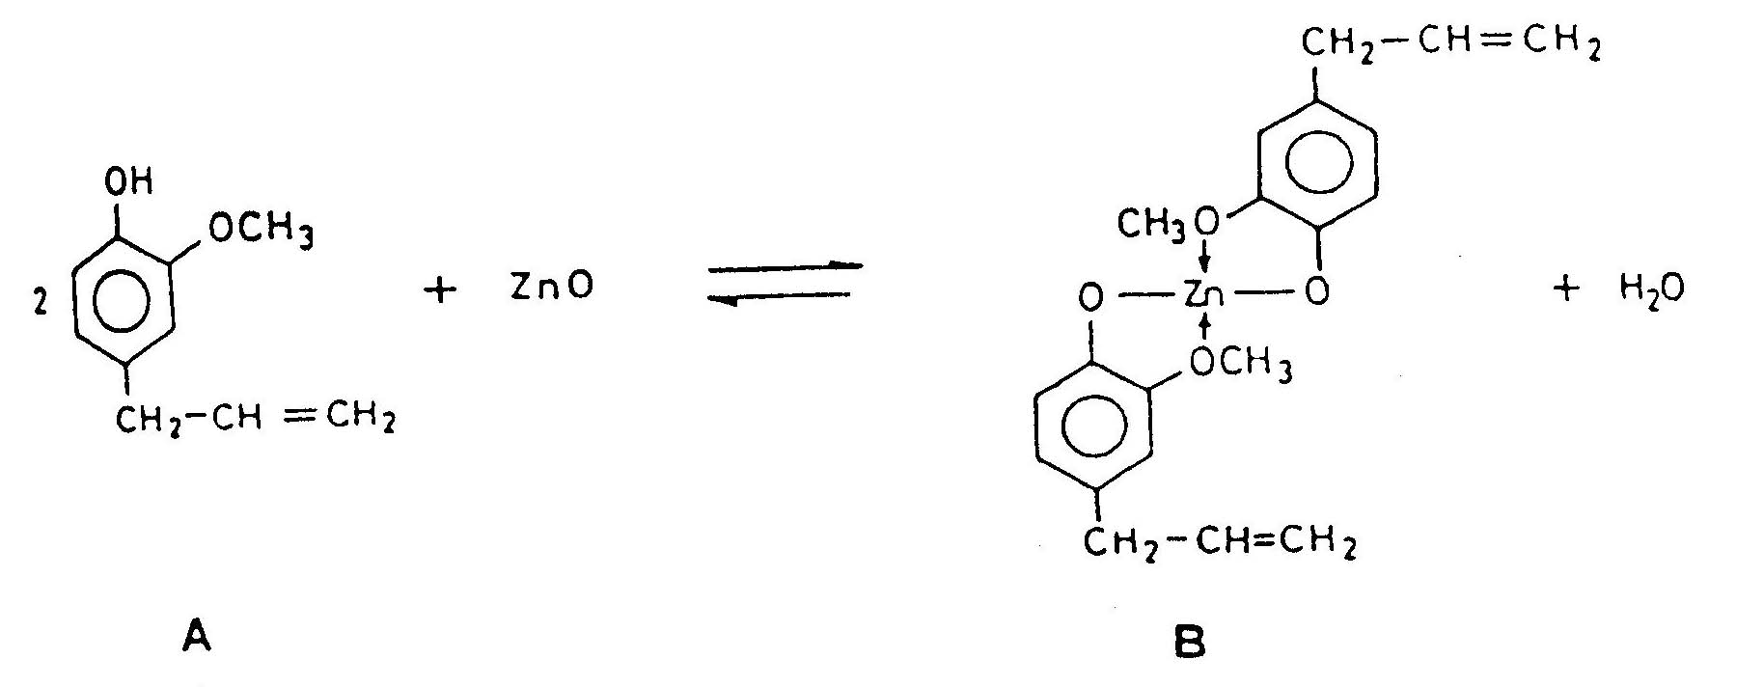

A five membered chelate is formed the methoxy group present in the eugenol at the ortho position. The set mass consists of residual zinc oxide particle bonded by a matrix of zinc eugenolate(C) hydrolysis of complex (D) showed that it is a unstable in water and get hydrolyzed to zinc hydroxide.
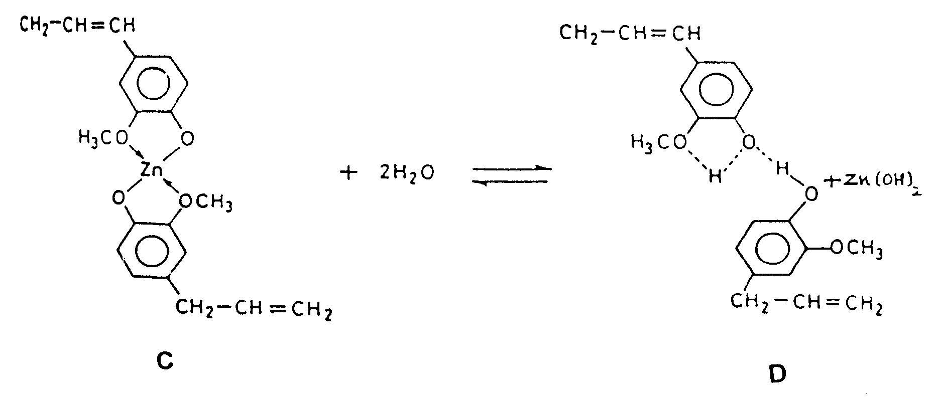

The compressive strength of this cement is low because of the weak nature of the binding agents. The solubility is high as 1.5% in distilled water after 24 hours resulting in the loss of eugenol from set cement by the hydrolytic decomposition of zinc eugenolate. With all these disadvantages this cement is still used as cavity lining material due their mildness, low irritability, good sealing ability and resistance to marginally penetration.

In the second type finely divided synthetic resins such as colophony (pine resin) poly (methyl methacrylate), polystyrene or Polycarbonate together with an accelerator such as zinc acetate are reinforced. The setting reaction is similar to zinc oxide eugenol cements. The compressive strength and tensile strength of these materials are improved by their reinforcement. The solubility is also low even though eugenol is released in aqueous condition.
The third type is ethoxy benzoic acid (E) cement called EBA cement. Reinforcement with aluminum in these cements improved compressive strength and lessened film thickness. The setting appears to involve the chelate formation between EBA and ZnO (F) similar to zinc oxide eugenol cements.

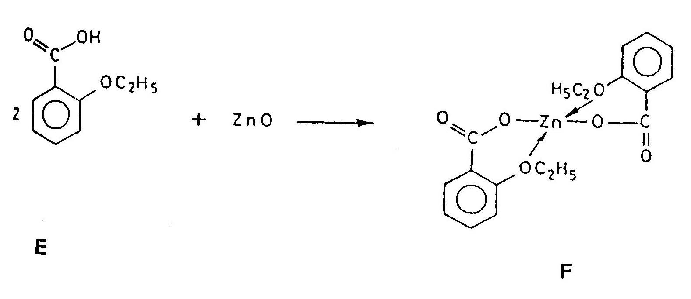

The solubility in aqueous medium is similar to zinc oxide eugenol cements with loss of eugenol the resistance to solubility in organic acids is higher like zinc phosphate cements. The biological properties appear to be similar to that of ZOE cements. Cements made from ester of syringic acids (G to I) n-hexyl vannilate(I) (as a substitute to eugenol) and mixtures of zinc oxide, alumina, hydrogenated resin were formed to posses higher strength and lower solubility in water.

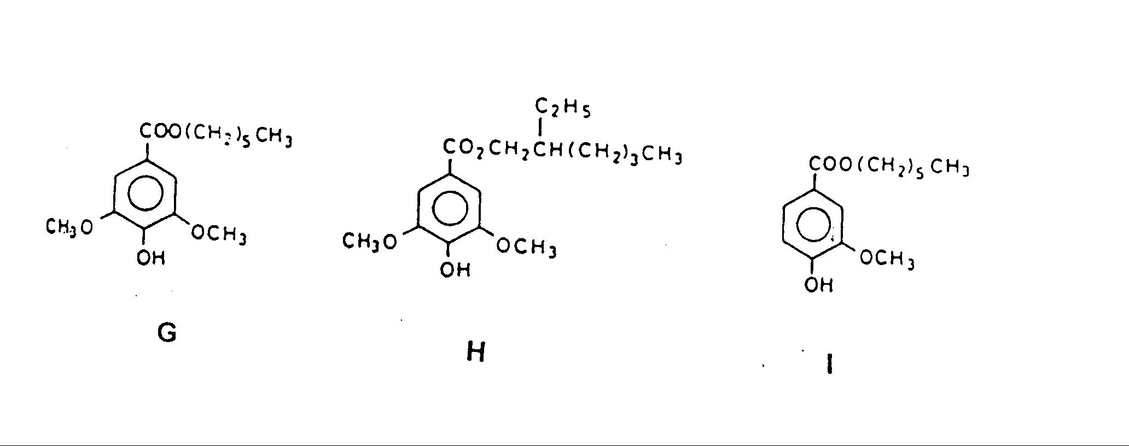

The main advantages of these materials are there compatibility in strength and film thickness to zinc phosphate cements, long working time and hydrolytic break down in oral fluids.

1.2.1.2 POLYALKENOATE CEMENTS

Work in the field of polyalkenoate cements namely poly-alkenoate and glass-ionomer cements started almost 30 years ago. Since then several developments have taken place in this area.

Zinc polyalkenoate cements

The polyalkenoate cements are relatively new system in which the strength of zinc phosphate and the biocompatibility of zinc oxide eugenol were combined. The powder in these cements is zinc oxide and the liquid is an aqueous solution of polyalkenoic acid such as polyacrylic acid, methacrylic acid, itaconic acid co-polymer. The cement sets between the reaction of the two components, forming a cross linked structure of zinc polyacrylate. The set cement consists of residual zinc oxide and other particles bonded together by the amorphous gel like matrix. Different workers have proposed various mechanisms. Initially a general acid-base mechanism was proposed.

Another theory is that the hydrogen ions (protons) from the liquid penetrate into the liquid where they combine with the anion to form a salt like gel matrix. However, hardening of the mixture was attributed to the neutralization of the polycarboxylic acid with the metal oxide and stiffening of the network by ionic iterations of carboxylic groups with zinc and magnesium ions and reinforcing action of metal oxides shown below.

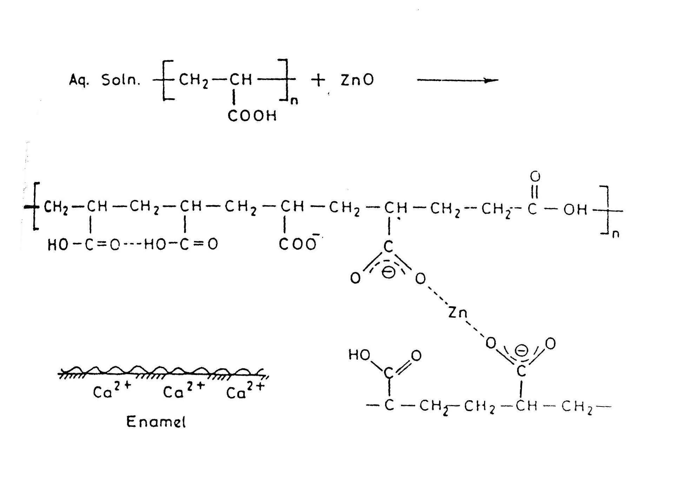

Figure: Mechanism of Hardening Zinc Oxide And Polyacrylic Acid To Zinc Polyacrylate

The adhesion of the poly-alkenoate cement is superior to any of the cements available. The adhesion of other cements to the tooth enamel is purely mechanical and need acid etching prior to cementation. The adhesion of polycarboxylic cement arise from etching of the enamel by the polyacrylic acid providing an easily wettable, porous surface amenable to mechanical interlocking with the hardened cement and formation of ionic bonds between the acid carboxylate ions at the resin enamel interface. The adhesion is good even after prolonged water exposure. Acid etching of the substrate surface prior
to application of the cement does not increase the bond strength. The general biocompatibility of these materials is excellent. The compressive strength of these is high but lower as compared to phosphate cements. The tensile strength is somewhat higher than phosphate cements.
Poly-alkenoate cement mixture though appears to be more viscous than other cement; it flows under the pressure to give a reasonable thickness. The material has mild effect on the pulp, comparable to zinc oxide eugenol. This occurs probably as a result of rapid rise of setting cement towards neutrality, localization of poly acrylic acid because of its molecular size and minimal movement of the fluid in the dentinal tubules. The main advantages of these cements are excellent adhesion to the tooth enamel coupled with the little pulp reaction. The main disadvantages are the need for accurate proportioning for optimum properties, lower compressive strength, and shorter working time than phosphate cements.

Glass-ionomer cements
Glass Polyalkenoate (Ionomer) Cements (GICs) were first introduced in early 1970s by Wilson and Kent and are now regarded as important restorative materials. Glass-ionomer cement is a hybrid of silicate and poly-alkenoate cement. It is a two-component system, consisting of powder and liquid like the poly alkenoate cement. the powder is an aluminosilico glass and the liquid is a homopolymer or copolymer of unsaturated carboxylic acid known as alkenoic acid known as alkenoic acids. The most commonly used alkenoic acids are poly (acrylic acid) and copolymer of acrylic acid and itaconic acid.
When the powder and aqueous liquid are brought together to form a paste the glass powder that is basic in nature, reacts with the polyalkenoic acid to form a salt hydro gel. Alternately, the setting mechanism is believed to involve the migration of protons from the acid into the glass displacing Al and Ca cations. These are accepted by polyacrylic acid to form chelate and sets into amorphous mass
GICs benefit greatly from its inherent qualities such as its ability to adhere to tooth structure and possess anticariogenic properties through its ability to release and
uptake fluoride. The influence of fluoride is found in a zone of resistance to demineralization at least 3mm wide around a glass-ionomer restoration. GICs also show reliable adhesion to dentine and enamel, and excellent biocompatibility. The exact mechanism of bonding of these materials to dentine and enamel is not clear. One theory is that polyacid molecules chelate with calcium at the tooth surface. This mechanism is supported by the fact that the formation of the interfacial calcium polyalkenoate salt would involve a reaction similar to that though to occur during the setting of the cement. Also, the greater bond strength achieved with enamel than that achieved with dentin suggests that it is the calcium of tooth
substance, which is involved in the bond formation. Another suggestion is that the outer layers of the apatite on the tooth surface become solubilised in the presence of acid. As more apatite dissolves and as the cement begins to set the pH begins to rise. This may cause re precipitation of a complex mixture of calcium phosphate (from the apatite) and calcium salts of the polyacid onto the tooth surface. This mechanism could operate on enamel or dentine surface. It has also been suggested that in the case of dentine there may also be some bonding between carboxylic acid groups of the cement and the reactive groups within the collagen, either by hydrogen bonding or by metallic ion bridge. Possible mechanism of bonding to tooth surface for GICs.

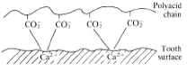

Fig: Mechanism of bonding of GICs to tooth surface for
Glass-ionomer cement is a hybrid of silicate and poly-alkenoate cement. It is a two-component system, consisting of powder and liquid like the poly alkenoate cement. The powder is an aluminosilico glass and the liquid is a homopolymer or copolymer of unsaturated carboxylic acid known as alkenoic acid known as alkenoic acids. The most commonly used alkenoic acids are poly (acrylic acid) and copolymer of acrylic acid and itaconic acid.
When the powder and aqueous liquid are brought together to form a paste the glass powder that is basic in nature, reacts with the polyalkenoic acid to form a salt hydro gel. Alternately, the setting mechanism is believed to involve the migration of protons from the acid into the glass displacing Al and Ca cations. These are accepted by polyacrylic acid to form chelate and sets into amorphous mass.
Glass-ionomer cements are reported to have strength comparable to silicate cements and posses higher tensile strength. The adhesive properties, biocompatibility, pulpal reactions are similar to poly-alkenoate cement.

1.2.3. A SUMMERY OF USES AND SELECTION OF DENTAL CEMENTS:

• Only those cements, which make use of polyacrylic acid, such as zinc polycarboxylate and glass polyalkenoate (glass ionomer), are capable of providing the carboxylate groups that have chemical adhesion to tooth structure.
• Zinc oxide-eugenol cements can have a detrimental effect on the setting of some resin systems used in composite materials and have the potential to contaminate tooth surface prior to using bonding agents.
• Glass ionomer cements are unfortunately sensitive to moisture immediately following mixing and during setting. Paradoxically, glass ionomer cements are best placed on moist tooth structure, excessive drying of the preparation is not recommended.
• Conventional glass ionomer cements are very important in geriatric dentistry due to the fact that they can release fluoride and can chemically bond to tooth structure. This is particularly valuable in erosion cavities and root caries situations.
• Resin modified glass ionomer cements generally have a much lower release of fluoride than the conventional glass ionomer materials.
• Creep of cements (continuous permanent deformation under a static force) can be detrimental to the performance of cements in certain clinical situations. The relatively high creep of zinc polycarboxylate cements may not be acceptable for certain fixed orthodontic appliances or for large (long-span) bridge structures.
• All “conventional” cements have similar low fracture toughness. However, conventional glass ionomer cements are generally stronger than zinc polycarboxylate cements. In contrast, the resin (BISGMA or urethane acrylate) and the resin-modified glass ionomer cements are both tougher and stronger than conventional cements.
• Manipulation of the cement is very important. Variations in the powder/liquid ratio can influence the working and setting time, the consistency and flow, as well as the degree of solubility, erosion, and strength and film thickness.

CHAPTER 2

OBJECTIVE AND PLAN OF WORK

This work is aimed at studying various properties and performance indices and effect of addition of filler on properties and performance indices of polyalkenoate cement in order to judge the usefulness of polyalkenoate cement as substitute of other dental cement.
Thermal properties, crystallinity, setting time, diametral tensile strength, and compressive strength are being studied.
The methods used include are thermo gravimetric analysis, differential thermal analysis infrared spectrum X – ray diffraction and strength testing
Two types of cements are prepared one without and another with filler. The filler used is cryolite, which is added to powder component of cement in10% ratio. The effect of filler addition on setting time, diametral tensile strength, compressive strength of cement is studied to check usefulness of filler in performance enhance of cement

CHAPTER 3

EXPERIMENTAL DETAILS

  - INTRODUCTION TO MATERIAL
Acrylic acid and methacrylic acid was polymerized to poly (acrylic acid-co-methacrylic acid) using potassium persulphate as initiator and isopropanol as chain transfer agent. Distilled water was used as a medium for solution polymerization ZnO. Which was deactivated, was used as the inorganic component (powder0 of the poly-alkenoate cement 2N NaOH was used as a solvent to dissolve the Poly (acrylic acid-co-methacrylic acid) for the molecular mass determination.
  - PREPARATION OF POLY (ACRYLIC ACID-CO-
METHACRYLIC ACID)
A three-necked round-bottomed flask fitted with a burette, thermometer pocket, reflux condenser was taken, and a magnetic stirrer was put inside it 200 ml of distilled water and 2.4 gms of potassium persulphate (K₂S₂O₈) were taken in the three necked round bottom flask. Two drops of isopropanol was added as chain transfer agent to control the molecular mass.
The three necked round bottom flask was then put on the magnetic stirrer cum heat control device and the temperature was increased until a fixed temperature of 90ºC was attained. Simultaneously the magnetic stirrer was kept “on” in order to dissolve the potassium persulphate (K₂ S₂ O₈) initiator in the distilled water inside the three-necked round bottom flask. While setting the temperature the mercury tip of the thermometer was well dipped inside the solution and care was taken so that the mercury tip should not touch the base of the round bottom flask for the accurate measurement of the temperature. 50 ml of acrylic acid methacrylic acid (4:1) was taken in a burette, which was fitted with one of the necks of the three necked round bottom flask. When the fixed temperature (90ºC) was attained, solution of acrylic acid and methacrylic acid was added drop wise from the burette at a rate of 2 ml per minute with constant stirring. When 10 ml solution of acrylic acid and methacrylic acid was consumed from the burette, another 10 ml of previously measured solution acrylic acid and methacrylic acid was added in the burette as a total of 60 ml solution was needed and burette capacity was only 50 ml. After the completion of addition, the stirring was continued for another two hours at the fixed temperature of 90ºC for complete polymerization.
The mixture was gradually cooled to room temperature with stirring resulting in the formation of Poly (acrylic acid-co-methacrylic acid) as a viscous aqueous solution. This was then concentrated at 50ºC; the concentrated aqueous Poly (acrylic acid-co-methacrylic acid) was precipitated, by adding it to acetone taken in a beaker, and stirring vigorously. The precipitate was decanted and was washed with acetone several times till no traces of unreacted acrylic acid and methacrylic acid were detected with alcoholic potassium permanganate (KMnO₄) solution fro unsaturation (Bayer’s test). The purple color of KNnO₄ disappears if the test is positive. It was dried at 50ºC for 6 hours. A 40% aqueous solution of the dried Poly (acrylic acid-co-methacrylic acid) was prepared and was used for further dental cement preparation. Experimental conditions for the preparation of Poly (acrylic acid-co-methacrylic acid) of desired molecular weigh of 45,000 to 55,000 is given in Table 3.1.
TABLE: 3.1
Acrylic acid and Methacrylic acid 60ml
[4:1 (v/v) 1]
Distilled water 200ml
Potassium Persulphate 2.4 grams
(4% of solution of acrylic acid
and methacrylic acid v/v)
Temperature 90ºC
Rate of addition of acrylic acid
And methacrylic acid solution 2 ml/min

  - DEACTIVATION OF ZINC OXIDE
The inorganic component of Polyalkenoate cement is Zinc Oxide. The reaction of commercial Zinc Oxide with Poly (acrylic acid-co-methacrylic acid) is too vigorous and fails to yield the required cement. To avoid this, the commercial Zinc Oxide was deactivated. By heating it at 1000ºC in a muffle furnace for 30 hours. Heating this way yields sintered ZnO. Which is also denser and more consolidated and of lower specific area than the original Zinc Oxide and these changes bring about the desired reduction in chemical reactivity. The yellow colored cake so obtained was powdered in a mortar pestle and was passed though a 75$μ$m sieve. This was the powder that was used for the preparation of Polyalkenoate cement.

  - PREPARATION OF POLYALKENOATE (CEMENT) COMPOSITE
It is true that any cement composition needs two impotent ingredients as a powder and a liquid. In the case of dental Polyalkenoate cement preparations the liquid is Poly (acrylic acid-co-methacrylic acid) solution and the powder is deactivated Zinc Oxide.
A 40% aqueous solution of Poly (acrylic acid-co-methacrylic acid) was carefully prepared. Now the viscous Poly (acrylic acid-co-methacrylic acid) solution is fit for the dental cement composition. This 40% aqueous solution of Poly (acrylic acid-co-methacrylic acid) was mixed with deactivated Zinc Oxide in powder/liquid ratio of 1.5:1 (w/w) on a glass plate to make the Polyalkenoate cement. The powder and liquid were mixed thoroughly with the help of a glass rod until a uniform paste was obtained. With time the paste gradually set and hardened to a solid mass.

  - PREPARARION OF CRYOLITE MODIFIED
POLYALKENOATE CEMENT
The grounded and sieved (through 75μm sieve) cryolite powder was added to deactivated zinc oxide in the ratio of 10% and now this powder mix was mixed with 40% aqueous solution of Poly (acrylic acid-co-methacrylic acid) in powder/liquid ratio of 1.5:1 (w/w) on a glass plate to make the modified Polyalkenoate cement. The powder and liquid were mixed thoroughly with the help of a glass rod until a uniform paste was obtained. With time the paste gradually set and hardened to a solid mass.

  - EVALUATION OF POLYALKENOATE CEMENT

Polyalkenoate dental cement (both normal and cryolite added) were evaluated by several properties such as setting time, compressive strength and diametral tensile strength, for their evaluation as restorative materials in dentistry.

    - SETTING TIME: Specimen Preparation and Determination of
Setting Time:
Setting time is defined as the period of time from the initiation of the mixing till the cement becomes brittle. Dental cements are required to set within a few minutes at oral temperature and harden rapidly. This property enables the dentist to trim and finish a restoration in a single session. It lessens the danger of displacing freshly cemented inlay or crown and reduces the risk of moisture damage to the vulnerable surface of hardening cement. This is dependent on the power/liquid ratio, temperature as well as humidity.

For the measurement of setting time a metallic ring of dimensions 4.8 mm height. 11.1 mm outer diameter and 9.5 mm inner diameter was placed on a flat glass plate and was filled with a portion of freshly prepared cement (P/L ratio 1:5:1 w/w) which was prepared at 38⁰C and 70⁰ Relative humidity. Four minutes after the starting of the mixing a standard Vicat needle weighing 6.9 grams was lowered on the cement sample that penetrates into it. The process was continued repeatedly in an interval of 30 seconds as long as the penetration of the needle more and more into the sample was observed.

The setting time was noted as the time elapsed from the starting of the experiment until the needle fails to penetrate into the cement.

3.6.2 COMPRESSIVE STRENGHT AND DIAMETRAL TENSILE
STRENGTH:
The most important quality for a material is to possess, is toughness i.e. its ability to absorb energy without fracturing. This parameter is difficult to measure in dental cements due to technical difficulties. Increased toughness can only be obtained at the expense of strength. There are two fundamental parameters of measuring strength such as tensile failure that occurs by the separation of planes and the shearing failure that occurs due to the sliding of planes one over the other.

Most common parameters of measuring the strength of dental cements are compressive strength and diametral tensile strength. The former is determined as the resistance to compression over a particular area.

Dental cements are brittle in nature. So the conventional methods of testing dumb-bell shaped specimen for tensile strength does not hold good for these cements. However, the tensile strength is measured under compression along the diametral axis (diametral compression method).
Zinc phosphate cement has the highest strength amongst the Zinc Oxide based cements such as Polycarboxylate and Zinc Oxide – Eugenol cements. However the compressive strength is dependent on the powder/liquid ratio. Dental cements are always prepared with an excess of powder over liquid. Normally only a fraction of powder is consumed in the cement forming reaction.

Thus dental cements can be regarded as composite materials where the excess of unattached powder acts as filler. For Zinc Phosphate the compressive strength increase sharply with increase in P/L ration whereas in Polyalkenoate cement the increase is gradual.

3.6.2.1 Specimen Preparation and Determination Of Compressive Strength:
For the determination of Compressive, strength a specimen of 6mm diameter and 13mm height was prepared in a stainless steel split mould at 23.5⁰C. The split mould was placed on a flat glass plate and was slightly overfilled with a portion of the standard mix of the cement within two minutes after commencing of the mix. A second plate was placed on the top of the mould and the plates were tightly pressed with a C-clamp.

An hour later the ends of the cylinder of cement was ground flat at right angles to the long axis by the use f a 240 grit Silicon Carbide paper. The test specimen was kept wet during the grinding and was rotated about a quarter turn for every few strokes.

After grinding the specimen was removed from the mould and was stored in distilled water for 23 hours. The compressive strength of the specimen was determined. The specimen was placed with the flat ends covered with wet filter paper between the platens of Instron Universal Testing Machine. So that the load is applied along the long axis of the specimen. The crosshead speed of the device was 0.05 cm/mm.

The maximum load at which the specimen fractured was recorded. The Compressive Strength was calculated using the formula.
P = 4F /$π$d², Where
P = Compressive Strength (Kg/cm²)
d = Diameter of the specimen (cm)
F = Maximum applied load (Kg)

3.6.2.2 Specimen Preparations and Determination of Diametral Tensile Strength:
Specimen preparation for the determination of Diametral Tensile Strength was prepared in the same manner and the size of the specimen was the same as those of used for Compressive strength determination.

For the determination of Diametral Tensile strength the specimen was placed with the diametral surface covered with a piece of wet filter paper between the platens of the testing machine so that the load is applied along the short axis of the specimen.

The maximum load where the specimen fractured was recorded. The Diametral Tensile Strength was calculated from the following formula.
T= 2F/$π$ L d
Where
T = Diametral Tensile Strength (kg / cm²)
F = Maximum load (Kg)
L = Length of specimen (cm)
d = Diameter of specimen (cm.)

CHAPTER 4

CHARACTERIZATION

The poly (acrylic acid-co-methacrylic acid) and the dental cement composition were characterized by the thermal analyses (TGA and DTA), IR Spectroscopy, X-Ray diffraction.

4.1 DETERMINATION OF MOLECULAR MASS OF POLY
(ACRYLIC ACID-CO-METHACRYLIC ACID)

The viscosity average molecular mass of prepared poly (acrylic acid-co-methacrylic acid) was determined. The solvent used for this purpose was 2N NaOH aqueous solution. Poly (acrylic acid-co-methacrylic acid) solution of 0.5% (g/dl) was prepared by dissolving 0.5 grams of Poly (acrylic acid-co-methacrylic acid) in 100ml of 2N NaOH. This solution was further diluted by adding the solvent to prepare solutions of three other concentrations i.e. 0.2%, 0.1% and 0.05%. The solvent flow time (t_{o}) and the solution flow time (t) of al the four different concentrations were measured at room temperature (24ºC) using an Ostwald viscometer.
The relative viscosities ($η_{r}$) were measured for each concentration. By calculating the inherent viscosities ($η_{r}$/C) at different concentrations. A plot of these was drawn against concentration of the polymer solution. The linear plot so obtained was extrapolated to zero concentration.
The ordinate intercept of this graph gives intrinsic viscosity ($η$). The Molecular mass was calculated by using the Mark-Houwink’s equation.
$\left[η\right]=K M^{a}$, Where
K= 4.222 14 ⁻⁴
$α=0\text{.}\text{64}$ (For 2N NaOH as solvent)
M = Molecular mass
$\left[η\right]$ ₌ Intrinsic Viscosity

For good performance of Polyalkenoate cement the Molecular mass of 45,000 to 55,000 was desired.

4.2 INFRARED (IR) SPECTRA:
The IR Spectra of Poly (acrylic acid-co- methacrylic acid) and Zinc Polyalkenoate cement was recorded in a Perkin-Elmer FTIR spectrometer in the range 400-4000cm⁻¹by using KBr pallet technique, in the University Science and Instrumentation Center (USIC), University of Delhi-Delhi.
The IR Spectra was studied for the examination of double bond in the sample to confirm complete polymerization and the structure of poly (acrylic acid-co-methacrylic acid) was investigated

4.3 TGA and DTA:
Simultaneously Thermo-gravimetric analysis (TG) and Differential Thermal Analysis (DTA) were recorded using 10.8 mg sample in a platinum crucible at a heating rate of 10⁰C per minute on a Rigaco – 8150 instrument at USIC. University of Delhi, Delhi. Alumina (Al₂O₃) was used as the reference material for DTA.
The DTA plot was studied to observe the endothermic and exothermic changes in the Poly (acrylic). The TG curve was investigated to observe the weight loss of Poly (acrylic acid co–methacrylic acid) sample at various temperatures. From the weight loss data against temperature, the Activation Energy and Arrhenius factor of Poly (acrylic acid co-methacrylic acid) was calculated by two different techniques. i.e.
(i) Sharp – Wentworth Method:
For n = 1 (first Order reaction)
log [dC/dT)/(1 – C) = log (A/β) – (Ea/2.303R)(1/T), Where
C (the fraction decomposed) = (W₀ – W_{T})/(W₀ – W_{F})
W₀ = Initial Weight
W_{T=} Weight at Temperature T
W_{F} =Final weight
E_{a} = Activation energy
A = Arrhenius (frequency) Factor
R = Universal Gas Constant
(ii) Broido Method:
For n = 1 (first order reaction)
In [g(α)] = In [A/β x (R/Ea) (T max)²] – [(Ea/R)(1/T)]
Where
Tmax = Temperature of maximum rate of weight loss
g (α) = The fraction decomposed (same as ‘C’ in Sharp – Wentworth method)
T₂ = Final Temperature
Ea = Activation Energy
R = Universal Gas Constant

4.4 X-RAY DIFFRACTION PATTERN:
The XRD pattern of both Poly (acrylic acid – methacrylic acid) and Zinc Polyalkenoate cement were recorded on a PHILIPS PW-3710 X-Ray Diffractometer, using Cu_{a} X-radiations of wave lengths 1.54056 A and 1.54439 A and a continuous scan of 3⁰ /min. The Diffractometer was operated at 40 kV and 20 mA current. The diffraction pattern was studied for crystallinity.
The crystallite size was determined by using Scherer formula. i.e.
L = 0.9 λ / Δ (2$θ$) Cos$θ$, Where
L = Coherence length (crystallite size)
λ = Wavelength of X-Ray radiation.
Δ(2$θ$) = Peak width
$θ$ = Reflection angle

CHAPTER 5

RESULTS AND DISCUSSION

  - POLY (ACRYLIC ACID CO – METHACRYLIC ACID):
The organic component of the polyalkenoate cement i.e. Poly (acrylic acid co-methacrylic acid) was characterized by various parameters such as Molecular mass, Infrared Spectroscopy, Thermo gravimetric analysis, Differential Thermal Analysis as well as X – Ray Diffraction studies which are discussed below.

5.1.1. Molecular Mass:
The flow time of the solvent (2N NaOH) and Poly (acrylic acid –co-methacrylic acid) solution at various concentrations were measured by using Ostwald viscometer. Which are given in table (5.1.1 a).

The average Molecular mass was determined by using the Mark – Houwink’s equation.
i.e. [$η$] = K$\overset{−}{M^{α}}$
K and $α$ has specific value for Poly (acrylic acid-co-methacrylic acid) and NaOH system.
Where

K = 4.22 x 10⁻⁴
$α$ = 0.64
$\overset{−}{M}$ = Average Molecular Mass.
[$η$] = Intrinsic Viscosity

The value of the Intrinsic Viscosity [$η$], which was taken from the plot by extrapolating to zero concentration, given in figures 5.1, was used to calculate the Molecular Mass. The Inherent viscosity at various concentrations was calculated in table (5.1). The Inherent Viscosity at zero concentration was found to be 0.43, which is the Intrinsic Viscosity [$η$]. From this, the Molecular Mass was calculated from Mark-Houwink’s equation

Solvent (2N NaOH) Flow Time (t₀) =102 Sec.
Concentration of poly (acrylic acid co-methacrylic acid), in g/dl | Flow Time (sec)
0.05 | 104.0
0.1 | 105.5
0.2 | 108.0
0.5 | 110.0

Calculation of Inherent Viscosity:
Table below shows the calculation of relative, specific, reduced, inherent viscosity of polymer from flow time data at various concentrations

Con. (g/dl) | Flow time (sec) | η_{rel}=t/t₀ | η_{sp}=η_{rel}-1 | η_{red}=η_{sp}/c | lnη_{rel} | η_{inh}=lnη_{rel}/c
0.05 | 104 | 1.0196 | 0.0196 | 0.392 | 0.0194 | 0.388
0.1 | 105.5 | 1.03 | 0.03 | 0.3 | 0.03 | 0.3
0.2 | 108 | 1.058 | 0.058 | 0.29 | 0.056 | 0.28
0.5 | 110 | 1.078 | 0.078 | 0.156 | 0.075 | 0.15

Where
η_{rel}= relative viscosity
η_{sp}= specific viscosity
η_{red}= reduced viscosity
η_{inh}= inherent viscosity

From Calculation The Average Molecular Mass Was Found To Be 50147

5.1.2 INFRARED (IR) ANALYSIS:
The Infrared spectra of poly (acrylic acid co-methacrylic acid) are shown in figure
- From the critical analysis of this spectrum it was found that there is no peak in the region 1680 cm⁻¹ to 1625 cm⁻¹ which confirms the absence of C = C stretching, and further confirms complete polymerization of acrylic acid and methacrylic acid.
- The peaks at 1171.5 cm⁻¹ to 850 cm⁻¹ can be assigned to the open chain C – C stretching in the polymer moiety.

- The peak around 3300 cm⁻¹ can be assigned to O – H stretching arises due to the presence of moisture in the system.

- The area registered at 2925.0 cm⁻¹ can be assigned to the aliphatic C – H asymmetric stretching frequencies and tat 2853.90 cm⁻¹ for symmetric stretching. The area registered at 1462.8 cm⁻¹ can be assigned tot eh aliphatic C – H asymmetric bending frequencies and at 1377.80 cm⁻¹ for symmetric bending.

- The peak observed at 1731.8 cm⁻¹ is due to C=O stretching of the carboxylic acid group. The peak observed at 1560.7 cm⁻¹ is due to asymmetric C – O stretching of the carboxylic acid group.

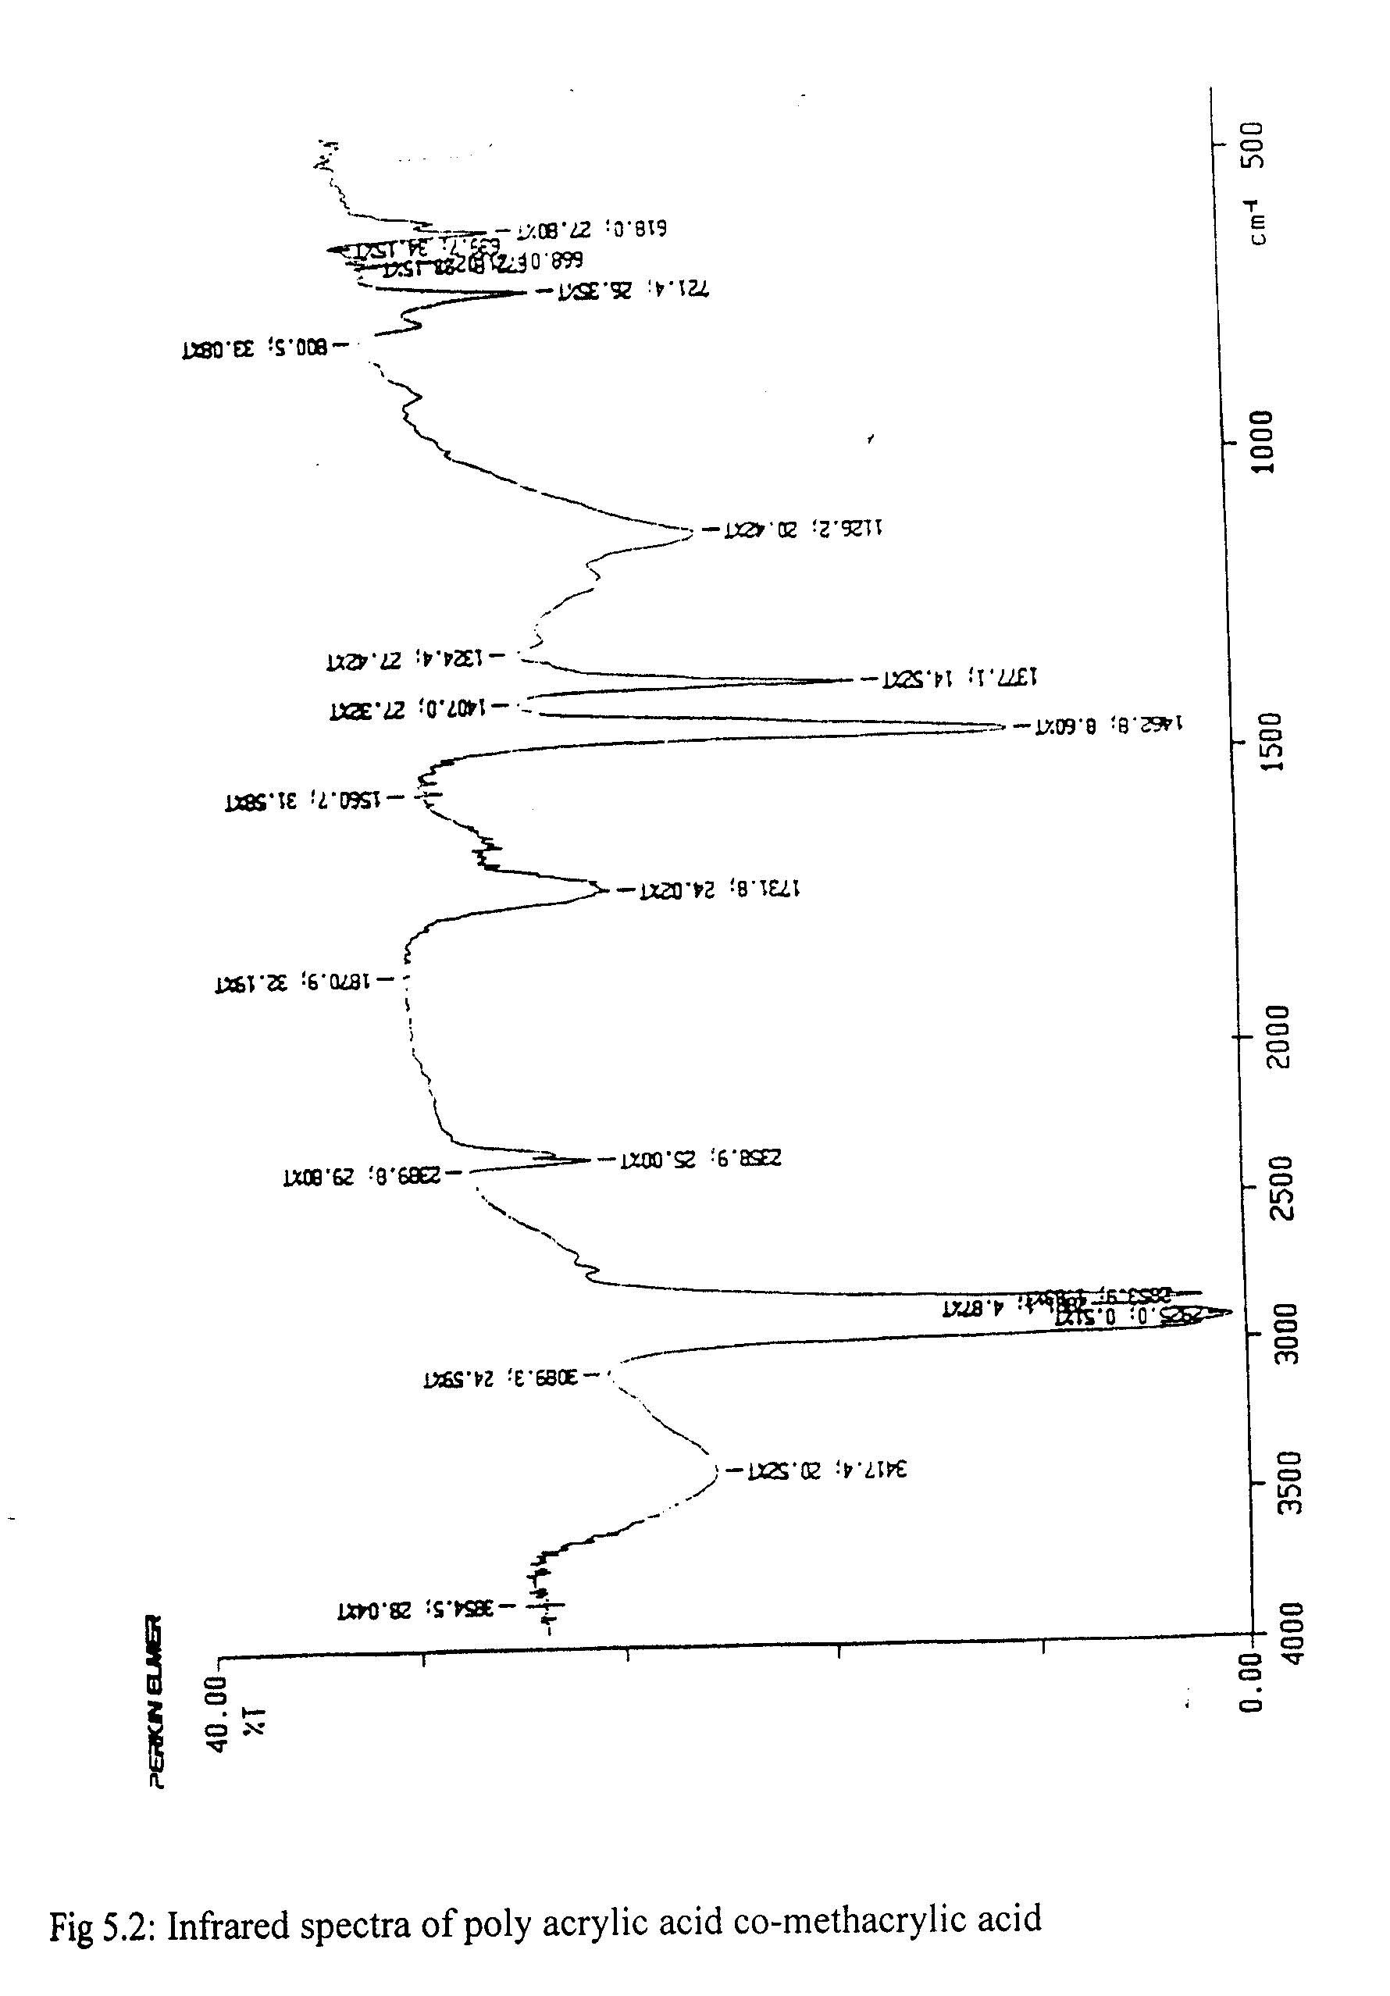
Fig 5.2 :Infrared spectra of poly acrylic acid co-methacrylic acid

5.1.3 Differential Thermal Analysis (DTA):
In differential thermo-gram (DTA curve) of Poly (acrylic acid-co-methacrylic acid), The first peak appeared in the thermogram at 82.1⁰C, can be assigned to the Glass transition temperature (Tg) of poly (acrylic acid – co – methacrylic acid). When Poly (acrylic acid-co-methacrylic acid) is heated around 200⁰C the endothermic peak observed at 194.0⁰C is due to the melting of Poly (acrylic acid-co-methacrylic acid). The peak at around 252.3⁰C is due to the liberation of a small of water to form anhydride, consisting mainly of six membered rings resulting in cross- linking. On further heating, the anhydride starts to decompose and heating at about 373.2⁰C, results in decarboxylation and rapid decomposition to and volatile hydrocarbons. The various endotherms observed are listed in table 5.3

Table: 5.3
DTA Peaks of Poly (acrylic acid – co-methacrylic acid)
Peaks | Temperature (⁰C) | Changes observed
Endo | 82.1 | Tg
Endo | 194.0 | Tm
Endo. | 252.3 | Anhydride formation  Causing de-polymerization and commencing of cross – linking.
Endo. | 373.2 | Rapid decomposition.

5.1.4. Thermo Gravimetric Analysis (TGA):

A typical TGA for Poly (acrylic acid-co-methacrylic acid) in air is given in figure 5.3. The degradation of the co-polymer was observed between 187.60⁰C to 390.59⁰C. The weight loss could be duet o chain scission resulting from oxidation and char formation. Activation Energy (Ea) and Arrhenius (frequency) factor (A) were calculated by two different methods.

(i) Sharp – Wentworth Method
For n = 1 (first Order reaction)
Log [(dC/dT)/(1-C)] = log (A/$β$) – (Ea/2.303R) (1/T)

From the weight loss data the values of C (the fraction decomposed were calculated by using the formula.

C = (W₀ –W_{T}) / (W₀ – W_{F})

The Activation Energy (Ea), Arrhenius Factor (A) of the thermal degradation of Poly (acrylic acid –co-methacrylic acid) was calculated.
The results are given in table 5.4.
(ii) Broido Method
For n = 1 (first order reaction)
In [g($α$)] = In [A/$β$ x (R/Ea)(Tmax)²] – [(Ea/R)(1/T)]

The value of g ($α$), same as ‘C’ in the Sharp – Wentworth method was calculated from the weight loss data. Tmax i.e. temperature of maximum rate of weight loss was found to be 542 K (269⁰C) which was used in the equation to calculate the Arrhenius factor from the intercept.
The Activation energy (Ea), Arrhenius factor (A) was calculated which are given in the table 5.4.

TABLE: 5.4 Activation energy (Ea) and Arrhenius factor (A) of degradation of Poly (acrylic acid – co- methacrylic acid) as calculated.

 | Sharp Went – Worth method | Broido method
Activation Energy (Ea) (Kcal/mol) | 5.20 | 0.766
Arrhenius Factor (A) (min⁻¹) | 10.5196 | 6.641 x 10³

MEASUREMENT CONDITIONS FOR TGA and DTA of POLY (ACRYLIC ACID – CO – METHACRYLIC ACID)

1) SAMPLE NAME |  | : CO
2) SAMPLE WEIGHT |  | mg : 15.5
3) TEMPERATURE AREA (T₁, T₂) |  | deg : 0, 600
4) RATE |  | deg/min : 10
5) SAMPLING TIME |  | sec : 2
6) TG RANGE |  | mg : 20
7) DTA RANGE |  | +/- microv : 100
Weight loss | Temperature |  | 1/K x 10³
(%) | (⁰C)
3.00 | 66.25 |  | 2.9468
6.00 | 112.80 |  | 2.5914
9.00 | 187.60 |  | 2.1706
12.00 | 237.00 |  | 1.9604
15.00 | 269.00 |  | 1.8477
18.00 | 301.09 |  | 1.7416
21.00 | 346.19 |  | 1.6148
24.00 | 390.59 |  | 1.5067
27.00 | 471.84 |  | 1.3424

5.1.5 X-Ray Diffraction:
X-Ray diffraction pattern of Poly (acrylic acid-co-methacrylic acid) shows a few significant peaks at Bragg’s angle (2θ): 30.30⁰, 28.135⁰ with relative intensity of 74.2%, 75.9% and 100% respectively. A few less intense peaks were also observed at (2θ); 21.790⁰ 38.17⁰, 43.935⁰ and 32.065⁰ with relative intensity of 25.5%, 26.5% and 44% respectively, which confirms some degree of crystallinity in Poly (acrylic acid-co-methacrylic acid) shown by figure 5.4.

The peak having relative intensity 100% is at (2θ) 31.30⁰, which corresponds to the d-spacing 2.8554 Ǻ. From the peak width (∆(2θ)) the coherence length (crystallite size) (L) of the crystalline order in the sample is calculated using Scherrer formula.

l.e L=0.9λ /∆(2θ) Cos θ, Where
L=Coherence length (crystallite size)
λ =Wavelength of X-Ray radiation
∆(2θ)= Peak width of the most intense peak
θ = Reflecting angle
Here using λ= 1.54056 Ǻ
∆(2θ) = 0.24. Ǻ

And θ = 2θ / 2 = 31.30⁰/2 = 15.65⁰
Cosθ = Cos 15.65⁰
=0.9629
L = (0.9× 1.54056) / 0.28×0.9629)
= 5.1425 Ǻ
The value of the crystallite size (L) of the Poly (acrylic acid-co-methacrylic acid) calculated in this way was found to be 5.1425 Ǻ.
Various parameters of x-ray diffraction analysis
Philips Analytical X-Ray B.V Pc-apd, Diffraction software
Sample identification: shco
Diffractometer type: PW3710 BASED
Tube anode: Cu
Generator tension [kV]: 40
Generator current [mA]: 20
Wavelength Alpha 1[A]: 1.54056 Ǻ
Wavelength Alpha 1[A]: 1.54439 Ǻ
Intensity ratio (alpha 1/alpha 2):0.5
Divergence slit 1⁰
Receiving slit: 0.1
Monochromator used: NO
Start angle [⁰2θ]: 10.010
End angle [⁰2θ]: 64.990
Step size [⁰2θ]: 0.020
Maximum intensity: 102.0100
Time per step[s]: 0.200
Type of scan: CONTINUOUS
Peak position defined by: Minimum of 2nd derivative of peak
Minimum peak tip width: 0.00
Maximum peak tip width: 1.00
Peak base width: 2.00
Minimum significance: 0.75
Number of peaks: 28

 |  |  | Peak | Peak | Back | Relative
Angle | d-Value | d-Value | Width | Intensity | Intensity | Intensity | Significance
[º2θ] | a1[Ǻ] | a2 [Ǻ] | [º2θ] | [counts] | [counts] | %
18.250 | 4.8571 | 4.8692 | 0.24 | 5 | 4 | 4.7 | 0.81
19.005 | 4.6658 | 4.6774 | 0.24 | 6 | 4 | 6.1 | 0.49
21.790 | 4.0754 | 4.0855 | 0.12 | 26 | 4 | 25.5 | 0.78
24.305 | 3.6590 | 3.6681 | 0.16 | 10 | 4 | 10.0 | 0.83
26.820 | 3.3214 | 3.3296 | 0.16 | 13 | 4 | 12.7 | 0.97
28.135 | 3.1690 | 3.1769 | 0.14 | 77 | 4 | 75.9 | 2.53
28.890 | 3.0879 | 3.0956 | 0.48 | 8 | 4 | 7.7 | 1.52
30.300 | 2.9474 | 2.9847 | 0.16 | 76 | 4 | 74.2 | 3.62
31.065 | 2.7890 | 2.7960 | 0.28 | 45 | 4 | 44.0 | 4.53
35.000 | 2.5616 | 2.5679 | 0.24 | 5 | 3 | 4.7 | 1.13
36.395 | 2.4665 | 2.4727 | 0.48 | 12 | 3 | 11.3 | 3.29
37.645 | 2.3875 | 2.3934 | 0.24 | 17 | 3 | 16.5 | 2.32
38.170 | 2.3550 | 2.3617 | 0.16 | 27 | 3 | 26.5 | 0.95
40.895 | 2.2049 | 2.2104 | 0.16 | 23 | 3 | 22.6 | 0.94
42.975 | 2.1029 | 2.1081 | 0.36 | 15 | 3 | 14.9 | 4.00
43.935 | 2.0591 | 2.0642 | 0.08 | 30 | 3 | 29.7 | 0.77
44.720 | 2..24. | 2.0290 | 0.20 | 11 | 3 | 10.7 | 1.13
46.535 | 1.9500 | 1.9548 | 0.12 | 17 | 3 | 16.5 | 1.06
48.645 | 1.8702 | 1.8748 | 0.24 | 7 | 3 | 7.1 | 2.35
51.775 | 1.7642 | 1.7686 | 0.64 | 3 | 3 | 3.2 | 1.17
54.305 | 1.6879 | 1.6921 | 0.40 | 7 | 3 | 6.6 | 1.04
55.410 | 1.6568 | 1.6609 | 0.32 | 7 | 3 | 7.1 | 1.02

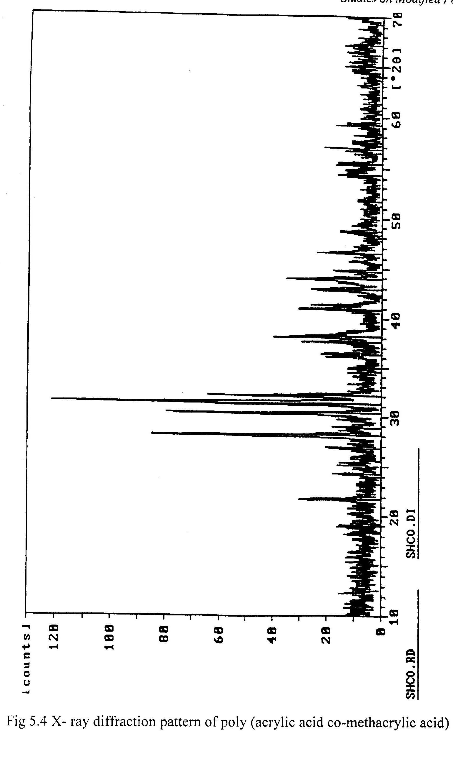

Fig 5.4 X- ray diffraction pattern of poly (acrylic acid co-methacrylic acid)

  - POLYALKENOATE CEMENT:
5.2.1 Infrared (IR) Analysis:

The Infrared spectra of Polyalkenoate cement are shown in figure 5.5. As the cement is set due to the reaction between Poly (acrylic acid-co-methacrylic acid) and Zinc Oxide (a basic oxide). So the area of our interest is concentrated on the type of bond formed between the Zn2+ ion and the carboxylic groups of the co-polymer acid.
The assignment of spectral bands is complicated because of the polymeric nature of the material. Being a polymer, it is unlikely to consist of discrete entitles of the type found in, for example, the crystalline zinc alkenoate
The five mostly likely modes of bonding, which can be exhibited by carboxylate groups, as described by different authors are given in fig. 5.6. These are

(a) Ionic
(b) Bridging bidentate
(c) Chelating bidentate-
(d) Asymmetric unidentate which is predominantly co-valent.
(e) An eight membered metal chelate ring with a ligand that is essentially

-OOC – CH – CH₂ – CH –

Bridging alkenoate give a band at about 1600 cm⁻¹ ionic species at about 1562 cm⁻¹ and chelating alkenoate at around 1550 cm⁻¹. For example in diacetatobisaquazinc (II), the band comes at 1550 cm⁻¹.
Comparing the IR spectra of the Polyalkenoate cement with the spectra obtained for Poly (acrylic acid-co-methacrylic acid) it is found that a broad band containing many small peaks is registered at 1558 cm⁻¹.
From the critical analysis of the spectrum around that region it can be ascertained that the peak at 1571.5 cm⁻¹ is most intense which confirms the bonding type is predominantly ionic.
The small bands around the region 1600cm⁻¹ might be due to the formation of \bridging (bidentate) carboxylate to some extent

The peaks around 1540 cm⁻¹ to 1550cm⁻¹ can be assigned to the formation of a small amount of chelating carboxylate as given in structures B and C respectively in figure 5.6

The presence of a few small peaks at around 1700-1730cm⁻¹ indicates the presence of a small amount of residual acid, which probably failed to bond with the Zn²⁺ ions.

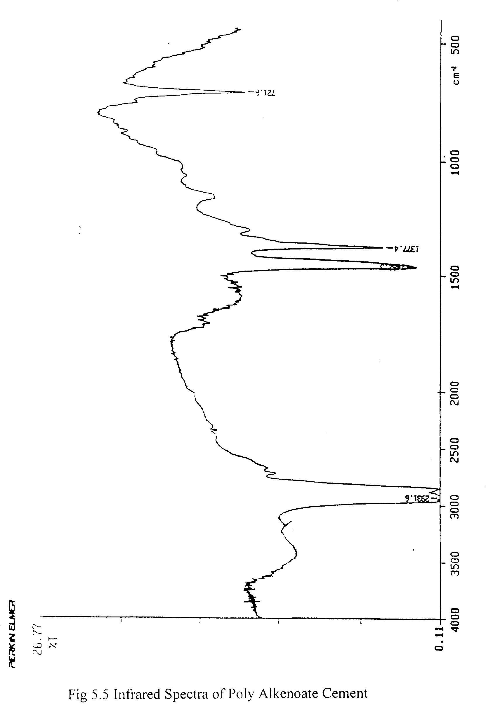

Fig 5.5 Infrared Spectra of Poly Alkenoate Cement
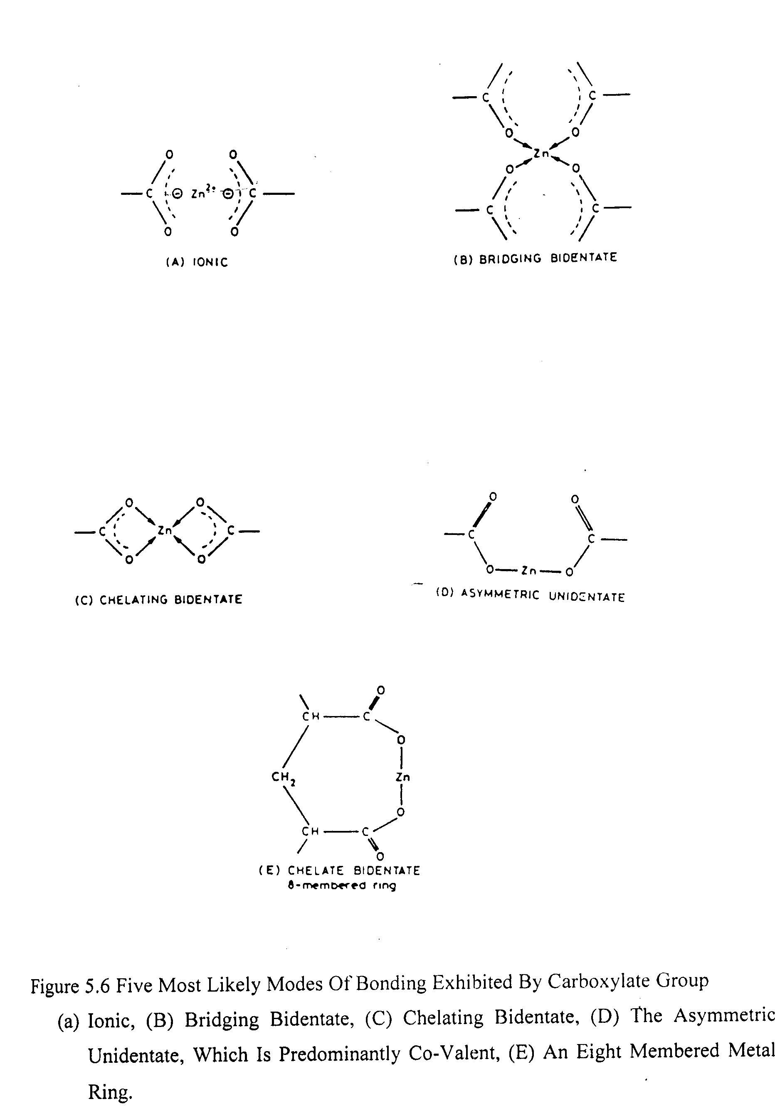
Figure 5.6 Five Most Likely Modes Of Bonding Exhibited By Carboxylate Group
- Ionic, (B) Bridging Bidentate, (C) Chelating Bidentate, (D) The Asymmetric Unidentate, Which Is Predominantly Co-Valent, (E) An Eight Membered Metal Ring.
5.2.2 Differential Thermal Analysis (DTA) :
From the DTA thermogram of Polyalkenoate cement, the peaks are shown in and figure 5.7 listed in table 5.5
The endothermic peak at 83.9ºC can be assigned to the water loss that might be due to the moisture absorbed during storage. When heated above 200ºC, the commencing of the broad peak at 280ºC is due the melting of the composite. The intense exothermic peak at 443.2ºC is due to combustion of the Polyalkenoate cement.

TABLE: 5.5 DTA peaks of Polyalkenoate Cement

Peaks  (Endo/Exo) | Temperature (ºC) | Changes observed
Endo | 83.9 ºC  Cement | Water loss form the
Endo | 280 ºC | Melting of the Cement
Exo | 443.2 ºC  Cement | Combustion of the

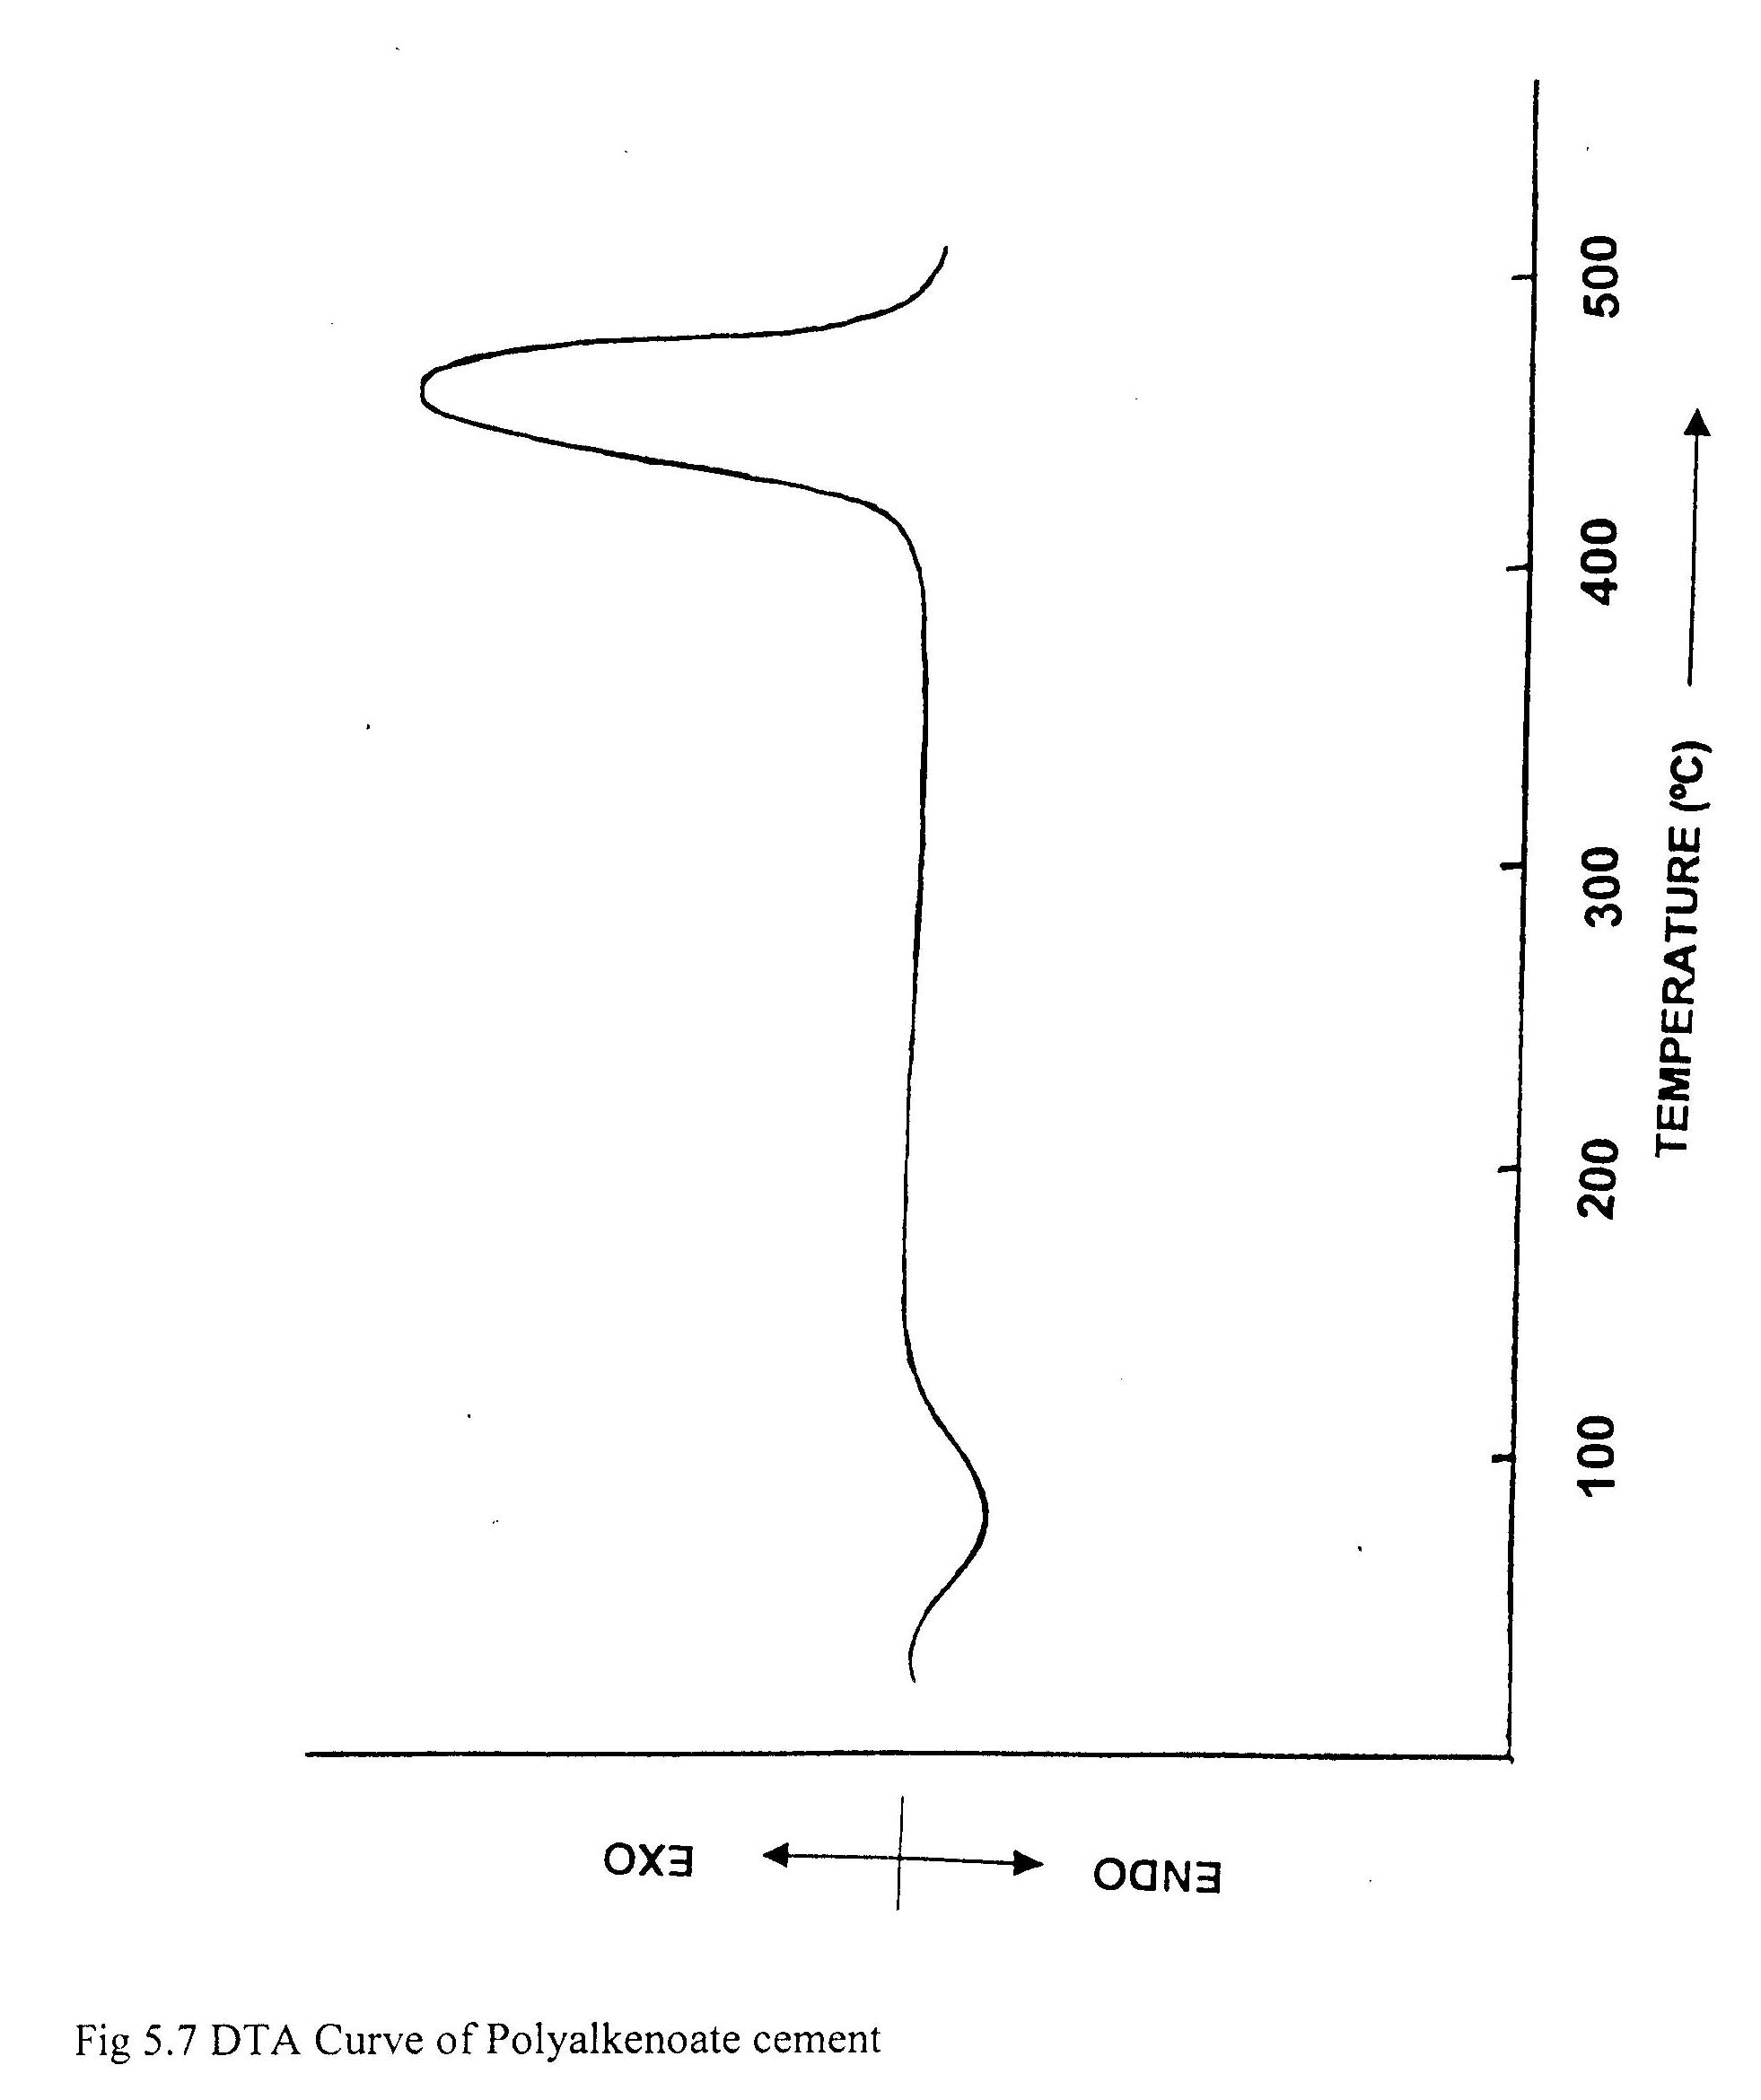
Fig 5.7 DTA Curve of Polyalkenoate cement

5.2.3 Thermo Gravimetric Analysis (TGA):
The TG thermogram of Polyalkenoate cement is shown in figure 5.8 from the curve it is indicated that the sample lost 4% of its initial weight unto 150 ºC. This may be attributed to the loss of water. Then a rapid weight loss occurred between 350 ºC to 450 ºC, which is assigned to the breakdown of the zinc polyalkenoate cement.

The Activation energy (Ea) and Arrhenius factor (A) was calculated by using Sharp Wentworth and Broido method using the same formula as used in case of Poly (acrylic acid-co-methacrylic acid). The results are given in table 5.6.

Activation energy (Ea) and Arrhenius facto (A) of degradation of Polyalkenoate cement were calculated by Sharp Wentworth and Broido method.
Table 5.6
Thermal Properties | Sharp Wentworth Method | Broido Method
Activation Energy (Ea)  (Kcal/mol) | 4.76 | 1.017
Arrhenius Factor (A)  (min⁻¹) | 14.852 | 1.02910⁴

MEASUREMENT CONDITIONS FOR TGA and DTA of POLYALKENOATE CEMENT

1) SAMPLE NAME : Poo
2) SAMPLE WEIGHT mg : 26.7
3) TEMPERATURE AREA (T₁T₂) deg : 0, 600
4) RATE deg/min : 10
5) SAMPLING TIME sec:2
6) TG RANGE mg : 50
7) DTA RANGE +/- microv : 100

Weight loss (%) | Temperature (ºC) | 1/K 10³
3.00 | 57.71 | 3.0229
6.00 | 72.74 | 2.9915
9.00 | 91.25 | 2.7446
12.00 | 167.65 | 2.2689
15.00 | 356.32 | 1.5888
18.00 | 427.62 | 1.4271
21.00 | 435.21 | 1.4113
24.00 | 446.82 | 1.3990
27.00 | 481.17 | 1.3258

5.2.4 X-Ray Diffraction:
The X-Ray diffraction pattern of Polyalkenoate cement is shown in figure 5.9 from the X-Ray diffraction pattern of Polyalkenoate cement, a few intense peaks were observed at Bragg’s angle (2θ) 56.71⁰, 31.99⁰ and 36.435⁰ with relative intensity of 36.9%, 43.7% and 100% respectively. Along with a few les intense peaks at 62.965⁰, 34.625⁰ with relative intensity of 30.6%, 32.7% and 33.7% respectively, which indicates the crystallinity of the cement?
The peak with relative intensity 100% is at (2θ) 36.435⁰, which corresponds to the d-spacing 2.4639 Ǻ.
From the peak width ((2θ)) the coherence length (crystallite size) (L) of the crystalline order in the sample was calculated using Scherrer formula.
i.e. L= 0.9λ / ∆(2θ) Cos θ, Where
L= Coherence length (crystallite size)
λ = Wavelength of X-Ray radiation
∆(2θ) = Peak width
θ = Reflection angle

The value of the crystalline size (L) calculated in this way was found to be 18.2473 Ǻ.
Various parameters of X-Ray diffraction analysis

Philips Analytical X-Ray B.V Pc-apd, Diffraction software
Sample identification: shco
Diffractometer type: PW3710 BASED
Tube anode: Cu
Generator tension [kV]: 40
Generator current [mA]: 20
Wavelength Alpha 1[A]: 1.54056 Ǻ
Wavelength Alpha 1[A]: 1.54439 Ǻ
Intensity ratio (alpha 1/alpha 2):0.5
Divergence slit 1⁰
Receiving slit: 0.1
Monochromator used: NO
Start angle [⁰2θ]: 10.010
End angle [⁰2θ]: 64.990
Step size [⁰2θ]: 0.020
Maximum intensity: 102.0100
Time per step[s]: 0.200
Type of scan: Continuous
Peak position defined by: Minimum of 2nd derivative of peak
Minimum peak tip width: 0.00
Maximum peak tip width: 1.00
Peak base width: 2.00
Minimum significance: 0.75
Number of peaks: 28

 |  |  | Peak | Peak | Back | Relative
Angle | d-Value | d-Value | Width | Intensity | Intensity | Intensity | Significance
[º2θ] | a1[Ǻ] | a2 [Ǻ] | [º2θ] | [counts] | [counts] | %
31.99 | 2.7954 | 2.8023 | 0.32 | 55 | 43.7 | 43.7 | 5.76
34.625 | 2.5885 | 2.5949 | 0.28 | 41 | 32.7 | 32.7 | 3.48
36.435 | 2.4639 | 2.47 | 0.08 | 125 | 100 | 100 | 0.86
38.45 | 2.3393 | 2.3451 | 0.2 | 42 | 33.7 | 33.7 | 2.69
44.74 | 2.0239 | 2.029 | 0.28 | 29 | 23.2 | 23.2 | 3.23
47.725 | 1.9041 | 1.9088 | 0.16 | 37 | 29.7 | 29.7 | 0.75
56.71 | 1.6219 | 1.6259 | 0.32 | 46 | 36.9 | 36.9 | 2.21
58.09 | 1.5866 | 1.5905 | 0.48 | 2 | 1.6 | 1.6 | 0.84
62.965 | 1.475 | 1.475 | 0.24 | 38 | 30.6 | 30.6 | 1.9

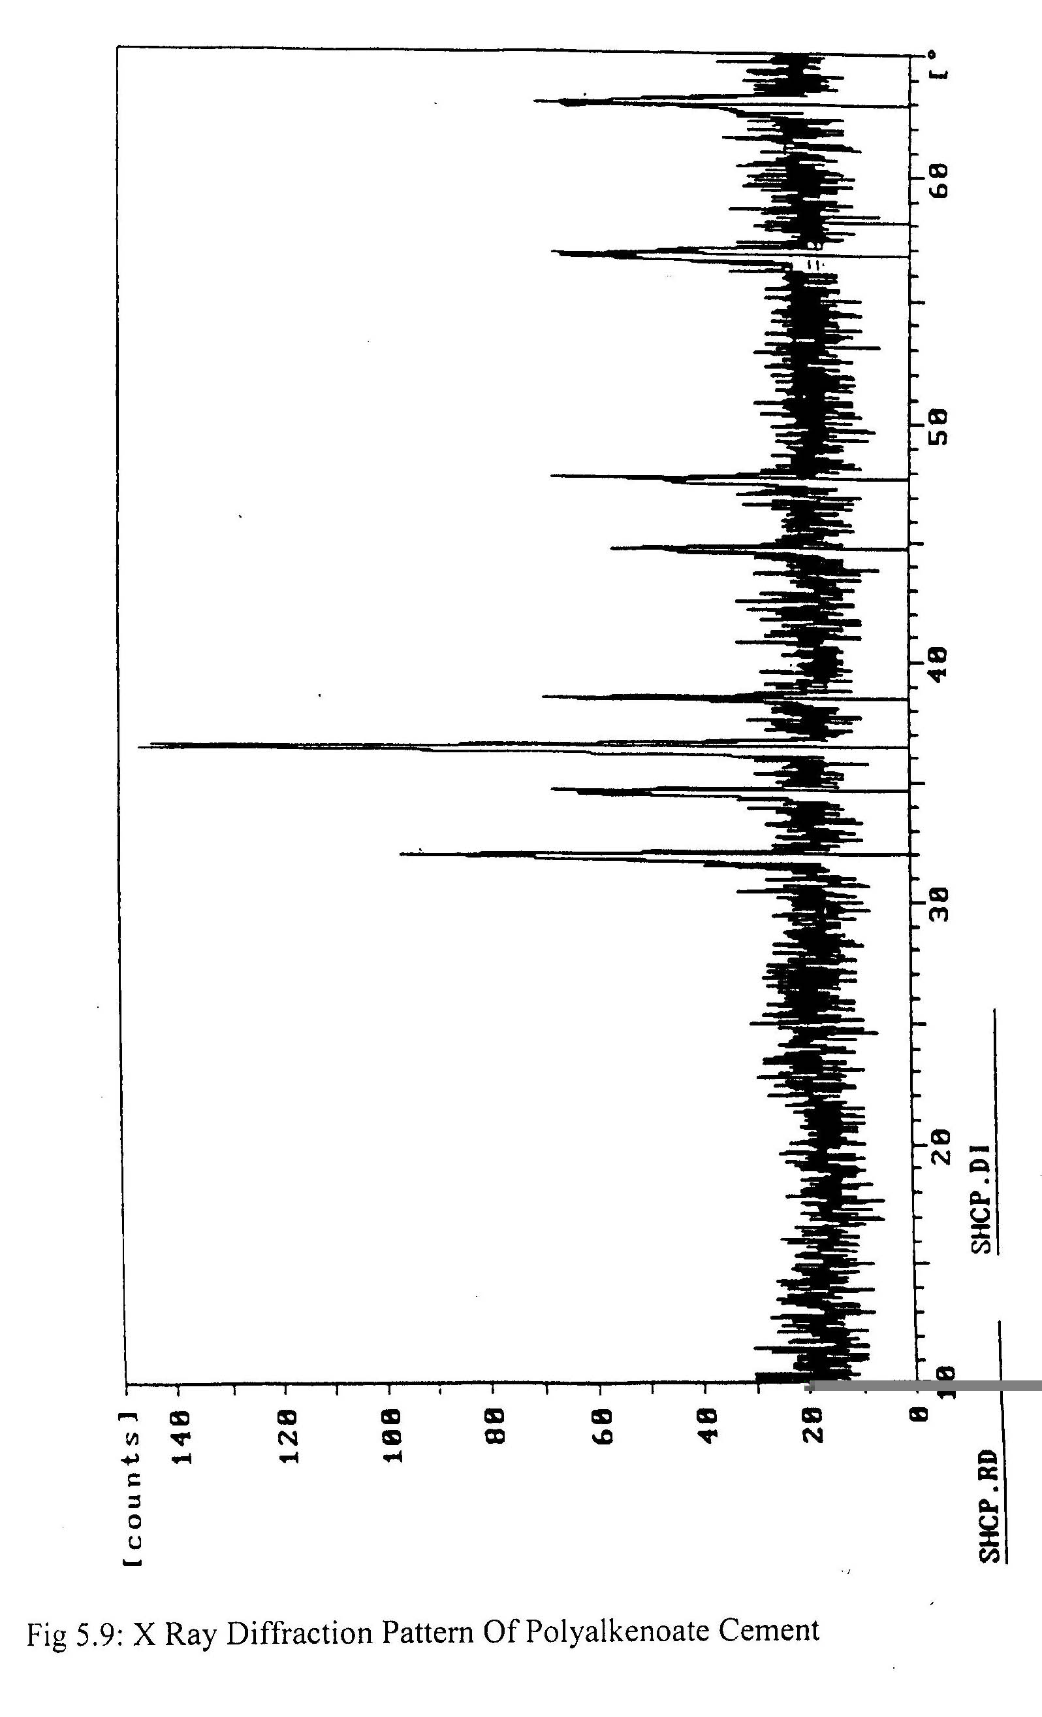

Fig 5.9: X Ray Diffraction Pattern Of Polyalkenoate Cement

5.3 EVALUATION OF POLYALKENOATE CEMENT:

The Polyalkenoate cement was evaluated for various properties. For this purpose the Polyalkenoate cement compositions were prepared by mixing the 40% aqueous solution of Poly (acrylic acid-co-methacrylic acid) with deactivated Zinc oxide in a P/L ratio 1.5:1. The various properties such as setting time, compressive strength and diametral tensile strength were also evaluated for these samples.

5.3.1 SETTING TIME:
Setting time is the parameter that indicates the ultimate process of setting of any cement. It is an important property in the restorative dentistry. The setting time that is indicated in the literature is 4 to 9 minutes without the reference to P/L ratio. The setting time for the cement sample prepared with P/L ration 1.5:1 was found to be 6.8 minutes.

    - COMPRESSIVE STRENGTH AND DIAMETRAL TENSILE STRENGTH:

The compressive strength and diametral strength were measured by, as the process outlined under section 3.6.2.1and 3.6.2.2 respectively.
The maximum load values at which the specimen fractured may to some extent depend on the crosshead speed of the device and hence different compressive as well as tensile strength may result. The universal testing machine was operated at a cross-head speed of 0.05 cm/min.

- COMPRESSIVE STRENGTH:
The maximum load along (F) the long axis at which the specimen fractured was found to be 108.5 kg.
P = 4F/${πd}^{2}$, Where
P = Compressive Strength (Kg/cm²)
d = Diameter of the specimen (cm)
F = Maximum applied load (Kg)
Diameter of the Specimen (d) = 5.93 mm.
Length of the specimen (L) = 12.1 mm.
Compressive Strength (P) = 394.38/cm²

- DIAMETRAL TENSILE STRENGTH:
The maximum load (F0 along the short axis (diametral compression) at which the specimen fractured was found to be 50.2 Kg.
T=2F/$π$Ld
Where
T = Diametral Tensile Strength (in Kg/cm²)
F = Maximum load (in Kg)
L = length of specimen (in cm)
D = Diameter of specimen (in cm)
Diameter of the Specimen (d) = 5.93 mm.
Length of the specimen (L) =12.1.mm.
Diametral Tensile Strength (T) = 44.56kg/cm²

  - EVALUATION OF CRYOLITE MODIFIED
POLYALKENOATE CEMENT:

The Cryolite modified Polyalkenoate cement was evaluated for various properties. For this purpose the Cryolite modified Polyalkenoate cement compositions were prepared by mixing the 40% aqueous solution of Poly (acrylic acid-co-methacrylic acid) with deactivated Zinc oxide in a P/L ratio 1.5:1. The various properties such as setting time, compressive strength and diametral tensile strength were evaluated for these samples.

5.4.1 SETTING TIME:
Setting time of cryolite modified polyalkenoate cement was found increased as compared to cement without cryolite. The setting time for the cement sample prepared with P/L ration 1.5:1 was found to be 8.7 minutes.

    - COMPRESSIVE STRENGTH AND DIAMETRAL TENSILE STRENGTH:
The compressive strength and diametral strength of cryolite modified polyalkenoate cement were found increased as compared to cement without cryolite.

- COMPRESSIVE STRENGTH:
The maximum load along (F) the long axis at which the specimen fractured was found to be 120.6 kg.
P = 4F/${πd}^{2}$
Where
P = Compressive Strength (Kg/cm²)
d = Diameter of the specimen (cm)
F = Maximum applied load (Kg)
Diameter of the specimen (d) =5.93 mm.
Length of the specimen (L) = 12.1 mm.
Compressive Strength (P) = 438.36/cm²

- DIAMETRAL TENSILE STRENGTH:
The maximum load (F0 along the short axis (diametral compression) at which the specimen fractured was found to be 56.7 Kg.
T=2F/$π$Ld, Where
T = Diametral Tensile Strength (in Kg/cm²)
F = Maximum load (in Kg)
L = length of specimen (in cm)
D = Diameter of specimen (in cm)

Diameter of the specimen (d) = 5.93 mm.
Length of the specimen (L) =12.1.mm.
Diametral Tensile Strength (T) = 50.41 kg/cm²

CHAPTER 6

CONCLUSION AND WORK FOR FUTURE

CONCLUSION
The cement is a replacement for the traditional phosphate and zinc oxide eugenol cements. As it is a polymer based dental cement, is less rigid and more liable to creep.
The performance of cement in terms of compressive strength and diametral tensile strength is enhanced with addition of 10%cryolite in powder component (zinc oxide) of the cement. However setting time of cement increased with addition of cryolite.
Its disadvantage is that it requires greater care in preparation related to the temperature control, initiator percentage and rate of addition of solution of acrylic acid and methacrylic acid while preparing poly (acrylic acid- co methacrylic acid) in addition, the powder/ liquid ratio is a factor for the performance of the polyalkenoate cement.
As from the study, stoichiometric zinc polyalkenoate cement is identical to the zinc polyacrylate salt. Most of the carboxylate groups are present a neutralized carboxylate salt, however a few free COOH group remain. A small amount of chelate is also formed along with the zinc- polyacrylate salt from the X- Ray diffraction analysis the polyalkenoate cement is found to be predominantly amorphous, though a little crystallinity is observed in the cement

WORK FOR FUTURE
On the basis of above conclusion, we can suggest following work for future.
- The effect of powder to liquid ratio on the performance of cement, especially to nullify the presence of unreacted -COOH group can be studied.
- The effect of mixing others fillers like talc, borax. On the performance of cent can be studied.
- The formation of small amount of chelate and its roll in setting of the cement can be studied by variation of poly (acrylic acid methacrylic acid) concentrations well as powder to liquid ratio.
- The effect of different monomer ratios on cement performance can be studied.

NECESSARY PRECAUTIONS

While working in the project various measures should be taken for the reason of health and safety. The most important measures were taken when Acrylic acid and methacrylic acid were polymerized to poly (acrylic acid-co-methacrylic acid). All those required are described below. Acrylic acid and methacrylic acid are moderately toxic when it is ingested or absorbed through the skin. When swallowed. They may cause severe intestinal burns and damage to the gastric tract. These liquids are strongly corrosive to the skin and especially to the eyes and may destroy tissue upon relatively short contact. Vapors of methacrylic acid are only mildly irritating to the eyes and skin, but may cause temporary redness around the eyes.

Protection required for safe handling of acrylic acid and methacrylic acid includes:
- The use of impervious gloves and clothing.
- The use of impermeable and splash proof goggles.
- Good ventilation of the work place.
- Upon contact with the monomer, the skin should promptly by washed with sufficient amount of water followed by wash with soap and water and medical consultation is required if any trouble appears.

REFERENCES

- I. Y. Yanas et al, J.Biomed. Mat. Res., 14, 107(1980).
- Alan D. Wilson, J. Biomed. Mater. Res., 1, (1982).
- D.C. Smith, New Dental Cement,” Br. Dent.J., 125, 381(1968).
- J.A. Miller, Science News, 112, (1977).
- G.M. Brauuer & J.W. Stansbury, J. Dent. Res., 63, 1315 (1984).
- R.W. Phillips, M.L. Swartz & B. Rhodes, J. Am. Dent. Assoc., 81, 1353(1970).
- W.J. Peters, R.W. Jackson & D.C. Smith, J. Biomed. Mater Res., 8, 53(1974).
- S.B. Mitra, J. dental Res., 70, 75(1991).
- M.L. Miller, EPST 1st ed. 1, 197-226.
- Ellliott, Holiday & Hornsby, Acid – Base Cements. 102-113.
- J.A. Williams & R.W. Billington, J. Oral Rehabil, 18, 163(1991).
- W.M. Tay, M. Braden, Biomaterials, 9, (1988).
- M.L. Swartz, R.W. Phillips H.E.Clark, J. Dent. Res. 84, (1984)
- J.A. Williams, G.J. Pearson & R.W. Billington, Br. Dent J., 173,340(1992).
- W.A. Brantley & R.E. Kerby, J.Oral Rehabil., 20, 61(1993)
- P.R. Wilson, Journal of Dentistry, 24, 1996, 269-273(1996).
- T.Apih, R.Blinc, P. Jevnikar, N.Funduk, O. Pawlig and R. Trettin. Magnetic Resonance Imaging, 19, 569-570(2001).
- G.J.P. Fleming, R.M. Shelton, G>Landini and P.M. Marquis, Dental Materials, 17, 14-20(2001).
- A.O. Muelleand D. Freeman, Materials Characterization, 35, 113-126 (1995).
- P.R.Wilson, Jounral of Dentistry, 24, 269-273(1996).
- S.G.Griffin and R.G. Hill, Biomaterials, 21, 399-403(2000).

______________________________________

