
STUDIES ON MIMO OFDM SYSTEM AND IT’S
TIME DOMAIN SIGNAL DETECTION

A dissertation submitted towards the partial fulfillment of requirements for the
award of the degree
Of
Master of Engineering
In
Electronics and Communication Engineering
By
MOHD JAVED KHAN
College Roll No. : 13/E&C/07
University Roll No. : 12272
Under the supervision and guidance of
Prof. Asok Bhattacharya
H.O.D (E&C)

DEPARTMENT OF ELECTRONICS AND COMMUNICATION ENGINEERING
DELHI COLLEGE OF ENGINEERING
UNIVERSITY OF DELHI
BAWANA ROAD DELHI-110042
Acknowledgements
At this point, I would like to express my gratitude to the people who supported and accompanied me during the preparation of this work. My foremost thanks goes to my project guide, Prof. A. Bhattacharyya (Head of the Department of Electronics & Communication Engineering, Delhi College of Engineering, Delhi) for giving the constant support during the preparation of the work and supervising this dissertation. He supported me with numerous ideas and discussions that helped me a lot to prepare this project.
Many thanks go to all the faculty members, my colleagues and friends, who not only gave helpful comments and hints, also created a friendly atmosphere.

Mohd Javed Khan
Date: College Roll No. : 13/E&C/07
Place: University Roll No. : 12272

List of Figures

Fig. 2.1 Subdivision of the bandwidth into K subbands 4
Fig. 2.2 Comparison of the bandwidth utilization for FDM and OFDM 6
Fig. 2.3 Cyclic Prefix 7
Fig. 2.4 Block diagram of an OFDM transceiver 8
Fig. 2.5 QAM System 9
Fig.2.6 Generation of QPSK 11
Fig. 2.7 FFT & IFFT diagram 14
Fig. 3.1: A MIMO system created by two antenna arrays, comprising nT transmit
elements and nR receive elements 17
Fig. 3.2: Comparison of channel capacity for SISO and MIMO systems 22
Fig.3.3. Generic coding architecture for MIMO channels 23
Fig. 3.4. Schematic of the transmission strategy for the Alamouti scheme. The MISO channel is orthogonalized irrespectively of the channel realization 25
Fig. 3.5. Comparison of the (uncoded) symbol error rate of the Alamouti scheme (MT= 2, MR = 1) with receive diversity (MT = 1,MR = 2) 26
Fig. 3.6. Schematic of delay diversity—a space-selective MISO channel is converted into a frequency-selective SISO channel 27
Fig. 3.7. Schematic of HE for spatial multiplexing. This is a suboptimal encoding technique that realizes at most MR th-order diversity but simplifies receiver design 28
Fig. 3.8. Schematic of VE for spatial multiplexing. VE spreads the information bits across all transmit antennas realizing MR MT th-order diversity at higher decoding complexity compared to HE 29
Fig. 3.9. Schematic of wavefront impinging on an antenna array Under the narrowband assumption the antenna outputs y1(t) and y2(t) are identical except for a phase shift 31
Fig. 3.10 Construction of the MIMO channel model from a physical scattering 32
Fig. 4.1 Multiple-input multiple-output (MIMO) orthogonal frequency division
multiplexing (OFDM) transmitter scheme 37
Fig. 4.2 MIMO OFDM receiver scheme 37
Fig. 5.1 Plot between BER and SNR for SISO system 53
Fig. 5.2 Plot between BER and SNR for MIMO OFDM system 54
Fig. 5.3 Plot between BER and SNR for MIMO OFDM system with L=14 55
Fig. 5.4 Plot between BER and SNR for MIMO OFDM system with L=16 55
Fig. 5.5 Plot between BER and SNR for MIMO OFDM system with L=18 56

CONTENTS

CHAPTER 1 : INTRODUCTION 1
CHAPTER 2 : OFDM Principle 2
2.1 Introduction 2
2.2 Multicarrier modulation 2
2.3 Orthogonal Frequency Division Multiplexing 6
2.4 Cyclic Prefix 7
2.5 OFDM System Model 8
2.5.1 Modulation Techniques: 9
2.5.1 .1 Quadrature Amplitude Modulation (QAM) 9
2.5.1.2 Quadrature Phase Shift Keying (QPSK) 10
2.5.2 FFT & IFFT 12
2.6 Advantages of OFDM signaling 14
2.7 Disadvantages of OFDM signaling 15
2.8 Problems with OFDM 15
2.8.1 Peak-to-Mean Power Ratio 15
2.8.2 Synchronization 16
CHAPTER 3 : MIMO Systems 17
3.1 Introduction 17
3.2 Performance Improvements Resulting from the use of MIMO Systems 18
3.2.1 Array Gain 18
3.2 .2 Spatial Diversity Gain 18
3.2.3 Spatial Multiplexing Gain 19
3.2.4 Interference Reduction and avoidance 19
3.3 Channel Capacity 20
3.4 MIMO Signaling 23
3.4.1 Space–Time Diversity Coding 24
3.4.2 Spatial Multiplexing 27
3.5 MIMO Channel Model 30
3.5.1 Construction of the MIMO Channel Through a Physical Scattering Model 31
3.5.2 Classical Frequency-Flat Rayleigh Fading i.i.d. MIMO Channel Model 33
3.5.3 Frequency-Flat Versus Frequency-Selective Fading 34
3.5.4 Real-World MIMO Channels 34
3.5.5 Discrete-Time Input–Output Relation 35
CHAPTER 4 : MIMO OFDM system 36
4.1 MIMO OFDM System Model 38
4.2 Time domain signal detection 43
4.2.1 Zero-Noise Case 44
4.2.2 Channel Noise Consideration 51
CHAPTER 5 : Simulation Results 53
CHAPTER 6 : Conclusion and Future works 57
References 58
Appendix 61

ABSTRACT
Multiple-input multiple-output (MIMO) wireless technology in combination with orthogonal frequency division multiplexing (MIMO OFDM) is an attractive air-interface solution for next-generation wireless local area networks (WLANs), wireless metropolitan area networks (WMANs), and fourth-generation mobile cellular wireless systems. This thesis provides an overview of the basics of MIMO-OFDM technology and focuses on a new system model in which the received OFDM block is left shifted by J samples to improve the system performance and an equalizer to cancel most of the intersymbol interference .It is shown by simulation that the channel lengths have insignificant effect on the proposed algorithm.

CHAPTER 1

INTRODUCTION

Recently, mobile communication has begun to permeate every aspect of our daily lives. However, with the development of mobile communications, the frequency spectrum becomes more and more crowded. As a result, the quest for high data rates with a high spectral efficiency is considered to be the main trend in the evolution of mobile communication systems
To achieve this goal, new concepts and methods are introduced .The use of multiple antennas at transmitter and receiver, popularly known as multiple-input multiple-output (MIMO) wireless is an emerging cost-effective technology that offers substantial leverages in making 1-Gb/s wireless links a reality.
The main goals in developing next-generation wireless communication systems are increasing the link throughput (bit rate) and the network capacity. Important improvements in throughput can be achieved when multiple antennas are applied at both the transmitter and receiver side, especially in a rich scattering environment for wireless communication links in both flat-fading as well as frequency-selective fading channels.
Multiple input-multiple output (MIMO) using multiple antennas at both the transmit and the receive ends becomes an important system for future wireless communications as it has the potential to greatly increase the system capacity without extra bandwidth. [2]-[5]
Generally, MIMO is applied in two situations.
- One is in space-time coding systems where the transmission quality [bit-error rate (BER)] is improved due to spatial diversity.
- The other is in spatial multiplexing or spatial multiple access systems where independent data streams are transmitted over different antennas, thus increasing the transmission rate or improving the system capacity.
Nevertheless, in high data rate communication, the wireless channel becomes frequency selective. As a result, the intersymbol interference (ISI) can cause tremendous influence on the system performance.
To reduce the ISI, a modulation method, called orthogonal frequency division multiplexing, which increases the symbol duration by dividing the entire channel into many narrow sub-channels, is combined with MIMO [1].
Orthogonal frequency division multiplexing (OFDM) technique has been widely utilized in digital audio broadcasting (DAB), digital video broadcasting (DVB), and broadband wireless local area networks (IEEE 802.11a) ,due to its ability to resist frequency selective fading. It is, therefore, desirable to combine OFDM with MIMO for high system capacity, as well as better performance [6].
In MIMO-OFDM systems over frequency selective fading channels, signal detection can be easily implemented by a set of parallel per-subcarrier signal detectors applicable to flat fading channels when the channel length is shorter than or equal to the cyclic prefix (CP) length [16].
However, when the channel length is longer than the CP length, inter block interference (IBI) occurs and the orthogonal property of subcarriers will be destroyed, resulting in substantial performance degradation of the signal detection algorithm.
Two indirect algorithms (which require estimating the channel matrix before signal detection) have been proposed for detecting the signals in this case.
- The first one is a frequency- domain algorithm , which applies the detection algorithm for MIMO systems to each subcarrier after modeling the smoothed persubcarrier received signal similarly to the smoothed received signal of a MIMO system [17] .
- The second one is a time-domain algorithm , in which an equalizer is first inserted to reduce the MIMO channels to ones with channel length shorter than or equal to the CP length. The general signal detection algorithm for MIMO-OFDM systems is then applied [18].
Unfortunately, both algorithms involve estimation of the channel matrix which requires channel length estimation followed by channel coefficient estimation.
In addition, accurate channel length estimation is difficult to achieve in practice and estimation error usually occurs, which will degrade the system performance. As for channel coefficient estimation, it is obvious that at least (the number of transmit antennas/users in MIMO-OFDM systems, and the maximum channel length) pilot symbols are required. The number of pilot symbols required increases linearly with the channel length , thereby reducing the transmission efficiency when the channel length is large.
In this thesis,A study on a time-domain signal detection algorithm based on second-order statistics (SOS) has been verified for general MIMO-OFDM systems over frequency selective channels. [1]
A new system model is first introduced in which the ith received OFDM block is left shifted by J samples. The new system model has certain structural properties that enable an equalizer to be designed to cancel most of the inter symbol interference (ISI) using SOS of the received signals.
At the output of the equalizer, only two paths of the transmitted signals are retained and the signals can readily be detected. Due to the special structure of the new system model, it turns out that only columns of the channel matrix need to be estimated. It follows that the minimum number of pilot symbols required to estimate the columns of the channel matrix is compared with conventional MIMO system to estimate the channel matrix and is independent of the channel length. It also means that channel length estimation is unnecessary, which implies that the proposed algorithm has substantial advantage computationally, as well as for avoiding performance degradation due to channel length estimation error, over existing algorithms .
Furthermore, the algorithm is applicable irrespective of whether the channel length is shorter than, equal to or longer than the CP length. Simulation results confirm the effectiveness of the proposed algorithm, and show that it outperforms the existing ones in all cases.

CHAPTER 2

OFDM Principle

2.1 Introduction
The basic principle of OFDM is to split a high-rate data stream into a number of lower rate streams that are transmitted simultaneously over a number of subcarriers. Intersymbol interference is eliminated almost completely by introducing a guard time in every OFDM symbol. In the guard time, the OFDM symbol is cyclically extended to avoid intercarrier interference [15].

2.2 Multicarrier modulation
In single carrier modulation, data is sent serially over the channel by modulating one single carrier at a baud rate of R symbols per second. The data symbol period T_{f} is then 1/R.
The basic idea of multicarrier modulation was that the available W is divided into a number K of sub bands, commonly called subcarriers, each of width Δf = W / K . The subdivision of the bandwidth is illustrated in Figure 2.1
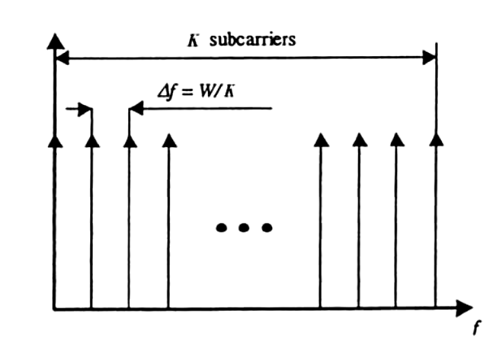
Fig. 2.1 Subdivision of the bandwidth into K subbands

where arrows represent the different subcarriers. Instead of transmitting the data symbols in a serial way, at a baud rate R, a multicarrier transmitter partitions the data stream into blocks of K data symbols that are transmitted in parallel by modulating the K carriers. The symbol duration for a multicarrier scheme is T_{f} = K / R .
In its most general form, the multicarrier signal can be written as a set of modulation carriers
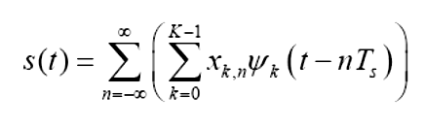
2.1

where x_{k,n} is the data symbol modulating the kth subcarrier in the nth signaling interval. Ψ_{k} is the waveform for the kth subcarrier.
The symbol duration can be made long compared to the maximum excess delay of the channel, or T_{f} >> τ_{max} , by choosing K sufficiently high.
At the same time the bandwidth of the subbands can be made small compared to the coherence bandwidth of the channel (B_{coh} >> W / K). The subbands then experience flat fading, which reduces equalization to a single complex multiplication per carrier.
Increasing K thus reduces the ISI and simplifies the equalizer into a single multiplication (remark that the number of multiplications is proportional with K but the rate at which they have to be calculated is reverse proportional with K). However, the performance in time variant channels is degraded by long symbols. If the coherence time T_{coh} of the channel is small compared to T_{f} , the channel frequency response changes significantly during the transmission of one symbol and a reliable detection of the transmitted information becomes impossible. As a consequence, the coherence time of the channel defines an upper bound for the number of subcarriers. Together with the condition for flat fading within the subbands a reasonable range for K can be derived as
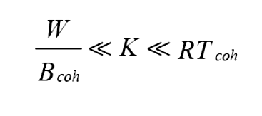
(2.2)
2.3 Orthogonal Frequency Division Multiplexing
Orthogonal Frequency Division Multiplexing (OFDM) can be simply defined as a form of multicarrier modulation where its carrier spacing is carefully selected so that each subcarrier is orthogonal to the other subcarriers. As is well known, orthogonal signals can be separated at the receiver by correlation techniques; hence, intersymbol interference among channels can be eliminated. Orthogonality can be achieved by carefully selecting carrier spacing, such as letting the carrier spacing be equal to the reciprocal of the useful symbol period.
The “orthogonal” part of the OFDM name indicates that there is a precise mathematical relationship between the frequencies of the carriers in the system. In a normal FDM system, the many carriers are spaced apart in such way that the signals can be received using conventional filters and demodulators. In such receivers, guard bands have to be introduced between the different carriers (Fig. 2.2), and the introduction of these guard bands in the frequency domain results in a lowering of the spectrum efficiency.

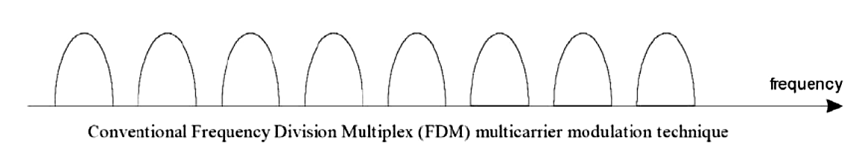

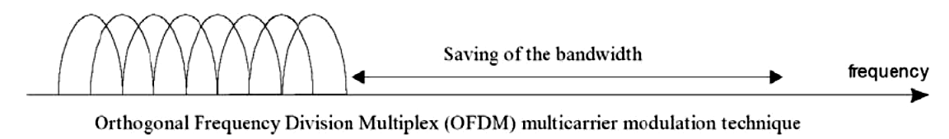

Fig. 2.2 Comparison of the bandwidth utilization for FDM and OFDM

It is possible, however, to arrange the carriers in an OFDM signal so that the sidebands of the individual carriers overlap and the signals can still be received without adjacent carrier interference. In order to do this the carriers must be mathematically orthogonal.
Orthogonality is defined for both real and complex valued functions. The functions ϕ_{m}(t) and ϕ_{n}(t) are said to be orthogonal with respect to each other over the interval a < t < b if they satisfy the condition:
Where n ≠ m
(2.3)
n

The inverse fast Fourier transform (IFFT) is the availability of this technique, and the technology that allows it to be implemented on integrated circuits at a reasonable price that has permitted OFDM to be developed as far as it has. The process of transforming from the frequency domain representation to the time domain representation uses the inverse Fourier transform itself, whereas the reverse process uses the Fourier transform.

2.4 Cyclic Prefix
Passing the signal through a time-dispersive channel causes inter symbol interference (ISI). In an OFDM system, it also makes that the orthogonality of the subcarriers is lost, resulting in inter carrier interference (ICI). To overcome these problems, the cyclic prefix was introduced. A cyclic prefix is a copy of the last part of the OFDM symbol that is pretended to the transmitted symbol (as shown in Figure 2.3) and removed at the receiver before the demodulation.

Fig. 2.3 Cyclic Prefix
The cyclic prefix should be at least as long as the significant part of the impulse response experienced by the transmitted signal. This way the benefit of the cyclic prefix is twofold.
- It avoids ISI because it acts as a guard space between successive symbols.
- It also converts the linear convolution with the channel impulse response into a cyclic convolution. As a cyclic convolution in the time domain translates into a scalar multiplication in the frequency domain, the subcarriers remain orthogonal and there is no ICI.
The length of the cyclic prefix should be made longer to avoid ISI and ICI.

2.5 OFDM System Model

Figure 2.4 shows the OFDM bock diagram, where the upper path is the transmitter chain and the lower path corresponds to the receiver chain.

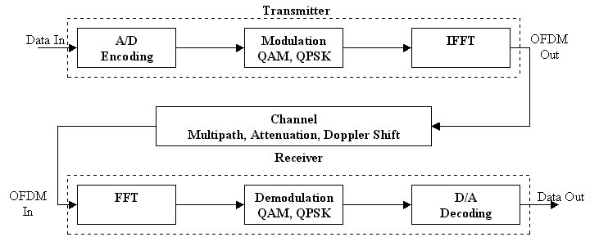
Fig. 2.4 Block diagram of an OFDM transceiver

In the center we see the IFFT, which modulates a block of input modulated values onto a number of subcarriers. In the receiver, the subcarriers are demodulated by an FFT, which performs the reverse operation of an IFFT. Binary input data is first encoded by a forward error correction code. The encoded data is then interleaved and mapped onto QAM or PSK values. In the receiver path, after passing the RF part and the analog-to-digital conversion, the signal processing starts with a training phase to determine symbol timing and frequency offset. An FFT is used to demodulate all subcarriers. The output of the FFT are mapped onto binary values and decoded to produce binary output data. Synchronization is a key issue in the design of OFDM receiver. Time and frequency synchronization are paramount to respectively identify the start of the OFDM symbol and to align the modulators’ and the demodulators’ local oscillator frequencies. If any of these synchronization tasks is not performed with sufficient accuracy, then the orthogonality of the subcarriers is partly lost. That is, inter-symbol-interference (ISI) and inter-carrier-interference (ICI) are introduced.

2.5.1 Modulation Techniques:
2.5.1.1 Quadrature Amplitude Modulation (QAM):
This modulation scheme is also called quadrature carrier multiplexing. In fact, this modulation scheme enables to DSB-SC modulated signals to occupy the same transmission BW at the receiver output. it is, therefore, known as a bandwidth-conservation scheme. The QAM Tx consists of two separate balanced modulators, which are supplied, with two carrier waves of the same freq but differing in phase by 90°. The o/p of the two balanced modulators are added in the adder and transmitted.

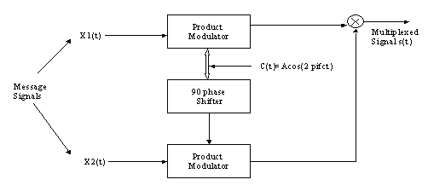

Fig. 2.5 QAM System

The transmitted signal is thus given by
(2.4)
S (t) = X₁ (t) A cos (2Πf_{c} t) + X₂ (t) A sin (2Πf_{c} t)

Hence, the multiplexed signal consists of the in-phase component ‘A X₁ (t)’ and the quadrature phase component ‘–A X₂ (t)’.

Balanced Modulator:
A DSB-SC signal is basically the product of the modulating or base band signal and the carrier signal. Unfortunately, a single electronic device cannot generate a DSB-SC signal. A circuit is needed to achieve the generation of a DSB-SC signal is called product-modulator i.e., Balanced Modulator.
We know that a non-linear resistance or a non-linear device may be used to produce AM i.e., one carrier and two sidebands. However, a DSB-SC signal contains only 2 sidebands. Thus, if 2 non-linear devices such as diodes, transistors etc., are connected in balanced mode so as to suppress the carriers of each other, then only sidebands are left, i.e., a DSB-SC signal is generated. Therefore, a balanced modulator may be defined as a circuit in which two non-linear devices are connected in a balanced mode to produce a DSB-SC signal.

2.5.1.2 Quadrature Phase Shift Keying (QPSK) :

In communication systems, we have two main resources. These are:
- Transmission Power
- Channel bandwidth
If two or more bits are combined in some symbols, then the signaling rate will be reduced. Thus, the frequency of the carrier needed is also reduced. This reduces the transmission channel Band Width (B.W.). Hence, because of grouping of bits in symbols; the transmission channel Band Width (B.W.) can be reduced. In QPSK two successive bits in the data sequence are grouped together. This reduces the bits rate or signaling rate and thus reduces the band width of the channel. In case of BPSK, we know that when symbol Changes the level, the phase of the carrier is changed by 180°. Because, there were only two symbols in BPSK, the phase shift occurs in two levels only. However, in QPSK, two successive bits are combined. Infact, this combination of two bits forms four distinct symbol’s. When the sym is changed to next symbol, then the phase of the carrier is changed by 45 degrees.

S.No I/p successive bits symbol phase shift in carrier
I=1 | 1(1v) | 0(-1v) | S1 | Π/4
I=2 | 0(-1v) | 0(-1v) | S2 | 3Π/4
I=3 | 0(-1v) | 1(1v) | S3 | 5Π/4
I=4 | 1(1v) | 1(1v) | S4 | 7Π/4

Generation of QPSK:
Here the input binary seq. is first converted into a bipolar NRZ type of signal. This signal is denoted by b(t). It represents binary ‘1’ by ‘+1V’ and binary ‘0’ by ‘-1V’. The demultiplexer divides b (t) into two separate bit streams of the odd numbered and even numbered bits. Here B_{e}(t) represents even numbered sequence and B_{o}(t) represents odd numbered sequence. The symbol duration of both of these odd numbered sequences is 2T_{b}. Hence, each symbol consists of two bits.

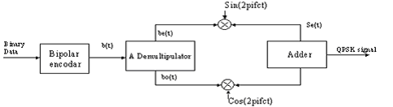

Fig.2.6 Generation of QPSK

It may be observed that the first even bit occurs after the first odd bit. Hence, even numbered bit sequence b_{e}(t) starts with the delay of one bit period due to first odd bit. Thus, first symbol of b_{e}(t) is delayed by one bit period due to first odd bit. Thus, first symbol of b_{e}(t) is delayed by on bit period ‘T_{b}’ with respect to first symbol of b_{o}(t). This delay of T_{b} is known as offset. This shows that the change in the levels of b_{e}(t) and b_{o}(t) can’t occur at the same time due to offset or staggering. The bit stream b_{e}(t)modulates carrier cosine carrier and b_{o}(t) modulates sinusoidal carrier. These modulators are the balanced modulators. The 2 carriers are √Ps.cos (2Πf_{c.}t) and √Ps.sin (2Πf_{c}t) have been shown in fig. Their carriers are known as quadrature carriers. Due to the offset, the phase shift in QPSK signal is Π/2.

2.5.2 FFT & IFF (FastFourier Transform and Inverse Fast Fourier Transform)
In practice, OFDM systems are implemented using a combination of FFT and IFFT blocks that are mathematically equivalent versions of the DFT and IDFT, respectively, but more efficient to implement.
The Fourier transform is used in linear systems analysis, antenna studies, etc., The Fourier transform, in essence, decomposes or separates a waveform or function into sinusoids of different frequencies which sum to the original waveform. It identifies or distinguishes the different frequency sinusoids and their respective amplitudes.
The Fourier transform of f(x) is defined as:
(2.5)
and its inverse is denoted by:
(2.6)
However, the digital age forced a change upon the traditional form of the Fourier transform to encompass the discrete values that exist is all digital systems. The modified series was called the Discrete Fourier Transform (DFT). The DFT of a discrete-time system, x(n) is defined as:
1 ≤ k ≤ N
(2.7)

and its associated inverse is denoted by:
1 ≤ n ≤ N
(2.8)
However, in OFDM, another form of the DFT is used, called the Fast Fourier Transform (FFT), which is a DFT algorithm developed in 1965. This “new” transform reduced the number of computations from something on the order of
to
(2.9)

An OFDM system treats the source symbols (e.g., the QPSK or QAM symbols that would be present in a single carrier system) at the Tx as though they are in the freq-domain. These symbols are used as the input’s to an IFFT block that brings the sig into the time domain. The IFFT takes in N symbols at a time where N is the num of sub carriers in the system. Each of these N input symbols has a symbol period of T secs. Recall that the basis functions for an IFFT are N orthogonal sinusoids. These sinusoids each have a different freq and the lowest freq is DC. Each input symbol acts like a complex weight for the corresponding sinusoidal basis function. Since the input symbols are complex, the value of the sym determines both the amplitude and phase of the sinusoid for that sub carrier.
The IFFT output is the summation of all N sinusoids. Thus, the IFFT block provides a simple way to modulate data onto N orthogonal sub carriers. The block of N output samples from the IFFT make up a single OFDM sym. The length of the OFDM symbol is NT where T is the IFFT input symbol period mentioned above.

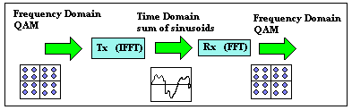
Fig. 2.7 FFT & IFFT diagram

After some additional processing, the time-domain sig that results from the IFFT is transmitted across the channel. At the Rx, an FFT block is used to process the received signal and bring it into the freq domain. Ideally, the FFT o/p will be the original sym’s that were sent to the IFFT at the Tx. When plotted in the complex plane, the FFT o/p samples will form a constellation, such as 16-QAM. However, there is no notion of a constellation for the time-domain sig. When plotted on the complex plane, the time-domain sig forms a scatter plot with no regular shape. Thus, any Rx processing that uses the concept of a constellation (such as symbol slicing) must occur in the frequency- domain [5].

2.6 Advantages of OFDM signaling:
- Makes efficient use of the spectrum by allowing overlap.
- By dividing the channel into narrowband flat fading sub channels, OFDM is more resistant to frequency selective fadings than single carrier systems are.
- Eliminates ISI and ICI through use of a cyclic prefix.
- Using adequate channel coding and interleaving one can recover symbols lost due to the frequency selectivity of the channel.
- Channel equalization becomes simpler than by using adaptive equalization techniques with single carrier systems.
- It is possible to use maximum likelihood decoding with reasonable complexity.
- OFDM is computationally efficient by using FFT techniques to implement the modulation and demodulation functions. Also, for multiple communication channels, as is the case in digital audio broadcasting (DAB) systems, partial FFT algorithms can be used in order to implement program selection and decimation.
- In conjunction with differential modulation there is no need to implement a channel estimator.
- It is less sensitive to sample timing offsets than single carrier systems are.
- Provides good protection against co channel interference and impulsive parasitic noise.
- Preservation of orthogonality in severe multipath.
- Used for highest speed applications.
- Supports dynamic packet access.

2.7 Disadvantages of OFDM signaling:
- The OFDM signal has a noise like amplitude with a very large dynamic range, therefore it requires RF power amplifiers with a high peak to average power ratio.
- It is more sensitive to carrier frequency offset and drift than single carrier systems are due to leakage of the DFT.

2.8 Problems with OFDM:

2.8.1 Peak-to-Mean Power Ratio:
An OFDM signal may exhibit a high instantaneous peak power with respect to the average signal level, seeing that the OFDM signal is the superposition of a large number of modulated sub channel signals. In addition, when a time-domain signal moves from a low to a high instantaneous power waveform, large amplitude swings are encountered. In the context, the peak-to-mean power envelope fluctuates considerably, when traversing the origin upon switching from one phasor to another.

In order to solve these problems, two things can be done:
- Reduce the peak-to-mean power ratio. Using a different encoding or mapping scheme before modulation can achieve this.
- Improve the amplification stage of the transmitter, such as post processing the time-domain OFDM signal or employ some sort of adaptive sub carrier allocation in order to reduce the Crest factor (peak-to-mean signal ratio).

2.8.2 Synchronization
To optimize the performance of an OFDM link, time and frequency synchronization between the transmitter and receiver is of absolute importance. This is achieved by using known pilot tones embedded in the OFDM signal or attach fine frequency timing tracking algorithms within the OFDM signal’s cyclic extension (guard interval).

CHAPTER 3
MIMO Systems

3.1 Introduction
In a conventional mobile wireless communication system, there is only one antenna at both transmitter and receiver. This system which is called the Single-Input Single-Output (SISO) antenna system suffers a bottleneck in terms of capacity due to the Shannon-Nyquist criterion , Future wireless mobile services demand much higher data bit-rate transmission. In order to increase the capacity of the SISO systems to meet such demand, the bandwidth and transmission power have to be increased significantly. Fortunately, recent developments have shown that using MIMO (Multiple-Input Multiple-Output) systems could increase the capacity in wireless communication substantially without increasing the transmission power and bandwidth . In the MIMO systems, multiple antenna elements are required at both transmitter and receiver, as shown in Figure 3.1.

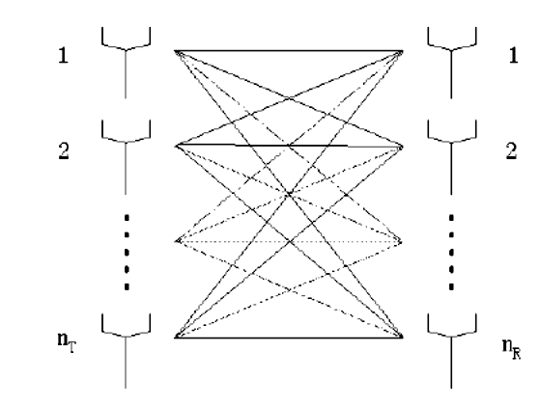

Figure 3.1: A MIMO system created by two antenna arrays, comprising n_{T} transmit
elements and n_{R} receive elements.
Usually the Rayleigh fading caused by the multipath signal propagation is considered to be a severe problem in a wireless communication channel. However, the MIMO system exploits the multipath signals to increase the system capacity.

3.2 PERFORMANCE IMPROVEMENTS RESULTING FROM THE USE OF MIMO SYSTEMS

The performance improvements resulting from the use of MIMO systems are due to array gain, diversity gain, spatial multiplexing gain, and interference reduction. A brief review each of these leverages in the following considering a system with n_{T} transmit and n_{R} receive antennas.
3.2.1 Array Gain
Array gain can be made available through processing at the transmitter and the receiver and results in an increase in average receive SNR due to a coherent combining effect. Transmit/receive array gain requires channel knowledge in the transmitter and receiver, respectively, and depends on the number of transmit and receive antennas. Channel knowledge in the receiver is typically available whereas channel state information in the transmitter is in general more difficult to maintain
Array gain is increase in receiver SNR that result from coherent combining of the wireless signals at a receiver. Array gain improves resistance to noise thereby improving the coverage and the range of wireless network.

3.2 .2 Spatial Diversity Gain

Signal power in a wireless channel fluctuates randomly (or fades). Diversity is a powerful technique to mitigate fading in wireless links. Diversity techniques rely on transmitting the signal over multiple (ideally) independently fading paths (in time/frequency/space).
Spatial (or antenna) diversity is preferred over time/frequency diversity as it does not incur an expenditure in transmission time or bandwidth. If the links composing the MIMO channel fade independently and the transmitted signal is suitably is possible using suitably designed transmit signals. The corresponding technique is known as space–time coding. A MIMO channel with n_{T} transmit antennas and n_{R} receive antennas potentially offers n_{T}n_{R} independently fading links , and hence sptial diversity order of n_{T}n_{R}.

3.2.3 Spatial Multiplexing Gain

MIMO channels offer a linear increase in capacity (data rate) for no additional power or bandwidth expenditure. This gain, referred to as spatial multiplexing gain, is realized by transmitting independent data signals from the individual antennas. Under suitable channel conditions, such as rich scattering, the receiver can separate the different data streams, yielding a linear increase in capacity [15].
Furthermore, each data stream experiences at least the same channel quality that would be experienced by single- input single-output system, effectively enhancing the capacity by multiplicative factor equal to the number of streams. In general, the number of data stream that can be reliably supported by a MIMO channel equqls the number of transmit antennas and number of receive antennas, i.e., min{n_{T},n_{R}}.The spatial multiplexing increases the capacity of wireless network.

3.2.4 Interference Reduction and avoidance

Cochannel interference arises due to frequency reuse in wireless channels. When multiple antennas are used, the differentiation between the spatial signatures of the desired signal and co channel signals can be exploited to reduce interference. (Interference may be mitigated in MIMO system by exploiting the spatial dimension to increase the separation between users.)
Interference reduction requires knowledge of the desired signal’s channel. Exact knowledge of the interferer’s channel may not be necessary. Interference reduction (or avoidance) can also be implemented at the transmitter, where the goal is to minimize the interference energy sent toward the cochannel users while delivering the signal to the desired user. Interference reduction allows aggressive frequency reuse and thereby increases multicell capacity. We note that in general it is not possible to exploit all the leverages of MIMO technology simultaneously due to conflicting demands on the spatial degrees of freedom (or number of antennas). The degree to which these conflicts are resolved depends upon the signaling scheme and transceiver design. constructed, the receiver can combine the arriving signals such that the resultant signal exhibits considerably reduced amplitude variability in comparison to a SISO link and we get th-order diversity. ( For instance in the presence of interference, array gain increases the tolerance to noise as well as interference power ,hence improving the signal -to -noise –plus interference ratio (SINR) . Additionally, the spatial dimension may be leveraged for the purpose of interference avoidance ,i.e., directing signal energy towards the intended user and minimizing interference to other users.
Interference reduction and voidance improve the coverage and the range of wireless networks [3].
In general, it may not be possible to exploit simultaneously all the benefits due to conflicting demand on spatial degree of freedom .However using some combination of the benefits across a wireless network will result in improved capacity, coverage, and reliability.

3.3 Channel Capacity

Figure 3.1 shows a MIMO system with n_{T} transmit elements and n_{R} receive elements.For a narrowband channel, the complex transmission coefficient between element k ϵ[1,….., n_{T}] at the transmitter and element j ϵ [1,…., n_{R}] at the receiver at time t is represented by h_{jk}(t). A matrix containing all channel coefficients (channel coefficient matrix, H(t)) can be shown as:
Hence, a system transmitting the signal vector x(t) = [x₁(t), x₂(t),….,x_{n}T(t)]^{T}, where x_{k}(t) is the signal transmitted from the kth element would result in the signal vector
y(t) = [y₁(t), y₂₍t),…..,y_{nR}(t)]^{T} being received, where y_{j}(t) is the signal received by the jth element, and
(3.1)
where n(t) is the noise vector.
Conceptually, the MIMO system enables multiple data streams to be transmitted simultaneously on the same frequency, hence increasing the bandwidth efficiency by the number of data streams employed .The capacity, C, for this system is shown to be:
(3.2)
where I is the identity matrix, ρ is signal to noise ratio, H is the channel coefficient matrix, the superscript + denotes conjugate transpose, and det (.) is the determinant.

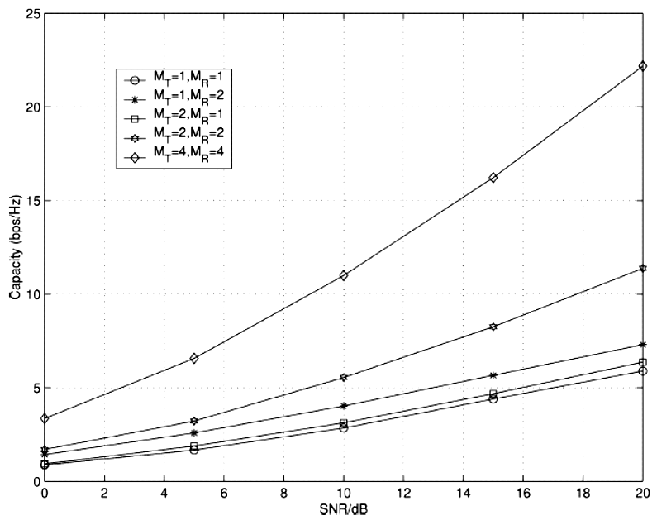
Figure 3.2: Comparison of channel capacity for SISO and MIMO systems

Fig. 3.2 depicts the capacity of several MIMO configurations as a function of SNR. As expected, the capacity increases with increasing and also with n_{T} and n_{R}.
We note that the capacity of a SIMO (nx1) channel is greater than the ergodic capacity of a corresponding MISO (1xn ) channel. This is due to the fact that in the absence of channel knowledge at the transmitter MISO channels do not offer array gain. The channel matrix H in the MIMO systems capacity of equation (3.2) is the mathematical representation of the physical transmission path, which includes not only the multipath channel characteristics of the physical environment but also the antenna configurations. Therefore the multipath channel characteristics as well as the antenna configurations play a key role in determining the communication performance in a MIMO system. The channel matrix H can be evaluated by measurement or modelling on a propagation environment.

3.4 MIMO SIGNALING
In this section, we review some basic MIMO signaling techniques. Consider the schematic in Fig.3.3

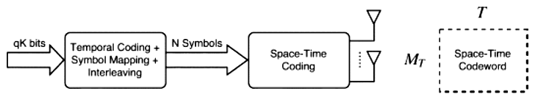

Fig.3.3. Generic coding architecture for MIMO channels (M_{T} =no. of transmitter )

Where qK information bits are input to a block that performs the functions of forward-error-correction (temporal) encoding, symbol mapping and interleaving. In the process q(N-K) parity bits are added resulting in N data symbols at the output with constellation size 2^{q} (for example, if 4-QAM modulation is employed). The resulting block of data symbols is then input to a space–time encoder that adds an additional M_{T} T-N parity data symbols and packs the resulting M_{T}T symbols into an M_{T} xT matrix (or frame) of length T . This frame is then transmitted over T symbol periods and is referred to as the space–time codeword. The signaling (data) rate on the channel is qk/T b/s/Hz, which should not exceed the channel capacity if we wish to signal asymptotically error-free. Note that we can rewrite the signaling rate as

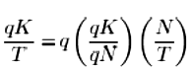
(3.3)
Where r_{t}=qK/qN is the (temporal) code rate of the outer encoder, while r_{s}=N/T is the spatial code rate , defined as the number of independent data symbols in a space–time codeword divided by the frame length.
Depending on the choice of the spatial signaling mode, the spatial rate varies between 0 and M_{T} . For certain classes of space–time codes, discussed below, such as space–time trellis codes, the functions of the symbol mapper and space–time encoder are combined into a single block.
In the following, we briefly discuss two space–time coding techniques— space–time diversity coding (r_{s}≤1 ) and spatial multiplexing ( r_{s}=M_{T}). Throughout this section we focus on the case where the transmitter does not have channel state information and the receiver knows the channel perfectly. For noncoherent case where neither the transmitter nor the receiver know the channel [4].

3.4.1 Space–Time Diversity Coding
The objective of space–time diversity coding is to extract the total available spatial diversity in the MIMO channel through appropriate construction of the transmitted space–time codewords. As examples we consider two specific diversity coding techniques, the Alamouti scheme and delay diversity both of which realize full spatial diversity (without requiring channel knowledge at the transmitter)[16].

Alamouti Scheme:
Consider a MIMO channel with two transmit antennas and any number of receive antennas. The Alamouti transmission technique is as follows: two different data symbols s₁ and s₂ are transmitted simultaneously from antennas 1 and 2, respectively, during the first symbol period, following which symbols –s*₂and s*₁ are launched from antennas 1 and 2, respectively (in Fig. 3.4).

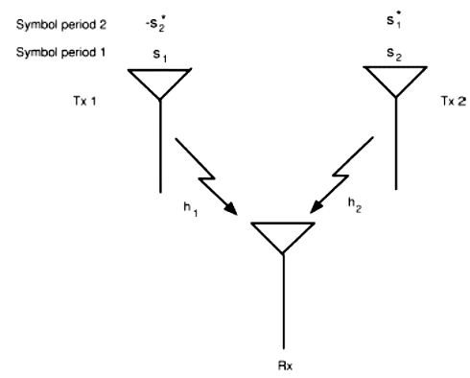

Fig. 3.4. Schematic of the transmission strategy for the Alamouti scheme. The MISO channel is orthogonalized irrespectively of the channel realization.

Note that r_{s}=1( two independent data symbols are transmitted over two symbol periods) for the Alamouti scheme.
We assume that the channel is independently identically distributed (i.i.d.) frequency-flat fading with h₁,h₂~CN(0,1) [CN=complex random variable] and remains constant over (at least) two consecutive symbol periods. Appropriate processing at the receiver collapses the vector channel into a scalar channel for either of the transmitted data symbols such that
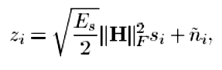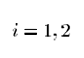
(3.4)
where z_{i} is the processed received signal corresponding to transmitted symbol s_{i} and
is scalar processed noise. Even though channel knowledge is not available to the transmitter, the Alamouti scheme extracts
2M_{R} th-order diversity [2].

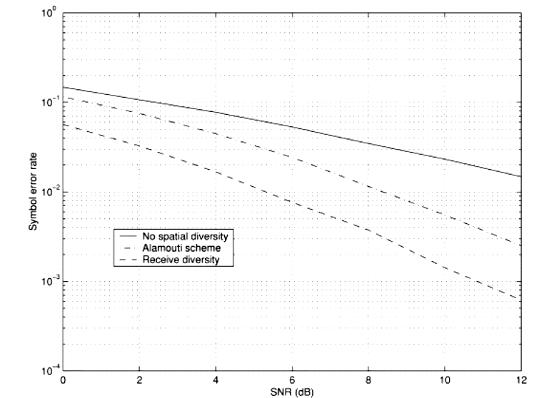

Fig. 3.5. Comparison of the (uncoded) symbol error rate of the Alamouti scheme (M_{T}= 2, M_{R} = 1) with receive diversity (M_{T} = 1,M_{R} = 2).

Both schemes achieve the same diversity order of two (reflected by the slope of the error rate curve), but receive diversity realizes an additional 3 dB receive array gain (reflected by the offset of the error rate curve).

We note, however, that (as shown in Fig. 3.5) array gain is realized only at the receiver (recall that the transmitter does not have channel state information). The Alamouti scheme may be extended to channels with more than two transmit antennas through orthogonal space–time block coding (OSTBC)] albeit at a loss in spatial rate (i.e.r_{s}<1). However, the low decoding complexity of OSTBC renders this technique highly attractive for practical applications.

Delay Diversity:
The second simple scheme for space–time diversity coding we want to discuss is delay diversity which converts spatial diversity into frequency diversity by transmitting the data signal from the first antenna and a delayed replica thereof from the second antenna (as shown in Fig. 3.6).

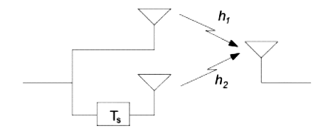

Fig. 3.6. Schematic of delay diversity—a space-selective MISO channel is converted into a frequency-selective SISO channel. T _{s} denotes a delay of one symbol period.

Retaining the assumption that M_{T}=2 and M_{R}=1 and assuming that the delay induced by the second antenna equals one symbol period, the effective channel seen by the data signal is a frequency-selective fading SISO channel with impulse response
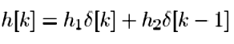
(3.5)

where h₁ and h₂ are as defined above. We note that the effective channel in (3.5) looks exactly like a two-path (symbol spaced) SISO channel with independently fading paths and equal average path energy. A maximum-likelihood detector will, therefore, realize full second-order diversity at the receiver.

3.4.2 Spatial Multiplexing
The objective of spatial multiplexing as opposed to space–time diversity coding is to maximize transmission rate. Accordingly, M_{T} independent data symbols are transmitted per symbol period so that r_{s}=M_{T}. In the following, we describe several encoding options that can be used in conjunction with spatial multiplexing.

Horizontal Encoding (HE):
The bit stream to be transmitted is first demultiplexed into M_{T} separate data streams (Fig. 3.7).

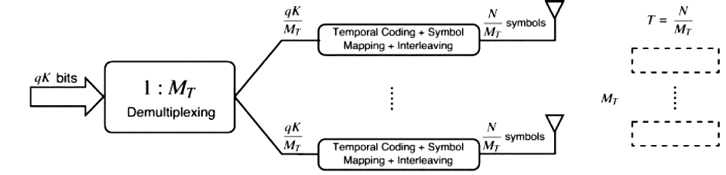

Fig. 3.7. Schematic of HE for spatial multiplexing. This is a suboptimal encoding technique that realizes at most M_{R} th-order diversity but simplifies receiver design.

Each stream undergoes independent temporal encoding, symbol mapping and interleaving and is then transmitted from the corresponding antennas. The antenna-stream association remains fixed over time. The spatial rate is clearly r_{s}=M_{T} and the overall signaling rate is, therefore, given by qr_{t}M_{T} b/s/Hz. The HE scheme can at most achieve M_{R}th-order diversity, since any given information bit is transmitted from only ne transmit antenna and received by receive antennas. This is a source of suboptimality of the HE architecture but it does simplify receiver design. The coding gain achieved by HE depends on the coding gain of the temporal code.Finally, we note that a maximum array gain of M_{R} can be realized.

Vertical Encoding (VE):
In this architecture the bit stream undergoes temporal encoding symbol mapping and interleaving after which it is demultiplexed into M_{T} streams transmitted from the individual antennas ( Fig. 3.8).

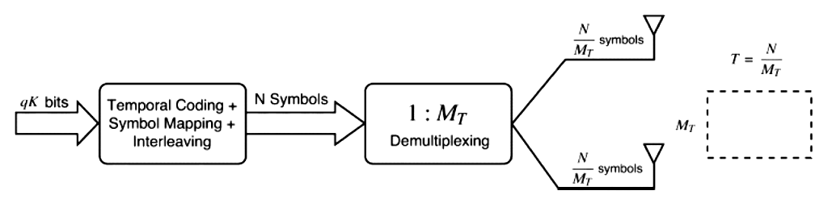
Fig.3.8 Schematic of VE for spatial multiplexing. VE spreads the information bits across all transmit antennas realizing M_{R}M_{T} th-order diversity at higher decoding complexity compared to HE.

This form of encoding can achieve full (M_{T} M_{R} th-order) diversity gain (provided the temporal code is designed properly) since each information bit can be spread across all the transmit antennas. However, VE requires joint decoding of the substreams which increases receiver complexity compared to HE where the individual data streams can be decoded separately. The spatial rate of VE is r_{s}=M_{T} and the overall signaling rate is given by qr_{t}M_{T} b/s/Hz. The coding gain achieved by VE will depend on the temporal code and a maximum array gain of M_{R} can be achieved.
Combinations of HE and VE: Various combinations/variations of the above two encoding strategies are possible. One such transmission technique is diagonal encoding (DE), where the incoming data stream first undergoes HE after which the antenna-stream association is rotated in a round-robin fashion. Making the codewords long enough ensures that each codeword is transmitted from all M_{T} antennas so that full ( M_{R}M_{T}th-order) diversity gain can be achieved. The distinguishing feature of DE is the fact that at full spatial rate of M_{T} and full diversity gain of order M_{R}M_{T} , the system retains the decoding complexity of HE.The Diagonal-Bell Labs Layered Space Time Architecture (D-BLAST) transmission technique follows a diagonal encoding strategy with an initial wasted space–time triangular block, where no transmission takes place. DE can achieve a maximum array gain of M_{R} [4]

3.5 MIMO CHANNEL MODEL
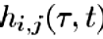
We consider a MIMO channel with M_{T} transmit and M_{R} receive antennas. The time-varying channel impulse response between the jth ( j=1,2,…, M_{T}) transmit antenna and the ith (i=1,2,…, M_{R}) receive antenna is denoted as This is the response
at time t to an impulse applied at time . The composite MIMO channel response is
given by the M_{R} x M_{T} matrix with

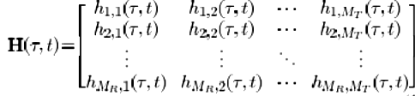
(3.6)

The vector is referred to as the spatio-temporal signature induced by the jth transmit antenna across the receive antenna array.
Furthermore, given that the signal s_{j}(t) is launched from the jth transmit antenna, the signal received at the ith receive antenna is given by
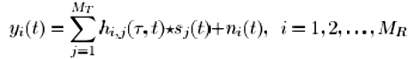
(3.7)
Where n_{i}(t) is additive noise in the receiver.

3.5.1 Construction of the MIMO Channel Through a Physical Scattering Model

For convenience, we suppress the time-varying nature of the channel and use the narrowband array assumption described in brief below.
Consider a signal wavefront ω(t) impinging at angle ɵ on an antenna array comprising two antennas spaced d apart ( Fig. 3.9).

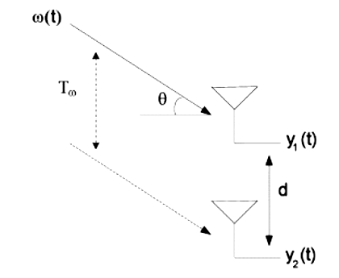
Fig. 3.9. Schematic of wavefront impinging on an antenna array Under the narrowband assumption the antenna outputs y₁(t) and y₂(t) are identical except for a phase shift.

We assume that the impinging wavefront has a bandwidth of B and is represented as
(3.8)
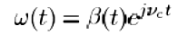
Where β (t) is the complex envelope of the signal (with bandwidth B ) and is the carrier frequency in radians.
Under the narrowband assumption, we take the bandwidth B to be much smaller than the reciprocal of the transit time T_{w} of the wavefront across the antenna array, i.e.,B<<1/ T_{w.} . Denoting the signal received at the first antenna by y₁₍t) , the signal received at the second antenna is then given by
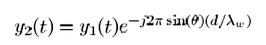
(3.9)
Where λ_{w} is the wavelength of the signal wavefront. It is clear from (3.9) that the signals received at the two antennas are identical, except for a phase shift that depends on the array geometry and the angle of arrival of the wavefront. This result can be extended to arrays with more than two antennas in a straightforward way.We emphasize that the narrowband assumption does not imply that the channel is frequency-flat fading.
We shall next make use of the narrowband assumption in constructing the MIMO channel below. For the sake of simplicity we assume a single bounce based scattering
model and consider a scatterer located at angle and delay with respect to the receive array and with complex amplitude S(ɵ,t) (see Fig. 3.10).

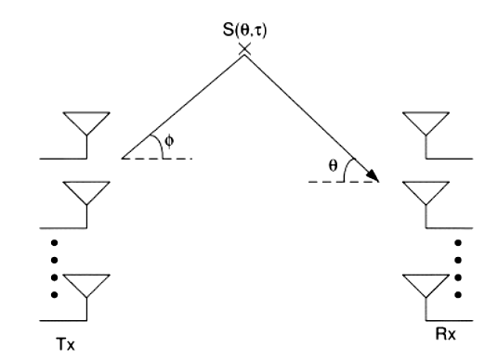
Fig. 3.10 Construction of the MIMO channel model from a physical scattering description.

The same scatterer appears at angle with respect to the transmit antenna array. Thus, given the overall geometries of transmit and receive arrays, any two of the variables , , and define the third one.

The M_{R}xM_{T} MIMO channel impulse response can now be constructed as
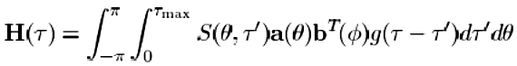
(3.10)
where is the maximum delay spread in the channel, is the combined response of pulse shaping at the transmitter and matched-filtering at the receiver, and and are the M_{R} x 1 and M_{T} x 1 array response vectors at the receiver and transmitter, respectively. The single bounce based scattering model in (3.10) has a number of limitations and cannot adequately model all observed channel effects. A more general model is to assume multiple bounces, i.e., energy from the transmitter uses more than one scatterer to reach the receiver. If we use a double (or multiple) scattering model, the parameters , , and in (3.10) become independent of each other.

3.5.2 Classical Frequency-Flat Rayleigh Fading i.i.d. MIMO Channel Model

Assuming that the delay spread in the channel is small compared to the reciprocal of the signal bandwidth, i.e. we can write (3.10) as
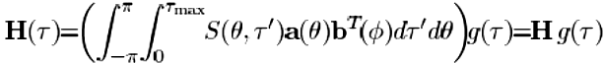
(3.11)
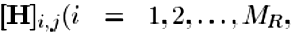
Furthermore, we take the combined response to be ideal, so that and henceforth focus on H only. With suitable choices of antenna element patterns and array geometry, using a double scattering model, the elements of can be assumed to be independent zero mean unit variance circularly symmetric complex Gaussian random variables, i.e., j = (1,2… M_{T}) ~ i.i.d. . Summarizing, we get , the classical frequency-flat Rayleigh fading MIMO channel, which is known to be accurate in NLOS environments with rich scattering and sufficient antenna spacing at transmitter and receiver with all antenna elements identically polarized.

3.5.3 Frequency-Flat Versus Frequency-Selective Fading
If the bandwidth-delay spread product of the channel satisfies the channel is generally said to be frequency selective . Otherwise, the channel is said to be frequency flat. The variation of the matrix-valued transfer function
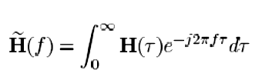
(3.12)
will depend on the delay spread and, hence, on the coherence bandwidth B_{C} (approximated by the reciprocal of the delay spread). For frequencies f₁and f₂ with (f₁₋ f₂ ) >> B_{C,} , we have under Rayleigh fading conditions
(3.13)

i.e., the channel responses at two frequencies spaced sufficiently apart are uncorrelated. The spatial statistics of will depend on the scattering environment and the array geometry at both the transmitter and receiver. With rich scattering andsufficient antenna spacing, the channel matrix is i.i.d. for all frequencies, i.e., . We note, however, that the correlation between the for different frequencies depends on the power delay profile of the channel and the delay spread..
3.5.4 Real-World MIMO Channels
In the real world, the statistics of H can deviate significantly from H_{w} due to a variety of reasons including inadequate antenna spacing and/or inadequate scattering leading to spatial fading correlation, the presence of a fixed (possibly LOS) component in the channel resulting in fading, and gain imbalances between the channel elements through the use of polarized antennas.

3.5.5 Discrete-Time Input–Output Relation
For frequency-flat fading MIMO channels, the input–output relation over a symbol period assuming single-carrier (SC) modulation is given by
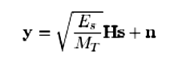
(3.14)
Where y is the MR x 1 received signal vector, s with ϵ{s} = 0 is the M_{R} x 1 transmitted signal vector, H is the M_{R}xM_{T} MIMO channel matrix, n is additive temporally white complex Gaussian noise with , and E_{S} is the total average energy available at the transmitter over a symbol period. We constrain the total average transmitted power over a symbol period by assuming that the covariance matrix of s, satisfiessatisfie satisfies .

CHAPTER 4

MIMO OFDM system

Consider a MIMO OFDM system with transmit (TX) and receive (RX) antennas. When the MIMO technique of spatial multiplexing is applied, encoding can be done either jointly over the multiple transmitter branches or per branch ( is called per-antenna-coding (PAC)). A transmitter scheme in which per-antenna-coding (PAC) (sometimes called horizontal coding )is applied to MIMO OFDM, is shown in Fig. Basically, the MIMO OFDM transmitter consists M_{T} of OFDM transmitters , among which the incoming bits are multiplexed, and then, each branch in parallel performs encoding, interleaving (∏), QAM mapping, N_{c} and -point inverse discrete fourier transformation (IDFT) and adds a cyclic prefix (CP) before the final TX signal is upconverted to radio frequency (RF) and transmitted. For reliable detection, it is typically necessary that the receiver knows the wireless communication channel and keeps track of phase and amplitude drifts. To enable estimation of the wireless communication channel, the transmitter occasionally sends known training symbols. In WLANs, a preamble, which includes channel training sequences, is added to every packet. Moreover, to track the phase drift, pilot symbols are inserted into every MIMO OFDM data symbol on predefined subcarriers[16].
The receiver first must estimate and correct for the frequency offset and the symbol timing, e.g., by using the training symbols in the preamble. Subsequently, the CP is removed, and the N_{c} -point discrete fourier transformation (DFT) is performed per receiver branch. Since the MIMO algorithms that are proposed in this paper are single carrier algorithms, MIMO detection has to be done per OFDM subcarrier . Therefore, the received signals of subcarrier are routed to the th MIMO detector to recover the N_{t} data signals transmitted on that subcarrier. Next,the symbols per TX stream are combined, and finally, demapping, deinterleaving(∏⁻¹) , and decoding are performed for the N_{t} parallel streams and the resulting data are combined to obtain the binary output data. Section IV-F explains how the detection and decoding block of Fig. 2 is filled in for PAC soft-decision output maximum likelihood detection (PAC SOMLD) and PAC vertical BLAST (PAC V-BLAST)
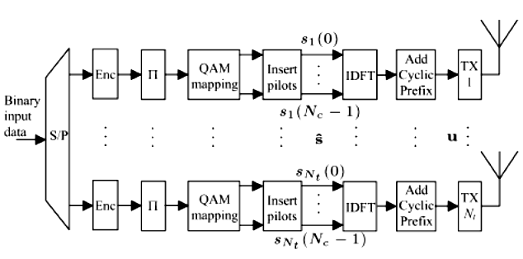

Fig. 4.1 Multiple-input multiple-output (MIMO) orthogonal frequency division
multiplexing (OFDM) transmitter scheme

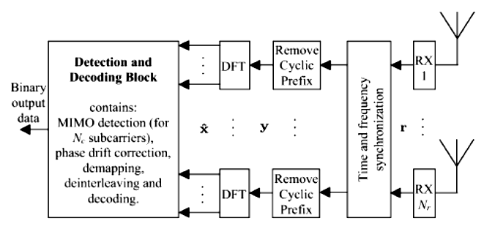
.

Fig. 4.2 MIMO OFDM receiver scheme

4.1 MIMO OFDM SYSTEM MODEL

Consider a MIMO-OFDM system (Spatial Multiplexing ) with P transmit antennas/ users and M receive antennas. The signal corresponding to the n th subcarrier of the p th OFDM block from the th transmit antenna/ user is

where N is the number of subcarriers in OFDM systems),
This is the so-called “frequency-domain” signal. Denote the frequency- domain signal vector of the th OFDM block from the pth transmit antenna/user as
(4.1)

where represents matrix transpose. Performing an N–point IFFT on it, the so-called “time-domain” signal vector from the p th transmit antenna /user is generated as

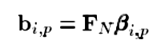
(4.2)
Where
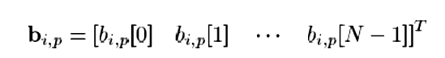
(4.3)
and F_{N} is the NXN IFFT matrix with the ( n+1,k+1)th entry as
It is obvious that the FFT matrix is and , where represents conjugate transpose and denotes the NXN identity matrix. A CP of length D is inserted into b_{i,p} to generate the i th transmitted signal block from the p th transmit antenna/userna/userdenoted by s_{i,p}
(4.4)

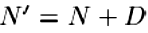
In which and
(4.5)
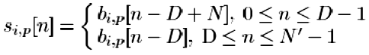
Denote the frequency selective channel between the pth transmit antenna/user and the mth receive antenna as h_{p,m}(l) , which is modeled as an Lpm th-order FIR filter. Here, the maximum channel length is defined as .
Without loss of generality, it is assumed to satisfy L < N-D which implies that the number of subcarriers is larger than the channel length plus the CP length. The ith received block at the m th receive antenna is, therefore
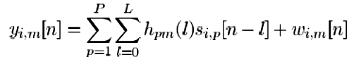
(4.6)

Where h_{pm} is zero-padded for ,
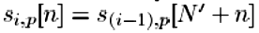
,w_{i,m}[n] is the channel noise, and
for .n<0

he signal-to-noise ratio (SNR) is defined as
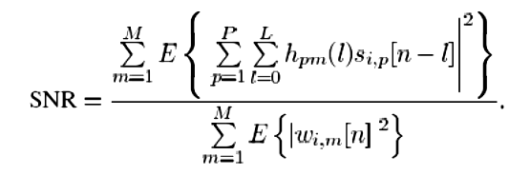

where
s_{i,p} = i ^{th} transmitted signal block from the p th transmit antenna
h_{p,m}(l) = channel between the pth transmit antenna/user and the mth receive antenna
w_{i,m}[n] = channel noise

By defining
(4.7)
(4.8)
(4.9)

equation (4.6) can be expressed in vector form as
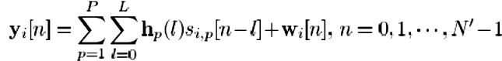
(4.10)

Traditionally, signal detection is performed based on the ith received OFDM block as
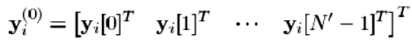
(4.11)
A newsystem model is now introduced in which the ith received OFDM block is left shifted by samples J as
(4.12)

where
for n<0
and for
It is apparent that contains the information from two consecutive received OFDM blocks. It follows that
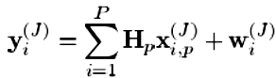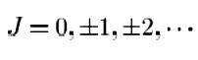
(4.13)

in (4.13)
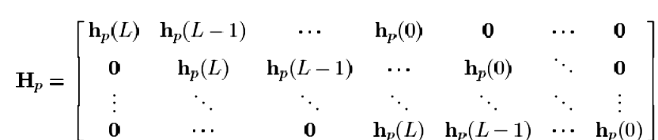
(4.14)
(4.15)
(4.16)

where
for n<0,

] for , N’≤n

for n<0
and
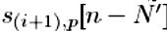 for , N’≤n
for . Defining
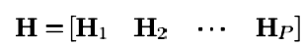
(4.17)
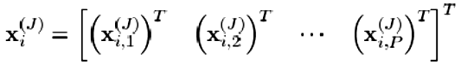
(4.18)

the received signal vector can be written as
(4.19)
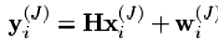
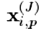
When , we observe that the signal vector in (4.15) can be expressed as
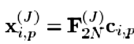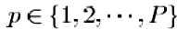
(4.20)
Where
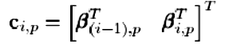
(4.21)

And

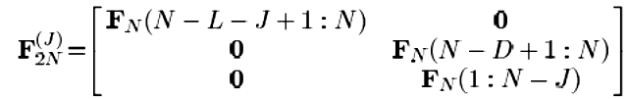
(4.22)

In (4.22), is a matrix and denotes
a submatrix of , composed by the rows between the ath row and the b th row of . It follows that the transmit signal vector in (4.18) can be written as
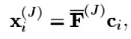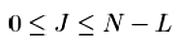
(4.23)
in which
(4.24)
(4.25)
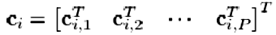

Applying (4.23) into (4.19), the received signal vector can be
remodeled as
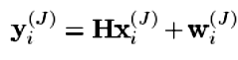
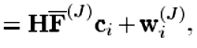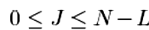
(4.26)

Based on the new system model (4.26), an equalizer is designed in the next section to cancel most of the ISI before signal detection

4.2 TIME-DOMAIN SIGNAL DETECTION

In this section, a time-domain signal detection algorithm based on second-order statistics (SOS) is given for MIMO-OFDM systems over frequency selective fading channels. The following general assumptions are made-
A1) Signals from different transmit antennas/users are statistically independent, and signals from each transmit antenna/user at different subcarriers are independent with zero mean and unit variance. It implies that each transmit antenna/user modulates all subcarriers with equal power. This situation arises in spatial multiplexing and spatial multiple access systems as independent data streams are transmitted over different antennas and different subcarriers. Note that this system is different from orthogonal frequency division multiple access (OFDMA) systems where each transmit antenna/user modulates only a portion of the subcarriers. The autocorrelation matrix of the signals before IFFT is, therefore
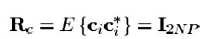
(4.27)

Where is the expectation operator.

A2) The noise components are independently identically distributed (i.i.d.) and independent of the signals from all transmit antennas/users.
A3) The e matrix H is of full column rank after removing all-zero columns, which means the nonzero columns are independent. This is a sufficient condition for detecting the signals based on SOS [23]. In order to meet this condition, the number of receive antennas, ,M must be chosen to satisfy , so that there are more rows than columns. In most cases, when the number of receive antennas M is chosen equal to the number of transmit antennas/users (P) plus one, the
above inequality will be satisfied. Under this assumption ,the matrix H has the property

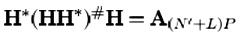
(4.28)
in which represents pseudoinverse and an matrix with one along the major diagonal except the rows corresponding to the all zero columns of H , which is equal to zero. In other words,
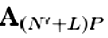is an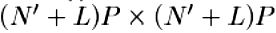 identity matrix H with all-zero rows corresponding to the all-zero columns of H .

4.2.1 Zero-Noise Case
To simplify the derivation of the algorithm, zero noise is first assumed. The effect of noise on the algorithm is then examined.
In the absence of noise, can be expressed as
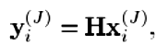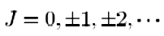
(4.29)

When 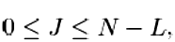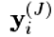can also be modeled as
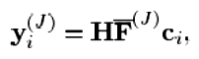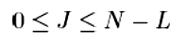
(4.30)

1) Equalization and Signal Detection: It is apparent from (4.15) and (4.29) that the received signal vector includes (N’+L) path signals [each path signal refers to one sample signal, see (4.15)] from each transmit antenna/user. Before deriving the equalizer designed to cancel most of the ISI, some useful properties are described first in the following.
Property 1: When , the matrix 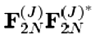is
given by
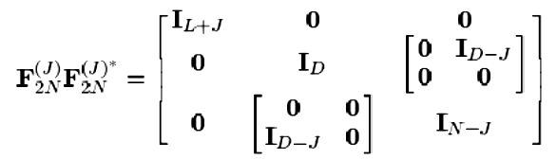
(4.31)
in which when
Proof: Using the orthogonal property of the IFFT matrix
, each column (row) of the matrix is orthogonal to the other columns (rows). It follows that
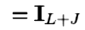
(4.32)
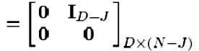
(4.33)
(4.34)
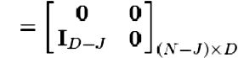
(4.35)

(4.36)

The property follows from (4.22) when (4.32)–(4.36) are applied.
Property 2: The matrices satisfy
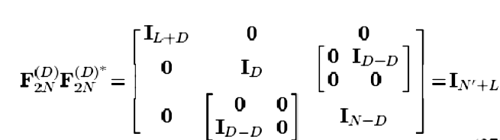
(4.37)

And
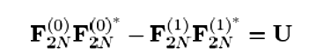
(4.38)

Where U is an (N’+L)X(N’+L) matrix with only two entries having values of one at the positions ( L+1,N+L+1 ) and ( N+L+1, L+1), while all remaining entries are zeros.
Proof: The result follows from Property 1.
Now consider the autocorrelation of the received signal vector . Under
Assumption A1), when
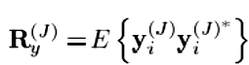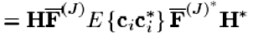
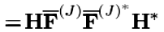
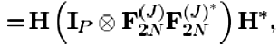
(4.39)
where denotes Kronecker product. It follows that
(4.40)
Applying Property 2 into (4.39) and (4.40), we have
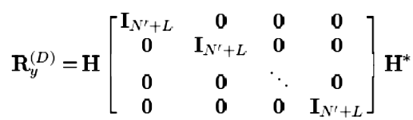
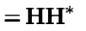
(4.41)
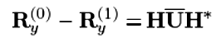
(4.42)
Where
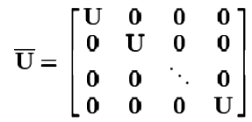
(4.43)
An equalizer is now constructed based on SOS 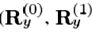
and 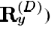 as
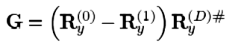
(4.44)
It follows that
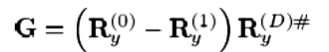
(4.45)
In (4.45), the matrix 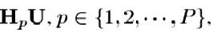has the following
property
Property 3: The matrix has all zero columns except the(L+1) th and the (N+L+1)th columns given by 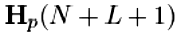and , respectively, where denotes the ath column of .
Proof: As the matrix U is a special matrix (N’+L) X(N’+L)with only two nonzero entries at the positions (L+1 ,N+L+1 ) and ( N+L+1,L+1 ), it follows
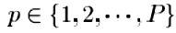
(4.46)
From the definition of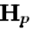 in (4.14), it is apparent that and are not all-zero columns and the proof follows.

To proceed with signal detection, the equalizer is applied to the received signal vector (4.29) to yield
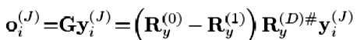
(4.47)
Using (4.15), (4.18), (4.28), (4.45), and Property 3, the output of the equalizer is given by
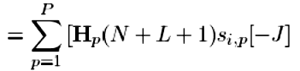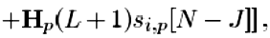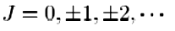
(4.48)
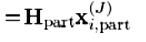
Where
(4.49)
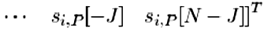
(4.50)

It is apparent that most of the ISI are cancelled by the equalizer G . The equalizer output O_{i}^{(J)}only contains two paths of the transmitted signals from each transmit antenna/user, i.e.,s_{i,p}[-J] and s_{i,p}[N-J] ,pϵ{1,2,…P} . In other words, only 2Pcolumns of the channel matrix H are retained. Note that channel length information is not needed in this step.
When the matrix H_{part} which contains only 2P columns of the channel matrix H is known,X_{i,part} ^{(J)} in (4.50) can be easily detected from the equalizer output based on the least-squares criteria [19]
(4.51)
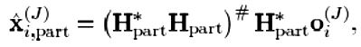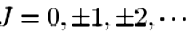
As 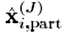 contains two paths of the estimated transmitted signals from each transmit antenna/user, either path can be used for signal detection. For example, by setting the parameter J= -D+1,-D+2…,N-D, , the estimation of the transmitted signal pϵ{1,2,…P},nϵ{D,D+1…N+D-1},, are obtained from the path of the s_{i,p} [N-J] vector 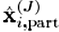. The frequency-domain signal vector β_{ip} is then detected by the FFT of , pϵ{1,2,…P}, nϵ{D,D+1…N+D-1}, based on (4.2) and (4.5).
Estimation: In order to perform signal detection, knowledge of the MN’x2P matrix H_{part} is necessary. For better performance, pilot symbols will be used. Note that the channel length information is not needed for the selection of pilot symbols as it is now embedded in the matrix H_{part} after equalization. Suppose the pilot symbols are inserted into each transmit antenna/user’s signal and X_{ipilot} consists of the pilot symbols i.e.
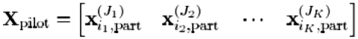
(4.52)
The matrix H_{part} can be straightforwardly estimated from the equalizer output [19] as
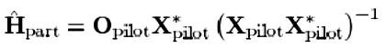
(4.53)
where
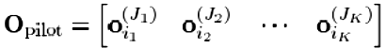
(4.54)
In order to achieve a unique estimate H_{part} of based on (4.53), some conditions on pilot symbols for identifiability need to be satisfied. These are discussed in the following.
(i) The MN’x2Pmatrix requires at least sets of (4.48) to be estimated, which means at least 2P pilot vectors are required. In other words, the parameter in (4.52) must be greater than or equal to . Based on the definition in (4.50), each pilot vector (X_{i1,part} ^{(J}₁⁾), X_{i2,part}^{(J}₂⁾),… X_{ik,part} ^{(J}_{k}⁾), in X_{pilot} contains two paths of the transmitted signals from each transmit antenna/user. Therefore, the minimum number of pilot symbols required by each transmit antenna/ user is 2Px2 .
(ii) In order to yield a unique estimation of H_{part}, the 2Px2 matrix X_{pilot} X_{pilot} * in (4.53) must be nonsingular. It follows that the rank of 2PxK the matrix X_{pilot} must be greater than or equal to 2P , which implies K≥2P and X_{pilot} is of full row rank.
(iii) Each pilot vector X_{ik,part} ^{(J}_{k}⁾),kϵ{1,2…K}, in X_{pilot} has the structure as shown in (4.50). It contains two symbols s_{ik,p}[-J_{k}] and s_{ik,p}[N-J_{k}] from each transmit antenna/user. If the pilot symbols are chosen from only one OFDM block, the first symbol s_{ik,p}[-J_{k}] will be the symbol in the cyclic prefix and is equal to the second symbol s_{ik,p}[N-J_{k}] . Consequently, the pilot matrix X_{ipilot} will not be of full row rank as the(2a+1) th row is the same as the(2a+2) th row, aϵ{0,1,…,P-1} .
Condition (ii) above is, therefore, not satisfied and it follows that the pilot symbols need to be distributed in more than one OFDM block. Note that when the pilot symbols are distributed in more than one OFDM block, generally condition (ii) can be satisfied. However, there is no guarantee and the chosen pilot symbols need to be checked to ensure that condition (ii) is satisfied.
3) Remark: In the algorithms [17], [18], knowledge of the channel matrix is necessary. Due to the structure H of [by (4.14) and (4.17)], only the channel coefficients ((h_{p}(0), h_{p} (1),…, h_{p} (L), pϵ{0,1,…,P}) are required to be estimated. Since they are directly estimated from the received signal which contains (L+1)paths of the transmitted signals from each transmit antenna/user, the minimum number of pilot symbols required is, therefore,(1+L)P and linearly increases with the channel length. Also, channel length estimation is necessary before selecting the pilot symbols. On the other hand, in the proposed algorithm, only knowledge of the matrix H_{part} which includes 2P columns of the channel matrix H is required. Each pair of columns of the matrix , corresponding to the th transmit antenna/user , pϵ{0,1,…,P}, contains all the channel coefficients (h_{p}(0), h_{p} (1),…, h_{p} (L)) [by (4.14), (4.17), and (4.49)]. When H_{part} is estimated, it follows that the channel matrix H is effectively estimated. In this case, only 4P pilot symbols are required to estimate H_{part} . As aforementioned, computationally intensive channel length estimation is not needed and the transmitted signals are detected straightforwardly (4.51) without the need to reconstruct the estimated channel matrix.
4.2.2 Channel Noise Consideration
In the presence of noise y_{i}^{(J)}, is given by (4.19) and (4.26). Let the variance of noise be σ² . When 0 ≤J≤N-L, the autocorrelation matrix of y_{i}^{(J)} is
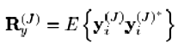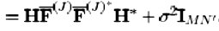
(4.55)
If σ² is known, the noise contribution can be subtracted from R_{y}⁽⁰⁾ , R_{y}⁽¹⁾
, R_{y}^{(D)} , and, therefore, it has no impact on the equalizer which can be constructed as
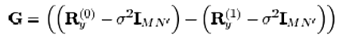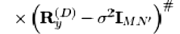
(4.56)
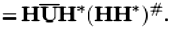

The output of the equalizer becomes O_{i}^{(J)}
(4.57)
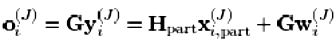
Taking into account the noise contribution Gw^{(J)} in O_{i}^{(J)}, the matrix H_{part} and the signal vector X_{i,part}^{(J})can be detected based on the minimum mean square error (MMSE) criterion [19].
If σ² is unknown, it can be estimated from the singular value decomposition of R_{y}^{(D)} [20] where R_{y}^{(D)} = HH* + σ² I_{MN’}. Since some error generally exists in the estimation σ² of and this error will degrade the performance, it is generally preferred not to subtract the noise contribution from R_{y}⁽⁰⁾ , R_{y}⁽¹⁾ , R_{y}^{(D) .}
Instead, the equalizer G is constructed based on G= (R_{y}⁽⁰⁾ - R_{y}⁽¹⁾ ) R_{y}^{(D) #} as if it were noiseless. It follows that the equalizer G includes two parts: the effective equalizer as
G_{effect} and the noise contribution to the equalizer as
. The output of the equalizer O_{i}^{(J)} is, therefore
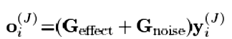
(4.58)
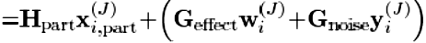

Here 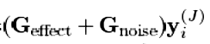 is considered as the noise contribution
to O_{i}^{(J)} . As the noise contribution is not known, H_{part} estimation and signal detection will be performed based on the least-squares criteria in the simulation in the noisy case.

CHAPTER 5

SIMULATION RESULTS

MATLAB simulations have been conducted to investigate the performance of the algorithm. In the following examples, a MIMO-OFDM system with P=4 transmit antennas/users and M=4 receive antennas (4x4 system) is considered. The Data length is selected as D=16 . All transmitted signals are modulated with QAM scheme. AWGN noise is used.

- Comparison between Single Input Single Output System (SISO) and MIMO OFDM System-
Plot obtained after simulation for both system is shown below.
.

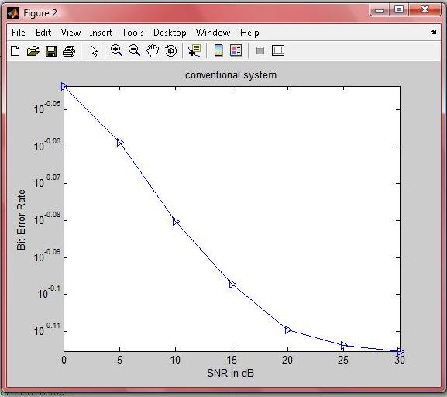

Fig. 5.1 Plot between BER and SNR for SISO system.
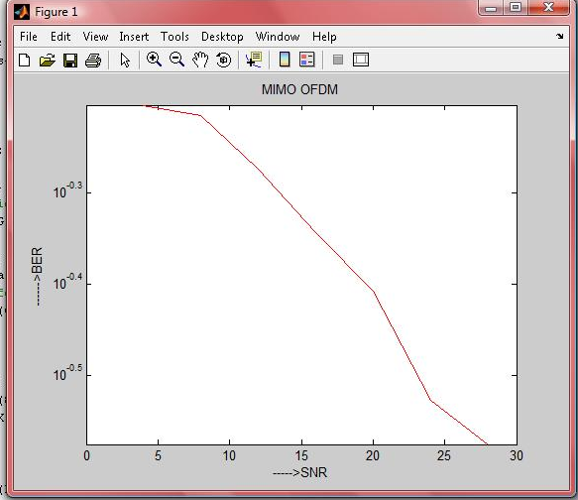

Fig. 5.2 Plot between BER and SNR for MIMO OFDM system

Comparing Fig. 5.1 and Fig. 5.2 we observe that MIMO OFDM System (space-time coding systems) has better BER performance than (conventional) SISO system

- The BER performance of algorithms under consideration for different channel length L=14 , L=16 and L=18 of MIMO OFDM system are shown in Fig.5. 1 , Fig. 5.2 and Fig. 5.3, respectively keeping fixed guard interval length.

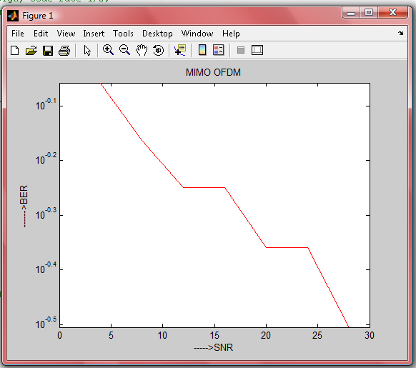

Fig. 5.3 Plot between BER and SNR for MIMO OFDM system with L=14

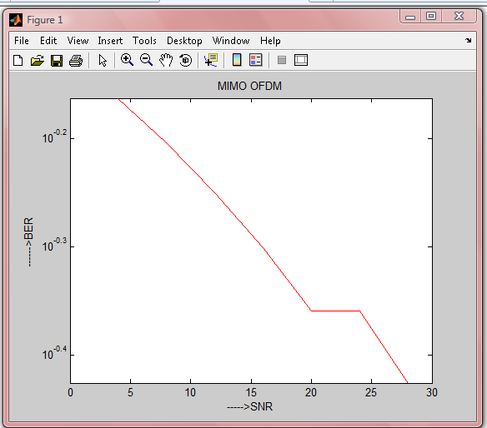

Fig. 5.4 Plot between BER and SNR for MIMO OFDM system with L=16

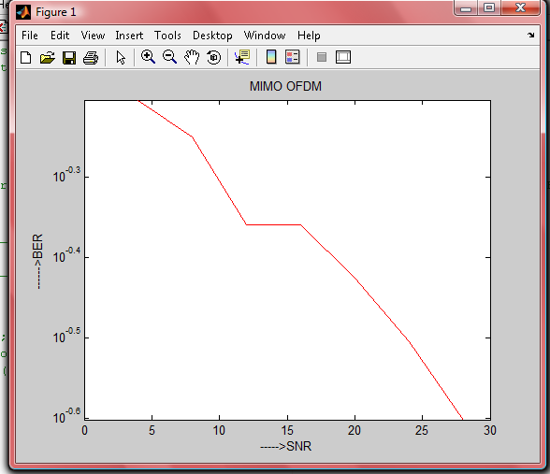

Fig. 5.5 Plot between BER and SNR for MIMO OFDM system with L=18

Comparing Fig. 5.3 , Fig. 5.4 and Fig. 5.5 we observethat the performance is only slightly degraded when the channel length increases from 14 to 18. It demonstrates that the channel lengths have insignificant effect on the proposed algorithm. It also verifies that the proposed algorithm is applicable irrespective of whether the channel length is shorter than, equal to or longer than the CP length.

CHAPTER 6
CONCLUSION AND FUTURE WORKS

CONCLUSION
MIMO OFDM System (space-time coding systems) has better BER performance than (conventional) SISO system. It has been shown that the channel length information is not needed. Channel lengths have insignificant effect on the this algorithm It has been shown that the proposed algorithm is applicable to general MIMO OFDM systems irrespective of whether the CP length is longer than, equal to or shorter than the channel length. Simulation results have shown that the this algorithm has better performance in all cases.

FUTURE WORKS
In channel estimation area, MIMO OFDM system needs an efficient and low complexity algorithm to estimate time varying channel coefficient. The future work can be defined as low complex adaptive channel estimation for MIMO OFDM system. In MIMO structure area, system needs receiver design or designing the detection algorithm with low computational complexity for different MIMO structure, such as orthogonal space–time block coding (OSTBC ). In a higher level the receiver can be design for time-varying environment which is known as adaptive receiver.

REFERENCES
[1] Shaodan Ma and Tung-Sang Ng, Fellow, IEEE, “Time-Domain Signal Detection Based on Second-Order Statistics for MIMO-OFDM Systems,” IEEE TRANSACTIONS ON SIGNAL PROCESSING, VOL. 55, NO. 3, MARCH 2007.
[2] D. Gesbert, M. Shafi,D. Shiu, P. J. Smith, and A. Naguib, “From theory to practice:an overview of MIMO space-time coded wireless systems,” IEEE J. Sel. Areas Commun., vol. 21, pp. 281–302, Apr. 2003.
[3] G. Foschini and M. Gans, “On limits of wireless communications in fading environment when using multiple antennas,” Wireless Pers. Commun., vol. 6, pp. 311–335, Mar. 1998.
[4] A. J. Paulraj, D. A. Gore, R. U. Nabar, and H. Bolcskei, “An overview of MIMO communications—A key to gigabit wireless,” IEEE Proc., vol. 92, pp. 198–218, Feb. 2004.
[5] Louis Litwin and Michael Pugel, "The principles of OFDM," RF signal processing, pp. 30-48, January 2001.
[6] M. Speth, S. A. Fechtel, G. Fock, and H. Meyr, “Optimum receiver design for wireless broad-band systems using OFDM—Part I,” IEEE Trans. Commun., vol. 47, pp. 1668–1677, Nov. 1999.
[7] B. Muquet, M. de Courville, and P. Duhamel, “Subspace-based blind and semi-blind channel estimation for OFDM systems,” IEEE Trans. Signal Process., vol. 50, pp. 1699–1712, Jul. 2002.
[8] V. Tarokh, N. Seshadri, and A. R. Calderbank, “Space–time codes for high data rate wireless communication: Performance criterion and code construction,” IEEE Trans. Inform. Theory, vol. 44, pp.744–765, Mar. 1998.

[9] H. Sampath, S. Talwar, J. Tellado, V. Erceg, and A. Paulraj, “A fourth generation
MIMO OFDM broadband wireless system: Design, performance, and field trial results,” IEEE Commun. Mag., vol. 40, pp. 143–149, Sep. 2002.
[10] Y. Li, J. H.Winters, and N. R. Sollenberger, “MIMO-OFDM for wireless communications: signal detection with enhanced channel estimation,” IEEE Trans. Commun., vol. 50, pp. 1471–1477, Sep. 2002.
[12] M. Shin, H. Lee, and C. Lee, “Enhanced channel-estimation technique for MIMO-OFDM systems,” IEEE Trans. Veh. Technol., vol. 53, pp. 261–265, Jan. 2004.
[13] I. Barhumi, G. Leus, and M. Moonen, “Optimal training design for MIMO-OFDM systems in mobiles wireless channels,” IEEE Trans. Signal Process., vol. 51, pp. 1615–1624, Jun. 2003.
[14] X. Li and X. Cao, “Low complexity signal detection algorithm for MIMO-OFDM systems,” Electron. Lett., vol. 41, Jan. 2005.
[15] G. L. Stuber, J. R. Barry, S.W.Mclaughlin, Y. Li, M. A. Ingram, and T. G. Pratt, “Broadband MIMO-OFDM wireless communications,” IEEE Proc., vol. 92, pp. 271–294, Feb. 2004.
[16] A. van Zelst and T. C. W. Schenk, “Implementation of a MIMO OFDM-based wireless LAN system,” IEEE Trans. Signal Process., vol. 52, pp. 483–494, Feb. 2004.
[17] G. Leus and M. Moonen, “Per-tone equalization for MIMO OFDM systems,” IEEE Trans. Signal Process., vol. 51, pp. 2965–2975, Nov. 2003.
[18] HELMUT BÖLCSKEI, ETH ZURICH, " MIMO-OFDM WIRELESS SYSTEMS: BASICS, PERSPECTIVES, AND CHALLENGES," IEEE Wireless Communications, pp. 31-37, August 2006.
[19] I. Barhumi, G. Leus, and M. Moonen, "Optimal training design for MIMO OFDM systems in mobile wireless channels," IEEE Trans. Signal Processing, vol.5, pp. 1615-1624, June 2003.
[20] J. Q. Shen and Z. Ding, “Direct blind MMSE channel equalization based on second-order statistics,” IEEE Trans. Signal Process., vol. 48, pp. 1015–1022, Apr. 2000.
[21] H. Akaike, “A new look at the statistical model identification,” IEEE Trans. Autom. Control, vol. AC-19, pp. 716–723, 1974.
[22] J. Rissanen, “Modeling by shortest data description,” Automatica, vol. 14, pp. 465–471, 1978.
[23] D. Agarwal, V. Tarokh, A. Naguib, and N. Seshadri, “Space–time coded OFDM for high data rate wireless communication over wideband channels,” in Proc. IEEE VTC, vol. 3, 1998, pp. 2232–2236.
[24] D. Agrawal, V. Tarokh, A. Naguib, and N. Seshadri, “Space–time coded OFDM high data-rate wireless communication over wideband channels,” in Proc. IEEE Vehicular Technology Conf., 1998, pp. 2232–2236.
[25] Y. (G.) Li, J. H.Winters, and N. R. Sollenberger, “MIMO-OFDM for wireless communications: Signal detection with enhanced channel estimation,” IEEE Trans. Commun., vol. 50, pp. 1471–1477, Sept. 2002.
[26] Y. Ogawa, K. Nishio, T. Nishimura, and T. Ohgane, "Channel estimation and signal detection for space division multiplexing in a MIMO-OFDM system," IEICE Trans. Commun, vol. E8-B, no.1, pp.10-18, January 2005.

Appendix

main.m
clc;
clear all;
close all;
L=4; %%% length 14,16,20,18
mimoofdm
figure,grid on;
semilogy(4:step:30,fliplr(sort(B_err)),'r');hold on; title('MIMO
OFDM');xlabel('----->SNR');ylabel('------>BER');
conventional
figure;
semilogy(snrv,mean(bErr1'),'b->');hold on;
xlabel('SNR in dB');ylabel('Bit Error Rate');
title('conventional system');legend('Coventional')
mimoofdm.m
warning off
clc
close all
clear all;
x=[-3 -3 -3 -3 -1 -1 -1 -1 3 3 3 3 1 1 1 1 ];
y=[3 1 -3 -1 3 1 -3 -1 3 1 -3 -1 3 1 -3 -1 ];
Qam=x+y*i;
Es=10; %average constellation energy for d=2;
L=14; % 16,18
index=1;
%set SNR step
step=4;
% SNR range is here
for SNR=4:step:30
%number of bit errors set to zero
count=0;
%number of iterations
N=4;
GI = 0.16; % guard interval length
%if SNR==20 N=3*4;end; % increase for higher SNR
for it=1:N
%generate 16 bits uniformly distributed
A=round(rand(1,16));
%A=[1 1 0 0 1 0 1 1 1 0 0 0 0 1 1 1];
% TX symbols
s1=Qam(bi2de(A(1:4),'left-msb')+1);
s2=Qam(bi2de(A(5:8),'left-msb')+1);
s3=Qam(bi2de(A(9:12),'left-msb')+1);
s4=Qam(bi2de(A(13:16),'left-msb')+1);
C1=[s1 s2 s3 s4; -s2 s1 -s4 s3; -s3 s4 s1 -s2; -s4 -s3 s2 s1];
C=[C1; conj(C1)];
%Channel coefficients
TrDataMod = Es*C;
TrDataIfft = ifft(TrDataMod,N);
TrDataIfftGi = [TrDataIfft(N-GI + 1 : N);TrDataIfft]; %%% insertion of gaurd interval of 12
h(1:step,1) = random('Normal',0,1,step,1)+j * random('Normal',0,1,step,1);
h = h./sum(abs(h)); % normalization
RxDataIfftGi = filter(h,1,TrDataIfftGi); % channel effect
%SNR=4;
k(it)=round(db(std(RxDataIfftGi(:,it)))-SNR);
RxDataIfftGiNoise(:,it) = awgn(RxDataIfftGi(:,it),k(it)); % normalization to signal power &adding awgn noise
N0(it)=(4*Es/10^(SNR/10)); %%%%%% for four antennasR
RxDataIfft(it,:)=RxDataIfftGiNoise(GI+1:N+GI);
end
K=1/sqrt(2)*(randn(4,1)+i*randn(4,1)); % normalize to the variance 1 CN(0,1)
Z=sqrt(N0(it)/2)*(randn(8,1)+i*randn(8,1)); % variance N0
b=[K(1) K(2) K(3) K(4); K(2) -K(1) -K(4) K(3); K(3) K(4) -K(1) -K(2); K(4) -K(3) K(2) -K(1)];
H=[b conj(b)];
b = round(rand(1,14));
RxDataMod1= ifft(fft(RxDataIfft(1:1+(L-1)),N) .* fft(b,N));
B1 = circshift(RxDataMod1,-3);
RxDataMod2= ifft(fft(RxDataIfft(2:2+(L-1)),N) .* fft(b,N));
B2 = circshift(RxDataMod2,-3);
RxDataMod3= ifft(fft(RxDataIfft(3:3+(L-1)),N) .* fft(b,N));
B3 = circshift(RxDataMod3,-3);
RxDataMod4= ifft(fft(RxDataIfft(1:1+(L-1)),N) .* fft(b,N));
B4 = circshift(RxDataMod4,-3);
H1=[K(1) K(2) K(3) K(4); K(2) -K(1) -K(4) K(3); K(3) K(4) -K(1) -K(2); K(4) -K(3) K(2) -K(1)];
H=[H1 conj(H1)];
S1=B1/(2*sum(abs(K).^2));
S2=B2/(2*sum(abs(K).^2));
S3=B3/(2*sum(abs(K).^2));
S4=B4/(2*sum(abs(K).^2));
%%%symbol decoding for 16-QAM
L1=[ abs(Qam-S1(1)); abs(Qam-S1(2)); abs(Qam-S1(3)); abs(Qam-S1(4))];
L2=[ abs(Qam-S2(1)); abs(Qam-S2(2)); abs(Qam-S2(3)); abs(Qam-S2(4))];
L3=[ abs(Qam-S3(1)); abs(Qam-S3(2)); abs(Qam-S3(3)); abs(Qam-S3(4))];
L4=[ abs(Qam-S4(1)); abs(Qam-S4(2)); abs(Qam-S4(3)); abs(Qam-S4(4))];
[D1,I1]=min(L1,[],2);[D2,I2]=min(L2,[],2);[D3,I3]=min(L3,[],2);[D4,I4]=min(L4,[],2);
% % %TX bits
dec_bits(1,1:4)=de2bi(I1(1)-1,4,'left-msb');
dec_bits(1,5:8)=de2bi(I1(2)-1,4,'left-msb');
dec_bits(1,9:12)=de2bi(I1(3)-1,4,'left-msb');
dec_bits(1,13:16)=de2bi(I1(4)-1,4,'left-msb');
% % %count errors
count1=count+sum(abs(A-dec_bits));
dec_bits(1,1:4)=de2bi(I2(1)-1,4,'left-msb');
dec_bits(1,5:8)=de2bi(I2(2)-1,4,'left-msb');
dec_bits(1,9:12)=de2bi(I2(3)-1,4,'left-msb');
dec_bits(1,13:16)=de2bi(I2(4)-1,4,'left-msb');
% % %count errors
count2=count+sum(abs(A-dec_bits));
dec_bits(1,1:4)=de2bi(I3(1)-1,4,'left-msb');
dec_bits(1,5:8)=de2bi(I3(2)-1,4,'left-msb');
dec_bits(1,9:12)=de2bi(I3(3)-1,4,'left-msb');
dec_bits(1,13:16)=de2bi(I3(4)-1,4,'left-msb');
% % %count errors
count3=count+sum(abs(A-dec_bits));
dec_bits(1,1:4)=de2bi(I4(1)-1,4,'left-msb');
dec_bits(1,5:8)=de2bi(I4(2)-1,4,'left-msb');
dec_bits(1,9:12)=de2bi(I4(3)-1,4,'left-msb');
dec_bits(1,13:16)=de2bi(I4(4)-1,4,'left-msb');
% % %count errors
count4=count+sum(abs(A-dec_bits));
B_err(index)=(count1+count2+count3+count4)/(N*16);
index=index+1;
end
figure,grid on;
semilogy(4:step:30,fliplr(sort(B_err)),'r');hold on; title('MIMO OFDM');xlabel('----->SNR');ylabel('------>BER');
conventional.m
% clear all;
% clc;
N = 256; % total number of subchannels
P = 256/8; % total number of Pilots
S = N-P; % totla number of data subchannels
GI = N/4; % guard interval length
M = 16; % modulation
pI = 8; % pilot position interval
L = 16; % channel length
nIt = 500; % number of iteration in each evaluation
snrv = [0:5:30]; % signal to noise ratio vector in dB
ber = zeros(1,length(snrv )); % initializing bit error rate
% Pilot Location and strength
Ip = [1:pI:N]; % location of pilots
Is = setxor(1:N,Ip); % location of data
Ep = 2; % energy in pilot symbols in comparison
% to energy in data symbols
% fft matrix
F = exp(2*pi*sqrt(-1)/N .* meshgrid([0:N-1],[0:N-1])...
.* repmat([0:N-1]',[1,N]));
for( i = 1 : length(snrv))
SNR = snrv(i);
for(k = 1 : nIt)
% generating random channel coefficients
h(1:L,1) = random('Normal',0,1,L,1) + ...
j * random('Normal',0,1,L,1);
h = h./sum(abs(h)); % normalization
% Tr Data
TrBit = randint(N,1,M);
TrMod = qammod(TrBit,M);
TrMod(Ip) = Ep * TrMod(Ip);
TrIfft = ifft(TrMod,N);
TrIfftGi = [TrIfft(N- GI + 1 : N);TrIfft];
% tx Data
TxIfftGi = filter(h,1,TrIfftGi); % channel effect
% adding awgn noise
TxIfftGiNoise = awgn(TxIfftGi ...
, SNR - db(std(TxIfftGi))); % normalization to signal power
TxIfft = TxIfftGiNoise(GI+1:N+GI);
TxMod = fft(TxIfft,N);
% Channel estimation
Spilot = TrMod(Ip); % trnasmitted pilots
Ypilot = TxMod(Ip); % received pilots
G = (Ep * length(Ip))^-1 ...
* ctranspose(sqrt(Ep)*diag(Spilot)*ctranspose(F(1:L,Ip)));
hHat = G*Ypilot; % estimated channel coefficient in time domain
TxBit = qamdemod(TxMod./(fft(hHat,N)),M);
% bit error rate computation
[nErr1 bErr1(i,k)] = symerr(TxBit(Is),TrBit(Is));
end
end
%figure,
%grid on;
%semilogy(snrv,mean(bErr1'),'b->');xlabel('SNR in dB');ylabel('Bit Error Rate');
%title('conventional system');

