STUDIES ON DEVELOPMENT AND CHARACTERIZATION

OF CARBON BASED COMPOSITES

A DISSERTATION SUBMITTED IN PARTIAL FULFILLMENT OF THE

REQUIREMENTS FOR THE AWARD OF THE DEGREE OF

MASTER OF ENGINEERING
IN
POLYMER TECHNOLOGY

Submitted By:

Ms. NEELAM
(ROLL NO. 3005)


DEPARTMENT OF POLYMER TECHNOLOGY
& APPLIED CHEMISTRY
DELHI COLLEGE OF ENGINEERING

UNIVERSITY OF DELHI
2006-2007

CERTIFICATE

This is to certify that the project entitled ‘Studies on development and characterization of Carbon based Composites’ submitted by Ms. NEELAM, student of Master of Engineering (Polymer Technology) from Delhi College of Engineering, Delhi was carried out by her under joint supervision of Prof. G.L.Verma, Head, Department of Polymer and Applied Chemistry, Delhi college of Engineering, Delhi and Dr. G. Bhatia, Head, Carbon Technology Unit, National Physical Laboratory, New Delhi, during the session 1st December 2006 to 31st May 2007. Her work has been found to be excellent for the partial fulfillment of the requirement for the degree of M.E. To the best of our knowledge and belief, this work has not been submitted to any other University or Institution for the award of any degree or diploma.

Prof. G. L. Verma Dr. G. Bhatia
Head, (Department of Applied Scientist-F Chemistry & Polymer Technology) Deputy Director & Head Delhi College of Engineering Carbon Technology Unit
Bawana Road National Physical Laboratory
New Delhi 110042 Dr. K. S. Krishnan Marg
New Delhi-110012

Endorsement No.

ACKNOWLEDGEMENTS
Any accomplishment requires the efforts of many people and this work is no exception. I appreciate the contribution and support, which various individuals have provided for the successful completion of the dissertation‘Studies on development and characterization of Carbon based Composites’ which is the latest field in carbon Technology and has excellent future.
Firstly my most sincere regards to my guide Dr. G. L. Verma, Professor and Head, Department of Polymer Technology and Applied Chemistry, DCE, for his inspiring guidance, Support, co-operation and healthy discussion.
I sincerely express deep sense of gratitude to my co-guide Dr. Gopal Bhatia, ‘Scientist F’ and Head of the Carbon Division, National Physical Laboratory, Delhi, for accepting me to work under his guidance and supervision. I am highly indebted to Dr. Bhatia for his useful discussions and constant encouragement during the course of my project work. I pay my special gratitude to Dr. (Mrs.) V. Raman, Scientist F, of National Physical Laboratory, for Technical guidance and continuous encouragement, critical interpretation of the results, keen interest in work and parent like behavior.
I am also thankful to Mr. P. R Sengupta, Mr. T. S. Negi, Mr. R. S. Bisht and Mr. Prem Lal, NPL to providing the technical help during my project work.
I am also grateful to Dr. Vikram Kumar, Director, NPL for allowing me to complete my project in this reputed organization.
Last but not the least I will be indebted to my Parents and Mr. Sunil Dogra for helping me to realize my goals and without whose blessings and support, this work would not have been possible.

Dated : Ms. NEELAM

CONTENTS
Page no.
LIST OF FIGURES 6
LIST OF TABLES 7
CHAPTER- 1 Introduction 8
1.2 The element “carbon” 8
1.2.1 Structure of Diamond 9
1.2.2 Ideal Graphite 10
1.2.3 Structure of Fullerene 11
1.2.4 Structure of Carbon nanotubes 13
1.2.5 ELECTRICAL AND THERMAL PROPERTIES OF GRAPHITE
SINGLE CRYSTAL 13
1.3 MANUFACTURE OF CONVENTIONAL CARBONS 14
1.3.3 ELECTRICAL AND THERMAL PROPERTIES OF CARBON
PRODUCTS 17

HIGH DENSITY- HIGH STRENGTH-ISOTROPIC GRAPHITE 17
Scope of the present investigations 19

CHAPTER -2 EXPERIMENTAL 21
2.1EXPERIMENTAL TECHNIQUES USED FOR CHARACTERISATION 21 2.2.1Determinationof softening point 21
2.1.1.2 Determination of coking Value 23
2.1.1.3 Determination of ash content 24
2.1.1.4 Determination of Toluene insoluble content. 24
2.1.1.5 Determination of Quinoline insoluble content 24
2.1.1.6 Determination of specific gravity 25
2.3.2.1 Determination of baked density. 34
2.3.2.2 Determination of Linear shrinkage 34
2.3.2.3 Determination of volume shrinkage. 34
2.3.2.4 Determination of weight loss. 34
2.3.2.9 Determination of Electrical resistivity. 35
2.3.2.10 Determination of Bending strength. 36
2.3.2.11 Determination of Young’s Modulus. 37
2.3.2.12 Determination of Shore hardness. 37

CHAPTER-3 DEVELOPMENT OF PITCH BASED CARBON COMPOSITE 39
3.1 Introduction 39
3.2 Methodology 40
  - Characterization of imported garphite samples 41
3.3.1Results and discussion 42
3.4 development of high density isotropic graphite 43
RESULTS AND DISCUSSION 45
CHAPTER-4 CONCLUSION 58
REFERENCES 60

LIST OF FIGURES

Sr. No. | FIGURES | PAGE NO.
1. | Structure of Diamond | 9
2. | Structure of Ideal Graphite | 10
3. | Structure of Fullerene | 11
4. | Structure of Carbon nanotubes | 13
5. | Manufacture of Conventional Graphite | 15
6. | Mettler Softening point Apparatus | 23
7. | Flow diagram of Production of Pitch | 27
8. | Pitch Distillation Assembly | 29
9. | SEM Micrograph of Graphite sample | 42
10. | Micrographs of Pitch and Coke | 47
11. | Micrographs of Green Coke based plates | 48

LIST OF TABLES

SR. No. | TABLES | PAGE NO.
1. | Imported special Graphite samples | 41
2. | Coal Tar Pitch and green coke Characteristics | 45
3. | Characteristics of Plates HTT at 1000-2500⁰C | 46
4. | Characteristics of precursor coal tar Pitch and green Coke | 49
5. | Characteristics of green coke plates having 0-45% natural graphite by weight of Pitch | 50
6. | Characteristics of precursor coal tar Pitch and green Coke | 53
7. | Characteristics of special Graphite blocks having 0-20% natural Graphite Content | 56

CHAPTER-1
INTRODUCTION
Carbon and graphite manufacture is a worldwide industry which is growing up rapidly because of the increasing interest being taken in this material by scientists and technologists. This is because of the fact that this material exhibits a unique combination of physical, chemical, mechanical, electrical, thermal and nuclear properties. Carbon and graphite products, in one form or the other, form indispensable components of almost all major industries, and thus they act as the backbone of the industrialization of a country. In fact, these products form an important part of our day-to-day life. Graphite electrodes for the steel industry, carbon anodes and cathodes for the Aluminum industry, carbon lining for the electrolytic cell in the production of caustic soda, calcium carbide etc., carbon brushes for the electric motors and generators, carbon granules for the telephone receiver sets, carbon crucibles for the melting of metals and alloys, carbon seals and bearings for mechanical applications, nose-cones and nozzle inserts for missiles and rockets, leading edges and brake pads for military and advanced civilian aircrafts, and moderator and reflector for nuclear reactors are some of the examples showing the vast applications of carbon and graphite. Recently, there has been an increased interest in this material, than ever before, and as a result, several newer products have come into existence. Carbon fibres, carbon fibre based composites, glassy carbon, high density - isotropic graphite, fullerenes, nanotubes are examples of some such products. These products are further widening the scope of the applications of this fascinating material.

1.2 THE ELEMENT ‘CARBON’
Carbon has an atomic weight of 12.011 and an atomic number of 6. The electronic ground state 2s² 2p² is almost unknown because of the energetic advantage of involving all the four outer orbital electrons in bonding between carbon atoms themselves, or with other atoms. Carbon displays catenation (bonding to itself) to a unique degree, which results in structure of chains, rings, and networks. In most chemical compounds, carbon is tetravalent because of the transition of one electron from the 2s orbital to the 2p orbital, resulting in the excited state configuration 1s² 2s¹ 2p_{x}¹ 2p_{y}¹ 2p_{z}¹. These‘s’ and ‘p’ orbitals in the outer shell undergo hybridization to give hybrid orbitals. In diamond, 1‘s’ and 3 ‘p’ orbitals hybridize to give four sp³ hybridized orbitals, resulting in a tetrahedral structure with a bond angle of 109° 28’. In graphite, 1 ‘s’ and 2 ‘p’ orbitals hybridize to give three sp² hybridized orbitals, resulting in a planar triangular structure with a bond angle of 120°.

1.2.1 STRUCTURE OF DIAMOND
Diamond (Fig. 1) has a face-centered-cubic structure with an interatomic distance of 1.54 A°. Each atom is covalently bonded to four other carbon atoms in the form of a regular tetrahedron [1]. The three dimensional isotropic structure accounts for the extreme hardness of diamond. Diamond is stable and chemically inert at moderate temperatures. However, at temperatures above 1500 °C in the absence of air, it is transformed into graphite [2]. Diamond can be synthesized from graphite at a pressure of about 85 K bars and a temperature of about 1600 °C [3].

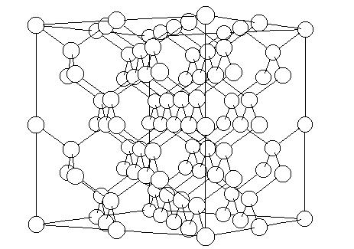 Fig. 1 Structure of diamond
1.2.2 STRUCTURE OF IDEAL GRAPHITE
The structure of ideal graphite was first proposed by Hull [4] in 1917 and later confirmed by Bernal [5] in 1924. It consists of parallel plane layers of carbon atoms covalently bonded in a regular open-centered hexagonal array. The layers are bonded together by weak van der Wall’s forces at a separation of 3.354 A° in a (AB AB AB .. .. ..) stacking sequence, as shown in Fig. 2, in such a way that atoms in alternate planes align with each other. Within each layer, C-C distance is 1.415 Å. The three sp² hybridized orbitals of each carbon atom form bonds with adjacent carbon atoms and the fourth electron in the ‘p’ orbital gives conjugated bonding. This results in delocalization of the p -electrons throughout the layer structure.

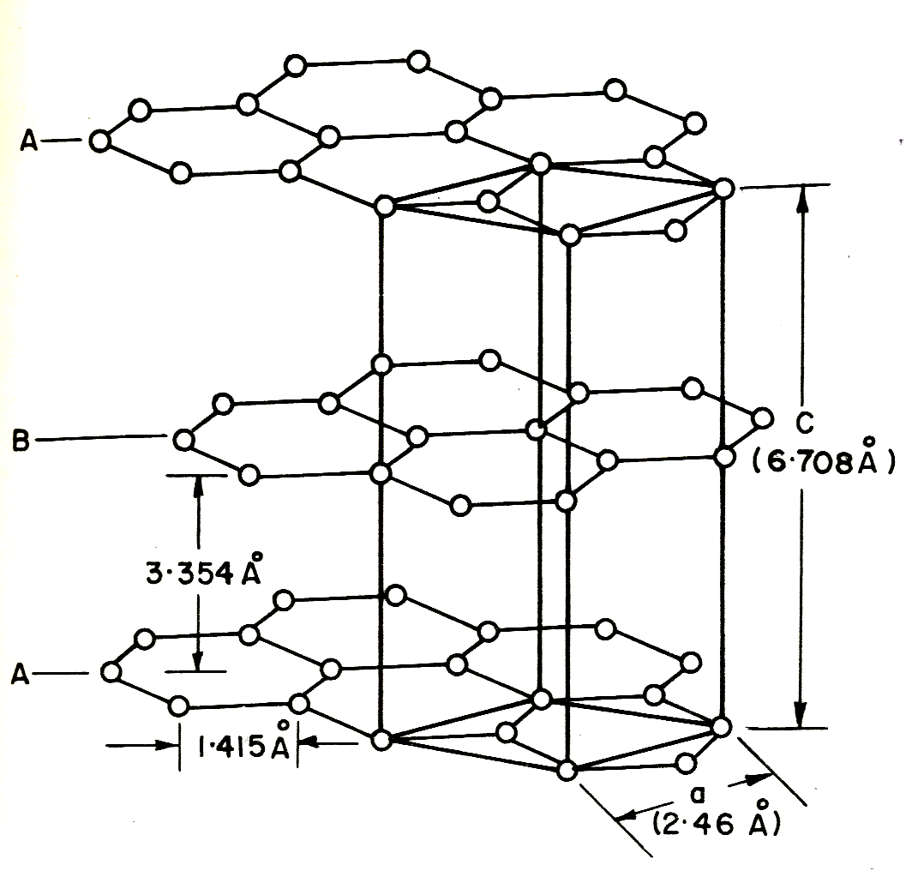
Fig. 2 Structure of Ideal graphite

A less frequently occurring structure is rhombohedral with ABC ABC … … stacking arrangement in which the atoms of every fourth layer align with each other [6,7]. This rhombohedral form, which occurs only in conjunction with hexagonal form, is less stable, and converts to the hexagonal form irreversibly at 2100 °C [8]. The bond energy between planes is 17 KJ mole⁻¹ and within planes is 477 KJ mole⁻¹. Graphite sublimes at a temperature of 3640 ± 25 °K at atmospheric pressure. However, it may be made to melt under a pressure of 125 ± 15 atmosphere at a temperature of 4020 ± 50 °K [9–13]. This temperature of about 4000 °K has been moved to about 5000 °K by way of more accurate measurements [14].

1.2.3 STRUCTURE OF FULLERENES
Fullerenes represent the third allotropic crystalline form of the element Carbon, referring to a new class of discrete molecules. C₆₀ molecule was first reported by Kroto et al. in 1985 in the mass spectrum of laser-ablated graphite [15]. Five years later, in 1990, W. Kratschmer et al. reported evidences for the presence of C₆₀ in a sample of carbon dust prepared from vaporized graphite [16] and they were able to isolate macroscopic quantities of C₆₀ and C₇₀ [17] molecules. Fullerenes can be considered as networks of pentagons and hexagons. Such molecules invariably have twelve pentagons in order to close into a spheroid although the number of hexagons varies widely. Examples of Fullerenes are C₆₀, C₇₀ and C₂₄₀ molecules. The C₆₀ molecule contains 20 hexagons. It is the roundest of all fullerene molecules and its structure is shown in Fig 3. Its stability can be explained by the molecular structure having perfect symmetry of a soccer ball. Fullerene molecules can be used to combine with free radicals, as it forms weak bonds at each of its junctions, which can be used someday in the fight against cancer. This molecule again shows a fractal patterning in this natural structure.

Fig. 3 Structure of C₆₀ fullerene molecule

1.2.4 STRUCTURE OF CARBON NANOTUBES

In 1991, Iijima [18] discovered a cylindrical form of the ‘bucky ball’, known as a carbon nanotube. (Fig. 4). Nanotubes fall into two broad classes – multiwall and single wall. Carbon nanotubes are unique tubular structures of nanometer diameter and large length-to-diameter (aspect) ratio. The nanotubes may consist of one up to tens and hundreds of concentric shells of carbon atoms with adjacent shells separation of ~ 0.34 nm. The carbon network of the shells is closely related to the honeycomb arrangement of the carbon atoms in the graphite sheets. The amazing mechanical and electronic properties of the nanotubes stem in their quasi-one-dimensional (1D) structure and the graphite-like arrangement of the carbon atoms in the shells. Thus, the nanotubes have high Young’s modulus and tensile strength, which makes them preferable for composite materials with improved mechanical properties. The nanotubes can be metallic or semiconducting depending on their structural parameters.

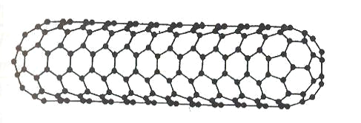
Fig. 4 Structure of carbon nanotubes

1.2.5 ELECTRICAL AND THERMAL PROPERTIES OF GRAPHITE SINGLE CRYSTAL
Since there is pronounced difference in bonding within the layers, the thermal and electrical properties of graphite are highly anisotropic [19, 20]. Along the layer planes, at the room temperature, resistivity is about 4 x 10⁻⁵ Ωcm⁻¹ [21], whereas across the layer planes, resistivity values vary from1 Ωcm⁻¹ [22] to 4 x 10⁻³ Ωcm⁻¹ [21]. Thus, the anisotropic ratio of electrical resistivity is at least 100. The room temperature values of thermal conductivity of the graphite crystal have been measured to be around 400 and 80 W/mK, respectively, in the direction parallel and perpendicular to the layer planes [20]. The anisotropic ratio of thermal conductivity is, therefore 5.

1.3 MANUFACTURE OF CONVENTIONAL CARBONS
As the graphite-liquid-gas triple point of the element carbon is close to 4020 °K at a pressure of 125 atmospheres, the process of melting and casting normally used with metals is inapplicable to carbon. Consequently, the bulk of carbon and graphite products are manufactured by a process analogous to the powder metallurgy. The conventional carbon products are, therefore, generally manufactured by kneading a carbonaceous filler material such as petroleum coke, pitch coke, metallurgical coke, anthracite coal, carbon black or natural graphite with a carbonaceous binder material, for example, coal tar pitch. The mixture after being molded or extruded into a product of desired shape and size is carbonised in an inert or non-oxidizing atmosphere to a temperature of 1000 °C or higher. Products in this form are widely used. However, for many applications, such a carbon product is further heat-treated to a temperature of about 2500 °C (Fig. 5) to convert it into a so-called ‘graphite’ product. For some applications, the baked carbon is impregnated with a suitable impregnating-grade coal tar pitch to densify it, which is then re-carbonized. This process of impregnation re-carbonization is repeated several times, after which the product is graphitized to 2500 °C or so to obtain the final densified graphite. Such a product has high density, coupled with high mechanical strength, low porosity, and other improved characteristics. The various technological aspects in the manufacture of carbon and graphite products have been described in details by Mantell, Liggett, Marsh et al. and others [23–27].

COKE (FILLER)

PITCH
(BINDER)

MIXTURE

Pulverization & Shaping

GREEN

PRODUCT

Carbonization
(HTT ~ 1000 °C)
Impregnation
(several cycles)

CARBON

PRODUCT

Graphitization
(HTT ~ 2700 °C)

GRAPHITE

Fig. 5 Flow diagram of the process for the manufacture of conventional graphite
products
1.3.1 TERMINOLOGY IN CARBON AND GRAPHITE INDUSTRY
As is the case in many other industries, the ‘carbon and graphite’ industry also has a language of its own. The term ‘carbon’, ‘amorphous carbon’, baked ‘carbon’ or ‘manufactured carbon’ are used by the industry to mean products made from the mixtures of suitable carbonaceous filler and binder materials, which have been baked to a temperature of 900–1800 °C. The term ‘green carbon’ refers to the formed carbonaceous product prior to the baking operation. The terms ‘graphite’, ‘electrographite’, ‘synthetic graphite’ or ‘industrial graphite’ refer to a product obtained from the heat-treatment of the baked carbon to a temperature of 2500 °C or higher.
However, the International Committee on Characterization and Nomenclature of Carbon has reviewed the scope of the terms ‘carbon’ and ‘graphite’ [28]. According to this committee, the term ‘carbon’ refers to the materials possessing an atomic C/H ratio of at least 10 and the term ‘graphite’ refers to such carbons, which have acquired the near-ideal structure of graphite. The term ‘carbon’ thus comprises all types of cokes and electrographite, all types of polycrystalline carbons and graphites, all types of activated carbons, all types of carbon blacks and all natural graphites etc., among the common varieties. Special varieties of carbon have increased in number in recent years and include pyrolytic graphite, graphite foils and felts, all types of carbon fibres, glass-like carbon as well as high density - high strength -isotropic graphite.

1.3.2 PHYSICAL STRUCTURE OF CARBON PRODUCTS
Carbons are composed of a large number of groups of graphite-like layers (crystallites) together with a certain proportion of disorganized carbon atoms [29]. The graphite-like layers in a group though held parallel, lack the stacking order because of their finite size. The average crystallite size in carbons varies widely, all the way from a low value of 1 nm for some carbon blacks and activated carbons to a value as high as 1 cm for some special synthetic graphite.

1.3.3 ELECTRICAL AND THERMAL PROPERTIES OF CARBON PRODUCTS
Typical room-temperatures values of electrical resistivity and thermal conductivity parallel to the extrusion direction in baked carbon products (with total porosity of about 25%) are 5 x 10⁻³ Ω cm and 4 W/mK, respectively. Upon graphitization at about 2600 °C, a carbon product of similar porosity has typical electrical resistivity of 7 x 10⁻⁴ Ω cm and 9 x 10⁻⁴ Ω cm in directions parallel and perpendicular, respectively, to the direction of extrusion. The anisotropy of electrical resistivity is thus only 1.3 compared to 100 in single crystal graphite. The comparable graphitised carbon products have typical thermal conductivity values of 230 and 140 W/mK in parallel and perpendicular directions, respectively. The anisotropy of thermal conductivity is 1.6 compared to 5 for a single crystal. Inspite the decrease in anisotropy in properties of carbon products compared to graphite single crystals has been attributed primarily to the resistance to electron and heat flow by the binder carbon bridges between the filler particles [30].
The properties of carbon materials can be altered or tailor-made by changing various production conditions such as, raw materials, size of blend particles, method of forming, and conditions of baking and graphitization, so as to make them acceptable to a broad range of applications in analytical, mechanical, electronics, aerospace, nuclear and other industries.

HIGH DENSITY- HIGH STRENGTH-ISOTROPIC GRAPHITE

High density - high strength - isotropic graphite (HD-HS-IG) is a recent addition to the family of carbon products. It is, in fact, a high purity graphite possessing a bulk density of more than 1.8 g/cm³, bending strength of more than 60 MPa, degree of anisotropy of 0.9 – 1.1, along with a homogeneous and fine microstructure. Its potential applications include electric discharge machine electrodes, electrical brushes and contacts, trolley wheels, heaters, crucibles, seals, bearings, packings, jigs, hot-pressing dies, nuclear moderator and shield, rocket nozzles, moulds for continuous casting of metals and alloys etc. This graphite was being imported from advanced countries costing India a huge amount annually in foreign exchange.

There are three methods known for the production of such high density- high strength isotropic graphite
First method involves the use of two raw materials i.e. coke filler and a pitch binder, whereas the other two involve the use of self-sintering single but different raw materials, namely, mesocarbon micro beads (MCMB) or raw (green) coke. In the first method, the filler such as coke is kneaded with coal tar pitch binder to obtain mixture which is isostatically pressed and carbonized to 1000°C, followed by repeated cycles of impregnation and re-carbonization to 1000°C or higher to 1300°C and finally heated to around 2700°C, if required. This typical process often results in a porous, low density (1.75-1.80 g cm⁻³ ), low bending strength (300-400 Kg cm⁻² ) product. This is due to pores in the filler coke particles, spaces (voids) among filler coke particles, the formation of the voids by the evolution of volatile products of the binder and the impregnating pitches and the formation of fine cracks by differing dimensional changes of the filler and the binder during the heat-treatment.
In the second method, mesophase (liquid crystalline) spherules of size 5-15 microns are formed in special coal tar pitch by suitable heat treatment, which is then separated out by solvent extraction with a suitable solvent. These self-sintering spherules, called MCMB, are molded into a product without any external binder. The product is heat treated to 1000°C or higher in an inert atmosphere to obtain a high density (1.85-1.90 g cm⁻³ ), high bending strength (600-900 Kg cm⁻²) carbon product.

In the third method, a suitable coal tar pitch is carbonized to a temperature of 500°C to obtain raw or green coke which is molded into a block and carbonized to 1000°C or higher to get high density (1.85-1.90 g cm⁻³ ), high bending strength (600-900 Kg cm⁻²) carbon product.

It may be mentioned that the processing details for the development of high density-high strength carbon products are not available in the literature. However both the last two methods mentioned above have been attempted in India at the National Physical Laboratory for the development of high density-high strength carbon product.

1.7 SCOPE OF THE PRESENT INVESTIGATIONS
Carbon is a very fascinating material as it exhibits a unique combination of physical, chemical, mechanical, metallurgical, electrical, thermal and nuclear properties. Carbon and graphite products, in one form or the other, form an important part of our day-to-day life. Graphite electrodes for the steel industry, carbon anodes and cathodes for the aluminum industry, carbon lining for the electrolytic cell in the production of caustic soda, calcium carbide etc., carbon brushes for the electric motors and generators, carbon granules for the telephone receiver sets, carbon crucibles for the melting of metals and alloys, carbon seals and bearings for mechanical applications, nose-cones and nozzle inserts for missiles and rockets, leading edges and brake pads for military and advanced civilian aircrafts, and moderator and reflector for nuclear reactors, activated carbons for purification of water for pollution control are some of the examples showing the vast applications of carbon and graphite. In fact, carbon and graphite products form indispensable components of almost all major, and thus act as the backbone of the industrialization of a country. During the last two three decades, because if a spurt in the advancement of technological development, the need of carbon / graphite materials had been felt much more than ever before, and as a result, several newer advanced carbon or carbon-based products were invented. Carbon fibres, carbon fibre based composites, glassy carbon, high density - high strength - isotropic graphite (HD - HS - IG), high thermal conductivity graphite, carbon-ceramic composites, fullerenes, nanotubes are examples of some such products. However, a search of literature reveals that though a lot of information is available about the characteristics and applications of these newer products, not much is reported about their developmental aspects. In view of this, under the present investigation, attempt was made to develop a pitch based carbon product, namely, high-density- high strength- isotropic graphite (HD - HS – IG). It is, in fact, a high purity graphite possessing a bulk density of more than 1.8 g/cm³, bending strength of more than 60 MPa, degree of anisotropy of 0.9 – 1.1, along with a homogeneous and fine microstructure.
.It has already been mentioned that potential applications of high density - high strength –isotropic graphite include electric discharge machine electrodes, electrical brushes and contacts, trolley wheels, heaters, crucibles, seals, bearings, packings, jigs, hot-pressing dies, nuclear moderator and shield, rocket nozzles, moulds for continuous casting of metals and alloys etc. This graphite is being imported from advanced countries costing India a huge amount annually in foreign exchange. Some specialized applications such as mechanical face seals, bearings, segmented seals, piston rings, thrust washers and bushes for use in different systems of aircraft in general require a high density isotropic high bending/compressive strength besides higher temperature stability. As a matter of fact, such special graphite seals can be used for twin-spool rotor bearing system of aero gas turbine engine seals for gearbox assembly and bearings & piston rings for shut off valve assembly for aerospace applications. This material is not presently being produced in India and is imported from advanced countries thereby costing our country large amount of foreign exchange.
The Aim of the present project is to develop and characterize high-density -high strength isotropic graphite of the following specifications, which has wide range of applications.

The Characteristics of the special – graphite (HD-HS-IG) to be developed

Characteristics Values
Bulk density (g cm⁻³) 1.85-1.90
Hardness Scleroscope 75-85
Electrical Resistivity (mΩcm) 1-2
Compressive strength (MPa) 130-170
Bending strength ( MPa) 70-90
Coeff. of thermal expansion (10⁻⁶/K) 4.7
Thermal conductivity (W/mK) 100

CHAPTER-2
EXPERIMENTAL
The experimental techniques used in carrying out the present investigations can be broadly divided (i) Experimental techniques used for the characterization (ii) Experimental techniques used for the processing and characterization of green, carbonized and graphitized products, as described in the following sub-sections:

2.1 EXPERIMENTAL TECHNIQUES USED FOR CHARACTERISATION
The following are the methods for the characterization of coal tar pitches, and green cokes –

2.1.1 DETERMINATION OF SOFTENING POINT (SP)

The softening point of the pitches was measured either by the Ring and Ball Method, in accordance with ASTM-D-2398 specifications, or by the Mettler Method, as per the ASTM-D-3104 / DIN 51920 specifications. The same are described in the following sub-sections.

2.1.1 (a) DETERMINATION OF RING AND BALL SOFTENING POINT

The Ring and Ball softening point is defined as the temperature at which a disc of the sample held within a horizontal ring is forced downward a distance of 2.54 cm under the specific weight of a steel ball, as the sample is heated at a prescribed rate in water or glycerin bath. It covers a softening point range of 30–230 °C.
A portion of the sample is heated until it has become sufficiently liquid to pour, the temperature to be raised by no more than 75 °C above the anticipated softening point. The sample is poured into two rings preheated to the pouring temperature. While filling, the rings should rest on an amalgamated brass plate. After cooling to room temperature, the excess material is trimmed off with a heated spatula or knife. Should it be necessary to repeat the process, a fresh sample and clean rings are mandatory. Centering guides are used to place the balls on the specimen, and the assembly is placed in a bath filled with distilled water or glycerin, to a depth of not less than 10 cm and not more than 10.6 cm. The temperature of bath is maintained at 5°C for 15 minutes. The temperature is raised at 5 ± 0.5 °C / min. The temperature observed at the instant the sample surrounding the ball touches the bottom plate, placed 2.54 cm below the ring holder, and is recorded as the softening point. If the difference between the values obtained for the two specimens exceeds 1°C, the test should be repeated.

2.1.1 (b) DETERMINATION OF METTLER SOFTENING POINT

The Mettler Softening Point of a material is defined as the temperature at which a softened sample of the material, taken in a standard softening point sample cup, flows 20 mm out of 6.35 mm diameter opening, on slow heating. The Mettler Softening Point Apparatus consists of a Cartridge Assembly comprising a Cup Holder and a Cylindrical Sample Cup with 6.35 mm diameter orifice and a collector sleeve, which is placed in a Measuring Cell (FP 83) surrounded by a small electrically-heated cylindrical furnace, as schematically shown in Fig. 6.

The test material, taken in the sample cup placed over the cup holder in the cartridge assembly, is heated in the Measuring Cell inside the electric furnace at a rate of 2 °C / min. The temperature at which the first drop of the sample obstructs the light beam placed 20 mm apart from the bottom of the sample is detected by a photoelectric sensor kept inside the Measuring Cell, and displayed on the Central Processing Unit (FP 90) of the Mettler Softening Point Apparatus, as the softening point of the test material.

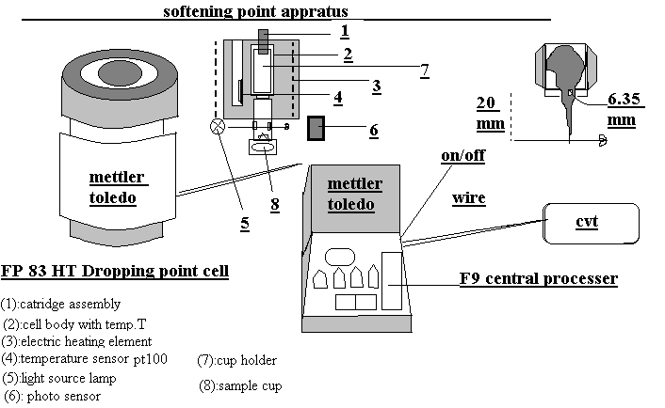

Fig. 6 Schematic diagram of Mettler softening point apparatus.

2.1.1.2 DETERMINATION OF COKING VALUE (CV)
A sample of the pitch is pyrolysed for a specific time at a specified temperature in equipment that limits the oxygen supply. A 1–2 g of sample of the dried pitch is weighed in a quartz crucible and placed in a quartz glass or stainless steel reaction vessel having a provision for flowing of high purity nitrogen gas. The quartz assembly is then placed in an electrical muffle furnace, the temperature of which is gradually raised to 950 °C at a rate of 200 °C / h and maintained at 950 °C for 30 minutes and then cooled to room temperature. The crucible is then weighed to get the weight of the coke. From these observations, the coking value is calculated as the residue percent weight of the sample taken.

2.1.1.3 DETERMINATION OF ASH CONTENT
The amount of sample to be ashed depends upon the anticipated ash content of the material and any subsequent analysis to be conducted on the ash. A minimum of 10 mg of ash is generally required. A suitable quantity of the representative dried sample is weighed out in an ignited crucible (porcelain, silica, or platinum) on an analytical balance. The crucible is then carefully heated in an electrical muffle furnace to 950°C for 30 minutes. When all the carbon has been combusted, the crucible is cooled and weighed again. The ignition at 950 °C is repeated until a constant weight is obtained. From these observations, the ash content is calculated as the residue percent weight of the sample taken.

2.1.1.4 DETERMINATION OF QUINOLINE INSOLUBLE CONTENT (QI)
To determine the quinoline insoluble content of a pitch, about 1 g of the sample is digested with 30 ml of the distilled quinoline at 70 °C for half an hour. The pitch, is first crushed, ground and sieved to obtain a (–30 B.S. mesh) powder, which is then used for the sample. It is then rapidly filtered with suction in a grade-4 sintered glass crucible. The residue is then washed with small portions of toluene and acetone successively, after which the crucible is dried at 110 °C in a drying oven. After cooling, it is weighed to get the quinoline insoluble content.

2.1.1.5 DETERMINATION OF TOLUENE INSOLUBLE CONTENT (TI)
To determine the toluene insoluble content of a pitch, about 1 g of the sample is accurately weighed and digested with 30 ml of toluene at 90–100 °C for half an hour. The material is first crushed, ground and sieved to obtain a (–30 B.S. mesh) powder, which is then used for the sample. It is then rapidly filtered with suction in a grade-4 sintered glass crucible and subsequently washed with small portions of acetone. The crucible is then dried at 110 °C in an oven. After cooling, it is weighed to get the toluene insoluble content.
      - DETERMINATION OF SPECIFIC GRAVITY (SG)

A thin synthetic fibre from an analytical balance and its weights suspends a fragment weighing 5–20 g of the pitch; both in air and in distilled water, at a particular temperature are determined. The specific gravity is then calculated from the relationship,

Specific gravity = a / (a–b)

Where, a and b are the weights of the specimen in air and in distilled water, respectively.

2.1.1.7 DETERMINATION OF KEROSENE DENSITY (KD)

An oven-dried specific gravity bottle is weighed and filled with pure distilled water and then weighed. This procedure is repeated with the kerosene oil. The ratio of the weight of kerosene oil to the weight of distilled water multiplied by the density of distilled water at room temperature gives the density of kerosene oil used. An oven-dried sample of the carbon material in the powder form (~ 200 B.S. meshes) is introduced into a weighed specific gravity bottle, which is then weighed again. The bottle is then partially filled with kerosene oil such that the sample dips well into the oil. The unstoppered bottle is then placed in a vacuum desiccator and evacuation is started with the help of a vacuum pump and is continued until no air bubbles are observed in the bottle. The remaining space is then filled with kerosene oil upto the full capacity and then weighed. The kerosene density of the material is then calculated by the following expressions:

Kerosene density = (W/w) x δ

Where, W = weight of the sample
w = weight of the kerosene oil displaced by the sample
δ = density of kerosene oil

2.1.2 EXPERIMENTAL TECHNIQUES USED FOR PROCESSING
The commercially available coal tars are obtained by the destructive distillation of metallurgical coals by the steel industry. These coal tars invariably contain quinoline insolubles (QI) consisting of soot-like fine particles formed by the thermal cracking of tar vapours, besides the entrained particles of coal and coke. Since coal tar pitches are residues obtained in the distillation of such coal tars, these very QI-particles are found in the resulting pitches also. The commercially available coal tar pitches normally contain QI in the range of 4–15%. This makes these pitches unsuitable as precursor for the development of high density - high strength - isotropic graphite, or high thermal conductivity graphite, or carbon-ceramic composites. Therefore, the removal of these QI-particles from the commercially available binder-grade coal tar pitches was essential.

2.1.2.1 PROCESSING OF BINDER-GRADE COAL TAR PITCH (CTP) INTO A QI-FREE PITCH

A novel, cost-effective and simple process to remove the QI-particles, developed by the Bhatia et. el, was made use of in the present work. It comprises heating of a commercial coal tar pitch in the presence of a mixture of suitable inexpensive commercial grade solvents in a requisite proportion (1:1 by weight). This treatment results in the fast precipitation of the QI-particles into a separable mass. A simple separating device easily removes this QI-mass and the QI-free pitch solution is distilled to recover the mixture of solvents and obtain the QI-free coal tar pitch. The flow diagram of this process is shown in Fig. 7.

AROMATIC COAL TAR ALIPHATIC
SOLVENT PITCH SOLVENT

MIXING
at 80–180 °C

SOAKING
at 40–80 °C

QI–FREE PITCH–SOLVENT QI– MASS SOLUTION

DISTILLATION
Under reduced pressure
at 150–300 °C

QI–FREE
IMPREGNATING
PITCH

Fig. 7 Flow diagram of the process for the production of QI-free coal tar pitch.
2.1.2.2 PROCESSING OF A QI-FREE COAL TAR PITCH INTO A HIGH SOFTENING POINT / INTERMEDIATE PITCH
The processing of coal tar pitch was carried out at suitable temperatures in an inert atmosphere of nitrogen and / or under a reduced atmospheric pressure. The experimental set-up, specially designed and developed for this purpose at the NPL, is shown in Fig. 8. A suitable quantity of QI-free coal tar pitch (as discussed in section 2.1.2.1) was taken in the flask and heated on a heating mantle with the help of a precision temperature controller to a temperature in the range of 370–450 °C in an inert atmosphere of nitrogen gas or under reduced atmospheric pressure conditions to facilitate polymerization and condensation reactions between the various molecular species to take place, as well as to allow the relatively low molecular weight compounds to escape. This heat-treatment results in the residual material exhibiting a high softening point (150-200 °C), along with high values of TI (40–55%) and coking value (60–75%).
The intermediate pitch (for green coke) was produced from the QI-free coal tar pitch (QI < 0.4%) by the thermal treatment of the pitch in an inert atmosphere using the same experimental set-up as used for the preparation of the high softening point pitch (Fig. 8). About 4 kg of the QI- free coal tar pitch was heated on a heating mantle with the help of a precision temperature controller to a temperature of ~430 °C for a period of ~4 h in an inert atmosphere to facilitate the polymerization and condensation reactions between the various molecular species of the pitch to take place, as well as to allow the low molecular weight components to escape. The typical heat-treatment yield of the coal tar pitch is in the range of 70-80%.

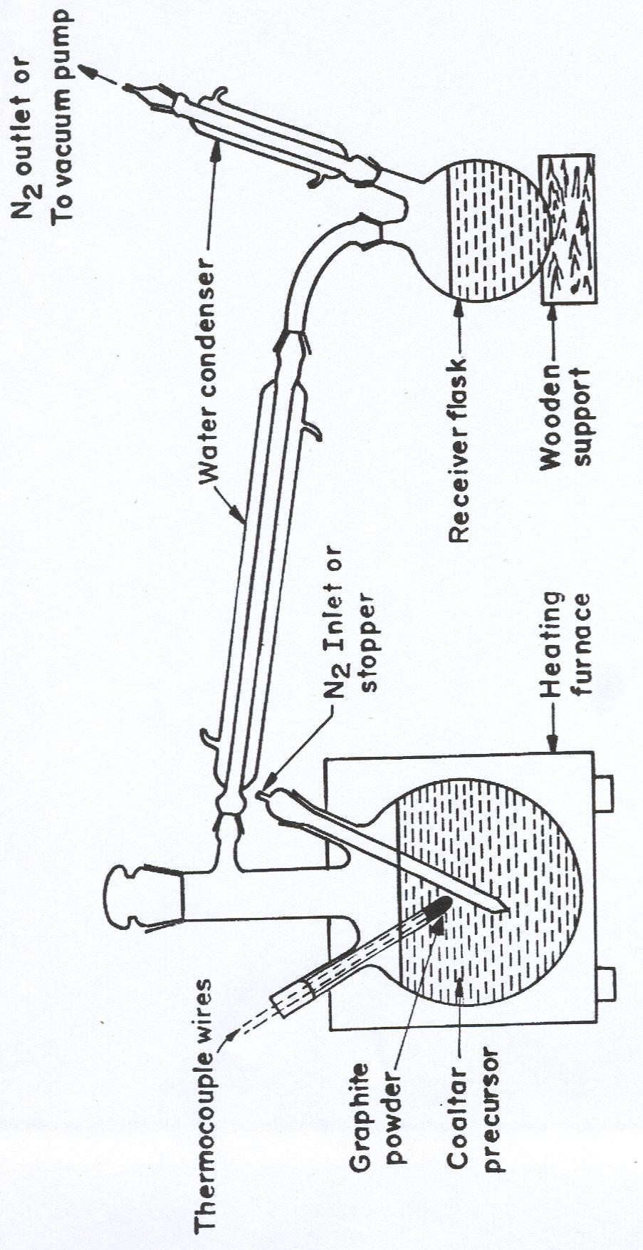
Fig: 8 Pitch Distillation assembly
2.1.2.3 PROCESSING OF THE INTERMEDIATE PITCH INTO A GREEN COKE
About 200–300 g portion of the intermediate pitch was taken in a stainless steel boat, which was placed inside a stainless steel reaction vessel having a provision for flow of an inert gas (nitrogen) into it. The reaction vessel containing the sample was kept in an electrically-operated muffle furnace which was gradually heated to the desired temperature in the range of 450–550 °C with the help of a microprocessor-based programmable temperature controller for a period of 1–5 h, while maintaining a flow of nitrogen gas inside the reaction vessel. The rate of heating is adjusted so as to allow the polymerization and dehydrogenative condensation reactions between the molecules to take place. During this heat-treatment low / medium molecular weight components as well as various reaction products are eliminated as volatiles and the pitch solidifies to coke, called as the 'green coke'. This green coke was then taken out of the boat for further processing.

2.3 EXPERIMENTAL TECHNIQUES USED FOR THE PROCESSING OF GREEN COKE AND CHARACTERISATION OF GREEN, CARBONIZED AND GRAPHITIZED PRODUCTS THERE FROM

The green coke obtained from the intermediate pitch (section 2.1.2.3) was first pulverized into a fine powder, which was moulded into a desired product. This product was then carbonized and subsequently graphitized to obtain the final product.

2.3.1 EXPERIMENTAL TECHNIQUES USED FOR PROCESSING

The experimental techniques used for the processing of green coke into the final product are discussed in the following sub-sections:

2.3.1.1 PULVERISATION OF THE GREEN COKE INTO A FINE POWDER

The green coke is first ground into mm size using pestle and mortar or an edge-runner grinder. It is then wet-ground into a fine powder using a centrifugal ball-mill having the jar (bowl-type) and the balls both made up of 99.9% pure alumina. The jar is rotated at a r.p.m. of 250–300 in the centrifugal ball-mill for a period of ~8 h so as to obtain the green coke powder having a mean size of around 7–8 µm . The material is then taken out of the jar and is characterized for quinoline and toluene insoluble contents and coking value.

2.3.1.2 MOULDING OF THE GREEN COKE POWDER (WITH OR WITHOUT ADDITIVES) INTO A (GREEN) PRODUCT

About 6 g of the fine green coke powder, with or without an additive, such as natural graphite was moulded (pressed) at room temperature into rectangular plates of size 60 mm x 20 mm x 4 mm, using a chrome-steel die on a conventional hydraulic press at a pressure of around 200 MPa. For isostatic moulding, the green coke powder / mixture was taken in a cylindrical rubber mould, which was then evacuated. This mould was mounted in a cold press and pressed isostatically under a pressure of 200 MPa to obtain a cylindrical block of diameter 40–60 mm and height 60–100 mm. The green plates or blocks, obtained in this manner, were measured for their mass and dimensions to obtain their green density.

2.3.1.3 CARBONIZATION (HTT~I000 °C) OF THE GREEN PRODUCT TO OBTAIN A BAKED CARBON PRODUCT

The green carbon plates or blocks were packed in a graphite or stainless steel boat using a high-purity graphite powder as the packing material. The boat was then loaded in a quartz tube or stainless steel reaction vessel having a provision for the flow of an inert gas such as high-purity nitrogen. The reaction vessel containing the samples was placed inside a muffle furnace which was electrically heated to ~l000 °C using a high-precision programmable temperature controller. The heating was done at a suitable rate with respect to the size of green carbon product, so as to eliminate the formation of any cracks in the baked carbons due to the fast evolution of volatiles during the baking. The broad range of heating rates employed during the carbonisation of the green products is as follows:

Heating schedule –
Room temperature – 400 °C = 20–90 °C / h
400 – 700 °C = 10–60 °C / h
700 – l000 °C = 20–90 °C / h
Cooling schedule –
1000 – 50 °C = 200 °C / h

The baked products (plates or blocks) were again measured for their mass and dimensions to determine their apparent baked density. These products were also characterized for other properties like electrical resistivity, bending strength and shore hardness. Some of the products were subjected to a further heat-treatment to a higher temperature of ≥ 2500 °C, i.e., graphitization.
2.3.1.4 GRAPHITIZATION (HTT ≥ 2500 °C) OF THE BAKED CARBON PRODUCT TO OBTAIN THE FINAL GRAPHITIZED PRODUCT

The baked carbons (HTT~1000 °C) were kept in a graphite boat and then heated to ≥ 2500°C or higher in a graphite tube furnace having a provision for the flow of high-purity nitrogen or argon gas. The temperature of the graphite tube furnace was controlled with the help of a precision microprocessor-based temperature programmer. The rate of heating followed during the graphitization of the samples is as given below:

Room Temperature – 900 °C = 600 °C / h
900– l000 °C = 120 °C / h
1500– 2500 °C = 300 °C / h
At 2500 °C = Constant – 0.5 h

The graphitized products are then taken out of the furnace and subjected to characterization with respect to various properties such as bulk density, kerosene density, electrical resistivity, ash content, bending strength, shore hardness, open porosity, thermal expansion, thermal conductivity and microstructure etc., as per the methods described in the following section 2.3.2.

2.3.2 EXPERIMENTAL TECHNIQUES USED FOR CHARACTERIZATION

The characterization of the green or carbonized (HTT~1000 °C) or graphitized (HTT ≥ 2500°C) product was done with respect to apparent (bulk) density, weight loss, linear and volume shrinkages, specific gravity, kerosene density, open porosity, ash content, electrical resistivity, bending strength, Shore hardness, and optical / scanning electron microscopy, as per the procedures described in the following sub-sections.

2.3.2.1 DETERMINATION OF APPARENT / BULK DENSITY
The apparent (bulk) density of a green carbonized or graphitized product is determined from the measurements of its mass and dimensions as the ratio of its mass to its volume.

2.3.2.2 DETERMINATION OF WEIGHT LOSS (WL)
The weight loss in a green carbon upon carbonization (HTT ~1000 °C) or graphitization (HTT ≥ 2500 °C) is obtained by the following expression: -

Weight loss (%) = [w/W] x 100

Where, W = weight of the green carbon, and
w = reduction in weight of the green carbon upon carbonization / graphitization.

2.3.2.3 DETERMINATION OF VOLUME SHRINKAGE (VS)
The volume shrinkage in a green carbon upon carbonization (HTT=1000 °C) or graphitization (HTT=2500°C) is determined knowing the volumes of the green carbon in the green and carbonized/ graphitized states. It is given by the expression:

Volume shrinkage (%) = (v/V) x 100

Where; V = volume of the green carbon, and
v = reduction in volume of the green carbon upon carbonization /
Graphitization.

2.3.2.4 DETERMINATION OF LINEAR SHRINKAGE (LS)
The linear shrinkage in a green carbon upon carbonization (HTT~1000 °C) or graphitisation (HTT~2500°C) is determined knowing the lengths of the carbon in the green and carbonized / graphitized states. It is given by the expression:

Linear shrinkage (%) = (l/L) x 100

Where, L = length of the green carbon, and
l = reduction in length of the green carbon upon
Carbonization / Graphitization.

2.3.2.5 DETERMINATION OF SPECIFIC GRAVITY (SG)
The specific gravity of the products (carbonized as well as graphitized) was done in the same manner as described in section 2.1.1.6.

2.3.2.6 DETERMINATION OF KEROSENE DENSITY (KD)
The kerosene density of the products (carbonized as well as graphitized) was done in the same manner as described in section 2.1.1.7.

2.3.2.7 DETERMINATION OF OPEN POROSITY (OP)
The open porosity in a carbon sample is obtained by the following expression:

Open porosity (%) = (1 – A.D. / K.D.) x 100

Where, A.D. = apparent density
K.D. = kerosene density

2.3.2.8 DETERMINATION OF ASH CONTENT

The ash content of the products (carbonized as well as graphitized) was done in the same manner as described in section 2.1.1.3.

2.3.2.9 DETERMINATION OF ELECTRICAL RESISTIVITY (ER)

The electrical resistivity of the specimen of a carbonized or graphitized product is determined by passing a suitable current across the cross-section of the specimen placed between two thick copper or brass plates and measuring the potential drop across a known distance along the length of the specimen with the help of a micro voltmeter using two probes. The electrical resistivity is then easily obtained from the following equation:

P = (V / I x A/L)

Where, P = resistivity of the test-specimen (Ohm cm)
V = potential drop across the probe pins (volt)
A = area of cross-section of test-specimen (cm²)
I = magnitude of d. c. current (Ampere)
L = distance between the probe pins (cm)

2.3.2.10 DETERMINATION OF BENDING STRENGTH (BS)
The Instron Universal Testing Machine, Model 4411, was used to determine the bending strength of the carbonized or graphitized products. The test-specimen is kept on two knife edges to hold the specimen tightly. A slowly increasing load is applied on the specimen at a cross-head speed of 0.5 mm/min through the middle knife edge till the specimen breaks. Stresses so developed in the test are measured with the help of a load cell and recorded on a chart. The vertical movement of the chart corresponds to the deflection in the specimen. Thus, a load versus deflection plot of the specimen is obtained. The bending strength is then calculated as follows:

Bending strength = (3 P_{max} . S) / (2 b t²)

Where,
P_{max} = maximum load at which the test-specimen breaks,
S = Span length (usually 30 mm),
b = width of the test-specimen, and
t = thickness of the test-specimen.

2.3.2.1 DETERMINATION OF YOUNG' S MODULUS (YM)
The Young's modulus is determined from the load versus deflection plot of the test-specimen as obtained in the bending strength measurement of the product on the Instron Universal Testing Machine, Model 4411. The Young's modulus is calculated from the following expression:

Young's modulus = [S³ / (4 b t³)] x p/d

Where, S = Span length
b = breadth of the test-specimen,
t = thickness of the test-specimen, and
p/d = slope of initial straight line portion of load- deflection curve.

2.3.2.12 DETERMINATION OF SHORE HARDNESS (SH)
The measurement of hardness is of significant importance in several applications of carbon and graphite. The hardness was measured using a Shore's Scleroscope (made by Coats Machine Tools Co. Ltd., London), which is based on the dynamic rebound testing. In Shore's sclerscope, a diamond-tipped hammer falls from a fixed height on the polished surface of the specimen. The rebound height of the hammer gives a measure of the hardness of the specimen. For the measurement of Shore's hardness, the specimen surface may be polished with a medium grit emery paper.

2.3.2.13 EXAMINATION OF MICROSTRUCTURE BY OPTICAL MICROSCOPY
The optical microscopic examination of the sample was done on the Leitz Mettaloplane Optical Microscope. The first step in the microscopic examination was the preparation of the sample, which was done in the following manner.
The test material was taken in a cylindrical plastic or glass capsule (approx. 25 mm diameter and 15 mm height), and a freshly prepared epoxy or polyester resin is poured over the material such that it just covers the specimen. After the resin has partially set, more of it was poured over the specimen to fill the capsule completely. The whole system was allowed to stand at room temperature till the resin was completely set. The mounted specimen was then removed from the plastic capsule and its surface was first ground manually on a silicon carbide waterproof cloth with grit size varying successively from 200 to 800, using tap water. Subsequently, the mounted specimen was polished on a lapping machine using alumina powders of size varying from 1 µm down to 0.05 µm, after which the sample was washed under tap water and finally in an ultrasonic cleaner using water to remove off any sticking alumina particles. The mounted specimen was then dried in air to make it ready for the microscopic examination. The specimen was observed for the microstructure under crossed polarizer and a photograph of the microstructure (micrograph) was obtained using the camera attached to the microscope.

CHAPTER- 3

DEVELOPMENT OF PITCH BASED CARBON COMPOSITES

3.1 Introduction
Carbon and graphite manufacture is a worldwide industry which is growing up rapidly because of the increasing interest being taken in this material by scientists and technologists both. This is because of the fact that this material exhibits a unique combination of physical, chemical, mechanical, electrical, thermal and nuclear properties. Carbon and graphite products, in one form or the other, are extensively used by almost all industries, major or minor. In fact, these products form an important part of our day-to-day life. The carbon products are usually manufactured by kneading carbonaceous filler material such as petroleum coke, pitch coke, lamp black or carbon black, natural graphite etc. with a carbonaceous binder material, for example coal tar pitch. The mixture after being moulded or extruded into a product of desired shape and size is pyrolysed in a inert atmosphere to a temperature of 1000°C or upto 1400°C and finally to 2500°C if required, to convert it into the graphite product.
It has already been mentioned that there are three methods known for the production of high density- high strength isotropic graphite. First method involves the use of two raw materials i.e. coke filler and a pitch binder, whereas the other two involve the use of self-sintering single but different raw materials, namely, Mesocarbon µ beads (MCMB) or raw (green) coke.
In the first method, the filler such as coke is kneaded with coal tar pitch binder to obtain mixture which is isostatically pressed and carbonized to 1000°C, followed by repeated cycles of impregnation and re-carbonization to 1000°C or higher to 1400°C and finally heated to around 2500°C, if required. This typical process often results in a porous, low density (1.75-1.80 g cm⁻³ ), low bending strength (300-400 Kg cm⁻² ) product. This is due to pores in the filler coke particles, spaces (voids) among filler coke particles, the formation of the voids by the evolution of volatile products of the binder and the impregnating pitches and the formation of fine cracks by differing dimensional changes of the filler and the binder during the heat-treatment.
In the second method, mesophase (liquid crystalline) spherules of size 5-15 microns are formed in special coal tar pitch by suitable heat treatment, which is then separated out by solvent extraction with a suitable solvent. These self-sintering spherules, called MCMB, are molded into a product without any external binder. The product is heat treated to 1000°C or higher in an inert atmosphere to obtain a high density (1.85-1.90 g cm⁻³ ), high bending strength (600-900 Kg cm⁻²) carbon product.
In the third method, a suitable coal tar pitch is carbonized to a temperature of about 500°C to obtain raw or green coke which is pulverized/ molded into a block and carbonized to 1000°C or higher to get high density (1.85-1.90 g cm⁻³ ), high bending strength (600-900 Kg cm⁻²) carbon product.
It may be mentioned that the processing details for the development of high density-high strength carbon products are not available in the literature. Some R&D work has been carried out in India at the National Physical Laboratory for the development of high density-high strength carbon product. However the studies on the development and characterization of Carbon based composites based on third method has been carried out in the present project and methodology is discussed in section 3.2.
An imported sample of high-density high strength isotropic graphite was characterized with respect to various parameters and the details are given in section 3.3. The study of development of high-density graphite using conventional hydraulic press was undertaken and the details are mentioned in section 3.3. The effect of addition of natural graphite in green coke to obtained carbon based composites was also studied, the details of which are described in section 3.5. Finally, the high density high strength graphite has been prepared with/without the addition of natural graphite in the green coke using cold isostatic press and the properties of the product obtained are described and discussed in section 3.6.

3.2 METHODOLOGY
A suitable QI free coal tar pitch was prepared at NPL and also procured from the pitch producer (NPL licensee). The pitches were characterized with respect to Softening Point (SP), Quinoline Insolubles (QI) , Toluene Insolubles (TI), Coking Value (CV) , Specific Gravity (SG) .It was subjected to heat treatment upto 430°C in inert atmosphere or under partial vacuum to get intermediate pitch which was then pyrolysed to a temperature of 430 - 500°C to obtain self sintering material ( green coke). This coke was crushed and ground in a centrifugal ball mill into a fine powder having a mean size of around 5–15μm. This powder was characterized with respect to QI, TI, CV, and was used as such. It was also mixed with suitable additives namely, natural graphite, synthetic graphite to obtain the modified green coke powder. This (as such) powder and modified powder were then moulded into a product (plate or block) using conventional press or an isostatic press, and carbonized to 1000°C or higher upto 1400°C/2500°C to obtain rigid carbon composites. The special-graphite composites were finally is characterized with respect to various parameters.
3.3 CHARACTERIZATION OF IMPORTED HIGH DENSITY GRAPHITE
The sample was characterized with respect to various characteristics such as apparent (bulk) density, electrical resistivity, compressive strength, shore hardness, ash content, crystallite size La, Lc and interlayer (d₀₀₂) spacing using SEM, etc. The characteristics of the imported samples are given below in Table-1

Table – 1The characteristics of the imported special – graphite samples
S. No. | Characteristics | Value
1. | Bulk density (g cm⁻³) | 1.89
3. | Hardness ( Scleroscope) | 80
4. | Compressive strength (MPa) | 130
5. | Electrical Resistivity (mΩcm) | 1.63
6. | Ash Content (%) | 1.65
7. | La (nm) | 19
8. | Lc(nm) | 15
9. | d₀₀₂(nm) | 0.3379

3.3.1 RESULTS AND DISCUSSION OF TABLE -1

It is observed that the special-graphite is found to posses’ bulk density of 1.89 gcm⁻³, Shore hardness (Scleroscope) of 80, compressive strength of 130 MPa, electrical resistivity of 1.63 mΩcm, La & Lc (crystallite size) values of 19 & 15 nm respectively, interlayer spacing d₀₀₂ of 0.3379 nm, and ash content of 1.65%, This ash content indicates that the special- graphite contains elements other than carbon which may be obtained due to the impregnation of special-graphite with inorganic salts/compounds. Such particles can be seen from the SEM photographs shown in fig .9.

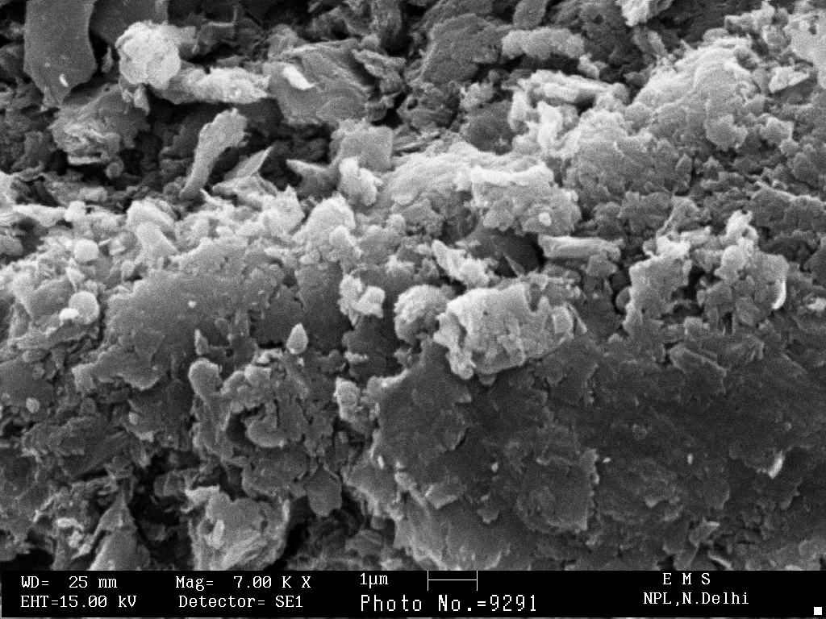

Fig .9 SEM micrograph of imported Special graphite sample

3.4 DEVELOPMENT OF HIGH DENSITY - ISOTROPIC GRAPHITE PLATES
A QI-free coal tar pitch of the characteristics given in Table–2 was prepared by the novel (NPL) method mentioned in section of chapter 2. It was heat-treated at 500 °C for 2 hour to obtain the green coke, which was crushed, and ground to a fine powder in a centrifugal ball-mill. The green coke powder was solvent-extracted to obtain the modified green coke powder, the characteristics of which are also given in Table–2. This powder was then moulded into rectangular plates of size 60mm x 20mm x 4mm under a pressure of 200 MPa using a conventional uni-directional hydraulic press. The resulting plates were carbonized in an inert atmosphere of Nitrogen to temperatures of, 1000, 1400, and 2500 °C. The heat-treated plates were subjected to determination of weight loss, volume and linear shrinkages, bulk density, bending strength, Young’s modulus, Shore hardness and electrical resistivity. The values of these characteristics at different HTTs are summarized in Table-3 Besides this, the precursor coal tar pitch, green coke made from it, and the green coke based plates heat-treated to 1000 °C and 2500 °C were also examined on an optical microscope, and the corresponding micrographs are shown in Figs. 10 (a, b) and 11 (a, b).

It is seen from Table 3 that the weight loss of the plates on heat- treatment increases slowly from 6.2% at 1000⁰C to 7.7% at 1400⁰C and 8.76% at 2500 °C. This weight loss corresponds to the evolution of various pyrolysis products. The volume shrinkage, in turn, first shows a value (expansion) of 28% at 1000 °C and then a fast increase to a value of 35.1% at a HTT of 1400 °C, beyond which it increases to a value of 37.3% at 2500 °C. The bulk density, starting from an initial value of 1.32g cm⁻³ in the green stage, increasing rapidly to, attains values of 1.72, 1.91 and 1.93 g cm⁻³ at the HTTs of 1000, 1400 and 2500 °C, respectively, as is observed from table no.3.
Regarding the bending strength of the plates, it is seen from this table that it posses a value of 91 MPa at 1000°C beyond which it decreases gradually from a value of 82 MPa at 1400°C right up to a value of 63 MPa at 2500 °C . Thereafter, the continuous decrease in the strength up to the final temperature of 2500 °C may be correlated to a continuous increase in the open porosity of the plates. Because of essentially these very reasons, the Young’s modulus (shown in table no.3), attains a value if 15.3 GPa at 1000 °C. After 1000 °C, it decreases to a value of 12.5 GPa at 1400°C and finally 9.0 GPa at the final HTT of 2500 °C. This may be due to continuous growth of the graphite like crystallites at the expense of the cross-linked disorganized matter between them. Shore hardness, in turn, starting from an already high value of 93 at 1000 °C, beyond which it also decreases continuously to a value of 63 at 2500 °C, as can be seen from table no.3. This behavior is essentially parallel to that of the Young’s modulus and is what is expected also. As far as the electrical resistivity (table.3) is concerned, it is observed that it decreases sharply to 4.6 mΩcm at 1000 °C and then slowly to 2.9 mΩcm at 1400 °C. Beyond a HTT of 1400 °C, it decreases sharply to its minimum value 1.5 mΩcm at the graphitization temperature of 2500 °C. This is what is expected, because the material is gradually getting converted from a molecular solid to essentially graphite. Besides the above, the optical micrographs of the precursor coal tar pitch reveals complete isotropy whereas the green coke made from it shows large domains of mesophase, as seen from Fig. 10 (a, b). The green coke based plates heat-treated to 1000 °C and 2500 °C, on the other hand, are found to have a homogeneous and fine isotropic microstructure, which may be seen from Fig. 11 (a, b).

TABLE–2
CHARACTERISTICS OF PRECURSOR COAL TAR PITCH AND
THE RESULTING GREEN COKE

S.No. | CHRACTERISTICS | PRECURSOR COAL TAR PITCH | GREEN COKE
1. | Softening point (°C) | 79.0 | –
2. | Specific gravity | 1.26 | –
3. | Quinoline insoluble content (%) | 0.2 | 95.5
4. | Toluene insoluble content (%) | 12.6 | 96.7
5. | Coking yield (%) | 46.5 | 92.5
6. | Volatile matter content (%) | 53.5 | 7.5

3.4.1 RESULTS AND DISCUSSION
It is seen from table 2 that precursor pitch posses a softening point of 79°C, specific gravity of 1.26, Quinoline and toluene insoluble contents of 0.2 and 12.6% respectively, coking value of 46.5 and volatile matter content of 53.5%. The green coke has higher value of Quinoline insoluble content (95.6) ,toluene insoluble content (92.5) compared to precursor coal tar pitch. This is due to polymerization and condensation reaction taking place during coking of coal tar pitch (upto 520°C) completed with removal of low molecular weight species from the pitch.

TABLE–3 SUMMARY OF THE CHARACTERISTICS OF PLATES HEAT-
TREATED TO TEMPERATURES OF 1000 – 2500 ⁰C
S.  No. | CHARACTERISTIC | HEAT-TREATMENT TEMPERATURE (°C)
S.  No. | CHARACTERISTIC | 1000 | 1400 | 2500
1. | GD (gcm⁻³) | 1.32 | 1.32 | 1.32
2. | WL (%) | 6.2 | 7.7 | 8.76
3. | VS (%) | 28 | 35.1 | 37.3
4. | LS (%) | 9.8 | 12.3 | 12.7
5. | BD (gcm⁻³) | 1.72 | 1.91 | 1.93
6. | BS (MPa) | 91 | 82 | 63
7. | SH | 93 | 76 | 63
8. | ER (mΩcm) | 4.6 | 2.9 | 1.5
9. | YM (GPa) | 15.3 | 12.5 | 9.0
10. | OP (%) | 7.4 | 9.4 | 13.2
11 | KD (gcm⁻³) | 1.86 | 2.9 | 2.21

NOTE: 1. GD = Green Density, WL = Weight Loss, VS = Volume Shrinkage, LS = Linear Shrinkage, BD = Bulk Density, BS = Bending Strength, YM = Young’s Modulus, SH = Shore Hardness, ER = Electrical Resistivity, KD = Kerosene density.
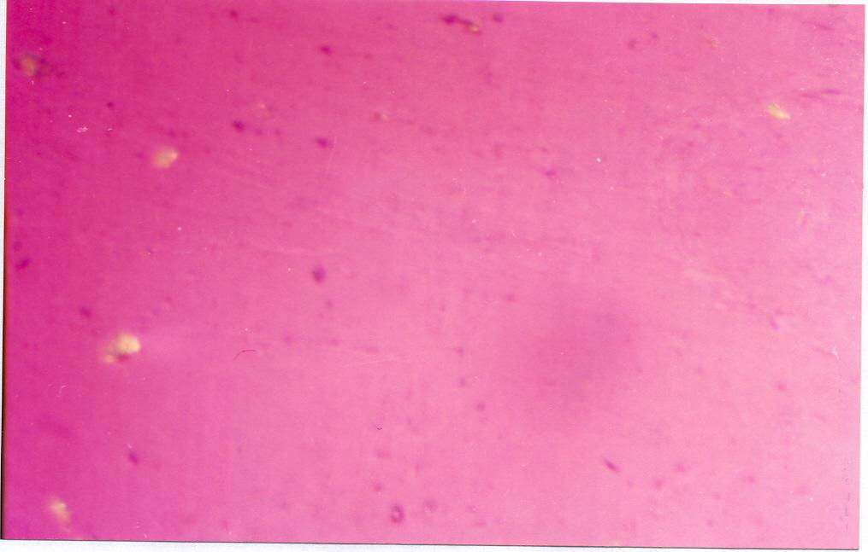
(a)

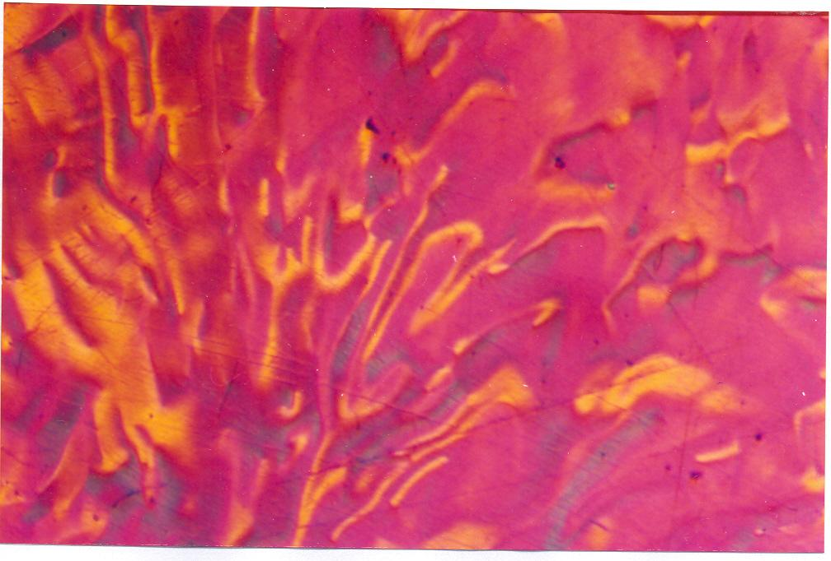
(b)
Fig. 10 Optical micrographs of– (a) precursor coal tar pitch
(b) resultant green coke (Magnification = 440).
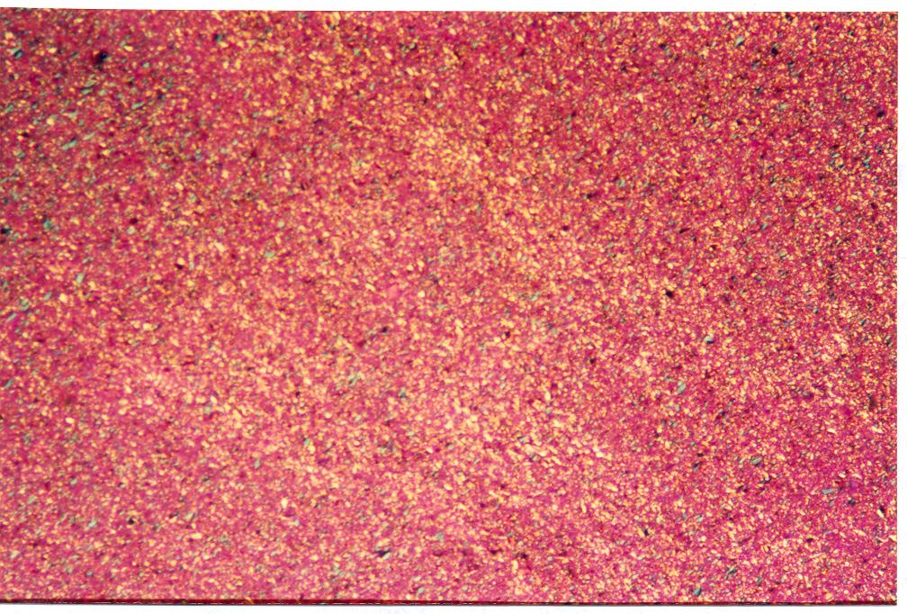
(a)

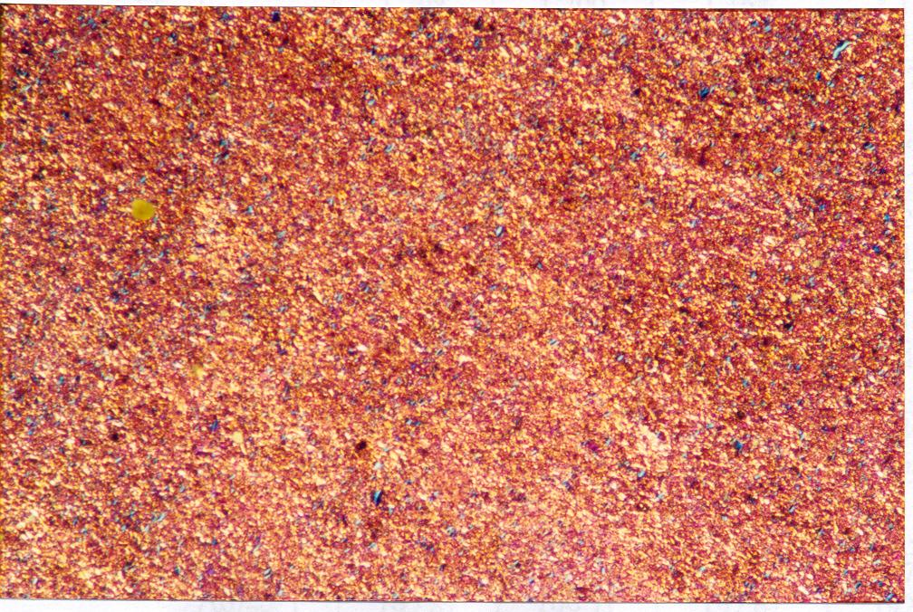
(b)

Fig 11. (a, b) Optical micrographs of green coke based plates
At 1000°C and 2500°C

3.5 DEVELOPMENT OF CARBON BASED COMPOSITES INVOLVING
NATURAL GRAPHITE
A coal tar pitch of characteristics shown in Table–4 was heat-treated at 500 °C for 1.5 hours in the presence of 0, 15, 30 and 45 % of finely-ground and purified natural graphite (Ash = 0.37 %) to obtain green cokes, which were ball-milled to fine powders in a centrifugal ball-mill and then solvent-extracted to obtain their modified powders. All these batches of powders were pressed into rectangular plates of size 60 mm x 20 mm x 4 mm using a conventional molding press, and the plates obtained were carbonized to 1000 °C and then graphitized to 2500 °C in an inert atmosphere. The characteristics of the resulting plates at both carbonized as well as graphitized levels are shown in Table–5

TABLE–4

CHARACTERISTICS OF PRECURSOR COAL TAR PITCH AND THE RESULTING GREEN COKE

S. No. | CHRACTERISTICS | PRECURSOR  COAL TAR PITCH | GREEN COKE
1. | Softening point (°C) | 90.1 | –
2. | Specific gravity | 1.27 | –
3. | Quinoline insoluble content (%) | 0.4 | 96.3
4. | Toluene insoluble content (%) | 19.4 | 98.4
5. | Coking yield (%) | 47.8 | 91.1

TABLE–5
CHARACTERISTICS OF GREEN COKE BASED PLATES (HTT = 1000 / 2500 °C) HAVING 0–45% OF NATURAL GRAPHITE BY WEIGHT OF PITCH
S. No. | CHARACTERISTICS | VALUES AT NATURAL GRAPHITE PERCENTAGE (BY WEIGHT OF PRECURSOR COAL TAR PITCH)
S. No. | CHARACTERISTICS | 0 | 15 | 30 | 45
1. | Green density (g cm⁻³) | 1.31 | 1.49 | 1.50 | 1.53
2. | Weight loss (%) | 7.5  (10.2) | 7.2  (8.9) | 5.1  (6.7) | 5.0  (6.4)
3. | Volume shrinkage (%) | 28.5  (38.7) | 20.4  (27.8) | 18.1  (24.5) | 15.5  (20.6)
4. | Linear shrinkage (%) | 10.4  (13.2) | 7.2  (8.4) | 5.7  (7.5) | 5.3  (5.6)
5. | Shore hardness | 92  (65) | 91  (60) | 73  (53) | 62  (50)
6. | Baked density (g cm⁻³) | 1.68  (1.94) | 1.74  (1.89) | 1.74  (1.91) | 1.74  (1.82)
7. | Electrical resistivity  (mΩcm) | 4.6  (1.10) | 2.5  (0.92) | 2.2  (0.84) | 1.8  (0.83)
8. | Thermal conductivity*  (W/mK) | 28  (118) | 54  (141) | 59  (154) | 72  (156)
9. | Bending strength  (MPa) | 75  (63) | 61  (47) | 45  (41) | 37  (31)
10 | Young’s modulus  (GPa) | 15.4  (9.4) | 12.4  (9.3) | 9.2  (8.6) | 8.1  (7.2)
NOTE : 1. The figures in parentheses refer to the values at a HTT of 2500 °C.
2. ‘*’ refers to estimated values.
It is seen from Table–5 that the introduction of natural graphite (up to 45%) increases gradually the green density of the plates from 1.31 to 1.53 g cm⁻³. This increase of green density with the increase in the content of natural graphite is due to higher density of the natural graphite compared to the green coke in the green coke - natural graphite mixture. It is further observed from this table that as the natural graphite content in the green coke-natural graphite mixture increases from 0 to45%, the weight loss decreases continuously from 7.5% to 5.0 % at 1000 °C and 10.2 to 6.4 % at 2500 °C. This is because of the decreasing content of green coke with the increasing content of the natural graphite in the green coke – natural graphite mixture, as it is only the green coke part of the mixture which is undergoing weight loss in the form of volatiles, the natural graphite being already heat-treated to around 2500 °C will have no weight loss upon heating up to 2500 °C. The volume and linear shrinkages, in turn, are observed to decrease continuously from 28.5% to 15.5% and 10.4% to 5.3 % respectively, at a HTT of 1000 °C and from 38.7% to 20.6% and 13.2% to 5.6% respectively, at 2500 °C , as the natural graphite content in the green coke - natural graphite mixture increased from 0 to 45%. This again is due to the fact that it is basically the green coke part of the green coke - natural graphite mixture which undergoes shrinkage, as the natural graphite (having no volatile matter) part will have no shrinkage upon this heat treatment.
The net result is that in spite of the gradual increase in the green density as the natural graphite content increases from 0 to 45 %, we have a nominal increase in the value of the bulk density from 1.68 to 1.74 g cm⁻³ at a HTT of 1000 °C along with decreasing value from 1.94 to 1.82 g cm⁻³ at a HTT of 2500 °C which can be explained on the basis of weight loss and volume shrinkage considerations.
The bending strength goes on decreasing from an initial value of 75 MPa to a value of 37 MPa at 1000 °C and from 63 MPa to 31 MPa at 2500 °C, with the increasing content of natural graphite from 0 to 45% explaining the decrease in the bending strength of the plates on heat-treatment to 2500 °C compared to that at the 1000 °C. In addition to this, the lowering of the bending strength with the addition of natural graphite is also due to poor wetting of the natural graphite by the binding components of the pitch. The Young’s modulus is seen to decrease from 15.4 to 8.1 GPa at 1000 °C and from 9.4 to 7.2 GPa at 2500 °C, whereas the shore hardness varies in the range of 92–62 at 1000 °C and 65–50 at 2500 °C. the above mentioned reasons explain the variations of Young’s modulus and Shore hardness at both the HTTs of 1000 °C and 2500 °C, as well as their variations with the increase in the NG content.
It is further seen from this table that the electrical resistivity of the plates decreases from 4.6 to 1.8 mΩcm at 1000 °C and 1.10 to 0.83 mΩcm at 2500 °C with the increase in the content of the natural graphite. As a result of this, the estimated value of thermal conductivity goes on increasing from an initial value of 28 W/mK to a value of 68 W/mK at HTT of 1000 °C, while at 2500 °C, it first sharply increases from 118 to 156 with the addition of 30% natural graphite in the green coke and then show a value of 152–156 W/mK on further addition of natural graphite in the green coke mixture. This continuous decrease in the electrical resistivity or continuous increase in the estimated thermal conductivity with the increase in the natural graphite content at both the HTTs is due to the higher electrical and thermal conductivity of natural graphite compared to that of the carbonized (HTT = 1000 °C) or graphitized (HTT = 2500 °C) green coke.
All the green coke based plates (HTT = 2500 °C) containing 0, 15, 30 and 45% of the natural graphite are found to have fine and homogeneous microstructure. it can be concluded from this series, that green coke containing 15 to 30% of natural graphite leads to a graphite with higher improvement in the electrical and thermal conductivities.

3.6 DEVELOPMENT OF ISOSTATICALLY MOULDED CARBON COMPOSITE
A low QI coal tar pitch precursor procured from NPL Licensee was characterized with respect to various characteristics (Table 6). It was heat treated at temperature upto 470°C to obtain self-sintering powder (also called green coke) which was ball milled & characterized. The characteristics values of the green coke are also shown in Table 6.
It is seen from the Table-6 that precursor coal tar pitch has a low QI content (1.3%) , low TI content (24.8%) and low coking yield (43.6%) , compared to self sintering powder having high QI content (94.3%) , high TI content (97.8%)& high coking yield (91.2%), This is due to the removal of volatile matter (on pyrolysis to 470°C) and also to the polymerization & condensation reactions taking place between the various molecular species of the coal tar pitch. Thus, volatile matter is reduced from a value of 56.4 % for the precursor coal tar pitch to a value of 8.8% for self -sintering (green coke) powder. The self-sintering powder was dry mixed with 0, 10, 20 % of finely ground & purified natural graphite (ash= 0.4%) to obtain three batches. Two more batches were prepared by wet mixing the same green coke powder with 0 & 20 % of same natural graphite.

TABLE – 6 CHARACTERISTICS OF PRECURSOR COAL TAR PITCH AND
THE RESULTING GREEN COKE

S. No. | CHRACTERISTICS | PRECURSOR COAL TAR PITCH | GREEN COKE
1. | Softening point (°C) | 87.5 | –
2. | Quinoline insoluble content (%) | 1.3 | 94.3
3. | Toluene insoluble content (%) | 24.8 | 97.8
4. | Coking yield (%) | 43.6 | 91.2
5. | Volatile matter content (%) | 56.4 | 8.8
6. | Specific gravity | 1.76 | –

It is seen from summary of characteristics of special-graphite blocks shown in Table–7 that the addition of natural graphite up to 20 % increases continuously the green density of the Composite blocks from 1.30 to 1.41 g / cm³. This is due to higher density of the natural graphite (which is free from any volatile matter) compared to that of the green coke, which is heat-treated only upto 470 °C and contains some volatile matter.
The weight loss of the green Composite blocks on carbonization is seen to decrease continuously with the increase in the content of natural graphite (upto 20%)in the GC–NG mixtures from a value of 9.3 to 7.5% at a HTT of 1000 °C and from 10.1 to 8.4 % at a HTT of 1400 °C. This is because of the fact that it is the green coke component, only, in GC-NG mixture, which is undergoing weight loss (in the form of volatiles), the proportion of which is decreasing continuously with the increase in the content of NG in the GC-NG mixtures. Similarly, the volume shrinkage is found to decrease from the initial values of 31.2% at 1000 °C and 36.5 % at 1400 °C at 0 % addition of NG to final values of 26.3 % at 1000 °C and 29.5% at 1400°C on addition of 20% of NG in the green coke. This again is due to the reasons explained above for the variation of weight loss i.e. it is the green coke component only, which is undergoing weight loss / volume shrinkage, the proportion of which is decreasing continuously with the increase in the content of NG in the GC-NG mixtures. Thus, the overall result of the variations of weight loss and volume shrinkage can explain slightly increasingly values of the bulk density (1.71–1.74 g / cm³) at a HTT of 1000 °C and almost a constant value of it (1.82–1.83g / cm³ ) at 1400°C. The bulk density of the Composite blocks at 2500°C is found to lie within the range of 1.89 – 1.88 g / cm^{3.}
It is further seen from this Table-7 that the electrical resistivity of the Composite blocks decreases from 3.1 to 2.4 mΩcm at 1400°C with the increase in the content of the natural graphite (upto 20%). This continuous decrease in the electrical resistivity with the increase in the content of natural graphite is due to the higher electrical conductivity of the natural graphite compared to that of the carbonized (HTT = 1400°C) green coke. Further, the electrical resistivity of GC-NG composite blocks attains a nearly constant value of around 1.1 – 1.2 mΩcm at 2500°C, which may be resulting from the increased electrical conductivity of green coke, based graphite part of the GC-NG composite blocks at 2500°C.
It is also observed from Table-7 that compressive strength of the dry mixed GC-NG powder based Composite blocks (at 1400°C) increase from a value of 103 to 138 MPa with the increase of graphite content to 20%. The increase in compressive strength of the Composite blocks with the increase in NG content may be due to densification of the GC-NG composite blocks due to lubricating effect / flow of NG in GC-NG mixtures during isostatic pressing, despite the fact that NG is known for its poor wetting properties. The compressive strength values, however, decrease significantly to 96 MPa for 0 % NG, which may be due to graphitization of GC particle of the GC-NG composite, blocks as the heat treatment temperature increases to 2500°C. The magnitude of the decrease in strength with increase in graphite content is however lowered at 2500°C. It is further interesting to note that the compressive strength values of the wet mixed GC-NG composite blocks are higher than those of dry mixed Composite blocks which could be because of better mixing / binding property of wet mixed materials.

TABLE –7 CHARACTERISTICS OF COMPOSITE BLOCKS HAVING 0 – 20% OF NATURAL GRAPHITE CONTENT
S. No. | CHARACTERISTICS | HTT  CODE | VALUES AT PERCENTAGE OF NATURAL GRAPHITE
S. No. | CHARACTERISTICS | HTT  CODE | DRY MIXING |  |  | WET MIXING
S. No. | CHARACTERISTICS | HTT  CODE | 0  (I-79) | 15  (I-95) | 20  (I-82) | 0  (I-81) | 20  (I-83)
1. | Green density (g cm⁻³) | RT | 1.30 | 1.34 | 1.40 | 1.29 | 1.41
2. | Baked density (g cm⁻³) | 1000°C  1400°C  2500°C | 1.71  1.82  1.89 | 1.75  1.83  1.87 | 1.75  1.82  1.87 | 1.72  1.87  1.91 | 1.74  1.82  1.88
3. | Weight loss (%) | 1000°C  1400°C | 9.3  10.1 | 8.3  9.2 | 7.3  8.1 | 9.5  10.5 | 7.5  8.4
4. | Volume shrinkage (%) | 1000°C  1400°C | 31.2  36.5 | 29.8  33.4 | 25.0  29.6 | 31.8  38.1 | 26.3  29.5
5. | Compressive  Strength (MPa) | 1400°C  2500°C | 103  96 | 134  78 | 138  75 | 169  118 | 144  78
6. | Electrical resistivity  (mΩcm) | 1400°C  2500°C | 3.1  1.1 | 2.5  1.1 | 2.3  1.1 | 3.0  1.2 | 2.4  1.2

Thus may be concluded from the above study that the samples of Composite block seem to possess better properties for wet mixed GC-NG mixture compared to dry mixed GC-NG mixture.
The bulk density of carbonized dry mixed GC-NG composite blocks increases from 1.71 to 1.74 g cm⁻³ with NG addition at HTT of 1000°C where as it remains constant (1.82 g cm⁻³ ) at 1400°C and (1.89 – 1.88) g cm⁻³ at 2500 °C respectively. The values of bulk density are better for wet mixed GC-NG composite blocks.
The compressive strength values for dry mixed material at 1400°C increases from 103 to 138 Mpa with increase in NG content to 20%, whereas the values decreases on heat treatment to 2500°C. The compressive strength of wet mixed GC-NG composite blocks is better than those of dry mixed blocks.
The electrical resistivity of GC-NG composite blocks decrease from 3.1 to 2.4 mΩcm at 1400°C for both dry & wet mixed materials. The values are nearly constant (1.1 –1.2 mΩcm) at 2500°C irrespective of content of natural graphite in GC-NG mixture.

CHAPTER-4
CONCLUSION
The following conclusions can be drawn from the present project carried out on the “Studies on development and characterization of Carbon based composites”.

[1] The green coke prepared posses a quinoline insoluble value, toluene insoluble value, coking value and volatile matter content of 95.5%, 96.6%, 92.5% and 75% respectively compared to those of 0.2%, 12.6%, 46.5% and 53.5%. for the precursor coal tar pitch the green coke based plates posses the bulk density of 1.32, 1.72, 1.91 and 1.92 g cm⁻³ in green stage and at HTT of 1000 °C, 1400°C and 2500°C respectively.
The bending strength of plates decreases from 91 to 63 MPa and electrical resistivity decreases from 4.6 to 1.5 mΩcm at HTT is increased from 1000 °C to 2500°C.
[2] The green density of the Carbon based composite (GC-NG) plates increases from 1.31 to 1.53 g cm⁻³,The bulk density of the composite plates increases from 1.68 to 1.74 g cm⁻³ at a HTT of 1000 °C along with decreasing value from 1.94 to 1.82 g cm⁻³ at HTT of 2500°C.
The weight loss of the Carbon based composite plates decreases continuously from 10.2 to 8.9 % at 1000 °C and 6.7 to 6.4 % at 2500 °C. The volume and linear shrinkages of the Carbon based composites plates decrease continuously from 28.5 to 15.5% and 10.4 to 5.3 % respectively, at a HTT of 1000 °C and from 38.7 to 20.6% and 13.2 to 5.6% respectively, at 2500 °C, as the natural graphite content in the green coke - natural graphite composite is increased from 0 to 45%.
The bending strength goes on decreasing from an initial value of 75 MPa to a value of 37 MPa at 1000 °C and from 63 MPa to 31 MPa at 2500 °C, with the increasing content of natural graphite from 0 to 45%, The lowering of the bending strength with the addition of natural graphite is also due to poor wetting of the natural graphite by the binding components of the pitch. The Young’s modulus is decrease from 15.4 to 8.1 GPa at 1000 °C and from 9.4 to 7.2 GPa at 2500 °C, whereas the shore hardness varies in the range of 92–62 at 1000 °C and 65–50 at 2500 °C. The electrical resistivity of the Composite plates decreases from 4.6 to 1.8 mΩcm at 1000 °C and 1.03 to 0.83 mΩcm at 2500 °C with the increase in the content of the natural graphite.
[3] The imported samples of high density graphite posses baked density value of 1.89 g cm^{-3,} compressive strength of 130 MPa, electrical resistivity of 1.63 mΩcm, shore hardness of 80, crystallite size La and Lc values of 19 and 15nm respectively.
[4] In case of Iso-moulds, the bulk density of carbonized dry mixed GC-NG composite blocks increases from 1.71 to 1.74 g cm⁻³ with NG addition at HTT of 1000°C where as it remains constant (1.82 g cm⁻³ ) at 1400°C and (1.89 – 1.88) g cm⁻³ at 2500 °C respectively. The values of bulk density are better for wet mixed GC-NG composite blocks.
The compressive strength values for dry mixed material at 1400°C increases from 103 to 138 Mpa with increase in NG content to 20%, whereas the values decreases on heat treatment to 2500°C. The compressive strength of wet mixed GC-NG composite blocks is better than those of dry mixed blocks. The electrical resistivity of GC-NG composite blocks decrease from 3.1 to 2.4 mΩcm at 1400°C for both dry & wet mixed materials. The values are nearly constant (1.1 –1.2 mΩcm) at 2500°C irrespective of content of natural graphite in GC-NG mixture.

REFERENCES

1. Bragg W.H. and Bragg W.L., Proc. Royal Soc. London, A89 (1913), p. 277.
2. Seal M., Nature, 185 (1960) 522.
3. Hall H.T., Proc. 3rd Carbon Conf. (Pergamon Press, New York, 1959), p. 75.
4. Hull A.W., Phys. Rev., 10 (1917) 661.
5. Bernal J.D., Proc. Royal Soc. London, A106 (1924), p. 749.
6. Lipson H. and Stockes A.R., Proc. Royal Soc. London, A181 (1942), p. 101.
7. Boehm H.P. and Hofmann U., Z. Anorg. Allgemein. Chern., 278 (1955) 58.
8. Boehm H.P. and Coughlin R.W., Carbon, 2 (1964) 1.
9. Basset M.J., J. Phys. Radium 10 (1939) 217.
10. Jones M.T. and Weltner W., Proc. 4th Carbon Conf. (Pergamon Press, New
York, 1960), Unpublished.
11. Biorenkerk H.P., Bundy F.P., Hall H.T., Stong H.M. and Wentorf (Jr.) R.H.,
Nature, 184 (1959) 1094.
12. Bundy F.P., J. Chem. Phys., 38 (1963) 618.
13. Noda T. and Matsuoka H., Proc. Int. Symposium on High Temp. Technol.
(McGraw Hill Book Co., New York, 1959), p. 286.
14. Bundy F.P., Bassett W.A., Weathers M.S., Hemley R.J., Mao H.K. and
Goncharov A.F., Carbon, 34 (1996) 141.
15. Kroto H.W., Heath J.R., O'Brein S.C., Curl R.F. and Smalley R.E., Nature,
318 (1985) 162.
16. Kratschmer W., Fostiropoulos K. and Huffman D.R., Chem. Phys. Lett., 170
(1990) 167.
17. Kratschmer W., Lamb L.D., Fostiropoulos K. and Huffman D.R., Nature,
347 (1990) 354.
18. Lijima S., Nature, 354 (1991) 56.
19. Dutta A.K., Phys. Rev., 90 (1953) 187.
20 Primak W. and Fuchs L.H., Phys. Rev., 95 (1954) 22.
21. De Combarieu, A., J. Phys. (France), 28 (1968) 931.
22. Nihara T. and Itawa T., Japanese J. Applied Phys., 14 (1975) 1099.
23. Mantell C.L., "Carbon and Graphite Handbook" (Interscience, New York,
(1968).
24. Liggett L.M., "Kirk-Othmer Encyclopedia of Chemical Technology", Vol. 4
(Interscience, New York, 1964).
25. Hutcheon J.M., "Modern Aspects of Graphite Technology" edited by L.C.F.
Blackman (Academic Press, London, 1970), p. 49-78.
26. Shobert II E.I., "Modern Materials", Vol. 4, edited by B.W. Gonser and H.H
Hausner (Acadamic Press, New York, 1964), p. 1-99..
27. Marsh H., Heintz E.A., Rodriguez–Reinoso F. “Introduction to Carbon
Technologies”, edited by H. Marsh, University of Alicante, Spain, 1997.
28. Carbon, 13 (1975) 251.
29. Franklin R.E., Proc. Royal Soc. London, 209, (1951), p. 196.
30. Mrozowski S., Proc. 2nd Carbon conf. (University of Buffalo, New York,
1956), 195.
31. Raman V., Bhatia G., Aggarwal R.K., Sengupta P. R. and Mishra A., Proc. of
Nat. Conf. on Carbon, (Indo-Carbon 2001), Vallabh-Vidhyanagar, Gujarat, India, Oct. 19-20, 2001, p. 159.
32. Raman V., Bhatia G., Aggarwal R.K., Sengupta P.R. and Mishra A.
J. Mater. Sci. Lett., 21(2002) 317.
33. Bhatia G., Raman V., Aggarwal R.K., Sengupta P.R., Mishra A., and Saha
M., Proc. of Nat. Conf. on Carbon (Indo-Carbon 2003), Kanpur, Nov. 25- 26, 2003, p. 272.
34. Mishra A., Saha M., Aggarwal R.K., Bhatia G., Raman V. and Sengupta P.R.,
Proc. of Int. Conf. on Carbon, Providence, USA, July 2004.
35. Aggarwal R.K., Bhatia G., Saha M., and Mishra A., Carbon Science, (In
press).

