STEGANOGRAPHY SYSTEM BASED
ON
BPCS TO THE IWT IMAGE
Major Project report submitted in partial fulfillment for the award of the degree of
MASTER OF ENGINEERING
IN
ELECTRONICS & COMMUNICATION
By:-
KULDEEP PANWAR
Roll No. 8802
(19/E&C/PT/2006)
Under the guidance of
Prof. Asok Bhattacharyya
(E &C Engg. Deptt.)



DEPARTMENT OF ELECTRONICS & COMMUNICATION ENGINEERING
DELHI COLLEGE OF ENGINEERING
UNIVERSITY OF DELHI, DELHI – 110042
DELHI COLLEGE OF ENGINEERING DELHI
Department of Electronics & Communication Engineering



CERTIFICATE

This is to Certify that the major project work/Thesis entitled, “Steganography System Based On BPCS To The IWT Image”, submitted by KULDEEP PANWAR (College Roll No: 19/E&C/PT/2006), in partial fulfillment of the requirement for the award of the degree of Master of Engineering (Electronics & Communication) of University of Delhi, is a record of the student’s own work carried out under my supervision. The work of this Thesis has not been submitted for the award of any other degree to the best of my knowledge and belief.
Dr. Asok Bhattacharyya
Professor, Electronics & Communication Engineering
Delhi College of Engineering, Delhi -110042
(Project Guide)

Forwarded by:
Dr. Rajeev Kapoor
Prof. & Head, E&C Department
Delhi College of Engineering,
Delhi- 110042

ACKNOWLEDGEMENT

It is distinct pleasure to express my deep sense of gratitude and indebtedness to my project guide Prof. Asok Bhattacharyya, Department of Electronics & Communication, Delhi College of Engineering, Delhi, for continuous inspiration, encouragement and guidance in every stage of preparation of this thesis.

I express my gratitude to my esteemed faculty members Dr. Neeta Pandey, Mrs. Rajeshwari Pandey and Mr. J. Panda and Mr. M. S. Choudhary who have evaluated my pre submission presentation. Lastly, I like to pay my sincere thanks to Dr. Rajeev Kapoor for my PG Seminar evaluation and his continuous encouragement.

KULDEEP PANWAR
University Roll No.: 8802.

ABSTRACT

Steganography is a technique to make secret message imperceptible to human eyes by embedding it in some vessel data. We call the visible/audible part of the vessel data "external information", and the embedded data "internal information." The external information is not so valuable to the data owner.
Digital Steganography exploits the use of a host data to hide a piece of information in such a way it is imperceptible to a human observer. In our project an image Steganography system, in which the data hiding (embedding) is realized in bit planes of sub band wavelets coefficients obtained by using the Integer Wavelet Transform (IWT) is implemented. To increase data hiding capacity while keeping the imperceptibility of the hidden data, the replaceable IWT coefficient areas are defined by a complexity measure used in the Bit-Plane Complexity Segmentation Steganography (BPCS). The proposed system shows a high data hiding capacity.

All of the traditional steganographic techniques have limited information-hiding capacity. They
can hide only 10% (or less) of the data amounts of the vessel. Our new Steganographic system uses, an image as the vessel data,, and we embed secret information in the bit-planes of the image. The information hiding capacity of a true color image is around 50%.

Table of Contents:

CONTENT: Page No.

Certificate….. ………………………………………………………………………ii

Acknowledgement…………………………………………………………………iii

Abstract…………………………………………………………………………….iv

INTRODUCTION:

1.1. Steganography Techniques

1.2. System Design

1.2.1. Security

1.2.2. Requirements
1.2.2.1. Embedding Process
1.2.2.2 Fingerprinting & watermarking

THEORY

BPCS STEGANOGRAPHY

INTEGER WAVELET TRANSFORMED

INTRODUCTION TO MATLAB

RESULTS

CONCLUSION

FUTURE SCOPE

REFERENCES AND BIBILOGRAPHY
INTRODUCTION:

The information communicated comes in numerous forms and is used in many applications. In a large number of these applications, it is desired that the communication to be done in secrete. Such secrete communication ranges from the obvious cases of bank transfers, corporate communications, and credit card purchases, on down to a large percentage of everyday email. Steganography is the ancient art of embedding a secret message into a seemingly harmless message. Most of the newer applications use steganography like a watermark, to protect a copy right on information. The forms of steganography vary, but unsurprisingly, innocuous spam messages are turning up more often containing embedded text. A new transform domain technique for embedding the secrete information in the integer wavelet transformed cover image is implemented here.

Cryptography is a technique to scramble a confidential message to make it unreadable for a third party. It is commonly used in the Internet communications today. Cryptography can hide the content of the message, but it can't hide its presence, i.e., the location of the secret message is obvious. This is the reason why an encrypted message can be targeted by the attackers. Watermarking is another information hiding technique which is used for hiding, actually embedding, some digital evidence, or symbol data, in the valuable digital data such as a photo picture, musical sound, digital movie, etc. The purpose of the watermarking is to protect copyright and/or ownership of the data. In this technique the robustness of the embedded evidence, that can be very small, is the most important. In watermarking the valuable information is the external information that is visible/audible.
Now days, various modes of communication like LAN, WAN and INTERNET are widely used for communicating information from one place to another around the globe. Such communication networks are open which any one can access easily. They are regularly monitored and an intercepted.
Steganography, from the Greek, means covered or secret writing, and is a long-practiced form of hiding information. Although related to cryptography, they are not the same. Steganography's intent is to hide the existence of the message, while cryptography scrambles a message so that it cannot be understood. More precisely, 'The goal of Steganography is to hide messages inside other harmless messages in a way that does not allow any enemy to even detect that there is a second secret message present."
Steganography includes a vast array of techniques for hiding messages in a variety of media. Among these methods are invisible inks, microdots, digital signatures, covert channels and spread-spectrum communications. A message is embedded in a cover media in an invisible manner so that one could not suspect about its existence.
In this paper we present a substitution based information protection method where we combine cryptographic, steganographic and signal processing concepts together for achieving security. The method is known as Steganography Based Information Protection method. In this method we substitute the information bit in randomly selected pixels at random places within LSB region.

Steganography Techniques

Information hiding techniques are receiving much attention today. The main motivation for this is largely due to fear of encryption services getting outlawed, and copyright owners who want to track confidential and intellectual property copyright against unauthorized access and use in digital materials such as music, film, book and software through the use of digital watermarks.
There are many ways to hide information in digital images. We look at the following approaches:
- Least Significant Bit Insertion
- Masking And Filtering
- Algorithms And Transformations
Each of these techniques has varying degrees of success.

Least significant bit insertion
Many stego tools make use of least significant bit (LSB). For example, 11111111 is an 8-bit binary number. The rightmost bit is called the LSB because changing it has the least effect on the value of the number. The idea is that the LSB of every byte can be replaced with little change to the overall file. The binary data of the secret message is broken up and then inserted into the LSB of each pixel in the image file.
Hiding the data
Using the Red, Green, Blue (RGB) model a stego tool makes a copy of an image palette, say, an 8-bit image. The copy is rearranged so that colors near each other in the RGB model are near each other in the palette. The LSB of each pixel’s 8-bit binary number is replaced with one bit from the hidden message. A new RGB color in the copied palette is found. A new 8-bit binary number of the new RGB color in the original palette is found. The pixel is changed to the 8-bit binary number of the new RGB color.
Recovering the data
The stego tool finds the 8-bit binary number of each pixel’s RGB color. The LSB of each pixel's 8-bit binary number is one bit of the hidden data file. Each LSB is then written to an output file.
A simplified example with an 8-bit image
1 pixel:
(00 01 10 11)
white red green blue
Insert 0011:
(00 00 11 11)
white white blue blue
As can be seen from the example, with an 8-bit image, the cover image must be carefully selected since LSB manipulation is not as forgiving because of the color limitations. To hide information in the LSBs of each byte of a 24-bit image, it is possible to store 3 bits in each pixel.
A simplified example with a 24-bit image
1 pixel:
(00100111 11101001 11001000)
Insert 101:
(00100111 11101000 11001001)
red green blue
LSB insertion works well with gray-scale images as well. It is possible to hide data in the least and second least significant bits and the human eye would still not be able to discern it.
Unfortunately LSB insertion is vulnerable to slight image manipulation such as cropping and compression. For example, converting a GIF or a BMP image, which reconstructs the original message exactly (lossless compression), to a JPEG format, which does not (lossy compression), and then converting back, can destroy the data in the LSBs.

Masking and filtering
Masking and filtering techniques hide information by marking an image and is usually restricted to 24-bit and gray-scale images. Digital watermarks include information such as copyright, ownership, or license. While traditional Steganography conceals information, watermarks extend information since it becomes an attribute of the cover image.
Masking techniques hide information in such a way that the hidden message is more integral to the cover image than simply hiding data in the "noise" level. Masking adds redundancy to the hidden information. This makes the masking technique more suitable than LSB with lossy JPEG images. It may also help protect against some image processing such as cropping and rotating.

Algorithms and transformations
Another Steganography technique is to hide data in mathematical functions that are in compression algorithms. The idea is to hide the data bits in the least significant coefficients.
A key advantage of JPEG images over other formats is its lossy compression methods. It enables high quality images to be stored in relatively small files. The compressed data is stored as integers but the calculations for the quantization process require floating point calculations which are rounded. Errors introduced by rounding define the lossy characteristic of the JPEG compression method. JPEG images use the discrete cosine transform (DCT) technique to achieve image compression. The DCT is "a technique for expressing a waveform as a weighted sum of cosines" [10]. In a JPEG file, the image is made up of DCT coefficient. When a file is steganographically embedded into a JPEG image, the relation of these coefficients is altered. Instead of actual bits in the image being changed as in LSB Steganography, it is the relation of the coefficients to one another that is altered.
In addition to DCT, images can be processed with fast Fourier transform (FFT). FFT is "an algorithm for computing the Fourier transform of a set of discrete data values" [11]. The FFT expresses a finite set of data points in terms of its component frequencies. It also solves the identical inverse problem of reconstructing a signal from the frequency data.
The wavelet transform is a transformation to basis functions that are localized in frequency. The wavelet compression methods are better at representing transients, such as an image of stars on a night sky. This means that "elements of some data signal that are transient can be represented by a smaller amount of information than would be the case if some other transform, such as the more widespread discrete cosine transform, had been used" [12]. Wavelet compressions are good for transient signal characteristics but not for smooth, periodic signals.
Many transform domain methods are not dependent on the image format so that the hidden message is retained after conversion between lossless and lossy formats.
Hiding the data
The steps are to take the DCT or wavelet transform of the cover image and find the coefficients below a specific threshold. Replace these bits with bits to be hidden (for example, use LSB insertion) and then take the inverse transform and store it as a regular image.

Recovering the data
To extract the hidden data take the transform of the modified image and find the coefficients below a specific threshold. Extract bits of data from these coefficients and combine the bits into an actual message.
Other techniques of Steganography include spread spectrum Steganography, statistical Steganography, distortion, and cover generation Steganography.

SYSTEM DESIGN:
These are the steps followed in image hiding while transmission and de noising after receiving:
1. Get a cover image (publicly accessible material)
2. Take the information to be hidden (message or image)
3. Combine cover image with the information to be hidden (we follow LSB algorithm for this)
4. While transmission it will be corrupted by noise
5. Use any of the filtering methods, ex: wiener filtering for de noising in wavelet domain
6. Here filter is employed in order to remove the noise
7. During extraction a password check is provided
8. If password is matched then extraction of hidden information.
SECURITY:
A method, SBIPM, for providing the security of our important information is based on the techniques of signal processing, cryptography, and Steganography. The security of information has been strengthened by applying scanning, coding, and encryption, cover processing and embedding techniques in the method. Reshaping step of the method provides robustness for detecting message correctly in such situation when stego image is distorted. The method developed is safe from various attacks. Simulation and steganalysis results shown in this paper shows that one will not be able to distinguish between cover and stego images.
Thus we conclude that the strength of security achieved is very high and unauthorized receiver will not be able to get back the original message using exhaustive without the knowledge of key parameters.
Digital Steganography is interesting field and growing rapidly for information hiding in the area of information security.lt has a vital role in defence as well as civil applications. In future we will more of secure systems based on this technology. Several methods for hiding data in, images were described, with appropriate introductions to the environments of each medium, as well as the strengths and weaknesses of each method. The key algorithm for designing the Steganography system has been dealt. Most data-hiding systems take advantage of human perceptual weaknesses, but have weaknesses of their own. We conclude that for now, it seems that no system of data-hiding is totally immune to attack.
However, Steganography has its place in security. Though it cannot replace cryptography totally, it is intended to supplement it. Its application in watermarking and fingerprinting, for use in detection of unauthorized, illegally copied material, is continually being realized and developed.
Steganography is a technique to make confidential information imperceptible to human eyes by embedding it in some innocent looking "vessel" data (aka "carrier", "cover" or "dummy" data) such as a digital image or a speech sound. Steganalysis is another research topic about steganography. The objective of steganalysis is to find out a stego-file among the given files. It is a technique to detect a suspicious image/sound file that is embedded with crime-related information. So, it is a topic to make a "sniffer-dog program" to break steganography. However, it is very difficult to make such program that really works.

Requirements:
Different requirements depending on the purpose of Steganography:
• Capacity: it is an important factor in captioning applications, when a lot of information should be embedded into a cover image, what is usually related to the current picture. For example when transmitting medical images, the personal data, and the diagnosis could be embedded into the same picture.
• Imperceptibility: it is important when a secret communication occurs between two parties and the fact of a secret communication is kept to be secret.
• Robustness: watermarking, fingerprinting and all copyright protecting applications demand robust steganographic method, i.e. where the embedded information cannot be removed without serious degradation of the image.

Survey of Methods, Experiments
The Embedding Process
Steganography embeds a secret message in a cover message, this process is usually parameterized by a stego-key, and the detection or reading of embedded information is possible only having this key. Fig.1 shows this process.

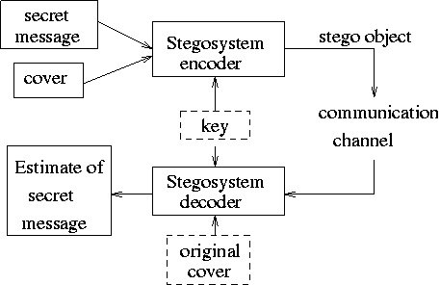

-
Fingerprinting and Watermarking

Nowadays Steganography is more and more important in publishing and broadcasting industries, where the embedding of copyright marks or serial numbers is needed in digital films, photos and other multimedia products. Some steganographic applications are able to scan the Internet, and to detect a copy of a specific image, or the modified image is published – so an illegal usage of a copyrighted image can be detected. In the case of audio materials, the automatic monitoring of radio advertisements is also possible, the advertiser can automatically count how many times a specific advertisement was transmitted by a given radio station. Another possible application in the case of still images is to embed captions and other information into the picture so that one does not have to store distinctly the images, and connected information.

When the purpose is the protection of intellectual property, we can make a distinction between fingerprinting and watermarking. In the case of watermarking copyright information is embedded in a digital media and this media is transmitted to users. Fingerprinting embeds separate mark in the copies of digital media, this embedded information serves as a serial number, and it can be detected who supplied this media to third parties.

All of the traditional steganographic techniques have limited information-hiding capacity. They can hide only 10% (or less) of the data amounts of the vessel. This is because the principle of those techniques was either to replace a special part of the frequency components of the vessel image, or to replace all the least significant bits of a multivalued image with the secret information. Our new steganography uses an image as the vessel data, and we embed secret information in the bit-planes of the vessel. The information hiding capacity of a true color image is around 50%. We can replace all of the “noise-like” regions in the bit-planes of the vessel image with secret data without deteriorating the image quality, which is termed as “BPCS-Steganography,” which stands for Bit- Plane Complexity Segmentation Steganography.

PROBLEM ANALYSIS:

Here a lossless data hiding method using IWT and BPCS, in which image data are decomposed by IWT and each bit plane of the sub-bands segmented in 8x8 blocks. All blocks are analyzed by complexity measures to determine which blocks will be replaced by secret message. The complexity measurement used in the proposed system is same one in the BPCS method. The proposed system can be recovered the hidden message in lossless manner if the communication channel is ideal. A wavelet transform that maps integers to integers is the S transform... In this large amounts of data can be compressed as smaller one by using IWT method, without data loss. This system is used to produce same quality of image while compressing and embedding the image, there will be no change in the quality of image and can be retained the same as the first. By using BPCS (Bit Plane Complexity Segmentation) the embedding process has been done here, so the security is very high for the embedded image.

BACKGROUND HISTORY:
The word steganography is of Greek origin and means "covered, or hidden writing". Its ancient origins can be traced back to 440 BC.

THEORY:

Steganography today is a computer technique to make confidential information imperceptible to human eyes by embedding it in some innocent looking "vessel" data (aka "carrier", "cover" or "dummy" data) such as a digital image or a speech sound. A typical vessel is a color image having Red, Green, and Blue color components in a multi-bit data structure. The embedded information can only be extracted by using a special extracting program and a key, the technique of steganography we are talking here is definitely different from what is called a "file deception" or "file camouflage" technique.
"File deception" or "file camouflage" is a technique to hide secret data in a computer file which looks like almost a steganography. But actually, it is a trick to disguise a secret-data-added file as a normal file. This can be possible because most computer file formats have some "don't-care portion" in one file. For example, a JPEG, MPEG3, or Word file allows any "extra" data to be added to the end of a regular file. Even if such extra data (which can be encrypted) are added, the JPEG, MPEG3, or Word file looks (sounds) like the original image, sound, or document on the computer. Some people might have misunderstood that such a trick is a type of steganography.
However, such tricked files may have an extra-lengthy file sizes, and they can be easily detected by most computer engineers. So, file deception is definitely different from steganographic technique we are discussing here.
Many "steganography software" on the market today is based on the file deception. If you find a steganography program that increases the output file size (i.e., the stego file size) just by the amount you have embedded, the program is obviously a file deception.
If you have some secret data, you should encrypt it to make it unreadable for the third party. Data encryption is a solution to keep secret information very safe. It is based on data scrambling by using some type of secret key.
However, data encrypting will draw much more attention of the near-by people than not encrypting it. So, the owner of the encrypted data will be easily known that he/she is hiding something. Therefore, encrypting is not enough.
There is another solution which is called steganography. Steganography today is like the following.
In steganography you will have two types of data. One is the secret data itself that is very valuable to you. The other one is a type of media data called "vessel", "carrier", or "dummy" data. Such vessel data is essential, but is not so valuable. It is the data in which the valuable data is "embedded." An "already embedded" vessel data is called "stego data." When you want to recover the valuable (or secret) data, you can "extract" it from the stego data. For both embedding and extracting you need a special program and a key.
A typical vessel is an image data with Red, Green, and Blue color components in a 24 bits pixel structure. The illustration below shows a general scheme of steganography.
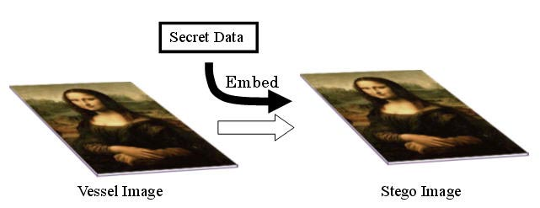
Steganography is a technique to hide secret data by embedding it in some innocent looking media data like Mona Lisa here. The embedded data is very safe because steganography hide both the content and the location of the secret information. There are many different methods to embed data in the media data. It is impossible to detect which method is used for embedding. Steganography can co-operate with cryptography in the sense that it can embed the encrypted secret data to make it much safer.
The most important point in steganography is that the stego data does not have any evidence that some extra data is embedded there. In other words, the vessel data and the stego data must be very similar. A user of steganography should discard the original vessel data after embedding in order not to allow anyone to compare the stego and the original data.
It is also important that the embedding capacity is large. The larger the better. For image steganography we are confident that BPCS method is the best of all currently available steganographic methods.

BPCS-Steganography:
BPCS-Steganography (Bit-Plane Complexity Segmentation Steganography) is a type of digital steganography. Typically, it uses an image file in true color format (BMP image) for a vessel. It can conceal (or "embed") very large amount of "confidential" data file in the vessel. It is reported that the ordinary embedding capacity amounts to 50% (or more) of the vessel image size. The principle of the embedding is to replace "noisy" areas on each bit-plane of the vessel image with the confidential data. This steganography exploits the characteristics of human vision system which can't see any shape information in a very noisy area on an image bit-plane. In the embedding process the image color value is transformed from the pure binary code system into the canonical gray code system because the canonical gray code keeps better image quality than pure binary code when the vessel is embedded with other data. Noisy area on the bit-plane is segmented according to a complexity measure for the binary image.
BPCS-Steganography (Bit-Plane Complexity Segmentation Steganography) is a new steganographic technique. Which can embed confidential information in vessel data which is typically a true color image (24-bit BMP format) and sometimes in an 8-bit indexed color image? Embedding (actually, replacing) is made on the bit-planes of the image. The most important feature of this steganography is that its embedding capacity is very large.

Bit-Plane Complexity Segmentation Steganography is our new steganographic technique, which has a large information hiding capacity. As was shown in the previous section, the replacement of the complex regions in each bit-plane of a color image with random binary patterns is invisible to the human eye. We can use this property for our information hiding (embedding) strategy. Our practical method is as follows.
In our method we call a carrier image a “vessel” or “dummy” image. It is a color image in BMP file format, which hides (or, embeds) the secret information (files in any format). We segment each secret file to be embedded into a series of blocks having 8 bytes of data each. These blocks are regarded as 8 × 8 image patterns. We call such blocks the secret blocks. We embed these secret blocks into the vessel image using the following steps.

1. Transform the dummy image from PBC to CGC system.
2. Segment each bit-plane of the dummy image into informative and noise-like regions by using a threshold value (α₀). A typical value is αα₀ = 0.3.
3. Group the bytes of the secret file into a series of secret blocks.
4. If a block (S) is less complex than the threshold (α₀), then conjugate it to make it a more complex block (S*). The conjugated block must be more complex than α₀ as shown by equation (6).
5. Embed each secret block into the noise-like regions of the bit-planes (or, replace all the noise-like regions with a series of secret blocks). If the block is conjugated, then record this fact in a “conjugation map.”
6. Also embed the conjugation map as was done with the secret blocks.
7. Convert the embedded dummy image from CGC back to PBC.

The Decoding algorithm (i.e., the extracting operation of the secret information from an embedded dummy image) is just the reverse procedure of the embedding steps.

The novelty in BPCS-Steganography is itemized in the following.
A) Segmentation of each bit-plane of a color image into “Informative” and “Noise-like” regions.
B) Introduction of the B-W boarder based complexity measure (α) for region segmentation
C) Introduction of the conjugation operation to convert simple secret blocks to complex blocks.
D) Using CGC image plane instead of PBC plan.

Principle of BPCS-Steganography:
1. Bit-Plane Decomposition of a Multi-Valued Image:
A multi-valued image (P) consisting of n-bit pixels can be decomposed into a set of n binary pictures. For example, if the image is an n-bit gray image, it is shown as,
P=(P1,P2,...,Pn).
In case the image is a Red, Green, Blue color picture, it is shown by
P=(PR1,PR2,..,PRn,PG1,PG2,..,PGn,PB1,PB2,..,PBn),
where PR1, PG1, PB1 are the most significant bit-planes (MSB), while PRn, PGn, PBn are the least significant planes (LSB).
Ordinary image data is represented by a Pure Binary Code system (referred to as PBC which is commonly used in image processing). It is also possible to use other code systems such as Canonical Gray Code (CGC) . CGC is better than PBC for BPCS-Steganography.
As far as the bit-planes of a natural image are concerned, complexity of each bit-plane pattern increases monotonically from the MSB (P1) to the LSB (Pn). An image data not having this property will be an artificially processed data. Most of the LSB planes look like random pattern. Figure 1 illustrates a couple of PBC bit-planes of a true color image (i.e., 24 bit color image).
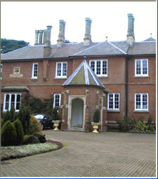 | 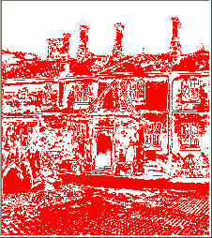 | 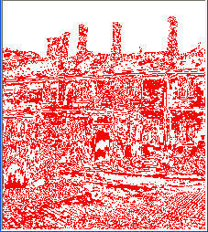 | 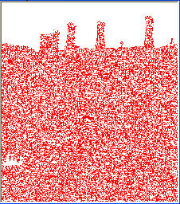
(A color image P) | (PR3) | (PR4) | (PR6)
Fig 1. Bit-Planes

2. Nature of the human vision system and information embedding
Each bit-plane can be segmented into "shape-informative" and "noise-looking" regions. A shape-informative region consists of simple patterns, while a noise-looking region consists of complex patterns. In Fig. 1, plane PR3 is mostly shape-informative, but PR6 is mostly noise-looking. PR4 is mixed with both shape-informative and noise-looking regions. It is reported that two regions can be segmented by using a "black-and-white boarder length" based complexity measure. It is also reported that we can replace each noise-looking region with another noise-looking patterns without changing the overall image quality. See Fig 2.
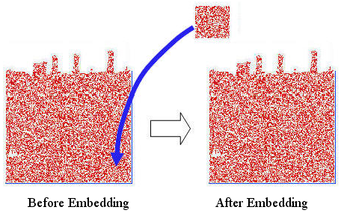
Fig 2. Embedding a "noisy" square in the bottom right corner of PR6

In Fig 2., a "noise-looking" square patch is placed (embedded) on the bottom right corner of the PR6 plane in Fig 1. However, no change is observed after embedding. BPCS-Steganography makes use of this nature of the human vision system.
BPCS-Steganography often uses the CGC code system for image representation.
3. BPCS-Steganography and traditional image-based steganography:
The most traditional image-based steganographic algorithms are as follows.
A. Use all the least significant bits of a vessel image for the hiding space of the secret data
B. Replace special components in the frequency domain of the vessel image with the secret data
C. Utilize the quantization error of the vessel image for a place to hide secret data
However, all these methods have a relatively small data hiding capacity. The capacity is 5-15 % of the vessel data. Therefore, the straightforward application of the steganography has been limited to “watermarking” because it does not need a large data hiding capacity.
BPCS-Steganography is absolutely different from traditional techniques. The most important feature is a large embedding capacity. In most cases it can embed 50% of the vessel data (a 24bit BMP image case).

The merits of BPCS-Steganography found by the experiments are as follows.
1. The information hiding capacity of a true color image is around 50%.
2. A sharpening operation on the dummy image increases the embedding capacity quite a bit.
3. Canonical Gray coded bit planes are more suitable for BPCS-Steganography than the standard binary bit planes.
4. Randomization of the secret data by a compression operation makes the embedded data more intangible.
5. Customization of a BPCS-Steganography program for each user is easy. It further protects against eavesdropping on the embedded information.
Keywords: Steganography, data hiding, information hiding, BPCS, digital picture envelope, vessel image, dummy image, encryption, compression, bit plan.

4. Watermarking and Steganography:
Watermarking is a technique to embed some symbol data (or evidence data) in some valuable data such as an image, voice, music, video clip, etc. It protects the original data from alteration. The embedded data can be small, but it must be very protective (robust) to filtering, re-sampling and other data alteration techniques. In watermarking the "external data" is valuable, but the embedded data is not so valuable.
While in steganography, the embedding capacity should be large enough. Larger the better. But, the embedded data can be fragile rather than robust. This is because the embedded data is secret. It should be better destroyed by attacking than robust enough to stay long. The external data is just a dummy.
So, the requirement and the objective of watermarking and steganography are very opposite even if they belong to the same information hiding technique.

INTEGER WAVELET TRANSFORM (IWT):
Integer to integer wavelet transforms maps an integer data set into another integer data set. This transform is perfectly invertible and yield exactly the original data set. A one dimensional discrete wavelet transform is a repeated filter bank algorithm. The reconstruction involves a convolution with the syntheses filters and the results of these convolutions are added. In two dimensions, we first apply one step of the one dimensional transform to all rows. Then, we repeat the same for all columns. In the next step, we proceed with the coefficients that result from a convolution in both directions. As shown in figure 1, these steps result in four classes of coefficients: the (HH) coefficients represent diagonal features of the image, whereas (HG and GH) reflect vertical and horizontal information. At the coarsest level, we also keep low pass coefficients (LL). We can do the same decomposition on the LL quadrant up to log2(min (height, width)).
Since the discrete wavelet transform allows independent processing of the resulting components without significant perceptible interaction between them, hence it is expected to make the process of imperceptible embedding more effective. However, the used wavelet filters have floating point coefficients. Thus, when the input data consist of sequences of integers (as in the case for images), the resulting filtered outputs no longer consist of integers, which doesn't allow perfect reconstruction of the original image. However, with the introduction of Wavelet transforms that map integers to integers we are able to characterize the output completely with integers.
Already knowing about IWT, now we will see the example, One example of wavelet transforms that map integers to integers is the S-transform. Its smooth (s) and detail (d) outputs for an index n are given in (1a) and (1b) respectively (the smooth and the detail outputs are the results of the application of the high-pass and the low-pass filters respectively). The S-transform is reversible and its inverse is given in equations (2a) and (2b).
S(n) = [X(2n) + X(2n+1)]/2 … (1a)
d(n) = X(2n) - X(2n+1) … (1b)
X(2n) = s(n) + [(d(n) + 1)/2] … (2a)
X(2n + 1) = s(n) - d(n)/2 … (2b)

However, these equations should be in 2D in order to be applied on images. In this section, we will define the construction of the 2D S Transform. Suppose that the original image (I) is Y pixels wide and X pixels high. Denote the color shade level of pixels located at position i and j by Ii,j.

Generally, the 2D S-transform can be computed for an image using equations (3a), (3b), (3c), and (3d). Of course the transform is reversible, i.e., we can exactly recover the original image pixels from the computed transform coefficients. The inverse is given in equations (4a), (4b), (4c), and (4d).
The transform results in four classes of coefficients:
(A) The low pass coefficients,
(H) coefficients represent horizontal features of the image,
(V) and (D) reflect vertical and diagonal information respectively.

During the transform we ignore any odd pixels on the borders.
Ai,j = (I 2i,2j + I 2i+1,2j) / 2 … (3a)
Hi,j = I 2i,2j+1 – I 2i,2j … ( 3b)
Vi,j = I 2i+1,2j - I 2i,2j … (3c)
Di,j = I 2i+1,2j+1 – I 2i,2j … (3d)
I2i, 2j=A i,j –[H i,j /2] … (4a)
I2i, 2j+1=A i, j+ [H i, j +1)/2] … (4b)
I2i+1,2j=I 2i, 2j+1 +V i, j –H i, j … (4c)
I2i+1, 2j+1=I 2i+1,2j + D i, j – V i, j … (4d)

Where, 1 ≤ i ≤ X/2, 1 ≤ j ≤ Y/2.

METHOD OF BIT PLANE COMPLEXITY SEGMENTATION (BPCS):
For a true 24-bit bitmap image, each of the RGB components takes one byte of memory. Each RGB component value ranges from zero (0) to 255 where zero represents darkest shade of the color and 255 represent brightest shade of this color. All other colors can be generated with the combinations of these ranges. A 4 by 4 sample image is given below [Fig 2]. Each pixel is a combination of red, green and blue values. Their integer values are given in Table 1.

This image has total 16 pixels and each pixel has three components having one-byte for each component, therefore the total size of the image is 48 bytes.

BPCS data hiding process
1. Bit plane decomposition.
2. Block segmentation.
3. Complexity measurement of each block.
4. Complexity measurement of secret message.
5. Replace complex image-data block to message block.

Bit plane decomposition
Alternatively the value of each RGB component can be represented in binary format as shown the Table 2.

Table 2: Binary representation of RGB values.

Following steps are followed for the constructions of the binary planes.

Step1: Formation of Channel Matrix
The selected channel (R in this case) is picked from all the pixels of the image. The channel matrix contains the N elements where N is the total number of pixels in the image.

Step 2: Get Corresponding Bits
In next step we get the corresponding ith bits from each of the channel to construct a plane. These bits are picked out using the same sequence in which the channel itself is allocated in the image. The height and width of a binary plane (as there are only 1’s and 0’s in plane) is the same as the height and width of the original image (4x4). Using this fact, we can easily
calculate the total number of bits in any of the plane.

Step 3: Formation of ‘N’ Binary Planes
Applying the same procedure described in the step 2, the following N planes are constructed. N is the number of bits per RGB component.

Table 4: Planes extracted from ‘R’ channel

Binary pixel blocks that form bit-planes is as shown in Fig.3.

Block segmentation
Each bit plane is segmented to blocks of 8x8 binary data.

Complexity measurement of each block
In this work the method of steganography makes use of the more complex regions of an image to embed data. There is no standard definition of image complexity. Kawaguchi [1] discussed this problem in connection with the image thresholding problem. We adopted a black and white border image complexity. We define a maximum value from 0 to 1 in each
channel. The planes having complexity value less are considered informative and planes having more complexity than threshold are considered noisy. Now planes can be replaced with message to be embedded in the image. The threshold value to determine if a block is complex or not is given by Th = 0.3Cmax
Where Cmax is the maximum complexity value in each channel

Complexity measurement of secret message:
Each 8 letters form a block of message, and complexity measurement is applied to each message block.

Conjugation of a binary image
Let P be an 8X8 size black-and-white image with black as the foreground area and white as the background area. We introduce two checkerboard patterns Wc and Bc, where Wc has a white pixel at the upper-left position, and Bc is
its complement, i.e., the upper-left pixel is black. We regard black and white pixels as having a logical value of “1” and “0”, respectively.
P is interpreted as follows. Pixels in the foreground area have the B pattern, while pixels in the background area have the W pattern. Now we define P* as the conjugate of P. The most important property about conjugation is the following.
Let α (P) be the complexity of a given image P, then we have, α (P*) = 1- α  (P). The complexity value of P* is always
symmetrical against P regarding α = 0.5. For example, if P has a complexity of 0.7, then P* has a complexity of 0.3.

Replace complex image-data block to message block
All complex image-data blocks determined by step 3 are replaced by message blocks.

BPCS hidden data extraction process
Bit plane decomposition.
Block segmentation.
Complexity measurement of each block.
Conjugation map extraction
• The first complex blocks are corresponded to the conjugation map. Hidden data extraction
• The complex blocks are extracted and conjugated if necessary to recover the secret message.

Embedding
a) Transformed image is decomposed into bit planes.
b) Each plane is segmented into 8X8 blocks and complexity is measured for each block.
c) Threshold value is chosen to determine whether the block is complex or non-complex.
d). Each 8 letters form a block of message, and complexity is measured for each message block. If a massage block is determined as no-complex block, the message block is conjugated.
i. Conjugation map is constructed from conjugated blocks.
ii. Complex image blocks are replaced by message blocks.

Extracting
a). Transformed image is decomposed into bitplanes.
b). Each plane is segmented into 8X8 blocks and complexity is measured for each block.
c). Threshold value is choosen to determine whether the block is complex or non-complex.
d). Secret message is extracted from the complex blocks, blocks are conjugated if necessary based on conjugation map information

Applications of Steganography:
Steganography is applicable to, but not limited to, the following areas.
1) Confidential communication and secret data storing
2) Protection of data alteration
3) Access control system for digital content distribution
4) Media Database systems

The area differs in what feature of the steganography is utilized in each system.

1. Confidential communication and secret data storing:

The "secrecy" of the embedded data is essential in this area.

Historically, steganography have been approached in this area. Steganography provides us with:

(A) Potential capability to hide the existence of confidential data
(B) Hardness of detecting the hidden (i.e., embedded) data
(C) Strengthening of the secrecy of the encrypted data
In practice, when you use some steganography, you must first select a vessel data according to the size of the embedding data. The vessel should be innocuous. Then, you embed the confidential data by using an embedding program (which is one component of the steganography software) together with some key. When extracting, you (or your party) use an extracting program (another component) to recover the embedded data by the same key ( "common key" in terms of cryptography). In this case you need a "key negotiation" before you start communication.
2. Protection of data alteration:
We take advantage of the fragility of the embedded data in this application area.
The embedded data can rather be fragile than be very robust. Actually, embedded data are fragile in most steganography programs.
However, this fragility opens a new direction toward an information-alteration protective system such as a "Digital Certificate Document System." The most novel point among others is that "no authentication bureau is needed." If it is implemented, people can send their "digital certificate data" to any place in the world through Internet. No one can forge, alter, nor tamper such certificate data. If forged, altered, or tampered, it is easily detected by the extraction program.

3. Access control system for digital content distribution:
In this area embedded data is "hidden", but is "explained" to publicize the content.
Today, digital contents are getting more and more commonly distributed by Internet than ever before. For example, music companies release new albums on their Webpage in a free or charged manner. However, in this case, all the contents are equally distributed to the people who accessed the page. So, an ordinary Web distribution scheme is not suited for a "case-by-case" and "selective" distribution. Of course it is always possible to attach digital content to e-mail messages and send to the customers. But it will takes a lot of cost in time and labor.
If you have some valuable content, which you think it is okay to provide others if they really need it, and if it is possible to upload such content on the Web in some covert manner. And if you can issue a special "access key" to extract the content selectively, you will be very happy about it. A steganographic scheme can help realize a this type of system.
We have developed a prototype of an "Access Control System" for digital content distribution through Internet. The following steps explain the scheme.
(1) A content owner classify his/her digital contents in a folder-by-folder manner, and embed the whole folders in some large vessel according to a steganographic method using folder access keys, and upload the embedded vessel (stego data) on his/her own Webpage.
(2) On that Webpage the owner explains the contents in depth and publicize worldwide. The contact information to the owner (post mail address, e-mail address, phone number, etc.) will be posted there.
(3) The owner may receive an access-request from a customer who watched that Webpage. In that case, the owner may (or may not) creates an access key and provide it to the customer (free or charged).
In this mechanism the most important point is, a "selective extraction" is possible or not.

4. Media Database systems:

In this application area of steganography secrecy is not important, but unifying two types of data into one is the most important.

Media data (photo picture, movie, music, etc.) have some association with other information. A photo picture, for instance, may have the following.
(1) The title of the picture and some physical object information
(2) The date and the time when the picture was taken
(3) The camera and the photographer's information

DIGITAL IMAGE PROCESSING

BACKGROUND:
Digital image processing is an area characterized by the need for extensive experimental work to establish the viability of proposed solutions to a given problem. An important characteristic underlying the design of image processing systems is the significant level of testing & experimentation that normally is required before arriving at an acceptable solution. This characteristic implies that the ability to formulate approaches &quickly prototype candidate solutions generally plays a major role in reducing the cost & time required to arrive at a viable system implementation.

What is DIP?

An image may be defined as a two-dimensional function f(x, y), where x & y are spatial coordinates, & the amplitude of f at any pair of coordinates (x, y) is called the intensity or gray level of the image at that point. When x, y & the amplitude values of f are all finite discrete quantities, we call the image a digital image. The field of DIP refers to processing digital image by means of digital computer. Digital image is composed of a finite number of elements, each of which has a particular location & value. The elements are called pixels.
Vision is the most advanced of our sensor, so it is not surprising that image play the single most important role in human perception. However, unlike humans, who are limited to the visual band of the EM spectrum imaging machines cover almost the entire EM spectrum, ranging from gamma to radio waves. They can operate also on images generated by sources that humans are not accustomed to associating with image

There is no general agreement among authors regarding where image processing stops & other related areas such as image analysis& computer vision start. Sometimes a distinction is made by defining image processing as a discipline in which both the input & output at a process are images. This is limiting & somewhat artificial boundary. The area of image analysis (image understanding) is in between image processing & computer vision.

There are no clear-cut boundaries in the continuum from image processing at one end to complete vision at the other. However, one useful paradigm is to consider three types of computerized processes in this continuum: low-, mid-, & high-level processes. Low-level process involves primitive operations such as image processing to reduce noise, contrast enhancement & image sharpening. A low- level process is characterized by the fact that both its inputs & outputs are images. Mid-level process on images involves tasks such as segmentation, description of that object to reduce them to a form suitable for computer processing & classification of individual objects. A mid-level process is characterized by the fact that its inputs generally are images but its outputs are attributes extracted from those images. Finally higher- level processing involves “Making sense” of an ensemble of recognized objects, as in image analysis & at the far end of the continuum performing the cognitive functions normally associated with human vision.
Digital image processing, as already defined is used successfully in a broad range of areas of exceptional social & economic value.

What is an image?

An image is represented as a two dimensional function f(x, y) where x and y are spatial co-ordinates and the amplitude of ‘f’ at any pair of coordinates (x, y) is called the intensity of the image at that point.

Gray scale image:

A grayscale image is a function I (xylem) of the two spatial coordinates of the image plane.
I(x, y) is the intensity of the image at the point (x, y) on the image plane.
I (xylem) takes non-negative values assume the image is bounded by a rectangle [0, a] ×[0, b]I: [0, a] × [0, b] → [0, info)

Color image:

It can be represented by three functions, R (xylem) for red, G (xylem) for green and B (xylem) for blue.
An image may be continuous with respect to the x and y coordinates and also in amplitude. Converting such an image to digital form requires that the coordinates as well as the amplitude to be digitized. Digitizing the coordinate’s values is called sampling. Digitizing the amplitude values is called quantization.

Coordinate convention:

The result of sampling and quantization is a matrix of real numbers. We use two principal ways to represent digital images. Assume that an image f(x, y) is sampled so that the resulting image has M rows and N columns. We say that the image is of size M X N. The values of the coordinates (xylem) are discrete quantities. For notational clarity and convenience, we use integer values for these discrete coordinates. In many image processing books, the image origin is defined to be at (xylem)=(0,0).The next coordinate values along the first row of the image are (xylem)=(0,1).It is important to keep in mind that the notation (0,1) is used to signify the second sample along the first row. It does not mean that these are the actual values of physical coordinates when the image was sampled. Following figure shows the coordinate convention. Note that x ranges from 0 to M-1 and y from 0 to N-1 in integer increments.
The coordinate convention used in the toolbox to denote arrays is different from the preceding paragraph in two minor ways. First, instead of using (xylem) the toolbox uses the notation (race) to indicate rows and columns. Note, however, that the order of coordinates is the same as the order discussed in the previous paragraph, in the sense that the first element of a coordinate topples, (alb), refers to a row and the second to a column. The other difference is that the origin of the coordinate system is at (r, c) = (1, 1); thus, r ranges from 1 to M and c from 1 to N in integer increments. IPT documentation refers to the coordinates. Less frequently the toolbox also employs another coordinate convention called spatial coordinates which uses x to refer to columns and y to refers to rows. This is the opposite of our use of variables x and y.

Image as Matrices:

The preceding discussion leads to the following representation for a digitized image function:
f (0,0) f(0,1) ……….. f(0,N-1)
f(1,0) f(1,1) ………… f(1,N-1)
f(xylem)= . . .
. . .
f(M-1,0) f(M-1,1) ………… f(M-1,N-1)
The right side of this equation is a digital image by definition. Each element of this array is called an image element, picture element, pixel or pel. The terms image and pixel are used throughout the rest of our discussions to denote a digital image and its elements.
A digital image can be represented naturally as a MATLAB matrix:
f(1,1) f(1,2) ……. f(1,N)
f(2,1) f(2,2) …….. f(2,N)
. . .
f = . . .
f(M,1) f(M,2) …….f(M,N)
Where f(1,1) = f(0,0) (note the use of a monoscope font to denote MATLAB quantities). Clearly the two representations are identical, except for the shift in origin. The notation f(p ,q) denotes the element located in row p and the column q. For example f(6,2) is the element in the sixth row and second column of the matrix f. Typically we use the letters M and N respectively to denote the number of rows and columns in a matrix. A 1xN matrix is called a row vector whereas an Mx1 matrix is called a column vector. A 1x1 matrix is a scalar.
Matrices in MATLAB are stored in variables with names such as A, a, RGB, real array and so on. Variables must begin with a letter and contain only letters, numerals and underscores. As noted in the previous paragraph, all MATLAB quantities are written using mono-scope characters. We use conventional Roman, italic notation such as f(x ,y), for mathematical expressions

Reading Images:
Images are read into the MATLAB environment using function imread whose syntax is
imread(‘filename’)
Format name Description recognized extension
TIFF Tagged Image File Format .tif, .tiff
JPEG Joint Photograph Experts Group .jpg, .jpeg
GIF Graphics Interchange Format .gif
BMP Windows Bitmap .bmp
PNG Portable Network Graphics .png
XWD X Window Dump .xwd
Here filename is a spring containing the complete of the image file(including any applicable extension).For example the command line
>> f = imread (‘8. jpg’);
reads the JPEG (above table) image chestxray into image array f. Note the use of single quotes (‘) to delimit the string filename. The semicolon at the end of a command line is used by MATLAB for suppressing output. If a semicolon is not included. MATLAB displays the results of the operation(s) specified in that line. The prompt symbol(>>) designates the beginning of a command line, as it appears in the MATLAB command window.
When as in the preceding command line no path is included in filename, imread reads the file from the current directory and if that fails it tries to find the file in the MATLAB search path. The simplest way to read an image from a specified directory is to include a full or relative path to that directory in filename.
For example,
>> f = imread ( ‘D:\myimages\chestxray.jpg’);
reads the image from a folder called my images on the D: drive, whereas
>> f = imread(‘ . \ myimages\chestxray .jpg’);
reads the image from the my images subdirectory of the current of the current working directory. The current directory window on the MATLAB desktop toolbar displays MATLAB’s current working directory and provides a simple, manual way to change it. Above table lists some of the most of the popular image/graphics formats supported by imread and imwrite.
Function size gives the row and column dimensions of an image:
>> size (f)
ans = 1024 * 1024

This function is particularly useful in programming when used in the following form to determine automatically the size of an image:
>>[M,N]=size(f);
This syntax returns the number of rows(M) and columns(N) in the image.
The whole function displays additional information about an array. For instance ,the statement
>> whos f
gives
Name size Bytes Class
F 1024*1024 1048576 unit8 array
Grand total is 1048576 elements using 1048576 bytes
The unit8 entry shown refers to one of several MATLAB data classes. A semicolon at the end of a whose line has no effect ,so normally one is not used.

Displaying Images:

Images are displayed on the MATLAB desktop using function imshow, which has the basic syntax:
imshow(f,g)
Where f is an image array, and g is the number of intensity levels used to display it. If g is omitted ,it defaults to 256 levels .using the syntax
imshow(f,{low high})
Displays as black all values less than or equal to low and as white all values greater than or equal to high. The values in between are displayed as intermediate intensity values using the default number of levels .Finally the syntax
Imshow(f,[ ])
Sets variable low to the minimum value of array f and high to its maximum value. This form of imshow is useful for displaying images that have a low dynamic range or that have positive and negative values.
Function pixval is used frequently to display the intensity values of individual pixels interactively. This function displays a cursor overlaid on an image. As the cursor is moved over the image with the mouse the coordinates of the cursor position and the corresponding intensity values are shown on a display that appears below the figure window .When working with color images, the coordinates as well as the red, green and blue components are displayed. If the left button on the mouse is clicked and then held pressed, pixval displays the Euclidean distance between the initial and current cursor locations.
The syntax form of interest here is Pixval which shows the cursor on the last image displayed. Clicking the X button on the cursor window turns it off.
The following statements read from disk an image called rose_512.tif extract basic information about the image and display it using imshow :
>>f=imread(‘rose_512.tif’);
>>whos f
Name Size Bytes Class
F 512*512 262144 unit8 array
Grand total is 262144 elements using 262144 bytes
>>imshow(f)
A semicolon at the end of an imshow line has no effect, so normally one is not used. If another image,g, is displayed using imshow, MATLAB replaces the image in the screen with the new image. To keep the first image and output a second image, we use function figure as follows:
>>figure ,imshow(g)
Using the statement
>>imshow(f),figure ,imshow(g) displays both images.

Note that more than one command can be written on a line ,as long as different commands are properly delimited by commas or semicolons. As mentioned earlier, a semicolon is used whenever it is desired to suppress screen outputs from a command line.
Suppose that we have just read an image h and find that using imshow produces the image. It is clear that this image has a low dynamic range, which can be remedied for display purposes by using the statement.
>>imshow(h,[ ])

WRITING IMAGES:

Images are written to disk using function imwrite, which has the following basic syntax:
Imwrite (f,’filename’)
With this syntax, the string contained in filename must include a recognized file format extension .Alternatively, the desired format can be specified explicitly with a third input argument. >>imwrite(f,’patient10_run1’,’tif’)
Or alternatively
For example the following command writes f to a TIFF file named patient10_run1:
>>imwrite(f,’patient10_run1.tif’)
If filename contains no path information, then imwrite saves the file in the current working directory.
The imwrite function can have other parameters depending on e file format selected. Most of the work in the following deals either with JPEG or TIFF images ,so we focus attention here on these two formats.

More general imwrite syntax applicable only to JPEG images is
imwrite(f,’filename.jpg,,’quality’,q)
where q is an integer between 0 and 100(the lower number the higher the degradation due to JPEG compression).
For example, for q=25 the applicable syntax is
>> imwrite(f,’bubbles25.jpg’,’quality’,25)
The image for q=15 has false contouring that is barely visible, but this effect becomes quite pronounced for q=5 and q=0.Thus, an expectable solution with some margin for error is to compress the images with q=25.In order to get an idea of the compression achieved and to obtain other image file details, we can use function imfinfo which has syntax.
Imfinfo filename
Here filename is the complete file name of the image stored in disk.
For example,
>> imfinfo bubbles25.jpg
outputs the following information(note that some fields contain no information in this case):
Filename: ‘bubbles25.jpg’
FileModDate: ’04-jan-2003 12:31:26’
FileSize: 13849
Format: ‘jpg’
Format Version: ‘ ‘
Width: 714
Height: 682
Bit Depth: 8
Color Depth: ‘grayscale’
Format Signature: ‘ ‘
Comment: { }
Where file size is in bytes. The number of bytes in the original image is corrupted simply by multiplying width by height by bit depth and dividing the result by 8. The result is 486948.Dividing this file size gives the compression ratio:(486948/13849)=35.16.This compression ratio was achieved. While maintaining image quality consistent with the requirements of the appearance. In addition to the obvious advantages in storage space, this reduction allows the transmission of approximately 35 times the amount of un compressed data per unit time.
The information fields displayed by imfinfo can be captured in to a so called structure variable that can be for subsequent computations. Using the receding an example and assigning the name K to the structure variable.
We use the syntax >>K=imfinfo(‘bubbles25.jpg’);
To store in to variable K all the information generated by command imfinfo, the information generated by imfinfo is appended to the structure variable by means of fields, separated from K by a dot. For example, the image height and width are now stored in structure fields K. Height and K. width.
As an illustration, consider the following use of structure variable K to commute the compression ratio for bubbles25.jpg:
>> K=imfinfo(‘bubbles25.jpg’);
>> image_ bytes =K.Width* K.Height* K.Bit Depth /8;
>> Compressed_ bytes = K.FilesSize;
>> Compression_ ratio=35.162
Note that iminfo was used in two different ways. The first was t type imfinfo bubbles25.jpg at the prompt, which resulted in the information being displayed on the screen. The second was to type K=imfinfo (‘bubbles25.jpg’),which resulted in the information generated by imfinfo being stored in K. These two different ways of calling imfinfo are an example of command_ function duality, an important concept that is explained in more detail in the MATLAB online documentation.
More general imwrite syntax applicable only to tif images has the form
Imwrite(g,’filename.tif’,’compression’,’parameter’,….’resloution’,[colres rowers] )
Where ‘parameter’ can have one of the following principal values: ‘none’ indicates no compression, ‘pack bits’ indicates pack bits compression (the default for non ‘binary images’) and ‘ccitt’ indicates ccitt compression. (the default for binary images).The 1*2 array [colres rowers]
Contains two integers that give the column resolution and row resolution in dot per_ unit (the default values). For example, if the image dimensions are in inches, colres is in the number of dots(pixels)per inch (dpi) in the vertical direction and similarly for rowers in the horizontal direction. Specifying the resolution by single scalar, res is equivalent to writing [res res].
>>imwrite(f,’sf.tif’,’compression’,’none’,’resolution’,……………..[300 300])
the values of the vector[colures rows] were determined by multiplying 200 dpi by the ratio 2.25/1.5, which gives 30 dpi. Rather than do the computation manually, we could write
>> res=round(200*2.25/1.5);
>>imwrite(f,’sf.tif’,’compression’,’none’,’resolution’,res)
where its argument to the nearest integer.It function round rounds is important to note that the number of pixels was not changed by these commands. Only the scale of the image changed. The original 450*450 image at 200 dpi is of size 2.25*2.25 inches. The new 300_dpi image is identical, except that is 450*450 pixels are distributed over a 1.5*1.5_inch area. Processes such as this are useful for controlling the size of an image in a printed document with out sacrificing resolution.
Often it is necessary to export images to disk the way they appear on the MATLAB desktop. This is especially true with plots .The contents of a figure window can be exported to disk in two ways. The first is to use the file pull-down menu is in the figure window and then choose export. With this option the user can select a location, filename, and format. More control over export parameters is obtained by using print command:
Print-fno-dfileformat-rresno filename
Where no refers to the figure number in the figure window interest, file format refers one of the file formats in table above. ‘resno’ is the resolution in dpi, and filename is the name we wish to assign the file.
If we simply type print at the prompt, MATLAB prints (to the default printer) the contents of the last figure window displayed. It is possible also to specify other options with print, such as specific printing device.

Data Classes:
Although we work with integers coordinates the values of pixels themselves are not restricted to be integers in MATLAB. Table above list various data classes supported by MATLAB and IPT are representing pixels values. The first eight entries in the table are refers to as numeric data classes. The ninth entry is the char class and, as shown, the last entry is referred to as logical data class.
All numeric computations in MATLAB are done in double quantities, so this is also a frequent data class encounter in image processing applications. Class unit 8 also is encountered frequently, especially when reading data from storages devices, as 8 bit images are most common representations found in practice. These two data classes, classes logical, and, to a lesser degree, class unit 16 constitute the primary data classes on which we focus. Many ipt functions however support all the data classes listed in table. Data class double requires 8 bytes to represent a number uint8 and int 8 require one byte each, uint16 and int16 requires 2bytes and unit 32.

Name Description
Double Double _ precision, floating_ point numbers the Approximate.
Uint8 unsigned 8_bit integers in the range [0,255] (1byte per Element).
Uint16 unsigned 16_bit integers in the range [0,65535] (2byte Per element).
Uint 32 unsigned 32_bit integers in the range [0,4294967295](4 bytes per element). Int8 signed 8_bit integers in the range[-128,127] 1 byte per element)
Int 16 signed 16_byte integers in the range [32768, 32767] (2 bytes per element).
Int 32 Signed 32_byte integers in the range [-2147483648, 21474833647] (4 byte per element).
Single single _precision floating _point numbers with values
In the approximate range (4 bytes per elements).
Char characters (2 bytes per elements).
Logical values are 0 to 1 (1byte per element).
int 32 and single, required 4 bytes each. The char data class holds characters in Unicode representation. A character string is merely a 1*n array of characters logical array contains only the values 0 to 1,with each element being stored in memory using function logical or by using relational operators.
Image Types:
The toolbox supports four types of images:
1 .Intensity images;
2. Binary images;
3. Indexed images;
4. R G B images.
Most monochrome image processing operations are carried out using binary or intensity images, so our initial focus is on these two image types. Indexed and RGB colour images.
Intensity Images:
An intensity image is a data matrix whose values have been scaled to represent intentions. When the elements of an intensity image are of class unit8, or class unit 16, they have integer values in the range [0,255] and [0, 65535], respectively. If the image is of class double, the values are floating _point numbers. Values of scaled, double intensity images are in the range [0, 1] by convention.

Binary Images:
Binary images have a very specific meaning in MATLAB.A binary image is a logical array 0s and1s.Thus, an array of 0s and 1s whose values are of data class, say unit8, is not considered as a binary image in MATLAB .A numeric array is converted to binary using function logical. Thus, if A is a numeric array consisting of 0s and 1s, we create an array B using the statement.
B=logical (A)
If A contains elements other than 0s and 1s.Use of the logical function converts all nonzero quantities to logical 1s and all entries with value 0 to logical 0s.
Using relational and logical operators also creates logical arrays.
To test if an array is logical we use the I logical function: islogical(c).
If c is a logical array, this function returns a 1.Otherwise returns a 0. Logical array can be converted to numeric arrays using the data class conversion functions.

Indexed Images:
An indexed image has two components:
A data matrix integer, x.
A color map matrix, map.
Matrix map is an m*3 arrays of class double containing floating_ point values in the range [0, 1].The length m of the map are equal to the number of colors it defines. Each row of map specifies the red, green and blue components of a single color. An indexed images uses “direct mapping” of pixel intensity values color map values. The color of each pixel is determined by using the corresponding value the integer matrix x as a pointer in to map. If x is of class double ,then all of its components with values less than or equal to 1 point to the first row in map, all components with value 2 point to the second row and so on. If x is of class units or unit 16, then all components value 0 point to the first row in map, all components with value 1 point to the second and so on.

RGB Image:
An RGB color image is an M*N*3 array of color pixels where each color pixel is triplet corresponding to the red, green and blue components of an RGB image, at a specific spatial location. An RGB image may be viewed as “stack” of three gray scale images that when fed in to the red, green and blue inputs of a color monitor
Produce a color image on the screen. Convention the three images forming an RGB color image are referred to as the red, green and blue components images. The data class of the components images determines their range of values. If an RGB image is of class double the range of values is [0, 1].
Similarly the range of values is [0,255] or [0, 65535].For RGB images of class units or unit 16 respectively. The number of bits use to represents the pixel values of the component images determines the bit depth of an RGB image. For example, if each component image is an 8bit image, the corresponding RGB image is said to be 24 bits deep.
Generally, the number of bits in all component images is the same. In this case the number of possible color in an RGB image is (2^b) ^3, where b is a number of bits in each component image. For the 8bit case the number is 16,777,216 colors

INTRODUCTION TO WAVELETS
Fourier Analysis
Signal analysts already have at their disposal an impressive arsenal of tools. Perhaps the most well-known of these is Fourier analysis, which breaks down a signal into constituent sinusoids of different frequencies. Another way to think of Fourier analysis is as a mathematical technique for transforming our view of the signal from time-based to frequency-based.

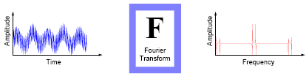
Figure 2.1
For many signals, Fourier analysis is extremely useful because the signal’s frequency content is of great importance. So why do we need other techniques, like wavelet analysis?
Fourier analysis has a serious drawback. In transforming to the frequency domain, time information is lost. When looking at a Fourier transform of a signal, it is impossible to tell when a particular event took place. If the signal properties do not change much over time — that is, if it is what is called a stationary signal—this drawback isn’t very important. However, most interesting signals contain numerous non stationary or transitory characteristics: drift, trends, abrupt changes, and beginnings and ends of events. These characteristics are often the most important part of the signal, and Fourier analysis is not suited to detecting them.

Short-Time Fourier analysis:
In an effort to correct this deficiency, Dennis Gabor (1946) adapted the Fourier transform to analyze only a small section of the signal at a time—a technique called windowing the signal.Gabor’s adaptation, called the Short-Time FourierTransform (STFT), maps a signal into a two-dimensional function of time and frequency.
Figure 2.2
The STFT represents a sort of compromise between the time- and frequency-based views of a signal. It provides some information about both when and at what frequencies a signal event occurs. However, you can only obtain this information with limited precision, and that precision is determined by the size of the window. While the STFT compromise between time and frequency information can be useful, the drawback is that once you choose a particular size for the time window, that window is the same for all frequencies. Many signals require a more flexible approach—one where we can vary the window size to determine more accurately either time or frequency.

Wavelet Analysis
Wavelet analysis represents the next logical step: a windowing technique with variable-sized regions. Wavelet analysis allows the use of long time intervals where we want more precise low-frequency information, and shorter regions where we want high-frequency information.
Figure 2.3

Here’s what this looks like in contrast with the time-based, frequency-based, and STFT views of a signal:

Figure 2.4
You may have noticed that wavelet analysis does not use a time-frequency region, but rather a time-scale region. For more information about the concept of scale and the link between scale and frequency, see “How to Connect Scale to Frequency?”

What Can Wavelet Analysis Do?

One major advantage afforded by wavelets is the ability to perform local analysis, that is, to analyze a localized area of a larger signal. Consider a sinusoidal signal with a small discontinuity — one so tiny as to be barely visible. Such a signal easily could be generated in the real world, perhaps by a power fluctuation or a noisy switch.

Figure 2.5
A plot of the Fourier coefficients (as provided by the fft command) of this signal shows nothing particularly interesting: a flat spectrum with two peaks representing a single frequency. However, a plot of wavelet coefficients clearly shows the exact location in time of the discontinuity.

Figure 2.6
Wavelet analysis is capable of revealing aspects of data that other signal analysis techniques miss, aspects like trends, breakdown points, discontinuities in higher derivatives, and self-similarity. Furthermore, because it affords a different view of data than those presented by traditional techniques, wavelet analysis can often compress or de-noise a signal without appreciable degradation. Indeed, in their brief history within the signal processing field, wavelets have already proven themselves to be an indispensable addition to the analyst’s collection of tools and continue to enjoy a burgeoning popularity today.

What Is Wavelet Analysis?
Now that we know some situations when wavelet analysis is useful, it is worthwhile asking “What is wavelet analysis?” and even more fundamentally,
“What is a wavelet?”
A wavelet is a waveform of effectively limited duration that has an average value of zero.
Compare wavelets with sine waves, which are the basis of Fourier analysis.
Sinusoids do not have limited duration — they extend from minus to plus infinity. And where sinusoids are smooth and predictable, wavelets tend to be irregular and asymmetric.

Figure 2.7
Fourier analysis consists of breaking up a signal into sine waves of various frequencies. Similarly, wavelet analysis is the breaking up of a signal into shifted and scaled versions of the original (or mother) wavelet. Just looking at pictures of wavelets and sine waves, you can see intuitively that signals with sharp changes might be better analyzed with an irregular wavelet than with a smooth sinusoid, just as some foods are better handled with a fork than a spoon. It also makes sense that local features can be described better with wavelets that have local extent.

Number of Dimensions:
Thus far, we’ve discussed only one-dimensional data, which encompasses most ordinary signals. However, wavelet analysis can be applied to two-dimensional data (images) and, in principle, to higher dimensional data. This toolbox uses only one and two-dimensional analysis techniques.

The Continuous Wavelet Transform:
Mathematically, the process of Fourier analysis is represented by the Fourier transform:

which is the sum over all time of the signal f(t) multiplied by a complex exponential. (Recall that a complex exponential can be broken down into real and imaginary sinusoidal components.) The results of the transform are the Fourier coefficients F(w), which when multiplied by a sinusoid of frequency w yields the constituent sinusoidal components of the original signal. Graphically, the process looks like:
Figure 2.8
Similarly, the continuous wavelet transform (CWT) is defined as the sum over all time of signal multiplied by scaled,shifted versions of the wavelet function. 
The result of the CWT is a series many wavelet coefficients C, which are a function of scale and position.
Multiplying each coefficient by the appropriately scaled and shifted wavelet yields the constituent wavelets of the original signal:
Figure 2.9

Scaling
We’ve already alluded to the fact that wavelet analysis produces a time-scale view of a signal and now we’re talking about scaling and shifting wavelets.
What exactly do we mean by scale in this context?
Scaling a wavelet simply means stretching (or compressing) it.
To go beyond colloquial descriptions such as “stretching,” we introduce the scale factor, often denoted by the letter a.
If we’re talking about sinusoids, for example the effect of the scale factor is very easy to see:
Figure 2.10
The scale factor works exactly the same with wavelets. The smaller the scale factor, the more “compressed” the wavelet.
Figure 2.11
It is clear from the diagrams that for a sinusoid sin (wt) the scale factor ‘a’ is related (inversely) to the radian frequency ‘w’. Similarly, with wavelet analysis the scale is related to the frequency of the signal.

Shifting
Shifting a wavelet simply means delaying (or hastening) its onset. Mathematically, delaying a function  (t) by k is represented by    (t-k)
Figure 2.12

The Discrete Wavelet Transform:
Calculating wavelet coefficients at every possible scale is a fair amount of work, and it generates an awful lot of data. What if we choose only a subset of scales and positions at which to make our calculations? It turns out rather remarkably that if we choose scales and positions based on powers of two—so-called dyadic scales and positions—then our analysis will be much more efficient and just as accurate. We obtain such an analysis from the discrete wavelet transform (DWT).
An efficient way to implement this scheme using filters was developed in 1988 by Mallat. The Mallat algorithm is in fact a classical scheme known in the signal processing community as a two-channel sub band coder. This very practical filtering algorithm yields a fast wavelet transform — a box into which a signal passes, and out of which wavelet coefficients quickly emerge. Let’s examine this in more depth.

One-Stage Filtering: Approximations and Details:
For many signals, the low-frequency content is the most important part. It is what gives the signal its identity. The high-frequency content on the other hand imparts flavor or nuance. Consider the human voice. If you remove the high-frequency components, the voice sounds different but you can still tell what’s being said. However, if you remove enough of the low-frequency components, you hear gibberish. In wavelet analysis, we often speak of approximations and details. The approximations are the high-scale, low-frequency components of the signal. The details are the low-scale, high-frequency components.
The filtering process at its most basic level looks like this:

Figure 2.13
The original signal S passes through two complementary filters and emerges as two signals.Unfortunately, if we actually perform this operation on a real digital signal, we wind up with twice as much data as we started with. Suppose, for instance that the original signal S consists of 1000 samples of data. Then the resulting signals will each have 1000 samples, for a total of 2000.
These signals A and D are interesting, but we get 2000 values instead of the 1000 we had. There exists a more subtle way to perform the decomposition using wavelets. By looking carefully at the computation, we may keep only one point out of two in each of the two 2000-length samples to get the complete information. This is the notion of own sampling. We produce two sequences called cA and cD.
Figure 2.14
The process on the right which includes down sampling produces DWT
Coefficients. To gain a better appreciation of this process let’s perform a one-stage discrete wavelet transform of a signal. Our signal will be a pure sinusoid with high- frequency noise added to it.
Here is our schematic diagram with real signals inserted into it:
Figure 2.15
Notice that the detail coefficients cD is small and consist mainly of a high-frequency noise, while the approximation coefficients cA contains much less noise than does the original signal.
You may observe that the actual lengths of the detail and approximation coefficient vectors are slightly more than half the length of the original signal. This has to do with the filtering process, which is implemented by convolving the signal with a filter. The convolution “smears” the signal, introducing several extra samples into the result.

Multiple-Level Decomposition:
The decomposition process can be iterated, with successive approximations being decomposed in turn, so that one signal is broken down into many lower resolution components. This is called the wavelet decomposition tree.

Figure 2.16
Looking at a signal’s wavelet decomposition tree can yield valuable information.
Figure 2.17

Number of Levels:
Since the analysis process is iterative, in theory it can be continued indefinitely. In reality, the decomposition can proceed only until the individual details consist of a single sample or pixel. In practice, you’ll select a suitable number of levels based on the nature of the signal, or on a suitable criterion such as entropy.
Wavelet Reconstruction:
We’ve learned how the discrete wavelet transform can be used to analyze or decompose, signals and images. This process is called decomposition or analysis. The other half of the story is how those components can be assembled back into the original signal without loss of information. This process is called reconstruction, or synthesis. The mathematical manipulation that effects synthesis is called the inverse discrete wavelet transforms (IDWT). To synthesize a signal in the Wavelet Toolbox, we reconstruct it from the wavelet coefficients:

Figure 2.18
Where wavelet analysis involves filtering and down sampling, the wavelet reconstruction process consists of up sampling and filtering. Up sampling is the process of lengthening a signal component by inserting zeros between samples:
Figure 2.19
The Wavelet Toolbox includes commands like idwt and waverec that perform single-level or multilevel reconstruction respectively on the components of one-dimensional signals. These commands have their two-dimensional analogs, idwt2 and waverec2.

Reconstruction Filters:
The filtering part of the reconstruction process also bears some discussion, because it is the choice of filters that is crucial in achieving perfect reconstruction of the original signal. The down sampling of the signal components performed during the decomposition phase introduces a distortion called aliasing. It turns out that by carefully choosing filters for the decomposition and reconstruction phases that are closely related (but not identical), we can “cancel out” the effects of aliasing.
The low- and high pass decomposition filters (L and H), together with their associated reconstruction filters (L' and H'), form a system of what is called quadrature mirror filters:
Figure 2.20

Reconstructing Approximations and Details:
We have seen that it is possible to reconstruct our original signal from the coefficients of the approximations and details.

Figure 2.21
It is also possible to reconstruct the approximations and details themselves from their coefficient vectors.
As an example, let’s consider how we would reconstruct the first-level approximation A1 from the coefficient vector cA1. We pass the coefficient vector cA1 through the same process we used to reconstruct the original signal. However, instead of combining it with the level-one detail cD1, we feed in a vector of zeros in place of the detail coefficients
vector:
Figure 2.22

The process yields a reconstructed approximation A1, which has the same length as the original signal S and which is a real approximation of it. Similarly, we can reconstruct the first-level detail D1, using the analogous process:

Figure 2.23
The reconstructed details and approximations are true constituents of the original signal. In fact, we find when we combine them that:
A1 + D1 = S
Note that the coefficient vectors cA1 and cD1—because they were produced by Down sampling and are only half the length of the original signal — cannot directly be combined to reproduce the signal.
It is necessary to reconstruct the approximations and details before combining them. Extending this technique to the components of a multilevel analysis, we find that similar relationships hold for all the reconstructed signal constituents.
That is, there are several ways to reassemble the original signal:

Figure 2.24

Relationship of Filters to Wavelet Shapes:
In the section “Reconstruction Filters”, we spoke of the importance of choosing the right filters. In fact, the choice of filters not only determines whether perfect reconstruction is possible, it also determines the shape of the wavelet we use to perform the analysis. To construct a wavelet of some practical utility, you seldom start by drawing a waveform. Instead, it usually makes more sense to design the appropriate quadrature mirror filters, and then use them to create the waveform. Let’s see how this is done by focusing on an example.
Consider the low pass reconstruction filter (L') for the db2 wavelet.
Wavelet function position
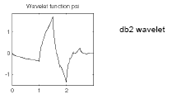

Figure 2.25
The filter coefficients can be obtained from the dbaux command:
Lprime = dbaux(2)
Lprime = 0.3415 0.5915 0.1585 –0.0915
If we reverse the order of this vector (see wrev), and then multiply every even sample by –1, we obtain the high pass filter H':
Hprime = –0.0915 –0.1585 0.5915 –0.3415
Next, up sample Hprime by two (see dyadup), inserting zeros in alternate positions:
HU =–0.0915 0 –0.1585 0 0.5915 0 –0.3415 0
Finally, convolve the up sampled vector with the original low pass filter:
H2 = conv(HU,Lprime);
plot(H2)
Figure 2.26
If we iterate this process several more times, repeatedly up sampling and convolving the resultant vector with the four-element filter vector Lprime, a pattern begins to emerge:
Figure 2.27
The curve begins to look progressively more like the db2 wavelet. This means that the wavelet’s shape is determined entirely by the coefficients of the reconstruction filters. This relationship has profound implications. It means that you cannot choose just any shape, call it a wavelet, and perform an analysis. At least, you can’t choose an arbitrary wavelet waveform if you want to be able to reconstruct the original signal accurately. You are compelled to choose a shape determined by quadrature mirror decomposition filters.
The Scaling Function:
We’ve seen the interrelation of wavelets and quadrature mirror filters. The wavelet function   is determined by the high pass filter, which also produces the details of the wavelet decomposition.
There is an additional function associated with some, but not all wavelets. This is the so-called scaling function . The scaling function is very similar to the wavelet function. It is determined by the low pass quadrature mirror filters, and thus is associated with the approximations of the wavelet decomposition. In the same way that iteratively up- sampling and convolving the high pass filter produces a shape approximating the wavelet function, iteratively up-sampling and convolving the low pass filter produces a shape approximating the scaling function.
Multi-step Decomposition and Reconstruction:
A multi step analysis-synthesis process can be represented as:

Figure 2.28
This process involves two aspects: breaking up a signal to obtain the wavelet coefficients, and reassembling the signal from the coefficients. We’ve already discussed decomposition and reconstruction at some length. Of course, there is no point breaking up a signal merely to have the satisfaction of immediately reconstructing it. We may modify the wavelet coefficients before performing the reconstruction step. We perform wavelet analysis because the coefficients thus obtained have many known uses, de-noising and compression being foremost among them. But wavelet analysis is still a new and emerging field. No doubt, many uncharted uses of the wavelet coefficients lie in wait. The Wavelet Toolbox can be a means of exploring possible uses and hitherto unknown applications of wavelet analysis. Explore the toolbox functions and see what you discover.

INTRODUCTION TO MATLAB

What Is MATLAB?

MATLAB® is a high-performance language for technical computing. It integrates computation, visualization, and programming in an easy-to-use environment where problems and solutions are expressed in familiar mathematical notation.
Typical uses include: Math and computation,
Algorithm development
Data acquisition
Modeling, simulation, and prototyping
Data analysis, exploration, and visualization
Scientific and engineering graphics

Application development, including graphical user interface building.

MATLAB is an interactive system whose basic data element is an array that does not require dimensioning. This allows you to solve many technical computing problems, especially those with matrix and vector formulations, in a fraction of the time it would take to write a program in a scalar non interactive language such as C or FORTRAN.
The name MATLAB stands for matrix laboratory. MATLAB was originally written to provide easy access to matrix software developed by the LINPACK and EISPACK projects. Today, MATLAB engines incorporate the LAPACK and BLAS libraries, embedding the state of the art in software for matrix computation.
MATLAB has evolved over a period of years with input from many users. In university environments, it is the standard instructional tool for introductory and advanced courses in mathematics, engineering, and science. In industry, MATLAB is the tool of choice for high-productivity research, development, and analysis.

MATLAB features a family of add-on application-specific solutions called toolboxes. Very important to most users of MATLAB, toolboxes allow you to learn and apply specialized technology. Toolboxes are comprehensive collections of MATLAB functions (M-files) that extend the MATLAB environment to solve particular classes of problems. Areas in which toolboxes are available include signal processing, control systems, neural networks, fuzzy logic, wavelets, simulation, and many others.

The MATLAB System:
The MATLAB system consists of five main parts:

Development Environment:
This is the set of tools and facilities that help you use MATLAB functions and files. Many of these tools are graphical user interfaces. It includes the MATLAB desktop and Command Window, a command history, an editor and debugger, and browsers for viewing help, the workspace, files, and the search path.

The MATLAB Mathematical Function:
This is a vast collection of computational algorithms ranging from elementary functions like sum, sine, cosine, and complex arithmetic, to more sophisticated functions like matrix inverse, matrix eigen values, Bessel functions, and fast Fourier transforms.
The MATLAB Language:
This is a high-level matrix/array language with control flow statements, functions, data structures, input/output, and object-oriented programming features. It allows both "programming in the small" to rapidly create quick and dirty throw-away programs, and "programming in the large" to create complete large and complex application programs.

Graphics:
MATLAB has extensive facilities for displaying vectors and matrices as graphs, as well as annotating and printing these graphs. It includes high-level functions for two-dimensional and three-dimensional data visualization, image processing, animation, and presentation graphics. It also includes low-level functions that allow you to fully customize the appearance of graphics as well as to build complete graphical user interfaces on your MATLAB applications.

The MATLAB Application Program Interface (API):
This is a library that allows you to write C and Fortran programs that interact with MATLAB. It includes facilities for calling routines from MATLAB (dynamic linking), calling MATLAB as a computational engine, and for reading and writing MAT-files.

RESULTS:
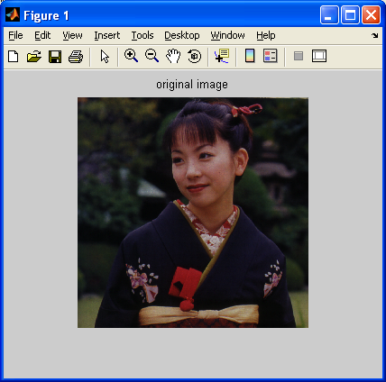
Bit planes
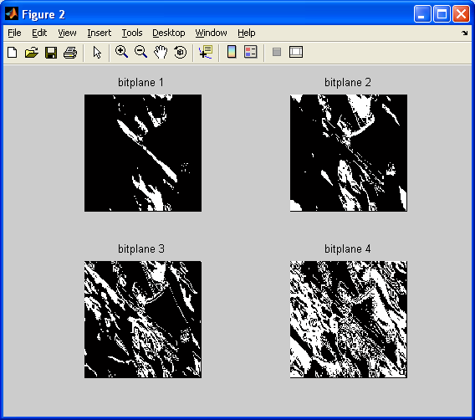
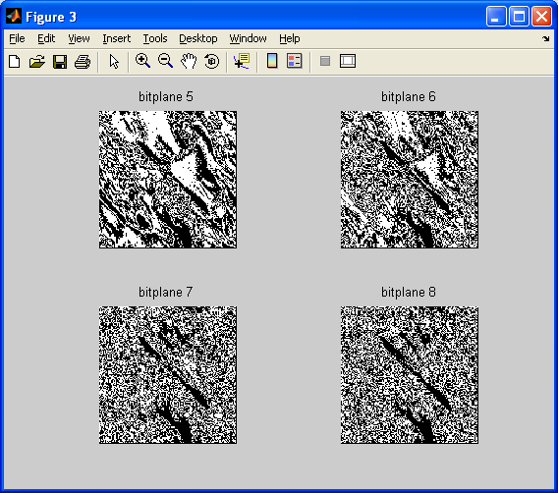

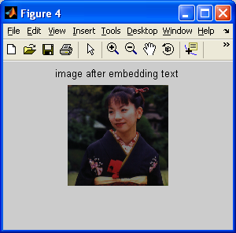

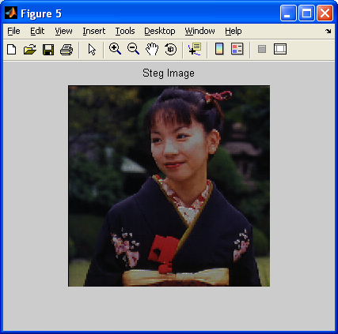

Embedded Text
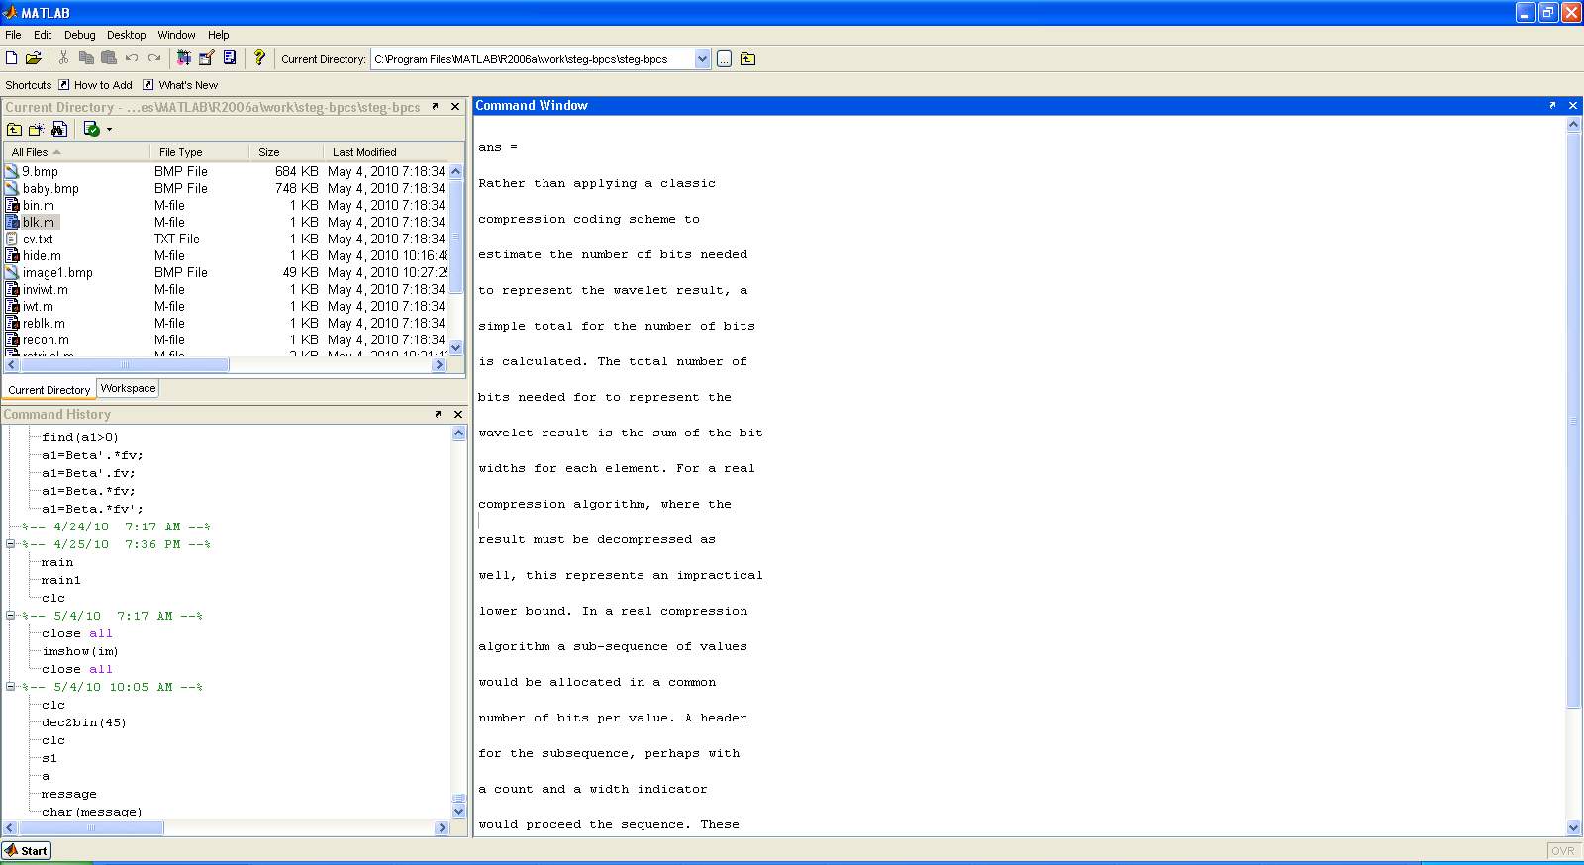

Retrieved Text
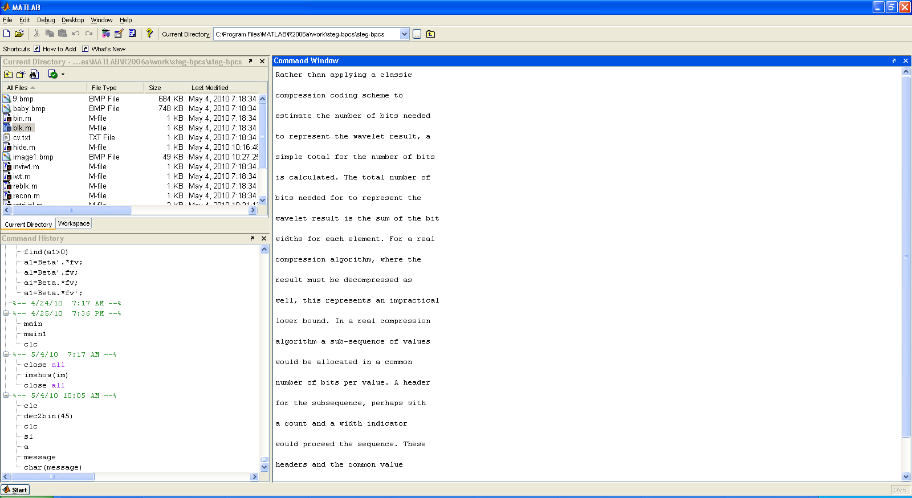

CONCLUSIONS:

We designed a lossless steganography system, in which the IWT and BPCS are used to get high data hiding capacity and low perceptibility. IWT is used to decompose the cover image. BPCS takes the advantage of human visual system which cannot recognize changes in complex positions of the image. The results show different hiding capacities based on the cover image chosen. The data extracted from the cover image also depends on the pixel values of the image. The system can be further developed to hide secret image in cover image. Most data-hiding systems take advantage of human perceptual weaknesses, but have weaknesses of their own. We conclude that for now, it seems that no system of data-hiding is totally immune to attack.
However, Steganography has its place in security. Though it cannot replace cryptography totally, it is intended to supplement it. Its application in watermarking and fingerprinting, for use in detection of unauthorized, illegally copied material, is continually being realized and developed.
Also, in places where standard cryptography and encryption is outlawed, Steganography can be used for covert data transmission. Steganography can be used along with cryptography to make an highly secure data high way. Formerly just an interest of the military, Steganography is now gaining popularity among the masses. Soon, any computer user will be able to put his own watermark on his artistic creations.
Thus we conclude that the strength of security achieved is very high and unauthorized receiver will not be able to get back the original message using exhaustive without the knowledge of key parameters.
Digital Steganography is interesting field and growing rapidly for information hiding in the area of information security.lt has a vital role in defence as well as civil applications.

FUTURE SCOPE:

In this report many relevant issues were presented, from a technical point of view. However, little has been done to motivate these studies. A more detailed investigation of applications, and a comparison with current techniques in Steganography would have been interesting. For example, a thorough evaluation of the advantages natural language-based techniques can offer over image-based techniques could have offered valuable insights.
An important contribution of this project to natural language Steganography is the linguistic sophistication of the model for word-substitution put forward. The lexical models employed in current substitution-based systems were often criticised and their inadequate behavior usually described with respect to language theory. These phenomena could have been demonstrated by example, showing texts and inadequate replacements carried out by current stegosystems. A more detailed analysis of how common these critical situations really are in typical text could have given clues for the construction of such systems, to decide whether the additional complexity introduced by statistical word-sense disambiguation is worth the effort.
Other linguistic models have been studied, in addition to the lexical ones, and put in relation to each other, and to their use for steganographic purposes. The steganographic aspects were then covered by information-theoretic models. However, little has been done to justify this choice. It might have been fruitful to present other characterizations of Steganography and to compare their suitability to natural language Steganography.
A central part of the problem motivating this report was that there are no models formalizing the design and analysis of natural language stegosystems. Although the present report somewhat improves the situation, by providing a systematic investigation of the topic, there is still no system to build upon for making formal claims about security or robustness in the natural language scenario.
We are very convinced that this Steganography is a very strong information security technique, especially when combined with encrypted embedded data. Furthermore, it can be applied to areas other than secret communication. Future research will include the application to vessels other than 24-bit images, identifying and formalizing the customization parameters, and developing new applications.
REFERENCE:

[1] Ms. K. Ramani, Dr. E. V. Prasad & Dr. S. Varadarajan Steganography Using BPCS to the Integer Wavelet Transformed Image in IJCSNS International Journal of Computer Science and Network Security, VOL.7 No.7, July 2007

[2] Eijji Kawagauch and Richard O. Eason “Principle and Application of BPCS-Steganography” in Proc. SPIE, vol. 3529, 1998, pp. 464-473.

[3] PETITCOLAS, F. A. P. – ANDERSON, R. J. – KUHN, M.G., Attacks on Copyright Marking Systems, In David Aucsmith, Ed., Second Workshop on Information Hiding, in Vol. 1525 of Lecture Notes in Computer Science, Portland, Oregon, U.S.A., 14–17 April, 1998, pp. 218–238. ISBN 3-540-65386-4.

[4] ANDERSON, R. J. – PETITCOLAS, F. A. P., On The Limits of Steganography, IEEE Journal of Selected Areas in Communications, 16 (4) pp. 474-481, May 1998. Special Issue on Copyright & Privacy Protection. ISSN 0733-8716.

[5] BRASSIL, J. – LOW, S. – MAXEMCHUK, N. F. – O’GORMAN, L., Hiding Information in Document Images, AT&T Bell Laboratories, Murray Hill, NJ.

[6] BENDER, W. – GRUHL, D. – MORIMOTO, N., Techniques for Data Hiding, Massachusetts Institute of Technology, Media Laboratory Cambridge, Massachusetts 02139 USA, From the Proceedings of the SPIE, 2420:40, San Jose CA, February, 1995.

[7] On Public-key Steganography in the Presence of an ActiveWarden, Scott Craver Intel Corporation Microcomputer Research Labs 2200 Mission College Blvd., Santa Clara, CA 95052–8119 Department of Mathematical Sciences Northern Illinois University DeKalb, IL 60115.

[8] JOHNSON, N. F. – JAJODIA, S., Exploring Steganography: Seeing the Unseen, George Mason University.

[9] KAWAGUCHI, E. – EASON, R. O., Principle and Applications of BPCS-Steganography Proc. of 1998 SPIE International Symposium on Voice, Video, and Data Communications, Conference #3528.

[10] CACHIN, C., An Information-Theoretic Model for Steganography, MIT Laboratory for Computer Science 545 Technology Square Cambridge, MA 02139, USA cachin@acm.org May 13, 1998 In Proceedings of 2nd Workshop on Information Hiding (D. Aucsmith, ed.), Lecture Notes in Computer Science, Springer, 1998.

[11] BENDER, W. – GRUHL, D. – MORIMOTO, N. – LU, A., Techniques for Data Hiding, IBM Systems Journal, 35, Nos. 3–4, 1996.

[12] HWANG, R. W., Robust Algorithm for Information Hiding in Digital Pictures, Master of Engineering at The Massachusetts Institute of Technology May 21, 1999.

[13] ZHAO, J. – KOCH, E., Embedding Robust Labels Into Images For Copyright Protection, Fraunhofer Institute for Computer Graphics Wilhelminenstr. 7, 64283 Darmstadt, Germany Email:{zhao, ekoch}@igd.fhg.de Proc. of the Int. Congress on Intellectual Property Rights for Specialized Information, Knowledge and New Technologies, Vienna, August 1995.

[14] KUNDUR, D. – HATZINAKOS, D., Mismatching Perceptual Models for EffectiveWatermarking in the Presence of Compression, Department of Electrical and Computer Engineering University of Toronto 10 King’s College Road Toronto, Ontario Canada M5S 3G4.

