Stress Analysis of Thick Pressure Vessel under Condition of High Pressure with ABAQUS®

A major project thesis submitted in partial fulfillment of the requirements for the award of the degree
of
MASTER OF ENGINEERING IN PRODUCTION ENGINEERING
Submitted by:
PARTHA SARKAR
University Roll No. 12325

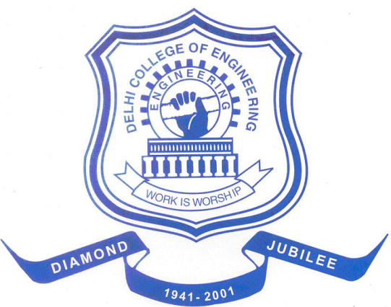

DEPARTMENT OF MECHANICAL ENGINEERING
DELHI COLLEGE OF ENGINEERING
DELHI UNIVERSITY, DELHI-110042

June 2009

