A
Major Project Report
On
“Settlement Analysis of Pile Foundations in Multi-Layered Elastic Medium”

Submitted in partial fulfillment of the requirements
For the award of the degree of
MASTER OF ENGINEERING
(Structural Engineering)
By
Gouseya Shahnaaz
College Roll No: 05/Str/07
Delhi University Roll No: 12363

Under the guidance of
Dr. A.K. Gupta



Department of Civil and Environmental Engineering
Delhi College of Engineering
Bawana Road, Delhi – 110042
CERTIFICATE
This is to declare that the Major project Thesis “Settlement Analysis of Pile Foundations in Multi-Layered Elastic Medium” is a bonafide record of work done by me in partial fulfillment of the requirement for the award of the degree of Master of Engineering in Civil Engineering (Structural Engineering) from Delhi College of Engineering.
This project has been carried out under the supervision of Dr. A.K.Gupta.
I have not submitted the matter embodied in this report to any other university or institution for the award of any degree or diploma.

Gouseya Shahnaaz
University Roll No: 12363
Certificate:
This is to certify that the above statement laid by the candidate is correct to the best of my knowledge.

Dr. A.K.Gupta
Project Guide
Dept. of Civil and Environmental Engineering
Delhi College of Engineering

ABSTRACT
Piles are one of the most important types of foundation in use today. Design of a pile foundation not very commonly includes a settlement analysis and it is usually limited to determining a factor of safety on pile capacity. This approach is uneconomical and sometimes unsafe too. Therefore, a comprehensive settlement analysis needs to be performed for the design of pile foundations.
A number of methods have been developed for estimating the behaviour of pile groups, ranging from simple closed form solutions to sophisticated non-linear finite element analysis.
The mechanism of load transfer in pile groups involves a complex system interaction of piles, pile cap, and surrounding soil. The process is affected by many factors such as soil properties, single pile and pile group geometry, single pile-soil interaction, and interaction between the different elements in the group. Then, due to the uncertainty or difficulty in quantifying these factors, there are no methods capable to accurately evaluate their effects on the pile group settlements.
In pile foundation design, bearing capacity and settlement are two important indices. Although pile foundation is one of the most commonly used foundation, owing to the complexity of problem, the engineering design is still in half experience and half theory state. A large number of researches have worked upon the ultimate bearing capacity, but not much attention has been paid to the settlement aspect of the pile foundation.
In most of the available prediction methods, the pile group settlement is related to the settlement of a single pile, similar to one of those in the group. For a pile group, the load transfer curves of the individual piles are modified to take into account the group effects by ‘stretching’ the curves, involving the displacements of a single pile and additional induced displacements due to the soil reactions.
A computer code for an analytical procedure for the settlement analysis of pile foundations, using modern techniques of evaluation, was developed and then implemented in a computer program ( Visual Basic, MS EXCEL, MATLAB) to study the load transfer and settlement behaviour of pile foundation and the result compared with established case histories. Some comparative study was also done to know the behaviour of different shapes of piles.
Moreover, a matrix method was used to calculate the settlement of a pile group. The result was compared with the settlement obtained by using some other techniques as mentioned in the established literature. A good agreement was found in the results got from the compared methods.

ACKNOWLEDGMENTS
Praise to Almighty who has decided whatever is best for us!
This project would not be what it is if it hadn’t been for the people whose constant comments and valuable guidance had made this project successful.
I would like to thank Dr. A.K.Gupta, my guide in this project for the constant motivation and support during the duration of this project. It is my privilege to have worked under his supervision.
I would like to thank Dr.S.K. Singh, HOD of Civil and Environmental Engineering.
Last but not least, I am thankful to my parents, my siblings, and my friends (Saima,Okstynn,Jamy), without whose constant moral support and motivation, I would have been unable to complete the project.
Thank you all!

Gouseya Shahnaaz

TABLE OF CONTENTS
1. Introduction 12
1.1 General 12
1.2 Objective of Study 14
2. Literature Review 15
2.1 General 15
2.2 The Literature Review 15
2.2.1 Single Pile Analysis: 15
2.2.2 Pile Group Analysis: 20
3. Numerical Methods of Analysis 25
3.1 Overview: Methods of analysis 25
3.2 Empirical Methods 25
3.3 Numerical Methods 26
3.3.1 Finite - element analysis: 26
3.3.2 Boundary- element methods: 27
4. Problem Description 1 31
4.1 Selection of Problem 1: 31
4.2 Problem Definition: 31
4.3 Analysis: 32
4.3.1 Potential Energy: 32
4.3.2 Soil Displacement: 33
4.3.3 Potential Energy density: 34
4.3.4 Principle of minimum potential energy: 34
4.3.5 Soil displacement profiles 38
4.3.6 Pile Displacement: 41
4.3.7 Physical meaning of the equations: 43
4.4 Solution to the Problem: 45
4.4.1 Iterative solution scheme: 45
4.4.2 The VBA Code for the Iterative Solution Scheme: 47
5. Problem Description 2 50
5.1. Project No.C1083201 of PWD’s Commonwealth Project Division. 50
5.2 Solution to the problem: 50
6. Results and Discussions: 57
6.1 Rectangular pile embedded in 4 layers of soil (weak soil layers overlying a stiff layer): 57
6.1.1 Pile Geometry (Pile 1): 57
6.1.2 Elastic Soil Properties and No of Layers of Soil: 57
6.1.3 Output: 58
6.1.4 Output Graphs: 60
6.1.5 Pile Geometry (Pile 2): 61
6.1.6 Elastic Soil Properties and No of Layers of Soil: 61
6.1.7 Output: 62
6.1.8 Output Graphs: 64
6.2 Circular pile embedded in 4 layers of soil (weak soil layers overlying a stiff layer): 65
6.2.1 Pile Geometry (Pile 1): 65
6.2.2 Elastic Soil Properties and No of Layers of Soil: 66
6.2.3 Output: 66
6.2.4 Output Graphs: 68
6.2.5 Pile Geometry (Pile 2): 70
6.2.6 Elastic Soil Properties and No of Layers of Soil: 70
6.2.7 Output: 70
6.2.8 Output Graphs: 72
6.3 Pile group 75
7. Conclusion 76
8. References 78
Appendix 81

LIST OF FIGURES
Figure 1: A curve between pile head settlement Δ and settlement to load ratio Δ/P (Chin, 1974) 16
Figure 2: Simplified analytical model for pile-soil system (Liu Jie, Zhang Ken-neng (2003)) 19
Figure 3: Basic problem of singly axially loaded pile (After Poulos, 1989) 29
Figure 4: An axially loaded pile in layered medium (D Bassu, M Prezzi, 2007) 32
Figure 5: Displacements and stresses in soil mass 33
Figure 6: Illustration of the two sources of soil resistance: soil compression and shear(Shen et al,2000) 44
Figure 7: Flow chart. 46
Figure 8: Concentric cylinders of soil around pile (Shen et al,2000) 50
Figure 9: Cross section of a Rectangular pile 57
Figure 10: Deformed Configuration of the Rectangular Pile1 after the application of load. 59
Figure 11: Axial Pile displacement (horizontal) along the depth of pile (Rec. Pile1) 60
Figure 12: Axial Load transferred along the depth of the pile. 60
Figure 13: Variation of soil displacement along the radius of influence. 61
Figure 14: Deformed Configuration of the Rectangular Pile 2 after the application of load. 63
Figure 15: Axial Pile displacement (horizontal) along the depth of pile. 64
Figure 16: Axial Load transferred along the depth of the pile. 64
Figure 17: Variation of soil displacement along the radius of influence. 65
Figure 18: Cross section of a Circular Pile 65
Figure 19: Deformed Configuration of the Circular Pile after the application of load. 67
Figure 20: Axial Pile displacement (horizontal) along the depth of pile. 68
Figure 21: Axial Load transferred along the depth of the pile. 68
Figure 22: Variation of soil displacement along the radius of influence. 69
Figure 23: Variation of pile head settlement with the increase of axial load 69
Figure 24: Deformed Configuration of the Circular Pile 2 after the application of load. 71
Figure 25: Axial Pile displacement (horizontal) along the depth of pile. 72
Figure 26: Axial Load transferred along the depth of the pile. 72
Figure 27: Variation of soil displacement along the radius of influence. 73
Figure 28: Variation of pile head settlement with the increase of axial load 73
Figure 29: Comparison of Horizontal Pile displacements in case of rectangular and circular pile 1 74
Figure 30: Comparison of Horizontal Pile displacements in case of rectangular and circular pile 2 74
Figure 31: Normalised Group Settlement ratio Vs Number of piles for l/ro = 50 (Shen.et al,2000) 82
Figure 32: Normalised group settlement ratio Vs number of piles for l/ro = 100 ( Shen et al,2000) 82

LIST OF TABLES
Table 1: Various Cross-sectional Dimensions and Elastic Properties of Rectangular Pile No 1 57
Table 2: Table showing various layers of soil continuum, depth and elastic property of each layer 58
Table 3: The calculated values of Head settlement, base settlement and load transferred to the base (Rec. Pile 1) 58
Table 4: Various Cross-sectional Dimensions and Elastic Properties of Rectangular Pile No 2 61
Table 5: Table showing various layers of soil continuum, depth and elastic property of each layer 62
Table 6: The calculated values of Head settlement, base settlement and load transferred to the base. 62
Table 7: Various Cross-sectional Dimensions and Elastic Properties of Circular Pile No 1 66
Table 8: Table showing various layers of soil continuum, depth and elastic property of each layer 66
Table 9: The calculated values of Head settlement, base settlement and load transferred to the base. 66
Table 10: Various Cross-sectional Dimensions and Elastic Properties of Circular Pile No 2 70
Table 11: Table showing various layers of soil continuum, depth and elastic property of each layer 70
Table 12: The calculated values of Head settlement, base settlement and load transferred to the base.  71

Introduction

1.1 General
The use of piles is one of the most common methods of overcoming the difficulties of founding on soft soils. Piles are vertical or slightly inclined relatively slender structural foundation members. They transmit loads from the superstructure to the competent soil layers. Length, method of installation, and way of transferring the load to the soil can vary greatly. Piles are used for a variety of reasons, as follows:
- When a competent soil layer can only be found at a depth.
- When the soil layers immediately below the structure though competent, are subject to scour.
- When the structure transmits large concentrated loads to the soil that cannot be spread out horizontally by means of a wide, shallow foundations.
- When the structure is very sensitive to differential settlement.
- When the site has a very high water table or artesian water conditions and the soil is sensitive to the construction of even shallow excavations required for mat or footing foundations.
In some cases, the piles serve only to improve the bearing capacity, density or stiffness of the surrounding soil without directly carrying the load of the structure.
In pile foundation design, bearing capacity and settlement are two important indices. Although pile foundation is one of the most commonly used foundation, owing to the complexity of problem, the engineering design is still in half experience and half theory state. A large number of researches have worked upon the ultimate bearing capacity, but not much attention has been paid to the settlement aspect of the pile foundation.
Design of a pile foundation not very commonly includes a settlement analysis and it is usually limited to determining a factor of safety on pile capacity. This approach is uneconomical and sometimes unsafe too. Therefore, a comprehensive settlement analysis needs to be performed for the design of pile foundations.
A number of methods have, however, been developed for estimating the behaviour of pile groups, ranging from simple closed form solutions to sophisticated non-linear finite element analysis.
The mechanism of load transfer in pile groups involves a complex system interaction of piles, pile cap, and surrounding soil. The process is affected by many factors such as soil properties, single pile and pile group geometry, single pile-soil interaction, and interaction between the different elements in the group. Then, due to the uncertainty or difficulty in quantifying these factors, there are no methods capable to accurately evaluate their effects on the pile group settlements.
In most of the available prediction methods, the pile group settlement is related to the settlement of a single pile, similar to one of those in the group. For example, the ‘hybrid’ approach (Lee 1993), originally proposed by O’Neill et-al (1977), models the single piles using load transfer (t-z) method, and the interaction between the piles, through the soil, is then evaluated using the Mindlin’s solution (Mindlin 1936)
For a pile group, the load transfer curves of the individual piles are modified to take into account the group effects by ‘stretching’ the curves, involving the displacements of a single pile and additional induced displacements due to the soil reactions.
The representation of a pile group by an equivalent pier provides a useful, practical tool for estimating the settlement behaviour of pile groups and can be used for either linear or non-linear analysis.
Traditionally, the settlement of a pile group has been estimated by considering an ‘equivalent’ raft situated two-thirds of the way down the part of the piles which penetrate the main founding stratum or at the level of the pile bases in the case of end-bearing piles. An alternative to equivalent raft approach is to consider the region of soil in which the piles are embedded as an equivalent continuum, effectively replacing the pile group by an equivalent pier (Poulos and Davis 1980)
The load- settlement response of the equivalent pier can be calculated by using the solutions for the response of a single pile. Naturally, the equivalent pier approach furnishes an estimation of only the average settlement of the pile group.
More recently, numerical methods have been developed and used to establish and study the load transfer mechanisms between the pile and the surrounding soil. These techniques include finite element methods, boundary element methods, discrete element methods, explicit finite difference methods, Winkler method, etc.

1.2 Objective of Study
Despite the significant volume of research, there has not been much effort to evaluate pile foundation design and analysis methods that involve settlement of piles and pile groups.
The objective of this study, therefore, is to develop an analytical procedure for the settlement analysis of pile foundations using modern techniques of evaluation and then implement the procedure in computer programs ( Visual Basic, MS EXCEL, MATLAB) to study the load transfer and settlement behaviour of pile foundation and compare the result with established case histories.

Literature Review

2.1 General
A number of researchers have suggested various approaches to the settlement behaviour of pile foundations. Difference of opinion exists in the method of analysis approach proposed to be adopted while studying the behaviour and load-transfer and energy transfer exchange mechanisms between pile and soil.
An extensive literature study has been carried out in this work. A number of research papers have been studied. The review of the literature studies is presented in the chronological order.

2.2 The Literature Review

2.2.1 Single Pile Analysis:
Chin (1970, 1972, and 1983) presented the method of plotting the behavior of both footing sand piles according to hyperbolic method and made it well known. This method has been widely adopted, although it has not been linked with soil parameters, but rather used as a method for defining ultimate loads. Fellenius (1980) has discussed the Chin method and other methods for defining ultimate loads; he and others have drawn attention to the fact that the Chin method appears to over predict. However, there is little doubt about that in most cases, according to the plotting method, linear functions represent pile performance very well. The method is represented by Chin in the form Δ/P = mΔ + C₁, where Δ is pile head settlement, P is applied load and C₁ is a constant. Thus, if Δ/P is plotted against an abscissa of Δ, a linear plot is obtained and the inverse slope gives an asymptotic limiting value of P. this, according to Chin, is true of piles that carry most of their load by shaft friction and also of footings and piles that carry most of their loads by in end bearing.

A typical relationship between pile head settlement Δ and settlement to load ratio Δ/P is given by:
Figure 1: A curve between pile head settlement Δ and settlement to load ratio Δ/P (Chin, 1974)
Δ / P
Δ
A
B

Chin suggested that the first part (A) of the relation represents shaft friction while the second part (B) represents total load. This cannot be strictly true because of the nature of hyperbolic functions, but it can easily be accepted that individually shaft and base performances are of hyperbolic form.
Poulos (1979), Randolph et al (1978, 79, 80) examined the load settlement behaviour of piles under axial loads using numerical methods based on theory of theory of elasticity. In these methods, the pile is modeled as a vertical line load inside the soil, while soil is assumed to be a homogeneous, linear, elastic, isotropic half-space with parameters E_{s} and ט, where E_{s} is Young’s modulus and ט is Poisson’s ratio
Ernesto (1993) gave an approximate elastic perfectly plastic solution in a closed form for axially loaded piles based on the t-z curve method. The closed- form solution allows prediction in very simple way of vertical pile movements and settlement at the pile head as well the value of the axial load at a certain depth from the ground surface. Differently from elastic solutions, the method can take into account the non-linear behaviour of the load-settlement curve. Because of the approximation made to derive simple expressions in a closed form, the method does not apply to situations where a significant portion of the working load is derived from end –bearing capacity. However, when the analysis is restricted to design loads and the choice of soil parameters is appropriate, the solution presented can give reasonable results.
Francesco Castelli and Michele Maugri (2000) gave a model for analyzing the non linear settlement behavior of a single pile subjected to axial load. The model is based on the load transfer approach, with the interaction between the pile and soil being simulated by a series of independent springs distributed along the pile shaft and at the base. The model employs hyperbolic load –transfer functions to model soil-pile interaction along the pile shaft and at the base. When these functions are combined, and the elastic shortening of pile is added, an accurate model is obtained.
The relationship between shaft and base mobilized load, f and q, respectively, with the vertical pile displacement, y, are expressed in terms of Konder-type hyperbolic curves as:
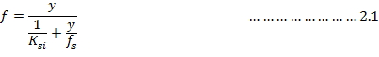
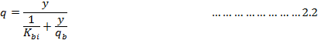
Where:
K_{si} & K_{bi} are initial shaft and base stiffness
f_{s:} shear strength at the pile shaft
q_{b}: limit unit load at the pile base.
The main difficulty of applying the proposed model is the correct determination of function parameters for a realistic evaluation of pile settlements and axial load distribution. By means of a computer code based on a pile finite element discretization, taking into account the non-linearity of the soil pile interaction on the basis of hyperbolic load-transfer functions, a back analysis of a number of published case histories was carried out. The examined cases refer to full scale instrumented bored piles in clay-like, silt-like, sandy and piro-clastic soils, with lengths ranging between 9.15 and 43.30m and diameters ranging 0.27 and 2.0m. The back analysis was performed to evaluate the practical applicability of the theoretical approach and to detect the more appropriate values of the main model parameters.
The settlement of a pile shaft for a given load is a direct function of the diameter D (Randolph and Wroth 1982), while the initial stiffness K_{si} is an inverse function of the ultimate shaft load fs. In a pile-soil interaction, the initial slope K_{si} can be linked to a dimensionless flexibility factor M_{s} (Fleming 1992):
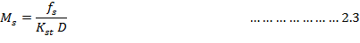
In this way the values of K_{si} can be deduced as a function of the shear strength f_{s} at the pile shaft.
According to Fleming (1992) M_{s} would be expected to have values in the range 0.001 to 0.004, which is agreement with the findings of Castelli et al, in which the values of M_{s} varying between 0.001 and 0.005 were deduced.
Liu Jie, Zhang Ken-neng (2003) gave a set of analytical equations for the variation of the axial force along the depth and pile-top load-settlement curve were established, using tri-linear softening model to pile-side soil and bilinear hardening model to pile-end soil. Influences of the pile side-side and pile-end soil behaviour on the load-settlement curve were discussed, indicating that the lowering reason for the variation step degree of the axial force along depth is the softening of the pile-side soil to result in the side friction lowering when the pile-top load is increased. To verify the reliability of this method, the parameters used in calculation were obtained from the test in Zhuzhou area. The obtained results were then compared with the tested results. Contrast showed that the calculated results and the tested values were very close, thus illustrating the reliability of the proposed model. The authors assumed the pile to be flexible rod with uniform cross section, and the load transfer function of the tri-linear softening and the bilinear hardening are used respectively to describe the action of the pile-side soil and pile-end soil (Fig 2(b), (c), where λ₁ and λ₂ represent the shear rigidity of the pile-side soil in the first and the second stage, respectively.k₁ and k₂ represent the compressive rigidity of the pile-end soil in the first and second stage, respectively. In the uniform foundation, both axial force and the settlement of the pile cross section will decrease with increasing depth, as the pile-top is subjected to an axial load. Therefore, with increasing pile-top load, the pile side soil will enter the softening state gradually from shallow to deep; at last enter the residual stress stage.
The model of the pile-soil interaction system as adopted by the authors is as shown:
Figure 2: Simplified analytical model for pile-soil system (Liu Jie, Zhang Ken-neng (2003))
(a)Model of pile soil interaction, (b) Softening model of pile side soil, (c) Fully plastic model of pile soil

D. Basu, M.Prezzi, R. Salgado and T. Chakraborty (2007) gave a method of settlement analysis for axially loaded piles embedded in a multilayered soil medium. The differential equations governing the displacements of the pile-soil system were obtained using variational principals. Closed form solutions for pile deflection and axial force along the pile shaft were then produced using the method of initial parameters.
The authors used the continuum based methods for the settlement analysis of axially loaded piles. The continuum approach is conceptually more appealing; however, it has traditionally required the use of expensive numerical techniques, such as boundary integral method, finite layer method or the finite element method to obtain the solutions. The assumptions have been made on the displacement field theory that reflect the rectangular shape of the pile cross section and derive the differential equations using energy principles. The closed form solutions of the pile axial deflection and axial force within each layer are obtained by the method of initial parameters.
Z.Y.Ai and Z.Q.Yue (2007) presented a method for the elastic analysis of axially loaded single pile in a layered spoil, based on the vertical point solution of multi-layered elastic medium. The analytical solution can be used with ease for the analysis and prediction of piles in layered soils. A computer programme was formed on the basis of the analytical procedure and a parametric study for a six layered soil system was further carried out. The results showed that the pile with larger compressibility ratio has a larger value for the normalised pile head stiffness, smaller values in the shaft shear stress on the upper part of the pile and greater values in the shaft shear stress on the lower part of the pile. The actual distribution of the shaft shear stress along the pile is dependent on the soil properties in depth and can be calculated with high accuracy.
J. Han, Z.Y.Ai (2008) gave an analytical solution for the analysis of axially loaded piles in multi-layered soil, using boundary element method. They used the solution for vertical and horizontal axi-symmetric ring loads in a multi-layered elastic medium. They applied the extended Sneddon and Muki solution with a boundary integral equation method to study the behaviour of axially loaded piles embedded in a multi-layered soil.
Their parametric study for a single pile in a multi-layered (eight layers) soil shows that the normalised pile head stiffness increases with the slenderness ratio at a larger pile soil modulus ratio but has little change at a smaller ratio. The results also show that the pile with a larger pile-soil modulus ratio has a higher normalised pile head stiffness, lower shear stresses in its upper portion and higher shear stresses in its lower portion. The distribution of shear stresses depends on the pile-soil modulus ratio and the modulus ratio of the individual soil layers.

2.2.2 Pile Group Analysis:
Works by Poulos (1968), Nair (1967), Pichumani and D’Appolonia (1967), and Butterfield and Banerjee (1971), have studied the settlement behaviour of pile groups in a way which adequately recognises the effects of interactions between the pile groups. These analyses have made use of Mindlin’s equations and are extensions of the single pile analysis due to Poulos, Nair, Pichumani and D’Appolonia, and Butterfield and Banerjee, respectively. Poulos has presented results which immediately give good insight into load distribution and settlement behaviour of a wide range of floating incompressible pile groups; Pichumani and D’Appolonia have concentrated mainly on the load distribution within a particular end-bearing and floating incompressible pile groups at the loads approaching the ultimate; Nair has described how his single pile analysis could be extended to the investigation of the pile group behaviour, but has given no actual results; Butterfield and Banerjee have analysed the behaviour of groups of floating compressible piles by extending a simplified version of their single pile analysis.
Poulos (1968) has considered initially the behaviour of a group of equally loaded incompressible pile equally spaced along the circumference of the circle (symmetrical group); in such a case pile in the group are identically related. The displacement influence factors were calculated for soil displacement at the midpoint of each element of one pile, due to stresses on all the elements of all the piles in a group, using Mindlin’s equation. Because the piles were incompressible, the displacements of all element midpoints were equal, and hence the stress distribution and the pile settlement could be calculated. Poulos then showed that if the settlement-increase due to interaction in a two pile-group was expressed in terms of the interaction factor α, the settlement of a pile in a larger pile group could be obtained by superposition of the α-factors for each pile group in turn considered as forming a 2 pile group with the pile being studied.
Pichumani and D’Appolonia (1967) followed a similar approach to that of Poulos, but have arrived at the load-distribution within a rigid-capped group by iteratively solving a large number of simultaneous equations.
Nair (1968) has given a brief description of how his single pile solution can be extended to a pile group in a similar manner as that of Poulos, to enable the behaviour of two-pile incompressible group to be studied, but no results of such analysis have been given.
Butterfield and Banerjee (1971) have analysed the behaviour of a group of floating piles under a rigid pile cap, making allowance for finite pile compressibility where necessary, and solving large number of equations to avoid invoking of superposition principle. Some general solutions have been presented, and indicate that for a group of incompressible piles at least, the assumptions made by Poulos are quite satisfactory. The solutions presented for compressible pile groups agree closely with those due to Poulos and Mattes (1971). No analysis has been described for a group of equally loaded piles (flexible cap) or for a group of end-bearing piles.
Davis and Poulos have further developed the analysis of the behaviour of a single pile and pile cap to study the analysis and design of pile-raft system and have presented a method of determining the number of piles necessary to bring the settlement of a raft foundation to a tolerable level, for the situation where the raft in isolation would have had adequate bearing capacity but unacceptable settlement behaviour.
R. Cair, E. Conte, G. Dente (2005) presented a simple method to carry out a direct small-strain analysis of pile groups under vertical harmonic vibration. The method makes use of the closed-form stiffness matrices derived by Kausel and Roe¨sset¹⁴ for the study of wave propagation problems in layered media. These matrices were incorporated in a calculation procedure that was essentially analytical and easy to use. In addition, using this procedure the soil layering effect was reliably accounted for. Limitations of the proposed solution could derive from the assumptions of soil linearity, perfect bonding between soil and pile, free-field soil displacements to simulate pile–soil–pile interaction, and lack of a requirement for lateral displacement compatibility at the soil–pile interface. However, many of these assumptions are common to many existing methods, and some of them could be overcome using simplified procedures available in literature. Moreover, an approximate simplification has been suggested to construct the soil flexibility matrix, which is part of the equation governing the dynamic response of a pile group. Taking advantage of this simplification, the proposed method allows the response of a pile group to be achieved using essentially the solution for the single pile. This leads to a significant reduction in the computational load, and therefore facilitates the analysis of groups consisting of a great number of piles. The accuracy of the method is assessed by comparing the results with those provided by existing theoretical solutions. Comparisons are also shown with experimental measurements from dynamic load tests on pile groups documented in literature.
S. Kucukarslan(2006) presented a transient analysis of a single pile and a 3x3 pile group for Gibson type non-homogenous soil by using a hybrid type of boundary and finite element formulation for the soil domain and pile domain, respectively. The formula is presented for a transient point force acting in the interior of a non-homogenous, isotropic half space. A time stepping boundary element algorithm for soil domain is used together with an implicit time integration scheme for finite pile domain. To investigate the validity of this formulation, a single pile and a pile group have been analysed under Heaviside loading and triangular transient loading. In the analysis, it could be concluded that the results agreed well for all the cases of the inhomogeneity index by comparing the Laplace domain solutions.
C. Y. Lee (2007) presented the elastic behaviour of the under-reamed piles in homogeneous soils. The modified boundary element method is used to obtain parametric solutions of the under-reamed piles under axial loading. The pile has been modelled as elastic cylinder and the surrounding soil mass as an elastic continuum. Lee has given due consideration to the effect of pile settlement ratio, pile-soil relative stiffness, under reamed diameter and bearing stratum on response of under-reamed piles. The characteristic of load distribution along the pile length has also been studied.
The most rigorous treatment of pile groups is provided by the finite element method(FEM) as described by Ottaviani, Pressley and Poulos, Polo and Clemente, or by the boundary element method(BEM) as described by Poulos, Poulos and Davis, Banerjee and Butterfield, and Lee and Poulos. In practice, the computational resources required to perform the ideal analysis become excessive almost for all foundation systems. It is, therefore, necessary to introduce a number of simplifications, as for example, the combination of load-transfer approach to quantify the relationship between load and settlement along the pile shaft and at the base.
Various methods of settlement predictions are reviewed for pile-groups from the case of a single pile, and it is demonstrated that several of them give realistic results. For practical estimation of a pile settlement, a convenient procedure which can be applied is the “equivalent pier” method. It considers the region of soil in which the piles are embedded as an equivalent continuum, replacing the pile group or the piled raft by an equivalent pier (Poulos and Davis 1980).
As suggested by Randolph (1994), the diameter of the equivalent pier D_{eq}, both for friction piles and end-bearing piles, can be taken as:
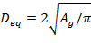
Where A_{g} = plan area of the pile group as a block.
Young’s modulus of the equivalent pier E_{eq} is then calculated as:
Where E_{p} = Young’s modulus of the piles; E_{s} = average Young’s modulus of the soil penetrated by the piles; and A_{tp} = total cross-sectional area of the piles in the group.
The load settlement response of a pile can be then calculated using the solutions of the response of a single pile. As for the case of the equivalent raft approach, the equivalent pier approach will furnish an estimation of only the average pile group settlement. Regarding the initial stiffness of the pile group-soil system, it is possible to take into account the reduction due to interaction effects determined by neighbouring piles, according to the expression:
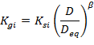
Where Kgi = initial stiffness of the soil-pile system considering the pile group as an equivalent pier and the exponent β equal to 0.30. Finally, the average head settlement of the pile group considered as an equivalent pier is given by:
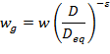
Where w_{g} = average head settlement of the pile group considered as an equivalent pier and ε = 0.15.

Numerical Methods of Analysis

3.1 Overview: Methods of analysis
Methods of settlement analysis of piles and pile groups can be broadly classified into three categories:
- Empirical methods: such as those by Meyerhof (1959) and Focht (1967) for single piles; and by Skempton (1953) and Meyerhof (1959) for pile groups.
- Simplified analytical methods: using theory of elasticity to provide design charts
- Numerical methods: finite-element and boundary element methods

3.2 Empirical Methods
Poulos and Davis (1980) comment that traditional methods of calculating the settlement of a pile rely on either an arbitrary assumption of the stress distribution along the pile and the use of conventional one dimension theory (Terzaghi, 1943), or on empirical corrections. Typical of these correlations are those proposed by Meyerhof (1959) for piles in sand and Focht (1967) for piles in clay. From an analysis of a number of load tests, Meyerhof has suggested that at loads less than about one-third of the ultimate, the settlement, ρ, of a pile could be estimated as follows (provided that no softer layers exist beneath the pile):
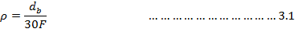
Where = diameter of pile base and F = factor of safety (>3) on ultimate load.
Focht (1967) has examined data from a number of load tests and has related the observed settlement, ρ, at the working load tests and has computed column deformation at the working load. Focht has defined a ‘movement ratio’ as and has found that for relatively long highly-stressed piles having > 8mm, the movement ratio is larger, of the order of 1.0
Estimates of the settlement of pile groups have been based either on empirical data or on simplified approaches based on one-dimensional consolidation theory. Among the empirical approaches are those for pile groups in sand devised by Skempton (1953), who on the basis of a limited number of field observations, suggested the following relationship between the settlement, of a group and the settlement,, of a single pile:
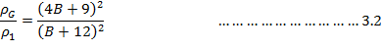
Where B = width of pile group in feet
For driven piles and displacement caissons in sand, Meyerhof (1959) suggested the following relationship for a square group:
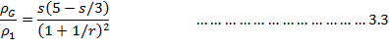
Where s = ratio of spacing to pile-diameter and r = number of rows for square group

3.3 Numerical Methods

3.3.1 Finite - element analysis:
Poulos (1989) observes that finite-element methods (e.g. Desai,1974; Valiappan et al. , 1974; Balaam et al. ,1975; Ottaviani, 1975; Jardine et al. ,1986) utilize a variety of constitutive soil models where such factors as soil non-homogeneity and anisotropy can be taken into account.
Finite element methods offer the most powerful analytical approach in that, not only can non-linear soil behaviour be modelled, but the complete history of the pile can be simulated, that is, the process of installation, reconsolidation of the soil following the installation and subsequent loading of the pile. Such analyses are valuable in leading to a better understanding of the details of pile behaviour, but are unlikely to be readily applicable to practical piling problems because of their complexity and the considerable number of geotechnical parameters required.
The finite element method treats as an assemblage of discrete elements whose boundaries are defined by nodal points. In finite element method, it is assumed that the response of the continuum can be described by the response of the nodal points. The finite element method is a numerical approach based on elastic continuum theory that can be used to model pile-soil system considering the soil as three dimensional, quasi-elastic continuum. Finite element techniques have been used to analyse complicated loading conditions on important projects and for research purposes. Salient features of this powerful method include the ability to apply any combination of axial, torsion and lateral loads; the capability of considering the non-linear behaviour of structure and soil; and the potential to model the structure-foundation-soil interactions. Time dependent results can be obtained and more intricate conditions such as battered piles, slopes, excavations, tie bricks and construction sequence can be modelled. The method can be used with a variety of soil stress-strain relationships, and is suitable for analyzing pile group behaviour performing three-dimensional finite element analysis requires considerable engineering time for generating input and interpreting results. For this reason, the finite element method has predominantly been used for research on pile group behaviour, rarely for design. The main advantages for geotechnical analysis may be summarised as follows:
- Non–linear material behaviour can be considered for the entire domain analysed.
- Modelling of excavation sequences including the installation of reinforcement and structural support system is possible.
- Structural features in the soil or rock mass, such as closely spaced parallel sets of joints or fissures, can be efficiently modelled, e.g. by applying a suitable homogenization technique.
- Time dependent material behaviour may be introduced.
- The conventional displacement formulation may be used for most load-path analysis.
- Special formulations are now available for other types of geotechnical problems, e.g. seepage analysis and the bound theorem solution in plasticity theory.
- The method has been extensively applied to solve practical problems and, thus, a lot of experience is already available.

3.3.2 Boundary- element methods:
Boundary element methods employ either load-transfer functions to represent the interface response (e.g. Coyle and Reese, 1966; Kraft et al., 1981) or elastic continuum theory to represent the soil mass response (e.g. Butterfield and Banerjee, 1971; Banerjee and Davies, 1978; Poulos and Davis, 1980).
A reasonable compromise between excessive complexity and unacceptable simplicity is provided by boundary-element methods, in which the pile-soil interface is discretized and the characteristics of the soil response are represented in a lumped form by ascribing the behavioural features of the soil to the interface elements. This method has been developed by a number of research workers and is widely used in practice, and attention is, therefore, focussed on this method. Although a considerable number of formulations exist, most appear to have a common underlying basis. A sub-structuring technique in which the pile (or piles) and the surrounding soil are considered separately and then the compatibility conditions are imposed.
The behaviour of each element is considered at a node which is located at the centre of that element and along a common vertical plane through the pile axis. Fig. 5 shows the division of a single pile into elements, the distribution of free-field soil movements due to some external cause (e.g. swelling or consolidation of the soil mass due to moisture changes or external loading) and the specified distributions of:
- The limiting pile-soil stresses, , for compression loading, and , for tensile loading; for shafts elements, the limiting pile-soil resistance is termed side resistance, while for base elements, the term end-bearing resistance is used; and
- The local stiffness, of the soil.
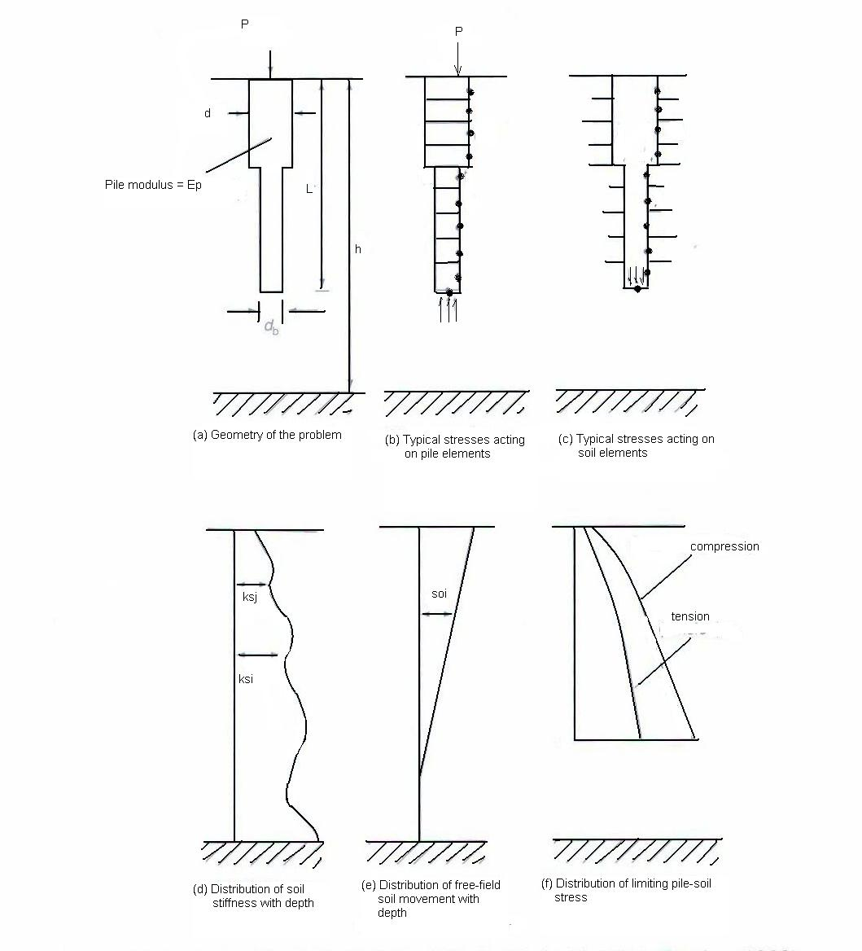
Figure 3: Basic problem of singly axially loaded pile (After Poulos, 1989)

At this stage, no assumptions are made regarding the nature of , and. These assumptions may vary with depth, stress (or displacement) level and time.
The responses of the pile and the soil elements to an increment of axial load are analysed in turn. Details of the equation that describes incremental displacements of the pile are given by Poulos (1979).
Boundary element methods have been effectively used in solving problems involving unbounded domains. The BEM has been successfully applied to the determination of the static as well as dynamic stiffness of a rigid foundation resting on or embedded in elastic half space. The studies have shown that BEM provides an accurate and effective procedure for problems in soil structure interaction. Significant advances have been made and as a consequence, this technique provides an alternative to the finite element method under certain circumstances.

Problem Description 1

4.1 Selection of Problem 1:
On the basis of review of research work described in Chapter 3, the basic problem chosen for analysis here is that described by D. Basu, M.Prezzi, R.Salgado and T. Chakraborty, (2007) in their research paper entitled “Settlement analysis of piles with rectangular cross-sections in multi-layered soils” where a method of analysis was developed for an axially loaded pile with rectangular cross section installed in a three-dimensional, multi-layered continuum.
In the present study, the same solutions have been implemented in VBA coding and the results obtained in the Microsoft Excel Spreadsheet. The results are obtained in analytical as well as graphical form. Moreover, the coding has been done for obtaining the solutions for rectangular as well as circular piles; and the study can be carried for up-to 10 layers of soil domain as against for 4 layers as done by the authors.

4.2 Problem Definition:
A pile with a rectangular cross section with dimensions 2a×2b and length L_{p} is considered embedded in a layered soil medium containing n layers, Fig (6). Each layer extends to infinity in all horizontal directions, and the bottom (nth) layer extends to infinity in the downward direction.
The depth to the base of any intermediate layer is i is H_{i}, which implies that the thickness of the ith layer is H_{i} − H_{i−1} with H₀ = 0. The pile head is at the level of the ground surface, and the base is embedded in the nth layer. The pile is subjected to an axial force F_{a} at the head.
The soil medium is assumed to be elastic and isotropic, homogeneous within each layer, with Lame’s constants λ_{si} and G_{si} for the ith layer. There is no slippage or separation between the pile and the surrounding soil or between the soil layers. The pile behaves as a column with an axial stiffness E_{p}A_{p} (E_{p} is the Young’s modulus of the pile and A_{p} = 2a × 2b is the area of the cross section).

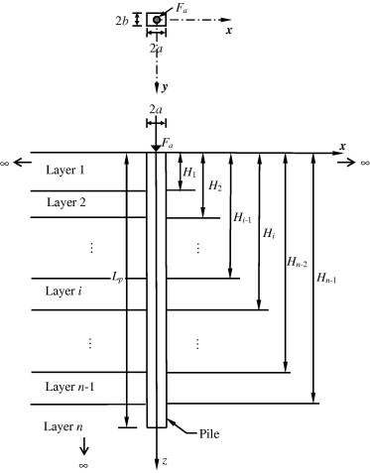
Figure 4: An axially loaded pile in layered medium (D Bassu, M Prezzi, 2007)
The main goal is to obtain the axial pile deflection as a function of depth due to the action of F_{a}. For that purpose, a rectangular Cartesian coordinate system with its origin coinciding with the center of the pile cross section at the elevation of the pile head and the positive z-axis pointing downward and coinciding with the pile axis is chosen.

4.3 Analysis:

4.3.1 Potential Energy:
The total potential energy of the pile–soil system, including both the internal and external potential energies, is given by:
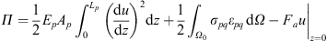……………………………..4.1

where u = u(z) is the vertical pile deflection; σ_{pq} and ε_{pq} are the stress and strain tensors, Fig (7) in the soil (summation is implied by the repetition of the indices p and q in the σ_{pq}ε_{pq} term); and Ω₀ represents the soil domain surrounding the pile (which extends from −∞ to +∞ in the x- and y-directions and from 0 to +∞ in the z-direction, excluding the volume L_{p} × 2a × 2b occupied by the pile). The first integral represents the internal potential energy of the pile, the second integral represents the internal potential energy of the soil continuum, and the last term represents the external potential energy.
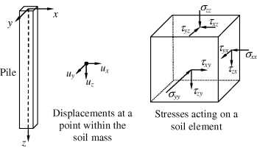
Figure 5: Displacements and stresses in soil mass

4.3.2 Soil Displacement:
The horizontal displacements (u_{x} and u_{y}) in the soil due to the axially loaded pile are generally small and are consequently neglected in our analysis. The vertical displacement u_{z} is expressed as a product of separable variables
$u_{z}=u(z)$$φ_{x}\left(x\right)φ_{y}\left(y\right)$……………………………………..4.2
where u(z) is the displacement function (with a dimension of length) varying with depth z, which describes the axial pile deflection; _{x}(x) is a dimensionless displacement function varying along x; and _{y}(y) is a dimensionless displacement function varying along y. The functions _{x}(x) and _{y}(y) describe how the displacement within the soil caused by pile settlement decreases with increasing horizontal distance from the pile axis. We set _{x} = 1 for −a x a; and _{y} = 1 for −b y b. This ensures proper pile–soil contact. The displacements in the soil must disappear at an infinite horizontal distance from the pile; therefore, _{x} = _{y} = 0 at x = ±∞ and y = ±∞.

4.3.3 Potential Energy density:
From the strain–displacement relationship,
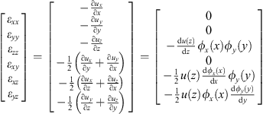……………………..4.3
The elastic stresses and strains within the soil are used to express the strain energy density at any point within the soil mass in terms of the displacement functions. The stress is given in terms of the strains as:
$σ_{\text{pq}}=λ_{s}δ_{\text{pq}}ε_{\text{kk}}+2G_{s}ε_{\text{pq}}$……………………………..4.4
where δ_{pq} is the Kronecker’s delta. Multiplying both sides of the equation by the corresponding strain, with summation implied by index repetition, and considering the strain–displacement relations (Eq. (4.3)) we get:
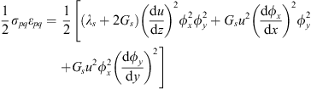………….4.5

4.3.4 Principle of minimum potential energy:
The equilibrium equations for the pile–soil system are obtained using the principle of minimum potential energy (according to which the first variation δΠ of the potential energy function is equal to zero) because, in a conservative system, a stable equilibrium configuration always corresponds to that with minimum potential energy. Substituting Eq.(4.5) in Eq(4.1). and applying the principle of minimum potential energy (i.e., δΠ = 0), we get:
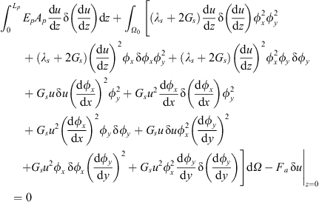……………………4.6
Physically, the principle of minimum potential energy expresses the idea that if there were a combination of the functions u(z), _{x}(x) and _{y}(y) with a higher potential energy, work would be done on the pile–soil system to lower that potential energy down to the minimum value, leading to the optimal displacement field. The optimal displacement field, and the functions u_{opt}(z), _{x,opt}(x) and _{y,opt}(y) that describe it, corresponds to the condition of equilibrium under the imposed loads.
Simplifying Eq.(4.6) further and considering a layered system we get:
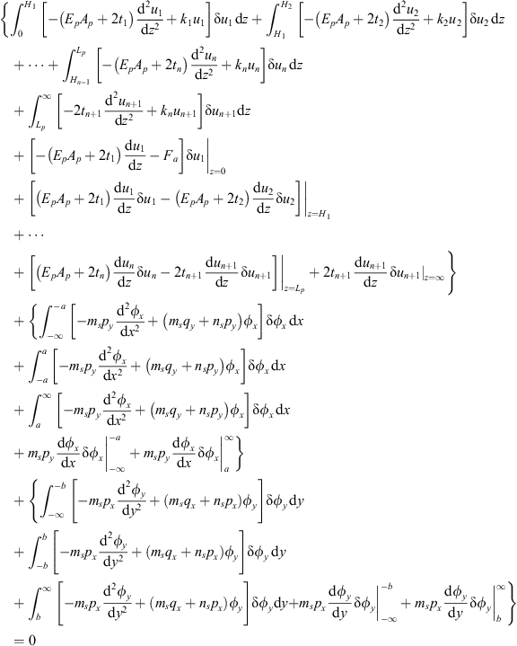4.7
Where
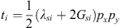 ……………………………………………………….4.8
$k_{i}=G_{\text{si}}\left(p_{x}q_{y}+p_{y}q_{x}\right)$ ……………………………………………………………4.9
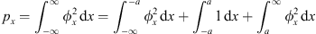……………………..4.10
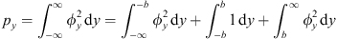……………………..4.11
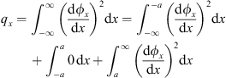…………………………………….4.12
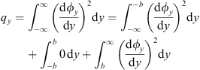…………………………………….4.13
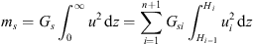……………………………………....4.14
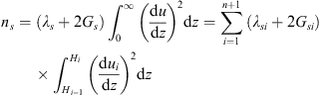……………………………4.15
The subscript i in the above equations represents the ith layer of the multi-layered soil continuum; u_{i} represents the function u (z) in the ith layer with u_{i}|_{z=Hi}=u_{i+1}|_{z=Hi}. Note that the nth (bottom) layer is split into two parts with the part below the pile denoted by the subscript n + 1; therefore, in the above equations, H_{n} = L_{p} and H_{n+1} → ∞.
Eq (4.7) is of the form:
$\text{δπ}=A\left(u\right)δu+B\left(φ_{x}\right){\text{δφ}}_{x}+C\left(φ_{y}\right){\text{δφ}}_{y}=0$………………………..……4.16
Since the variations δu, δ_{x} and δ_{y} of the functions u(z), _{x}(x) and _{y}(y) are independent, the terms associated with each of these variations must individually be equal to zero (i.e., A(u) = 0, B(_{x}) = 0 and C(_{y}) = 0) in order to satisfy the condition δΠ = 0. The resulting equations produce the optimal functions u_{opt}(z), _{x,opt}(x) and Ф_{y,opt}(y) that describe the equilibrium configuration of the pile–soil system.
In order to calculate the variation of the potential energy, we separately consider the variations of u(z), _{x}(x) and _{y}(y) over their respective domains. In the case of u, we consider the sub-domains, 0 z H₁, H₁ z H₂, … , H_{n−1} z L_{p} and L_{p} z < ∞. That way, u satisfies equilibrium within each of the sub-domains and, hence, over the entire domain. For _{x} and _{y}, the variations are considered over −∞ < x < ∞ and −∞ < y < ∞, respectively.

4.3.5 Soil displacement profiles
Referring back to Eq (4.7), all the terms of δΠ associated with δ_{x} are summed up and equated to zero:
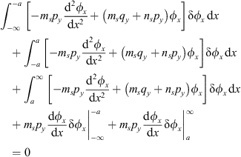……………………………..4.17
The last two terms in the above equation contain multiples of δ_{x} at x = ±∞ and at x = ±a. At these points, the values of _{x} are prescribed (i.e., known) by the boundary conditions of the problem (_{x} = 1 at x = ±a and _{x} = 0 at x = ±∞). This makes the terms zero because, when the function _{x} is known, its variation δ_{x} becomes zero. The second term also vanishes because _{x} = 1 over −a x a which makes δ_{x} = 0. Thus, the first and the third integral terms are left. Since the function _{x} is not known a priori within the domains −∞ < x −a and a x < ∞, δ_{x} ≠ 0 because of which the corresponding integrands must be zero in order to satisfy Eq.(4.17). This gives the differential equations of _{x} for −∞ < x −a and a x < ∞, solving which we get _{x,opt}. The differential equation is the same for both the domains (as can be observed from Eq(4.17), and is given by:
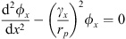……………………………………………………………..4.18
Where
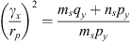……………………………………………………………..4.19
With
Where r_{p} is a representative length used to make the parameter γ_{x} dimensionless. This is not an equivalent pile radius mandated by the analysis but rather a quantity chosen to normalize the equations. The parameter γ_{x} describes the rate at which the function _{x} (and hence, the displacement) decreases with increasing horizontal distance from the pile in the x-direction.
Solving Eq(4.18) subject to the conditions that _{x} = 0 at x = ±∞ and _{x} = 1 for −a x a,
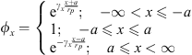…………………………………………………….4.20
Substituting Eq(4.20) into Eqs(4.10) and(4.12),
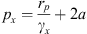…………………………………………………………………………..4.21
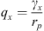…………………………………………………………………………………4.22
Following a similar procedure for δ_{y} as for δ_{x}, i.e., collecting all the terms in Eq(4.7) associated with δ_{y} and equating their summation to zero, the differential equation of _{y} for −∞ < y −b and b y < ∞ are obtained as:
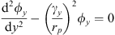…………………………………………………………………..4.23
Where
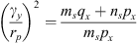………………………………………………………………….4.24
Solving Eq(4.23) subject to the boundary conditions _{y} = 0 at y = ±∞ and _{y} = 1 for −b x b,:
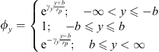……………………………………………………….4.25
The dimensionless factor γ_{y} describes the rate at which the displacement within the soil mass decreases as the horizontal distance from the pile along the y-direction increases.
Substituting Eq(4.25) into Eqs(4.11) and (4.13),:
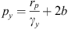……………………………………………………………………………4.26
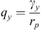…………………………………………………………………………………4.27
Using the expressions for p_{x}, p_{y}, q_{x} and q_{y}, from Eqs(4.8) and (4.9),
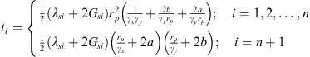…………………………….4.28
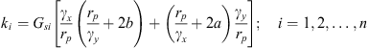…………………………...4.29

4.3.6 Pile Displacement:
Now the variation of the function u is considered. From Eq (4.7) and all the terms associated with δu, their sum is equated to zero: 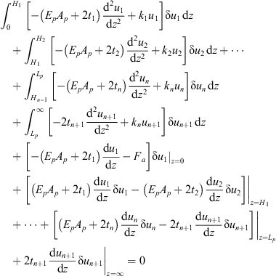…………………………4.30
The domain below the pile, i.e., L_{p} z < ∞, is considered. The terms associated with δu in Eq (4.30) for L_{p} z < ∞ are equated to zero so that u (z) within this domain contributes to δΠ = 0. Since the variation of u (z) is not known a priori within L_{p} z < ∞, δu ≠ 0 because of which the integrand in the integral between z = L_{p} and z = ∞ must be equal to zero in order to satisfy Eq (4.30). This results in the following differential equation:
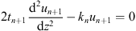……………………………………………………………..4.31
The displacement in the soil must vanish at infinite vertical distance. We use this as our boundary condition:
…………………………………………………………………4.32
The above equation implies that δu_{n+1} = 0 at z = ∞, making the last term in Eq(4.30) equal to zero (which is of course required to satisfy Eq (4.30)
The solution of Eqn (4.31) subject to the boundary condition (4.32) is:
……………………………………………………………….4.33
Now the function u for the domains 0 z H₁, H₁ z H₂, … , H_{n−1} z L_{p} is considered. Within a typical domain H_{i−1} z H_{i}, the variation of u_{i} is not known a priori. Hence, the corresponding integral between H_{i−1} z H_{i} can be zero (required to satisfy Eq(4.30) only if the integrand is set to zero. This gives the differential equation for the ith layer, which, written in terms of normalized depth and normalized displacement, is given by:
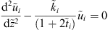……………………………………………………………………4.34
The terms associated with the boundaries of each domain (i.e., at z = H_{i}) in Eq(4.30) must also each be equal to zero. Setting each term separately equal to zero, yields the boundary conditions for the differential equations represented by Eq(4.34) These terms can be seen to be a product of an expression and the variation of the displacement u_{i}. If the displacement is specified at the boundary, then its variation is equal to zero; otherwise, the expression multiplying the variation of the displacement is equal to zero. The boundary conditions at the pile head are as follows:
……………………………………………………………………………4.35
Or
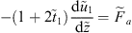……………………………………………………………………4.36
At the interface between any two layers (z = H_{i} or ):
………………………………………………………………………………..4.37
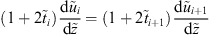………………………………………………………4.38
At the pile base (z = L_{p} or z = 1), the boundary conditions are:
…………………………………………………………………………4.38a
or
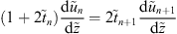……………………………………………………………..4.39
Eq (4.39) is further simplified and solely expressed in terms of by differentiating u_{n+1} in Eq (4.33) with respect to z, normalizing the resulting expression, and then substituting it in Eq (4.39) to obtain
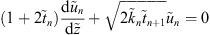……………………………………………………….4.40
The dimensionless terms in the above equations are defined as follows:
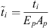………………………………………………………………………………..4.41
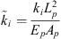………………………………………………………………………………..4.42
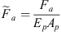……………………………………………………………………………….4.43
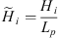…………………………………………………………………………………..4.44

4.3.7 Physical meaning of the equations:
The governing differential equation for the pile resembles that of a column (or axially loaded rod) supported by an elastic foundation (the soil mass). The parameter t_{i} accounts for the resistance of the soil due to vertical compression, while k_{i} represents the resistance of soil against shearing in the vertical direction. Thus, the total resistance against vertical movement of the pile comes partly from stiffness in vertical soil compression and partly from stiffness in soil shear in the vertical direction, Fig (6):

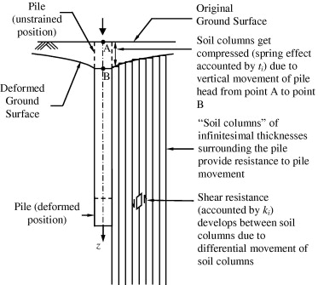
Figure 6: Illustration of the two sources of soil resistance: soil compression and shear(Shen et al,2000)
The axial force F(z) (compression positive) at any depth is given by:
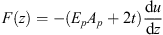…………………………………………………..4.45
which, in dimensionless form, is given by:
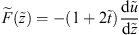……………………………………………………….4.46
The axial force originates from the compressive resistance offered by both the pile and the surrounding soil. The governing differential equation (4.34) describes how the change in the axial force with depth is balanced by the shear resistance of the soil. The boundary conditions at the interfaces of the adjacent layers ensure the continuity of displacements and axial forces (Eqs (4.37) and (4.38)). The boundary condition in terms of deflection is rarely used in practice, so, at the pile head, the axial force is typically taken as equal to the applied load (Eq (4.36). At the base, the two possible boundary conditions are displacement-based as given by Eq(4.38a), (the pile deflection is assumed to be zero if the pile is socketed in a very firm layer; this is often referred to as the fixed-base condition) or stress-based described by Eq. (4.39) (the axial force in the pile infinitesimally above the base is assumed to be equal to that infinitesimally below it; this is a free-base condition).

4.4 Solution to the Problem:
The authors (D. Basu, M.Prezzi, R.Salgado and T. Chakraborty, (2007), “Settlement analysis of piles with rectangular cross-sections in multi-layered soils”) have used Finite Element Method to analyze the given problem and have presented the solutions in graphical format.
In this project thesis, a parallel study of the paper has been presented. The above equations have been developed into algorithm. The programming has been done using Visual Basic Editor of Microsoft Excel. The results are obtained in graphical as well as analytical output. Moreover, the program has been developed to analyze circular piles as well. The number of layers can be varied up to 10 layers.

4.4.1 Iterative solution scheme:
Eqs. (4.8),(4.9), (4.28),(4.29) show, the parameters γ_{x} and γ_{y} need to be known in order to estimate the parameters k_{i} and t_{i}, without which Eq.(4.34) for the pile deflection cannot be solved. The parameters γ_{x} and γ_{y}, in turn, depend on the pile deflection and its derivative and also on each other. Hence, an iterative solution scheme is required.
In the first iteration, initial guesses on γ_{x} and γ_{y} are made, and pile deflection and its derivative (obtained from the axial force) are calculated. At the end of the iteration, γ_{x} and γ_{y} are calculated using the calculated pile deflection and its derivative values, and compared with the assumed initial values of γ_{x} and γ_{y}, respectively. If the differences are greater than some small limits, iterations are continued with the calculated values of γ_{x} and γ_{y} taken as the new guesses. Successive iterations are continued until the values of both γ_{x} and γ_{y} obtained from two consecutive iterations fall below the prescribed limits. We chose a value of one as the initial guess for both γ_{x} and γ_{y}, although we observed that any initial choice can be made without affecting significantly the computation time or the accuracy. The tolerance limit taken on both γ_{x} and γ_{y} between the ith and (i + 1) th iteration is:

The above iteration scheme can be represented with the help of a flow chart as shown:
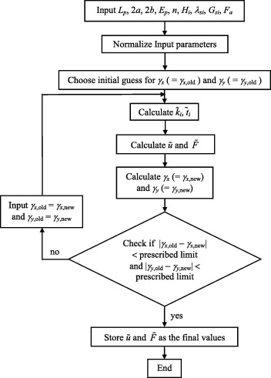
Figure 7: Flow chart.

4.4.2 The VBA Code for the Iterative Solution Scheme:
Private Sub CommandButton3_Click()
Dim itr_cnt As Integer
Dim i As Integer
Dim j As Integer
Dim k As Integer
Dim NL As Integer
Dim NB As Integer
Dim N As Integer
Dim prod_term As Variant
Dim Ndelz As Integer
NL = Worksheets("CALS").Range("B8")
NB = Worksheets("CALS").Range("B9")
N = Worksheets("CALS").Range("B10")
'Check inputs
If Worksheets("MAIN").Cells(NL + 2, 6).Value <> Worksheets("MAIN").Range("C4").Value Then
MsgBox ("Depth to the final layer within the shaft must be the same as pile length.")
End
Else
End If
Worksheets("CALS").Range("S3:S22").Value = Null
Worksheets("CALS").Range("W3:W22").Value = Null
Worksheets("CALS").Range("B11").Value = 1
Worksheets("CALS").Range("B14").Value = 1
Worksheets("CALS").Range("B13").Value = 1
Worksheets("CALS").Range("B16").Value = 1
'Iteration loop starts
itr_cnt = 0
Do Until Worksheets("CALS").Range("B13").Value < 0.00001 And Worksheets("CALS").Range("B16").Value < 0.00001
prod_term = 1
For i = 1 To N - 1
prod_term = prod_term * Worksheets("CALS").Cells(i + 2, 15)
Next i
Worksheets("CALS").Cells(N + 2, 23).Value = 2 ^ (N - 1) * Worksheets("CALS").Range("B7") * prod_term
Worksheets("CALS").Cells(N + 2, 19).Value = 0
For k = 1 To N - 1
j = N - k
Worksheets("CALS").Cells(j + 2, 19).Value = Worksheets("CALS").Cells(j + 2, 17) * Worksheets("CALS").Cells(j + 3, 19) + Worksheets("CALS").Cells(j + 2, 18) * Worksheets("CALS").Cells(j + 3, 23)
Worksheets("CALS").Cells(j + 2, 23).Value = Worksheets("CALS").Cells(j + 2, 21) * Worksheets("CALS").Cells(j + 3, 19) + Worksheets("CALS").Cells(j + 2, 22) * Worksheets("CALS").Cells(j + 3, 23)
Next k
Worksheets("CALS").Range("B11").Value = Worksheets("CALS").Range("B12")
Worksheets("CALS").Range("B13").Value = Abs(Worksheets("CALS").Range("B12") - Worksheets("CALS").Range("B11"))
Worksheets("CALS").Range("B14").Value = Worksheets("CALS").Range("B15")
Worksheets("CALS").Range("B16").Value = Abs(Worksheets("CALS").Range("B15") - Worksheets("CALS").Range("B14"))
itr_cnt = itr_cnt + 1
Worksheets("Main").Range("K10").Value = itr_cnt
Loop
'Algorithm for plot starts
Ndelz = Worksheets("PlotTable").Range("A2")
i = 1
For j = 1 To (Ndelz + 1)
If Worksheets("PlotTable").Cells(j + 4, 1).Value <= Worksheets("CALS").Cells(i + 2, 4) Then
Worksheets("PlotTable").Cells(j + 4, 2).Value = Worksheets("CALS").Cells(i + 2, 14)
Worksheets("PlotTable").Cells(j + 4, 3).Value = Worksheets("CALS").Cells(i + 2, 15)
Worksheets("PlotTable").Cells(j + 4, 4).Value = Worksheets("CALS").Cells(i + 2, 24)
Worksheets("PlotTable").Cells(j + 4, 5).Value = Worksheets("CALS").Cells(i + 2, 25)
Else
i = i + 1
Worksheets("PlotTable").Cells(j + 4, 2).Value = Worksheets("CALS").Cells(i + 2, 14)
Worksheets("PlotTable").Cells(j + 4, 3).Value = Worksheets("CALS").Cells(i + 2, 15)
Worksheets("PlotTable").Cells(j + 4, 4).Value = Worksheets("CALS").Cells(i + 2, 24)
Worksheets("PlotTable").Cells(j + 4, 5).Value = Worksheets("CALS").Cells(i + 2, 25)

End If
Next j
End Sub

Problem Description 2

5.1. Project No.C1083201 of PWD’s Commonwealth Project Division.
As a part of Corridor Improvement programme for UP Link road, the Delhi PWD proposes to construct 2 flyovers and one bridge along the UP Link Road from NH-24 bye-pass (Noida Mor) to Chilla Regulator along with widening of the same stretch to facilitate smooth traffic flow. The flyover foundation comprises of pile groups of 23m deep piles and the number of piles in each group varies from 4 to a maximum of 14 piles; i.e. in groups of 4, 6, 8, 9, 12 and 14. As a part of this study, the settlement analysis of six pile group was conducted and the results were cross checked by using established load-settlement curves as given by Shen, Chow and Yong (2000).

5.2 Solution to the problem:
It is considered that the load is transferred from the pile shaft by shear stresses generated in the soil on vertical and horizontal planes. A pile may be considered as surrounded by concentric cylinders of soil with shear stress on each cylinder.
Figure 8: Concentric cylinders of soil around pile (Shen et al,2000)

Let = shear stresses in soil
ɤ = radius from pile
= shear stress on the pile shaft
ɤ_{o}= radius of pile shaft.
For equilibrium,
. Therefore,
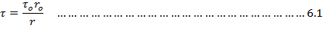
Shear strain
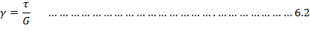
And,
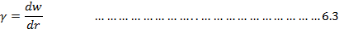
Therefore,
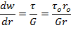
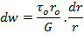
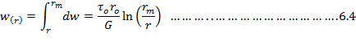
Where is the limiting radius of influence of pile and indicates the maximum radius at which deflections in soil vanish.
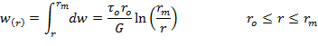
Pile base acts as a rigid punch on the surface of the lower layer of the soil. This deformation is given by the Boussinesq solution (Timoshenko and Goodyear, 1970).
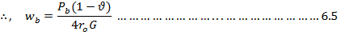
Total load transferred to the soil from pile shaft,
From equation 6.4 and 6.6, we have
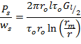

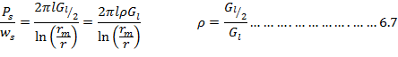
Where, G_{l} and G_{l/2} are respectively the soil shear modulus at whole depth and mid depth respectively.
Total load,
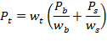
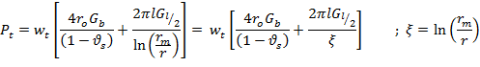
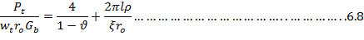
Equation 6.8 gives load-settlement ratio of a single pile in a dimensionless form.
In a group, the overall settlement is the sum of settlement due to own load plus that due to neighboring pile’s displacement fields. Thus, for a pile shaft,
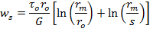
where, s is pile spacing in a group. Therefore, load-settlement ratio for each pile shaft is
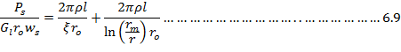
Settlement at the pile base is given by:
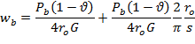
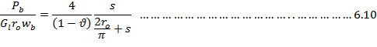
Thus, overall load-settlement ratio for each pile is given by:
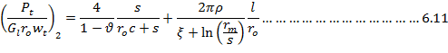
c = 2/π.
Similarly, due to the influence of 3 piles, load-settlement ratio is given by:

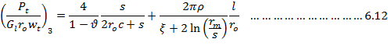
And, due to the influence of 4th pile, we have:
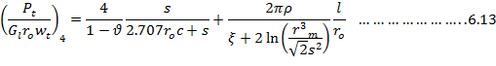
A pile group can be modeled by a hyperbolic load transfer curve (Shen et al 1997). Displacements of a group are represented by a finite series as:
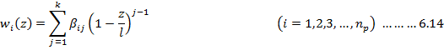
n_{p} = no of piles in the group.
A matrix equation relating loads at the pile head and the undetermined coefficients can be obtained as:

From a, we have:
Flexibility relationship of the piles in the group at the pile head can only be obtained through proper addition of rows and columns of the matrix [h]⁻¹.
In (a) [h] can be expressed as:

And,
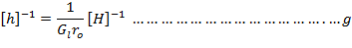
From (c) & (f), we have:
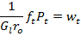
f_{t} is a coefficient obtained by summing all the terms in [H]⁻¹ i.e. f_{t} = ∑[H_{ij}]⁻¹.
Therefore, stiffness relationship for a pile is then obtained as:
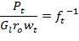
This means that the reciprocal of the total sum of each term in matrix [H]⁻¹ i.e. f_{t} is the pile load-settlement ratio:
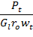
.
The elements of [H] can be arranged from equations 6.8, 6.9,....., 6.12.

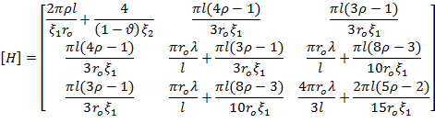
Where,
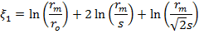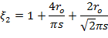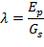

Now, the data for the given 6 pile group (2x3) as provided by the agency in their soil investigation report and the structural drawings is as under:
- Pile to pile spacing, s = 4m
- Radius of each pile, r_{o} = 0.50m
- Depth of each pile, l = 23m
- Poisson’s ratio of soil, ʋ = 0.3
- Young’s modulus of pile material, E_{p} = 2.96 x 10⁴ MPa
- Dead load of pile group including pile cap = 3942 kN
- Total load on pile group including dead load, P_{t} = 5040 kN
However, the given data was incomplete in terms of the fact that correct value of Young’s modulus of soil was not given. The properties of the soil (index properties, particle size, c,ɸ,etc) were compared with related soils and the average value of Young’s modulus of Elasticity of soil, E_{s}, taken as 150 MPa.
Therefore, G_{s} = 57.69 MPa.
Using these values, we get the following parameters:
- ξ₁ = 10.96
- ξ₂ = 1.22
- ρ = 1
The elements of the matrix [H] are as:
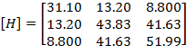

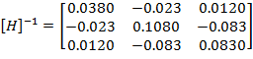

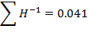
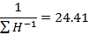
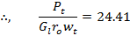
The validity of the above results was cross checked using the load-settlement curves as given those by Chin, Lee, et al. (SEE APPENDIX)

Results and Discussions:
The study for problem No. 1, was initially conducted for a pile embedded in 4 layers and the results were obtained for both, rectangular as well as circular piles. Following are the results for various assumed soil and pile parameters (viz Pile geometry, elastic properties of soil, load, soil layers, etc).

6.1 Rectangular pile embedded in 4 layers of soil (weak soil layers overlying a stiff layer):
Figure 9: Cross section of a Rectangular pile

6.1.1 Pile Geometry (Pile 1):
For Rectangular Pile No 1, the cross-sectional dimensions and elastic properties are given in the following table:
Pile diameter B_{x} (m) | 1.13
Pile diameter B_{y} (m) | 0.56
Pile length L_{p} (m) | 40
Young's modulus of  the pile E_{p} (GPa) | 31
Table 1: Various Cross-sectional Dimensions and Elastic Properties of Rectangular Pile No 1

6.1.2 Elastic Soil Properties and No of Layers of Soil:
A multi-layered soil continuum has been taken. There are 4 layers of soil, having varied elastic properties. The pile is embedded in 3 layers and has 1 layer below its base. A load of 8000kN has been applied at the pile head. The depths and elastic properties of each layer are given in the Table 2, as shown:
Layer | Depth to the  layer H (m) | Young's modulus  of the soil E_{s} (MPa) | Poisson's ratio  of the soil ν_{s}
1 | 10 | 60 | 0.49
2 | 25 | 80 | 0.15
3 | 40 | 167 | 0.15
4 | 55 | 1000 | 0.15
Table 2: Table showing various layers of soil continuum, depth and elastic property of each layer

6.1.3 Output:
The program gives output in analytical as well as graphical form. The head as well as base settlement is calculated; and also the load transferred to the base is also calculated. The calculated values of each of these are shown in the table below:
Head settlement  w_{t} (mm) | 8.16
Base settlement  w_{b} (mm) | 0.46
Base load  Q_{b} (kN) | 1431
γ_{x} | 0.08864
γ_{y} | 0.08647
Table 3: The calculated values of Head settlement, base settlement and load transferred to the base (Rec. Pile 1)
γx andγy represent the rate at which settlement in soil decreases with the increase in radial distance from the pile shaft along x- and y- axes.

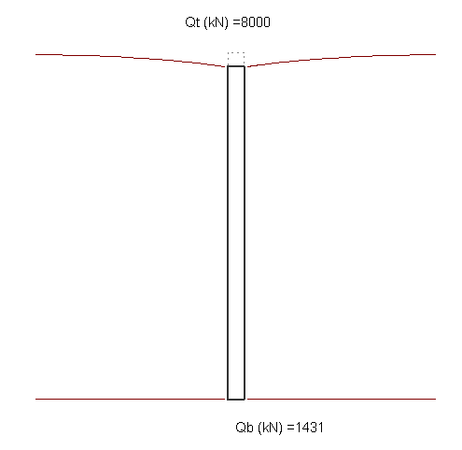
Figure 10: Deformed Configuration of the Rectangular Pile1 after the application of load.
Load applied at the head and load transferred to the base is also shown.

6.1.4 Output Graphs:
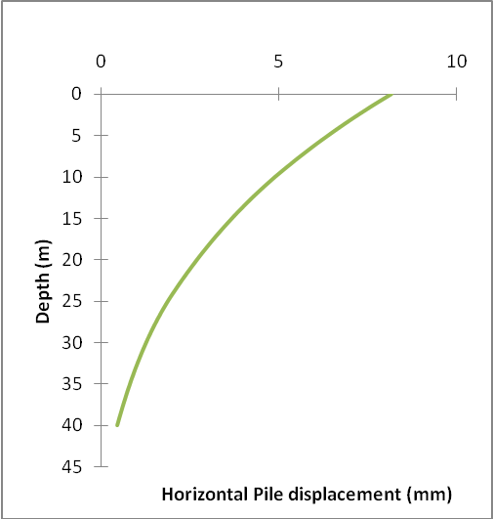
Figure 11: Axial Pile displacement (horizontal) along the depth of pile (Rec. Pile1)
Deflection is maximum at the pile head and minimum at pile base. Pile acts as an axially loaded coloumn.

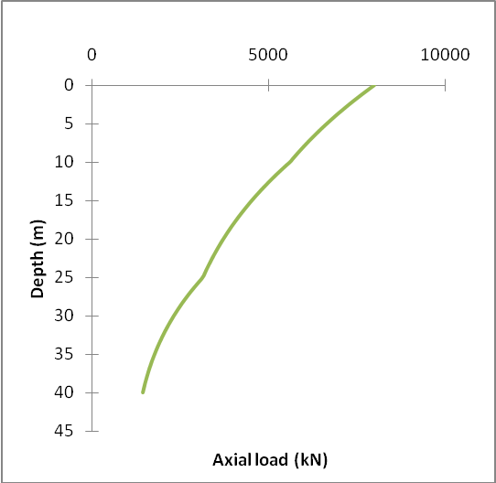
Figure 12: Axial Load transferred along the depth of the pile.
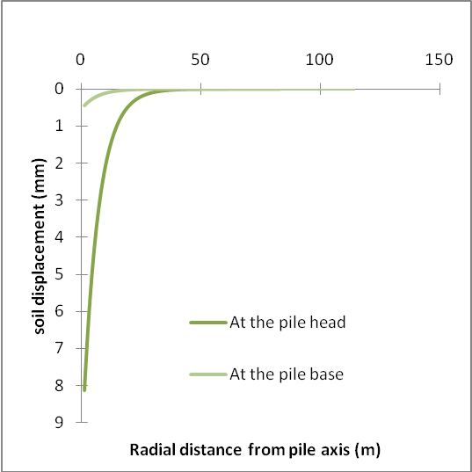
Figure 13: Variation of soil displacement along the radius of influence.
The settlement in the soil decreases with the increase in distance from the axis of the pile and vanishes at certain distance (rm=limiting radius of influence) from the pile shaft.

6.1.5 Pile Geometry (Pile 2):
For Rectangular Pile No 2, the cross-sectional dimensions and elastic properties are given in the following table:
Pile diameter B_{x} (m) | 2.7
Pile diameter B_{y} (m) | 1.2
Pile length L_{p} (m) | 20
Young's modulus of  the pile E_{p} (GPa) | 25
Table 4: Various Cross-sectional Dimensions and Elastic Properties of Rectangular Pile No 2

6.1.6 Elastic Soil Properties and No of Layers of Soil:
A multi-layered soil continuum has been taken. There are 4 layers of soil, having varied elastic properties. The pile is embedded in 2 layers and has 2 layers below its base. A load of 8000kN has been applied at the pile head. The depths and elastic properties of each layer are given in the Table 5, as shown:
Layer | Depth to the  layer H (m) | Young's modulus  of the soil E_{s} (MPa) | Poisson's ratio  of the soil ν_{s}
1 | 2 | 15 | 0.40
2 | 20 | 25 | 0.30
3 | 30 | 80 | 0.30
4 | 55 | 45 | 0.15
Table 5: Table showing various layers of soil continuum, depth and elastic property of each layer

6.1.7 Output:
The program gives output in analytical as well as graphical form. The head as well as base settlement is calculated; and also the load transferred to the base is also calculated. The calculated values of each of these are shown in the table below:
Head settlement  w_{t} (mm) | 13.23
Base settlement  w_{b} (mm) | 11.82
Base load  Q_{b} (kN) | 3389
γ_{x} | 0.24306
γ_{y} | 0.22982
Table 6: The calculated values of Head settlement, base settlement and load transferred to the base.
γx andγy represent the rate at which settlement in soil decreases with the increase in radial distance from the pile shaft along x- and y- axes.
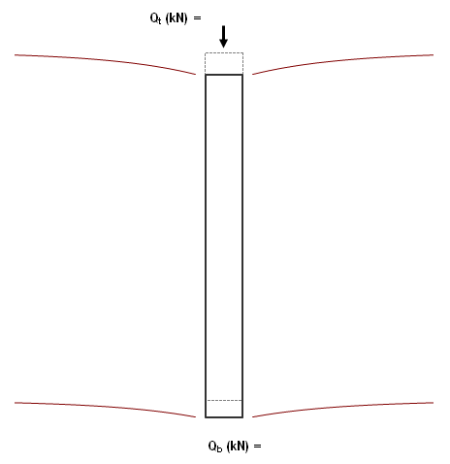
8000
3389
Figure 14: Deformed Configuration of the Rectangular Pile 2 after the application of load.
Load applied at the head and load transferred to the base is also shown.

6.1.8 Output Graphs:
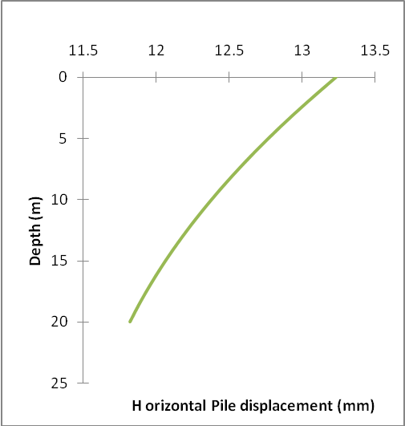
Figure 15: Axial Pile displacement (horizontal) along the depth of pile.
Deflection is maximum at the pile head and minimum at pile base. Pile acts as an axially loaded coloumn.

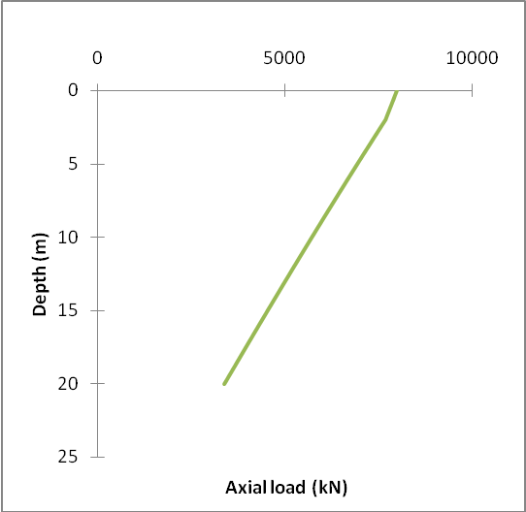
Figure 16: Axial Load transferred along the depth of the pile.
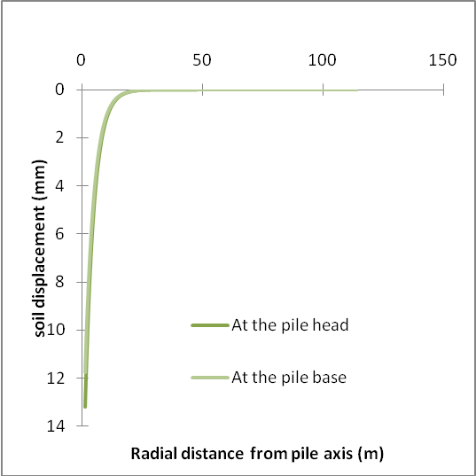
Figure 17: Variation of soil displacement along the radius of influence.
The settlement in the soil decreases with the increase in distance from the axis of the pile and vanishes at certain distance (rm=limiting radius of influence) from the pile shaft.

6.2 Circular pile embedded in 4 layers of soil (weak soil layers overlying a stiff layer):
Figure 18: Cross section of a Circular Pile

6.2.1 Pile Geometry (Pile 1):
For Circular Pile No 1, the cross-sectional dimensions and elastic properties are given in the following table:
Pile diameter B_{r} (m) | 0.89
Pile length L_{p} (m) | 40
Young's modulus of  the pile E_{p} (GPa) | 31
Table 7: Various Cross-sectional Dimensions and Elastic Properties of Circular Pile No 1

6.2.2 Elastic Soil Properties and No of Layers of Soil:
A multi-layered soil continuum has been taken. There are 4 layers of soil, having varied elastic properties. The pile is embedded in 3 layers and has 1 layer below its base. A load of 8000kN has been applied at the pile head. The depths and elastic properties of each layer are given in the Table 2, as shown:
Layer | Depth to the  layer H (m) | Young's modulus  of the soil E_{s} (MPa) | Poisson's ratio  of the soil ν_{s}
1 | 10 | 60 | 0.49
2 | 25 | 80 | 0.15
3 | 40 | 167 | 0.15
4 | 55 | 1000 | 0.15
Table 8: Table showing various layers of soil continuum, depth and elastic property of each layer

6.2.3 Output:
The program gives output in analytical as well as graphical form. The head as well as base settlement is calculated; and also the load transferred to the base is also calculated. The calculated values of each of these are shown in the table below:
Head settlement  w_{t} (mm) | 6.75
Base settlement  w_{b} (mm) | 0.30
Base load  Q_{b} (kN) | 891
γ_{r} | 0.110483
Table 9: The calculated values of Head settlement, base settlement and load transferred to the base.
γr represents the rate at which settlement in soil decreases with the increase in radial distance from the pile shaft
891
Figure 19: Deformed Configuration of the Circular Pile after the application of load.
Load applied at the head and load transferred to the base is also shown.

6.2.4 Output Graphs:
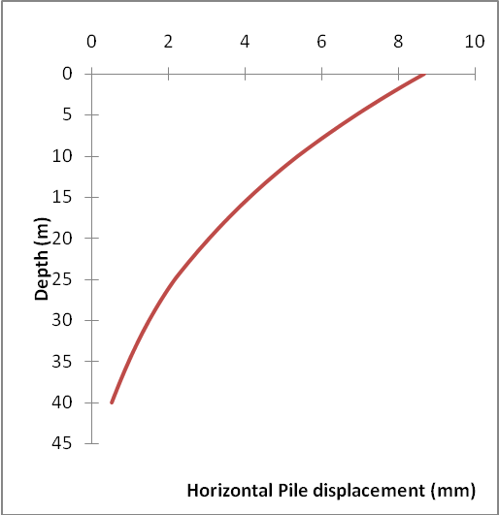
Figure 20: Axial Pile displacement (horizontal) along the depth of pile.
Deflection is maximum at the pile head and minimum at pile base. Pile acts as an axially loaded coloumn.

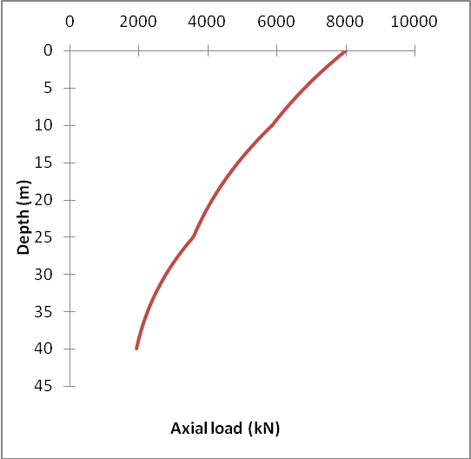
Figure 21: Axial Load transferred along the depth of the pile.
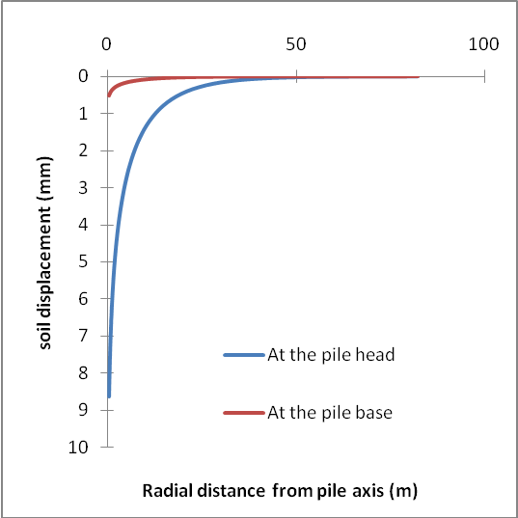
Figure 22: Variation of soil displacement along the radius of influence.
The settlement in the soil decreases with the increase in distance from the axis of the pile. Soil settlement is more at the pile head as compared to the pile base.

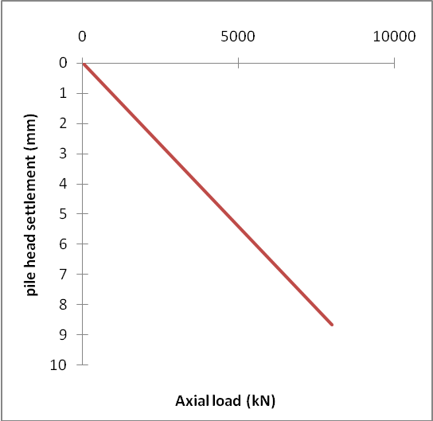
Figure 23: Variation of pile head settlement with the increase of axial load

6.2.5 Pile Geometry (Pile 2):
For Circular Pile No 2, the cross-sectional dimensions and elastic properties are given in the following table:
Pile diameter B_{r} (m) | 2.0
Pile length L_{p} (m) | 20
Young's modulus of  the pile E_{p} (GPa) | 25
Table 10: Various Cross-sectional Dimensions and Elastic Properties of Circular Pile No 2

6.2.6 Elastic Soil Properties and No of Layers of Soil:
A multi-layered soil continuum has been taken. There are 4 layers of soil, having varied elastic properties. The pile is embedded in 2 layers and has 2 layers below its base. A load of 8000kN has been applied at the pile head. The depths and elastic properties of each layer are given in the Table 5, as shown:
Layer | Depth to the  layer H (m) | Young's modulus  of the soil E_{s} (MPa) | Poisson's ratio  of the soil ν_{s}
1 | 2 | 15 | 0.40
2 | 20 | 25 | 0.30
3 | 30 | 80 | 0.30
4 | 55 | 45 | 0.15
Table 11: Table showing various layers of soil continuum, depth and elastic property of each layer

6.2.7 Output:
The program gives output in analytical as well as graphical form. The head as well as base settlement is calculated; and also the load transferred to the base is also calculated.

The calculated values of each of these are shown in the table below:
Head settlement  wt (mm) | 13.03
Base settlement  wb (mm) | 11.53
Base load  Qb (kN) | 3826
γ_{r} | 0.1269
Table 12: The calculated values of Head settlement, base settlement and load transferred to the base.
γr represents the rate at which settlement in soil decreases with the increase in radial distance from the pile shaft along x- and y- axes.
8000
3826
Figure 24: Deformed Configuration of the Circular Pile 2 after the application of load.
Load applied at the head and load transferred to the base is also shown.

6.2.8 Output Graphs:
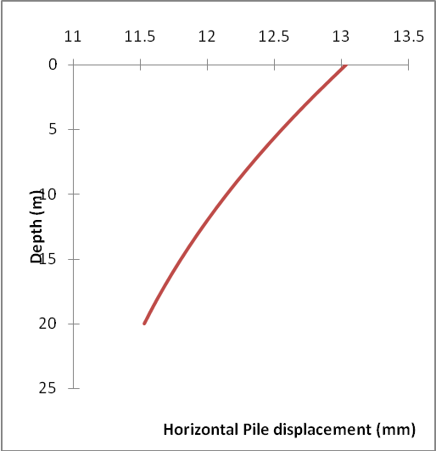
Figure 25: Axial Pile displacement (horizontal) along the depth of pile.
Deflection is maximum at the pile head and minimum at pile base. Pile acts as an axially loaded coloumn.

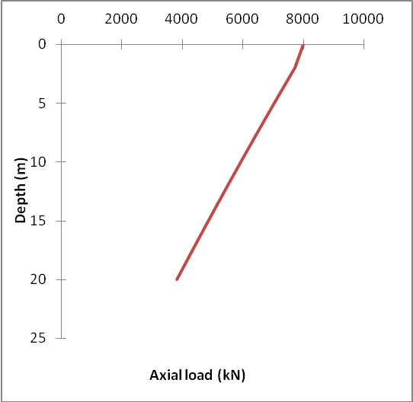
Figure 26: Axial Load transferred along the depth of the pile.
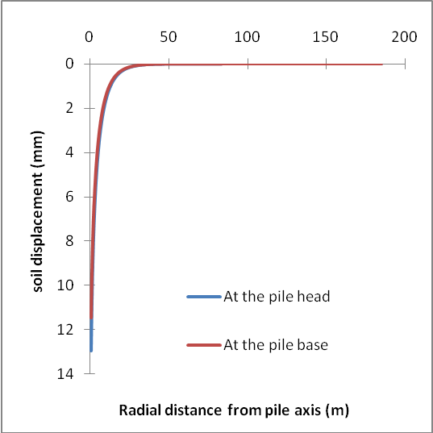
Figure 27: Variation of soil displacement along the radius of influence.
The settlement in the soil decreases with the increase in distance from the axis of the pile and vanishes at certain distance (rm=limiting radius of influence) from the pile shaft.

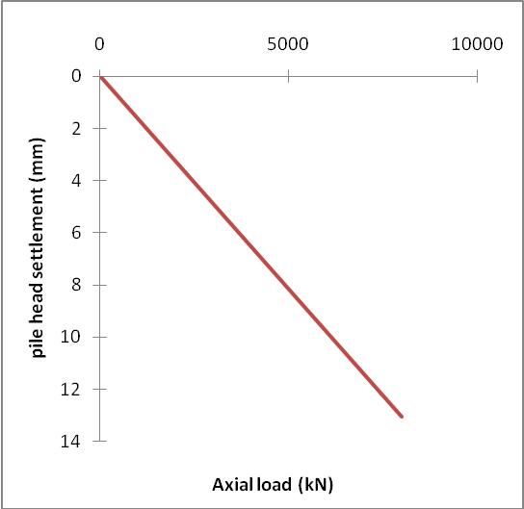
Figure 28: Variation of pile head settlement with the increase of axial load

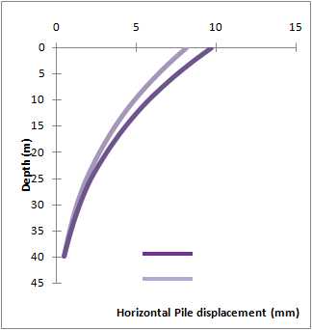
Rectangular Pile
Circular Pile
Figure 29: Comparison of Horizontal Pile displacements in case of rectangular and circular pile 1

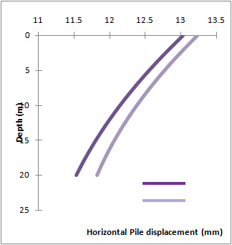
Rec.Pile
Cir.Pile
Figure 30: Comparison of Horizontal Pile displacements in case of rectangular and circular pile 2

6.3 Pile group
In case of Problem No 2, matrix method has been used to determine the settlement of a pile group, consisting of 6 piles (3 x 2). The method has been developed using a load transfer curve model and involves the transfer of load from the pile shaft by shear stresses generated in the soil on vertical and horizontal planes. The results agree well with those got from some well established methods. While, the settlement for the pile group was 12.7 mm as got from the stiffness matrix method, the same was 13.8mm when calculated by using rigid pile settlement ratio curves given by Shen et al.
The given data (as provided by the authorities) was incomplete in terms of the fact that correct value of Young’s modulus of soil was not given. The properties of the soil (index properties, particle size, c,ɸ,etc) were compared with related soils and the average value of Young’s modulus of Elasticity of soil, E_{s}, taken as 150 MPa.

Conclusion

The various observations and conclusions drawn from the work cited in the above chapters can be listed as given below:
- A method of analysis for the rectangular and circular piles embedded in multi-layered soil continuum was presented. The analysis is based on the solution of the governing differential equations for pile and soil displacements obtained using the principle of minimum energy and calculus of variation
- The analysis produces pile displacement and axial force as functions of depth and vertical soil displacement as a function of the horizontal distance from the centerline of the pile, if the following are known: the pile cross-sectional dimensions and length, the thicknesses of the soil layers, Young’s modulus of the pile material, the Young’s modulli and Poisson’s ratios of the soils in the various layers, and the magnitude of the applied axial force.
- The code developed can be used to analyze the rectangular and circular piles embedded in up to 10 layers of soil.
- Different parametric studies can be done to know the effect of changing various variables and, thus, the behaviour of pile foundation in different soil and material conditions can be studied.
- Using the above method, a comparative study between circular and rectangular piles having same cross-sectional area was done. The shape of cross section affects the response as is evident from the examples solved above.
- The graphical outputs of the examples, that have been solved, suggest that rectangular piles deflect less than the circular piles, for the same cross sectional area (provided the other parameters, i.e. soil properties remain same). However, axial profiles with depth are almost independent of the shape.
- For the Case Study No 2 (which involved study and settlement analysis of pile groups) a matrix method has been presented.
- It involves the transfer of load from the pile shaft by shear stresses generated in the soil on vertical and horizontal planes.
- The method is based on variational solutions for pile groups embedded in soil modeled using a load transfer curve model and elastic half-space model.
- Using this practical method, the settlement of pile groups can be estimated quickly without recourse to complex computer programs based on numerical models, resulting in savings in time and cost. The solutions obtained using this approach, are in good agreement with rigorous variational solutions.

References

Armaleh, S., and Desai, C. S. (1987). “Load-deformation response of axially loaded piles.” Journal of Geotechnical Engineering,Division. 113(12), 1483–1500.
Basu, D., Prezzi, M., Salgado, R., and Chakraborty, T. (2008). “Settlement analysis of piles with rectangular cross sections in multi-layered soils.” Computers and Geotechnics, 35(4), 563–575.
Blaney, G. W., Kausel, E., and Roesett, Journal of M. (1976). “Dynamic stiffness of piles.” Proc., 2nd International Conference on Numerical Methods in Geomechanics, ASCE, Blacksburg, Va., 1001–1012.
Butterfield, R., and Banerjee, P. K. (1971). “The elastic analysis of compressible piles and pile groups.” Geotechnique, 21(1), 43–60.
Callanan,., and Kulhawy, F. H. (1985). “Evaluation of procedures for predicting foundation uplift movements.” Rep. to Electric Power Research Inst., No. EPRI EL-4107, Cornell Univ., Ithaca, N.Y.
Chang, M. F., and Wong, I. H. (1987). “Shaft friction of drilled piers in weathered rocks.” Proc., 6th International Conference on Rock Mechanics, ISRM, Montreal, Canada, 313–318.
Coyle, H. M., and Reese, L. C. (1966). “Load transfer for axially loaded piles in clay.” Journal of Soil Mechanics and Found. Div., 92(2), 1–26.
El-Sharnouby, B., and Novak, M. (1990). “Stiffness constants and interaction factors for vertical response of pile groups.” Canadian Geotechnical Journal, 27, 813–822.
Fellenius, B. H., Altaee, A., Kulesza, R., and Hayes, (1999). “O-cell testing and FE analysis of 28-m-deep barrette in Manila, Philippines.” Journal of Geotechnical and Geoenvironmental Engineering, 125(7), 566–575.
Guo, W. D. (2000). “Vertically loaded single piles in Gibson soil.” Journal of Geotechnical and Geoenvironmental Engineering., 126(2), 189–193.
Guo, W. D., and Lee, F. H. (2001). “Load transfer approach for laterally loaded piles.” International Journal of Numerical and Analytical Methods in Geomechanics., 25(11), 1101–1129.
Guo, W. D., and Randolph, M. F. (1997). “Vertically loaded piles in non-homogeneous media.” International Journal of Numerical and Analytical Methods in Geomechanics.21(8), 507–532.
Kim, S., Jeong, S., Cho, S., and Park, I. (1999). “Shear load transfer characteristics of drilled shafts in weathered rocks.” Journal of Geotech. Geoenviron. Eng., 125(11), 999–1010.
Kodikara, Journal of K., and Johnston, I. W. (1994). “Analysis of compressible axially loaded piles in rock.” International Journal of Numerical and Analytical Methods in Geomechanics., 18, 427–437.
Kraft, L. M., Ray, R. P., and Kagawa, T. (1981). “Theoretical t-z curves.”Journal of Geotechnical Engineering. Div., 107(11), 1543–1561.
Lee, C. Y., and Small, Journal of C. (1991). “Finite-layer analysis of axiallyloaded piles.” Journal of Geotechnical Engineering., 117(11), 1706–1722.
Lee, K.-M., and Xiao, Z. R. (1999). “A new analytical model for settlement analysis of a single pile in multi-layered soil.” Soils Found., 39(5), 131–143.
Mattes, N. S., and Poulos, H. G. (1969). “Settlement of single compressible pile.” Journal of Soil Mechanics and Found. Div., 95(1), 189–207.
Motta, E. (1994). “Approximate elastic-plastic solution for axially loaded piles.” Journal of Geotechnical Engineering., 120(9), 1616–1624.
Murff, Journal of D. (1975). “Response of axially loaded piles.” Journal of Geotech.
Engrg. Div., 101(3), 356–360.
Mylonakis, G. (2001). “Winkler modulus for axially loaded piles.” Geotechnique, 51(5), 455–461.
Ng, C. W. W., and Lei, G. H. (2003). “Performance of long rectangular barrettes in granitic saprolites.” Journal of Geotechnical and Geoenvironmental Engineering, 129(8),685–696.
Poulos, H. G. (1979). “Settlement of single piles in nonhomogeneous soil.” Journal of Geotechnical Engineering. Div., 105(5), 627–641.
Poulos, H. G., and Davis, E. H. (1968). “The settlement behavior of single axially loaded incompressible piles and piers.” Geotechnique, 18(3), 351–371.
Poulos, H. G., and Davis, E. H. (1980). Pile foundation analysis and design, Wiley, New York.
Rajapakse, R. K. N. D. (1990). “Response of an axially loaded elastic pile in a Gibson soil.” Geotechnique, 40(2), 237–249.
Randolph, M. F. (1981). “The response of flexible piles to lateral loading.” Geotechnique, 31(2), 247–259.
Randolph, M. F., and Wroth, C. P. (1978). “Analysis of deformation of vertically loaded piles.” Journal of Geotechnical Engineering. Div., 104(12), 1465–1488.
Seed, H. B., and Reese, L. C. (1957). “The action of soft clay along friction piles.” Journal of Geotechnical Engineering. Div., ASCE., 122, 731–754.
Seo, H., and Prezzi, M. (2007). “Analytical solutions for a vertically loaded pile in multilayered soil.” Geomech. Geoeng., 2(1), 51–60.
W. Y. Shen, Y. K. Chow, K. Y. Yong(2000), “Practical method for settlement analysis of pile groups.” Journal of Geotechnical Engineering. Div., ASCE.,166,675-678
Vallabhan, C. V. G., and Mustafa, G. (1996). “A new model for the analysis of settlement of drilled piers.” International Journal of Numerical and Analytical Methods in Geomechanics., 20, 143–152.

Appendix

A practical method that can be used to evaluate the settlement of pile groups has been given by W. Y. Shen, Y. K. Chow, and K. Y. Yong, in the form of various curves, in terms of the inverse of the rigid pile group settlement ratio R_{sr} versus number of piles in the group. This method is developed based on variational solutions for pile groups embedded in soil modeled using a load transfer curve model and elastic half-space model. Using this practical method, the settlement of pile groups can be estimated quickly without recourse to complex computer programs based on numerical models, resulting in savings in time and cost. The solutions obtained using this approach are in good agreement with rigorous variational solutions and are also in reasonable agreement with field measurements.
These curves are plotted to logarithmic scales for a rigid pile groups ranging from single piles up-to 25x25 large pile group embedded either in homogenous soil (ρ=1) or in soil with stiffness increasing linearly with depth (ρ = 0.5). The rigid group settlement ratio R_{sr} is defined as the ratio of rigid pile group settlement to the settlement of a rigid single pile under the average load per pile carried by the group.
The group settlement ratio R_{sr} can be expressed as:

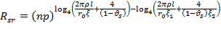
The normalized group settlement ratio is then obtained from the different curves (as shown ):

Figure 31: Normalised Group Settlement ratio Vs Number of piles for l/ro = 50 (Shen.et al,2000)

Figure 32: Normalised group settlement ratio Vs number of piles for l/ro = 100 ( Shen et al,2000)
The group settlement ratio of a compressible pile group is then obtained by multiplying the normalized pile group settlement ratio and rigid pile group settlement ratio.
Now, for the given problem, we have:
λ = 513
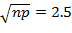
Using Normalized Group settlement ratio curves, we get 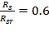
Therefore, R_{s} = 0.6 x 2.835 = 1.701.
Thus, group settlement ratio of compressible pile groups, R_{s} = 1.701
Now, stiffness matrix for a single pile group is as:
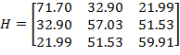
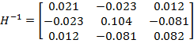
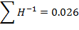
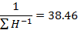
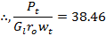
Therefore, settlement of the pile group is given by:
This is comparable to the settlement found previously.

