CHAPTER 1
INTRODUCTION

In the present era of computers and fast communication, one needs to protect communicated information (message or plain text) from unauthorized user, while sending it through any electronic media. So, security of visual data is an important issue in the design of communication systems. Data hiding techniques and visual cryptography are used to introduce confidentiality and security when visual data are transmitted through unsecured communication channels. Data hiding techniques try to embed data in digital media and transmit it in an imperceptible way.
The private-key and the public-key are the two well-known cryptosystems, using these we enable to keep the secret data securely in such a way that that invader cannot able to understand what the secret data means. The data encryption standard (DES) and Rivest, Shamir, Adleman (RSA) and Advanced Encryption Standard (AES) are three representative methods. Apart from cryptography, steganography provides another way to keep the data secure. The Steganography consists of techniques to allow the communication between two persons. It hides not only the contents but also the existence of the communication in the eyes of any observer. These techniques use a second perceptible message, with meaning disjoined by the secret message. This second message works as a “Trojan horse”, and is a container of the first one. The new technologies and, in special way, the information networks require more and more sophisticated strategies in order to prevent the message privacy. In this context, digital images and audio is excellent candidate to turn into containers of the messages, since the bits of a secret text message can be superimposed, as slight noise, to the bits employed for coding a digital image.

There are two methods of performing steganography, one in spatial domain, and the other in frequency domain. Each technique has its own advantage and disadvantage. In the spatial domain, we can simply insert data into host image by changing the gray levels of some pixels in the host image, but the inserted information may be easily detected using computer analysis. In the frequency domain, we can insert data into the coefficients of a transformed image, for example using discrete Fourier transform (DFT), discrete cosine transform (DCT) and discrete Wavelet transform (DWT). But we cannot embed too much data in the frequency domain because the quality of the host image will be distorted significantly.
The mechanism is desirable in which the secret depends not on one person but on a group of people which is known as the secret sharing. The real life application of this scheme is when it’s necessary in a company that the managers to share the digital documents. This concept gives a good solution for data security because all members are required to break the secret and this the main advantage of the secret sharing.
In 1994, Naor and Shamir described a new (k, n) visual cryptographic scheme using black and white images, where the dealer encodes a secret into n participants. The secret is visible only if k or more participants stack in their shares together. The concept of arcs to construct colored
visual cryptography scheme has been proposed by Verheul and Van Tilborg where colored secret images could be shared. The number of colors and number of sub pixels determined the resolution of the revealed image and thus if the number of colors was large, then coloring the sub pixels and stacking the shares precisely becomes a difficult task. In, a new visual cryptographic scheme to improve the visual effect of the shares was proposed by Hwang. This scheme was useful when the number of shares was large and could be implemented only for black and white images. Subsequently Chang, Tsai and Chen modified and extended this scheme to color images using Color Index Tables. In, Chang proposed a scheme wherein the size of the shares is fixed and independent of the number of colors appearing in the secret image. Further, the pixel expansion was only 9, which was the least amongst the previously proposed methods. But this algorithm is only applicable for (n, n) schemes.
Steganography is one of the data hiding technique in which Secret communications take place that conceal the very existence of the message. Cryptography in another type of data hiding technique in which message to be hidden is encoded using encryption or coding techniques. Here we know that a message is there but cannot understand it. Watermarking is another technique in which information that is hided is directly related to the item in which it is embedded.
On the other hand, in visual cryptography or visual secret sharing (vss), the original input image is shared between a set of participants P by a dealer (secret image holder). Based on the sharing policy, only qualified subsets of participants can recover the original input image.

Two important factors that used to determine the efficiency of any visual cryptography scheme, namely:
1) The quality of the reconstructed image and
2) The pixel expansion (m).
Any loss of information during the reconstruction phase leads to reduction in the quality of the recovered image. On the other hand pixel expansion refers to the number of sub pixels in the generated shares that represents a pixel of the original input image. For bandwidth constrained communication channels it is desirable to keep m as small as possible. For color images, reducing pixel expansion is of paramount importance since they occupy more space and consume more bandwidth compared to grayscale and binary images. Most of the previous works in this area try to optimize pixel expansion or obtain perfect reconstruction.

In Visual Cryptography schemes (VCS) the traditional stacking operation of sub pixels and rows interrelations is modified. This new technique does not require transparencies stacking and hence, it is more convenient to use in real applications. However, it requires the use and storage of a Color Index Table (CIT) in order to losslessly recover the secret image. CIT requires space for storage and time to lookup the table.
Also, if number of colors c increases in the secret image, CIT becomes bigger and the pixel expansion factor becomes significant which results in severe loss of resolution in the camouflage images.
Ours is an advanced scheme for hiding a colored image into multiple images that does not require a CIT. This technique achieves a lossless recovery of the secret image but the generated shares (camouflage images) contain excessive noise.

Visual cryptography is a new cryptographic scheme where the cipher text is decoded by the human visual system. Hence, there is no need to any complex cryptographic computation for decryption. The idea is to hide a secret message (text, handwriting, picture, etc…) in different images called shares or cover images. When the shares (transparencies) are stacked together in order to align the sub pixels, the secret message can be recovered. The simplest case is the 2 out of 2 scheme where the secret message is hidden in 2 shares, both needed for a successful decryption. This can be further extended to the k out of n scheme where a secret message is encrypted into n shares but only k shares are needed for decryption where k≤ n. If k-1 shares are presented, this will give no information about the secret message. The inconvenience with the previous schemes was that they used meaningless shares to hide the secret and the quality of the recovered plain text is bad. More advanced schemes based on visual cryptography where a colored image is hidden into multiple meaningful cover images is a new colored secret sharing and hiding scheme.

CHAPTER 2
CRYPTOGRAPHY

2.1 Introduction to Cryptography

Cryptography (from Greek krypto’s, "hidden", and gr’aphein, "to write") is, traditionally, the study of means of converting information from its normal, comprehensible form into an incomprehensible format, rendering it unreadable without secret knowledge — the art of encryption. In the past, cryptography helped ensure secrecy in important communications, such as those of spies, military leaders, and diplomats. In recent decades, the field of cryptography has expanded its remit in two ways. Firstly, it provides mechanisms for more than just keeping secrets: schemes like digital signatures and digital cash, for example. Secondly, cryptography has come to be in widespread use by many civilians who do not have extraordinary needs for secrecy, although typically it is transparently built into the infrastructure for computing and telecommunications, and users are not aware of it.
Cryptography has had a long and colorful history. Generally speaking the earliest forms of secret writing required only pen and paper, and are now collectively termed classical cryptography. The two main categories are transposition ciphers, which rearrange the order of letters in a message, and substitution ciphers, which systematically replace groups of letters with others. Classical ciphers tend to leak varying amounts of information about the statistics of the plaintext, and because of this they are easily broken, for example by frequency analysis. Classical ciphers still enjoy popularity today, though mostly as puzzles .
Various devices and aids have been used for encryption. Early in the 20th century, several mechanical devices were invented for performing encryption, including rotor machines - most famously the Enigma cipher used in World War II. The ciphers implemented by these machines brought about a significant increase in the complexity of cryptanalysis. The various attacks on Enigma, for example, succeeded only after considerable effort. Occasionally, these devices have featured in films, such as in the James Bond adventure From Russia with Love.
With the advent of digital computers and electronics, very complex ciphers could be implemented. A characteristic of computer ciphers is that they operate on binary strings unlike classical and mechanical schemes, which use an alphabet of around 26 letters, depending on the language. Computer ciphers are also much more resistant to cryptanalysis; few are susceptible to a cipher text-only attack.
Extensive academic research into modern cryptography is relatively recent — it only began in the open community during the 1970s with the specification of DES and the invention of RSA. It is well that much progress has been made in a short time; popular applications such as the Internet and mobile phones have repositioned cryptography, historically the sole province of a few groups with exceptional needs for secrecy, into a mainstream technology on which millions rely.
As well as noting lessons from its history, cryptographers are also careful to consider the future. Moore’s law is routinely taken into account when specifying key-lengths and the potential effects of quantum computing have already been considered. Note also quantum cryptography.
Visual cryptography is a cryptographic technique which allows visual information (pictures, text, etc.) to be encrypted in such a way that the decryption can be performed by humans (without computers).
The first visual cryptographic technique was pioneered by Moni Naor and Ad Shamir in1994. It involved breaking up the image into n shares so that only someone with all n shares could decrypt the image by overlaying each of the shares over each other. Practically this can be done by printing each share on a separate transparency and then placing all of the transparencies on top of each other. In their technique n-1 shares revealed no information about the original image.
Cryptography is the science of using mathematics to encrypt and decrypt data.
Cryptography is the art of secret writing. It enables to store information or transmit it across insecure networks, so that it cannot be read by anyone except the intended recipient. Cryptography is the practice of using encryption to conceal text.

Cryptographic systems are characterized as:

- The type of operations used to transforming plaintext to ciphertext : All the encryption algorithms are based on substitution in which one element is replaced for another, and transposition in which the order of the elements is rearranged. Most systems involve multiple stages of substitutions and transpositions.

- The number of key used: In symmetric encryption, only one key is used for encryption and decryption. It is referred as secret key, single key or conventional encryption. In asymmetric encryption, two keys are used. It is also referred as two key, or public key encryption.

- Ways of processing the plaintext: There are two ways to process the plaintext: viz. block cipher, and stream cipher. In the clock cipher, the input plaintext is divided into block and each block is processed at a time. The result of block cipher is one block for each block of input plaintext. In stream cipher, we process the input elements continuously one by one. The result of steam cipher is one element for each element of input plaintext.

2.2 Encryption

Encryption is the process of encoding information (plaintext) to make it unreadable without special knowledge. While encoding, the meaning of the message is not obvious. Decryption is the reverse process. The process of decoding or transforming an encrypted message (ciphertest) back to its readable and original form (plaintext) called decryption. In other words, encryption helps us to hide meaning of the original message so that we can send it safely, and decryption helps us reveal the original message from the secret message. In encryption, we use various techniques to encode the message whereas in decryption, the prior knowledge of key or password is required to decode the message. Thus, encryption and decryption help in secure transmission of the message and in protecting the message from unauthorized persons. A system for encryption and decryption is called a cryptosystem. The techniques used for enciphering constitute the area of study known as cryptography. The technique used for deciphering a message without any knowledge of the enciphering details fall into the area of cryptanalysis, also called Breaking the code. The areas of cryptography and cryptanalysis together are called cryptology.

2.3 Encryption Methods

The method of data encryption and decryption are relatively straightforward, and can be mastered easily. We divide encryption methods into two parts:

- Symmetric encryption

2 Asymmetric encryption

2.3.1 Symmetric Encryption

Symmetric encryption is also referred as conventional encryption. For example , A and B agreed on an encryption method and a shared key. A uses the key and the encryption method to encrypt (or encipher) a message and sends it to B, B uses the encryption method to decrypt (or decipher) the message .Symmetric encryption is similar to the process followed by most people to make their home safe. A person purchases a lock of some company to close his door. The same key is required to open and lock the door. Another key from the same company cannot open or close the lock. Similarly, in symmetric encryption the same key is required for encryption as well as decryption. A few well-examined encryption algorithms that everyone could use just like the model of the lock may be the same, but keys are different. The components of symmetric encryption are the following.

- Plaintext: This is the original message written or created by the sender used as input for the encryption algorithm.

- Encryption algorithm: Here we have to use various encryption algorithms to encrypt the plaintext. This helps us to convert the plaintext into ciphertext. An encryption algorithms is called breakable when, given enough time and data, an

analyst can determine the algorithm. However, if the algorithm is theoretically breakable, it is in fact, impractical to try to break it. Practically, however, things are different. Estimates of breakability are based on current technology. Those algorithms which require thousands of years to break may break within a day due to advance technology. Technology evolves very fast. Most encryption algorithms are mathematical in nature or can be explained and studied with mathematics. Text symbols are coded with numbers and encryption operates on the numerical representation of the symbols ( ASCII codes).

- Key: Key is used as the input to the encryption algorithm. The key is the same for encryption and decryption. For every different keys will produce more security.

- Ciphertext: this is the output of the plaintext after encryption. This depends on the key and the plaintext. Two different keys will produce two different ciphertexts. The ciphertext is a set or random stream of data.

- Decryption algorithm: The decryption algorithm runs in reverse of the encryption algorithm. The input of this algorithm is the ciphertext and the key. The key for decryption is the same as that used for encryption.

2.4 Decryption

Decryption is the reverse process. The process of decoding or transforming an encrypted message or data (ciphertext) back to its readable and original form (plaintext) is called decryption. In other words, decryption helps us reveal the original message from the secret message. Decryption requires a secret key or password.

2.5 Cryptanalysis

Cryptanalysis is the study of methods for obtaining the meaning of encrypted information without access to the secret information which is normally required to do so. Typically, this involves finding the secret key. In non-technical language, this is the practice of trying to break any ciphertext message to obtain the original message called plaintext. The person who attempts to break the security is called the cryptanalyst.

The cryptanalyst can break encrypted message (ciphertext) by any or all of the following ways.
- Breaking the message

- Recognizing patterns in encrypted messages in order to be able to break subsequent ones.

- Concluding some meaning from the ciphertext without breaking it.

- Finding general weaknesses in an encryption algorithm

- Deducing the key in order to break subsequent messages easily

The cryptanalyst tries every possible key on a piece of ciphertext until a intelligible translation into plaintext is obtained. Therefore, to make the secure message transformation, we need a strong encryption algorithm so that the cryptanalyst or the opponent who knows the algorithm and has access to one or more ciphertext is unable to decrypt it, and also unable to find out the key. We also need to keep the key secure. Key may be generated using random number generation for every new message transformation, use we key.

There is no need to keep the symmetric encryption algorithm secret. Only keep the key secure.

We said the algorithm is secure if the cost of breaking the ciphertext exceeds the value of the encrypted information, and also the time required to break the ciphertext exceeds the useful lifetime of the information. If an encryption algorithm fulfils thee two criteria, then it is computationally secure.

Throughout this book, we have used the convention that plaintext is written in lower case letters and ciphertext in uppercase letters. As most of the encryption algorithms are based on mathematical transformation, they can be studied more easily in the mathematical form.

The following example shows ciphertext for the plaintext.

Plaintext a b c d e f g h i j k l m
Ciphertext 5 6 7 8 9 10 11 12 13 14 15 16 17
Plaintext n o p q r s t u v w x y z
Ciphetext 18 19 20 21 22 23 24 25 26 1 2 3 4

2.6 Substitution Ciphers

The two building blocks of all encryption techniques are:

- Substitution ciphers and

2 Transposition ciphers

2.6.1 Substitution ciphers

The technique in which the elements of plaintext are replaced by other elements or by numbers or symbols is called substitution ciphers. Substitution ciphers are called mono alphabetic ciphers (simple substitution). If the plaintext is viewed as a sequence of bits, then substitution involves replacing plaintext bit patterns with patterns with ciphertext bit patterns. There are two different types of substitution ciphers:

- Monoalphabetic ciphers and

- Playfair ciphers

2.6.2 Transposition ciphers

Transposition ciphers encrypt plaintext by moving small pieces of the message around. Transposition ciphers are rarely encountered nowadays. They differ from substitution ciphers, in a transposition cipher the letters of the plaintext are shifted about to form the cryptogram. This can be done in a number of the ways and there are some systems where even whole words are transposed, rather than individual letters.

CHAPTER 3
VISUAL CRYPTOGRAPHY

3.1 Introduction to Visual Cryptography
Visual Cryptography is a graphical form of information concealing. It can be seen as a cryptographic primitive, since it offers methods and technologies for building more complex information security systems.
The techniques of visual cryptography are inspired from the general secret sharing schemes as presented by Adi Shamir and G.R. Blakley. The main difference between the visual and the general secret sharing schemes is that for the first ones the secret will be visually reconstructed in the decryption phase.
In its simplest scenario, a visual cryptography scheme involves a dealer and two participants to the scheme. The dealer chooses a secret message that can be written text, a picture, a scheme, a spreadsheet calculation etc. and splits it in two “shadow images” called shares. Every participant to the scheme will receive a separate share printed onto a transparency. In the decryption process, the participants only have to carefully superimpose their shares and the secret will be visually revealed. Such a scheme will be called a two–out–of–two visual cryptography scheme.
Novelty contributions are provided in implementing general k–out–of–n visual cryptography schemes. In such schemes the secret information can be reconstructed if and only if a minimum of k participants in a set of n participants will superimpose the shares they own. An adversary analyzing less then k shares can obtain no information (from the theory of information point of view) considering the secret message, no matter her computing power and analysis method used.
Hierarchical visual cryptography schemes based on access structures and graph theory are also considered. In this type of visual cryptography schemes, some definite sets of qualified participants from a general set P of participants can be chosen. The qualified subsets are the only ones that can reconstruct the secret information.
On special interest are the extended visual cryptography schemes for “natural images” – continuous tone gay images. In a two–out–of–two extended visual cryptography scheme, the two shares the secret image is split into are “innocent” images hiding the very intention of sending a secret message.
Further contributions are made considering the applications of visual cryptography in e-commerce, especially for scenarios that involve the presence of a corrupt Post of Sale (POS).
Being an one-time-pad method, visual cryptography is information-theoretically secure. That means, its security derives purely from the information theory. This aspect makes visual cryptography interesting since the security of the most actual cryptographic primitives is based on the difficulty of solving hard mathematical problems.

A visual cryptography scheme is a secret sharing scheme to encode a secret image SI in such a way that any qualified subset of participants can “visually” recover the secret image, while forbidden subsets have no information on SI. A “visual” recovery consists of Xeroxing the shares, which are shadow images, onto transparencies and stacking them one on the top of the others. The participants in a qualified subset will be able to see the secret image without any knowledge of cryptography and without performing any cryptographic computation. Visual cryptography is a powerful tool for teaching cryptography to general audience. Applications have also been proposed to realize authentication, identification schemes and, recently, e voting schemes.

Steganography is the art and science of hiding the fact that communication is taking place. Using steganography, you can embed a secret message inside a piece of unsuspicious information and send it without anyone knowing of the existence of the secret message.

Steganography and cryptography are closely related. Cryptography scrambles messages so they cannot be understood. Steganography on the other hand, will hide the message so there is no knowledge of the existence of the message in the first place. In some situations, sending an encrypted message will arouse suspicion while an”invisible” message will not do so. Both sciences can be combined to produce better protection of the message. In this case, when the steganography fails and the message can be detected, it is still of no use as it is encrypted using cryptography techniques.

3.2 Secret Sharing Schemes
Secret sharing is a fundamental primitive in cryptography; it was introduced in 1979 independently by Blakley and by Shamir. Secret sharing schemes have been extensively studied along the years. In its basic form, a secret sharing scheme is a protocol divided into a Sharing Phase and a Reconstruction Phase. During the Sharing Phase, a dealer distributes a secret among a set of participants by sending in a secure way a piece of information, called share, to each of them. Then, during the Reconstruction Phase, some subsets of participants (qualified subsets), by pooling together their shares, reconstruct the secret; while, other subsets, (forbidden subsets), are not able to reconstruct the secret. Moreover, if the scheme is such that forbidden subsets, by pooling together and processing their shares, do not get any information about the secret, it is said to be perfect. In such a model, dealer and participants are supposed to be honest.

3.3 Efficiency and Information Rate
One of the basic issues in the area of secret sharing schemes is that of estimating the information rate of the scheme, that is, the ratio between the size of the secret and that of the largest share given to any participant. Although the issue has received considerable attention some interesting problems remain still open. Schemes where the information rate is equal to one are said to be ideal.

3.4 Linear Secret Sharing Schemes
An important class of secret sharing schemes is the class of linear secret sharing schemes. Brickell was the first author who considered (ideal) linear schemes and introduced the vector space construction, generalized later by Van Dijk. General linear secret sharing schemes were studied by Simmons. Geometric secret sharing schemes, considered by Jackson and Martin, are also general linear secret sharing schemes. Karchmer and Wigderson showed that monotone span programs realize any linear secret sharing scheme.

3.5 Verifiable Secret Sharing Schemes
In order to design secret sharing schemes that keep working in hostile environments, the concept of verifiability was introduced in .With this more general approach, some extra information is used to enable participants to detect a dishonest dealer, who sends inconsistent shares during the Sharing Phase, and to verify during the Reconstruction Phase that each participant sends a correct share. There is an extensive literature on verifiable secret sharing schemes for the unconditionally secure setting and, for the computationally secure setting. Verifiable secret sharing schemes play a key-role in multi-party computation

3.6 Proactive Verifiable Secret Sharing Schemes
The concept of proactive security was introduced in and applied to the secret sharing setting in . Basically the idea is that, if the shares held by the participants stay the same for all the lifetime of the system, then an adversary can eventually corrupt a sufficient number of participants to learn the secret. On the other hand, if time is divided into periods, and at the beginning of each period the stored shares change (while the shared secret stays the same), then the adversary probably does not have enough time to corrupt the necessary number of participants. Moreover, the shares he learns during period p are useless during period p + i, for i = 1, 2 . . .. So, he has to start a new attack from scratch during each time period.

CHAPTER 4
Secrete Image Hiding Algorithm

4.1 DEVELOPMENT

The proposed approach uses meaningful shares (cover images) to hide the colored secret image and the recovery process is lossless. The scheme defines a new stacking operation (XOR) and requires a sequence of random bits to be generated for each pixel. This scheme can be generalized to an n out of n approach.

4.2 Methodology

Assume that a gray image with 256 colors constitute a secret to be hidden. Each color can be represented as an 8-bit binary vector. The main idea is to expand each colored pixel into m sub pixels and embed them into n shares. This scheme uses m=9 as an expansion factor. The resulting structure of a pixel can be represented by an nx9 Boolean matrix S= [S_{ij}] where (1≤ i ≤ n, 1≤ j≤ 9) and S_{ij} =1, if and only if, the jth sub pixel in the ith share has a non-white color. To recover the color of the original secret pixel, an “XOR” operation on the stacked rows of the n shares is performed.

4.3 Hiding Algorithm

For a 2 out of 2 scheme, the construction can be described by a collection of 2x9 matrices C. If a pixel with color k=(k₁k₂…k₈)₂ needs to be shared, a dealer randomly picks an integer r between 1 and 9 inclusively as well as one matrix in C. The construction is considered valid if the following conditions are satisfied:

k_{i} = S_{1 j} ⊕ S_{2 j} (1)

Where k_{i} = S_{1 j} ⊕ S_{2 j} and j= { i if i<r
i+1 if i>r

Note that the number of 1’s in the first row of S must exceed the number of 0’s by one.

4.3.1 Steps of the Algorithm

- Take a colored secret image I_{HL} of size HxL and choose any two arbitrary cover images O ¹_{HL} and O ²_{HL} of size HxL

- Scan through I_{HL} and convert each pixel I_{ij} to an 8-bits binary string denoted
as k= (k₁k₂…k₈)₂
- Select a random integer rp, where 1 ≤ r_{p}≤ 9 for each pixel I_{ij}

- According to r_{p} and k for each pixel, construct S to satisfy equation (1)

- Scan through O¹ and for each pixel of color k¹ _{p} , arrange the row “i” in S as a 3x3 same for O² and construct B²_{p} . The resulting blocks B¹_{p} and B²_{p} are the subpixels of the pth pixel after the expansion

- After processing block B¹p and fill the subpixels valued “1” with the color k ¹_{p}
- Do the all the pixels in I_{HL}, two camouflage colored images O^{1’} and O²’ are generated. In order to losselessly recover I_{HL}, both O¹’ and O²’ as well as a sequence of random bits R={r₁, r₂, … , r _{|I|}}are needed.
- This process is repeated for all pixels in I_{HL} to construct both camouflage images O¹’ and O²’.

4.4 Recovering Algorithm

In order to recover the secret image in a 2 out of 2 scheme, both camouflage images O¹’, O²’ as well as the string of random bits R are required for the recovery process
2). The camouflage images are t time bigger than I_{HL} due to the expansion factor of subpixels.

4.4.1 Steps of the Algorithm

- Extract the first 3x3 blocks V¹_{r} and V²_{r} from both camouflage images O¹’and O²’, respectively.
- Re-arrange V¹_{r} and V²_{r} in a 2x9 matrix format S_{r}
- Select the first random bit rp corresponding to the first encrypted pixel
- Input S_{r} and r_{p} to the function corresponding to equation (1).
- Recover k_{p}, the first pixel in I_{HL}
- Repeat for all 3x3 blocks in O¹’and O²’

4.5 Construction of S matrix

Step1:
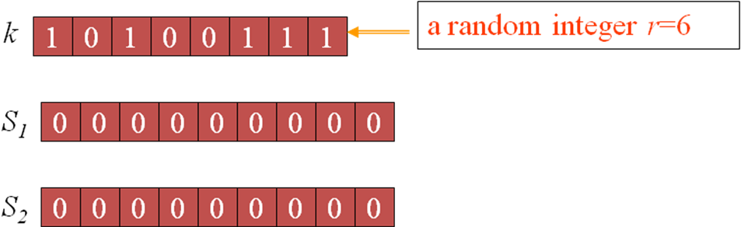

Step2:

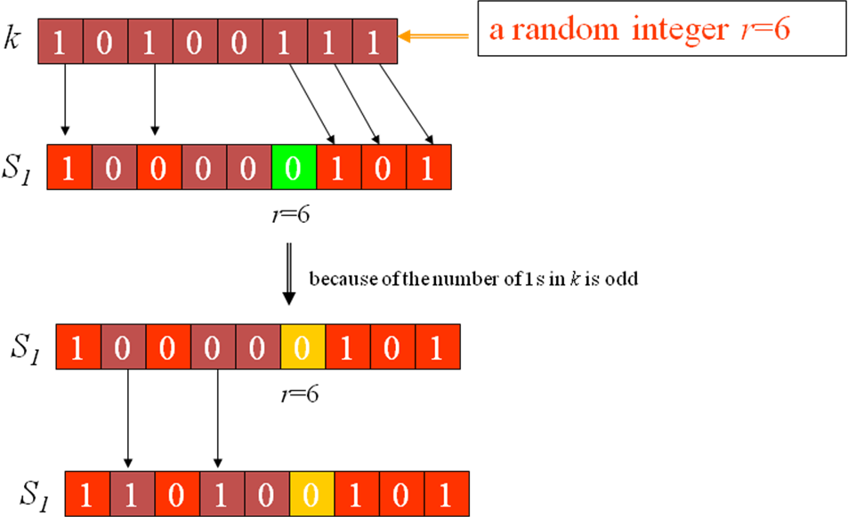

Step3:
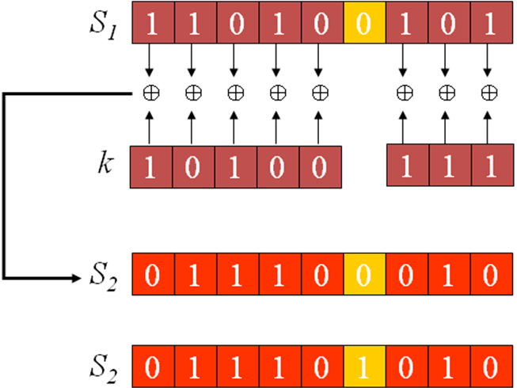

4.6 FLOW CHART

Figure 4.6.1: Secret sharing algorithm flowchart

Secret sharing algorithm flowchart

Figure 4.6.2: Secret sharing recovering algorithm

4.7 Improved image generation scheme

In this section, algorithm to generate better quality camouflage images is given. Most of the modifications are applied to the subpixel expansion block described in the next section.

4.7.1 Hiding Algorithm

Before subpixel expansion, add one to all pixels in the cover images and limit their maximum value to 255. This ensures that no “0” valued pixels exist in the images. When the images are expanded, replace all the 0’s in S₀, S₁ by values corresponding to k₁-1 in B₁ and k₂-1 in B₂ (Figure 4.7.1) instead of leaving them transparent. Also, adjust all pixel values to be between 0-255

Figure 4.7.1: Improved block subpixel expansion technique

4.7.2 Decryption algorithm
To recover the secret image, both camouflage images O¹’, O²’ and the string of random bits R are required.

Steps of the Algorithm

- Take all regions of size txt in the camouflage images
- Re-structure the square matrices as 1xm vectors
- Scan through the 9 subpixels in the vector and note the coordinates of the k¹ and the k¹-1 colors previously encrypted
- Count the number of k and k-1 pixels in the processed vector, denoted as count _{k-1}, count _{k}, respectively.
- If count _{k-1} < count _{k} , the transparent pixel is color k-1, otherwise, set it to k
- Use the k¹ and k² colors to find the secret pixel using the F(.,.) function and the random number previously transmitted
- Repeat for all txt block pixels in the camouflage images

CHAPTER 5
Simulation Results

5.1 Simulation Result for Visual Cryptography

Result obtain from visual cryptography algorithm is shown in below-

- Displaying input images in RGB color space

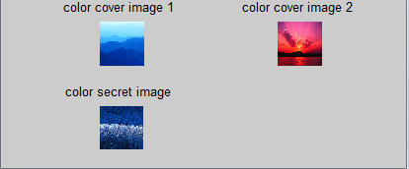

Figure 5.1.1 : Displaying input images in RGB color space

- Resizing the images

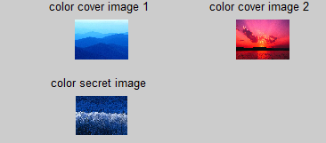
Figure 5.1.2 : Displaying resized RGB color images

- Displaying images in YIQ color space

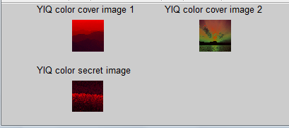

Figure 5.1.3 : Displaying images in YIQ color space

- Displaying gray scale images

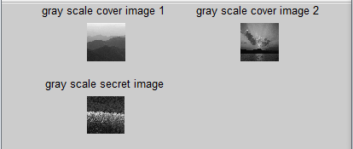
Figure 5.1.4 : Displaying images in gray scale

- After using algorithm the hided image obtain by first cover image is shown below

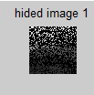
Figure 5.1.5 Hided image obtained by first cover image

- After using algorithm the hided image obtain by second cover image is shown below

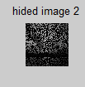
Figure 5.1.6 Hided image obtained by second cover image

7. Reconstructed image obtained from two hided image in Gray Scale

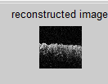
Figure 5.1.7 Reconstructed image obtained from two hided image in Gray Scale

8. Restored Color image from reconstructed gray scale image

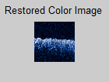

Figure 5.1.8 Restored Color image from reconstructed gray scale image
A secret image is hidden in two cover images. The reconstruction of hidden image is done. The decryption is done using very less cryptographic computation. A 62X62 secret image is hidden into two 62x62 cover images .The camouflage images obtained using the algorithm are noisy.However, the recovery process is lossless and the used cover images are meaningful.

5.2 Simulation Result for Improved Visual Cryptography

Result obtain from improved visual cryptography algorithm is shown in below-

- Displaying images in RGB color space

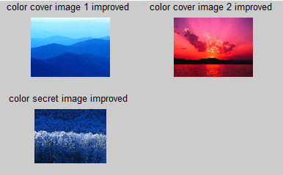

Figure 5.2.1 : Displaying input images in RGB color space

- Resizing the images

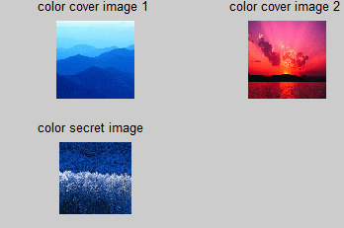

Figure 5.2.2 : Displaying resized RGB color images

- Displaying images in YIQ color space

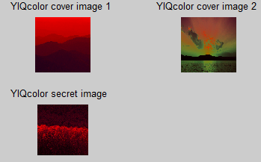

Figure 5.2.3 : Displaying images in YIQ color space

- Displaying gray scale images

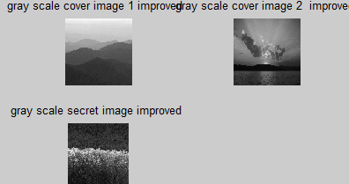

Figure 5.2.4 : Displaying images in gray scale

- After using algorithm the hided image obtain by first cover image is shown below

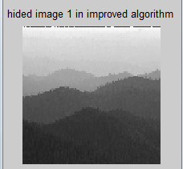
Figure 5.2.5 Hided image obtained by first cover image

- After using algorithm the hided image obtain by second cover image is shown below

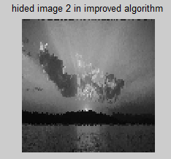
Figure 5.2.6 Hided image obtained by second cover image
- Reconstructed image obtained from two hided image in Gray Scale

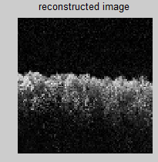
Figure 5.2.7 Reconstructed image from two hided image in Gray Scale

8 . Restored Color image from reconstructed gray scale image

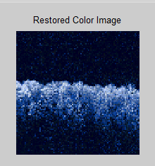
Figure 5.2.8 Restored Color image from reconstructed gray scale image
A secret image is hidden in two cover images. The reconstruction of hidden image is done. The decryption is done using very less cryptographic computation. A 100X100 secret image is hidden into two 100X100 cover images .

CHAPTER 6
CONCLUSION AND FUTURE WORK

A new technique based on Chang et al. algorithm to hide a color secret image into multiple colored images is implemented. The generated camouflage images contain less noise compared to the ones previously obtained using the original Chang’s embedding algorithm. This results in a considerable improvement in the signal to noise ratio of the camouflage images by producing images with similar quality to the originals. An improvement in signal to noise ratio of 9.3 dB and 19.97 dB were obtained for the initial camouflage images used for hiding the secret image. This developed method does not require any additional cryptographic computations and achieves a lossless recovery of the secret image. In addition, the camouflage images obtained using the modified algorithm look less susceptible of containing a secret message than the ones obtained using the original method.
This scheme can possibly be modified to hide two independent colored secret images into n meaningful colored cover images. The recovery process of both secret images should remain lossless while using the same expansion factor as described here.

As future work, this scheme can possibly be modified to hide two independent colored secret images into n meaningful colored cover images. The recovery process of both secret images should remain lossless while using the same expansion factor as described in this thesis.

Appendix
MATLAB CODE
visualcrypt.m
%Reading images
file = uigetfile({'*.jpg;','*.bmp;''*.tif;''*.png;''*.gif''All Image Files'});
cim1=imread(file);%cover image 1
file1 = uigetfile({'*.jpg;','*.bmp;''*.tif;''*.png;''*.gif''All Image Files'});
cim2=imread(file1);%cover image 2
file3 = uigetfile({'*.jpg;','*.bmp;''*.tif;''*.png;''*.gif''All Image Files'});
si=imread(file3);%secret image
% Displaying images in RGB color space
figure;
subplot(2,2,1),imshow(cim1);title('color cover image 1 ');
subplot(2,2,2),imshow(cim2);title('color cover image 2 ');
subplot(2,2,3),imshow(si);title('color secret image ');
%Resizing the images
cim1=imresize(cim1,[62,62]);
cim2=imresize(cim2,[62,62]);
si=imresize(si,[62,62]);
%Displaying images in RGB color space
figure;
subplot(2,2,1),imshow(cim1);title('color cover image 1 ');
subplot(2,2,2),imshow(cim2);title('color cover image 2 ');
subplot(2,2,3),imshow(si);title('color secret image ');

%Conversion from RGB color space to YIQ color space
YIQcim1 = rgb2ntsc(cim1);%
YIQcim2 = rgb2ntsc(cim2);
YIQsi = rgb2ntsc(si);

X = YIQcim1(:,:,1);% Extracting the gray part or the intensity part from YIQ color space
Y = YIQcim2(:,:,1);
Z = YIQsi(:,:,1);
% Procedure to convert the fractional or double class to uint8
for x =1:62
for y = 1:62
temp = X(x,y) * 255;
if( ( ceil(temp) -temp) > (temp - floor(temp)))
X(x,y) = floor(temp);
else
X(x,y) = ceil(temp);
end
end
end

for x =1:62
for y = 1:62
temp = Y(x,y) * 255;
if( ( ceil(temp) -temp) > (temp - floor(temp)))
Y(x,y) = floor(temp);
else
Y(x,y) = ceil(temp);
end
end
end

for x =1:62
for y = 1:62
temp = Z(x,y) * 255;
if( ( ceil(temp) -temp) > (temp - floor(temp)))
Z(x,y) = floor(temp);
else
Z(x,y) = ceil(temp);
end
end
end
for x =1:62
for y = 1:62
gc1(x,y) = uint8(X(x,y));
end
end

for x =1:62
for y = 1:62
gc2(x,y) = uint8(Y(x,y));
end
end

for x =1:62
for y = 1:62
gsi(x,y) = uint8(Z(x,y));
end
end

%Displaying images in YIQ color space
figure;
subplot(2,2,1);imshow(YIQcim1);title('YIQ color cover image 1 ');
subplot(2,2,2);imshow(YIQcim2);title('YIQ color cover image 2 ');
subplot(2,2,3);imshow(YIQsi);title('YIQ color secret image ');
g1c1=gc1;
g2c2=gc2;
%Displaying gray scale images
figure;
subplot(2,2,1),imshow(gc1);title('gray scale cover image 1 ');
subplot(2,2,2),imshow(gc2);title('gray scale cover image 2 ');
subplot(2,2,3),imshow(gsi);title('gray scale secret image');
%Converting intensity values to binary
kc1=dec2bin(gc1);% binary equivalent of each pixel value of cover image 1
kc2=dec2bin(gc2);% binary equivalent of each pixel value of cover image 2
ksi=dec2bin(gsi);% binary equivalent of each pixel value of secret image

r=zeros(1,length(ksi));% random value is taken to represent each pixel value

bp1=zeros(3,3,length(ksi));
bp2=zeros(3,3,length(ksi));
x=zeros(2,9,length(ksi));

for m=1:length(ksi)
count1=0;count2=0;count3=0;count4=0;
r(m)=randint(1,1,[1 9]);

for i=1:8
if i == r(m)
x(1,i,m)= 0;
end
if strread(ksi(m,i))== 1
if i>r
x(1,i+1,m)= strread(ksi(m,i));
count1 = count1+1;
if mod(count1,2) == 0%complimenting even number of 1's
x(1,i+1,m)= 0;
end
else
x(1,i,m)= strread(ksi(m,i));
count1=count1+1;
if mod(count1,2) == 0%complimenting even number of 1's before the rth position (random value)
x(1,i,m)= 0;
end
end
else
if i>r
x(1,i+1,m)= strread(ksi(m,i));
else
x(1,i,m)= strread(ksi(m,i));
end
end
end
if mod(count1,2)~= 0
x(1,r(m),m)= 0;
x(2,r(m),m)= 1;
else
x(1,r(m))=1;
x(2,r(m))= 0;
end
for i= 1:8
if x(1,i,m)== 0
count2 = count2 + 1;
if mod(count2,2) ~= 0 && i<r(m)%complimenting odd number of 0's before the rth position
x(1,i,m)=1;
end
end
end
for i= 1:8
if i>r(m)
x(2,i+1,m)= xor(strread(ksi(m,i)),x(1,i+1));
else
x(2,i,m)= xor(strread(ksi(m,i)),x(1,i));
end
end
%substituting pixel value of secret image in 1 value of bp1 matrix
% and embeddind it into cover image
for j=1:length(kc1)
if gc1(j)== gsi(m)
count3=count3+1;
bp1(:,:,m)=[x(1,1,m),x(1,2,m),x(1,3,m);x(1,4,m),x(1,5,m),x(1,6,m);x(1,7,m),x(1,8,m),x(1,9,m)];
for g= 1:3
for h=1:3
if bp1(g,h,m)== 1
bp1(g,h,m)=gc1(m);

end
end
end
g1c1(m)=imresize(bp1(:,:,m),[1,1]);
if count3== 1
break;
end

end

end

%substituting pixel value of secret image in 1 value of bp2 matrix
% and embeddind it into cover image
for j=1:length(kc2)
if gc2(j)== gsi(m)
count4=count4+1;
bp2(:,:,m)=[x(2,1,m),x(2,2,m),x(2,3,m);x(2,4,m),x(2,5,m),x(2,6,m);x(2,7,m),x(2,8,m),x(2,9,m)];
for g= 1:3
for h=1:3
if bp2(g,h,m)== 1
bp2(g,h,m)=gc2(m);

end
end
end
g2c2(m)=imresize(bp2(:,:,m),[1,1]);
if count4== 1
break;
end

end

end
end

figure;imshow(g1c1);title('hided image 1');
figure;imshow(g2c2);title('hided image 2');

% restoration code
ksi1=zeros(length(ksi),8);%restored k value of secret image in improved algorithm
x1=zeros(2,9,length(ksi));%resored S matrix
gsirec=zeros(1,length(kc1));%restored decimal values of pixels of secret image

% converting bp1 into 1x9 matrix to sorm 2 x 9 S matrix denoted by x1im
for i=1:length(kc1)
x1(1,:,i)=[bp1(1,1,i),bp1(1,2,i),bp1(1,3,i),bp1(2,1,i),bp1(2,2,i),bp1(2,3,i),bp1(3,1,i),bp1(3,2,i),bp1(3,3,i)];
x1(2,:,i)=[bp2(1,1,i),bp2(1,2,i),bp2(1,3,i),bp2(2,1,i),bp2(2,2,i),bp2(2,3,i),bp2(3,1,i),bp2(3,2,i),bp2(3,3,i)];
end
% restoring k value from S matrix
for j=1:length(kc1)
if x1(:,:,i)>0
x1(:,:,i)=1;
end
end
% converting binary vector to decimal

for k=1:length(kc1)
for i=1:8
if i<r(k)
j=i;
elseif i>r(k)
j=i+1;
end
ksi1(k,i)=xor(x1(1,j,k),x1(2,j,k));
end
end
sik=num2str(ksi1);
for i=1:length(kc1)
gsirec(i)=bin2dec(sik(i,:));
end

s1=size(g1c1);
% reshaping the decimal values into matrix of size of secret image
rec=reshape(gsirec,s1(1),s1(2));
rec1=mat2gray(rec);% representing matrix values as gray scale values

figure;imshow(rec1);
title('reconstructed secret image ');
t1=rec1;
t2=si;
imt=imadd(t2(:,:,1),uint8(t1));
imshow(imt);title('reconstructed image');
ims=t2;
[sx sy sz]=size(imt);
[tx ty tz]=size(ims);
if sz~=1
imt=rgb2gray(imt);
end
if tz~=3
disp ('img2 must be a color image (not indexed)');
else
imt(:,:,2)=imt(:,:,1);
imt(:,:,3)=imt(:,:,1);

% Converting to ycbcr color space
nspace1=rgb2ycbcr(ims);
nspace2= rgb2ycbcr(imt);
ms=double(nspace1(:,:,1));
mt=double(nspace2(:,:,1));
m1=max(max(ms));
m2=min(min(ms));
m3=max(max(mt));
m4=min(min(mt));
d1=m1-m2;
d2=m3-m4;
% Normalization
dx1=ms;
dx2=mt;
dx1=(dx1*255)/(255-d1);
dx2=(dx2*255)/(255-d2);
[mx,my,mz]=size(dx2);
%Luminance Comparison
disp('Please wait..................');
for i=1:mx
for j=1:my
iy=dx2(i,j);
tmp=abs(dx1-iy);
ck=min(min(tmp));
[r,c] = find(tmp==ck);
ck=isempty(r);
if (ck~=1)
nimage(i,j,2)=nspace1(r(1),c(1),2);
nimage(i,j,3)=nspace1(r(1),c(1),3);
nimage(i,j,1)=nspace2(i,j,1);
end
end
end
rslt=ycbcr2rgb(nimage);
% figure,imshow(uint8(imt));
figure,imshow(uint8(rslt));title('Restored Color Image');
R=uint8(rslt);
% toc
end

improveviscry.m

%Reading images
file = uigetfile({'*.jpg;','*.bmp;''*.tif;''*.png;''*.gif''All Image Files'});
cim1im=imread(file);%cover image 1 in improved algorithm
file1 = uigetfile({'*.jpg;','*.bmp;''*.tif;''*.png;''*.gif''All Image Files'});
cim2im=imread(file1);%cover image 2 in improved algorithm
file2 = uigetfile({'*.jpg;','*.bmp;''*.tif;''*.png;''*.gif''All Image Files'});
siim=imread(file2);%secret image in improved algorithm
%Displaying images
figure;
subplot(2,2,1),imshow(cim1im);title('color cover image 1 improved ');
subplot(2,2,2),imshow(cim2im);title('color cover image 2 improved ');
subplot(2,2,3),imshow(siim);title('color secret image improved ');
cim1im=imresize(cim1im,[100,100]);
cim2im=imresize(cim2im,[100,100]);
siim=imresize(siim,[100,100]);

% YIQcim1im=imresize(YIQcim1im,[100,100]);
% YIQcim2im=imresize(YIQcim2im,[100,100]);
% YIQsiim=imresize(YIQsiim,[100,100]);

figure;subplot(2,2,1);imshow(cim1im);title('color cover image 1 ');
subplot(2,2,2);imshow(cim2im);title('color cover image 2 ');
subplot(2,2,3);imshow(siim);title('color secret image ');
%adding 1 to all pixels of cover image
mcim1im=cim1im+1;% adding 1 to each pixel value in cover image 1
mcim2im=cim2im+1;% adding 1 to each pixel value in cover image 1

YIQcim1im = rgb2ntsc(mcim1im);
YIQcim2im = rgb2ntsc(mcim2im);
YIQsiim = rgb2ntsc(siim);

figure;subplot(2,2,1);imshow(YIQcim1im);title('YIQcolor cover image 1 ');
subplot(2,2,2);imshow(YIQcim2im);title('YIQcolor cover image 2 ');
subplot(2,2,3);imshow(YIQsiim);title('YIQcolor secret image ');

X = YIQcim1im(:,:,1);
Y = YIQcim2im(:,:,1);
Z = YIQsiim(:,:,1);

for x =1:100
for y = 1:100
temp = X(x,y) * 255;
if( ( ceil(temp) -temp) > (temp - floor(temp)))
X(x,y) = floor(temp);
else
X(x,y) = ceil(temp);
end
end
end
for x =1:100
for y = 1:100

end
end

for x =1:100
for y = 1:100
temp = Y(x,y) * 255;
if( ( ceil(temp) -temp) > (temp - floor(temp)))
Y(x,y) = floor(temp);
else
Y(x,y) = ceil(temp);
end
end
end

for x =1:100
for y = 1:100
temp = Z(x,y) * 255;
if( ( ceil(temp) -temp) > (temp - floor(temp)))
Z(x,y) = floor(temp);
else
Z(x,y) = ceil(temp);
end
end
end

for x =1:100
for y = 1:100
X1(x,y) = uint8(X(x,y));
end
end

for x =1:100
for y = 1:100
Y1(x,y) = uint8(Y(x,y));
end
end

for x =1:100
for y = 1:100
Z1(x,y) = uint8(Z(x,y));
end
end

%Converting to gray scale
% gc1im=rgb2gray(mcim1im); % gray scale cover image 1
% gc2im=rgb2gray(mcim2im);% gray scale cover image 2
% gsiim=rgb2gray(siim);% gray scale secret image
% g1c1im=gc1im;
% g2c2im=gc2im;

gc1im = X1;
gc2im = Y1;
gsiim = Z1;
g1c1im=gc1im;
g2c2im=gc2im;
%Displaying gray scale images
figure;
subplot(2,2,1),imshow(gc1im);title('gray scale cover image 1 improved ');
subplot(2,2,2),imshow(gc2im);title('gray scale cover image 2 improved');
subplot(2,2,3),imshow(gsiim);title('gray scale secret image improved ');

%Converting intensity values to binary
kc1im=dec2bin(gc1im);% binary equivalent of each pixel value of cover image 1
kc2im=dec2bin(gc2im);% binary equivalent of each pixel value of cover image 2
ksiim=dec2bin(gsiim);% binary equivalent of each pixel value of secret image

rim=zeros(1,length(ksiim));
bp1im=zeros(3,3,length(ksiim));% bp1 (3 x 3)form of 1st row of S matrix
bp2im=zeros(3,3,length(ksiim));% bp2 (3 x 3)form of 2nd row of S matrix
xim=zeros(2,9,length(ksiim));

% construction of S matrix denoted by xim
for m=1:length(ksiim)
count1=0;count2=0;count3=0;count4=0;
rim(m)=randint(1,1,[1 9]);

for i=1:8
if i == rim(m)
xim(1,i,m)= 0;
end
if strread(ksiim(m,i))== 1
if i>rim
xim(1,i+1,m)= strread(ksiim(m,i));
count1 = count1+1;
if mod(count1,2) == 0 %complimenting even number of 1's before the rth position (random value)
xim(1,i+1,m)= 0;
end
else
xim(1,i,m)= strread(ksiim(m,i));
count1=count1+1;
if mod(count1,2) == 0
xim(1,i,m)= 0;
end
end
else
if i>rim
xim(1,i+1,m)= strread(ksiim(m,i));
else
xim(1,i,m)= strread(ksiim(m,i));
end
end
end
if mod(count1,2)~= 0
xim(1,rim(m),m)= 0;
xim(2,rim(m),m)= 1;
else
xim(1,rim(m))=1;
xim(2,rim(m))= 0;
end
for i= 1:8
if xim(1,i,m)== 0
count2 = count2 + 1;
if mod(count2,2) ~= 0 && i<rim(m)
xim(1,i,m)=1;
end
end
end
for i= 1:8
if i>rim(m)
xim(2,i+1,m)= xor(strread(ksiim(m,i)),xim(1,i+1));
else
xim(2,i,m)= xor(strread(ksiim(m,i)),xim(1,i));
end
end

% substituting pixel value of secret image in 1 value of bp1 matrix
% and embeddind it into cover image

for j=1:length(kc1im)
if gc1im(j)== gsiim(m)
count3=count3+1;
bp1im(:,:,m)=[xim(1,1,m),xim(1,2,m),xim(1,3,m);xim(1,4,m),xim(1,5,m),xim(1,6,m);xim(1,7,m),xim(1,8,m),xim(1,9,m)];
for g= 1:3
for h=1:3
if bp1im(g,h,m)== 1
bp1im(g,h,m)=gc1im(m);
elseif bp1im(g,h,m)== 0
if m==1
bp1im(g,h,m)=gc1im(length(kc1im));
else
bp1im(g,h,m)=gc1im(m-1);
end
end
end
end
g1c1im(m)=imresize(bp1im(:,:,m),[1,1]);
if count3== 1
break;
end

end
end

for j=1:length(kc2im)
if gc2im(j)== gsiim(m)
count4=count4+1;
% substituting pixel value of secret image in 1 value of bp2 matrix
% and embeddind it into cover image
bp2im(:,:,m)=[xim(2,1,m),xim(2,2,m),xim(2,3,m);xim(2,4,m),xim(2,5,m),xim(2,6,m);xim(2,7,m),xim(2,8,m),xim(2,9,m)];
for g= 1:3
for h=1:3
if bp2im(g,h,m)== 1
bp2im(g,h,m)=gc2im(m);
elseif bp2im(g,h,m)== 0
if m==1
bp2im(g,h,m)=gc2im(length(kc1im));
else
bp2im(g,h,m)=gc2im(m-1);
end

end

end
end
g2c2im(m)=imresize(bp2im(:,:,m),[1,1]);
if count4== 1
break;
end

end
end

end

figure;imshow(g1c1im);title('hided image 1 in improved algorithm');
figure;imshow(g2c2im);title('hided image 2 in improved algorithm');

% restoration code
ksi1im=zeros(length(ksiim),8);%restored k value of secret image in improved algorithm
x1im=zeros(2,9,256);%resored S matrix
gsirecim=zeros(1,length(kc1im));%restored decimal values of pixels of secret image
rkcim1=zeros(1,9); % dummy variables used in the reconstruction of k value in cover image 1 shows the current pixel vales
rk1cim1=zeros(1,9);% dummy variables used in the reconstruction of k value in cover image 1 shows the previous pixel values
rkcim2=zeros(1,9);% dummy variables used in the reconstruction of k value in cover image 2 shows the current pixel vales
rk1cim2=zeros(1,9);% dummy variables used in the reconstruction of k value in cover image 2 shows the previous pixel values

% converting bp1 into 1x9 matrix to sorm 2 x 9 S matrix denoted by x1im
for i=1:length(kc1im)
x1im(1,:,i)=[bp1im(1,1,i),bp1im(1,2,i),bp1im(1,3,i),bp1im(2,1,i),bp1im(2,2,i),bp1im(2,3,i),bp1im(3,1,i),bp1im(3,2,i),bp1im(3,3,i)];
x1im(2,:,i)=[bp2im(1,1,i),bp2im(1,2,i),bp2im(1,3,i),bp2im(2,1,i),bp2im(2,2,i),bp2im(2,3,i),bp2im(3,1,i),bp2im(3,2,i),bp2im(3,3,i)];
end

% restoring k value from S matrix
for i=1:length(kc1im)
countk=0;countk1=0;count1k=0;count1k1=0;
dum1=x1im(1,1,i);
dum2=x1im(2,1,i);
b=1;t=1;p=1;q=1;

for j=1:9
if dum1==x1im(1,j,i)
countk=countk+1;
rkcim1(t)=j;
t=t+1;
else
rk1cim1(b)=j;
b=b+1;
countk1=countk1+1;
end

if dum2==x1im(2,j,i)
rkcim2(p)=j;
p=p+1;
count1k=count1k+1;

else
rk1cim2(q)=j;
q=q+1;
count1k1=count1k1+1;
end
end
for s=1:9
if countk1>countk
if rk1cim1(s)>0 && rkcim1(s)>0
x1im(1,rk1cim1(s),i)=0;
x1im(1,rkcim1(s),i)=1;
end
else
if rkcim1(s)>0 && rk1cim1(s)>0
x1im(1,rkcim1(s),i)=1;
x1im(1,rk1cim1(s),i)=0;
end
end
if count1k1>count1k
if rk1cim2(s)>0 && rkcim2(s)>0
x1im(2,rk1cim2(s),i)=0;
x1im(2,rkcim2(s),i)=1;
end
elseif count1k>count1k1
if rkcim2(s)>0 && rk1cim2(s)>0
x1im(2,rkcim2(s),i)=0;
x1im(2,rk1cim2(s),i)=1;

end
end
end

for k=1:8
if k<rim(i)
j=k;
elseif k>rim(i)
j=k+1;
end
ksi1im(i,k)=xor(x1im(1,j,i),x1im(2,j,i));
end
end
% converting binary vector to decimal
sikim=num2str(ksi1im);
for i=1:length(sikim)
gsirecim(i)=bin2dec(sikim(i,:));
end

s1=size(g1c1im);
% reshaping the decimal values into matrix of size of secret image
imrec=reshape(gsirecim,s1(1),s1(2));
recim=mat2gray(imrec);% representing matrix values as gray scale values
figure;imshow(recim);title('reconstructed secret image improved');

t1=recim;
t2=siim;
save t1 t1
save t2 t2
gray2rgb

function R=gray2rgb(imt,ims);

load t1
load t2

imt=imadd(t2(:,:,1),uint8(t1));
imshow(imt);title('reconstructed image');
ims=t2;
[sx sy sz]=size(imt);
[tx ty tz]=size(ims);
if sz~=1
imt=rgb2gray(imt);
end
if tz~=3
disp ('img2 must be a color image (not indexed)');
else
imt(:,:,2)=imt(:,:,1);
imt(:,:,3)=imt(:,:,1);

% Converting to ycbcr color space
nspace1=rgb2ycbcr(ims);
nspace2= rgb2ycbcr(imt);

ms=double(nspace1(:,:,1));
mt=double(nspace2(:,:,1));
m1=max(max(ms));
m2=min(min(ms));
m3=max(max(mt));
m4=min(min(mt));
d1=m1-m2;
d2=m3-m4;
% Normalization
dx1=ms;
dx2=mt;
dx1=(dx1*255)/(255-d1);
dx2=(dx2*255)/(255-d2);
[mx,my,mz]=size(dx2);
%Luminance Comparison
disp('Please wait..................');
for i=1:mx
for j=1:my
iy=dx2(i,j);
tmp=abs(dx1-iy);
ck=min(min(tmp));
[r,c] = find(tmp==ck);
ck=isempty(r);
if (ck~=1)
nimage(i,j,2)=nspace1(r(1),c(1),2);
nimage(i,j,3)=nspace1(r(1),c(1),3);
nimage(i,j,1)=nspace2(i,j,1);
end
end
end
rslt=ycbcr2rgb(nimage);
% figure,imshow(uint8(imt));
figure,imshow(uint8(rslt));title('Restored Color Image');
R=uint8(rslt);
% toc
end

References

[1] Chang, C. C. and Yu. T. X., Sharing a Secret Gray Image in Multiple Images, in the
Proceedings of International Symposium on Cyber Worlds: Theories and Practice, Tokyo, Japan, Nov. 2002, pp.230-237.

[2] M. Naor and A. Shamir, Visual cryptography. Advances in Cryptology EUROCRYPT ’94. Lecture Notes in Computer Science, (950):1–12, 1995

[3] C. Chang, C. Tsai, and T. Chen, A new scheme for sharing secret color images in computer network. In the Proceedings of International Conference on Parallel and Distributed Systems, pages 21–27, July 2000.

[4] E. Verheul and H. V. Tilborg., Constructions and properties ofk out of n visual secret sharing schemes. Designs, Codes and Cryptography, 11(2):179–196, 1997.

[5] C. Yang and C. Laih., New colored visual secret sharing schemes. Designs, Codes and Cryptography, 20:325–335,2000.

[6] R.L. Lagendijk and J. Biemond, Iterative Identification and Restoration of Images. Norwell, MA: Kluwer Academic Publishers, 1991.

[7] G. Ateniese, C. Blundo, A. D. Santis, and D. Stinson. Constructions and bounds for visual cryptography. Proc. 23rd International Colloquium on Automata, Languages, and Programming (ICALP ’96), 1099:416–428, 1996.

[8] G. Ateniese, C. Blundo, A. D. Santis, and D. Stinson. Visual cryptography for general access structures. Information and Computation, 129(2):86–106, 1996.

[9] C. Chang, C. Tsai, and T. Chen. A new scheme for sharing secret color images in computer network. Proceedings of International Conference on Parallel and Distributed Systems, pages 21–27, July 2000.

[10] S. Droste. New results on visual cryptography. Advances in Cryptology-CRYPTO ’96, Lecture Notes in Computer Science, (1109):401–415, 1996.

[11] R. Hwang and C. Chang. Some secret sharing schemes and their applications. Ph.D. dissertation of the Department of Computer Science and Information Engineering, National Chung Cheng University, Chiayi, Taiwan, 1998.

[12] M. Naor and A. Shamir. Visual cryptography. Advances in Cryptology-EUROCRYPT ’94, Lecture Notes in Computer Science, (950):1–12, 1995.

[13] E. Verheul and H. V. Tilborg. Constructions and properties of k out of n visual secret sharing schemes. Designs, Codes and Cryptography, 11(2):179–196, 1997.

[14] C. Yang and C. Laih. New colored visual secret sharing schemes. Designs, Codes and Cryptography, 20:325–335, 2000.

[15] G. Ateniese, C. Blundo, A. de Santis, and D. Stinson, “Visual cryptography for general access structures,” Information and Computation, vol. 129, no. 2, pp. 86-106, 1996.

[16] Y. C. Hou, C. F. Lin, and C. Y. Chang, “Visual cryptography for color images without pixel expansion,” Journal of Technology, vol. 16, no. 4, pp. 595-603, 2001.

[17] Y. C. Hou, and S. F. Tu, “A visual cryptographic technique for chromatic images using multi-pixel encoding method,” private communication, 2004.

[18] R. Ito, H. Kuwakado, and H. Tanaka, “Image size invariant visual cryptography,” IEICE Transactions on Fundamentals, vol. E82-A, no. 10, pp. 2172-2177, 2002.

[19] H. J. Kim, and Y. S. Choi, “Secret sharing by natural image visual cryptography,” WIAMIS 2005 .

[20] C.-C. Lin, and W.-H. Tsai, “Visual cryptography for gray-level images by dithering techniques,” Pattern Recognition Letters, vol. 24, issue 1-3, pp. 349-358, 2003.

[21] M. Nakajima, and Y. Yamaguchi, “Extended visual cryptography for natural images,” Proceedings of the.10th International Conference in Central Europe on Computer Graphics, Visualization and Computer Vision, University of West Bohemia, Czech Republic, pp. 303–340,2002.

[22] M. Naor, and A. Shamir, “Visual cryptography,” Lecture Notes in Computer Science, vol. 950, Springer-Verlag, pp. 1-12, 1995.

[23] W. G. Tzeng, and C. M. Hu, “A new approach for visual cryptography,” Designes, Codes and Crryptography, vol. 27, pp. 207-227, 2002

