ESTIMATION OF VEHICULAR POLLUTION IN DELHI,
AND STRATIGIES FOR CONTROL

A major thesis submitted
In partial fulfilment of the requirements for the award of the degree of

Master of Engineering
In
Thermal Engineering

By

Sanjay Kumar Parida
University Roll No - 10242
Session 2007-08

Under the Guidance of
Mr. Amit Pal
Sr.Lecturer
Department of Mechanical Engineering,


Department of Mechanical Engineering
Delhi College of Engineering,
University of Delhi

CANDIDATE’S DECLARATION

I hereby declare that the work which is being presented in this project report entitled, “ESTIMATION OF VEHICULAR POLLUTION IN DELHI, AND STRATIGIES FOR CONTROL” submitted as major project towards the fulfilment of the requirements for the award of the degree of Master of Engineering with specialization in Thermal Engineering, D.C.E. Delhi, is an authentic record of my own work carried out under the supervision of Sr. Lect. Amit Pal, Mechanical Engineering Department, at Delhi College of Engineering, Delhi.

The matter embodied in this dissertation report has not been submitted by me for the award of any other degree.

Sanjay Kumar Parida
14/THR/05
University Roll No …10242

CERTIFICATE

This is to certify that the above statement made by the candidate is true to the best of my knowledge.
Prof. Amit Pal
Sr.Lecturer
Mechanical Engg. Deptt,
Delhi College of Engineering, Delhi.
Acknowledgement

It is distinct pleasure to express my deep sense of gratitude and indebtedness to my learned supervisor Prof. Amit Pal, Sr. Lecturer in the Department of Mechanical Engineering, at Delhi College of Engineering, for his invaluable guidance, encouragement and patient review. His continuous inspiration only has made me complete this major dissertation on time.

I would also like to take this opportunity to present my sincere regards to all my teachers for their kind support and encouragement. I am also thankful to my friends and classmates for their unconditional support and motivation during this project.

At last but not least, I wish to extend my heartiest felt gratitude to everybody whoever helped me in anyway throughout the course of this dissertation.

Sanjay Kumar Parida
14/THR/05
University Roll No. 10242

ABSTRACT

Pollution has definitely been a curse on contemporary and is a hot topic of debate at all levels. In the last decade, the importance of environment conservation has assumed great significance. People and institutions alike have been battling it out for a “cleaner, greener, world” even in Delhi, once declared as the world’s fourth polluted city, the last couple of years has witnessed a greater devotion and awakening towards protection of environment.

Main aim of this project is to estimate present pollution load of Delhi, and find the main culprit among the various components of the Transportation System. In this work we were able to find out basically two wheelers and four wheelers are the main polluters. While Auto rickshaws and goods vehicles show a negative growth in recent past, whereas Taxies and Buses are not being added in required quantity and thus need to be taken care off to limit the growth of private vehicles.

Motor vehicles, including cars, trucks, and motorized two and three-wheelers, non-motorized vehicles are expected to grow at an even faster rate. The domestic auto industry is predicting car sale increases of 10 percent per year. With an extensive network of roads and increasing income, there is every reason to expect this vehicle sale and use to continue on a sharp, upward trajectory. Delhi is expected to continue growing at a rapid rate. Total estimated vehicles in Delhi in 2030 will be 10177807. Thus it is the need of the hour to firmly consolidate our efforts in right direction with full determination to combat vehicular pollution. There are different options which require different priorities for their implementation. This project gives an insight on this too.

TABLE OF CONTENTS

Pages
Declaration 2
Certificate 2
Acknowledgement 3
Abstract 4
List of figures 7
List of tables 8

1. INTRODUCTION 9 -11

2. LITERATURE REVIEW 12-15

2.1 Delhi’s transportation system
2.2 Delhi’s Growth of Transport Vehicles
2.3 History of Delhi’s Vehicle Exhaust Emissions
2.4 Challenges of Delhi’s Transportation system
3. Research Methodology 24-27
3.1 Collection of Data
3.2 Emission factors
3.3 Forecasting method
4. Estimation of Delhi’s Vehicular Pollution 31-37
4.1 Growth of vehicles in Delhi
4.2 Exploring the Current Status of Delhi’s Transportation System
4.3 Estimation of Delhi’s Vehicular Pollution

5. Control of Delhi’s Vehicle Exhaust Emissions 38-47
5.1 Use of Advanced Vehicle technologies
5.2 Improvement in Fuel Quality
5.3 Improvement in Public transportation System
5.4 Improvement in Roads, Flyovers, traffic lights etc.
5.5 Use of Alternative (Cleaner/Renewable) Fuels
5.6 Augmentation of Delhi Metro
5.7 Re-organization of Cycle Rickshaws
5.8 Re-organization of Ring Rail
5.9 Stringent emission norms
6. Prediction for future 47-52
6.1 Growth of vehicles in future
6.2 Different Pollution Scenarios
7. Result & Discussions 53
8. References 54-56

LIST OF FIGURES
Fig.No. Name Page No.
1.1: comparision of vehice in Dehi and Mumbai........................................11
2.2: Growth of vehicle in delhi from 1991 to 2007.....................................16
3.2: Emission factor test cell layout.............................................................27
3.3 Forecast of vehice stock in india.............................................................30
4.1 Growth of vehicuar popuation in delhi..................................................37
4.3 Graphs of CO,HC,Nox,PM & Total component...................................42
5.8 Ring rail network......................................................................................52

LIST OF TABLES
Table No. Name Page No.
2.1 Description of Delhi metro line currently operating…………16
2.2 Vehicular growth in delhi…………………………………….19
2.4 Transportation system for international cities………………24
4.1 Growth rate of vehicle from 2000 to 2007 in Delhi…………37
5.2 Emission related fuel quality specification…………………..43
6.1 Growth of vehicle in future…………………………………..54

1. INTRODUCTION
Project background
The rapid growth of Delhi in recent times has resulted in significant increase in environmental pollution. It is widely perceived that the problem is threatening to get out of hand. Hence, effective and co-ordinated measures for controlling pollution need to be put in place without delay. In view of the seriousness of the issue, the Minister of Environment and Forests decided to have a series of interactive meetings with concerned government agencies, NGOs, experts and citizens, with the objective of defining a plan of action to combat the problem. The outcome of these meetings is a White Paper on Pollution in Delhi with an Action Plan (henceforth, Action Plan) covering various aspects of pollution control, including vehicular and industrial pollution, solid waste management and noise pollution.

Increasing Pollution in Delhi

Rise in population and growth in economic activity has led to increase in pollution in Delhi. After Independence, the city became a major centre of commerce, industry and education. The growth of government departments and office complexes has also contributed to the spread of the city. Civic amenities have not kept pace. Unabated in-migration has compounded the problem. Land use regulations have been flouted. The green cover has dwindled.

According to the 1991 census, Delhi had a population of 94.21 lakhs. The population is projected to touch 132 lakhs in 2001. Presently, about 30% of the population lives in squatter settlements. The number of industrial units in Delhi in 1951 was approximately 8,000. By 1991 this number had increased to more than 1, 25,000. The vehicular population has increased phenomenally, from 2.35 lakhs in 1975 to 26.29 lakhs in 1996, and expected to touch 60 lakhs in 2011. In 1975 the vehicular population in Delhi and Mumbai was about the same; today Delhi has three times more vehicles than Mumbai. ^{[1]}

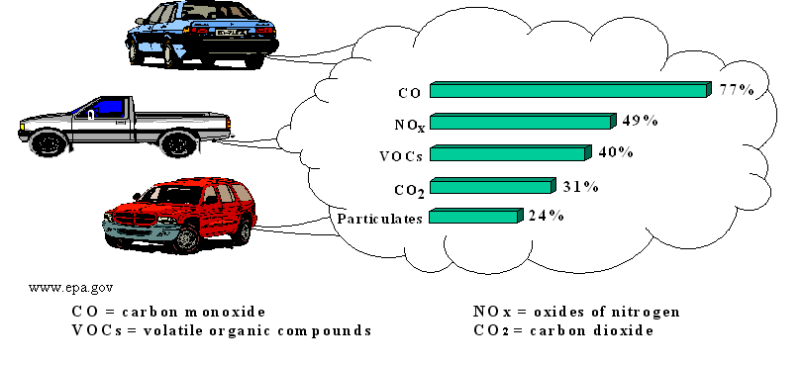
Vehicular pollution contributes 67% of the total air pollution load (approximately 3,000 mt per day) in Delhi. Another 25% of air pollution is generated by industries and coal based thermal power plants.

Fig.1 Increase in vehicular pollution in Delhi

Action Plan
For controlling pollution in Delhi, the Ministry of Environment and Forests has now prepared an Action Plan. This is the result of a series of interactions and meetings which the Minister of Environment and Forests had with concerned agencies and informed citizens. Also included in the plan are the existing projects for pollution abatement. The plan stipulates the implementation of a time bound programme entailing a coordinated inter-departmental strategy. It is recognized that environment protection measures are inherently multi-agency. Though the main responsibility for implementation of such measures rests with government agencies, a key role also has to be played by community and local resident’s organizations.

Target
The target being pursued by the Action Plan is the protection and improvement of the environment keeping in view pollution trends and the prescribed ambient standards. The ambient standards for air (residential-industrial) in respect of sulphur dioxide, oxides of nitrogen and suspended particulate matter are, respectively, 60-80 micrograms per m3, 60-80 and 140-360 microgrammes per m3, on annual average basis.
2. LITERATURE REVIEW

2.1 DELHI TRANSPORT SYSTEM: AN OVERVIEW

Delhi, the national capital of India, has significant reliance on its transport infrastructure. The city has a developed and complex public transport system, which is undergoing rapid modernization and expansion. There are 55 lakh (5.5 million) registered vehicles in the city, which is the highest in the world among all cities (within municipal limits), while the Delhi metropolitan region (NCT Delhi) has 112 lakh (11.2 million) motor vehicles (1), again highest in the world among all metropolitan regions. This adds significantly to city's traffic and pollution woes. Delhi and NCR lose nearly 42 crore (420 million) man-hours every month while commuting between home and office through public transport, due to the traffic congestion (2). Therefore serious efforts, including a number of transport infrastructure projects and increasing quality and quantity of vehicles are required to curtail the vehicle pollution.

Overview
Because of relatively large development of road infrastructure, public transport in the metropolis is largely road-based and includes a bus system, auto-rickshaw, cyce-rickshaw and taxis. With the introduction of Delhi Metro, a rail-based mass rapid transit system, rail-based transit systems have gained ground. Other means of transit include suburban railways, inter-state bus services and private taxis which can be rented for various purposes. However, buses continue to be the most popular means of transportation for intra-city travel, as they cater to about 60% of the total commuting requirements.⁽³⁾ Private vehicles account for 30% of the total demand for transportation, while the rest of the demand is met largely by auto-rickshaws, taxis, rapid transit system and railways.
Indira Gandhi internationa Airport (IGI) serves Delhi for both domestic and international air connections, and is situated in the south-western corner of the city. In 2005-2006, IGI recorded traffic of more than 20.44 million passengers. (Both Domestic and International),⁽⁴⁾ Heavy air-traffic has stressed on the need for a secondary airport, which is expected to come-up in the form of Taj International Airport near Greater noida, alongside Delhi-Agra highway.The Delhi government is planning to have 120 km of metro, 292 km of BRT, and 50 km each of monorail and light rail by 2020. ⁽⁵⁾

Road Transport
Transportation in Delhi is largely dependent upon roads. Railways, including rapid transit systems like Dehi metro, serve only 1% of the total demand. Roads in Delhi are maintained by Muncipal Corporation of Delhi (MCD), New Delhi Muncipal Committee (NDMC), Delhi Cantonment Board (DCB), Public Works Department (PWD) and Delhi development Authority (DDA). At 1749 km of road length per 100 km², Delhi has one of the highest road densities in India. Major roadways include the Ring Road and the Outer Ring Road, which had a traffic density of 110,000 vehicles per day in 2001. Total road length of Delhi was 28,508 km, including 388 km of National Highways. Major road-based public transport facilities in Delhi are provided by buses, auto-rickshaw, taxis and cycle-rickshaw.

Buses
Delhi has one of India's largest bus transport system. Buses are the most popular means of transport catering to about 60% of Delhi's total demand. ⁽⁶⁾ Buses are operated by the state-owned Delhi Transport Corporation (DTC), which owns largest fleet of Compressed Natural Gas (CNG)-fueled buses in the world, private Blueline bus operators and several chartered bus operators. It is mandatory for all private bus operators to acquire a permit from the State Transport Authority. The buses traverse various well-defined intra-city routes. Other than regular routes, buses also travel on Railway Special routes; Metro Feeder routes. Mudrika (Ring) and Bahri Mudrika (Outer Ring) routes along Ring and Outer-Ring road respectively are amongst the longest intra-city bus routes in the world.
With the introduction of Bus Rapid Transit (BRT) and the development of dedicated corridors for the service, bus service is set to improve further. Of late, the DTC has started introducing air-conditioned buses and brand new low-floor buses on city streets to replace the conventional buses. A revamp plan is underway to improve bus-shelters in the city and to integrate GPS (Global Positioning System) systems in DTC buses and bus stops so as to provide reliable information about bus arrivals. Many other modernization plans are also in the pipe-line.
In 2007, after public uproar concerning the large number of accidents caused by privately-owned Blueline buses, the Delhi government, under pressure from the Delhi High Court decided that all Blueline Buses shall be phased out and be eventually replaced by the state-owned DTC fleet.⁽⁷⁾

^{Auto-rickshaws}
The auto-rickshaws (popularly known as Auto) are an important and popular means of public transportation in Delhi, as they are cheaper than taxis. Hiring an Auto in Delhi is very tricky, as very few auto-drivers agree to standard meter charges. The typical method is to haggle for an agreeable rate. This rarely is a source of conflict, because the fares charged are modest and the ride ensures speedy arrival to the destination.

Taxis
Though easily available, taxis are not an integral part of Delhi public transport. The Indian Tourism Ministry and various private owners operate most taxis. The Tourism Ministry grants private companies permits to operate taxis. Recently, Radio Taxis have started to gain ground in Delhi. Brands such as Mega Cabs, Ezee Cabs, etc, provide the on-call radio taxi service, which is slightly more expensive than conventional Black and Yellow taxis. Other than these two mentioned, companies such as Hertz Car Rental and Avis Car Rental provide rent-a-car service.
Delhi Metro
Rapid increase of population coupled majorly owing to large-scale immigration due to high economic growth rate has resulted in ever increasing demand for better transport, putting excessive pressure on the city's existent transport infrastructure. Like many other cities in the developing world, the city faces acute transport management problems leading to air pollution, congestion and resultant loss of productivity. In order to meet the transportation demand in Delhi, the State and Union government started the construction of an ambitious Mass Rapid Transit system, known as Delhi Metro in 1998. The project started commercial operations on December 24' 2002. It is alleged to have set many performances and efficiency records ever since and is continuously expanding at a very rapid pace. As of 2007, the metro operates 3 lines with a total length of 65.70 km ⁽⁸⁾ and 59 stations ⁽⁹⁾ while several other lines are under construction.

Table 1: Description of three Delhi Metro lines that currently operate - As of July, 2007

Line name | Between stations | Length (km) | No. of stations | Rolling stock
RED-LINE | Shahdra-Rithal | 22.06 | 18 | 23 Trains
YELLOW-LINE | Vishwavidyalaya-Centralsecretrait | 10.84 | 10 | 13 Trains
BLUE-LINE | Indraprashta-Dwarkasubcity | 32.10 | 31 | 24 Trains

The second phase (Phase II) which is under construction has 128 km of route length and is slated to be completed by 2010. Phases III (112 km) and IV (108.5 km) will be completed by 2015 and 2020 respectively, with the network totaling 413.8 km, making it longer than the Ondon underground. With further development of the city, the network will be further expanded by adding new lines, thus crossing 500 km by 2020.

Air-ports
Indira Gandhi International Airport (IGI) serves Delhi for both domestic and international connections, and is situated in the southwestern corner of the city, alongside Delhi-Gurgaon Expressway. In the year 2006-2007, IGI recorded traffic of 20.44 million passengers. By 2008-2009, it will be the busiest airport in South Asia, thus also making it one of the busiest in all of Asia itself. ⁽¹⁰⁾ It operates two terminals — Terminal 1 for domestic and Terminal 2 for international air travel. The airport is witnessing massive expansion and modernisation by a consortia led by GMR. The airport will get its third runway in August 2008 and a new integrated Terminal 3 by 2010. Terminals 4, 5 and 6 will be built in a phased manner. By 2024, airport will have 4 runways and will handle more than 100 million passengers per annum, which is more than what Atlanta airport (world's busiest airport) handles now. Apart from the expanded IGI airport, Delhi will also receive its second airport by 2012-2013. The airport being named as Taj International Aviation Hub would be located in Jewar in Greater Noida. It would be 75 km from IGI airport.

2.2 Delhi’s Growth of Transport Vehicles

Delhi, the heart of the country is very much plagued today by environmental degradation. Ever since the declaration of Delhi as national capital City in 1911, there has been a steady influx of people from every nook and corner of the country. Rise in population and growth in economic activity has led to increase in pollution in Delhi. In Delhi, in 1971, there were only 2 lakes registered vehicles, which have now crossed 4.6 million marks, which is more than the combined vehicular population of Mumbai, Chennai and Calcutta. In 1975 the vehicular population in Delhi and Mumbai was about the same; today Delhi has approximately three times more vehicles than Mumbai. Delhi is the metropolitan city where commuters are primarily dependent on a single transport system, road. This has led to an enormous increase in the number of vehicles with the associated problems of traffic-congestion and increase in air pollution.

Delhi residents cannot afford to pay even the low, subsidized fares. Consider that a single one-way bus fare for people living on the outskirts of the city is $0.20-$0.25 (Rs.8 to Rs.10), depending on the number of transfers. For the poorest 28 percent of households with monthly incomes of less than Rs.2, 000 (about US $40), a single worker would spend 25 percent or more of their entire income on daily round trip bus fare. For those with incomes much less than Rs 2,000, the already low bus fare is prohibitively expensive. One market response, at the bottom of the service scale, is privately operated, indigenously designed auto rickshaws and four-wheel vehicles (sometimes referred to as
jeeps) with 8 to 12 seats. These vehicles comprise an estimated 3 percent of the total vehicle fleet.They operate without a schedule and sometimes without a fixed route. They are required to register with the Transport Authority, which requires meters to measure distance and fares, but many are known to evade these requirements. The vehicles are generally highly polluting, inefficient and noisy. They do not adhere to safety and emission standards and very little effort has been made to improve them .Delhi’s registered vehicular population has nearly doubled to 4.5 million from 2.2 million in 1994, registering a growth rate of 10% per annum. About two-Third of the Motor Vehicles are Delhi is expected to continue growing at a rapid rate into the foreseeable future. Its population is expected to surpass 79 lakh by 2020, and motor vehicles are expected to grow at an even faster rate. The domestic auto industry is predicting car sale increases of ten percent per year. With an extensive network of roads and increasing income, this sharp upward trajectory in vehicle sales and use is plausible.

TABLE -2: VEHICUAR GROWTH DURING LAST 1995-2004 YEARS IN DEHI
Type of vehicles | YEARS
Type of vehicles | 95-96 | 96-97 | 97-98 | 98-99 | 99-2000 | 2000-01 | 2001-02 | 2002-03 | 2003-04
Cars &jeeps | 633802 | 705923 | 765470 | 818962 | 869820 | 957925 | 1047048 | 1139753 | 1243759
Scooter & motor cyce | 1741260 | 1876053 | 1991710 | 2101876 | 2184581 | 2199051 | 2339923 | 2502484 | 2659449
Auto Rickshaw | 79011 | 80210 | 80210 | 86985 | 86985 | 86985 | 86985 | 86987 | 87012
Taxies | 13765 | 15015 | 16654 | 17136 | 17762 | 18362 | 20628 | 21732 | 22893
Buses | 27889 | 29572 | 32333 | 35254 | 37733 | 41483 | 12302 | 20503 | 24073
Good vehicle | 133918 | 140922 | 146668 | 150243 | 156157 | 158492 | 161650 | 168289 | 171854
Total | 2629645 | 2847695 | 3033045 | 3210456 | 3353038 | 3456479 | 3516414 | 3939748 | 4209040

REFERENCE- SOURCE CPCB 1995

2.3 History of Delhi’s Vehicle Exhaust Emissions

Delhi ranks amongst the worst polluted megacities of Asia. Its low air quality is held responsible for about 18600 premature deaths per year (TERI, 2001a). Emissions in mega city Delhi have been calculated using an emission factor based approach for the source categories e.g. Power plants, transport, domestic sector, industrial processes, agriculture and waste treatment. Compounds included in this inventory are CH4, CO, CO2, N2O, NH3, NMVOC, NOx, SO2 and TSP.

Varshney and Aggarwal (1992) and Singh et al. (1997) have shown that ozone levels in Delhi approached or exceeded the limit of air quality standards set by the World Health Organization (WHO). Also, measurements from the Central Pollution Control Board (CPCB, 2001a) show that total suspended particle (TSP) concentrations have exceeded air quality standards throughout the period 1990-2000. Consequently, Delhi's air pollution problem has received much attention and various policy measures have been proposed. Especially for the transport sector several control measures have been implemented, such as lowsulfur diesel in the mid 1990s, EURO-II equivalent emission norms for passenger vehicles in 2000, and replacement of diesel fuelled commercial vehicles with Compressed Natural Gas (CNG) vehicles in 2001.

Emissions from Vehicles

Before going into what instruments can be used, it is instructive to see what causes the vehicular pollution. Vehicular pollution sources are not homogenous as there is a complete range of technological mix. The mix could be in terms of fuel used – gasoline or diesel; engine type – twostroke or four-stroke and a combination of these.

Gasoline-powered engines are of two types – four-stroke and two-stroke. The exhaust emissions consisting of CO, HC, oxides of nitrogen (NOx), SO2, and partial oxides of aldehydes, besides particulate matters including Pb salts account for the larger chunk of all pollution from gasoline-run vehicles.
The incomplete combustion of gasoline due to an imbalance in the air-fuel ratio leads to emissions of CO and HC. In two-stroke engines, unburned HC are emitted due to the short-circuiting of the air-fuel mixture. On the other hand, the NOx are formed due to high combustion temperature and availability of oxygen and nitrogen in the combustion chamber, while aldehydes result from the partial oxidation of HC. In cities, majority of the pollution is emitted by vehicles consuming gasoline, especially two and three-wheelers, having predominantly two-stroke engine. The two-stroke and three-wheelers require 2-T oil for lubrication of engine. The lubrication is carried out through either premixing mode or oil injection system. In either case it is a total loss system, as the oil is burnt along with the fuel. Since the burning quality of mineral based lubricating oil is very poor vis-à-vis gasoline, major fraction of the lubricating oil entering the engine either remains unburned or burns only partially. This unburned and partially burned oil comes through the exhaust and is responsible for smoke and SPM emission. The studies indicate that two-stroke engine’s exhaust contains almost 15-25% of the fuel unburned (Pundir, 2001). In actual practice, the two stroke vehicles require 2% concentration of 2 T oil i.e., 20 ml in a litre of petrol. The studies show that even a modest 1% increase of oil, may lead to 15% increase in SPM besides visible smoke (CPCB, 1999a). In Delhi, gasoline or petrol driven vehicles comprise over 90% of the total vehicles registered at least since 1971. The data shows that as on 1996, close to 93% of total vehicle registered were petrol driven (UNEP, 1999: 24). This implies controlling pollution from them can have significant pay-offs.

Emissions from Diesel vehicles
As diesel engines breathe only air, blowby gases from the crankcase (consisting primarily of air and (HC) are rather low. Moreover, due to its low volatility, evaporative emissions from the fuel tank can safely be ignored. Though the concentration of CO and un-burnt HC in the diesel exhaust are rather low, they are compensated by high concentration of NOx (higher than that in gasoline vehicles),which have high nuisance value. Smoke from diesel engines comes in three different hues – white smoke emitted during cold start idling and at low loads; blue smoke from the burning of lubricating oil and additives; and black smoke, a product of incomplete combustion. Black smoke, the most obvious type of vehicular air pollution, consists of irregular shaped agglomerated fine soot/particulates, the formation of which depends on injector nozzle parameter and type of combustion chamber (direct or indirect injection). Black smoke is a particular problem with diesel engines that are not well tuned.

Impact of Fuel Quality

Much of the pollution control depends on the quality of the fuel. So the characteristics that determine fuel quality also become important. A high Reid pressure⁽¹¹⁾ in the case of gasoline engine causes a high evaporative emission while an increase in the density is followed by a simultaneous increase in⁽¹²⁾ CO and HC in the exhausts. Likewise in the case of diesel vehicles, a higher density causes higher smoke, CO and NOx emissions, while a heightening of the cetane number ⁽¹²⁾ of ignition quality lowers the smoke emission. The sulphur content of diesel has been observed to have a direct bearing on the SPM and SO2 emissions (CPCB, 1999a).

2.4 Challenges of Delhi’s Transportation system

Over the years, Delhi has witnessed unprecedented growth in its population as it has increased from 94.21 Lakh in 1991 to 137.83 Lakh in 2001. The character and requirements of the city have also been changing due to heavy influx of about 2.5 Lakh people every year into Delhi, who mostly settles down in slums or jhuggi clusters. The majority of this population (88%) is residing in urban areas and only 12% in rural areas.

Studies show that by 2021, Delhi will be a mega city with an estimated population of more than 20 million. This phenomenal increase in population will further strain the transport network. As on 31-3-2001, the vehicle population in Delhi is 34.56 Lakh and is growing at the compound growth rate of 6.7% per annum. This has resulted in several problems like high level of air and noise pollution, congestion on roads, increase in number of accidents and poor level of satisfaction of commuters demand for transport services. This is particularly attributable to absence of adequate mass transport network resulting in tremendous increase in the use of personalised vehicles, which in turn is causing the problems of congestion and parking, which needs to be addressed.
Compared to the other cities in the developed countries number of both the public and private vehicles are very small as compared to the cities of the developed countries. The share of public transport is very high (see table), but the quality of public transportation system is worse because of poor quality of public transport vehicles, rowdy attitude of private operators and lack of hygienic passenger facilities.

Table 3 : Transportation Systems of International Cities

The Planning Commission, in a document titled ‘Urban Transport in the Integrated Transport Policy’, has emphasised two important issues to meet the challenge. One of them is mass transit requirement of the metro cities and the other strategic land use development policy with an aim to integrate land use with mass transit transport planning models. In a multi-modal transport system, the urban transit system should complement and not compete with other components of the system. Since mass transit system is expensive, it requires massive resource mobilisation and a long gestation period. In this situation, financing issues in urban transport projects needs to be addressed by a multi-pronged approach. Therefore, financing of urban transport projects needs to be taken up with consortium approach. In Delhi, there is a multiplicity of authorities, who are handling different aspects of urban transport with an acute lack of coordination amongst them. There is a need to create a statutory body like unified metropolitan transport authority (UMTA) to coordinate the various agencies & modes and strengthen the regulatory framework within each mode. Besides the requirements of slow moving vehicles, cyclists and pedestrians are to be accommodated. During the 9th Five Year Plan, against the approved outlay of Rs 145000.00 Lakh, an expenditure (tentative) of Rs 120215.00 Lakh was incurred. For the 10th Five Year Plan, an outlay of Rs 293891.00 Lakh is approved including Rs 57669.00 Lakh for the Annual Plan 2002-03.

The Delhi road system was not designed and is not managed with this disparate vehicle mix in mind. The diverse traffic characteristics, modal mix, and land use patterns have overwhelmed the capabilities of the authorities. It is widely believed among local transportation professionals that modest efforts at managing traffic flows and separating motorized and non-motorized vehicles would greatly reduce congestion. None, however, could cite successful local examples during interviews. Road congestion can be particularly unpleasant in Delhi. The hot climate, absence of air conditioning, and dense exhaust fumes can turn congested traffic delays into disagreeable and dangerous experiences, especially for packed bus passengers and riders of two-wheeled vehicles exposed to the elements. Congestion can also be expensive. A study by the Petroleum Conservation Research Association estimated in 1998 that Delhi wastes $300,000 in fuel daily just through vehicles idling at traffic lights.⁽¹³⁾ Local experts, planners, policy-makers, and environmental advocates indicate that a large share of the problem with the transportation system in Delhi is that too many organizations are making disjointed decisions. Even within government offices, there are many disagreements about who is responsible for what. No single agency at the central, state, or local level has responsibility to plan, finance, build, and manage transportation projects and vehicular traffic. As many as a dozen agencies influence the supply, maintenance, and management of transportation infrastructure (city roads, highways, overpasses, underground crosswalks, etc.).
One small example of the lack of coordination is the recent construction by the Public Works Department of tunneled pedestrian walkways under several arterial roads. Most pedestrians still cross busy surface roads instead because the location of these underground walkways was not coordinated with the location of bus stops, which is handled by the Traffic Police and Delhi Transport Corporation. The Traffic Police are now trying to remedy the problem by relocating bus stops close to the underground pedestrian walkways. Most major cities have this same multiplicity of agencies and governments. What is unusual in Delhi is the lack of coordination and accountability. A draft bill has been proposed to enable the establishment of a unified metropolitan transport authority, and a high-powered road safety and traffic engineering committee is functioning under the chairmanship of the Chief Secretary of Government of the National Capital Territory of Delhi. With the exception of these initiatives and recent Supreme Court decisions, there appears to be no serious effort to overcome this institutional handicap.

3. Research Methodology

3.1Collection of Data

In this project we needed various data on the history of vehicle growth in Delhi, Development of roads, Growth of population, and Demand for the transportation fuels, Development of Metro transportation system, Demand and requirement of power, Economic status of the people of Delhi etc. Mainly we collected these through reports of economic survey of Delhi, reports of transport Department and Mashelkar committee report on Auto Fuel Policy etc. We also used different emission factors for the exhaust emission from different category of vehicles, developed by Automotive Research Association of India and Central Pollution Control Board.

3.2 Emission factor

The emissions factors are reported by ARAI are as per the categories denoting vehicle category, engine cubic capacity, vintage, test vehicle model, etc. The based on the following logistics:

While reporting the emission factors, it has been attempted to optimize the number of emission factors subject to vehicle category, vintage and engine cubic volume . Wherever there are 2- 3 nos. of vehicle models in the same vintage and category, emission data of such vehicles has been averaged for before maintenance tests and after maintenance tests.
Wherever it is seen that the results are not as per the expected trend, results of such vehicles would be replaced with results available from Source Profiling of Vehicular Emissions project. Around forty eight different emission factors are available under Source Profiling of Vehicular Emissions project ranging from moped 2S to HCV vehicles of 1991 vintage to Post 2005.

It also seen in some of the cases that although the vehicle is fitted with cat. con., the results are higher than previous vintages. In such cases it is found that the vehicles are practically 5-6 year old at the time of testing and efficacy of cat. Con. is difficult to ascertain. In such cases also Source Profiling of Vehicular Emissions data is considered for arriving at emission factors. In case of technology matrix, mass emission results of euro-III fuel were considered as emission factors. These vehicles being brand new vehicles, maintenance was not necessary and hence before maintenance effect does not reflect in the emission factors.

CNG/LPG vehicles of various vintages are very difficult to source. These vehicles were tested for after maintenance tests after maintenance results are considered as Emission Factors. In case of passenger cars and MUV, of post 2000 vintage results on both IDC and MIDC are available. The 4 wheelers of pre 2000 were subject to mass emission testing on IDC and post 2000 cars/MUV were subjected to IDC and MIDC. In case of pre 2000 emission factors are based on IDC and in case of post 2000 vehicles MIDC results were considered for emission factors and IDC results were considered for comparative study. However, only MIDC results are to be considered as emission factors and IDC results can be referred for comparative study with earlier vintage emission factors.
The compilation of emission factors is a continuous process and lot of effort is put in to test the vehicles year on year. Also the test cycles with different speeds ranging from 5 mph to 59 mph in steps of 5 mph are developed and the vehicles are tested on these cycles to arrive at speed dependent emission factors. The Emission Factors, which are reported in this study, are based on prevailing Driving Cycles used as per regulations. Though use of city specific Driving Cycle will lead us to more closer EF to real world scenario, there are also uncertainties involved such as the Driving Cycle in different part of the city will not be same. There is continuous change in the road traffic pattern such as synchronization of traffic signal, construction of flyovers, one way traffic, restriction of entries of HCV in city areas and continuous increase in density of vehicles. Thus formulation of city specific driving cycle is a complex phenomenon. This can be further seen with the fact that the regulation and certification cycles were formulated during seventies which is being used till today.

However the latest approach is to estimate correction factor based on certain field data co relation and efforts are being put in this direction, though the instrumentation used are not fully proven to measure the parameters such as CO, HC, NOx, PM on different vehicles/different routes in the city environment. Even the regulatory Driving cycles are formulated more than 3 decades ago, which are being used as on date for certification. The world harmonized driving cycles are under discussions and expected to be adapted from 2010 onwards to 2015 for different categories of vehicles. In that scenario it will be mandatory to use single cycle for certification purpose all over the world.

Test Procedure

Emission cycles are a sequence of speed and load conditions performed on an engine or chassis dynamometer. Emissions measured on vehicle (chassis) dynamometers are expressed in grams of pollutant per unit of travelled distance, expressed in g/km. In a transient cycle such as the one used for the chassis dynamometer testing, the vehicle follows a prescribed driving pattern, which includes accelerations, decelerations, changes of speed and load, etc. The final test results are obtained by analyzing exhaust gas samples collected in polyurethane bags over the duration of the cycle.
In order to determine the emission of a vehicle, the vehicle was tested in Arai’s emissions test cell under conditions which accurately simulated the driving cycle as applicable to the vehicle category under test.

Each test vehicle was mounted with its drive wheels on the rollers of the test bed whose rotational resistance was adjusted to simulate friction and aerodynamic drag. Inertial masses were added to simulate the weight of the test vehicle as per the category of the vehicle. A variable speed vehicle cooling blower mounted at a short distance in front of the vehicle provided the necessary cooling. The test vehicle was then soaked (i.e., cooled to bring it to ambient temperature and conditions and maintained in that state till the commencement of the test) on the chassis dynamometer to get the vehicle and the engine conditions to the test cell ambient conditions.
A schematic layout of the test cell with vehicle is given in figure below.
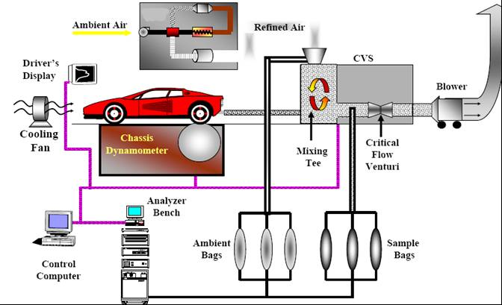
Figure.2 Schematic Test Cell Layout

Before starting the Test, the chassis dynamometer was warmed up for 30 minutes with the vehicle mounted on the chassis dynamometer and the engine in OFF condition. After the warm up chassis dynamometer was calibrated to compensate the frictional losses and then the vehicle was ready to undergo test. The same procedure was followed for all the vehicles. A highly skilled driver was enlisted to drive the test vehicles on the chassis dynamometer. The same driver strictly followed the test cycle by maintaining the speed and also changing the gears and the acceleration and deceleration of the vehicle as displayed on the driver’s aid monitor. After ensuring the calibration of the test cell, the driver started the engine and remained idling for prescribed period as per the applicable regulatory test procedure depending upon the vintage and category of the vehicle. Thereafter, the exhaust sampling was started. The exhaust gases produced by the test vehicle were diluted with fresh air using a DT (dilution tunnel) and a criticalflow venturi-type CVS (constant volume sampler). For gaseous emission measurement, a constant proportion of the diluted exhaust gas was extracted for collection in one sample bag.

The pollutant concentration in the sample bag at the end of the test corresponded exactly with the mean concentration in the total quantity of fresh air/exhaust mixture that was extracted. As the total volume of the fresh air/mixture could be defined, the pollutant concentrations were used as the basis for calculating the pollutant masses produced during the course of the test. For THC (total hydrocarbon) emission measurement for diesel vehicles, the diluted exhaust gas was sampled through a heated (191°C) and measured continuously by using heated FID THC analyser. The exhaust gas emission analysers were calibrated before the gas analysis. The gas analysis of each sample bag was done immediately after each test. The gases in the sampling bag was analysed for concentrations of CO (carbon monoxide), NOx (nitrogen oxides), THC (gasoline) and CO2 (carbon dioxide), and the emissions were expressed in g/km. Additionally, for tests where PM was measured, the particulate filters were analysed for SOF (soluble organic fraction) and IOF (insoluble organic fraction) in order to identify the source of PM emission, whether oil or fuel. Basically, this elemental analysis of PM is not a mandatory requirement. The soxhelt extraction method was used to carry out the elemental analysis of the total particulate matter. The extracted particulate samples were analysed with the use of High pressure liquid and Gas chromatographic analyser to determine the SOF and IOF.

For PM measurement, the flow capacity of the CVS and DT system was such that the temperature at the particulate sampling point was below 52 °C during the test. The particulate emissions were collected on the primary and back up filters. Before starting the test the primary and secondary particulate filters were conditioned as per the procedure given in EEC directives. They were then weighed and mounted on the filter holder assembly and then installed in the particulate sampling system. At the end of the test the filters were removed and again conditioned as per the procedure given by the EEC and weighed.

A precisely known charge given to particles in the charger is measured in real time with highly sensitive multichannel electrometers as the particles impact the collection plates. An interactive user interface enables monitoring of total concentration and particle size distribution in several different modes. These modes include parallel real-time size distribution and total concentration monitoring even from several units at the same time in the same window. Instant and continuous feedback as a function of particle size makes the particle removal device development illustrative and more efficient.

Mass Emission Calculations

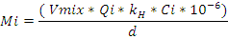
The mass emissions of pollutants are calculated by means of the following equation:

Mi = Mass emission of the pollutant i in g/km
Vmix = Volume of the diluted exhaust gas expressed in m3/test and corrected to standard conditions 293 K and 101.33 kPa
Qi = Density of the pollutant i in kg/m3 at normal temperature and pressure (293 K and 101.33 kPa)
kH = Humidity correction factor used for the calculation of the mass emissions of oxides of nitrogen. There is no humidity correction for HC and CO.
Ci = Concentration of the pollutant i in the diluted exhaust gas expressed in ppm and corrected by the amount of the pollutant i contained in the dilution air.
d = distance covered in km.

3.3 Forecasting method

Bose and Nesamani constructed a regression model to forecast future increases in vehicle ownership and travel by different modes their model is based on government projections that population would increase 3.2 percent per year from 2000 to 2010 and 1.6 percent the following ten years, and that per capita income would grow 4.3 percent per year from 2000 to 2010 and 5.4 percent the following decade. Based on these population and income projections and on travel patterns of the past two decades, the model predicts that total motorized passenger travel would increase from 94 billion passenger-kilometers in 2000 to 503 billion in 2020. This represents an 8.7 percent annual increase in somewhat faster rate than the 7 percent rate experienced in the 1990s. The major factors behind this rapid increase in travel are higher levels of per capita income, more people, overall economic growth, greater access to personal vehicles, and greater distances traveled per vehicle. Accounting for the likely effects of the Supreme Court directives, planned rapid transit investments, and vehicle usage patterns, Bose and Nesamani converted projections of travel and vehicles into specific forecasts for each travel mode based on surveys of distance traveled by vehicle type and countrywide data on vehicle occupancy. Freight travel increased 2.4 percent per year from 1990 to 2000, but is forecast to grow at a much faster rate of 8.9 percent from 2000 to 2020 roughly 4 percent per year faster than regional economic growth.

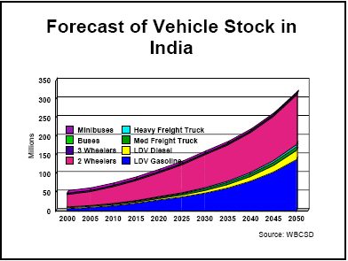
Fig.3 Forecast of vehicle stock in India

In forecasting method we have used linear regression method.In regression response and predictor are year and number of vehicles in that year. As per our forecast number of vehice in Delhi in the year, comes out to be 10177807.
4. Estimation of Delhi’s Vehicular Pollution

It has been observed that vehicular pollution in Delhi is diminishing recently due to a number of initiatives taken by the judiciary, government and the automobile manufacturers. An analysis of last 11 years i.e. 1996-07 shows this trend quiets significantly.In Delhi,in 1996,the total number of vehicles included motor cycle and scooters (56.64%) followed by cars and jeeps (33.32%).The goods vehicles were (5.6%) followed by auto-rickshaw (3.57%), buses (1.11%) and taxies (0.30%).In Delhi , in 2007 ,the total number of vehicles included motor cycle (63.77%) followed by car and jeeps (30.56%),good vehicles (2.73%), auto-rickshaw (1.43%), buses (0.88%) and taxis (0.63%) respectively.

4.1 Growth of vehicles in Delhi

Delhi's experience with personal vehicles is instructive to other large cities in the developing world. In India, Delhi is the third largest city, but it ranks first in total vehicles and vehicles per capita. Indeed, its vehicle ownership rate approaches that of many affluent OECD cities. As of 1993, 81 percent of households owned a vehicle, though only 13 percent owned cars. Most vehicle-owning households possess small scooters and motorcycles. Motorized two and three wheelers represent two-thirds of the total vehicle fleet in Delhi.

4.2 Exploring the Current Status of Delhi’s Transportation System

On January 23, 2004, the Amicus Curiae for the ongoing public interest litigation on air pollution in the National Capital Region of Delhi had submitted an Intervener application (IA No. 226) to the Hon’ble Supreme Court. This IA brought to focus the rapidly growing number of vehicles that threatened to destroy the gains of pollution control. If not checked with public transport augmentation and travel demand management plans the gains from small improvements in vehicle technology and fuels would be lost. The Amicus presented data to show how growing numbers, crippling congestion and slow traffic were aggravating the haze of pollution. The IA 226 has taken note of the following affidavits from the Delhi government that have made reference to improving public transport in the city and made comments:

Types of vehicle | 2000-01 during cumulative |  | 01-02 during cumulative |  | 02-03  during cumulative |  | 03-04 during cumulative |  | 04-05 during cumulative |  | 05-06 during cumulative |  | 06-07 during cumulative
Car&jeeps | 844  82 | 957  925 | 891  23 | 1047  048 | 927  05 | 1139  753 | 112  585 | 1471  858 | 104  006 | 124  3759 | 115  514 | 135  9273 | 113  585 | 147  288
2 wheeler | 121  465 | 219  9051 | 140  872 | 233  9923 | 162  561 | 250  2484 | 238  822 | 307  8660 | 156  965 | 265  9449 | 180  389 | 2839  838 | 2570  00 | 3096  838
Ambulance | 77 | 1498 | 132 | 1630 | 90 | 1720 | 107 | 2088 | 137 | 1857 | 124 | 1981
Auto-rickshaw | 0 | 701  45 | 1 | 701  46 | 0 | 701  46 | 0 | 741  88 | 329  2 | 734  38 | 750 | 741  88 | 188 | 738  12
Taxies | 105  9 | 9604 | 329  4 | 128  98 | 196  9 | 148  67 | 250  9 | 206  46 | 136  6 | 162  33 | 190  4 | 181  37 | 299  0 | 211  27
Buses | 146  7 | 169  81 | 352  2 | 205  03 | 231  4 | 228  17 | 714 | 255  11 | 125  6 | 240  73 | 724 | 247  97 | 198  70 | 446  67
Others | 964 | 657  7 | 284  2 | 941  9 | 337  4 | 127  93 | 201  2 | 183  78 | 193  9 | 147  32 | 163  4 | 163  66
Table 4: GROWTH DURING LAST 2000 TO 2007 YEARS IN DELHI)
The affidavit of the government of NCT of Delhi in response to the EPCA report dated May 2, 2003. The state government presented plans to improve the public transport but these plans remained without clear milestones and deadlines. The government of the NCT of Delhi in its affidavit dated December 6, 2003 had sought the Court’s directions on purchase of 10 high capacity buses to augment its public transportation schemes. But once again, the government had failed to give to the Court detailed schedule and dates of completion.
IA 226 has sought that the directions be issued to the Delhi government to submit an integrated and cohesive plan to lower the rate of growth of private vehicles, congestion including a plan to augment public transport and the implementation of high capacity bus system in the city. Plan to include firm deadlines and milestones to monitor implementation. In response to IA No. 226, the Hon’ble Supreme Court on January 23, 2004 served notice to the Delhi government.

Increase in number of buses
The Stage Carriage Fleet (city transport) has been augmented to about 7,300 buses on stage carriage routes of which 3,100 are operated by DTC. This is supplemented by 2,700 CNG buses on the chartered services and about 4,200 mini buses. In order to improve the efficiency of the bus system, efforts have been made to ply these on the basis of Unified Time Table (UTT) and rationalization of routes.

Delhi Metro Rail

This Project has been planned for 245 km. Phase I of this project is being implemented through the Delhi Metro Rail Corporation (DMRC). These consists three lines Shahdara to Rithala (line no. 1), Vishwa Vidyalaya to Central Sectt. (Line no. 2) and Barakhamba Road to Connaught Place to Dwarka (line no.3).

Modernized luxurious CNG buses

The Transport Department has taken a policy decision that only modernized luxurious CNG buses will be allowed in the city for which the government is prepared to consider higher fares.

Integrated Rail Cum Bus Transit System (IRBT)

It has been proposed to establish Integrated Rail Cum Bus Transit System (IRBT) in the NCR towns of Delhi in associations with the central government. It will initially have three Corridors linking Ghaziabad, Sahibabad and Gurgaon to Delhi.

4.3 Estimation of Delhi’s Vehicular Pollution

In this work we have estimated the pollution load of Delhi, by using the emission factors which have been developed by ARAI in association with CPCB. These emission factors takes into account different make, vintage, engine capacity, engine technology and type of fuel of the vehicles. These emission factors are specified for different pollutant in

Gram/km of the vehicle travel. We multiply these emission factors to the number of vehicles in each category, and further the results were multiplied by the average distance travel by the category of vehicle in a day. This provides the pollution load for the different pollutants in each category of vehicles

Fig-4 Total carbon monoxide 517.3214 TPD
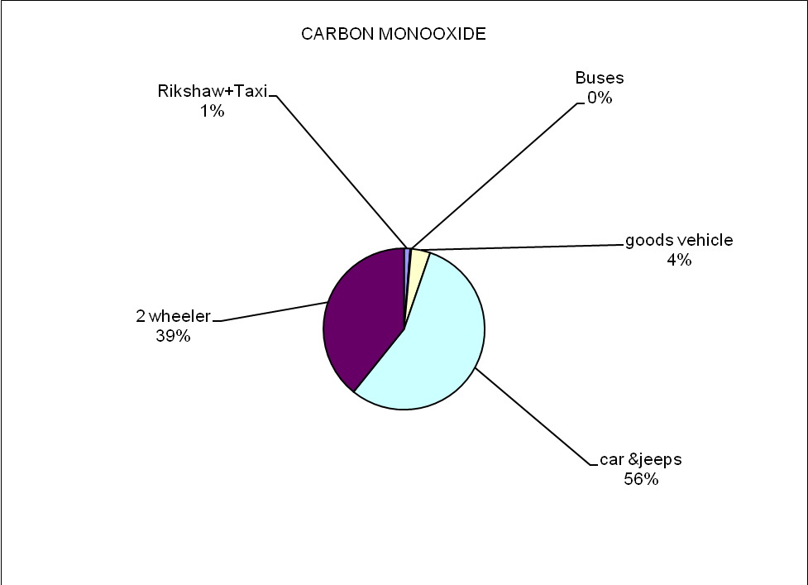
Fig-5 Total hydrocarbon 226.0813 TPD
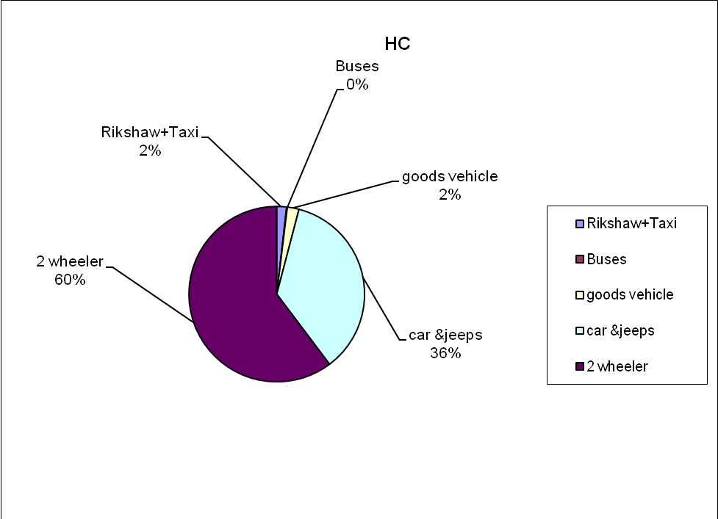
Fig-6 Total particulate matter 13.91183 TPD
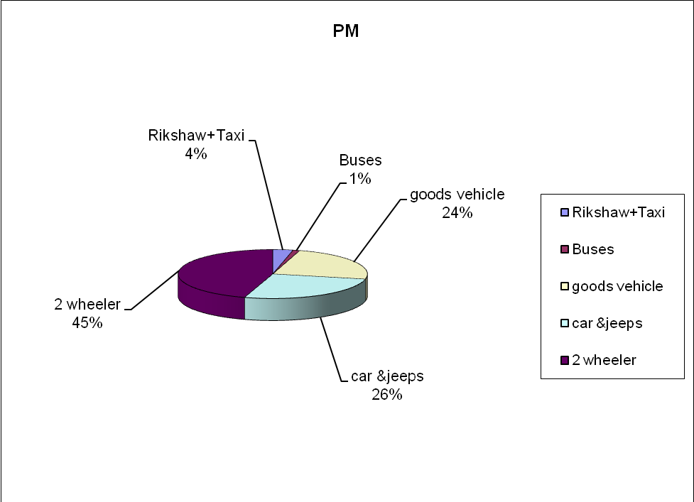

Fig-7 Total nitrous oxide 227.0581 TPD
5. Control of Delhi’s Vehicle Exhaust Emissions

There is no straightforward method to control the Vehicle Exhaust Emissions. It requires a multidirectional approach starting from improving the public transportation system, reducing/optimizing the office and school distances from residences, improving the quality, security and availability of Taxies/Auto-rickshaws, staggering the school and office timings. Some key options are discussed below.

5.1 Use of Advanced Vehicle technologies

There are 3 wave technology innovations sweeping throughout the international automotive industry for advanced vehicle technology. These three also took hold for Delhi also.
The first wave is aimed at reducing air pollutant emissions from conventional internal combustion engines. These changes are coming to India in response to the country's adoption of more stringent emission standards and greater foreign investment. They include improvements in combustion processes, treatment of exhaust gases (i.e., with catalytic converters), and use of cleaner burning fuels. However, improved engine combustion and exhaust gas treatment will have virtually no effect on energy efficiency or GHG emissions. The use of natural gas, alcohol fuels, and propane in gasoline engines will provide reductions of about 20 to 30 percent in GHG emissions, but their use in diesel engines will not reduce GHG emissions and may even increase them. Efforts are underway by auto manufacturers in India to introduce improved technologies for engines running on alternative fuels. But additional incentives and fuel supply infrastructure are needed before substantial shifts will occur in all areas other than buses.
A second wave of innovation is aimed at increasing the energy efficiency of conventional engines. Vehicles operating today in India are not energy efficient by international standards. If the Indian auto industry were to adopt technology already available in the international market, energy efficiency would be substantially improved. The average fuel economy for new, small cars sold today in India is over 30 miles per gallon (mpg) (8 liters/100 kilometers). Small two-stroke motorcycles achieve over 80 mpg (3 liters/100 km) and buses over 7 mpg (34 liters/100 km). These impressive fuel economy numbers are not the result of state-of-the-art technology, but lower power and smaller size. With more advanced technology, considerable improvements are possible. Automakers are continuing to increase vehicle efficiency in response to existing fuel economy standards in Japan and the United States, voluntary CO2 standards in Europe, and high fuel prices in most countries. They are fighting to extend the life of internal combustion engine technology through incremental improvements.

A third wave of innovations is more radical. It involves a transition away from internal combustion Engines to electric drive propulsion technology. These innovations have the potential for the greatest reductions in GHG emissions. The use of electric-drive systems — fuel cells, batteries, and hybrid electric systems — would improve energy efficiencies by 50 percent or more, with much less pollution. These technologies are still novel and expensive, but costs are dropping quickly and could be cost-competitive with conventional technologies within one to two decades. Battery electric vehicles made in India with U.S. collaboration are expected to be marketed in India in 2001. Several international automakers are likely to sell small, mass-produced, two-seat battery electric vehicles in many countries by 2002. Competitively priced hybrid electric vehicles became available internationally from Honda and Toyota in 2000. Other automakers have announced plans for mass production of hybrid vehicles by 2004. Fuel cell buses will be available from DaimlerChrysler in 2002, though at high prices.

5.2 Improvement in fuel quality

Fuel quality is directly responsible for the quantity and quality of vehicular emissions. Adulteration of transport fuel, which is currently a very flourishing business in our country, can lead to economic losses, increased emissions and deterioration of performance and parts of engines using the adulterated fuels. It may be noted that all forms of adulteration are not harmful to public health. Some adulterants increase emission of harmful pollutants significantly, whereas others have little or no effect on air quality.
The specifications for emission related fuel quality is presented in following table.

Table 5: EMISSION RELATED FUEL QUALITY SPECIFICATION

Fuel | Parameters | Pre 1996 | 1996 | 2000 | 2005
Motor-gasoline | Lead, g/litre  (Max) | 0.56 | 0.15 | 0.013 | 0.005
Motor-gasoline | Benzene, % V/v (Max) | No limit | 5 | 3 | 1
Motor-gasoline | Sulphur, % W/w (Max) | 0.25 | 0.20 (leaded)  0.10 (unleaded) | 0.10 | 0.03
Diesel | Sulphur, % W/w (Max) | 0.5 | 0.5 | 0.25 | 0.05
Diesel | Cetane number (Min) | 42 | 45 | 48 | 50
Diesel | Density, Kg/M³ | No limit | 820-880 | 820-860 | 820-855

Benzene and aromatics in petrol
Due to high level of benzene in atmosphere, benzene content of gasoline needs to be reduced to 1% (v/v) or lower as in other countries. With the reduction of benzene in gasoline (<1%) it is possible to achieve significant reduction in benzene emission from exhaust. Benzene and PAH emission also depend upon the aromatic content of gasoline. Therefore, in addition to reduction of benzene, it is also necessary to reduce the aromatic content in petrol.

Sulphur Content in Diesel
Sulphur in diesel has direct effect on SO₂ and particulate emission and indirectly on other pollutants due to its poisoning effect on catalytic converter. In European countries, sulphur content in diesel has been reduced to 0.05% from 1996 and it will be further reduced to 0.005 from the year 2000.
Reformulated gasoline
Reformulated gasoline with the use of oxygenates and additives etc. help reducing pollution load from on-road vehicles. According to a study commissioned by CPCB, 3-5% ethanol can be used in petrol without affecting the engine performance and with the attendent benefits in terms of emission control.

5.3 Improvement in Public transportation System
Some of the key point for improvement in public transport system are following

Increase the number of buses
Presently in Delhi the State Carriage Fleet (city transport) has been augmented to about 7,300 buses on stage carriage routes of which 3,100 are operated by DTC. This is supplemented by other 2,700 CNG buses on the chartered services and about 4,200 mini buses. In order to improve the efficiency of the bus system, efforts have been made to ply these on the basis of Unified Time Table (UTT) and rationalization of routes.

High Capacity Bus System (HCBS) and Electric trolley Buses (ETB)
An Expert Committee constituted under the chairpersonship of the Chief Secretary had submitted a report on ‘Sustainable Transport System” in Delhi in which plans for implementation of two mass transportation systems, namely, High Capacity Bus System (HCBS) and Electric Trolley Bus System (ETB) was recommended. The Delhi government is in the process of establishing the infrastructure for HCBS, ETB and light rail transit (LRT) (in the walled city). The counter affidavit gives the timetable for the implementation of these systems. Corridors were identified as follows: High Capacity Bus corridors (total 98 km).

Modernized luxurious CNG buses

The Transport Department has taken a policy decision that only modernized luxurious CNG buses will be allowed to run in the city for which the government is prepared to considering higher fares.

Integrated Rail cum Bus Transit System (IRBT)

It has been proposed to establish Integrated Rail Cum Bus Transit System (IRBT) in the NCR towns of Delhi in associations with the central government. It will initially have three corridors linking Ghaziabad, Sahibabad and Gurgaon to Delhi.

5.4 Improvement in Roads, Flyovers, traffic lights etc.

The expansion of the road network and the growth in vehicular traffic in Delhi resulted in installation of traffic signals almost at every intersection within short distances. This has led to excessive time and fuel consumption for all vehicular trips. To overcome this problem by providing uninterrupted movement of traffic, a special programme to construct flyovers was started in 1998-99. During the 9th Five Year Plan, 11 flyovers/ ROB/Grade-Separators were constructed in Delhi by various agencies (PWD, DDA, DTTDC & MCD). During first three years of 10th five year plan, 18 Flyovers and 2 RUB were constructed by the concerned agencies. 3 more flyovers have been completed during 2005-06. Besides the above, following major projects have been taken up.
Keeping in view the new urban extension area, development of new commercial, institutional and public places and Commonwealth Games – 2010, Govt. has decided to construct a number of flyovers, RUB, Under pass, Corridors for better traffic flow. Some of the new flyovers / RUB / under pass proposed to be constructed by 2010 are given below in the table.

5.5 Use of Alternative (Cleaner/Renewable) Fuels

In addition to conventional gasoline and diesel fuels, many countries around the world have identified significant benefits associated with a shift to alternative fuels, especially CNG, LPG, and ethanol. Besides CNG (mainly composed of methane) and LPG (composed of propane or butane), alternative fuels include methanol, ethanol, hydrogen, electricity, vegetable oils (including biodiesel), synthetic liquid fuels derived from coal, and various fuel blends such as gasohol.

Natural gas

Natural gas (85-99% methane) is clean burning, cheap and abundant in many parts of the world. Because natural gas is mostly methane, natural gas vehicles (NGVs) have much lower non-methane HC emissions than gasoline vehicles, but higher methane emissions. Since the NGV fuel system is sealed, there are no evaporative emissions and refuelling emissions are negligible. Cold-start emissions from NGVs are also low, since cold-start enrichment is not required. In addition, this reduces both VOC and CO emissions. NOx emissions from uncontrolled NGVs may be higher or POLICY GUIDELINES FOR REDUCING VEHICLE EMISSIONS IN ASIA lower than comparable gasoline vehicles, depending on the engine technology, but are typically slightly lower. Light-duty NGVs equipped with modern electronic fuel control systems and threeway catalytic converters have achieved NOx emissions more than 75% below the stringent California Ultra Low-Emission Vehicle standards. As a substitute for diesel, NGVs should have somewhat lower NOx and substantially lower PM emissions, unless the diesel vehicle is burning ULSD and is equipped with a PM filter. Given equal energy efficiency, greenhouse gas (GHG) emissions from NGVs will be approximately 15–20% lower than from gasoline vehicles, since natural gas has lower carbon content per unit of energy than gasoline. NGVs have about the same GHGs as diesel fuel vehicles.

Liquefied petroleum gas

Engine technology for LPG vehicles is very similar to that for NGVs.As a fuel for spark-ignition engines; it has many of the same advantagesas natural gas, with the additional advantage of being easier to carry aboard the vehicle. LPG’s major disadvantage is the limited supply, which would rule out any large-scale conversion to LPG fuel. LPG has many of the same emissions characteristics as natural gas. The fact that it is primarily propane (or a propane/butane mixture) rather than methane, affects the composition of exhaust VOC emissions, their photochemical reactivity, and its global warming potential, but otherwise the two fuels are similar. The cost of conversion from gasoline to propane is considerably less than conversion to natural gas, due primarily to lower cost fuel tanks. As with natural gas, the cost of conversion for high-use vehicles can typically be recovered through lower fuel costs within a few years. LPG is produced in the extraction of heavier liquids from natural gas, and as a byproduct in petroleum refining. Presently, LPG supply exceeds demand in most petroleumrefining countries, so the price is low compared to other hydrocarbons. Depending on the locale, however, the additional costs of storing and transporting LPG may more than offset this advantage. LPG is already widely used as a vehicle fuel in the United States, Canada, Netherlands, Japan and elsewhere. In Japan, 260,000 taxis—94% of the country’s total taxi fleet use LPG. Many diesel-fuelled taxis in Hong Kong, China have also shifted to LPG.

Biodiesel

Biodiesel is produced by reacting vegetable or animal fats with methanol or ethanol to produce a lower-viscosity fuel similar in physical characteristics to diesel, and which can be used neat or blended with petroleum diesel in a diesel engine. Over the years, many factors have stimulated interest in biofuels including biodiesel. For example, the primary initial motivation for the Brazilian Alcohol program was energy-related concerns. However, it seems that the greatest motivation today for increased interest in biomass-based fuels in many countries is environmental concern, especially with urban air pollution and global warming. Further, there is growing interest in providing a profitable market for excess farm production. Biodiesel is a zero-sulfur diesel fuel, therefore many of the points noted above apply equally to biodiesel, especially with regard to the potential impact on advanced diesel control technologies. In general, biodiesel will soften and degrade certain types of elastomers and natural rubber compounds over time. Using high percent blends can impact fuel system components (primarily fuel hoses and fuel pump seals) that contain elastomer compounds incompatible with biodiesel. Manufacturers recommend that natural or butyl rubbers do not come in contact with pure biodiesel, as this will degrade the materials over time, although the effect is lessened with biodiesel blends. The general consensus is that blended or neat biodiesel has the potential to reduce diesel CO emissions (although these are already low), smoke opacity, and measured HC emissions. However, many studies show an increase in NOx emissions for biodiesel fuel when compared to diesel fuel at normal engine conditions. While research shows a reduction in HC emissions when biodiesel is used, the effect of organic acids and/or oxygenated compounds in biodiesel may affect the response of the instrument that measures HC (the flame ionization detector) and thus, understate the actual HC emissions. Particulate data are mixed; most studies show a reduction but some show increases under certain conditions. For example, one study found that “biodiesel gave generally higher particulate emissions and the highest levels of particulate associated soluble organic fraction for all driving cycles.”¹⁴ The high cost of biodiesel is one of the principal barriers to it being an attractive diesel fuel substitute.

Methanol

Methanol has many desirable combustion and emissions characteristics, including lean combustion capability, low flame temperature (leading to low NOx emissions) and low photochemical reactivity. It is also a liquid, which makes its storage and handling much simpler than gaseous fuels. At current and foreseeable prices, the most economical feedstock for methanol production is natural gas, especially natural gas found in remote regions where it has no ready market. The most common methanol fuel is M-85, a methanol-gasoline blend consisting of 85% methanol and 15% unleaded gasoline.

Ethanol

Ethanol is produced primarily by starch fermentation from grains (mostly corn) or sugar from sugar cane. It is most commonly used as an oxygenate in reformulated gasoline and in a gasoline blend called “gasohol.” These fuels can be burned in gasoline engines, but specialized engines are necessary to burn pure ethanol. In engines burning reformulated gasoline using ethanol, VOCs and CO are reduced but NOx tends to increase slightly.

5.6 Augmentation of Delhi Metro

According to the guidelines for Master Plan for Delhi 2021, issued by the Ministry of Urban Development and Poverty Alleviation (July 2003), a major theme of the new Master Plan should be redevelopment of old and degraded areas (while taking care that buildings of heritage value are protected and conserved). The existing legal and procedural barriers to redevelopment, whether contained in the slum related legislation or in the municipal laws, need to be reviewed and positive incentives (such as higher FAR in the old city and the "special area") can be considered. The guidelines also state that an opportunity for redevelopment in Delhi is offered on the two sides of the metro rail routes, about 70 kilometers of which will become available in the first phase to be completed in 2005. That will be the best use of the synergy between transportation and urban development. A practical approach of providing the requisite infrastructure on the sides of the tracks, say to a depth of about half a kilometer and of permitting a suitable enhanced FAR in construction could be devised and included in the Master Plan. Shahdara ISBT-Tis Hazari Metro corridor (8.3 km) and Tis Hazari-Trinagar (4.5 km), are already operational, whereas Barakhamba Road – Kirti nagar (9.2 km) and University-Sadar Bazar-Cannaught Place-Central Secretariat corridors are at an advanced stage of development. These will provide improved accessibility to the inner city. Of this about 17.7 kms of metro corridor falls within or touches the Special Area (Old City) and about 1200 ha. or about 50 per cent of the Old City will be within 8 to10 minutes walking distance from the metro stations. Also about 1200 ha of Special Area along the metro corridors will be within 500m influence zone. This is going to alter radically the movement pattern and land use structure of the old city.

5.7 Re-organization of Cycle Rickshaws

The age-old cost-effective and pollution-free mode of transport, cycle-rickshaw, which is often perceived as a major cause of congestion here in the Capital, has found some support in the new Master Plan for Delhi-2021. The Master Plan has elaborate proposals for decongesting Delhi's roads that are choked by tens of thousands of motor vehicles and buses day in and day out. MPD-2021 has also taken care of the source of livelihood of a section of society. Along with Bus Rapid Transit System, monorail and light rail, the Master Plan has underlined the need to adopt an inclusive approach when it comes to transport. "Bicycle and cycle-rickshaw could be an important mode of travel," according to MPD-2012.
Advocating the use of cycle-rickshaws and bicycles for short and medium trips, the Master Plan elaborates: "To the extent that it meets individual and public transport needs, it is a non-energy consuming and non-polluting mode of transport." Taking into account lack of safety of cycle-rickshaws on the roads with fast moving mixed traffic, the Master Plan has suggested provisions in the road system to accommodate it.
The Master Plan has also asked for cycle tracks on sub-arterial and local level roads and streets in urban extensions.

5.8 Re-organization of Ring Rail

The 35 km long ring rail, a legacy of the 1982 Asiad, died a slow death owing to poor connectivity with other modes of transportation in the capital and poor accessibility to stations. There should be reorganization of entire ring rail system by properly connecting it to the roads/Metro improving time schedule and increasing its frequency and security must also be enhanced.
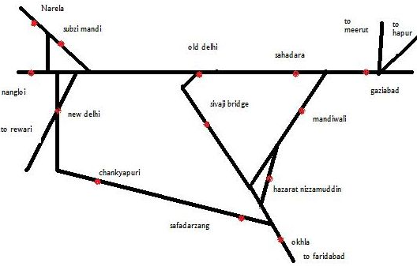

Figure.9 Ring rail network

5.9 Stringent emission norms

All in-use vehicles in India are required to have a valid Pollution Under Control (PUC) certificate. But even as emission norms for the new vehicles were made stringent, the government did not revise the norms for checking the emissions from the in-use fleet. Therefore, the old vehicles (which clearly would emit higher), were regulated at par with new vehicles, which should be emitting lesser emissions. In February 10, 2004, the Ministry of Road Transport and Highways (MoRTH) revised the in-use emissions norms, which are to be implemented across the country from October 1, 2004. EPCA had reviewed the implementation of the new in-use emission norms throughout the country. EPCA has talked to various key officials of different state transport departments, and state pollution control board. In its special report "The implementation of the in-use emission norms as amended by the Union government in February 2004" submitted in November 2004, directions from the Hon’ble Supreme Court have been sought.
6. Prediction for future

We calculate total pollution load for two wheelers and four wheeler up to 2007.now we calculated pollution load up to 2025 based on Minitab regression technique .It is a simple technique by which we get a regression equation and using this equation we calculate vehicle data for remaining decade.

6.1 Growth of vehicles in future

Two wheeler and four wheeler increases rapidly in the city.Its estimation upto 2007 is 4652324.Buses,auto&taxis,good vehicles increases significantly as compared to 2wheeler and 4wheeler.Numer of four wheeler upto 1995-96 is 6.34 lakh.In 2005-06 it also increases 14.72 lakh i.e. its decenial growth rate is 132.18%. Similarly two wheeler in 1995-96 17.41 lakh,in 2005-06 its growth upto 30.79 lakh i.e. its decenial growth rate 76.85%.similarly commercial vehicle like auto rickshaw in 1995-96 is 0.79 lakh but in 2005-06 it also decreases 0.74 lakh only.so its decenial growth rate is (-)6.33%.Buses are the main source of transportation for most of the Delhi public.its growth rate in 1995-96 is 0.28 lakh now in recent 2005-06 its amount is 0.44 lakh. So its decinal growth rate is 57.11%.In future the vehicle growth rate must increases,as per our calculation the two wheeler and four wheeler growth rate upto 2030 exceeds 1 crore.

Table 6: Numbers of two wheeler increases in future after 2007 and up to 2030
Year | Two  Wheeler | Car & Jeeps | Taxies | Buses | Goods Vehicle | Auto rickshaws
2007 | 3438918 | 1261422 | 25281 | 29718 | 185663 | 99662
2008 | 3566192 | 1342768 | 26378 | 32574 | 190197 | 101575
2009 | 3693466 | 1424114 | 27475 | 35430 | 194731 | 103489
2010 | 3820740 | 1586806 | 28572 | 38286 | 199265 | 105402
2011 | 3948014 | 1668152 | 29669 | 41142 | 203799 | 107316
2012 | 4075288 | 1749498 | 30766 | 43998 | 208333 | 109229
2013 | 4202562 | 1830844 | 31863 | 46854 | 212867 | 111142
2014 | 4329836 | 1912190 | 32960 | 49710 | 217401 | 113056
2015 | 4457110 | 1993536 | 34057 | 52566 | 221935 | 114969
2016 | 4584384 | 2074882 | 35154 | 55422 | 226469 | 116883
2017 | 4711658 | 2156228 | 36251 | 58278 | 231003 | 118796
2018 | 4838932 | 2237574 | 37348 | 61134 | 235537 | 120710
2019 | 4966206 | 2318920 | 38445 | 63990 | 240071 | 122623
2020 | 5093480 | 2400266 | 39542 | 66846 | 244605 | 124536
2021 | 5220754 | 2481612 | 40639 | 69702 | 249139 | 126450
2022 | 5348028 | 2562958 | 41736 | 72558 | 253673 | 128363
2023 | 5475302 | 2644304 | 42833 | 75414 | 258207 | 130277
2024 | 5602576 | 2725650 | 43930 | 78270 | 262741 | 132190
2025 | 5729850 | 2806996 | 45027 | 81126 | 267275 | 134104
2026 | 5857124 | 2888342 | 46124 | 83982 | 271809 | 136017
2027 | 5984398 | 2969688 | 47221 | 86838 | 276343 | 137930
2028 | 6111672 | 3051034 | 48318 | 89694 | 280877 | 139844
2029 | 6238946 | 3132380 | 49415 | 92550 | 285411 | 141757
2030 | 6366220 | 3232053 | 50512 | 95406 | 289945 | 143671

6.2 Different vehicular Pollution Scenarios

Due to lack of effective quality, public transport system the entire vehicle fleet is contineously growing in Delhi. Particulary private vehicles (two wheelers and car and jeeps) growth is directly related to effectiveness of pubic transportation system.Number of two wheeler increase from 18.76 lakh in 1997 to 33.36 lakh in 2007 showing annual compound growth rate 5.61 percent.where was the growth of four wheeler is equally depending on effective quality pubic transportation system as well aseconomic deveolpment of the country. The number of four wheeler increase from 7.06 lakh in 1997 to 15.99 lakh in year 2007, showing annual compound growth rate of 8.64 percent. Where as the growth rate for taxis and buses(RTV) has a moderate annual compound growth rate of 3.71 and 4.07 respectively.while annual compound growth rate during the same period for auto-rickshaw and goods vehicle are reported negative (-1.37) and (-1.11) respectively.

We have projected the figures for 2020 and 2030 using above mentioned growth factors and three possible scenerios.

1. Business as usual we neglect reduction factor and apply only growth rate. There is no change in present set up.so the growth rate in 2007 to 2010, 2010 to 2020 and 2020 to 2030 increases.

2.Future scenario 1, the reduction factor also considered.Reduction in private vehicle 10% in 2008 to 2010.Improvement in fuel quality and advance vehicle technology the reduction factor also 20% in 2010 to 2020.In 2030 the reduction factor also 40%.The decenial growth rate and annual growth rate increases as usual.

3. Future scenario 3 the reduction factor in 2008 to 2010 is 20%.In 2010 to 2020 the reduction factor is 40% due to advance vehicle technology and vehicles dependent on petroleum fuels.In 2030 the reduction factor is 50%.

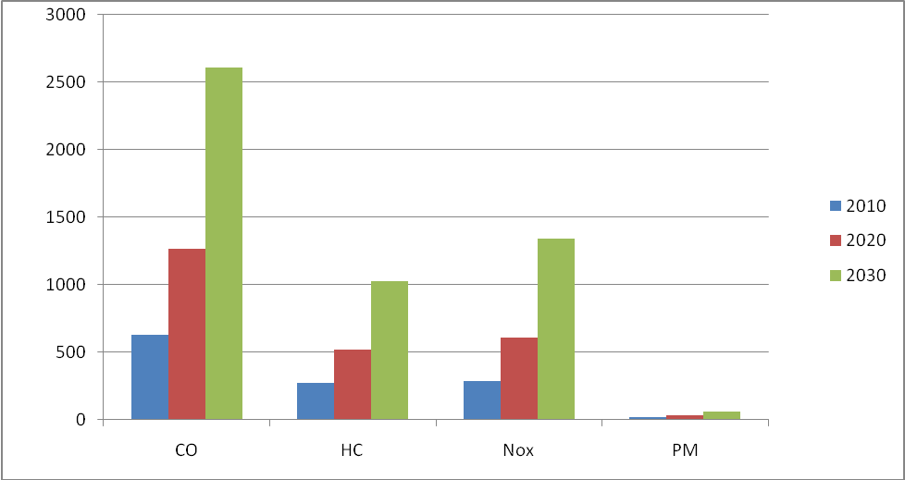
BUSINESS AS USUAL
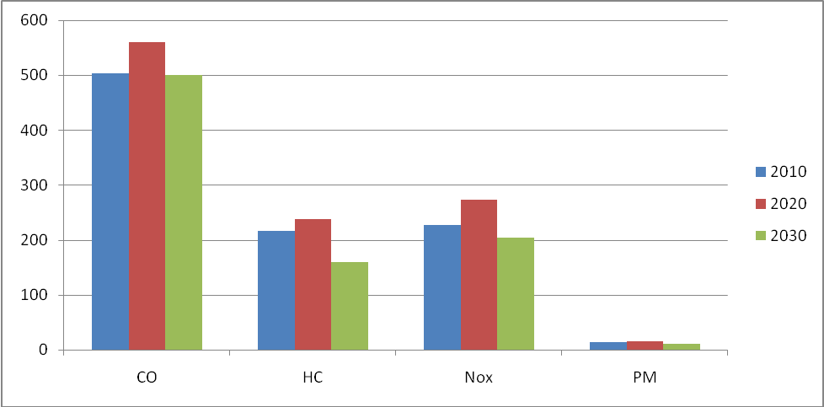
FUTURE CONTROL SCENARIO1

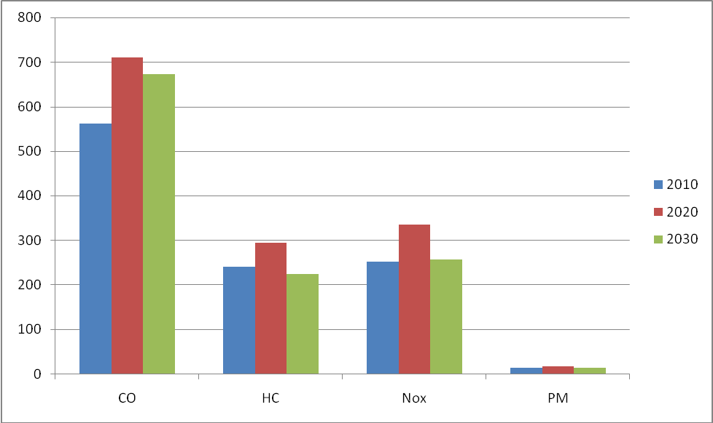
FUTURE CONTROL SCENARIO 2
CONCLUSION

These growth rate are having adverse effect on controlling the vehicular pollution because as per our estimation of emission from different categories of vehicle, the highest contribution are from two and four wheeler where as the other category of vehicles produce less amount of pollution from passenger. Hence government must insure the growth of public transportation system via. Relaxtion factor in taxes and subsidies on operating cost.

Delhi figures prominently in the world environment map for the simple reason that it is one of the most polluted cities in the world caused by spectacular vehicular growth in the past 2-3 decades. Incidentally, few years back it was acclaimed as one of the greenest capital also. In order to restore the air quality and refurbish its image, a number of CAC policy instruments have been implemented in Delhi in the past few years. Infact containment of vehicular pollution requires integrated approach, with many essential components i.e. improving in public transportation system, optimisation of traffic flow,improve in fuel quality,improve in vehicle technology and tightening emission norms .

REFERENCE

1. Ministry of Environment and Forestry (1997): ‘White Paper on Pollution in Delhi with an Action Plan,’ http://envfor.nic.in/divisions/cpoll/delpolln.html.
2. Agarwal, Anil, Anju Sharma, and Anumita RoyChowdhury (1996): Slow Murder: The Deadly Story of Vehicular Pollution in India, Centre for Science and the Environment, New Delhi.
3. Environment Pollution (Prevention and Control) Authority (1998a): 1st Progress Report (March–June 1998) submitted to the Supreme Court of India.
4. Anon. (2003): ‘Poll Posturing,’ Down to Earth, November 15, Society for Environmental Communications, New Delhi.
5. Saikia Committee on Vehicular Pollution (November 1991): Fourth Bi-Monthly Report (submitted to the Supreme Court of India).
6. Anon. (1994b): ‘Fair Air on CNG,’ Down to Earth, June 30, Society for Environmental Communications, New Delhi.
7. Central Pollution Control Board,1999a. Parivesh: Newsletter. Ministry of Environment and Forests,Delhi,6 (1).
8. Pundir,B.P.,2001. Vehicular air pollution in India: recent control measures and related issues. In: India Infrastructure Report 2001. Oxford University Press,Delhi.
9. Kathuria,V.,2001. Vehicular pollution control in Delhi: are the efforts enough? Beijer Discussion Paper No. 144,The Beijer International Institute of Ecological Economics,Stockholm.
10. Delhi Planning, 2006. /http://delhiplanning.nic.in/Economic%
20Survey/ES%202005-06/Chpt/2.pdfS.
11. Cropper, M.L., N.B. Simon, A. Alberini, S. Arora and P.K. Sharma (1997), “The health benefits of Air Pollution Control in Delhi”, American Journal of Agricultural Economics, Vol. 79, No. 5, 1625-29.
12. da Motta, R.S. and M.R. Behrem (2000), ‘Air Pollution Tradable Permits in Santiago, Chile’ in Rietbergen-McCracekn, J. and H. Abaza eds. Economic Instruments for Environmental Management, Earthscan Publication, London, pp. 178-84.
13.“Losses of Petroleum Products at Traffic Intersections Due to Idling of Vehicles,” Central Road Research Institute, October 1996, Delhi. Sponsored by the Petroleum Conservation Research Association.
14. A regression model statistically determines the mathematical relationships among existing or historical phenomena and makes forecasts assuming these relationships continue to hold.
15. Bose,R.K. and Nesamani, K.S.2000. Urban Transport,Energy and Environment-A case of Delhi,Institute of transportation studies,University of carlifornia,Davis,USA,UCD-ITS-RR-00-11,September, 2000.
16. Ministry of Home Affairs, Population Projection for India and States 1996 - 2016,
Registrar General of India, Controller of Publications, 1996.
17. Ministry of Surface Transport, Motor Transport Statistics of India, 1997.
18. Draft report on“Emission Factor development for Indian Vehicles “as a part of Ambient Air Quality Monitoring and Emission Source Apportionment Studies
.project Executed by ARAI, Pune © The Automotive Research Association of India P.O. Box. 832, Pune-4.
19. State of Environment Report for Delhi 2001; TERI & Department of Environment, Govt. of National Capital Territory, Delhi.
20. www.delhimetro.com
21. Report of the High Powered Committee on Comprehensive Action Plan on Environment & Pollution Control in Delhi, 1994.
22. Jaroslav Smutny, Urban Geographic System of Rail Transport using ArcInfo, Department of Railway Constructions and Structures, Faculty of Civil Engineering, Technical University of Brno, Czech Republic .
23. The imperative of controlling vehicle numbers and increasing access: Report on public transport projects in Delhi in Response to the Hon’ble Supreme Court Order Dated January 23, 2004 (In the matter of W.P.(C) No.13029 of 1985; M.C. Mehta v/s UOI & others July 2004
24. Published By : Dr. B. Sengupta, Member Secretary, Central Pollution Control Board, Delhi e-mail : cpcb@alpha.nic.in; Website www.cpcb.delhi.nic.in

