En-LEACH
An enhanced LEACH protocol to handle node-Mobility non-uniform Energy distribution and Localization in Sensor Networks

A dissertation
submitted in partial fulfillment
of the requirement for the degree
of
Master of Engineering
in
Computer Technology and Application

By
Bhagwan Sahai (University Roll No. 9001)

Under the guidance of
Ms. Rajni Jindal


Department of Computer Engineering
Delhi College of Engineering
Delhi
July 2006
CERTIFICATE

This is to certify that dissertation, entitled “En-Leach:-An Enhanced LEACH protocol to handle node mobility ,non-uniform energy distribution and localization in sensor networks ” which is submitted by Mr. Bhagwan Sahai , Roll No: 19/CTA/03, University Roll No. 9001 in partial fulfillment of the requirements for the award of the degree Master of Engineering in Computer Technology and Application submitted to the Department of Computer Engineering, Delhi College of Engineering, Delhi, is the work carried by him under my supervision during the period October 2005 to July 2006.

Signature of the student Signature of the supervisor

CANDIDATE’S DECLARATION

I hereby declare that the work, which is presented in this dissertation, entitled “En-Leach:-An Enhanced LEACH protocol to handle node mobility ,non-uniform energy distribution and localization in sensor networks ” in partial fulfillment of the requirements for the award of the degree of Master of Engineering in Computer Technology and Application submitted in the Department of Computer Engineering, Delhi College of Engineering, Delhi, is a record of my own work carried out during the period October 2005 to July 2006 under the guidance of Ms. Rajni Jindal, Lecturer, Department of Computer Engineering, Delhi College of Engineering, Delhi (India).

Date: July, 2006
Place: New Delhi (BHAGWAN SAHAI)

ACKNOWLEDGEMENTS

It is my privilege and pleasure to express my profound sense of respect, gratitude and indebtedness to Ms. Rajni Jindal, Lecturer, Department of Computer Engineering, Delhi College of Engineering, Delhi, for his indefatigable inspiration, guidance, cogent discussion, constructive criticisms and encouragement throughout this dissertation work.
I express my sincere thanks to Dr. Goldie Gabrani, Professor & Head of Dept. of Computer Engineering, DCE, Delhi, for providing necessary facilities for the successful completion of this work.
I greatly indebted to all of my friends, who have graciously applied themselves to the task of helping me with ample moral support and valuable suggestions.
Last but far from least, I wish to acknowledge my parents and all family members for giving the moral strength and constant encouragement.

(BHAGWAN SAHAI)

ABSTRACT

A wireless network consisting of a large number of small sensors with low-power transceivers can be an effective tool for gathering data in a variety of environments like civil and military applications. The data collected by each sensor is communicated through the network to a single processing centre called base station that uses all reported data to determine characteristics of the environment or detect an event. The communication or message passing process must be designed to conserve the limited energy resources of the sensors. Clustering sensors into groups, so that sensors communicate information only to local cluster-heads and then the cluster-heads communicate the aggregated information to the processing center, may save a lot of energy.
LEACH is one such type of clustering based protocol that utilizes randomized rotation of local cluster-heads to evenly distribute the energy load among the sensors in the network. LEACH (Low-Energy Adaptive Clustering Hierarchy) uses localized coordination to enable scalability and robustness for dynamic networks, and incorporates data fusion into the routing protocol to reduce the amount of information that must be transferred to the base station. But LEACH is based on the assumption that each sensor nodes contain equal amount of energy which is not valid in real scenarios. In actual scenario the node’s energy may vary depending upon its role in sensor network (.e. whether it is a head or cluster member) and the amount of data being sensed.

This thesis gives an overview, detailed simulation study and comparison of LEACH with other existing conventional routing protocol like direct transmission and static clustering protocol and finally a modified LEACH protocol (En-LEACH) has been proposed which will be adaptable to handle non-uniform energy distribution characteristic of a dynamic sensor network.

The simulation is done in MATLAB.

TABLE OF CONTENTS

Page No

CERTIFICATE…………………………………………………………………... 2
CANDIDATE’S DECLARATION……………………………………………… 3

ACKNOWLEDGEMENTS ……………………………………………………... 4

ABSTRACT………………………………………………………………………. 5

LIST OF FIGURES……………………………………………………………… 9
LIST OF TABLES………………………………………………………………. 12
GLOSSARY OF TERMS……………………………………………………….. 13
1. INTRODUCTION AND OBJECTIVE OF DISSERTATION……………. 14
1.1. Introduction………………………………………………………... 14
1.2. Contribution of This Dissertation………………………………… 17
1.3. Dissertation Structure …………………………………………….. 17
2. WIRELESS MICROSENSOR NETWORKS………………………………. 18
2.1. Introduction…………………………………………………………. 18
2.2. Design Goals for Wireless Microsensor Network Protocol………. 21
2.3. Challenge: Meeting the Design Goals……………………………. 22
2.4. Existing Routing Protocols in Sensor Networks………………… 24
2.4.1. Direct Communication Protocol………………………... 25
2.4.2. Flooding and Gossiping…………………………………. 25
2.4.3. Minimum Energy Routing Protocol……………………. 25
2.4.4. SPIN Protocol……………………………………………. 27
2.4.5. Static Clustering Protocol………………………………. 28
2.4.6. Adaptive Clustering Protocol…………………………… 29
3. LEACH PROTOCOL ARCHITECTURE…………………………………. 30
3.1. Introduction………………………………………………………… 30
3.2. Distributed Cluster Formation Algorithm for LEACH…………. 32
3.2.1. Advertisement Phase……………………………………… 33
3.2.2. Cluster Setup Phase……………………………………….. 34
3.2.3. Schedule Creation Phase………………………………….. 34
3.2.4. Data Transmission Phase…………………………………. 34
3.3. Multiple Clusters…………………………………………………… 36
3.4. Hierarchal Clustering ……………………………………………… 37
4. SCOPE OF IMPROVEMENT IN THE LEACH PROTOCOL…………… 38
4.1. Introduction…………………………………………………………... 38
4.2. Advantages of the LEACH Protocol……………………………….. 38
4.3. Disadvantages of the LEACH Protocol……………………………. 39
4.4. New Proposals to Enhance The LEACH Protocol……………….. 40
4.4.1. Changes Proposed in Cluster Setup Phase………. …… 40
4.4.2. Changes proposed in Data transmission Phase…………. 41
5. ENHANCED LEACH PROTOCOL ARCHITECTURE………………….. 42
5.1. Introduction………………………………………………………… 42
5.2. En-LEACH Algorithm Detail……………………………………… 42
5.2.1. Advertisement Phase……………………………………… 42
5.2.2. Cluster Setup Phase……………………………………….. 45
5.2.3. Schedule Creation Phase………………………………….. 45
5.2.4. Data Transmission Phase………………………………… 46
5.2.5. Future Cluster-Head Update Phase……………………... 47
6. SIMULATION METHODOLOGY………………………………………… 49
6.1. Introduction to Simulation Model………………………………… 49
6.1.1. Radio Energy Dissipation Model………………………… 49
6.1.2. Node Energy Model………………………………………. 50
6.1.3. Network Topology Model ………………………………... 51
7. RESULTS AND DISCUSSION……………………………………………. 52
7.1. Introduction……………………………………………………….. 52
7.2. Experimental Setup………………………………………………. 52
7.3. Simulation Results………………………………………………... 54
7.3.1. Nodes Begins with equal Energies………………….. 54
7.3.1.1. Test Case1: LEACH vs. Conventional Protocol. 54
7.3.1.2. Test Case2: En-LEACH vs. LEACH Protocol 55
7.3.2. Nodes Begins with unequal Energies………………….. 60
7.3.2.1. Test case: LEACH vs. En-LEACH…………... 60
8. CONCLUSIONS……………………………………………………………. 64
8.1. Work done………………………………………………………… 64
8.2. Suggestions for future work……………………………………… 64

REFERENCES & BIBLIOGRAPHY…………………………………………… 66

LIST OF FIGURES

Figure 1-1: DOT – Wireless sensor network device designed to be the approximate size of a quarter. Future devices will continue to be smaller, cheaper and longer lasting……………………………………………………………………………… 15

Figure 1-2: Possible deployment of ac-hoc wireless embedded network for precision
agriculture. Sensors detect temperature, light levels and soil moisture at hundreds of
points across a field and communicate their data over a multi-hop network for analysis……………………………………………………………………………. 16

Figure 2-1: A wireless micro sensor network. Each node obtains a certain view of the environment. By intelligently combining the views of the nodes, the end-user can remotely monitor events in the environment……………………………………… 18

Figure 2-2: The old paradigm for extracting data from the environment included the use of large, expensive, bulky macro sensor nodes connected via a tethered network to the end-user. This figure shows a picture of seismic exploration……… ……………. 19

Figure 2-3: Microsensor nodes can be dropped from planes to enable monitoring of remote or dangerous areas. This requires self-configuring protocols that do not rely on a fixed infrastructure………………………………………………………………. 21

Figure 2-4: In minimum transmission energy (MTE) routing, node A would transmit to node C through node B if Etransmit(d = AB) + Etransmit(d = BC) < Etransmit(d = AC)
…………………………………………………………………………………… 26

Figure 2-5: In MTE routing applied to a microsensor network, data are passed along the routes until they reach the base station………………………………………….. 26

Figure 2-6: In static clustering in a microsensor network, data are passed from the nodes to the cluster-heads, who forward the data to the base station…………………… 28

Figure 3-1: The LEACH protocol for microsensor networks. LEACH includes adaptive, self-configuring cluster formation, localized control for data transfers, low-energy media access, and application-specific data processing………………………………… 31

Figure 3-2: Time-line showing LEACH operation. Adaptive clusters are formed during the set-up phase and data transfers occur during the steady-state phase………... 32

Figure 3-3: Flow-graph of the distributed cluster formation algorithm for LEACH.
…………………………………………………………………………………… 35
Figure 3-4: Dynamic cluster formation during two different rounds of LEACH. All nodes marked with a given symbol belong to the same cluster, and the cluster-head nodes are marked with *…………………………………………………………….. 35

Figure 3-5: Flow-graph of the steady-state operation for LEACH…………… 36

Figure 5-1: Cluster-Head decision in En-LEACH protocol …………………… 44

Figure 5-2: Flow-graph of the steady-state operation for En-LEACH……… 48

Figure 6-1: Radio energy dissipation model ………………………………… 49

Figure 7-1: 100-node random test network. The base station is located at (1000,0) (not shown)………………………………………………………………………… 53

Figure 7-2(a): System lifetime using Direct transmission protocol…………… 56

Figure 7-2(b): System lifetime using static clustering protocol……………….. 56

Figure 7-2(c): System lifetime using LEACH protocol (equal energy case)….. 57

Figure 7-2(d): System lifetime using En-LEACH protocol (equal energy case)….. 57

Figure 7-3(a): Sensors that remain alive (+ sign) and those that are dead (dots) after 6 round for direct transmission protocol………………………………………… 58

Figure 7-3(b): Sensors that remain alive (+ sign) and those that are dead (dots) after 6 round for static clustering protocol………………………………………… … 58

Figure 7-3(c): Sensors that remain alive and those that are dead (dots) after 31 round for LEACH protocol and clusters are denoted using different colors (equal energy case)
…………………………………………………………………………………… 59

Figure 7-3(d): Sensors that remain alive and those that are dead (dots) after 31 round for En-LEACH protocol and clusters are denoted using different colors (equal energy case)
…………………………………………………………………………………… 59

Figure 7-4(a): System lifetime using LEACH protocol (unequal energy case)….. 61

Figure 7-4(b): System lifetime using En-LEACH protocol (unequal energy case)…61

Figure 7-4(c): Sensors that remain alive and those that are dead (dots) after 31 round for LEACH protocol and clusters are denoted using different colors (unequal energy case)
…………………………………………………………………………………….. 62

Figure 7-4(d): Sensors that remain alive and those that are dead (dots) after 31 round for En-LEACH protocol and clusters are denoted using different colors (unequal energy case)………………………………………………………………………….. 62

LIST OF TABLES

Table 7-1: Characteristics of test network…………………………………… 53

GLOSSARY OF TERMS

Base Station – The base station is a master node. Data sensed by the network is routed
back to the base station. Sensor networks in this thesis contain a single base station.

Fidelity – With respect to sensor networks, fidelity is a measure of the quality of data
received at the base station. Fidelity can change as a result of adaptations made in the sensor network, and it can degrade due to the failure of sensor nodes.

Hop – With respect to wireless networks, a hop is a communication link between two nodes, without any intermediate nodes to forward data messages.

Longevity – With respect to sensor networks, longevity is a measure of the time required
for sensor network performance to degrade to some specified threshold. Time can be measured in seconds, in requests issued by the base station, or in responses received by the base station.

Node – A node is a sensing device, containing a complete computer system with a processor, memory, radio data link, and one or more electronic sensors. Nodes are typically battery powered.

Sensor Network – A sensor network is a collection of communicating sensing devices, or nodes, with a base station. All of the nodes are not necessarily communicating at any particular time, and nodes can only communicate with a few nearby nodes.

Chapter 1

INTRODUCTION AND OBJECTIVE OF DISSERTATION

  - INTRODUCTION
The emerging field of wireless sensor networks combines sensing, computation, and communication into a single tiny device. Through advanced mesh networking protocols, these devices form a sea of connectivity that extends the reach of cyberspace out into the physical world. As water flows to fill every room of a submerged ship, the mesh networking connectivity will seek out and exploit any possible communication path by hopping data from node to node in search of its destination. While the capabilities of any single device are minimal, the composition of hundreds of devices offers radical new technological possibilities.
The power of wireless sensor networks lies in the ability to deploy large numbers of tiny nodes that assemble and configure themselves. Usage scenarios for these devices range from real-time tracking, to monitoring of environmental conditions, to ubiquitous computing environments, to monitor the health of structures or equipment. While often referred to as wireless sensor networks, they can also control actuators that extend control from cyberspace into the physical world.
The most straightforward application of wireless sensor network technology is to monitor remote environments for low frequency data trends. For example, a chemical plant could be easily monitored for leaks by hundreds of sensors that automatically form a wireless interconnection network and immediately report the detection of any chemical leaks. Unlike traditional wired systems, deployment costs would be minimal. Instead of having to deploy thousands of feet of wire routed through protective conduit, installers

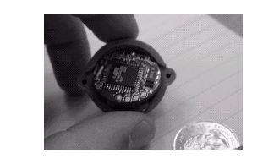
Figure 1-1: DOT – Wireless sensor network device
designed to be the approximate size of a quarter.
Future devices will continue to be smaller, cheaper and
longer lasting.

simply have to place quarter-sized device, such as the one pictured in Figure 1-1, at each
sensing point. The network could be incrementally extended by simply adding more devices – no rework or complex configuration.

In addition to drastically reducing the installation costs, wireless sensor networks
have the ability to dynamically adapt to changing environments. Adaptation mechanisms can respond to changes in network topologies or can cause the network to shift between drastically different modes of operation. For example, the same embedded network performing leak monitoring in a chemical factory might be reconfigured into a network designed to localize the source of a leak and track the diffusion of poisonous gases. The network could then direct workers to the safest path for emergency evacuation.

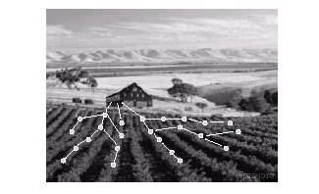
Figure 1-2: Possible deployment of ac-hoc wireless
embedded network for precision agriculture. Sensors
detect temperature, light levels and soil moisture at
hundreds of points across a field and communicate
their data over a multi-hop network for analysis.

An example network is shown in Figure 1-2. It depicts a precision agriculture deployment—an active area of application research. Hundreds of nodes scattered throughout a field assemble together, establish a routing topology, and transmit data back to a collection point. The application demands for robust, scalable, low-cost and easy to deploy networks are perfectly met by a wireless sensor network. If one of the nodes should fail, a new topology would be selected and the overall network would continue to deliver data. If more nodes are placed in the field, they only create more potential routing opportunities [1, 2, 3, 4].
Hence core design challenge in wireless sensor networks is coping with the harsh resource constraints placed on the individual devices. Embedded processors with kilobytes of memory must implement complex, distributed, ad-hoc networking protocols. Many constraints derive from the vision that these devices will be produced in vast quantities and must be small and inexpensive. As Moore’s law marches on, each device will get smaller, not just grow more powerful at a given size. Size reduction is essential in order to allow devices to be produced as inexpensively as possible, as well as to be able to allow devices to be used in a wide range of application scenarios.
The most difficult resource constraint to meet is power consumption. As physical
size decreases, so does energy capacity. Underlying energy constraints end up creating computational and storage limitations that lead to a new set of architectural issues. Many devices, such as cell phones and pagers, reduce their power consumption through the use specialized communication hardware in ASICs that provide low-power implementations of the necessary communication protocols [5] and by relying on high-power infrastructure. However, the strength of wireless sensor networks is their flexibility and universality. The wide range of applications being targeted makes it difficult to develop a single protocol, and in turn, an ASIC, that is efficient for all applications. A wireless sensor network platform must provide support for a suite of application-specific protocols that drastically reduce node size, cost, and power consumption for their target application.
1.2. CONTRIBUTION OF THIS DISSERTATION
The objective of this dissertation is to arrive at an energy-efficient communication protocol for sensor networks which is adaptable to non-uniform and dynamic energy distribution among the sensor nodes and the changing network configurations. Towards this end, a communication protocol called LEACH (Low Energy Adaptive Clustering Hierarchy), originally proposed by W.R.Heinzelman, A.Chandrakasan and H.Balakrishnan [6], has been modified and enhanced to face the network challenges mentioned above.
  - DISSERTATION STRUCTURE
Remaining of the thesis is organized as follows:
- Chapter 2 gives some background information regarding wireless microsensor network and its existing communication protocols.
- Chapter 3 describes LEACH protocol in detail which is the basis of this thesis.
- Chapter 4 describes scope of improvement in LEACH protocol.
- Chapter 5 describes the new proposed En-LEACH protocol algorithm.
- Chapter 6 describes various simulation models used in the theses.
- Chapter 7 presents numerical results and discussion of the same.
- Chapter 8 presents conclusions and suggestions for future work.

CHAPTER 2

WIRELESS MICROSENSOR NETWORKS

2.1. INTRODUCTION
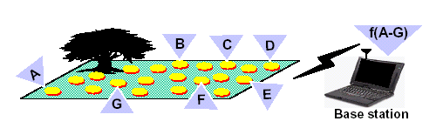
Figure 2-1: A wireless micro sensor network. Each node obtains a certain view of the environment.
By intelligently combining the views of the nodes, the end-user can remotely monitor events in the
environment.

A sensor is any device that maps a physical quantity from the environment to a quantitative measurement. Advances in sensor technology, low-power analog and digital electronics, and low-power radio frequency (RF) design have enabled the development of small, relatively inexpensive and low-power sensors, called microsensors. Microsensors are equipped with a sensor module (e.g., acoustic, seismic, image sensor) capable of sensing some quantity about the environment, a digital processor for processing the signals from the sensor and performing network protocol functions, a radio module for communication, and a battery to provide energy for operation. Each sensor obtains a certain view of the environment, as shown in Figure 2-1. A given sensor's view of the environment is limited both in range and in accuracy; it can only cover a limited physical
area of the environment and, depending on the quality of the hardware, may produce noisy data.
Combining or aggregating the views of the individual nodes allows users to accurately and reliably monitor an environment. To enable remote monitoring of an environment, the nodes must send the high-level description of events to a distant base station, through which an end-user can access the information.
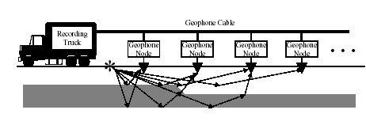
Figure 2-2: The old paradigm for extracting data from the environment included the use of large,
expensive, bulky macro sensor nodes connected via a tethered network to the end-user. This figure
shows a picture of seismic exploration.

Wireless microsensor networks represent a new paradigm for extracting data from the environment. Conventional systems use large, expensive macrosensors that are often wired directly to an end-user and need to be accurately placed to obtain the data. For example, the oil industry uses large arrays of geophone sensors attached to huge cables to perform seismic exploration for oil , as shown in Figure 2-2. These sensor nodes are very expensive and require large amounts of energy for operation. The sensors must be placed in exact locations, since there are a limited number of nodes extracting information from the environment. Furthermore, deployment of these nodes and cables is costly and awkward, requiring helicopters to transport the system and bulldozers to ensure the sensors can be placed in exact positions. There would be large economic and environmental gains if these large, bulky, expensive macrosensor nodes could be replaced with hundreds of cheap microsensor nodes that can be easily deployed. This would save significant costs in the nodes themselves as well as in the deployment of these nodes. These microsensor networks would be fault-tolerant, as their sheer number of nodes can ensure that there is enough redundancy in data acquisition that not all nodes need to be functional. Using wireless communication between the nodes would eliminate the need for a fixed infrastructure.

Wireless microsensor networks enable the reliable monitoring of a variety of environments for applications that include home security, machine failure diagnosis, chemical/biological detection, medical monitoring, and surveillance. Deploying hundreds or thousands of nodes in a wireless microsensor network brings new benefits to these sensing applications, including:
- Extended range of sensing: - Single macrosensor nodes can only extract data about events in a limited physical range. In contrast, microsensor networks enable large numbers of nodes to be physically separated; while nodes located close to each other will have correlated data (e.g., these nodes will be gathering data about the same event), nodes that are farther apart will be able to extract information about different events.
- Fault-tolerance: - Ensuring that several nodes are located close to each other and hence have correlated data makes these systems much more fault tolerant than single macrosensor systems. If the macrosensor node fails, the system cannot function, whereas if a small number ofmicrosensor nodes from a network fail, there is enough redundancy in the data from different nodes that the system may still produce acceptable quality information.
- Improved accuracy: - While an individual microsensor's data might be less accurate than a macrosensor's data, combining the data from nodes increases the accuracy of the sensed data. Since nodes located close to each other are gathering information about the same event, aggregating their data enhances the common signal and reduces the uncorrelated noise.
- Lower cost: - Even though there are many microsensors replacing each macrosensor, due to reduced size, reliability, and accuracy constraints on microsensor nodes, these nodes are much cheaper than their macrosensor counterparts. Therefore, microsensor systems are less expensive than macrosensor systems.

In order to achieve these benefits, we must design protocols that enable microsensor networks to provide the necessary support to the sensing applications [7].

2.2. Design Goals for Wireless Microsensor Network Protocols
In order to design good protocols for wireless microsensor networks, it is important to understand the parameters that are important to the sensor applications [7]. While there are many ways in which protocols are beneficial to the application, we use the following metrics:
- Ease of deployment: - Sensor networks may contain hundreds or thousands of nodes, and they may need to be deployed in remote or dangerous environments. If these nodes are small enough and cheap enough, we can imagine throwing hundreds or thousands of microsensors from a plane flying over a remote or dangerous area to allow us to extract information in a way that would not be possible otherwise (as shown in Figure 2-3 below).

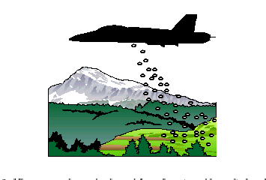

Figure 2-3: Microsensor nodes can be dropped from planes to enable monitoring of remote or
dangerous areas. This requires self-configuring protocols that do not rely on a fixed infrastructure.

- System lifetime: - These networks should function as long as possible. System lifetime can be measured using generic parameters, such as the time until the nodes die, or it can be measured using application-specific parameters, such as the time until the sensor network is no longer providing acceptable quality results (e.g., there are too many missed events).
- Latency: - Data from sensor networks are typically time-sensitive, so it is important to receive the data in a timely manner. Long delays due to processing or communication may be unacceptable.
- Quality: - This parameter measures the accuracy with which the result of the sensor network matches what is actually occurring in the environment. Although this is an application-specific and data-dependent quantity, one possible application-independent method of determining quality is to determine the amount of data (either actual or aggregate) received at the base station. The more data the base station receives, the more accurate its view of the remote environment will be.

Tradeoffs can be made among these different parameters, and algorithms can be created that are scalable and adaptive to change the relative importance of the different parameters. For example, when energy is plentiful, the end-user may desire high-quality results. As the energy gets depleted, the end-user may request that the quality of the results be reduced in order to reduce the energy dissipation in the nodes and hence lengthen the total system lifetime. Thus microsensor network algorithms and protocols should be power aware such that energy usage is scaled appropriately for a given quality specification [8, 9].

2.3. Challenge: Meeting the Design Goals
As discussed in the previous section, it is important that microsensor networks be easily deployable, possibly in remote or dangerous environments. This requires that the nodes be able to communicate with each other even in the absence of an established network infrastructure. In addition, there are no guarantees about the locations of the sensors, such as the uniformity of placement. To function in such ad-hoc settings, microsensor networks should be self-configuring, requiring no global control to set-up or maintain the network.

In the scenario where the sensors are operating in remote or dangerous territory, it may be
impossible to retrieve the nodes in order to recharge batteries. In other sensor network scenarios, such as machine monitoring or medical monitoring, it may just be inconvenient to replace the battery of a node. Therefore, the network should be considered to have a certain lifetime during which nodes have energy and can gather, process, and transmit information. This means that all aspects of the node, from the sensor module to the hardware and protocols, must be designed to be extremely energy-efficient. Decreasing energy usage by a factor of two can double system lifetime, resulting in a large increase in the overall usefulness of the system. In addition to reducing energy dissipation, protocols should be robust to node failures in order to maximize system lifetime. The protocols should be fault-tolerant, such that the loss of a small number of nodes does not greatly affect the overall system performance. In addition, the protocols should be scalable such that the addition of new nodes requires low overhead to incorporate the nodes into the existing network.
Events occurring in the environment being sensed may be time-sensitive. Therefore, it is often important to bind the end-to-end latency of data dissemination. Protocols should therefore minimize overhead and extraneous data transfers. Researchers have been studying wireless networks for a number of years and have developed fairly sophisticated protocols for voice delivery using cellular networks and data delivery over wireless local area networks (WLANs) and ad-hoc data networks [10,11, 12]. In cellular networks, nodes are organized into clusters where each node is able to communicate directly with the cluster base station. This requires a fixed infrastructure (placement of base stations) so that nodes can be connected to the network wherever they are. WLANs usually require point-to-point connectivity so any user can communicate with any other user, often without the use of a central base-station; these networks typically use some form of multi-hop routing. While these protocols are good at optimizing delay and fairness parameters, they are designed for applications where each user is creating data that may be transferred to any other user at any given time. These goals are very different than those of a wireless microsensor network. In a microsensor network, data sensed by each node are required at a remote base station, rather than at other nodes, and the data are being extracted from the environment, leading to large amounts of correlation among data signals. Therefore, the notion of quality in a microsensor network is very different than in a WLAN or cellular network. For sensor networks, the end-user does not require all the data in the network because (1) the data from neighboring nodes are highly correlated, making the data redundant, and (2) the end-user cares about a higher-level description of events occurring in the environment the nodes are monitoring. The quality of the network is therefore based on the quality of the aggregate data set, rather than the quality of the individual data signals; protocols should be designed to optimize for the unique, application-specific quality of a sensor network.

To summarize, wireless microsensor network protocols should be:
- self-configuring, to enable ease of deployment of the networks,
- energy-efficient and robust, to extend system lifetime,
- latency-aware, to get the information to the end-user as quickly as possible, and
- cognitive of the application-specific nature of sensor network quality.

The research presented in this dissertation on microsensor networks focuses on ways in which this last feature may be exploited to create a protocol architecture that optimizes the different desired features of these networks. This is accomplished by using application-level information in the design of all layers of the traditional protocol stack.

2.4. Existing Routing Protocols for Wireless Microsensor Networks
Network protocols must be designed to achieve fault tolerance in the presence of individual node failure while minimizing energy consumption. Since the limited wireless channel bandwidth must be shared among all the sensors in the network, routing protocols for these networks should be able to perform local collaboration to reduce bandwidth requirements. There have been several network routing protocols proposed for wireless networks [13]. We examine the following such protocols.

2.4.1. Direct Communication Protocol
Each sensor node sends its data directly to the base station. If the base station is far away from the nodes, direct communication will require a large amount of transmit power from each node. This will quickly drain the battery of the nodes and reduce the system lifetime. However, the only receptions in this protocol occur at the base station, so if either the base station is close to the nodes, or the energy required to receive data is large, this may be an acceptable method of communication.
In the direct-transmission, the nodes farthest from the base station will need the maximum energy to transmit the data messages to the base station. As a result these nodes will die down relatively faster. As nodes far from the base station die, that area of the environment is no longer being monitored.

2.4.2. Flooding and Gossiping
Each node acts as a router for the communication of the data from other nodes to the base station as well as a sensor to sense its environment and send the data generated by it. On sensing/receiving a new data, each node stores it and sends a copy to all its neighbors (except from which it received the data). This strategy is simple and aims at fastly disseminating the data throughout the network. But, in addition to the problem of wasteful use of energy, flooding has additional problems like Implosion (Reception of multiple copies of the same data via different routes), Overlap (Multiple nodes sensing & disseminating overlapping pieces of data) and Resource-blindness (Nodes don’t modify their activities/decisions according to the available energy).
Gossiping is a variant of flooding where each node sends data to random sets of its neighbors (including the node from which the data was received). Though this strategy helps in reducing the energy usage and data replication to some extent but it results in increased latency.

2.4.3. Minimum Energy Routing Protocol
There are several power-aware routing protocols proposed for wireless sensor networks. In these protocols, nodes route data destined ultimately for the base station through intermediate nodes (see figure 2-4). Thus nodes act as routers for other nodes’ data in addition to sensing the environment. These protocols differ in the way the routes are chosen. Some of these protocols only consider the energy of the transmitter and neglect the energy dissipation of the receivers in determining the routes. The intermediate nodes are chosen such that the transmit amplifier energy is minimized (see figure2-5). However, for this minimum-transmission-energy (MTE) routing protocol, rather than just one (high-energy) transmit of data, each data message must go through numerous (low-energy) transmits and the same number of receives. Depending on the relative costs of the transmit amplifier and the radio electronics, the total energy expended in the system might actually be greater using MTE routing than direct transmission to the base station.
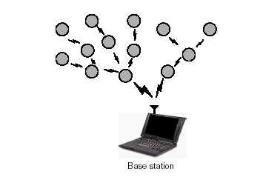

Figure 2-4: In MTE routing applied to a microsensor network, data are passed along the routes
until they reach the base station.

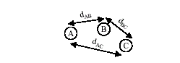
Figure 2-5: In minimum transmission energy (MTE) routing, node A would transmit to node C
through node B if Etransmit(d = AB) + Etransmit(d = BC) < Etransmit(d = AC).

In MTE routing, the nodes closest to the base station will be used to route a large number of data messages to the base station. Thus these nodes will die out quickly, causing the energy required to get the remaining data to the base station to increase and more nodes to die. This will create a cascading effect that will shorten system lifetime. In addition, as nodes close to the base station die, that area of the environment is no longer being monitored [13].

2.4.4. SPIN – Sensor Protocol for Information via Negotiation
Nodes name their data using high level data-descriptors called “meta-data”. Sensor nodes use meta-data to succinctly and completely describe the data that they collect. For SPIN to be beneficial, the size of the meta-data should be much smaller than that of the actual data it represents. If two pieces of actual data are distinguishable, then their corresponding meta-data should also be distinguishable. Two pieces of indistinguishable data should share the same meta-data representation. Meta-data negotiations are carried out between the nodes before actual data transfer. This helps in eliminating the overlap of the same data received from different source nodes as also to eliminate implosion of the same data coming via different routes within the network.

Main features of the SPIN are:
- Decisions are based on application specific knowledge of data and available resources (eliminates resource blindness to extend lifetime)
- Dissemination of individual sensor data to all the nodes
- Based on Application Level Framing by employing ADUs (Application Data Units)
- Meta-data format is application specific, e.g. node ID (x), camera location and orientation (x,y,Ø)
- Resource management parameters
  - Available energy
  - Computation costs
  - Communication costs

The three types of messages exchanged between the nodes are:
- ADV: New data advertisement (meta-data)
- REQ: Request for data (meta-data)
- DATA: Data message (data + meta-data header)

Once a node has some sensor data to send, it periodically retransmits ADV messages to advertise this data to other nodes in the network. A node which doesn’t already has the data advertised by an ADV message requests for the same by sending a REQ message back to the node which sent the ADV message. On receiving a REQ message, the source node sends the actual data via a DATA message to the requesting node. The REQ messages are retransmitted after time-outs for missing REQ or DATA messages.

2.4.5. Static Clustering Protocol

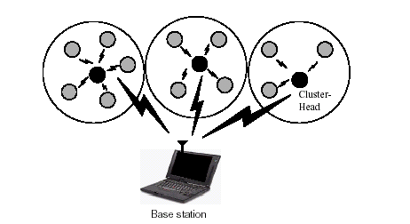
Figure 2-6: In static clustering in a microsensor network, data are passed from the nodes to the
cluster-heads, who forward the data to the base station.

Nodes are organized into clusters that communicate with a local base station, and these local base stations transmit the data to the global base station, where it is accessed by the end-user as seen in figure 2-6. This greatly reduces the distance nodes need to transmit their data, as typically the local base station is close to all the nodes in the cluster. Thus, clustering appears to be an energy-efficient communication protocol. However, the local base station is assumed to be a high-energy node; if the base station is an energy-constrained node, it would die quickly, as it is being heavily utilized. Thus, conventional clustering would perform poorly for microsensor networks.

2.4.6. Adaptive Clustering Protocol
A serious shortcoming of the conventional clustering protocol is that the cluster-head nodes are overloaded with energy depleting communication activities for routing other nodes’ messages to the base station, and thus die down very fast, rendering all the nodes covered by them as useless. To address this deficiency, various adaptive-clustering protocols have been proposed wherein the nodes getting the responsibility of acting as cluster-heads are changed repeatedly in order to uniformly distribute the energy-intensive communication activities among the network nodes. A simple scheme is to randomly select the cluster-heads without any dependence on node-parameters. A better strategy, in the name of LEACH (Low Energy Adaptive Clustering Hierarchy), has been proposed by W.R.Heinzelman, A.Chandrakasan and H.Balakrishnan which excludes the recently selected nodes from the current selection of cluster-heads [6]. This is discussed in the next chapter.

CHAPTER 3

LEACH PROTOCOL ARCHITECTURE
3.1. INTRODUCTION
Wireless microsensor networks will enable reliable monitoring of remote areas. These networks are essentially data-gathering networks where the data are highly correlated and the end-user requires a high-level description of the environment the nodes are sensing. In addition, these networks require ease of deployment, long system lifetime, and low-latency data transfers. This is a very different paradigm than traditional wireless networks that require point-to-point connectivity, have uncorrelated data, and often can rely on a fixed infrastructure. The limited battery capacity of microsensor nodes and the large amount of data that each node may produce translates to the need for high application-perceived performance at a minimum cost, in terms of energy and latency. A cross-layer or application-specific protocol architecture can meet these specifications by exposing
lower layers of the protocol stack to the requirements of the application.
To meet the requirements of wireless microsensor networks, LEACH (Low-Energy Adaptive Clustering Hierarchy), an application-specific protocol architecture was developed [6].
LEACH is a clustering-based protocol that includes the following features:
- randomized, adaptive, self-configuring cluster formation,
- localized control for data transfers,
- low-energy media access, and
- application-specific data processing, such as data aggregation.

The application that typical microsensor networks support is the remote monitoring of an environment. Since individual nodes' data are correlated in a microsensor network, the end-user does not require all the (redundant) data; rather, the end-user needs a high-level function of the data
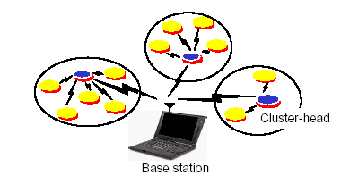
Figure 3-1: The LEACH protocol for microsensor networks. LEACH includes adaptive, self-
configuring cluster formation, localized control for data transfers, low-energy media access, and
application-specific data processing.

that describes the events occurring in the environment. Because the correlation is strongest among data signals from nodes located close to each other, we chose to use a clustering infrastructure as the basis for LEACH. This allows all data from nodes within the cluster to be processed locally, reducing the data set that needs to be transmitted to the end-user. In particular, data aggregation techniques can be used to combine several correlated data signals into a smaller set of information that maintains the effective data (i.e., the information content) of the original signals. Therefore, much less actual data needs to be transmitted from the cluster to the base station. If the cost in terms of energy dissipation of communicating data is greater than the cost of computing on the data, considerable energy savings can be achieved by locally aggregating a large amount of data into a smaller set of data before transmission to the base station.
In LEACH, the nodes organize themselves into local clusters, with one node acting as the cluster-head. All non-cluster-head nodes must transmit their data to the cluster-head, while the cluster-head node must receive data from all the cluster members, perform signal processing functions on the data (e.g., data aggregation), and transmit data to the remote base station (see figure3-1). Therefore, being a cluster-head node is much more energy-intensive than being a non-cluster-head node. In the scenario where all nodes are energy-limited, if the cluster-heads were chosen a priori and fixed throughout the system lifetime, as in a static clustering algorithm, the cluster-head sensor nodes would quickly use up their limited energy. Once the cluster-head runs out of energy, it is no longer operational.
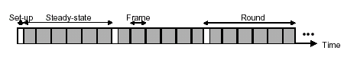

Figure 3-2: Time-line showing LEACH operation. Adaptive clusters are formed during the set-up
phase and data transfers occur during the steady-state phase.

Thus, when a cluster-head node dies (e.g., uses up all its battery energy), all the nodes that belong to the cluster lose communication ability. Thus LEACH incorporates randomized rotation of the high-energy cluster-head position such that it rotates among the sensors in order to avoid draining the battery of any one sensor in the network. In this way, the energy load associated with being a cluster-head is evenly distributed among the nodes. Media access in LEACH was chosen to reduce energy dissipation in the non-cluster-head nodes. Since the cluster-head node knows all the cluster members, it can create a TDMA schedule that tells each node exactly when to transmit its data. This allows the nodes to remain in the sleep state, with internal modules powered-down, as long as possible. In addition, using a TDMA schedule for data transfer prevents intra-cluster collisions.
The operation of LEACH is divided into rounds. Each round begins with a set-up phase when the clusters are organized, followed by a steady-state phase where several frames of data are transferred from the nodes to the cluster-head and on to the base station, as shown in Figure 3-2. The nodes must all be time-synchronized in order to start the set-up phase at the same time. In order to minimize the set-up overhead, the steady-state phase is long compared to the set-up phase [7].

3.2. DISTRIBUTED CLUSTER FORMATION ALGORITHM FOR LEACH
The operation of LEACH is broken up into rounds, where each round begins with a set-up phase, when the clusters are organized, followed by a steady-state phase, when data transfers to the base station occur. In order to minimize overhead, the steady-state phase is long compared to the set-up phase. The whole cycle is depicted through flow diagram as seen in figure 3-3.
The different phases involved in LEACH protocol are as follows:

3.2.1. Advertisement Phase
Initially, when clusters are being created, each node decides whether or not to become a cluster-head for the current round. This decision is based on the suggested percentage of cluster heads for the network (determined a priori) and the number of times the node has been a cluster-head so far. This decision is made by the node n choosing a random number between 0 and 1. If the number is less than a threshold T(n), the node becomes a cluster-head for the current round. The threshold is set as:
T(n) = p/{1-p*(r mod 1/p)} if n € G
0 otherwise

where p = the desired percentage of cluster heads (i.e. 5% as suggested by LEACH) , r = the current round, and G is the set of nodes that have not been cluster-heads in the last 1/p rounds. Using this threshold, each node will be a cluster-head at some point within 1/p rounds. During round 0 (r=0) each node has a probability p of becoming a cluster-head. The nodes that are cluster-heads in round 0 cannot be cluster-heads for the next 1/p rounds. Thus the probability that the remaining nodes are cluster-heads must be increased, since there are fewer nodes that are eligible to become cluster-heads. After 1/p - 1 rounds, T =1 for any nodes that have not yet been cluster-heads, and after 1/p rounds, all nodes are once again eligible to become cluster-heads. Here it is assumed that all nodes begin with the same amount of energy and being a cluster-head removes approximately the same amount of energy for each node.

Each node that has elected itself a cluster-head for the current round broadcasts an advertisement message to the rest of the nodes. For this “cluster-head-advertisement” phase, the cluster-heads use a CSMA MAC protocol, and all cluster-heads transmit their advertisement using the same transmit energy. The non-cluster-head nodes must keep their receivers on during this phase of set-up to hear the advertisements of all the cluster-head nodes. After this phase is complete, each non-cluster-head node decides the cluster to which it will belong for this round. This decision is based on the received signal strength of the advertisement. Assuming symmetric propagation channels, the cluster-head advertisement heard with the largest signal strength is the cluster-head to whom the minimum amount of transmitted energy is needed for communication. In the case of ties, a random cluster-head is chosen.

3.2.2. Cluster Set Up Phase
After each node has decided to which cluster it belongs, it must inform the cluster-head node that it will be a member of the cluster. Each node transmits this information back to the cluster-head again using a CSMA MAC protocol. During this phase, all cluster-head nodes must keep their receivers on. The dynamic cluster formation is shown in figure 3-4.

3.2.3. Schedule Creation Phase
The cluster-head node receives all the messages for nodes that would like to be included in the cluster. Based on the number of nodes in the cluster, the cluster-head node creates a TDMA schedule telling each node when it can transmit. This schedule is broadcast back to the nodes in the cluster.

3.2.4. Data Transmission Phase or Steady-state Phase
Once the clusters are created and the TDMA schedule is fixed, data transmission can begin. Assuming nodes always have data to send, they send it during their allocated transmission time to the cluster head. This transmission uses a minimal amount of energy (chosen based on the received strength of the cluster-head advertisement). The radio of each non-cluster-head node can be turned off until the node’s allocated transmission time, thus minimizing energy dissipation in these nodes. The cluster-head node must keep its receiver on to receive all the data from the nodes in the cluster. When all the data has been received, the cluster head node performs signal processing functions to compress the data into a single signal. For example, if the data are audio or seismic signals, the cluster-head node can beamform the individual signals to generate a composite signal. This composite signal is sent to the base station. Since the base station is far away, this is a high-energy transmission. This is the steady-state operation of LEACH networks
[figure 3-5] .After a certain time, which is determined a priori, the next round begins with each node determining if it should be a cluster-head for this round and advertising this information, as described earlier.
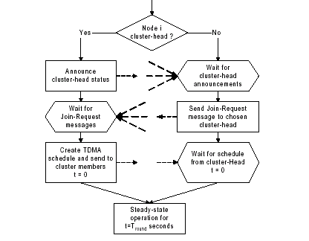
Figure 3-3: Flow-graph of the distributed cluster formation algorithm for LEACH.

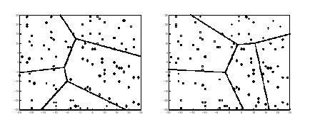
Figure 3-4: Dynamic cluster formation during two different rounds of LEACH. All nodes marked
with a given symbol belong to the same cluster, and the cluster-head nodes are marked with *.

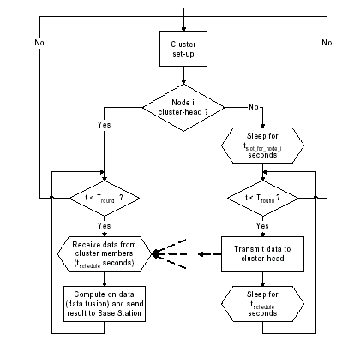

Figure 3-5: Flow-graph of the steady-state operation for LEACH.

3.3. MULTIPLE CLUSTERS
The preceding discussion describes how the individual clusters communicate among nodes in that cluster. However, radio is inherently a broadcast medium. As such, transmission in one cluster will affect (and hence degrade) communication in a nearby cluster. To reduce this type of interference, each cluster communicates using different CDMA codes. Thus, when a node decides to become a cluster-head, it chooses randomly from a list of spreading codes. It informs all the nodes in the cluster to transmit using this spreading code. The cluster-head then filters all received energy using the given spreading code. Thus neighboring clusters’ radio signals will be filtered out and not corrupt the transmission of nodes in the cluster. Efficient channel assignment is a difficult problem, even when there is a central control center that can perform the necessary algorithms. Using CDMA codes, while not necessarily the most bandwidth efficient solution, does solves the problem of multiple-access in a distributed manner.

3.4. HIERARCHICAL CLUSTERING
LEACH can be extended to form hierarchical clusters. In this scenario, the cluster-head nodes would communicate with “super cluster-head” nodes and so on until the top layer of the hierarchy, at which point the data would be sent to the base station. For larger networks, this hierarchy could save a tremendous amount of energy.

CHAPTER 4

SCOPE OF IMPROVEMENT IN LEACH PROTOCOL

4.1. INTRODUCTION
As mentioned earlier the objective of this dissertation is to design an efficient communication protocol for sensor networks, adaptable to dynamic network characteristics like non-uniform or dynamic energy distribution among the sensor nodes and the changing network configurations. The LEACH protocol, which has been described in the previous chapter, has been used as a baseline for the target protocol. some changes, modifications and enhancements have been made in the basic LEACH protocol to deal with its severe shortcomings with respect to handling of node‘s non-uniform and time variant energy distribution and other sensor network challenges.

4.2. ADVANTAGES OF THE LEACH PROTOCOL
There are strong motivations behind selecting the LEACH as a baseline for our target protocol. It has been a landmark in the search for efficient protocols for sensor networks. Its major contributions towards solving the sensor network challenges are:

- The LEACH protocol assumes all the nodes to be similar in their capabilities and doesn’t require the cluster head nodes to be more efficient than the others in any respect. As such it provides a fairly generic network and protocol architecture which makes it relevant to a majority of sensor network applications.
- It successfully distributes the energy load over all the nodes of the sensor network by dynamically rotating the cluster-head functionality among the nodes.

- It makes the cluster-head decision and selection process truly distributed without requiring a central arbitrator for these decisions.

- It makes the data aggregation strategy integrated with the basic protocol. This strategy goes a long way in making a judicious use of the node energies and avoids the inefficiencies associated with data replication.

- It proposes CDMA codes as a viable solution to the problem of interference between the signals propagating in neighboring clusters.

4.3. DISADVANTAGES OF THE LEACH PROTOCOL
- Failure of cluster-head is a problem.

- The LEACH protocol has no provisions to be functional in face of mobile nodes. Moving nodes mean that they can migrate from one cluster area to another, but according to the original LEACH protocol, in this scenario the node loses all communication to other nodes or the base station till it is accommodated in a new cluster during the next cluster selection phase.

- It assumes that the energy of all the nodes is same and remains so with time, further assuming that the energy usage patterns across the network are identical as the cluster-head activity is rotated among the nodes. These assumptions are too much restricting, and on relaxing these assumptions the LEACH protocol is found wanting as the decision of becoming a cluster head is totally unrelated to the residual energy of a node. Thus, nodes with little energy are as likely to become cluster heads as the nodes with abundance of energy. This will make the energy deficient nodes to die down fast and will gradually render the network useless even though there might be numerous nodes still having enough energy to be functional.

- It addresses only a single and very simple communication scenario, where each node needs to communicate only with the base station. But, in various sensor network applications, other communication scenarios can also be visualized where a node might need to communicate with another node, a group of nodes lying within a particular geographical region within the network, or to all the nodes of the network.

- It doesn’t deal with the addressing and localization issues. Integrating these issues with the basic communication protocol can lead to immense advantages and synergies.

In the proposed protocol, some of the limitations of the LEACH protocol are addressed and provided solutions for in addition to other innovations.

4.4. NEW PROPOSALS TO ENHANCE THE LEACH PROTOCOL
In the rest of this chapter, the modifications and enhancements to the LEACH protocol and some innovations are discussed which are ultimately incorporated into the design of the target protocol as described in the next chapter.

4.4.1. Changes Proposed in Cluster Setup Phase to handle Non-Uniform Energy Distribution
In LEACH, probability of becoming a cluster-head is based on the assumption that all nodes start with an equal amount of energy, and that all nodes have data to send during each frame. If nodes begin with different amounts of energy (or an event-driven model is used, whereby nodes only send data when some event occurs in the environment), the nodes with more energy should be cluster-heads more often than the nodes with less energy, in order to ensure that all nodes die at approximately the same time. This can be achieved by setting the probability of becoming a cluster-head as a function of a node's energy level relative to the aggregate energy of the cluster in the network, rather than purely as a function of the number of times the node has been cluster-head:

Probability of becoming cluster-head = Energy of the node/Energy of the cluster

4.4.2. Changes proposed in Data Transmission phase
Since failure of cluster-head is a big problem in LEACH protocol and chances of its failure are more in data transmission phase, because this phase involves more energy dissipation compared to other phases in LEACH. So a method should be evolved where failure of cluster-head can be conveyed to its cluster members, which will help in saving a lot of energy of its cluster members. So here the idea is that when during data transmission phase all members of clusters send data to their respective cluster-head then individual cluster-head will check if the energy required to transfer a aggregated data to base station is more than what it currently has, if this is true then first it will broadcast a “CLUSTER_HEAD_DOWN” message to all its members and then transmit a amount of aggregated data depending upon it’s energy left. On receiving “CLUSTER_ HEAD_DOWN” message all the members of cluster head will stop transmitting their data towards cluster-head until next cluster head election takes place. This is how they can prevent wastage of their energy on cluster-head’s death. Also note that in this case we have assumed that all members of a cluster will keep their receiver on during data transmission phase.

CHAPTER 5

ENHANCED-LEACH PROTOCOL ARCHITECTURE

5.1. INTRODUCTION
In this chapter, the complete details of the new proposed protocol are described. We call the new protocol as the ENHANCED-LEACH (En-LEACH) protocol as the enhancements and innovations devised in this protocol have following objectives:
- To handle cluster-head failure
- To account for the non-uniform and dynamic residual energy of the nodes

5.2. EN-LEACH ALGORITHM DETAIL
Protocol rounds are repeated with a periodicity Tr, with each round consisting of the following phases.

5.2.1. Advertisement phase
The first round (i.e. round number zero) is started by each node calculating Threshold value ( or probability to become cluster-head) using same method as used in LEACH protocol and comparing the threshold value with random no (0 to 1) selected by the node. If the threshold value is greater than the random number chosen then the node becomes the cluster-head for this round. Hence the probability of becoming cluster-head in round zero is given as:
P(n) = p/(1-(p*(r mod 1/p)))

Here p indicates optimum number of cluster-head in a round ( 5 % as suggested by LEACH) and r denotes round number.

So in the round zero each node’s probability to become cluster-head can be re-written as:

P(n) = p ; since for r = 0 , r mod 1/p is equal to 0

But during other than first round the cluster-head is selected based on the residual energy left in node. Actually during Data Transmission phase of each round every member sends data along with information regarding its residual energy to their cluster-head and based on the information the cluster-head decides which node will become the future cluster head. This is done by calculating the probability of becoming cluster head as a function of node energy divided by total energy of the cluster.

P(n) = Energy of node/Total energy of the cluster

The above calculated probability is conveyed by each cluster-head to their cluster members after completion of Data Transmission phase. So that when the next round will start each node can decide whether they can become the cluster-head by comparing their P(n) with selected random number( 0 to 1).
if P(n) > random number(0 to 1) then the node becomes cluster head for this round else not. So the whole idea is summarized in below flow diagram Figure 5-1:
If
Round
Equal to zero
Yes
No

P(n)=p
Where p indicates optimum no of cluster-heads
P(n) = (Energy of node/
Total energy of cluster)
if P(n)> rand(0 - 1)
No
Yes
Node is cluster-head for this round
Node is not cluster-head for this round

Figure 5-1 : Cluster-head decision in En-LEACH protocol

Each node that has elected itself a cluster-head for the current round broadcasts an advertisement message to the rest of the nodes. For this “cluster-head-advertisement” phase, the cluster-heads use a CSMA MAC protocol, and all cluster-heads transmit their advertisement using the same transmit energy. The advertisement message contains the following fields:
- The advertisement message flag ADVERTISE_MESSAGE
- Cluster-head id
- Cluster-head location

After this phase is complete, each non-cluster-head node decides the cluster to which it will belong for this round. This decision is based on the received signal strength (RSSI) of the advertisement. Assuming symmetric propagation channels, the cluster-head advertisement heard with the largest signal strength is the cluster-head to whom the minimum amount of transmitted energy is needed for communication i.e. shortest distance of communication . In the case of ties, a random cluster-head is chosen.

A non-cluster-head node would receive advertisement messages from multiple cluster-head nodes. It would select the cluster-head with the maximum RSSI as its cluster-head.

When a node decides to become a cluster-head, it chooses randomly from a list of spreading codes. In the schedule creation phase, it informs all the nodes in the cluster to transmit using this spreading code. The cluster-head then filters all received energy using the given spreading code.

5.2.2. Cluster Set-up Phase
After each node has decided to which cluster it belongs, it must inform the cluster-head node that it will be a member of the cluster. Each node transmits this information back to the cluster-head again using a CSMA MAC protocol through a message we call the selection message. The contents of the selection message are:
- The selection message flag CLUSTER_SELECT_MESSAGE
- Cluster-head identity
- Self node id

5.2.3. Schedule Creation Phase
The cluster-head node receives all the messages for nodes that would like to be included in the cluster. Based on the number of nodes in the cluster, the cluster-head node creates a TDMA schedule telling each node when it can transmit. This schedule is broadcast back to the nodes in the cluster along with the CDMA spreading code to be used for data transmissions within the cluster.

The schedule creation broadcast message consists of the following fields:
- The schedule message flag SCHED_MESSAGE
- The CDMA spreading code to be used for communications within the cluster
- The TDMA schedule consisting of N number of {node-identity(node_id) – TDMA time-slot} pairs

5.2.4. Data Transmission Phase or Steady-state Phase
Once the clusters are created and the TDMA schedule is fixed, data transmission can begin. If the nodes have data to send, they send it during their allocated transmission time to the cluster head. The cluster-head node must keep its receiver on to receive all the data from the nodes in the cluster. Also in this case each member node must keep their receiver on to receive cluster-head status.

A data message which is sent to cluster-head consists of the following fields:
- The Data message flag DATA_MESSAGE
- Identity of the source node n
- Cluster-head id
- Residual energy left in node n ,E(n)
- The actual data if any

When all the data has been received, the cluster head node performs signal processing functions to compress the data into a single signal. Then cluster-head checks if its energy is greater then what is required to send the aggregated data to base station plus sending cluster-head status to all its members.
If the energy is greater, then it just sends the aggregated data to base station. Otherwise (if energy is less or equal to the amount needed to send the aggregated data to base station plus sending cluster-head status to all its members) cluster-head will send the CLUSTER_HEAD_DOWN status to all its members.
The cluster-head status message contain following field:
- The message flag CLUSTER_HEAD_DOWN
- The cluster-head id
- The probability of becoming cluster-head for each node i.e. (P(n) , node id) pair.
Where P(n) = Energy of the node/total energy of the cluster
On receiving this message all member of the cluster will stop transmitting the data until next round begins.

5.2.5. Future Cluster-head Update Phase
If the cluster-head is alive even after data transmission phase then it can update the probability of each of its members becoming future cluster head by sending following update message:
- The message flag CLUSTER_UPDATE_MESSAGE
- Cluster-head id (it’s own id)
- Probability of each of its members { node id(n), P(n)} in pair.
The all states of the newly proposed algorithms are summarized with the flow graph Figure5-2.

Node cluster-head?
Yes
No
Announce cluster-head status
Wait for cluster-head announcement aaaannouncement
Wait for join-request
Send join-request to chosen cluster-head
Create TDMA schedule and send to cluster members
Wait for schedule from cluster-head
Steady-state operation for t = Tsteady-state
Calculate probability of each node to become cluster-head and send to each member
Steady-state operation for t = Tsteady-state
Wait for receiving probability to become next round cluster-head
Next round

Figure 5-2: Flow-graph of the distributed cluster formation algorithm for En-LEACH.

CHAPTER 6

SIMULATION METHODOLOGY

6.1. INTRODUCTION TO SIMULATION MODELS
In order to compare different protocols, it is important to have good models for all aspects of communication. This section describes the models that were used for communication energy dissipation, energy distribution among nodes and network topology.

6.1.1. Radio Energy Dissipation Model
A simple model is assumed where the radio dissipates E_{elec} = 50 nJ/bit to run the transmitter or receiver circuitry and є_{amp} = 100 pJ/bit/m² for the transmit amplifier to achieve an acceptable SNR. These parameters are slightly better than the current state-of-the-art in radio design. We also assume an r² energy loss due to channel transmission (see figure 6-1). Thus, to transmit a k-bit message a distance d using our radio model, the radio expends:
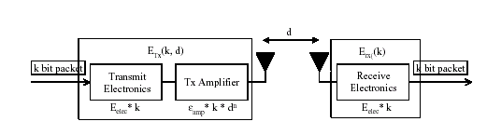
Figure 6-1: Radio energy dissipation model.

E_{Tx}(k, d) = E_{Tx-elec}(k, d) + E_{Tx-amp}(k, d)

=> E_{Tx}(k, d) = E_{elec} * k + є_{amp} * k * d²

and to receive this message, the radio expends:

E_{Rx}(k) = E_{Rx-elec}(k)

=> E_{Rx}(k) = E_{elec} * k

For these parameter values, receiving a message is not a low cost operation; the protocols should thus try to minimize not only the transmit distances but also the number of transmit and receive operations for each message.

We make the assumption that the radio channel is symmetric such that the energy required to transmit a message from node A to node B is the same as the energy required to transmit a message from node B to node A for a given SNR [6, 7]

6.1.2. The Node-Energy Model
At the initialization all nodes other than base station have been assumed to have energy E(n) , which is uniformly distributed between E(max) and E(min).
- In case of uniform energy distribution E(max) and E(min) both are equal to 20J.
- In case of non uniform energy distribution ,we assign the empirical values E(max) = 30 J and E(min)= 10 J

In addition, base station node can be designated as Energy Abundant Nodes (EANs), i.e., the nodes which are connected to some renewable energy resource whose energy is not exhausted as a result of the energy expended in the communication and computation activities in the network. For such nodes:

E(n) = infinity

6.1.3. The Network Topology Model

For the simulation purpose, we adopt a simple network topology, where the base station is located at the position BS(1000, 0) and the sensor nodes are randomly distributed within two dimensional coordinates:
Where X Co-ordinate lies between -500 to +500
And Y Co-ordinate lies between -500 to +500
Distance is in meter(m).

CHAPTER 7

RESULTS AND DISCUSSION

7.1. INTRODUCTION
Numerical results obtained for our simulation have been presented in this chapter. Now that we have the details of the En-LEACH protocol worked out and the concerns and challenges of the sensor networks dealt with, we can proceed with the most important task of simulating our protocol using our network models and getting the results to which are necessary to evaluate the performance of the protocol. The simulation tool we used for the purpose is MATLAB(version 6.5), which provides an efficient and time-tested platform, as also the obvious choice for comparing the performance of the En-LEACH protocol against that of the original LEACH protocol, as the LEACH protocol has also been simulated on MATLAB.

The major test cases simulated and presented in the theses are as follows:
- Since LEACH protocol is the base on which new proposal was build ,hence first
LEACH has been simulated and compared performance wise with a conventional communication protocol like Direct Transmission and static clustering Protocol.
- Next EN-LEACH protocol was simulated and compared performance wise with LEACH protocol both in uniform and non-uniform energy distribution scenario.

7.2. EXPERIMENTAL SET-UP
We ran wireless microsensor network simulations using MATLAB to determine the benefits of the different protocol architectures discussed in this dissertation. For all these experiments, the random, 100-node network shown in Figure 7-1 .The base station was placed at location (1000, 0). The test network parameters are shown in table 7-1.

Table 7-1. Characteristics of test network
Parameter | Value
Nodes | 100
Network size | 1000m × 1000m
Base station location | (1000, 0)
Node Energy | Based on Node Energy Model
Node position | Based on Network topology
Data size | 1000 bits
Desired percentage of cluster head | 5%
No of rounds executed | 100
No of data transmission cycle per round | 100
Compression ratio used at cluster-head during data transmission phase in case of LEACH and MEL-LEACH | 10

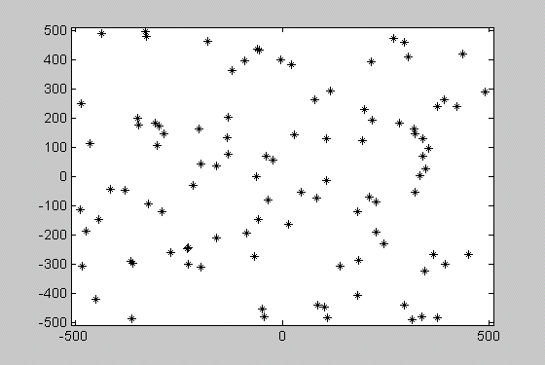

Figure 7-1: 100-node random test network. The base station is located at (1000, 0) (not shown).

7.3 SIMULATION RESULTS
For the experiments described in this section, we implemented LEACH, En-LEACH, direct transmission routing, and static clustering protocols.

7.3.1. Nodes Begins with Equal Energy
For the first set of experiments, each node (except base station) begins with equal energy i.e. 20 J of energy. We tracked the rate at which the data are transferred to the base station and the amount of energy required to get the data to the base station. Since the nodes have limited energy, they use up this energy during the course of the simulation. Once a node runs out of energy, it is considered dead and can no longer transmit or receive data. For these simulations, energy is removed whenever a node transmits or receives data.

7.3.1.1. Test case-1: LEACH vs. conventional protocols
It is very much clear from the results shown in Figure 7-2 (a), 7-2(b), 7-2(c) and 7-2(d) that LEACH performs far better as compared to direct transmission and static clustering protocols as far as lifespan of sensor networks is considered. It is evident from figure 7-3(a), 7-3(b) and 7-3(c) that in case of direct transmission protocol ,since all nodes are involved in direct transmission of sensed data irrespective of their distance from base station.
Hence nodes which are very far from base station are first one to die. Also since for each node, average distance for data transmission is more compared to LEACH protocols, hence overall lifespan of the system in case of direct transmission is less as compared to LEACH protocol. Similarly in case of static clustering protocol though the average distance for data transmission for each node is same as LEACH protocol, but it is also true that cluster-head nodes need to transfer more data to base station, so it involves high energy. Moreover in static clustering protocol cluster-head are fixed for life time, hence once a cluster-head dies all its member nodes will not be able to transmit data to base station. So it is evident form the results that the lifespan of sensor networks in case of static clustering protocol is very small compared to LEACH protocol.

So the whole experimental results are summarized as follows:
- The first node death in LEACH occurs over 8 times later than the first node death in direct transmission and static clustering protocol.
- Similarly the last node death in LEACH occurs over 8 times later than the last node death in direct transmission and static clustering protocol.
Hence LEACH outperforms all conventional protocol as far as system lifetime is concerned. The results are almost matches with earlier research in LEACH protocol [6].

73.1.2. Test case-2: LEACH vs. En-LEACH
It is evident after comparing the system lifetime graphs (figure 7-2(c) ,7-2(d)) of both LEACH as well as En-LEACH that En-LEACH is better than LEACH as far as system life time of sensor network is considered.
The results can be summarized as follows:
- The first death in En-LEACH occurs at round 38, whereas in case of LEACH the first node dies at round 22, hence first node death is approximately 2 times later than the LEACH protocol.
- Also the last node death in En-LEACH occurs much later than the last node death in case of LEACH.
Hence the new proposed En-LEACH outperforms LEACH as far as system life time is concerned.

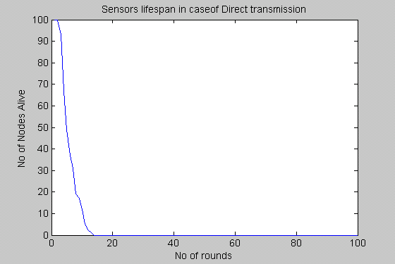
Figure 7-2(a) System lifetime using direct transmission protocol

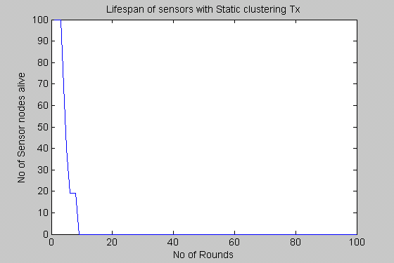
Figure 7-2(b) System lifetime using static clustering protocol

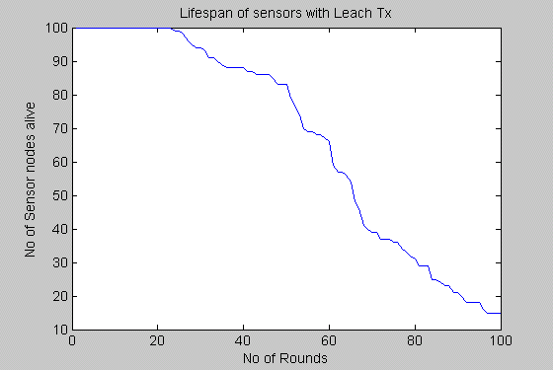
Figure 7-2(c) System lifetime using LEACH protocol (equal energy case)

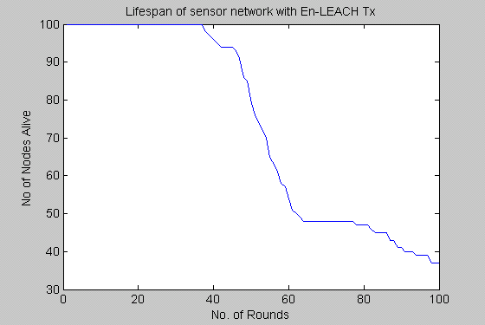
Figure 7-2(d) System lifetime using En-LEACH protocol (equal energy case)

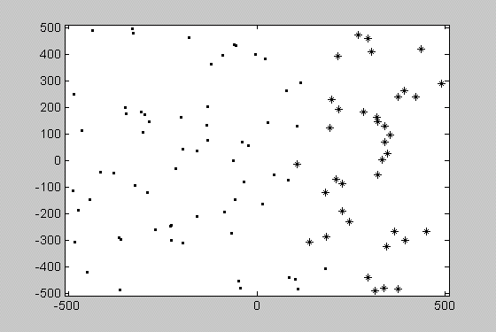
Figure 7-3(a) Sensors that remain alive (+ sign) and those that are dead (dots) after 6 round for direct transmission protocol
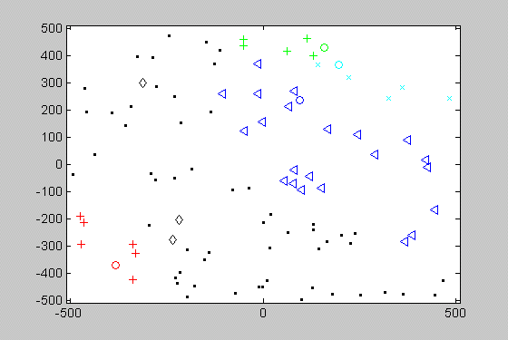
Figure 7-3(b) Sensors that remain alive (other than dot sign) and those that are dead (dots) after 6 round for static clustering protocol. Clusters are indicated using different color.
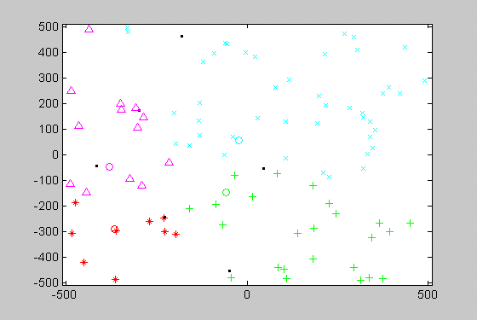
Figure 7-3(c) Sensors that remain alive (other than dot sign) and those that are dead (dots) after 31 round for LEACH protocol. Clusters are indicated using different colors.
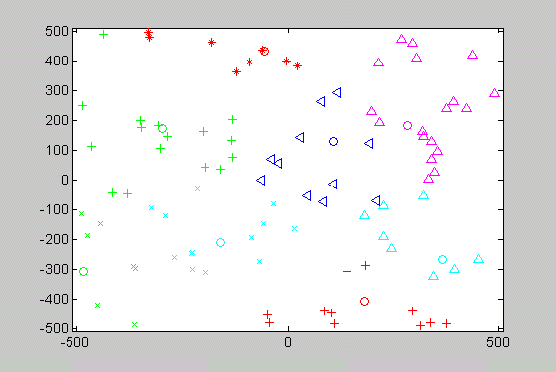
Figure 7-3(d) Sensors that remain alive (other than dot sign) and those that are dead (dots) after 31 round for En-LEACH protocol. Clusters are indicated using different colors

7.3.2. Nodes Begins with Unequal Energy (Non-uniform Energy Distribution case)
For this experiment node begins with non-uniform energy distribution where energy of each node (except base station) is uniformly distributed E(max) =30 J and E(min)=10 J. Also base station is assumed to having infinite energy. Since the nodes have limited energy, they use up this energy during the course of the simulation. Once a node runs out of energy, it is considered dead and can no longer transmit or receive data. For these simulations, energy is removed whenever a node transmits or receives data.

7.3.2.1. Test Case: En-LEACH vs. LEACH Protocol
After analyzing system lifetime graphs of En-LEACH and LEACH as shown in figure 7-4(a) and 7-4 (b), it is evident that En-LEACH outperforms LEACH as far as system lifetime of sensor network is concerned. Since LEACH was proposed assuming each sensor node is having equal energy. But after one or more round ,the nodes energy do not remain equal ,since variable amount of energy is consumed by each nodes depending upon whether it is cluster-head or not. Moreover in real scenario even each non cluster nodes consumes unequal amount of energy depending upon the amount of data sensed from environment. So in case of LEACH, there may be a case when cluster-head chosen is having less amount of energy as compared to its cluster member nodes ,which will result in early death of cluster-head. But since in case of En-LEACH we have chosen cluster-head depending upon energy left in the node, hence it is bound to perform better than LEACH. Also in case of En-LEACH all cluster members are kept informed about the status of their cluster-head (whether it is alive or dead), since the probability of failure of cluster-head is high during data transmission phase (as energy involved in case of cluster-head is much higher due to large amount of data aggregation and long distance data transmission). Hence lot of energy can be saved if cluster nodes are informed about the any sudden death of their cluster-head during steady state phase, since they will stop transmitting as soon as they are informed about the death status of their cluster-head ,which will lead to lot of energy saving. This provision is missing in LEACH protocol.

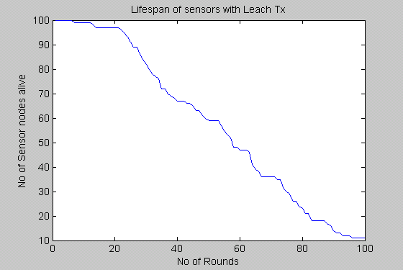
Figure 7-4(a) System lifetime using LEACH protocol (non-uniform energy distribution case)

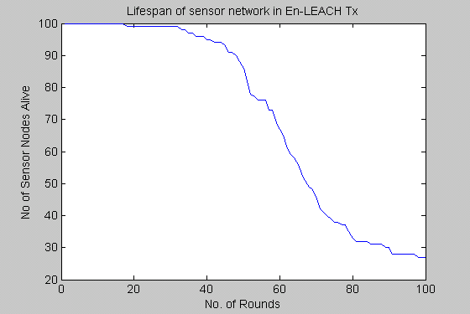
Figure 7-4(b) System lifetime using En-LEACH protocol (non-uniform energy distribution case)

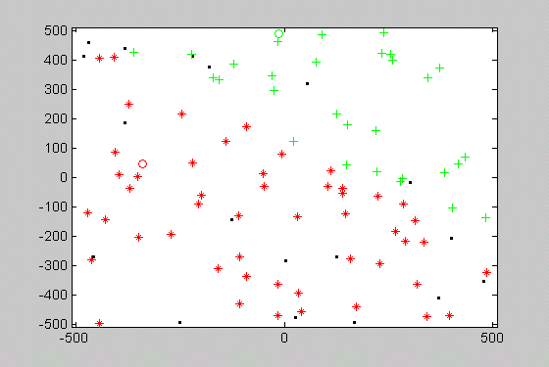
Figure 7-4(c) Sensors that remain alive (other than dot sign) and those that are dead (dots) after 31 round for LEACH protocol. Clusters are indicated using different colors (non-uniform energy distribution case).
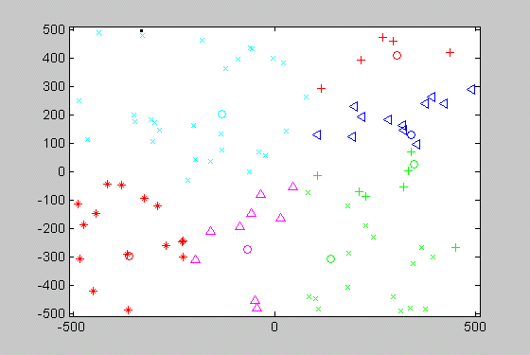
Figure 7-4(c) Sensors that remain alive (other than dot sign) and those that are dead (dots) after 31 round for En-LEACH protocol. Clusters are indicated using different colors (non-uniform energy distribution).
The experimental result in case of non-uniform energy distribution case is summarized as follows:
- The first death in En-LEACH occurs at approximately 2 times later than the first node death in case of LEACH protocol.
- Also the last node death in En-LEACH occurs much later than the last node death in case of LEACH.
Hence the new proposed En-LEACH outperforms LEACH both in uniform and non-uniform energy distribution case as far as system life time is concerned.

CHAPTER 8

CONCLUSIONS

8.1. WORK DONE
First we studied the functionality of LEACH protocol along with other conventional protocol like direct transmission, MTE and static clustering protocol. Then we selected LEACH protocol as the baseline for my theses. There were strong reasons behind selection of LEACH protocol since it has been a landmark in the search of energy efficient protocol in sensor networks. Then all communication protocol like direct transmission, static clustering and LEACH protocol have been implemented and simulated in MATLAB Simulator (version 6.5). All the above protocols have been graphically compared as far as their nodes lifespan is concerned. Then a new scheme (En-LEACH) to improve sensor nodes lifespan has been proposed and simulated.

Following conclusion can be drawn from the study and simulation:
- En-LEACH is more effective since it is designed to exploit the application of sensor networks; producing high level information about the environment the nodes are monitoring in an energy-efficient way.
- Also En-LEACH is able to handle non-uniform energy distribution of sensor nodes which is an important characteristic of a dynamic sensor networks.

8.2. SUGGESIONS FOR FUTURE WORK
In our simulation the sensor nodes are assumed to be static in their position but in some sensor network applications, nodes can be mobile in nature. Also we have assumed that all nodes know their position in advance without considering how?. Hence in future work we can add mobility and localization feature into this protocol.
In our simulations, we modeled the energy dissipated when a node communicates data. In addition to the energy dissipated while the radio is transmitting and receiving, a node will dissipate static energy while they are idle or they are computing data. Nodes are often described as being in one of the following states: sleep, idle, or active. If the node is in the sleep state, the radio and processor are turned off and only the sensor module is active. In this state, the node dissipates Psleep . In the idle state, all modules are turned on and are ready to perform but not currently processing data or radio signals. The power dissipated in this state is Pidle . Finally, the node is in the active mode if it is transmitting, receiving, or computing on data. The power dissipated in this state is equal to the idle power plus the power required to perform the function.
Therefore,
P_{Rx_active} = P_{idle} + P_{Rx} = P_{idle} + E_{Rx(l)Rb}
P_{Tx_active} = P_{idle} + P_{Tx} = P_{idle} + E_{Tx(l, d)Rb}
P_{compute_active} = P_{idle} + P_{compute} = P_{idle} + E_{compute(l)Rb}

Using this static power dissipation model, protocols that allow nodes to remain in the sleep state as long as possible obtain a large advantage over protocols that do not (e.g., TDMA allows nodes to go to sleep whenever they are not transmitting data, whereas FDMA requires nodes be on at all times, transmitting at a lower rate) [7].
Also in a large, distributed network, it may be advantageous to have the cluster-head nodes form a multi-hop backbone to get data from the cluster-head nodes to the base station. In this case, aggregate signals would be sent along a pre-determined route until they reached the base station. This may save energy by reducing the long-distance transmissions between far-away cluster-head nodes and the base station.

REFERENCES & BIBLIOGRAPHY

- Malik Tubaishat and Sanjay Madria. Sensor networks: an overview. In IEEE Potentials, April/May 2003, Pages: 20–23
- Deborah Estrin, David Culler, Kris Pister and Gaurav Sukhatme. Connecting the Physical World with Pervasive Networks. In IEEE Pervasive Computing, Volume 1, Issue 1 (January 2002), Pages: 59–69.
- Berkeley, University of California, 800 node self-organized wireless sensor network. 2001: http://today.cs.berkeley.edu/800demo/
- System Architecture for Wireless Sensor Networks: http://www.jlhlabs.com/jhill_cs/jhill_thesis.pdf.
- McMahan, M.L., Evolving Cellular Handset Architectures but a Continuing,
Insatiable Desire for DSP MIPS. 2000, Texas Instruments Incorporated.
- Wendi Rabiner Heinzelman, Anantha Chandrakasan, and Hari Balakrishnan. Energy-Efficient Communication Protocol for Wireless Microsensor Networks. In Proceedings of the Hawaii International Conference on System Sciences, January 4-7, 2000, Maui, Hawaii.
- Wendi Rabiner Heinzelman, Anantha Chandrakasan, and Hari Balakrishnan , An Application-specific Protocol Architecture for Wireless Microsensor Networks ,in IEEE transaction on wireless communications ,vol-1, no-4, October 2002. http://www.sigmobile.org/phd/2000/thesis/heinzelman.pdf.
- M. Bhardwaj and A. Chandrakasan. Power Aware Systems, presented at the 34th Asilomar Conference on Signals, Systems and Computers, November 2000.
- X. Lin and I. Stojmenovic. Power-Aware Routing in Ad Hoc Wireless Networks. In SITE, University of Ottawa, TR-98-11, Dec. 1998.
- J. Broch, D. Maltz, D. Johnson, Y. Hu, and J. Jetcheva. A Performance Comparison of Multi-Hop Wireless Ad Hoc Netowrk Routing Protocols. In Proc. 4th ACM International Conference on Mobile Computing and Networking (Mobicom'98), October 1998.
- V. Garg and J. Wilkes. Wireless and Personal Communications Systems. Prentice Hall PTR, New Jersey, 1996.
- K. Pahlavan and A. Levesque. Wireless Information Networks. John Wiley & Sons, Inc., New York, 1995.
- A Survey of Routing Protocols for Wireless Sensor Networks: http://www.cs.umbs.edu/kemall/mypapers/Akkaya_Younis_JoAsHocRevised.pdf
- Intanagonwiwat, C., R. Govindan, and D. Estrin, Directed Diffusion: A Scalable and Robust Communication Paradigm for Sensor Networks. 2000: Mobile Computing and Networking.
- Perkins, C., Ad-hoc on-demand distance vector routing. MILCOM, 1997.
- Wendi Rabiner Heinzelman, Joanna Kulik and Hari Balakrishnan. Adaptive protocols for information dissemination in wireless sensor networks. In Proceedings of the 5th annual ACM/IEEE international conference on Mobile computing and networking, Seattle, Washington, United States, 1999, Pages: 174–185.
- Sensor Networks : An Overview
http://www.missouri.edu/~mma4n6/publications/IEEE03.pdf.
- Instrumenting the world with Wireless Sensor Networks :
http://www.fit.edu/~cchen/index_files/ECE5118_papers/overview/ICASSP-2001.pdf
- C.Chong and S.Kumar, Sensor Networks: Evolution, opportunities and challenges, proceeding of the IEEE, vol-91, no-8, pp.1247, 2003.
- Emerging Challenges: Mobile Networking for “ Smart Dust”
http://www-ee.stanford.edu/~jmk/pubs/jcn.00.pdf

