ABSTRACT
Both tap-changer transformers and static VAR compensators can contribute to power systems voltage stabilities. Combining these two methods is the subject of this thesis. Effect of the presence of tap-changing transformers on static VAR compensator controller parameters and ratings required to stabilize load voltages at certain values are highlighted. The interrelation between transformer off nominal tap ratios and the SVC controller gains and droop slopes and the SVC rating are found. For any large power system represented by its equivalent two nodes system, the power/voltage nose curves are found and their influences on the maximum power/critical voltage are studied.
Several studies have shown that transformers with automatic tap-changing can be used for improvement of voltage stabilities, for both steady-state and transient voltage stabilities. Some of these studies were interested in proposing, new models for tap-changing transformer on the other hand, static VAR compensator is used for improvement of voltage stabilities due to lines opening in the presence of induction motor or due to recoveries of short-circuit at induction motor terminals or due to heavy load abilities or due to high impedance corridors due to switching of parallel circuits.
This is the main aim of the thesis, effects of tap-changing transformers alone forms the first part of this thesis, static VAR compensator (SVC) effects alone is given in another study. The influence of the tap-changing transformer on compensator gains, reference voltage values and ratings are given in detail. The studied system represents any large system seen from the load node under consideration.
Static VAR compensator rating and controller references and gains are found in order to stabilize load voltage at certain specified values. Interaction between these two means parameters are highlighted.

CHAPTER-1 INTRODUCTION
Most if not all of the worlds electric power supply systems are widely connected, involving connections inside utilities own territories which extend to inter-utility interconnections and then to inter-regional and international connections. This is done for economic reasons, to reduce the cost of electricity and to improve reliability of power supply. We need these interconnections because, apart from delivery, the purpose of the transmission network is to pool power plants and load centers in order to minimize the total power generation capacity and fuel cost. Worldwide transmission systems are undergoing continuous changes and restructuring due to steady growth in demand for electric power, much of which has to be transmitted over long distances. However, public concern over the environmental impact of power generation and transmission, coupled with problems related to cost and right-of-way issues, have hindered the addition of new plants to meet this increased demand. Moreover, in today scenario power systems are more difficult to operate, reason behind this is deregulation issues which requires an open access power delivery system which enable power delivery within and between the regions, facilitate access to interconnected competitive generation, little or no market based incentives for transmission investment & the other one reliability, security and stability issues. These trends have led to extensive research interest in flexible ac transmission systems (FACTS), with the aim of developing new devices and technologies to control the flow of power, so as to allow more efficient usage of existing power generation and transmission power plants. The FACTS technology opens up new opportunities for controlling power and enhancing the usable capacity of present, as well as new and upgraded lines .These opportunities arise through the ability of FACTS controllers to control the interrelated parameters that govern the operation of transmission system including series impedance, current, voltage, phase angle and the damping of oscillations.

The focus of this thesis and research is on the application of Static VAR Compensator with tap-changing transformer to solve voltage regulation and power transfer capabilities. SVC is a mature thyristor based controller that provides rapid voltage control to support electric power transmission voltages during and immediately after major system disturbances. Since the advent of deregulation and the separation of generation and transmission systems in the electric power industry, voltage stability and reactive power-related system restrictions have become an increasingly growing concern for electric utilities. With deregulation came an “open access” rule to accommodate competition that requires utilities to accept generation and load sources at any location in the existing transmission system. This “open access” structure has challenged transmission owners to continually maintain system security, while at the same time trying to minimize costly power flow congestion in transmission corridors. When voltage security or congestion problems are observed during the planning study process, cost effective solutions must be considered for such problems. Traditional solutions to congestion and voltage security problems were to install new costly transmission lines that are often faced with public resistance, or mechanically-switched capacitor banks that have limited benefits for dynamic performance due to switching time and frequency. One approach to solving this problem is the application of “Flexible AC transmission System” (FACTS) technologies, such as the Static VAR Compensator (SVC). FACTS technologies are founded on the rapid control response of thyristor-based reactive power controls. Over the last several years, there were numerous installations of FACTS in the United States and around the world. FACTS have proven to be environmental friendly and cost effective solutions to a wide range of the power system needs. FACTS have given utilities the option to delay new transmission line construction by increasing capacity on existing lines and compensation of the system voltages. FACTS controllers are available in different forms such as static VAR compensators (SVCs), thyristor controlled series capacitors (TCSCs), static reactive compensators (STATCOMs), and unified power flow controllers (UPFCs).

  - VOLTAGE STABILITY
Voltage stability is a problem in power systems which are heavily loaded, faulted or have a shortage of reactive power. The nature of voltage stability can be analysed by examining the production, transmission and consumption of reactive power. The problem of voltage stability concerns the whole power system, although it usually has a large involvement in one critical area of the power system.
This chapter describes the voltage stability phenomena. First voltage stability, voltage instability and voltage collapse are defined and the aspects of voltage stability are classified. Then a short ex ample of maximum transfer capacity is described. After that an introduction to the stability of non-linear system is given. Then the modelling and the effect of power system components in the long-term voltage stability studies are described. The modelling and the effect of following components are considered: synchronous generator, automatic voltage controller, load, on-load tap changer, thermostatic load, and compensation devices. The scenario of classic voltage collapse is also presented to describe the problem.

    - DEFINATION AND CLASSIFICATION OF VOLTAGE STABILITY

1.1.1(a) Definition of voltage stability, voltage instability and voltage collapse

Power system stability is defined as a characteristic for a power system to remain in a state of equilibrium at normal operating conditions and to restore an acceptable state of equilibrium after a disturbance. Traditionally, the stability problem has been the rotor angle stability, i.e. maintaining synchronous operation. Instability may also occur without loss of synchronism, in which case the concern is the control and stability of voltage.

“The voltage stability is the ability of a power system to maintain steady acceptable voltages at all buses in the system at normal operating conditions and after being subjected to a disturbance.”

Power system is voltage stable if voltages after a disturbance are close to voltages at normal operating condition. A power system becomes unstable when voltages uncontrollably decrease due to outage of equipment (generator, line, transformer, bus bar, etc.), increment of load, decrement of production and/or weakening of voltage control. According to reference the definition of voltage instability is “Voltage instability stems from the attempt of load dynamics to restore power consumption beyond the capability of the combined transmission and generation system.” Voltage control and instability are local problems. However, the consequences of voltage instability may have a widespread impact. Voltage collapse is the catastrophic result of a sequence of events leading to a low-voltage profile suddenly in a major part of the power system.

Voltage stability can also called “load stability”. A power system lacks the capability to transfer an infinite amount of electrical power to the loads. The main factor causing voltage instability is the inability of the power system to meet the demands for reactive power in the heavily stressed systems to keep desired voltages. Other factors contributing to voltage stability are the generator reactive power limits, the load characteristics, the characteristics of the reactive power compensation devices and the action of the voltage control devices. The reactive characteristics of AC transmission lines, transformers and loads restrict the maximum of power system transfers. The power system lacks the capability to transfer power over long distances or through high reactance due to the requirement of a large amount of reactive power at some critical value of power or distance. Transfer of reactive power is difficult due to extremely high reactive power losses, which is why the reactive power required for voltage control is produced and Consumed at the control area.

1.1.1(b) Classification of power system stability

Power system stability is classified above as rotor angle and voltage stability. A classification of power system stability based on time scale and driving force criteria is presented in Table 1.1. The driving forces for an instability mechanism are named generator-driven and load-driven. It should be noted that these terms do not exclude the affect of other components to the mechanism. The time scale is divided into short and long-term time scales.

TABLE1.1 CLASIFICATION OF POWER SYSTEM STABILITY
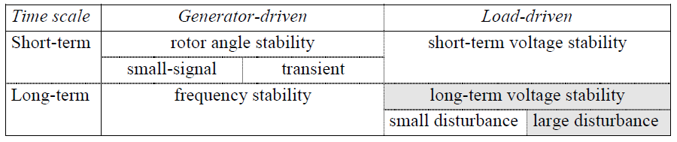

The rotor angle stability is divided into small-signal and transient stability. The small-signal stability is present for small disturbances in the form of undamped electromechanical oscillations. The transient stability is due to lack of synchronizing torque and is initiated by large disturbances. The time frame of angle stability is that of the electromechanical dynamics of the power system. This time frame is called short-term time scale, because the dynamics typically last for a few seconds. The voltage problem is load-driven as described above. The voltage stability may be divided into short and long-term voltage stability according to the time scale of load component dynamics. Short-term voltage stability is characterized by components such as induction motors, excitation of synchronous generators, and electronically controlled devices such as HVDC and static VAR compensator. The time scale of short-term voltage stability is the same as the time scale of rotor angle stability. The modeling and the analysis of these problems are similar. The distinction between rotor angle and short-term voltage instability is sometimes difficult, because most practical voltage collapses include some element of both voltage and angle instability.

When short-term dynamics have died out sometime after the disturbance, the system enters a slower time frame. The dynamics of the long-term time scale lasts for several minutes. Two types of stability problems emerge in the long-term time scale: frequency and voltage problems. Frequency problems may appear after a major disturbance resulting in power system islanding. Frequency instability is related to the active power imbalance between generators and loads. An island may be either under or over-generated when the system frequency either declines or rises. The analysis of long-term voltage stability requires detailed modeling of long-term dynamics. The long-term voltage stability is characterized by scenarios such as load recovery by the action of on-load tap changer or through load self-restoration, delayed corrective control actions such as shunt compensation switching or load shedding. The long-term dynamics such as response of power plant controls, boiler dynamics and automatic generation control also affect long-term voltage stability. The modeling of long-term voltage stability requires consideration of transformer on-load tap changers, characteristics of static loads, manual control actions of operators, and automatic generation control. For purposes of analysis, it is sometimes useful to classify voltage stability into small and large disturbances. Small disturbance voltage stability considers the power system’s ability to control voltages after small disturbances, e.g. changes in load. The analysis of small disturbance voltage stability is done in steady state. In that case the power system can be linearised around an operating point and the analysis is typically based on eigen value and eigenvector techniques. Large disturbance voltage stability analyses the response of the power system to large disturbances e. g. faults, switching or loss of load, or loss of generation. Large disturbance voltage stability can be studied by using non-linear time domain simulations in the short-term time frame and load-flow analysis in the long-term time frame. The voltage stability is, however, a single problem on which a combination of both linear and non-linear tools can be used.

1.1.2 ANALYSIS OF POWER SYSTEM VOLTAGE STABILITY

A simple example:
The characteristics of voltage stability are illustrated by a simple example. Figure 1.1 shows a simplified two-bus test system. The generator produces active power, which is transferred through a transmission line to the load. The reactive power capability of the generator is infinite; thus the generator terminal voltage is constant. The transmission line is presented with a reactance (jX). The load is constant power load including active P and reactive Q parts.

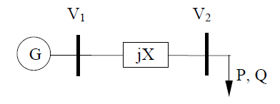
Fig 1.1 Two-bus test system
The purpose of the study is to calculate the load voltage with different values of load. The load voltage can be calculated analytically in this simple example. Generally voltages are solved with a load-flow program. The solution of Equation 1.1 is the load voltage for the load-flow equations of the example, when the voltage angle is eliminated.

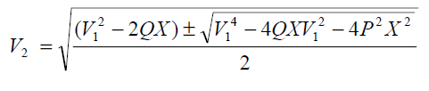
1.1
The solutions of load voltages are often presented as a PV-curve (see Figure 1.2). The PV-curve presents load voltage as a function of load or sum of loads. It presents both solutions of power system. The power system has low current-high voltage and high current-low voltage solutions. Power systems are operated in the upper part of the PV-curve. This part of the PV-curve is statically and dynamically stable. The head of the curve is called the maximum loading point. The critical point where the solutions unite is the voltage collapse point. The maximum loading point is more interesting from the practical point of view than the true voltage collapse point, because the maximum of power system loading is achieved at this point. The maximum loading point is the voltage collapse point when constant power loads are considered, but in general they are different. The voltage dependence of loads affects the point of voltage collapse. The power system becomes voltage unstable at the voltage collapse point. Voltages decrease rapidly due to the requirement for an infinite amount of reactive power. The lower part of the PV-curve (to the left of the voltage collapse point) is statically stable, but dynamically unstable. The power system can only operate in stable equilibrium so that the system dynamics act to restore the state to equilibrium when it is perturbed.
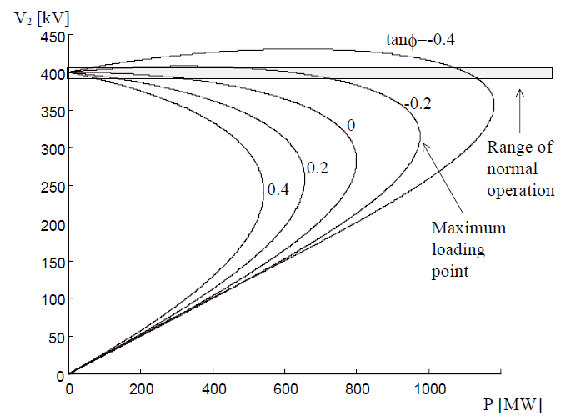
Fig-1.2 PV-curve.

Figure 1.2 presents five PV-curves for the test system (=400 kV and X =100 Ω). These curves represent different load compensation cases (tan¢=Q/P). Since inductive line losses make it inefficient to supply a large amount of reactive power over long transmission lines, the reactive power loads must be supported locally. According to Figure1.2 addition of load compensation (decrement of the value of tan¢) is beneficial for the power system. The load compensation makes it possible to increase the loading o f the power system according to voltage stability. Thus, the monitoring of power system security becomes more complicated because the critical voltage might be close to voltages of normal operation range.

The opportunity to increase power system loading by load and line compensation is valuable nowadays. Compensation investments are usually much less expensive and more environment friendly than line investments. Furthermore, construction of new line has become time-consuming if not even impossible in some cases. At the same time new generation plants are being constructed farther away from load centers, fossil-fired power plants are being shut down in the cities and more electricity is being exported and imported. This trend inevitably requires addition of transmission capacity in the long run.

  - ON-LOAD TAP-CHANGING TRANSFORMER

The automatic voltage control of power transformers is arranged with on-load tap changers. The action of tap changer affects the voltage dependence of load seen from the transmission network. Typically a transformer equipped with an on-load tap changer feeds the distribution network and maintains constant secondary voltage. When voltage decreases in the distribution system, the load also decreases. The tap changer operates after time delay if voltage error is large enough restoring the load.

The action of an on-load tap changer might be dangerous for a power system under disturbance. The stepping down of the tap changer increases the voltage in a distribution network; thus reactive power transfer increases from the transmission network to the distribution network. Figure1.3 illustrates the action of tap changer caused by a disturbance seen from the transmission network. The power system operates at point A in the pre-disturbance state. Due to the disturbance the operation point moves to point B, which is caused by decrement of secondary voltage and load dependence of voltage. The load curve represents the state of power system just after the disturbance. After a time delay the tap changer steps down to increase secondary voltage. The operation point seen from the transmission network moves along the post-disturbance PV-curve towards a maximum loading point, which causes decrement of the primary voltage. The tap changer operates until the secondary voltage reaches the nominal voltage at point D. The amount of load at points A and D is equal due to action of tap changer. The operation point D is stable, but quite closes the post-disturbance maximum loading point.

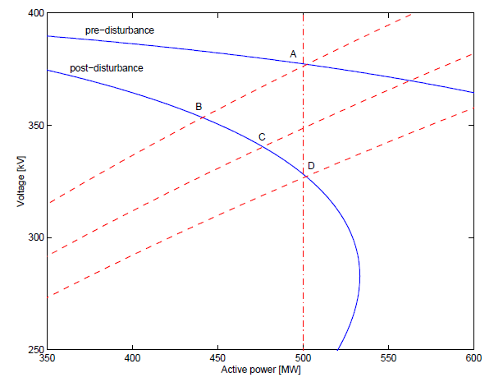
Fig-1.3. The action of on-load tap changer caused by a disturbance.

The voltage dependence of the loads can be seen when the on-load tap changer reaches the tap changer minimum limit, in which case on-load tap changer is not capable of maintaining constant secondary voltage. The step size of the on-load tap changer should also be taken into account in load-flow based long-term voltage stability studies. The restoration of load may occur although distribution network voltage is not increased to nominal or pre-disturbance value. A thermostat typically controls heating and cooling loads. The energy consumed in the thermostatic loads is constant in the long run. Although heating loads are resistive, the thermostats increase the amount of load if the decrement of load voltage is long enough. The time constants of thermostatic loads are high, which makes this phenomenon slow. The thermostatic load is modeled as constant impedance load with a long time constant. A long interruption or voltage decrement might also cause a phenomenon called cold load pick-up, where the load becomes higher than nominal value due to manual connection of additional load to compensate decreased power supply.

1.3 FACTS CONTROLLERS FOR POWER SYSTEM

Flexibility of electric power transmission is “The ability to accommodate the changes in the electric transmission system or operating conditions while maintaining sufficient steady state and transient margins.”

Flexible AC Transmission system (FACTS) is “Alternating current transmission system incorporating power electronic based and other static controllers to enhance controllability and increase power transfer capability.”

FACTS Controller is “A power electronic based system and other static equipment that provide control of one or more AC transmission system parameters.”

In general FACTS controllers can be divided in to three categories:
- shunt connected controllers
- series connected controllers
- combined shunt & series connected controllers
Key benefits of applying FACTS to eliminate transmission constraints:
- Voltage stability
- Increased loading and more effective use of transmission corridors
- Added power flow control
- Increased system security
- Increased system reliability
- Added flexibility in sitting new generation
- Elimination or deferral of the need for new transmission lines

1.3.1 SHUNT CONNECTED CONTROLLERS
By placing the shunt compensator in the middle of a line and therefore dividing the line into two segments, the voltage at this point can be controlled such that it has the same value as the end line voltages. This has the advantage that the maximal power transmission is increased. If the shunt compensator is located in the end of a line in parallel to a load it is possible to regulate the voltage at this end and therefore to prevent voltage instability caused by load variations or generation or line outages. As shunt compensation is able to change the power flow in the system by varying the value of the applied shunt compensation during and following dynamic disturbances the transient stability can be increased and effective power oscillation damping is provided. Thereby the voltage of the transmission line counteracts the accelerating decelerating swings of the disturbed machine and therefore dampens the power oscillations.

1.3.1.1 Static Synchronous Compensator (STATCOM):
A static synchronous generator operated as a shunt connected static VAR compensator whose capacitive or inductive output current can be controlled independent of the AC system voltage. STATCOM is one key FACTS Controller. It can be based on a voltage sourced or current sourced converter. From an overall cost point of view, the voltage- sourced converters seem to be preferred, and will be the basis for presentations of most converter-based FACTS Controllers. For the voltage-sourced converter, its ac output voltage is controlled such that it is just right for the required reactive current flow for any ac bus voltage dc capacitor voltage is automatically adjusted as required to serve as a voltage source for the converter. STATCOM can be designed to also act as an active filter to absorb system harmonics.

1.3.1.2 Static Synchronous Generator (SSG):
A static self commutated switching power converter supplied from an appropriate electric energy source and operated to produce a set of adjustable multiphase output voltages, which may be coupled to an ac power system for the purpose of exchanging independently controllable real and reactive power. Clearly SSG is a combination of STATCOM and any energy source to supply or absorb power. The term, SSG generalizes connecting any source of energy including a battery, flywheel, superconducting magnet, large dc storage capacitor, another rectifier/ inverter, etc. An electronic interface known as a chopper is generally needed between the energy source and the converter. For a voltage sourced converter, the energy source serves to appropriately compensate the capacitor charge through the electronic interface and maintain the required capacitor voltage.

1.3.1.3 Battery Energy Storage System (BESS):
A chemical based energy storage system using shunt connected voltage source converters capable of rapidly adjusting the amount of energy which is supplied to or absorbed from an ac system. For transmission applications, BESS storage unit sizes would tend to be small (a few tens of MWHs) and if the short time converter rating was large enough, it could deliver MWs with a high MW/MWH ratio for transient stability. The converter can also simultaneously absorb or deliver reactive power within the converters MVA capacity. When not supplying active power to the system, the converter is used to charge the battery at an acceptable rate.

1.3.1.4 Superconducting Magnetic Energy Storage (SMES):
A superconducting electromagnetic energy storage device containing electronic converters that rapidly injects or absorbs real or reactive power dynamically controls power flow in an ac system. Since the dc current in the magnet does not change rapidly, the power input or output of the magnet is changed by controlling the voltage across the magnet with a suitable electronics interface for connection to a STATCOM.

1.3.1.5 Static VAR Compensator (SVC):
A shunt connected static VAR generator or absorber whose output is adjusted to exchange capacitive or inductive current so as to maintain or control specific parameters of the electrical power system (typically bus bar voltage). This is the general term used for a thyristor-controlled or thyristor-switched reactor or thyristor-switched capacitor or combination. SVC is based on thyristor without the gate turn off capability. SVC is considered by some as a lower cost alternative to STATCOM, although this may not be the case if the comparison is made based on the required performance and not just the MVA size.

1.3.1.6 Thyristor Controlled Reactor (TCR):
A shunt connected, thyristor controlled inductor whose effective reactance is varied in a continuous manner by partial conduction control of the thyristor valve. TCR is a subset of SVC in which conduction time and hence, current in a shunt reactor is controlled by a thyristor-based ac switch with firing angle control.
1.3.1.7 Thyristor Switched Reactor (TSR):
A shunt connected thyristor-switched inductor whose effective reactance is varied in a stepwise manner by full or zero-conduction operation of thyristor valve. TSR is another subset of SVC. TSR is made up of several shunt connected inductors which are switched in and out by thyristor switches without any firing angle controls in order to achieve the required step changes in the reactive power consumed from the system. Use of thyristor switches without firing angle control results in lower cost and losses, but without a continuous control.

1.3.1.8 Thyristor Switched Capacitor (TSC):
A shunt-connected, thyristor-switched capacitor whose effective reactance is varied in a stepwise manner by full or zero conduction operation of the thyristor valve. TSC is also a subset of SVC in which thyristor based AC switches are used to switch in and out (without firing angle control) shunt capacitors unit, in order to achieve the required step change in the reactive power supplied to the system. Unlike shunt reactors, shunt capacitors cannot be switched continuously with variable firing angle control.

1.3.1.9 Static VAR Generator or absorber (SVG):
A static electrical device, equipment or system that is capable of drawing controlled capacitive and inductive current from an electrical power system and thereby generating or absorbing the reactive power. Generally considered to consist of shunt connected, thyristor controlled reactor(s) or thyristor switched capacitors. The SVG as broadly defined by IEEE, is simply a reactive power (VAR) source that, with appropriate controls can be converted in to any specific or multipurpose reactive shunt capacitor. Thus both SVC and the STATCOM are static VAR generators equipped with appropriate control loops to vary the VAR output so as to meet specific compensation objectives.

1.3.1.10 Static VAR system (SVS):
A combination of different static and mechanically switched VAR compensators whose outputs are coordinated.

1.3.1.11 Thyristor Controlled Braking Resistor (TCBR):
A shunt-connected thyristor-switched resistor, which is controlled to aid stabilization of a power system or to a minimize power acceleration of a generating unit during a disturbance. TCBR involves cycle-by-cycle switching of a resistor (usually a linear resistor) with a thyristor based ac switch with a firing angle control. For lower cost, TCBR may be thyristor switched, i.e., without firing angle control. However, with firing angle control, half-cycle by half-cycle firing control can be utilized to selectively damp low-frequency oscillations.

1.3.2 SERIES CONNECTED CONTROLLERS
The variable series compensation is highly effective in both controlling power flow in the line and in improving stability. With series compensation the overall effective series transmission impedance from sending end to the receiving end can be arbitrarily decreased. This capability to control power flow can effectively be used to increase transient stability limit and to provide power oscillation damping.

1.3.2.1 Static Synchronous Series Compensator (SSSC):
A static synchronous generator operated without an external electric energy source as a series compensator whose output voltage is in quadrature with, and controllable independently of the line current for the purpose of increasing or decreasing the overall reactive voltage drop across the line and thereby controlling the transmitted electric power. The SSSC may include transiently rated energy storage or energy absorbing devices to enhance the dynamic behavior of the power system by additional temporary real power compensation, to increase or decrease momentarily, the overall real (resistive) voltage drop across the line.

1.3.2.2 Interline Power Flow Controller (IPFC):
The combination of two or more Static Synchronous Series Compensators which are coupled via a common dc link to facilitate bi-directional flow of real power between the ac terminals of the SSSCs, and are controlled to provide independent reactive compensation for the adjustment of real power flow in each line and maintain the desired distribution of reactive power flow among the lines. The IPFC structure may also include a STATCOM, coupled to the IFFCs, common dc link, to provide shunt reactive compensation and supply or absorb the overall real power deficit of the combined SSSCs.

1.3.2.3 Thyristor-Controlled Series Capacitor (TCSC):
A capacitive reactance compensator which consists of a series capacitor bank shunted by a thyristor-controlled reactor in order to provide a smoothly variable series capacitive reactance. The TCSC is based on thyristors without the gate turn-off capability. It is an alternative to SSSC above and like an SSSC above and like an SSSC, it is a very important FACTS controller. A variable reactor such as TCR is connected across a series capacitor. When the TCR firing angle is 180 degrees, the reactor becomes non conducting and the series capacitor has its normal impedance. As the firing angle is advanced from 180 degrees to less than 180 degrees, the capacitive impedance increases. At the other end, when the TCR firing angle is 90 degrees, the reactor becomes fully conducting, and the total impedance becomes inductive, because the reactor impedance is designed to be much lower than the series capacitor impedance. With 90 degrees firing angle, the TCSC helps in limiting fault current. The TCSC may be single, large unit, or may consist of several equal or different-sized smaller capacitors in order to achieve a superior performance.

1.3.2.4 Thyristor-Switched Series Capacitor (TSSC):
A capacitive reactance compensator which consists of a series capacitor bank shunted by a thyristor-switched reactor to provide a stepwise control of series capacitive reactance. Instead of continuous control of capacitive impedance, this approach of switching inductors at firing angle of 90 degrees or 180 degrees but without firing angle control could reduce cost and losses of the controller. It is reasonable to arrange one of the modules to have thyristor control, while others could be thyristor switched.

1.3.2.5 Thyristor-Controlled Series Reactor (TCSR):
An inductive reactance compensator which consists of a series reactor shunted by a thyristor controlled reactor in order to provide a smoothly variable series inductive reactance. When the firing angle of thyristor controlled reactor is 180 degrees, it stops conducting, and the uncontrolled reactor acts as a fault current limiter. As the angle decreases below 180 degrees, the net inductance decreases until firing angle of 90 degrees, when the net inductance is the parallel combination of the two reactors. As for the TCSCs the TCSR may be single large unit or several smaller series units.

1.3.2.6 Thyristor-Switched Series Reactor (TSSR):
An inductive reactance compensator which consists of a series reactor shunted by a thyristor-controlled switched reactor in order to provide a stepwise control of series inductive reactance. This is a complement of TCSR but with thyristor switches fully on or off (without firing angle) to achieve a combination of stepped series inductive reactance.

1.3.3 COMBINED SHUNT AND SERIES CONNECTED CONTROLLERS

1.3.3.1 Unified Power Flow Controllers (UPFC):
A combination of static synchronous compensator (STATCOM) & a static series compensator (SSSC) which are coupled via a common dc link, to allow bidirectional flow of real power between the series output terminals of the SSSC and the shunt output terminals of the STATCOM, and are controlled to provide concurrent real and reactive series line compensation without an external electric energy source. The UPFC by means of angularly unconstrained series voltage injection is able to control, concurrently or selectively, the transmission line voltage, impedance and angle or alternatively the real and reactive power flow in the line. The UPFC may also provide independently controllable shunt reactive compensation.

1.3.3.2 Thyristor Controlled Phase Shifting Transformer (TCPST):
A phase shifting transformer adjusted by thyristor switches to provide a rapidly variable phase angle.

1.3.3.3 Interphase Power Controller (IPC):
A series-connected controller of active and reactive power consisting in each phase of inductive and capacitive branches subjected to separately phase-shifted voltages. The active power and reactive power can be set independently by adjusting the phase shifts or the branch impedances using mechanical or electronic switches. In the particular case where the inductive and capacitive impedance form a single conjugate pair, each terminal of IPC is a passive current source dependent on the voltage at the terminal.

CHAPTER-2 LITERATURE REVIEW
2.1 OVERVIEW OF VOLTAGE STABILITY BY USING STATIC VAR COMPENSATOR, SERIES CAPACITOR AND TAP-CHANGING TRANSFORMER
Several studies have shown that transformer with automatic tap-changing can be used for improvement of voltage stabilities [4,5], for both steady state and transient voltage stabilities. Some of these studies were interested in proposing new models of tap-changing transformers. On the other hand, Static VAR compensator is used for improvement of voltage stabilities [6,7,8] due to line opening in the presence of induction motor or due to starting of induction motor or due to recoveries of short-circuit at induction motor terminals or due to heavy lodabilities. With this static VAR compensator we can also use the series capacitor [9].The combination of the static VAR compensator and tap-changing transformer is suggested in [10].
  - RECENT WORK
Hiroshi Ohtsuki, Akihiko Yokoyama, Yasuji Sekine, presented the work on Reverse action of on-load tap-changer in association with voltage collapse [4]. They discuss the reverse action that the secondary voltage of a transformer is pulled down when the tap position of on-load tap changer is raised to increase the secondary voltage. A dynamic model of an induction motor is adopted as a load model simulating this kind of reverse action during voltage collapse. The transient mechanisms of the reverse action are analyzed by using P-V curves.

S. Milan, Calovic, presented the work on Modeling and analysis of under load tap-changing transformer control systems [5]. Here a nonlinear system model is derived, suitable for analysis of voltage and reactive power flow control applications of ULTC transformers in the consideration of mid-term and long-term dynamics and steady-state behavior of power systems. The model is verified with the example of a distribution ULTC transformer, used for the voltage control. As an illustration of the feasibility of the model in various voltage and reactive flow control applications, some digital simulation results of such a distribution voltage control are also presented.
M.Z. El-Sadek, et al, discussed the Enhancement of steady-state voltage stability by using static VAR compensators [6]. Steady-state voltage instability can certainly be enhanced by static VAR compensators which can hold certain node voltages constant and create infinite buses within the system nodes. Static VAR compensator parameters needed for this purpose are found. Controller gains, droop slopes, reference voltages and compensator ratings are determined for maintaining the load node voltages constant irrespective of system load abilities to values which lead to voltage instabilities. Influence of system equivalent impedances on these parameters is finally discussed.

Mark Ndubuka NWOHU, discussed the Voltage Stability Improvement using Static VAR Compensator in Power Systems [7]. They investigate the effects of Static VAR Compensator (SVC) on voltage stability of a power system. The functional structure for SVC built with a Thyristor Controlled Reactor (TCR) and its model are described. The model is based on representing the controller as variable impedance that changes with the firing angle of the TCR.

Dr. N Kumar, Dr. A Kumar, P.R. Sharma, discussed the Determination of optimal amount of location of series compensation and SVC for an AC Transmission System [8]. They have determined the optimal location of series compensation and SVC for a given transmission system, for this they have developed generalized expression for maximum receiving and power, compensation efficiency and optimal value of series compensation have been developed in terms of line constants and capacitive reactance used for different schemes of series compensation. On the basis of steady-state performance analysis, they have determined that in the compensation scheme the series compensation and SVC are located at the midpoint of the transmission line and yielded maximum receiving end power and maximum compensation efficiency.

M.Z. El-Sadek, et al, presented the work on Series capacitor combined with static VAR compensator for enhancement of steady-state voltage stability [9].They discussed the nonlinear dynamic controller for a combination of static series capacitor compensation and power system stabilizer, for enhancement of both voltage and transient stability of power system. The proposed controller implement speed deviation signal and generator terminal current deviation signal. The proposed Scheme is validated using a sample single machine infinite bus power system loaded by a frequency dependent voltage dependent nonlinear dynamic load type.

M.Z. El-Sadek, M.M. Dessouky, G.A. Mahmoud, W.I. Rashed, presented the work on Combined use of tap-changing transformer and static VAR compensator for enhancement of steady-stat voltage stabilities [10].They discuss that both tap-changer transformers and static VAR compensators can contribute to power systems voltage stabilities. Combining these two methods is the subject of this paper. Effect of the presence of tap-changing transformers on static VAR compensator controller parameters and ratings required to stabilize load voltages at certain values are highlighted. The interrelation between transformer off nominal tap ratios and the SVC controller gains and droop slopes and the SVC rating are found. For any large power system represented by its equivalent two nodes system, the power/voltage nose curves are found and their influences on the maximum power/critical voltage are studied.

CHAPTER-3 ANALYSIS OF TAP-CHANGING TRANSFORMER AND STATIC VAR COMPENSATOR
3.1 STUDIED SYSTEM:
A large Power System which feeds a certain load or power is used in this study as shown in Fig. 3.1. The system, at steady-state conditions can be represented by its Thevenin’s equivalent seen from node 5 as shown in fig. 3.2. The tap-changing transformer is connected at the load terminal, its off-nominal tap ratio is ‘t’ .
Transformer reactance at unity off-nominal tap ratio is
In order to be able to use the approximate voltage drop formula; 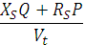=. All the system voltage and impidance will be refered to the system load side, i.e. (), ( (), (

Loads

1
3
2
3
1

5
j
4
2
i

P + jQ
Fig. 3.1 Large power system.

SVC

Fig.3.2 Thevenin’s equivalent system shows the load node terminals.

The link voltage drop will therefore be.
V=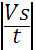–=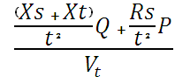 (1a)
Data used in this study: = 1.004 p.u., = 0.3228 p.u., = 0.0126 p.u. and t = 0.8 – 1.2.

3.2 POWER SYSTEM MODEL WITH TAP-CHANGING TRANSFORMER AND STATIC VAR COMPENSATOR
A thyristor-control reactor /fixed capacitor (TCR/FC) type is used. Its control system consists of a measuring circuit for measuring its terminal voltage Vt, a regulator with reference voltage and a firing circuit which generates gating pulses in order to command variable thyristor current, through the fixed reactor reactance XL. This variable current draws variable reactive power (which corresponds to variable virtual reactance of susceptance given by: = , Together with the fixed capacitive reactive power , these from the hole variable inductive and capacitive reactive power of that static compensator. Fig. 3.3 shows a block diagram of that compensator when connected to a large power system.
ISVC
Measuring
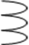
Regulator
Regulator
off
off
Gating
Pulses

Fig. 3.3. Static VAR compensator and power system block diagram.

Fig. 3.4 shows the transfer function of the power system provided by the tap changing transformer and a static VAR compensator. The off-nominal tap ratio of the tap-changing transformer is ‘t’. Fig. 3.5 shows the simplified transformer function block diagram of that system with combined tap-changing transformer and static VAR compensator.

1/t
P

+
+
G1
G2
1/
1/
+
-
1/
+
Bc Ic
-
H
Q

Fig. 3.4. Block diagram of a loaded power system, tap-changing transformer and SVC

3.3 STSTEM EQUATIONS:

G1 = 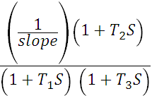 (1b)
The slope is regulator drop slop equals to 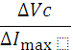 Volt/ampere. is a delay time. are the regulator compensator time constants. is the reference voltage. The firing angle circuit can be represented by a gain (nearly unity) and a time delay as:

G2 = 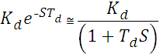 (2)
Which is equal to 2.77s for TCR and equal to 5.55s for TSC. The limiter refers to the limits of the virtual compensator variable susceptance ‘B’.
The measuring circuit forms the feedback link and can be represented by a gain equal nearly unity and a time delay S as:

H = 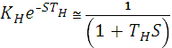 (3)
of the order of 20-50 ms, While is usually from 8 – 16 ms. usually takes a value around 1.0 p.u, are determined by the regulator designed for each studied system, as they are function in system parameter.
Solving block diagram of a loaded power system, tap-changing transformer and SVC. Multiplication of B by yields the SVC current following in the series link (), which is given by:
= (4)
The power system which is provided by a tap-changing transformer at the load inlet can be represented by its Thevenin’s voltage, system and transformer impedance (All Referred to the load voltage side. The load voltage drop to system equivalent series impedance and through the tap-changing transformer link is given by:
||-||=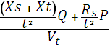 (5)

Where is the load node and SVC terminal voltage and ‘S’ is the laplace operator, which vanishes in steady-state condition.

Defining
And
The compensator current is given by: (6)
And the SVC control system feedback voltage is given by:

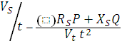

G=G1 G2
+
+
+
-

H

Fig. 3.5. Simplified transfer function block diagram of a loaded power system, tap-changing transformer and SVC

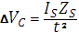 = 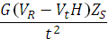 (7)

Therefore, the load terminal voltage is given by:
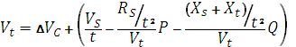 (8)
or:
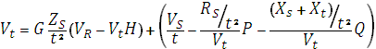 (9)
From which:
(10)

Its solution is:
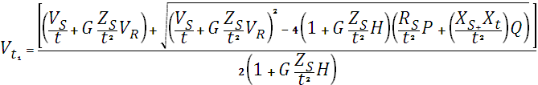 (11)

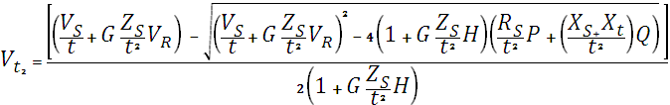 (12)

and the compensator controller gain is given from Eq. (10) by:

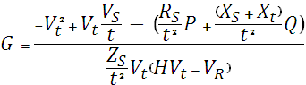 (13)

While, the regulator reference voltage is given from Eq. (10) by:

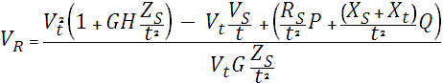 (14)

The regulator slope is obtained from the known V/I characteristics of SVC as:

Slope = 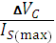 (15)

After substituting of Eq. (7) and (4) in Eq. (15), we get:

Slope = 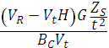 (16)

Defining:
= 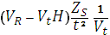

Eq. (16) becomes:
Slope = 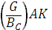 (17)
With:
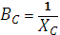 (18)
Where Xc is the compensator fixed reactance, Bc is its rating in p.u referred to its own rating (at 1.0 p.u terminal voltage basis).

3.4 COMPENSATOR RATING:
Compensator rating is given by or simply by at p.u. It can therefore be calculated from Eq. (17) by:
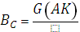Slope

CHAPTER-4 RESULTS AND DISCUSSION USING MATLAB
4.1 SYSTEM DATA:
Having used the system under study with the mentioned data:
p.u.
p.u.
p.u.
1 p.u.
1 p.u.
p.u.
p.u.
p.u.
The load reactive power is assumed to be kept constant at = 0.18 p.u.
In order to kept the terminal voltage constant at p.u up to 1.05 p.u for different system power P.
4.2 POWER VERSUS VOLTAGE (P-V) CURVE WITH THE PRESENCE OF TAP-CHANGING TRANSFORMER AND STATIC VAR COMPENSATOR.
The famous nose curve of the Voltage/Power relation is plotted in Fig. 4.1. When the transformer off-nominal tap ratios are varied within the known practical range ( = 0.8-1.2) and with various static compensator gains, i.e. = 0.0 (without compensator action), = 2.5, = 5, = 10. The feedback loop is in the operation and the system impedance is taken as: = 0.3228, while the transformer reactance at = 1 is 0.0126 p.u.

4.2 (a) CASE 1 WHEN 0.0 (i.e. WITHOUT COMPENSATOR ACTION)
SCRIPT FILE:
G=0.0
Q=0.18
Xs=0.3125
Rs=0.08126
t=0.8
H=1
Xt=0.0126
Vr=1
Zs=0.3228
Vs=1.004

for P=0:.01:2.39

Vt=(((Vs/t)+(G*Zs*Vr/t^(2)))-((((Vs/t)+(G*Zs*Vr/t^(2)))^(2))-4*((1)+(G*Zs*H/t^(2)))*((Rs*P/t^(2))+((Xs+Xt)/t^(2))*Q))^(1/2))/((2)*((1)+(G*Zs*H/t^(2))));
Vt1=(((Vs/t)+(G*Zs*Vr/t^(2)))+((((Vs/t)+(G*Zs*Vr/t^(2)))^(2))-4*((1)+(G*Zs*H/t^(2)))*((Rs*P/t^(2))+((Xs+Xt)/t^(2))*Q))^(1/2))/((2)*((1)+(G*Zs*H/t^(2))))

plot(P,Vt,'--rs','LineWidth',2,...
'MarkerEdgeColor','k',...
'MarkerFaceColor','K',...
'MarkerSize',1)
plot(P,Vt1,'--rs','LineWidth',2,...
'MarkerEdgeColor','k',...
'MarkerFaceColor','K',...
'MarkerSize',1)
hold all
end

G=0.0
Q=0.18
Xs=0.3125
Rs=0.08126
t=0.9
H=1
Xt=0.0126
Vr=1
Zs=0.3228
Vs=1.004

for P=0:.01:2.39
Vt=(((Vs/t)+(G*Zs*Vr/t^(2)))-((((Vs/t)+(G*Zs*Vr/t^(2)))^(2))-4*((1)+(G*Zs*H/t^(2)))*((Rs*P/t^(2))+((Xs+Xt)/t^(2))*Q))^(1/2))/((2)*((1)+(G*Zs*H/t^(2))));
Vt1=(((Vs/t)+(G*Zs*Vr/t^(2)))+((((Vs/t)+(G*Zs*Vr/t^(2)))^(2))-4*((1)+(G*Zs*H/t^(2)))*((Rs*P/t^(2))+((Xs+Xt)/t^(2))*Q))^(1/2))/((2)*((1)+(G*Zs*H/t^(2))))
plot(P,Vt,'--rs','LineWidth',2,...
'MarkerEdgeColor','b',...
'MarkerFaceColor','b',...
'MarkerSize',1)
plot(P,Vt1,'--rs','LineWidth',2,...
'MarkerEdgeColor','b',...
'MarkerFaceColor','b',...
'MarkerSize',1)
hold all
end

G=0.0
Q=0.18
Xs=0.3125
Rs=0.08126
t=1
H=1
Xt=0.0126
Vr=1
Zs=0.3228
Vs=1.004

for P=0:.01:2.39

Vt=(((Vs/t)+(G*Zs*Vr/t^(2)))-((((Vs/t)+(G*Zs*Vr/t^(2)))^(2))-4*((1)+(G*Zs*H/t^(2)))*((Rs*P/t^(2))+((Xs+Xt)/t^(2))*Q))^(1/2))/((2)*((1)+(G*Zs*H/t^(2))));
Vt1=(((Vs/t)+(G*Zs*Vr/t^(2)))+((((Vs/t)+(G*Zs*Vr/t^(2)))^(2))-4*((1)+(G*Zs*H/t^(2)))*((Rs*P/t^(2))+((Xs+Xt)/t^(2))*Q))^(1/2))/((2)*((1)+(G*Zs*H/t^(2))))

plot(P,Vt,'--rs','LineWidth',2,...
'MarkerEdgeColor','r',...
'MarkerFaceColor','r',...
'MarkerSize',1)
plot(P,Vt1,'--rs','LineWidth',2,...
'MarkerEdgeColor','r',...
'MarkerFaceColor','r',...
'MarkerSize',1)
hold all
end

G=0.0
Q=0.18
Xs=0.3125
Rs=0.08126
t=1.1
H=1
Xt=0.0126
Vr=1
Zs=0.3228
Vs=1.004

for P=0:.01:2.39

Vt=(((Vs/t)+(G*Zs*Vr/t^(2)))-((((Vs/t)+(G*Zs*Vr/t^(2)))^(2))-4*((1)+(G*Zs*H/t^(2)))*((Rs*P/t^(2))+((Xs+Xt)/t^(2))*Q))^(1/2))/((2)*((1)+(G*Zs*H/t^(2))));
Vt1=(((Vs/t)+(G*Zs*Vr/t^(2)))+((((Vs/t)+(G*Zs*Vr/t^(2)))^(2))-4*((1)+(G*Zs*H/t^(2)))*((Rs*P/t^(2))+((Xs+Xt)/t^(2))*Q))^(1/2))/((2)*((1)+(G*Zs*H/t^(2))))

plot(P,Vt,'--rs','LineWidth',2,...
'MarkerEdgeColor','g',...
'MarkerFaceColor','g',...
'MarkerSize',1)
plot(P,Vt1,'--rs','LineWidth',2,...
'MarkerEdgeColor','g',...
'MarkerFaceColor','g',...
'MarkerSize',1)
hold all
end

G=0.0
Q=0.18
Xs=0.3125
Rs=0.08126
t=1.2
H=1
Xt=0.0126
Vr=1
Zs=0.3228
Vs=1.004

for P=0:.01:2.38

Vt=(((Vs/t)+(G*Zs*Vr/t^(2)))-((((Vs/t)+(G*Zs*Vr/t^(2)))^(2))-4*((1)+(G*Zs*H/t^(2)))*((Rs*P/t^(2))+((Xs+Xt)/t^(2))*Q))^(1/2))/((2)*((1)+(G*Zs*H/t^(2))));
Vt1=(((Vs/t)+(G*Zs*Vr/t^(2)))+((((Vs/t)+(G*Zs*Vr/t^(2)))^(2))-4*((1)+(G*Zs*H/t^(2)))*((Rs*P/t^(2))+((Xs+Xt)/t^(2))*Q))^(1/2))/((2)*((1)+(G*Zs*H/t^(2))))
plot(P,Vt,'--rs','LineWidth',2,...
'MarkerEdgeColor','m',...
'MarkerFaceColor','m',...
'MarkerSize',1)
plot(P,Vt1,'--rs','LineWidth',2,...
'MarkerEdgeColor','m',...
'MarkerFaceColor','m',...
'MarkerSize',1)
hold all
end

xlabel('Power in p.u','FontSize',12)
ylabel('Voltage in p.u','FontSize',12)

4.2 (a) CASE 1 WHEN 0.0
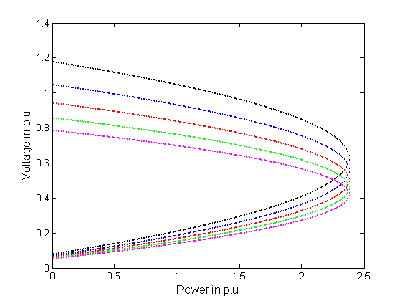
t = 0.8 t = 0.9 t = 1
t = 1.1 t = 1.2

Fig. 4.1 Voltage/Power response with different off-nominal tap ratios (0.8-1.2), with constant Q and with G = 0.0

4.2 (b) CASE 2 WHEN 2.5

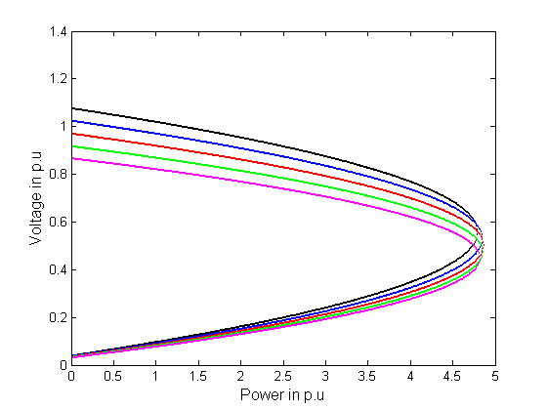
t = 0.8 t = 0.9 t = 1
t = 1.1 t = 1.2

Fig. 4.2 Voltage/Power response with different off-nominal tap ratios (0.8-1.2), with constant Q and with G = 2.5

4.2 (c) CASE 3 WHEN 5

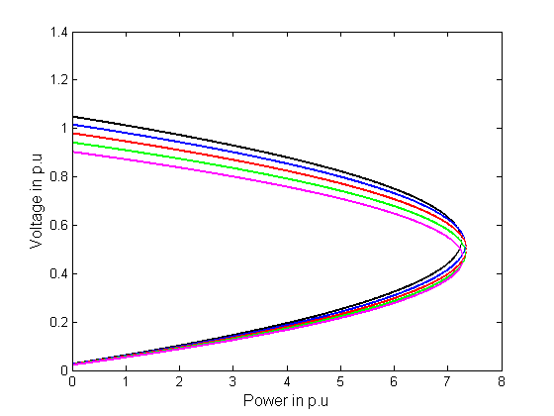
t = 0.8 t = 0.9 t = 1
t = 1.1 t = 1.2

Fig. 4.3Voltage/Power response with different off-nominal tap ratios (0.8-1.2), with constant Q and with G = 2.5

4.2 (d) CASE 4 WHEN 10

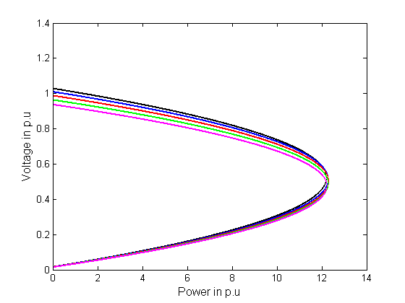
t = 0.8 t = 0.9 t = 1
t = 1.1 t = 1.2

Fig. 4.4 Voltage/Power response with different off-nominal tap ratios (0.8-1.2), with constant Q and with G = 10

4.2.1 VOLTAGE VERSUS REACTIVE POWER (V-Q) CURVE WITH THE PRESENCE OF TAP-CHANGING TRANSFORMER AND STATIC VAR COMPENSATOR.
G=0.0
P=0.18
Xs=0.3125
Rs=0.08126
t=0.8
H=1
Xt=0.0126
Vr=1
Zs=0.3228
Vs=1.004

for Q=0:.01:2.39

Vt=(((Vs/t)+(G*Zs*Vr/t^(2)))-((((Vs/t)+(G*Zs*Vr/t^(2)))^(2))-4*((1)+(G*Zs*H/t^(2)))*((Rs*P/t^(2))+((Xs+Xt)/t^(2))*Q))^(1/2))/((2)*((1)+(G*Zs*H/t^(2))));
Vt1=(((Vs/t)+(G*Zs*Vr/t^(2)))+((((Vs/t)+(G*Zs*Vr/t^(2)))^(2))-4*((1)+(G*Zs*H/t^(2)))*((Rs*P/t^(2))+((Xs+Xt)/t^(2))*Q))^(1/2))/((2)*((1)+(G*Zs*H/t^(2))))

plot(Vt,Q'--rs','LineWidth',2,...
'MarkerEdgeColor','k',...
'MarkerFaceColor','K',...
'MarkerSize',1)
plot(Vt1,Q'--rs','LineWidth',2,...
'MarkerEdgeColor','k',...
'MarkerFaceColor','K',...
'MarkerSize',1)
hold all
end

G=0.0
P=0.18
Xs=0.3125
Rs=0.08126
t=0.9
H=1
Xt=0.0126
Vr=1
Zs=0.3228
Vs=1.004

for Q=0:.01:2.39
Vt=(((Vs/t)+(G*Zs*Vr/t^(2)))-((((Vs/t)+(G*Zs*Vr/t^(2)))^(2))-4*((1)+(G*Zs*H/t^(2)))*((Rs*P/t^(2))+((Xs+Xt)/t^(2))*Q))^(1/2))/((2)*((1)+(G*Zs*H/t^(2))));
Vt1=(((Vs/t)+(G*Zs*Vr/t^(2)))+((((Vs/t)+(G*Zs*Vr/t^(2)))^(2))-4*((1)+(G*Zs*H/t^(2)))*((Rs*P/t^(2))+((Xs+Xt)/t^(2))*Q))^(1/2))/((2)*((1)+(G*Zs*H/t^(2))))
plot(Vt,Q'--rs','LineWidth',2,...
'MarkerEdgeColor','b',...
'MarkerFaceColor','b',...
'MarkerSize',1)
plot(Vt1,Q'--rs','LineWidth',2,...
'MarkerEdgeColor','b',...
'MarkerFaceColor','b',...
'MarkerSize',1)
hold all
end

G=0.0
P=0.18
Xs=0.3125
Rs=0.08126
t=1
H=1
Xt=0.0126
Vr=1
Zs=0.3228
Vs=1.004

for Q=0:.01:2.39

Vt=(((Vs/t)+(G*Zs*Vr/t^(2)))-((((Vs/t)+(G*Zs*Vr/t^(2)))^(2))-4*((1)+(G*Zs*H/t^(2)))*((Rs*P/t^(2))+((Xs+Xt)/t^(2))*Q))^(1/2))/((2)*((1)+(G*Zs*H/t^(2))));
Vt1=(((Vs/t)+(G*Zs*Vr/t^(2)))+((((Vs/t)+(G*Zs*Vr/t^(2)))^(2))-4*((1)+(G*Zs*H/t^(2)))*((Rs*P/t^(2))+((Xs+Xt)/t^(2))*Q))^(1/2))/((2)*((1)+(G*Zs*H/t^(2))))

plot(Vt,Q,'--rs','LineWidth',2,...
'MarkerEdgeColor','r',...
'MarkerFaceColor','r',...
'MarkerSize',1)
plot(Vt1,Q'--rs','LineWidth',2,...
'MarkerEdgeColor','r',...
'MarkerFaceColor','r',...
'MarkerSize',1)
hold all
end

G=0.0
P=0.18
Xs=0.3125
Rs=0.08126
t=1.1
H=1
Xt=0.0126
Vr=1
Zs=0.3228
Vs=1.004

for Q=0:.01:2.39

Vt=(((Vs/t)+(G*Zs*Vr/t^(2)))-((((Vs/t)+(G*Zs*Vr/t^(2)))^(2))-4*((1)+(G*Zs*H/t^(2)))*((Rs*P/t^(2))+((Xs+Xt)/t^(2))*Q))^(1/2))/((2)*((1)+(G*Zs*H/t^(2))));
Vt1=(((Vs/t)+(G*Zs*Vr/t^(2)))+((((Vs/t)+(G*Zs*Vr/t^(2)))^(2))-4*((1)+(G*Zs*H/t^(2)))*((Rs*P/t^(2))+((Xs+Xt)/t^(2))*Q))^(1/2))/((2)*((1)+(G*Zs*H/t^(2))))

plot(Vt,Q'--rs','LineWidth',2,...
'MarkerEdgeColor','g',...
'MarkerFaceColor','g',...
'MarkerSize',1)
plot(Vt1,Q'--rs','LineWidth',2,...
'MarkerEdgeColor','g',...
'MarkerFaceColor','g',...
'MarkerSize',1)
hold all
end

G=0.0
P=0.18
Xs=0.3125
Rs=0.08126
t=1.2
H=1
Xt=0.0126
Vr=1
Zs=0.3228
Vs=1.004

for Q=0:.01:2.38

Vt=(((Vs/t)+(G*Zs*Vr/t^(2)))-((((Vs/t)+(G*Zs*Vr/t^(2)))^(2))-4*((1)+(G*Zs*H/t^(2)))*((Rs*P/t^(2))+((Xs+Xt)/t^(2))*Q))^(1/2))/((2)*((1)+(G*Zs*H/t^(2))));
Vt1=(((Vs/t)+(G*Zs*Vr/t^(2)))+((((Vs/t)+(G*Zs*Vr/t^(2)))^(2))-4*((1)+(G*Zs*H/t^(2)))*((Rs*P/t^(2))+((Xs+Xt)/t^(2))*Q))^(1/2))/((2)*((1)+(G*Zs*H/t^(2))))
plot(Vt,Q'--rs','LineWidth',2,...
'MarkerEdgeColor','m',...
'MarkerFaceColor','m',...
'MarkerSize',1)
plot(Vt1,Q'--rs','LineWidth',2,...
'MarkerEdgeColor','m',...
'MarkerFaceColor','m',...
'MarkerSize',1)
hold all
end

Figure 4.4 (a) V-Q curve
A V-Q curve expresses the relationship between the reactive support Q at a given bus and the voltage at that bus. It can be determined by connecting a fictitious generator with zero active power Q produced as the terminal voltage V being varied. It must be noted at this point that the VQ curve is a characteristic of both the network and the load. As the curve aims at characterizing the steady state operation of the system, the load must be accordingly represented through its steady-state characteristic.

4.4 ADDITION OF SERIES CAPACITOR IN THE CIRCUIT.

SVC

Fig.4.5 Thevenin’s equivalent system in the presence of series Capacitor, Tap-Changing Transformer and SVC.

4.4 PLOTS BETWEEN LOAD POWER AND VOLTAGE RESPONSE WITH PRESENCE OF SERIES CAPACITOR, TAP-CHANGING TRANSFORMER AND STATIC VAR COMPENSATOR.
When the transformer off-nominal tap ratios are varied within the known practical range ( = 0.8-1.2), taking the static compensator gain as G = 5 and by taking the capacitor with 25%, 50% and 75% of transmission line i.e. ( = 0.0781, 0.1562, 0.2343).

4.4 (a) CASE 1 WITH IS 25% OF i.e. = 0.0781

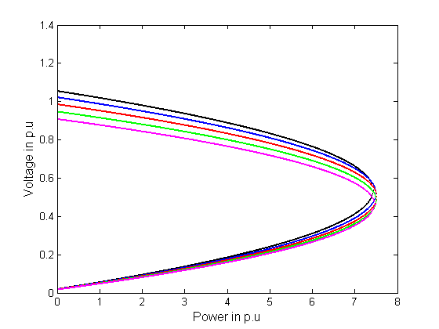
t = 0.8 t = 0.9 t = 1
t = 1.1 t = 1.2
Fig 4.6 Power/Voltage with Xc = 0.0781

4.4 (b) CASE 2 WITH IS 50% OF i.e. = 0.1562

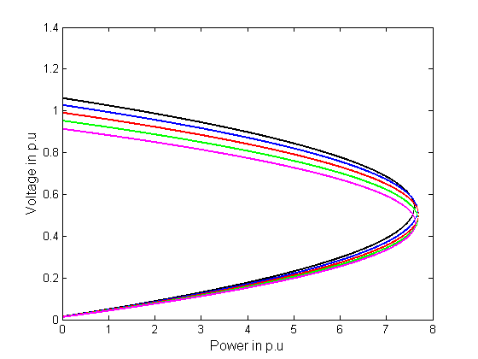
t = 0.8 t = 0.9 t = 1
t = 1.1 t = 1.2
Fig 4.7 Power/Voltage with Xc = 0.1562

4.4 (c) CASE 3 WITH IS 75% OF i.e. = 0.2343

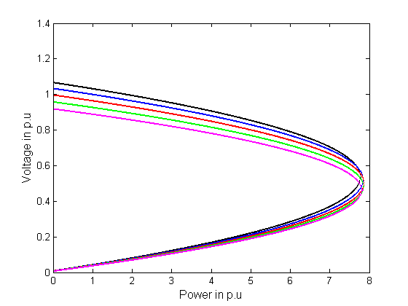
t = 0.8 t = 0.9 t = 1
t = 1.1 t = 1.2
Fig 4.8 Power/Voltage with Xc = 0.2343

As we can see in these three plots that by the use of Capacitor in the circuit, the peak-load voltage can be increased by increasing the capacitor rating.

TABLE-1: MAXIMUM LOAD POWER AS AFFECTED BY COMPENSATOR CONTROLLER GAINS WITHOUT SERIES CAPACITOR.
Compensator Gain (G)
Approximate
Maximum Power
0.0
2.5
5.0
10.0

2.39
4.80
7.30
12.30

From all these curves we notice that the off-nominal tap ratio variation does not affect the critical power value at various SVC gain, i.e. this value remains constant at all off-nominal transformer’s ratios. However off-nominal tap ratio affects largely the load voltage magnitude at no-load conditions. At lower values, they affect the load at other loadings conditions.
The compensator application increases the maximum power largely as shown in the figures 4.1, 4.2, 4.3, 4.4, for different SVC controller gains. The same previous features of their variations with different off-nominal tap ratios are noticed. The same maximum power and different critical voltages largely affect the no-load conditions than the heavy loadings.
Table-1, however, shows the maximum load power corresponding to various values of SVC controller gains. Once more, this value is same at all off-nominal transformer tap ratios.
Therefore, at a gain of 5 the maximum transmitted power can be increased to 360% and a gain of 10can increase it by 600% of its value without static VAR compensator. This is important result illustrates the limited effects of the tap-changing transformer compared to the static VAR compensator, significant effects, at different controller gains.

4.5 STATIC VAR COMPENSATOR PARAMETERS IN THE PRESENCE OF LOAD TAP-CHANGING TRANSFORMER.

4.5.1 COMPENSATOR CONTROLLER GAIN ‘G’:
4.5.1 (a) CASE 1 GAIN WITH ACTIVE POWER.
SCRIPT FILE:
Q=0.18
Xs=0.3125
Rs=0.08126
t=.8
H=1
Xt=0.0126
Vr=1
Zs=.3228
Vs=1.004
Vt=.99

for P=0:.01:8

G=(-((Vt)^(2))+((Vt*Vs)/t)-(((Rs/(t^(2)))*P)+((Xs*Q+Xt*Q)/(t^(2)))))/((Zs/(t^(2)))*Vt*((H*Vt)-Vr))

plot(P,G,'--rs','LineWidth',2,...
'MarkerEdgeColor','k',...
'MarkerFaceColor','k',...
'MarkerSize',1)

hold all
end

Q=0.18
Xs=0.3125
Rs=0.08126
t=.9
H=1
Xt=0.0126
Vr=1
Zs=.3228
Vs=1.004
Vt=.99

for P=0:.01:8

G=(-((Vt)^(2))+((Vt*Vs)/t)-(((Rs/(t^(2)))*P)+((Xs*Q+Xt*Q)/(t^(2)))))/((Zs/(t^(2)))*Vt*((H*Vt)-Vr))

plot(P,G,'--rs','LineWidth',2,...
'MarkerEdgeColor','g',...
'MarkerFaceColor','g',...
'MarkerSize',1)

hold all

end

Q=0.18
Xs=0.3125
Rs=0.08126
t=1
H=1
Xt=0.0126
Vr=1
Zs=.3228
Vs=1.004
Vt=.99

for P=0:.01:8

G=(-((Vt)^(2))+((Vt*Vs)/t)-(((Rs/(t^(2)))*P)+((Xs*Q+Xt*Q)/(t^(2)))))/((Zs/(t^(2)))*Vt*((H*Vt)-Vr))

plot(P,G,'--rs','LineWidth',2,...
'MarkerEdgeColor','b',...
'MarkerFaceColor','b',...
'MarkerSize',1)

hold all
end

Q=0.18
Xs=0.3125
Rs=0.08126
t=1.1
H=1
Xt=0.0126
Vr=1
Zs=.3228
Vs=1.004
Vt=.99

for P=0:.01:8

G=(-((Vt)^(2))+((Vt*Vs)/t)-(((Rs/(t^(2)))*P)+((Xs*Q+Xt*Q)/(t^(2)))))/((Zs/(t^(2)))*Vt*((H*Vt)-Vr))

plot(P,G,'--rs','LineWidth',2,...
'MarkerEdgeColor','r',...
'MarkerFaceColor','r',...
'MarkerSize',1)

hold all
end

Q=0.18
Xs=0.3125
Rs=0.08126
t=1.2
H=1
Xt=0.0126
Vr=1
Zs=.3228
Vs=1.004
Vt=.99

for P=0:.01:8

G=(-((Vt)^(2))+((Vt*Vs)/t)-(((Rs/(t^(2)))*P)+((Xs*Q+Xt*Q)/(t^(2)))))/((Zs/(t^(2)))*Vt*((H*Vt)-Vr))

plot(P,G,'--rs','LineWidth',2,...
'MarkerEdgeColor','m',...
'MarkerFaceColor','m',...
'MarkerSize',1)

hold all
end

xlabel('Power in p.u','FontSize',12)
ylabel('Gain','FontSize',12)

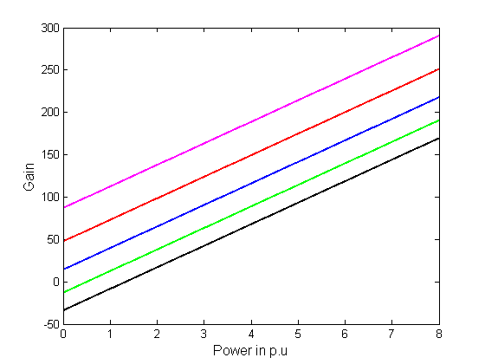
t = 0.8 t = 0.9 t = 1
t = 1.1 t = 1.2
Fig. 4.9 Gain/Active Power response for constant load voltage (Vt = 0.99) and constant load reactive power (Q = 0.18) in presence of tap-changing transformer

Here we see that the importance of the static VAR compensator over the automatically tap-changing transformer, the Gain/Power characteristics which can kept the load voltage constant at 0.99 p.u, is plotted in the fig. 4.9. For different transformer off-nominal tap ratio’s t = 0.8-1.2. The reactive power is kept constant at 0.18 p.u. It is clear here that to obtain the same value of load power with different off-nominal tap ratio’s different SVC controller gains should be adjusted adaptively. Negative values can be required at lower load powers. At P = 4.0 p.u. for example, with t = 0.8-1.2, the gain should be varied between 60 and 200, respectively, for the studied system

4.5.1 (b) CASE 2 GAIN WITH REACTIVE POWER.
SCRIPT FILE:
P=0.3
Xs=0.3125
Rs=0.08126
t=0.8
H=1
Xt=0.0126
Vr=1
Zs=0.3228
Vs=1.004
Vt=0.99

for Q=0:.01:8

G=(-((Vt)^(2))+((Vt*Vs)/t)-(((Rs/(t^(2)))*P)+((Xs*Q+Xt*Q)/(t^(2)))))/((Zs/(t^(2)))*Vt*((H*Vt)-Vr))

plot(Q,G,'--rs','LineWidth',2,...
'MarkerEdgeColor','k',...
'MarkerFaceColor','k',...
'MarkerSize',1)

hold all
end

P=0.3
Xs=0.3125
Rs=0.08126
t=0.9
H=1
Xt=0.0126
Vr=1
Zs=0.3228
Vs=1.004
Vt=0.99

for Q=0:.01:8

G=(-((Vt)^(2))+((Vt*Vs)/t)-(((Rs/(t^(2)))*P)+((Xs*Q+Xt*Q)/(t^(2)))))/((Zs/(t^(2)))*Vt*((H*Vt)-Vr))

plot(Q,G,'--rs','LineWidth',2,...
'MarkerEdgeColor','g',...
'MarkerFaceColor','g',...
'MarkerSize',1)

hold all
end

P=0.3
Xs=0.3125
Rs=0.08126
t=1
H=1
Xt=0.0126
Vr=1
Zs=0.3228
Vs=1.004
Vt=0.99

for Q=0:.01:8

G=(-((Vt)^(2))+((Vt*Vs)/t)-(((Rs/(t^(2)))*P)+((Xs*Q+Xt*Q)/(t^(2)))))/((Zs/(t^(2)))*Vt*((H*Vt)-Vr))

plot(Q,G,'--rs','LineWidth',2,...
'MarkerEdgeColor','b',...
'MarkerFaceColor','b',...
'MarkerSize',1)

hold all
end

P=0.3
Xs=0.3125
Rs=0.08126
t=1.1
H=1
Xt=0.0126
Vr=1
Zs=0.3228
Vs=1.004
Vt=0.99

for Q=0:.01:8

G=(-((Vt)^(2))+((Vt*Vs)/t)-(((Rs/(t^(2)))*P)+((Xs*Q+Xt*Q)/(t^(2)))))/((Zs/(t^(2)))*Vt*((H*Vt)-Vr))

plot(Q,G,'--rs','LineWidth',2,...
'MarkerEdgeColor','r',...
'MarkerFaceColor','r',...
'MarkerSize',1)

hold all
end

P=0.3
Xs=0.3125
Rs=0.08126
t=1.2
H=1
Xt=0.0126
Vr=1
Zs=0.3228
Vs=1.004
Vt=0.99

for Q=0:.01:8

G=(-((Vt)^(2))+((Vt*Vs)/t)-(((Rs/(t^(2)))*P)+((Xs*Q+Xt*Q)/(t^(2)))))/((Zs/(t^(2)))*Vt*((H*Vt)-Vr))

plot(Q,G,'--rs','LineWidth',2,...
'MarkerEdgeColor','m',...
'MarkerFaceColor','m',...
'MarkerSize',1)

hold all
end

xlabel('Reactive Power in p.u','FontSize',12)
ylabel('Gain','FontSize',12)

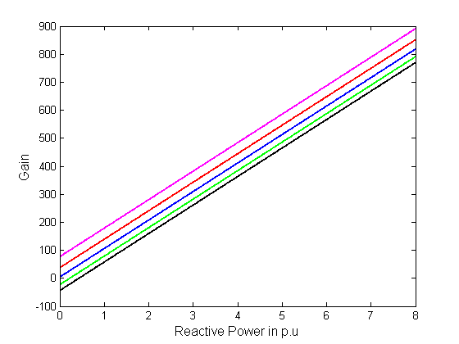

t = 0.8 t = 0.9 t = 1
t = 1.1 t = 1.2
Fig. 4.10 Gain/Reactive Power response for constant load voltage (Vt = 0.99) and constant load active power (P = 0.3) in presence of tap-changing transformer

Similarly as the plot of Gain/Active power, the Gain/Reactive power plot is also showing that when the active power is kept constant at 0.3 p.u, it is clear that to obtain the same value of load power with different off-nominal tap ratio’s different SVC controller gains should be adjusted adaptively. As shown in fig. 4.10.

4.5.2 INFLUENCE OF TAP-CHANGING TRANSFORMER ON SVC CONTROLLER GAIN VERSUS SLOPE RELATION
SCRIPT FILE:
Bc=1/4.5
t=0.8
H=1
Zs=0.3110
Vt=0.99
vr=1

for G=0:2:200

slope=(G*(Vr-((Vt)*H))*(Zs))/((t^(2))*(Vt)*(Bc))

plot(slope,G,'--rs','LineWidth',2,...
'MarkerEdgeColor','k',...
'MarkerFaceColor','k',...
'MarkerSize',1)

hold all
end

Bc=1/4.5
t=0.9
H=1
Zs=0.3110
Vt=0.99
vr=1

for G=0:2:200

slope=(G*(Vr-((Vt)*H))*(Zs))/((t^(2))*(Vt)*(Bc))

plot(slope,G,'--rs','LineWidth',2,...
'MarkerEdgeColor','g',...
'MarkerFaceColor','g',...
'MarkerSize',1)

hold all
end

Bc=1/4.5
t=1
H=1
Zs=0.3110
Vt=0.99
vr=1

for G=0:2:200

slope=(G*(Vr-((Vt)*H))*(Zs))/((t^(2))*(Vt)*(Bc))

plot(slope,G,'--rs','LineWidth',2,...
'MarkerEdgeColor','b',...
'MarkerFaceColor','b',...
'MarkerSize',1)

hold all
end

Bc=1/4.5
t=1.1
H=1
Zs=0.3110
Vt=0.99
vr=1

for G=0:2:200

slope=(G*(Vr-((Vt)*H))*(Zs))/((t^(2))*(Vt)*(Bc))

plot(slope,G,'--rs','LineWidth',2,...
'MarkerEdgeColor','r',...
'MarkerFaceColor','r',...
'MarkerSize',1)

hold all
end

Bc=1/4.5
t=1.2
H=1
Zs=0.3110
Vt=0.99
vr=1

for G=0:2:200

slope=(G*(Vr-((Vt)*H))*(Zs))/((t^(2))*(Vt)*(Bc))

plot(slope,G,'--rs','LineWidth',2,...
'MarkerEdgeColor','m',...
'MarkerFaceColor','m',...
'MarkerSize',1)

hold all
end

xlabel('Slope','FontSize',12)
ylabel('Gain','FontSize',12)

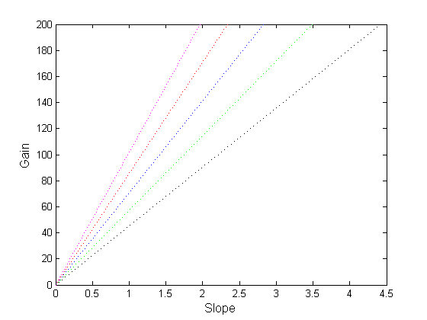
t = 0.8 t = 0.9 t = 1
t = 1.1 t = 1.2
Slope = (G/)AK (from eq. 17)
Fig. 4.11 SVC controller drop Slope/Gain relation in the presence of tap-changing transformer in order to maintain the load voltage constant.

Fig. 4.11 shows the SVC controller drop slope/gain relation plots for five off-nominal transformer tap ratio’s that are t = 0.8, 0.9, 1, 1.1 and 1.2. They are plotted for reference voltage = 1.0 p.u and load terminal voltage = 0.99 p.u. For the same gain value, different slops should be adjusted with different transformer tap ratios in order to keep load voltage constant at 0.99 p.u. of the compensator is selected to be 4.5 p.u. i.e its rating is 0.22 p.u. This means using automatic tap-changing transformer needs inherent adaptive controller parameters.

4.5.2 (a) SVC CONTROLLER GAIN VERSUS SVC RATED REACTIVE POWER
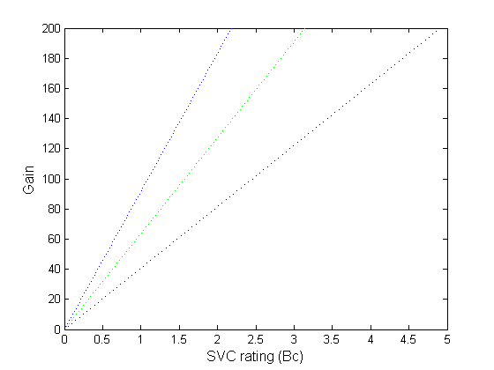
t = 0.8 t = 1 t = 1.2
= (GAK)/Slope (from eq. 17)
Fig. 4.12 Compensator design parameter/controller gain relation in the presence of tap-changing transformer

For a slope of 0.2, the SVC controller gain/compensator rating (1/) relation is plotted in fig. 4.12 with three off-nominal tap ratio’s as t = 0.8, 1 and 1.2. The plot shows different compensator power ratings are required at each compensator controller gain, in order to keep load voltage constant in the presence of automatic tap-changing transformer of different off-nominal tap ratios.

TABLE-2: COMPENSATOR RATING AT DIFFERENT GAINS (COMPENSATOR RATING IN P.U)
Gain
Off-nominal tap
ratio t = 0.8
Off-nominal tap
ratio t = 1
Off-nominal tap
ratio t = 1.2
50
70
100
150

1.2
1.7
2.43
2.7

0.7
1.08
1.57
1.74

0.56
0.75
1.07
1.2

Table-2 shows the needed SVC ratings corresponding to different controller gain, and different transformer off-nominal tap ratios.
4.5.2 (b) SVC CONTROLLER GAIN VERSUS REACTANCE OF SVC (1/Bc)

SCRIPT FILE:
slope=.2
t=0.8
H=1
Zs=0.3110
Vt=0.99
Vr=1

for Xc=0.7:.07:11

G=((slope)*(t^(2))*(Vt))/((Xc)*(Vr-((Vt)*H))*(Zs))

plot(Xc,G,'--rs','LineWidth',2,...
'MarkerEdgeColor','k',...
'MarkerFaceColor','k',...
'MarkerSize',1)

hold all
end

slope=.2
t=0.9
H=1
Zs=0.3110
Vt=0.99
Vr=1

for Xc=0.7:.07:11

G=((slope)*(t^(2))*(Vt))/((Xc)*(Vr-((Vt)*H))*(Zs))

plot(Xc,G,'--rs','LineWidth',2,...
'MarkerEdgeColor','g',...
'MarkerFaceColor','g',...
'MarkerSize',1)

hold all
end

slope=.2
t=1
H=1
Zs=0.3110
Vt=0.99
Vr=1

for Xc=0.7:.07:11

G=((slope)*(t^(2))*(Vt))/((Xc)*(Vr-((Vt)*H))*(Zs))

plot(Xc,G,'--rs','LineWidth',2,...
'MarkerEdgeColor','b',...
'MarkerFaceColor','b',...
'MarkerSize',1)

hold all
end

slope=.2
t=1.1
H=1
Zs=0.3110
Vt=0.99
Vr=1

for Xc=0.7:.07:11

G=((slope)*(t^(2))*(Vt))/((Xc)*(Vr-((Vt)*H))*(Zs))

plot(Xc,G,'--rs','LineWidth',2,...
'MarkerEdgeColor','r',...
'MarkerFaceColor','r',...
'MarkerSize',1)

hold all
end

slope=.2
t=1.2
H=1
Zs=0.3110
Vt=0.99
Vr=1

for Xc=0.7:.07:11

G=((slope)*(t^(2))*(Vt))/((Xc)*(Vr-((Vt)*H))*(Zs))

plot(Xc,G,'--rs','LineWidth',2,...
'MarkerEdgeColor','m',...
'MarkerFaceColor','m',...
'MarkerSize',1)

hold all
end
xlabel('Reactance of SVC (1/Bc)','FontSize',12)
ylabel('Gain','FontSize',12)

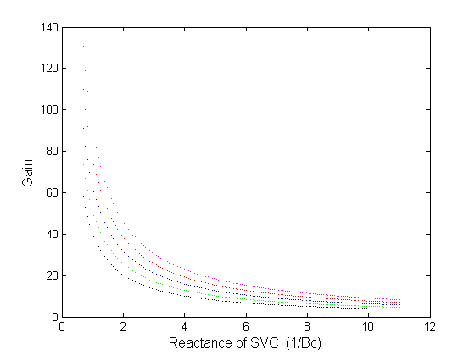

t = 0.8 t = 0.9 t = 1
t = 1.1 t = 1.2
Gain = Slope / ( AK)
Fig. 4.13 Compensator reactive power reactance () / Gain.
Fig. 4.13 shows that the reactance of the SVC with the gain at the tap ratios t=0.8, 0.9, 1, 1.1 and 1.2 in order to kept the load voltage constant at 0.99 p.u.

4.5.3 COMPENSATOR CONTROLLER REFERENCE VOLTAGE IN PRESENCE OF TAP-CHANGING TRANSFORMER:
In the presence of tap-changing transformer having off-nominal tap ratios in the known practical ranges (0.8-1.2), the voltage /power responses are plotted in fig. 4.10 ,4.11 and 4.12 for different controller gain in order to kept the load node voltage constant at 0.99 p.u. The three controller gains are considered as G = 2.5, 5 and 10.
4.5.3 (a) CASE 1 WHEN 2.5

SCRIPT FILE:
G=2.5
Q=0.18
Xs=0.3125
Rs=0.08126
t=.8
H=1
Xt=0.0126
Zs=.3228
Vs=1.004
Vt=.9

for P=0:.05:8

Vr=(((Vt)^(2))*(1+(G*H*Zs)/(t^(2)))-((Vt*Vs)/t)+(((Rs*P)/(t^(2)))+(((Xs*Q)+(Xt*Q))/(t^(2)))))/((Vt*G*Zs)/(t^(2)))

plot(P,Vr,'--rs','LineWidth',2,...
'MarkerEdgeColor','k',...
'MarkerFaceColor','k',...
'MarkerSize',1)

hold all
end

G=2.5
Q=0.18
Xs=0.3125
Rs=0.08126
t=0.9
H=1
Xt=0.0126
Zs=0.3228
Vs=1.004
Vt=0.9

for P=0:.05:8

Vr=(((Vt)^(2))*(1+(G*H*Zs)/(t^(2)))-((Vt*Vs)/t)+(((Rs*P)/(t^(2)))+(((Xs*Q)+(Xt*Q))/(t^(2)))))/((Vt*G*Zs)/(t^(2)))

plot(P,Vr,'--rs','LineWidth',2,...
'MarkerEdgeColor','g',...
'MarkerFaceColor','g',...
'MarkerSize',1)

hold all
end

G=2.5
Q=0.18
Xs=0.3125
Rs=0.08126
t=1
H=1
Xt=0.0126
Zs=0.3228
Vs=1.004
Vt=0.9

for P=0:.05:8

Vr=(((Vt)^(2))*(1+(G*H*Zs)/(t^(2)))-((Vt*Vs)/t)+(((Rs*P)/(t^(2)))+(((Xs*Q)+(Xt*Q))/(t^(2)))))/((Vt*G*Zs)/(t^(2)))

plot(P,Vr,'--rs','LineWidth',2,...
'MarkerEdgeColor','b',...
'MarkerFaceColor','b',...
'MarkerSize',1)

hold all
end

G=2.5
Q=0.18
Xs=0.3125
Rs=0.08126
t=1.1
H=1
Xt=0.0126
Zs=0.3228
Vs=1.004
Vt=0.9

for P=0:.05:8

Vr=(((Vt)^(2))*(1+(G*H*Zs)/(t^(2)))-((Vt*Vs)/t)+(((Rs*P)/(t^(2)))+(((Xs*Q)+(Xt*Q))/(t^(2)))))/((Vt*G*Zs)/(t^(2)))
plot(P,Vr,'--rs','LineWidth',2,...
'MarkerEdgeColor','r',...
'MarkerFaceColor','r',...
'MarkerSize',1)

hold all
end

G=2.5
Q=0.18
Xs=0.3125
Rs=0.08126
t=1.2
H=1
Xt=0.0126
Zs=0.3228
Vs=1.004
Vt=0.9

for P=0:.05:8

Vr=(((Vt)^(2))*(1+(G*H*Zs)/(t^(2)))-((Vt*Vs)/t)+(((Rs*P)/(t^(2)))+(((Xs*Q)+(Xt*Q))/(t^(2)))))/((Vt*G*Zs)/(t^(2)))

plot(P,Vr,'--rs','LineWidth',2,...
'MarkerEdgeColor','m',...
'MarkerFaceColor','m',...
'MarkerSize',1)

hold all
end

xlabel('Power in p.u','FontSize',12)
ylabel('Reference Voltage in p.u','FontSize',12)

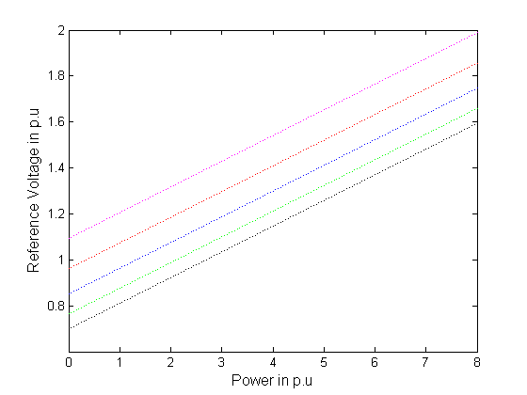
t = 0.8 t = 0.9 t = 1
t = 1.1 t = 1.2
Fig. 4.14 SVC controller reference voltage/power relation with G = 2.5

4.5.3 (b) CASE 2 WHEN 5

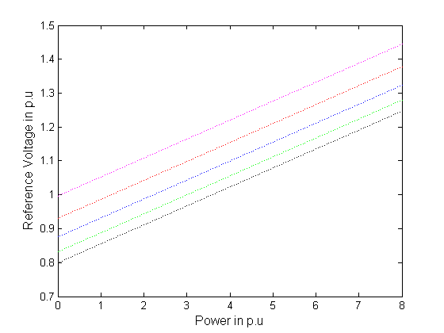
t = 0.8 t = 0.9 t = 1
t = 1.1 t = 1.2
Fig. 4.15 SVC controller reference voltage/power relation with G = 5

4.5.3 (c) CASE 3 WHEN 10
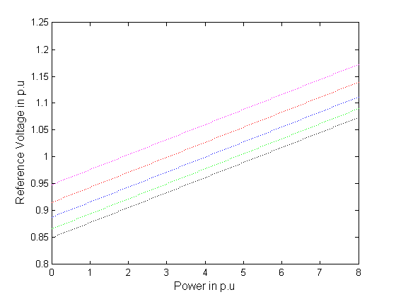
t = 0.8 t = 0.9 t = 1
t = 1.1 t = 1.2
Fig. 4.16 SVC controller reference voltage/power relation with G = 10

Examining these plots shows that the increasing gain requires very close reference voltages at different off-nominal transformer tap ratios. On the other hand a lower tap ratio of 0.8 requires lower reference voltages than those with higher ratios 1.2, in order to keep the terminal voltage constant. These results are logic as increasing the SVC controller gains increases its effectiveness in controlling the load voltage and consequently decreases its dependence on the off-nominal transformer tap-ratio.
Fig. 17 (a), (b), (c) shows the compensator gain relations with different load powers or with corresponding compensator reactance, in the presence of different transformer off-nominal tap retios (0.8-1.2). The load reactive power is assumed to be kept constant at 0.18 p.u.
t = 0.8 t = 0.9 t = 1
t = 1.1 t = 1.2
4.17 (a) Gain/Active Power response for constant load voltage (Vt = 0.99) and constant load reactive power (Q = 0.18) in presence of tap-changing transformer
t = 0.8 t = 0.9 t = 1
t = 1.1 t = 1.2
Fig. 4.17 (b) Compensator reactive power reactance () / Gain.
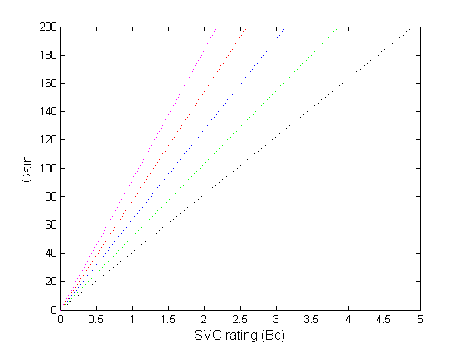
t = 0.8 t = 0.9 t = 1
t = 1.1 t = 1.2
Fig. 4.17 (c) Gain/SVC rating (Bc) with different transformer tap ratios

SVC controller gain versus its rating in p.u is plotted in figure. 4.17 (a), (b), (c), with different transformer tap ratios. The range of change of compensator rating for certain given load power is shown in the presence of different transformer taps. Once more, for the same SVC controller gain, higher SVC rating is required with lower transformer off-nominal tap ratios and vice versa. On contradictory higher load power can be taken at that load fixed terminal voltage in the presence of lower off-nominal transformer tap ratio.

CHAPTER-5 CONCLUSIONS

1. Presence of only tap-changing transformers does not improve voltage stability significantly. They do affect the voltage levels and slightly the critical voltages, but does not affect the maximum powers corresponding to these critical voltages. Therefore, tap-changing transformer at the load terminals can slightly contribute to its voltage stability.

2. By using the series capacitor with the tap-changing transformer and SVC the Peak-load voltage can significantly be increased.

3. Presence of Static VAR Compensator with different controller gains can Increase the maximum load powers several times its original value without Static VAR Compensator.

4. There is an interaction between the transformer off-nominal tap ratio and the compensator controller gains and reference voltages, in order to keep the load node voltage constant at all loading conditions.

5.The compensator ratings is affected with presence of tap changing transformer, the fixed reactance of the TCR type compensator changes significantly with the presence of tap-changing transformer. Certain transformer off-nominal tap ratios minimizes the SVC needed ratings, i.e. in the presence of tap-changing transformer, the SVC rating required to keep the load voltage constant at certain value is reduced significantly.

REFERENCES

- Enrique Acha and Claudio R. Fuerte-Esquivel, FACTS Modelling and Simulation in Power Networks, John wiley and sons, 2004

- A.R. Bergen and V. Vittal, Power Systems Analysis, Pearson, India, 2004.

- W.D. Stevenson and J.J. Grainger, Power System Analysis, TMH, India, 1998.

- Hiroshi Ohtsuki, Akihiko Yokoyama, Yasuji Sekine, “Reverse action of on-load tap-changer in association with voltage collapse”, IEEE trans. Power syst., Vol.6. No. 1, 1991.

- S. Milan, Calovic, Modeling and analysis of under load tap-changing transformer control systems. IEEE trans, 103 (7) (1984) 1909-1913.

- M.Z. El-Sadek,et al, “Enhancement of steady-state voltage stability by using static VAR compensators”, Electric Power System Research, 43 (1997) 179-185.

- Mark Ndubuka NWOHU, “Voltage Stability Improvement using Static VAR Compensator in Power Systems”, Leonardo Journal of Sciences ISSN 1583-0233, P 167-172, issue 14 January-June 2009

- Dr. N Kumar, Dr. A Kumar, P.R. Sharma, “Determination of optimal amount of location of series compensation and SVC for an AC Transmission System”, IE (I) Journal-EL, Vol. 83, March 2003.

- M.Z. El-Sadek,et al, “Series capacitor combined with static VAR compensator for enhancement of steady-state voltage stability”, Electric Power System Research, 44(1998) 137-143.

- M.Z. El-Sadek, M.M. Dessouky, G.A. Mahmoud, W.I. Rashed, “Combined use of tap-changing transformer and static VAR compensator for enhancement of steady-stat voltage stabilities”, Electric Power System Resarch, 45 (1998) 47-55.

- Farag Ali El-Sheikhi, Mabruk Saad, Saleh Omar Osman,Khalil M. El- Arroudi, “Voltage Stability Assessment Using Modal Analysis of Power Systems including Flexible AC Transmission System (FACTS)”, Eastern Generation & transmission Administration. GECOL, IEEE 2003.

SCOPE FOR FUTURE WORK

1. Location of series capacitor can be determined for optimal performance
along with tap-changing transformer and static VAR compensator for improving the voltage stability.

2. Future work related to study of voltage regulation and voltage stability
should be focused in the area of load modeling. In particular, the static load
characteristics and percentage of dynamic motor load needs to more
accurately eflect, what is in the “real system” under study. The load model has significant influence on the system’s response to disturbances, and therefore significantly influences the rating of any
proposed solution.

