1. Introduction

1.1 WHAT IS EMBEDDED CONTROL AND IT’S NEED?
An embedded control is done by a special-purpose computer system designed to perform one or a few dedicated functions, often with real-time computing constraints. It is usually embedded as part of a complete device including hardware and mechanical parts. In contrast, a general-purpose computer, such as a personal computer, can do many different tasks depending on programming. Embedded systems control many of the common devices in use today.
Embedded controllers are often the heart of an industrial control system or a process control application.The majority of computer systems in use today is embedded in other machinery, such as automobiles, telephones, appliances, and peripherals for computer systems. While some embedded systems are very sophisticated, many have minimal requirements for memory and program length, with no operating system, and low software complexity. Typical input and output devices include switches, relays, solenoids, LEDs, small or custom LCD displays, radio frequency devices, and sensors for data such as temperature, humidity, light level etc. Embedded systems usually have no keyboard, screen, disks, printers, or other recognizable I/O devices of a personal computer, and may lack human interaction devices of any kind.
1.2 ADVANTAGES and important features OF EMBEDDED-CONTROLLER
The main differentiating feature of an embedded controller is that external PC controls not all system operation. In fact, the CPU running the system is actually built into the I/O system itself. While some type of general purpose Personal Computer complete with mouse, monitor and other human interface devices (HID) hosts a typical, slaved data acquisition system, an Embedded Controller's processor is usually dedicated to controlling the I/O system and often does not provide any direct human interface.
Differences between an embedded controller and a standard PC are easily observed. However, the differences in software are equally noticeable. While most PCs operating systems for your desktop and laptop computer are large (in terms of RAM and hard drive space needed), operating systems developed for embedded systems are likely to be smaller and have been developed without all of the built-in GUIs as well as much of office equipment peripheral support.
Since embedded processors are usually used to control devices, they sometimes need to accept input from the device they are controlling. This is the purpose of the analog to digital converter. Since processors are built to interpret and process digital data, i.e. 1's and 0's, they won't be able to do anything with the analog signals that may be being sent to it by a device. So the analog to digital converter is used to convert the incoming data into a form that the processor can recognize. There is also a digital to analog converter that allows the processor to send data to the device it is controlling

In addition to the converters, many embedded microprocessors include a variety of timers as well. One of the most common types of timers is the Programmable Interval Timer, or PIT for short. A PIT just counts down from some value to zero. Once it . eaches zero, it sends an interrupt to the processor indicating that it has finished counting. This is useful for things such as thermostats, which periodically test the temperature around them to see if they need to turn the air conditioner on, the heater on, etc.
In the earliest years of computers in the 1930-40s, computers were sometimes dedicated to a single task, but were far too large and expensive for most kinds of tasks performed by embedded computers of today. Over time however, the concept of programmable controllers evolved from traditional electromechanical sequencers, via solid state devices, to the use of computer technology.
Since these early applications in the 1960s, embedded systems have come down in price and there has been a dramatic rise in processing power and functionality. The first microprocessor for example, the Intel 4004 was designed for calculators and other small systems but still required many external memory and support chips. In 1978 National Engineering Manufacturers Association released a "standard" for programmable microcontrollers, including almost any computer-based controllers, such as single board computers, numerical, and event-based controllers.
Physically, embedded systems range from portable devices such as digital watches and MP3 players, to large stationary installations like traffic lights, factory controllers, or the systems controlling nuclear power plants. Complexity varies from low, with a single microcontroller chip, to very high with multiple units, peripherals and networks mounted inside a large chassis or enclosure.
We can summarize the important features of embedded controller as follows:
- Embedded systems are designed to do some specific task, rather than be a general-purpose computer for multiple tasks. Some also have real-time performance constraints that must be met, for reasons such as safety and usability; others may have low or no performance requirements,allowing the system hardware to be simplified to reduce costs.
- Embedded systems are not always separate devices. Most often they are physically built-in to the devices they control.
- The software written for embedded systems is often called firmware, and is stored in read-only memory or Flash memory chips rather than a disk drive. It often runs with limited computer hardware resources: small or no keyboard, screen, and little memory.

  - Components of Microcontroller based Embedded -
system

- central processing unit - ranging from small and simple 4-bit processors to complex 32- or 64-bit processors
- discrete input and output bits, allowing control or detection of the logic state of an individual package pin
- serial input/output such as serial ports (UARTs)
- other serial communications interfaces like I²C, Serial Peripheral Interface and Controller Area Network for system interconnect
- peripherals such as timers, event counters, PWM generators, and watchdog
- volatile memory (RAM) for data storage
- ROM, EPROM, EEPROM or Flash memory for program and operating parameter storage
- clock generator - often an oscillator for a quartz timing crystal, resonator or RC circuit
- many include analog-to-digital converters
- in-circuit programming and debugging support
This integration drastically reduces the number of chips and the amount of wiring and circuit board space that would be needed to produce equivalent systems using separate chips. Furthermore, and on low pin count devices in particular, each pin may interface to several internal peripherals, with the pin function selected by software. This allows a part to be used in a wider variety of applications than if pins had dedicated functions. Microcontrollers have proved to be highly popular in embedded systems since their introduction in the 1970s.

  - MICROCONTROLLER USED IN BOTTLE FILLING PLANT

1.4.1 General Overview
A single chip that contains the processor (the CPU), non-volatile memory for the program (ROM or flash), volatile memory for input and output (RAM), a clock and an I/O control unit. Also called a "computer on a chip.
microcontroller (or MCU) is a computer-on-a-chip. It is a type of microprocessor emphasizing self-sufficiency and cost-effectiveness, in contrast to a general-purpose microprocessor (the kind used in a PC).
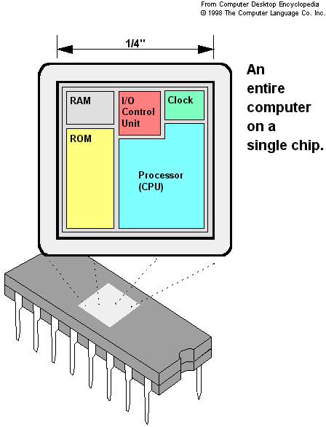

A micro controller is a single integrated chip, commonly with the following features:
- Central Processing Unit- ranging from small and simple 4-bit processors to sophisticated 32- or 64-bit processors
- Input/output interface such as serial ports(UARTs)
- other serial communications interfaces like I²C, Serial Peripheral Interface and Controller Area Network for system interconnect
- peripherals such as timers and watchdog
- RAM for data storage
- ROM, EPROM, EEPROM or Flash memory for program storage
- Clock generator - often an oscillator for a quartz timing crystal, resonator or RC circuits.
The main differences between Microcontroller and Microprocessor are as follows:

Microprocessor
- CPU is stand-alone, RAM, ROM, I/O, timer are separate
- Designer can decide on the amount of ROM, RAM and I/O ports.
- expansive
- versatility
- general-purpose

Microcontroller
•CPU, RAM, ROM, I/O and timer are all on a single chip
•fix amount of on-chip ROM, RAM, I/O ports
•for applications in which cost, power and space are critical
•single-purpose

1.4.2 BLOCK DIAGRAM OF MICRO CONTROLLER

CPU
On-chip RAM
On-chip ROM for program code
4 I/O Ports
Timer 0
Serial Port
OSC
Interrupt Control
External interrupts
Timer 1
Timer/Counter
Bus Control
TxD RxD
P0 P1 P2 P3
Address/Data

    - DESCRIPTION OF AT89S52 MICROCONTROLLER

The AT89S52 is a low power, high performance CMOS 8-bit microcontroller with 4Kbytes of flash programmable and erasable read only memory(PEROM).this device is compatible with the industry standard 8051 instruction set and pin out. The on-chip Flash allows the program memory to be quickly reprograms using a nonvolatile memory programmer such as the PG302 (with the ADT87 adapter). By combining the industry standard 8-bit CPU with Flash on a monolithic chip, the 8952 is a powerful microcomputer, which provides a highly flexible and cost effective solution to many embedded control application.
THE 8952 features are as follows:
- 4Kbytes of Flash.
- 128 bytes of RAM.
- 32 I/O lines.
- Two 16-bit timer /counter.
- Five vector, two level interrupt architecture.
- Full duplex serial port.
- On chip oscillator and clock circuitry.
- Endurance : 1000 Write/Erase Cycles
- Compatible with MCS-51 Products
- Fully Static Operation : 0Hz to 24MHz
- Three Level Program Memory Lock

1.4.4 ATMEL AT89S52 Pin out and Description

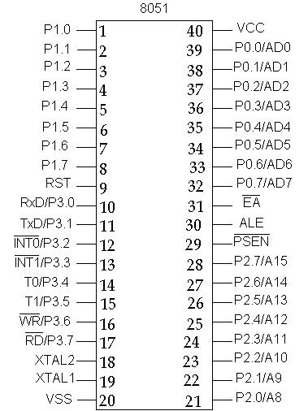

Description of Pins:
PIN 9: PIN 9 is the reset pin which is used reset the microcontroller’s internal registers and ports upon starting up.
PINS 18 & 19: The 8051 has a built-in oscillator amplifier hence we need to only connect a crystal at these pins to provide clock pulses to the circuit.
PIN 40 and 20: Pins 40 and 20 are VCC and ground respectively. The 8051 chip needs +5V 500mA to function properly, although there are lower powered versions like the Atmel 2051 which is a scaled down version of the 8051 which runs on +3V.
PINS 29, 30 & 31: As described in the features of the 8051, this chip contains a built-in flash memory. In order to program this we need to supply a voltage of +12V at pin 31. If external memory is connected then PIN 31, also called EA/VPP, should be connected to ground to indicate the presence of external memory. PIN 30 is called ALE (address latch enable), which is used when multiple memory chips are connected to the controller and only one of them needs to be selected. We will deal with this in depth in the later chapters. PIN 29 is called PSEN. This is "program select enable". In order to use the external memory it is required to provide the low voltage (0) on both PSEN and EA pins.
There are 4 8-bit ports: P0, P1, P2 and P3.
PORT P1 (Pins 1 to 8): The port P1 is a general purpose input/output port which can be used for a variety of interfacing tasks. The other ports P0, P2 and P3 have dual roles or additional functions associated with them based upon the context of their usage.
PORT P3 (Pins 10 to 17): PORT P3 acts as a normal IO port, but Port P3 has additional functions such as, serial transmit and receive pins, 2 external interrupt pins, 2 external counter inputs, read and write pins for memory access.
PORT P2 (pins 21 to 28): PORT P2 can also be used as a general purpose 8 bit port when no external memory is present, but if external memory access is required then PORT P2 will act as an address bus in conjunction with PORT P0 to access external memory. PORT P2 acts as A8-A15, as can be seen from fig 1.1
PORT P0 (pins 32 to 39) PORT P0 can be used as a general purpose 8 bit port when no external memory is present, but if external memory access is required then PORT P0 acts as a multiplexed address and data bus that can be used to access external memory in conjunction with PORT P2. P0 acts as AD0-AD7
The 8051 requires the existence of an external oscillator circuit. The oscillator circuit usually runs around 12MHz, although the 8051 (depending on which specific model) is capable of running at a maximum of 40MHz. Each machine cycle in the 8051 is 12 clock cycles, giving an effective cycle rate at 1MHz (for a 12 KHz clock) to 3.33MHz (for the maximum 40MHz clock).

8051 Software Tools Overview

To develop our 8051-based project, we will need three PC-based programs and a development board with a monitor ROM. Here is the typical data flow using these tools:

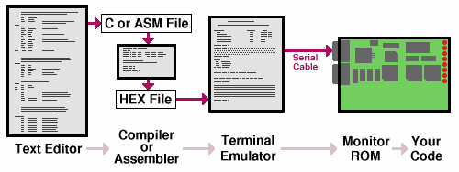
For each tool, there we may choose on of several options. The basic tools are:
- Text Editor
This is where we will compose the code that ultimately will run on our 8051 board and make us project function. All PC operating systems include a text editor, and there are many free text editors available on the internet. PJRC does not provide a text editor. All Microsoft Windows systems have NOTEPAD, which is a very simple editor. Linux systems usually have VI and EMACS installed, as well as several others.
- Compiler or Assembler
Either an Assembler or Compiler will turn our source code into a .HEX file, depending on our choice of programming language. PJRC provides free downloads of the AS31 assembler and SDCC C Compiler. These free tools are available for Linux-based Systems and Microsoft Windows. It is also possible to use other compilers, such as the Kiel C compiler.
- Terminal Emulator
To communicate with our 8051 board, we must run a terminal emulator program. We will be able to transmit our .HEX file to the board and run its code, observe its results and information it may send to the serial port, and we can also use the terminal emulator to examine and manipulate memory with the Monitor ROM. Microsoft provides HyperTerminal with windows (often it must be installed from the windows cdrom using "add/remove programs"). Linux distributions usually provide Mincom.
- Monitor ROM
The Monitor ROM is 8051 code that runs when our board boots. It provides interactive menus that allow us to download code, run it, manipulate memory and perform other functions. All 8051-development boards from PJRC come with PAULMON2 loaded in the non-erasable internal memory of the 87C52 chip. Using the monitor, we can cause our code to run on the board. It is also possible to download our code to non-volatile memory on the board together with a "auto-start header" that causes PAULMON2 to run our code automatically when the board boots.

1.5 OBJECTIVE OF THE PROJECT

The objective of this project is to design construct and test hardware and software to create an autonomous prototype of bottle filling plant. In the present times, most automated manufacturing tasks are carried out by specialized system designed to perform predetermined functions in a manufacturing process. The inflexibility and generally high cost of these machine often called hand automation systems in fulfillment of these interests , initiate the use of robots which are capable of performing a variety of manufacturing functions in more flexible to perform the process control and object transfer routine as in modern industrial production system. It implies to fill the liquid in bottle on the conveyer belt and a lift with a robotic arm to carry and place the bottle its specified destination.

1.6 DISSECTION OF THE PROJECT REPORT
The report of the major project based on embedded control prototype of bottle filling plant comprises of eight chapters.
Chapter 1 covers introductory subjects that familiarize the necessary background information about the embedded controller and the microcontroller 8051 used in this project. This includes advantage & important features, components of embedded controller and some of its practical applications. This Chapter continues with the general overview of microcontroller briefly explaining its difference with microprocessor, microcontroller block diagram, pin-outs and software tools with relevant diagrams.
Chapter 2 is dedicated to the objective of the project.
Chapter 3 shows project layout showing a rough sketch of the main components used in the project.
Chapter 4 provides literature about the microcontroller 8051 discussing its uses, operations, components and power supply. It also provides a general overview of Stepper motor and Robot.
Chapter 5 provides a table of all the components with their specifications and quantity used in the designing of the prototype.
Chapter 6 shows the Project view and discusses the implementation of the hardware where the bottle filling system is divided in three parts. In moving System, firstly, there is an explanation of conveyor belt, stepper motor and its driver circuit then robotic arm in which there is a discussion of DC motor, Gears, and H-Bridge with their circuit diagrams. Sensing System is a discussion of the sensor i.e., LDR with LASER, Reed Switch and Driver circuit used in the project. Controlling system is a brief of microcontroller 8051 with power supply and general terms like power supply, optocoupler etc.
Chapter 7 covers Software implementation describing IDE version, Sample IDE window and steps to burn the microcontroller.
Chapter 8 shows the Flow chart and Circuit diagram.
Chapter 9 shows the expected result.
Chapter 10 is the conclusion of the project and chapter 11 closes with brief discussion of the future scope of the project.
At the end of the report References used and the Appendix is given where program code of project is shown.

2. PROBLEM DEFINITION

To make an autonomous plant such that bottles can be filled with least human interference.
Dependent Resistor (LDR), which will get the input by the LASER beam. A person will keep normally Empty bottles at the starting position. Then the bottle will be moved with a moving mechanism (a conveyor belt) driven by stepper motor.

Second LDR and the LASER mechanism will sense the bottle to the filling point. In addition, the microcontroller will command the moving mechanism to stop. Then a pumping device will fill the bottle.

Third LDR and the LASER mechanism will sense the presence of the filled bottle at the end point and the microcontroller will command the driver circuit to stop the conveyor belt.

A robotic arm will pick up the bottles. The microcontroller 8051 itself will initialize the movement of the robotic arm. The movement of the robotic arm will be governed by the combination of H-Bridge and the Reed Switch.

3. Project Layout

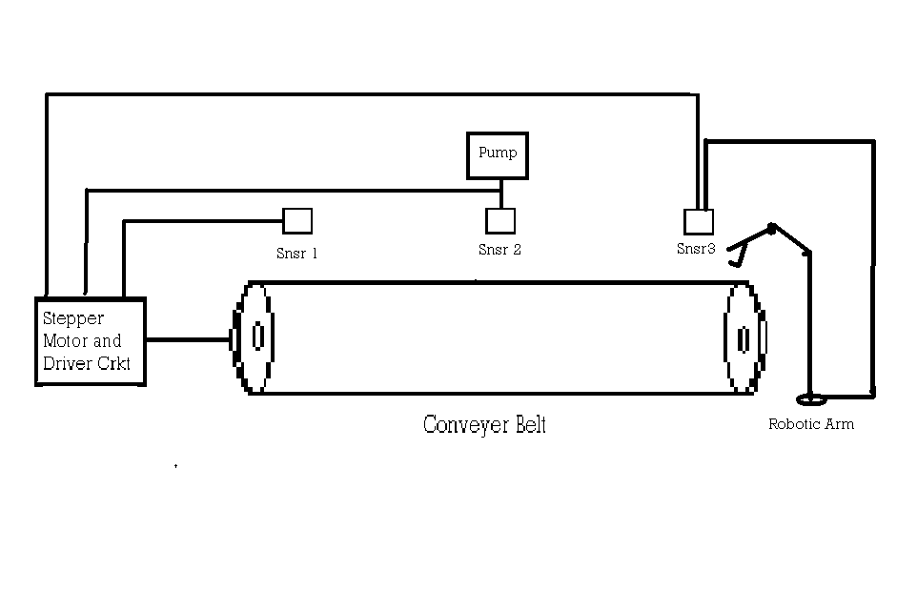

Relay

R₁
8051 MCU
R₂

R₃

Autonomous Bottle Filling Plant

4. Literature review

4.1 What are microcontrollers and what are they used
FOR?
As all other good things, this powerful component is basically very simple and is obtained by uniting tested and high- quality "ingredients" (components) as per following receipt: the simplest computer’s processor is used as a "brain" of the future system.
Depending on the taste of the producer, it is added: a bit of memory, a few A/D converters, timers, input/output lines etc.
It is all placed in one of standard packages.
Simple software that will be able to control it all and about which everyone will be able to learn has been developed. Three things have had a crucial impact on such a success of the microcontrollers:
- Powerful and intelligently chosen electronics embedded in the microcontrollers can via input/output devices (switches, push buttons, sensors, LCD displays, relays…) control various processes and devices such as industrial automatics, electric current, temperature, engine performance etc.
- A very low price enables them to be embedded in such devices in which, until recent time it was not worth embedding anything. Thanks to that, the world is overwhelmed today with cheap automatic devices and various “intelligent” appliances.
- Prior knowledge is hardly needed for programming. It is sufficient to have any kind of PC (software in use is not demanding at all and it is easy to learn to work on it) and one simple device (programmer) used for “transferring” completed programs into the microcontroller.

4.2 How does microcontroller operate?
Even though there is a great number of various microcontrollers and even greater number of programs designed for the microcontrollers’ use only, all of them have many things in common. That means that if you learn to handle one of them you will be able to handle them all. A typical scenario on whose basis it all functions is as follows:
- Power supply is turned off and everything is so still…chip is programmed, every thing is in place, and nothing indicates what is to come…
- Power supply connectors are connected to the power supply source and every thing starts to happen at high speed! The control logic registers what is going on first. It enables only quartz oscillator to operate. While the first preparations are in progress and parasite capacities are being charged, the first milliseconds go by.
- Power supply connectors are connected to the power supply source and every thing starts to happen at high speed! The control logic registers what is going on first. It enables only quartz oscillator to work. While the first preparations are in progress and parasite capacities are being charged, the first milliseconds go by.
- Voltage level has reached its full value and frequency of oscillator has become stable. The bits are being written to the SFRs, showing the state of all peripherals and all pins are configured as outputs. Everything occurs in harmony to the pulses’ rhythm and the overall electronics starts operating. Since this moment, the time is measured in micro and nanoseconds.
- Program Counter is reset to zero address of the program memory. Instruction from that address is sent to instruction decoder where its meaning is recognized and it is executed with immediate effect.
- The value of the Program Counter is being incremented by 1 and the whole process is being repeated...several million times per second.

4.3 What is in microcontroller?

Obviously, everything that occurs in the microcontroller occurs at high speed and quite simple, but it would not be so useful if there were no special interfaces, which make it, complete. Text below refers to that (in short).

4.3.1 Program Memory (ROM)
The Program Memory is a type of memory, which permanently stores a program being executed. Obviously, the maximal length of the program that can be written to depends on the size of the memory. Program memory can be built in the microcontroller or added from outside as a separate chip, which depends on type of the microcontroller. Both variants have advantages and disadvantages: if added from outside, the microcontroller is cheaper and program can be considerably longer. At the same time, a number of available pins is decremented as the microcontroller uses its own input/output ports to be connected to the memory. The capacity of Internal Program Memory is usually smaller and more expensive but such a chip has more possibilities of connecting to peripheral environment. Program memory size ranges from 512B to 64KB.

4.3.2 Data Memory (RAM)
Data Memory is a type of memory used for temporary storing and keeping different data and constants created and used during operating process. The content of this memory is erased once the power is off. For example: when the program performs addition, it is necessary to have a register presenting what in everyday life is called “a sum”. For that purpose, one of the registers in RAM is named as such and serves for storing results of addition. Data memory size goes up to a few KBs.

4.3.3 EEPROM Memory
The EEPROM Memory is a special type of memory which not all the types of the microcontrollers have. Its content can be changed during program execution (similar to RAM), but it is permanently saved even after the power goes off (similar to ROM). It is used for storing different values created and used during operating process and which must be saved upon turning off the device (calibration values, codes, values to count up to etc.). A disadvantage of this memory is that programming is relatively slow- measured in milliseconds.

4.3.4 SFRs (Special Function Registers)
SFRs are a particular part of memory whose purpose is defined in advance by the producer. Each of these registers has its name and controls some of interfaces within the microcontroller. For example: by writing zero or one to the SFR controlling some input/output port, each of the port pins can be configured as input or output (each bit in this register controls the purpose of one single pin).

4.3.5 Program Counter
Program Counter is an engine which starts the program and indicates the address in memory where next instruction to execute is found. Immediately after its execution, the value of the counter is incremented by 1. For this automatic increment, the program executes one instruction at a time as it is written. However…the program counter value could be changed at any moment, which will cause “jump” to a new location in the program memory. This is how subroutines or branch instructions are executed. When finding its new place in the program, the counter resumes even automatic counting +1, +1, +1…

4.3.6 CPU (Central Processor Unit)
As its name tells, this is "Big Brother" who monitors and controls all operations being performed within the microcontroller and the user cannot affect its work. It consists of several smaller units. The most important are:
- Instruction decoder - a part of electronics, which recognizes program instructions and based on which runs other circuits.
- Arithmetical Logical Unit (ALU) - performs all mathematical and logical operations with data. The features of this circuit are described in the "instruction set" which differs for each type of the microcontroller..
- Accumulator - is a special type of the SFR closely related to operating mode of the ALU. It is a kind of desk on which all data needed to perform some operation on are set (addition, shift etc.). It also contains a result, ready to be used further in operation. One of the SFRs, called the Status Register, is closely related to the accumulator, showing at any time the "status" of a number being in the accumulator (the number is greater than or less than zero etc.).
Bit - a word invented to confuse people who start handling electronics. In practice (only in practice), this word indicates whether the voltage is applied to an electrical conductor or not. In the first case, a logical one is present on the pin, i.e. the bit’s value is 1. Otherwise, if the voltage level is 0 V, i.e. a logical zero is present on the pin, the bit’s value is 0. It is more complicated in theory where the bit is actually a digit in a binary system, whereas, a bit is just a bit whose value amounts 0 or 1 (in decade system we are used to the digits’ value amounting 0, 1 , 2 , 3 , …..8 or 9).

4.37 Input/output ports (I/O Ports)
The microcontroller cannot be of any use without being connected to peripheral devices. For that reason, each microcontroller has one or more registers connected to its pins (called ports in this case).
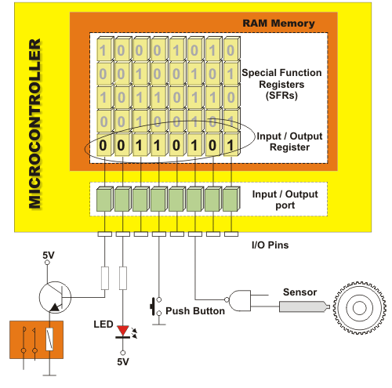
With input/output the user can change pin’s role according to his/her own needs. These are, in fact, the only registers in the microcontroller whose state can be checked by voltmeter!

4.3.7 Oscillator
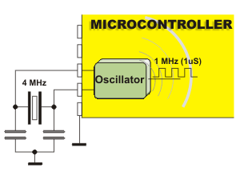
The oscillator can be compared with rhythm section of a mini orchestra. Equalized pulses coming from this circuit enable harmonious and synchronic operating of all other parts of the microcontroller. It is commonly configured to use quartz crystal or ceramics resonator for frequency stabilization. Besides, it can often operate without elements for frequency stabilization (like RC oscillator). It is important to know that instructions are not executed at the rate ordered by oscillator but several times slower. The reason for this is that each instruction is executed in several steps (In some microcontrollers execution time of all instructions is equal, while in others microcontroller’s execution time differs for different instructions). Consequently, if our system uses quartz crystal of 20MHz, execution time of a program instruction is not 50nS but 200, 400 or even 800 nS!

4.3.8 Timers/Counters

Most programs use in some way these miniature electronic "stopwatches". They are mostly 8- or 16-bit SFRs whose value is automatically incremented with each coming pulse. Once the register is completely "filled up"- an interrupt is generated!
If the registers use internal oscillator for its operating then it is possible to measure the time between two events ( if the register value is T1 at the moment measuring has started, and T2 at the moment measuring has finished, then the time that has passed is equal to the value gained by their subtraction T2-T1 ). If the registers for its operating use pulses coming from external source then such a timer is converted to counter.
This is a very simple explanation used to describe the essence of the operating. It is a bit more complicated in practice.
4.3.9 Register is another name for a memory cell. Beside 8 bits available to the user, each register has also addressing part usually not visible to the user. It is important to know:
- All registers in ROM as well as those in RAM memory identified as general-purpose registers are mutually equal and nameless. During programming, each register can be assigned a name, which makes operating much easier.
- All SFRs have their own names that are different for different types of the microcontrollers and each of them has a particular role.

4.3.10 Watchdog timer
Its name tells a lot about its purpose. Watchdog Timer is a timer connected to a particular and very independent RC oscillator within the microcontroller.
If enabled to operate, every time it "counts up to end", the microcontroller is reset and program execution starts from the first instruction. The to keep this from happening by using particular command. The whole idea is because every program circulates, in other words, the program is executed in several longer or shorter loops.
If the instructions, which reset the value of the watchdog timer, are set at some important program locations, besides commands being regularly executed, then the operation of the watchdog timer will not be noticed.

4.3.11 Power Supply Circuit
Two things within the circuit that take care of the microcontroller power supply are worth attention:
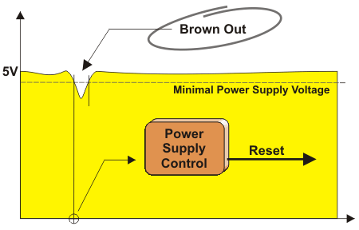
Brown out is potentially dangerous state coming up now the microcontroller is being turned off or in situations when due to powerful disturbances, voltage supply comes to the lowest limit. As the microcontroller consists of several circuits, which have different operating voltage levels, this can cause its "out of control" performance. In order to prevent that, a circuit for brown out reset is usually embedded. When the voltage level drops below the lower limit then this circuit immediately resets the whole electronics.

Reset pin is usually identified as MCLR (Master Clear Reset) and serves for "external" reset of the microcontroller by applying logical zero or one depending on type of the microcontroller. In case the brown out is not embedded, a simple external circuit for brown out reset can be connected to this pin.

4.3.12 Serial communication
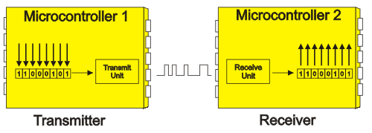
Connection between the microcontroller and peripheral devices established through I/O ports is an ideal solution for shorter distances- up to several meters. But, when it is needed to enable communication between two devices on longer distances or when for any other reason it is not possible to use "parallel" connection ( for example remote control of the aircraft ) it is obvious that something so simple cannot be taken into account. In such and similar situations, communication through pulses, called serial communication is the most appropriate to use.
Serial communication problem has been resolved a long time ago and nowadays several different systems enabling this kind of connection are embedded as a standard equipment into most microcontroller. Which of them will be used in very situation depends on several factors. The most important are the following:

- With how many devices the microcontroller must exchange data?
- How fast the serial communication must be?
- What is the distance between devices?
- Is there any need to transmit and receive data simultaneously?

One of the most important things concerning the use of serial communication is to strictly observe the Protocol. It is a set of rules, which must be applied in order to enable devices to recognize the data being exchanged. Fortunately, the microcontrollers automatically take care of it, which leads to a reduction of the programmer’s work to simple writing and reading data.

Byte - 8 bits next to each other make entity called a program word or a byte. If the bit is a digit then it is logical that bytes are numbers. All mathematical operations can be performed upon them, just like with usual decimal numbers and they are performed in the ALU. It is important to note that byte ( as each number) has “two sides”, i.e. digits a byte consists of are not of equal significance. The highest value has a digit on the far left called the most significant bit (MSB). A digit on the far right has the least value and is called the least significant bit (LSB). As 8 digits can be combined in 256 different ways, the greatest decimal number that can present one byte is 255 (zero is also presented with one combination).

Program

Unlike other integrated circuits, which only need to be connecting to other components and then powered on, the microcontrollers need to be programmed too prior to turning the power on. This is so called "a bitter pill" and the main reason why hardware-oriented electronics engineers mainly avoid the microcontrollers. It is a trap causing huge losses because the microcontrollers programming is in fact very simple.
Interrupt - electronics is usually faster than physical process in environment it should keep under control. That’s why the microcontroller spends the most of its time waiting for something to happen or execute. In order to avoid continuous checking for logical state on input pins and in internal registers, the interrupt is generated. It is a signal interrupting regular program execution. Since several events can cause interrupt, when it occurs, the microcontroller immediately stops operating and checks for the cause. If it is needed to perform some action, a current state of the program counter is pushed on the Stack and the appropriate program is executed (so called interrupt routine).
Stack is a part of RAM used for storing the current state of the program counter (address).This address lets the controller know where to return after the subroutine has been executed. Stack can consist of several levels. This enables subroutines’ nesting, i.e. calling one subroutine from another.

4.4 ALPHABETICAL LIST OF INSTRUCTIONS

- ACALL: Absolute Call
- ADD, ADDC: Add Accumulator (With Carry)
- AJMP: Absolute Jump
- ANL: Bitwise AND
- CJNE: Compare and Jump if Not Equal
- CLR: Clear Register
- CPL: Complement Register
- DA: Decimal Adjust
- DEC: Decrement Register
- DIV: Divide Accumulator by B
- DJNZ: Decrement Register and Jump if Not Zero
- INC: Increment Register
- JB: Jump if Bit Set
- JBC: Jump if Bit Set and Clear Bit
- JC: Jump if Carry Set
- JMP: Jump to Address
- JNB: Jump if Bit Not Set
- JNC: Jump if Carry Not Set
- JNZ: Jump if Accumulator Not Zero
- JZ: Jump if Accumulator Zero
- LCALL: Long Call
- LJMP: Long Jump
- MOV: Move Memory
- MOVC: Move Code Memory
- MOVX: Move Extended Memory
- MUL: Multiply Accumulator by B
- NOP: No Operation
- ORL: Bitwise OR
- POP: Pop Value From Stack
- PUSH: Push Value Onto Stack
- RET: Return From Subroutine
- RETI: Return From Interrupt
- RL: Rotate Accumulator Left
- RLC: Rotate Accumulator Left Through Carry
- RR: Rotate Accumulator Right
- RRC: Rotate Accumulator Right Through Carry
- SETB: Set Bit
- SJMP: Short Jump
- SUBB: Subtract From Accumulator With Borrow
- SWAP: Swap Accumulator Nibbles
- XCH: Exchange Bytes
- XCHD: Exchange Digits
- XRL: Bitwise Exclusive OR
- Undefined: Undefined Instruction

4.5 STEPPER Motors

Stepper motors consist of a permanent magnet rotating shaft, called the rotor, and electromagnets on the stationary portion that surrounds the motor, called the stator. Figure 1 illustrates one complete rotation of a stepper motor. At position 1, we can see that the rotor is beginning at the upper electromagnet, which is currently active (has voltage applied to it). To move the rotor clockwise (CW), the upper electromagnet is deactivated and the right electromagnet is activated, causing the rotor to move 90 degrees CW, aligning itself with the active magnet. This process is repeated in the same manner at the south and west electromagnets until we once again reach the starting position.
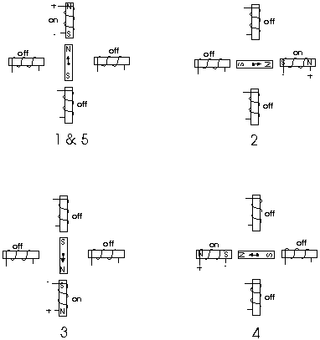
In the above example, we used a motor with a resolution of 90 degrees or demonstration purposes. In reality, this would not be a very practical motor for most applications. The average stepper motor's resolution -- the amount of degrees rotated per pulse -- is much higher than this. For example, a motor with a resolution of 5 degrees would move its rotor 5 degrees per step, thereby requiring 72 pulses (steps) to complete a full 360-degree rotation.
You may double the resolution of some motors by a process known as "half-stepping". Instead of switching the next electromagnet in the rotation on one at a time, with half stepping you turn on both electromagnets, causing an equal attraction between, thereby doubling the resolution. As you can see in figure 2, in the first position only the upper electromagnet is active, and the rotor is drawn completely to it. In position 2, both the top and right electromagnets are active, causing the rotor to position itself between the two active poles. Finally, in position 3, the top magnet is deactivated and the rotor is drawn all the way right. This process can then be repeated for the entire rotation.
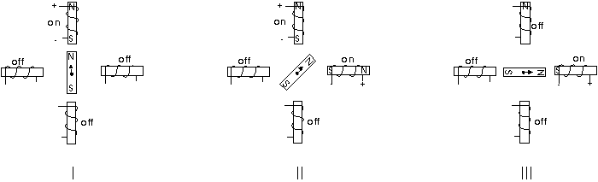
There are several types of stepper motors. 4-wire stepper motors contain only two electromagnets; however, the operation is more complicated than those with three or four magnets are, because the driving circuit must be able to reverse the current after each step. For our purposes, we will be using a 6-wire motor.
Unlike our example motors, which rotated 90 degrees per step, real-world motors employ a series of mini-poles on the stator and rotor to increase resolution. Although this may seem to add more complexity to the process of driving the motors, the operation is identical to the simple 90-degree motor we used in our example. An example of a multipole motor can be seen in figure 3. In position 1, the north pole of the rotor's permanent magnet is aligned with the south pole of the stator's electromagnet. Note that multiple positions are aligned at once. In position 2, the upper electromagnet is deactivated and the next one to its immediate left is activated, causing the rotor to rotate a precise amount of degrees. In this example, after eight steps the sequence repeats.
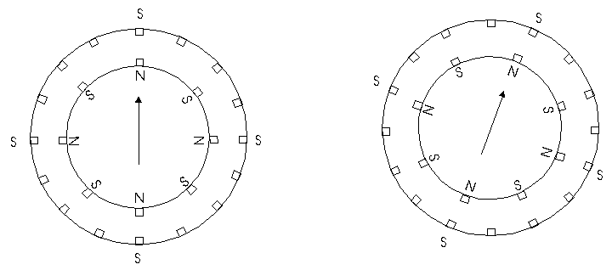

4.6 ROBOT
Automation and Robotics are closely related technologies. In an industry context, we can define automation as technology that is concern with the use of mechanical, electronics, computer-based systems in the operation and control of operation.
Robot is a type of mechanical slave with great strength.
It is programmable multifunctional manipulator designed to move material, parts, tools or special device throughout variable programmed motions for the performance of a variety of tasks.
Analogously the Robot can be defined in to four major components:

Arm: It is made up of several Joints and Links for the degree of freedom of movement
About X-axis-axis & Z-axis.
Gripper: It is same like that of end of human arm i.e. Palm and Fingers.
Muscles: To move the Palm, Arm & Fingers.
Brain: To control the movement of Palm, arm &Fingers.
Sense Organs: Eye, Ear & Skin (sense of touch). To provide valuable information to
Brain (Microcontroller) in controlling the action of various parts.
Robot Anatomy: The robot anatomy is the study of Skelton of robot i.e. physical construction of the manipulator that consists of rigid bodies (links) connected by means of joints, is segmented in to a arm that ensure mobility and reachibility,a wrist that confers orientation, and an end effecter that performs the required task.
Links: the mechanical structure of a robotic manipulator is a mechanism, whose members are rigid links or bars. A rigid link that can be connected, at most, with two other links is referred to as a binary link.
Joints: Two types of joints can be made between two links- Revolute and Prismatic. In former case, two links are joined by a pin about a axis of which the links can rotate w.r.t each other. In latter case, two links are so jointed that they can slide w.r.t each other.
Degree of Freedoms: The number of independent movement that an object can perform in a 3D space. A rigid body free in space has 6 degree of freedoms- three for position and three for orientation. A manipulator of 6 DOF to position and orient a body freely in a 3D space.
End Effecter: The end effectors are external to the manipulator and its DOF don’t combine with manipulator DOF. The different types of end effectors are gripper and tools.

Sensors and Vision
Sensors provide intelligence to the manipulator for its motion control, joint link position, velocity, torque is required to be sensed and the end effectors position and orientation is required. Sensors may be proximity, range, contact or non-contact, tactile or non-tactile, or a vision system.
Controller: Robot controller generally performs three functions:
- Initiation and termination of the motion of components of the manipulator ib desired sequence.
- Storage of position and data sequence
- Interfacing of robot with outside world via sensors.
Controllers may be Simple step sequencer, Pneumatic Logic System or microcontroller based.

- Design Consideration

The following are components used in making of embedded control of bottle filling prototype plant:

S.No. | APPARATUS | SPECIFICATIONS | QUANTITY
1. | Microcontroller 8051 | - Power Regulator - 7805  - Capacitor 25 V, 1000μF  - Diode IN-4007  - IC- 89S52  - Pull up Resistor A103J, 10K  - Crystal Oscillator- 11.059MHz  - Capacitor 50 V, 10μF  - Capacitor 50 V, 30pF  - Capacitor 104 miller | 1  1  4  1  1  1  2  2  1
2. | Input Sources | - LDR – 10K  - Reed Switch – 0.1 mm | 3  6
3. | OPAMP circuit | - IC-LN324  - Pull up Resistor 22K  - Trimmer 10K  - Resistor 1K | 1  1  1  4
4. | Relay Circuit | - Opto-coupler PC-817  - (b) Transistor BC557(PNP)  - (c) Relay 120V-AC,10A;  24V- DC,10A  - Diode- IN4007  - Resistor - 1K  10k  (f) LED | 1  1  1  1  3  1  1
5. | H-Bridge | - Power supply-  - Yellow Wire-12V  - Orange wire-5V  - Red wire-clock wise  - Brown wire-ctr clock wise  - Black wire- ground  - Transistor BC557(PNP)  - Opto-coupler  - Resistor 1K  - Diode IN4007  - Transistor TIP122  TIP127 | 1  1  1  8  4  2  2
6. | Pump | 12V, 300rpm,1.1-1.5A | 1
7. | Robotic Arm | - Base Motor 100rpm,12V, 1A  - Joint Motor 125rpm,12V, 1A  - Gripper Motor 80rpm,12V, 1A | 1  1  1
8. | Stepper Motor | 12V,1.8º step, 300mA | 1
9. | Driver Circuit | - IC STK6713BMK4  - Filters 220µF,50V  10µF,50V  (c) Resistor 5K  10K | 1  1  1  1  1

6. Hardware Description

6.1 PROJECT VIEW

6.2 HARDWARE IMPLEMENTATION

The Hardware of the Bottling Plant consists of three parts:

- Moving System
- Sensing System
- Controlling System
- Actuating System

6.2.1 Moving system:

- Conveyor Belt
- Robotic Arm

6.2.1.1 CONVEYOR BELT: - conveyor belt is supported on rollers at both the ends. Stepper Motor along with its driver circuitry (IC-STK 6713 BMK4) is used for the operation of conveyor belt.

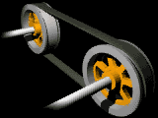

A belt conveyor consists of two or more pulleys, with a continuous loop of material - the conveyor belt - that rotates about them. One or both of the pulleys are powered, moving the belt and the material on the belt forward. The powered pulley is called the drive pulley while the empowered pulley is called the idler.

The belt consists of one or more layers of material they can be made out of rubber. Many belts in general material handling have two layers. An under layer of material to provide linear strength and shape called a carcass and an over layer called the cover. The carcass is often a cotton or plastic web or mesh. The cover is often various rubber or plastic compounds specified by use of the belt. Covers can be made from more exotic materials for unusual applications such as silicone for heat or gum rubber when traction is essential.

Rubber Conveyor Belts are commonly used to convey items with irregular bottom surfaces, small items that would fall in between rollers or bags of product that would sag between rollers. Belt conveyors are generally fairly similar in construction consisting of a metal frame with rollers at either end of a flat metal bed. . In heavy use applications the beds which the belting is pulled over are replaced with rollers. The rollers allow weight to be conveyed as they reduce the amount of friction generated from the heavier loading on the belting. Belt conveyors can now be manufactured with curved sections which use tapered rollers and curved belting to convey products around a corner.

The Conveyor belt used is looped around each of the rollers and when one of the rollers is powered (by an electrical motor- STEPPER MOTOR) the belting slides across the solid metal frame bed, moving the product.

STEPPER MOTOR
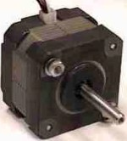
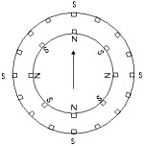
Stepper Motor
Internal diagram

Stepper Motors work under a very similar principle to DC motors, except they have many coils instead of just one. So to operate a stepper motor, one must activate these different coils in particular patterns to generate motor rotation. So stepper motors need to be sent patterned commands to rotate. These commands are sent (by a microcontroller) as high and low logic over several lines, and must be pulsed in a particular order and combination. Steppers are often used because each 'step,' separated by a set step angle, can be counted and used for feedback control. For example, a 10-degree step angle stepper motor would require 36 commands to rotate 360 degrees. However, external torque can force movement to a different step, invalidating feedback. Therefore, external torque must never exceed the holding torque of a stepper.
Stepper motors can be easily found in any 3.5" disk drive or from junk market. They require special stepper motor controllers (i.e. SLA7024M, STK6713BMK4). They have a set resolution; higher resolutions mean higher accuracy but lower holding torque. If torque applied to stepper is greater than holding torque, stepper will lose accurate position measurements

Voltage: Polarized (current cannot be reversed) typically from 5-12V, but can range to extremes in special application motors. Higher voltages generally mean more torque, but they also require more power. Steppers can run above or below rated voltage (to meet other design requirements) most efficient at rated voltage.
Current: When buying a motor, consider Stall Current, Holding Current and Operating Current (maximum and minimum).
Stall Current - The current that a stepper motor requires when powered but held so that it does not rotate.
Holding Current - The current that a stepper motor requires when powered but not signaled to rotate.
Operating Current - The current drawn when a stepper motor experiences zero resistance torque.
It is best to determine current curves relating voltage, current, and required torque for optimization. When a stepper motor experiences a change in torque (such as motor reversal), expect short-lived current spikes. Current spikes can be up to 2x the stall current, and can fry control circuitry if unprotected. Use diodes to prevent reverse current into your circuitry. Check power ratings of your circuitry and use heat sinks if needed.
Power (Voltage x Current) - Running motors close to Stall Current often, or reversing current frequently under high torque, can cause motors to melt Heat Sink.

Torque - When buying a stepper motor, consider Stall Torque and Operating Torque (maximum and minimum).

Stall Torque - The torque a stepper motor requires when powered but held so that it does not rotate.

Holding Torque - The torque a stepper motor requires when powered but not signaled to rotate.

Operating Torque - The torque a stepper motor can apply when experiencing zero resistance torque. Changing the voltage will change the torque.

Velocity - Motors run most efficient at the highest possible speeds. Gearing a motor allows the stepper motor to run fast, yet have a slower output speed with much higher torque. Remember that torque determines acceleration, so a fast robot with poor acceleration is really a slow robot. If uncertain, favor torque over velocity. Stepper motors are slower than DC motors.

Efficiency - Stepper motors are most efficient at rated voltage. They are less efficient than DC motors due to non-continuous stepping. Use gearing (opt to buy stepper motors with built-in gearing or gear heads) for higher efficiency.

Control Methods - Stepper Motors require a special stepper controller (driver) to prevent loss of torque. It has a more precise control than a DC motor.
Driver Circuit of Stepper Motor:
C1
+12V
+5V
+
_
JP2
JP1
IC – STK6713BMK4
1
3
5
8
10
12
14
16
2
4
7
11
13
15
6
9
C3 100pF
C4 0.1μF
R1 2KΩ
R2 1KΩ
C2
+
_
13
11
9
7
3
1
5
6
4
2
12
10
8
Connector
D
C
B
A
GND
A
B
C
D

A
+
-
D
C
B

6.2.1.2 ROBOTIC ARM
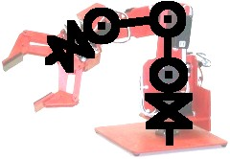

Robotic Arm is made up of a manipulator with 3 Revolt Joints and an End Effecter (Gripper which is used to pick the Bottle). The tasks to be performed by the manipulator are: 1) to move the end effectors along the desired trajectory, and 2)to exert a force3 on the environment to carry out the desired task which in this project is to pick the bottle. The controller of the manipulator has to control both tasks; the former is Position control (Trajectory control) and later is Force control. Sequential operation of Robotic arm is performed by 3 different Geared DC Motors which start working one by one after getting signals from microcontroller. To achieve movement of DC Motor in either direction, H-Bridge is used.

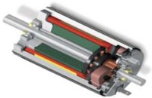
Dc Motor

From the start, DC motors seem quite simple. Apply a voltage to both terminals, and it spins. However, what if we want to control which direction the motor spins? Correct, we reverse the wires. Now what if we want the motor to spin at half that speed? we would use less voltage. However, how would we get a robot to do those things autonomously? How would we know what voltage a motor should get? Why not 50V instead of 12V? What about motor overheating? Operating motors can be much more complicated than we think.
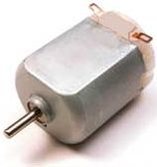
Voltage - We probably know that DC motors are non-polarized - meaning that we can reverse voltage without any bad things happening. Typical DC motors are rated from about 6V-12V. The larger ones are often 24V or more. But for the purposes of a robot, we probably will stay in the 6V-12V range. So why do motors operate at different voltages? As we all know (or should), voltage is directly related to motor torque. More voltage, higher the torque. But don't go running our motor at 100V cause that’s just not nice. A DC motor is rated at the voltage it is most efficient at running. If we apply too few volts, it just will not work. If we apply too much, it will overheat and the coils will melt. Therefore, the general rule is, try to apply as close to the rated voltage of the motor as we can.

Current - As with all circuitry, we must pay attention to current. Too little, and it just won't work. Too much, and we have meltdown. When buying a motor, there are two current ratings we should pay attention to. The first is operating current. This is the average amount of current the motor is expected to draw under a typical torque. Multiply this number by the rated voltage and we will get the average power draw required to run the motor. The other current rating, which we need to pay attention to, is the stall current. When we power up the motor, but we put enough torque on it to force it to stop rotating. This is the maximum amount of current the motor will ever draw, and hence the maximum amount of power too. Therefore, we must design all control circuitry capable of handling this stall current. In addition, if we plan to constantly run our motor, or run it higher than the rated voltage, it is wise to heat sink the motor to keep the coils from melting.
Power Rating - How high of a voltage can we over apply to a motor? Well, all motors are (or at least should be) rated at a certain wattage. Wattage is energy. Inefficiency of energy conversion directly relates to heat output. Too much heat, the motor coils melt. So the manufacturers of [higher quality] motors know how much wattage will cause motor failure, and post this on the motor spec sheets. Do experimental tests to see how much current our motor will draw at a desired voltage.
The equation is:
Power (watts) = Voltage * Current
Power Spikes - There is a special case for DC motors that change directions. To reverse the direction of the motor, you must also reverse the voltage. However, the motor has a built up inductance and momentum, which resists this voltage change. So for the short period of time it takes for the motor to reverse direction, there is a large power spike. The voltage will spike double the operating voltage. The current will go to around stall current. The moral of this is design your robot power regulation circuitry properly to handle any voltage spikes.
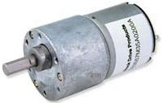
Torque - When buying a DC motor, there are two torque value ratings, which you must pay attention to. The first is operating torque. This is the torque the motor was designed to give. Usually it is the listed torque value. The other rated value is stall torque. This is the torque required to stop the motor from rotating. We normally would want to design using only the operating torque value, but there are occasions when you want to know how far we can push our motor. If we are designing a wheeled robot, good torque means good acceleration. If we have 2 motors on our robot, make sure the stall torque on each is enough to lift the weight of our entire robot times our wheel radius. Always favor torque over velocity. As stated above, our torque ratings can change depending on the voltage applied. So if we need a little more torque to crush that cute kitten, going 20% above the rated motor voltage value is fairly safe (for we, not the kitten).

Velocity - Velocity is very complex when it comes to DC motors. The general rule is, motors run the most efficient when run at the highest possible speeds. Obviously however this is not possible. There are times we want our robot to run slowly. So first you want gearing - this way the motor can run fast, yet we can still get good torque out of it. Unfortunately gearing automatically reduces efficiency no higher than about 90%. So include a 90% speed and torque reduction for every gear meshing when we calculate gearing. For example, if we have 3 spur gears, therefore meshing together twice, you will get a 90% x 90% = 81% efficiency. The voltage and applied torque resistance obviously also affects speed.
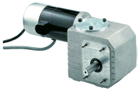
Control-Methods - The most important of DC motor control techniques is the H-Bridge. After we have our H-Bridge hooked up to our motor, to determine our wheel velocity/position we must use an encoder. Lastly, we should read up on good DC Motor Braking methods.
Introduction to gears - No good robot can ever be built without gears. As such, a good understanding of how gears affect parameters such as torque and velocity are very important.
Mechanical Advantage, Torque vs. Rotational Velocity - Gears work on the principle of mechanical advantage. This means that by using different gear diameters, we can exchange between rotational (or translation) velocity and torque.

As with all motors, by looking at the motor datasheet we can determine the output velocity and torque of our motor. But unfortunately, for robots, motors commercially available do not normally have a desirable speed to torque ratio (the main exception being servos and high torque motors with built in gearboxes). For example, do we really want our robot wheels to rotate at 10,000 rpm at low torques? In robotics, torque is better than speed.

With gears, we will exchange the high velocity with a better torque. This exchange happens with a very simple equation that you can calculate:

Torque Old * Velocity Old = Torque New * Velocity New

Torque Old and Velocity Old can be found simply by looking up the datasheet of your motor. Then what we need to do is put a desired torque or velocity on the right hand side of the equation. So for example, suppose our motor outputs 3 lb-in torque at 2000rps according to the datasheet, but we only want 300rps. This is what our equation will look like:
3 lb-in * 2000rps = Torque New * 300rps
With high school algebra, we can then determine that our new torque will be 20 lb-in.
Now suppose, with the same motor, we need 5 lb-in (minimum force to crush a cat, obviously). But suppose we also need 1500rps minimum velocity. How would we know if the motor is up to spec and can do this?
3 lb-in * 2000rps = 5 lb-in * Velocity New
Velocity New = 1200rps
We now have just determined that at 1200 rps the selected motor is not up to spec. Designing our robot, and doing all the necessary equations beforehand, will always save us tons of money and time.
Gearing Ratios - We would use two gears (sometimes more) of different diameters to have a particular gearing ratio. In any pair of gears, the larger gear will move more slowly than the smaller gear, but it will move with more torque. Thus, torque the bigger the size difference (or gearing ratio) between two gears, the greater the difference in speed and.
The gearing ratio is the value at which we change our velocity and torque. Again, it has a very simple equation. The gearing ratio is just a fraction which we multiple our velocity and torque by.
Suppose our gearing ratio is 3/1. This would mean we would multiple our torque by 3 and our velocity by the inverse, or 1/3.
Example; Torque Old = 10 lb-in, Velocity Old = 100rps

Gearing ratio = 2/3
Torque * 2/3 = 6.7 lb-in
Velocity * 3/2 = 150rps

Achieving a Particular Gearing Ratio - If we wanted a simple gearing ratio of say 2 to 1, we would use two gears, one being twice as big as the other is. It isn’t really the size as much as the diameter ratio of the two gears. If the diameter of one gear were 3 times bigger than the other gear, we would get a 3/1 (or 1/3) gearing ratio. We can easily figure out the ratio by hand measuring the diameter of the gears you are using.
We can also calculate the ratio by the ratio of teeth on the gears. If one gear has 28 teeth and the other has 13, we would have a (28/13=2.15 or 13/28=.46) 2.15 or .46 gearing ratio. In a worm gear setup, one gear always has a single tooth, while the other has many - a guaranteed huge ratio. Counting teeth will always give us the most exact ratio.
Gear Efficiency - Unfortunately, by using gears, we lower our input to output power efficiency. This is due to obvious things such as friction, misalignment of backlash pressure angles, lubrication, gear (spacing between meshed gear teeth between two gears) and angular momentum, etc. Different gear setups, different types of gears, different gear materials, and wear and tear on the gear, will all have different efficiencies.



Direction of Gear Rotation - When designing our gear setup we should understand how gearing changes the rotation direction of our output. Two gears touching will always be counter rotation; meaning if one rotates clockwise, the other will always rotate counterclockwise.
Worm Gears (~70% efficiency)
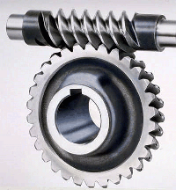

Worm gears have a very high gearing ratio. To mathematically calculate, consider the worm gear as a single tooth. Another advantage to the worm gear is that it is not back drivable. What this means is only our motor can rotate the main gear, so things like gravity or counter forces will not cause any rotation. This is good say if we have a robot arm holding something heavy, and we don’t want to waste power on holding torque. The efficiency is low, but lubrication really helps.

H-BRIDGE
An H-bridge can be implemented with various kinds of components (common bipolar transistors, FET transistors, MOSFET transistors, power MOSFETs, or even chips).
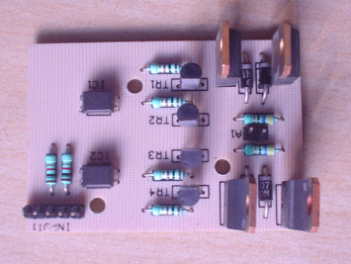
1
2
4
5
3
6
7
8
Motor Supply (+12V / +24V)
Logic Supply (+5V)
Clockwise (Active Low)
Counter-Clockwise (Active Low)
Ground
Points to be soldered to DC motor
Power Transistor
Opto-Coupler Device to provide isolation

Physical motion of some form helps differentiate a robot from a computer. It would be nice if a motor could be attached directly to a chip that controlled the movement. But, most chips can't pass enough current or voltage to spin a motor. Also, motors tend to be electrically noisy (spikes) and can slam power back into the control line
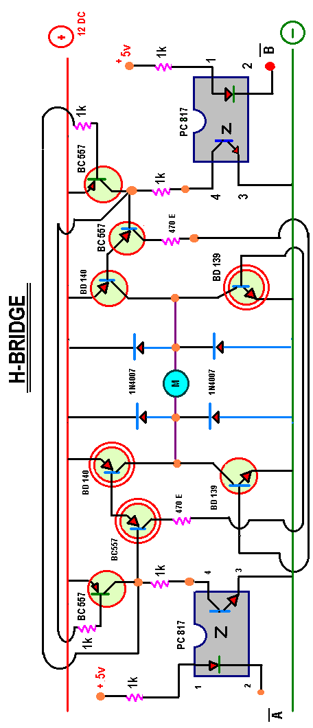When the motor direction or speed is changed. Specialized circuits (motor drivers) have been developed to supply motors with power and to isolate the other ICs from electrical problems. These circuits can be designed such that they can be completely separate boards, A very popular circuit for driving DC motors (ordinary or gear head) is called an H-bridge. It's called that because it looks like the capital letter 'H' on classic schematics. The great ability of an H-bridge circuit is that the motor can be driven forward or backward at any speed, optionally using a completely independent power source.

When we take a battery; hook the positive side to one side of our DC motor and connect the negative side of the battery to the other motor lead. The motor spins forward& on swapping, the battery leads the motor spins in reverse. Using Micro Controller Unit (MCU) to control the motor, we can do these using solid-state devices like transistor.
NOTE: Connect these relay circuits, remember to put a diode across the coil of the relay. This will keep the spike voltage (back EMF), coming out of the coil of the relay, from getting into the MCU and damaging it. The anode, which is the arrow side of the diode, should connect to ground. The bar, which is the Cathode side of the diode, should connect to the coil where the MCU connects to the relay
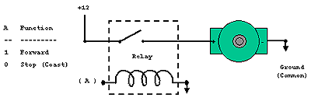
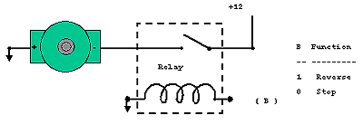
For connecting this circuit to a small hobby motor we can control the motor with a processor (MCU, etc.) Applying a logical one, (+12 Volts in our example) to point A causes the motor to turn forward. Applying a logical zero, (ground) causes the motor to stop turning (to coast and stop).
Hook the motor up in this fashion and the circuit turns the motor in reverse when apply a logical one (+12Volts) to point B. Apply a logical zero, which is usually a ground, causes the motor to stop spinning.
If we hook up these circuits we can only get the motor to stop or turn in one direction, forward for the first circuit or reverse for the second circuit.
Motor Speed - You can also pulse the motor control line, (A or B) on and off. This powers the motor in short burst and gets varying degrees of torque, which usually translates into variable motor speed.
But if we want to be able to control the motor in both forward and reverse with a processor, you will need more circuitry. We will need an H-Bridge. Notice the "H"-looking configuration in the next graphic. Relays configured in this fashion make an H-Bridge. The "high side drivers" are the relays that control the positive voltage to the motor. This is called sourcing current.
The "low side drivers" are the relays that control the negative voltage to sink current to the motor. "Sinking current" is the term for connecting the circuit to the negative side of the power supply, which is usually ground.

So, we turn on the upper left and lower right circuits, and power flows through the motor forward, i.e.: 1 to A, 0 to B, 0 to C, and 1 to D.

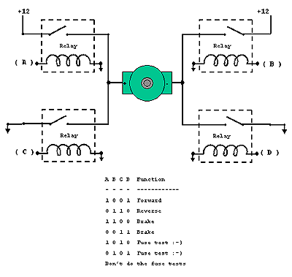

Then for reverse we turn on the upper right and lower left circuits and power flows through the motor in reverse, i.e.: 0 to A, 1 to B, 1 to C, and 0 to D.

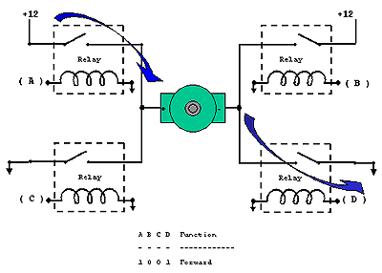
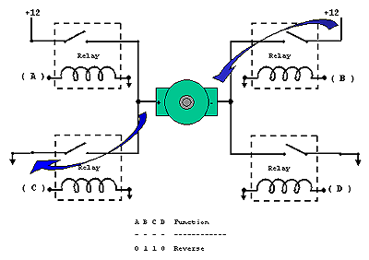

CAUTION: We should be careful not to turn on both circuits on one side and the other, or we have a direct short which will destroy our circuit; Example: A and C or B and D both high (logical 1).
The solid-state circuits provide power and ground connections to the motor, as did the relay circuits. The high side drivers need to be current "sources" which is what PNP transistors and P-channel FETs are good at. The low side drivers need to be current "sinks" which is what NPN transistors and N-channel FETs are good at.
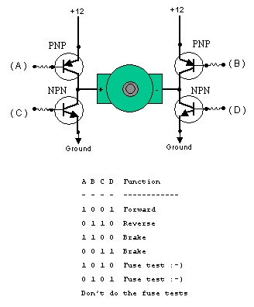
If we turn on the two upper circuits, the motor resists turning, so we effectively have a breaking mechanism. The same is true if you turn on both of the lower circuits. This is because the motor is a generator and when it turns, it generates a voltage. If the terminals of the motor are connected (shorted), then the voltage generated counteracts the motor’s freedom to turn. It is as if we are applying a similar but opposite voltage to the one generated by the motor being turned. Vis-à-vis, it acts like a brake.
To be nice to transistors, we should add diodes to catch the back voltage that is generated by the motor's coil when the power is switched on and off. This fly back voltage can be many times higher than the supply voltage! If we don't use diodes, we could burn out our transistors.
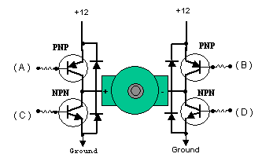
Transistors, being a semiconductor device, will have some resistance, which causes them to get hot when conducting much current. This is called not being able to sink or source very much power, i.e.: Not able to provide much current from ground or from plus voltage.
Mosfets are much more efficient; they can provide much more current and not get as hot. They usually have the fly back diodes built in so you don't need the diodes anymore. This helps guard against fly back voltage frying your MCU.
It is important that the four quadrants of the H-Bridge circuits be turned on and off properly. When there is a path between the positive and groundside of the H-Bridge, other than through the motor, a condition exists called "shoot through". This is a direct short of the power supply and can cause semiconductors to become ballistic, in circuits with large currents flowing. There are H-bridge chips available that are much easier, and safer, to use than designing your own H-Bridge circuit.
    - SENSING SYSTEM
The basic aim of the project is to implement sequential process control, which is achieved with the help of sensors like LDR using LASER, and Reed switches along with their amplifier circuit as the signal as output of sensor is insufficient low to actuate moving system.
A sensor is a device which measures a physical quantity and converts it into a signal which can be read by an observer or by an instrument. For accuracy, all sensors need to be calibrated against known standards.
There are innumerable applications for sensors which include automobiles, machines, aerospace, medicine, industry, and robotics..
A photo resistor or Light Dependent Resistor or CDS Cell is an electronic component whose resistance decreases with increasing incident light intensity. It can also be referred to as a photoconductor.
A photo resistor is made of a high resistance semiconductor. If light falling on the device is of high enough frequency, photons absorbed by the semiconductor give bound electrons enough energy to jump into the conduction band. The resulting free electron (and its hole partner) conduct electricity, thereby lowering resistance.
A photoelectric device can be either intrinsic or extrinsic. An intrinsic semiconductor has its own charge carriers and is not an efficient semiconductor, e.g. silicon. In intrinsic devices, the only available electrons are in the valence band, and hence the photon must have enough energy to excite the electron across the entire band gap. Extrinsic devices have impurities added, which have a ground state energy closer to the conduction band — since the electrons don't have as far to jump, lower energy photons (i.e. longer wavelengths and lower frequencies) are sufficient to trigger the device. If a sample of silicon has some of its atoms replaced by phosphorus atoms (impurities), there will be extra electrons available for conduction. This is an example of an extrinsic semiconductor.
Cadmium sulfide cells
Cadmium sulfide (CdS) cells rely on the material's ability to vary its resistance according to the amount of light striking the cell. The more light that strikes the cell, the lower the resistance. Although not accurate, even a simple CdS cell can have a wide range of resistance from less than 100 Ω in bright light to in excess of 10 MΩ in darkness. Many commercially available CdS cells have a peak sensitivity in the region of 500nm - 600nm (green light). The cells are also capable of reacting to a broad range of frequencies, including infrared (IR), visible light, and ultraviolet (UV). They are often found on street lights as automatic on/off switches. They were once even used in heat-seeking missiles to sense for targets.
Standard cadmium based LDRs have a frequency response that varies according to light level, but is routinely below 1Hz, so they are unsuitable for data links and picture scanning. Silicon based photodiodes and phototransistors are orders of magnitude faster.
Probably the best known LDR is the ORP12. Smaller cheaper devices are more popular today.
Lead sulfide- and indium antimonide-LDR are used for the mid infrared spectral region. At the other end of the scale, Ge:Cu photoconductors are among the best far-infrared detectors available, and are used for infrared astronomy and infrared spectroscopy. Continues power dissipation is 80mW and the Maximum voltage which can be applied to its 100V

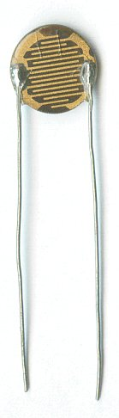

6.2.2.1 LIGHT DEPENDENT RESISTOR
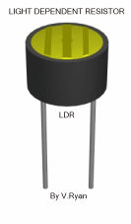 | LDRs or Light Dependent Resistors are very useful especially in light/dark sensor circuits. Normally the resistance of an LDR is very high, sometimes as high as 1000 000 ohms, but when they are illuminated with light resistance drops dramatically.
The animation opposite shows that when the torch is turned on, the resistance of the LDR falls, allowing current to pass through it. | 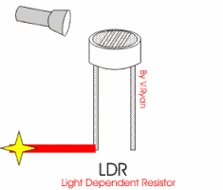
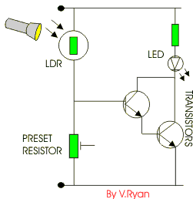 | This is an example of a light sensor circuit :  When the light level is low, the resistance of the LDR is high. This prevents current from flowing to the base of the transistors. Consequently the LED does not light.  However, when light shines onto the LDR its resistance falls and current flows into the base of the first transistor and then the second transistor. The LED lights.  The preset resistor can be turned up or down to increase or decrease resistance, in this way it can make the circuit more or less sensitive.

6.2.2.2 LASER
A laser is an electronic-optical device that emits coherent light radiation. The term "laser" is an acronym for Light Amplification by Stimulated Emission of Radiation.^{[1]} ("Laser" is incorrect when referring to this kind of device and is not a valid alternative spelling.) A typical laser emits light in a narrow, low-divergence monochromatic (single-colored, if the laser is operating in the visible spectrum), beam with a well-defined wavelength. In this way, laser light is in contrast to a light source such as the incandescent light bulb, which emits light over a wide area and over a wide spectrum of wavelengths.
In industry, lasers are used for cutting steel and other metals and for inscribing patterns (such as the letters on computer keyboards). Lasers are also commonly used in various fields in science, especially spectroscopy, typically because of their well-defined wavelength or short pulse duration in the case of pulsed lasers. Lasers are used by the military for target identification and illumination for weapons delivery. Lasers used in medicine are used for internal surgery and cosmetic applications.

Design
The word light in the acronym Light Amplification by Stimulated Emission of Radiation is typically used in the expansive sense, as photons of any electromagnetic energy, and it is not limited to photons in the visible spectrum. Hence there are infrared lasers, ultraviolet lasers, X-ray lasers, etc. For example, a source of atoms in a coherent state can be called an atom laser.
A laser consists of a gain medium inside a highly reflective optical cavity, as well as a means to supply energy to the gain medium. The gain medium is a material (gas, liquid, solid or free electrons) with appropriate optical properties. In its simplest form, a cavity consists of two mirrors arranged such that light bounces back and forth, each time passing through the gain medium. Typically, one of the two mirrors, the output coupler, is partially transparent. The output laser beam is emitted through this mirror.
Light of a specific wavelength that passes through the gain medium is amplified (increases in power); the surrounding mirrors ensure that most of the light makes many passes through the gain medium, stimulating the gain material continuously. Part of the light that is between the mirrors (that is, within the cavity) passes through the partially transparent mirror and escapes as a beam of light.
The process of supplying the energy required for the amplification is called pumping. The energy is typically supplied as an electrical current or as light at a different wavelength. A typical pump source is a flash lamp or perhaps another laser. Most practical lasers contain additional elements that affect properties such as the wavelength of the emitted light and the shape of the beam

6.2.2.3 OP-AMP CIRCUIT
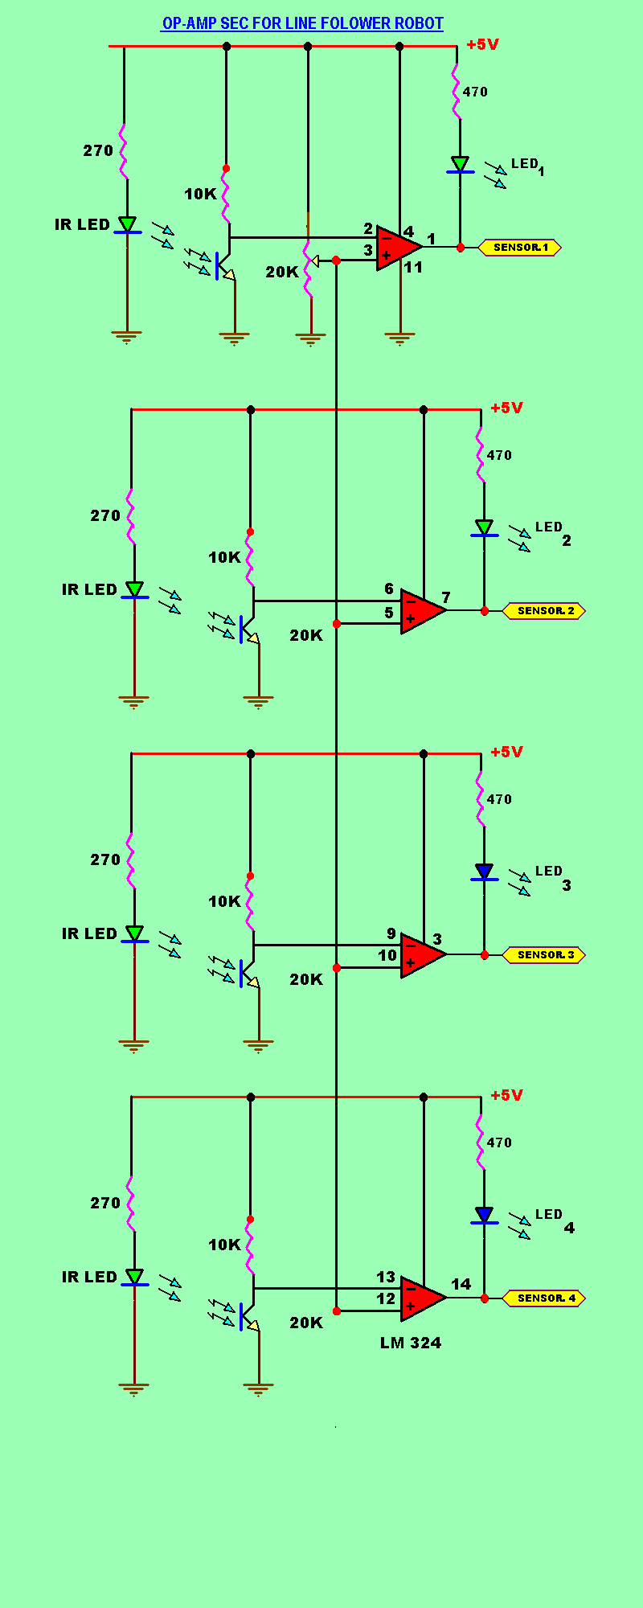
6.2.2.4 REED SWITCHES

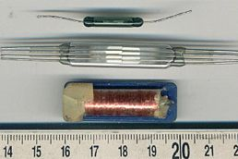
Reed relay and reed switches Showing the contacts clearly
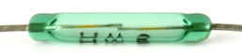
The reed switch is an electrical switch operated by an applied magnetic field. It was invented at Bell Telephone Laboratories in 1936 by W. B. Elwood. It consists of a pair of contacts on ferrous metal reeds in a hermetically sealed glass envelope. The contacts may be normally open, closing when a magnetic field is present, or normally closed and opening when a magnetic field is applied. The reed relay is a type of relay, in which a reed switch is mounted inside a coil.^{[1]}.

Description
The reed switch contains two magnetically and electrically conductive metal reeds which have end portions separated by a small gap when the switch is open. The reeds are hermetically sealed in opposite ends of a tubular glass envelope.
A magnetic field (from an electromagnet or a permanent magnet) will cause the contacts to pull together, thus completing an electrical circuit.^{[2]} The stiffness of the reeds causes them to separate, and open the circuit, when the magnetic field ceases. A more complicated configuration contains a non-ferrous normally closed contact that opens when the ferrous normally open contact closes. Good electrical contact is assured by plating a thin layer of precious metal over the flat contact portions of the reeds. There are also versions of reed switches with mercury "wetted" contacts.
Since the contacts of the reed switch are sealed away from the atmosphere, they are protected against atmospheric corrosion. The hermetic sealing of a reed switch make them suitable for use in explosive atmospheres where tiny sparks from conventional switches would constitute a hazard.
One important quality of the switch is its sensitivity, the amount of magnetic energy necessary to actuate it. Sensitivity is measured in units of Ampere-turns, corresponding to the current in a coil multiplied by the number of turns. Typical pull-in sensitivities for commercial devices are in the 10 to 60 AT range.
In production, a metal reed is inserted in each end of a glass tube and the end of the tube heated so that it seals around a shank portion on the reed. Infrared-absorbing glass is used, so an infrared heat source can concentrate the heat in the small sealing zone of the glass tube. The thermal coefficient of expansion of the glass material and metal parts must be similar to prevent breaking the glass-to-metal seal. The glass used must have a high electrical resistance and must not contain volatile components such as lead oxide and fluorides. The leads of the switch must be handled carefully to prevent breaking the glass envelope.
Reed switches are widely used for electrical circuit control, particularly in the communications field. Reed switches are commonly used in mechanical systems as proximity switches as well as in door and window sensors in burglar alarm systems and tamper proofing methods; however they can be disabled if they are in a strong, external magnetic field. Reed switches were formerly used in the keyboards for computer terminals, where each key had a magnet and a reed switch actuated by depressing the key. Speed sensors on bicycles use a reed switch to detect when the magnet on the wheel passes the sensor.

Reed relays
A reed switch combined with an electromagnet is a reed relay. This consists of a coil with the reed switch inside. Reed relays are used when high operating speed is required, or where very low-level signals must be switched. Millions of reed relays were used for temporarily storing information in middle 20th Century telephone exchanges. The inert atmosphere around the reed contacts ensures that oxidation will not affect the contact resistance. Mercury-wetted reed relays are sometimes used, especially in high-speed counting circuits. Such relays must be mounted in a particular orientation otherwise drops of mercury may unintentionally bridge the contacts.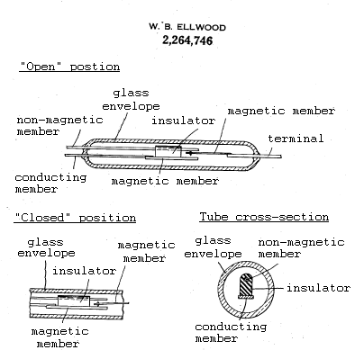

6.3 CONTROLLING SYSTEM

The 8051 microcontroller is computer-on -chip is the brain of Bottle Filling Plant, which makes decisions and controls all the functions of plant to make it autonomous along with its circuitry. ATMEL 89C52 IC is used in which program is burned In its RAM.

PART NO. SPECIFICATIONS:

a = AT 89 C 51/52 − 24 PC

CMOS 24 MHZ Plastic Commercial

b = AT 89 LV 51/52

Low Voltage

c = AT 89 S 51/52

Serial (for ISP)
ISP - In System Programming

BASIC CIRCUIT DIAGRAM OF 8051
AT89C51
39 32 PO
1 8 P1
10 17 P3
40 29 31
30 PF
20
18
19
30 PF
10 μF
9
+
−
D₀ D₇
LED
⊕
⊝
P∗.∗
5V
RST
O
11.0592
MHz
21 28 P2
1 K
10 K

POWER SUPPLY

○

7805
IN4007
⊕
⊝
5V
+
−
1000 μF
10 μF
220 V
AC
+
12 V
AC

The kit is active low to avoid spikes &to have more fan-out.
Fan-out is a measure of the ability of a logic gate output, implemented electronically, to drive a number of inputs of other logic gates of the same type. In most designs, logic gates are connected together to form more complex circuits, and it is common for one logic gate output to be connected to several logic gate inputs. The technology used to implement logic gates usually allows gate inputs to be wired directly together with no additional interfacing circuitry required.
Fan-out is a term that defines the maximum number of digital inputs that the output of a single logic gate can feed. Most transistor-transistor logic (TTL) gates can feed up to 10 other digital gates or devices. Thus, a typical TTL gate has a fan-out of 10.
PC 817-opto isolator is used to isolate control circuitry with power circuit.
Opto isolator
A common implementation involves a LED and a phototransistor, separated so that light may travel across a barrier but electrical current may not. When an electrical signal is applied to the input of the opto-isolator, its LED lights, its light sensor then activates, and a corresponding electrical signal is generated at the output. Unlike a transformer, the opto-isolator allows for DC coupling and generally provides significant protection from serious over voltage conditions in one circuit affecting the other.
Pins of the ports of microcontroller is used to have signals from the sensors as inputs commands and outputs to different actuators are given on the other pins according to the programming to achieve the desired task in sequential manner.

7. Software Description

START

e
Sensor 1 Sense Bottle

7.1 HOW TO USE THE IDE

The sample IDE window is shown below

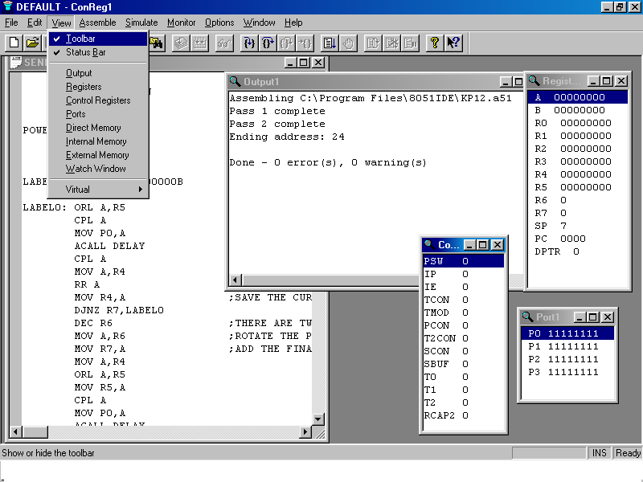
21
32
53
4
1

- Window 1 is the main window where the program is written.
- Window 2 shows the output window, which on the execution of the program shows the errors occurred, warnings encountered and other similar data. This is selected by pointing to ‘view’-> ‘output’.
- Window 3 shows the Registers used along with their values. For dynamic variation of these values reflecting their values in the memory, one needs to ‘Simulate’ which will be further explained at a later stage. This is selected by pointing to ‘view’-> ‘Registers’.
- Window 4 shows Port Window showing the values acquired by the ports. This window is also useful when simulating. This is selected by pointing to ‘view’-> ‘Ports’.
- Window 5 shows the values of important internal variables including Timers, TMOD, and IE etc.

On writing the program in the program window, the program is compiled (converted to .HEX file) by pointing to ‘Assemble’-> ‘Assemble’. The errors, if any, as mentioned above, will be shown on the output window.
On assembling the program, in the folder containing the file, the following files are created:

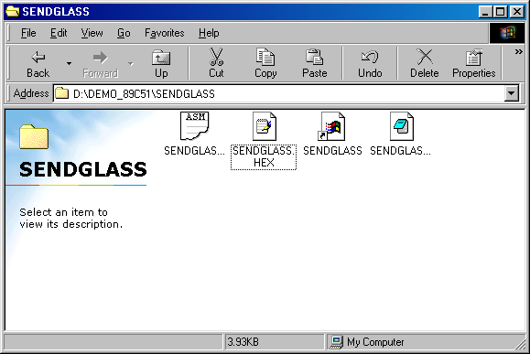
1
2
3
4
- File 1 is a .ASM file and is the file in which you have written your program.
- File 2 is a .HEX file
- File 3 is a shortcut to the .ASM file
- File 4 is an .LST, which contains all the commands, important definitions of the labels and the addresses of each command.

Simulation

To debug a program, in a more effective way, the option to ‘Simulate’ is provided. On choosing the appropriate windows to be shown (by choosing them from ‘Views’ on the menu bar), option of ‘Simulate’ is selected and further the option of ‘Start Simulator’ is chosen. While the program is running, the dynamic values of the variables are shown in their respective windows step-by-step value-by-value. To go to the next step, click on ‘Simulate’->’Step Into’ or as a shortcut, press F11. The various values stored in the respective variable can than be checked and matched with their expected values for any fault.

7.2 Sample ide window for the project

The Program for prototype of Bottle Filling Plant is written in 8051 IDE VERSION1.0. The Sample window is shown below:
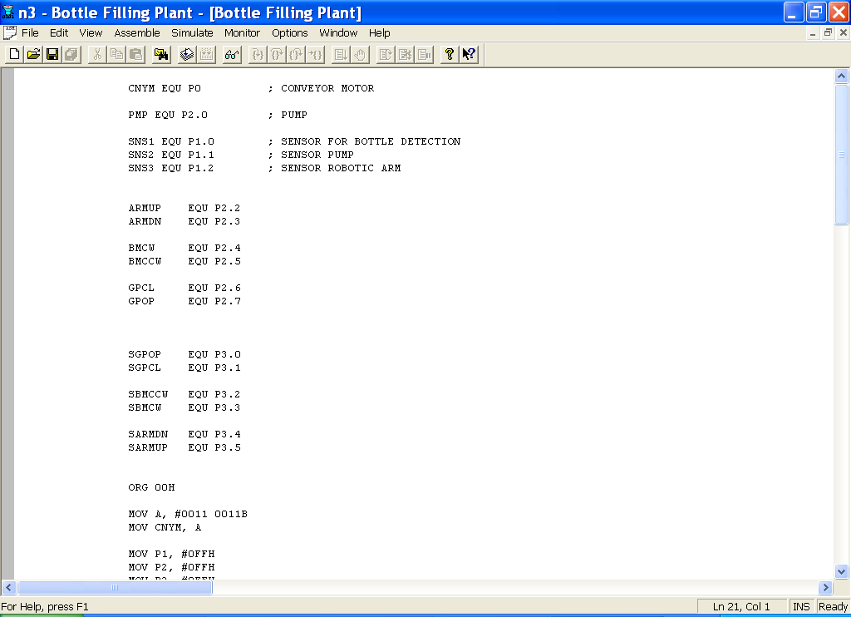

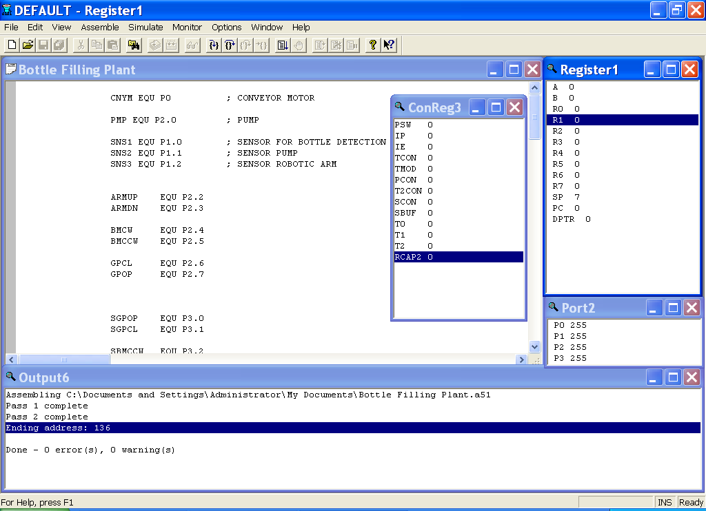

7.3 HOW TO BURN THE MICROCONTROLLER

- Double click on the icon for SpiPgm. In addition, the following window will appear in front of us.

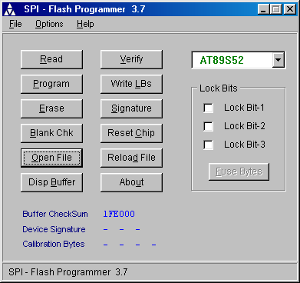
- Now select the device AT89S52.
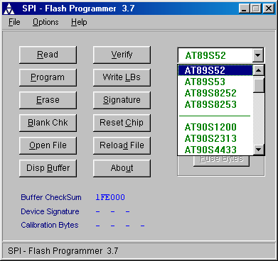
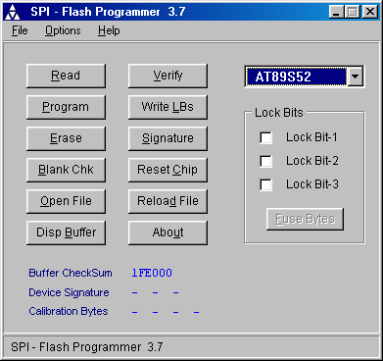
- Now click on ‘Erase’ to erase the contents of microcontroller.

- Now click on ‘Open File’ and select the desired program.

5. Now click on ‘Program’ to burn the microcontroller.

6. Our program should now run if all steps were followed correctly and our program
is also correct.

8. WORKING

8.1 FLOW CHART
START

Place Bottle

Sensor 1 Sense Bottle

Set the arm in Counter
Clockwise Position
Stepper Motor starts to rotate
Conveyor Belt
Motor stops Arm picks Bottle
Starts Again if
Sensor 1
Sense Bottle
No
No

Sensor 2 Senses

Yes

Motor stops
Pumps starts
Delay (40 sec)

Stepper Motor starts to rotate
Conveyor Belt

Sensor 3 Senses

Yes

Stop

8.1 CIRCUIT DIAGRAM

Motor
5V
P1.1
P1.2
P1.3
P1.6
P1.7
18
19
30 pF
30 pF
10 μF
RESET
10 k
29 31 40
P2.0
1K
10 K
1K
PC 817
P1.5
Sensor 1
Sensor 2
Sensor 3
20
⊕
⊝
Pump
Relay
220VAC
+ 12V
BC 557
1K
1N4007
AT 89 S52
ICLN 324
P1.0
CW (P2.4)

H Bridge
CCW (P2.5)
Motor
CW (P2.1)

H Bridge
CCW (P2.2)
Motor
CW (P2.1)

H Bridge
CCW (P2.2)
+ 5V
+ 5V
+ 5V
+ 12V
+ 12V
+ 12V
Driver Ckt.
Stepper Motor
P0.1
P0.2

8.3 WORKING

In the Bottle Filling Plant System when the supply is given through SMPS, the sensor checks the position of Robot and a signal is given by the microcontroller to first DC Motor(at the base of ROBOT) to move the robot to its desired position. The movement of the robotic arm will be governed by the combination of H-Bridge and the Reed Switch.
When the bottle is put on the conveyor belt, it interrupts the LASER, the Dependent Resistor (LDR) will get the input by the LASER beam, and it gives the signal to the microcontroller through amplifier circuit. A person will keep normally Empty bottles at the starting position. The presence of the bottle will be sensed by using Light; the LASER beam will intersect the centre of the LDR. Whenever, a bottle is placed between these two systems, the LDR will not get the input of the LASER beam. Thus, the circuit will be broken, the microcontroller will direct the stepper motor driver to move the conveyor belt through stepper motor, and the bottle will be moved with a moving mechanism (a conveyor belt).
At a certain distance, there is a filling point where the bottle will be filled. The LDR and the LASER mechanism will sense whether the bottle has reached to that point. As soon as the bottle reaches to that point, the microcontroller will command the moving mechanism to stop. Then the bottle will wait for some time to be filled which a pumping device will do.
After the bottle is filled, the conveyor belt will move again until the bottle reaches the end point. There again the LDR and the LASER mechanism will sense the presence of the filled bottle and then the microcontroller will command the driver circuit to stop the conveyor belt. Microcontroller will give the command to the second Dc motor (at the arm joint of ROBOT) and with the help of reed switches, the Robotic Arm will set to its required position. The movement of Gripper will be initialized by third DC motor (at the end Effecter) which picks up the bottle and comes back to its initial position.

9. EXPECTED RESULT

The expected result of the working of the project has been achieved. The autonomous bottle filling plant designed using the 8051 microcontroller and the LDR-LASER sensing mechanism has been run successfully according to the programming done using the IDE software. The bottling plant as been verified with its entire component thoroughly checked and the bottles are successfully sensed and filled from the pump. In addition, the robotic arm properly picks up the bottle from the end, without changing the content of liquid in it.

10. CONCLUSIONS

- The prototype of bottle filling plant based on embedded system was implemented and working successfully using microcontroller 8051and robotic arm.
- The industrial prototype was built and the conclusions are as follows:

- The system can perform the task of autonomous quality control system used in industrial production.

- The interfacing of microcontroller programming with hardware of prototype of bottle filling plant was tested and working successfully.

- Implementation of various sensors like LDR with LASER and Reed switches for the control of conveyor belt and robotic arm is functioning successfully

11. FUTURE SCOPE OF WORK

Though the autonomous bottling plant made using the 8051 microcontroller is quite simple and automated, but this realization can be made advanced and faster using PLC (programmable logical control) which provides faster realization of the circuits. PLCs are well adapted to a range of automation tasks. These are typically industrial processes in manufacturing where the cost of developing and maintaining the automation system is high, relative to the cost of the automation, and where changes to the system would be expected during its operational life.

Even though this project is very much set as per the production because, we can only fill and pick up the bottle. We can further modify it using various technologies and processes like capping the filled bottles, putting the label, varying the height and even packing four to six bottles in a carton. Also with further work in the future, we can modify it, as if by using the Ultrasonic sensors instead of LDR-LASER mechanism, installing a robotic arm collaborated with a height detector, so that the robotic arm can function according to the height of the bottles to be filled. Thus, we can create a lot of scope for future working with certain modifications.

REFERENCES

- Encarta Encyclopedia.
- Wikipedia.
- Ask.com.
- Alibaba.com.
- Robotic Engineering by Richard D.Klafter, Thomas.
- A, Michael Negin.
- The 8051 Microcontroller by Kenneth J.Ayala.
- The 8051 Microcontroller and Embedded Systems by M. A. Mazidi.
- Introduction to Robotics by Sayeed B. Nikku.

12. APPENDIX

BOTTLE FILLING PLANT

CNYM EQU P0 ; CONVEYOR MOTOR

PMP EQU P2.0 ; PUMP ; PUMP

SNS1 EQU P1.0 ; SENSOR FOR BOTTLE DETECTION
SNS2 EQU P1.1 ; SENSOR PUMP
SNS3 EQU P1.2 ; SENSOR ROBOTIC ARM

ARMUP EQU P2.2
ARMDN EQU P2.3

BMCW EQU P2.4
BMCCW EQU P2.5

GPCL EQU P2.6
GPOP EQU P2.7

SGPOP EQU P3.0
SGPCL EQU P3.1

SBMCCW EQU P3.2
SBMCW EQU P3.3

SARMDN EQU P3.4
SARMUP EQU P3.5

ORG 00H

MOV A, #0011 0011B
MOV CNYM, A

MOV P1, #0FFH
MOV P2, #0FFH
MOV P3, #0FFH

CLR BMCCW
MAIT: JB SBMCCW, MAIT
SETB BMCCW

CLR ARMUP
MAIT1: JB SARMUP, MAIT1
SETB ARMUP

CLR GPOP
MAIT2: JB SGPOP, MAIT2
SETB GPOP

MAIN:
JB SNS1, MAIN
MAIN8: RR A
MOV CNYM, A
MOV R7, #1
ACALL DELAY
JB SNS2, MAIN8

CLR PMP
MOV R7, #50
ACALL DELAY
SETB PMP
MOV R7, #5
ACALL DELAY

MAIN1: RR A
MOV CNYM, A
MOV R7, #1
ACALL DELAY
JB SNS3, MAIN1

CLR ARMDN
MAIT3: JB SARMDN, MAIT3
SETB ARMDN

CLR GPCL
MAIT4: JB SGPCL, MAIT4
SETB GPCL

CLR ARMUP
MOV R7, #2
ACALL DELAY
SETB ARMUP

CLR BMCW
MAIT5: JB SBMCW, MAIT5
SETB BMCW

CLR ARMDN
MAIT6: JB SARMDN, MAIT6
SETB ARMDN

CLR GPOP
MAIT7: JB SGPOP, MAIT7
SETB GPOP

CLR ARMUP
MAIT8: JB SARMUP, MAIT8
SETB ARMUP

CLR BMCCW
MAIT9: JB SBMCCW, MAIT9
SETB BMCCW

MOV R7, #20
ACALL DELAY
AJMP MAIN

DELAY:
L3: MOV R6, #255
L2: MOV R5, #255
L1:
END
DJNZ R5, L1
DJNZ R6, L2
DJNZ R7, L3
RET

