ELECTRICAL CHARACTERIZATION OF CaBa₄SmTi₃Nb₇O₃₀ FERROELECTRIC CERAMIC
by
MONIKA
DEPARTMENT OF APPLIED PHYSICS
DELHI COLLEGE OF ENGINEERING
DELHI, INDIA

Submitted in fulfillment of the requirements for
the degree of
MASTER OF SCIENCE
to the
UNIVERSITY OF DELHI
DELHI, INDIA

Under the supervision of
Dr. A. K. JHA
Prof. Applied Physics Department
Delhi College of Engineering
Delhi University, Delhi.

ACKNOWLEDGEMENT

Acknowledgment is not only a ritual, but also an expression of indebtedness to all those who have helped in the completion process of the project. One of the most pleasant aspects in collecting the necessary and vital information and compiling it is the opportunity to thank all those who actively contributed to it.

I owe my deepest gratitude and profound indebtedness to Dr. A. K. Jha, my project guide for imparting me the right training, showing the right direction, guidance and giving an opportunity to prove my ability in this challenging arena. I would like to express my deep felt gratitude to him for permitting me to complete the project work, which is an important part of my curriculum.

I am also thankful to Dr. R. K. Sinha, for providing me all the required facilities and vision.

I am grateful to Applied Physics Deptt. Delhi College of Engineering, Delhi University for providing me the opportunity to complete the project in an appropriate environment in the stipulated span of time.

CERTIFICATE
________________________________________________________________________

Certified that the project entitled “ELECTRICAL CHARACTERIZATION OF CaBa₄SmTi₃Nb₇O₃₀ FERROELECTRIC CERAMIC “ being submitted for the Master of Science ( Applied Physics ) from Delhi College of Engineering, Delhi University during a academic year 2008-09 in a bonafied piece of project work carried by

MONIKA (22122)

To the fulfillment of award of degree M. Sc. (Applied Physics) under my guidance and supervision and no part thereof has been submitted for any degree or diploma.

Dr. A.K.JHA Dr. R.K.SINHA
Prof. Applied Physics Deptt. H.O.D. Applied Physics Deptt.
Delhi College of Engineering Delhi College of Engineering
Delhi University Delhi University
(Guide)

ABSTRACT
Long back when the electronic ceramics were discovered, it must have been difficult for anyone to imagine the extent of their applications. Undoubtedly the scope of these ceramics is unlimited as these materials have been utilized in manufacturing a large number of appliances for daily life in the form of sensors, actuators, ultrasonic motors, thin film hybrid displays, mobile phones, and arrays of material strips to produce electricity during motion of an aeroplane, etc. A wide range of electronic ceramics have been investigated for their properties such as electrical insulation; dielectric properties and such other unique properties as spontaneous polarization, transparency and various barrier layer properties associated with significant resistive or capacitive changes. Ferroelectrics, a special class of piezoelectric materials, have drawn attention of physicists because of their remarkable capacitive and memory features. The groups of physicists and material scientists are working vigorously to understand the basic science behind the versatility of these materials.
Among ferroelectrics, tungsten bronze type ceramics have received special attention because of their potential use as a material for laser modulation, pyroelectric detectors, hydrophones, and ultrasonic applications. The high Curie point (T_{c} = 560 ºC for lead niobate) of their compounds makes them suitable for high temperature applications. The tungsten bronze type ferroelectric crystals have a structure similar to tetragonal tungsten bronze K_{x}WO₃ (x<1). Lead niobate (PbNb₂O₆) was one of the first crystals of the tungsten bronze type structure to show useful ferroelectric properties. At present, tungsten bronze family of oxide ferroelectrics, numbers more than 85. From this family Ba₅SmTi₃Nb₇O₃₀ barium samarium titanium niobate was chosen for present work. It was studied with calcium doping. This material is known to have a dielectric anomaly of ferroelectric to paraelectric type at 170 C, and exhibits diffuse phase transition. Bulk resistance is observed to decrease with an increase in temperature, showing a typical negative temperature coefficient of resistance (NTCR) type behavior. It was doped with calcium as a method to improve its properties.
Solid state reaction method has been used to prepare the samples. Sintering was done at a high temperature (as per the optimum sintering condition) to yield high dielectric constant and low dielectric loss.
The electrical contacts were made by deposition of silver by vacuum deposition technique. Silver was used in form of high purity silver wires and silver vapours were made to get deposited in vacuum over the two faces of the pallete.
Electrical characterization was done. Variation of dielectric constant and dielectric loss with temperature, frequency and voltage was studied.
Piezoelectric characterization included polling of the ceramic at a high polling field. Piezoelectric parameters were measured such as d₃₃, g₃₃, voltage sensitivity, tan∂ etc.
Among ferroelectric characterization P-E loop was recorded and remnant polarization, coercive field, saturation polarization were measured.
The project report is presented in three chapters.
Chapter 1 describes a short review of historical developments of ferroelectrics and their applications. This chapter also includes classes of materials and the introduction of the chosen sample with its structure.
Chapter 2 deals with electrical characterization of Ba₅SmTi₃Nb₇O₃₀ with ca doping. It includes making the sample suitable for characterization by forming electrical contacts and measurement of its dielectric properties, piezoelectric properties, and ferroelectric properties.
Chapter 3 contains conclusion of results and their detailed discussion. It also summarizes the inferences from the work.

CONTENTS
Page no. CHAPTER 1 INTRODUCTION
1.1 Introduction 7
1.2 Applications of ferroelectric materials 8
1.3 Classes of materials 10
1.4 Sample and its structure 24

CHAPTER 2 ELECTRICAL CHARACTERIZATION
2.1 Sample preparation 27
2.2 Dielectric characterization 28
- Variation with temperature 33
- Variation with frequency 41
- Variation with bias voltage 45
2.3 Piezoelectric characterization 52
2.4 Ferroelectric characterization 58

CHAPTER 3 INFERENCES
3.1 Variation of dielectric constant and loss with temperature 61
3.2 Variation of dielectric constant and loss with frequency 61
3.3 Variation of dielectric constant and loss with bias voltage 61
3.4 Piezoelectric measurements 62
3.5 Ferroelectric measurements 62

REFERENCES 63

Chapter 1

INTRODUCTION

  - Introduction
Ferroelectric ceramics were born in the early 1940’s with the discovery of the phenomenon of ferroelectricity as the source of the unusually high dielectric constant in ceramics. Since that time, they have been the heart and soul of several multi-billion-dollar industries, ranging from high dielectric constant capacitors to later developments of piezoelectric transducers, PTC devices and electro-optic light valves. The era of ferroelectricity began in early 1940’s under a cloud of secrecy, because World War 2 was under way. Materials based on two compositional systems, barium titanate and lead zirconate titanate, have dominated the field throughout their history. The more recent developments in the field of ferroelectric ceramics, such as medical ultrasonic composites, high-displacement piezoelectric actuators (Moonies, RAINBOWS), photostrictors, and thin and thick films for piezoelectric and integrated-circuit applications have served to keep the industry young amidst its growing maturity.
The tungsten bronze type ferroelectric crystals have a structure similar to tetragonal tungsten bronze K_{x}WO₃ (x<1). Lead niobate (PbNb₂O₆) was one of the first crystals of the tungsten bronze type structure to show useful ferroelectric properties. The site occupancy formula for this type of structure is given by (A₁)₂(A₂)₄(C)₄(B₁)₂(B₂)₈O₃₀. Figure 14 shows the schematic of the projection of the tungsten bronze type structure on the (001) plane. For lead niobate the B₁ and B₂ sites are occupied by Nb⁵⁺ ions. The open nature of the structure as compared to the perovskite allows a wide range of cation and anion substitutions without loss of ferroelectricity. At present, tungsten bronze family of oxide ferroelectrics, numbers more than 85.The ferroelectric crystals grown from solid solutions of alkali and alkaline earth niobates have shown great potential for being used as a material for laser modulation, pyroelectric detectors, hydrophones, and ultrasonic applications. The high Curie point (T_{c} = 560 ºC for lead niobate) of their compounds makes them suitable for high temperature applications.

1.2 Applications of ferroelectric materials
• Capacitors
The nonlinear nature of ferroelectric materials can be used to make capacitors with tunable capacitance. Typically, a ferroelectric capacitor simply consists of a pair of electrodes sandwiching a layer of ferroelectric material. The permittivity of ferroelectrics is not only tunable but commonly also very high in absolute value, especially when close to the phase transition temperature. This fact makes ferroelectric capacitors smaller compared to dielectric (non-tunable) capacitors of similar capacitance.
• Non-volatile memory
The spontaneous polarization of ferroelectric materials implies a hysteresis effect which can be used as a memory function. Indeed, ferroelectric capacitors are used to make ferroelectric RAM for computers and RFID cards. These applications are usually thin films of ferroelectric materials as this allows the high coercive field required to switch the polarization to be achieved with a moderate voltage, though a side effect of this is that a great deal of attention needs to be paid to the interfaces, electrodes and sample quality for devices to work reliably.
• Piezoelectrics for ultrasound imaging and actuators
All ferroelectrics are required by symmetry considerations to be also piezoelectric and pyroelectric. The combined properties of memory, piezoelectricity, and pyroelectricity make ferroelectric capacitors very useful, e.g., for sensor applications. Ferroelectric capacitors are used in medical ultrasound machines (the capacitors generate and then listen for the ultrasound ping used to image the internal organs of a body).
• Electro-optic materials for data storage applications
High quality infrared cameras (the infrared image is projected onto a two dimensional array of ferroelectric capacitors capable of detecting temperature differences as small as millionths of a degree Celsius), fire sensors, sonar, vibration sensors, and even fuel injectors on diesel engines. Also, the electro-optic modulators that form the backbone of the Internet are made with ferroelectric materials.
- Ferroelectric tunnel junctions
One new idea of recent interest is the ferroelectric tunnel junction (FTJ) in which a contact made up by nanometer-thick ferroelectric film placed between metal electrodes. The thickness of the ferroelectric layer is thin enough to allow tunneling of electrons. The piezoelectric and interface effects as well as the depolarization ﬁeld may lead to a giant electroresistance (GER) switching effect.
- Multiferroics
Another hot topic is multiferroics, where researchers are looking for ways to couple magnetic and ferroelectric ordering within a material or heterostructure; there are several recent reviews on this topic.
• Thermistors
• Switches known as transchargers or transpolarizers
• Oscillators and filters
• Light deflectors, modulators and displays.
.

1.2 Classes of ferroelectric materials
Dielectrics are electrically non-conducting materials such as glass, porcelain etc, which exhibit remarkable behavior because of the ability of the electric field to polarize the material creating electric dipoles.

Ferroelectricity: Some dielectric materials spontaneously acquire an electric dipole moment below a certain temperature. This is referred to as spontaneous polarization. Analogy with magnetic material results in a type of dielectric materials called ferroelectric materials. Similar to Ferromagnetic materials Ferroelectric materials also exhibit ferroelectric hysteresis. It is a plot of
polarization (P) versus Electric field strength (E). Ferroelectric hysteresis is the lagging of the
polarization with respect to applied electric field Strength during the positive polarization and
negative polarization of the specimen.
The static dielectric constant of a ferroelectric material changes with temperature which is given by
ir Where C is a constant, T is the temperature and q is a temperature very close to a temperature
called Curie temperature (Tc). Ferroelectric materials exhibit Piezoelectricity and Pyro-electricity. Quartz, Lithium Niobate and Barium Titanate are the few examples of ferroelectric materials. Ferroelectric materials are used in pressure transducers, Ultrasonic transducers, microphones, Infrared detectors and capacitors.

Piezoelectric Materials:
Certain dielectric materials are electrically polarized when their surfaces are stressed. This phenomenon is called piezoelectric effect and the materials are called piezoelectric materials. The charges produced on the surface due to stressing are proportional to the applied force which is utilized in the conversion of mechanical energy into electrical energy. When crystals like Tourmaline, Rochelle salt and Quartz are sliced in a particular fashion they exhibit piezoelectric effect. In the crystal the distribution of the ionic charges about their lattice sites is symmetrical. Thus the net internal field is zero. But when the crystal is stressed the symmetry is altered due to the displacement of charges which results in non zero internal field. Piezoelectric strains are very small. Hence the corresponding electric fields are very high. For quartz for a strain of the order 10-7 the corresponding electric field is 1000v/cm. The inverse of Piezoelectricity is called electrostriction. Electrostriction is a phenomenon of straining a crystal by applying an electric field. Hence the piezoelectric materials are also called electro-strictive materials. The piezoelectric crystals are used in electro-mechanical transducers, as Oscillators to generate highly stable frequency and measurement of velocity of ultrasonics in solids and liquids.

The types of ferroelectric materials discussed in this chapter have been grouped according to their structure. The four main types of structures discussed include the corner sharing oxygen octahedra, compounds containing hydrogen bonded radicals, organic polymers and ceramic polymer composites.

1.2.1 Corner Sharing Octahedra

A large class of ferroelectric crystals is made up of mixed oxides containing corner sharing octahedra of O²⁻ ions schematically shown in Fig. 4. Inside each octahedron is a cation B^{b+} where 'b' varies from 3 to 6. The spaces between the octahedra are occupied by A^{a+} ions where 'a' varies from 1 to 3. In prototypic forms, the geometric centers of the A^{a+}, B^{b+} and O²⁻ ions coincide, giving rise to a non-polar lattice. When polarized, the A and B ions are displaced from their geometric centers with respect to the O²⁻ ions, to give a net polarity to the lattice. These displacements occur due to the changes in the lattice structure when phase transitions take place as the temperature is changed. The formation of dipoles by the displacement of ions will not lead to spontaneous polarization if a compensation pattern of dipoles are formed which give zero net dipole moment. The corner sharing oxygen octahedra discussed in this chapter includes the perovskite type compounds, tungsten bronze type compounds, bismuth oxide layer structured compounds, and lithium niobate and tantalate.

- Perovskites
Perovskite is a family name of a group of materials and the mineral name of calcium titanate (CaTiO₃) having a structure of the type ABO₃. Many piezoelectric (including ferroelectric) ceramics such as Barium Titanate (BaTiO₃), Lead Titanate (PbTiO₃), Lead Zirconate Titanate (PZT), Lead Lanthanum Zirconate Titanate (PLZT), Lead Magnesium Niobate (PMN), Potassium Niobate (KNbO₃), Potassium Sodium Niobate (K_{x}Na_{1-x}NbO₃), and Potassium Tantalate Niobate (K(Ta_{x}Nb_{1-x})O₃) have a perovskite type structure. Most of the above are discussed in detail below.

(a) Barium Titanate (BaTiO₃, BT)

Barium titanate (BaTiO₃) has a paraelectric cubic phase above its Curie point of about 130º C. In the temperature range of 130º C to 0º C the ferroelectric tetragonal phase with a c/a ratio of ∼ 1.01 is stable. The spontaneous polarization is along one of the [001] directions in the original cubic structure. Between 0º C and -90º C, the ferroelectric orthorhombic phase is stable with the polarization along one of the [110] directions in the original cubic structure. On decreasing the temperature below -90º C the phase transition from the orthorhombic to ferroelectric rhombohedral phase leads to polarization along one of the [111] cubic directions.
The spontaneous polarization on cooling BaTiO₃ below the Curie point T_{c} is due to changes in the crystal structure. As shown in Fig. 2 the paraelectric cubic phase is stable above 130º C with the center of positive charges (Ba²⁺ and Ti⁴⁺ ions) coinciding with the center of
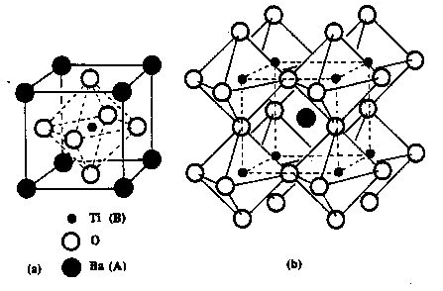
Fig. 1 (a) A cubic ABO₃ (BaTiO₃) perovskite-type unit cell and (b) three dimensional network of corner sharing octahedra of O²⁻ ions.
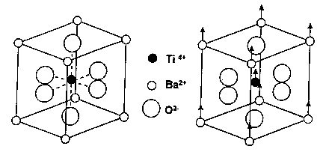
Fig. 2 The crystal structure of BaTiO₃ (a) above the Curie point the cell is cubic; (b) below the Curie point the structure is tetragonal with Ba²⁺ and Ti⁴⁺ ions displaced relative to O²⁻ ions.

negative charge (O²⁻). On cooling below the Curie point T_{c}, a tetragonal structure develops where the center of Ba²⁺ and Ti⁴⁺ ions are displaced relative to the O²⁻ ions, leading to the formation of electric dipoles. Spontaneous polarization developed is the net dipole moment produced per unit volume for the dipoles pointing in a given direction.
Various A and B site substitutions in different concentrations have been tried to see their effect on the dielectric and ferroelectric properties of BaTiO₃. Sr²⁺ substitutions to the A site have been found to reduce the Curie point linearly towards room temperature. The substitution of Pb²⁺ for Ba²⁺ raises the Curie point. The simultaneous substitution into both A and B sites with different ions can be used to tailor the properties of BaTiO₃. The effect of various isovalent substitutions on the transition temperatures of BaTiO₃ ceramic are shown in Fig. 6

(b) Lead Titanate (PbTiO₃, PT)

Lead titanate is a ferroelectric material having a structure similar to BaTiO₃ with a high Curie point (490ºC). On decreasing the temperature through the Curie point a phase transition from the paraelectric cubic phase to the ferroelectric tetragonal phase takes place.
Lead titanate ceramics are difficult to fabricate in the bulk form as they undergo a large volume change on cooling below the Curie point. It is the result of a cubic (c/a = 1.00) to tetragonal (c/a = 1.064) phase transformation leading to a strain of > 6%. Hence, pure PbTiO₃ ceramics crack and fracture during fabrication. The spontaneous strain developed during cooling can be reduced by modifying the lead titanate with various dopants such as Ca, Sr, Ba, Sn, and W to obtain a crack free ceramic. One representative modified lead titanate composition that has been extensively investigated recently is (Pb_{0.76} Ca_{0.24} ) ((Co_{0.50} W_{0.50} )_{0.04} Ti_{0.96} )O₃ with 2 mol. % MnO added to it. This composition has a decreased c/a ratio and Curie point of 255 ºC).
(c) Lead Zirconate Titanate [Pb(Zr_{x}Ti_{1-x})O₃, PZT]

Lead Zirconate Titanate (PZT) is a binary solid solution of PbZrO₃ an antiferroelectric (orthorhombic structure) and PbTiO₃ a ferroelectric (tetragonal perovskite structure). PZT has a perovskite type structure with the Ti⁴⁺ and Zr⁴⁺ ions occupying the B site at random. The PZT phase diagram is shown in Fig. 8. At high temperatures PZT has the cubic perovskite structure which is paraelectric. On cooling below the Curie point line, the structure undergoes a phase transition to form a ferroelectric tetragonal or rhombohedral phase. In the tetragonal phase, the spontaneous polarization is along the <100> set of directions while in the rhombohedral phase the polarization is along the <111> set of directions. As shown in Fig. 9 most physical properties such as dielectric and piezoelectric constants show an anomalous behavior at the morphotropic phase boundary (MPB). The MPB separating the two ferroelectric tetragonal and orthorhombic phases has a room temperature composition with a Zr/Ti ratio of  52/48. PZT ceramics with the MPB composition show excellent piezoelectric properties. The poling of the PZT ceramic (see Section 4) is also easy at this composition because the spontaneous polarization within each grain can be switched to one of the 14 possible orientations (eight [111] directions for the rhombohedral phase and six [100] directions for the tetragonal phase). Below the Zr/Ti ratio of 95/5 the solid solution is antiferroelectric with an orthorhombic phase. On the application of an electric field to this composition a double hysteresis loop is obtained. This is because of the strong influence of the antiferroelectric PbZrO₃ phase.
(d) Lead Lanthanum Zirconate Titanate ((Pb_{1-x}La_{x}) (Zr_{1-y}Ti_{y})_{1-x/4} O₃ V^{B}_{0.25x} O₃, PLZT)
PLZT is a transparent ferroelectric ceramic formed by doping La³⁺ ions on the A sites of lead zirconate titanate (PZT). The PLZT ceramics have the same perovskite structure as BaTiO₃ and PZT. The transparent nature of PLZT has led to its use in electro-optic applications. Before the development of PLZT, the electro-optic effect was seen only for single crystals. The two factors that are responsible for getting a transparent PLZT ceramic include the reduction in the anisotropy of the PZT crystal structure by the substitution of La³⁺ and the ability to get a pore free ceramic by either hot pressing or liquid phase sintering.
The general formula for PLZT is given by (Pb_{1-x}La_{x}) (Zr_{1-y}Ti_{y})_{1-x/4}O₃V^{B}_{0.25x}O₃ and (Pb_{1-x}La_{x})_{1-0.5x}(Zr_{1-y}Ti_{y})V^{A}_{0.5x}O_{3.} The first formula assumes that La³⁺ ions go to the A site and vacancies (V^{B}) are created on the B site to maintain charge balance. The second formula assumes that vacancies are created on the A site. The actual structure may be due to the combination of A and B site vacancies.
The room temperature phase diagram of PLZT system is shown in Fig. 10. The different phases in the diagram are a tetragonal ferroelectric phase (F_{T}), a rhombohedral ferroelectric phase (F_{R}), a cubic relaxor ferroelectric phase (F_{C}), an orthorhombic antiferroelectric phase (A₀) and a cubic paraelectric phase (P_{C}).
The electro-optic applications of PLZT ceramics depends on the composition. Figure 11 shows the hysteresis loops for various PLZT compositions from the phase diagram. PLZT ceramic compositions in the tetragonal ferroelectric (F_{T}) region show hysteresis loops with a very high coercive field (E_{C}). Materials with this composition exhibit linear electro-optic behavior for E < E_{C}. PLZT ceramic compositions in the rhombohedral ferroelectric (F_{R}) region of the PLZT phase diagram have loops with a low coercive field. These PLZT ceramics are useful for optical memory applications.
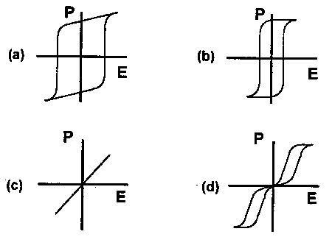
Fig. 3 Representative hysteresis loops obtained for different ferroelectric compositions (a) F_{T} (b) F_{R} (c) F_{C} and (d) A_{O} regions of the PLZT phase diagram. PLZT ceramic compositions with the relaxor ferroelectric behavior are characterized by a slim hysteresis loop. They show large quadratic electro-optic effects which are used for making flash protection goggles to shield them from intense radiation. This is one of the biggest applications of the electro-optic effect shown by transparent PLZT ceramics. The PLZT ceramics in the antiferroelectric region show a hysteresis loop expected from an antiferroelectric material. These components are used for memory applications.
(e) Lead Magnesium Niobate (Pb(Mg_{1/3}Nb_{2/3})O₃, PMN)
Relaxor ferroelectrics are a class of lead based perovskite type compounds with the general formula Pb(B₁,B₂)O₃ where B₁ is a lower valency cation (like Mg²⁺, Zn²⁺, Ni²⁺, Fe³⁺) and B₂ is a higher valency cation (like Nb⁵⁺, Ta⁵⁺, W⁵⁺). Pure lead magnesium niobate (PMN or Pb (Mg_{1/3}Nb_{2/3})O₃) is a representative of this class of materials with a Curie point at -10º C. The main differences between relaxor and normal ferroelectrics are shown in Table 2.
Relaxor ferroelectrics like PMN can be distinguished from normal ferroelectrics such as BaTiO₃ and PZT, by the presence of a broad diffused and dispersive phase transition on cooling below the Curie point. Figure 12 shows the variation in the dielectric properties with temperature for PMN ceramic. It shows a very high room temperature dielectric constant and a low temperature dependence of dielectric constant. The diffused phase transitions in relaxor ferroelectrics are due to the compositional heterogeneity seen on a microscopic scale. For example, there is disorder in the B site for Pb (Mg_{1/3}Nb_{2/3})O₃. The composition of Mg and Nb is not stoichiometric in the micro regions, leading to different ferroelectric transition temperatures which broaden the dielectric peak.
The relaxors also show a very strong frequency dependence of the dielectric constant. The Curie point shifts to higher temperatures with increasing frequency. The dielectric losses are highest just below the Curie point T_{c}. For relaxors which have a second order phase transition, the remnant polarization, P_{r}, is not lost at the Curie point but gradually decreases to zero on increasing the temperature beyond T_{c.}
The most widely studied relaxor material is the PMN-PT solid solution system. The phase diagram of PMN-PT is shown in Fig. 13. The addition of PT, which has a Curie point of 490ºC, shifts the T_{c} of the composition towards higher temperatures. The morphotropic phase boundary composition (0.65 PMN and 0.35 PT) is piezoelectric in nature. Ceramics with this composition are excellent candidates for piezoelectric transducers. Compositions with a Curie point near room temperature (like 0.95 PMN and 0.10 PT) have very large dielectric constants (ɛ_{r} > 20,000) which make them very attractive for multilayer capacitor and strain actuator applications.

2) Tungsten Bronze type Compounds
The tungsten bronze type ferroelectric crystals have a structure similar to tetragonal tungsten bronze K_{x}WO₃ (x<1). Lead niobate (PbNb₂O₆) was one of the first crystals of the tungsten bronze type structure to show useful ferroelectric properties. The site occupancy formula for this type of structure is given by (A₁)₂(A₂)₄(C)₄(B₁)₂(B₂)₈O₃₀. Figure 14 shows the schematic of the projection of the tungsten bronze type structure on the (001) plane. For lead niobate the B₁ and B₂ sites are occupied by Nb⁵⁺ ions. The open nature of the structure as compared to the perovskite allows a wide range of cation and anion substitutions without loss of ferroelectricity. At present, tungsten bronze family of oxide ferroelectrics, numbers more than 85.
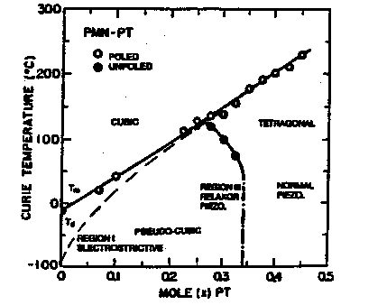
Fig 4 Phase diagram for PMN-PT solid solution.

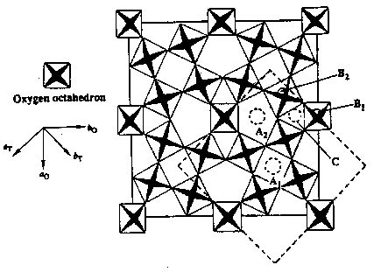
Fig. 5 Schematic diagram showing a projection of the tungsten-bronze structure on the (001) plane. The orthorhombic and tetragonal cells are shown by solid and dotted lines respectively.
The ferroelectric crystals grown from solid solutions of alkali and alkaline earth niobates have shown great potential for being used as a material for laser modulation, pyroelectric detectors, hydrophones, and ultrasonic applications. The high Curie point (T_{c} = 560 ºC for lead niobate) of their compounds makes them suitable for high temperature applications.
It is difficult to fabricate piezoelectric PbNb₂O₆ ceramics because of the formation of a stable non-ferroelectric rhombohedral phase on cooling to room temperature. Rapid cooling from the sintering temperature is used to prevent the formation of the rhombohedral phase. Another problem associated with this type of materials is the large volume change due to phase transformation on cooling below the Curie point, leading to cracking of the ceramic.

- Bismuth Oxide Layer Structured Ferroelectrics

The two most important piezoelectric materials with the (Bi₂O₂)²⁺ layer structure are bismuth titanate (Bi₄Ti₃O₁₂) and lead bismuth niobate (PbBi₂Nb₂O₉). As shown in Fig. 15, the structure of PbBi₂Nb₄O₉ consists of corner linked perovskite-like sheets, separated by (Bi₂O₂)²⁺ layers.
The plate like crystal structure of these compounds leads to highly anisotropic ferroelectric properties. The ceramics fabricated from the (Bi₂O₂)²⁺ layer compounds do not have very good piezoelectric properties because of a very low poling efficiency. The piezoelectric properties have been shown to be improved by grain orientation during the processing step. One fabrication method involves the tape casting of plate like Bi₄Ti₃O₁₂ and PbBi₂Nb₄O₉ powders. The powders get aligned during the formation of the green tape. The orientation is further enhanced on sintering. In the other method, the ceramic is hot forged leading to the orientation of the grains along the forged direction.
The bismuth oxide layer structured ferroelectrics may become important piezoelectric ceramics because of their higher stability, higher operating temperature (T_{c} = 550-650ºC), and higher operating frequency. These ceramics are mainly useful for piezoelectric resonators which need to exhibit a very stable resonant frequency.
4) Lithium Niobate and Tantalate
Lithium niobate (LiNbO₃) and lithium tantalate (LiTaO₃) have similar structures. As shown in Fig. 16 the LiNbO₃ structure is actually a variant of the perovskite structure with a much more restrictive arrangement. The ferroelectric behavior of LiNbO₃ and LiTaO₃ was first discovered in 1949. Their crystals are very stable with very high Curie points of 1210º C and 620º C for LiNbO₃ and LiTaO₃ respectively. These compounds are mainly used in the single crystal form and have found applications in piezoelectric, pyroelectric and electro-optic devices.

1.2.2 Compounds Containing Hydrogen Bonded Radicals
Several water soluble ferroelectrics usually made in the single crystal form have hydrogen bonded radicals in them.
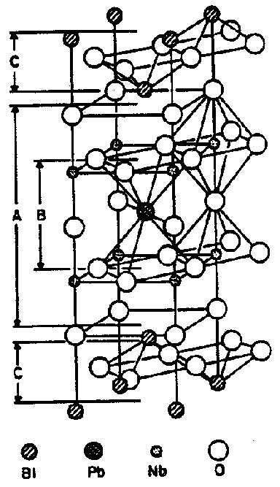
Fig. 6 One half of the tetragonal (4/mmm) unit cell of PbBi₂Nb₂O₉. A denotes the perovskite double layer (PbNb₂O₇)²⁻; B is a hypothetical PbNbO₃ and C denotes the (Bi₂O₂)²⁺ layers.
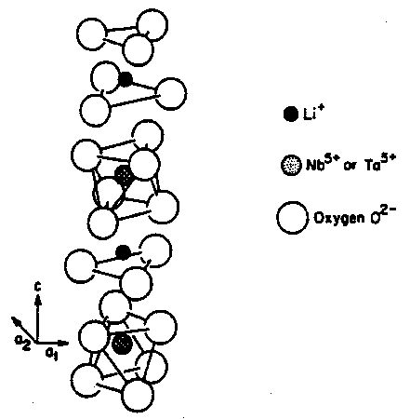
Fig. 7 Structure of Ferroelectric LiNbO₃ and LiTaO₃

Potassium dihydrogen phosphate (KH₂PO₄, KDP) has a tetragonal point group 42m. Hence this crystal shows only piezoelectricity and no ferroelectric behavior at room temperature. On decreasing the temperature below the Curie point (T_{c} = -150º C) it transforms into a ferroelectric orthorhombic phase. KDP single crystals exhibit very good electro-optical and non-linear optical properties. Triglycine sulfate (NH₂CH₂COOH)₃H₂SO₄, TGS) has a ferroelectric monoclinic point group 2 at room temperature. On heating the crystal above the Curie point (T_{c} = 49.7º C) the crystal structure changes from the ferroelectric monoclinic point group to a centrosymmetric monoclinic point group 2/m. The TGS crystals show good pyroelectric properties. Rochelle salt (NaKC₄H₄O₆ . 4H₂O, sodium potassium tantalate tetrahydrate) was the first ferroelectric material to be discovered. Between the two Curie points of -18º C and +24º C, Rochelle salt is ferroelectric with a monoclinic point group 2. In the non-ferroelectric region, Rochelle salt has an orthorhombic point group 222 and hence it shows piezoelectric effect. Single crystals of Rochelle salt are widely used for piezoelectric transducers. These water soluble crystals are still used due to their superiority over other crystals in some properties. Yet these crystals have many deficiencies such as weak ferroelectricity, low Curie point, poor mechanical properties, and deliquescence. For these reasons, KDP, TGS and Rochelle salt single crystals are being gradually replaced by piezoelectric ceramics.

1.2.3 Organic Polymers
Polyvinylidene fluoride (PVDF, (CH₂-CF₂)_{n}) and copolymers of PVDF with trifluoroethylene {P(VDF-TrFE)} have found applications as piezoelectric and pyroelectric materials. The piezoelectric and pyroelectric properties of these polymers are due to the remnant polarization obtained by orienting the crystalline phase of the polymer in a strong poling field. Hence the piezoelectric and pyroelectric properties depend on the degree of crystallinity of the polymer and the ferroelectric polarization of the crystalline phase.
The piezo-polymers have some properties which make them better suited for use in medical imaging applications. The density of these polymers is very close to that of water and the human body tissues, hence there is no acoustic impedance mismatch with the body. The piezo-polymers are also flexible and conformable to any shape. However, there are also some problems associated with the piezoelectric polymers including the very low dielectric constant (K = 5-10) which could lead to electrical impedance matching problems with the electronics. The dielectric losses at high frequencies are very large for these piezopolymers. The polymers also have a low Curie point and the degradation of the polymer starts occurring at low temperatures (70-100º C). The poling efficiency is very low for polymer specimens with large thickness (>1mm).

1.2.4 Ceramic Polymer Composites
The drive for piezoelectric composites stems from the fact that desirable properties could not be obtained from single phase materials such as piezoceramics or piezopolymers. For example, in an electromechanical transducer, the desire is to maximize the piezoelectric sensitivity, minimize the density to obtain good acoustic matching with water, and make the transducer mechanically flexible to conform to a curved surface. Neither a ceramic nor a polymer satisfies these requirements. The requirement can be optimized by combining the most useful properties of the two phases which do not ordinarily appear together. Piezoelectric composites are made up of an active ceramic phase embedded in a passive polymer. The properties of the composite depend on the connectivity of the phases, volume percent of ceramic, and the spatial distribution of the active phase in the composite. The concept of connectivity developed by Newnham et al. [65] describes the arrangement of the component phases within a composite. It is critical in determining the electromechanical properties of the composite. Figure 17 shows the 10 different types of connectivity possible in a diphase composite. It is shown in the form A-B where 'A' refers to the number of directions in which the active phase is self connected or continuous. 'B' shows the continuity directions of the passive phase. The density, acoustic impedance, dielectric constant and the piezoelectric properties like the electromechanical coupling coefficient k_{t} change with the volume fraction of the ceramic. Optimum material and piezoelectric parameters for medical ultrasound applications are obtained for ~ 20-25 vol. % PZT ceramic in the composite.

  - Sample and its structure
The aim of my project work is to carry out electrical characterization of a tungsten bronze ferroelectric ceramic. CaBa₄SmTi₃Nb₇O₃₀ i.e. (Ba₄SmTi₃Nb₇O₃₀ with Ca doping) is chosen for this purpose because previous studies suggest that its electrical characteristics vary with temperature and frequency. My aim is to take this work further by characterizing it with respect to different bias voltages along with temperature and frequency. Its dimensions are as follows-
- Sample composition – CaBa₄SmTi₃Nb₇O₃₀
- Thickness – 0.85 mm
- Diameter – 1.38 cm
- It has a Tungsten Bronze structure as shown below…

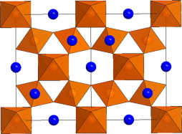
Fig. 8 Schematic diagram showing a projection of the tungsten-bronze structure on the (001) plane. The orthorhombic and tetragonal cells are shown by solid and dotted lines respectively

CHAPTER 2

ELECTRICAL CHARACTERIZATION

2.1 Sample preparation
The sample chose for the project is a ceramic in form of a pallete formed by sintering the well ground ceramic at high temperature. It has the composition CaBa₄SmTi₃Nb₇O₃₀. Its dimensions are as follows-
- Sample composition – CaBa₄SmTi₃Nb₇O₃₀
- Thickness – 0.85 mm
- Diameter – 1.38 cm

Silver deposition on sample pallete
To characterize the sample first it has to be made a Metal-Insulator-Metal (MIM) structure. i.e. electrodes must be deposited on both sides of the ceramic sample. Silver is deposited by Vacuum Deposition technique. First silver is deposited on one side of pallete with following conditions-
Pressure – 10 ⁻⁵ mBar
VARIAC Voltage – 120 V
Thickness of silver deposited is found out to be 1765 A⁰.
Then silver is deposited on the back face with conditions-
Pressure – 9 x 10⁻⁶ mBar
VARIAC Voltage – 120 V
Thickness of silver deposition came out to be 1774 A⁰.

Sample was kept insulated from humidity so that oxide is not formed as it can hinder the required characterization.
2.2 Dielectric characterization
The dielectric properties of the various materials used in semiconductor fabrication and packaging play an important role in achieving the desired performance of integrated circuits. A basic understanding of dielectric properties is therefore needed by most engineers working in the semiconductor industry.

Dielectric permittivity
One important property of a dielectric material is its permittivity. Permittivity (ε) is a measure of the ability of a material to be polarized by an electric field.
It is, however, easier to grasp the concept of permittivity by first discussing a closely related property, capacitance (C). Capacitance is a measure of the ability of a material to hold charge if a voltage is applied across it, and is best modeled by a dielectric layer that's sandwiched between two parallel conductive plates.
If a voltage V is applied across a capacitor of capacitance C, then the charge Q that it can hold is directly proportional to the applied voltage V, with the capacitance C as the proportionality constant. Thus, Q = CV, or C = Q/V. The unit of measurement for capacitance is the farad (coulomb per volt).
The capacitance of a capacitor depends on the permittivity ε of the dielectric layer, as well as the area A of the capacitor and the separation distance d between the two conductive plates. Permittivity and capacitance are mathematically related as follows: C = ε (A/d).
When the dielectric used is vacuum, then the capacitance Co = ε_{o} (A/d), where ε_{o} is the permittivity of vacuum (8.85 x 10⁻¹² F/m).

Dielectric constant

The dielectric constant (k) of a material is the ratio of its permittivity ε to the permittivity of vacuum ε_{o}, so k = ε/ε_{o}. The dielectric constant is therefore also known as the relative permittivity of the material. Since the dielectric constant is just a ratio of two similar quantities, it is dimensionless.

Given its definition, the dielectric constant of vacuum is 1. Any material is able to polarize more than vacuum, so the k of a material is always > 1. Note that the dielectric constant is also a function of frequency in some materials, e.g., polymers, primarily because polarization is affected by frequency.
The dielectric constant in polycrystalline ferroelectric materials is due to four types of polarizations; i) Electronic Pe , ii) Ionic Pi, iii) Orientational Po and Space charge Ps represented as :

P = Pe + Pi + Po + Ps

At lower frequencies, all polarizations are known to contribute to the dielectric constant but with increase in frequency, these are damped out corresponding to respective relaxation/resonance absorption phenomenon. Electronic and ionic polarization modes being less dependent on temperature and frequency normally damp out at high frequencies of the order of 10¹⁶ Hz and 10¹⁰⁻¹³ Hz respectively. The orientational and space charge polarization modes are strongly temperature and field dependent and are observed to damp out near 10³⁻⁵ Hz and 10⁸⁻⁹ Hz respectively. In polar dielectrics, orientational and space charge polarizations are the major contributors to the total dielectric constant value.

Complex permittivity
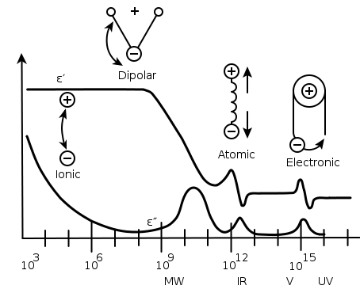
Fig. 9 variation of relative permittivity with frequency.

Dielectric constant as a function of frequency and temperature was measured using the expression
C_{O} = ∈_{O} A/D
Where ɛ_{o} = 8.854 × 10⁻¹² is the free space permittivity or dielectric constant.

Dielectric loss

The amount of power losses in a dielectric under the action of applied voltage id commonly known as dielectric losses. This is general term determining the in a dielectric when either a dielectric or an alternating voltage is applied. Dielectric loss tangent (tan δ) values were directly measured using the impedence analyzer for frequency as well as temperature variations. Dielectric losses, when a direct voltage is applied, can easily be found out from the equation;

P = V² / R

Where V is the voltage applied and R is the resistance of the insulation. However, the losses under an alternating voltage are determined by regularities that are more intricate. For the case of applied voltage being sinusoidal, charge stored in the dielectric can be expressed as:

Q = C V_{o} e^{iωt}
Therefore,

I = dQ/dt = iωCV = iɛ_{r}ωC_{o}V

Where, I represent the current flow on discharge of the dielectric cell in time t. However, for a real dielectric the current I have vector components I_{C} and I_{R}, where I_{C} is the capacitive current proportional to the charge stored in the capacitor. The current I_{C} is frequency dependent and leads the voltage by 90⁰ and the current I_{R}, is ac conduction current in phase with the voltage V, which represent the energy loss or power dissipated in the dielectric. This condition can be expressed clearly by choosing complex form of dielectric constant ɛ.

I = iω (ɛ’- iɛ’’) ɛ_{o}C_{o}V,

Where ɛ’ is the real part of dielectric constant and ɛ’’ is the imaginary part, ɛ_{o} is the absolute permittivity of the air/ free space = 8.854 × 10⁻¹² F/m, ω is the angular frequency of the applied field.

I = iωɛ’ɛ_{o}C_{o}V + ω ɛ’’ɛ_{o}C_{o}V

I = I_{C} + I_{R}

The dissipation factor is defined by the ratio of energy dissipated per cycle to the energy stored per cycle as,

tan δ = | I_{R} / I_{C} | = ɛ”/ ɛ’

tan δ = 1 / ω ɛ’ ɛ_{o}ρ,

where ρ is the resistivity of the dielectric material.

Experimental

To characterize the dielectric properties the sample in the form of a capacitor is studied by giving it a bias voltage and a range of frequency over a temperature ranging from room temperature to 300ºC. This was done at different bias voltages (such as 1V, 5V, 10V, 20V) and results were compared.

- Variation with temperature:
Graphs at 1 Volt
observations
The variation of dielectric constant or relative permittivity with temperature is shown. The observations were recorded at 1 V bias voltage and over a range of frequencies. Frequencies ranged from 1 KHz to 800 KHz. Single phase transition from ferroelectric to paraelectric phase is observed at 210ºC identified as Curie temperature. The value of dielectric constant is (250.18 at 100 KHz) maximum at Curie temperature. The value of dielectric constant increases with temperature till it reaches Curie temperature. Beyond Curie temperature it starts decreasing. The value of dielectric constant at a particular temperature is observed to decrease with increasing frequency.
Inference and explanation
Ferroelectricity depends on temperature. Above θc ferroelectric behavior is lost and the material becomes paraelectric. The change from the ferroelectric to the nonferroelectric state is accompanied either by a change in crystal symmetry (e.g., as in BaTiO3).
The relative permittivity shows a characteristic peak at Tcw (curie – Weiss temperature) and falls off at higher temperatures following the Curie–Weiss law:

Ɛr – 1 = χ = C / ( T- T_{CW} ).
Observations
The variation of dielectric loss Vs temperature is shown. Dielectric loss remains invariable for some range and then increases with temperature.
Inference and explanation
It is due to increased thermal motion which raises randomness. This increased randomness accounts for the difficulty that dipoles have to overcome in order to get polarized. They have to face increased internal friction and energy dissipates in form of heat. Dissipation of energy in form of heat is called dielectric loss and hence it increases with temperature.
Graphs at 5 Volt
GRAPHS AT 5 V
Observations-
For dielectric constant
The variation of dielectric constant or relative permittivity with temperature is shown in fig. 2.1. The observations were recorded at 5 V bias voltage and over a range of frequencies. Frequencies ranged from 1 KHz to 800 KHz. Single phase transition from ferroelectric to paraelectric phase is observed at 209ºC identified as Curie temperature at which the value of dielectric constant is ( 296.1934 at 100 KHz) maximum. The value of dielectric constant increases with temperature till it reaches Curie temperature. Beyond Curie temperature it starts decreasing with increasing temperature. The value of dielectric constant at a particular temperature is observed to decrease with increasing frequency
Inference and explanation
Ferroelectricity depends on temperature. Above θc ferroelectric behavior is lost and the material becomes paraelectric. The change from the ferroelectric to the nonferroelectric state is accompanied either by a change in crystal symmetry (e.g., as in BaTiO3).
The relative permittivity shows a characteristic peak at Tcw (Curie- Weiss temperature) and falls off at higher temperatures following the Curie–Weiss law:

Ɛr – 1 = χ = C / (T- T_{CW}).
For dielectric loss-
The dielectric loss remains invariable up to a small temperature range say till 175- 200oC. Beyond this temperature it increases sharply with temperature.
Inference and explanation
It is due to increased thermal motion which raises randomness. This increased randomness accounts for the difficulty that dipoles have to overcome in order to get polarized. They have to face increased internal friction and energy dissipates in form of heat. Dissipation of energy in form of heat is called dielectric loss and hence it increases with temperature.
GRAPHS AT 10 V
Observations
The variation of dielectric constant or relative permittivity with temperature is shown in Fig. 2.1. The observations were recorded at 10 V bias voltage and over a range of frequencies. Frequencies ranged from 1 KHz to 800 KHz. Single phase transition from ferroelectric to paraelectric phase is observed at 210ºC identified as Curie temperature at which the value of dielectric constant is ( 194.0536 at 100 KHz) maximum. The value of dielectric constant increases with temperature till it reaches Curie temperature. Beyond Curie temperature it starts decreasing with increasing temperature. The value of dielectric constant at a particular temperature is observed to decrease with increasing frequency
Inference and explanation
Ferroelectricity depends on temperature. Above θc ferroelectric behavior is lost and the material becomes paraelectric. The change from the ferroelectric to the nonferroelectric state is accompanied either by a change in crystal symmetry (e.g., as in BaTiO3).
The relative permittivity shows a characteristic peak at Tcw ( Curie- Weiss temperature) and falls off at higher temperatures following the Curie–Weiss law:

Ɛr – 1 = χ = C / (T- T_{CW}).
For dielectric loss-
The dielectric loss remains invariable up to Curie temperature. Beyond this temperature it increases with temperature.
Inference and explanation
It is due to increased thermal motion which raises randomness. This increased randomness accounts for the difficulty that dipoles have to overcome in order to get polarized. They have to face increased internal friction and energy dissipates in form of heat. Dissipation of energy in form of heat is called dielectric loss and hence it increases with temperature.

Graphs at 20 Volt
Observations
The variation of dielectric constant or relative permittivity with temperature is shown in fig. 2.1. The observations were recorded at 20 V bias voltage and over a range of frequencies. Frequencies ranged from 1 KHz to 800 KHz. Single phase transition from ferroelectric to paraelectric phase is observed at 205ºC identified as Curie temperature at which the value of dielectric constant is (155.7135 at 100 KHz) maximum. The value of dielectric constant increases with temperature till it reaches Curie temperature. Beyond Curie temperature it starts decreasing with increasing temperature. The value of dielectric constant at a particular temperature is observed to decrease with increasing frequency.
Inference and explanation
Ferroelectricity depends on temperature. Above θc ferroelectric behavior is lost and the material becomes paraelectric. The change from the ferroelectric to the nonferroelectric state is accompanied either by a change in crystal symmetry (e.g., as in BaTiO3).
The relative permittivity shows a characteristic peak at Tcw ( Curie- Weiss temperature) and falls off at higher temperatures following the Curie–Weiss law:

Ɛr – 1 = χ = C / (T- T_{CW}).
For dielectric loss-
The dielectric loss remains invariable up to Curie temperature. Beyond this temperature it increases with temperature.
Inference and explanation
It is due to increased thermal motion which raises randomness. This increased randomness accounts for the difficulty that dipoles have to overcome in order to get polarized. They have to face increased internal friction and energy dissipates in form of heat. Dissipation of energy in form of heat is called dielectric loss and hence it increases with temperature.
- Variation with frequency
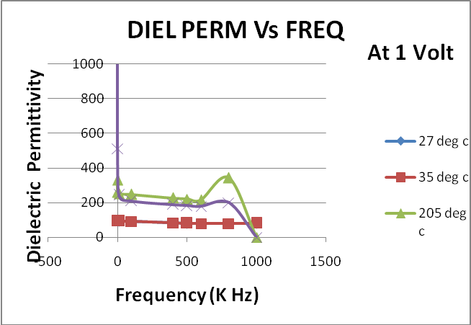
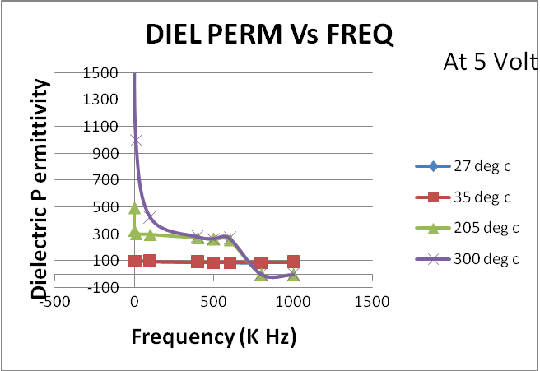
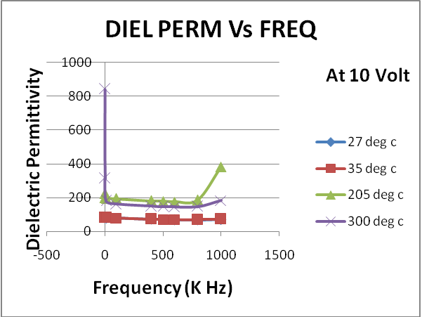
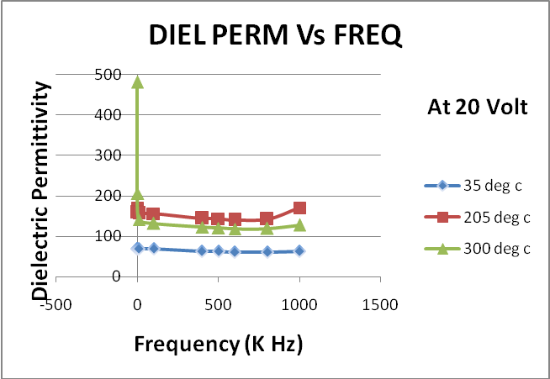
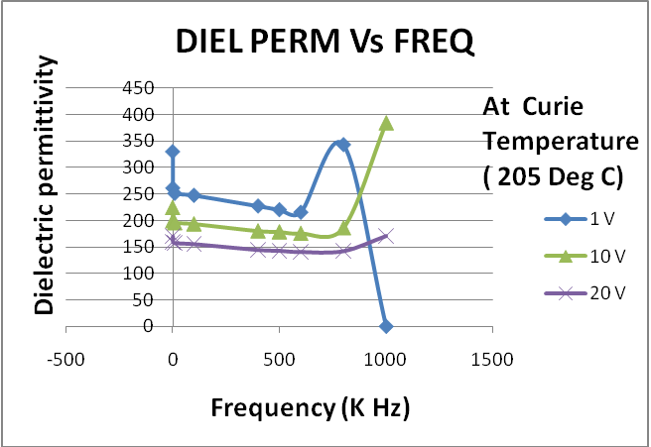

Observations
It is observed that dielectric permittivity remains constant for intial frequency range and then shows a small resonance peak. After this point it decreases sharply.
Inference and explanation
We know that a dielectric becomes polarized in an electric field. Now imagine switching the direction of the field. The direction of the polarization will also switch in order to align with the new field. This cannot occur instantaneously: some time is needed for the movement of charges or rotation of dipoles. If the field is switched, there is a characteristic time that the orientational polarization (or average dipole orientation) takes to adjust, called the relaxation time. Typical relaxation times are ~10¹¹s. Therefore, if the electric field switches direction at a frequency higher than ~10¹¹ Hz, the dipole orientation cannot ‘keep up’ with the alternating field, the polarization direction is unable to remain aligned with the field, and this polarization mechanism ceases to contribute to the polarization of the dielectric.
In an alternating electric field both the ionic and the electronic polarization mechanisms can be thought of as driven damped harmonic oscillators (like a mass on a spring), and the frequency dependence is governed by resonance phenomena. This leads to peaks in a plot of dielectric constant versus frequency, at the resonance frequencies of the ionic and electronic polarisation modes. A dip appears at frequencies just above each resonance peak, which is a general phenomenon of all damped resonance responses, corresponding to the response of the system being out of phase with the driving force (we shall not go into the mathematical proof of this here). In this case, in the areas of the dips, the polarisation lags behind the field. At higher frequencies the movement of charge cannot keep up with the alternating field, and the polarisation mechanism ceases to contribute to the polarisation of the dielectric.
As frequency increases, the material’s net polarisation drops as each polarisation mechanism ceases to contribute, and hence its dielectric constant drops. The animation below illustrates these effects. At sufficiently high frequencies (above ~10¹⁵ Hz), none of the polarisation mechanisms are able to switch rapidly enough to remain in step with the field. The material no longer possesses the ability to polarize, and the dielectric constant drops to 1 – the same as that of a vacuum.
Dielectric constant decreases with increasing frequency which suggests that interfaces and dipoles play an important role at low frequency.

For dielectric loss
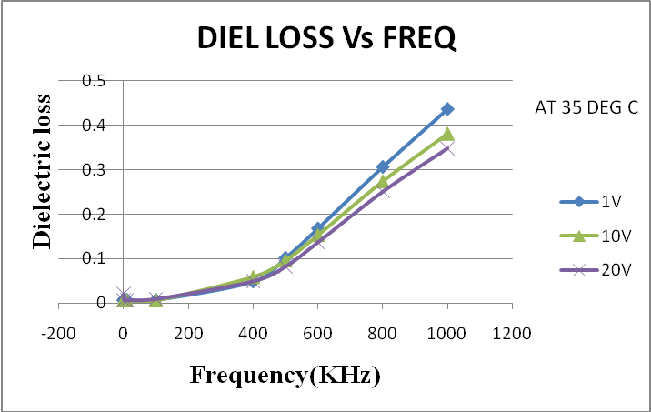
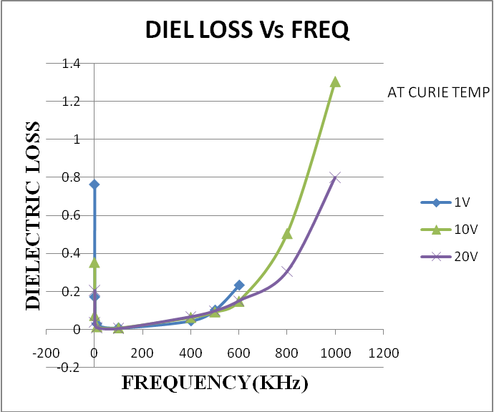

Observations
Dielectric loss remains almost constant upto 500 KHz and then rises sharply with increasing frequency. Slope of dielectric loss is maximum at 1V bias voltge and decreases for higher bias potentials - 10 V and 20 V.

Inference and explanation
The dielectric loss increases with increasing frequencies for Ba₅SmTi₃Nb₇O₃₀ because the number of larger Ba²⁺ ions is not equal to the number of larger interstices A₂₋sites, hence, it
intends to form disordered state.
Also in the alternating field conditions during the rotation of dipoles they have to overcome some sort of internal friction, which is dissipated as heat by the material. This is called as dielectric loss. As the frequency increases dipoles moves in opposite directions very rapidly. Therefore internal friction countered is more and more and hence dielectric loss increases with increase in frequency.

- Variation with voltage
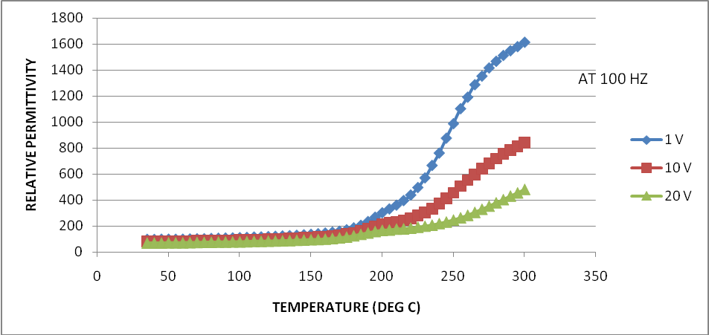
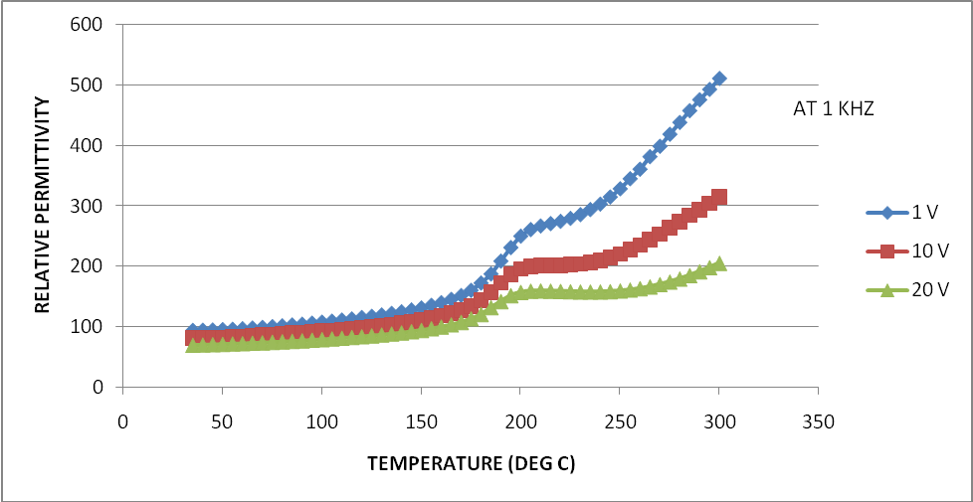
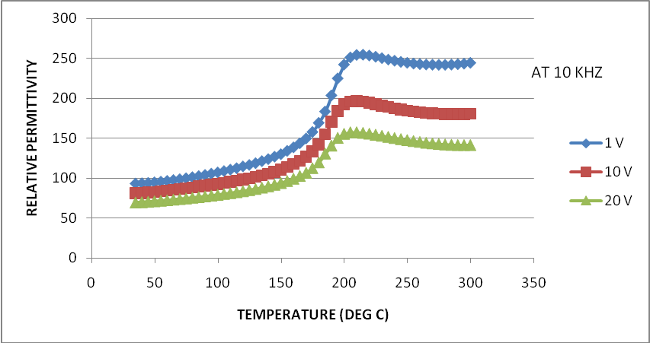
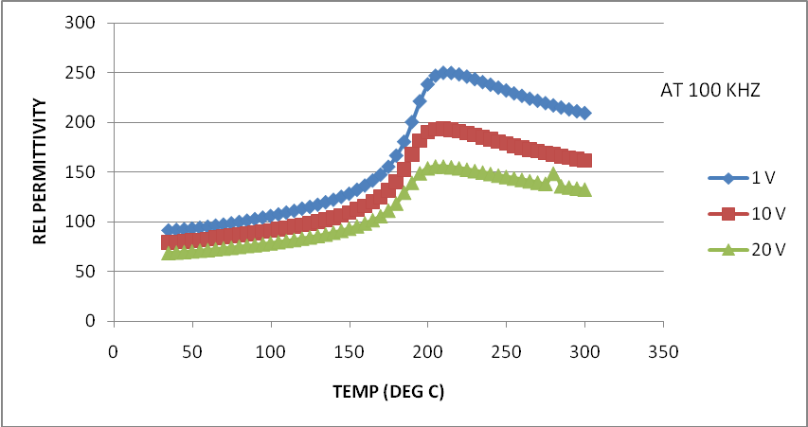
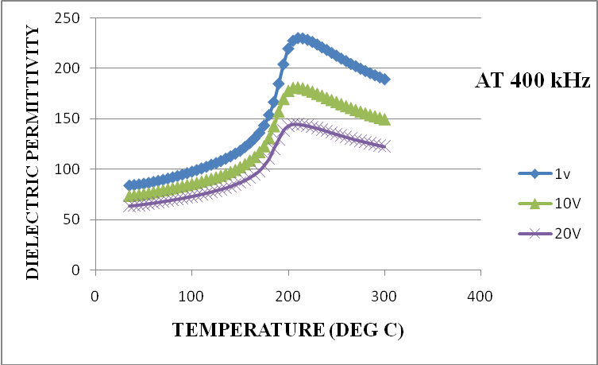
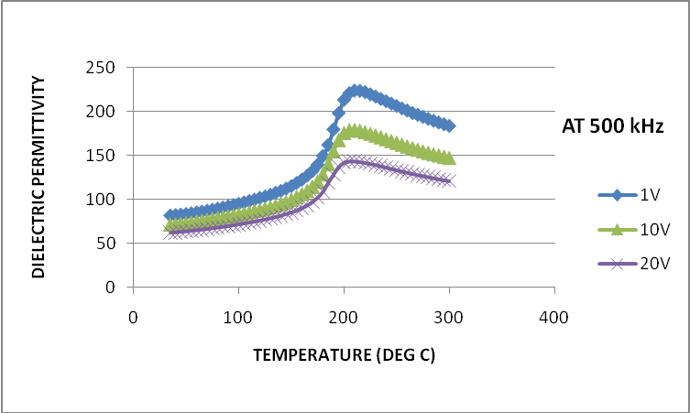
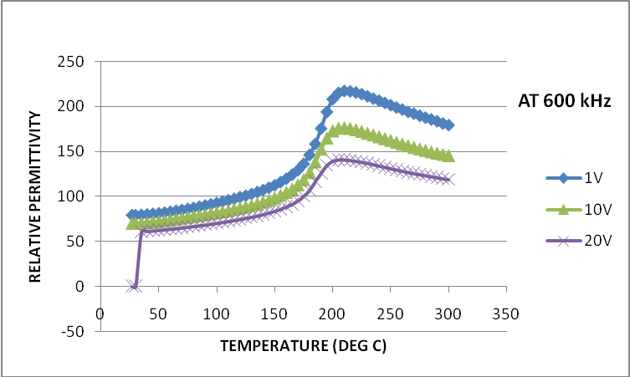
Observation
When relative permittivity is plotted against temperature for different bias votages, it is observed that as the voltage increases the value of dielectric constant decreases at a particular temperature. At lower frequencies like 100 Hz and 1 KHz the phase transition from ferroelectric to paraelectric phase is not evident. However, pattern of dielectric constant for different bias voltage is same as mentioned above. Phase transition appears for 10 KHz and onward frequencies.

Inference and explanation

With increasing of bias electric field, the dielectric constant and dielectric loss decrease. Such a kind of decrease of dielectric loss with increasing electric field is related to pinning effect of domain or movable charge defects. The characterization of dielectric constant depending on the bias dc voltage provides a useful foreground in tunable devices.

Also, polarization is a mechanism in which dipoles tend to align in the direction of external field. But in an ac field direction of field changes very rapidly acoording to its frequency. As frequency increases dipoles are not able to follow the rapid change in direction and polarization ceases. Now when we change bias voltage the field becomes increasingly stronger and it pulls the dipoles more strongly but it is also very rapidly changing its direction side by side . so, it becomes more and more difficult for dipoles to align and hence the polarization of the dielectric decreases with increase in bias voltage.

For dielectric loss
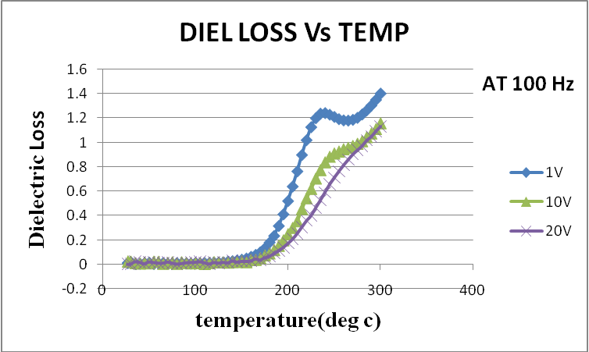
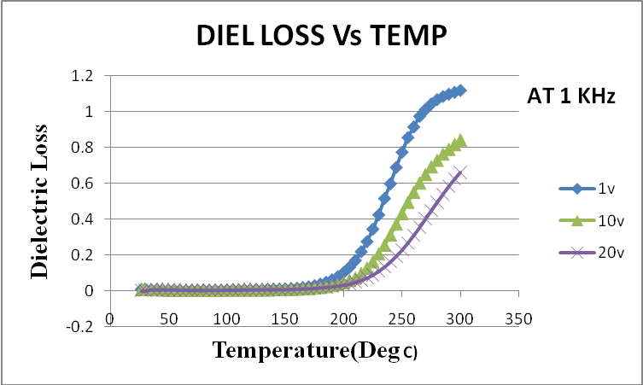
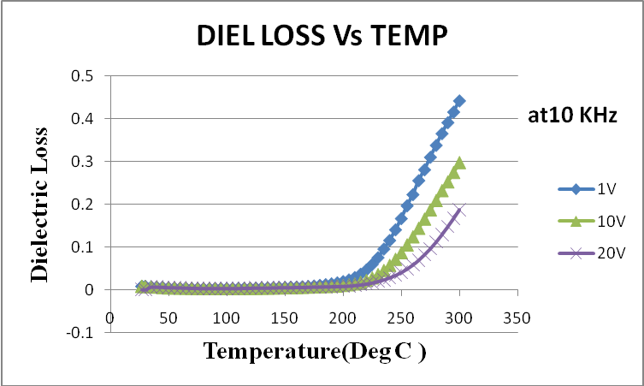
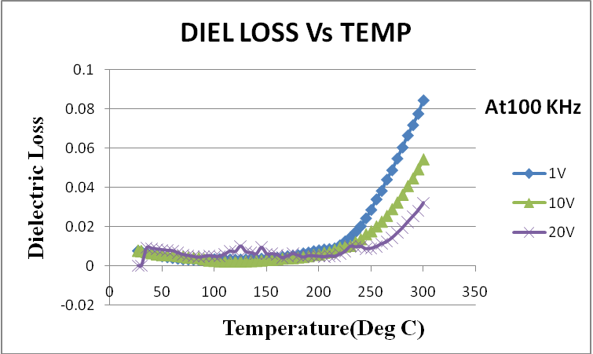

Observations
At lower frequencies dielectric loss remains constant till Curie temperature and increases sharply afterwards. With the increase in bias voltage the increase in dielectric loss ic more at a particalar temperature.
Inference and explanation

It is due to increased thermal motion which raises randomness. This increased randomness accounts for the difficulty that dipoles have to overcome in order to get polarized. They have to face increased internal friction and energy dissipates in form of heat. Dissipation of energy in form of heat is called dielectric loss and hence it increases with temperature. With increasing of bias electric field, the dielectric constant and dielectric loss decrease. Such a kind of decrease of dielectric loss with increasing electric field is related to pinning effect of domain or movable charge defects

2.3 Piezoelectric Characterization
Piezoelectricity is the ability of some materials (notably crystals and certain ceramics, including bone) to generate an electric field or electric potential in response to applied mechanical stress. The effect is closely related to a change of polarization density within the material's volume. If the material is not short-circuited, the applied stress induces a voltage across the material. The word is derived from the Greek piezo or piezein, which means to squeeze or press.
The piezoelectric effect is reversible in that materials exhibiting the direct piezoelectric effect (the production of an electric potential when stress is applied) also exhibit the reverse piezoelectric effect (the production of stress and/or strain when an electric field is applied). For example, lead zirconate titanate crystals will exhibit a maximum shape change of about 0.1% of the original dimension.
The effect finds useful applications such as the production and detection of sound, generation of high voltages, electronic frequency generation, microbalances, and ultra fine focusing of optical assemblies. It is also the basis of a number of scientific instrumental techniques with atomic resolution, the scanning probe microscopies such as STM, AFM, MTA, SNOM etc, and everyday uses such as acting as the ignition source for cigarette lighters and push-start proupane barbecues.
Many of the ferroelectric perovskite materials described above are also piezoelectric; that is, they generate a voltage when stressed or, conversely, develop a strain when under an applied electromagnetic field. These effects result from relative displacements of the ions, rotations of the dipoles, and redistributions of electrons within the unit cell. Only certain crystal structures are piezoelectric. They are those which, like BaTiO₃, lack what is known as an inversion centre, or centre of symmetry—that is, a centre point from which the structure is virtually identical in any two opposite directions.

Poling
The dipoles within a single domain have the same orientation. In ferroelectric ceramics with fine grain sizes (< 1  m) each grain is a single domain with the domain wall at the grain boundary. If the grain size is larger (> 1  m) then there could be multiple domains in a single grain. As schematically shown in Fig. 19 (a), when the ferroelectric ceramic is cooled after sintering, it does not show any piezoelectricity because of the random orientations of the ferroelectric domains in the ceramic. Piezoelectric behavior can be induced in a ferroelectric ceramic by a process called "poling". In this process a direct current (dc) electric field with strength larger than the coercive field strength is applied to the ferroelectric ceramic at a high temperature, but below the Curie point. On the application of the external dc field the spontaneous polarization within each grain gets orientated towards the direction of the applied field, as shown in Fig. 19 (b). This leads to a net polarization in the poling direction. All the domains in a ceramic can never get fully aligned along the poling axis because the orientations of the polarization is restricted by the symmetry. For example, if the material has an orthorhombic perovskite structure then the polarization gets oriented along one of the eight [111] directions. The higher the number of possible orientations, the better is the poling efficiency.
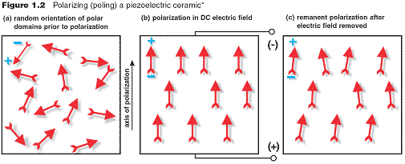
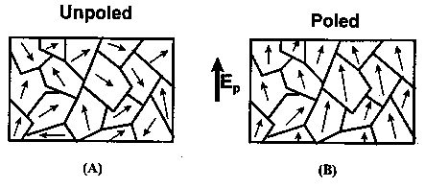
Fig. 19: Schematic of the poling process in piezoelectric ceramics: (a) In the absence of electric field the domains have random orientation of polarization; (b) the polarization within the domains aligns in the direction of the applied field.

Piezoelectric Constants
The piezoelectric charge constant, d, is the polarization generated per unit of mechanical stress (T)
applied to a piezoelectric material or, alternatively, is the mechanical strain (S) experienced by a
piezoelectric material per unit of electric field applied.
d33 - induced polarization in direction 3 (parallel to direction in which ceramic element is
polarized) per unit stress applied in direction 3.
Or
induced strain in direction 3 per unit electric field applied in direction 3.
Piezoelectric Voltage Constant
The piezoelectric voltage constant, g, is the electric field generated by a piezoelectric material per

unit of mechanical stress applied or, alternatively, is the mechanical strain experienced by a piezoelectric material per unit of electric displacement applied.
g33 - induced electric field in direction 3 (parallel to direction in which ceramic element is
polarized) per unit stress applied in direction 3.
Or
induced strain in direction 3 per unit electric displacement applied in direction 3.

Dielectric Dissipation Factor
The dielectric dissipation factor (dielectric loss factor), tan, for a ceramic material is the tangent of the dielectric loss angle. tan is determined by the ratio of effective conductance to effective
susceptance in a parallel circuit, measured by using an impedance bridge. Values for tan typically are determined at 1 kHz.

Experimental

- Polling at 1.80 KV dc field at 150ºC for two hours.
(Cooling without field).

S.no. | Frequency  (Hz) | Dynamic  Force  (N) | Capacitance  (pF) | d33  (pC/N) | Tan δ | g33  (Vm/N) | Voltage  Sensitivity  dB | polarity
1. | 110 | 0.25 | 165 | 0.5 | 0.0047 | 0.54 | -.246.8 | -ve down
2. | 110 | 0.10 | 164 | 0.6 | 0.0050 | 0.62 | -247.2 | -ve down

- Polling at 1.90 KV dc field at 150ºC for two hours.
(Cooling with field).
S.no. | Frequency  (Hz) | Dynamic  Force  (N) |  |  | Capacitance  (pF) | d33  (pC/N) | Tan δ | g33  (Vm/N) | Voltage  Sensitivity  dB | polarity
1. | 153 |  | 0.25 | 161 |  | 1.9 | 0.0054 | -2.1 | -235.1 | -ve down
2. | 100 |  | 0.25 | 161 |  | 2.6 | 0.0052 | -2.84 | -232.3 | -ve down
3. | 200 |  | 0.25 | 161 |  | -4.6 | 0.0052 | 4.82 | -228.1 | -ve down

- Polling at 2.15 KV dc voltage at 150ºC for 2 hours.
(Cooling with field on).
S.no. | Frequency  (Hz) | Dynamic  Force  (N) | Capacitance  (pF) | d33  (pC/N) | Tan δ | g33  (Vm/N) | Voltage  Sensitivity  dB | polarity
1. | 110 | 0.25 | 30 | 2.4 | 0.0026 | -5.0 | -230.5 | -ve down
2. | 110 | 0.5 | 30.0 | -3.0 | 0.0048 | -6.2 | -228.5 | -ve down
3. | 50 | 0.5 | 30.2 | -3.0 | 0.0048 | 6.23 | -228.5 | -ve down
4. | 50 | 0.25 | 30.0 | 4.0 | 0.0026 | 8.31 | -226.0 | -ve down
Observations:
Poling is better observed when it is done with field. Also when we are applying more field per cm the results are better and we are getting better piezoelectric parameters.

Inference and explanation:
The results are in sync with theory. When we apply more ac field the dipoles are strongly aligned and all the domains show a better polarization. Also when we cool the sample in presence of external field the remnant polarization is more.

2.4 Ferroelectric characterization:
Ferroelectric Domains and Hysteresis Loop:

Pyroelectric crystals show a spontaneous polarization P_{s} in a certain temperature range. If the magnitude and direction of P_{s} can be reversed by an external electric field, then such crystals are said to show ferroelectric behavior. Hence, all single crystals and successfully poled ceramics which show ferroelectric behavior are pyroelectric, but not vice versa. For example tourmaline shows pyroelectricity but is not ferroelectric.
Ferroelectric crystals possess regions with uniform polarization called ferroelectric domains. Within a domain, all the electric dipoles are aligned in the same direction. There may be many domains in a crystal separated by interfaces called domain walls. A ferroelectric single crystal, when grown, has multiple ferroelectric domains. A single domain can be obtained by domain wall motion made possible by the application of an appropriate electric field. A very strong field could lead to the reversal of the polarization in the domain, known as domain switching.
The main difference between pyroelectric and ferroelectric materials is that the direction of the spontaneous polarization in ferroelectrics can be switched by an applied electric field. The polarization reversal can be observed by measuring the ferroelectric hysteresis as shown in Fig. 2. As the electric field strength is increased, the domains start to align in the positive direction giving rise to a rapid increase in the polarization (OB). At very high field levels, the polarization reaches a saturation value (P_{sat}). The polarization does not fall to zero when the external field is removed. At zero external field, some of the domains remain aligned in the positive direction, hence the crystal will show a remnant polarization P_{r}. The crystal cannot be completely depolarized until a field of magnitude OF is applied in the negative direction. The external field needed to reduce the polarization to zero is called the coercive field strength E_{c}. If the field is increased to a more
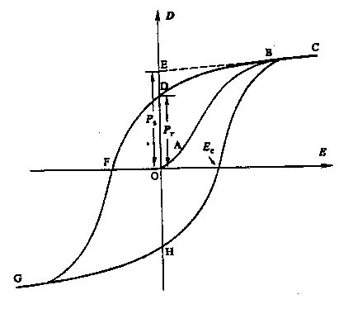
Fig. 2 A Polarization vs. Electric Field (P-E) hysteresis loop for a typical ferroelectric crystal.

negative value, the direction of polarization flips and hence a hysteresis loop is obtained. The value of the spontaneous polarization P_{s} (OE) is obtained by extrapolating the curve onto the polarization axes (CE).

Observed P-E hysteresis loop:
Saturation polarization (P_{sat}) = 0.042 μC/cm²
Remnant polarization (P_{r}) = 0.03 μ C/cm²
Coercive field strength (E_{c}) = 8.2 kV

Inference and explanation: the observed P-E hysteresis loop shows that the specimen is a lossy ferroelectric material. The remnant polarization value shows that the sample is not able to retain much polarization in absence of electric field . Although it shows a complete hysteresis loop which is a characteristic of ferroelectric behavior of the sample.

Chapter 3
INFERENCES

  - Variation of dielectric constant and loss with temperature

- The dielectric constant increases with temperature till it reaches Curie temperature. After this point dielectric constant decreases with increasing temperature.
- The dielectric loss increase with temperature after 125oC – 130Oc. The increase is more evident for limiting frequencies i.e. 100Hz, 1 KHz, 800 Hz and 1MHz. for intermediate frequencies increase in dielectric loss does not appreciably increase.

  - Variation of dielectric constant and loss with frequency
a) The dielectric permittivity remains constant for initial frequency range and then shows a small resonance peak. After this point it decreases sharply.
b) dilectric loss remains almost constant upto 500 KHz and then rises sharply with increasing frequency. Slope of dielectric loss is maximum at 1V bias voltge and decreases for higher bias potentials - 10 V and 20 V.

3.3 Variation of dielectric constant and loss with bias voltage
a) When relative permittivity is plotted against temperature for different bias votages, it is observed that as thevoltage increases the value of dielectric constant decreases at a particular temperature. At lower frequencies like 100 Hz and 1 KHz the phase transition from ferroelectric to paraelectric phase is not evident. Howeverpattern of dielectric constant for different bis voltage is same as mentioned above. Phase transition appears for 10 Hz and onward frequencies.
b) At lower frequencies dielectric loss remains constant till Curie temperature and increases sharply afterwards. But for higher frequencies say 800 KHz and 1 MHz it starts increasing well before the curie temperature. However at Curie point the phase transition occurs and dielectric loss starts decreasing with increasing temperature.

  - Piezoelectric measurements
Poling is better observed when it is done with field. Maximum value of d33 observed i4.0 with g33= 8.4. at a field 2.15 KV/cm and colling in presence of electric field.

  - Ferroelectric measurements:
P-E hysteresis loop was formed with the following parameters.
Saturation polarization (Psat) = 0.042 microC/cm2
Remnant polarization (Pr) = 0.03 micro C/cm2
Coercive field strength (Ec) = 8.2 kV

REFERENCES
- Ceramic materials – Science and Engineering by C. Barry Carter & M. Grant Norton.

- Crystal structure and dielectric properties of ferroelectric ceramics in the BaO-Sm₂O₃-TiO₂-Nb₂O₅ system - X. H. Zheng and X. M. Chen - Department of Materials Sciences and Engineering, Zhejiang University, Hangzhou 310 027, People's Republic of China.

- Complex impedance studies of tungsten–bronze structured Ba₅SmTi₃Nb₇O₃₀ ferroelectric ceramics - Prasun Ganguly A.K. Jhaand K.L. Deori - Thin Film & Materials Science Laboratory, Department of Applied Physics, Delhi College of Engineering, Delhi–110042, India.

- Crystal structure and dielectric properties of ferroelectric ceramics in the BaO-Sm₂O₃-TiO₃-Nb₂O₅ system - ZHENG X. H.; CHEN X. M., Department of Materials Sciences and Engineering, Zhejiang University, Hangzhou 310 027, CHINE, journal title-Solid state communications ISSN 0038-1098 CODEN SSCOA4

- Ferroelectric Ceramics : Processing, Properties & Applications by Ahmad Safari, Rajesh K. Panda, and Victor F. Janas , Department of Ceramic Science and Engineering, Rutgers University, Piscataway NJ 08855, USA.

- Ceramic materials for electronics- Processing properties & applications by Relva C. Buchanan.

- Crystal structure and dielectric properties of ferroelectric ceramics in the BaO-Sm2O3-TiO2-Nb2O5 system - X.H. Zheng, X.M. Chen*
Department of Materials Sciences and Engineering, Zhejiang University, Hangzhou 310027,
People’s Republic of China Received 16 May 2002; accepted 11 October 2002 by J.H. Davies

