THE EFFECT OF VARIATION OF PARAMETERS ON MECHANICAL PROPERTIES AND FEM ANALYSIS OF RESISTANCE SPOT WELDING

DISSERTATION

Submitted in partial fulfillment of the requirement
for the fulfillment of degree of M.E

To the



Department of Production Engineering
Delhi College of Engineering,
Bawana Road, Delhi

By
RISHU SHARMA
(Roll No: 8611)

JUNE 2006

CERTIFICATE

This is to certify that this major project entitled, “Study of weld bead characteristics with the variation of welding current in CO₂ MIG Welding”, submitted by Yogesh Sharma (8618), in partial fulfillment of the requirements for the award of degree of Master of Engineering in Production Engg. at Delhi College of Engineering, Bawana Road, Delhi, is true record of work undertaken by her as a part of curriculum under my guidance and supervision

Dr C.K.Dutta
Professor & Head
Department of Production Engg
D.C.E, Delhi

ACKNOWLEDGEMENTS

I express my sincere gratitude to my guide Dr C.K.Dutta, Professor & Head, Department of Production Engineering, Delhi College of Engineering, for his valuable guidance, proper advice and constant encouragement during the course of my work on this major project.

I am particularly thankful to Mr Kanchan Kishore Srivastav (Deputy Manager,Maruti Udyog Limited). Mr P.Arun Sanker (Astt. Manager, Maruti Udyog Limited) and Mr Sidharth Dutt Sharma(Sr Engineer, Caparo Maruti Limited) for their help and cooperation which went long way in successful completion of present work. I am also thankful to Mr Rakesh Thakural (Controls and Switchgears Pvt ltd) and Mr Mukesh Sood (CAD Tech Engineers Pvt Ltd) for their valuable support.

I am deeply indebted to my family for their inspiration and ever encouraging moral support, which enabled me to pursue my studies. I also express my feeling of thanks to all my friends for their help, inspiration and moral support during the work.

Lastly I am thankful to all the Faculty and staff members of the Department for their direct and indirect help and cooperation

Rishu Sharma

ABSTARCT
Resistance Spot Welding process have been focus of research in the fields of sheet metal manufacturing form last many years. In this process, an electrical current flows through resistive circuit to generate enough heat between two pieces of sheet metal so that the metal reaches molten stage. The resistance to the flow of current is provided by the work piece. The maximum heat is generated at the point of maximum resistance.

The purpose of most spot weld qualification procedure is to insure that, for given material, a weld nugget of adequate size can be achieved. There are three recognized parameters of resistance spot welding – weld current, cycle time and forging pressure which effects the nugget size. Due to variation of these parameters, their is also effect on the mechanical properties spot weld joint. The experimental work is done to study the effects of variation of parameters on nugget diameter and properties in resistance spot welding process for a particular isotropic material. The experiments are conducted on isotropic material and its various physical and thermal properties were known.

Experiments alone cannot easily study the separate effects of many factors involved in the resistance spot welding process, nor can they accurately predict the complex behavior of coupled electrical, mechanical and thermal processes during the spot welding procedure. Moreover, they are often limited in scope because of the restricted operational capabilities with regard to the available hardware. Also. the scope is reduced due to excessive time and cost associated with experimental procedures, which involve many influential parameters. FEM is numerical based technique and considered to be powerful tool for solving field problems. In comparison to the analytical analysis, one important merit of this model is that it can be easily applied to a model, which includes the non uniform material properties and/or complex boundaries.

Temperature at faying surface (plate to plate interface) attains very high value during the welding process due to application of high value of current. The temperature is not same along the whole dimension but is varying. The present work gives the temperature distribution during the process of resistance spot welding process using computer simulation. The stress distribution taking place in sheet metal due to application of load during the process also presented with help of structural analysis.

Keywords: Advanced High Strength Steel (AHSS), Spot Welding, Parameters, FEM, ANSYS

TABLE OF CONTENT

List of Figures i

List of Tables iii

Chapter 1 Introduction 1-3

  - Objective of Project 1
  - Problem Statement 1
  - Plan of work 2
  - Organization of Thesis 2

Chapter 2 Literature Review 4 - 19

2.1 Overview 4
2.2 Theoretical Background 5
2.3 Recent work 14
2.4 Summary 19

Chapter 3 20 - 36

3.1 Details of the apparatus 20
3.2 Details of test material 28
3.3 Procedures 30
3.4 Repeatability 35
3.5 Limitation of the Apparatus 36

Chapter 4 Results and Discussions 37 - 60
4.1 Experimental Results 37
4.2 Analytical Results 50

Chapter 5 Conclusion and Recommendations 61 - 62
List of References 63 - 64
Appendices 65 - 68

List of Figures

Figure 2.1:Spot welding process details 5
Figure 2.2 :Welding Current 6
Figure 2.3: Contact Resistance 7
Figure 2.4: Measured Process Parameters 9
Figure 2.5: Spot Weld Cycle 10
Figure 2.6: Basic resistance Spot Welding Cycles 11
Figure 2.7:Depression in Sheet 12
Figure 2.8: Influence of Weld Current on Nugget Diameter 13
Figure 2.9: Temperature Distribution 13
Figure 2.10.a: Relation ship of current and time 14
Figure 2.10.b: Relation between current and pressure 15
Figure 2.11: Dynamic Resistance 16
Figure 3.1: IT Spot Weld Gun 19
Figure 3.2 : Display of TE450 21
Figure 3.3 :Parameters of IT gun 22
Figure 3.4 : Pyramid shaped diamond for Hardness Test 25
Figure 3.5: Future Tech Micro Hardness tester 26
Figure 3.6: Universal Testing Machine 26
Figure 3.7: Microstructure of Test Material 29
Figure 3.8: Lap Joint with cycle time varying 31
Figure 3.9: Lap Joint with Current Varying 32
Figure 4.1.a Cycle Time vs. Nugget Diameter 39
Figure 4.1.b: Cycle Time vs. Hardness of Weld Zone 40
Figure 4.1.c: Cycle Time vs Hardness of HAZ 41
Figure 4.1.d: Cycle Time vs. Shear Strength 42
Figure 4.1.e: Cycle Time vs. Depression 43
Figure 4.2.a: Current vs, Nugget Diameter 45
Figure 4.2.b: Current vs Hardness of Weld Zone 46
Figure 4.2.d: Current vs. Hardness of HAZ 47
Figure 4.2.e: Current vs. Shear Strength 48
Figure 4.3.1: Thermal Analysis 51
Figure 4.3.2: Temperature distribution at faying surface 52
Figure 4.3.3: Temperature distribution at electrode workpiece interface 53
Figure 4.3.4: Temperature distribution along the thickness 54
Figure 4.3.5: Structural Analysis 55
Figure 4.3.6: Stress Plot at faying surface 56
Figure 4.3.7: Stress Distribution along the thickness 57
Figure 4.3.8: Deformation Plot 58
Figure 4.4: Temperature at faying surface 59
Figure 4.5: Stresses at Faying surface 59
Figure 4.6: Temperature variation at electrode surface 60
Figure I: Shape of the Test Material 66
Figure II: Continuous Spot Welding Test Material 67

List of tables

Table 3.1: Specification of the IT Spot Weld Gun 20
Table 3.2: Physical properties of electrode 20
Table 3.3 : Types of parameter and their ranges 22
Table 3.4: Specifications of Tensile Testing Machine 27
Table 3.5: System Requirements for ANSYS 8.0 28
Table 3.6 : Chemical Composition of Test Material 28
Table 3.7: Properties of Test Material 29
Table 3.8 : Dimensions of Test Piece 30
Table3.9: Conditions for first experiments 30
Table 3.10: Spots Welds for first experiment 31
Table 3.11: Conditions for second experiments 32
Table 3.12: Spots Welds for second experiment 32
Table 4.1: Results with variation in Cycle time 37
Table 4.2 : Results with variation in current 44
Table 4.3: Peak to Valley Value 49
Table I: Spot welding data 65
Table II: Dimension of Test Piece and Test Material 67

CHAPTER 1: INTRODUCTION

Because of its light weight and ease of manufacturing, sheet metal is commonly used in industry. For effective application, rapid and low cost, joining processes are necessary for various kinds of sheet metal. From this point of view, the resistance spot welding process is very attractive joining method, since it is relatively simple in principle and requires minimum operator skill.
FEM has become powerful tool for numerical solution to a wide range of engineering problems. With aid of statistical design and advances in computer technology, FEM can provide quick and accurate solution to complex problem with relative ease. Using this numerical procedure, the uncertainties associated with experiments can be avoided and cost can be significantly reduced. Therefore, FEM is employed to analyze spot welded joint.

  - OBJECTIVES OF PROJECT

The objective of the project is to gain the knowledge within the field of spot welding and FEM. The following objectives are specified:
- To study the spot welding experimentally and by aid of computer simulation.
- To find the effect of variation in parameters in spot welding process.
- To study the effect of application of heat and load to work material.

  - PROBLEM STATEMENT

- Experimental relation of parameters in the process:
  - To find the effect of variation of current on nugget diameter; hardness of weld zone and harness of HAZ; and shear strength.
  - Also to study the effect of cycle time on nugget diameter; hardness of weld zone and harness of HAZ; and shear strength.
- Find the stress distribution and temperature variations during the process of resistance spot welding.

  - PLAN OF WORK

AHSS is used as test material in the project for spot welding analysis. This material is used frequently in automobile industry due to its high strength. JIS standard is followed to prepare Lap joint with help of resistance spot welding process. Spot Welding is done with Microprocessor Controlled IT (Integrated Transformer) spot weld gun at an Automobile industry. The value of current and cycle time is varied and weld properties are noted down with specific instruments. FEM is done with ANSYS 8.0 software. Modeling is done with AUTOCAD software and then the model is imported to ANSYS for the analysis. A simple axis symmetric model is assumed and real time boundary conditions are given in the FEM tool for the analysis.

  - ORGANIZATION OF THE THESIS

The thesis contains five chapters and travels from introduction to conclusion. Chapter 1 in the thesis covers the basic objective of the project and the problem statement. This unit gives the overview of the whole work and expected outcome. The literature review is clearly given in next section. This unit gives the basic idea about spot welding and FEM. The recent advancements in these areas are also covered in this unit. The work done in past is clearly stated.

Chapter 3 gives the details of material and machine used for the work. The specifications for the same are also given. This section also defines the ANSYS- the FEM software. In later part of this chapter, experimental as well as analytical procedure is also discussed in detail. With the procedure and assumption referred in this unit, the results are clearly stated in terms of graphs and tables in chapter 4. The experiments includes variation of nugget diameter, hardness of weld zone and HAZ ; also shear strength and depression with current and cycle time. The analysis gives the clear picture of temperature and stress distribution for the test material during the resistance spot welding process. The thesis ends with conclusion, scope of work and bibliography.

CHAPTER 2: LITERATURE REVIEW

Resistance spot welding is a process that has been widely used in sheet metal fabrication, with advantages of high speed suitability of automation and inclusion in high production assembly lines with the other fabricating operations. This chapter deals with the principle and theoretical background of spot welding process. Also some light is given on the recent work in this area.

2.1 OVERVIEW
Resistance spot welding was invented in 1877 by Eiihu Thomson and has been widely used since then as manufacturing process in process for joining sheet metal. A resistance welding machine is designed to pass electrical current through the parts to be joined, bringing these components to plastic state. Once in this state, a mechanical force is required to forge the parts together. This process if applied correctly, will produce a weld nugget that is stronger than the base metal. The correct application of electrode force will eliminate metal expulsion (flash) and minimize electrode wear. Even when joining galvanized steel, a clean strong joint can be accomplished without the usual sparks seen in most resistance welding process. Fused properly, the resistance welding process is the fastest and most economical process of joining sheet metals [1]. The basic joint is primarily accomplished through forging of plastic state material. To reach this ideal state, a proper balance between force and heat must be obtained. Since heat is created between parts being joined by the voltage drop across the electrical resistance (nugget area), a higher force will lower this resistance and thus reduce the effective heat. Reduction of force will raise this resistance to provide higher heat, but at same time lower the forging action of the machine. The balance between these two factors is important.

Figure 2.1: Spot welding process details

2.2 THEORETICAL BACKGROUND
The principle of resistance welding is the Joule heating law where the heat Q is generated depending on three basic factors as expressed in the following formula:

where I is the current passing through the metal combination, R is the resistance of the base metals and the contact interfaces, and t is the duration/time of the current flow. In an actual welding process, there are numerous parameters; some researchers had identified more than 100, to influence the results of a resistance welding. In order to have a systematic understanding of the resistance welding technology, the most influential parameters are summarized into the following eight types:
1) Welding current
The welding current is the most important parameter in resistance welding which determines the heat generation by a power of square as shown in the formula. The size of the weld nugget increases rapidly with increasing welding current, but too high current will result in expulsions and electrode deteriorations. The figure below shows the typical types of the welding current applied in resistance welding including the single phase alternating current (AC) that is still the most used in production, the three phase direct current (DC), the condensator discharge (CD), and the newly developed middle frequency inverter DC. Usually the root mean square (RMS) values of the welding current are used in the machine parameter settings and the process controls.

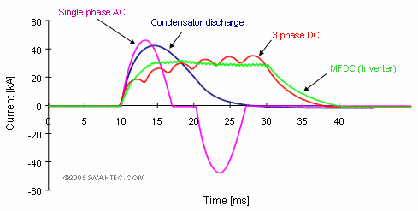
Figure 2.2 :Welding Current

2) Welding Time
The heat generation is directly proportional to the welding time. Due to the heat transfer from the weld zone to the base metals and to the electrodes, as well as the heat loss from the free surfaces to the surroundings, a minimum welding current as well as a minimum welding time will be needed to make a weld. If the welding current is too low, simply increasing the welding time alone will not produce a weld. When the welding current is high enough, the size of the weld nugget increases with increasing welding time until it reaches a size similar to the electrode tip contact area. If the welding time is prolonged, expulsion will occur or in the worst cases the electrode may stick to the workpiece.
3) Welding force
The welding force influences the resistance welding process by its effect on the contact resistance at the interfaces and on the contact area due to deformation of materials. The workpieces must be compressed with a certain force at the weld zone to enable the passage of the current. If the welding force is too low, expulsion may occur immediately after starting the welding current due to fact that the contact resistance is too high, resulting in rapid heat generation. If the welding force is high, the contact area will be large resulting in low current density and low contact resistance that will reduce heat generation and the size of weld nugget
4) Contact resistance
The contact resistance at the weld interface is the most influential parameter related to materials. It however has highly dynamic interaction with the process parameters. The figure below shows the measured contact resistance of mild steel at different temperatures and different pressures. The contact resistance generally decreases with increasing temperature but has a local ridge around 300°C, and it decreases almost proportionally with increasing pressure. All metals have rough surfaces in micro scale. When the welding force increases, the contact pressure increases thereby the real contact area at the interface increases due to deformation of the rough surface asperities. Therefore the contact resistance at the interface decreases which reduces the heat generation and the size of weld nugget. On the metal surfaces, there are also oxides, water vapour, oil, dirt and other contaminants. When the temperature increases, some of the surface contaminants (mainly water and oil based ones) will be burned off in the first couple of cycles, and the metals will also be softened at high temperatures. Thus the
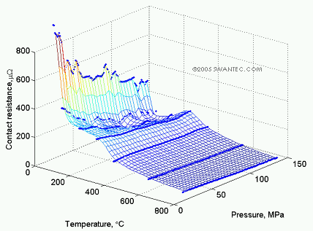
contact resistance generally decreases with increasing temperature.

Figure 2.3: Contact Resistance

5) Materials properties
Nearly all material properties change with temperature which adds to the dynamics of the resistance welding process. The resistivity of material influences the heat generation. The thermal conductivity and the heat capacity influence the heat transfer. In metals such as silver and copper with low resistivity and high thermal conductivity, little heat is generated even with high welding current and also quickly transferred away. They are rather difficult to weld with resistance welding. On the other hand, they can be good materials for electrodes. When dissimilar metals are welded, more heat will be generated in the metal with higher resistivity. Hardness of material also influences the contact resistance. Harder metals (with higher yield stress) will result in higher contact resistance at the same welding force due to the rough surface asperities being more difficult to deform, resulting in a smaller real contact area. Electrode materials have also been used to influence the heat balance in resistance welding, especially for joining light and non-ferrous metals.
6) Surface coatings
Most surface coatings are applied for protection of corrosion or as a substrate for further surface treatment. These surface coatings often complicate the welding process. Special process parameter adjustments have to be made according to individual types of the surface coatings. Some surface coatings are introduced for facilitating the welding of difficult material combinations. These surface coatings are strategically selected to bring the heat balance to the weld interface. Most of the surface coatings will be squeezed out during welding, some will remain at the weld interface as a braze metal.
7) Geometry and dimensions
The geometry and dimensions of the electrodes and work pieces are very important, since they influence the current density distribution and thus the results of resistance welding. The geometry of electrodes in spot welding controls the current density and the resulting size of the weld nugget. Different thicknesses of metal sheets need different welding currents and other process parameter settings.
8) Welding machine characteristics
The electrical and mechanical characteristics of the welding machine have a significant influence on resistance welding processes. The electrical characteristics include the dynamic reaction time of welding current and the magnetic / inductive losses due to the size of the welding window and the amount of magnetic materials in the throat. The up-slope time of a welding machine can be very critical in micro resistance welding as the total welding time is often extremely short. The magnetic loss in spot welding is one of the important factors to consider in process controls. The mechanical characteristics include the speed and acceleration of the electrode follow-up as well as the stiffness of the loading frame/arms. If the follow-up of the electrode is too slow, expulsion may easily occur in projection welding.
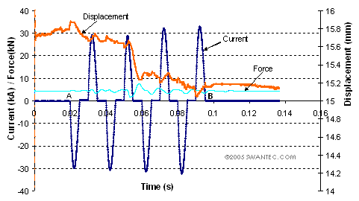

Figure 2.4: Measured Process Parameters

The spot weld cycle is clearly defined in figure 2.5.
Squeeze time, the welding current is applied at the end of this time. Weld time, the welding current flows through the circuit. Hold time, the electrode pressure is maintained until the metal has somewhat cooled. Off time, the interval of the hold time to the beginning of the squeeze time

Figure 2.5: Spot Weld Cycle

Squeeze time, the welding current is applied at the end of this time. Weld time, the welding current flows through the circuit. Hold time, the electrode pressure is maintained until the metal has somewhat cooled. Off time, the interval of the hold time to the beginning of the squeeze time.
Slope Control refers to rise and fall of the welding current as shown in figure 2.6.b. The current may be made to build up gradually (upslope) or to decrease gradually (down slope or current decay). Upslope gives the electrode a few impulses of time to seat before they have to carry the full welding current. The down slope or decay helps to reduce internal cracking of the weld nugget. Retarding the cooling action ensures a proper temperature during the forging action. An increase in electrode pressure as the weld solidifies produces the forging effect (figure 2.6.c). Multiple impulse welding cycles (figure 2.6.d) provide short heating periods alternating with short cooling periods for better control of the weld nugget, which reduces spitting. Spitting refers to the molten metal being propelled out from the weld nugget.

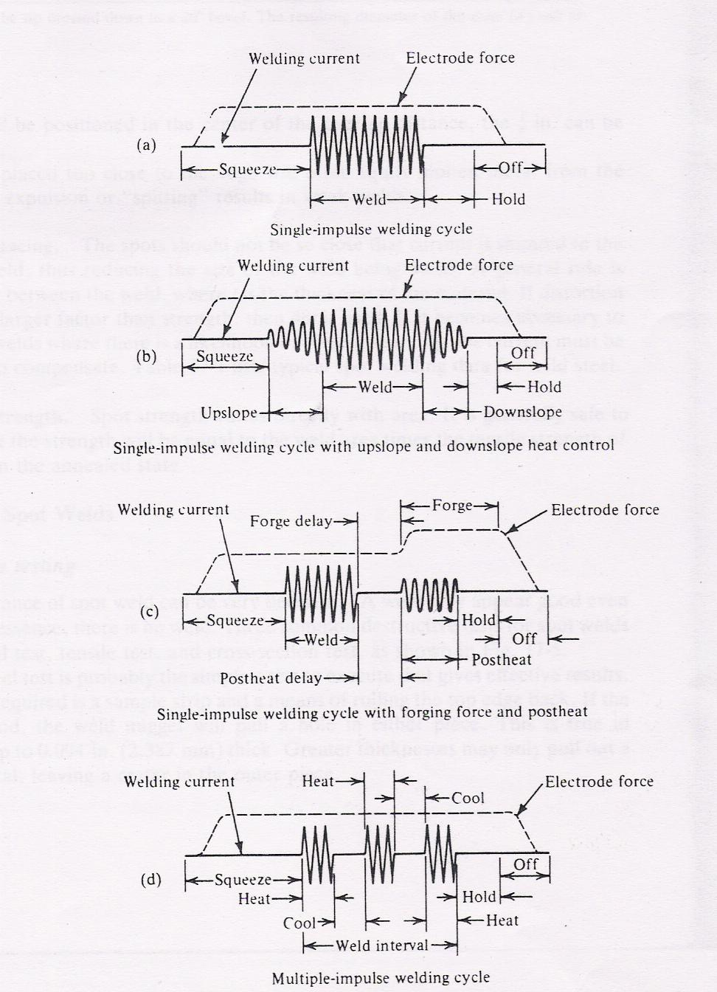

Figure 2.6: Basic resistance Spot Welding Cycles show the relationship of time, current, and electrode force for each segment
Depression is observed in spot welds when high pressure is applied by the electrode to the plates as shown in figure. 2.7. The maximum value of depression is 0.10 times thickness of sheet. The variation w.r.t current is also shown. The graph reveals that with increasing value of current and time , depression is also increasing.
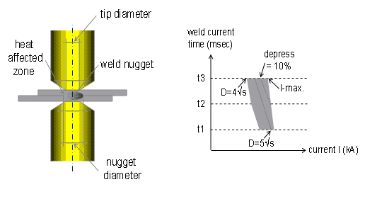
The weld nugget diagram is shown in figure 2.8. Nugget formation is the most important aspect of resistance spot welding. This is the fusion area between two plates to be joined.
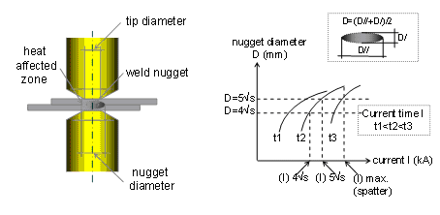
Figure 2.8.a: Influence of Weld Current on Nugget Diameter
During the process of spot welding very high current flows for extremely short duration (0.02sec – 0.05 sec, ammeter cannot respond so quickly. In spot welding current is measured with help of totoidal coil. When high current flows it generates magnetic field and magnetic flux interlink with the coil generate Electromotive force in proportion to rate of change of current to time V = K di/dt K is constant. Coil output V is in proportion to the coil area and nos. of turns This type of sensor can measure any large current in differential value. To get absolute value it is interlink with electronic circuit.
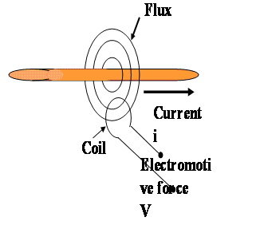
Figure 2.8.b: Current Measurement

2.3 RECENT WORK
According to published literature, research on the spot welding started in early 1950’s. Temperature distribution during the process of spot welding is one of the crucial aspects for the study. Temperature distribution at various zones during the process is clear from the following figure 2.9
Tsai [2] predicted temperature histories at six locations along the central axis of the joint (with welding conditions: welding current 12,200A; weld time 16cycles; electrode force 365kgf). The temperature history at the center of work piece faying surface shows thermal arrests at liquidus and solidus temperatures of work piece material due to latent heat effect. He showed that weld nugget initiated at periphery of the contact area and was in toroid shape. In very short time during the weld cycles, the molten nugget spread rapidly inward toward the center and very little growth in outward radial direction. According to Tsai, the nugget grew much faster along the interface than in material thickness direction and once molten material reached central axis, it began to grow into the joint thickness as the weld cycles continued.

The attributes for spot weld quality were studied by many researchers. Spindella [3] suggested that good welds are welds with large buttons and high tensile strength without expulsion or partial button. In Newton et al [4], a weld with full size nugget and at least minimum strength, and without cracks, flash or porosity was regarded as good weld. Their study also tried to define nonconformable weld as those of too small weld size, or with cracks, excessive porosity, excessive expulsion, and damaged adhesive layers for weld bonding. These classifications are generally qualitative and depend on multiple parameters, in addition to the materials welded (Steel or Aluminum). In many cases, the nugget width or button diameter is used as sole parameter to describe the quality of a spot weld.
Current, time and pressure are the three variables which influences weld quality. The variation of current and pressure; and relation of current and time is shown in figure 2.10

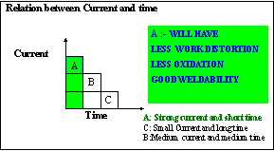

Figure 2.10.a: Relation ship of current and time on weld quality

Figure 2.10.b: Relation between current and pressure for weld quality

Zhou [6] attempted to link a weld’s quality to its attributes under tensile shear testing. The use of combined statistical design and analyses, and computer simulation provided a systematic and effective means to study multivariate nature of spot welds. Through his integrated numerical analysis he found out effect of weld parameters such as weld diameter, penetration, indentation, size of HAZ and sheet thickness of base metal on spot weld quality. He also provided J-integral, which was further used to describe fracture behavior of welded joint by treating edge of weld as crack.

Figure 2.11 gives the variation of resistance in spot welding. R₂ and R₆ are resistance between electrode tip and sheet; R₄ is the surface contact resistance; R₃ and R₅ are sheet individual resistance. Dynamic resistance is frequently referred to as good process variable for monitoring resistance spot weld quality.

Na and Park [7] proposed a hybrid approach to predict dynamic resistance. They suggested to explicitly include the effect of micro contacts for calculating the distribution of electric potential and temperature in resistance spot welding process. The contamination film was assumed to be the insulating oxide layer, which is uniformly distributed in the contact interface. Moreover it was assumed that the oxide contamination layer is so brittle that it is crushed to pieces as soon as contacting pressure is applied. The broken layers were then assumed to be of a certain size and were distributed in the contact surface at regular interface. The dynamic resistance was then defined as the value of voltage drop between two electrodes divided by overall current flowing through work piece. The results showed for first two cycles, the dynamic resistance decreased very steeply and reached its minimum value. This was taken due to effect of the contamination films and fresh asperities existing in the work piece to work piece interface and/or work piece to electrode interface. The study also revealed that in the low force range it is not sufficient to consider only the contamination film, because of the surface inconsistence which prevents full contact. In the relatively high contracting force range, considerably satisfying results were obtained.

Mechanical characteristics of resistance spot welding machines, such as stiffness, friction, and moving mass have complex. These factors were systematically investigated by Tang, Hou, Zang, Feng and Kimchi [11] through experiments. These mechanism of influences were explored by analyzing process signature, such as welding forces and electrode displacement and other process characteristics, such as electrode alignment. They recommended high stiffness as machine mechanical characteristics and concluded its positive influence on expulsion prevention and weld quality.

The effect of tip force on weld quality and electrode life was studied by Hirsch[12] high electrode force reduces heat created within the nugget area to greatly reduce penetration. This results in low tensile strength welds that have poor weldability. He also suggested insufficient force at the electrode creates conditions that produce inconsistent welds. Low electrode force causes high localized heating at the electrode tip to burn away copper and thus greatly increases the electrode contact area.

Nied [5] introduced an electrically, thermally and structurally coupled axisymmetric model considering temperature dependent properties and joules heating for squeeze and weld cycle. The displacements and stress distribution of electrode and work piece were illustrated. The temperature dependency of contact resistance was not considered. Gould [8] studied nugget development during resistance spot welding. Nugget thickness calculated by finite element analysis was compare with the measured data. The analysis scheme was modeled by one dimensional heat transfer and considered the temperature dependent contact resistance and material properties. Cho and Cho[9] presented a theoretical basis for thermal behavior of resistance spot welding. Finite difference models were developed to predict the temperature and voltage distribution during nugget formation, incorporating the thermal-electrical interaction at the faying surface. The thermoelectric interaction at weldment interface on internal heat generation was undertaken. Based on the model, time behavior of the temperature field in the weldment, nugget diameter growth and nugget penetration was solved.

Cha and Na [10] obtained residual stresses from electrical-thermal structural analysis and the parameters that effect residual stresses. The results were focused on the residual stress around the nugget edge because the tensile residual stress around it contributes most in increasing the maximum stress of spot welded structures. Equations for residual stresses were developed in terms of welding conditions and were used to find welding conditions that minimize residual stresses. The results were helpful not only when the mean stress effect on fatigue strength needs to be calculated, but also when the maximum stress is to be obtained considering the residual stress.

2.4 SUMMARY
Spot welding is metal joining process and widely used in sheet metal industry. The basic resistance welding process has not appreciably since long time. At its most, it consists of passing electrical current through two or more layers of the metal that are being held together by force, when current passes through this “sandwich”, the metal is heated and coalesces. The process is controlled combination of forging and melting. Temperature along the interfaces in the welding processes is the important aspects of welding. Various studies are conducted to study thermal effects during the processes. The main consideration during the spot welding is formation of correct nugget. The works have been done to study the effects of weld parameters on nugget growth experimentally and also using finite element method.

CHAPTER 3: EXPERIMENTAL PROCEDURES

This chapter deals with the details of experimental procedure and apparatus used in the work. The sections discusses about the characteristics/specification of the machines and material utilized in the project. The information about the spot weld joint is also discussed herewith.

3.1 DETAILS OF THE APPARATUS

The Spot welding Machine and the Testing machine for measuring hardness and nugget size are given below

3.1.1 About the Spot Weld Machine

The IT (Integrated Transformer) Spot Welding Gun-X Type is used for welding of the plates. The conventional rating of the transformer for conventional spot welding machine is 150KVA and for IT gun it reduces to 38KVA, thus reducing the losses.

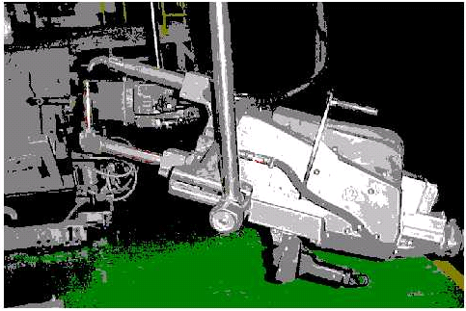

Figure 3.1 : IT Spot Weld Gun
The specifications of the machine are listed in Table 3.1
Table 3.1: Specification of the IT Spot Weld Gun
Specification of the IT Spot Weld Gun
Make | Techno, Italy
Rating | 38KVA
No load Secondary Voltage | 5.14V
Supply Voltage | 415V,50Hz
Throat Depth | 470mm
Throat gap | 230mm
Air Pressure | 6bar
Force | 180Kgf – 220Kgf

Tip material used is CRM 16-CuCrZr with composition Cr 0.4 - 1 % , Zr 0.02 -0.1 % & Cu-bal. The Conductivity and hardness ranges from75 ~ 80 and 130~170 BHN respectively. IS819 1957( Part II & II-A) is used for selecting the proper electrode tip specification. The tip diameter is 13mm and is required to be dressed after 2000 spots(approximately four times in a shift).

Table 3.2: Physical properties of electrode
Property | Value
Thermal Conductivity | 3.014 X 10³ W/m.º C
Electrical Resistivity | 3.83 X 10⁻² µΩm
Specific Heat | 4.102 X 10² kg/m³
Convection Heat Coefficient | 4.187 X 10⁴ W/ m² º C

TE450 is a microprocessor welding control unit for IT spot weld guns. The welding control unit is used to control the welder parts, and in particular the thyristors adjusting the welding current. The control unit includes specific functions to be used when working with welding guns, such as: double stroke control. TE450 can work in constant current mode; it displays the welding current and check the current according to the set limits. It is possible to select 63 different welding programs; it is possible to directly recall 2 programs by means of an external selector commonly installed on the handle. Besides simple 4 times cycle, the control unit enables to carry out welding processes with per-weld current, post weld current , slope and pulses.

Main Technical Data
- Simplified programming by means of 5 push buttons and LCD display.
- 63 welding programs to be stored up; 2 programs can be recalled from the handle.
- 18 programmable parameters for each program.
- Slope and pulse functions; pre-weld and post-weld functions.
- Double working modes: standard and constant current.
- Automatic double stroke function
- Welds counter.
- Compensation of secondary current to weld oxidized sheets and rods
- Single and automatic cycle. WELD/NOWELD function.
- Control of solenoid valve 24V dc,72W max with protected output against short circuit
- Self adjustment of mains frequency 50/60 Hz

As soon as the welding control unit is turned on, the displays shows the supply frequency as shown below in figure 3.2.

SUPPLY FREQUENCY

50 HZ
TE 450 REL 1.50

WELD CONTROL

Figure 3.2 : Display of TE450

To start the programming push simultaneously the push buttons for at least a second. After 8seconds of inactivity, the control unit will automatically end the programming operation and enable the working process. The first selection concerns the number of programs to be used for the adjustment in process. After having selected the number of the program, it is possible to select the parameters forming the program by means of push buttons. The display shows the following data:
1 2 3

ADJ1 PRG01 PRM07

WELD 1 08.0 ~

4 5
Figure 3.3: Parameters of IT gun

- Selected adjustment(ADJ1=ADJUSTMENT 1, ADJ2=ADJUSTMENT 2)
- Number of selected program(PRG01= program number 1)
- Identification mark of selected parameter
- Name of the parameter
- Value of parameter

The value of the welding parameter can be adjusted by means of the push button + or – either increasing or decreasing the value shown by the display. The parameters can be adjusted to different values according to the type of parameter, the limit range for each parameter given in following table.

Table 3.3: Types of parameter and their ranges
Parameter Number | Parameter | Range Value
A | Working Mode | 1K – PW%
B | Control Mode | No Current Degree
C | Stroke | Short – Long – Automatic
1 | Squeeze 1 | 01-99 cycles
2 | Squeeze | 01-99 cycles
3 | Pre-Weld | 0-99.5 cycles
4 | Pre-Power | 01 – 99%
5 | Cold 1 | 0 – 50 cycles
6 | Slope Up | 0 – 25 cycles
7 | Weld 1 | 0.5 – 99.5 cycles
8 | Power 1  Current 1 | 10 – 99%  2 – 36 KAmp
9 | N.Impluse | 0 – 99
10 | Cold 2 | 1 – 50 cycles
11 | Slope Down | 0 – 25 cycles
12 | Cold 3 | 0 – 55 cycles
13 | Post Weld | 0 – 99.5 cycles
14 | Post Power | 1 – 99%
15 | Hold Time | 1 – 99 cycles
16 | Off Time | 0 – 99 cycles
17 | Current Min  Angle Mini | 2.0 – 36.0 KAmp  001 - 180°
18 | Current Max  Angle Max | 2.0 – 36 KAmp  001 - 180°

3.1.2 About the Micro Hardness Tester
The term Micro Hardness test usually refers to static indentations made with loads not exceeding 1 kgf. The indenter is either the Vickers diamond pyramid or the Knoop elongated diamond pyramid. The Micro hardness test method according to ASTM E-384 specifies a range of loads using a diamond indenter to make an indentation which is measured and converted to a hardness value. It is very useful for testing on a wide type of materials as long as test samples are carefully prepared. There are two types of indenters, a square base pyramid shaped diamond for testing in a Vickers tester and a narrow rhombus shaped indenter for a Knoop tester. Typically loads are very light, ranging from a few grams to one or several kilograms, although "Macro" Vickers loads can range up to 30 kg or more. The Micro-hardness methods are used to test on metals, ceramics, composites - almost any type of material. There are a number of considerations in Microhardness testing. Sample preparation is usually necessary in order to provide a specimen that can fit into the tester, make a sufficiently smooth surface to permit a regular indentation shape and good measurement, and be held perpendicular to the indenter. Usually the prepared samples are mounted in a plastic medium to facilitate the preparation and testing. The indentations should be as large as possible to maximize the measurement resolution.

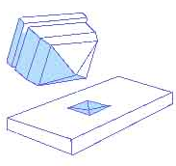

Figure 3.4: Pyramid shaped diamond for Vickers Hardness Test

The hardness testing equipments with specification given below is used for the experiments.

Machine | Micro Vickers Hardness Testing Equipments
Make | M/s Future Tech, Japan
Load Used | 1Kgf
Least Count | 0.1 HV
Indentor | Pyramid shaped Diamond Indentor


Figure 3.5: Future Tech Micro Hardness tester

3.1.3 About the UTM
The UTM for measuring the shear strength is shown figure

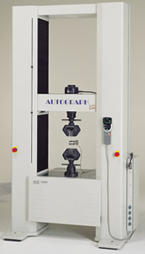

Figure 3.6: Universal Testing Machine

The features of UTM and specifications are listed below:

- Controller with high level of operability and safety
- Software linked with test machine on many dimensions.
- High quality test data
- Diverse System Lineup
- Various accessories accommodating all users lineup

Table 3.4: Specifications of Tensile Testing Machine
Machine | Universal Testing Machine
Make | M/s Shimadzu, Japan
Capacity | 25 tons
Least Count | 0.1 N
Cross Head Speed during Testing | 20 mm/min

3.1.4 About the FEA tool – ANSYS software
Finite Element Analysis is technique to simulate loading conditions on a design and determine the design’s response to those conditions. The Finite Element method of structural analysis was created by academic and industrial researchers during 1950s and 1960s. The underlying theory is over 100 years old, and was the basis pen-and-paper calculations in the evaluation of suspension bridges and steam boilers.

ANSYS is a complete FEA software simulation package developed by ANSYS Inc – USA. It is used by engineers worldwide in virtually all fields of engineering:

- Structural
- Thermal
- Fluid (CFD, Acoustics, and other fluid analyses)
- Low and High Frequency Electromagnetics

Table 3.5: System Requirements for ANSYS 8.0
System Requirements to run ANSYS 8.0
Pentium IV, 1.4 GHz
256 MB RAM
SVGA Monitor
650 MB Hard disk Space
Windows 2000, Windows XP
Microsoft TCP/IP
Ethernet Network Adapter

3.2 DETAILS OF TEST MATERIAL
The experiments were conducted on Advanced High Strength Steel with the chemical composition described in table 3.6

Table 3.6 : Chemical Composition of Test Material
Element | Percentage
Carbon | 0.0601
Sulphur | 0.0055
Phosphorous | 0.0079
Magnese | 0.2379
Silicon | 0.0183
Chromium | 0.0312
Nickel | 0.0533
Cobalt | 0.0013
Aluminum | 0.0291
Vanadium | 0.064
Molybdenum | 0.015

The different mechanical and thermal properties are summarized below:

Table 3.7: Properties of Test Material
Property | Value
Mechanical properties
Hardness | 90 – 100 HV
Density (X 1000kg/m³) | 7.872
Poisson’s Ratio | 0.27 to 0.30
Modulus of Elasticity | 190 – 210 GPa
Tensile Strength | 350MPa
Yield Strength | 300MPa
Thermal Properties
Thermal Expansion(10⁻⁶/ º C) | 12.6
Specific Heat(J/Kg-K) | 481
Thermal Conductivity(10⁻⁶/ º C) | 15
Resistivity | 30 micro ohm-inch

The microstructure of the base metal Ferrite + Pearlite and is given in figure
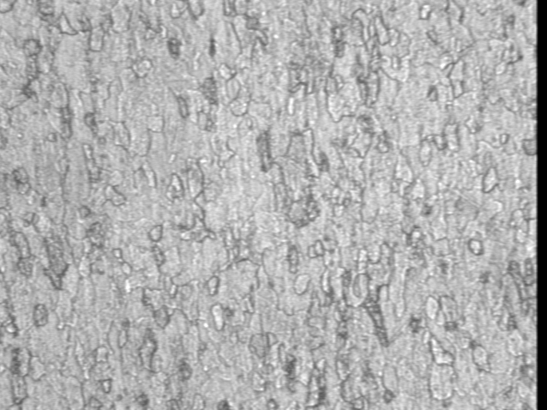
Figure 3.7: Microstructure of Test Material
3.3 PROCEDURES
The objective of the thesis is to study the behavior of spot welds analytically as well as experimentally. The procedure for conducting the experiments and performing the analysis is herewith discussed.

3.3.1 Experimental Procedure
For conducting the experiments, spot weld is made with IT gun discussed in section 3.1.1. The weld joint was made according to Japanese Standard JIS Z 313a [refer Annexure 2]. As per the standard following values are selected:

Table 3.8 : Dimensions of Test Piece
Nominal thickness of plate (mm) | W(mm) | L(mm) | P(mm)
0.8 to 1.3 excl | 30 | 100 | 30

As discussed in later sections, the main parameters of spot welding includes current, cycle time, pressure and accordingly certain variables are effected during the process. For this study, current and cycle time were selected as parameters to be varied and this effects are to be seen on Nugget diameter, Hardness of weld zone as well as hardness of HAZ, Penetration and shear strength.

The first set of experiments was conducted by varying cycle time and keeping other parameters constant. The conditions for the experiments is listed below in table
Table3.9: Conditions for first experiments
Parameter | Value
Material | AHSS
Thickness of work material | 0.7mm
Force | 220Kgf
Current | 9500 Amperes
Cycle time varied: 12, 14,16,18, 20 cycles

With these conditions, the series of spot welds made is described in table given below. The weld is made by varying cycle time and keeping other parameters constant.

Table 3.10: Spots Welds for first experiment
Value of Cycle time | Spot number
12 cycles | a , b
14 cycles | c , d
16 cycles | e , f
18 cycles | g , h
20 cycles | i , j

The joint made for first experiment is shown below
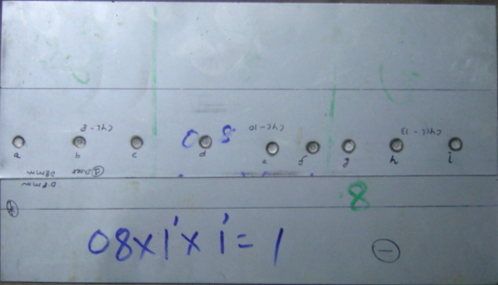
Figure 3.8: Lap Joint with cycle time varying

The second set of experiments was conducted by varying the value of current and keeping other parameters constant. The conditions for the same are given in table 3.11
Table 3.11: Conditions for second experiments
Parameter | Value
Material | AHSS
Thickness of work material | 0.7mm
Force | 220Kgf
Cycle Time | 10 cycles
Current varied: 9000Amp;9500Amp;10,000Am;10,500Amp;11,000Amp

With these conditions, the series of spot welds made is described in table given below. The weld is made by varying value of current and keeping other parameters constant.

Table 3.12: Spots Welds for second experiment
Value of Current (Amperes) | Spot number
9000 | a , b
9500 | c , d
10,000 | e , f
10,500 | g , h
11,000 | i , j

The picture of the joint made by second experiment is shown in figure 3.9
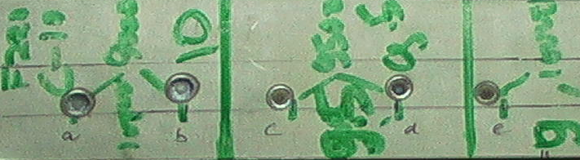
Figure 3.9: Lap Joint with Current Varying

After making the joint with above stated conditions, the welds are examined and tested with equipments listed in last section. Nugget diameter is measured at after taking cross section.

3.3.2 Analytical Procedure

The ANSYS is taken as FEA tool. Thermal analyses and stress analyses is done of the plate material of thickness 0.8mm. The advanced high Strength Steel material is taken as the base metal with properties defined in section 3.2

The procedure for analytical study of FEA method is now discussed. Following four steps used for FEA analysis are listed below:

- Preliminary Decisions
- Preprocessing
- Processing
- Solution

- Preliminary Decisions: This involves selection of type of analysis which is to be done, depending upon the nature of the problem. The analysis type usually belongs to one of the following disciplines:

  - Structural: Motion of solid bodies, pressure on solid bodies, or contact of solid bodies.
  - Thermal: Applied heat, high temperatures, or changes in temperature
  - Electromagnetic: Devices subjected to electric currents (AC or DC), electromagnetic waves, and voltage or charge excitation.
  - Fluid: Motion of gases/fluids, or contained gases/fluids.

The structural and thermal analysis is done for the performing the analysis on spot welded joints. Firstly thermal analysis is done and then structural analysis is done on the plate.

- Preprocessing: The process of pre processing includes creating the solid model, performing meshing and defining the material.

  - Creating the Solid Model: A typical solid model is a geometry defined by volumes, areas, lines and key points. Also, a model with just areas and bellows such as a shell or 2D plane model is still considered a solid model in ANSYS terminology. As an alternative to create a model directly in ANSYS, it can be created in some other CAD software like PRO-E, AutoCAD, UNIGRAPHICS, CATIA etc. the model is then imported into ANSYS. The plate to be welded is created in AutoCAD software and then imported as .sat file. The pate with dimension 100X50X0.8 is taken for the purpose of analysis.
- Defining Material Properties: ANSYS allows choosing predefined set of properties for a given material. For this work own material library is made. The common inputs required for defining material includes Young’s modulus, Poisson ratio, modulus of elasticity, density as mechanical properties and thermal conductivity, thermal expansion. The material is defined on the basis of thermal and mechanical properties defined in section 3.2
  - Creating FEA model(Meshing): ANSYS do not use the solid model in the solution of the model. It needs to use finite elements. To create FEA model, meshing is done on the solid model. Meshing is the process used to “fill” the solid model with nodes and elements. The three steps in meshing were followed:
    - Defining the element attributes which includes element types(determines element characteristics – Degree of freedom, element shape, dimensionality); element category(line elements, shell elements, 2D solids and 3D solids).
    - Specifying mesh controls to control mesh density both on global and local level
    - Generating mesh

- Processing: In this step the boundary conditions, thermal conditions and load conditions are applied. The conditions for each as per the work are defined below:

Boundary conditions for thermal analysis:

- In boundaries room temperature of 30°C is applied
- Upper surface in contact with electrode area, temperature is 500°C is applied
- Lower surface in contact with other plate, temperature of 1500°C is applied

Boundary and Load Conditions for structural analysis:

- Output of thermal analysis is taken as input for the stress analysis.
- Boundaries of panel are fixed.
- Upper surface in contact with the electrode area , load of 1800N is applied
- Lower surface in contact with other plate, Z translation is fixed.

4) Solution: The output of the analysis is seen in this step. Thermal analysis is first solved and after that structural analysis is chosen with conditions specified in previous step.

3.4 REPEATABILITY

The spots welds are made on sheet with specifications of joint and material discussed above. The conditions for making the joint and variations in the parameters are also referred in section 3.3.To get better degree of accuracy at similar conditions two spots are made. This is done to avoid any mistake which can occur during measurement process.

3.5 LIMITATION OF APPRATUS
The force range of the particular IT spot weld gun is 180Kgf – 220Kgf but for thicker plates this force may be insufficient. In these cases, thus, IT spot gun can give some non-confirming results. Also the current range for IT gun is 8,000 – 13,000Amperes and with this range expulsions were not possible to be studied.

CHAPTER 4: RESULTS AND DISCUSSIONS

The objective of this chapter is to give the experimental and analytical results which are conducted for the project. Also, the inferences from the experiments are given this chapter.

4.1 EXPERIMENTAL RESULTS

The first set of experiments is conducted under following conditions:

Material: AHSS
Thickness of sheet: 0.7mm
Force: 220Kgf
Current: 9500Amp
Cycle time varied as under:
- Spots a and b with cycle time 12 cycles
- Spots c and d with cycle time 14 cycles
- Spots e and f with cycle time 16 cycles
- Spots g and h with cycle time 18 cycles
- Spots i and j with cycle time 20 cycles

Table 4.1: Results with variation in Cycle time
S.No | Nugget Diameter  (mm) | Hardness of Weld Zone(HV) | Hardness of HAZ (HV) | Shear Strength(Kgf) | Depression  (mm)
Cycle Time = 12cycles
a) | 4.95 | 164 - 172 | 99 | 280 | 0.32
b) | 4.90 | 164 - 172 | 99 | 280 | 0.33
Cycle Time = 14 cycles
c) | 4.83 | 165 – 179 | 99 | 288 | 0.36
d) | 4.81 | 165 – 181 | 99 | 288 | 0.35
Cycle Time = 16 cycles
e) | 5.20 | 154 – 183 | 99 | 289 | 0.40
f) | 5.22 | 150 – 185 | 99 | 289 | 0.39
Cycle Time = 18 cycles
g) | 4.80 | 159 – 186 | 99 | 266 | 0.42
h) | 4.80 | 155 – 184 | 99 | 266 | 0.42
Cycle Time = 20 cycles
i) | 4.91 | 165 – 192 | 99 | 315 | 0.46
j) | 4.89 | 165 – 190 | 99 | 315 | 0.43

The above results are shown graphically in figure 4.1

Figure 4.1.a Cycle Time vs. Nugget Diameter

Inferences:
- Peak to valley Value is 0.60.
- Initially Diameter decreases with increase in cycle time. After 14 cycles, there is steep increase in the diameter and then it reduces to minimum value.
- Their in large variation seen in nugget diameter with cycle time.

Figure 4.1.b: Cycle Time vs. Hardness of Weld Zone(HV)

Inferences:
    - Peak to Valley Value is 18 HV.
    - Hardness of weld zone is seen to be increasing with increasing value of cycle time at almost constant rate

Figure 4.1.c: Cycle Time vs Hardness of HAZ (HV)

Inferences::
    - Hardness of HAZ is not varying with varying value of cycle time

Figure 4.1.d: Cycle Time vs. Shear Strength Kgf)
Inferences:
    - Peak to Valley Value is 118 Kgf
    - Shear Strength initially increases with value of cycle time at almost constant rate and after certain value it comes down and increases after an interval.

Figure 4.1.e: Cycle Time vs. Depression

Inferences:
  - Cycle time Vs Depression
    - Peak to Valley Value
    - Depression value increases at constant rate with the value of cycle time

The second set of experiments is conducted under following conditions and varying the value of current.
Material: AHSS
Thickness of sheet: 0.7mm
Force: 220Kgf
Cycle Time: 10 cycles
Current varied as under:
- Spots a and b with current 9,000Amp
- Spots c and d with current 9,500Amp
- Spots e and f with current 10,000Amp
- Spots g and h with current 10,500Amp
- Spots i and j with current 11,000Amp

Table 4.2 : Results with variation in current
S.No | Nugget Diameter  (mm) | Hardness of Weld Zone(HV) | Hardness of HAZ (HV) | Shear Strength(Kgf)
a) | 5.40 | 268 – 293 | 137 | 550
b) | 5.39 | 266 – 295 | 137 | 550
c) | 5.70 | 281 – 290 | 158 | 588
d) | 5.80 | 280 – 290 | 156 | 588
e) | 6.90 | 281 – 293 | 144 | 668
f) | 6.88 | 281 – 293 | 143 | 668
g) | 5.30 | 260 – 300 | 147 | 623
h) | 5.30 | 259 - 299 | 149 | 623
i) | 6.00 | 260 – 280 | 142 | 605
j) | 5.97 | 261 – 282 | 144 | 605

The graphical representation of above is shown in figure 4.2

Figure 4.2.a: Current vs, Nugget Diameter
Inferences:
- Peak to valley Value is 1.60
- Initially Diameter decreases with increase in current. With value of current as 10,000 amperes, the nugget diameter reaches its peak value and reduces after this value.
- Their in large variation seen in nugget diameter with change in the value of current.

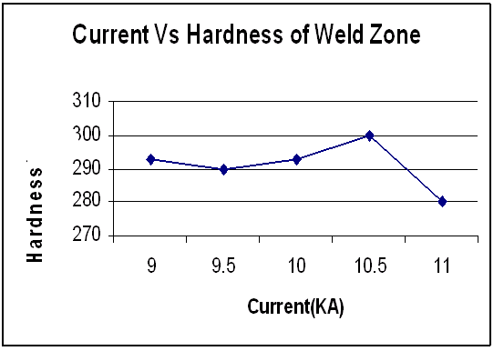
Figure 4.2.b: Current vs Hardness of Weld Zone
Inferences:
  - Current Vs Hardness of Weld Zone
    - Peak to Valley Value is 20 HV
    - Hardness of weld zone increases at almost constant rate up to one value of current (10,500 amperes). After this value, the hardness reduces and attains minimum value.

Figure 4.2.d: Current vs. Hardness of HAZ
Inferences:
  - Current Vs Hardness of HAZ
    - Peak to Valley Value is 21 HV
    - Hardness increases from minimum value of current and reaches its maximum value. At 9,500 amperes the value of hardness is maximum and at next value it reduces and becomes almost constant at later intervals.

Figure 4.2.e: Current vs. Shear Strength
Inferences:
  - Current Vs Shear Strength
    - Peak to Valley Value is 35 Kgf
    - Shear Strength initially increases with value of current at almost constant rate and after attaining the maximum value, decreases with constant rate.

The peak to valley value for variation in current and cycle time based on table 4.1 and table 4.2 can be summarized in table 4.3.

Table 4.3: Peak to Valley Value
Parameter | Cycle Time | Current
Nugget Diameter | 0.60 mm | 1.6 mm
Hardness of weld Zone | 18 HV | 20 HV
Hardness of HAZ | - | 21 HV
Shear Strength | 118 Kgf | 35 Kgf

The peak to valley value of nugget diameter and hardness of weld zone is more with variation of current but the value of shear strength is more when varying cycle time.

The microstructure is also taken noted and shown in figure 4.2.e.
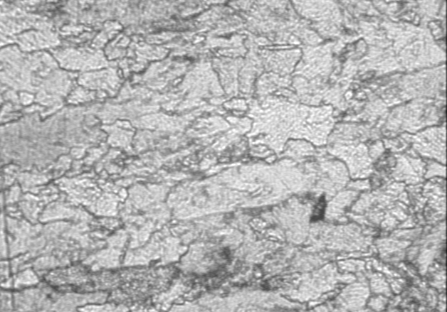

Figure 4.2.e: Microstructure of weld zone
The microstructure is Ferrite + Pearlite with elongated grains. This is due to high amount of heat in the weld zone which causes these metallurgical changes.

4.2 ANALYTICAL RESULTS

The analysis done on ANSYS is summarized here. The analysis is done on basis of boundary conditions stated in section 3.3. Based on those, the results in graphical form are given in figure 4. 3. Thermal analysis gives the temperature distribution on the plate with specified conditions. Temperature distribution along the thickness is also shown graphically.

The second stage of analysis is covered in figure 4.3.e-h. The structural analysis is done at this stage. The stress distribution of heated plate and also along the thickness is shown graphically. The range of temperature is shown on axis.

Figure 4.3.1: Thermal Analysis
Figure 4.3.2: Temperature distribution at faying surface
Figure 4.3.3: Temperature distribution at electrode workpiece interface

Figure 4.3.4: Temperature distribution along the thickness

Figure 4.3.5: Structural Analysis

Figure 4.3.6: Stress Plot at faying surface

Figure 4.3.7: Stress Distribution along the thickness

Figure 4.3.8: Deformation Plot

Figure 4.4: Temperature at faying surface

Figure 4.5: Stresses at Faying surface

Figure 4.6: Temperature variation at electrode surface

Based on the outputs referred in figure 4.3, graphical representation of temperature distribution is shown in figure 4.4 and figure 4.5. The graphs are drawn for one quadrant moving along the length (axis symmetric). The graph reveals that temperature is decreasing while moving away from the nugget and the minimum value of temperature is at the end. The stress nature can be similarly studied. The stresses are maximum near the center and decreases as shown in figure 4.5. The stresses are minimum at the ends of the plate. The comparison of temperature distribution at faying surface and work piece electrode interface shows that the temperature at fusion zone decreases continuously after moving away from the centre of nugget but at electrode work piece interface, temperature increases and then decreases. The maximum temperature is always less at electrode surface than the faying surface.

CHAPTER 5: CONCLUSIONS

5.1 Conclusions
` Resistance Spot Welding is one of the simplest methods of joining two or more plates. Recognized fundamental variations in spot welding are force, cycle time and current. The effect of the variations on weld properties is done successfully.

Nugget development of AHSS has been characterized as function of cycle time and current. Differences in nugget growth behavior with respect to welding current and welding time were described in terms of relative sizes of each variation. Nugget diameter depends on the cycle time and current. From the experiments it has been seen that hardness of weld zone increases to appreciable amount. This may be result of presence of Chrominium, Vanadium and Molybdenum in the base metal which leads to the carbide formation and results in the increase in the value of hardness.

Indentation or depression is taking place at weld. This is due to high pressure applied by means of electrode. From experiments it can be concluded that depression is increasing with variations taking place during the process of welding.

The deformation is observed on the plates by the process of welding. This is due to application of high electrode pressure which causes indentation. From FEM analysis it is seen that there exists deformation moving away from the nugget. This is local deformation that occurs in the electrode and the workpiece. The concentrated contact pressure exerted on the workpiece to lift up in area beyond the common contact interface between the workpieces and causes deformation.

Temperature distribution at two contact surfaces is developed which indicated that the temperature along the faying surfaces reduces as the radius approaches the outer edge of contact. The temperature distribution at electrode – workpiece interface is less than in the interior due to heat conduction into the electrode. However there is temperature maximum along this surface in an annular region beyond the edge of the electrode.
Finite element modeling and analysis provide insightful information regarding the stress and the temperature distribution. It has been shown that the finite element modeling of the resistance spot welding process can provide good simulation. It is common practice in industry to use welding conditions tabulated in handbooks as the starting point to develop a welding schedule. The results presented herein indicate that there is another alternative: the use of analytical model. Finite element modeling and analysis is well developed technique. Using this method, one can investigate weld nugget formation for a variety of materials to be joined and different electrode configurations. The use of an analytic tool by process engineer provided him with another procedure to develop weld schedules before going onto the shop floor to conduct tests.

5.2: Recommendations
In the world of resistance welding, control of parameters is very important to the production of quality of spot welds. Resistance welding is accomplished by the application of three components: current, time and force. Mechanical force is required to forge the parts together and get high quality joint. In the present work, the effect is seen with varying values of current and cycle time. Variation of force is not taken into account. To know proper weld geometry, variation of force should be taken into account. This may give more accurate result and will be helpful in deciding the optimum weld quality.
The nugget development is studied by experimental procedure. To get more range of results, computer simulation shall be used. Finite element method is suggested to study nugget growth as function of welding variables. Finite element method to predict contact resistance variation at work piece to work piece interface is also proposed.

List of References

- Hirsch B.Roger .March 1993. Tip force controls equals spot weld quality. Welding Journal pp 57-60
- Tsai C.L, Dai W.L, Dickinsan D.W, Papritian J.C. December 1991. Analysis and Development of real time control methodology in Resistance Spot Welding. Welding Journal. Pp 339s – 351s
- Spindella D.J.1994 Using fuzzy logic to determine optimum parameter for resistance spot welding of Aluminum. Sheet metal welding conference VI, Detriot
- Newton C.J, Browne D.J, Thornton M.C, Boomer D.R and Keay B.F. 1994. The fundamentals of Resistance Spot welding of Aluminum, Sheet Metal Conference VI, Detriot.
- Nied H.A.April .1984 .The Finite Element Modeling of the Resistance Spot Welding Process. Welding Journal. Pp 123s-132s
- Zhou.M, Zang.H, Hu.J.S. April 2003. Relationship between quality and attribute of spot welds. Welding Journal. Pp 72s – 77s
- Na.S.J, Park S.W. August 1996. the theoretical study of electrical and thermal response in resistance spot welding. Welding Journal. Pp 233s – 241s
- Gould J.E.January 1987. An examination of nugget development during Spot Welding, using both Experimental and Analytical Technique. Welding Journal. Pp 1s – 10s
- Cho H.S, Cho Y.J.June 1989. A study of thermal behavior in resistance spots welds. Welding Journal. Pp 236s – 244s
- Cha.B.W, Na S.J.2003. A study on the relationship between welding conditions and residual stress pof resistance spot welded 304-Type stainless steel. Journal of Manufacturing Systems. Pp 181 – 189
- Zhang H.Y, Feng.Z, Kimchi.M. May 2003. Influence of welding machine mechanical characteristics of Resistance Spot Welding Process and weld quality. Welding Journal. Pp 116 s- 124s
- Hirsch Roger B. The effect of tip force on weld quality and electrode life.
- Zienkiewiez O.C,3rd Edition. The Finite Element Analysis. Tata Mcgraw Hill Publications.
- Lindberg R.A. 4th Edition. Processes and Materials of Manufacture. Prentice Hall India.
- Anver S.H. 2nd Edtion. Introduction to physical Mettalurgy. Tata McGraw Hill Publications

ANNEXURE 1

Table I: SPOT WELDING DATA

Sheet thickness, t  [mm] | Electrode force, F [kN] | Weld current, I [A] | Weld time [cycles] | Hold time [cycles] | Electrode diameter, d [mm]
0.63 + 0.63 | 2.00 | 8 500 | 6 | 1 | 6
0.71 + 0.71 | 2.12 | 8 750 | 7 | 1 | 6
0.80 + 0.80 | 2.24 | 9 000 | 8 | 2 | 6
0.90 + 0.90 | 2.36 | 9 250 | 9 | 2 | 6
1.00 + 1.00 | 2.50 | 9 500 | 10 | 2 | 6
1.12 + 1.12 | 2.80 | 9 750 | 11 | 2 | 6
1.25 + 1.25 | 3.15 | 10 000 | 13 | 3 | 6 7
1.40 + 1.40 | 3.55 | 10 300 | 14 | 3 | 6 7
1.50 + 1.50 | 3.65 | 10 450 | 15 | 3 | 6 7
1.60 + 1.60 | 4.00 | 10 600 | 16 | 3 | 6 7
1.80 + 1.80 | 4.50 | 10 900 | 18 | 3 | 6 7
2.00 + 2.00 | 5.00 | 11 200 | 3x7+2 | 4 | 7 8
2.24 + 2.24 | 5.30 | 11 500 | 3x8+2 | 4 | 7 8
2.50 + 2.50 | 5.60 | 11 800 | 3x9+3 | 5 | 8

ANNEXURE 2

JIS Z 3139 STANDARD

Scope:
This Japanese Industrial Standard specifies the method of macro test and details for section of spot welded joint of metallic materials not more than 5.0 mm in plate thickness.

Two - Plate Lap Joint
This is regarding the shape of test piece. The shape of test piece shall confirm to Figure I and Table II, and shall be cut from test material joined by not less that 10 continuous spot weldings The pitch of the spots (P) shall confirm to the value shown in Table II as the standard.
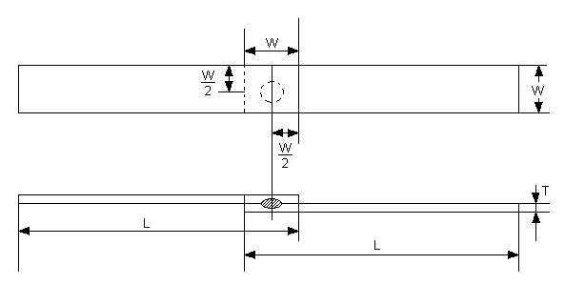
Figure I: Shape of the Test Material

Table II: Dimension of Test Piece and Test Material
Nominal Thickness of plate t (mm) | W(mm) | L(mm) | P(mm)
Under 0.8 | 20 | 75 | 20
0.8 to 1.3 excl | 30 | 100 | 20
1.3 to 2.5 excl | 40 | 125 | 40
2.5 to 3.5 excl | 50 | 150 | 55
3.5 to 4.4 excl | 50 | 150 | 70
4.4 to 5.0 excl | 50 | 150 | 80

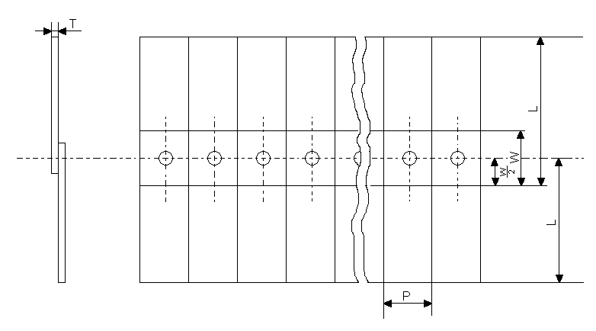
Figure II: Continuous Spot Welding Test Material

In figure II, the value of pitch should confirm to value shown in table II as standard, but it may be adjusted as the purpose of the may require. The test piece for the joint of plates different in thickness and quality shall have a thickness of the base metal, whichever is less in the product tensile strength and the thickness.

