Pressure Coefficient Contours

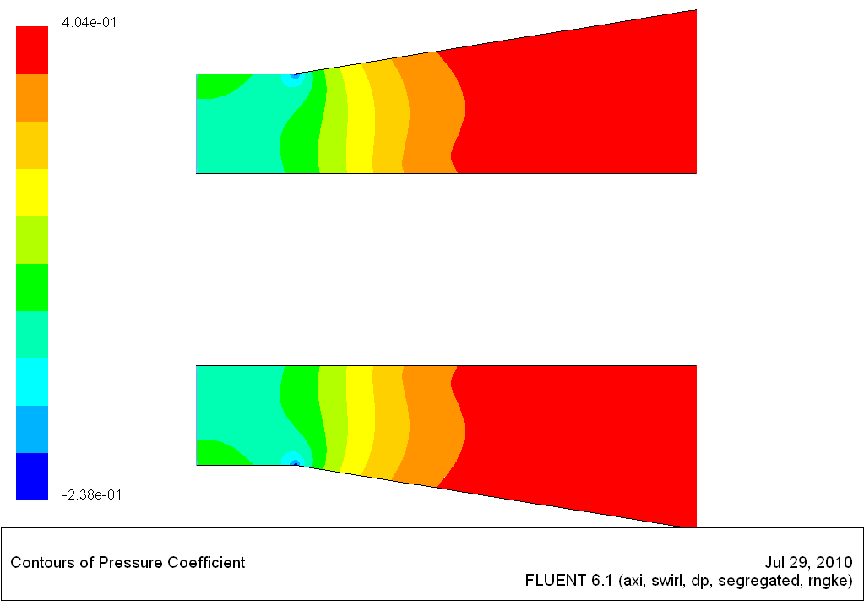
Fig. 1 Swirl angle = 0, 200rpm

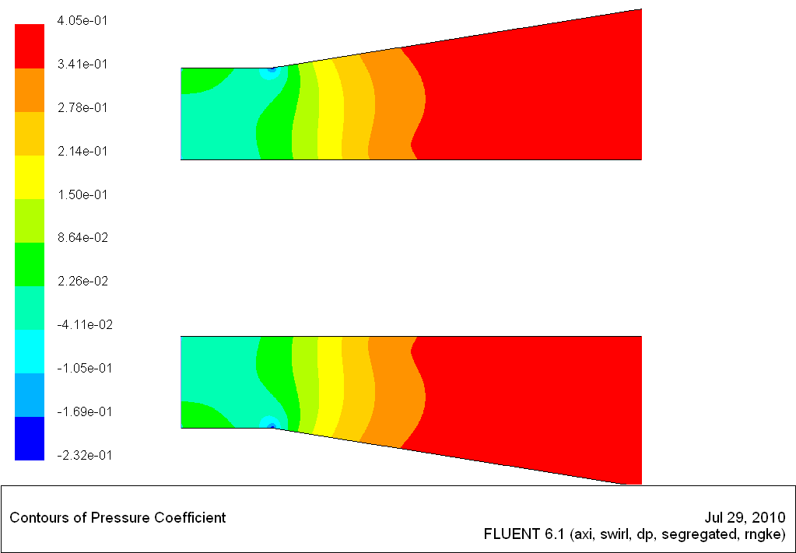
Fig. 2 Swirl angle =0, 800rpm

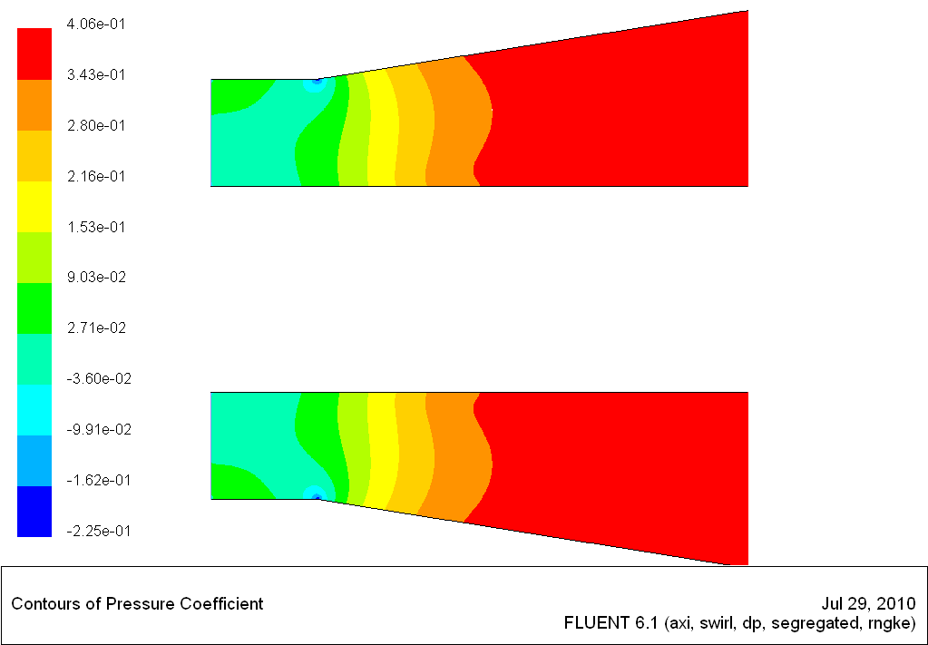
Fig. 3 Swirl angle 0, 1600rpm

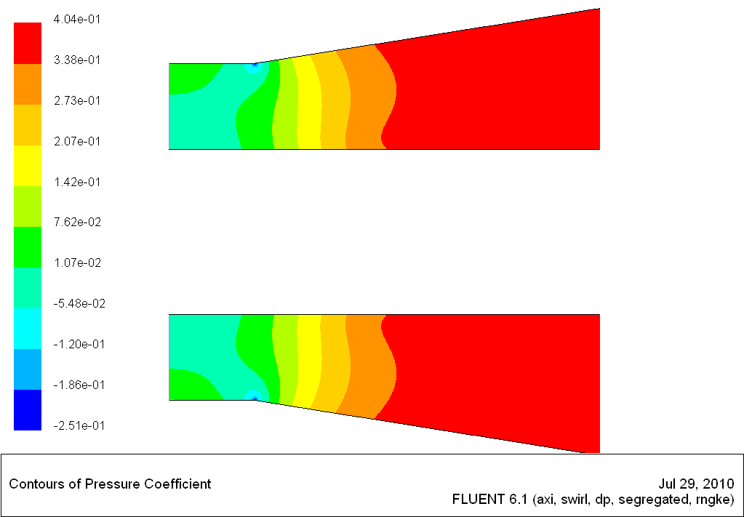
Fig. 4 Swirl angle 0, 3200 rpm

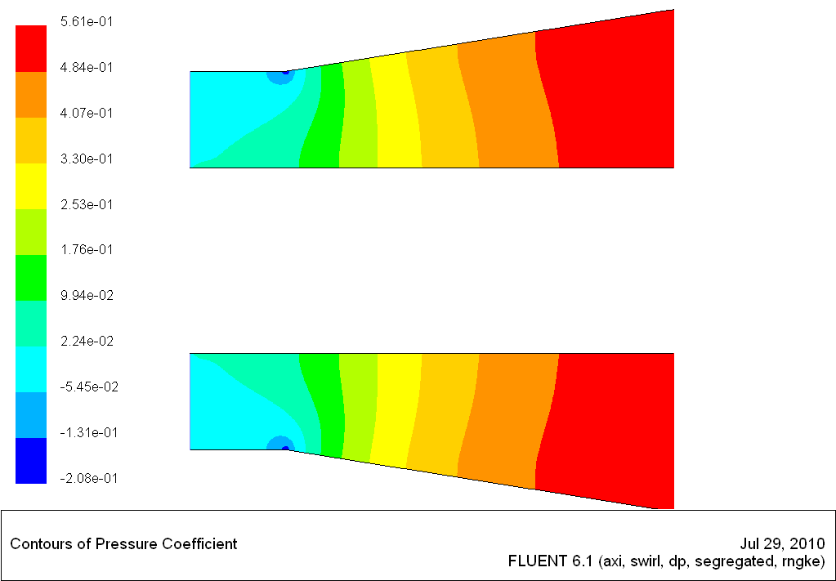
Fig. 5 swirl angle 12, 200rpm

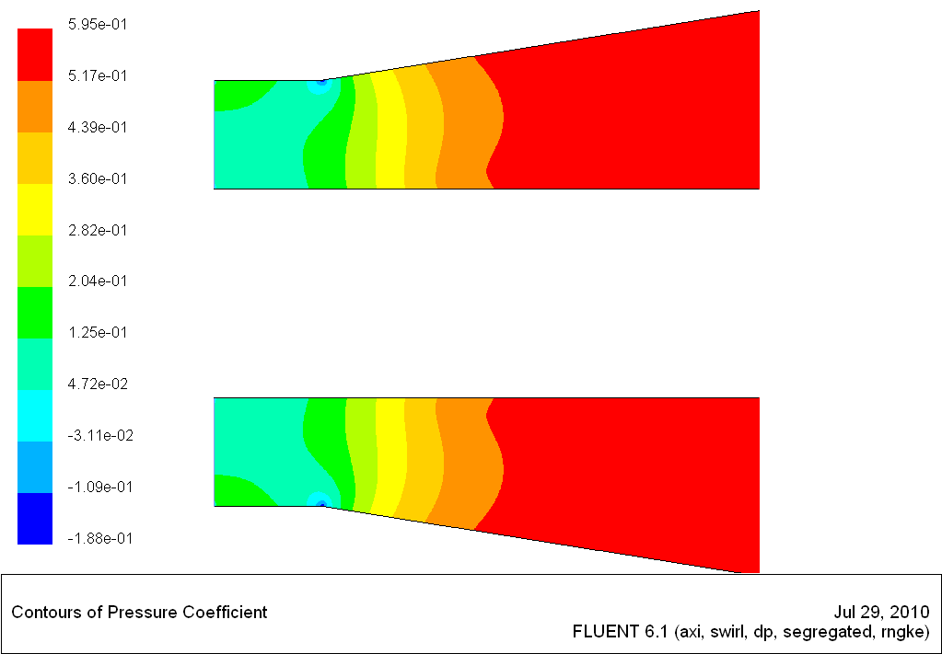
Fig. 6 swirl angle 12, 800rpm

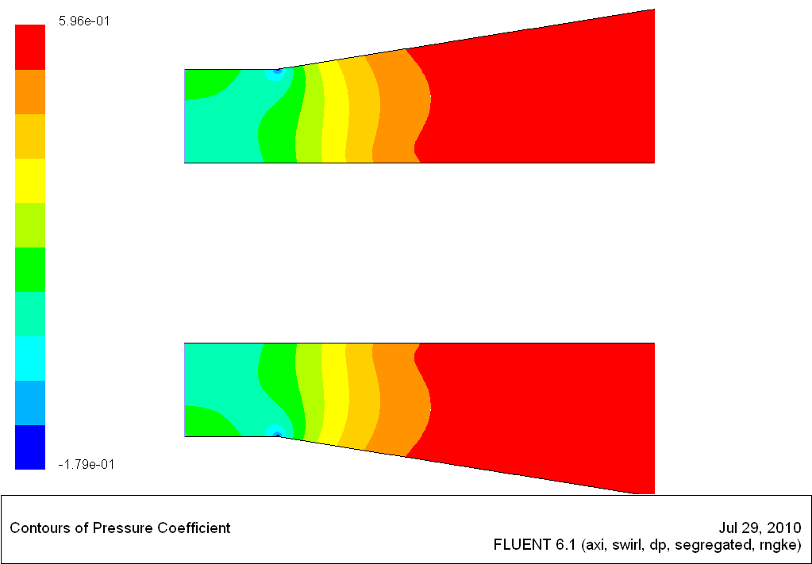
Fig. 7 swirl angle 12, 1600rpm

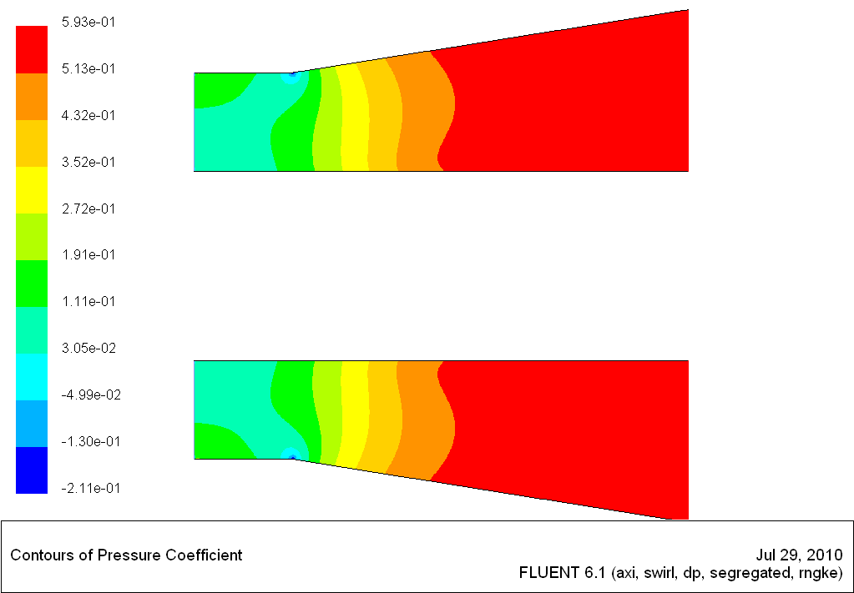
Fig. 8 swirl angle 12, 3200rpm

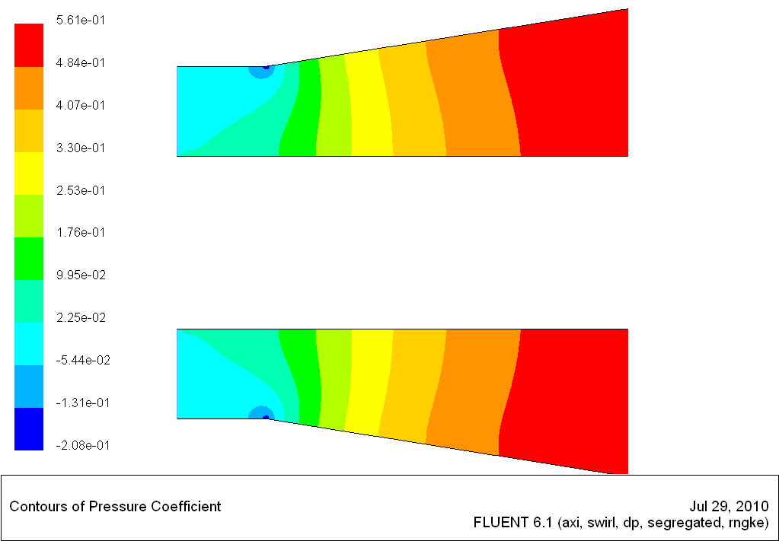
Fig. 9 swirl angle 17, 200rpm

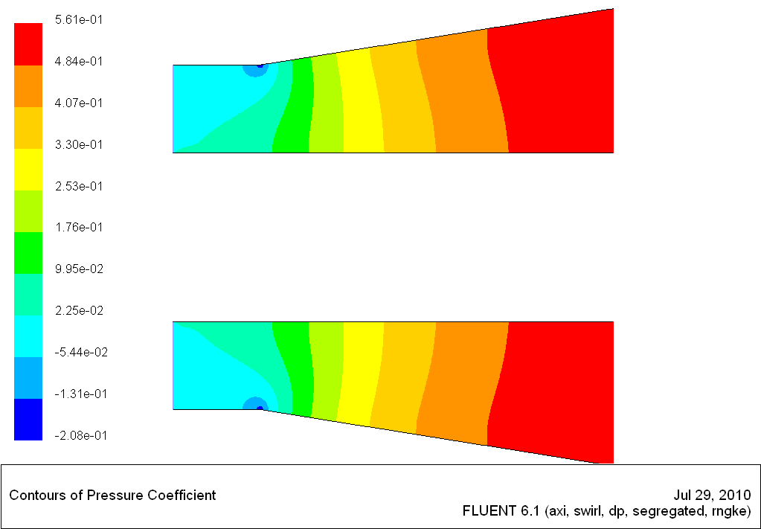
Fig.10 swirl angle 17, 800rpm

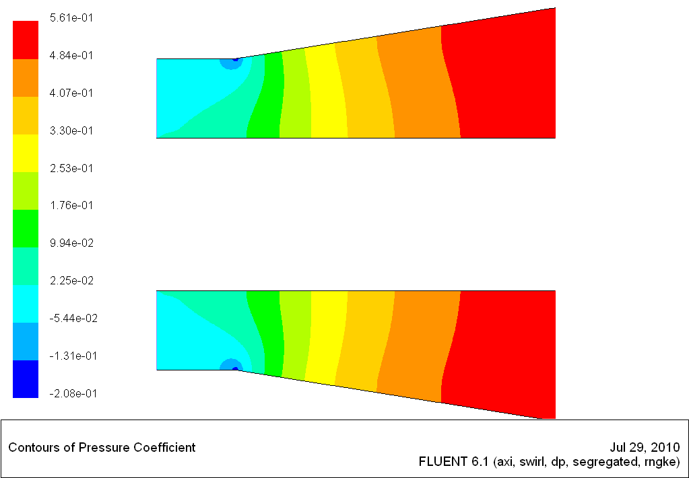
Fig.11 swirl angle 17, 1600rpm

Fig.12 swirl angle 17, 3200rpm

Contours of Velocity Magnitude (m/s)

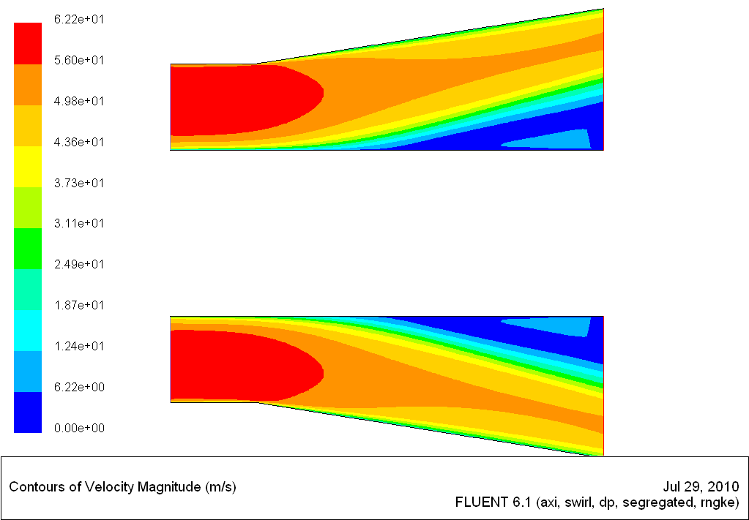
Fig.13 swirl angle0, 200rpm

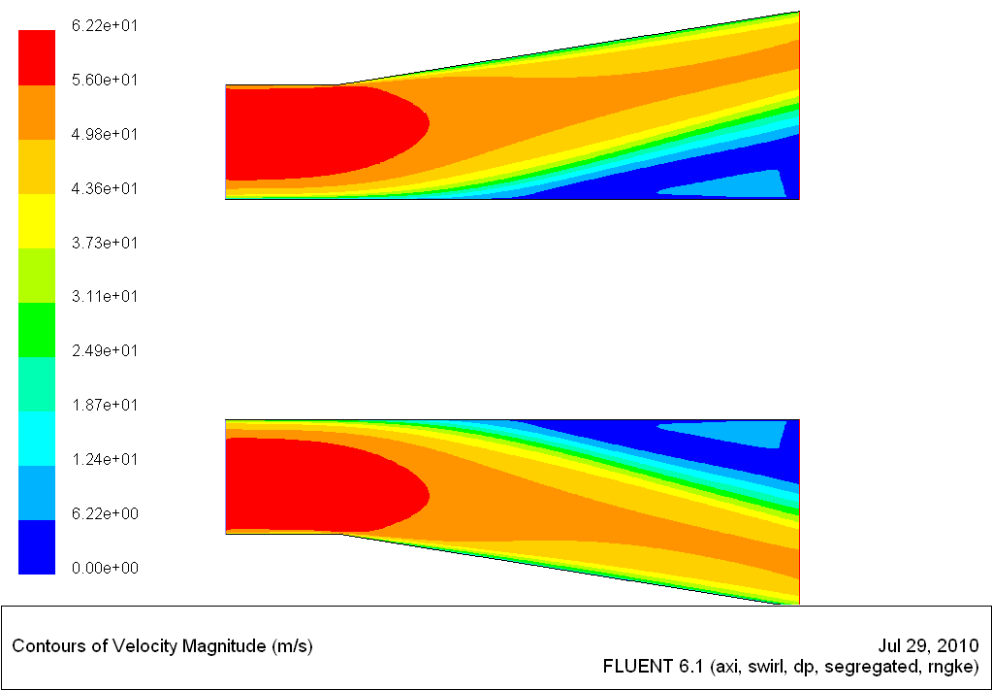
Fig.14swirl angle0, 800rpm

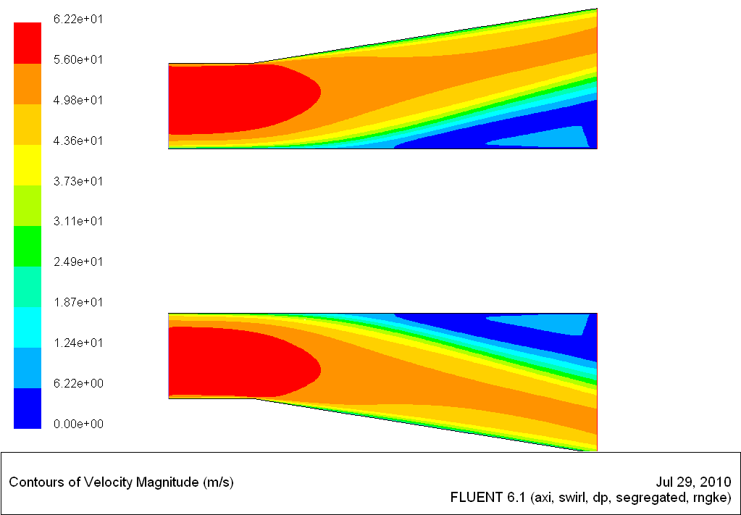
Fig.15 swirl angle0, 1600rpm

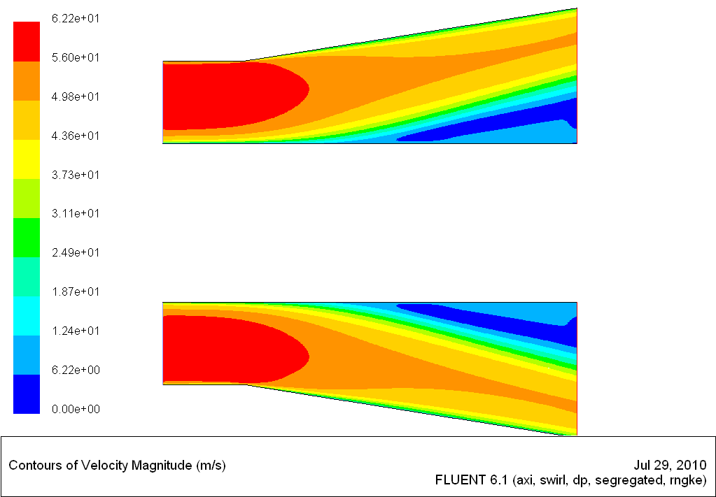
Fig.16 swirl angle0, 3200rpm

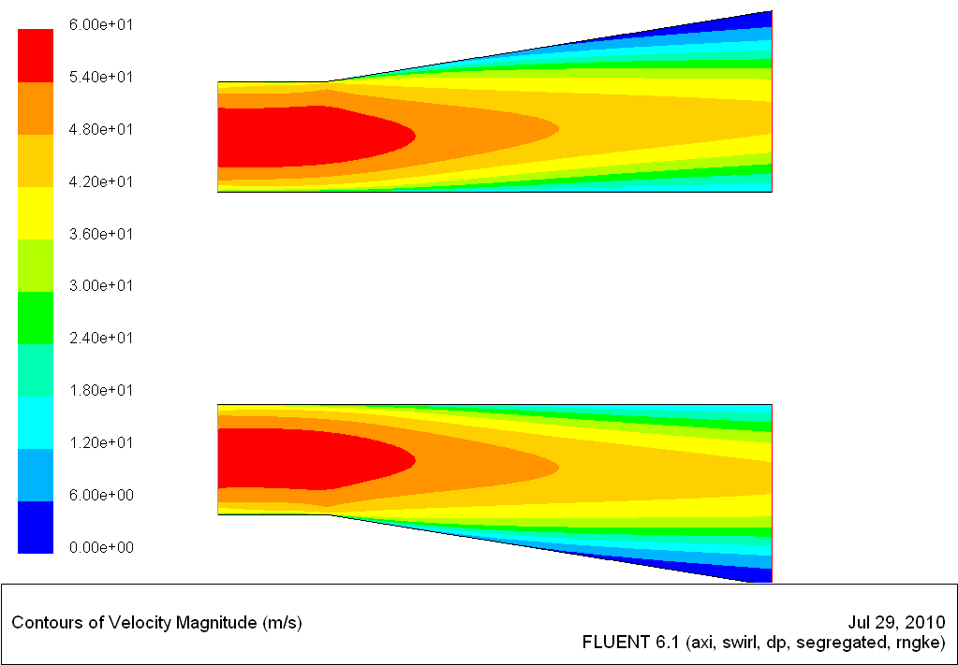
Fig.17 swirl angle12, 200rpm

Fig.18 swirl angle12, 800rpm
Fig.19 swirl angle12, 1600rpm

Fig.20 swirl angle12, 3200rpm

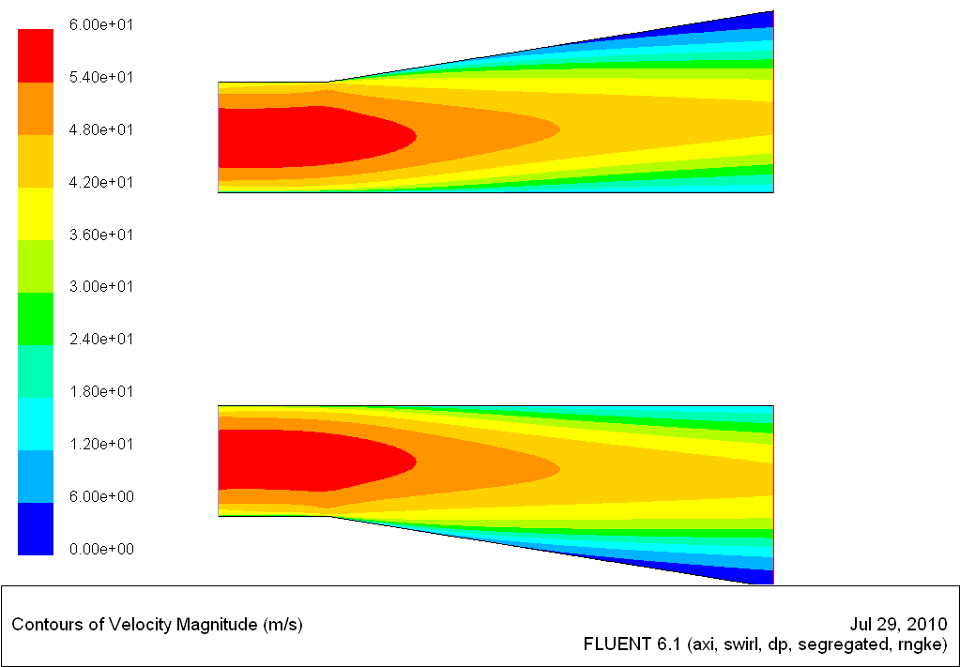
Fig.21 swirl angle17, 200rpm

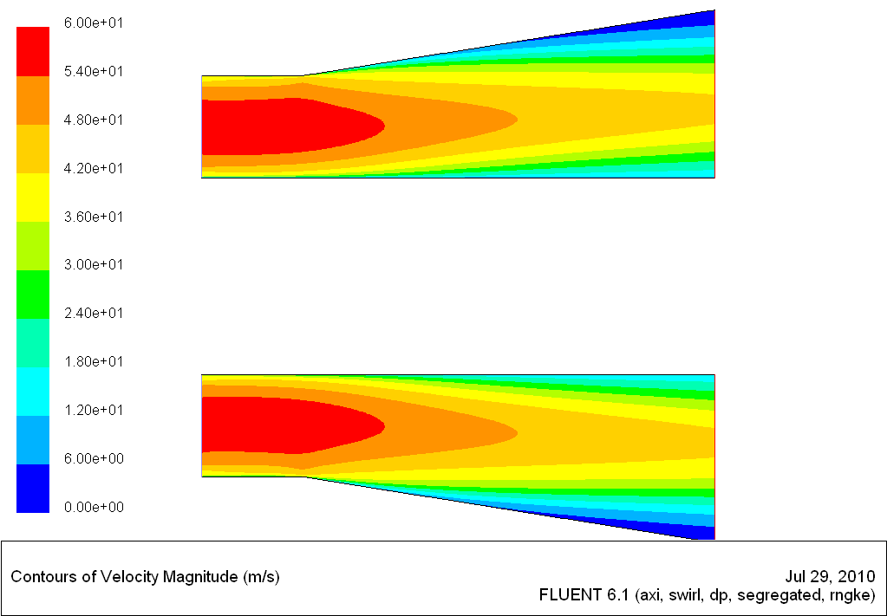
Fig.22 swirl angle17, 800rpm
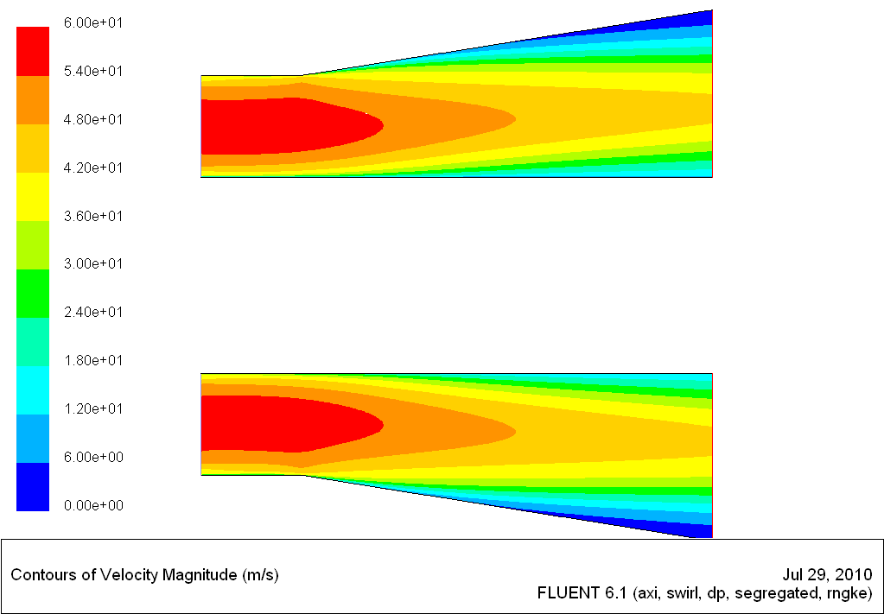
Fig.23 swirl angle17, 1600rpm

Fig.24 swirl angle17, 3200rpm

