LINEAR AND NONLINEAR FUZZY CONTROLLERS FOR GUIDED MISSILE SYSTEM
A
Dissertation
Submitted in partial fulfillment
of the requirements for
the award of degree of
MASTER OF ENGINEERING
IN
ELECTRICAL ENGINEERING
(CONTROL & INSTRUMENTATION)
Submitted By:
Shikha Pande
(13/C&I/2005)
University Roll No. 2608
Under the guidance Of:
Dr. Madhusudan Singh
Assistant Professor

DEPARTMENT OF ELECTRICAL ENGINEERING
DELHI COLLEGE OF ENGINEERING
UNIVERSITY OF DELHI
2007

CERTIFICATE

This is to certify that the thesis entitled “LINEAR AND NONLINEAR FUZZY CONTROLLERS FOR GUIDED MISSILE SYSTEM” is submitted by Ms. SHIKHA PANDE towards partial fulfillment of the requirements for the award of Degree “ MASTER’S OF ENGINEERING IN ELECTRICAL ENGG. (CONTROL & INSTRUMENTATION)” is a bonafide report of her work carried out under my supervision and guidance. The matter embodied in this thesis has not been submitted elsewhere for award of any other Degree or Diploma.

DELHI Dr.MADHUSUDAN SINGH
2007 ASSISTANT PROFESSOR
DEPTT. OF ELECT. ENGG
DELHI COLLEGE OF ENGG
DELHI

ACKNOWLEDGEMENT

It is a matter of great pleasure for me to express my deep sense of gratitude and thanks to my guide, Dr. Madhusudan Singh, Assistant Professor, Electrical Engg. Dept., Delhi College of Engg., for his valuable guidance, constant encouragement and helpful discussion throughout the course of work.
I would like to thank Dr. Parmod Kumar, Professor and Head of Deptt. Electrical Engg., Delhi College of Engg., for his helpful suggestions & kind cooperation extended to me during the course of course work.

DELHI SHIKHA PANDE
2007 M.E(Control&Instrumentation) (C&I/13/2005)
University Roll No.
(2608)

CONTENTS
CHAPTERS
ABSTRACT 3
1: INTRODUCTION 4
  - General 4
  - Types Of Missile Guided System 4
  - Operation Of Missile Guided System 4
  - Fuzzy Controller For Guided Missile System 5
  - Conclusion 7
2: LITERATURE REVIEW 8
2.1 General 8
2.2 Literature Review 9
2.3 Conclusion 11
3: FUZZY LOGIC PRINCIPLES AND FUZZY CONTROLLER 12
3.1 General 12
3.2 Basic Principle Of Fuzzy System 12
3.3 Preliminary Mathematics 15
3.4 Defuzzification 17
3.5 Conclusion 17
4: DESIGN OF FUZZY CONTROLLER 18
4.1 General 18
4.2 Types Of Fuzzy Control 19
4.2.1 Direct Control 19
4.2.2 Feedforward Control 19
4.2.3 Gain Scheduling Control 20
4.3 Sources Of Control Rules 21
4.4.1 Preprocessing 21
4.4.2 Fuzzification 22
4.4 Structure Of Fuzzy Controller 21
4.4.3 Rule Base 23
4.4.4 Inference Engine 25
4.4.5 Defuzzificaztion 26
4.4.6 Postprocessing 27
4.5 Table Controller 27
4.6 Procedure 28
4.7 Structure Of Fuzzy Controller In Simulink 28
4.8 Implementation Of Fuzzy Controller In Simulink 29
4.9 Details Of Fuzzy PD Controller For Angular Position 30
4.10 Details Of Fuzzy PD Controller For Horizontal Position 34
4.11 Conclusion 37
5: MATHEMATICAL MODELING OF MISSILE SYSTEM AND MATLAB SIMULINK SIMULATION 38
  - General 38
  - System Description 38
  - Non Linear Model Of Guided Missile System And Simulations 40
  - Linear Model Of Guided Missile System 52
  - Conclusion 57
6:Conclusion And Future Scope Of Work 58
6.1 Main Conclusion 58
6.2 Future Scope Of Work 59
REFERENCES AND BIBLIOGRAPHY

ABSTRACT

In recent years control system has gained an increasingly important role in development of advance systems for military applications This thesis entitled Linear and Non-linear Fuzzy Controller for Guided Missile System deals with the design of controller for highly efficient actuation and positioning of the guided missile system, when the parameters of missile system vary with time. The controller gives the required direction to the actuation system for missile mounted on the moving vehicle. This guiding system is established with the help of the controller which analyses the performance of the system and helps it to attain equilibrium position with the help of linear/non linear Proportional Derivative Fuzzy Controller. The analyses of guided missile system for both linear as well as non linear model, is presented.
The applied controller use close loop Fuzzy Proportional Derivative controllers for vertical and horizontal positioning of the missile system when missile parameter vary. The difference from equilibrium position is taken as the error and fed back to the controller to further improve it, to reach the desired equilibrium conditions.
The amount of force required to bring the system to equilibrium position is made available with the help of servomotor .This amount of force is made equivalent to the amount of voltage and angular velocity of the wheels of the cart on which the system is mounted and the same amount of force is applied on the system to bring the system to required equilibrium.
In order to examine the system performance the above scheme has been modeled and simulated using SIMULINK, a toolbox in MATLAB software. The simulated results for nonlinear and linear model of dynamical missile are presented and analyzed. It is observed that as the real time missile system is a nonlinear system and therefore the use of nonlinear fuzzy controller for positioning the guided missile system towards its equilibrium state is more accurate and effective as compared to linear conventional controllers.

CHAPTER I
INTRODUCTION

1.1General
Missiles are the objects used in defence operations for tracing the enemy object and destroying it. The missile system must have high amount of accuracy in order to trace the object in minimum time at the exact position. To fulfill these needs an elaborate group of systems are required. These systems are termed as guided missile system

1.2 Types of Missile Guided System
Every missile guidance system consists of an attitude control system and a flight path control system. The attitude control system functions to maintain the missile at the desired attitude on the ordered flight path, by controlling the missile in pitch, roll, and yaw. The attitude control system operates as an auto-pilot, damping out fluctuations that tend to deflect the missile from its ordered flight path. The function of the flight path control system is to determine the flight path necessary for target interception and to generate the orders to the attitude control system to maintain that path.
It should be clear at this point that the concept of "Guidance and Control" involves not only the maintenance of a particular vehicle's path from point A to B in space, but also the proper behavior of the vehicle while following the path. A missile that follows a prescribed path half the way to a target and then becomes dynamically unstable is then incapable of remaining upon the path (or else fails structurally due to aero-dynamic loading). Such a vehicle, in order to perform properly, must be "piloted" and capable of responding to control signals.
1.3 Operation of Missile Guidance System
The operation of a guidance and control system of missile is based on the principle of feedback. The control units make corrective adjustments of the missile control surfaces when a guidance error is present. The control units will also adjust the control surfaces to stabilize the missile in roll, pitch, and yaw. Guidance and stabilization corrections are combined, and the result is applied as an error signal to the control system.
The Fuzzy control designed for the fight control of missile system is based on the same principle and is more accurate and effective. The conventional control requires an elaborate arrangement of equipments which form quite complicated system. Besides, that the system has a large number of mechanical parts whose accuracy has to be checked, time to time. Other than, guidance system the missile control system consist of many other systems which are required to control other function in the device such as sensing, communication etc, for these purpose different electronics and communication devices are used. Fig1.1 shows the complete system for control missile. The whole system altogether becomes very complicated .That is why it is required to use guiding system which is simple and operated from a distance. Fuzzy based controllers for positioning of missile is highly accurate and effective means to stabilize the missile at equilibrium state when its parameters vary .
1.4 Fuzzy Controller for Guidance of Missile
The proportional and derivative (PD) fuzzy controller aided by servomotor provides a simple control for nonlinear as well as linear model of missile system. This system can be more accurate and less complicated, which can be used as the controller in missile and rockets guidance.
In this dissertation a simple proportional and derivative (PD) fuzzy controller is designed to contribute to the task of guiding missile and rocket system. The analysis also contains the comparative study of the non linear fuzzy, linear fuzzy, linear proportional integral and derivative (PID), linear proportional and derivative (PD) and proportional and integral (PI) controller performance when parameter of system vary. The controller’s adaptability is based on achieving same equilibrium condition while parameters of missile vary.
The conventional missile control system uses Robotics and Hydraulic systems as they control whole lot of systems of fight control .These systems are quite accurate and are very complicated. Fuzzy control system designed in the dissertation can be very simple system to control the direction of flight(only) more accurately. The analysis consists of two controllers which can control the direction of the system by controlling the angular position of the missile and also control the exact position of the launching vehicle (to small extend) by the movement of the vehicle on which missile is installed. Both requirements can be met simultaneously with one PC (personal computer) and a Servo motor, which is also shown in Fig1.1.
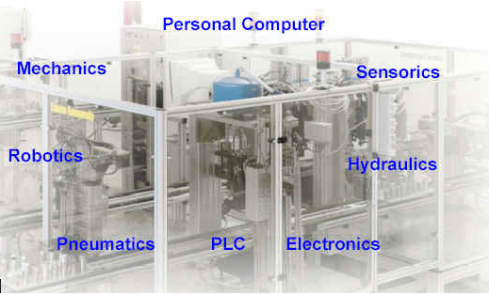
Fig1.1 Complete System For All Types of Control in Missiles

Fig1.2 shows the complete block diagram of guided missile system which is regulated by a computer. The controller gets the control signal from computer, which is given to the control surface through a actuator. The feedback is used to the computer to control whether further control action is required or not. In this way the whole system works as a closed loop system.

Sensor
Guided missile att
Amplifier
Followup
Reference
Control surface
Controller
Computer
Actuator

Fig 1.2 Block Daigram of Missile Control System

1.5 Conclusion
A brief introduction to guided missile system has been presented, citing the importance and application of the controllers in the guided missile system. The description of different functional elements in the missile guided missile system is also presented in detail.

CHAPTER II
LITERATURE REVIEW

  - General
In past few years there has been lot of developments in control methods. In this dissertation inverted pendulum is Inverted pendulum is considered analogous to guided missile system or rocket launcher installed on the moving vehicle. The pendulum is analogous to the missile and the arm of the pendulum is the launcher, together they are installed on the moving cart which is as same as the launching vehicle. Inverted pendulum has been a common apparatus of study for all the control methods because it is simple as well as complicated. It is simple because it is easy to install this apparatus and complicated because it contains all kinds of nonlinearities. So in order to review any control system in the real form with nonlinearities, inverted pendulum is the first choice. Besides its nonlinearities, it is useful also, because this principle is directly adapted in many control applications control applications.
Fuzzy logic has been one of the important tool used in controllers. Applying fuzzy controllers in guided missile system may make missile control system bit less complicated. In this dissertation PD (Proportional and derivative) fuzzy controller is used in guided missile systems. Both linear and non linear fuzzy are used in controller of the system. Big and complicated systems based on the hydraulics and pneumatic principles are used in missile guidance. Fuzzy logic can be one more option to control these missile systems. Whole lot of research has been made in fuzzy and its applications. As every real system contain nonlinearities, so inverted pendulum is the first choice to study the effect of nonlinearities in the systems.
In this dissertation a servomotor is used as the controlling device whose control depends on the amount of force required to generate a definite amount of voltage which produces the required amount of force to control the system. So, some sought of study of the control of Servo motor, Fuzzy logic and Inverted pendulum is done.

  - Literature Review
The basic principle of Inverted pendulum was developed by Moris . which has the capability of 360⁰ rotation and the cart was free to move within ±0.5 m from equilibrium.
A Neural Network based control was used by Anderson 1989 [1] to control Inverted Pendulum. The result obtain were satisfactory but learning of Nerons require a lot of exact knowledge base for the motion of inverted pendulum.
Training of the Real Model of the Cart based pendulum was desired by S.Geva et al. 1993 [2]. This was the real break through because it lead to control the Pendulum in real time mechanically.
DAneil J Pack et al. 1993 [4] designed and fabricated a two-link inverted pendulum, and learned about, its relationships and the tradeoffs that exist in such a device. The comparative study compares experimentally and by simulation, five different control schemes. A PD control, Linear Quadratic control, Neural Networks Control, Nonlinear Control and Fuzzy Control
Michal et al. 1993 [5] presents a new hybrid fuzzy logic controller which can balance an inverted pendulum supported on a linear track cart starting from any arbitrary initial conditions for the pendulum. The controller is hybrid in the sense that it combines fuzzy logic, deterministic rules and energy based control concepts.
Geva et al. 1994 [6] presents a survey of fuzzy set theory, Fuzzy Logic Controller (FLC),a general strategy for constructing an FLC and evaluation of its performance. The control of stabilizing an inverted pendulum is held as an example of control problem. lt is a model of stabilizing a pole. The authors present a more interesting example to evaluate the control technology.
C. K. Lee et al. 1994 [7] deals with adapting the parameters of PI controller in a servomotor control system. The PI controller, being the parameters tuned by a fuzzy logic controller, forms an adaptive controller for a servomotor system. It provides a fast tuning ability and has the ability to adapt to a large variation of system parameters.
Abramouitch 1994 [8] deals with pros and corns of Fuzzy. It also described about the ideal system in which Fuzzy should be applied.
Ming-Yuan Shieh et al. 1995 [9] addresses the experimental implementation of an integrated fuzzy logic controller to a dc-servomotor system. We apply the proposed structure to improve the performance of the original existed control system.
Tomonobu Seiijyu et al. 1996 [10] have proposed robust position control of DC servomotors considering, the estimation errors of equivalent disturbance torque observer and speed observer is proposed. The simulation and experimental verification are shown to demonstrate the validity of the proposed control method.
Mario E. Maga˜na et al. 1998 [12] presents an experimental setup of a fuzzy-logic controller of an inverted pendulum that uses vision feedback. The results that are obtained support the claim, within certain limits, that it is possible to control an inverted pendulum using fuzzy-logic control and vision feedback.
Shuliang Lei et al. 2000 [13] uses dynamical hierarchical control to stabilize a double inverted pendulum. The double inverted pendulum is decomposed into subsystems. Fuzzy logic controllers are designed for each subsystem at the lower level of the hierarchy. At the higher level a fuzzy logic based coordinator is built up to supervise the complete system.
Feijun Song et al. 2000 [14] presents a Takagi-Sugeno (TS) type Fuzzy Logic Controller (FLC) with only 3 rules for a 4 dimensional inverted pendulum system. This controller is able to control the system over a larger range of pole angle and cart position compared with other control schemes.
M.Alta et al. 2001 [16] An interactive procedure is presented for controller design of nonlinear systems by integrating available classical as well as modem tools such as fuzzy logic, and Neural Networks. The proposed approach is based on quasi-linear dynamic models of the plant. Classical optimal controllers for each set of operating conditions were developed. These controllers are used to construct a single Fuzzy-logic gain scheduling-like controller. Adaptive-Neuro-Fuzzy inference system was used to construct the rules for the fuzzy gain schedule.
Chin-Gook Lhee et al. 2002 [18] presents, a fuzzy logic controller (FLC) is designed based on the similarity between the FLC and the sliding mode control (SMC). The proposed scheme provides the sliding mode-like FLC with fast self-tuning the dead-zone parameters under parameter variations of the controlled system.
T. T. dos Santos et al. 2003 [20] presents an alternative proposal for the teaching of automation and control subjects. The main idea is the use of an inverted pendulum process, in which the concepts relating to mathematical description, controller synthesis, remote supervision and data interchange are presented in an integrated way.
Sergey A. Terentiev et al. 2004 [21] developed a control system by the direct-current servomotor which uses in the robot manipulator.
Jan Jantzen 2007 [23] this book presents most of the basic information for design of Fuzzy Controller. It also contains exclusive Nonlinear analysis of the Fuzzy system
  - Conclusion
The chapter presents a brief overview of the various control methods used for control of inverted pendulum. The features and advantages gained through advance controllers based on fuzzy logic, neural network and other nonlinear controllers have been described in brief.

CHAPTER III
FUZZY LOGIC PRINCIPLES
AND
FUZZY CONTROL
3.1 General
Conventional controllers are derived from control theory techniques based on mathematical models of the open-loop process. These processes are called system to be controlled. The purpose of the feedback controller is to guarantee a desired response of the output say y. The process of keeping the output say ‘y’ close to the setpoint (reference input) ‘y∗’, despite the presence of disturbances and noise in the system parameters, is called regulation .The output of the controller (which is the input of the system) is the control action u. The general form of the discrete-time control law is
u(k) = f(e(k), e(k − 1), . . . , e(k − τ ), u(k − 1),. . . , u(k − τ ))
providing a control action that describes the relationship between the input and the output of the controller.
• ‘e’ represents the error between the desired setpoint y∗ and the output of the system y,
• parameter ‘τ’ defines the order of the controller,
• ‘f’ is in general a nonlinear function.
3.2 Basic Principle of Fuzzy System
In a fuzzy logic controller (FLC), the dynamic behavior of a fuzzy system is characterized by a set of linguistic description rules based on expert knowledge. The expert knowledge is usually of the form IF (a set of conditions are satisfied) THEN (a set of consequences can be inferred). Since the antecedents and the consequents of these IF-THEN rules are associated with fuzzy concepts (linguistic terms), they are often called fuzzy conditional statements. In our terminology, a fuzzy control rule is a fuzzy conditional statement in which the antecedent is a condition in its application domain and the consequent is a control action for the system under control.
Basically, fuzzy control rules provide a convenient way for expressing control policy and domain knowledge. Furthermore, several linguistic variables might be involved in the antecedents and the conclusions of these rules. When this is the case, the system will be referred to as a multi-input-multi-output (MIMO) fuzzy system.
For example, in the case of two-input-single-output (MISO) fuzzy systems, fuzzy control rules have the form
1 : if x is A₁ and y is B₁ then z is C₁
also
2 : if x is A₂ and y is B₂ then z is C₂
n : if x is A_{n} and y is B_{n} then z is C_{n}
where x and y are the process state variables, z is the control variable, A, B, and C are linguistic values of the linguistic variables x, y and z in the universes of discourse U, V , and W, respectively, and an implicit sentence connective also links the rules into a rule set or, equivalently, a rule-base. Which can represent the FLC in a form, similar to the conventional control law
u(k) = F(e(k), e(k − 1), . . . , e(k − τ ), u(k − 1),. . . , u(k − τ )) (3.1)
where the function F is described by a fuzzy rulebase. However it does not mean that the FLC is a kind of transfer function or difference equation. The knowledge-based nature of FLC dictates a limited usage of the past values of the error ‘e’ and control ‘u’ because it is rather unreasonable to expect meaningful linguistic statements for
e(k−3), e(k− 4), . . . ,e(k − τ ).
A typical FLC describes the relationship between the change of the control
Δu(k) = u(k) − u(k − 1) (3.2)
on the one hand, and the error e(k) and its change
Δe(k) = e(k) − e(k − 1). (3.3)
on the other hand. Such control law can be formalized as
Δu(k) = F(e(k), Δ(e(k)) (3.4)
and is a manifestation of the general FLC expression
with τ = 1.
N error ZE P
The actual output of the controller u(k) is obtained from the previous value of control
u(k − 1) that is updated by Δu(k)
u(k) = u(k − 1) + Δu(k). (3.5)
This type of controller was suggested originally by Mamdani and Assilian in 1975 and is called the Mamdani type FLC. A prototypical rule-base of a simple FLC realising the control law above is listed in the following
1: If e is ”positive” and Δe is ”near zero” then Δu is ”positive”
2: If e is ”negative” and Δe is ”near zero” then Δu is ”negative”
3: If e is ”near zero” and Δe is ”near zero” then Δu is ”near zero”
4: If e is ”near zero” and Δe is ”positive” then Δu is ”positive”
5: If e is ”near zero” and Δe is ”negative” then Δu is ”negative”
So, our task is to find a crisp control action z₀ from the fuzzy rule-base and from the actual crisp inputs x₀ and y₀:
1: if x is A₁ and y is B₁ then z is C₁
2: if x is A₂ and y is B₂ then z is C₂
n: if x is A_{n} and y is B_{n} then z is C_{n} input x is x₀ and y is y₀ output z₀
Of course, the inputs of fuzzy rule-based systems should be given by fuzzy sets, and therefore, we have to fuzzify the crisp inputs. Furthermore, the output of a fuzzy system is always a fuzzy set, and therefore to get crisp value we have to defuzzify it. Different defuzzification methods are available for the purpose. Fuzzy logic control systems usually consist of four major parts: Fuzzification interface, Fuzzy rulebase, Fuzzy inference machine and Defuzzification interface. The (fig3.1) shows the functional block diagram of fuzzy logic control system .A fuzzification operator has the effect of transforming crisp data into fuzzy sets. In most of the cases we use fuzzy singletons as fuzzifiers fuzzifier (x₀) := ￣x₀ where x₀ is a crisp input value from a process. The (fig3.2) shows the fuzzy singleton as fuzzyfier
.
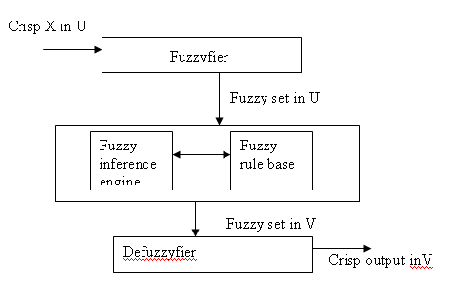
Fig 3.1 Block Diagram Of Fuzzy Controller
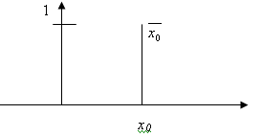
Fig 3.2 Fuzzy Singleton

3.3 Preliminary Mathematics
Suppose that there are two input variables x and y. A fuzzy control rule
i : if (x is Ai and y is Bi) then (z is Ci) is implemented by a fuzzy implication Ri and is defined as
Ri(u, v,w) = Ai(u) and Bi(v)→ Ci(w) (3.6)
where the logical connective and is implemented by the minimum operator, i.e.
Ai(u) and Bi(v)→ Ci(w) =
Ai(u)×Bi(v)→ Ci(w) = min{Ai(u),Bi(v)} → Ci(w) (3.7)
Of course, one can use any t-norm to model the logical connective. Fuzzy control rules are combined by using the sentence connective also. Since each fuzzy control rule is represented by a fuzzy relation, the overall behavior of a fuzzy system is characterized by these fuzzy relations. In other words, a fuzzy system can be characterized by a single fuzzy relation which is the combination of question involves the sentence connective also. Symbolically, if we have the collection of rules
1 : if x is A₁ and y is B₁ then z is C₁
2 : if x is A₂ and y is B₂ then z is C₂
n : if x is A_{n} and y is B_{n} then z is Cn
The procedure for obtaining the fuzzy output of such a knowledge base consists of following three steps:
1 Find the firing level of each of the rules.
2 Find the output of each of the rules.
3 Aggregate the individual rule outputs to obtain the overall system output.
To infer the output z from the given process states x, y and fuzzy relations Ri, we apply the compositional rule of inference:
1 : if x is A₁ and y is B₂ then z is C₁
2 : if x is A₂ and y is B₂ then z is C₂
n : if x is A_{n} and y is B_{n} then z is C_{n}
fact : x is ￣x₀ and y is ￣y₀
consequence : z is C where the consequence is computed by
consequence = Agg (fact ◦ _1, . . . , fact ◦ _n).
That is,
C = Agg(￣x₀ × ￣y₀ ◦ R1, . . . , ￣x₀ × ￣y₀ ◦ Rn) (3.8)
taking into consideration that
￣x₀(u) = 0, u _= x₀
and
￣y₀(v) = 0, v _= y₀,
the computation of the membership function of C is very simple:
C(w) = Agg{A₁(x₀) × B₁(y₀) → C1(w),. . . , A_{n}(x0) × B_{n}(y0) → C_{n}(w)} (3.9)
for all w ∈ W. The procedure for obtaining the fuzzy output of such a knowledge base can be formulated as
• The firing level of the i-th rule is determined by Ai(x₀) × Bi(y₀).
• The output of of the i-th rule is calculated by Ci(w) := Ai(x₀) × Bi(y₀) → Ci(w) for all
w ∈ W.
• The overall system output, C, is obtained from the individual rule outputs Ci by
C(w) = Agg{C₁, . . . , C_{n} } for all w ∈ W.
3.4 Defuzzification
The output of the inference process so far is a fuzzy set, specifying a possibility distribution of control action. In the on-line control, a nonfuzzy (crisp) control action is usually required. Consequently, one must defuzzify the fuzzy control action (output) inferred from the fuzzy control algorithm, namely: z₀ = defuzzifier(C), where z₀ is the nonfuzzy control output and defuzzifier is the defuzzification operator. Defuzzification is a process to select a representative element from the fuzzy output C inferred from the fuzzy control algorithm.
3.5 Conclusion
Above details includes the basic mathematics involved in the fuzzy logic operations. It also gives the brief description of how these operations are performed while designing the fuzzy logic controller.

CHAPTER IV
DESIGN OF FUZZY CONTROLLERS

4.1 General
Fuzzy controllers are used to control consumer products, such as washing machines, video cameras, and rice cookers, as well as industrial processes, such as cement kilns, underground trains, and robots. Fuzzy control is a control method based on fuzzy logic. Just as fuzzy logic can be described simply as ’’computing with words rather than numbers ’’, fuzzy control can be described simply as ’’control with sentences rather than equations ’’.A fuzzy controller can include empirical rules, and that is especially useful in operator controlled plants.
Take for instance a typical fuzzy controller
1. If error is Neg and change in error is Neg then output is NB
2. If error is Neg and change in error is Zero then output is NM
The collection of rules is called a rule base. The rules are in the familiar if-then format, and formally the if-side is called the condition and the then-side is called the conclusion . The input value ’’Neg’’ is a linguistic term short for the word negative_ the output value ’’NB’’ stands for negative big and ’’NM’’ for negative medium. The computer is able to execute the rules and compute a control signal depending on the measured inputs error and change in error .The objective here is to identify and explain the various design choices for engineers .In a rule based controller the control strategy is stored in a more or less natural language .The control strategy is isolated in a rule base opposed to an equation based description. A rule based controller is easy to understand and easy to maintain for a non-specialist end-user. An equivalent controller could be implemented using conventional techniques, but this method is just more convenient to isolate the control strategy in a rule base from operator controlled systems.

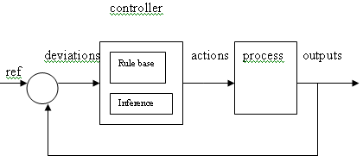
Fig 4.1 Direct Control
.
4.2 Types of Fuzzy Control
Fuzzy controllers are being used in various control schemes some of them are as under:-
4.2.1 Direct control- Where the fuzzy controller is in the forward path in a feedback control system. The process output is compared with a reference, and if there is a deviation, the controller takes action according to the control strategy. (Fig 4.1) shows the block diagram of Direct Fuzzy Control
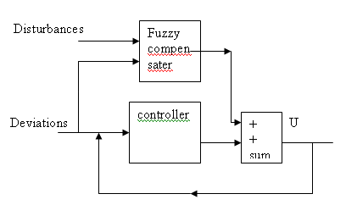
Fig 4.2 Feedforward Control

4.2.2 Feedforward control – In this a measurable disturbance is being compensated. It requires a good model, but if a mathematical model is difficult or expensive to obtain, a fuzzy model may be useful. It uses a controller and the fuzzy compensator, the process and the feedback loop are omitted for clarity. The scheme, disregarding the disturbance input, can be viewed as a collaboration of linear and nonlinear control actions. (Fig4.2) shows the block diagram of Feedforward Fuzzy Control

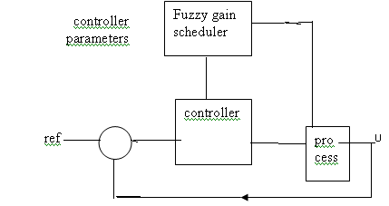
Fig 4.3 Gain Scheduler
4.2.3 Gain Scheduling control-Fuzzy rules are also used to correct tuning parameters in Parameters Adaptive Tuning schemes. (Fig4.3) shows functional block diagram of Fuzzy Gain Scheduler If a nonlinear plant changes operating point, it may be possible to change the parameters of the controller according to each operating point. This is called Gain Scheduling since it was originally used to change process gains. A gain scheduling controller contains a linear controller whose parameters are changed as a function of the operating point in a preprogrammed way. It requires thorough knowledge of the plant, but it is often a good way to compensate for nonlinearities and parameter variations. Sensor measurements are used as Scheduling Variables that govern the change of the controller parameters, often by means of a table look-up. Whether a fuzzy control design will be stable is a somewhat open question. Stability concerns the system’s ability to converge or stay close to equilibrium. A linear system will converge to the equilibrium asymptotically no matter where the system state variables start from. It is relatively straight forward to check for stability in linear systems, for example by checking that all eigen values are in the left half of the complex plane. For nonlinear systems, and fuzzy systems are most often nonlinear, the stability concept is more complex. A nonlinear system is said to be Asymptotically Stable if, when it starts close to an equilibrium, it will converge to it. Even if it just stays close to the equilibrium, without converging to it, it is said to be Stable (in the sense of Lyapunov). To check conditions for stability is much more difficult with nonlinear systems, partly because the system behaviour is also influenced by the signal amplitude apart from the frequency .Another possibility is to approximate the fuzzy controller with a linear controller, and then apply the conventional linear analysis and design procedures on the approximation. It seems likely that the stability margins of the nonlinear system would be close in some sense to the stability margins of the linear approximation depending on how close the approximation is.
4.3 Sources Of Control Rules
There are at least four main sources for finding control rules.
4.3.1 Expert Experience and knowledge of Control Engg One classical example is the operator’s handbook for a cement kiln. The most common approach to establishing such a collection of thumb rule, is to question experts or operators using a carefully organised questionnaire.
4.3.2 Based on operators Control Action Fuzzy if-then rules can be deduced from observations of an operator’s control actions or a log book. The rules express input-output relationships.
4.3.3 Based on Fuzzy Model of the Process A linguistic rule base may be viewed as an inverse model of the controlled process. Thus the fuzzy control rules might be obtained by inverting a fuzzy model of the process. This method is restricted to relatively low order systems, but it provides an explicit solution assuming that fuzzy models of the open and closed loop systems are available. Another approach is fuzzy identification
4.3.4 Based on Learning- The self-organising controller is an example of a controller that finds the rules itself. Neural network is another possibility. There is no design procedure in fuzzy control, because the rules are often nonlinear.
4.4 Structure of Fuzzy Controller
There are specific components characteristic of a fuzzy controller to support a design procedure. In the block diagram, the controller is between a preprocessing block and a post-processing block.
    - Preprocessing
The inputs are most often hard or crisp measurements from some measuring equipment, rather than linguistic. A preprocessor, conditions the measurements before they enter the controller. Examples of preprocessing are:
Quantisation in connection with sampling or rounding to integers;
Normalisation or scaling onto a particular, standard range;
Filtering in order to remove noise;
Averaging to obtain long term or short term tendencies;
A combination of several measurements to obtain key indicators;
Differentiation and integration or their discrete equivalences
Aquantiser is necessary to convert the incoming values in order to find the best level in a discrete universe. Assume, for instance, that the variable error has the value 4.5, but the universe is u = (-5,-4…….4 ,5). The quantiser rounds to 5 to fit it to the nearest level. Quantisation is a means to reduce data, but if the quantisation is too coarse the controller may oscillate around the reference or even become unstable.
Nonlinear scaling is an option. In the F.L Smidth controller the operator is asked to enter three typical numbers for a small, medium and large measurement respectively. They become break-points on a curve that scales the incoming measurements . The overall effect can be interpreted as a distortion of the primary fuzzy sets. It can be confusing with both scaling and gain factors in a controller, and it makes tuning difficult. When the input to the controller is error, the control strategy is a static mapping between input and control signal. A dynamic controller would have additional inputs, for example derivatives, integrals, or previous values of measurements backwards in time. These are created in the preprocessor thus making the controller multi-dimensional, which requires many rules and makes it more difficult to design. The preprocessor then passes the data on to the controller.
4.4.2 Fuzzification
The first block inside the controller is fuzzification, which converts each piece of input data to degrees of membership by a lookup in one or several membership functions. The fuzzification block thus matches the input data with the conditions of the rules to determine how well the condition of each rule matches that particular input instance. There is a degree of membership for each linguistic term that applies to that input variable.

    - Rule Base
The rules may use several variables both in the condition and the conclusion of the rules. The controllers can therefore be applied to both multi-input-multi-output (MIMO)problems and single-input-single-output (SISO) problems. The typical SISO problem is to regulate a control signal based on an error signal. The controller may actually need both the error, the change in error, and the accumulated error as inputs, but we will call it single-loop control, because in principle all three are formed from the error measurement. To simplify, this section assumes that the control objective is to regulate some process output around a prescribed setpoint or reference. The presentation is thus limited to single-loop control.
Rule Format- Basically a linguistic controller contains rules in the if -then format, but they can be presented in different formats. In many systems, the rules are presented to the end-user in a format similar to the one below,
1. If error is Neg and change in error is Neg then output is NB
2. If error is Neg and change in error is Zero then output is NM
3. If error is Neg and change in error is Pos then output is Zero
4. If error is Zero and change in error is Neg then output is NM
5. If error is Zero and change in error is Zero then output is Zero
6. If error is Zero and change in error is Pos then output is PM
7. If error is Pos and change in error is Neg then output is Zero
8. If error is Pos and change in error is Zero then output is PM
9. If error is Pos and change in error is Pos then output is PB
It should be emphasized , though, that the relational format implicitly assumes that the connective between the inputs is always logical AND or logical OR for that matter as long as it is the same operation for all rules and not a mixture of connectives. Incidentally,a fuzzy rule with an OR combination of terms can be converted into an equivalent AND combination of terms using laws of logic (DeMorgan’s laws among others). In even more compact form. The input variables are laid out along the axes, and the output variable is inside the table. In case the table has an empty cell, it is an indication of a missing rule, and this format is useful for checking completeness. When the input variables are error and change in error, as they are here, that format is also called a linguistic rules . In case there are n>2 input variables involved, the table grows to an n-dimensional array, rather user-ufriendly.
Connectives- In mathematics, sentences are connected with the words AND,OR,IF-THEN and IF AND ONLY IF, or modifications with the word NOT. These five are called five connectives. It also makes a difference how the connectives are implemented. The most prominent is probably multiplication for fuzzy AND instead of minimum.
Universe-The universe contains all elements that can come into consideration. Before designing the membership functions it is necessary to consider the universes for the inputs and outputs. Take for example the rule If error is Neg and change in error is Pos then output is zero. Naturally, the membership functions for Neg and Pos must be defined for all possible values of error and change in error and a standard universe may be convenient .Another consideration is whether the input membership functions should be continuous or discrete. A continuous membership function is defined on a continuous universe by means of parameters. A discrete membership function is defined in terms of a vector with a finite number of elements. In the latter case it is necessary to specify the range of the universe and the value at each point. The choice between fine and coarse resolution is a trade off between accuracy, speed and space demands. The quantiser takes time to execute, and if this time is too precious, continuous membership functions will make the quantiser obsolete. A way to exploit the range of the universes better is scaling. If a controller input mostly uses just one term, the scaling factor can be turned up such that the whole range is used. An advantage is that this allows a standard universe and it eliminates the need for adding more terms.
Membership Functions- Every element in the universe of discourse is a member of a fuzzy set to some grade, maybe even zero. The grade of membership for all its members describes a fuzzy set, such as Neg. In fuzzy sets elements are assigned a grade of membership function such that the transition from membership to non-membership is gradual rather than abrupt. The set of elements that have a non-zero membership is called the support of the fuzzy set. The function that ties a number to each element of the universe is called the membership function,.(fig6) shows different types of membership function.
.
A certain amount of overlap is desirable in selection of the range of the membership functions; otherwise the controller may run in poorly defined states, where it does not return a well defined output.
The preliminary answer to question is that the necessary and sufficient number of sets in a family depends on the width of the sets, and vice versa. A solution could be to ask the process operators to enter their personal preferences for the membership curves, but operators also find it difficult to settle on particular curves. The manual for the TILShell product recommends the membership function to be selected.
4.4.4 Inference Engine
For each rule, the inference engine looks up the membership values in the condition of the rule.
Aggregation -The operation is used when calculating the degree of fulfillment or firing strength. A_{k} of the condition of a rule k. A rule, say rule 1, will generate a fuzzy membership value from the error and a membership value from the change in error measurement. The aggregation is their combination, is their AND. Similarly for the other rules, also. Aggregation is equivalent to fuzzification, when there is only one input to the controller. Aggregation is sometimes also called fulfillment of the rule or firing strength.
Activation – The Activation of a rule is the deduction of the conclusion, possibly reduced by its firing strength. Thickened lines in the column indicate the firing strength of each rule. Only the thickened part of the singletons are activated, and MIN or product (*)is used as the operator of activation
Accumalated- All activated conclusions are accumulated, using the MAX operation. Alternatively, SUM accumulation counts overlapping are as more than once. Singleton output and sum accumulation results in the simple output
4.4.5 Defuzzification
The resulting fuzzy set must be converted to a number that can be sent to the process as a control signal. This operation is called defuzzification. The resulting fuzzy set is thus defuzzified into a crisp control signal. There are several defuzzification methods.
Centre of gravity -The crisp output value x is the abscissa under the centre of gravity of the fuzzy set
$$U=\frac{\sum{μ}}{}\frac{(\text{xi})\text{xi}}{μ(\text{xi})}$$
Here xi is a running point in a discrete universe, and μ(xi), is its membership value in the membership function. The expression can be interpreted as the weighted average of the elements in the support set. For the continuous case, replace the summations by integrals. It is a much used method although its computational complexity is relatively high. This method is also called centroid of area.
Centre of gravity and methods of singletons- If the membership functions of the conclusions are singletons, the output value is as per the mathematical expression
Here S_{i} is the position of singleton i in the universe, and U(s_{i}) is equal to the firing strength. This method has a relatively good computational complexity, and U is differentiable with respect to the singletons S_{i}, which is useful in neurofuzzy systems.
Bisection of area - This method picks the abscissa of the vertical line that divides the area under the curve in two equal halves. In the continuous case
$$U=\int_{\text{min}}^{x}{μ(\text{xi})\text{dx}}=\int_{x}^{\text{max}}{μ(\text{xi})\text{dx}}$$
Here X is the running point in the universe, U(x) is its membership, MAX is the leftmost value of the universe, and MIN is the rightmost value. Its computational complexity is relatively high, and it can be ambiguous. For example, if the fuzzy set consists of two singletons any point between the two would divide the area in two halves; consequently it is safer to say that in the discrete case, BOA is not defined.
Mean of maxima- An intuitive approach is to choose the point with the strongest possibility, i.e. maximal membership. It may happen, though, that several such points exist,and a common practice is to take the Mean of Maxima (MOM). This method disregards the shape of the fuzzy set, but the computational complexity is relatively good.Left Most Maximum(LM) Right Most Maxima(RM)- Another possibility is to choose the leftmost maximum (LM), or the rightmost maximum (RM). In the case of a
robot, for instance, it must choose between left or right to avoid an obstacle in front of it. The defuzzifier must then choose one or the other, not something in between. These methods are indifferent to the shape of the fuzzy set, but the computational complexity is relatively small.
4.4.6 Post-Processing
Output scaling is also relevant. In case the output is defined on a standard universe this must be scaled to engineering units_ for instance, volts, meters, or tons per hour. An example is the scaling from the standard universe [-1,1] to the physical units [-10,10] volts. The postprocessing block often contains an output gain that can be tuned, and sometimes also an integrator.
4.5 Table Based Controller
If the universes are discrete, it is always possible to calculate all thinkable combinations of inputs before putting the controller into operation. In a Table Based Controller the relation between all input combinations and their corresponding outputs are arranged in a table. With two inputs and one output, the table is a two-dimensional look-up table. With three inputs the table becomes a three-dimensional array. The array implementation improves execution speed, as the run-time inference is reduced to a table look-up which is a lot faster, at least when the correct entry can be found without too much searching.
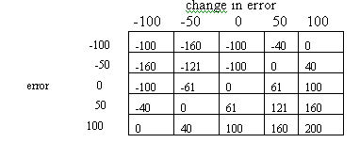
A typical application area for the table based controller is where the inputs to the controller are the Error and the Change of Error. The controller can be embedded in a larger system, a car for instance, where the table is downloaded to a table look-up mechanism.(above table)
4.6 Procedure
When fuzzy set theory is used to solve the real problems, the following steps are generally followed
Step1 Description of original problem. The to be solved first stated mathematically and linguistically
Step2 Defining the thresholds of the variables. The values corresponding to the greatest and least degree of satisfaction are termed thresholds.
Step3 Fuzzy quantization .Base on the threshold values the membership functions are selected
Step4 Selections of the fuzzy operations, in terms of decision making process by human experts .the most commonly used operations are Mamdani’s and Zadeh’s 4.7 Structure of Fuzzy PD Controllers
A Fuzzy PD controller is similar to fuzzy controller comprising of fuzzification interface, a knowledge base, an inference engine and defuzzification engine
1) The fuzzification engine performs following functions
- Measures the values of input variables
- Performs a scale mapping that transfers the range of values of input variables into corresponding universes of discourse
- Performs the functions of fzzification that converts input data into suitable linguistic values
2) Knowledge Base it comprises of date base and rule base
3)Decision making logic operations based on fuzzy concepts and of inferring fuzzy control actions employing Fuzzy implications and rules of inference in Fuzzy logic
4)The defuzzification interface yields a non Fuzzy control action from an inferred fuzzy control action . It converts the range of values of output variables into corresponding universes of discourse
4.8 Implementation of Fuzzy Controller using Fuzzy Logic Tool Box in Simulink
Using GUI tools of Fuzzy Logic Tool Box of Simulink , fuzzy inference system of this Pd controller has been constructed. To start this system , we type fuzzy at the MATLAB promt. The generic untitled FIS Editor opens, with one input, labeled input1 , and one output, labled output1. Here we select two input and one output .The two input are error and derror and the output was named force
The steps to Implement the Controller
- Assign the names to inputs and output
- Select the membership functions and assign their ranges using Membership functions in the edit window of the editor.
- Give rule base to the controller by selecting Rules in the Edit window
- Now the design of the controller is complete. Export the file either to Disk or Workspace, whichever is required and name it .
There are two controller designed in order to Control the system are
1) pendulum2
Inputs: theta and dtheta
Output: output1
2) displacement2
Inputs: displacement and velocity
Output : force

4.9 Details Of The PD(Proportional And Derivative) Controller For Control Of Angular Position Of Missile ’Pendulum2’

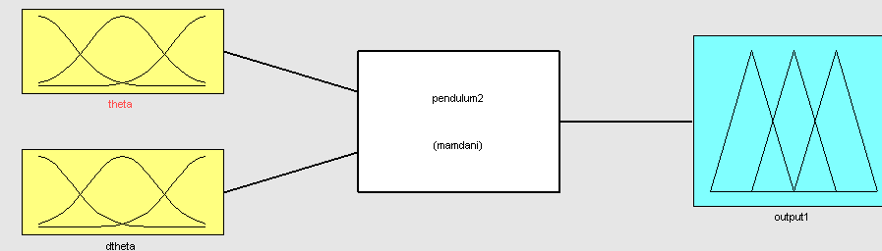

Fig 4.4 Block Diagram Of Controller To Control The Angular Position Of Missile

Fig 4.4 Shows the block diagram of the controller to control the angular position of missile guided system which has two input the error(theta) and the change of error (dtheta) and the output1 is the force generated to control the angular position of the system of the system.

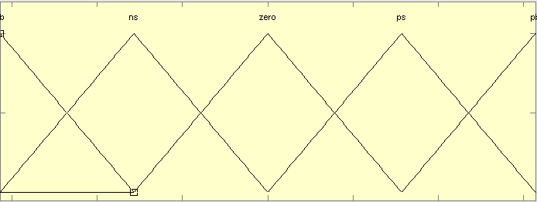
-1.5 -1 -.5 0 .5 1 1.5
Fig4.5 Membership Function for Input1(theta)

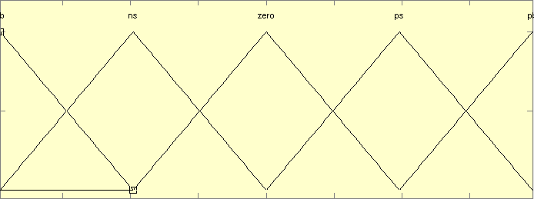
-.6 -.4 -.2 0 .2 .4 .6
Fig4.6 Membership Function for Input2 (dtheta)

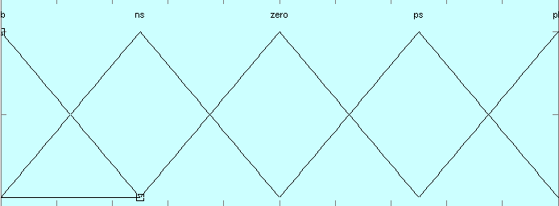
-1 -.8 -.6 -.4 -.2 0 .2 .4 .6 .8 1
Fig 4.7 Membership Function of output1
Fig 4.5, Fig 4.6, Fig 4.7 Gives the type and the range of the membership function applied as two inputs and the output, to design the PD controller to control the angular position of missile

Rule Base for the Controller
The rule base for implementing fuzzy PD controller for angular position control of guided missile system was developed using IF THEN relationship and rule base edit window of simulink. The sample of rule base for fuzzy PD controller to control the angle position of missile is given as under:

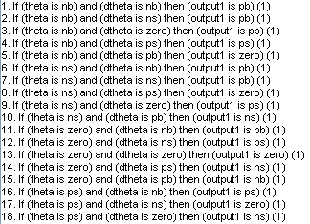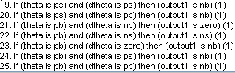

There are total 25 rules in Fuzzy Proportional and Derivative Controller to control the angular position of missile in FIS file ‘pendulum2’

Complete Description of the FIS ‘pendulum2’

[System]
Name=’pendulum2’
Type=’mamdani’
Version=2.0
NumInputs=2
NumOutputs=1
NumRules=25
AndMethod=’min’
OrMethod=’max’
ImpMethod=’min’
AggMethod=’max’
DefuzzMethod=’som’

[Input1]
Name=’theta’
Range=[-1.57 1.57]
NumMFs=5
MF1=’nb’:’trapmf’,[-Inf –Inf -1.57 -0.785]
MF2=’ns’:’trimf’,[-1.57 -0.785 0]
MF3=’zero’:’trimf’,[-0.785 0 0.785]
MF4=’ps’:’trimf’,[0 0.785 1.57]
MF5=’pb’:’trapmf’,[0.785 1.57 Inf Inf]

[Input2]
Name=’dtheta’
Range=[-0.785 0.785]
NumMFs=5
MF1=’nb’:’trapmf’,[-Inf –Inf -0.785 -0.3925]
MF2=’ns’:’trimf’,[-0.785 -0.3925 0]
MF3=’zero’:’trimf’,[-0.3925 0 0.3925]
MF4=’ps’:’trimf’,[0 0.3925 0.785]
MF5=’pb’:’trapmf’,[0.3925 0.785 Inf Inf]

[Output1]
Name=’output1’
Range=[-5 5]
NumMFs=5
MF1=’nb’:’trimf’,[-7.5 -5 -2.5]
MF2=’ns’:’trimf’,[-5 -2.5 0]
MF3=’zero’:’trimf’,[-2.5 0 2.5]
MF4=’ps’:’trimf’,[0 2.5 5]
MF5=’pb’:’trimf’,[2.5 5 7.5]
4.10 Details Of The Of The PD(Proportional Derivative) Controller For Horizontal Position Of Vehicle Control’displacement2’

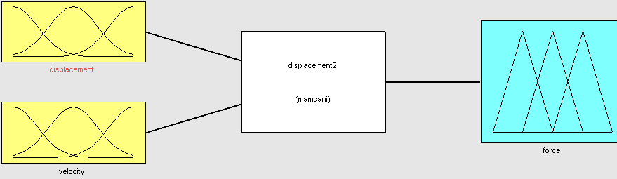
Fig 4.8 Block diagram of Fuzzy PD controller to control the horizontal position of vehicle from which missile is launched. It comprises of two inputs(displacement, velocity) and one output (force)

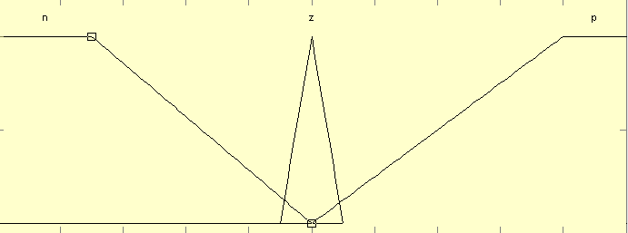
-1 -.8 -.6 -.4 -.2 0 .2 .4 .6 .8 1
Fig 4.9 Membership Function for Input1(displacement)

-1 -.8 -.6 -.4 -.2 0 .2 .4 .6 .8 1
Fig 4.10 Membership Function for Input2(velocity)

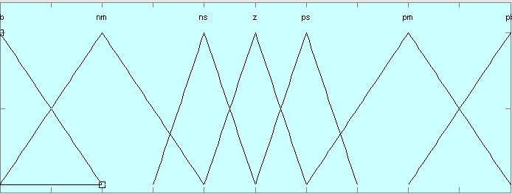1 -.8 -.6 -.4 -.2 0 .2 .4 .6 .8 1
Fig4.11 Membership Function for 0utput(force)

Fig4.9, Fig4.10, Fig4.11 Gives the type and the range of the membership function applied as two inputs and the output, to design the PD controller to control the cart position.

Rule Base
The rule base for implementing fuzzy PD controller for horizontal position control of guided missile system was developed using IF THEN relationship and rule base edit window of simulink. The sample of rule base for fuzzy PD controller to control the linear position of missile is given as under:

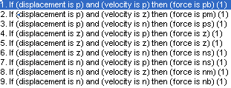

The rule base of FIS ‘displacement2’ contains 9 rules to control the horizontal position of vehicle on which missile is installed.
Complete Details of FIS ‘displacement2’
[System]
Name='displacement2'
Type='mamdani'
Version=2.0
NumInputs=2
NumOutputs=1
NumRules=9
AndMethod='min'
OrMethod='max'
ImpMethod='min'
AggMethod='max'
DefuzzMethod='som'

[Input1]
Name='displacement'
Range=[-1 1]
NumMFs=3
MF1='n':'trapmf',[-Inf -Inf -0.7 0]
MF2='z':'trimf',[-0.1 0 0.1]
MF3='p':'trapmf',[0 0.8 Inf Inf]

[Input2]
Name='velocity'
Range=[-1 1]
NumMFs=3
MF1='n':'trapmf',[-Inf -Inf -1 0]
MF2='z':'trimf',[-0.1 0 0.1]
MF3='p':'trapmf',[0 1 Inf Inf]

[Output1]
Name='force'
Range=[-1 1]
NumMFs=7
MF1='nb':'trimf',[-1.4 -1 -0.6]
MF2='nm':'trimf',[-1 -0.6 -0.2]
MF3='ns':'trimf',[-0.4 -0.2 0]
MF4='z':'trimf',[-0.2 0 0.2]
MF5='pm':'trimf',[0.2 0.6 1]
MF6='ps':'trimf',[0 0.2 0.4]
MF7='pb':'trimf',[0.6 1 1.4]

4.11 Conclusion
The chapter presents the stepwise design of fuzzy logic controllers. It also includes the procedure of implementing fuzzy controller in MATLAB simulink. The details of the controllers and their functional analysis of is also done.

CHAPTER V
MATHEMATICAL MODELING OF MISSILE SYSTEM &
MATLAB SIMULINK SIMULATION

5.1 General
Mathematical modeling of any system is the mathematical representation of the system. It is derived by applying basic law of mechanics on the body of the system. Applying these laws gives the set of mathematical equations which represents the system. These set of equations are used in simulation to obtain the more accurate required results economically.
5.2 System Description
The inverted pendulum is a nonlinear dynamic system which is unstable in its open loop. Considering the center of gravity in its geometric center the figure represents the free body diagram of the system. Fig5.1(a) shows the schematic diagram of inverted pendulum, positioned on a movable vehicle in real time guided missile system. The angular position pendulum and horizontal displacement of movable are the controlled variables, to retain the equilibrium state of the system when the parameters of missile system are varied. Fig 5.1(b), (c) shows the separate free body diagram of moveable vehicle and the arm of the pendulum i.e the position of missile. Following equations can be derived with the help of the diagram.
Where:
M: mass of the vehicle in (Kg);
m: mass of the missile(Kg);
F: force of control applied on the missile(N);
I: inertia of missile in relation to its center of gravity(Kgm²);
θ : angular position of the missile on the launching vehicle(rad)
b : friction coefficient(N/m/s)
x : position of launching vehicle(m)
l: length of the missile(m)
g: acceleration of gravity(m/s²)

The balance of the forces on the launching vehicle in the horizontal direction represents
$M\overset{¨}{x}+b\overset{˙}{x}+N=F$ (5.1)
The active forces in the horizontal direction of pendulum are
$N=m{\overset{¨}{x}}_{G}$ (5.2)
where x_{G} is the linear position of missile’s gravity center
$\begin{aligned}x_{G}=x+l\text{sin}θ \\ {\overset{˙}{x}}_{G}=\overset{¨}{x}+l\text{cos}θ\text{.}\overset{˙}{θ} \\ {\overset{¨}{x}}_{G}=\overset{¨}{x}+l\overset{¨}{θ}\text{cos}θ−l{\overset{˙}{θ}}^{2}\text{sin}θ\end{aligned}$ (5.3)
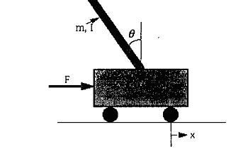
Fig 5.1(a) Inverted Pendulum
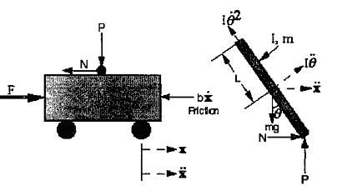
Fig 5.1(b) Fig 5.1(c)
Analysis of Forces of Inverted Pendulum

${\begin{aligned}N=m\overset{¨}{x}+\text{ml \{}\overset{¨}{θ}\text{cos}θ−\text{ml \{}\overset{˙}{θ}\end{aligned}}^{2}\text{sin}θ\left(M+m\right)\overset{¨}{x}+b\overset{˙}{x}+\text{ml \{}\overset{¨}{θ}\text{cos}θ−\text{ml \{}\overset{˙}{θ}{}^{2}\text{sin}θ=F$ (5.4)
The balance of perpendicular forces on the missile and moment around center of gravity
$\begin{aligned}−P\text{sin}θ+N\text{cos}θ+\text{mg}\text{sin}θ=\text{ml \{}\overset{¨}{θ}+m\overset{¨}{x}\text{cos}θ\end{aligned}\text{Pl}\text{sin}θ−\text{Nl}\text{cos}θ=I\overset{¨}{θ}\left(I+{\text{ml}}^{2}\right)\overset{¨}{θ}+\text{ml \{}\overset{¨}{x}\text{cos}θ=\text{mgl}\text{sin}θ$ (5.5)
$\begin{aligned}\left(I+{\text{ml}}^{2}\right)\overset{¨}{θ}+\text{ml \{}\overset{¨}{x}=\text{mgl}θ\end{aligned}\left(M+m\right)\overset{¨}{x}+b\overset{˙}{x}+\text{ml \{}\overset{¨}{θ}=F$ (5.6)
With these sets of equations substituting the values in the equations the relation for $\overset{¨}{θ}$ and $\overset{¨}{x}$ can be obtained as under
$\overset{¨}{θ}=\frac{−\left(M+m\right)g\text{sin}θ+\text{cos}θ\left(F+\text{ml \{}\overset{˙}{θ} | | 2\text{sin}θ−b\overset{˙}{x}\right)}{\left[m{\text{cos}}^{2}θ−(M+m)\right]l}$ (5.7)
$\overset{¨}{x}=\frac{\text{mg}\text{sin}θ\text{cos}θ−\left(F+\text{ml \{}\overset{˙}{θ} | | \text{sin}θ−b\overset{˙}{x}\right)}{m{\text{cos}}^{2}θ−\left(M+m\right)}$ (5.8)
Eq-5.7 and Eq-5.8 are the required equation for the model

These nonlinear equations are used in designing nonlinear Simulink model of guided missile system that is shown in Fig5.3 below.
5.3 Non Linear Model Of Guided Missile System
Equations 5.7 and 5.8 represents the nonlinear model of guided missile system which is simulated in MATLAB simulink for determining the variables θ and x, using functional b and integrator block. The model is shown in Fig(5.2). The whole system will be shown as a subsystem in further simulink models. The simulation results of the developed model is shown in Fig (5.4), and Fig(5.5), it is observed that in the absence of appropriate controller stability of the system is poor because under the influence of the external force both angular position and cart position get deviated from the equilibrium state of the system. Fig(5.3) the shows the simulink model of the missile system, when a small amount of disturbance is applied to it ..
Fig5.2 Simulink model for Non linear missile system

Fig 5.3 Simulink model of Missile System with initial Force

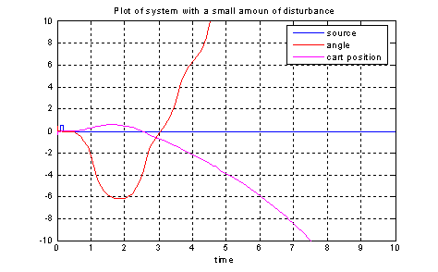
Fig 5.4 Variation of angular position of missile and linear displacement of missile guiding system with a small impulse of .5
Fig 5.5 Variation of angular position and linear displacement of missile guidance system with a large impulse of 8
Fig 5.6 shows a simulink model of the guided missile system with proportional and derivative fuzzy controller. Two fuzzy controllers for angular position and linear position are used. The controllers do not contain any external nonlinearities.

Fig 5.6 Simulink model of linear PD Fuzzy controller for angular and linear position of guided missile system
fig5.7 shows the variation of uncontrolled angular position θin and controlled angular position θc (linear PD fuzzy) . The result shows that system settles to equilibrium state with very small steady state error with minimum overshoots and oscillations. Under the influence of large external force.
Fig 5.7 Variation of angular position of missile with linear PD Fuzzy controller (missile parameters l = 0.22m, m = 0.28kg, θ₀ = 0.7 rad)
fig5.8 shows the variation of uncontrolled linear position xi and controlled linear position xc (linear PD fuzzy) . The result shows that system settles to equilibrium state with very small steady state error and minimum overshoots.
xi
xc
Fig 5.8 Variation of position of missile with linear PD Fuzzy controller (parameters missile l = 0.22m, m = 0.28kg, θ₀ = 0.7rad)
Fig 5.9 Simulink model with non linear PD Fuzzy controller for angular position and linear position of guided missile system (missile parameters l = 0.22m, m = 0.28kg, θ₀ = 0.7rad)

Fig 5.9 shows the simulink model of system with PD fuzzy controller with external nonlinearities, and it is observed that the controller effectively controls the system at required set point even in the presence of external nonlinearities also. Fig5.10 and Fig5.11 shows the controlled variation of angular and linear position of the guided missile with nonlinear PD controller respectively. The results obtained are similar as compared to Fig 5.7 & Fig5.8 (linear PD fuzzy) respectively
Fig 5.10 Variation of angular position of missile with non linear PD Fuzzy controller (missile parameters l = 0.22m, m = 0.28kg, θ₀ = 0.7rad)
xc
xi
Fig 5.11 Variation of position of missile with non linear PD Fuzzy controller (missile parameters l = 0.22m, m = 0.28kg, θ₀ = 0.7rad)

From fig 5.12 to 5.19 shows simulation results for angular and linear position of guided missile system with linear and nonlinear PD Fuzzy controllers for different parameters of missile. The results shows that nonlinear PD controllers produces less oscillations and less overshoots as compared to linear Fuzzy controllers. So, nonlinear fuzzy controllers are recommended over linear Fuzzy controllers in guided missile system.

Fig 5.12 Variation of angular position of missile with linear PD Fuzzy controller (missile parameters l = 0.4m, m = 0.3kg, θ₀ = 0.4rad)
Fig 5.13 Variation of position of missile with linear PD Fuzzy controller (missile
parameters l = 0.4 m, m = 0.3 kg, θ₀= 0.4 rad)
Fig 5.14 Variation of angular position of missile with nonlinear PD Fuzzy controller (missile parameters l = 0.4m, m = 0.3kg, θ₀ = 0.4rad)

Fig 5.15 Variation of position of missile with nonlinear PD Fuzzy controller (missile parameters l = 0.4m, m = 0.3kg, θ₀ = 0.4rad)

Fig 5.16 Variation of angular position of missile with linear PD Fuzzy controller (missile parameters l = 0.22m, m = 0.3kg, θ₀ = 0.5rad)

Fig 5.17 Variation of position of missile with linear PD Fuzzy controller (missile parameters l = 0.22m, m = 0.3kg, θ₀ =.5rad)
Fig 5.18 Variation of angular position of missile with nonlinear PD Fuzzy controller (missile parameters l = 0.22m, m = 0.3kg, θ₀= 0.5rad)

Fig 5.19 Variation of position of missile with nonlinear PD Fuzzy controller (missile parameters l = 0.22m, m = 0.3kg, θ₀ = 0.5rad)
Fig 5.20 shows the Simulink model of the Fuzzy PI controller to control angular and linear position of the missile guidance system. The controlled variation of the angular position and the linear position of the missile with Fuzzy PI controller is shown in Fig 5.21 & Fig 5.22 respectively. The results obtained with Fuzzy PI controller increases the settling time and oscillations in the system as compared to the Fig 5.14 &Fig5.15 respectively ( Fuzzy PD). So Fuzzy PI controller is non recommended
Fig 5.20 Simulink model of PI Fuzzy controller for angular position and linear position of guided missile system (missile parameters l = 0.4m, m = 0.3kg, θ₀ = 0.4rad)
Fig 5.21 Variation of angular position of missile with PI Fuzzy controller (missile parameters l = 0.4m, m = 0.3kg, θ0 = 0.4rad)

Fig 5.22 Variation of linear position of missile with PI Fuzzy controller (missile parameters l = 0.4m, m = 0.3kg, θ₀ = 0.4rad)

5.4 Linear Model of the Guided Missile System
Linear model of the guided missile system can be obtained by applying linear approximation in eq 5.7 and 5.8. if sinθ = θ and cosθ =1 where θ is very small . The transfer function of angular position ( θ(s)) and force input (u(s)) can be obtained by substituting the value of displacement (x(s)) in terms of θ(s) & u(s) and vice versa. Equation 5.9 gives the transfer function for angular position and force and Eq-5.8 gives the transfer function of for linear displacement and force. The equations derived are as follows:

$\frac{θ(s)}{U(s)}=\frac{\text{sml}/q}{s^{3}+\frac{{\text{bs}}^{2}(I+{\text{ml}}^{2})}{q}−\frac{\text{mgl}(M+m)}{q}}$ (5.9)
$\frac{x(s)}{U(s)}=\frac{s^{2}(I+{\text{ml}}^{2})−\text{gml}q}{s^{4}+\frac{{\text{bs}}^{3}(I+{\text{ml}}^{2})}{q}−\frac{\text{mgl}(M+m)s^{2}}{q}−\frac{m\text{glb}s}{q}}$ (5.10)
where symbols have the same meaning as mentioned earlier and q is
$q=\left[(M+m)(I+{\text{ml}}^{2})−{\text{ml}}^{2}\right]$
The above equations Eq-5.9 and Eq-5.10 represents transfer functions for linear model of guided missile system. The different transfer functions are evaluated by substituting the values of different parameters.
Fig 5.23 shows the Simulink model of the PD Fuzzy controller for linear system of guided missile system. Fig 5.24 ,5.25 & 5.26 shows the variation of angular position of missile guidance system for different parameters with linear PID and PD fuzzy controller. The results obtained proves that the PD fuzzy controller is the better one out of the two, as PID controller takes longer time to settle and gives larger overshoots.

Fig 5.23 Simulink Model of PID and PD Fuzzy controller for control of angular position of missile for linear model of missile system with set point one

Fig5.24 Variation of angular position of missile for linear model of guided missile system with different controllers (missile parameters l = 0.22 m, m = 0.28 kg),
Fig5.25 Variation of angular position of missile for linear model of guided missile system with different controllers for (missile parameters l = 0.4m, m = 0.3kg)
Fig5.26 Variation of angular position of missile for linear model of guided missile system with different controllers (missile parameters l = 0.22m, m = 0.3kg )
Fig 5.27 shows the simulink model of PD Fuzzy controller and PID controller to control the linear position of guided missile system. Fig 5.28, 5.29 shows the variation of linear position of missile guidance system with PD Fuzzy and PID controller. The result obtain proves PD Fuzzy as the better controller out of two.
Fig 5.27 Simulink model of PD Fuzzy controller & PID controller for control of linear position for linear model of guided missile system

Fig5.28 Variation of linear position of vehicle for linear model of guided missile system with different controllers for parameters l = 0.22m, m = 0.28kg

Fig5.29 Variation of linear position of vehicle for linear model of guided missile system with different controllers for parameters l = 0.4m, m = 0.3kg
Fig5.30 Variation of linear position of missile for linear model of missile system with linear PD and PD fuzzy controllers for missile parameters l = 0.22m, m= 0.3kg
Fig 5.30 is the variation of angular position of guided missile system with PD Fuzzy and linear PD controller and the results obtained shows a larger steady state error with linear PD controller as compared to PD Fuzzy controller. Fig 5.31 is the variation of linear position of guided missile system with linear PI controller and PD fuzzy controller. The figure shows large number of oscillations with linear PI controller which is not desirable.
Fig 5.31 Variation of linear position of missile for linear guided missile system with linear PI and PD fuzzy controllers for parameters l = 0.4m, m = 0.3kg,

5.5 Conclusion: The PD fuzzy controller comes to be most appropriate controller to control linear and non linear system of guided missile system. The chapter contains the simulation results of guided missile system with control variables as θ (angular position) and x (horizontal position) for linear as well as nonlinear model of the guided missile system with different types of controllers. The nonlinear model is treated with linear and non linear PD & PI controllers and PD fuzzy is recommended. The linear model is treated with linear PD Fuzzy, PID, PD & PI controllers and again PD Fuzzy is recommended.

CHAPTER VI
CONCLUSION
AND
FUTURE SCOPE OF WORK

6.1 Main Conclusion
With recent developments in missile technology there are many methods available to guide the trajectory of the missile in proper direction. But the basic purpose of all types of controller is to give a definite direction to missile as per the direction of target. For this purpose the controller should have the ability to set at any equilibrium point in any direction at any angle even with varied parameters. In the present work a mathematical model of an analogous system of guided missile i.e inverted pendulum is derived, which is in the form of two second order differential equations. After applying suitable approximation a linear model of the missile system is also obtained. In order to maintain the equilibrium state of the system when some of its parameters vary, suitable controllers are necessary.
To achieve this objective Fuzzy PD controller is designed and implemented for missile system in MATLAB Simulink . The controller is designed as such, so that it may set at any angle with any initial condition and any parameter.
The system is designed using the single stage missile launcher. The simulation were carried out on linear and non linear model of missile guided system in consideration. The controller performance is evaluated for all the sets of parameter for Linear and Non Linear model of the system with linear Fuzzy, non linear Fuzzy and linear conventional controllers.
Linear Model with Linear and Non Linear Fuzzy :
Linear model of the system when observed with linear PD Fuzzy controller the gives excellent results with all missile parameters and stabilizes the system at the desired equilibrium point, without any oscillations as expected with linear model of the system. The results had been same for both Linear and Non Linear Fuzzy, as the system is linearized and free from nonlinearities
Non Linear Model with Linear and Non linear PD Fuzzy:
Non linear model when observed with linear PD Fuzzy stabilizes the system at a definite equilibrium state. The controller works exactly in the same way with all the set of parameters. The same non linear model when observed with Non Linear Fuzzy controller i.e introducing non linearities in the system, which a real system may contain, comes out with a controller which is equally accurate and less oscillatory.
The results obtained, proves that PD Fuzzy controller gets adapted to the change in parameter of the missile and stabilizes at the required equilibrium point. It becomes more effective because it do not get disturbed even if external nonlinearities are present in the system, which is quite common in real system.
The linear model of the guided missile system was also simulated with conventional linear controllers such as PD, PID and PI. But, PD Fuzzy comes out to be the best of all as far as the fast stabilizing to equilibrium state is considered under varying system parameters condition
6.2Future Scope of work
The PD fuzzy controller is designed for a single stage launcher. However the following investigation could further be carried out:
1. Though in the present study only the equilibrium state of missile system has been examined under varying parameters, but in the same controller options on path trajectory of missile and target tracking could also be integrated.
2. Use of Neural –Fuzzy and Genetic Algorithm based intelligent adaptive control for guided missile system
3. The controller for two and multistage launcher can also be designed on the same line.
The multistage launcher can be used in complicated rocket and missile guidance system as well as in the robotic arms.

REFERENCES AND BIBLIOGRAPHY

[1] Anderson.Charles “Learning to Control Inverted Pendulum by Neural Networks” IEEE Trans Neural Network, vol 4, pp 496-522, 1989
[2] S.Geva and J. Sittle “A Cart Pole Experiment for Trainable Pendulum” IEEE Trans Control Systems, vol 7, pp 1280-1297, 1993
[3] G.Kandel and Langholtzg “Fuzzy Control System” CRC Press 1994
[4] Daneil. J.Pack, Hlin Rleng, A.C Liak “Comparative Study of Motion Control Methods for Nonlinear Sytems” IEEE conference of Industrial Electronics and Control Instrumentation, proceedings vol 4, pp 1413-1420, 1993
[5] Michael deSylval and Juris Vagne “Hybrid Controller to Stabilise Inverted Pendulum from any Arbitary Intial conditions” IEEE conference on Intelligent Control proceedings pp 383-390,1993
[6] Galip Cansever, and O.Faruk Ozguven “ Applications of fuzzy Set theory to Stabilisation of Inverted Pendulum by High Speed Fuzzy Logic Controller” IEEE Trans Fuzzy Applications, vol 6, pp 1085-1089, 1994
[7] C.K Lee, W.H. Pang “Rule Based Adaptive Control in Servomotor Control System” IEEE conference on Control, proceeding vol 2, 1994
[8] Abramouitch “Some Crisp Knowledge of Fuzzy Logic” IEEE Conference proceedings of Fuzzy systems,1994
[9] Ming-Yuan Shieh and Tzuu-Hseng S. Li “Implementation of Integrated Fuzzy Controller for Servomotor” IEEE joint conference Fuzzy Systems, pp 1755- 1762, 1996
[10] Tomonobu Seiijyu, Shingo Ashimine, and Katsumi Uezato “Robust Control of DC Servo Motor using Adaptive Gain Law” IEEE conference of Power Electronics 1996
[11] M.Santos, S.Dormindo, J.M. de la Cruz “Fuzzy –PID controller vs Fuzzy PI –Controllers” IEEE Fuzzy systems 1996 ,proceedings, in fifth IEEE International conference
[12] Chen Wei Ji , Fang Lie , Lie Kam Kin “ Fuzzy Logic Controller for Inverted Pendulum” IEEE Conference, Intelligent Processing Systems,Beging, Oct 1997
[13] Mario E. Maga˜na and Frank Holzapfel “Fuzzy-Logic Control of an Inverted Pendulum with Vision Feedback”IEEE Trans Education, vol 41,May 1998
[14] Shuliang Lei and Reza Langari “Hierarchical Fuzzy Logic Control of a Double Inverted Pendulum” IEEE Trans Fuzzy Systems, vol 9, pp 1074-1078 , 2000
[15] Feijun Song, Samuel M. Smith “Takagi-Sugeno Type Fuzzy Logic Controller with only 3 Rules for a 4 Dimensional Inverted Pendulum System” IEEE Conference, Intelligent Systems , proceedings, 2000
[16] Nenad Muškinja, Boris Tovornik “ Controlling of Real Inverted Pendulum with Fuzzy Logic” IEEE Conference, Fuzzy Systems, 2000
[17] M.Alta , K Demirili “Fuzzy Control and Gain Schedule Case Study: Robust Stabilisation of Inverted Pendulum” IEEE Conference IFSA World Congress, proceedings, pp 3015- 3021, 2001
[18] Lawrence Bush “Fuzzy Logic Controller for the Inverted Pendulum Problem” Troy New York Nov 2001
[19] Chin-Gook Lhee, Jae-Sam Park, Hyun-Sik Ahn, and Do-Hyun Kim “Sliding Mode-Like Fuzzy Logic Control with Self-Tuning the Dead Zone Parameters” IEEE Trans, Fuzzy Systems, vol 9, 2002
[20] T. T. dos Santos, M. C. Magnus, C. C. Scharlau, J.F. Haffner, L.F.A. Pereira “A Decentralized Control of Inverted Pendulum and Supervision Based on Internet Tools” IEEE conference, Industrial Electronics,2003
[21] Yonggon Lee and Stanislaw H. ˙ Zak “Uniformly Ultimately Bounded Fuzzy Adaptive Tracking Controllers for Uncertain Systems” IEEE Trans Fuzzy Systems, vol 12, Dec 2004
[22] Sergey A. Terentiev, Student member, IEEE, Evgeniy S. Povernov, Eugene “The Direct-Current Servornotor ControlSystem” conference, Electronics Devices and Material, pp 184-187,2004
[23] R. Shahnazi, H. Shanechi, Senior Member, IEEE, and N. Pariz “Position Control of Induction and DC Servomotors: A Novel Adaptive Fuzzy PI Sliding Mode Control” IEEE conference, Power Systems, 2006
[24] Jan Jantzen “Foundation to Fuzzy Contol” Wiley Publisher Ed 2007
[25] Guanrong Chen ,Chapman and Hall, “Introduction to Fuzzy Systems” CRC Press
[26] C.J Chesmond “Basic Control System Technology” ELBS Publisher 1990
[27] Kevin M. Passino, Stephen Yurkovich “Fuzzy Control” Pub Addison Wesley 1997

