EFFECT OF CHANGE OF OCCUPANCY TYPE ON SEISMIC
BEHAVIOUR OF MASSONRY BUILDING
A Major Project
Submitted In Partial Fulfilment of Requirements
For The Award of the Degree of
MASTER OF ENGINEERING
IN
CIVIL ENGINEERING
(WITH SPECIALIZATION IN STRUCTURAL ENGINENEERING)
Submitted by
SUMEET ISSAR
University Roll No.12692
Under the Supervision of
SHRI ALOK VERMA
(Lecturer, Civil Engineering Division)
CIVIL Engineering Department

DEPARTMENT OF CIVIL ENGINEERING
DELHI COLLEGE OF ENGINEERING
UNIVERSITY OF DELHI
DELHI-110042

Department of Civil & Environmental Engineering

Delhi College of Engineering, Delhi-110042


CERTIFICATE

This is to certify that the project entitled “EFFECT OF CHANGE OF OCCUPANCY TYPE ON SEISMIC BEHAVIOUR OF MASONRY BUILDINGS” being submitted by me, is a bonafide record of my own work carried by me under the guidance of Mr. Alok Verma in partial fulfillment of requirements for the award of the degree of Master of Engineering (Structural Engineering) in Civil Engineering, Delhi University, Delhi.

The matter embodied in this project has not been submitted for the award of any other degree.

SUMEET ISSAR

Roll No: 12692
M.E. (Structural Engineering)

CERTIFICATE
This is to certify that the above statement made by the candidate is correct to the best of my knowledge.

Alok Verma
Lecturer
Department of Civil Engineering
Delhi College of Engineering,
Delhi- 110042.
Acknowledgement

It is a matter of great pleasure to express my deep sense of gratitude and ineptness to Shri.Alok Verma, Lecturer for his valuable guidance without which completion of this project would not have been possible.

i feel privileged in expressing my earnest obligations, deep sense of gratitude, appreciation & honour to my guide Shri Alok Verma, Lecturer Delhi College of Engineering, for their constant guidance and unflinching encouragement throughout the development of this project. His benevolent guidance and suggestions, unstinted help & constructive criticism have inspired me in successful completion of this dissertation work.

Last but not the least, I am thankful to my parents and friends for their help and encouragement.

SUMEET ISSAR
ROLL NO. 12692

ABSTRACT

Structural adequacy of masonry walls depends upon a number of factors, among which mention may be made of quality and strength of masonry units and mortars, workmanship, methods of bonding, unsupported height of wall, eccentricity in the loading, position and size of openings in walls, location of cross walls and the combination of various external loads to which wall are subject.
It is very important to know the performance of a masonry system under seismic loading when occupancy type is changed.
Now a day’s many alterations in structural system are made in buildings without knowing there after- effects, for example, in a masonry structure occupancies are changed by using the structure for some other purpose, without knowing its strength and capability to resist new loads. Also many structural member such as load bearing walls from a masonry structure are removed from the original structure for sake of change in occupancy, which can result fatal accidents. Hence a study is required to know the performance of building under these changes and to review the consequences.
In the present work, performances of masonry structure subjected to Seismic loading under changed occupancy were studied .A model of an existing masonry building and buildings with changes made in them were analysed with variation in occupancies and structural system. Percentage change in base shear value, time period, story drift and variation in seismic weight as a result of change in relative stiffness were studied and compared with STAAD 2005 software. Changes in structural system leads to changes in performance of buildings.

CONTENTS
List of Notations
List of Figures
List of Tables
List of charts
Chapters
Chapter 1.
INTRODUCTION
1.1 BACKGROUND AND MOTIVATION
1.2 OBJECTIVE AND OUTLINE
Chapter 2.
LITRATURE REVIEW
Chapter 3.
CONCEPT AND PLAN OF STUDY
  - BEHAVIOURAL ASPECT
  - METHOD OF CACULATION OF VARIOUS PARAMETERS
Chapter 4.
NUMERICAL EXAMPLE
  - DATA
  - CALCULATION OF DIFFERENT PARAMETERS OF MASONRY
  - ANALYSIS
Chapter 5
DISCUSSION AND RESULTS
Chapter 6
CONCLUSION AND FURTHER SCOPE
  - CONCLUSION
  - FURTHER SCOPE
REFERENCES
LIST OF NOTATIONS

E_{m} Modulus of Elasticity for masonry

f’_{m} Compressive strength of masonry in

G_{m} Shear Modulus of Masonry

µ Poisson’s Ratio

LIST OF FIGURES

  - Seismic zoning map of India

2.1 Response Spectra for Rock and Soil Site For 5 Percent Damping

LIST OF TABLES

2.1 Values of Zone Factor, Z

2.2 Values of Importance Factor, I

2.3 Values of Response Reduction Factor, R

2.4 Mix proportion and strength of mortars for masonry

2.5 Minimum thickness of basement walls in masonry construction.

2.6 Maximum slenderness ratio for a load bearing wall in masonry construction.

5.1.1 Comparison of % variation in Base Shear in X-Direction

5.1.2 Comparison of % variation in Base Shear in Z-Direction

5.1.3 Comparison of % variation inTime Period in X-Direction

5.1.4 Comparison of % variation in Time Period in Z - Direction

5.1.5 Comparison of % variation in seismic weight

5.1.6 Comparison of % variation in Story Drift in X-Direction

5.1.7 Comparison of % variation in Story Drift in Zs-Direction

LIST OF BAR CHARTS

5.1.1 Comparison of % variation in Base Shear in X-Direction

5.1.2 Comparison of % variation in Base Shear in Z-Direction

5.1.3 Comparison of % variation inTime Period in X-Direction

5.1.4 Comparison of % variation in Time Period in Z - Direction

5.1.5 Comparison of % variation in seismic weight

5.1.6 Comparison of % variation in Story Drift in X-Direction

5.1.7 Comparison of % variation in Story Drift in Z-Direction

Chapter 1.
INTRODUCTION

  - Background and motivation
Earthquakes pose an important challenge for the art and science of structural engineering. Traditionally, India has been vulnerable to various natural hazards on account of its unique geo climatic conditions especially earthquakes, which is considered to be among the most destructive with the potential of inflicting huge losses to life and property.
The earthquake has recently appeared as threat to this region. Therefore, it is essential to develop an earthquake preparedness program for the region in order to reduce the potential losses expected from the disaster.
One of the major concerns during an earthquake is the inadequacy of stiffness of a masonry structures such building need to identify. Time period, Base shear, story drift and stress values are the parameters are usually used to identify behaviour of buildings and estimate adequate section for load bearing wall .Many cases with variation in stiffness of load bearing structure are analyse. A quantitative comparison method is used to develop earthquake vulnerability scenario of a load bearing building in this research work.

Earthquake
Earthquake is the shaking of the Earth’s surface caused by rapid movement of the Earth’s rocky outer layer. Earthquakes occur when energy stored within the Earth, usually in the form of strain in rocks, suddenly releases. This energy is transmitted to the surface of the Earth by earthquake waves. The point within the earth where earthquake waves originate is called the focus. Vibrations from the focus spread in all directions. The vibration first reaches the ground surface at a point immediately above the focus, which is called the “epicentre”. The destruction an earthquake causes depends on its magnitude and duration, or the amount of shaking that occurs. Earthquakes vary from small, imperceptible shaking to large shocks felt over thousands of kilometres. Earthquakes can deform the ground, make buildings and other structures collapse, and create tsunamis.

Causes of Earthquake
Earthquakes occur when a build-up of pressure or strain between sections of rocks within the earth's crust is suddenly released, causing minor or severe vibrations on the surface of the land. The point at which layers of rock shift and reposition in relation to one another, is called the focus. This is the effective centre of the earthquake.
This energy can be generated by a sudden dislocation of segments of the crust or plate, by a volcanic eruption, or even by manmade explosions. The earth is divided into three main layers - a hard outer crust, a soft middle layer and a centre core. The outer crust is broken into massive, irregular pieces called "plates". The majority of earthquakes in recent years falls under the category of plate tectonics. When two plates interact at their boundaries they put forces on each other. These forces of reaction cause physical and chemical changes at their boundaries. Plates move side to side, up and down, and also interact head on. Earthquakes also occur in these areas where new plates are being created and old plates are being sub ducted into the Earth's interior. Earthquakes which are due to the interaction of plates are called inter plate earthquakes. But what about inter plate earthquakes, which occur across one plate? Less common than earthquakes that occur at plate boundaries, these earthquakes are due to local systems of forces, such as lack of strength or changes in temperature below the Earth's crust. Most often they are due to movement on pre-existing faults.

As we all know that structural changes in existing buildings without knowing there after-effect can be very dangerous and fatal, but it is expericenced that in seismic zones 2 and 3 there effect is very nominal. But in zone 4 and 5 these changes can produce enormous destruction, hence while excuting these changes in buildings one should had a fair idea of seismic zoning of India.

Seismic Zoning of India

In the seismic zoning map of India (figure 1.1), the country is divided into four generalised zone: zone-II, zone-III, zone-IV and zone-V, Ref. (IS 1893(Part 1):2002 Criteria For Earthquake Resistant Design Of Structures)

A study carried based on the building data in the vulnerability atlas of India 1997 shows that only in the seismic zone V of India covering an area of 12% of the total land area of the country, there are 11.1 million vulnerable housing units as per census of India 1991. If one accounts for similar vulnerable buildings in seismic zone IV also, the number will at least be 5o million,( Ref Prof. A.S Arya, Earthquake Hazards Damage Proceeding of workshop on retrofitting of structure, Oct.2003.)

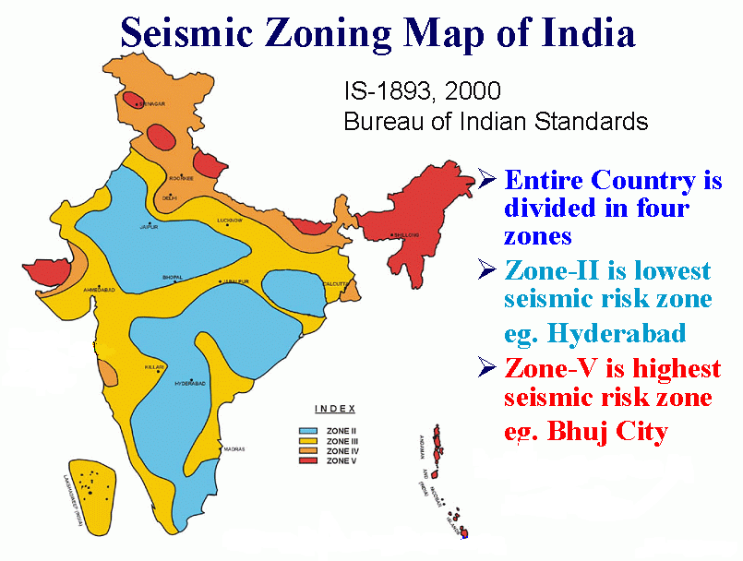

Fig 1.1: Seismic zoning map of India

Effect of change of occupancy type on seismic behaviour of masonry building is very important to know in conditions in which we live, changes are part of our life and our living places, therefore there is a great probability of structural alteration in our living places without knowing the consequences.If we take an example of a masonry structure designed for all possible load for purpose of residence,there is a chance that it can later be used for some commericial activity which can result in increase in loads for which the original building is not designed. This can result in some fatal accidents as the building can go for local faliure under gravity load or it can fail under seismic loading conditions.Also there is a chance that some load bearing wall can be removed from the original structure as a part of some interior modifications, without having a good idea of load transmition to the foundation.This also can be a very dangerous condition in terms of stability of structure.All these after-effects of alterations in a masonry building mainly established in zone 4 and 5 of earthquake creats a urge to study the behaviour of these altered buildings with respect to original building for all parameters under earthquake which can creat a question mark on saftey of buildings.

1.2 Objective of study

- To study the effect of occupancy type of masonry buildings and their performance

- To study affects on various parameters such as Time period and Base shear etc. due to changes in occupancy type.

- To compare the performance of such buildings where structural changes were made to accomodate change in occupancy type.

- To investigate the variation of stresses in individual components of structuraly altered buildings.

Chapter 2.

LITRATURE REVIEW

To Know the Behaviour of Masonry structure subjected to Earthquake lateral loading it is necessary to know following terminology of earthquake engineering and masonry structures:-

Natural Period (T)

Natural period of a structure is its time period of undamped free vibration.

Fundamental Natural Period (T1)

It is the first (longest) modal time period of vibration.

Design Seismic Base Shear (V_{b})

It is the total design lateral force at the base of a structure.
The total design lateral force or design seismic base shear (V_{b}) along any principal direction shall be determined by the following expression:

V_{b} = A_{h}*W

Ah = Design horizontal acceleration spectrum
W = Seismic weight of the building

Design Horizontal Acceleration Coefficient (A_{h})

It is a horizontal acceleration coefficient that shall be used for design of structures.

The design horizontal seismic coefficient A_{h} for a structure shall be determined by the following expression:

A_{h} = Z*I*Sa
2*R*g

Zone Factor (Z)

It is a factor to obtain the design spectrum depending on the perceived maximum seismic risk characterized by Maximum Considered Earthquake (MCE) in the zone in which the structure is located. Table 2.1 will give various Zone factors values, (Ref.IS 1893(Part 1):2002 Criteria for Earthquake Resistant Design of Structure
Table 2.1: Values of Zone Factor, Z

Seismic 2 3 4 5
Zone

Seismic Low Moderate Severe Very Severe
Intensity

Z 0.10 0.16 0.24 0.36

Importance Factor
It is a factor used to obtain the design seismic force depending on the functional use of the structure, characterized by hazardous consequences of its failure, its post-earthquake functional need, historic value, or economic importance. Table 2.2 will give various Importance factors values, (Ref.IS 1893(Part 1):2002 Criteria For Earthquake Resistant Design Of Structures)

Table 2.2: Values of Importance Factor, I

Sl.No. Structure Importance Factor

1. Important service and community 1.5
Buildings, such as hospitals, schools,
Monumental Structures, emergency
Buildings like telephone exchange,
Railway station fire station buildings,
Large community halls like cinemas,
Assembly halls and subway station,
Power stations

2. All other buildings 1.0

Response Reduction Factor (R)
It is the factor by which the actual base shear force, that would be generated if the structure were to remain elastic during its response to the Design Basis Earthquake (DBE) shaking, shall be reduced to obtain the design lateral force, Table 2.3 will give various Importance factors values, (Ref.IS 1893(Part 1):2002 Criteria For Earthquake Resistant Design Of Structures)

Table 2.3: Values of Response Reduction Factor, R
(Ref.IS 1893(Part 1):2002 Criteria For Earthquake Resistant Design Of Structures)

Structural Response Factors (S_{a}/g)

It is a factor denoting the acceleration response spectrum of the structure subjected to earthquake ground vibrations, and depends on natural period of vibration and damping of the structure. Fig 2.1, shows the proposed 5 percent spectra, (Ref.IS 1893(Part 1):2002 Criteria For Earthquake Resistant Design Of Structures)

Fig: 2.1 Response Spectra for Rock and Soil Site For 5 Percent Damping

Values for response spectra for various soil types, (Ref.IS 1893(Part 1):2002 Criteria For Earthquake Resistant Design Of Structures)

For rocky or hard soil sites:-

S_{a/g =} 1+15T for 0.00 < T < 0.10

2.50 for 0.10 < T < 0.40

1.00/T for 0.40 < T < 4.00

For Medium Soil Site:-

S_{a/g =} 1+15T for 0.00 < T < 0.10

2.50 for 0.10 < T < 0.55

1.36/T for 0.55 < T < 4.00

For soft soil site:-

S_{a/g =} 1+15T for 0.00 < T < 0.10

2.50 for 0.10 < T < 0.67

1.67/T for 0.67 < T < 4.0

Seismic Weight (W)

It is the total dead load plus appropriate amounts of specified imposed load.

Storey Drift

It is the displacement of one level relative to the other level above or below.

Load Bearing Wall

A wall designed to carry an imposed vertical load in addition to its own weight, together with any lateral load.

Masonry

An assemblage of masonry units properly bonded together with mortar.

Masonry Units

Well burnt bricks conforming to IS 1077: 1992 or solid concrete blocks conforming to IS 2185 (Part 1): 1979 and having a crushing strength not less than 3.5 MPa shall be used. The strength of masonry unit required shall depend on the number of stores and thickness of walls (IS 1905: 1987).

Mortar

Mortars, such as those given in Table 3 or of equivalent specification, shall preferably be used for masonry construction for various categories of buildings.
Also as per masonry codes below mentioned are some of mandatory requirements to be fulfilled while designing masonry structure:-

Mix proportion and strength of mortar s for masonry (Ref.IS: 1905-1987 Code Of Practice For Structural Use Of Unreinforced Masonry)

Minimum thickness of basement walls: Table 2.5 gives us values of Minimum thickness of basement walls in masonry construction, (Ref.IS: 1905-1987 Code Of Practice For Structural Use Of Unreinforced Masonry)

Table 2.5: Minimum thickness of basement walls

Sl. No. Minimum Thickness Height of ground above basement
Of basement wall (Cm) floor level with wall loading
(Permanent load) in meters

More than Less than
50kn/m 50kn/m

- 40 2.50 2.0

2 30 1.75 1.40

Maximum slenderness ratio for a load bearing wall:
Table 2.6 gives us values of maximum slenderness ratio for a load bearing walls
in masonry construction, (Ref.IS: 1905-1987 Code Of Practice For Structural Use Of Unreinforced Masonry)

Table 2.6: Maximum slenderness ratio for a load bearing wall

No. of storeys. Maximum Slenderness Ratio

Using Portland cement Using Lime Mortar
Or Portland Pozzolana
Cement in Mortar

Not Exceeding 2 27 20

Exceeding 2 27 13

Chapter 3.

CONCEPT AND PLAN OF STUDY

  - Behavioural Aspect

In Order to understand the behaviour of masonry building under seismic condition it is important to analyses a load bearing structure under these conditions.

Step by step procedure for study behaviour of load bearing structure

- An existing load bearing structure is analysed on STAAD 05 structural engineering software with all parameter of existing building were given in as input. The existing building is a ground +1 storied load bearing structure which is used for residential purpose, it has eight flats in total four – four each on ground and first floor.

Now to make a comparative study we have followed various cases as an input to our software

Case 1 (C1a): In this case all Walls (interior and exterior) of building were kept 230mm thick and plan of whole building is kept similar to the existing building. Building in this case (C1a) is treated as original building as it does not differ from the existing building in any aspect. Original building is located in seismic zone 4 (Z=0.24) of earthquake as per code of earthquake IS1893 (PART 1): 2002. This original building is further analysed for different earthquake zones as per code under different Cases

Case 2 (C1b): Original building is analysed for earthquake Zone 2 (Z=0.10)

Case 3 (C1c): Original building is analysed for earthquake Zone 3 (Z=0.16)

Case 4 (C1d): Original building is analysed for earthquake Zone 5 (Z=0.36)

Case 5 (C2a): In this case all exterior walls were kept 230 mm thick and interior walls are modified with thickness to115 mm.Rest plan of building is kept same as of original building. In this case building is analysed for Zone 4 (Z=0.24) of earthquake.This building is again analysed for all remaining earthquake Zones as mentioned below.
Case 6 (C2b): Case 5 building is analysed for earthquake Zone 2 (Z=0.10)
Case 7 (C2c): Case 5 building is analysed for earthquake Zone 3 (Z=0.16)
Case 8 (C2d): Case 5 building is analysed for earthquake Zone 5 (Z=0.36)
Case 9 (C3a): In this case Live load on first floor is changed from 200kg/m² to 500kg/m² as the occupancy on first floor is changed from residential to commercial (Goods storage). Also here all walls were kept 230 mm (exterior and interior walls).Rest plan of building is kept same as of original building. In this case building is analysed for Zone 4 (Z=0.24) of earthquakeThis building is again analysed for all remaining earthquake Zones as mentioned below.
Case 10 (C3b): Case 9 building is analysed for earthquake Zone 2 (Z=0.10)
Case 11 (C3c): Case 9 building is analysed for earthquake Zone 3 (Z=0.16)
Case 12 (C3d): Case 9 building is analysed for earthquake Zone 5 (Z=0.36)
Case 13 (C4a): In this case Ground floor is used for commercial purpose by removing some interior partition walls and providing girders on there places.One flat is converted into a shop in this manner all four flats on ground floor are converted into shops. Here all walls (exterior and interior) were kept 230 mm thick.Rest plan of building on first floor was kept same as of original building, but loading on first floor was revised from 200kg/m² to 500kg/m² as it is used for Goods storage purpose. In this case building is analysed for Zone 4 (Z=0.24) of earthquake.This building is again analysed for all remaining earthquake Zones as mentioned below.
Case 14 (C4b): Case 13 building is analysed for earthquake Zone 2 (Z=0.10)
Case 15 (C4c): Case 13 building is analysed for earthquake Zone 3 (Z=0.16)
Case 16 (C4d): Case 13 building is analysed for earthquake Zone 5 (Z=0.36)

- Calculation of base shear (V_{b}) of a system as per varying time period and Zone factor is made.
- Calculation of Seismic weight (W) of building as per variation of loading on building is made.
- Calculation of Natural time period (T) of building as per varying stiffness is made..

- Calculation of Relative Storey Drift within a building is made.

- Performance of various buildings mentioned above, are compared

3.2 METHOD OF CACULATION OF VARIOUS PARAMETERS

Various parameters involved in for studying the behaviour of masonry building are to be calculated in following manner.
Natural period (T): It is calculated as per stiffness of the building and can be measured for static analysis conducted in STAAD 05 Structural Engineering Software.
Fundamental Natural Period (Ta): The approximate fundamental natural time period of vibration may be estimated by expression, (Ref.IS 1893(Part 1):2002 Criteria For Earthquake Resistant Design Of Structures)

Ta = 0.09h
√ (d)

Where

H = Height of building
d = Base dimension of building at the plinth level in meters, along the considered direction of the lateral force.
Base shear (V_{b}): Base shear of building can be calculated by the expression:

V_{b} = W * A_{h}

Where
W = seismic weight of building
A_{h} = Horizontal Seismic coefficient
(Ref.IS 1893(Part 1):2002 Criteria For Earthquake Resistant Design Of Structures)
Horizontal Seismic Coefficient (A_{h}): Horizontal Seismic Coefficient can be calculated by following expression:

A_{h} = Z * I * Sa
2 * R * g
Where

Z = Zone factor
I = Importance Factor
R = Response Reduction Factor
S_{a}/g = Average Response acceleration coefficient
(Ref.IS 1893(Part 1):2002 Criteria For Earthquake Resistant Design Of Structures)
All other parameters such as story drift and seismic weight are observed from the various analyses conducted on the buildings.
Now after analysing all buildings under various cases results for different values of base shear, time period, story drift and seismic weight are compared.

Chapter 4:

NUMERICAL EXAMPLE

A two storied, load bearing structure is considered for study of masonry structure under seismic loading.

  - DATA: Original Building

1. Type of structure : Load Bearing

2. Number of stories : Two (Ground+1)

3. Floor to floor height : 3 meters

4. Height of Plinth : 0.5 meters above ground level

5. Depth of foundation : 1.0 m below ground level

6. External wall thickness : 230 mm

7. Internal wall thickness : 230mm

8. Material : Brick (Density 20kn/m³), M2 type mortar
M25 Grade of concrete for Structural Slab

9. Loads :

a. Dead Loads : 0.125 *25 = 3.125kn/m² (125mm thick Slab)

b. Floor finish : 0.075*20 = 1.5kn/m² (75mm thick flooring)

c. Wall load : 20*0.23 = 4.6kn/m/m height (230mm thick wall)

20*0.115 = 2.3kn/m/mheight

d. Live Load : 2kn/m² (Residential)

5kn/m² (commercial Go down)

10. Slab thickness : 125 mm

11. Soil type : Medium soil

12. Importance Factor : 1

13. Elastic Modulus of concrete: 5000√(f_{ck})

5000*√25= 25000 N/mm²

14. Unit Weight of concrete : 25 kn/m²

15. Elastic Modulus of Masonry : 1800 N/mm²

  - Calculations of diffirent parameters for masonry

- Modulus of Elasticity for masonry (E_{m}) : It is calculated as per following expression :-
Ref (T. Paulay and M.J.N.Priestley, “Seismic Design of Reinforced Concrete and Masonry buildings”)

E_{m} = 600*f’_{m}

Where F’m = Compressive strength of masonry in N/mm²
For M2 Grade of mortar with (1:6) ratio of cement: sand minimum compressive strength at 28 days is 3 N/mm²
Therefore Em = 3 *600 = 1800 N/mm²

- Shear Modulus of Masonry (G_{m}): It is calculated as per following expression :-
Ref (T. Paulay and M.J.N.Priestley, “Seismic Design of Reinforced Concrete and Masonry buildings”)
G_{m} = 0.4 E_{m}
Therefore Gm = 0.4 *1800 =720 N/mm²

- Poisson’s Ratio (µ): It is calculated as per following expression :-

G_{m} = E_{m}
2(1+µ)

Therefore 720 = 1800
2(1+µ)

µ = 0.25

ANALYSES

3-Dimensional view of Original Building

Below mention is the input file of analysis on STAAD Structural Engineering Software for Original building Case 1(C1a)

STAAD Input File For Case 1.(C1a)

STAAD SPACE
START JOB INFORMATION
ENGINEER DATE 27-Jun-09
END JOB INFORMATION
INPUT WIDTH 79
UNIT METER KN
JOINT COORDINATES
1 0 0 0; 2 2.13 0 0; 3 4.63 0 0; 4 0 0 1.5; 5 2.13 0 1.5; 6 2.13 0 0.4;
7 4.63 0 0.4; 8 2.13 0 3.79; 9 4.63 0 3.79; 10 1.13 0 3.79; 11 2.13 0 2.59;
12 1.13 0 2.59; 13 1.19209e-007 0 2.59; 14 1.13 0 1.5; 15 0 3 0; 16 2.13 3 0;
17 4.63 3 0; 18 0 3 1.5; 19 2.13 3 1.5; 20 2.13 3 0.4; 21 4.63 3 0.4;
22 2.13 3 3.79; 23 4.63 3 3.79; 24 1.13 3 3.79; 25 2.13 3 2.59; 26 1.13 3 2.59;
27 1.19209e-007 3 2.59; 28 1.13 3 1.5; 29 0 6 0; 30 2.13 6 0; 31 4.63 6 0;
32 0 6 1.5; 33 2.13 6 1.5; 34 2.13 6 0.4; 35 4.63 6 0.4; 36 2.13 6 3.79;
37 4.63 6 3.79; 38 1.13 6 3.79; 39 2.13 6 2.59; 40 1.13 6 2.59;
41 1.19209e-007 6 2.59; 42 1.13 6 1.5; 43 1.13 0 0; 44 1.13 3 0; 45 1.13 6 0;
46 3.38 0 0.4; 47 3.38 3 0.4; 48 3.38 6 0.4; 49 4.63 0 1.5; 50 4.63 3 1.5;
51 4.63 6 1.5; 52 4.63 0 2.59; 53 4.63 3 2.59; 54 4.63 6 2.59; 55 0.13 0 3.79;
56 0.13 3 3.79; 57 0.13 6 3.79; 58 1.13 0 4.99; 59 1.13 3 4.99; 60 1.13 6 4.99;
61 0.13 0 4.99; 62 0.13 3 4.99; 63 0.13 6 4.99; 64 -1 0 4.99; 65 -1 3 4.99;
66 -1 6 4.99; 67 -1 0 6.08; 68 -1 3 6.08; 69 -1 6 6.08; 70 0.13 0 6.08;
71 0.13 3 6.08; 72 0.13 6 6.08; 73 -1 0 7.58; 74 -1 3 7.58; 75 -1 6 7.58;
76 1.13 0 7.58; 77 1.13 3 7.58; 78 1.13 6 7.58; 79 1.13 0 6.08; 80 1.13 3 6.08;
81 1.13 6 6.08; 82 1.13 0 7.18; 83 1.13 3 7.18; 84 1.13 6 7.18; 85 3.63 0 7.18;
86 3.63 3 7.18; 87 3.63 6 7.18; 88 3.63 0 7.58; 89 3.63 3 7.58; 91 3.63 0 3.79;
92 3.63 3 3.79; 93 3.63 6 3.79; 94 0.13 0 7.58; 95 0.13 3 7.58; 96 0.13 6 7.58;
97 2.38 0 7.18; 98 2.38 3 7.18; 99 2.38 6 7.18; 100 3.63 0 6.08;
101 3.63 3 6.08; 102 3.63 6 6.08; 103 3.63 0 4.99; 104 3.63 3 4.99;
105 3.63 6 4.99; 106 3.63 6 7.58; 107 9.26 0 0; 108 7.13 0 0; 109 9.26 0 1.5;
110 7.13 0 1.5; 111 7.13 0 0.4; 112 7.13 0 3.79; 113 8.13 0 3.79;
114 7.13 0 2.59; 115 8.13 0 2.59; 116 9.26 0 2.59; 117 8.13 0 1.5;
118 9.26 3 0; 119 7.13 3 0; 120 9.26 3 1.5; 121 7.13 3 1.5; 122 7.13 3 0.4;
123 7.13 3 3.79; 124 8.13 3 3.79; 125 7.13 3 2.59; 126 8.13 3 2.59;
127 9.26 3 2.59; 128 8.13 3 1.5; 129 9.26 6 0; 130 7.13 6 0; 131 9.26 6 1.5;
132 7.13 6 1.5; 133 7.13 6 0.4; 134 7.13 6 3.79; 135 8.13 6 3.79;
136 7.13 6 2.59; 137 8.13 6 2.59; 138 9.26 6 2.59; 139 8.13 6 1.5;
140 8.13 0 0; 141 8.13 3 0; 142 8.13 6 0; 143 5.88 0 0.4; 144 5.88 3 0.4;
145 5.88 6 0.4; 146 9.13 0 3.79; 147 9.13 3 3.79; 148 9.13 6 3.79;
149 8.13 0 4.99; 150 8.13 3 4.99; 151 8.13 6 4.99; 152 9.13 0 4.99;
153 9.13 3 4.99; 154 9.13 6 4.99; 155 10.26 0 4.99; 156 10.26 3 4.99;
157 10.26 6 4.99; 158 10.26 0 6.08; 159 10.26 3 6.08; 160 10.26 6 6.08;
161 9.13 0 6.08; 162 9.13 3 6.08; 163 9.13 6 6.08; 164 10.26 0 7.58;
165 10.26 3 7.58; 166 10.26 6 7.58; 167 8.13 0 7.58; 168 8.13 3 7.58;
169 8.13 6 7.58; 170 8.13 0 6.08; 171 8.13 3 6.08; 172 8.13 6 6.08;
173 8.13 0 7.18; 174 8.13 3 7.18; 175 8.13 6 7.18; 176 5.63 0 7.18;
177 5.63 3 7.18; 178 5.63 6 7.18; 179 5.63 0 7.58; 180 5.63 3 7.58;
181 5.63 0 3.79; 182 5.63 3 3.79; 183 5.63 6 3.79; 184 9.13 0 7.58;
185 9.13 3 7.58; 186 9.13 6 7.58; 187 6.88 0 7.18; 188 6.88 3 7.18;
189 6.88 6 7.18; 190 5.63 0 6.08; 191 5.63 3 6.08; 192 5.63 6 6.08;
193 5.63 0 4.99; 194 5.63 3 4.99; 195 5.63 6 4.99; 196 5.63 6 7.58;
ELEMENT INCIDENCES SHELL
1 1 15 44 43; 2 43 44 16 2; 3 15 29 45 44; 4 44 45 30 16; 5 4 18 28 14;
6 18 32 42 28; 7 2 16 20 6; 8 6 20 19 5; 9 16 30 34 20; 10 20 34 33 19;
11 1 15 18 4; 12 4 18 27 13; 13 15 29 32 18; 14 18 32 41 27; 15 13 27 26 12;
16 27 41 40 26; 17 10 24 26 12; 18 24 38 40 26; 19 11 25 22 8; 20 25 39 36 22;
21 10 24 22 8; 22 24 38 36 22; 23 6 20 47 46; 24 46 47 21 7; 25 20 34 48 47;
26 47 48 35 21; 27 3 17 21 7; 28 7 21 50 49; 29 49 50 53 52; 30 52 53 23 9;
31 17 31 35 21; 32 21 35 51 50; 33 50 51 54 53; 34 53 54 37 23; 35 55 56 24 10;
36 56 57 38 24; 37 8 22 92 91; 38 91 92 23 9; 39 22 36 93 92; 40 92 93 37 23;
41 55 56 62 61; 42 56 57 63 62; 43 64 65 62 61; 44 65 66 63 62; 45 64 65 68 67;
46 67 68 74 73; 47 65 66 69 68; 48 68 69 75 74; 49 67 68 71 70; 50 68 69 72 71;
51 73 74 95 94; 52 94 95 77 76; 53 74 75 96 95; 54 95 96 78 77; 55 76 77 83 82;
56 82 83 80 79; 57 77 78 84 83; 58 83 84 81 80; 59 58 59 24 10; 60 59 60 38 24;
61 82 83 98 97; 62 97 98 86 85; 63 83 84 99 98; 64 98 99 87 86; 65 88 89 86 85;
66 85 86 101 100; 67 100 101 104 103; 68 103 104 92 91; 69 89 106 87 86;
70 86 87 102 101; 71 101 102 105 104; 72 104 105 93 92; 73 15 44 28 18;
74 44 16 19 28; 75 16 17 21 20; 76 18 28 26 27; 77 28 19 25 26; 78 26 25 22 24;
79 56 24 59 62; 80 65 62 71 68; 81 62 59 80 71; 82 68 71 95 74; 83 71 80 77 95;
84 83 86 89 77; 85 20 21 50 19; 86 19 50 53 25; 87 22 25 53 23;
88 80 101 86 83; 89 59 104 101 80; 90 24 92 104 59; 91 29 45 42 32;
92 45 30 33 42; 93 30 31 35 34; 94 32 42 40 41; 95 42 33 39 40; 96 40 39 36 38;
97 57 38 60 63; 98 66 63 72 69; 99 63 60 81 72; 100 69 72 96 75;
101 72 81 78 96; 102 84 87 106 78; 103 34 35 51 33; 104 33 51 54 39;
105 36 39 54 37; 106 81 102 87 84; 107 60 105 102 81; 108 38 93 105 60;
109 107 118 141 140; 110 140 141 119 108; 111 118 129 142 141;
112 141 142 130 119; 113 109 120 128 117; 114 120 131 139 128;
115 108 119 122 111; 116 111 122 121 110; 117 119 130 133 122;
118 122 133 132 121; 119 107 118 120 109; 120 109 120 127 116;
121 118 129 131 120; 122 120 131 138 127; 123 116 127 126 115;
124 127 138 137 126; 125 113 124 126 115; 126 124 135 137 126;
127 114 125 123 112; 128 125 136 134 123; 129 113 124 123 112;
130 124 135 134 123; 131 111 122 144 143; 132 143 144 21 7;
133 122 133 145 144; 134 144 145 35 21; 135 146 147 124 113;
136 147 148 135 124; 137 112 123 182 181; 138 181 182 23 9;
139 123 134 183 182; 140 182 183 37 23; 141 146 147 153 152;
142 147 148 154 153; 143 155 156 153 152; 144 156 157 154 153;
145 155 156 159 158; 146 158 159 165 164; 147 156 157 160 159;
148 159 160 166 165; 149 158 159 162 161; 150 159 160 163 162;
151 164 165 185 184; 152 184 185 168 167; 153 165 166 186 185;
154 185 186 169 168; 155 167 168 174 173; 156 173 174 171 170;
157 168 169 175 174; 158 174 175 172 171; 159 149 150 124 113;
160 150 151 135 124; 161 173 174 188 187; 162 187 188 177 176;
163 174 175 189 188; 164 188 189 178 177; 165 179 180 177 176;
166 176 177 191 190; 167 190 191 194 193; 168 193 194 182 181;
169 180 196 178 177; 170 177 178 192 191; 171 191 192 195 194;
172 194 195 183 182; 173 118 141 128 120; 174 141 119 121 128;
175 119 17 21 122; 176 120 128 126 127; 177 128 121 125 126;
178 126 125 123 124; 179 147 124 150 153; 180 156 153 162 159;
181 153 150 171 162; 182 159 162 185 165; 183 162 171 168 185;
184 174 177 180 168; 185 122 21 50 121; 186 121 50 53 125; 187 123 125 53 23;
188 171 191 177 174; 189 150 194 191 171; 190 124 182 194 150;
191 129 142 139 131; 192 142 130 132 139; 193 130 31 35 133;
194 131 139 137 138; 195 139 132 136 137; 196 137 136 134 135;
197 148 135 151 154; 198 157 154 163 160; 199 154 151 172 163;
200 160 163 186 166; 201 163 172 169 186; 202 175 178 196 169;
203 133 35 51 132; 204 132 51 54 136; 205 134 136 54 37; 206 172 192 178 175;
207 151 195 192 172; 208 135 183 195 151;
ELEMENT PROPERTY
73 TO 108 173 TO 208 THICKNESS 0.125
1 TO 72 109 TO 172 THICKNESS 0.23
DEFINE MATERIAL START
ISOTROPIC CONCRETE
E 2.17185e+007
POISSON 0.17
DENSITY 23.5616
ALPHA 1e-005
DAMP 0.05
ISOTROPIC MASONARY
E 1.8e+006
POISSON 0.25
DENSITY 20
ALPHA 1e-005
DAMP 0.05
END DEFINE MATERIAL
CONSTANTS
MATERIAL CONCRETE MEMB 73 TO 108 173 TO 208
MATERIAL MASONARY MEMB 1 TO 72 109 TO 172
SUPPORTS
1 TO 14 46 49 52 55 58 61 64 67 70 73 76 79 82 85 88 91 94 97 100 103 107 -
108 TO 117 143 146 149 152 155 158 161 164 167 170 173 176 179 181 184 187 -
190 193 FIXED
43 140 FIXED
DEFINE 1893 LOAD
ZONE 0.24 RF 1.5 I 1 SS 2 DM 0.05
JOINT WEIGHT
1 weight 9.074
2 weight 4.83
3 weight 1.38
4 weight 12.834
5 weight 3.795
6 weight 9.487
7 weight 13.8
8 weight 12.765
9 weight 11.04
10 weight 15.18
11 weight 4.14
12 weight 8.039
13 weight 7.659
14 weight 3.899
15 weight 20.243
16 weight 12.751
17 weight 5.233
18 weight 29.286
19 weight 17.561
20 weight 23.611
21 weight 36.872
22 weight 30.722
23 weight 29.498
24 weight 37.036
25 weight 18.189
26 weight 20.431
27 weight 16.841
28 weight 14.617
29 weight 11.169
30 weight 7.921
31 weight 3.853
32 weight 16.452
33 weight 13.766
34 weight 14.124
35 weight 23.072
36 weight 17.957
37 weight 18.458
38 weight 21.856
39 weight 14.049
40 weight 12.392
41 weight 9.182
42 weight 10.719
43 weight 7.349
44 weight 18.647
45 weight 11.298
46 weight 8.625
47 weight 17.25
48 weight 8.625
49 weight 7.556
50 weight 28.648
51 weight 21.093
52 weight 7.901
53 weight 29.957
54 weight 22.056
55 weight 7.59
56 weight 16.664
57 weight 9.074
58 weight 4.14
59 weight 18.189
60 weight 14.049
61 weight 8.039
62 weight 20.431
63 weight 12.392
64 weight 7.659
65 weight 16.841
66 weight 9.182
67 weight 12.834
68 weight 29.286
69 weight 16.452
70 weight 3.899
71 weight 14.617
72 weight 10.719
73 weight 9.074
74 weight 20.243
75 weight 11.169
76 weight 4.83
77 weight 12.751
78 weight 7.921
79 weight 3.795
80 weight 17.561
81 weight 13.766
82 weight 9.488
83 weight 23.611
84 weight 14.124
85 weight 9.487
86 weight 23.611
87 weight 14.124
88 weight 1.38
89 weight 3.996
91 weight 12.765
92 weight 29.239
93 weight 16.474
94 weight 7.349
95 weight 18.647
96 weight 11.298
97 weight 8.625
98 weight 17.25
99 weight 8.625
100 weight 7.556
101 weight 21.88
102 weight 14.324
103 weight 7.901
104 weight 22.879
105 weight 14.978
106 weight 2.616
107 weight 9.074
108 weight 4.83
109 weight 12.834
110 weight 3.795
111 weight 9.488
112 weight 12.765
113 weight 15.18
114 weight 4.14
115 weight 8.039
116 weight 7.659
117 weight 3.899
118 weight 20.243
119 weight 12.751
120 weight 29.286
121 weight 17.561
122 weight 23.611
123 weight 30.722
124 weight 37.036
125 weight 18.189
126 weight 20.431
127 weight 16.841
128 weight 14.617
129 weight 11.169
130 weight 7.921
131 weight 16.452
132 weight 13.766
133 weight 14.124
134 weight 17.957
135 weight 21.856
136 weight 14.049
137 weight 12.392
138 weight 9.182
139 weight 10.719
140 weight 7.349
141 weight 18.647
142 weight 11.298
143 weight 8.625
144 weight 17.25
145 weight 8.625
146 weight 7.59
147 weight 16.664
148 weight 9.074
149 weight 4.14
150 weight 18.189
151 weight 14.049
152 weight 8.039
153 weight 20.431
154 weight 12.392
155 weight 7.659
156 weight 16.841
157 weight 9.182
158 weight 12.834
159 weight 29.286
160 weight 16.452
161 weight 3.899
162 weight 14.617
163 weight 10.719
164 weight 9.074
165 weight 20.243
166 weight 11.169
167 weight 4.83
168 weight 12.751
169 weight 7.921
170 weight 3.795
171 weight 17.561
172 weight 13.766
173 weight 9.487
174 weight 23.611
175 weight 14.124
176 weight 9.487
177 weight 23.611
178 weight 14.124
179 weight 1.38
180 weight 3.996
181 weight 12.765
182 weight 29.239
183 weight 16.474
184 weight 7.349
185 weight 18.647
186 weight 11.298
187 weight 8.625
188 weight 17.25
189 weight 8.625
190 weight 7.556
191 weight 21.88
192 weight 14.324
193 weight 7.901
194 weight 22.879
195 weight 14.978
196 weight 2.616
LOAD 1 EQX
1893 LOAD X
LOAD 2 EQZ
1893 LOAD Z
LOAD 3
SELFWEIGHT Y -1
ELEMENT LOAD (Dead load)
73 TO 108 173 TO 208 PR GY -1.5
LOAD 4 (live load)
ELEMENT LOAD
73 TO 108 173 TO 208 PR GY -2
PERFORM ANALYSIS
FINISH

Charter 5.

DISCUSSION AND RESULTS
Results:
5.1.1 Comparison of Base Shear valuesin X-Direction for different cases (with reference to numerical example considered)

Table 5.1.1 Comparison of Base Shear

SL No. | Case | Base Shear (KN) | % Variation in Base Shear
1 | C1a | 490 (Original building) | 0
2 | C1b | 204 | -58.37
3 | C1c | 327 | -33.27
4 | C1d | 736 | 50.20
5 | C2a | 452 | -7.76
6 | C2b | 189 | -61.43
7 | C2c | 302 | -38.37
8 | C2d | 679 | 38.57
9 | C3a | 558 | 13.88
10 | C3b | 233 | -52.45
11 | C3c | 372 | -24.08
12 | C3d | 837 | 70.82
13 | C4a | 568 | 15.92
14 | C4b | 237 | -51.63
15 | C4c | 379 | -22.65
16 | C4d | 852 | 73.88

Bar Chart presenting Comparison of percentage variation in base shear values in X-Direction from original building (5.1.1)

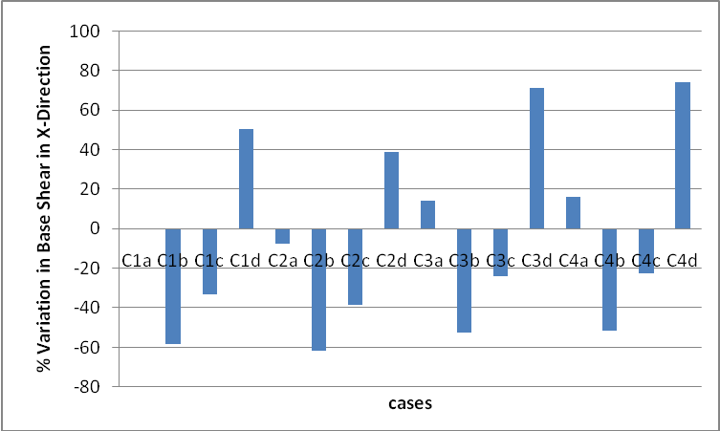

Bar Chart 5.1.1

Discussion: As we compare % variation in base Shear we observe following points

  - Base shear values in seismic zone 5 cases (C1d, C2d, C3d, C4d) are somewhere 40 to 70% more than the original building, this is because zone 5 has higher zone factor value (0.36) than original building which is situated in zone 4 with zone factor of 0.24.Also in Case C3d and C4d Live load is increased from 200kg/m² to 500 kg/m² which leads to high lateral forces.
  - Base Shear values in Seismic Zone 2 cases (C1b, C2b, C3b, and C4b) are somewhere 50 to 60% less than the original building, this is because zone factor value of zone 2 is 0.10, whereas original building is in zone 4 with zone factor of 0.24, which generate high seismic forces.

5.1.2 Comparison of Base Shear valuesin Z-Direction for different cases (with reference to numerical example considered)

Table 5.1.2 Comparison of Base Shear

SL No. | Case | Base Shear (KN) | % Variation in Base Shear
1 | C1a | 510 (Original building) | 0
2 | C1b | 213 | -58.24
3 | C1c | 340 | -33.33
4 | C1d | 765 | 50.00
5 | C2a | 475 | -6.86
6 | C2b | 198 | -61.18
7 | C2c | 316 | -38.04
8 | C2d | 713 | 39.80
9 | C3a | 580 | 13.73
10 | C3b | 242 | -52.55
11 | C3c | 387 | -24.12
12 | C3d | 870 | 70.59
13 | C4a | 546 | 7.06
14 | C4b | 228 | -55.29
15 | C4c | 364 | -28.63
16 | C4d | 819 | 60.59

Bar Chart presenting Comparison of percentage variation in base shear values in Z-Direction from original building (5.1.2)

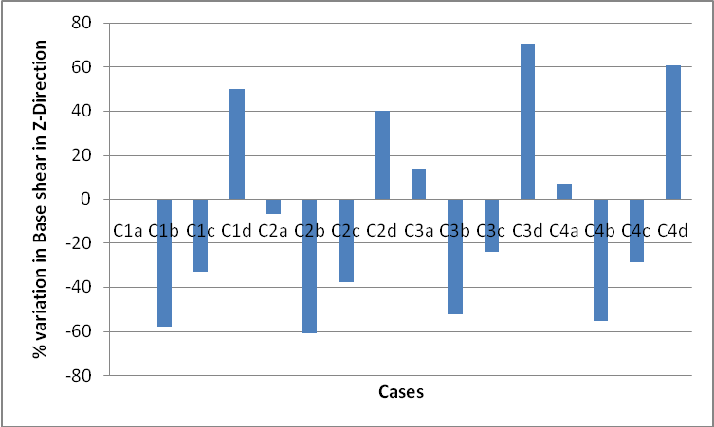

Bar Chart 5.1.2

Discussion: As we compare % variation in base Shear we observe following points

- Base shear values in seismic zone 5 cases (C1d, C2d, C3d, C4d) are somewhere 40 to 70% more than the original building, this is because zone 5 has higher zone factor value (0.36) than original building which is situated in zone 4 with zone factor of 0.24.Also in Case C3d and C4d Live load is increased from 200kg/m² to 500 kg/m² which leads to high lateral forces.
- Base Shear values in seismic Zone 2 cases (C1b, C2b, C3b, and C4b) are somewhere 50 to 60% less than the original building, this is because zone factor value of zone 2 is 0.10, whereas original building is in zone 4 with zone factor of 0.24, which generate high seismic forces.

5.1.3 Comparison of Time Period in X-Direction for Four basic reference cases (CaseC1a, Case C2a, CaseC3a, CaseC4a)
Table 5.1.3 Comparison of Time Period in X-Direction

SL No. | Case | Time Period (Second) | % Variation in Time Period
1 | C1a | 0.0857 (Original building) | 0
2 | C2a | 0.0846 | -1.28
3 | C3a | 0.0915 | 6.76
4 | C4a | 0.1058 | 23.45

Bar Chart presenting Comparison of percentage variation in Time period in X-Direction from original building (5.1.3)

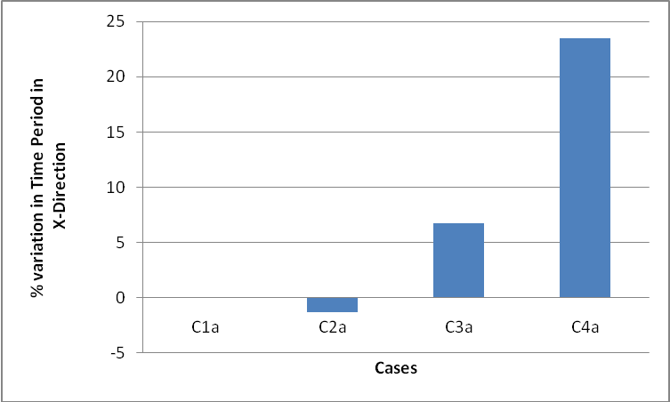

Bar Chart 5.1.3

Discussion: As we compare % variation in Time Period in X -Direction we observe following points:

- Time Period values in case 4a is around 23.5% more than original building. This because stiffness in X -Direction of building in case C4a is less than original building as some load bearing wall are removed from it.

- Time Period values in case 2a is around 1.2% less than original building.This is because stiffness in X -Direction of building in case C2a is marginally more than original building.

5.1.4 Comparison of Time Period in Z Direction for Four basic reference cases (CaseC1a, Case C2a, CaseC3a, CaseC4a)
Table 5.1.4 Comparison of Time Period in Z –Direction

SL No. | Case | Time Period (Second) | % Variation in Time Period
1 | C1a | 0.0918 (Original building) | 0
2 | C2a | 0.0921 | 0.32
3 | C3a | 0.0978 | 6.53
4 | C4a | 0.0936 | 1.96

Bar Chart presenting Comparison of percentage variation in Time period in Z-Direction from original building (5.1.4)

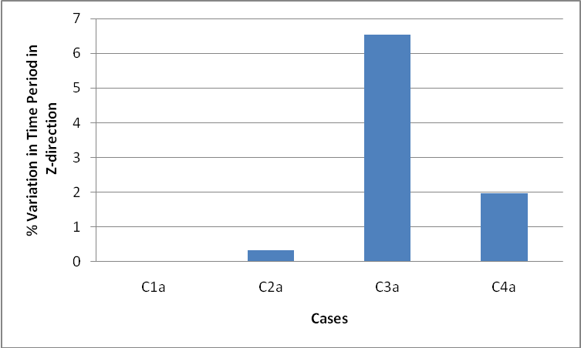 Bar Chart 5.1.4

Discussion: As we compare % variation in Time Period in Z -Direction we observe following points:
- Time Period values in case C3a is around 6.5% more than original building. This because stiffness in Z -Direction of building in case C3a is less than original building.

- Time Period values in case 2a is around 0.3% more than original building.This is because stiffness of building in Z -Direction in case C2a is marginally less than original building.

5.1.5 Comparison of Seismic Weight for Four basic reference cases (CaseC1a, Case C2a, CaseC3a, CaseC4a)

Table 5.1.5 Comparison of Seismic Weight

SL No. | Case | Seismic Weight (KN) | % Variation in Time Period
1 | C1a | 2680 (Original building) | 0
2 | C2a | 2491 | -7.05
3 | C3a | 2939 | 9.66
4 | C4a | 2839 | 5.93

Bar Chart presenting Comparison of percentage variation in Seismic Weight from original building (5.1.5)

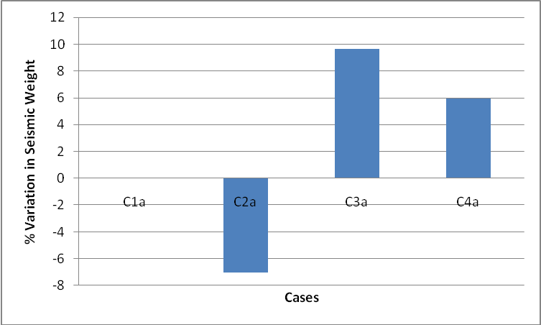

Bar Chart 5.1.5
Discussion: As we compare % variation in seismic weight we observe following points:

- Seismic weight values in case C3a is around 9.5% more than original building. This because in this case live load is increased from 200kg/m² to 500 kg/m²

- Seismic weight values in case C2a is around 7% less than original building. This because in this case live internal walls thickness was reduced to 115 mm from 230 mm.

5.1.6 Comparison of Story Drift values in X-Direction for different cases (with reference to original building considered)

Table 5.1.6 Comparison of Story Drift

SL No. | Case | Base Shear (KN) | % Variation in Base Shear
1 | C1a | .377 (Original building) | 0
2 | C1b | 0.157 | -58.36
3 | C1c | 0.251 | -33.42
4 | C1d | 0.566 | 50.13
5 | C2a | 0.358 | -5.04
6 | C2b | 0.149 | -60.48
7 | C2c | 0.239 | -36.60
8 | C2d | 0.537 | 42.44
9 | C3a | 0.433 | 14.85
10 | C3b | 0.181 | -51.99
11 | C3c | 0.289 | -23.34
12 | C3d | 0.65 | 72.41
13 | C4a | 0.445 | 18.04
14 | C4b | 0.185 | -50.93
15 | C4c | 0.296 | -21.49
16 | C4d | 0.667 | 76.92

Bar Chart presenting Comparison of percentage variation in StoryDrift in X-Direction from original building (5.1.6)

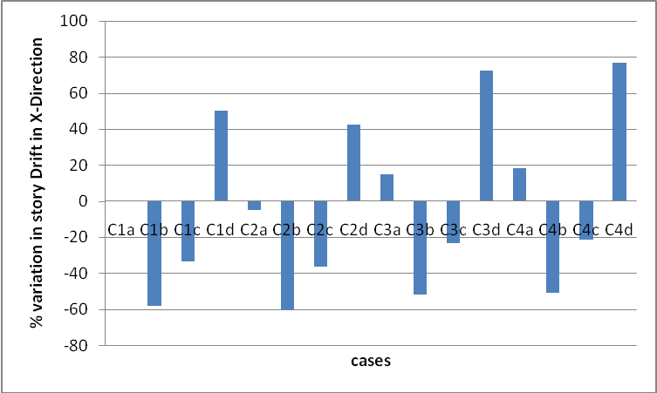

Bar Chart 5.1.6.

Discussion: As we compare % variation in Story Drift in X-Direction we observe following points

- Story Drift values in seismic zone 5 cases (C1d, C2d, C3d, C4d) are somewhere 40 to 75% more than the original building, this is because zone 5 has higher zone factor value (0.36) than original building which is situated in zone 4 with zone factor of 0.24.which leads to high lateral forces and high drift
- Story Drift values in seismic Zone 2 cases (C1b, C2b, C3b, and C4b) are somewhere 50 to 60% less than the original building, this is because zone factor value of zone 2 is 0.10, whereas original building is in zone 4 with zone factor of 0.24, which generate high seismic forces and high drift.

5.1.7 Comparison of Story Drift values in Z-Direction for different cases (with reference to numerical example considered)

Table 5.1.7 Comparison of Story Drift

SL No. | Case | Base Shear (KN) | % Variation in Base Shear
1 | C1a | 0.8 (Original building) | 0
2 | C1b | 0.383 | -52.13
3 | C1c | 0.533 | -33.38
4 | C1d | 1.199 | 49.88
5 | C2a | 0.787 | -1.63
6 | C2b | 0.327 | -59.13
7 | C2c | 0.524 | -34.50
8 | C2d | 1.18 | 47.50
9 | C3a | 0.864 | 8.00
10 | C3b | 0.36 | -55.00
11 | C3c | 0.576 | -28.00
12 | C3d | 1.296 | 62.00
13 | C4a | 0.837 | 4.62
14 | C4b | 0.349 | -56.38
15 | C4c | 0.558 | -30.25
16 | C4d | 1.255 | 56.88

Bar Chart presenting Comparison of percentage variation in StoryDrift in Z-Direction from original building (5.1.7)

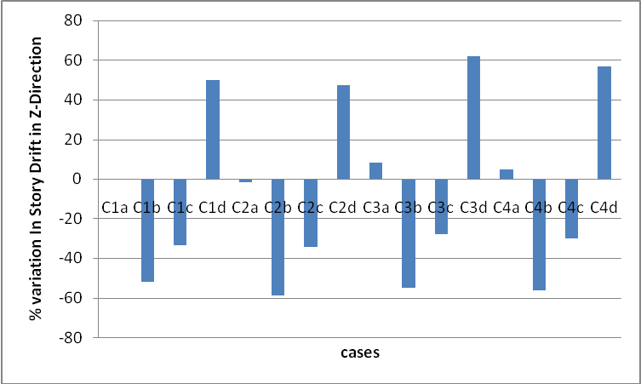

Bar Chart 5.1.7

Discussion: As we compare % variation in Story Drift in Z direction we observe following points

- Story Drift values in seismic zone 5 cases (C1d, C2d, C3d, C4d) are somewhere 45 to 65% more than the original building, this is because zone 5 has higher zone factor value (0.36) than original building which is situated in zone 4 with zone factor of 0.24 which leads to high lateral forces and high drift..
- Story Drift values in seismic Zone 2 cases (C1b, C2b, C3b, and C4b) are somewhere 50 to 60% less than the original building, this is because zone factor value of zone 2 is 0.10, whereas original building is in zone 4 with zone factor of 0.24, which generate high seismic forces and high drift.

Chapter 6

CONCLUSION AND FUTURE SCOPE OF STUDY

6.1 Conclusion

Analysis of a two storied masonry building was carried out to understand the seismic behaviour under change in occupancy conditions. Based on analysis following conclusion were drawn.

- From Table 5. 1. 1 and 5.1.2 it is observed that base shear values in cases where zone factor is higher than of original building (cases with Z=0.36) are higher compare to original building. Also this value of base shear decreases from original building in cases where zone factor values are less the original building ,when original building has a change in occupancy its base shear value can vary within -50to+70% generally for such a structure.
- From Table 5.1.3 and 5.1.4 it is observed that time period values in case C4a is more that original building , this is because the stiffness of building in this case is less than of original building as some structural members were omitted from it as a part of change in occupancy. When original building has a change in occupancy its time period value can vary within -1to 23%generaklly for such a structure.
- From Table 5.1.5 it is observed that seismic weight value in case C3a is higher than of original building this is because in this case live load as a part of occupancy changes is increased from 200kg/m2 to 500kg/m2 when original building has a change in occupancy its seismic weight value can vary within -7to9.5% generally for such a structure.
- From Table 5.1.6 to 5.1.7 it is observed that story drift values in cases where zone factor higher than of original building(cases with Z=0.36) are high as compare to original building this is because in these cases lateral forces are high which finally result in drift of building also this value of story drift decreases from original building in cases where Zone factor values are less that original building(Cases with Z=0.16 and Z=0.10),as in this case lateral forces are less as compare to original building. When original building has a change in occupancy its story drift value can vary within -50 to 75% generally for such a structure.
- Similar studies on different such structures may help in quantifying changes in different parameters. These may be helpful in taking quick decisions during the design of such structures.

  - Scope for future developments

As we have tried to study the seismic behaviour of masonry building under change in occupancy, still there are some areas where work can be done to attain a better idea of seismic behaviour of masonry building.

- Under revised occupancy conditions stresses (both axial & shear) in masonry building can be compared, and they can be checked for their permissible values .

- Analysis in present study is conducted ground+1 (Two storied) building. It can further be conducted on a building with higher number of floors, so that a better comparison of results can be done.

REFERCENCES

IS CODES

IS: 1905-1987 Code of Practice for Structural Use of Unreinforced Masonry

IS 1893(Part 1):2002 Criteria for Earthquake Resistant Design Of Structures

IS 4326:1993 Earthquake Resistant Design and Construction Of Buildings
Code of Practice

Text Books

T. Paulay and M.J.N.Priestley, “Seismic Design Of Reinforced Concrete and Masonry

Buildings”.

Technical Paper

Prof. A.S Arya, Earthquake Hazards Damage Proceeding of workshop on retrofitting of structure, Oct.2003.

