Chapter 1
INTRODUCTION
For a long time, concrete was very durable material but in recent years this is not true as the concrete is subjected to highly aggressive environments. In the recent revision of BIS-456- 2000, one of the major points discussed, deliberated and revised is the durability aspects of concrete. It is now recognized that strength of concrete alone is not sufficient, the degree of harshness of the environmental condition to which concrete is exposed over its entire life is equally important. Therefore, both strength and durability have to be considered explicitly at the design stage.
1.1 Aim and objectives
Aim:-To investigate the influence of acidic environment on different grade of concrete mixes
Objectives:-
- To determine the basic properties of cement, sand and coarse aggregate
- To prepare concrete mixes of different grades
- To examine these mixes for 180 days curing time in water and sulfuric acid of 0.2 N concentration.
- To perform the non destructive tests such as mass, rebound number, ultra sonic pulse velocity and destructive tests such as compressive strength of concrete after180 days curing in water and acid.
- To draw the stress strain curve and determine the modulus of elasticity
- To draw the conclusions

CHAPTER: 2
LITERATURE REVIEW
2.1 Durability Concepts
Concrete may deteriorate with time in a number of ways. The most common durability failures in an outdoor climate are due to reinforcement corrosion or frost attack. In special environments concrete may suffer form chemical attack by various substances such as sulfates, acids, soft water etc. causing disintegration or expansion. Durability failure may also occur because of internal expansion from concrete constituents that are swelling, usually because of a reaction product absorbing water. ‘Service life’ is a much better concept for describing the durability of concrete. The service life is defined as ‘the time during which a concrete fulfills its performance requirements’, without non-intended maintenance.
2.2 Forms of deterioration of concrete
The basic nature of deterioration is mainly of three types: chemical, physical or electrochemical, the latter concerning reinforcement corrosion. A chemical attack involves dissolution of substances or chemical reaction between substances and components of the concrete. Reaction products might cause problems, due to dissolution or expansion. Examples are numerous:
- Acid attack dissolving the binder from the concrete surface
- Sulphate attack from the surface, by ground water or sea water, or internal sulfate attack (‘delayed ettringite formation’) creating a reaction product that absorbs a significant amount of water, causing internal swelling and cracking
- Alkali-aggregate reaction from alkali from the cement, or the exterior, reacting with components of certain reactive aggregate, to produce expansive products.
- Carbonation or neutralization from weak acids, including airborne carbon dioxide, that reacts with components in the pore liquid, to reduce pH
- Soft water attack causing leaching of the alkalis and calcium oxide, that in turn causes dissolution of deposited calcium hydroxide Ca (OH)₂ and binder components.
A ‘pure’ physical attack could be a non-reacting liquid, or heat, penetrating into concrete or a concrete component, causing internal stresses and expansion, that will result in internal cracking or surface scaling. Examples are:
- Extreme temperature exchanges and gradients due to fire or other significant heating and cooling
- Frost attack or frost and salt attack
- Erosion, weathering etc.
The typical electrochemical attack is reinforcement corrosion, where chemical reaction at the anode and cathode are combined with an electrical current through the steel and through the concrete.
2.2.1 Chemical attack on concrete
This part deals first with sulphate attack and acid attack, these being the principal types of chemical attack that are of concern for concrete placed in the ground. The aggressive chemical agents responsible commonly occur in both natural ground and land contaminated by activities of mankind. Additionally, this part identifies the more rarely occurring forms of chemical attack, caused by high levels of chemical species such as ammonium and chromium, and organics such as phenols. Generally these agents are found in troublesome concentrations only in contaminated land. With some exception, specific guidance is not given in this special Digest in respect of protecting concrete from the action of these less commonly destructive agents.
Generally the protective principles applied in will be beneficial, for example, specifying a well-compacted concrete, with a low water/cement ratio or providing an appropriate protective coating. Specialist advice should be sought when appropriate. Finally, this part explains the action of aggressive carbon dioxide in respect of concrete in contact with flowing water. While not taken into account in a standard ground investigation or general concrete specification, the possible damaging effect of high levels of aggressive carbon dioxide are catered for the design of specific precast concrete products such as pipeline systems. The potential for this form of attack should also be taken into account when designing cast-in place structures that carry flowing water, e.g. culverts.
2.2.2. Principal type of chemical attack on concrete
Sulphate Attack
The essential agents for sulphate attack are sulphate anions these are transported to the concrete in various concentration is water, together with cations, the more common of which are calcium, magnesium and sodium. Where porous concrete is in contact with saturated ground the water phase is continuous across the ground/concrete interface and sulfate ions will be readily carried into the body of the concrete. Well compacted, dense, low water/cement ratio concrete in such an environment will, however, initially restrict access of the ions to the surface layer. Migration of sulfate ions from unsaturated ground into the concrete can take place by diffusion provided there is sufficient water to coat the particles of soil, but the rate will be slow and dependent on the sulfate concentration.
The reactions that take place when sulphates enter the concrete matrix are complex and contentious. There is extensive research literature on the topic, including some recent collaborative books and conferences. A simple guide is given here in order to understand the basic chemistry and resultant effects. The reactions have been demonstrated to depend on the type of cement, on the availability of reactive carbonate in, for example, the aggregate and groundwater, and on the temperature. Two separate forms of sulfate attack on Portland cement concretes are described here:
- A well-known type (commonly called the ‘conventional form of sulfate attack’) leading to the formation of ettringite and gypsum;
- A more recently indentified type producing thaumasite. In practice, both can operate together to some extent in field conditions in buried concrete.
Sulphate attack can only be diagnosed when the concrete in question is showing physical signs of degradation such as expansion (with or without notable cracking), surface erosion or softening of the cement paste matrix. The identification of levels of sulfate significantly greater than 4% by weight of cement within the surface of a visually sound concrete does not automatically imply that sulfate attack has taken place; it may only be a warning of potential attack in the future.
Conventional form of sulphate attack
For sulphate attack to occur leading to the formation of ettringite and gypsum in susceptible concrete the following must be present.
- A source of sulfates, generally from sulfates or sulfides in the ground;
- The presence of mobile ground water.
- Calcium hydroxide and calcium aluminates hydrate in the cement matrix. In the highly alkaline pore solution (pH>10) provided by the sodium, potassium and calcium hydroxides liberated during the cement hydration reactions, sulfate ions that have penetrated the hardened concrete react with calcium aluminates hydrate to form calcium sulfoaluminate hydrate (ettringite, CaO. A1₂0₃. 3CaSO₄. 31H₂O)
The formation of this mineral can be destructively expansive since it has a solid volume greater than the original constituents and it grows as myriad acicular (needle-shaped) crystals that can collectively generate high internal stresses in the concrete.
In sulphate-resisting portland cement (SRPC), the tri-calcium aluminates (C₃A in cement notation) level is kept to a minimum so reducing the extent of this reaction Incoming sulfate ions may also react with calcium hydroxide Ca(OH)₂ to form gypsum (calcium sulfate di-hydrate, CaSO₄. 2H₂O). This reaction product also has a greater solid volume than the original constituents and in some cases can contribute to degradation of the concrete. If magnesium ions accompany the sulfates, they may also react with calcium hydroxide, producing brucite (magnesium hydroxide, Mg (OH₂) which because of its low solubility precipitates out of solution, also leading to increase in solid volume. Magnesium ions also attack calcium silicate hydrates, the principal bonding material in set concrete. Laboratory tests show that the fist effect of the conventional form of sulfate attack is to increase the pore space. When it is filed, further ettringite formation induces expansive internal stresses in the concrete which, if greater that the tensile strength of the concrete, will expansively disrupt the affected region. This cracking together with white crystalline accumulations is the characteristic signs of the conventional form of sulphate attack.

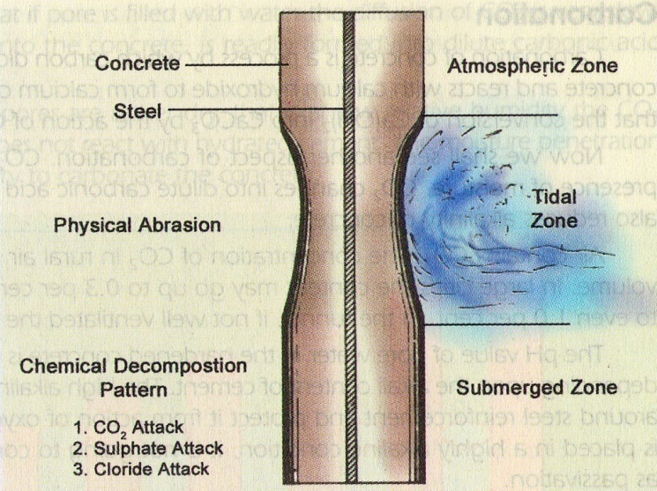

Figure 1 Deterioration of concrete exposed to seawater.
fj
gg
Reference M.S. Shetty
2.2.3. Acid attack
The acids most commonly encountered by concrete (all found in some natural ground waters) are carbonic acid, holmic and sulphuric acid. The first two are only moderately aggressive and will not produce a pH below about 3.5. Sulphuric acid is a highly ionized mineral acid and may result in a pH lower than 2. Other similarly aggressive mineral acid and may occasionally be found in ground contaminated by industrial processes.
The primary effect of any type of acid attack on concrete is the dissolution of the cement paste matrix. This weakens the affected concrete, but unlike sulfate attack, the degradation does not involve significant expansion. Neither ettringite nor thaumasite are stable in acid solution so that the reaction product from sulfuric acid attack will be primarily gypsum in concrete with siliceous gravel, granite or basalt aggregate, the surface attack will produce an ‘exposed aggregate’ appearance. However, in concrete with limestone (calcium carbonate) aggregates, the aggregate may dissolve at a rate similar to the cement paste and leave a smoother surface.
The rate of attack depends more on the rate of water movement over the surface and on the quality of the concrete, than on the type of cement or aggregate:
- Acidic ground waters that are not mobile appear to have little effect on buried concrete.
- Mildly acidic (pH above 5.5) mobile water will attack concrete significantly, but the rate of attack will be generally slow, particularly if the acids are primarily organic in origin.
- Flowing acidic water may cause rapid deterioration of concrete, therefore high quality concrete is needed. In the case of humic acid, reaction products formed on the surface of concrete are mainly insoluble and tent to impede further attack. Several cases of acid attack on concrete in the INDIA are described by Eglinton (1975) Occurrence of acidic ground conditions is dealt with in section and assessment of the ground conditions in relation to acidity and mobility of water is included in section.
2.2.4 Other types of chemical attack on concrete: - A large number of chemicals have been reported as attacking concrete, albeit most in the longer term at high concentration. For instance a USA document lists more than 100 potentially destructive inorganic and organic substances. The chance of encountering the vast majority of these in the ground is remote.
Magnesium ions
Magnesium is a common element in soil and groundwater but is generally only hazardous to concrete when the Mg⁺² cations is present in high concentrations in association with certain other chemical agents the key one being sulfate anions. Laboratory studies have found concretes made with some cements are by equivalent concentrations of sodium sulfate. Because of this effect, recommendations for concrete specification in this and previous digests have differentiated between low and high magnesium levels when combined with high sulfate concentrations. In practice the high Mg levels will be found in the ground having industrial residues. Other than the above, magnesium chloride (MgCI₂) is reported to be especially aggressive. The action of magnesium ions in concrete is complex, but a key mechanism is the replacement of Ca in calcium-silicate-hydrates that form much of the cement paste. This leads to a loss of the binding properties. Formation of brucite (Mg (OH)₂ and Mg- silicate hydrates is an indication of attack.

Ammonium ions
Ammonium ions (NH₄) will be a problem to concrete. Ground having chemical residues left by man (including in this case agriculture). Ammonium salts are reported to act as cation-exchange compounds, transforming the insoluble calcium in the hardened cement paste into readily soluble calcium salts that are subsequently leached away. During the reaction, ammonia is liberated and escapes as a gas. The removal of both reaction products results in an increase in the porosity of the concrete, leaving it vulnerable to further attack.
Ammonium salts are also reported to act as weak acids and neutralize the alkaline hardened cement paste; the removal of the hydroxide ions results in softening and gradual decrease in strength of the concrete. In addition to the corrosive action of the ammonium ion, some further deterioration may be caused by the action of the associated anions. Ammonium sulfate, (NH₄), is one of the most aggressive salts to concrete; cases of attack have occurred resulting from spillage of the material around fertilizer stores.
Assessment of ammonium concentration is not specifically include in the scheme presented in this document for assessment of ground aggressive to concrete, or for guidance given for specification of chemically resistant concrete. Specialist advice should be sought if the presence of ammonium ions is suspected.
Chloride ions
Chloride (Cl) is a common anion in soil and groundwater, in most cases being associated with sodium (NaCI is common salt). However, the levels of chloride found in the ground are generally chemically innocuous; indeed, they may be beneficial since there is considerable evidence, from seawater studies, that the presence of chloride generally reduces sulfate attack. This is taken into account for brackish water (12000-17000mg/I chloride) the risk of corrosion of embedded metals in buried concrete in non-aggressive soil is generally lower than in externally exposed concrete. However, high chloride concentration in the ground will increase the risk of corrosion, since chloride ions may migrate into the concrete and lead to a reduction
in passivity at the metal surface. The recommendations for the protection of steel reinforcement given in BIS 8500-I should be followed.
On brown field sites that have industrial residues, the presence of chloride ions, together with a pH below 5.5, could indicate the existence of hydrochloric acid that may cause acid attack. It will, therefore, be important to determine the amount of chloride in the soil and/ or groundwater during site investigation. The procedure for taking account of the measured chloride content in this particular circumstance. Apart from this and the need to identify brackish and sea waters, no account is taken of chloride concentration in the procedure for concrete specification given in Section. Specialist advice should be sought if exceptionally high chloride levels are encountered, for example, related to past industrial use of land. Such high concentration has been reported as chemically affecting hardened concrete. Detrimental mechanisms include the reaction of calcium and magnesium chlorides with calcium aluminate hydrate to form chloroaluminates which may result in low-medium expansion of concrete.
Organic compounds
Phenols are the most commonly encountered troublesome organic group. These are contaminants typically generated as by-products during the manufacture of town gas, tar and coke. The concentrations present are rarely sufficient to attack hardened concrete. However, their presence may well affect the setting of concrete through an inhibition or modification of the hydration of the cement where in in-situ concrete is placed directly against ground suspected of substantial contamination by phenols, consideration should be given to the use of a barrier, such as polyethythene sheeting, as protection during the setting and hardening period. It has been reported that where phenol is present in exceptionally high concentration (eg several thousand mg/I), it has the potential to attack hardened concrete. The phenol is said to react with calcium hydroxide in the cement paste form calcium phenolate. This crystallizes in the pores of the concrete causing deterioration as a result of physical expansion. In addition to naturally occurring humic acid derived from decay of organic matter, acids may also occasionally be produced by activities of man, for example lactic acid, acetic acid and butyric acids.

Attack from aggressive carbon dioxide
Aggressive carbon dioxide is relevant only to certain situations where water is continually flowing over (or seeping through) the concrete. Diversion pipes or culverts around dams retaining moorland waters containing high concentration of aggressive carbon dioxide ca be subject to erosion, as can poorly compacted concrete, or permeable concrete products (for example some aggregate concrete blocks) used in foundations.
Calcium carbonate (CaCo₃) is practically insoluble in water but calcium bicarbonate (Ca(HCO₃)₂) is soluble. Where carbon dioxide dissolves in water, carbonic acid (H₂CO₃) is formed and this will react with any carbonated cement (or limestone aggregate) to form calcium bicarbonate that goes into solution. This is how swallow holes and caves are formed in limestone. With bicarbonate ions (HCO₃) now in solution, a certain amount of the dissolved carbon dioxide will be needed to stabilize it, so there will be less available to attack further carbonated concrete. It is this remaining available portion of the dissolved carbon dioxide that is referred to as ‘aggressive’. Measures to take account of aggressive carbon dioxide for some uses of specific precast concrete products are incorporated into guidance for specific precast concrete products. These measures are also relevant to cast-in-situ structures that are in contact with flowing water containing aggressive carbon dioxide.
Attack from pure water
‘Pure’ (soft) water, which contains low concentrations of dissolved ions, is aggressive when it flows in quantity over a concrete surface. Concrete surfaces that are carbonated are less prone to this form of attack.
Damage to concrete from crystallization of salts.
In addition to causing chemical attack on concrete, soluble compounds originating in the ground can led to degradation of concrete through a physical mechanism involving crystallization of salts, usually sulfates or chlorides, near to the concrete surface. A classic scenario for this its where concrete of high permeability is partly buried in wet sulfate or chloride bearing ground and partly exposed to air. Sulfates or chlorides in solution may be drawn through the concrete by capillary suction to evaporate at or close to the free surface.
Crystallization of salts in pores close to the surface of the concrete may generate expansive stresses that disrupt the concrete, while surface salt deposits form a characteristic efflorescence. The process may be aggravated by repeated wetting and drying of the exposed concrete surface; this leads to cyclical salt precipitation and dissolution and fatigue stressing of the concrete fabric. Additionally, where crystallization initially occurs at a relatively high temperature producing an anhydrous salt, subsequent wetting may lead to conversion to a hydrous crystalline form of substantially greater volume. A salt particularly implicated in this latter mechanism is sodium sulfate which, subjected to alternate wetting and drying, may alternate between anhydrous thenardite (Na₂SO₄) and hydrous mirabilite (Na₂504. 10H₂O), with a change in crystalline volume of some 300% and a potentially large cyclical stress change. A comprehensive discussion of the topic is included in sulfate attack on concrete. In the INDIA, degradation of partly buried concrete due to crystallization of salts originating from the ground is rarely a problem. For most ground conditions, the measures recommended here to mitigate chemical attack on concrete (and in particular specified free water/cement ratios of 0.5 or less) should also be effective against physical degradation due to crystallization of likely salts.
2.3 Durability performance of concrete containing condensed silica fume
B.J. Magee et.al (1999) studied on the durability performance of various condensed silica fume concrete in comparison to portland cement concrete. Mix proportions were designed to provide 28-day strengths of 30,40,and 50 MPa. Concrete durability was inferred from a suite of durability index tests designed to measure concrete resistance to gas, liquid and ion transport mechanism. It is shown that concrete durability is dramatically improved through the use of CSF. Optimum performance was achieved through the use of CSF as a 10% addition by mass to initial binder content.

2.4 Durability of concrete made with EAF slag as aggregate
Milagros Losanez et.al (2006) studied on the use of electric arc furnace slag in hydraulic concrete and bituminous mixtures. Concrete made with EAF oxidizing slag as an aggregate shows good physical and mechanical properties and the durability of slag concrete is acceptable, though slightly lower than that of conventional concrete. When the mix proportions are adequate, both the mechanical strength and the durability of slag concrete are satisfactory but the high porosity of EAF slag is an obstacle to making a concrete resistant to freezing. Eventual improvements in this field could be further analysed by adding specific admixtures.
2.5 Effect of lime putty addition on durability properties of concrete
P. Mira et.al (2001) studied on the effect of lime putty addition on main structural and durability properties of concrete .Different types of cement were used for concrete preparation such as Portland cement, pozzolanic cement and the Portland cement with the 20% by mass of fly ash. It was found that the lime putty addition in concrete improves the compressive strength when pozzolanic materials are used in parallel. The compressive strength of OPC concrete exhibits significant variation in the presence of lime putty taking either higher or lower values than that of OPC concrete without lime putty. When lime putty is added in concrete that contains pozzolanic materials, a significant improvement in durability is observed. Adenser structure is created, which is responsible for the lower degree of concrete carbonation due to chloride attack.
2.6 Effect of freezing and thawing on durability properties of concrete
M.S. Shetty studied on the durability of concrete on account of freezing and thawing. Action of frost is not of great importance to Indian conditions. But it is of greatest considerations in most part of the world. However, certain regions in India, experience sub-zero temperatures in winter. The concrete structure particularly, the one which are exposed to atmosphere are subjected to cycles of freezing and thawing and as such suffer from the damaging action of frost.
The frost action is one of the most powerful weathering actions on the durability of concrete. In the extreme conditions, the life span of concrete can be reduced to just a couple of years. Though the durability of concrete is affected by alternative wetting and drying, heating and cooling, penetration and deposition of salt and other aggressive chemicals, leaching of calcium hydroxide, action of certain acids, alkali-aggregate reaction, mechanical wear and tear, abrasion and cavitations, one of the very important factors affecting the durability of concrete in the cold countries, is the action of frost.
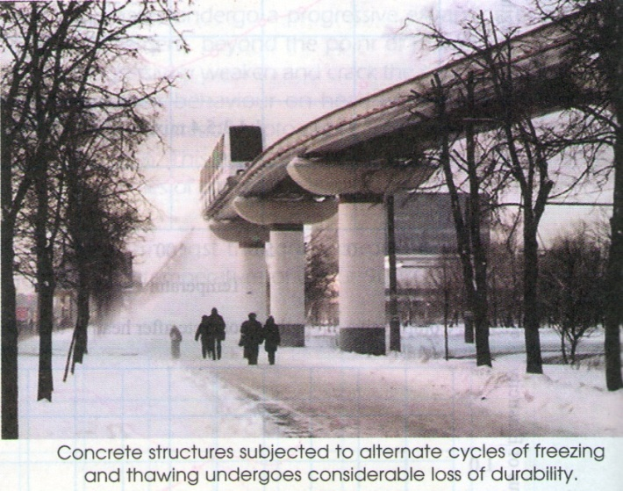
It is very well known that fresh concrete should not be subjected to freezing temperature. Fresh concrete contains a considerable quantity of free water, if this free water is subjected to freezing temperature discrete ice lenses are formed. Water expands about 9% in volume during freezing. The formation of ice lenses formed in the body of fresh concrete disrupt the fresh concrete causing nearly permanent damage to concrete.
The fresh concrete once subjected to forst action, will not recover the structural integrity, if later on allowed to harden at a temperature higher than the freezing temperature. Therefore, the fundamental point to note in dealing with cold weather concreting is that the temperature of the fresh concrete should be maintained above 0⁰C. The hardening concrete also should not be subjected to an extremely low temperature. It has been estimated that the freezing of water in the hardened concrete may exert a pressure of about 14 MPa. The strength of concrete should be more than the stress to which it is subjected at any point of time of withstands the damaging action.
Figure 2Reference M.S. Shetty

2.7 Sulphate attack on alkali-activated slag concrete
Rangan and shah et.al (1971) studied on the use of alkali-activated slag in concrete manufacturing has environmental benefits as its production requires less energy than ordinary portland cement and it utilizes industrial by-products. AAS concrete was also reported to have a superior durability in aggressive environments as compared to OPC. However, variability in chemical composition of slag may have and effect on its durability, and concrete prepared using different slags may have different resistance in aggressive media. This paper presents the study of the durability of AAS concrete produced using Australian slag in sulfate environment. Sulfate attack is known to produce significant degradation in concrete structures. Therefore, much attention was drawn to provide an adequate protection for a concrete in contact with surrounding with high content of sulfate ions.
It was established that the sulphate attack on OPC concrete is associated with the chemical reaction of sulfate ions as the aggressive substance and the aluminates component of hardened cement paste. The reaction between these substances, if enough water is present, produces ettringite and gypsum and causes expansion of the OPC concrete, leading to cracking with an irregular pattern. These cracking gives easier access to further penetration of sulphates and the process continues up to complete disintegration. In 1930s, it was established that OPC concrete that was low in aluminum had a superior resistance in sulphate environment. Later, it was found that slag concrete had good durability in sulfate environment and the mode of degradation of slag concrete was different from that of OPC concrete.
At the same time as time as the sulphate attack, the attack of magnesium ions and, to a lesser extent, the sodium ions on C-S-H starts when CH is depleted. This attack leads to gypsum precipitation and decalcification of C-S-H. The decalcification of C-S-H destroys the binding capacity of C-S-H and leads to a loss of adhesion and strength in concrete. Two tests were used to determine resistance of AAS concrete to sulphate attack. These tests involved immersion in 5% magnesium sulphate and 5% sodium sulfate solution. The compressive strength measurements showed that the strength of AAS concrete decreased by up to 17% for AAS concrete and up to 25% for OPC concrete in the case of sodium sulfate solution. In the case of the magnesium sulphate solution, the compressive strength decrease was more substantial, up to 37% for OPC, and 23% for AAS. The main products of degradation in sulphate attack are gypsum and ettringite in the case OPC concrete and gypsum in the case of AAS concrete.
2.8 Durability of concrete with high cement replacement
W. Chan et.al (2000) studied on the durability of concrete made from various non-reactive waste materials, i.e. carbon black, silts and clays, and with various water contents were investigated. It was found that the critical problem of maintaining or increasing the designed workability could be solved by using high specific surface area material and with the superplasticizer admixture. The present study also indicated that and alternative durable concrete could also be made with 25% by volume of cement replaced with silts and clay using a water/cement (w/c) ratio of 0.5. That is, the cement and water contents were less than those in OPC. Also, the cost of concrete will be lowered.
The primary requirements of durability of concrete are strength, workability and impermeability. These could be satisfied even with 25% of the cement replaced by waste or recyclable material. The use of this type of new formulation will be environmentally friendly. The sorptivity and permeability of given concrete mix were found to be independent of the cement content to provide nearly the same compressive strength. However, water sorptivity and permeability decreased with increasing concrete strength. As a result, water content and densification of mix proportion would be the governing factors to sorptivity and permeability.
Finally, the problem of maintaining or increasing the designed workability can be solved by using high specific surface area material with a superplasticizer admixture.
2.9 The influence of superplasticizer and superfine mineral powder on the flexibility, strength and durability of HPC
Reverte gatt et.al (1994) studied on the change of workability, strength and durability, including the resistance to freezing and thawing, sulphate attack and diffusion coefficient of chloride, of high-performance concrete in which part of the ordinary Portland cement was replaced by superfine mineral powder of phosphoric slag (SFPS). The results of this study show that the partial replacement of OPC by SFPS can increase the fluidity, improve the compressive strength, decrease the chloride diffusion coefficient of concrete and obtain good durability of HPC.

Traditional concrete, which is primarily made of only three fundamental ingredients, i.e., aggregates, cement and water, has been used for over a century. In recent years, a new type of concrete termed high-performance concrete (HPC) has become popular in the concrete construction industry. This type of concrete usually uses superplasticizer (SL), superfine powder, and segregation reducing powder, aggregates and cement. One of the most important principles is to use the least amount of cement in the HPC. The reasons for supporting this standpoint are threefold. The first is for preserving our natural resources, since cement is the most expensive and energy-consuming ingredient compared with the other constituents in concrete. The second is for economic reasons of saving the cost of materials and energy. The third reason is for long-term durability considerations, since an excessive amount of cement in concrete results in a higher heat of hydration, as higher creep and shrinkage and a higher risk of cracking.
2.10 Effect of SCM on the strength and durability of short-term cured concrete
N. Delatte et.al (2000) studied the effect of different supplementary cementitious materials such as silica fume, fly ash and slag on strength and durability of concrete cured for a short period of time. Over 16 mixes were made and compared to the control mix. Each of these mixes was either differing in the percentage of the additives or was combination of two or more additives. All specimens were moist cured for 14 days before testing. It was found that at 14 days of curing the use of supplementary cementitious materials reduced both strength and freeze-thaw durability of concrete. The combination of 10% silica fume, 25% slag and 15% fly ash produced high strength and high resistance to freeze-thaw exposures as compared to other mixes.
2.11 Effectiveness of surface coatings in improving concrete durability
F.M. Khan et.al (2000) studied on the durability of concrete coated with concrete surface coatings. The durability of the uncoated and coated concrete specimens was evaluated by assessing water absorption, chloride permeability and chloride diffusion. The chemical resistance was evaluated by immersing the specimens in 2.5% sulphuric acid. The results show that epoxy and polyurethane coatings performed better than acrylic, polymer and chlorinated rubber coatings.

Chapter 3
MATERIALS and METHODS
3.0 MATERIALS USED FOR THE INVESTIAGTION:
The materials used for the manufacturing of various grade of concrete and its properties determined as per recommendations of BIS in the following paragraph.
3.1 CEMENT
The shree ultra 43 grade cement (OPC) of one batch was procured in the laboratory .The determination of physical properties of the cement is carried out in laboratory as explained briefly in the following paragraph. The chemical properties of the cement was determined by Shri Ram Testing Institute, Delhi by using spectro photometer
Table No. 3.1. Physical characteristics of cement
Sr. No | Properties | Referred Code | Value | Codal Requirement
1 | Fineness (cm²/g) | IS:4031(P-2)-1999 | 2880 | 222 Min
2 | Specific Gravity |  | 3.16 | -
3 | Soundness | IS: 4031(P-3)-1988 | 1.6 | 30
4 | Normal consistency |  | 31.0 | 30
5 | Initial Setting Time (min) | IS:4031(P-5)-1988 | 65 | -
6 | Final Setting time (min) | IS:4031(P-5)-1988 | 235 | 600 Max

Table No.3.2 Chemical Properties of Cement
Sr No. | Chemical | Chemical compositions (%)
1 | Loss of ignition | 2.02
2 | SiO₂ | 20.6
3 | Al₂O₃ | 3.23
4 | Fe₂O₃ | 5.4
5 | CaO | 64.76
6 | MgO | 1.4
7 | SO₃ | 3.4
8 | Free Lime | 1.49

3.2 AGGREGATES
An aggregate are the important constituent in concrete. They give body to the concrete, reduce shrinkage and effect economy. The mere fact that the aggregate occupy 70-80 per cent of volume of concrete, their impact on various characteristics and properties of concrete is undoubtedly considerable.
(A) Coarse aggregates. For this study we procure the natural coarse aggregate from the market and performed the two tests namely specific gravity and sieve analysis for gradation

(a)Specific gravity using pycnometer is given by the expression
Specific gravity = (W₂ – W₁) / ((W₂- W₁)-(W₃ – W₄))
= (1298 – 690) / ((1298 -690) – (1956 - 1575))
= 2.67
Where,
W₁ = Wt. of empty pycnometer = 690 gm
W₂= Wt. of pycnometer + Wt. of oven dried sand = 1290 gm
W₃ = Wt. of pycnometer + sand + water = 1956 gm
W₄= wt. of pycnometer + water. = 1575
(b) Sieve analysis
Table No.3.3 Sieve Analysis of Aggregate
IS Sieve Size | Wt. Retained kg | Cumulative Wt.Retained kg | Cumulative percentage .Retained | Cumulative percentage passing
20 mm | 6 | 6 | 40 | 60
10 mm | 5 | 11 | 68.4 | 31.6
4.75 mm | 4 | 15 | 100 | 00
2.36 mm | -- | -- | 100 | 00
1.18 mm | -- | -- | 100 | 00
600 micron | -- | -- | 100 | 00
300 micron | -- | -- | 100 | 00
150 micron | -- | -- | 100 | 00
 | Σ 15 kg
Fineness Modulus = (708.4/100) = 7.08

Fine aggregate: For this study we procure the Badarpur sand form vendor as per BIS code for fine and coarse aggregates. We perform the sp. gravity, silt content and sieve analysis and bulking of sand. All test result on aggregates are follows
(B)Sand
(a)Specific Gravity using Pycnometer is given by expression
Specific gravity = (W₂ – W₁) / ((W₂- W₁)-(W₃ – W₄))
= (1300 - 695) / (1300 -695) – (1902 - 1531))
= 2.60
Where,
W₁ = Wt. of empty pycnometer = 692 gm
W₂= Wt. of pycnometer + Wt. of oven dried sand = 1310 gm
W₃ = Wt. of Pycnometer + sand + water = 1902 gm
W₄= wt. of pycnometer + water. = 1531gm
(b)Bulking of sand
Free moisture forms a film around each particle this film of moisture exerts what is known as surface tension which keep the neighboring particles away from it .Similarly the force exerted by surface tension keep every particle away from each other. Therefore, no point of contact is possible between the particles. This phenomenon is called bulking of sand
The bulking of fine aggregate is determined in laboratory using measuring jar. The result obtained is given in Table no 3.4

Table No.3.4 Estimation Bulking of Sand
% of water | Initial Reading (h1) | Final Reading (h2) | Volume of Bulking  (h2–h2)/h1 x 100
5 % | 200 | 215 | 6.97 %
10 % | 200 | 220 | 9.09 %
15 % | 200 | 195 | 2.56 %
20 % | 200 | 150 | 1.33 %

(D)Silt content test.
In sand sample contain appreciable amount of clay as in that case silt and clay sized particles will stick to sand sized particles. The pipette testing is used for the determination of silt content in sand, The silt content in sand sample is given in table no 3.5
Table No.3.5 Silt content Test
Sr.No. | Silt above Sand height Sand | Sand height below silt | Silt Content
1 | 2 ml | 58 | (2/55)x100 =3.4%

(d) Sieve analysis
Sand sample: - Wt of sample 1000 gm

Table No 3.6 Grading zones for coarse and fine aggregate from natural sources for concrete (as per IS Code 383: 1970)
Sr. No | IS Sieve Size in mm | Percentage passing for |  |  |  | Sand Sample
Sr. No | IS Sieve Size in mm | Grading  Zone I | Grading  Zone II | Grading  Zone III | Grading  Zone IV | Sand Sample
1 | 10 | 100 | 100 | 100 | 100 | 100 %
2 | 4.75 | 60-95 | 90-100 | 90-100 | 90-100 | 100 %
3 | 2.36 | 30-70 | 75-100 | 85-100 | 95-100 | 100%
4 | 1.18 | 35-59 | 55-90 | 75-100 | 90-100 | 87.5%
5 | 0.600 | 15-34 | 60-79 | 80-100 | 80-100 | 66.50 %
6 | 0.300 | 5-20 | 8-30 | 12-40 | 15-50 | 26.40%
7 | 0.150 | 0-10 | 0-10 | 0-10 | 0-15 | 3 %

Sand Sample Satisfy and confirming the Zone III As per IS 383:1970
Table No.3.7 Sieve analysis of sand sample.
Wt of sample | Sr.No. | Sieve Size | Wt. Retaind | Wt. Passed | % age Passing | Requirement of Zone III Type
1000 gm | 1 | 10 mm | 0 | 1000 | 100 % | 100%
1000 gm | 2 | 4.75 mm | 0 | 1000 | 100 % | 90-100
1000 gm | 3 | 2,36 mm | 0 | 1000 | 100 % | 85-100
1000 gm | 4 | 1.18 mm | 122 | 878 | 87.8 % | 75-100
1000 gm | 5 | 600 micron | 213 | 665 | 66.50 % | 60-100
1000 gm | 6 | 300 micron | 401 | 264 | 26.40 % | 12-40
1000 gm | 7 | 150 micron | 234 | 30 | 3 % | 0-10

3.3 Admixture:
The admixtures is procured from the fosroc chemical limited as we expected that the slump value for water/cement ratio 0.5,0.42,0.4,0.35,0.45and is observed to be very low, so we used the fosroc admixture for workability test on concrete. In this study we take the 1.5 % wt of cement to get 100 to120mm slump..
3.4 Water:
In making concrete and for curing simple tap water are used
3.5 Mix design
According to IS: 456:2000 and IS: 1343-1980 the design of concrete mix should be based on the following factors:
- Grade of designation
- Types of Cement
- Maximum nominal size of aggregates
- Grading of combined aggregates
- Water- Cement ratio
- Workability
- Durability
- Quality control.

    - Mix design calculation
- Design stipulations:
Compressive strength = 20 Mpa
Degree of workability =0.70
Degree of quality control = Good
Types of exposure = Mild

- Test data for materials
Cement sp.gravty =3.05
Sp. gravity of coarse =2.68
Sp gravity of fine sand=2.6
3) Target mean strength = fs + K*S
= 20+ 4.6*1.65
=27.59
- Water cement Ratio- = from graph of SP-23-1982
The w/c ratio for 27.59 Mpa is 0.50 < 0.65
- Selection of water content= from tables and graph of grading zone III of sand the water content is 180 kg + adjustment
= 180.42
- Cement content = w/c ratio is 0.50
Cement = 180.42/0.50
= 360.84Kg
- Determination of coarse and sand content= taking 2% of amount of air in the wet concrete.
V=(W +(C/SP.G) + (1/p)*(FA/Sp.G) ) * (1/1000)
FA =584 Kg
CA= 1223.8 Kg
Table No.3.8 The final mix proportion for concrete
Water | Cement | Fine Aggregate | Coarse Aggregate
180.42 | 440 kg | 584 kg | 122.83 kg
0.50 | 1 | 1.62 | 3.4

3.5.2 Mix design calculation
- Design stipulations:
Compressive strength = 25 Mpa
Degree of workability =0.80
Degree of quality control = Good
Types of Exposure = mild
- Test Data for materials
Cement sp.gravity =3.05
Sp. gravity of coarse aggregate =2.7
Sp gravity of fine sand=2.7
- Target mean strength = fs + K*S
= 35+ 4.6*1.65
=32.59
- Water cement Ratio- = from graph of SP-23-1982
The w/c ratio for .48 Mpa is 0.48 < 0.65
- Selection of water content= from tables and graph of grading zone II of sand the water content is 186 kg + Adjustment
= 18o + 5.58 = 185.58 kg
- Cement content = W/C ratio is 0.48
Cement = 386.62 Kg
- Determination of coarse and sand content= Taking 2% of amount of air in the wet concrete.
V= (W +(C/SP.G) + (1/p)*(FA/Sp.G)) * (1/1000)
FA=556.06 kg
AND CA =1248.3 Kg

Table No.3.9 Final mix proportion for concrete
Water | Cement | Fine Aggregate | Coarse Aggregate
185.58 | 386.62 kg | 576.06 kg | 1238.3 kg
0.48 | 1 | 1.48 | 3.20

    - MIX DESIGN OF M-30
- Design stipulations:
Compressive Strength = 30 Mpa
Degree of workability =0.80
Degree of quality control = Good
Types of Expouse = Mild
- Test Data for materials
Cement sp.Gravity =3.05
Sp. Gravity of coarse =2.7
Sp gravity of fine sand=2.7
- Target mean Strength = fs + K*S
= 30+ 6.5*1.65
=38.25
4) Water cement Ratio- = from graph of SP-23-1982
The w/c ratio for 38.25 Mpa is 0.42 < 0.65

5) Selection of water content= from tables and graph of grading zone III of sand the water content is 180 kg + Adjustment
= 180 + 5.22 = 185 kg
6) Cement content = W/C ratio is 0.42
Cement = 185/0.42
= 440 Kg
7) Determination of coarse and sand content= Taking 2% of amount of air in the wet concrete.
V= (W +(C/SP.G) + (1/p)*(FA/Sp.G) ) * (1/1000)
FA=342.95 KG
AND CA = 1201.3 KG

Table No.3.10 The final mix proportion for concrete
Water | Cement | Fine Aggregate | Coarse Aggregate
195 | 440 kg | 343.95 kg | 1201.3 kg
0.43 | 1 | 1.28 | 2.656

    - Mix design of M- 35
- Design stipulations:
Compressive Strength = 35 Mpa
Degree of workability =0.90
Degree of quality control = Good
Types of Exposure = Very sever

- Test Data for materials
Cement sp.gravity =3.05
Sp. Gravity of coarse =2.7
Sp gravity of fine sand=2.7
- Target mean Strength = fs + K*S
= 35+ 6.5*1.65
=45.725
- Water cement Ratio- = from graph of SP-23-1982
The w/c ratio for 45.725 Mpa is 0.45 < 0.65
- Selection of water content= from tables and graph of grading zone II of sand the water content is 186 kg + Adjustment
= 186 + 5.58 = 191.58 kg
- Cement content = W/C ratio is 0.45
Cement = 425.3 Kg

- Determination of coarse and sand content= Taking 2% of amount of air in the wet concrete.
V= (W +(C/SP.G) + (1/p)*(FA/Sp.G)) * (1/1000)
FA=556.06 kg
AND CA =1248.3 Kg
Table No.3.11 Final mix proportion for concrete
Water | Cement | Fine Aggregate | Coarse Aggregate
191.58 | 425.3 kg | 556.06 kg | 1248.3 kg
0.45 | 1 | 1.31 | 2.99

    - Mix Design M-40
Compressive strength =40 Mpa
Degree of quality control = good
Degree of workability =. 0.8
Type of exposure = sever
Sp. gravity of cement = 3.15
Sp. gravity of coarse aggregate = 2.65
Target mean strength = 48.25
Assume w/c ratio = 0.4
Assume cement content = 400 kg/m³ as per min
Quantity of water .4x400 =160 kg <186kg
Calculation of coarse aggregate =1168 kg
Calculation of fine aggregate =660 kg
Final proportion

Water | Cement | Fine Aggregate | Coarse Aggregate
160 kg | 400 kg | 660 kg | 1168 kg
0.4 | 1 | 1.65 | 2.92

3.5.6 Mix Design M-45
(1)Target mean strength of concrete
45+ [7*1.65] =56.55
(2) Selection of w/c ratio=0.35(assume)
= 180 kg/m3 [as per table no IS 10262]
As plasticizer is proposed we can reduced water content by 20%
Now water content =180*0.8=144kg/m3
(3) Calculation of cement content
Cement content = 144/0.35=411.4kg/m3
(4) Sand as percent of total aggregate by absolute volume=25%
(5) Fine aggregate=425kg/m3
(6) Coarse aggregate = 1502kg/m3
Water | Cement | F.A. | C.A
0.35 | 412 | 425 | 1502

Water | Cement | F.A. | C.A
0.35 | 1 | 1.03 | 3.64

3.6 EXPERIMENTAL SETUP AND TEST PROCEDURE
In this study, an ordinary Portland cement 43 grade with specific gravity 3.16 was used as a cementations material.
With specific gravity of 2.34 coarse aggregate and specific gravity of 2.75 fine aggregate used in the test and super plasticizer was used to achieve the required work ability (slump value 100 mm + 20 mm) of the concrete mixes.
Concrete mixes were prepared for six different grade M-20 to M-45 having w/c ratio 0.50 and 0.35 respectively.
The proportioning and description of concrete mixture are summaries in Table (3.8) fresh concrete mixtures were prepared in mixer. The sequence of mixing procedure was as follows
- The aggregates were placed in the mixer and dry mixed for two minutes.
- Half of the water with addition of superplasticizer was added to mixture and the mixture is run for two minutes.
- Afterwards, cement and the remainder of water +superplasticizer were added to the mixer and the mixer was run for and additional two minutes. Total mixing time was six minutes for all concrete mixtures
100mm x 100mm x 100mm cube and 150mm diameter and 300mm height cylinder specimen were prepared for uniaxial compression strength and split tensile strength test.
Immediately after mixing and casting of concrete, the cube molds were stored in humidity room for 24 hrs at 95 % relative humidity and 20°C temperature. Then the cube and cylinder specimens were removed from the mould and cured in water for 180 days and 0.4N acidic environment of sulphuric acid. At the end of the curing periods, all specimens were dried at room temperature for 24 hr. specimens were exposed to air. The compressive strength, split tensile strength, mass loss, rebound no. and ultrasonic pulse velocity tests were perform on all specimens concrete mixture.

3.7 Test on Hardened concrete
3.7.1 Mass Test: the mass test is performed on cube size 100x100x100 the electronic balance is used to determine the mass of cube sample of 6grade of concrete. The details of test results is given in test result chapter 4 and it is shown in Graph 4.1.
3.7.2 Rebound hammer Test: Schmidt’s rebound hammer developed in 1948 is one of the commonly adopted equipments for measuring the surface hardness. Rebound hammer is performed because of it provide the quick inexpensive means of checking uniformity of concrete. The method is based on the principle that the rebound of an elastic mass depends on the hardness of the surface which it strikes. The test is fast and is unlikely to cause damage to the concrete
The rebound hammer is carried on the cube sample and rebound number is correlate with the compressive strength of concrete. The details of rebound number is given table No 4.4 and it is shown in fig.3.1
Fig.3.1 Rebound Hammer
3.7.3 Ultra sonic Pulse Velocity Test: Ultra sonic pulse velocity method which involved measurement of the time of travel of electronically generated mechanical pulses through the concrete. The basic principle of this method of testing is that the velocity of an ultrasonic pulse through concrete is related to its density and elastic properties. Some care is necessary when testing, but an experienced operator may obtain a considerable amount of information about a concrete member. The advantage of this method is that the pulse passes through the complete thickness of the concrete so that the significant defects can be detected. The pulse can be generated either by the use of an elecroacoustic transducer, elecroacoustic transducers are preferred as they provide better control on the type and frequency of pulses generated
The unit which is used in work “PUNDIT’ (Portable ultrasonic Non destructive Digital Indicating Tester) .the direct transmit ion type of method is used. The all the test value obtained from the test is verified from the codal provision. The suggested pulse velocity is given in table No. 3.9 and it is shown in fig.3.2
Table No 3.12Velocity criteria for concrete quality grading (As per IS: 13311 – Part I) in m/sec
Pulse Velocity | Concrete Quality control
4575 | Excellent
3660 – 4575 | Good
3050 – 3660 | Questionable
2135 – 3050 | Poor
2135 | Very Poor

Fig. 3.2 USPV Test Equipment.
3.7.4 Compressive Strength Test: - The comp strength of concrete is one of most important properties of concrete .in most structural applications concrete is employed primarily to resist compressive stresses.
Cube of 100x100x100mm size is used to determine the compressive strength of the normal concrete the mix design we taken for the different grade. The test result came from the 28 days are given in table no (4.5) and it is shown in figure no. (4.4 and 4.5) Specimens before failure and after failure are shown in fig. 3.5 and fig. 3.6 respectively and experiment setup is also shown in fig.3.3and 3.4.
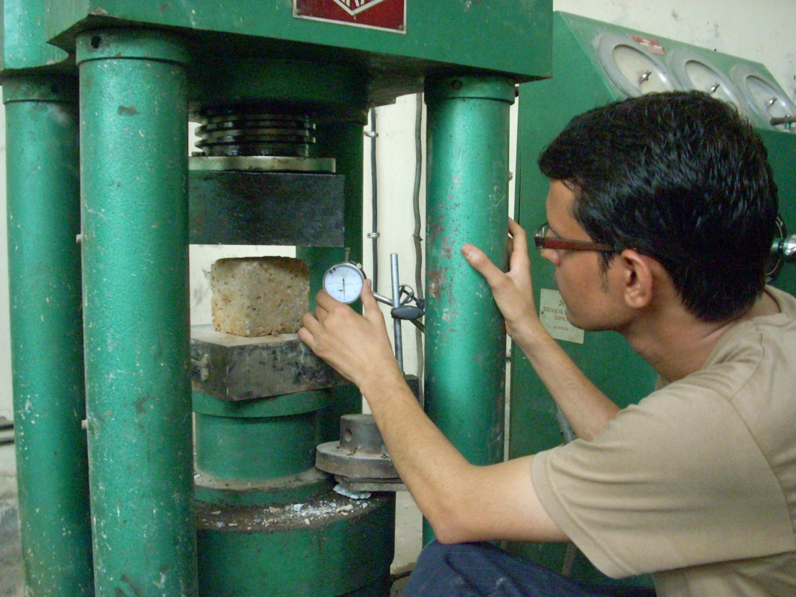
Fig. 3.3 Compressive Strength testing machine

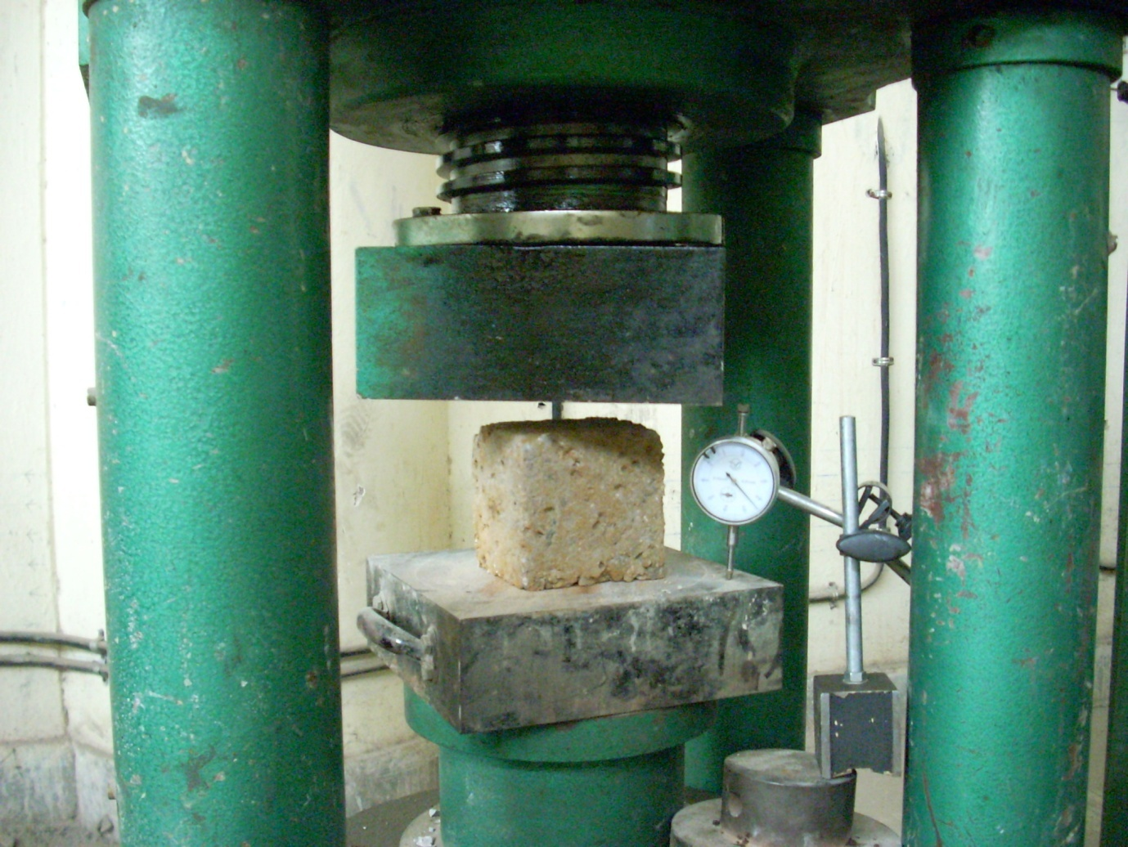 Fig. 3.4 Experimental setup for compression test
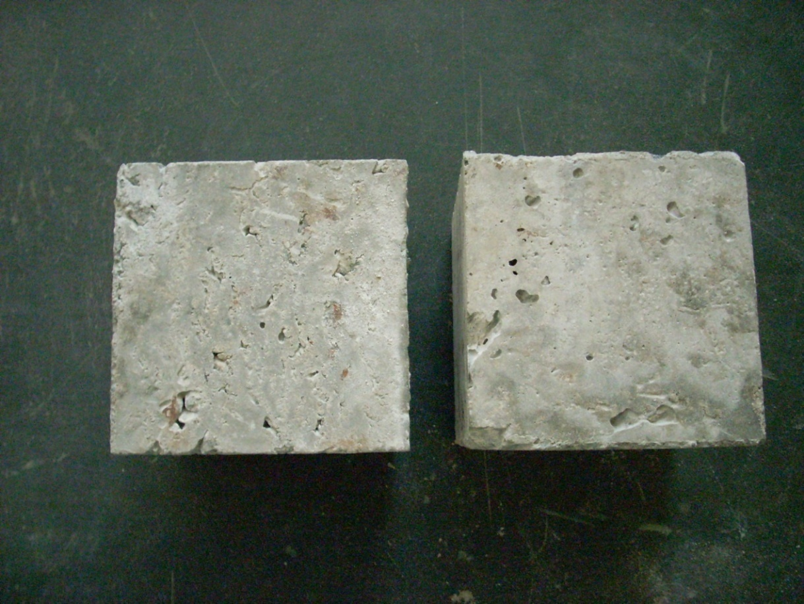
Fig. 3.5 Specimen:Before failure
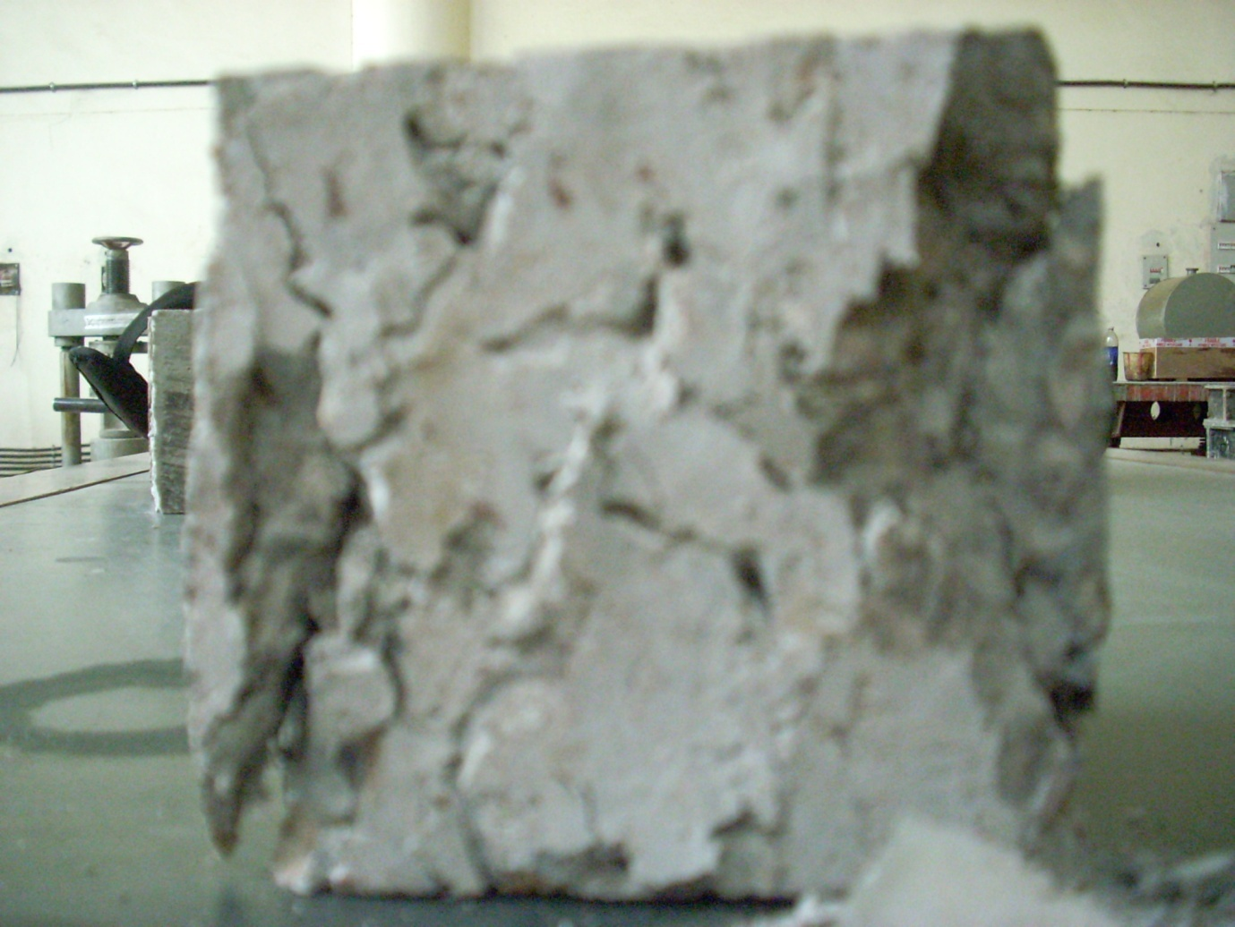
Fig. 3.6(a) Specimen: After Failure at Room temperature.
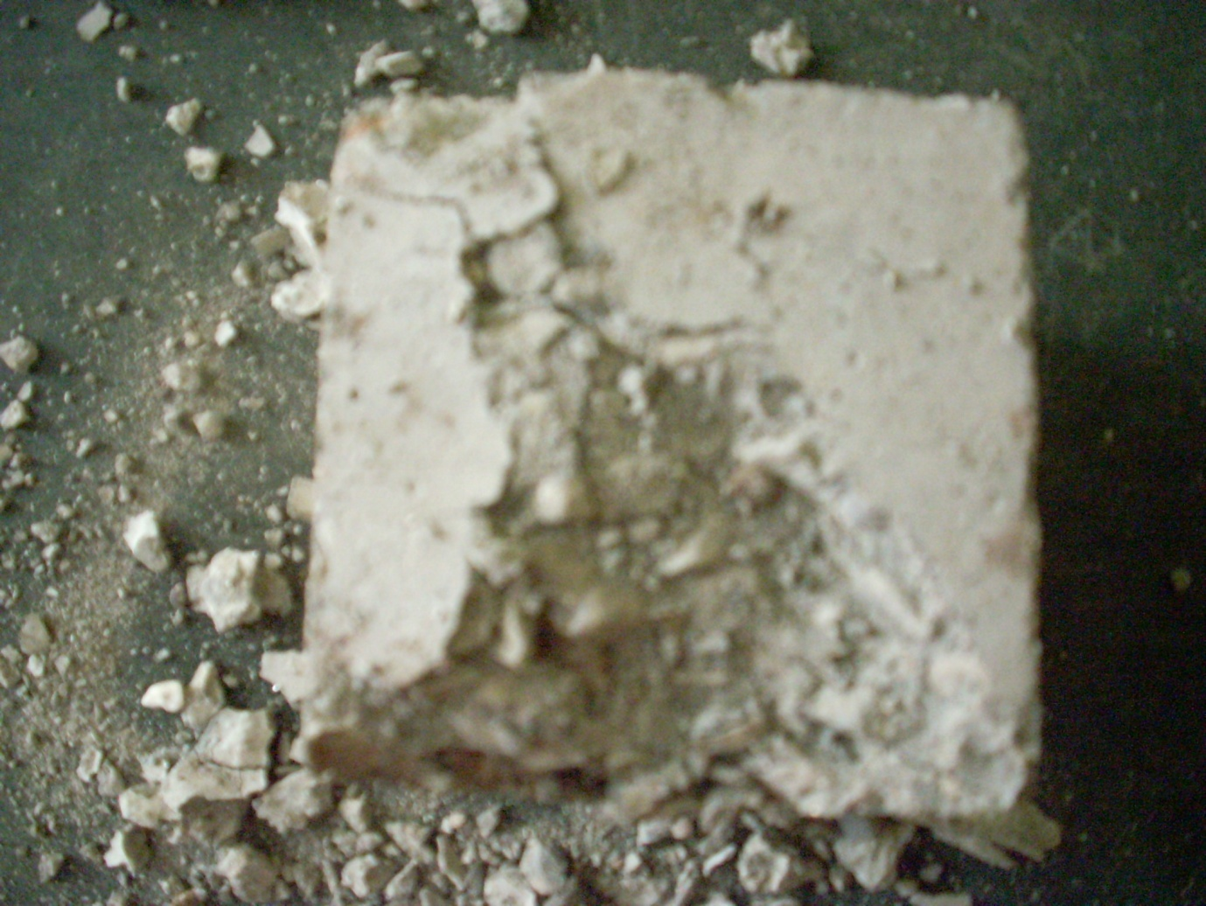
Fig.3.6(b) : Specimen: After Failure at acid effect
3.7.5 Split Tensile Strength: Apart from the flexure test, the other methods used to determine the tensile strength of concrete can be broadly classified as direct and indirect method. The indirect method of test i.e. in general a compressive force is applied to a concrete specimen in such a way that the specimen fails due to tensile stresses. The magnitude of this tensile stress (acting in a direction perpendicular to the line of action of applied compression) is given by (2P/(3.14DL)), where, P is applied load, D and L are the diameter and length of cylinder. Due to the tensile stress, the specimen fails finally by splitting along the loaded diameter and knowing P at failure, the tensile strength is determined.
This ASTM test method covers the determination of the splitting tensile strength of cylindrical concrete specimens. This method consists of applying a diametral compressive force along the length of a cylindrical specimen. This loading induces tensile stresses on the plane containing the applied load. Tensile failure occurs rather than compressive failure. Plywood strips are used so that the load is applied uniformly along the length of the cylinder. The maximum load is divided by appropriate geometrical factors to obtain the splitting tensile strength
The spilt tensile strength is carried on the cylinder, experiment setup us also shown in fig. 3.7

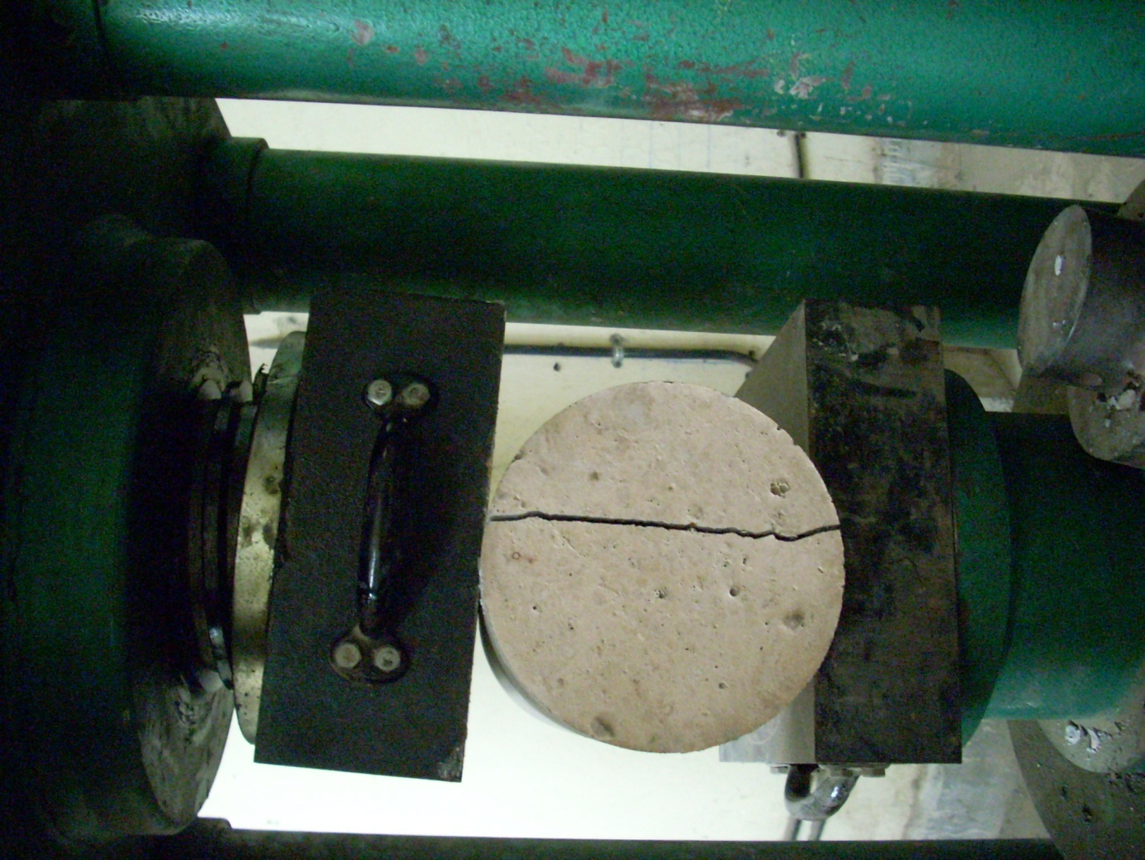
Fig. 3.7 Experimental setup for spilt tension test.

CHAPTER – 4
RESULTS AND DISCUSSION

On the basis of the experiments conducted on different grades of concrete various results obtained are presented below.
4.1 Mass Test
Table 4.1: Mass of concrete mixes
Mix grade | Cured in water (gm) | Cured in acid (gm) | % loss
M-20 | 2503.67 | 1452.23 | 41.99
M-25 | 2440.33 | 1623.23 | 33.44
M-30 | 2427.12 | 1650.58 | 31.99
M-35 | 2382.45 | 1752.23 | 26.45
M-40 | 2380.33 | 1796.25 | 24.53
M-45 | 2240.42 | 1875.25 | 16.29

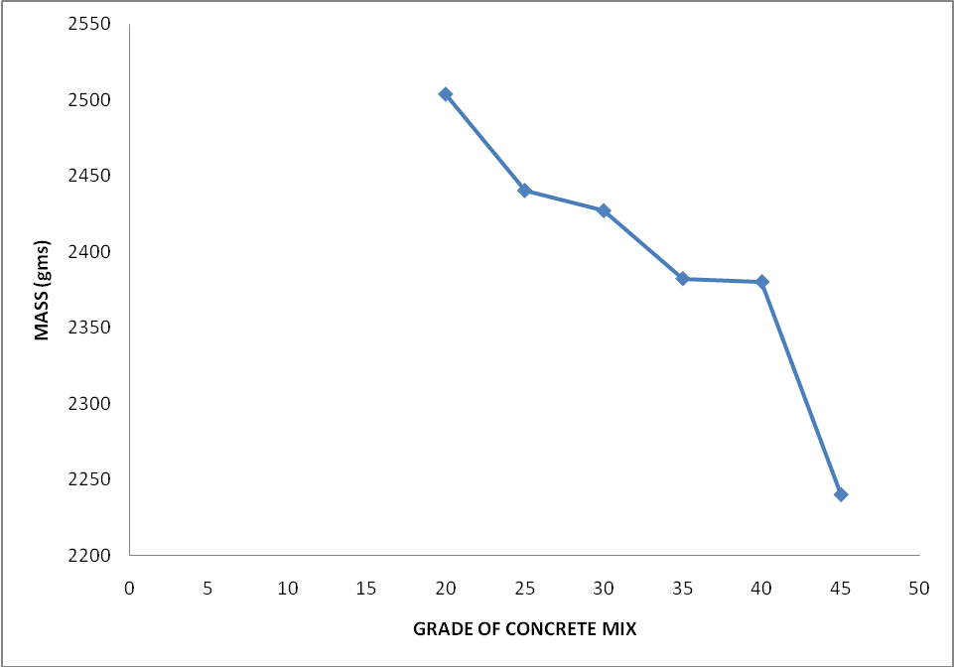
Fig 4.1 Variation of mass of various grade of concrete mixes cured in ordinary water for 180 days

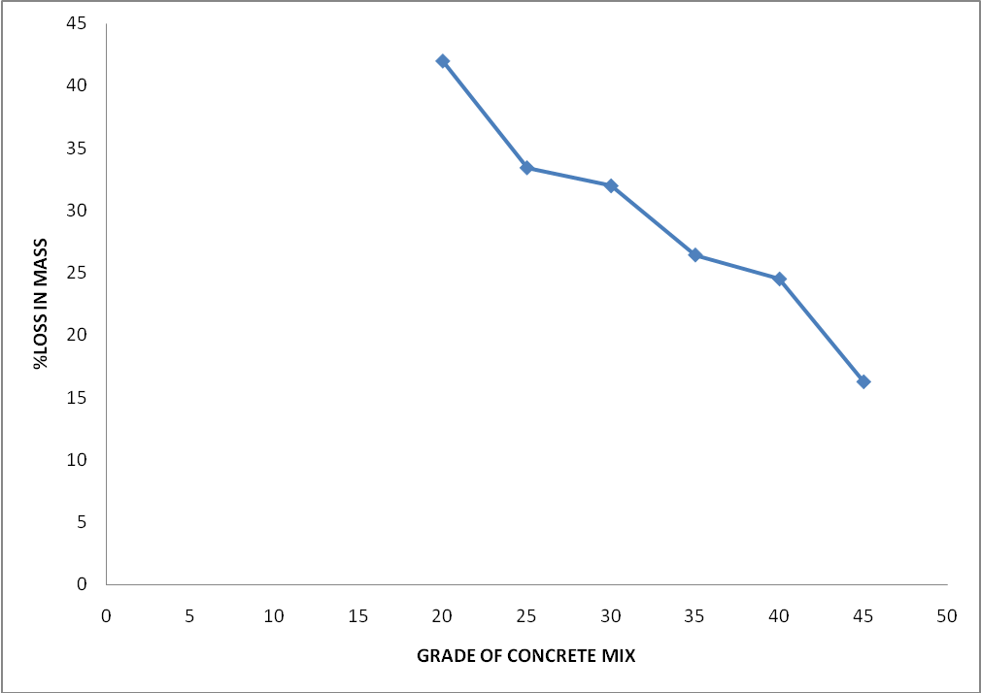
Fig 4.2 Loss in mass of various grade of concrete mixes exposed to 0.2N sulphuric acid for 180 days

The mass of various grade of concrete mixes cured in water and sulphuric acid of 0.2 N for 180 days are presented in table 4.1 and fig 4.1 and 4.2 respectively. the mass of concrete for low grade is high as compared to the high grade concrete. The loss in mass of concrete is more in low grade concrete .This may be due to the fact that high grade concrete is more resistant to acid as compared to that of low grade concrete.
4.2 Compressive strength test
Table4.2: Compressive strength of concrete mixes
Mix grade | Cured in water(Mpa) | Cured in acid (Mpa) | %loss
M-20 | 32.21 | 3.21 | 90.03
M-25 | 39.21 | 5.09 | 87.01
M-30 | 49.24 | 8.43 | 82.87
M-35 | 53.07 | 13.26 | 75.01
M-40 | 62.01 | 18.60 | 70.14
M-45 | 67.41 | 29.96 | 55.55

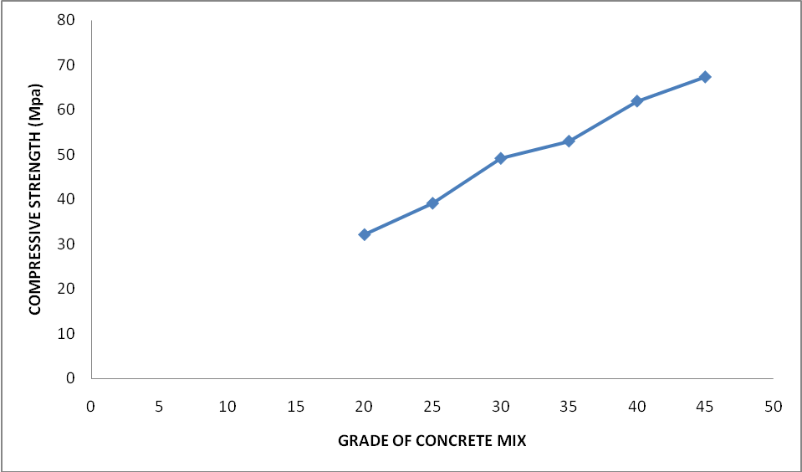
Fig 4.3 Variation of compressive strength of various grade of concrete mixes cured in ordinary water for 180 days
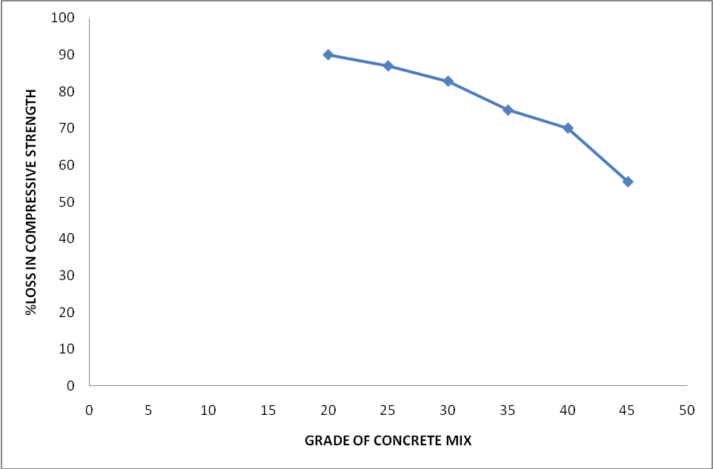
Fig 4.4 Loss in compressive strength of various grade of concrete mixes exposed to 0.2N sulphuric acid for 180 days.
The compressive strength of various grade of concrete cured in ordinary water and 0.2N for 180 days are presented in table 4.2 and fig 4.3 & 4.4 respectively from fig 4.4 that clear that loss in compressive strength is much more in low grade concrete.
4.3 Rebound hammer test
Table 4.3: Rebound hammer of concrete mixes
Mix grade | Cured in water | Cured in acid | % loss
M-20 | 27.83 | 22.66 | 18.57
M-25 | 25.66 | 21.66 | 15.58
M-30 | 23.83 | 20.89 | 12.33
M-35 | 22.26 | 20.21 | 9.20
M-40 | 21.60 | 20 | 7.4
M-45 | 21.56 | 20 | 7.23

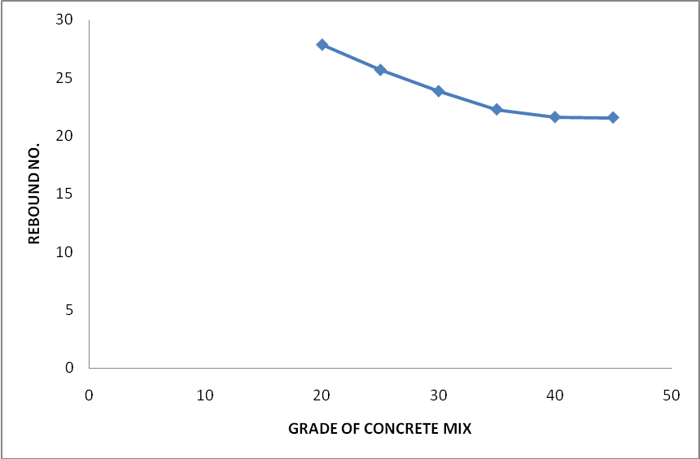
Fig 4.5 Variation of rebound no of various grade of concrete mixes cured in ordinary water for 180 days

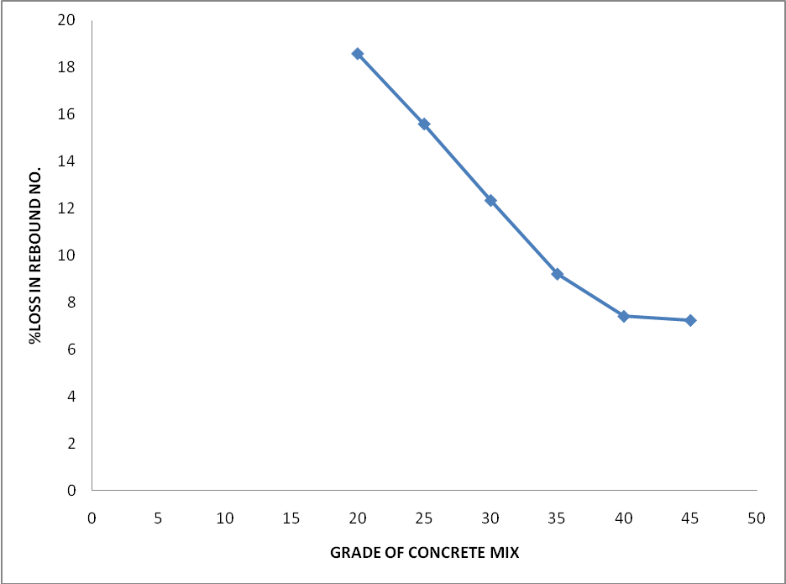
Fig 4.6 Loss in rebound no. of various grade of concrete mixes exposed to 0.2N sulphuric acid for 180 days

The rebound no of various grade of concrete mixes cured in water and sulphuric acid of 0.2 N for 180 days are presented in table 4.3 and fig 4.5 and 4.6 respectively.the rebound no. of concrete for low grade is high as compared to the high grade concrete. The loss in rebound no. of concrete is more in low grade concrete .This may be due to the fact that high grade concrete is more resistant to acid as compared to that of low grade concrete.
4.4 Ultrasonic pulse velocity test of concrete mix
Table 4.4: Ultrasonic pulse velocity of concrete mix
Mix grade | Cured in water (m/sec) | Cured in acid (m/sec) | % loss
M-20 | 3042.00 | 2135.00 | 29.81
M-25 | 3447.00 | 2472.00 | 28.28
M-30 | 3123.00 | 2287.00 | 26.76
M-35 | 3560.00 | 2720.00 | 23.59
M-40 | 3660.00 | 2960.00 | 19.12
M-45 | 4240.00 | 3526.00 | 16.83

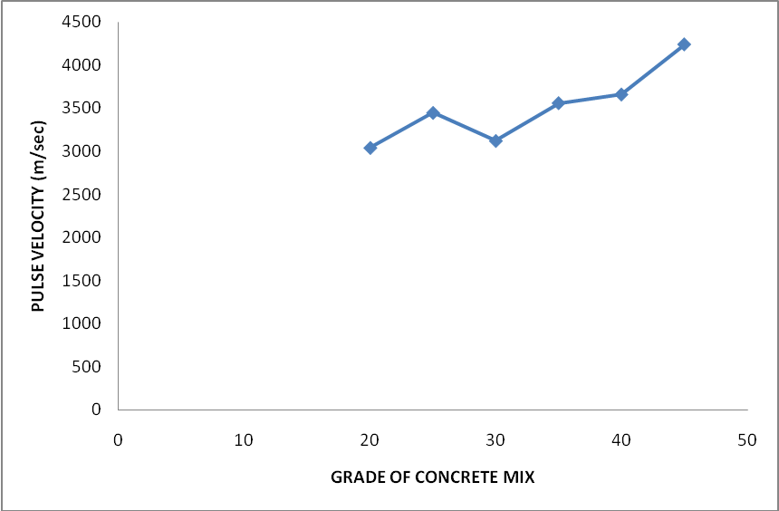

Fig 4.5 Variation of upv of various grade of concrete mixes cured in ordinary water for 180 days
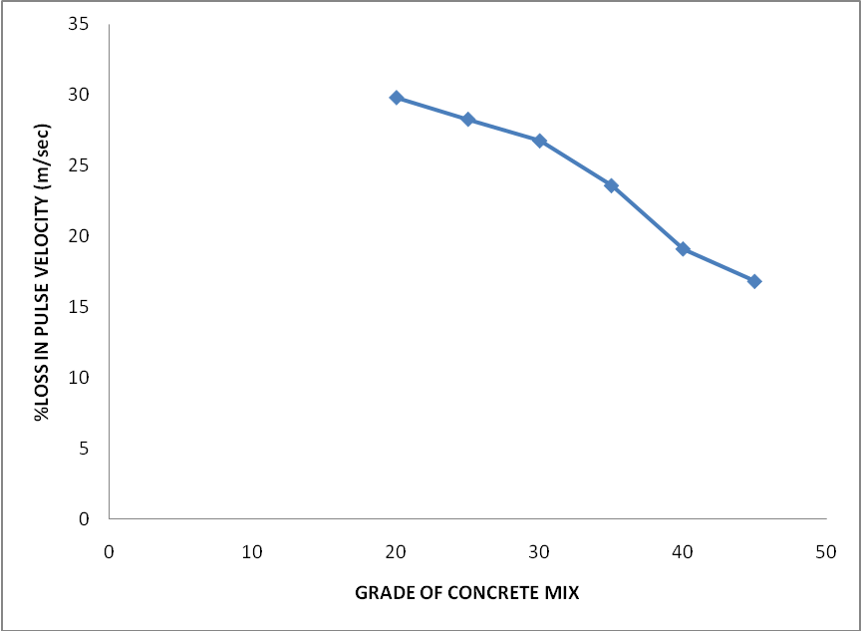
Fig 4.6 Loss in velocity of various grade of concrete mixes exposed to 0.2N sulphuric acid for 180 days
The pulse velocity of various grade of concrete mixes cured in water and sulphuric acid of 0.2 N for 180 days are presented in table 4.4 and fig 4.5 and 4.6 respectively.the velocity of concrete for low grade is high as compared to the high grade concrete. The loss in velocity of concrete is more in low grade concrete .This may be due to the fact that high grade concrete is more resistant to acid as compared to that of low grade concrete.

4.5 Tensile strength test
Table 4.5: Tensile strength of concrete mix
Mix grade | Cured in water(Mpa) | Cured in acid(Mpa) | % loss
M-20 | 2.93 | .34 | 88.39
M-25 | 3.52 | .44 | 87.50
M-30 | 4.49 | .62 | 86.19
M-35 | 4.76 | 1.19 | 75.00
M-40 | 5.58 | 1.67 | 70.07
M-45 | 6.06 | 2.42 | 60.06

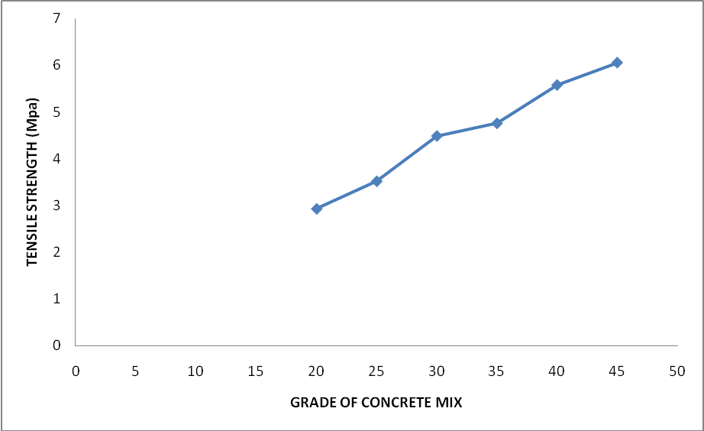
Fig 4.7Variation of tensile strength of various grade of concrete mixes cured in ordinary water for 180 days
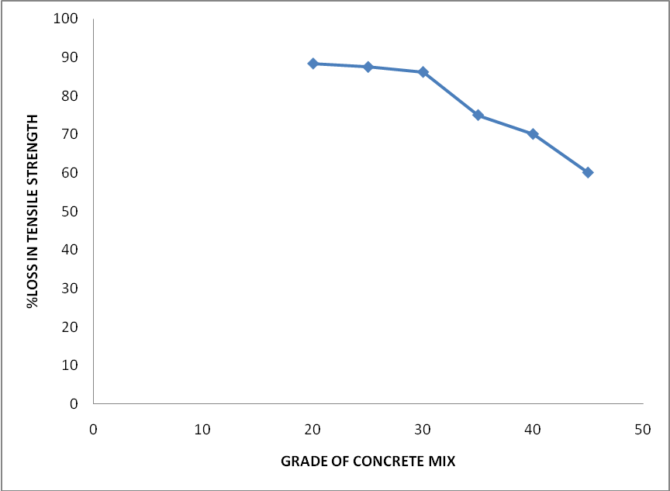
Fig 4.8 Loss in tensile strength of various grade of concrete mixes exposed to 0.2N sulphuric acid for 180 days
The tensile strength of various grade of concrete mixes cured in water and sulphuric acid of 0.2 N for 180 days are presented in table 4.5 and fig 4.7 and 4.8 respectively.the tensile strength of concrete for low grade is high as compared to the high grade concrete. The loss in tensile strength of concrete is more in low grade concrete .This may be due to the fact that high grade concrete is more resistant to acid as compared to that of low grade concrete.

4.6 Relationship b/w compressive strength & mass of concrete mixes
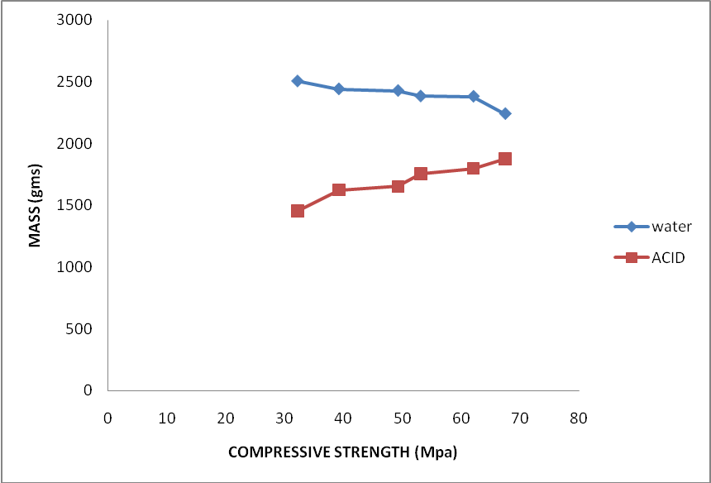
Fig 4.11 Relationship b/w mass and compressive strength of various concrete mix

The relation between compressive strength and mass of various grade cured in ordinary water and sulphuric acid of 0.2N for 180 days are shown in figure 4.11

4.7 Relationship b/w compressive strength and rebound no.
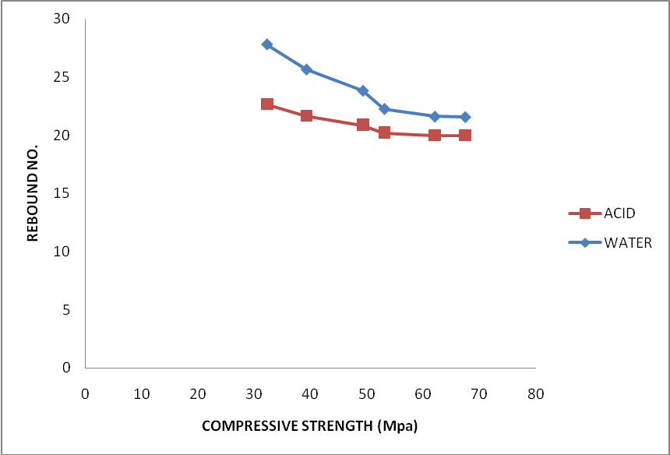
Fig 4.12 Relationship b/w compressive strength and rebound no.
The relation between compressive strength and rebound No.of various grade cured in ordinary water and sulphuric acid of 0.2N for 180 days are shown in figure 4.12

4.8 Relationship b/w compressive strength and upv
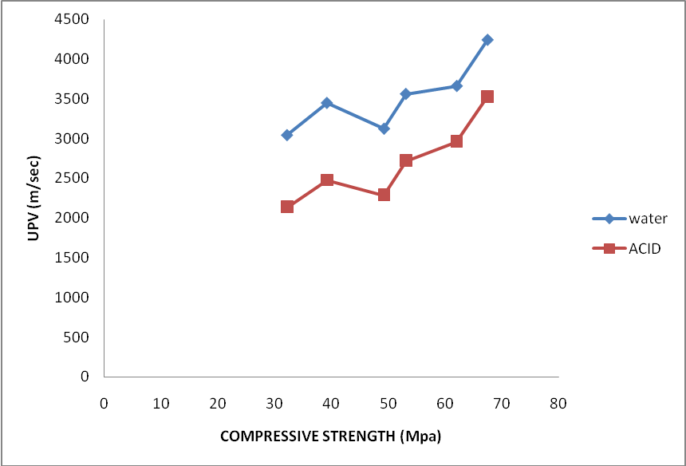
Fig 4.13 Relationship b/w compressive strength and UPV
The relation between compressive strength and UPV (m/sec) of various grade cured in ordinary water and sulphuric acid of 0.2N for 180 days are shown in figure 4.13

4.9 Relationship b/w compressive strength and tensile strength
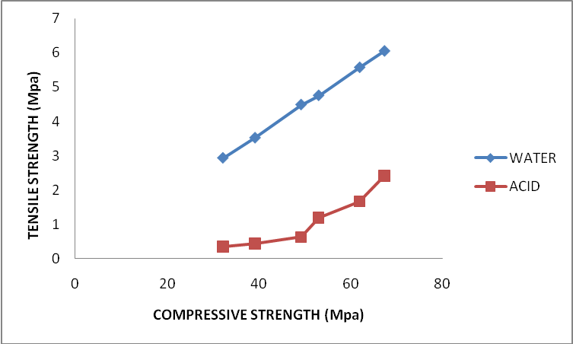
Fig 4.14 Relationship b/w compressive strength and tensile strength

4.7 Modulus of Elasticity (A)
Table 4.7: Modulus of Elasticity of various grades of concrete mixes
Mix grade | Stress (Mpa) | Strain | Modulus of elasticity (Mpa)
M-20 | 32.61 | 1.9x10⁻³ | 17.16x10³
M-25 | 39.21 | 2.15x10⁻³ | 18.23x10³
M-30 | 49.94 | 2.6x10⁻³ | 19.23x10³
M-35 | 53.07 | 3.3x10⁻³ | 16.208x10³
M-40 | 62.01 | 3.45x10⁻³ | 17.97x10³
M-45 | 67.41 | 3.6x10⁻³ | 18.72x10³

4.7 Modulus of Elasticity (B)
Table 4.7: Modulus of Elasticity of various grade of concrete mixes
Mix grade | Stress (Mpa) | Strain | Modulus of elasticity (Mpa)
M-20 | 3.21 | 7.98x10⁻³ | 401
M-25 | 5.097 | 8.3x10⁻³ | 614.09
M-30 | 6.24 | 8.1x10⁻³ | 770.74
M-35 | 13.26 | 8.5x10⁻³ | 1560
M-40 | 18.60 | 2.3x10⁻³ | 8113.04
M-45 | 26.96 | 3.2x10⁻³ | 8425

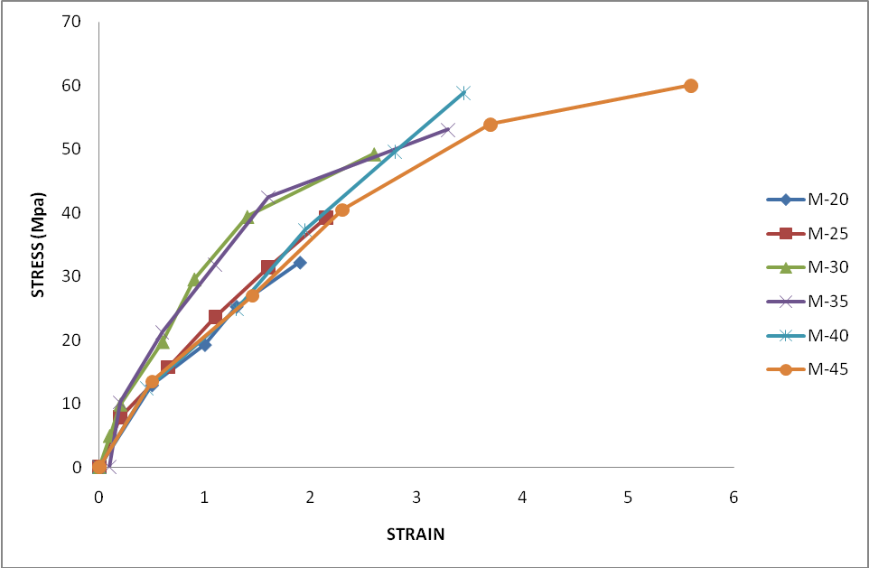
Fig 4.15 Stress - Strain curve for concrete mixes
Fig 4.15 show the stress –strain curve for different grade of concrete also the value of stress and strain show in table 4.7 for each grade modulus of elasticity determine and conclude that in acidic curing loss is more in low grade concrete

Chapter No. 5
CONCLUSIONS

On the basis of experimental investigations carried out in laboratory on various grade of concrete mixes cured in water and 0.2 N sulphuric acid for 180 days following conclusion may be drawn-
- The loss in mass , compressive strength, tensile strength, upvt, occurred when exposed to sulphuric acid of 0.2N for 180 days as compared when cured in water
- The losses are less in high grade concrete
- The relation b/w mass, RN, upvt, tensile strength and compressive strength are established.

However more data is to be generated for the further validity of these relation.

..

FUTURE SCOPE OF STUDY

The following research needs are intended as a spectrum of area that need immediate attention of young Researcher,
- Durability of higher grade concrete
- Effect of other type of acid
- Other types of concrete such as fly ash concrete
- Effect of other binding material such as silica fume, fly ash etc.

REFERENCES

1) www.sciencedirect.com
2) www.google.com.
3) M.S. Shetty “Book of concrete technology”.
4) John Newman & Ban Seng Choo “Factore affecting the durablility of concrete” (2003)
5) Maslehuddin M, Saricimen H, Al-Mana AI, Shamim M. Performance of concrete in a high-chloride sulfate environment, ACI SP-122. 1990. P. 469-94
6) Rasheeduzzafar R, Dakhil Fh, Al-Gahtani As. Corrosion of reinforcement in concrete structures in the Middle East. Concr Int 1985; 7 (9):48-55.
7) Mehta P.K. Concrete technology at the crossroads, ACI SP-144. p. 1-31
8) R. Boynton, Chemistry and Technology of Lime and Limestone. Interscience Pub., New York, 1966
9) V.G. Papakakis, C.G. Vayenas, M.N. Fardis, Fundamental modeling and experimental investigation of concrete carbonation, ACI Mater. J. 88 (1991) 363-373
10) H.F.W. Taylor, The Chemistry of Cements, Academic Press, London, 1964.
11) A.M. Neville, Properties of Concrete, Longman, Essex, 1995.
12) Motz H, Geiseler J. Products of steel slags: an opportunity to save natural resources. Waste Manage. 2001; 21:285-93.
13) Lopez FA, Lopez-Delgado A, Balcazar N. Physico-chemical and mineralogical properties of EAF and AOD slags. Afinidad LIII 1996; 461:39-46.
14) Vazquez-Ramonich E, Barra M. Reactivity and expansion of electric are furnace slag in their application in construction. Mater construce 2001;51 (263-264): 137-48
15) Maslehuddin M, Sharif AM, Shameem M, Ibrahim M, Barry MS. Comparison of properties of steel slag and crushed limestone aggregate concretes. Constr Build Mater 2003;17:105-12
16) Moon Han Young, Yoo Jung Hoon, Kim Seong Soo. A fundamental study on the steel slag aggregate concrete. Geosyst Eng 2002;5 (2): 38-45.
17) Beshr H, Almusallam AA, Maslehuddin M. Effect of coarse aggregate quality on the mechanical properties of high strength concrete. Constr Build Mater 2003;17:97-103.
18) M. Lachemi, G. Li, A. Tagnit-Hamou, P.-C. Aitcin, Long-term performance of silica fume concretes, Concr int 20 (1) (1998) 59.
19) J. Bijen, Benefits of slag and fly ash, Construction & Building Materials, 10 (1996)5.
20) V. M. Malhotra, Fly ash, slag, silica fume and rice-hus ash in concrete. A review, Concr Int 15 (1993) 4.
21) Building Rresearch Establishment. Durability of blastfurnace slag cement concretes, BRE Information paper, IP 6/92, 1992.
22) M. Connell, Long-term performance of high slag concrete, Concrete (London), 32 (1998) 6.
23) M.R. Jones, R.K. Dhir, B.J. Magee, Conc. Containing termar blended binders: Resistance to chloride ingress and carbonation, Cem Concr Res 27(1997) 6.

24) Durability of concrete with cement replacement, W.W.J.CHAN University of Hong Kong (2000)
25) Effect of ultrafine particles on durability M.Nehdi, S.Mindess University of Canada (1998)
26) Delagrave, A., Pigeon, M. and Reverte /gatt.,” Influence of Chloride Ions and pH Level on the Durability of High Performance Cement Pastes”, Cement and Concrete Research vol l. 24, pp. 1433-14431,9 94.
27) Alkali-Activated slag concrete , SP-44,Ameriican Concrete Institute,Detrot,Michigan,1974,554 pp Shah, S.P.; and Rangan, B.V.,Fiber Reinforced Concrete Properties,”ACI Jouranal, Vol.68,No.2 1971,pp 126-135

