A MAJOR PROJECT

ON

DEVELOPMENT OF SUPERVISORY CONTROL AND DATA ACQUISITION SYSTEM FOR ENERGY MANAGEMENT

Submitted In Partial Fulfillment of Requirements

For The Award of the Degree of

MASTER OF ENGINEERING

(CONTROL & INSTRUMENTATION)

By

SANDEEP SINGH

College Roll No. 10/C&I/08

Delhi University Roll No: 8458

Under the Supervision

of

PROF. MADHUSUDAN SINGH



DEPARTMENT OF ELECTRICAL ENGINEERING

DELHI COLLEGE OF ENGINEERING

UNIVERSITY OF DELHI

DELHI-110042

July, 2010

CERTIFICATE

This is to certify that the work presented in this project entitled “Development of Supervisory Control and Data Acquisition System for Energy Management”, in partial fulfilment of the requirement for the award of the degree of Master of Engineering in Control & Instrumentation submitted by Sandeep Singh (10/C&I/08) to the Department of Electrical Engineering, is a record of the student’s work carried out under my supervision and guidance.

(Dr. MADHUSUDAN SINGH.)

Professor

Electrical Engineering Department

Delhi College of Engineering

Delhi-110042

ACKNOWLEDGMENTS

I am thankful to the Almighty without his countless blessings this work would not have been possible.

I would like to express my deepest gratitude to Prof. Madhusudan Singh, my project supervisor for his constant motivation, invaluable guidance and encouragement during the entire duration of this project.

It is my privilege and honour to have worked under his supervision. I would also like to thank Dr. Parmod Kumar, Professor Electrical Engineering Department, for his support and encouragement.

I am sincerely thankful to GE-FANUC support team for their guidance during difficult moments in this project. Last but not least, I am thankful to my parents, my siblings, saima and my friends for their moral support and help.

SANDEEP SINGH

College Roll No.10/C&I/08

University Roll No: 8458

M.E (C&I)

CONTENTS

CERTIFICATE

ACKNOWLEDGEMENTS

LIST OF FIGURES

ABSTRACT

Chapter - I INTRODUCTION
  - General
  - An Overview of Three Phase Energy metering
    - Types of Three phase Energy meter
      - Electromagnetic Energy meter
      - Electronic Energy meter
1.3 Neptune M9 Power Analyzer (digital electronic energy meter)
1.3.1 Main Features
1.3.2 Technical Specifications
    - Communication Details
  - Energy Management using SCADA
  - Scope of Present Work
1.6 Conclusion

Chapter - II LITERATURE REVIEW
2.1 General
2.2 Literature survey
    - Need of Energy Management
    - Applications of Electronic Energy Meters in Energy Management
2.2.3 Role of SCADA in Energy Management
2.2.4 Role of PLC in Energy Management
2.3 Conclusion

Chapter-III DESCRIPTION OF SCADA SYSTEM
  - General
  - SCADA System Software
    - Designing SCADA System for Energy Management
  - Development of a Virtual SCADA Application Platform for Automatic Car
Washing
  - Hardware Details for SCADA interface with Energy Meter
    - Three Phase Current Transformer
    - RS 485 to 232 Converter
    - Three Phase AC Contactor
    - Three Phase Induction Motor
    - Three Phase Energy Meter
  - Conclusion

CHAPTER IV EXPERIMENTAL RESULTS AND DISCUSSION
  - General
  - Logical and Graphical Analysis
    - Description of PLC and PLC Programming Software
    - Description of Ladder Programming For Designing Virtual Animated Screen
    - Implementing logic operation through PLC
    - Development of Virtual Animated Screen Using SCADA
4.3 Interfacing of Energy meter to SCADA Software
4.4 Testing of Energy meter in Real Time
4.5 Conclusion

CHAPTER V CONCLUSION AND FUTURE SCOPE OF WORK
5.1 Main Conclusion
5.2 Future Scope of Work

ABSTRACT
Energy management has become a key issue for large industrial and commercial users. In recent years due to increasing gap between supply and demand of electricity. The supervisory control and data acquisition system (SCADA) is widely used in modern industries to achieve higher productivity and product quality. Today's SCADA systems are critically dependent on the proper functioning of computing and communications technologies. The management and functional needs of such systems often require connection to public network infrastructure. Rational use of electricity in processes require on-line monitoring and consumption control of electricity.
This dissertation describes how energy management is achieved using PLC and SCADA. A Programmable Logic Controller (PLC) based energy monitoring and consumption control scheme has been designed and implemented. This energy monitoring scheme is realised through PLC programming and SCADA control. CIMPLICITY 7.5 (SCADA software) has been used to display on-line readings of load parameters. PROFICY MACHINE EDITION 5.9 software has been used for ladder programming.
A digital electronic energy meter with capabilities to read the data/ download the data via PLC system has been used to communicate with SCADA system. A complete energy monitoring and control experimental set-up has been developed and tested under different load conditions. The necessary communication protocols were established between PLC and energy meter as well as between PLC and SCADA system. The energy meter parameters such as KWhr, KW, KVA, p.f, voltage were logged into SCADA software (cimplicity 7.5) to design & develop and display through SCADA system.

CHAPTER I
INTRODUCTION
  - GENERAL
In this fast developing electronic era, automation has become an integral part of process industries. Due to strong growth of the Indian economy during the last one decade, the per capita consumption of electrical energy is also increasing. The per capita energy consumption is around 631 KWhr and the government has taken initiative to increase it to more than 1000 KWhrs by 2012. Conventionally, the energy consumption in domestic & commercial and industrial sectors were meterd through the earlier version of electromechanical meters (Ferraci type). Distribution companies are replacing these Ferraci type meters with more efficient electronic energy meters. The technology of digital electronic meters (DEM) are well developed , quite reliable and proven. These DEM are equipped with accurate current sensors(current transformer,CTs) and intelligent data processing devices such as micro-controller and LCD for data presentation. The meter readings are sent via programmable(PLC) or via GSM service to the local billing centeres instead of a person coming and taking the readings. Further, through digital electronic metering the distribution company can have a mechanism by which they cut-off the power supply automatically by sensing the tampering and there by ensuring that tampering is reduced.

  - AN OVERVIEW OF THREE PHASE ENERGY METERING
Conventionally, the metallic disc energy meters were in use about a decade ago. Slowly, the electronic/ digital meters started making an entry during late 90’s and early 2000. The next generation meters are introduced with capabilities to read the data/ download the data for the spot billings.
An electric meter or energy meter is a device that measures the amount of electrical energy consumed by the load. Electric meters are typically calibrated in billing units , the most common one being the kilowatt hour. Periodic readings of electric meters establishes billing cycles and energy used during a cycle. In settings where energy savings during certain periods are desired, meters may measure demand, the maximum use of power in some interval. In some areas, the electric rates are higher during certain periods, where it is desired that, meters may measure demand , the maximum use of power for that interval. In some areas, the electric rates are higher during certain times of day , to encourage reduction in use. Also, in some areas meters have relays to turn off non essential equipment.
Energy in three phase circuits can be measured by a group of single phase energy meters connected as required by Blondel’s theorem .The total energy is the sum of the readings of all energy meters (a negative sign is used for the reading of any meter which runs backwards). However, in commercial measurements, the above arrangement is not used but instead poly phase energy meters are used. Similar to the case of wattmeters for measurement of power in poly phase circuits. The electrical energy in a ‘n’ conductor system requires (n-1) measuring elements for measurement of total energy. Thus a 3 phase, 3 wire system requires a 2 element energy meter and a 3 phase 4 wire system requires a 3 element energy meter.

1.2.1 TYPES OF THREE PHASE ENERGY METER
Electricity meters operate by continuously measuring the instantaneous voltage and current and finding the product of these to give instantaneous electrical power (watts) which is then integrated against time to give energy used .
The Three phase meters fall into two categories:-
- Electro Mechanical
- Electronic

      - ELEECTROMECHANICAL METER
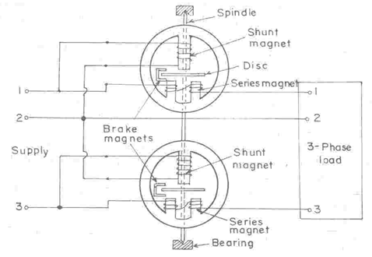
Fig.1 Electromechanical meter
Fig.1 shows a schematic layout of the electro-mechanical energy meter technologically. The electromechanical induction meter operates by counting the revolutions of an aluminium disc which is made to rotate at a speed proportional to the power. The number of revolutions is thus proportional to the energy usage. It consumes a small amount of power, typically around 2 watts. The metallic disc is acted upon by two coils, pressure coil and current coil. The necessary adjustment is made with the coils energised from a single phase supply. The pressure coils are connected in parallel and the current coils in series in such a manner that the torques produced by the two elements oppose each other. The magnetic shunt is adjusted to a position where the two torques are exactly equal and opposite and therefore there is no rotation of disc. One coil is connected in such a way that it produces a magnetic flux in proportion to the vType equation here.oltage and the other produces a magnetic flux in proportion to the current. The field of the voltage coil is delayed by 90 degrees using a lag coil. This produces eddy currents in the disc and the effect is such that a force is exerted on the disc in proportion to the product of the instantaneous current and voltage. A permanent magnet exerts an opposing force proportional to the speed of rotation of the disc. The equilibrium between these two opposing forces results in the disc rotating at a speed proportional to the power being used. If the time in seconds taken by the disc to complete one revolution is t, then the power in watts is 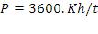. For example, if Kh = 7.2, as above, and one revolution took place in 14.4 seconds, the power is 1800 watts.
The design and operation of the electromechanical energy meters is quite complicated, crude and complex

1.2.1.2 ELECTRONIC METERS:-
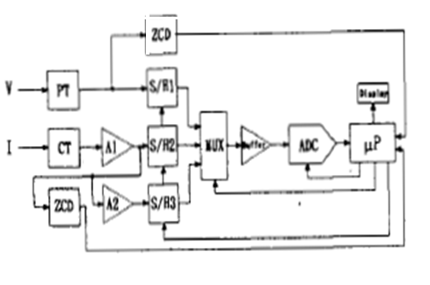
Fig.2 Electronic meter

Fig.2 shows the block diagram of the digital electronic meter. The meter consists of the following major blocks: Transducers (CT and PT), phase lead/ lag detector (ZCD circuits),sample and hold circuit, multiplexer(MUX), A to D converter(ADC), and microprocessor(µp). A resistor divider is used as PT ( potential transformer). The phase lead/lag detector is composed of two zero crossing detectors(ZCDs). One ZCD is employed to detect the zero- crossing point of voltage waveform, the other ZCD to detect the zero-crossing point of current waveform. The S/H is an analog voltage storage device in which an input voltage is sampled and then stored on the capacitor. The input voltage which occurs at the time of “hold” command is retained for subsequent A/D conversion.
Electronic meters display the energy used on an LCD or LED display , and can also record other parameters of the load and supply such as maximum demand, power factor and reactive power used etc. They can also support time-of-day billing.
Electronic meters now use Low Power Radio, GSM, GPRS, BLUETOOTH as well as RS-485 wired link. The meters can now store the entire usage profiles with time stamps and relay them at a click of a button. The demand readings stored with the profiles accurately indicate the load requirements of the customer. An electronic meter can transmit its readings by telephone line or radio to a central billing office. Automatic meter reading can be done with GSM (Global System for Mobile Communications) modems, one is attached to each meter and the other is placed at the central utility office.

  - DESCRIPTION OF DIGITAL ELECTRONIC ENERGY METER(Neptune M9 Power Analyzer)
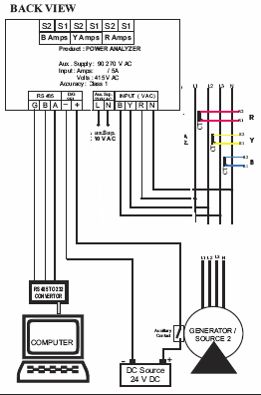
Fig .3
Fig.3 shows digital electronic energy meter (Neptune m9 power analyzer). M9 Power Analyzer has been designed to meet the technical requirements of modern power distribution systems or electric installations . This measuring device can also be used in co-generation power systems, stand-by generating sets or production machinery. Critical waveform conditions, such as voltage and currents with high harmonic content and variable frequency, do not influence the Phasetrac M-9 high accuracy multi meter readouts because of rigorous design. It has more than 32. Phasetrac M-9 comprises excellent features and energy metering, it has an isolated communication ports for PC link.

1.3.1 MAIN FEATURES
- State of art microcontroller based design
- 4 line ultra bright red LED display to show phase wise & system parameters on
Same page.
- Site programmable CT&PT ratio.
- True RMS measurement.
- Auto scrolling facility.
- Password protection.
- EEPROM retains energy parameters on power fail.
- Monitors import & Export energy.
- Computer interface( RS 485).
- Pulse output for PLC/ SCADA interface.
- Optional: Data logging of all parameters with date & time stamp.(site programmable logging time interval ).

1.3.2 TECHNICAL SPECIFICATIONS
The phase trac M-9 multi meter is available in a unique model, in flush mount 96*96 mm housing. It is equipped with a RS-485 interface for the direct connection to PC through converter.

- Aux. Supply : 90 - 270 VAC / DC
- Input : 3 phase 4 wire
- Volts : Range 85 - 130V for 110 V model
: Range 330 - 470V for 415 V model
- Amps : 0.25 - 6.0 Amps for 5A model
0.05 - 1.2 Amps for 1A model

- Burden : 0.2 VA max. per input for Voltage
& Current Signals
3 VA max. on Aux. Supply

- Display : 4 Line x 4 Digit{0.39 Inches 7 Segment LED Display}

- Accuracy : Class 1.0

- Computation : True RMS

- Frequency : 45 Hz - 55 Hz.

1.3.3 COMMUNICATION DETAILS
- Protocol : MODBUS
- Mode : RTU
- The Character Format : A) 1 Start bit
B) 8 Data bits
C) No Parity bits
D) 1 Stop bit
- Baud Rate : 9600 Bits / Sec.

- Public Functions Supported:
A) 01h = Read Coils
B) 03h = Read Holding Register

1.4 ENERGY MANAGEMENT USING SCADA

Operation, monitoring, control and protection systems can be implemented to automate various industrial processes and record their energy used pattern. Applications mainly for oil and gas sector, water and power industries use SCADA system for their processes to be automated. Power Control operation with Supervisory Control Data Acquisition (SCADA) System is mandatory to run smooth electricity distribution and management. High scale SCADA system with enhanced features not only used for wide are system operation, but also covers Distribution Management System (DMS), Energy Management System (EMS), various Network Applications and Metering Management systems. This implementation includes significant performance, enhancement for smooth operation, control and protection of processes. Highly efficient, fast and effective control system has become a vital need in industrial sector. Small scale Industries usually prefer sequential control system to be installed to handle industrial controls and provide effective monitoring. The purpose of SCADA is to allow operators to observe and control the processes. It supports both energy management and distribution automation. The system consists of a master station that communicates with remote terminal units (RTUs). RTUs transmit device status and in turn receive control commands. The specific tasks SCADA performs are:
Data Acquisition provides measurements and status information to operator.
Trending plots measurements on selected time scales.
Supervisory Control allows to remotely control devices such as circuit breakers.
Training restricts operation of a device within specified parameters and prevents unauthorized operation.
Alarms informs operator of unplanned events and undesirable operating conditions.
Logging logs all operator entries, all alarms and specified information.
Load Shedding provides for both automatic and operator initiated tripping of load in response to system emergencies. It can range from compact, standardised systems to large and tailor-made ones. Communication is mostly via dedicated circuits. Implementation of SCADA system for Power Control provides an efficient and smart system with multiple controlling and monitoring features. Fiber optic communication makes system more efficient due to its highly reliable communication as compare to other available communications. However PLC can also be implemented to utilize installed infrastructure. RTUs are the main control devices to get and transfer field instrumentation information and instruction to/from master control system. High scale SCADA system with enhanced features provides benefits in system operation through different application to provide protection against power outages and to manage load shedding. High level instrumentation provides protection of the network with standard interlocking conditions. Future work of SCADA will lead to implementation of wireless media with better communication features to provide ease in link deployment.

1.5 SCOPE OF PRESENT WORK
This project work includes the development of supervisory control and data acquisition system(SCADA) for energy management. SCADA is not a full control system, but rather focuses on the supervisory level. As such, it is a purely software package that is positioned on the top of hardware to which it is interfaced ,in general via Programmable Logic Controllers(PLCs),or other commercial hardware modules.
- In the present work a three- phase digital electronic energy meter with MODBUS communication features has been interfaced to SCADA data logging and subsequently the real-time data are used to design a SCADA system for energy monitoring and control of the process(i.e. load).

- In this project, a single load is being used. This project has provision to implement by connecting a number of three phase loads at the output. Which load should be switched off, is decided by PLC and SCADA. By this way, power consumption can be reduced.Whenever there is an overloading, load will be automatically switched off through PLC. By this way , energy is managed.

c) Control systems developed using PLC possess larger amount of flexibility in operation and control of field devices, since field devices can be connected to input, output and networking modules of PLC as required. Diagnosis of the status of entire experimental setup can be done by LED indicators present on control panel of the PLC. The input as well as output status such as over load warning can be continuously monitored and diagnosed for the said purpose.

SCADA helps in real time control and monitoring of field devices. Proficy SCADA/HMI Cimplicity 7.5 software provides provision for development of graphical animation, data trends and graphs. Several studies on applications of SCADA like car washing and animated screen for energy management have been developed and tested using Proficy SCADA/HMI Cimplicity 7.5 software.

1.6 CONCLUSION
This chapter describes energy management scheme that has been used designed and developed for a three phase load using PLC and SCADA system. Use of PLC and SCADA in automation of control processes, their importance and advantages have been discussed. The scope of energy management & features of the modern electronic meters have been described in detail.

CHAPTER II

LITERATURE REVIEW

  - GENERAL

A brief description of work carried out on application of PLC, SCADA and energy management is presented in this chapter. A properly designed PLC based system proves to be more beneficial in terms of saving money and time and providing qualitative and reliable control. The PLC based control schemes used in controlling several field devices have also been discussed. Besides, use of Supervisory Control and Data Acquisition (SCADA) for remotely controlling various processes has also been covered. A SCADA system as such saves man power and time by eliminating the need for service personnel to visit each site for inspection, data logging or for monitoring system parameters in Real-time.
  - LITERATURE SURVEY

2.2.1 NEED OF ENERGY MANAGEMENT
D.P.Kothari et. al.[1] describes the need and scope of energy management in an industrial environment. Some Renewable sources: solar power, wind power and geothermal power technology need to be utilized to a greater extent. But with the available technology, one could hardly generate 5% of total power generation. Secondly, for economic growth the need of more and more energy to increase the pace of development is essential. In other words, demand is more than resources.

Joao Figueiredo et al.[2] describes the need of energy management in industrial building The main objective of energy management in buildings is that there should be the maintenance of the electric consumption below a specific maximal limit. Today, a term intelligent building is very popular. In an intelligent building, there are several technologies like flow and discharge system, electric energy systems, ventilation and temperature control systems , computer network , lightening control systems, fire control systems entrance control systems, mechanical control systems. These control systems are designed for an intelligent building. By this way energy is managed in buildings to reduce power consumption by doing automation of building.
R.J. St Clair et al.[3] emphasized the importance of energy management for electricity industry. In recent years, due to privatization of electricity industries, competition has been increased that is, there is a competition between electricity industries for the supply of utilities like electricity supply and distribution to consumers . Consumers have a lot of opportunities and option for multiple utilities. So, before embarking on an energy management service, one must first establish what customer needs are being met by the program. As a whole, this paper concludes with a review of energy management requirements of industrial and commercial customers and service available to fulfill those needs.
Eric Williams and Scott Mathews et al.[4] describes the proper use of energy in homes through energy management. Unoccupied houses and homes waste a lot of energy in heating, cooling, and lighting. Such integration will offer the possibility of future benefits to the consumer in terms of convenience, cost savings and reduction in energy used at a reasonable incremental cost. By this way, energy monitoring and control or energy management is essential to reduce residential energy consumption.

Wan Norsyafizan W.Muhamad et. al.[5] presents the need of energy efficient lighting system design for buildings. The efficient and effective use of lighting can offer major energy and cost saving. Lighting performance is affected by several factors such as paint colours, reflection factor, maintenance factor and utilization factor. These factors should be taken into account for perfect illumination. The author emphasizes the design for improvement of current lightening system by lamp replacement. Lamps are the removable and replaceable portion of luminaries that converts electrical energy to both visible and non-visible electromagnetic energy. Lamp replacement will stop the wastefulness of commercial, industrial, residential and community lighting. So, energy management is important to reduce the usage of electricity. Thus, it will reduce the user’s annual or monthly expenses for electricity bill. Such type of lightening system design reduces the operating cost and manages the electricity efficiently.

2.2.2 ELECTRONIC ENERGY METERS IN ENERGY MANAGEMENT
M.F. Lai and Y-P.Wu et. al.[6] illustrates that The electronic meter can measure instantaneous values of voltage, current , and power of electrical power distribution system. Furthermore, the accuracy of the meter is improved significantly by compensation of phase shift error due to current transformer (CT). Moreover, the AID quantization error is compensated for low current measurement A prototype including CT is built to verify the theoretical analysis and examine the performance of the proposed system. The proposed meter can be used as a universal electrical meter for both local power consumption indication and computerized power management system. It also facilitate precise control of power consumption for efficient energy management.

Hyun Sang Cho. et. al [7] describes the importance of energy management in residences using electronic energy meters (smart meters). Meters connect the home energy management system of individual residences and optimizes the production distribution and consumption of electric power. Smart meters not only monitors but also controls the electric power consumption. Actually the smart meter sends the data to the utility companies and the utility companies use the data for decision making of power generation and distribution and billing. The companies send the cumulative power consumption data and the corresponding price of the power consumption to the smart meter in order to display the information on an in-home-display (IHD) for encouraging customers to reduce their power consumption.

Juan Antonio Sanchez et.al [8] describes the replacement of meters by smart meters. Smart meters automate the collection of usage data. Smart meters use the communication with a centralized system. This paper proposes large projects to implement advanced meter management solutions (AMM). It proposes anarchitecture for AMM solutions. That architecture is the solution for scalability and realistic gradual investment for an optimum and orderly massive deployment.

Hakki Cavdar et. al. [9] provides the solution for illegal use of electricity in an electronic way. Power line communication is used for an automatic meter reading to provide an interesting and economical solution. This paper proposes detector and control system. Detection is done by digital energy meter. The value of energy is stored. The recorded energy is compared with the value at the main kilowatthour meter. In the case base on the difference between two recorded energy data, an error signal is generated and transmitted via PLC network.

Negnevisky et al. [10] presents an energy meter reading interface application. Energy pulses for every quarter of an hour are counted on a microcontroller and stored on a non-volatile medium, all required data being transmitted to the energy dispatcher control unit via an internet communication embedded controller. We use a combination of very low cost microcontrollers to interface the existing meters and the energy balance software. The idea may be applied in power substations and it is also useful for medium-size consumers who have multiple exchange points with the energy supplier, equipped with standard meters that are able to provide only free potential relay contacts for billing applications Using standard Ethernet communications. All data will be available in real time to the energy management unit. The application tested and presented here does not interfere with the billing data from the meter memory, so there is no need for meter testing and approvals.

2.2.3 ROLE OF SCADA IN ENERGY MANAGEMENT
Subir ghosh et. al.[11] describes the important role of SCADA in industrial energy management. SCADA mainly finds its wide application in chemical, pulp, paper and steel industry. In industries, energy consumption related data acquisition is done by SCADA. This acquired data is used for performance calculations of various equipments. The performance data is compared with design performance data and various actions are taken to improve performance. Actually energy management activity starts at basic plant design itself and yearly energy audits can be taken to prevent leaks, faulty traps, venting of steam or air, uninsulated hot lines, oversized pumps, heat from waste gases not recovered and smoking chimneys.

Muhammad Aamir et. al[12] illustrates that SCADA systems have now become very smart and intelligent system to overcome all problems related to electric power instability, outages and network performance. Variety of SCADA system features makes system smart enough to handle all critical issues by itself and provide system operator an opportunity to enhance network performance. SCADA system not only provides basic supervisory control and monitor features but it also run different applications in parallel to provide additional features to tackle Energy Management issues, statistics of network application and operation of distribution management system.

Soumitra K. Ghosh et. al[13] describes the role of SCADA in manufacturing plant. There are number of processes in manufacturing plant like water supply, irrigation system, sewage life system, oil field and pipeline control, power generation/transmission/automation power distribution system, security system ,early warning siren system in which SCADA is implemented. In such type of plants SCADA works as central computer by which cost effective decisions are taken in the plant.
L. L. Lai et. al.[14] defined that Energy Management System (EMS) is the centre of a control system. EMS extends the scope of the Supervisory Control and Data Acquisition (SCADA) systems by the provision of power application software to assist the operator in report monitoring and control of the electrical network.
Masahiko Oka et. al. [15] describes intranet based SCADA that has enhanced real time performance and reliability of supervisory control. Intranet technology is meant for the use LAN (LOCAL AREA NETWORK) and the distribution of functions among several computers or workstations of the LAN. This technology has been applied to various field. Actually this paper focuses the ultra high voltage equipment pilot plant using intranet technologies.

2.2.4 ROLE OF PLC IN ENERGY MANAGEMENT
YASAR BIRBIR et.al.[16] describes that with the rapid changes in industries and information technologies in recent years, some traditional bulk electronic appliances have to be monitored for a long time. All of their control devices such as communication interfaces gradually enter the Intemet information era. The control of all equipment has been performed through the use of computers. Most equipment uses PLC to connect with computers to monitor each load and electricity consuming devices. Programmable Logic Controllers (PLC) are widely used in industrial control because they are inexpensive, easy to install and very flexible in applications. A PLC interacts with the external world through its inputs and outputs. Since, technology for motion control of electric drives became available, the use of programmable logic controllers (PLC) with power electronics in electric machines applications has been introduced in the manufacturing automation. Many factories use PLC in automation processes to diminish production cost and to increase quality and reliability.

Yuanrui Chen et. al.[17] describes the Stability of wind/solar hybrid power system. In this paper, a grid-connected wind/solar hybrid power system is proposed. It contains four subsystems: wind turbine generation, solar photovoltaic (PV), storage batteries and loads. Each of them is connected to the AC bus or DC bus. The energy management and control system is implemented by a programmable logic controller (PLC). Four operation modes, i.e., ready, stand by, run, stop, are defined. It employs agent-based cooperative control strategy to achieve maximum power point tracking (MPPT) of wind turbine and photovoltaic, and the system runs under optimal operation condition. Experiments show that this system can runs under either grid-connected mode or stand-alone mode. It has a graphical user interface (GUI) and high performance. The proposed scheme is finally implemented by a programmable logic controller (PLC) with a single-chip microcontroller.
M.M.negem et. al. [18] proposes a Power Factor Controller (PFC) for a 3-phase Induction Motor (IM), utilizing the Programmable Logic Controller (PLC). This work focuses on the implementation of a laboratory model for a PLC based PFC to improve the power factor of a 3-phase induction motor.

2.3 CONCLUSION

An extensive literature review on the need of energy management as well as the role of SCADA in energy management has been presented. Applications relating both PLC and SCADA has also been covered in brief in this chapter.

CHAPTER III

DESCRIPTION OF SCADA SYSTEM

3.1 GENERAL

A detailed description of the SCADA software as well as hardware requirements for SCADA interface has been discussed in this chapter. This chapter describes that how SCADA system is designed for energy management applications. SCADA system monitors the energy consumed by load and represents this information. The procedure to design a virtual system in the SCADA software is also discussed.

3.2 SCADA SYSTEM SOFTWARE
Monitoring and control of the various output devices connected to PLC such as servomotor, induction motor, etc. is realised through SCADA (Supervisory Control and Data Acquisition) system. The SCADA can be defined as a system that gets data about a system under supervision in order to control that system. A SCADA system has two elements:
a) The system or machine to be monitored and controlled. It can be a power plant, a PLC system, a network, a system of traffic lights, or anything else.
b) A network of intelligent devices that interfaces with the first system through sensors and control outputs. This gives SCADA system ability to measure and control specific elements of the former system.
SCADA provide supervision in form of graphical animation and data trends of all the processes on the window of personal computer or screen of HMI. User defined controls like start, stop, speed control, etc. can also be developed on the software window to control the system remotely. Using SCADA makes monitoring of processes very easy. SCADA along with auxiliary software systems provide data logging or data acquisition of all the device parameters in form of graphs trends, excel sheet, tables etc.
GE-Fanuc’s Proficy HMI/ SCADA Cimplicity 7.5 software is used for remote monitoring and control of the system. A minimum recommended hardware and operating system requirements for running this software are given in the table below:

Operating system | Windows XP with Service Pack 2
Computer type
Minimum computer type | Pentium 4-based 1 GHz
For optimum performance | Pentium 4-based 3 GHz
Minimum recommended RAM | 1 GB
Minimum recommended free hard disk | 800 MB
Installation requirement | CD-ROM drive
Network communication and certain I/O drivers | NETBIOS-compatible or TCP/IP-compatible network interface adapter.
I/O hardware connections | One direct-connect USB port (For license keys). Pointing devices and I/O drivers require a USB port.
Monitor | SVGA or better color graphics monitor and a 100% IBM-compatible, 24-bit graphics card capable of 800x600 resolution and at least 65,535 colors.

Table 1: System requirement for GE-Fanuc’s Proficy HMI/ SCADA Cimplicity 7.5 software

CIMPLICITY software is scalable from a Human Machine Interface to a fully networked Supervisory Control and Data Acquisition (SCADA) system. The networking capabilities are inherent at all levels and the software virtually eliminates redundant configuration within a network.
CIMPLICITY is based on a client-server architecture consisting of servers and viewers. Servers are responsible for the collection and distribution of data. Viewers connect into servers and have full access to the collected data for viewing and control actions. Servers and viewers can be easily networked together to seamlessly share data without the need to replicate point database from node to node. For example, points are configured once and only once on a server. Screens can be developed and stored in a single location on the network and accessed by any other CIMPLICITY display on the network. This gives system flexibility in communication and gives it dynamism by adding feature of any where control to its features.

3.2.1 DESIGNING SCADA SYSTEM FOR ENERGY MANAGEMENT
The following steps are used to create SCADA system window for data monitoring & control.
Step1. To create a new file on the Cimplicity workbench window, go to file option and select New Project as shown in Figure below.
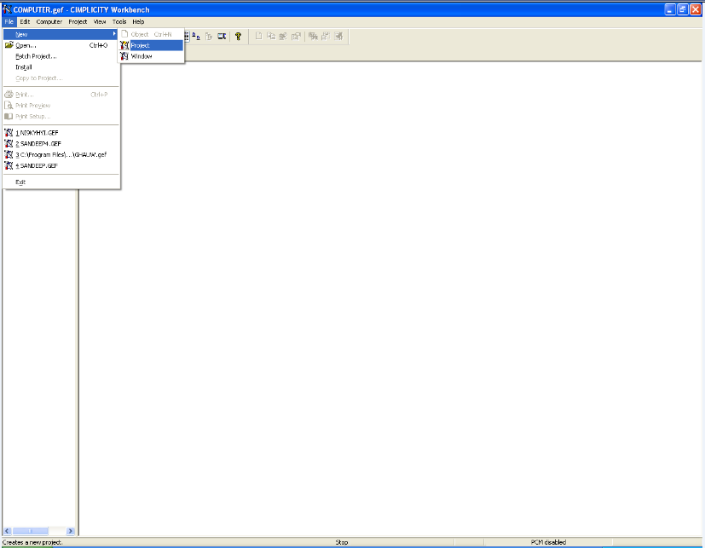
Fig.4: Start-up Window on Cimplicity(SCADA software)

Step 2. A Dialog box will appear as shown above . In the dialog box, select protocol type as “S90 TRIPLEX”, and select option type as “Database Logger: points”. Name the project as say “NEW PROJECT” and finally click on create.
Step 3. Another dialog box appears as shown below. In that enable project broadcast and give an appropriate IP address. A Cimplicity Project wizard window appears in front as shown below. In this window configure PLC type, ports used, etc. Project wizard by itself guides user to configure the device connected to the personal computer, as PLC is connected to PC in this case. The wizard also configures various communication ports and controller type of the connected device. It also helps in input addressing, output addressing and memory addressing by creating new points corresponding to these addresses. After finishing all this click exit to escape from project wizard window. It will automatically configure available information and create points corresponding to addresses used in PLC program.
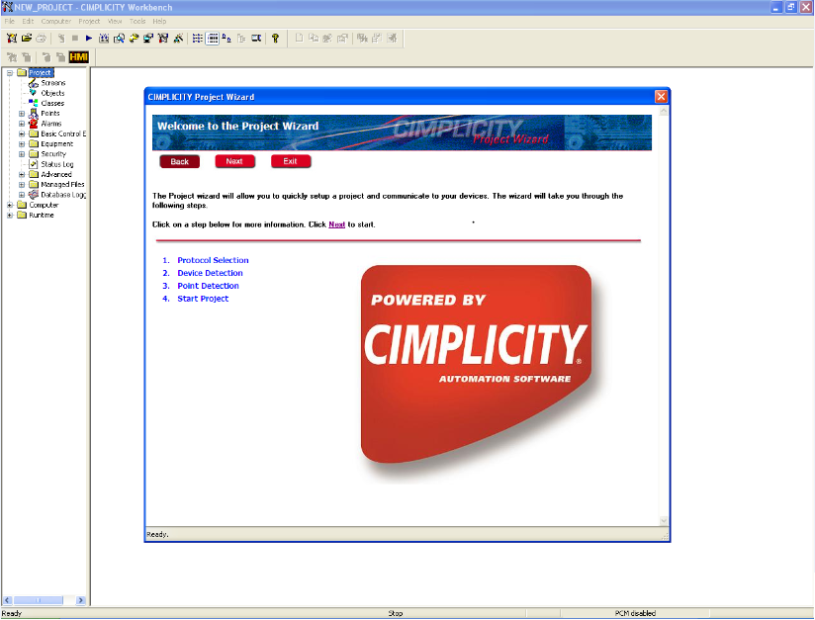

Fig.5: Cimplicity Project Wizard Window
Step 4. Click on screen icon of Cimplicity workbench screen and start the project, this will make SCADA to communicate with PLC. Create a graphical interactive window as required by using object explorer. Lastly, click on test screen icon to run the project.

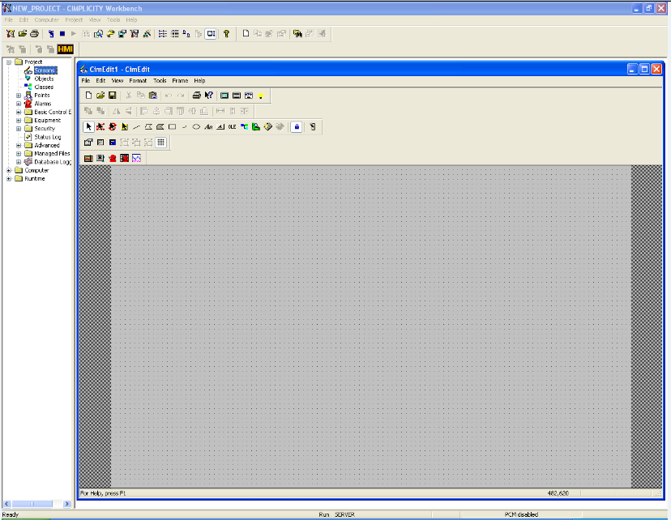
Fig.6
Fig.6 shows a virtual window with Cim Edit menu. CimEdit provides a set of tools that can graphically represent any control process. Windows users will quickly notice the toolbars located around the screen. The toolbars provide the drawing tools such as the capability to draw line, polyline, polygon, rectangle and ellipse, arcs, text and button objects. Trending, quality charts, and alarm viewer are examples of CIMPLICITY ActiveX objects. With this combination of graphic tools, drawing graphic screens that accurately depict a production process is very simple. Once the objects are placed on the screen, another toolbar provides a powerful set of alignment tools. Objects can be aligned automatically with a configurable grid, or aligned as groups using the object alignment tools, which include the ability to space objects evenly as well as align them in relation to each other. Objects can also be rotated, flipped, grouped, or ungrouped. Any object can then be animated using the object property sheet that pops up when we double-click on an object or click on the property sheet icon on the forms toolbar. This property sheet allows user to choose from a wide variety of animation and control functions. These animation properties include: rotation, fill, movement, colour, and text annunciation, geometry, scaling, events, etc.
3.3 DEVELOPMENT OF A VIRTUAL SCADA APPLICATION PLATFORM FOR AUTOMATIC CAR WASHING
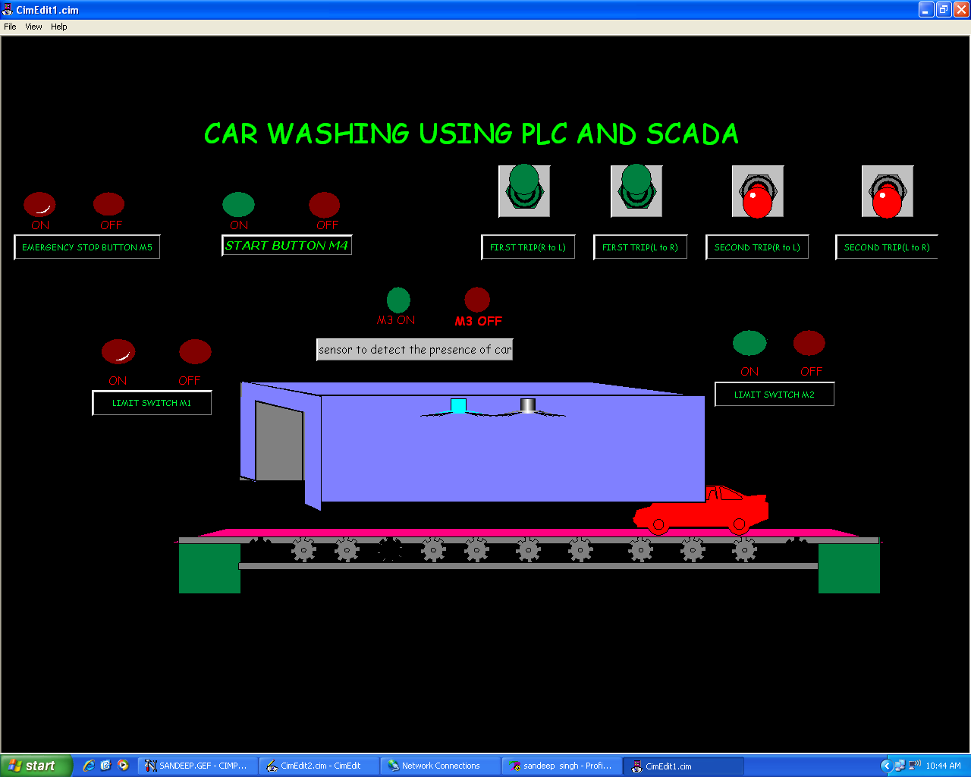
Fig.7 An animated window developed for Car Washing
Fig.7 shows an automatic car washing scheme, developed using real time input from PLC. It consists of start, emergency stop,first trip right to left and left to right movement switches. The presence of car on conveyor under washing operation is detected with the help of proximity sensors. The operation of motor for conveyor (start,stop) is controlled by a PLC. The PLC outputs are used to operate the motor for conveyor.
The necessary sequential logic for all modes/ steps involved in washing operation of car are implemented through ladder programming of PLC. The PLC depending on the state of different input control such as start, stop, L to R or R to L movements generates output signal which control the operation of motor driving the conveyor in real time.

  - HARDWARE DETAILS FOR SCADA INTERFACE WITH
ENERGY METER
The energy metering system under test was connected to a three phase induction motor (load) through CTs. The energy consumption pattern of the motor (load) is accessed by the meter and data is acquired in SCADA system using SCADA software(Cimplicity7.5) through RS485 to RS232 converter. The modbus communication protocol of energy meter is utilized for transfer data from energy meter. The presentation of data are made in SCADA system. The necessary LADDER programming is done by PLC software (Proficy Machine Edition 5.9) to control the operation of load from SCADA. PLC has a Ethernet communication with SCADA.
The SCADA based energy monitoring system developed in the present work comprises of following devices.

    - CURRENT TRANSFORMER(CT)
Three CTs are used to scale down the actual current of three phase load to the current level of digital energy meter. A CT with 100/5A,5VA is used in the present application.
Fig.8 shows that Like any other transformer a current transformer has a primary winding, a magnetic core and a secondary winding. The alternating current flowing in the primary produces a magnetic field in the core, which then induces current flow in the secondary winding circuit. A primary objective of current transformer design is to ensure that the primary and secondary circuits are efficiently coupled, so that the secondary current bears an accurate relationship to the primary current.
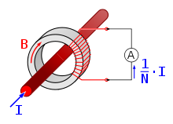
Fig .8 current transformer
The most common design of CT consists of a length of wire wrapped many times around a silicon steel ring passed over the circuit being measured. The CT's primary circuit therefore consists of a single 'turn' of conductor, with a secondary of many hundreds of turns. The primary winding may be a permanent part of the current transformer, with a heavy copper bar to carry current through the magnetic core. Window-type current transformers are also common, which can have circuit cables run through the middle of an opening in the core to provide a single-turn primary winding. When conductors passing through a CT are not centered in the circular (or oval) opening, slight inaccuracies may occur.
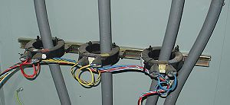
Fig.9 connection layout of CTs for three phase load
The primary circuit is largely unaffected by the insertion of the CT. The rated secondary current is commonly standardized at 1 or 5 amperes. For example, 100:5 CT would provide an output current of 5 amperes when the primary was passing 100 amperes. The secondary winding can be single ratio or multi ratio, with five taps being common for multi ratio CTs. The load, or burden, of the CT should be of low resistance. If the voltage time integral area is higher than the core's design rating, the core goes into saturation towards the end of each cycle, distorting the waveform and affecting accuracy.

    - RS 485 TO RS 232 CONVERTER
A converter SMART CONVERTER-SC04U converts RS 485 signal to RS 232 signal to create compatible communication protocol with SCADA/ PLC systems. It works on 230V/110V AC. 24V & 48V DC power supply options are available on request. Auto Baud Rate(ABRT) is available as default. Select the position of the DIP SW3 to ON to enable this device. Try the ABRT option if the Query/ Responses are fast.Hardware Flow Control, through RTS positive signal, is available in Model SC04 U1 through DIP SW2.This switch is ineffective in MODEL SC04U. The technical details of RS-232 is as follows.
Connector :- 9 pin D type Female
PIN NO. | DIRECTION
2 | OUTGOING FROM SC04 U.
3 | INCOMING FOR SC04U.
4 & 6 | SHORTED
7,8 | SHORTED
5 | GND

RECOMMENDED CABLE CONNECTION FOR RS 232C SIDE
PC SIDE (9 PIN DTYPE,MALE) | SIGNAL | SC04U-SIDE  (9 PIN D TYPE ,FEMALE)
1 | DCD | 1
2 | Rx D | 2
3 | T x D | 3
4 | DTR | 4
5 | GND | 5
6 | DSR | 6
7 | RTS | 7
8 | CTS | 8
9 | RI | 9

RS 485 SIDE DETAILS
CONNECTOR-Terminal Strip
SIGNAL DETAILS:
FOR RS 485,4 WIRE
SIGNAL OF SC04U | DIRECTION | WILL CONNECT  TO
TX+ | OUTPUT FROM SC04U | RX+ OF YOUR DEVICE
TX-- | OUTPUT FROM SC04U | RX-- OF YOUR DEVICE
RX+ | INPUT TO SC04U | TX+ OF YOUR DEVICE
RX-- | INPUT TO SC04U | TX- OF YOUR DEVICE

FOR RS 485 ,TWO WIRE
SIGNAL OF  SC04U | DIRECTION | WILL CONNECT  TO
TX+ | Bi-directional SIGNAL | TX+ of your device
TX- | Bi-directional SIGNAL | TX-- of your device

DATA FLOW --At Power ON, both TX & RX LED’s are OFF. When data is Received from RS 232 side, transmission is enabled and TX LED will blink. When data is received from RS 422 side RX LED will blink.

DIP SWITCH SETTING DETAILS
OPERATION | SW1 | SW2 | SW3
RS 422. | OFF | OFF | OFF
RS 485.Auto Baud Rate Enabled | OFF | OFF | ON
RS485. RTS Controlled | OFF | ON | OFF
RS 485.Auto Baud Rate Disabled | ON | OFF | OFF
RS 485 MODE | SW4 | SW5
RS 485 - 2 WIRE | ON | OFF
RS 485 - 4 WIRE | OFF | ON

BAUD RATE SETTING | SW6 | SW7 | SW8
19.2 TO 38.4 Kbps | ON | OFF | OFF
9.6 kbps | OFF | ON | ON
4.8 kbps | OFF | ON | OFF
Below 2.4 kbps | OFF | OFF | ON
Selection of DIP Switch no. 6,7,8 is valid only when SW1 is ON.

    - THREE PHASE AC CONTACTOR

When a relay is used to switch a large amount of electrical power through its contacts, it is designated by a special name: contactor. Contactors typically have multiple contacts, and those contacts are usually (but not always) normally-open, so that power to the load is shut off when the coil is de-energized. Perhaps the most common industrial use for contactors is the control of electric motors.
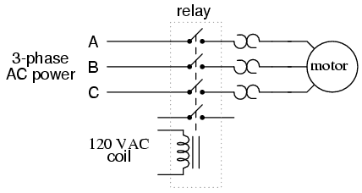
Fig.10, Three Phase ac contactor
The top three contacts switch the respective phases of the incoming 3-phase AC power, typically at least 480 Volts for motors 1 horsepower or greater. The lowest contact is an "auxiliary" contact which has a current rating much lower than that of the large motor power contacts, but is actuated by the same armature as the power contacts. The auxiliary contact is often used in a relay logic circuit, or for some other part of the motor control scheme, typically switching 120 Volt AC power instead of the motor voltage. One contactor may have several auxiliary contacts, either normally-open or normally-closed, if required.
Description of the used contactor in the project:
Three phase ac contactor (MNX 25,L&T CONTACTOR) has been used. Three-phase, 480 volt AC power comes in to the three normally-open contacts at the top of the contactor via screw terminals labeled "L1," "L2," and "L3" (The "L2" terminal is hidden behind a square-shaped "snubber" circuit connected across the contactor's coil terminals). Power to the motor exits the overload heater assembly at the bottom of this device via screw terminals labeled "T1," "T2," and "T3." A1& A2 acts as control inputs.

    - THREE PHASE INDUCTION MOTOR (LOAD)

A three phase induction motor has been used as a three phase balanced load. The energy consumption of the motor at different voltage level is monitored and accessed through PLC in SCADA system .
Specifications:
Connection: Star Connected
Power : .8 KW,1hp
Current : 1.7 Amp
Voltage : 400/440V
Rpm :1440

    - THREE PHASE ENERGY METER

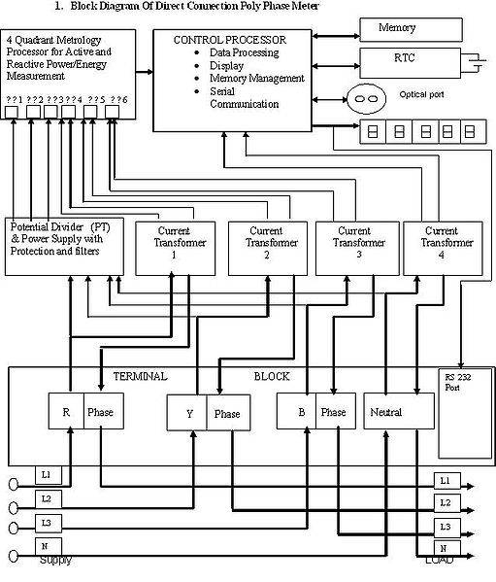
Fig.11 A Block Diagram of a 3 Phase Electronic Energy Meter
As in the block diagram Fig.11, the meter has a power supply, a metering engine, a processing and communication engine (i.e. a microcontroller), and other add-on modules such as RTC, LCD display, communication ports/modules and so on. The metering engine is given the voltage and current inputs and has a voltage reference, samplers and quantiser followed by an ADC section to yield the digitised equivalents of all the inputs. These inputs are then processed using a Digital Signal Processor to calculate the various metering parameters such as powers, energies etc.The largest source of long-term errors in the meter is drift in the preamp, followed by the precision of the voltage reference. Both of these vary with temperature as well, and vary wildly because most meters are outdoors. Characterizing and compensating for these is a major part of meter design. The processing and communication section has the responsibility of calculating the various derived quantities from the digital values generated by the metering engine. This also has the responsibility of communication using various protocols and interface with other add on modules connected as slaves to it.RTC and other add-on modules are attached as slaves to the processing and communication section for various input/output functions. On a modern meter most if not all of this will be implemented inside the microprocessor, such as the Real Time Clock (RTC), LCD controller, temperature sensor, memory and analog to digital converters.

  - CONCLUSION
The chapter presents a detailed description of the hardware devices used in energy management of three phase induction motor. The necessary SCADA application window and PLC ladder programming is developed to give real-time feel of the energy monitoring and control operation of consumer load.
CHAPTER IV
EXPERIMENTAL RESULTS AND DISCUSSION
4.1 GENERAL

In this chapter, experimental results regarding energy management has been discussed. For clear understanding of energy management, necessary Ladder programming in PLC, configuring SCADA software has been described. Designing of virtual animated screen using ladder programming and animated screen in real time using hardware devices have been presented in detail. This chapter shows that how energy consumed by load is displayed on SCADA screen and how it is reduced or managed. The variation in current, power, phase voltages (through auto transformer) has been also shown in the form of tables and charts.

4.2 LOGICAL AND GRAPHICAL ANALYSIS

4.2.1 DESCRIPTION OF PLC AND PLC PROGRAMMING SOFTWARE
A programmable logic controller (PLC) or simply programmable controller is a digital computer which accepts and senses inputs from switches and sensors, stores user-oriented instructions using programmable memory, evaluates these in accordance with a stored program, executes specific functions that include ON/OFF control, timing, counting, sequencing, etc. and generates outputs to control machines and processes involved. In actual operation, the memory unit sequentially scans and senses inputs (sensors, limit switches, push buttons, etc.) in cyclic fashion to determine which outputs (contacts, motor starters, solenoids, pilot lights, converters, etc.) are to be turned ON or OFF. The PLC output module runs and controls field devices as per the specified ladder logic program (user-logic). The program is downloaded into the PLC from a personal computer through RS-232 serial communication (as well as through Ethernet for high speed control). The PLC used in this project is GE Fanuc Series 90-30 type, having modular structure with provision of its expansion.

Proficy Machine Edition 5.9 proves excellent software for PLC programming. It gives an easy access to various virtual devices like ON-Delay timer, OFF-delay timer, UP-Counter, DOWN-Counter; normally open Switch, Relay coil, etc. The programs developed can be validated before downloading it to PLC controller. The software provides a fully-integrated environment in which every tool and editor works efficiently with each other. Proficy Machine Edition in short offers a complete solution for the development of automation applications under one roof. Procedure for development of PLC program in Proficy Machine Edition 5.9 has been described below:

Step 1. Fig.12 shows that Open the Proficy Machine Edition 5.9 icon by simply double clicking on its shortcut. A window appears in front of us as shown below. To create a new project, right click on “My Computer” in the left side of window and select option “New”.

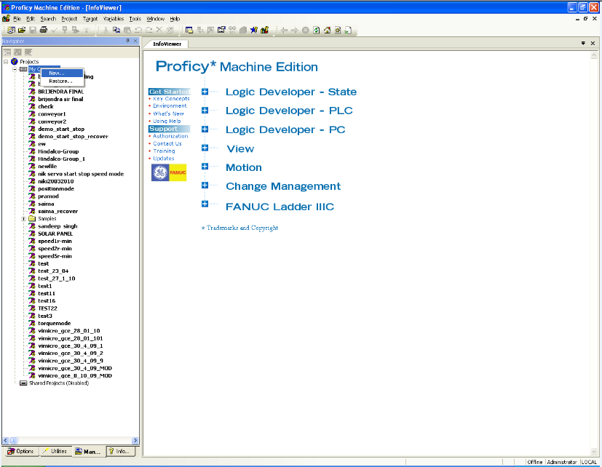
Fig.12
Step 2. Fig.13 describes that Give an appropriate name to the project say “NEW PROJECT” on the dialog box that appears in front and select project template as GE Fanuc Series 90-30 PLC. Click OK to proceed further. The software by itself configures settings for 90-30 PLC and apparently other screen overlays itself on the previous window screen. The figure below shows the captured view of NEW PROJECT widow.
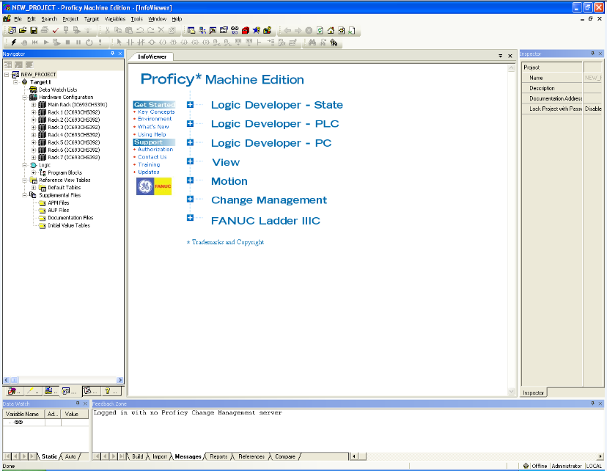
Fig.13
Step 3. Fig.14 shows that In the “NEW PROJECT” window, right click on the NEW PROJECT. Select “Add target” and then in the GE Fanuc Controller option, select “Series 90-30 PLC”. Next change the hardware configuration to the one installed in the setup. For the present setup add Power supply module (IC693PWR330), CPU type (IC693CPU374), Digital Input module (IC693MDL645), Digital Output module (IC693MDL740) and Bus controller module (IC693PBM200). Since the experimental set up involves two output modules, therefore, select two slots for output while adding hardware configuration to the project. The procedure for addition of Digital input module is shown in the window below.
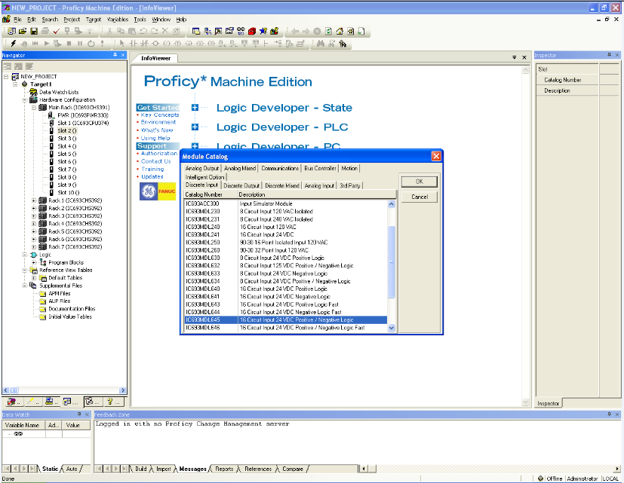
Fig.14
Step 4. Fig.15 shows that Create a new ladder diagram by selecting “MAIN” in program blocks present in logic folder given on left side of the programming window as is shown below. The figure basically represents programming window in offline mode with two vertical rails having provision for addition of rungs so as to develop ladder logic program on it which is the ultimate goal of Proficy Machine Edition software. The figure shows a simple PLC program incorporating various virtual devices that include normally open and normally closed switches, timers and relay coils.
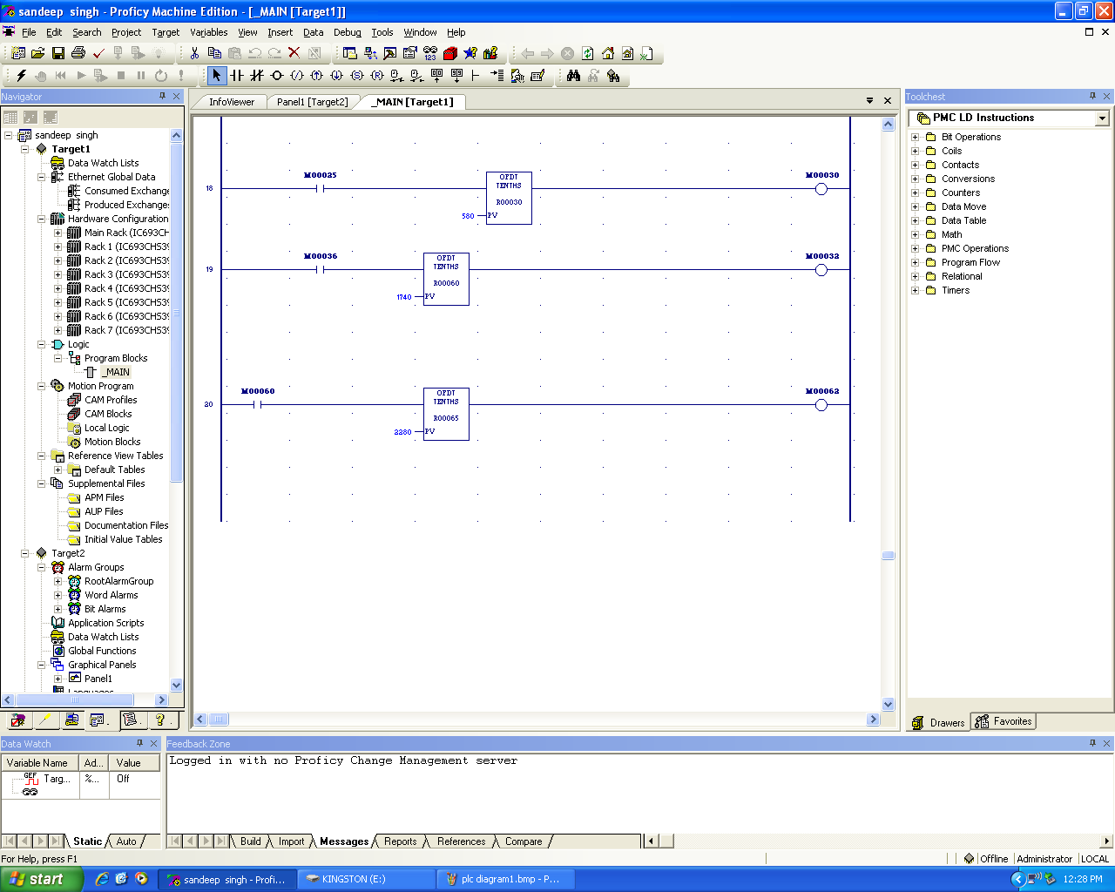
Fig.15
Step 5. Fig.16 shows that Save the program and right click on target PLC select “Go online”, if PLC is connected properly through serial communication or through Ethernet it will show “connected”. If it shows “unable to go online” check connections and modules selected. When PLC is online, go to the “Programmer Mode”, and select “Download and Run Program”, Machine Edition software will by itself check the program and for a correct program, PLC goes into Run mode indicated by a green LED on PLC board. Figure below shows PLC in run mode.

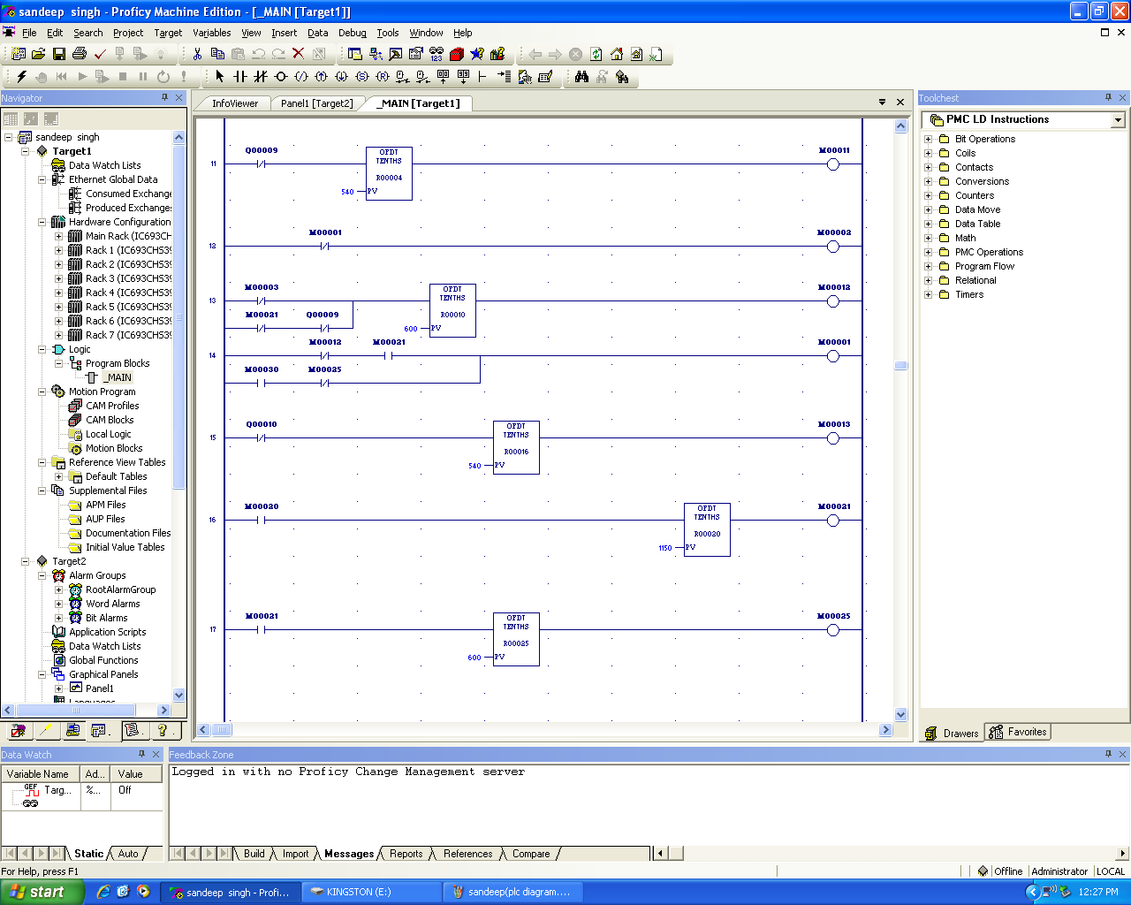

Fig. 16

4.2.2 DESCRIPTION OF LADDER PROGRAMMING FOR DESIGNING VIRTUAL ANIMATED SCREEN

Ladder logic is the programming language used in this project. Ladder logic programs are represented by graphical diagrams which represent the interconnection of the virtual devices needed to control field devices (servomotor in this case) as desired and is based on the electrical circuit diagrams of relay-based logic hardware, also known as ladder diagram. The name is based on the observation that programs in this language resemble ladders, with two vertical rails and a series of horizontal rungs between them. The logic in a ladder diagram typically flows from left to right. Each rung typically consists of a combination of input instructions. These instructions lead to a single output instruction. Each input or output instruction is assigned an address indicating the location in the PLC memory where the state of that instruction is stored. Fig. 3.13 shows a view of ladder logic program in which start button, relay coil and output Q1 are represented by normally open switches and emergency stop by a normally closed switch. As soon as the start switch is ON, relay is activated, which activates latched relay coil and an on-delay timer simultaneously. After 100 seconds, Q1 is ON which makes the motor to run. By switching ON emergency stop switch, motor can be stopped at any moment as required.
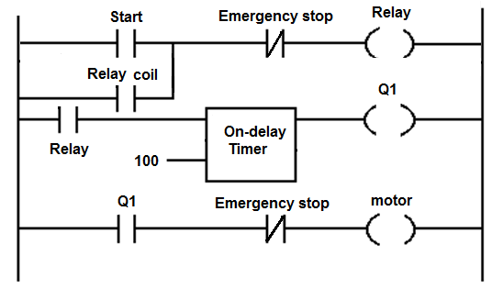
Fig. 17: PLC ladder logic program

4.2.3 IMPLMENTATION LOGIC OPERATION THROUGH PLC
START
Go Online PLC through
Proficy Machine Edition 5.9

Now Start SCADA screen

Then click graphical button on screen to start the project
Automatic loading of graphical motor will start

At 800 rpm current will be 2A
At 400 rpm current will be 1A
At 1400 rpm current will be 3A

At 1400 rpm motor will automatically stop through PLC

Fig.18 flow chart to operate 3 phase load in different modes
Fig. 18 shows sequence of operation designed to demonstrate the energy consumption pattern and controlled mode in operation of the load. This flow chart gives the basic idea regarding designing of screen and ladder logic that has been used to design the screen. The ladder programming that has been used in the project to design a virtual screen is discussed here. This ladder programming consists of 24 rungs. In this programming timers have been used to display of motor (load) parameters like voltage, current, rpm, frequency and power factor. Off- timers will be only discussed. Although on timers are also used. But they are used for providing delays and synchronization.

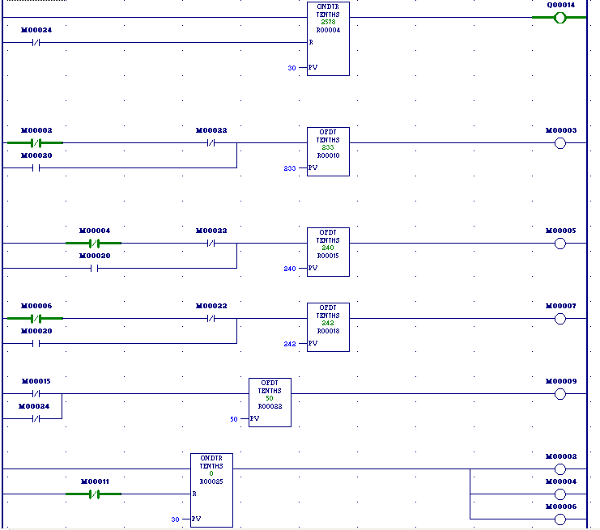 Fig.19 Ladder diagram for showing phase to neutral voltages and frequency
- Fig.19 shows four off- timers. Three of them are used for phase to neutral voltages and the last off-timer of value 50 is used for frequency.

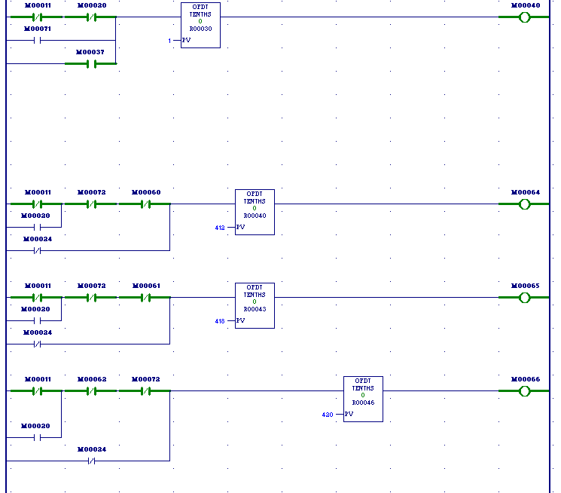 Fig.20 Ladder diagram for showing phase to phase voltages and current in SCADA screen
Fig.20 shows four off-timers. Three of them are used for phase to phase voltages and the timer having value 1 is used for current 1Amp.
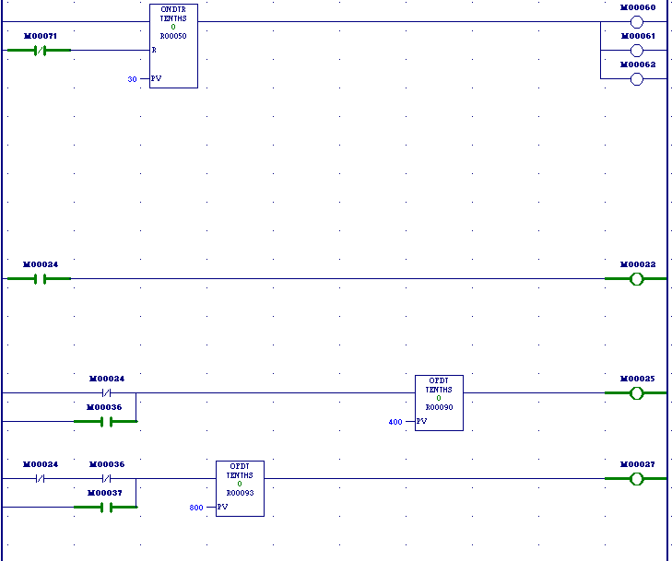
Fig.21 Ladder diagram for showing speed variation in SCADA
Fig.21 shows two off- timers. These two off-timers having values 400 and 800 are used for speed variation upto 400 RPM and 800 RPM.
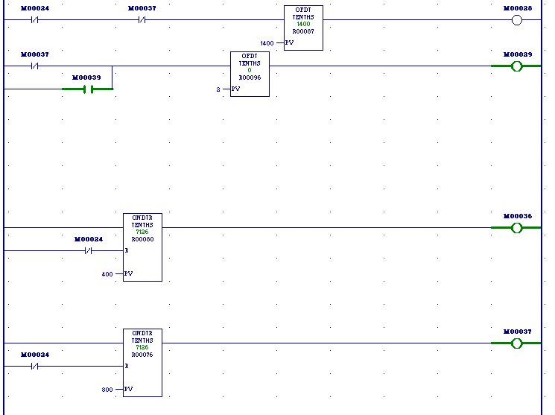
Fig.22 Ladder diagram for showing speed and current variation in SCADA
Fig.22 shows two off –timers for speed variation upto 1400 RPM and current value of 2 Amp.

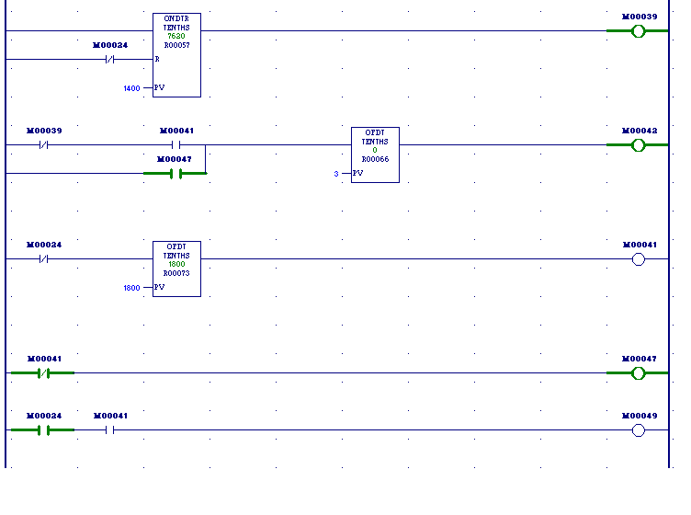 Fig.23 Ladder diagram for displaying current of 3 Amp in SCADA screen
Fig.23 shows two off- timers but off- timer of value 3 is necessary to discuss. This timer is used for showing current value of 3 Amp
4.2.4 DEVELOPMENT OF VIRTUAL ANIMATED SCREEN USING SCADA
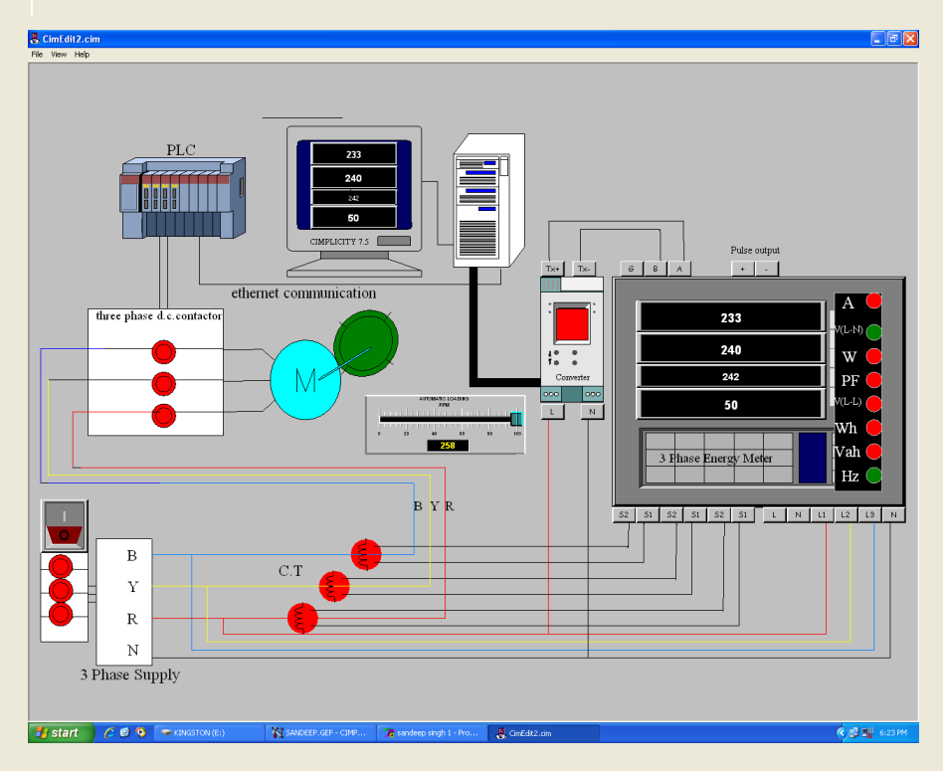 Fig .24 A virtual animated screen designed of present experimental set up in SCADA
Procedure to design the graphical screen:
As discussed earlier in flow chart (Fig.18), the basic concept is to control the three phase load (ac motor) by a PLC which is animated. The procedure for animation is as follows:

(a) Click on screen icon of Cimplicity workbench screen and start the project, this will make SCADA to communicate with PLC. Create a graphical interactive window as required by using object explorer. Lastly, click on test screen icon to run the project. In the screen there are many graphical tools like rectangle, ellipse, polygon, text button, text string for designing the screen (fig.24). In this case rectangular blocks are used to represent the three phase supply and dc contactor. Graphical blocks for energy meter, PLC , converter, computer ,CPU, motor and a switch for supply are taken from object explorer tool. All connecting wires are taken from “line” tool.

(b) After making suitable connection diagram, some of selected objects need to be configured through point configuration(as discussed earlier) like energy meter block, converter block to be switched on, motor block to be rotated. Switch to be on or off, contactor block to be on or off. These blocks are configured through PLC programming as discussed earlier. Memory switches are used to represent the normally open or normally closed switches in PLC programming through proper addressing. The addressing is used to configure a point in SCADA software.

(c) For example, in screen if a switch is used for giving supply, this switch is configured using memory address M00022 in point configuration. Q00014 for converter to be switched on. R00073 (TIMER) is used for motor to be rotated. R000093, 90, 87 are used for speed variation. Buttons with energy meter block for some parameters like phase to neutral, phase to phase voltages, current, power factor are configured through M00022, M00071, M00039, M00047. Voltages, currents, power factor are shown through timers in PLC programming.

  - INTERFACING OF ENERGYMETER TO SCADA SOFTWARE
To interface energy meter to SCADA software we need to have communication parameters as discussed earlier regarding protocol, baud rate, parity, data bits, flow control stop bits. These parameters will be used by SCADA software which will be discussed briefly as given below.
- In order to make new project enter “MODBUS RTU” protocol in the protocols field of project properties and in the “options” field all options will be marked except server redundancy and spc charts. After that create a project with a project name.
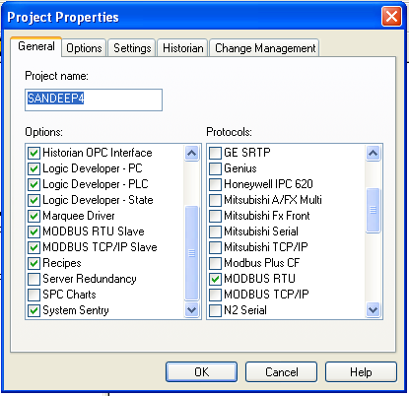
Fig.25

- After doing the above procedure port is selected from equipment option.COM1 will be used as a port. In the serial field of port properties communication parameters of energy meter as discussed in chapter1 will be entered. In the connection method serial port will be selected.

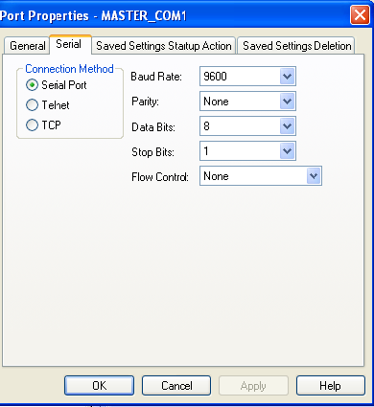
Fig.26

(c) After configuring port, the device will be configured in equipment option by taking COM1 as a port. In the general option of device properties model type will be generic_plc. All other entries will remain same.
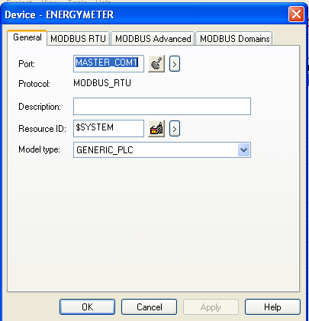

Fig.27

- In the MODBUS RTU field of device properties RTU address will be 1 and ENABLE will be yes.

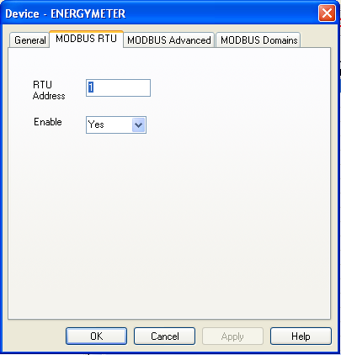

Fig.28

(e) After doing the above procedure, for data acquisition, point will be made using holding registers as given in the energy meter manual. Addresses of registers will start from 4. For example,42013 as shown in fig. given below.
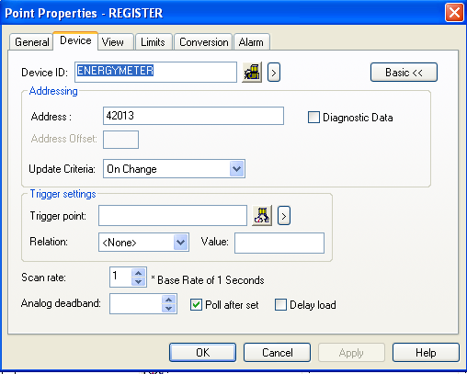
Fig.29
(f) Some holding registers having values of current, voltage, power and power factor are given below.
Data Address & Data Lengths:
Address Parameter Length
( in words)
2013 ------- RY Voltage ------------ 2
2015 ------- YB Voltage ------------ 2
2017 ------- BR Voltage ------------ 2
2019 ------- RN Voltage ----------- 2
2021 ------- YN Voltage ------------ 2
2023 ------- BN Voltage ------------ 2
2025 ------- R Watts ( kW) ------- 2
2027 ------- Y Watts ( kW) ------- 2
2029 ------- B Watts ( kW) - 2
2043 ------- R - Current ----------- 2
2045 ------- Y - Current ---------- 2
2047 ------- B - Current --------- 2
2049 ------- R - Power Factor ---- 2
2051 ------- Y - Power Factor --- 2
2053 ------- B - Power Factor ---- 2
2055 ------- Frequency ------- 2

(g) In general field of point properties enter data type UDINT. This completes the point configuration. After point configuration screen can be designed for displaying reading of energy meter on SCADA by configuring graphical blocks using configured points.
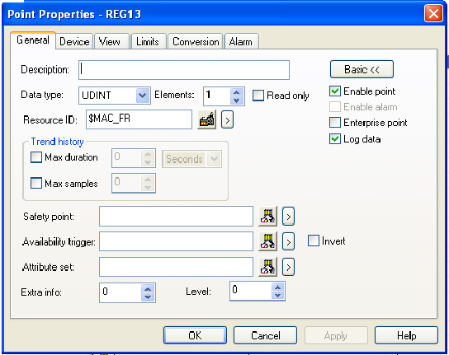

Fig.30

  - TESTING OF ENERYMETER IN REALTIME

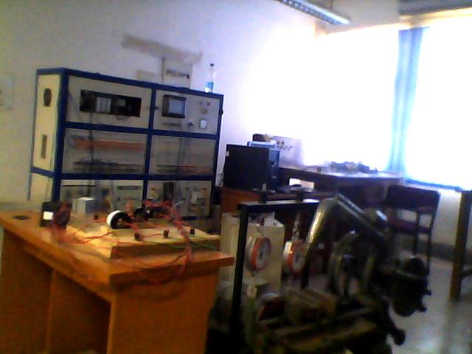

Fig. 31 A photograph of the experimental set up developed & tested
The real time testing of energy meter is done by monitoring the energy consumed by a three phase load( induction motor) which is shown in Fig.11 Three phase supply is given to the Induction motor through a three phase autotransformer. A PLC is also incorporated which can be used to operate the motor. This is achieved by writing a ladder logic and down loading the same in the PLC memory. The various parameters of the motor which are monitored by the energy meter are given in the following tables (Table 2& Table 3) for different voltage levels.
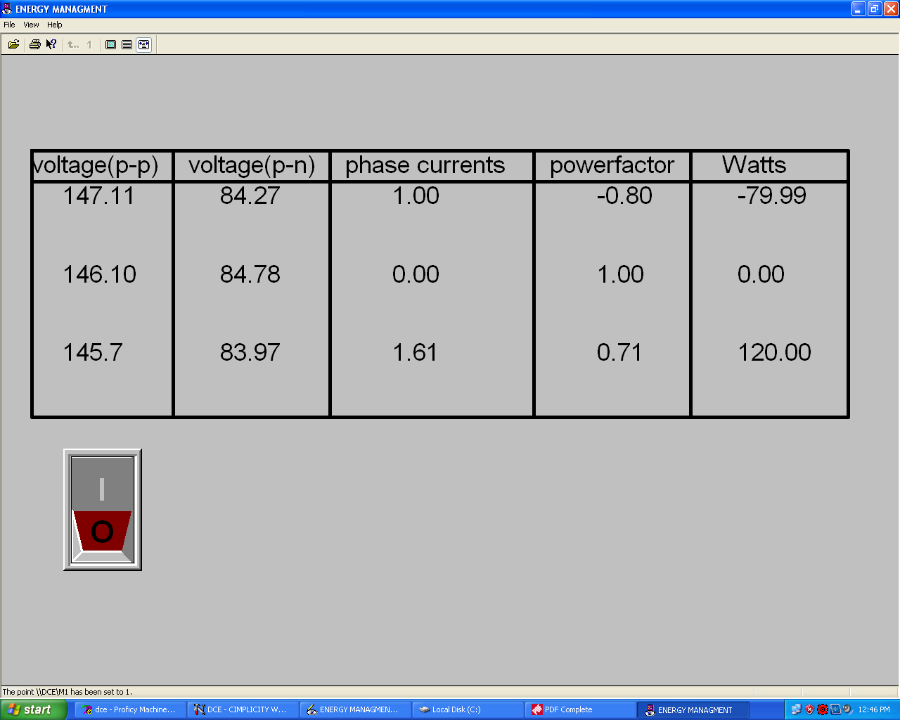
Table.2
.
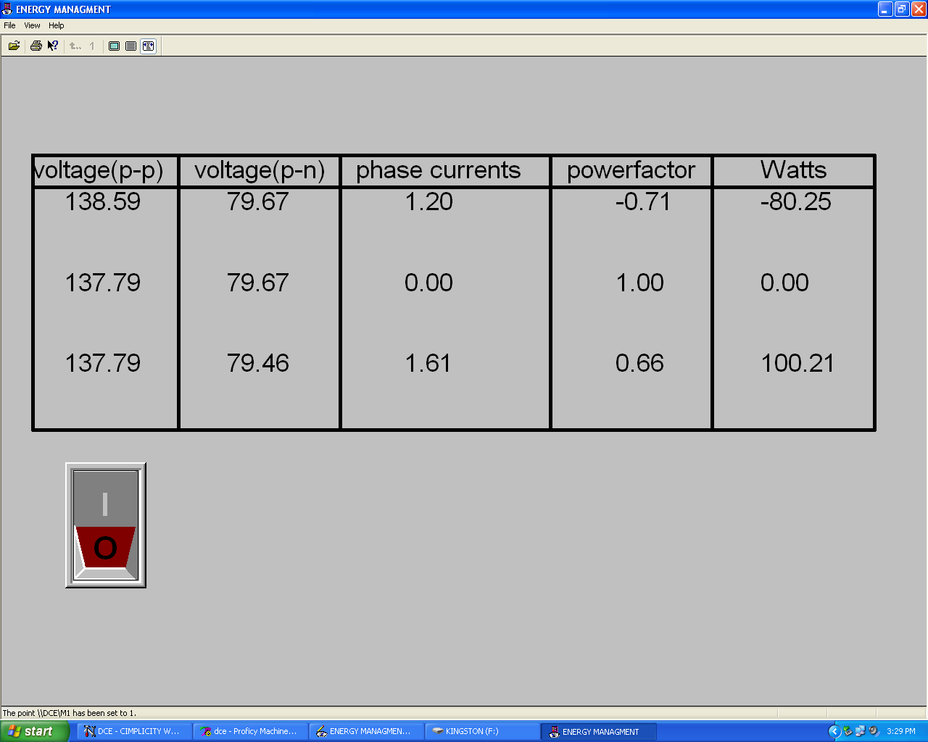

Table .3
(a) In the Table.4 given below shows that the motor can be switched off using PLC programming when it is not in use. The configured graphical switch is used to switch on or off the motor. So, current and power values of motor in screen are of zero value when the motor is switched off by PLC.

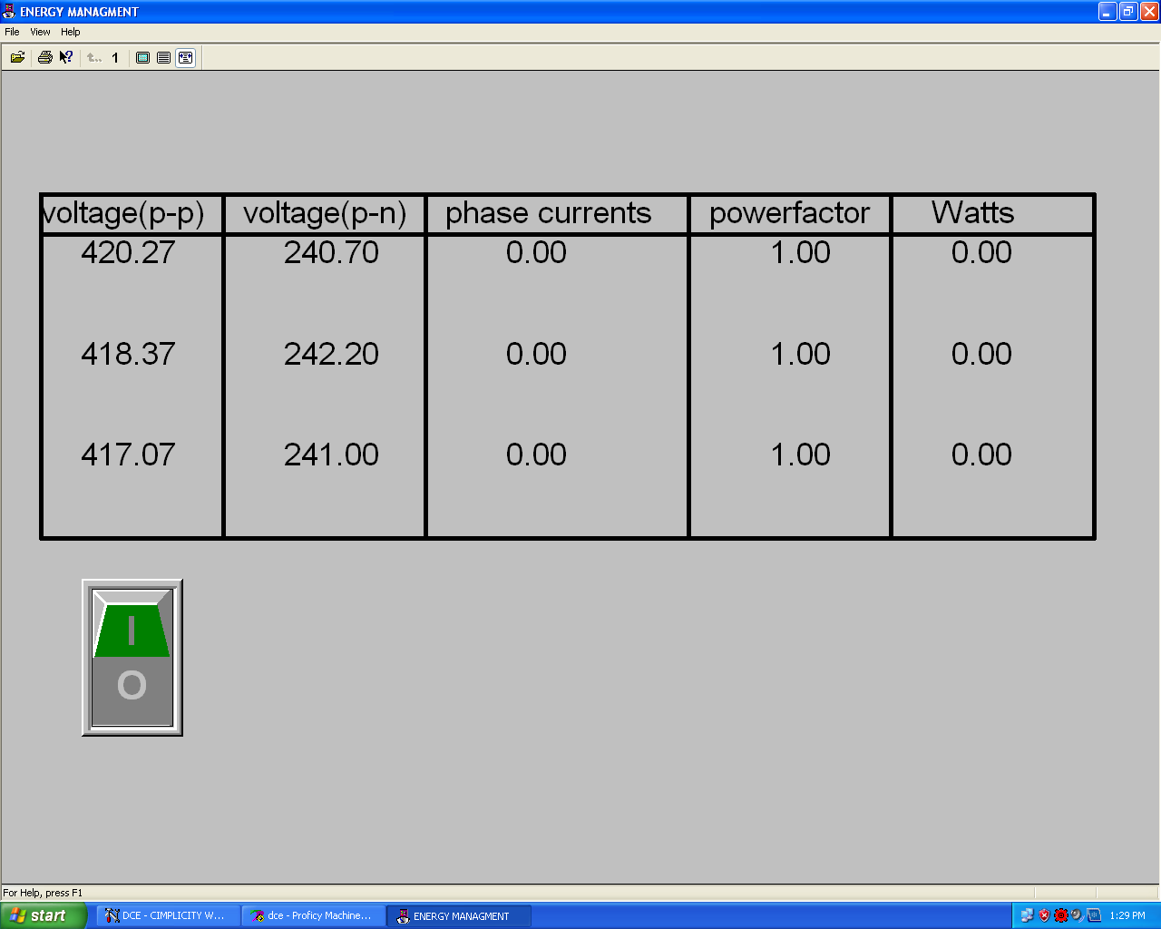

Table.4

(b) The Fig.32,33,34,35 show the variation of phase to phase voltages, phase to neutral voltages ,phase currents and power with respect to time. This variation is achieved using auto transformer.
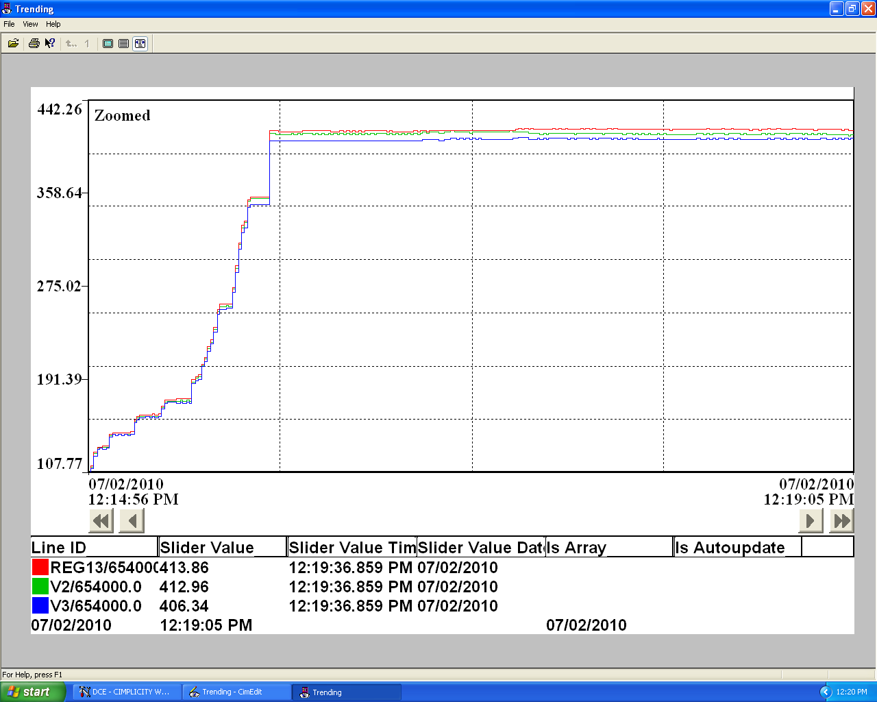

Fig.32 Monitoring of Variation in Phase to Phase voltages in SCADA

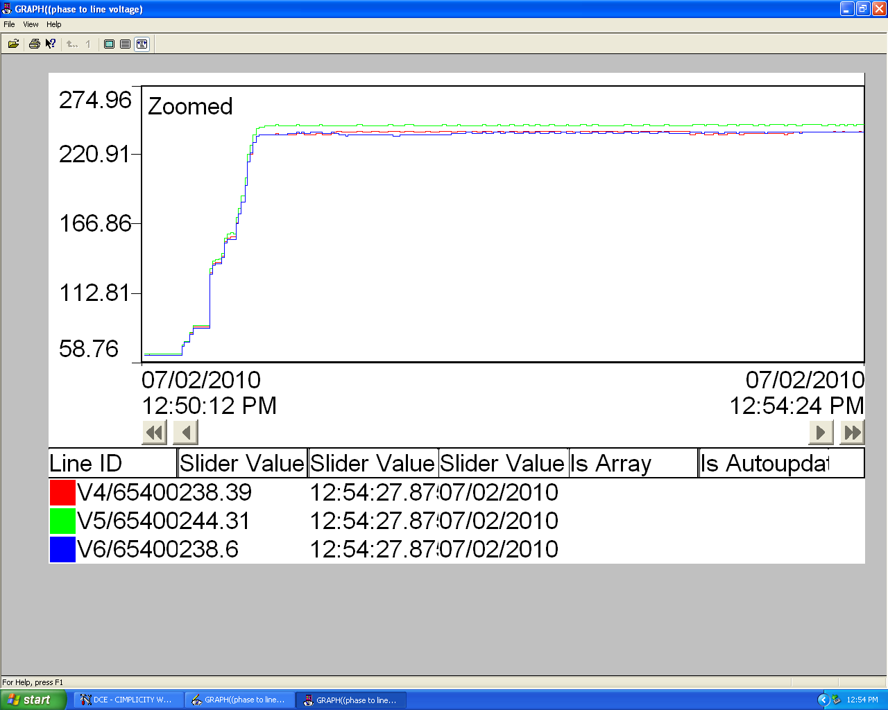

Fig.33 Monitoring of Variation in Phase to Neutral Voltages in SCADA

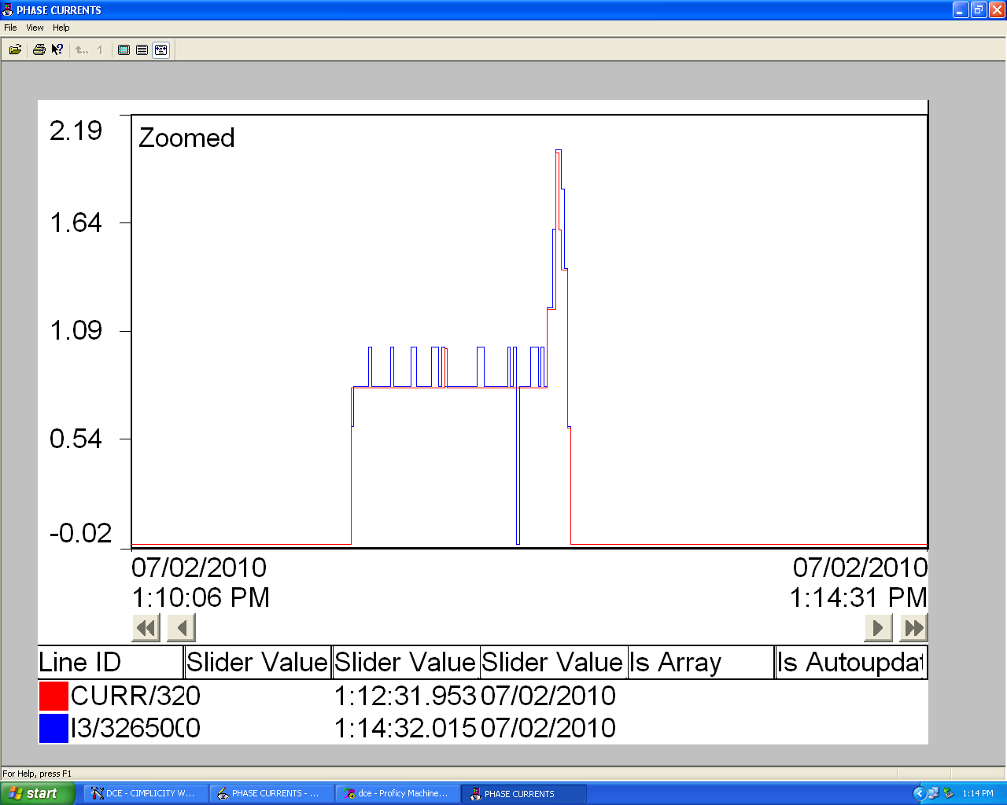

Fig.34 Monitoring of variation in Phase Currents in SCADA

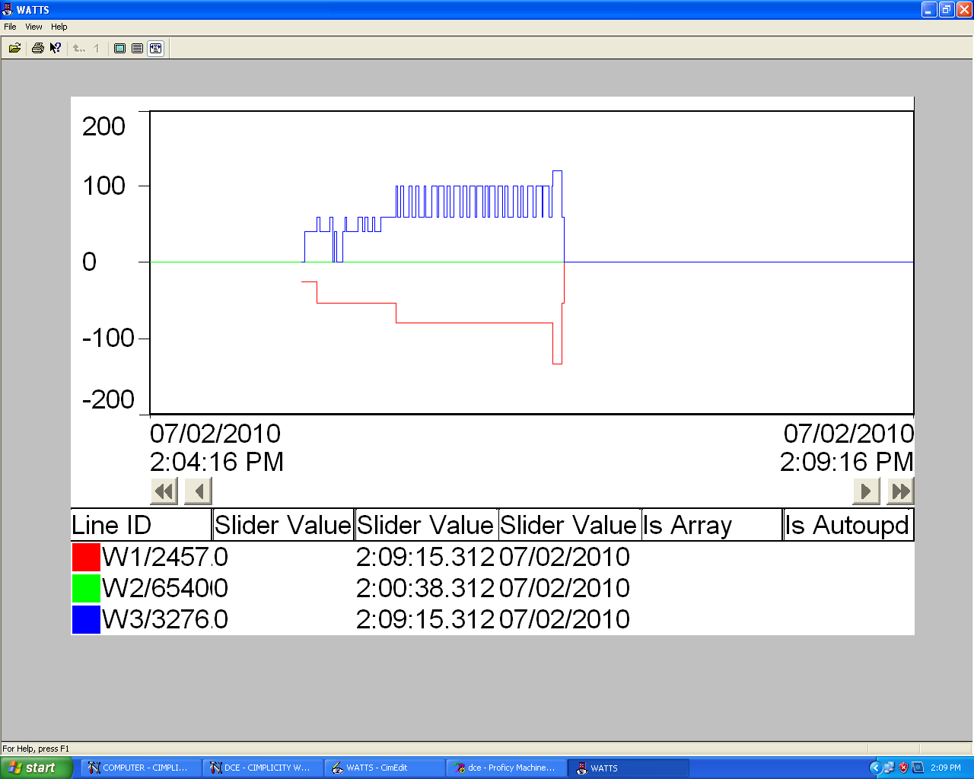

Fig.35,Monitoring of variation in Power in SCADA

  - CONCLUSION

This chapter explains the importance of measurement to control the motor performance parameters using the application of PLC and SCADA. This chapter also explains the various tools like graphical blocks, trend charts etc. to design a screen. There are a number of software for data acquisition but this SCADA software (cimplicity 7.5) provides additional features of screen designing, trend charts, linking with PLC software to control the motor. As a whole SCADA and PLC play an important role in reducing power consumption or managing energy efficiently.

CHAPTER V

CONCLUSION AND FUTURE SCOPE OF WORK

5.1 MAIN CONCLUSION
This dissertation describes how energy management is achieved using PLC and SCADA. A Programmable Logic Controller (PLC) based automation scheme for control of three phase load (induction motor) and monitoring of its parameters is developed. A control method for three phase load has been designed and tested under varying speed conditions. The speed is varied by varying the applied voltage through an auto transformer. The control of induction motor is achieved through PLC programming and SCADA software. SCADA CIMPLICITY 7.5 software has been used to display the readings of motor parameters. PROFICY MACHINE EDITION 5.9 software has been used for ladder programming. Experimental results regarding energy management has been discussed. Detailed description of the hardware devices used for the energy management of three phase induction motor is also given. There are a number of software for data acquisition but SCADA CIMPLICITY 7.5 software provides additional features like screen designing, trend charts, linking with PLC software to control the motor. Thus SCADA gives a feel of application development which is the ultimate goal of the experimental setup. SCADA and PLC play an important role in reducing power consumption or managing energy efficiently.

5.2 FUTURE SCOPE OF WORK
In this project work, a single three phase induction motor is used as a load whose speed is varied by varying the applied voltage through an auto transformer. A suitable drive for varying speed can also be used. These days, sensor less drives are widely used for variable speed application, which can be controlled by a PLC. Instead of having a single Induction motor , many drives can be used in a Distributed drive system and the same can be controlled by the PLC which is acting as a supervisory control. On the basis of the project and future scope of work, more energy efficient system can be made.

REFRENCES

- D.P.Kothari "Energy problems facing the third world," Power Engineering Conference, 2009. AUPEC 2009. Australasian Universities, pp.1-12, 27-30 Sept. 2009, Adelaide, SA.
2. Joao Figueiredo "A Concept for an Operative Platform to Manage Intelligent Buildings," International Conference on Power Engineering, Energy and Electrical Drives, 2007. pp. 300-305, 12-14 April 2007, Setubal, portugal.

3. R.J. St clair "Energy management for multi-utilities" Ninth International Conference on Metering and Tariffs for Energy Supply, 1999. pp.200-204, Aug 1999, Birmingham.

4. Eric Williams and Scott Mathews "Use of a Computer-Based System to Measure and Manage Energy Consumption in the Home," Proceedings of the 2006 IEEE International Symposium on Electronics and the Environment, 2006. pp.167-172, 8-11 May 2006, Scottsdale, AZ.

5. Wan Norsyafizan W.Muhamad "Energy Efficient Lighting System Design for Building" International Conference on Intelligent Systems, Modelling and Simulation (ISMS), pp.282-286, 27-29 Jan. 2010, Liverpool.

6. M.F. Lai and Y-P.Wu "Design and implementation of a microprocessor-based intelligent electronic meter," international Conference on Industrial Technology, 1994. Proceedings of the IEEE, pp.268-272, 5-9 Dec 1994, Guangzhou.

7. Hyun Sang Cho "Determining location of appliances from multi-hop tree structures of power strip type smart meters," IEEE Transactions on Consumer Electronics, vol.55, no.4, pp.2314-2322, November 2009, Kaist, Seoul, South Korea.
8. Juan Antonio Sanchez "Key point for the future challenges of the SmartGrids: The architecture of the Smart T-Station," IET-CIRED Seminar on Smart Grids for Distribution, 2008, pp.1-4, 23-24 June 2008, Frankfurt.
9. Hakki Cavdar "A solution to remote detection of illegal electricity usage via power line communications," IEEE Transactions on Power Delivery, vol.19, no.4, pp. 1663- 1667, Oct. 2004, Trabzon, Turkey.
10. Negnevisky "A model of domestic energy management enabling low-cost technology," Power Engineering Conference, 2008. AUPEC '08. Australasian Universities , pp.1-6, 14-17 Dec. 2008, Sydney, NSW.
11. Subir ghosh "Industrial energy management: the role of distributed control systems," Proceedings of the 1996 International Conference on Power Electronics, Drives and Energy Systems for Industrial Growth, 1996, vol.2, no., pp.1047-1053 vol.2, 8-11 Jan 1996, New Delhi.
12. Muhammad Aamir "Performance analysis of wide area operation, control and protection using high scale SCADA system," Electric Power Conference, 2008. EPEC 2008. IEEE Canada , vol., no., pp.1-7, 6-7 Oct. 2008, Vancouver, BC.
13. Soumitra K. Ghosh "Changing role of SCADA in manufacturing plant," Industry Applications Conference, 1996. Thirty-First IAS Annual Meeting, IAS '96., Conference Record of the 1996 IEEE , vol.3, no., pp.1565-1566 vol.3, 6-10 Oct 1996, San Diego, CA.
14. L. L. Lai "The impact of new technology on energy management systems and SCADA ," IEE Colloquium on Advanced SCADA and Energy Management Systems, pp.1/1-1/3, 6 Dec 1990, London.
15. Masahiko Oka "Rapidly increasing application of Intranet technologies for SCADA (supervisory control and data acquisition system)," Transmission and Distribution Conference and Exhibition 2002: Asia Pacific. IEEE/PES, vol.1, no., pp. 22- 25 vol.1, 6-10 Oct. 2002, Toshiba Corp., Tokyo, Japan.
16. Yasar Birbar “Design and Implementation of PLC-Based Monitoring Control System for Three-Phase Induction Motors Fed by PWM Inverter” international journals of system applications, engineering and development ,Issue 3, Volume 2, 2008,Istanbul, turkey.
17. Yuanrui Chen "Agent-based energy management and control of a grid-connected wind/solar hybrid power system," International Conference on Electrical Machines and Systems, 2008. ICEMS 2008, pp.2362-2365, 17-20 Oct. 2008, Wuhan.
18. A. R. Al-Ali, M. M. Negm, and M. Kassas, “A PLC based power factor controller for a 3-phase induction motor” in Proceedings Conf. Rec. IEEE Industry Applications, vol. 2, 2000, pp. 1065–1072, Rome.

