CHAPTER-1
1.1 Introduction
There has been a rapid growth in the development of harder and difficult to machine metals and alloys during the last two decades. Conventional edged tool machining is uneconomical for such materials and the degree of accuracy and surface finish attainable is poor. The advancing strength level would have a catastrophic effect on the total machining bill of there was no corresponding improvement in machining technology. In view of seriousness of this problem, Merchant (1960) [1] emphasized the need for the development of newer concepts in metal machining. By applying a adopting a unified programmed and utilizing the result of basic and applied result it has now possible to process some of materials which were formerly considered to be un-mechinable under normal conditions. The newer machining that developed is often called ‘modern machining processes or ‘non-traditional machining process.’ The word unconventional is used in sense that the metal like tungsten, hardened stainless steel tantalum, some high strength steel alloys etc. are such that they can’t be machined by conventional method but require some special technique . The conventional methods in spite of recent advancements are inadequate to machine such materials from stand point of economic production.
The unconventional methods of machining have several specific advantages over conventional methods of machining. And these promise formidable tasks to be undertaken and set a new record in the manufacturing technology. These methods are not limited by hardness, toughness, and brittleness of the material and can produce any intricate shape on any work piece material by a suitable control over various physical parameter of the process.

In unconventional machining methods, there is no direct contact between the tool and work piece; hence the tool need not to be harder than work piece. Further, in spite of the recent technical advancement, the conventional machining processes are inadequate to produce complex geometries shapes in hard and temperature resistant alloy and die steels. Keeping these requirements into mind, a number of non-conventional methods have been developed. Below give classification of machining process based on type of energy used, the mechanism of metal removal, the source of energy requirement.

1 Mechanical Energy (Mechanical Processes ) : In mechanical processes metal removal takes place either by a mechanism of simple shear or by erosion mechanism where high velocity particles are used as transfer or by erosion mechanism where high velocity particles are used as transfer media and pneumatic /hydraulic pressure acts as source of energy. It includes ultrasonic machining, water jet machining and abrasive jet machining etc.

2 Thermal Energy (Thermal Process): Thermal processes involve the application of the application of very thin intense local heat. Here melting or vaporization from the small areas at the surface of the work piece removes material. The source of energy used is amplified light, ionized material and high voltage. Examples are laser beam machining, ion beam machining, plasma arc machining and electric discharge machining.

3 Electrical Energy (Electro chemical Processes): Electrochemical processes involve removal of metal by mechanism of ion displacement. High current is required as the source of energy, and electrolyte acts as transfer media. It includes electro-chemical machining, electro chemical grinding etc.

4 Chemical Energy (Chemical processes): Chemical processes involve the application of resistant material (acidic or alkaline in nature) to certain portion of the work piece. The desired amount of material is removed from the remaining area of the work piece by subsequent application of an etching that converts the work piece material into a dissolve metallic salt. It includes chemical machining and photochemical machining.

1.2 Process parameters
1.2.1 Accuracy
The accuracy of the process mainly depends on the spark gap [1]. The smaller the gap the higher is the accuracy, but a smaller gaps leads to a lower working voltage and hence a slow metal removal rate. Thus an optimum gap is necessary for higher accuracies tolerances of ±0.05 mm can be obtained in normal EDM operations. In precision operations, with close control of process variables, tolerance up to ±0.003 mm can be achieved. EDM also produces taper, overcut and corner radii, which are not desirable. The taper is of the order of 0.005 to 0.05mm per 10 mm depth. The taper effect reduces gradually to zero after about 75mm penetration .taper effect can be eliminated by the use of vacuum flushing of dielectric fluid.
The range of overcut is 5 to 100 microns and depth on the roughening operations .the effect of corner radii is equal to the spark gap. Its value is lower in finishing operations, where low park gaps are used.

1.2.2 Heat affected zone (HAZ)
The instant heating and vaporization of metal due to spark, leaves behind a small amount of molten metal on the machined surface which re-solidifies and due to fast cooling action of the dielectric fluid forms a hard surface. This becomes the heat affected zone. In EDM operations .the HAZ is about 2 to 10micron 10 micron deep on the work surface and its hardness is about 60HRC.the hard surface is a source for thermal stresses ,plastic deformation and fine cracks at the grain boundaries .the depth of HAZ is small in finishing operations which can be removed by producing after EDM operations.

1.2.3 Tool electrode wear
While performing the operations ,the tool gets eroded due to sparking action so the tool material should be a material should which is difficult to machine such as a graphite which goes to vaporization without melting.


Wear ratio=material removal from work/material removal from the tool·
Typical electrode materials are,
- - copper,
- - tungsten
- - graphite
Electrode material is selected on the basis of wear ratio, metal removal rate ,cost and ease of grinding the electrode most commonly used materials may include brass copper graphite ,al –alloys ,cu-alloys etc. flow hole should be made while making for the circulation of dielectric flow so as to attain large flow rates at low pressure.

1.3 Metal removal rate
Metal removal rate it is direct proportional to the current density used. It is defined as the volume of metal removed per unit time per ampere. The metal removal rate in roughening operations of steel with a graphite electrode 50 A current is about 400mm3/min and with 400A current it is about 4800mm³/min . But for high precision works with use of high frequency (500-1000) kHz and low current (1-2A), metal removal rate is as low as 2mm3/min.

1.4 Surface finish
In EDM operations, each electrical spark discharge develops a spherical crater in the work piece, as well as in the electrode. The volume of crater is proportional to the energy in the spark. Thus the depth of the crater is proportional to the energy in the spark. Thus the depth of the crater on work piece defines the surface finish and it depends upon the current density, frequency and the electrode material. usually high frequency and low current density give better surface finish, the best surface finish on steel is of the order of 0.4 micron (at 1000khz &1A).in a typical no-wear EDM ,the surface finish is about 3.2micron (generally roughing operations)

1.5 Conclusion
There are various parameters which can be considered in EDM process. Some of these parameters are electrode wear out, heat effected zone, accuracy, material removal rate, surface roughness etc. In this report the consideration is on material removal rate and surface roughness. As it is clear that material removal rate is directly proportional to the current density and also surface roughness increases with current density. In this report the effect of electrode material on material removal rate and surface finish is also considered. Also the optimized value of material removal rate and surface roughness is considered.

CHAPTER-2
LITERATURE REVIEW
2.1 Introduction
Optimize product and process design; study the effect of multiple factor on process. Study the influence of individual factors on the performance and determine which factor has more influence, which one has less. It can also find which factor should have higher tolerance and which tolerance should be relaxed.

2.2 Review of literature view
Qing Gao et al [2] Electrical discharge machining (EDM) process, at present is still an experience process, wherein selected parameters are often far from the optimum, and at the same time selecting optimization parameters is costly and time consuming. In this paper, artificial neural network (ANN) and genetic algorithm (GA) are used together to establish the parameter optimization model. An ANN model which adapts Levenberg-Marquardt algorithm has been setup to represent the relationship between material removal rate (MRR) and input parameters, and GA is used to optimize parameters, so that optimization results are obtained. The model is shown to be effective, and MRR is improved using optimized machining parameters.
S. Assarzadeh and M. Ghoreishia [3] new integrated neural network-based approach is presented for the prediction and optimal selection of process parameters in die sinking electro-discharge machining (EDM) with a flat electrode (planning mode). A 3–6–4–2-size back-propagation neural network is developed to establish the process model. The current (I), period of pulses (T), and source voltage (V) are selected as network inputs. The material removal rate (MRR) and surface roughness (Ra) are the output parameters of the model. Experimental data were used for training a testing the network. The results indicate that the neural model can predict process performance with reasonable accuracy, under varying machining conditions. The effects of variations of the input machining parameters on process performance are then investigated and analyzed through the network model. Having established the process model, a second network, which parallelizes the augmented Lagrange multiplier (ALM) algorithm, determines the corresponding optimum machining conditions by maximizing the MRR subject to appropriate operating and prescribed Ra constraints. The optimization procedure is carried out in each level of the machining regimes, such as finishing (Ra≤2 μm), semi-finishing (Ra≤4.5 μm), and roughing (Ra≤7 μm), from which, the optimal machining parameter settings are obtained. The optimization results have also been discussed, verified experimentally, and the amounts of relative errors calculated. The errors are all in acceptable ranges, which, again, confirm the feasibility and effectiveness of the adopted approach.
Ko-Ta Chiang [4] Electric discharge machining (EDM) has achieved remarkable success in the manufacture of conductive ceramic materials for the modern metal industry. Mathematical models are proposed for the modeling and analysis of the effects of machining parameters on the performance characteristics in the EDM process of Al2O3+TiC mixed ceramic which are developed using the response surface methodology (RSM) to explain the influences of four machining parameters (the discharge current, pulse on time, duty factor and open discharge voltage) on the performance characteristics of the material removal rate (MRR), electrode wear ratio (EWR), and surface roughness (SR). The experiment plan adopts the centered central composite design (CCD). The separable influence of individual machining parameters and the interaction between these parameters are also investigated by using analysis of variance (ANOVA). This study highlights the development of mathematical models for investigating the influences of machining parameters on performance characteristics and the proposed mathematical models in this study have proven to fit and predict values of performance characteristics close to those readings recorded experimentally with a 95% confidence interval. Results show that the main two significant factors on the value of the material removal rate (MRR) are the discharge current and the duty factor. The discharge current and the pulse on time also have statistical significance on both the value of the electrode wear ratio (EWR) and the surface roughness (SR).
Kuang-Yuan Kung et al [5] In this article, a material removal rate (MRR) and electrode wear ratio (EWR) study on the powder mixed electrical discharge machining (PMEDM) of cobalt-bonded tungsten carbide (WC-Co) has been carried out. This type of cemented tungsten carbide was widely used as moulding material of metal forming, forging, squeeze casting, and high pressure die casting. In the PMEDM process, the aluminum powder particle suspended in the dielectric fluid disperses and makes the discharging energy dispersion uniform; it displays multiple discharging effects within a single input pulse. This study was made only for the finishing stages and has been carried out taking into account the four processing parameters: discharge current, pulse on time, grain size, and concentration of aluminum powder particle for the mach inability evaluation of MRR and EWR. The response surface methodology (RSM) has been used to plan and analyze the experiments. The experimental plan adopts the face-centered central composite design (CCD). This study highlights the development of mathematical models for investigating the influence of processing parameters on performance characteristics.
Ali Ozgedik and Can Cogun [6] In this study, the variations of geometrical tool wear characteristics – namely, edge and front wear – and machining performance outputs – namely, work piece removal rate, tool wear rate, relative wear and work piece surface roughness – were investigated with varying machining parameters. Experiments were conducted using steel work pieces and round copper tools with a kerosene dielectric under different dielectric flushing conditions (injection, suction and static), discharge currents and pulse durations. The experiments have shown that machining parameters and dielectric flushing conditions had a large effect on geometric tool wear characteristics and machining performance outputs. Additionally, published research on tool wear is presented in detail in this study.
Yusuf Keskin et al [7] Electrical discharge machining (EDM) is a nontraditional production method that has been widely used in the production of dies throughout the world in recent years. The most important performance measure in EDM is the surface roughness; among other measures material removal and tool wear rates could be listed. In this study, experiments were performed to determine parameters effecting surface roughness. The data obtained for performance measures have been analyzed using the design of experiments methods. A considerably profound equation is obtained for the surface roughness using power, pulse time, and spark time parameters. The results are discussed.
JI Renjiet et al [8] A new method which employs a group pulse power supply for electric discharge milling of the silicon carbide ceramic with the resistivity of 500 Ω·cm is presented. Due to the good machining stability and high pulse utilization, the material removal rate (MRR) can reach 72.9mm³/min. The effects of high-frequency pulse duration, high-frequency pulse interval, peak voltage, peak current, polarity, rotate speed and group frequency on the process performance have been investigated. Also the EDM surface microstructure is examined with a scanning electron microscope (SEM), an X-ray diffraction (XRD), an energy dispersive spectrometer (EDS) and a micro hardness tester. The results show that the conditions of smaller high-frequency pulse duration and pulse interval, higher peak voltage and peak current, and positive tool polarity are suitable for machining the SiC ceramic. The optimal rotate speed is 1090 r/min and the preferable group frequency is 730 Hz. In addition, there is a small quantity of iron on machined surface when machining with steel electrode. The average grain size of the EDM surface is smaller than that of the unprocessed, and the micro hardness of machined surface is superior to that of the unprocessed.
Paulo Peças and Elsa Henriques [9] The addition of powder particles to the electrical discharge machining (EDM) dielectric fluid modifies some process variables and creates the conditions to achieve a higher surface quality in large machined areas. This paper presents a new research work that aims to study the improvement in the polishing performance of conventional EDM when used with a powder-mixed-dielectric (PMDEDM). The analysis was carried out varying the silicon powder concentration and the flushing flow rate over a set of different processing areas and the effects in the final surface were evaluated. The evaluation was done by surface morphologic analysis and measured through some quality surface indicators. The results show the positive influence of the silicon powder in the reduction of crater dimensions, white- layer thickness and surface roughness. Moreover, it was demonstrated that an accurate control of the powder concentration and flushing flow is a requirement for achieving an improvement in the process polishing capability.
Young-Cheol Ahn and Young-Seup Chung [10] The electrical discharge manufacturing process of a ceramic composite material consisting of alumina and titanium carbide has been modeled as an unsteady state mathematical model and solved by using Galerkin's implicit finite element method. For several selected currents and powers the spark melted and sublimated the work piece to form a crater which gradually expanded outwards. The size and shape of the crater anticipated by the computation were in good agreement with the scanning electron micrograph of the crater formed in an experiment. An increased electric current and duty factor would increase the material removal rate in expense of roughened surface and deteriorated mechanical properties.
Qing Gao et al [11] In this paper, artificial neural network (ANN) and genetic algorithm (GA) are used together to establish the parameter optimization model. An ANN model which adapts Levenberg-Marquardt algorithm has been set up to represent the relationship between material removal rate (MRR) and input parameters, and GA is used to optimize parameters, so that optimization results are obtained. The model is shown to be effective, and MRR is improved using optimized machining parameters.
S. Assarzadeh et al [12] a new integrated neural network-based approach is presented for the prediction and optimal selection of process parameters in die sinking electro-discharge machining (EDM) with a flat electrode (planning mode). A 3–6–4–2-size back-propagation neural network is developed to establish the process model. The current (I), period of pulses (T), and source voltage (V) are selected as network inputs. The material removal rate (MRR) and surface roughness (Ra) are the output parameters of the model. Experimental data were used for training and testing the network. The results indicate that the neural model can predict process performance with reasonable accuracy, under varying machining conditions. The effects of variations of the input machining parameters on process performance are then investigated and analyzed through the network model. Having established the process model, a second network, which parallelizes the augmented Lagrange multiplier (ALM) algorithm, determines the corresponding optimum machining conditions by maximizing the MRR subject to appropriate operating and prescribed Ra constraints. The optimization procedure is carried out in each level of the machining regimes, such as finishing (Ra≤2 μm), semi-finishing (Ra≤4.5 μm), and roughing (Ra≤7 μm), from which, the optimal machining parameter settings are obtained. The optimization results have also been discussed, verified experimentally, and the amounts of relative errors calculated. The errors are all in acceptable ranges, which, again, confirm the feasibility and effectiveness of the adopted approach.
B. Izquierdo et al [13] in this paper a new contribution to the simulation and modeling of the EDM process is presented. Temperature fields within the work piece generated by the superposition of multiple discharges, as it happens during an actual EDM operation, are numerically calculated using a finite difference schema. The characteristics of the discharge for a given operation, namely energy transferred onto the work piece, diameter of the discharge channel and material removal efficiency can be estimated using inverse identification from the results of the numerical model. The model has been validated through industrial EDM tests, showing that it can efficiently predict material removal rate and surface roughness with errors below 6%.
M.K. Pradhan [14] Response surface methodology was used to investigate the relationships and parametric interactions between the three controllable variables on the material removal rate (MRR). Experiments are conducted on AISI D2 tool steel with copper electrode and three process variables (factors) as discharge current, pulse duration, and pulse off time. To study the proposed second-order polynomial mode for MRR, they used the central composite experimental design to estimation the model coefficients of the three factors, which are believed to influence the MRR in EDM process. The response was modeled using a response surface model based on experimental results. The significant coefficients were obtained by performing analysis of variance (ANOVA) at 5% level of significance. It was found that discharge current, pulse duration, and pulse off time significant effect on the MRR. This methodology is very effectual, needs only 20 experiments to assess the conditions, and model sufficiency was very satisfactory as the coefficient of determination was 0.962.
Dawei Luy et al [15] The approach presented in this paper takes advantage of both the Taguchi method and a fuzzy-rule based inference system, which forms a robust and practical methodology in tackling multiple response optimization problems. The paper also presents a case study to illustrate the potential of this powerful integrated approach for tackling multiple response optimization problems. The variance analysis is also an integral part of the study, which identifies the most critical and statistically significant parameters.
C. L. Lin [16] In this paper, the use of the grey relational analysis based on an orthogonal array and fuzzy-based Taguchi method for optimizing the multi-response process is reported. Both the grey relational analysis method without using the S/N ratio and fuzzy logic analysis are used in an orthogonal array table in carrying out experiments for solving the multiple responses in the electrical discharge machining (EDM) process. Experimental results have shown that both approaches can optimize the machining parameters (pulse on time, duty factor, and discharge current) with considerations of the multiple responses (electrode wear ratio, material removal rate, and surface roughness) effectively. It seems that the grey relational analysis is more straightforward than the fuzzy-based Taguchi method for optimizing the EDM process with multiple process responses.
A Yahya et al [17] this article presents a model of the EDM system for an Electrical Discharge Machine (EDM), which accurately predicts the material removal rate for particular electrodes and work-pieces. A value for the material removal rate constant, α has been identified based on the empirical analysis carried out on the experimental data and compared with the simulation result from the model using the Matlab/Simulink simulation tool. The EDM controller is designed based on the TMS320LF2407 DSP microprocessor.
Y. S. Tarng [18] an orthogonal array, the signal-to-noise ratio, multi-response performance index, and analysis of variance are employed to study the performance characteristics in the submerged arc welding process. The process parameters, namely arc current, arc voltage, welding speed, electrode protrusion, and preheat temperature are optimized with considerations of the performance characteristics, including deposition rate and dilution. Experimental results are provided to confirm the effectiveness of this approach.
Ko-Ta Chiang et al [19] The rapidly re-solidified layer is formed by the re-solidification of residual molten materials on the machined surface during the electric discharge machining (EDM) process. This study adopts a range of 4–29 wt% to change the silicon content in Al-Si alloy specimens to clarify the effect of silicon particles including the content, area fraction and intercept length of primary silicon particles on the performance of the rapidly re-solidified layer during the EDM process. The layer thickness, surface roughness and ridge density on the rapidly re-solidified layer are considered in the performance evaluation and explored by experiment. Experimental results indicate that the EDM surface has a continuous ridge appearance and the effect of silicon particles including the content, area fraction and intercept length of primary silicon particles has the advantage of more ridge density. The rapidly re-solidified layer thickness and surface roughness on the EDM surface tend to increase with increasing the content and area fraction of the silicon particles.
S. H. Yeo [20] This paper presents a methodology for the multi-objective analysis of the electric discharge machining (EDM) processes. A utility function was employed to determine the utility levels of various dielectrics by integrating the factors involving time, energy, quality and weighted mass. Using the utility function, the process or material with the highest rating represents the condition with the best match of all the key factors. It will therefore give a more balanced result, leading to savings in resources, which helps in protecting the environment.

2.3 Conclusion
In the above literature view various techniques of optimization of material removal rate and surface roughness are given. Some techniques are related to the effect of electrodes on MRR and surface roughness. Some describes the effect with change in input variables. In this report the consideration is on to find optimized value of material removal rate and surface roughness with the help of S/N ratio.

CHAPTER-3
ELECTRICAL DISCHARGE MACHINING
3.1 Introduction
In 1970 the English scientist, Priestly, first detected the erosive effect of electrical discharge on metals [1]. More recently, during research the soviet scientists, Lazarenko and lazarenko, decided to exploit the destructive effect of an electrical discharge and develop a controlled method of metal machining. In 1943 they announced the construction of the first spark erosion machine. The spark generator used in 1943, known as lazarenko circuit, has been employed over many years in power supplies for EDM machines and an improved form is being used in many current applications.
The EDM process can be compared with the conventional cutting process, except that in this case, a suitable shaped tool electrode, with a precision controlled feed movement is employed in place of cutting tool, and the cutting energy is provided by means of short duration electrical pulses EDM has found ready application in the machining of hard metals or alloys which cannot be machined easily by conventional methods. It thus plays a major role in the machining of dies, tools, etc, made of tungsten carbide, satellites or hard steels. Alloys used in aeronautics industry, for example, hast alloy, nimoic, etc, could also be machined conveniently by this process. This process has added advantage of being capable of machining complicated components. The popularity of EDM process is due to the following advantages:

1. The process can be readily applied to electrical conductive materials. Physical and metallurgical properties of the work material, such as strength, toughness, microstructure, etc are no barrier to its application.
2. During machining, the work piece is not subjected to mechanical deformation as there is physical contact between the tool and work. This makes process more versatile. As a result, slender and fragile jobs can be machined congenitally.
3. Although the metal removal in this case is due to thermal effects, there is no heating in the bulk of the material.
4. Complicated die contours in hard materials can be produced to a high degree of accuracy and surface finish
5. Overall production rate compares well with the conventional process because it can dispense with operations like grinding
6. The surface produce by EDM consists of multitude of small crates. This may help in oil retention and better lubrication , specially for components where lubrication is a problem The random distribution of the craters does not result in an appreciable reduction in fatigue strength of the components machined by EDM
7. The process can be automated easily requiring very little attention from the operator.

3.2 Spark Erosion machining process
Electrical discharge machining is the removal of the materials conducting electricity by electrical discharge between two electrodes, a dielectric fluid being used in the process [1]. The aim of the process is controlled removal of material from the work piece.

3.2.1Sinking by EDM

In this case , the metal removal is affected by non-stationary electrical discharges which are separated from each other which are separated from each other both spatially and temporarily . This process includes those EDM operations in which the average relative speed between the tool and work piece is coincident with the penetration speed in the work piece (fig 3.1)

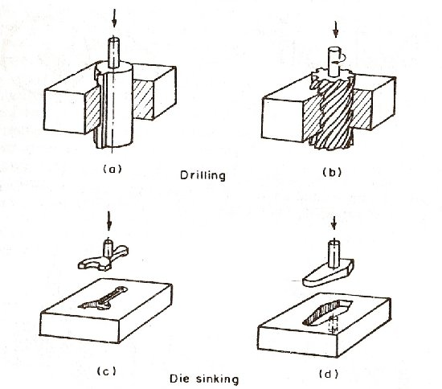

Figure 3.1 process of sinking by EDM

3.2.2 Cutting by EDM

It includes those machining operations where the work piece is cut off or notched.

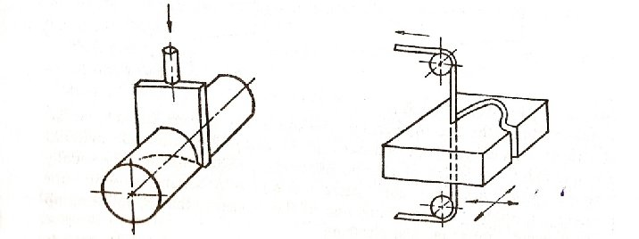

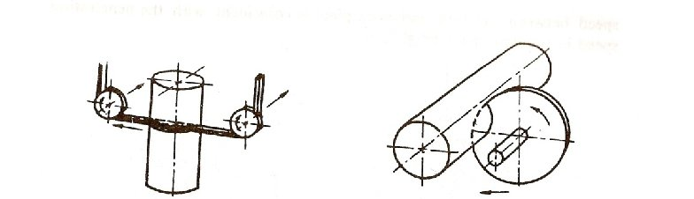

Figure 3.2 cutting by EDM

3.2.3 Grinding by EDM

Spark erosion grinding embraces the machining process made with an electrode rotating around an axis in addition to the normal electrode feed.

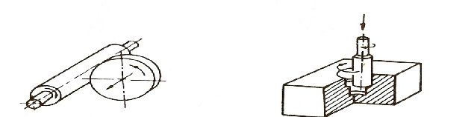

Figure 3.3 grinding by EDM

3.3 WORKING PRINCIPLE OF EDM PROCESS

Fundamentally, the electro sparking method of metal working involves an electric erosion effect which connotes the breakdown of electrode material accompanying any form of electric discharge. A necessary condition for producing a discharge in ionization of the dielectric is splitting up of its molecules into ions and electrons.
Consider the case of a discharge between two electrodes through a gaseous or liquid medium.
As soon as suitable voltage is applied across the electrodes, the potential intensity of the electric field between them builds up, until at some predetermined value, the individual electrons break loose from the surface of the cathode and are impelled towards the anode under influence of field forces. While moving in the inter electrode space, the electrons collide with the neutrals molecules of the dielectric, detaching electrons from them and causing ionization. At some time or other, the ionization becomes such that a narrow channel of continuous conductivity is formed. When this happen, there is a considerable flow of electrons along the channel to the anode, resulting in a momentary current impulse or discharge. The liberation of energy accompanying the discharge leads to the generation of extremely high temperature between 8000 degree Celsius and 1200 degree Celsius, causing fusion or partial vaporization of the metal and the dielectric fluid at the point of discharge. The metal in the form of liquid drops is dispersed into the space surrounding the electrodes by explosive pressure of the gaseous products in the discharge .This result in the formation of a tiny crater at the point of discharge in the work piece.
Comparatively less metal is eroded from the cathode as compared to the anode work due to the following reasons:
1. The momentum with which positive ions strike the cathode surface is much less than the momentum with the electron stream impinges on the anode surface
2. A compressive force is generated on the cathode surface by the spark which helps reduce tool wear.
Most of the EDM operations are conducted with electrodes immersed in the liquid dielectric. For example paraffin and the mechanism of sparking are similar to that described above except that the deflective is contaminated with the conductive particles. Furthermore, the particles removed from the electrodes due to the discharge fall in liquid, cool down and contaminate the area around the electrodes by forming colloidal suspensions of metal. These suspensions along with the products of decomposition of the liquid dielectric are drown to the space between the electrodes during the initial part of the discharge process and are distributed along the electric lines of force, thus forming current carrying bridges. Discharge then occurs along one of these bridges as a result of ionization.

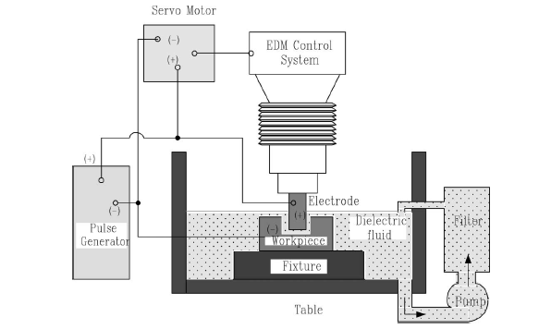

Figure 3.4 Typical set up for EDM.

3.4 SPARK EROSION GENERATORS
In EDM process, electrical energy in the form of short duration impulses are required to be supplied to the machining gap. For more this purpose, especially designed generators are employed. The generators for spark erosion are distinguished according to the way the voltage is transmitted and pulse is controlled, and also on characteristic of discharge.
On basis of these facts, generators for EDM can be classified into:

1. Relaxation generators

2. Rotary generators

3. Static pulse generator

3.4.1Relaxation generator
The relaxation generator or the r-c circuit was the first to be used in EDM. The circuit comprises of a d.c. power source that charges a capacitor C across a resistance R. If condenser is initially uncharged and the d.c. supply is switched on, a heavy current will flow into the circuit with the condenser voltage rising continuously. The condenser voltage at instant time t can describe by the relationship:

Equation (1) predicts that the condenser voltage will approach the supply voltage with time constant equal to RC and after t= RC the condenser voltage will be 63% of the supply voltage. A discharge across the working gap will occur if U1/2(t) equals the breakdown voltage Ub of the dielectric within gap after the dielectric deionizes, the capacitor is recharged and cycle repeats itself
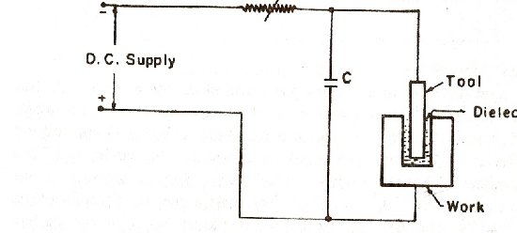

Figure 3.5 relaxation circuit

In practice, the spark gap is adjusted so that the discharge takes place corresponding to a gap voltage of about 0.72Us. Although a higher gap voltage would liberate much more energy, the time required to recharge the condenser increases. it has been found in an R-C circuit , that for a given condenser and breakdown voltage , there exists a certain value of r that will ensure correct length of the charging cycle.
In relaxation generator , the spark repetition rate , for a given supply voltage and capacitance , cannot be increased beyond a critical value and is determined by the speed at which the spark gap is deionized and clear of the debris after each discharge . Forced circulation of the dielectric through the gap is necessary if high metal removal rate is required. As the working gap is 0.025-0.050 mm, forced circulation is difficult, especially when large electrodes are involved. In such a case a lower erosion rate must be accepted than is possible with small size electrode .heir comparative cheapness, simplicity of design,
The fundamental advantage of this circuit are there comparative cheapness, simplicity of design, robustness and relatively extensive range of discharge . In spite of many modifications of relaxation circuits they are liable to result in high tool wear and slow metal removal rates compare with other rate type of generator

3.5 Electrode Feed Controller

Since during operation both the work piece and tool get eroded, the feed control must maintain a movement of electrode towards the work piece at such a speed that the working gap and hence the sparking voltage remain unaltered. Actuation of the control drive is derived from an error indication signal obtained from an electrical sensing device responsive to either the gap voltage or working current or both. Servo mechanism affecting the movement of the electrode may be electric driven motor, solenoid operated or hydraulically operated or combination of these. The axial movement of spindle is controlled through reduction gear box driven by a d.c shunt motor, which is reversible so that electrode can be withdrawn.
The motor armature is connected across a bridge network , the arms of which consist of a potential divider A connected across the d.c supply , while other arm consist of ballast resistance B and condenser C of the charging circuit, the latter arms also being connected across the supply. The control gear work as follows.
Assume the electrode to be initially widely spaced from the work piece and the current supply switched on to the condenser. This will cause the condenser to be charged and voltage will rise to approach the supply voltage. The supply voltage will therefore will prevail across one lower arm of bridging and .the voltage across the other arm will depend on the potentiometer setting, and if this setting is midway, then voltage across the bridge will be half the supply voltage .This voltage will tends to rotate the motor causing the electrode to close the gap. When the electrode reaches the correct position sparking takes place and the condenser rapidly charges and discharges so that a saw tooth wave form is produced across its terminals. The electrode will rend to move when the average value of this voltage equals that prevailing across lower limb of potentiometer. Under this condition the bridge, the bridge is balanced and there is no armature current. The electrode overshoots, the gap width will smaller and average condenser voltage will fall since the condenser will no longer be charge able to charge up to the specific voltage. The bridge is now unbalanced with reverse polarity so that motor reverse and widens the gap until correct position attained. If electrode touches the work, the condenser is short circuit, causing the supply voltage to appear across the blast resistance and electrode is lifted away from work piece.

3.6 Process Parameters

3.6.1 Discharge Voltage
Discharge voltage in the EDM is related to the spark gap and breakdown strength of the dielectric. Before current can flow, the open gap voltage increases until it creates an ionization path through the dielectric. Once the current starts to flow, voltage drops and stabilizes at the working gap level. The preset voltage determines the width of the spark gap between the leading edge of the electrode and work piece. Higher voltage settings increase the gap, which improves the flushing conditions and helps to stabilize the cut. MRR<TWR and surface roughness increases with increasing open circuit voltage because electric field strength increases.
3.6.2 Peak Current
This is the amount of power used in discharge machining, measured in units of amperage and is the most important machining parameter in EDM. During each on-time pulse, the current increases until it reaches a preset level, which is expressed as the peak current. Higher currents will improve MRR but at the cost of TWR and surface finish.
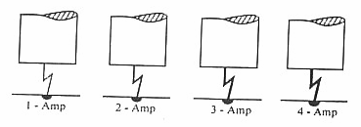

Figure 3.6 Effect of current on surface
3.6.3 Pulse On-time & Off-time
Each cycle has an on-time and off-time that is expressed in units of microseconds. Since all the work is done during on-time, the duration of these pulses and the number of cycles per second are important. Metal removal is directly proportional to the amount of energy applied during the on-time. The energy is controlled by the peak current and the length of the pulse on-time. The resulting crater will be deeper and broader than a crater produced by a shorter on-time. Excessive on-times can be counterproductive when the optimum on-time for each electrode-work material combination is exceeded, material rate starts to decrease.
The cycle is completed when sufficient off-time is allowed before the start of the next cycle. Off-time will affect the speed and stability of the cut Shorter the off-time, the faster will be the machining operation. However, if the off-time is too short, the ejected work piece material will not be swept away by the flow of the dielectric and the fluid will not be deionized. This will cause the next spark to be unstable. Unstable conditions cause erratic cycling and retraction of the advancing servo. This slows down cutting more than long, stable off-times. Off-time must be greater than the deionization time to prevent continued sparking at one point.

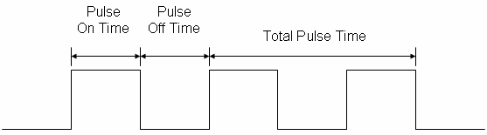

Figure 3.7 Concept of Pulse on Time and Pulse off Time

3.6.4 Polarity
The polarity of the electrode can be either positive or negative. The current passing the gap creates high temperatures causing material evaporation at both electrode spots. As the electron processes show quicker reaction, the anode material is worn out predominantly. This causes minimum wear to the tool electrodes and becomes of importance under finishing operations with shorter on-times. However while longer discharges, the early electron process predominance changes to positron process, resulting in high tool wear. In this experiment setup, positive polarity is selected. The recommended polarity for different tool-jobs is given in Table below:

Table 3.1 Recommended Polarities for different Tool-Job pairs.

Work material | Rougher | Finisher
Tool steel | +(*) | + -
Stainless steel | +(*) | + -
Aluminum | + - | + -
Titanium | - | -
Carbides | - | -
Copper | - | -

3.6.5 Electrode Gap
The tool servo-mechanism is of considerable importance in the efficient working of EDM and its function is to control responsively the working gap of the set value. Mostly electro-mechanical systems are used. The most important requirements for good performance are gap stability and the reaction speed of the system; the presence of the backlash is practically undesirable.
3.6.6 Frequency
This is a measure of the number of times the current is turned on and off. During roughing, the ‘on time’ is increased significantly for high removal rates and fewer cycles per second, hence a lower frequency setting as shown in Figure 3.8. Frequency is distinct from the duty cycle, as this is a measure of efficiency.

Figure 3.8 Frequency setting
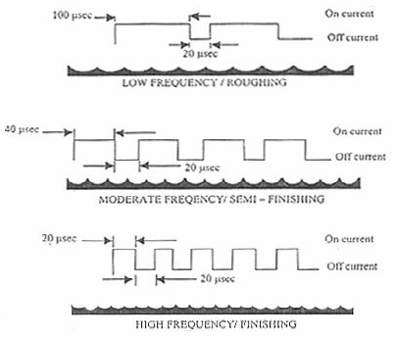

3.7 Dielectric Fluids
Dielectric fluid used in EDM should be:
1. Remain electrically nonconductive until the required breakdown voltage is reached that is they should have high dielectric strength.
2. Breakdown electrically in shortest possible time once the breakdown voltage has been reached.
3. Quench the spark rapidly deionize the spark gap after discharge has occurred
4. Provide an effective cooling medium.
5. Have a good degree of fluidity
6. Be cheap and easily available
7. Light hydro carbons oil satisfies this condition. Table 2.4 compares performance of several dielectric fluids.

3.8 Flushing
Flushing is defined as correct circulation of dielectric fluid between work piece and tool.
Suitable flushing is necessary for highest machining efficiency. To start with dielectric should be fresh that is free from eroded particles and residue resulting from dielectric cracking and its insulation strength is high. With successive discharges dielectric gets contaminated, reducing its insulation strength and hence discharge can take place easily. If density of the particles becomes too high at certain points within the gap bridges are formed which lead to abnormal discharges and damage the tool as well as the work electrode. This buildup of the wear debris is eliminated by flushing. Flushing can be achieved by one of following methods:
1. Injection flushing
2. Suction flushing
3. Side flushing
4. Flushing by dielectric pumping

CHAPTER-4
EFFECT OF CURRENT ON MATERIAL
REMOVAL RATE AND SURFACE FINISH
4.1 Introduction
It is found already many work has been done in MRR and Surface finish but very little work has been done on optimization of MRR to batch production .In this report relation between optimum value of material removal rate and surface finish is to be considered. The various input parameters will be taken under investigation and then model will be prepared then again experimentation work to be performed. Tool material is of mild steel because of easy available in market and lower in cost.

Various Input parameters
- Discharge Voltage
- Peak Current
- Pulse Waveform
- Pulse on-time
- Pulse Frequency
- Polarity
- Electrode Gap
- Type of Dielectric flushing

After extensive research it has been found that above are important input parameters for studying material remove rate. The report is on model SPARKONIX A-35 and four main input parameters are peak current, pulse on time, gap between work piece and electrode, material. One parameter polarity is kept fixed for the whole experiment. Polarity has been fixed as straight polarity (electrode negative) forth experiments because it is desirable setting for material transfer to occur. With straight polarity, the energy available per discharge at work surface is higher as compared to the tool electrode and consequently material removal rate is also higher.

4.2 Objective of Work

The objective of this research work is to study effect of electrode on material removal rate and Surface roughness. The two most important outputs are material removal rate and surface finish has been selected as response parameters for this research work also. The effect of the variation in input process parameter will be studied on these two response parameters and the experimental data will be analyzed as per Taguchi method to find out the optimum machining condition and percentage contribution of each factor.

Table 4.1 machining parameters

S.no | Machining Parameters | Fixed Value
1 | Open Circuit Voltage | 60 ± 5% Volts
2 | Polarity | Straight
3 | Depth of cut | 0.5 mm
4 | Type of Di-electric | Kerosene

4.3 Experimental Procedure
The metal removal was carried out using SPARKONIX (35A) based electric discharge machining as shown in fig. 4.1 & 4.2. Fig. 4.1 shows the schematic diagram of setting of electrode. Fig.4.2 shows the schematic diagram of work-piece and electrode setup. The various controller of the machine were given above. In the experiment a copper electrode was used and mild steel was used as work-piece material. In the experiment a copper electrode with 29.2 mm diameter was used. All experiment was carried out with same electrode and kerosene oil was used as dielectric fluid. A direct current up-to 35 A was used for various readings.
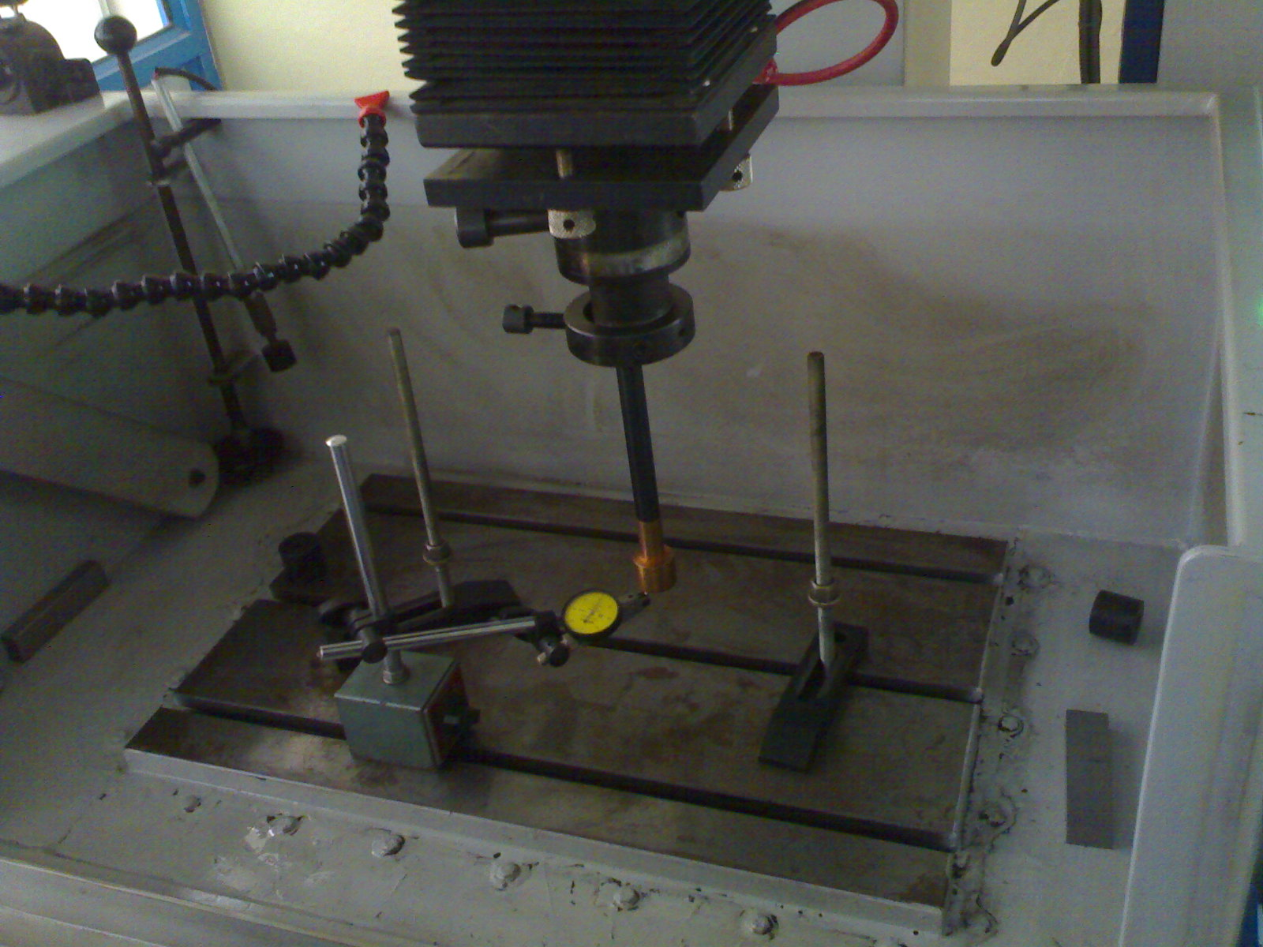
Fig. 4.1: To check level of the lower surface of the electrode
Initially the lower surface was made parallel to the bed of the EDM machine. After measuring the thickness all around the diameter to the electrode fixed the electrode into the chuck. After that the level was checked to avoid some manual error during fixing the electrode.
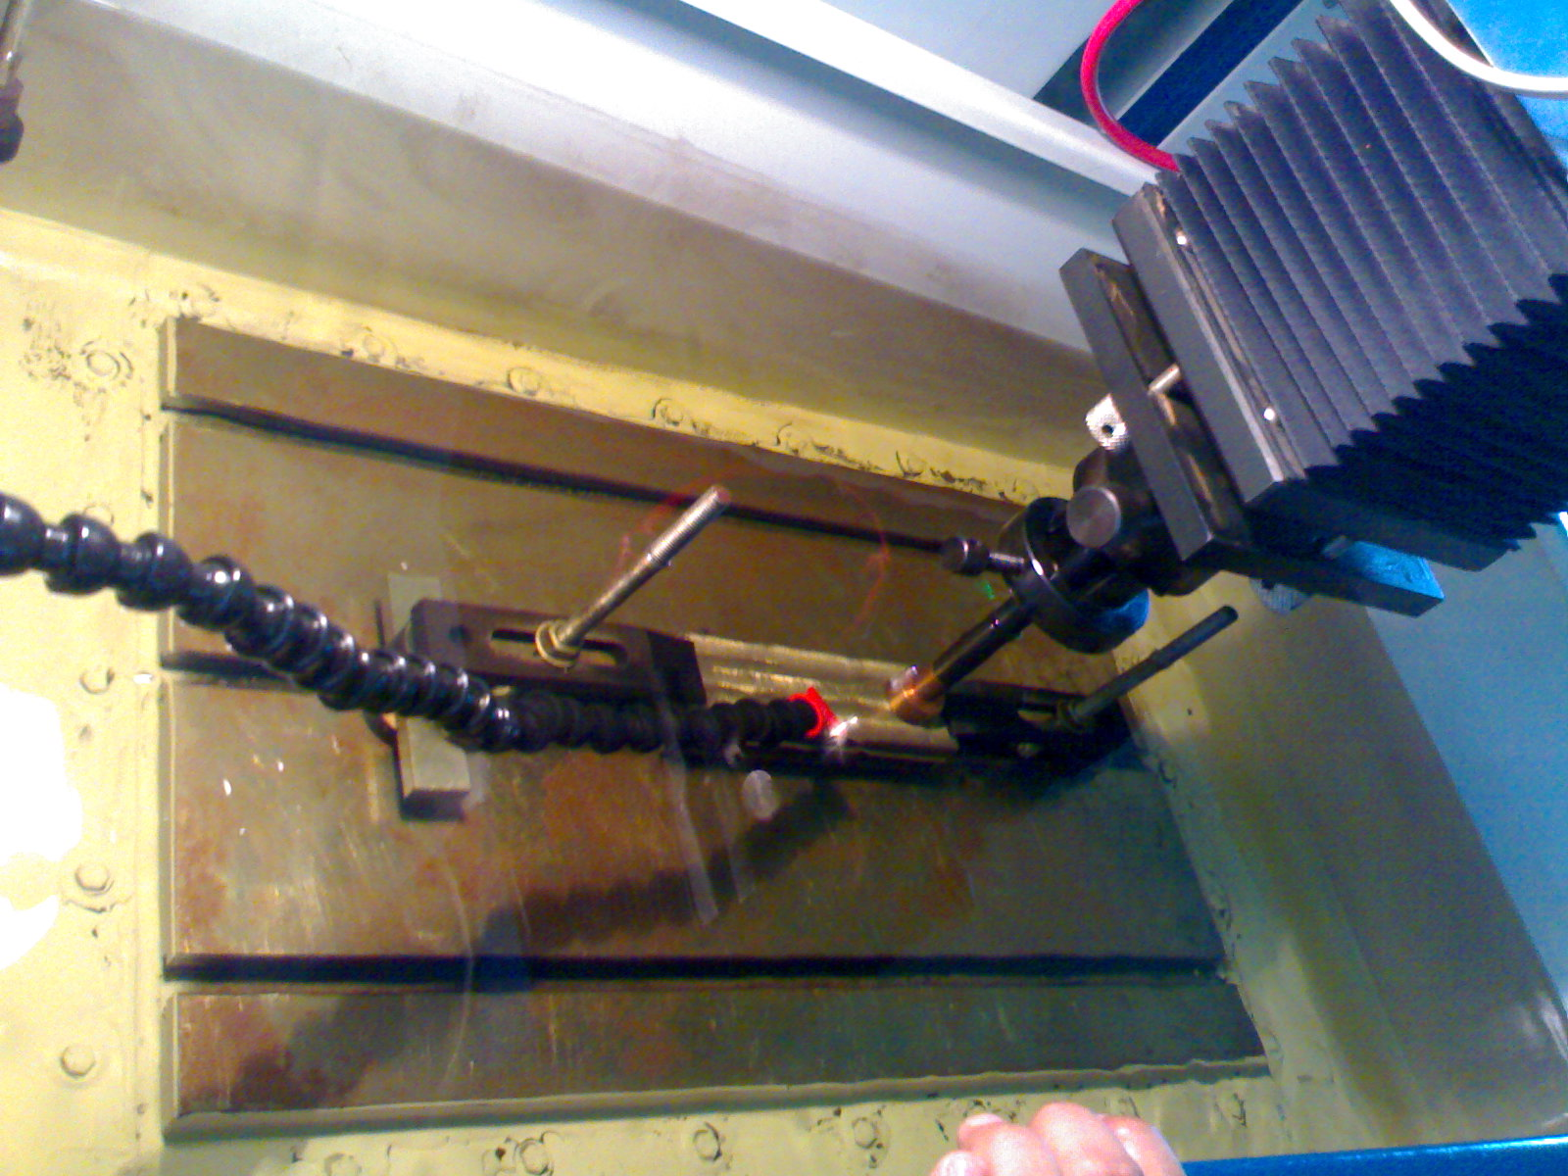
Fig. 4.2: Setup of work piece & electrode
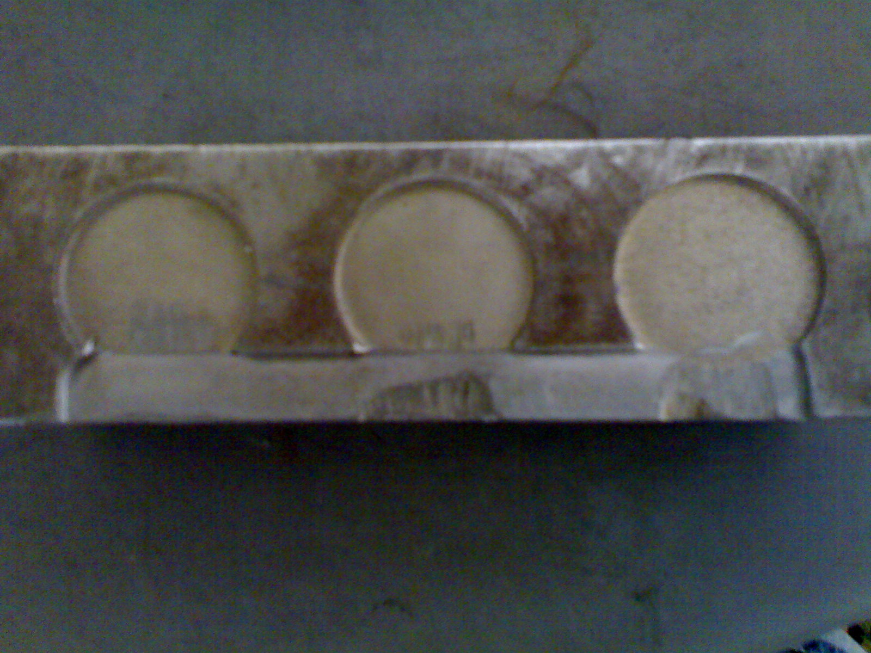
Fig 4.3: Work-piece for final analysis

Table: 4.2 Specification of machine.
SR. NO. | PARAMETERS USED | UNITS | PARAMETERS VALUE
1 | MACHINING UNIT |  | SN35
2 | TANK SIZE | MM | 775*450*325
3 | TABLE SIZE | MM | 550*350
4 | LONG-CROSS TRAVEL | MM | 200*200
5 | QUILL | MM | 200
6 | MAXIMUM HEIGHT OF WORK-PIECE | MM | 300
7 | MAXIMUM WEIGHT OF WORK-PIECE | Kg | 400
8 | MAXIMUM ELECTRODE WEIGHT | Kg | 35
9 | PARALLELISM OF TABLE SURFACE WITH TRAVEL | MM | 0.02
10 | SQUARENESS OF THE ELECTRODE TRAVEL | MM | 0.02/300

Table: 4.3 Parameters for experiment.
SR. NO. | PARAMETER USED | PARAMETER VALUE
1 | WORK-PIECE MATERIAL | MILD STEEL
2 | APPLIED VOLTAGE | 60V
3 | MAXIMUN CURRENT | 35A
4 | POWER SOURCE | (415V, 3hase, 50Hz)
5 | ELECTRODE DIAMETER | 29.2MM
6 | ELECTRODE MATERIAL | COPPER, ALUMINIUM
7 | TIME B/W TWO SPARK | 3 sec.

The roughness on electric discharging machine at a voltage of 440V AC, 3 phases, 50 Hz are as follows.
The table for material removal rate and surface roughness is given below.

Surface roughness and MRR with aluminium electrode
Table: 4.4 surface roughness at various values of current with Al electrode
SR.NO. | CURRENT  (ampere) | TIME  (minutes) | DEPTH OF CUT  (mm) | SURFACE ROUGHNESS(µm)
1 | 4 | 57 | 0.5 | 4.58
2 | 6 | 44 | 0.5 | 8.08
3 | 8 | 33 | 0.5 | 14.23
4 | 10 | 25 | 0.5 | 22.12
5 | 12 | 16 | 0.5 | 32.53
6 | 14 | 12 | 0.5 | 44.14

Table: 4.5 Material removal rates at various values of current with Al electrode
SR. NO | CURRENT  (ampere) | TIME  (minutes) | DEPTH OF CUT  (mm) | MATERIAL REMOVAL RATE  =(∏*r*r*D.O.C)/time  Mm3/min
1 | 12 | 20 | 0.5 | 17.58
2 | 16 | 16 | 0.5 | 25.79
3 | 18 | 13 | 0.5 | 31.23
4 | 20 | 11 | 0.5 | 41.12
5 | 22 | 10 | 0.5 | 57.53
6 | 24 | 8 | 0.5 | 71.27

For a clear view about the current and surface roughness relationship graph between current and surface roughness was drawn as shown in fig. 4.1a. Similarly, to know about a relationship between current and material removal rate the graph between then was drawn in fig. 4.1b.

SURFACE ROUGHNESS (MM)
Current in ampere
Graph 4.1a: Effect of current on surface roughness with Al electrode
From the graph roughness of the surface is directly related to the current density. As current density increases surface become more and more rough.

MATERIAL REMOVAL RATE (MM³/MINUTE)
Current in ampere
Graph 4.1b: Effect of current on material removal rate with Al electrode
The graph indicates that material removal rate is also directly related to the current density. As the current density increases material removal rate also increases in the same proportion.

Surface roughness and material removal rate with copper electrode
Table: 4.6 Material removal rates at various currents with Cu electrode
SR.NO. | CURRENT  (ampere) | TIME  (minutes) | DEPTH OF CUT  (mm) | Roughness  (µm)
1 | 8 | 16 | 0.5 | 7.52
2 | 10 | 11 | 0.5 | 11.24
3 | 12 | 8 | 0.5 | 17.46
4 | 14 | 6 | 0.5 | 25.68

Table: 4.7 Effect of current on material removal rate with Cu electrode

SR. NO | CURRENT  (ampere) | TIME  (minutes) | DEPTH OF CUT  (mm) | MATERIAL REMOVAL RATE  =(∏*r*r*D.O.C)/time  Mm3/min
1 | 8 | 16 | 0.5 | 17.58
2 | 10 | 11 | 0.5 | 25.79
3 | 12 | 8 | 0.5 | 31.23
4 | 14 | 6 | 0.5 | 41.12

SURFACE ROUGHNESS (MM)
Current in ampere
Graph 4.1c: Effect of current on surface roughness with Cu electrode
From the graph roughness of the surface is directly related to the current density. As current density increases surface become more and more rough.

MATERIAL REMOVAL RATE (MM³/MINUTE)
Current in ampere
Graph 4.1d: Effect of current on material removal rate with Cu electrode
The graph indicates that material removal rate is also directly related to the current density. As the current density increases material removal rate also increases in the same proportion.

4.4 Analyzing MRR and surface roughness by S/N method
Table: 4.8 S/N ratios of MRR and surface roughness

Sr.  no | Current  (A) | Material  (B) | gap  (D) | MRR(g/min) | S/N Ratio  For MRR | Surface finish (µm) | S/N Ratio  for hardness
1 | 4 | Al | 0.5 | 5.40 | 14.64 | 4.58 | 13.21
2 | 6 | Al | 0.5 | 7 | 16.90 | 8.08 | 18.14
3 | 8 | Al | 0.5 | 9.33 | 19.39 | 14.23 | 23.06
4 | 10 | Al | 0.5 | 12.32 | 21.81 | 22.12 | 26.82
5 | 12 | Al | 0.5 | 19.25 | 25.68 | 32.53 | 30.24
6 | 14 | Al | 0.5 | 25.66 | 28.18 | 44.14 | 32.89
7 | 8 | Cu | 0.5 | 6.28 | 15.95 | 7.52 | 17.52
8 | 10 | Cu | 0.5 | 9.09 | 19.17 | 11.24 | 21.01
9 | 12 | Cu | 0.5 | 12.5 | 21.93 | 17.46 | 24.84
10 | 14 | Cu | 0.5 | 16.67 | 24.43 | 25.68 | 28.19

4.5 CONFIRMATION TEST

After evaluating the optimal parameter settings, the next step of the Taguchi approach is to predict and verify the enhancement of quality characteristics using the optimal parametric combination. The estimated S/N ratio using the optimal level of the design parameters can be calculated:

Is the total mean S/N ratio, is the mean S/N ratio at optimum level and’ o’ is the number of main design parameter that effect quality characteristic. Based on the above equation the estimated multi-response signal to noise ratio can be obtained.

= 11.135 + (6.28-11.135) + (9.09-11.135) + (12.5-11.135) + (16.67-11.135)
Optimal value of MRR = 5.8

Corresponding value of MRR = 336.72

= 18.35

Similarly optimal value of SURFACE FINISH can be obtained by:

= 15.547+ (7.52-15.547) + (11.24-15.547) + (17.46-15.547) - (25.68-15.547)

Optimal value of SURFACE FINISH = 8.4

Corresponding value of surface finish = Y²_{opt=}

=503.10

Y_{opt} 22.43

4.6 LIMITATIONS

1 Polarity was kept constant that is work piece was as anode and tool as cathode.
2 Pulse on time was kept at knob position of 3, 4 and 5 but large range of pulse on time was available.
3 Kerosene was only dielectric which was use but there are wide variety of dielectric fluid are available in market.
4 Copper tool was used but other tool materials are also available.

4.7 Conclusion

1 Parameters are not making much significant on determining optimum parameter.
2 | Although parameters are not significant but we able to improve MRR and ROUGHNESS.

CHAPTER 6
Results analysis and discussion
6.1 Effect of current on surface roughness
Surface roughness increases with increase in current density. As the current increases surface of the final product becomes more and more rough. With the current increases from 12 ampere to 14 ampere surface roughness increases from 17.46 to 25.68 as shown in table 4.6. Also, current and surface roughness relationship can be graphed as shown in fig. 4.1a, 4.2b, 4.3c, & 4.4d.

6.2 Effect of current on material removal rate
Material removal rate increases with increase in current density. As current density increases material removal rate also increases. From table 4.6 as current density increases from 12 ampere to 14 ampere material removal rate increases from 31.23 to 41.12 mm³/ minute. Increase of current increase the temperature between the electrode and work-piece due to which more vaporization of work-piece takes place. The graph between material removal rate and current is shown in fig. 4.1b & 4.1c.

CHAPTER 7
Conclusion and future scope
The present method adopted to solve the optimization problem of EDM process is simple enough and is flexible in selection of objective functions and the constraints for such machining processes. At any stage, the dominance factor of the input variables and output variables contained in the constraints and objective functions can be computed. This technique helps in getting the reliable multi-objective decisions under constrained penalties for the constrained optimization of such processes.
During the solution of the problem, it has been found that the results obtained by the S-N approach shows their convergence towards the exact solutions obtained by optimization of objective functions. However, the absolute values of the objective function differ significantly for their absolute values.
Even though a number of numerical optimization tools in the workbench of the software’s are available now a days, such optimization methods are contributing a lot for optimization of machining processes due to their localized flexible nature of the constraints and the interchangeable objective functions. A list of suggested proposals of work which can be carried out beyond the scope of this work is as below.
- A number of other non-traditional machining methods are available for advanced manufacturing. This method or algorithm may be used for getting the optimized results of the respective processes.
- The approach can be used for the probabilistic sensitivity analysis of the manufacturing processes including EDM process. This work will give a symbolic justification of the effect of external and internal system variables on the accuracy of surfaces.
- This approach may be coupled to other optimization algorithms to get multistage multi-criterion optimization by one integrated bi-criterion approach. Then this method will be able to show its importance in real life complex manufacturing problem solution.

REFRENCES
- Book title:- “Modern Machining Processes”.
By P.C. Pandey; H.S. Shan.
2. Qing Gao et al, “Parameter optimization model in electric discharge machining process,” PP-28, 2007.
3. S. Assarzadeh and M. Ghoreishi, “Neural-network-based-modelling and optimization of electro discharge machining,” PP 28-29, 2008.
4. Ko-Ta Chiang, “Modeling and analysis of the effects of machining parameters on the performance characteristics in the EDM process,” PP-29, 1996.
5. Kuang-Yuan Kung & Jenn-Tsong Horng & Ko-Ta Chiang, “ Material removal rate and
electrode wear ratio study on the powder mixed electrical discharge machining of cobalt- bonded tungsten carbide”, PP-30, 2007.
6. Ali Ozgedik ,Can Cogun,”An experimental investigation of tool wear in electric discharge machining, PP-30,2005.
7. Yusuf Keskin ,H.Selc¸uk Halkacı ,Mevlut Kizil,” An experimental study for determination
of the effects of machining parameters on surface roughness in electrical discharge machining (EDM),PP 30-31,2005.
8. JI RenJie, LIU YongHong, Yu LiLi, LI XiaoPeng & DONG Xin, “Study on high efficient electric discharge milling of silicon carbide ceramic with high resistivity”, PP-31,2001.
9. Paulo Peças & Elsa Henriques, “Effect of the powder concentration and dielectric flow in the surface morphology in electrical discharge machining with powder-mixed dielectric (PMD-EDM),”PP-31,2007.
10. Young-Cheol Ahn and Young-Seup Chung, “Numerical Analysis of the Electro-discharge Machining Process for Alumina-Titanium Carbide Composite, PP-32-35,2001.
11. Qing gao, Qin-he zhang, Shu-peng su, Jian-hua zhan, “Parameter optimization model in electrical discharge machining process,” PP-32, 2007.
12. S. Assarzadeh & M. Ghoreishi, “Neural-network-based modeling and optimization of the electro-discharge machining process, PP 32-33, 2007.
13. B. Izquierdo, J.A.Sanchez, S.Plaza,I.Pombo,N.Ortega ,”A numerical model of the EDM process considering the effect of multiple discharges”, PP-33, 2008.
14. M.K.Pradhan , “Modelling of machining parameters for MRR in EDM using response surface methodology”,PP-33, 2008.
15. Dawei Luy and Jiju Antonyy,” Optimization of multiple responses using a fuzzy-rule based inference system”, PP33-38, 2007.
16. C. L. Lin J. L. Lin and T. C. Ko , “Optimisation of the EDM Process Based on the Orthogonal Array with Fuzzy Logic and Grey Relational Analysis Method” , PP 34-39, 2002.
17. A Yahya and C D Manning, “Modelling, Simulation and Controller Design for Electro Discharge Machine System, electronic systems and control division research”, PP34-41, 2001.
18 Y. S. Tarng, “orthogonal arrays to study the entire parameter space with only a small number of experiments.”1998.
19. Ko-Ta Chiang & De-Chang Tsai, “Effect of silicon particles on the rapidly resolidified layer of Al-Si alloys in the electro discharge machining process”, PP 34-35,2008.
20. S. H. Yeo ,”A Method for Green Process Planning in ElectricDischarge Machining,”
PP17-31, 1999.

