CHAPTER-1
INTRODUCTION
1.1 Introduction
Optimization is a mathematical results and numerical methods for finding and identifying the best candidate from a collection of alternatives without having to explicitly enumerate and evaluate all possible alternatives. The process of optimization lies at the root of engineering, since the classical function of the engineering is to design new, better, more efficient and less expensive systems as well as to devise plans and procedures for the improved operation of existing systems [1].
The power of optimization methods to determine the best case without actually testing all possible cases come through the use of a modest level of mathematics and at the cost of performing iterative numerical calculations using clearly defined logical procedures or algorithms implanted on computing machines. The development of optimization methodology will therefore require some facility with basic vector-matrix manipulations, a bit of linear algebra and calculations, and some element of real analysis. We use mathematical concepts and constructions not simply to add rigor to the proceedings.
The present work aims beyond the mini-max approaches use for such optimization problems. In order to justify the related work a machining method of Electric Discharge Machining (EDM) process is used. The work contained in this project report covers the effects of various input variables on performance parameters of the EDM machine. Regression analysis techniques have been adopted to obtain the relationships. Once the problem of EDM process has been modeled it tried to justify the importance of bi-criterion approaches in and the individual objective functions and values are compared to those obtained by using bi-criterion approaches. The generalized genetic algorithms have been used for the nonlinear objective functions for a given constraints in the form of crisp value bounded domains and tried to find out the optimization values of the output parameters which are given as material removal rate (MRR), power consumption by the machine and try to find out maximize material removal rate with minimum power consumption and did the same to find out maximum material rate removal rate at minimum electrode consumption. In this report it is considered the various maximum and minimum input variable parameters of a machine and putting them into the regression analysis eqn. for finding mini-max values by applying chebyshev goal programming method.
There are lots of optimization techniques to optimized output parameters. The need for selecting and implementing optimal machining conditions and the most suitable cutting tool has been felt over the last few decades. Furthermore, for realistic solutions, the many constraints met in practice, such as low machine tool power, torque, force limits and component surface roughness must be overcome.
The main objective of the project is to optimize material removal rate in EDM of mild steel. The experiment was performed on EDM machine and then Chebyshev goal programming method was applied to find out the optimized values of material removal rate for the various values of input variables. After finding the optimized value of that particular machine it was analyzed experimentally

1.2 Electric Discharge Machining
Electrical Discharge Machining (EDM) is a controlled metal-removal process that is used to remove metal by means of electric spark erosion. In this process an electric spark is used as the cutting tool to cut (erode) the work piece to produce the finished part to the desired shape. The metal-removal process is performed by applying a pulsating (ON/OFF) electrical charge of high-frequency current through the electrode to the work piece. This removes (erodes) very tiny pieces of metal from the work-piece at a controlled rate.

1.3 Optimization
Optimization is a mathematical discipline that concerns the finding of minima and maxima of functions, subject to so-called constraints. Optimization originated in the 1940s, when George Dantzig used mathematical techniques for generating "programs" (training timetables and schedules) for military application. Since then, his "linear programming" techniques and their descendent were applied to a wide variety of problems, from the scheduling of production facilities, to yield management in airlines. Today, optimization comprises a wide variety of techniques from Operations Research, artificial intelligence and computer science, and is used to improve business processes in practically all industries.
Discrete optimization problems arise, when the variables occurring in the optimization function can take only a finite number of discrete values. For example, the machines in industries are limited and also we have limited time. So, we have to minimize some factor to achieve maximum output. Discrete optimization aims at taking these decisions such that a given function is maximized (for example material removal rate) or minimized (for example power consumption), subject to constraints, which express regulations or rules, such as required numbers of rest days for the staff in a schedule.
Perhaps surprisingly, discrete optimization is more difficult than its "continuous" counterpart, where variables are allowed to take fractional values or even "real numbers". In fact, there is no general solution known for optimization problems that reliably and speedily computes solutions to discrete optimization problems. A variety of computation techniques compete for the best solution. In recent years, it has become clear that different application domains lend themselves to different solution techniques. Linear programming has been applied to discrete optimization using so-called "branch-and-bound" techniques, for example to solve facility location problems. Heuristic search aims at finding good but not necessarily optimal solutions quickly. This technique is successfully used in a wide variety of applications; for example the Lin Kernighan heuristic for the Traveling Salesman problem finds solutions that are extremely close to the optimal solution for very large problem instances. Constraint programming is a solution technique that developed out of programming language research and artificial intelligence. It employs specialized algorithms in the general framework of tree search, and has been successfully applied to production scheduling problems.
Another recent trend is the combination of optimization techniques for problems that do not lend themselves easily to one technique alone. Today, these techniques prove to deliver robust engines that provide very high quality solutions for even very large problem instances.

1.4 Need of optimization in production
To apply the mathematical results and numerical techniques of optimization theory to concentrate engineering problems, it is necessary to clearly delineate the boundaries of the engineering system to be optimized, to define the quantitative criterion on the basis of which candidates will be ranked to determine the” best,” to select the system variables that will be used characterize or identify candidates, and to define a model that will express a manner in which the variables are related.
It is very challenging for all the production industries to meet the required standard of the customer as well as to utilize all its resources to gain maximum profit and minimum loss. For production of components on a nonconventional machining the material removal rate, power consumption, electrode wear-out and surface finish are some major factors which are to be considered. So, from the above factors we need maximum material removal rate at low power consumption. Similarly, we require a very less electrode wear-out for a maximum material removal rate. So, there should be an intermediate value for both material removal rate and power consumption at which we can achieve our target. The process which we used to find that value is known as optimization.
Also, the optimization is helpful to find out at what minimum value of power consumption material removal rate can be maximized. Also, optimization is helpful to find for what power electrode wear-out will be minimize to get maximum material removal rate. The goal of an optimization strategy for material process planning is to help manufacturing engineers in identifying optimal manufacturing process plans in complex manufacturing activities. Implementation of optimal manufacturing process plans is crucial in dynamic manufacturing environments since it ensures that optimal operating levels are attained. In seeking an optimal solution, it is necessary to employ an appropriate optimization solution technique. From public literature on process planning, genetic algorithms have been identified as one option for solving complex process planning problems in an optimization perspective.
The problem under study considers applications of the genetic algorithms in handling material removal rate, electrode wear-out, and power consumption optimization for multiple parts flowing in a reconfigurable manufacturing line. Thus, given a production scenario (composed of many parts to be manufactured) and manufacturing resources (an array of processing modules that make up the reconfigurable manufacturing line), the problem is to select an optimal manufacturing process plan. So, in this thesis our target is to concentrate on the mostly required output parameter by taking consideration on other parameters

1.5 Goal Programming
This report considered only one objective function to optimize [1]. However, in practical problems, one may desire to optimize several conflicting criteria simultaneously. One way of treating multiple criteria is to select one as the primary criterion and the rest as secondary criteria. The primary criteria is then used as objective function to optimize, while the secondary criteria are assigned acceptable minimum or maximum values and are treated as problem constraints. However, if careful consideration were not given while selecting the acceptable levels, a feasible solution that will satisfy all the constraints may not exists. This problem is overcome by an approach called goal programming, which is fast becoming a practical method for handling conflicting to multiple criteria.
In goal programming, all the criteria are assigned acceptable target levels of achievement and a relative priority an achieving these levels. Goal programming treats these targets as goal to aspire for and not as absolute constraints. If then attempts to find a solution that comes as “close as possible” to the targets in the order of specified priorities.

1.6 Research and Methodology
Several multi-objective optimization methods are available in the literature including the weighted multi-objective method, Archimedean goal programming, non-Archimedean goal programming, and the original Chebyshev goal programming methods [2]. The weighted multi-objective method involves subjectivity and bias in specifying the weights in order to aggregate several non-commensurable and conflicting objectives into a single equivalent function. Archimedean and non-Archimedean goal programming methods suffer from the difficulties in determining the weights for deviation variables within a lower priority; and the ranking of the goals in a preemptive preference order. With the original Chebyshev approach, the final solution could be dictated by a single goal. The modified Chebyshev goal programming MCGP approach helps to avoid the above difficulties and will be used in this study. It should also be noted that the MCGP is in fact a fuzzy programming approach and hence can be used to effectively deal with objectives that are imprecise or fuzzy in nature, such as the intangible cost mentioned above. The MCGP can be implemented using the Lingo software

1.7 Motivation and objectives
The motivation was provided by the desire to explore a method to determine the best case without actually testing all possible cases come through the use of a modest level of mathematics and at the cost of performing iterative numerical calculations using clearly defined logical procedures or algorithms implanted on computing machines.
The main objective of the work is to find out the optimized value of the various output parameters in the electric discharge machining (sparkonix35A). The research has been carried out to find out these optimized parameters.
The main objective of this report was to find out optimize values without testing the machine so many times. By considering the input variables and putting them in chebshev goal programming equations and then applying bi-criteria method, optimized values of the material removal rate can be achieved. Finally these values were analyzed.

1.8 Conclusion
This chapter deals with the introduction to optimization, the need of optimization in production, and various methodology adopted. With optimization it becomes easy to find the optimized parameters so that by adjusting these parameters we may get the required material removal rate according to product requirements.
CHAPTER - 2
LITERATURE REVIEW
2.1 Introduction
Efforts are being made now a day to solve complex engineering problems through mathematical algorithms with high computations accuracy. A number of research papers exist in the literature related to these newly developed optimization techniques. Many researchers used the concept of genetic algorithms for solving the complex formulated problems of the Electric Discharge Machining process. The stress has been given on understanding the problem from the core and some of the research papers used for formulation and understanding the problem are outlined as below:

  - Literature Review
Joopelli, V [3] tried to model and formulate the Electric Discharge Machining process with the optimization of objective functions related to moving trajectories of machine tool electrode. Gradient based methods have been used to optimize the single objective function variable. A moving frame reference has also been used to locate the tool electrode at any instant along its traversed trajectories.
Jain V. K. [4] formulated the generalized Electro Discharge Machining method with the limited constraints related to Pulse interval time and pulse duration. Many operating variables are considered as parameters with fixed working values over a given erosion depth and erosion rate on the work piece. The formulated problem has been analyzed by using a simple optimization algorithm by keeping other objective functions unaffected and the results are concluded to give the suitable operating variable value selection on the basis of output obtained.
Kahng, C. H [5] stated that operating working voltage and the pulse interval plays an important role in obtaining the required surface finish. The flow movement of the dielectric fluid controls the homogeneous surface characteristics in the entire EDM controlled region. The spark gap control has also been explained to obtain the desired level of surface roughness for a given set of operating variables. Fluttering of the edges in the EDM region has been investigated for the variation in the controlling parameters.
Kee. P. [6] specified an integrated approach for jointly solving process selection, machining parameter selection, and tolerance design problems to avoid inconsistent and infeasible decision. The integrated problem is formulated as bi-criterion model to handle both tangible and intangible costs. The model is solved using a modified chebyshev goal programming method to achieve a preferred compromise between the two conflicting and non-commensurable criteria.
L.C. Lim, H.H. Lu [7] specified the basic thumb rules for the analysis of surface features of Electro discharge machining process. This paper is mainly meant for skilled workmanship towards achieving the desired surface characteristics in minimum time and with safety. The saving of the production cost is justified for the EDM process carried out. Common measures and precautions which are helpful in carrying out the EDM process for efficient operation are also been suggested. This paper is recommended for peer mainly.
Madhu, P., Jain, V. K [8] developed the governing equations for the analysis of Electro Discharge machining process under a controlled environment. A computer program has also been developed in the form of subroutines for the calculation of electrode wear rate. Metal removal rate and dielectric material effect on the EDM process. The results obtained by the formulation used with the help of quadratic elements have shown a good convergence with those obtained by the commercial packages.
Masstoshi, S., and Ryo, Kubota [9] studied the imprecise or fuzzy nature of the data in real-world problems, job shop scheduling with fuzzy processing time and fuzzy due date is introduced. On the basis of the agreement index of fuzzy due date and fuzzy completion time, multi-objective fuzzy job shop scheduling problems are formulated as three-objective ones which not only maximize the minimum agreement index but also maximize the avg. agreement index and minimize the maximum fuzzy completion time.
Pandit, S. M [10] stated the critical factors affecting the performance of the Electro Discharge machining process when the work piece material is Cemented carbide. A suitable hard alloy material is selected as electrode tool material. And the dielectric fluid is given turbulent flow in and around the EDM region. The operating variables like Pulse duration, Discharge Current, Operating voltage, Pulse Interval time and heat dissipation rate differ in operating ranges considerably as compared to electro discharge machining of Steel alloys. However, it has been claimed that consistency and repeatability of the machine towards maintaining the minimum deviation in the operating conditions helps a lot in the Machining accuracy in the process.
Pandit, S. M [11] considered the theoretical aspects of the Electro Discharge machining Process. The energy parameters and the Metal removal rate relationships have been developed for the given set of operating voltages and the dielectric pressure. The relationships obtained have been used to plot graphs for the variation in the operating controlling parameters and their effects on the consequents such as metal removal rate, surface roughness and the power consumption by the machine etc. These graphs can be directly used for the selection of given constrained condition of operating variables for the desired objectives.
Rajurkar, K.P., Zhu, D[12] elaborated a number of alternatives for the improvement in the electrochemical machining process by changing the sensitivity parameters and have stated that in comparison to other operating variables, the trajectory of the electrode movement plays a vital role in improving the surface characteristics of the ECM process.
Spedding, T.A [13] used the concept of conformal transformation of the operating characteristic variables. The variables are parameterized and the parametric representation of the metal removal rate, surface roughness has been mapped onto parametric surface. The surface characteristics of the wire-Cut EDM process have been analyzed for the sensitivity of the operating variables. The dependencies of the decision variable on each other are represented and a computation algorithm has been proposed to evaluate the mapped point for specified surface characteristics onto parametric plane.
Spedding, T.A. and Wang, Z.Q [14] considered the theoretical aspects of the modeling of the wire-Cut EDM process. A user friendly approach has been adopted for the definition of process parameters and these parameters are compared to other various ranges of operating variables. The interpretation of output variables variations has been carried out for the wire Cut EDM process and the suggested ranges of the input variables are given for a desired set of output variables in terms of metal removal rate and power consumption etc.
Smyers, S., Guha, A. [15] stated a practical approach for Machining the Beryllium Copper alloys as work piece by Electro Discharge Machining process. Methods have been suggested for obtaining the desired level of surface characteristics by using this EDM method. Safety precautions and the indicative measures are suggested for the fruitful implementation of the process. A brief note is also given for specifying the operating characteristics and safety precautions for the EDM process to be carried out.
Wang W.M. [16] stated that spark gap and the controlling parameters for a sensitive EDM process layout can be controlled in number of ways. A feedback system with real time stability analysis and process monitoring through digital modern sensors and transducers can give an efficient responding mechanism for the EDM process control. The author also states that transducers, circuitry, encoders etc. can be selected to give influence of simultaneous variation of operating variables and their response data storage facility. The author has developed an artificial neural network for the entire Electro Discharge Machining process. The relationships between the operating intermediate processes along with decision variables have been framed. The performance index evaluation for the EDM process for a given specified crisp sets of the operating variables helps in understanding the efficiency of the process to be carried out. The performance Index evaluated by using this method helps in analyzing the adverse and positive gradient effects of the variation in the Metal removal rate, the surface roughness and the power consumption by the machine.
Zhang, B [17] calculated the effect of motion and turbulence level in the dielectric material during various stages of the electro-discharge machining process. The results are tabulated and graphs have been recommended for use for the machining of steel materials. The effect of the selection of dielectric fluid has also been analyzed for a given set of electrode tool and material combination.
Zhang C [18] developed tolerances for the different machining parameters, the results have recommended for the machining parameters.
Zimmermann H. J [19] developed Fuzzy Programming and Linear Programming with Several Objective Functions.

  - Conclusion
In this chapter different research papers published in the journals of international repute were studied and the end results of different experiments carried out by the researchers around the world are written in this chapter. After the review of these papers it was decided to find out the optimized values for various parameters.
The chapter gives a brief literature review about the various methods and techniques applied to find the optimized parameters in non-conventional machining (EDM).

CHAPTER-3
Optimization
3.1 Introduction
In the simplest case, this means solving problems in which one seeks to minimize or maximize a real valued function by systematically choosing the values of real or integer variables from within an allowed set [20]. This formulation, using a scalar, real-valued objective function, is probably the simplest example; the generalization of optimization theory and techniques to other formulations comprises a large area of applied mathematics more generally, it means finding "best available" values of some objective function given a defined domain, including a variety of different types of objective functions and different types of domains.
It has long been recognized that conditions during cutting, such as feed rate, cutting speed and depth of cut, should be selected to optimize the economics of machining operations, as assessed by productivity, total manufacturing cost per component or some other suitable criterion. Taylor (1907) [21] showed that an optimum or economic cutting speed exists which could maximize material removal rate. Manufacturing industries have long depended on the skill and experience of shop-floor machine-tool operators for optimal selection of cutting conditions and cutting tools. Considerable efforts are still in progress on the use of handbook- based conservative cutting conditions and cutting tool selection at the process planning level. The most adverse effect of such a not-very scientific practice is decreased productivity due to sub-optimal use of machining capability.
The need for selecting and implementing optimal machining conditions and the most suitable cutting tool has been felt over the last few decades. The non-availability of the required technological performance equation represents a major obstacle to implementation of optimized cutting conditions in practice. This follows since extensive testing is required to establish empirical performance equations for each tool coating–work material combination for a given machining operation, which can be quite expensive when a wide spectrum of machining operations is considered.

3.2 Literature Review of traditional optimization techniques
Traditionally, the selection of cutting conditions for metal cutting is left to the machine operator [22]. In such cases, the experience of the operator plays a major role, but even for a skilled operator it is very difficult to attain the optimum values each time. Machining parameters in metal turning are cutting speed, feed rate and depth of cut. The setting of these parameters determines the quality characteristics of turned parts. Following the pioneering work is given by:
Taylor (1907) [21] and his famous tool life equation, different analytical and experimental approaches for the optimization of machining parameters have been investigated.
Gilbert (1950) [23] studied the optimization of machining parameters in turning with respect to maximum production rate and minimum production cost as criteria.
Armarego & Brown (1969) [24] investigated unconstrained machine-parameter optimization using differential calculus.
Brewer & Rueda (1963) [25] carried out simplified optimum analysis for non-ferrous materials. For cast iron (CI) and steels, they employed the criterion of reducing the machining cost to a minimum. A number of monograms were worked out to facilitate the practical determination of the most economic machining conditions. They pointed out that the more- difficult-to-machine materials have a restricted range of parameters over which machining can be carried out and thus any attempt at optimizing their costs is artificial.
Brewer (1966) [26] suggested the use of lagrangian multipliers for optimization of the con- strained problem of unit cost, with cutting power as the main constraint.
Bhattacharya et al (1970) [27] optimized the unit cost for turning, subject to the constraints of surface roughness and cutting power by the use of Lagrange’s method.
Ermer & Kromodiharajo (1981) [28] developed a multi-step mathematical model to solve a constrained multi-pass machining problem. They concluded that in some cases with certain constant total depths of cut, multi-pass machining was more economical than single-pass machining, if depth of cut for each pass was properly allocated. They used high speed steel (HSS) cutting tools to machine carbon steel.
Hinduja et al (1985) [29] described a procedure to calculate the optimum cutting conditions for turning operations with minimum cost or maximum production rate as the objective function. For a given combination of tool and work material, the search for the optimum was confined to a feed rate versus depth-of-cut plane defined by the chip-breaking constraint. Some of the other constraints considered include power available, work holding, surface finish and dimensional accuracy.
Tsai (1986) [30] studied the relationship between the multi-pass machining and single-pass machining. He presented the concept of a break-even point, i.e. there is always a point, a certain value of depth of cut, at which single-pass and double-pass machining are equally effective. When the depth of cut drops below the break-even point, the single-pass is more economical than the double-pass, and when the depth of cut rises above this break-even point, double-pass is better. Carbide tools are used to turn the carbon steel work material.
Gopalakrishnan & Khayyal (1991) [31] described the design and development of an analytical tool for the selection of machine parameters in turning. Geometric programming was used as the basic methodology to determine values for feed rate and cutting speed that minimize the total cost of machining SAE 1045 steel with cemented carbide tools of ISO P-10 grade. Surface finish and machine power were taken as the constraints while optimizing cutting speed and feed rate for a given depth of cut.
Agapiou (1992) [32] formulated single-pass and multi-pass machining operations. Production cost and total time were taken as objectives and a weighting factor was assigned to prioritize the two objectives in the objective function. He optimized the number of passes, depth of cut, cutting speed and feed rate in his model, through a multi-stage solution process called dynamic programming. Several physical constraints were considered and applied in his model.
In his solution methodology, every cutting pass is independent of the previous pass, hence the optimality for each pass is not reached simultaneously.
Prasad et al (1997) [33] reported the development of an optimization module for determining process parameters for turning operations as part of a PC-based generative CAPP system. The work piece materials considered in their study include steels, cast iron, aluminum, copper and brass. HSS and carbide tool materials are considered in this study. The minimization of production time is taken as the basis for formulating the objective function. The constraints considered in this study include power, surface finish, tolerance, work piece rigidity, range of cutting speed, maximum and minimum depths of cut and total depth of cut. Improved mathematical models are formulated by modifying the tolerance and work piece rigidity constraints for multi-pass turning operations. The formulated models are solved by the combination of geometric and linear programming techniques.
3.3 Optimization techniques
The various techniques for optimization include fuzzy logic, scatter search technique, genetic algorithm, taguchi technique and response surface methodology [34].

3.3.1 Fuzzy logic
Fuzzy logic has great capability to capture human commonsense reasoning, decision-making and other aspects of human cognition. Kosko (1997) [35] stated that it overcomes the limitations of classic logical systems, which impose inherent restrictions on representation of imprecise concepts. Vagueness in the coefficients and constraints may be naturally modeled by fuzzy logic. Modeling by fuzzy logic opens up a new way to optimize cutting conditions and also tool selection.

3.3.2 Genetic algorithm (GA)
These are the algorithms based on mechanics of natural selection and natural genetics, which are more robust and more likely to locate global optimum. It is because of this feature that GA goes through solution space starting from a group of points and not from a single point. The cutting conditions are encoded as genes by binary encoding to apply GA in optimization of machining parameters. A set of genes is combined together to form chromosomes, used to perform the basic mechanisms in GA, such as crossover and mutation.
Crossover is the operation to exchange some part of two chromosomes to generate new offspring, which is important when exploring the whole search space rapidly. Mutation is applied after crossover to provide a small randomness to the new chromosomes. To evaluate each individual or chromosome, the encoded cutting conditions are decoded from the chromosomes and are used to predict machining performance measures. Fitness or objective function is a function needed in the optimization process and selection of next generation in genetic algorithm. Optimum results of cutting conditions are obtained by comparison of values of objective functions among all individuals after a number of iterations. Besides weighting factors and constraints, suitable parameters of GA are required to operate efficiently. GA optimization methodology is based on machining performance predictions models developed from a comprehensive system of theoretical analysis, experimental database and numerical methods. The GA parameters along with relevant objective functions and set of machining performance constraints are imposed on GA optimization methodology to provide optimum cutting conditions.

3.3.3 Scatter search technique (SS)
This technique originates from strategies for combining decision rules and surrogate constraints. SS is completely generalized and problem-independent since it has no restrictive assumptions about objective function, parameter set and constraint set. It can be easily modified to optimize machining operation under various economic criteria and numerous practical constraints. It can obtain near-optimal solutions within reasonable execution time on PC. Potentially, it can be extended as an on-line quality control strategy for optimizing machining parameters based on signals from sensors.

3.3.4 Taguchi technique
Genichi Taguchi is a Japanese engineer who has been active in the improvement of Japan’s industrial products and processes since the late 1940s. He has developed both the philosophy and methodology for process or product quality improvement that depends heavily on statistical concepts and tools, especially statistically designed experiments. Many Japanese firms have achieved great success by applying his methods. Wu (1982) [36] has reported that thousands of engineers have performed tens of thousands of experiments based on his teachings. In 1986, Taguchi received the most prestigious prize from the International Technology Institute – The Willard F. Rockwell Medal for Excellence in Technology. Taguchi’s major contribution has involved combining engineering and statistical methods to achieve rapid improvements in cost and quality by optimizing product design and manufacturing processes.

3.3.5 Response surface methodology (RSM)
Experimentation and making inferences are the twin features of general scientific methodology. Statistics as a scientific discipline is mainly designed to achieve these objectives. Planning of experiments is particularly very useful in deriving clear and accurate conclusions from the experimental observations, on the basis of which inferences can be made in the best possible manner. The methodology for making inferences has three main aspects. First, it establishes methods for drawing inferences from observations when these are not exact but subject to variation, because inferences are not exact but probabilistic in nature. Second, it specifies methods for collection of data appropriately, so that assumptions for the application of appropriate statistical methods to them are satisfied. Lastly, techniques for proper interpretation of results are devised.
The advantages of design of experiments as reported by Adler et al and Johnston are as follows.
(1) Numbers of trials are reduced.
(2) Optimum values of parameters can be determined.
(3) Assessment of experimental error can be made.
(4) Qualitative estimation of parameters can be made.
(5) Inference regarding the effect of parameters on the characteristics of the process can be made.

3.4 Conclusions
A review of literature shows that various traditional machining optimization techniques like Lagrange’s method, geometric programming, goal programming, dynamic programming etc. have been successfully applied in the past for optimizing the various turning process variables. Fuzzy logic, genetic algorithm, scatter search, Taguchi technique and response surface methodology are the latest optimization techniques that are being applied successfully in industrial applications for optimal selection of process variables in the area of machining.
A review of literature on optimization techniques has revealed that there are, in particular, successful industrial applications of design of experiment-based approaches for optimal set- tings of process variables. Taguchi methods and response surface methodology are robust design techniques widely used in industries for making the product/process insensitive to any uncontrollable factors such as environmental variables.

CHAPTER-4
Multiple Criteria Decision Making
4.1 Introduction
Multiple criteria decision making (MCDM) refers to making decisions in the presence of multiple, usually conflicting, criteria [37]. MCDM problems are common in everyday life. In personal context, a house or a car one buys may be characterized in terms of price, size, style, safety, comfort, etc. In business context, MCDM problems are more complicated and usually of large scale. Purchasing departments of large companies often need to evaluate their suppliers using a range of criteria in different area, such as after sale service, quality management, financial stability, etc.
A multi-criteria decision problem usually involves selection of a number of alternatives to achieve an overall result based on the suitability of those alternatives against a set of criteria. The criteria will normally be weighted in terms of their importance to the decision maker, since criteria are rarely of equal importance. When a suitable process is applied to the problem, a rating of the alternatives can be formed into a rank, based on preferences.

4.2 Multiple criteria decision making methods
There are two types of MCDM methods. One is compensatory and the other is non- compensatory [38].
1 Non Compensatory methods
2 Compensatory methods

4.2.1 Non-compensatory Methods
Non-compensatory methods do not permit tradeoffs between attributes. An unfavorable value in one attribute cannot be offset by a favorable value in other attributes. Each attribute must stand on its own. Hence comparisons are made on an attribute-by-attribute basis. The MCDM methods in this category are credited for their simplicity. Examples of these methods include:

4.2.1.1 Dominance method: Eliminate all dominated alternatives. There could be more than one solutions generated by this method.

4.2.1.2 Maxmin method: Find the weakest attribute value (min) of each alternative and then choose the alternative with the best (max) weakest attribute value. The logic is that a chain is as strong as its weakest link. This method is applicable only when attribute values are comparable with one another, either measured in the same unit or transformed to a common scale.

4.2.1.3 Maxmax Method: In contrast to the Maxmin method, the Maxmax method selects an alternative by its best attribute value. It is also applicable only when attributes are comparable.

4.2.1.4 Conjunctive constraint method: By setting up a minimum standard for each attribute, the alternative selection or evaluation process is simplified to compare each attribute against its standard. If the standard reflects the decision maker’s expectations, the obtained solutions are satisfying solutions.

4.2.1.5 Disjunctive constraint method: This method evaluates an alternative on its best attribute regardless of all other attributes.
These techniques may have their application domains in which they are reasonable, but they may not be very useful for general decision making.

4.2.2 Compensatory Methods
Compensatory methods permit tradeoffs between attributes. A slight decline in one attribute is acceptable if it is compensated by some enhancement in one or more other attributes. Compensatory methods can be classified into the following 4 subgroups.

4.2.2.1 Scoring Methods
The scoring method selects or evaluates an alternative according to its score (or utility). Utility or score is used to express the decision maker’s preference. It transforms attribute values into a common preference scale such as (0,1) so that comparisons between different attributes becomes possible. A very popular method in this category is the Simple Additive Weighting method. This method calculates the overall score of an alternative as the weighted sum of the attribute scores or utilities. The Analytical Hierarchy Process (AHP) is another popular method in this category. This method calculates the scores for each alternative based on pairwise comparisons.

4.2.2.2 Compromising Methods
The compromising method selects an alternative that is closest to the ideal solution. The Technique for Order Preference by Similarity to Ideal Solution (TOPSIS) method belongs to this category. This method first normalizes the decision matrix of a MCDM problem. Then based on the normalized decision matrix, it calculates the weighted distances of each alternative from an ideal solution and a nadir solution. A solution relatively close to the ideal solution and far from the nadir solution is evaluated to be the best.

4.2.2.3 Concordance Methods
The concordance method generates a preference ranking which best satisfies a given concordance measure. The Linear Assignment Method is one of the examples in this family. In this method it is believed that an alternative having many highly ranked attributes should be ranked high.

4.2.2.4 Evidential Reasoning Approach
The evidential Reasoning (ER) approach is the latest development in the MCDM area
(Yang and Singh) [39]. It is different from the above 3 conventional methods. Instead of describing a MCDM problem with a decision matrix, the ER approach uses an extended decision matrix, in which each attribute of an alternative is described by a distributed assessment using a belief structure. For example, the distributed assessment result of the quality of a car engine could be {(Excellent, 90%), (Good, 70%), (Average, 50%), (Poor, 30%), (Worst, 10%)}, which means the quality of the car engine is assessed to be Excellent with 90% of belief degree and Good with 70% of belief degree.

4.3 Applications of multiple criteria decision making
Some of the MCDA applications are [40]:
- Analytic hierarchy process (AHP)
- Analytic network process (ANP)
- Weighted sum model (WSM)
- Weighted product model (WPM)
- Inner product of vectors (IPV)
- Multi-attribute value theory (MAVT)
- Multi-attribute utility theory (MAUT)
- Multi-Attribute Global Inference of Quality (MAGIQ)
- Goal programming
- ELECTRE (Outranking)
- PROMETHÉE (Outranking)
- Data envelopment analysis
- The evidential reasoning approach
- Dominance-based Rough Set Approach (DRSA)
- Aggregated Indices Randomization Method (AIRM)
- Nonstructural Fuzzy Decision Support System (NSFDSS)
- Grey relational analysis (GRA)
- Superiority and inferiority ranking method (SIR method)
- Potentially All Pairwise RanKings of all possible Alternatives (PAPRIKA)
- Value Engineering (VE)
- Value analysis (VA)
The choice of which model is most appropriate depends on the problem at hand and may be to some extent dependent on which model the decision maker is most comfortable with.

4.4 Conclusion
From the above discussion one can find the appropriate application of the multiple criteria of decision making. Thus it becomes easier to choose bi-criteria method for the optimization process. It also illustrates the various applications for various other purposes.

CHAPTER-5
Electric discharge machining
5.1 Introduction
Electrical Discharge Machining (EDM) is a controlled metal-removal process that is used to remove metal by means of electric spark erosion [41]. In this process an electric spark is used as the cutting tool to cut (erode) the work piece to produce the finished part to the desired shape. The metal-removal process is performed by applying a pulsating (ON/OFF) electrical charge of high-frequency current through the electrode to the work piece. This removes (erodes) very tiny pieces of metal from the work-piece at a controlled rate.
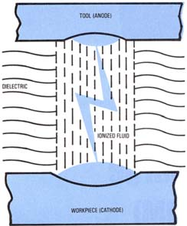
Fig: 5.1 Action of spark between electrode and work-piece [41]

5.1.1EDM Process
EDM spark erosion is the same as having an electrical short that burns a small hole in a piece of metal it contacts [41]. With the EDM process both the work-piece material and the electrode material must be conductors of electricity.
The EDM process can be used in two different ways:

- A reshaped or formed electrode (tool), usually made from graphite or copper, is shaped
To the form of the cavity it is to reproduce. The formed electrode is fed vertically down and the reverse shape of the electrode is eroded (burned) into the solid work piece.
- A continuous-travelling vertical-wire electrode, the diameter of a small needle or less, is
Controlled by the computer to follow a programmed path to erode or cut a narrow slot through the work piece to produce the required shape.

5.1.2 Conventional EDM
In the EDM process an electric spark is used to cut the work piece, which takes the shape opposite to that of the cutting tool or electrode. The electrode and the work piece are both submerged in a dielectric fluid, which is generally light lubricating oil. A servomechanism maintains a space of about the thickness of a human hair between the electrode and the work, preventing them from contacting each other.
In EDM ram or sinker machining, a relatively soft graphite or metallic electrode can be used to cut hardened steel, or even carbide. The EDM process produces a cavity slightly larger than the electrode because of the overcut.

5.1.3 Basics of EDM
The use of thermoelectric source of energy in developing the non-traditional techniques has greatly helped in achieving an economic machining of the extremely low machinability materials and difficult jobs [42]. The process of material removal by controlled erosion through a series of electric sparks, commonly known as EDM, was first started in 1943 in USSR. When a discharge takes place between two points of the anode and cathode, the intense heat generated near the zone melts and evaporates the materials in the sparking zone. For improving the effectiveness, the work piece and the tool are submerged in the Dielectric fluid. The basic EDM process has been shown in Fig. 5.1. It has been observed that if both the electrodes are made of the same material, the electrode connected to the positive terminal generally erodes at faster rate. For this reason, the work piece is generally made the anode. A suitable gap, known as the spark gap, is maintained between the tool and the work piece surfaces. The sparks are made to discharge at a high frequency with a suitable source. Since the spark occurs at the spot where the tool and the work piece surfaces is the closest and, since, the spot changes after each spark, the spark ravel all over the surface. This results in a uniform material removal all over the surface and finally the work face confirms to the tool surface. Thus the tool produces the required impression on the work piece.
For maintaining the predetermined spark gap, a servo control unit is generally used. The gap is sensed through the average voltage across it and this voltage is compared with a preset value. The difference is used to control the servomotor. The efficiency and accuracy of performance have been found to improve when a forced circulation of the dielectric fluid is provided. In the present work, the tool material is copper & aluminum for conducting the experiment or investigations.
Electric discharge machining is a chip less metal removal process that uses the principle of metal erosion by an interrupted electric spark discharge between the tool and the work piece. This process is also called spark erosion process.

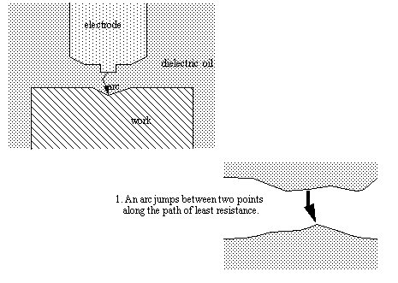

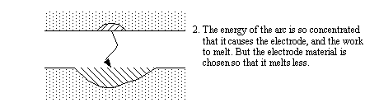

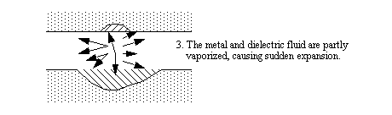

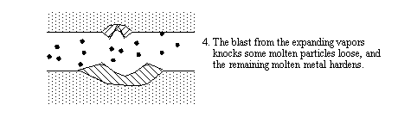
Fig: 5.2 Basic EDM Processes [42]
5.1.4 Principle of operation
We know that whenever an arc is caused by an accidental short circuit, pitting erosion occurs on the surface of the shorted material. EDM also works on the same principle of erosion by arcing. It involves the controlled erosion of electrically conducting materials by rapid and repetitive discharge of spark between the electrode tool and work piece (hence the name spark erosion) the tool is usually made the cathode and the work piece made the anode. The work piece and tool separated by a small gap and termed as the spark gap. The spark gap ranges from 0.005 mm to 0.05mm depending upon the cutting action required and the current density, this spark gap is either flooded or immersed in a dielectric fluid, the spark discharge is produced by the controlled pulsing and direct current. The frequency ranges from a few hundred to several thousand kilohertz with the application of a suitable voltage across the anode and cathode, electrons are the emitted from the cathode and cause the ionization of the fluid in the spark gap, when more electrons are collected in the gap, the resistance drops causing an electric spark to jump between the work and the tool gap. The spark causes a focused stream of electrons to move with a high velocity and acceleration from the cathode toward the anode, thus creating high compression shock waves .such shock waves result in local rise in temperature to the order of about 10,000 c and cause melting of the metal. The forces of electric and magnetic fields caused by the spark produced a tensile force and tear off particles of molten and soften metal from the work piece, Thereby resulting in the metal and carried away by the flowing dielectric fluid.
Work piece and the tool are separated by the dielectric fluid in a container. The dielectric breaks down when a proper DC voltage (50-450) V is applied across the anode and the cathode, and electrons are emitted from the cathode and the gap is ionized, thereby causing electrical discharge and machining operation. The electro-magnetic field cause compressive forces to act on the cathode thus metal removal from the tool is much slower than the work piece .the duration of the electric pulse is about 0.001 seconds, hence the whole cycle of sparking and metal removal take place in a few microseconds. The particles of the metal so removed are driven away by the flowing dielectric fluid .the current density and the power density used is the order of 10,000a/cm2 and 500mw/cm2 respectively.

5.2: Parameters affecting EDM process
A number of controlling variables play an important role in the entire Electric Discharge machining process. A few of them are:
(i). Pulse duration
(ii). Pulse interval time
(iii). Discharge current
(iv). Erosion diameter
(v). Erosion depth
The few process parameters which are useful in analyzing the EDM process accuracy and efficiency are as below:
(i). Metal removal rate
(ii). Electrode wear
(iii). Surface Roughness
(iv). Power consumption by the Machine

5.3 Process parameters
The various process parameters of electric discharge machining are given below.

5.3.1 Metal removal rate
Metal removal rate it is direct proportional to the current density used. It is defined as the volume of metal removed per unit time per ampere. The metal removal rate in roughening operations of steel with a graphite electrode 50 A current is about 400mm3/min and with 400A current it is about 4800mm³/min . But for high precision works with use of high frequency (500-1000) kHz and low current (1-2A), metal removal rate is as low as 2mm3/min.

5.3.2 Accuracy
The accuracy of the process mainly depends on the spark gap. The smaller the gap the higher is the accuracy, but a smaller gaps leads to a lower working voltage and hence a slow metal removal rate. Thus an optimum gap is necessary for higher accuracies tolerances of ±0.05 mm can be obtained in normal EDM operations. In precision operations, with close control of process variables, tolerance up to ±0.003 mm can be achieved. EDM also produces taper, overcut and corner radii, which are not desirable. The taper is of the order of 0.005 to 0.05mm per 10 mm depth. The taper effect reduces gradually to zero after about 75mm penetration .taper effect can be eliminated by the use of vacuum flushing of dielectric fluid.
The range of overcut is 5 to 100 microns and depth on the roughening operations .the effect of corner radii is equal to the spark gap. Its value is lower in finishing operations, where low park gaps are used.

5.3.3 Surface finish
In EDM operations, each electrical spark discharge develops a spherical crater in the work piece, as well as in the electrode. The volume of crater is proportional to the energy in the spark. Thus the depth of the crater is proportional to the energy in the spark. Thus the depth of the crater on work piece defines the surface finish and it depends upon the current density, frequency and the electrode material. usually high frequency and low current density give better surface finish, the best surface finish on steel is of the order of 0.4 micron (at 1000khz &1A).in a typical no-wear EDM ,the surface finish is about 3.2micron (generally roughing operations)

5.3.4 Heat affected zone (HAZ)
The instant heating and vaporization of metal due to spark, leaves behind a small amount of molten metal on the machined surface which re-solidifies and due to fast cooling action of the dielectric fluid forms a hard surface. This becomes the heat affected zone. In EDM operations .the HAZ is about 2 to 10micron 10 micron deep on the work surface and its hardness is about 60HRC.the hard surface is a source for thermal stresses, plastic deformation and fine cracks at the grain boundaries. The depth of HAZ is small in finishing operations which can be removed by producing after EDM operations.

5.3.5 Tool electrode wear
While performing the operations ,the tool gets eroded due to sparking action so the tool material should be a material should which is difficult to machine such as a graphite which goes to vaporization without melting.


Wear ratio=material removal from work/material removal from the tool·
Typical electrode materials are,
- - copper,
- - tungsten
- - graphite
Electrode material is selected on the basis of wear ratio, metal removal rate ,cost and ease of grinding the electrode most commonly used materials may include brass copper graphite ,al –alloys ,cu-alloys etc. flow hole should be made while making for the circulation of dielectric flow so as to attain large flow rates at low pressure.

5.4 Dielectric fluid
As mentioned the dielectric fluid acts as an insulator between the electrode and the mold cavity. There are many dielectrics to choose from based on the insulation properties of the fluid. Air is not a very good insulator. Water is best. But water has a few drawbacks. First, it causes rust. Second, the electrical discharge separates the water into pure hydrogen and pure oxygen, a very explosive pair. A good compromise then is kerosene. No rust problem and no dangerous gasses are produced with kerosene.
The dielectric must be constantly filtered, cooled and re-circulated. A great deal of heat is generated during the EDM process and the dielectric absorbs the most of it. Additionally the process creates a lot of debris and these needs to be filtered out of the system
In an EDM process a dielectric fluid in an essential working medium .it is flushed through the spark gap or supplied to the gap through a hole in the tool or from external jets. In some cases the fluid is also supplied through openings in the work piece wherever feasible, The flow of this working medium operations .the different flow patterns are discussed in the subsequent sections.
Functions of dielectric fluids
The functions of a dielectric fluid in EDM are as follows.
1. To serve as a spark conductor in the spark gap between the tool and the work material
2. To act as a coolant to quench the spark and to cool the tool and the work piece
3. To carry away the condensed metal particles and to maintain the gap for continuous and smooth operation.

5.4.1 Requirement of dielectric fluid
The essential requirements in the selection of a dielectric fluid are as follows.
1. It should have a stable and sufficient dielectric strength to act as insulation between the tool and the work piece.
2. It should have low viscosity and high wettability.
3. It should be chemically inert, so that the tool work piece container etc. is not attacked.
4. It should be able to deionize immediately after the spark discharge. It should have a high flash point. It should not emit toxic vapors and should not have unpleasant odors.
5. It should not alter its basic properties under operating conditions of temperature variations, contamination by metal particles and products of decomposition. It should be economical for use.

5.4.2 Selection of dielectric fluid
The main consideration in the selection of a dielectric fluid is the operating conditions; the choice of dielectric fluids depends on the size of work piece, complexity of the shape, surface finish required and material removal rate. Some of the dielectric fluids a, their machining rate and wear ratios.
The choice of a particular dielectric fluid depends on the tolerance required, size and shape of the work material removal rate and the type of electrode. For example, white spirit is used to machine tungsten carbide and metals for with intricate shapes and requiring high surface finish. Generally, low viscosity fluids are used for very high surface finishes; the used dielectric fluid is re-circulated and after proper filtering action removes the metal particles. Filtering medium like wound cotton yarn cartridge diatomaceous earth filter are used to remove wastes from the medium for normal precision works filters better than 2 microns sizes are used.
The commonly used dielectrics are kerosene, paraffin transformer oil or mixture of various oils.

5.5 Spark gap
The spark gap between the tool and the work is in the range of 0.005 to 0.05mm.this gap depends on the type of tool, work material. Dielectric fluid and the current density used.
Before solving the optimization problem for this process, some parameters or variables are generally specified such as erosion diameter, erosion depth, applied working voltage, dielectric pressure etc. once the operating conditions and work piece-tasking is defined, the same machine is to be run for various investigations with in the controlled parameter variation. The parameter variation ranges are specified in upcoming chapter on problem formulation and solutions.

5.6 Description of EDM Controls
The various controls of EDM (SPARKONIX A-35) as given in figure are listed below:
1. Rotary Switch (Mains)
2. Indicator Lamps (Three phase)
3. Rotary Switch (Pump)
4. Rotary Switch (Finish)
5. Rotary Switch (Current Range)
6. Rotary Knob (Current Adjust)
7. Ammeter (Gap current)
8. Rotary Switch (Duration)
9. Rotary switch (Base)
10. Indicator (Gap)
11. Rotary Potentiometer (Gap Control)
12. Toggle Switch (Soft Pulse)
13. Indicator Lamp (Spark)
14. Push Button (Spark)
15. Toggle switch (Auto flushing)
16. Rotary Potentiometer (Sparking Time)
17. Indicator Lamp (OV/SP)
18. Push Button (Off)
19. Rotary Switch (AUT/MAN)
20. Push Button (UP/DN)
21. Indicator Lamp (Interlock)
22. Rotary Switch (Ignition)
23. Indicator Lamp (Pump ON).
24. Push Button (AUTOPOS)
25. Indicator Lamp (Pump On)
26. Piezo Ceramic Alarm (Buzzer)
27. Toggle Switch (Buzzer Select)
28. Decade counter (Hour Counter)

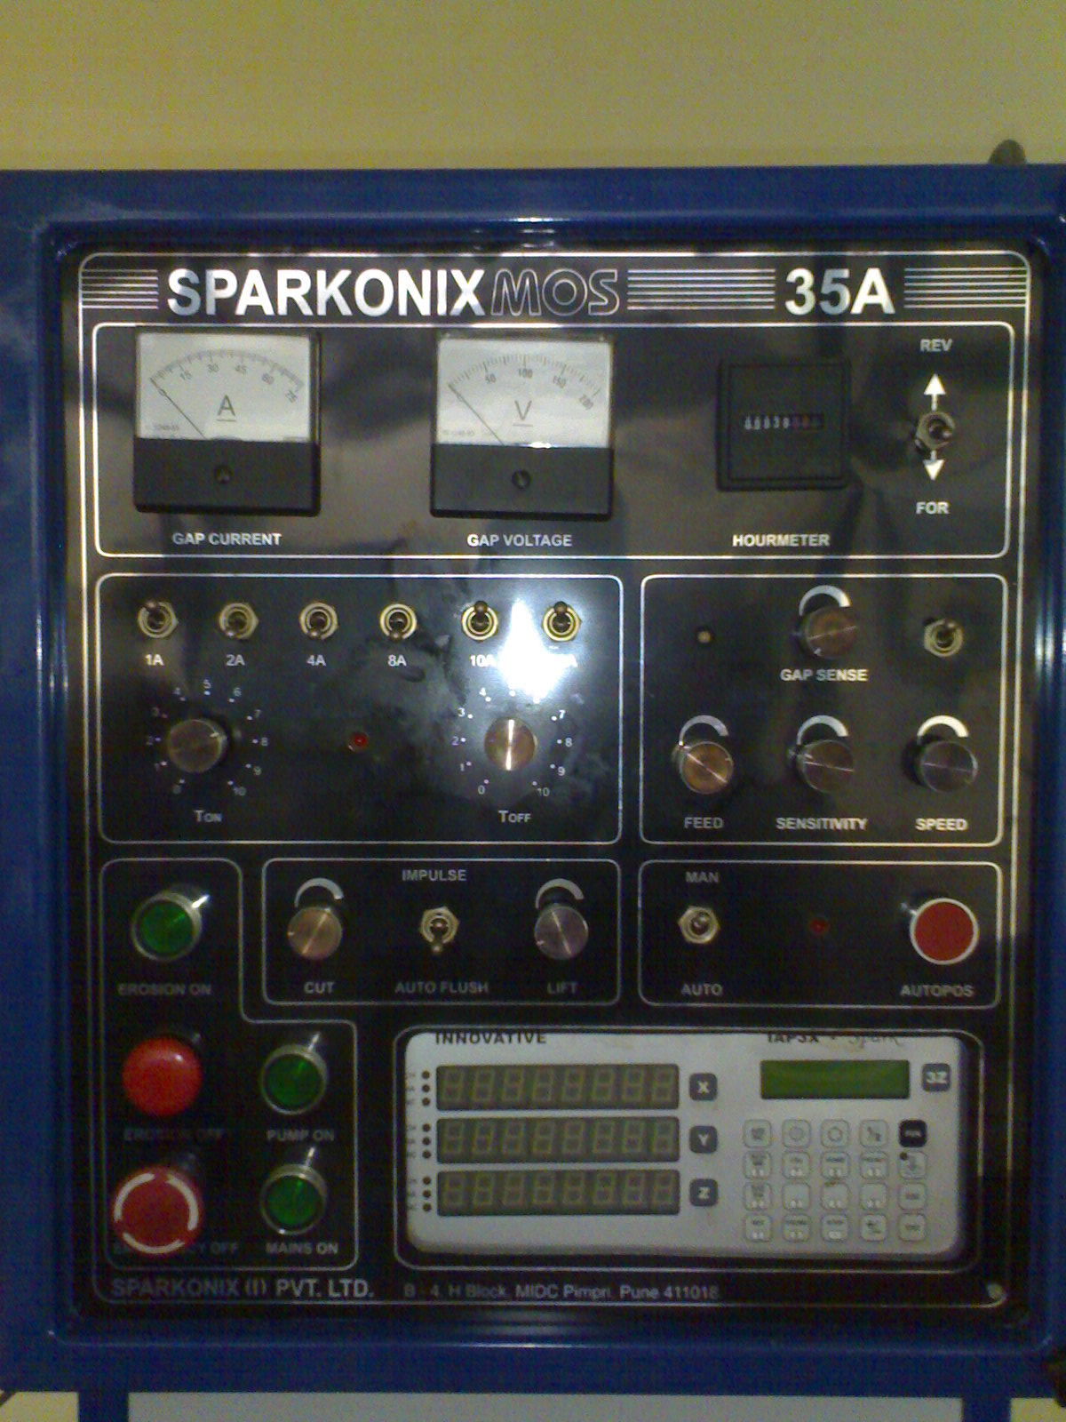
Fig: 5.3 Controller of EDM (SPARKONIX A-35)

1 Rotary Switch (mains)
This is main switch for total power supply (generator). IN position ‘1’, the supply is on and in the position ‘0’ the supply is off.

2 Indicator Lamps (Three Phase)
There is three LED’s (light emitting diodes) indicating presence of three phase of main supply.

3 Rotary Switches (Finish)
This has two positioning viz. NORMAL and MIRROR. The positioning MIRROR is selected only while polishing the job, while for all other setting, electrode and work piece material combinations the NORMAL position is to be selected.

4 Rotary Switches (Pump)
This switch has two positions 0 and 1 and in position 1 the dielectric pump is started and in position ‘0’ pump is off

5 Rotary Switches (Current Range)
This switch has three positions. The positions ‘1’ through ‘3’ increase machining current in steps of 4 amperes.

6 Rotary Knob (Current Adjust)
This knob continuously adjusts machining current in the span of about four amperes. In Range ‘1’, the current varies from 0.2 to 4 amperes approximately. Current is minimum when the knob is in fully counter clockwise (CCW) position and goes on increasing as the knob is turned in clockwise (CW) direction
7 Ammeter (Gap Current)
This is a moving coil type ammeter indicating average machining current during the machining processes. This range provided is from 0 to 15 amps. Green band is up to 12 amps and the remaining is red band.

8 Rotary Switches (Base)
This switch has 8 positions which are explained as given below:
High Current | - | Roughing
Just higher than mean current | - | Semi-finishing
Just lower than mean current | - | Finishing
At low current | - | Super-finishing

To achieve good machining stability, the range of machining current are recommended

9 Rotary Switches (Duration)
This switch has 12 positions. The pulse duration can change from minimum (position 1) to maximum (position 12) in ‘12’ positions by switch ‘9’ (Duration) for each position of switch ‘8’ (Base). Thus one can obtain a full range of pulse duration from a minimum of 2 us to a maximum of 520 us which largely covers the duration reduces the machining rate with drastic reduction in the relative electrode tool wear. Too long pulse duration(duration position ‘10’ to ‘12’) with copper electrode and steel work piece results in excessive accumulation of carbon in the machining zone with a subsequent instability of the machining processes.

10 Indicators (Gap)
Under healthy machining condition, the deflection is 1 to 1.5 divisions of its scale

11 Indicator Lamps (Spark)
This LED is ON when machining starts. It is turned OFF momentarily during lifting period of auto flush cycle or when the machining gap is short.

12 Push Buttons (Spark)
Pressing of this push button (with indicator ‘18’ and ‘22’ OFF) starts the machining processes.

13 Toggle Switch (Auto flushing)
This switch selects auto flushing (lifting during machine) in position ‘1’. At position 1 auto flushing does not work.
14 Rotary Potentiometers (Sparking Time)
This controls adjusts lofting time Toggle Switch ‘15’ (Auto flushing) selecting .In CW
Direction, the sparking time goes on increasing.

15 Rotary Potentiometers (Lifting Time)
This control adjusts lifting time with Toggle Switch ‘15’ (Auto flushing) selected. In CW
Direction, times goes on increasing.

16 Indicator Lamps (OV/SP)
This LED is ON under single phasing or over voltage condition of main input i.e. when the voltage of one or more of the 3 phase main input is above or below the safe working unit.

17 Push Button Red (OFF)
The machining (sparking) or auto position function can be stopped by pressing this push button.

18 Rotary Switch (AUT/MAN)
This switch selects one of the two modes of operation .Automatic and manual. In position
‘AUT’ either sparking or auto positioning can be started. In position ‘MAN’, the manual up and movement of quill is possible.
19 Push Button (UP/DN)
This switch has center off position. This switch is ‘MAN’ position of switch. With UP and DN position of the switch, upward and downward movement of quill is possible.

20 Indicator Lamp (interlock)
The LED is ON when level of dielectrics low in the working tank and causes interruption in the machining operation.

21 Panel Switch (Ignition)
This is a 4 position switch .It controls the energy of ignition of discharge channel. This energy is maximum in position 1 of this switch and it decreases progressively as the switch is rotated from position 1 to 4. Excessive ignition of the discharge channel provokes arching tendency and instability of machining process. Hence, whenever the arching tendency is more or the panel meter GAP (in spite of adjusting the GAP control) is overshooting frequency , a higher position of switch ignition should be selected.

22 Indicator Lamp (Pump ON)
This is ON when switch 4 above is in position 1 when dielectric pump is ON.

23 Push Button (AUTOPOS)
This is useful in position of the job. For actuation of this control, switch 20 has to be in position AUTO. On pressing this push button 20, the quill starts down slowly. As the dielectric comes in the vicinity of the work piece, it maintains a constant gap at low voltage between the electrode and the work piece with weak sparking. The AUTOPOS can be stopped by pressing push button.

5.7 Experimental Procedure
The metal removal was carried out using SPARKONIX (35A) based electric discharge machining as shown in fig. 5.4 & 5.5. Fig. 5.4 shows the schematic diagram of setting of electrode. Fig. 5.5 shows the schematic diagram of work-piece and electrode setup. The various controller of the machine were given above. In the experiment a copper electrode was used and mild steel was used as work-piece material. In the experiment a copper electrode with 29.2 mm diameter was used. All experiment was carried out with same electrode and kerosene oil was used as dielectric fluid. A direct current up-to 35 A was used for various readings. For calculating more accurate result six readings were carried out as shown in fig. 5.6. Experimental set up are shown in fig 5.4 & 5.5.

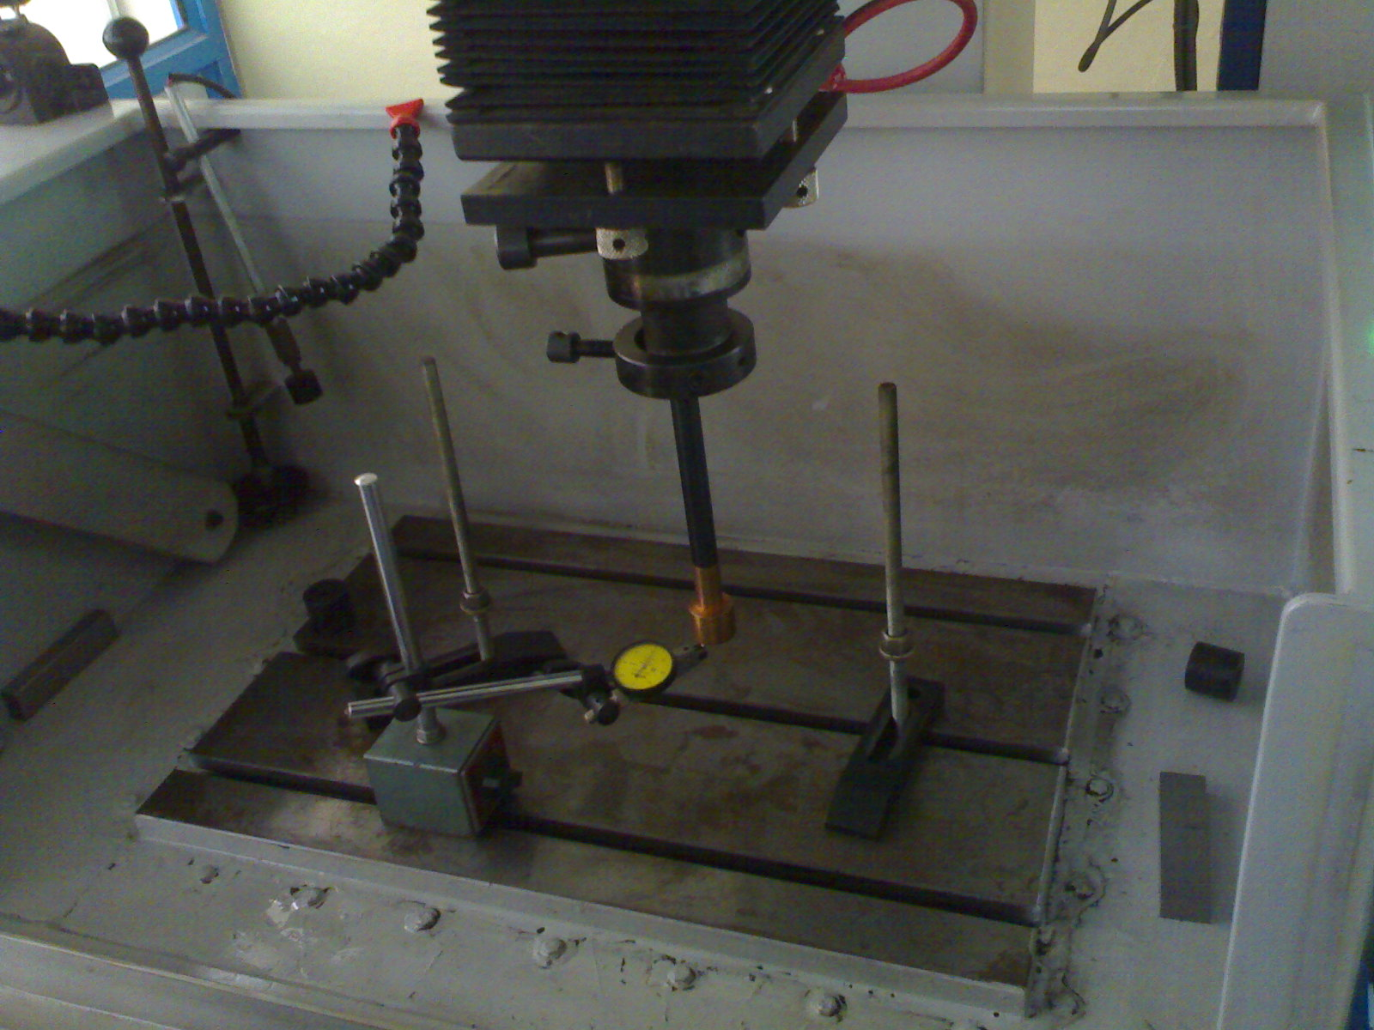
Fig. 5.4: To check level of the lower surface of the copper electrode
Initially the lower surface was made parallel to the bed of the EDM machine. After measuring the thickness all around the diameter to the electrode fixed the electrode into the chuck. After that the level was checked to avoid some manual error during fixing the electrode.
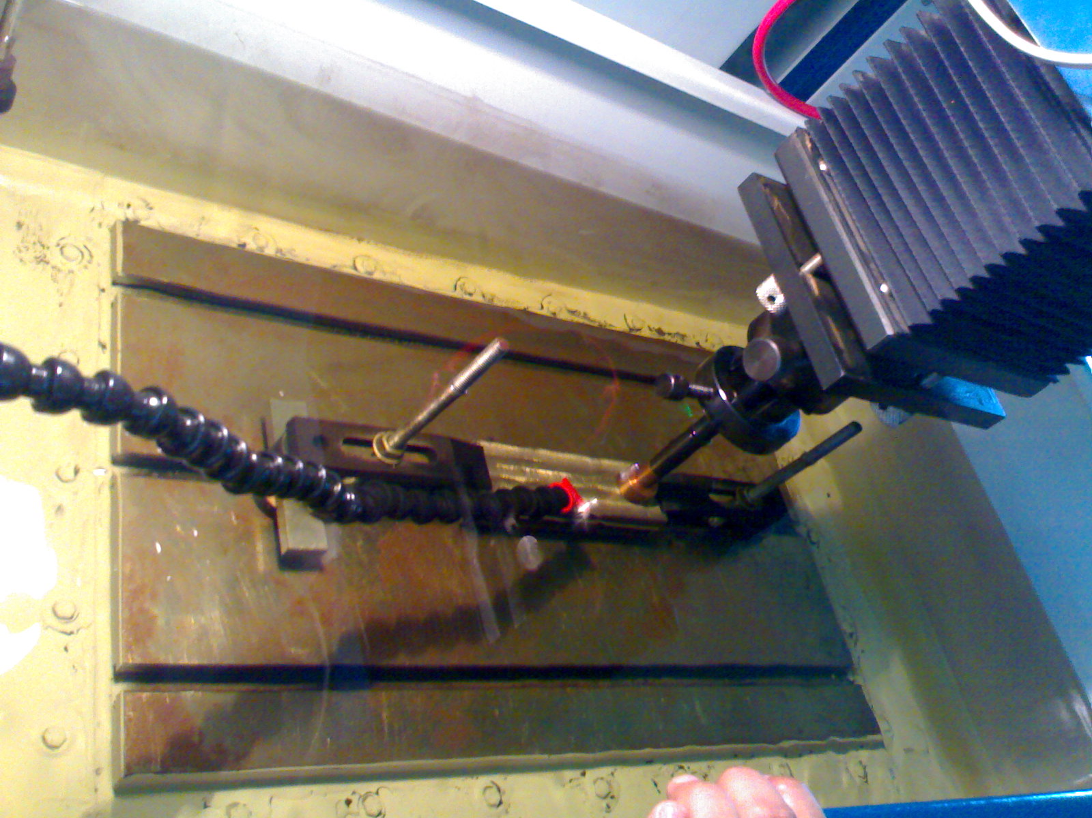
Fig. 5.5: Setup of work piece & electrode
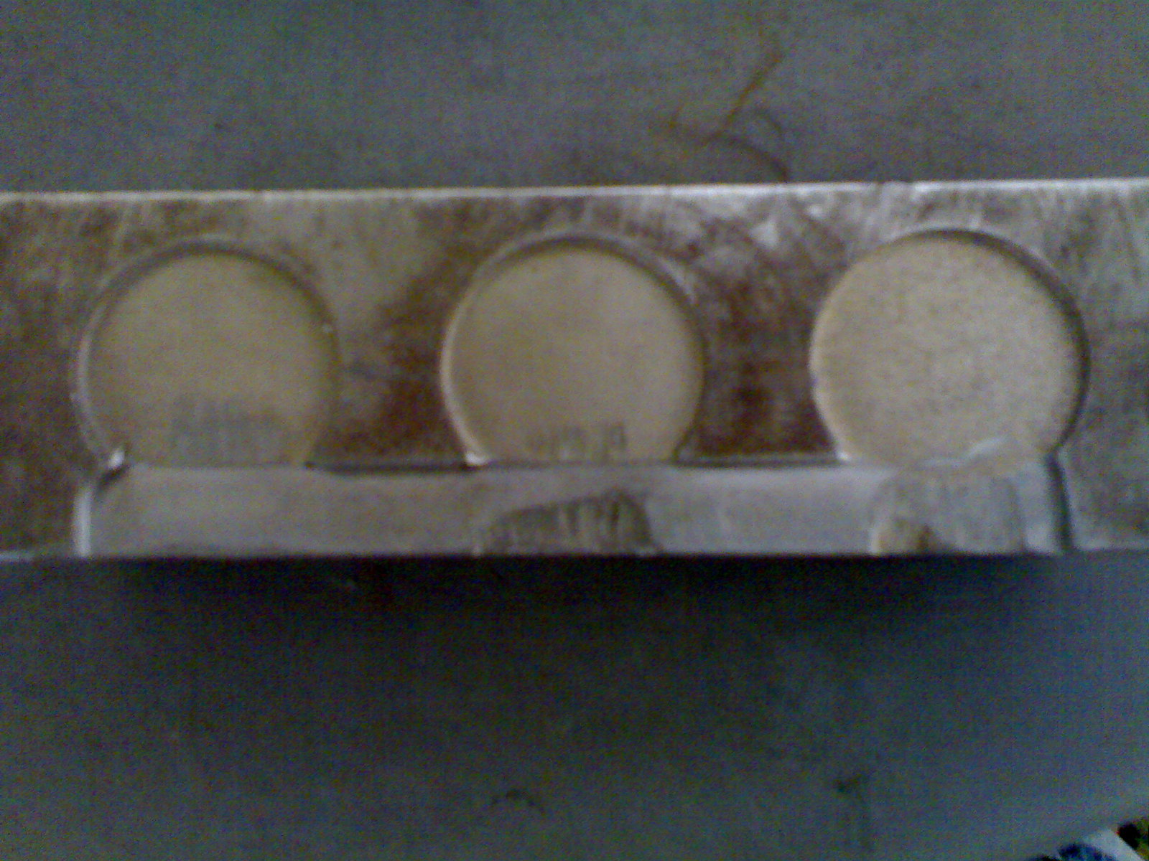
Fig 5.6: Work-piece for final analysis

Table: 5.1 Specification of machine.
SR. NO. | PARAMETERS USED | UNITS | PARAMETERS VALUE
1 | MACHINING UNIT |  | SN35
2 | TANK SIZE | MM | 775*450*325
3 | TABLE SIZE | MM | 550*350
4 | LONG-CROSS TRAVEL | MM | 200*200
5 | QUILL | MM | 200
6 | MAXIMUM HEIGHT OF WORK-PIECE | MM | 300
7 | MAXIMUM WEIGHT OF WORK-PIECE | Kg | 400
8 | MAXIMUM ELECTRODE WEIGHT | Kg | 35
9 | PARALLELISM OF TABLE SURFACE WITH TRAVEL | MM | 0.02
10 | SQUARENESS OF THE ELECTRODE TRAVEL | MM | 0.02/300

Table: 5.2 Parameters for experiment.
SR. NO. | PARAMETER USED | PARAMETER VALUE
1 | WORK-PIECE MATERIAL | MILD STEEL
2 | APPLIED VOLTAGE | 60V
3 | MAXIMUN CURRENT | 35A
4 | POWER SOURCE | (415V, 3hase, 50Hz)
5 | ELECTRODE DIAMETER | 29.2MM
6 | ELECTRODE MATERIAL | COPPER
7 | TIME B/W TWO SPARK | 3 sec.

Table: 5.3 surface roughness at various values of current
SR.NO. | CURRENT  (ampere) | TIME  (minutes) | DEPTH OF CUT  (mm) | SURFACE ROUGHNESS(µm)
1 | 12 | 20 | 0.5 | 17.58
2 | 16 | 16 | 0.5 | 25.79
3 | 18 | 13 | 0.5 | 31.23
4 | 20 | 11 | 0.5 | 41.12
5 | 22 | 10 | 0.5 | 57.53
6 | 24 | 8 | 0.5 | 71.27

Initially thickness of the copper electrode = 15 mm.
Finally calculated thickness of electrode = 14 mm (approximate)
So, average wear-out of the electrode = (15-14)/6
= 0.166666 mm

Table: 5.4 Material removal rates at various values of current
SR. NO | CURRENT  (ampere) | TIME  (minutes) | DEPTH OF CUT  (mm) | MATERIAL REMOVAL RATE  =(∏*r*r*D.O.C)/time  Mm3/min
1 | 12 | 20 | 0.5 | 17.58
2 | 16 | 16 | 0.5 | 25.79
3 | 18 | 13 | 0.5 | 31.23
4 | 20 | 11 | 0.5 | 41.12
5 | 22 | 10 | 0.5 | 57.53
6 | 24 | 8 | 0.5 | 71.27

For a clear view about the current and surface roughness relationship graph between current and surface roughness was drawn as shown in fig. 5.2a. Similarly, to know about a relationship between current and material removal rate the graph between then was drawn in fig. 5.2b.
SURFACE ROUGHNESS (MM)
Current in ampere
Fig 5.1a: Effect of current on surface roughness
From the graph roughness of the surface is directly related to the current density. As current density increases surface become more and more rough.

MATERIAL REMOVAL RATE (MM³/MINUTE)
Current in ampere
Fig 5.1b: Effect of current on material removal rate
The graph indicates that material removal rate is also directly related to the current density. As the current density increases material removal rate also increases in the same proportion.

CHAPTER 6
OPTIMIZATION OF MATERIAL REMOVAL RATE
6.1 Introduction
In many engineering activities, it is very difficult to obtain an explicitly or implicitly formalized description of the system which could them be optimized. Recently most of the research work is devoted to the methods for finding a statistically- experimental model of such systems. These methods are based on the experiments and their aim is to determine an investigation program which is compromise between a required number of investigations in real life condition and their in formativeness. The data thus obtained are analyzed by means of regression methods and then the mathematical model of the system is then obtained. This model describes the functional dependence between input variables and out variables. The forms of approximation functions can be considered different. For the EDM process formulation same techniques have been applied and the relationships have been developed as specified objective functions in the problem [2].

In Electric Discharge machining process, main input quantities are:
a). Pulse Duration
b). Pulse Interval
c). Amplitude of Discharge current
d). Erosion surface
e). Erosion depth etc.
f). Applied current
Whereas the main output quantities are
i). Metal removal rate
ii). Electrode wear
iii). Power consumption
iv). Surface roughness
v). Dimensional shape accuracy of the work piece

A theoretically recommended approach to the problem of finding a mathematical description of the EDM process would be to carry out investigations in the whole region of the space of input variables. The space of variables can be restricted to the region which is physically sensible and sets of equations are obtained.
These sets of equations give a mathematical description of the EDM process which is the basis for building the optimization model. In the present model, the decision variables are those input quantities whose values are set on the machine i.e. Pulse duration, Pulse interval time and discharge current. If the erosion surface does not change in the machining process and depth of erosion is also known in advance, these two input quantities are treated as parameters.
The choice of the objective and constraint functions depends on the user requirement. The output quantities usually chosen as objective functions are: maximizing metal removal rate, minimizing tool electrode wear rate.
The surface roughness and the dimension and shape accuracy of the work piece can be taken as the third and fourth objective functions in case of the accurate machining. In this process rough machining has been considered, so these two quantities may be considered as constraints or they may be omitted. Similarly, the power consumption by the machine may be either a new objective function or the constraint or it may be discarded.
In the problem formulation a particular case of EDM process has been analyzed. It is granted that cylindrical copper electrode is to be used as a tool and mild steel as the machining material. It is assumed to have constant dielectric pressure and average working voltage while taking the experimental readings which are to be used further for regression analysis.
The Objective Functions of the problem formulated after regression analysis of the investigations are as below

Q= e^{11.744}I11.744+0.032lnTi+0.022lnTo+0.0205lnΦ+0.026lngTi-1.555+0.047lnTo+2.76lnΦ+0.051lngTo^{-0.107-}
^{0.174lnΦ+0.155lng}Φ^{-1.067-0.124lng}g-0.742 …………………. (i)
δ ⁼ e^{-81.509}I5.634-0.349lnTi-0.335lnTo+0.119lnΦ+0.174lngTi3.726-0.051nTo-0.344lnΦ+0.253lngTo^{13.609-}
^{2.045lnΦ+0.207lng}Φ^{12.219-0.171lng}g-3.102 ………………… (ii)
N = e^{-0.663}I1.341-0.066lnTi-0.119lnTo+0.14lnΦ+0.053lngTi0.23+0.0711nTo-0.048lnΦ+0.0.016lngTo^{0.845-0.197lnΦ-}
^{0.058lng}Φ^{0.557-0.003lng}g0.005 ………………….. (iii)

6.2 Constraints
Ti ≥ 500 x 10⁻⁶ the pulse duration in Seconds does not exceed
Ti ≤ 2000 x 10⁻⁶ these minimum and Maximum Limits
To ≤ 250 x 10⁻⁶ the pulse Interval time in Seconds does not exceed
To ≥ 125 x 10⁻⁶ these minimum and Maximum Limits
I ≤ 35 The Discharge Current in Amperes does not exceed
I ≥ 1 these minimum and Maximum Limits
Φ ≤ 50 The Erosion Diameter in mm does not exceed
Φ≥ 20 these minimum and Maximum Limits
g ≤ 5 The Erosion Depth in mm does not exceed
g ≥ 0.1 These minimum and Maximum Limits
V= 60 ± 3 the applied working Voltage is kept almost constant
P= 60.8 Pa the dielectric pressure is kept almost constant and equal to this value for a case when cylindrical

This problem is a case of Multi- Criteria Optimization type with different Mini-Max constraints and objective Functions Conditions. For a given set of constraint each objective function can be evaluated by using any nonlinear programming technique or by using Genetic algorithms. However, in each case there is no guarantee to get optimized results of the parameters when other objective functions are not taken into account. A number of some other approaches exist to solve a Multi-objective function problem but all of them are either derivative function based or assumes suitable penalty functions for the account of other objective function.
While solving such cases, the approximate solution is achieved but is considerably away from the exact solutions. The integrated problem is formulated as a bi-criterion model to handle both tangible and intangible costs. The model is solved using a modified Chebyshev goal programming method to achieve a preferred compromise between the two conflicting and noncommensurable criteria.
In the above problem formulation, it is clear that for a given set of entry constraints variables, the objective functions are of following types:
(i). Q, Material removal rate : To be maximized
(ii). δ, Electrode Wear in percentage : To be minimized
(iii). N, power consumption in Watts : To be minimized

When multi- criteria model is developed, the nature of the objective functions are conflicting type and the combination of objective Function for Metal removal rate with other two objective functions in terms of electrode wear and power consumption makes objective function mini-max type.
According to the Bi-Criteria Model formulation to the above problem, such combination of Mini-Max type objective functions along with constraints is considered and the optimal values of the parameters and objective functions are evaluated at particular instances.

6.3 Mathematical analysis
Case I: considering objective functions (i) and (ii)

Maximize Q = e^{11.744} I11.744+0.032lnTi+0.022lnTo+0.0205lnΦ+0.026lngTi-1.555+0.047lnTo+2.76lnΦ+0.051lng
To^{-0.107-0.174lnΦ+0.155lng}Φ^{-1.067-0.124lng}g^{-0.742}
Minimize δ ⁼ e^{-81.509}I5.634-0.349lnTi-0.335lnTo+0.119lnΦ+0.174lngTi3.726-0.051nTo-0.344lnΦ+0.253lng
To^{13.609-2.045lnΦ+0.207lng}Φ^{12.219-0.171lng}g^{-3.102}

Subjected to Constraints
Ti ≥ 500 x 10⁻⁶ Ti ≤ 2000 x 10⁻⁶
To ≤ 250 x 10⁻⁶ To ≥ 125 x 10⁻⁶
I ≤ 35 I ≥ 1
Φ ≤ 50 Φ≥ 20
g ≤ 5 g ≥ 0.1

Case II: considering objective functions (i) and (iii)
Maximize Q = e^{11.744} I11.744+0.032lnTi+0.022lnTo+0.0205lnΦ+0.026lngTi-0.555+0.047lnTo+2.76lnΦ+0.051lng
To^{-0.107-0.174lnΦ+0.155lng}Φ^{-1.067-0.124lng}g^{-0.742}
Minimize N = e^{-0.663}I1.341-0.066lnTi-0.119lnTo+0.14lnΦ+0.053lngTi0.23+0.0711nTo-0.048lnΦ+0.0.016lng
To^{0.845-0.197lnΦ-0.058lng}Φ^{0.557-0.003lng}g^{0.005}
Subjected to Constraints
Ti ≥ 500 x 10⁻⁶ Ti ≤ 2000 x 10⁻⁶
To ≤ 250 x 10⁻⁶ To ≥ 125 x 10⁻⁶
I ≤ 35 I ≥ 1
Φ ≤ 50 Φ≥ 20
g ≤ 5 g ≥ 0.1

Step 2: Solve the problem with one objective at a time
The problem is solved by using generalized genetic algorithm for the given set of constraints and only one objective function at a time. The values obtained for each case are tabulated as below:
Case I
 | Minimize δ, mm | Maximize Q, mm/min | Difference
Value _Min δ | 0.1823498 | 0.9866789 | 0.8043291
Value_max Q | 6.546541 | 237.885891 | 231.33935
Case II
 | Minimize N, Watt | Maximize Q, mm/min | Difference
Value_min N | 43.18557102 | 3283.59375 | 3240.408179
Value_max Q | 5.826525852 | 237.885891 | 232.0593651

As we see the two objectives conflict to each other in each case. Minimize δ leads to a lower value of Q while maximizing Q leads to an considerable increase in the value of δ in case I and in case II, Minimize N leads to a lower value of Q while maximizing Q leads to a considerable increase in the value of N. Neither solution can be considered desirable particularly when the differences are substantial as shown in the table above.
This calls for a compromise solution by solving modified Chebyshev Goal programming problem in the next step.
Step III: Formulation and solution by modified Chebyshev Goal programming problem.
The problem can be formulated by using this bi-criterion approach for each case as below:

Case I:
Subjected to: Maximize Ω
(value_maxQ-value_maxQ*)
Ω ≤ ---------------------------------- = (value_maxQ-6.54651)/ 231.33935
(value_maxQ₂*-value_maxQ₁*)
(value_minδ₂*-value_minδ)
Ω ≤ ---------------------------------- = (0.9866789- value_minδ)/ 0.8043291
(value_minδ₂*-value_minδ₁*)

Ti ≥ 500 x 10⁻⁶ Ti ≤ 2000 x 10⁻⁶
To ≤ 250 x 10⁻⁶ To ≥ 125 x 10⁻⁶
I ≤ 35 I ≥ 1
Φ ≤ 50 Φ≥ 1
g ≤ 5 g ≥ 0.1
Similarly, for case II
Subjected to: Minimize Δ

(value_maxQ-value_maxQ*)
Δ ≤ ---------------------------------- = (value_maxQ-5.826525852)/ 232.0593651
(value_maxQ₂*-value_maxQ₁*)

(value_minN₂*-value_minN)
Δ ≤ ---------------------------------- = (3283.59375- value_minN)/ 3240.408179
(value_minN₂*-value_minN₁*)

Ti ≥ 500 x 10⁻⁶ Ti ≤ 2000 x 10⁻⁶
To ≤ 250 x 10⁻⁶ To ≥ 125 x 10⁻⁶
I ≤ 35 I ≥ 1
Φ ≤ 50 Φ≥ 50
g ≤ 5 g ≥ 0.1

The notion is that the best deviation from the two worst values of two objectives is obtained by maximizing Ω and minimizing Δ.

Solving this problem: We obtain the following results

Case I : maximizing Ω
 | Previous calculated value | Final calculated values | Difference
Value _Min δ | 0.1823498 | 0.1904325 | 0.0080827
Value_max Q | 6.546541 | 132.65478 | 126.108239
Case II : minimizing Δ
 | Previous calculated value | Final calculated values | Difference
Value_min N | 43.18557102 | 1439.86349 | 1396.677919
Value_max Q | 5.826525852 | 112.93497 | 107.108441

CHAPTER 7
Results analysis and discussions

7.1 Effect of current on surface roughness
Surface roughness increases with increase in current density. As the current increases surface of the final product becomes more and more rough. With the current increases from 12 ampere to 16 ampere surface roughness increases from 17.58 to 25.79 as shown in table 5.3. Also, current and surface roughness relationship can be graphed as shown in fig. 5.2a.

7.2 Effect of current on material removal rate
Material removal rate increases with increase in current density. As current density increases material removal rate also increases. From table 5.4 as current density increases from 18 ampere to 22 ampere material removal rate increases from 31.23 to 57.53 mm³/ minute. Increase of current increase the temperature between the electrode and work-piece due to which more vaporization of work-piece takes place. The graph between material removal rate and current is shown in fig. 5.2b.

7.3 Optimization analysis
On comparison the calculated values by optimization process & by the experimental values it is clear that both the values are not exactly equal but are nearly equal to each other.
- On measuring the MRR by bi-criteria method & by analyzing it comes out not exactly the same but both are nearly to each other.
- Similarly, the power consumption (calculated value) is also comes out nearly equal to the power consumption calculated by bi criteria method.
As both the values come out at the current near to 22 to 24 ampere.
From the above result computation it is clear that the results are close enough to take a decision about the behavioral response of the objective functions and the constraints. The developed bi-criterion method for the Electric Discharge machining process optimization is also quite useful for observing the sensitivity of the objective functions. Any set of the objective functions with respect to any set of constraint can be analyzed for their significant behavioral response. This technique seems to be quite useful for solving such constraint based machining parameter optimization problems.

CHAPTER 8
Conclusion and future scope
The present method adopted to solve the optimization problem of EDM process is simple enough and is flexible in selection of objective functions and the constraints for such machining processes. At any stage, the dominance factor of the input variables and output variables contained in the constraints and objective functions can be computed. This technique helps in getting the reliable multi-objective decisions under constrained penalties for the constrained optimization of such processes.
During the solution of the problem, it has been found that the results obtained by the bi-criterion approach show their convergence towards the exact solutions obtained by optimization of objective functions under min-max condition. However, the absolute values of the objective function differ significantly for their absolute values under max-max or min-min condition.
Even though a number of numerical optimization tools in the workbench of the software’s are available now a days, such optimization methods are contributing a lot for optimization of machining processes due to their localized flexible nature of the constraints and the interchangeable objective functions. A list of suggested proposals of work which can be carried out beyond the scope of this work is as below.
- A number of other non-traditional machining methods are available for advanced manufacturing. This method or algorithm may be used for getting the optimized results of the respective processes.
- The approach can be used for the probabilistic sensitivity analysis of the manufacturing processes including EDM process. This work will give a symbolic justification of the effect of external and internal system variables on the accuracy of surfaces.
- This approach may be coupled to other optimization algorithms to get multistage multi-criterion optimization by one integrated bi-criterion approach. Then this method will be able to show its importance in real life complex manufacturing problem solution.

References
1. Book title:- “Engineering optimization: methods and applications.”
By: A. Ravindran, K. M. Ragsdell, G.V. Reklaitis
2. A charnes and W. W. Cooper, “Goal programming and multiple objective programming.” Pp. 39-54, 1977.
3. Joopelli, V., "Multi-Objective Optimization of Parameter Combinations in Electrical Discharge Machining with Orbital Motion of Tool Electrode," Journal of Processing of Advanced Materials, Vol. 4, pp. 1-12, 1994.
4. Jain, V. K., "Multi-Objective Optimization of Electro discharge Machining Process," Microtechnic journal issue, Vol. 2, pp. 33-37, 1990.
5. Kahng, C. H., "Surface Characteristic Behavior Due to Rough and Fine Cutting by EDM," Annuals of the CIRP, Vol. 26/1, pp. 77 -82, 1977.
6. Kee, P., “Development of Constrained Optimization Analyses and Strategies for Multi-Pass Rough Turning Operations,” Int. J. Mach. Tools Manuf., pp. 115–127, 1996.
7. L.C. Lim, H.H. Lu," Better Understanding of the Surface Features of Electro-discharge”, Journal of Materials Processing Technology, Vol. 24, pp.513-523, 1990.
8. Madhu, P., Jain, V. K., "Finite Element Analysis of EDM Process," Journal of processing of Advanced Materials, Vol. 2, pp. 161-173, 1991.
9.. Masatoshi, S., and Ryo, Kubota, “Fuzzy Programming for Multiobjective Job Shop Scheduling with Fuzzy Processing Time and Fuzzy Due date through Genetic Algorithms,” Europian Journal of Operation research, Volume 120, pp. 393–407, 2005.
10. Pandit, S. M., "Analysis of Electro-Discharge Machining of Cemented Carbides," Annuals of the CIRP, Vol. 30/1, pp. 111-116, 1981.
11. Pandit, S. M., "A Mathematical Model for Electro-Discharge Machined Surface Roughness," Trans. and Proc. of the 8th NAMRC, pp. 339-345, 1978.
12. Rajurkar, K.P., and Zhu, D., "Improvement of Electrochemical Machining by Using Orbital Electrode Movement," Annuals of the CIRP, Vol.48/1, pp.139-142, 1992.
13. Spedding, T.A. and Wang, Z.Q. "Study on Modelling of Wire EDM Process" International Journal of Materials Processing Technology Vol 69, No 1-3,18-28, 1997.
14. Spedding, T.A., "Parametric Optimization and Surface Characterization of the Wire EDM Process" Journal of Precision Engineering, American Society of Precision Engineering, , Vol 20, No 1, 5-15, 1997.
15. Smyers, S., Guha, A., "Electrodischarge Machining of Beryllium Copper Alloys Safely and Efficiently," Proceedings of the International Symposium on Electro -Machining, ISEM-11, pp. 217-224, 1995.
16. Wang, W.M., "Advances in EDM Monitoring and Control Systems Using Modern Control Concepts," International Journal of Electro machining, No.2, pp. 1-7, January 1997.
17. Zhang, B., "Effect of Dielectric Fluid Characteristics on EDM Performance," a report from GE Research and Development, December 1997.
18. Zhang, C., and Wang, H. P., “Integrated Tolerance Optimization with Simulated.1998
19. Zimmermann, H. J., “Fuzzy Programming and Linear Programming with Several Objective Functions,” Fuzzy Sets Syst., 1, pp. 45–55, 1978
20. wikipedia, 2010
21. W. F. Taylor, “On the art of cutting metal.” pp. 31-35, 1970.
22. M.V. rebeiro and N.L. coppini, “An applied database system for the optimization of cutting condition and tool selection” 2000.
23. Gilbert, “Optimization of machining techniques” 2005.
24. Armaeago and brown, “Unconstrained machine parameter optimization using differential calculus”1969.
25. Brewer and Rueda, “Simplified optimum analysis for nonferrous material”1963.
26. Brewer, “Use of lagrangian multiplier for optimization of constriants problems of unit cost with cutting power.”1966.
27. Bhattacharya et al., “optimized the unit cost for turning”(1970).
28. Ermer & Kromodiharajo, “developed a multi-step mathematical ... model to solve a constrained multi-pass machining problem” 1981.
29. Hinduja et al, “objective function and constraints in terms of depth of cut and the difference between the minimum production cost and the minimum”1985.
30. Tsai,” studied the relationship between the multi-pass machining and single-pass machining.”1986.
31. Gopalakrishnan & Khayyal, ”described the design and development of an analytical tool for the selection of machine parameters in turning”1991.
32. Agapiou, “formulated single-pass and multi-pass machining operations. Production cost and total time were taken as objectives”.1992.
33. Prasad et al. , ”developed a PC-based generative CAPP system”.1997.
34. Aman aggarwal and Hira singh ,”Optimization of machining techniques — A retrospective and literature review”2007.
35. Kosko. “Neural network fuzzy system – A dynamic approach to machine intelligence.” 1997.
36 Wu V. “Off-line quality control: Japanese quality engineering.” 1982.
37. G al, Tomas: Stewart, Theodor J., Hanne, Thomas (Eds.), “Advances in MCDM Models, Algorithms, theory and applications.” 1991.
38. Dr. Ling Xu, Dr. Jian-Bo Yang,“Introduction to Multi-Criteria Decision making and the Evidential Reasoning Approach.” 2001.
39. Yang J. B. & Singh M. G.,”An evidential reasoning approach for multiple attribute decision making with uncertainty.” 2000.
40. Wikipedia-2010
41. Steve Krar,” Electric Discharge Machining: cutting metal to precise Shapes using electricity.” 1994.
42. Anand Pandey & Shankar Singh,” Current research trends in variants of Electric Discharge Machining: A review.” 2010.

