MMR FOR GA BASED

MULTIOBJECTIVE

ECONOMIC LOAD DISPATCH

A DISSERTATION SUBMITTED IN THE PARTIAL FULFILLMENT
FOR THE DEGREE OF

MASTER OF ENGINEERING
(CONTROL & INSTRUMENTATION)
(2008 – 2010)

Submitted by
IQBAL SINGH
Roll No: 8454

Under the guidance of
Prof. N.K Jain
&
Dr. Uma Nangia
Electrical Engineering Department



Delhi College of Engineering
(University of Delhi)

CERTIFICATE

It is certified that Mr. IQBAL SINGH, Roll No 8454 , student of M.E, Control and Instrumentation, Department of Electrical Engineering, Delhi College of Engineering, has submitted the dissertation entitled “ MMR FOR GA BASED MULTIOBJECTIVE ECONOMIC LOAD DISPATCH “ under our guidance towards partial fulfillment of the requirements for the award of the degree of Master of Engineering ( Control & Instrumentation Engineering ).

This dissertation is a bonafide record of project work carried out by him under our guidance and supervision. His work is found to be outstanding and has not been done earlier.

I wish him success in all his endeavors.

New Delhi Prof. N.K Jain
JUNE, 2010 Electrical Engineering Department
Delhi College of Engineering

Dr. Uma Nangia
Electrical Engineering Department
Delhi College of Engineering

ACKNOWLEDGEMENT

I express my sincere gratitude and indebtedness to the guides Prof. N.K Jain & Dr. Uma Nangia, Electrical Engineering Department, Delhi College Of Engineering for their initiative in this field of research, their valuable guidance, encouragement and affection for the successful completion of this work. Their sincere sympathies and kind attitude always encouraged me to carry out the present work firmly. I express my thankfulness to Prof. NARENDRA Kumar, Head, Electrical Engineering department, Delhi college of Engineering, New Delhi, for providing me with the best facilities in the Department and timely suggestions.

Last but not the least I would like to thank all my friends and well wishers who were involved directly or indirectly in successful completion of the present work.

IQBAL SINGH
ROLL NO 8454
ME (C&I)

ABSTRACT

Reliable power production is critical to the economic viability of electricity utilities. Economic Load Dispatch (ELD) is one of the main functions of modern Energy Management System (EMS), which determines the optimal real power settings of generating units with an objective of minimizing the total fuel cost.
A MATLAB program has been developed for Evolutionary Programming and Evolutionary Computation such as Genetic Algorithm (GA) to solve economic load dispatch problem considering transmission losses & environmental pollution.
In this thesis, the use of Constraint method has been applied to solve Economic Load Dispatch problems for IEEE 5, 14 & 30 Bus systems using GA tool box in MATLAB R2008b and Maximization of Minimum Relative attainments (MMR) technique is used to obtain the Target Point in 2-D and 3-D space.

LIST OF FIGURES:
12

15

22

24
27

28

31

41

44

49

52

56

60

71

76

77

78
Fig 2.1 Feasible Region in Objective Space
Fig 2.2 Flow Chart for Maximization of Minimum Relative Attainments (MMR)
Fig 3.1 Flow Chart Genetic Algorithm
Fig 3.2 The Evolutionary Cycle
Fig 4.1 Launch Optimization Tool
Fig 4.2 GA Tool Box In Matlab R2008b
Fig 4.3 Roulette wheel
Fig 5.1 Plot between Cost and Losses (5 Bus System)
Fig 5.2 Plot between Cost and Losses (14 Bus System)
Fig 5.3 Plot between Cost and Losses (30 Bus System)
Fig 5.4 Plot between Emission and Losses (5 Bus System)
Fig 5.5 Plot between Emission and Losses (14 Bus System)
Fig 5.6 Plot between Emission and Losses (30 Bus System)
Fig 5.7 Noninferior Solutions of 5-Bus System for fixed
transmission losses
Fig 5.8 Noninferior Solutions of 5-Bus System in 3-D Space
Fig 5.9 Noninferior Solutions of 14-Bus System in 3-D Space
Fig 5.10 Noninferior Solutions of 30-Bus System in 3-D Space
Fig (I-A) Bus-Code Diagram 5 Bus System
81
89
97
Fig (I-B) Bus-Code Diagram 14 Bus System
Fig (I-C) Bus-Code Diagram 30 Bus System

List of tables:
Table 1: Noninferior Set of IEEE 5 Bus System in 2-D Space
37

40
42

43
45

47

51
53

54

55

57

58

59

61
Table 2: Minimum Relative Attainments of IEEE 5-Bus System
in 2-D Space
Table 3: Noninferior Set of IEEE 14 Bus System in 2-D Space
Table 4: Minimum Relative Attainments of IEEE 14-Bus System
in 2-D Space
Table 5: Noninferior Set of IEEE 30 Bus System in 2-D Space
Table 6: Minimum Relative Attainments of IEEE 30Bus System
in 2-D Space
Table 7: Noninferior Set of IEEE 5 Bus System in 2-D Space
(F_{L} & F_{E})
Table 8: Noninferior Set Of IEEE 5 Bus System in 3-D Space
Table 9: Minimum Relative Attainments of IEEE 5-Bus System
in 3-D Space
Table 10: Noninferior Set of IEEE 14 Bus System in 2-D Space
(F_{L} & F_{E})
Table 11: Noninferior Set Of IEEE 14 Bus System in 3-D Space
Table 12: Minimum Relative Attainments of IEEE 14-Bus System
in 3-D Space
Table 13: Noninferior Set of IEEE30 Bus System in 2-D Space
(F_{L} & F_{E})
Table 14: Noninferior Set of IEEE 30 Bus System in 3-D Space
Table 15: Minimum Relative Attainments of IEEE 30-Bus System
62

63

63

63

64

65

65

66

67

67

68

69

69

70

in 3-D Space
Table 16: Target Point for in 2-D Space
Table 17: Target Point in 3-D Space
Table 18: Noninferior Set Of IEEE 5 Bus System For Fixed
Transmission Losses (5.060 MW)
Table 19: Noninferior Set Of IEEE 5 Bus System For Fixed
Transmission Losses (5.065 MW)
Table 20: Noninferior Set Of IEEE 5 Bus System For Fixed
Transmission Losses (5.070 MW)
Table 21: Noninferior Set Of IEEE 5 Bus System For Fixed
Transmission Losses (5.075 MW)
Table 22: Noninferior Set Of IEEE 5 Bus System For Fixed
Transmission Losses (5.080 MW)
Table 23: Noninferior Set Of IEEE 5 Bus System For Fixed
Transmission Losses (5.085 MW)
Table 24: Noninferior Set Of IEEE 5 Bus System For Fixed
Transmission Losses (5.090 MW)
Table 25: Noninferior Set Of IEEE 5 Bus System For Fixed
Transmission Losses (5.095 MW)
Table 26: Noninferior Set Of IEEE 5 Bus System For Fixed
Transmission Losses (5.10 MW)
Table 27: Noninferior Set Of IEEE 5 Bus System For Fixed
Transmission Losses (5.15 MW)
Table 28: Noninferior Set Of IEEE 5 Bus System For Fixed
Transmission Losses (5.20 MW)
73
74
74
82
82
83
90
91
92
98
100
102
102
103
Table 29: Percentage Distance of IEEE 5 Bus System in 3-D Space
Table 30: Percentage Distance of IEEE 14 Bus System in 3-D Space
Table 31: Percentage Distance of IEEE 30 Bus System in 3-D Space
Table I-A: Line Data or Impedance Data (5 Bus System)
Table I-B: Bus Data or Operating Conditions (5 Bus System)
Table I-C: Regulated Bus Data (5 Bus System)
Table I-D: Impedance and Line-Charging Data (14 Bus System)
Table I-E: Bus Data or Operating Conditions (14 Bus System)
Table I-F: Regulated Bus Data (14 Bus System)
Table I-G: Impedance or Line-Charging Data (30 Bus System)
Table I-H: Bus Data or Operating Conditions (30 Bus System)
Table I-I: Regulated Bus Data (30 Bus System)
Table I-J: Transformer Data (30 Bus System)
Table I-K: Static Capacitor Data (30 Bus System)

Contents
- Acknowledgement
- Abstract
- List Of Figures
- List Of Tables
1

1
2
2
2
4
4
5
6
8

9

9

9

11
11
12
13
14

17

17

19

20
20
23
24

CHAPTER 1 INTRODUCTION

1.1 Economic Load Dispatch
1.2 Objectives and Methodology
1.3 Survey of Literature
1.3.1 Economic Load Dispatch
1.3.2 Multiobjective Optimization
1.3.2.1 Historical Development
1.3.2.2 Advantages of Multiobjective Planning
1.3.3 Genetic Algorithm
1.4 Plan of Thesis

CHAPTER 2 MULTIOBJECTIVE OPTIMIZATION
2.1 Introduction
2.2 Formulation of General
Multiobjective Programming Problem
2.3 Noninferiority
2.3.1 Graphical Explanation of Noninferiorty
2.4 Constraint Method
2.4.1 Modified Form of Constraint Method
2.5 Maximization of Minimum Relative Attainments

CHAPTER 3 GENETIC ALGORITHM
3.1 Introduction
3.2 Genetic Algorithms and Traditional Search Methods
3.3 Biological Terminology
3.4 Evolutionary Computation
3.5 The Evolutionary Cycle
3.6 Advantages and Limitation of GA
26

26
26
27
29
29
30
30
31
32
32
33
33
34

35

37
38
39
42
45
49
51
51
55
59
72

79

79
80

81
109
111

CHAPTER 4 OPTIMIZATION USING GENETIC ALGORITHM
4.1 Exploring Genetic Algorithm Tool in Matlab R2008b
4.1.1 Calling the Function at the Command Line
4.1.2 Running the Problem in GA Tool
4.2 Different Parameters in GA Tool
4.2.1 Population
4.2.2 Fitness Scaling
4.2.3 Selection
4.2.4 Reproduction
4.2.5 Mutation
4.2.6 Stopping Criteria
4.2.7 Display Option
4.3 Run Solver in GA Tool
4.4 Optimization Problem

CHAPTER 5 MULTIOBJECTIVE APPROACH TO ECONOMIC
LOAD DISPATCH

5.1 Problem Formulation in 2-D Space
5.2 Computational Results in 2-D Space
5.2.1 IEEE 5 bus system
5.2.2 IEEE 14 bus system
5.2.3 IEEE 30 bus system
5.3 Problem Formulation in 3-D Space
5.4 Computational Results in 3-D Space
5.4.1 IEEE 5 bus system
5.4.2 IEEE 14 bus system
5.4.3 IEEE 30 bus system
5.5 Discussion

CHAPTER 6 CONCLUSIONS & FUTURE DIRECTIONS

6.1 Conclusions
6.2 Future Directions

APPENDIX I
APPENDIX II
References
CHAPTER 1
INTRODUCTION
1.1 ECONOMIC LOAD DISPATCH

Economic load dispatch (ELD) is an important function in power system planning and operation. In this work the economic load dispatch problem has been solved considering transmission losses and environmental pollution. The problem has been formulated by the modified form of constraint method. The intelligent optimization technique i.e. GAs (genetic algorithm) has been used to generate the noninferior set for IEEE 5, 14 and 30 bus systems. The Target point has been achieved by using Maximization of Minimum Relative Attainments (MMR).
The basic object of economic load dispatch is the distribution of total generation of power in the network such that the cost of power delivered is minimum. By economic load dispatch we mean to find the generation of the different generators or plants so that the total fuel cost is minimum and at the same time the total demand and the losses at any instant must be met by the total generation. In case of economic load dispatch the generations are not fixed but they are allowed to take values again within certain limits so as to meet a particular load demand with minimum fuel consumption. This means economic load dispatch problem is really the solution of large number of load flow problems and choosing the one which is optimum in the sense that it needs minimum cost of generation.
To solve the economic load dispatch problem many techniques were proposed such as classical techniques, linear programming (LP), nonlinear programming (NLP), Quadratic Programming (QP), swarm optimization, evolutionary programming, tabu search, genetic algorithm, etc. Modified form of constraint method is used to generate non-inferior set using genetic tool for IEEE 5, 14 and 30 bus systems. Maximization of Minimum Relative Attainments (MMR) has been used to achieve the target point.

1.2 OBJECTIVES AND METHODOLOGY

Our objective in this work is to solve economic load dispatch problem considering transmission losses and environmental pollution using genetic algorithm. For this IEEE 5, 14 & 30 bus systems have been considered. The Target point or the best compromise solution has been achieved by using Maximization of Minimum relative attainments (MMR) technique.
The work has been carried out in the following order:
Exploring and Analyzing the Tools of Genetic Algorithm in Matlab R2008b.
Performing Constrained Minimization.
Economic Load Dispatch considering transmission losses & environmental pollution for IEEE 5, 14 & 30 Bus Systems.

1.3 SURVEY OF LITERATURE

1.3.1 ECONOMIC LOAD DISPATCH:

Economic load dispatch (ELD) is a method to schedule power generator outputs with respect to the load demands and to operate a power system economically, so as to minimize the operation cost of the power system. The input-output characteristics of modern generators are nonlinear by nature because of the valve-point loadings and rate limits. Thus the characteristics of ELD problems are multimodal, discontinuous and highly nonlinear. The economic-emission load dispatch (EELD) problem which accounts for minimization of both cost and emission is a multiple, conflicting objective function problem. Goal programming techniques are most suitable for such type of problems. In the paper ‘Economic-Emission Load Dispatch through Goal Programming Techniques’ Nanda et al.[7] solved the economic-emission load dispatch problem through linear and non-linear goal programming algorithms. The application and validity of the proposed algorithms are demonstrated for a sample system having six generators. In reality, the ELLD problem is a multiple objective problem with conflicting objectives because minimum pollution is conflicting to minimum cost of generation. In the paper, the EELD problem is solved using linear goal programming (LGP) technique. A maiden attempt is made to solve this conflicting, Multiobjective problem with the use of LGP technique as well as with NLGP technique.
S.H.Ling et al.[17] presented an algorithm using swarm optimization technique for economic load dispatch. In this paper, an improved genetic algorithm for economic load dispatch is proposed. New genetic operations of crossover and mutation are introduced. On realizing the crossover operation, the offspring spreads over the domain so that a higher chance of reaching the global optimum can be obtained. On realizing the mutation, each gene will have a chance to change its value. Consequently, the search domain will become smaller when the training iteration number increases in order to realize a fine-tuning process. Operating at absolute minimum cost can no longer be the only criterion for dispatching electric power due to increasing concern over the environmental considerations.
Ling et al.[20] proposed particle swarm optimization approach to solve economic load dispatch problem. It applies a wavelet theory to enhance PSO in exploring solution spaces more effectively for better solutions. Particle swarm optimization (PSO) is a recently proposed population based stochastic optimization algorithm, which is inspired by the social behaviors of animals like fish schooling and bird flocking.

1.3.2 MULTIOBJECTIVE OPTIMIZATION

Single objective optimization techniques give optimal solution in respect of a single aspect, i.e. they give the best value of the objective function under consideration. The values of the other objectives at such a solution may be intolerably bad. The utilities would not be willing to accept such a solution. The power system analyst has nothing else to present before the utilities to facilitate the decision-making process. The way out lies in multiobjective approach to the problem solving [6,7].
Multiobjective programming and planning is concerned with decision making problems in which there are several objectives, some of which may be conflicting.

1.3.2.1 Historical Development

The analysis of the multiobjective programming has evolved over the last 35-40 years in the areas of operation research, economics and psychology, applied mathematics and engineering. The theoretical work of Kuhn and Tucker [1] provided the basis for later algorithmic developments of mathematical programming. Gass and Satty [2] provided the first approach to multiobjective programming problems. They generated the noninferior solutions in two-objective problems by parametrically varying the coefficients of objective functions.

1.3.2.2 Advantages of Multiobjective Planning

The consideration of many objectives in the planning process accomplishes three major improvements in the problem solving:
(i) Multiobjective programming and planning promotes more appropriate roles for the participants in the planning and decision making process.
(ii) A wider range of alternatives is usually identified.
(iii) The power system analyst’s perception of a problem will be more realistic if many objectives are considered.
There are two parts of multiobjective decision making process; analysis and decision making. Analysis of a problem provides information about the problem for making decisions. Multiobjective approaches pursue an important decision making process: an explicit consideration of the relative impacts of the different objectives on the problem. These approaches emphasize the range of choice associated with a decision problem. The responsibility of the assigning relative values to the objectives remains with the decision maker. The beauty of multiobjective approaches is that these provide sufficient information and facilitate the decision making process.
Regardless of the actual nature of decision making process, multiobjective approaches can be useful in promoting the explicit consideration of the value judgments which are implicitly made in the application of single objective approaches.
Multiobjective techniques are used to generate and evaluate more than one alternative. These techniques indicate to decision makers a range of choices beyond one optimal alternative identified by single objective method. A general rule for decision making which is assumed is that more information carefully presented is better than less information. The decision to accept or reject a single optimal alternative is an uninformed decision. Informed decision making requires knowledge of full range of possibilities provided by multiobjective analysis. Multiobjective analysis allows several noncommensurable effects to be treated without artificially combining them.

1.3.3 GENETIC ALGORITHM
A genetic algorithm (GA) is a search technique used in computing to find exact or approximate solutions to optimization and search problems. Genetic algorithms are categorized as global search heuristics. Genetic algorithms are a particular class of evolutionary algorithms that use techniques inspired by evolutionary biology such as inheritance, mutation, selection, and crossover (also called recombination). Zalzala et al.[13] made the review on the current development techniques in genetic algorithm. It explains theoretical aspects of genetic algorithms and genetic algorithm applications. Theoretical topics under review include genetic algorithm techniques, genetic operator technique, niching techniques, genetic drift, and method of benchmarking genetic algorithm performances, measurement of difficulty level of a test-bed function, population genetics and developmental mechanism in genetic algorithms. According to zalzala et al.[14] there were two types of genetic algorithm earlier one was Breeder genetic algorithm and the other was simple genetic algorithm. Breeder Genetic Algorithm (BGA) is first introduced by Miihleiibein and Schlierkamp-Voosen (1993). The major difference between simple genetic algorithm and BGA is the method of selection. Generally, truncation selection is used in BGA. Genetic drift is an important phenomenon in genetic algorithm search. Once the algorithm is converged, the size of original gene pool is reduced to the size of found solution(s) gene pool. This leads to genetic drift. Two niching techniques - simple sub-population scheme and deterministic crowding are being reviewed. Many traditional optimization algorithms suffer from myopia for highly complex search spaces, leading them to less than desirable performance (both in terms of execution speed and fraction of time they need to find an optimal solution) [11]. This paper helps us in understanding application of genetic algorithm on multiple fault diagnosis problems. It is seen that in a MFD problem, there are regions of the search space and there is little information to direct the search (e.g., in a flat valley). Consequently, local search algorithms may exhibit less than desirable performance. To handle irregular search spaces, such heuristics should adopt a global strategy and rely heavily on intelligent randomization. Genetic algorithms follow just such a strategy. Following the model of evolution, they establish a population of individuals, where each individual corresponds to a point in the search space. An objective function is applied to each individual to rate their fitness. Using well conceived operators, a next generation is formed based upon the survival of the fittest. Therefore, the evolution of individuals from generation to generation tends to result in fitter individuals, solutions, in the search space.

1.4 PLAN OF THESIS

This dissertation has been arranged in six chapters. The contents of the chapters are briefly outlined as indicated below:
Chapter 1: Discusses the introduction to economic load dispatch and Research objectives of the thesis. Literature survey of the covered topics has also been presented.
Chapter 2: Discusses the Multiobjective optimization. This presents formulation of general multiobjective problem and the concept of Noninferiorty, Constraint Method and Maximization of Minimum Relative Attainments (MMR).
Chapter 3: Presents Genetic Algorithms and its applications.
Chapter 4: Explores the concepts of Genetic Algorithm in Matlab R2008b. Analysis of various parameters in GA tool box has been carried out.
Chapter 5: Discusses Multiobjective Approach to Economic Load Dispatch and deals with problem formulation in 2-D and 3-D space for IEEE 5, 14 and 30 bus systems. Results have been presented and Maximization of Minimum Relative Attainments (MMR) technique has been applied for finding the Target Point.
Chapter 6: Conclusion and the prospects for Future Directions have been discussed.
Appendix and references are at the end of the thesis.
Chapter 2
MULTIOBJECTIVE OPTIMIZATION
2.1 INTRODUCTION

The various objectives of power systems are cost of generation, system transmission losses, environmental pollution, security etc. These objectives are conflicting in nature and cannot be handled by conventional single objective optimization techniques. Single objective technique gives optimal solution in respect of an objective function under consideration. The way out, therefore, lies in the multiobjective approach to problem solving.

2.2 FORMULATION OF GENERAL MULTIOBJECTIVE PROGRAMMING PROBLEM:

The general multiobjective optimization problem with n decision variables, m constraints and h objectives is
Minimize
Z(X₁, X₂,…………X_{n}) = [Z₁ (X₁,X₂,…………..X_{n}); (2.1a)
Z₂(X₁, X₂……………X_{n});
………….….…….…;
Z_{h}(X₁, X₂ ……………X_{n})];
s.t.
g_{i}(X₁,X₂,…..X_{n}) 0 i= 1,2,………m (2.1b)
X_{j} 0 j= 1,2,…….…n (2.1c)
Where Z(X₁,X_{2,}…..X_{n}) is the multiobjective function and Z₁(X_{1,}X₂…….X_{n)}, Z₂(X₁,X₂,……X_{n}),………Z_{h}(X_{1,}X₂,…….X_{n}) are the h individual objective functions. In the multiobjective function Z, the various individual functions Z₁,Z₂,…….Z_{h} have just been written, but it does not imply any kind of operation say multiplication, addition or anything else whatsoever in general. In particular, Z can be designed to incorporate Z₁,Z₂,…….Z_{h} depending upon the approach.
Multiobjective approach to economic load dispatch has been carried out on IEEE 5, 14 and 30 bus systems [3] in 2-D space and 3-D space. The data of 5, 14 and 30 bus systems is given in [appendix I]. In 2–D space, two objectives i.e. cost of generation (F_{C}) and system transmission losses (F_{L}) have been considered. In 3-D space, in addition to the above mentioned two objectives, environmental pollution (F_{E}) is also considered.
The ideal situation where one would like to operate the power systems is one where all the objectives i.e. cost of generation (F_{C}), system transmission losses (F_{L}) and environmental pollution (F_{E}) are minimum. Such a point is called the Ideal Point. In 2-D space, it is represented by (F_{CMIN}, F_{LMIN}) where as in 3-D space; it is represented by (F_{CMIN}, F_{LMIN}, F_{EMIN}). But such a point is not feasible. If it was, then there would not be any conflict among the objectives.
A strategy has to be adopted by the power system operator to achieve optimum values as per his satisfaction level and requirements. The operating point so obtained is called Target Point (TP) or the best-compromise solution.

2.3 NONINFERIORITY

A feasible solution to a multiobjective programming problem is noninferior if there exists no other feasible solution that will yield an improvement in one objective without causing degradation in at least one of the other objectives [7]. A given non inferior solution may or may not be acceptable to the decision maker. However, it is important to note that, it is one of these noninferior solutions for which decision maker looks for.

2.3.1 GRAPHICAL EXPLANATION OF NONINFERIORTY

Let us explain this definition graphically. An arbitrary collection of feasible alternatives for a two objective minimization problem is shown in Fig 2.1. Curve 1 form the boundary of the feasible region. The definition of noninferiorty can be used to find noninferior solutions in Fig 2.1. All the feasible solutions above curve 1 are inferior because they yield more of both Z₁ (F_{C}) and Z₂ (F_{L}). Consider an exterior point C in Fig 2.1, which is inferior. Alternative A gives less of Z₁ (F_{C}) than does C without increasing the amount of Z₂ (F_{L}). Alternative B gives less amount of Z₂ (F_{L}) without increasing the amount of Z₁ (F_{C}). Consider point D on curve AB. Suppose it is desired to achieve lesser value of Z₁ (F_{C}) than the value at point D. Since it is not desirable to move to the left of curve AB as even through it gives lesser value of Z₁ (F_{C}), yet it lies in the infeasible region. Therefore, it is desirable to move upward only along the curve AB to have lesser value of Z₁ (F_{C}). Let us say, we get point E. At this point, we get less value of Z₁ (F_{C}) but there is some increase in Z₂ (F_{L}). In other words, in order to gain on Z₁ (F_{C}), we have to sacrifice ∆Z₂ (∆F_{L}) units of Z₂ (F_{L}). Similarly, in moving from D to F, we have to sacrifice ∆Z₁ (∆F_{C}) units of Z₁ (F_{C}) to gain on Z₂ (F_{L}). So we can say that points D, E and F are noninferior.
The mathematical statement of noninferiorty also is given in [Appendix II].

Z₂ (F_{L})
∆ Z₂
∆ Z₁
Z₁ (F_{C})
A
B
C
IP
D
F
E
FEASIBLE
CURVE 1
INFEASIBLE
FEASIBLE

Fig 2.1: FEASIBLE REGION IN OBJECTIVE SPACE

2.4 CONSTRAINT METHOD

The constraint method is the most appealing generating technique. It operates by optimizing one objective while all others are constrained to some value. Marglin [4] introduced this method for public investment problems; this method has been applied to water resource problem by Cohon and Marks [5].
Mathematically, a multiobjective problem with h objectives is formulated using constraint method as:
Minimize

Z_{t} (X₁, X₂……..X_{n}) (2.2a)
s.t.
g_{i} (X₁,X₂……...X_{n}) ≤ 0 i = 1,2…..m (2.2b)
X_{j} ≥ 0 j = 1,2…...n (2.2c)
Z_{k} (X₁, X2….…X_{n}) ≤ L_{k} k = 1,2…t-1,t+1...h (2.2d)
Where the t^{th} objective is arbitrarily chosen for minimization. This is single objective formulation.

2.4.1 MODIFIED FORM OF CONSTRAINT METHOD

The solutions are generated with the help of a modified form of constraint method. i.e. if given a problem with h objectives, h-2 of them are set at predetermined values and one of remaining two objectives is minimized with the other objective constrained at varying levels, e.g. if Z₁ is to be minimized, Z₂ is varied over some range of values and Z₃, Z₄….. Z_{h} are fixed at levels L₃, L₄….. L_{h}. The modified constrained problem is

Minimize
Z₁ (X) (2.3a)
Subject to
gi(X₁, X₂,…., X_{n}) ≤ 0 i = 1,2,……,m (2.3b)
Xj ≤ 0 j = 1,2,…….,n (2.3c)
Z₂(X) ≤ L₂ (2.3d)
Z_{k-1}(X) = L_{k-1} (2.3e)
Z_{k}(X) = L_{k} k = 3, 4…….h (2.3f)
In other words, the original h objective problem is reduced to a two objective problem
2.5 MAXIMIZATION OF MINIMUM RELATIVE ATTAINMENTS
This method assumes that all the objectives are being minimized and seeks the solution which is maximizes the minimum relative attainment, τ_{i} (x) by any objective Z_{i}(x) of its ideal reference value Z_{imin} relative to its worst feasible value Z_{iatZ(i+k).}
(2.4)
τ_{i} (x) = =
Z_{i}(x) – Z_{iatZ(i+k)}
Z_{imin} – Z_{iatZ(i+k)}

i = 1, 2……k, k+1…….h
Where h is the number of objectives.
This method is explained in the flow chart as shown in Fig 2.2 and the algorithm is given below:
START
S_{K} = S + λ_{Ki}
Calculate
λ_{Ki}(x)= Z_{i}(x) - Z_{i}^{worst}
Z_{i}* - Z_{i}^{worst}
S =0.0
i =1
K = 1
Generate noninferior set N
Define Z as per eqn (2.3a)
Input h = no. of objectives oobobjectivesobjectives
Is
i>h
IF K>1
A = Max (S_{K},S_{K-1}) , if K=2
A = Max (S_{K},A) , if K>2

K = K+1
Is
K>N
Output A and the corresponding Target Point
STOP
No
No
Yes
No
Yes
Yes
Fig 2.2: FLOW CHART FOR MAXIMIZATION OF MINIMUM RELATIVE ATTAINMENTS
ALGORITHM 2.1
1. Define the function.
2. Generate the noninferior set by constraint method.
3. Take the first element of the noninferior set. Put K=1.
4. Calculate the relative attainments of all the objectives using eq. (2.4).
5. Calculate the sum of Minimum Relative Attainments of all the objectives corresponding to the element of noninferior set.
6. If K>1, find the sum which is maximum. Else, increment K by 1.
7. Check if all the elements of noninferior set have been considered.
8. If yes, output the objectives corresponding to Maximization of Minimum Relative Attainments and stop; else, go to step 4.

Chapter -3
GENETIC ALGORITHM
3.1 INTRODUCTION

Genetic Algorithms are a way of solving problems by mimicking the same processes Mother Nature uses. They use the same combination of selection, recombination and mutation to evolve a solution to a problem. Genetic algorithms are one of the best ways to solve a problem for which little is known. They are a very general algorithm and so will work well in any search space and will be able to create a high quality solution. Genetic algorithms use the principles of selection and evolution to produce several solutions to a given problem.
Genetic algorithms tend to thrive in an environment in which there is a very large set of candidate solutions and in which the search space is uneven and has many hills and valleys.
A genetic algorithm (GA) is a search technique used in computing to find exact or approximate solutions to optimization and search problems. Genetic algorithms are categorized as global search heuristics. GA has been developed by John Holland, his colleagues and his students at the University of Michigan. The goals of their search have been two fold i.e.
- To abstract and rigorously explain the adaptive processes of natural systems.
- To design artificial systems software that retains the important mechanisms of natural systems.
Genetic algorithms are a particular class of evolutionary algorithms (EA) that use techniques inspired by evolutionary biology such as inheritance, mutation, selection, and crossover. Genetic algorithm should be used in case when alternate solutions are too slow or overly complicated.
A GA is heuristic, which means it estimates a solution which could be the exact solution, but that may be a minor concern. In fact, most real-life problems are like that: you estimate a solution rather than calculating it exactly.
For most problems there is no such formula for solving the problem because it is too complex, or if done, it just takes too long to calculate the solution exactly. An example could be space optimization - it is very difficult to find the best way to put objects of varying size into a room so they take as little space as possible. The most feasible approach then is to use a heuristic method.
Genetic algorithms are different from other heuristic methods in several ways. The most important difference is that a GA works on a population of possible solutions, while other heuristic methods use a single solution in their iterations. Another difference is that GAs are probabilistic (stochastic), not deterministic.
Each individual in the GA population represents a possible solution to the problem. The suggested solution is coded into the "genes" of the individual. One individual might have these genes: "1100101011", another has these: "0101110001". The values (0 or 1) and their position in the "gene string" tell the genetic algorithm what solution the individual represents.
Then the rules of evolution to the individuals are applied. Finding the individuals which sense to be the best suggestions to the problem and then combine these individuals into new individuals. Using this method repeatedly, the population will hopefully evolve good solutions.

3.2 GENETIC ALGORITHMS AND TRADITIONAL SEARCH METHODS.
A population of points is used for starting the procedure instead of a single design point. If the number of design variables in n, usually the size of the population is taken as 2n to 4n. Since several points are used as candidate solutions, GAs is less likely to get trapped at a local optimum.
GAs uses only the value of objective function. The derivatives are not used in search procedure.
In GAs the design variable are represented as strings of binary variables that correspond to the chromosomes in natural genetics. Thus the search method is naturally applicable for solving discrete and integer programming problems. For continuous design variables, the string length can be varied to achieve any desired resolution.
The objective function value corresponding to a design vector plays the role of fitness in natural genetics.
In every new generation, a new set of strings is produced by using randomized parents selection and crossover from the old generation (old set of strings). Although randomized, GAs is not simple random search techniques. They efficiently explore the new combinations with the available knowledge to find a new generation with better fitness or objective function value.
3.3 BIOLOGICAL TERMINOLOGY
Chromosome: A chromosome (also sometimes called a genome) is a set of parameters which define a proposed solution to the problem that the genetic algorithm is trying to solve. The chromosome is often represented as a simple string; although a wide variety of other data structures are also used.
Genes: The chromosome is divided in parts called genes. Genes code for properties.
Allele: The possibility of the genes for one trait is called Allele.
Locus: Every gene has a unique position on the chromosome is called locus.
3.4 EVOLUTIONARY COMPUTATION
The GA is a stochastic global search method that mimics the metaphor of natural biological evolution. GAs operates on a population of potential solutions applying the principle of survival of the fittest to produce (hopefully) better and better approximations to a solution. At each generation, a new set of approximations is created by the process of selecting individuals according to their level of fitness in the problem domain and breeding them together using operators borrowed from natural genetics. This process leads to the evolution of populations of individuals which are better suited to their environment than the individuals that they were created from.
The most common type of genetic algorithm works like this: a population is created with a group of individuals created randomly. The individuals in the population are then evaluated. The evaluation function is provided by the programmer and gives the individuals a score based on how well they perform at the given task. Two individuals are then selected based on their fitness, the higher the fitness, the higher and the chance of being selected. These individuals then "reproduce" to create one or more offspring, after which the offspring are mutated randomly. This continues until a suitable solution has been found or a certain number of generations have passed, depending on the needs of the programmer.
The genetic algorithm uses three main types of rules at each step to create the next generation from the current population:
Selection rules select the individuals, called parents that contribute to the population at the next generation.
Crossover rules combine two parents to form children for the next generation.
Mutation rules apply random changes to individual parents to form children.
Following are the steps of genetic algorithm:
- Produce an initial population of individuals.
- Evaluate the fitness of all the individuals.
- Determine if the solution is found; if yes go to step 8.
- Select fitter individuals for reproduction.
- Produce new Individuals by crossover and mutation.
- Evaluate fitness of new individuals.
- Generate a new population by choosing some new “fit” Individuals.
- Stop.
This flowchart illustrates the basic steps GA:

Initialize
Population
Population
Calculate
Fitnesses
Solution Found
YES
Stop
Iterations
Genetic
Operations
NO
“Offspring”
Transfer
Fig: 3.1 Flow chart of Genetic algorithm
Crossover
This is simply the chance that two chromosomes will swap their bits. A good value for this is around 0.7. Crossover is performed by selecting a random gene along the length of the chromosomes and swapping all the genes after that point.

E.g. Given two chromosomes
10001001110010010
01010001001000011
Choose a random bit along the length, say at position 9, and swap all the bits after that point so the above become:
10001001101000011
01010001010010010
Mutation
This is the chance that a bit within a chromosome will be flipped (0 becomes 1, 1 becomes 0). This is usually a very low value for binary encoded genes.
So whenever chromosomes are chosen from the population the algorithm first checks to see if crossover should be applied and then the algorithm iterates down the length of each chromosome mutating the bits if applicable.

3.5THE EVOLUTIONARY CYCLE
The evolutionary cycle which evaluates the process of genetic algorithm is shown below in Fig 3.1.
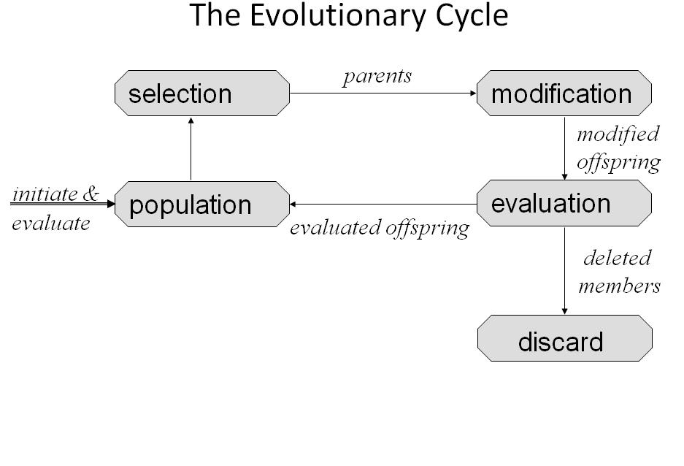

Fig 3.2 The Evolutionary Cycle

3.6 ADVANTAGES AND LIMITATION OF GAs
A GA has a number of advantages. It can quickly scan a vast solution set, easy to understand and supports multi-objective optimization. Bad proposals do not affect the end solution negatively as they are simply discarded. The inductive nature of the GA means that it doesn't have to know any rules of the problem - it works by its own internal rules. This is very useful for complex or loosely defined problems. There are different parameters such as population size, generation etc. to speed up and improve GAs basic application.
GAs has drawbacks too, of course. While the great advantage of GAs is the fact that they find a solution through evolution, this is also the biggest disadvantage. Evolution is inductive; in nature life does not evolve towards a good solution - it evolves away from bad circumstances. This can cause a species to evolve into an evolutionary dead end. Likewise, GAs risk finding a sub-optimal solution.

Chapter 4

OPTIMIZATION USING GENETIC ALGORITHM
4.1 EXPLORING THE TOOLS OF GENETIC ALGORITHM IN MATLAB R2008B
In Matlab, GA operations are explored in many ways to get the global optimal points running the GA from the command prompt and executing the GA tool in a separate window.
4.1.1 Calling the Function at the Command Line
To use the genetic algorithm at the command line, call the genetic algorithm
function ga with the syntax
[[[
[x fval] = ga(@fitnessfun, nvars, options)
Where

@fitnessfun - A function handle to the M-file that computes the fitness
function.

nvars is the number of independent variables for the fitness function.
If it does not pass in this argument, ga uses its default options.
The output results are given by

x — Point at which the final value is attained

fval — Final value of the fitness function at x
Return results directly to the MATLAB® workspace.
Run the genetic algorithm multiple times with different options, by calling ga from an M-file by clicking file open command on Matlab R2008b.
4.1.2 Running the Problem in GA TOOL
To launch the Optimization Tool, go to MATLAB Start menu as pictured:

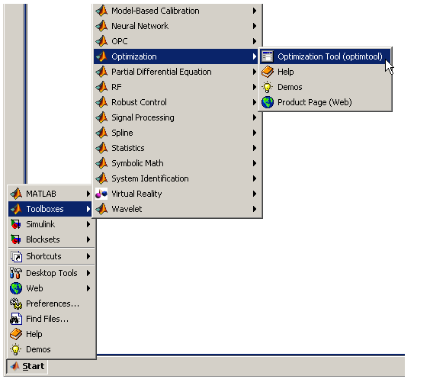
Fig 4.1 Launching Optimization Tool
Another mode to open the optimization tool is to enter optimtool ('ga') at the command line, or enter optimtool and then choose ga from the Solver menu.
Fig: 4.2 GA tool box in Matlab R2008b
4.2 DIFFERENT PARAMETERS IN GA TOOL
Populations
Fitness scaling
Selection
Reproduction
Mutation
Crossover
Stopping criteria
Display to the command window
4.2.1 Population
Population options specify options for the population of the genetic algorithm.
Population type specifies the type of the input to the fitness function. It is easy to set Population type to be double vector, or Bit string, or Custom. If select Custom, then it is necessary to write your own creation, mutation, and crossover functions that work with your population type, and specify these functions in the fields Creation function, Mutation function, and Crossover function, respectively.
(* Matlab R2008b uses the default population type as double vector, whereas all the standard textbooks use Bit string as the population type).
Initial population enables us to specify an initial population for the genetic algorithm. If initial population is not specified then, the algorithm creates one using the Creation function. Initial score enables us to specify scores for initial population. If we do not specify initial scores, the algorithm computes the scores using the fitness function. Moreover, Initial range specifies lower and upper bounds for the entries of the vectors in the initial population. It is easy to specify Initial range as a matrix with 2 rows and Initial length columns.
4.2.2 Fitness Scaling
The scaling function converts raw fitness scores returned by the fitness function to values in a range that is suitable for the selection function.
Rank scales the raw scores based on the rank of each individual, rather than its score. The rank of an individual is its position in the sorted scores. The rank of the fittest individual is 1, the next fittest is 2, and so on. Rank fitness scaling removes the effect of the spread of the raw scores.
4.2.3 Selection
The selection function chooses parents for the next generation based on their scaled values from the fitness scaling function.
It is easy specify the function that performs the selection in the Selection function field.

The most popular Roulette wheel selection (mostly used) is explained below

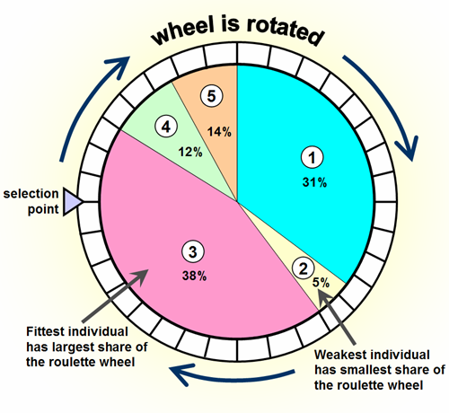
Fig 4.3 Roulette wheel

Roulette simulates a roulette wheel with the area of each segment proportional to its expectation. The algorithm then uses a random number to select one of the sections with a probability equal to its area.
4.2.4 Reproduction
Reproduction options determine how the genetic algorithm creates children at each new generation. Elite count specifies the number of individuals that are guaranteed to survive to the next generation. Set Elite count to be a positive integer less than or equal to Population size. Crossover fraction specifies the fraction of the next generation, other than elite individuals, that are produced by crossover.
4.2.5 Mutation
Mutation functions make small random changes in the individuals in the population, which provide genetic diversity and enable the Genetic Algorithm to search a broader space. It is easy to specify the function that performs the mutation in the Mutation function field. The default option in Mutation function field is Gaussian. Gaussian is normally used for unconstrained problems. For constrained problems adapt feasible option is used.
4.2.6 Stopping Criteria
Stopping criteria determines what causes the algorithm to terminate.
Generations specifies the maximum number of iterations the genetic algorithm performs.

Time limit specifies the maximum time in seconds the genetic algorithm runs before stopping.
Fitness limit — If the best fitness value is less than or equal to the value of Fitness limit, the algorithm stops.
Stall generations — if the weighted average change in the fitness function value over Stall generations is less than Function tolerance, the algorithm stops.
Stall time limit — if there is no improvement in the best fitness value for an interval of time in seconds specified by Stall time limit, the algorithm stops.
Function tolerance — if the cumulative change in the fitness function value over Stall generations is less than Function tolerance, the algorithm stops.
4.2.7 Display option
Level of display specifies the amount of information displayed in the MATLAB Command Window when you run the algorithm. Choose from the following:
Off — Display no output.
Iterative — Display information at each iteration of the algorithm.
Diagnose — Information is displayed at each iteration. In addition, the diagnostic lists some problem information and the options that are changed from the defaults.
Final — Display only the reason for stopping at the end of the run.

4.3 RUN SOLVER IN GA TOOL
To run the solver, click Start under Run solver. When the algorithm terminates, the Status and results pane displays the reason the algorithm terminated. The Final point updates to show the coordinates of the final point.

4.4 OPTIMIZATION PROBLEM
The test function used for performing experiments is given below.
f(X₁,X₂) = X₁-X₂+2X₁²+2X₁X₂+X₂²
Different parameters of GA tool Population Size, Generation, Stall Generation, Function Tolerance etc are varied and their effect on accuracy and final generation has been studied. The computational effort is measured in by product of population size and current iteration and the combination of various parameters to get minimum computational efforts.
The following observations have been made:
- If the stall generation is less than five, correct optimum could not be achieved. Therefore the value of stall generation should always be kept more than five.

- The computational efforts* or the cost of calculation increases with the population size. The cost of computation is measured as the product of population size and the no. of iterations.
Cost
Of Calculation
*
; f (v) = POPULATION SIZE X CURRENT ITTERATION

Therefore, it can be concluded that in order to minimize the computational efforts we should keep the minimum population size and stall generation minimum as long as it gives acceptable results. So, to achieve best results we should take value of stall generation 15 instead of 50 (default) & value of function tolerance 1e-8 instead of 1e-6 (default).

CHAPTER 5
MULTIOBJECTIVE APPROACH TO ECONOMIC LOAD DISPATCH
Economic Load Dispatch (ELD) is one of the main functions of modern Energy Management System (EMS), which determines the optimal real power settings of generating units with an objective of minimizing the total fuel cost.
We have considered three objectives of power system – Cost of Generation, Transmission Losses & Environmental Pollution. In 2-D space, Cost of Generation & Transmission Losses has been considered where as in 3-D space, Cost of Generation, Transmission Losses & Environmental Pollution has been considered.
The objective function for cost of generation Fc is:
F_{c} (P_{gi})= $\sum_{i=1}^{\text{NG}}{}$ a_{i}P_{i}²+b_{i}P_{i}+c_{i} $/hr (5a)
Where:
a_{i,} b_{i} & c_{i} are the cost coefficients.
P_{gi} is the real power generation and is decision variable.
NG is the number of generators.
One of the most important, simple but approximate methods of expressing transmission loss as a function of generator powers is through

B- Coefficients. This method uses the fact that under normal operating conditions, the transmission loss is quadratic in the injected real powers. The transmission loss is expressed as a function of generator powers using B-coefficients.
F_{L} = $\text{NG}$ P_{i}B_{ij}P_{j} MW (5b)
Where:
P_{i,}=P_{j} = Real power injections at the i^{th}, j^{th} bus.
B_{ij}= Loss coefficients.
NG is number of generator buses.
In 3-D space, the environmental pollution has also been considered in addition to the transmission losses and cost. The objective function to minimize pollution is given as
F_{E} = $\sum_{i=1}^{\text{NG}}{}$F [E_{i}(P_{gi})] (5c)
Where:
Pgi is the active power generation at i^{th} generator.
Ei is the amount of pollution in terms of oxides of nitrogen emissions for the i^{th} generator.

5.1 PROBLEM FORMULATION IN 2-D SPACE
The problem has been formulated using modified form of constraint method as:
Minimize
F_{C}(P_{gi}) (5.1a)
s.t.
P_{gimin} < P_{gi} < P_{gimax} (5.1b)
P_{D} + P_{L} - $\sum_{n=1}^{\text{NG}}{}$P_{n} = 0 (5.1c)
F_{L} ≤ L₁
Where:
L₁ lies between F_{Lmin} & F_{Lmax}.
The solution of above problem gives the noninferior set by varying L₁ in steps of δF_{L}. The range of transmission losses F_{L} which lies between F_{Lmin} & F_{Lmax} has been obtained by solving the following problem:
Minimize loss
s.t.
Inequality constraint & Equality constraint

Mathematically:
Minimize
F_{L}(P_{gi}) (5.2a)
s.t.
P_{gimin} < P_{gi} < P_{gimax} (5.2b)
P_{D} + P_{L} - $\sum_{n=1}^{\text{NG}}{}$P_{n} = 0 (5.2c)
Where:
P_{D} represents total load demand
P_{L} represents transmission losses
The Target Point has been obtained by using Maximization of Minimum Relative Attainments (MMR) technique.

5.2 COMPUTATIONAL RESULTS IN 2-D SPACE
The noninferior set for IEEE 5, 14 and 30 bus systems is shown in Tables 1, 3, 5 respectively. The relative attainments of the IEEE 5, 14 and 30 systems by using MMR are shown in Tables 2, 4 and 6 respectively.

APPENDIX I shows the details of above three test systems.

5.2.1 IEEE 5 bus system
TABLE 1
(NONINFERIOR SET OF IEEE 5 BUS SYSTEM IN 2-D SPACE)
S.No | LOSSES  (FIXED) MW | No. of  ITERATIONS | P₁  (MW) | P₃  (MW) | COST  ($/hr)
1 | 5.05 | 58 | 84.367 | 80.691 | 763.158
2 | 5.055 | 74 | 84.374 | 80.684 | 763.157
3 | 5.06 | 39 | 85.93 | 79.13 | 762.658
4 | 5.065 | 48 | 87.392 | 77.673 | 762.246
5 | 5.07 | 100 | 88.353 | 76.717 | 762.007
6 | 5.075 | 100 | 89.111 | 75.964 | 761.835
7 | 5.08 | 100 | 89.781 | 75.299 | 761.697
8 | 5.085 | 41 | 90.37 | 74.715 | 761.583
9 | 5.090 | 100 | 90.406 | 74.679 | 761.491
10 | 5.095 | 41 | 90.921 | 74.17 | 761.411
11 | 5.10 | 100 | 91.869 | 73.231 | 761.342
12 | 5.11 | 100 | 92.722 | 72.388 | 761.230
13 | 5.12 | 100 | 93.489 | 71.631 | 761.147
14 | 5.13 | 79 | 94.206 | 70.924 | 761.082
15 | 5.14 | 63 | 94.87 | 70.269 | 761.035
16 | 5.15 | 100 | 94.498 | 69.652 | 761.001
17 | 5.16 | 39 | 96.09 | 69.07 | 760.978
18 | 5.17 | 100 | 96.654 | 68.516 | 760.965
19 | 5.18 | 100 | 97.195 | 67.985 | 760.960
From the above table we have observed that:
Minimum loss is F_{Lmin} = 5.05 MW
Minimum cost is F_{Cmin} =760.960 $/hr
Value of loss at minimum cost is F_{LatFcmin} =5.18 MW
Value of cost at minimum loss is F_{CatFLmin} =763.158 $/hr
TABLE 2
(MINIMUM RELATIVE ATTAINMENTS OF 5-BUS SYSTEM IN 2-D SPACE)
S.No | F_{C}  ($/hr) | τ_{C} | F_{L}  (MW) | τ_{L} | $Σ$_{τ}
1 | 763.158 | 0.0000 | 5.05 | 1.0000 | 1
2 | 763.157 | 0.0004 | 5.055 | 0.9615 | 0.09619
3 | 762.658 | 0.2274 | 5.06 | 0.9230 | 1.1504
4 | 762.246 | 0.4149 | 5.065 | 0.8846 | 1.2995
5 | 762.007 | 0.5236 | 5.07 | 0.8461 | 1.3697
6 | 761.835 | 0.6019 | 5.075 | 0.8076 | 1.4095
7 | 761.697 | 0.6646 | 5.08 | 0.7692 | 1.4338
8 | 761.583 | 0.7165 | 5.085 | 0.7307 | 1.4472
9 | 761.491 | 0.7584 | 5.090 | 0.6923 | 1.4507
10 | 761.411 | 0.7948 | 5.095 | 0.6538 | 1.4486
11 | 761.342 | 0.8262 | 5.10 | 0.6153 | 1.4415
12 | 761.230 | 0.8771 | 5.11 | 0.5384 | 1.4155
13 | 761.147 | 0.9149 | 5.12 | 0.4615 | 1.3764
14 | 761.082 | 0.9444 | 5.13 | 0.3846 | 1.3290
15 | 761.035 | 0.9658 | 5.14 | 0.3076 | 1.2734
16 | 761.001 | 0.9813 | 5.15 | 0.2307 | 1.2121
17 | 760.978 | 0.9918 | 5.16 | 0.1538 | 1.1456
18 | 760.965 | 0.9977 | 5.17 | 0.0769 | 1.0746
19 | 760.960 | 1.0000 | 5.18 | 0.000 | 1

The relative attainments of the objectives are added and the result is shown in the last column of Table 2. The Target Point is one for which the sum of relative attainments is maximum. It is seen that Target Point for 5-Bus system in 2-D space is:
F_{C} = 761.491 $/hr F_{L} = 5.09 MW
It is shown at s.no 9 of the Table 2. The noninferior set has also been shown in Fig 5.1.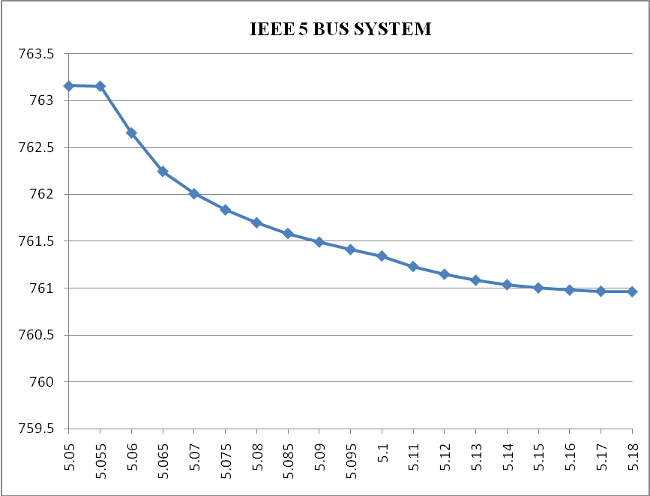
F_{L} (MW)
TARGET POINT (761.491; 5.090)
TP
F_{C} ($/hr)
Fig 5.1 Plot between Cost of Generation and Transmission Losses
5.2.2 IEEE 14 bus system
TABLE 3
(NONINFERIOR SET OF IEEE 14 BUS SYSTEM IN 2-D SPACE)
S.No | LOSSES  (FIXED)  MW | No. of ITERATIONS | P₁ (MW) | P₂  (MW) | P₆  (MW) | COST  ($/hr)
1 | 7.00 | 100 | 85.09 | 103.58 | 77.54 | 1184.64
2 | 7.10 | 100 | 85.12 | 103.56 | 77.54 | 1183.63
3 | 7.20 | 39 | 91.03 | 98.86 | 76.35 | 1176.50
4 | 7.30 | 26 | 99.67 | 88.44 | 78.17 | 1168.11
5 | 7.40 | 63 | 109.04 | 88.44 | 78.17 | 1157.98
6 | 7.50 | 65 | 114.42 | 87.89 | 64.18 | 1153.20
7 | 7.60 | 38 | 117.19 | 90.71 | 58.69 | 1150.89
8 | 7.70 | 74 | 119.12 | 96.08 | 51.53 | 1149.98
9 | 7.80 | 63 | 120.00 | 96.79 | 50.00 | 1141.63
10 | 7.90 | 62 | 120.00 | 96.80 | 50.00 | 1140.61
11 | 8.00 | 57 | 136.93 | 76.78 | 55.56 | 1140.14
12 | 8.10 | 79 | 142.11 | 64.26 | 55.70 | 1139.00
13 | 8.20 | 84 | 145.41 | 63.20 | 58.40 | 1138.62
14 | 8.30 | 36 | 145.80 | 70.46 | 51.00 | 1137.32
15 | 8.40 | 100 | 148.70 | 68.63 | 50.00 | 1136.75
16 | 8.50 | 100 | 150.00 | 67.96 | 50.00 | 1136.40
17 | 8.60 | 100 | 150.00 | 67.47 | 50.00 | 1136.10

From the above table we have observed that:
Minimum loss is F_{Lmin} = 7.00 MW
Minimum cost is F_{Cmin} =1136.10 $/hr
Value of loss at minimum cost is F_{LatFcmin} =8.60 MW
Value of cost at minimum loss is F_{CatFLmin} =1184.64 $/hr
TABLE 4
(MINIMUM RELATIVE ATTAINMENTS OF 14-BUS SYSTEM IN 2-D SPACE)
S.No | F_{C}  ($/hr) | τ_{C} | F_{L}  (MW) | τ_{L} | $Σ$_{τ}
1 | 1184.64 | 0.0000 | 7.00 | 1.0000 | 1
2 | 1183.63 | 0.0207 | 7.10 | 0.9375 | 0.9582
3 | 1176.50 | 0.1675 | 7.20 | 0.8750 | 1.0425
4 | 1168.11 | 0.3405 | 7.30 | 0.8125 | 1.1530
5 | 1157.98 | 0.5492 | 7.40 | 0.7500 | 1.2990
6 | 1153.20 | 0.6476 | 7.50 | 0.6875 | 1.3350
7 | 1150.89 | 0.6953 | 7.60 | 0.6250 | 1.3203
8 | 1149.98 | 0.7140 | 7.70 | 0.5625 | 1.2765
9 | 1141.63 | 0.7212 | 7.80 | 0.5000 | 1.2212
10 | 1140.61 | 0.7216 | 7.90 | 0.4375 | 1.1590
11 | 1140.14 | 0.9166 | 8.00 | 0.375 | 1.2910
12 | 1139.00 | 0.9408 | 8.10 | 0.3125 | 1.2530
13 | 1138.62 | 0.9480 | 8.20 | 0.2500 | 1.1980
14 | 1137.32 | 0.9748 | 8.30 | 0.1875 | 1.1620
15 | 1136.75 | 0.9866 | 8.40 | 0.1250 | 1.1110
16 | 1136.40 | 0.9938 | 8.50 | 0.0625 | 1.0560
17 | 1136.10 | 1.0000 | 8.60 | 0.0000 | 1

The relative attainments of the objectives are added and the result is shown in the last column of Table 4. The Target Point is one for which the sum is maximum. It is seen Target Point achieved for 14-Bus system in 2-D space is:
F_{C} = 1150.89 $/hr F_{L} = 7.60 MW
It is shown at s.no 7 of the Table 4. The noninferior set has also been shown in Fig 5.2.

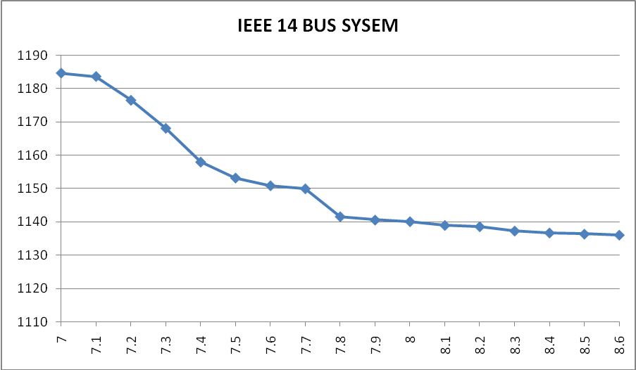
TARGET POINT (1150.89; 7.60)
F_{L} (MW)
Fig 5.2 Plot between Cost of Generation and Transmission Losses
F_{C} ($/hr)
TP

5.2.3 IEEE 30 bus system
TABLE 5
(NONINFERIOR SET OF IEEE 30 BUS SYSTEM IN 2-D SPACE)
S.No | LOSSES  (FIXED)  MW | No. of  ITERATIONs | P₁ (MW) | P₂  (MW) | P₆  (MW) | COST  ($/hr)
1 | 6.90 | 64 | 50.36 | 120 | 120 | 1358.07
2 | 7.00 | 100 | 52.18 | 118.21 | 120 | 1355.07
3 | 7.10 | 100 | 57.70 | 112.79 | 120 | 1346.35
4 | 7.20 | 67 | 62.77 | 111.03 | 117.49 | 1338.74
5 | 7.30 | 68 | 67.01 | 103.68 | 119.99 | 1333.12
6 | 7.40 | 78 | 68.62 | 111.94 | 110.23 | 1326.81
7 | 7.50 | 70 | 73.43 | 105.36 | 112.10 | 1321.11
8 | 7.60 | 44 | 74.14 | 112.09 | 104.75 | 1317.80
9 | 7.70 | 75 | 79.49 | 103.51 | 108.08 | 1312.15
10 | 7.80 | 65 | 82.18 | 102.99 | 106.02 | 1308.30
11 | 7.90 | 51 | 82.97 | 107.64 | 100.68 | 1305.82
12 | 8.10 | 36 | 93.80 | 84.48 | 113.16 | 1300.44
13 | 8.20 | 76 | 92.00 | 100.31 | 99.27 | 1295.63
14 | 8.30 | 43 | 97.42 | 89.37 | 104.90 | 1292.88
15 | 8.40 | 39 | 97.57 | 95.73 | 98.49 | 1290.15
16 | 8.50 | 42 | 97.84 | 100.30 | 93.75 | 1288.60

S.No | LOSSES  (FIXED)  MW | No. of  ITERATIONs | P₁ (MW) | P₂  (MW) | P₆  (MW) | COST  ($/hr)
17 | 8.60 | 55 | 100.10 | 99.13 | 92.76 | 1286.33
18 | 8.70 | 24 | 101.64 | 99.70 | 9075 | 1284.55
19 | 8.80 | 46 | 103.37 | 99.63 | 89.18 | 1282.77
20 | 8.90 | 52 | 109.75 | 86.68 | 95.86 | 1279.81
21 | 9.00 | 43 | 112.73 | 82.60 | 96.99 | 1278.43
22 | 9.10 | 34 | 110.81 | 93.18 | 88.50 | 1276.81
23 | 9.20 | 49 | 114.11 | 88.57 | 89.90 | 1274.98
24 | 9.30 | 43 | 114.25 | 88.57 | 89.90 | 1273.94
25 | 9.40 | 100 | 120.00 | 80.61 | 92.18 | 1272.54
26 | 9.50 | 42 | 116.44 | 94.37 | 82.07 | 1271.84
27 | 9.60 | 15 | 118.60 | 92.63 | 81.756 | 1270.44
28 | 9.70 | 100 | 120.00 | 92.54 | 80.522 | 1269.43
29 | 9.80 | 100 | 120.00 | 95.99 | 77.21 | 1269.14
30 | 9.90 | 100 | 120.00 | 99.04 | 74.25 | 1269.11

From the above table we have observed that:
Minimum loss is F_{Lmin} = 6.90 MW
Minimum cost is F_{Cmin} =1269.11 $/hr
Value of loss at minimum cost is F_{LatFcmin} =9.90 MW
Value of cost at minimum loss is F_{CatFLmin} =1358.07 $/hr

TABLE 6
(MINIMUM RELATIVE ATTAINMENTS OF 30-BUS SYSTEM IN 2-D SPACE)
S.No | F_{C}  ($/hr) | τ_{C} | F_{L}  (MW) | τ_{L} | $Σ$_{τ}
1 | 1358.07 | 0.0000 | 6.90 | 1.0000 | 1
2 | 1355.07 | 0.0337 | 7.00 | 0.9667 | 1.0040
3 | 1346.35 | 0.1317 | 7.10 | 0.9333 | 1.0656
4 | 1338.74 | 0.2167 | 7.20 | 0.9000 | 1.1167
5 | 1333.12 | 0.2805 | 7.30 | 0.8667 | 1.1472
6 | 1326.81 | 0.3514 | 7.40 | 0.8333 | 1.1847
7 | 1321.11 | 0.4155 | 7.50 | 0.8000 | 1.2155
8 | 1317.80 | 0.4527 | 7.60 | 0.7667 | 1.2194
9 | 1312.15 | 0.5161 | 7.70 | 0.7333 | 1.2495
10 | 1308.30 | 0.5595 | 7.80 | 0.7000 | 1,2595
11 | 1305.82 | 0.5873 | 7.90 | 0.6667 | 1,2540
12 | 1300.44 | 0.6478 | 8.10 | 0.6000 | 1.2478
13 | 1295.63 | 0.7019 | 8.20 | 0.5667 | 1.2686
14 | 1292.88 | 0.7328 | 8.30 | 0.5333 | 1.2661
15 | 1290.15 | 0.7635 | 8.40 | 0.5000 | 1.2635
16 | 1288.60 | 0.7809 | 8.50 | 0.4667 | 1.2476
17 | 1286.33 | 0.8064 | 8.60 | 0.4333 | 1.2397
18 | 1284.55 | 0.8264 | 8.70 | 0.4000 | 1.2264
19 | 1282.77 | 0.8464 | 8.80 | 0.3667 | 1.2131
S.No | F_{C}  ($/hr) | τ_{C} | F_{L}  (MW) | τ_{L} | $Σ$_{τ}
20 | 1279.81 | 0.8797 | 8.90 | 0.3333 | 1.2130
21 | 1278.43 | 0.8952 | 9.00 | 0.3000 | 1.1952
22 | 1276.81 | 0.9134 | 9.10 | 0.2667 | 1.1851
23 | 1274.98 | 0.9340 | 9.20 | 0.2333 | 1.1673
24 | 1273.94 | 0.9457 | 9.30 | 0.2000 | 1.1457
25 | 1272.54 | 0.9614 | 9.40 | 0.1667 | 1.1281
26 | 1271.84 | 0.9693 | 9.50 | 0.1333 | 1.1026
27 | 1270.44 | 0.9850 | 9.60 | 0.1000 | 1.0856
28 | 1269.43 | 0.9964 | 9.70 | 0.0667 | 1.0631
29 | 1269.14 | 0.9997 | 9.80 | 0.0333 | 1.0330
30 | 1269.11 | 1.0000 | 9.90 | 0.0000 | 1

The relative attainments of the objectives are added and the result is shown in the last column of Table 6. The Target Point is one for which the sum is maximum. It is seen Target Point achieved for 30-Bus system in 2-D space is:
F_{C} = 1295.63 $/hr F_{L} = 8.20 MW
It is shown at s.no 13 of the Table 6. The noninferior set has also been shown in Fig 5.3.

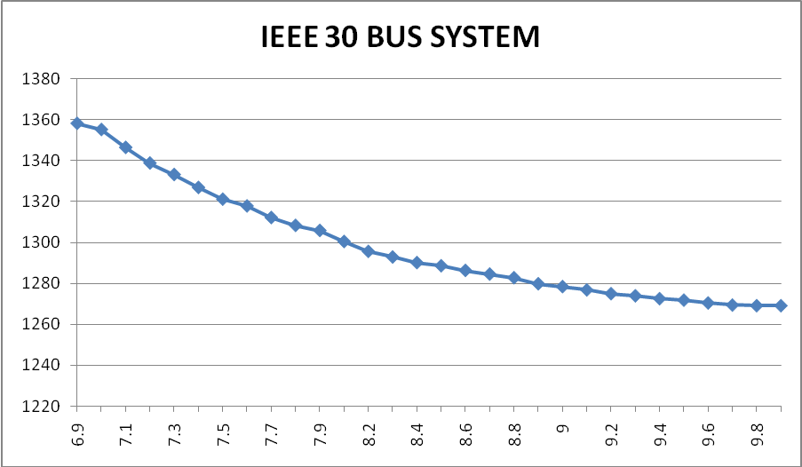
TP
F_{C} ($/hr)
F_{L} (MW)
TARGET POINT (1295.63; 8.20)
Fig 5.3 Plot between Cost of Generation and Transmission Losses

5.3 PROBLEM FORMULATION IN 3-D SPACE
In 3-D space, the problem has been formulated as:
Minimize
F_{C}(P_{gi}) (5.3a)
s.t.
P_{gimin} < P_{gi} < P_{gimax} (5.3b)
P_{D} + P_{L} - $\sum_{n=1}^{\text{NG}}{}$P_{n} = 0 (5.3c)
F_{L} ≤ L₁ (5.3d)
F_{E}≤E₁ (5.3e)
Where:
E₁ lies between F_{Emin} & F_{Emax}
L₁ lies between F_{Lmin} & F_{Lmax}
In 3-D space, the domain in which system transmission losses and environmental pollution are supportive has been explored. Then the noninferior set in 3-D space has been obtained by minimizing cost keeping loss and pollution fixed at these values.
The range of emission F_{E} which lies between F_{Emin} & F_{Emax} has been obtained by solving the following problem:
Minimize emission
s.t.
Inequality constraint & Equality constraint
Mathematically:
Minimize
F_{E}(P_{gi}) (5.4a)
s.t.
P_{gimin} < P_{gi} < P_{gimax} (5.4b)
P_{D} + P_{L} - $\sum_{n=1}^{\text{NG}}{}$P_{n} = 0 (5.4c)
F_{L} ≤ L₁ (5.4d)

Where:
L₁ lies between F_{Lmin} & F_{Lmax}
P_{D} represents total load demand
P_{L} represents transmission losses
The Maximization of Minimum Relative Attainments (MMR) Technique has been applied to obtain best compromise solution or Target Point for IEEE 5, 14 & 30 bus systems.
5.4 COMPUTATIONAL RESULTS IN 3-D SPACE
The noninferior set for IEEE 5, 14 and 30 bus systems in 2-D space (F_{L} & F_{E}) is shown in Tables 7, 8, 10 respectively and 3-D space is shown in Tables 11, 13, 14 respectively. The relative attainments of the IEEE 5, 14 and 30 systems in 3-D space are shown in Tables 9, 12 and 15 respectively.
APPENDIX I shows the details of above three test systems.
5.4.1 IEEE 5 bus system
TABLE 7
(NONINFERIOR SET OF 5 BUS SYSTEM IN 2-D SPACE (F_{L} & F_{E}))
S.No | F_{L(FIXED)}  (MW) | No. of  ITERATIONS | P₁  (MW) | P₃  (MW) | F_{E}  (Kg/hr)
1 | 5.060 | 30 | 85.893 | 79.166 | 120.7
2 | 5.065 | 27 | 87.290 | 77.775 | 121.4
3 | 5.070 | 21 | 88.350 | 76.720 | 122
4 | 5.075 | 21 | 89.162 | 75.913 | 122.5
5 | 5.080 | 20 | 89.924 | 75.158 | 123
S.No | F_{L(FIXED)}  (MW) | No. of  ITERATIONS | P₁  (MW) | P₃  (MW) | F_{E}  (Kg/hr)
6 | 5.085 | 32 | 90.643 | 74.445 | 123.5
7 | 5.090 | 36 | 91.056 | 74.035 | 123.8
8 | 5.095 | 20 | 91.325 | 73.769 | 124
9 | 5.10 | 24 | 91.977 | 73.124 | 124.5
10 | 5.15 | 22 | 95.619 | 69.533 | 127.6
11 | 5.20 | 29 | 98.214 | 66.986 | 130.4

From the above table we have observed that:
Minimum loss is F_{Lmin} = 5.06 MW
Minimum emission is F_{Emin} =120.7 Kg/hr
Maximum loss is F_{Lmax} = 5.20 MW
Maximum emission is F_{Emax} = 130.4 Kg/hr
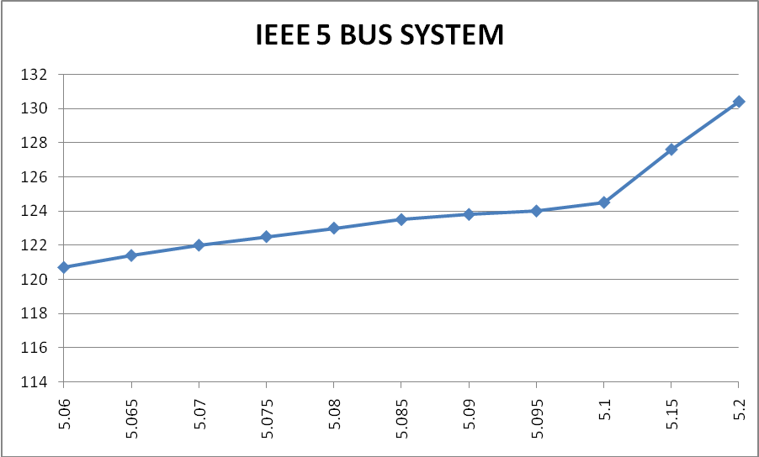
LOSSES (MW)
EMISSION
(Kg/hr)
Fig 5.4 Plot between Emission and Losses

TABLE 8
(NONINFERIOR SET OF IEEE 5 BUS SYSTEM IN 3-D SPACE)
S.No | F_{E(FIXED)}  (Kg/h) | F_{L(FIXED)}  (MW) | No. of  ITERATIONS | P₁  (MW) | P₃  (MW) | F_{C}  ($/hr)
1 | 120.7 | 5.060 | 22 | 85.893 | 79.166 | 762.668
2 | 121.4 | 5.065 | 28 | 87.290 | 77.775 | 762.273
3 | 122 | 5.070 | 23 | 88.350 | 76.720 | 762.007
4 | 122.5 | 5.075 | 27 | 89.162 | 75.913 | 761.824
5 | 123 | 5.080 | 20 | 89.924 | 75.158 | 761.668
6 | 123.5 | 5.085 | 20 | 90.643 | 74.445 | 761.536
7 | 123.8 | 5.090 | 21 | 91.056 | 74.035 | 761.466
8 | 124 | 5.095 | 41 | 91.325 | 73.769 | 761.423
9 | 124.5 | 5.10 | 63 | 91.977 | 73.124 | 761.326
10 | 127.6 | 5.15 | 20 | 95.619 | 69.533 | 760.999
11 | 130.4 | 5.20 | 20 | 98.214 | 66.986 | 760.972

From the above table we have observed that;
Minimum loss is F_{Lmin} = 5.06 MW
Minimum emission is F_{Emin} =120.7 Kg/hr
Minimum cost is F_{Cmin} = 760.972 $/hr
Value of loss at minimum cost is F_{LatFcmin} =5.20 MW
Value of emission at minimum cost is F_{EatFcmin} = 130.4 Kg/hr
Value of cost at minimum loss is F_{CatFLmin} = 762.668 $/hr
Value of cost at minimum emission F_{CatFEmin} = 762.668 $/hr
TABLE 9
MINIMUM RELATIVE ATTAINMENTS OF IEEE 5-BUS SYSTEM IN 3-D SPACE
S.NO | F_{C} ($/hr) | τ_{C} | F_{E}  Kg/hr) | τ_{L} | F_{L}  (MW) | τ_{E} | $Σ$ _{τ}
1 | 762.668 | 0 | 120.7 | 1 | 5.060 | 1 | 2
2 | 762.273 | 0.2320 | 121.4 | 0.9642 | 5.065 | 0.9278 | 2.1240
3 | 762.007 | 0.3890 | 122 | 0.9285 | 5.070 | 0.8650 | 2.1820
4 | 761.824 | 0.4976 | 122.5 | 0.8928 | 5.075 | 0.8144 | 2.2040
5 | 761.668 | 0.5896 | 123 | 0.8571 | 5.080 | 0.7628 | 2.2090
6 | 761.536 | 0.6674 | 123.5 | 0.8214 | 5.085 | 0.7110 | 2.1998
7 | 761.466 | 0.7087 | 123.8 | 0.7850 | 5.090 | 0.6800 | 2.1737
8 | 761.423 | 0.7340 | 124 | 0.7500 | 5.095 | 0.6590 | 2.1430
9 | 761.326 | 0.7912 | 124.5 | 0.7140 | 5.10 | 0.6080 | 2,1130
10 | 760.999 | 0.9840 | 127.6 | 0.3570 | 5.15 | 0.2886 | 1.6296
11 | 760.972 | 1 | 130.4 | 0 | 5.20 | 0 | 1

The relative attainments of the objectives are added and the result is shown in the last column of Table 9. The Target Point is one for which the sum is maximum. It is seen that Target Point achieved for 5-Bus system in 3-D space is:
F_{C} = 761.668 $/hr F_{L} = 5.080 MW F_{E} = 123 Kg/hr
It is shown at s.no 5 of the Table 9. The noninferior set of (F_{E} & F_{L}) has also been shown in Fig 5.4.

5.4.2 IEEE 14 bus system
TABLE10
(NONINFERIOR SET OF 14 BUS SYSTEM IN 2-D SPACE (F_{L} & F_{E}))
S.No | F_{L(FIXED)}  (MW) | No. of  ITERATIONS | P₁  (MW) | P₂  (MW) | P₆  (MW) | F_{E}  (Kg/hr)
1 | 7.218 | 100 | 84.730 | 104.804 | 76.277 | 499
2 | 7.239 | 100 | 81.652 | 112.200 | 72.014 | 504
3 | 7.286 | 100 | 89.975 | 110.241 | 65.732 | 508
4 | 7.377 | 100 | 106.821 | 93.338 | 65.896 | 512
5 | 7.432 | 100 | 112.418 | 86.469 | 67.214 | 516
6 | 7.483 | 100 | 116.463 | 80.959 | 68.724 | 520
7 | 7.532 | 100 | 119.608 | 76.855 | 69.727 | 524
8 | 7.653 | 26 | 120 | 58.958 | 87.363 | 528
9 | 7.760 | 29 | 120 | 53.05 | 93.358 | 532
10 | 7.874 | 30 | 120 | 50 | 97.179 | 536
11 | 8.015 | 53 | 120 | 50 | 99.335 | 540
12 | 8.163 | 24 | 120 | 50 | 101.554 | 544
13 | 8.318 | 25 | 120 | 50 | 103.829 | 548
14 | 8.479 | 40 | 120 | 50 | 106.151 | 552
15 | 8.647 | 24 | 120 | 50 | 108.511 | 556

From the above table we have observed that:
Minimum loss is F_{Lmin} = 7.218 MW
Minimum emission is F_{Emin} =499 Kg/hr
Maximum loss is F_{Lmax} = 8.647 MW
Maximum emission is F_{Emax} = 556 Kg/hr

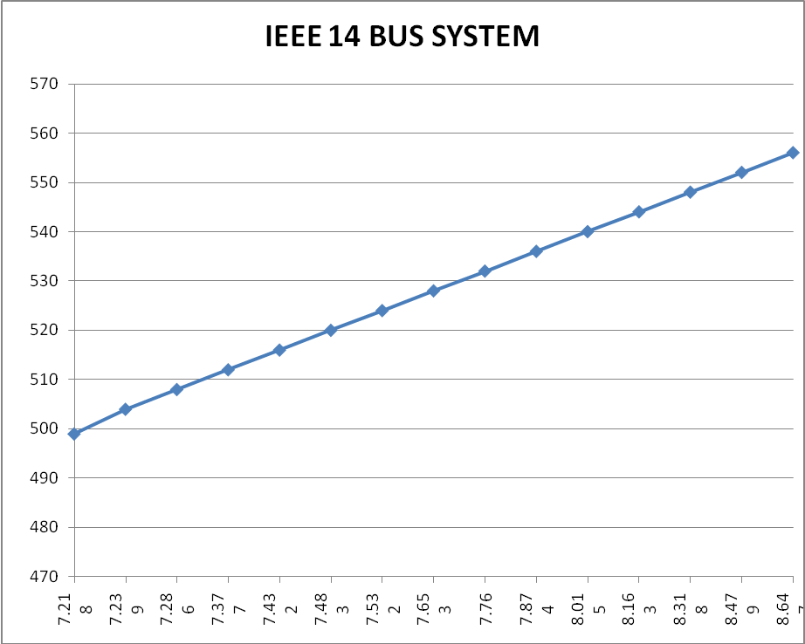
EMISSION
(Kg/hr)
LOSSES (MW)
Fig 5.4 Plot between Emission and Losses

TABLE 11
(NONINFERIOR SET OF IEEE 14 BUS SYSTEM IN 3-D SPACE)
S.No | F_{E(FIXED)}  (Kg/hr) | F_{L(FIXED)}  (MW) | No. of  ITERATIONS | P₁ (MW) | P₂  (MW) | P₆  (MW) | F_{C}  ($/hr)
1 | 499 | 7.218 | 22 | 98.316 | 81.543 | 86.487 | 1172.50
2 | 504 | 7.239 | 35 | 103.637 | 74.336 | 88.450 | 1169.35
3 | 508 | 7.286 | 42 | 103.032 | 94.544 | 68.765 | 1163.28
4 | 512 | 7.377 | 35 | 110.994 | 71.812 | 83.650 | 1161.80
5 | 516 | 7.432 | 22 | 114.325 | 73.295 | 78.858 | 1157.42
6 | 520 | 7.483 | 48 | 117.107 | 75.878 | 73.520 | 1153.62
7 | 524 | 7.532 | 33 | 115.006 | 97.530 | 54.125 | 1152.90
8 | 528 | 7.653 | 23 | 117.094 | 93.354 | 56.180 | 1151.03
9 | 532 | 7.760 | 22 | 119.990 | 91.745 | 54.950 | 1148.98

From the above table we have observed that:
Minimum loss is F_{Lmin} = 7.218 MW
Minimum emission is F_{Emin} =499 Kg/hr
Minimum cost is F_{Cmin} = 1148.98 $/hr
Value of loss at minimum cost is F_{LatFcmin} = 7.760 MW
Value of emission at minimum cost is F_{EatFcmin} = 532 Kg/hr
Value of cost at minimum loss is F_{CatFLmin} = 1172.50 $/hr
Value of cost at minimum emission F_{CatFEmin} = 1172.50 $/hr

TABLE 12
MINIMUM RELATIVE ATTAINMENTS OF IEEE14-BUS SYSTEM IN 3-D SPACE
S.No | F_{C} ($/hr) | τ_{C} | F_{E}  (Kg/hr) | τ_{L} | F_{L}  (MW) | τ_{E} | $Σ$ _{τ}
1 | 1172.500 | 0 | 499 | 1 | 7.218 | 1 | 2
2 | 1169.35 | 0.1330 | 504 | 0.9610 | 7.239 | 0.8480 | 1.9420
3 | 1163.28 | 0.3920 | 508 | 0.8740 | 7.286 | 0.7270 | 1.9930
4 | 1161.80 | 0.4540 | 512 | 0.7060 | 7.377 | 0.6060 | 1.7660
5 | 1157.42 | 0.6411 | 516 | 0.6051 | 7.432 | 0.4848 | 1.7310
6 | 1153.62 | 0.8020 | 520 | 0.5110 | 7.483 | 0.3630 | 1.6760
7 | 1152.90 | 0.8330 | 524 | 0.4206 | 7.532 | 0.2424 | 1.4963
8 | 1151.03 | 0.9128 | 528 | 0.1970 | 7.653 | 0.1212 | 1.2310
9 | 1148.98 | 1 | 532 | 0 | 7.760 | 0 | 1

The relative attainments of the objectives are added and the result is shown in the last column of Table 12. The target point is one for which the sum is maximum. It is seen Target Point achieved for 14-Bus system in 3-D space is:
F_{C} = 1163.28 $/hr F_{L} = 7.286 MW F_{E} = 508 Kg/hr
It is shown at s.no 3 of the Table 12. The noninferior set of (F_{E} & F_{L}) has also been shown in Fig 5.5.

5.4.3 IEEE 30 bus system
TABLE 13
(NONINFERIOR SET OF 30 BUS SYSTEM IN 2-D SPACE (F_{L} & F_{E}))
S.No | F_{L(FIXED)}  (MW) | No. of  ITERATIONS | P₁  (MW) | P₂  (MW) | P₆  (MW) | F_{E}  (Kg/hr)
1 | 8.83 | 41 | 109.545 | 83.490 | 99.190 | 523
2 | 9.29 | 20 | 118.457 | 80.230 | 94.000 | 533
3 | 10.01 | 35 | 120 | 102.271 | 71.141 | 543
4 | 10.36 | 23 | 119.970 | 112.220 | 61.600 | 553
5 | 10.73 | 37 | 119.660 | 119.990 | 54.470 | 563
6 | 10.78 | 22 | 120 | 120 | 55.354 | 573
7 | 10.82 | 28 | 120 | 120 | 57.200 | 583
8 | 10.88 | 26 | 120 | 120 | 60.116 | 593
9 | 10.98 | 40 | 120 | 120 | 65.102 | 603
10 | 11.19 | 50 | 120 | 120 | 73.575 | 613
11 | 11.51 | 29 | 120 | 120 | 84.942 | 623
12 | 11.88 | 35 | 120 | 120 | 96.386 | 633
13 | 12.25 | 23 | 120 | 120 | 106.699 | 643
14 | 12.62 | 34 | 120 | 120 | 115.892 | 653
15 | 12.80 | 23 | 120 | 120 | 120 | 663

From the above table we have observed that;
Minimum loss is F_{Lmin} = 8.83 MW
Minimum emission is F_{Emin} = 523 Kg/hr
Maximum loss is F_{Lmax} = 12.80 MW
Maximum emission is F_{Emax} = 663 Kg/hr

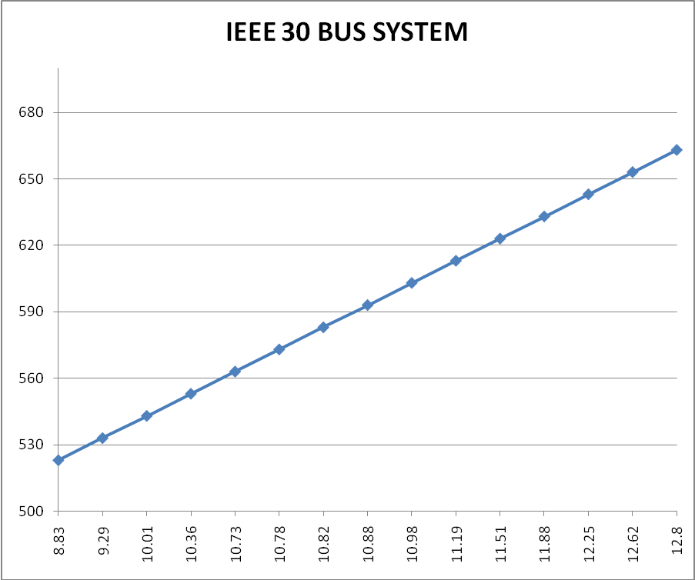
LOSSES (MW)
Fig 5.6 Plot between Emission and Losses
EMISSION
(Kg/hr)

TABLE 14
(NONINFERIOR SET OF IEEE 30 BUS SYSTEM IN 3-D SPACE)
S.No | F_{E (FIXED)}  (Kg/hr) | F_{L}  (MW) | TOTAL  ITERATION | P₁ (MW) | P₂  (MW) | P₆  (MW) | F_{C}  ($/hr)
1 | 523 | 8.830 | 14 | 109.550 | 83.560 | 99.110 | 1281.30
2 | 528 | 9.020 | 18 | 105.370 | 108.550 | 78.640 | 1280.47
3 | 533 | 9.290 | 16 | 110.070 | 107.730 | 75.060 | 1276.60
4 | 538 | 9.440 | 15 | 114.076 | 107.110 | 71.945 | 1273.65
5 | 543 | 10.002 | 30 | 115.59 | 109.66 | 67.900 | 1272.16
6 | 548 | 10.004 | 40 | 118.898 | 109.493 | 65.210 | 1271.60
7 | 553 | 10.408 | 52 | 119.977 | 112.219 | 61.604 | 1271.40

From the above table we have observed that;
Minimum loss is F_{Lmin} = 8.83 MW
Minimum emission is F_{Emin} = 523 Kg/hr
Minimum cost is F_{Cmin} = 1271.40 $/hr
Value of loss at minimum cost is F_{LatFcmin} = 10.408 MW
Value of emission at minimum cost is F_{EatFcmin} = 553 Kg/hr
Value of cost at minimum loss is F_{CatFLmin} = 1281.30 $/hr
Value of cost at minimum emission F_{CatFEmin} = 1281.30 $/hr

TABLE 15
MINIMUM RELATIVE ATTAINMENTS OF IEEE 30-BUS SYSTEM IN 3-D SPACE
S.No | F_{C} ($/hr) | τ_{C} | F_{E}  (Kg/hr) | τ_{L} | F_{L}  (MW) | τ_{E} | $Σ$ _{τ}
1 | 1281.30 | 0 | 523 | 1 | 8.830 | 1 | 2
2 | 1280.47 | 0.0838 | 528 | 0.8330 | 9.020 | 0.8790 | 1.7958
3 | 1276.60 | 0.4747 | 533 | 0.6660 | 9.290 | 0.7080 | 1.8407
4 | 1273.65 | 0.7720 | 538 | 0.5000 | 9.440 | 0.6130 | 1.8850
5 | 1272.16 | 0.9232 | 543 | 0.3300 | 10.002 | 0.2509 | 1.5041
6 | 1271.60 | 0.9797 | 548 | 0.1660 | 10.004 | 0.2560 | 1.4017
7 | 1271.40 | 1 | 553 | 0 | 10.408 | 0 | 1

The relative attainments of the objectives are added and the result is shown in the last column of Table 15. The Target Point is one for which the sum is maximum. It is seen Target Point achieved for 30-Bus system in 3-D space is:
F_{C} = 1273.65 $/hr F_{L} = 9.44 MW F_{E} = 538 Kg/hr
It is shown at s.no 4 of the Table 15. The noninferior set of (F_{E} & F_{L}) has also been shown in Fig 5.6.
The Target Points for all the systems in 2-D space and 3-D space are summarized in Tables 16 and 17 respectively.

Table 16
TARGET POINTS IN 2-D SPACE
SYSTEM | F_{C} ($/hr) | F_{L}(MW)
5-Bus | 761.491 | 5.09
14-Bus | 1150.89 | 7.60
30-Bus | 1295.63 | 8.20

Table 17
TARGET POINTS IN 3-D SPACE
SYSTEM | F_{C}($/hr) | F_{L}(MW) | F_{E}(Kg/hr)
5-Bus | 761.668 | 5.080 | 123
14-Bus | 1163.28 | 7.286 | 508
30-Bus | 1273.65 | 9.44 | 538

With that and moving forward in new directions the cost of generation (F_{c}) has also been determined by keeping the transmission losses fixed at different values and varying the environmental pollution in a certain range for IEEE 5 bus system and their results has been shown in Tables 18 to 28 respectively.

Table 18
(NONINFERIOR SET OF 5 BUS SYSTEM FOR FIXED TRANSMISSION LOSSES (5.060MW))
S.No. | F_{L(FIXED)}  (MW) | F_{E}  (Kg/hr) | No. of ITERATIONS | P₁  MW) | P₃  (MW) | COST  ($/hr)
1 | 5.060 | 120.7 | 30 | 85.894 | 79.166 | 762.668
2 | 5.060 | 121.4 | 23 | 87.290 | 77.774 | 762.271
3 | 5.060 | 122 | 20 | 88.350 | 76.719 | 762.004
4 | 5.060 | 122.5 | 40 | 89.163 | 75.912 | 761.820
5 | 5.060 | 123 | 21 | 89.924 | 75.156 | 761.663
S.No. | F_{L(FIXED)}  (MW) | F_{E}  (Kg/hr) | No. of ITERATIONS | P₁  MW) | P₃  (MW) | COST  ($/hr)
6 | 5.060 | 123.5 | 23 | 90.643 | 74.443 | 761.529
7 | 5.060 | 123.8 | 40 | 91.057 | 74.003 | 761.458
8 | 5.060 | 124 | 40 | 91.326 | 73.766 | 761.412
9 | 5.060 | 124.5 | 28 | 91.978 | 73.121 | 761.314
10 | 5.060 | 127.6 | 31 | 95.516 | 69.630 | 760.976
11 | 5.060 | 130.4 | 53 | 98.214 | 66.979 | 760.939

Table 19
(NONINFERIOR SET OF 5 BUS SYSTEM FOR FIXED TRANSMISSION LOSSES (5.065MW))
S.No. | F_{L(FIXED)}  (MW) | F_{E}  (Kg/hr) | No. of ITERATIONS | P₁  MW) | P₃  MW) | COST  ($/hr)
1 | 5.065 | 120.7 | 20 | 85.890 | 79.160 | 762.672
2 | 5.065 | 121.4 | 22 | 87.290 | 77.770 | 762.272
3 | 5.065 | 122 | 20 | 88.350 | 76.720 | 762.007
4 | 5.065 | 122.5 | 32 | 89.162 | 75.912 | 761.821
5 | 5.065 | 123 | 20 | 89.924 | 75.156 | 761.664
6 | 5.065 | 123.5 | 33 | 90.643 | 74.443 | 761.530
7 | 5.065 | 123.8 | 38 | 91.057 | 74.033 | 761.460
8 | 5.065 | 124 | 20 | 91.326 | 73.767 | 761.414
9 | 5.065 | 124.5 | 24 | 91.978 | 73.121 | 761.316
10 | 5.065 | 127.6 | 27 | 95.516 | 69.630 | 760.978
11 | 5.065 | 130.4 | 57 | 98.214 | 66.979 | 760.941

Table 20
(NONINFERIOR SET OF 5 BUS SYSTEM FOR FIXED TRANSMISSION LOSSES (5.070MW))
S.No. | F_{L(FIXED)}  (MW) | F_{E}  (Kg/hr) | No. of ITERATIONS | P₁  (MW) | P₃  (MW) | COST  ($/hr)
1 | 5.070 | 120.7 | 22 | 85.893 | 79.168 | 762.673
2 | 5.070 | 121.4 | 21 | 87.289 | 77.775 | 762.273
3 | 5.070 | 122 | 31 | 88.350 | 76.720 | 762.008
4 | 5.070 | 122.5 | 20 | 89.162 | 75.913 | 761.822
5 | 5.070 | 123 | 21 | 89.924 | 75.157 | 761.665
6 | 5.070 | 123.5 | 25 | 90.643 | 74.444 | 761.531
7 | 5.070 | 123.8 | 26 | 91.057 | 74.034 | 761.461
8 | 5.070 | 124 | 24 | 91.326 | 73.763 | 761.415
9 | 5.070 | 124.5 | 27 | 91.978 | 73.122 | 761.317
10 | 5.070 | 127.6 | 29 | 95.516 | 69.630 | 760.979
11 | 5.070 | 130.4 | 22 | 98.214 | 66.980 | 760.942

Table 21
(NONINFERIOR SET OF 5 BUS SYSTEM FOR FIXED TRANSMISSION LOSSES (5.075MW))
S.No. | F_{L(FIXED)}  (MW) | F_{E}  (Kg/hr) | No. of ITERATIONS | P₁  (MW) | P₃  (MW) | COST  ($/hr)
1 | 5.075 | 120.7 | 25 | 85.892 | 79.160 | 762.674
2 | 5.075 | 121.4 | 32 | 87.289 | 77.770 | 762.275
3 | 5.075 | 122 | 21 | 88.349 | 76.721 | 762.009
4 | 5.075 | 122.5 | 20 | 89.162 | 75.913 | 761.823
S.No. | F_{L(FIXED)}  (MW) | F_{E}  (Kg/hr) | No. of ITERATIONS | P₁  (MW) | P₃  (MW) | COST  ($/hr)
6 | 5.075 | 123.5 | 22 | 90.640 | 74.440 | 761.532
7 | 5.075 | 123.8 | 22 | 91.057 | 74.034 | 761.462
8 | 5.075 | 124 | 21 | 91.326 | 73.760 | 761.418
9 | 5.075 | 124.5 | 21 | 91.978 | 73.122 | 761.320
10 | 5.075 | 127.6 | 21 | 95.516 | 69.630 | 760.980
11 | 5.075 | 130.4 | 21 | 98.214 | 66.980 | 760.943
6 | 5.075 | 123.5 | 22 | 90.640 | 74.440 | 761.532

Table 22
(NONINFERIOR SET OF 5 BUS SYSTEM FOR FIXED TRANSMISSION LOSSES (5.080MW))
S.No. | F_{L(FIXED)}  (MW) | F_{E}  (Kg/hr) | No. of ITERATIONS | P₁  (MW) | P₃  (MW) | COST  ($/hr)
1 | 5.080 | 120.7 | 25 | 85.890 | 79.160 | 762.675
2 | 5.080 | 121.4 | 24 | 87.289 | 77.777 | 762.277
3 | 5.080 | 122 | 20 | 88.349 | 76.721 | 762.010
4 | 5.080 | 122.5 | 56 | 89.162 | 75.914 | 761.825
5 | 5.080 | 123 | 33 | 89.920 | 75.150 | 761.668
6 | 5.080 | 123.5 | 22 | 90.640 | 74.440 | 761.534
7 | 5.080 | 123.8 | 21 | 91.057 | 74.034 | 761.463
8 | 5.080 | 124 | 20 | 91.326 | 73.760 | 761.419
9 | 5.080 | 124.5 | 22 | 91.978 | 73.122 | 761.321
10 | 5.080 | 127.6 | 21 | 95.516 | 69.630 | 760.981
11 | 5.080 | 130.4 | 22 | 98.214 | 66.980 | 760.944

Table 23
(NONINFERIOR SET OF 5 BUS SYSTEM FOR FIXED TRANSMISSION LOSSES (5.085MW))
S.No. | F_{L(FIXED)}  (MW) | F_{E}  (Kg/hr) | No. of ITERATIONS | P₁  (MW) | P₃  (MW) | COST  ($/hr)
1 | 5.085 | 120.7 | 21 | 85.892 | 79.120 | 762.676
2 | 5.085 | 121.4 | 21 | 87.289 | 77.770 | 762.279
3 | 5.085 | 122 | 20 | 88.349 | 76.722 | 762.012
4 | 5.085 | 122.5 | 21 | 89.162 | 75.914 | 761.827
5 | 5.085 | 123 | 21 | 89.923 | 75.158 | 761.670
6 | 5.085 | 123.5 | 23 | 90.643 | 74.445 | 761.536
7 | 5.085 | 123.8 | 24 | 91.056 | 74.035 | 761.464
8 | 5.085 | 124 | 22 | 91.326 | 73.768 | 761.421
9 | 5.085 | 124.5 | 22 | 91.978 | 73.123 | 761.322
10 | 5.085 | 127.6 | 23 | 95.516 | 69.631 | 760.983
11 | 5.085 | 130.4 | 23 | 98.214 | 66.980 | 760.945

Table 24
(NONINFERIOR SET OF 5 BUS SYSTEM FOR FIXED TRANSMISSION LOSSES (5.090MW))
S.No. | F_{L(FIXED)}  (MW) | F_{E}  (Kg/hr) | No. of ITERATIONS | P₁  (MW) | P₃  (MW) | COST  ($/hr)
1 | 5.090 | 120.7 | 22 | 85.891 | 79.170 | 762.678
2 | 5.090 | 121.4 | 24 | 87.288 | 77.770 | 762.280
3 | 5.090 | 122 | 36 | 88.349 | 76.722 | 762.013
4 | 5.090 | 122.5 | 20 | 89.162 | 75.914 | 761.828
S.No. | F_{L(FIXED)}  (MW) | F_{E}  (Kg/hr) | No. of ITERATIONS | P₁  (MW) | P₃  (MW) | COST  ($/hr)
5 | 5.090 | 123 | 32 | 89.923 | 75.158 | 761.671
6 | 5.090 | 123.5 | 30 | 90.643 | 74.445 | 761.537
7 | 5.090 | 123.8 | 23 | 91.056 | 74.035 | 761.466
8 | 5.090 | 124 | 20 | 91.326 | 73.768 | 761.422
9 | 5.090 | 124.5 | 28 | 91.978 | 73.123 | 761.324
10 | 5.090 | 127.6 | 33 | 95.516 | 69.631 | 760.985
11 | 5.090 | 130.4 | 73 | 98.214 | 66.981 | 760.946

Table 25
(NONINFERIOR SET OF 5 BUS SYSTEM FOR FIXED TRANSMISSION LOSSES (5.095MW))
S.No. | F_{L(FIXED)}  (MW) | F_{E}  (Kg/hr) | No. of ITERATIONS | P₁  (MW) | P₃  (MW) | COST  ($/hr)
1 | 5.095 | 120.7 | 27 | 85.891 | 79.171 | 762.679
2 | 5.095 | 121.4 | 22 | 87.288 | 77.770 | 762.282
3 | 5.095 | 122 | 23 | 88.349 | 76.723 | 762.014
4 | 5.095 | 122.5 | 23 | 89.162 | 75.915 | 761.830
5 | 5.095 | 123 | 20 | 89.923 | 75.159 | 761.673
6 | 5.095 | 123.5 | 58 | 90.642 | 74.445 | 761.538
7 | 5.095 | 123.8 | 39 | 91.056 | 74.035 | 761.467
8 | 5.095 | 124 | 21 | 91.325 | 73.769 | 761.423
9 | 5.095 | 124.5 | 20 | 91.977 | 73.123 | 761.325
10 | 5.095 | 127.6 | 23 | 95.516 | 69.631 | 760.986
11 | 5.095 | 130.4 | 21 | 98.214 | 66.981 | 760.947
Table 26
(NONINFERIOR SET OF 5 BUS SYSTEM FOR FIXED TRANSMISSION LOSSES (5.10MW))
S.No. | F_{L(FIXED)}  (MW) | F_{E}  (Kg/hr) | No. of ITERATIONS | P₁  (MW) | P₃  (MW) | COST  ($/hr)
1 | 5.10 | 120.7 | 20 | 85.891 | 79.172 | 762.681
2 | 5.10 | 121.4 | 25 | 87.288 | 77.779 | 762.283
3 | 5.10 | 122 | 23 | 88.349 | 76.723 | 762.016
4 | 5.10 | 122.5 | 21 | 89.161 | 75.915 | 761.831
5 | 5.10 | 123 | 21 | 89.923 | 75.159 | 761.674
6 | 5.10 | 123.5 | 21 | 90.642 | 74.446 | 761.539
7 | 5.10 | 123.8 | 32 | 91.056 | 74.036 | 761.468
8 | 5.10 | 124 | 23 | 91.325 | 73.769 | 761.424
9 | 5.10 | 124.5 | 29 | 91.977 | 73.124 | 761.326
10 | 5.10 | 127.6 | 43 | 95.516 | 69.632 | 760.987
11 | 5.10 | 130.4 | 52 | 98.214 | 66.981 | 760.949

Table 27
(NONINFERIOR SET OF 5 BUS SYSTEM FOR FIXED TRANSMISSION LOSSES (5.15MW))
S.No. | F_{L(FIXED)}  (MW) | F_{E}  (Kg/hr) | No. of ITERATIONS | P₁  (MW) | P₃  (MW) | COST  ($/hr)
1 | 5.15 | 120.7 | 43 | 85.887 | 79.179 | 762.697
2 | 5.15 | 121.4 | 34 | 87.285 | 77.780 | 762.298
3 | 5.15 | 122 | 24 | 88.347 | 76.728 | 762.030
4 | 5.15 | 122.5 | 38 | 89.160 | 75.920 | 761.845
5 | 5.15 | 123 | 23 | 89.922 | 75.163 | 761.687
6 | 5.15 | 123.5 | 26 | 90.641 | 74.450 | 761.550
S.No. | F_{L(FIXED)}  (MW) | F_{E}  (Kg/hr) | No. of ITERATIONS | P₁  (MW) | P₃  (MW) | COST  ($/hr)
7 | 5.15 | 123.8 | 21 | 91.055 | 74.039 | 761.482
8 | 5.15 | 124 | 44 | 91.325 | 73.770 | 761.438
9 | 5.15 | 124.5 | 39 | 91.977 | 73.127 | 761.339
10 | 5.15 | 127.6 | 46 | 95.516 | 69.634 | 760.999
11 | 5.15 | 130.4 | 22 | 98.214 | 66.983 | 760.960
Table 28
(NONINFERIOR SET OF 5 BUS SYSTEM FOR FIXED TRANSMISSION LOSSES (5.20MW))
S.No. | F_{L(FIXED)}  (MW) | F_{E}  (Kg/hr) | No. of ITERATIONS | P₁  (MW) | P₃  (MW) | COST  ($/hr)
1 | 5.20 | 120.7 | 22 | 85.883 | 79.186 | 762.714
2 | 5.20 | 121.4 | 38 | 87.283 | 77.790 | 762.313
3 | 5.20 | 122 | 30 | 88.345 | 76.733 | 762.044
4 | 5.20 | 122.5 | 34 | 89.158 | 75.924 | 761.895
5 | 5.20 | 123 | 31 | 89.921 | 75.167 | 761.701
6 | 5.20 | 123.5 | 36 | 90.640 | 74.454 | 761.566
7 | 5.20 | 123.8 | 21 | 91.054 | 74.043 | 761.495
8 | 5.20 | 124 | 21 | 91.324 | 73.776 | 761.451
9 | 5.20 | 124.5 | 39 | 91.976 | 73.131 | 761.352
10 | 5.20 | 127.6 | 22 | 95.516 | 69.637 | 761.011
11 | 5.20 | 130.4 | 20 | 98.214 | 66.986 | 760.972
For the above results of IEEE 5 bus system, it has been observed that when transmission losses increases at particular environmental pollution then cost of generation also increases which is also shown in Fig 5.7
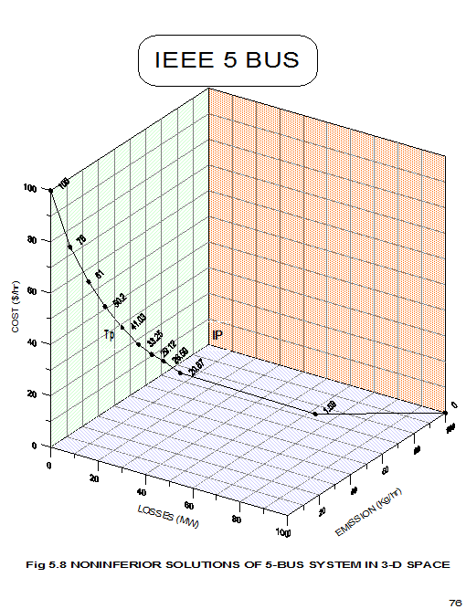
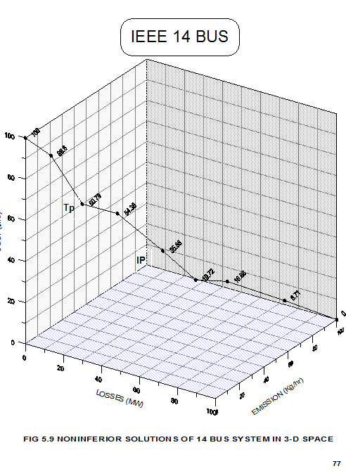
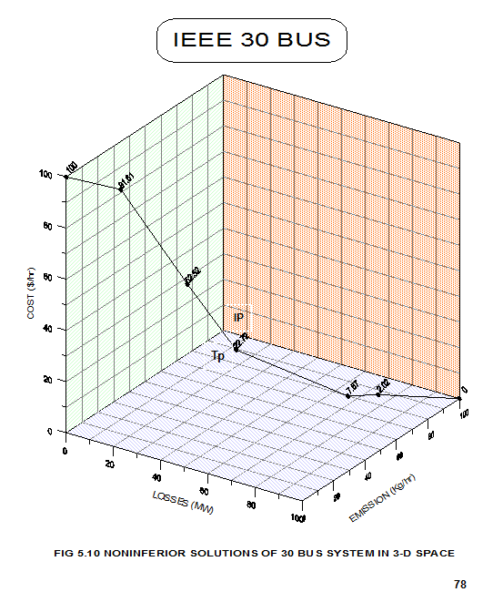
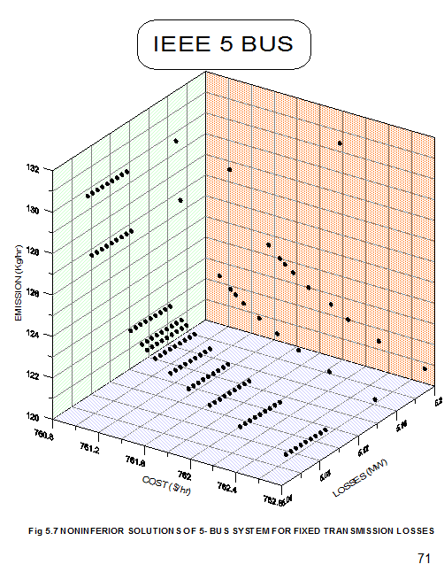

5.5 DISCUSSION
From table 1, the ideal point for 5 bus system in 2-D space is (760.960$/hr, 5.05MW).Similarly, the ideal point for 14 bus system in 2-D space is (1136.10$/hr, 7.00MW) and for 30 bus system, it is (1269.11$/hr, 6.90MW). The ideal point for 5, 14 and 30 bus systems in 3-D space are (760.972$/hr, 5.060MW, 120.7Kg/hr), (1148.98$/hr, 7.218MW, 499Kg/hr) and (1271.40$/hr, 8.83MW, 523Kg/hr) respectively. However, it can be realized that the ideal point as defined and located above cannot be achieved in practice. So, an attempt is made to obtain the Target Point which gives equal satisfaction levels for all the objectives. Such a point is obtained by the use of Maximization of Minimum Relative Attainments (MMR).
The Target Point in 3-D space has been displayed by 3-D graph drawn in Golden software grapher 7. In these graphs, the origin represents the ideal points i.e. (F_{Cmin}, F_{Lmin}, F_{Emin}). X-axis represents the % distance of the system transmission losses F_{L} from the origin, i.e.
% distance from origin along X-axis = F_{L} - F_{Lmin} x 100 (5.5)
F_{Lmax} – F_{Lmin}
Similarly, Y-axis represents the % distance of F_{C} from the origin, i.e.
% distance from origin along Y-axis = F_{C} - F_{Cmin} x 100 (5.6)
F_{Cmax} - F_{Cmin}

And Z-axis represents the % distance of pollution F_{E} from the origin, i.e.
% distance from the origin along Z-axis = F_{E} - F_{Emin} x 100 (5.7)
F_{Emax} - F_{Emin}
Where
F_{Lmax} = Maximum of F_{L} in 3-D space.
F_{Cmax} = Maximum of F_{C} in 3-D space.
F_{Emax} = Maximum of F_{E} in 3-D space.
Table 29
IEEE 5 BUS SYSTEM
S.No | F_{L} (MW) | F_{C}  ($/hr) | F_{E}  (Kg/hr) | %Distance  on X-axis | %Distance  on Y-axis | %Distance  on Z-axis
1 | 5.060 | 762.668 | 120.7 | 0 | 100 | 0
2 | 5.065 | 762.273 | 121.4 | 3.5 | 76 | 7.2
3 | 5.070 | 762.007 | 122 | 7.14 | 61 | 13.4
4 | 5.075 | 761.824 | 122.5 | 10.7 | 50.2 | 18.5
5 | 5.080 | 761.668 | 123 | 14.2 | 41.03 | 23.7
6 | 5.085 | 761.536 | 123.5 | 17.85 | 33.25 | 28.86
7 | 5.090 | 761.466 | 123.8 | 21.4 | 29.12 | 31.95
8 | 5.095 | 761.423 | 124 | 25 | 26.59 | 34.02
9 | 5.10 | 761.326 | 124.5 | 28.57 | 20.87 | 39.17
10 | 5.15 | 760.999 | 127.6 | 64.28 | 1.59 | 71.13
11 | 5.20 | 760.972 | 130.4 | 100 | 0 | 100

Table 30
IEEE 14 BUS SYSTEM
S.No | F_{L} (MW) | F_{C}  ($/hr) | F_{E}  (Kg/hr) | %Distance  on X-axis | %Distance  on Y-axis | %Distance  on Z-axis
1 | 7.218 | 1172.50 | 499 | 0 | 100 | 0
2 | 7.239 | 1169.35 | 504 | 3.87 | 86.6 | 15.15
3 | 7.286 | 1163.28 | 508 | 12.54 | 60.79 | 27.27
4 | 7.377 | 1161.80 | 512 | 23.33 | 54.36 | 39.39
5 | 7.432 | 1157.42 | 516 | 39.48 | 35.88 | 51.51
6 | 7.483 | 1153.62 | 520 | 48.89 | 19.72 | 63.63
7 | 7.532 | 1152.90 | 524 | 57.93 | 16.66 | 75.75
8 | 7.653 | 1151.03 | 528 | 80.25 | 8.71 | 87.87
9 | 7.760 | 1148.98 | 532 | 100 | 0 | 100

Table 31
IEEE 30 BUS SYSTEM
S.No | F_{L} (MW) | F_{C}  ($/hr) | F_{E}  (Kg/hr) | %Distance  on X-axis | %Distance  on Y-axis | %Distance  on Z-axis
1 | 8.830 | 1281.30 | 523 | 0 | 100 | 0
2 | 9.020 | 1280.47 | 528 | 12.04 | 91.61 | 16.66
3 | 9.290 | 1276.60 | 533 | 29.15 | 52.52 | 33.33
4 | 9.440 | 1273.65 | 538 | 38.65 | 22.72 | 50
5 | 10.002 | 1272.16 | 543 | 74.9 | 7.67 | 66.66
6 | 10.004 | 1271.60 | 548 | 76.67 | 2.02 | 83.33
7 | 10.408 | 1271.40 | 553 | 100 | 0 | 100

The readings of Table 18, 19 and 20 have been scaled and plotted in 3-D space in Golden software grapher7. 3-D curve is also drawn connecting these points. In these graphs, the Target Point is marked as TP.

Chapter 6
CONCLUSIONS & FUTURE DIRECTIONS
6.1 CONCLUSIONS
Following are the conclusions based on the results of previous chapters.
- Constrained method has been used to generate Noninferior Set in 2-D and 3-D space for IEEE 5, 14 and 30 bus systems respectively. When the noninferior set is obtained by constrained method, Maximization of Minimum Relative Attainments (MMR) is used to obtain the Target Point (TP) or the best compromise solution. This technique is computationally fast and has no limitation in handling more than three objectives.
- It has been observed that if cost of generation (F_{C}) increases then system transmission losses (F_{L}) and environmental pollution decreases; vice-versa. However, the objectives may not always follow the conflicting and supportive behaviors in all the domains.
- Genetic encoding techniques have significant influence on GAs performance in solving some problems with bigger algorithm complexities. One thing that is striking about genetic algorithms is the richness of this form of computation. What may seem like simple changes in the algorithm such as population size, generation etc. often results in surprising kinds of emergent behaviors. Recent theoretical advances have also improved our understanding of genetic algorithms and have opened the door to using more advanced analytical methods. We had also noticed that in order to minimize the computational efforts, we should keep population size and stall generation minimum as long as it gives the acceptable results.

6.2 FUTURE DIRECTIONS

Following are the suggestions for the future research work:

- The objectives considered in the present research work are – Cost of Generation (F_{C}), System Transmission Losses (F_{L}) and Environmental Pollution (F_{E}) which are noncommensurable because of their nature. However, transmission losses and environmental pollution can be expressed in monetary units to be compatible with the cost of generation. This objective function can be minimized to reach the Target Point (TP) or the best – compromise solution.
- Neural networks can be used to predict the load demand and to identify the noninferior set from a set of feasible solutions.
- Interactive multiobjective programming techniques should be developed which can identify the Target Point (TP) in a single step.

APPENDIX I
1) IEEE 5 BUS SYSTEM

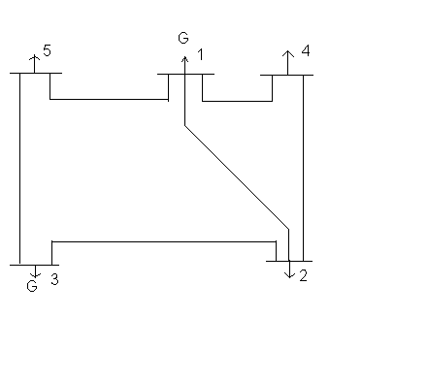
Fig. (I-A) Bus-Code Diagram 5 Bus System

TABLE I-A
LINE DATA or IMPEDANCE DATA (5 Bus System)
LINE DESIGNATION | *R (p.u.) | *X (p.u.) | LINE CHARGING
1-2 | 0.10 | 0.4 | 0.0
1-4 | 0.15 | 0.6 | 0.0
1-5 | 0.05 | 0.2 | 0.0
2-3 | 0.05 | 0.2 | 0.0
2-4 | 0.10 | 0.4 | 0.0
3-5 | 0.05 | 0.2 | 0.0

* The impedances are based on MVA as 100.
TABLE I-B
BUS DATA or OPERATING CONDITIONS (5 Bus System)
 | GENERATION | GENERATION | LOAD | LOAD
BUS NO. | MW | VOLTAGE MAGNITUDE | MW | MVAR
1* | ------- | 1.02 | ------- | -------
2 | ------- | ------- | 60 | 30
3 | 100 | 1.04 | ------- | -------
4 | ------- | ------- | 40 | 10
5 | ------- | ------- | 60 | 20
*Slack Bus

TABLE I-C
REGULATED BUS DATA (5 Bus System)
BUS NO. | VOLTAGE MAGNITUDE | MINIMUM MVAR CAPABILITY | MAXIMUM MVAR CAPABILITY | MINIMUM MW CAPABILITY | MAXIMUM MW CAPABILITY
1 | 1.02 | 0.0 | 60 | 30 | 120
3 | 1.04 | 0.0 | 60 | 30 | 120

The nodal load voltage inequality constraints are 0.9<= V_{i} <=1.05
Cost Characteristics
The cost characteristics of the IEEE 5 Bus System are as follows:

C₁ = 50 P₁^2 + 351 P₁ + 44.4 $/hr

C₃ = 50 P₃^2 + 389 P₃ + 40.6 $/hr

Here, the total load demand of the system is 160 MW. Maximum and minimum active power constraint on the generator bus for the given system is 120 MW and 30 MW respectively. Voltage magnitude constraint for generator at bus 3 is 1.04 pu.
The noninferior set for the above system has been obtained by solving the following problem.
Minimize
F_{(C)}
s.t. 30< P_{gi}< 120 i = 1, 3
P_{D} + P_{L} - $\sum_{n=1}^{\text{NG}}{}$P_{n} = 0
F_{L} ≤ F_{Lmin} + δF_{L}
Emission Characteristics
E₁ = 135.5 P₁^2 – 126.5 P₁ +22.9 $/hr
E₃ = 124.8 P₃^2 - 137.8 P₃ + 137.3 $/hr
The noninferior set for the above system has been obtained by solving the following problem.
Minimize
F_{(E)}
s.t.
30< P_{gi}< 120 for i = 1, 3
And
P_{D} + P_{L} - $\sum_{n=1}^{\text{NG}}{}$P_{n} = 0
F_{L} ≤ L₁
M-file For Calculating B- Coefficients:
clear
basemva=100;
accuracy=0.0001;
maxiter=10;
busdata=[1 1 1.02 0 0 0 0 0 0 60 0;2 0 1 0 60 30 0 0 0 0 0;3 2 1.04 0 0 0 82 0 0 60 0;4 0 1 0 40 10 0 0 0 0 0;5 0 1 0 60 20 0 0 0 0 0];
linedata=[1 2 0.10 0.4 0 1;1 4 0.15 0.6 0 1;1 5 0.05 0.2 0 1;2 3 0.05 0.2 0 1;2 4 0.10 0.4 0 1;3 5 0.05 0.2 0 1];
disp(busdata)
disp(linedata)
mwlimits=[30 120;30 120];
lfybus
lfnewton
busout
bloss
B- Coefficients Calculated (based on equal intercept criterion)
B11 = 0.00035336
B12 = 0.0000103196
B21 = 0.0000103196
B22 = 0.000368992

PROBLEM FORMULATION FOR 2-D SPACE:

To solve the economic load dispatch problem in 2-D space, Formulation of problem is done in the following manner:
Minimize F(c) = C₁ + C₂ + C₃ + …. + C_{n}
s.t.
P_{gimin} < P_{gi} < P_{gimax}
P_{D} + P_{L} - $\sum_{n}^{\text{NG}}{}$P_{n} = 0
$\sum_{i=1}^{\text{NG}}{}$$\sum_{j=1}^{\text{NG}}{}$P_{i}B_{ij}P_{j} – Specified Loss = 0

Where:
C₁, C₂…, C_{n} are the cost characteristics
P_{D} represents total load demand, P_{L} represents losses, B_{nj} represents B-coefficients.

M- File For 2-D PROBLEM:
Objective Function File:
Functionz = objective5bus(x)
z=((50*(x(1)/100)*(x(1)/100))+(351*(x(1)/100))+44.4+(50*(x(2)/100)*(x(2)/100))+(389*(x(2)/100))+40.6);

Constraint Function File:
Function [c,ceq]=constraint5bus(x)
c= [-x(1)+30;x(1)-120;-x(2)+30;x(2)-120];
ceq=[x(1)+x(2)-0.00035336*x(1)*x(1)-2*0.0000103196*x(1)*x(2)-0.000368992*x(2)*x(2)160;0.00035336*x(1)*x(1)+2*0.0000103196*x(1)*x(2)+0.000368992*x(2)*x(2)-specified loss];

PROBLEM FORMULATION FOR 3-D SPACE:
To solve the economic load dispatch problem in 3-D space, Formulation of problem is done in the following manner:

Minimize F_{(E)} = E₁ + E₂ + E₃ + …. + E_{n} Kg/hr
s.t.
P_{gimin} < P_{gi} < P_{gimax}
P_{D} + P_{L} - $\sum_{n}^{\text{NG}}{}$P_{n} = 0
$\sum_{i=1}^{\text{NG}}{}$$\sum_{j=1}^{\text{NG}}{}$P_{i}B_{ij}P_{j} – Specified Loss = 0
Where:
E₁, E₂…, E_{n} are the emission characteristics
P_{D} represents total load demand, P_{L} represents losses, B_{nj} represents B-coefficients.
The specified loss in the above equation is a fixed value of transmission loss which is used to obtain the supportive values of emission. This gives us the portion of noninferior set. After obtaining the noninferiors set then minimize cost subject to fixed losses and fixed emission. The problem is formulated as follows:
Minimize
F_{(c)} = C₁ + C₂ + C₃ + …. + C_{n}
s.t.
P_{gimin} < P_{gi} < P_{gimax}
P_{D} + P_{L} - $\sum_{n}^{\text{NG}}{}$P_{n} = 0
$\sum_{n}^{\text{NG}}{}$$\sum_{n}^{\text{NG}}{}$P_{n}B_{nj}P_{j} – Specified Loss = 0
& $\sum_{i=1}^{\text{NG}}{}$(α_{i}P_{i}² + β_{i}P_{i}² + γ_{i}) - Specified Emission = 0
Where:
C₁, C₂…, C_{n} are the cost characteristics
α_{i} , β_{i} , & γ_{i} are the emission coefficients.

M- File FOR 3-D PROBLEM:

Objective Function File:
Function z = objective5busel(x)
z=((50*(x(1)/100)*(x(1)/100))+(351*(x(1)/100))+44.4+(50*(x(2)/100)*(x(2)/100))+(389*(x(2)/100))+40.6);
Constraint Function File:
Function [c,ceq]=constraint5busel(x)
c= [-x(1)+30;x(1)-120;-x(2)+30;x(2)-120];
ceq=[x(1)+x(2)-0.00035336*x(1)*x(1)-2*0.0000103196*x(1)*x(2)-0.000368992*x(2)*x(2)-160;135.5*(x(1)/100)*(x(1)/100)+(-126.5*(x(1) /100))+22.9+(124.9*(x(2)/100)*(x(2)/100))+(-137.8*(x(2)/100))+137.3-specifiedemission;0.00035336*x(1)*x(1)+2*0.0000103196*x(1)*x(2)+0.000368992*x(2)*x(2)-specified loss];

2)IEEE 14 BUS SYSTEM:
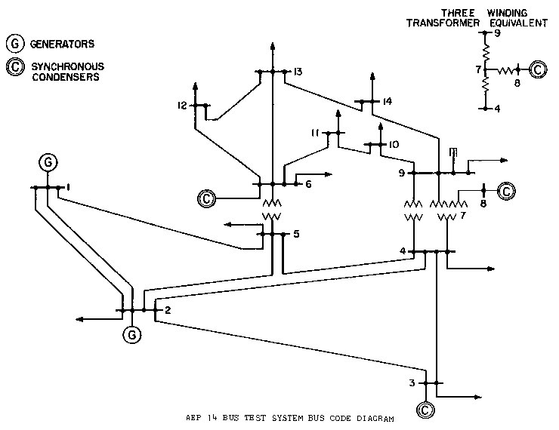

Fig. (I-B) Bus-Code Diagram 14 Bus System

TABLE I-D
Impedance and Line-Charging Data (14 Bus System)
Line Designation | Resistance p.u.* | Reactance p.u.* | Line Charging | Tap Setting
1-2 | 0.01938 | 0.05917 | 0.0264 | 1
1-5 | 0.05403 | 0.22304 | 0.0246 | 1
2-3 | 0.04699 | 0.19797 | 0.0219 | 1
2-4 | 0.05811 | 0.17632 | 0.0187 | 1
2-5 | 0.05695 | 0.17388 | 0.0170 | 1
3-4 | 0.06701 | 0.17103 | 0.0173 | 1
4-5 | 0.01335 | 0.04211 | 0.0064 | 1
4-7 | 0 | 0.20912 | 0 | 1
4-9 | 0 | 0.55618 | 0 | 1
5-6 | 0 | 0.25202 | 0 | 1
6-11 | 0.09498 | 0.19890 | 0 | 1
6-12 | 0.12291 | 0.25581 | 0 | 1
6-13 | 0.06615 | 0.13027 | 0 | 1
7-8 | 0 | 0.17615 | 0 | 1
7-9 | 0 | 0.11001 | 0 | 1
9-10 | 0.03181 | 0.08450 | 0 | 1
9-14 | 0.12711 | 0.27038 | 0 | 1
10-11 | 0.08205 | 0.19207 | 0 | 1
12-13 | 0.22092 | 0.19988 | 0 | 1
13-14 | 0.17093 | 0.34802 | 0 | 1

* Impedance and line-charging susceptance in p.u. on a 100 MVA base. Line charging one-half of total charging of line.
TABLE I-E
BUS DATA or Operating Conditions (14 Bus System)
 |  |  | Generation | Generation | Load | Load
Bus No. | Magnitude p.u. | Phase Angle deg. | MW | MVAR | MW | MVAR
1* | 1.06 | 0 | 0 | 0 | 0 | 0
2 | 1 | 0 | 40 | 0 | 21.7 | 12.7
3 | 1 | 0 | 0 | 0 | 94.2 | 19.0
4 | 1 | 0 | 0 | 0 | 47.8 | -3.9
5 | 1 | 0 | 0 | 0 | 7.6 | 1.6
6 | 1 | 0 | 0 | 0 | 11.2 | 7.5
7 | 1 | 0 | 0 | 0 | 0 | 0
8 | 1 | 0 | 0 | 0 | 0 | 0
9 | 1 | 0 | 0 | 0 | 29.5 | 16.6
10 | 1 | 0 | 0 | 0 | 9.0 | 5.8
11 | 1 | 0 | 0 | 0 | 3.5 | 1.8
12 | 1 | 0 | 0 | 0 | 6.1 | 1.6
13 | 1 | 0 | 0 | 0 | 13.5 | 5.8
14 | 1 | 0 | 0 | 0 | 14.9 | 5.0

* Slack Bus
TABLE I-F
REGULATED BUS DATA(14 Bus System)
Bus No. | Voltage Magnitude p.u. | Minimum MVAR capability | Maximum MVAR capability
2 | 1.045 | -40 | 50
3 | 1.010 | 0 | 40
6 | 1.070 | -6 | 24
8 | 1.090 | -6 | 24

Cost Characteristics:
C₁ = 50 P₁^2 + 245 P₁ + 105 $/hr
C₂ = 50 P₂^2 + 351 P₂ + 44.4 $/hr
C₆ = 50 P₆^2 + 389 P₆ + 40.6 $/hr
Here the total load demand of the system is 259 MW. Maximum and minimum active power constraint on the generator bus for the given system is 150 MW and 50 MW respectively. Voltage magnitude constraint for generator bus 2 is 1.045, for bus no. 6 is 1.070, for bus no. 3 is 1.010 & for bus no. 8 is 1.090
The noninferior set for the above system has been obtained by solving the following problem.
Minimize
F_{(C)}
s.t.
50< P_{gi}< 150 for i = 1, 2, 6
P_{D} + P_{L} - $\sum_{n=1}^{\text{NG}}{}$P_{n} = 0
F_{L} ≤ F_{Lmin} + δF_{L}

Emission Characteristics

E₁ = 135.5 P₁^2 – 126.5 P₁ +22.9 $/hr

E₂ = 124.8 P₂^2 - 137.8 P₂ + 137.3 $/hr

E₆ = 80.5 P₆^2 – 76.7 P₆ + 367.7 $/hr
The noninferior set for the above system has been obtained by solving the following problem.
Minimize
F_{(E)}
s.t.
50< P_{i}< 150 for i = 1, 2, 6
P_{D} + P_{L} - $\sum_{n}^{\text{NG}}{}$P_{n} = 0
F_{L} ≤ L₁
M-file For Calculating B- Coefficients:
clear
basemva=100;
accuracy=0.0001;
maxiter=10;
busdata=[1 1 1.06 0 0 150 0 0 0 0 0;2 2 1.045 0 21.7 12.7 63.11 0 -40 50 0;3 0 1.01 0 94.2 19 0 0 0 40 0;4 0 1 0 47.8 -3.9 0 0 0 0 0;5 0 1 0 7.6 1.6 0 0 0 0 0;6 2 1.07 0 11.2 7.5 77.12 0 -6 24 0;7 0 1 0 0 0 0 0 0 0 0;8 0 1.09 0 0 0 0 0 -6 24 0;9 0 1 0 29.5 16.6 0 0 0 0 0;10 0 1 0 9 5.8 0 0 0 0 0;11 0 1 0 3.5 1.8 0 0 0 0 0;12 0 1 0 6.1 1.6 0 0 0 0 0;13 0 1 0 13.5 5.8 0 0 0 0 0;14 0 1 0 14.9 5 0 0 0 0 0];
linedata=[1 2 0.01938 0.05917 0.0264 1;1 5 0.05403 0.22304 0.0246 1;2 3 0.04699 0.19797 0.0219 1;2 4 0.05811 0.17632 0.0187 1;2 5 0.0595 0.17388 0.0170 1;3 4 0.06701 0.17103 0.0173 1;4 5 0.01335 0.04211 0.0064 1;4 7 0 0.20912 0 1;4 9 0 0.55618 0 1;5 6 0 0.25202 0 1;6 11 0.09498 0.19890 0 1;6 12 0.12291 0.25581 0 1;6 13 0.06615 0.13027 0 1;7 8 0 0.17615 0 1;7 9 0 0.11001 0 1;9 10 0.03181 0.08450 0 1;9 14 0.12711 0.27038 0 1;10 11 0.08205 0.19207 0 1;12 13 0.22092 0.19988 0 1;13 14 0.17093 0.34802 0 1];
disp(busdata)
disp(linedata)
mwlimits=[50 150;50 150;50 150];
lfybus
lfnewton
busout
bloss

B-Coefficients Calculated are:
B11 = 0.0231
B12 = 0.0078
B13 = - 0.0007
B21 = 0.0078
B22 = 0.0182
B23 = 0.0022
B31 = - 0.0007
B32 = 0.0022
B33 = 0.0329

M- File For 2-D PROBLEM:
Objective Function M-file:
Function z = objective14bus(x)
z = ((50*(x(1)/100)*(x(1)/100)) + (245*(x(1)/100)) + 105 + (50*(x(2)/100) *(x(2)/100)) + (351*(x(2)/100)) + 44.4 + (50*(x(3)/100)*(x(3)/100)) + (389 *(x(3)/100)) + 40.6);
Constraint Function M-file:
Function [c,ceq]=constraint14bus(x)
c=[-x(1)+50;x(1)-150;-x(2)+50;x(2)-150;-x(3)+50;x(3)-150];
ceq=[(x(1)+x(2)+x(3))-259-(100*(((x(1)/100)*(x(1)/100)*0.0231) +(2*(x(1) /100)*(x(2)/100)*0.0078)+(2*(x(1)/100)*(x(3)/100)*( -0.0007))+((x(2)/100) *(x(2)/100)*0.0182)+(2*(x(2)/100)*(x(3)/100)*0.0022)+((x(3)/100)*(x(3)/100)*0.0329)));(100*(((x(1)/100)*(x(1)/100)*0.0231)+(2*(x(1)/100)*(x(2)/100)*0.0078)+(2*(x(1)/100)*(x(3)/100)*(-0.0007))+((x(2)/100)*(x(2)/100)* 0.0182)+(2*(x(2)/100)*(x(3)/100)*0.0022)+((x(3)/100)*(x(3)/100)*0.0329)))-specified loss];
M- File For 3-D PROBLEM:
Objective Function M-file:
Function z = objective14busel(x)
z = ((50*(x(1)/100)*(x(1)/100)) + (245*(x(1)/100)) + 105 + (50*(x(2)/100)* (x(2)/100)) + (351*(x(2)/100)) + 44.4 + (50*(x(3)/100)*(x(3)/100)) + (389* (x(3)/100)) + 40.6);
Constraint Function M-file:
Function [c,ceq]=constraint14busel(x)
c=[-x(1)+50;x(1)-150;-x(2)+50;x(2)-150;-x(3)+50;x(3)-150];
ceq=[(x(1)+x(2)+x(3))-259-(100*(((x(1)/100)*(x(1)/100)*0.0231)+(2*(x(1) /100)*(x(2)/100)*0.0078)+(2*(x(1)/100)*(x(3)/100)*( -0.0007))+((x(2)/100) *(x(2)/100)*0.0182)+(2*(x(2)/100)*(x(3)/100)*0.0022)+((x(3)/100)*(x(3)/100)*0.0329)));((135.5*(x(1)/100)*(x(1)/100)) + (-126.5*(x(1)/100)) + 22.9 + (124.8*(x(2)/100)*(x(2)/100)) + (-137.8*(x(2)/100)) + 137.3 + (80.5*(x(3) /100)*(x(3)/100))+(-76.7*(x(3)/100))+367.7)-specifiedemission];(100*(((x (1)/100)*x(1)/100)*0.0231)+(2*(x(1)/100)*(x(2)/100)*0.0078)+(2*(x(1)/100)*(x(3)/100)*(0.0007))+((x(2)/100)*(x(2)/100)*0.0182)+(2*(x(2)/100)* (x(3)/100)*0.0022)+((x(3)/100)*(x(3)/100)*0.0329-specified loss)));

3) IEEE 30 BUS SYSTEM

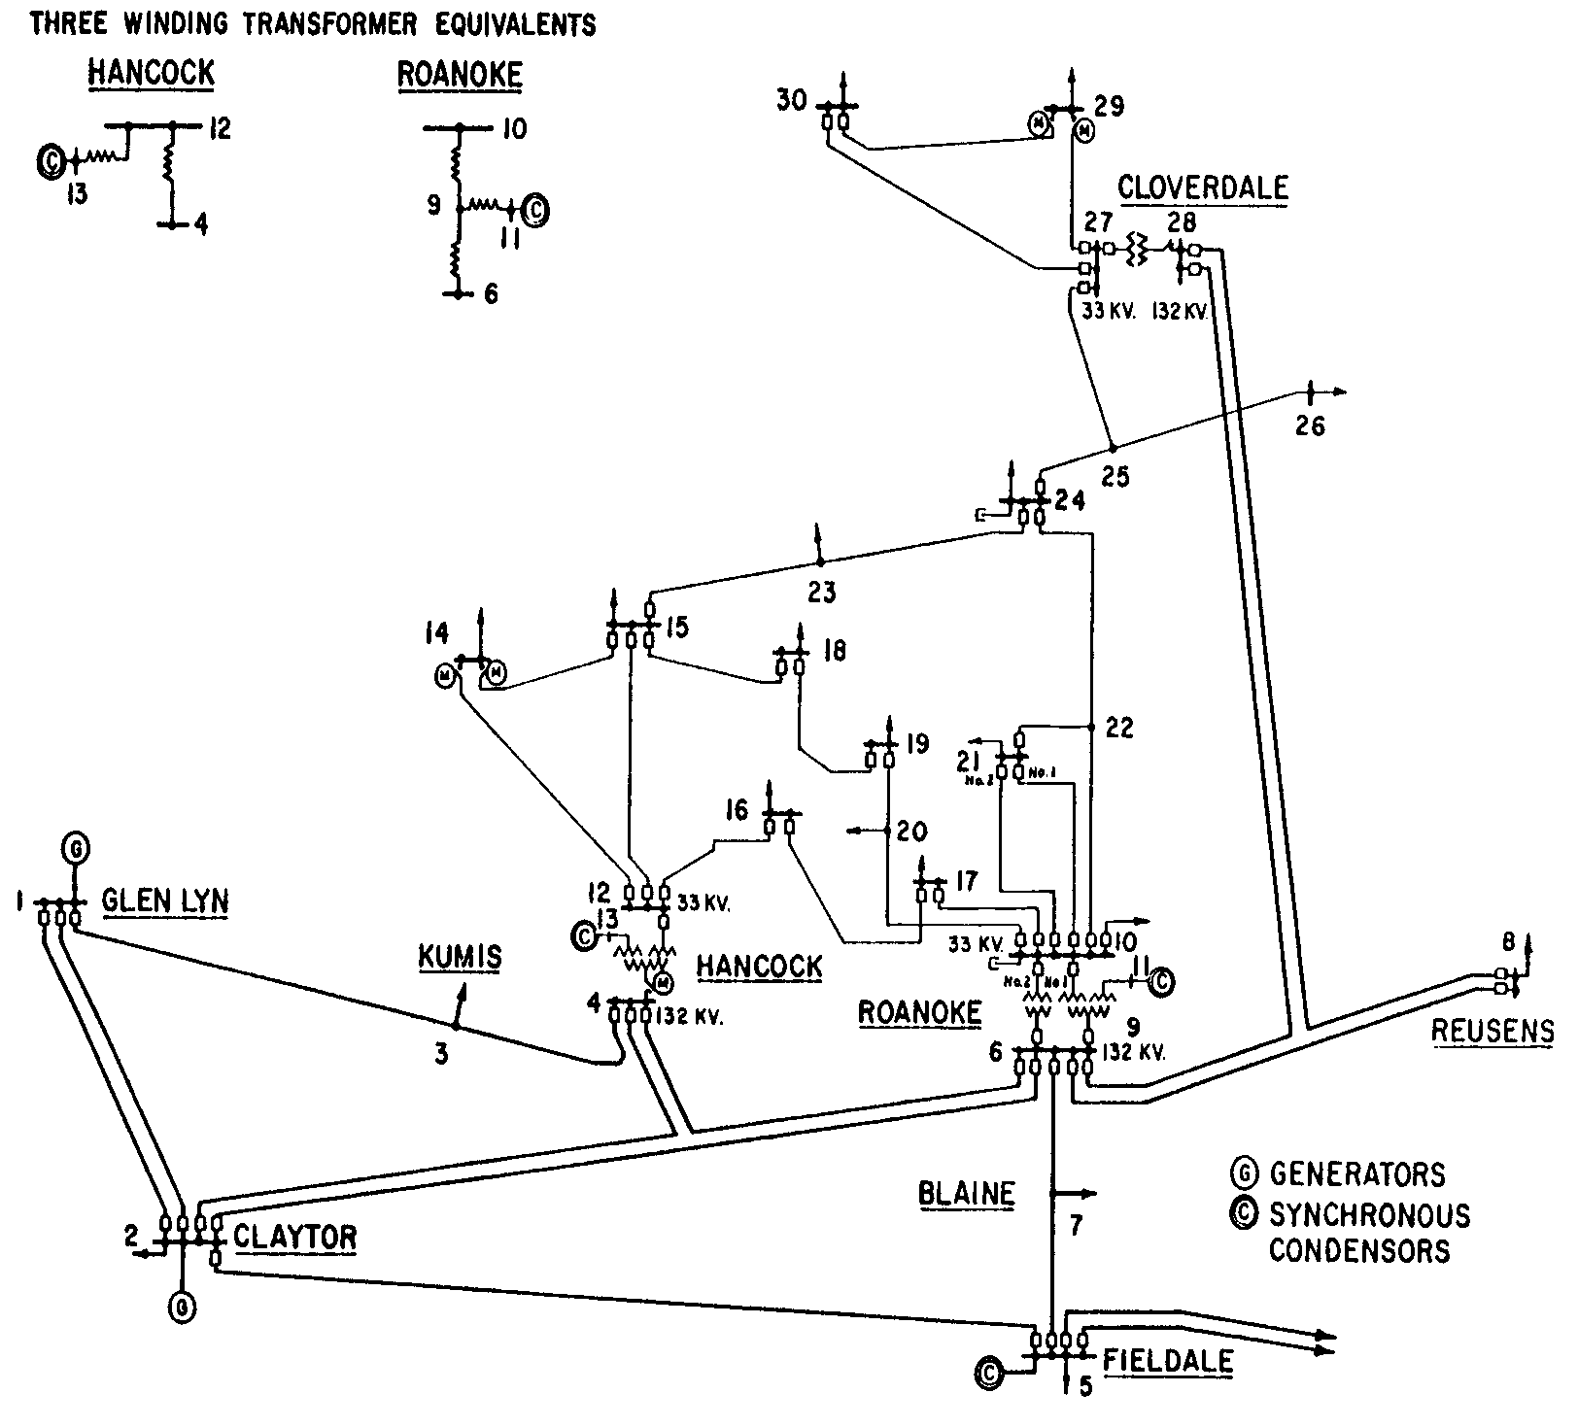

Fig (I-C) Bus-Code Diagram 30 Bus System

TABLE I-G
IMPEDANCE or LINE-CHARGING DATA (30 Bus System)
Line Designation | Resistance p.u.* | Reactance p.u.* | Line Charging | Tap Setting
1-2 | 0.0192 | 0.0575 | 0.0264 | 1
1-3 | 0.0452 | 0.1852 | 0.0204 | 1
2-4 | 0.0570 | 0.1737 | 0.0184 | 1
3-4 | 0.0132 | 0.0379 | 0.0042 | 1
2-5 | 0.0472 | 0.1983 | 0.0209 | 1
2-6 | 0.0581 | 0.1763 | 0.0187 | 1
4-6 | 0.0119 | 0.0414 | 0.0045 | 1
5-7 | 0.0460 | 0.1160 | 0.0102 | 1
6-7 | 0.0267 | 0.0820 | 0.0085 | 1
6-8 | 0.0120 | 0.0420 | 0.0045 | 1
6-9 | 0 | 0.2080 | 0 | 0.978
6-10 | 0 | 0.5560 | 0 | 0.969
9-11 | 0 | 0.2080 | 0 | 1
9-10 | 0 | 0.1100 | 0 | 1
4-12 | 0 | 0.2560 | 0 | 0.932
12-13 | 0 | 0.1400 | 0 | 1
12-14 | 0.1231 | 0.2559 | 0 | 1
12-15 | 0.0662 | 0.1304 | 0 | 1
12-16 | 0.0945 | 0.1987 | 0 | 1
14-15 | 0.2210 | 0.1997 | 0 | 1
16-17 | 0.0824 | 0.1923 | 0 | 1
15-18 | 0.1070 | 0.2185 | 0 | 1
18-19 | 0.0639 | 0.1292 | 0 | 1
19-20 | 0.0340 | 0.0680 | 0 | 1
10-20 | 0.0936 | 0.2090 | 0 | 1
10-17 | 0.0324 | 0.0845 | 0 | 1
10-21 | 0.0348 | 0.0749 | 0 | 1
10-22 | 0.0727 | 0.1499 | 0 | 1
21-22 | 0.0116 | 0.0236 | 0 | 1
15-23 | 0.1000 | 0.2020 | 0 | 1
22-24 | 0.1150 | 0.1790 | 0 | 1
23-24 | 0.1320 | 0.2700 | 0 | 1
24-25 | 0.1885 | 0.3292 | 0 | 1
25-26 | 0.2544 | 0.3800 | 0 | 1
25-27 | 0.1093 | 0.2087 | 0 | 1
27-28 | 0 | 0.3960 | 0 | 0.968
27-29 | 0.2198 | 0.4153 | 0 | 1
27-30 | 0.3202 | 0.6027 | 0 | 1
29-30 | 0.2399 | 0.4533 | 0 | 1
8-28 | 0.0636 | 0.2000 | 0.0214 | 1
6-28 | 0.0169 | 0.0599 | 0.0065 | 1

*Impedance and line-charging susceptance in p.u. on a 100 MVA base. Line charging one-half of total charging line.
TABLE I-H
BUS DATA or Operating Conditions (30 Bus System)
 |  |  | Generation | Generation | Load | Load
Bus No. | Magnitude p.u. | Phase Angle  Degrees | MW | MVAR | MW | MVAR
1* | 1.06 | 0 | 0 | 0 | 0 | 0
2 | 1 | 0 | 40 | 0 | 21.7 | 12.7
3 | 1 | 0 | 0 | 0 | 2.4 | 1.2
4 | 1 | 0 | 0 | 0 | 7.6 | 1.6
5 | 1 | 0 | 0 | 0 | 94.2 | 19.0
6 | 1 | 0 | 0 | 0 | 0 | 0
7 | 1 | 0 | 0 | 0 | 22.8 | 10.9
8 | 1 | 0 | 0 | 0 | 30.0 | 30.0
9 | 1 | 0 | 0 | 0 | 0 | 0
10 | 1 | 0 | 0 | 0 | 5.8 | 2.0
11 | 1 | 0 | 0 | 0 | 0 | 0
12 | 1 | 0 | 0 | 0 | 11.2 | 7.5
13 | 1 | 0 | 0 | 0 | 0 | 0
14 | 1 | 0 | 0 | 0 | 6.2 | 1.6
15 | 1 | 0 | 0 | 0 | 8.2 | 2.5
16 | 1 | 0 | 0 | 0 | 3.5 | 1.8
17 | 1 | 0 | 0 | 0 | 9.0 | 5.8
18 | 1 | 0 | 0 | 0 | 3.2 | 0.9
19 | 1 | 0 | 0 | 0 | 9.5 | 3.4
20 | 1 | 0 | 0 | 0 | 2.2 | 0.7
21 | 1 | 0 | 0 | 0 | 17.5 | 11.2
22 | 1 | 0 | 0 | 0 | 0 | 0
23 | 1 | 0 | 0 | 0 | 3.2 | 1.6
24 | 1 | 0 | 0 | 0 | 8.7 | 6.7
25 | 1 | 0 | 0 | 0 | 0 | 0
26 | 1 | 0 | 0 | 0 | 3.5 | 2.3
27 | 1 | 0 | 0 | 0 | 0 | 0
28 | 1 | 0 | 0 | 0 | 0 | 0
29 | 1 | 0 | 0 | 0 | 2.4 | 0.9
30 | 1 | 0 | 0 | 0 | 10.6 | 1.9
* Slack Bus

TABLE I-I
Regulated Bus Data (30 Bus System)
Bus Number | Voltage Magnitude p.u. | Minimum MVAR Capability | Maximum MVAR Capability
2 | 1.045 | -40 | 50
5 | 1.01 | -40 | 40
8 | 1.01 | -10 | 40
11 | 1.082 | -6 | 24
13 | 1.071 | -6 | 24

TABLE I-J
Transformer Data (30 Bus System)
Transformer Designation | Tap Setting*
4-12 | 0.932
6-9 | 0.978
6-10 | 0.969
28-27 | 0.968

* Off-nominal turns ratio, as determined by the actual transformer-tap positions and the voltage bases. In the case of nominal turns ratio, this would equal 1.

TABLE I-K
Static Capacitor Data (30 Bus System)
Bus Number | Susceptance* p.u.
10 | 0.19
24 | 0.043

* Susceptance in p.u. on 100 MVA base.

Cost Characteristics:
C₁ = 50 P₁^2 + 245 P₁ + 105 $/hr
C₂ = 50 P₂^2 + 351 P₂ + 44.4 $/hr
C₈ = 50 P₈^2 + 389 P₈ + 40.6 $/hr
Maximum and minimum active power constraint on the generator bus for the given system is 150 MW and 50 MW respectively. Voltage magnitude constraint for generator bus 2 is 1.045, for bus no. 5 is 1.01, for bus no. 8 is 1.010, for bus no. 11 is 1.082 & for bus no. 13 is 1.071
The noninferior set for the above system has been obtained by solving the following problem.

Minimize
F_{(C)}
s.t.
50<=P_{i}<=150 for i = 1, 2, 8
P_{D} + P_{L} - $\sum_{n}^{\text{NG}}{}$P_{n} = 0
F_{L} ≤ F_{Lmin} + δF_{L}

Emission Characteristics

E₁ = 135.5 P₁^2 – 126.5 P₁ +22.9 $/hr
E₂ = 124.8 P₂^2 - 137.8 P₂ + 137.3 $/hr
E₈ = 80.5 P₈^2 – 76.7 P₈ + 367.7 $/hr
The noninferior set for the above system has been obtained by solving the following problem.
Minimize
F_{(e)}
st.
50<=P_{i}<=150 for i = 1, 2, 8
P_{D} + P_{L} - $\sum_{n}^{\text{NG}}{}$P_{n} = 0
F_{L} ≤ L₁
M-file For Calculating B-Coefficients:
clear
basemva=100;
accuracy=0.0001;
maxiter=10;
busdata=[1 1 1.06 0 0 0 0 0 0 0 0; 2 2 1.045 0 21.7 12.7 90 0 -40 50 0; 3 0 1 0 2.4 1.2 0 0 0 0 0; 4 0 1 0 7.6 1.6 0 0 0 0 0; 5 0 1.01 0 94.2 19 0 0 -40 40 0; 6 0 1 0 0 0 0 0 0 0 0; 7 0 1 0 22.8 10.9 0 0 0 0 0; 8 2 1.01 0 30 30 150 0 -10 40 0; 9 0 1 0 0 0 0 0 0 0 0; 10 0 1 0 5.8 2 0 0 0 0 0.19; 11 0 1.082 0 0 0 0 0 -6 24 0; 12 0 1 0 11.2 7.5 0 0 0 0 0; 13 0 1.071 0 0 0 0 0 -6 24 0; 14 0 1 0 6.2 1.6 0 0 0 0 0; 15 0 1 0 8.2 2.5 0 0 0 0 0; 16 0 1 0 3.5 1.8 0 0 0 0 0; 17 0 1 0 9 5.8 0 0 0 0 0; 18 0 1 0 3.2 0.9 0 0 0 0 0; 19 0 1 0 9.5 3.4 0 0 0 0 0; 20 0 1 0 2.2 0.7 0 0 0 0 0; 21 0 1 0 17.5 11.2 0 0 0 0 0; 22 0 1 0 0 0 0 0 0 0 0; 23 0 1 0 3.2 1.6 0 0 0 0 0; 24 0 1 0 8.7 6.7 0 0 0 0 0.043; 25 0 1 0 0 0 0 0 0 0 0; 26 0 1 0 3.5 2.3 0 0 0 0 0; 27 0 1 0 0 0 0 0 0 0 0; 28 0 1 0 0 0 0 0 0 0 0; 29 0 1 0 2.4 0.9 0 0 0 0 0; 30 0 1 0 10.6 1.9 0 0 0 0 0];
linedata=[1 2 0.0192 0.0575 0.0264 1; 1 3 0.0452 0.1852 0.0204 1; 2 4 0.0570 0.1737 0.0184 1; 3 4 0.0132 0.0379 0.0042 1; 2 5 0.0472 0.1983 0.0209 1; 2 6 0.0581 0.1763 0.0187 1; 4 6 0.0119 0.0414 0.0045 1; 5 7 0.0460 0.1160 0.0102 1; 6 7 0.0267 0.0820 0.0085 1; 6 8 0.0120 0.0420 0.0045 1; 6 9 0 0.2080 0 0.978; 6 10 0 0.5560 0 0.969; 9 11 0 0.2080 0 1; 9 10 0 0.1100 0 1 ; 4 12 0 0.2560 0 0.932; 12 13 0 0.1400 0 1; 12 14 0.1231 0.2559 0 1; 12 15 0.0662 0.1304 0 1; 12 16 0.0945 0.1987 0 1; 14 15 0.2210 0.1997 0 1; 16 17 0.0824 0.1923 0 1; 15 18 0.1070 0.2185 0 1; 18 19 0.0639 0.1292 0 1; 19 20 0.0340 0.0680 0 1; 10 20 0.0936 0.2090 0 1; 10 17 0.0324 0.0845 0 1; 10 21 0.0348 0.0749 0 1; 10 22 0.0727 0.1499 0 1; 21 22 0.0116 0.0236 0 1; 15 23 0.1000 0.2020 0 1; 22 24 0.1150 0.1790 0 1; 23 24 0.1320 0.2700 0 1; 24 25 0.1885 0.3292 0 1; 25 26 0.2544 0.3800 0 1; 25 27 0.1093 0.2087 0 1; 27 28 0 0.3960 0 0.968;27 29 0.2198 0.4153 0 1; 27 30 0.3202 0.6027 0 1; 29 30 0.2399 0.4533 0 1;8 28 0.0636 0.2000 0.0214 1; 6 28 0.0169 0.0599 0.0065 1];
disp(busdata)
disp(linedata)
lfybus
lfnewton
busout
bloss
B-Coefficients Calculated are as:
B11 = 0.0307
B12 = 0.0129
B13 = 0.0002
B21 = 0.0129
B22 = 0.0152
B23 = - 0.0011
B31 = 0.0002
B32 = - 0.0011
B33 = 0.0190

M- File For 2-D PROBLEM:
Objective Function M-file:
Function z = objective30bus(x)
z = ((50*(x(1)/100)*(x(1)/100)) + (245*(x(1)/100))+105 + (50*(x(2)/100)* (x(2)/100)) + (351*(x(2)/100)) + 44.4 + (50*(x(3)/100)*(x(3)/100)) + (389* (x(3)/100))+40.6);

Constraint Function M-File:
Function [c,ceq]=constraint30bus(x)
c=[-x(1)+50;x(1)-150;-x(2)+50;x(2)-150;-x(3)+50;x(3)-150];
ceq=[(x(1)+x(2)+x(3))-283.4-(100*(((x(1)/100)*(x(1)/100)*0.0307) + (2* (x(1)/100)*(x(2)/100)*0.0129) + (2*(x(1)/100)*(x(3)/100)*(0.0002)) + (( x(2)/100)*(x(2)/100)*0.0152) + (2*(x(2)/100)*(x(3)/100)*(-0.0011)) + (( x(3)/100)*(x(3)/100)*0.0190))); (100*(((x(1)/100)*(x(1)/100)*0.0307) + ( 2*(x(1)/100)*(x(2)/100)*0.0129) + (2*(x(1)/100)*(x(3)/100)*(0.0002)) + (( x(2)/100)*(x(2)/100)*0.0152) + (2*(x(2)/100)*(x(3)/100)*(-0.0011)) + (( x(3)/100)*(x(3)/100)*0.0190)))-specified loss];

M- File For 3-D PROBLEM:

Objective Function M-file:
Function z = objective30busel(x)
z = ((50*(x(1)/100)*(x(1)/100)) + (245*(x(1)/100))+105 + (50*(x(2)/100) *(x(2)/100)) + (351*(x(2)/100)) + 44.4 + (50*(x(3)/100)*(x(3)/100)) + (389 *(x(3)/100))+40.6);

Constraint Function M-File:
Function [c,ceq]=constraint30busel(x)
c=[-x(1)+50;x(1)-150;-x(2)+50;x(2)-150;-x(3)+50;x(3)-150];
ceq=[(x(1)+x(2)+x(3))-283.4-(100*(((x(1)/100)*(x(1)/100)*0.0307) + (2* (x(1)/100)*(x(2)/100)*0.0129) + (2*(x(1)/100)*(x(3)/100)*(0.0002)) + (( x(2)/100)*(x(2)/100)*0.0152) + (2*(x(2)/100)*(x(3)/100)*(-0.0011)) + (( x(3)/100)*(x(3)/100)*0.0190)));((135.5*(x(1)/100)*(x(1)/100)) + (-126.5* (x(1)/100)) + 22.9 + (124.8*(x(2)/100)*(x(2)/100)) + (-137.8*(x(2)/100)) + 137.3 + (80.5*(x(3)/100)*(x(3)/100)) + (-76.7*(x(3)/100)) + 363.7)-specified emission]; (100*(((x(1)/100)*(x(1)/100)*0.0307) + (2*(x(1)/100)*(x(2)/100)*0.0129) + (2*(x(1)/100)*(x(3)/100)*(0.0002)) + ((x(2)/100)*(x(2)/100)*0.0152) + (2*(x(2)/100)*(x(3)/100)*(-0.0011)) + ((x(3)/100)*(x(3)/100)*0.0190-specified loss)));

APPENDIX II

MATHEMATICAL STATEMENT OF NONINFERIORTY

Single objective problems are characterized by complete ordering of their feasible solutions. Any two feasible solutions X₁ and X₂ are comparable in terms of the objective function; i.e. either
Z(X¹) = Z(X²), Z(X¹) > Z(X²), Z(X¹)<Z(X²).
This comparison can be made for all the feasible solutions, and the solution X* for which there exists no other solution X such that Z(X) < Z(X*) is called optimal solution for a minimization problem. But, in multiobjective problems, it is not possible to compare all the feasible solutions because the comparison on the basis of one objective function may contradict the comparison based on another objective function.
Suppose there are two objective functions,
Z(X) = [(Z₁(X), Z₂(X)] (1)
and two solutions X^{1,} X² . Then,
Z(X¹) = [ Z₁(X¹), Z₂(X¹)] (2)
Z(X²) = [ Z₁(X²), Z₂(X²)] (3)
X¹ is better than X² if
Z₁(X¹) < Z₁(X²) and Z₂(X¹) ≤ Z₂(X²)
or
Z₁(X¹) ≤ Z₁(X²) and Z₂(X¹) < Z₂(X²)
but if Z₁(X¹) < Z₁(X²) AND Z₂(X¹) > Z₂(X²), then nothing can be said about the two solutions – X¹ , X² , i.e. they are incomparable. This is what is meant by partial ordering. All solutions are not comparable on the basis of the values objective functions only. Since a complete order is not available, the notion of optimality must be dropped.
The partial ordering in multiobjective problems does not allow some feasible solutions to be eliminated. Inferior solutions, which are dominated by at least one feasible solution, may be dropped. Noninferior solutions are the alternatives of interest.
Mathematically, a solution X is noninferior for a minimization problem if there exist no fesible Y such that
Z_{K}(Y) ≤ Z_{K}(X) VK= 1,2……H (4)
and
Z_{K}(Y) < Z_{K}(X) for at least one K = 1,2……h (5)
The noninferior set generally includes many alternatives, all of which obviously cannot selected. The objectives must be traded off against each other in moving from one noninferior alternative to another and a strategy has to be adopted by the analyser to achieve optimum values as per his satisfaction level and requirements. The preferred alternative is called Target Point or the best compromise solution.

REFRENCES
- Kuhn, H.W., Tucker, A.W. ‘Nonlinear Programming’, Proc. Of Second Berkley Symposium on mathematical Statistics and Probability, edited by J.Neyman, University of California Press, Berkeley, California, 1951, pp.481-492.
- Gass, S., And Satty, T., ‘ The Computational Algorithm for the Parametric Objective Function,’ Naval Res. Logist. Quart., Vol. 2, No.39, 1955.
- Steveson,W.D., ‘ Elements Of Power System Analysis’, McGraw Hill Book Co., 1962.
- Marglin, S., ‘Public Investment Criteria,’ MIT Press, Cambridge, Mass., 1967.
- Cohon, J. Marks, D., ‘Multiobjective Screening Models and Water Resources Investment’, Water Resources Res, Vol.9, No.826, 1973 .
- Cohon, J.L. Marks, D.H., ‘A Review and Evaluation of multiobjective programming techniques,’ Water Resource Research, April, Vol. 11, 1975, pp.208-220.
- Jared L. Cohon, Multi-objective Programming and Planning, Academic Press New York, 1978.
- J.Nanda, D.P.Kothari, K.S.Lingamurthy “Economic-Emission Load Dispatch through Goal Programming Techniques” by. IEEE Transactions on Energy Conversion, Vol. 3, No. 1, March 1988, pp.26-32.
- D. E. Goldberg, Genetic Algorithm in Search, Optimization and Machine Learning, Addison Wisely, 1989.

- Wadhwa, C.L, Jain,N.K, ‘ Multiple Objective Optimal Load Flow: a new perspective’, IEE Proc.c, Vol.137, No.1, Jan 1990, PP 11-18.
- Miller, J.A.; Potter, W.D.; Gandham, R.V.; Lapena, C.N “An evaluation of local improvement operators for genetic algorithms”; Systems, Man and Cybernetics, IEEE Transactions on Volume 23, Issue 5, Sept.-Oct. 1993, pp.1340 - 1351 Digital Object Identifier 10.1109/21.260665.
- Nagia, Uma, Jain, N.K, Wadhwa, C.L, ‘ Multiobjective Load Flow Studies Through Maximisation of Minimum Relative Attainments’, Vol 77, Nov 1996, pp.154-159.
- Chaiyaratana, N.; Zalzala, A.M.S “Recent developments in evolutionary and genetic algorithms: theory and applications”; Genetic Algorithms in Engineering Systems: Innovations and Applications, 1997. GALESIA 97. Second International Conference On (Conf. Publ. No. 446) 2-4 Sept. 1997, pp.270 – 277.
- A.M.S Zalzala & P.J. Fleming, genetic algorithms in engineering systems, Institution of Electrical Engineering, 1997.
- Melane Mitchell, an Introduction to Genetic Algorithm, Mit Press, 1998.
- Hadi Saadat, Power System Analysis, Mcgraw Hill, 2002.
- Ling, S.H.; Lam, H.K.; Leung, F.H.F.; Lee, Y.S “Improved genetic algorithm for economic load dispatch with valve-point loadings”; Industrial Electronics Society, 2003. IECON '03. The 29th Annual Conference of the IEEE Volume 1, 2-6 Nov. 2003, pp.442 - 447 vol.1 Digital Object Identifier 10.1109/IECON.2003.1280021.

- D.P Kothari and J.S Dhillon, Power System Optimization, Prentice Hall of India, 2006.
- S.S.Rao, Optimization Theory and Application by, Wiley, 2007.
- Ling, S.H.; Lu, H.H.C.; Chan, K.Y.; Ki, S.K, “Economic load dispatch: A new hybrid particle swarm optimization approach”; Universities Power Engineering Conference, 2007. AUPEC 2007. Australasian 9-12 Dec. 2007 pp.1 - 8 Digital Object Identifier 10.1109/AUPEC.2007.4548052.
- Michael Affenzeller , Stefan Wanger , Stepahan Winkler & Andreas Bahem ; Genetic Algorithm and Genetic Programming, Crc Press, 2009.
- C.L.Wadhwa, Electrical Power System, New Age International Publisher Ltd, 2009.

