SPECIALTY POLYMERS
(With Special Reference to Hydrophilic Polymers-Hydrogel)

A MINOR PROJECT SUBMITTED IN THE PARTIAL FULFILLMENT OF THE REQUIREMENT OF FOR THE AWARD
OF THE DEGREE OF

MASTER OF ENGINEERING
IN
POLYMER TECHNOLOGY

Submitted By

LALKESH BAHADUR SINGH
Under The Supervision Of
Dr. A.P. GUPTA

DEPARTMENT OF APPLIED CHEMISTRY and Polymer Technology

DELHI COLLEGE OF ENGINEERING
(University Of Delhi)
New Campus, Bawana Road,
Delhi-42

Certificate

This is to certify that the project entitled “SPECIALTY POLYMERS” Submitted by Mr. Lalkesh Bahadur Singh for the award of the degree of Mater of Engineering in Polymer Technology. This is a bonafide record of the work carried by him under the Guidance and supervision of the Undersigned.
The project have not been submitted to any other university or Institute for the award of any degree or Diploma to the best of our knowledge.

Dr. A.P.Gupta Dr. G.L. Verma
Supervisor Head
Department of Applied Department of
Chemistry & Polymer applied chemistry
Tech. & Polymer Tech.
Delhi College of Engg. Delhi college of Engg.

Acknowledgement

I am highly grateful and indebted to Dr. A.P. Gupta, Supervisior Department of Applied Chemistry and Polymer Technology, Dr. G.L. Verma, Head, Department of Applied Chemistry and Polymer Technology for their valuable guidance, moral support and motivation through out the period of my course.

(LALKESH BAHADUR SINGH)

SUMMARY
The contribution of polymers are to be seen around the home, at work, in transport and in leisure pursuits. The majority of these polymers are synthetic and are derived from oil products. The most important of these in- terms of tonnage used are polymers based upon styrene, vinyl chloride, ethylene, propylene and butadiene among plastics and rubber materials, and nylons, Polyethyleneterephthalate and polyacrylonitrile among fibres. The total amount of these polymers used each year runs into millions of tonnes.
These polymers are known as commodity polymers because they are used for everyday. Often, grades are specially designed and formulated to meet particular requirements and called as specialty polymer.
There are many advantages to using polymers in applications which previously would not have been considered suitable or feasible. A great deal of research and development has gone into creating polymers to meet the demands of these specialized applications. The electronics industry. for example. could not have developed without the use of polymeric materials which have been created to meet the most exacting requirements. Compared with the commodity polymers, the tonnage production of these Polymers is small being measured in tonnes each year. They are usually costly partly because the quantities required are small and partly because the processes for making them are themselves expensive.

CONTENTS
Page No.
Chapter 1. POLYMER STRUCTURES AND GENERAL PROPERTIES
  - INTRODUCTION 1
  - POLYMER STRUCTURES 1
  - MORPHOLOGY AND SOFTENING BEHAVIOUR 4
  - AMORPHOUS POLYMERS AND SOFTENING BEHAVIOUR 7
  - SEMI-CRYSTALLINE POLYMERS AND SOFTENING BEHAVIOUR 8
  - MOLECULAR WEIGHT 10

  - COPOLYMERS 12

  - CHEMICAL BEHAVIOUR 14
  - SOLUBILITY 18
  - ELECTRICAL PROPERTIES 19
Chapter 2. HYDROPHILIC POLYMERS (HYDROGELS)
  - HYDROGELS 21
2.2 POLYACRYLAMIDE HYDROPHILIC POLYMERS 26
2.3 POLYVINYL ALCOHOL 28
2.4 POLYVINYL PYRROLIDONE (PVP) 29
Chapter 3. APPLICATIONS OF HYDROPHILIC POLYMERS 30

Refrences

CHAPTER – 1
POLYMER STRUCTURES AND GENERAL PROPERTIES
1.1 INTRODUCTION
Polymers are large molecular structures in which many small units are linked together. The molecular weights of polymers vary from 20000 to infinity depending on the type and structure. The majority of useful polymers are organic chemicals i.e. they are based upon the elements carbon and hydrogen. They occur in nature as starches, cellulose and proteins and some of these are chemically converted into useful derivative are known as semi-synthetic polymers. The vast majority of polymers used today as plastics, rubbers, adhesives and paints are synthetic and are made from chemicals derived from oil. The reason for this is that the properties of a polymer depend on the chemical structure and composition. Natural polymers exist with a particular chemical structure and although in some cases this can be chemically modified. The synthesis of polymers from simple chemicals derived from oil affords the potential to produce an almost unlimited range of polymers with desirable properties.
1.2 POLYMER STRUCTURES
There are two types of polymer. those which are linear or branched and those which are cross-linked. Linear polymers are long chain molecules in which the units which make up the polymer are joined together end to end like beads in a necklace . An example is polyethylene in which ethylene units are joined together in the polymerization process to form polyethylene:
CH₂=CH₂→ —CH₂-CH₂-CH₂-CH₂-CH₂-CH₂-
Sometimes, these chains are branched, i.e. the chain divides at some point to produce two linked chains. In the majority of branched chain structures, the branches are long and few in number. In the case of polyethylene. however. the branches are short and contain an even number of carbon atoms between
1
two and eight depending on the type of polyethylene. A typical long chain branched structure is shown in Figure 1.
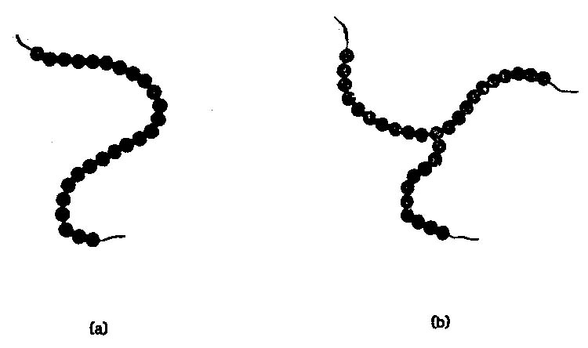
Figure 1: Polymer chains (a) linear : (b) branched
Linear polymers are thermoplastic. If they are heated, they soften at a temperature which is characteristic of the polymer. This softening behaviour is reversible if the polymer is cooled. It will harden again as the characteristic temperature is traversed. Polymers which soften below room temperature are rubbery solids or viscous fluids at room temperature. Polymers which soften above room temperature are hard brittle solids or tough ductile solids at room temperature.
Cross-linked polymers consist of chains which are joined together by a sequence of covalently bonded atoms which form the cross-links. The cross-links may be long or short but in most commercial polymers, the cross-links are short. Examples of cross-linked polymers are vulcanized rubbers and thermosetting plastics such as urea formaldehyde. A diagrammatic representation of a cross linked system is shown in Figure 2. The properties of a cross-linked polymer will depend upon the degree of cross-linking. If the degree of cross-linking is low, there will be relatively long sequences of the main polymer chain between cross-links. In such cases, the polymer will behave in some respects like an uncross-linked polymer. For example, such polymers show softening behaviour.
2
Vulcanized rubber usually have a low degree of cross-linking and the cross-links are present to achieve the properties of high elasticity and creep resistance on the polymer. These polymers show reversible hardening if cooled sufficiently below room temperature. If the degree of cross-linking is high, the chain sequences between cross-links are very short and softening behavior is lost. The thermoset polymers such as urea formaldehyde,they set permanently during cross-linking to form hard brittle materials which are not softened by heat.
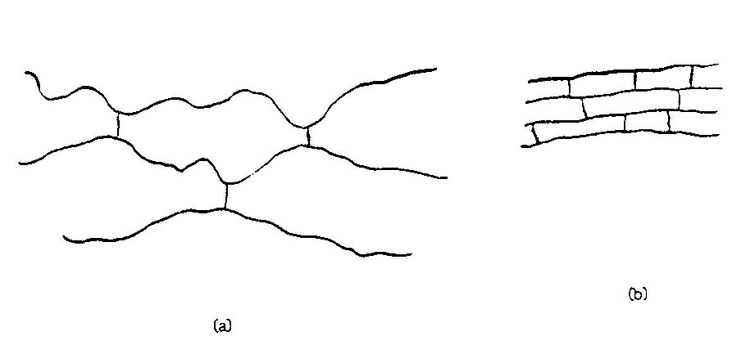
Figure 2: Cross-lined polymers : (a) with low degree of cross linking (b) with high degree of cross-linking.
Cross-linking makes polymers insoluble although lightly cross-linked polymers will swell in Liquids that are solvents for the non-cross-linked polymer. The amount of swelling decreases with increasing cross-link density and highly cross-linked polymers hardly swell at all.

3
1.3 MORPHOLOGY AND SOFTENING BEHAVIOUR
Linear polymers can be divided into those which can crystallize and those which cannot. Those which cannot crystallize form an amorphous solid which can be regarded as a frozen liquid structure. Polymers which can crystallize never crystallize completely and are referred to as semi-crystalline even though the amount of crystallinity may very between 25% and 80%. Whether a polymer can crystallize or not depends upon the regularity of the chain structure.
Polymer will crystallize if they are able to pack together in a highly ordered way. Although there are exceptions, like polyvinyl alcohol this meanes that the polymer chains themselves should have regular structures. The polyethylene chain is highly regular and therefore readily crystallizes. It should be noted, however. that the highly branched low density polyethylene is less crystalline than the more linear high density polyethylene.

4
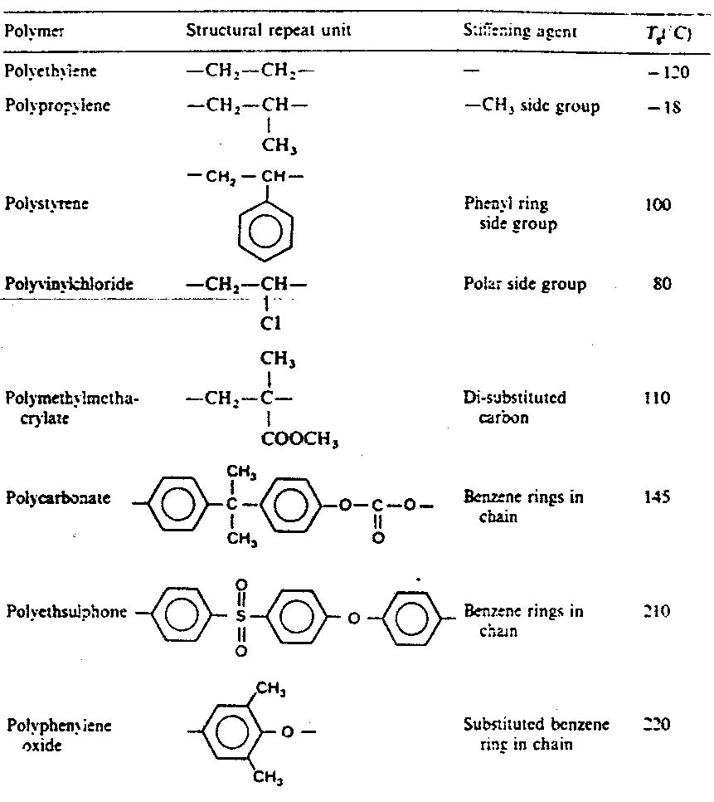
Table : 1 Structure of some Polymers

5
In substituted hydrocarbon chains the attached atom or group (X) is attached to alternate carbon atoms:
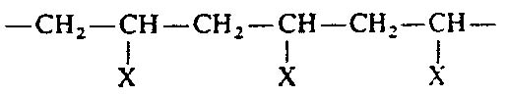
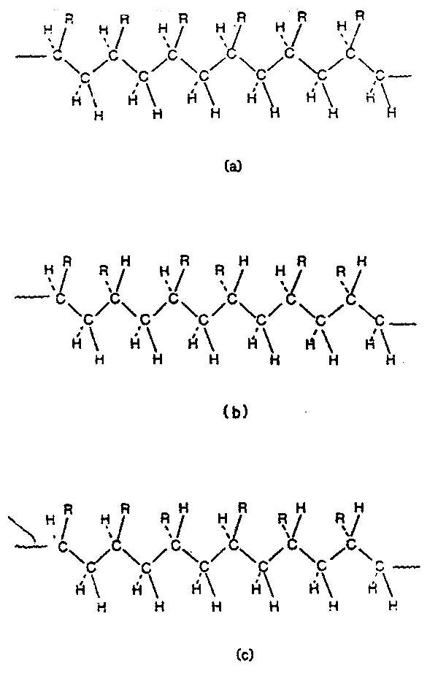
Fig. 3 : Monosubstituted Polymer tacticity : (a) Isotectic Syndiotectic (c) atactic
The substituted carbon atom is asymmetric and this leads to three possible chain structures which are shown in Figure 3. Only the isotactic and syndiotactic forms are regular and these are the forms that will crystallize. The actactic form is too irregular to crystallize and atactic polymers are mostly amorphous. Polyvinyl alcohol is atactic but crystallizes because the -OH group is small enough to be accommodated in a close packed arrangement of the polymer chains.
6
Interpolation of groups in the polymer chain usually permits crystallization if the interpolation is on a regular basis.
An important factor in determining whether a polymer is found in the semi-crystalline state, even it is crystallizable, is the rate of crystallization. If the rate is very slow crystallinity may not be observed. An example is natural rubber which crystallizers very slowly at room temperature but appreciably faster at about -23⁰C. other examples include many engineering thermoplastics such as polycarbonates which only crystallize at appreciable rates at temperatures well above room temperature. Consequently these polymers, although crystallizable, are usually amorphous.
1.4 AMORPHOUS POLYMERS AND SOFTENING BEHAVIOUR
The temperature at which the polymer changes from a rigid polymer to a flexible polymer is known as the glass transition temperature (T_{g}).
The value of T_{g} for a specific polymer will depend upon the structure of the polymer. Side groups attached to the polymer main chain will in general hinder rotation in the polymer backbone necessitating higher temperatures to give enough energy to enable rotation to occur. The amount of extra energy will depend upon the size, stiffness, polarity and frequency of the attached groups. An increase in any of these factors will increase T_{g} (Table 1). If groups are introduced into the polymer chain, T_{g} will be affected. If rigid group are introduced, the polymer chain becomes inherently stiffer and will require high temperatures to make the chain flexible. The benzene ring is a common stiffening unit in polymers designed to have a high softening point and if these are present at sufficient frequency in the chain, the glass transition temperature can be well above 200 °c. Amorphous polymers retaining glass-like properties to high temperatures are almost always aromatic in character. A consequence of creating stiff chains to produce polymers with high Tg the melt viscosity also becomes very high. Melt processing therefore becomes very difficult and sometimes impossible. It would appear that a T_{g} of around 250 C is the highest temperature obtainable that is compatible with melt processing.
7
1.5 SEMI-CRYSTALLINE POLYMERS AND SOFTENING BEHAVIOUR
The melting point is the temperature at which sufficient thermal energy is available to disrupt the ordered structure of the crystalline polymer. Since the melting point is higher than the glass transition temperature, the polymer becomes an amorphous liquid above the melting point.
The melting point is given by
$$T_{m}=\frac{ΔH}{ΔS}$$
where ΔH is the heat (enthalpy) of melting and ΔS is the entropy change which accompanies melting. The enthalpy is essentially the energy required to overcome the inter-chain forces which bind the polymer chains together in the crystalline regions. The energy required will depend upon the strength and frequency of the inter-chain forces. Inter-chain forces commonly found in polymers in decreasing order of strength are: hydrogen bonds (e.g. polyamides) polar or dipole bonds (e.g. polyesters) dispersion forces (e g. polyethylene). The entropy term is a measure of the change in chain flexibility as the polymer melts. Chains which are inherently flexible in the melt will have a high entropy change whereas polymer chains which are inherently stiff in the melt will have a small entropy change. Flexible chains will be characterized by a low glass-transition temperature and a low melt viscosity whereas rigid chains will be characterized by a high Tg and a high melt viscosity.
For most polymers it is the enthalpy which determines the melting point but in the case of polytetrafluoroethylene (PTFE) it is the entropy which determines the very high melting point 327 ⁰C. The inter-chain forces in PTFE are weak but the fluorine atoms provide exceptional rigidity on the polymer chain to the extent that even in the liquid state above T_{m}, the polymer chains are virtually inflexible. The melt viscosity is so high that PTFE cannot be processed by normal melt processing techniques.

8
It follows from the above that a rigid chain structure should lead to a high melting point and to a high glass transition temperature. This is found to be so in practice and there is a rule-of-thumb derived from experimental observations which relates T_{g} and T _{m} (both in K) viz:
$$\frac{T_{g}}{T_{m}}=\frac{2}{3}$$
At temperatures between the melting point and glass transition temperature, the amorphous content of the polymer will be soft and rubbery while the crystalline content will retain its integrity until the melting point is reached. Since the crystalline polymer confers rigidity on the polymer as a whole it is clear that the softening temperature of the polymer is control1ed by the amount of crystalline. For a high softening point, it is desirable to have as much crystalline as possible but most commercial process for shaping polymer do not allow significant control of the amount of crystallinity with the majority of semi-crystalline polymers.

9
1.6 MOLECULAR WEIGHT
The molecular weight of linear polymers affects their properties. The molecular weight is related to the number of repeat units in the chain by the equation :1
M = n x M₀
where n is the number of repeat units in the chain and M₀ is the molecular weight of the repeat unit. It is impossible to manufacture polymer in which the chains all have the same length. A polymer sample therefore contains a distribution of molecular weights (Figure 4).
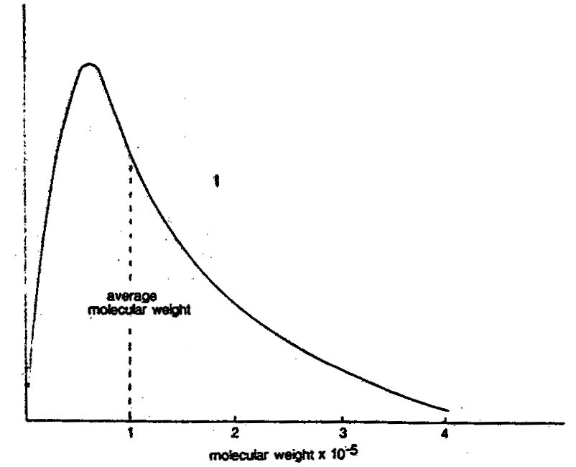
Figure 4: Calculated molecular weight distribution curve for polystyrene of average molecular weight 10⁵

10
Equation 1 should be modified to
M=n x M₀
M is the average molecular weight and n is the average number of units per chain. It is easy to control the molecular weight average during polymerization but not the distribution.
The strength properties increase with increasing molecular weight in a non-linear fashion (Figure :5). It is found that there is a minimum molecular weight before desirable strength properties are obtained. This minimum is usually about 20000. Increasing the molecular weight above this minimum is desirable for increased strength but increasing molecular weight has sometimes undesirable, effects. The melt viscosity for example increases and makes melt processing more difficult, solubility decreases and crystallization becomes more difficult because of the increase in chain entanglements in the melt. If the molecular ‘weight distribution is broad the presence of the high and low molecular weight fractions in the distribution will affect the properties of the polymer and it will behave different from a narrow molecular weight distribution of the same polymer having the same average molecular weight. The presence of low molecular weight polymer will, for example, enhance melt flow but presence of high molecular weight polymer may lead to incomplete solubility when the polymer is placed in suitable solvents.
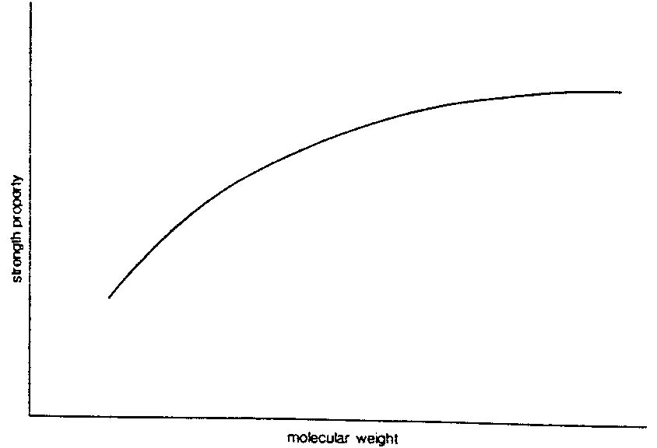
Figure :5 Effect of molecular weight (chain length) on strength properties.
11
1.7 COPOLYMERS
Copolymers are polymer chains which consists of two types of repeat units. Typical examples are vinyl chloride-vinyl acetate copolymers for the manufacture of gramophone record and styrene-butadiene copolymers which are the most important synthetic rubbers in terms of tonnage used. The name ‘homopolymer’ is sometimes used for polymers consisting of a single repeat unit. Polymers with three repeat units comprising the chain are called terpolymers.
The properties of copolymers depend upon the chemical nature of the constituent units, the relative amounts of these units in the copolymer chain and the arrangement of the units in the chain. There are four types of arrangement in principle, and the are called block copolymers, graft copolymers, alternating copolymers and random copolymers. These are illustrated in Figure :6 where A and B denote the two different repeat units.
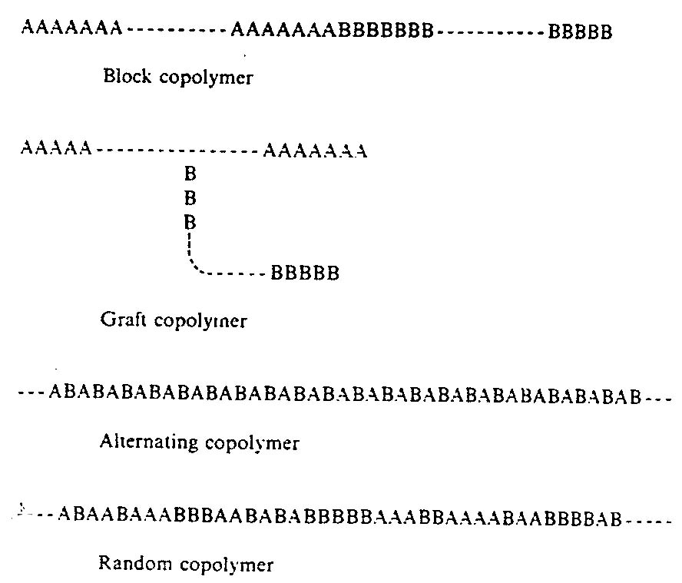
Fig. 6 Copolymer Type

12
Random copolymers tend to be amorphous polymers especially if both units are present in significant amounts. This is because the random nature of the chain does not allow regular alignment of the polymer chains in crystalline structures. However, if one unit predominates, and this unit is capable of producing a crystalline homopolymer, then the copolymer is likely to be crystalline also but with reduced crystallinity. For example the copolymer comprising 90% propylene and 10% ethylene units is a semicrystalline thermoplastic polymer which resembles polypropylene itself. As the ethylene content of the copolymer is increased the amount of crystallinity decreases until the copolymer is obtainable only in amorphous form. Commercially, such materials are available as rubber (EPR, EPDM).
The glass transition temperature of a random copolymer lies between the glass transition temperatures of the homopolymers made from the constituent repeat units. A equation to estimate the copolymer glass transition temperature (T_{gc}) is.
$$\frac{1}{T_{\text{gc}}}=\frac{W_{a}}{T_{\text{ga}}}+\frac{\text{Wb}}{T_{\text{gb}}}$$
where w_{a} and w_{b} are the weight fractions of the two units in the copolymer chain and T_{ga} and T_{gb} are the glass transition temperatures of the respective homopolymers. All temperatures in this equation are in Kelvin (K).
Random copolymers which are made from units that are isomorphous may crystallize.
Block and graft copolymers tend to behave as a mixture of two homopolymers, especially if the sequence lengths are long. In other words they show a combination of two sets of properties rather than a resultant of two sets of properties. Block copolymers show two glass transition temperature which correspond to the glass transition temperatures of the two homopolymers. Crystallization may occur if either or both homopolymers are crystallizable.

13
If the two sections of a block copolymer are chemically dissimilar, the two sections of the chain may be incompatible leading to phase separation. Careful design of the block copolymer can lead to useful new materials. For example, the SBS tri-block copolymer made from styrene and butadiene is a thermoplastic rubber if the butadiene centre block is long and the styrene end blocks are short. The polystyrene and polybutadiene sequences are incompatible and separate into two phases the polystyrene ends forming small domains in a polybutadiene matrix. At room temperature, the polystyrene phase is hard and rigid and the domains act as cross-link to the flexible rubber phase. On heating to a temperature above 100⁰C. the polystyrene phase softens and a copolymer melt is produced. On cooling. the effective cross-links are reformed as the polystyrene domains harden again. The copolymer behaves as a cross-linked rubber at room temperature but is thermoplastic on heating.
If SBS block copolymers are made with short polybutadiene sequences and long polystyrene. the resultant copolymer is a rigid thermoplastic material that is tough and transparent.
1.8 CHEMICAL BEHAVIOUR
The ability to withstand or undergo chemical attack depends on the chemical constituents of the polymer chain. Polymers consisting of C-C, C- H or C - F bonds are resistant to chemical attack as are their simple low molecular weight analogues. Polyolefins are resistant to chemical attack at room temperature except by concentrated oxidizing acids, and fluorinated polymers show greater resistance that increase with fluorination. Polytetrafluoroethylene is virtually inert over a wide temperature range. The C-Cl bond is also fairly resistant to chemicals. Chlorinated hydrocarbon polymers such as polyvinyl chloride and polyvinylidene chloride show good chemical resistance. Other bonds and groups of atoms are more reactive and polymers containing these reactive entities are themselves susceptible to chemical attack by specific types of chemicals. Two examples must suffice of illustrate this. The C=C double bond is attached by oxygen and ozone.
14
As a consequence diene rubbers undergo progressive loss of elasticity and embrittlement on exposure to the atmosphere unless stabilized. The ester and amide linkages in polyesters and polyamides are susceptible to hydrolysis and are therefore degraded in the presence of concentrated alkalis.
Not all chemical reactivity of groups in polymer structures is undesirable. Considerable use is made of the reactivity of said groups to modify or completely change polymers into different polymers. Polyvinyl acetate, for example. is readily converted into polyvinyl alcohol by alcoholysis of the acetate group by treatment with ethanol and alkali. Even relatively unreactive polymers such as polyethylene can be converted into other polymers. When polyethylene is treated with chlorine and sulphur in chlorinated hydrocarbon solution, a useful rubber, chlorosulphonated polyethylene, is produced.
The action of heat on polymers depends largely on whether or not oxygen is present. Heat alone causes bond scission at temperature which reflect the bond strength of the covalent bonds which bind the atoms of the polymer chain together. Table :2 gives bond dissociation energies for some linkages found in polymers. The higher the bond dissociation energy, the higher is the temperature at Which the bond breaks.
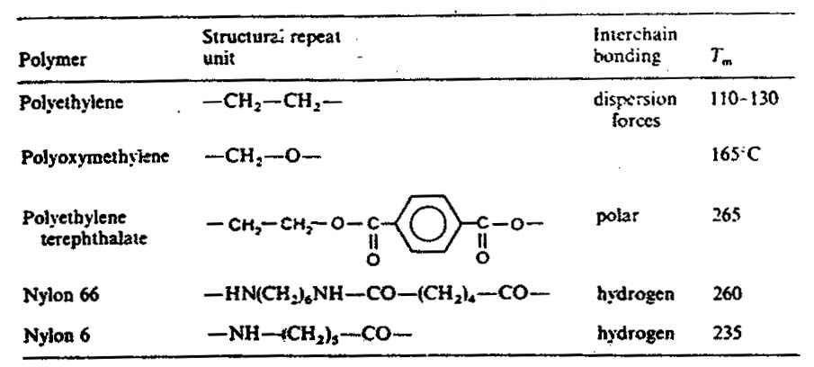
Table :2 Polymer Structure and Melting point

15
The weakest bond in a polymer will therefore determine the thermal stability of a polymer chain in the absence of oxygen. In practice, thermal stability is usually less than expected from the chemical structure due to the accidental inclusion of weak links, notably the peroxide link,(-O-O-) during polymerization. In presence of oxygen, it is the ability of bonds to withstand reaction with oxygen at elevated temperature that is important. The bonds with the highest bond dissociation energy (Table 3) are the most susceptible to oxygen attack at elevated temperature. Consequently, polymers containing -CN, -C=O, -C=C-, -OH and -CI are all readily degraded by heat in the presence of oxygen. The -CF bond, although not having the highest
Table :3 Bond dissociation energies
Bond | Dissociation energy kJ mole⁻¹
C=N | 890
C=0 | 748
C=C | 610
O-H | 464
C-F | c.500
C-H | 414
N-H | 389
C-0 | 359
C-C | 347
C-C1 | 343
C-N | 305
0-0 | 145
bond dissociation energy, has remarkable resistance to oxygen and so polytetrafluoroethylene has excellent heat stability in the presence of oxygen (up to around 400 ⁰C). Polymers with aromatic backbones also show excellent thermal stability due to the relative inertness of the phenylene ring. The thermal stability of these polymers is determined by the nature of the groups which link the phenylene ring together in the chain.
Electromagnetic radiation can produce a reaction. usually degradative, if the radiation has sufficient energy. The energy of the radiation is related to the wavelength of the radiation.
$$\text{Energy}=\frac{\text{hc}}{λ}$$
where h is Plank’s constant, λ is the wavelength and c is the speed of light. It therefore increases with decreasing wavelength. Sufficient energy for bond scission is found in the ultra-violet (UV) region and electromagnetic radiation of shorter wavelength. It is not simply that sufficient energy is available. The energy must be capable of being- absorbed. Bonds have characteristic absorption frequencies and only radiation of the frequencies can be absorbed. On the earth’s surface, UV light occurs in the range 300-400 nm due to filtration of smaller wavelengths by the atmosphere. Most bonds in polymers do not absorb in this region, a exception being the carbonyl group -C=O. Most polymers should therefore be stable in sunlight.
Radiations with energy higher than that of UV light (gamma rays and electron beams) generally have a degradative effect on polymers. In some-cases, like polyethylene, high energy radiation produces significant amounts of cross-linking. High energy radiation is exploited commercially to produce cross-linked forms of a polymer to improve mechanical properties, especially at higher temperatures or to increase insolubility. Alternatively it is used to produce degradation and hence increased solubility.

17
1.9 SOLUBILITY
The process of dissolution involves three fundamental steps: the penetration of the solvent. the separation of the chains and the salvation of the chains.
For separation of the chains to occur, the solvent liquid must be able to overcome the inter-chain forces which vary in strength from weak dispersion forces to strong hydrogen bonds. It follows therefore that since the inter-chain forces are determined by the chemical nature of the polymer, the chemical nature of the solvent in relation to the polymer is of importance. In addition to separating the chains the liquid must be able to solvate the polymer chains, in order to reduce the free energy of the separated chains so that dispersion of the chains in the liquid can take place.
In general non-polar liquids are solvents for non-polar polymers and polar liquids are solvents for polar polymers. Solubility parameter are used to predict the suitability of a liquid as a solvent for a polymer .
The rate of dissolution depends primarily upon the rate at which the solvent can penetrate the solid polymer structure. The rate of diffusion is determined by the inter-chain forces and by the polymer morphology. Amorphous polymer will tend to dissolve more quickly than crystalline polymer because the closer packing of the crystalline chains hinders diffusion. In some cases the rate of diffusion is so slow that the polymer is effectively insoluble in the solvent. In such cases, raising the temperature often produces dissolution. Polyvinyl alcohol does not dissolve at an appreciable rate in cold water but rapidly dissolves in hot water.
Molecular weight can also significantly affect the solubility of polymer chains. Low molecular weight polymer dissolves more readily than high molecular weight polymer. The high molecular weight polymer may be insoluble.

18
Where a polymer has a wide molecular weight distribution, this has led to the lower molecular weight fractions dissolving but not the higher molecular weight fractions. This partial solubility can often be converted into complete solubility by heating the solution.
Cross-linked polymers will not dissolve even in ideal liquids. The cross-links consist of covalently linked atoms and consequently the polymer chains are permanently tied together. Although penetration of the liquid may be possible, dispersion of the chains is not. The result is that cross-linked polymer swells as the liquid is absorbed but it will not dissolve. Highly cross-linked polymers will swell very little but lightly cross-linked polymers may absorb several times their own weight of liquid to produce highly swollen gels.
1.10 ELECTRICAL PROPERTIES
Polymers in common use are non-conducting materials. Conductivities vary from 10⁻¹⁰ to 10⁻¹⁸ S cm⁻¹ and consequently, polymers are widely used as insulating materials. Good conductors such as copper (conductivity 6 x 10⁵ S cm⁻¹) conduct because there are electrons available to transmit the current when an electrical potential is applied. This is not the case with most common polymers since the electrons are tightly bound in covalent bonds. Polar polymers such as polyvinyl chloride have higher conductivities than non-polar polymers because of the electric dipole which is present. The polar polymers are essentially non-conductors and are widely used in low voltage insulation. They also make useful dielectric materials where their polarity and insulating character enables small capacitors of high storage capability to be manufactured. Especially useful in this area are polyvinyl fluoride and polyvinylidene fluoride in film form.
The most common method of making polymers electrically conductive is to incorporate a conductive material in the polymer. These materials include carbon and metal powders. However, polymers that are intrinsically conductive are feasible provided that electrons are available to transmit current.
19
Polymers with conjugated double bonds are found to be more conductive than non-conjugated polymer structures. The conduction is due to the delocalization of the π electrons of the double bonds. The simplest polymer of this type is polyacetylene:
-CH=CH-CH=CH-CH=CH-CH=CH
and among the commercially available polymers. polyphenylene sulphide
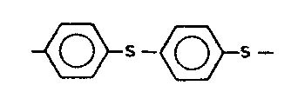
shows conductive capability due to delocalization involving the aromatic ring and the sulphur atom.
In itself. delocalization does not significantly improve the conductive nature of the polymer but if the polymer is doped with additives (electron donors or acceptors) conductivity values of up to 10Scm⁻¹ can be achieved depending on the additive, its concentration and the polymer. In effect, the dopant is making electrons or positive holes (due to the removal of electrons) available for conduction. Other methods of releasing electrons include the use of heat, light and mechanical stress.

20
CHAPER :2
HYDROPHILIC POLYMERS (HYROGELS)
These are prepared by synthetic chemical reactions from a range of speciality vinyl and acrylic monomers. The simplest definition of a hydrogel is ‘a network which swells in water’. However, they are better considered as polymeric materials which are able to swell in water and retain a significant fraction (typically 30%) of water within their structure, but do not completely dissolve in water. Hence, hydrogels are characterized by a pronounced affinity of their chemical structure towards water, in which they merely swell, but do not ‘dissolve. This is due to the existence of cross-links which, at least in water, bind macromolecules or their segments either by permanent bonds-’fixed’ chemical links-or through more extensively organized regions which can be considered as “effective” cross-links as formed from molecular associations usually as hydrogen bonds. These effective cross-links are formed by bonds of sufficient strength so that changes in the physical structure occur only slowly and normally under stress.
Within the above definitions, both natural polymers (such as gelatin (a protein, derived from animal collagen) agar, and alginates (both carbohydrates, derived from vegetable sources), and synthetic polymers, can be included. However, most of the these are synthetic polymers. The largest group comprises the homopolymer and copolymer derivatives of acrylic and methacrylic acids:
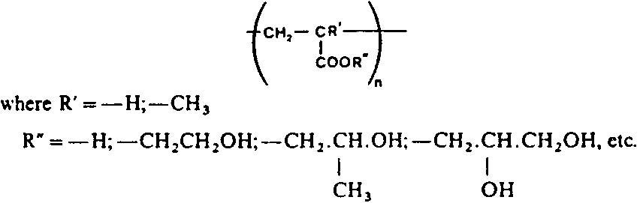

21
The most frequently used monomer is hydroxyethyl methacrylate (HEMA):
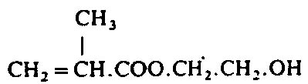
and the hydrogels prepared from this monomer are known as Poly hydroxyethyl methacylates.
During preparation of the polymers, alteration of the ratio of hydrophobic and hydrophilic monomers allows the degree of hydrophilicity to be varied. The degree of hydrophilicity is also affected by the relative hydrophilicity of the chemical cross-linking agents employed. Although this possibility, in principle. allows wide variation in control of hydrophilic/hydrophobic behaviour, there are, in practice, certain constraints due to the possible in homogeneity of copolymer composition, especially if the copolymer reactivity ratios are significantly different.
Other synthetic hydrogels are based on derivatives of acrylamide polymers:
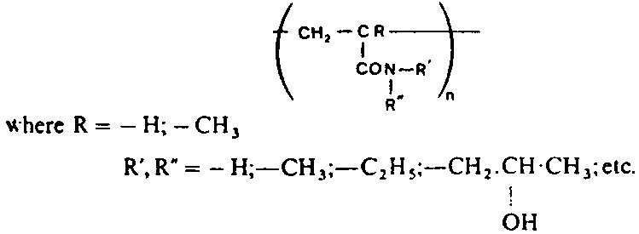
These polymers swell to a greater or lesser extent in water. depending on the hydrophilic power of the side group. With lower hydrophilicity, the polymer will swell in water, but with further increase in hydrophilicity, the polymer becomes water-soluble. In general, increased hydrophilicity is related to a greater proportion of hydroxyl groups in the polymer, since this increases the polarity of the molecule.
22
Other polymer molecules containing polar groups, such as polyvinyl pyridine and poly-N-vinylpyrrolidone are water-soluble, and behave as hydrogels only if they are cross-linked chemically, by a second reaction following that of polymerization of the starting monomer. The most commonly used cross-linking agents are derivatives of ethylene glycol dimethacrylate:
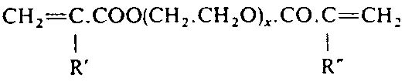
or of methylene-bis-acrylamide;
CH₂=CH.CO.NH.CH_{2.}NH.CO.CH=CH₂
Hydrolysed polyacrylonitrile can also be considered as a hydrogel system when it is converted to a polyacrylamide-polyacrylate copolymer:
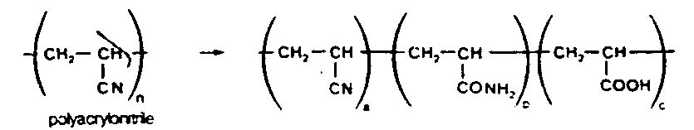
The unhydrolysed nitrile sequences are more extensively organized regions of the molecular chain which prevent the complete solution of the hydrolysis products, even though the hydrophilicity of both the polyacrylamide and polyacrylate sequences is high. The molecular structures and solution behaviour of certain types of polyvinyl alcohol are similar, in many features to those of polyhydroxyethyl methacrylate (HEMA) type hydrogels. Polyvinyl alcohol is in terms of annual tonnage produced commercially, the most important water-soluble polymer.

23
It is a group of copolymers formed by the partial or complete hydrolysis of polyvinyl acetate:

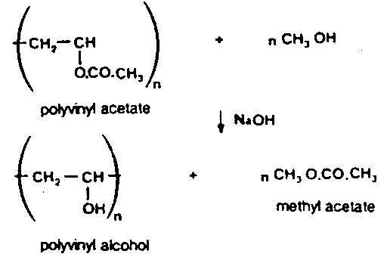
Polyvinyl alcohol becomes water-soluble when more than approximately 80% of the the acetate groups have been removed from the starting polyvinyl acetate but can be insolubilized by further reaction with cross-linking agents, such as formaldehyde (HCHO), glyoxal (OHC.CHO) Or glutaraldehyde (OHC.CH2.CHO), each of which will react, more or less controllably, to provide acetal cross-links between the linear polymer molecules e.g.:
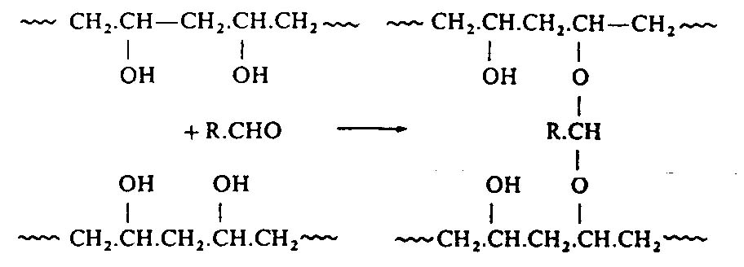
The affinity for water, and the polarity of the hydrophilic groups are important in relation to the properties of the polymers. Some hydrogels are almost completely neutral, e.g. polyhydroxyethyl methacrylate (HEMA), or sucrose/methacrylate, whereas others are acidic, e.g., polyacrylic and polymethacrylic acid and their copolymers, or basic, such as polyvinylpyridine and its derivatives.
24
In addition, it is possible for mixtures of positively and negatively charged polymers to form water insoluble, but water-swellable, comp\exes which behave as hydrogels.
Other macromolecular species form hydrogels, including several crosslinked natural polymers, and physical blends can also be prepared, e.g. from poly hydroxyethyl methacrylate (HEMA) and collagen, which can have improved mechanical strength compared with the parent polymers. Because of their high degree of hydration as water-plasticized polymeric networks, hydrogels have low mechanical strength, and this strength decreases as the water content is increased. Hydrogels are prepared both by bulk and solution polymerization, and suspension polymerization may also be employed to prepare macroporous hydrogels with a high degree of cross-linking, and, hence, with a low degree of swelling in water.
Because of low mechanical strength, the fabrication of hydrogels into useful shapes presents practical difficulties. Thin layers of hydrogels can be cast from aqueous solution on to other films and fibres, and other forms can be prepared, like optically pure blocks and films. porous sponges, and almost unswellable porous beads. Transparency is important, since hydrogels are used in soft contact lenses. These are prepared by several different methods – a spin-casting technique is used, or the standard methods of Casting into moulds made to patterns of ophthalmic prescriptions, or, sometimes, by controlled machining of individual frozen hydrogel blocks. In all these methods care has to be taken to achieve high surface polish. In contact lenses, an advantage of the use of hydrogels is that these polymers are permeable to oxygen, which is necessary for the cornea of the eye. Hydrogel lenses, for this reason, are filled close to the cornea surface, unlike hard contact lenses, and remain practically static on the cornea, while other types move as the eye blinks. The corneal surface depends more on the oxygen which passes across the lens with hydrogenl lenses than with the hard lenses, usually made from polymethyl methacrylate.

25
2.2 POLYACRYLAMIDE HYDROPHILIC POLYMERS
Acrylamide monomer, CH2=CH.CO.NH2, is, when pure, a white crystalline powder of moderate toxicity (it can be absorbed through the skin, causing interference with nerve functions), which can be polymerized in aqueous solution to yield polymers of very high molecular weight. These polymers, if suitably prepared and purified, are not toxic. Pure polyacrylamidcs are relatively inert, and are little used in this form, but can be convened by hydrolysis of some of the amide groups into the acid form, giving anionic polymers which have many applications. Alternatively, by special polymerization techniques, similar anionic polymers can be prepared by copolymerization of acrylamide monomer with unsaturated acid, and cationic polymers from acrylamide and cationic comonomers. The most common comonomers are:
(a) Weak acids: acrylic and methacrylic acids
(b) Strong acids: vinyl sulphonic acid; 2-acrylamido-2methyl-propane sulphonic acid (AMPS)
(c) Bases : dimethylaminoethyl methacrylate: dimethylaminoethyl acrylate; diallyl dimethylammonium chloride and their quaternary salts.

The behaviour of acrylamide copolymers in solution is complex. The viscosity depends not only on the solution concentration, molecular weight and temperature, but also on the rheology, including the shear rate at which the viscosity is measured, and the previous history of the solution. The viscosity of acrylamide homopolymers is independent of pH, but that of their partially hydrolysed forms is sensitive to the presence of other ions, especially metallic cations such as aluminium. Solution viscosity is reduced by high shear, and by oxidation-both of which can occur in certain oil well drilling applications.

26
High molecular weight polyacrylamides can form gels in water. These gels can also be cross-linked, either by copolymcrization or by post chemical treatment . These gels are employed in analytical separation techniques, notably in gel electrophoresis.
Most applications of polyacrylamides (both homopolymers after hydrolysis and copolymers) depend on:
(a) High solubility in water
- Possible high molecular weight (for many uses, especially those-involving flocculation, a large molecule is essential for satisfactory and cost-effectively performance)
(c) The ability to produce specific polymers for partic..lar end-uses, by copolymerization. Cationics are used mainly as papermaking additives: high molecular weight anionics are used in mining, water treatment and oil recovery processes. Nonionics are mainly used in mining and ore treatment.
In general. polyacrylamides are used in relatively small quantities (often as little as 1-10 parts per million), to improve processes. rather than in formulation and finished products. Partially hydrolysed polyacrylamides are used to clarify potable water. In municipal sewage treatment, an anionic polyacrylamide is added to improve flocculation of the suspended solids, and so reduce the oxygen demand. Cationic polyacrylamide may then be added to the resulting sludges, to improve filtration rates. so that the dewatered solids can be converted into solid cake more readily. In mining operations, polyacrylamides are used to recover valuable solids from washings, slurries, and waste water, by assisting rapid settling and dewatering of concentrates and tailings.
Typically, anionic polyacrylamides are used to:
(a) Increase filter capacity of metal sulphide ore concentrates
(b) Increase solids content of magnetite (iron ore) products
- Aid coal washing, by recovery of tailings (fines) and reduction of waste water pollution

27
(d) Improve separation of ‘red mud’ (iron oxides) in the production of alumina.
Polyacrylamides are also used to improve the extraction of ores of copper, potassium, titanium dioxide, uranium, zinc, and some precious metals.
In paper making, cationic polyacrylamides are added at the sheet forming stage, to reduce the loss of fibre and pigment fines through the formation wire. The selected polyacrylamides flocculate the fibres and pigment, improving drainage of water, so reducing the drying times of the formed paper, improving production speeds, and economizing with heat energy.
Other applications of acrylamide copolymers include soil modification in civil engineering projects, to consolidate load bearing, scaling, and grouting of dams and ponds; increasing the viscosity, and altering the flow properties of water-based latexes and adhesives, improving the handling of slurries.
2.3 POLYVINYL ALCOHOL
This is mainly used as a component of warp sizes. especially for polyester fibres Other principal industrial applications include water-based adhesives, paper coatings, cements, binders for non woven fabrics, and binders for the phosphorescent pigments of television picture tubes. Polyvinyl alcohol film, made by solution of extrusion casting, is a high clarity film. The water solubility can be altered by controlled cross-linking. For some special purposes, water-soluble polyvinyl alcohol film is converted into bags, e.g. for fishery bait, and also for laundry bags for collection of highly soiled laundry in hospitals, where the entire bag and its contents can be sealed and placed unopened into a washing machine.
Polyvinyl alcohol is non-toxic, and is, therefore, often used as a component of the adhesive used in food packaging.

28
2.4 POLYVINYL PYRROLIDONE (PVP)
This was developed as a by-product of the explosive chemicals-from-coal-based technology using acetylene as the basic monomer. Acetylene can be obtained from the reaction of water on calcium carbide, which was manufactured from lime and coke heated in an electric furnace at 2000 ⁰C Acetylene can also be obtained from natural gas, but is stiIl more expensive than ethylene. The manufacturing route is by solution polymerization of the monomer N-vinyl-2-pyrrolidone ( ‘N-vinyl-2-pyrrolidinone’), from acetylene.
Polyvinyl pyrrolidone is offered commercially in a range of molecular weights, designated by K-value which derives from solution viscosity measurements of molecular weight. The K-values the available of polymers fall between 15 and 90, indicate the molecular size of the polymers. taking certain assumptions about the relationships between measured viscosity in aqueous solution and shape and size of the polymer molecules being measured.
Because of the complex manufacturing process, PVP is relatively expensive, but has certain important properties which govern the main applications.
The polymer is
(a) Compatible with many biological systems, has low toxicity, and is non irritant to the skin
(b) Soluble in water and many organic solvents. notably water-miscible solvents, such as ethanol
(c) Able to form good films, with good adhesion to other substrates.
As a consequence of these properties, PVP is used in some cosmetics, such as hair and skin-care preparations
Industrial applications of PVP are sparse, mainly because of cost. It is used in some non-gelatin based specialist photographic systems, and it has been proposed as a component of oil well drilling muds, where the thermal resistance of PVP could be useful. Cross-linked grades of PVP are available with lower solubility in water which are used in limited amounts in pharmaceutical applications as tablet binders.
29

CHAPTER : 3
APPLICATIONS OF HYDROPHILIC POLYMERS
Applications of hydropbilic and water-soluble industrial polymers are diverse. The most important include
(a) Paper manufacture, where water-soluble polymers are used in formation of the paper web, in pulp retention, and as the binder of coating compositions
(b) Textile sizing (during spinning of the yarn) and finishing (of the woven fabrics)
(c) Water purification and effluent treatment (in flocculation processes)
(d) In the formulation and production of many specialist fluids, where it is necessary to control the viscosity and the flow properties, e.g. in water based adhesives and in emulsion paints
(e) In film-forming materials, where the flexibility and moisture sensitivity of the film can be modified by the incorporation of plasticizers, humectants, or cross-linking agents e.g. many water soluble polymer mixtures such as water-based adhesives and emulsion paints, and coatings for paper.

Many more special applications, in which water-soluble polymers are used as part of a mixture. include medical applications such as surgical dressings and sanitary products, the hydrogel polymers of contact lenses ; personal products (cosmetics, ointments; antiperspirants, hair sprays and lotions); domestic products (detergents, cleaners, polishes); latex processing aids (e.g., for carpet backing, where a controlled viscosity is required for coating to an even thickness); and oil-well drilling fluids and additives.
30
The biodegradability of water-soluble polymers, which contrasts with water resistant, organic solvent soluble and solid polymers, can contribute to their industrial value. The rate of biodegradation depends on the molecular structure and molecular size of individual polymers, as well as the presence of specific enzymes, but, in general, natural polymers (starches, proteins carbohydrate gums) and semi-synthetic polymers (such as cellulose ethers) are readily biodegradable, while most synthetic water-soluble polymers are relatively resistant to biological degradation. However, biological degradation processes can be retarded to a useful extent by addition of relatively small amounts of carefully selected bactericide.

31
References:
- Speciality Polymers by Blackie published by Chapmann & Hall – 1987.
- Polymer Materials by JA Brydson, fifth edition, McGraw Hill-1974.
- Billmeyer F.W. (1962-1971) Textbook of polymer science. John Wiley, New York.
- Rodrigues F. (1985) Principles of polymer systems. McGraw-ill, New York.
- Davidson R.L. (Ed.) (1980) Handbook of water soluble gums and risins, McGraw-Hill, New York.
- Finch C.a. (Ed.) (1983) Chemistry and technology of water soluble polymers. Plenum Press, New York and London.
- Finch C.a. (Ed.) (1973) Polyvinl alcohol: properties and applications. Wiley, Chichester and New York.

32

