A
MINOR THESIS
ON

DETECTION OF VARIOUS DEFECTS IN SUBMERGED ARC WELDING BY DYE PENETRANT AND MPI TEST

SUBMITTED IN PARTIAL FULFILLMENT OF THE REQUIREMENTS
FOR THE AWARD OF DEGREE OF

MASTER OF ENGINEERING
IN
PRODUCTION ENGINEERING

SUBMITTED BY:
TAPAS BAJPEI
COLLEGE ROLL NO.: 11/PRO/08

UNDER THE SUPERVISION OF
DR. (Mrs.) REETA WATTAL


DEPARTMENT OF MECHANICAL ENGINEERING
DELHI COLLEGE OF ENGINEERING
UNIVERSITY OF DELHI, DELHI-110042
2008-2010
CANDIDATE’S DECLARATION

I, TAPAS BAJPEI, hereby certify that the work which is being presented in the thesis entitled “DETECTION OF VARIOUS DEFECTS IN SUBMERGED ARC WELDING USING DYE PENETRANT AND MPI TEST” in the partial fulfillment of requirement for the award of degree of MASTER OF ENGINEERING submitted in the Department of Mechanical Engineering at DELHI COLLEGE OF ENGINEERING under UNIVERSITY OF DELHI, DELHI, is an authentic record of my own work carried out during a period from July 2008 to July 2010, under the supervision of Dr. (Mrs.) Reeta Wattal, Assistant professor, Department of Mechanical engineering. The matter presented in this thesis has not been submitted in any other University / Institute for the award of any degree.

TAPAS BAJPEI
Roll No. 11/PRO/08

CERTIFICATE
This is to certify that the above statement made by the candidate is correct to best of my knowledge.
PROJECT SUPERVISOR:

DR. (Mrs.) REETA WATTAL
ASSITANT PROFESSOR
DEPARTMENT OF MECHANICAL ENGINEERING,
DELHI COLLEGE OF ENGINEERING, DELHI

ACKNOWLEDGEMENT

I am thankful to the Almighty because without his blessings this work was not possible. It is a great pleasure to have the opportunity to extent my heartfelt gratitude to everybody who helped me throughout the course of this project.
It is distinct pleasure to express my deep sense of gratitude and indebtedness to my learned supervisor Dr. (Mrs.) Reeta Wattal for her valuable guidance, encouragement and patient reviews. Her continuous inspiration has made me complete this dissertation.
My heartily thanks to Prof. B. D. Pathak, Head of Mechanical Department and all other faculty members for providing necessary guidance and support from the department.
I would like to thank Mr. Vinay Kumar and Mr. Bhushan Nagpal, Welding Lab Incharge, for their cooperation for their cooperation and support.
I am grateful to my parents, specially my mother and all my family members who gave me the strength, love and care to carry out this course successfully.
I am also thankful to my friends and classmates for their unconditional support and motivation for this project.

TAPAS BAJPEI
RollNo.11/PRO/08

ABSTRACT

This experimental study was carried out to analyse the effects of pulse parameters on mechanical behavior of TIG welded aluminium alloy 1100. Pulsed current gas tungsten arc welding (PCGTA) is a variant of GTA welding which involves cycling of the welding current from higher level to lower level at selected regular frequency. The main aim of pulsing is to achieve maximum penetration without excessive heat built-up. The use of high current pulses is to penetrate deeply during peak current time and allow the weld pool to dissipate some of the heat during background current duration. This variant is frequently used for the welding of aluminium alloys as it provides good control over heat input.
Fractional factorial technique is used to formulate the experimental layout and to analyse the effects of pulse parameters on the properties of aluminium alloy 1100. The response factors are tensile strength, yield strength and percentage elongation, affected by peak current, background current, pulse frequency and peak current time have been investigated and analysed. The models developed have been checked for their adequacy and significance by using t-test. Main and interaction effects of the process variables on responses are presented in graphical form.
Keywords: Pulsed current GTA welding, Aluminium alloy 1100, Fractional factorial technique.

TABLE OF CONTENTS

 | Contents | Page
 | Candidate’s declaration  Certificate  Acknowledgement  Abstract  Table of Contents  List of figures  List of tables  List of abbreviations | ii  ii  iii  iv  v  viii  xi  xiii
 | CHAPTER 1: INTRODUCTION  - Introduction  - Characteristics of Aluminium  - Aluminium alloys and weldability  1.3.1 Aluminium alloy designation system  1.3.2 Aluminium and its alloys  1.3.3 Weldability of Aluminium  1.4Motivation and Objectives  1.5 Statement of problem | 1-5  1  1  2  2  3  4  5  5
 | CHAPTER 2: LITERATURE REVIEW  2.1 Literature Review  2.2 Summary | 6-10  6  9
 | CHAPTER 3: GAS TUNGSTEN ARC WELDING (GTAW)  3.1 Introduction  3.2 Gas Tungsten Arc Welding Equipment  3.2.1 TIG Torch  3.2.2 Types of Nozzles  3.2.3 Filler wire Feeders  3.2.4 Welding Cables  3.2.5 Power Source  3.2.5.1 Power Sources  3.2.6 Shielding gas equipment  3.3 Electrodes for GTAW process  3.3.1 Classification of Electrodes  3.3.2 Electrode Sizes and Current Capacities  3.3.3 Electrode Tip Configuration  3.3.4 Electrode preparation and effect of Tip angle  3.3.5 Electrode Extension  3.4 Shielding Gas  3.4.1 Shielding Gas Selection  3.4.2 Gas Flow Rate  3.5 Metals welded by GTAW process  3.6 Base- Metal thickness  3.7 Arc Initiation  3.7.1 Rectification  3.8 Joint Design  3.8.1 Edge Joints  3.8.2 Butt Joints  3.8.3 Corner Joints  3.8.4 T- Joints  3.9 Advantages and Limitations  3.10 Applications | 10-45  10  12  13  15  17  18  19  20  21  23  24  26  29  30  32  33  34  35  35  36  37  38  39  40  40  43  43  44  44
 | CHAPTER 4: EXPERIMENTAL SETUP  4.1 Welding machine  4.2 Material Information  4.2.1 Base Metal  4.2.2 Filler wire | 46-50  46  49  49  50
 | CHAPTER 5: DESIGN OF EXPERIMENT  5.1 Introduction  5.2 General quantitative approach  5.3 Factorial design  5.4 Plan of investigation  5.4.1 Identifying the welding variables  5.4.2 Selection of process parameters and their limits  5.4.3 Developing the design matrix  5.4.3.1 Symmetry related to the centre of the experiment  5.4.3.2 Normalisation  5.4.3.3 Orthogonality  5.4.3.4 Rotatability  5.4.4 Design Matrix  5.4.4.1 Developing Design Matrix for Calculating the  Coefficient  5.3.5 Conducting Experiments as per the design matrix | 51-65  51  51  52  53  54  55  56  57  57  57  57  58  58  59
 | CHAPTER 6: MATHEMATICAL MODELLING  6.1 Introduction  6.2 Development of a mathematical model  6.3 Evaluation of the co-efficient of the model  6.4 Adequacy of the model  6.5 Significance of the co-efficient  6.6 Calculation of variance of optimization parameters (S ²y)  6.7 Calculation of variance of adequacy factor (S ²ad)  6.8 t-test for significant coefficient  6.9 Proposed mathematical models | 66-78  66  66  67  70  71  72  74  77  78
 | CHAPTER 7: RESULTS & DISCUSSION  7.1 Main and interaction effects of process parameters on UTS  7.2 Main and interaction effects of process parameters on Yield Strength  7.3 Main and interaction effects of process parameters on Effect on % Elongation | 79-88  79  83  86
 | CHAPTER 8: CONCLUSION & FUTURE SCOPE  8.1 Conclusion  8.2 Scope for future work | 89  89  89
 | REFERENCES | 90

LIST OF FIGURES

Figure No. | Title | Page No.
Fig. 3.1 | Process diagram- TIG Welding | 10
Fig. 3.2 | Pulsed current transient for GTAW | 11
Fig. 3.3 | Set up of GTAW | 12
Fig. 3.4 | TIG torch and its various components | 13
Fig. 3.5 | Various components of TIG torch | 14
Fig. 3.6 | An air cooled Torch | 14
Fig. 3.7 | A water cooled GTAW torch | 15
Fig. 3.8 | A nozzle and a nozzle with a gas lens | 16
Fig. 3.9 | Automatic feeding of filler wire | 17
Fig 3.10 | Welding cable | 19
Fig. 3.11 | Penetration with DCEN polarity | 20
Fig. 3.12 | Penetration with DCEP polarity | 20
Fig. 3.13 | Penetration with AC polarity | 20
Fig. 3.14 | A welding sequence | 21
Fig. 3.15 | A gas flowmeter | 22
Fig .3.16 | Electrode tip configuration | 30
Fig. 3.17 | Correct way of electrode preparation | 30
Fig. 3.18 | Electrode tip parameters | 31
Fig. 3.19 | Effect of electrode tip penetration profile | 32
Fig. 3.20 | Electrode extension | 32
Fig. 3.21 | A representation of the affects on the arc and bead produced by argon and helium shielding gases | 33
Fig. 3.22 | Basic voltage waveform obtained with high frequency high voltage unit | 37
Fig. 3.23 | Principle of current rectification | 39
Fig. 3.24 | Edge joints | 40
Fig. 3.25 | Butt joints | 41
Fig. 3.26 | Corner joints | 43
Fig. 3.27 | T-joints | 43
Fig. 4.1 | Front view of T2.05 Triton 220 AC/DC welding machine | 44
Fig. 4.2 | Control panel of T2.05 Triton 220 AC/DC welding machine | 48
Fig. 5.1 | Edge preparation of plates by shaper machine | 60
Fig. 5.2 | V-groove butt joint | 60
Fig. 5.3 | Configuration of designed V- groove butt joint | 60
Fig. 5.4 | Tack welds on plates | 61
Fig. 5.5 | Protrusion of electrode for root pass | 61
Fig. 5.6 | TIG welded plates | 62
Fig. 5.7 | TIG welded plate with divided sections | 63
Fig. 5.8 | Preparation of tensile specimens on wire EDM machine | 63
Fig. 5.9 | Wire EDM machine | 64
Fig. 5.10 | Tensile test specimen | 64
Fig. 5.11 | Configuration of tensile test specimen | 64
Fig. 5.12 | Tensile test specimen in UTM machine | 65
Fig. 7.1 | Effect of peak current on UTS. | 79
Fig. 7.2 | Effect of background current on UTS. | 80
Fig. 7.3 | Effect of pulse frequency on UTS. | 80
Fig. 7.4 | Interaction effect of peak current and background current on UTS. | 81
Fig. 7.5 | Interaction effect of peak current and pulse frequency on UTS. | 81
Fig. 7.6 | Interaction effect of peak current time and peak current on UTS. | 82
Fig. 7.7 | Interaction effect of background current and pulse frequency on UTS. | 82
Fig. 7.8 | Effect of peak current on YS. | 83
Fig. 7.9 | Effect of pulse frequency on YS | 84
Fig. 7.10 | Effect of peak current time on YS | 84
Fig. 7.11 | Interaction effect of peak current and background current on YS | 85
Fig. 7.12 | Interaction effect of pulse frequency and peak current time on YS | 85
Fig. 7.13 | Effect of peak current on %E. | 86
Fig. 7.14 | Effect of pulse frequency on %E. | 87
Fig. 7.15 | Effect of peak current time on %E. | 87
Fig. 7.16 | Interaction effect of pulse frequency and peak current on %E. | 88
Fig. 7.17 | Interaction effect of peak current time and peak current on %E. | 88

LIST OF TABLES

Table No. | Title | Page No.
Table 3.1 | TIG electrode current carrying capacity | 23
Table 3.2 | Colour code and alloying elements for various tungsten electrode alloys | 24
Table 3.3 | Work function of various elements | 26
Table 3.4 | Typical type of current, tungsten electrodes and shielding gases for welding different metals | 27
Table 3.5 | Typical current ranges for tungsten electrodes for GTAW | 28
Table 3.6 | Tungsten electrode tip shapes and current ranges | 31
Table 3.7 | Choice of the correct shielding gases according to the metal being welded | 35
Table 3.8 | Typical welding parameters for manual GTAW of butt joints in aluminium with AC and argon shielding | 42
Table 4.1 | Technical data of T2.05 Triton 220 AC/DC welding machine | 46
Table 4.2 | Chemical properties of AA-1100 | 49
Table 4.3 | Physical properties of AA-1100 | 49
Table 4.4 | Mechanical properties of AA-1100 | 49
Table 4.5 | Chemical properties of E-4043 | 50
Table 4.6 | Mechanical properties of E-4043 | 50
Table 5.1 | Welding parameters and their limits | 55
Table 5.2 | Design Matrix | 58
Table 5.3 | Design Matrix for calculating coefficients | 58
Table 5.4 | Confounded Design Matrix | 59
Table 5.5 | Welding conditions | 62
Table 5.6 | Responses | 65
Table 6.1 | Coefficient calculation for Ultimate tensile strength (UTS) | 68
Table 6.2 | Coefficient calculation for Yield Strength (YS) | 68
Table 6.3 | Coefficient calculation for % Elongation (%EL) | 69
Table 6.4 | Estimated value of the coefficients of the models | 69
Table 6.5 | Variance of optimization for UTS | 72
Table 6.6 | Variance of optimization for YS | 73
Table 6.7 | Variance of optimization for % Elongation | 73
Table 6.8 | Variance of adequacy for UTS | 74
Table 6.9 | Variance of adequacy for YS | 74
Table 6.10 | Variance of adequacy for %Elongation | 75
Table 6.11 | Analysis of variance | 76
Table 6.12  Table 6.13 | t-values for coefficients of model  Significant coefficients after t-test model | 77  77

LIST OF ABBREVIATIONS

Symbols/Notations used throughout the text of this thesis are explained as given below in alphabetical order.

PCGTAW Pulsed Current Gas Tungsten Arc Welding
UTS Ultimate Tensile Strength
YS Yield Strength
% E Percentage Elongation
HFHV High frequency high voltage
GMAW Gas metal Arc welding
PAW Plasma arc welding

Chapter-1
INTRODUCTION

1.1 Introduction
Aluminium is word’s most abundant metal and is third most common element, comprising 8% of the earth’s crust. The popularity and rapid increase in demand for aluminium and its alloys in manufacturing wide variety of products world-wide, is generally due to their high specific modulus of elasticity and excellent corrosion resistance in the atmosphere, water, oil and many chemicals. On the basis of specific modulus of elasticity, aluminium and its alloys as a group takes the second place among all the known engineering metallic materials, the first place being taken by titanium alloys [1]. It is light in weight and retains ductility at subzero temperatures, has high resistance to corrosion and is non toxic. It is having strength to weight ratio superior to steel. It is an excellent conductor of both heat and electricity and due to this reason it is most commonly used material in large power transmission lines. Pure aluminium has a melting point of 660⁰c while its alloys have an approximate melting range of 482ºc to 660⁰c [2].

1.2 Characteristics of Aluminium
Aluminium possesses a number of properties that make welding it different than the welding of steels. These are: aluminium oxide surface coating; high thermal conductivity; high thermal expansion coefficient; low melting temperature; and the absence of colour change as temperature approaches the melting point. The normal metallurgical factors that apply to other metals apply to aluminium as well [2].
- Aluminium is an active metal, which reacts with oxygen in the air to produce a hard, thin film of aluminium oxide on the surface. The melting point of aluminium oxide is approximately 1982 ºc, which is almost three times the melting point of pure aluminium 660 ºc. In addition, this aluminium oxide film absorbs moisture from the air, particularly as it becomes thicker.
Moisture on the surface might decomposes beneath the arc and creates hydrogen, which causes porosity in aluminium welds. Hydrogen may also come from oil, paint, and dirt in the weld area. It also comes from the oxide and foreign materials on the electrode or filler wire, as well as from the base metal. Hydrogen will enter the weld pool and is soluble in molten aluminium.
As the aluminium solidifies, it will retain much less hydrogen. The hydrogen is rejected during solidification. With a rapid cooling rate, free hydrogen is retained within the weld and will cause porosity. Porosity will decrease weld strength and ductility, depending on the amount.
The aluminium film oxide must be removed prior to welding. It is an insulator and can cause preferential arcing. If it is not completely removed, small particles of unmelted oxide will be trapped in the weld pool and will cause a reduction in ductility, lack of fusion, and possibly weld cracking.
- Aluminium has high thermal conductivity. If it is welded slowly, the heat travels ahead of the arc and thus continuous in current and travel speed has to be made. Because of the high heat conductivity, procedures should utilize higher speed welding processes using high heat input. Both the gas tungsten arc and the gas metal arc processes supply this requirement. Preheating is often used for thicker sections.
- The thermal expansion of aluminium is twice that of steel. In addition, aluminium welds decrease about 6 percent in volume when solidifying from the molten state. This change in dimension may cause distortion and cracking.

  - Aluminium alloys and Weldability
1.3.1 Aluminium alloy designation system
A system of four-digit numbers has been developed by the American Aluminium Association to designate the various wrought aluminium alloy types. This system of alloy groups is as follows:
- 1XXX - pure Al (99% or greater)
- 2XXX - Al-Cu alloys
- 3XXX - Al-Mn alloys
- 4XXX - Al-Si alloys
- 5XXX - Al-Mg alloys
- 6XXX - Al-Mg-Si alloys
- 7XXX - Al-Zn alloys
- 8XXX – Al + Other Elements
First digit - principal alloying constituent
Second digit - Variation of initial alloy
Third and fourth digit – Individual alloy variation

1.3.2 Aluminium and its alloys
Pure aluminium is readily alloyed with many other metals to produce a wide range of physical and mechanical properties. The means by which the alloying elements strengthen aluminium are used as the basis to classify aluminium alloys into two categories:
- Non Heat treatable
- Heat treatable
The non- heat treatable alloys are mainly found in the 1XXX, 3XXX, 4XXX and 5XXX alloys series depending upon their major alloying elements .The initial strength of the non-heat treatable aluminium alloys depends primarily upon the hardening effects of alloying elements such as silicon, magnesium iron and manganese. These elements affect increases in strength either as dispersed phase or solid solution phase. A further increase in strength of these alloys is obtained through various degrees of cold working or strain hardening. Cold working or strain hardening is accomplished by rolling, drawing through dies, stretching or similar operations where area reduction is obtained. When fusion welded, these alloys lose the effect of strain hardening in narrow HAZ adjacent to the weld; the strength in the HAZ will approach that of annealed condition.
The heat treatable alloys are found primarily in the 2XXX, 6XXX and 7XXX alloy series. Heat treatable aluminium alloys develop their properties by solution heat treating and quenching followed by either natural or artificial aging. The heat treatable alloys may also be annealed to attain maximum ductility. These alloys can be soldered, brazed and resistance spot welded satisfactorily.
Aluminium alloy 1100 belongs to non heat treatable category. It consists of 99.00% aluminium, and is also known as ‘commercially pure aluminium’. It has excellent electrical conductivity, good formability and high resistance to corrosion, and is used where high strength is not needed. It has low density and excellent thermal conductivity. It can be hardened by cold work but it is not heat treatable to higher strength. It can be readily cold formable as it has good ductility. It is readily welded by TIG and MIG processes. Commonly used filler for these alloys are 4043 and 1050. It can also be gas welded or resistance welded, but the resulting joints are not as strong or as corrosion resistant as the inert gas welded joints. Al-1100 find its application in general sheet metal work, lightly stressed panels, architectural flashings, name plates, foils and strips for packaging, chemical equipments, tank, car or truck bodies, light reflectors and welded assemblies [2].

1.3.3 Weldability of Aluminium
The Welding of aluminium and its alloys has always represented a great challenge for designers and technologists. As a matter of fact, lots of difficulties are associated to this kind of joint process, mainly related to the presence of a tenacious oxide layer, high thermal conductivity, high coefficient of thermal expansion, solidification shrinkage and high solubility of hydrogen and other gases, in molten state [3, 4]. Aluminium and its alloys can be satisfactorily welded by arc welding processes, beam welding processes, resistance welding processes, friction & friction stir welding, explosive welding, and ultrasonic welding. Aluminium can also be joined by brazing and soldering techniques. The principal advantage of using arc welding processes is that a highly concentrated heating zone is obtained with the arc. For this reason, excessive expansion and distortion of the metal are prevented. Inert gas shielded arc-welding processes such as gas tungsten arc welding (GTAW) with all its variants, plasma arc welding (PAW) and gas metal arc welding (GMAW) with all its variants are the most preferred arc welding processes for joining aluminium and it’s alloys. The GTAW and PAW processes result in excellent quality welds. Whereas, for welding thicker sections and achieving higher welding speeds, the GMAW is the most often used process.
1.4 Motivation and objectives
The motivation was provided by the desire to explore the frontiers of welding technology, which forms the backbone of manufacturing industries. Several researchers have attempted to investigate the effects of various process parameters on responses in aluminium alloy.
The main objective of this project was study the effects of welding process parameters such as peak current, background current and peak current time and pulse frequency on mechanical properties of aluminium alloy 1100.

1.5 Statement of problem
“Effect of pulse parameters on mechanical behaviour of TIG welded aluminium alloy”.
The project describes the effects of peak current, background current, pulse frequency and peak current time on tensile strength, yield strength and % elongation of TIG welded aluminium alloy 1100. Mathematical models were developed for predicting tensile strength, yield strength and % elongation using factorial technique.

Chapter-2
LITERATURE REVIEW

  - Literature review
With the growing popularity of Aluminium and its alloys lot of research has been carried out in the area of Aluminium welding and its optimization. Generally Aluminium and its alloys are considered difficult to weld due to the impervious oxide layer formed on it which is really hard. Hence normal techniques like SMAW etc are not suitable. The techniques most commonly used are GTAW and GMAW for welding aluminium and its alloys. These gas shielded arc welding processes result in optimum weld quality and minimum distortion. Furthermore, welding can be done in all positions as there is no slag to be worked out of the weld by gravity or by puddling.
There are numerous research papers published in the area of Aluminium welding in various journals. The following literature reviews makes an attempt to provide an insight in to the above mentioned area:
Kumar et.al [5] analysed the effects of various parameters on the bead geometry in pulsed GTAW process for AA-7039.Various parameters included peak current, background current, pulse frequency, pulse duty cycle and % of He in argon. Taguchi technique was used to formulate the experimentation layout, to analyse the effects of various parameters on the bead geometry and to predict the optimum welding process parameter. The observation revealed that there is decrease in micro-hardness from the weld centre towards the base metal with the increase in pulse frequency and current due to grain coarsening and precipitation hardening.
Kumar.A.and S. Sunderrajan [6] studied the effects of various parameters on the mechanical properties of AA 5456 aluminium alloys welds through pulsed TIG. Four process parameters and two levels were selected. Taguchi method is employed for optimising the selected process parameters. Tensile test specimens are prepared, tests are carried out and UTS, YS, %elongation, micro-hardness of the weldments is evaluated. Regression technique is used to develop mathematical models were in order to get the effects of various parameters on the properties. ANOVA is employed to check the adequacy of the developed model. The effect of planishing on mechanical properties was studied and it was found that there is an improvement in mechanical properties due to relieving of internal stresses.
Kumar.S.et.al. [7] analysed the influences of pulsed current tungsten inert gas welding parameters on the tensile properties of AA 6061 aluminium alloy. The study revealed that the use of pulsed current parameters was found to improve the mechanical properties of the welds compared to those of continuous current welds of this alloy due to grain refinement occurring in the fusion zone
Balasubramanian M. [8] developed mathematical models to predict the tensile properties of pulsed current GTA welded Ti-6Al-4V alloy weldments. Four factors peak current, background current, pulse frequency and pulse on time were selected along with five levels and rotatable design matrix to optimise the number of experiments. Mathematical models were developed by response surface method and their adequacy was checked by ANOVA technique.
Nagesh D.S.and Dutta G.L. [9] in this paper neural network is applied for predicting the weld bead geometric descriptors and genetic algorithm is used for optimization of process parameters. Modelling of weld bead is carried out by using TIG welding. Multiple regression technique is applied on conventional experimental data and mathematical models were developed for various parameters, considering the effects of main variables as well as their factors. Also an attempt has been made to predict the bead shape parameters using back propagation neural network by using the same experimental data.
Zhang Y.M. and S.B. Zhang S.B. [10] carried out welding of Aluminium alloy AA6061 using Opposing Dual torch GTAW process. They disconnected the workpiece from the power supply and placing a second torch on the opposite side of the workpiece. Such a modification changed the direction of current flow, improved the weld penetration and reduced the heat input. This reduced the crack sensitivity of AA6061 and the alloy could be welded without filler metal.
Juang S.C., Tarng Y.S. (11) in this paper Taguchi technique is applied to select the process parameters in order to obtain optimum weld pool geometry in TIG welding of stainless steel. Arc gap, flow rate welding current and welding speed are the parameters selected. Modified Taguchi method is applied to analyse the effect of each welding process parameter on the weld pool geometry and to determine the process parameters with the optimal weld pool geometry.
Durgutulu Ahmet (12) studied the effects of hydrogen in argon used as a shielding gas for TIG welding of 316L austenitic stainless steel. Microstructure, penetration and mechanical properties were observed. Pure argon, 1.5%H₂-Ar and 5%H₂-Ar is used. With the addition of H₂ there is a significant increase in the volume of molten in the weld pool. Grain size and penetration is also increased with the increase in hydrogen content. Highest tensile strength is observed from the sample which was welded under the shielding gas of 1.5% H₂-Ar.
Manti Rajesh et.al. (13) studied the influence of pulse TIG parameters on microstructure, hardness and tensile strength of two Al-Mg-Si alloys. Pulse frequency and duty cycle are taken as welding parameters. It is observed that at low pulse frequency strength and hardness is greater than at higher pulse frequency.
Balasubramanian M. (14) in this paper mathematical models were developed to predict grain size and hardness of argon tungsten pulse current arc welded titanium alloy weldment. Four factors peak current, base current, pulse frequency and pulse on time were taken. Five levels and rotatable design matrix is used to optimise the required number of experiments. Mathematical models were developed by response surface method and their adequacy is checked by ANOVA technique. The conclusion is that the developed models are effective for predicting the grain size and hardness of Ti-6Al-4V alloy within the range of parameters.
Balasubramanian V. (15) studied the effect of pulsing on Ti-6Al-4V alloy in GTAW process and reported advantages such as improved bead contour, lower heat input requirements, less residual stresses and less distortion. Metallurgical advantages of pulsed current welding include refinement of fusion zone grain size, reduced width of heat affected zone. All these factors help in improving mechanical properties. Effects of various parameters on the mechanical properties of titanium alloy are studied and graph is plotted between them.
Balasubramanian M. (16) in this article the weld pool geometry of pulsed GTA welded titanium alloy was analysed. Mathematical equations are required for to predict the weld pool geometry. For that, mathematical model were developed using four factors, five levels and central composite design. Developed models were checked for their adequacy. Design of experiments, ANOVA and lexicographic method was used for optimizing the process parameters. After employing the developed models in process weld pool geometry of desired quality level is achieved.
Tarng Y.S. et.al. (17) in this paper a neural network is used to construct the relationships between welding process parameters and weld pool geometry in TIG welding. A back propagation network is used to construct the relationships between the process parameters and features on the weld pool geometry. Simulated annealing is then applied to the network for the selection of optimum process parameters. Finally the quality of weld pool geometry is classified and verified by fuzzy clustering technique.

2.2 Summary
In this chapter different research papers published in the journals of international repute were studied and the end results of different experiments carried out by the researchers around the world were written. After the review of these papers it was decided to study the effects of pulse parameters on the mechanical behaviour of TIG welded AA-1100.

Chapter-3
GAS TUNGSTEN ARC WELDING (GTAW)

3.1 Introduction
Gas Tungsten Arc Welding, often called TIG welding, is an arc welding process in which the heat is produced between a non-consumable electrode and the work metal. The heat of the arc produced melts the base metal and produces a weld pool. In contrast to normal stick welding, in GTAW, an inert gas shields the weld area in order to prevent air from contaminating the weld. This shielding gas prevents oxidation of the tungsten electrode, the molten weld puddle, and the heat-affected zone adjacent to the weld bead [18]. As the electrode is non-consumable a weld can be produced by the fusion of the base metal, however depending on the requirements that have been established for the particular joint. GTAW is an all position welding process and is especially well adapted to the welding of thin metals. The process can be applied by the manual, semiautomatic and automatic methods. Fig. 3.1.shows the process diagram.

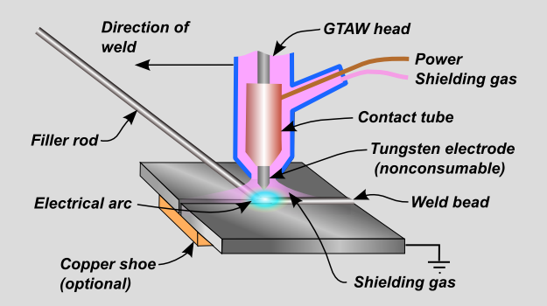
Fig. 3.1: Process diagram- TIG Welding [19].
There are number of variants of GTAW process some of them are as follow :
- Pulsed current GTAW
- Hot wire TIG
- Twin electrode GTAW
- Gas tungsten arc spot welding
In pulsed current GTAW the welding current is supplied in pulses rather than a constant magnitude. The welding current weaves periodically between peak current and base current. The high level of the peak current is selected to give adequate penetration and bead contour without excessive heat build up, while the low level of the background is set at level sufficient to maintain stable arc and controls the solidification rate of the molten bead This permits arc energy to be used efficiently to fuse a spot of controlled dimensions in a short time producing the weld as a series of overlapping nuggets and limits the wastage of heat into adjacent parent metal as in constant current welding. As the heat energy required to melt the base metal is supplied only during peak current pulses for brief intervals of time allows the heat to dissipate into the base metal leading to narrower heat affected zone [8,20]. Fig. 3.2. shows the pulsed current transient for GTAW.

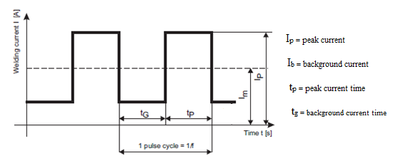
Fig. 3.2: Pulsed current transient for GTAW [21].

3.2 Gas Tungsten Arc Welding Equipment
The TIG welding equipment chiefly consists of :
- A TIG torch to control the arc. It has a collet body combination which holds the electrode.
- A power source which is capable of providing the necessary welding current.
- A TIG unit with incorporated contol systems that make it possible to adjust the welding current, arc initiation etc.
- A shielding gas cylinder with pressure reducing valve and flowmeter.

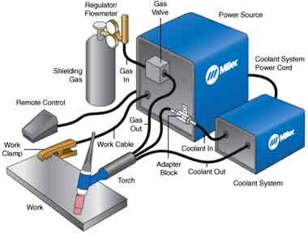
Fig. 3.3: Set up of GTAW [19]

3.2.1 TIG Torch
The torch carries the non-consumable tungsten electrode in an adjustable clamp arrangement and can be fitted with various ceramic nozzles to guide the gas flow to the arc area [22]. The torch must be compact, lightweight and fully insulated. It must provide a handle for holding it, a means for conveying the shielding gas to the arc area. The torch assembly normally includes various cables, hoses and adapters for connecting the torch to source of power, gas and water. The selected torch must carry the maximum welding current that is likely to be needed and ensures that the nozzle and electrode assembly allow full access to the area being welded. It is preferable to weld in the flat position to take full advantage of the effect of gravity.
An extremely large variety of ceramic gas cups is available. Ceramics are graded by orifice size, smaller the electrode, lower the gas flow rate, smaller the orifice size. Gas flow rate depends on the type of gas and cup orifice diameters. Fig.3.4. shows a TIG torch and its various components.

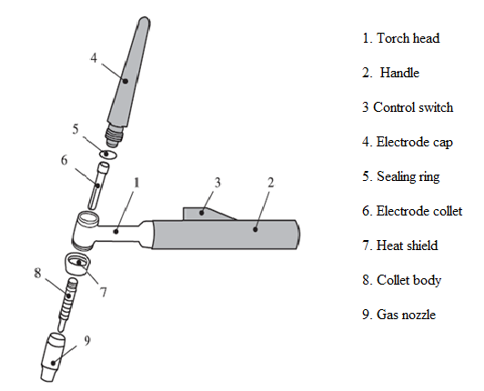
Fig. 3.4: TIG torch and its various components [19]
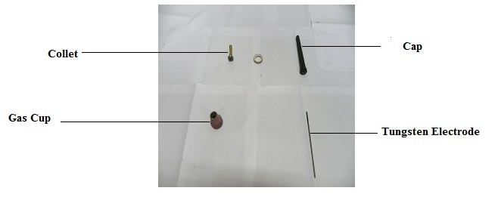
Fig. 3.5: Various components of TIG torch

The flow of shielding gas through the torch has some cooling effect which is sufficient for low production rates. For reasons of economy, however, it is better that the gas flow is kept to a minimum, but it reduces the cooling effect. This means that the torch could become uncomfortably warm during continuous use and need water cooling. Torches above 125A capacity are generally available as either gas or water cooled. The major distinction among torches for GTAW is whether they are air cooled or water cooled.
Air Cooled Torches- They are usually light weight, small, compact and less expensive. They have a maximum welding current of about 200A. They are normally used for thin welding metal and for limited duty cycles. The various components of Air Cooled TIG torches are shown in Fig.3.6.
Fig. 3.6: An air cooled Torch [19]
Water Cooled Torches- Fig shows the component parts of a water cooled TIG torch and its fittings. These are designed for continuous high current welding. They operate continuously within current range of 200A to 1000A. In some cases the water is directed in and out of the torch by separate tubes, but it is not uncommon for the cooling water to be concentrically piped away from the torch via the current input cable which cools the cable as well. The flow of the cooling water needs only to be fairly small about 1.5 l/min. This flow of water is controlled by a solenoid valve provided in the welding machine [17]. The flow of current to a TIG torch used in hand welding is usually controlled by a auxiliary switch, leaving one hand free to apply filler wire. There are some torches which have flexible neck. These are useful where access to the weld is very difficult. Various components of water cooled torch is as shown in fig.3.7.

Fig. 3.7: A water cooled GTAW torch [19]

3.2.2 Types of Nozzles
Several types of nozzles or gas cups are used in GTAW: ceramic, metal, fused quartz and dual shielded nozzles. Ceramic nozzles cost the least and are most popular, although water-cooled metal nozzles have longer service lives.
Ceramic nozzles become brittle after continuous use and must be replaced when the tip of the nozzle becomes rough. A rough, uneven lip interferes with the flow of shielding gas and causes non-uniform gas coverage of the weld area.
Sleeve type metal nozzles have limited current carrying capacity. Because they are delicate, they are easily damaged and misused. Water cooling of these nozzles makes it possible to use welding current in the range of 500A to 1000A.
Fused quartz nozzles are transparent and are preferred by some welders, who maintain that superior vision of the weld operation. Due to the contamination of the electrode, violent ejection of the metallic vapours away from its surface dulls the inside of the quartz nozzle, and visibility of the weld is thereafter severely impaired.
The dual shielded nozzle permits a relatively small flow of shielding gas around the electrode to shield the immediate weld pool, while an annular grooved section around the central nozzle sends down an atmosphere of nitrogen or CO₂ to exclude air from contact with the central inert gas column. This type of nozzle is rarely used in industries.
Another type of gas nozzle is gas lens which is constructed in such a way that the shielding gas passes through a wire grid in order to make the flow of gas more stable at a longer distance. The advantage of the long gas flow is the fact that the electrode can have a longer stick-out thus allowing to have a better view of the weld pool. Fig.3.8. shows a gas nozzle and gas nozzle with gas lens.
Fig. 3.8: a nozzle and a nozzle with a gas lens [19]
3.2.3 Filler wire Feeders
The wire feed mechanism for GTAW consists of three components viz; wire drive mechanism, speed control and the wire guide attachment. The drive mechanism consists of a geared motor to drive the grooved rolls to push the wire. The speed control mechanism is essentially a constant speed governor and the wire is guided from the roller to the guide attachment through a flexible conduit. An adjustable wire guide is attached to the welding head so as to maintain the correct position and angle of approach with respect to the tungsten electrode, work surface and the joint seam. An automatic filler wire feeder is as shown in fig.3.9.
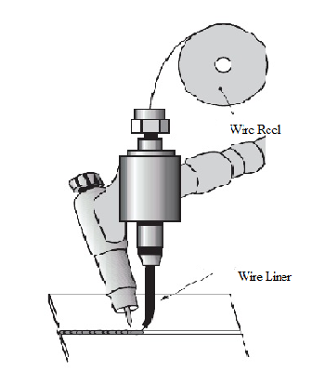
Fig. 3.9: Automatic Feeding of filler wire [19]
In semiautomatic machine or automatic welding machine, filler wire feeders are required to supply filler metal. For manual welding, filler metal is added by the operator. There are two types of feeding systems are used. They are
- Cold wire feed system
- Hot wire feed system
Cold wire feed system- It includes a wire drive, wire speed control and wire guide to feed the wire into the leading edge of the molten metal pool. The wire drive is controlled by a motor and gears to propel the wire. A constant speed can be achieved by electronic or mechanical control.
Hot wire feed system- Equipment for hot wire systems are similar to cold wire equipment. The, wire however is electrically resistance heated to the desired temperature before it reaches the weld pool. Alternating current from constant-current power source is used to heat the wire. Shielding gas may be used to prevent oxidation of the filler wire. Hot wire feed systems are used to weld copper alloys, stainless steel, carbon and low alloy steels and nickel alloys.
3.2.4 Welding Cables
Welding cables and fixturing, connectors or work leads, link the power source to the torch and workpiece. Cables normally are made of copper or aluminium and consist of fine stranded wires enclosed in insulated casings of natural or synthetic rubber. A protective wrapping is placed between the stranded conductor wires and insulated jacket to permit some movement between them and provide maximum flexibility.
Cables must be kept to minimum length, and must be of ample size to carry the welding current without overheating. Excessive long cables or undersize cables will cause loss of current and voltage. Long cables should never be coiled up; rather, the proper length of the cable is used. Welding cables must not be operated at current in excess of their rated capacity otherwise it will cause overheating or rapid deterioration of the insulation. Worn cables must be replaced to prevent short circuiting.
For welding with high frequency arc stabilization, cables should be as short as practical to prevent high frequency attenuation. The cable between the high frequency unit and the torch should be suspended from insulated hangers and not be looped with other cables. In mechanized welding operations where a jig or holder is used, all metallic parts containing the workpiece must be grounded, to prevent burning. Fig.3.10. shows welding cable.
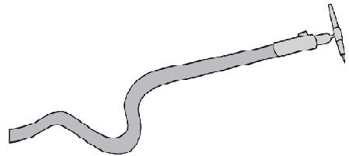

Fig. 3.10: welding cable [19]

3.2.5 Power Source
GTAW must be operated with a drooping, constant current power source - either DC or AC. A constant current power source is essential to avoid excessively high currents being drawn when the electrode is short-circuited on to the work piece surface. This could happen either deliberately during arc starting or inadvertently during welding. If, as in MIG welding, a flat characteristic power source is used, any contact with the work piece surface would damage the electrode tip or fuse the electrode to the work piece surface. In DC, because arc heat is distributed approximately one-third at the cathode (negative) and two-thirds at the anode (positive), the electrode is always negative polarity to prevent overheating and melting. However, the alternative power source connection of DC electrode positive polarity has the advantage in that when the cathode is on the work piece, the surface is cleaned of oxide contamination. For this reason, AC is used when welding materials with a tenacious surface oxide film, such as aluminium.
AC GTAW usually uses argon as a shielding gas. The process is a multipurpose process, which offers the user great flexibility. By changing the diameter of the tungsten electrode, welding may be performed with a wide range of heat input at different thicknesses. AC GTAW is possible with thicknesses down to about 0.5 mm. For larger thicknesses, greater than 5 mm, AC GTAW is less economical compared to MIG-welding due to lower welding speed.
DC GTAW is applicable for welding thicknesses in the range 0.3mm to 12 mm. DC GTAW with electrode negative is used for welding thicknesses above 4 mm. The negative electrode gives a poor oxide cleaning compared to AC-GTAW and MIG, and special cleaning of joint surfaces is necessary. The process usually uses helium shielding gas. This gives a better penetration in thicker sections because it concentrates the heat in the joint area.
When welding is done with DCEP heat will be concentrated at the positive side of the arc; therefore the greatest amount of heat is distributed into the electrode. On the other hand workpiece receives lesser amount of heat resulting in a shallow penetration. However, it provides good cleaning action by removing oxide layer due to flow of positive ions from tungsten electrode. Fig.3.11, 3.12 and 3.13. shows the penetration obtained with different polarities.

Fig. 3.11: penetration with Fig. 3.12: Penetration with Fig. 3.13: Penetration with
DCEN polarity DCEP polarity AC polarity
3.2.5.1 Power Sources
Modern power sources are much lighter and less bulky, provides efficient cooling through the use of modern materials such as light alloys in their construction. It is basically of four types:
- Transistor Series regulator power source- DC only
These use power transistors for current regulation, with analogue control from a low current signal. They are low in efficiency but give accurate and very stable control of the welding current and provide pulsing waveforms and frequency.
- Switch transistorised power sources- usually DC only
Using power transistors with HF switching of the DC supply, these power sources give similar current control characteristics to type 1, are more electrically efficient but give smaller range of pulsing frequency and waveforms.
- Thyristor Power source- AC/DC
These power sources uses very advanced electronics, using thyristors instead of diodes on the transformer output side. These power sources give excellent current and weld time accuracy, square AC waveforms, and can be used in the pulsed mode, with limited pulsing frequency response.
- AC rectifier plus inverter power sources- AC/DC
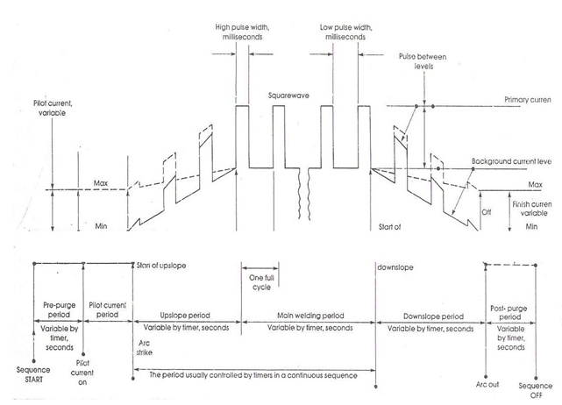
These power sources are widely used in industry. These power sources are highly versatile, light in weight, very cost effective, very cost effective and small in size with high efficiency. These are highly precise solid state, transistorised units and used where extremely stable and consistent arcs are required. Fig. 3.14. shows a welding sequence which should be available from these power sources
Fig. 3.14: A welding sequence [22]
3.2.6 Shielding gas equipment
Shielding gas is supplied from many sources- single cylinders, portable or stationary manifold systems etc. Gas flow is controlled by flowmeters and regulators. The shielding gas is brought to the welding torch through hoses, which may be connected straight to the torch or through the power supply or to an inert gas attachment to the torch.

Hoses- When setting up a GTAW operation, new fittings and hoses should be used. When old hoses are used for argon or helium, they may continue for long time to contaminate the inert gas transmitted through them. When argon or helium gas lines are disconnected, both male and female connections should be closed with pressure sensitive tape or with plastic plugs to prevent moisture or any other contaminants from entering the gas passages.

Mixers- When a mixture of two or more gases is used, the mixture is made by metering the separate gases into a mixture are made by metering the separate gases into a mixing chamber. Here the gases are combined and mixed, after which the mixture exits through the port.

Gas Flowmeters- For monitoring the shielding gas in GTAW, standard single stage regulators with flowmeters are used. Different flowmeters are used for different shielding gases, each calibrated separately. The flowmeter may be of circular dial type with needle indicator or glass tube type with a float is as shown in fig. The gas flow rate is normally marked both in litres/min and cubic feet /hr. The range varies from 0 litres/min to 50 litres/min. Fig. 3.15 shows a gas flowmeter.

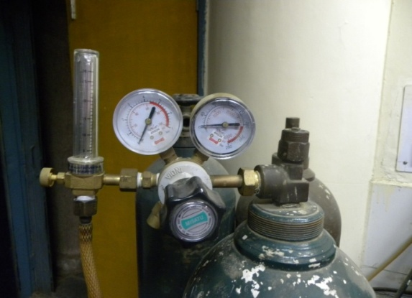
Fig. 3.15: A Gas Flowmeter

3.3 Electrodes for GTAW process
GTAW uses a non-consumable, non-melting tungsten electrode. Electrodes for TIG welding are almost entirely made from tungsten which has melting temperature of 3370⁰c and boils at 6135⁰c. The rods are mainly products of powder metallurgy produced by compression and sintering. They are generally obtainable in round form about 150mm long. The electrodes come in variety of diameters ranging from 0.25mm to 6mm.
Several types of electrodes are used in GTAW including thoriated, lanthaniated, ceriated, and pure tungsten. Some characteristics to consider in an electrode are good ignition and re-ignition properties, constant arc, long lifetime, and high current-loading capacity. Considering these characteristics it is common practice to mix small quantities of powder in the tungsten electrode. These include oxide powders of zirconium thorium, lanthanum and cerium in various percentages. Thoriated and Zirconiated electrodes have better electron emission characteristics than pure tungsten electrodes, making them more suitable for DC operations. The electrode is normally ground to a point or truncated cone configuration to minimize arc wander [1, 18 and 22]. Table3.1 below shows the size of various electrodes for particular weld current range based on 2% thoriated electrodes:
Table 3.1: TIG electrode current carrying capacity [22]
S.no | Diameter (mm) | DCEN or DCSP  Current capacity (A) | DCEP/ AC  Current capacity (A)
1. | 1 | 15-50 | Up to 20
2. | 1.6 | 50-100 | 20-50
3. | 2.0 | 50-150 | 50-100
4. | 2.4 | 50-200 | 50-150
5 | 3.2 | 200-300 | 150-200
6 | 4.8 | 250-400 | 200-300
7 | 6.4 | 400-600 | 300-400

3.3.1 Classification of Electrodes
The classification of tungsten electrode is done on the basis of their chemical composition, as summarized in table 3.2 below: [24]
Table 3.2: Colour code and alloying elements for various tungsten electrode alloys [2]:

AWS  Classification | Colour | Alloying  Element | Alloying  Oxide | Nominal Weight  of Alloying Oxide  % | Remarks
EWP | Green | _ | _ | _ | Provides good arc stability for AC welding. Reasonably good resistance to contamination. Lowest current carrying capacity. Least expensive. Maintains a balled end.
EWCe-2 | orange | Cerium | CeO₂ | 2 | Similar performance to thoriated tungsten. Easy arc starting, good arc stability, long life. Possible replacement for thoriated.
EWLa-1 | Black | Lanthanum | La₂O₃ | 1 | _
EWTh-1 | Yellow | Thorium | ThO₂ | 1 | _
EWTh-2 | Red | Thorium | ThO₂ | 2 | Easier arc starting. Higher current capacity. Greater arc stability. High resistance to weld pool contamination. Difficult to maintain balled end on AC.
EWZr-1 | Brown | Zirconium | ThO₂ | 2 | Excellent for AC welding due to favourable retention of balled end, high resistance to contamination, and good arc starting. Preferred when tungsten contamination of weld is intolerable.
EWG | Gray | Not Specified | _ | _ | _

An important parameter for characterising tungsten electrodes is the work function of the electrode material. The work function of a material indicates the amount of energy to give off electrons i.e. to follow current to flow. The work function of pure tungsten is 4.4eV [25, 26]. The addition of stable oxide of a metal lowers the work function of the tungsten electrodes and makes it easier to give off electrons and strike an arc [27]. The work functions of some of the elements whose oxides are used as additions to tungsten electrodes are as given below in table 3.3:
Table 3.3: Work function of various elements [2]

S.no. | Elements | Work Function  (eV)
1. | Zirconium | 4.2
2. | Thorium | 3.4
3. | Lanthanum | 3.3
4. | Cerium | 2.6

The oxide additions also affect the current carrying capacity of the electrodes because these oxides are insulators. Thus, the electrode with lowest volume of oxides should have the highest current carrying capacity. The alloying additions improve arc characteristics, help stabilize the arc and increase the life of the electrode.
3.3.2 Electrode Sizes and Current Capacities
The choice of an electrode, its size and welding current depend on the type and thickness of the base metal being welded. The current carrying capacities of all types of tungsten electrodes are affected by the type of welding torch, the type of power source and the shielding gas. In an arc, about 70% of the heat is generated at the anode and 30% at the cathode. Therefore, with DCEN polarity the cathode (electrode) can carry much higher current without over-heating. Whereas with DCEP polarity a much larger diameter is required to support a given level of current because the tip is not cooled by the emission of electrons but it is heated by their impact.
In case of AC power supply, the electrode tip is cooled during each electrode negative half cycle and is heated in the positive cycle. Hence the current carrying capacity of an electrode with AC supply lies between DCEP and DCEN. Therefore, a large diameter electrode is required in case of welding with AC supply. The suggested current ranges for each electrode type and size using argon shielding gas along with gas cup diameters recommended for use with different types of welding power sources are as listed in the table 3.4 and 3.5 below [28]:
Table 3.4: Typical type of current, tungsten electrodes and shielding gases for welding different metals

S.no. | Type of metal | Thickness (mm) | Type of current | Electrode | Shielding gas
1. | Aluminium | All  Over3  Under3 | AC  DCEN  DCEP | Pure or Zirconium  Thoriated  Thoiated or Zirconium | Ar or Ar-He  Ar or Ar-He  Ar
2. | Copper, copper alloys | All  Under 3 | DCEN  AC | Thoriated  Pure or Zirconium | He or Ar-He  Ar
3. | Magnesium alloys | All  Under3 | AC  DCEP | Pure or Zirconium  Zirconium or Thoriated | Ar  Ar
4 | Stainless steel | All  Under3 | DCEN  AC | Thoriated  Pure or Zirconium | Ar or Ar-He  Ar
5 | Titanium | Under3  All | AC  DCEN | Pure or Zirconium  Thoriated | Ar  Ar
6 | Nickel, Nickel alloys | All | DCEN | Thoriated | Ar or Ar-He

Table 3.5: Typical current ranges for tungsten electrodes for GTAW [2]
S.no. | Electrode  Diameter  (mm) | Gas Cup ID (mm) | Direct Current (A) |  | Alternating Current (A)
S.no. | Electrode  Diameter  (mm) | Gas Cup ID (mm) | DCEN | DCEP | Unbalanced  Wave AC |  | Balanced  Wave AC
1.  2.  3.  4.  5.  6.  7.  8.  9. | 0.25  0.50  1.00  1.50  2.50  3.175  4.000  4.750  6.350 | 6  6  10  10  12  12  12  15  18 | EWP  EWCe-1  EWLa-1  EWTh-1  EWTh-2  Up to 15  5-20  15-80  70-150  150-200  250-400  400-500  500-750  750-1000 | EWP  EWCe-1  EWLa-1  EWTh-1  EWTh-2  N/A  N/A  N/A  10-20  15-30  25-40  40-55  55-80  80-125 | EWP  Up to 15  5-15  10-60  50-100  100-160  150-210  200-275  250-350  325-450 | EWCe-1  EWLa-1  EWTh-1  EWTh-2  EWZr-1  Up to 15  5-20  15-80  70-150  140-235  225-325  300-400  400-500  500-630 | EWP  Up to 15  10-20  20-30  30-80  60-130  100-180  160-240  190-300  250-400 | EWCe-1  EWLa-1  EWTh-1  EWTh-2  EWZr-1  Up to 15  5-20  20-60  60-120  100-180  160-250  200-320  320-390  340-425
Operating at higher current levels than recommended for a given electrode size may cause the melting or erosion of electrode. Also tungsten particles may get into the weld pool and act as discontinuities or defect in the weld. Whereas operating at too low current levels may cause arc instability.
3.3.3 Electrode Tip Configuration
The shape of the electrode tip is an important process variable in GTAW. The preferred electrode tip shape impacts the temperature and erosion of the tungsten. Tungsten electrodes are ground to a tip to provide improved arc starting with high frequency ignition. These electrodes may have an end profile that is pointed, hemispherical or a bulbous mass at the tip of the electrode. A pointed tip is ideal for welding in narrow zones and permits the current to be maintained. An electrode with a hemispherical end profile has the greatest current density as less of the electrode end is in contact with the arc [18]. Tip configuration of electrodes for various power sources are as follows:
- For AC Sine Wave and conventional square wave
With AC the tip is subjected to more heat. To allow larger mass at the tip to withstand the higher heat tip is rounded. The melted end must be small to ensure best arc suitability. These electrodes should have a hemispherical or balled end formed. The diameter of the end should not exceed the diameter of the electrode by more than 1.5 times. If it becomes larger than this because of excessive current, there is the possibility of it dropping off to contaminate the weld. If the end is excessively large, and the current is decreased before the molten tip drops off, the arc tends to wander around on the large surface of the electrode tip. The arc becomes very hard to control as it wanders from side to side. For improved arc focus ceriated, lanthanated or thoriated tungsten electrode is used.
- For DC electrode Negative
Since all of the weld energy is provided by electrode negative, there is very little heating affect on the tungsten and sharp pointed tungsten is preferred. With DCEN a pointed tip concentrates the arc and improves arc starting. Fig shows the preferred shapes for balled and the various types of points used with the DC and AC wave shaped power sources.
- For DC electrode positive
DCEP has the highest heat input to the electrode tip. For this reason a slight ball of molten tungsten is suspended at the end of tapered electrode tip. The liquid tungsten surface tension with large mass above the molten ball holds it in place.
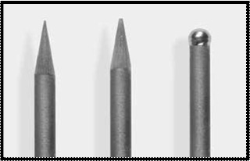
Fig. 3.16: Electrode tip configuration[29]

3.3.4 Electrode preparation and effect of Tip angle
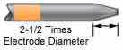
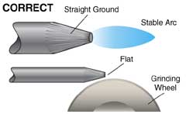
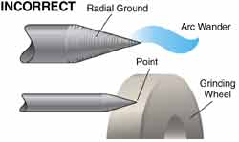
Electrodes are grinded in order to provide taper for a distance of 2 to 2.5 electrode diameters. Fig.3.17. shows the correct preparation of tungsten electrode.

Fig. 3.17: Correct way of electrode preparation [19]

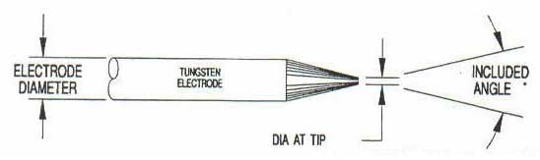
Tip angle has also significant influence on penetration characteristics and the width of the weld pool. The electrode tip parameters are shown in fig 3.18. The electrode taper angle is the angle that is ground on the end of the tungsten electrode as shown in the fig. Taper angle usually range from 30⁰ to 120⁰. Smaller taper angles tend to wear more quickly, especially when the tip of electrode touches the work. On increasing the taper angle from 30º to 120⁰ width of bead –on-plate welds decreases. For the same increase in taper angle, the depth of penetration increases. Table 3.6 below gives recommended electrode tip sizes and current ranges:

Fig. 3.18: Electrode tip parameters [29]

Table 3.6: Tungsten electrode tip shapes and current ranges [2]
DCEN ( Electrode Negative/ Straight Polarity with Argon as Shielding gas)
S.no. | Electrode Diameter(mm) | Diameter at tip (mm) | Constant included angle (degrees) | Constant Current range(A) | Pulsed current range (A)
1.  2.  3.  4.  5.  6.  7.  8. | 1.02  1.02  1.59  1.59  2.38  2.38  3.18  3.18 | 0.125  0.25  0.5  0.8  0.8  1.1  1.1  1.5 | 12  20  25  30  35  45  60  90 | 2-15  5-30  8-50  10-70  12-90  15-150  20-200  25-250 | 2-25  5-60  8-100  10-140  12-180  15-250  20-300  25-350

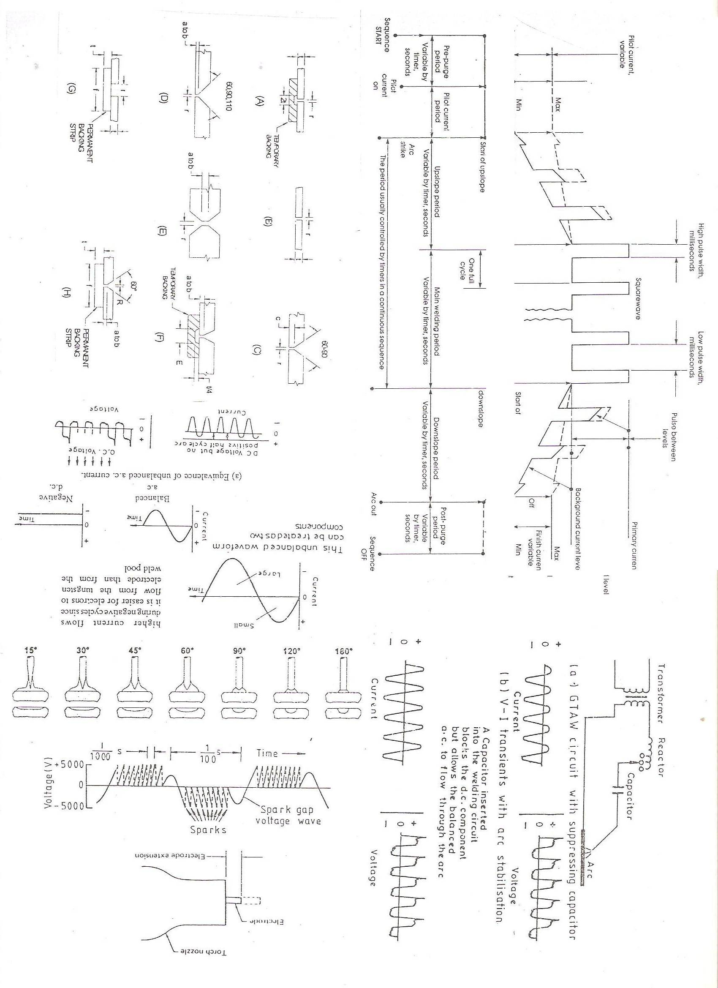
The angle of cone, which is formed at the end of tungsten electrode, affects the penetration shape of the weld metal. The effect of electrode tip on penetration profile is as shown in fig. 3.19.

Fig. 3.19: Effect of electrode tip penetration profile [2]

3.3.5 Electrode Extension
As the inclination of the torch varies from one joint to another, some variation in electrode extension must accompany it. To conserve gas and provide adequate shielding of the weld pool, the electrode should be extended no farther than absolutely necessary [18]. Also, if the electrode is slightly off centre, the nozzle lip nearest the electrode may begin to melt and vaporize and thus contaminate the shielding.
Electrode protrusion beyond the gas nozzle is determined by the joint design and welding position. For e.g., in downhand welding the electrode may extend up to 5mm beyond the nozzle, fillet welds are more difficult to handle from the point of view of access so an extension of up to 6mm, while for corner welds an extension 1.5mm to 3mm is adequate [23].
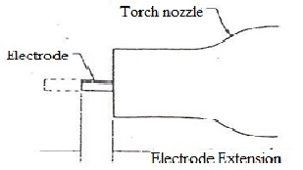
Fig. 3.20: Electrode extension [18]

3.4 Shielding Gas
In GTAW, the gas used to shield the welding arc and hot metals is an inert gas. Inert gases are gases whose atomic structures do not allow them to react with metals or other gases. Argon, helium, or an argon-helium mixture is used as the inert gas in GTAW.
Argon is a relatively heavy gas. It has several benefits when used in GTAW. The ionisation potential of argon is 15.5 electron volts which is quite lower than that of helium which has an ionisation potential of 24.5 eV. Hence it requires a lower arc voltage for a given arc length and current used. It also provides easier arc starting. Its heavier weight as compared to helium provides for good shielding with lower flow rates. Argon has high arc energy density i.e. high concentration of energy within the arc area. This allows production of narrow weld seams and it can be obtained at a purity of better than 99.90% which is essential for welding [22].
In contrast to argon, helium is the lightest of the inert gases. Because of its light weight, about two to three times more helium is needed as compared to argon to shield the weld area. Despite this, helium has an advantage over argon in that it can be used with greater arc voltages. Because of this, helium is preferred when working with thick metal sections.
Another difference in the two gases is their cleaning ability. Both helium and argon allow for good cleaning action when using DC. However, when using AC, argon provides for better cleaning action. Argon also provides better arc stability than helium when using AC. Comparison of bead produced by argon and helium is shown in fig. 3.21.

Fig. 3.21: A representation of the affects on the arc and bead produced by argon and helium shielding gases [19]
3.4.1 Shielding Gas Selection
A proper gas selection is very important for GTAW. If we use the wrong gas mixture, the tungsten electrode will quickly be consumed or deposited in the weld puddle. Table 3.7 below shows the choice of correct shielding gas according to metal being welded.
Selection of shielding gases according to the material being welded
- Argon - The most commonly-used shielding gas which can be used for welding a wide range of materials including steels, stainless steel, aluminium and titanium. It provides easy arc initiation, better cleaning action and superior weld quality.
- Argon and H₂ mixture - The addition of hydrogen to argon will make the gas slightly reducing, assisting the production of cleaner-looking welds without surface oxidation. As the arc is hotter and more constricted, it permits higher welding speeds and hence this mixture is found most suitable in continuous welding of tubes and structural sections. Ar-H₂ mixtures may be satisfactorily used in fabrication of jet engines and food and chemical handling equipments. The mixture is frequently used to weld stainless steel, inconel and monel alloys. Disadvantages include risk of hydrogen cracking in carbon steels and weld metal porosity in aluminium alloys.

- Helium and helium/argon mixtures – are used when the greater penetration of helium is desired but the arc softening action of argon is helpful from standpoint of control. Adding helium to argon will raise the temperature of the arc. This promotes higher welding speeds and deeper weld penetration. This mixture is widely used for deeper penetration in thicker sections. Disadvantages of using helium or a helium/argon mixture is the high cost of gas and difficulty in starting the arc.

- Nitrogen – Nitrogen in a shielding-gas mixture is always detrimental to arc stability, because of the inherent steady attack on, and deterioration of, the electrodes. However, nitrogen markedly increases the voltage and attendant heat in the welding of copper alloys, for which an extremely hot arc is essential. If high purity nitrogen is used as the shielding atmosphere for welding deoxidized copper, the higher arc voltage obtainable permits higher current to be used with standard equipments.
Table 3.7: Choice of the correct shielding gases according to the metal being welded
Gases | Non alloyed steels | Stainless  Steels | Nickel alloyed | Copper  alloyed | Aluminium  Alloyed
Ar | x | x | x | x | x
Ar / H₂ |  | x | x
Ar /He |  |  | x | x | x
He |  |  |  | x | x

3.4.2 Gas Flow Rate
Setting a proper gas flow rate is another important element to successful GTAW. Contrary to what may seem to be common sense, more isn’t better. If the gas flows out of the torch at too high a velocity, it ends up bouncing off the surface being welded and starts a swirling motion parallel to the torch cup called a venturi. This venturi effect will suck air into the gas flow, creating an impure weld atmosphere. This results in pinholes in the weld. Typical flow rates with manual torches are 5 to 12 litres/min for argon and 12 lit/min to21 litres/min for helium [30]. If welding is done in a flat position, a flow rate of about 10 to 13 lit/min is typically adequate. For overhead welding, a flow rate of 13 lit/min is required.
3.5 Metals welded by GTAW process
The nature of GTAW permits its use for welding of most metals and alloys. Metals that are welded by GTAW process include carbon and alloy steels, stainless steels, heat resistant alloys, refractory materials, beryllium alloys, aluminium alloys, copper alloys, titanium alloys and zirconium alloys. Lead and Zinc are difficult to weld by GTAW. The low melting temperatures of these metals make control of the process extremely difficult. The boiling pt. of zinc is 906.11ºc temp. which is far below the arc temperature and poor weld result from vaporization of zinc. Welds in coated metals are likely to have low mechanical properties due to interalloying. Special procedures are required for the welding of metals that are coated with other metals. To prevent interalloying in welding coated metals, the coating should be removed in the area to be welded [18].

3.6 Base- Metal thickness
GTAW is applicable to wide range of base- metal thicknesses. The process is well adapted to welding sections 3mm or less, because of the intense, concentrated heat produced by the arc. Multiple-pass welding with the addition of filler metal can be done. For thickness range lies between 0.5mm to 5mm AC power source is used. For aluminium alloys commonly welded by GTAW thickness range varies from 1mm to 9.5mm are manually welded and thickness range varies from 0.25mm to 25mm are welded automatically. For base metal more than 6mm thick, other welding processes are generally used, although multiple-pass GTAW is used for thick sections in applications where high quality is mandatory.

3.7 Arc Initiation
Regular flow of electrons is required for arc initiation to take place. The ‘touch and draw’ method used for arc initiation can be used but it results in contamination of tungsten electrode. This results in tungsten inclusion in the weld metal, higher consumption of electrode and in the establishment of unstable arc [23]. Arc initiation in GTAW is done by one of the following methods.

- By touch and draw method
- Using auxiliary apparatus that provides high frequency high voltage supply
- Using a low current pilot arc

Arc can be initiated by touch and draw method on scrap material. The arc should not be started by touching the tungsten electrode to the aluminium workpiece because this may mark the work or result in aluminium being picked up on the electrode which is likely to cause an uncontrollable arc and a dirty weld. The initial arc should be struct on a starting block to heat the electrode to its operating temperature. The arc should never be struck on carbon block because this contaminates the electrode and leads to the formation of tungsten carbide which has and results in increasing the size of molten spherical end. Due to this there is an increase in arc resistance which reduces the current density.
Another way of starting the GTAW arc is to use High Frequency (HF). HF consists of high voltage sparks of several thousand volts which last for a few microseconds. HF is often used in conjugation with AC power source to achieve easy arc initiation without touching the electrode to the workpiece. When high frequency high current is superimposed over the normal welding circuit it quickly ionises the arc gap between the electrode tip and the workpiece thereby making it easy for the electron emission to ensue from the tungsten electrode. Once an electron/ion cloud is formed, current can flow from the power source. After the arc is initiated and stabilised the HFHV current is switched off and the normal welding circuit comes into operation. The high frequency used ranges between 100 KHz and 2 MHz for a voltage of 3000V to 5000V. This method of arc initiation is very efficient and clean and gives a long life to the tungsten electrode. Fig. 3.22 depicts the basic waveform obtained from HFHV arc initiation system.

Fig. 3.22: Basic voltage waveform obtained with high frequency high voltage unit [23]

Low current pilot arc system is highly reliable arc initiating method which may be used with DC welding system. The pilot arc is powered by a small auxiliary power source and provides conditions for initiating the welding arc.

3.7.1 Rectification

Due to setting up of high temperatures in GTAW the tungsten electrode gets heated to a much higher temperature than the temperature of metal being welded. This results in different abilities of the electrode and the workpiece to emit electrons. Due to this there exists a difference in resistance to current flow which tends to produce unbalanced AC as shown in fig.3.23. As a result higher voltage is needed when the electrode is positive; it results in lower current flow which causes partial rectification. This partial rectification results in DC component of current which tends to saturate the transformer resulting in its derating. The detrimental effects of rectification can be corrected by inserting banks of reversible electrolytic capacitors which may give up to 100microF/A in the power circuit. This results in charge being left on these capacitors when the electrode is negative which makes more current to flow when the electrode is positive. Rectification can also be eliminated by the use of balanced wave transformer. This unit incorporates into the welding current circuit a series capacitor of a capacity that will permit the alternating welding current to flow efficiently but will block the direct current component. These units are designed for open-circuit voltages in the range of 100V to 150V, require high frequency current for arc starting only and are used extensively in welding of aluminium alloys and magnesium alloys.

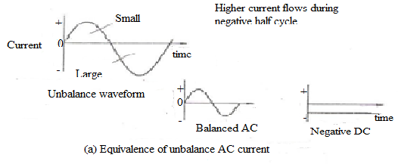

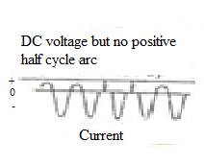
Fig. 3.23: Principle of current rectification [18]

  - Joint Design
The basic types of joints used in GTAW are butt, T, lap, corner and edge. Variations of these joints can be made to meet special requirements. Selection of the proper design for a particular application depends primarily on:
- Mechanical properties desired
- Cost of preparing the joint and making the weld
- Type of metal being welded
- Size and configuration of the components being welded

Edge and joint preparation are critical to the obtaining of sound welds, because proper joint fit-up is necessary particularly for square groove butt joints and other joints to be made without adding filler material.
3.8.1 Edge Joints
Edge joints are often used when the members to be welded will not be subjected to great stresses. Edge joints are not recommended where impact stress may occur to one or both the weld members. An edge joint occurs when the edges of the members are parallel and joined by a weld [30]. Fig shows different types of edge joints. If required the joints can be altered by machining the edges into groove. The groove can be square, bevelled, V, J or U.

Fig. 3.24: edge joints [19]
3.8.2 Butt Joints
Fig.3.25 shows different types of butt joints with various types of grooves. Butt joints are often used to join pressure vessels, boilers, tanks, plates, pipes or other applications where smooth weld face is required. Butt joints can be designed in various ways. The edges can be prepared into a groove that is square, bevelled, V, J or U grooved. A square- groove butt joint is the easiest to prepare, and can be welded with or without filler metal, depending upon the thickness of the pieces being welded. Table 3.8 below shows the welding parameters for manual GTAW of butt joints in aluminium with AC and argon shielding.

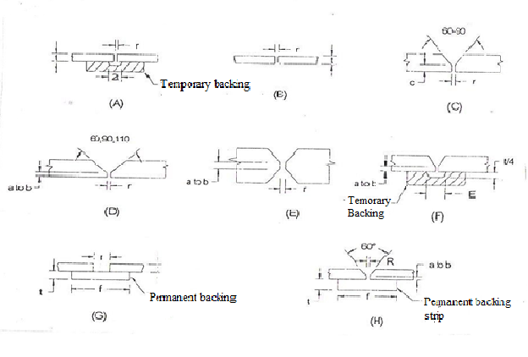
Fig. 3.25: Butt joints [2]

Table 3.8: Typical welding parameters for manual GTAW of butt joints in aluminium with AC and argon shielding [2]
Section  Thickness | Welding  Position | Joint  Geometry | Root  Opening | No. of weld passes | Filler Rod Diameter | Electrode  Diameter | Welding  Current | Welding  Speed
Mm |  | As in fig.3.25 | mm |  | Mm | mm | A | mm/s
1.6  2.4  3.2  4.8  6.4  9.5 | F, V, H,  O  F  V, H  O  F  V, H  O  F  V  H  O  F  V  H  O  F | (b)  (b)  (b)  (b)  (b)  (b)  (b)  (b)  (d) 60⁰ (d) 60⁰  (d) 90⁰  (d) 110⁰  (d) 60⁰ (d) 60⁰  (d) 90⁰  (d) 110⁰  (d) -60⁰  (e)  (d)- 60⁰  (e)  (d) -90⁰  (d)- 110⁰ | 0-1.6  0-1.6  0-2.4  0-2.4  0-2.4  0-3.2  0-2.4  0-2.4  0-3.2  0-2.4  0-2.4  0-2.4  0-3.2  0-2.4  0-2.4  0-2.4  0-3.2  0-2.4  0-2.4  0-2.4  0-2.4  0-2.4 | 1  1  1  1  1  1-2  1-2  1-2  2  2  2  2  2  2  2-3  2  2  2  3  2  3  3 | 1.6-2.4  1.6-2.4  3.2  2.4, 3.2  2.4, 3.2  3.4, 4.2  3.2  3.2, 4.2  4.0, 4.8  4  4  4  4.8  4.8  4.0, 4.8  4.8  4.8, 6.4  4.8, 6.4  4.8  4.8  4.8  4.8 | 1.6  1.6  2.4  2.4  2.4  2.4  2.4  2.4  3.2  3.2  3.2  3.2  4.0  4.0  4.0  4.0  4.8  4.8  4.8  4.8  4.8  4.8 | 60-80  60-75  95-115  85-110  90-110  125-150  110-140  115-140  170-190  160-175  155-170  165-180  220-275  200-240  190-225  210-250  315-375  340-380  260-300  240-300  240-300  260-300 | 3.4-4.2  3.4-4.2  3.4-4.2  3.4-4.2  3.4-4.2  4.2-5.1  4.2-5.1  4.2-5.1  4.2-5.1  4.2-5.1  4.2-5.1  4.2-5.1  3.4-4.2  3.4-4.2  3.4-4.2  3.4-4.2  3.4-4.2  3.4-4.2  3.4-4.2  3.4-4.2  3.4-4.2  3.4-4.2

3.8.3 Corner Joints
When members to be welded come together at 90⁰ and take the shape of an “L” they form a corner joint. Corner Joints are quite easily assembled and require little joint penetration. Several types of corner joints are as shown in fig.

Fig. 3.26: corner joints [19]

3.8.4 T- Joints
A T-joint occurs when the surfaces of the two members come together at approximately right angles or 90⁰. Fig shows T-joints. These joints possess good mechanical strength. They generally require little or no joint preparation.

Fig. 3.27: T- joints

3.9 Advantages and Limitations
GTAW process employs numerous advantages over other welding processes including:
- The ability to weld most metals and alloys, however it is not used for welding of low melting metals such as tin and lead.
- No slag, which eliminates postweld cleaning.
- No weld spatter and hence a very clean weld is obtained.
- All position welding.
- Reduced heat input through pulsing.
- Ability to join thin base metals because of excellent control of heat input.
- The process itself does not produce any smoke or fumes.
Some limitations of this process are:
- Low deposition rates; welding thick sections is thus time consuming and expensive.
- The increased amounts of ultraviolet rays from the arc cause the formation of ozone and nitrous oxides.
- Particles from the tungsten electrode can enter the weld pool and produce a weld defect or discontinuity.

3.10 Applications
GTAW is applied in all industrial sectors but is especially suitable for high quality welding. In manual welding, the relatively small arc is ideal for thin sheet material or controlled penetration (in the root run of pipe welds). Because deposition rate can be quite low (using a separate filler rod) MIG may be preferable for thicker material and for fill passes in thick-wall pipe welds.
GTAW is a general purpose welding process for welding of aluminium. Especially at thinner sheet thicknesses the process is qualified. The process is widely used for welding of pressure vessels, heat exchangers and pipes where tightness is important since the process produces welds with very low pore fractions. GTAW is also beneficial for welds with frequently starts and stops and for short welds due to excellent quality with low porosity. DC GTAW (negative electrode) could in addition also be beneficial for welding thin walled structures and profiles.
GTAW is also widely applied in mechanised systems either autogenously or with filler wire. However, several 'off the shelf' systems are available for orbital welding of pipes, used in the manufacture of chemical plant or boilers. Because the welder has less control over arc and weld pool behaviour, careful attention must be paid to edge preparation (machined rather than hand-prepared), joint fit-up and control of welding parameters.

Chapter-4
EXPERIMENTAL SETUP

  - Welding machine
Gas Tungsten Arc Welding (GTAW) process was used to weld the test specimens. The welding machine used is TRITON 220 AC/DC.
Technical data of GTAW machine
Table 4.1: Technical data of T2.05 Triton 220 AC/DC welding machine
Parameter | Value
Setting range:  Welding Current / Welding Voltage | 3A(5A AC) – 220A / 10.1V – 18.8V
Max. welding current at  20°C ambient temperature:  40%DC  45%DC  50%DC  60%DC  100%DC  40°C ambient temperature:  35%DC  40%DC  50%DC  60%DC  100%DC | 220A  -  -  180A  150A  220A  -  -  160A  130A
Load alteration | 10min (60%DC)
Open Circuit voltage | 45V
Mains voltage (tolerances) | 1*230V -40%; +15%  1*140V -40%; +10%
Frequency | 50/60Hz
Mains connection lead | 3*2.5mm²
Max. connected power | 5.9kVA
Recommended generator rating | 8.0kVA
cosφ / efficiency | 1.0 / 89%
Insulation class/protection classification | F/IP23
Ambient temperature | -10°C to +40°C
Machine cooling/torch cooling | Fan/gas or water
Workpiece lead | 35mm²
Dimensions L*W*H (mm) | 480*185*390
Weight | 18kg
Mains fuse (slow-blow safety fuse) | 1*16A
Constructed to standards | IEC60974/EN60974/VDE0544  EN50199/VDE 0544 Teil206

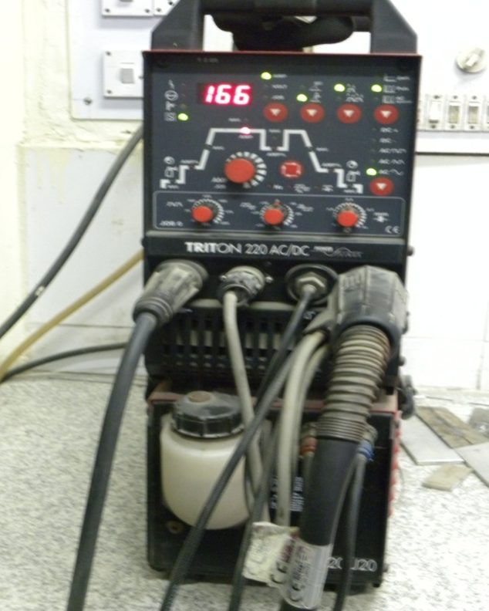

Fig. 4.1: Front view of T2.05 Triton 220 AC/DC welding machine

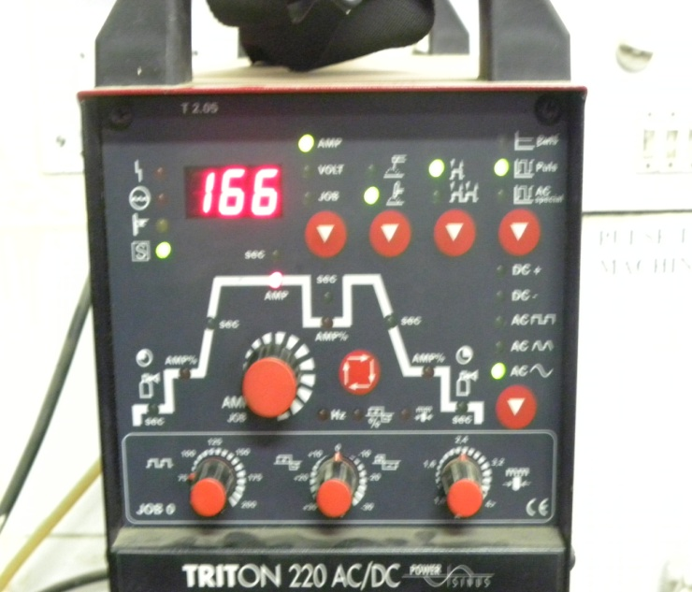

Fig. 4.2: Control panel of T2.05 Triton 220 AC/DC welding machine

4.2 Material Information
4.2.1 Base Metal:
The base material used in this study is AA-1100 of thickness 4.8mm.Table shows chemical, physical and mechanical properties of Aluminium alloy 1100 alloy.
Table 4.2: Chemical properties of AA-1100
Grade |  | Al (%) | Cu (%) | Si+ Fe (%) | Mn (%) | Zn (%) | Others (%)
AA-1100 | Min.  Max. | 99%  - | -  0.05-0.20 | -  0.95 | -  0.05 | -  0.10 | -  0.05

Table 4.3: Physical properties of AA-1100
Grade | Density  (Kg/mm³) | Mean Coefficient of  Thermal Expansion(µm/m/°C) | Thermal conductivity(W/m⁰c)  at 25⁰c | Electrical  Resistvity (μΩ.m)at 20⁰c
AA-1100 | 2710 | 23.6 | 222 | 0.292

Table 4.4: Mechanical properties of AA-1100
Grade | 0.2% proof  Stress, Mpa | Tensile  Strength, Mpa | Elongation %
AA-1100 | 92.02 | 122 | 15

4.2.2 Filler wire:
Table 4.5 shows the chemical composition and mechanical properties of filler wire used in experiments. The AWS recommended filler wire for AA-1100 is E-4043 of diameter 3.2mm is employed as the welding consumable
Table 4.5: Chemical properties of E-4043
Grade | Al | Si | Mn | Mg | Fe | Zn
E-4043 | 93.5 | 5.25 | 0.04 | 0.04 | 0.8 | 0.08

Table 4.6: Mechanical properties of E-4043
Grade | 0.2% proof  Stress, Mpa | Tensile  Strength, Mpa | Elongation %
E-4043 | 137 | 234 | 18

Chapter-5
DESIGN OF EXPERIMENT

5.1 Introduction
It is highly essential to design an experiment to determine the effects of variable and welding parameter on the various welding responses on a sound basis rather than a commonly employed trial and error basis in conjunction with a small number of repeat experiments for confirmation of results. Apart from the trial and error method of investigation the following techniques are commonly employed by researches.
- Theoretical approach
- Qualitative approach
- Qualitative cum dimensional analysis method
- General quantitative approach
5.1 General Quantitative approach
This method is most commonly used to design the experiments for welding research to predict the effects of welding input parameters on the output parameters or responses. Bases on the result of the factorial designed experiments, regression equations are established using the method of least squares. The correlation co-efficient is a number between +1 and -1 with the intermediate value of zero indicating the absence of correlation but it does not mean that variations are also independent. The limiting value of correlation co-efficient indicates perfect positive or negative correlation. The F-ratio is measure of scatter of the observed values about a predicted curve and it lies between zero and infinity. The larger the value of F the lesser the scatter so in general this approach helps in minimizing the cost and time of testing and of the same time increase the chance of success.
It is evident from the comparison of various research techniques that the general quantitative approach is based on a more sound logic than any other approach for the generalization of research data. Thus it was decided to make the approach, the basis of designing the experiments. There are various techniques available from the statistical theory of experimental design, which are well suited to engineering investigations. One such technique is a two level factorial design for studying the effects of parameters of responses, and this is one, which is selected for experiments.

5.3 Factorial Design
Factorial design is a standard statistical tool to investigate the effects of number of parameters on the response or output parameter. The most important advantage of this design is that the numbers of parameters are simultaneously studies for a more complete insight into the combined effects of the parameters on the response. In addition to that the interaction between two or more parameters can also be evaluated which is not possible with the conventional approach. Since in that approach all parameters, other than one investigated are held constant.
The experimental plan is to first choose fixed number of level for each of the parameters believed to affect the system under study. The simplest and most economical factorial design is to use two levels for each parameter. With each parameter at two levels, the full factorial design consists of 2^{k} runs at all possible combinations of testing condition, where k is the number of variables. The number of runs required by a full 2^{k} factorial design increases geometrically as k is increased and the large increase in the number of trials called for is primarily to provide for estimates of increasing number of higher order interactions which most likely do not exist. Therefore experiments for such estimates would be wasted, increasing cost and time of experimentation. Under such conditions it is possible and advantageous to use only part of the full factorial design i.e., fractional factorial design. In the fractional factorial designed experiment, the main effect of the factors are mixed (confounded) with the effects of higher order interactions. Since, these higher order interaction effects are assumed to be small and thus neglected. Here only four variables are taken due to Lab Constraints, so fractional factorial design was selected. Here number of trial is 2^{k-1} = 2⁴⁻¹ = 2³ = 8, where k= number of controllable variable [32].

5.4 Plan of investigation
In order to achieve the desired aim, the investigations were planned to be carried out in the following steps:
- Identifying the welding variables.
- Selection of the useful limits of the welding parameters, namely, peak current, background current, pulse frequency and peak current time.
- Developing the design matrix.
- Conducting the experiment as per design matrix.
- Development of mathematical models.
- Evaluation of co-efficient of equations.
- Checking adequacy of the models.
- Testing the significance of regression co-efficient and arriving at the final form of the mathematical models.
- Presenting the main effects and the significant interaction between different parameters in graphical forms.
- Analysis of results and conclusions.

Identifying the welding variables
Selection of the useful limits of the welding parameters

Developing the design matrix

Conducting the experiment as per design matrix

Development of mathematical models
Checking adequacy of the models
Testing the significance of regression co-efficient
Generation of Proposed models

Presenting the main and interaction effects

Analysis of results and conclusions

5.4.1 Identifying the welding variables
The welding variables were identified to develop mathematical models to predict individual and combined effects of the parameters. The various parameters selected were:
- Peak Current (I_{p})
- Background Current (I_{b})
- Pulse Frequency (F_{p})
- Peak Current Time (T_{p})
A two level, half fractional factorial design of eight (2⁴⁻¹ ) runs was selected and the effects of all the four variables were investigated simultaneously by confounding the main effects in a half fractional factorial design. This design also helped in reducing the experimental runs to the minimum possible[32, 33, 34].
5.4.2 Selection of process parameters and their limits
The limits of the welding parameters were selected on the basis of excessive trial runs. The basis of selection of the given range for various welding parameters was that the resultant weld should have good bead appearance, configurations and be free from the visual defects. From the trials following observations were made:
  - If peak current (I_{p}) < 185A incomplete penetration is observed. If peak current >215 overheating, undercuts were observed.
  - If background current (I_{b}) < 37A, arc length was found to be very short. If B > 64A arc will be get unstable.
  - If pulse frequency (F_{p}) < 50 Hz bead appearance was not so good. If F > 125 Hz harsh sound is observed.
  - If peak current time (T_{p}) < 1sec narrow bead is observed. If T > 4sec too wide bead is observed due to over melting of filler and base metal.
The two levels selected for each of the five variables are shown in table 5.1
Table 5.1: Welding parameters and their limits
Parameters | Notations | Units | Level
Parameters | Notations | Units | Low (-1) | High (+1)
Peak current | I_{p} | Amp | 185 | 215
Background  current | I_{b} | Amp | 37 | 64.5
Pulse frequency | F_{p} | Hz | 75 | 125
Peak current time | T_{p} | Sec | 1 | 4

For the convenience of recording and processing the experimental data, the upper and lower levels of the variables were coded as +1 and -1, respectively and the coded values of any intermediate levels were calculated by using the expression,

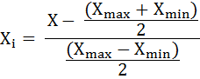
Where X_{i} = required coded value of a variable
X = any value of the variable from Xmax to Xmin
Xmax = upper level of the variable
Xmin = lower level of the variable
i = number of parameter

5.4.3 Developing the design matrix
Factorial design can be represented in the form of design matrix where column and row correspond to levels of factors and the different experimental runs respectively. The sign of column of design matrix were selected in such a way that these are having certain necessary optimal properties, which are given below:
5.4.3.1 Symmetry related to the centre of the experiment
The algebraic sum of the elements of the column vector of each parameter should be equal to zero, or
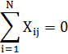
Where,
i = number of factors
N = number of trials, j=1, 2.....k
5.4.3.2 Normalisation
The sum of the squares of the elements of each column should be equal to number of trials, or
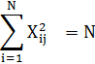
5.4.3.3 Orthogonality
The sum of the term by term product of any column vectors of a matrix should be equal to zero.
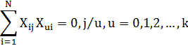
5.4.3.4 Rotatability
The points in a design matrix should be so selected that the precision of predicting the values of the optimization parameters is same at equal distances from the centres of the experiment and does not depend on the direction. The experimental conditions for 2⁴⁻¹ i.e. designs were given in table. The fourth column was generated by confounding the main effect b₄ with factor interaction of b_{1,} b_{2,} b_{3,} i.e. b₄ = (b₁. b₂. b₃).

5.4.4 Design Matrix
Table 5.2: Design Matrix
S.No. | Direct parameters
S.No. | I_{p} | I_{b} | F_{p} | T_{p}
S.No. | 1 | 2 | 3 | 4
1. | + | + | + | +
2. | - | + | + | -
3. | + | - | + | -
4. | - | - | + | +
5. | + | + | - | -
6. | - | + | - | +
7. | + | - | - | +
8. | - | - | - | -
Salient features of Design Matrix table are:
- Trials indicate the sequence number of run under consideration.
- b₀ represents the mean parameter of the experiment.
- b_{1,} b_{2,} b_{3,} and b₄ represent the notation used for controlled variables in the order of peak current, background current, pulse frequency and peak current time respectively.
- The signs +1 and -1 as already indicated refer to the upper and lower levels of that parameter under which they are recorded. The levels (or signs) for the parameter b₄ are derived by the relation b₄= b₁ b₂ b₃.
5.4.4.1 Developing Design Matrix for Calculating the Coefficient
Table 5.3: Design Matrix for calculating coefficients
S.No. | b₀ | b₁ | b₂ | b₃ | b₄ | b₁₂ | b₁₃ | b₁₄ | b₂₃ | b₂₄ | b₃₄
S.No. | b₀ | I_{p} | I_{b} | F_{p} | T_{p} | I_{p} I_{b} | I_{p} F_{p} | I_{p}T_{p} | I_{b}F_{p} | I_{b}T_{p} | F_{p}T_{p}
1. | + | + | + | + | + | + | + | + | + | + | +
2. | + | - | + | + | - | - | - | + | + | - | -
3. | + | + | - | + | - | - | + | - | - | + | -
4. | + | - | - | + | + | + | - | - | - | - | +
5. | + | + | + | - | - | + | - | - | - | - | +
6. | + | - | + | - | + | - | + | - | - | + | -
7. | + | + | - | - | + | - | - | + | + | - | -
8. | + | - | - | - | - | + | + | + | + | + | +

Table 5.4: Design Matrix for calculating coefficients
S.No. | b₀ | b₀ | b₁ | b₂ | b₃ | b₄ | b₁₂ | b₁₃
S.No. | b₀ | I_{p} | I_{b} | F_{p} | T_{p} | I_{p} I_{b}= F_{p}T_{p} | I_{p} F_{p}= I_{b}T_{p} | I_{p}T_{p}= I_{b}F_{p}
1. | + | + | + | + | + | + | + | +
2. | + | - | + | + | + | - | - | +
3. | + | + | - | + | - | - | + | -
4. | + | - | - | + | + | + | - | -
5. | + | + | + | - | + | + | - | -
6. | + | - | + | - | - | - | + | -
7. | + | + | - | - | + | - | - | +
8. | + | - | - | - | - | + | + | +

Y= b₀ + b₁I_{p} + b₂I_{b} + b₃F_{p} + b₄T_{p}+ b₅ (I_{p} I_{b}+ F_{p}T_{p}) + b₆ (I_{p} F_{p}+ I_{b}T_{p}) +
b₇ (I_{p}T_{p}+ I_{b}F_{p})

5.4.5 Conducting Experiments as per the design matrix
PROCESSES INVOLVED:
The following procedure was adopted while carrying out the experimentation in the welding lab:
- Cutting Aluminium strip
The base metal sheets of dimensions 150mm x 65mm x 4.8mm were cut on power hacksaw machine using kerosene as a cutting fluid.
- Job preparation
- As the thickness of the plates is 4.8mm a V groove butt joint of 60º groove angle is required. Edge preparation is done on shaper machine as shown in fig.5.1
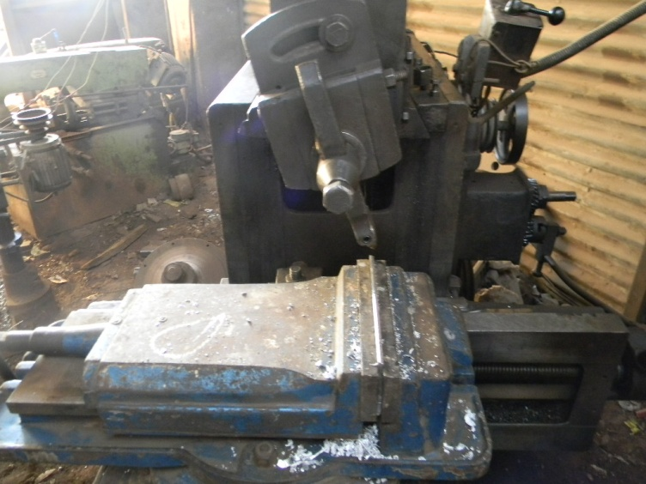
Fig. 5.1: Edge preparation of plates by shaper machine

- The designed V groove butt joint with its configuration is as shown in fig.5.2
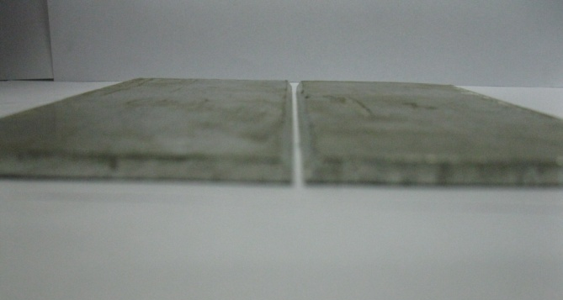
Fig. 5.2: V-groove butt joint
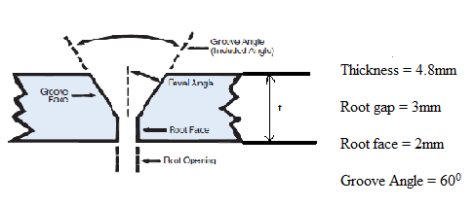
Fig. 5.3: Configuration of designed V- groove butt joint

- Welding
- Before welding, edges were cleaned in order to remove dirt, oil and grease. The plates are then kept on backing bars and ends were clamped in order to maintain the root gap and alignment. Then tack welds are made 10cm apart.

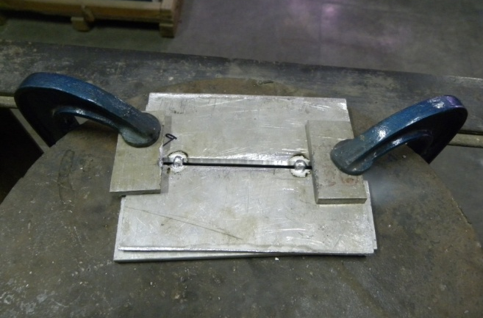
Fig. 5.4: Tack welds on plates

- Table shows the welding conditions. Joints are prepared in two root passes. For the first root pass electrode is slightly extended for 7mmto 8mm so that heat must be concentrated in the narrow zone as shown in fig.5.5. Weld beads of 10cm were deposited in second pass along the length using 3.2 mm filler wires of Al-4043 alloy as shown in fig.5.6.

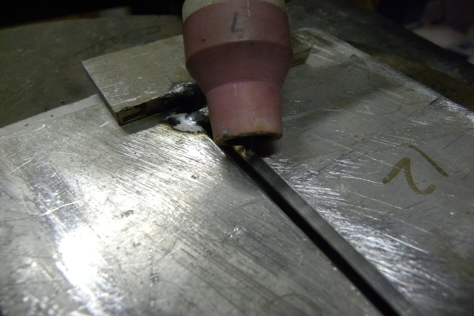
Fig. 5.5: Protrusion of electrode for root pass

Table 5.5: Welding conditions
Polarity | Pulsed AC
Welding current | 185A-215A pulsed current
Electrode length | 120mm
Electrode diameter | 2.4mm
Gas flow rate | 10 l/min
Background current time | 0.64 sec
Welding operation | Manual
Upslope time | 1 sec
Downslope time | 5sec
Gas Pre-flow time | 0.5 sec
Gas Post-flow time | 1.5 sec

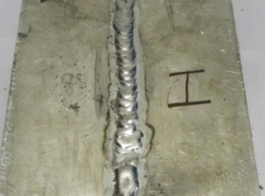
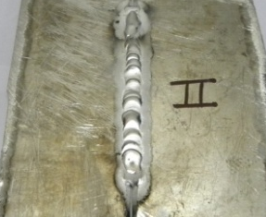
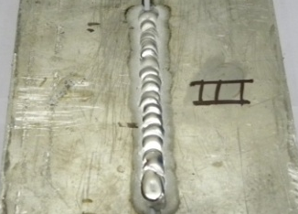

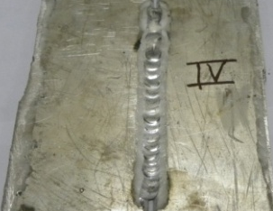
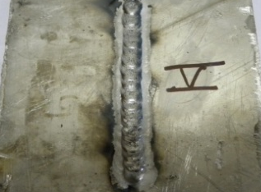
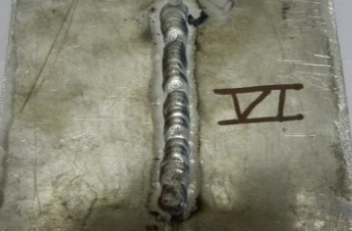

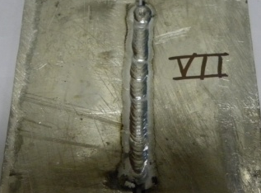
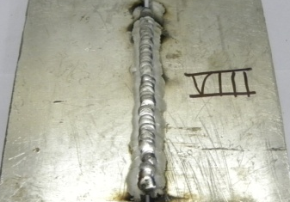

Fig. 5.6: TIG welded plates

- Preparation of tensile test specimens
The welded section is divided into 3 equal sections as shown in fig.5.7. Transverse tensile specimens are then prepared over wire EDM machine as shown in fig.5.8

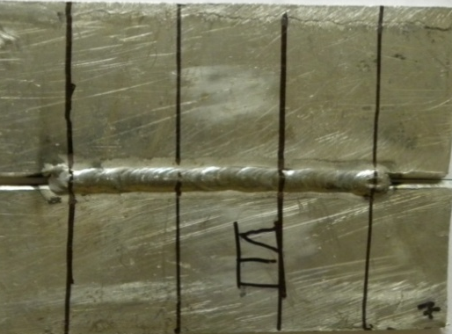
Fig. 5.7: TIG welded plate with divided sections

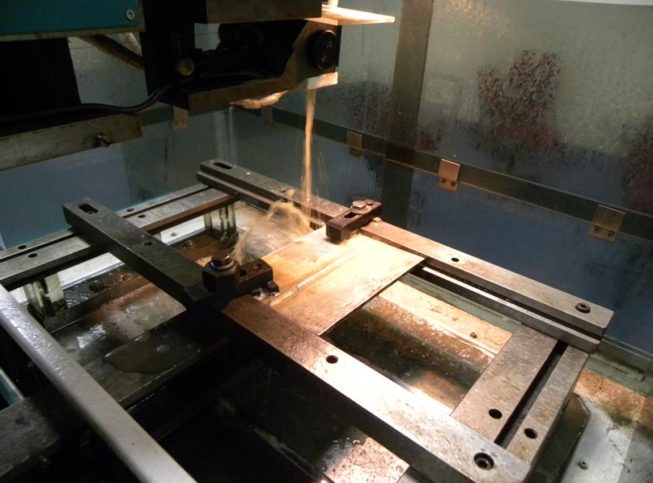
Fig. 5.8: Preparation of tensile specimens on wire EDM machine

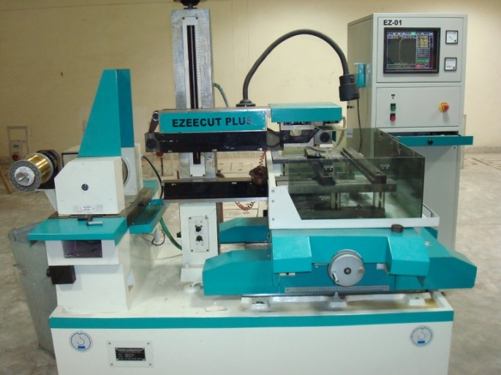
Fig. 5.9: Wire EDM machine

Tensile test specimen prepared is as shown in fig.5.10

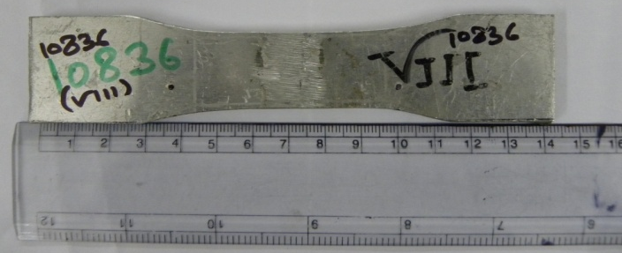
Fig. 5.10: tensile test specimen
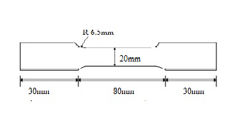
Fig. 5.11: Configuration of tensile test specimen

- Tensile Testing
Tensile test is then carried out on computer controlled UTM machine with a cross head speed of 5mm/min.
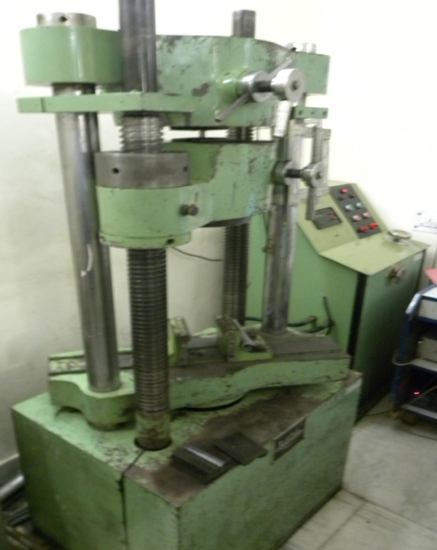
Fig. 5.12: Tensile test specimen in UTM machine
Table 5.6: Responses
S.No. | Ultimate Tensile Strength (MPa) |  |  | Yield Strength (MPa) |  |  | % Elongation (%EL)
S.No. | U₁ | U₂ |  | Y₁ | Y₂ |  | E₁ | E₂
1 | 95.32 | 93.42 | 94.37 | 65.8 | 70.3 | 68.05 | 10.88 | 10 | 10.44
2 | 97.3 | 96.3 | 96.80 | 73.2 | 68.5 | 70.85 | 9.4 | 9.2 | 9.30
3 | 84.2 | 86.6 | 85.40 | 62.4 | 66.4 | 64.40 | 12.8 | 14.4 | 13.60
4 | 93 | 91.7 | 92.35 | 68.2 | 67.9 | 68.05 | 10.2 | 10.4 | 10.30
5 | 96.2 | 99.6 | 97.90 | 75 | 77.07 | 76.04 | 11.4 | 11.4 | 11.40
6 | 90 | 91 | 90.50 | 71.6 | 73.1 | 72.35 | 10.4 | 9.2 | 9.80
7 | 94.3 | 93.1 | 93.70 | 64.3 | 68.2 | 66.25 | 8.4 | 8.4 | 8.40
8 | 98.5 | 97.4 | 97.95 | 80.3 | 77.3 | 78.80 | 10.05 | 9.2 | 9.63

Chapter-6
MATHEMATICAL MODELLING

6.1 Introduction
Mathematical models were developed for predicting the effect of pulse parameters on tensile strength; yield strength and % elongation of TIG welded AA-1100 using factorial technique. The coefficients of models were determined with the method of least squares. The adequacy and the significance of the coefficients of the models were tested by the analysis of variance (ANOVA) technique and student’s ‘t’ test respectively.
6.2 Development of a mathematical model
The response function can be expressed as:
Y = f (I_{p}, I_{b}, F_{p}, T_{p})
Where, Y= response parameter
I_{p}=Peak current
I_{b} = background current
F_{p}= Pulse frequency
T_{p}= Peak current time
The effects caused by changes in the four main process parameters and their first order interactions can be expresses as:
Y= b₀ + b₁I_{p} + b₂I_{b} + b₃F_{p} + b₄T_{p}+ b₅ (I_{p} I_{b}+ F_{p}T_{p}) + b₆ (I_{p} F_{p}+ I_{b}T_{p}) +
b₇ (I_{p}T_{p}+ I_{b}F_{p})
Where b_{0,} is constant and b_{1,} b_{2,} b_{3,} b_{4,} b_{12,} b_{13,} b_{14,} b_{23,} b_{24,} b_{34,} are co-efficient of the model.

6.3 Evaluation of the co-efficient of the model
The main and interaction effects were determined by using the formula:
/N

Where j = 0, 1, 2, 3, .................K
i = 1, 2, 3, .................N
N = the total number of observations
Xij = Value of a factor or interaction in coded form
Yi = Average value of response parameter
A matrix was designed in order to apply this formula and the coefficients of the equations were determined by dividing the effects of the variables and interactions of the variables by two and the constant b₀ was found by the formula:

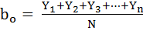
Where, N= No. of trials
and, Y₁, Y₂, Y₃, Y₄… Y_{n} are the outputs of n trials.

Table 6.1: Coefficient calculation for Ultimate tensile strength (UTS):
S.No | b₀ | b₁ | b₂ | b₃ | b₄ | b₁₂=b₂₃ | b₁₃=b₂₄ | b₁₄=b₃₄
1. | 94.37 | 94.37 | 94.37 | 94.37 | 94.37 | 94.37 | 94.37 | 94.37
2. | 96.8 | -96.8 | 96.8 | 96.8 | -96.8 | -96.8 | -96.8 | 96.8
3. | 85.4 | 85.4 | -85.4 | 85.4 | -85.4 | -85.4 | 85.4 | -85.4
4. | 92.35 | -92.35 | -92.35 | 92.35 | 92.35 | 92.35 | -92.35 | -92.35
5. | 97.9 | 97.9 | 97.9 | -97.9 | -97.9 | 97.9 | -97.9 | -97.9
6. | 90.5 | -90.5 | 90.5 | -90.5 | 90.5 | -90.5 | 90.5 | -90.5
7. | 93.7 | 93.7 | -93.7 | -93.7 | 93.7 | -93.7 | -93.7 | 93.7
8. | 97.95 | -97.95 | -97.95 | -97.95 | -97.95 | 97.95 | 97.95 | 97.95
Total/8  (Up to 2 decimal  places) | 93.62 | -1.08 | 1.27 | -1.39 | -0.89 | 2.02 | -1.57 | 2.08

Table 6.2: Coefficient calculation for Yield Strength (YS):
S.No | b₀ | b₁ | b₂ | b₃ | b₄ | b₁₂ =b₂₃ | b₁₃ =b₂₄ | b₁₄ =b₃₄
1. | 68.05 | 68.05 | 68.05 | 68.05 | 68.05 | 68.05 | 68.05 | 68.05
2. | 70.85 | -70.85 | 70.85 | 70.85 | -70.85 | -70.85 | -70.85 | 70.85
3. | 64.40 | 64.40 | -64.40 | 64.40 | -64.40 | -64.40 | 64.40 | -64.40
4. | 68.05 | -68.05 | -68.05 | 68.05 | 68.05 | 68.05 | -68.05 | -68.05
5. | 76.04 | 76.04 | 76.04 | -76.04 | -76.04 | 76.04 | -76.04 | -76.04
6. | 72.35 | -72.35 | 72.35 | -72.35 | 72.35 | -72.35 | 72.35 | -72.35
7. | 66.25 | 66.25 | -66.25 | -66.25 | 66.25 | -66.25 | -66.25 | 66.25
8. | 78.80 | -78.80 | -78.80 | -78.80 | -78.80 | 78.80 | 78.80 | 78.80
Total/8  (Up to 2 decimal  places) | 70.60 | -1.91 | 1.22 | -2.76 | -1.92 | 2.14 | 0.30 | 0.39

Table 6.3: Coefficient calculation for % Elongation (%EL):
S.No | b₀ | b₁ | b₂ | b₃ | b₄ | b₁₂=b₂₃ | b₁₃=b₂₄ | b₁₄=b₃₄
1. | 10.44 | 10.44 | 10.44 | 10.44 | 10.44 | 10.44 | 10.44 | 10.44
2. | 9.30 | -9.30 | 9.30 | 9.30 | -9.30 | -9.30 | -9.30 | 9.30
3. | 13.60 | 13.60 | -13.60 | 13.60 | -13.60 | -13.60 | 13.60 | -13.60
4. | 10.30 | -10.30 | -10.30 | 10.30 | 10.30 | 10.30 | -10.30 | -10.30
5. | 11.40 | 11.40 | 11.40 | -11.40 | -11.40 | 11.40 | -11.40 | -11.40
6. | 9.80 | -9.80 | 9.80 | -9.80 | 9.80 | -9.80 | 9.80 | -9.80
7. | 8.40 | 8.40 | -8.40 | -8.40 | 8.40 | -8.40 | -8.40 | 8.40
8. | 9.63 | -9.63 | -9.63 | -9.63 | -9.63 | 9.63 | 9.63 | 9.63
Total/8  (Up to 2 decimal  places) | 10.36 | 0.60 | -0.12 | 0.55 | -0.62 | 0.08 | 0.51 | -0.92

Table 6.4: Estimated value of the coefficients of the models
S.No. | Coefficient  b_{j} | Estimated value for response
S.No. | Coefficient  b_{j} | UTS | YS | %EL
1 | b₀ | 93.62 | 70.60 | 10.36
2 | b₁ | -1.08 | -1.91 | 0.60
3 | b₂ | 1.27 | 1.22 | -0.12
4 | b₃ | -1.39 | -2.76 | 0.55
5 | b₄ | -0.89 | -1.92 | -0.62
6 | b₅ | 2.02 | 2.14 | 0.08
7 | b₆ | -1.57 | 0.30 | 0.51
8 | b₇ | 2.08 | 0.39 | -0.92

6.4 Adequacy of the model
The analysis of variance (ANOVA) technique was used to check the adequacy of the developed models. As per this technique,
- The F-ratio of the developed model was calculated and compared with the standard tabulated value of F-ratio for a specific level of confidence ,
- If calculated value of F-ratio does not exceed the tabulated value, then with the corresponding confidence probability the model may be considered adequate.
For this purpose, the F-ratio of the model is defined as the ratio of variance adequacy, also known as residual variance (S²ad) to the variance of reproducibility, also known as variance of optimization parameter (S² _{y}). Therefore:
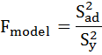

Here
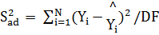
Where, N = Number of trials
Y_{i} = third observed value of the response
= Predicted / Estimated value of response
DF = Degree of freedom = [N – (K +1)], Where K = Number of independently controllable variables
Where K= Number of independently controllable variables.
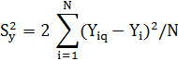
Where
Y_{iq} = One of the observed value of the two responses
Y_{i} = Average value of the two response
N = No. of trials

6.5 Significance of the coefficients
The values of the regression co-efficient give an idea as to what extent the control variables affect the responses quantitatively. It is evident that those of the co-efficient, which are not significant, can be eliminated, along with the responses with which they are associated, without sacrificing much of accuracy, thereby reducing the mathematical labor. To enable this, the student’s t test is used. As per this test,
- The calculated value of t corresponding to a coefficient is compared with the standard tabulated value of specific level of probability. Here the standard tabulated value of t is 2.3 at 8, 0.05.
- If the calculated value of t exceeds the tabulated one, then with the corresponding confidence probability the co-efficient is said to be significant.
For this purpose the value of t is given by
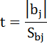
Where │bj│ represents the absolute value of co-efficient whose significance is being tested, and S_{bj} the standard deviation of co-efficient given by
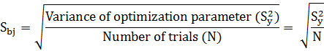

The calculation of S²_{y}, S²_{ad} and S_{bj} are shown in Table 6.5, 6.6 and 6.7.
When the significant co-efficient are known, the model is redeveloped by using these values. The model so developed is utilized to determine the values of response parameter for each given set of welding variables and the data so produced are represented graphically.

6.6 Calculation of variance of optimization parameters (S²y)
Table 6.5: Variance of optimization for ultimate tensile strength
S.No. | U₁ | U₂ | =(U₁+U₂)/2
1 | 95.32 | 93.42 | 94.37 | 0.95 | 0.90
2 | 97.3 | 96.3 | 96.8 | 0.5 | 0.25
3 | 84.2 | 86.6 | 85.4 | -1.2 | 1.44
4 | 93 | 91.7 | 92.35 | 0.65 | 0.42
5 | 96.2 | 99.6 | 97.9 | -1.7 | 2.89
6 | 90 | 91 | 90.5 | -0.5 | 0.25
7 | 94.3 | 93.1 | 93.7 | 0.6 | 0.36
8 | 98.5 | 97.4 | 97.95 | 0.55 | 0.30
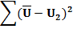 |  |  |  |  | 6.82
S²y |  |  |  |  | 1.70

Table 6.6: Variance of optimization for yield strength
S.No. | YS₁ | YS₂ | =(YS₁+YS₂)/2
1 | 65.8 | 70.3 | 68.05 | -2.25 | 5.06
2 | 73.2 | 68.5 | 70.85 | 2.35 | 5.52
3 | 62.4 | 66.4 | 64.4 | -2 | 4.00
4 | 68.2 | 67.9 | 68.05 | 0.15 | 0.02
5 | 75 | 77.07 | 76.035 | -1.035 | 1.07
6 | 71.6 | 73.1 | 72.35 | -0.75 | 0.56
7 | 64.3 | 68.2 | 66.25 | -1.95 | 3.80
8 | 80.3 | 77.3 | 78.8 | 1.5 | 2.25
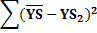 |  |  |  |  | 22.29
S²y |  |  |  |  | 5.57

Table 6.7: Variance of optimization for % Elongation
S.No. | E₁ | E₂ | =(E₁+E₂)/2
1 | 10.88 | 10 | 10.44 | 0.44 | 0.19
2 | 9.4 | 9.2 | 9.3 | 0.1 | 0.01
3 | 12.8 | 14.4 | 13.6 | -0.8 | 0.64
4 | 10.2 | 10.4 | 10.3 | -0.1 | 0.01
5 | 11.4 | 11.4 | 11.4 | 0 | 0.00
6 | 10.4 | 9.2 | 9.8 | 0.6 | 0.36
7 | 8.4 | 8.4 | 8.4 | 0 | 0.00
8 | 10.05 | 9.2 | 9.625 | 0.425 | 0.18
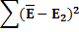 |  |  |  |  | 1.39
S²y |  |  |  |  | 0.35

6.7 Calculation of variance of adequacy factor (S²ad)
Table 6.8: Variance of adequacy for ultimate tensile strength
S. No. | U_{est} | U_{obsd}
1 | 94.37 | 92 | 2.37 | 5.62
2 | 96.8 | 95.3 | 1.5 | 2.25
3 | 85.4 | 86.24 | -0.84 | 0.71
4 | 92.35 | 92.01 | 0.34 | 0.12
5 | 97.9 | 98.9 | -1 | 1.00
6 | 90.5 | 91.45 | -0.95 | 0.90
7 | 93.7 | 92.6 | 1.1 | 1.21
8 | 97.95 | 95.5 | 2.45 | 6.00
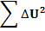 |  |  |  | 17.80
S²ad |  |  |  | 5.93

Table 6.9: Variance of adequacy for yield strength
S. No. | YS_{est} | YS_{obsd}
1 | 68.05 | 68 | 0.05 | 0.006
2 | 70.85 | 70.5 | 0.35 | 0.12
3 | 64.4 | 65.07 | -0.67 | 0.45
4 | 68.05 | 68 | 0.05 | 0.00
5 | 76.035 | 75.3 | 0.735 | 0.54
6 | 72.35 | 70.85 | 1.5 | 2.25
7 | 66.25 | 66.13 | 0.12 | 0.01
8 | 78.8 | 77 | 1.8 | 3.24
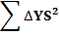 |  |  |  | 6.62
S²ad |  |  |  | 2.21

Table 6.10: Variance of adequacy for %Elongation
S. No. | E_{est} | E_{obsd}
1 | 10.44 | 10.5 | -0.06 | 0.00
2 | 9.3 | 9.8 | -0.5 | 0.25
3 | 13.6 | 13.2 | 0.4 | 0.16
4 | 10.3 | 9.5 | 0.8 | 0.64
5 | 11.4 | 11.3 | 0.1 | 0.01
6 | 9.8 | 9.5 | 0.3 | 0.09
7 | 8.4 | 8.45 | -0.05 | 0.00
8 | 9.625 | 10 | -0.375 | 0.14
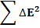 |  |  |  | 1.30
S²ad |  |  |  | 0.43

Table 6.11: Analysis of variance
S.No. | Parameter | Degree of freedom |  | Variance of optimization parameter  S²y | Standard deviation of coefficients  S_{bj} | Variance of adequacy  S²ad | F-ratio (model)  F_{m}= S²ad/ S²y | F-ratio from tables at (3,8,0.05) | Model whether adequate
S.No. | Parameter | S²y | S²ad
1 | UTS | 8 | 3 | 1.7 | 0.46 | 5.93 | 3.48 | 4.1 | YES
2 | YS | 8 | 3 | 5.57 | 0.83 | 2.21 | 0.39 | 4.1 | YES
3 | %E | 8 | 3 | 0.35 | 0.21 | 0.43 | 1.22 | 4.1 | YES

6.8 t-test for significant coefficient
Table 6.12: t-values for coefficients of model
S.No. | Coefficient (b_{ij}) | t= b_{j}/S_{bj} (for responses)
S.No. | Coefficient (b_{ij}) | UTS | YS | %E
1 | b_{o} | 203.52 | 85.06 | 49.33
2 | b₁ | -2.34 | -2.32 | 2.85
3 | b₂ | 2.76 | 1.46 | -0.57
4 | b₃ | -3.02 | -3.32 | 2.61
5 | b₄ | -1.93 | -2.31 | -2.95
6 | b₅ | 4.39 | 2.57 | 0.38
7 | b₆ | 3.41 | 0.36 | 2.42
8 | b₇ | 4.53 | 0.46 | -4.38

Table 6.13: Significant coefficients after t-test of model
S.No. | Coefficient (b_{j}) | UTS | YS | %E
1 | b_{o} | 93.62 | 70.60 | 10.36
2 | b₁ | -1.08 | -1.91 | 0.60
3 | b₂ | 1.27 | - | -
4 | b₃ | -1.39 | -2.76 | 0.50
5 | b₄ | - | -1.92 | -0.62
6 | b₅ | 2.02 | 2.14 | -
7 | b₆ | -1.57 | - | 0.51
8 | b₇ | 2.08 | - | -0.92

6.9 Proposed mathematical models
Neglecting the higher order interactions as per t-value of coefficients, the proposed models for predicting weld bead parameters are as follows:
Ultimate Tensile Strength (UTS):
UTS = 93.62 - 1.08I_{p} + 1.27I_{b} - 1.39F_{p} + 2.02I_{p}I_{b} + 2.02F_{p}T_{p} - 1.57I_{p}F_{p} - 1.57I_{b}T_{p} + 2.08I_{p}T_{p} + 2.08I_{b}F_{p}
Yield Strength (YS):
YS = 70.60 - 1.91I_{p} – 2.76F_{p} – 1.94T_{p} + 2.14I_{p}I_{b} + 2.14F_{p}T_{p}
% Elongation (%E):
%E = 10.36 + 0.60I_{p} + 0.50F_{p} - 0.62T_{p} + 0.51I_{p}F_{p} + 0.51I_{b}T_{p} - 0.92I_{p}T_{p} - 0.92I_{p}F_{p}

Chapter-7
RESULTS & DISCUSSION

7.1 Main and interaction effects of process parameters on UTS
Ultimate tensile strength (UTS) decreased from 94.7Mpa to 92.54Mpa when peak current increases from low level to high level as shown in fig.7.1. UTS increases from
92.35Mpa to 94.89Mpa when peak current increases from low level to high level as shown in fig 7.2. UTS decreases from 95.01Mpa to 92.23Mpa when peak current increases from low level to high level as shown in fig 7.3.
The interaction effects of peak current, background current, pulse frequency and peak current time is shown in fig. 7.4, 7.5, 7.6 and 7.7.

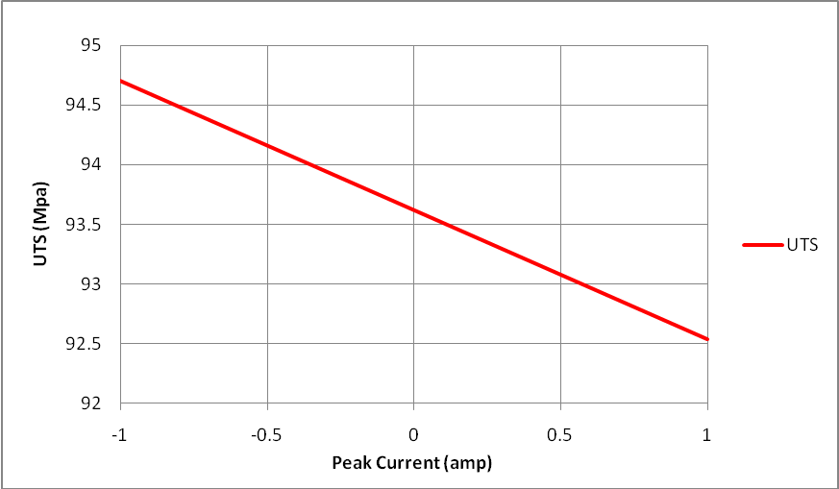

Fig. 7.1: Effect of peak current on UTS.
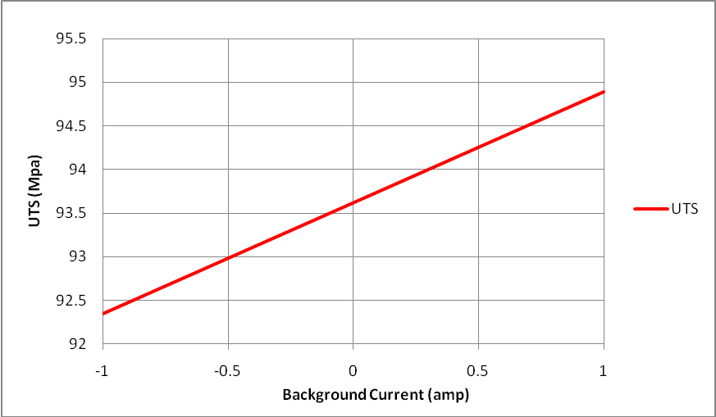
Fig. 7.2: Effect of background current on UTS.

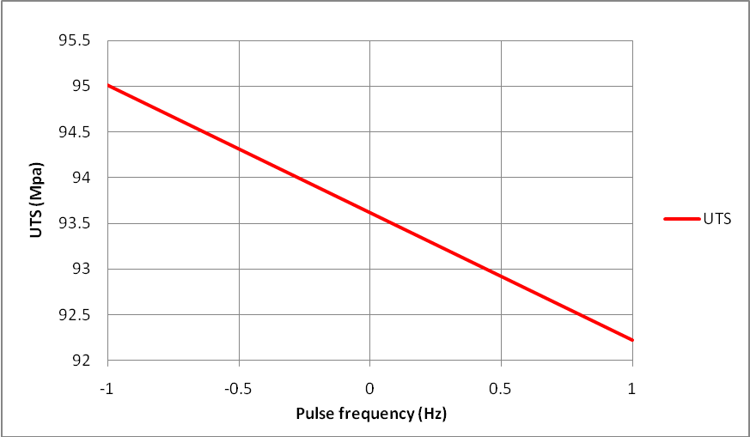
Fig. 7.3: Effect of pulse frequency on UTS.

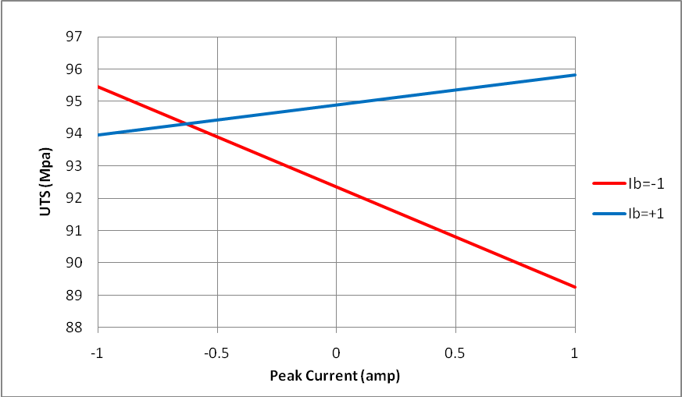
Fig. 7.4: Interaction effect of peak current and background current on ultimate tensile strength.

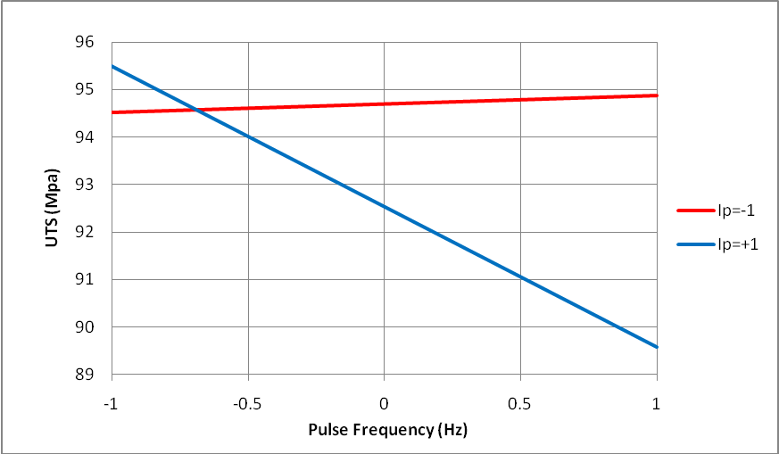
Fig. 7.5: Interaction effect of peak current and pulse frequency on ultimate tensile strength.

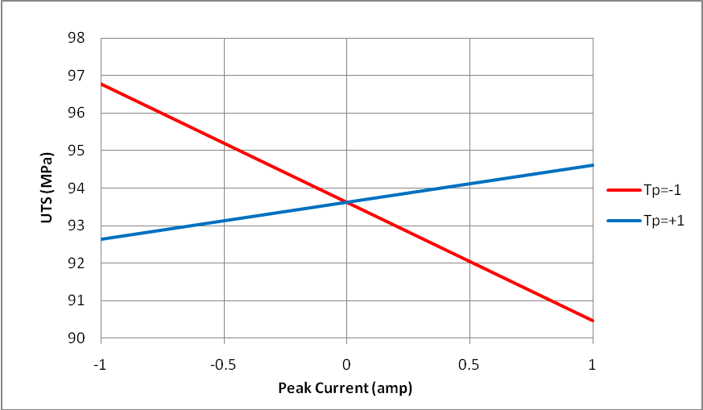
Fig. 7.6: Interaction effect of peak current time and peak current on ultimate tensile strength.

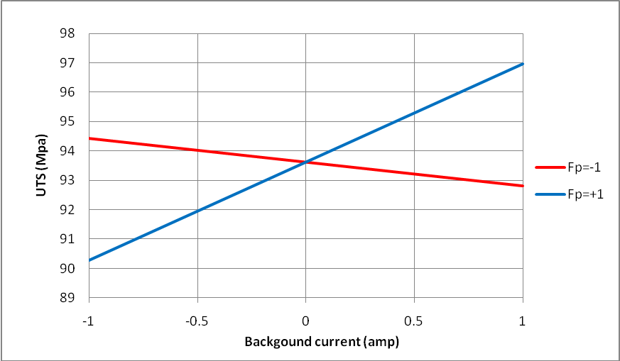
Fig. 7.7: Interaction effect of background current and pulse frequency on ultimate tensile strength.

  - Main and interaction effects of process parameters on Yield Strength
Yield strength (YS) decreased from 72.51Mpa to 68.69Mpa when peak current increases from low level to high level as shown in fig.7.8. Yield strength decreases from 73.36Mpa to 67.84Mpa when pulse frequency increases from low level to high level as shown in fig 7.9. YS decreases from 72.54Mpa to 68.66Mpa when peak current time increases from low level to high level as shown in fig 7.10.
The interaction effects of peak current and background current, pulse frequency and peak current time on yield strength is shown in fig. 7.11 and 7.12.

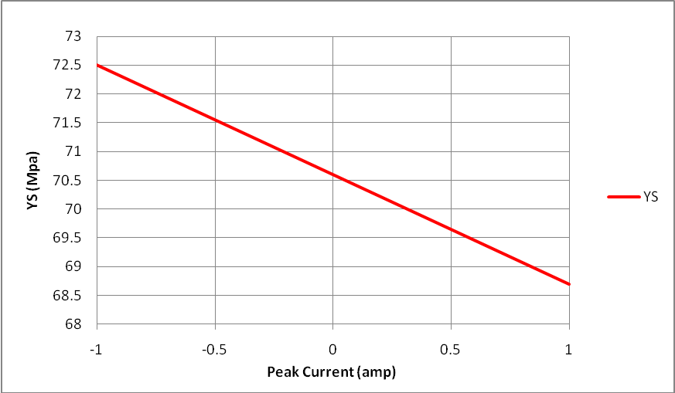
Fig. 7.8: Effect of Peak current on yield strength.

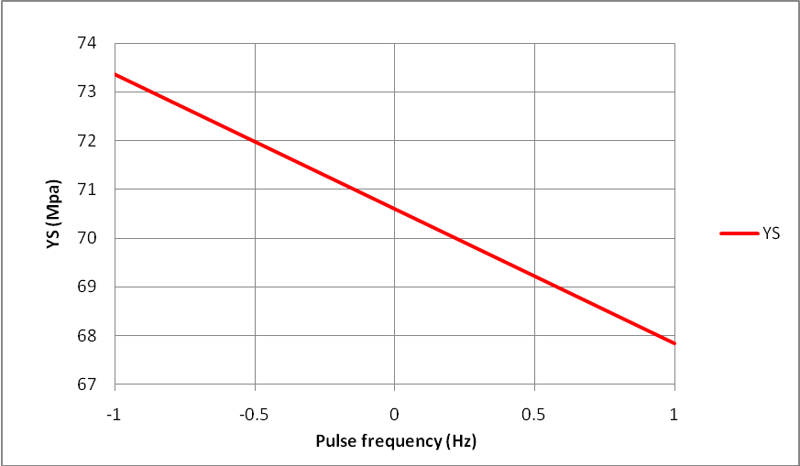

Fig. 7.9: Effect of pulse frequency on yield strength

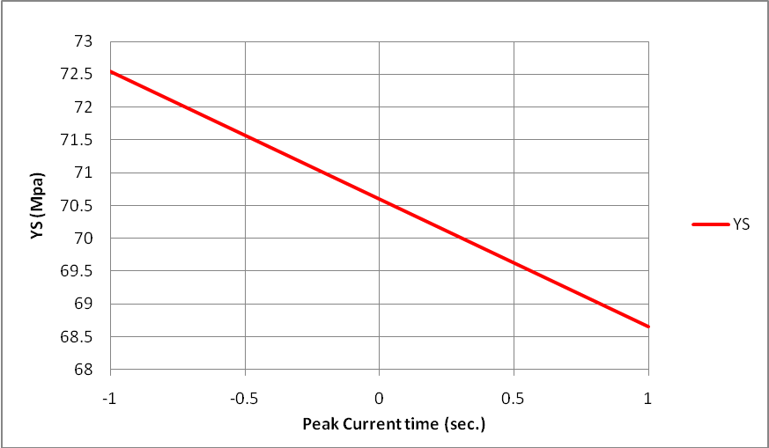
Fig. 7.10: Effect of peak current time on yield strength

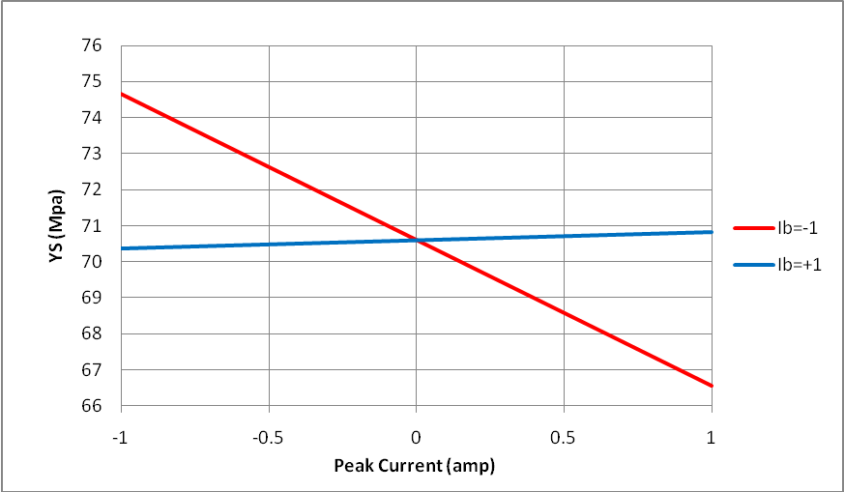
Fig. 7.11: Interaction effect of peak current and background current on yield strength

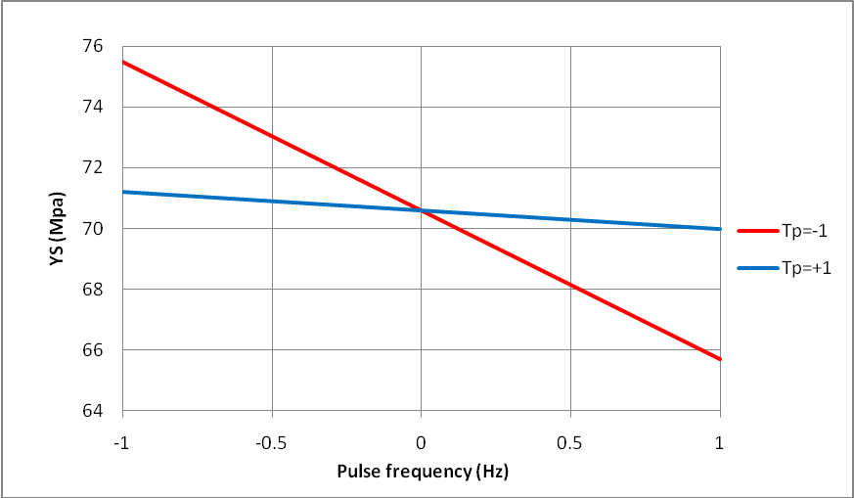
Fig. 7.12: Effect of pulse frequency and peak current time on yield strength

7.3 Main and interaction effects of process parameters on Effect on % Elongation
Elongation increases from 9.76 to 10.96 when peak current increases from lower level to higher level as shown in fig 7.13. Elongation increases from 9.86 to 10.86 when pulse frequency increases from lower level to higher level as shown in fig 7.14. Elongation decreases from 9.74 to 10.98 as peak current time increases from lower level to higher level as shown in fig 7.15.
The interaction effects of pulse frequency and peak current, peak current and peak current time on %E is shown in fig. 7.16 and 7.17.

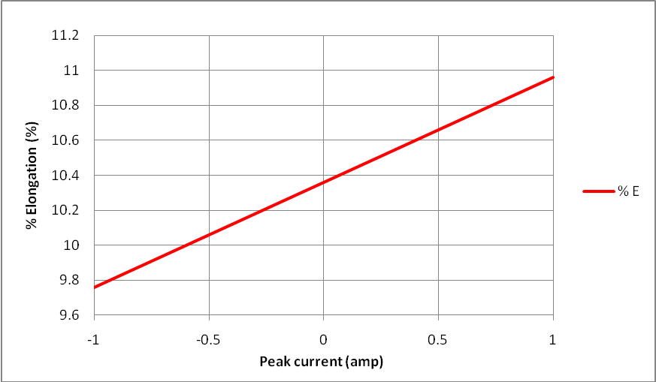
Fig. 7.13: Effect of peak current on %E.

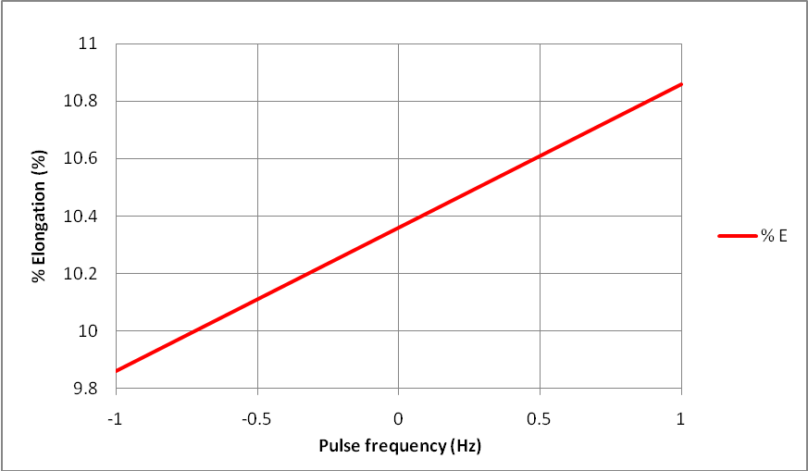
Fig. 7.14: Effect of pulse frequency on %E.

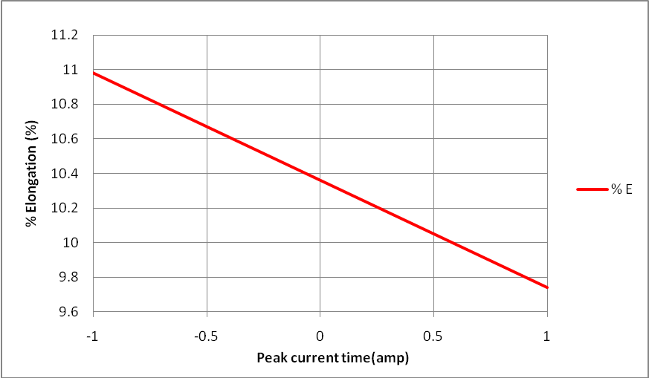
Fig. 7.15: Effect of peak current time on %E.

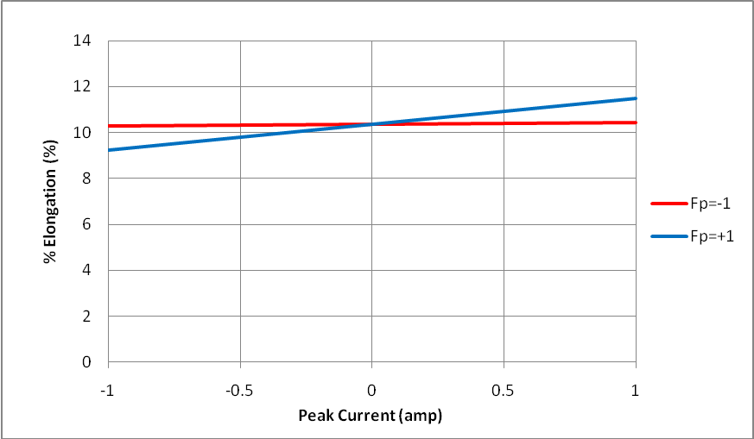
Fig. 7.16: Interaction effect of pulse frequency and peak current on %E.

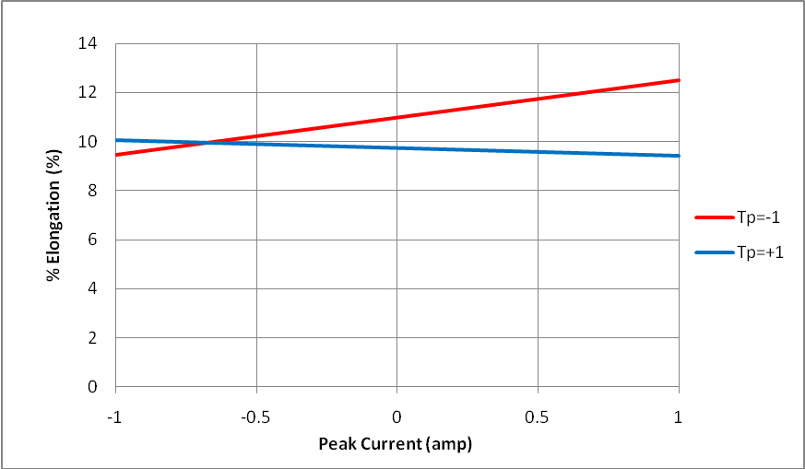
Fig. 7.17: Interaction of peak current time and peak current on %E.

Chapter-8
CONCLUSION & FUTURE SCOPE
8.1 Conclusion
The effects of welding process parameters on mechanical properties using pulsed GTAW process have been studied and the following conclusions may be drawn from this analysis:
- Mathematical models have been developed to predict the mechanical behavior of TIG welded aluminium alloy 1100 incorporating pulsed current parameters.
- The developed models can be effectively used to predict the mechanical behaviour tensile of pulsed current GTA welded aluminium alloy 1100 within the range of parameters considered.
- Ultimate tensile strength (UTS) increases with increase in background current while it decreases with increase in pulse frequency and peak current.
- Yield strength decreases with increase in peak current, pulse frequency and peak current time.
- Elongation increases with increase in peak current while it decreases with increase in pulse frequency and peak current time.
- Interaction effects have considerable influence over the mechanical properties and their effects cannot be neglected.
- All the relationships are linear in nature and can be effectively utilized for optimizing the conditions.

8.2 Scope for future work
In this study, selected parameters were peak current, back ground current, pulse frequency and peak current time. Effects of selected parameters on micro-hardness and microstructure can be studied.

REFERENCES

- Pandey S., Wattal R., Garg G., Agakhani M. “ Recent trends in welding of Aluminium”, Workshop organised by the Aluminium Association of India and Indian Institute of Metals, Chandigarh, Febraury 21, 2002, Paper No.4.
- Mandal N.R. “Aluminium Welding”, Second edition, Narosa Publishing House Pvt. Ltd. (2002), New Delhi, India.
- Matrukanitz P.R., Selection and weldability of heat treatable aluminium alloys, ASM Handbook- Welding, Brazing and Soldering 6 (1990) 528-536.
- Mohamed, A.A. Optimisation of weld bead dimensions in GTAW of Al-Mg alloy. Materials and Manufacturing processes, vol. 16 no.5, 2001, pp 725-736.Cary B. H., Modern Welding Technology, Prentice-Hall, Englewood Cliffs, NJ, 1989.
- Kumar P., Kolhe P. K., Ashutosh S. & Dutta C.K., Optimisation of bead geometry of pulsed GTAW process for Al-7039 alloy using Ar +He gas mixture, Indian Welding Journal (2009) 26-33.
- Kumar A. & S. Sunderrajan, Optimisation of TIG welding process parameters on mechanical properties of Al-5456 alloy weldments, Material and Design 30(2009) 1288-1297.
- Kumar T. S., Balasubramanian V. &. Sanavullah M.Y., Influences of pulsed current tungsten inert gas welding parameters on the tensile properties of AA 6061 aluminium alloy, Materials and Design 28 (2007) 2080-2092.
- Balasubramanian M., Jayabalan V. & Balasubramanian V., Developing mathematical models to predict the tensile properties of pulsed current gas tungsten arc welded Ti-6Al-4V alloy, Material and Design 29 (2008)92-97.
- Nagesh S. D. & Dutta L. G. , Genetic algorithm for optimization of welding variables for height to width ratio and application of ANN for prediction of bead geometry for TIG welding process, Applied soft computing 10 (2010) 897-907.
- Zhang Y. M. and Zhang B.S., Welding Aluminium alloy 6061 with the opposing Dual-Torch GTAW process, Welding Research supplement (June1999) 202-206.
- Durgutlu A., Experimental investigation of the effect of hydrogen in argon as a shielding gas on TIG welding of austenitic stainless steel, Materials and Design 25 (2004) 19-23.
- Manti R., Dwivedi K.D. and Agarwal A., Pulsed TIG welding of two Al-Mg-Si alloys, Journals of Material Engineering and Performance Vol. 17(5) (October 2008)-667.
- Balasubramanian M., Jayabalan V. & Balasubramanian V., Developing mathematical models to predict grain size and hardness of argon tungsten pulse current arc welded titanium alloy, Journal of Materials Processing Technology 196 (2008) 222-229.
- Balasubramanian V., Jayabalan V. & Balasubramanian M., Effect of current pulsing on tensile properties of titanium alloy, Material and Design 29 (2008) 1459-1466.
- Balasubramanian M., Jayabalan V., Balasubramanian V., Prediction and optimisation of pulsed current GTAW welding process parameters to obtain sound weld pool geometry in Titanium alloy using Lexicographic method, Journal of Materials Engineering and Performance, Volume 18(7) (2009) 871.
- Tarng S.Y., Tsai L.H. & Yeh S.S., Modelling, optimisation and classification of weld quality in TIG welding, International Journals of machine tools and Manufacture 39 (1999) 1427-1438.
- Tarng S.Y., Tsai L.H. & Yeh S.S., Modelling, optimisation and classification of weld quality in TIG welding, International Journals of machine tools and Manufacture 39 (1999) 1427-1438.
- Olson D.L., Siewert T.A., Liu S. & Edwards G.R, “ASM Hand-Book Vol.6, Welding, Brazing and Soldering, Fourth Edition, (1997), The Materials Information Society, U.S.A.
- Manual for Gas tungsten arc welding of Miller Electric Mfg. Co. USA.
- Prasad Rao K. Fusion zone grain refinement in GTA welds using magnetic arc oscillation and current pulsing, RAMP, (2001). P. 176-96.
- D. Dzelnitzki, Muendersbach, “Direct-Current welding with High frequency pulses, an interesting process variant © 2000 EWM HIGHTECH WELDING GmbH.
- Peter W.M., “Practical GTAW welding”, First edition (1991), Abington Publishing, Abington Hall, Abington, Cambridge CB1 6AH, England.
- Parmar R.S., “Welding process and technology”, Second edition, Khanna Publishers, Delhi, India, (1995), pp 232-244.
- ANSI/ AWS A5.12-92, “Specification for tungsten and tungsten alloy Electrodes for Arc welding and Cutting”, American Welding Society, Miami, (1992).
- Weast R.C., Ed., Handbook of chemistry and physics, CRC press, (1973-1974), 54th Ed. pp. E-80 to E-82.
- Osram Sylvania, Inc. Literature.
- Campbell R.D. & Lacoursire E.J., “A Guide to the Use of Tungsten Electrodes for GTA Welding”, Welding Journal, (1995), pp-39-45.
- Welding Handbook, 8th Edition, Vol. 2, (1991), American Welding Society, Miami.
- www.weldreality.com.
- Ushio, M., and Matsuda, F., “Study on GTAW arc electrodes: Comparative study on characteristics if tungsten oxide cathode”, IIW Document Number 212-(1986), 648-86, International Institute of Welding.
- Mohler and Rudy, “Practical welding technology”, Third edition (1983), Industrial press Inc., Newyork, Newyork U.S.A.
- Douglas C. Montgomery, “Design and Analysis of experiments”, Fifth edition, John Wiley and sons Ltd., Singapore, (1991).
- Wattal R. & Pandey S., “Prediction of weld bead geometry in GMAW of aluminium alloy 7005”, Global Conference on production and industrial engineering, CPIE-(2007), National Institute of Technology, Jalandhar, march 22-24, Paper no.327.
- Davis O.L., “The design and analysis of industrial experiments, New York: Longman, (1978).

