Design of Open Traffic Information System for Generating & Disseminating Traffic Information through Mobile Messaging

A thesis submitted in partial fulfillment of the requirement for the award of degree of

Master of Engineering
In
Computer Technology and Application

By
ANKUR GUPTA
College Roll No. – 0 2 / C T A / 0 6
University Roll No. – 1 0 1 8 2

Under the guidance of
Mrs. Rajni Jindal



Department of Computer Engineering
Delhi College of Engineering
University of Delhi
2007-2008

CERTIFICATE

This is to certify that Ankur Gupta has carried out his Major Project work entitled “Design of Open Traffic Information System for Generating & Disseminating Traffic Information through Mobile Messaging” as a partial requirement for the award of Master of Engineering degree in Computer Technology and Application by Delhi College of Engineering, Delhi University, New Delhi and is a record of his work carried out and completed under my supervision and guidance during the academic session 2007-2008.

Mrs. Rajni Jindal
(Project Guide)

Assistant Professor
Delhi College of Engineering, Delhi

ACKNOWLEDGEMENT

I take this opportunity to express my gratitude towards my project guide, Mrs. Rajni Jindal, for her continued assistance and guidance throughout the development of the project. I am grateful to her for giving me the freedom to work on the subjects of my interest and for always being around when needed.
I would also like to thank our Head of Computer Engineering department, Dr. Daya Gupta, my department teachers Dr. S. K. Saxena and Mr. Manoj Sethi and all other teachers for their valuable inputs and support throughout the course of the project.
I thank my friends Ashish (for sharing my work load), Kailash (for inputs on Petri Nets), Sanjay (for lending his cell phone) and others whose names I haven’t been able to mention, for their precious support. Last but not the least I thank my family and the God Almighty, without them this project would not have been possible.

ANKUR GUPTA

M.E. (Computer Technology & Application)
College Roll No. – 02/CTA/06
University Roll No. – 10182

ABSTRACT

With increasing number of vehicles on roads, traffic congestion has become routine and is causing immense physical, economic and environmental losses. This thesis proposes a novel Open Traffic Information System (OTIS) in which the traffic information is not only received by the mobile phone users but is also generated by them. The users of the system work ‘for the system’ and in return gain ‘from the system’. The proposed system is open in the sense that any person with access to mobile phone may generate traffic information and receive traffic updates through mobile messages. All existing traffic information systems either require significant investments in new infrastructure or depend on third party sources to generate traffic information whereas the proposed system could be instantaneously deployed over the existing cellular network. The thesis develops the system using two approaches namely, Data Flow Diagram and Petri Nets, and then presents a working model of the system.

TABLE OF CONTENTS

1 Introduction 1
1.1 Motivation 2
1.2 Objective 3
2 Traffic Information System 4
2.1 Related Work 4
2.1.1 Self-Organizing Traffic Information System 4
2.1.2 Situation-aware Mobile Traffic Information System 6
2.1.3 Integrated Traffic Information System 6
2.1.4 Mapunity 7
2.2 Drawbacks of Existing Systems 8
3 Mobile Messaging 9
3.1 Short Message Service Point-to-Point 9
3.1.1 The SMS Basic Network Architecture 11
3.1.2 Transport Protocol Data Unit (TPDU) 11
3.2 SMS Center / SMSC 18
3.3 Cell Broadcast Service (CBS) 19
3.3.1 Message Parameters 20
4 Open Traffic Information System (OTIS) 23
4.1 Receiving Traffic Information from Mobile Users 23
4.2 Propagating Updates to Mobile Users 24
4.2.1 Active Updates 25
4.2.2 Passive Updates 25
4.3 Processing Traffic Information 25
4.4 Effectiveness of OTIS 26
4.5 Discussion on possible issues in OTIS 28
5 System Model 30
5.1 Data Flow Diagram Approach 30
5.2 Petri Net Approach 31
5.2.1 Petri Net Basics 32
5.2.2 High Level Stochastic Petri Nets 35
5.2.3 PN Model of OTIS 36
6 Implementation 40
6.1 SMS Application Connection Options 40
6.1.1 Connecting Directly to SMSC 40
6.1.2 Connecting Directly to GSM Modem 41
6.1.3 Connecting using SMS Gateway 41
6.2 Working 44
6.3 Code Snippets 47
6.4 Snapshots & Screenshots 53
6.5 Analysis 60
7 Conclusion & Future Scope 62
7.1 Conclusion 62
7.2 Future Scope 63
8 List of Publications from thesis 64
9 References 65

LIST OF FIGURES

Figure 2.1 : Block Diagram of SOTIS structure implemented in each vehicle 5
Figure 2.2 : Distributed Service Architecture 7
Figure 3.1 : SMS Network Architecture 10
Figure 3.2 : CBS Network Architecture 20
Figure 4.1 : Position of OTIS in the Network Structure 24
Figure 4.2 : Traffic Status Keyword Scale 27
Figure 5.1 : Data Flow Diagram of OTIS 31
Figure 5.2 : A simple Petri net illustration 34
Figure 5.3 : Petri nets modeling of OTIS 37
Figure 6.1 : Connecting Directly to SMSC 42
Figure 6.2 : Connecting Directly to GSM Modem 42
Figure 6.3 : Using SMS Gateway to Connect to SMSC 43
Figure 6.4 : Using SMS Gateway to Connect to GSM Modem 43
Figure 6.5 : Sony Ericsson W700i mobile being used as a GSM modem 53
Figure 6.6 : OTIS is started and is waiting for incoming messages 54
Figure 6.7 : A user entering a traffic-update message in the mobile station 55
Figure 6.8 : OTIS receives an incoming message 56
Figure 6.9 : User receiving an acknowledgement from OTIS 57
Figure 6.10 : A user entering a traffic-request message in the mobile station 58
Figure 6.11 : User receiving traffic information from OTIS 58
Figure 6.12 : Data from location table – ‘loctab’ 59
Figure 6.13 : Data from status table – ‘statustab’ 60

LIST OF TABLES

Table 3.1 : TPDU Types 12
Table 3.2 : SMS-DELIVER type 12
Table 3.3 : SMS-SUBMIT type 14
Table 3.4 : Parameters of the CBS Message sent to MS by BTS 21
Table 5.1 : Explanation of Petri net model of OTIS 37

Introduction
Traffic congestions on the road are now routine phenomena. Considering the fast paced lives people are living today a substantial amount of time is wasted in traffic jams resulting in physical, economic as well as environmental losses. There is an urgent need to have a system in place that makes a user more informative regarding the traffic conditions on the route that he may be visiting, thereby giving him more control over his time. This thesis proposes a novel Traffic Information System (TIS) named Open Traffic Information System or OTIS to both generate and disseminate traffic information through mobile messaging.
In OTIS the traffic information is not only received by the mobile phone users but is also generated by them. The system makes use of the mobile messaging service that is a feature of all the prevalent mobile standards. Although there are a few systems that provide traffic information, they require large infrastructure or new hardware equipments and use indirect means of generating traffic information like using radio broadcasts, roadside sensors or other mapping techniques. On the contrary, the proposed model doesn’t require any major changes to the existing setup as it would work on existing mobile telephone infrastructure and would only require the use of a messaging technology like cell broadcasts or Short Message Service (SMS) that is a standard part of all the current and upcoming mobile standards like Global Systems for Mobile Communications (GSM), Universal Mobile Telecommunications System (UMTS) etc. Moreover, the system would be able to generate real-time up-to-date traffic information by allowing mobile phone users that are ‘on the scene’ to generate and update traffic information. Hence, those who will be benefiting from the system will also be the ones generating the information for the system. This from the system – for the system aspect lends credibility to the system and prevents misuse of it similar on the lines of open access projects like Wikipedia (www.wikipedia.org) and Open Directory Project (www.dmoz.org).

Motivation
The need for such a system is felt every time we get caught in a traffic jam! At present, mobile operators broadcast location information that gets displayed on the handsets of the subscribers provided they have activated the service. Similarly, if along with the location data traffic information could be sent to the subscribers then it would empower them to make choices over which routes to take and manage their time better. However, sending traffic information to the subscribers is only half the job. The generation of traffic information also demands necessary attention. Rather than relying on indirect sources of information like roadside sensors, personnel agents in select areas, Internet databases, mapping number of mobile users to vehicles on roads etc. the mobile users who are on the roads can generate and send the traffic information to the wireless providers through mobile messaging. Traffic jams can be frustrating and time consuming but the prospect of the commuters helping each other out by updating traffic information in such situations is exciting as it puts into use this time that may be otherwise wasted in traffic jams.

Objective
The objective of this thesis is to design an information system for generating as well as propagating traffic information among mobile phone users. The thesis also attempts to demonstrate a working model of the proposed system that is open to further improvements and modifications as and when it is implemented in the real conditions. The contribution of this thesis is in providing a novel means of generating traffic information without requiring any change in the existing cellular network setup. The proposed system allows mobile phone users who may be on the roads to generate traffic updates while on the move which other subscribed users may then receive. All other systems until now have found it difficult to generate traffic data and those that have tried to generate require extensive infrastructure and new equipment. The advantage of using a mobile phone system based method of gathering traffic information over other methods such as using Global Positioning System (GPS), mobile user density mapping or other vehicle tracking equipments is that it has a substantial reach and ease of use.

This thesis is organized as follows: Section 2 describes some existing traffic information systems and their drawbacks; Section 3 gives detailed description of mobile messaging; Section 4 explains the proposed system OTIS; Section 5 presents the Data Flow Diagram model and Petri Net model of the system; Section 6 describes how the system was implemented; Section 7 presents the thesis results while Section 8 concludes the paper along with future work.

Traffic Information System
Traffic Information System or TIS is vast topic that incorporates a range of functionalities. It may deal with generating route maps and alternate routes between destinations or provide information about vehicular traffic conditions on the roads in an area. In this thesis we concentrate on TISs that directly or indirectly collect information about vehicular traffic conditions on the roads and provide a way to circulate this information to the users of the system. There are many existing and proposed TISs that vary in their approach in collecting, generating and/or disseminating traffic information. Some of them are discussed in the section 2.1.

Related Work

Self-Organizing Traffic Information System
Self-Organizing Traffic Information System (SOTIS) [1] is a system that makes use of ad-hoc inter-vehicle communication (IVC) for generating traffic information. SOTIS assumes that the participating vehicles are fitted with a GPS receiver, digital street maps, small data processing unit and a digital radio. This combination of a wireless interface inside each vehicle and a self-organizing radio network is used by SOTIS for generating and circulating traffic information among the surrounding vehicles. Figure 2.1 [1] depicts the block diagram of the SOTIS structure that is implemented in each vehicle. In the figure, the SOTIS packets are first received by the system and are then analyzed using the information in the knowledge base. Finally, SOTIS packets are generated and the time slot is ascertained when they will be distributed to other vehicles over the radio network. All the three phases of receiving, analyzing and sending packets are independent from each other.
Figure 2.1 : Block Diagram of SOTIS structure implemented in each vehicle

Though SOTIS doesn’t require any road traffic monitoring sensors or mobile base stations, it requires a different set of hardware components like GPS receivers, digital radio, data processing units etc. for its working. It can work on only those vehicles fitted with these equipments and that are within a certain radius of each other, thereby limiting the system’s reach. Moreover, this system can only track vehicular speeds and is unable to provide information of any accidents, road works or other conditions that cannot be tracked by the vehicle’s equipment.

Situation-aware Mobile Traffic Information System
The Situation-aware Mobile Traffic Information System suggested in [2] provides route information, alternative route information, traffic jam alerts etc. through emails or SMS to its registered users. However, it relies on third party sources like online Internet sources for collecting traffic information. Since it provides advanced services like alternate paths and route planning it requires that the users be using handsets that are General Packet Radio Service (GPRS) or Wireless Access Protocol (WAP) enabled as the traffic information is sent and received over the Internet. It also provides personalized services but for that also the users need to send their profiles online through their Internet enabled handsets. The system can be implemented in centralized/distributed architectures depending upon the environment it will be used in. Figure 2.2 depicts the distributed architecture of the system. The combining engine combines the traffic information collected from the online sources over the Internet and using appropriate algorithms prepares the information for delivery. Depending upon the compatibility of the user’s handset, the information is formatted and sent to the user through Internet. The requirement of high-end handsets to be able to use this service significantly limits the reach of this service. Also the dependence on third party sources for traffic information results in inherent delays in transmission.

Integrated Traffic Information System
In [3], an integrated TIS approach is put forward where using certain algorithms multiple means of transport are integrated to generate traffic information. It focuses on providing cost estimates and routes between various destinations taking into consideration the different modes of transport available between them, but again, the means of disseminating the data to the users is through the Internet alone and external sources are used for generating the traffic information. Using Internet as the sole method of transferring information to the users again limits the number of commuters that may benefit from this service.
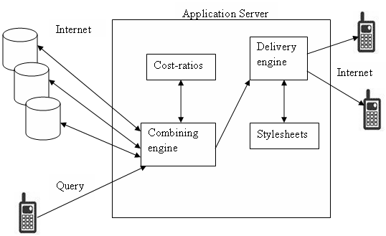
Figure 2.2 : Distributed Service Architecture

Mapunity
There have also been systems that use cellular network data to generate vehicular traffic information. Such systems basically work in two phases. The first phase consists of collecting information from the Mobile Stations (MSs) such as location information or movement information and the second phase consists of mapping this information into traffic information. An upcoming system is from Mapunity [4] that has tied up with a major GSM operator to map its mobile user density within an area into vehicular traffic information in that area. It works by installing micro towers over particular roads and crossings, measuring the number of mobile phone users within a particular tower’s range and then converting this information to the vehicular traffic condition in that area. The users of this service can then get traffic alerts by SMS to a pre-assigned number of the mobile phone operator. The service also provides route planning and mapping information over the web. To be successful this service requires installation of large number of micro towers on assigned roads so that only those mobile users that are actually on the roads are counted rather than including those that are in residential areas or other gatherings which would otherwise adulterate the sample.

Drawbacks of Existing Systems
Many drawbacks from the above discussed systems come to light that the proposed system OTIS attempts to address. Some of the existing systems require high-end GPRS/WAP enabled handsets to transmit information to the users. Some require the vehicles to be fitted with special equipments or installation of additional towers to do tracking while others use various estimation and mapping techniques to indirectly calculate the traffic information. OTIS is equipped to handle all these problems and the thesis explores them in detail in the following sections.

Mobile Messaging
Mobile messaging at the most basic level allows mobile phone stations to send or receive alphanumeric messages in the form of short message services. Other forms of information like picture, animation, sound etc. can also be included in a message and this service is known as Enhanced Messaging Service (EMS) but this thesis focuses on alphanumeric messages only. As mobile messaging is being used as the means of communication between OTIS and its users, this section explains the mobile messaging technology. There are two types of short message services that have been specified by the 3rd Generation Partnership Project (3GPP) – short message service point-to-point [5] and cell broadcast short message service [6]. Although both are forms of short message service, the former owing to its popularity among the mobile users has become synonymous with the term SMS. In this thesis also whenever the term SMS is used we imply the short message service point-to-point form.

Short Message Service Point-to-Point
It is more popular of the 2 types of short messages and is popularly referred to as SMS. An SMS has a maximum size of 140 octets, i.e. 160 7-bit ASCII characters may be sent in a single SMS. Some basic terminology is discussed before moving on with its network architecture description. SMS makes use of a Service Centre (SC), which acts as a store and forward centre for short messages. A Short Message Entity (SME) is any equipment that is capable of sending and/or receiving an SMS. A Short Message originating from an MS and destined for another SME like a mobile user, or a computer etc is called Mobile Originated (MO) and needs to be transferred from the MS to the SC. Similarly, a Short Message that needs to be transferred from the SC to the MS is called Mobile Terminated (MT). An MT message may have been input to the Service Centre by other mobile users (via a mobile originated short message) or by any other source. The 3GPP has laid down specifications for only that portion of the network that is involved in sending a message to an MS or receiving a message from an MS. Any SME, other than a mobile station, lies outside the scope of 3GPP specifications. Figure 3.1 depicts the basic SMS network architecture.
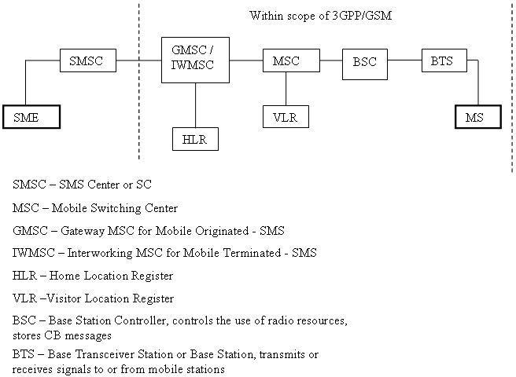

Figure 3.3 : SMS Network Architecture

The SMS Basic Network Architecture
The main components of the SMS network architecture are shown in Figure 3.1.
When routing an MO short message, the SMSC forwards the short message to the GMSC. The GMSC queries the HLR for routing information and sends the short message to the appropriate MSC which delivers the short message to the MS. In contrast, when routing an MT short message, the MS addresses the required SMSC according to its global title. If roaming abroad the visited public limited mobile network (PLMN) will route the short message to the appropriate IWMSC. Although an SMSC is not part of the GSM PLMN, the MSC and SMSC can be integrated.

Transport Protocol Data Unit (TPDU)
The short message transfer layer (SM-TL) where SMSs are exchanged uses TPDU as the data unit. An active MS should be able to send and receive a TPDU at any time regardless of any speech or data call in progress. Table 3.1 [5], [7] lists the six types of TPDUs at SM-TL. The SMS-Deliver and SMS-Submit TPDUs at the SM-TL contain the actual user message data while the other four are for reporting/status purposes. The tables 3.2 and 3.3 list the various fields of the SMS-Deliver and SMS-Submit TPDUs respectively [5]. These TPDUs contain the fields like originating address, destination address, user data, time stamp etc. that are extracted by any application that needs to process a short message.

Table 3.1 : TPDU Types
SMS-Deliver | Conveying a short message from the SMSC to the MS
SMS-Deliver-Report | Conveying a failure cause
SMS-Submit | Conveying a short message from the MS to the SMSC
SMS-Submit-Report | Conveying a failure cause
SMS-Status-Report | Conveying a status report from the SMSC to the MS
SMS-Command | Conveying a command from the MS to the SMSC

Table 3.2 : SMS-DELIVER type
ABBR. | REFERENCE | P¹⁾ | R²⁾ | DESCRIPTION
TP-MTI | TP-Message-Type-Indicator | M | 2b | Parameter describing the message type.
TP-MMS | TP-More-Messages-to-Send | M | b | Parameter indicating whether or not there are more messages to send.
TP-RP | TP-Reply-Path | M | b | Parameter indicating that Reply Path exists.
TP-UDHI | TP-User-Data-Header-Indicator | O | b | Parameter indicating that the TP-UD field contains a Header
TP-SRI | TP-Status-Report-Indication | O | b | Parameter indicating if the SME has requested a status report.
TP-OA | TP-Originating-Address | M | 2-12o | Address of the originating SME.
TP-PID | TP-Protocol-Identifier | M | o | Parameter identifying the above layer protocol, if any.
TP-DCS | TP-Data-Coding-Scheme | M | o | Parameter identifying the coding scheme within the TP-User-Data.
TP-SCTS | TP-Service-Centre-Time-Stamp | M | 7o | Parameter identifying time when the SC received the message.
TP-UDL | TP-User-Data-Length | M | I | Parameter indicating the length of the TP-User-Data field to follow.
TP-UD | TP-User-Data | O | ³⁾

¹⁾ Provision: Mandatory (M) or Optional (O).
²⁾ Representation: Integer (I), bit (b), 2 bits (2b), Octet (o), 7 octets (7o),
2-12 octets (2-12o).
³⁾ Dependent on the TP-DCS.

Table 3.3 : SMS-SUBMIT type
ABBR. | REFERENCE | P¹⁾ | P²⁾ | DESCRIPTION
TP-MTI | TP-Message-Type-Indicator | M | 2b | Parameter describing the message type.
TP-RD | TP-Reject-Duplicates | M | b | Parameter indicating whether or not the SC shall accept an SMS-SUBMIT for an SM still held in the SC which has the same TP-MR and the same TP-DA as a previously submitted SM from the same OA
TP-VPF | TP-Validity-Period-Format | M | 2b | Parameter indicating whether or not the TP-VP field is present.
TP-RP | TP-Reply-Path | M | b | Parameter indicating the request for Reply Path.
TP-UDHI | TP-User-Data-Header-Indicator | O | b | Parameter indicating that the TP-UD field contains a Header.
TP-SRR | TP-Status-Report-Request | O | b | Parameter indicating if the MS is requesting a status report.
TP-MR | TP-Message-Reference | M | I | Parameter identifying the SMS-SUBMIT.
TP-DA | TP-Destination-Address | M | 2-12o | Address of the destination SME.
TP-PID | TP-Protocol-Identifier | M | o | Parameter identifying the above layer protocol, if any.
TP-DCS | TP-Data-Coding-Scheme | M | o | Parameter identifying the coding scheme within the TP-User-Data.
TP-VP | TP-Validity-Period | O | o/7o | Parameter identifying the time from where the message is no longer valid.
TP-UDL | TP-User-Data-Length | M | I | Parameter indicating the length of the TP-User-Data field to follow.
TP-UD | TP-User-Data | O | ³⁾

¹⁾ Provision: Mandatory (M) or Optional (O).
²⁾ Representation: Integer (I), bit (b), 2 bits (2b), Octet (o), 7 octets (7o),
2-12 octets (2-12o).
³⁾ Dependent on the TP-DCS.

The definitions for the various TPDU parameters as listed in the tables 3.2 and 3.3 are given as follows:

TP-Message-Type-Indicator (TP-MTI): It is a 2-bit field that distinguishes between the 6 possible types of TPDUs.

TP-More-Messages-to-Send (TP-MMS): It is a one-bit field that indicates to the MS if more messages are waiting for it in the service centre (SC).

TP-Reply-Path (TP-RP): It is a 1-bit field that indicates whether the Reply-Path parameter is set or not set. Reply-path procedure is a mechanism which allows an SME to request that an SC should be permitted to handle a reply sent in response to a message previously sent from that SME to another SME.

TP-User-Data-Header-Indicator (TP-UDHI): It is a 1-bit field that indicates whether or not a header is present in addition to the short message.

TP-Status-Report-Indication (TP-SRI): It is a 1-bit field that indicates whether or not a status report will be returned to the SME.

TP-Originating-Address (TP-OA): It contains the address of the originating SME.

TP-Protocol-Identifier (TP-PID): Parameter identifying the above layer protocol, if any.

TP-Data-Coding-Scheme (TP-DCS): Parameter identifying the coding scheme within the TP-User-Data, such as 7-bit data, 8-bit data etc.

TP-Service-Centre-Time-Stamp (TP-SCTS): Parameter identifying time when the SC received the message.

TP-User-Data-Length (TP-UDL): Parameter indicating the length of the TP-User-Data field to follow.

TP-User-Data (TP-UD): The TP-User-Data field may comprise just the short message itself or a Header in addition to the short message depending upon the setting of TP-UDHI.

TP-Reject-Duplicates (TP-RD): Parameter indicating whether or not the SC shall accept an SMS-SUBMIT for an SM still held in the SC which has the same message reference and the same destination address as a previously submitted short message from the same originating address.

TP-Validity-Period-Format (TP-VPF): It is a 2-bit field that indicates the validity period format.

TP-Message-Reference (TP-MR): The TP-Message-Reference field gives an integer representation of a reference number of the SMS-SUBMIT submitted to the SC by the MS.

TP-Destination-Address (TP-DA): Address of the destination SME.

TP-Validity-Period (TP-VP): Parameter identifying the time from where the message is no longer valid.

SMS Center / SMSC
As mentioned before, the SMS center (SMSC) is responsible for handling the SMS operations of a wireless network. An SMS message sent from a MS reaches the SMSC first which then forwards it towards the destination. An SMS message may need to pass through more than one network entity (e.g. SMSC and SMS gateway) before reaching the destination. The main duty of an SMSC is to route SMS messages and regulate the process. In case the recipient is unavailable (when the mobile phone is switched off or message storage memory is full), the SMSC will store the SMS message. It will forward the SMS message when the recipient is available.
Very often an SMSC is dedicated to handle the SMS traffic of one wireless network. A network operator usually manages its own SMSC(s) and locates them inside its wireless network system. However, it is possible for a network operator to use a third-party SMSC that is located outside the wireless network system.
It is important to know the address of the wireless network operator's SMSC in order to use SMS messaging with the MS. Typically an SMSC address is an ordinary phone number in the international format and is pre-set in the SIM card by the wireless network operator for user’s convenience.

Cell Broadcast Service (CBS)
Under CBS, Cell Broadcast Entities (CBEs) generate the messages and are connected to a Cell Broadcast Center (CBC). CBS messages can then be broadcasted by the CBC to all the receivers (mobile stations) in the cell broadcast area. The area may comprise of a single cell or the entire network depending upon the service and usage. A major advantage of CBS over SMS is that it bypasses the SMSC for message transmission thereby freeing up resources. A CBS page consists of 82 octets, i.e. 93 7-bit ASCII characters. A maximum of 15 such CBS pages may be concatenated to form a CBS message. CBS messages are broadcast cyclically by the cell at a frequency and for a duration agreed with the information provider. The frequency at which CBS messages are repeatedly transmitted will be dependent on the information that they contain; for instance, it is likely that dynamic information such as road traffic information, will require more frequent transmission than weather information. The repetition period will also be affected by the speed with which the mobile stations are traversing the cells. CBS is only one-way, and no confirmation of receiving is sent to the originator, i.e. the mobile stations may only receive messages under this service.
Cell Broadcast Service is yet to be fully exploited and is currently being used by few operators around the world. Some operators use it to provide area information or location information to its subscribers depending upon the cell area they are in or their proximity to a base station. Some countries have even used this service to give warnings to its citizens in times of emergency [8]. In the proposed system the traffic information is intended to be sent to the users through SMS and/or CBS. Figure 3.2 gives the basic CBS network architecture.

Figure 3.4 : CBS Network Architecture

Message Parameters
For messages to be broadcast from the CBC to the MS, information needs to be relayed first to the BSC and then to the MS. Within a CBC-BSC interface, a CBS message is uniquely identified by the quartet (Message Identifier, Serial Number, Cell Identifier, Channel Indicator) [6]. Although many parameters are sent from the CBC to the BSC, the information listed in table 3.4 is finally sent to the MS by the BTS.

Table 3.4 : Parameters of the CBS Message sent to MS by BTS
Octet Number(s) | Field
1-2 | Serial Number
3-4 | Message Identifier
5 | Data Coding Scheme
6 | Page Parameter
7-88 | Content of Message

Serial Number: This parameter is a 16-bit integer which uniquely identifies a particular CBS message as more than one message can have the same message identifier.

Message Identifier: This parameter identifies the source and type of the CBS message. For example, "OTIS" (source), “Traffic Status" (type) could correspond to one value. A number of CBS messages may originate from the same source and/or be of the same type and will be distinguished by the Serial Number.

Data Coding Scheme: This parameter indicates the method the CBS message will be handled at the MS, the alphabet/coding, and the language (when applicable).

Page Parameter: This parameter consists of 2 fields. The first field (bits 0-3) indicates the binary value of the total number of pages in the CBS message and the second field (bits 4-7) indicates binary the page number within that sequence.

Content of Message: This parameter is of a fixed length of 82 octets and carries up to and including 82 octets of user information. If the user information is less than 82 octets, the remaining octets must be filled with padding.

Open Traffic Information System (OTIS)
Open Traffic Information System or OTIS is the traffic information model proposed in this thesis. OTIS uses mobile messaging technology for communicating traffic information with the users. Under OTIS a mobile phone user will be able to send traffic updates using SMS and can get updates through CBS or SMS. For the user of the system, OTIS acts as just another mobile user with which SMSs can be exchanged. The information system OTIS will be set up at one end of the system that will provide the traffic information to the users. Figure 4.1 illustrates the position of OTIS in the network structure. The arrows in the figure denote that while traffic updates can be both sent and received using the SMS, the broadcast part of the network is only used to propagate traffic updates as it is a unidirectional service. The various processes that will be involved in OTIS are discussed next.

Receiving Traffic Information from Mobile Users
The user can generate an SMS indicating the traffic conditions on the road and send it to a predefined number. Since the current technology cannot ascertain the area information of a user sending an SMS, the user will also have to message his location along with the traffic update. The receiving short message entity, i.e. OTIS in this case, will continuously store all incoming traffic updates and then process them.

Figure 4.5 : Position of OTIS in the Network Structure

Propagating Updates to Mobile Users
Updates may be propagated to the users in two ways – actively or passively.

Active Updates
Active updates are sent through SMS. An SMS is sent as a reply to a user who has messaged to the system to know the traffic condition of a particular location. OTIS locates the current traffic status of the location indicated by the user and replies to him with the available information.

Passive Updates
Passive updates are made through Cell Broadcasts. The MS and the Base Station often exchange data in the event of the MS moving to a new area, or a change in the state of the MS like handset switched-on, incoming/outgoing calls etc. In such situations the base station can broadcast the local traffic information pertaining to its area along with the area information to all the subscribed users under its coverage. For instance, whenever users enter an area under a base station, appropriate traffic updates may be broadcasted to them.

Processing Traffic Information
This is the most crucial step of the system where all the updates will come together and be consolidated to generate meaningful and correct information. Incoming short messages could be in many forms like natural language, keywords, short forms, etc. and thus, this step may involve natural language processing, efficient filtering, matching and estimation techniques to generate meaningful information. This processing step could be simplified by requiring users to enter fixed keywords to indicate traffic status rather than using plain English. A database of known locations and roads could be created and the incoming messages could be processed to ascertain which locations are being referred to. The first keyword of the incoming message could indicate the level of congestion, while the following text could refer to the location. Similarly other flexible options could be provided to the users as the system evolves. Figure 4.2 illustrates some examples along with a keyword scheme. A way to measure traffic condition of a location could be to take sum of all the traffic status keywords belonging to the same location. Then, a higher sum would indicate more traffic congestion and an appropriate update could be generated and dispatched to the users. Another option could be to use weighted means of the traffic congestion values of the incoming messages by giving higher importance to the more recent messages to reflect latest traffic position of a location. A separate keyword could be used to indicate that the incoming SMS is requesting traffic information rather than providing it. i.e., the SMS is requesting an active update. The keyword, location pair is much easier for processing as well as a faster means of writing text for the user. In the example scale of figure 4.2 the user enters the keyword 1 to indicate smooth traffic or the keyword 3 to indicate heavy traffic i.e. a jam and so on and so forth.

Effectiveness of OTIS
Following points indicate why OTIS would be a successful traffic information system:
- It is based on mobile telecommunication that is growing rapidly throughout the world and is widely available. In many countries, including India, the number of mobile connections has surpassed the number of landline telephone connections.
- Mobile messaging in the form of SMS and CBS is part of GSM/UMTS standard that is embraced throughout the world and has worldwide presence.
- As people are carrying cell phones wherever they go they are in the best position to inform about the traffic patterns in their vicinity thereby reducing delays and latency in traffic updates.
- Short messaging involves low overheads both from the customer and providers point of view. It is low cost and doesn’t put much load on the network.
- OTIS doesn’t require any traffic monitoring sensors, GPS equipment or any special software/hardware at the user’s end.
- OTIS only requires a software application that would run on one end of the network without requiring any changes in the infrastructure making it instantaneously deployable.

Figure 4.6 : Traffic Status Keyword Scale

Discussion on possible issues in OTIS
Following points discuss solution of some problems that may arise in OTIS-
- Since OTIS will use SMS to both propagate and receive traffic updates, the short message center may be considered to be a bottleneck. However, this can be easily averted by using distributed network architectures and appropriate SMSC hardware like CMG HP SMSC that supports 2500 messages/sec [9]. Also, by using CMS for propagating updates, the load on SMSC may be reduced.
- Use of mobile phones for messaging while driving could be a distraction but most messaging is likely to be done during traffic jams where the vehicles are intermittently moving and stopping. Furthermore, in cases where other passengers may be accompanying the driver, the messages can be sent and/or received by them.
- Corrective measures would have to be developed as part of the system to deal with a situation when some user may deliberately try to send incorrect traffic updates. Many methods could be employed to tackle such a situation. A minimum number of messages from different users could be assigned as a threshold value for each location before a traffic request message can be replied from that location. Similarly, a limit could be set on the number of messages that can be accepted from the same user within a specified time frame. Since each message’s sender’s information is received by the system, identifying and blocking an offending user is possible.
- Another concern is to maintain the correctness and validity of the traffic information being sent to the users. Incorrect information can be prevented from being sent to the users by taking weighted average of the various traffic updates coming in, prioritizing the more recent message updates. Moreover, by constantly adding and updating locations in the database the updates can be made more successful and accurate.

System Model
Information process modeling is a fundamental activity in the development of an information processing system, enabling both the developer and the end-user to better understand the information process. The effectiveness and efficiency of the modeling technique greatly determines the quality of the implementation of the system. This section discusses two approaches to model the information system OTIS – Data Flow Diagram (DFD) approach and Petri Net (PN) approach. Both have their own set of advantages that help in understanding the system. While DFD is easily understood by the end user, the PN model effectively captures the stochastic and concurrent aspects of the system.

Data Flow Diagram Approach
A data flow diagram (DFD) is a modeling technique that models the flow of information in the system. It tracks the various entities that input information to the system and gain output from the system as well as the processes that perform some kind of transformation on the data. Figure 5.1 [10] depicts the DFD of the proposed information system OTIS. It pictorially explains the flow of information through the system. The figure is simple and easy to understand and quickly explains the system to both the developers and the end users of the system. The figure depicts the two main modules of the system, one that processes incoming messages and the other that generates and sends outgoing messages. The mobile station is the external entity that both supplies information to the system as well as consumes from it. The figure also shows the data store that contains the database of locations and traffic information and is queried while sending traffic updates to the users.
Figure 5.7 : Data Flow Diagram of OTIS

Petri Net Approach
Petri net, a powerful mathematical and graphical modeling tool, can be effectively used for describing and studying information processing systems of varied characteristics. It was introduced by C.A.Petri in 1962 [11]. It is a method which enables graphical modeling of system behavior while simultaneously enabling introduction of mathematical formal rules for system behavior definition. Petri nets are one of the most widely used methods for modeling of concurrent, asynchronous, distributed, parallel, nondeterministic and/or stochastic systems. A number of Petri nets extensions have been developed to add special modifications or restrictions suited to particular applications. These include the notion of ‘color’, ‘time’ and ‘hierarchy’. High Level Petri nets collectively refer to these extensions.
For a system like OTIS that needs to deal with aspects like communication, concurrency, synchronization and resource sharing is especially well modeled by Petri nets as they have powerful abilities for representation of system dynamics like - entity arrival dynamics, resource availability, resource interdependency, unique representation of causal relations, start and termination of activities, event firing conditions and other control mechanisms.
Moreover, Petri nets are powerful methods for simulation modeling because they capture all the elements important for process dynamics and system behavior presentation. Such an advantage of closely tying the system model with its simulation is a major benefit that Petri nets have over other modeling techniques.

Petri Net Basics
A Petri Net (PN) is a particular type of directed, weighted, bipartite graph [11] with two kinds of nodes: places and transitions. The weighted arcs are either from a place to a transition or from a transition to a place. A transition has a certain number of input and output places. Input place for a transition T has an outgoing arc to transition T and Output place to transition T has an incoming arc from transition T. Arcs are labeled with their weight which are positive integers normally denoted by w(P,T) (or w(T,P)),where w(P,T) means weight of arc from a place P to transition T (or from a transition T to place P respectively). A k-weighted arc can be interpreted as a set of k parallel arcs. Labels for weights with unit value are generally omitted.
The dynamics of a PN is described by means of the concept of marking. A marking is a function that assigns a nonnegative integer m (say) to each place P. Then graphically; we say that place P is marked with m tokens. A marking is denoted by M, an m-vector, where m is the total number of places. The initial state of the net is represented by the initial marking, denoted with M₀.
Definition 5.1: Formal Definition of a Petri net [11]
A Petri net is a 5-tuple, PN = (P, T, F, W, M₀) where:
P = {P1, P2,…,Pn} is a finite set of places,
T = {T1, T2,…,Tm} is a finite set of transitions,
F (P x T) U (T x P) is a set of arcs (flow relation),
W: F -> {1, 2, 3,…} is a weight function,
M₀: P -> {0, 1, 2, 3,…} is the initial marking,
Graphically, places are usually represented by circles, transitions by bars or rectangles and tokens by black dots into places. k tokens in a place indicate that k data items or k resources are available.
Figure 5.2 shows a simple PN illustration.
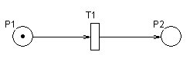
Figure 5.8 : A simple Petri net illustration

A state or marking in a Petri net is changed according to the following transition (or firing) rules required to simulate the dynamic behavior of the system:
- A transition T is said to be enabled to "fire" if each input place P of T is marked with at least w(P,T) tokens.
- An enabled transition may or may not fire depending on whether the event actually takes place.
- A firing of an enabled transition T removes w(P,T) tokens from each input place P of T, and adds w(T,P) tokens to each output place P of T.
- The marking of the other places which are neither input nor output of T remains unchanged.

When there are more than one enabled transitions then priorities, probabilities or some predefined rules (e.g. race conditions) are used to resolve conflicts. A transition without any input place is called a source transition. A transition without any output place is called a sink transition. A pair of a place P and a transition T is called self-loop if P is both an input and output place of transition T. A Petri net is said to be pure if it has no self-loop.

High Level Stochastic Petri Nets
Many ways of incorporating time have been introduced in Petri nets to evaluate system performance and to integrate stochastic elements that are so frequent in real world problems. Time can be associated with transitions, places, tokens and/or arcs. In most timed Petri net models, transitions have associated time which determines the delay between the moment the transition becomes enabled (when an appropriate number of tokens have appeared in incoming places) and the moment the transition becomes fireable [12]. A firing of an enabled transition T removes tokens from each incoming place of T and adds tokens to each outgoing place of T, according to weights of corresponding arcs. When several transitions are simultaneously enabled, the transition that has the shortest delay will fire first.
Time delays may be deterministic or may be probabilistically given. In Stochastic Petri nets delays are associated with exponentially distributed random variables. An immediate transition has no firing delay and is used to represent a logical control or an activity whose delay is negligible compared with those associated with timed transitions. A Petri net may have immediate, deterministic and/or generally distributed stochastic transitions. Transitions can have a capacity to limit the number of concurrent enabling/firings of the same transition [13]. There are three capacity related semantics: Single server semantics- A firing delay is set when the transition is first enabled, and new delays are generated upon transition firing; Infinite server semantics- every enabling set of tokens is processed as soon as it forms in the input places of the timed transition; multiple server semantics- enabling sets of tokens are processed as soon as they form in the input places of the transition up to a maximum degree of parallelism (say n).

PN Model of OTIS
This section illustrates how Petri nets can be used to efficiently model OTIS along with all its characteristics. In Petri net model of OTIS, as depicted in figure 5.3 [14], transitions follow infinite server semantics and atomic firings [13] i.e. tokens are not reserved during the time period associated with transitions. There are no capacity restrictions on places. To represent databases used in the system, doubled line circles have been used. To resolve conflict between simultaneously enabled transitions, notion of Priority Nets [15] is used which define a binary priority relation on conflicting transitions. The relation is assumed to be non-reflexive and anti-symmetric. An enabled transition can fire only if no other transition with higher priority fires. The priority relation in Figure 5.3 is represented by a dashed line going from the less priority transition to the transition with higher priority.
Two types of transitions are used in the model: deterministic transitions and stochastic transitions. In the model, all transitions are deterministic transitions with non-zero time delay except transitions T1 and T5. Transition T1 is a stochastic transition while T5 is a zero-time delay deterministic transition. The various places and transitions depicted in figure 5.3 are defined in the table 5.1.

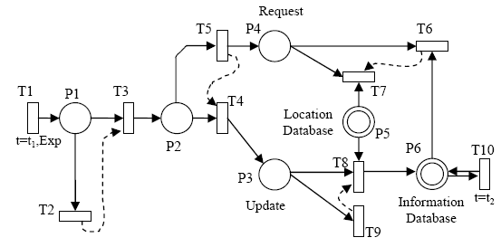
Figure 5.9 : Petri nets modeling of OTIS

Table 5.5 : Explanation of Petri net model of OTIS
Pi | Explanation | Ti | Explanation
P1 | Message received | T1 | Shows event of message arrival
P2 | Valid message is received | T2 | Sends “ Invalid Format” message to user
P3 | Update message is received | T3 | valid message is received
P4 | Request message is received | T4 | Received message is update message
P5 | Location Database | T5 | Received message is request message
P6 | Information Database | T6 | Sends traffic information status to user
 |  | T7 | Sends “location not found” message to user
 |  | T8 | Message has valid location, information database updated
 |  | T9 | Sends “location not found” message to user
 |  | T10 | Update database for each time slot

Following is a step-by-step description of the OTIS functioning as depicted in the figure 5.3 -
- Transition T1, which has exponentially distributed time association, signals the random arrival of messages as multiple users may send messages to the system in any arbitrary order.
- Next, the incoming message needs to be processed for validation. If the message was found to be valid, transition T3 signals a valid message and forwards the message for further processing. Otherwise T2 sends back a reply to the user indicating that the message sent was in an invalid format. Transition T3 has higher priority over transition T2.
- A valid message is further processed by transition T4 to determine its type. If it is an update message T4 fires otherwise transition T5 processes the message.
- Both request and update messages are checked to match the location mentioned in the SMS with those in the location database. If no match is found then T7 and T9 send back “location not found” messages to the user.
- If location is matched then transition T8 performs a traffic update in the information database while transition T6 will query the information database to get the traffic status information for the corresponding location and reply appropriately to the user.
- To prevent the database from giving back old information to the users, the transition T10, a deterministic transition with some non-zero time delay, keeps updating the database periodically, say every 10 minutes. The non-zero time delay indicates that the transition can simultaneously fire for any number of times.

The Petri net model of figure 5.3 shows the parallel nature of two subsystems - one for updating the database and the other for extracting information from the database. It also depicts start and end points of the system, for instance, the source transition T1 and sink transitions like T2, T7 and T9 represent respectively the start and end points of the system. Processes of deterministic durations like transition T8 that updates the database and transition T4 that checks the nature of incoming messages are also represented by the model. The transition pairs like (T4 and T5) and (T6 and T7) - that are examples of decision sequences - are clearly modeled using priority relation. Although both transitions are enabled simultaneously, only one of them may fire. Such control flow and decision constructs that are inherent to OTIS are unambiguously depicted by the Petri net model.

Implementation
Until now the thesis has concentrated on the design of OTIS. In this section the implementation details are discussed. For the purpose of implementation CBS updates were not considered and only the SMS updates feature was incorporated in the system.

SMS Application Connection Options
To handle the incoming and outgoing SMSs OTIS requires an SMS application that can read incoming messages and generate outgoing messages. SMSs may be sent or received on a computer by a direct connection to the SMSC of the wireless carrier or to a GSM modem. However, it is much more convenient to use an intermediate SMS gateway that disburdens the application from the complexities of communicating with the SMSC/modem.

Connecting Directly to SMSC
Connection may be established with an SMSC by using certain communication protocols, for instance, Nokia has an SMSC protocol called CIMD whereas another SMSC vendor, CMG, has an SMSC protocol called EMI [16]. As SMSCs manufactured by different companies use different protocols for communication this involves embedding knowledge of different protocols into the application which makes the system complex.

Connecting Directly to GSM Modem
The other option is to connect to a GSM modem directly which in turn connects to the SMSC of the concerned wireless carrier. A GSM modem could be in the form of a specialized GSM modem device or a normal GSM cell phone which has inbuilt modem. However, to interact with a GSM modem requires knowledge of AT (Attention) command language which unnecessarily increases the complexity of the system.

Connecting using SMS Gateway
Another alternative is to connect the SMS application to an SMS gateway that in turn takes care of all the complexities. The gateway acts as an intermediary that has knowledge of the various communication protocols and AT commands. The application need not be concerned with the protocols being employed at the SMSC or have the knowledge of the AT commands, all it needs to do is to have knowledge of the interface to the gateway once which then handles the rest of the communication. Thereafter, only simple modifications are required to be done with the gateway to handle different protocols.
As an SMS gateway avoids the need to directly connect to an SMSC or a GSM modem it is important to understand which method is suited to an application. While having a connection with an SMSC provides the fastest means of sending/receiving SMSs it is difficult to gain access to a wireless carrier’s SMSC as permission from them is required. On the other hand anyone may use a GSM modem to connect an SMS application but it is a much slower method with SMS sending/receiving rates of 6-10 per minute [16].
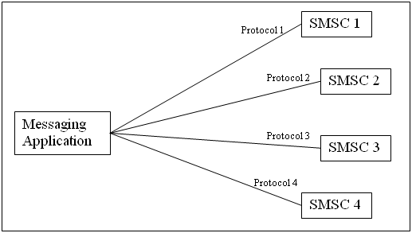
Figure 6.10 : Connecting Directly to SMSC

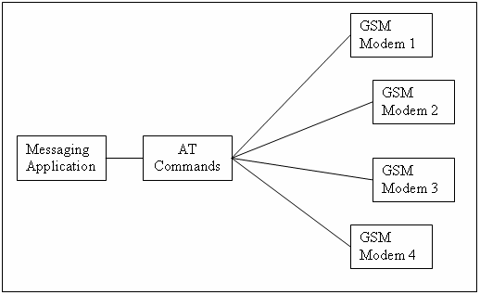
Figure 6.11 : Connecting Directly to GSM Modem
Thus, from a developer’s point of view, using an SMS gateway to connect either to an SMSC or a GSM modem reduces the complexity of the system. But whether to choose an SMSC or a GSM modem depends entirely on the scale and purpose of use of the SMS application.
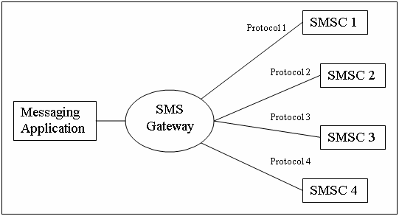
Figure 6.12 : Using SMS Gateway to Connect to SMSC

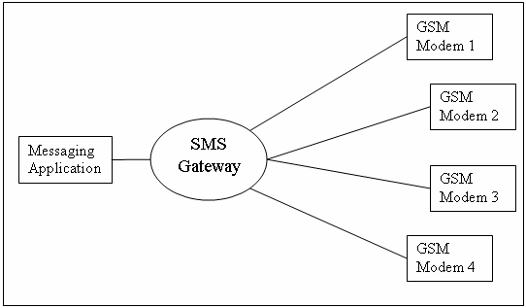
Figure 6.13 : Using SMS Gateway to Connect to GSM Modem

Working
To develop a working model of the traffic information system OTIS a combination of SMS gateway and a GSM modem was used. The SMS gateway used is SMSLib [17] which is an open source SMS gateway. It is built entirely in the Java programming language and provides Application Programming Interface (API) for external applications to interact with it. Instead of going in for a specialized GSM modem, a mobile phone with inbuilt GSM modem was used for the implementation purposes. It also acts as the destination mobile address to which the users will send traffic update/request SMSs. The database for the system was built in Microsoft Office Access database. This database stores incoming update message details like sender mobile number, timestamp, keyword, location etc. and is queried when a request message for traffic information is received. The database consists of two tables – one is a location table that stores a list of locations which are currently supported by the system and a status table that stores the details of incoming request-messages described later.
The working model of OTIS is implemented as follows-
- Once the system OTIS is up and running it waits for any incoming SMSs.
- As an SMS is received by the mobile phone attached to the computer it is extracted by the application and processed.
- Depending upon the keyword present in the text of the SMS the message could be an update-message or a request-message. In the current implementation, the keyword ‘0’ represents an update-message while keyword in the set {1, 2, 3} represents a request-message where 1 stands for ‘smooth’ traffic, 2 stands for ‘slow’ traffic and 3 stands for ‘heavy’ traffic or a ‘jam’ as shown in figure 4.2.
- In case the incoming message is an update-message, the location mentioned in the SMS is matched from the available locations in the location table. If a match is found then an entry is made in the status table with the traffic information for that location as per the keyword contained in the message. Also, the sender is notified of the successful receipt of his SMS.
- In case the input location cannot be matched with the available locations the sender is sent back an SMS informing him the same.
- If in step 3, the incoming message is found to be a request-message then the location mentioned in it is matched against the location table. If a match occurs then the status table is queried for all rows containing traffic information for that location.
- Next, some logic needs to be applied to ensure that only latest updates are considered for generating an estimation of the traffic condition for that location. This is done by considering only those rows of information that were generated within 10 minutes of receiving the request-message being currently handled. Then an average is taken over all the keyword values among these rows and an estimated traffic status is generated. For instance, for a location called ‘naraina’ if there are 4 rows with keyword value 1 and 6 rows with keyword value 2, then the average value calculated will be ( (4*1) + (6*2) )/10 = 1.6 . For purposes of this implementation values in the range of 1 - 1.5 are categorized as smooth, values in the range 1.5 - 2.5 are categorized as slow while those falling in 2.5 - 3 bracket will represent heavy traffic i.e. jam. A message like ‘traffic at naraina is slow’ will be sent back to the user if calculated value is 1.6 for location ‘naraina’.
- If in step 6 a match could not be made or if no rows were found to qualify the 10 minute window in step 7, an appropriate message is sent back to the user informing the decision of the system.

Following alternatives are possible in the procedures discussed above-
  - The time window of 10 minutes may be reduced or increased depending upon various parameters like frequency of request-messages, traffic flow etc.
  - A procedure could be setup for the database to periodically go through the status table in the database and invalidate those rows that do not qualify to be in the defined time window.
  - Instead of simply averaging the keyword values as mentioned in step 7, a weighted average could be taken giving priority to the messages that are more recent.

Code Snippets
The SMS application of the system OTIS is written entirely in Java programming language and interacts with an open source SMS gateway called SMSLib (also written in Java) for sending/receiving SMSs. This section explains some of the important parts of the application code.
The following code describes some of the initializations performed for setting up the serial GSM modem with the gateway.
//-------------------------------------------------------------------//
.
.
.
// Create new Service object - the parent object in the SMSLib gateway
srv = new Service();
// Create the Gateway representing the serial GSM modem.
SerialModemGateway gateway = new
SerialModemGateway("modem.com11", "COM11", 115200, "SonyEric", "W700i");
gateway.setInbound(true); // Gateway can receive SMS
gateway.setOutbound(true); // Gateway can send SMS

// Add the Gateway to the Service object.
srv.addGateway(gateway);
// Similarly, many Gateway objects can be defined representing various // GSM modems, added in the Service object and controlled.

// Start! (connect to all defined Gateways)
srv.startService();
.
.
.
//-------------------------------------------------------------------//
The following part of the code is where incoming SMS is received and sent to another class for processing. This code also shows how the outgoing SMS is generated and dispatched.

//-------------------------------------------------------------------//
.
.
.
// This loop continually runs to check for any incoming messages
while(true)
{
msgList.clear(); // clears message list

// Checks if any incoming UNREAD message is queued in the list
srv.readMessages(msgList, MessageClasses.UNREAD);

// This for loop runs for all UNREAD messages in the list
for (int i = 0; i < msgList.size(); i++)
{
System.out.println("****----****----****----*****----****");

// Current time after receiving message
long appInTime = (new Date()).getTime();

System.out.println(msgList.get(i));

InboundMessage msg = (InboundMessage) msgList.get(i);
String no, usermsg,reply;
no= msg.getOriginator(); // Extract sender number from message
usermsg= msg.getText(); // Extract text from message

// Above details sent to messageClass object for processing
messageClass message = new messageClass(no,usermsg);
reply = message.processMessage();

// Current time after processing message
long replyTime = (new Date()).getTime();
System.out.println(reply);

// Reply returned from messageClass will be sent as
// outgoing SMS to sender
OutboundMessage msgout = new OutboundMessage(no, reply);
srv.sendMessage(msgout);
System.out.println(msgout);
// Dispatch time of outgoing SMS
long msgOutTime = msgout.getDispatchDate().getTime();

System.out.print("Time taken for entire cycle: ");
System.out.println ((float)(msgOutTime-appInTime)/1000 +" seconds");
System.out.print("Time taken for processing: ");
System.out.println ((float)(replyTime-appInTime)/1000 +" seconds");

}
}//while
.
.
.
//-------------------------------------------------------------------//

The following part of the code describes the messageClass where the incoming SMS is sent for processing and the output is generated. The messageClass class has 3 main methods –
processMessage() – checks validity of incoming message and determines whether it is a request-message or update-message.
updateMessage() – handles incoming update SMS that provides traffic information to the system.
requestMessage() – handles incoming request SMS that requires traffic information from the system.

Connection establishment between the messageClass and database is shown by the following lines of code.
//-------------------------------------------------------------------//
.
.
.
// Establishes connection between database and messageClass
Class.forName("sun.jdbc.odbc.JdbcOdbcDriver");
String dsn = "OTIS";
String dburl = "jdbc:odbc:" + dsn;
Connection con = DriverManager.getConnection(dburl,"","");
.
.
.
//-------------------------------------------------------------------//

//------------------- updateMessage() method--------------------------//
.
.
.
// Creates the SQL statement for updating the table ‘statustab’
PreparedStatement updateStmt =
con.prepareStatement("insert into statustab values (?,?,?,?)");

updateStmt.setString(1,clientid); // inserts client mobile no
Timestamp ts = new Timestamp((new Date()).getTime());
updateStmt.setTimestamp(2,ts); // inserts time
updateStmt.setInt(3,locid); // inserts location ID
updateStmt.setInt(4,keyword); // inserts traffic status
updateStmt.executeUpdate(); // executes SQL statement
updateStmt.close();
reply = "Traffic status of "+ location+ " updated."; // Reply to user
.
.
.
//-------------------------------------------------------------------//

//------------------- requestMessage() method--------------------------//
.
.
.
// Creates the SQL statement for retrieving all rows with traffic
// information about required location
PreparedStatement getupdateStmt =
con.prepareStatement("select timestamp,trafficvalue from statustab where locid =?");
getupdateStmt.setInt(1,locid);
rs = getupdateStmt.executeQuery();

while ( (rs.next())|| rs.getRow()!=0 )
{
temptime=((rs.getTimestamp(1)).getTime()); // message time in database
timediff = (querytime - temptime)/1000; // seconds

// criterion for determining qualifying rows
if ( timediff < 600 )// 10 minutes = 10 * 60 sec
{
numerator+=(rs.getInt(2))/(float)(timediff+1);
denominator+= 1.0 / (timediff+1);
ctr++;
}
}
if(ctr!=0) // if any rows qualify then…
{
float averageval = numerator/denominator; // weighted average
if(averageval>=1 && averageval <=1.5)
reply = "Traffic at "+location+" is SMOOTH, value="+averageval;//1-1.5
else if(averageval>1.5 && averageval <2.5)
reply = "Traffic at "+location+" is SLOW, value="+averageval;//1.5-2.5
else if(averageval>=2.5 && averageval <=3)
reply = "Traffic at "+location+" is in JAM, value="+averageval;//2.5-3
.
.
.
//-------------------------------------------------------------------//

Snapshots & Screenshots
Figure 6.5 is a snapshot of the mobile handset Sony Ericsson W700i that was used as the GSM modem for the implementation in this thesis. It is connected to a computer on which OTIS is running. The GSM modem is a serial modem connected to one of the communication ports of the computer.

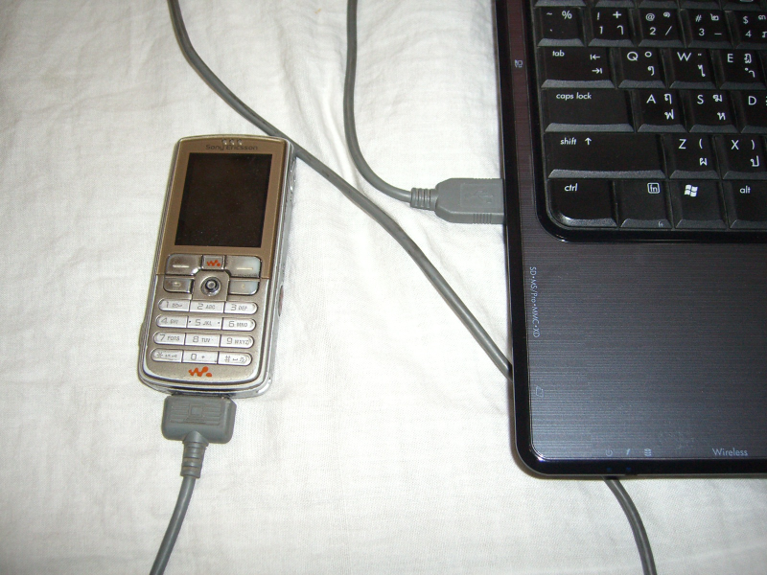
Figure 6.14 : Sony Ericsson W700i mobile being used as a GSM modem

Figure 6.6 is a screenshot of the OTIS.java program that is running and waiting for incoming messages. It shows the modem information of the connected GSM modem.

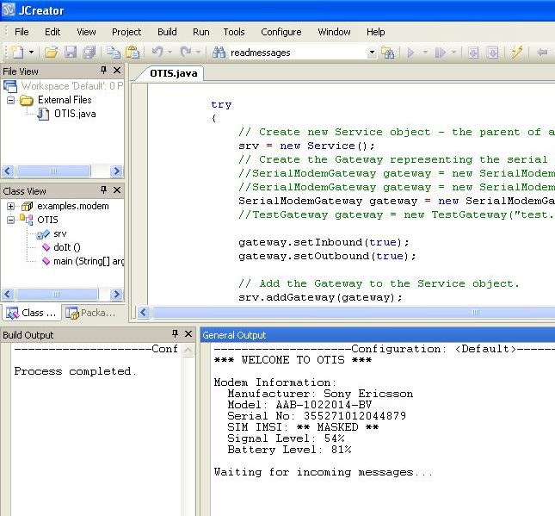

Figure 6.15 : OTIS is started and is waiting for incoming messages

In figure 6.7 a user is preparing an update-message to be sent to OTIS (keywords between 1, 2 and 3 indicate update-message). Figure 6.8 shows the status of the system upon receiving an incoming message. The inbound message, the reply after processing and the outgoing message, all three are displayed in this figure. Figure 6.9 displays the SMS that the user has received from OTIS as an acknowledgement to his traffic update message to the system.

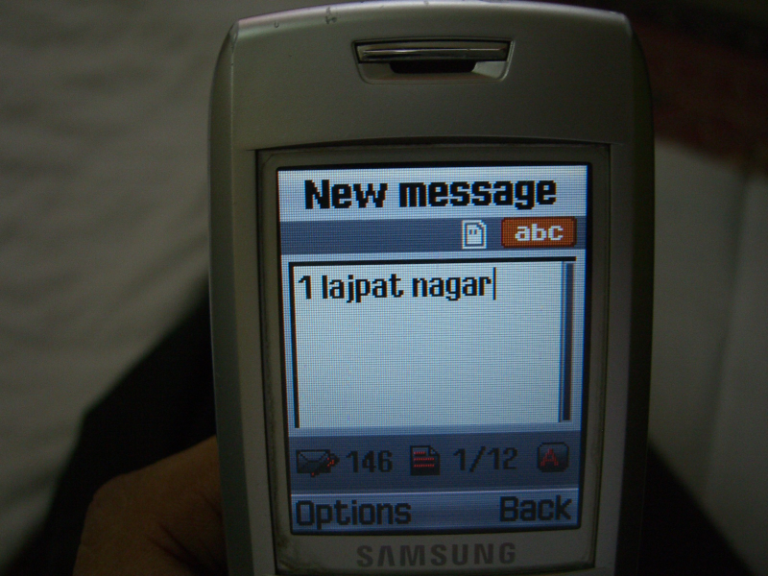
Figure 6.16 : A user entering a traffic-update message in the mobile station

In figure 6.10 a user is preparing a request-message to be sent to OTIS (keyword 0 indicates a request-message). Figure 6.11 displays the SMS that the user has received from OTIS as a reply to his traffic request message to the system.

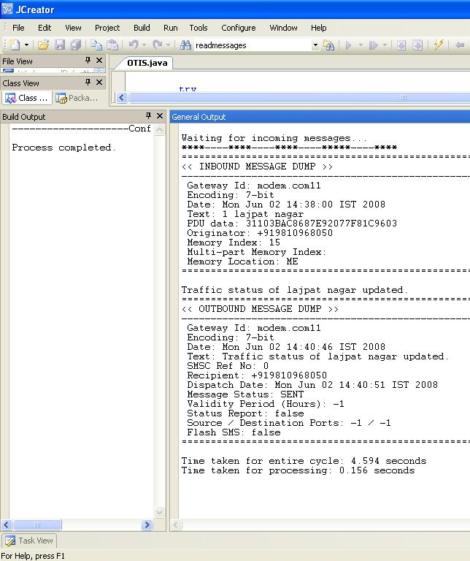
Figure 6.17 : OTIS receives an incoming message

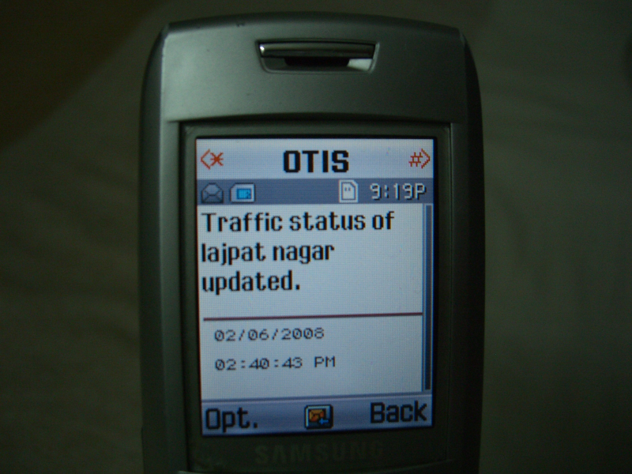
Figure 6.18 : User receiving an acknowledgement from OTIS

Figures 6.12 and 6.13 display the database in the system. Figure 6.12 is the location table ‘loctab’ that contains a list of the available locations for which traffic information can be received and sent. The table consists of the location ID and the location name. figure 6.13 shows the table containing information about incoming messages called the ‘statustab’. This table consists of the client no, the time of message, the location ID (from loctab) and the traffic status keyword indicating the traffic value that was sent by the user.

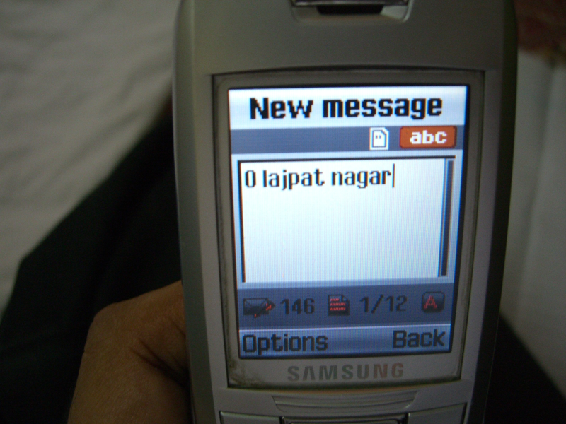
Figure 6.19 : A user entering a traffic-request message in the mobile station

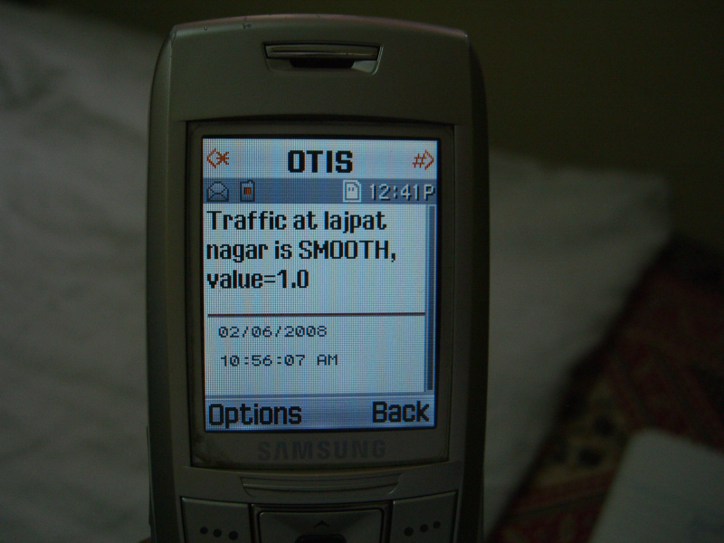
Figure 6.20 : User receiving traffic information from OTIS
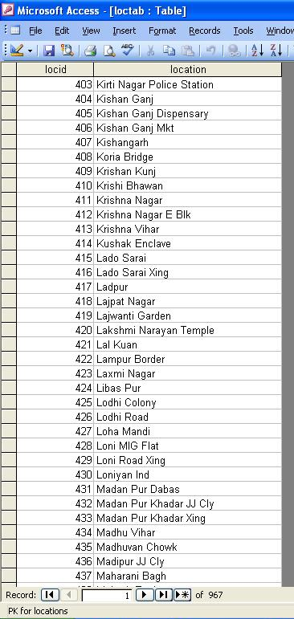
Figure 6.21 : Data from location table – ‘loctab’

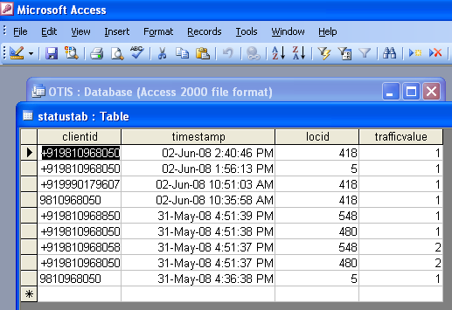
Figure 6.22 : Data from status table – ‘statustab’

Analysis
The processing time i.e. the time taken to process a received message and generate its response took on an average about 0.14 seconds. However, the combined time taken to process a received message and successfully send an appropriate reply to it was around 4.4 seconds. The increase in time was due to the limitations of a serial GSM modem that was used in the implementation setup. When the time taken by the messages to travel between the system and the user’s mobile station is also included, the whole cycle was found to take around 10 seconds. This time may further vary depending upon network parameters like number of mobile users of a particular wireless carrier messaging at that time, the capacity of the SMSC of a wireless carrier etc. This shows that a large fraction of time is spent in network communication which is beyond the scope of OTIS. Still, the performance can be improved by using multiple modems to concurrently handle the SMS traffic, or to procure a direct connection to a wireless carrier’s SMSC which is the fastest option available.
The number of locations in the location table of the database was found to have little effect on the processing time of the system however, the number of qualifying entries that will be processed from the status table will affect the processing time. Moreover, the complexity of the logic used to define the qualifying criterion will also affect the processing time. The processing time can be improved by using faster processing hardware.

Conclusion & Future Scope

Conclusion
This thesis has proposed a novel means of generating traffic information using mobile phone technology. The proposed system – OTIS – allows mobile phone users to not only receive updates regarding the traffic position in a particular area, but also to generate this information in the form of a short message (SMS). Although there are numerous other methods to generate traffic data, the proposed system suggests the use of SMS for generating it as it requires no change in current network infrastructure and makes this system instantaneously deployable. By allowing people who are moving through a particular road or a location to generate its traffic status rather than relying on other agencies like radio and vehicular probes, real time up-to-date information can be collected using this system. This thesis has also implemented a working model of the system using a Java language based SMS application, an open source SMS gateway and an inbuilt GSM modem of a mobile phone. By implementing a working model of the system, this thesis demonstrates the feasibility of the proposed traffic information system OTIS. The implementation analysis showed that majority of time taken during exchange of information with the users was due to network communication delays. Thus, for real world application purposes faster means of exchanging SMSs need to be used like directly connecting to the wireless operator’s SMSC.

Future Scope
Once the system is implemented other methods of data collection and dissemination may be added to further improve the system. The CBS method of generating traffic updates that was proposed in the thesis remains to be implemented and is a prospect for future work. Another important functionality that can be added to the system is a location tracking feature that will automatically send a user’s location to the system along with an incoming SMS so that the user may need not type the location along with the traffic keyword each time he sends a traffic update message to the system. This is important as in the current setup the location name entered by the user may not always match with the available list of locations.
This project has enormous future implications and can be used in a wide range of applications. Since users will be identifying the locations for which they need traffic updates, even more meaningful and personalized content may be delivered to them. For instance, if the user has subscribed for a localized content service then there could be another parallel database that checks the location of the user and accordingly sends back messages, such as nearby food outlets, gas stations, restaurants, hotels, hospitals etc. It may also be used to deliver targeted advertisements if the user has subscribed for it. For instance, if any event is going on in or around the user’s location he may be notified regarding the same. The addition of such a location aware advertisement module could even act as a source of revenue that could allow waiving the SMS charges for sending traffic updates for the benefit of the users.

List of Publications from thesis

- Rajni Jindal, Ankur Gupta, "Open Traffic Information System", International Conference on Challenges and Development in IT-2008, 4th International Conference, Punjab, India, 2008

- Manoj Sethi, Kailash Gupta, Ankur Gupta, “High Level Petri Nets – An Effective Modeling Tool for Information Processing Systems”, International Conference on Information Processing 2008, Bangalore, India (in press), 2008

- Rajni Jindal, Ankur Gupta, “Generating Traffic Information through Mobile Messaging”, International Conference on Wireless Information Networks and Systems 2008, Porto, Portugal (in press), 2008

References

[1] L. Wischhof, A. Ebner, H. Rohling, M. Lott and R. Halfmann, “SOTIS – A Self-Organizing Traffic Information System”, Vehicular Technology Conference, 2003, The 57th IEEE Semiannual Volume 4, Issue, 22-25 April 2003
[2] W.-T. Balke, W. Kießling, C. Unbehend, “A Situation-aware Mobile Traffic Information System”, Proceedings of the 36th Hawaii International Conference on System Sciences (HICSS’03), IEEE 2002.
[3] T.Preuss and J.H. Syrbe, “An Integrated Traffic Information System”, Proc. 6th Int. Conf. Appl. Computer Networking in Architecture, Construction, Design, Civil Eng., and Urban Planning (europIA '97), 1997
[4] Mapunity: Geography for Development, http://www.mapunity.co.in
[5] 3rd Generation Partnership Project, “Technical realization of the Short Message Service (SMS)”, GPP TS 23.040 V8.1.0, 2003
[6] 3rd Generation Partnership Project, “Technical realization of Cell Broadcast Service (CBS)”, GPP TS 23.041 V7.0.0, 2003
[7] G. Peersman and S. Cvetkovic, “The Global System for Mobile Communications Short Message Service”, IEEE Personal Communications, June 2000
[8] Welcome to CellAlert Canada, http://www.cellalert.com/news/Jan_10_2006.html
[9] Wireless Developer Network - SMS: Can Networks Handle the Explosive Growth?, http://www.wirelessdevnet.com/channels/sms/features/smsnetworks.html
[10] Rajni Jindal, Ankur Gupta, "Open Traffic Information System", International Conference on Challenges and Development in IT-2008, 4th International Conference, India, (under press) 2008
[11] T. Murata, “Petri Nets: Properties, Analysis and Applications”, Proceedings of IEEE, 1989
[12] Reijers, Hajo, “Design and Control of Workflow Processes-Business Process Management for the Service Industry”, Series: Lecture Notes in Computer Science, 2003
[13] G. Balbo, “An Introduction to Generalized Stochastic Petri Nets”, 21st International Conference on Application and Theory of Petri Nets, Aarhus, Denmark, June 26-30, 2000
[14] Manoj Sethi, Kailash Gupta, Ankur Gupta, “High Level Petri Nets – An Effective Modeling Tool for Information Processing Systems”, International Conference on Information Processing 2008, Bangalore, India (under press), 2008
[15] A.Abdelli, N.Badache, “Synchronized Transitions Preemptive Time Petri Nets: A New Model towards Specifying Multimedia Requirements”, IEEE, 2006
[16] Short Message Service / SMS Tutorial, http://www.developershome.com/sms/
[17] SMSLib, http://smslib.org/

