DESIGN OF ELECTROSTATIC PRECIPITATOR FOR REMOVAL OF SUSPENDED PARTICLES FROM FLUE GAS EMISSION OF THERMAL POWER PLANTS
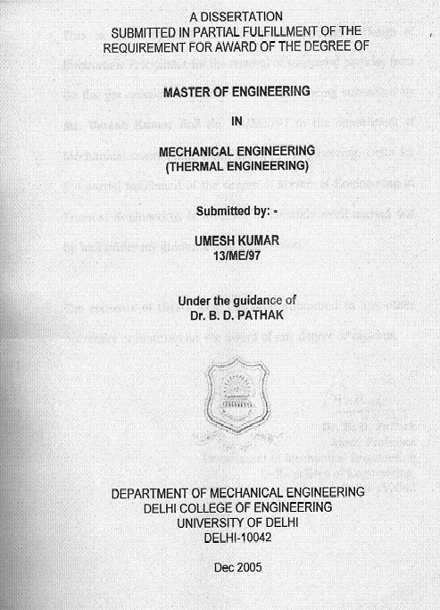
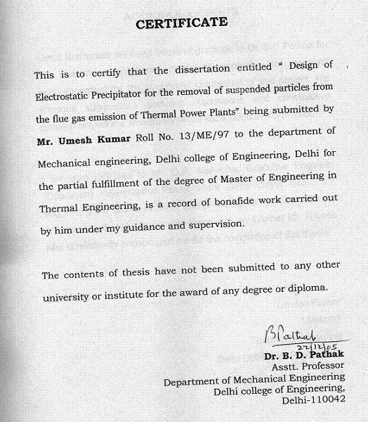
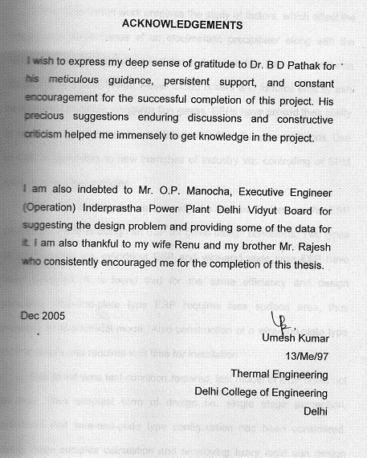
ABSTRACT
This dissertation work presents the study of factors, which affect the design, and performance of an electrostatic precipitator along with the design of an electrostatic precipitator for real life flue gas emission conditions for Power Plants. Fossil fueled boilers and furnace emit fly ash as suspended particle alongwith flue gases. ESPs have proved their ability to separate out suspended particulate matter from flue gas emissions. Use of ESP is spreading to new branches of industry viz. controlling of SPM level in rooms and vehicles.
The aim of project was to study the various factors on the ESP performance and to design an ESP for given design conditions. Two types of configuration viz. cylindrical ESP and wire-and plate type ESP have been designed. It is found that for the same efficiency and design condition, wire-and-plate type ESP requires less surface area, thus presents an economical model. Also construction of a wire-and-plate type ESP is simple and requires less time for installation.
Due to extreme test condition required, test model of ESP could not be built. Also simplest form of design i.e. single stage perception, cylindrical and wire-and-plate type configuration has been considered. Using more complex calculation and employing fuzzy logic can design more efficient and versatile ESP.

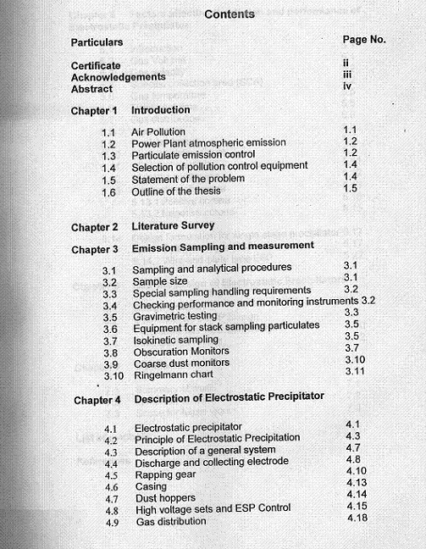
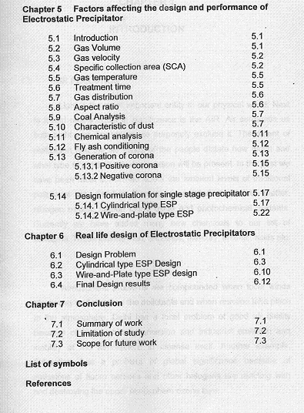
CHAPTER 1
INTRODUCTION

  - AIR POLLUTION
Light is the most important entity in our physical world. Next to it is and nearly equal in significance is the AIR. Air surrounds us both night and day unless we purposely exclude it. The extent of civilization and the life styles of the people dictate how much and what type of atmospheric degradation will be present. In the past we have been most concerned about the ambient levels of traditional pollutants viz. Sulpher Di Oxide, suspended particulate matter, nitrogen oxides, carbon mono oxide and photochemical oxidants. Currently we have added many new chemicals to our list of concerns. These include lead, asbestos, mercury, arsenic, acids etc.

Atmospheric problems are compounded when local winds blow away and disperse the pollutants and when reaction take place in the atmosphere. Delhi has a local problem of good air quality because of high vehicular emission and industrial emission and inability of the atmosphere to cleanse itself. Another example, Antarctica, has a problem of global significance because of emissions of fluoro carbons and other halogens are reacting with and destroying the upper atmosphere ozone layer.

  - Power Plant Atmospheric Emission
Fossil fueled electric generating plants emit combustion gases to the atmosphere that may contain pollutants in gas phase or as suspended solid or liquid particulates that can be emitted to the atmosphere. Potential air pollutant combustion gas emission can be controlled prior to combustion by switching, blending, or co firing with low sulpher and ash containing fuels or using other reduced pollutant content fuels. In addition, cleaning coal by beneficiation can reduce pollutants in the fuel.
Pollution can also be reduced by energy conservation measures or by increasing plant thermal efficiency.

1.3 PARTICULATE EMMISSION CONTROL
After combustion most fossil fuels, excluding natural gas or liquefied petroleum gas, yield residual particulate. The primary particulate constituents are ash or unburned carbon. The ash consists of silica, alumina and other non-combustible compounds. The amount of ash varies widely sometimes-exceeding 50 wt.%. These particulates leave the boiler as bottom ash, economizer ash or fly ash. Bottom ash falls to the bottom of the boiler and is removed periodically. Economizer ash generally has larger size, separates from the flue gas and drops into hoppers for removal in the economizer are. Fly ash is relatively small and leaves the boiler entrained with the flue gas.
The following table lists typical ash distributions for a variety of boiler types.

BOILER TYPE BOTTOM ASH FLY ASH ECONOMISER ASH
Pulverized coal 10%-30% 70%-90% 0-10%
Stoker 60%-80% 20%-40% 0-5%
Cyclone 50%-80% 15%-50% 0-10%
Circulating Fluidized bed 5%-90% 10-%-95% 0-5%

The ash split is a function of
- Fuel particle size
- Ash fusion and deformation temperatures
- Ash particle size, density and shape
- Boiler flue gas velocity
Stoker fired units produce the largest particles, wall and corner fired pulverized coal fueled boilers produce smaller, spherical shaped particles. Particles from cyclone-fired units are also mostly spherical and are smaller than ash from PC boilers. Fluidized bed units produce a wide range of particles that are asymmetrical, non-spherical and shaped more like crystals.
Knowledge of boiler type, fuel characteristics the resultant fly ash mineral analysis, particle loading and particle size is essential in the selection and design of an appropriate particulate removal control technology. Electrostatic precipitators (ESP) and fabric filter are the most prevalent choices. The final selection is generally based on economics and compatibility with the designed fuel, operating conditions, regulatory requirements and other pollution control technology required for the unit.

1.4 SELECTION OF POLLUTION CONTROL EQUIPMENT
To remove the particulate matter from gas streams, various control equipments are available. But to select the required equipment, the following parameters must be known.
- Quantity of gas to be treated and its variation with time.
- Nature and concentration of particulate matter to be removed.
- Temperature and pressure of gas stream.
- Nature of the gas phase (for solubility and corrosive effects)
- Knowledge of boiler type Fuel characteristics
- Desired quality of the treated effluent i.e. efficiency of removal of particulate required.

1.5 STATEMENT OF THE PROBLEM
Problem undertaken is stated as
- To study the factors affecting the design and performance of an electrostatic precipitator
- To design a real life Electrostatic precipitator for given design condition

1.6 OUTLINE OF THE THESIS
The whole report is divided into seven chapters.
- The very first chapter is of introduction.
- Second chapter deals work done on particulate emission control and performance analysis of electrostatic precipitators by various authors and research scholars. Literatures available on ESP, case studies methodologies have been discussed.
- Third chapter deals various emission sampling and measurement techniques. It includes sapling and analytical procedures, sample sizes and various monitors available for sampling.
- Fourth chapter deals with the description and construction of an ESP system. It includes the principle upon which an ESP works. Various components of an ESP and their role are discussed in details in this chapter.
- Fifth chapter deals with the factors affecting the design and performance of an Electrostatic Precipitator. It covers the gas volume, collection area, gas temperature, treatment time, coal analysis, dust characteristics and ash condition for better performance of an ESP.
- Sixth chapter deals with a real life design of an ESP system under given conditions.

CHAPTER 2
LITERATURE SURVEY

2.1 INTRODUCTION
In this chapter an attempt has been made to bring out various issues, models, observations and comments made by different authors and research scholars. The objective of literature review is to identify the issues related directly or indirectly to control options and tools that may be used in solving particulate emission control using Electrostatic precipitator.
Istvan Kiss and Istvan Berta presented a new concept on ESP modeling based on fuzzy logic. With this the capacity of an existing ESP model can be extended for uncertain information. The method was presented for the model of dust re-entrainment. The capabilities of earlier method were limited as they were valid only under certain conditions. Back corona, dust re-entrainment, and corona quenching presented modeler with complicated problems. Fuzzy logic is widely used in handling of uncertainty for control purposes.
Simone Vlad, Michaela Mihailescu and Dan Rfiroiu discussed numerical analysis of the electric field in plate type electro static separators. They found that by changing the shape and size of the high voltage electrode and by modifying its position with respect to the inclined grounded plate, the electric field could be designed to meet the requirements of any specific application. They found that the circular profile tubular high voltage (active) electrode generate an intense electric field on only 2/3 of the grounded (passive) electrode. By using an ellipse profile tubular active electrode the resulted electric field was more uniform and separation efficiency is increased.
Jerzy Mizeraczyk, Marek Kocik and Miroslaw Dors worked on the use of Particle Image Velocimetry (PIV) method for investigation of flow field in ESP models. They found that PIV method is well suited for investing the characteristics of secondary and reversal flows, which result in flow turbulence. The level of this electrically generated turbulence is significant due to a strong interaction between the electric field, the electric charge and the gas flow. The secondary flow has a great impact on the motion and precipitation of small particles, mainly those in sub micron range.
D. Blanchard, L.M. Dumitran and P. Atten also discussed the effect of electro-aero-dynamically induced secondary flow on transport of fine particles in ESP. They confirmed that a typical velocity of this secondary flow could be of the order of 1m/s. They also found that an ion injection modulated in the vertical direction induces a vigorous secondary motion. This in turn results in a strong mixing of the charged particles.
Maria jedrusik, Juliusz B. Gajewski studied the effect of the particle diameter and corona electrode geometry on the particle migration velocity in electro static precipitator. Their paper presents the results of research on the movement of fly ash particles in the model of an ESP with different corona electrodes; barbed plate; barbed tube, wire and spiked band. The experiments were performed with the use of one type of fly ash with different diameters and for given supply voltages and a constant inlet gas velocity.
All the electrodes used in the experiments were energized with the supply voltage up to a maximum value of 40 KV. The upper values are limited by the spark breakdown. The lower values are limited by the corona onset. Supply voltage has a significant and important effect on the migration velocity of the solid particles over the range of the particle diameters of the fly ash tested. For a supply voltage of 30 KV, which is common maximum one for all the electrodes geometries, the migration velocity reaches its maximum value for the wire electrode for diameters ranging from 100 to 160 micrometer. For the diameters from 63 um to 100 um, the barbed plate geometry has higher value of the migration velocity. Moreover the curves of the migration velocity tend to have a certain maximum around a diameter value of 80 um.
As for the migration velocity and the electrode geometries one can state on the basis of the experimental results that the highest values of the velocity are obtained for the wire and barbed plate electrodes while the spiked band and barbed tube electrodes have lower values within the range of common particle diameters. The barbed tube electrodes demonstrate in turn a certain tendency to increase in migration velocity both with increasing particle diameter and supply voltage.
The results, of their research paper, on the influence of the electrode geometry on the migration velocity suggest that the barbed tube is the most effective transport of solid particles towards the collection electrodes.
CONCLUDING REMARKS
Study of various literature and case studies revealed that corona electrode geometry affects the migration velocity deeply. The barbed tube is the most effective corona electrode for effective transport of solid particles towards the collection electrodes. This supports the latest trend towards the widespread application of this type electrode to ESPs. The ESP is a typical fuzzy system, so fuzzy logic must be used in handling of uncertainty for control purposes. With this capacity of an existing ESP model can extended for uncertain information.
CHAPTER-3
EMISSION SAMPLING AND MEASUREMENT

To evaluate emission quality and to design an efficient air pollution control system, it is necessary to determine emission rates from the source of pollution and to analyse the type and amount of pollutants in the emission. In this chapter various sampling techniques and equipments have been discussed.

3.1 SAMPLING AND ANALYTICAL PROCEDURES
Before sampling, information pertaining to the process or equipment to the sampled must be gathered. This would include a site survey for adequacy and accessibility of sample location, personnel expertise, literature searches and a sampling plan. Other type of necessary information required is:
- Process flow diagrams
- Equipment layouts and specifications
- Equipment operating conditions
- Operating parameters (Temperature, flow rate etc.)

3.2 SAMPLE SIZE
Sample size depends on the analyst’s level of investigation. Minimum sample requirement for typical level1 investigations are as follows
Sample Type Sample Size
Stack Gases 3 Litres
Stack Particulates 30 m³

3.3 SPECIAL SAMPLING HANDLING REQUIREMENTS
Precautions to be taken for sample handling are necessary because of the potential of extremely low pollutant levels
- Sampling equipment must be inert, that is, it must not in any manner change the sample constituents.
- Sample Preservation techniques should be utilized.
- Sampling equipment must be closely cared for to avoid contamination. Clean equipment and work environments are required. Seals should be carefully checked to prevent leakage.

3.4 CHECKING PERFORMANCE AND MONITORING INSTRUMENTS
The efficient operation of all dust arrests plant is essential if the objectives are to be achieved. Day to day performance can be judged from the records of the approved particulate monitors and electrical conditions of the precipitators. The monitors should be used as indicators of trends in the emission levels and station operating instructions should define the action to be taken when emission levels exceed the normal operating value.
The required action should include investigation, diagnosis and reporting of the incident in the station log.

3.5 GRAVIMETRIC TESTING
At the present time there is only one way to assess the quantity of dust that is being carried in a gas stream within a duct and this is by gravimetric testing. The test position selected should be at the greatest distance possible downstream of any bend or change of section in the ductwork. The position selected for the new plant is checked for satisfactory flow patterns on a model of the precipitators.
The duct is considered to be split into a grid of between 18 and 36 sampling position depending upon the size of the duct. For instance, eight sampling holes in one side of the duct would enable the sampling probe to be entered and testing carried out in four positions in the depth giving a required 32 position. In a test, the first activity is to establish, using a pitot tube, the gas velocity at each of the grid positions.
At the start of the test, usually of four hours duration, a dust-sampling probe is placed in each position for equal periods and a sample of gas with the entrained dust extracted at the velocity recorded from the previous survey. The dust is filtered out in fabric bags and the total quantity of dust is related to the total gas flow to give a dust burden usually measured in gm/m³ at STP.
Figure 3.1 shows the automatic dust sampler for the measurement of emission in Pulverized fuel (PF) boilers.
To check the collecting efficiency of a precipitator, all inlet ducts and all outlet ducts are simultaneously sampled and the burdens at inlet and outlet are compared.
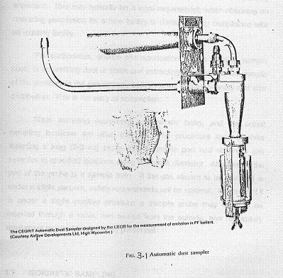

3.6 EQUIPMENT FOR STACK SAMPLING PARTICULATES
In defining air pollution problems, the sources of pollutants must first be quantified and therefore source characterization is extremely important. This may typically be a legal requirement, when obtaining an operating permission for a new facility or demonstrating compliance with an existing facility.
For particulates, source characterization means locating sample posts in an emitting duct or stack and extracting a representative sample of the particles in the gas stream, both in terms of their quantity and size distribution. This is not easy to accomplish.
Stack sampling equipment is generally bulky, and the actual sampling locations are often difficult. The procedure itself involves inserting a long (2-3 mt) probe into a sample port and obtaining gas samples at specified locations along the stack diameter. Attached to the end of the probe is a sample train. If the gas stream to be sampled is under a slight vacuum, safety requirements will be minimal. However, if it is under a slight positive pressure a sample probe may have to be inserted through a valve, and sealed from the outside; and respiratory equipment required for sampling personnel.

3.7 ISOKINETIC SAMPLING
In measuring the properties of a system, the measuring techniques themselves will influence the results obtained. For example, in measuring the voltage difference between two electrodes, the voltmeter itself will draw a small amount of current. That current will affect the surface characteristics of the electrodes and, therefore, the voltage being measured. The object of any program of source characterization is to minimize or compensate for the effect of the measuring tool.
In stack sampling for particulates, the measuring tool is a sample probe, which is inserted in the stack to withdraw a gas sample. Resorting to isokinetic sampling minimizes the effect of this probe on the measured particle properties. This means that gas samples are drawn through the probe at the same velocity as that in the stack or duct.

If the sample were drawn at a lower velocity than that in the duct gas would back up in front of the probe tip, and the smaller particles (diameter<5 μm) would follow the gas streamlines around the probe. However the larger particles (diameter>5 μm), by virtue of their greater inertia, would leave their streamlines and enter the probe tip. Therefore additional particles would enter the gas sample. In this case, when the solids content of the sample is measured and extrapolated to the entire gas stream, the net result would be overestimate the amount of particulate present in the stack or duct. Further the sample would show a greater proportion of larger particles than actually exists in the gas stream.
On the other hand, if the sample were drawn too fast, the smaller particles would again follow the gas streamlines and be sucked into the probe while the larger particles would leave their streamline and miss the probe altogether. This means that for the gas sampled, the solids content would be underestimated and the particle size distribution biased toward the smaller particles.
Since the solids content of the gas being sampled is always considered on a weight basis, even the presence of a relatively small percentage of larger particles may have a significant impact on the reported values for those cases that are non isokinetic. The maintenance of isokinetic conditions is probably the most important consideration in particle sampling. Unless the particles are all small (<5 μm), the results of sampling program will be meaningless if the sampling velocity is outside the range of 0.9 to1.1 times the gas velocity in the duct at the sample point.

3.8 OBSCURATION MONITORS

Obscuration monitors record the obstruction to a light beam passing across the gas stream. These are more sophisticated instrument and are preferred since these are more reliable and require less maintenance.
These are of two types:
- The Erwin sick monitor
- The Serop monitor.

The Erwin sick monitor (fig.3.2) has a light source and a photocell housed on one side of the duct and a light reflector on the other, allowing the loss of light due to the dust concentration to be registered and recorded on a chart. Special features include a reference beam to counteract changes in lamp brightness and a periodic zero check, which is recorded. Both housings have air purging to prevent the ingress of dust.

The Serop Monitor (fig.3.3) also employs a light beam and provides a continuous record, but in this case the light is housed at one end of a 2.3m long tube with a photocell at the other end. The tube, which has a 1.37m slot on both sides, through which the gas passes, is installed in the duct with the photocell situated outside the duct.

Air purging keeps the light source receiver clean. It has the advantage of only requiring access to one side of the duct.
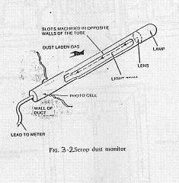
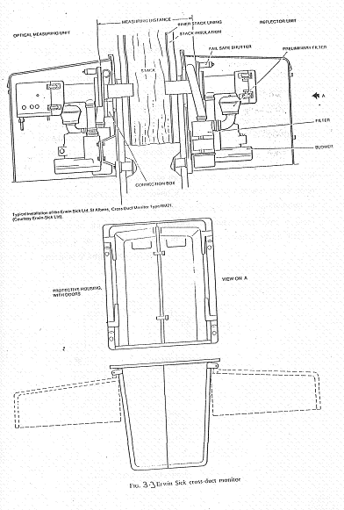

3.9 COARSE DUST MONITORS
In many power plants coarse dust monitors are fitted. These have a vertical tube in the duct with an opening facing the gas stream and dust entering the tube drops down and is deposited on a glass plate. Periodically the density of the deposited dust is recorded by passing light through the layer to a photocell. After an interval of time the dust is blown clear and a wiper mechanism clean the glass.
On coal fired stations these monitors can, with the agreement of the local inspector, be removed if obscuration monitors have been fitted. On oil fired stations these monitors are recommended in addition to the obscuration monitor, because they give a good indication of poor atomization in the burner which gives rise to emission of large agglomerates.

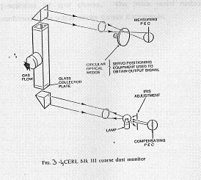
3.10 THE RINGELMANN CHART
The visual assessment of smoke emission for the purpose of the clean air act is by means of the Ringelmann Chart, the darkness of the smoke being compared with standard shades of gray on the chart. The shades of gray are obtained by cross-hatching in black on a white background so that a known percentage of the white is obscured. The chart is placed at such a distance from the observer that the black lines merge into the white background and reproduce for each shade uniform gray. The number of shades (Ringelmann Numbers) ranges from 0 (all white) to 5 (all black) in stages of 20% obscuration of background. The British Standards Institutions has now produced the standard Ringelmann Chart BS 2742 C and also instructions for the use of this chart.
Although the Ringelmann Chart is the legal criterion it is only practicable for spot checks. The more usual method is by continuously recording smoke density instruments.
CHAPTER-4
DESCRIPTION OF ELECTROSTATIC PRECIPITATOR
INTRODUCTION
Several type of air cleaning devices can collect or trap air pollutants before they are emitted into the atmosphere. Some of these devices serve to control only suspended particulates and others control only gaseous pollutants. The design or selection of a particular type of air cleaning apparatus depends on the physical and chemical properties of the pollutants to be removed, as well as on temperature, corrosivity and other characteristics of the pollutant and the carrier gas.
There are many kinds of particulate control equipment including Electrostatic precipitators, gravity settlers, cyclone, fabric filters and wet scrubbers. Some are much less expansive than others but are also less efficient in removing fine particulates from the carrier gas. Some are limited to cleaning dry, low temperature gases.

4.1 ELECTRO STATIC PRECIPITATOR (ESP)
On all modern power stations where pulverized coal is being fired, Electro static precipitator does the removal of the dust from the gas stream. ESPs are particulate collection devices that utilize electrical energy directly to assist in the removal of the particulate matter. They have been successfully used for removal of fine dust from all kind of waste gases with very high efficiency. Particles as small as tenth of micron can be removed. The gas passes through a precipitator at a very low velocity and
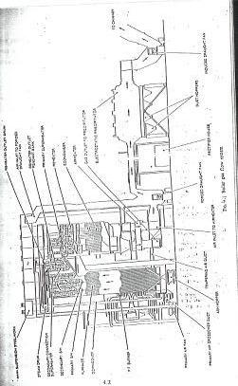
consequently the resistance to the flow is less than 12 mm of water gauge thus keeping the power absorbed by the induced draught fans to a minimum.

4.2 Principle Of Electrostatic Precipitation
The principle, upon which an electrostatic precipitator operates is that dust laden gases pass into a chamber where the individual particles of dust are given a negative electric charge by absorption of free ions from a high voltage DC ionizing field. Electric forces causes a stream of ions to pass from the discharging electrodes to the collecting electrodes and the particles of dust entrained in the gas are deflected out of the gas stream onto the collecting surfaces where they are retained. The particles have a negative charge and are thus held on the collecting plates that are earth positive. The particles give up their charge and are held by molecular attraction until they are removed by rapping gear. This causes the dust particles to drop into the dust hoppers situated below the collecting electrodes.
Immediately before an Electrostatic Precipitator the ductwork has a taper section so that the gas velocity is reduced from around 15 m/s in preparation for its passing through the precipitator casing at between 1.0 m/s and 2.0 m/s. Fig- 4.5 shows the plan arrangements of ductwork and electrodes in a typical three-stage precipitator
Within the casing are suspended collecting electrodes that are in the form of flat plates, suitably stiffened to prevent their becoming unstable in the gas stream. They are between 6m and 15m in height and are spaced generally between 200mm and 300mm apart (although this spacing can be up to 400mm). Thus in the casing there are formed a number of gas lanes from one end to the other. Between the collecting electrodes there are
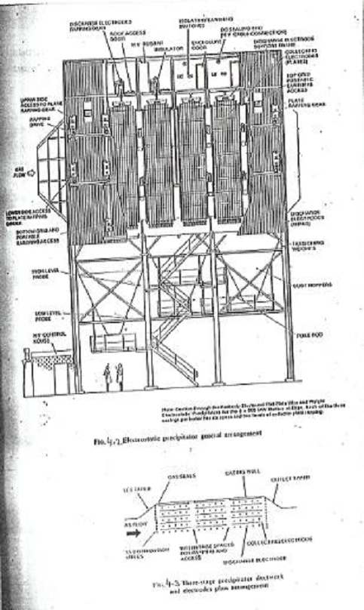
discharge electrodes suspended from suitable insulators, on which the high-tension voltage is impressed.
The design of precipitator depends on the velocity a particle of dust effectively travels towards the collecting electrode. By effective it is meant that a particle may be collected and then entrained in the gas stream before it is finally trapped. This velocity is known as the effective migration velocity. Deutsch Anderson has given the following formula showing relationship between ESP efficiency, effective migration velocity, the collecting area and the volume of the gas to be treated.
$E=1−e^{{−\text{wA}}/v}$
Where E = ESP removal efficiency, %
=$\begin{aligned}\frac{\text{inlet}\text{.}\text{dust}\text{.}\text{loading}−\text{outlet}\text{.}\text{dust}\text{.}\text{loading}}{\text{inlet}\text{.}\text{dust}\text{.}\text{loading}}×\text{100} \\ \end{aligned}$
where w= Effective migration velocity m/s
A= Collecting Surface Area, m²
V= Gas flow to be treated measured at operating conditions in m³/sec.
This expression can thus be transposed as
W= $\frac{1}{K}\text{ln}\left(\frac{1}{1−E}\right)$
It can thus be seen W is purely a convenient way to bring together these three parameters, efficiency, gas volume and plate area. The value of W derived from the data obtained during tests on installed plant can then be used as a design basis for new plant.
The inlet dust burden is dependent upon the ash content of the coal and the carry over from the boiler. The outlet dust burden will be dependent upon the legislation governing environment matters. From these two figures obviously the required collecting efficiency can be established. Careful consideration needs to be given to the decision on collecting efficiency required. If the collecting efficiency is kept too low, it will necessitates costly additions later and too high collecting efficiency adds considerably to the first cost. A precipitator designed to have an efficiency of 99.3% would have to be increased in size some 10% to attain 99.5% and 30% for 99.8%. This is less surprising when it is considered the slip has been decreased from 0.7% to 0.5% and 0.2%. The effect is worsened by the fact that the migration velocity decreases with the larger SCA values that are required for more efficient plant. In some cases it is desirable to investigate the performance of a particular dust, on a pilot plant, to establish the value of W, effective migration velocity. If the maximum current density is used then extremely high migration velocities can be achieved, anything up to 20 cm/s while on a full-scale plant the figure could be less than 8 cm/s. The pilot plant has, therefore, to operate on the current density that is thought to be attainable on a full-scale plant.

After having established the required collecting efficiency, the gas volume to be treated and the characteristics of the coal and ash, it is simple matter to calculate the required collecting plant area, bearing on mind that the dust is collected on both sides of the plates.

4.3 DESCRIPTION OF A GENERAL SYSTEM
Basically, an electrostatic precipitator consists of six major components
- A source of high voltage,
- Discharge electrodes and collecting electrodes,
- Inlet and outlet for the gas,
- A means (generally a hopper) for disposal of the collected material,
- An electronic cleaning system, and
- An outer casing to form an enclosure around the electrodes.

The entire electrostatic precipitator is enclosed in a casing. The actual geometric configuration may be either rectangular or cylindrical. In all the cases there is an inlet and outlet connection for gases, hoppers to collect the precipitated matter and necessary discharge electrodes and collector surfaces. Usually, there will be a penthouse on the precipitator. This is a weatherproof gastight enclosure over the precipitator that houses the high voltage insulators.
The gases entering an electrostatic precipitator may or may not have pretreatment before entering the unit. The pretreatment could consists of removing a part of dust loading by use of certain mechanical collectors or by adding chemicals to the gas to change the physical properties of the gas to enhance precipitation action.
ESPs are built with a number of auxiliary components which include access doors, dampers, safety devices, and gas distribution system. The access provisions can be either a door or a plate which are closed and bolted under normal operating conditions but which can be opened when necessary for inspection and maintenance. Dampers are the means by which the quantity of the gas flow is controlled. In addition the safety grounding system is extremely important and must always be in place during operation and especially during the periods of inspection. The most common grounding system consists of conductor, one end of which is grounded to the casing, and the other end is attached to the high voltage system by an insulated operating lever.
The collecting system consists of the collecting surfaces where the particulates matter is deposited. Also a device for rapping or vibrating the collecting surface is included so that the deposited particles can be dislodged.
The high voltage system includes the discharge electrode and the insulators. Electric insulation must be done for safety purpose. The precipitator hopper is integral with the precipitator shell and is made from the same material. The function of the hopper is to collect the precipitated material for final disposal.
The electrostatic precipitator requires a high voltage direct current source of energy for operation. Therefore transformers are required to step up the normal service voltage to high voltages. Rectifiers convert the alternating current to unidirectional current (i.e. Direct Current)

4.4 DISCHARGE AND COLLECTING ELECTRODE
The discharge electrodes are of various types but generally fall into two categories:
- Wires electrode
- Barbed electrode
Wires have a circular or square with hollow sided cross section of dimensions between 3.2 mm and 4.8 mm with sharp corners to promote corona discharge. Barbed electrodes have some form of pointed metal protrusion either attached to a vertical member or formed from that member.
The assembly of the discharge electrodes also varies. They can be strung from the top support grids straight down for the full height of the plates to the bottom grids. A 32 mm tube can be used which is supported from the top grid and steadies at the bottom and has, at intervals, cross tubes through which the wire is threaded and secured to give electrodes either side and parallel to the main tube (or mast as it is generally known). In other designs, tubular frames are suspended between the plates and the electrodes fixed to the frames. These are split into sections by cross bars up the height, so that each electrode is 3 m - 4 m long instead of the full height of up to 15 m.
The collecting electrodes, or plates as they are commonly called, are virtually flat plates or cylinders, suitably stiffened to give the required stability or a series of vertical channels between which the flat plates are assembled.
Another type is called the strip electrodes. This is a series of strips each of which is rolled to a suitable section to give the rigidity required for the full height. Theses formed strips are about 0.5 m in width and there are about three to ten strips per zone.
It is necessary to ensure that the aspect ratio of the whole treatment zone does not exceed unity, that is, the height of the plates must not exceed the total length of the treatment zones. If this ratio is not adhered to, there is a risk that dust release from the top of the plate will not have time to reach the hoppers before reaching the outlet. For the efficiencies normally required for a modern power station, the no. of zones is series would not be less than four and can be as high as eight.
The number of zones in series with the number of casings in parallel gives the total self-contained zones per boiler, each having its own HV set and independent rapping. If this does not give sufficient performance with a zone (or zones) out of service because of a fault, it is necessary to subdivide the zone electrically by means of isolating switchgear.

4.5 RAPPING GEAR
Although the majority of the dust collects on the plates (collecting electrode), a certain amount adheres to the discharge electrodes. If this material gets too thick, the electrical characteristics became unstable (spark or arc over, back-corona or decrease in corona generation) and collection decreases. To promote the maximum current flow, both collection electrode and discharge electrodes must be kept clean. Rapping gear is therefore installed for both. Periodic rapping cleans the collecting and discharge electrodes to ensure the proper functioning of the electrostatic precipitator.
During rapping, groups of these electrodes receive short and generally intense intermittent energy inputs via rotating hammers, vibrators or dropped weights. The resultant shearing acceleration forces cause large sheets of fly ash to fall from the collecting electrodes into the hoppers. If the acceleration forces perpendicular to the plate surfaces are too large, the fly ash is excessively re-entrained into the gas stream. The majority of precipitators have some form of hammer which strikes the plate and electrode assembles, the point of impact being within the precipitator since if the hammer strikes a shaft which is designed to transmit the energy to the required position, losses are incurred which makes the rapping gear ineffective. The rapping energy is imparted to either the top, bottom or sides (edge) of the collection plates and discharge electrodes. All these locations are successful.
For the discharge electrode rapping, the hammers can be on a shaft across the width of the plant which are raised and released at the required intervals, all the hammers striking virtually simultaneously the electrode support frames or grids. In another system, rods are lifted by cams and dropped. Although with this system the cams can be in gas stream, they are usually housed above the gas chamber and the rods raised through a suitable gas seal and then released to drop and strike the electrode grids.
The rapping of the collecting electrode plates has to be arranged so that only a small area is rapped at the same time to avoid an unduly high carryover of dust. In this case hammer levers are spaced along a rotating shaft, each successive one being radially displaced so that each hammer in turn falls to give the required impact. With flat plates the hammer will strike on the leading or trailing edge and there can be more than one shaft within the height of the plate to give extra rapping. On strip plates, the hammer strike a bar connected to each electrode strip.
In another system, flat plates are struck vertically downwards by rods, which have been lifted by cams and released. The cams arranged along the shaft are displaced radially so that only one rod drops at a time.
The plate rapping gear has to be set up to rap more frequently on the inlet zone, where there would be a heavier dust burden than on latter zone where most of the dust has previously been removed. There is so little dust collected on the discharge electrodes that these are usually rapped with the same interval at each stage. On most installations, the interval and the period of rapping is controlled by individual time clocks.
The online capability to adjust the rapping frequency, sequence, intensity or combinations of these parameters to match the changes in load or fly ash properties, may improve overall collection or electrical efficiency. This capability is helpful in increasing fuel or operating flexibility. However, many ESPs with interval and unadjustable online rapping intensity or sequence designs operate successfully.
Advances in rapper control technology may increase Electrostatic precipitator efficiency by enhancing the plate and discharge electrodes cleaning to match the rate at which particulate is collecting in any given mechanical section. The rapper control system customizes the rapper sequence, frequency, and intensity by comprehensive measurements of ESP operating parameters. On recent designs a microprocessor is used, which facilitates adjustment and ensures that rapping is sequential as it is detrimental to performance if more than one zone is one casing is rapped simultaneously.

4.6 CASINGS
The casings and support structures are designed to withstand the suction of the induced draught fans and take the loads imposed by the mechanical equipment as well as the weight of the dust adhering to the plates and collected in the hoppers. The height of the casings makes any allowance for wind loading extremely important. The gas temperature in the casing is usually 120⁰ C for design purposes, but can rise well above this, and the construction has to allow for considerable expansion in all directions. The support structure is usually rigid and the casing is supported on this by rollers or sliding pads.
The casings are lagged to ensure that the gas does not come into contact with cold surfaces, which would then cause condensation and acid attack from the sulphur in the coal. Cladding protects all the lagged vertical surfaces and case is taken to ensure that there is no heat bridge where the cladding support structure passes through the cladding. The roof has more dense lagging material with chequer plate on the top for walk way and working areas, the whole, in most cases, being roofed over to prevent ingress of water and to give a protected area for maintenance.
For the most part, the casings for electrostatic precipitators are constructed in 6mm steel plate suitably stiffened, but on older installations reinforced concrete was used. Unless there were particular local reasons, reinforced concretes would not now be used because it results in a very heavy casing requiring extra foundations; the time for erection on site is longer and should corrosion occurs later, it is difficult to repair.

4.7 DUST HOPPERS
The hoppers situated under the collecting plates are in most cases designed to hold a 24 hour accumulation of dust and because some 80% of the total dust is collected in the first hoppers, these have to be considerably larger than for the subsequent zones. All hoppers are designed to give an angle of slope in the four corners, known as the valley angle, of 55⁰ from the horizontal to ensure that dust not accumulates. The capacity of the hoppers is calculated with a low bulk density to allow for the aerated state of collected dust, but the strength of hopper and its support is based on a heavier density of a dust that has compacted prior to its removal. Dust emitted from pulverized fuel boilers is free flowing while it is till hot, but when it cools in a hopper it can become damp and sticky. For this reason the bottom of the hoppers are electrically trace heated and the whole of each hopper is lagged. The area around the hoppers for each casing is enclosed to prevent local nuisance from escaping dust and also to prevent wind cooling of the hoppers.
The dust handling system for the collected dust has to include a value to prevent air being drawn into the casing via hoppers.
In some cases, the dust is removed continuously, a system that allows the first zone hopper to be made smaller but still having capacity to allow for the repair of dust handling plant before the dust level rises too high. A further advantage is that there is little likelihood of the dust cooling and being difficult to remove.
The hoppers are fitted with high-level indicators, which are at some distance from the bottom grids of the discharge electrodes and give warning before the dust rises to a level where the electrodes are shorted to earth. In many installations, low-level indicators are fitted to show that hoppers have been satisfactorily emptied during the ashing period.
In most cases a poke rod is fitted near the hopper mouth to break up any bridging of the dust that might occur. Chains from each top corner of the hopper can be attached to the end of the rod, which, when agitated, help to remove accumulated dust. Aeration pads to assist the flow of dust can also be used.

4.8 HIGH VOLTAGE SETS AND ELECTROSTATIC PRECIPITATOR CONTROL
On a particular station burning a consistent fuel, the collecting efficiency of precipitator would normally vary directly as the amount of power supplied to the electrodes, provided excessive flash over does not occur or other faults which would cause leakage paths to earth. Obviously a certain minimum voltage must be applied in order to ensure a healthy corona discharge. The optimum operating voltage will be dependent upon the design of the precipitator, the gas condition and the characteristics of the particulate to be collected.
The objective of the ESP control system is to create and maintain an electrical field so that the desired collection of fly ash occurs. An additional control objective is to minimize power consumption consistent with performance. This is accomplished by transformers rectifiers, the current limiting reactors and a supervisory control system. The transformers step up the voltage from 480 v to between 25kv and 125kv, depending upon the plate spacing and particulate electrical resistivity and convert alternating current (AC) to direct current (DC). An ESP with wide plate spacing requires transformers with a high voltage rating and more current capability than an ESP with narrow spacing. If barbed discharge electrodes are used with a space between the plates of 250mm. The voltage may vary between 40kv to 50kv. The rectifiers that are housed in the transformer tank have silicon diodes.
A slight reduction from the optimum power fed to the discharge electrodes, results in a significant reduction in the collecting efficiency and it is therefore important that sophisticated control systems are used.
The firing of thrystor, which increase the voltage from zero at a steady rate until a spark occurs, regulates the voltage to the precipitators. At this point the voltage is slightly reduce and then again ramped up until there is a further spark. This process is continuous and thus the optimum is always sought. The rate of increase is adjustable. If, on the commencement of ramp-up after a spark, there is a further spark within a period of 180ms, it would be considered as an arc and the voltage would be reduced to zero for an adjustable period up to 100ms, this period being necessary to allow ionized gas within the precipitator to disperse. If the voltage remains at a very low value for a pre set period in spite of attempts by the control to raise it, then the equipment would be tripped out and an alarm is initiated.
An alternative system is by means of a controller, which increases the primary input energy at preset intervals. It then compares the potential existing on the discharge electrodes before the raising step with the value obtained after. If the high-tension voltage has in fact, increase, the potential remains at this higher level until the next step. If the potential should however, be below the original value, the controller reduces the primary input energy. In this way, the maximum high-tension voltage, which can be applied to the discharge electrodes, is continuously searched for and is maintained.
Analog controls sense sparks or arcs and reduce power input. Newer computerize digital control system react much faster. They sense the change in the shape or slope of the power input curve and react rather than waiting for a spark to occur. They allow the operator to control the set back voltage, setback time, power up ramp rate, and the duration of set back and power up. They also allow the ESP to operate at the most efficient particulate removal by using the highest voltage and current possible with automatic phase back if the spark rate is exceeded and interrupt/pedestal/ramp or phase back if an arc occur.
Discharge opacity can also be an input power limiting parameter with a computer control system. An opacity control system can limit power use by changing the apparent current limit of the controlled TRs. As the opacity dips below the set print, power is stepped back so that energy is saved. Conversely, as the opacity increases beyond a set print, the input power is allowed to seek up to the level determined by the spark or arc characteristics.
Intermittent energisation uses the ESP’s larger capacitor behavior and shuts off power for part of the Ac half cycles. The input power to the ESP is reduced because the AC power to the T-RS is stopped for short, adjustable periods measured in fractions of a second. During these short time periods, the ESP acts as a large capacitor, and the removal efficiency is not decreased because the ESP voltage is maintained and the particle charging rate is not significantly impacted.

4.9 GAS DISTRIBUTION
The total gas quantity from the boiler must be split to give equal portions in each of the precipitators and, having done that, gas control devices have to be installed to give uniform gas flow in all parts of each zone. It is also essential to ensure that the gas cannot bye pass the treatment zone via the hoppers.
Because of the size of modern installations it is not possible to carry out all the work required by the installation and adjustment of splitters, guide vanes and baffles to obtains good gas distribution. Each change would result in an unacceptable amount of work and also add considerably to the time to commission a new plant. The work should therefore be carried out on a scale model of between one-eighth and one twelfth full sizes where adjustments can speedily be made. The model includes all the gas flues from the air heaters to the induced draught fans.
To obtain a satisfactory distribution of gas through the treatment zones of a precipitator, it is first necessary to obtain an even distribution of the gas in the ducts upstream of the inlet taper, this being done by installing splitter and vanes, particularly where there are bends in the flue gas. Having obtained this it is then possible to install one or two perforated baffles in the inlet taper of the precipitator to spread the gas satisfactorily. The free area of various parts of the baffles is adjusted to give the desired result. Less elaborate baffles are required at outlet end of the precipitator to prevent the flow contracting towards the duct.
Control vanes are added to the baffles as well as baffles between zones to reduce any gas flow into the hoppers.
A high standard of distribution is required; this being that 90% of the test points in a plane should be within ± 25% of the average velocity in that plane. This is necessary because the loss in the collecting efficiency caused by high velocity is not compensated by the gain in the low velocity areas. It is possible to obtain the required standard without incurring a high-pressure loss, which would put unacceptable load on the induced draught fans. The pressure drop across the precipitator is usually less than 12 mm water gauge.
CHAPTER-5
FACTORS AFFECTING THE DESIGN AND PERFORMANCE OF ELECTROSTATIC PRECIPITATORS

5.1 INTRODUCTION
In this chapter an elaborative study of factors has been done which affects the design of an Electrostatic precipitator. Also theory behind the design of an ESP has been discussed in brief.

5.2 GAS VOLUME
The gas volume has to be calculated from the boiler heat output required and the quality of coal that is to be fired. To this figure must be added adequate margins to allow for leakage, particularly across the air heater. Account should be taken of the possible deterioration in the performance of the boiler and turbine over the life of the plant and any foreseen changes in the coal supply.
The gas volume entering a precipitator is expressed in terms of quantity of gas in m³/s at the operating temperature. Fig. 5.1 4.10(CBG) shows the typical effect of changed gas volume on dust emission plotted for various values of sulphur in coal.

5.3 GAS VELOCITY
The speed with which the flue gas moves through the ESP is important in the design and sizing of the ESP. Higher design velocity result in smaller ESP cross sectional area inlets but could result in an under sized ESP with high ash re-entrainment losses and low treatment time. Lower velocities are suggested for ash with a high potential for re-entrainment, such as particulate with high carbon content. However, the effects of too low a velocity as would be experienced during low boiler load operation must also be considered. Too low a velocity in the ESP could result in the flue gas meandering and possibly allowing ionization of the gas, which leads to spark over, and performance degradation.
For power stations the gas velocity is preferably between 1m/s and 2 m/s in the treatment area, higher velocities tending to scour the collected dust off the plates. The required velocity is obtained by the correct sizing of the cross sectional area of the precipitator whilst the required total plate area is obtained by altering the length of the plant. It is seen that up to a gas velocity of about 1.5m/s, the effective migration velocity tends to increase but beyond this velocity the migration velocity falls.

5.4 SPECIFIC COLLECTION AREA (SCA)
The ESP size is often measured in terms of the specific collection area. The specific collection area (SCA) of a precipitator has units of square metres per 1000m³ per min. of flue gas flow. The SCA for the required performance can be determined by using the Deutsch-Anderson equation, which relates the collection efficiency (E) to the unit gas flow rate V, the particulates effective migration velocity W and collection surface area, A
1- E= e$\frac{−\text{wA}}{V}$ exp(-WA/V) e$\frac{−\text{wA}}{V}$
or A= $\frac{v}{w}\text{ln}\left[\frac{1}{1−E}\right]$
Where E = ESP removal efficiency, %
= $\text{100}\left[\frac{\text{inletdustloading}−\text{outletdustloading}}{\text{Inletdustloading}}\right]$
W = effective migration velocity, m/s
A = collection surface area, m², and
V = Gas flow, m³/s

Because of the assumption about an effective migration velocity to make use of this sizing equation, the empirical nature of ESP design is obvious. It is nearly impossible to provide effective migration velocities without an abundance of application related information. In general, sizing an ESP is still most of an art than a science.
If high efficiency is required for a given installation, then the specific collection area to attain this, with a given effective migration velocity will also be high. High efficiency means that more of the fine dust will have to be collected and because of this, W (effective migration velocity) is reduced since the precipitator decreases in performance for fine dust. Thus the design has to take account of the SCA in its effect on W as well as its effect on the efficiency.
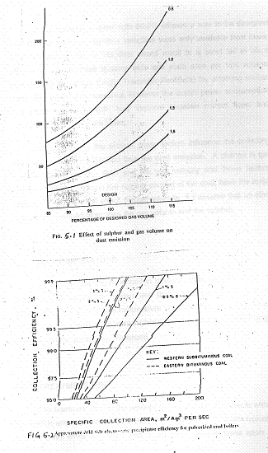
If, for instance, a plant with 99.6% efficiency was to be designed and data on effective migration velocities were only available from lower efficiency plants, use of this data would result in a short fall in plant efficiency. Larger plate spacing with less plate area per unit volume requires higher voltage (larger Transistor-Rectifiers) for attaining similar particulate removal performance, However the overall power consumption and efficiency of the ESP may improve because current flows and associated spark rates are lower.
As indicated in this section, many factors influence the collecting efficiency of a precipitator and thus the dust emission. A change in gas volume alters both the SCA and the gas velocity and these factors, combined with changes in the sulphur content of the coal, have the major impact. To illustrate the effect, the curves in fig. 4.10 CEGB assume that no other factors are changed other than the gas volume and the sulphur.

5.5 GAS TEMPERATURE
Within the range experienced in modern power stations where the precipitator follow the air heaters and the gas temperature is between 120º C and 150º C , the gas temperature has little effect on performance. However if the temperature were higher than the envisaged in the design, the gas volume would have increased.

5.6 TREATMENT TIME
The treatment time is the amount of time that the flue gas is within the electric and collection fields of the ESP. High efficiency ESPs typically has treatment times between 7 and 20 seconds. Shorter times apply to high sulphur fuels with higher permissible emissions. Longer times are required for low sulphur fuels with low sodium oxide fly ash contest or lower permissible emissions.

5.7 GAS DISTRIBUTION
Optimum particulate removal requires uniform gas velocity through out the entire precipitator treatment volume with minimum gas bye pass or sneakage around the discharge electrodes or collection plates. If the flue gas distribution is not uniform, the particulate removal will decrease and re-entrainment losses will increase in high velocity areas. This will reduce overall collection efficiency.

5.8 ASPECT RATIO
The aspect ratio is the ratio of treatment length (effective ESP length excluding walkways meant for maintenance) to the collection plate height. Higher aspect ratios allow the particulate collected at the top of the inlet collect plates to reach the hoppers before exiting the ESP. Aspect ratio of around 0.8 to 1.2 may be appropriate for applications where a problem with a re-entrainment is not expected or where regulatory requirements are not severe. However meeting contemporary particulate emission limits generally necessitates aspect ratios in he range of 1.2 and 2.0.

5.9 COAL ANALYSIS
The coal analysis obviously affects the gas volume, an important factor as already mentioned, but other characteristics of the coal are of particular importance to precipitator performance. The most important is the sulphur content of the coal, which can vary from 0.2% to 3.0%, because it affects the electrical characteristics of the dust.
The ash content of the coal dictates the quantity of the dust carried in the gas stream and thus the required collecting efficiency of the precipitator. The average ash content is about 20%, but it can be as high as 30% and down to 5%. High dust burdens from high ash fuels reduce the collecting efficiency. For reasons that are not fully understood, high volatile coals give a dust which is precipitated more readily.

5.10 CHARACTERISTICS OF DUST
- Fineness: The fineness of dust entering a precipitator has a considerable effect on the collecting efficiency because larger particles are more readily collected than the finer ones.
Dust size (micron, less than) | 100 | 80 | 60 | 40 | 20 | 10 | 5
Efficiency (%) | 86 | 82 | 74 | 64 | 52 | 34 | 15

Grading of Pulverized Fuel dust entering the ESP
For the purpose of precipitator design this is not altogether a convenient definition of the dust size and therefore it is an advantage to express it by a single figure representing the specific surface area (SSA). A simple method for obtaining a reasonably accurate value for the SSA from a dust size grading, expressed as cm²/g of dust is given below:

1 | 2 | 3 | 4
Micron Size | % in range | Weighting Factor | (2*3)
<5 | 15 | 7500 | 112500
5 to 10 | 19 | 4000 | 76000
10 to 20 | 18 | 2200 | 39600
20< | 48 | 950 | 45600
 |  | Total | 273700

Specific Surface Area = Total ⁄100= 273700⁄100
= 2737 cm²/g

It will be seen that the weighting factors are larger for the finer dust fractions and thus the SSA reflects the degree of difficulty in collection. A course dust grading could have an SSA of 2000 cm²/gm whilst a fine dust could be 3500 cm²/g and if nothing else changed, a precipitator handling the typical dust given above emitting 0.115 gm/m² would emit 0.8 gm/m² with the course dust and 0.160 gm/m³ with the fine dust. These figures are given to illustrate the effect of dust grading which has to be taken into consideration the design stage.
The overall design of the precipitator has also to allow for a lower migration velocity in each subsequent stage as the dust becomes finer due to the preferential removal of the larger fractions, until the last stages are handling dust for the most part of less than 5 micron.
- Resistivity: Resistivity is a measure of how easily the ash particulate acquires an electric charge. Typical values for resistivity range from 10⁸ohm cm to 10 ¹⁴-ohm cm. High resistivity particulate is difficult to remove because it does not accept the charge easily. Conversely, with very lower resistivity particulate, the collected particles can rapidly loose their charge and become re entrained. High resistivity requires a larger ESP than those with a lower resistivity. The effective migration velocity, W, is lower for high resistivity. The ideal resistivity range for ESP is 5× 10 ⁹ ohm cm to 5× 10 ¹⁰ ohm cm.
Operating resitivity varies with the flue gas moisture and SO₃ content, ash chemical composition, and temperature. The SO₃ content is the largest single factor affecting the operating resistivity. The amount of S0₃ condensed on the fly ash is a function of the sulphur content of the coal, the amount of the oxidation of S0₂ to S0₃ and the operating temperature of ESP. For medium and high sulphur fuels, the particulate surface SO₃ resistivity controls precipitation. For low sulphur fuels, the volume resistivity, as determined by fly ash chemical composition, controls precipitation. For these sodium oxide above 0.5 wt% has the biggest influence. The resistivity of fly ash follows a bell shaped curve with maximum resistivity at a temperature of about 150ºC. The resistivity is lower at higher or lower temperature. Thus low sulphur fuels, which can form only small amounts of SO₃, produce particulate that is difficult to precipitate at the typical 150º C air heater outlet temperature. High sulphur coals with corresponding high SO₃, generation produce ash that is easily precipitated.
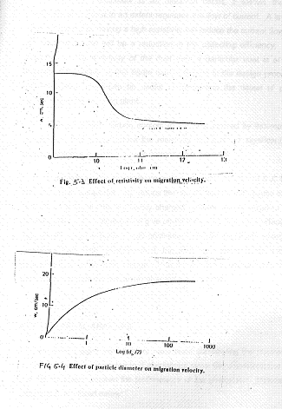
Since a precipitator is an electrical circuit, it follows that the resistivity of the dust to an extent regulates the flow of current. A layer of dust on the plates having a high resistivity will reduce the current flow and consequently there will be a reduction in the collecting efficiency. The prediction of the resistivity of the dust from a particular coal is at the moment not possible so the figure cannot feature in the design process, but its measurement can be useful in diagnosing the cause of poor performance on operating plant.
If there is high carbon content in the dust caused by incomplete combustion, this would reduce the resistivity, but it is not significant on modern boilers where the figure is normally less than 5%.
High resistivity is generally considered to be in excess of 5 X 10¹¹ ohm cm. High values not only reduce the current flow but can cause back ionization. Normally the negatively charged particles are attracted to the earth positive plate. Where they give up their charge, thus the surface of the collected dust is positive and continues to attract negatively charged particles. With high resistivity dust, the dust layer prevents the newly deposited dust giving up its charge. Thus the surface becomes negatively charged and repels the negatively charged dust particles.

5.11 CHEMICAL ANALYSIS
In recent years investigators have been considering the chemical analysis of the ash presented to a precipitator since the characteristics of coal did not always explain the performance of the precipitator. Important constituents are listed below:
a) Iron Oxide (Fe₂ O₃) is important since it acts as a catalyst, which assists in the conversion from SO₂ to SO₃ in the gas and thus has an influence on the surface condition of the dust particles.
b) Calcium Oxide (CaO), particularly if the percentage is high, because it tends to absorb the available surface acid and thus causes a reduction in the collecting efficiency of the precipitator.
c) Sodium Oxide is considered to be important particularly where the sulphur content of the coal is low (less than 1%)
In majority of cases, the ash analysis becomes less important if the sulphur in the coal is high (above2%) and becomes of primary important if sulphur content is below 1%.

5.12 FLY ASH CONDITIONING
High resistivity dust causes a fall in the effective migration velocity of the precipitator and for a particular collecting efficiency a larger precipitator has to be installed. High resistivity dust often results from firing low sulphur coal, results in the dust not being coated with the conductive sulphric acid. Fly ash conditioning systems alter the effective ash resistivity and makes the ash easier to collect. They use various conditioning agents to improve the fly ash’s resistivity or cohesiveness. Most conditioning systems reduce the surface resistivity by condensing the additive on the ash particle. However higher moisture levels in the flue gas lower ash resistivity, even when the gas is above the water dew point temperature. As temperature fall below to approach the water saturation, resistivity may become so low that particle re-entrainment may result in increase emissions.
The most popular conditioning agent is SO₃. Sulphur Tri Oxide is injected into the gas stream, which has the effect of reducing the dust resistivity. The injection point in the duct has to be upstream of the precipitator and at a position it give sufficient time for the SO₃ to mix with the gas before entering the precipitator. The SO₃ is injected in very small quantities, between 12 and 18 parts per million is sufficient to raise the collecting efficiency very considerably. These small quantities do not increase the quantity of sulphur emitted from the Chimney because it is converted to sulphuric acid and coated on the dust particles, which are then collected. It is seen that as the injection rate is increased, so did the acidity of the dust but the SO₃ in the gas remained minute until the dust was fully coated. At this point the acidity of the dust was fully constant whilst the SO₃ in the gas increased.
Surface resistivity of low sulphur coal fly ash, at or below the acid dew point temperatures, frequently can be reduced by the injection of trace amount of SO₃ into the flue gas ahead of ESP. This allows a smaller ESP for a new plant. It allows an existing plant to reduce emission or burn a coal with a lower sulphur content or higher inlet ash content then those for which the ESP was originally designed.
Very small particles may not be collected or will be re-entrained when the ESP is rapped. Ammonia injection often causes the particles to agglomerate and be collected. Ammonia also enhances ash particle adhesion to reduce re-entrainment.
Dual conditioned units utilizing both SO₃ additive and ammonia injection benefit from the reduced resistivity from SO₃ injection and enhanced particles agglomeration and cohesion from the ammonia addition. With the gas conditioning an ESP may be 20% to 30% smaller.

5.13 Generation of Corona
Successful operation of an electrostatic precipitator depends upon a copious supply of ions, which will attach themselves to the particles and, in conjunction with the applied electric field, apply forces to the particles causing them to migrate to collecting electrode. The corona is a phenomenon, which occurs under certain conditions where electricity flows in a gas.
Under ordinary conditions when subjected to moderate voltage gradients, a gas will conduct electricity in minute amounts only. The small current, which flows, is due to the presence of a few lionized gas atoms. These ions are formed from the gas atom by incident background radiation, which knocks an electron off from the atom. As the electors migrate towards the positive electrode and positive ions towards the negative electrode a small current flows. This current is negligible as far as corona is concerned but the presence of the small number of free electrons is of crucial importance. These free electrons plus the presence of a strong electric field create the necessary condition for formation of a corona.
When an electron is present in an electric field it will be accelerated in the direction of the field towards the region of more positive voltage. This acceleration will continue until the electron collides with an atom, another electron or a particle.
Collision with atoms will occur more frequently than those with other electrons or particles. When an electron collides with an atom or a molecule of a gas, it may bounce off with no change in energy and continue to be accelerated by electric field. But if the electron possesses sufficient energy, upon collision, it may knock an electron off from the molecule thus producing a second free electron, which will also be accelerated by the electric field, as well as leaving behind a positive ion. There are now two free electrons for further collision. This process continues very rapidly until each original free electron produces many thousands of free electrons. During this process for each free electron formed a positive ion is also created. This process occurs within the corona region which is a narrow region surrounding the wire electrode.

Positive Corona:
In this case the wire is positively charged relative to the collector electrode, the electrons then move towards the wire. The field strength is maximum at the wire surface. The avalanche process commences at the edge of the corona region and proceeds all the way to the wire surface. There is no opportunity for the electrons to be absorbed and hence no negative ions are produced. However there is large number of positive ions produced in the avalanche process. And these migrate out of the corona region towards the collector electrode. These positive ions then attach to the particles present charging them positively and causing them to migrate towards the collector electrode. The free electrons then rush into the wire are carried away as current in the wire. It appears that the number of free electrons formed by back ground radiations although sufficient to start a corona is not enough the sustain it. Additional free electrons are formed near the edge of the corona by ultraviolet emission from the corona itself.

Negative Corona:
In the negative corona, the electron avalanche begins at the surface of the wire and proceeds readily outward to about the edge of the corona region. The free electrons begin to attach to gas molecules near the edge of the corona and this attachment process continues for some distance beyond the corona. In the attachment process, negative ions are formed. These ions attach to the particles and cause the particles to migrate-towards the collecting electrode, which is at positive voltage relative to the wire. The positive ions formed in the avalanche process more towards the wire and are neutralized there by electrons conducted in the wire.
The mechanism of corona formation suggests that the edge of the corona is defined by the electric field strength these, with a higher strength inside the corona and a lower strength outside. An empirical expression for the field strength at the edge of the corona has be given by peek as:
$E_{o} = ±3x{\text{10}}^{6}f \left(\frac{T_{o}P}{{\text{TP}}_{o}} + 0\text{.}\text{03} \sqrt{\frac{T_{o}P}{{\text{TP}}_{o}r_{o}}}\right)$
……1
Eo = Field strength at the edge of the corona
P_{o} = 1.0 atom, T_{o} = 293K are room temperatures
r_{o} = radius act the edge of the corona
f = Roughness factor
Since the effect of any rough spot is to reduce this field strength, factor f is less than or equal to unity
f = 1 for clean smooth wire
f = 0.6 for practical encountered wires.
Above equation can be used for both positive as well as negative corona positive sign is used for positive corona and the negative sign for negative corona.

5.14 DESIGN FORMULATION FOR Single Stage Precipitator

5.14.1 CYLINDFERICAL TYPE ESP

It is assumed that the particles are charged essentially to saturation very quickly after entering the precipitator thereafter volumetric charge density in the cylinder decreases as particles are collected but the charge on each particle remains the same.
The field strength at the edge of the corona is fixed and is given by

$β=\frac{\text{36231} q_{\text{Ps}}C_{r_{o}}E_{o}}{\text{dQ}}$…….2

$V_{o} = \frac{q_{\text{vp}}}{4∈_{o}} \left(r_{c}^{2} − r_{{}_{o}}^{2} − 2r_{o}^{2}\text{ln}\frac{r_{c}}{r_{o}}\right) + r_{o} E_{o} \text{ln}\frac{r_{c}}{r_{o}}$
……3

Since r_{o} is much less than r_{c}
$V_{o} = \frac{q_{\text{vp}}r_{c}^{2}}{4∈_{o}} + r_{o}E_{o}\text{ln} \frac{r_{c}}{r_{o}}$

…..4

The mean charge is given as:
$E_{m} = \frac{q_{\text{vp}}r_{c}}{3∈_{o}} + \frac{2E_{o}r_{o}(r_{c}−r_{o})}{r_{c^{2}}}$

………..5

At entrance to the precipitator, the mean field strength is:
${\text{Em}}_{o} = \frac{q_{{\text{vp}}_{o}}r_{c}}{3∈_{o}} + \frac{2E_{o}r_{o}(r_{c}−r_{o})}{r_{c^{2}}}$
………….6
Where $q_{{\text{vp}}_{o}}$ = Charge density the particles acquire when they reach saturation at the mean field.
The saturation charge is given by
$q_{\text{ps}} = \frac{3k}{k+2} + π∈_{o}d^{2} \text{Em}$
…..7
Combining (6) and (7) and noting that charge density is related to saturation charge and the particle density C_{nv} is
……8
$\begin{aligned}q_{\text{vp}} = q_{\text{ps}}C_{\text{nv}} \text{and} q_{{\text{vp}}_{o}} = q_{\text{ps}} C_{\text{nvo}} \\ \\ q_{\text{vpo}} = \frac{2E_{o}r_{o}(r_{c}−r_{o})}{r_{c}^{2}\left[(k+2)/3kπ∈_{o}d^{2}C_{\text{nvo}}−r_{c}3∈_{o}\right]}\end{aligned}$…….9

The saturation charge becomes
$q_{\text{Ps}} = \frac{q_{{\text{vp}}_{o}}}{C_{\text{nvo}}} = \frac{3E_{o}r_{o}(r_{c}−r_{o}) ∈_{o}}{r_{c}^{2}\left[(k+2)/3{kπd}^{2}−r_{c} C_{\text{nvo}}3\right]}$

……10
$q_{\text{vp}} = \frac{2E_{o}r_{o}(r_{c}−r_{o}) ∈_{o}C_{\text{nv}}}{r_{c}^{2}\left[(k+2)/3{kπd}^{2}−r_{c}{C_{\text{nvo}}}/3\right]}$Equation 8 then gives the charge density at any point along the precipitator
…..11

Then equation (2) gives the field strength
$E = \frac{E_{o}r_{o}(r_{c}−r_{o}) C_{\text{nv}} (r−{r_{o}^{2}}/r)}{r_{c}^{2}\left[(k+2)/3{kπd}^{2}−r_{c}{C_{\text{nvo}}}/3\right]} + \frac{r_{o}E_{o}}{r}$
……12

And voltage at the edge of the corona in terms of the particle density along the cylinder
$\overline{V_{o}} = \frac{E_{o}r_{o}(r_{c}−r_{o}) C_{\text{nv}}}{2[(K+2)/3{kπd}^{2}−r_{c} {C_{\text{nvo}}}/3]} + r_{o}E_{o}\text{ln}\frac{r_{c}}{r_{o}}$
………….13

$E_{m} = \frac{2E_{o}r_{o}(r_{c}−r_{o}) C_{\text{nv}}}{r_{c}\left[(K+2)/{{Kπd}^{2}}−r_{c}C_{\text{nvo}}\right]} + \frac{2E_{o}r_{o}(r_{c}−r_{o})}{r_{c}^{2}}$and …..14
$E_{m_{o}} = \frac{2E_{o}r_{o}(r_{c}−r_{o}) C_{\text{nv}}}{r_{c}\left[(K+2)/{{Kπd}^{2}}−r_{c}C_{\text{nvo}}\right]} + \frac{2E_{o}r_{o}(r_{c}−r_{o})}{r_{c}}$
………15

And the collecting field strength i.e. field strength at the inner surface of cylinder becomes
$E_{c} = \frac{E_{o}r_{o}(r_{c}−r_{o}) C_{\text{nv}}}{r_{c}\left[(K+2)/{{Kπd}^{2}}−r_{c}{C_{\text{nvo}}}/3\right]} + \frac{r_{o}−E_{o})}{r_{c}}$
………16
$−\frac{\text{dN}}{N} = \frac{2q_{\text{Ps}}E_{c}r_{c}C}{3μ\text{dQ}} d_{x}$Figure 5.5___ shows the arrangement of corona and collecting cylinder. The particle density C_{nv} varies with distance along the cylinder as particles are collected which causes the field strength E, collecting field strength E_{c} and the voltage at the edge of the corona V_{o} to vary in x direction. The rate of diminution of particles crossing a given section at position x is given by:

The rate at which particles cross a given section N is related to the particle density as N = C_{nv}Q

$∴ \frac{{\text{dC}}_{\text{nv}}}{C_{\text{nv}}} = \frac{2q_{\text{Ps}}C_{\text{ro}} E_{o}}{3μ\text{dQ}} \left[\frac{3(r_{c}−r_{o})C_{\text{nv}}}{(K+2)/{{Kπd}^{2}}−r_{c}C_{\text{nvo}}}+1\right]\text{dx}$.

Upon integrating C_{nvo} at x = 0 to C_{nvL} at x = L where C_{nvL=} C_{nvo} (1-η)

$L = \frac{1}{β}\text{ln} \frac{ {αC}_{\text{nvo}}+1/(1−η)}{{αC}_{\text{nvo}}+1}$

.
$\begin{aligned}\text{where} α = \frac{3(r_{c}−r_{o})}{(K+2)/{{kπd}^{2}}−r_{c}C_{\text{nvo}}} m^{3} \\ \\ β = \frac{2q_{\text{Ps}}C_{r_{o}}E_{o}}{3μ\text{dQ}} m^{−1}\end{aligned}$

$β=\frac{\text{36231} q_{\text{Ps}}C_{r_{o}}E_{o}}{\text{dQ}}$

For Standard air

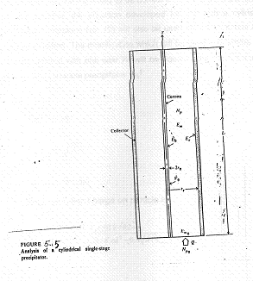

Wire and Plate Type Precipitator

An exact analysis of the electric field formed in the wire-and–plate precipitator involves partial differential equations. But the formulae already developed for the case of the cylindrical precipitator can be manipulated for the wire-and-plate precipitator. The collecting field strength E_{c} can be taken as constant along the length of the precipitator. With low dust concentration the particles can be imparted their saturation charge in a short distance from the entrance and thus the charge may be assumed to be constant. To determine the charge on the particles, the equation developed for use with a cylindrical precipitator (equation No. 10) will also be used here after r_{c} has been suitably modified. The modification which will be used is to let the plan area associated with one wire Wl will be equal to the cross-sectional area of the cylindrical precipitator πr_{c}²

$q_{\text{Ps}} = \frac{6E_{o}ε_{o}r_{o}(0\text{.}8\sqrt{\text{Wl}−}r_{o}}{0\text{.}\text{64}\text{Wl}[(K+2)/{{Kπd}^{2}} − 0\text{.}8\sqrt{\text{Wl} }C_{\text{nvo}}}$i.e.

Thus saturation charge on particle is
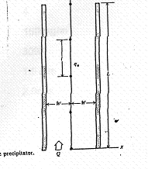$q_{\text{Ps}} = \frac{6E_{o}ε_{o}r_{o}(0\text{.}8\sqrt{\text{Wl}−}r_{o}}{0\text{.}\text{64}\text{Wl}[(K+2)/{{Kπd}^{2}} − 0\text{.}8\sqrt{\text{Wl} }C_{\text{nvo}}]}$

CHAPTER – 6

In this chapter design of an Electrostatic Precipitator has been made for given emission conditions. Two configurations viz. cylindrical type ESP and wire-and-plate type electrostatic precipitator has been designed.

DESIGN PROBLEM
The flue gas stream from a pulverized coal fired furnace units emits at a rate of 1000m³/s. The flue gas stream contains fly ash polluting the environment. It is proposed to deploy Electrostatic Precipitators to control the particulate emission level.
Following are the parameters of emission
Flue Gas Emission Rate, Q = 1000m³/s
Temperature of Flue gas stream T = 425K
Pressure of Flue gas stream P = 1 atm
Particle Concentration load, C_{nv} = 0.01kg/m³
Average size (diameter) of the particle = 4 μm
Dielectric constant of the particle, k = 4
Density of the particle, ρ_{p} = 1500kg/m³
Ambient Temperature T_{o} = 300K
Ambient Pressure P_{o} = 1.0 atm
Velocity of gas stream = 2.0m/s
Electrostatic Precipitator to be designed will employ stage precipitation. The ESP must have an efficiency of 99%. Both cylindrical precipitator and wire-and-plate type ESP Configuration have to be designed for final consideration.
Following dimensions and data are to be chosen.
For Cylindrical ESP
Radius of cylinder of ESP, r_{c} = 0.25m.
Radius at the edge of corona, r_{o} = 0.004 m

Configuration on factor c = 1.0
μ = 1.8x10⁻⁵ kg/ms

Roughness Factor of wire, f = 0.6

For Wire-and-Plate type ESP
Spacing between collecting electrode plates = 0.5m
i.e. Gap between discharge wire electrode and collecting electrode plate, W = 0.25 m
Height of collection plate, H = 10m
Spacing between wires, l = 0.4 m
Take E_{c} = 0.2 E_{o}
Cylinderical Electro Static Precipitatior
The flow rate through each tube is computed as:
$\begin{aligned}Q = \text{AV} \\ \\ Q = \frac{π}{4}(0\text{.}5)^{2}(2\text{.}0) \\ \\ Q = 0\text{.}\text{393}{m^{3}}/S\end{aligned}$

Thus number of tubes, N required is
$N_{T} = \frac{\text{Total} \text{Flow}}{\text{Flow} \text{through} \text{each} \text{tube}}$

N_{T} = 2545
These tubes can be arranged in an array of 50x51 tubes

$\begin{aligned}R_{e} = \frac{{\text{VD}}_{c}P}{μ} \\ \\ R_{e} = \frac{\text{20}\text{.}x0\text{.}5x1\text{.}\text{185}}{1\text{.}8x{\text{10}}^{−5}} \\ \\ R_{e} = \text{65},\text{833}\end{aligned}$The Reynold Number Re

Incoming Particle Density
The incoming particle density is computed from C_{mv} and the mass of each particle.

$\begin{aligned}C_{\text{nvo}} = \frac{6C_{\text{mv}}}{{\text{πρ}}_{p}d^{3}} \\ \\ C_{\overset{˙}{n}\text{vo}} = \frac{6×0\text{.}\text{01}}{π(\text{1500})({\text{10}}^{−\text{15}})} \\ \\ C_{\text{nvo}} = 1\text{.}\text{27}×{\text{10}}^{\text{10}} {\text{particles}}/{m^{3}}\end{aligned}$

The field strength at the edge of the corona
$E_{o} = ±3×{\text{10}}^{6}f\left(\frac{T_{o}P}{{\text{TP}}_{o}}+0\text{.}\text{03}\sqrt{\frac{T_{o}P}{{\text{TP}}_{o}r_{o}}}\right)$ The field strength at the edge of the corona is computed as

$E_{o} = ±3×{\text{10}}^{6}(0\text{.}6) \left(\frac{\text{300}×1}{\text{425}×1}+0\text{.}\text{03}\sqrt{\frac{\text{300}×1}{\text{425}×0\text{.}\text{004}}}\right)$

$E_{o} = ±3×{\text{10}}^{6}×0\text{.}6 \left(0\text{.}\text{7059}+0\text{.}\text{3985}\right)$
$E_{o} = ±1\text{.}\text{988}x{\text{10}}^{6}vm$

$E_{o} = −1\text{.}\text{988}x{\text{10}}^{6}vm$Taking negative sign only

$q_{{\text{vp}}_{o}} = \frac{2E_{o}r_{o}(r_{c}−r_{o})}{r_{c}^{2}\left[(k+2)/3k{\text{πε}}_{o}d^{2}C_{\text{nvo}}−r_{c}3ε_{o}\right]}$Initial Charge density, q_{vpo}

$q_{{\text{vp}}_{o}} = \frac{2×(−1\text{.}\text{988}×{\text{10}}^{6})(0\text{.}\text{004})(0\text{.}\text{25}−0\text{.}\text{004})}{0\text{.}{\text{25}}^{2}\left[(4+2)/3×4×(8\text{.}\text{85}×{\text{10}}^{−\text{12}})({\text{10}}^{−\text{10}})(1\text{.}\text{27}×{\text{10}}^{\text{10}})π\right]− 0\text{.}{\text{25}}/3×8\text{.}\text{85}×{\text{10}}^{−\text{12}}]}$

$\begin{aligned}q_{{\text{vp}}_{o}} = −1\text{.}\text{32}x{\text{10}}^{−5}C/{m^{3}} \\ \\ \end{aligned}$

The saturation charge q_{ps}
$\begin{aligned}q_{\text{ps}} = \frac{q_{{\text{vp}}_{o}}}{C_{{\text{nv}}_{o}}} = \frac{−1\text{.}\text{32}×{\text{10}}^{−5}}{1\text{.}\text{27}×{\text{10}}^{\text{10}}} \\ \\ q_{\text{Ps}} = −1\text{.}\text{0394}x{\text{10}}^{−\text{15}}c \\ \\ \end{aligned}$

$E = \frac{E_{o}r_{o}(r_{c}−r_{o})C_{\text{nv}}(r−{r_{o}^{2}}/r)}{r_{c}^{2} \left[(k+2)/3{Kπd}^{2}−r_{c}{C_{{\text{nv}}_{o}}}/3\right]} + \frac{r_{o}E_{o}}{r}$

The field strength
$∴ E = \frac{−1\text{.}\text{988}×{\text{10}}^{6}×0\text{.}\text{004}(0\text{.}\text{25}−0\text{.}\text{004})C_{\text{nv}}\left[r−\frac{(0\text{.}\text{004})^{2}}{r}\right]}{0\text{.}{\text{25}}^{2}\left[(4+2)3x4π{\text{10}}^{−\text{10}}−0\text{.}\text{25}×1\text{.}\text{27}×\text{10}\text{10}3\right]} + \frac{0\text{.}\text{004}(−1\text{.}\text{988}x{\text{10}}^{6})}{r}$
$E = −5\text{.}\text{87}x{\text{10}}^{−5} C_{\text{nv}}\left[r−\frac{1\text{.}6x{\text{10}}^{−5}}{r}\right]− \frac{\text{7952}}{r} Vm$

$E_{x=0} = −7\text{.}\text{4549}×{\text{10}}^{5}r − \frac{\text{7952}}{r} Vm$At the entrance, the value of mean electric field strength becomes

$E_{x=0} = \frac{2E_{o}r_{o}(r_{c}−r_{o})C_{\text{nv}}}{r_{c}\left[(k+2)/{{kπd}^{2}}−r_{c}C_{{\text{nv}}_{o}}\right]} + \frac{2E_{o}r_{o}(r_{c}−r_{o})}{r_{c}^{2}}$The mean field strength, E_{m}

$E_{m} = \frac{2×−1\text{.}\text{988}x{\text{10}}^{6}x0\text{.}\text{004}(0\text{.}\text{246})C_{\text{nv}}}{0\text{.}\text{25}\left[64π{\text{10}}^{−\text{10}} − 0\text{.}\text{25}×1\text{.}\text{27}x{\text{10}}^{\text{10}}\right]} + \frac{2(−1\text{.}\text{988}x{\text{10}}^{6})(0\text{.}\text{004})(0\text{.}\text{246})}{0\text{.}{\text{25}}^{2}}$
$= −9\text{.}\text{783}x{\text{10}}^{−6}C_{\text{nv}} − \text{62598} Vm$
At the entrance, the value of mean electric field strength becomes E_{mo}
E_{mo} = 186843 V/m

Collecting Field Strength
$E_{c} = \frac{E_{o}r_{o}(r_{c}−r_{o})C_{\text{nv}}}{r_{c}\left[(k+2)/3{kπd}^{2}−r_{c}C_{\text{nvo}}3\right]} + \frac{r_{o}E_{o}}{r_{c}}$ The field strength at inner surface of cylinder gives collecting field strength i.e.

$E_{c} = \frac{−1\text{.}\text{988}x{\text{10}}^{6}(\text{.}\text{004})(0\text{.}\text{246})C_{\text{nv}}}{0\text{.}\text{25}\left[6\text{12}π{\text{10}}^{−\text{10}}−0\text{.}\text{25}×1\text{.}\text{27}×\text{10}\text{10}3\right]} + \frac{0\text{.}\text{004}(−1\text{.}\text{988}x{\text{10}}^{6})}{0\text{.}\text{25}}$Thus E_{c} becomes

$E_{c} = −1\text{.}\text{467}x{\text{10}}^{−5}C_{\text{nv}}−\text{31808}Vm$

$E_{c_{x=0}} = −\text{218117}Vm$ At the entrance collecting field strength becomes

At the exit collecting field strength becomes
$E_{c_{x=L}} = −\text{33671}Vm$
$V_{o} = \frac{E_{o}r_{o}(r_{c}−r_{o})C_{\text{nv}}}{2\left[(k+2)/3{kπd}^{2}−r_{c}C_{\text{nvo}}3\right]}+r_{o}E_{o}\text{ln}\frac{r_{c}}{r_{o}}$The voltage at the edge of the corona V_{o}
$= \frac{−1\text{.}\text{988}x{\text{10}}^{6}x0\text{.}\text{004}(0\text{.}\text{25}−0\text{.}\text{004})C_{\text{nv}}}{2\left[6\text{12}π×{\text{10}}^{−\text{10}}−0\text{.}\text{25}(1\text{.}\text{27}x{\text{10}}^{\text{10}}3\right]} + 0\text{.}\text{004}(−1\text{.}\text{988}x{\text{10}}^{6)}\text{ln}\frac{0\text{.}\text{25}}{0\text{.}\text{004}}$

$= −1\text{.}\text{8343332}×{\text{10}}^{−6}C_{\text{nv}} − \text{32882}\text{.}8$

At the entrance C_{nv} = 1.27x10¹⁰
At the entrance Voltage V₀₀
$\begin{aligned}V_{\text{00}} = −1\text{.}\text{8343332}×{\text{10}}^{−6}×1\text{.}\text{27}x{\text{10}}^{\text{10}}−\text{32882}\text{.}8 \\ \\ V_{\text{00}} = −\text{23296}−\text{32882}\text{.}8 \\ \\ V_{\text{00}} = −\text{53178}\text{.}8 V \\ \\ V_{\text{00}} = −\text{56200} V\end{aligned}$.

Thus the entrance voltage calculated as V_{oo} = -56200V

At the exit C_{nv} = 0.01 C_{nvo}

$\begin{aligned}V_{\text{oL}} = −1\text{.}\text{8343332}×{\text{10}}^{−6}×0\text{.}\text{01}×{\text{10}}^{\text{10}}−\text{32882}\text{.}8 \\ \\ = −\text{233}−\text{32882}\text{.}8 \\ \\ V_{o 1} = \text{33115} ≃ \text{33100}V\end{aligned}$

At the exit
V_{oL} = -33100V

Length of Precipitator
$L = \frac{1}{β} \text{ln} \frac{{αC}_{\text{nvo}}+1(1−η)}{{αC}_{\text{nvo}}+1}$ As discussed in previous chapter length of a precipitator is calculated as

$\begin{aligned}α = \frac{3(r_{c}−r_{o})}{(k+2)/π{\text{kd}}^{2}−r_{c}C_{\text{nvo}}} m^{3} \\ \\ β = \frac{2q_{\text{Ps}}C_{r_{o}}E_{o}}{3μ\text{dQ}} m^{−1}\end{aligned}$

Thus in our case α is
$\begin{aligned}α = \frac{3(0\text{.}\text{25}−0\text{.}\text{004})}{(4+2)/4π{\text{10}}^{−\text{10}} − 0\text{.}\text{25}×1\text{.}\text{27}×{\text{10}}^{\text{10}}} \\ \\ α = 4\text{.}\text{6135}×{\text{10}}^{−\text{10}} m^{3}\end{aligned}$
Where

$β = \frac{2×(−1\text{.}\text{0394}×{\text{10}}^{−\text{15}})(1\text{.}0)(0\text{.}\text{004})(−1\text{.}\text{988}×{\text{10}}^{6})}{3×1\text{.}8×{\text{10}}^{−5}×\text{10}×{\text{10}}^{−6}×0\text{.}\text{393}}$
$= 0\text{.}\text{078} = 7\text{.}8x{\text{10}}^{−2}$And
$L = \frac{1}{0\text{.}\text{078}} \text{lu} \frac{4\text{.}{\text{6135}}^{−\text{10}}x1\text{.}\text{27}x{\text{10}}^{\text{10}}+\frac{1}{1−0\text{.}\text{99}}}{4\text{.}\text{6135}x{\text{10}}^{−\text{10}}x1\text{.}\text{27}x{\text{10}}^{\text{10}}}$

L = 35 m

Radius of Wire
The Radius at the edge of the corona is usually chosen arbitrarily. The choice of this radius makes a tremendous difference in the required length of the precipitator. The limit to r_{o} is radius of wires r_{w}. The relation between r_{o} as r_{w} is given as
$\begin{aligned}r_{o} = r_{w}+0\text{.}\text{03}\sqrt{r_{w}} \\ \\ r_{w} = r_{o} + 0\text{.}\text{0045}−0\text{.}\text{03}\sqrt{\text{.}\text{004}+\text{.}\text{00022}}\end{aligned}$

$∴ \text{Radius} \text{of} \text{wire} = 0\text{.}\text{004}+0\text{.}\text{00045}−0\text{.}\text{03}\sqrt{\text{.}\text{004}+\text{.}\text{00022}}$$\begin{aligned}r_{w} = 0\text{.}\text{0025}\text{mt} \\ \\ = 0\text{.}\text{25}\text{cm} = 2\text{.}5\text{mm}\end{aligned}$

Wire and Plate Precipitator
$E_{o} = −1\text{.}\text{988}×{\text{10}}^{6}Vm$ We have calculated earlier the field strength at the edge of the corona

$C_{\text{nvo}} = 1\text{.}\text{27}×{\text{10}}^{\text{10}} {\text{Particles}}/{m^{3}}$Incoming particle density, C_{nvo}

$\begin{aligned}E_{c} = 0\text{.}2E_{o} \\ \\ E_{c} = −3\text{.}\text{976}x{\text{10}}^{5} Vm\end{aligned}$Let us take collecting field strength E_{c}

$q_{\text{Ps}} = \frac{6E_{o}∈_{o}r_{o}(0\text{.}8\sqrt{\text{Wl}}−r_{o})}{0\text{.}\text{64}\text{Wl}\left[(k+2){Kπd}^{2}−0\text{.}8\sqrt{\text{Wl}} C_{\text{nvo}}\right]}$The saturation charge on particle, q_{ps}
$ℓ_{\text{Ps}} = \frac{6×(−1\text{.}\text{988}x{\text{10}}^{6})(8\text{.}\text{85}x{\text{10}}^{−\text{12}})(0\text{.}\text{004})(0\text{.}8\sqrt{0\text{.}\text{25}x0\text{.}4}−0\text{.}\text{004})}{0\text{.}\text{64}(0\text{.}\text{25})(0\text{.}4)\left[64π{\text{10}}^{−\text{10}} − 0\text{.}8\sqrt{0\text{.}\text{25}x0\text{.}4} × 1\text{.}\text{27}×{\text{10}}^{−\text{10}}\right]}$
$q_{\text{Ps}} = \frac{−1\text{.}\text{0513304}×{\text{10}}^{−7}}{\text{99953548}}$

$q_{\text{Ps}} = −1\text{.}\text{052}x{\text{10}}^{−\text{15}}C$

The flow rate through the half section is given as
Q = WHV
Q = 0.25x10x2 = 5m3/s
Collecting Surface Area Ac = HL
$L = − \frac{3\text{πμ}\text{dQ}\text{ln}(1−η)}{q_{\text{Ps}}{\text{CHE}}_{c}}$The length of the precipitator, L is given by

$L = 9\text{.}\text{546}\text{mt}$
$= \frac{\text{1000}}{\text{10}x2} = \text{50}$The number of sections required for a total flow rate of 1000m³/S is

Total width of precipitator = 50x0.5 = 25mt.
This width does not include the extra space required for housing.

6.4 Final result of Design

Wire-and-plate precipitator

Collection area per zone = 9.546 X10 X 2
= 190.92m²

Total collection area = 190.92x50
= 9546m²

Specific collection area = 95.46m²
Radius of discharge electrode, wire r_{w} = 2.5mm
Velocity of Fire gas = 2.0 m/s

Spacing Between Collecting Plates = 0.5 m
Height of collection plate = 10 m

Length of collection plate = 9.546 m
Spacing between wires = 0.4 m
Voltage applied at the inlet of ESP = -56,200v
Voltage at the outlet of ESP = -33100v

Cylindrical Electrostatic Precipitator

Collection Area/Cylinder = 2 π r_{c} L

= 2 πX 0.25 X 35

a_{c} = 55 m²

Total Collection Area required = 55 X 2545

A_{c} = 1,39,975 m²

Specific Collection Area, SCA

SCA = Collection Area/ 1000m³/s of emission

SCA = 1,39,975 m²

Length of Cylindrical ESP = 35 mt

Potential difference applied at inlet of ESP = - 56200 V

Potential difference applied at the outlet of ESP = 33100 V

Radius of wire = 2.5 mm

CHAPTER - 7
CONCLUSION
This chapter deals with the summary of the work done in this project. After studying the work of research scholars and various authors on particulate emission control and performance analysis of electrostatic precipitator and studying the factors which affects the design and performance of an ESP, an attempt has been made to design a real life Electrostatic Perception system.
SUMARY OF WORK
This dissertation is on designing an Electrostatic precipitation system. This covered:
- Design of an ESP system for given real life flue gas conditions.
- Study of factors affecting the design.
- Work done on Particular emission control technology by research scholars.
Limitations of Study
Designing an electro static precipitation system is a very complex problem, as it requires a lot of computation. Also field conditions may vary considerably from design conditions affecting the performance of an ESP.
At this level, model of an ESP can not be made due to extreme conditions require. Also due to complex computations required for multi stage ESP and high dust concentration, a single state ESP with low dust concentration load has been designed.

SCOPE OF FUTRUE WORK
In the present work, a single stage cylindrical ESP and wire and plate type ESP has been designed. For better performance two stage and three-stage precipitator may be designed. Similarly precipitator may be designed for high dust concentration.
List of Symbols

Q Flue Gas Emission Rate, m3/s
Tp Temperature of Flue gas stream, K
P Pressure of Flue gas stream, atm
Cnv Particle Concentration load, kg/m3
K Dielectric constant of the particle
Pp Density of the particle, kg/m3
To Ambient Temperature, K
Po Ambient Pressure, atm
rc Radius of cylinder of ESP,m.
ro Radius act the edge of the corona, m
c Configuration factor
H Height of collection plate, m
Ac Collecting Surface Area m2
F Wire Roughness Factor

REFERENCES
- Bethea, Robert M. Air Pollution Control Technology (Van Nostrand Reinhold Co., 1998)
- Black and Veater, Power Plant Engineering (Chapman and Hall, 2001)
- Bohm, Jaroslav, Electrostatic Precipitators, (Elsevier Scientific Publishing Company, 1982)
- Crawford, Martin, Air Pollution Control Theory, (Tata McGraw Hill, 1976)
- Howard E Hesketh, Air Pollution Control - Traditional and Hazardous Pollutants (Technic Publishing, 1996)
- Lloyd I. Lavely and Alan W. Fefuson, Power Plant Atmospheric Emission Control, (BECG, 1995)
- Rao C.S., Environmental Pollution Control Engineering (New Age International, 1999).
- Rao M.N. and Rao H.V.N., Air Pollution, (Tata McGraw Hill, 2001).
- William Licht, Air Pollution Control Engg. (Marcel Dekker, Inc. New York, 1999)
- Blanchard, D., LM Dumitran, P. Atten, Effect of Electro-Aero-dynamically induced secondary flow on transport of fine particles in an ESP, Journal of Electrostatics 51, 52(2001) page 212-217
- Istvan Kiss and Istvan Berta, New Concept of ESP Modeling based on Fuzzy logic, Journal of Electrostatics 51,52(2001) page 206-211.
- Jedruski, Maria and Juluisz B Gajewski, Effect of Particle diameter and corona electrode geometry on the particle migration velocity in ESP, Journal of Electrostatics, 51-52(2001) page245-251
- Jerzy Mizeraczyk, Marek Kocik, Miro. Dors, Measurements of Velocity field of the flue gas flow in an ESP model using PIV method, Journal of Elctrostatics 51, 52(2001) page272-277
- Simone Vlad, Michaela Mihailesen and Dan Rfiroiu, Numerical Analysis of Electrified in Plate Type ESP, Journal of Electrostatic 48(2000) page 217-229

