A

PROJECT REPORT

ON

Design and Simulation of 4-Bit Comparator Using
Dynamic CMOS Logic

A Dissertation Submitted to
Delhi College of Engineering, Delhi
In partial fulfillment of the requirements for the award of degree of

MASTER OF ENGINEERING
IN
ELECTRICAL ENGINEERING (CONTROL & INSTRUMENTATION)
Submitted by
Reshu Yadav (16/C&I/2005)
University Roll No: 2611

Under the guidance of

Dr. Pramod Kumar
HOD, Deptt. Of Electrical Engg., DCE, Delhi


Department Of Electrical Engineering
DELHI COLLEGE OF ENGINEERING
University Of Delhi
2007

DELHI COLLEGE OF ENGINEERING
DELHI-110042

Department of Electrical Engineering

CERTIFICATE
This is to certify that Reshu Yadav student of final Semester M.E. Electrical Engineering of Delhi College of Engineering during the session 2006-2007 has successfully completed the project work on:
Design and Simulation of 4-Bit Comparator Using
Dynamic CMOS Logic
and has submitted a satisfactory report on this volume as per requirement of university which may accepted for the partial fulfillment of the degree of Master of Engineering in Electrical Engineering(Controls and Instrumentation).

Dr. Pramod Kumar

Project Guide
Head of Department,
Department of Electrical Engg.
D.C.E, Delhi.

Acknowledgement

Prof. Pramod Kumar initiated the founding ideas behind this thesis and provided insight and valuable information into many of the problems that were encountered. His positive attitude throughout the duration of this thesis always put things into perspective whenever difficulties arose. This thesis would not have been possible without him.

There are many other people that have contributed directly or indirectly to this thesis. Some acting as sounding boards, sources of information, or providing resources that contributed to the development of my electronics. While their individual contributions have been small, their efforts have still been greatly appreciated.

Finally, I would like to thank my family and friends for keeping me sane.

RESHU YADAV (2611)

ABSTRACT

A CMOS Logic 4-Bit Comparator is design using SCL 1.2um technology. The logic diagram is determined to implement the comparator functions less than and equal to and Top-to- Down Full Custom approach is used for the VLSI design flow. The goal of the project is to maximize the performance of the comparator (to achieve high speed).

In the designing of CMOS Logic 4-Bit comparator first the VLSI Design Flow chart has been decided. After considering the design specification the Behavior representation, Logic(gate-level)Representation, Circuit Representation and layout representation is done. This process includes VHDL coding, simulation, synthesis, Spice simulation. After all this CMOS Logic is implementer and worst case analysis is done. In last a final layout is drawn on L-edit and area, delay and power is estimated.

This is quantified by the worst-case propagation delay of the structure and power. Due to some constraints in Tanner database containing standard cell layouts and also SPR/DRC/Layer setups for SCL 1.2µ Technology, the area is not optimized but still smallest rectangular box can be drawn around the design with no DRC errors.

The worst-case propagation delay is determined by using the following input pattern: A = (0000) and B = (0001) with the left-most bit being the MSB. This will set LT to 1 and EQ to 0.

Dynamic logic is used as an implementation approach rather than simply Static CMOS Inverter logic and thus able to achieved desired specifications in a more optimized way.

1. INTRODUCTION

2

Table of Contents

- Introduction
1.1 General overview
1.2 Dynamic CMOS
1.3 Condition ON output
1.4 Properties of Dynamic CMOS

2. Literature review

3. Designing
3.1 Design Specification
3.2 Design Flow
3.2.1 VLSI Design Flow
3.2.2 Basic Algorithm

4. Simulation & Synthesis
4.1 Simulation
4.2 Synthesis

5. Logic Gate Level Implementation
5.1 Logic Diagram
5.2 Technology Schematic
5.3 Critical Path

6. Implementation
6.1 Implementing design in FPGA
6.1.1 Field Programmable Gate Array
6.1.2 Implementing Design in FPGA-Altera Max
6.2 Dynamic CMOS Logic Implementation
6.2.1 Schematic Diagram of EQ Stage
6.2.2 Schematic Diagram of LT Stage
6.2.3 Schematic Diagram of 4 Bit comparator

7. Spice Simulation
7.1 First Hand Analysis
7.2 Simulation Waveforms
7.3 Manual Transistor Sizing & Simulation
7.3.1 Progressive Transistor Sizing
7.4 Modification in EQ & LT Stage
7.5 Worst Case Analysis

8. Final Layout of 4-Bit Comparator
8.1 Final layout using L-Edit
8.2 design Rule Check
8.3 Layout of each Sub-Block
8.4 Layout of EQ Stage
8.5 Layout of LT Stage
8.6 Complete Layout
8.7 Post layout Simulations

9. Estimation of Area, Delay, Power
9.1 Area Estimation
9.2 Delay Estimation
9.3 Power Estimation

10. Discussions and Future Scope of work
10.1Limitations
10.2Future Work
10.3Conclusion

References

Appendix A

1.1 General overview

A 4-bit Comparator device compare two binary codes and present the three possible magnitude results as outputs (A<B, A=B, A>B). The 4 bit input words are weighted (A0 to A3 & Bo to B3) where A3 and B3 are the most significant bits.

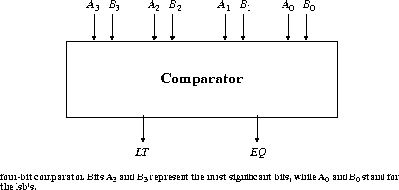

1.2 Dynamic CMOS In static circuits in steady-state (i.e., when not actively switching) the output is connected to either GND or VDD via a low resistance path whereas in Dynamic circuits rely on the temporary storage of signal values on the capacitance of high impedance nodes.

1.3 Dynamic Gate
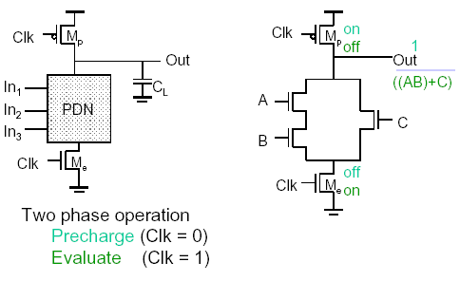

3
1.4 Conditions on Output

- Once the output of a dynamic gate is discharged, it cannot be charged again
until
the next precharge operation.
2) Inputs to the gate can make at most one transition during evaluation phase.
3) Output can be in the high impedance state during evaluation (PDN off), state is stored
on CL.

1.5 Properties of Dynamic Gates

- Logic function is implemented by the PDN only (number of transistors is N + 2 versus 2N for static complementary CMOS).
- Full swing outputs (VOL = GND and VOH = VDD).
- Faster switching speeds
  - reduced load capacitance due to lower input capacitance (Cin).
  - reduced load capacitance due to smaller output loading (Cout).
  - NMOS only, faster devices (optimize for one transition direction).
  - no Isc, so all the current provided by PDN goes into discharging CL.
- Overall power dissipation higher than static CMOS
– higher transition probabilities (most critical).
- extra load on Clk.
- Smaller devices (caps) helps reduce impact.
- PDN starts to work as soon as the input signals exceed VTn, so VM, VIH and
VIL equal to VTn.
- Need a precharge/evaluate clock.

NOTE: Dynamic gates provide speed benefits but add complexity, worsen power.

4

2. LITERATURE REVIEW

5

Literature Review

The electronics industry has achieved a phenomenal growth over the last two decades, mainly due to the rapid advances in integration technologies, large-scale systems design - in short, due to the advent of VLSI. The current leading-edge technologies already provide the end-users a certain amount of processing power, speed and portability. This trend is expected to continue, with very important implications on VLSI and systems design.

Figure 2.1 gives an overview of the prominent trends in information technologies over the next few decades. The current leading-edge technologies already provide the end-users a certain amount of processing power and portability. This trend is expected to continue, with very important implications on VLSI and systems design. One of the most important characteristics of information services is their increasing need for very high processing power and bandwidth (in order to handle real-time video, for example). The other important characteristic is that the information services tend to become more and more personalized (as opposed to collective services such as broadcasting), which means that the devices must be more intelligent to answer individual demands, and at the same time they must be portable to allow more flexibility/mobility .

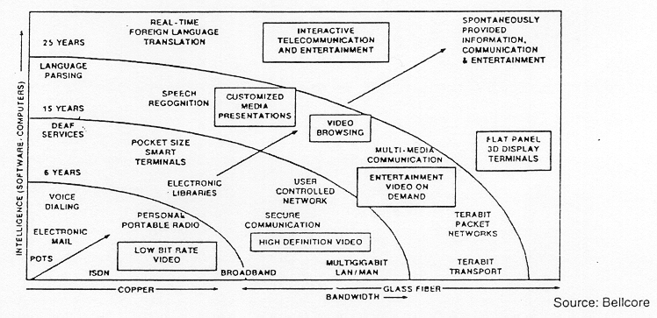Figure-2.1: Prominent trends in information service technologies.

6
As more and more complex functions are required in various data processing and telecommunications devices, the need to integrate these functions in a small system/package is also increasing. The levels of integration as measured by the number of logic gates in a monolithic chip has been steadily rising for almost three decades, mainly due to the rapid progress in processing technology and interconnect technology. Table 1.1 shows the evolution of logic complexity in integrated circuits over the last three decades, and marks the milestones of each era. Here, the numbers for circuit complexity should be interpreted only as representative examples to show the order-of-magnitude. A logic block can contain anywhere from 10 to 100 transistors, depending on the function. State-of-the-art examples of ULSI chips, such as the DEC Alpha or the INTEL Pentium contain 3 to 6 million transistors.
ERA DATE COMPLEXITY
(number of logic blocks per chip)

Single transistor 1959 less than 1
Unit logic (one gate) 1960 1
Multi-function 1962 2 - 4
Complex function 1964 5 - 20
Medium Scale Integration 1967 20 - 200 (MSI)
Large Scale Integration 1972 200 - 2000 (LSI)
Very Large Scale Integration 1978 2000 - 20000 (VLSI)
Ultra Large Scale Integration 1989 20000 - ? (ULSI)
Table-1.1: Evolution of logic complexity in integrated circuits.
The most important message here is that the logic complexity per chip has been (and still is) increasing exponentially. The monolithic integration of a large number of functions on a single chip usually provides:
- Less area/volume and therefore, compactness
- Less power consumption
- Less testing requirements at system level
- Higher reliability, mainly due to improved on-chip interconnects
- Higher speed, due to significantly reduced interconnection length
- Significant cost savings

7
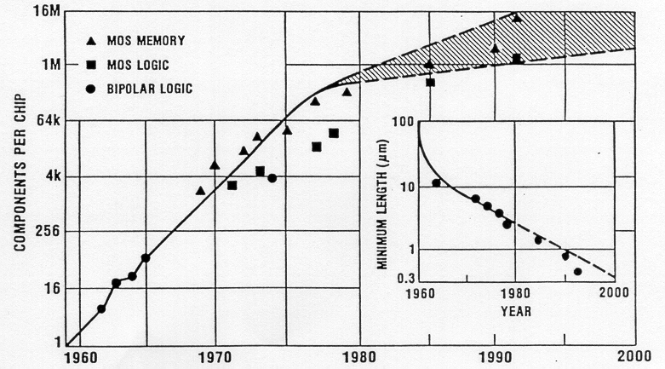
Figure-2.2: Evolution of integration density and minimum feature size

Integrated circuits means many transistors on one chip and Very Large Scale Integration (VLSI) means thousands of transistors on one chip.CMOS technology has played an important role in the global integrated circuit industry. Complementary Metal Oxide Semiconductor are Fast, cheap, low power transistors. The basic principle of CMOS technology is based on nMos and pMOS transistors.CMOS is the device which uses both the polarity device(nMOS,pMOS).

This technology is introduced in early 1960s and later on Inverter, Nor gate, and Nand gate implemented as MOS devices. Today CMOS technology has increased in level of importance to the point where it is now clearly holds centre stage as the dominant VLSI technology. Various CMOS Logics like Static CMOS, Dynamic CMOS, Quasi-Dominos can be used for a chip design according to their application.

Static CMOS is used for a low power, Dynamic CMOS is used for high speed and Quasi-Dominos is used for high speed low power. A Dynamic CMOS logic 4-Bit Comparator is designed using the SCL 1.2uTechnology.A 4-Bit Comparator by implementing CMOS logic transistor sizing and worst case analysis can be performed and then final layout and fabrication is done.

8

3. DESIGNING

9

3.1 DESIGN SPECIFICATIONS

SCL's 1.2µ Technology digital standard cell library has been characterized for the below mentioned ranges. Operation of the device outside this range may result in the device failing to meet some of its specifications.

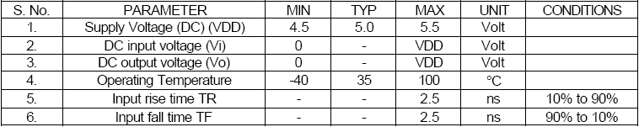

Propagation delay time (tplh/tphl)

This is the time taken for a logic transition to pass from input to output.
tp -> time difference between the 50 % input transition & 50% output transition.
tplh -> propagation delay when o/p is changing from low to high.
tphl -> propagation delay when o/p is changing from high to low.

Total Power Dissipation

Three major components of power in CMOS
– Dynamic: charging & discharging capacitors
– Short-circuit: small, typically ignore
– Static: subthreshold leakage, growing fast

Pdyn = CL * Vdd ² * fsw
where fsw is the frequency with which CL switches
Pstat = Vdd *Ileakage

10

3.2 Design Flow

3.2.1 VLSI Design Flow
The design process, at various levels, is usually evolutionary in nature. It starts with a given set of requirements. Initial design is developed and tested against the requirements. When requirements are not met, the design has to be improved.
The Y-chart (first introduced by D. Gajski) shown in Fig. 3.1 illustrates a design flow for most logic chips, using design activities on three different axes (domains) which resemble the letter Y.

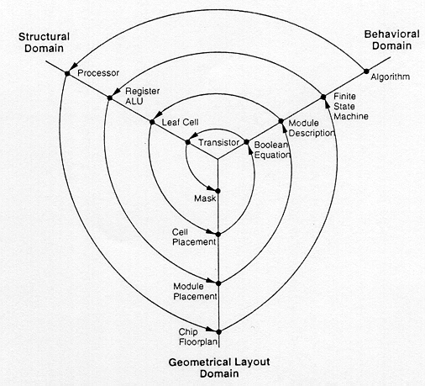

Figure-3.1: Typical VLSI design flow in three domains (Y-chart representation).

11
The Y-chart consists of three major domains, namely:
- Behavioral domain- describes how a particular design will respond to a given sets of inputs. For this we use VHDL
- Structural domain- how components are interconnected to achieve a designated behavior .For this we use VHDL and Simulator Spice.
- Geometrical layout domain- describes the final layout of a chip using L-Edit.

The design flow starts from the algorithm that describes the behavior of the target chip.

A more simplified VLSI Flow is given below in form of flow chart:

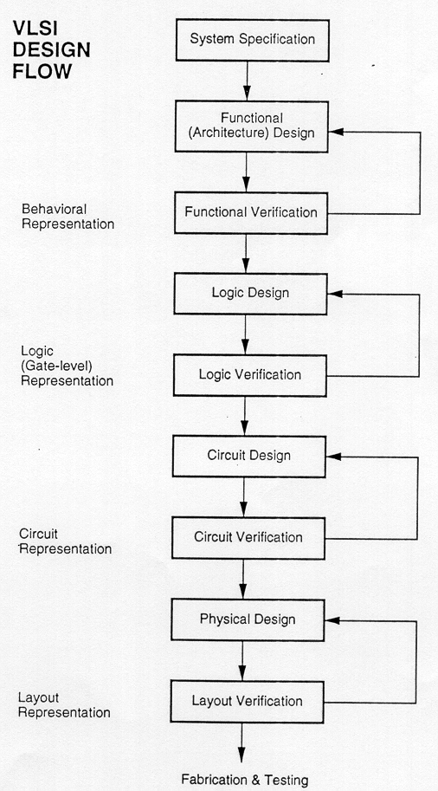

Figure-3.2 A more simplified view of VLSI design flow.

12
3.2.2 Basic Algorithm

Start

- Design Specification

- VHDL Coding

- Simulation and Synthesis of VHDL Coding

- Schematic Diagram

- Spice Simulation and Sizing

- Layout and Design Rule Check

- Extraction of Layout(Extraction of parasitic capacitances)

- Lumped all parasitic capacitances

- Finding total load(sum of all the capacitances)

Finished
(Basic algorithm for design of 4-Bit Comparator)

13

4. SIMULATION AND SYNTHESIS

14

4.1 Simulation

A VHDL Simulator allows us to define and apply
inputs to our
design, and to observe its outputs, without ever having to build the physical circuit.

A design description written in VHDL is run trough a VHDL simulator to verify the behavior of the modeled system. To simulate a design a designer must supply the simulator with a set of stimuli. The simulation program applies the stimuli to the input description at the specified times and generate the response of the circuit. Here the simulation of 4-Bit Comparator is done on Xiling, after giving the inputs output result is shown below:

Input Signal: - A<B (A Less Then B)

As the Input A is less than B we can see that the lt is high.

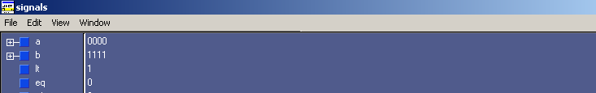
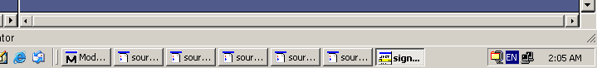

Wave Form: - A<B (A Less Then B)

Waveforms of lt and eq are shown high and low

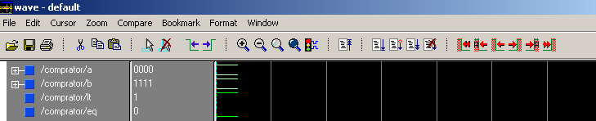

15

Input Signal: - A = B (A Equal B)

Here the input signals are equal therefore the eq is high.

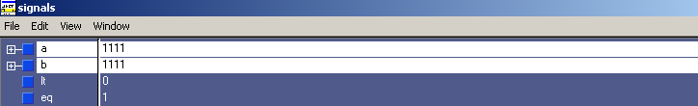

Wave Form: - A = B (A Equal B)

Corresponding waveforms to the input is shown in the table.

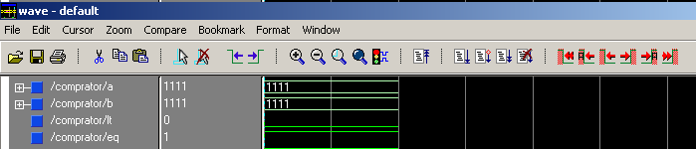

16

4.2 SYNTHESIS

Synthesis can be defined as translation of a design from one level of abstraction to another level of abstraction. It could be a behavior to behavior translation or behavior to structure. The translation process is similar to the compilation of the high level programming language like C into assembly code.

After Verification, we are ready to move into “Back-end” Stage. The nature of and tools for this stage vary somewhat, Depending on the target technology for the design, but there are three basic steps. The first is Synthesis, converting the VHDL description into set of primitives or components that can assembled in target technology. The inputs to the synthesis tools include as HDL description, timing and area goals and technology library. The outputs are optimize net list, estimated performance add the area of synthesized design.

17
Info: setting part to EPF10K10TC144:-

Target Device: - EPF10K10TC144
Set Process: - -4

*******************************************************
Cell: comprator1 View: Behavioral Library: work
Cell: comprator1 View: Behavioral Library: work
*******************************************************
Number of ports : 10
Number of nets : 19
Number of instances : 11
Number of references to this view : 0

Total accumulated area :

Number of CASCADEs : 6

Number of LCs : 8

Number of accumulated instances : 11
****************************************************
Device Utilization for EPF10K10TC144
****************************************************
Resource Used Avail Utilization
-----------------------------------------------------------------------------
IOs 10 102 9.80%
LCs 8 576 1.39%
DFFs 0 720 0.00%
Memory Bits 0 6144 0.00%
CARRYs 0 576 0.00%
CASCADEs 6 576 1.04%
----------------------------------------------------------------------------
Area Report:-
**********************************************************
Cell Library References Total Area
**********************************************************
CASCADE2 flex10 3 x 1 3 CASCADEs
1 3 LCs
F2_CAS flex10 2 x 1 2 CASCADEs
1 2 LCs
F2_LUT flex10 1 x 1 1 LCs
F4_CAS flex10 1 x 1 1 CASCADEs
1 1 LCs
F4_LUT flex10 4 x 1 4 LCs

18
Critical Path Report:-
Critical path #1, (unconstrained path)
NAME GATE ARRIVAL LOAD
----------------------------------------------------------------------------------------------------------
B4/ 0.00 0.00 ns 0.00
NOT_eq1_nx0/O F2_CAS 6.24 6.24 ns 0.00
nx168/O F4_LUT 4.92 11.16 ns 0.00
EQ/O CASCADE2 1.32 12.48 ns 0.00
EQ/ 0.00 12.48 ns 0.00
data arrival time 12.48
data required time not specified
---------------------------------------------------------------------------------------------------------
data required time not specified
data arrival time 12.48

Critical path #2, (unconstrained path)
NAME GATE ARRIVAL LOAD
----------------------------------------------------------------------------------------------------------
A4/ 0.00 0.00 ns 0.00
NOT_eq1_nx0/O F2_CAS 6.24 6.24 ns 0.00
nx168/O F4_LUT 4.92 11.16 ns 0.00
EQ/O CASCADE2 1.32 12.48 ns 0.00
EQ/ 0.00 12.48 ns 0.00
data arrival time 12.48
data required time not specified
---------------------------------------------------------------------------------------------------------
data required time not specified
data arrival time 12.48
----------
Critical path #3, (unconstrained path)
NAME GATE ARRIVAL LOAD
---------------------------------------------------------------------------------------------------------
B2/ 0.00 0.00 up 0.00
nx165/O F4_CAS 6.24 6.24 up 0.00
nx164/O CASCADE2 1.32 7.56 up 0.00
LT/O F4_LUT 4.92 12.48 up 0.00
LT/ 0.00 12.48 up 0.00
data arrival time 12.48

data required time not specified
--------------------------------------------------------------------------------------------------------
data required time not specified
data arrival time 12.48
----------

19

Critical path #4, (unconstrained path)
NAME GATE ARRIVAL LOAD
---------------------------------------------------------------------------------------------------------
B3/ 0.00 0.00 up 0.00
nx165/O F4_CAS 6.24 6.24 up 0.00
nx164/O CASCADE2 1.32 7.56 up 0.00
LT/O F4_LUT 4.92 12.48 up 0.00
LT/ 0.00 12.48 up 0.00
data arrival time 12.48
data required time not specified
--------------------------------------------------------------------------------------------------------
data required time not specified
data arrival time 12.48
----------

Critical path #5, (unconstrained path)
NAME GATE ARRIVAL LOAD
---------------------------------------------------------------------------------------------------------
A2/ 0.00 0.00 up 0.00
nx165/O F4_CAS 6.24 6.24 up 0.00
nx164/O CASCADE2 1.32 7.56 up 0.00
LT/O F4_LUT 4.92 12.48 up 0.00
LT/ 0.00 12.48 up 0.00
data arrival time 12.48
data required time not specified
--------------------------------------------------------------------------------------------------------
data required time not specified
data arrival time 12.48
----------
Critical path #6, (unconstrained path)
NAME GATE ARRIVAL LOAD
---------------------------------------------------------------------------------------------------------
A3/ 0.00 0.00 up 0.00
nx165/O F4_CAS 6.24 6.24 up 0.00
nx164/O CASCADE2 1.32 7.56 up 0.00
LT/O F4_LUT 4.92 12.48 up 0.00
LT/ 0.00 12.48 up 0.00
data arrival time 12.48
data required time not specified
--------------------------------------------------------------------------------------------------------
data required time not specified
data arrival time 12.48
----------

20

Critical path #7, (unconstrained path)
NAME GATE ARRIVAL LOAD
----------------------------------------------------------------------------------------------------------
B1/ 0.00 0.00 up 0.00
nx167/O F4_LUT 4.92 4.92 up 0.00
nx164/O CASCADE2 1.32 6.24 up 0.00
LT/O F4_LUT 4.92 11.16 up 0.00
LT/ 0.00 11.16 up 0.00
data arrival time 11.16
data required time not specified
------------------------------------------------------------------------------
data required time not specified
data arrival time 11.16
----------

Unconstrained path Critical path #8, (unconstrained path)
NAME GATE ARRIVAL LOAD
------------------------------------------------------------------------------
B1/ 0.00 0.00 up 0.00
nx167/O F4_LUT 4.92 4.92 up 0.00
nx164/O CASCADE2 1.32 6.24 up 0.00
LT/O F4_LUT 4.92 11.16 up 0.00
LT/ 0.00 11.16 up 0.00
data arrival time 11.16
data required time not specified
------------------------------------------------------------------------------
data required time not specified
data arrival time 11.16
----------
unconstrained path

21

5. LOGIC GATE LEVEL REPESENTATION

22

5.1 Logic Diagram

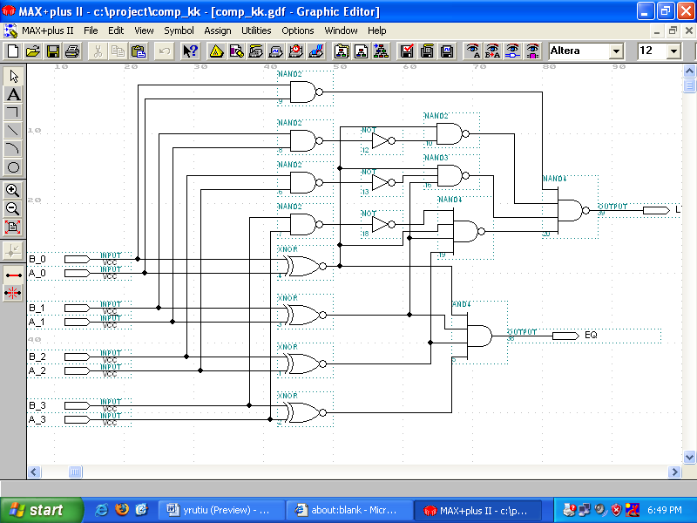

23

5.2 Technology Schematic

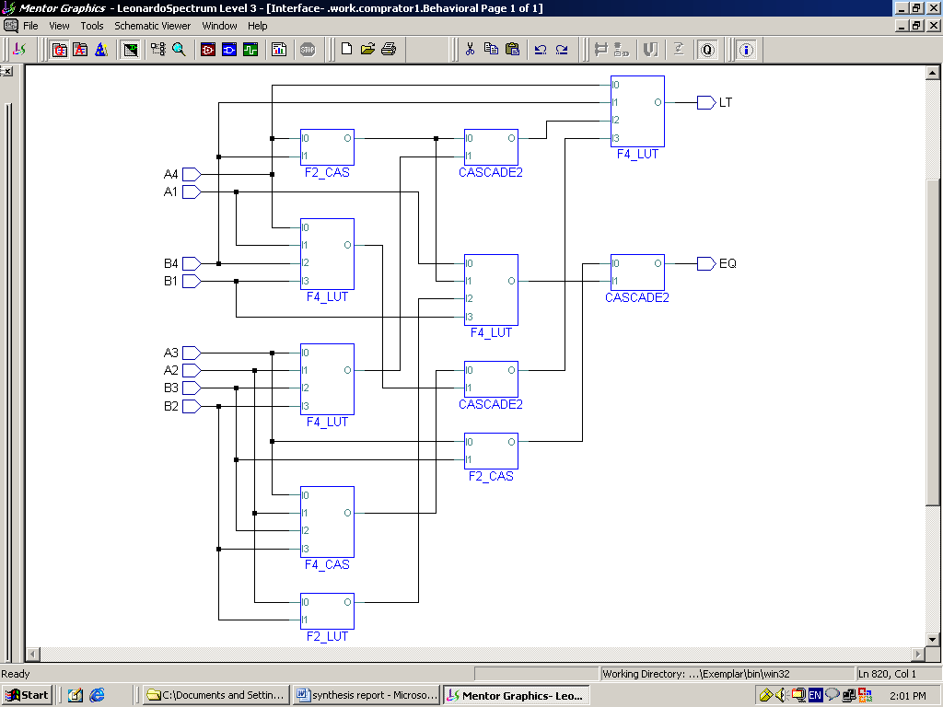

24

5.3 Critical Path (Tmin)

The minimum Delay (taken by maximum path) from input to Output. The Maximum frequency of operation is decided by the Tmin

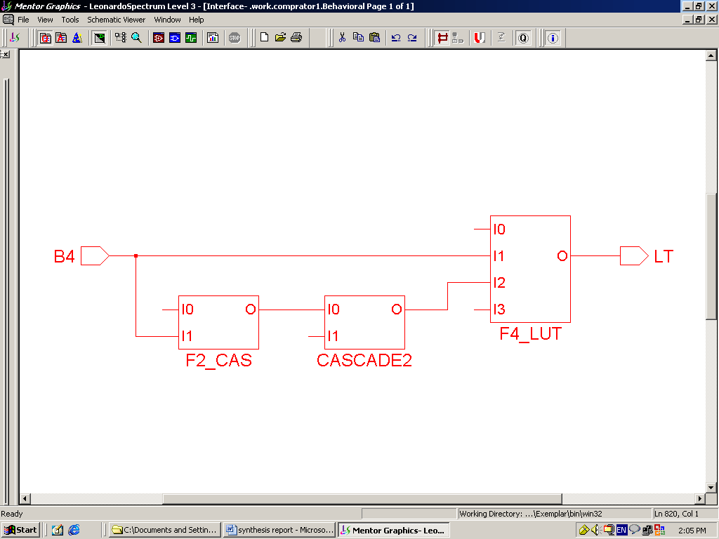

25

6. IMPLEMENTATION

26

6.1 Implementing Design in FPGA

6.1.1 Field Programmable Gate Array (FPGA):Several VLSI design styles can be considered for chip implementation of specified algorithms or logic functions. Each design style has its own merits and shortcomings, and thus a proper choice has to be made by designers in order to provide the functionality at low cost.
Fully fabricated FPGA chips containing thousands of logic gates or even more, with programmable interconnects, are available to users for their custom hardware programming to realize desired functionality. This design style provides a means for fast prototyping and also for cost-effective chip design, especially for low-volume applications. A typical field programmable gate array (FPGA) chip consists of I/O buffers, an array of configurable logic blocks (CLBs), and programmable interconnect structures. The programming of the interconnects is implemented by programming of RAM cells whose output terminals are connected to the gates of MOS pass transistors. A general architecture of FPGA from XILINX is shown in Fig. 6.1. A more detailed view showing the locations of switch matrices used for interconnect routing is given in Fig. 6.2
A simple CLB (model XC2000 from XILINX) is shown in Fig. 6.3. It consists of four signal input terminals (A, B, C, D), a clock signal terminal, user-programmable multiplexers, an SR-latch, and a look-up table (LUT). The LUT is a digital memory that stores the truth table of the Boolean function. Thus, it can generate any function of up to four variables or any two functions of three variables. The control terminals of multiplexers are not shown explicitly in Fig. 6.3.
The CLB is configured such that many different logic functions can be realized by programming its array. More sophisticated CLBs have also been introduced to map complex functions. The typical design flow of an FPGA chip starts with the behavioral description of its functionality, using a hardware description language such as VHDL. The synthesized architecture is then technology-mapped (or partitioned) into circuits or logic cells. At this stage, the chip design is completely described in terms of available logic cells. Next, the placement and routing step assigns individual logic cells to FPGA sites (CLBs) and determines the routing patterns among the cells in accordance with the netlist. After routing is completed, the on-chip
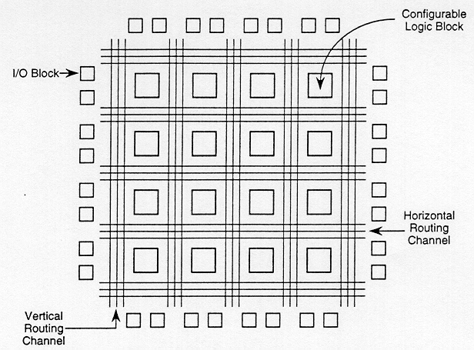
Fig 6.1 General Architecture Of Xilinx FPGAs

27
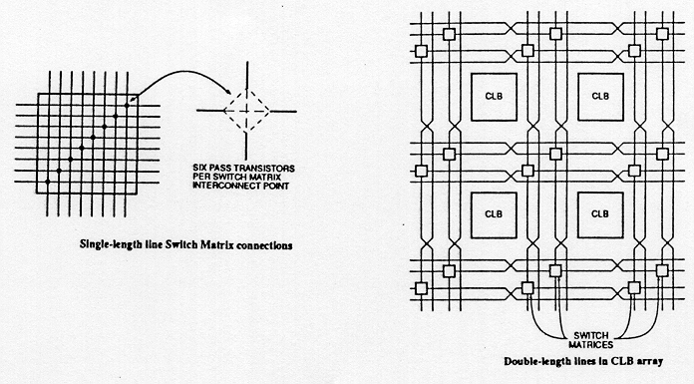
Figure-6.2: Detailed view of switch matrices and interconnection routing between CLBs.
performance of the design can be simulated and verified before downloading the design for programming of the FPGA chip. The programming of the chip remains valid as long as the chip is powered-on, or until new programming is done. In most cases, full utilization of the FPGA chip area is not possible - many cell sites may remain unused.
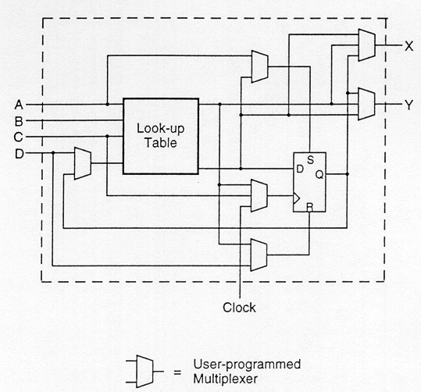
Figure-6.3: XC2000 CLB of the Xilinx FPGA
The largest advantage of FPGA-based design is the very short turn-around time, i.e., the time required from the start of the design process until a functional chip is available. Since no physical manufacturing step is necessary for customizing the FPGA chip, a functional sample can be obtained almost as soon as the design is mapped into a specific technology. The typical price of FPGA chips are usually higher than other realization alternatives (such as gate array or standard cells) of the same design, but for small-volume production of ASIC chips and for fast prototyping, FPGA offers a very valuable option.
28
6.1.2 Implementing Design in FPGA- ALTERA MAX PLUS

Steps:

Graphic Entry

1. Create a new Project.
2. Create a new file name.
3. Set up and display guidelines.
4. Enter primitives and macro functions.
5. Remove, delete, recover and duplicate on circuit symbol.
6. Connect Pins.
7. Identify the names I/O pin and net list.
8. Save and check basic errors.
9. Create a default symbol.
10. Compile for Functional Simulation.
11. Close the Design file.

Floor Plan and Design Compilation

1. Setting up the processing of the compiler.
2. Selecting FPGA Chip.
3. Floor Plan.
4. Design Compilation after floor plan.

29

6.2 Dynamic CMOS Logic Level Implementation

The S-Edit Tool is used and standard SCL Schematic Library is provided by SCL for 1.2µ Technology. The CMOS level Circuit Diagram helps us in doing the necessary analysis and simulation, before actually moving to layout part. Thus it provides us a platform to check the the basic functionality at CMOS level and approximate considerations to meet design specifications and constraints.

The S-Edit tool is provided by Tanner. Using this tool Schematic of EQ stage ,Schematic of LT stage and Schematic of 4-Bit Comparator is designed. These designs are prepared using the Dynamic CMOS Logic.

30

6.2.1 Schematic Diagram of EQ stage

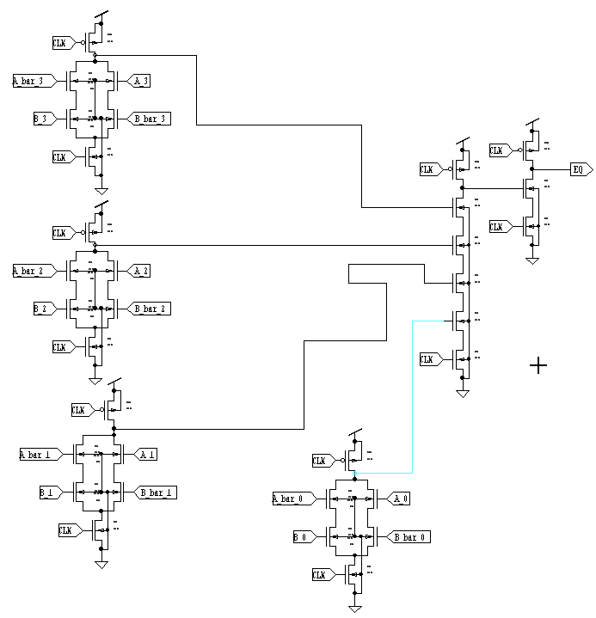

31

6.2.2 Schematic Diagram of LT stage

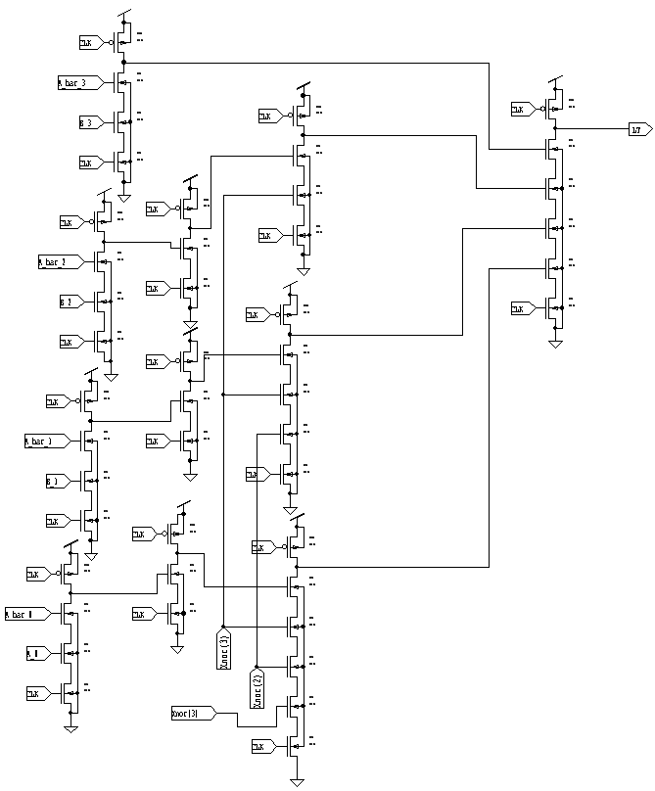

32

6.2.3 Schematic of 4-Bit comparator

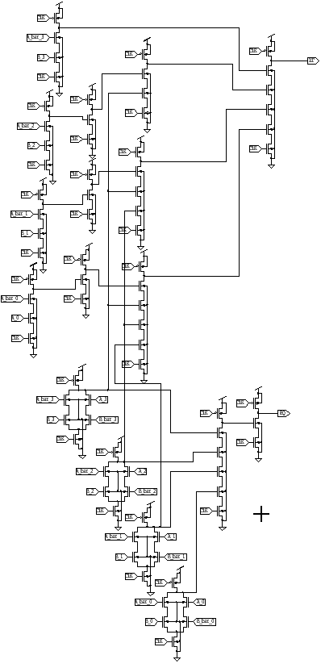

33

7. SPICE SIMULATION

34
7.1 First Hand Analysis: A Pre-layout Simulation is done by simply
extracting the file
from S-Edit. This extracted Spice file is not able to meet our requirement even on fundamental basis like simple functionality check.

Extracted Spice File:

*************************************************************
.include "C:\indiachipv3\tanner\tanner_icp\models\tntp13_5v.md"
M1 N6 A_bar_0 N40 Gnd nmos L=1.2u W=7u AD=27.3p PD=21.8u AS=26.25p PS=21.5u M=1
M2 N19 B_bar_0 N41 Gnd nmos L=1.2u W=7u AD=27.3p PD=21.8u AS=26.25p PS=21.5u M=1
M3 N40 B_0 N19 Gnd nmos L=1.2u W=7u AD=27.3p PD=21.8u AS=26.25p PS=21.5u
M=1
M4 N41 A_0 N6 Gnd nmos L=1.2u W=7u AD=27.3p PD=21.8u AS=26.25p PS=21.5u
M=1
M5 N19 CLK Gnd Gnd nmos L=1.2u W=7u AD=27.3p PD=21.8u AS=26.25p PS=21.5u
M=1
M6 N22 CLK Gnd Gnd nmos L=1.2u W=7u AD=27.3p PD=21.8u AS=26.25p PS=21.5u M=1
M7 N42 A_3 N9 Gnd nmos L=1.2u W=7u AD=27.3p PD=21.8u AS=26.25p PS=21.5u M=1
M8 N43 B_3 N22 Gnd nmos L=1.2u W=7u AD=27.3p PD=21.8u AS=26.25p PS=21.5u M=1
M9 N22 B_bar_3 N42 Gnd nmos L=1.2u W=7u AD=27.3p PD=21.8u AS=26.25p PS=21.5u M=1
M10 N9 A_bar_3 N43 Gnd nmos L=1.2u W=7u AD=27.3p PD=21.8u AS=26.25p PS=21.5u M=1
M11 N16 CLK Gnd Gnd nmos L=1.2u W=7u AD=27.3p PD=21.8u AS=26.25p PS=21.5u
M=1
M12 N44 A_2 N8 Gnd nmos L=1.2u W=7u AD=27.3p PD=21.8u AS=26.25p PS=21.5u M=1
M13 N45 B_2 N16 Gnd nmos L=1.2u W=7u AD=27.3p PD=21.8u AS=26.25p PS=21.5u M=1
M14 N16 B_bar_2 N44 Gnd nmos L=1.2u W=7u AD=27.3p PD=21.8u AS=26.25p PS=21.5u M=1
M15 N8 A_bar_2 N45 Gnd nmos L=1.2u W=7u AD=27.3p PD=21.8u AS=26.25p PS=21.5u M=1
M16 N13 CLK Gnd Gnd nmos L=1.2u W=7u AD=27.3p PD=21.8u AS=26.25p PS=21.5u
M=1
M17 N46 A_1 N7 Gnd nmos L=1.2u W=7u AD=27.3p PD=21.8u AS=26.25p PS=21.5u
M=1
M18 N47 B_1 N13 Gnd nmos L=1.2u W=7u AD=27.3p PD=21.8u AS=26.25p PS=21.5u
M=1

35

M19 N13 B_bar_1 N46 Gnd nmos L=1.2u W=7u AD=27.3p PD=21.8u AS=26.25p
PS=21.5u M=1
M20 N7 A_bar_1 N47 Gnd nmos L=1.2u W=7u AD=27.3p PD=21.8u AS=26.25p PS=21.5u M=1
M21 N49 N8 N48 Gnd nmos L=1.2u W=7u AD=27.3p PD=21.8u AS=26.25p PS=21.5u
M=1
M22 N12 N9 N49 Gnd nmos L=1.2u W=7u AD=27.3p PD=21.8u AS=26.25p PS=21.5u
M=1
M23 N48 N7 N50 Gnd nmos L=1.2u W=7u AD=27.3p PD=21.8u AS=26.25p PS=21.5u
M=1
M24 N50 N6 N51 Gnd nmos L=1.2u W=7u AD=27.3p PD=21.8u AS=26.25p PS=21.5u
M=1
M25 N51 CLK Gnd Gnd nmos L=1.2u W=7u AD=27.3p PD=21.8u AS=26.25p PS=21.5u
M=1
M26 EQ N12 N39 Gnd nmos L=1.2u W=42u AD=27.3p PD=21.8u AS=26.25p PS=21.5u
M=1
M27 N39 CLK Gnd Gnd nmos L=1.2u W=7u AD=27.3p PD=21.8u AS=26.25p PS=21.5u
M=1
M28 N38 CLK Gnd Gnd nmos L=1.2u W=7u AD=27.3p PD=21.8u AS=26.25p PS=21.5u
M=1
M29 N36 N53 N38 Gnd nmos L=1.2u W=7u AD=27.3p PD=21.8u AS=26.25p PS=21.5u
M=1

M30 N78 N37 N36 Gnd nmos L=1.2u W=7u AD=27.3p PD=21.8u AS=26.25p PS=21.5u
M=1
M31 LT N34 N90 Gnd nmos L=1.2u W=7u AD=27.3p PD=21.8u AS=26.25p PS=21.5u
M=1
M32 N90 N80 N78 Gnd nmos L=1.2u W=7u AD=27.3p PD=21.8u AS=26.25p PS=21.5u
M=1
M33 N87 CLK Gnd Gnd nmos L=1.2u W=7u AD=27.3p PD=21.8u AS=26.25p PS=21.5u
M=1
M34 N88 B_2 N87 Gnd nmos L=1.2u W=7u AD=27.3p PD=21.8u AS=26.25p PS=21.5u
M=1
M35 N81 CLK Gnd Gnd nmos L=1.2u W=7u AD=27.3p PD=21.8u AS=26.25p PS=21.5u
M=1
M36 N83 B_3 N81 Gnd nmos L=1.2u W=7u AD=27.3p PD=21.8u AS=26.25p PS=21.5u
M=1
M37 N85 CLK Gnd Gnd nmos L=1.2u W=7u AD=27.3p PD=21.8u AS=26.25p PS=21.5u
M=1
M38 N96 A_0 N85 Gnd nmos L=1.2u W=7u AD=27.3p PD=21.8u AS=26.25p PS=21.5u
M=1
M39 N86 CLK Gnd Gnd nmos L=1.2u W=7u AD=27.3p PD=21.8u AS=26.25p PS=21.5u
M=1
M40 N92 B_1 N86 Gnd nmos L=1.2u W=7u AD=27.3p PD=21.8u AS=26.25p PS=21.5u
M=1
M41 N95 A_bar_0 N96 Gnd nmos L=1.2u W=7u AD=27.3p PD=21.8u AS=26.25p
PS=21.5u M=1

36

M42 N33 A_bar_2 N88 Gnd nmos L=1.2u W=7u AD=27.3p PD=21.8u AS=26.25p
PS=21.5u M=1
M43 N52 A_bar_1 N92 Gnd nmos L=1.2u W=7u AD=27.3p PD=21.8u AS=26.25p
PS=21.5u M=1
M44 N34 A_bar_3 N83 Gnd nmos L=1.2u W=7u AD=27.3p PD=21.8u AS=26.25p
PS=21.5u M=1
M45 N55 CLK Gnd Gnd nmos L=1.2u W=7u AD=27.3p PD=21.8u AS=26.25p PS=21.5u
M=1
M46 N57 N9 N55 Gnd nmos L=1.2u W=7u AD=27.3p PD=21.8u AS=26.25p PS=21.5u
M=1
M47 N80 N67 N57 Gnd nmos L=1.2u W=7u AD=27.3p PD=21.8u AS=26.25p PS=21.5u
M=1
M48 N69 CLK Gnd Gnd nmos L=1.2u W=7u AD=27.3p PD=21.8u AS=26.25p PS=21.5u
M=1
M49 N77 N8 N69 Gnd nmos L=1.2u W=7u AD=27.3p PD=21.8u AS=26.25p PS=21.5u
M=1
M50 N89 N9 N77 Gnd nmos L=1.2u W=7u AD=27.3p PD=21.8u AS=26.25p PS=21.5u
M=1
M51 N73 N9 N66 Gnd nmos L=1.2u W=7u AD=27.3p PD=21.8u AS=26.25p PS=21.5u
M=1
M52 N53 N3 N73 Gnd nmos L=1.2u W=7u AD=27.3p PD=21.8u AS=26.25p PS=21.5u
M=1
M53 N66 N8 N60 Gnd nmos L=1.2u W=7u AD=27.3p PD=21.8u AS=26.25p PS=21.5u
M=1
M54 N67 N33 N91 Gnd nmos L=1.2u W=7u AD=27.3p PD=21.8u AS=26.25p PS=21.5u
M=1
M55 N91 CLK Gnd Gnd nmos L=1.2u W=7u AD=27.3p PD=21.8u AS=26.25p PS=21.5u
M=1
M56 N2 N52 N93 Gnd nmos L=1.2u W=7u AD=27.3p PD=21.8u AS=26.25p PS=21.5u
M=1
M57 N93 CLK Gnd Gnd nmos L=1.2u W=7u AD=27.3p PD=21.8u AS=26.25p PS=21.5u
M=1
M58 N3 N95 N94 Gnd nmos L=1.2u W=7u AD=27.3p PD=21.8u AS=26.25p PS=21.5u
M=1
M59 N94 CLK Gnd Gnd nmos L=1.2u W=7u AD=27.3p PD=21.8u AS=26.25p PS=21.5u
M=1
M60 N37 N2 N89 Gnd nmos L=1.2u W=7u AD=27.3p PD=21.8u AS=26.25p PS=21.5u
M=1
M61 N60 N7 N1 Gnd nmos L=1.2u W=7u AD=27.3p PD=21.8u AS=26.25p PS=21.5u
M=1
M62 N1 CLK Gnd Gnd nmos L=1.2u W=7u AD=27.3p PD=21.8u AS=26.25p PS=21.5u
M=1
M63 N6 CLK Vdd Vdd pmos L=1.5u W=14u AD=51.8p PD=35.4u AS=54.6p PS=35.8u
M=1
M64 N9 CLK Vdd Vdd pmos L=1.5u W=14u AD=51.8p PD=35.4u AS=54.6p PS=35.8u
M=1
M65 N8 CLK Vdd Vdd pmos L=1.5u W=14u AD=51.8p PD=35.4u AS=54.6p PS=35.8u
M=1
M66 N7 CLK Vdd Vdd pmos L=1.5u W=14u AD=51.8p PD=35.4u AS=54.6p PS=35.8u
M=1

37

M67 N12 CLK Vdd Vdd pmos L=1.5u W=14u AD=51.8p PD=35.4u AS=54.6p PS=35.8u
M=1
M68 EQ CLK Vdd Vdd pmos L=1.5u W=84u AD=51.8p PD=35.4u AS=54.6p PS=35.8u
M=1
M69 LT CLK Vdd Vdd pmos L=1.5u W=14u AD=51.8p PD=35.4u AS=54.6p PS=35.8u
M=1
M70 N95 CLK Vdd Vdd pmos L=1.5u W=14u AD=51.8p PD=35.4u AS=54.6p PS=35.8u
M=1
M71 N33 CLK Vdd Vdd pmos L=1.5u W=14u AD=51.8p PD=35.4u AS=54.6p PS=35.8u
M=1
M72 N52 CLK Vdd Vdd pmos L=1.5u W=14u AD=51.8p PD=35.4u AS=54.6p PS=35.8u
M=1
M73 N34 CLK Vdd Vdd pmos L=1.5u W=14u AD=51.8p PD=35.4u AS=54.6p PS=35.8u
M=1
M74 N80 CLK Vdd Vdd pmos L=1.5u W=14u AD=51.8p PD=35.4u AS=54.6p PS=35.8u
M=1
M75 N37 CLK Vdd Vdd pmos L=1.5u W=14u AD=51.8p PD=35.4u AS=54.6p PS=35.8u
M=1
M76 N53 CLK Vdd Vdd pmos L=1.5u W=14u AD=51.8p PD=35.4u AS=54.6p PS=35.8u
M=1
M77 N67 CLK Vdd Vdd pmos L=1.5u W=14u AD=51.8p PD=35.4u AS=54.6p PS=35.8u
M=1
M78 N2 CLK Vdd Vdd pmos L=1.5u W=14u AD=51.8p PD=35.4u AS=54.6p PS=35.8u
M=1
M79 N3 CLK Vdd Vdd pmos L=1.5u W=14u AD=51.8p PD=35.4u AS=54.6p PS=35.8u M=1
Vclk CLK Gnd PULSE(0 5 0 2.5ns 2.5ns 12.5ns 30ns)
Va3 A_bar_3 Gnd 5v
Vb3 B_bar_3 Gnd 5v
Vc3 A_3 Gnd 0v
Vd3 B_3 Gnd 0v
Va2 A_bar_2 Gnd 5v
Vb2 B_bar_2 Gnd 5v
Vc2 A_2 Gnd 0v
Vd2 B_2 Gnd 0v
Va1 A_bar_1 Gnd 5v
Vb1 B_bar_1 Gnd 5v
Vc1 A_1 Gnd 0v
Vd1 B_1 Gnd 0v

Va0 A_bar_0 Gnd 5v
Vb0 B_bar_0 Gnd 0v
Vc0 A_0 Gnd 0v
Vd0 B_0 Gnd 5v

vdd vdd Gnd 5v
.TRAN 1ns 80ns
.Print TRAN V(CLK) V(EQ) V(LT)

38
Simulation waveforms: The desired Output is not achieved as shown below
in waveforms

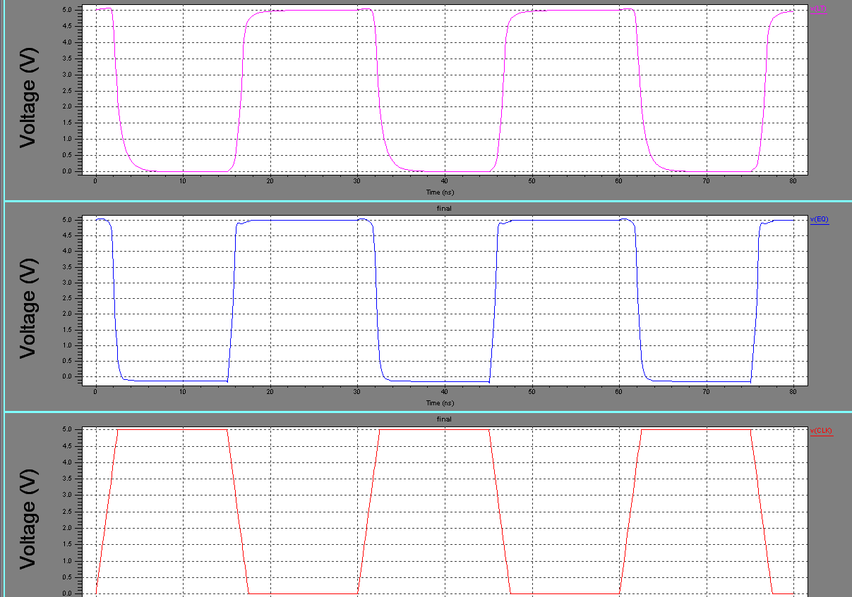

39
7.3 Manual Transistor Sizing and Simulation

Transistor Sizing: Increasing the transistor sizes, increases the available
charging and
discharging current. As we know that widening results in large parasitic capacitor in transistor, which do not only affect the propagation delay of the gate but also presents a large load to the preceding gate.

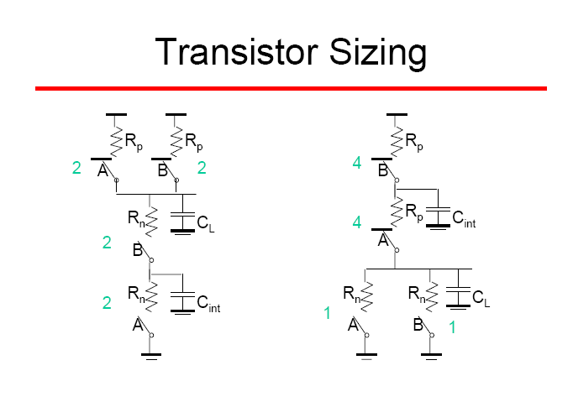

40

7.3.1 Progressive Transistor Sizing: Here, we only present an intuitive approach for optimizing
the delay by sizing the devices progressively.

the delay by sizing the devices progressively

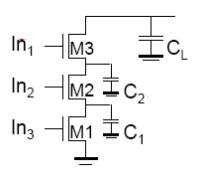

While transistor M3 has to conduct discharge current of the load capacitance CL, M1 has to carry discharge current from the total capacitance.

C total = CL + C3 +C2 + C1
Consequently, a progressive scaling of the transistor is beneficial:
M1>M2>M3
M3 is minimum size,

WM2 = WM3 (CL + C2)/ CL
WM1 = WM2 (CL + C2 + C1)/ CL

41
SPICE CODE: (With Sizing)

***********************************************************************
.include "C:\indiachipv3\tanner\tanner_icp\models\tntp13_5v.md"
M1 N6 A_bar_0 N40 Gnd nmos L=1.2u W=7u AD=27.3p PD=21.8u AS=26.25p PS=21.5u
M=1
M2 N19 B_bar_0 N41 Gnd nmos L=1.2u W=8.05u AD=27.3p PD=21.8u AS=26.25p
PS=21.5u M=1
M3 N40 B_0 N19 Gnd nmos L=1.2u W=8.05u AD=27.3p PD=21.8u AS=26.25p PS=21.5u
M=1
M4 N41 A_0 N6 Gnd nmos L=1.2u W=7u AD=27.3p PD=21.8u AS=26.25p PS=21.5u
M=1
M5 N19 CLK Gnd Gnd nmos L=1.2u W=9.01u AD=27.3p PD=21.8u AS=26.25p PS=21.5u
M=1
M6 N22 CLK Gnd Gnd nmos L=1.2u W=9.01u AD=27.3p PD=21.8u AS=26.25p PS=21.5u
M=1
M7 N42 A_3 N9 Gnd nmos L=1.2u W=7u AD=27.3p PD=21.8u AS=26.25p PS=21.5u
M=1
M8 N43 B_3 N22 Gnd nmos L=1.2u W=7u AD=27.3p PD=21.8u AS=26.25p PS=21.5u
M=1
M9 N22 B_bar_3 N42 Gnd nmos L=1.2u W=8.05u AD=27.3p PD=21.8u AS=26.25p PS=21.5u
M=1
M10 N9 A_bar_3 N43 Gnd nmos L=1.2u W=7u AD=27.3p PD=21.8u AS=26.25p PS=21.5u M=1
M11 N16 CLK Gnd Gnd nmos L=1.2u W=9.01u AD=27.3p PD=21.8u AS=26.25p PS=21.5u M=1
M12 N44 A_2 N8 Gnd nmos L=1.2u W=7u AD=27.3p PD=21.8u AS=26.25p PS=21.5u
M=1
M13 N45 B_2 N16 Gnd nmos L=1.2u W=8.05u AD=27.3p PD=21.8u AS=26.25p PS=21.5u M=1
M14 N16 B_bar_2 N44 Gnd nmos L=1.2u W=8.05u AD=27.3p PD=21.8u AS=26.25p PS=21.5u
M=1
M15 N8 A_bar_2 N45 Gnd nmos L=1.2u W=7u AD=27.3p PD=21.8u AS=26.25p PS=21.5u
M=1
M16 N13 CLK Gnd Gnd nmos L=1.2u W=9.01u AD=27.3p PD=21.8u AS=26.25p PS=21.5u
M=1
M17 N46 A_1 N7 Gnd nmos L=1.2u W=7u AD=27.3p PD=21.8u AS=26.25p PS=21.5u
M=1
M18 N47 B_1 N13 Gnd nmos L=1.2u W=8.05u AD=27.3p PD=21.8u AS=26.25p PS=21.5u M=1
M19 N13 B_bar_1 N46 Gnd nmos L=1.2u W=8.05u AD=27.3p PD=21.8u AS=26.25p PS=21.5u M=1
M20 N7 A_bar_1 N47 Gnd nmos L=1.2u W=7u AD=27.3p PD=21.8u AS=26.25p PS=21.5u
M=1
M21 N49 N8 N48 Gnd nmos L=1.2u W=8.05u AD=27.3p PD=21.8u AS=26.25p PS=21.5u
M=1
M22 N70 N9 N49 Gnd nmos L=1.2u W=7u AD=27.3p PD=21.8u AS=26.25p PS=21.5u
M=1
M23 N48 N7 N50 Gnd nmos L=1.2u W=9.01u AD=27.3p PD=21.8u AS=26.25p PS=21.5u
M=1

42
M24 N50 N6 N51 Gnd nmos L=1.2u W=10.15u AD=27.3p PD=21.8u AS=26.25p PS=21.5u M=1
M25 N51 CLK Gnd Gnd nmos L=1.2u W=11.2u AD=27.3p PD=21.8u AS=26.25p PS=21.5u M=1
M26 EQ N70 N72 Gnd nmos L=1.2u W=3.6u AD=27.3p PD=21.8u AS=26.25p PS=21.5u
M=1
M27 N38 CLK Gnd Gnd nmos L=1.2u W=7u AD=27.3p PD=21.8u AS=26.25p PS=21.5u
M=1
M28 N36 N53 N38 Gnd nmos L=1.2u W=7u AD=27.3p PD=21.8u AS=26.25p PS=21.5u
M=1
M29 N78 N37 N36 Gnd nmos L=1.2u W=7u AD=27.3p PD=21.8u AS=26.25p PS=21.5u
M=1
M30 LT N34 N90 Gnd nmos L=1.2u W=7u AD=27.3p PD=21.8u AS=26.25p PS=21.5u
M=1
M31 N90 N80 N78 Gnd nmos L=1.2u W=7u AD=27.3p PD=21.8u AS=26.25p PS=21.5u
M=1
M32 N87 CLK Gnd Gnd nmos L=1.2u W=7u AD=27.3p PD=21.8u AS=26.25p PS=21.5u
M=1
M33 N88 B_2 N87 Gnd nmos L=1.2u W=7u AD=27.3p PD=21.8u AS=26.25p PS=21.5u
M=1
M34 N81 CLK Gnd Gnd nmos L=1.2u W=7u AD=27.3p PD=21.8u AS=26.25p PS=21.5u
M=1
M35 N83 B_3 N81 Gnd nmos L=1.2u W=8.05u AD=27.3p PD=21.8u AS=26.25p PS=21.5u M=1
M36 N85 CLK Gnd Gnd nmos L=1.2u W=7u AD=27.3p PD=21.8u AS=26.25p PS=21.5u
M=1
M37 N96 A_0 N85 Gnd nmos L=1.2u W=7u AD=27.3p PD=21.8u AS=26.25p PS=21.5u
M=1
M38 N86 CLK Gnd Gnd nmos L=1.2u W=7u AD=27.3p PD=21.8u AS=26.25p PS=21.5u
M=1
M39 N92 B_1 N86 Gnd nmos L=1.2u W=7u AD=27.3p PD=21.8u AS=26.25p PS=21.5u
M=1

M40 N95 A_bar_0 N96 Gnd nmos L=1.2u W=7u AD=27.3p PD=21.8u AS=26.25p PS=21.5u M=1
M41 N33 A_bar_2 N88 Gnd nmos L=1.2u W=7u AD=27.3p PD=21.8u AS=26.25p PS=21.5u M=1
M42 N52 A_bar_1 N92 Gnd nmos L=1.2u W=7u AD=27.3p PD=21.8u AS=26.25p PS=21.5u M=1
M43 N34 A_bar_3 N83 Gnd nmos L=1.2u W=7u AD=27.3p PD=21.8u AS=26.25p PS=21.5u M=1
M44 N55 CLK Gnd Gnd nmos L=1.2u W=7u AD=27.3p PD=21.8u AS=26.25p PS=21.5u
M=1
M45 N57 N9 N55 Gnd nmos L=1.2u W=7u AD=27.3p PD=21.8u AS=26.25p PS=21.5u
M=1

43
M46 N80 N67 N57 Gnd nmos L=1.2u W=7u AD=27.3p PD=21.8u AS=26.25p PS=21.5u
M=1
M47 N69 CLK Gnd Gnd nmos L=1.2u W=7u AD=27.3p PD=21.8u AS=26.25p PS=21.5u
M=1
M48 N77 N8 N69 Gnd nmos L=1.2u W=8.05u AD=27.3p PD=21.8u AS=26.25p PS=21.5u
M=1
M49 N89 N9 N77 Gnd nmos L=1.2u W=7u AD=27.3p PD=21.8u AS=26.25p PS=21.5u
M=1
M50 N73 N9 N66 Gnd nmos L=1.2u W=7u AD=27.3p PD=21.8u AS=26.25p PS=21.5u
M=1
M51 N53 N3 N73 Gnd nmos L=1.2u W=7u AD=27.3p PD=21.8u AS=26.25p PS=21.5u
M=1
M52 N66 N8 N60 Gnd nmos L=1.2u W=7u AD=27.3p PD=21.8u AS=26.25p PS=21.5u
M=1
M53 N67 N33 N91 Gnd nmos L=1.2u W=7u AD=27.3p PD=21.8u AS=26.25p PS=21.5u
M=1
M54 N91 CLK Gnd Gnd nmos L=1.2u W=7u AD=27.3p PD=21.8u AS=26.25p PS=21.5u
M=1
M55 N2 N52 N93 Gnd nmos L=1.2u W=7u AD=27.3p PD=21.8u AS=26.25p PS=21.5u
M=1
M56 N93 CLK Gnd Gnd nmos L=1.2u W=7u AD=27.3p PD=21.8u AS=26.25p PS=21.5u
M=1
M57 N3 N95 N94 Gnd nmos L=1.2u W=7u AD=27.3p PD=21.8u AS=26.25p PS=21.5u
M=1
M58 N94 CLK Gnd Gnd nmos L=1.2u W=7u AD=27.3p PD=21.8u AS=26.25p PS=21.5u
M=1
M59 N37 N2 N89 Gnd nmos L=1.2u W=7u AD=27.3p PD=21.8u AS=26.25p PS=21.5u
M=1
M60 N60 N7 N1 Gnd nmos L=1.2u W=9.01u AD=27.3p PD=21.8u AS=26.25p PS=21.5u
M=1
M61 N1 CLK Gnd Gnd nmos L=1.2u W=7u AD=27.3p PD=21.8u AS=26.25p PS=21.5u
M=1
M62 N72 CLK Gnd Gnd nmos L=1.2u W=5.6u AD=27.3p PD=21.8u AS=26.25p PS=21.5u M=1
M63 N6 CLK Vdd Vdd pmos L=1.5u W=14u AD=51.8p PD=35.4u AS=54.6p PS=35.8u
M=1
M64 N9 CLK Vdd Vdd pmos L=1.5u W=14u AD=51.8p PD=35.4u AS=54.6p PS=35.8u
M=1
M65 N8 CLK Vdd Vdd pmos L=1.5u W=14u AD=51.8p PD=35.4u AS=54.6p PS=35.8u
M=1
M66 N7 CLK Vdd Vdd pmos L=1.5u W=14u AD=51.8p PD=35.4u AS=54.6p PS=35.8u
M=1
M67 N70 CLK Vdd Vdd pmos L=1.5u W=14u AD=51.8p PD=35.4u AS=54.6p PS=35.8u
M=1
M68 EQ CLK Vdd Vdd pmos L=1.5u W=14u AD=51.8p PD=35.4u AS=54.6p PS=35.8u
M=1
M69 LT CLK Vdd Vdd pmos L=1.5u W=14u AD=51.8p PD=35.4u AS=54.6p PS=35.8u
M=1
M70 N95 CLK Vdd Vdd pmos L=1.5u W=14u AD=51.8p PD=35.4u AS=54.6p PS=35.8u]] M=1
44
M71 N33 CLK Vdd Vdd pmos L=1.5u W=14u AD=51.8p PD=35.4u AS=54.6p PS=35.8u
M=1
M72 N52 CLK Vdd Vdd pmos L=1.5u W=14u AD=51.8p PD=35.4u AS=54.6p PS=35.8u
M=1
M73 N34 CLK Vdd Vdd pmos L=1.5u W=14u AD=51.8p PD=35.4u AS=54.6p PS=35.8u
M=1
M74 N80 CLK Vdd Vdd pmos L=1.5u W=14u AD=51.8p PD=35.4u AS=54.6p PS=35.8u
M=1
M75 N37 CLK Vdd Vdd pmos L=1.5u W=14u AD=51.8p PD=35.4u AS=54.6p PS=35.8u
M=1
M76 N53 CLK Vdd Vdd pmos L=1.5u W=14u AD=51.8p PD=35.4u AS=54.6p PS=35.8u
M=1
M77 N67 CLK Vdd Vdd pmos L=1.5u W=14u AD=51.8p PD=35.4u AS=54.6p PS=35.8u
M=1
M78 N2 CLK Vdd Vdd pmos L=1.5u W=14u AD=51.8p PD=35.4u AS=54.6p PS=35.8u
M=1
M79 N3 CLK Vdd Vdd pmos L=1.5u W=14u AD=51.8p PD=35.4u AS=54.6p PS=35.8u
M=1

46

Vclk CLK Gnd PULSE(0 5 0 5ns 5ns 10ns 30ns)
Va3 A_bar_3 Gnd 5v
Vb3 B_bar_3 Gnd 5v
Vc3 A_3 Gnd 0v
Vd3 B_3 Gnd 0v

Va2 A_bar_2 Gnd 5v
Vb2 B_bar_2 Gnd 5v
Vc2 A_2 Gnd 0v
Vd2 B_2 Gnd 0v

Va1 A_bar_1 Gnd 5v
Vb1 B_bar_1 Gnd 5v
Vc1 A_1 Gnd 0v
Vd1 B_1 Gnd 0v

Va0 A_bar_0 Gnd 5v
Vb0 B_bar_0 Gnd 5v
Vc0 A_0 Gnd 0v
Vd0 B_0 Gnd 0v

vdd vdd Gnd 5v

.TRAN 1ns 40ns
.Print TRAN V(CLK) V(EQ) V(LT)
**********************************************************************************

47

Output Wave-forms (With Sizing):

a) When A=B
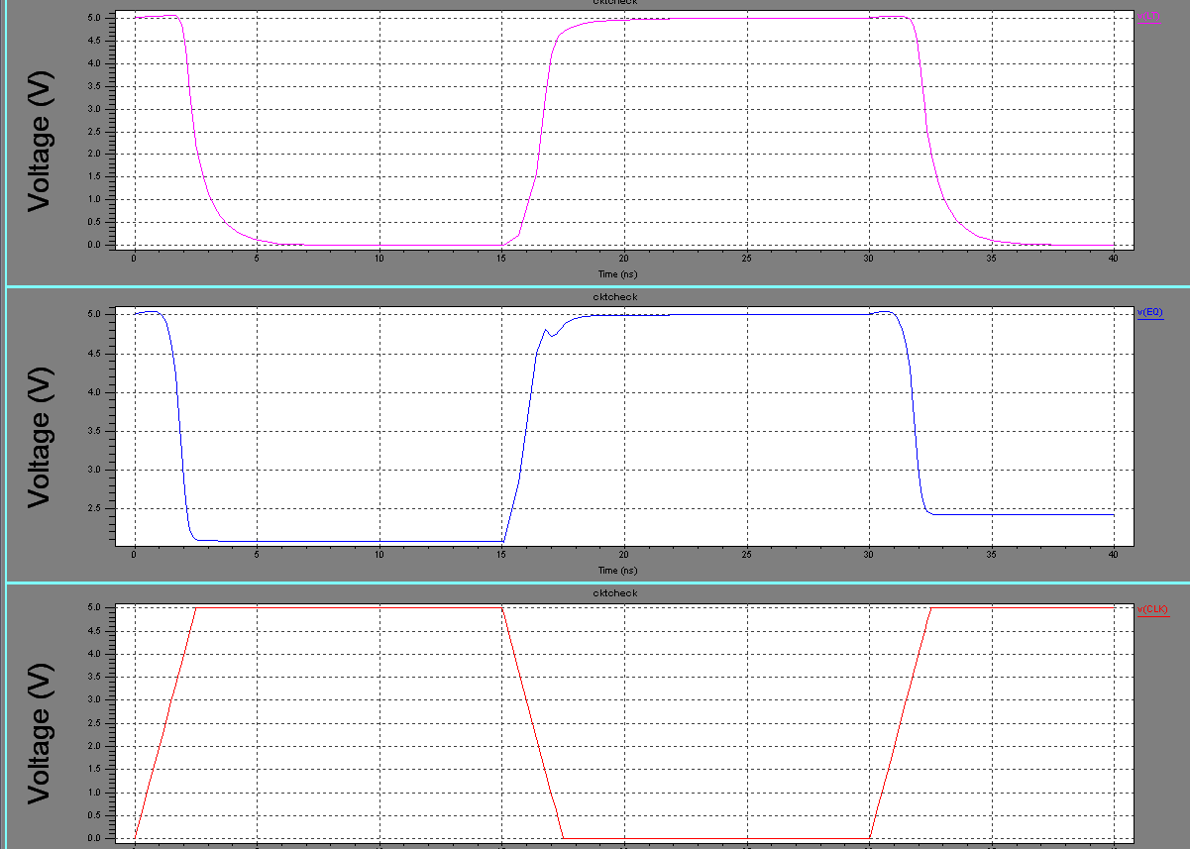

b)WhenA<B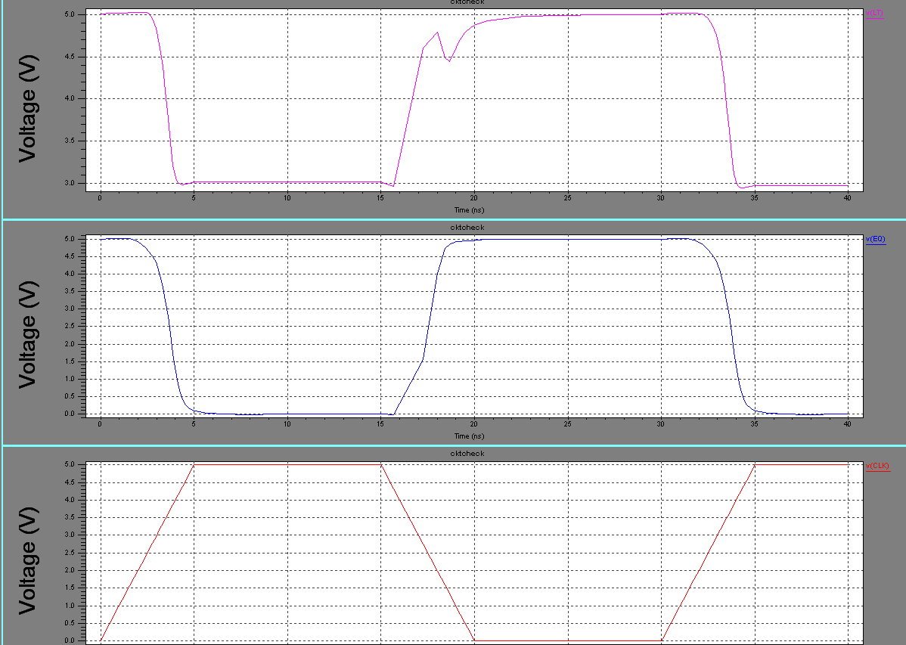

48
7.4 Modification in EQ & LT Stage:To achieve proper output in the case of equal stage. After doing the optimal sizing, we inserted a buffer at the end. Insertion of buffer is much more optimal solution then doing the sizing in the last stage as it will not increase the delay.

Spice Code (After inserting Buffer)
**************************************************************
.include "C:\indiachipv3\tanner\tanner_icp\models\wnwp13_5v.md"
M1 N6 A_bar_0 N40 Gnd nmos L=1.2u W=7u AD=27.3p PD=21.8u AS=26.25p PS=21.5u
M=1
M2 N19 B_bar_0 N41 Gnd nmos L=1.2u W=8.05u AD=27.3p PD=21.8u AS=26.25p PS=21.5u M=1
M3 N40 B_0 N19 Gnd nmos L=1.2u W=8.05u AD=27.3p PD=21.8u AS=26.25p PS=21.5u
M=1
M4 N41 A_0 N6 Gnd nmos L=1.2u W=7u AD=27.3p PD=21.8u AS=26.25p PS=21.5u M=1
M5 N19 CLK Gnd Gnd nmos L=1.2u W=9.01u AD=27.3p PD=21.8u AS=26.25p PS=21.5u M=1
M6 N22 CLK Gnd Gnd nmos L=1.2u W=9.01u AD=27.3p PD=21.8u AS=26.25p PS=21.5u M=1
M7 N42 A_3 N9 Gnd nmos L=1.2u W=7u AD=27.3p PD=21.8u AS=26.25p PS=21.5u M=1
M8 N43 B_3 N22 Gnd nmos L=1.2u W=7u AD=27.3p PD=21.8u AS=26.25p PS=21.5u M=1
M9 N22 B_bar_3 N42 Gnd nmos L=1.2u W=8.05u AD=27.3p PD=21.8u AS=26.25p PS=21.5u M=1
M10 N9 A_bar_3 N43 Gnd nmos L=1.2u W=7u AD=27.3p PD=21.8u AS=26.25p PS=21.5u M=1
M11 N16 CLK Gnd Gnd nmos L=1.2u W=9.01u AD=27.3p PD=21.8u AS=26.25p PS=21.5u M=1
M12 N44 A_2 N8 Gnd nmos L=1.2u W=7u AD=27.3p PD=21.8u AS=26.25p PS=21.5u M=1
M13 N45 B_2 N16 Gnd nmos L=1.2u W=8.05u AD=27.3p PD=21.8u AS=26.25p PS=21.5u M=1
M14 N16 B_bar_2 N44 Gnd nmos L=1.2u W=8.05u AD=27.3p PD=21.8u AS=26.25p PS=21.5u M=1
M15 N8 A_bar_2 N45 Gnd nmos L=1.2u W=7u AD=27.3p PD=21.8u AS=26.25p PS=21.5u M=1
M16 N13 CLK Gnd Gnd nmos L=1.2u W=9.01u AD=27.3p PD=21.8u AS=26.25p PS=21.5u M=1
M17 N46 A_1 N7 Gnd nmos L=1.2u W=7u AD=27.3p PD=21.8u AS=26.25p PS=21.5u
M=1
M18 N47 B_1 N13 Gnd nmos L=1.2u W=8.05u AD=27.3p PD=21.8u AS=26.25p PS=21.5u M=1
M19 N13 B_bar_1 N46 Gnd nmos L=1.2u W=8.05u AD=27.3p PD=21.8u AS=26.25p PS=21.5u M=1
M20 N7 A_bar_1 N47 Gnd nmos L=1.2u W=7u AD=27.3p PD=21.8u AS=26.25p PS=21.5u M=1
48
M21 N49 N8 N48 Gnd nmos L=1.2u W=8.05u AD=27.3p PD=21.8u AS=26.25p PS=21.5u M=1
M22 N70 N9 N49 Gnd nmos L=1.2u W=7u AD=27.3p PD=21.8u AS=26.25p PS=21.5u M=1
M23 N48 N7 N50 Gnd nmos L=1.2u W=9.01u AD=27.3p PD=21.8u AS=26.25p PS=21.5u M=1
M24 N50 N6 N51 Gnd nmos L=1.2u W=10.15u AD=27.3p PD=21.8u AS=26.25p PS=21.5u M=1
M25 N51 CLK Gnd Gnd nmos L=1.2u W=11.2u AD=27.3p PD=21.8u AS=26.25p PS=21.5u M=1
M26 EQ N70 N72 Gnd nmos L=1.2u W=3.6u AD=27.3p PD=21.8u AS=26.25p PS=21.5u M=1
M27 N38 CLK Gnd Gnd nmos L=1.2u W=11.2u AD=27.3p PD=21.8u AS=26.25p PS=21.5u M=1
M28 N36 105 N38 Gnd nmos L=1.2u W=10.15u AD=27.3p PD=21.8u AS=26.25p PS=21.5u M=1
M29 N78 N37 N36 Gnd nmos L=1.2u W=9.01u AD=27.3p PD=21.8u AS=26.25p PS=21.5u M=1
M30 LT 106 N90 Gnd nmos L=1.2u W=7u AD=27.3p PD=21.8u AS=26.25p PS=21.5u M=1
M31 N90 N80 N78 Gnd nmos L=1.2u W=8.05u AD=27.3p PD=21.8u AS=26.25p PS=21.5u M=1

M32 N87 CLK Gnd Gnd nmos L=1.2u W=9.01u AD=27.3p PD=21.8u AS=26.25p PS=21.5u M=1
M33 N88 B_2 N87 Gnd nmos L=1.2u W=8.05u AD=27.3p PD=21.8u AS=26.25p PS=21.5u M=1
M34 N81 CLK Gnd Gnd nmos L=1.2u W=9.01u AD=27.3p PD=21.8u AS=26.25p PS=21.5u M=1
M35 N83 B_3 N81 Gnd nmos L=1.2u W=8.05u AD=27.3p PD=21.8u AS=26.25p PS=21.5u M=1
M36 N85 CLK Gnd Gnd nmos L=1.2u W=9.01u AD=27.3p PD=21.8u AS=26.25p PS=21.5u M=1
M37 N96 A_0 N85 Gnd nmos L=1.2u W=8.05u AD=27.3p PD=21.8u AS=26.25p PS=21.5u M=1
M38 N86 CLK Gnd Gnd nmos L=1.2u W=9.01u AD=27.3p PD=21.8u AS=26.25p PS=21.5u M=1
M39 N92 B_1 N86 Gnd nmos L=1.2u W=8.05u AD=27.3p PD=21.8u AS=26.25p PS=21.5u M=1
M40 N95 A_bar_0 N96 Gnd nmos L=1.2u W=7u AD=27.3p PD=21.8u AS=26.25p PS=21.5u M=1
M41 N33 A_bar_2 N88 Gnd nmos L=1.2u W=7u AD=27.3p PD=21.8u AS=26.25p PS=21.5u M=1
M42 N52 A_bar_1 N92 Gnd nmos L=1.2u W=7u AD=27.3p PD=21.8u AS=26.25p PS=21.5u M=1
M43 N34 A_bar_3 N83 Gnd nmos L=1.2u W=7u AD=27.3p PD=21.8u AS=26.25p PS=21.5u M=1
M44 N55 CLK Gnd Gnd nmos L=1.2u W=9.01u AD=27.3p PD=21.8u AS=26.25p PS=21.5u M=1
49

M45 N57 N9 N55 Gnd nmos L=1.2u W=8.05u AD=27.3p PD=21.8u AS=26.25p PS=21.5u
M=1
M46 N80 N67 N57 Gnd nmos L=1.2u W=7u AD=27.3p PD=21.8u AS=26.25p PS=21.5u
M=1
M47 N69 CLK Gnd Gnd nmos L=1.2u W=10.15u AD=27.3p PD=21.8u AS=26.25p
PS=21.5u M=1
M48 N77 N8 N69 Gnd nmos L=1.2u W=9.01u AD=27.3p PD=21.8u AS=26.25p PS=21.5u
M=1
M49 N89 N9 N77 Gnd nmos L=1.2u W=8.05u AD=27.3p PD=21.8u AS=26.25p PS=21.5u
M=1
M50 N73 N9 N66 Gnd nmos L=1.2u W=8.05u AD=27.3p PD=21.8u AS=26.25p PS=21.5u
M=1
M51 N53 103 N73 Gnd nmos L=1.2u W=7u AD=27.3p PD=21.8u AS=26.25p PS=21.5u
M=1
M52 N66 N8 N60 Gnd nmos L=1.2u W=9.01u AD=27.3p PD=21.8u AS=26.25p PS=21.5u M=1
M53 N67 N33 N91 Gnd nmos L=1.2u W=7u AD=27.3p PD=21.8u AS=26.25p PS=21.5u M=1
M54 N91 CLK Gnd Gnd nmos L=1.2u W=8.05u AD=27.3p PD=21.8u AS=26.25p PS=21.5u M=1
M55 N2 N52 N93 Gnd nmos L=1.2u W=7u AD=27.3p PD=21.8u AS=26.25p PS=21.5u M=1
M56 N93 CLK Gnd Gnd nmos L=1.2u W=8.05u AD=27.3p PD=21.8u AS=26.25p PS=21.5u M=1
M57 N3 N95 N94 Gnd nmos L=1.2u W=7u AD=27.3p PD=21.8u AS=26.25p PS=21.5u M=1
M58 N94 CLK Gnd Gnd nmos L=1.2u W=8.05u AD=27.3p PD=21.8u AS=26.25p PS=21.5u M=1
M59 N37 N2 N89 Gnd nmos L=1.2u W=7u AD=27.3p PD=21.8u AS=26.25p PS=21.5u
M=1
M60 N60 N7 N1 Gnd nmos L=1.2u W=10.15u AD=27.3p PD=21.8u AS=26.25p PS=21.5u
M=1
M61 N1 CLK Gnd Gnd nmos L=1.2u W=11.2u AD=27.3p PD=21.8u AS=26.25p PS=21.5u
M=1
M62 N72 CLK Gnd Gnd nmos L=1.2u W=5.6u AD=27.3p PD=21.8u AS=26.25p PS=21.5u
M=1
M63 N6 CLK Vdd Vdd pmos L=1.5u W=14u AD=51.8p PD=35.4u AS=54.6p PS=35.8u
M=1
M64 N9 CLK Vdd Vdd pmos L=1.5u W=14u AD=51.8p PD=35.4u AS=54.6p PS=35.8u
M=1
M65 N8 CLK Vdd Vdd pmos L=1.5u W=14u AD=51.8p PD=35.4u AS=54.6p PS=35.8u
M=1
M66 N7 CLK Vdd Vdd pmos L=1.5u W=14u AD=51.8p PD=35.4u AS=54.6p PS=35.8u
M=1
M67 N70 CLK Vdd Vdd pmos L=1.5u W=14u AD=51.8p PD=35.4u AS=54.6p PS=35.8u
M=1
M68 EQ CLK Vdd Vdd pmos L=1.5u W=14u AD=51.8p PD=35.4u AS=54.6p PS=35.8u
M=1
M69 LT CLK Vdd Vdd pmos L=1.5u W=14u AD=51.8p PD=35.4u AS=54.6p PS=35.8u
M=1
50
M70 N95 CLK Vdd Vdd pmos L=1.5u W=14u AD=51.8p PD=35.4u AS=54.6p PS=35.8u
M=1
M71 N33 CLK Vdd Vdd pmos L=1.5u W=14u AD=51.8p PD=35.4u AS=54.6p PS=35.8u
M=1
M72 N52 CLK Vdd Vdd pmos L=1.5u W=14u AD=51.8p PD=35.4u AS=54.6p PS=35.8u
M=1
M73 N34 CLK Vdd Vdd pmos L=1.5u W=14u AD=51.8p PD=35.4u AS=54.6p PS=35.8u
M=1
M74 N80 CLK Vdd Vdd pmos L=1.5u W=14u AD=51.8p PD=35.4u AS=54.6p PS=35.8u
M=1

M75 N37 CLK Vdd Vdd pmos L=1.5u W=14u AD=51.8p PD=35.4u AS=54.6p PS=35.8u
M=1
M76 N53 CLK Vdd Vdd pmos L=1.5u W=14u AD=51.8p PD=35.4u AS=54.6p PS=35.8u
M=1
M77 N67 CLK Vdd Vdd pmos L=1.5u W=14u AD=51.8p PD=35.4u AS=54.6p PS=35.8u
M=1
M78 N2 CLK Vdd Vdd pmos L=1.5u W=14u AD=51.8p PD=35.4u AS=54.6p PS=35.8u
M=1
M79 N3 CLK Vdd Vdd pmos L=1.5u W=14u AD=51.8p PD=35.4u AS=54.6p PS=35.8u
M=1
CL1 LT 0 400fF
CL2 101 0 400fF
M80 100 EQ Vdd Vdd pmos L=1.5u W=14u AD=70.8p PD=55u AS=74p PS=55u M=1
M81 101 100 Vdd Vdd pmos L=1.5u W=14u AD=70.8p AD=70.8p PD=55u AS=74p
PS=55u M=1
M82 100 EQ Gnd Gnd nmos L=1.2u W=7u AD=57.3p PD=51.8u AS=56.25p PS=51.5u M=1
M83 101 100 Gnd Gnd nmos L=1.2u W=7u AD=57.3p PD=51.8u AS=56.25p PS=51.5uM=1
M84 102 N3 Vdd Vdd pmos L=1.5u W=7u AD=51.8p PD=35.4u AS=54.6p PS=35.8u M=1
M85 103 102 Vdd Vdd pmos L=1.5u W=7u AD=51.8p PD=35.4u AS=54.6p PS=35.8u M=1
M86 102 N3 Gnd Gnd nmos L=1.2u W=3.6u AD=27.3p PD=21.8u AS=26.25p PS=21.5u
M=1
M87 103 102 Gnd Gnd nmos L=1.2u W=3.6u AD=27.3p PD=21.8u AS=26.25p PS=21.5u
M=1
M88 104 N53 Vdd Vdd pmos L=1.5u W=7u AD=51.8p PD=35.4u AS=54.6p PS=35.8u M=1
M89 105 104 Vdd Vdd pmos L=1.5u W=7u AD=51.8p PD=35.4u AS=54.6p PS=35.8u M=1
M90 104 N53 Gnd Gnd nmos L=1.2u W=3.6u AD=27.3p PD=21.8u AS=26.25p PS=21.5u
M=1
M91 105 104 Gnd Gnd nmos L=1.2u W=3.6u AD=27.3p PD=21.8u AS=26.25p PS=21.5u
M=1
M92 106 N34 Vdd Vdd pmos L=1.5u W=7.2u AD=51.8p PD=35.4u AS=54.6p PS=35.8u
M=1
M93 107 106 Vdd Vdd pmos L=1.5u W=7.2u AD=51.8p PD=35.4u AS=54.6p PS=35.8u
M=1

M94 106 N34 Gnd Gnd nmos L=1.2u W=3.6u AD=27.3p PD=21.8u AS=26.25p PS=21.5u
M=1
51

M95 107 106 Gnd Gnd nmos L=1.2u W=3.6u AD=27.3p PD=21.8u AS=26.25p PS=21.5u
M=1
***************************************************************************************
Vclk CLK Gnd PULSE(0 5 0 2.5ns 2.5ns 12.5ns 30ns)
Va3 A_bar_3 Gnd 5v
Vb3 B_bar_3 Gnd 5v
Vc3 A_3 Gnd 0v
Vd3 B_3 Gnd 0v
Va2 A_bar_2 Gnd 5v
Vb2 B_bar_2 Gnd 5v
Vc2 A_2 Gnd 0v
Vd2 B_2 Gnd 0v
Va1 A_bar_1 Gnd 5v
Vb1 B_bar_1 Gnd 5v
Vc1 A_1 Gnd 0v
Vd1 B_1 Gnd 0v
Va0 A_bar_0 Gnd 5v
Vb0 B_bar_0 Gnd 0v
Vc0 A_0 Gnd 0v
Vd0 B_0 Gnd 5v
vdd vdd Gnd 5v
.TRAN 1ns 40ns
.Print TRAN V(EQ) V(CLK) V(101) V(LT)

Output Wave-forms
a) When A=B
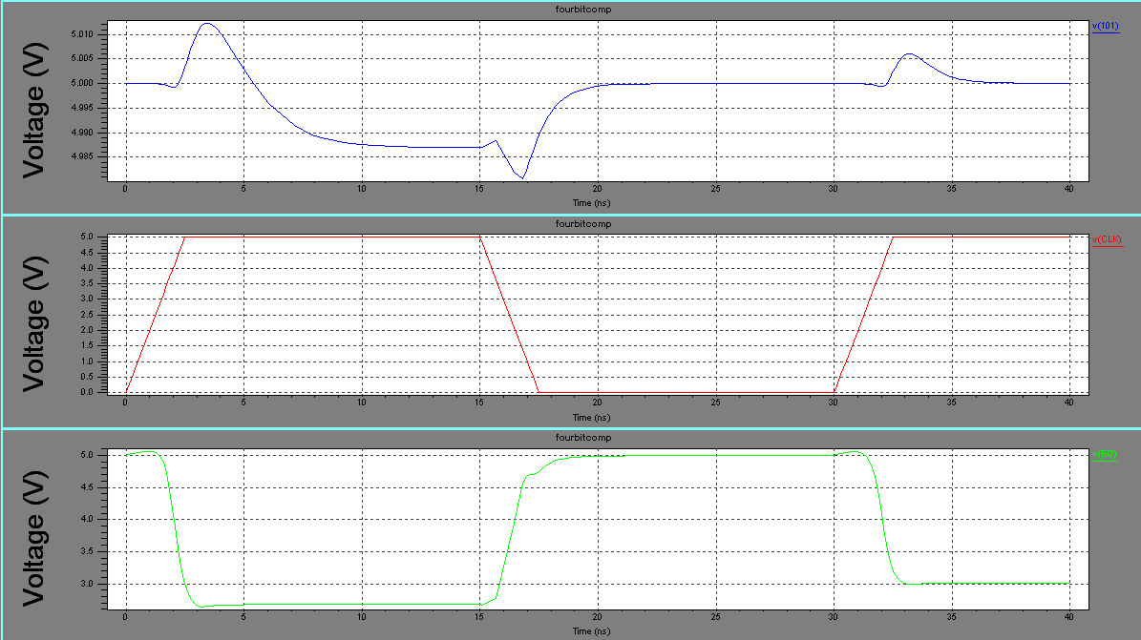
52

b) When A<B

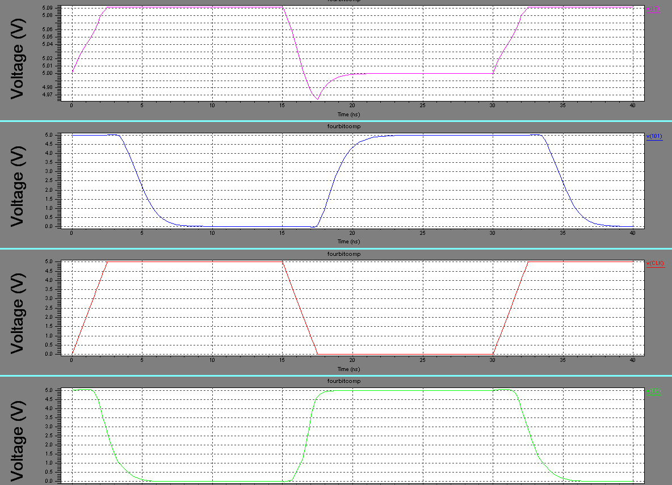

53

7.5 Worst case Analysis:The following input pattern: A = (0000) and B = (0001) with the left-most bit being the MSB. This will set LT to 1 and EQ to 0

In this case we were not able to achieve proper output response at LT stage. So again doing the analysis at different nodes and wherever we feel that output level at particular node is not optimal, we placed a buffer. The worst case is completely removed and worst case propagation delay is evaluated with the help of placing three buffers at different level of stages.

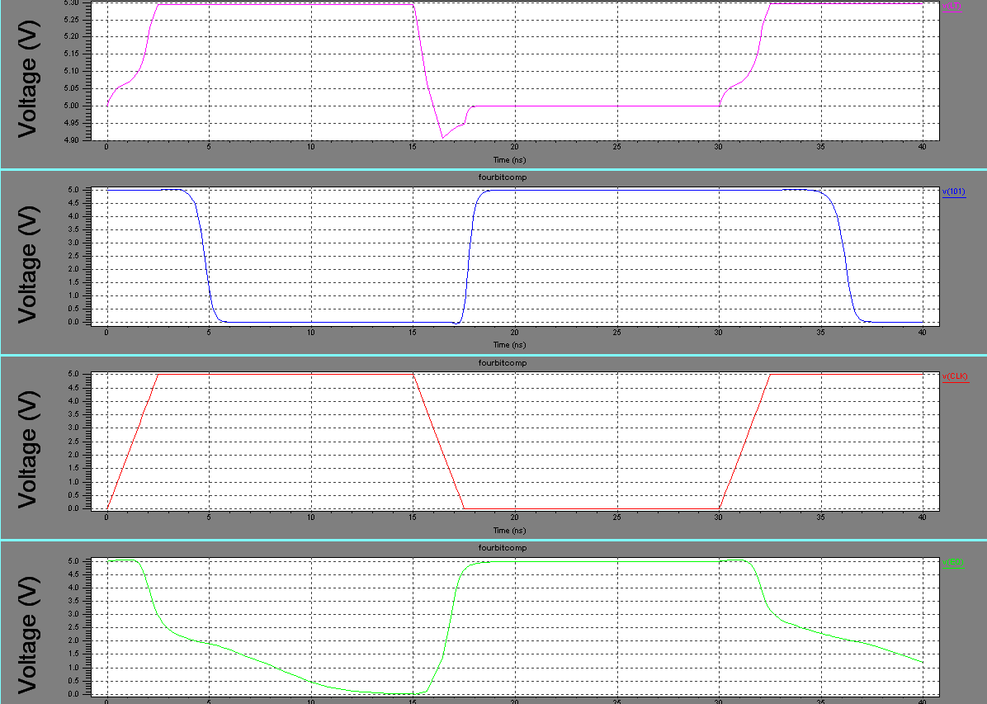

54

8. FINAL LAYOUT OF FOUR-BIT COMPARATOR

55
8.1 Final Layout using L-Edit: It is used to prepare the final Layout of 4-Bit Comparator.
L-Edit is an interactive, graphical mask layout editor for ASIC design that is fast, easy to use, and fully hierarchical. A full-featured, high performance tool, L-Edit handles an unlimited number of mask layers, levels, and cells. L-Edit provides all- angle, 45 degree, and orthogonal drawing ability. The user environment is fully customizable, including color palette, stipple, fill, and outline patterns. Editing features include edit-in-place for the editing of instances within their hierarchical content. This allows a cell that is levels below the top of a design, to be edited from the top level and maintain the view of its context.
A window stretch capability permits the simultaneous stretching of a group of polygons, rectangles, and/or wires. Object cut and merge capability allows selected objects to be cut along a user-specified horizontal or vertical axis and overlap-ping objects to be merged into a single object. Group and Un-group commands allow objects to be grouped into a new cell definition and an instance of a cell to be ungrouped. The insides of instances can be shown or hidden on an individual basis.
Across-section viewer allows the designer to simulate grow/deposit, implant/diffuse, and etch steps for mask layers corresponding to the VLSI fabrication process. L-Edit supports CIF and GDSII file formats and directly produces the mask specification format required by MOSIS. L-Edit 5.0 comes with a complete set of optimized layer, design rule, and device extraction setups for 2.0um and 1.2um processes and Orbit/Foresight2.0um, and 1.2um processes.

8.2 Design Rule Check

L-Edit/DRC is an on-line geometric design rule checker for use with L-Edit. The DRC features user programmable DRC rules. Use of L-Edit's user-definable logical layer operations in DRC rule specifications allows integrated circuit designers to verify their layout against the published geometric DRC constraints of a silicon foundry. Rules are one of seven basic types. Minimum width rules check for minimum size of objects (e.g. minimum transistor width). Exact width rules are for objects which must be an exact size (e.g. contacts). Minimum spacing rules ensure a minimum distance between two objects (e.g. minimum distance between two transistors). The minimum surround rule verifies that a specified object is contained within another object (e.g. metal contact surrounded by metal). Overlap and Extension rules check for overlap and extension of intersection objects respectively. The design rule definitions used by L-Edit/DRC can be specified using any derived layer from L-Edit's Generate Layers feature. This capability greatly expands the set of rules which can be specified. Intermediate layers can be temporarily generated using AND, OR, NOT, GROW, and SHRINK operations, and the derived results can be utilized in a design rule definition. The derived layers are generated and disposed of automatically The design rules and the set of layers used by L-Edit/DRC are constructed using menus and dialogs within L-Edit.
The DRC Error Browser and Object Browser (Find Ports on Error Layer) cycles through the DRC error ports one at a time, selecting them and optionally centering them on the screen.
On L-Edit in accordance to design rules layout is prepared.
56
8.3 Layout of each Sub-Block

Layout of XNOR:

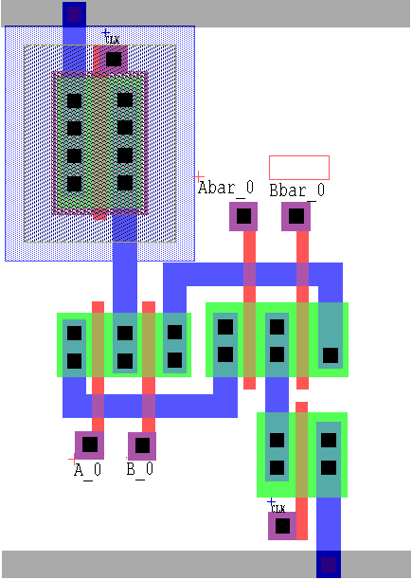

Layout of NAND:

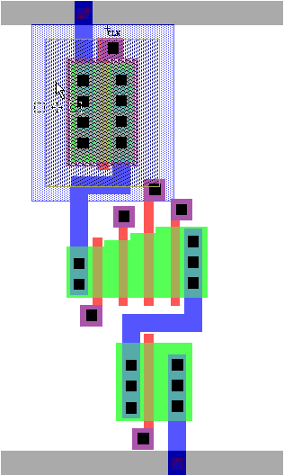

57
Layout of INVERTER:

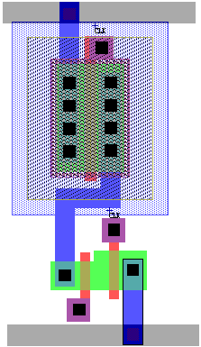

Layout of BUFFER:

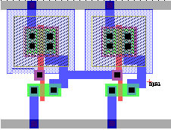

58

8.4 Layout of EQ STAGE:

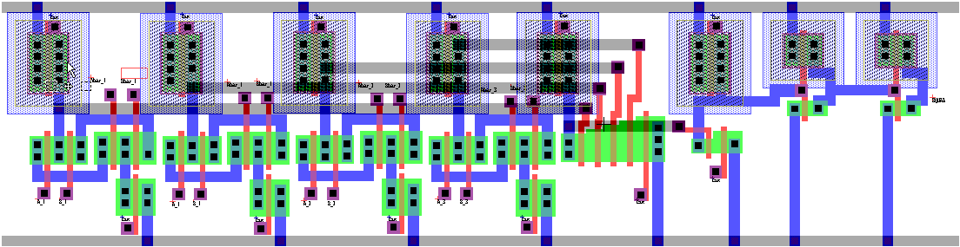

8.5 Layout of LT STAGE:

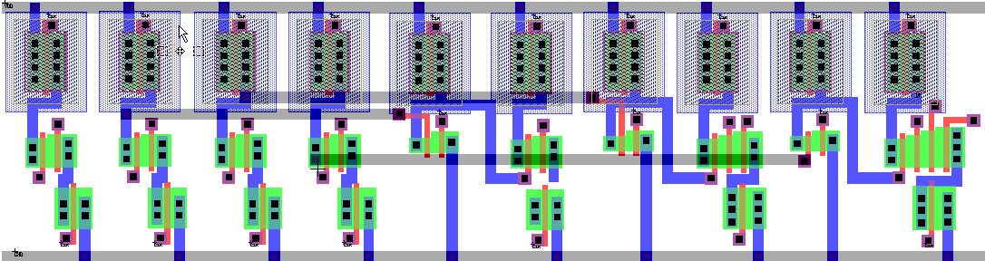

59

8.6 Final Layout of four-Bit Comparator:

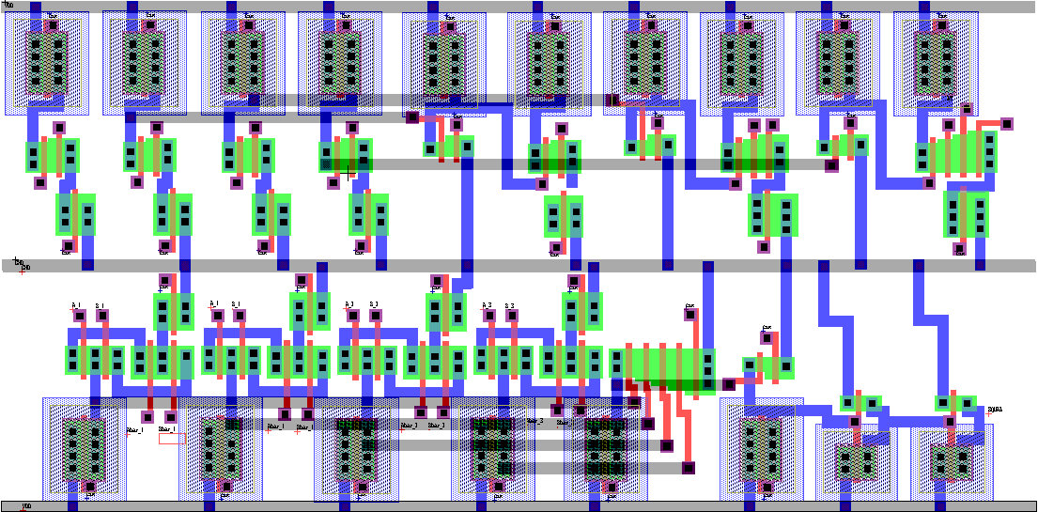

8.7 Post Layout SimulationThe extracted spice code from layout, the
various parasitic
Capacitances are obtained.

Various Parasitic Capacitances
Cpar1 1 148 C=5.31E-016
Cpar2 2 148 C=5.31E-016
Cpar3 3 148 C=5.31E-016
Cpar4 4 148 C=5.31E-016

60
Cpar5 5 148 C=5.31E-016
Cpar6 6 148 C=5.31E-016
Cpar7 7 148 C=5.31E-016
Cpar8 8 148 C=5.31E-016
Cpar9 9 148 C=5.31E-016
Cpar10 10 148 C=5.31E-016
Cpar11 11 148 C=43.294367f
Cpar12 12 148 C=3.06993f
Cpar13 13 148 C=4.99725f
Cpar14 14 148 C=5.31E-016
Cpar15 15 148 C=4.098f
Cpar16 CLK_3 148 C=5.31E-016
Cpar17 17 148 C=5.31E-016
Cpar18 18 148 C=5.31E-016
Cpar19 19 148 C=4.55142f
Cpar20 20 148 C=5.31E-016
Cpar21 21 148 C=5.31E-016
Cpar22 29 148 C=6.7788f
Cpar23 30 148 C=4.4859f
Cpar24 31 148 C=4.2549f
Cpar25 32 148 C=5.31E-016
Cpar26 33 148 C=5.31E-016
Cpar27 34 148 C=5.181E-016
Cpar28 CLK_1 148 C=5.31E-016
Cpar29 36 148 C=5.31E-016
Cpar30 37 148 C=5.31E-016
Cpar31 38 148 C=5.31E-016
Cpar32 39 148 C=5.181E-016
Cpar33 40 148 C=5.31E-016
Cpar34 41 148 C=5.31E-016

Cpar35 42 148 C=5.31E-016
Cpar36 43 148 C=2.2221f
Cpar37 44 148 C=5.31E-016
Cpar38 B_3 148 C=5.31E-016
Cpar39 46 148 C=5.31E-016
Cpar40 47 148 C=5.31E-016
Cpar41 48 148 C=5.31E-016
Cpar42 49 148 C=5.31E-016
Cpar43 50 148 C=2.2221f
Cpar44 51 148 C=5.31E-016
Cpar45 52 148 C=5.31E-016
Cpar46 53 148 C=0.91674f
Cpar47 CLK_4 148 C=5.31E-016
Cpar48 55 148 C=8.69112f
Cpar49 56 148 C=5.31E-016
Cpar50 57 148 C=3.36555f
Cpar51 58 148 C=5.31E-016

61
Cpar52 59 148 C=5.31E-016
Cpar53 60 148 C=4.5552f
Cpar54 61 148 C=5.31E-016
Cpar55 62 148 C=8.8008f
Cpar56 63 148 C=5.31E-016
Cpar57 64 148 C=5.31E-016
Cpar58 65 148 C=1.3905f
Cpar59 66 148 C=4.5552f
Cpar60 67 148 C=5.8665644f
Cpar61 68 148 C=7.1736866f
Cpar62 74 148 C=8.74002f
Cpar63 88 148 C=4.4859f
Cpar64 89 148 C=4.2549f
Cpar65 90 148 C=4.4859f
Cpar66 91 148 C=4.2549f
Cpar67 92 148 C=4.4859f
Cpar68 93 148 C=4.2549f
Cpar69 94 148 C=5.31E-016
Cpar70 95 148 C=5.31E-016
Cpar71 96 148 C=5.31E-016
Cpar72 97 148 C=5.31E-016
Cpar73 98 148 C=5.31E-016
Cpar74 99 148 C=2.2221f
Cpar75 100 148 C=5.31E-016
Cpar76 101 148 C=5.31E-016
Cpar77 102 148 C=5.31E-016

Cpar78 103 148 C=5.31E-016
Cpar79 104 148 C=5.31E-016
Cpar80 105 148 C=5.31E-016
Cpar81 106 148 C=2.2221f
Cpar82 107 148 C=5.31E-016
Cpar83 108 148 C=5.31E-016
Cpar84 109 148 C=5.31E-016
Cpar85 110 148 C=5.31E-016
Cpar86 111 148 C=2.83878f
Cpar87 CLK_5 148 C=5.31E-016
Cpar88 113 148 C=5.31E-016
Cpar89 114 148 C=5.31E-016
Cpar90 115 148 C=2.83878f
Cpar91 CLK_6 148 C=5.31E-016
Cpar92 117 148 C=5.31E-016
Cpar93 118 148 C=5.31E-016
Cpar94 119 148 C=2.83878f
Cpar95 CLK_2 148 C=5.31E-016
Cpar96 121 148 C=5.31E-016
Cpar97 122 148 C=5.31E-016
Cpar98 123 148 C=2.83797f
62
Cpar99 CLK 148 C=5.31E-016
Cpar100 125 148 C=5.31E-016
Cpar101 126 148 C=5.31E-016
Cpar102 127 148 C=4.55142f
Cpar103 128 148 C=36.986768f
Cpar104 129 148 C=70.408703f
Cpar105 130 148 C=9.1500946f
Cpar106 131 148 C=11.19003f
Cpar107 132 148 C=13.30761f
Cpar108 133 148 C=13.569388f
Cpar109 134 148 C=11.045687f
Cpar110 135 148 C=9.7128248f
Cpar111 140 148 C=5.31E-016

Ctotal = ∑ Cpar

We lumped all the parasitic Capacitance and we got the load of 400 fF

Final Simulation Result (with load):
CL = 400 fF

63
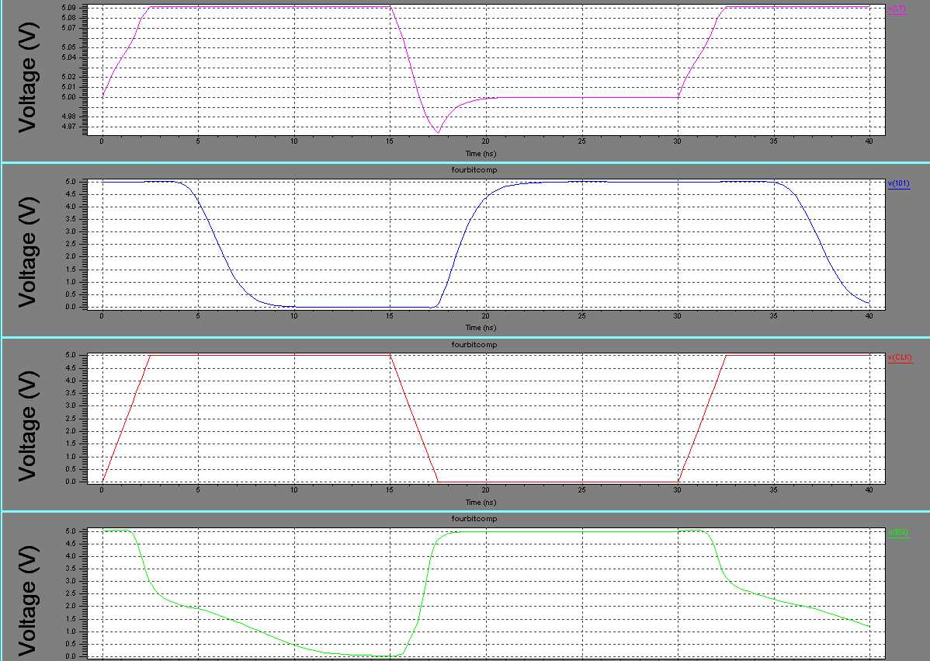

64

9. ESTIMATION OF AREA, DELAY, POWER

65

  - Area Estimation :The area can be estimated considering smallest
rectangular block
drawn around the layout.

Area = Height * Width

Area of XNOR:
Height = 62.5 micron , Width = 44 micron
= 2750 micron²

Area of NAND:
Height = 68.5 micron , Width = 40.7 micron
= 2787.95 micron2

Area of Inverter:
Height = 44.5 micron , Width = 25 micron
= 1112.5 micron2

Area of Equal:
Height = 66.1 micron , Width = 240.2 micron
= 15877.22 micron2

Area of LT:
Height = 65.8 micron , Width = 252.8 micron
= 16634.24 micron2

Total Area of Design = 31915.910 micron²

66

9.2 Delay Estimation

Propagation delay Time (tplh/tphl):

This is the time taken for a logic transition to pass from input to output.
tpd -> time difference between the 50 % input transition & 50% output transition.
tplh -> propagation delay when o/p is changing from low to high.
tphl -> propagation delay when o/p is changing from high to low.

Tpd = (tplh + tphl)/2

Without Load( Worst –case) : Tpd = 3.3 ns

With Load( Worst –case) : Tpd = 5.35 ns

Maxmium Operating Frequency: 33.3 Mhz

67
9.3 Power Estimation

Total Power Dissipation:

Three major components of power in CMOS
- Dynamic: charging & discharging capacitors
- Short-circuit: small, typically ignore
-Static: sub threshold leakage, growing fast

Pdyn = CL * Vdd ² * fsw
where fsw is the frequency with which CL switches

Dynamic Power Estimation:

C_{L} = 400 fF
V_{dd} = 5V
f_{sw} = 33.3 Mhz

Pdyn = 330 µwatts

68

10. DISCUSSION AND FURTHER SCOPE OF WORK

69
10.1 LIMITATIONS:

- The area is not optimized due to some constraints in SCL layout library.

- Routing problem in layout due to availability of only 2 metal layers in SCL

library.

- We were not able to reduce the delay below 1 ns as we desired before starting our design.

10.2 Future Work:

Dynamic CMOS Logic Comparator can be further designed for deep
submicrons (less than 0.5um). In this project it is done for SCL1.2um.Quasi-Domino Logic can implemented for obtaining high speed and low power.

10.3 CONCLUSION

Four- bit comparator is designed and is successfully implemented through dynamic logic
using standard SCL’s 1.2µ Technology. The design is optimized and able to meet all the
desired objectives.

Objectives Achieved:

- Successfully Implemented on FPGA
- Top-to-Down Full Custom Approach using Dynamic logic
- Able to meet specifications:

Delay: 5.35 ns (with load)
3.3 ns ( without load)

Max Operating frequency: 33.3Mhz

Dynamic Power: 330 µ watts

Area of the total design: 31915.910 micron²
70
REFRENCES

- Weste and Eshraghian “Principles of CMOS VLSI Design”
- J Bhaskar “VHDL Primer “ PHI
- Roberts and Sedra, Spice 2nd Edition
- John F Wakerly “Degital Design Practice and Principles.
- “A high-performance 0.25um CMOS Technolgy I-Design and Characterisation,”IEEE Transactions on Electron Devices, vol,no.4,apr 1992.
- “An interactive layout design systems with real time logical verification and ectraction of layout parasitics “ieee journal of solid state circuits,vol.23no.3,jun1998,www.ieeexplore.ieee.org
- Ieee transactions on electron devices vol.44 no.4 Apr 1997 Area-efficient layout design for Cmos output transistors, Ming-duoker,member IEEE,Chung Yu Wi,Member IEEE
- Top-Down Approach to technology migration for full custom mask layouts. Apanovich Z.V. Marchuk,Institute of informatics Systems,Russia,Acadmey of science.
- Proceedings of the 1995 winter simulation conference ed C Alexporlous k.kkong
- ,W.R.Lilegdonand D. Goldsman- strategic layout planning & simuklation for lean manufacturing
- John Y.Chen CMOS Devices and technology VLSI
- J.Mavor,Jack and P.B. Denyer, Introduction to MOS LSI Design
- R.D.Rung,”determining ic layout rules for cost minimisation”,IEEE Journal,vol. SC-16,no.1,feb1981
- Bernhard Hoppe,Gerd Nevendorf,Doris Schmitt-Landsiedel,and Will Specks,“optimisation of high speed CMOS logic circuits with analytical models for signal delay, chip area and dynamic power dissipation”,IEEE transaction on computer-aided Design,vol9,no.3,mar 1990.

71
Appendix A

VHDL Code Of Inverter Gate

Library IEEE;
Use IEEE.STD_LOGIC_1164.ALL;
Use IEEE.STD_LOGIC_ARITH.ALL;
Use IEEE.STD_LOGIC_UNSIGNED.ALL;

Entity INV_1 is
PORT (A: IN STD_LOGIC;
Z: OUT STD_LOGIC);
End INV_1;

Architecture Behavioral of INV_1 is

Begin

Z<= NOT A;

End Behavioral;

VHDL Code Of AND Gate

Library IEEE;
Use IEEE.STD_LOGIC_1164.ALL;
Use IEEE.STD_LOGIC_ARITH.ALL;
Use IEEE.STD_LOGIC_UNSIGNED.ALL;

Entity AND_1 is

PORT (A, B, C: IN STD_LOGIC;
D: IN STD_LOGIC;
Z: OUT STD_LOGIC);
End AND_1;
Architecture Behavioral of AND_1 is

Begin

Z<= ((A AND B) AND(C AND D));

End Behavioral;

72
VHDL Code of NAND Gate

Library IEEE;
Use IEEE.STD_LOGIC_1164.ALL;
Use IEEE.STD_LOGIC_ARITH.ALL;
Use IEEE.STD_LOGIC_UNSIGNED.ALL;

Entity NAND_1 is

PORT (A, B, C: IN STD_LOGIC;
D: IN STD_LOGIC;
Z: OUT STD_LOGIC);
End NAND_1;
Architecture Behavioral of NAND_1 is

Begin
Z<= NOT ((A AND B) AND (C AND D));

End Behavioral;

VHDL Code of EXNOR Gate

Library IEEE;
Use IEEE.STD_LOGIC_1164.ALL;
Use IEEE.STD_LOGIC_ARITH.ALL;
Use IEEE.STD_LOGIC_UNSIGNED.ALL

Entity XNOR_1 is
PORT (A: IN STD_LOGIC;
B: IN STD_LOGIC;
Z: OUT STD_LOGIC);
End XNOR_1;

Architecture Behavioral of XNOR_1 is

Begin
Z<=not (A xor B);

End Behavioral;

73
VHDL Code of 4-Bit Comparator

Library IEEE;
Use IEEE.STD_LOGIC_1164.ALL;
Use IEEE.STD_LOGIC_ARITH.ALL;
Use IEEE.STD_LOGIC_UNSIGNED.ALL

Entity comparator is
Port (A: in std_logic_vector (3 downto 0) ;
B: in std_logic_vector (3 downto 0);
LT: out std_logic;
EQ: out std_logic);
End comparator;

Architecture Behavioral of comparator is

Signal S1,S2,S3,S4,S5,S6,S7,S8,S9,S10,S11:std_logic;
Signal I0, I1, I2, I3, I4, I5, I6: std_logic;

COMPONENT INV_1
PORT (A: IN STD_LOGIC;
Z: OUT STD_LOGIC);
End COMPONENT;

COMPONENT AND_1
PORT (A, B, C: IN STD_LOGIC;
D: IN STD_LOGIC;
Z: OUT STD_LOGIC);
End COMPONENT;

COMPONENT NAND_1
PORT (A, B, C: IN STD_LOGIC;
D: IN STD_LOGIC;
Z: OUT STD_LOGIC);
End COMPONENT;

COMPONENT XNOR_1
PORT (A: IN STD_LOGIC;
B: IN STD_LOGIC;
Z: OUT STD_LOGIC);
End COMPONENT;

Begin
--*********** FOR ALL INPUT INVERT********---
74
INV1:INV_1 port map (A (3), I3);
INV2:INV_1 port map (A (2), I2);
INV3:INV_1 port map (A (1), I1);
INV4:INV_1 port map (A (0), I0);
INV5:INV_1 port map (S6, I4);
INV6:INV_1 port map (S7, I5);
INV7:INV_1 port map (S8, I6);

--*********** FIRST STAGE OF EQ********---

eq1:XNOR_1 port map (A (3), B (3), S1);
eq2:XNOR_1 port map (A (2), B (2), S2);
eq3:XNOR_1 port map (A (1), B (1), S3);
eq4:XNOR_1 port map (A (0), B (0), S4);

--*********** FINAL STAGE OF EQ********---

eq5:AND_1 port map (S1, S2, S3, S4, EQ);

--*********** FIRST STAGE OF LT********---

LT1:NAND_1 PORT MAP (I3, B (3), B (3), B (3), S5);
LT2:NAND_1 PORT MAP (I2, B (2), B (2), B (2), S6);
LT3:NAND_1 PORT MAP (I1, B (1), B (1), B (1), S7);
LT4:NAND_1 PORT MAP (I0, B (0), B (0), B (0), S8);

--*********** SECONDS STAGE OF LT********---

LT5:NAND_1 PORT MAP (I4, S1, S1, S1, S9);
LT6:NAND_1 PORT MAP (S1, I5, S2, S1, S10);
LT7:NAND_1 PORT MAP (I6, S1, S2, S3, S11);

--*********** FINAL STAGE OF LT********---

LT8:NAND_1 PORT MAP (S5, S9, S10, S11, LT);

End Behavioral;

75

