chapter 1

Introduction

This section presents an overview, motivation and objective of the thesis. This section also deals with the overall structure of the thesis.

Introduction to HDLC
HDLC [High-level Data Link Control] is a group of protocols for transmitting [synchronous] data [Packets] between [Point-to-Point] nodes. In HDLC, data is organized into a frame. HDLC protocol resides with Layer 2 of the OSI model, the data link layer. It is an efficient layer2 protocol standardized by ISO for point-to-point and multipoint data links. HDLC provides minimal overhead to ensure flow control, error control, detection and recovery for serial transmission.
The HDLC frame is synchronous and therefore relies on the physical layer to provide method of clocking and synchronizing the transmission and reception of frames. The frames are separated by HDLC flag sequences that are transmitted between each frame and whenever there is no data to be transmitted. To inform the receiving station that a new packet is arriving and synchronizes the receive clock with the transmitted clock a specific bit pattern is added at the front and the back of the packet. The header of the packet contains an HDLC address and an HDLC control field. The specific bit pattern is used to affix with the packet in the case of HDLC Controller is 01111110. The length of the address field is normally 0, 8 or 16 bits in length. In many cases the address field is typically just a single byte, but an Extended Address [EA] bit may be used allowing for multi-byte addresses. A one residing in the LSB bit indicates [the end of the field] that the length of the address field will be 8 bits long. A zero in this bit location [now the first byte of a multi-byte field] indicates the continuation of the field [adding 8 additional bits]. The Control field is 8 or 16 bits and defines the frame type; Control or Data to guarantee that a flag does not appear inadvertently anywhere else in the frame; HDLC uses a process called bit stuffing. Every time the user wants to send a bit sequence having more than 5 consecutive 1s, it inserts (stuffs) one redundant 0 after the fifth 1. The trailer is found at the end of the frame, and contains a Cyclic Redundancy Check (CRC), which detects any errors that may occur during transmission. A CRC value is generated by a calculation that is performed at the source device. The destination device compares this value to its own calculation to determine whether errors occurred during transmission. First, the source device performs a predetermined set of calculations over the contents of the packet to be sent. Then, the source places the calculated value in the packet and sends the packet to the destination. The destination performs the same predetermined set of calculations over the contents of the packet and then compares its computed value with that contained in the packet. If the values are equal, the packet is considered valid. If the values are unequal, the packet contains errors and is discarded. The receiver can be configured into transparent mode, effectively disabling the HDLC protocol functions. In normal HDLC protocol made, all received frames are presented to the host on the output register. A status register is provided which can be used to monitor the status of the receiver channel, and indicates if the packet currently being received includes any errors.

Motivation and Objectives
The objective of thesis is to design and implement a high performance HDLC Controller for the bit oriented, switched, nonswitched, packet transmission to permit synchronous, data transmission. Initially, the digital design (block diagram) is drafted showing the basic functioning of the hardware in terms of the blocks. This is then be coded in a hardware description language (VHDL). The functioning of the coded design is simulated on simulation software (e.g. ModelSim). After proper simulation, the design is synthesized and then translated to a structural architecture in terms of the components on the target FPGA/CPLD devices and the post-translate simulation performed in order to ensure the proper functioning of the design after translation. After the successful simulation of the post-translate model the design is mapped to the existing slices of the FPGA and the post-map model simulated. The post-map model doesn’t include the routing delays. After the successful completion of the post-map simulation, a programming file is generated to program the FPGA device. The objective is to run the programmed FPGA at a frequency as high as possible.
Features:
The main features are
- Full duplex mode of operation
- Automatic frame check sequence generation and checking.
- Minimum CPU overhead.
- Capable of working in various modes.

Organisation of the Thesis
The remainder of the thesis is structured as follows. In chapter 2 information about networks, OSI layer and HDLC controller is given. It also covers a brief description of various HDLC controllers. In chapter 3 The Design and implementation of HDLC is carried out. It also includes how data flows between different components inside the block and how HDLC block interfaces with other layers of OSI model. In chapter 4 the results of Functional simulation and synthesis is presented. In chapter 5 the thesis is concluded with some future scope of this thesis.

chapter 2

Overview of HDLC

This section presents an overview HDLC, history of networking and some concepts of OSI layer.

The HDLC controller operates at the data link layer of the OSI Model. Hence the main focus is to understand the data link layer and develop a protocol which can offer its services to the layer above it i.e. is the network layer and the layer below it i.e. the physical layer.
The main function of this protocol controller is to perform a number of separate activities like physical addressing, to check for errors, flow control etc.
2.1 History of Internetworking
The layered concept of networking was developed to accommodate changes in technology. Each layer of a specific network model may be responsible for a different function of the network. Each layer will pass information up and down to the next subsequent layer as data is processed. [1]
2.1.1 OSI 7 Layers Reference Model For Network Communication
Open Systems Interconnection (OSI) model is a reference model developed by ISO (International Organization for Standardization) in 1984, as a conceptual framework of standards for communication in the network across different equipment and applications by different vendors. It is now considered the primary architectural model for inter-computing and internetworking communications. Most of the network communication protocols used today have a structure based on the OSI model. The OSI model defines the communications process into 7 layers, which divides the tasks involved with moving information between networked computers into seven smaller, more manageable task groups. A task or group of tasks is then assigned to each of the seven OSI layers. Each layer is reasonably self-contained so that the tasks assigned to each layer can be implemented independently. This enables the solutions offered by one layer to be updated without adversely affecting the other layers. [1]
2.1.2 Network Layers
The following list details the seven layers of the Open System Interconnection (OSI) reference model:
•Layer 7—Application
•Layer 6—Presentation
•Layer 5—Session
•Layer 4—Transport
•Layer 3—Network
•Layer 2—Data link
•Layer 1—Physical
The specific description for each layer is as follows:
Application Layer:
The application layer is the OSI layer closest to the end user, which means that both the OSI application layer and the user interact directly with the software application. This layer interacts with software applications that implement a communicating component. Such application programs fall outside the scope of the OSI model. Application layer functions typically include identifying communication partners, determining resource availability, and synchronizing communication. When identifying communication partners, the application layer determines the identity and availability of communication partners for an application with data to transmit. When determining resource availability, the application layer must decide whether sufficient network resources for the requested communication exist. In synchronizing communication, all communication between applications requires cooperation that is managed by the application layer. Some examples of application layer implementations include Telnet, File Transfer Protocol (FTP), and Simple Mail Transfer Protocol (SMTP). [1]

Presentation Layer:
The presentation layer provides a variety of coding and conversion functions that are applied to application layer data. These functions ensure that information sent from the application layer of one system would be readable by the application layer of another system. Some examples of presentation layer coding and conversion schemes include common data representation formats, conversion of character representation formats, common data compression schemes, and common data encryption schemes. Common data representation formats, or the use of standard image, sound, and video formats, enable the interchange of application data between different types of computer systems. Using different text and data representations, such as EBCDIC and ASCII, uses conversion schemes to exchange information with systems. Standard data compression schemes enable data that is compressed at the source device to be properly decompressed at the destination. Standard data encryption schemes enable data encrypted at the source device to be properly deciphered at the destination. Presentation layer implementations are not typically associated with a particular protocol stack. Some well-known standards for video include QuickTime and Motion Picture Experts Group (MPEG). QuickTime is an Apple Computer specification for video and audio, and MPEG is a standard for video compression and coding. Among the well-known graphic image formats are Graphics Interchange Format (GIF), Joint Photographic Experts Group (JPEG), and Tagged Image File Format (TIFF). GIF is a standard for compressing and coding graphic images. JPEG is another compression and coding standard for graphic images, and TIFF is a standard coding format for graphic images. [2]
Session Layer
The Session layer controls the dialogues/connections (sessions) between computers. It establishes, manages and terminates the connections between the local and remote application. It provides for either full-duplex or half-duplex operation, and establishes check pointing, adjournment, termination, and restart procedures. The OSI model made this layer responsible for "graceful close" of sessions, which is a property of TCP, and also for session check pointing and recovery, which is not usually used in the Internet protocols suite. [3]

Transport Layer
The Transport layer provides transparent transfer of data between end users, thus relieving the upper layers from any concern while providing reliable data transfer. The transport layer controls the reliability of a given link through flow control, segmentation/desegmentation, and error control. Some protocols are state and connection oriented. This means that the transport layer can keep track of the packets and retransmit those that fail. The best known example of a layer 4 protocol is the Transmission Control Protocol (TCP). The transport layer is the layer that converts messages into TCP segments or User Datagram Protocol (UDP), Stream Control Transmission Protocol (SCTP), etc. packets. Perhaps an easy way to visualize the Transport Layer is to compare it with a Post Office, which deals with the dispatching and classification of mail and parcels sent.
Layer 3: Network Layer
The Network layer provides the functional and procedural means of transferring variable length data sequences from a source to a destination via one or more networks while maintaining the quality of service requested by the Transport layer. The Network layer performs network routing functions, and might also perform segmentation/desegmentation, and report delivery errors. Routers operate at this layer sending data throughout the extended network and making the Internet possible. This is a logical addressing scheme – values are chosen by the network engineer. [4] The addressing scheme is hierarchical. The best known example of a layer 3 protocol is the Internet Protocol (IP). Perhaps it's easier to visualize this layer as the actual Air Mail or Consolidated Carrier that transfers the mail from Point A to Point B.
Layer 2: Data Link Layer -
The Data Link layer provides the functional and procedural means to transfer data between network entities and to detect and possibly correct errors that may occur in the Physical layer. The best known example of this is Ethernet. Other examples of data link protocols are HDLC and ADCCP for point-to-point or packet-switched networks and Aloha for local area networks. On IEEE 802 local area networks, and some non-IEEE 802 networks such as FDDI, this layer may be split into a Media Access Control (MAC) layer and the IEEE 802.2 Logical Link Control (LLC) layer. It arranges bits from physical layer into logical chunks of data, known as frames. This is the layer at which the bridges and switches operate. Connectivity is provided only among locally attached network nodes forming layer 2 domains for unicast or broadcast forwarding. Other protocols may be imposed on the data frames to create tunnels and logically separated layer 2 forwarding domain. [5]
Layer 1: Physical Layer-
The Physical layer defines all the electrical and physical specifications for devices. This includes the layout of pins, voltages, and cable specifications. Hubs, repeaters, network adapters and Host Bus Adapters (HBAs used in Storage Area Networks) are physical-layer devices. The major functions and services performed by the physical layer are:
- Establishment and termination of a connection to a communications medium.
- Participation in the process whereby the communication resources are effectively shared among multiple users. For example, contention resolution and flow control.
- Modulation or conversion between the representation of digital data in user equipment and the corresponding signals transmitted over a communications channel. These are signals operating over the physical cabling (such as copper and fiber optic) or over a radio link. [6]

2.2 Network Layer Interaction

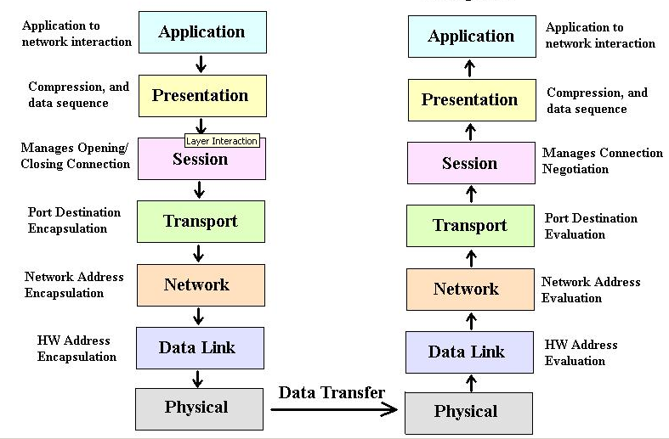

Figure 2.1 Network layer interactions [2]

2.2.1 OSI Model Layers and Information Exchange
The seven OSI layers use various forms of control information to communicate with their peer layers in other computer systems. This control information consists of specific requests and instructions that are exchanged between peer OSI layers. Control information typically takes one of two forms: headers and trailers. Headers are prepended to data that has been passed down from upper layers. Trailers are appended to data that has been passed down from upper layers. An OSI layer is not required to attach a header or a trailer to data from upper layers. Headers, trailers, and data are relative concepts, depending on the layer that analyzes the information unit. At the network layer, for example, an information unit consists of a Layer 3 header and data. At the data link layer, however, all the information passed down by the network layer (the Layer 3 header and the data) is treated as data. In other words, the data portion of an information unit at a given OSI layer potentially can contain headers, trailers, and data from all the higher layers. This is known as encapsulation. Figure 2-2 shows how the header and data from one layer are encapsulated into the header of the next lowest layer. [1]
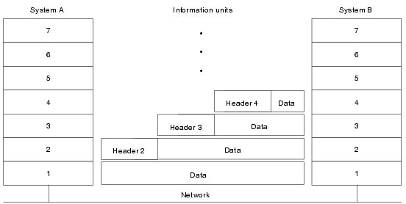

Figure 2.2 Headers and Data Can Be Encapsulated During Information Exchange

Information Exchange Process
The information exchange process occurs between peer OSI layers. Each layer in the source system adds control information to data, and each layer in the destination system analyzes and removes the control information from that data. If System A has data from software application to send to System B, the data is passed to the application layer. The application layer in System A then communicates any control information required by the application layer in System B by pre-pending a header to the data. The resulting information unit (a header and the data) is passed to the presentation layer, which prepends its own header containing control information intended for the presentation layer in System B. The information unit grows in size as each layer pre-pends its own header (and, in some cases, a trailer) that contains control information to be used by its peer layer in System B. At the physical layer, the entire information unit is placed onto the network medium. The physical layer in System B receives the information unit and passes it to the data link layer. The data link layer in System B then reads the control information contained in the header prepended by the data link layer in System A. The header is then removed, and the remainder of the information unit is passed to the network layer. Each layer performs the same actions. [1] The layer reads the header from its peer layer, strips it off, and passes the remaining information unit to the next highest layer. After the application layer performs these actions, the data is passed to the recipient software application in System B, in exactly the form in which it was transmitted by the application in System A
Information Formats
The data and control information that is transmitted through internetworks takes a variety of forms. The terms used to refer to these information formats are not used consistently
in the internetworking industry but sometimes are used interchangeably. Common information formats include frames, packets, datagrams, segments, and messages, cells, and data units. [1]
A frame is an information unit whose source and destination are data link layer entities. A frame is composed of the data link layer header (and possibly a trailer) and upper-layer data. The header and trailer contain control information intended for the data link layer entity in the destination system. Data from upper-layer entities is encapsulated in the data link layer header and trailer. Figure 2-3 illustrates the basic components of a data link layer frame.
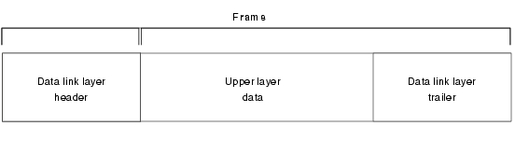
Figure 2.3 Data link layer Frame
A packet is an information unit whose source and destination are network layer entities. A packet is composed of the network layer header (and possibly a trailer) and upper-layer data. The header and trailer contain control information intended for the network layer entity in the destination system. Data from upper-layer entities is encapsulated in the network layer header and trailer. Figure 2-4 illustrates the basic components of a network layer packet.
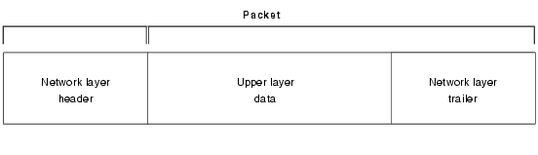
Figure 2.4 Network Layer Packet Format
The term datagram usually refers to an information unit whose source and destination are network layer entities that use connectionless network service. The term segment usually refers to an information unit whose source and destination are transport layer entities. A message is an information unit whose source and destination entities exist above the network layer (often at the application layer).
A cell is an information unit of a fixed size whose source and destination are data link layer entities. Cells are used in switched environments, such as Asynchronous Transfer Mode (ATM) and Switched Multi-megabit Data Service (SMDS) networks. A cell is composed of the header and payload. The header contains control information intended for the destination data link layer entity and is typically 5 bytes long. The payload contains upper-layer data that is encapsulated in the cell header and is typically 48 bytes long. The length of the header and the payload fields always are the same for each cell.
Figure 2-5 depicts the components of a typical cell.
Figure 2.5 Two Components Make Up a Typical Cell
Data unit is a generic term that refers to a variety of information units. Some common data units are service data units (SDUs), protocol data units, and bridge protocol data units (BPDUs). SDUs are information units from upper-layer protocols that define a service request to a lower-layer protocol. PDU is OSI terminology for a packet. BPDUs are used by the spanning-tree algorithm as hello messages.
Connection-Oriented and Connectionless Network Services
In general, transport protocols can be characterized as being either connection-oriented or connectionless. Connection-oriented services must first establish a connection with the desired service before passing any data. A connectionless service can send the data without any need to establish a connection first. In general, connection-oriented services provide some level of delivery guarantee, whereas connectionless services do not.
Connection-oriented service involves three phases: connection establishment, data transfer, and connection termination. [1]
During connection establishment, the end nodes may reserve resources for the connection. The end nodes also may negotiate and establish certain criteria for the transfer, such as a window size used in TCP connections. This resource reservation is one of the things exploited in some denial of service (DOS) attacks. An attacking system will send many requests for establishing a connection but then will never complete the connection. The attacked computer is then left with resources allocated for many never-completed connections. Then, when an end node tries to complete an actual connection, there are not enough resources for the valid connection.
The data transfer phase occurs when the actual data is transmitted over the connection. During data transfer, most connection-oriented services will monitor for lost packets and handle resending them. The protocol is generally also responsible for putting the packets in the right sequence before passing the data up the protocol stack.
When the transfer of data is complete, the end nodes terminate the connection and release resources reserved for the connection. [1]
Connection-oriented network services have more overhead than connectionless ones. Connection-oriented services must negotiate a connection, transfer data, and tear down the connection, whereas a connectionless transfer can simply send the data without the added overhead of creating and tearing down a connection. Each has its place in internetworks.

Flow Control Basics
Flow control is a function that prevents network congestion by ensuring that transmitting devices do not overwhelm receiving devices with data. A high-speed computer, for example, may generate traffic faster than the network can transfer it or faster than the destination device can receive and process it. The three commonly used methods for handling network congestion are buffering, transmitting source-quench messages, and windowing.
Buffering is used by network devices to temporarily store bursts of excess data in memory until they can be processed. Occasional data bursts are easily handled by buffering. Excess data bursts can exhaust memory, however, forcing the device to discard any additional datagrams that arrive.
Source-quench messages are used by receiving devices to help prevent their buffers from overflowing. The receiving device sends source-quench messages to request that the source reduce its current rate of data transmission. First, the receiving device begins discarding received data due to overflowing buffers. Second, the receiving device begins sending source-quench messages to the transmitting device at the rate of one message for each packet dropped. The source device receives the source-quench messages and lowers the data rate until it stops receiving the messages. Finally, the source device then gradually increases the data rate as long as no further source-quench requests are received. [1]
Windowing is a flow-control scheme in which the source device requires an acknowledgment from the destination after a certain number of packets have been transmitted. With a window size of 3, the source requires an acknowledgment after sending three packets, as follows. First, the source device sends three packets to the destination device. Then, after receiving the three packets, the destination device sends an acknowledgment to the source. The source receives the acknowledgment and sends three more packets. If the destination does not receive one or more of the packets for some reason, such as overflowing buffers, it does not receive enough packets to send an acknowledgment. The source then retransmits the packets at a reduced transmission rate.

Error-Checking Basics
Error-checking schemes determine whether transmitted data has become corrupt or otherwise damaged while traveling from the source to the destination. Error checking is implemented at several of the OSI layers. [1]
One common error-checking scheme is the cyclic redundancy check (CRC), which detects and discards corrupted data. Error-correction functions (such as data retransmission) are left to higher-layer protocols. A CRC value is generated by a calculation that is performed at the source device. The destination device compares this value to its own calculation to determine whether errors occurred during transmission. First, the source device performs a predetermined set of calculations over the contents of the packet to be sent. Then, the source places the calculated value in the packet and sends the packet to the destination. The destination performs the same predetermined set of calculations over the contents of the packet and then compares its computed value with that contained in the packet. If the values are equal, the packet is considered valid. If the values are unequal, the packet contains errors and is discarded.

Multiplexing Basics
Multiplexing is a process in which multiple data channels are combined into a single data or physical channel at the source. Multiplexing can be implemented at any of the OSI layers. Conversely, demultiplexings is the process of separating multiplexed data channels at the destination. One example of multiplexing is when data from multiple applications is multiplexed into a single lower-layer data packet. Figure 2-6 illustrates this example.

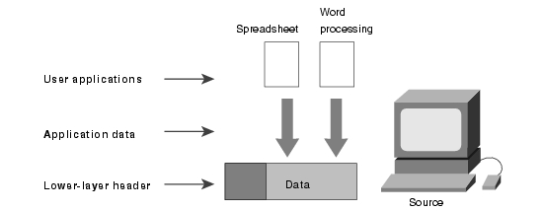
Figure 2.6 Multiple Applications Can Be Multiplexed into a Single Lower-Layer Data Packet

Another example of multiplexing is when data from multiple devices is combined into a single physical channel (using a device called a multiplexer). Figure 2-7 illustrates this example.

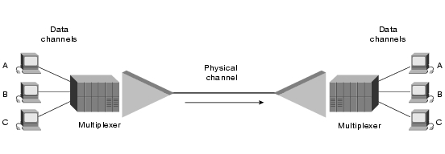
Figure 2.7 Multiple Devices Can Be Multiplexed into a Single Physical Channel

A multiplexer is a physical layer device that combines multiple data streams into one or more output channels at the source. Multiplexers demultiplex the channels into multiple data streams at the remote end and thus maximize the use of the bandwidth of the physical medium by enabling it to be shared by multiple traffic sources.
Some methods used for multiplexing data are time-division multiplexing (TDM), asynchronous time-division multiplexing (ATDM), frequency-division multiplexing (FDM), and statistical multiplexing. [1]
In TDM, information from each data channel is allocated bandwidth based on preassigned time slots, regardless of whether there is data to transmit. In ATDM, information from data channels is allocated bandwidth as needed by using dynamically assigned time slots. In FDM, information from each data channel is allocated bandwidth based on the signal frequency of the traffic. In statistical multiplexing, bandwidth is dynamically allocated to any data channels that have information to transmit.

2.3 Networking Protocols and Standards
A protocol in the context of networking is essentially a system of rules which define how data is transferred from a source to a destination, at different levels of abstraction from the physical level of electrical pulses carried via cables or wireless, or fiber-optical signals, to the more abstract level of messages sent by an application such as email.
In order for computers with different hardware and operating systems to be able to communicate effectively over a network or an internet, it is clearly important for there to be a uniform set of protocols and standards which the communicating systems and applications will conform to. This in turn suggests a need for organizations with commonly recognized authority that will develop, define and publish standards in different domains.

2.3.1 PDU, Protocol Data Unit
Layers communicate using a thing called a PDU, or Protocol Data Unit. Each layer may have a different PDU format, etc. It is only required that corresponding layers be able to understand their PDU (the interface between layers). For this purpose, we often attach a number to the PDU, to know what layer it belongs to. For example, a 3-PDU would correspond to the 3rd layer PDU, and so on for any N-PDU. Layer N needs to be able to talk to layer N + 1 and layer N − 1, but not to any other layer.

Encapsulation
Layers are arranged in a way that each layer only has to know about layers that are directly below or directly above. All data from the higher layers is wrapped (and subsequently unwrapped at the destination) so that, for example, the data-link layer doesn’t have to know whether you’re browsing the web or transferring files—all it sees are just a bunch of bits that need to be transferred.
Services
We can also view the layered model as higher layers getting services from lower layers and lower layers providing a service to higher layers.
Service Access Points
An entity at layer N may service more than one entity at layer N + 1. Layer N may use a Service Access Point address to determine which entity at a higher layer will get serviced. An example of that are Port addresses in TCP/IP.
Lower Layer Protocols
The first layers of the OSI model include functions of the physical, data link, and network layers. It is important that we grasp what is going on at these layers in order to comprehend the various protocols that we often hear of. We will begin by examining the first level of interaction with the transmission medium itself - the physical layer and its specifications.
2.3.2 Physical Layer Specifications
Today's popular LAN types delineate themselves by how they allow data to reach the transfer medium (coax, fiber optic, etc.). In effect they control aspects of both the physical layer of the OSI model and the data link layer. There are, however, specifications dealing with just the physical layer. These are important because they control movement of data between devices that often interact with the networks including PCs and modems.

The RS-232 Standard

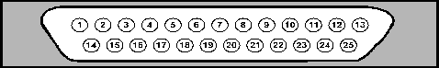
Figure 2.8 the DB-25 connector is typically used in implementing RS-232 specifications.

1-Protective Ground | 2-Transmit Data | 3-Receive Data | 4-Request to Send | 5-Clear to Send
6-Data Set Ready | 7-Signal Ground | 8-Carrier Detect | 9-Reserved | 10-Reserved
11-Unassigned | 12-Sec. Carrier Detect | 13-Sec. Clear to Send | 14-Sec. Transmit | 15-Transmit Clock
16-Sec. Receive Data | 17-Receiver Clock | 18-Unassigned | 19-Sec. Req. to Send | 20-Data Terminal Ready
21-Signal Quality Detector | 22-Ring Indicator | 23-Data Rate Select | 24-External Clock | 25-Unassigned

Figure 2.9 pin description of RS-232

This standard was developed by the Electronic Industries Association (EIA) to provide a reference for connecting Data Terminal Equipment (DTE) with Data Circuit-terminating Equipment or Data Communications Equipment (DCE). An example would be connecting a PC to a modem. This connection would take place over a standard type of connector and cable according to the RS-232 spec. The cabling type has changed through the years. [5]
The specification calls not only for certain cabling and connectors, it also details voltage levels on the cable and what these voltage levels represent.
RS-232 formerly described a 25-pin connector (typically a DB-25 connector) and the functions of data traveling down each pin. As this is a physical layer process, the data is simply electrical impulses. Figure 2.8 illustrates the arrangement of the pins and what they represent. The cabling is to be no more than 50 feet in length and capable of supporting all 25 channels of impulses. The voltage levels include -3V to represent a binary 1 and +3V to represent a binary 0. The speed of the transmission is no more than 20 Kbps. If two computers wish to communicate through modems, a standard procedure called "handshaking" takes place. Handshaking is simply a way to initiate data transmission
Other Standards
The EIA enhanced the RS-232 standard in the mid-70s and created the RS-449 Specification. This spec describes a more resilient connection of devices with more intricate data transmission specifications and increased distance capabilities. The result was a faster but more costly and cumbersome system. A newer specification called EIA530 solves problems by allowing the RS-449 specs to be used with RS-232's common DB-25 connector.
The Consultative Committee on International Telegraphy and Telephony (CCITT) has its own set of physical layer specifications called the X series. The X series is numbered (i.e. X.25) and mainly deals with public data networks. The specs numbered 1 through 39 deals with all manner of data transmission techniques and devices. Those numbered 40 through 199 involve network activities including structure and transmission methods. CCITT's V series specifications deal with communication interfaces and speeds.
The telecommunication industry also uses its own specifications. T-1 is a designation of a specific type of transmission line capable of carrying data at 1.544 Mbps in the US and 2.048 Mbps in Europe. The T-1 can be dedicated to carry only digital data or it can carry 24 voice channels that have been digitized. The T-3 lines can carry data at 45.54 Mbps. It is the equivalent of many T-1 links. It, too, may be used for all-digital data or for digitized voice lines.

2.3.3 Data Link Layer Specifications
The physical layer takes care of getting data on the wire and off of it again. At the data link layer, we must take this incoming stream of data from higher or lower layers and create frames from it. Handling the data requires a solid protocol that can perform better error checking and more efficient throughputs. The first to really address these needs was the Synchronous Data Link Control (SDLC) protocol from IBM. Developed for their Systems Network Architecture (SNA) systems, IBM created what is known as a bit-oriented protocol. This meant that specific bits themselves had meaning. Information wasn't formed just on the byte level. [6]
SDLC supported the computer structure of the 70s with provisions for host systems. Primary devices as well as secondaries were supported. Primary devices are those that control a communications channel to themselves or other devices. The other devices are called secondary devices were able to assume the role of either primary or secondary depending on the need. Functionality beyond this was added by the standards-setting organization that adapted and renamed SDLC. The ISO termed it as High level Data Link Control (HDLC), ANSI called it Advanced Data Communication Control Procedures (ADCCP) and CCITT later termed it Link Access Procedure - B (LAPB).
A SDLC frame consists of several fields that comprise a command that is sent to secondaries. The secondaries use their own unique frame to respond to the commands.

There are three different types of command frames.
1. Supervisory frames carry acknowledgments, flow control and status information.
2. Data frames carry general carry information for upper layers.
3. Unnumbered frames are used for station initialization and testing procedures
The first field in the SDLC frame is the flag field. It carries a special arrangement of bits that ordinarily would not occur elsewhere within the frame. In order to make sure the flag field is unique, SDLC uses "bit stuffing", a method by which any consecutive group of more than five 1s are broken up by a 0. The receiver recognizes this and removes the 0. The same flag is used to signal the end of a frame.

Flag | Address | Control | Data | Frame Check Sequence | Flag
Figure 2.10 SDLC Data Frame

The address field contains the unique address of a secondary that the SDLC frame is coming from or going to. The control field follows with one or two bytes worth of information. It denotes whether the frame is a supervisory, a data or an unnumbered frame. Supervisory frames are mainly used to allow or disallow transmission between a secondary and primary. The control frame begins with a 10 pattern that signifies that the frame will be a supervisory one. As a response to an information frame, this field may communicate that a frame has been rejected, that a secondary is ready to receive, that a primary is polling a secondary, or that a secondary is not able to accept any more frames. If there is a problem then the receive sequence number is not changed and the packet with the error can be resent. After the P/F bit, an information field follows.
The Unnumbered frames are used to create and destroy connections between senders and receivers. The control field for an unnumbered frame begins with an 11. The frame itself contains no sequence numbers. Each SDLC frame contains a Cyclical Redundancy Check field (CRC). This special value is created from the contents of the frame and is used in error detection. The sender places the frame contents through an equation and generates a CRC. It then sends the CRC with the frame. The receiver runs each frame through the same equation. The CRC that it comes up with must match the one in the frame, or the frame is discarded. SDLC uses a 16-bit CRC.
HDLC uses a 32-bit CRC and is very similar to SDLC. As a close cousin, its functions are virtually identical to SDLC with the exception of a few minor differences. The importance of HDLC lies in its three transfer modes that are borrowed for yet another SDLC cousin - LAPB. HDLC's transfer modes are as follows:
1. ARM - Asynchronous Response Mode. This mode allows a secondary machine that normally must receive permission from the primary to transmit; to communicate at will with the primary.
2. NRM - Normal Response Mode. This mode allows secondaries to transmit only after having received permission to do so from a primary device.
3. ABM - Asynchronous Balance Mode - This mode allows machines that function as both primaries and secondaries to communicate at will.
LAPB is very similar to SDLC and HDLC. LAPB operates only in an Asynchronous Balanced Mode fashion.

Ethernet Systems
Ethernet was originally conceived of in the early 70s by Xerox designers. Its successful use in the Xerox Alto PC led two a consortium of three companies who wanted to be able to interlink various minicomputers. The companies were Digital Equipment Company (DEC), Intel Corporation and Xerox Corporation. Intel took on the task of providing the chips for NICs. Xerox wrote the software to operate it and DEC stepped in to make use of the technology for its minicomputers. The result was a high-speed connection that provided an alternative to IBM's networking architectures. In 1980 these companies released a specification for Ethernet Version 1. This version was followed by a second version in 1982. These early versions comprise the standard we should refer to as "Ethernet" today.
Version 1 Ethernet's specifications called for a contention access method to the physical cabling. This meant that machines had to monitor the LAN for an opportunity to use the wire if necessary. This technology is called Carrier Sense Multiple Access/Collision Detection or CSMA/CD. The physical cabling was and is known as thick coaxial cable (.405 inches in diameter and fairly rigid). It supported a standard throughput of 10 Mbps and the maximum length of cable allowed between nodes of about 500 meters (about 1500 feet).
Ethernet's frame size and content was defined by the Version 1 standard as well. This early standard has become known as the DIX Standard. DIX is an acronym for DEC, Intel and Xerox. This frame size may be between 72 and 1526 bytes in length. The spec also called for Manchester encoding is used for the digital signal.
Soon after Ethernet Version 2 was released in 1982, the IEEE 802 Committee issued its own standard for Ethernet-type networks. Not surprisingly, the 802 spec was startlingly similar to Ethernet 2. Let's compare the frames of Ethernet and 802.3 so you can see the differences as well as the similarities. [6]

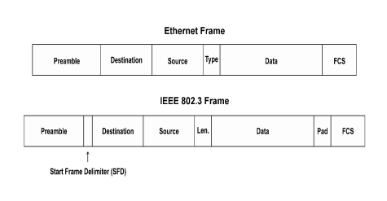
Figure 2.11 The Ethernet and IEEE 802.3 Frames Compared

The preamble for the Ethernet frame is 8 bytes (technically called octets) in length. It is actually the repetitive pattern of 10101010 for seven bytes followed by one byte with a 10101011 pattern. The preamble for 802.3 is identical except the final byte is called the "Start Frame Delimiter" or SFD. The destination address follows for both frame types. This field is 6 bytes in length. It is followed by a source address field that is also six bytes in length. In the Ethernet frame, the next field is the type field that specifies the software protocol (TCP/IP, NetWare) with which the Ethernet frame is being used. This field is typically called the Ethertype field.
In the 802.3 frame, the type field was replaced with a length field that provides the length in octets of the data field to follow. The data field contains information bound for the higher layers in the OSI model. This structure can vary in length from 46 bytes to 1500 bytes. In IEEE framework, the data is considered to be a data unit from another layer. If that data unit is less than 46 bytes, it is padded to bring it to that minimum length. Therefore a pad field may or may not exist.
Finally, both frame types have a 32-bit (8 byte) CRC check field that is created out of information from other fields. In the Ethernet frame, CRC is computed from the address, type and data fields. In 802.3, the CRC is created from the address, length, data and pad fields. It should be plainly evident that in spite of striking similarities between the two frame types, there are a couple of crucial differences. First, Ethernet has no length field and 802.3 have no type field. Upper layers that might use this information would obviously get confused. Second, Ethernet provides no padding to make sure its data field is at least 46 bytes in length. This task would have to be performed by another layer. There is one other difference worth noting. The oldest version of Ethernet does not use a special signal known as SQE (Signal Quality Error) so using it with more modern Ethernet-type systems presents a problem. Since the 802.3 frame is the most commonly used today, we'll limit our discussion to it and the specifications surrounding its use. And for the sake of keeping our vernacular constant with what we experience today, we'll refer to the 802.3 frame generically as "Ethernet”. Ethernet as a protocol (packet type), deals only with the Physical and Data Link layers of the OSI model. The layers above these are involved with software protocols such as NetWare's IPX and SPX packet types or TCP/IP packets. In transmitting TCP/IP on an Ethernet LANs, the TCP/IP information is placed in the data field of the Ethernet frame. When the frame is received, the Ethernet stuff is stripped away leaving TCP/IP information for higher layers.
There is another crucial difference between Ethernet specs and 802.3 specs. Ethernet only specifies one type of physical medium - thick coax. The 802.3 standards provide for several physical media including coax, twisted pair and fiber. Each of these standards has been given a unique designation by the 802.3 subcommittee. An example of one of these designations is "10BASE5". This specifies that the LAN throughput is 10 Mbps (10). It is a baseband network; meaning only digital data is transmitted on it (BASE). Finally, the maximum length of medium acceptable between any two nodes is about 500 meters (5). Here is a breakdown of what designations there are and what they entail.

ARC net Systems
ARC net could be called the protocol that would not die. That's because although there are newer and faster networking solutions, ARC net has a loyal following due to unrivaled interoperability among vendors and budget-oriented pricing. The Attached Computer Resources network (ARC net) was created by a company called Data point in the late 70s. Later on this technology was licensed out to SMC (Standard Microsystems Corporation) who is still manufacturing ARC net products today. The interesting thing about ARC net is that its speed was based on the fastest speeds of disk drive subsystems in the late 70s ARC net typically uses a star topology, though it can use a bus, and supports coax, TP or fiber. ARC net can actually combine topologies as in the case where nodes are hooked up in a bus topology radiating from a central hub device. [7]

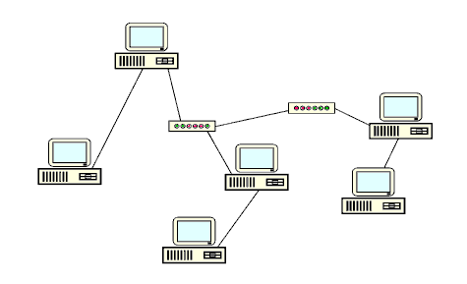

Figure 2.12 : ARC net LANs can utilize a star topology and a bus topology together.

In order to accommodate all of the different types of mediums out there, ARC net vendors have created just about every kind of connector you can imagine. This includes coax to TP converters as well as coax and fiber converters.

Fiber Distributed Data Interface (FDDI)-
FDDI, in a nutshell, is like very fast token ring on fiber. Its throughput speed is 100 Mbps, and compared to standard token ring and Ethernet, that is fast. FDDI was designed for a couple of main reasons. First, it allows mainframe and minicomputers networks to move data at a much higher speed, or it can serve as a high speed backbone for several LANs. Second, highly processor and data intensive applications such as Computer-Aided Design (CAD) systems needed to be able to move and retrieve huge volumes of data in a rapid fashion. [8]
FDDI shares many commonalties with token ring. Its layout is similar. It uses a token. It is similarly fault-tolerant. It can be easily managed, and FDDI can be easily integrated with token ring. As far a frame construction, FDDI is very similar to token ring in that there are token frames and data frames. Here is a breakdown:

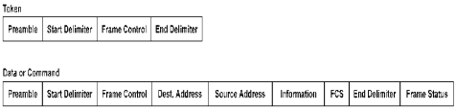
Figure 2.13 : FDDI mainframe

Each node in a FDDI network has built-in clock that allows data signals to be correctly interpreted. The preamble contains a group of sixteen 1s to synchronize the receiving station's clock. The starting delimiter is next followed by a frame control field that provides information such as whether the transmission is synchronous or asynchronous, whether a 16-bit or 48-bit address will be used, and whether the frame is used on the receiver's MAC layer or passed up to the LLC layer. The destination and source addresses follow. They are typical addresses. If the first bit of the destination address is a 1 then the message is designed to go to every node on the ring. It is a "broadcast" message. The data field follows with a frame check status field behind. The FCS carries a 32-bit CRC created from the frame control, address and information fields.
The end delimiter signifies whether or not the frame was a token or data frame. Finally the frame status field works just like token rings. It signifies if a frame has been received and copied into the memory of the intended receiver. The FDDI token has only 4 fields. It has a preamble, start delimiter, a frame control field and an end delimiter. The end delimiter contains information signifying that the frame is a token, not a data frame. FDDI is replete with fault-tolerance offering a dual counter-rotating ring for redundancy. If the primary ring fails, the secondary ring will allow nodes to continue to operate. Machines on the ring are classified in A or B groupings. Stations are those that make use of a second ring for fault-tolerance. B stations are only on the primary ring. Thus, if the primary ring fails, all Class B nodes would be inoperative. According to specification, FDDI rings are not supposed to have over 1000 nodes or extend beyond 200 kilometers in circumference. About every 2 km or so, a repeater is needed to boost the signal along the fiber optic cabling. Fortunately, fiber optic cable is not susceptible to EMI.
FDDI with its many features and speed will continue to grow in its acceptance as a practical backbone for most LANs. Mass production has decreased the expense of getting into FDDI. Some vendors are selling their FDDI wares at half the price they were a year ago. These trends are favorable for what is a costly system to implement. One day, FDDI may be commonplace at the desktop. The main companies supporting FDDI are Intel, Codenoll, Cisco Systems, Fibronics, Interphase, Rockwell/CMC, Advanced Micro Devices, National Semiconductor and IBM.

2.4 Data Link Layer and its Protocols
2.4.1 The Data Link layer performs a number of separate activities, including:

- Physical addressing
- Network topology
- Error notification
- Access to the physical medium
- Flow control
Different data link layer specifications define different network and protocol characteristics, including physical addressing, network topology, error notification, sequencing of frames, and flow control.
Physical addressing is not to be confused with network or IP addressing. The physical address defines how devices are labeled in the data link layer. This physical address is most commonly called the Media Access Control (MAC) address. The MAC address is a unique number assigned by the manufacturer. This numbering system is actually administered by one of the networking governing bodies.
Network topology consists of the data-link layer specifications that often define how devices are to be physically connected, such as in a bus or a ring topology. Error notification alerts upper layer protocols that a transmission error has occurred, and the sequencing of data frames reorders frames that are transmitted out of sequence. Finally, flow control moderates the transmission of data so that the receiving device is not overwhelmed with more traffic than it can handle at one time. [3]
The data link layer also provides service to the Network Layer above it:
- The network layer is interested in getting messages to the corresponding network layer module on an adjacent machine.
- The remote Network Layer peer should receive the identical message generated by the sender (e.g., if the data link layer adds control information, the header information must be removed before the message is passed to the Network Layer).
- The Network Layer wants to be sure that all messages it sends, will be delivered correctly (e.g., none lost, no corruption). Note that arbitrary errors may result in the loss of both data and control frames.
- The Network Layer wants messages to be delivered to the remote peer in the exact same order as they are sent.
The Data Link layer is divided into two sub layer by the 802 standards:
- Logical Link Control (LLC)
- Media Access Control (MAC) sub layers.

2.4.1.1 Logical Link Control (LLC)
Conceptually, the LLC sub layer sits on top of the MAC sub layer. It's defined by the 802.2 standard to be topology independent. [9]
The LLC functions include:
- Managing frames to upper and lower layers
- Error Control
- Flow control
- The LLC works with the transport layer by providing connection-oriented and connectionless services. It manages and creates the communication link.
The LLC sub layer transfers data in two ways:
- Connectionless services: Messages are not acknowledged by the receiving device, which speeds up the processing. Although it sounds unreliable, this type of transfer is commonly used at this level because the upper OSI layers implement their own error checking and control.
- Connection-oriented services: Because each message is acknowledged, this service is much slower than connectionless services, but it's much more reliable. [3]

2.4.1.2 Flow Control
Another communications control defined on the LLC sub layer is flow control. The Transport layer of the OSI model actually manages the mechanisms used to control the flow of data between two hosts. The Data Link layer defines the data values used in the flow control signaling between two transmitting hosts. [18]
There are two types of flow control implemented in data communications - software and hardware:
- Software flow control, common to networking, involves a process called XON/XOFF, which roughly stands for transmission on/transmission off.
- Hardware flow control, also called RTS/CTS (ready to send/clear to send), uses two wires in a cable, one for RTS and one for CTS. When either is turned off, the flow is interrupted.
2.4.1.3 Error Detection-
Another function of the Data Link layer is error detection. Error detection is the process of detecting whether errors occurred during the transmission of the bits across the wire. The Data Link layer uses a calculated value called the CRC (Cyclic Redundancy Check) that's placed into the Data Link trailer that's added to the message frame before it's sent to the Physical layer. The receiving computer recalculates the CRC and compares it to the one sent with the data. If the two values are equal, it's assumed that the data arrived without errors. Otherwise, the message frame may need to be retransmitted under control of an upper layer. Although the Data Link layer implements error detection, it does not include a function to perform error recovery. This is left for the upper layers to deal with, primarily on the Transport layer. [3]
2.4.1.4 MAC-
The MAC sub layer carries the physical address of each device on the network. This address is more commonly called a device's MAC address. The MAC address is a 48-bit address that's encoded on each network device by its manufacturer. It's the MAC address that the Physical layer uses to move data between nodes of the network.
2.4.1.5 ARP (Address Resolution Protocol)-
ARP maintains a small database in memory, called the ARP cache, those cross-references physical and logical addresses. When a device wants to communicate with a local device, it checks its ARP cache to determine whether it has that device's MAC address. If it doesn't, it sends out an ARP broadcast request to all devices on the local network. Each device examines the message to see whether the request is intended for it. If it is, the device responds with its MAC address, which is stored in the sending device's ARP cache.
2.4.1.6 CSMA/CD (Carrier Sense Multiple Access/Collision Detection)-
CSMA/CD is the method used in Ethernet networks for controlling access to the physical media by network nodes. CSMA/CD process can be described as follows: [10]
- Listen to see whether the wire is being used.
- If the wire is busy, wait.
- If the wire is quiet, send.
- If a collision occurs while sending, stop wait a specific amount of time, and send again.

2.5.1 General HDLC Frame Format:

Figure 2.14: General HDLC Frame

Opening flag 8 bits [01111110] [7E Hex]
Address 8 bits/16 bits
Control 8 bits or 16 bits
Data Variable, not used in some frames, or may be padded to complete the fill
CRC 16 bits, or 32 bits
Closing Flag 8 bits [01111110] [7E hex]
User data which contains 7E is resolved using an escape sequence which converts 7E to 7D-5E [with 7D being the escape character]. If 7D is used in the data stream it again is converted into 7D-5D. Address 11111111 is known as all stations, 00000000 is this station. Frames may be aborted by sending an abort sequence [01111111] instead of the normal flag sequence [01111110]. An abort sequence will cause the frame to be discarded. During idle times when no frames are being transmitted idle flags [11111111] may be sent to fill the area between frames. A continuous series of flags [01111110] may be sent to fill the area between frames instead of sending idle flags [11111111].

Figure 2.15 Fill between Frames

2.5.2 Bit stuffing
To guarantee that a flag does not appear inadvertently anywhere else in the frame, HDLC uses a process called bit stuffing. Every time the user wants to send a bit sequence having more than 5 consecutive 1s, it inserts (stuffs) one redundant 0after the fifth 1. For example the sequence 01111111111000 becomes 011111101111000. This extra zero is inserted regardless of whether the sixth bit is another one or not. Its presence tells the receiver that the current sequence is not a flag. Once the receiver has seen the stuffed 0, it is dropped from the data and the original stream is retorted. Fig.2.16 shows the bit stuffing at the sender’s end and bit removal at the receiver.

0001111111110011111100
Flag Address Control 0001111101100111110100 FCS Flag
stuffed bits
Data sent
Flag Address Control 0001111101100111110100 FCS Flag

00011111110011111100

Figure 2.16 bit stuffing and removal

When it finds five consecutive 1s after a zero, it checks the seventh bit. If the seventh bit is a 0, the receiver recognizes it as a stuffed bit and discards it, and resets the counter. If the seventh bit is a 1, the receiver checks the eighth bit. If the eighth bit is another 1, the receiver continues counting. A total of 7 to 14 consecutive 1s indicates an abort. A total of 15 or more 1s indicates an idle channel.

2.5.3 HDLC Opening Flag
8 bits [01111110], [7E hex]. The Opening flag may be preceded by additional flags [01111110] or idle flags [11111111], both used as inter-frame fill.
2.5.4 HDLC Address Field
The length of the address field depends on the data link layer protocol used, but is normally 0, 8 or 16 bits in length. In many cases the address field is typically just a single byte, but an Extended Address [EA] bit may be used allowing for multi-byte addresses. A one residing in the LSB bit indicates [the end of the field] that the length of the address field will be 8 bits long. A zero in this bit location [now the first byte of a multi-byte field] indicates the continuation of the field [adding 8 additional bits]. The SDLC protocol will use only an 8-bit address. The SS7 protocol, which is used in point-to-point links, does not use an address field at all. The first [MSB] bit in the Address field indicates if the frame is a unicast or multicast message. A zero in the MSB bit location indicates a unicast message; the remaining bits indicate the destination node address. A one in the MSB bit location indicates multicast message, the remaining bits indicate the group address.
2.5.5 HDLC Control Field
the Control field is 8 or 16 bits and defines the frame type; Control or Data. The Control field is protocol dependent.
2.5.6 HDLC Data Field
the Data field may vary in length depending upon the protocol using the frame. Layer 3 frames are carried in the data field.
2.5.7 HDLC FCS Field
The CRC [Cyclic Redundancy Checking] or FCS [Frame Check Sequence] contains an error checking number that the Destination can use to verify that the packet is error free. This is usually done by the data link protocol and calculated CRC is appended to the end of the data link layer frame.
FCS [16 bits] = X16 + X12 + X5 + 1
FCS [32 bits] = X32 + X26 + X23 + X22 + X16 + X12 + X11 + X10 + X8 + X7 + X5 + X4 + X2 + X + 1

Cyclic Redundancy Check
The CRC is calculated by performing a modulo 2 division of the data by a generator polynomial and recording the remainder after division. [13]
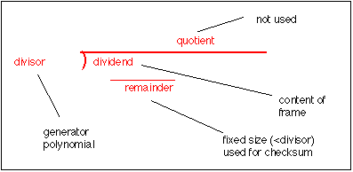
Three polynomials are in common use they are:
CRC-16 = x16 + x15 + x2+ 1 (used in HDLC)
CRC-CCITT = x16 + x12 + x5 + 1
CRC-32 = x32 + x26 + x23 + x22 + x16 + x12 + x11 + x10 + x8 + x7 + x5 + x4 + x2 + x + 1
Although this division may be performed in software, it usually performed using a shift register and X-OR gates. The hardware solution for implementing a CRC is much simpler than a software approach. One example for a CRC-16 is:
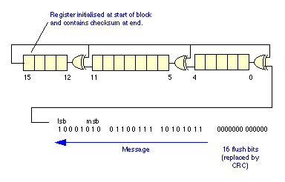
A practical implementation of a decoder also requires a method to initialise the encoder prior to transmission of the first bit of data in a frame, and to flush the encoder after sending the last byte. In the example below (which uses a different representation of the schematics for X-OR gates and shift register elements), the process starts by initialising the encoder with zero bits, by setting the switch to B. Some CRC's initialise the register to a non-zero value, which can give added detection capability when the first set of bits in a frame may themselves be zero. Then the switch is moved to position A and one data bit enter the encoder for each clock cycle. The data bits are immediately available at the output. After the last bit has been sent, the switch is returned to position B and the contents of the encoder are sent to the output. This is often called flushing the encoder and requires one clock cycle per bit held in the shift register.

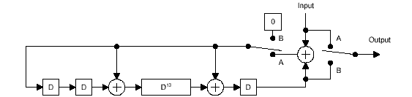

Figure 2.17: Diagram of suggested implementation of an Encoder/Decoder

On reception, the process is reversed. The CRC register is first set to zero (or the initial value on transmission, if non-zero). The bits (this time including the CRC) are fed into the register on each clock cycle. If the CRC contains the value zero (assuming initialisation was zero), the CRC is valid, if not it has detected an error. The CRC-16 is able to detect all single errors, all double errors, all odd numbers of errors and all errors with burst less than 16 bits in length. In addition 99.9984 % of other error patterns will be detected. Protocols at the network layer and higher (e.g. IP, UDP, TCP) usually use a simpler checksum to verify that the data being transported has not been corrupted by the processing performed by the nodes in the network.

2.5.8 Bit Order
The CRC is the only field, which is by convention sent most significant bit first. (This is contrary to all header and payload bytes which are sent least significant bit first.) Thus the first bit of the CRC-16 to be sent is the bit corresponding to X16 and the last, the bit corresponding to X1.

2.5.9 Frame Encapsulation:
A few different versions of the HDLC frame are shown below. These include the PPP [Point-to-Point Protocol] HDLC frame, and the Ethernet HDLC frame.

Figure 2.18: Ethernet HDLC Frame Encapsulation

Chapter 3

Design and implementation of HDLC Controller

This chapter contains the description of HDLC design and implementation. In the first section, details of the transmitter are presented and in the second section, the receiver is described. The code described herein has been written in vhdl

Whole design is organized as a collection of 2 sections that work together to efficiently perform the operation as shown in fig. 3.1. These units are:
Transmitter Section:
The Transmit Data Interface provides a byte wide interface between the transmission host and the HDLC Protocol core. Transmit data is loaded into the core on the rising edge of clk when the TxData_Valid input asserted. The start and end bytes of a transmitted HDLC frame are indicated by asserting the appropriate signals with the same timing as the data bytes. The HDLC core will, on receipt of the first byte of a new packet, issue the appropriate flag sequence and transmit the frame data calculating the FCS. When the last byte of the frame is seen, the FCS is transmitted along the closing flag. Extra zeroes are inserted into the Bit stream to avoid transmission of the control flag sequence within the frame data. The transmit data is available on the TxData pin with appropriate setup to be sampled be clk.
Receiver Section:
Receiver accepts a bit stream on port RxData. The data is latched on the rising edge of clk under the control of the enable input RxEN. The flag detection block stream for the flag sequence in order to determine the frame boundaries. Any stuffed zeroes are detected and removed and the FCS is calculated and checked. Frame data is placed on the receiver data interface and made available to the host. In addition, flag information is passed over indicating the start and end bytes of the HDLC frame as well as showing any error condition which may have been detected during receipt of the frame.
Transmitter Interfaces and Ports
Port Name | Direction | Width | Comments
TxClk | I/P | 1 | Clock I/p
Reset_N | I/P | 1 | Synchronous reset
Address_Size | I/P | 1 | Selects address size 8 or 16 bit
TxAddr_En | I/P | 1 | Enables transmission of address field
TxAddr_In | I/P | 8 or 16 bit | Address to be sent
TxFCS_Size | I/P | 1 | For CRC-16 or CRC-32
Enable_FCSError | I/P | 1 | Introduces error in FCS just for testing purpose
TxHDLC_En | I/P | 1 | Transmitter enabled
TxData_req | O/P | 1 | When high transmitter can receive data from upper layer
TxData_Valid | O/P | 1 | Upper layer sends this signal to transmitter indicating that data given to transmitter is valid data.
TxData_In | I/P | 8 | Parallel data in to transmitter
TxData | O/P | 1 | Serial data out from transmitter

TABLE 3.1: I/O Functions of the HDLC Transmitter

Receiver interfaces and ports
Port Name | Direction | Width | Comments
RxClk | I/P | 1 | Clock I/p
Reset_N | I/P | 1 | Synchronous reset
Address_Size | I/P | 1 | Selects address size 8 or 16 bit
RxAddr_Valid | O/P | 1 | Indicates a valid address received
RxAddr_Out | O/P | 16 bit | Address
TxFCS_Size | I/P | 1 | For CRC-16 or CRC-32
RxFCS_Error | O/P | 1 | Indicates error in received data
TxHDLC_En | I/P | 1 | Transmitter enabled
RxHDLC_En | I/P | 1 | Enables receiver section
RxData_Valid | O/P | 1 | A valid data is received
RxData | I/P | 1 | Serial data in to receiver
RxData_Out | O/P | 8 | parallel data out from receiver

TABLE 3.2: I/O Functions of the HDLC Receiver

BLOCK DIAGRAM

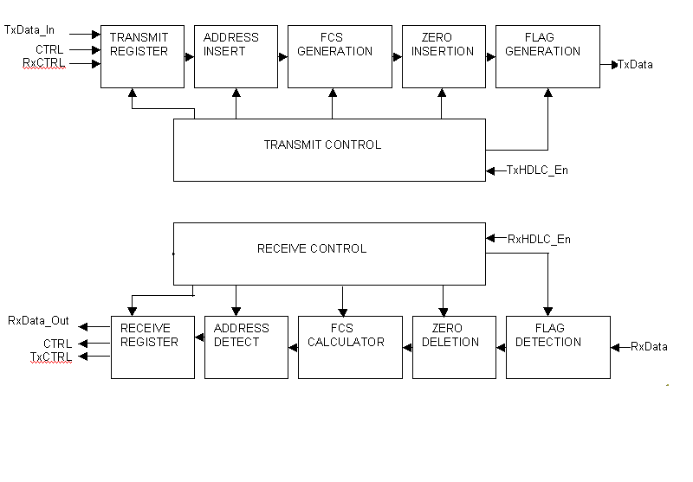
Figure 3.19 basic block diagram of HDLC controller

Transmitter Section:
The transmit data interface provides the byte wise interface between the transmission host and the HDLC protocol core. The HDLC core will on receipt of the first byte of the new packet, issue the appropriate flag sequence and transmit the frame data calculating the FCS. When the last byte of the frame is seen, the FCS is transmitted along with the closing flag. Extra zeroes are inserted into the bit stream to avoid transmission of control flag sequence within the frame data.
The various blocks of the transmitter section are:

Transmit register:
The transmit register contains the data in the bits format to be transmitted. The length of the register can vary according to the length of the data. In case of this HDLC Controller the transmit register is 8 bit long.

Address insertion block:
The length of the address field depends on the data link layer protocol used, but is normally 0, 8 or 16 bits in length this block contains the address of the destination. As many systems can be connected together at the receiver side, therefore, it is important to assign address to each system so that they can be differentiated and the data reaches its proper destination. From here onwards the data along with its destination address are sent to the FCS generation block.

FCS generation block:
A powerful method for detecting errors in the received data is by grouping the bytes of data into a block and calculating a Cyclic Redundancy Check (CRC). This is usually done by the data link protocol and calculated CRC is appended to the end of the data link layer frame.
The CRC is calculated by performing a modulo 2 division of the data by a generator polynomial and recording the remainder after division.
A string of 0s is appended to the data unit. The no. n is less than the no. of data of bits in the predetermined divisor, which is n+ 1 bit.
The newly elongated is divided by the divisor. The remainder is the CRC
CRC replaces n 0 bits derived in step 2 at the end of data unit
Data unit arrives at the receiver data first, followed by CRC. The receiver treats the whole string as a data unit and divides by the same divisor.
If remainder comes out to be 0 the string is error free

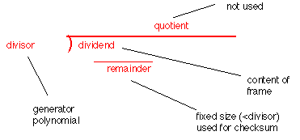

Figure 3.2 Modular Division

Three polynomials are in common use they are:
CRC-16 = x16 + x15 + x2+ 1 (used in HDLC)
CRC-CCITT = x16 + x12 + x5 + 1
CRC-32 = x32 + x26 + x23 + x22 + x16 + x12 + x11 + x10 + x8 + x7 + x5 + x4 + x2 + x + 1 (used in Ethernet)
Although this division may be performed in software, it usually performed using a shift register and X-OR gates. The hardware solution for implementing a CRC is much simpler than a software approach. One example for a CRC-16 is:

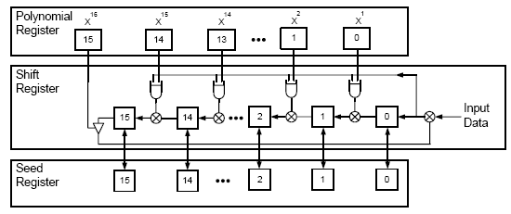

Figure 3.3: Basic Block Diagram of CRC 16

Basic Encoder/Decoder for a 16-bit CRC
- Change the polynomial to a divisor of size N+1
- Make a shift register of size N
- Align the shift register cells with the divisor so that the cells are located between the bits
- Put a XOR gate where there is a 1 in the divisor except for the leftmost bit
- Make a feedback connection from the leftmost bit to the XORs.
Protocols at the network layer and higher (e.g. IP, UDP, TCP) usually the processing has not corrupted use a simpler checksum to verify that the data being transported performed by the nodes in the network.

Zero insertion block:
To guarantee that a flag does not appear inadvertently anywhere else in the frame, HDLC uses a process called bit stuffing. Every time the user wants to send a bit sequence having more than 5 consecutive 1s, it inserts (stuffs) one redundant 0after the fifth 1.

0001111111110011111100
Flag Address Control 0001111101100111110100 FCS Flag
stuffed bits

Figure 3.4: Bit stuffing

Flag generation block:
To inform the receiving station that a new packet is arriving and synchronizes the receive clock with the transmitted clock we add a specific bit pattern at the front and the back of the packet. The specific bit pattern is used to affix with the packet in the case of HDLC Controller is 01111110

Receiver Section:
The HDLC protocol core receiver accepts a bit stream. The flag detection block searches the bit stream for the flag sequence in order to determine the frame boundaries. Any stuffed zeroes are detected and removed by the zero deletion blocks and the FCS is calculated and checked by the FCS-16 or FCS-32 block depending on the control register word. The bit stream is accepted on port RxD. The data is latched on the rising edge of clk under the control of the enable input RxEN. Frame data is placed on the receiver data interface and made available to the host. In addition, flag information is passed over indicating the start and end bytes of the HDLC frame as well as showing any error condition which may have been detected during receipt of the frame.
The receiver can be configured into transparent mode, effectively disabling the HDLC protocol functions. In normal HDLC protocol mode, all received frames are presented to the host on the output register. A status register is provided which can be used to monitor the status of the receiver channel, and indicates if the packet currently being received includes any errors. The various blocks in this section are:

Flag detection block:
This block checks for the incoming flag and on detecting the flag, it drops the flag bits that are attached at the beginning and at the end of the packet and passes on rest of the packet to the next block.

Zero detection block:
This block deletes the stuffed zeroes which were introduced during transmission. The process the receiver follows to identify and a stuffed bit is as follows. As the receiver reads the incoming bits, it counts 1s. When it finds five consecutive 1s after a 0, it checks the next bit. If the seventh bit is a 0, the receiver recognizes it as a stuffed bit discards it and resets the counter

Flag Address Control 0001111101100111110100 FCS Flag

00011111110011111100

RECEIVED BITS

Figure 3.5: Zero deletion

The flow chart in fig.3.6 shows the process the receiver follows to identify and discard a stuffed bit. As the receiver reads the incoming bits, it counts 1s. When it finds five consecutive 1s after a zero, it checks the seventh bit. If the seventh bit is a 0, the receiver recognizes it as a stuffed bit and discards it, and resets the counter.

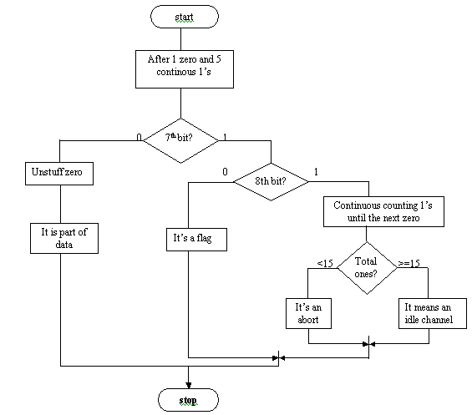
Figure 3.6: Discarding stuffed bit

If the seventh bit is a 1, the receiver checks the eighth bit. If the eighth bit is another 1, the receiver continues counting. A total of 7 to 14 consecutive 1s indicates an abort. A total of 15 0r more 1s indicates an idle channel.

FCS calculator:
This block performs the reverse function of the FCS generator. The whole packet is again divided by the same polynomial that was used at the transmitter end i.e.
CRC-16 = x16 + x15 + x2+ 1
CRC-32 = x32 + x26 + x23 + x22 + x16 + x12 + x11 + x10 + x8 + x7 + x5 + x4 + x2 + x + 1
If after the packet with the polynomial the remainder comes out to be zero that means the transmission and reception are error free and in case the remainder is not zero that means an error has occurred during the process and hence the packet is discarded and the whole packet is retransmitted.

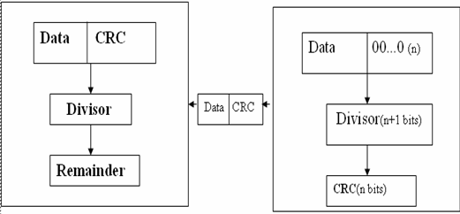

Figure 3.7: FCS calculation

- Data unit arrives at the receiver data first, followed by CRC. The receiver treats the whole string as a data unit and divides by the same divisor.
- If remainder comes out to be 0 the string is error free and is accepted but if the remainder comes out to be other than 0, it is assumed that it contains an error and the whole frame is discarded and is retransmitted.

Address detector:
The address detector detects the address and incase it matches the address of the particular destination it drops it and the rest of the data bits is sent to the receive register.

Receiver register:
This register contains the original 8 data bits that were actually sent from the transmitter.

Chapter 4

Results of Behavioral Simulation and synthesis
This section gives behavioral simulation and results in the form of waveforms. We take different cases and modes of operation of HDLC chip. Circuit is simulated in ModelSim simulator and synthesized by using xilinx synthesis tool.

4.1 Results of behavioral simulation:
A test bench has been written which inserts vectors into transmitter section and loops back it from receiver section to check correctness of results. This test bench has option of selecting 8 bit address or 16 bit address field. This test bench also has control to insert error in transmitted CRC to check correctness of error detection feature of protocol.

4.2.1 Case 1:
Fig 4.1 shows simulation results for 16 bit address (6699 HEX) and a fixed pattern data (7E Hex).Address size control is kept at high and no error is introduced in data transmission.

4.2.2 Case 2:
Fig 4.2 shows simulation results for 16 bit address (6699 HEX) and a fixed pattern data (AA Hex).Address size control is kept at high and no error is introduced in data transmission.

4.2.3 Case 3:
Fig 4.1 shows simulation results for 16 bit address (6699 HEX) and a fixed pattern data (FF Hex).Address size control is kept at high and no error is introduced in data transmission.

4.2.4 Case 4:
Fig 4.1 shows simulation results for 8 bit address (89 HEX) and a rotating pattern data (FD Hex).Address size control is kept at low and no error is introduced in data transmission.

4.2.5 Case 5:
Fig 4.1 shows simulation results for 8 bit address (89 HEX) and a rotating pattern data (FD Hex).Address size control is kept at low and FCS error is introduced in data transmission by making enable_FCS error line ‘true’

4.2 Results of synthesis:
The code has been synthesized using xilinx synthesis tool (release 6.1i) and circuits generated are shown in figures.

4.2.1 Top level entity:
Fig 4.6 (a) and 4.6 (b)

4.2.2 Transmitter entity:
Fig 4.7 (a) and 4.7 (b)

4.2.3 Receiver entity:
Fig 4.8 (a) and 4.8 (b)

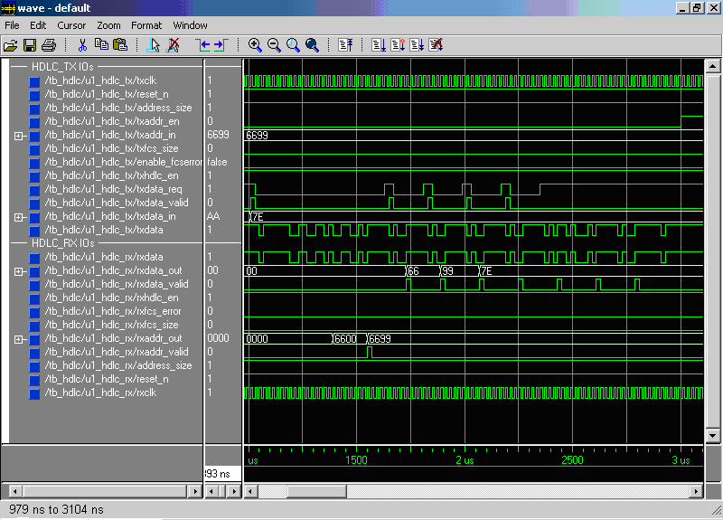

Figure 4.1: address 6699 data 7E

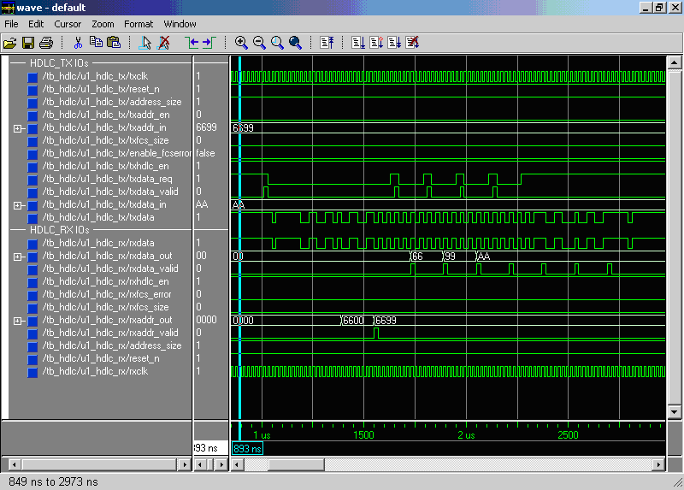

Figure 4.2: address 6699 data AA

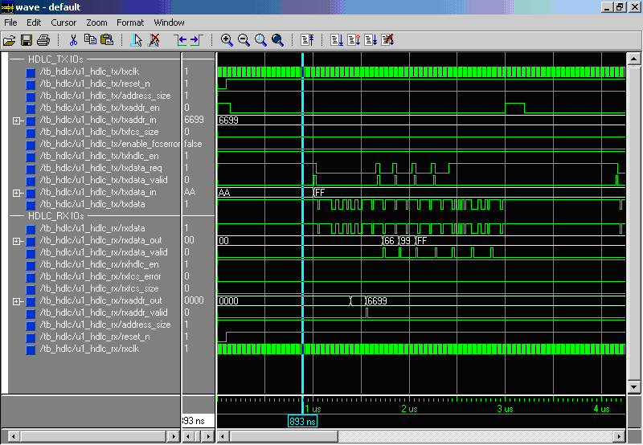

Figure 4.3: address 6699 data FF

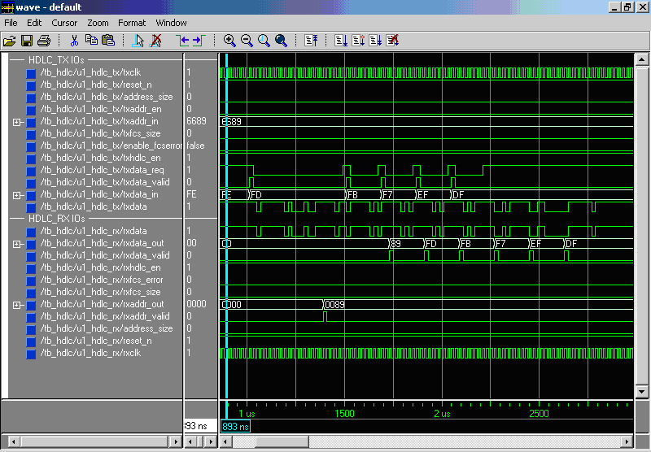

Figure 4.4: address 89 data FE with no error

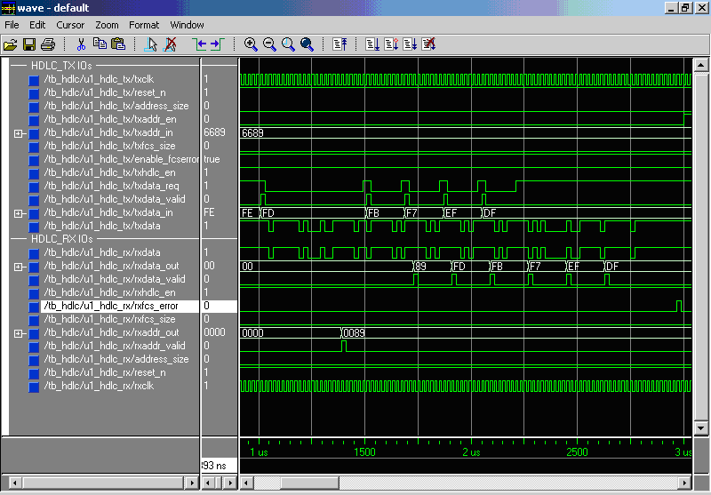

Figure 4.5: address 89 data FE with FCS error

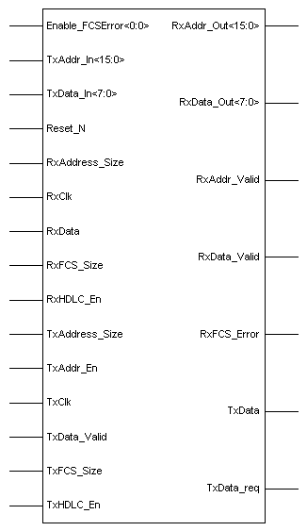

Figure 4.6(a): Top level Entity synthesized by xilinx synthesis Tool

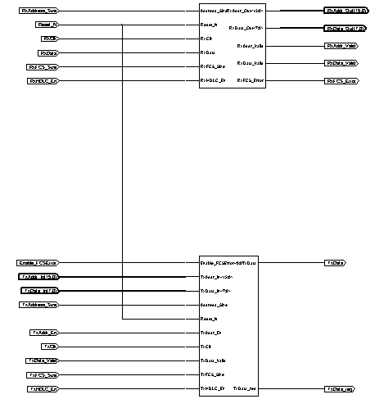

Figure 4.6(b): Top level Entity synthesized by xilinx synthesis Tool

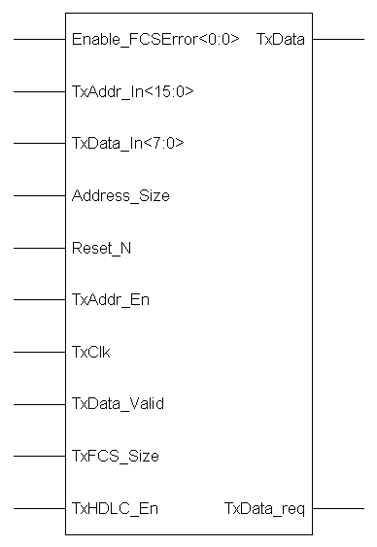

Figure 4.7(a): Transmitter Entity synthesized by xilinx synthesis Tool

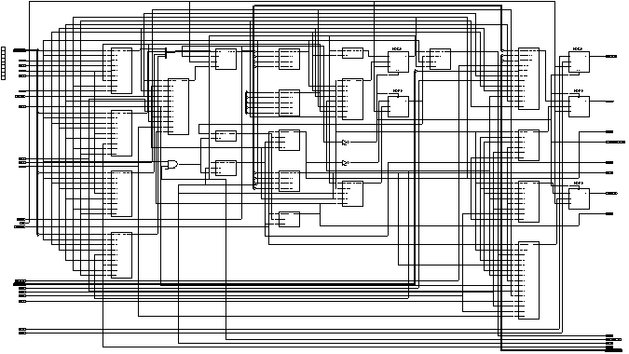

Figure 4.7(b): Transmitter Entity synthesized by xilinx synthesis Tool

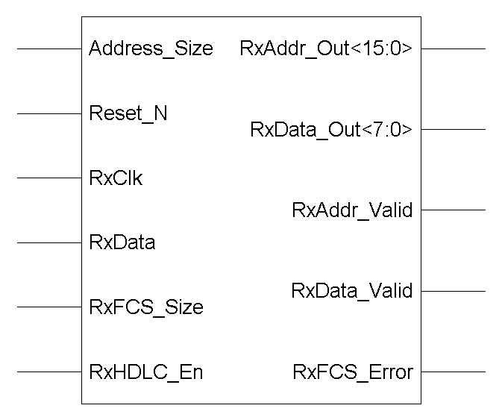

Figure 4.8(a): Receiver Entity synthesized by xilinx synthesis Tool

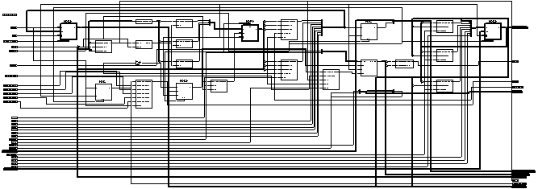

Figure 4.8(b): Receiver Entity synthesized by xilinx synthesis Tool
Chapter 5

Conclusion and Future Work
A brief conclusion and summary is given in the first section of this chapter. Some potential areas of future work that are related to this thesis are presented in the second section.

5.1 Conclusions:
The simulated waveforms presented in this report have proven the reliability of the VHDL implementation to describe the characteristics and the architecture of the designed HDLC controller. The simulated waveforms also have shown the observer how; long test results can be achieved by using the VHDL test bench. By using VHDL a simple and optimized design can be implemented on FPGA/CPLD.
HDLC Controller has been developed with the following features-
- The controller has the capability to operate in full duplex mode
- It can automatically check frame sequence generation using cyclic redundancy checks i.e. CRC-16 to ensure error free transmission.
- 8 bit/16 bit address insertion and detection –selectable.
- To guarantee that a flag does not appear inadvertently anywhere else in the frame, HDLC uses a process called bit stuffing where it stuffs a zero whenever it finds 5 consecutive 1’s.
- A VHDL model for the HDLC Controller has been developed simulated, synthesized and implemented.

5.2 Future Scope:
Although the HDLC Controller has been successfully developed in this thesis work, but some more features can be added to increase its utility. There are several modifications, which can further improve its performance. These are listed below-
- To reduce cost and complexity FIFO’s have not been used here for buffering. As a future these two data buffering can be considered at both receiver and transmitter side.
- Only simulation, synthesis and implementation are done on tool and there has been no actual programming or downloading of design on any CPLD/FPGA.This can be taken as future work.
- Transmit Packet Priority Setting.
- To ensure better error detection and correction CRC-32 can also be added and control can be added to select CRC-16 or CRC-32
- This is designed to work in single byte data mode. It can be extended to work for 2 byte data.
- Facility to disable protocol functions

REFERENCES

- www.filibeto.org/sun/lib/networking/internetworking_technology_overview/Internetworking_Basics.pdf.
- www.uwsg.iu.edu/usail/network/nfs/layers.html - 6k
- www.webopedia.com/quick_ref/OSI_Layers.asp
- www.comptechdoc.org/independent/networking/protocol/protlayers.html - 14k -
- www.lutron.com/technical_info/rs232proginst/040134b.pdf.
- people.du.ac.in/~ngupta/CS204/ Data%20Link%20Layer%20Protocols.ppt
- www.arccontrol.com/pdf/Tutorial.pdf
- www.cisco.com/univercd/ cc/td/doc/cisintwk/ito_doc/fddi.htm - 35k
- discovery.bits-pilani.ac.in/rahul/CompNet/ CN-Lecture-set-1-Data-Link-Layer-Fundamentals-2005-2006-secure.pdf
- www.jbmelectronics.com/product/sdlc.htm - 10k
- www.interfacebus.com/HDLC_Protocol_Description
- www2.rad.com/networks/1994/hdlc/hdlc.htm
- www.erg.abdn.ac.uk/users/gorry/course/dl-pages/crc.html - 5k
- www.gdatech.com/IP/pdf/HDLC_PB.PDF
- www.quicklogic.com/images/amphion_hdlc_ql_1.pdf
- www.actel.com/ipdocs/MC-ACT-HDLC-DS.pdf
- toolbox.xilinx.com/products/ logicore/alliance/memec/xf-hdlc.pdf
- products.zarlink.com/product_profiles/MT8952.htm
- www.cast-inc.com/cores/sdlc/cast_sdlc.pdf
- ‘VHDL: programming by example’ by Douglas L. Perry, fourth edition
- ‘VHDL for PROGRAMMABLE LOGIC’ by KEVIN SKAHILL cypress semiconductors.
- Xilinx Application Notes: HDLC

