APPENDIX – I I

SOURCE CODE OF THE SUBSTATION MONITORING SYSTEM

SOFTWARE DESCRIPTION

SOFTWARE CODES

Option Explicit

Dim stop_flag, Timer_flag As Boolean
Dim Store_flag As Boolean
Dim tim, storetime As Variant

Private Sub about_Click()
frmAbout.Show
End Sub

Private Sub analyze_Click()
SelectParam.Show
End Sub

Private Sub com1_Click()
com1.Checked = True
com2.Checked = False
If MSComm1.PortOpen = True Then
MSComm1.PortOpen = False
MSComm1.commport = 3
If MSComm1.PortOpen = False Then
MSComm1.PortOpen = True
End If
End If
End Sub

Private Sub com2_Click()
com2.Checked = True
com1.Checked = False
If MSComm1.PortOpen = True Then
MSComm1.PortOpen = False
MSComm1.commport = 2
If MSComm1.PortOpen = False Then
MSComm1.PortOpen = True
End If
End If
End Sub

Private Sub Exit_Click()
Unload Me
End Sub

Private Sub diag_Click()
SendDiag
End Sub

Private Sub eepdata_Click()
ReadEEPROM
End Sub

Private Sub Form_Activate()
readnode_Click
End Sub

Private Sub Form_Load()
Misc.Enabled = False
MSComm1.commport = 1
If MSComm1.PortOpen = False Then
MSComm1.PortOpen = True
End If
NodeID = 1
storetime = 1
tim = 0
End Sub

Private Sub min1_Click()
storetime = 1
End Sub
Private Sub min5_Click()
storetime = 5
End Sub
Private Sub min15_Click()
storetime = 15
End Sub
Private Sub min30_Click()
storetime = 30
End Sub
Private Sub min60_Click()
storetime = 60
End Sub

Private Sub readnode_Click()

Timer1.Enabled = True
stop_flag = False
Timer_flag = True
Misc.Enabled = False

Do
DoEvents
If Timer_flag = True Then
Text2.Text = ""
ComMessage = ""
Save.Visible = False
Timer_flag = False
If SendDiag = True Then
Text2.Text = ComMessage
If ReadRegister(0, 25) = True Then
If Store_flag = True Then
Save.Visible = True
Text2.Text = "Storing DATA into the Data base..."
Store_flag = False
Store_Data (NodeID)
End If
End If
Text2.Text = ComMessage
End If
Calculate
End If
Loop Until stop_flag = True

End Sub

Private Sub select_Click()
NodeID = InputBox("Enter the Node ID (1..255):", "STATION ID", NodeID)
End Sub

Private Sub Stop_Click()
stop_flag = True
Misc.Enabled = True
End Sub

Private Sub Timer1_Timer()
Timer_flag = True
End Sub

Private Sub Form_Unload(Cancel As Integer)
Unload Me
End
End Sub

Private Sub Timer2_Timer()
tim = tim + 1
If tim = storetime Then
Store_flag = True
tim = 0
End If
End Sub

/* CODE USED IN SELECTPARAM.FRM*/

Option Explicit

Private Sub CancelButton_Click()
SelectParam.Hide
End Sub

Private Sub Form_Load()
Dim myname
myname = Dir$(app.Path & "\*.dbf", vbHidden)
Do While myname <> "" ' Start the loop.
cmbDate.AddItem Mid$(myname, 1, InStr(myname, ".") - 1)
myname = Dir ' Get next entry.
Loop
cmbDate.Text = cmbDate.List(0)
End Sub

Private Sub OKButton_Click()
GraphDate = cmbDate.Text
Param = cmbParam.Text
StartTime = StartT
EndTime = EndT
TREND.Show
End Sub
/* CODES USED TRENDGRAPGH.FRM*/

Option Explicit

Dim rs1 As ADODB.Recordset
Dim cn As New ADODB.Connection

Private Sub Form_Activate()
Dim rCount As Integer

TREND.MousePointer = vbHourglass

If Param = "Voltage" Then
Set rs1 = cn.Execute("SELECT Times, Volt1, Volt2, Volt3 FROM " & GraphDate & " where nodeid = 1 and Times between '" & StartTime & "' and '" & EndTime & "' order by Times")
ElseIf Param = "Current" Then
Set rs1 = cn.Execute("SELECT Times, Curr1, Curr2, Curr3 FROM " & GraphDate & " where nodeid = 1 and Times between '" & StartTime & "' and '" & EndTime & "' order by Times")
ElseIf Param = "Power Factor" Then
Set rs1 = cn.Execute("SELECT Times, Pf1, Pf2, Pf3 FROM " & GraphDate & " where nodeid = 1 and Times between '" & StartTime & "' and '" & EndTime & "' order by Times")
ElseIf Param = "kW" Then
Set rs1 = cn.Execute("SELECT Times, Kw1, Kw2, Kw3 FROM " & GraphDate & " where nodeid = 1 and Times between '" & StartTime & "' and '" & EndTime & "' order by Times")
ElseIf Param = "kVA" Then
Set rs1 = cn.Execute("SELECT Times, Kva1, Kva2, Kva3 FROM " & GraphDate & " where nodeid = 1 and Times between '" & StartTime & "' and '" & EndTime & "' order by Times")
ElseIf Param = "kVAr" Then
Set rs1 = cn.Execute("SELECT Times, Kvar1, Kvar2, Kvar3 FROM " & GraphDate & " where nodeid = 1 and Times between '" & StartTime & "' and '" & EndTime & "' order by Times")
ElseIf Param = "kWH" Then
Set rs1 = cn.Execute("SELECT Times, Kwh FROM " & GraphDate & " where nodeid = 1 and Times between '" & StartTime & "' and '" & EndTime & "' order by Times")
End If

If rs1.EOF = False Then
rs1.MoveFirst
Else
MsgBox "No Record for the spefied Time"
End If

rCount = 0
If Param <> "kWH" Then
MSChart1.ColumnCount = 3
Else
MSChart1.ColumnCount = 1
End If

MSChart1.RowLabel = "Time"
MSChart1.ColumnLabel = Param

MSChart1.TitleText = "Off-Line Graph: " & Param

Do While rs1.EOF = False
rCount = rCount + 1
MSChart1.RowCount = rCount
MSChart1.Row = rCount
MSChart1.RowLabel = rs1.Fields(0) 'TIME
MSChart1.Column = 1
MSChart1.Data = Format(Abs(rs1.Fields(1)), "0.00")
If Param <> "kWH" Then
MSChart1.Column = 2
MSChart1.Data = Format(Abs(rs1.Fields(2)), "0.00")
MSChart1.Column = 3
MSChart1.Data = Format((Abs(rs1.Fields(3))), "0.00")
End If
rs1.MoveNext
If rs1.EOF = True Then
Me.MousePointer = vbDefault
Exit Do
End If
Loop
rs1.Close

TREND.MousePointer = vbDefault
TREND.MousePointer = vbDefault
End Sub

Private Sub Form_Load()
cn.CursorLocation = adUseClient
cn.ConnectionString = "driver=Microsoft dBase Driver (*.dbf);DBQ=" & app.Path
cn.Open
End Sub

Private Sub Form_Terminate()
Unload Me
End Sub

Private Sub Form_Unload(Cancel As Integer)
cn.Close
Unload Me
End Sub

Private Sub PrintGraph_Click()
Me.PrintForm
Exit Sub
End Sub

Private Sub MSChart1_PointSelected(Series As Integer, DataPoint As Integer, MouseFlags As Integer, Cancel As Integer)
Dim s As String
MSChart1.Row = DataPoint
MSChart1.Column = Series
If Param = "Voltage" Then
MSChart1.ToolTipText = "Time =" & MSChart1.RowLabel & ", Data = " & MSChart1.Data & "(Volts)"
ElseIf Param = "Current" Then
MSChart1.ToolTipText = "Time =" & MSChart1.RowLabel & ", Data = " & MSChart1.Data & "(Amps)"
ElseIf Param = "Power Factor" Then
MSChart1.ToolTipText = "Time =" & MSChart1.RowLabel & ", Data = " & MSChart1.Data
ElseIf Param = "kW" Then
MSChart1.ToolTipText = "Time =" & MSChart1.RowLabel & ", Data = " & MSChart1.Data & "(kW)"
ElseIf Param = "kVA" Then
MSChart1.ToolTipText = "Time =" & MSChart1.RowLabel & ", Data = " & MSChart1.Data & "(kVA)"
ElseIf Param = "kVAr" Then
MSChart1.ToolTipText = "Time =" & MSChart1.RowLabel & ", Data = " & MSChart1.Data & "(kVAr)"
End If
End Sub
/* CODE used in CALC.BAS */

Dim Status As Byte

Dim vlt(3), cur(3), pfa(3), kw(3), kva(3), kvar(3) As Single
Dim avolt, acurr, apf, akw, akva, akvar, freq As Single
Dim ncurr As Double
Dim kwh, kvarh As Double
Dim CTRATIO As Integer
Public GraphDate, Param, StartTime, EndTime As String

Public Sub Calculate()

Dim lop As Byte
Dim realpart, imagpart As Double
Dim cosx(3), sinx(2) As Single

On Error Resume Next

avolt = 0
acurr = 0
apf = 0
akw = 0
akva = 0
akvar = 0

For lop = 0 To 2
vlt(lop) = Dat_Buf(lop * 3 + 3)
cur(lop) = Dat_Buf(lop * 3 + 4)
pfa(lop) = Dat_Buf(lop * 3 + 5)
kw(lop) = vlt(lop) * cur(lop) * Abs(pfa(lop))
kva(lop) = vlt(lop) * cur(lop)
kvar(lop) = Sgn(pfa(lop)) * Sqr(kva(lop) * kva(lop) - kw(lop) * kw(lop))

avolt = avolt + 1.732 * vlt(lop)
acurr = acurr + cur(lop)
apf = apf + pfa(lop)
akw = akw + kw(lop)
akva = akva + kva(lop)
akvar = akvar + kvar(lop)

Main.volt(lop).Text = Format(vlt(lop), "0.00 V")
Main.curr(lop).Text = Format(cur(lop), "0.00 A")
Main.pf(lop).Text = Format(pfa(lop), "0.00")
Main.ap(lop).Text = Format(kw(lop) / 1000, "0.000 kW")
Main.rp(lop).Text = Format(kvar(lop) / 1000, "0.000 kVAr")
Main.app(lop).Text = Format(kva(lop) / 1000, "0.000 kVA")
cosx(lop) = kw(lop) / kva(lop)
sinx(lop) = kvar(lop) / kva(lop)
Next lop

avolt = avolt / 3
acurr = acurr / 3
apf = apf / 3
Main.Text1(0).Text = Format(avolt, "0.00 V")
Main.Text1(1).Text = Format(acurr, "0.00 A")
Main.Text1(2).Text = Format(apf, "0.00")
Main.Text1(3).Text = Format(akw / 1000, "0.00 kW")
Main.Text1(4).Text = Format(akva / 1000, "0.00 kVA")
Main.Text1(5).Text = Format(akvar / 1000, "0.00 kVAr")

kwh = Abs(Dat_Buf(0) / 1000)
kvarh = Abs(Dat_Buf(1) / 1000)
freq = Dat_Buf(2)
Status = Dat_Buf(12)
Main.ae.Text = Str(Format(kwh, "0.000")) + " kWh"
Main.re.Text = Str(Format(kvarh, "0.000")) + " kVArh"
Main.freq.Text = Format(freq, "0.00 Hz")

' Neutral Current Calculation

realpart = cur(0) * cosx(0) + cur(1) * ((-0.5) * cosx(1) - 0.866 * sinx(1)) + cur(2) * ((-0.5) * cosx(2) + 0.866 * sinx(2))
imagpart = cur(0) * sinx(0) + cur(1) * (0.866 * cosx(1) - 0.5 * sinx(1)) + cur(2) * ((-0.866) * cosx(2) - 0.5 * sinx(2))
ncurr = Sqr(realpart * realpart + imagpart * imagpart)
Main.curr(3) = Format(ncurr, "0.00")

' Display status
Main.Status(0).FillColor = vbGreen
Main.Status(1).FillColor = vbGreen
Main.Status(2).FillColor = vbGreen
Main.Status(3).FillColor = vbGreen

If Status And &H40 Then ' Phase Sequence Error
Main.Status(3).FillColor = vbRed
End If

If Status And &H20 Then ' Missing Phase Error
If Status And &H10 Then Main.Status(2).FillColor = vbRed ' Phase 3 Missing
If Status And &H8 Then Main.Status(1).FillColor = vbRed ' Phase 2 Missing
If Status And &H4 Then Main.Status(0).FillColor = vbRed ' Phase 1 Missing
End If

End Sub

Public Sub Store_Data(id As Integer)

Dim fname As String
Set cn = New ADODB.Connection
cn.CursorLocation = adUseClient
cn.ConnectionString = "driver=Microsoft dBase Driver (*.dbf);DBQ=" & app.Path
cn.Open
fname = Format(Date, "ddmmyy")

If Dir$(app.Path & "\" & fname & ".dbf") = "" Then
cn.Execute " create table " & fname & "(NodeID byte ,times text(10) ,volt1 double ,volt2 double ,volt3 double ,curr1 double ,curr2 double ,curr3 double ,pf1 double ,pf2 double ,pf3 double ,kw1 double ,kw2 double ,kw3 double ,kvar1 double ,kvar2 double ,kvar3 double ,kva1 double ,kva2 double ,kva3 double ,kwh double ,kvarh double ,freq double ,ncurr double)"
End If
cn.Execute ("insert into " & fname & " values (" & id & ",'" & Format(Time, "hh:mm") & "'," & vlt(0) & "," & vlt(1) & "," & vlt(2) & "," & cur(0) & "," & cur(1) & "," & cur(2) & "," & pfa(0) & "," & pfa(1) & "," & pfa(2) & "," & kw(0) & "," & kw(1) & "," & kw(2) & "," & kvar(0) & "," & kvar(1) & "," & kvar(2) & "," & kva(0) & "," & kva(1) & "," & kva(2) & "," & kwh & "," & kvarh & "," & freq & "," & ncurr & ")")
cn.Close

End Sub
/* CODES USED IN MODBUS.BAS*/

Option Explicit

Public cn As New ADODB.Connection
Public rs As New ADODB.Recordset

Public Declare Function LdExp Lib "dllbasic" (ByVal x As Single, ByVal y As Integer) As Single
Public Declare Function Rtl Lib "dllbasic" (ByVal value As Long, ByVal cnt As Byte) As Long
Public Declare Function Rtr Lib "dllbasic" (ByVal value As Long, ByVal cnt As Byte) As Long

Public NodeID As Variant
Public ComMessage As String
Public Dat_Buf(12) As Single

Dim PackData, pack, id As Variant
Dim chksum As Variant
Dim rec_buff(100) As Variant
Dim err_flag As Boolean
Dim strData, chkstr As String
Dim exception_flag As Boolean

Public Sub SendPack()

Main.MSComm1.DTREnable = False
Main.MSComm1.Output = strData
Main.MSComm1.DTREnable = True

End Sub

Public Sub FramePacket()

Dim i As Integer

For i = 0 To 12
Dat_Buf(i) = 0
Next i

strData = Main.MSComm1.Input

strData = ""
SendPack
SendPack
SendPack
SendPack

For i = 0 To 5
strData = strData & Chr(PackData(i))
Next i

chkstr = CalCRC16
strData = strData & chkstr
SendPack

strData = ""
SendPack
SendPack
SendPack
SendPack

End Sub

Public Function SendDiag() As Boolean

Dim i As Variant

PackData = Array(NodeID, 8, 0, 0, &HA5, &H37, 0, 0)
FramePacket
Receive (8)
Commcheck
Main.Text3.Text = ""
If err_flag = False And exception_flag = False Then
For i = 0 To 5
Main.Text3.Text = Main.Text3.Text & Asc(Mid(strData, i + 1, 1)) & " "
Next i
SendDiag = True
Else
SendDiag = False
End If

End Function

Public Function ReadRegister(addr As Integer, Regcnt As Integer) As Boolean

Dim msb, lsb As Byte
Dim i, j, k As Variant
Dim bytecnt As Integer
Dim tmp(4) As Variant

msb = CByte(addr / 256)
lsb = CByte(addr Mod 256)
PackData = Array(NodeID, 3, msb, lsb, 0, Regcnt, 0, 0)
FramePacket
bytecnt = Regcnt * 2
Receive (bytecnt + 5)
Commcheck

If err_flag = False And exception_flag = False Then
k = 0
For i = 4 To bytecnt - 2 Step 4
For j = 0 To 3
tmp(j) = Asc(Mid(strData, i + j, 1))
Next j
If tmp(0) > &H7F Then
Dat_Buf(k) = -1
tmp(0) = tmp(0) And &H7F
Else
Dat_Buf(k) = 1
End If
Dat_Buf(k) = Dat_Buf(k) * Long_Float(tmp(0) * 2 ^ 24 + tmp(1) * 2 ^ 16 + tmp(2) * 2 ^ 8 + tmp(3))
k = k + 1
Next i
Dat_Buf(k) = Asc(Mid(strData, bytecnt + 2, 1))
ReadRegister = True
Else
ReadRegister = False
End If

End Function

Public Function ReadEEPROM() As Boolean

Dim i, j, k As Variant
Dim bytecnt As Integer
Dim tmp(4) As Variant

PackData = Array(NodeID, 4, 0, 0, 0, 45, 0, 0)
FramePacket
Receive (50)
Commcheck
Main.Text3.Text = ""
If err_flag = False And exception_flag = False Then
ReadEEPROM = True
k = 0
For i = 4 To 48
Main.Text3.Text = Main.Text3.Text & Hex(Asc(Mid(strData, i, 1))) & " "
Next i
Else
ReadEEPROM = False
End If

End Function

Public Sub Receive(cnt As Variant)

Dim times As Long
Dim ncount As Variant

strData = ""

times = 50000
Do
DoEvents
ncount = Main.MSComm1.InBufferCount
times = times - 1
Loop Until ((ncount = cnt) Or (ncount = 5) Or (times = 0))

If (ncount = 5 And ncount <> cnt) Then exception_flag = True

err_flag = True

If times = 0 Then Exit Sub

Main.MSComm1.InputLen = ncount
strData = Main.MSComm1.Input
chkstr = Right(strData, 2)
strData = Mid$(strData, 1, Len(strData) - 2)
If chkstr = CalCRC16 Then err_flag = False

End Sub

Public Function CalCRC16() As String

Dim lCrc, lGenerator As Long
Dim i, j As Integer
Dim byTemp As Byte
Dim bBit As Boolean
lCrc = 65535
lGenerator = 40961
For i = 1 To Len(strData)
byTemp = Asc(Mid(strData, i, 1))
lCrc = lCrc Xor byTemp
For j = 1 To 8
bBit = lCrc And 1
lCrc = lCrc \ 2
If bBit = True Then lCrc = lCrc Xor lGenerator
Next j
Next i

CalCRC16 = Chr(lCrc Mod 256) & Chr(lCrc \ 256)

End Function

Public Sub Commcheck()

Dim response As Byte

If err_flag = False Then
ComMessage = "COMMUNICATION IS OK"
ElseIf err_flag = True Then
ComMessage = "COMMUNICATION ERROR"
Exception_Record NodeID, 0, ComMessage
End If

If exception_flag = True Then
If strData <> "" Then
response = Asc(Mid(strData, 3, 1))
ComMessage = "!Exception Error!"
Select Case (response)
Case 1
ComMessage = "Exception Error: ILLEGAL FUNCTION"
Case 2
ComMessage = "Exception Error: ILLEGAL DATA ADDRESS"
Case 3
ComMessage = "Exception Error: ILLEGAL DATA VALUE"
Case 4
ComMessage = "Exception Error: SLAVE DEVICE FAILURE"
Case 5
ComMessage = "Exception Error: ACKNOWLEDGE"
Case 6
ComMessage = "Exception Error: SLAVE DEVICE BUSY"
Case 7
ComMessage = "Exception Error: NEGATIVE ACKNOWLEDGE"
Case 8
ComMessage = "Exception Error: MEMORY PARITY ERROR"
End Select
Exception_Record NodeID, response, ComMessage
End If
End If

End Sub

Public Function Long_Float(value As Long) As Single

Dim lMant, iExpo As Long
Dim i As Integer
Dim j As Single

lMant = value And &H7FFFFF
iExpo = (Rtl(value, 23) And &HFF) - 127
j = 0
For i = 1 To 23
If lMant And &H400000 Then
j = j + 2 ^ (-i)
End If
lMant = Rtr(lMant, 1)
Next i
j = (j + 1) / 2
If value > &H7FFFFFFF Then j = j * (-1)
Long_Float = LdExp(j, iExpo + 1)

End Function

Public Sub Exception_Record(id As Variant, excepcode As Byte, message As String)

Dim fname As String

Set cn = New ADODB.Connection
cn.CursorLocation = adUseClient
cn.ConnectionString = "driver=Microsoft dBase Driver (*.dbf);DBQ=" & app.Path
cn.Open
fname = "ComError"

If Dir$(app.Path & "\" & fname & ".dbf") = "" Then
cn.Execute " create table " & fname & "(eDate text(10) ,eTime text(10) ,eID byte ,ExcepCode byte ,ExcepDesc text(20))"
End If
cn.Execute ("insert into " & fname & " values ('" & Format(Date, "dd/mm/yy") & "','" & Format(Time, "hh:mm:ss") & "', " & id & "," & excepcode & ",'" & message & "')")
cn.Close

End Sub

- 0 0 0 -
APPENDIX – III

USER INTERFACE OF THE SUBSTATION MONITORING SYSTEM

Software Menus and its Description:

Main Screens:

Figure shows the Main Screen of the EMS software. This screen displays the information about the phase-wise measure voltage, current, power factor, active, reactive, apparent powers, energies, frequency and the status information about the load or feeder. The status gives the information about the phase sequence error or missing phase etc. The 3-phase equivalent information like Line-Line voltage, average current, average power factor, total kW, kVA, kVAr etc also displayed.
Screen-1
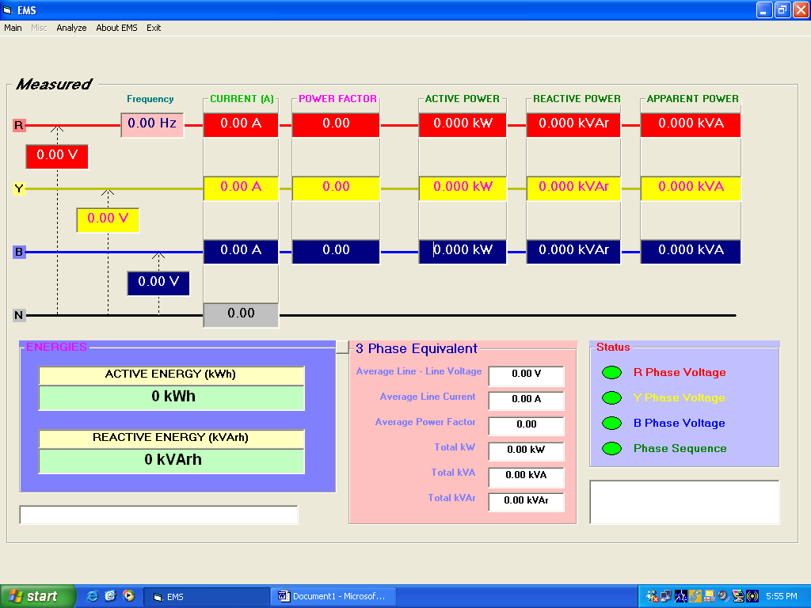

Menu Description:
The menu bar consists of five items. They are
- MAIN Menu
- MISC. Menu
- ANALYZE Menu
- ABOUT EMS menu
- EXIT menu
MAIN Menu:
This menu consists of two items; namely
- SELECT NODE ID
- SELECT INTERVAL

SELECT NODE ID:

Figure shows the snapshot of the Screen when the user selects the SELECT NODE ID menu. One can select the STATION ID from 0 -255.
Screen-2
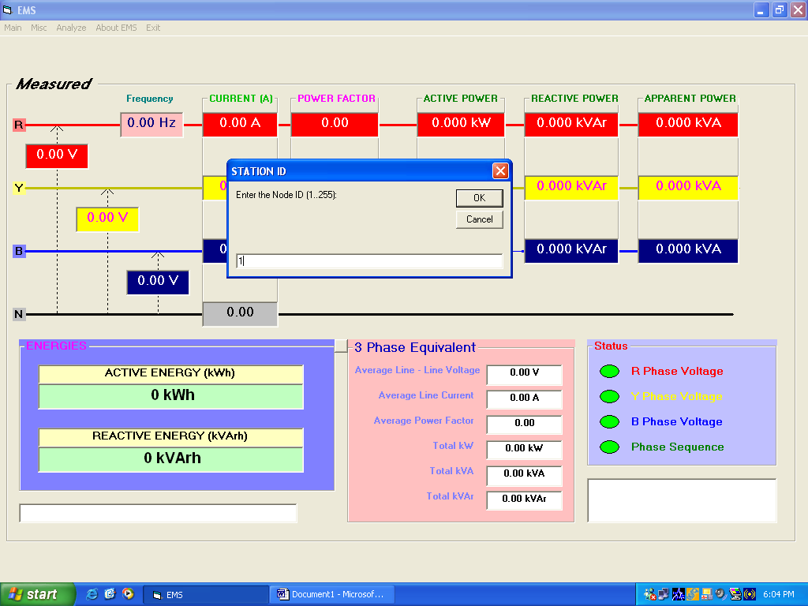

SELECT INTERVAL:

The user can select the Data Storage interval of 1, 5, 15, 30, 60 minutes for storing the information in the database.
Screen - 3
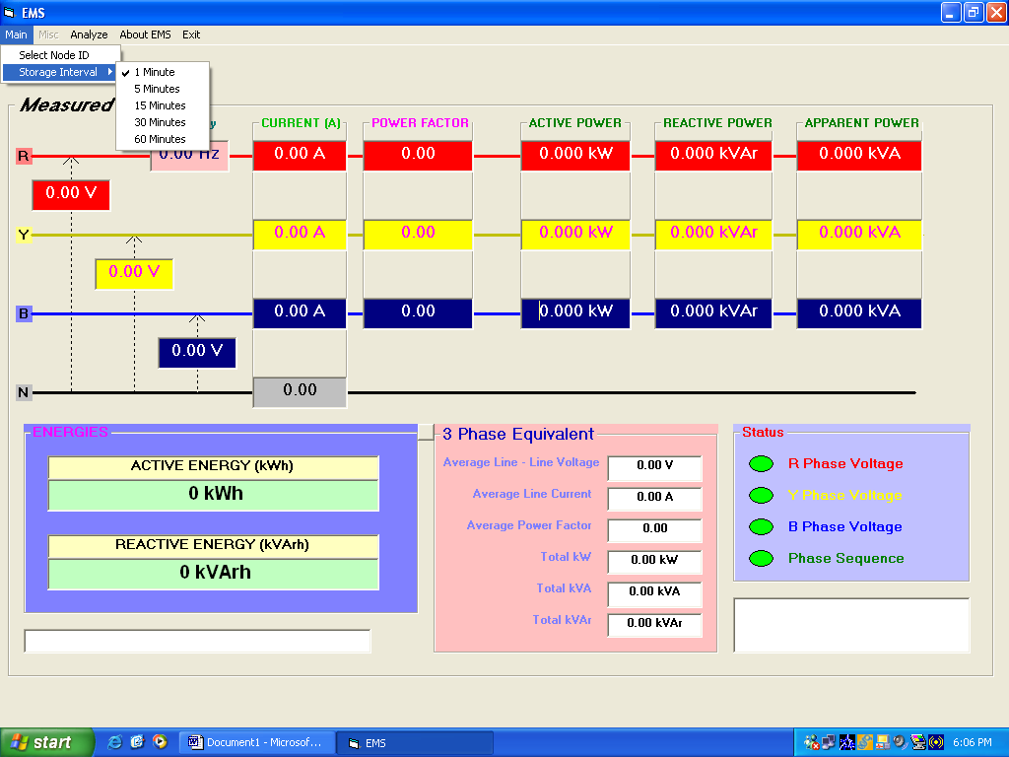

MISC. Menu:

This menu is basically hidden for the general user and only the authorized person can use this command. This menu consists of the following items;
- COM PORT
- DIAGNOSE
- READ EEPROM DATA
- READ REGISTER.
Screen - 4
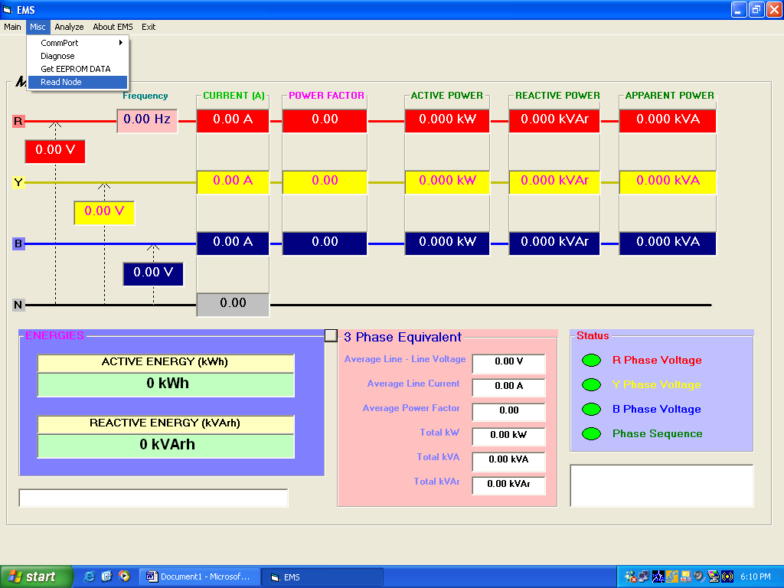

COM PORT:

This sub-menu is used to select the Communication port to be used for RS-485 serial communication. The options regarding the available COM ports will be automatically displayed. One can choose the connected COM port.
Screen - 5
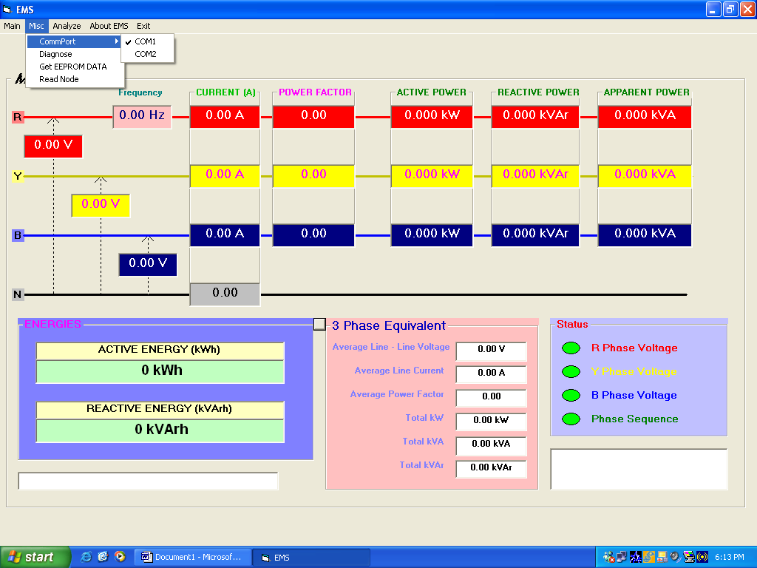

DIAGNOSE, READ EEPROM DATA, READ REGISTER Menu:

These commands are used to check the communication in step-by-step mode for network problems.
ANALYZE Menu:

This menu is used to analyze the data and to generate the reports. When this menu is clicked, then it displays the dialog box, which is used to select the DATE, Parameter, Start & Stop time of the interest.
Screen -6
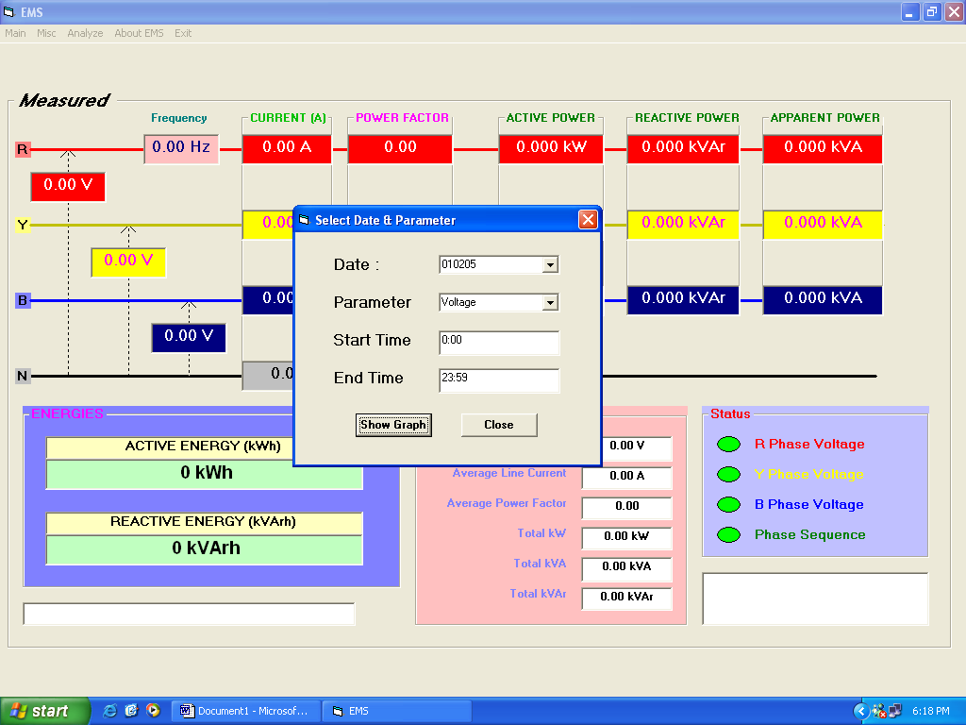

Once the Date, parameter, start time and end time are selected one can click the SHOW GRAPH command. This will show the graph for the selected parameter with the specified time frame. One can go for hard copy of the same by clicking the Printer option. Figure shows one such off-line graph for the Voltage parameter.
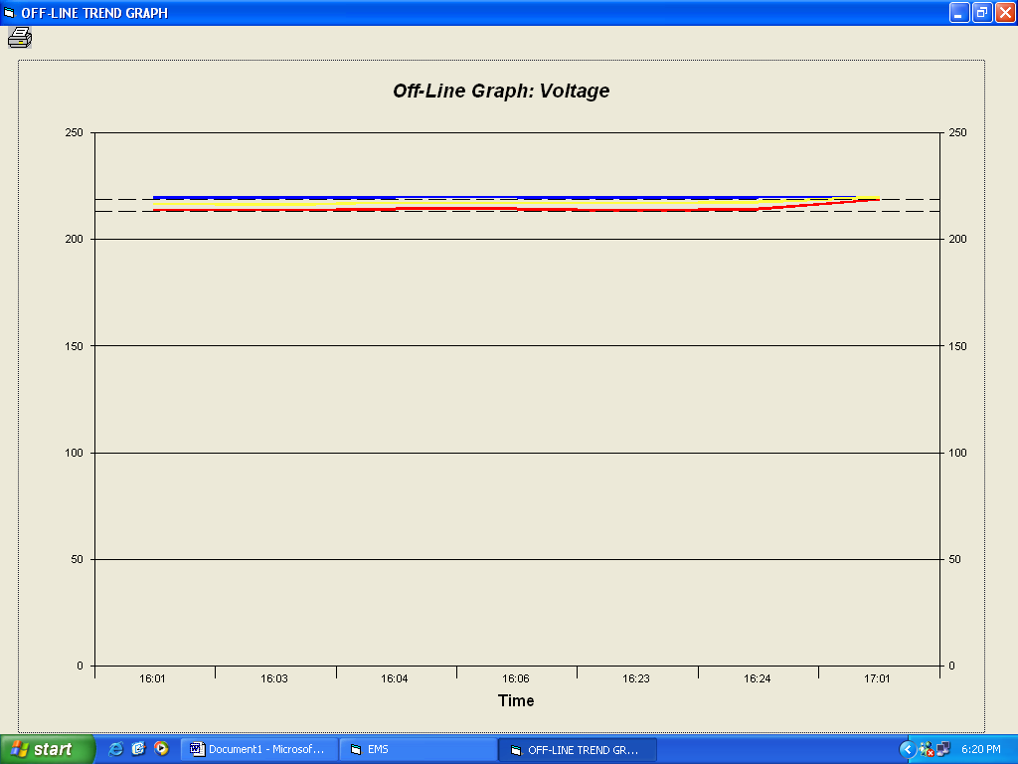
Screen -7
ABOUT EMS:
This shows the EMS description and the Company Name etc.
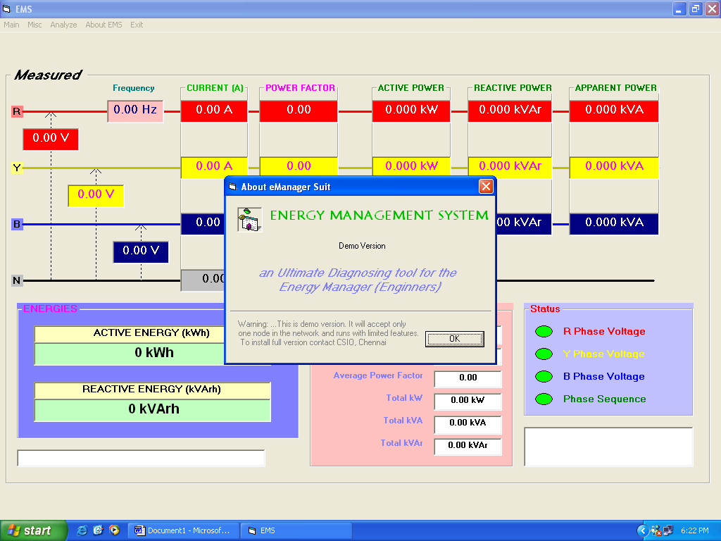
Screen - 8
EXIT Menu:
This menu is used to close the EMS application.

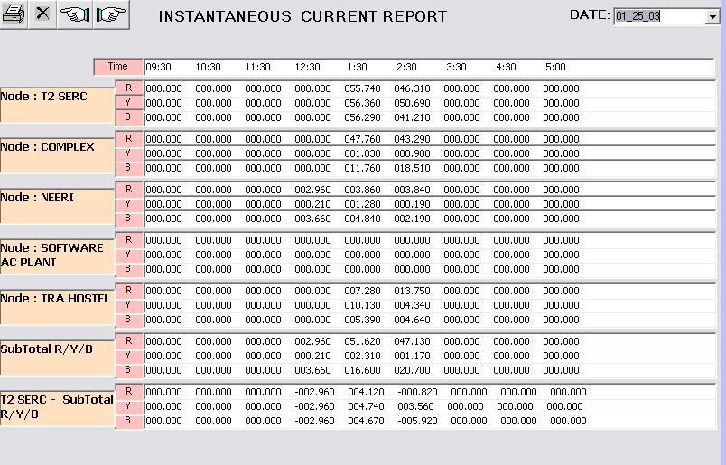

Screen - 9 Instantaneous Current Report

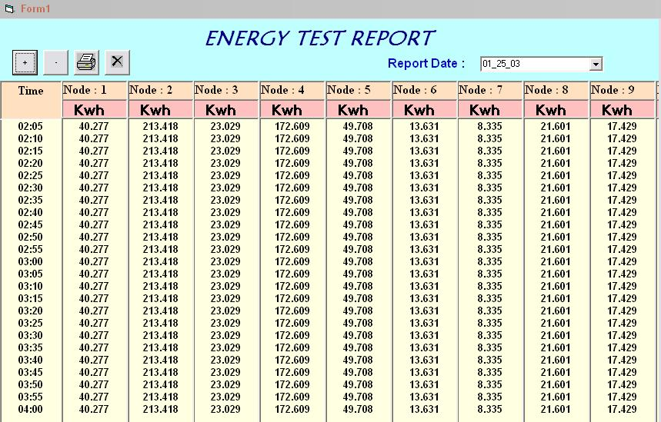

Screen -10 Energy Test Report

- 0 0 0 -

