The six voltage signals from the current and voltage transducers are digitized with ADCs. There ADCs are 16-bit second order sigma-delta with an over sampling rate of 833 KHz. A high pass filter in the current channel removes the dc component from the current signal. This eliminates any inaccuracies in the real power calculation due to offsets in the voltage or current signals.
(a) Power Calculations
The real power calculation is derived from the instantaneous power signal. The instantaneous power signal is generated by a direct multiplication of the current, and voltage signals of each phase. In order to extract the real power component, the instantaneous power signal is low-pass filtered on each phase. The total real power information is then obtained by adding the individual phase real power. This scheme correctly calculates real power for non sinusoidal current and voltage wave forms at all power factors. All signal processing is carried out in the digital domain for superior stability over temperature and time.
The low frequency output of the ADE-7752 is generated by accumulating the total power information. This low frequency inherently means a long accumulation time between output pulses. The output frequency is therefore, proportional to the average real power. This average real power information can, in turn, be accumulated (e.g. by a counter) to generate real energy information. Because of its high output frequency and therefore, shorter integration time, the CF output is proportional to the instantaneous real power. This pulse is useful for system calibration purposes.
(b) Power Factor Consideration
Let us suppose that the current wave form on each phase is lagging to its voltage by degree then
The component will be filtered out by the low pass filter on each phase and instantaneous real power will appear at the output of low pass filter. All the three phase powers are get added and integrated so signals at F1 & F2 appears corresponding to real energy.
(c) Non sinusoidal voltage and current
Let the voltage and current on each phase is given by
and
Where V_{k} & I_{k} are the amplitudes of the Kth harmonic components of the voltage and current, k and and the corresponding phase angles. and are the dc components of the voltage and current.
The instantaneous power received by the circuit on each phase is given by
The average power P_{av} is defined by
Or Pav =
Or
for m n
Since a harmonic real power component is generated for every harmonic, provided that harmonic is present in both the voltage and current wave forms.
Hence for all k
for all k
for all k
Due to high pass filter present in the current section I_{dc} = 0
Therefore P1 = 0
Hence, the frequency F1 & F2 will be proportional to the average power of the circuit that’s why the real power calculation.
Methods also holds true for non sinusoidal current and voltage wave forms.

3.3 Conclusion In this chapter, design of the various component of three phase electronic energy meter like design of current sensor, voltage sensor, power supply, display unit and the description of IC is discussed and it is concluded that the existing meter gives the actual energy for sinusoidal as well as non sinusoidal voltage and currents at all power factors.
CHAPTER 4
DEVELOPMENTS OF ELECTRONIC ENERGY METER
4.0 General
In the previous chapters the design of single phase and three phase energy meters have been presented. In this chapter a details of development of a protype single phase & three phase Electronic Energy Meter are described.

  - Development of Single Phase Electronic Energy Meter
The description of various components used in the development of single phase, 10-40A, 240V, 50Hz, 100imp/kwh, electronic energy meter are given below

4.1.1 Current Sensor Rating
CT Turn Ratio : 1:1800(2 No.)
Size of Burden Resistor : 8.2, ¼ W (2 Nos.)
Multilayer ceramic capacitor : 0.104 F, 6.3 V (2 No.)
SMT resistor : 2.2 K, 1/8 Watt. (2 No.)
    - Voltage sensor rating Calibration Range : ± 30%
Items Name | Specification / ratings | Quantity
SMT Resister | 680K , 1/8 W | 1
SMT Resister | 150K , 1/8W | 1
SMT Resister | 39 K , 1/8 W | 1
SMT Resister | 18K , 1/8 W | 1
SMT Resister | 2.2K , 1/8W | 1
SMT Resister | 2.2K , 1/8W | 1
SMT Resister | 1K , 1/8W | 1
SMT Resister | 1.2K , 1/8W | 1
SMT Resister | 820, 1/8W | 1
SMT Resister | 470, 1/8 W | 4

Multilayer ceramic capacitor | .104F, 6.3V | 2

4.1.3 IC Details Figure 4.0 shows the Pin diagram of AD7751 IC
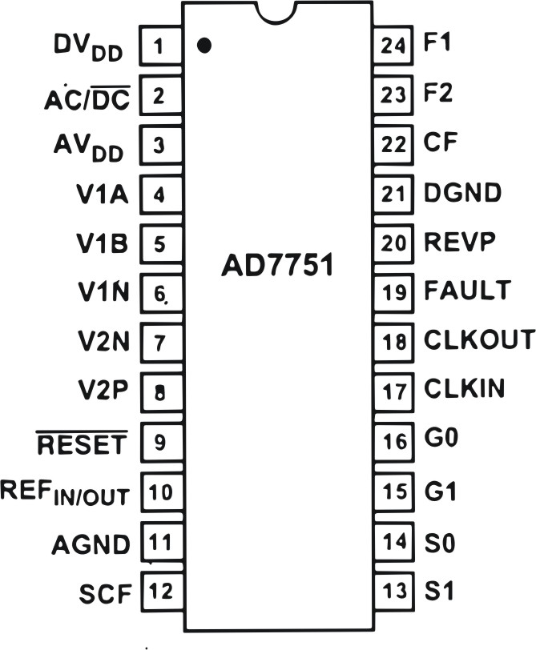
Figure 4.0 Pin Diagram of AD7751 IC
PIN FUNCTION DESCRIPTIONS AD7751
Pin No. | Mnemonic | Description
1. | DV_{DD} | Digital Power Supply. This pin provides the supply voltage for the digital circuitry in the AD7751.
2. | AC/DC | High-Pass Filter Select. This logic input is used to enable the HPF in Channel 1
3. | AV_{DD} | Analog Power Supply. This pin provides the supply voltage for the analog circuitry in the AD7751.
4, 5. | V1A, V1B | Analog inputs for Channel 1.

6. | V1N | Negative input pin for differential voltage inputs V1A and V1B.
7,8. | V2N, V2P | Negative and positive inputs for Channel 2 (voltage channel).
9. | RESET | Reset pin for the AD7751. A logic low in this pin will hold the ADCs and digital circuitry in a rest condition. Bringing this pin logic low will clear the AD7751 internal registers.
10. | REF_{IN/OUT} | The on-chip reference has a nominal value of 2.5V±8% and a typical temperature coefficient of 30 ppm/ºC.
11. | AGND | This provides the ground reference for the analog circuitry in the AD7751, i.e., ADCs and reference.
12. | SCF | Select Calibration Frequency.
13,14 | S1, S0 | These logic inputs are used to select one of four possible references for the digital-to-frequency.
15,16 | G1, G0 | These logic inputs are used to select one of four possible gains for the analog inputs V1A and V1B. The possible gains are 1, 2, 8 and 16. See Analog Input section.
17. | CLKIN | An external clock can be provided at this logic input. Alternatively a crystal can be connected across CLKIN and CLKOUT to provide a clock source for the AD7751.
18. | CLKOUT | A crystal can be connected across this pin and CLKIN as described above to provide a clock source for the AD7751.
19. | FAULT | This logic output will go active high when a fault condition occurs. The logic output will be reset to zero when a fault condition is no longer detected.

20. | REVP | This logic output will go logic high when negative power is detected, i.e., when the phase angle between the voltage and current signals is greater that 90º.
21. | DGND | This provides the ground reference for the digital circuitry in the AD7751, i.e., multiplier, filters and digital-to-frequency converter.
22. | CF | Calibration Frequency Logic output.
23, 24 | F2, F1 | Low frequency logic outputs, F1 and F2 supply average real power information.

4.1.4 Power Supply
Item | Specification / Rating | Quantity
MOV | 200V, 1/8W, S20K 275 | 1
Diode | 400V, 1W, IN4007 | 2
Zener Diode | 5.6V, 12.5mA, IN4744A | 1
Transistor | V_{BE} = 0.6V, I_{c}=200mA, , 2N4123 | 1
Capacitor | 1000 F, 16V, Electrolyte | 2
Capacitor | 0.47 F, 440V, Electrolyte | 1
Resister | 220 , 2W, SMT | 1
Resister | 220 , 1W, SMT | 1
Resister | 1M , 1W, SMT | 1
Resister | 1K , ¼W, SMT | 1

4.1.5. Counter : 2 Phase stepper motor 6 digit decimal
counter.
Grear Ratio : 200/1
Voltage Rating : 5V
Current Rating : 10 mA
Winding Resistance : 450
    - Others
Item | Specification / Rating | Quantity
LED | HPHLMP-D150) | 3
Resistors | 4.7K, 1/8W | 2
Capacitor | 22PF, Multilayer Ceramic, 50V | 2
Crystal | 3.579545MHz Quartz Crystal | 1

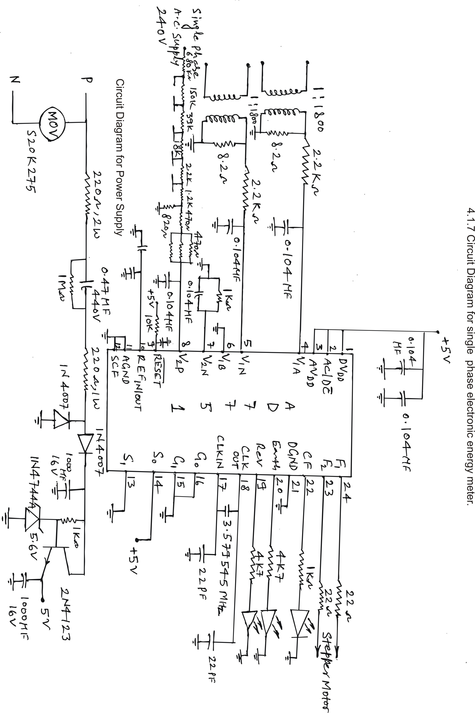

Fig. 4.1
4.2 Development of three phase electronic energy meter.
The description of various components used in the development of three phase, 50A, 3 x 240V, 50Hz, 100imp/kwh, electronic energy meter are given below

4.1.1 Current Sensor Rating
CT Turn Ratio : 1:5000(3 No.)
Size of Burden Resistor : 24, ¼ W (3 Nos.)
Multilayer ceramic capacitor : 0.104 F, 6.3 V (3 No.)
SMT resistor : 1 K, 1/8 Watt. (3 No.)
    - Voltage sensor rating Calibration Range : ± 30%
Items Name | Specification / ratings | Quantity
SMT Resister | 680K , 1/8 W | 3
SMT Resister | 150K , 1/8W | 3
SMT Resister | 39 K , 1/8 W | 3
SMT Resister | 18K , 1/8 W | 3
SMT Resister | 2.2K , 1/8W | 3
SMT Resister | 2.2K , 1/8W | 3
SMT Resister | 1K , 1/8W | 3
SMT Resister | 1.2K , 1/8W | 3
SMT Resister | 820, 1/8W | 3
SMT Resister | 470, 1/8 W | 4
Multilayer ceramic capacitor | 0.047F, 6.3V | 3

4.1.4 Power Supply
Item | Specification / Rating | Quantity
MOV | 200V, 1/8W, S20K 275 | 3
Diode | 400V, 1W, IN4007 | 6
Zener Diode | 5.6V, 12.5mA, IN4744A | 1
Transistor | V_{BE} = 0.6V, I_{c}=200mA, , 2N4123 | 1
Capacitor | 1000 F, 16V, Electrolyte | 2
Capacitor | 0.47 F, 440V, Electrolyte | 3
Resister | 220 , 2W, SMT | 3
Resister | 220 , 1W, SMT | 3
Resister | 1K , ¼W, SMT | 1

4.2.4 Counter : LCD counter (LCD 093)
12 C509 micro controller.
24 CO2 E² ROM
Power consumption in micro watts.
    - Others
Item | Specification / Rating | Quantity
LED | HPHLMP-D150) | 5
Resistors | 1K, 1/8W | 2
Resistors | 4.7K, 1W | 1
Capacitor | 0.047F, Multilayer ceramic | 4
Capacitor | 0.104F, Multilayer ceramic | 4
Capacitor | 22pF, Multilayer ceramic, 50V | 2
Crystal | 3.579545MHz Quartz Crystal | 1

4.26 IC Details
Pin Diagram of AD7752 IC is shown in figure 4.2
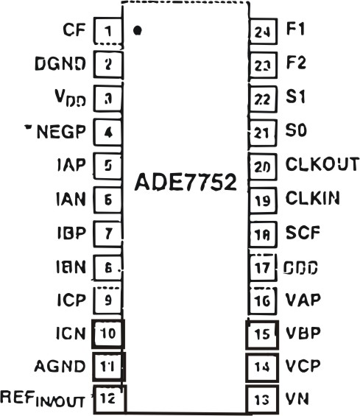
Figure 4.2 Pin Diagram of AD7752 IC

PIN FUNCTION DESCRIPTION ADE7752
1. | CF | Calibration Frequency Logic Output. The CF logic output gives instantaneous real power information.
2. | LGND | This provides the ground reference for the digital circuitry in the ADE7752, i.e., multiplier, filers, and digital to frequency converter.
3. | V_{DD} | Power Supply, This pin provides the supply voltage for the digital circuitry in the ADE7752.
4. | NEGP | This logic output will go logic high when negative power is detected on any of the three phase inputs i.e., when the phase angle between the voltage and the current signals is greater than 90º.
5, 6, 7, 8, 9, 10 | IAP, IAN, IBP, IBN, ICP, ICN | Analog inputs for current channel, signal levels of ±0.5V.

11 | AGND | This pin provides the ground reference for the analog circuitry in the ADE 7752, i.e, ADCs, temperature sensor, and reference. It is acceptable to place the entire device on the analog ground plane.
12. | REF_{IN/OUT} | The on-chip reference has a nominal value of 2.4V±8% and a typical temperature coefficient of 20ppm/ºC.
13-16 | VN, VCP, VBP, VAP | Analog Inputs for the Voltage Channel.
17 | ABS | This logic input is used to select the way the three active energies from the three phases are summed. (Absolute value).
18. | SCF | Select Calibration Frequency.
19. | CLKIN | Master Clock for ADCs and Digital Signal Processing.
20. | CLKOUT | A crystal be connected across this pin and CLKIN
21, 22 | S0, S1 | These logic inputs are used to select one of four possible frequencies for the digital –to-frequency conversion.
23, 24 | F2, F1 | Low frequency logic outputs. F1 and F2 supply average real power information.

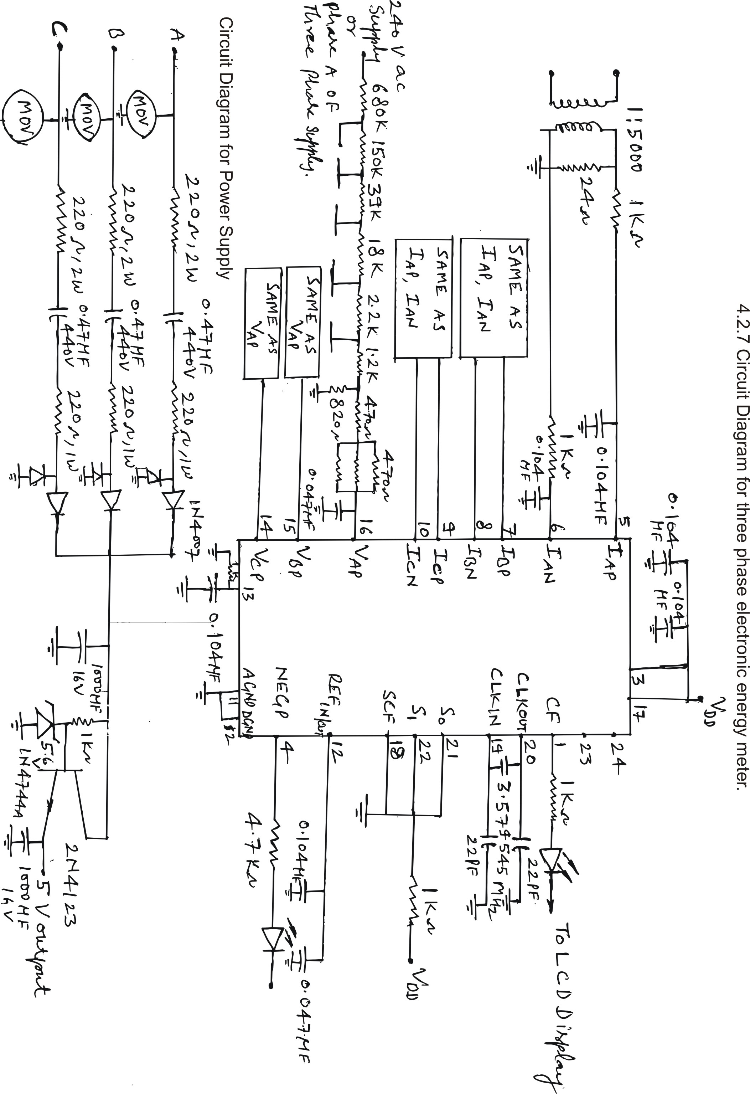
Fig. 4.3
4.2.8 Circuit Diagram for LCD Display
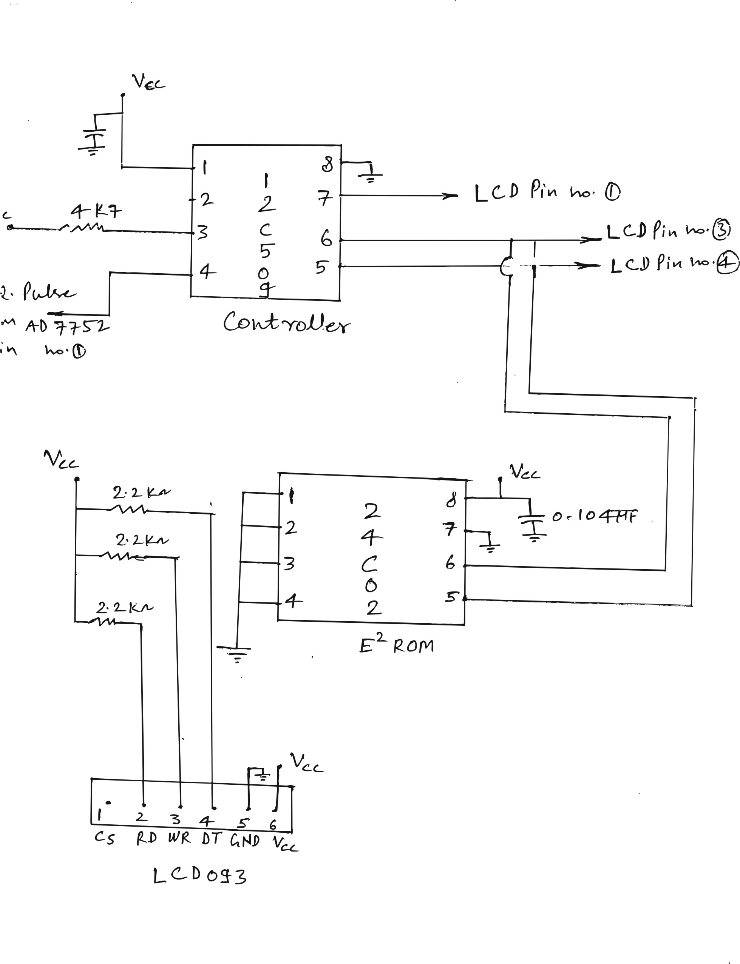

Fig. 4.4 Circuit diagram for LCD Display
4.3 Conclusion : Development of a single phase electronic energy meter is discussed and the requirement of various components is listed. Circuit diagram of the complete unit of single phase and three phase electronic energy meter are developed for 240V, 10-40 A and 3 x 240 V, 50A respectively and are shown in this chapter.
CHAPTER 5
CALIBRATION AND TESTING OF ELECTRONIC ENERGY METER
5.0 General
The calibration and testing of single phase and three phase electronic energy meter is discussed in this chapter.

5.1 Calibration When all the component of the meter are fabricated and assembled then the meter is calibrated to check the accuracy. The accuracy class of the sub standard must be at least 1/10 times to that of the accuracy class of the meter to be calibrated. The calibration of the single phase and three phase electronic energy meter is described below :
5.1.1 Calibration of Single Phase Electronic Energy Meter
From the design of voltage sensor it was observed that the meter is simply calibrated by attenuating the line voltage down to 117.3 mV The line voltage attenuation is carried out by the resistor divider network as shown in figure 4.1 in the voltage channel. In order to calibrate the meter each jumper is closed, starting from 150 k in order of ascendance, e.g., 39K, 18K, ….. 2.2 K. If the Calibration Frequency on (CF), i.e. 16 x 100 imp/kwh (at I_{b} = 10A, CF is expected to be 1.12 Hz) is exceeded when any jumper is closed it should be opened again. All jumpers are tested. Since the AD7751 transfer function is extremely linear, a one point calibration (at I_{b}) at unity power factor is all that is needed to calibrate the meter. If the correct precautions have been taken at the design stage no calibration will be necessary at low Power factor (e.g., PF=0.5). Even though if the calibration is required at PF = 0.5 it can be done by cutting or soldering the resistors connected between the 820 resistor and 0.104 F capacitor.
5.1.2 Calibration of Three Phase Electronic Energy Meter In order to calibrate the three phase electronic energy meter each phase voltage channel is attenuated individually while other two phases are switch off. The procedure for the calibration of each voltage channel is same as that of single phase electronic energy meter. When the attenuation of all three voltage channel is completed individually then all the three phases are switched on and the accuracy of the meter is checked. The transfer function of AD 7752 is also extremely linear, a one point calibration (at I_{b}) at unity power factor for each phase is all that is needed for calibration of the meter.
5.2 Tests Carried Out On Electronic Energy Meter Tests carried out on single phase and three phase Electronic Energy Meter to check the conformity with the requirement of the standard are discussed below
5.2.1 Tests Carried Out On Single Phase Electronic Energy Meter Various tests carried out on single Phase, 10-40A, 240V, 1600 impulse / kwh and class 1.0 Electronic Energy Meter are tabulated below
5.2.1.1 Tests On Limits of Error
I_{b} = Basic current = 10A.
I_{max} = Maximum current = 40A
5% I_{b} UPF (±1.0%) | 10% I_{b} UPF (±1.0%) | 10% I_{b} 0.5 lag (±1.0%) | 10% I_{b} 0.8 lead (±1.0%) | 100% I_{b} UPF (±1.0%) | 100% I_{b} 0.5 lag (±1.0%) | 100% I_{b} 0.8 lead  (±1.0%) | I_{max} UPF (±1.0%) | I_{max} 0.5 lag (±1.0%) | I_{max} 0.8 lead (±1.0%)
0.08 | 0.08 | –0.13 | –0.01 | 0.03 | –0.29 | 0.20 | 0.03 | –0.33 | 0.21
Table 5.0
5.2.1.2 Test Of Starting Condition, No Load Condition And Test Of Meter Constant
Test of Starting Condition at o.4% of I_{b} | Test of No load condition 120% V_{ref} (288V) | Test of Meter constant
Test of Starting Condition at o.4% of I_{b} | Test of No load condition 120% V_{ref} (288V) | Initial counter reading | Final Counter Reading | Difference in kwh
OK | OK | 8.0 | 9.0 | 1
Table 5.1
5.2.1.3 Test Of Power Consumption, HV & IR
Power Consumption |  | HV Test at 4KV | IR Test at 500 V DC
Voltage Circuit (V_{ref} = 250V)  1.5 watt | Current Circuit at I_{b}  4VA | HV Test at 4KV | IR Test at 500 V DC
0.39 Watt | 0.023 | OK | Ok
Table 5.2
5.2.1.4 Repeatability of Error
5% I_{b} UPF |  |  |  |  |  | 100% I_{b} UPF
1 | 2 | 3 | 4 | 5 | Variation (0.5%) | 1 | 2 | 3 | 4 | 5 | Variation (0.5%)
0.08 | 0.07 | 0.09 | 0.08 | 0.08 | 0.02 | 0.03 | 0.03 | 0.03 | 0.04 | 0.03 | 0.01
Table 5.3
5.2.1.5 Anti-Tamper Test At I_{b} UPF
Input and out terminal Inter change  % Error | Phase and neutral Inter change % Error | Current is drawn through local earth (load has been earthed) |  | Effect of external magnetic field as per CBIP -88 at 0.2 Tesla | Effect of external DC magnetic field as per CBIP-88 at 0.2 Tesla | Phase to phase voltage given to phase neutral i.e. 415V with stand test for 30 minutes
Input and out terminal Inter change  % Error | Phase and neutral Inter change % Error | Phase and neutral correct % error | Phase and neutral interchange % error
0.03 | 0.05 | 0.10 | 0.12 | OK | OK | OK
Table 5.4
5.2.2.1 Test of Limits Of Error (Balance Load)
5% I_{b} in UPF (±1.0%) | 5% I_{b} 0.5 lag (±1.5%) | 5% I_{b} 0.8 lead (±1.5%) | 10% I_{b} UPF (±1.0%) | 10% I_{b} 0.5 lag (±1.0%) | 10% I_{b} 0.8 lead (±1.0%) | 100% I_{b} UPF (±1.0%) | 100% I_{b} 0.5 lag (±1.0%) | 100% I_{b} 0.8 lead (±1.0%) | I_{max =} UPF (±1.0%) | I_{max} 0.5 lag (±1.0%) | I_{max} 0.8 lead (±1.0%)
0.15 | 0.32 | 0.15 | 0.30 | 0.39 | 0.16 | 0.16 | 0.27 | 0.02 | 0.21 | 0.16 | 0.17
Table 5.5
5.2.2.2 Test Of Starting Condition, No Load Condition And Test Of Meter Constant
Test of Starting Condition at o.4% of I_{b} | Test of No load condition 120% V_{ref} (288V) | Test of Meter constant
Test of Starting Condition at o.4% of I_{b} | Test of No load condition 120% V_{ref} (288V) | Initial counter reading | Final Counter Reading | Difference in kwh
OK | OK | 3.0 | 4.0 | 1
Table 5.6
5.2.2.3 Test of Power Consumption, HV and IR
Power consumption |  |  |  |  |  |  |  |  | HV Test at 4KV | IR Test at 500 VDC
Voltage Circuit (V_{ref} = 240V) |  |  |  |  |  | Current Circuit at I_{b} |  |  | HV Test at 4KV | IR Test at 500 VDC
1.5 Watt |  |  | 10 VA |  |  | 4 VA |  |  | HV Test at 4KV | IR Test at 500 VDC
R | Y | B | R | Y | B | R | Y | B | HV Test at 4KV | IR Test at 500 VDC
0.71 | 0.72 | 0.72 | 0.79 | 0.64 | 0.81 | 0.022 | 0.023 | 0.021 | OK | OK
Table 5.7
5.2.2.4 Repeatability of Error
5% I_{b} UPF |  |  |  |  |  |  | 100% I_{b} UPF
1 | 2 | 3 | 4 | 5 | 6 | Variation (0.5%) | 1 | 2 | 3 | 4 | 5 | 6 | Variation (0.5%)
0.21 | 0.21 | 0.20 | 0.22 | 0.26 | 0.27 | 0.07 | 0.20 | 0.20 | 0.20 | 0.15 | 0.18 | 0.20 | 0.05
Table 5.8
5.2.2.5 Anti Tamper Test At Ib UPF
Input & output terminal inter change % Error | Phase Missing |  |  | Neutral Missing | Phase sequence Reverse | Current circuit By Pass | External AC Magnetic Field as per CBIP-88 at 0.2 Tesla | External DC magnetic Field as per CBIP-88 at 0.2 Tesla | Phase to Phase voltage given to Phase Neutral i.e. 415V withstand for 30 minutes
Input & output terminal inter change % Error | R OFF | Y OFF | B OFF
0.48 | 0.28 | 0.65 | 0.31 | 0.42 | 0.39 | OK | OK | OK | OK
Table 5.9

5.3 Tests Performed on Energy Meter To Prove Conformity Of The Required Standard
The following tests are performed on energy meters to prove their conformity according to the required standard these are broadly classified under three categories.
(i) Type Test Series of tests carried out on one meter or a small number of metes of the same type having identical characteristics, selected by manufacturer to prove conformity with all the required standard. These are intended to prove the general qualities and design of a given type of meter.
(ii) Acceptance Test Tests carried out on samples taken from a lot for the propose of acceptance of the lot.
(iii) Routine Test Tests carried out an each meter to check conformity with the requirements of the standard in aspects which are likely to very during production.
Details of all the three above mentioned test, is given in the table 5.10
S.No. | Name of Test | Type Test | Acceptance | Routine
1. | Test of Insulation Properties
1.1 | Impulse voltage test | P | -- | --
1.2 | ac High voltage Test | P | P | P
1.3 | Insulation Test | P | P | P
2.0 | Test of Accuracy requirements
2.1 | Test of limits of error | P | P | P
2.2 | Interpretation of test result | P | P | --
2.3 | Test of meter constant | P | P | --
2.4 | Test of starting condition | P | P | P
2.5 | Test of No load condition | P | P | P
2.6 | Test of ambient temperature influence | P | - | -
2.7 | Test of repeatability of error | P | P | -
2.8 | Test of influence quantities | P | - | -
3.0 | Test of electrical requirements
3.1 | Test of power consumption | P | P | -
3.2 | Test of Influence of supply voltage | P | - | -
3.3 | Test of influence short time over current | P | - | -
3.4 | Test of influence of self heating | P | - | -
3.5 | Test of influence of heating | P | - | -
3.6 | Test of influence of immunity to earth fault | P | - | -
4.0 | Test for electromagnetic compatibility | - | - | -
4.1 | Radio interference measurement | P | - | -
4.2 | Fast transient burst test | P | - | -
4.3 | Test of immunity to electrostatic discharges | P | - | -
4.4 | Test of immunity to electromagnetic HF field | P | - | -
5.0 | Test for climate influences
5.1 | Dry heat test | P | - | -
5.2 | Cold test | P | - | -
5.3 | Damp heat cyclic test | P | - | -
6.0 | Test for mechanical requirement
6.1 | Vibration test | P | - | -
6.2 | Shock test | P | - | -
6.3 | Spring hammer test | P | - | -
6.4 | Protection against penetration of dust and water | P | - | -
6.5 | Test of resistance to heat & fire | P | - | -
Table 5.10 various test in their details
5.3.1 Test Of Insulation Properties The test shall be carried out only on a complete meter with its cover and terminal cover, the terminal screws being screwed down to maximum applicable conductor fitted in the terminals. Test procedure shall be in accordance with IS 2071 (Part-I)
For the purpose of these tests, the earth has the following meaning
(a) When the meter case is made of metal, the earth is the case itself placed on and flat conducting surface.
(b) When the meter case or only a part of it is made of insulating martial the earth is a conducting foil wrapped around the meter, touching all accessible conducting parts and connected to the flat conducting surface on which the meter base is placed. Where the terminal cover makes it possible, the conductive foil shall approach the terminals and holes for the conductors within a distance of not more than 2 cm.
The normal conditions for insulation test are :
Ambient temperature 20ºC to 35ºC.
Relative humidity 45% to 95%.
Atmospheric pressure 36 to 106 Kpa.
      - Impulse Voltage Test
The impulse of 5KV is applied ten times with one polarity and then repeated with the other polarity. The minimum time between the impulses shall be 3 sec. The wave form and the generator characteristics shall be in accordance with IEC 61000-4-5 (1995-03).
AC Voltage Tests Are Perform As Per Details Shown in Table 5.11
Test Voltage (rms) 2 kv | (a) Points of application of the test voltage test to be carried out with the case closed and terminal cover in place.  (i) Between, on the one hand, all the current and voltage circuits as well as the auxiliary circuit whose reference voltage is over 40V, connected together, and on the other hand, earth.  (ii) Between circuits not intended to be connected together in service.
4 KV (for test in item (a) | (b) Additional tests for insulating enclosed meters :  (i) Between, on the one hand, all the current and voltage circuits as well as the auxiliary circuits whose reference voltage is over : 40V, connected together, and on the other hand, earth  (ii) A visual inspection for compliance with the conditions of table (A)
40 V (For test in item c) | (c) Between, on the one hand, all conductive parts in side the meter, connected together and, on the other hand all conductive parts outside the meter case that are accessible with test finger connected together (the test is not necessary, if test in item (b) leaves no doubt).
Table 5.11
Clearance and Creep Age Distance The Details Of The Applied Voltage and Creepage Distance are Shown In Table 5.12
Voltage between phase to earth | Minimum clearance(mm) | Minimum creepage distance (mm)
Not exceeding 50 | 0.8 | 1.2
Not exceeding 100 | 0.8 | 1.4
Not exceeding 150 | 1.5 | 1.6
Not exceeding 300 | 3.0 | 3.2
Not exceeding 400 | 5.5 | 6.3
Table 5.12

(a) Impulse Voltage Test For Circuits And Between The Circuits
The test shall be made independently on each circuit for assembly of circuits) which are insulated from the other circuits of the meter in normal use. The terminals of the circuits which are not subjected to impulse voltage shall be connected to earth.

(b) Impulse Voltage Test Of Electric Circuits Relative To Earth
All the terminals of the electric circuits of the meter, including those of the auxiliary circuits with a reference voltage over 40V, shall be connected together.
The auxiliary circuits with a reference voltage below or equal to 40V shall be connected to earth.
The impulse voltage shall be applied between all the electric circuits and earth
5.3.1.2 AC Voltage Test The ac voltage test shall be carried out in accordance with the following table for type test and acceptance test of new meters. For any subsequent test, the voltage applied shall be 80% of the test voltage indicated in the table.
During the test no flashover, disruptive discharge, puncture shall occur.
5.3.1.3 Insulation Resistance Test The insulation resistance test shall be carried out in accordance with the following table. The voltage shall be applied for a minimum of one minute or more as per details shown in table 5.13
Test Voltage | Points of application of the test voltage | Insulation resistance
500 ±50Vdc | (a) Between, on the one hand, all the current and voltage circuits as well as the auxiliary circuits whose reference voltage is over 40V connected together, and one the other hand earth  (b) Between circuits not intended to be connected together in service. | 5 M  50M
Table 5.13

5.3.2 Test of Accuracy Requirements these tests includes the following
5.3.2.1 Test of limits of Error
5.3.2.1.1 Limits of error due to variation of the current
When the meter is under the reference conditions, the percentage error shall not exceed the limits for the relevant accuracy class given in table 1 & 2.
5.3.2.1.2 Limits of error due to other influence quantities (voltage –variation, frequency variation, phase-sequence, wave form, voltage un-balance) : Limits of variation in percentage error due to the change of influence quantities with reference conditions, shall not exceed the limits for the relevant accuracy class given in table 3.
5.3.2.1.3 Limits of Error due to ambient temperature variation :-
The mean temperature coefficient shall not exceed the limits given in table 5.14.
Percentage error limits (single phase meters & 3 phase meters with balanced loads)
Value of Current |  | P.F. | Percentage error limits for meters of class
For direct connected meters | For transformer operated meter |  | 1 | 2
0.05Ib Ib 0.1 Ib | 0.02 Ib 0.05 Ib | 1 | 1.5 | 2.5
0.1Ib Ib Imax | 0.05 Ib Ib Imax | 1 | 1.0 | 2.0
0.1 Ib Ib 0.2 Ib | 0.05 Ib Ib 0.1 Ib | 0.5 lagging  0.8 leading | 1.5  1.5 | 2.5
0.2 Ib Ib Imax | 0.1 Ib Ib Imax | 0.5 lagging  0.8 leading | 1.0  1.0 | 2.0
When specially requested by the user from 0.2 Ib to Ib | When requested by the used from 0.1 Ib to Ib | 0.25 lagging  0.5 leading | 3.5  2.5
Table 5.14

Percentage Error Limits (3 phase meters carrying a 1 phase load, but with balanced poly phase voltage applied to voltage circuits are shown in table 5.15
Value of Current |  | P.F. | Percentage error limits for meters of class
For direct connected meters | For transformer operated meter |  | 1 | 2
0.1Ib Ib Imax | 0.05 IbIbImax | 1 | 2.0 | 3.0
0.2 IbIb Imax | 0.1 Ib Ib Imax | 0.5 lagging | 2.0 | 3.0
Table 5.15
S.No. | Influence quantities | Value of current | Power factor | Limits of variation in percentage error
(i) | Voltage variation (10%) | Ib | 1 | 0.7 | 1.0
 |  |  | 0.5 lag | 1.0 | 1.5
(ii) | Frequency variation (5%) | Ib | 1 | 0.8 | 1.3
 |  |  | 0.5 lag. | 1.0 | 1.5
(iii) | Wave from: 10% of third harmonic in the current | Ib | 1 | 0.6 | 0.8
(iv) | Reversed phase sequence (applicable for active E.M. only | 0.1Ib | 1 | 1.5 | 1.5
(v) | Voltage unbalance | Ib | 1 | 2.0 | 4.0
(vi) | Continuous magnetic induction of external origin | Ib | 1 | 2.0 | 3.0
(vii) | dc component in ac current circuit (this test does not apply to transformer operated meters) | 0.5 Imax | 1 | 3.0 | 6.0
(viii) | Magnetic induction of external origin | Ib | 1 | 2.0 | 3.0
(ix) | Electromagnetic F fields | Ib | 1 | 0.5 | 1.0
(x) | Operation of accessories | 0.05 Ib | 1 | 0.5 | 1.0
Table 5.16
Temperature Coefficient
Value of Current | P.F. | Mean temperature coefficient
Value of Current |  | Class 1.0 | Class 2.0
From 0.1 Ib to Imax | 1.0 | 0.05 | 0.1
From 0.2 Ib to Imax | 0.5 Lagging | 0.07 | 0.15
Table 5.17
5.3.2.2 Interpretation Of Test Results
Permissible displacement of the zero line, percent | Class 1.0 meters | Class 2.0 meters
 | 0.5 | 1.0
Table 5.18
5.3.2.3 Test Of Meter Constant Relation between the test output and the indication in the display shall comply with the marketing on the name plate.
5.3.2.4 Test Of Starting Current The meter shall start and continue to register at the current shown in table 5.19
Meter for | P.F. | Class of Meter
 |  | Class 1.0 | Class 2.0
Direct connection percentage of basic current Ib. | 1.0 | 0.4 | 0.5
Connection through C.T. percentage of basic current Ib | 1.0 | 0.2 | 0.3
Table 5.19
5.3.2.5 Test Of No. Load Condition When the voltage is applied with no current flowing in the current circuit, the test output of the meter shall not produce more than one output pulse count.
5.3.2.6 Test Of Ambient Temperature Influence Increase the temperature of the surrounding & then test for limits of variation for various current.
5.3.2.7 Test Of Repeatability Of Error Repeatability of error at 10 percent Ib and UPF load shall not exceed 0.5 for class 1 and 1.0 for class 2.
5.3.2.8 Test Of Influence Quantities These test are performed on the meter in accordance with table 5.16.
5.3.3 Test of Electrical Requirements
5.3.3.1 Test of Power Consumption
Power consumption in voltage circuit in including the power supply
Class of meters 1 & 2
Single phase and poly phase (per phase) 1.5W and 8 VA

Power consumption in current circuit
Class of meters
1.0 2.0
Direct connection Single phase and 4.0 VA 2.5VA
Poly phase (per phase)
Connection through C.T. Single Phase 4.0 VA 2.5VA
And poly phase (per phase)

5.3.3.2 Test of Influence Of Supply Voltage The meter should comply the limits as per table 3 when any voltage between 0.80 to 1.1 Vref is applied.
Voltage dips and interruptions shall not produce a change in the resister of more than 0.01 kwh and this value is based on the rated current of 5A and 100V of the meter. For other voltage and current ratings the value 0.01kwh has to be converted accordingly. Further, after this test the data from the memory should not be lost.
5.3.3.3. Test of Influence Short-Time Over Currents
Short-time over current shall not damage the meter. Moreover the variation of error shall not exceed the values shown in the table 5.20
Meters for | Value of current | Power factor | Limits of variation in percentage error for meters of class
 |  |  | Class 1.0 | Class 2.0
Direct connection | Ib | 1 | 1.5 | 1.5
Connection through CT | Ib | 1 | 0.5 | 1.0
Table 5.20
The direct connection meter shall be able to carry a short time over current of 30 Imax for one half-cycle at rated frequency. The C.T. meters shall be able to carry 20 Imax current for a period of 0.5 second.

5.3.3.4 Test of Influence of Heating & Self Heating Under normal conditions of use, electrical circuits and insulation shall not reach a temperature which might adversely affect the operation of the meter. The temperature rise at any point of the external surface of the meter shall not exceed by more than 20K with an ambient temperature at 45ºC.
The variation in percentage error due to self –heating shall not exceed the values given in table 5.21.
Value of current | Power factor | Limits of variation in percentage error for meters of
 |  | Class 1.0 | Class 2.0
Imax | 1 | 0.7 | 1.0
Imax | 0.5 Lagging | 1.0 | 1.5
Table 5.21
5.3.3.6 Test of Influence of Immunity To Earth Fault
This test is applies to three phase four wire meters. The change of error measures when the meter is back at nominal working in the table 5.22.
Value of current | Power factor | Limits of variation in percentage error for meters of
 |  | Class 1.0 | Class 2.0
Imax | 1 | 0.7 | 1.0
Table 5.22
5.3.4 Test For Electro Magnetic Compatibility For all these tests, the meter shall be in its normal working position with the cover and terminal cover in place. All parts intended to be earthed shall be earthed.
After there tests, the meter shall show no damage or change of information.
5.3.4.1 Radio Interference Measurement The test for radio interference shall be carried out for the frequencies from 0.15 MHz to 30 MHz and for the frequencies from 30 MHz to 300 MHz as per IS 6842.
5.3.4.2 Fast Transient Burst Test The test shall be to IEC 61000-4-4 (1995-01) under the following conditions :
- Meter in operating condition.
- Voltage and auxiliary circuits energized with reference voltage.
- Without any current in the current circuits and the current terminals should be open circuit.
- Test voltage : 4 KV
- Test severity level : 3
- Duration of the test : minimum 60 Sec.

Test points are :
- Between the terminals of each circuit normally connected to the mains :
- Between any two independent circuits having reference voltages over 40V; and
- Between each independent circuits having reference voltages over 40V and earth.
During the test, there shall not be a change in the resister of more than 0.01 Kwh. These values are based on the rated current 0f 5A and 100V of the meter. For the other voltage and current ratings the value 0.01 kwh has to be converted accordingly.
5.3.4.3 Test of immunity to electrostatic discharge : The test shall carried out according to IEC 61000-4-2 (1995-01) under the following conditions :
- Contract Discharge
- Test voltage : 8 KV
- Test severity level : 4
- Number of discharges : 10
- Voltage and auxiliary circuits energized with reference voltage.
- Without any current in the current circuits and the current terminal should be open circuit.
The application of the electrostatic discharge shall not produce a charge in the register as discussed in 4.2
5.3.4.4 Test of immunity to electromagnetic HF field :
The test shall be carried out according to IEC 6100-4-3 (1995-03). Under the following conditions
Voltage and auxiliary circuits energized with reference voltage.
Frequency band : 80 MHz to 1000 MHz
Test field strength : 10V/m
Test severity level : 4
(a) With open current circuit, the application of the HF field shall not produce a change in the register as discussed in leading 4.2.
(b) with basic current Ib and power factor equal to unity at sensitive frequencies or frequencies of dominant interest, the variation of error shall be within limit given in table 5.16.
5.3.5 Test For Climate Influences After each of the climatic tests, the meter shall show no damage or change of the information. These tests should not affect the functioning of the meters.
5.3.5.1 Dry Heat Test The test shall be carried out according to relevant section of IS 9000 (Part 3/sec 1 to 5). Under the following conditions
Meter in non-operating condition.
Temperature : +70 ±2ºC
Duration of the test : 72 hrs.
5.3.5.2 Cold Test The test shall be carried out according to relevant section of IS 9000 (part 2 / sec 1 to 4) under the following conditions :
- Meter in non operating condition
- Temperature : –25 ±2ºC
- Duration of the test : 72 Hours
5.3.5.3 Damp Heat Cycle Test The test shall be carried out according to relevant section of IS 9000 (Part 5/sec 1 and 2) under the following conditions
- Meter in operating condition.
- Voltage and auxiliary circuits energized with reference voltage.
- Without any current in the current circuit.
- Upper temperature 40ºC ±2ºC
- No special precautions shall be taken regarding the removal of surface moisture.
- Duration of test : 6 cycles
24 hours after the end of this test the meter shall be submitted to the following tests :
(a) An insulation test and
(b) A functional test.
5.3.6. Test For Mechanical Requirements The following tests for mechanical requirements are perform
5.3.6.1 Vibration Test The test shall be carried out as per IS 9000 (Parts) under the following conditions :
- Meter is in non-operation condition without the packing
- Frequency range : 10-150 -10Hz
- Transition frequency : 60 Hz
- f < 60Hz constant amplitude of movement 0-15 mm.
- f>60Hz constant acceleration 2g(1g = 9.8 m/s²)
- Single point control
- Number of sweep cycles per axis : 10
After the test the meter shall show no damage or change of information. After the test variation in percentage of error of the meter error shall not exceed 50% of class index at 0.05 Ib, basic current and maximum current (at upf.)
5.3.6.2 Shock Test The test shall be carried out as per IS 9000 (part 7/sec 1 to 5) under the following condition :
Meter in non-operating condition, without the packing
Half sine pulse
Peak acceleration : 40g (400 m/s²)
Duration of the pulse : 18 ms.
Number of shock : two in both direction of three mutual perpendicular axis.
After the test, the meter shall show no damage or change of information. After the test, variation in percentage error shall not exceed the 50% of accuracy class index at Ib, 0.05 Ib and Imax (at upf.)
5.3.6.3 Spring Hammer Test The mechanical strength of the meter case shall be tested with a sprint hammer (IEC 60068 -2-75(1997).
The meter shall be mounted in its normal working position and the spring hammer shall at on the outer surfaces of the meter cover including windows and on the terminal cover with a kinetic energy of 0.22 Nm ±0.05 Nm.
The result of the test is satisfactory of the meter case and terminal cover do not sustain damage which could affect the function of the meter and it is not possible to touch live parts slight damage which does not impair the protection against indirect contact or the penetration of solid objects, dust and water is acceptable.
5.3.6.4 Test Of Protection Against Penetration Of Dust And Water The test shall be carried out according to IS 12063 under the following conditions
(a) Protection Against Penetration Of Dust
Meter is in non operating condition and mounted on an artificial wall
The test should be conducted with sample length of cable (exposed ends sealed) of the types specified by the manufacturer in place :
Any ingress of dust only be in a quantity not impairing the operation of the meter, and not impairing its dielectric strength.
(b) Protection Against Penetration Of Water
Meter is in non-operating condition.
Any ingress of water must only be in a quantity not impairing the operation of the meter, and not impairing its dielectric strength.
5.3.6.5 Test of Resistance To Heat And Fire The test shall be carried out according to IS : 11000(part 2 / sec 1), with the following temperatures :
Terminal block : 960ºC ±15ºC
Terminal cover and meter case : 650ºC ±10ºC
Duration of application : 30 s ±15
The contact with the glow wire may occur at any random location. If the terminal block is integral with the meter base, it is sufficient to carry out the test only on the terminal block.
5.4 Conclusion The calibration of single phase and three phase electronic energy meter, various tests carried out on Single Phase and Three Phase Electronic Energy Meter and the various tests performed to prove the conformity and requirement of IS 13799 & IEC 1036 (1996 -99) has been discussed.
CHAPTER 6
CONCLUSION & FUTURE SCOPE OF WORK
6.1 Conclusion
The importance, scope and limitations of electronics energy meter over electro mechanical meters are presented in detail, Functional block diagram of the electronics energy meter and the review of various literature published in IEEE and other international conferences are summarized. Design of various components of single phase electronics energy meter like design of current sensor, design of voltage sensor, design of power, supply, display unit and the IC AD7751 description are discussed. It is observed that existing single phase electronics energy meter gives the real energy consumption for sinusoidal as well as non sinusoidal signals at all power factors. Design of various components of three phase electronics energy meter like design of current sensor, design of voltage sensor, design of power supply, display unit and the description of AD7752 IC are also discussed in detail. It is observed that the existing 3 phase electronics energy meter gives the real energy consumption for sinusoidal and non sinusoidal signal at all power factors. Development of single phase meter and its circuit diagram along with material requirements for prototype is described. Calibration of single phase and three phase electronics energy meter and various tests performed on single phase and three phase meters to prove the conformity of design and various changes occurs during manufacturing as per the IS 13779 : 1999 are discussed. It can be seen that designed energy meters gives the energy information proportional to the real power consumed in the various load whatever of its nature (i.e. unity P.F. condition, P.F. condition, sinusoidal voltage and current and non sinusoidal voltage and current) and meet the requirement of the IS 13779:1999 and IEC 1036 (1996-99) and passes all the advantages / features described in the report.
6.2 Future Scope of Work
Following further improvements can be suggested for the designed energy meters.
1. The designed single phase energy meter does not have the input neutral missing feature. However, by the introduction of an additional C.T. called power C.T. in the current circuit along with a voltage amplifier, this feature can be introduced.
2. The designed energy meters gives energy proportional to the real power consumption and does not give any information regarding reactive power, so this can be further modifier to give kwh, KVAR, KVA and as well power factor of the load.
3. The electronics energy meters are more vulnerable to EMI disturbances and may act as a source of polluting power line as well as electro magnetic environment due to use of SMPS, clock & processing circuits etc. Therefore, further modification can be done to avoid all these sorts of pollution.
4. The existing meters can be modified to prepaid meters.
5. The existing energy meter can be further modified to networked electronic energy meters.
REFERENCES
- R. De Vre, R. Huybreechts, “Electronic Energy meters – Principles, performance and tests” Electricity Distribution, 1993 CIRED, 12th International Conference on 17-21 May page(s)5.8/1-5.8/5 vol.5.
- Roberto Caceres, Roberto correa, Pablo Ferreyra, and Eduado cordero, “Study of active electric energy meters – Behavior of Induction and electronic types” Transmission and distribution Conference and Exposition Latin America, 2006.TDC’06, IEEE/ PES Aug-2006 page(s): 1-6.
3. Gorazd Modrijan, Peterzajee, Janer Nastran, Henric Lavric, Danijel Vancina, “All three phase power source with low THD for Energy meters calibration” EPE-PEMC2006,portoroz,slovenia.
4. F. Calegari, “Electric Power / Energy Measurements for residential
single-phase networks” IEEE ISIE 2005, June 20-23, 2005, Dubrovnik, Croatia.
5. P.S. Nagendra Rao and Ravishankar Deekshit, “Energy Loss Estimation in distribution feeders” IEEE Transactions on Power Delivery, VOL.21, no.3,July2006.
6. Fracisco Dyarte, J. Machado Da Silva, Jose C. Alves, G.A. pinho, Tose S. Matos, “A processor for testing mixed signal covers in system on chip” Proceedings of the 2005 8th Euro mica Conference on Digital System Design (DSD 05)..
7. Benjamin Yue Zongbin, member IEEE and charles Leong Pou U “Preparing for move competitive markets” 2004 IEEE International Conference on Electric Utility Deregulation, Restructuring and Power Technology (DRTP 2004) April 2004 HongKong.
8. M.Wada and O Naka Mura, K Akiyama, “Development of Remote meter reading system in distribution automation” Metering. Apparatus and Tariffs for Electricity Supply,1992, Seventh International Conference on 17-19Nov 1992 Page(s):212-216.
9. T.K. Abdel-Galil, E.F. EI-Saadany and MMA Salama, “Effect of New Deregulation policy on powe quality monitoring and mitigation techniques” Transmission and Distribution Conference and Exposition, 2001 IEEE/PES Volume 1,28 Oct-2 Nov.2001 page(s)554-560 vol.1.
10. Mihai Gavrilas, “Identifying typical load profiles using neural –fuzzy models” Transmission and Distribution Conference and Exposition, 2001 IEEE/PES volume 1,Oct 28-Nov.2001 page(s) 421-426 vol.1.
11. Henric–Lavric, Javez Nastram “A hybrid voltage Amplifier for power calibrator with harmonic analysis capability, Applied Power Electronics Conference and Exposition, 2003.APEC’03. Eighteenth Annual IEEE volume 2,9-13 Feb.2003 page(s)925-929 vol.2.
12. Natasha Wan, Kerin Manning, “Exceeding 60-years life expectancy from an electronic energy meter”, metering Asia Pacific conference, 20-22, February 2001, Conference Documentation.
13. Arun sachedeva and Sulekh Chand, “EMC Evaluation and Analysis of Electronic Energy Meter” Proceeding of the International Conference on Electromagnetic Interference and Compatibility ‘99.
14. M Nagaraju, T. Praveen Kumar, “Networked Electronic Energy Meter with power quality analysis” Power Quality 98,1998 page(s)45-57.
15. Antonio Barreiro, Jose Ferreira, Carlos Abreu, and Michael Blanck,” Energy Management for rational electricity use-reducing cost and consumption at SECIL’s outao cement plant Purtagal” ,IEEE Transactions on Industry Applications.Vol 27,No.3 May/June 1991.
16. IS 13779 : 1999
17. AN-563 Application note & Data Sheet available on http//www.analog.com.
18. AN-641 Application note & data sheet available on http://www.analog.com
19. S. Madu, “Linear Circuit Analysis” Prentice-hall international editions, 1998.
20. Robert Boylertad, Louis Nasheusly, “Electronic Devices and circuit theory” prentice Hall of India 2001 edition.
21. A. K. Sawhney, “Electrical Machine Design” Danpat Rai & Co., 2003 Edition.
22. Muhammad H. Rasid, “Power Electronics” Pearson Education, Third Edition.

