Design and Analysis of Automated Material Handling System at Door Fabrication and Assembly in Weld Shop

A Major Project thesis submitted

In partial fulfillment for the requirement of the degree of

Master of Engineering
In
Production Engineering

By

PRADEEP KHANNA
Roll No. 4201
(Session 2004-07)

Under the Guidance of
Prof. S. K. GARG



DEPARTMENT OF MECHANICAL ENGINEERING
DELHI COLLEGE OF ENGINEERING, DELHI UNIVERSITY
NEW DELHI-110042 (INDIA)

Candidate’s Declaration

I hereby certify that the work which is being presented in the dissertation entitled “Design and Analysis of Automation System in Material Handling of Door Assembly in Weld Shop”, in partial fulfillment of the requirements for the award of the degree of Master of Engineering in Production Engineering, submitted in the department of Mechanical Engineering, Delhi College of Engineering, Delhi is an authentic record of my own work carried out under the supervision of Dr. S. K. Garg, Professor of Mechanical Engineering Department, Delhi College of Engineering, Delhi.

I have not submitted the matter embodied in this dissertation for the award of any other degree.

Pradeep Khanna

This is to certify that the above statement made by the candidate is true to the best of my knowledge.

Dr. S. K. Garg
Professor
Department of Mechanical Engineering
Delhi College of Engineering
New Delhi-10042 (India)

Acknowledgements

I would like to acknowledge those people who have given the knowledge, guidance and support for making this work a success. I express my heartily and sincere gratitude and indebtedness to Dr. S. K. Garg, professor, Mechanical Engineering Department, Delhi College of Engineering, Delhi for his valuable guidance and wholehearted co-operation. He has been constantly a source of inspiration for me throughout this project.

I would like to acknowledge Maruti Udyog Limited, Gurgaon, for providing resources and people to support me while pursuing this project. At Maruti Udyog, I must express my gratefulness to following: Mr. Mani, Mr. Sandeep Gupta, Manager Weld shop -3. I must convey my special thanks to Mr. Ram Singh, technician weld shop-3 and Mr. Saurabh Kainth Asstt. Manager; production engineering, without whose sincere support, completion of this project would have become very difficult. I must also thanks Dr. N. K. Tewari for his valuable suggestions and comments.

Finally my sincere thanks go to my parents for their blessings and my family who gave me strength love and care to carry out this work successfully.

Pradeep Khanna

List of Abbreviations and Symbols

A : Production station of hoods and back doors.
B : Production station of front right and front left doors.
C : Production station of rear right and rear left doors.
A1 : Assembly station of rear left door.
A2 : Assembly station of rear right door.
B1 : Assembly station of front left door.
B2 : Assembly station of front right door.
C1 : Assembly station of hood.
C2 : Assembly station of back door.
AGV : Automated guided vehicle.
AHP : Analytical Hierarchy Process
DM : Decision Matrix
MEMS : Micro Electro Mechanical Systems
MUL : Maruti udyog limited.
OEM : Original equipment manufacturer.
OTC Overhead Trolley Conveyor
P : Point where white bodies descend at door assembly line.
PAC : Programmable automation controller.
PLC : Programmable logic controller.
SMC : Suzuki motor company.
TLC : In-floor Tow Line Conveyor
List of Figures
Sl. No. | Fig. No. | Title | Page No.
1 | 1.1 | Present status of material transfer in door assembly shop | 16
2 | 2.1 | Five levels of automation and control | 20
3 | 2.2 | Close loop system | 22
4 | 2.3 | Open loop system | 23
5 | 2.4 | Product volume and product variety | 27
6 | 2.5 | Flexible versus fixed automation | 28
7 | 2.6 | Integration of various disciplines | 39
8 | 3.1 | Status of in-house automation at MUL | 46
2 | 3.2 | Door coming out of hemming press | 49
3 | 3.3 | Manual transfer of doors from fabrication to assembly station | 50
4 | 3.4 | Partially filled trolley transfer (lack of synchronization) | 51
5 | 3.5 | Trolleys occupying the useful aisle space | 52
6 | 3.6 | Interference with other material handling equipments | 53
7 | 3.7 | Door assembly operation | 54
8 | 3.8 | Empty trolley transfer from assembly to fabrication station | 55
16 | 4.1 | Automated Guided Vehicle | 60
17 | 4.2 | AGV in present layout | 61
18 | 4.3 | In-floor towline conveyor | 66
19 | 4.4 | In-floor tow trolleys in present layout | 68
20 | 4.5 | Overhead trolley conveyor | 72
21 | 4.6 | Overhead trolley conveyor in present layout | 74
22 | 5.1 | Hierarchy of the decision making process | 83
23 | 5.2 | Chain link (vertical and horizontal) | 106
24 | 5.3 | Shear pin | 107
25 | 5.4 | Chain wheel | 107
26 | 5.5 | Chain assembly | 108
27 | 5.6 | The carrier | 109
List of Tables

Sl. No. | Table No. | Title | Page No.
1 | 2.1 | Comparison of different energy media | 35
2 | 5.1 | Scale of relative importance | 81
3 | 5.2 | Format of pairwise comparison matrix | 82
4 | 5.3 | Priority weights for factors | 84
5 | 5.4 | Priority weights for cost | 86
6 | 5.5 | Priority weights for operational | 88
7 | 5.6 | Priority weights for flexibility | 90
8 | 5.7 | Total weighted evaluation of the alternatives | 103
9 | 5.8 | AHP ranking of the alternatives | 103

TABLE OF CONTENTS

CANDIDATE’S DECLARATION 2
ACKNOWLEDGEMENTS 3
LIST OF ABBREVIATIONS AND SYMBOLS 4
LIST OF FIGURES 5
LIST OF TABLES 6
EXECUTIVE SUMMARY 10

CHAPTER1: INTRODUCTION 12
  - Problem statement 14
  - Objective 17
  - Scope of the project 17
  - Methodology 17

CHAPTER 2: LITERATURE REVIEW 18
  - Automation 18
  - Levels of Automation 19
  - Elements of an Automated System 21
  - Reasons of Automation 23
  - Types of Automation 24
2.5.1 Fixed Automation 24
2.5.2 Programmable Automation 24
2.5.3 Flexible Automation 25
2.6 Special Automation Functions 28
2.6.1 Safety Monitoring 28
2.6.2 Maintenance and Repair Diagnostics 29
2.6.3 Error Detection and Recovery 30
2.7 Choice of Working Media in Automated Systems 32
2.8 Programmable Automation Systems 35
2.9 Mechatronics 38
2.9.1 Mechatronics in Manufacturing 39
2.10 Automation in Industry 40
2.10.1 Social Effects of Automation 41

CHAPTER 3: AUTOMATION IN AUTOMOBILE SECTOR 44
  - Domestic Sector 44
3.1.1Destination India 45
3.2 Maruti Udyog Limited 45
3.2.1 State-of-the-Art Manufacturing Facilities 46
3.2.2 Employee Quality Measures 46
3.3 Weld Shop 3 47
3.4 Present Status of Material Transfer in Weld Shop 3 48

CHAPTER 4: ALTERNATIVES TO IMPROVE MATERIAL FLOW IN 57
WELD SHOP 3
4.1 Automated Guided Vehicle 57
4.1.1 Application of AGV in Present Work 59
4.1.2 Specifications of AGV 60
4.1.3 Analysis of Material Handling Through AGV 63
4.1.4 Working 65
4.1.5 Benefits and limitations of using AGV 66
4.2 In-Floor Tow Line Conveyor 67
4.2.1 The System 68
4.2.2 Analysis of the System 70
4.2.3 Working 71
4.2.4 Safety Measures 71
4.2.5 Benefits and Limitations 72
4.3 Overhead Trolley Conveyor 73
4.3.1 The System 74
4.3.2 Analysis of the System 76
4.3.3 Working 76
4.3.4 Benefits and Limitations 77

CHAPTER 5: EVALUATION OF ALTERNATIVES 78
  - Introduction 78
  - Criteria selection 78
  - Analytical Hierarchy Process 80
5.3.1 AHP Procedure 81
  - Analyses of the present system by AHP 83
  - Discussion of result 105
  - Sizing of elements for overhead trolley conveyor 105
CHAPTER 6: CONCLUSION AND FUTURE SCOPE OF WORK 111
  - Conclusion 111
6.2 Recommended procedure for diagnosis and implementation of an 112
Automated material handling system in an assembly shop
6.3 Future scope of work 115

REFERENCES 116

BIBLIOGRAPHY 117

Executive summary
In general, the term automation describes the employment of automatic devices as a substitute for human physical and mental labor. In an automated manufacturing process, functions once performed by humans are replaced by automatic devices that replicate those functions. Computers are widely used for process control (15). Automation arose out of a need for improved efficiency, higher output greater uniformity of product and a solution to worker’s fatigue. Thus automation has simplified the work. Initially, robots were used to perform simple tasks too dangerous for humans. But nowadays highly advanced robots can accomplish a wide variety of jobs. They can transfer, manipulate and position any kind of work piece (13). Though, automation is most widespread in automobile industry due to its rapid growth, widely and fast changing demands, cash richness and frantic competition between the players, its use is rapidly increasing in non manufacturing applications as well. There appears no end to technological innovations in the foreseeable future and to the application of automation to new areas. The new frontiers for automation are no longer production but the service industries. Prominent among them are health care, financial services, retail and transportation (15).

The present work has been carried out to automate the door transfer system of a car assembly shop. This is a mixed production line where two models of cars say X and Y are being assembled. Due to high production rate of model X as compared to Y, doors of the former are produced at the assembly stations and assembled to model X then and there only. Whereas doors for model Y are produced at a separate line somewhere 200 m away and are then transported to assembly line by manually towed trolleys. This system has following drawbacks;
- Requirement of considerable manpower.
- Delays in deliveries.
- Interference with other material handling equipments.
- Chances of damage to the products.
- Noise pollution.
To automate the present door transfer system, following three alternatives are analyzed;
- AGV
- In floor towline conveyor.
- Overhead trolley conveyor.
In first alternative, an AGV is used to tow the loaded trolleys from door production stations to the assembly line and taking the empty trolleys back to production stations. The system is cost effective, silent, results in manpower reduction, smooth material flow with very less chances of product damage. But at the same time, may interfere with other material handling equipments on the floor which will result in delays and chances of accidents also can not be ruled out. It requires more maintenance and some manpower is still required for loading and unloading of doors.

In second alternative, an in floor towline conveyor is considered for door transfer. In this system, trolleys are pulled by a motorized chain contained in a trench cut in the floor. Loaded/unloaded trolleys required to be transported, are latched in the chain with the help of a pin. On reaching the destination, they are delatched and used. The system is simplest with low startup cost, requires less maintenance, reduced manpower, low noise levels, less chances of product damage. But in the absence of any smart safety system (unlike AGV), it has more chances of meeting accidents and traffic snarls on shop floor.

The third alternative is of overhead trolley conveyor which not at all uses floor area. In this system, a power driven chain located overhead .forms closed loop. To this chain are attached equally spaced carriers. The door sets are loaded on these carriers at the production stations and unloaded at the assembly station. These carriers travel overhead in the assembly line thus ruling out even the minutest chance of its interference with other material handling equipments running on the assembly shop floor. The system gives guaranteed no accidents, timely delivery and smooth material flow, elimination of man power, silent operation low maintenance, and no damage to the product. But the system demands huge initial investments and longer installation time.

These three alternatives are then evaluated by AHP technique. The overall rating of each alternative is then calculated and the one with highest rating is selected. In present case the selected alternative is overhead trolley conveyor.
Chapter 1
Introduction
In today’s global business environment, products must be developed quickly and inexpensively and manufactured at lowest cost. Where the products are developed is irrelevant- productivity is the key. The companies that can utilize resources effectively through the tools of automation will generate growth and success. In today’s global markets every business is facing worldwide competition with consistently improving productivity, better performance and shrinking prices. This scenario has created an ever increasing demand for automation solutions in every direction. Because of the huge varieties of applications, industrial automation typically utilizes new technologies developed in other markets. Automation solution providers tend to customize products for specific applications and requirements. So the innovation comes from targeted application and not from any hot new technology (14).

Automation means “to act by itself”. An automated process is a self dictated process which is designed to have extended capacity of performing certain tasks formerly done by humans and to control sequence of operations without human intervention. Automation is a step beyond mechanization. In mechanization, need for physical effort is reduced whereas in automation, need for human sensory and mental requirement is reduced. In automating a manufacturing process, functions once performed by humans are performed by automatic devices that replicate those functions (21). Computers are widely used for the process control. Manufacturers invest in automation because it increases productivity per worker employed, gives better product quality consistently and lowers cost per unit of output (15).

One of the earliest examples of industrial automation was introduced with the invention of mechanized weaving machines in the 1700s. This increased the output of weavers and saved them from many tedious hours of creating and often reworking designs. In 1801, Joseph Jacquard took the idea a step further and developed a programmable weaving loom operated entirely by punched cards. This invention revolutionized the textile industry. The second important forerunner of modern automation was the development of a centrifugal governor by a Scottish engineer James Watt. This device was used for the self regulation of the steam engines and was important because it was one of the earliest mechanical devices to use “feedback” (16).

Over the past few decades, some innovations have indeed given industrial automation new surges of growth: the programmable logic controller (PLC) was designed to replace the relay-logic. It generated growth in applications where custom logic was difficult to implement and change. The PLC was a lot more reliable than relay contacts and much easier to program and reprogram. Growth was rapid in automobile sector where reprogramming was often required for new car models. The PLC has a long and productive life and has almost become a commodity in automobile sector. Similarly, the development in other fields like electronic controllers, electrical drives, hydraulic and pneumatic systems led to further sophistication, reliable and precise working of automated systems. However, we can not figure out future trends merely by extending past trends. It’s like trying to drive by looking only at rear view mirror. The automation industry does not extrapolate to smaller and cheaper PLCs, supervisory control and data acquisition systems as these functions will simply be embedded in the hardware and software. Instead, future growth will come from totally new directions like nanotechnology, nanoscale assembly systems, MEMS, nanotech sensors (which can measure everything and anything), the pervasive internet and machine to machine networking (14).

A few years ago, industrial automation required a lot of proprietary knowledge which generated significant value for the specialists of that field. Industrial automation products were the essential and high value ingredients in the factories and process plants, away from the reach of small and medium size industry. But at the turn of the century, a lot of the proprietary content has been melted away through the rapid and widespread growth of information technology in the global arena. Automation knowledge that produces good quality products at low cost has now become a commodity. Everyone knows how to do it. In many cases, the western world chased cheaper labor in the Far East and educated the locals with their knowledge as a part of the project (14).
The most visible part of modern automation can be said to be the industrial robotics. Some advantages are repeatability, tighter quality control, higher efficiency, increased productivity and reduction of labor. Some disadvantages are high capital requirements, severely decreased flexibility and increased dependence on maintenance and repair. For example Japan had to scrap many of its industrial robots when they were found to be incapable of adaptation to substantially changed production requirements (17).

Currently, for manufacturing companies, the purpose of automation has shifted from increasing productivity and reducing costs to broader issues, such as increasing quality and flexibility in the manufacturing processes. For example, automobile pistons used to be installed into engines manually. When the same was done through automated machine, the error rate dramatically reduced from 1.5% to 0.0001%. Similarly, the manufacturers are increasingly demanding the ability to easily switch from manufacturing product A to manufacturing product B without having to completely rebuild the production lines (17).

1.2 Problem Statement

The present work concentrates on automation of material handling in automobile industry. The door assembly line under study is a mixed product line where two different car models are being manufactured on the same line. On this line white bodies (car bodies without paint and without any doors) of the two different models arrive on a conveyor in such a manner that after every fixed no. of car model X, one no. of model Y comes. Keeping in view the higher production rate of car X, its door spot welding stations say, A(for rear left and right), B(for front left and right) and C(for hood and back door), are located on either side of the line. When model X reaches here, its doors are prepared then and there only on separate stations and are fitted to the body while it keeps moving. The conveying speed of the car body X and the door production time are so synchronized that by the time the body leaves a station, the respective doors are prepared and fitted on the body and we get a smooth flow of product.
The doors for the model Y however are fabricated at stations A, B and C situated at some 200m away from door assembly line. Here the doors are produced in batches and are transported at stations A1, B1 and C1 through manually towed trolleys, as shown in fig. 1.1. The buffer of these doors is maintained at stations A1, B1 and C1 from where they are fitted to model Y as it comes. At least four workers are deputed on the job of bringing loaded trolleys from A, B, C to A1, B1 and C1 respectively and taking the empty trolleys back. Presently 250 cars of model Y are being produced at this assembly line. Ten doors of a type can be loaded on a trolley, which mean six trolleys have to ferry 25 times per shift plus some additional trolleys to maintain the buffer stock. This method even though is the most obvious and simplest one has many disadvantages;

- It keeps the gangway heavily congested.
- Excessive movement of trolleys creates lot of noise.
- Trolleys require regular maintenance.
- Requires large manpower.
- It’s a crude method and doesn’t go with the automation status of the plant.
- Chances of damage to the doors are more due to mishandling.

Present work is aimed to automate the door transfer of model Y and to eliminate the above mentioned disadvantages. Different alternatives will be considered keeping in view the present constraints. These alternatives will then be analyzed by laying down certain criterion which may affect the decision.

Present situation of material handling arrangements can be clearly understood by referring to figures 3.2-3.8

Hood(Y) Back door(Y)
C

B
Front door left(Y) Front door right(Y)

A
Rear door left(Y) Rear door right(Y)

Hood(X) Back door(X)
C1
C2

B2
B1
Front door left(X) Front door right(X)

A2
A1
Rear door left(X) Rear door right(X)

P

Figure.1.1 Present State of Material Transfer in Door Assembly Shop

  - Objective

Aim of the project is to design and analyze the automation of the door transfer system of a car body assembly shop. The objectives of the project are;
- To study and analyze different alternatives available to automate the door assembly Line.
- To check the feasibility of each alternative in the light of practical constraints present on the line and select the most appropriate one.
- To eliminate the requirement of manpower for door transfer.
- To decongest the gangway.
- To reduce the noise pollution caused by the movement of the trolleys.
- To streamline the door assembly process.

1.4 Scope of the project
- To fabricate and install an automated door transfer system in the door assembly shop of a car manufacturing company.
- To incorporate necessary measures in the system to enable it meet the flexibility of demand.
- To streamline the production of doors of model Y and synchronize its production rate with that of the model Y car. This will eliminate the chances of chaos and confusion.

  - Methodology
- The present system of manual door transfer was carefully studied and analyzed.
- The need for automation was ascertained.
- Various methods of door transfer were investigated in the light of constraints like space, technical feasibility and movement of other material handling equipment.
- AHP analysis was performed.
- The method which gave no risk of accidents with other material handling equipments apart from the other benefits was finally selected (highest final ranking in AHP analysis).
Chapter 2
Literature Review

2.1 Automation: Automation is the technology by which a process or procedure is accomplished without human assistance. It is implemented using a program of instructions combined with a control system that executes the instructions. To automate a process, power is required, both to drive the process itself and to operate the program and control system (3). Automation is applicable everywhere where people have to carry out dull, heavy, unpleasant or harmful routine tasks. It also results in improved efficiency, higher output, and a solution to worker fatigue. Thus automation has simplified the work. Initially robots were used to perform simple tasks too dangerous for humans. Modern robots however can transfer, manipulate and position any kind of work pieces.-be it red hot iron bar or sharp metal pieces. Integrated systems of automated machines are now used in automobile industry (13). Examples of automated manufacturing systems (3):
- Automated machine tools that process parts.
- Transfer lines that perform a series of machining operations.
- Automated assembly systems.
- Manufacturing systems that use industrial robots to perform processing or assembly operations.
- Automatic material handling and storage systems to integrate manufacturing operations.
- Automatic inspection systems for quality control.
Apart from this, automation can also be used to describe non manufacturing systems, in which programmed gadgets can operate without human intervention. For example,
- In the telecommunication industry, an automatic switching exchange is used. Dialing, transmission and billing are done automatically.
- In the field of aviation, an aircraft can be set to ‘autopilot’ mode.
- Another good example is in the military. Ballistic missiles are guided till the very stage when they can be allowed to fall as free projectiles. The most advanced cruise missiles can detect and avoid obstacles in their paths (13).

2.2 Levels of Automation
The automation of work processes can be divided into five levels
- Device level. This is the lowest level of automation. It includes the actuators, sensors and other hardware components that comprise the machine level. The devices are combined into the individual control loops of the machine. For example, one joint of an industrial robot.
- Machine level. Hardware at the device level is assembled into individual machines. For example, industrial robots, powered conveyors, automated guided vehicles etc. control functions at this level include performing the sequence of steps in the program of instructions in the correct order and making sure that each step is properly executed.
- System level. Automation at this level operates under instructions from the plant level. A manufacturing system is a group of machines or workstations connected and supported by a material handling system, computer and other appropriate equipment. Production lines are included in this level. Functions included are part dispatching and machine loading, coordination amongst the machines and material handling system.
- Plant level. At this level the system receives the instructions from the corporate information system and translates them into operational plans for production. Functions included are, order processing, process planning, inventory control, purchasing, material requirement planning, shop floor control and quality control.
- Enterprise level. This is the highest level, consisting of the corporate information system. It is concerned with all of the functions necessary to manage the company. Marketing and sales, accounting, design, research, aggregate planning and master production schedule (3).

Enterprise level
5 Corporate information system

Plant level
4 Production system

System level
3 Manufacturing system
Groups of machines

Machine level
2 Individual machines

Device level
1 Sensors, actuators and other
Hardware elements

Figure 2.1 Five Levels of Automation and Control (3).

2.3 Elements of an Automated System
An automated system typically consists of three basic elements:
- Power: an automated system is used to operate some process and power is required to drive the process as well as the controls. The principle source of power in automated systems is electrical energy. Use of alternative power sources is rare in automated systems. Even when they are used, they are used to drive the process only where as electrical energy is used for the controls that automate the operation. For example, in casting or heat treatment, the furnace may be heated by fossil fuels, but the control system to regulate temperature and time cycle is electrical.
- Program of instruction: The actions performed by an automated process are defined by a program of instructions. Each part or product style made in the operation involves one or more processing steps that are unique to that style. These processing steps are performed during a work cycle. a new part is completed during each work cycle . The particular processing steps for the work cycle are specified in a work cycle program.
- Control system: The control system of the automated system executes the program of instructions. The control system causes the process to accomplish its defined function, which for our purpose is to carry out some manufacturing process.

The controls in an automated system can be either closed loop or open loop. A closed loop control system also known as feed back control system, is one in which the output variable is compared with an input parameter, and any difference between the two is used to drive the output in agreement with the input. A closed loop system is shown in fig. 2.2 and is consisting of six basic elements; 1) input parameter, 2) process, 3) output variable, 4) feed back sensor, 5) controller and 6) actuator. The input parameter often referred to as set point, represents the desired value of the output. In a home temperature control system, the set point is the desired thermostat setting. The process is the operation or the function being controlled. Output variable is the one which is being controlled in the loop and usually is some process variable like temperature, force or flow rate etc. a sensor is used to measure the out put variable and close the loop between input and output. Sensors perform the feedback function in a closed loop control system. The controller compares the output with the input and makes the required adjustments in the process to reduce the difference between them. The adjustment is accomplished using one or more actuators, which are the hardware devices which physically carry out the control actions such as an electric motor, a flow control valve (3) or pneumatic positioner etc

Controller
Actuator
Process
Feed back
Sensor
Input
Parameter
Output
Variable

Figure 2.2 A Closed Loop System (3)

In contrast to the closed loop control system, an open loop control system operates without a feedback loop as shown in fig. 2.3 in this case; the controls operate without measuring the output variable, so no comparison is made between the actual value of the output and the desired input parameter. The controller relies on the accurate model of the effect of its actuator on the process variable. With an open loop system there is always a risk that the actuator will not have the intended effect on the process. Its advantage is that it is generally simple and less expensive as compared to a closed loop system. Open loop systems are generally used under following conditions;
- The actions performed by the control system are simple.
- The actuating function is very reliable.
- Any reaction forces acting opposite to the actuation are small enough to have no effect on the actuation (3).

Input
Parameter
Output
Variable
Actuator
Controller
Process

Figure 2.3 Open Loop System (3)

2.4 Reasons of Automation: Some of the reasons used to justify automation are as follows
- To increase labor productivity. Automating a manufacturing system usually increases production rates. This means greater output per hour of labor input
- To reduce labor cost. Ever increasing labor cost has been and continues to be the trend in the industry. This justifies the replacement of human labor by the high capital requiring machines.
- To improve worker safety. Automation of a given manufacturing process has transferred the operator from its active involvement in the process to a supervisory role making the work safer. The safety and well being of the worker has become a matter of concern with the enactment of OSHA (Occupational Safety and Health Act). This has further strengthened the path for widespread application of automation.
- To improve product quality. An automated process performs the operation with greater uniformity and conformity to quality specifications. Reduction of fraction defect rate is one of the chief benefits of automation.
- To reduce the effects of labor shortage. Shortage of labor in many areas has stimulated the development of automated operations as a substitute for labor.
- To eliminate routine tasks. There is a social value in automating operations that are routine, boring and fatiguing. Automating such tasks serves a purpose of improving the general level of working conditions.
- To perform operations that can not be done manually. There are operations that require precision, complexity and miniaturization which can not be achieved manually. For example, IC fabrication, Rapid prototyping etc (3).
2.5 Types of Automation:
Automation of manufacturing systems can be classified into three types;
- Fixed automation.
- Programmable automation
- Flexible automation

2.5.1 Fixed automation: It is a system in which the sequence of processing operations is fixed by the equipment configuration. Each of the operation in the sequence is usually simple, involving perhaps a plain linear or rotational motion or an uncomplicated combination of the two. Typical features of fixed automation are;
- High initial investment for custom engineered equipment.
- High production rates.
- Relatively inflexible in accommodating product variety.

Therefore this system is suitable for mass production applications where high initial cost of the equipment can be spread over a very large number of units, thus making the unit `cost attractive. Example of this type of system is automated assembly machines (3). Operations manager favor fixed automation when demand volumes are high, product designs are stable and product life cycles are long. These two conditions compensate for the process’s two primary drawbacks: large initial investment cost and relative inflexibility. Because fixed automation is designed around a particular product, changing equipment to accommodate new products is difficult and costly. However, fixed automation maximizes efficiency and yields the lowest variable cost per unit (18).

2.5.2 Programmable automation: In this system the production equipment is designed with the capability to change the sequence of operations to accommodate different product configurations. The operation sequence is controlled by a program, which is a set of instructions coded so that they can be read and interpreted by the system. New programs can be prepared and entered into the equipment to produce new products. Some features of programmable automation are;
- High investment in general purpose equipment.
- Lower production rates than fixed automation.
- Flexibility to deal with variations and changes in product configuration.
- Most suitable for batch production.
To produce each new batch of products, the system must be reprogrammed with the set of machine instructions that correspond to the new product. The physical setup of the machine must also be changed: tools must be loaded, fixtures must be attached to the machine table and the required machine settings must be entered. This changeover procedure takes time. Consequently the typical cycle for a given product includes a period during which set up and reprogramming takes place followed by a period in which the batch is produced. Examples of programmable automation include numerically controlled machine tools, industrial robots and programmable logic controllers (3).

2.5.3 Flexible automation: It is an extension of programmable automation. A flexible automated system is capable of producing a variety of parts with virtually no time lost for changeovers from one part style to another. There is no lost production time while reprogramming the system and altering the physical setup like tooling, fixtures, machine settings etc. consequently, the system can produce various combinations of parts instead of requiring that they may be produced in batches. What makes flexible automation system possible is that the differences between the parts produced are not significant. It is a case of soft variety, so that the amount of changeover required between different types is minimal. Some of the features of flexible automation are;
- High investment for a custom engineered system.
- Continuous production of variable mixtures of products.
- Medium production rates.
- Flexibility to deal with product design variations (3).

As industry places growing emphasis on agility, the need for systems with flexibility at scales not previously possible is becoming critical. Automakers, for example, traditionally produced only one car on a particular assembly line, and that model usually would be made continuously for at least several years, so an inflexible system did not pose any problem. Nowadays, however, competition is dictating that automakers manufacture several models on one line, so more versatile equipment is needed. Flexible automation is an operational response to this need. “Manufacturing is shifting from attempting to exploit economies of scale to exploiting economies of scope”. Said Michael Higgins, marketing director of ABB Flexible Automation Inc. “As a result, the ability to adapt to changing market requirements, product designs, and technological developments is becoming a key factor in the competitiveness of an organization. Viewed from the shop floor, this translates into dealing efficiently with frequent changeovers of parts and small production batches.”(25).

Traditional automation systems were extremely limited in scope. Each would do a single task very well over and over again but had little or no ability to adapt to any other task. For example, when an automobile manufacturer needed a robot welder on an assembly line to work on a different part, technicians and engineers had to make significant hardware and software changes. Besides being labor intensive, such changeovers typically required extensive downtime (25).

Whereas traditional automation systems could only handle one part, existing technology has made it feasible for them to handle batches of the same part. The systems under development however, will be so versatile that they can work effectively even if every part is different. Genesis Systems Inc. in Davenport, Iowa, is developing a system that identifies parts in real time using a bar code or magnetic tag. As a part moves down the line, vision devices automatically identify the tag. Contained in the system is a database that specifies the proper control program for a part with that tag. By the time this part makes it to the tool, that tool is ready to perform the appropriate operations on it.
A part can not be positioned exactly the same way every time, however, so the vision system may not always be able to identify it. Such part identification systems have improved enormously in recent years, and many can handle position deviations. Furthermore the software can be configured to adjust the program slightly to account for minor deviations in position (25).

Eventually, operator intervention will not be needed in the reprogramming process. Information about a particular part won’t even need to be stored in the database, because all the information about a particular part will be taken solely from the vision system. The system will look at the part and will write the control program on the spot. Theoretically, the system can then work on any part, as long as the part’s dimensions are within the range that the hardware can handle (25).

The area in which flexible automation is most pervasive is the automotive industry. This industry not only has a great need for automation systems but also has the budget to afford such expensive and elaborate systems. However, as the system prices decrease steadily, flexible automation is beginning to penetrate virtually every sector of manufacturing. Eventually anyone on a factory floor will be able to use a flexible automation system just like using any other tool. A significant benefit of this is that the companies will no longer need to worry about a key employee retiring or changing jobs. The knowledge will be retained in the software and accessible to any authorized user (25). Figure 2.4 shows the applicability of different types of automation system with respect to the production volume and product variability.
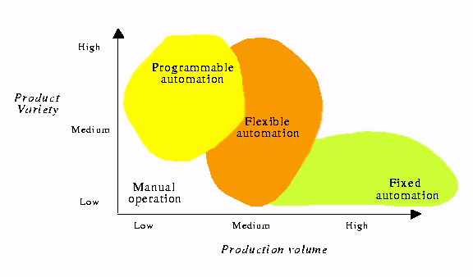
Figure2.4 Product Volume and Product Variety (28).
A relationship is shown between fixed and flexible automation in fig. 2.5. Capital intensity is the amount of investment on automation equipment. Resource flexibility is the ease with which the equipment and the employees can handle a wide variety of resources.

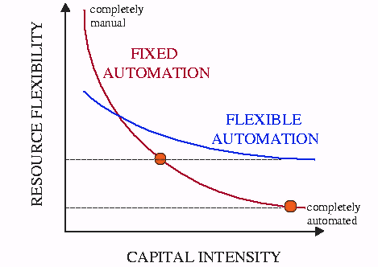
Figure 2.5 Flexible V/s Fixed Automation (28).

2.6 Special Automation Functions: In addition to provide its intended benefits. Automated systems should be capable of providing certain special functions which are not application specific. These are;
1). Safety monitoring
2). Maintenance and repair diagnostics.
3). Error detection and recovery.

2.6.1 Safety monitoring. One of the significant reasons for automating a manufacturing process is to remove operator from a hazardous working environment. It is often installed to perform a potentially dangerous operation that would otherwise be accomplished by a human operator. There are two reasons for providing an automated system with a safety monitoring facility: (1) To protect human workers in the vicinity of the system and (2) To protect the equipment associated with the system. Safety monitoring in an automated system involves the use of sensors to track the system’s operations and identify conditions and events that are unsafe. The system is programmed to respond to unsafe conditions in one or more of the following ways.

- Complete stoppage of the automated system.
- Sounding an alarm.
- Reducing the operating speed of the system.
Following are some of the sensors used for the purpose of safety monitoring.
- Limit switches to detect the proper positioning of the part.
- Photoelectric sensors to check the presence or absence of the part.
- Temperature sensors to detect the temperature of the coolant in an engine that gives an indication of the amount of engine heating.
- Smoke sensors to detect fire hazards.
- Pressure sensitive floor pads to detect the presence of human intruder inside the work cell.

2.6.2 Maintenance and repair diagnostics: it refers to the capabilities of an automated system to assist in the identification of the stage where system requires maintenance. Following are the three modes of maintenance and repair diagnostics.

- Status monitoring. Here the diagnostic subsystem monitors and records the status of key sensors and parameters of the system during normal operation. When desired, the system can display any of these values and provide an interpretation of current system status. Status monitoring serves two important functions (1) providing information for diagnosing a current failure and (2) providing data to predict a future failure. First, when failure of the equipment has occurred, it is usually difficult for the repair team to determine the reason for failure and what steps should be taken for repairs. It is often helpful to reconstruct the events leading up to the failure. The computer is programmed to monitor and record the variables and to draw logical inferences from their values about the reason for the malfunction or failure. This diagnosis helps the repair team to make the necessary repairs and replace the appropriate components. This is especially helpful in electronic repairs where it is often difficult to determine on the basis of visual inspection which components have failed.
The second function of status monitoring is to identify signs of an impending failure, so that the affected components can be replaced before failure actually causes the system to go down. These parts replacement can be done during the night shift or other time when the process is not operating, with the result that the system experiences no loss of regular operation.
- Failure diagnostics. It invokes when a malfunction or a failure takes place. Its purpose is to interpret the current values of the monitored variables and to analyze the recorded values preceding the failure so that the cause of the failure can be identified.
- Recommendation of repair procedure. Here the subsystem provides a recommended procedure to the repair team as to the steps that should be taken to effect repairs.

2.6.3 Error detection and recovery. The error detection step uses the automated system’s available sensor systems to determine when a deviation or malfunction has occurred, correctly interpret the sensor signals and classify the error. Design of the error detection subsystem must begin with a classification of the possible errors that can occur during the system’s operation. The errors in a manufacturing process tend to be very application specific and must be anticipated correctly in advance in order to select the sensors that will enable their detection.

The two main design problems in error detection are, (1) to anticipate all of the possible errors that can occur in a given process and (2) to specify the appropriate sensor systems and associated interpretive software so that the system is capable of recognizing each error. Solving the first problem requires a systematic evaluation of the possibilities of error occurrence. If the error has not been anticipated, then the error detection subsystem can not correctly detect and identify it.

Error Recovery. It is concerned with applying the necessary corrective action to overcome the error and bring the system back to normal operation. The problem of designing an error recovery system focuses on devising appropriate strategies and procedures that will either correct or compensate for the variety of errors that can occur in the process. Generally, a specific recovery strategy and procedure must be designed for each different error. Following are the different strategies adopted for the purpose;

- Make adjustments at the end of the current work cycle. When the current work cycle is completed, the part program branches to a corrective action subroutine specifically designed for the error detected, executes the subroutine, and then returns to the work cycle program. This action reflects a low level of urgency and is most commonly associated with random errors in the process.
- Make adjustments during the current cycle. In this case the action to correct or compensate for the detected error is initiated as soon as the error is detected. However, it must be capable to accomplish the designated corrective action while the work cycle is still being executed. This kind of action reflects a higher level of urgency.
- Stop the process to invoke the corrective action. In this case the deviation or malfunction requires that the execution of the work cycle be suspended during corrective action. It is assumed that the system is capable of automatically recovering from the error without human assistance. At the end of the corrective action, the regular work cycle is resumed.
- Stop the process and call for help. In this case the error requiring stoppage of the process can not be resolved through automated recovery procedures. This situation arises when the error can not be classified into the predefined lists of errors. Here human assistance is required to correct the problem.

Error detection and recovery requires an interrupt system. When an error in the process is detected and identified, an interrupt in the current program execution is invoked to branch to the appropriate recovery subroutine. This is done either at the end of the current working cycle or immediately. At the completion of the recovery procedure, program execution reverts back to the normal operation (3).

2.7 Choice of working media in an automated system: (1) Working media is the type of energy selected for enabling the automated system to perform the intended task. Following are the types,
- Electrical
- Hydraulics
- Pneumatics
- A combination of the above.
Following are the selection criteria for the working media,
- Force
- Type of motion
- Speed
- Size
- Service life sensitivity
- Safety and reliability
- Energy costs
- Controllability
- Handling
- Storage

A comparison of the different working media is explained in following table (table 2.1)

 | pneumatic | hydraulic | Electric
Energy production | Electrically or engine driven compressor plant | Electrically or engine driven pump plant | Supplied from local power station or engine generated
Energy storage | Large quantities can be stored economically | Limited storage capability. | Storage highly difficult and elaborate.
Energy transportation | Readily transported through piping (with loss of pressure) | Can be transported through piping(with loss of pressure) | Easily transported over unlimited distances.
leakage | No drawback except loss of energy. Compressed air dissipates into the atmosphere. | Loss of energy and substantial environmental fouling due to leaking oil(accident risk) | No loss of energy without conductive connection to other parts.(lethal accident risk at high voltage)
Cost of energy | High | Medium | Smallest
Environmental effects | Insensitive to temperature changes. No fire or explosion hazards. Risk of icing at high humidity, high flow and low temperature | Sensitive to variations in temperature. Fire hazard entailed with oil leakage. | Insensitive to temperature variations in normal range (insulation). Risk of fire or explosion hazard.
Linear motion | Convenient with cylinders, strokes up to about 2m. high accelerations and speeds 10-15m/s | Convenient with cylinders. Well amenable to control in slow speed range. | Short travel only with solenoids and linear motors. Otherwise through mechanical linkage to translate rotary motion.
Angular motion | Through swivel actuators motion up to 360 degrees can be conveniently obtained | Through swivel actuators motion up to 360 degrees can be conveniently obtained | Translated from rotary motion through mechanical linkage.
Rotary motion | Air motors of various types with wide range of speeds up to 500,000rpm and higher, simple reversal of rotation. | Hydraulic motors of various types, smaller speed range than air motors, but better control in slow speed range. | Best efficiency for rotary drive.
Linear thrust | Narrow range of force due to low pressure. | Wide range of force due to high pressure. | Poor efficiency due to force transmission through mechanical linkage. Can not be overloaded. High energy consumption at idle load.
Controllability | Thrust conveniently controlled through pressure regulation in range 1:10 dependent on load. Speed conveniently controlled through flow control valve or quick exhaust valve. Poor control in low range. | Thrust conveniently controlled over a wide range through pressure. Little dependence on load. Speed control is very good and precise at slow speeds. | Limited means of control. Highly elaborate and costly.
Handling | Good results obtainable with little knowledge. Convenient make-up and commissioning of open loop system. Good training instrument. | More intricate than pneumatic systems. Safety considerations at high pressures. Leakage and return lines. Sealing problems. | Specialized knowledge required. Accidents and short circuit risks. Equipments and controls easily destroyed with faulty connections.
Noise | Unpleasant exhaust noise can be greatly reduced by installing silencers. | Pump noise at high pressures. Noise conducted through rigid piping. | Loud actuating noise of contactors and solenoids, otherwise within limits of workshop noise levels.

Table 2.1 Comparison of Individual Factors of Different Energy Media. (2)

2.8 Programmable Automation Controllers (PAC): (20) For many years, PLC’s have provided OEM’s and end users with a highly reliable method of control. However engineers working with PLC’s have to plan for generational upgrades to achieve greater functionality and improve their control system’s ability to communicate beyond the plant floor. Now a new type of control system called PAC, offers significantly more flexibility, openness and performance. It allows the user to make a leap in capability without re-engineering.

PLC’s have been the control solution of choice for more than two decades, delivering the speed and reliability necessary in industrial applications, rugged design for demanding plant environments and proven performance. While not an issue in the past, these controllers are built on proprietary architectures, and are designed for programming and implementation in a specific application. In recent years however, many organizations have sought to integrate disparate plant floor equipment and networking systems, and to connect them to operations and enterprise level systems and processes. This level of integration promises many business benefits, including:
- Enabling the operational excellence that allows companies to build superior products, achieve profits and grow the business.
- Combining lean manufacturing with more agile processes to reduce wastage and respond to market variability.
- Strengthening and enhancing core competencies to more clearly define and market the business.
- Designing and building the products at any location to extend the product lifecycle globally.
- Adopting common standard-based architectures to keep costs down.
- Preserving assets to help maintain profitability.

Traditional control systems do not allow the level of openness and flexibility required to deliver these desired benefits often because numerous platforms and systems must be deployed to automate the entire enterprise. Enabling interoperability and information exchange among these pieces of equipment and systems can be a challenge, if not impossible in some cases. In this new model, traditional control systems have the following limitations.
- Control system implementation may not be fast or easy due to multiple platforms from different vendors, all requiring different programming for discrete process and motion logic.
- While recognizing the value of implementing the automation control technologies, the user may be hesitant to adopt them for the fear that they will become obsolete.
- The time and expense to re-engineer the existing system might not be offset by the benefits of the upgraded system’s capabilities.
- Current automation systems can often have difficulty in keeping pace with the need to accommodate ever increasing quantities of data.
- The quantity of user and engineering tools and platforms can be overwhelming, leading to extensive delays in specifying and implementing automation.
- Once it’s up and running, a specific control system may perform well in one application; however, successfully adapting it to another one can often prove difficult.

Given these limitations, the functionality of PLC’s has been expanding during recent years to provide greater application flexibility and interoperability. However, most PLC manufacturers haven’t adequately defined and positioned their controllers or sought to extend their functionality to transform them into more revolutionary solutions.
Whereas PAC is powered by a single, portable control engine using a single development tool for multiple applications. Pac’s enable true control convergence and integration of plant floor operations with business systems, rather than a mere, less-than-seamless connection of disparate parts and pieces.

While a PAC’s form factor can be similar to that of a PLC but a PAC’s capabilities are far more comprehensive. PAC’s are multifunctional controller platforms that encompass various technologies and products that users can mix, match and implement at will. PLC’s on the other hand, are products grounded in proprietary architectures that are equipped with the capabilities that the manufacturer deems necessary. A PLC’s capabilities are grounded in specific hardware and can not be moved from PLC to PLC, a PAC’s functionality is rooted in its portable control engine. Each application interfaces with this engine, which sits on top of the user’s operating system, with only a few changes required to move applications from system to system. Since the engine is separate from the hardware and uses a common operating system, the platform can grow and change as rapidly as user needs demand.

From an applications standpoint, traditional PLC’s are strong in discrete control but can be weaker in other areas. Whereas users can develop and implement discrete, process and motion control applications from the PAC’s single platform with equal agility and reliability. And while PLC’s are built on proprietary technologies, PAC’s make extensive use of COTS (Commercial OFF The Shelf) products and technologies which:
- Help ensure reliability and availability of system as hardware and software can be maintained quickly and easily.
- Reduce system price and downtime as they are readily available off the shelf.
- Increase openness, flexibility and scalability.
2.9 Mechatronics:
Mechatronics is the synergistic integration of mechanical engineering, with electronics and intelligent computer control in the design and manufacture of products and processes. from this definition it is clear that mechatronics is not itself a separate discipline within the overall spectrum of engineering but rather it represents an integration across a number of different fields within engineering as shown in fig.2.4. it is the application of latest techniques in precision mechanical engineering, control theory , computer science and electronics to design and development of products and systems. The word mechatronics was first coined by a senior engineer of a Japanese company Yaskawa in 1969, as a combination of “mecha” of mechanisms and “tronics” of electronics and the company was granted the trademark rights on this word in 1971, though it was given up later (6).

In the first stage in 1970’s the technologies used in mechatronic systems developed rather independently of each other and individually. During the second stage, in eighties, a synergistic integration of different technologies started taking place, the notable example being in optoelectronics (integration of optics and electronics). The concept of hardware/software co-design also started in these years. The third stage starts with the early nineties with increased use of computational intelligence in mechatronic products and systems, possibility of miniaturization of components in the form of micro actuators and micro sensors and systems, possibility of miniaturization of components in the form of micro actuators and micro sensors (6).

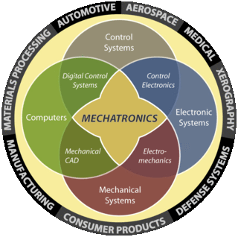

Figure.2.6 Integration of Various Disciplines (27).

2.9.1 Mechatronics in manufacturing:
Manufacturing is a vital part of any industrialized economy. It is the main element of development resulting in stiff global competition. More recently, manufacturing has come to be understood as a system, with all parts of the system interacting with each other. Computers and other electronic devices have been used extensively for the control of the production processes and equipment with the aid of CNC/DNC. A better understanding of processes and the development of appropriate transducers allow control in adaptive mode, responding to changes in process conditions. These interfaced systems termed as mechatronics, provide the solution to present day manufacturing situations of small/medium batch production of variety of components subject to frequent changes in design often needing shorter lead-time to meet fluctuating market demands (10).

2.10 Automation in Industry:
Industries use automation in various amounts depending upon the type of application and financial standing. Many industries are highly automated whereas others use automation only in some part of their operation. In telephone industry, dialing, transmission and billing are all done automatically. Railroads too are controlled by automatic signaling devices, which have sensors that detect cars passing a particular point. In this way the movement and location of the trains can be monitored.
Not all the industries require same amount of automation. Agriculture, sales, and some service industries difficult to automate. The agriculture industry may become more mechanized, especially in processing and packaging the food. However, in many service industries such supermarkets, for example, a check out counter may be automated but the shelves or supply bins must still be stocked by hands. Similarly, doctors may consult a computer to assist in diagnosis, but they must make the final decision and prescribe accordingly (21).

The oil and chemical industries have developed the continuous flow method of production, owing to the nature of raw material used and the final product. In a refinery, crude oil enters at a point and flows continuously through pipes in cracking, distillation and reaction devices as it is being processed into gasoline and fuel oil etc. an array of automatically controlled devices governed by microprocessor and coordinated by a central computer is used to control valves, heaters and other devices, thereby regulating both the flow and reaction rates (21).

In steel, beverage and canned food industry where production takes place in batches a different set up of automation is used. For example, a steel furnace is charged with the ingredients brought up to heat and a batch of steel ingots is produced. In this phase very little automation is evident. These ingots, however then be processed automatically into sheets or other structural forms by being squeezed through a series of rollers until the desired shape is achieved (21).

The automobile and other consumer product industries use the mass production techniques of step by step manufacture and assembly. This technique approximates the continuous flow process but involves transfer machines; thus from the viewpoint of the auto industry, transfer machines are essential to the definition of automation. Each of these industries uses automated machines in all or part of its manufacturing process. As a result each industry has a concept of automation that fits its particular production needs. More examples can be found in almost every phase of commerce. The widespread use of automation and its influence on daily life provides the basis for the concern expressed by many about the influence of automation on society and the individual (21).

2.10.1 Social effects of automation: Automation has made a major contribution towards increase in both free time and real wages enjoyed by most workers in industrialized nations. It has greatly increased production and lowered costs, thereby making automobiles, refrigerators, televisions telephones and other goods available to more people. Not all the results of automation have been positive. Some argue that automation has caused overproduction and waste, and that it has created alienation among the workers and that it generates unemployment. Of these issues, the relationship between automation and unemployment has received the most attention. Some economists argue that automation has little if any effect on unemployment-that workers are displaced rather than dismissed and are usually employed in another position in the same company or in the same position at another company that has not automated (21).

Some claim that automation generates more jobs than it displaces. They point out that although some laborers may become unemployed; the industry producing the automated machinery generates more jobs than were eliminated. The computer industry is often cited to illustrate this claim. Business executives would agree that although the computer has replaced many workers, the industry itself has generated more jobs in the manufacturing, sales and maintenance of computers than the device has eliminated (21).

These social issues that are derived from automation will continue to confront society. There appears to be no end to the technological innovations in the foreseeable future and to the application of automation in new areas. The demands of future will require manufacturing systems, which could need to be engineered to provide for flexibility without intervention of human element. While elements of the system could be readily obtained, the systems will have to be designed with appropriate sensors and other interfacing devices, reprogrammable systems with common database so that real time control can provide the required quality of specific varieties in quantities in specific time frame in the most competitive manner. The new frontier for automation is no longer production only, but the service industries. Prominent among them are health care financial services, telecommunication, retail and transportation (10, 15).

Chapter 3
Automation in Automobile Sector

3.1 Domestic Sector:
Following India’s openness, the arrival of new and existing models, easy availability of finance at relatively low rate of interest and price discounts offered by the dealers and the manufacturers, have stirred the demand for vehicles and a strong growth of the Indian automobile industry. Year 2005-06 has witnessed a steep growth in exports and touched an impressive 35.4% (26)

Government has liberalized the norms for foreign investment and import of technology and that appears to have benefited the automobile sector. The production of total vehicles increased from 4.2 million in 1998-99 to 8.5 million in 2005-06. The Indian auto industry has grown at an impressive 16.82 per cent over the last year with total sales of vehicles reaching around 10 million vehicles till November 2006 as against 8.5 million in 2005. The domestic car market has recorded a historic growth of 22.66 per cent in April December, 2006. Furthermore, two-wheeler output continues to dominate the volume statistics of the sector. In 2003-04, for every passenger car turned out by the sector, there were 7 two-wheelers produced. Economic survey 2006-07 says, the installed capacity of automotive industry has been growing at a compounded annual rate of over 16 percent since 2001-02. (26)

The above data clearly shows that the Indian automobile industry is growing at a frantic pace. This growth has invoked a cut-throat competition among the market players. As the players continue to introduce new models and variants, the competition may intensify further. The ability of the players to reduce costs and focus on exports will be critical for the performance of their companies. It can be summed up like, a market player can survive and grow only if he can deliver,
- Quality product at low cost
- Wide variety

This can be achieved by producing variety in masses (mass customization), which is possible by flexible automation. This fact seems to have been understood by the automobile industry, thus making it a major client for automation solutions. This industry due to its cash richness also, can afford automation at large scales.

3.1.1 Destination India:
India is on every major global automobile player’s roadmap, and it’s not hard to see:
- India is second largest two-wheeler market in the world.
- Fourth largest commercial vehicle market in the world.
- Eleventh largest passenger car market in the world.
- Expected to be seventh largest by 2016. (26)

3.2 Maruti Udyog Limited:
Maruti Udyog limited was established as a government company in February 1981. On 14th December 1983, first maruti 800 rolled off MUL at gurgaon. Spread over 297 acres with 3 fully integrated production facilities, the MUL has already rolled out over 5 million vehicles. In fact on an average two vehicles roll out of factory every minute. Today Maruti has a range of 11 models available in 50 variants. In august 2003, MUL crossed a milestone of exporting 300000 vehicles since its first export in 1986. It has exported vehicles to over 100 countries in 5 continents. Europe is the largest destination of maruti’s export, comprising over 70% of cumulative exports. In the Netherlands, the alto has captured a significant portion of the small car segment reaching the number one position in 2003. All these vehicles for exports are manufactured using the same production facilities used for domestic vehicles (24)

Car market scenario:
When Maruti began operation in 1983, there were only two other car companies in India and the total size of the Indian passenger car market was measly 40,000 units per year. From the start, Maruti caught the imagination of Indian car customers and launched 4 new models. Each of these models was an instant draw with the Indian consumer (24) after which there was no looking back.

3.2.1 State-of-the art manufacturing facilities:
The Gurgaon plant comprises of three fully integrated, state-of-the-art production facilities spread over a sprawling 297 acres. While the three plants have a total installed capacity of 3,50,000 cars per year, several productivity improvements over the years have made it possible to manufacture nearly 6,30,000 cars per year at these facilities. Working towards a goal of making India a global hub for small cars, SMC and MUL have drawn up an investment plan of Rs 9000/- crore in India up to 2010. With three fully integrated stat-of-the-art plants at gurgaon and the newly commissioned fourth assembly line at Manesar, Maruti’s production capacity at its peak is capable of producing close to a million cars per annum by 2010. (26)

Market share: Till date, over 6 million Maruti cars have rolled out from its manufacturing facilities. At the end of 2005-06, Maruti had a market share of about 54 per cent of the Indian passenger car market. (24)

3.2.2 Employee quality measures:

An employee suggestion scheme is in existence in maruti for past many years where employees are motivated to perform kaizens. Kaizen is based on the concept of making incremental improvements in products and processes. It incorporates a series of continuous small and simple improvements, which aim at involving employees at all levels. Over 50,000 suggestions are received from employees every year. It is this unwavering commitment to quality that will lead to the further growth of the organization as competition increases. (24)It is this encouragement to the employees that has resulted in ever-increasing numbers of in-house automations as visible from the fig. 3.1
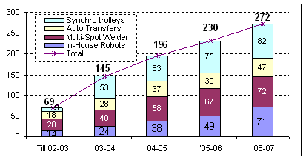
Figure 3.1 Status of In-house Automation at MUL

3.3 Weld Shop-3:

In this shop two most famous models are being manufactured, Alto and Wagon-R. There is a consistent increase in the demand of these models, so for meeting the market requirements, line capacity has been increased. In Alto the capacity has been increased to 245,000 units per annum from 210,000 units per annum. This is achieved by

- Installation of 12 new robots.
- Making new robot programmes for 29 existing robots internally.

The Wagon-R production was also increased from 110,000 to 125,000 units per annum, by programming robots. The overall output from weld shop 3 is 370,000 units per annum on two shift basis that is nearly 1320 bodies per day.

Wagon-R door line automation:

In line with Maruti’s philosophy of improving its productivity and ensuring consistency in product quality, much of the low cost in-house automation has been carried out on this line.

- Now 48% of spot automation has been achieved through installation of 6 numbers of 2- axis robots & 6 numbers of multispot welders.
- Saving of 10 manpower per day. This is a saving of around Rs. 1.9 million per annum.
- Also an increase in capacity of doors from 360 units/day to 470 units per day is achieved.

Alto door line automation:

In Alto door line, automation of nearly all the spots has been completed.
- Now 96% of the spots are automated.
- This has resulted in a manpower saving of 18 persons per day which is a saving of Rs. 3.05 million per annum.
- With this automation the capacity has been increased from 650 doors to 840 doors per day.

3.4 Present status of material transfer in weld shop 3:

The door assembly line under study is a mixed product line where two different car models are being manufactured on the same line. On this line white bodies (car bodies without paint and without any doors) of the two different models arrive on a conveyor in such a manner that after every fixed no. of car model X, one no. of model Y comes. Keeping in view the higher production rate of car X, its door spot welding stations say, A(for rear left and right), B(for front left and right) and C(for hood and back door), are located on either side of the line. When model X reaches here, its doors are prepared then and there only on separate stations and are fitted to the body while it keeps moving. The conveying speed of the car body X and the door production time are so synchronized that by the time the body leaves a station, the respective doors are prepared and fitted on the body and we get a smooth flow of product.

The doors for the model Y however are fabricated at stations A, B and C situated at some 200m away from door assembly line. Here the doors are produced in batches and are transported at stations A1, B1 and C1 through manually towed trolleys, as shown in fig. 1.1. The buffer of these doors is maintained at stations A1, B1 and C1 from where they are fitted to model Y as it comes. At least four workers are deputed on the job of bringing loaded trolleys from A, B, C to A1, B1 and C1 respectively and taking the empty trolleys back. Presently 250 cars of model Y are being produced at this assembly line. Ten doors of a type can be loaded on a trolley, which mean six trolleys have to ferry 25 times per shift plus some additional trolleys to maintain the buffer stock. (The present method of door transfer in the shop can be easily understood from figures 3.2-3.8). This method even though is the most obvious and simplest one has many disadvantages;

- It keeps the gangway heavily congested.
- Excessive movement of trolleys creates lot of noise.
- Trolleys require regular maintenance.
- Requires large manpower.
- It’s a crude method and doesn’t go with the automation status of the plant.
- Chances of damage to the doors are more due to mishandling.

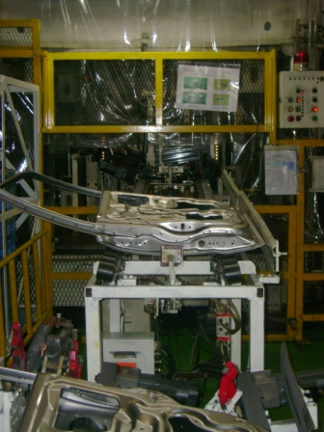

Figure 3.2 Doors Coming Out of the Hemming Press

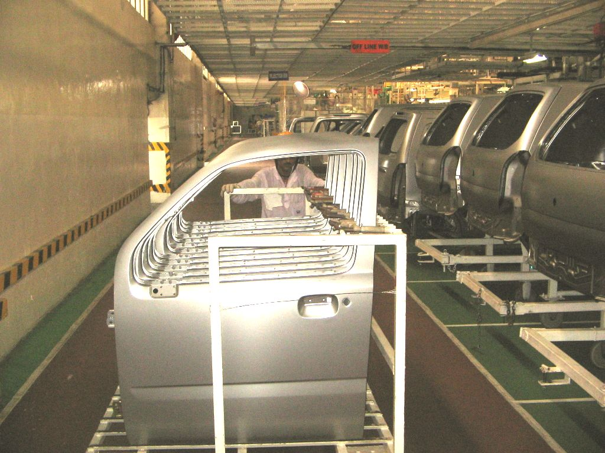

Figure 3.3 Manual Transfer of Doors from Fabrication to Assembly Stations

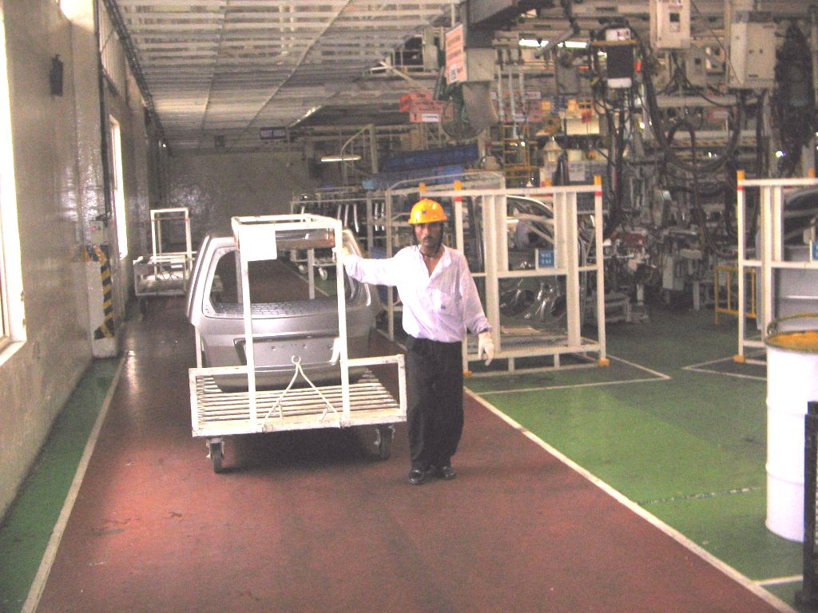

Figure 3.4 Partially Loaded Trolley Transfer (Lack of Synchronization)

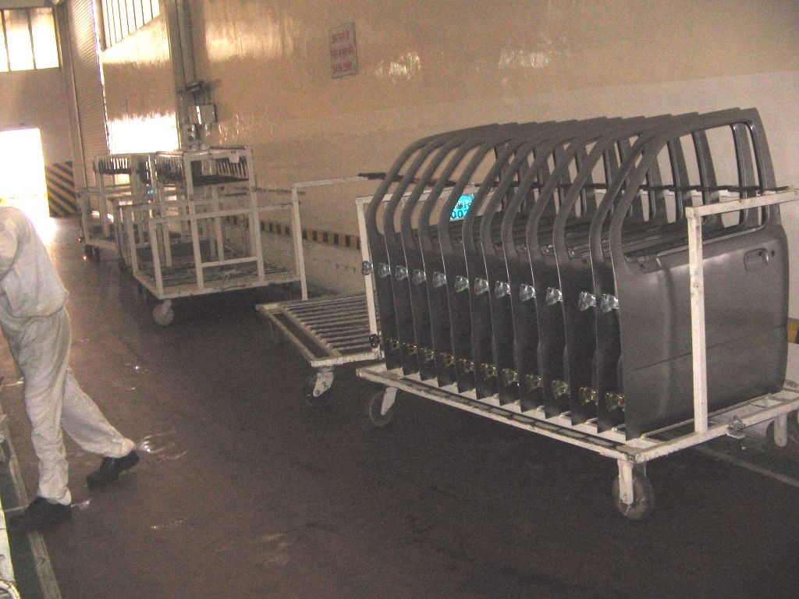

Figure 3.5 Trolleys Occupying the Useful Aisle Space

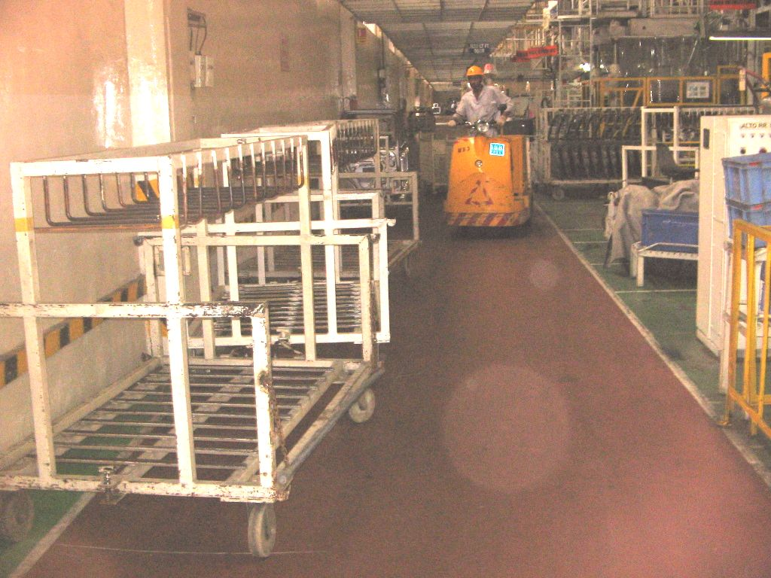

Figure 3.6 Interference of Trolleys with Other Material Handling Equipments

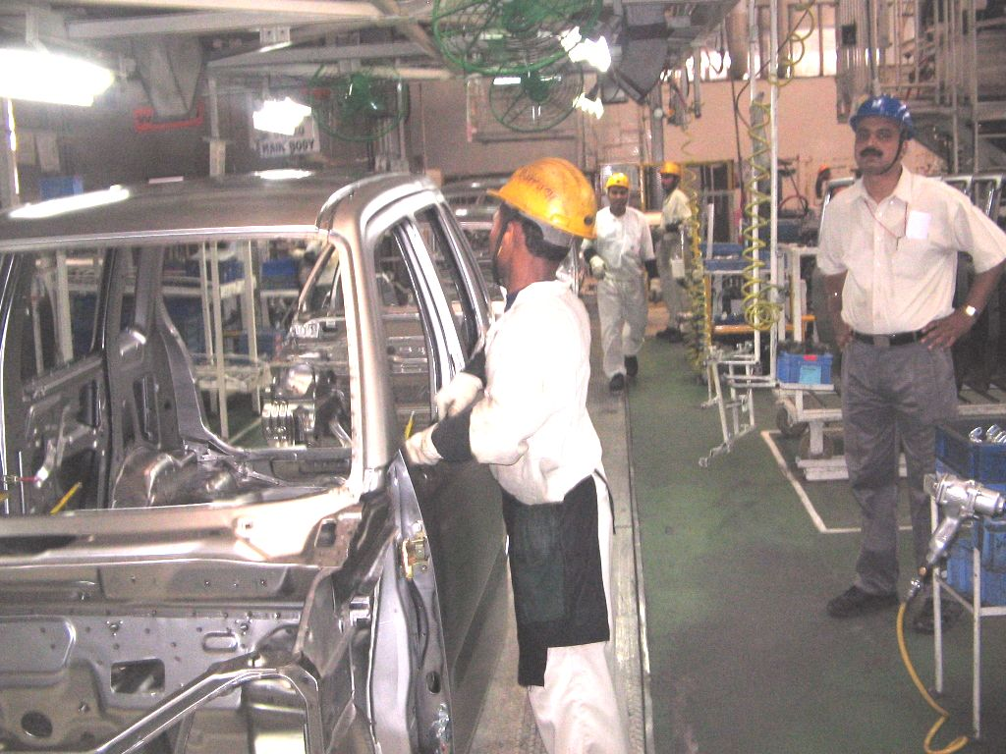

Figure 3.7 Door Assembly Operations

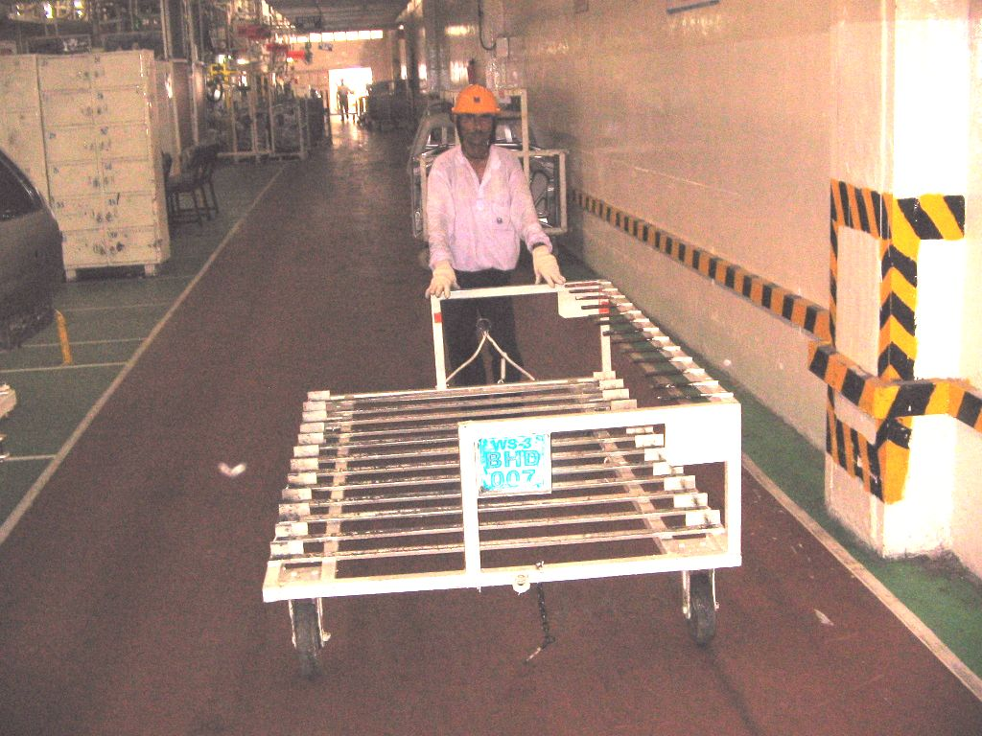

Figure 3.8 Empty Trolley Transfer from Assembly to Fabrication Station

Chapter 4
Alternatives to Improve Material Flow in Weld Shop-3

Alternative # 1
4.1 Automated guided vehicle (AGV):
An automated guided vehicle is essentially a driverless industrial truck. It is steerable, driven by electric motors using storage batteries, and it follows a predefined path along an aisle (fig 4.1). AGV may be designed to operate as a tractor, pulling one or more carts, or may be unit load carrier (22).AGV’s are programmed to drive to specific points and perform designated functions. Since their introduction in1955, AGV’s have found they are becoming increasingly popular worldwide in applications that require repetitive actions over a distance. They are able to navigate a guide path network which is flexible and easy to program. AGV can be an integral part of a conventional warehouse characterized by long distances and “same path” movement. It offers an alternative to fixed-path conveyors and overhead materials handling equipment for this type of facility (23).A distinguishing feature of an AGV, compared to rail guided vehicle systems and most conveyor systems, is that the pathways are unobtrusive. An AGV is appropriate where different materials are moved from various load points to various unload points (3).

AGVs as a part of FMS:

AGV usage is growing. One reason is that as manufacturers strive to become more competitive, they are adopting FMS. These systems integrate automatic material handling systems, robots, NC machine tools and automated inspection stations. FMS are more responsive to changes in production requirements. These systems yield high product quality and increased productivity. FMS can benefit from the linkage with AGVs. While robots are often highlighted as saving billions in production costs, at some plants- automated material handling systems have made the biggest inroads (12).

Steering control:
To help an AGV navigate, differential speed control system is most commonly used. In this method, there are two sets of wheels being driven by different drives (motors). These drives are driven at different speeds in order to turn and at same speed in order to move straight. The AGV turns in a similar fashion to a tank. This method of steering is good in the sense that it is easy to maneuver in small spaces. More often than not, this system is seen on AGV that is used to transport and turn in tight spaces or when the AGV is working near machines (12).

Navigation:
It refers to following a predefined path and stopping or slowing down as per the requirements. One of the methods of navigation is magnetic tape mode where a magnetic tape is laid on the surface of the floor. Not only does it provide the path for the AGV to follow but also select desired path. A magnetic tape is a thin plastic film containing small magnetic particles whose pole orientations can be used to encode bits of data into the tape. The different combinations of these poles tell the AGV to change lane and also speed up slow down and stop (3, 12).

Safety features of AGV:

- The safety of humans located along the pathway is an important objective in AGV design. An inherent safety feature of AGV is that its traveling speed is slower than the normal walking pace of a human. This minimizes the risk of overtaking a human walking along the guide path in front of the vehicle.
- AGVs are usually provided with automatic stopping of the vehicle if it strays more than 50-150mm from the guide path. This distance is referred to as vehicle’s acquisition distance.
- An obstacle detection sensor is located on each vehicle. The vehicles are programmed to stop or slow down when an obstacle is sensed ahead of the vehicle. The reason for slowing down is that the sensed obstacle may be located off to the side of the vehicle path or directly ahead but beyond a turn in the guide path or the obstacle may be a person who will move out of the way as the AGV approaches. In any of these cases the vehicle is permitted to proceed at a slower (safer) speed until it has passed the obstacle. The disadvantage of programming a vehicle to stop when it encounters an obstacle is that this delays the delivery and degrades system’s performance.
- A safety device included on virtually all the commercial AGVs is a safety bumper. It surrounds the front of the vehicle and protrudes by a distance of 300mm or more. When the bumper makes contact with an object, the vehicle is programmed to brake immediately.
- Other safety devices are warning lights (blinking or rotating) and or warning bells which alert humans that the vehicle is present (3).

Advantages of using AGV:
- Reduced manpower.
- Increased productivity.
- Elimination of unnecessary fork-lift trucks.
- Reduced product damage.
- Better control of material management.
- Vehicles are always available, alleviating problems associated with scheduling employees on nights, weekends and holidays.
- They are flexible and can be adapted to many different needs.

4.1.1 Application of AGV in present work:
It’s a mixed product line where two models X and Y are being produced. Production rate of model X is higher than that of Y. white bodies of these models descend on this line at point P from an overhead conveyor. Rear left and right doors for model X are produced at A1 and A2 and are fitted then and there only to the white body of model X. Front left and right doors are produced and fitted at B1 and B2. Similarly, hoods and back doors for model X are produced and fitted at C1 and C2.

However for model Y, these six doors are produced at A, B and C alternately in batches of 10 and are transported to A1, A2 ,B1, B2, C1 and C2 respectively to be fitted on model Y. these doors are transported on manually towed trolleys. Four workers are deputed only for effecting these movements of loaded and unloaded trolleys. This system seems to be the simplest and most obvious has many disadvantages like uncontrollable traffic of trolleys on aisles, confusion, noise and chances of accidents.

In an attempt to automate this door transfer system, possibility of using AGV is explored and analyzed. The figure 4.2 shows the present layout of the assembly line. The solid boundary line in the figure shows the path of AGV.

4.1.2 Specifications of AGV:
- Towing load : 1000kgf
- Max speed : 1m/sec
- Steering : 2- spindle
- Safety functions : Emergency stop
: Safety bumper
: Obstruction sensor
: Alarm
- Drive motor : 400W, AC Servo wheel motor x 2
- Power source : 24V DC
- Controller : PLC

Warning lights
Obstruction sensor
(Upper)

Emergency stop

Obstruction sensor
(Left)

Start button
Switch

Obstruction sensor (Right)

Address sensor
Safety bumper

Figure 4.1 Automated guided vehicle (11).

15 55 150 25 25 25

C
B
A
C1
B1
A1
C2
B2
A2
20
AGV

All distances in meters

P
Figure 4.2 Track of AGV in the Present Layout
4.1.3 Analyses of material transfer through AGV:

For these analyses, we assume that the vehicle operates at a constant velocity throughout its operation and ignores effects of acceleration, deceleration and other speed differences that might depend on whether the vehicle is empty or loaded.
The delivery cycle time (TC), defined as the total time the vehicle takes to complete one return journey, and consists of,
- Loading time at the pick up station, TL (sec)
- Travel time to the drop off station, TTL (sec)
- Unloading time at the drop off station, TU (sec)
- Empty travel time, TTU (sec)

In our case loading and unloading times at each station are 30 sec.
From the fig4.1, total delivery cycle time comes out to be,

TC= Travel time +Loading/unloading time

Travel time= 25+25+25+150+5+5+15+20+15+5+5+150+25+25+25+20=540 sec

Loading/unloading time= 30+30+30+30+30+30=180 sec.

TC = 540+180=720 sec. = 12min.

The value found above is an ideal one as it ignores time losses due to non reliability, traffic congestion etc. that may slow down delivery.
Hourly rate of delivery per vehicle is 60min divided by the delivery cycle time, TC
Possible time losses are
- Availability (A): the proportion of total shift time that the vehicle is operated.
- Traffic congestion (TF): It results in time loss on account of waiting at intersections, blocking of vehicles etc. let us express the effect of this time loss on the system performance as traffic factor (TF). So, if there is no blocking of the vehicle, TF = 1 and it decreases as the congestion increases.
With these factors at work, the available time per hour per vehicle is given by,
Available time (AT) = 60 .A.TF (1)
$∴$Rate of deliveries per vehicle per hour is given by,
RD = AT/ TC (2)
The number of Y models produced per hour = 30
This means, each model Y comes to the assembly line after 120 sec.
One car requires six doors (R/R, R/L, F/R, F/L, hood and back door); therefore 180 doors are required to be delivered per hour.
One trolley carries 10 doors of one type at a time, and the AGV carries three trolleys at a time.
This means, six deliveries are required to be made per hour.
The batteries of AGV require one hour of charging per shift therefore taking availability,
A= 0.9
And traffic factor, TF = 0.75

Available time AT = 60* 0.9*0.75 = 40.5 min/hr
From equation. (2)

RD = AT/ TC

=40.5/12
=3.375 3 deliveries per minute
Whereas we require six deliveries per hour.
Therefore more than one AGV is required
Number of vehicles required

N = $\frac{\text{WL}}{\text{AT}}$ where WL is the work load and AT is the available time
WL = number of deliveries X TC
= 6 X 12 = 72min
AT = 40.5min
N = $\frac{\text{72}}{\text{40}\text{.}5}$ = 1.72 2
Therefore 2 numbers of AGVs are required to carry out the material handling work in the present case.

The installation cost of two AGVs comes out to be about 25lacs

Monthly savings due to manpower reduction = 0.5 lac

Therefore cost of AGVs will be recovered in 4 years approximately.

4.1.4 Working:
Working of the system can be explained by the following steps,

- AGV moves only when operator presses start button mounted on its panel.

- AGV stops at the desired destination automatically if an address mark is located there. Address mark actually is an 8-bit magnetic code which when sensed and decoded by the AGV, it stops.

- AGV otherwise stops either by pressing emergency button mounted on its panel or if the obstruction sensor senses an obstacle in the path of AGV.
- At station A, trolley containing hoods is attached to the AGV. Operator presses the start button; AGV starts moving and reaches at B, stops here by decoding the address mark and gives out sound signals to make its presence felt to the operator at B.

- At B, F/R doors trolley is attached to AGV. Operator presses start button and AGV reaches at C, stops here and is attached with the trolley of R/R doors.

- At C when the operator presses start button, AGV moves to station C1 and stops there. Loaded hoods trolley is replaced by empty hoods trolley. Operator presses start button and AGV moves to B1.

- At B1, F/R doors trolley is replaced by the empty trolley of the same. Operator presses start button and AGV reaches A1.

- At A1, R/R doors trolley is replaced by empty trolley of the same. Operator presses start button and AGV now attached with three empty trolleys moves to station A

- By this time, the other AGV would have left for delivering back doors, F/L doors and R/L doors to stations A1, B1, C1 respectively and so on.

4.1.5 Benefits of using AGVs
- Manpower reduction
- Smooth material flow.
- No chaos
- Reduced noise level
- No damage to the products during transport.

Limitations:
- The floor surface used by the system is shared by other material handling equipments also. So the chances of interferences con not be ruled out which may affect the performance of the system.
- The system still involves the operator for loading and unloading of material.
- The magnetic tape laid for guiding the vehicle may get prematurely damaged due to fork lift movement.

Alternative # 2

4.2 In-floor Towline Conveyor (TLC):
It’s a variant of a chain conveyor. In this conveyor system, four wheel trolleys are used which are powered by a moving chain or cable located in trenches in the floor as shown in fig 4.3. The chain or cable is called the tow-line; hence, the name of the conveyor. Pathways for the conveyor system are defined by the trench and the chain. The chain is driven by the electric motor. Switching between powered pathways is possible in a towline system to achieve flexibility in routing. The trolleys use steel pins that project below the floor level into the trench to engage the chain for towing. This pin can be pulled out of the chain to disengage the trolley for loading, unloading, accumulation of the parts and manually pushing a trolley off the main pathway. Towline conveyors are used in the manufacturing plants and warehouses (3).

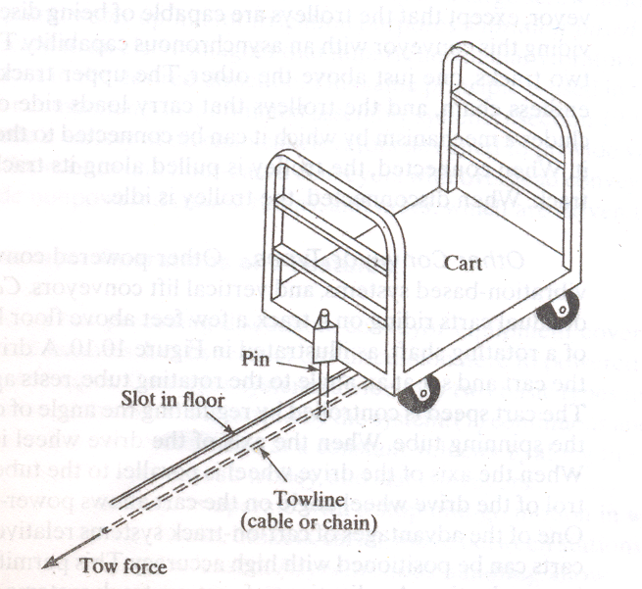

Figure 4.3 In-floor Tow Line Conveyor (3).

4.2.1 The system:
The lay out of the system is shown in figure 4.4. The boundary line shows the trench cut in the floor. This trench is 80mm wide and 150mm deep. An endless chain is positioned in this trench. At four corners of the trench is fitted one sprocket each a, b, c and d with sprocket a mounted on the electric drive. The electric drive is a motor positioned below the floor level, coupled with a gear box for speed reduction. There is no need to fabricate new trolleys as the existing ones can be utilized for the purpose of material handling system with slight modifications. Each trolley will now have;
- A bracket fixed at its front edge to accommodate a latching pin.
- A protrusion at a specific orientation so that it hits the limit switch of a desired station only.
- Its identification code (this code actually is the name of the door) written boldly on all sides of it for clear visibility. The purpose is to load batches of different doors on the trolleys dedicated to them only. For example, a trolley with R/R written on it should be loaded with rear right (R/R) doors only and same is applicable for other doors as well.
- Each trolley is fitted with a battery source that raises an alarm when the obstruction sensor mounted on it senses an obstruction. The warning lights provided on the trolleys also keep on glowing continuously. Therefore in one set there will be six trolleys.
- Each trolley is painted with bright fluorescent color for better visibility.
At loading stations A, B, and C conveyor start and stop buttons are provided in addition to limit switches. When a code R/R comes, it will hit only the limit switch at station C. this will stop the conveyor and sound a buzzer so as to make its presence felt to the operator at station C. it is now loaded with the batch of R/R doors and start push button is pressed, making the conveyor to start. At unloading stations A1, A2, B1, B2, C1 and C2 only resettable limit switches are provided. When any of these limit switches is hit by a corresponding trolley, the conveyor stops and the buzzer goes on. The conveyor will start again and the buzzer will go off only when the operator resets the limit switch. The stop signals are given preference over the start signals. This means that if a trolley has been stopped at a given station, it will start only if the start signal is given by the same station.
15 55 150 25 25 25

C
B
A
C1
B1
A1
C2
B2
A2
20
c
d

In floor trench housing the conveyor chain.

Trolley

F/L

R/R

Hood
Direction of movement of trolleys

F/R

BD

R/L

All distances in meters

P
Figure 4.4 In- floor Tow Trolleys in Present System.
a
b
For example, if a trolley is getting unloaded at station say A1, and at the same time a start signal is given at any other station whether in the form of pressing the start push button or resetting of the stop limit switch, conveyor will not start. It will only start when limit switch at A1 is reset by the operator.

4.2.2 Analysis of the system:
- In present set up 30 cars of model Y are being manufactured in one hour.
- 30 cars require 30 doors each of the types mentioned earlier.
- There is a dedicated trolley for each type of door and each trolley can be loaded with 10 numbers of doors.
- This means, each trolley is required to make three deliveries per hour.
- Speed of trolleys is 500mm/sec.
- Loading /unloading time per trolley is 30 sec.
The delivery cycle time, TC = total travel time + (loading/unloading) time
= 540X2 + 60 = 1080+60 = 1140 sec. = 19 min.
Rate of deliveries per trolley per hour is given by,
RD = AT/ TC, where AT is the available time
Taking availability A= 0.95 and traffic factor TF = 0.85
AT = 60*0.95*0.85 = 48.45 min.
RD = $\frac{\text{48}\text{.}\text{45}}{\text{19}}$= 2.55 deliveries per hour.
Whereas our requirement is of three deliveries per hour. This means more than one trolley of each type is required.
Number of trolleys for one type of door required is given by,
N = $\frac{\text{WL}}{\text{AT}}$ where WL is the work load and AT is the available time

WL = number of deliveries X TC
= 3 X 19 = 57min.
AT = 48.45 min.
Thus, N =$\frac{\text{57}}{\text{48}\text{.}\text{45}}$= 1.17 2,
$∴$Number of trolleys required of each type is 2.

4.2.3 Working:
- Let us start with the instance where an empty trolley marked R/R approaches station A. it will neither stop at A nor at B due to the specific orientation of its protrusion. The protrusion will hit the limit switch of station C only.
- The conveyor stops and the buzzer go on. The operator pulls out the latching pin and manually pulls the trolley away from the tow line. If at this station no other trolley is ready for dispatch, the operator simply presses the start push button and lets the conveyor move.
- At the same station if another trolley of R/R doors is loaded and ready to dispatch, then the operator will push this one to the tow line, engage the latching pin and then press the start push button.
- This trolley now moves towards the assembly stations. It will hit the limit switch of station A2 only. The conveyor stops and the buzzer go on. The operator delatches the pin, pulls the loaded trolley and if there is an empty trolley (R/R), he latches it with the conveyor and resets the limit switch.
- In the similar manner, loaded and unloaded trolleys are transported between the stations.
- The presence of specifically oriented protrusions on these trolleys ensure that the trolley belonging to a specific station stops there only as it can not hit limit switches of other stations due to the specific orientation of the protrusion.

4.2.4 Safety measures:
- The trolleys are painted with bright fluorescent colors for clear visibility.
- The speed of trolleys is fixed to a maximum of 500mm/sec which is less than the normal walking speed of humans. This feature ensures that the trolley will not chase and hit a person even if he is walking ahead of it.
- Emergency switches are provided at convenient locations in the line which when pressed, stops the conveyor.
- An obstruction sensor is provided on each trolley along with a battery operated warning light and a horn. When this sensor senses any obstruction in front of the trolley, warning lights start glowing and the horn makes sound to attract the attention of people around. If the obstruction is a human, then he will clear the passage, but if the obstruction is an object then this horn may attract someone’s attention who will press the emergency switch to stop the conveyor.

4.2.5 Benefits of the system:
- Low cost solution.
- Man power reduction.
- No need to make new trolleys. Cost of making new trolleys is saved.
- Simple in construction.
- Robust with very long life.
- Very less maintenance is required. The wear and tear of trolleys is also less as they now move smoothly at a slow speed
- Chances of damage to the product due to mishandling are also eliminated.
- Latching pins can be spring loaded for easy and positive engagement of pins with the chain.

Limitations:
- The major limitation of this system is that it does not stop on its own after sensing an obstruction on its way
- The system still involves the operator for loading and unloading operations.
- The system may interfere with the movement of other material handling equipment like fork lift trucks. Chances of accidents can not be ruled out.

Alternative#3
4.3 Overhead Trolley Conveyor (OTC):
The two systems explained so far in the form of alternative #1 and #2, operate at floor level. This on one hand makes the system simple, easy to operate, easy to maintain and easy to inspect, but at the same time, they consume one of the most valuable asset of any manufacturing unit- floor space. To avoid the occupation of floor space, chain driven conveyors can be designed to operate overhead, suspended from the ceiling of the facility so as not to consume floor space. The most common types are overhead trolley conveyors (3).
A trolley in a material handling system is wheeled carriage running on an overhead rail from which loads can be suspended (3). An overhead trolley conveyor is shown in figure 4.5.

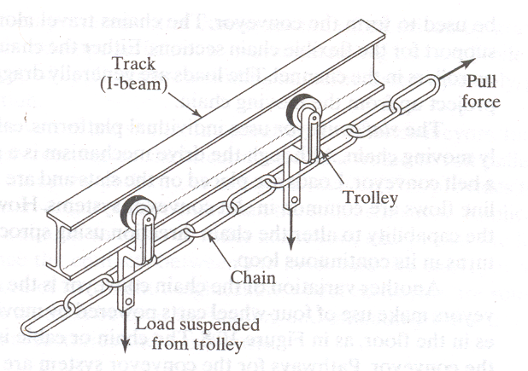

Figure 4.5 Overhead Trolley Conveyor (3).

It consists of multiple trolleys, usually equally spaced along a fixed track. The trolleys are connected together and moved along the track by means of a chain or cable that forms a complete loop. Suspended from the trolleys are hooks, carriers, baskets or other receptacles to carry loads. The chain is attached to a drive wheel that supplies power to move the chain at a constant velocity. The conveyor path is determined by the configuration of the track system, which has turns and possible changes in elevation. These types of conveyors are used in the factories to move parts and assemblies between different stations (3). These conveyors prove to be ideal choice at places where there is shortage of floor space and/or there if considerable traffic of other material handling equipment.

4.3.1 The system:
The layout of the system is shown in figure 4.5. The boundary line represented by the points M, Q, U, V, W, Z, L, R, S and T shows the pathway of the overhead trolley conveyor. The conveyor remains overhead during TMQUV, NLR and ORS respectively. It comes down to ground working level during WN, ZO and ST. the conveyor is having one more attractive feature that at points S, T N and O where the conveyor rises, the carriers swivel in the horizontal plane. This feature makes the doors move very near to the ceiling, resulting in virtually no interference with the traffic of other material handling equipment moving on the shop floor making the system almost invisible. Each carrier mounted on the trolleys carries one complete set of six doors of a car. The carriers are designed in such a way that each one of them can split into two parts. One part contains R/L, F/L and hood, whereas the other part contains R/R, F/R and back door. A loaded carrier splits into two parts at Q and these parts again rejoin at R after getting unloaded at assembly stations. The spacing between these carriers is fixed and is equal to the spacing of model Y white bodies. These carriers move at a constant velocity which is equal to that of the door assembly conveyor. Q, U, V, W shows the extra path followed by one half of the conveyor. This has been done to make time of arrival of both the parts of carrier same at stations A1 and A2.

C
T
M

B
A
A1
A2
B1
B2
C1
C2
Q
R
P
S
U
V
W
Z
Figure 4.6 Overhead Trolley Conveyor in the Present System
L

N
O

4.3.2 System Analysis:
Each model Y car reaches the assembly line after 120 seconds.
Speed of the assembly conveyor is 80 mm/sec.
Therefore in 120 sec. the distance traveled by a car on conveyor = 9.6m.
This means the spacing between the carriers of the overhead conveyor has to be 9.6m and its speed should be 80mm/sec.
With this speed of 80mm/sec and spacing between carriers 9.6m carriers will reach the door production stations (A, B, C) after a fixed interval of 2 min.
At door production stations, A, B and C, these doors are produced in alternate batches of some fixed size say, x. this means that at any given time, if station A is producing R/L, station B is producing F/L and station C is producing hoods in a quantity x each the same stations at some other time will be producing R/R, F/R and back doors respectively. Between two consecutive batches of size x each, the dies at these stations are required to be changed.
For present analysis, the batch size is fixed for 20 doors at each station.
The die change time is 120 sec. (SMED). And the door making cycle time is 50 sec.
Therefore 20 doors will be produced in 1000 sec. = 16.6 min. adding to it, the die changing time and loading time, we get one batch of 20 doors of one type in 20 min. per station. This is followed by 20 doors of other type in next 20 minutes at the same station. Since the rate of production of doors is double than that of the arrival interval of carriers at each station. There would not be any difficulty in making and loading complete sets of doors (six pieces) on each carrier during its travel from A to C.

4.3.3 Working:
Starting at station A.
- Operator starts producing R/R doors and makes 20 of them in first 20 minutes.
- During these 20 minutes, 10 numbers of carriers might have passed through this station without getting loaded.
- At the end of first 20 minutes, at station A we have 20 R/R doors ready with 10 empty carriers already gone.
- During next 20 minutes, the operator will produce 20 numbers of R/L doors. During this duration 10 carriers have passed through this station with all of them loaded with one each of R/R and R/L.
- At the end of second 20 minutes, we have 10 numbers of R/R and 10 numbers of R/L.
- During next 20 minutes interval, the operator will produce 20 R/R doors at station A. During this duration, next 10 carriers might have passed through this station. All of them loaded with one each of R/R and R/L.
- So, at the end of third 20 minutes duration, we have 20 R/R doors and no R/L door.
- The process from step 4 onwards is repeated.
- Similar would be the manner of loading at stations Band C also.

4.3.4 Benefits of the system:
- No accidents guaranteed.
- No interference with other material handling equipments.
- Smooth material flow.
- Manpower earlier required for doors handling is virtually eliminated.
- Highly reliable.
- No noise pollution.

Limitations:
  - Very high initial investment.
  - Longer installation times.

Chapter 5:
Evaluation of alternatives

5.1 Introduction: We have discussed and analyzed three different alternatives so far, for material handling problem at hand. Each one has got its own advantages and disadvantages. We have to now make the decision as to which one is the right alternative for the final selection. The decision has to be based on some logical considerations because once implemented, it will have long lasting effects both good as well as bad. Secondly, the money and reputation at stake is also huge. In the process of alternate selection, the alternatives are evaluated by a method which includes appraisals of qualitative factors. The method is explained as below;
- We first identify the factors important for selecting among alternatives. When selecting factors, there is constant trade-off between simplicity and completeness. We do not want to omit factors that may be important, yet we do not want to include the factors that have a very small effect on our decision. In addition, the only factors important for selection among alternatives are those on which the alternatives differ. Even if a factor such as cost is important, it can be dropped from the analysis if all the alternatives are equally good with respect to it.(4)

5.2 criteria (factor) selection:
There could be numerous criteria (factors) available which may affect the selection among alternatives. A careful study of the line helped to list following criterions;
Criteria (factor) Expectation
Criteria (factor) Expectation
- Installation cost Low
- Maintenance cost Low
- Life expectancy of the alternative Long
- Housekeeping Good
- Safety High
- Simplicity Reasonable
- Material flow Smooth
- Noise level Low
- Congestion of aisles Less
- Product damage Nil
- Synchronization between the fabrication and assembly stations Excellent
- Scope of further improvement Good
- Flexibility Reasonable
- User friendly Yes
- Manpower reduction Yes
- Reliability Good
- Labor cost Low
- Ease of maintenance Yes
- Standardization Yes
- Floor space requirements Less
Out of the above mentioned criterions (factors) we have to consider the selected ones that have considerable impact on the selection decision. In present case, based on survey conducted on the assembly line with the people who are very near to the process, following three criterions with twelve sub criterions were short listed;
- Cost
- Installation cost: This includes the actual cost of the system and commissioning cost.
- Maintenance cost: This includes the preventive maintenance cost and breakdown costs
- Manpower cost: This includes the salaries and perks paid to the manpower required (if any) after installation of this automation system at assembly line
- Operational
- Safety: Safety against interference with other material handling equipments and human operators which may result in accidents.
- Floor space requirements: Presently the floor space is shared by many other material handling equipments so the proposed alternative should be conservative as far as this requirement is concerned
- Reliability: The proposed system should be reliable in performance with minimum breakdowns.
- Synchronization: The system must ensure synchronization of material delivery between fabrication and assembly stations.
- Standardization: Parts used in the proposed system should be of standard nature to have cheap and less spare parts inventories.
- Ease of maintenance: Maintenance of the system should be easy and less time consuming.
- Flexibility
- Flexibility of design: the system must be capable to accommodate any change in the present design of the product without major changes.
- Flexibility of layout: The system must be capable to accommodate any future change in layout without incurring much cost, labor and time.
- Flexibility of volume: the system must be capable of handling any fluctuation in the demand of the product without affecting the synchronization of delivery.

5.3 Analytical Hierarchy Process (AHP):
Analytical Hierarchy Process as propounded by Saaty (1980) is used to priorities multiple criteria of the decision making and indicate the overall preference for each of the decision alternatives. AHP is designed to handle tangible as well as intangible factors and thus the subjective judgment of individuals is fully represented. This enables decision makers to represent the interactions of multi criteria in complex and unstructured situations by developing a hierarchy of the problem. Then judgment is provided about the relative importance of each of the criteria and then to specify a preference for each decision alternative with respect to each criterion. The key benefits of AHP are as follows:
- The AHP model is transparent. The hierarchical structure is easy to understand and communicate.
- AHP is easy to apply iteratively. The hierarchy can be expanded; for example, the criteria can further be decomposed to encompass still lower level attributes.
- AHP permits managers to quantify their subjective judgments. This is especially useful when one is evaluating to incorporate the multiple viewpoints of different user departments in an organization.
- The approach is useful to solve unstructured problems.
- Both tangible and intangible factors can be considered.
- Flexible technique capable of analyzing many complex problems.
- The hierarchical structure of AHP makes it possible to disaggregate many intangible factors into more meaningful and quantifiable factors.

5.3.1 AHP Procedure:
The general approach of AHP is to decompose the total problem into smaller sub problems such that each sub problem can be analyzed and handled appropriately with practical perspectives in terms of data and information. The general structure of the AHP approach that provides decision support can be under stood with the help of the following sequential procedure as given by Mohanty and Deshmukh (1996).

- List the set of equipment alternatives that are shortlisted.
- Identify the factors that may intrinsic as well as extrinsic, tangible as well as intangible, which may have an impact on the choice of alternatives.
- Develop a graphical representation of the problem in terms of the overall goal, the factors, the criteria and the decision alternatives. Such a graph depicts the hierarchy for the problem.
- Perform pairwise comparison of elements in one level relative to a single element in level immediately above it to derive local priorities of these elements that reflect their relative contribution to the subject of comparison.
- Assign weights to each alternative on the basis of the relative importance of its contribution to each decision criterion. Table 5.1 shows a typical scale for pairwise comparison, which may be used foe preparing the pairwise matrix for each criterion. The format of comparison matrix is given in table 5.2. the entries of the matrix are the responses to the questions asked during pairwise comparison. These are supplied by the decision maker rather than the analyst. Only the upper triangular part of this matrix is shown since it is a reciprocal matrix.
- Consistency Ratio: For an n dimensional matrix of the AHP, it can be shown that the largest Eigenvalue of the matrix, λ_{max} –n ≥ n, (Arbel and Siedmann 1984), where equality holds for a perfectly consistent case. A consistency index (CI) is defined as:
CI = (λ_{max} –n)/ (n-1)
Consistency ratio (CR) is defined by Saaty (1980) as:
CR = CI/RI
Where, random index (RI) has been recommended by Saaty (1980) as:

n | 1 | 2 | 3 | 4 | 5 | 6 | 7 | 8 | 9 | 10
RI | 0.00 | 0.00 | 0.58 | 0.90 | 1.12 | 1.24 | 1.32 | 1.41 | 1.45 | 1.49

Consistency Ratio (CR) is required to be less than 0.10 for acceptable results.

Table 5.1: Scale of Relative Importance (7)

Scale | Definition
1 | Equally Preferred
2 | Equally to Moderately Preferred
3 | Moderately Preferred
4 | Moderately to Strongly Preferred
5 | Strongly Preferred
6 | Strongly to Very Strongly Preferred
7 | Very Strongly Preferred
8 | Very Strongly to Extremely Preferred
9 | Extremely Preferred

Table 5.2: Format of Pairwise Comparison Matrix
Evaluation criteria | C₁ | C₂ | C₃ | C_{m}
C₁ | 1 | Degree of preference of C₁ over C₂ | Degree of preference of C₁ over C₃ | Degree of preference of C₁ over C_{m}
C₂ |  | 1 | Degree of preference of C₂ over C₃ | Degree of preference of C₂ over C_{m}
C₃ |  |  | 1 | Degree of preference of C₃ over C_{m}
C_{m} |  |  |  | 1
Places below the diagonal to be filled by reciprocal of entries
- Using the priority of the single element in the level immediately above it, the global priorities of the elements are derived. The process is repeated for all the levels and global priorities of all elements are determined.
- Once the global priority of each element is established by pairwise comparison, the normalized priority of each alternative is synthesized. This is done as follows:
- Compare the alternatives with respect to each of the elements of the lowest level in the hierarchy structure and local priorities of the alternatives are derived.
- Using the priorities for the elements, the local priorities for each alternative are converted into global priorities.
- The sum of the global priorities of the alternatives yields the normalized priority of the alternatives.
5.4 Analyses of the present system by AHP:
In present system, we start by laying out the overall hierarchy of the decision. This hierarchy reveals the factors to be considered as well as the various alternatives in the decision. Then, a number of pair wise comparisons are done, which result in the determination of factor weights and factor evaluations. The decision hierarchy for present case has four different levels. The top level describes the overall decision. In our case it’s the selection of the best alternative. The second level in the hierarchy describes the three factors- cost, operational and flexibility which will contribute to the achievement of the overall goal. The third level of the hierarchy reveals the sub factors which will play a vital role in the contribution of each factor and finally at fourth level we have three alternatives to automate the door transfer system. The decision hierarchy for the present case is shown in figure 5.1.

Best door transfer automation system

GOAL

Cost

Operational

Flexibility

FACTORS

Installation Cost

Maintenance Cost

Manpower Cost
Safety

Floor Space

Reliability

Synchronization

Standardization

Ease of Maintenance

Flexibility of Volume

Flexibility of Design

Flexibility of Layout

CRITERIA

AGV
TLC
OTC
ALTERNATIVES

Figure 5.1: Hierarchy of the Decision Making Process
Evaluation of factors
Operational factor is moderately to strongly preferred over cost (use scale value 4). Operational factor is strongly to very strongly preferred over flexibility, (use scale value 6). Finally, cost is moderately to strongly preferred over flexibility, (Use scale value 4).

Factor | Cost | Operational | Flexibility
Cost | 1 | 1/4 | 4
Operational | 4 | 1 | 6
Flexibility | 1/4 | 1/6 | 1
Column total | 5.25 | 1.416 | 11

All the diagonally vacant places will be occupied by 1 as at these places an alternative is being compared to itself, means equally preferred (scale value 1).
The numbers in the table above are divided by their respective column totals to get Normalized matrix (below)
Factor | Cost | Operational | Flexibility
Cost | 0.190 | 0.176 | 0.363
Operational | 0.761 | 0.706 | 0.545
Flexibility | 0.047 | 0.117 | 0.090

Row averages of normalized matrix gives the priority weights for factors (table 5. 3)
Factor | Weights
Cost | 0.243
Operational | 0.670
Flexibility | 0.084

Weighted sum vector
It is determined by multiplying the factor evaluation number for the first alternative times the first column of the original pair wise comparison table. We multiply the second factor evaluation times the second column, and the third factor times the third column of the original matrix of pair wise comparisons. Then we sum these values over the rows.

0.243X1 0.67X1/4 0.084X 4 0.746
Weighted sum vector = 0.243X4 0.67X1 0.084X6 = 2.146
0.243X1/4 0.67X1/6 0.084X1 0.255

The next step is to determine the consistency vector. This is done by dividing the weighted sum vector by the factor evaluation values determined previously (table 5.3).
0.746/0.243 3.069
Consistency vector = 2.146/0.670 = 3.202
0.255/0.084 3.035

Now that the consistency vector has been found out, two more terms are required to be computed, lambda ($λ$) and the consistency index (CI), before the final consistency ratio can be computed. The value for lambda is simply the average of the consistency vector. The formula for CI is, CI=$\frac{λ−n}{n−1}$, where n is the no. of alternatives/factors being compared. In the present case, n=3 for three different alternatives being compared.
$λ$= (3.069+3.202+3.035)/3
$λ$=3.102
CI=$\frac{λ−n}{n−1}$ = $\frac{3\text{.}\text{102}−3}{3−1}$ = 0.051
Finally, we are in a position to compute the consistency ratio (CR), which is equal to the consistency index (CI) divided by random index (RI). The random index is a direct function of the no. of alternatives being considered.
CR=$\frac{\text{CI}}{\text{RI}}$ , for n=3, RI= 0.58
Therefore, CR=$\frac{\text{CI}}{\text{RI}}$= $\frac{0\text{.}\text{051}}{0\text{.}\text{58}}$= 0.087
Since CR is less than 0.10, our pairwise comparison of factors in this case is consistent.

Evaluation of sub factors (criterions)
- Cost :
Installation cost is moderately preferred over maintenance cost (use scale value 3). Installation cost is strongly preferred over labor cost, (use scale value 5). Finally, maintenance cost is moderately preferred over labor cost, (Use scale value 3).

Factor | Installation cost | Maintenance cost | Manpower cost
Installation cost | 1 | 3 | 5
Maintenance cost | 1/3 | 1 | 3
Manpower cost | 1/5 | 1/3 | 1
Column total | 1.533 | 4.333 | 9

The numbers in the table above are divided by their respective column totals to get Normalized matrix (below)
Factor | Installation cost | Maintenance cost | Manpower cost
Installation cost | 0.652 | 0.692 | 0.555
Maintenance cost | 0.217 | 0.230 | 0.333
Manpower cost | 0.130 | 0.076 | 0.111

Row averages of normalized matrix gives the priority weights for cost (table 5.4)
Factor | Weights
Installation cost | 0.633
Maintenance cost | 0.260
Labor cost | 0.105

0.633X1 0.26X3 0.105X 5 1.938
Weighted sum vector = 0.633X1/3 0.26X1 0.105X3 = 0.785
0.633X1/5 0.26X1/3 0.105X1 0.317

1.938/0.633 3.061
Consistency vector = 0.785/0.260 = 3.019
0.317/0.105 3.019

$λ$= (3.061+3.019+3.019)/3
$λ$=3.033
Consistency Index, CI=$\frac{λ−n}{n−1}$ = $\frac{3\text{.}\text{033}−3}{3−1}$ = 0.016
Consistency Ratio, CR=$\frac{\text{CI}}{\text{RI}}$ , for n=3, RI= 0.58
Therefore, CR=$\frac{\text{CI}}{\text{RI}}$= $\frac{0\text{.}\text{016}}{0\text{.}\text{58}}$= 0.028
Since CR is less than 0.10, our pairwise comparison of criterions in this case is consistent.
- Operational:
Paired comparison matrix
Criteria | Safety | Floor space | Reliability | Synchronization | Standardization | Ease of maintenance
Safety | 1 | 3 | 4 | 4 | 6 | 4
Floor space | 1/3 | 1 | 2 | 4 | 5 | 2
Reliability | 1/4 | 1/2 | 1 | 3 | 4 | 2
Synchronization | 1/4 | 1/4 | 1/3 | 1 | 4 | 3
Standardization | 1/6 | 1/5 | 1/4 | 1/4 | 1 | 1/3
Ease of Maintenance | 1/4 | 1/2 | 1/2 | 1/3 | 3 | 1
Column total | 2.249 | 5.45 | 8.083 | 12.583 | 23 | 12.333

Normalized matrix
Criteria | Safety | Floor space | Reliability | Synchronization | Standardization | Ease of maintenance
Safety | 0.444 | 0.550 | 0.494 | 0.317 | 0.260 | 0.324
Floor space | 0.148 | 0.183 | 0.247 | 0.317 | 0.217 | 0.162
Reliability | 0.111 | 0.091 | 0.123 | 0.238 | 0.173 | 0.162
Synchronization | 0.111 | 0.045 | 0.041 | 0.079 | 0.173 | 0.243
Standardization | 0.073 | 0.036 | 0.030 | 0.019 | 0.043 | 0.027
Ease of Maintenance | 0.111 | 0.091 | 0.061 | 0.026 | 0.130 | 0.081

Priority weights for operational (table 5.5)
Criteria | Weights
Safety | 0.398
Floor space | 0.212
Reliability | 0.149
Synchronization | 0.115
Standardization | 0.038
Ease of Maintenance | 0.083

Weighted sum vector is given below,

0.398X1 0.212X3 0.149X4 0.115X4 0.038X6 0.083X4
0.398X1/3 0.212X1 0.149X2 0.115X4 0.038X5 0.083X2
0.398X1/4 0.212X1/2 0.149X1 0.115X3 0.038X 4 0.083X2
0.398X1/4 0.212X1/4 0.149X1/3 0.115X1 0.038X4 0.083X3
0.398X1/6 0.212X1/5 0.149X1/4 0.115X1/4 0.038X1 0.083X1/3
0.398X1/4 0.212X1/2 0.149X1/2 0.115X1/3 0.038X3 0.083X1

2.650 2.650/0.398 6.658
Weighted 1.458 1.458/0.212 6.877
Sum = 1.017 , Consistency vector = 1.017/0.149 = 6.825
Vector 0.717 0.717/0.115 6.234
0.238 0.238/0.038 6.263
0.514 0.514/0.083 6.192

$λ$= (6.658+6.877+6.825+6.234+6.263+6.192)/6
$λ$=6.506
Consistency Index, CI=$\frac{λ−n}{n−1}$ = $\frac{6\text{.}\text{506}−6}{6−1}$ = 0.1012

Consistency Ratio, CR=$\frac{\text{CI}}{\text{RI}}$ , for n=6, RI= 1.24

Therefore, CR=$\frac{\text{CI}}{\text{RI}}$= $\frac{0\text{.}\text{1012}}{1\text{.}\text{24}}$= 0.081

Since CR is less than 0.10, our pairwise comparison of criterions in this case is consistent.

- Flexibility:

Paired comparison matrix
Factor | Flexibility of volume | Flexibility of design | Flexibility of layout
Flexibility of volume | 1 | 4 | 6
Flexibility of design | 1/4 | 1 | 3
Flexibility of layout | 1/6 | 1/3 | 1
Column total | 1.416 | 5.333 | 10

Normalized matrix
Factor | Flexibility of volume | Flexibility of design | Flexibility of layout
Flexibility of volume | 0.706 | 0.750 | 0.6
Flexibility of design | 0.176 | 0.187 | 0.3
Flexibility of layout | 0.117 | 0.062 | 0.1

Priority weights for flexibility (table 5.6)
Criterion | Weights
Flexibility of volume | 0.685
Flexibility of design | 0.221
Flexibility of layout | 0.093

0.685X1 0.22X34 0.093X 6 2.127
Weighted sum vector = 0.685X1/3 0.22X1 0.093X3 = 0.671
0.685X1/6 0.22X1/3 0.093X1 0.229

2.127/0.685 3.105
Consistency vector = 0.671/0.221 = 3.030
0.229/0.093 3.000
$λ$= (3.105+3.030+3.000)/3
$λ$=3.045
Consistency Index, CI=$\frac{λ−n}{n−1}$ = $\frac{3\text{.}\text{045}−3}{3−1}$ = 0.022
Consistency Ratio, CR=$\frac{\text{CI}}{\text{RI}}$ =$\frac{0\text{.}\text{022}}{0\text{.}\text{58}}$= 0.038
Since CR is less than 0.10, our pairwise comparison of criterions in this case is consistent.
Evaluation of alternatives with respect to different criterions
- Comparing criteria: Installation cost

Paired comparison matrix
Installation cost | AGV | TLC | OTC
AGV | 1 | 1/4 | 6
TLC | 4 | 1 | 8
OTC | 1/6 | 1/8 | 1
Column Total | 5.16 | 1.37 | 15

Normalized matrix
Installation cost | AGV | TLC | OTC
AGV | 0.19 | 0.18 | 0.40
TLC | 0.77 | 0.72 | 0.53
OTC | 0.03 | 0.08 | 0.06

Priority weights
Factor | AGV | TLC | OTC
Installation cost | 0.25 | 0.67 | 0.05
$λ$= (2.84+3.08+3.40)/3
$λ$=3.10
Consistency index CI=$\frac{λ−n}{n−1}$ = $\frac{3\text{.}\text{10}−3}{3−1}$ = 0.05
Consistency ratio CR=$\frac{\text{CI}}{\text{RI}}$ = $\frac{0\text{.}\text{05}}{0\text{.}\text{58}}$= 0.08
Since CR is less than 0.10, therefore our pairwise comparison of factors in this case is consistent

- Maintenance cost:

Paired comparison matrix
Maintenance cost | AGV | TLC | OTC
AGV | 1 | 1/5 | 1/4
TLC | 5 | 1 | 3
OTC | 4 | 1/3 | 1
Column Total | 10 | 1.53 | 4.25

Normalized matrix
Maintenance cost | AGV | TLC | OTC
AGV | 0.10 | 0.13 | 0.05
TLC | 0.50 | 0.65 | 0.70
OTC | 0.40 | 0.21 | 0.23

Priority weights
Factor | AGV | TLC | OTC
Maintenance cost | 0.09 | 0.61 | 0.28
$λ$= (3.11+3.11+3.00)/3
$λ$=3.07
Consistency index CI=$\frac{λ−n}{n−1}$ = $\frac{3\text{.}\text{07}−3}{3−1}$ = 0.035
Consistency ratio CR=$\frac{\text{CI}}{\text{RI}}$ = $\frac{0\text{.}\text{035}}{0\text{.}\text{58}}$= 0.06
Since CR is less than 0.10, therefore our pairwise comparison of factors in this case is consistent.

- Manpower cost:

Paired comparison matrix
Manpower cost | AGV | TLC | OTC
AGV | 1 | 1 | 1/5
TLC | 1 | 1 | 1/5
OTC | 5 | 5 | 1
Column Total | 7 | 7 | 1.4

Normalized matrix
Manpower cost | AGV | TLC | OTC
AGV | 0.14 | 0.14 | 0.14
TLC | 0.14 | 0.14 | 0.14
OTC | 0.71 | 0.71 | 0.71

Priority weights
Factor | AGV | TLC | OTC
Manpower cost | 0.14 | 0.14 | 0.71

$λ$= (3.00+3.00+2.97)/3
$λ$=2.99
Consistency index CI=$\frac{λ−n}{n−1}$ = $\frac{2\text{.}\text{99}−3}{3−1}$ = 0.005 (ignoring –ve sign)

Consistency ratio CR=$\frac{\text{CI}}{\text{RI}}$ = $\frac{0\text{.}\text{005}}{0\text{.}\text{58}}$= 0.008
Since CR is less than 0.10, therefore our pairwise comparison of factors in this case is consistent.
- Safety

Paired comparison matrix
Safety | AGV | TLC | OTC
AGV | 1 | 5 | 1/6
TLC | 1/5 | 1 | 1/9
OTC | 6 | 9 | 1
Column Total | 7.20 | 15 | 1.27

Normalized matrix
Safety | AGV | TLC | OTC
AGV | 0.13 | 0.33 | 0.12
TLC | 0.02 | 0.06 | 0.08
OTC | 0.83 | 0.60 | 0.78

Priority weights
Factor | AGV | TLC | OTC
Safety | 0.19 | 0.05 | 0.73

$λ$= (2.89+3.2+3.15)/3
$λ$=3.08
Consistency index, CI=$\frac{λ−n}{n−1}$ = $\frac{3\text{.}\text{08}−3}{3−1}$ = 0.04

Consistency ratio, CR=$\frac{\text{CI}}{\text{RI}}$ =$\frac{0\text{.}\text{04}}{0\text{.}\text{58}}$= 0.068

Since CR is less than 0.10, therefore our pairwise comparison of factors in this case is consistent.
- Floor space

Paired comparison matrix
Floor space | AGV | TLC | OTC
AGV | 1 | 1 | 1/7
TLC | 1 | 1 | 1/7
OTC | 7 | 7 | 1
Column Total | 9 | 9 | 1.28

Normalized matrix
Floor space | AGV | TLC | OTC
AGV | 0.111 | 0.111 | 0.109
TLC | 0.111 | 0.111 | 0.109
OTC | 0.777 | 0.777 | 0.781

Priority weights
Factor | AGV | TLC | OTC
Floor space | 0.110 | 0.110 | 0.778

$λ$= (2.981+2.981+3.010)/3
$λ$=2.99
Consistency index, CI=$\frac{λ−n}{n−1}$ = $\frac{2\text{.}\text{99}−3}{3−1}$ = 0.005

Consistency ratio, CR=$\frac{\text{CI}}{\text{RI}}$ =$\frac{0\text{.}\text{005}}{0\text{.}\text{58}}$= 0.008

Since CR is less than 0.10, therefore our pairwise comparison of factors in this case is consistent.

- Reliability

Paired comparison matrix
Reliability | AGV | TLC | OTC
AGV | 1 | 1/4 | 1/6
TLC | 4 | 1 | 1/3
OTC | 6 | 3 | 1
Column Total | 11 | 4.25 | 1.499

Normalized matrix
Reliability | AGV | TLC | OTC
AGV | 0.090 | 0.058 | 0.110
TLC | 0.363 | 0.235 | 0.222
OTC | 0.545 | 0.705 | 0.667

Priority weights
Factor | AGV | TLC | OTC
Reliability | 0.086 | 0.273 | 0.639

$λ$= (3.023+3.036+3.089)/3
$λ$=3.049
Consistency index, CI=$\frac{λ−n}{n−1}$ = $\frac{3\text{.}\text{049}−3}{3−2}$ = 0.024

Consistency ratio, CR=$\frac{\text{CI}}{\text{RI}}$ =$\frac{0\text{.}\text{024}}{0\text{.}\text{58}}$= 0.042

Since CR is less than 0.10, therefore our pairwise comparison of factors in this case is consistent.

- Synchronization

Paired comparison matrix
Synchronization | AGV | TLC | OTC
AGV | 1 | 2 | 1/4
TLC | 1/2 | 1 | 1/5
OTC | 4 | 5 | 1
Column Total | 5.5 | 8 | 1.45

Normalized matrix
Synchronization | AGV | TLC | OTC
AGV | 0.181 | 0.250 | 0.172
TLC | 0.090 | 0.125 | 0.137
OTC | 0.727 | 0.625 | 0.689

Priority weights
Factor | AGV | TLC | OTC
Synchronization | 0.201 | 0.117 | 0.680

$λ$= (3.009+3.017+3.042)/3
$λ$=3.022
Consistency index, CI=$\frac{λ−n}{n−1}$ = $\frac{3\text{.}\text{022}−3}{3−2}$ = 0.011

Consistency ratio, CR=$\frac{\text{CI}}{\text{RI}}$ =$\frac{0\text{.}\text{011}}{0\text{.}\text{58}}$= 0.018

Since CR is less than 0.10, therefore our pairwise comparison of factors in this case is consistent.

- Standardization

Paired comparison matrix
Standardization | AGV | TLC | OTC
AGV | 1 | 1/3 | 4
TLC | 3 | 1 | 5
OTC | 1/4 | 1/5 | 1
Column Total | 4.25 | 1.533 | 10

Normalized matrix
Standardization | AGV | TLC | OTC
AGV | 0.235 | 0.217 | 0.400
TLC | 0.705 | 0.652 | 0.500
OTC | 0.058 | 0.130 | 0.100

Priority weights
Factor | AGV | TLC | OTC
Standardization | 0.284 | 0.619 | 0.096

$λ$= (3.07+3.15+3.02)/3
$λ$=3.08
Consistency index, CI=$\frac{λ−n}{n−1}$ = $\frac{3\text{.}\text{08}−3}{3−2}$ = 0.04

Consistency ratio, CR=$\frac{\text{CI}}{\text{RI}}$ =$\frac{0\text{.}\text{04}}{0\text{.}\text{58}}$= 0.068

Since CR is less than 0.10, therefore our pairwise comparison of factors in this case is consistent.

- Ease of maintenance

Paired comparison matrix
Ease of maintenance | AGV | TLC | OTC
AGV | 1 | 1/3 | 3
TLC | 3 | 1 | 5
OTC | 1/3 | 1/5 | 1
Column Total | 4.333 | 1.533 | 9

Normalized matrix
Ease of maintenance | AGV | TLC | OTC
AGV | 0.230 | 0.217 | 0.333
TLC | 0.692 | 0.652 | 0.555
OTC | 0.076 | 0.130 | 0.111

Priority weights
Factor | AGV | TLC | OTC
Ease of maintenance | 0.260 | 0.633 | 0.105

$λ$= (3.019+3.061+3.019)/3
$λ$=3.033
Consistency index, CI=$\frac{λ−n}{n−1}$ = $\frac{3\text{.}\text{033}−3}{3−2}$ = 0.016
Consistency ratio, CR=$\frac{\text{CI}}{\text{RI}}$ =$\frac{0\text{.}\text{016}}{0\text{.}\text{58}}$= 0.028

Since CR is less than 0.10, therefore our pairwise comparison of factors in this case is consistent.

- Flexibility of volume change

Paired comparison matrix
Flexibility of volume change | AGV | TLC | OTC
AGV | 1 | 2 | 1/5
TLC | 1/2 | 1 | 1/6
OTC | 5 | 6 | 1
Column Total | 6.5 | 9 | 1.366

Normalized matrix
Flexibility of volume change | AGV | TLC | OTC
AGV | 0.153 | 0.222 | 0.146
TLC | 0.076 | 0.111 | 0.121
OTC | 0.769 | 0.666 | 0.732

Priority weights
Factor | AGV | TLC | OTC
Flexibility of volume change | 0.173 | 0.102 | 0.722

$λ$= (3.005+3.009+3.045)/3
$λ$=3.019
Consistency index, CI=$\frac{λ−n}{n−1}$ = $\frac{3\text{.}\text{019}−3}{3−1}$ = 0.009
Consistency ratio, CR=$\frac{\text{CI}}{\text{RI}}$ =$\frac{0\text{.}\text{009}}{0\text{.}\text{58}}$= 0.016

Since CR is less than 0.10, therefore our pairwise comparison of factors in this case is consistent.

- Flexibility of design change

Paired comparison matrix
Flexibility of design change | AGV | TLC | OTC
AGV | 1 | 2 | 4
TLC | 1/2 | 1 | 3
OTC | 1/4 | 1/3 | 1
Column Total | 1.75 | 3.333 | 8

Normalized matrix
Flexibility of design change | AGV | TLC | OTC
AGV | 0.571 | 0.600 | 0.500
TLC | 0.285 | 0.300 | 0.375
OTC | 0.142 | 0.099 | 0.125

Priority weights
Factor | AGV | TLC | OTC
Flexibility of design change | 0.557 | 0.320 | 0.122

$λ$= (3.025+3.012+3.008)/3
$λ$=3.015
Consistency index, CI=$\frac{λ−n}{n−1}$ = $\frac{3\text{.}\text{015}−3}{3−1}$ = 0.007
Consistency ratio, CR=$\frac{\text{CI}}{\text{RI}}$ =$\frac{0\text{.}\text{007}}{0\text{.}\text{58}}$= 0.012

Since CR is less than 0.10, therefore our pairwise comparison of factors in this case is consistent

- Flexibility of layout change

Paired comparison matrix
Flexibility of layout change | AGV | TLC | OTC
AGV | 1 | 4 | 6
TLC | 1/4 | 1 | 3
OTC | 1/6 | 1/3 | 1
Column Total | 1.416 | 5.333 | 10

Normalized matrix
Flexibility of layout change | AGV | TLC | OTC
AGV | 0.706 | 0.750 | 0.600
TLC | 0.176 | 0.187 | 0.300
OTC | 0.117 | 0.062 | 0.100

Priority weights
Factor | AGV | TLC | OTC
Flexibility of layout change | 0.685 | 0.221 | 0.093

$λ$= (3.105+3.036+3.000)/3
$λ$=3.047
Consistency index, CI=$\frac{λ−n}{n−1}$ = $\frac{3\text{.}\text{047}−3}{3−1}$ = 0.023
Consistency ratio, CR=$\frac{\text{CI}}{\text{RI}}$ =$\frac{0\text{.}\text{023}}{0\text{.}\text{58}}$= 0.04

Since CR is less than 0.10, therefore our pairwise comparison of factors in this case is consistent

Table 5.7: Total Weighted Evaluations of the Alternatives
Criteria | Local priorities | Global priorities  A | AGV  score  B | AGV  Weighted  Score  (AXB) | TLC  Score  C | TLC  Weighted  Score  (AXC) | OTC  Score  D | OTC  Weighted  Score  (AXD)
Cost | 0.243
Installation | 0.633 | 0.153 | 0.250 | 0.048 | 0.670 | 0.102 | 0.050 | 0.007
Maintenance | 0.260 | 0.063 | 0.090 | 0.005 | 0.610 | 0.038 | 0.280 | 0.017
Manpower | 0.105 | 0.025 | 0.140 | 0.003 | 0.140 | 0.003 | 0.710 | 0.017
Operational | 0.670
Safety | 0.398 | 0.266 | 0.190 | 0.050 | 0.050 | 0.013 | 0.730 | 0.194
Floor space | 0.212 | 0.142 | 0.110 | 0.025 | 0.110 | 0.015 | 0.778 | 0.120
Reliability | 0.149 | 0.099 | 0.086 | 0.008 | 0.273 | 0.027 | 0.639 | 0.063
Synchronization | 0.115 | 0.077 | 0.201 | 0.015 | 0.117 | 0.009 | 0.680 | 0.065
Standardization | 0.038 | 0.025 | 0.284 | 0.007 | 0.619 | 0.015 | 0.096 | 0.002
Ease of maintenance | 0.083 | 0.055 | 0.260 | 0.014 | 0.633 | 0.034 | 0.105 | 0.005
Flexibility | 0.084
Of volume change | 0.685 | 0.057 | 0.173 | 0.009 | 0.102 | 0.005 | 0.722 | 0.041
Of design change | 0.221 | 0.018 | 0.557 | 0.010 | 0.320 | 0.005 | 0.122 | 0.002
Of layout change | 0.093 | 0.007 | 0.685 | 0.004 | 0.221 | 0.001 | 0.093 | 0.000
Total weighted score |  |  |  | 0.198 |  | 0.267 |  | 0.535

Table 5.8: AHP Ranking of the Alternatives
Alternatives | Score | Ranking
AGV | 0.198 | III
TLC | 0.267 | II
OTC | 0.535 | I

  - Discussion of the Result:
From the diagnosis and analysis of the present case, implementation of OTC is finalized due to its highest final ranking. The ranking score of the other alternatives are low indicating their low contribution towards safety, floor space saving and manpower reduction.

In fact, if we look at the ranking score total of the three alternatives in case of factors like, flexibility of layout change, ease of maintenance and installation cost, we find that AGV and TLC definitely having an upper edge over OTC. But it’s due to company’s policy of “Safety First”, commitment towards complete automation (manpower reduction) and good house keeping (floor space saving) that lead OTC to first choice.

  - Sizing of Elements for Overhead Trolley Conveyor:
The principal components of the selected system are selected as following,
Electric motor
Weight of one carrier = 25kg
Weight of 60 carriers = 1500kg
Weight of 1m of chain = 5kg
Weight of 600m of chain = 3000kg
Weight of one set of doors = 100kg
Weight of 45 sets of doors = 4500kg
Total weight = 9000kg
Thrust = $μ$mg
= 0.08X9000X10 = 7200 N
(Taking $μ$=0.08 for rolling friction)
Diameter of the sprocket = 200mm
Torque required = $\frac{\text{7200}X\text{100}}{\text{1000}}$ = 720 Nm
Speed = 80mm/sec
N (rpm) required =$\frac{\text{80}X\text{60}}{3\text{.}\text{14}X\text{200}}$ 8rpm
Power of motor required =$\frac{2π\text{NT}}{\text{60}}$ = $\frac{2X3\text{.}\text{14}X8X\text{720}}{\text{60}}$
= 0.6kWatts
Considering the efficiency of motor as 75% = 0.75 kWatts

Shear pin:
The shear pin is the one where two adjacent chain links are connected. This pin is under a state of double shear.
Diameter of the pin = d mm
Shear strength of the material (τ) = 60MN/sq.m
Shearing load on the pin = (π d² /4) τ 1.85 (1.85 for double shear)
7200 = (3.14X d²/4) X60X1.85
Diameter of the shear pin d = 9mm
Shear pin is shown in figure 5.3

Chain Link
The details of the chain link are shown in figure 5.2
For making chain links, take steel strip of standard width (w) =25mm
Let the thickness of this strip = t mm
Tensile load on this strip = 7200N
Tearing strength of steel (σ) = 80MN/sq.m
Tearing load = t (w-d) σ
7200 = t (25-9.5) 80
Thickness of the chain link t ≈ 6mm

Pitch of the chain (7) ≤ 250{90/N} ^{2/3}
≤ 250 (90/8) ^{2/3}
≤ 1265mm

Referring to the standard pitches for transmission chains as per IS: 2403—1975, a pitch size of 101.6mm is selected.

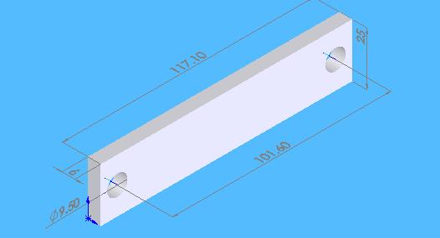

Figure 5.2a Chain Link (vertical member)

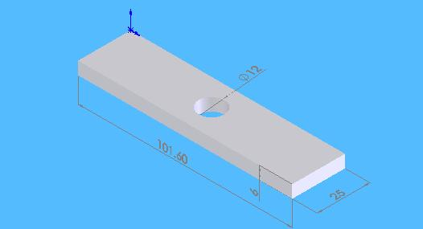

Figure 5.2b Chain Link (Horizontal Member)

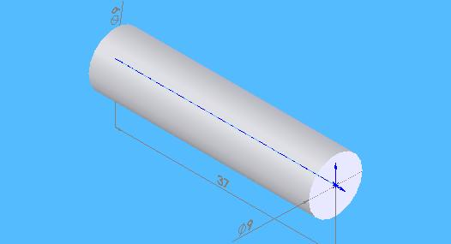

Figure 5.3 Shear Pin

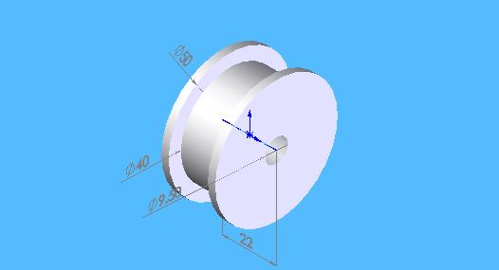

Figure 5.4 Chain Wheel

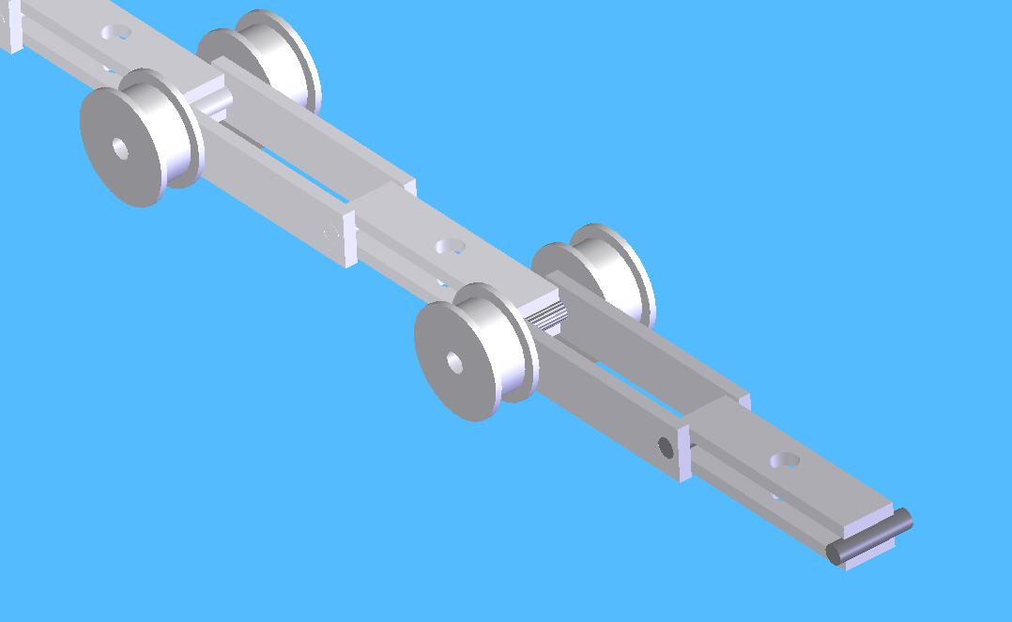

Figure 5.5 Chain Assembly

Carrier:
These carriers are fabricated out of steel pipes of size 1 inch to reduce weight. A carrier is divided into two parts with three racks in each part. An arrangement is made in such away that when it reaches at point Q (refer figure 4.6), the two parts separate with first one going along QUVW and the second one along QWZ to deliver different sets of doors. They again recombine at point R.They can swivel in horizontal plane when wheels provided at their bottom follow a specifically designed track. This saves lot of space. (Fig 5.6)

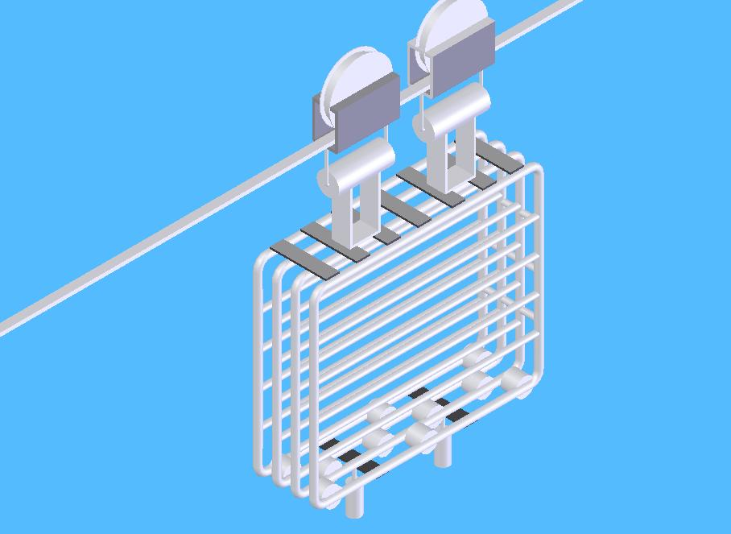

Figure 5.6 Carrier for Conveying the Doors

Chapter 6
Conclusion and Future scope of work

6.1 Conclusion:

In the present work, an attempt has been made to design and analyze the automation of door transfer between the fabrication and assembly stations. Three alternative solutions were designed keeping in view the layout, production rate and other constraints of the line. For the analysis part, various criterions that could affect the final selection of an alternative were listed. A careful survey of the line and the people very closely associated with it helped to narrow down a few most important factors which are Cost, Operational performance and Flexibility. These factors are then further divided into twelve sub factors for proper analyses. The analysis was done by AHP approach, where different factors were compared pairwise by using an appropriate scale to evaluate factor weights. The alternatives were also evaluated pairwise for each factor separately. In each case, the consistency of pairwise comparisons was also checked. Finally, the overall ranking of the alternatives was evaluated with alternative OTC receiving the highest ranking.

Factors like safety, floor space saving, and manpower cost received the highest weightage and clearly outweighed the other two alternatives leaving behind the one that does not consumes the floor space at all- Overhead Trolley Conveyor. This solution has a very high installation cost and least flexibility of layout change, but once installed, gives noiseless operation, synchronization between fabrication and assembly stations, no accidents, excellent housekeeping and no product damage. Adaptation of this alternative will prove to be a step further in the direction of continuous improvement and will strengthen company’s commitment towards quality products at low cost with total customer satisfaction.

6.2 Recommended Procedure for Diagnosis and Implementation of an Automated Material Handling System in an Assembly Shop
Study of the existing process.
# It’s a mixed product line.
# Models X & Y are fitted with doors on same line
# Production rate of X > Y

Model X

# Doors fabricated on assembly line itself
and fitted to model X then and there only
Model Y

# Doors fabricated at a distant place
# transported to assembly line on manually towed
trolleys
# kept in bulk at assembly stations
# fitted to Y as and when it comes to assembly stn.

Door transfer distance is
very small 1-2m
Door transfer distance is very large about 200m

Identification of difficulties in the existing system
Identification of difficulties in the existing system

No material handling problem
# No synchronization between fabrication and
assembly stations.
# Chances of accidents and product damage
# Congested aisles, noise pollution
# Considerable manpower required

Automation for door transfer is not required
Automation for door transfer is required

End
A
A
Identification of expected performance parameters
# Doors fabricated at fabrication stations.
# Loaded onto automated carriers at fabrication stations.
# Loaded carriers automatically move to assembly stations
# Carriers unloaded at assembly stations.
# Empty carriers return automatically to assembly stations

Brainstorming to generate ideas

Three alternative solutions (say)

Alternative # 1
Alternative # 2
Alternative #3
Automated guided vehicle (AGV)
In-floor towline conveyor
(TLC)
Overhead trolley conveyor (OTC)

Features of Alt. # 1
Features of Alt. # 2

Features of Alt. # 3

AGV
- Low cost
- Smart safety features
- Flexibility
- Less noisy
- High maintenance
- Consumes floor space
- Chances of accidents
- Congested aisles
- Partial automation
TLC
- Very low cost
- Simple in construction
- Less noisy
- Very low maintenance
- Consumes floor space
- Congested aisles
- More chances of accidents
- Partial automation
OTC
- High installation cost
- Noiseless
- Does not consume floor space
- Low maintenance
- Free aisles
- No accidents
- Full automation
- Long installation time

B
B
Evaluation of alternatives by MCDM techniques like DM, AHP, ANP etc
AHP analyses
- Cost
1. Installation
2. Maintenance
3. Manpower
- Operational
1. Safety
2. Floor space
3. Reliability
4. Synchronization
5. Standardization
6. Ease of maintenance
- Flexibility
1. Flexibility of volume change
2. Flexibility of design change
3. Flexibility of layout change

Selection of best Alternative for implementation
Overhead trolley conveyor (OTC)

Design and development of the selected Alternative

End

6.3 Future scope of work:

The present work has been carried out by considering twelve criterions analyzed by AHP. While recommending the automation process of similar kind in future, more numbers of criterions can be considered, survey base for the selection of criterions can be broadened with more rigorous brainstorming. Other analysis techniques like ANP (Analytical Network Process) can also be applied along with sensitivity analysis to make the selection of alternatives more consistent. Financial aspects can be included in more details with the calculation of ‘return on investments’. The selected alternative can be implemented with more technical up gradations like

- Automatic tension control by pneumatic or hydraulic means.

- Automatic speed adjustments in accordance with the speed of the main conveyor.

- Automatically putting the carriers on other conveyors moving at different speeds to have different amounts of buffer stock of doors to meet different demand rates.

- Smart safety features automatically stopping the conveyor in the event of chain breakage, failure of tension control system, overloading etc.

- Improvements in carrier design so as to make them accommodate doors of more than one type of cars.

- Mistake proofing; if a carrier is not carrying complete set of doors by mistake, then this information should be reflected at the concerned fabrication station.

References:
- Croser, P. “Pneumatics-Basic level” Festo Didactic KG, Esslingen, 1992.
- Deppert, W., Stoll, K. “Cutting costs with pneumatics” Vogel- Buchverlag Wurzburg, Germany, 1988.
- Groover, M. P., “Automation, Production Systems, and Computer-Integrated Manufacturing.” 2nd edition, Prentice Hall of India (P) Ltd., New Delhi, 2002
- Martinich, J. S., “Production and Operation Management- an applied modern approach”, John Wiley & Sons (Asia) Pte Ltd., Singapore, 2005.
- Mohanty, R. P. and Deshmukh, S. G., “An AHP application for manpower evaluations”, Industrial Engineering Journal, 1996, vol. 25, no. 4, pp 21-26.
- Nakra, B. C., “Mechatronics”, proceedings,AICTE-ISTE sponsored short-term course on Mechatronic Systems, 9-21 June-2003, New Delhi.
- Render, B., Stair, R. M. Jr., “Quantitative Analysis for Management”, 4th edition, Allyn and Bacon, USA, 1991.
- Saaty, T. L., “The Analytical Hierarchy Process”, 1980, McGraw Hill, New York.
- Singh, S. “Machine Design”, 3rd edition, Khanna Publishers, New Delhi, 1999.
- Tewari, N. K, “Mechatronics in manufacturing”, proceedings, AICTE-ISTE sponsored short-term course on Mechatronic Systems, 9-21 June-2003, New Delhi.
- Operation/maintenance manual for automatic guided vehicle
- www.answers.com/topic/automated -guided-vehicle
- www.articleworld.org/index.php?title=Automation
- www.automation .com/smc/print.php?stripImages=no
- www.bookrags.com/printfriendly/?p=gale&u=automation-este-0001_0001_0
- www.bookrags.com/printfriendly/?p=gale&u=automation-woi
- www.bookrags.com/prinfriendly/?p=wiki&u=Automation
- www.cob.ohio-state.edu/~kinard_1/russian_dl/course/OM/Text/Unit2/Unit2.html
- www.frog.nl/faq-EN.php
- www.gefanuc.com
- www.history.com/encyclopedia.do
- http://info.lu.farmingdale.edu/depts/met/ind315/agv.html
- www.iqsdirectory.com/AGV/
- www.marutiudyog.com
- www.memagazine.org/backissues/membersonly/april98/features/flex/flex.html
- www.siamindia.com
- www.en.wikipedia.org/wiki/Mechatronics
- www.seas.upenn.edu/~meam520/slides/intantoslides.pdf
Bibliography:
- Alciatore, D. G., Histand, M. B., “Introduction to Mechatronics and Measuring Systems”, 2nd edition, Tata McGraw Hills Publication, India, 2003.
- Bolton, W., “Mechatronics, Electronic Control Systems for Mechanical and Electrical Engineering”, 2nd edition, Longman Publisher, Thomson press India Ltd.1999.
- Croser, P., Thomson, J. “Electro pneumatics-Basic level” Festo Didactic KG, Esslingen, 1990.
- Hesse, S. “Compressed air as an energy carrier” Blue digest on automation, Festo AG & Co., Esslingen, 2002.
- Hesse, S. “Sensors in Production Engineering”, Blue digest on automation, Festo AG & Co., Esslingen, 2001.
- Hughes, T. A., “Programmable Controllers”, Instrument society of America, 1997.
- Johnson, C. D., “Process Control Instrumentation Technology”, 7th edition, 2003, Pearson Education, India.
- Majumdar, S. R. “Pneumatic systems; Principles and Maintenance”, Tata McGraw Hill Publishing Co Ltd. New Delhi, 2001.
- Mattone, R., Campagiormi, G., Galati, F. “Sorting of items on a moving conveyor part1; a technique for detecting and classifying objects”, journal of Robotics and Computer Integrated Manufacturing, vol. 16, 2000, p. 73-80.
- Mollenkamp, R. A., “Introduction to Automatic Process Control”, Instrument society of America, 1988.
- Otter, J. D., “PLC: operation, interfacing and programming”, Prentice Hall International, Inc. New Jersey, 1988.
- “Principles and theory of pneumatics”, Trade and Technical Press Ltd. England, 1970.
- Petruzella, F. D. “Industrial Electronics” McGraw Hill Book Co., Singapore, 1996.
- Reininger, T. Welker, F., Vonzepplin, M. “Sensors in position control applications for industrial automation”, journal of sensors and actuators, vol.129, 2006, p. 270-274.
- Rohner, P., Gordon, S. “Pneumatic controls for industrial automation”, John Willey & Sons, N.S.W, 1990.
- Rohner, P., “PLC; Automation with PLC”, Macmillan press ltd. London, 1996.
- Swider, J., Wszolek, G., Carvalho, W. “Programmable controller designed for electro pneumatic systems”, journal of Material Processing Technology, vol. 164, 2005, p 1459-1465.
- Topcu, E., Yuksel, I., Kamis, Z. “Development of electro pneumatic fast switching valve and investigation of its characteristics”, journal of Mechatronics, vol. 16, 2006, p. 365-378.

