Data Communication over Powerline

A Dissertation Submitted
In Partial Fulfillment Of The Requirements For The Award Of The Degree Of

MASTER OF ENGINEERING
IN
(CONTROL AND INSTRUMENTATION)

Submitted By

Sandhya Varshney (10/C&I/06)
University Roll No.: - 10219

Under the Esteemed Guidance Of

Dr. PARMOD KUMAR
(PROFFESOR & HEAD)



DEPARTMENT OF ELECTRICAL ENGINEERING
DELHI COLLEGE OF ENGINEERING
UNIVERSITY OF DELHI
DELHI-110042
2008

DELHI COLLEGE OF ENGINEERING
DELHI

Department of Electrical Engineering

CERTFICATE

This is to certify that Ms. Sandhya Varshney student of final semester M.E.(C&I), Electrical Engineering Department, Delhi College of Engineering, during the session 2007-2008 has successfully completed the project work on Data Communication Over Powerline and has submitted a satisfactory report in partial fulfillment for the award of the degree of Master Of Engineering (Control and Instrumentation) in Electrical Engineering Department.

( )

Prof. Parmod Kumar
Project Guide
HOD, EED
Delhi College of Engineering,
Delhi

__ Acknowledgement__

I would like to extend my sincere gratitude and thanks to my guide Dr. Parmod Kumar, Professor and Head of Electrical Engineering Department, Delhi College of Engineering, Delhi for his valuable guidance, constant encouragement and helpful discussions throughout the course of this work. He initiated the founding ideas behind this thesis and provided insight and valuable information into many of the problems that were encountered. His positive attitude throughout the duration of this thesis always put things into perspective whenever difficulties arose. This thesis would not have been possible without him.

I would also like to thank respected Rachna Garg madam and all my friends mainly Mr. Roopesh Kumar Singh for immense help, advice and cooperation to complete this work.

I am extremely grateful to my parents for their encouragement, support and dedication which have helped me in great way to complete this work. Without their blessings, this work would not have been possible.

Lastly, I thank Almighty GOD for his countless blessings.

Sandhya Varshney

M.E(C&I)

_Abstract_

The multifunctional use of power transmission line provides a cost effective method for data and voice signal transmission, besides the power transfer by electric utilities. It utilizes the existing infrastructure of electric utilities and electricity consumers by using the multi access carrier digital communication technology. Broadband over power line is one of the technology uses the existing electric transmission line as a carrier channel for the delivery of Broadband to the consumer.

However, the technology meets the drawback that the electric wires might radiate electromagnetic waves at high frequencies. The power-lines are designed to distribute power in an efficient way; hence it is not adapted for communication. The high-speed data transmission power lines require appropriate digital communication techniques that efficiently use the available frequency band. Orthogonal Frequency Division Multiplexing (OFDM), as a type of multicarrier modulation, has become one of the preferred communication schemes to achieve reliable high-rate data transmission.

In this thesis, I have designed and presented the broadband over power-line using OFDM method for modulation and multiplexing the signal. Also, the mathematical model which takes into account the coupling equipment and transmission line has been developed. The simulation studies for the combined system and OFDM has been carried out using MATLAB code. The results and limitations have been presented in this thesis.

__Table of Contents__

Abstract 4

List of Figures 7-8

CHAPTER 1 Introduction 9-19
1.1 Introduction
1.2 Powers-Line Communication
1.2.1 Advantages and Disadvantages
1.3 Powers-Line Communication Channel
1.3.1 Channel Model
1.3.2 Coupling Methods
1.4 Digital Communication
1.5 Objective of Study
1.6 Dissection of Dissertation
1.7 Conclusions

CHAPTER 2 Literature Review 20-27

  - Interfacing communication equipment with power-line
  - Limitation of analog and conventional digital communication system
  - Selection of bandwidth and frequency
  - Modulation scheme for Communication
    - Direct Sequence Spread Spectrum
    - Orthogonal Frequency Division Multiplexing

CHAPTER 3 Modulation Method for the Power-Line Communication
Channel—OFDM 28-48

3.1 Introduction
3.2 Modulation
3.2.1 Analog Modulation
3.2.2 Digital Modulation
3.3 Theory of OFDM
3.2.1 Advantages of OFDM
3.2.2 Drawbacks of OFDM
3.4 Importance of Orthogonality
3.5 Algorithm for OFDM
3.6 Generation of OFDM signal
3.7 OFDM Model
3.8 Conclusions
CHAPTER 4 Transmitter, Channel model & Receiver Strategies
for PLC 49-61

4.1 Introduction
4.2 System Modeling
4.2.1 Transmitting Part
4.2.2 The Transmission Channel
4.2.2.1 Power line carrier coupling equipment
4.2.2.2 Effect of coupling equipment
4.2.3 Receiving Part
4.3 Conclusions

CHAPTER 5 Results & Discussion 62-71

Conclusions 72-73

Bibliography 74-78
Appendices 79-91

Appendix A
Appendix B
Appendix C

__List of Figures__

CHAPTER 1
Figure 1.1: A digital communication system for the power-line channel 14
Figure 1.2: Phase to Ground Coupling 15
Figure 1.3: Phase to Phase Coupling 16

CHAPTER 3
Figure 3.1: Amplitude Modulation 31
Figure 3.2: Spectrum of Amplitude Modulation 31
Figure 3.3: Frequency Modulation 32
Figure 3.4: Phase Modulation 33
Figure 3.5: Amplitude Shift Keying 34
Figure 3.6: Frequency Shift Keying 35
Figure 3.7: Phase Shift Keying 36
Figure 3.8: Comparison between the Conventional FDM and OFDM 38
Figure 3.9: OFDM Spectrum 39
Figure 3.10: OFDM Transmitter and Receiver 45
Figure 3.11: Mapping/De-mapping Scheme 46
Figure 3.12: Adding the cyclic prefix by duplicating
the first part of the original signal 48

CHAPTER 4
Figure 4.1: System Flowchart 51
Figure 4.2: Generated Random Binary Data 52
Figure 4.3: 64-QAM Modulated Data 53
Figure 4.4: OFDM system parameters used in programming 54
Figure 4.5: OFDM Signal 55
Figure 4.6: Simplified equivalent circuit of coupling equipment 57
Figure 4.7: Representation of bundle conductor transmission line including coupling
equipment 59

CHAPTER 5
Figure 5.1: Magnitude of Characteristic Impedance 65
Figure 5.2: Real Part of Characteristic Impedance 66
Figure 5.3: Imaginary Part of Characteristic Impedance 67
Figure 5.4: Real Part of Propagation Constant 68
Figure 5.5: Imaginary Part of Propagation Constant 69
Figure 5.6: Insertion Loss versus Length 70
Figure 5.7: Computational Results 71

CHAPTER 1
==========

Introduction

  - Introduction

One of the most important features of present data communication is its orientation on broadband services. To meet this requirement several media and solutions can be opted viz. utilizing the existing telephone lines through digital subscriber lines (DSL) or cable distributions via cable modems (CATV), using wireless technologies (WLL, WLAN) or utilizing electrical power lines (PLC).

Electrical utility industry is in the process of deregulation and restructuring with the major economic objectives. Power transmission lines, hence are used for multifunctional purposes, besides the electrical power transmission.

Multimedia applications, HDTV etc. are some of the important functions met over power line, interested to electric utilities. These applications use the existing infrastructure of electric utility and consumers available even in the remote areas. Further, electricity is being supplied via a permanent connection, the data service offered over the electrical infrastructure is also permanently connected (no need to dial up the connection), making it ideal for the increasing number of online services. Power utilities will thus be able to market a basic Internet connection service at a flat-rate monthly subscription, like some cable operators. [18]

By providing electricity consumers to access the Internet through their existing electrical lines and domestic cables, this technology possesses potential mass-market scale, without having to invest cabling.

Electrical power lines are usually classified into the high ( >l00 kV), medium (1-100 kV) and low (<1 kV) voltage networks, with respectively increasing communications difficulties. Electrical power is transmitted over high voltage transmission lines, distributed over medium voltage, and used inside buildings at lower voltages. Powerline communications can be applied at each stage. In this thesis, the utility of high voltage power lines for broadband services are studied.
The use of existing high-voltage power lines, typically operating at or above 66 kV, for transmitting data and voice is interesting because it provides electric utilities with an alternative to traditional communication networks.

The lines used for delivery of broadband services are same as those used for transmission of electricity. The development of newer, faster digital processors and sophisticated modulation schemes allowed to send high speed data through existing electric cables along with electrical power frequency currents. All power line communication systems operate by impressing a modulated carrier signal propagate over transmission lines. A multi-carrier technique viz. Orthogonal Frequency Division Multiplexing (OFDM) is considered as an alternative solution for data communication over power line [3], [32].

  - Power- line Communication

Communication over power-line is based on electrical signals, carrying information, propagating over the power-line. The application for the power line communication would be a system where the wiring would impose the main expenses and a radio based system would not be feasible or too expensive. These prerequisites for power line communication system would be met by high voltage or medium voltage power lines because power cables are up to several tens/hundreds of kilometers and approaching even remote and rural areas.

Power system comprises of:

- Power generation unit
- Transmission lines
- Distribution system

including monitoring and control equipment along with transformer switch gear protection. Transmission and distribution lines are designed for transmission of power from generating station to end user only. However, transmission lines, 66kV and above are presently employed for audio communication between the operators at two end of the transmission lines viz. substation operators, carrier protection schemes and telemetry signal. These signals are modulated before sending on transmission lines in the frequency range of 100 KHz – 500 KHz for overhead transmission lines and 10 KHz – 100 KHz for underground cables.

Such conventional modulated communication system over power line functions satisfactory during normal operation of power system. However, during transient condition when a fault occurs on the transmission lines, power frequency harmonics up to 100 KHz frequency are generated and distributed to the communication system.

It is, therefore required some methodology that the communication shall not be disturbed during transient and emergencies for the safe operation of power system. Since the power wiring system was originally intended for transmission of AC power, the power wire circuits have only a limited ability to carry higher frequencies.

Power lines are unshielded and will act as antennas for the signals they carry, and have the potential to interfere with shortwave radio communications. For such a case, a novel method using OFDM for data communication over power-line is presented. OFDM modulation, allows to mitigate interference with radio services by removing specific frequencies used.

1.2.1 Advantages And Disadvantages

The power network has the advantage of being an independent communications network where existing cable infrastructure can be used for dual purposes.

The high and medium voltage networks cover long distances. Only a fraction of the capacity of a fiber optic network in parallel to the high voltage network, for signaling purposes, is currently used.

On the other hand, power lines provide spur and discontinuity to the communication signal. The attenuation in the cable at frequencies of interest to communications is usually very large because of large capacitance.

1.3 Power-Line Communication Channel

In this section, the power-line as a communication channel is discussed. A communication channel is defined as a physical path between two communication nodes on which the communication signal is propagated. Here, I have mentioned basic channel model along with the coupling methods.

1.3.1 Channel model

Figure (1.1) below shows a digital communication system using the power-line as a communication channel. The transmitter is shown to the left and the receiver to the right. Important parameters of the communication system are the output impedance, Zt, of the transmitter and the input impedance, Zl, of the receiver.
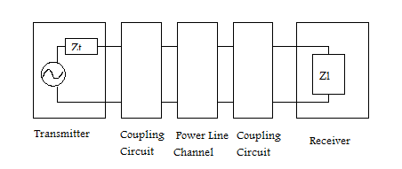 Figure 1.1 A digital communication system for the power-line channel

A coupling circuit is used to connect the communication system to the power-line. The purpose of the coupling circuits is two-fold:
Firstly, it prevents the damaging 50 Hz signal, used for power distribution, to enter the equipment.
Secondly, it certifies that the major part of the received/transmitted signal is within the frequency band used for communication. This increases the dynamic range of the receiver and makes sure the transmitter introduces no interfering signals on the channel.

1.3.2 Coupling Methods

Power transmission line operates at high voltage whereas communication equipment functions at volt to milivolts. It is therefore necessary to protect the communication equipment from high voltage transmission line. These equipments are coupled to the transmission line through coupling capacitor or capacitive voltage transformer (CVT) [2].
In order that the communication signal is transmitted in the desired direction, a wave trap is connected towards the substation bus side.

There are two schemes for coupling the equipment to the transmission line:

- Phase to Ground coupling
- Phase to Phase coupling

- Phase to Ground coupling

In phase to ground coupling as shown in figure (1.2), communication equipments are connected only with single conductor. Thus earth is used for the returning path. Here only ground mode is used for propagation of communication signal from transmitter to receiver. Phase to ground coupling is economical and simple to design. However, reliability of such system is poor especially during transmission and emergency hour.

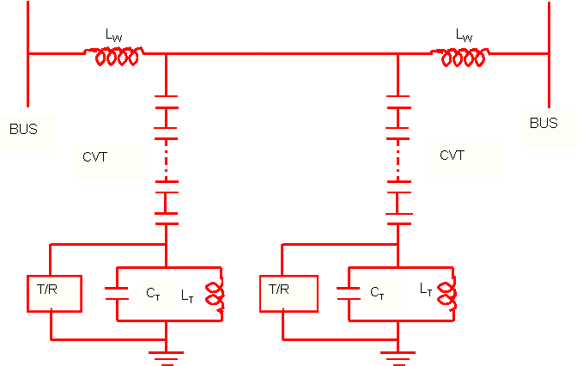

Figure 1.2 Phase to ground coupling

(ii) Phase to Phase coupling

In phase to phase coupling, the conductors of the two phases are used for coupling the communication equipments as shown in figure (1.3). Here the signals are fed to transmission lines in differential mode and outer conductors of the phases are generally used for enhancing the reliability though the coupling equipment in the scheme is doubled. Thus, the cost of such coupling scheme is higher to phase to ground coupling.

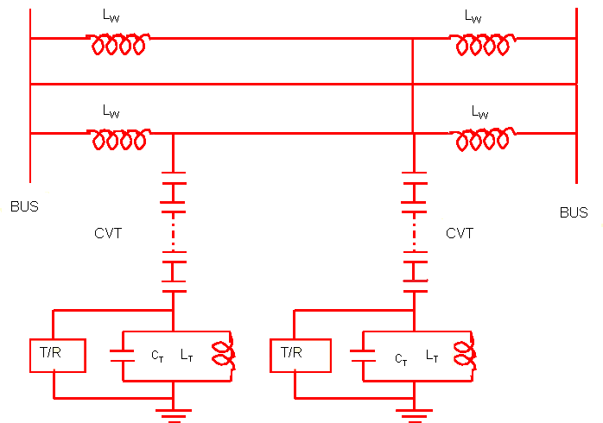

Figure 1.3 Phase to phase coupling

1.4 Digital communication

Digital communication refers to the transmission of digital data. The data to be transmitted could origin from any source of information. Therefore, the objective of the digital communication system is to communicate digital information i.e. a sequence of binary information digits over a channel at as high bit rates as possible.

This is in contrast to analog communications. While analog communications use a continuously varying signal, a digital transmission can be broken down into discrete messages. Transmitting data in discrete messages allows for greater signal processing capability so that errors caused by random processes can be detected and corrected.

Alternatively, an analog source output can be converted into a digital form and the message can be transmitted via digital modulation [20]. The most important reason is that signal fidelity is better controlled through digital transmission than analog transmission.

The term digital communication covers a broad area of communication techniques including digital transmission and digital radio. Digital transmission involves transmission of digital pulses from a digital source or transmission of analog signals after converting these into digital pulses from analog sources. Digital radio involves the transmission of digitally modulated analog carriers between two or more points in a communication system [25].

Digital transmission system requires a physical channel between the transmitter and receiver such as a metallic wire pair or a coaxial cable. In digital radio system, the transmission medium could be free space or a physical channel such as optical fiber cable.

  - Objectives of the study

The objective of this thesis is to examine the systematic model for the power-line using a small set of parameters. This model is applied for a high voltage power line. This project is oriented to the application of OFDM to the power-line carrier. In brief, the objectives of the present dissertation are:

- Design the OFDM scheme for multifunctional power transmission line.
- Effect of line length on the attenuation of broadband channel.
- Effect of frequency on characteristic impedance.

  - Dissection of Dissertation

This thesis has been organized into five chapters. The first chapter introduces data communication over power-line and deals with power-line as a communication channel. Further, it presents the fundamentals of digital communication.

Chapter two presents the literature review related to
- Communication,
- Broadband,
- Modulation and
- Interfacing broadband equipment with high voltage transmission line.

Chapter three reveals the analog and digital modulation. It presents the generation of the multicarrier modulation technique viz. OFDM along with its advantages and disadvantages.

In chapter four mathematical modeling is undertaken to ascertain the issue of data communication over power-line. The modeling is based on an assumed environment and tries to create a framework for understanding the rectangular same. Simulation is carried out in an assumed environment in MATLAB 7.0 software. The code carried out to develop this simulation is given in appendix [B] and appendix [C].

Chapter five discusses the result of the simulated model and further scope of this particular study. The results are used to decipher the problem and find a probable solution for the same.

  - Conclusions

This chapter presents the introduction of broadband communication over power-line and objectives of this thesis. Also summary of coupling of broadband equipment with high voltage lines is presented. A brief idea about the digital communication has been introduced. This chapter also highlights the need for selection of this topic of research. Further, this chapter provides a starting point for the research topics and issues to follow.

CHAPTER 2
==========

Literature Review

This chapter contains a brief literature review on the subject:

- Interfacing communication equipment with power-line.
- Limitation of analog communication system.
- Selection of bandwidth and frequency for communication over power-line in related to multifunctional use of lines, and
- Modulation scheme for communication.

without exhaustive presentation.

2.1 Interfacing communication equipment with power-line

Broad-band coupling for power-line carrier system was developed some 20 years ago but it is only in the past few years that it has any appreciable use. Several things have contributed to the revived interest in its application. Coupling equipment is an essential part of a broadband channel. Broad-band coupling may be defined simply as the use of filter circuits in lieu of conventional resonant type tuning units to obtain broader channel bandwidth [16].

High voltage power lines are constructed with such strength that they are in general superior to any communication circuit except underground cable. Experience has demonstrated that power lines withstand storms, sleet, and floods long after all circuits are carried away. In view of the vital necessity of communication to a power company, it is very much natural that the power line should be used as a communication circuit because of its mechanical superiority. The method of utilizing a power line as a telephone line is to superimpose high frequency currents on the power conductors. These currents are transmitted over the line as ordinary alternating currents. They are produced and received by equipment similar to the usual space radio apparatus [2].

In considering the power line as a communication circuit it is immediately apparent that such a circuit differs from the usual telephone line. The principle difference is that the line is operated at high voltage [23]. This gives rise to more or less noise due to spitting insulators and similar effects. In addition the line is not a simple circuit connecting the transmitter and receiver. In practice a power line is usually part of an extensive high voltage network with loops, taps and spurs. Such a network is not a constant and stable system from communication point of view because of more or less continuous changes due to switching. In general every time a switch is opened or closed in any part of the system, it makes a change in the communication circuit. These factors are now generally recognized. In some cases it was found that the natural changes in line characteristics due to switching were so great that a satisfactory communication circuit could not be obtained. Efforts have been made to solve this problem by modifying the communication apparatus. Modification tending to reduce the number of frequencies per channel and introduction of special system of modulation has greatly increased the amount and complexity of the equipment.

By its very nature power line communication equipment should be kept just as simple and reliable as possible. Instead of complicating the equipment it is proposed to correct the trouble at its source by stabilizing the power line. The method is to insert high frequencies resistances in to the power line at such points as are necessary to block off detrimental circuits and provide a clear circuit for the channel desired. Apparatus for this purpose has been developed which has proved very effective. This apparatus consists of an inductance coil very similar to those ordinary used for lighting arrester work together with the necessary tuning equipment. These tuned circuits do not absorb energy at the power frequencies nor in any way disturb the power system. In order to appreciate the problem presented by a power network some of the properties of transmission line at very high frequencies may be noted. A line of great length does not act like a large capacity or a large inductance but rather as a pure resistance of approximately 400 to 600 ohms for the average power line construction. The impedance of a short line open at the end varies over a wide range [12].

A broad-band coupling system provides a carrier path not only at and near the resonant frequency of the trap, but also at frequencies considerably removed from trap resonance. Broad-band coupling offers advantages of versatility in multiple frequency coupling, and in special applications allows the use of groups requiring band-widths unattainable with resonant tuned circuits [2].

2.2 Limitation of analog and conventional digital
communication system

The purpose of any communication system is to transmit information from a source station to a destination station through a communication channel viz. wired or wireless. Information may be in the form of symbols that can be analog such as voice, video or music or digital such as binary coded numbers, graphic symbol etc [17], [13].

Analog is a transmission standard that uses electrical impulses to emulate the audio waveform of sound. The main drawback of an analog communication system is that the effect of the random noise can make the signal loss and it is impossible to recover the signal distortion [20], [25].

By the 1970’s, analog communication system were fast getting replaced by digital communication system with the advent of revolutionary advances in computers and solid state electronic devices. In 1990’s the entire communication has become digital with very high speed computer communication networks and digital wireless networks.

The explosive growth of wire and wireless communication has been sparked by need for personal communication of voice, video and data and the reliability of low cost IC and microprocessor. There is a relentless push for higher speed data transmission over wire and wireless system.

In conventional digital communication system, more bandwidth is required to transmit the information and synchronization is required at the receiver end [25]. These two limitations of conventional digital communication system lead to the enhanced digital communication i.e. OFDM, DSSS etc.

  - Selection of bandwidth and frequency

As in [11], PLC uses the power transmission lines to transmit radio frequency signals in the range of 30 Hz to 500 kHz. The security of this communications is very high since the power line carrier equipment is located within the substations. PLC systems are used to provide voice, telemetry, SCADA (supervisory control and data acquisition), and relaying communications on portions of the 220/230 kV, 110/115 kV, or 66 kV interconnected power transmission network.

Most BPL products operate within the frequency range 1.7 MHz to 30 MHz, although submissions to the United States (US) BPL inquiry indicated equipment could operate in frequencies up to 80 MHz [10]. This spectrum is used for various radio communications applications including defense purposes, short-wave broadcasting, maritime and aeronautical communications, radio astronomy, amateur radio and numerous short-range applications such as medical emergency alarms.

To provide an adequate channel of communication, the European Economic Commission’s Committee for Electrotechnical standardization CENCELC, have produced a standard for such transmission and reception of data into and around buildings [21].

The frequency band 3 KHZ to 148.5 KHZ is designated for data communication over low voltage distribution network. The band is subdivided into two frequency range 3 KHz to 95 KHz is used for utility signaling band and rest is used for customer services inside the building [36].

It has been studied that modulated carrier beyond 500KHz used overhead power transmission lines create disturbances in the other communication systems, whereas frequency below 100 KHz when used attenuate very fast, since the transmission lines are designed for power transmission. In single sided band (SSB) mode, bandwidth of 4 KHz is available to the system carrier in the present amplitude modulation scheme. 2.2 KHz is generally used for speech transmission, 2.2 KHz - 2.4 KHz is used for pilot signal and 2.4 KHz - 2.8 KHz is used for protection purpose and balance up to 4 KHz is used for telemetry function.

The bandwidth for the transmission is limited and therefore the choice of modulation system in conjunction with data rate is of prime importance. However, due to present technological changes; it is possible to use the power transmission lines for broadband functions such as internet, TV program etc.

  - Modulation scheme for communication

The spread spectrum and multicarrier techniques used in the BPL system as a modulation technique are briefly discussed in this section. Two most widely used techniques are as under:

    - Direct Sequence Spread Spectrum

Spread spectrum has been in practical use since the late 1950’s and first was developed for use by the military [19] because it uses wideband signals that are difficult to detect and that resist attempts at jamming. In recent years, researchers have turned their attention to applying spread spectrum processes for commercial purposes, especially in local area wireless networks. The literature in the field of spread spectrum communications is quite voluminous and ranges from text books to specialized conference and journal papers.

According to [31] “Spread spectrum is a means of transmission in which the signal occupies a bandwidth in excess of the minimum necessary to send the information; the band spread is accomplished by means of a code which is independent of the data, and a synchronized reception with the code at the receiver is used for despreading and subsequent data recovery.”

DSSS is one of two types of spread spectrum techniques wherein a data signal at the transmitter is combined with a higher data rate bit sequence, or chipping code, that divides the user data according to a spreading ratio [5]. The chipping code is a redundant bit pattern for each bit that is transmitted, which increases the signal's resistance to interference. The redundancy of data helps in recovering the bits that are corrupted during data transmission.

As in [33], Direct Sequence Spread spectrum is a communication technique wherein the transmitted modulation is spread (increased) in bandwidth prior to transmission over the channel and then de-spread (decreased) in bandwidth by the same amount at the receiver. A DSSS message encrypted with a particular PN-code is transmitted an arbitrary number of times within a single transmission period. The received signal need only recover one of these copies, or different parts of separate copies in order to decrypt the entire original signal correctly.

This gives DS-SS such a strong advantage in communication scenarios where error correction can only be performed in the forward path, and where ultimately error correction is a last resort to not receiving the message at all.

    - Orthogonal Frequency Division Multiplexing

Orthogonal frequency-division multiplexing (OFDM) is the modulation technique for European standards such as the Digital Audio Broadcasting (DAB) and the Digital Video Broadcasting (DVB) systems. As such it has received much attention and has been proposed for many other applications, including local area networks and personal communication systems. OFDM is a type of multichannel modulation that divides a given channel into many parallel subchannels or subcarriers, so that multiple symbols are sent in parallel. Earlier overviews of OFDM can be found in [6], [24].

The first multichannel modulation systems appeared in the 1950's as military radio links, systems best characterized as frequency-division multiplexed systems. The first OFDM schemes were presented by [8] and [26]. Actual use of OFDM was limited and the practicability of the concept was questioned. However, OFDM was made more practical through work of [9], [22]. The type of OFDM that will be use in this thesis uses the discrete Fourier transform (DFT) [9] with a cyclic prefix [22]. The DFT implemented with a fast Fourier transform (FFT) and the cyclic prefix has made OFDM both practical and attractive to the radio link designer.

The choice for OFDM as transmission technique could be justified by comparative studies with single carrier systems. However, few such studies have been documented in the literature, e.g., [35]. OFDM is often motivated by two of its many attractive features: it is considered to be spectrally efficient and it offers an elegant way to deal with equalization of dispersive slowly fading channels.

CHAPTER 3
==========

Modulation Method for Power-Line Communication
OFDM

3.1 Introduction

The transmission of information is an extreme and vital process. The information in the audio band (20 Hz-20 KHz) cannot be directly transmitted efficiently through the wire, atmosphere and space. Radio frequency signals above 20 KHz can be propagated through wires or space both efficiently and economically. Therefore, a common method of transmitting audio information and high frequency information is to process it with carrier signal. This processing is called modulation. After such a signal is received, the original information is extracted by a process is called demodulation or detection.

The intention with this chapter is to present a modulation scheme that may be a candidate to be used in a communication system for the power-line channel.

3.2 Modulation

Modulation [25], [17] is the process of varying some characteristic of a periodic wave with an external high frequency signal. It is utilized to send an information bearing signal over long distances. These high frequency carrier signals can be transmitted over the transmitted lines or air and are capable of traveling long distances. The carrier signal can be an electrical current, a radio or microwave frequency or light. The process of extracting the information at the receiving end is called demodulation.

The characteristics (amplitude, frequency, or phase) of the carrier signal are varied in accordance with the information bearing signal. This information bearing signal is also known as the modulating signal. This modulating signal is a slowly varying signal as opposed to the rapidly varying carrier frequency.

Therefore, there are three basic types of modulation: amplitude modulation (AM) varies the amplitude; frequency modulation (FM) varies the frequency, and phase modulation (PM) varies the angle of the wave.

Carriers are used to transmit multiple channels simultaneously within a wire or fiber. For example, several voice, data and video signals can travel over the same line, each residing in its own carrier vibrating at a different frequency.

Instead of sending a separate stream of data in each carrier, multiple carriers can be used for only one channel of data. For example, the widely used Orthogonal Frequency Division Multiplexing (OFDM) method uses numerous carriers (sub carriers) for only one transmitting channel and one stream of data [28].

Types of modulation:
There are two methods of modulation:
- Analog modulation, and
- Digital modulation

3.2.1 Analog Modulation
In analog modulation, the message signal is a continuous waveform i.e. an analog signal. There are various analog modulation techniques, some of them are:

Amplitude modulation

Amplitude modulation (AM) is also widely used to alter a carrier wave to transmit data. In AM, amplitude of the carrier is varied by the incoming signal, whose frequency is invariably lower than that of the carrier. In this case, the modulating wave implies an analog signal.

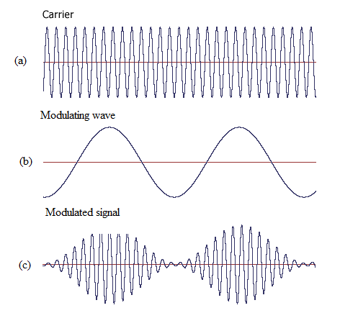
Figure 3.1 Amplitude modulation

Figure (3.1) shows a carrier$v_{C}(t)=V_{C}\text{cos}ω_{C}t$, modulating signal $v_{m}(t)=V_{m}\text{cos}ω_{m}t$ and an amplitude modulated signal which is mathematically defined as,
$v(t)=V_{C}(1+m\text{cos}ω_{m}t)\text{cos}ω_{C}t$
where $ω_{m}$<< $ω_{C}$

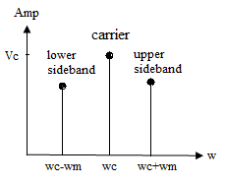
Figure 3.2 Spectrum of Amplitude Modulation

The spectrum of the AM signal is shown in figure (3.2). The sinusoid whose frequency is $ω_{C}$+$ω_{m}$ is known as upper sideband and the one whose frequency is $ω_{C}$-$ω_{m}$ is the lower sideband. Since the lower sideband of an AM signal is the mirror image of upper sideband, it is redundant. Therefore, this sideband is eliminated and the resulting signal is referred as SSB signal.

Frequency Modulation

In frequency modulation (FM), the frequency of the carrier wave is varied by the incoming signal. In this example, the modulating wave implies an analog signal.

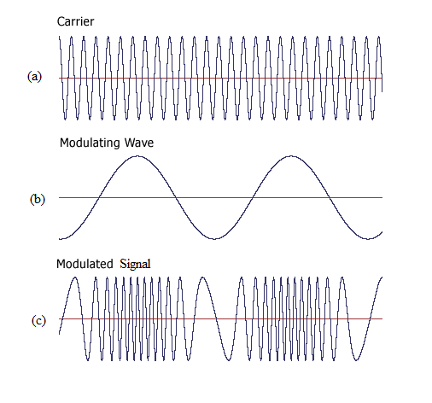
Figure 3.3 Frequency modulation

Figure (3.3) shows the waveform of a FM carrier$v_{C}(t)=A\text{cos}ω_{C}t$, a modulating signal $v_{m}(t)=V_{m}\text{cos}ω_{m}t$ and the resulting FM signal $v(t)=A\text{cos}[ω_{C}t+k_{1}v_{m}(t)]$
where $k_{1}$ is a constant.
The change in amplitude of modulating signal causes the change in the frequency of the FM signal.

Phase Modulation

In phase modulation (PM), the angle of the carrier wave is varied by the incoming signal in order to transmit the analog data. PM and FM are closely allied as both are a type of angle modulation.

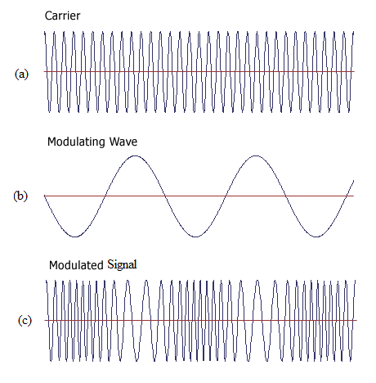
Figure 3.4 Phase modulation

In PM, the phase$φ$ is varied on changing the amplitude of the modulating signal. Figure (3.4) shows the waveform of a PM carrier$v_{C}(t)=A\text{cos}ω_{C}t$, a modulating signal $v_{m}(t)=V_{m}\text{cos}ω_{m}t$ and the resulting PM signal $v(t)=A\text{cos}[ω_{C}t+φ(t)]$ which can be further written as $v(t)=A\text{cos}[ω_{C}t+k_{2}v_{m}(t)]$
where $k_{2}$ is a constant.

    - Digital Modulation
The transmitted message for a digital modulation system represents a small set of abstract symbols e.g. 0s and 1s for a binary transmission system.
The digital modulation has three basic forms namely:

Amplitude Shift Keying

Amplitude modulation (AM) is also used for digital data. Amplitude Shift Keying (ASK) is the simplest digital modulation technique. In this method, there is only one unit energy carrier and it is switched on or off depending upon the binary sequence. ASK uses two levels for 0 and 1 as shown in figure (3.5)

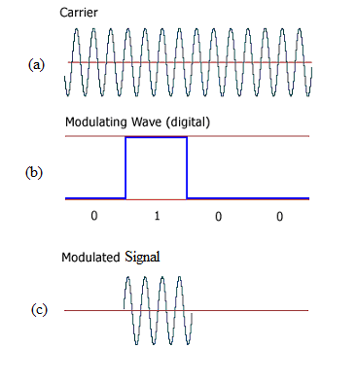
Figure 3.5 Amplitude Shift Keying

The ASK waveform may be represented as:
$s(t)=\sqrt{2P_{S}}\text{cos}(2{πf}_{C}t)$ to transmit symbol ‘1’
and the signal $s(t)=0$ to transmit symbol ‘0’
Hence, the ASK waveform looks like an ON-OFF of the signal. Therefore, it is also called ON-OFF keying.

Frequency Shift Keying

In Frequency Shift Keying (FSK), the frequency of the carrier is shifted according to binary symbol. FSK uses two frequencies for 0 and 1 as shown in figure (3.6) given below.

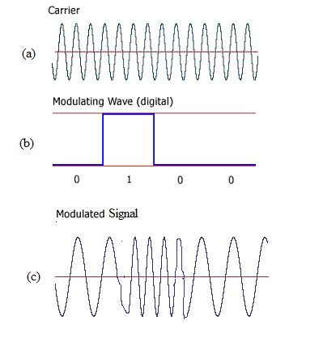
Figure 3.6 Frequency Shift Keying

In binary FSK the binary data waveform $d(t)$generates a binary signal
$s(t)=\sqrt{2P_{S}}\text{cos}[ω_{0}t+d(t)Ωt]$,
where $Ω$ is a constant offset from the nominal carrier frequency $ω_{0}$, and

$$d(t)=\begin{aligned}\left\{+1\text{ when symbol '1' is transmit} | \right.\end{aligned}$$

Phase Shift Keying

In Phase Shift Keying (PSK), binary symbol ‘1’ and ‘0’ modulate the phase of the carrier as shown in figure (3.7).

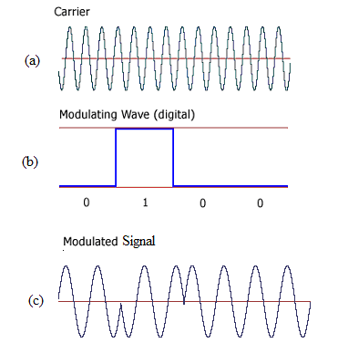
Figure 3.7 Phase Shift Keying

Binary PSK has one fixed phase when the data is at one level and when the data is at other level the phase is different by$π$.
Mathematically
$s(t)=b(t)\sqrt{2P_{S}}\text{cos}(2{πf}_{C}t)$

Here, $b(t)=\begin{aligned}\left\{+1\text{ when symbol '1' is transmit} | \right.\end{aligned}$

  - Theory of OFDM

Orthogonal frequency-division multiplexing (OFDM) is a method of digital modulation in which a signal is split into several narrowband channels at different frequencies [11]. In OFDM the signal itself is first split into independent channels, modulated by data and then re-multiplexed to create the OFDM carrier. Therefore, OFDM is a combination of modulation and multiplexing.

The technology was first conceived in the 1960’s and 1970’s. One of the main reasons to use OFDM is to increase the robustness against frequency selective fading or narrowband interference. In a single carrier system, a single fade or interferer can cause the entire link to fail, but in a multicarrier system, only a small percentage of the subcarriers will be affected [4].

OFDM is a multi-carrier transmission technique [6], which divides the available spectrum into many carriers, each one being modulated by a low rate data stream. In some respects, OFDM is similar to conventional Frequency Division Multiplexing (FDM) in that the multiple user access is achieved by subdividing the available bandwidth into multiple channels, that are then allocated to users. The difference lies in the way in which the signals are modulated and demodulated. However, OFDM uses the spectrum much more efficiently by spacing the channels much closer together.
This is achieved by making all the carriers orthogonal to one another, preventing interference between the closely spaced carriers. Figure (3.8) shows the comparison between the conventional FDM and OFDM.

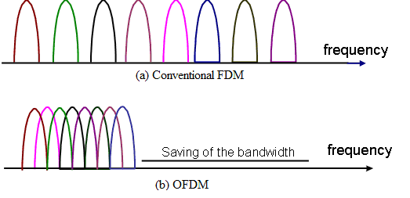
. Figure 3.8 Comparison between the conventional FDM and OFDM

For a large number of subchannels, the arrays of sinusoidal generators and coherent demodulators required in a parallel system become unreasonably expensive and complex. The receiver needs precise phasing of the demodulating carriers and sampling times in order to keep crosstalk between subchannels acceptable. In [26], the discrete Fourier transform (DFT) to parallel data transmission system as part of the modulation and demodulation process is applied. In addition to eliminating the banks of subcarrier oscillators and coherent demodulators required by FDM, a completely digital implementation could be built around special-purpose hardware performing the fast Fourier transform (FFT).

OFDM is a technique for transmitting data in parallel by using a large number of modulated sub-carriers. These sub-carriers (or sub-channels) divide the available bandwidth and are sufficiently separated in frequency (frequency spacing) so that they are orthogonal. The orthogonality of the carriers means that each carrier has an integer number of cycles over a symbol period. Due to this, the spectrum of each carrier has a null at the center frequency of each of the other carriers in the system. This results in no interference between the carriers, although their spectra overlap. The separation between carriers is theoretically minimal so there would be a very compact spectral utilization. This is shown in figure (3.9) below.

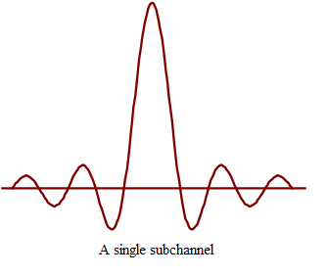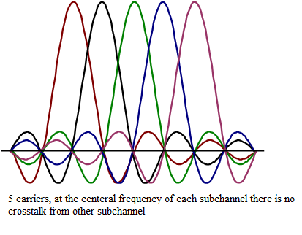
Figure 3.9 OFDM spectrum

3.3.1 Advantages
The OFDM transmission scheme has the following key advantages:

- Makes efficient use of the spectrum by allowing overlap.
- By dividing the channel into narrowband flat fading subchannels, OFDM is more
resistant to frequency selective fading than single carrier systems.
- Eliminates ISI and IFI through use of a cyclic prefix.
- Provides good protection against cochannel interference and impulsive parasitic noise.

3.3.2 Drawbacks
There are two main drawbacks:

- The large dynamic range of the signal, also known as the peak-to-average-power ratio (PAPR). Solutions to deal with this problem have been (and still are) developed and one of the most used ones is clipping.
- Sensitivity to frequency errors.

Most research centers throughout the world are mainly focusing their work on these two topics in their attempt to optimize OFDM.

  - Importance of Orthogonality

The “orthogonal” part of the OFDM name indicates that there is a precise mathematical relationship between the frequencies of the carriers in the system [30]. To arrange the carriers in an OFDM signal so that the sidebands of the individual carriers overlap and the signals can still be received without adjacent carrier interference. In order to do this the carriers must be mathematically orthogonal. The receiver acts as a bank of demodulators, translating each carrier down to DC, the resulting signal then being integrated over a symbol period to recover the raw data. If the other carriers all beat down to frequencies which, in the time domain, have a whole number of cycles in the symbol period ($τ$), then the integration process results in zero contribution from all these carriers. Thus the carriers are linearly independent (i.e. orthogonal) if the carrier spacing is a multiple of 1/$τ$.

Mathematically, suppose we have a set of signals$ψ$, where $ψ_{p}$ is the p^{th} element in the set. The signals are orthogonal if

$$\int_{a}^{b}{ψ_{p}}(t)ψ_{q}^{}(t)\text{dt}=\begin{aligned}\left\{\text{k for p}=q | \right.\end{aligned}$$

where the * indicates the complex conjugate and interval [a, b] is a symbol period. A fairly simple mathematical proof exists, that the series sin(mx) for m=1,2,… is orthogonal over the interval -$π$ to $π$.

  - Algorithm for OFDM

The mathematical definition of the modulation system formulates the signal generation and defines the way in which the receiver operates. As discussed above, OFDM transmits a large number of narrowband carriers, closely spaced in the frequency domain. In order to avoid a large number of modulators and filters at the transmitter and complementary filters and demodulators at the receiver, it is desirable to be able to use modern digital signal processing techniques, such as fast Fourier transform (FFT) [30].

Mathematically, each carrier can be described as a complex wave:

$SC(t)=AC(t)\text{exp}j[ωct+φc(t)]$ (1)

The real signal is the real part of$SC(t)$. Both Ac(t) and fc(t), the amplitude and phase of the carrier, can vary on a symbol by symbol basis. The values of the parameters are constant over the symbol duration period $τ$.

OFDM consists of many carriers. Thus the complex signal$SC(t)$ is represented by:

$Ss(t)=\frac{1}{N}\sum_{n=0}^{N−1}{An}(t)\text{exp}j[ωnt+φn(t)]$ (2)

Where $ωn=ω\text{0 }+\text{ n}Δω$

This is of course a continuous signal. If we consider the waveforms of each component of the signal over one symbol period, then the variables Ac(t) and fc(t) take on fixed values, which depend on the frequency of that particular carrier, and so can be rewritten
$\begin{aligned}φn(t)⇒φn \\ An(t)⇒An\end{aligned}$

If the signal is sampled using a sampling frequency of 1/T, then the resulting signal is represented by:

$Ss(\text{kT})=\frac{1}{N}\sum_{n=0}^{N−1}{An}(t)\text{exp}j[(ω\text{0 }+\text{ n}Δω)\text{kT}+φn]$ (3)

At this point, the time is restricted, over which the signal is analyze to N samples. It is convenient to sample over the period of one data symbol. Thus we have a relationship $τ=\text{NT}$

without a loss of generality by letting $ω0$=0, then the signal becomes:

$Ss(\text{kT})=\frac{1}{N}\sum_{n=0}^{N−1}{An}\text{exp}j[\text{ n}Δω)\text{kT}]\text{exp}[jφn]$ (4)

Now Eq. 4 can be compared with the general form of the inverse Fourier transform:

$g(\text{kT})=\frac{1}{N}\sum_{n=0}^{N−1}{G(\frac{n}{\text{NT}})}\text{exp}j[2π{\text{nk}}/N]$ (5)

Equations 4 and 5 are equivalent if:

$$Δf=\frac{Δω}{2π}=\frac{1}{\text{NT}}=\frac{1}{τ}$$

This is the same condition that was required for orthogonality . Thus, one consequence of maintaining orthogonality is that the OFDM signal can be defined by using Fourier transform procedures.

3.6 Generation of OFDM signal

To generate OFDM successfully the relationship between all the carriers must be carefully controlled to maintain the orthogonality of the carriers. For this reason, OFDM is generated by firstly choosing the spectrum required, based on the input data, and modulation scheme used. Each carrier to be produced is assigned some data to transmit. The required amplitude and phase of the carrier is then calculated based on the modulation scheme (typically differential BPSK, QPSK, or QAM). In QAM, the constellation points are usually arranged in a square grid with equal vertical and horizontal spacing. In QAM, the amplitude of two waves, 90 degrees out-of-phase with each other (in quadrature) is modulated to represent the data signal. In the present work, 64-QAM [35] is used as a mapping.

The required spectrum is then converted back to its time domain signal using an Inverse Fourier Transform. In the OFDM system, Inverse Fast Fourier Transform/Fast Fourier Transform (IFFT /FFT) algorithms are used in the modulation and demodulation of the signal.
The IFFT transforms a spectrum into a time domain signal whereas FFT performs a reverse operation by transforming a cyclic time domain signal into its equivalent frequency spectrum. The amplitude and phase of the sinusoidal components represent the frequency spectrum of the time domain signal.

An IFFT converts a number of complex data points, of length which is a power of 2, into the time domain signal of the same number of points. Each data point in frequency spectrum used for an FFT or IFFT is called a bin. The IFFT performs the transformation very efficiently, and provides a simple way of ensuring the carrier signals produced are orthogonal. The orthogonal carriers required for the OFDM signal can be easily generated by setting the amplitude and phase of each bin, then performing the IFFT. Since each bin of an IFFT corresponds to the amplitude and phase of a set of orthogonal sinusoids, the reverse process guarantees that the carriers generated are orthogonal. After performing IFFT, a guard period is added to generate the OFDM signal.

3.7 OFDM Model

The previous section has shown that the generation of the OFDM signal can be realized through the IFFT/FFT processing block to which the mapped original data is applied. However, several complementary operations have to achieved and applied to the information bits before they are submitted to the IFFT processing, as illustrated by figure (3.10). The OFDM model consists of transmitter and receiver. The receiver basically does the reverse operation to that of transmitter.

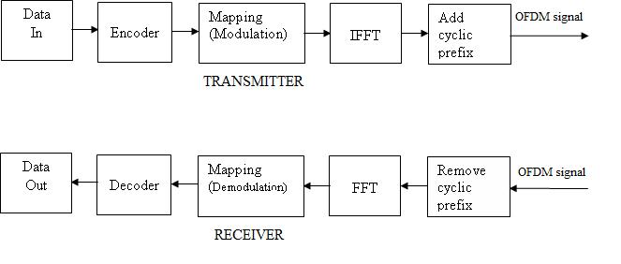
Figure 3.10 OFDM transmitter and receiver

The input serial data stream is formatted into the word size required for transmission and shifted into a parallel format. The data is then transmitted in parallel by assigning each data word to one carrier in the transmission. The coding [29] of the original information is a primordial step to make the transmission over the real channels possible, and this is because of the distortion.

The mean functionality required for the realization of an OFDM system can be summarized as follows:

Coding/Decoding

At the transmitter side and before modulating the information signal, a channel coding is used so that the correctly received data of the relatively strong subcarriers corrects the erroneously received data of the relatively weak subcarriers. A set of channel coding [7], [10] schemes have been investigated for application within OFDM systems including block codes, convolutional codes and turbo codes.

In this thesis, convolution codes are used as an encoding method. Convolution codes also known as tree codes or trellis codes are implemented by sequential logic circuits.

At the receiver side, decoding is performed in order to get the original ordering of the bits. The decoding function is realized by viterbi algorithm in the present work.

Mapping/De-mapping

After coding, the bits to be conveyed are mapped to a convenient modulation symbol. This mapping can be carried out without differential encoding. Therefore, the data bits are directly mapped to the complex modulation symbols. Generally, this encoding is realized either by M-ary Phase Shift Keying (M-PSK) or by M-ary Quadrature Amplitude Modulation (M-QAM). In figure (3.11), a Gray encoded 16-PSK and 16-QAM signal constellation is illustrated, where binary words are assigned to adjacent symbol states and differ by only one digit.
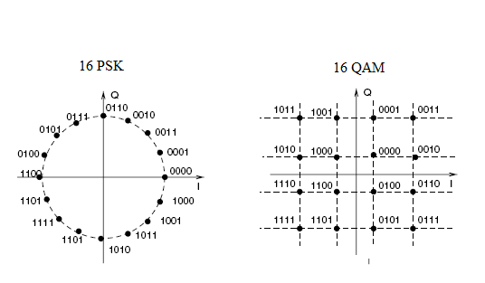
Figure 3.11 Mapping/De-mapping scheme
64-QAM is used for mapping and de-mapping the encoded data. The data to be transmitted on each carrier is mapped into a quadrature amplitude modulation (QAM) format. In the case of QAM, the amplitude of two waves, 90 degrees out-of-phase with each other (in quadrature) is modulated to represent the data signal. One signal is called the Inphase signal, and the other is called the Qadrature signal. It achieves a greater distance between adjacent points in the I-Q plane by distributing the points more evenly as shown in figure (3.11). The two modulated carriers are combined at the source for transmission. At the destination, the carriers are separated, the data is extracted, and then the data is combined into the original signal.

Fourier Transform

The Fourier transform relates the events in time domain to events in frequency domain. For this purpose, the fast version of Discrete Fourier Transform (DFT) viz. Fast Fourier Transform (FFT) is used. The process of transforming from the time domain representation to the frequency domain representation uses the Fourier transform itself, whereas the reverse process uses the inverse Fourier transform.

At the transmitter, the signal is defined in the frequency domain. Therefore, an Inverse Fast Fourier transform (IFFT) [9] is used to find the corresponding time waveform. At the receiver end, an inverse operation of IFFT i.e. FFT is performed to extract the data.

Guard Interval

One of the most important properties of OFDM transmissions is the robustness against multipath delay spread. This is achieved by having a long symbol period, which minimizes the inter-symbol interference. The level of robustness can in fact be increased even more by the addition of a guard period between transmitted symbols.

The most effective way is a cyclically extended guard interval, where each OFDM symbol is preceded by a periodic extension of the signal itself, while maintaining the orthogonality of the waveform. A guard time is added to the OFDM symbol, and periodicity around this OFDM symbol is made by duplicating the content of this guard time from the first part of the symbol, as represented in figure (3.12). In this case, the guard time becomes the cyclic prefix (CP). The insertion of the appropriate cyclically extended guard time eliminates ISI and ICI in a linear dispersive channel.

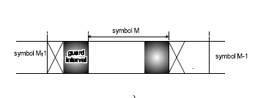
Figure 3.12 Adding the cyclic prefix by duplicating
the first part of the original signal

Using this cyclic extended symbol the samples required for performing the FFT, can be taken anywhere over the length of the symbol. This provides multipath immunity as well as symbol time synchronization tolerance. After the guard has been added, the symbols are then converted back to a serial time waveform. This is then the base band signal for the OFDM transmission.

3.8 Conclusions

This chapter formulates the OFDM transmission technique with its key properties, the FFT and the cyclic prefix. It also discusses the advantages and drawbacks of OFDM. Further, it gives a brief idea about modulation and its types.
CHAPTER 4
==========

Transmitter, Channel model & Receiver Strategies for PLC

4.1 Introduction

In previous section, Chapter 3 gives an idea about the OFDM generation and Chapter 1 and Chapter 2 explains the behavior of the power-line. In the following section, a strategy is described for the data communication over power-line.

4.2 System Modeling

Figure (4.1) shows a simplified flowchart of the MATLAB simulation code. The MATLAB code is given in Appendix [B] and [C].

The simulation model shown in figure (4.1) can be divided into three main parts:

1. The transmitting part — it is responsible for encoding and modulation of signals into a form suitable for the transmission channel. After this, a guard period is added followed by Inverse Fast Fourier Transform (IFFT) to generate the OFDM signal.

2. The transmission channel (high voltage power line) — this part of the model accounts for the negative influences of the PLC environment on the transmitted signal. Above all, these are the insertion loss and characteristic impedance. Coupler and decoupler are provided at the transmitting and receiving end for proper communication.

3. The receiving part — it is conceptually inverse in comparison with the transmitter. Its main functions are removal of guard period; perform Fast Fourier Transform, demodulation and correction of error information bits.

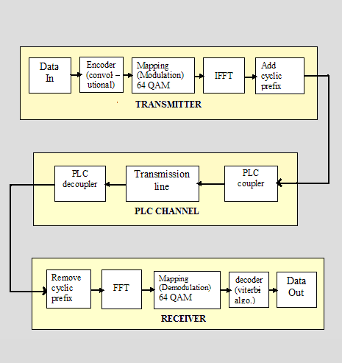
Figure 4.1 System Flowchart

4.2.1 Transmitting Part

A detailed description about signal generation is given in Chapter-3. The base band signal from legacy networks to provide backend infrastructure support has been generated as a random binary data with a given length as shown in figure.(4.2)

Figure 4.2 Generated random binary data

Encoder: In order to reduce the bit error probability the channel encoder adds redundancy viz. extra control bits to the bit sequence in a controlled way. When an error appears in the bit stream the extra information is used by the channel decoder, to detect, and possibly correct, the error. The redundancy added is depending on the amount of correction needed but is also tuned to the characteristics of the channel.

Two coding techniques often used are block codes [32] and convolutional codes [32], [7]. In the present work, convolutional coding is used as an error-control coding.

Convolutional coding is a special case of error-control coding. A convolutional coder is not a memoryless device. Even though it accepts a fixed number of message symbols and produces a fixed number of code symbols, its computations depend not only on the current set of input symbols but on some of the previous input symbols.

Modulation: At this stage, the data is converted to a form of signal that is suitable to propagate over the channel. There are several modulation techniques, described in Chapter-3. In this study, 64-QAM is used as a modulation technique for the mapping of the encoded data. By using this technique, a large number of bits can be sent together. Figure (4.3) given below, shows the 64-QAM modulated data.

Figure 4.3 64-QAM modulated data
IFFT: The modulated signal is in the time domain. Therefore, IFFT is used to convert this signal into time domain. Before performing the IFFT, zeros are added to the modulated signal to achieve over-sampling and to center the spectrum.

An inverse Fast Fourier transform converts the frequency domain data set into samples of the corresponding time domain representation of this data. Specifically, the IFFT is useful for OFDM because it generates samples of a waveform with frequency components satisfying orthogonality conditions. Figure (4.4) shows the OFDM system parameters that are used in programming.

Parameter | Value
Carrier Modulation used | 64 QAM
FFT size | 1024
Guard interval | 1/8

Figure 4.4 OFDM system parameters used in programming

Cyclic Prefix: The prefix is added after doing the IFFT just once to the composite OFDM signal. The guard time is cyclically extended for the prefix to a signal. A detailed description about the guard interval is given in section 3.7. Figure (4.5) given below, shows the OFDM signal.

Figure 4.5 OFDM signal

This signal cannot readily pass through transformers, as their high inductance makes them act as low-pass filters, blocking high-frequency signals; therefore coupling equipment is required at the transmitting end. Therefore, this signal is sent through the power-line using PLC coupler.

4.2.2 The Transmission Channel

In this thesis, the power-line is used as a transmission channel. Different types of powerline communications use different frenquency bands, depending on the signal transmission characteristics of the power wiring used. Since the power wiring system was originally intended for transmission of AC power, the power wire circuits have only a limited ability to carry higher frequencies.
The HV power line is a multiconductor line and signal propagation is defined by the eigenvector and eigenvalue of a propagation matrix [2]. Impedance and admittance matrices are frequency dependent and can be found using propagation matrix [2] that depends on the line parameters R, L, C. The MATLAB code for finding the same is given in Appendix [C].

The total signal attenuation on the PLC channel consists of two parts: coupling losses and line losses [2]. The negative influences of the PLC environment upon the signal transmission depend on the parameters of power-line (core material, cable insulation, cable length, core diameter, the number, position and properties of additional wires tapered from the main path) as well as on the number and properties of points of nonhomogeneity (instrument panels, PLC signal coupling units, regenerator units). To achieve exact results from the simulation, all these factors must be accepted. But, this acceptance leads to a complicated and complex PLC simulation model. Therefore, for modeling of the PLC transmission channel, a generalized model is used because of its accuracy, easy implementation and understandability [27], [12]. The transmission line data and constants to calculate the line parameter and characteristic impedance are given in Appendix [A].

Since in a high-voltage power line system one of the most important limiting factor can be a line mismatch between the transmitter and the receiver station due to the coupling, switching or bypass devices, therefore a channel characterized by the strong attenuation is considered here.

The communication equipment can be coupled to the power line in different ways utilizing different power- line conductors. This is defined by coupling methods as explained in Chapter 1.

4.2.2.1 Power line carrier coupling equipment

The major power line carrier coupling components are shown in fig. (4.6). The inductance of the wave trap L_{W} with capacitance C_{W} and inductance of tuning coil L_{T} with capacitance C_{T} for two parallel tuning circuits, while the capacitance C_{C} of the coupling capacitor with the inductance L_{C} of the stack tuning coil form a series tuning circuit. All the tuned circuits have a common midband frequency f₀. Thus, the coupling equipment at one end forms a $π$ section band-pass filter.
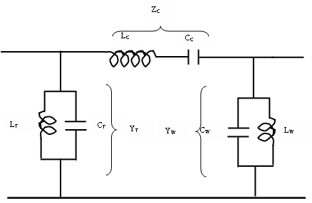
Figure 4.6 Simplified equivalent circuit of coupling equipment

where

$L_{T}$,$L_{W}$ are the inductance of the tuning coil and wave trap respectively,
$C_{T}$, $C_{W}$ are the capacitance of the tuning coil and wave trap respectively,
$Y_{T}$, $Y_{W}$ are the admittance of the tuning coil and wave trap respectively, and
$Z_{C}$ is the impedance of the coupling.

R₀ represents the matching termination which is equal to the source resistance. In [23], it is shown that for L_{T} = 0.5 C_{C} R₀²

The optimum bandwidth at the half power points under maximally flat conditions can be calculated from f = 4 $π$ f₀² C_{C} R₀

In [2], a mathematical model of a transmission line which takes into account the coupling equipment has been developed. In this, the system is terminated by its characteristic impedance to avoid excessive mismatches losses. Characteristic impedance is the inverse of characteristic admittance.

According to [1], characteristic admittance is defined by using propagation matrix. The propagation matrix has an important property that any function of $ψ$ is a function of only the diagonal propagation matrix$λ^{1/2}$, and is defined as

$ψ={Qλ}^{1/2}Q^{−1}$

where
$ψ$ is the propagation matrix
$Q$ is the eigen vector corresponding to the eigen value $λ$

and
$$Y_{0}=\text{YQ}λ^{{−1}/2}Q^{−1}$$
where $Y_{0}$ is the characteristic admittance.

Therefore, the characteristic impedance is given as:
$Z_{0}$=$Y_{0}^{−1}$

4.2.2.2 Effect of coupling equipment

The effect of coupling equipment is to introduce additional losses due to mismatches in the carrier channel. These effects of coupling equipment have been considered by using a
$π$ equivalent circuit as shown in figure (4.7) . The coupling capacitor impedance Z_{C} and two shunt admittance Y_{W} and Y_{T} corresponds to wave trap and shunt tuning coil, respectively.

A1= ($\sum{ai}$) and B1= ($\sum{bi}$) are the equivalent two wire admittance parameters of the coupled transmission lines.

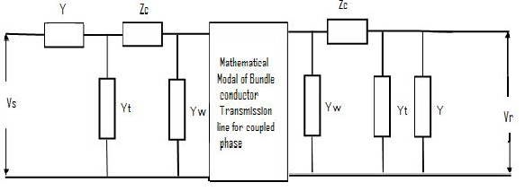
Figure 4.7 Representation of bundle conductor transmission line
including coupling equipment

Then the insertion loss $A_{s}^{'}$ of the circuit of figure (4.7) as described by [23] is given as

$A_{s}^{'}$ = ln$\left|\frac{VS}{VR}\right|$
= ln$\left|(\text{A1}+Y_{R}^{'})\right|$ + ln$\left|\left\{1+ZC(YT+Y)\right\}\right|$ + ln$\left|\left\{1+ZC(YW+Y_{S}^{'})\right\}\right|$ - ln$\left|(B1)\right|$ - ln$\left|(Y+YS)\right|$

where,

$Y_{R}^{'}=Y_{W}+(Y_{T}+Y)/{\left\{1+Z_{C}(Y+Y_{T})\right\}}$
$Y_{S}^{'}=A1−B{1^{2}}/(A1+Y_{R}^{'})$
$Y_{S}=Y_{T}+(Y_{W}+Y_{S}^{'})'\left\{1+Z_{C}(Y_{W}+Y_{s}^{'})\right\}$
$Y$ is the source impedance.

For the sake of simplicity, wave trap and tuning coil coupling capacitor are assumed as pure inductance and capacitance, respectively.

4.2.3 Receiving Part

The receiver section is similar to the transmitter. Receiver performs the operation in a reverse manner to the transmitter i.e. cyclic prefix is removed before packet data is sent to FFT for demodulation.

After the signal has arrived at the receiver, first the prefix is removed to get back the perfectly periodic signal so it can be FFT’d to get back the symbols on each carrier. The received signal is then demodulated followed by performing FFT.

The demodulated signal is then decoded using Viterbi algorithm [7], [10] as it is a decoding method for the convolution codes.

Finally, the corrected sequence is compared with the original transmitted message and the error rate is calculated. The results are shown in Chapter-5.

4.3 Conclusions

This thesis presents the data transmission by means of PLC technology. Together with the PLC transmission environment, a modulation technique-OFDM is introduced in order to create a complete picture of the PLC transmission path. The basic scheme of the proposed theory is composed of 3 parts — transmitter, transmission channel and receiver. Here every single component of the transmission path is not considered but is analyzed as a whole. A power-line model of the complex frequency response up to 1MHz is considered and the model is derived from the physical effects of these elements.

CHAPTER 5
==========

Results and Discussion

Results & Discussion

The MATLAB code accepts input as random binary data. It then generates the corresponding OFDM signal, simulates a channel, attempts to recover the input data, and performs an analysis to determine the mean error rate and bit error rate.

The communication medium viz. the power lines, has been designed for transmitting electrical power. It generally appears as a harsh environment for the low-power high frequency communication signals. The important channel parameters, namely characteristic impedance and insertion loss, are highly variable with frequency and length of the line. For the power-line channel, results obtained from the theoretical data are here as under:

The value of per unit length series impedance matrix is, Z

Z =

0.0687 + 2.4101i 0.0640 + 0.5257i 0.0544 + 0.2949i
0.0640 + 0.5257i 0.0687 + 2.4101i 0.0640 + 0.5257i
0.0544 + 0.2949i 0.0640 + 0.5257i 0.0687 + 2.4101i

The value of per unit length shunt admittance matrix is, Y

Y =

1.0e-004 *

0 + 0.1772i 0 - 0.0320i 0 - 0.0117i
0 - 0.0320i 0 + 0.1822i 0 - 0.0320i
0 - 0.0117i 0 - 0.0320i 0 + 0.1772i

Eigen values of propagation matrix is, d

Lam =

1.0e-004 *

-0.4240 + 0.0244i 0 0
0 -0.3995 + 0.0027i 0
0 0 -0.3956 + 0.0003i

Eigen vectors of propagation matrix is, eignVec

eigVec =

0.5654 - 0.0050i 0.7071 -0.4040 - 0.0063i
0.6006 0.0000 - 0.0000i 0.8206
0.5654 - 0.0050i -0.7071 + 0.0000i -0.4040 - 0.0063i

Propagation constant is, $λ^{1/2}$

lam1 =

0.0002 + 0.0065i 0 0
0 0.0000 + 0.0063i 0
0 0 0.0000 + 0.0063i

Characteristic impedance matrix, Z0

Z0 =

1.0e+002 *

3.7673 - 0.0529i 0.7756 - 0.0491i 0.4207 - 0.0416i
0.7756 - 0.0491i 3.7672 - 0.0528i 0.7756 - 0.0491i
0.4207 - 0.0416i 0.7756 - 0.0491i 3.7673 - 0.0529i

Fig 5.1 Magnitude of Characteristic impedance

This graph is plotted between the magnitude of the characteristic impedance and the frequency. The plot shows that its value increases as the frequency increases upto 550 KHz. Beyond this frequency the characteristic impedance increases as ramp function upto frequency of 850 KHz and at 550 KHz it abruptly increases from 480 ohm to 590 ohm and then become almost constant as frequency increases after decreasing abruptly at 850 KHz from 800 ohm to 385 ohm as shown in figure (5.1).

This may be because of break even frequency due to distributed components i.e. C and L of transmission line.

Fig 5.2 Real part of Characteristic impedance

This graph is plotted between the real parts of the characteristic impedance and the frequency, the plot shows that its value decreases as the frequency increases upto 400 KHz. Beyond this frequency the characteristic impedance increases linearly upto 850 KHz and then become almost constant with 370 ohm. But it abruptly changes at 550 KHz from 270 ohm to 360 ohm. This may be because of the resistance of the earth return path or resistance of earth.

$Y_{0}=\text{YQ}λ^{{−1}/2}Q^{−1}$
where
$Y_{0}$ is the characteristic admittance.
$Q$ is the eigen vector corresponding to the eigen value $λ$
Therefore, the characteristic impedance is given as:
$Z_{0}$=$Y_{0}^{−1}$

Figure 5.3 Imaginary part of characteristic impedance

Graph 5.3 is plotted between the Imaginary parts of characteristic impedance and the frequency. The plot shows that its value decreases almost linearly as the frequency increases upto 850 KHz. At 850 KHz there is a suddenly increment in characteristic impedance may be due to the reactance of the earth return path or conductor.

Figure 5.4 Real part of Propagation constant

The graph shown in figure (5.4) is plotted between the real part of propagation constant and frequency. Real part of propagation constant is also called as attenuation constant of the overhead wire. This graph shows that attenuation constant increases almost linearly with frequency upto 850 KHz and then become zero at 850 KHz after an abrupt change at the same frequency. This frequency is the critical frequency. This change may be due to change in the mode of propagation i.e. mode 3 as in this mode the attenuation is smallest and velocity approaches to the speed of light or this change may be due to the real practical changes.

Figure 5.5 Imaginary part of Propagation constant

This graph shows the changes in the imaginary part of propagation constant with respect to frequency. Imaginary part of propagation constant is also called as phase constant of the overhead wire. As the frequency increases, the value of phase constant also increases upto 850 KHz and then changes linearly after an abrupt decrement at 850 KHz shown in figure (5.5).

Figure 5.6 Insertion loss versus length

Figure (5.6) is a graph plotted between the insertion loss and line length. This graph shows that at frequency 300 KHz, as the length increases the insertion loss changes in a marked way but at higher frequencies it changes in an undefined way may be because of the coupling equipments.

The result of the transmitted and received signal through power-line channel is shown in figure (5.7).

Figure 5.7 Computational Results

In this thesis, the FFT size of 1024 points and 64-QAM is used as a mapping scheme for the transmitted random binary data. The results show that the mean error rate is 3.0749 dB and bit error rate is 0.40069

--Conclusions--

Conclusions

This thesis presents the data communication over the power- lines. The main advantage of this kind of communication system is the use of existing power-lines infrastructure, which simplifies the implementation. The thesis starts with a general introduction to power-line communication, by studying some measurements of basic properties using MATLAB to understand the behavior of the power-line as a communication channel. Then these results combined with the modulation method to present a communication strategy for the power-line channel. In Chapter 3 we study a modulation method that may be a candidate to be used in power-line communications.

The MATLAB results show that the Bit Error Rate is 0.40069. Figures in Chapter 5 show the measurements of the attenuation of the channel and variation of characteristic impedance and insertion loss with frequency.

The analysis of the results obtained from the proposed model in a frequency-range up to 1MHz, are as under:

- Real part of propagation constant also referred as attenuation constant of the overhead wire increases with frequency.
- The magnitude of characteristic impedance increases and decreases in the frequency range.
These studies are carried out to understand the radiation of signal in space and the reflection of signal.

The approach in designing a communication system for the power-line channel is a simple implementation. The result is a flexible structure which can be upgraded and adapted to future needs. System level simulation of digital power line carrier communication is carried out by considering all the basic building blocks. Convolution code can be effectively used to reduce BER and hence improve the performance of power-line channel. The performance and throughput of the proposed system can further be improved using turbo or LDPC codes.

--Bibliography--

Bibliography

[1] Parmod Kumar, “Sensitivity Analysis of Multiconductor Transmission Systems”, Ph.D Thesis, 1982. IIT, Delhi.

[2] P.K. Gupta, N.K. Mehta, M. Selot, “Some Studies on Intrabundle PLCC in Overhead Lines,” Institution of Engineers (I), journal EL, volume 66, 5 April 1986.

[3] G.Gong, “ Multicarrier Modulaion and OFDM”, E & CE 411, Spring 2005.

[4] D. Rafaeli, E. Bassin, “A Comparison between OFDM, Single Carrier and Spread Spectrum for High Data rate PLC,” Proceedings of ISPLC 99, Lancaster, Mar 30-April 1, 1999.

[5] R. C. Dixon “Spread Spectrum Systems with Commercial Applications”,3rd ed. NewYork: Wiley, 1994.

[6] J.A.C. Bingham, “Multi-carrier modulation for data transmission: An idea whose time has come,” IEEE communications Magazine, pp.5-14, May 1990.

[7] Andre Neubauer, Jurgen Freudenberger, Volker Kuhn, “Coding Theory- Algorithms, Architectures and Applications”, John Wiley & Sons Ltd, 2007.

[8] R.W. Chang, “Synthesis of Band-Limited Orthogonal Signals for Multichannel Data Transmission,” Bell System Technical Journal, 45, pp. 1775-1796.

[9] S.B. Weinstein, and P.M. Ebert, “Data Transmission by Frequency-Division Multiplexing Using the Discrete Fourier Transform,” IEEE Transactions on Communications, 19, 5, pp. 628-634.

[10] Halid Hrasnica, Abdelfatteh Haidine, Ralf Lehnert, “Broadband Powerline Communications Networks-Network Design”, John Wiley & Sons Ltd, 2004.

[11] Raju Hormis, Inaki Berenguer, Xiaodong Wang, “A Simple Baseband Transmission Scheme for Power Line Channels”, IEEE Journal on Selected Areas in Communications, vol. 24, no. 7, july 2006.

[12] M.G. Bienhoff, “ Power Line Carrier Coupling--- An Analysis”, AIEEE Transaction, Dec. 1955.

[13] A.V. Oppenheim, R.W. Schaffer, “Discrete -time signal processing”, Prentice-Hall International,1989.

[14] www.mathworks.com

[15] www.complextoreal.com

[16] H.I. Dobson, “Experiences with Broad-Band Carrier Coupling”, AIEEE Transaction, Feb. 1959.

[17] Kennedy, Davis, “Electronic Communication system”, Tata McGraw-Hill, 1993.

[18] P. Amirshahi, M. Kavehrad, “On The Channel Characteristics of Overhead Medium Voltage Powerlines for Broadband Communications,” Annual Review of communications,Volume 58, ISBN: 978-1-931695-36-7,December 2005.

[19] Marvin K. Simon, Jim K. Omura, Robert A. Scholtz, and Barry K. Levitt. “Spread Spectrum Communications” Handbook. McGraw-Hill, revised edition edition, 1994.

[20] J. G. Proakis, “Digital Communications”, 2nd ed. New York: McGraw-Hill, 1989.

[21] Youbing Zhang, Cheng Shijie, Joseph Nguimbis, Lan Xiong, “Analysis And simulation Of A Low-Voltage Powerline Channel Using Orthogonal Frequency Division multiplexing”, Journal Of Electrical & Electronics Engineering, volume 3, no. 1, 2003.

[22] A. Peled, and A. Ruiz, “Frequency Domain Data Transmission Using Reduced Computational Complexity Algorithms,” in Proceedings of the IEEE International Conference on Acoustics, Speech, and Signal Processing (ICASSP’80), pp. 964-967.

[23] L.M. Wedopohl and E.G. Wasley. “Propagation of carrier signals in Homogeneous, Non- homogeneous and mixed Multiconductor system”, Proceeding of IEE, volume 115, January 1968, p179.

[24] W.Y. Zou, and Y. Wu, “COFDM: an Overview,” IEEE Transactions on Broadcasting, 41, 1, pp. 1-8.

[25] Simon Haykin “Communication Systems”, 4th Edition, John Wiley & Sons, Inc. 2004

[26] B.R. Saltzberg, “Performance of an Efficient Parallel Data Transmission System,” IEEE Transactions on Communications, 15, 6, pp. 805-811.

[27] H. Meng, S. Chen, Y. L. Guan, C. L. Law, P. L. So, E. Gunawan, T. T. Lie. “Modeling of Transfer Characteristics for the Broadband Power Line Communication Channel”, IEEE Transactions on Power delivery, vol. 19, no. 3, July 2004.

[28] Louis Litwin, Michael Pugel, “The principles of OFDM”, January 2001.

[29] Ezio Biglieri, Politecnico di Tornio, “Coding and Modulation for a Horrible Channel”, IEEE Communication Magazine, May 2003

[30] Dušan Matiæ, “OFDM as a possible modulation technique for multimedia applications in the range of mm waves”

[31] Raymond L. Pickholtz, Donald L. Schilling, Laurence B. Milstein, “Theory of Spread Spectrum Communications-A Tutorial”, IEEE Transactions on Communications, vol. Com -30, No.5, MAY 1982

[32] R.C.T.Lee, Mao- Ching Chiu, Jung-Shan Lin, “Communications Engineering”, IEEE Communications Society, John Wiley & Sons Ltd, 2007.

[33] M. K. Simon, “Spread Spectrum Communications”. Rockville, MD:Computer Science, 1985, vol. I–III.

[34] Thomas C. Kutz ,“ Broadband over Power Line:A New Technology for the Future”, The Telecommunications Review 2005.

[35] M. Gosh, “Analysis of the Effect of Impulse Noise on Multicarrier and Single Carrier QAM Systems,” IEEE Transactions on Communications, 44, 2, pp. 145-147.

[36] Rastislav R´oka, Stanislav Dlh´aˇn. “Modeling Of Transmission Channels Over The Low–Voltage Power Distribution Network”, Journal of Electrical Engineering, vol. 56, no. 9-10, 2005, 1–9

--Appendices--

Appendix – A

Determination of model parameters

Transmission Line Data and Constants (in meter) are given as:

No. of circuits: 1
No. of conductor per phase: 4
Conductor resistivity: 2.45e-8
Earth resistivity: 100
Height of the conductor from ground: 20.425
GMR for the conductor: 0.0853
No. of strands in the outer layer: 24

A transmission line can be analyzed by determining the series impedance matrix and shunt admittance matrix per unit length of line.

Series impedance matrix is given as:-
Z=R_{c}+R_{e}+j(X_{g}+X_{e}+X_{c}) (A.1)

Where suffixes g, e, c represent contributions due to geometry of the conductor ,earth return path, physical properties of the conductor material, respectively X_{g} is given as:-

X_{g}=j*ω*μ_{ο}/2*π (A.2)

When earth wires are present, their effects can be considered as per conventional conductor present while forming the potential coefficient matrix, [F]. However, considering zero potential on these conductors eliminates them and accordingly the rows and column related to earth are discarded.

The elements of matrix F can be given as

F_{ii}=ln 2h_{i}/r_{i} (A.3)
F_{ij}=ln U_{ij}/u_{ij} (A.4)

Where h is the height of the conductor above the earth plane, r is the radius of the conductor, U_{ij} is the distance between the i^{th} conductor and the image of the j^{th} conductor, u_{ij} is the distance between the i^{th} conductor and j^{th} conductor.

The resistance and reactance due to conductor can be given as

R_{c}=X_{c}= (k*sqrt(μ_{ο}∗ρ_{c}/2)*sqrt(ω*i)/(r_{s}*(n_{s}+2)*π)) (A.5)

Where k is a factor due to conductor stranding, r_{s} is the radius of each outer strand,
n_{s} are the number of strands in the outermost layer ρ_{c} is the resistivity of conductor material.

Resistance and reactance due to earth return path can be given as

R_{e}=2Pωμ_{ο}/2*π (A.6)

X_{e}=2Qωμ_{ο}/2*π (A.7)

Where P and Q are correction component matrices and can be calculated in terms of two parameters C_{ij} and Θ_{ij},

C_{ij=} sqrt((μ_{ο}∗ω/ρ_{c})* U_{ij}) (A.8)

Θ_{ij} is the angle subtended at the i^{th} conductor by the images of i^{th} and j^{th} conductor.

Shunt admittance matrix can be given as

Y=jω2πε_{ο}M (A.9)

Where matrix M is the inverse of potential coefficient matrix F.

All the parameters are calculated at frequency of 300 KHz.

Appendix - B

MATLAB Code

%==============================================================
% data communication over powerline
%==============================================================

% Initialization
clear all;
close all;
clc;

%==============================================================
% Setting Parameters
%==============================================================

% OFDM System Parameters

N =1024; % length of OFDM IFFT
M1 = 64; % number of QAM constellation points
k1 = log2(M1);
numOfZeros = N/4+1; % numOfZeros
GI = 1/8; % Guard Interval
BW = 20e6; % OFDM signal Band width
Tu=112e-6; %useful OFDM symbol period
T=Tu/2048; %baseband elementary period
tt=0:T/2:Tu;

%==============================================================% OFDM Transmission
%==============================================================

% data generation
TD = randint(2*256,1);

% coding
trel = poly2trellis([5 4],[23 35 0;0 5 13]); % Trellis
code = convenc (TD,trel); % Encode the message.
figure(1)
stairs(tt(1:30),TD(1:30));

% QAM modulation

TDM = qammod(code,M1);
figure(2)
subplot(211);
stem(tt(1:30),real(TDM(1:30)),'filled');
xlabel('Time(sec)');
ylabel('Amplitude');
title('Inphase modulated data');
subplot(212);
stem(tt(1:30),imag(TDM(1:30)),'filled');
xlabel('Time(sec)');
ylabel('Amplitude');
title('Quadrature modulated data');

% zeros padding

TDZ = [TDM((N-numOfZeros+1)/2:end,:);...
zeros(numOfZeros,1);...
TDM(1:(N-numOfZeros+1)/2,:)];

% IFFT

TDZIFFT = sqrt(N)*ifft(TDZ,N);

% Guard Interval Insertion
TGI = [TDZIFFT((1-GI)*N+1:end,:);TDZIFFT];

figure(3)
plot(tt(1:100),(TGI(1:100)));
xlabel('Time(sec)');
ylabel('Amplitude');
title('OFDM signal ');

%=============================================================
% Power Line channel
%=============================================================

TGIAbs = abs(TGI);
TGIAng = angle(TGI);

TGIAbsTL= TGIAbs.*real(Hf1);

TGIAngTL= TGIAng.*imag(Hf1);

TGITL = TGIAbsTL.*exp(sqrt(-1) * TGIAngTL);

% tx data amplitude mean and standard deviation

TGIAbsMean = mean(mean(TGIAbs));
TGIAbsStd = mean(std(TGIAbs));

% mean of amplitude after transmission
TGIAbsTLAmean = mean(mean(abs(TGITL)));
% standard deviation after transmission
TGIAbsTLStd = mean(std(abs(TGITL)));

loss=20*log10(TGIAbsTLAmean/TGIAbsMean);

%=============================================================
% OFDM Reception
%=============================================================

% Guard Interval removal

RDZIFFTTL = TGITL(GI*N+1 : N+GI*N,:);

% FFT operation

RDZTL = 1/sqrt(N)*fft(RDZIFFTTL,N);

% zero removal and rearrangement

RDMTL = [RDZTL((N-(N-numOfZeros-1)/2):N,:);...
RDZTL(1:(N-numOfZeros+1)/2,:)];

% demodulation

RDTL = qamdemod(RDMTL/mean(std(RDMTL))*mean(std(TDM));
BD= rem(RDTL,2);

% decodeding

RD = vitdec(BD ,trel,34,'cont','hard');
[number,ratio] = biterr(RD(68+1:end),TD(1:end-68)) ;

%=============================================================
% statistical computation
%=============================================================

% Mean Error Rate computation
MER = 10*log10(mean(var(RDMTL./mean(std(RDMTL))...
- TDM./mean(std(TDM)))))

% Bit Error Rate computation
[num BER] = symerr(RD,TD);

%=============================================================
% graphical observation
%=============================================================

figure(6);
subplothandle=subplot(2,1,1);
text(0,.9 ,['Mean Error Rate : ',num2str(MER),' dB']);
text(0,.7 ,['Modulation : ',num2str(M1),' QAM']);
text(0,.5,['IFFT Size : ',num2str(N),' points']);
text(0,.3,['Error in no. of bits : ',num2str(number),]);
text(0,0.1,['BER : ',num2str(ratio),]);

% setting the axes invisibale
set(subplothandle,'Xcolor',[1 1 1]);
set(subplothandle,'Ycolor',[1 1 1]);

Appendix - C

Power-line channel coding

%==============================================================
constants_TL
%==============================================================

%Constants in m,
f=300e3;
w=2*pi*f;
k=2.25;
r=0.0853;
rs=0.00176;
h=20.425;
l=5000;
mu=4*pi*1e-7;
rho=2.7e-8; % conductor resistivity
rhoe=100; %earth resistivity.
ns=24; %conductor strands
E0=8.85e-12;
I = [1 0 0; 0 1 0; 0 0 1];
D=13;
x1=sqrt(D^2+(2*h)^2);
x2=sqrt((2*D)^2+(2*h)^2);
U=[2*h x1 x2; x1 2*h x1; x2 x1 2*h];
c=sqrt(w)*sqrt(mu/rhoe)*U;

%==============================================================
TL
%==============================================================

constants_TL %calling the script

Rc1 = (k*sqrt(mu*rho/2)*sqrt(w*i)/(rs*(ns+2)*pi));
Rabs=abs(Rc1);
Rc=(Rabs/4)*I;
Xc=Rc;
Lc=Xc/w;
x1=sqrt(D^2+(2*h)^2);
x2=sqrt((2*D)^2+(2*h)^2);

%F is potential coefficient matrix
F=[log(2*h/r) log(x1/D) log(x2/(2*D)); log(x1/D) log(2*h/r) log(x1/D);...
log(x2/(2*D)) log(x1/D) log(2*h/r)];

%Finding out M
M=inv(F);
Xg=w*mu*F/(2*pi);
Lg=Xg/w;

%Finding out Xe and Re hence P and Q matrix

carsonrig2 % Calling the carson script
Re= (2*P*w*mu)/(2*pi);
Xe= (2*Q*w*mu)/(2*pi);
Le= (2*Q*mu)/(2*pi);
R=Rc+Re;
L=(Xg+Xc+Xe)/w;

%Finding out Z

disp('The value of per unit length series impedence matrix is,Z');
Z=Re+Rc+(Xc+Xg+Xe)*i;
Za=abs(Z);
Zb=angle(Z);
C=2*pi*E0*M;

%Finding out Y

disp('The value of per unit length shunt admittance matrix is,Y');
Y=w*i*C;

disp('Line propagation matrix is Pdt=Z*Y');
Pdt=Z*Y;

[V,d]=eig(Pdt);
disp('Eigen values of propagation matrix is,d');
Lam=d; %eigen values
disp('Eigen vectors of propagation matrix is,eignVec');
eigVec=V; %Eigen vector matrix
disp('Propagation constant is ');
lam1=sqrtm(Lam);
lam2=inv(lam1);

%calculating psi
psi=eigVec*lam1*inv(eigVec);

%calculating psi inverse
psinv=eigVec*lam2*inv(eigVec);
psiL=psi*l;

%Calculating the surge impedance matrix

disp('Characteristic admittance matrix,Y0');
Y0=Y*psinv;

disp('Characteristic impedance matrix,Z0');
Z0=inv(Y0)
Z0r=real(Z0);
Z0ang=angle(Z0);
A=Y0*coth(psiL);
B=Y0*csch(psiL);
A1=A(2,2)+A(3,3);
B1=B(2,2)+B(3,3);

%==============================================================
plchannel
%==============================================================

TL %calling the script
lt=39e-3; %ind of tuning coil
ct=22.67e-12; %cap of tuning coil
lw=2e-3; %inductance of wave trap
cw=0.442e-9; %cap of wave trap
lc=0.2e-3; %ind of coupling cap.
cc=4400e-12; %cap of couplng cap
r0=431.7; % source resistance
Yct=i*w*ct;
Ylt=-i*inv(w*lt);
Yt=Yct+Ylt;
Ycw=i*w*cw;
Ylw=-i*inv(w*lw);
Yw=Ycw+Ylw;
y=120;
Xlc=i*w*lc;
Xcc=-i*inv(w*cc);
Zc=Xlc+Xcc;
Yr1=Yw+((y+Yt)/(1+Zc*(y+Yt)));
Ys1= (A1-B1^2)*inv(A1+Yr1);
Ys=Yt+((Yw+Ys1)'*(1+Zc*(Yw+Ys1)));

% insertion loss

Asdb= -20*log10(((abs(A1+Yr1))*(abs(1+Zc*(y+Yt)))*(abs(1+Zc*(Yw+Ys1))))/…
((abs(B1))*(abs(y+Ys))))); % in db

Hf = ((((((A2+Yr1))*((1+Zc*(y+Yt)))*((1+Zc*(Yw+Ys1))))/(((B2))*((y+Ys))))));
Hf1=inv(Hf);

Carsonrig Script

U=[2*h x1 x2; x1 2*h x1; x2 x1 2*h];
c=sqrt(w)*sqrt(mu/rhoe)*U;
theta=[0 asin(D/x1) asin(2*D/x2); asin(D/x1) 0 asin(D/x1); asin(2*D/x2) asin(D/x1) 0];
gam=1.7811; %eulers const

P=zeros(3,3);
Q=zeros(3,3);
if(c<=5)

for col=1:3

for row=1:3

s4(row,col)=((c(row,col)/2)^4)*(1/12)*cos(4*theta(row,col))-(c(row,col)/2)^8)*(1/2880)*cos(8*theta(row,col))+...
((c(row,col)/2)^12)*(1/3628800)*cos(12*theta(row,col))-((c(row,col)/2)^16)*(1/(3628800*4032))*cos(16*theta(row,col))+...
((c(row,col)/2)^20)*(1/(3628800*4032*9900))*cos(20*theta(row,col));

t4(row,col)=((c(row,col)/2)^4)*(1/12)*sin(4*theta(row,col))-((c(row,col)/2)^8)*(1/2880)*sin(8*theta(row,col))+...
((c(row,col)/2)^12)*(1/3628800)*sin(12*theta(row,col))-((c(row,col)/2)^16)*(1/(3628800*4032))*sin(16*theta(row,col))+...
((c(row,col)/2)^20)*(1/(3628800*4032*9900))*sin(20*theta(row,col));

s2(row,col)=((c(row,col)/2)^2)*(1/2)*cos(2*theta(row,col))-((c(row,col)/2)^6)*(1/144)*cos(6*theta(row,col))+...
((c(row,col)/2)^10)*(1/86400)*cos(10*theta(row,col))-((c(row,col)/2)^14)*(1/(86400*2352))*cos(14*theta(row,col))+...
((c(row,col)/2)^18)*(1/(86400*2352*6480))*cos(18*theta(row,col));

t2(row,col)=((c(row,col)/2)^2)*(1/2)*sin(2*theta(row,col))-((c(row,col)/2)^6)*(1/144)*sin(6*theta(row,col))+...
((c(row,col)/2)^10)*(1/86400)*sin(10*theta(row,col))-((c(row,col)/2)^14)*(1/(86400*2352))*sin(14*theta(row,col))+...
((c(row,col)/2)^18)*(1/(86400*2352*6480))*sin(18*theta(row,col));
end

end

for col=1:3

for row=1:3

w1(row,col)=(((c(row,col)/3))*cos(theta(row,col)))-(((c(row,col))^5)*(1/1575)*cos(5*theta(row,col)))+...
(((c(row,col))^9)*(1/9823275)*cos(9*theta(row,col)))-(((c(row,col))^13)*(1/(9823275*27885))*cos(13*theta(row,col)))+...
(((c(row,col))^17)*(1/(9823275*27885*82365))*cos(17*theta(row,col)));

w2(row,col)=((5/4)*s2(row,col))+((47/24)*s2(row,col))+((71/30)*s2(row,col))+((1487/560)*s2(row,col))+ ((1451/504)*s2(row,col));

w3(row,col)=(((c(row,col))^3)*(1/45)*cos(3*theta(row,col)))-(((c(row,col))^7)*(1/99225)*cos(7*theta(row,col)))+...
(((c(row,col))^11)*(1/(99225*14157))*cos(11*theta(row,col)))-(((c(row,col))^15)*(1/(99225*14157*49725))*cos(15*theta(row,col)))+...
(((c(row,col))^19)*(1/(99225*14157*49725*128877))*cos(19*theta(row,col)));

w4(row,col)=((5/3)*s4(row,col))+((131/60)*s4(row,col))+((353/140)*s4(row,col))+((6989/2520)*s4(row,col))+...
(2.9744*s4(row,col));

end

end

for row=1:3

for col=1:3

P(row,col) = ((pi/8)*(1-s4(row,col)))+(.5*log(2/(gam*c(row,col)))*s2(row,col))+(.5*theta(row,col)*t2(row,col)) -((1/sqrt(2))*w1(row,col))+((.5)*w2(row,col))+((1/sqrt(2))*w3(row,col));

Q(row,col) = 0.25+(.5*log(2/(gam*c(row,col)))*(1-s4(row,col)))-(.5*theta(row,col)*t4(row,col))-((pi/8)*s2(row,col))...
+((1/sqrt(2))*(w1(row,col))+((1/sqrt(2))*w3(row,col)))-(.5*w4(row,col));

end
end
end

if(c>5)

for row=1:3
for col=1:3

P(row,col) = (cos(theta(row,col))/(sqrt(2)*(c(row,col))))-(cos(2*theta(row,col))/((c(row,col))^2))... +(cos(3*theta(row,col))/(sqrt(2)*((c(row,col))^3)))+(3*cos(5*theta(row,col))/(sqrt(2)*((c(row,col))^5)));

Q(row,col) = (cos(theta(row,col))/(sqrt(2)*(c(row,col))))-(cos(3*theta(row,col))/(sqrt(2)*((c(row,col))^3)))...
+(3*cos(5*theta(row,col))/(sqrt(2)*((c(row,col))^5)));

end
end
end

