1
INTRODUCTION

1.1 NEED OF POWER FLOW CONTROL
Electrical networks are interconnected to different generating stations and load centers according to the existing plan. But load demands on the system are not constant. With the increase of industrial growth and domestic load, more power is consumed by the different loads. To fulfill the load demand, either electrical system network to be reevaluated or the power carrying capability the transmission line to be increased. Economic point of view, modification or alteration of electric network is costly. Thus aim is to increase the power carrying capability of transmission line.

1.2 HOW TO CONTROL POWER FLOW:
The various parameters involved in power flow are [3] [6]:
- load angle
- Transmission line impedance
- Operating variables such as voltage and current
To control the power flow from one bus to another bus, either of three parameters to be controlled.
Power systems of today are mechanically controlled. Mechanical switching action is slow and power flow control is not fast enough according to the load variation. Another problem of mechanical control is that it cannot be initiated frequently as it leads to wear and tear.
To maintain both dynamic and steady state operation, the new technology i.e. FACTS (Flexible AC Transmission System) is used which is a power electronics based system. Its main role is to enhance controllability and power transfer capability in ac systems. FACTS technology uses switching power electronics to control power flow in the range of few tens to a few hundreds of megawatts.
The various FACTS controller are capable of controlling the interrelated line parameters and other operating variables as mentioned in this paragraph. Thus FACTS controller govern the operation of transmission system by providing series impedance, shunt impedance, line current, voltage, phase angle and damping of oscillations at various frequencies below the rated frequency. By providing added flexibility, FACTS controllers can enable a transmission line to carry power.

- Up to its thermal rating
- By maintaining proper insulation of transmission line without over-voltage.
- By maintaining stability in the system
Thus use of FACTS technology increases the power carrying capability of existing transmission network which is more economical.

1.3 VARIOUS FACTS CONTROLLERS [3]
In general FACTS controllers can be divided into four categories :
- Series Controller
- Shunt Controller
- Combined series-series Controllers
- Combined series-shunt Controllers.
In this project, it is considered about one of the Series Controller that is Thyristor Controlled Series Capacitor (TCSC) to control the power flow in the transmission line. TCSC is one of the FACTS devices which consist of a series capacitor bank shunted by a thyristor-controlled reactor in order to provide a smoothly variable series capacitive reactance by varying the firing angle of Thyristor-controlled reactor.

1.4 OBJECTIVE AND SCOPE OF DISSERTATION :
With the objective of controlling the power flow in the transmission line using TCSC, it is essential to know the power flow between two buses and the various parameters involved in the power flow equation. Power Electronic Control in Electrical Systems offers a solid theoretical foundation for the electronic control of active and reactive power in the transmission line. Thus use of Flexible AC transmission System FACTS controller, has strong impact on power flow control.
2
LITERATURE REVIEW
A review of earlier paper published on the FACTS controller shows that a lot of work done on different FACTS controller. Also several papers published on Thyristor Controlled Series Capacitor (TCSC) which is used for different application as mentioned below. Still a lot of work to be done to improve the power flow control in long transmission line.

2.1 APPLICATION OF TCSC [13] :
(a) Continuous control of the transmission line series compensation level.
(b) Dynamic control of power flow in selected transmission lines within the network to enable optimal power flow condition.
(c) Damping of the power swings from local and inter area oscillations.
(d) Suppression of sub-synchronous oscillations.
(e) Enhanced level of protection for series capacitors.
(f) Voltage regulation by generating reactive power.
(g) Reduction of the short-circuit current.

2.2. VARIOUS WORKS ON DIFFERENT APPLICATIONS :
Fuerte-Esquivel. C.R.; Acha, E.; Ambriz-Perez, H. [8] presented a paper on TCSC model for the power flow solution of practical power networks in which power flow from one bus to another bus is determined. In this paper he discussed how TCSC can be incorporated into electrical network having large number of buses. Also he found load flow solution using Newton-Raphson method within the specified tolerance.
R. Mohan Mathur, Rajiv K Verma, IEEE Press Series on Power Engineering, 2002 [13], discussed the various applications of TCSC such as improvement in system stability, the damping of power oscillations, the alleviation of sub-synchronous resonance (SSR) and the prevention of voltage collapse. In addition, he described about two TCSC’s installation : one in Sweden, the other in Brazil.
P.H. Ashmole described in IEEE publication [6] about the FACTS controllers and its utility. In his discussion in “Introduction to FACTS” he described that FACTS controller are mainly aim to control three parameters such as voltage, phase angle and impedance. According to him the various advantages of the FACTS devices are :
(a) Potential to control flows as required
(b) Less environmental impact than most alternative techniques of transmission reinforcement.
(c) Depending on the cost benefit analysis could cost less than other alternatives.
Also the described about the various FACTS controller, in which TCSC is one of the FACTS controllers. Development stage of various FACTS controllers also presented in that publications.
Jonas Person, Lennart Soder [15] [18] developed a linear model of TCSC and he found that simulation with linear model take few secs as compared to actual model takes an hour to complete.
Narain G. Hingorani, Laszlo Gyugyi, [3] has described about all FACTS controller in his book ‘Understanding FACTS”. Out of many FACTS controller TCSC is one of the important FACTS controller about which he described in details how its range of reactance varies from inductive to capacitive region.
Persson, J.; Rouco, L.; Soder, L, [18] presented a related topic on Linear analysis with two linear models of a thyristor-controlled series capacitor at Power Tech Conference Proceedings, 2003 IEEE Bologna.
Abdel-Moamen, M.A.; Padhy, N.P, [12] presented a paper on Multi-objective optimal power flow model with TCSC for practical power networks at Power Engineering Society General Meeting, 2004. In this paper he has discussed how the transmission line loss in a 30-bus system can be minimized using Newton’s method.
Xiaobo Tan and Luyuan Tong presented a paper on “Characteristics and Firing angle control of Thyristor Controlled Series Compensation installations” [23]. This paper studies two important aspects of TCSC characteristics, the time constant of TCSC dynamic response and impacts of reference signals for thyristor firing angle on TCSC dynamic response. A two stage firing control method is presented to accomplish smooth switching between the capacitive region and inductive region. EMTDC/PSCAD software is used to analyze the behavior of TCSC circuit.
R. Billinton, M. Fotuhi-Firuzaba and S.O. Faried describe the impact of a Thyristor Controller Series Capacitor (TCSC) on power system reliability [24]. In this application the TCSC is employed to adjust the natural power sharing of two different parallel transmission lines and therefore enable the maximum transmission capacity to be utilized. A reliability model of a multi-module TCSC has been developed and incorporated in the transmission system. The result of the investigation shows a significant improvement in the system reliability when the TCSC is utilized.
Zhao Xueqiang and Chen Chen, senior member IEE developed mathematical equations of TCSC for any period of time (including the whole transient process from firing the thyristos to a study to a steady state) [25]. The accurate mathematical relationship between fundamental impedance of TCSC and the firing angle of the thyristor is further derived by using Fourier analysis. The validity of the mathematical analysis is demonstrated by using the Electro-magnetic Transient Program (EMTP) digital simulations. The test result agrees well with the analytical and simulation results and clarifies the validity of the assumption that the line current keeps sinusoidal, which is taken both in the mathematical analysis and the EMTP digital simulations.
A. Ally and B.S Rigby, member of IEEE, investigated the impact of TCSC to improve the small signal and transient stability under fault condition [22]. Both the constant power and constant angle modes power flow control are examined for a range of controller response time. The result indicates that the effect of a power flow controller on system stability is dependent on both the mode of the controller on system stability is dependent on both the mode of the controller and its response time.
The research work is unending on Thyristor Controlled Series Capacitor to improve it characteristics and to apply in many more electrical technology to improve the power flow stability, power flow control and in related applications.
3
CONCEPT OF ACTIVE AND REACTIVE POWER FLOW

Vr 0
Generator

Is Ir

R + jX
Ss = Ps + jQs Sr = Pr + jQr Load

Two Bus System

Fig 3.1

3.1 ACTIVE AND REACTIVE POWER FLOW [1] [4] :
From Fig 3.1 which is a two bus system connected two generators and one load
Let
Is = Sending end current
Ir = Receiving end current
Es = Sending end voltage =
Er = Receiving end voltage = Vr 0
R = Transmission line resistance
X = Transmission line reactance
Transmission line impendence z = R+ jX = |Z|
Sending end Current
Ss = Sending end complex power = Vs Is*
Real power or active power flow from sending end is
Ps = Real (Ss)
Reactive power at sending end is
Qs = Imaginary (Ss)

Power system transmission lines have small resistance compared to the reactance i.e. R/X ratio is very small. Also power loss in the transmission line is negligible. Thus with this assumption
R = 0, Z = |X| 90
i.e. =90⁰
So equation (3.2) and (3.3) becomes
From the equations (3.4) and (3.5), it is clear that for a typical power system with small R/X ratio, the following important observations are made :
1. Equ. (3.4) shows that flow of real power from sending end is proportional to sin . That is with small change in phase angle between sending end and receiving end voltage has significant effect on the real power flow. But small changes in voltage magnitude will not have appreciable effect on the real power flow.
If Es leads Er. Then load angle is positive and real power flows from sending end to receiving end.
If Es lags Er. Then load angle is negative and power flows from receiving end to sending end.
2. If resistance R = 0, then maximum real power flow from sending end occurs at = 90⁰.
The maximum power flow is given by
3. For maintaining transient stability, the power system is usually operated with small load angle . Thus cos 1 for is very very small. Thus reactive power flow from sending end for small is given by :
Thus reactive power flow from sending end to receiving end is affected very much with small voltage difference between sending end and receiving end voltage.

3.2 ANALYSIS OF POWER FLOW USING PSCAD-4.0 SOFTWARE :
Using PSCAD software, we will analyse how power flow from one end to other end of a two bus system can be controlled or varied. The various parameters involved for power flow control are :
(a) Load angle ()
(b) Transmission line impendence variation (Z)
(c) Voltage variation between two ends.
3.3 POWER FLOW ANALYSIS OF TWO BUS NETWORK (SIMULINK BLOCK)

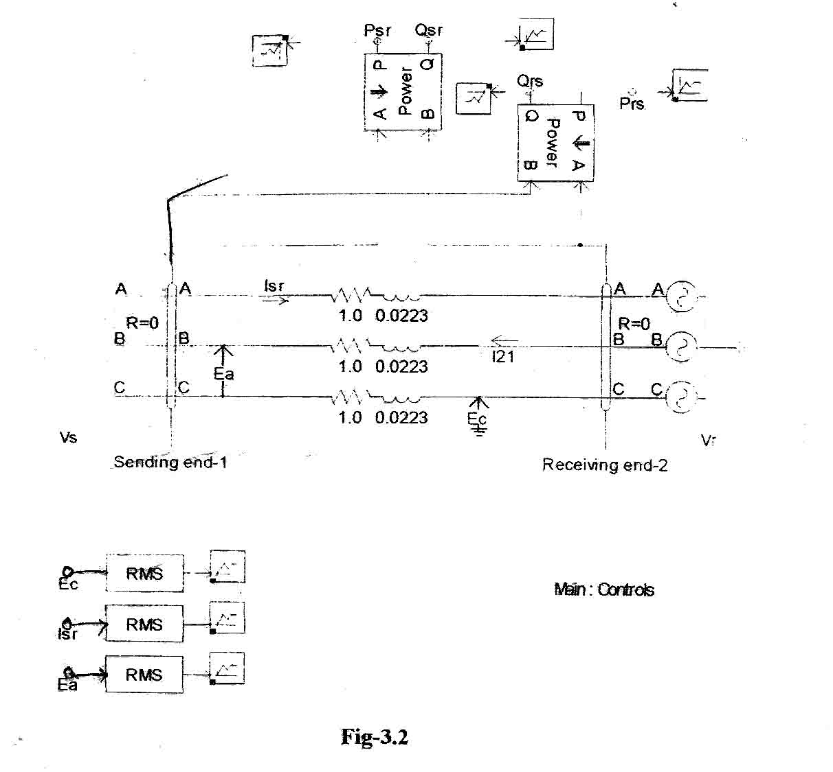
CASE – 1
Following data are assumed for the purpose of simulation of simple two bus network to analyze the power flow from one bus to another.
Vs = magnitude of sending end voltage
= 208 volts (line to line)
, = phase angle of sending end = 30⁰
Vr = magnitude of receiving end voltage
= 173 volts (line to line)
, = phase angle of receiving end = 0⁰
R = resistance of line = 1 ohm per phase
L = inductance of line = 0.0223 Henry per phase
Psr = Active power flow from sending end to receiving end
Prs = Active power flow from receiving end to sending end
Qsr = Reactive power flow from sending end to receiving end
Qrs = Reactive power flow from receiving end to sending end.

SIMULATION RESULT FOR CASE-1 :

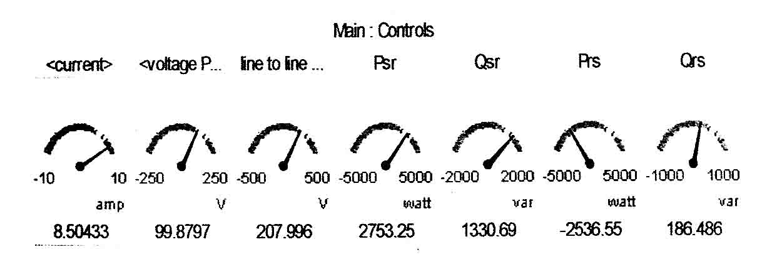
CASE – 2
(Variation of load angle i.e. load angle is increased with respect to CASE-1)
Vs = magnitude of sending end voltage
= 208 volts (line to line)
, = phase angle of sending end = 40⁰
Vr = magnitude of receiving end voltage
= 173 volts (line to line)
, = phase angle of receiving end = 0⁰
R = resistance of line = 1 ohm per phase
L = inductance of line = 0.0223 Henry per phase
Psr = Active power flow from sending end to receiving end
Prs = Active power flow from receiving end to sending end
Qsr = Reactive power flow from sending end to receiving end
Qrs = Reactive power flow from receiving end to sending end.

SIMULATION RESULT FOR CASE-2

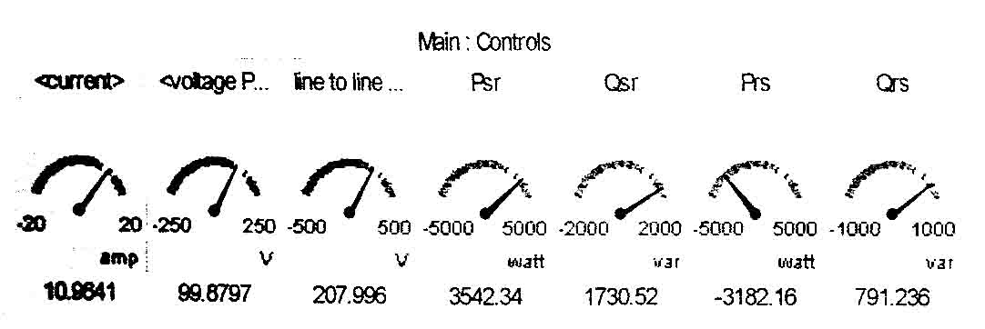

From the result it is clear that with the increase of sending end phase angle from 30⁰ to 40⁰, there is increase of active power flow from sending end to receiving end (Psr) i.e. 2753.25 watt to 3542.34 watt.

CASE – 3
(Variation of load angle i.e. load angle is decrease with respect to CASE-1)
Vs = magnitude of sending end voltage
= 208 volts (line to line)
, = phase angle of sending end = 20⁰
Vr = magnitude of receiving end voltage
= 173 volts (line to line)
, = phase angle of receiving end = 0⁰
R = resistance of line = 1 ohm per phase
L = inductance of line = 0.0223 Henry per phase
Psr = Active power flow from sending end to receiving end
Prs = Active power flow from receiving end to sending end
Qsr = Reactive power flow from sending end to receiving end
Qrs = Reactive power flow from receiving end to sending end.

SIMULATION RESULT FOR CASE – 3

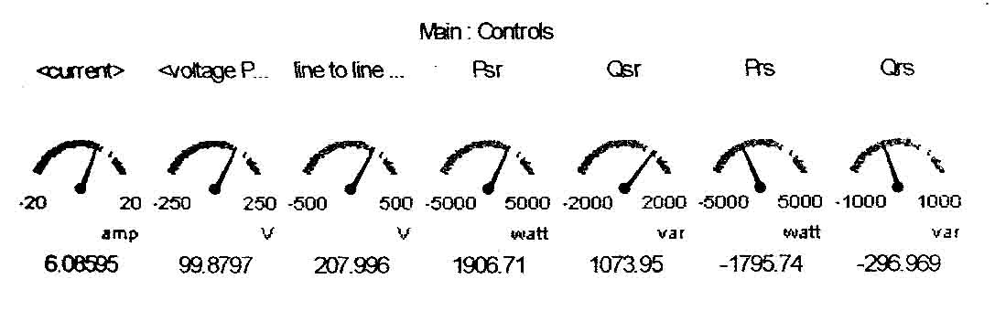

From the result it is clear that with the decrease of sending end phase angle from 30⁰ to 20⁰, there is decrease of active power flow from sending end to receiving end (Psr) i.e. 2753.25 watt to 1906.71 watt.

CASE – 4
(Variation of line impedance; i.e. increasing the inductance with respect to Case-1)
Vs = magnitude of sending end voltage
= 208 volts (line to line)
, = phase angle of sending end = 30⁰
Vr = magnitude of receiving end voltage
= 173 volts (line to line)
, = phase angle of receiving end 0⁰
R = resistance of line = 1 ohm per phase
L = inductance of line = 0.0723 Henry per phase
Psr = Active power flow from sending end to receiving end
Prs = Active power flow from receiving end to sending end
Qsr = Reactive power flow from sending end to receiving end
Qrs = Reactive power flow from receiving end to sending end

SIMULATION RESULT FOR CASE – 4 :
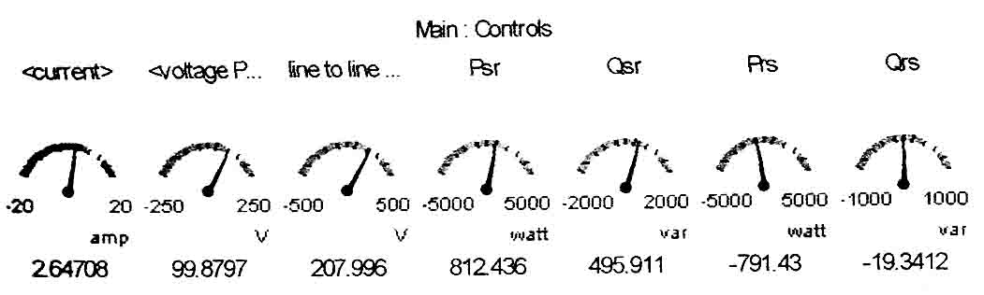

From the result it is clear that with the increase of line inductance from 0.0223 H to 0.0723 H, there is decrease of active power flow from sending end to receiving end (Psr) i.e. 2753.25 watt to 812.436 watt.
CASE – 5
(Variation of in impedance; i.e. decreasing the inductance with respect to Case – 1)
Vs = magnitude of sending end voltage
= 208 volts (line to line)
, = phase angle of sending end = 30⁰
Vr = magnitude of receiving end voltage
= 173 volts (line to line)
, = phase angle of receiving end = 0⁰
R = resistance of line = 1 ohm per phase
L = inductance of line = 0.0198 Henry per phase
Psr = Active power flow from sending end to receiving end
Prs = Active power flow from receiving end to sending end
Qsr = Reactive power flow from sending end to receiving end
Qrs = Reactive power flow from receiving end to sending end.

SIMULATION RESULT FOR CASE – 5
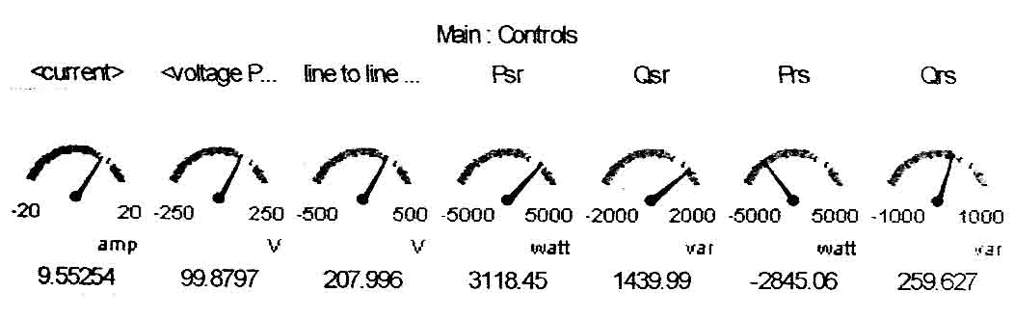

From the result it clear that with the decrease of line inductance from 0.0223 H to 0.0198 H, there is increase of active power flow from sending end to receiving end (Psr) i.e. 2753.25 watt to 3118.45 watt.
CASE – 6
(Variation of terminal voltage as compared to Case – 1)
Vs = magnitude of sending end voltage
= 173 volts (line to line)
, = phase angle of sending end = 300
Vr = magnitude of receiving end voltage
= 208 volts (line to line)
, = phase angle of receiving end = 00
R = resistance of line = 1 ohm per phase
L = inductance of line = 0.0223 Henry per phase
Psr = Active power flow from sending end to receiving end
Prs = Active power flow from receiving end to sending end
Qsr = Reactive power flow from sending end to receiving end
Qrs = Reactive power flow from receiving end to sending end.

SIMULATION RESULT FOR CASE – 6
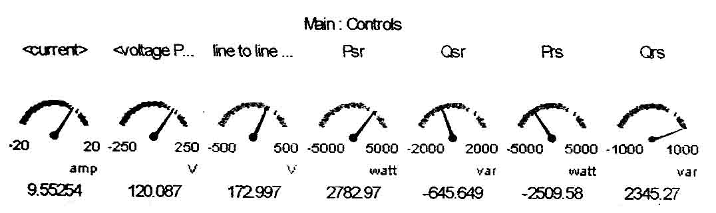

From the result it is clear that reactive power flow from receiving end is increased to 2345.27 var as receiving end voltage is more than that of sending end as compared to CASE-1. In CASE-1, sending end voltage is more than receiving end voltage. Thus reactive power flows from sending end.

3.4 CONCLUSION :
From the above simulation result using PSCAD, it is clear that power flow in the transmission line varies with various parameters such as load angle. Line impedance and terminal voltage. So power flow control involves the control of various parameters such as load angle, transmission line impedance and terminal voltage.

4
POWER FLOW ANALYSIS
4.1 PRINCIPLE OF POWER TRANSMISSION
To understand the principle of power transmission it is essential to represent the transmission line. Transmission line can be represented by a series reactance with the sending end and receiving end voltages [2]. This is shown in figure below for one phase of three phase system and all quantities such as voltage and currents are defined per phase. I
jX/2

jX/2

+ + +

Vs Vr

_ _ _

- Two-Machine Power System

Vs

δ/2 Vm
Vx = iXl
δ/2 I

Phasor diagram

Vr
FIGURE 4.1
From Fig 4.1 (a)
Let Vs = per phase sending end voltage magnitude
Vr = per phase receiving end voltage magnitude
Vm = per phase mid point voltage magnitude
jX/2 = Thevenin equivalent impedance located on the right of left side of the mid point.
= Phasor angle between sending and receiving end voltage
let us assume that the magnitude of the terminal voltages remain constant and equal to V.
That is
Vs = Vr = V
The two terminal voltages can be expressed in phase notations in rectangular coordinates as follows
Vs = V e^{j/2} = V (cos /2 + j sin /2) (4.1)
Vr = V e^{-j/2} = V (cos /2 j sin /2) (4.2)
So Vm is equal to average value of Vs and Vr as given by
(4.3)
The line current phasor is given by
(4.4)
Where the magnitude of |I| is I = 2V/X sin /2.

For lossless line, the power is same at both ends and at the midpoint. Thus active power at sending end (Ps) is equal to the active power at the mid point (Pm) and also equal to the active power at receiving end (Pr).
Ps = Pr = Pm = |Vm||I|

Applying the value of magnitude of Vm from equ. L(4.3) and the value of line current I from equ. (4.4)
(4.5)
The reactive power at the receiving-end Qr is equal and opposite of the reactive power Qs supplied by the sources. Thus the reactive power Q for the line is given by
Applying the value of current I in above expression we get,
(4.6)
From the above analysis it is clear that active power flow becomes maximum
P_{max} = (V2/X) at = 90⁰
And the reactive power becomes the maximum
Q_{max} = (2V2/X) at 180⁰.

By writing a small MATLAB program we will analyze how the load angle control both the active power demand and reactive power demand on sending end and receiving end. Also we will see how reactive power demand changes with the any changes in active power flow.
MATLAB PROGRAM 2.1
Analysis of Active and Reactive Power Flow in a Loss less Transmission Line (Attached in appendix – ‘A’)
After execution of this program, we come to know that load angle is an parameter to control the both active and reactive power according to load demand.
DATA USED :
line voltage = 220 V
line reactance = 1.2 ohm

RESULT IS :::::
delta P Q
1.0e+004 *
0 0 0
0.0010 0.7004 0.0613
0.0020 1.3795 0.2432
0.0030 2.0167 0.5404
0.0040 2.5926 0.9436
0.0050 3.0897 1.4408
0.0060 3.4930 2.0167
0.0070 3.7901 2.6539
0.0080 3.9721 3.3330
0.0090 4.0333 4.0333 (P=Q=Pmax)
0.0100 3.9721 4.7337
0.0110 3.7901 5.4128
0.0120 3.4930 6.0500
0.0130 3.0897 6.6259
0.0140 2.5926 7.1230
0.0150 2.0167 7.5263
0.0160 1.3795 7.8234
0.0170 0.7004 8.0054
0.0180 0.0000 8.0667 (P=0, Q=2Pmax)
0
20
40
60
80
100
120
140
160
180
0
1
2
3
4
5
6
7
8
9
x 10
4
ACTIVE AND REACTIVE POWER vs LOAD ANGLE
load angle
P,Q

δ

Fig -4.2
4.2 CONTROLLABLE PARAMETER :
From the above discussion it is clear that the power and current in the transmission line can be controlled by the following means [2] [3] :
- Applying a voltage in the midpoint can increase an decrease the magnitude of power.
- Applying a voltage in series with the line, and in phase quadrature with the current flow, can increase or decrease the magnitude of current flow. As the current flow lags the voltage by 90º, there is injection of reactive power in series.
- If a voltage with variable magnitude and a phase is applied in series, then varying the amplitude and phase angle can control both active and reactive power. This requires injection of both active power and reactive power in series.
- Increasing and decreasing the value of the reactance X can also decrease and in crease the power height of both active and reactive power.
- Power flow can also be controlled by regulating the magnitude of sending and receiving end voltages Vs and Vr. This type of control has much influence on reactive power flow than active power flow.

4.3 CONCLUSION :
From the above MATLAB analysis, we come to know that how the active and reactive power varies with the load angle. Analysis clearly shows that the plotted graph which is obtained from the execution of MATLAB code resembles with curve drawn in different books by different author. In this curve we come to know, as we vary the line reactance, the height of active power curve varies.
5
SERIES COMPENSATION
5.1 PRINCIPLE OF SERIES COMPENSATION :
A voltage in series with the transmission line can be introduced to control the current flow and thereby the power transmissions from the sending end to the receiving end [2]. An ideal series compensator is represented by the voltage source Vc which is connected in the middle of a transmission lien as shown in Fig. 5.1 (a)

Ideal Series Compensator
Vc
I + -
jX/2

jX/2

+ + +

Vm1 Vm2
Vs Vr
_ _ _

- Two-Machine Power System

-jX/2 I -jX/2
jX/2

jX/2

+ + +

Vm
Vs Vr
_ _ _

- Two-Machine Power System

-jXc/2l

δ/2 Vm Vx

I
δ/2

-jXc/2l

- Phasor diagram

FIGURE 5.1

From Fig – 5.1 (a)
Let Vs = per phase sending end voltage magnitude
Vr = per phase receiving end voltage magnitude
Vc = per phase mid point voltage magnitude is applied in series
X = Transmission line impedance
= Phase angle between sending and receiving end voltage
Assuming Vs = Vr = Vc = V
The current flowing through transmission line is given by
(5.1)
If the series applied voltage Vc is in quadrature with respect to the line current, the series compensator cannot supply or absorb active power. This is because phase angle between voltage and line current is 90⁰ (i.e. cos 90⁰=0). Thus the power at the source Vc terminal can be only reactive. This means that capacitive or inductive equivalent impedance may replace the voltage source Vc.
So equivalent transmission lien impedance of compensated line can be represented by
X_{eq} = X – X _{comp} = X (1-r) (5.2)
where
and r is the degree of series compensation and its range is and X_{comp} is the series equivalent compensation reactance which is positive if it is capacitive and negative if it is inductive.
The magnitude of the current through the line is given by using equ. (4.4)
(5.3)
The reactive power Qc at the source Vc terminal is given by using equ. (4.6)
(5.5)
For capacitive compensation the line current leads the voltage Vc by 90⁰ whereas for inductive compensation the line current lags the Vc by 90⁰.
Series capacitive impedance decreases the overall transmission lien impedance and thereby increases the transmittable power. Whereas series inductive impedance increases the overall transmission line impedance, thus decreases the transmittable power.
Principle of series compensation is analyzed by using a series capacitor in transmission line and this is analyzed with the help of PSCAD-4.0 software as given below

5.2 SIMULATION BOOCK FOR CAPACITIVE COMPENSATION:
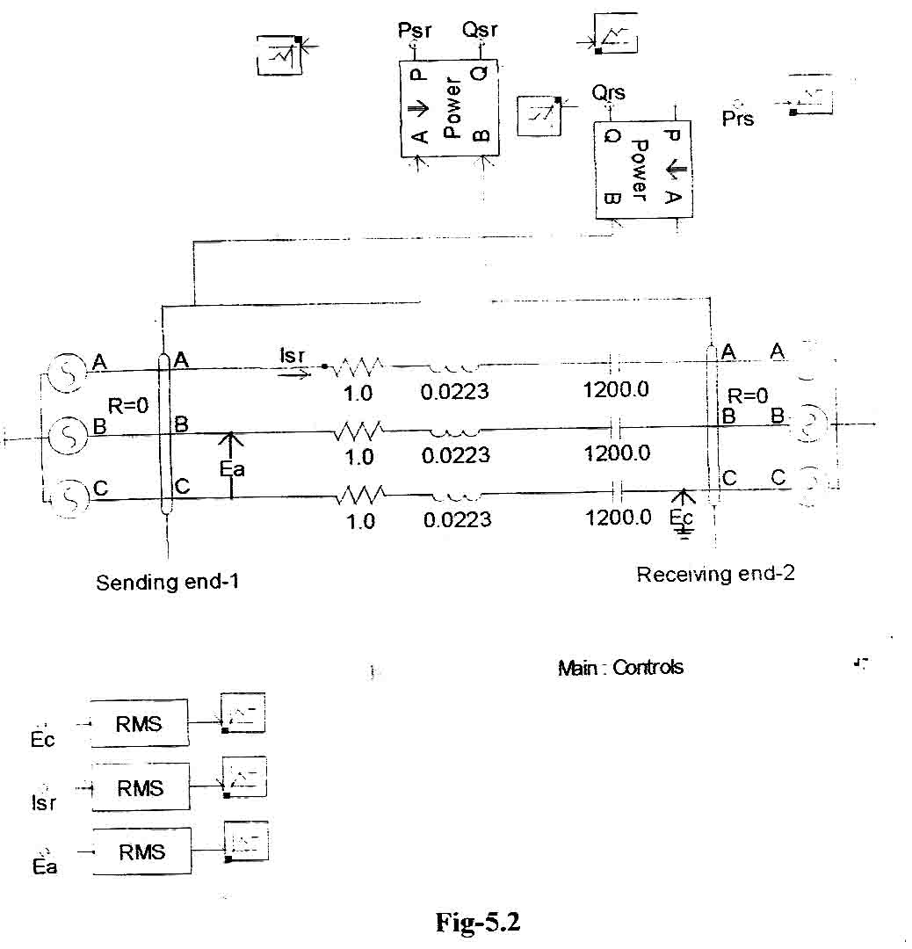

DATA FOR THE SIMULATION BLOCK (FIG-5.2)
Vs = magnitude of sending end voltage
= 208 volts (line to line)
s = phase angle of sending end = 30º
Vr = magnitude of receiving end voltage
= 173 volts (line to line)
r = phase angle of receiving end = 0º
R = resistance of line = 1 ohm per phase
L = inductance of line = 0.0223 Henry per phase
C = compensation capacitor = 1200 micro farad
Psr = Active power flow from sending end to receiving end
Prs = Active power flow from receiving end to sending end
Qsr = Reactive power flow from sending end to receiving end
Qrs = Reactive power flow from receiving end to sending end.
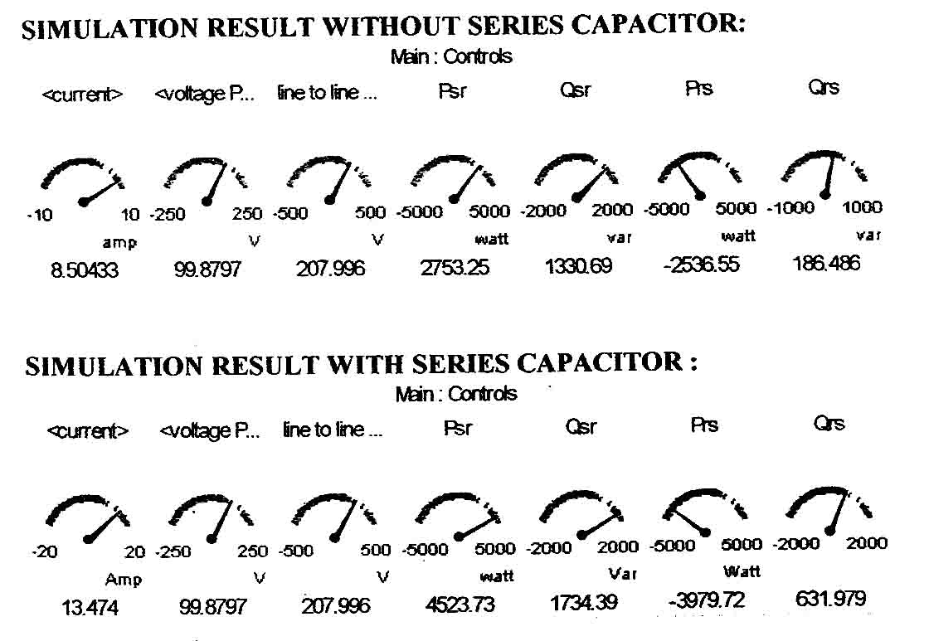

From the result it is clear that active power flow from sending end is increased from 2753.25 watt to 4523. 73 watt with the use of 1200 micro farad series capacitor.

5.3 TYPES OF SERIES COMPENSATOR [2] :
- Thyristor-switched series capacitor
- Thyristor-controlled series capacitor
- Forced-commutation-controlled series capacitor
- Series static VAR compensator
- Advanced SSVC

Out of these series compensator, Thyristor-controlled series capacitor (TCSC) is discussed in the next chapter and a MATLAB program is used for it to analyze, how it control the power flow.

5.4 CONCLUSION :
From the PSCAD simulation result, we concluded that use of capacitor in the transmission line will provide series compensation of the transmission line. By varying the capacitor value, we can change the power transfer capability of the transmission line.
6
THYRISTOR-CONTROLLED SERIES CAPACITOR (TCSC)
6.1 INTRODUCTION :
The TCSC varies the electrical length of the compensated transmission line with little delay [7]. Owing to this characteristic, it may be used to provide fast active power flow regulation. It also increases the stability margin of the system and has proved very effective in damping Sub-Synchronous Resonance (SSR) and power oscillation. The TCSC is the parallel combination of Thyristor Controlled reactor (TCR) and a fixed capacitor. So before discussing in details about TCSC, let us discuss about TCR.
6.2 Thyristor-controlled Reactor (TCR) [2]
It consists of a fixed reactor of inductance L and a bidirectional thyristor switch SW as shown Fig 6.1.
6.2 THYRISTOR-CONTROLLED REACTOR (TCR) [2]
It consists of a fixes reactor of inductance L and a bidirectional thyristor switch SW as shown Fig 6.1
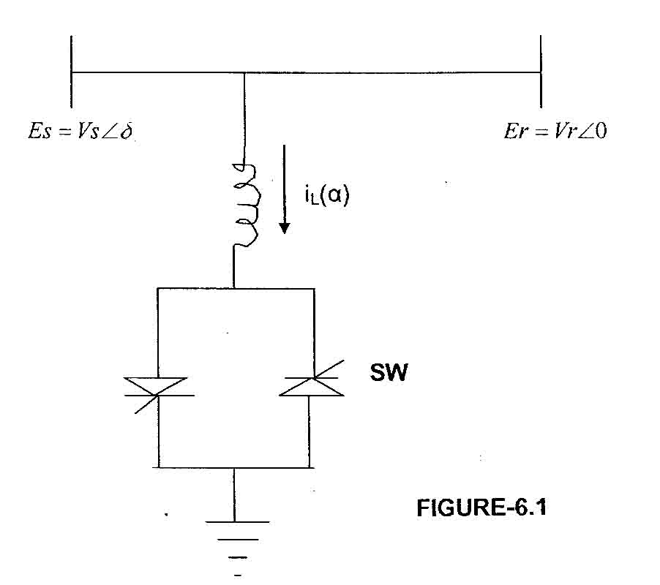

The current through the reactor can be controlled from zero (when the switch is open) to maximum (when the switch is closed) by varying the firing angle of the thyristor. Thus the conduction angle of the thyristor is . If the switch is permanently closed when =0, then it has no effect of the inductor current.
Let the supply voltage v(t) = Vm cos wt = .
where Vm = peak voltage of supply voltage
Thus instantaneous inductor current can be expressed as a function of as follows :
(6.1)
which is valid for
From the equation (6.1) it is clear that i_{L}(t) is maximum when =0 and it is zero when =
The fundamental root-mean-square (rms) current of the reactor can be found as
(6.2)
which is (firing angle) dependent
Thus admittance for the shunt compensator for fundamental current is given by
(6.3)
The impedance of compensator
(6.4)
which is dependent on .

6.3 PHYSICAL MODEL OF TCSC :
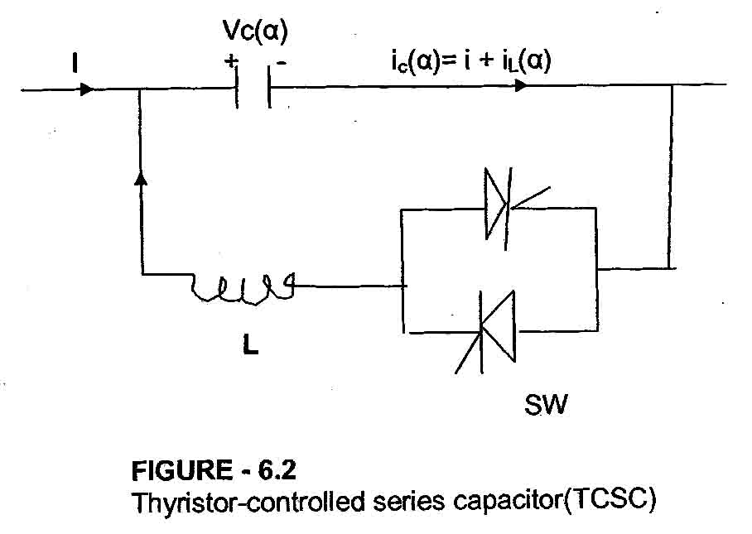

The TCSC consists of the series-compensating capacitor shunted by a thyristor controlled reactor (TCR) as shown in fig. 6.2. [2] [3]. The impedance of the reactor X_{L} is sufficiently smaller than that of the capacitor impedance Xc is taken. By varying the delay angle or firing angle of TCR, the inductive impedance of TCR can be varied. Thus TCSC can provide variable capacitance by means of canceling the effective capacitance by the TCR. Therefore, the steady state impedance of TCSC is simply that of the parallel LC circuit, consisting of fixed capacitive impedance Xc and variable inductive impedance X_{L}.
The effective impedance of the TCSC is given by
(6.5)
where X_{L} () is the variable impedance of TCR which can be taken from equ. (6.4)
that is
(6.6)
where and is the delay angle measured from the crest of the capacitor voltage or the zero crossing of the line current.
The TCSC behaves as a tunable parallel LC-circuit to the line current. As the impedance of the controlled reactor X_{L}() is varied from its maximum (infinity) toward its minimum () i.e. when varies from 900 to 00, then TCSC increases its minimum capacitive impedance XT(min)=Xc=, until parallel resonance occurs at Xc=X_{L}() and X_{T}() approaches to it maximum value _{XT(max)}=infinite. If we decrease X_{L}() further, the X_{T}() becomes inductive and approaches to its minimum value of X_{T}(min)=XcX_{L}(X_{L}-Xc) at =0º. i.e. the effect of capacitor is bypassed by TCR.
Angle has two limiting values (1) one for inductive _{L(lim)} and (2) one for capacitive _{C(lim)}.
The TCSC has two operating ranges around its internal circuit resonance :
(1) one is the range, where X_{T}() is capacitive
(2) the other is the range, where X_{T}() is inductive.

6.4 MODES OF OPERATION [7] [13] :
The TCSC has three fundamental modes of operation as follows :
(a) Thyristor-blocked mode : In this mode of Operation, the current through the TCR is zero and the TCSC function as a capacitive reactance Xc.
(b) Thyristor-bypassed mode : In this mode, the thyristor valves are fired with no delay and the TCSC has small inductive impedance.
(c) Thyristor – phase controlled mode : In this mode the value of the firing angle determines the direction of the current through the TCR and the capacitor, enabling the TCSC to work as either a capacitive or an inductive reactance. In this mode, the thyristor firing mechanism is controlled to vary the amount of effective reactance connected to the system.

6.5 ANALYSIS OF THE TCSC EQUIVALENT CIRCUIT :
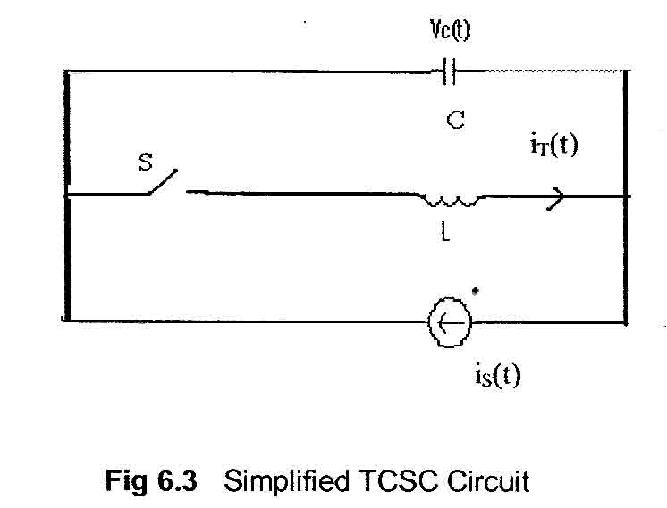
The analysis of TCSC operation in the vernier-control mode is performed based on the simplified TCSC circuit as shown in Fig. 6.3. [8] [13] [25].

From the Fig – 6.3
is (t) = Transmission line current which is modeled as an external current source and assumed to be sinusoidal current.
IT(t) = Thyristor-valve current
u = switching variable
when u = 1, thyristor is conducting i.e. switch S is closed
when u = 0, thyristor is blocked i.e. switch S is open
C = Fixed capacitor used in parallel with TCR circuit
L = Inductance used in series with Thyristor bidirectional switch
Vc(t) = voltage across the capacitor C
The current through the fixed capacitor C is expressed as
(6.7)
The current through thyristor is given by
(6.8)
Let the line current is(t) be represented by
is(t)=Im cost wt (6.9)
In equidistant firing-pulse control, for balanced TCSC operation, the thyristors are switched on twice in each cycle of the line current at instants t₁ and t₃ and these are given by
Where is the angle of advance (before the forward voltage becomes zero) or,
where is the firing angle of the thyristor. This angle is generated using a reference signal that can be in phase with the capacitor voltage. The thyristor switch S turns off at the instants t₂ and t₄, defined as
where is the conduction angle, which is assumed to be the same in both the positive and the negative cycle of conduction. Also
Solving the TCSC equations (6.7) – (6.9) result in the steady state thyristor current i_{T}.
(6.10)
where w_{r} is called resonance frequency and is given by
where X_{c} and X_{L} are capacitive reactance and inductive reactance respectively.
The steady state capacitor voltage at the instant wt = is expressed as
(6.11)
At wt = , i_{T} = 0, the capacitor voltage is given by
V_{c} (wt = ) v_{c2} = -vc1
Finally the capacitor voltage is given by
(6.13)
(6.14)
Because the non-sinusoidal capacitor voltage, Vc, has odd symmetry about the axis wt = 0, the fundamental component, V_{CF}, is obtained as
(6.15)
The equivalent TCSC reactance is computed as the ratio of V_{CF} to I_{m} :
(6.16)
If we apply , in equation (6.16) the reactance of TCSC becomes as :
(6.17
where
From the equation (6.17) it is clear that the reactance of TCSC is dependent on the firing angle of thyristor and this reactance varies from inductive region to capacitive region to capacitive region between firing angle 90⁰ to 180⁰ and at around 140⁰ there is a condition of resonance.
A MATLAB PROGRAM is written for analyzing the active and reactive power flow control by TCSC. Output of the result shows that the compensating coefficient ‘r’ is having both inductive and capacitive compensation value which varies according to the firing angle. From the analysis it is clear that height of load angle curve increases with the more capacitive reactance of TCSC. But the height of the load angle curve decrease with more inductive reactance of TCSC.
Similarly the reactive power curve for capacitive compensation is positive and reactive power curve for inductive compensation is negative.
Also both active and reactive power decreases with the increase of firing angle up to certain value where the reactance of TCSC is inductive. At 90⁰ of firing angle the reactance of TCSC becomes capacitive and both active and reactive power increases.

MATLAB PROGRAM – 4.1
%ANALYSIS OF ACTIVE AND REACTIVE POWER FLOW
%WITH VARIATION OF FIRING ANLGE
(Attached in Appendix – ‘A’)

SET OF DATA

Line voltage= 220
line reactance= 200
inductive reactance of TCR= 0.15
fixed capacitive impedance= 130
phase angle= 30

RESULT IS
alpha Pc Qc r
0 120.9092 -0.0486 -0.0008 (Inductive Compensation)
10.0000 120.8836 -0.0623 -0.0010 (Inductive Compensation)
20.0000 120.8416 -0.0848 -0.0013 (Inductive Compensation)
30.0000 120.7677 -0.1243 -0.0019 (Inductive Compensation)
40.0000 120.6245 -0.2006 -0.0031 (Inductive Compensation)
50.0000 120.3050 -0.3703 -0.0058 (Inductive Compensation)
60.0000 119.4153 -0.8381 -0.0133 (Inductive Compensation)
70.0000 115.7277 -2.7023 -0.0456 (Inductive Compensation)
80.0000 71.6491 -15.6604 -0.6888 (Inductive Compensation)
90.0000 345.7143 344.0686 0.6500 (Capacitive Compensation)

Out Put Graph Of
Active & Reactive Power Vs Firing Angle
Active Power Vs Load Angle
Reactive Power Vs Load Angle

Fig -6.4

6.6 SIMULATION OF TCSC CIRCUIT USING PSCAD-4.0
The basic model of the TCSC is implemented in PSCAD in order to identify its main characteristics [7] [23]. For the purpose of the simulation, a constant Ac voltage source Vs = 1kV is used to supply a series R-L load. The thyristors are fired at an angle of 130 degree. The waveforms of the simulated TCSC model are obtained for each element used in the circuit. Of course with the help of slider used for varying the firing angle, we can vary the firing angle from 90⁰ to 180⁰ and there will be change in waveform.

C = Fixed Capacitor – 212 micro farad
L = Inductance used in series with thyristor = 0.015 Henry
R_{L} = Load resistance = 1 ohm
L_{L} = Load inductance = 1 Henry
V_{cap} = Voltage across fixed capacitor
V_{ind} = Voltage across series inductor used with thyristor
V_{load} = Voltage across load
I_{cap} = Current through Capacitor
L_{ind} = Current through series inductor
I_{load} = Current through load
Alpha = Firing angle = 130⁰.

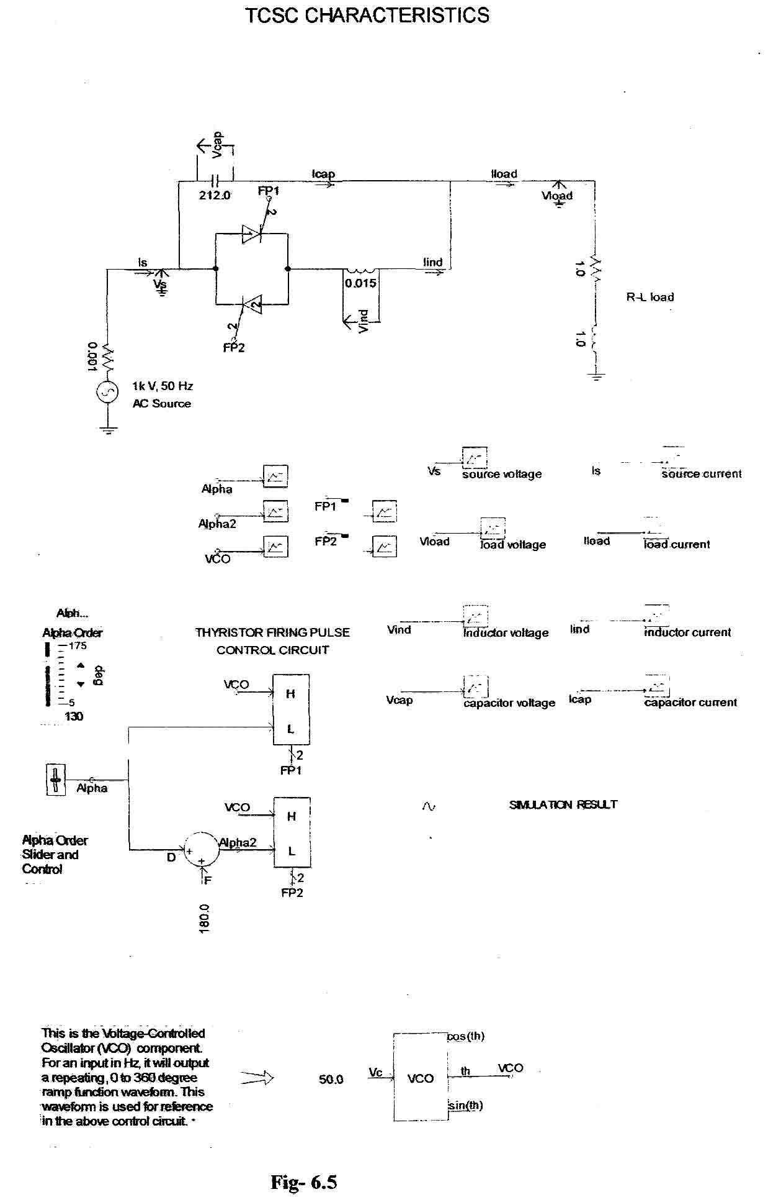
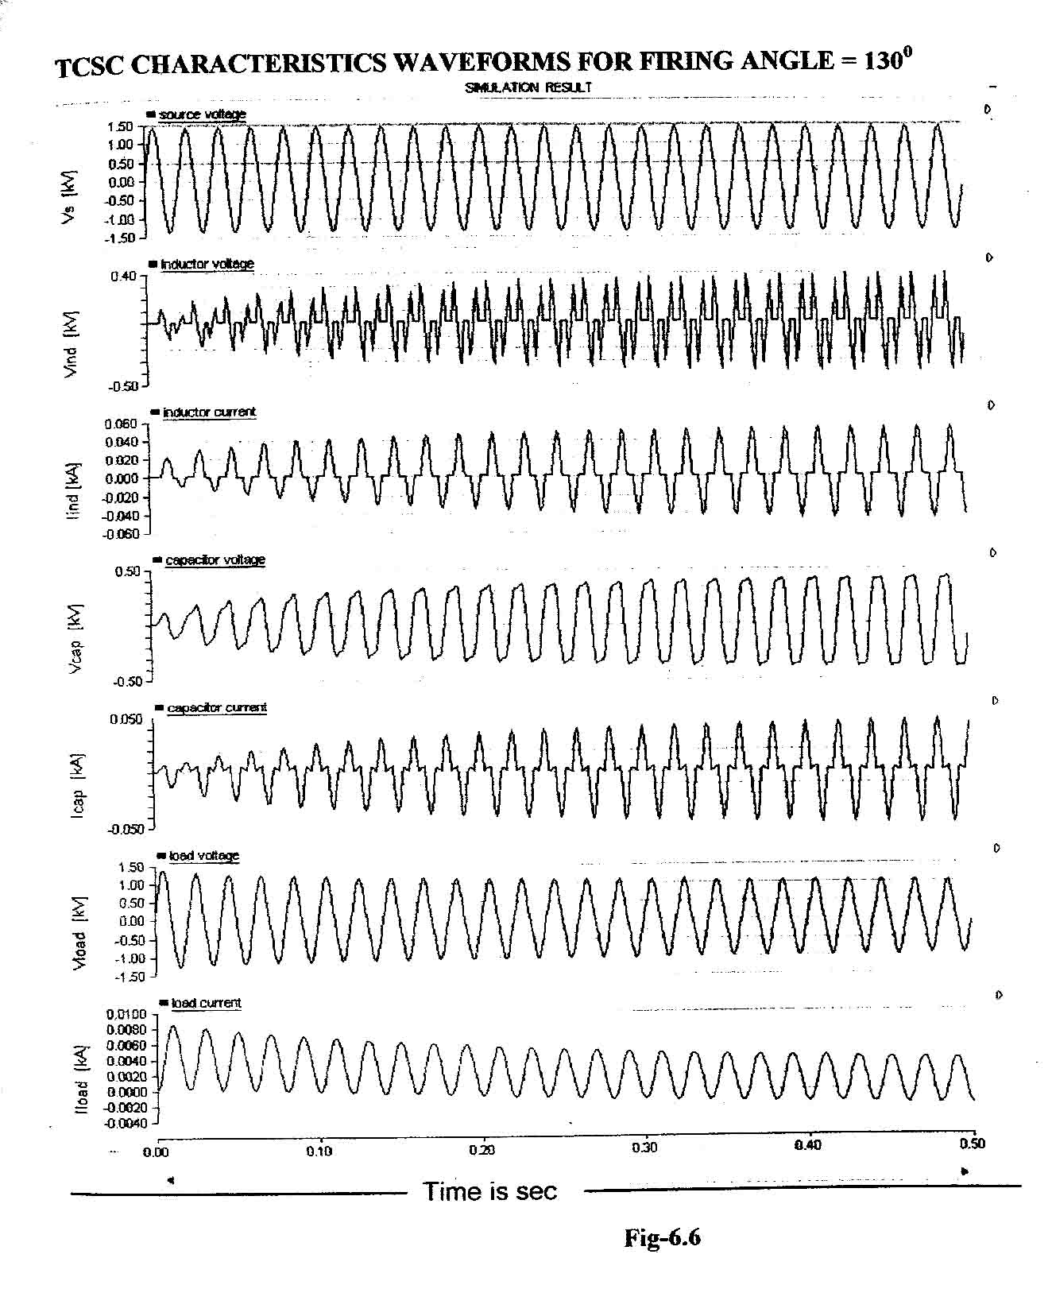
6.7 TCSC STEADY STATE CHARACTERISTICS (SIMULINK BLOCK) [7]
In this circuit TCSC is used in parallel with two transmission line having inductance of 0.07956 H and fixed capacitor is having value of 176.83 micro farad. Voltage source applied is 11 kV. For the circuit steady state rms load current I_{load} is found.
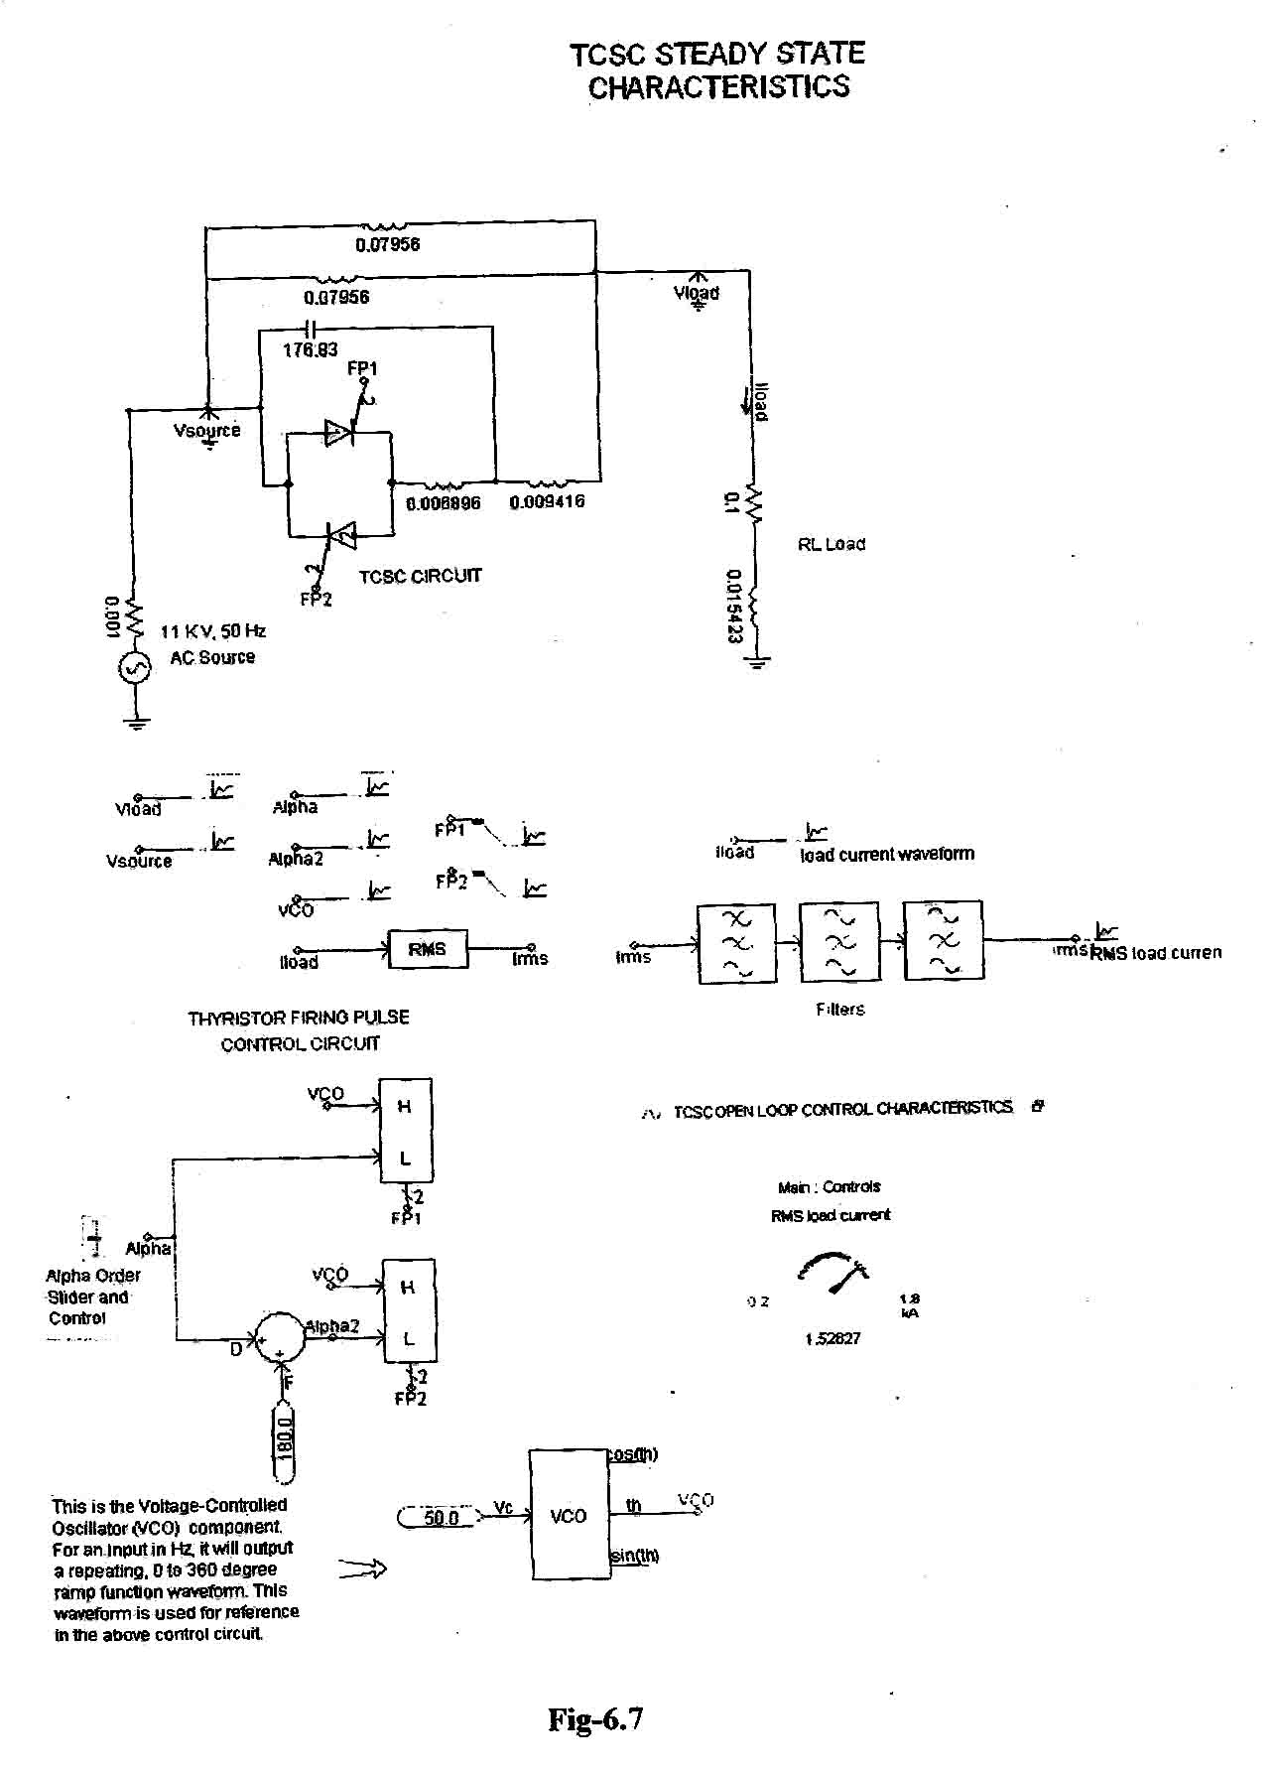

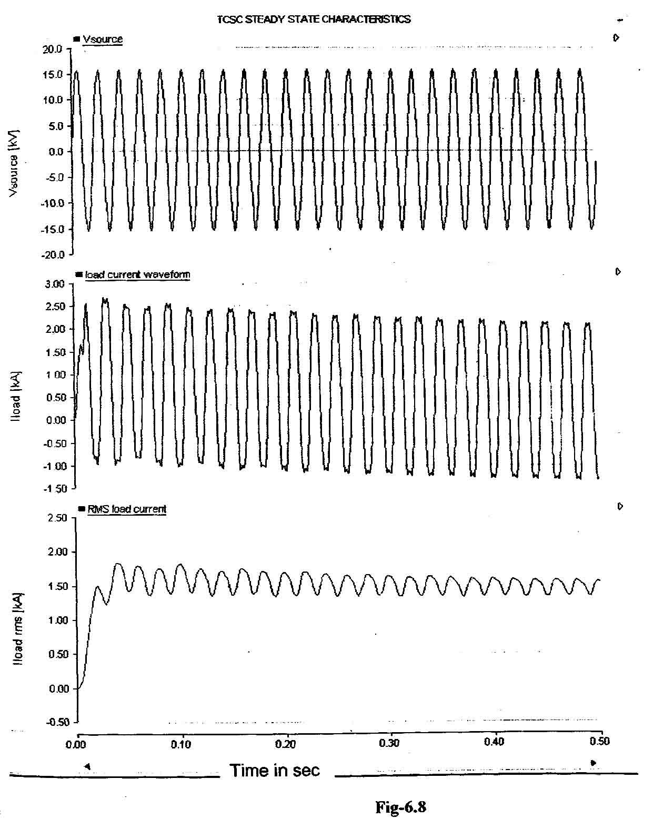

From the above graph which is obtained after simulation the I_{load} rms current = 1.528 kA. This load current also obtained from the RMS load current meter.

6.8 DYNAMIC CHARACTERISTICS OF TCSC (OPEN LOOP CONTROL)
In this case the test system comprises of a constant AC voltage source feeding a linear Series R-L load through three parallel branch transmission circuits. The equivalent impedance of each transmission path is adjusted to be equal, with one of them including a TCSC. The top branch contains a breaker, Brk, which is used to simulate the opening of this branch at a given point in time of the transient simulation and to analyze the dynamic performance of the TCSC under the new operating condition. When Brk opens the equivalent impedance of the transmission system increases and consequently the current supplied to the load drops. The TCSC is operated at firing angle of 130⁰ and Brk opens at t = 0.2 secs and the dynamic characteristics of the TCSC is observed from the output graph which is obtained after simulation of the test circuit as given in Fig. 6.9 in the next page.
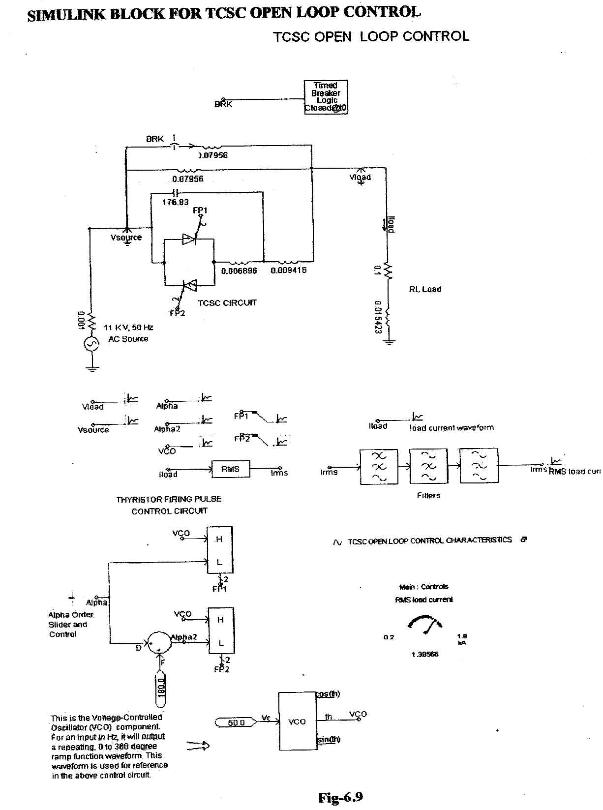

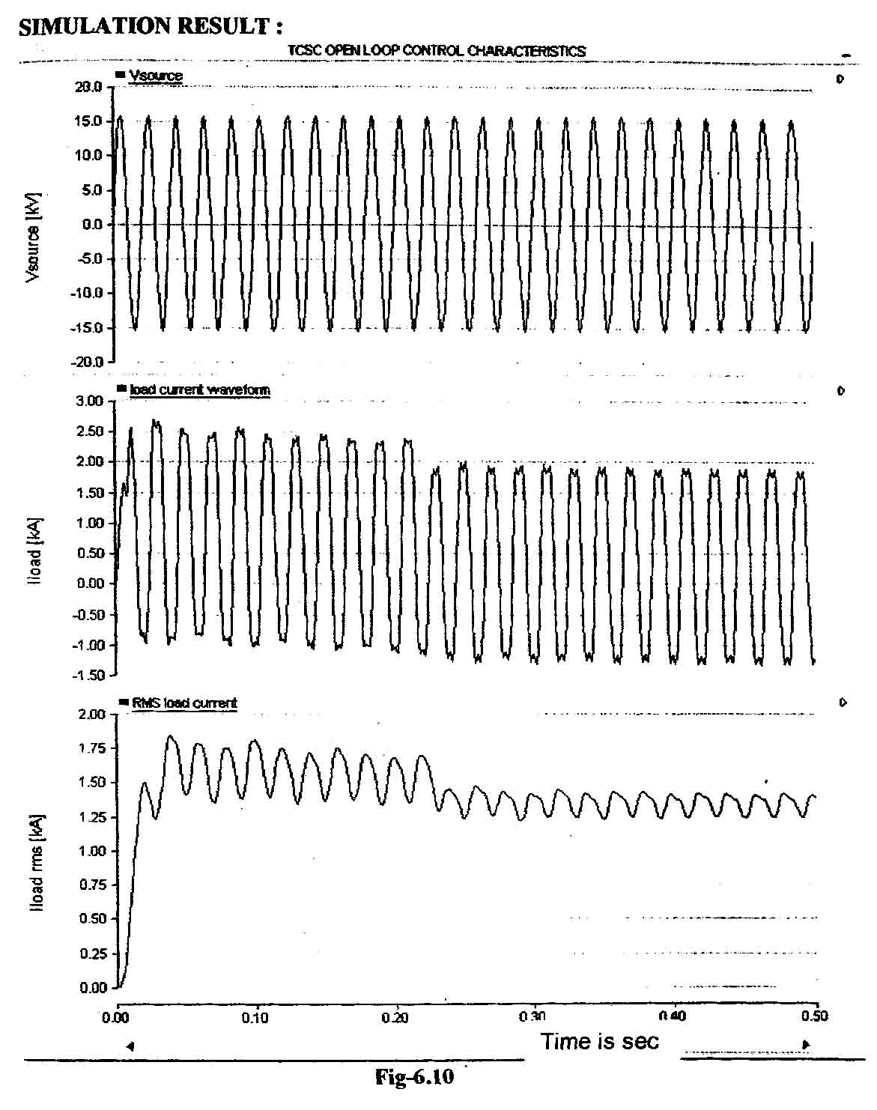
From the simulation result, it is clear that the rms load current is decreased from 1.528 kA (steady state value) to 1.385 kA (when breaker opens at t=0.2 sec). Graphical result also shows the same as I_{load} rms value decreases at t = 0.2 sec.

6.9 SIMULINK BLOCK FOR TCSC CLOSED LOOP CONTROL :
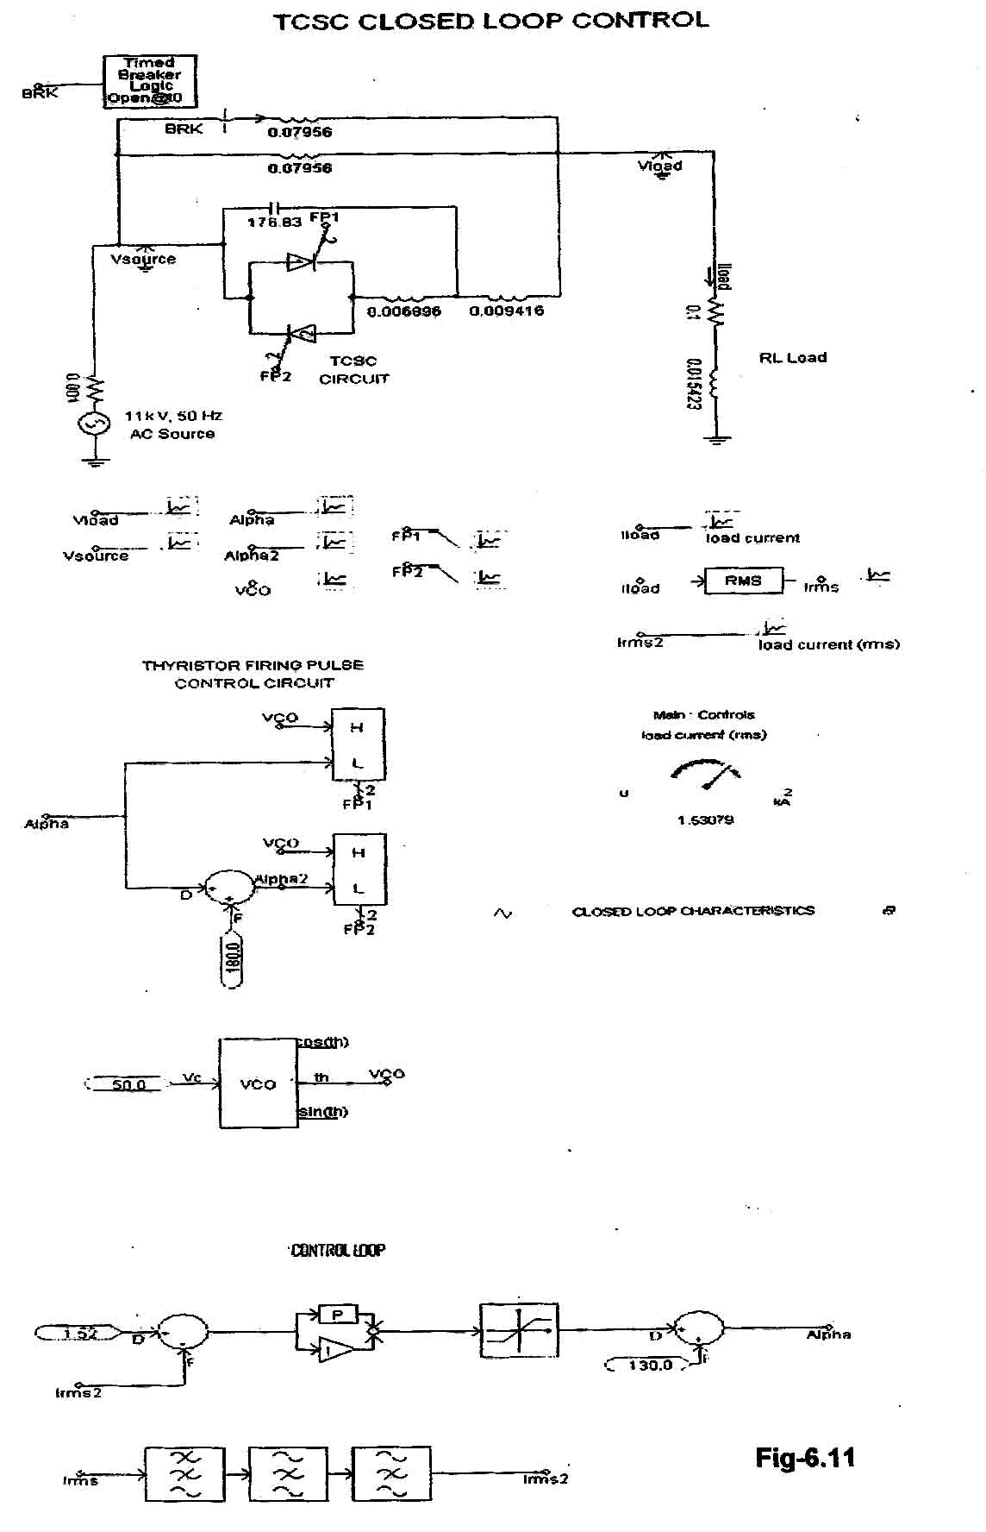

SIMULATION RESULT FOR TCSC CLOSED LOOP CONTROL
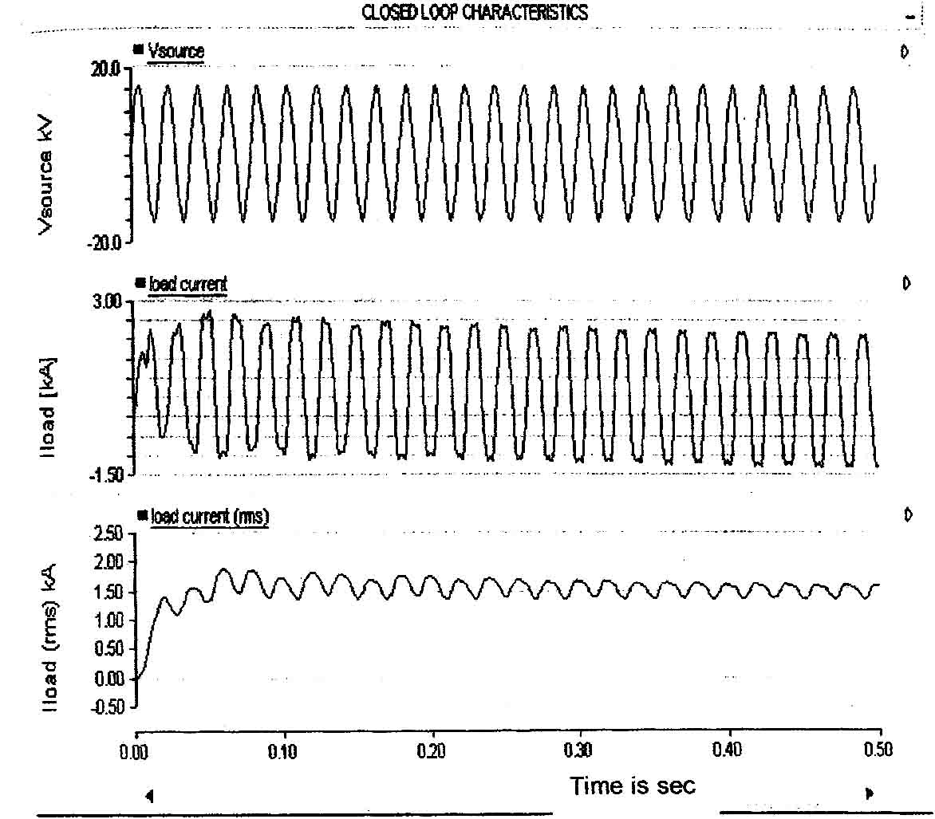

From the result it is clear that the load current I_{load} (rms) which is decreased to 1.385 kA in the open loop control arrangement is automatically regain to its steady state value (1.53 kA). Thus TCSC provides required series compensation to regain the decreased current to steady state value though one of the parallel inductor is in open condition.

From the analysis, we come to know that TCSC is good current controller. Thus it can be utilized as active power controller. This will be discussed in the next simulation block.

6.10 POWER FLOW CONTROL USING TCSC
(SIMULINK BLOCK)
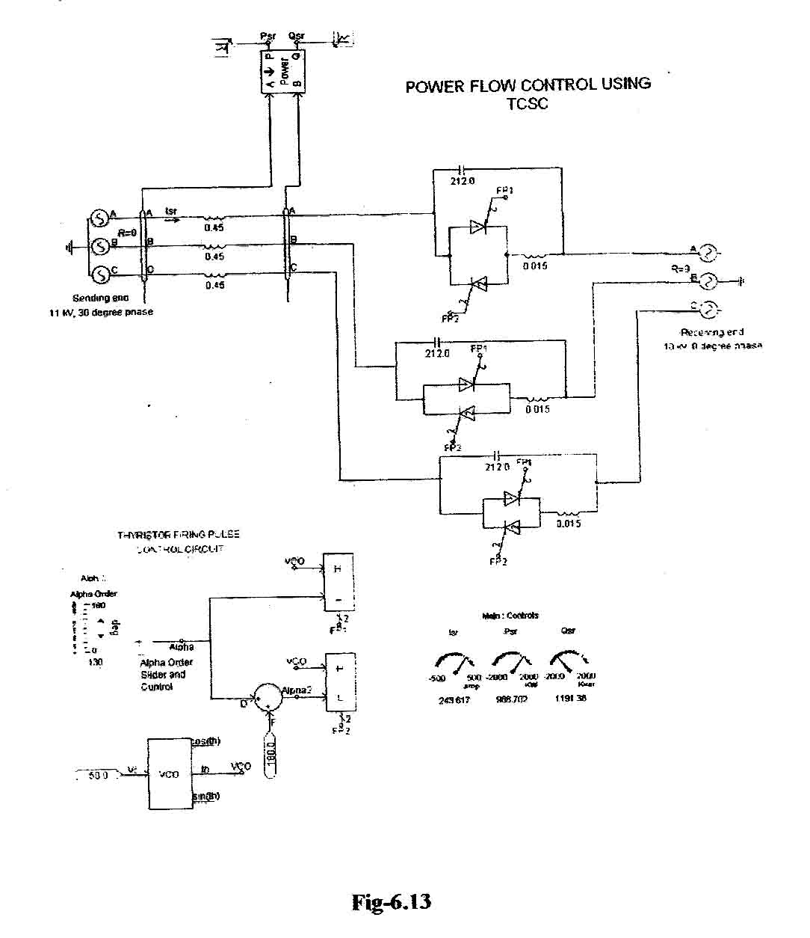
In the above block, a two bus system is considered for simulation and analyzing the power flow control. For the above block in Fig-6.13, set of data are given in the next page and simulation result is shown.

Firing angle for thyristor = alpha = 130⁰
Sending end voltage (line-line) = 11 kV
Receiving end voltage (line-line) = 10kV
Sending end phase angle = 30⁰
Receiving end phase angle = 0⁰
Isr = Sending end current
Psr = Active power flow from sending end
Qsr=Reactive power flow from receiving end
Transmission line inductance = 0.45 H (per phase)
Fixed capacitor of TCSC = 212 micro farad
Series inductance of TCSC = 0.015 H
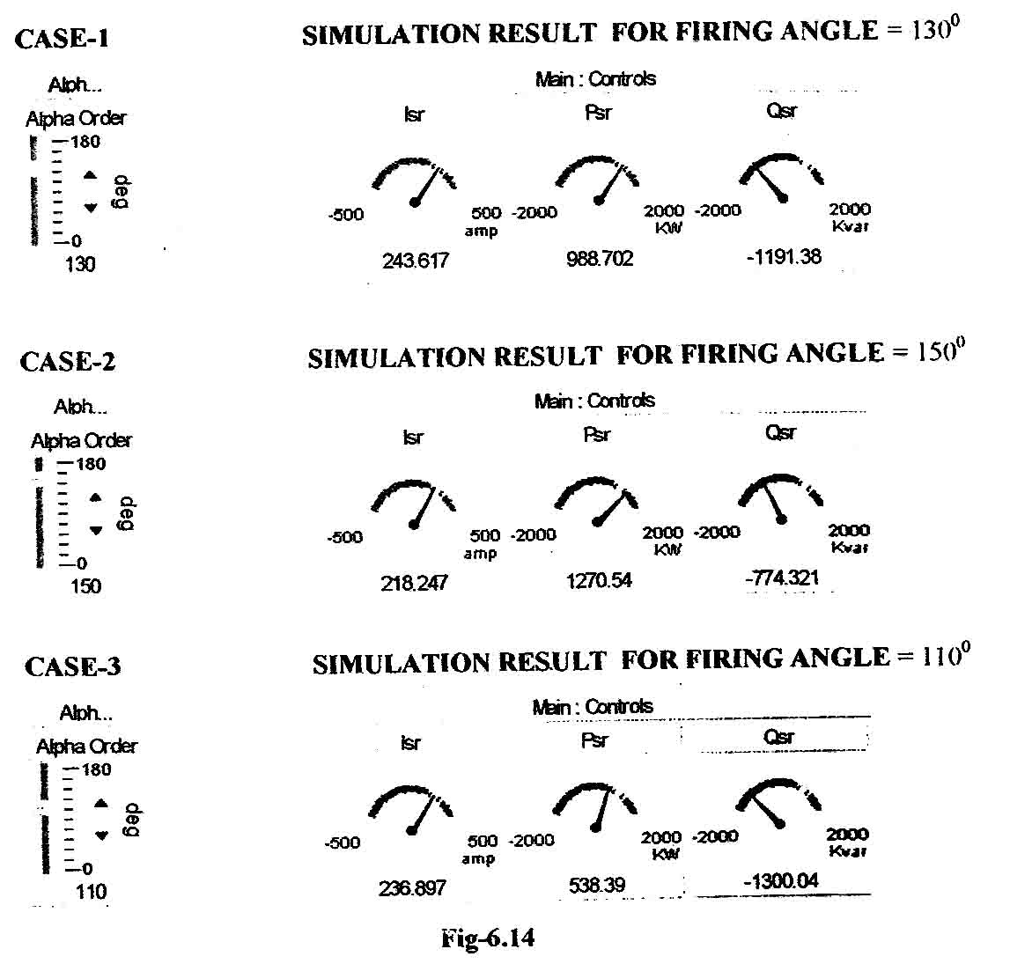

From the three cases of simulation result, it is clear that as we increase the firing angle from 130º to 150º, the TCSC causes capacitive compensation and the real power flow from sending end is increased from 988.72 KW to 1270.54 KW. Similarly when firing angle decreases from 130º to 110º, TCSC increases the inductive reactance of the transmission line. Thus real power flow from sending end to receiving end is decreased from 988.72 KW to 538.39 KW.

6.11 CONCLUSION
Thus with the discussion and simulation result it is very clear that, both current and the power flow in the transmission line can be controlled by varying the firing angle of TCSC to the desired value. Now in the next two chapter, we will consider the 5-bus network and we will find the power flow between two buses using load flow solution. Also we will find out the desired amount of power flow to be controlled between two particular bus. For the analysis and result we will use MATLAB code.
7
POWER FLOW SOLUTION OF LARGE ELECTRICAL NETWORK

7.1 OBJECTIVE
The main objective of a power flow study is to determine the steady state operation condition of the electrical power network. The steady state may be determined by finding out the flow of active and reactive power throughout the network and the voltage magnitude and phase angles at all nodes of the network [4] [8].
The planning and daily operation of modern power systems call for numerous power flow studies. Such information is used to carry out security assessment analysis, where the nodal voltage magnitudes and active and reactive power flows in transmission lines and transformers are carefully observed to assess whether or not they are within prescribed operating limits. If the power flow study indicates that there are voltage magnitudes outside bounds at certain points in the network, then appropriate control actions become necessary in order to regulate the voltage magnitude. Similarly, if the study predicts that the power flow in a given transmission line is beyond the power carrying capacity of the line then control action will be taken.

7.2 POWER FLOW SOLUTION :
A electrical network consists of various electrical elements such as generator, load, transmission line, transformer etc. Here we assume that all the data for generator, load, and transmission line parameters are given in per unit system and common MVA base [8].
Before building the power flow equation it is necessary to know the bus admittance matrix for the given network. Here we will build a bus admittance matrix for n-bus electrical network. The same principle can be applied to any number buses.

7.3 BUS ADMITTANCE MATRIX :
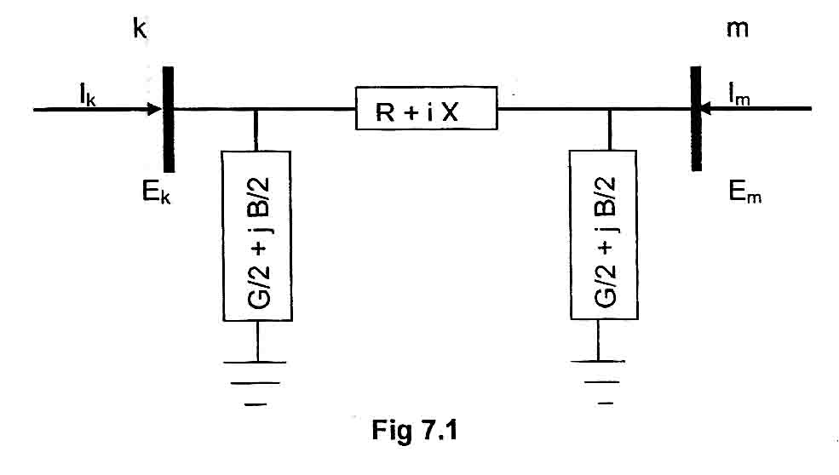
The Fig 7.1 shows a simple transmission line connected between k-th and m-th node and the transmission lien parameter are as follows :
R = resistance of transmission lien
X = reactance of transmission line
G = conductance of transmission line
B = susceptance of transmission line
I_{k} = current injected at the k-th node
I_{m} = current injected at m-th node
E_{k} = voltage at k-th node
E_{m} = voltage at m-th node

Self admittance at node-k is given by
(7.1)
(7.2)
Y_{km} = -y_{mk}.
Also shunt element connected each node contributes to Y_{bus} matrix. The additional amount of self admittance is added to Y_{kk}. The contribution of shunt element to Y_{bus} admittance matrix is given by :
(7.3)
where as Y_{kk} is called self-admittance and these elements constitute diagonal element of Y_{bus} matrix and y_{km}, y_{mk} is called mutual admittance and these elements constitute the off-diagonal element of the Y_{bus} matrix. In general Y_{bus} matrix for a n-bus network can be written as :
(7.4)

7.4 POWER FLOW EQUATION [8]
In order to develop suitable power flow equations, it is necessary to find relationship between injected bus currents and bus voltages. Based on above fig 7.1 the injected complex current at bus-k which is denoted by Ik may be expressed in terms of complex bus voltage Ek and Em as follows :
I_{k} = y_{k0}E_{k}+y_{km}(E_{k} – E_{m}) = (y_{k}= + y_{km}) E_{k} – Y_{km} E_{m} = Y_{kk} E_{k} + Y_{km}E_{m} (7.5)
where Y_{kk} = y_{ko} + y_{km} and Y_{km} = -y_{km}
Similarly for bus m,
I_{m} = Y_{mo} E_{m} + y_{mk} (E_{m} – E_{k}) = (y_{mo} + y_{mk}) E_{m} – Y_{mk} E_{k} = Y_{mm} E_{m} + y_{mk} E_{k} (7.6)
where Y_{mm} = y_{mo} + y_{mk} and Y_{mk} = -y_{km}
The above equation can be written in matrix form as :
(7.7)
where the bus admittances and voltage can be expressed in more explicit form :
Yij = Gij + jBij
Ei = Viej = Vi (cosI + jsini)
where i = k, m and j = k, m
The Complex power injected at bus k is given by :
S_{k} = P_{k} + jQ_{k} = E_{k}I_{k}*
= E_{k} (Y_{kk}E_{k} + Y_{km} E_{m})
Where I_{k}* is the complex conjugate of the current injected at bus k
Applying the value of Y_{ij} and E_{i} in S_{k} we get.
S_{k} = V_{k} (cos_{k} + jsin_{k}) {(G_{kk} + jB_{kk}) V_{k} (cos_{k} + jsin_{k}) + ( G_{km} + jB_{km}) V_{m} (cos_{m} + jsin_{m})}*
The expression for real and reactive power injected at k-th bus can be determined by taking real and imaginary parts of the above expression of Sk.
So the real power injected at k-th bus is
(7.8)
Similarly the reactive power injected at k-th bus is
(7.9)
From the equations (7.8) and (7.9) it is clear that the powers injected at bus k is flown through the ith element of the transmission line. However, a practical power system will consists of many buses and many transmission line elements. This calls for the above two equation to be expressed as the summation of the power flowing at each one of the transmission elements terminating at this bus. This is illustrated in Fig 7.2 and Fig 7.3 for the cases of active and reactive powers respectively.

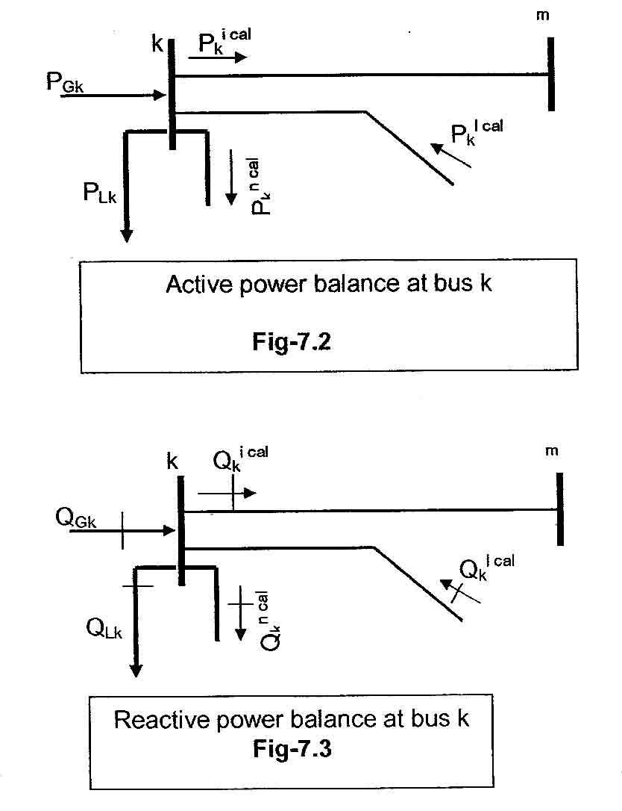
The generic net active and reactive powers injected at bus k are :
where and are active and reactive power flows contributed by the mutual admittance elements i.e. from k-bus to m-bus.
7.5 POWER MISMATCH EQUATIONS [4] [8] :
For steady state operation of power system, at a given bus the generation, load and power exchanged through the transmission elements connecting to the bus must add up to zero. This applies to both active and reactive power. These equation are termed as ‘power mismatch equations’ and at bus k they take the following form :
Where the terms and are the mismatch active and reactive powers at bus k respectively.
P_{GK} and Q_{GK} represent the active and reactive power injected by the generator at bus k respectively.
P_{LK} and Q_{L} represent the active and reactive powers drawn by the load at bus-k respectively.
Further for specified levels of power generation and power load at bus k the power mismatch equations can be written as :
(7.10)
(7.11)
The generic power mismatch equations at bus k are :
(7.12)
(7.13)

7.6 NET ACTIVE AND REACTIVE POWER
The generation and the load at bus k may be measured by the electric utility and in the parlance of power system engineers, their net values are known as the ‘scheduled active and reactive powers’:
7.7 VARIABLES AND BUS TYPE :
Four variables are associated with each bus. These are [7]
voltage magnitude |V|
phase angle
real power P
reactive power Q
The system buses are generally classified into three types and these are :
Slack Bus : It is the reference bus, where the magnitude and phase angle of the voltage are specified. This bus makes up the difference between the scheduled loads and generated power that are caused by the losses in the network.
Load Bus : At these buses the active and reactive powers are specified. The magnitude and phase angle of the voltage are unknown. These buses are called P-Q buses.
Regulated buses : These buses are the generator buses. These are also known as voltage controlled buses. At these buses, the real power and voltage magnitude are specified. The phase angle of the voltages and the reactive power are to be determined. The limits on the value of the reactive power are also specified. These buses are called P-V buses.
7.8 POWER FLOW SOLUTION METHOD
The most common techniques used for the iterative solution of nonlinear algebra equations are Gauss-Seidel, Newton-Raphson method etc. [4]. As power flow equation are nonlinear in nature, the following three common methods used for the solution of power flow equation.
(a) Gauss-Seidel (GS) method
(b) Newton-Raphson (NR) method
(c) Fast Decoupled power flow solution method
Out of these three method, use of Newton-Raphson (NR) method is more powerful for medium and large network. This is because it works faster and is sure to converge in most cases. Number of iteration required is less and the convergence process is faster than any other method. Its only draw back is the large requirement of computer memory, which can be overcome through a compact storage scheme. That’s why in this project Newton-Raphson method is used to solve power flow equation.
7.9 NEWTON-RAPHSON ALGORITHM :
This approach uses iteration to solve the following set of nonlinear algebraic equations [7] [8] :
f₁ = (x₁, x₂, …,x_{n}) = 0
f₂=(x₁, x₂, …, x_{n})=0
f_{N} = (x₁, x₂, …, x_{n})=0
Or F(X) = 0
where F represents the set of n nonlinear equations and X is the vector of n unknown state variables.
The essence of the method consists of determining the vector of state variables X by performing a Taylor series expansion of F(x) about a initial estimate X(0) :
F(X) = F(X⁽⁰⁾⁺J(X⁽⁰⁾ (X-X⁽⁰⁾ + higher – order terms
where J(X⁽⁰⁾) is a matrix of first-order partial derivatives of F(X) with respect to X and is called Jacobian which is evaluated at X = X ⁽⁰⁾.
This expansion in equation (7.15) lends itself to a suitable formulation for calculating the vector of state variables X by assuming that X(1) is the value computed by the algorithm at iteration 1 and that this value is sufficiently close to the initial estimate X(0). Based on this premise, all high-order derivatives terms in the expression. (5.15) can be neglected. Hence,
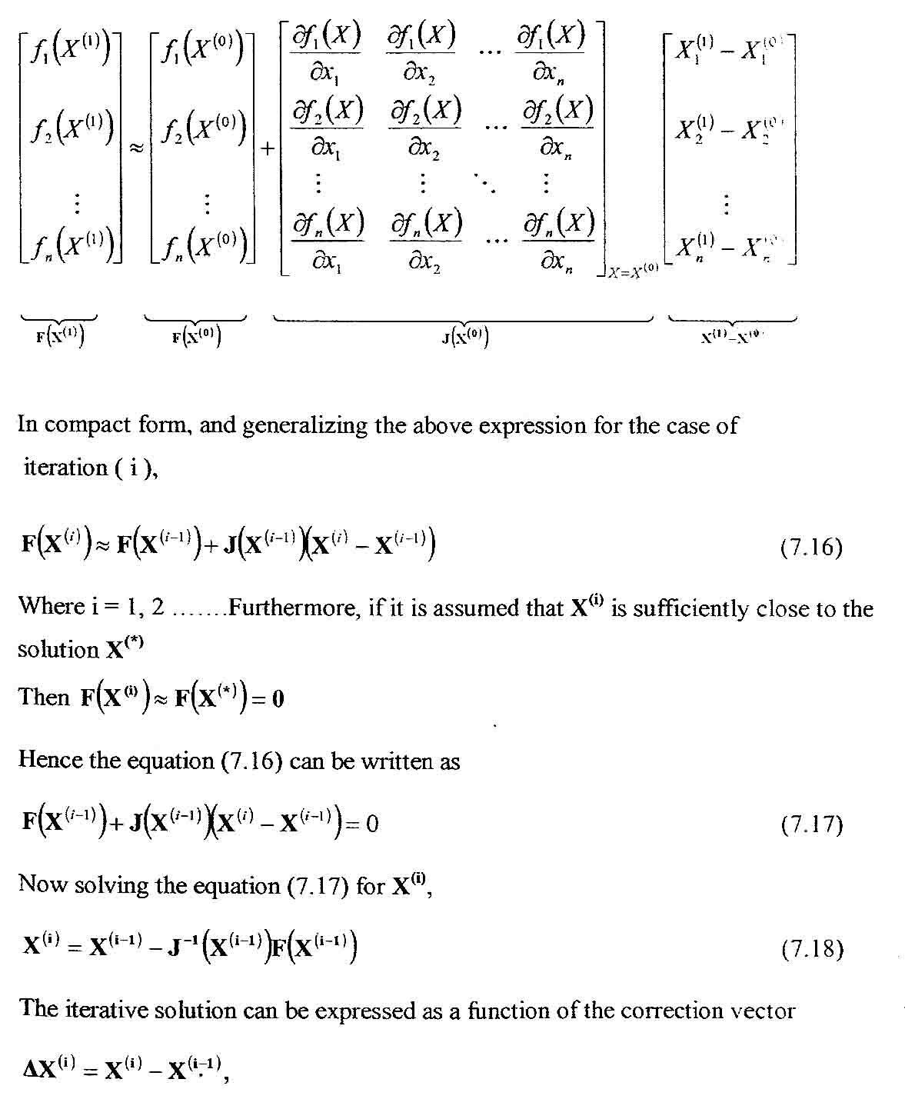
The iterative solution can be expressed as a function of the correction vector
(7.19)
and the initial estimates are updated using the following relations :
(7.20)
The calculation is repeated as many times as required using the most up-to-date values of X in the above equation. This is done until mismatches are within a prescribed small tolerance (i.e. le-12)

7.10 NEWTON-RAPHSON METHOD FOR POWER FLOW PROBLEM :
Similar analogy can be made for power flow equation as described above as the power flow equation is also a nonlinear algebraic equation consists of variables nodal voltage magnitudes V and phase angles . Thus the power mismatches Equations and are expanded around a base point and hence, the power flow Newton-Raphson algorithm is expressed by the following relationship [8]:
(7.21)
Further this can be written in this form as :
(7.22)
where J₁, J₂, J₃ and J₄ constitutes the Jacobian matrix, each element of the order of (nb-1) x (nb-1).
Nb=total number of buses

Thus Jacobian matrix are written as :
where k = 1, 2, …….. nb
and m = 1, 2, ……..., nb
but omitting the slack bus entries.
It must be pointed out that the correction terms are divided by to compensate for the fact that Jacobian term are multiplied by . It is shown in the derivative terms given below that this artifice yields useful simplifying calculations.
Consider the l-th elements connected between buses k and m in Fig. 7.1 for which self and mutual Jacobian terms are given below :
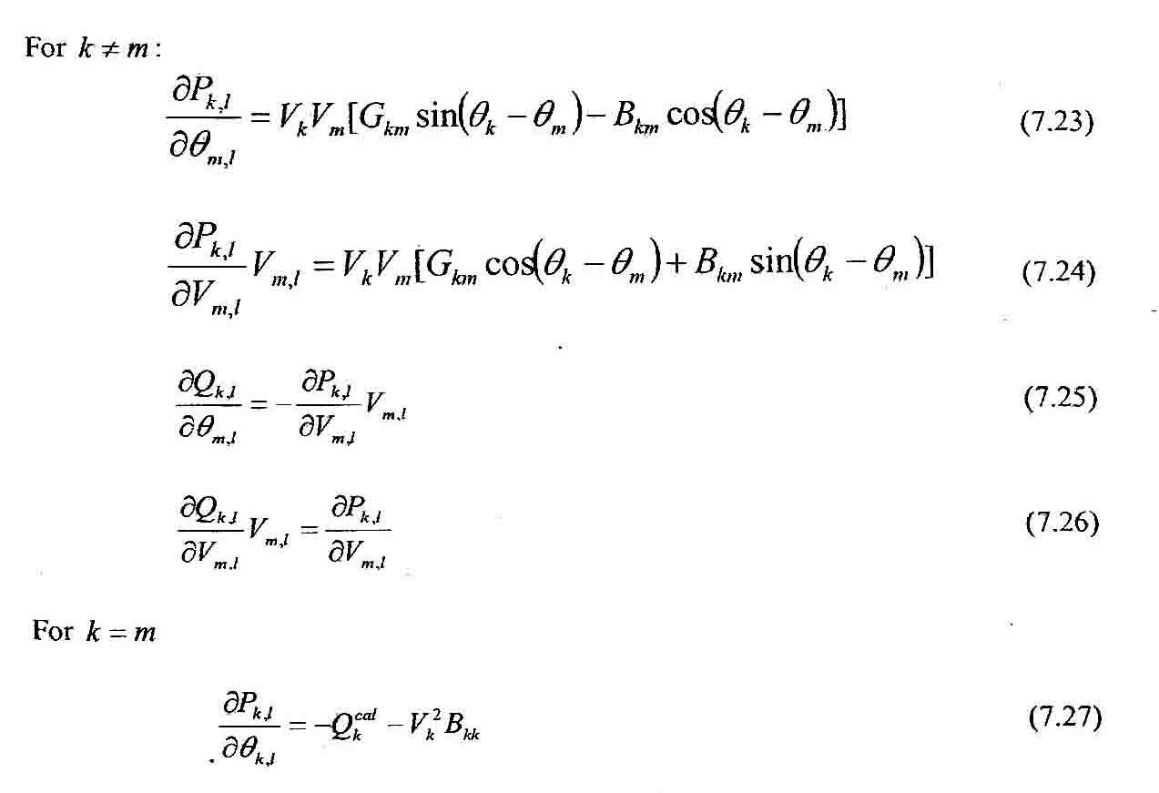
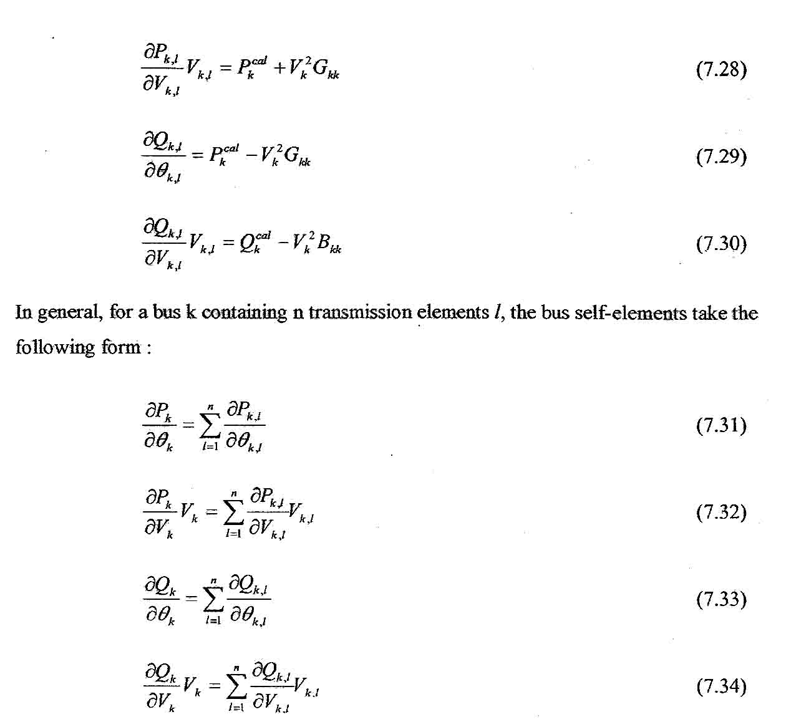
After the convergence of the power flow solution, we get the final value of state variables i.e. voltage magnitudes and phase angles have been calculated. Then active and reactive power flows throughout the transmission system are determined quite straightforwardly.

7.11 STATE VARIABLE INITIALIZATION :
The effectiveness of the Newton-Raphson method to achieve feasible interactive solutions is dependent upon the selection of suitable initial values for all the state variables involved in the study [8].
The power flow solution starts with initial value of voltage magnitude of 1 p.u. at all PQ buses. The slack and PV buses are given their specified values, which remain constant throughout the iterative solution if no generator reactive power limits are violate. The initial voltage phase angles are selected to be 0 at all buses.

7.12 GENERATOR REACTIVE POWER LIMIT :
For the interactive solution of power flow equations, it is essential to check the calculated reactive power is within the generator reactive power limits [8] :
Q_{Gmink}<Q_{Gk}<Q_{Gmaxk}
If either of the following condition occur during the interactive process :
Bus k becomes a generator PQ bus with either of the following mismatch power equations incorporated in Power flow mismatch equation as :
Depending on the violated limit, together with relevant Jacobian entries. The nodal voltage magnitude at bus k is allowed to vary and Vk becomes a state variable.
It should be remarked that bus k may revert to being a generator PV bus at some point during the iterative process if better estimates of , calculated with more accurate nodal voltages, indicate that the reactive power requirements at bus k can, after all be met by the generator connected at bus k. Hence, reactive power limit checking is carried out at each iteration.
7.13 GENERALIZED POWER FLOW SOLUTION FOR 5-BUS NETWORK
A 5-Bus network is given in the next page in Fig – 7.4 to analyze the power flow solution and to determine the active power flow and reactive power flow from each bus. Also nodal voltage magnitude and nodal phase angle is determined where these quantities are not known. For this purpose a computer program is used to solve the power flow solution.
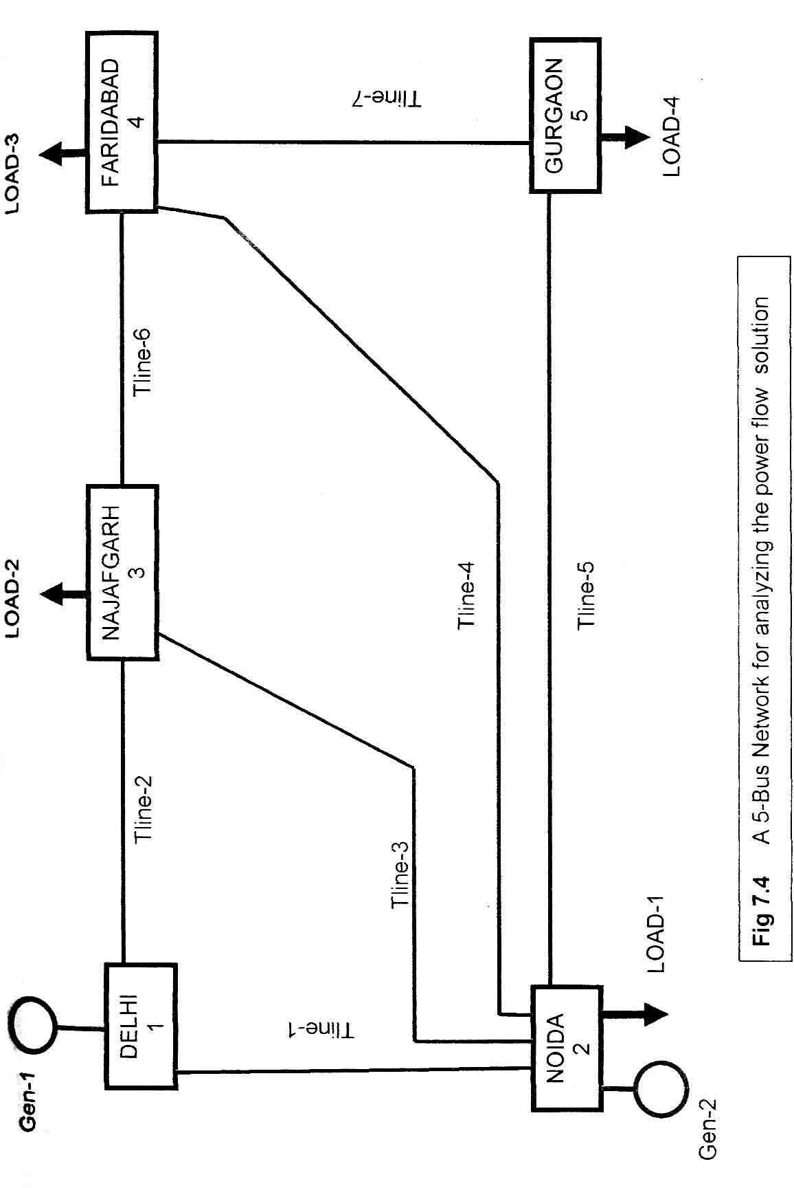
DATA FOR 5-BUS NETWORK :
TRANSMISSION LINE DATA
Total no of transmission line = 7
Transmission Line | Fm | To | Resistance in p.u | Reactance in p.u | Susceptance in p.u
Tline-1 | Delhi | Noida | 0.02 | 0.06 | 0.06
Tline-2 | Delhi | Najafgarh | 0.08 | 0.24 | 0.05
Tline-3 | Noida | Najafgarh | 0.06 | 0.18 | 0.04
Tline-4 | Noida | Faridabad | 0.06 | 0.18 | 0.04
Tline-5 | Noida | Gurgaon | 0.04 | 0.12 | 0.03
Tline-6 | Najafgarh | Faridabad | 0.01 | 0.03 | 0.02
Tline-7 | Faridabad | Gurgaon | 0.08 | 0.24 | 0.05

GENERATOR BUS DATA
Total no of Generator = 2
Bus No | Bus Type | Bus Type Nodal voltage in p.u | Nodal phase angle in p.u | Active power injected in p.u | Reactive power injected in p.u | Generators reactive power upper limits in p.u. | Generators reactive power lower limit in p.u
Delhi-1 | Slack Bus | 1.06 | 0 | Unknown | Unknown | 5 | -5
Noida-2 | Generator PV Bus | 1.00 | ? | 0.4 | ? | 3 | -3

LOAD BUS DATA
Total no of load = 4
Bus No | Bus Type | Nodal voltage in p.u | Nodal phase angle in p.u | Active power drawn in p.u | Reactive power drawn in p.u
Noida-2 | Load PQ Bus | ? | ? | 0.20 | 0.10
Najafgarh-3 | Load PQ Bus | ? | ? | 0.45 | 0.15
Faridabad-4 | Load PQ Bus | ? | ? | 0.40 | 0.05
Gurgaon-5 | Load PQ Bus | ? | ? | 0.60 | 0.1

General Parameters :
Maximum Iteration = 100,
Tolerance = le – 12

MATLAB PROGRAM-5.1
COMPUTER PROGRAM FOR POWER FLOW SOLUTION
USING NEWTON-RAPHSON METHOD
For the 5-bus network shown in Fig. 7.4 a computer program is written using MATLAB Code to solve the power flow equation. These program are attached in Appendix-‘B’. Here the main program is shown.

%Main program to get the output of power flow solution of a given network
%BUS DATA
%nb=number of buses
%bus type=type of bus
%VM=nodal voltage magnitude
%VA=nodal voltage phase angle

%TYPE OF BUS USED IN THE NETWORK
%bus type = 1 is slack or swing bus
%bus type = 2 is generator PV bus
%bus type = 3 is load PQ bus
%bus type = 4 is generator bus

%The five buses in the network are numbered for the purpose of the power
%flow solution, as follows:

%DELHI=1
%NOIDA=2
%NAJAFGARH=3
%FARIDABAD=4
%GURGAON=5

nb=5;
bus type(1)=1;VM(1)=1.06;VA(1)=0;
bus type(2)=2;VM(2)=1; VA(2)=0;
bus type(3)=3;VM(3)=1; VA(3)=0;
bustype(4)=3;VM(4)=1; VA(4)=0;
bustype(5)=3;VM(5)=1; VA(5)=0;

%GENERATOR DATA
%ngn=number of generators
%genbus=generator bus number
%PGEN=scheduled active power contributed by generator
%QGEN=scheduled reactive power contributed by generator
%QMAX=generator reactive power upper limit
%QMIN=generator reactive power lower limit
ngn=2;
genbus(1)=1;PGEN(1)=0; QGEN(1)=0;QMAX(1)=5;QMIN(1)=-5;
genbus(2)=2;PGEN(2)=0.4; QGEN(2)=0;QMAX(2)=3;QMIN(2)=-3;

%TRANSMISSION LINE DATA
%nt1=number of transmission lines
%tlsend=sending end of transmission line
%tlrec=receiving end of transmission line
%tlresis=series resistance of transmission line
%tlreac=series reactance of transmission line
%tlcond=shunt conductance of transmission line
%tlsuscep=shunt susceptance of transmission line

ntl=7;
tlsend(1)=1;tlrec(1)=2;tlresis(1)=0.02;tlreac(1)=0.06;tlcond(1)=0;tlsuscep(1)=0.06;
tlsend(2)=1;tlrec(2)=3;tlresis(2)=0.08;tlreac(2)=0.24;tlcond(2)=0;tlsuscep(2)=0.05;
tlsend(3)=2;tlrec(3)=3;tlresis(3)=0.06;tlreac(3)=0.18;tlcond(3)=0;tlsuscep(3)=0.04;
tlsend(4)=2;tlrec(4)=4;tlresis(4)=0.06;tlreac(4)=0.18;tlcond(4)=0;tlsuscep(4)=0.04;
tlsend(5)=2;tlrec(5)=5;tlresis(5)=0.04;tlreac(5)=0.12;tlcond(5)=0;tlsuscep(5)=0.03;
tlsend(6)=3;tlrec(6)=4;tlresis(6)=0.01;tlreac(6)=0.03;tlcond(6)=0;tlsuscep(6)=0.02;
tlsend(7)=4;tlrec(7)=5;tlresis(7)=0.08;tlreac(7)=0.24;tlcond(7)=0;tlsuscep(7)=0.05;

%SHUNT DATA
%nsh=number of shunt elements
%shbus=shunt element bus number
%shresis=resistance of shunt element
%shrea=reactance of shunt element
%+ve for inductive reactance and -ve for capacitive reactance

nsh=0;
shbus(1)=0;shresis(1)=0;shreac(1)=0;

%LOAD DATA
%nld=number of load elements
%loadbus=load element bus number
%PLOAD=scheduled active power consumed at the bus
%QLOAD=scheduled reactive power consumed at the bus

nld=4;
loadbus(1)=2;PLOAD(1)=0.2;QLOAD(1)=0.1;
loadbus(2)=3;PLOAD(2)=0.45;QLOAD(2)=0.15;
loadbus(3)=4;PLOAD(3)=0.4;QLOAD(3)=0.05;
loadbus(4)=5;PLOAD(4)=0.6;QLOAD(4)=0.1;

%GENERAL PARAMETERS
%itmax=maximum number of iterations permitted before the iterative process
%is terminated
%tol=criterion tolerance to be met before the iterative solution is
%successfully brought to an end
itmax=100;
tol=1e-12;
nmax=2*nb;
VA=VA*180/pi;
MVAbase=100;%base MVA
[YR,YI]=Ybus(tlsend,tlrec,tlresis,tlreac,tlsuscep,tlcond,shbus,shresis,shreac,ntl,nb,
nsh);
[VM,VA,it]=NewtonRaphson(nmax,tol,itmax,ngn,nld,nb,bustype,genbus,loadbus,PGEN,QGEN,QMAX,QMIN,PLOAD,QLOAD,YR,YI,YM,VA);
[PQsend,PQrec,PQloss,PQbus]=PQflows(nb,ngn,ntl,nld,genbus,loadbus,tlsend,tlrec,tlresis,tlreac,tlcond,tlsuscep,PLOAD,QLOAD,YM,VA);
Psend=real(PQsend)*MVAbase;%active power sent from each bus
Qsend=imag(PQsend)*MVAbase;%reactive power sent from each bus
Prec=real(PQrec)*MVAbase;%active power recieved at each bus
Qrec=imag(PQrec)*MVAbase;%reactive power recieved at each bus
Ploss=real(PQloss)*MVAbase;%active power loss in each transmission line
Qloss=imag(PQloss)*MVAbase;%reactive power loss in each transmission line
Pinjected=(real(PQbus)*MVAbase);
Pgen=[Pinjected(1,1)+Pinjected(1,2)-PLOAD(1)*MVAbase+Pinjected(1,3)+Pinjected(1,4)+Pinjected(1,5)];
Qinjected=(imag(PQbus)*MVAbase);
Qgen=[Qinjected(1,1)+Qinjected(1,2)-QLOAD(1)*MVAbase+Qinjected(1,3)+Qinjected(1,4)+Qinjected(1,5)];
disp('ACTIVE POWER SENT FROM EACH BUS ')
disp(' DELHI DELHI NOIDA NOIDA NOIDA NAJAF FBAD')
disp(' NOIDA NAJAF NAJAF FBAD GURGAON FBAD GURGAON')
disp(' ===== ===== ===== ==== ======= ==== =======')
disp(Psend)
disp('ACTIVE POWER RECEIVED AT EACH BUS::::')
disp(' NOIDA NAJAF NAJAF FBAD GURGAON FBAD GURGAON')
disp(' ===== ===== ===== ==== ======= ==== =======')
disp(Prec)
disp('ACTIVE POWER LOSS ON TRANSMISSION LINE::::')
disp(' DELHI DELHI NOIDA NOIDA NOIDA NAJAF FBAD')
disp(' NOIDA NAJAF NAJAF FBAD GURGAON FBAD GURGAON')
disp(' ===== ===== ===== ==== ======= ==== =======')
disp(Ploss)
disp('REACTIVE POWER SENT FROM EACH BUS ')
disp(' DELHI DELHI NOIDA NOIDA NOIDA NAJAF FBAD')
disp(' NOIDA NAJAF NAJAF FBAD GURGAON FBAD GURGAON')
disp(' ===== ===== ===== ==== ======= ==== =======')
disp(Qsend)
disp('REACTIVE POWER RECEIVED AT EACH BUS::::')
disp(' NOIDA NAJAF NAJAF FBAD GURGAON FBAD GURGAON')
disp(' ===== ===== ===== ==== ======= ==== =======')
disp(Qrec)
disp('REACTIVE POWER LOSS ON TRANSMISSION LINE::::')
disp(' DELHI DELHI NOIDA NOIDA NOIDA NAJAF FBAD')
disp(' NOIDA NAJAF NAJAF FBAD GURGAON FBAD GURGAON')
disp(' ===== ===== ===== ==== ======= ==== =======')
disp(Qloss)
disp('NET ACTIVE POWER INJECTED/OUTAGE AT GENERATOR/LOAD BUS::::')
disp(' DELHI NOIDA NOIDA NAJAF FBAD GURGAON ')
disp(Pgen)
disp('NET REACTIVE POWER INJECTED/OUTAGE AT GENERATOR/LOAD BUS::::')
disp(' DELHI NOIDA NOIDA NAJAF FBAD GURGAON ')
disp(Qgen)
TOTALGEN=(PQbus(1,1)+PQbus(1,2))*MVAbase;
TOTALGENERATION_ACTIVEPOWER=real(TOTALGEN)
TOTALGENERATION_REACTIVEPOWER=imag(TOTALGEN)
TOTAL_ACTIVE_LOAD=-(PLOAD(1)+PLOAD(2)+PLOAD(3)+PLOAD(4))*MVAbase
TOTAL_REACTIVE_LOAD=-(QLOAD(1)+QLOAD(2)+QLOAD(3)+QLOAD(4))*MVAbase
TOTAL_ACTIVEPOWER_LOSS=TOTALGENERATION_ACTIVEPOWER+TOTAL_ACTIVE_LOAD
TOTAL_REACTIVEPOWER_LOSS=TOTALGENERATION_REACTIVEPOWER+TOTAL_REACTIVE_LOAD
TOTAL_ITERATION=it
%end of main program
EXECUTION OF MAIN PROGRAM :
When this main program is executed the list of result is obtained which is summarized as below :-
SUMMARY OF OUTPUTS :

ACTIVE POWER SENT FROM EACH BUS::::
DELHI DELHI NOIDA NOIDA NOIDA NAJAF FBAD
NOIDA NAJAF NAJAF FBAD GURGAON FBAD GURGAON
===== ===== ===== ==== ======= ==== =======
89.4458 42.0023 24.5614 27.8124 54.7540 19.3916 6.6320

ACTIVE POWER RECEIVED AT EACH BUS::::
NOIDA NAJAF NAJAF FBAD GURGAON FBAD GURGAON
===== ===== ===== ==== ======= ==== =======
-86.8455 -40.2730 -24.1132 -27.2521 -53.4448 -19.3461 -6.5552

ACTIVE POWER LOSS ON TRANSMISSION LINE::::
DELHI DELHI NOIDA NOIDA NOIDA NAJAF FBAD
NOIDA NAJAF NAJAF FBAD GURGAON FBAD GURGAON
===== ===== ===== ==== ======= ==== =======
2.6002 1.7293 0.4482 0.5603 1.3092 0.0455 0.0768
REACTIVE POWER SENT FROM EACH BUS::::
DELHI DELHI NOIDA NOIDA NOIDA NAJAF FBAD
NOIDA NAJAF NAJAF FBAD GURGAON FBAD GURGAON
===== ===== ===== ==== ======= ==== =======
74.1880 17.0217 -2.4910 -1.6897 5.6034 2.8679 0.5491
REACTIVE POWER RECEIVED AT EACH BUS::::
NOIDA NAJAF NAJAF FBAD GURGAON FBAD GURGAON
===== ===== ===== ==== ======= ==== =======
-72.9084 -175125 -.3523 -.8306 -4.8292 -4.6878 -5.1708
REACTIVE POWER LOSS ON TRANSMISSION LINE::::
DELHI DELHI NOIDA NOIDA NOIDA NAJAF FBAD
NOIDA NAJAF NAJAF FBAD GURGAON FBAD GURGAON
===== ===== ===== ==== ======= ==== =======
1.2797 -0.4908 -2.8433 -2.5202 0.7742 -1.8199 -4.6216

NET ACTIVE POWER INJECTED/OUTAGE AT GENERATOR/LOAD BUS:::
Delhi Noida Noida Najaf Fbad Gurgaon
131.4481 40.2823 -20.0000 -44.9946 -39.9663 -60.0000
NET REACTIVE POWER INJECTED/OUTAGE AT GENERATOR/LOAD BUS::
Delhi Noida Noida Najaf Fbad Gurgaon
91.2097 -61.4856 -10.0000 -14.9969 -4.9692 -10.0000
TOTAL GENERATION _ ACTIVE POWER =
171.7304
TOTAL GENERATION _ REACTIVE POWER =
29.7241
TOTAL L_ACTIVE_LOAD
-165
TOTAL_REACTIVE_LOAD =
-40
TOTAL_REACTIVE POWE LOSS =
6.7304
TOTAL_REACTIVE POWER_LOSS =
-10.2759
TOTAL ITERATION =
6

7.14 CONCLUSION :
The summary of result are superimposed on the given 5-bus network shown in Fig-5.5, so that at each bus we can find out how much power flows from each bus and the losses on the transmission line are also mentioned. The summary of output shows that at each bus, power mismatch equation is satisfied. Also power flow solution is converges to prescribed tolerance of le-12 within six iteration.
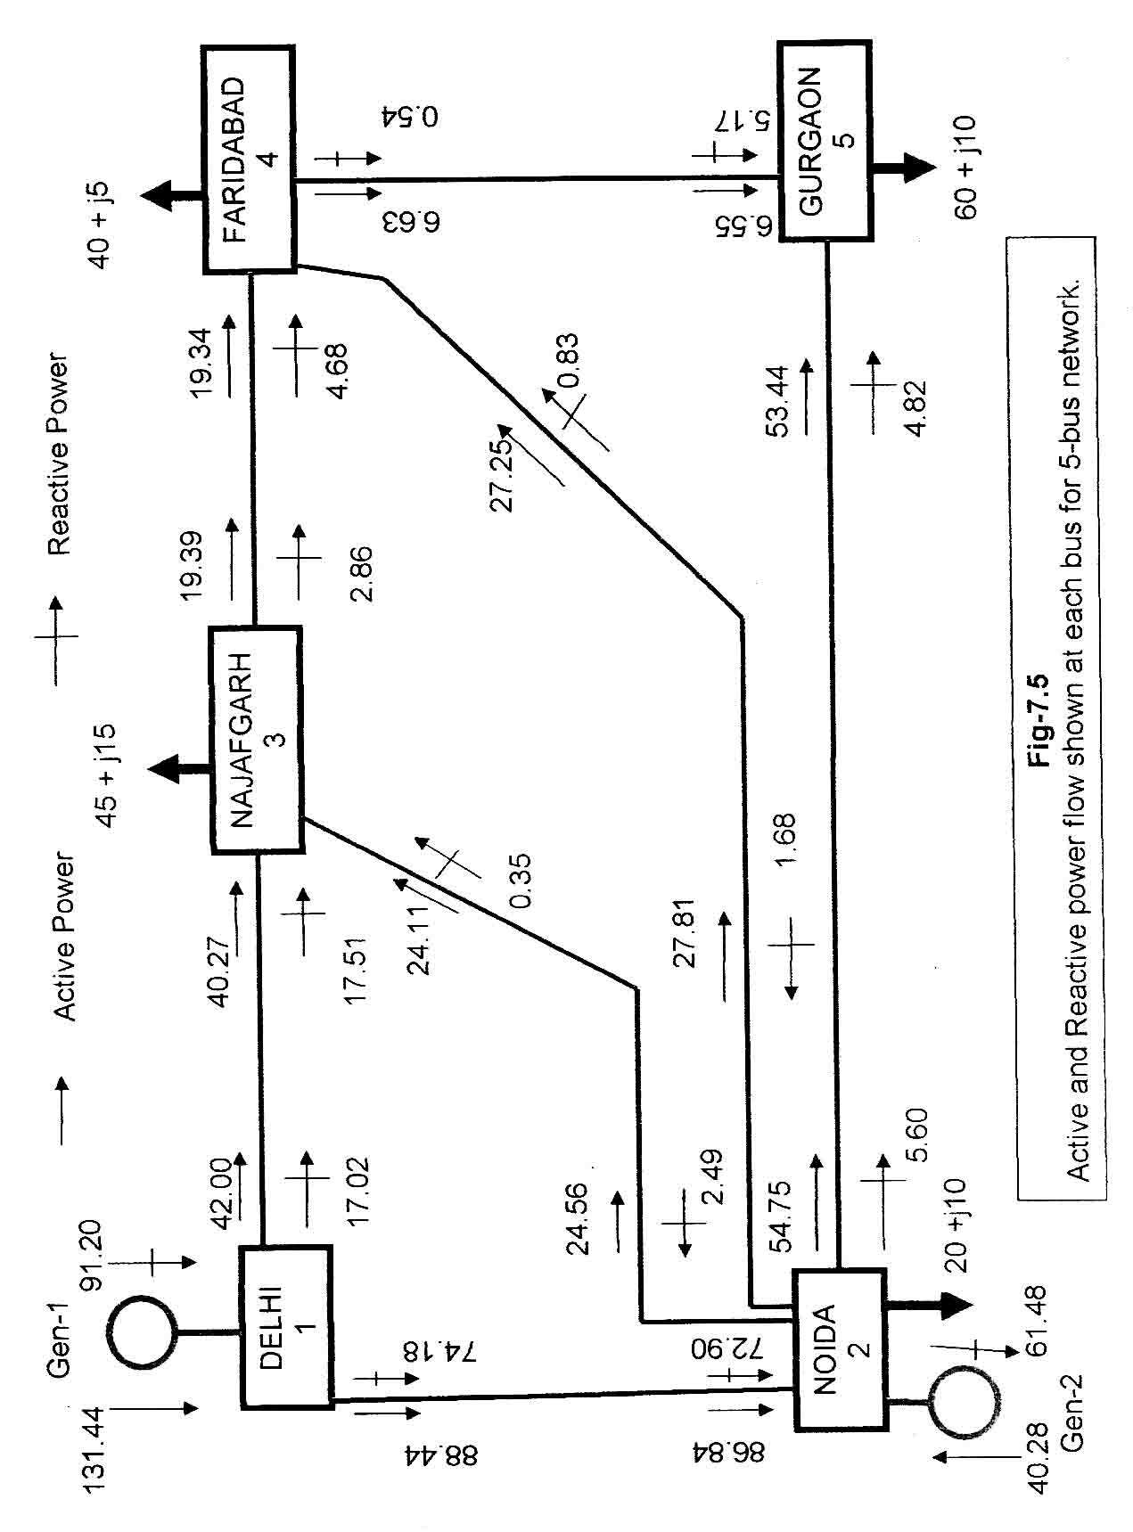

8
POWER FLOW CONTROL USING TCSC
8.1 ACTIVE AND REACTIVE POWER FLOW THROUGH TCSC :
As Thyristor Controlled Series Capacitor (TCSC) will control the power flow in the transmission line of a large electrical network, here we will model the TCSC as a
variable reactance which varies in terms of firing angle of thyristor [7] [8] [9].

k m
Ik Im

Vk Vm

XL

Fig-8.1
TCSC connected between buses k & m

The fundamental frequency equivalent reactance XTCSC of the TCSC which is already derived in equation (6.17) is given by :

where
The TCSC active and reactive power equations at bus k are
(8.1)
(8.4)
where
For the case when the TCSC controls active power flowing from bus k to bus m at a specified vale, the set of linearised power flow equations is :
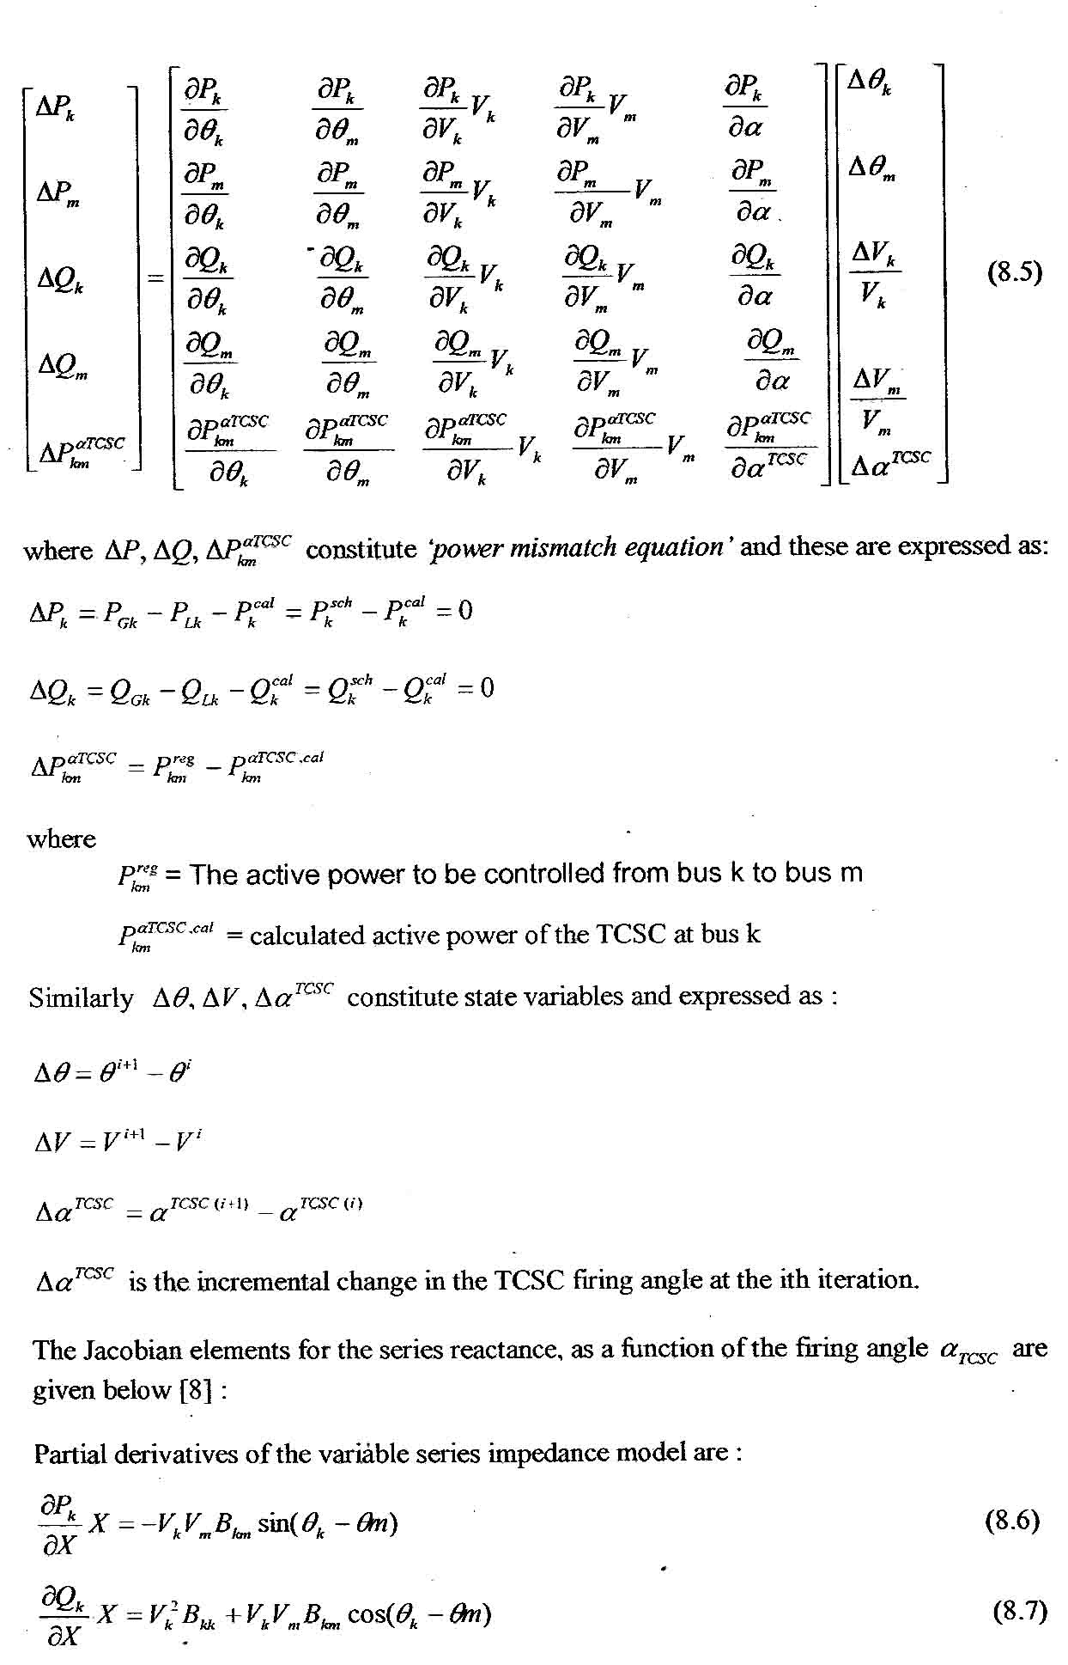
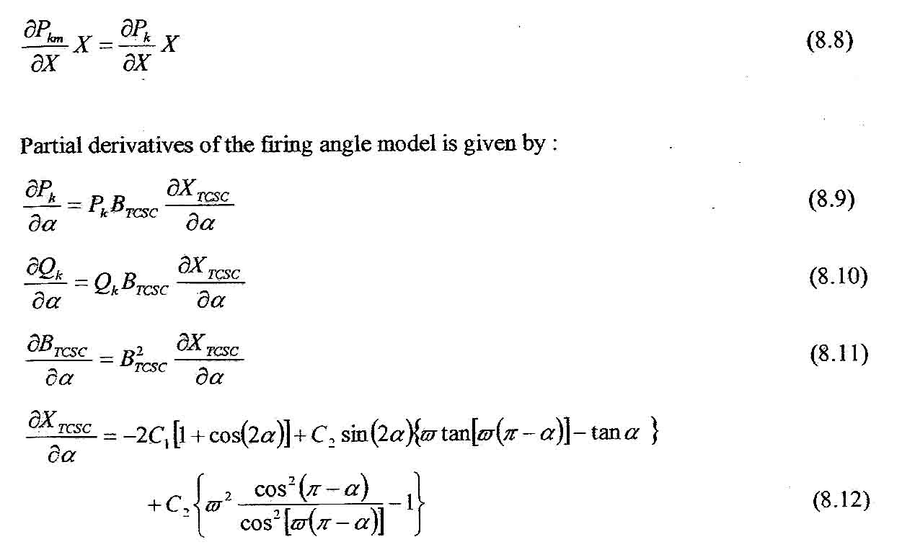

8.2 POWER FLOW SOLUTION FOR 6-BUS NETWORK :
Power flow solution for the network where TCSC is used in the network is solved in the similar way using Newton-Raphson method already discussed in Chapter-7. In the next page of 6-Bus network is drawn, in which a TCSC is used in between Najafgarh to Dwarka. By writing a MATLAB code in the similar fashion as written in Chapter-7 for power flow solution, we analyze how the Thyristor-Controlled Series Capacitor is effective for controlling the specified amount of active power in between two buses.

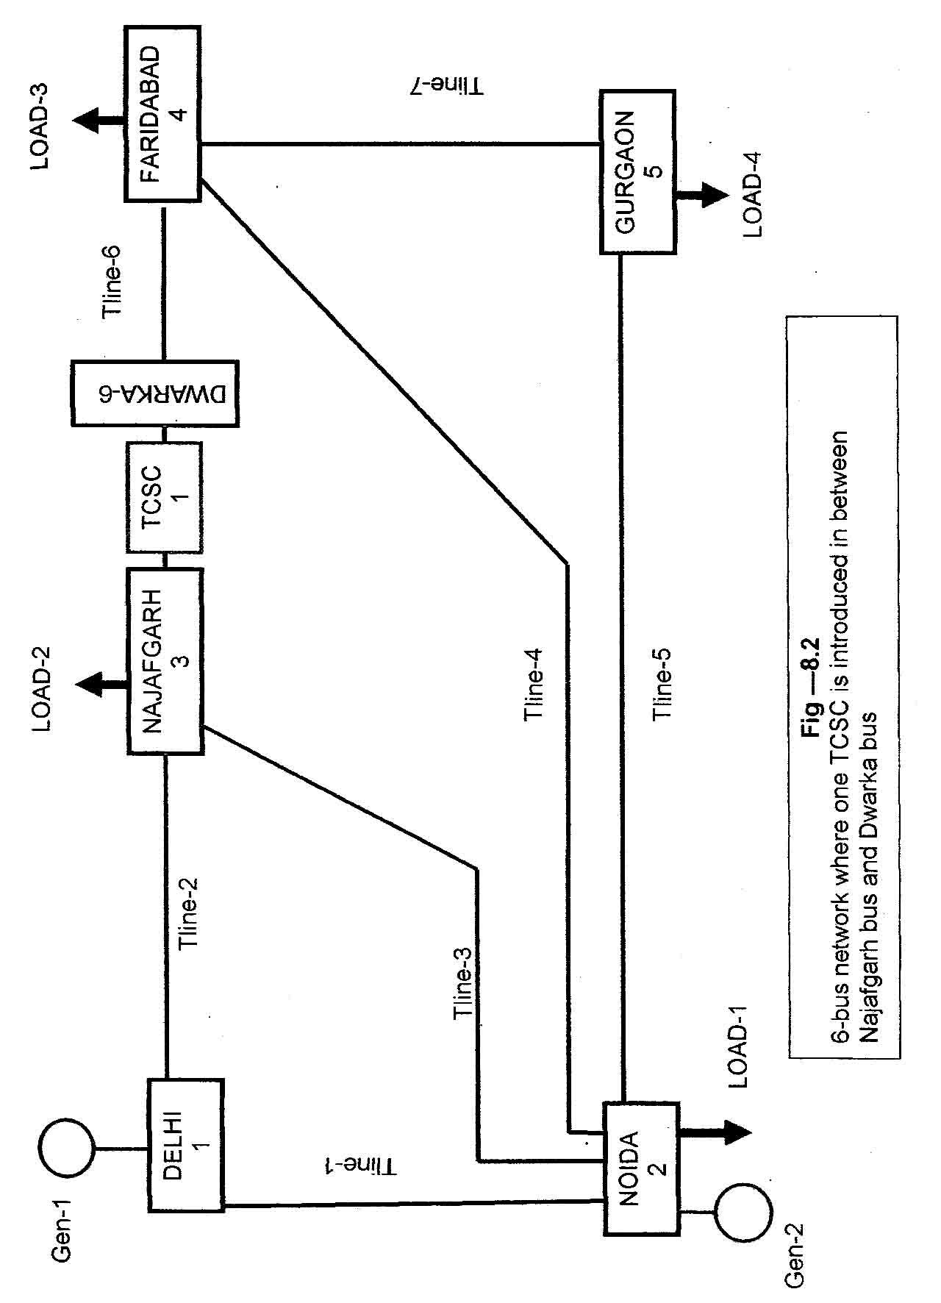

DATA FOR 6-BUS NETWORK IN WHICH TCSC-1 IS CONNECTED :
TRANSMISSION LINE DATA :
Total no of transmission line = 7
Transmission Line | Fm | To | Resistance in p.u | Reactance in p.u | Susceptance in p.u
Tline-1 | Delhi | Noida | 0.02 | 0.06 | 0.06
Tline-2 | Delhi | Najafgarh | 0.08 | 0.24 | 0.05
Tline-3 | Noida | Najafgarh | 0.06 | 0.18 | 0.04
Tline-4 | Noida | Faridabad | 0.06 | 0.18 | 0.04
Tline-5 | Noida | Gurgaon | 0.04 | 0.12 | 0.03
Tline-6 | Dwarka | Faridabad | 0.01 | 0.03 | 0.02
Tline-7 | Faridabad | Gurgaon | 0.08 | 0.24 | 0.05
GENERATOR BUS DATA
Total no of Generator = 2
Bus No | Bus Type | Bus Type Nodal voltage in p.u | Nodal phase angle in p.u | Active power injected in p.u | Reactive power injected in p.u | Generators reactive power upper limits in p.u. | Generators reactive power lower limit in p.u
Delhi-1 | Slack Bus | 1.06 | 0 | Unknown | Unknown | 5 | -5
Noida-2 | Generator PV Bus | 1.00 | ? | 0.4 | ? | 3 | -3
LOAD BUS DATA
Total no of load = 4
Bus No | Bus Type | Nodal voltage in p.u | Nodal phase angle in p.u | Active power drawn in p.u | Reactive power drawn in p.u
Noida-2 | Load PQ Bus | ? | ? | 0.20 | 0.10
Najafgarh-3 | Load PQ Bus | ? | ? | 0.45 | 0.15
Faridabad-4 | Load PQ Bus | ? | ? | 0.40 | 0.05
Gurgaon-5 | Load PQ Bus | ? | ? | 0.60 | 0.1

TCSC’s DATA
Total No of TCSC = 1
Connected between : Najafgarh-3 to Dwarka-6
Capacitive reactance of TCSC = 9.375e-3
Inductive Reactance of TCSC = 1.625e-3
Initial Firing Angle = 145 degree
Firing angle lower limit = 90 degree
Firing angle upper limit = 180 degree
Active Power to be controlled = 0.21 p.u

General Parameters :
Maximum Iteration = 100,
Tolerance = 1e-12

MATLAB PROGRAM—6.1
COMPUTER PROGRAM FOR POWER FLOW CONTROL USING TCSC (THYRISTOR CONTLLED SERIES CAPACITOR):

To solve the power flow equation of above network which contains one TCSC to control the required amount of active power between DWARKA and FARIDABAD, a program is written in MATLAB code and is attached in Appendix- ‘C’ Only the main program is show here.

% Main TCSC –FA Program to get the output of power flow solution of a given network
% BUS DATA
% nb = number of bus
% bus type = type of bus
% VM = nodal voltage magnitude
% VA = nodal voltage phase angle

% TYPE OF BUS USED IN THE NETWORK
% bus type = 1 is slack or swing bus
% bus type = 2 is generator PV bus
% bus type = 3 is load PQ bus
% bus type = 4 is generator bus

% The six buses in the network are numbered for the purpose of the power
% Flow solution, as follows:

% DELHI = 1
% NODIDA = 2
% NAJAFGARH = 3
% FARIDABAD = 4
% GURGOAN = 5
% DWARAKA = 6

nb=6;
Bus type (1)=1;VM (1)=1.06;VA (1)=0;
Bus type (2)=2;VM (2)=1; VA (2)=0;
Bus type (3)=3;VM (3)=1; VA (3)=0;
Bus type (4)=3;VM (4)=1; VA (4)=0;
Bus type (5)=3;VM (5)=1; VA (5)=0;
Bus type (6)=3;VM (6)=1; VA (6)=0;

%GENERATOR DATA
%ngn=number of generators
%genbus=generator bus number
%PGEN=scheduled active power contributed by generator
%QGEN=scheduled reactive power contributed by generator
%QMAX=generator reactive power upper limit
%QMIN=generator reactive power lower limit

ngn=2;
genbus(1)=1;PGEN (1)=0; QGEN (1)=0;QMAX(1)=5;QMIN(1)=-5;
genbus(2)=2;PGEN (2)=0.4; QGEN (2)=0;QMAX(2)=3;QMIN(2)=-3;

% TRANSMISSION LINE DATA
% nt1=number of transmission lines
% tlsend=sending end of transmission line
% tlrec=receiving end of transmission line
% tlresis=series resistance of transmission line
% tlreac=series reactance of transmission line
% tlcond=shunt conductance of transmission line
% tlsuscep=shunt susceptance of transmission line

ntl=7;
tlsend(1)=1;tlrec(1)=2;tlresis(1)=0.02;tlreac(1)=0.06;tlcond(1)=0;tlsuscep(1)=0.06;
tlsend (2)=1;tlrec(2)=3;tlresis(2)=0.08;tlreac(2)=0.24;tlcond(2)=0;tlsuscep(2)=0.05;
tlsend(3)=2;tlrec(3)=3;tlresis(3)=0.06;tlreac(3)=0.18;tlcond(3)=0;tlsuscep(3)=0.04;
tlsend(4)=2;tlrec(4)=4;tlresis(4)=0.06;tlreac(4)=0.18;tlcond(4)=0;tlsuscep(4)=0.04;
tlsend(5)=2;tlrec(5)=5;tlresis(5)=0.04;tlreac(5)=0.12;tlcond(5)=0;tlsuscep(5)=0.03;
tlsend(6)=3;tlrec(6)=4;tlresis(6)=0.01;tlreac(6)=0.03;tlcond(6)=0;tlsuscep(6)=0.02;
tlsend(7)=4;tlrec(7)=5;tlresis(7)=0.08;tlreac(7)=0.24;tlcond(7)=0;tlsuscep(7)=0.05;

%SHUNT DATA
%nsh=number of shunt elements
%shbus=shunt element bus number
%shresis=resistance of shunt element
%shrea=reactance of shunt element
%+ve for inductive reactance and -ve for capacitive reactance

nsh=0;
shbus (1)=0;shresis (1)=0;shreac(1)=0;

%LOAD DATA
% nld =number of load elements
% load bus =load element bus number
% PLOAD =scheduled active power consumed at the bus
% QLOAD =scheduled reactive power consumed at the bus

nld = 4;
load bus (1)=2;PLOAD(1)=0.2;QLOAD(1)=0.1;
load bus (2)=3;PLOAD(2)=0.45;QLOAD(2)=0.15;
load bus (3)=4;PLOAD(3)=0.4;QLOAD(3)=0.05;
load bus (4)=5;PLOAD(4)=0.6;QLOAD(4)=0.1;
% NTCSCFA = Number of TCSC
% NTCSCF A send = Sending bus
% TCSCF Arec = receiving bus
% Xc = TCSC’s inductance (p.u.)
% Xl = TCSC’s inductance ( p.u.)
% FA = Initial firing angle (deg)
% FALo = Firing angle lower limit (deg)
% FAHi = Firing angle higher limit (deg)
% Flow = Power flow direction: 1 is for sending to receiving bus:
% 1 indicates opposite direction
% Psp = Active power flow to be controlled (p.u.)
% Psta = indicate the control status for active power: 1 is on; 0 is off
NTCSCFA = 1;
TCSCF Asend (1) = 3; TCSCF Arec (1) = 6; Xc (1) = 9.375 e-3; X1 (1) = 1.625 e-3; FA (1) = 145; FALo (1) = 90; FAHi (1) = 1; Psta (1)= 0.21;

%GENERAL PARAMETERS
%itmax=maximum number of iterations permitted before the iterative process
%is terminated
%tol=criterion tolerance to be met before the iterative solution is
%successfully brought to an end
itmax=100;
tol=1e-12;
nmax=2*nb;
VA=VA*180/pi;
MVAbase=100; %base MVA

[YR, YI]=Ybus (tlsend, tlrec, tlresis, tlreac, tlsuscep, tlcond, shbus, shresis, shreac, ntl, nb, nsh);
[VM, VA, it]= NewtonRaphson (nmax, tol, itmax, ngn, nld, nb, bustype, genbus, loadbus, PGEN, QGEN, QMAX, QMIN, PLOAD, QLOAD, YR, YI, YM, VA);
[PQsend, PQrec, PQloss, PQbus]=PQ flows (nb, ngn, ntl, nld, genbus, loadbus, tlsend, tlrec, tlresis,Tlreac, tlcond, tlsuscep, PLOAD, QLOAD, YM, VA);
[PQTCSC SEND, PQTCSC rec] = TCSCPQ power (VA, VM, NTCSCFA, TCSCFA send, TCSCFA rec, X)
VA = VA *180/pi;
MVA base = 100; % MVA base
Psend=real (PQsend)*MVAbase; %active power sent from each bus
Qsend=imag (PQsend)*MVAbase; %reactive power sent from each bus
Prec= real (PQrec)*MVAbase; %active power received at each bus
Qrec= imag (PQrec)*MVAbase; %reactive power received at each bus
Ploss= real (PQloss)*MVAbase; %active power loss in each transmission line
Qloss= imag (PQloss)*MVAbase; %reactive power loss in each transmission line
Pinjected=(real (PQbus)*MVAbase);
Pgen=[Pinjected (1,1)+Pinjected (1,2)-PLOAD (1)*MVAbase+Pinjected (1,3)+Pinjected (1,4) Pinjected (1,5) Pinjected (1,6)];
Qinjected=(imag (PQbus)*MVAbase);
Qgen=[Qinjected (1,1)+Qinjected (1,2)-QLOAD (1)*MVAbase+Qinjected (1,3)+Qinjected (1,4) Qinjected (1,5) Pinjected (1,6)];

disp('ACTIVE POWER SENT FROM EACH BUS::::::::;)
disp(' DELHI DELHI NOIDA NOIDA NOIDA NAJAF FBAD')
disp('NOIDA NAJAF NAJAF FBAD GURGAON FBAD GURGAON')
disp(' ===== ===== ===== ==== ======= ==== =======')
disp(Psend)
disp('ACTIVE POWER RECEIVED AT EACH BUS::::')
disp('NOIDA NAJAF NAJAF FBAD GURGAON FBAD GURGAON')
disp(' ===== ===== ===== ==== ======= ==== =======')
disp(Prec)
disp('ACTIVE POWER LOSS ON TRANSMISSION LINE::::')
disp(' DELHI DELHI NOIDA NOIDA NOIDA NAJAF FBAD')
disp(' NOIDA NAJAF NAJAF FBAD GURGAON FBAD GURGAON')
disp(' ===== ===== ===== ==== ======= ==== =======')
disp(Ploss)
disp('REACTIVE POWER SENT FROM EACH BUS ')
disp(' DELHI DELHI NOIDA NOIDA NOIDA NAJAF FBAD')
disp(' NOIDA NAJAF NAJAF FBAD GURGAON FBAD GURGAON')
disp(' ===== ===== ===== ==== ======= ==== =======')
disp(Qsend)
disp('REACTIVE POWER RECEIVED AT EACH BUS::::')
disp(' NOIDA NAJAF NAJAF FBAD GURGAON FBAD GURGAON')
disp(' ===== ===== ===== ==== ======= ==== =======')
disp(Qrec)
disp('REACTIVE POWER LOSS ON TRANSMISSION LINE::::')
disp(' DELHI DELHI NOIDA NOIDA NOIDA NAJAF FBAD')
disp(' NOIDA NAJAF NAJAF FBAD GURGAON FBAD GURGAON')
disp(' ===== ===== ===== ==== ======= ==== =======')
disp(Qloss)
disp('NET ACTIVE POWER INJECTED/OUTAGE AT GENERATOR/LOAD BUS::::')
disp(' DELHI NOIDA NOIDA NAJAF FBAD GURGAON ')
disp(Pgen)
disp('NET REACTIVE POWER INJECTED/OUTAGE AT GENERATOR/LOAD BUS::::')
disp(' DELHI NOIDA NOIDA NAJAF FBAD GURGAON ')
disp(Qgen)
TOTALGEN=(PQbus (1,1)+PQbus (1,2))*MVAbase;
TOTALGENERATION_ACTIVEPOWER=real (TOTALGEN)
TOTALGENERATION_REACTIVEPOWER=imag (TOTALGEN)
TOTAL_ACTIVE_LOAD=-(PLOAD (1)+PLOAD (2)+PLOAD (3)+PLOAD (4))*MVAbase
TOTAL_REACTIVE_LOAD=-(QLOAD (1)+QLOAD (2)+QLOAD (3)+QLOAD (4))*MVAbase
TOTAL_ACTIVEPOWER_LOSS=TOTALGENERATION_ACTIVEPOWER+TOTAL_ACTIVE_LOAD
TOTAL_REACTIVEPOWER_LOSS=TOTALGENERATION_REACTIVEPOWER+TOTAL_REACTIVE_LOAD
ACTIVE_POWER_INJECTED_IN_TCSC= (real (PQTCSC send)*MVA base
REACTIVE_POWER_INJECTED_IN TCSC = image (PQTCSC send)* MVA base
FINAL_FIRINGANGEL= FA
TOTAL_ITERATION=it
% end of main program
SUMMARY OF OUTPUT:

ACTIVE POWER SENT FROM EACH BUS:::::

DELHI DELHI NOIDA NOIDA NOIDA NAJAF FBAD
NOIDA NAJAF NAJAF FBAD GURGAON FBAD GURGAON
===== ===== ===== ==== ======= ==== =======
88.7927 42.6632 25.5906 26.7005 54.1990 21.0060 7.1711

ACTIVE POWER RECEIVED AT EACH BUS::::
NOIDA NAJAF NAJAF FBAD GURGAON FBAD GURGAON
===== ===== ===== ==== ======= ==== =======
-86.2091 -40.8924 -25.1076 -26.1804 -52.9147 -20.9535 -7.0853

ACTIVE POWER LOSS ON TRANSMISSION LINE::::
DELHI DELHI NOIDA NOIDA NOIDA NAJAF FBAD
NOIDA NAJAF NAJAF FBAD GURGAON FBAD GURGAON
===== ===== ===== ==== ======= ==== =======
2.5836 1.7708 0.4830 0.5201 1.2843 0.0524 0.0858

REACTIVE POWER SENT FROM EACH BUS:::::
DELHI DELHI NOIDA NOIDA NOIDA NAJAF FBAD
NOIDA NAJAF NAJAF FBAD GURGAON FBAD GURGAON
===== ===== ===== ==== ======= ==== =======
74.3796 16.9521 -2.6660 -1.5331 5.6513 2.5142 0.4444

REACTIVE POWER RECEIVED AT EACH BUS::::
NOIDA NAJAF NAJAF FBAD GURGAON FBAD GURGAON
===== ===== ===== ==== ======= ==== =======
-73.1461 -17.3287 -0.0832 -1.0971 -4.9491 -4.3160 -5.0509

REACTIVE POWER LOSS ON TRANSMISSION LINE::::
DELHI DELHI NOIDA NOIDA NOIDA NAJAF FBAD
NOIDA NAJAF NAJAF FBAD GURGAON FBAD GURGAON
===== ===== ===== ==== ======= ==== =======
1.2335 -0.3766 -2.7493 -2.6302 0.7021 -1.8018 -4.6065

NET ACTIVE POWER INJECTED/OUTAGE AT GENERATOR/LOAD BUS::::
DELHI NOIDA NOIDA NAJAF FBAD GURGAON DWARKA
===== ===== ===== ==== ====== ======= =======
131.4559 40.2810 -20.0000 -66.0000 -39.9629 -60.0000 21.0060

NET REACTIVE POWER INJECTED/OUTAGE AT GENERATOR/LOAD BUS::::
DELHI NOIDA NOIDA NAJAF FBAD GURGAON DWARKA
===== ===== ===== ==== ====== ======= =======
91.3317 -61.6940 -10.0000 -17.4119 -4.9687 -10.0000 2.5142

TOTAL GENERATION_ACTIVE POWER =
171.7369
TOTAL GENERATION_REACTIVE POWER =
29.6377
TOTAL_ACTIVE_LOAD=
-165
TOTAL_REACTIVE_LOAD =
-40
TOTAL_ACTIVE POWER_LOSS =
6.7369
ACTIVE_POWER_INJECTED_IN_TCSC =
21.0000
REACTIVE_POWER_INJECTED_IN_TCSC =
2.4119
FINAL_FIRING ANGLE =
148.4675
TOTAL_REACTANCE =
-0.0216
TOTAL_ITERATION =
8
The output is superimposed on the give in 6-bus network in Fig-8.2 for easy reference and modified figure is shown in Fig-8.3.

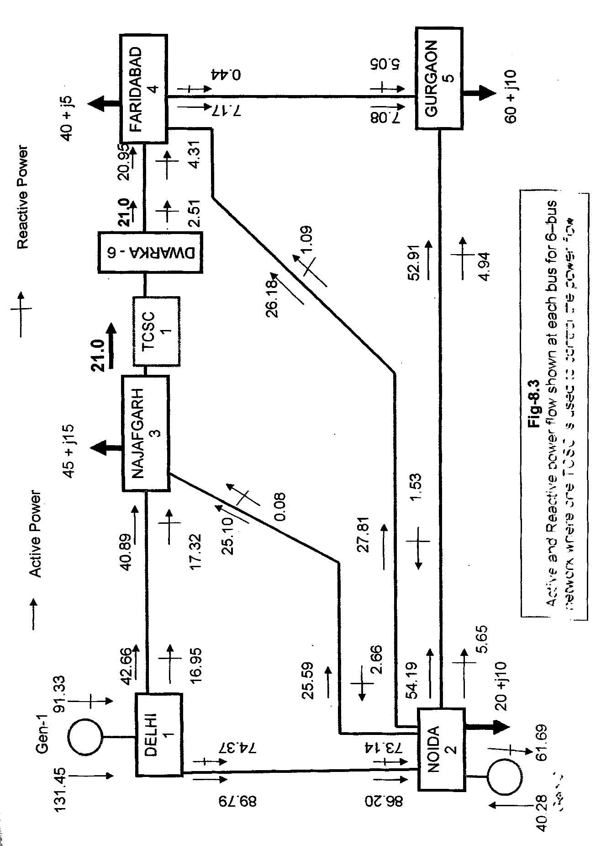

RESULT – 1 :
Fig. 7.5 is modified and reproduced in Fig-8.3, in which one TCSC is connected between Najafgarh and Dwarka to control 21 MW of power flow from Najafgarh to Faridabad. The power flow solution is obtained in 8 iteration to a power mismatch tolerance of le-12. The power flow results are shown in fig-8.3.
Since the TCSC cannot generate active power, there is an increase in active power flow from DELHI bus to NAJAFGARH bus (i.e. from 42.00 MW to 42.66 MW). At the same time there is increase of active power flow from NOIDA bus to NAJAFGARH bus (i.e. from 24.56 MW to 25.59 MW). In total there is increase of active power flow from NAJAFGARH to FARIDABAD ( i.e. from 19.39 MW to 21 MW).
It should be remarked that transmission line from NAJAFGARH to FARIDABAD is series compensated by the use of TCSC-1 and there is an increase of active power flow from 19.38 MW to 21 MW, which is just under 8% active power increase. Thus TCSC with firing angle control provides a good series compensation in the transmission line for controlling the active power flow.
8.3 POWER FLOW SOLUTION OF 7-BUS NETWORK
The network shown in Fig-8.4 consists of two TCSC for controlling the power flow. One TCSC is connected in between Najafgarh and Dwarka. Other is connected in between Faridabad and Badarpur. The MATLAB code which is written for one TCSC is now modified with additional data for TCSC-2 and executed. The power flows varies in the transmission line and it is different from the case used for one TCSC.

DATA FOR 7-BUS NETWORK IN WHICH TCSC-1 AND TCSC-2 IS CONNECTED :
TRANSMISSION LINE DATA :
Total no of transmission line = 7
Transmission Line | Fm | To | Resistance in p.u | Reactance in p.u | Susceptance in p.u
Tline-1 | Delhi | Noida | 0.02 | 0.06 | 0.06
Tline-2 | Delhi | Najafgarh | 0.08 | 0.24 | 0.05
Tline-3 | Noida | Najafgarh | 0.06 | 0.18 | 0.04
Tline-4 | Noida | Faridabad | 0.06 | 0.18 | 0.04
Tline-5 | Noida | Gurgaon | 0.04 | 0.12 | 0.03
Tline-6 | Dwarka | Faridabad | 0.01 | 0.03 | 0.02
Tline-7 | Badarpur | Gurgaon | 0.08 | 0.24 | 0.05
GENERATOR BUS DATA
Total no of Generator = 2
Bus No | Bus Type | Bus Type Nodal voltage in p.u | Nodal phase angle in p.u | Active power injected in p.u | Reactive power injected in p.u | Generators reactive power upper limits in p.u. | Generators reactive power lower limit in p.u
Delhi-1 | Slack Bus | 1.06 | 0 | Unknown | Unknown | 5 | -5
Noida-2 | Generator PV Bus | 1.00 | ? | 0.4 | ? | 3 | -3
LOAD BUS DATA
Total no of load = 4
Bus No | Bus Type | Nodal voltage in p.u | Nodal phase angle in p.u | Active power drawn in p.u | Reactive power drawn in p.u
Noida-2 | Load PQ Bus | ? | ? | 0.20 | 0.10
Najafgarh-3 | Load PQ Bus | ? | ? | 0.45 | 0.15
Faridabad-4 | Load PQ Bus | ? | ? | 0.40 | 0.05
Gurgaon-5 | Load PQ Bus | ? | ? | 0.60 | 0.1

TCSC’s Data
Total No of TCSC = 2

Data for TCSC-1
Connected between : Najafgarh-3 to Dwarka-6
Capacitive reactance of TCSC-1 = 9.375e-3
Inductive Reactance of TCSC-1 = 1.625e-3
Initial Firing Angle = 145 degree
Firing angle lower limit = 90 degree
Firing angle upper limit = 180 degree
Active Power to be controlled = 0.21 p.u

Data for TCSC-2
Connected between : Faridabad-4 to Dwarka-7
Capacitive reactance of TCSC-2 = 9.375e-3
Inductive Reactance of TCSC-2 = 1.625e-3
Initial Firing Angle = 145 degree
Firing angle lower limit = 90 degree
Firing angle upper limit = 180 degree
Active Power to be controlled = 0.22 p.u

General Parameters :
Maximum Iteration = 100,
Tolerance = 1e-12

MATLAB PROGRAM—6.2

% Main TCSC –FA Program for TCSC-1 & TCSC-2 to get the output of power flow solution of a given network (MATLAB PROGRAM-6.1 is modified and some additional data is added for TCSC-2 and the portion of modified program is shown below)

% The six buses in the network are numbered for the purpose of the power
% Flow solution, as follows:

% DELHI = 1
% NOIDA = 2
% NAJAFGARH = 3
% FARIDABAD = 4
% GURGAON = 5
% DWARAKA = 6
% BADARPUR= 7

nb=7;
Bus type (1)=1;VM (1)=1.06;VA (1)=0;
Bus type (2)=2;VM (2)=1; VA (2)=0;
Bus type (3)=3;VM (3)=1; VA (3)=0;
Bus type (4)=3;VM (4)=1; VA (4)=0;
Bus type (5)=3;VM (5)=1; VA (5)=0;
Bus type (6)=3;VM (6)=1; VA (6)=0;
Bus type (7)=3;VM (7)=1; VA (7)=0;

% TRANSMISSION LINE DATA
% nt1=number of transmission lines
% tlsend=sending end of transmission line
% tlrec=receiving end of transmission line
% tlresis=series resistance of transmission line
% tlreac=series reactance of transmission line
% tlcond=shunt conductance of transmission line
% tlsuscep=shunt susceptance of transmission line

ntl=7;
tlsend(1)=1;tlrec(1)=2;tlresis(1)=0.02;tlreac(1)=0.06;tlcond(1)=0;tlsuscep(1)=0.06;
tlsend (2)=1;tlrec(2)=3;tlresis(2)=0.08;tlreac(2)=0.24;tlcond(2)=0;tlsuscep(2)=0.05;
tlsend(3)=2;tlrec(3)=3;tlresis(3)=0.06;tlreac(3)=0.18;tlcond(3)=0;tlsuscep(3)=0.04;
tlsend(4)=2;tlrec(4)=4;tlresis(4)=0.06;tlreac(4)=0.18;tlcond(4)=0;tlsuscep(4)=0.04;
tlsend(5)=2;tlrec(5)=5;tlresis(5)=0.04;tlreac(5)=0.12;tlcond(5)=0;tlsuscep(5)=0.03;
tlsend(6)=3;tlrec(6)=4;tlresis(6)=0.01;tlreac(6)=0.03;tlcond(6)=0;tlsuscep(6)=0.02;
tlsend(7)=4;tlrec(7)=5;tlresis(7)=0.08;tlreac(7)=0.24;tlcond(7)=0;tlsuscep(7)=0.05;

% TCSC DATA
NTCSCFA = 1;
TCSCF Asend (1) = 3; TCSCF Arec (1) = 6; Xc (1) = 9.375 e-3; X1 (1) = 1.625 e-3; FA (1) = 145; FALo (1) = 90; FAHi (1) = 180; Flow(1)=1;Psta (1)=1; Psp(1)=0.21; TCSCF Asend(2)=4;TCSCF A rec (2)=7; Xc(2)=12.375 e-3;Xl(2)=0.625e-3; FA(2)=145;FALo(2)=90;FAHI(2)=180;Flow(1)=1;Psta (1)=1;Psp(1)=0.21;Psta(1)= 0.22;

% Main Program
[YR, YI]=Ybus (tlsend, tlrec, tlresis, tlreac, tlsuscep, tlcond, shbus, shresis, shreac, ntl, nb, nsh);
[VM, VA, it]= NewtonRaphson (nmax, tol, itmax, ngn, nld, nb, bustype, genbus, loadbus, PGEN,
QGEN, QMAX, QMIN, PLOAD, QLOAD, YR, YI, YM, VA,NTCSCFA, TCSCF A send, TCSCFA REC, Xc,Xl,FA,FALo,FAHi,Flow, Psta, Psp);
[PQsend, PQrec, PQloss, PQbus]=PQ flows (nb, ngn, ntl, nld, genbus, loadbus, tlsend, tlrec, tlresis,
Tlreac, tlcond, tlsuscep, PLOAD, QLOAD, YM, VA);
[PQTCSC SEND, PQTCSC rec] = TCSCPQ power (VA, VM, NTCSCFA, TCSCFA send, TCSCFA rec, X)
VA = VA *180/pi;
MVA base = 100; % MVA base
Psend=real (PQsend)*MVAbase; %active power sent from each bus
Qsend=imag (PQsend)*MVAbase; %reactive power sent from each bus
Prec= real (PQrec)*MVAbase; %active power received at each bus
Qrec= imag (PQrec)*MVAbase; %reactive power received at each bus
Ploss= real (PQloss)*MVAbase; %active power loss in each transmission line
Qloss= imag (PQloss)*MVAbase; %reactive power loss in each transmission line
Pinjected=(real (PQbus)*MVAbase);
Pgen=[Pinjected (1,1)+Pinjected (1,2)-PLOAD (1)*MVAbase+Pinjected (1,3)+Pinjected (1,4) Pinjected (1,5) Pinjected (1,6) Pinjected(1,7)];
Qinjected=(imag (PQbus)*MVAbase);
Qgen=[Qinjected (1,1)+Qinjected (1,2)-QLOAD (1)*MVAbase+Qinjected (1,3)+Qinjected (1,4) Qinjected (1,5) Pinjected (1,6) Pinjected (1,7)];

disp('ACTIVE POWER SENT FROM EACH BUS::::::::;)
disp(' DELHI DELHI NOIDA NOIDA NOIDA NAJAF BPUR')
disp(' NOIDA NAJAF NAJAF FBAD GURGAON FBAD GURGAON')
disp(' ===== ===== ===== ==== ======= ==== =======')
disp(Psend)
disp('ACTIVE POWER RECEIVED AT EACH BUS::::')
disp(' NOIDA NAJAF NAJAF FBAD GURGAON FBAD GURGAON')
disp(' ===== ===== ===== ==== ======= ==== =======')
disp(Prec)
disp('ACTIVE POWER LOSS ON TRANSMISSION LINE::::')
disp(' DELHI DELHI NOIDA NOIDA NOIDA DWARKA BPUR')
disp(' NOIDA NAJAF NAJAF FBAD GURGAON FBAD GURGAON')
disp(' ===== ===== ===== ==== ======= ==== =======')
disp(Ploss)
disp('REACTIVE POWER SENT FROM EACH BUS ')
disp(' DELHI DELHI NOIDA NOIDA NOIDA DWARKA BPUR')
disp(' NOIDA NAJAF NAJAF FBAD GURGAON FBAD GURGAON')
disp(' ===== ===== ===== ==== ======= ==== =======')
disp(Qsend)
disp('REACTIVE POWER RECEIVED AT EACH BUS::::')
disp(' NOIDA NAJAF NAJAF FBAD GURGAON FBAD GURGAON')
disp(' ===== ===== ===== ==== ======= ==== =======')
disp(Qrec)
disp('REACTIVE POWER LOSS ON TRANSMISSION LINE::::')
disp(' DELHI DELHI NOIDA NOIDA NOIDA DWARKA BPUR')
disp(' NOIDA NAJAF NAJAF FBAD GURGAON FBAD GURGAON')
disp(' ===== ===== ===== ==== ======= ==== =======')
disp(Qloss)
disp('NET ACTIVE POWER INJECTED/OUTAGE AT GENERATOR/LOAD BUS::::')

disp(' DELHI NOIDA NOIDA NAJAF FBAD GURGAON DWARKA BPUR')
disp(' ===== ===== ===== ==== ======= ==== ======== ======')
disp(Pgen)
disp('NET REACTIVE POWER INJECTED/OUTAGE AT GENERATOR/LOAD BUS::::')
disp(' DELHI NOIDA NOIDA NAJAF FBAD GURGAON DWARKA BPUR ')
disp(Qgen)
TOTALGENERATION_ACTIVEPOWER=(Pgen(1,1)+Pgen(1,2))
TOTALGENERATION_REACTIVEPOWER=(Qgen(1,1)+ (Qgen(1,2)+ (Qgen(1,5)
TOTAL_ACTIVE_LOAD=-(PLOAD (1)+PLOAD (2)+PLOAD (3)+PLOAD (4))*MVAbase
TOTAL_REACTIVE_LOAD=-(QLOAD (1)+QLOAD (2)+QLOAD (3)+QLOAD (4))*MVAbase
TOTAL_ACTIVEPOWER_LOSS=TOTALGENERATION_ACTIVEPOWER+TOTAL_ACTIVE_LOAD
TOTAL_REACTIVEPOWER_LOSS=TOTALGENERATION_REACTIVEPOWER+TOTAL_REACTIVE_LOAD

SUMMARY OF OUTPUTS :
ACTIVE POWER SENT FROM EACH BUS ::::
Delhi |  | Delhi | Noida | Noida | Noida | Dwarka | BPur
Noida |  | Najaf | Najaf | FBad | Gurgaon | FBad | Gurgaon
89.2434 |  | 42.7349 | 25.4970 | 43.1498 | 38.3180 | 21.0033 | 22.9577
ACTIVE POWER REACEIVED AT EACH BUS::::
Noida |  | Najaf | Najaf | FBad | Gurgaon | FBad | Gurgaon
-86.6484 |  | -40.9829 | -25.0142 | -41.8647 | -37.6175 | -20.9519 | -22.3825
ACTIVE POWER LOSS ON TRANSMISSION LINE :::::
Delhi |  | Delhi | Noida | Noida | Noida | Dwarka | BPur
Noida |  | Najaf | Najaf | Fbad | Gurgaon | Fbad | Gurgaon
2.5951 |  | 1.7520 | 0.4828 | 1.2851 | 0.7005 | 0.0514 | 0.5752
REACTIVE POWER SENT FROM EACH BUS::::
Delhi |  | Delhi | Noida | Noida | Noida | Dwarka | BPur
Noida |  | Najaf | Najaf | FBad | Gurgaon | FBad | Gurgaon
74.2474 |  | 16.0179 | -3.8013 | -7.0318 | 10.0700 | -0.1455 | -4.4705
REACTIVE POWER LOSS ON TRANSMISSION LINE ::::
Noida |  | Najaf | Najaf | FBad | Gurgaon | Fbad | Gurgaon
-72.9821 |  | -16.4735 | 1.0360 | 6.4911 | -11.0271 | -1.6681 | 1.0271
REACTIVE POWER LOSS ON TRANSMISSION LINE ::::
Delhi |  | Delhi | Noida | Noida | Noida | Dwarka | BPur
Noida |  | Najaf | Najaf | Fbad | Gurgaon | Fbad | Gurgaon
1.2653 |  | -0.4556 | -27653 | -0.5408 | -0.9571 | -1.8136 | -3.4434
NET ACTIVE POWER INJECTED OUTAGE AT GENERATOR/LOAD BUS :::::
Delhi | Noida | Noida | Najaf | FBad | Gurgaon | Dwarka | BPur
131.9784 | 40.3164 | -20.0000 | -65.9971 | -62.8167 | -60.0000 | 21.0033 | 22.9577
NET REACTIVE POWER INJECTED/OUTAGE AT GENERATOR/LOAD BUS::::
Delhi | Noida | Noida | Najaf | FBad | Gurgaon | Dwarka | BPur
90.2652 | -63.7452 | -10.0000 | -15.4376 | 4.8229 | -10.0000 | -0.1455 | -4.4705

TOTAL GENERATION_ACTIVE POWER =
172.2948
TOTAL GENERATION _ REACTIVE POWER =
31.3430
TOTAL_ACTIVE_LOAD =
-165
TOTAL_REACTIVE_LOAD=
-40
TOTAL_ACTIVE_POWER LOSS =
7.2948
TOTAL_REACTIVE POWER_LOSS=
-8.6570

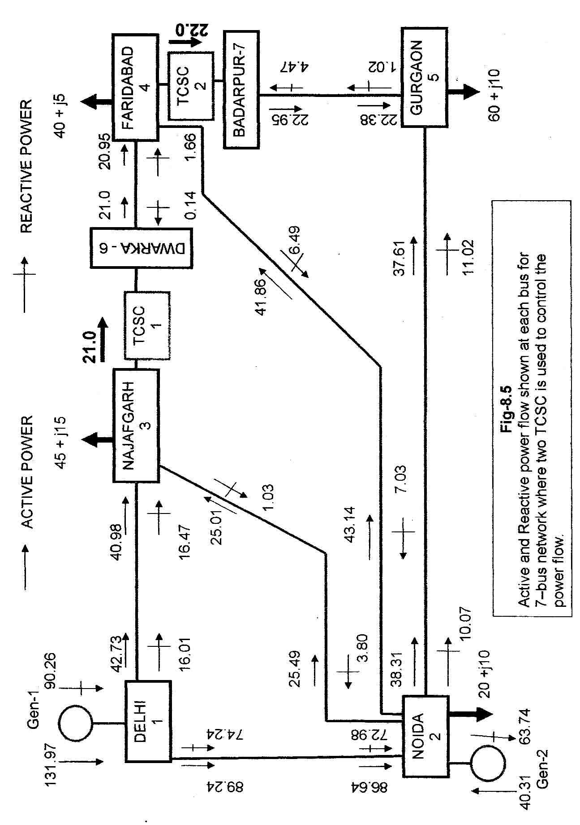

RESULT – 2
From Fig-8.5, we observe that TCSC-1 provides series compensation in the transmission line between Najafgarh to Faridabad bus. This is because active power flow from NAJAFGARH to FARIDABAD is increased from 19.39 MW (shown in fig 7.5) to 21 MW. At the same time the active power flow from DELHI to NAJAFGARH is increased from 42.00 MW to 42.73 MW and from NOIDA to NAJAFGARH is increased from 24.56 MW to 25.49 MW as TCSC doesn’t generate any active power.
Similarly from Fig-8.5, we observe that TCSC-2 provides series compensation in the transmission line between FARIDABAD to GURGAON. This is because active power flow from FARIDABAD to GURGAON is increased from 6.63 MW to 22 MW. At the same time the active power flow from NOIDA to FARIDABAD is increased from 27.81 MW to 27.81 MW and NOIDA to GURGAON is decreased from 54.75 MW to 38.31 MW as TCSC does not generate any active power.
Also power mismatch equation is satisfied at each bus, after using two TCSC. Thus from the analysis it is very clear that both TCSC provides effective series compensation in the two different transmission line and specified amount of active power is controlled.

8.4 CONCLUSION :
From the Result-1 and Result-2, we reached at conclusion that, how effectively Thyristor-Controlled Series Capacitor (TCSC) can control the active power flow between to buses. With the use of TCSC, a specified amount of power can be transferred from one bus to other as TCSC does not consume or generate active power.
9
CONCLUSION AND FURTHER SCOPE OF WORK
9.1 SUMMARY OF WORK :
Objective of the whole work is to control the power flow in the transmission line. This can be achieved by knowing the various parameters which are involved in power flow in the transmission line. In chapter 3rd and 4th conventional method used to determine the various parameters. For each of the parameter, we have discussed how can we control the active and reactive power flow in the transmission line. For each parameter we have used PSCAD-4.0/MATLAB application software to analyze the power flow.
As Thyristor-Controlled Series Capacitor (TCSC), is a series compensator used in transmission lien to control the active power flow, so in Chapter-5 it is discussed about the principle of series compensation and simulation block is used to verify the truth ness, how capacitor is effective element to reduce the series reactance. For this PSCAD-4.0 software is used.
In further discussion in Chapter-6, we have analyzed the characteristics of TCSC. By using PSCAD software and we come to know how effectively, TCSC can control the current and active power flow in the transmission lien by varying the firing angle of TCSC.
A practical electrical network is having large number of buses. Thus in this work, a 5-bus imaginary network is considered in Chapter-7 for finding the power flow solution. Newton-Raphson method is used to solve this network. By using MATLAB code for his network, power flow between each buses is determined. Power flow solution of this network satisfies the power mismatch equation at each bus.
In Chapter-8, Jacobian matrix is determined for 6-bus network in which one TCSC is used in between two buses. Again power flow solution is determined for this network and we come to know that it also satisfies the power mismatch equations at each bus. At the same time, a specified amount of active power is allowed flow between two buses by using the TCSC. In the next section again two TCSC is used to analyze the power flow in different transmission line. Here also MATLAB code is used for finding the power flow solution of given electrical network.
9.2 CONCLUSION :
From the execution of simulation block in PSCAD and MATLAB code, we reached at a conclusion that Thyristor-Controlled Series Capacitor is one of the fast acting power electronic controller which can provide current and power flow control in the transmission line by varying its firing angle. Thus TCSC can be used as a series capacitor to reduce the overall transmission line reactance. Depending on the enhancement of power transfer desired at the time, without affecting other system-performance criteria, series compensation can be varied by TCSC. Thus TCSC is one of the important FACTS controller, which increases the overall power transfer capacity in the transmission line.
9.3 FURTHER SCOPE OF WORK :
Works on the topic never ends with limited application. It has much more area of application such as damping of the power swings from local and inter-area oscillations, Voltage regulation of local network, reduction of short-circuit current etc. Various research works are going on control interaction between multiple Thyristor-Controlled Series Capacitor (TCSC). Also SVC-TCSC can be combined and used within power systems to enhance inter-area stability. In this work MATLAB code is used for 5-bus network for power flow solution. PSCAD-4.0 can also be used for designing a physical 5-bus network to determine the exact power flow from one bus to another. Though in this discussion PSCAD-4.0 software is used for two bus system, but it can be used for large bus network. Further study can be made on the Influence of TCSC on Fault Component Distance Protection and Impact of TCSC on the Protection of Transmission Lines. Thus TCSC can be used in many fields.
Appendix – ‘A’
MATLAB PROGRAM 2.1
%ANALYSIS OF ACTIVE AND REACTIVE POWER FLOW IN A LOSS LESS %TRANSMISSION LINE
Vs=input('line voltage= ');
Vr=Vs;
V=Vs;%assuming terminal voltage Vs=Vr=V
X=input('line reactance= ');
delta=(0:10:180);
delta1=delta*pi/180;
l=length(delta1);
P=(V^2/X.*sin(delta1));
Q=(V^2/X).*(ones(1,1)-cos(delta1));
result=[delta,P,Q];
disp('RESULT IS ');
disp(' delta P Q');
disp(result)
plot(delta,P,delta,Q)

MATLAB PROGRAM 4.1

%ANALYSIS OF ACTIVE AND REACTIVE POWER FLOW WITH VARIATION %OF FIRING ANGLE
Vs=input('line voltage= ');
Vr=Vs;
V=Vs;
X=input('line reactance= ');
X1=input('inductive reactance of TCR= ');
Xc=input('fixed capacitive impedance= ');
delta=input('phase angle= ');%difference of phase angle between sending end and receiving end
delta1=(0:10:180);%variation of load angle
alpha=(0:10:90);%variation of firing angle
alpha1=alpha*pi/180;
l=length(alpha1);
k=length(delta1);
var1=ones(1,1)*pi;
var2=(var1-2.*alpha1-sin(2.*alpha1));
X1_alpha=X1*pi./(var2);%reactance of TCR
Xc_new=ones(1,1)*Xc;
XT_alpha=(Xc.*X1_alpha)./(X1_alpha-Xc_new);%reactance of TCSC
r=(XT_alpha)./X;%compensating ratio
Xeq=(ones(1,1)*X-XT_alpha);%reactance of transmission line
%after compensation
Pc=(V^2*sin(delta*pi/180))./(Xeq);
Qc=(2*V^2/X)*(1-cos(delta*pi/180)).*(r./(ones(1,1)-r).^2);
result=[alpha,Pc,Qc,r];
disp('RESULT IS ');
disp(' alpha Pc Qc r')
disp(result)
Pc1=(V^2/(1-r(1,1))*X).*sin(delta1.*pi/180);%active power for first element of r %column matrix
Pc9=(V^2/(1-r(1,9))*X).*sin(delta1.*pi/180);%active power for ninth element of r %column matrix
Pc10=(V^2/(1-r(1,10))*X).*sin(delta1.*pi/180);%active power for 10th element of r %column matrix
Qc1=(2*V^2/X)*(r(1,1)/(1-r(1,1))^2).*(ones(1,1)-cos(delta1.*pi/180));%reactive %power for first element of r column matrix
Qc9=(2*V^2/X)*(r(1,9)/(1-r(1,9))^2).*(ones(1,1)-cos(delta1.*pi/180));%reactive %power for 9th element of r column matrix
Qc10=(2*V^2/X)*(r(1,10)/(1-r(1,10))^2).*(ones(1,1)-cos(delta1.*pi/180));%reactive %power for 10th element of r column matrix
subplot(2,2,1),plot(alpha,Pc,alpha,Qc)
title('ACTIVE POWER AND REACTIVE POWER vs FIRING ANGLE')
Xlabel('firing angle')
Ylabel('P,Q')
subplot(2,2,2),plot(delta1,Pc1,delta1,Pc9,delta1,Pc10)
title('ACTIVE POWER vs LOAD ANGLE')
Xlabel('load angle')
Ylabel('active power(P)watts')
subplot(2,2,3),plot(delta1,Qc1,delta1,Qc9,delta1,Qc10)
title('REACTIVE POWER vs LOAD ANGLE')
Xlabel('load angle')
Ylabel('reactive power(Q)var')

Appendix – ‘B’

MATLABPROGRAM—5.1

COMPUTER PROGRAM FOR POWER FLOW CONTROL USING NEWTON RAPHSON METHOD:
% Build up admittance matrix
function [YR, YI]= Y bus (tlsend,tlrec, tlresis, tlreac, tlsuscep, tlcond, shbus, shresis, shreac, ntl, nsh);
YR=zero (nb,nb);
YI=zero (nb,nb);
% Transmission Line Contribution
for 1=1:ntl %numbering of transmission line
k= tlsend(1);% sending end of transmission line
m= tirec(1);% receiving end of transmission line
denom= tlresis(1)^2 + tlreac(1) ^2;
YR (k,k)= YR(k,k) + tlresis(1)/denom+0.5*tlcond(1); %self conductance
YI (k,k)= YI(k,k) + tlresis(1)/denom+0.5*tlcond(1); %self conductance
YR (k,m)= YR(k,m) + tlresis(1)/denom; %mutual conductance
YI (k,m)= YI (k,m) + tlresis(1)/denom; %mutual conductance
YR (m,k)= YR(m,k) - tlresis(1)/denom;
YI (m,k)= YI(m,k) + tlresis(1)/denom;
YR (m,m)= YR(m,m) + tlresis(1)/denom+0.5*tlcond(1);
YI (m,m)= YI(m,m) - tlresis(1)/denom+0.5*tlcond(1);
end

% Shunt element contribution
for n= 1:nsh % numbering of shunt connected
k= shbus(1);% sending end of shunt
denom= shresis(n)^2 +shresis(n) ^2;
YR (k,k)= YR(k,k) + shresis(n)/denom;
YI (k,k)= YI(k,k) + shresis(n)/denom;
end
% end of function Ybus

% Carry out iterative solution using the Newton-Raphson method
[VM, VA, it]= NewtonRaphson (nmax, tol, itmax, ngn, nld, nb, bustype, genbus, loadbus, PGEN,QGEN, QMAX, QMIN, PLOAD, QLOAD, YR, YI, YM, VA);

% GENERAL SETTINGS
D= zeros(1,nmax);
Flag=0;
it= 1;

% CALCULATION NET POWERS
[PNET, QNET]=Netpowers(nb,ngn, nld, genbus, loadbus, PGEN,QGEN, PLOAD, QLOAD);

while (it< itmax & flag = =0);

% CALCULATED POWERS
[PCAL,QCAL]=calculatedpowers(nb,VM,VA,YR,YI);

% CHECK FOR POSSIBLE GENERATOR’S REACTIVE POWERS LIMITS VIOLATIONS
{QNET,bustype}=GeneratorsLimits (ngn,genbus,bustype,QGEN,QMAX,QCAL,QNET,QLOAD, it, VM,nld,loadbus);

% POWER MISMATCHS
[DPQ,DP,DQ,flag]= PowerMismatches(nmax,nb,tol,bustype,flag,PNET,QNET,PCAL,QCAL);

% JACOBIAN FORMATION
[JAC]= NewtonRaphsonJacobian(nmax,nb,bustype,PCAL,QCAL,VM,VA,YR,YI);

% SOLVE FOR THE STATE VARIABLES VECTOR
D= JAC\DPQ;

% UPDATE STATE VARIABLES
[VA,VM]= StateVariableUpdates(nb,D,VA,VM):
for it=it+1;
end

%End function Newton-Raphson

% Function to calculate the net scheduled powers
function [PNET,QNET]=Netpowers(nb,ngn,nld,genbus,loadbus,PGEN,QGEN,PLOAD,QLOAD);

% CALCULATE POWERS
PNET=zeros (1, nb);
QNET=zeros (1, nb);
for ii = 1: ngn
PNET (genbus (ii)=PNET (load bus (ii) +PGEN (ii);
QNET (genbus (ii)=QNET (load bus (ii) +QGEN (ii);
end
for ii = 1: nld
PNET (genbus (ii)=PNET (load bus (ii) +PGEN (ii);
QNET (genbus (ii)=QNET (load bus (ii) +QGEN (ii);
end

%End function Net power
% FUNCTION TO CALCULTE INJECTED BUS POWER
Function [PCAL, QCAL]=Calculate powers (nb, VM, VA, YR, YI);

% Include all entries
PCAL=zeros (1, nb);
QCAL=zeros (1, nb);
for k=1:nb
PSUM=zeros (1, nb);
QSUM=zeros (1, nb);
for m=1:nb
PSUM=PSUM+VM (k)*VM (m)(YR (k, m)*cos(VA(k)-
VA(m)+YI(k,m)*sin(VA(k)-VA(m)));
QSUM=QSUM+VM (k)*VM (m)(YR (k,m)*cos(VA(k)-
VA(m)+YI(k,m)*sin(VA(k)-VA(m)));
end
PCAL= PSUM;
QSUM=QCAL;
end

% End of function calculated powers
% Function to check whether or not solution is within generators limits
Function [QNET, bustype]= Generators Limits (ngn, genbus, bustype, QGEN, QMAX, QMIN, QCAL, QNET, QLOAD, it, VM nld, loadbus)
% CHECK FOR POSSIBLE GENERATORS REACTIVE POWERS LIMITS VIOLATIONS
If it> 2
flag2= 0;
for ii=1:ngn
jj= genbus (ii);
if (bustype (jj)= =2
if (QCAL(jj)>QMAX(ii);
QNET (genbus (ii)=QMIN (ii);
bustytpe(jj)=3;
flag2=1;
elseif (QCAL (jj)<QMIN(ii)
QNET (genbus (ii)=QMIX (ii);
bustype(jj)=3;
flag2=1;
end
if flag2= 0;
for ii=1:nid;
if loadbus(ii)==jj
QNET (loadbus (ii)=QNET (ii)-QLOAD (ii);
end
end
end
end
end
end
% End function Generators Limits

% Function to compute power mismatches
function [DPQ, DP, DQ, flag] = power Mismatches (nmax, nb, tol, bustype, flag, PNET, QNET, PCAL, QCAL);
% POWER MISMATCHES
DPQ=zero (1, nmax);
DP=zero (1, nb);
DQ=zero (1, nb);
DP=PNET-PCAL; % active power mismatches
DQ=QNET-QCAL; % reactive power mismatches
% To remove the active and reactive power contribution of the slack
% bus and reactive power of all PV buses
for k= 1:nb
if (bustype(k)==1)
DP (k)=0;
DQ (k)= 0;
elseif (bustype (k)==2
DQ (k)=0;
end
end
% Re-arrange mismatch entires
kk=1;
for k= 1:nb
DPQ (kk)= DP (k);
kk=kk+2;
end
% Check for convergence
for k= 1:nb*2
if (abs(DPQ)<tol)
flag=1;
end
end
% end function Power Mismatches

% Function to built the Jacobian matrix
function [JAC]=Newton Raphson Jacobian (nmax,nb, bustype, PCAL, QCAL, VM, VA, YR, YI);
% JACCOBIAN FORMATION
%Include all entries
JAC=zero (nmax, nmax);
iii=1;
for k=1:nb
jjj=1;
for m=1:nb
if k= = m
JAC (iii, jjj)= -QCAL (k)-VM (k) ^2*YI (k,k);
JAC (iii,jjj+1)= -PCAL (k)-VM(k) ^2YR(k,k);
JAC (iii+1,jjj)= -PCAL (k)-VM (k) ^2YR(k,k);
JAC (iii+1,jjj+1)= -QCAL (k)-VM (k) ^2YI(k,k);
else
JAC (iii, jjj)=VM (k)*VM (m)*(YR (k, m)*sin (VA(k)-
VA(m)+YI(k,m)*cos(VA(k)-VA(m)));
JAC (iii+1, jjj)= -VM (k)*VM (m)*(YI (k, m)*sin (VA (k)-VA (m)+YR
(k,m)*cos(VA(k)-VA(m)));
JAC (iii, jjj+1)= -JAC (iii+1,jjj)
JAC (iii+1,jjj+1)= JAC (iii, jjj)
end
jjj=jjj+2
end
iii=iii+2
end
% Delete the voltage magnitude and phase angle equations of the slack
%bus and voltage magnitude equations corresponding to PV buses
for kk=1:nb
if(bustype(kk)= = 1)
k=kk*2-1;
for m = 1:2 *nb
if k= = m
JAC (k,m)= 1;
else
JAC (k,m) =0;
JAC (m,k) =0;
end
end
end
if (bustype(kk) = =1) | (bustype(kk)= = 2)
k = kk*2;
for m = 1:2*nb
if k = =m
JAC (k,k) = 1;
else
JAC (k,m)= 0;
JAC (m,k) =0;
end
end
end
end
%End of function NewtonRaphsonJacobian

%Function to update state variables
function [VA, VM]=Sate Variables Updates (nb, D, VA, VM);
iii=1;
for k= 1:nb
VA(k)=VA(k)+D(iii);
VM(k)=VM(k)+D(iii)*VM(k);
iii = iii+2;
end
%End function State Variables Updating

%Function to calculation to calculate the power flows
function[Pqsend,Pqrec,Pqloss,Pqbus]=Pqflows(nb,ngn,nld,genbus, loadbus, tlsend, tlrec, tlresis, tlreac, tlcond, tlsuscep, PLOAD, QLOAD, VM, VA);
PQsend=zeros(1, ntl);
PQrec=zeros(1, ntl);
%Calculate active and reactive power at all sending and receiving ands of
% transmission line)
for 1=1:ntl
Vsend=(VM(tlsend(1)*cos(VA(tlsend(1)))+(VM(tlsend(1)*sin(VA(tlsend(1)))*j));
Vrec=(VM(tlrec(1)*cos(VA(tlrec(1)))+(VM(tlrec(1)*sin(VA(tlrec(1)))*j));
Tlimped=tlresis(1)+tlreac(1)*j;
Current= (Vsend-Vrec)/tlimped+Vrec(tlcond(1)+tlsuscep(1)*j)*0.5;
Pqsend(1)=Vsend*conj(current);
Current= (Vrec-Vsend)/tlimped+Vrec(tlcond(1)+tlsuscep(1)*j)*0.5;
PQrec(1)=Vrec*conj(current);
Pqloss(1)=Pqsend(1)+Pqrec(1);
end
%Calculate active and reactive powers injections at buses
PQbus=zeros (1,nb);
for 1=1:ntl
PQbus (tlsend (1)= PQbus (tlsend (1) + PQsend (1);
PQbus (tlrec (1)= PQbus (tlrec (1) + PQrec (1);
end

% Make corrections at generator buses, where there is load in order to get
% correct generators contributions
for it =1:nlb;
jj=loadbus (ii);
for kk=1:ngn
ll= genbus(kk);
if jj= =ll
PQbus(jj)=PQbus(jj)+(PLOAD(ii)+QLOAD(ii)*j);
end
end
end
% End functions PQ flows

Appendix – ‘C’

MATLABPROGRAM—6.1

COMPUTER PROGRAM FOR POWER FLOW CONTROL USING TCSC (THYRISTOR CONTLLED SERIES CAPACITOR):

% Build up admittance matrix
function [YR, YI]= Y bus (tlsend, tlrec, tlresis, tlreac, tlsuscep, tlcond, shbus, shresis, shreac, ntl,nb, nsh);(This is same as mentioned in Appendix-B)

% Carry out iterative solution using the Newton-Raphson method where TCSC
controller is used in the network.

Function([VM, VA, it, FA, X] =TCSCFA NewtonRaphson (nmax, tol, itmax, ngn, nld, nb, bustype, genbus, loadbus, PGEN,QGEN, QMAX, QMIN, PLOAD, QLOAD, YR, YI, YM, VA, NTCSCFA, TCSCF Asend, TCSCF Arec, Xc, Xl, FA,FALo, FAHi, Flow, Psta, Psp);

% GENERAL SETTINGS
D= zeros (1, nmax);
Flag=0;
It= 1;

% CALCULATION NET POWER
[PNET, QCAL]=Netpowers (nb,ngn, nld, genbus, loadbus, PGEN,QGEN, PLOAD, QLOAD);

while (it< itmax & glag = = 0);

% CALCULATE POWERS
[PNET, QCAL]=calculated powers (nb, VM, VA, YR, YI);

% POWER MISMATCHS
[DPQ, DP, DQ,flag]= Power Mismatches (nmax,nb,tol, bustype, flag, PNET, QNET, PCAL, QCAL);

%TCSC POWER MISMATCHES
[DPQ]=TCSCFA Power Mismatches(nb, DPQ, VM, VA, NTCSCFA, TCSCF Asend., TCSCF Arec, X, Flow, it, Psp, Psta);

%check for convergence
if flag == 1
break
end

% JACOBIAN FORMATION
[JAC]= Newton Raphson Jacobian (nmax,nb, bustype, PCAL, QCAL, VM, VA, YR, YI);
%MODIFICATION JACOBIAN FOR TCSC-FA-it calculate the TCSC equivalent
% reactance
[JAC=TCSCFAJacbian(it, nb, JAC, VM, VA, NTCSCFA, TCSCFAsend, TCSCFArec, FA, Xc, Xl, Flow, Psta);

% SOLVE JACOBIAN
D=JAC/DPQ;
%UPDATE STATE VARIABLES
[VA, VM]=State Variables Updates (nb, D, VA, VM);
% UPDATE THE TCSC-FA VARIABLES
[FA]=TCSCFA_Updating (it, nb, NTCSCFA, FA, Psta);
% CHECK IMPEDENCE LIMITS
[FA]=TCSCFALimits (NTCSCFA, FA, FALo,FAHi, PSta);
it=it+1;
end
%End function TCSCFA Newton-Raphson
% Function to calculate injected bus powers
Function [PCAL, QCAL]= Calculated powers (nb, VM, VA, YR, YI);

% indclude all entries
(This is same as mentioned in appendix-B)

%Function to calculate injected bus powers by TCSC-FA
function [PCAL, QCAL, X]=TCSCFACalculate Power(PCAL, QCAL< VM, VA, NTCSCFA, TCSCFAsend, TCSCFArec, FA, Xc, Xl);
for ii=1:NTCSCFA
%Calculate Equivalent Reactance TCSCX
Xlc=Xc(ii)*Xl(ii)/(Xc(ii)-Xl(ii);
w =sqrt (Xc(ii)/Xl(ii);
C1= (Xc(ii)+Xlc(ii)/pi;
C1=4* Xlc^2/(Xl(ii)*pi;
Ang=pi-FA(ii)*pi/180;
X(ii)= -Xc(ii)+C1*(2*Ang+sin(2*Anf)-C2*cos(Ang) ^2*(w*tan(w*Ang)-tan(Ang));
Bmm= -1/X(ii);
Bmk=1/X(ii);
for kk=1:2
A=VA TCSCFAsend (ii)-VA (TCSCFArec (ii);
Pcal=VM (TCSCFAsend (ii)*VM (TCSCFArec (ii)*Bmk*sin (A);
Qcal= -VM (TCSCSFAsend(ii)^2*Bmm-
VM (TCSCFAsend (ii)*VM (TCSCFArec (ii)*Bmk*cos (A);
If kk==1
TCSC_PQsend(ii)=Pcal+j*Qcal;
else
TCSC_PQrec(ii)=Pcal+j*Qcal;
end
Send= TCSCFAsend(ii);
TCSCFAsend(ii)=TCSCFArec(ii);
TCSCFArec(ii)=send;
end
end
end

% Function to compute power mismatches
function [DPQ, DP, DQ, flag] = power Mismatches (nmax, nb, tol, bustype, flag, PNET, QNET, PCAL, QCAL);
% (This is already mentioned in Appendix-B)

%Function to compute power mismatches with TCSC-FA
function [DPQ] = TCSCFA power Mismatches (nb, DPQ, VM, VA, NTCSCFAsend, TCSCFArec, X, Flow, it, Psp, PSta);
if it>1
for ii=1:NTCSCFA
if Psta(ii)==1
Bmk=1/X(ii);
for kk= 1:2
A=VA(TCSCFAsend(ii)-VA(TCSCFArec(ii);
A=VM(TCSCFAsend(ii)*VM(TCSCFArec(ii)*Bmk*sin(A);
DPQ(1, 2*nb+ii)=Psp(ii)-Pcal;
Break;
end
Send=TCSCFAsend(ii);
TCSCFAsend(ii)=TCSCFArec(ii);
TCSCFArec(ii)=send;
end
else
DPQ(1, 2*nb+ii)=0;
end
end
end

% end function TCSCFA Power Mismatches

% Function to built the Jacobian matrix
function [JAC]=Newton Raphson Jacobian (nmax,nb, bustype, PCAL, QCAL, VM, VA, YR, YI);
% JACCOBIAN FORMATION
%Include all entries
% (This is already mentioned in Appendix-B)
% Function to add the TCSC-FA elements to jacobian matrix

function[JAC]=TCSCFA Jacobian (it, nb, JAC, VM, VA, NTCSCFA, TCSCFAsend, TCSCFArec, Fa, Xc, Xl, Flow, Psta);
for ii=1: NTCSCFA

%Calculate Equivalent Reactance TCSCX
Xlc=Xc(ii)*Xl(ii)/(Xc(ii)-Xl(ii);
w =sqrt (Xc(ii)/Xl(ii);
C1= (Xc(ii)+Xlc(ii)/pi;
C1=4* Xlc^2/(Xl(ii)*pi;
Ang=pi-FA(ii)*pi/180;
TCSCX= -Xc(ii)+C1*(2*Ang+sin(2*Anf)-C2*cos(Ang) ^2*(w*tan(w*Ang)-tan(Ang));

%Calculate Reactance Derivative
DTCSCX1=-2*C1*(1+cos (2*Ang);
DTCSCX2=C2*(w ^2*(cos (Ang) ^2/cos (w*Ang) +cos(2*Ang) ^2)) ;
DTCSCX3= -C2*(w* tan (w *Ang) *sin (2*Ang));
DTCSCX4= -C2*( tan (Ang) *sin (2*Ang)-1);
DTCSCX=DTCSCX1+ DTCSCX2+ DTCSCX3+ DTCSCX4
Bmm= -1/TCSCX;
Bmk=1/TCSCX;
for kk= 1:2
A=VA(TCSCFAsend(ii)-VA(TCSCFArec(ii);
Hkm= -VM(TCSCFAsend(ii)* VM(TCSCFArec(ii))*Bmm*cos(A);
Nkm= -VM(TCSCFAsend(ii)* VM(TCSCFArec(ii))*Bmm*sin(A);
JAC(2*TCSCFAsend(ii)-1, 2*TCSCFAsend(ii)-1=JAC(2*TCSCFAsend(ii)-
1,2* TCSCFAsend (ii)-1)-VM(TCSCFAsend(ii) ^ 2Bmm;
JAC (2*TCSC FAsend(ii)-1, 2*TCSCFArec(ii)-1=JAC(2*TCSCFAsend(ii)-
1,2 *TCSCFArec (ii)-1)-Hkm;
JAC (2*TCSCFAsend (ii)-1, 2*TCSCFArec(ii)=JAC(2*TCSCFAsend(ii)-
1,2 *TCSCFArec (ii)-1)-Nkm;
JAC(2*TCSCFAsend(ii)2*TCSCFAsend(ii)=JAC(2*TCSCFAsend(ii) 2
*TCSCFAsend(ii)- VM(TCSCFAsend(ii) ^ 2Bmm;
JAC (2*TCSCFAsend (ii) 2*TCSCFArec (ii)-1=JAC (2*TCSCFAsend (ii), 2
*TCSCFArec (ii) - 1+Nkm;
JAC (2*TCSCFAsend (ii), 2*TCSCFArec (ii)=JAC (2*TCSCFAsend (ii), 2
*TCSCFArec (ii) -Hkm;
if it>1
if Psta(ii)==1
A=VA (ii) TCSCFAsend (ii)-VA (TCSCFArec (ii));
Elm=-VM(TCSCFAsend(ii)*VM(TCSCFArec(ii)*Sin(A)*Bmk^
2*DTCSCX;
Fem.=-VM(TCSCFAsend(ii) ^ 2*VM(TCSCFAsend(ii)* VM(TCSCFArec
(ii)*cos(A)))*Bmk^ 2*DTCSCX;
If (Flow (ii)==1 & kk ==1)| (Flow (ii)==-1& kk==2)
Hkm= -VM (TCSCFAsend (ii)*VM (TCSCFArec (ii)*Bmk*cos (A);
Nkm=VM (TCSCFAsend (ii)*VM (TCSCFArec (ii)*Bmk*sin (A);
JAC (2*nb+ii,2*TCSCFAsend(ii)-1)=-Hkm;
JAC (2*nb+ii,2*TCSCFAsend(ii))=Nkm;
JAC (2*nb+ii,2*TCSCFArec(ii)-1)=Hkm;
JAC (2*nb+ii,2*TCSCFArec(ii))=-Nkm;
end
JAC (2*TCSCFAsend (ii)-1,2*nb+ii,)=-Elm;
JAC (2*TCSCFAsend (ii), 2*nb+ii,)=-Fem.;
else
JAC (2*nb+ii,2*nb+ii)=1;
end
end
send = TCSCFAsend(ii);
TCSCFAsend(ii)=TCSCFArec(ii);
TCSCFArec(ii)=send;
end
end
% Function to update state variables
function[VA,VM]=State Variables Updates (nb,D,VA, VM);
iii=1;
for k=1:nb
VA=(k)=VA (k)+D (iii);
VM=(k)=VM (k)+D (iii+1)*VM (k);
iii= iii+2;
end
%End function State Variables Updating
% Function to Update TCSC-FA state variables
Function [FA}=TCSCFA_Updating (it,nb,D,NTCSCFA, FA, PSta);
if it >1
for ii= 1:NTCSCFA
if Psta(ii)==1
FA (ii)= FA (ii)+D(2*nb+ii,1)*180/pi;
end
end
end

%CHECK IMPEDANCE LIMIT
Function[FA]= TCSCFALimits(NTCSCFA,FA, FALo, FAHi, Psta);
for ii=1:NTCSCFA
%Check impedance Limits
if FA(ii)<FALo(ii) | FA(ii)>FAHi(ii)
Psta(ii)=0;
If FA(ii) < FALo(ii)
FA(ii)=FALo(ii);
else if FA (ii)> FAHi(ii)
FA(ii)=FAHi(ii);
end
end
end

% Function to calculate the power flows in TCSC_FA controller
function [PQTCSCsend, PQTCSCrec]=TCSCPQpower(VA,VM,NTCSCFA,TCSCFAsend,TCSCFArec,X);
for ii=1:NTCSCFA
Bmm= -1/X(ii);
Bmk=1/X(ii);
for kk=1:2
A=VA (TCSCFAsend (ii)-VA (TCSCFArec (ii);
Ptcsc=VM (TCSCFAsend (ii)*VM (TCSCFArec (ii)*Bmk*sin (A);
Qtcsc= -VM (TCSCFAsend (ii)^2*Bmm-VM (TCSCFAsend (ii)* VM
(TCSCFArec (ii)* Bmk*cos (A);
If kk==1
PQTCSCsend (ii,kk) = Ptcsc+j*Qtcsc;
else
PQTCSCrec (ii,kk) = Ptcsc+j*Qtcsc;
end
Send = TCSCFAsend(ii);
TCSCFAsend(ii)=TCSCFArec(ii);
TCSCFArec(ii)=send;
end
end

REFERENCES :
1. Hadi Saddat, “Power System Analysis (MATLAB concept)”, Tata McGraw-Hill, Edition, 2002
2. Muhammad H. Rashid, “Power Electronics (concept of Flexible AC Transmission Systems)”, Pearson Education-3rd Edition, 2004
3. Narain G. Hingoriani/Laszlo Gyugyi, “Understanding FACTS”, IEE press, 1st Indian Edition, 2001
4. IJ Nagrath / DP Kothari, “Powr System Engineering (concept of series and shunt compensation)”, Tata McGraw-Hill, 2003
5. C. L. Wadhwa, “Electrical Power systems (compensation in power system)”, New Age International, 3rd Edition, 2004.
6. P. Moore and P. Ashmole, “Flexible ac transmission systems : part 4-advanced FACTS controller,” Power Engineering Journal, April 1998, pp.95-100.
7. E Acha/VG Agelidis / THE Miller, “Power Electronic Control in Electrical Systems”, Newnes Power Engineering Series, 1st Indian Edition, 2006.
8. Fuerte-Esquivel, C.R.; Acha, E.; Ambriz-Perez, H.: “A thyristor controlled series compensator model for the power flow solution of practical power networks”, power systems, IEEE transactions on Power Delivery, Volume 15, Issue 1, Feb. 2000 Page (s) : 58 – 64
9. Gama, C.; Tenorio, R.; “Improvements for power systems performance: modeling, analysis and benefits of TCSCs”, Power Engineering Society Winter Meeting, 2000. IEEE Volume 2, 23-27 Jan. 2000 Page(s): 1462-1467 vol. 2
10. Xie Da; Niu Hui; Chen Chen; Wu Jishun, “An algorithm to control the power flow in large systems based on TCSC “Power System Technology, 1998. Proceedings. Powercon’ 98. Volume 1, 18-21 Aug. 1998 Page(s): 344-348 vol.1
11. Geng Jucheng; Tong Luyun; Ge Jun; Wang Zhonghong; “Mathematical model for describing characteristics of TCSC”, Power System Technology, 2002. Proceedings. PowerCon 2002. Volume 3, 13-17 Oct. 2002 page(s) : 1498 – 1502
12. Abdel-Moamen, M.A.; Narayana Prasad Padhy, “Power flow control and transmission loss minimization model with TCSC for practical power networks” Power Engineering Society General Meeting, 2003, Volume 2, 13-17 July 2003.
13. R. Mohan Mathur, Rajiv K. Varma; “Thyristor-Based FACTS Controllers for Electrical Transmission Systems”, A John Wiley & Sons, Inc. Publication, 2002.
14. Matsuki, J.; Ikeda, K.; Abe, M.; “Investigations of thyristor-controlled series capacitor’, Industrial Electronics, Control, and Instrumentation, 1996., Proceedings of the 1996 IEEE IECON 22nd International Conference, Volume 2, 5-10 Aug. 1996 Page(s) : 683-688.
15. Persson, J.; Rouco, L.; Soder, L “Linea analysis with two linear models of a thyristor-controlled series capacitor”, Power Tech Conference Proceedings, 2003 IEEE Bolagna, Volume 3,23-26 June 2003 Page(s) : 8pp
16. IEEE Power Engineering Society, “FACTS Application”, IEEE press, New York, 1996.
17. William D. Stevenson, Jr. “Elements of Power System Analysis”, McGraw-Hill Series in Electrical Engineering, Fourth Edition, 1982
18. Persson, J.; Rouco, L.; Sodel, L,Linear analysis with two linear models of a thyristor-controlled series capacitor”, Power Tech Conference Proceedings, 2003 IEEE Bologna
19. Rudra Pratap Singh, “Intoduction to MATLAB”, 1st Edition, 2004
20. Guo Chulin, Tong Luyuan, Wang Zhonghang, “Stability Control of TCSC between interconnected Power networks”, Power System Technology, 2002 proceedings, volume-3 13-17 Oct. 2002, pages 1943-1946.
21. Stephen J. Chapman, “MATLAB Programming for engineers”, Thomsan Learning, Third Edition, 2004.
22. A. Ally, B. S. Rigby, Member, IEEE, “An Investigation into the Impact of a Thyristor Controlle Series Capacitor-Based Closed Loop Power Flow Controller under Fault Conditions” IEEE Africon 2004, pages 675-681.
23. Xiaobo Tan, Luyuan Tong, “Characteristics and Firing angle control of Thyristor Controlled Series Compensation installations”, IEEE Conf. 1998, pages 672-676.
24. R. Billinton, M. Fotuhi-Firuzaba and S.O. Faried, “Power System Reliability Enhancement using a Thyristor Controlled Series Capacitor” IEEE Transactions on Power systems vol. 14, No. 1, February 1999.
25. Zhao Wuequang and Chen Chen,” Circuit Analysis of a Thyristor Controlled Series Compensaion”, IEEE Paper 1998, Pages 1067-1072.

SOFTWARE USED :
MATLAB-6.5
PSCAD-4.0

