A
Major Project
On

COMPARISON OF INTERNAL & EXTERNAL PRESTRESSING IN PRESTRESSED CONCRETE BRIDGE

Submitted in Partial fulfillment of the requirement
for the award of the degree of

MASTER OF ENGINEERING
(Structural Engineering)

Submitted by
Anil GUPTA
(University Roll No. 12701)

Under the Guidance of
Mr G P Awadhiya
Assistant professor



DEPARTMENT OF CIVIL & ENVIRONMENTAL ENGINEERING
DELHI COLLEGE OF ENGINEERING
BAWANA ROAD, DELHI -110042
UNIVERSITY OF DELHI
July 2009
CERTIFICATE

This is to declare that the major project on “Comparison of Internal & External Prestressing in Prestressed Concrete Bridge” is a bonafide record of work done by me for partial fulfilment of requirement of award of degree in M.E. Civil Engineering (Structural Engineering) at Delhi College of Engineering.

This project has been carried out under the supervision of Mr G P Awadhiya Assistant Professor, Delhi College of Engineering, Delhi.

I have not submitted the matter embodied in this report to any other University or Institution for the award of any Degree or Diploma.

Anil Gupta
College Roll no - 12/STR/05
University Roll no - 12701

This is to certify that the above statement laid by the candidate is correct to the best of my knowledge.

Mr. G P Awadhiya
Assistant Professor Professor and Head
Dept. of Civil and Dept. of Civil and
Environmental Engineering Environmental Engineering
Delhi College of Engineering Delhi College of Engineering
New Delhi - 110042 New Delhi - 110042

ACKNOWLEDGEMENT

It is a great pleasure to have the opportunity to extent my heartfelt gratitude to everybody who helped me throughout the course of this project.
It is distinct pleasure to express my deep sense of gratitude and indebtedness to my learned supervisor Prof G P Awadhiya for his invaluable guidance, encouragement and patient reviews. His continuous inspiration has made me complete this major project. He kept on boosting me time and again for putting an extra ounce of effort to realize the work.
I would also like to take this opportunity to present my sincere regards to H.O.D. Dr. S K Singh for his support and encouragement.
I am thankful to our Librarian, Computer Centre Head and other staff members for providing me unconditional and anytime access to the resources.
I am also thankful to my friends for their unconditional support and motivation during this work.

Anil Gupta
College Roll no 12/STR/05
University Roll no. 12701
M.E. (Structural Engineering)
Department of Civil and Environmental Engg
Delhi College of Engineering
Delhi-110042

Abstract

In this research work, 3 span continuous Box Girder superstructure with external prestressing cable (one of the latest development in prestressed concrete technology) has been done. Prestressing is a technique in which highly stress cables/wires has been tensioned against concrete. Pre stressing can be classified as internal prestressing and external prestressing based on the positioning of cables/tendons. Internal Pre stressing is a technique in which Prestressing tendons are placed within the concrete section while in External Prestressing, tendons are placed outside the concrete section. The External Prestressing is mainly used in bridges and this technique is getting popular due to its various practical advantages such as increase in speed of construction and inspection, monitoring and replacement of tendons becomes simple in case of distress.
.
External prestressing technique is also adopted for strengthening of existing structures, construction of new bridges and as temporary prestressing in incremental launching.
RM2006 software has been used in analysis & design of pre-stressed concrete multi cell box girder superstructure. RM software is an invention of TDV-Austria. This software has two parts; one is geometry processor (GP) and second is Real Modelling (RM analyzer). The geometry and cross-section of the superstructure are interactively defined through GP where it automatically calculates the section properties and assigns to the beam elements for the analyze and design purpose. The serviceability fibre stress check and ultimate design of the superstructure are performed in RM. This software has distinct advantage over other bridge software such as ADAPT and MIDAS, like better and simple graphical user interface. It calculates and assigns the section properties to beam element while in other software user have to define the same.

The friction loss in internal prestressing system occurs throughout the span while in external prestressing same occurs at deviator block position. It has been found that the bridge with external prestressing can become economically competitive for larger girder depths.
Contents
1 Introduction 1
1.1 External Pre-stressing 1
1.2 Applications of External Pre-stressing – a few Case studies 1
1.3 Additional Measures required to adopted in External Prestressing 8
1.4 Advantages & Limitations of External Prestressing 12
2 Literature Review 13
A. Bridge model adopted in paper 13
B. Data Adopted by the paper: 15
3 Loadings, Analysis and Design Methodology 25
3.1 Geometry Definition 25
3.2 Selection criteria of Span 25
3.3 Loading and Load Combination (reference BD 37/01) 26
3.4 Comments on IRC Loadings 34
3.5 Transverse Analysis of box Girder 34
3.6 Longitudinal Analysis and Design 36
3.7 Losses in Prestress 38
3.8 Types of Flexural Failure 41
3.9 Types of Shear Cracks 43
3.10 Deflection and Camber 44
3.11 Serviceability Limit State of Cracking 46
4 Codal Provisions 52
4.1 Section Check criteria 52
4.2 Prestressing Tendons 53
4.3 Sheathing Duct 55
5 Design 61
5.1 Introduction 61
5.2 Basic Data 62
5.3 Design Basis 63
5.4 Model Idealization 64
5.5 Typical Web Thickness Variation Detail 65
5.6 Summary of Deck Cross Section Dimensions 68
5.7 Support Idealization 68
5.8 Loads 69
5.9 Methodology for Stress check in RM 76
5.10 Idealization of Supports 77
6 Comparison of Results 119
7 Conclusion 120

List of Tables
Sr. No. | Table No. | Description | Page No.
1 | 3.1 | Load Combination as per British Standards | 29
2 | 3.2 | Live Load Considered for design | 32
3 | 3.3 | Load Combination & Permissible stresses as per Indian Road Congress | 33
4 | 3.4 | Relaxation of steel | 40
5 | 4.1 | Design Bursting Forces in End Block | 59
6 | 4.2 | Concrete Grade & respective Compressive Strength | 59
7 | 4.3 | Minimum Concrete grade for Bridges | 60
8 | 6.1 | Support Reaction for Internal post-tensioning
9 | 6.2 | Support Reaction for External post-tensioning

List of Figures
Sr. No. | Figure No. | Description | Page No.
1 | 1.1 | Typical Layout of an Externally post-tensioned box girder bridge | 1
2 | 1.2 | Shigenobu River Bridge, Japan | 2
3 | 1.3 | External tendon inside box girder | 2
4 | 1.4 | Pedestrian Bridge with large Eccentricity Post-tensioning tendon | 3
5 | 1.5 | Typical section of a prestressed concrete bridge with corrugated webs | 4
6 | 1.6 | Complete view of Shirasawa Bridge | 4
7 | 1.7 | Shirarika River bridge made of HLA concrete | 5
8 | 1.8 | Trasparent sheaths used for inspection of Grouting | 5
9 | 1.9 | View of the concrete Bridge after Strengthening | 6
10 | 1.10 | Kemlaka gede Bridge after strengthening | 6
11 | 1.11 | Morrison Bridge Headstock Strengthening, USA | 7
12 | 1.12 | Puttesund Bridge, Norway | 7
13 | 1.13 | Tendon Placement in external post-tensioning | 8
14 | 1.14 | Typical alignment of Tendons in Repair/Rehabilitation Works | 9
15 | 1.15 | Typical alignment of Tendons in New Construction | 10
16 | 1.16 | Arrangement of Deviator Blocks | 11
17 | 1.17 | Typical repair/rehabilitation Scenario | 11
18 | 2.1 | Elevation of Model Bridges | 14
19 | 2.2 | Cross sections of Model Bridges | 14
20 | 2.3 | Influence of span deviator position on required amount of prestressing force | 15
21 | 2.4 | Required prestressing force for internal & external prestressing for a constant deflection value | 16
22 | 2.5 | Influence of girder depth on requirement amount of prestressing force for internal & external prestressing | 16
23 | 2.6 | Reinforcement required in addition to the prestressing and minimum reinforcement | 17
24 | 2.7 | Required Shear reinforcement for bridges with internal & external prestressing | 18
25 | 2.8 | Arrangement of test Beams | 19
26 | 2.9a | Relation between Ratio of Increase in effective external prestressing force & ecc. of cable force/depth ratio. | 20
27 | 2.9b | Relation between Ratio of Increase in effective external prestressing force & span/effective tendon depth | 20
28 | 2.10 | Relation between Ratio of Increase in effective external prestressing force & number of deviators | 21
29 | 2.11 | Relation between Ratio of Increase in effective external prestressing force & deviator/span distance ratio | 22
30 | 2.12 | Relation between Ratio of Increase in effective external prestressing force & concrete strength | 23
31 | 2.13 | Relation between Ratio of Increase in effective external prestressing force & span/depth ratio | 23
32 | 3.1 | Plan of HB Loading | 27
33 | 3.2 | Placement of HA & HB Loading | 28
34 | 3.3 | Plan of Class AA Tracked Loading | 30
35 | 3.4 | Class A wheeled train | 30
36 | 3.5 | Idealization for Transverse Analysis of Box Girder | 35
37 | 3.6 | Cable Profile Sketch | 36
38 | 3.7 | Flexural Failure Modes of Prestressed Beam | 43
39 | 3.8 | Types of Shear Cracks in Prestressed Beams | 44
40 | 3.9 | Deflection of a Typical Cantilever | 45
41 | 3.10 | Comparison of deflection in precast & insitu construction | 46
42 | 3.11 | Crack Control | 47
43 | 4.1 | Different types of Tendon | 53
44 | 4.2 | Details of Sleeve Coupler | 56
45 | 4.3 | Details of Heat Shrink Coupler | 57
46 | 4.4 | Anchorage Sectional View | 58
47 | 5.1 | Elevation of Bridge | 61
48 | 5.2 | Cross Section of Bridge | 61
49 | 5.3 | Model Geometry | 64
50 | 5.4 | X-Section of Box with Internal Prestressing System | 66
51 | 5.5 | X-Section of Box with External Prestressing System | 67
52 | 5.6 | Thrust Line for Internal & External Prestressing system | 80
53 | 5.7 | Limiting Zone for Cable in Inxternal Post-tensioning | 83
54 | 5.8 | Friction-Slip Force diagram in Internal Post-tensioning | 84
55 | 5.9 | B.M diagram due to Self weight, Internal Post-tensioning | 85
56 | 5.10 | B.M diagram due to SIDL, Internal Post-tensioning | 86
57 | 5.11 | B.M diagram due to FPLL, Internal Post-tensioning | 87
58 | 5.12 | Cable Force diagram(LC 500), Internal Post-tensioning | 88
59 | 5.13 | B.M diagram due to LC 500, Internal Post-tensioning | 89
60 | 5.14 | Cable Force diagram(LC 601), Internal Post-tensioning | 90
61 | 5.15 | B.M diagram due to LC 601, Internal Post-tensioning | 91
62 | 5.16 | Cable Force diagram(LC 699), Internal Post-tensioning | 92
63 | 5.17 | B.M diagram in Stage-1, Internal Post-tensioning | 93
64 | 5.18 | Final B.M diagram, Internal Post-tensioning | 94
65 | 5.19 | Stress diagram in Comb-1, Internal Post-tensioning | 95
66 | 5.20 | Stress diagram in Comb-3, Internal Post-tensioning | 96
67 | 5.21 | Deflection diagram, Internal Post-tensioning | 97
68 | 5.22 | ULS moment capacity diagram, Internal Post-tensioning | 98
69 | 5.23 | Shear Reinforcement diagram, Internal Post-tensioning | 99
70 | 5.24 | Shear capacity diagram, Internal Post-tensioning | 100
71 | 5.25 | Friction-Slip Force diagram in External Post-tensioning | 101
72 | 5.26 | B.M diagram for Self weight, External Post-tensioning | 102
73 | 5.27 | B.M diagram due to SIDL, External Post-tensioning | 103
74 | 5.28 | B.M diagram due to FPLL, External Post-tensioning | 104
75 | 5.29 | Cable Force diagram(LC 500), External Post-tensioning | 105
76 | 5.30 | B.M diagram due to LC 500, External Post-tensioning | 106
77 | 5.31 | Cable Force diagram(LC 600), External Post-tensioning | 107
78 | 5.32 | B.M diagram due to LC 600, External Post-tensioning | 108
79 | 5.33 | Cable Force diagram(LC 699), External Post-tensioning | 109
80 | 5.34 | B.M diagram due to LC 699, External Post-tensioning | 110
81 | 5.35 | B.M diagram in Stage-1, Internal Post-tensioning | 111
82 | 5.36 | Final B.M diagram, Internal Post-tensioning | 112
83 | 5.37 | Stress diagram in Comb-1, Internal Post-tensioning | 113
84 | 5.38 | Stress diagram in Comb-3, Internal Post-tensioning | 114
85 | 5.39 | Deflection diagram, Internal Post-tensioning | 115
86 | 5.40 | ULS moment capacity diagram, Internal Post-tensioning | 116
87 | 5.41 | Shear Reinforcement diagram, Internal Post-tensioning | 117
88 | 5.42 | Shear capacity diagram, Internal Post-tensioning | 118

Introduction

External Pre-stressing
External Pre-stressing is one of the latest developments in pre-stressed concrete technology. It refers to pre-stressing techniques where the pre-stressing tendons are places outside the concrete section and thus no continuous bond is provided between the pre-stressing elements and concrete by virtue of which concrete and pre-stressing tendons develop structural interaction. In these types of structures, the pre-stressing force is transferred to the concrete by means of end anchorages and deviators. The prestressing elements and the concrete elements behave as different component structures of the overall structure, acting in unison by virtue of connection at anchorages and deviators, and thereby contribute to overall strength. The external pre-stressing has been applied mainly in bridges and this technique is growing in popularity because of the speed of construction and minimal disruption to traffic flows. Because of its practice advantages, external pre-stressing becomes a widely used technique in construction and strengthening of bridge structures.
Figure 1.1 shows typical layout of an externally pre-stressed post-tensioned box girder bridge. Generally, the external tendons are placed in the hollow section of the box girder. The pre-stressing force is transferred to the beam through end anchorages and deviations.
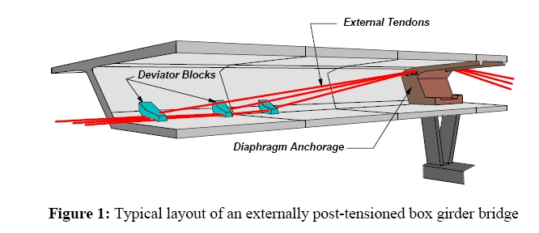

Figure 1.1: Typical layout of an externally post-tensioned box girder bridge

Applications of External Pre-stressing – a Few Case studies

1.2.1 New Bridge with External Post-tensioning

The world’s first externally pre-stressed concrete bridge was built in Germany in 1936. The main span of this bridge was 25.2m long. From that time, the design and application had changed and currently the external prestressing is used to large span modern bridges. From that time, the design and application had changed and currently the external prestressing has been limited until late seventies after finding some serious shortcomings with external tendons. The main problem with the external tendons was the corrosion of steel tendons which were inadequately protected.
After the invention of high performance steel with adequate protection against corrosion, the use of external prestressing again comes in picture. Some of the resent application of external prestressing in the new bridges is discussed in the following section.
    - Segmental Viaduct with External Prestressing

The Shigenobu River Bridge is an externally pre-stressed segmental bridge constructed in Japan in 1997. Considerable time saving is one of the important factors that favour this type of construction.
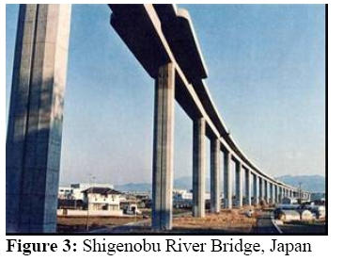

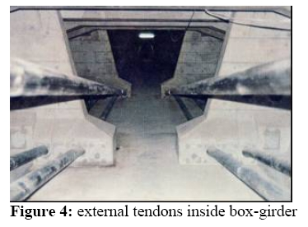
Figure 1.2: Shigenobu River Bridge, Japan

Figure 1.3: External tendon inside box girder

1.2.3 Girder Bridge with Large Eccentricity

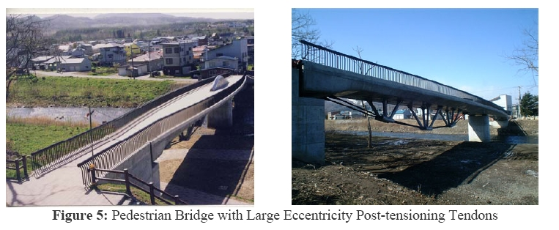
A new type of continuous girder bridge with large eccentricity was constructed in 2001 for a pedestrian bridge in Japan. In this structure, the external tendons are placed below the girder in the mid-span region by means of steel structures. At the intermediate support design, it is placed near bridge deck. This is a novel application where the use of externally prestressing has been effectively used to enhance the appetence of the bridge.
Figure 1.4: Pedestrian Bridge with Large Eccentricity Post-tensioning Tendon
    - Composite Bridge using External Pre-stressing

External prestressing has been used not only in concrete bridges but also in composite bridges either in classical composite bridges or in new type of bridges with different ways associating concreting and steel.
The use of pre-stressing concrete box girder bridges with corrugated steel webs is being constructed widely considering the cost effectiveness to construct new bridges. In these structures, the concrete webs are placed with corrugated steel plates to reduce the self weight which also simplifies the construction.
Figure 1.5 shows the typical section of a prestressed concrete bridge with corrugated webs. Basically, the prestress is provided by means of bonded tendons arranged in the upper and lower flanges of concrete slab and unbounded external tendon for webs, since the webs are made of steel plates. It is studied and concluded that a reduction of self weight of about 25% can be achieved in this kind of structures compared to conventional PSC box girder bridges.
Number of bridges with corrugated steel webs has been constructed worldwide. Some examples of such bridges constructed will these techniques are described below:
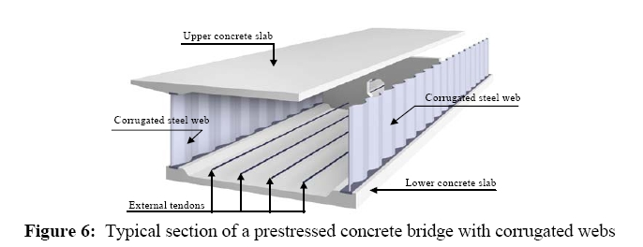

Figure 1.5: Typical section of a Pre-stressed concrete Bridge with Corrugated Webs
The Givizon-Miyuki Bridge has five spans with a total length of 210m, which was the first bridge to be constructed in Japan using incremental launching method. Weathering steel plates were used for the web. The feature of this bridge is that stud dowel connectors were adopted for the connection between concrete and steel plate. Further, the connection between steel plates in the direction of the bridge axis was by means of bolt connection of the end plates. This method was adopted considering the aesthetic appearance of the bridge.
The Shivasawa Bridge has a span of 50m was also constructed in Japan using supported formwork. The unique feature of this bridge is that “perforbond” connection was adopted for the first time in Japan to connect the steel web and lower flange of concrete slab.
The Kogawauchi-Gawa Bridge with a total length of 160m was constructed by the cantilever launching method. Pointed steel plates were used for the web.
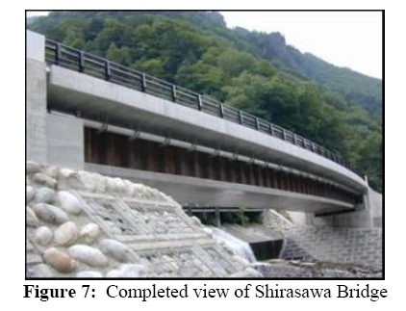
The above examples illustrate by the use of external prestressing how composite bridges can be designed to enhance better performance by effective use of materials such as steel and concrete.

Figure 1.6: Complete View of Shirasawa Bridge
    - Lightweight Concrete Bridge with External Pre-Stressing

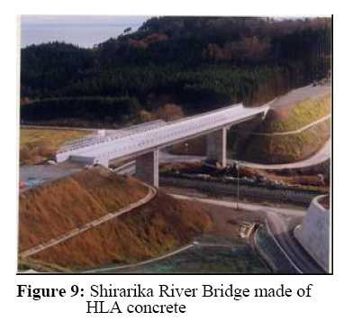
Another development in the bridge industry is the use of lightweight concrete in construction of new bridges as well as rehabilitation of existing bridges. Sirarika River Bridge is Japan was constructed with lightweight concrete with external prestressing. This was first bridge in Japan, which adopted HLA concrete for a PSC bridge. It is a three spans continuous box girder bridge with prestressing in the longitudinal direction being provided competently by external tendons. Another important feature in this bridge is that transparent sheets were used to cover for external tendons. This facilitates proper monitoring of grouting of external tendons to prevent any corrosion. It is expected with improved protection to steel external tendons, the use of this technology will become more popular.

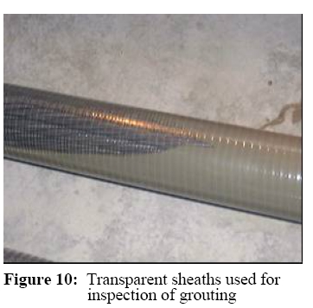
Figure 1.7: Shirarika River Bridge Made of HLA Concrete

Figure 1.8: Transparent Sheaths used for Inspection of Grouting

    - Strengthening of Bridges using External Prestressing

External prestressing has been also considered as one of the most powerful techniques for structural strengthening and rehabilitation works. External pre-stressing is preferred for bridge strengthening projects due to its following advantages.
- Minimal disruption to traffic
- Low weight of the additional component
- Speed and short duration of construction
- Low costs involved
- Future re-stressing operations could be carried out quickly and conventionally if required.
Some projects are listed here involving application of external pre-stressing in strengthening of projects.
1.2.6.1 Flexural Strengthening of Bridges Girders
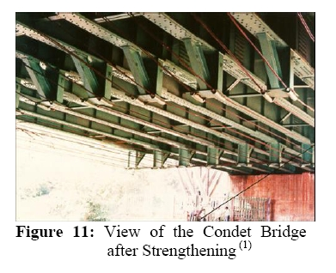
In Indonesia, two bridges, Condet Bridges (steel beam and concrete slab composite bridge built in 1989) and Kemlaka Gede Bridge (single span steel beam bridge) were strengthened by external pre-stressing to enable it to carry full design loading. Both are very similar flexure strengthening projects using external prestressing.

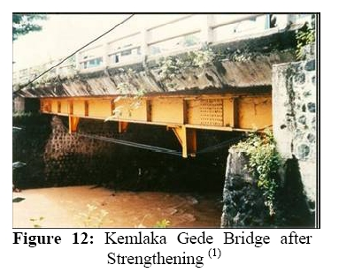
Figure 1.9: View of the Condet Bridge after Strengthening

Figure 1.10: Kemlaka Gede Bridge after Strengthening
1.2.6.2 Shear Strengthening of Headstocks/ Pier Cap
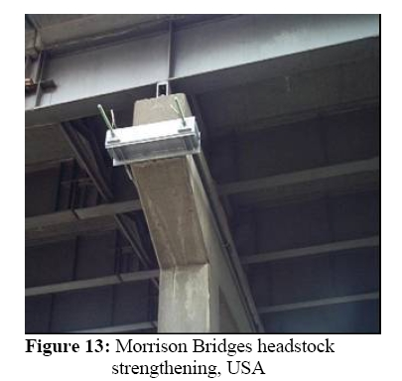
The headstocks of the Hawthorne and Morrison Bridges in USA were strengthened by External Prestressing. A system of externally mounted post-tensioned bars has been used to increase the compressive strength of the concrete caps thus increasing the load carrying capacity of the head stocks / pier cap. A steel I-beam was used as an anchoring block on each end of the head stocks. Figure 1.11 shows the typical application of the external pre-stressing in head stocks / pier cap strengthening.

Figure 1.11: Morrison Bridge Headstock Strengthening, USA
1.2.6.3 Rehabilitation with Lightweight Concrete
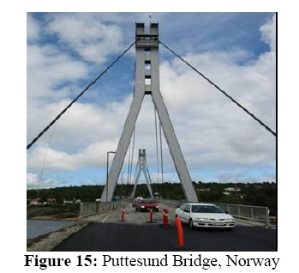
The deck of the Puttesund Bridge in Norway was rehabilitated by replacing concrete sidewalls with aluminum replacing portion of slab and surfacing with lightweight concrete and installing external prestressing. This bridge was original constructed in 1970 and rehabilitated in 2002 to extend its life according to current demands.

Figure 1.12: Puttesund Bridge, Norway
Based on above examples, three broad areas of applications of external pre-stressing applicable to bridges can be summarized as mentioned below:-
- A new bridge with external Tendons: In the first type, the unbounded pre-stressing tendons/cables comprise the total pre-stressing force. Segmental constructed bridge and cast-in-situ box girder bridge superstructure using external cables are an example of this category.

- Strengthening of Existing PSC bridges: In the second type, the unbounded elements act as part of total pre-stressing force, the other part being provided by bounded pre-stressing elements embedded in concrete. External pre-stressing provided for repair/rehabilitation/strengthening of existing PSC bridge is an example of this type. The external pre-stress may or may not contribute to the enhancement of ultimate strength.

- Strengthening of Existing RCC bridges: In the third type, the external pre-stressing is used as a means of applying external load acting in the desired direction and quantum and the deformation of the structure due to subsequent live load-both in service and under ultimate condition do not affect the magnitude and direction significantly. The external pre-stressing is taken as equivalent load only without considering its contribution to the strength of the structure. This type of application is used in strengthening of existing RCC structure by using pre-stressing elements to relieve part of the dead load effects.
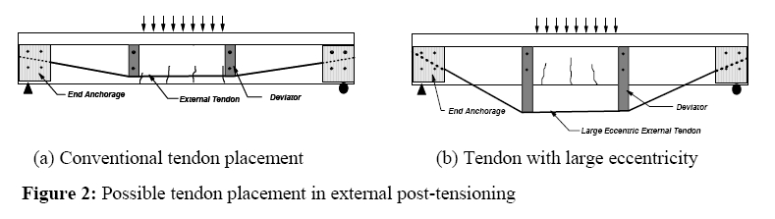

Figure 1.13: Possible tendon placement in external post-tensioning

Additional Measures required to adopted in External Prestressing

1.3.1 Protection of Pre-stressing Steel/Anchorages/Deviators
Pre-stressing tendons/steel shall be protected during temporarily exposed stages by coating with water sealable oils, grease or other suitable means. The permanent protection to the steel from corrosion & fire shall be provided by the cement grout, nuclear-grade grease or other suitable means. The external exposed steel components of deviations supporting brackets etc shall be protected by clear epoxy paint coating.
The anchorages and exposed free lengths of cables (left for de-tensioning) shall be properly housed in steel boxes and filled with protective agents such as nuclear grade grease or other suitable material.

1.3.2 Alignment of External Cables and Their Straight Length Between Deviators
The tendons can be straight or draped using deviators depending on the particular requirements. Various profiles can be adopted to suit the required combination of axial load and bending. Some of the commonly adopted shapes for alignment are shown in figure 1.14 and figure 1.15. Typical arrangements of deviators are shown in figure 1.16. Typical details of anchorages often adopted in repair/rehabilitation work are show in figure 1.17.
(i) Trapezoidal Cable profile in Continuous bridges:
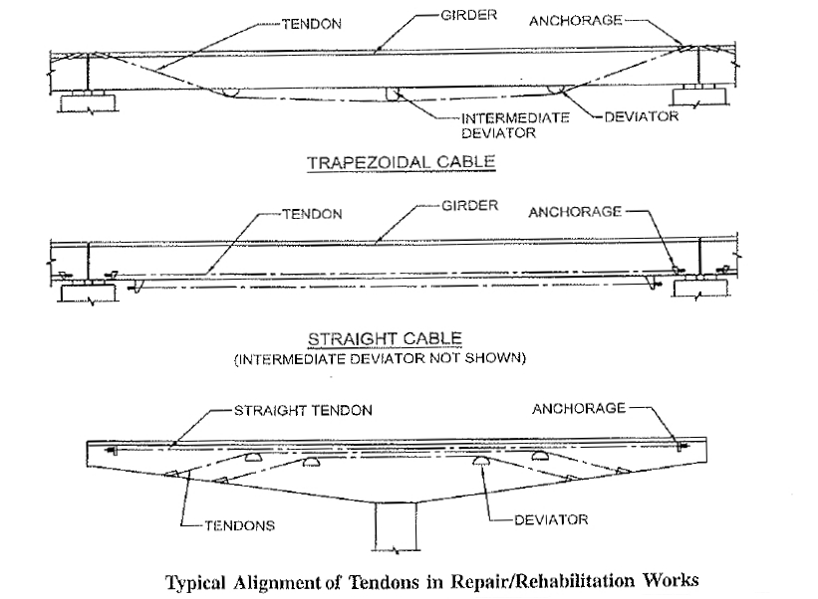
Figure 1.14
(ii) Straight profile in simply supported bridge
(iii) Cable profile for cantilever Construction Bridge

Figure 1.15 Typical Alignment of Tendons for New Construction
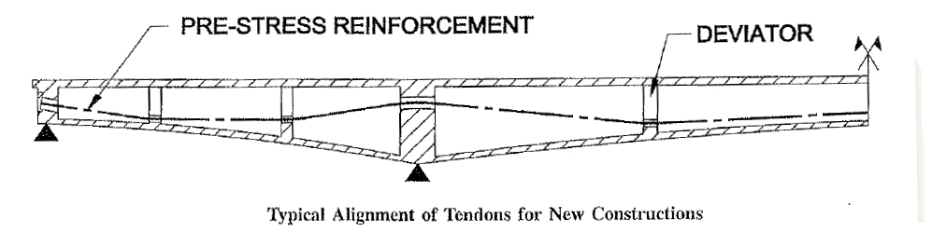
(i) External Deviators
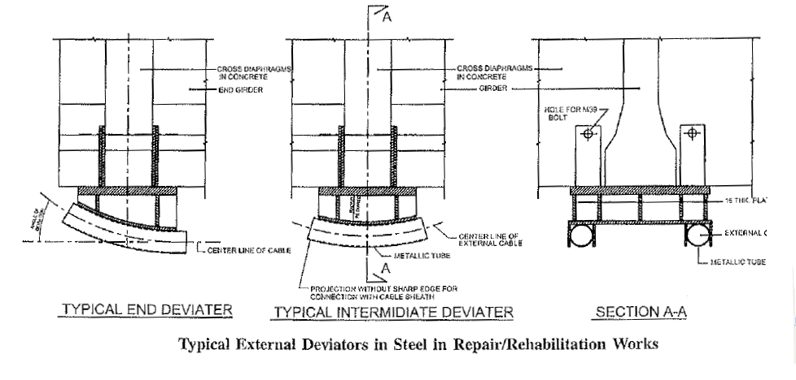
Typical External Deviators in Repair/Rehabilitation works

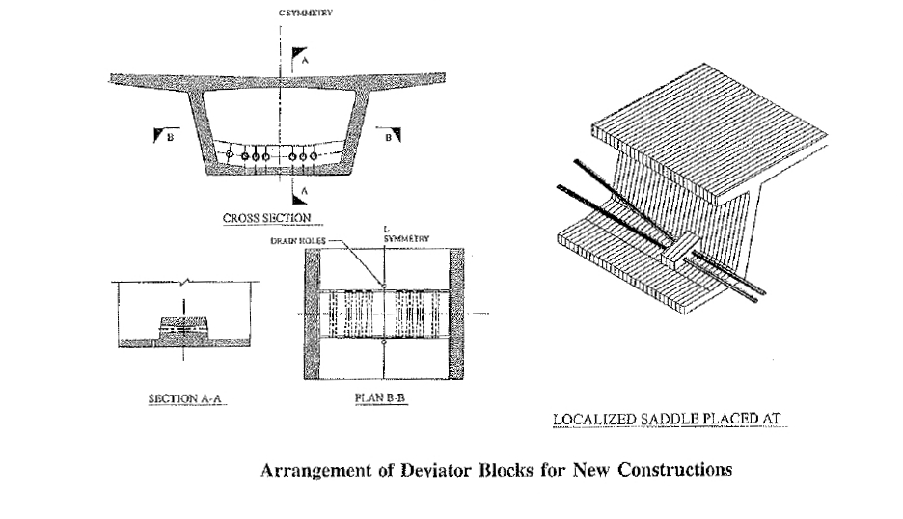
C. Anchoring Arrangement
Figure 1.16
(ii) Internal Deviators

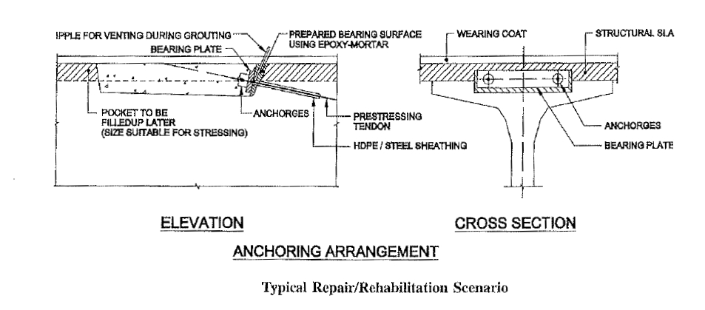
Figure 1.17

Advantages & Limitations of External Prestressing

The various advantages of external post-tensioning are described below:
- The casting of structure is simplified by eliminating the presence of ducts in the webs and flanges. The formwork, fixing of reinforcement and concreting are all made easier.
- Reduced web thickness due to the absence of ducts result in a saving on superstructure weight and substructure costs.
- Installation is made easier by having access to all parts of the duct. Placing of the strands is more straight forward and not prone to the blockage of the duct that can be associated with internal prestressing.
- Tendon layouts are simplified.
- Grouting of tendon is easier due to the better access available and because individual tendon can be grouted without the leakage or blockage problems that can occur with internal tendons in some forms of construction.
- Reduced friction losses within the tendon results in a higher effective force in the strand.
- It is easier to inspect tendon during construction and for long term maintenance.
- The tendon is replaceable in the future.

The various disadvantages of external pre-stressing are described as below:
- Only straight profile of tendon is possible.
- Additional cost for ducts and anchorages.
- Diffusion of Post-Tensioning forces.
- External tendons are more sensitive to fire and more easily attackable by the vandals.
- The prestressing force disappears over the overall length of the tendon once a section of tendon is broken.
- External tendons are protected by HDPE ducts which are fully cement grouted or wax filled which result in a higher initial material cost for the prestressing system.
- Under ultimate bending conditions, external tendons require more pre-stressing to generate the same moment of resistance.
- Anchorage points and deviators are subjected to high concentrations of forces which need to be properly tied into the structure.

Literature Review

Oliver Burdet and Mare Badoux present a paper showing comparison of the external prestressing & internal prestressing in IABSE held in Lucurne in year 2000.
This paper suggested that External prestressing offers designers the potential to create structures that have a better durability and that can easily be retrofitted in the case of deterioration or to increase their capacity. This is a very important characteristic for urban bridges for which traffic interruption pose a real problem.
It is generally thought that a change from internal to external prestressing results in a significant increase in the amount of reinforcement required. A comparative study was performed on a realistic model of a five span continuous single cell box girder: one design is being done with internal prestressing and the other with external prestressing. The parameter investigated are the bridge span and depth of the girder. They performed preliminary design only to determine the amount of prestressing of flexural reinforcement and of shear reinforcement. The design was carried in accordance the current Swiss design codes.

Bridge model adopted in paper

An extensive study is carried out on a realistic model of a typical highway bridge. The structure is five span continuous Box Girder Bridge with a constant depth. The side span length is kept as 85% of inner span length. The tendons are laid out in a classic parabolic shape for the internal prestressing and in a trapezoidal layout with two deviators in the span for external prestressing as shown in figure 2.1. The cross section shown in figure 2.2 has a constant depth, with a thicker bottom flange on intermediate supports. The webs of the bridge with external prestressing are thinner then the webs of the bridge with internal prestressing (0.5m) to account for easier concreting conditions without web tendons. The bottom flange is 0.2m thick in the span and 0.4m over intermediate support.
The prestressing was determined on the basis of serviceability criteria in both cases to reach a level of deflection allowable. This level represents the amount used in many structures and typically assures a satisfactory behaviour in service. The amount of prestressing required in external prestressing system depends upon the location of deviators in the span. The optimal location for these deviators is at 3/8th and 5/8th of the span but in this study, the span deviators are kept at 1/3 of the span which is close to the optimum. The amount of prestressing required to achieve the same level of deflection with a parabolic cable would be larger.
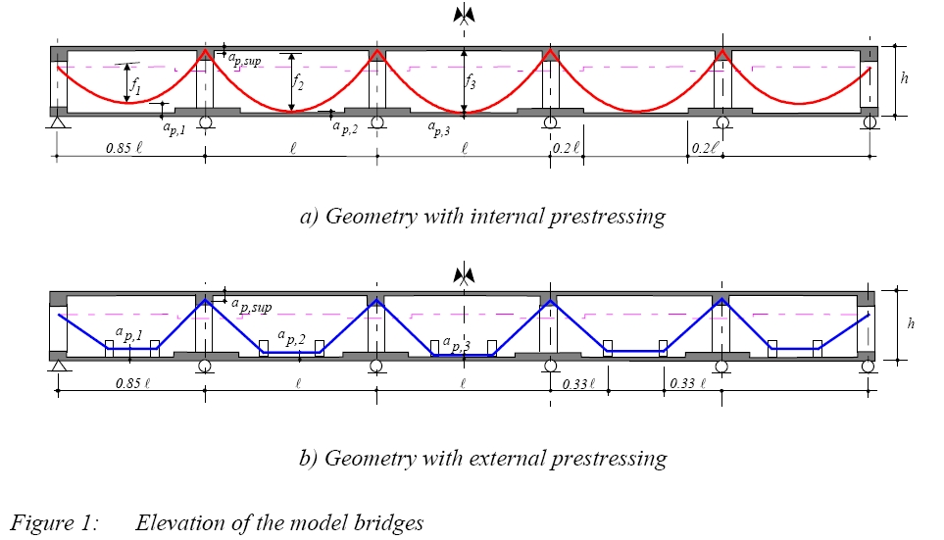
Figure 2.1: Elevation of model bridges
This comparison shows that bridge with external prestressing can become economically competitive for large girder depths. The effect of the smaller stress in the prestressing steel at the ultimate limit state is more than compensated by the thinner webs made possible by the absence of ducts.
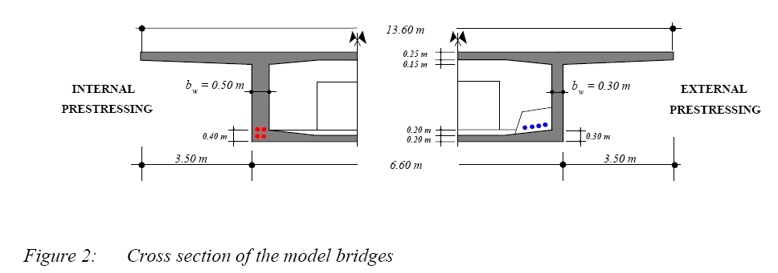
Figure 2.2 Cross section of the model bridges
The prestressing was determined on the basis of serviceability criteria to reach a satisfactory level of deflection β. The tendon layout was fined tuned to ensure that the level of compensation of deflection β be identical in all spans. This was achieved by setting the length of side spans to 85% of the central span and by fine tuning the position of the cables at lowest point as showing in Figure 2.1.
The tendon layout for the external prestressing is trapezoidal with two deviators in the span, while the location of the deviators in the span can be chosen by the designer. Figure 2.3 shows that it influences the amount of prestressing required to achieved a desired level compensation of deflection. The optimal location for these deviator are at 3/8 & 5/8 of the span. In this study, the deviators are located at 1/3 of the span which is close to the optimum. The amount of prestressing required to achieve the same level of compensation of deflection with a parabolic cable would be larger.
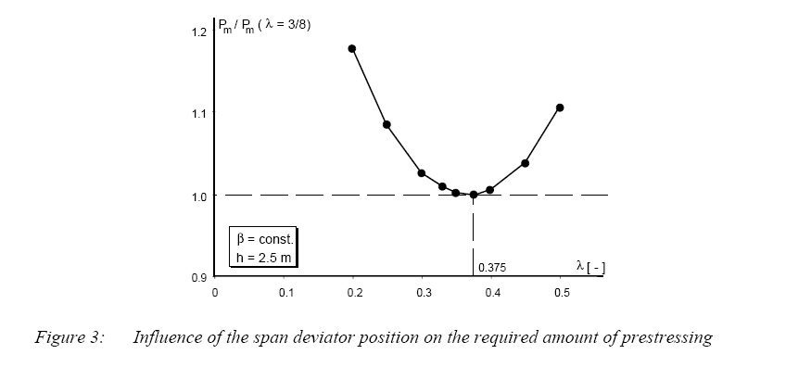
a. Deviator Position Vs Prestressing Force
λ = position of deviator block
h = depth of superstructure
β= amount of deflection
Figure 2.3: Influence of the span deviator position on the required amount of prestressing

Data Adopted by the paper:

The comparative parametric study was performed using a simple analytical model of each structure. The two main parameters of the investigation are:-

- Girder span ( 30 to 80m)
- Girder depth (girder span to depth ration as15 to 25)
The results present hereafter are valid within the limit and for the assumption of this parametric study which cover multiple span continuous bridges with a constant depth. The range of spans and girder depths considered includes the majority of structure in that category that may be considered for external prestressing applications. Figure 2.4 shows the required amount of prestressing force as a function of main bridge span for bridges with internal and external prestressing. The amount of prestressing increases with increase in span and span to depth ratio. It is clear from the figure that external prestressing requires large amount of prestressing force as compare to internal prestressing while in larger span external prestressing system require typically less prestress for span exceeding 35m to 60m.
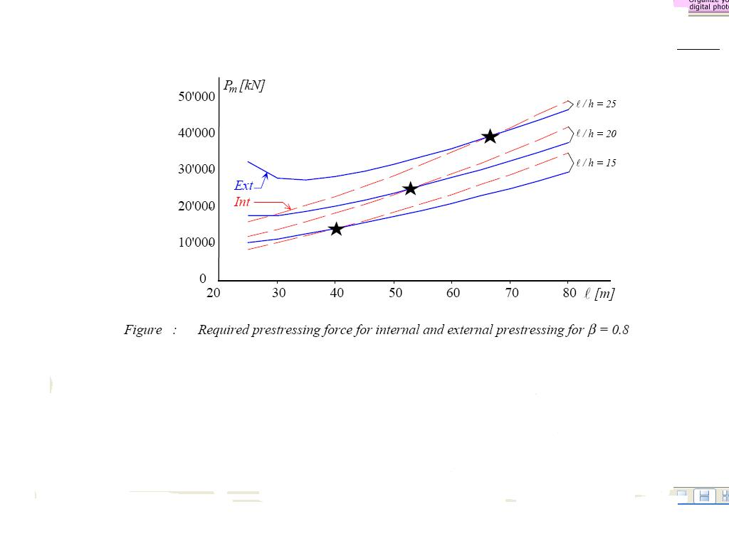
b. Comparison of External & Internal Prestressing Force Vs Various Span-Depth Ratio
Figure 2.5 indicates that required amount of prestressing is with internal prestressing system seems lower for girder depth smaller than 3m and larger above that value. In most cases, these differences are small and it can be concluded that from a serviceability point of view, the two prestressing types are very close to one another. Finally it must be note that part of this advantage is due to the more efficient cable layout used for external prestressing. It is shown above that a trapezoidal cable layout is more efficient than the usually adopted parabolic layout as shown in figure 2.3.
Figure 2.4
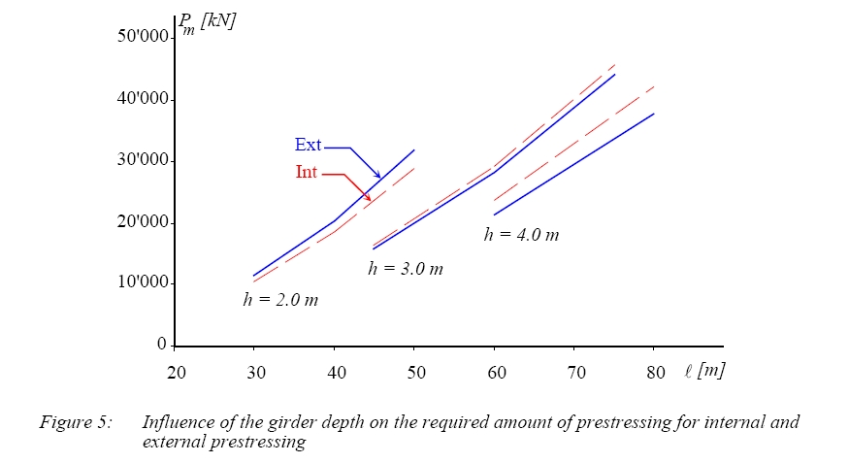
c. Comparison of External & Internal Prestressing Force Vs Various Depths
Figure: 2.5 Influence of the girder depth on the required amount of prestressing for internal and external prestressing
The design of the bridge was then completed to satisfy, ultimate limit state safety requirements as per present Swiss standards. At this limit state, external tendons have a disadvantage because they cannot reach their ultimate capacity. Taking into account the amount of severability prestressing determined earlier and the minimal reinforcement required, it has been found that bridges with internal prestressing required no additional ULS reinforcement while bridges with external tendon require this type of reinforcement. The amount of additional ULS reinforcement increases with the span of the bridge. It must be noted that requirement of ULS reinforcement is different from code to code, as amount of minimal reinforcement prescribed in Euro code is significantly larger then that of the corresponding Swiss code, hence almost no additional ULS reinforcement would be needed in this case.
d. Comparison of ULS reinforcement Vs Span
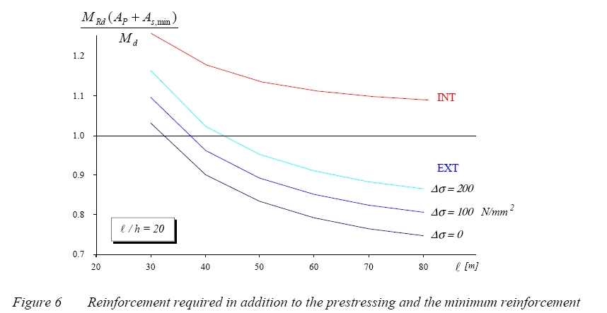

Figure 2.6 Reinforcement required in addition to Prestressing and the minimum reinforcement

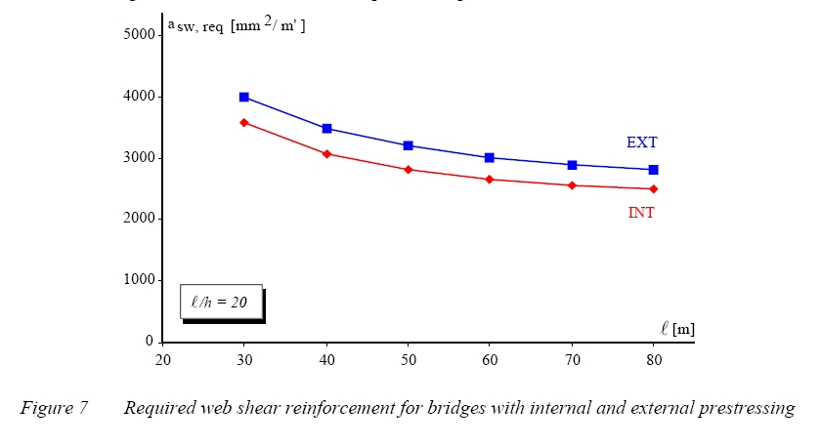
e. Comparison of Shear reinforcement Vs Span

Figure 2.7 Required web shear reinforcement for bridges with internal and external prestressing
The amount of shear reinforcement is not very different for both types of prestressing as figure 2.7shows. Bridges with external prestressing have thinner webs which decreases dead load but also decrease the web shear resistance. These two effects partially compensate one another leaving a relatively small advantage to the solution with internal prestressing.
This paper concludes that the differences between the two solutions (external & internal prestressing) are smaller than anticipated. For small spans, the solution with internal prestressing leads to a smaller amount of reinforcement both passive and prestressed. For deeper x-sections, the solution with external tendon requires less reinforcement.
Another paper on ‘Factors affecting the External Prestressing stress in Externally strengthened Prestressed Concrete Beams’ published by Ahmed Ghallab & A W Beeby in year 2004. This paper studied the effect of several factors on the increase in the ultimate stress in external tendons. The various factors studied include tendon profile (straight or deviated), strength of concrete, effective tendon depth and number of deviators.
They did experiment work on beams after being strengthened by external post-tensioning as shown in figure 2.8. Beams were tested under static loads; two concentrated loads at the third span or one load at the mid span.

f.

Figure 2.8 Arrangement of Test Beams
f. Effective depth of the External Post-tensioning force
The increase in the tendon stress is relative to its distance from the neutral axis; the greater the distance the higher the stress, as can be seen from Fig. 2.9a. Within the depth (d_{e} < h), increasing the tendon depth slightly increased the tendon stress while increasing the tendon depth to more than the section depth has a significant effect on the ultimate stress in the tendon.
The effect of the effective depth of the external prestressing tendon can be taken as (L/de) ratio where L is the beam span. Fig. 2.9b shows the relation between the increase in the tendon stress and (L/d_{e}) ratio.

Figure 2.9a. Relation between Ratio of increase in effective External Prestressing Stress and (ecc. of External Prestressing force/depth) ratio

Figure 2.9 b Relation between Ratio of increase in effective External Prestressing Stress and span/Effective External tendon depth
g. Number of Deviators
Fig. 2.10 shows the relation between the increase in the ultimate tendon stress and the number of deviators used for strengthening. Beams were subjected to two concentrated load at the third span and strengthened using deviators located at the mid span (one deviator) and/or at the third span (two deviators or three deviators). The increase in the number of deviators significantly increased the ultimate stress in the deviated tendons and had less effect on the ultimate stress of the straight tendons.
The improvement in the ultimate stress of the deviated tendons when using more than one deviator can be attributed to the increase in tendon eccentricity along a wider distance (between deviators) thus increases the ultimate strength of the beam. In case of straight tendons, using more than one deviator kept the straight tendons in position, reduced the loss in tendon eccentricity (second-order effect) during loading and improved the ultimate stress of the tendons.

Figure 2.10 . Relation between the ratio of increase in effective external prestressing stress and the number of deviators.
h. Effect of the ratio of the distance between Deviators to the span (S_{d}/L,)
Fig. 2.11 shows the effect of the ratio of (S_{d}/L) on the increase in the stress in the external tendons at ultimate. Beams were strengthened using straight or deviated tendons and loaded by two concentrated loads. The distances between loads varied between L/3 and L/5.
Generally, the optimum value of the increase in the external tendon stress at ultimate was reached when the distance between deviators (S_{d}) ~ L/3. For beams subjected to two concentrated loads at the third span and strengthened using tendons deviated at mid span, the critical section is under the concentrated load where the bending moment is high and the eccentricity of the external tendons is lower than at the mid-span. Hence, the failure occurred at a lower load at that section than when using two deviators at the third span. When the distance between the two deviators exceeds that between the two concentrated loads, the effect of the reduction in the tendon eccentricity at the mid span become significant and results in a rapid failure of the beam. This was also observed when the distance between the two concentrated loads was less than L/3.
The effect of the distance between deviators on the ultimate stress in the straight external tendons was less than that with the deviated tendons. For beam loaded by two concentrated loads at the third span there was a slight difference between the ultimate stresses in the straight external prestressing tendons supported by two

Figure 2.11: Relation between the ratio of increase in effective external
prestressing stress and (deviator distance/span distance) ratio.
deviators and the ultimate stress in the straight external prestressing tendons supported by one deviator at mid span. This is because the variations in the eccentricity of the external tendon at the critical section as well as the tendon elongation when one deviator was used at mid span or two deviators at different distances (within the studied ratios) were small.
i. Effect of concrete strength
Increase in concrete strength results in an increase in the prestressing force in the external tendons at ultimate, as can be seen from Figure 2.12. Also, by comparing the effect of concrete strength with that of the other factors considered, concrete strength can be seen to be one of the main factors influencing the ultimate tendon stress.

Figure 2.12: Relation between the ratio of increase in effective external
prestressing stress and the concrete strength.
j. Effect of span/depth ratio (L/h,)
As can be seen from Fig. 2.13, variation in (L/h) ratio has a slight influence on the value of the increase in the tendon stress, with a tendency to reduce as (L/h) increases. The reduction in tendon stress at the low (L/h) ratio can be attributed
Figure 2.13. Relation between the Ratio of Increase in Effective External Prestressing Stress and (span/depth) ratio.
to the reduction in ductility while the reduction in the tendon stress at the high L/h ratio can be related to the reduction in the tendon eccentricity (second-order effect). Therefore, the design equations proposed to calculate the tendon stress in the unbonded internal prestressed beams would be less accurate when used for externally prestressed beams with high L/h ratio.
k. Load type
Two load types were examined in this study; a concentrated load at the mid span and two concentrated loads at the third span (produces almost the same moment as the uniform load). The increase in the tendon stress in the beam subjected to loads at the third span is 32% greater than that in the beam with a single load at mid span. This is because, during loading, cracks started to appear on the beam surface and spread as the load increased. This continued up to the formation of the plastic hinge where the strain concentrated and stress increased up to failure. This resulted in the beam with the single load developing a smaller equivalent plastic hinge length at failure, and hence a smaller deflection, than the beam with two loads (or a uniform load. As the increase in the tendon stress depends on the deformation of the full member, the higher the deflection, the greater the increase in tendon stress.
This paper concludes that the ultimate stress in deviated External tendon is significantly influenced by the value of the pretsress, the number of deviators, concrete strength and the ratio of the distance between deviators to the span. There is an increase in stress in the external tendons by increasing the concrete strength. The effective depth of the of the external prestressing tendons has a significant effect on the ultimate stress in the tendon.
Another paper published by T.G. Suntharavadivel & Thiru Aravinthan. on ‘Overview of External Post-tensioning in bridges’ published in Southern engineering Conference in 2005. They describes the various application of External post-tensioning and its various advantages & limitations.
One other paper published by Oliver Burdet and Marc Badoux on ‘Long term deflection monitoring of PSC bridges retrofitted by external post-tensioning example from Switzerland’ in 1999 at IABSE conference in Brazil.
Based on these papers, the various codes related to external post-tensioning published.

Loadings, Analysis and Design Methodology

Geometry Definition
The most common form of PSC bridges in the small to medium span range consists of pre-cast, pre-tensioned or post-tensioned standard I-Girder with a cast-in-place deck slab. For somewhat longer spans the pre-cast concrete I-girder can be made continuous by using reinforcement over support. Post tensioned voided slab bridges are an alternative for PSC bridges which has been widely used in small to medium span range. They are particularly suitable for highway interchange bridges which are typically curved in plan and have limited headroom. In recent time, box-girder bridges have become increasingly popular for medium to long span bridges. The cross-section of a box girder has excellent tensioned resistance and efficiently carries large possible and negative moments. The figure given below summarizes the cost break down for a number of post-tensioned concrete bridges.
Single cell Box Girder super structure minimize the formwork cast but for multilane bridges (3 or more traffic lane), multicell box girder superstructure shall be useful. It helps in minimize the thickness of top & bottom slab. The total width of superstructure depends on the no. of lanes/traffic is to apply/move on bridges and presence of footpath for pedestrian movement. The span to depth is different for various types of superstructure which are mentioned as below:-

The span to depth ratio vary from 13 to 15 for precast post tensioned beam with cast-in-situ slab.

The span to depth ratio for Box Girder Bridge vary from 18 to 20 for PSC bridges.

Selection criteria of Span
Considering only the variable items, for a given linear waterway, the total cost of the superstructure increases and the total cost of substructure decreases with increase in the span length. The most economical span length is that for which the cost of superstructure equals the cost of substructure. This condition may be derived as below:
Let A = cost of approaches
B = cost of two abutments, including foundations
L = total linear waterway
s = length of one span
n = number of spans
P = cost of one pier, including foundation
C = total cost of bridge
Assuming that the cost of superstructure of one span is proportional to the square of span length, total cost of superstructure equals n.ks2, where k is a constant.
The cost of railings, flooring; etc., is proportional to the total length of the bridge and be taken as K’L.
C = A+ B÷(n-1) P + nks²+ K’L
For minimum cost, dC/ds should be zero.
Substituting n = L/s and differentiating, and equating the result of differentiation to zero) we get P=ks2
Therefore, for an economical span, the cost of superstructure of one span is equal to the cost of substructure of the same span.
The economical span (s_{e}) can then be computed from Equation (3.1).
s_{e} = √P/k …(3.1)
P and k are to be evaluated as average over a range of possible span lengths.

Loading and Load Combination (reference BD 37/01)
While the primary purpose of a bridge is to safely support the traffic crossing over it, the dominant loading for many bridges is in fact the self weight of the superstructure. In addition to the traffic loads and the dead loads, the bridge must be capable of withstanding safely superimposed dead load such as wearing coat, crash barrier, kerb stone, rolling and services load, if any. The design must investigate the safety of the bridge not only in its service condition but also in its various construction stages.
These are various types of live load as per different codal provisions. The various types of live load as per British Standards are HA and HB loading.
HA loading is a formula loading representing normal traffic while HB loading is an abnormal vehicle unit loading. Both loading include impact.
Type HA Loading: It consists of a uniformly distributed load and a concentrated load combined or of a single wheel load. The HA udl is given below in reference codes .
The concentrated load shall be taken as 120 kN.

Type HB loading. Fig 3.1 shows the plan and axle arrangement for one unit of nominal HB loading. One unit shall be taken as 10 kN/axle. For all highway bridge in Great Britain, the min. no. of units shall normally constituted as 30 but it can be increased to 45 if so directed by appropriate authority. Overall length of the HB vehicle shall be taken as 10, 15, 20, 25 or 30m for inner axle spacing of 6,11,16,21 or 26m respectively and the effects of the most severe of these cases shall be adopted. The overall width shall be taken as 3.5m.
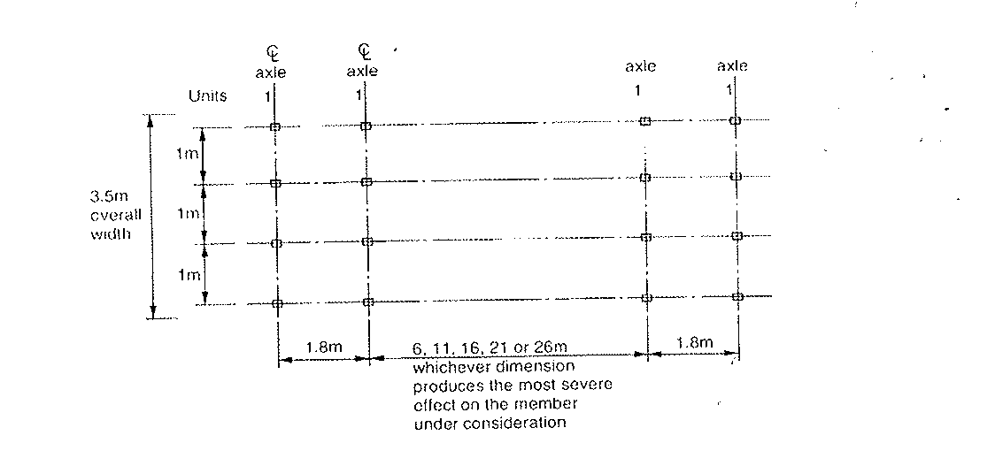

Fig 3.1 Plan of HB Loading

Application of types HA and HB loading.

- Type HA loading: It determined for the appropriate loaded length and type HA concentrated load shall be applied to each notional lane in the appropriate parts of the influence line for the member under consideration. The lane loadings are interchangeable between the notional lanes and a notional lane or lanes may be left unloaded it this causes the most severe effect on the member. The point load shall be applied at one point only in each notional lane. The HA udl and point load shall be multiplied by the appropriate factors given in codes.

- Types HA and HB loading combined. These two loading shall be combined as give in figure 3.2.

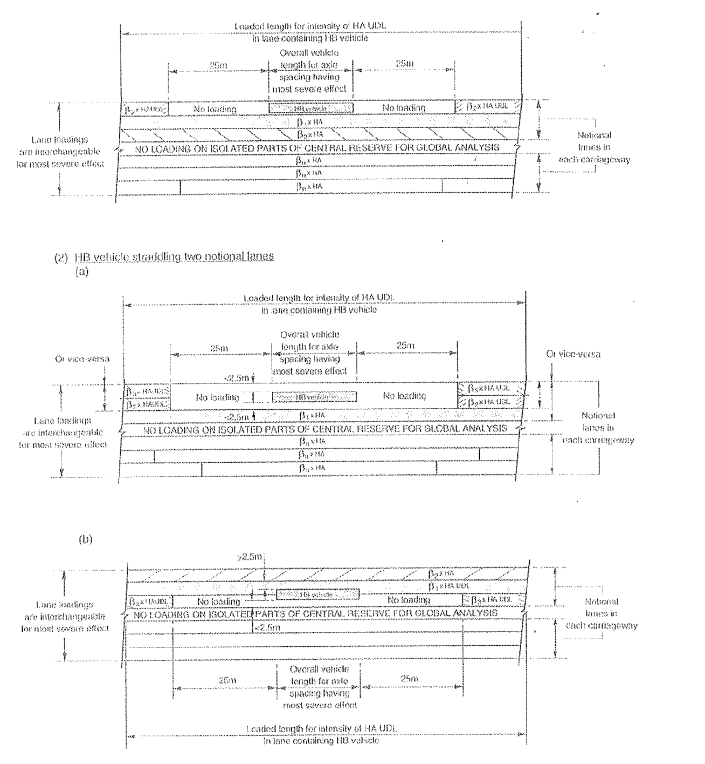
Fig 3.2 Location of HA & HB Loading
Table 3.1 Load Combination as per British Standard
ULS: Ultimate Limit State SLS: Serviceability Limit State
Clause No. | Load | Limit State | To be considered in combination
Clause No. | Load | Limit State | 1 | 2 | 3 | 4 | 5
5.1 | Dead: Steel  Concrete | ULS  SLS | 1.05  1.00 | 1.05  1.00 | 1.05  1.00 | 1.05  1.00 | 1.05  1.00
5.1 | Dead: Steel  Concrete | ULS  SLS | 1.15  1.00 | 1.15  1.00 | 1.15  1.00 | 1.15  1.00 | 1.15  1.00
5.2 | Superimposed dead: deck surfacing  Other loads | ULS+  SLS+ | 1.75  1.20 | 1.75  1.20 | 1.75  1.20 | 1.75  1.20 | 1.75  1.20
5.2 | Superimposed dead: deck surfacing  Other loads | ULS  SLS | 1.20  1.00 | 1.20  1.00 | 1.20  1.00 | 1.20  1.00 | 1.20  1.00
5.1.2.2 & 5.2.2.2 | Reduced load factor for dead and superimposed dead load where this has a more severe total effect | ULS | 1.00 | 1.00 | 1.00 | 1.00 | 1.00
5.3 | Wind: during erection | ULS  SLS |  | 1.10  1.00
5.3 | With dead plus superimposed dead load only, and for members primarily resisting wind loads | ULS  SLS |  | 1.40  1.00
5.3 | With dead plus superimposed dead plus other appropriate combinations 2 loads | ULS  SLS |  | 1.10  1.00
5.3 | Relieving effect of wind | ULS  SLS |  | 1.00  1.00
5.4 | Temperatures: Restraint to movement, except frictional | ULS  SLS |  |  | 1.30  1.00
 | Frictional boring restraint | ULS  SLS |  |  |  |  | 1.30  1.00
 | Effect temperature difference | ULS  SLS |  |  | 1.00  0.80
5.6 | Differential settlement | ULS  SLS | 1.20  1.00 | 1.20  1.00 | 1.20  1.00 | 1.20  1.00 | 1.20  1.00
5.7 | Exceptional loads |  | To be assessed and agreed between the engineer & the appropriate authority
5.8 | Earth pressure: vertical loads  Retained fill and/or live load | ULS  SLS | 1.20  1.00 | 1.20  1.00 | 1.20  1.00 | 1.20  1.00 | 1.20  1.00
 | Non-vertical loads | ULS  SLS | 1.50  1.00 | 1.50  1.00 | 1.50  1.00 | 1.50  1.00 | 1.50  1.00
 | Relieving effect | SLS | 1.00 | 1.00 | 1.00 | 1.00 | 1.00
5.9 | Erection: temporary loads | ULS  SLS |  | 1.15  1.00 | 1.15  1.00
6.2 | Highway bridges live loading: HA alone | ULS  SLS | 1.50  1.00 | 1.25  1.00 | 1.25  1.00
6.3 | HA with HB or HB alone | ULS  SLS | 1.30  1.10 | 1.10  1.00 | 1.10  1.00
6.5 | Footway and cycle track loading | ULS  SLS | 1.50  1.00 | 1.25  1.00 | 1.25  1.00
6.6 | Accidental wheel loading | ULS  SLS | 1.50  1.00
Live load as per Indian Road Congress (Reference IRC:6)
The various type of live load is given in code IRC:6. Which are described as below;

(i) Class AA tracked vehicle

Total wt = 70t
Traffic direction

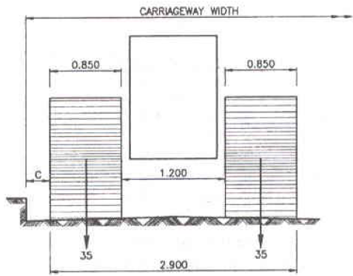

Figure 3.3 Plan of tracked vehicle

The value of C is 0.3m for single lane bridge.

The value of C is 0.6m for multi lane bridge having carriageway width less than 5.5m and 1.2m having carriageway width more than 5.50m

- Class A wheeled vehicle

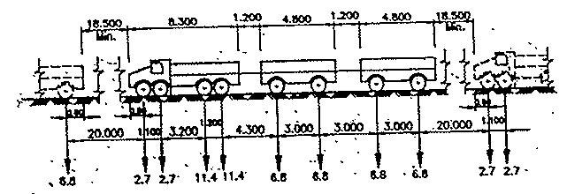

Fig 3.4 Class A Train

- The nose to tail distance between successive trials shall not be less than 18.4m
- No other live load shall cover any part of the carriageway when a train of vehicles is crossing the bridge.
- The minimum clearance “f” between outer edge of the wheel and the roadway face of the kerb and the minimum distance “g” between the outer edge of passing or crossing vehicles on multi=lane bridges shall be as given below:

Clear carriageway width | g | f
5.5m to 7.5m  Above 7.5m | Uniformly increasing from 0.4m to 1.2m  1.2m | 150mm for all carriageway width

- Class 70R wheeled vehicle
1st train
2nd train

17t
17t
8t
17t
17t
17t
12t
12t

1.37mm
1.37mm
2.13mm
3.05mm
1.52mm
13.4mm
3.96m
30m

- The noise to tail distance between successive train shall not be less than 30m.
- No other live load shall cover any part of the carriageway when a train of vehicle is crossing the bridge.
- The minimum clearance from edge of road kerb to face of wheel is same as for tracked vehicle.

Table 3.2 Live Load considered for Design

Carriageway width | Nos. of lane  for design purpose | Load combination
Less than 5.3m | 1 | One lane of class “A” considers occupying 2.3m. The remaining width of carriageway shall be loaded with 500 kg/m²
5.3m and above but less than 9.6m | 2 | One lane of class 70R or 2-lanes of class A
9.6m and above but less than 13.1m | 3 | One lane of class 70R with one lane of class A or 3 lanes of class A
13.1m and above but less than 16.6m | 4 | One lane of class 70R for every two lanes with one lane of class A for remaining lanes if any or one lane of class A for each lane.
16.6m and above but less than 20.1m | 5
20.1m and above but less than 23.6m | 6

Reduction in the longitudinal effect on bridges accommodating more than two traffic lanes

There is a reduction in the longitudinal effect on bridges having more than two traffic lanes due to the low probability that all lanes will be subjected to the characteristics loads simultaneously shall be in accordance with the table shown below:

Nos. of lanes | Reduction in longitudinal effect
For two lanes | No reduction
For three lanes | 10% reduction
For four lanes | 20% reduction
For five or more lanes | 20% reduction

However, it should be ensured that the reduced longitudinal effects are not less severe than the longitudinal effects, resulting from simultaneous load on two adjacent lanes.

No. | G | Q |  | G | 1 | F | V | F | F of F | &/or F | F | F | G | F | F | F | F | F | F | F | G | %
 | Dead Load | Live load | Show Load | Vehicle Impact | Impact Floating Bodies | Vehicle collisonLoad | wind | Water Current | Tractive | Braking | Bearing Friction | Centrifugal Force | buoyancy | Earth Pressure | Temperature | Deformation Effects | Secondary Effects | Erection Effects | Scismic | Wave Pressure | Grade Effect | Permissibel Stresses | REMARKS
I | 1 | 1 | * | 1 |  |  |  | 1 | 1 | 1 | 1 | 1 | 1 | 1 |  |  |  |  |  |  | 1 | 100
IIA | 1 | 1 | * | 1 |  |  |  | 1 | 1 | 1 | 1 | 1 | 1 | 1 | 1 | 1 | 1 |  |  |  | 1 | 115
IIB | 1 | (0.50) |  | (0.50) |  |  |  | 1 | (0.50) | (0.50) | (0.50) | (0.50) | 1 | 1 | 1 | 1 | 1 |  |  |  | 1 | 115
IIIA | 1 | 1 | * | 1 |  |  | 1 | 1 | 1 | 1 | 1 | 1 | 1 | 1 | 1 | 1 | 1 |  |  | 1 | 1 | 133
IIIB | 1 | (0.50) |  | (0.50) |  |  |  |  | (0.50) | (0.50) | (0.50) | (0.50) | 1 | 1 | 1 | 1 | 1 |  |  | 1 | 1 | 133
IV | 1 | 1 | * | 1 |  |  | 1 | 1 | 1 | 1 | 1 | 1 | 1 | 1 |  | 1 | 1 |  |  | 1 | 1 | 133
V | 1 |  |  |  |  | 1 |  |  |  |  |  |  |  |  |  |  |  |  |  |  |  | 150
VI | 1 | 0.5 |  | 0.5 |  |  |  | 1 | 0.5 | 0.5 | 0.5 | 0.5 | 1 | 1 | 1 | 1 | 1 |  | 1 | 1 | 1 | 150
VII | 1 | 1 | * | 1 | 1 |  | 1 | 1 | 1 | 1 | 1 | 1 | 1 | 1 | 1 | 1 | 1 |  |  |  | 1 | 133
VIII | 1 |  |  |  |  |  | 1 | 1 |  |  |  |  | 1 | 1 |  |  |  | 1 |  |  | 1 | 133 | Construction Condition
IX | 1 |  |  |  |  |  |  | 1 |  |  |  |  | 1 | 1 |  |  |  | 1 | 0.5 |  | 1 | 150 | Construction Condition
Table 3.3 : Load Combination & Permissible Stresses as per Indian Road Congress

Comments on IRC Loadings
A comparative study of the IRC loadings with the loadings of seven other countries has been made. It is seen that the IRC loading is the most severe for a single lane bridge, but is less severe than the French, West German, Japanese and British loadings for a two lane bridge, Further, the loadings are complicated in application to design, especially if Class 70A, Class AA and Class A loadings are to be considered in the design to determine the severest effects.
Very little information is available on the basis for the IRC loadings. While considerable refinement in the methods of analysis and design has been achieved, studies on the accuracy and adequacy of the assumptions of loadings have been neglected. The laborious computations involved in applying the IRC loadings, to an actual design may create an impression that the design moments are being assessed precisely. In fact, the IRC loadings have little relation to the vehicles currently in use in the country. The Class AA tracked vehicle load of 700 kN is by no means an accurate representation of present military tanks, and a specified tail to nose distance of 90 m is not likely to be observed in the event of any emergency. Similarly axle loads and spacing specified for wheel trains need not be exact. While trucks manufactured in our country could perhaps be controlled, imported vehicles may not satisfy these specifications. Thus the design moments and shears assessed from these hypothetical loadings after laborious computations can at best be only approximate. The value of refinement of knowledge and accuracy of prediction of the behavior of structures under load is considerably diminished if it is not matched by corresponding precision of estimation of the loadings that cause that behavior.
Even basic anomalies exist in the prescribed loadings. For example, the nose to tail spacing between two successive vehicles of Class AA tracked vehicle is 90 m while that for Class 70R is 30 m, though the vehicles are very similar in both cases. Further, the justification for the use in India of severer loadings than in advanced countries deserves serious consideration.
The basis for lRC provisions regarding impact is not clear. The actual impact factor will depend on the surface characteristics of the’ bridge and the spring constant of the vehicle. No systematic study has been made to derive realistic impact factor for conditions in our country. Field experiments in Britain by Mitchell indicated that the impact effect need not be considered for the full live load but need only be applied to the heaviest axle or the pair of adjacent wheels causing the maximum moment or shear.

Transverse Analysis of box Girder

The transverse analysis of superstructure is also essential in addition to the longitudinal analysis. The transverse design of box section is done as RCC section. The analysis takes into account differential deflection of the constituent beams under the applied load and derives the transverse slab moments on the basis of the strain energy dissipated in flexing the transverse slab resting on elastically sinking supports. Considering a typical continuous concrete box section bridge as shown in figure 3.5. It is assumed that the bridge deck has ‘n’ vertical webs as shown in figure 3.5. For the design of the transverse slab the governing live load is assumed to be a wheeled truck load because the transverse slab spans are elements, interconnected and sinking elastically the moment of inertia of the entire effective section is given by
n
I= Φ ∑I_{W}
w=1

Where I_{W} = MOI of the w^{th} slab-web-slab component element
Φ = Reduction factor

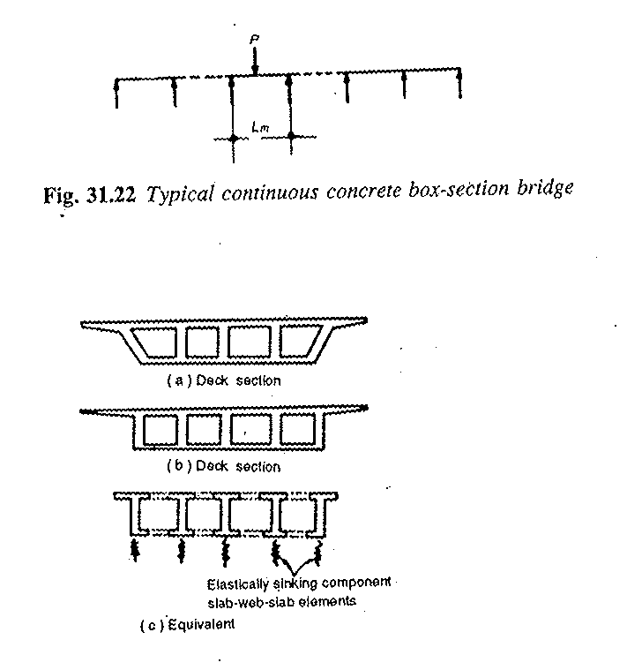

TYPICAL CONCRETE BOX GIRDER SECTION

Fig 3.5 Idealization for Transverse Analysis of Box girder

because the moment of inertia of the whole may not be equal to the arithmetic sum of the moments of inertia of the component elements. In the case of bridge decks consisting of similar beams interconnected by a number of diaphragms and a top slab is very close to unity and I is equal to nI_{W}
The following loads need to be considered in transverse analysis of box girder superstructure.

(a) Self weight of Superstructure
(b) Super imposed dead Load
(c) Temperature force
(d) Live load i/c impact factor
The various positions of live load wheel along the transverse span need to be studied for critical design moment in the transverse slab along the transverse span. The transverse analysis is generally done for unit width of superstructure. Thus the bending moment per unit width caused by concentrated loads on solid span spanning in one direction or on cantilever slabs may also be calculated by assessing the width of slab that may be taken as effective in resisting the bending moments due to the concentrated loads. The effective width is calculated as per clause no 305.16 of IRC:21. The dispersion of concentrated load along the span is also required to be considered. It shall be taken as equal to the dimension of the tyre contact area over the wearing surface of the slab in the direction of the span plus twice the overall depth of slab inclusive of the thickness of wearing course.

Longitudinal Analysis and Design

After computing the design bending moments & shear forces at critical section along the span length of superstructure, it is essential to fix pre-stressing force and finalize the cable profile.

Cable Profiling

Because of the changes in stress induced by the application of loading at different sections along the span length, the optimum use of pre-stressing requires that the position of the tendons should change within the section from one point to another along the span length. Tendon profiles are usually of parabolic shape. The tendon profile for a simply supported span consists of one parabolic curve with the maximum eccentricity being located at midspan. Tendon profiles in continuous superstructure can be a series of parabolic segments with concave segments in the span and convex segments over the span as shown in figure.
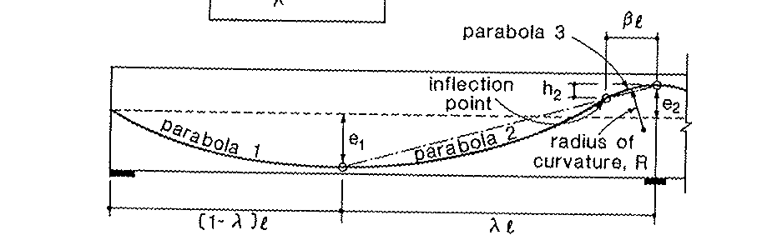

Fig 3.6 Cable Profile Sketch

Figure 3.6 illustrates how a series of parabolic segments fit together. At the location of maximum eccentricity e₁, parabola 1 & 2 both have zero slopes and hence are compatible. In order that parabola 2 & 3 are compatible, their slopes at the infection point should be equal. The convex segment over the support is required to avoid a kink in the tendon at this location. The length of the convex segments need to be chosen such that over the support the radius of curvature R of the tendon is not less than the minimum radius of curvature recommended for the particular tendon.

This can be achieved without difficulty by fixing the cable ducts to the required profile before concreting. The tendon can be pulled or deflected out of a straight line to approximate to the stressing procedure and is only reckoned as appropriate for a large units. An alternative technique for simulating the effect of a profile is to break the bond between selected tendons and surrounding concrete near the ends of the unit. This debonding is achieved by placing sleeves over the selected tendons and thus rendering them ineffective in those zones.
The pre-stressing force is such calculated that it satisfies all codal provisions at different stages of loading to which a structure is often subjected. For a cast-in-place structure, prestressed concrete has to be designed for at least two stages: the initial stage during prestressing and the final stage under external loadings. For precast, members, a third stage, that of handling and transportation, has, to be investigated. During each of these three stages, there are again different periods when the member or structure may be under different loading conditions. These will be analyzed below.

Initial Stage
The member or structure is under prestress but not subjected to any superimposed external loads. This can be further subdivided into the following periods, some of which may not be important and hence may’ be neglected in certain designs.
Before Prestressing: Before the concrete is prestressed, it is quite weak in carrying load; hence the yielding of its supports must be prevented. Provision must be made for the shrinkage of concrete if it might occur. This is often significant because any shrinkage cracks will destroy the capacity of the concrete to carry tensile stresses.
During Prestressing: This is a critical test for the strength of the tendons. Oftentimes, the maximum stress to which the tendons will be subjected throughout their life occurs at that period. It occasionally happens that an individual wire may be broken during prestressing, owing to defects in its manufacture. But this is seldom significant, since there are often many wires in a member. If a bar is broken in a member with only a few bars, it should be properly replaced. For concrete, the prestressing operations impose a severe test on the bearing strength at the anchorages. Since the concrete is not aged at this period while the prestress is at its maximum, crushing of the concrete at the anchorages is possible if its quality is inferior, again, unsymmetrical and concentrated prestress from the tendons may produce overstresses in the concrete. Hence the order of prestressing the various tendons must often be studied before hand.
At Transfer of Prestress:. For post-tensioned members, the transfer is often gradual, the prestress in the tendons being transferred to the concrete one by one. There is no external load on the member except its own weight. Thus, the initial prestress, with little loss as yet taking place, imposes a serious condition on the concrete and often controls the design of the member. For economic reasons the design of a prestressed member often takes into account the weight of the member itself in holding down the cambering effect of prestressing, This is done on the assumption of a given condition of support for the member. If that condition is not realized in practice, failure of the member might result. For example, the weight of a simply supported prestressed girder is expected to exert a maximum positive moment at midspan which counteracts the negative moment due to prestressing; If the girder is cast and prestressed on soft ground without suitable pedestals at the ends, the expected positive moment may be absent and the prestressing may produce excessive tensile stresses on top fibres of the girder, resulting in its failure. Likewise, if the supporting staging is very flexible (not massive and rigid), the cambering effect due to prestress may still not allow the self weight of the structure to act freely since the recompressed staging may, despite its decompression, still keep touching the soffit of structure, thereby allowing only a part of dead load to act. This may cause severe, tension in top fibre.
Decentering and Retensioning: If a member is cast and prestressed in place, it generally becomes self-supporting during or after prestressing. Thus the false work can be removed after prestressing, and no new condition of loading is imposed upon the structure. Some concrete structures are retensioned, i.e., prestressed in two or more stages. Then the stresses at various stages of tensioning must be studied.

Intermediate Stage
This is the stage during transportation and erection. It occurs only for precast members when they are transported to the site and erected in position. It is highly important to ensure that the members are properly supported and handled at all times. For example, a simple beam designed to be supported at the ends will easily break if lifted farther away from its ends.
Not only during the erection of the member itself, but also when adding ‘the superimposed dead loads, attention must be paid to the conditions of support and loading. This is especially true for a cantilever layout, when partial loading may result in more serious bending than a full loading.

Final Stage

This is the stage when the ‘actual working loads come on the structure. As for other types of construction, the designer must consider various combinations of live loads on different portions of the structure with lateral loads such as wind and earthquake forces, and with strain loads such as those produced by settlement of supports and temperature effects. For prestressed concrete structures, especially those of unconventional types, it is often necessary to investigate their cracking and ultimate loads, in addition to the working load.

Losses in Prestress

The initial/applied prestress in concrete undergoes a gradual reduction with time from the stage of transfer due to various causes. This is generally referred as loss of prestress. A reasonably good estimate of the magnitude of loss of prestress is necessary from the design point of view. The various types of losses occurred in concrete are as follows:-
(a) Friction and slip loss
(b) Elastic deformation of concrete
(c) Relaxation of stress in steel
(d) Shrinkage of concrete
(e) Creep of concrete

Friction and slip loss
In post-tensioned members, the tendons are placed in ducts embedded in concrete. The ducts are either straight or follow a curved profile depending upon the design requirements. The friction loss occurs due to friction between the tendons & surrounding ducts and change in angle of the tendon profile. The magnitude of this loss is of following types.

(i) Loss of stress due to the curvature effect which depends upon the tendon form or alignment which generally follows a curved profile along the span.
(ii) Loss of stress due to the wobble effect which depends upon the local deviation in the cable profile. The wobble effect is the result of accidental or unavoidable misalignment since ducts or sheath cannot be perfectly located throughout the span.
The anchoroage loss occurs due to slippage of anchorage wedge employed to grip the wires before the wires are firmly housed between the wedge during the stressing of cable. The magnitude of slip depends upon the type of wedge and stress in the wires.

Elastic deformation of concrete

This prestress loss depends on the modular ratio and the average stress in concrete at the level of steel.

Stress in steel corresponding to concrete strain = Es x fc
Ec
Where fc= prestress in concrete at steel level
Es = Modulus of elasticity of steel
Ec= Modulus of elasticity of concrete

Relaxation of stress in steel

Mostly codes provide for the loss of stress to due to relaxation of steel as a percentage of the initial stress in steel. The loss of prestress due to relaxation of steel recommended in Indian codes and British Standards is given in Table 3.4.

Loss due to shrinkage of concrete

The shrinkage of concrete in prestressed members results in shortening of tensioned wires and hence contributes to the loss of stress. The shrinkage of concrete is influenced by the type of cement and aggregates and the method of curing used. Use of high strength concrete with low water cement ratio results in a reduction in shrinkage and consequent loss of prestress. The primary cause of drying shrinkage is the progressive loss of water from concrete.
Loss of stress = Ecs x Es
Where Ex – Modulus of elasticity of steel &
Ecs= Total residual shrinkage strain given in table of IRC:18.
The British Standard recommended for shrinkage include environmental humidity as a factor. The recommended residual shrinkage is 200x10⁻⁶ for normal and 700x10⁻⁶ for humid conditions.
Table 3.4 Loss of Prestress due to Relaxation of Steel
Recommendations of British Codes
Type of tendon | Range of characteristic strength, N/mm² | Modulus of elasticity, kN/mm² | Percentage loss of prestress for
Type of tendon | Range of characteristic strength, N/mm² | Modulus of elasticity, kN/mm² | f_{pi}  0.7 | f_{pu}  0.8
Cold drawn steel wire to BS-2691  1. Pre-straightened (normal relaxation) | 1570-1720 | 200 | 5 | 8.5
2. Pre-straightened (low relaxation) | 1570-1720 | 200 | 2 | 3.0
Seven wire strand to BS-3617
1. Normal relaxation | 1640-1820 | 200 | 7 | 12
2. Low relaxation | 1640-1820 | 200 | 2 | 3
Nineteen wire strand to BS-4757
1. As spun | 1480-1540 | 175 | 9 | 14
2. Normal relaxation | 1760 | 175 | 7 | 12
3. Low relaxation | 1760 | 175 | 2.5 | 3.5

Loss due to creep of concrete

The sustained prestress in the concrete of a prestressed member results in creep of concrete which effectively reduces the stress in high tensile steel. The loss of stress in steel due to creep of concrete can be estimated if the magnitude of ultimate creep strain or creep coefficient is known.
(i) Ultimate creep strain method
If ε_{cs} = ultimate creep strain for a sustained unit stress
f_{c} = compressive stress in concrete at the level of steel
E_{s} = modulus of elasticity of steel
Then the loss of stress in steel due to creep of concrete = ε_{cs} f_{c} E_{s}
(ii) Creep coefficient method
If ε_{c} = creep strain
ε_{s} = elastic strain
α_{c} = modular ratio
f_{c} = stress in concrete
E_{s} = modulus of elasticity of steel
E_{c} = modulus of elasticity of concrete
Creep coefficient = creep strain
Elastic strain
Then the loss of stress in steel = ε_{c} E_{s} = Φ fc α_{c}
The magnitude of the creep coefficient, Φ, varies depending upon the humidity, concrete quality, duration of applied loading and the age of the concrete when loaded. The general, values recommended for ‘the creep coefficient vary from 1.5 for watery situations to 4.0 for dry conditions and relative humidity of 35 per cent.
The British code for structural concrete recommends design values of ultimate creep strain of 36 x 10-6 fo post-tensioning. These values have to be increased in inverse proportion if the compressive strength of concrete at transfer is less than 40 N/mm².

Types of Flexural Failure

When prestressed concrete members are subjected to bending loads, different types of flexural failures are possible at critical sections, depending upon the principal controlling parameters, such as the percentage of reinforcement in the section, degree of bond between tendons and concrete, compressive strength of concrete and the ultimate tensile length of the tendons. In the post-cracking stage, the behavior of a stressed concrete member is more akin to that of a reinforced concrete member
The various types of flexural failures encountered in prestressed concrete members are examined in the light of recommendations of various codes of practice.
(i) Fracture of Steel In Tension: The sudden failure of a prestressed member without any warning is generally due to the fracture of steel in tension zone. This type of failure is imminent when the percentage of steel provided in the section is so low that when the concrete in the tension zone cracks, the steel is not in a position to bear up the additional stress transferred to it by the cracked concrete. This type of failure can be prevented by providing a certain minimum percentage of steel in the cross-section.
The Indian standard code IS: 1343 -1980 prescribes minimum longitudinal reinforcement of 0.2 and 0.15 percent of the cross-sectional area for mild steel and HYSD bars respectively. The percentage of steel provided, both tensioned and untensioned taken together, should be sufficient so that when the concrete in the precompressed tensile zone cracks, the steel is in a position to bear the additional tensile stress transferred to it by the cracking of the adjacent fibres of the concrete, thereby preventing a sudden failure of the beam due to fracture of steel in tension.
In contrast, the British Code BS: 8110-1985 prescribes that the number of prestressing tendons should be such that cracking of the concrete proceeds the failure of the beam. This requirement will be satisfied if the ultimate moment of resistance of the section exceeds the moment necessary to produces a flexural tensile stress in the concrete at the extreme tension fibres of magnitude equal to 0.6 f_{cu}. In these computations, the effective prstress in concrete should be considered after allowing for the various losses.
(ii) Failure of Under Reinforces Section: If the cross section is provided with an amount of steel greater than case mentioned above, the failure is characterized by an excessive elongation of steel followed by crushing of concrete. As bending loads are increased, excessive elongation of the steel raises the neutral axis closer to the compression face at the critical section. The member approaches failure due to the gradual reduction of the compression zone, exhibiting large deflections and cracks, which develop at the soffit and progress towards the compression face. When the area of concrete in the compression force, the ultimate flexural failure of the member takes place through the crushing of concrete. Large deflections and wide cracks are the characteristics features of under-reinforced sections at failure. This type of behavior is generally desirable since there is considerable warning before the impending failure. As such, it is common practice to design under-reinforced sections which become more important in the case of statically indeterminate structures.
- Failure of Over-Reinforced section: When the effective reinforcement exceeds a certain range of values, the section is said to be over-reinforced. Generally, over-reinforced members fail by sudden crushing of concrete, the failure being characterized by small deflections and narrow cracks as shown in figure 3.7. The area of steel being comparatively large, the stresses developed in steel at failure of the member may not reach the tensile strength and in many cases it may well be within the proof stress of the tendons.
In structural concrete members, it is undesirable to have sudden failures without any warning in the form of excessive deflections and widespread
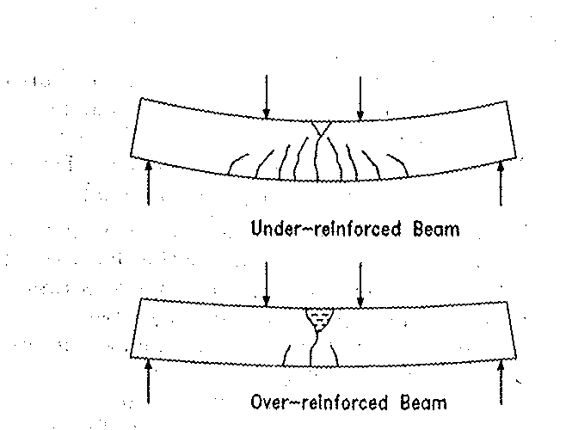
Figure 3.7 Flexural Failure Modes of Prestressed Beams
cracks, and consequently the use of over-reinforced sections is discouraged. The amount of reinforcement used in practice should, preferably, not exceed that required for a balanced section. In this connection, most of the codes follow a conservative approach in formulating the evaluation procedures for flexural strength calculations of over-reinforced sections. The redistribution of moments in an indeterminate structure depends upon the rotation capacities of the critical sections of the member under a given system of loads. The use of over-reinforced sections in such structures curtails the rotation capacity of the sections, consequently affecting the ultimate load on the structure.

Types of Shear Cracks

There are two major modes of shear cracking in structural concrete beams. These two types, generally referred to as web-shear and flexure-shear cracks, as shown in figure 3.8 given below. Web-shear cracks generally start from an interior point, when the local principal tensile stress exceeds the tensile strength of concrete. Web-shear cracks are likely to develop in highly prestressed beams with thin webs, particularly when the beam is subjected to large concentrated loads near a simple support. Flexure-shear cracks are first initiated by flexural cracks in the inclined direction. Flexure-shear cracks develop when the combined shear and flexural tensile stresses produce a principal tensile stress exceeding the tensile strength of concrete. In members without shear reinforcement, the inclined shear cracks extend to the compression face resulting in sudden explosive failures. This is sometimes referred to as the diagonal tensile mode of failure.
Figure 3.8 Types of Shear Cracks in Prestressed Beams 

Deflection and Camber

The deflection of prestressed concrete member due to ‘short term’ live load, ‘long term’ dead loads and sustained live load need to be calculated. In calculating long term camber and deflections, creep & shrinkage of concrete and relaxation of the steel are to be taken into account. The computed deflections are not to exceed the limits given in different codes. It is how general practice that structural concrete members should be designed to have adequate stiffness to limit deflections which may adversely affect the strength or serviceability of the structure at working loads.
Suitable control on deflections is very essential for the following reasons:
- Excessive sagging of principal structure members is not only unsighty but at times also renders the floor unsuitable for the intended use.
- Large deflections under the dynamic effects and variable loads cause the discomfort to users.
The deflections of PSC bridges are influenced by the following salient features:
- Imposed Load and self weight.
- Magnitude of the rpe-stressing force & tendon profile.
- Elastic modulus of concrete and M.O.I of cross section.
- Shrinkage, creep and relaxation of steel stress
- Span of the member
Here a typical problem of camber in box girder superstructure with cantilever type construction is discussed in detail. Each cantilever arm consists of several segments fabricated, installed, and loaded at different points in Lime. It is important, therefore, to predict accurately the deflection curves of the various cantilevers so as to provide adequate camber either in the fabrication plant for precast segmental construction or for adequate adjustment of the form-travellers for cast-in-situ construction.
While the structure is statically determinate, the cantilever arm deflections are due to:
(a) The concrete girder weight
(b) The weight of the travellers or the segment-placing equipment
(c) The cantilever prestress
If the structure is finally a continuous type, then after continuity between individual cantilevers is achieved, the structure becomes statically indeterminate and continues to undergo additional deflections for the following reasons:
(d) Continuity prestress
(e) Removal of travellers or segment-placing equipment (reverse loading, but on continuous structure)
(f) Removal of ‘provisional supports’ and release of ‘deck to pier connections’ if any (again a reverse loading)
(g-) Placing of superimposed loads

Even if the structure is non-continuous, items (e), (f) and (g) still cause deflection.
Subsequent long-term deflections due to concrete-creep and prestress-losses will also take place. Compensation for the deflections resulting in the following three states must be provided-for by adequate camber or adjustment:
1. Cantilever arms (during construction)
2. Short term in-service deck statically determinate or
3. Long term in service deck indeterminate

The concrete modulus of elasticity varies both with the ‘age at the time of first loading’ and with the ‘duration of the load’. Deflections of states 2 and 3 above are easily accommodated by changing the theoretical longitudinal profile by the corresponding reverse amount in each section to offset the anticipated future deflections. A more delicate problem is to further accurately predict, allow for, and adequately follow the deflections of the individual cantilever arms during construction (at each stage there is- a new cantilever). For this it is necessary to analyze each construction stage and to determine the deflection curve of each successive cantilever arm (as construction proceeds segment by segment). A simple case with a five- segment cantilever is shown in Fig. 3.9. The broken line represents the envelope of the various deflection curves or the ‘space-trajectory’, followed by the cantilever-tip at each construction stage (i.e., at the end of each segment addition).
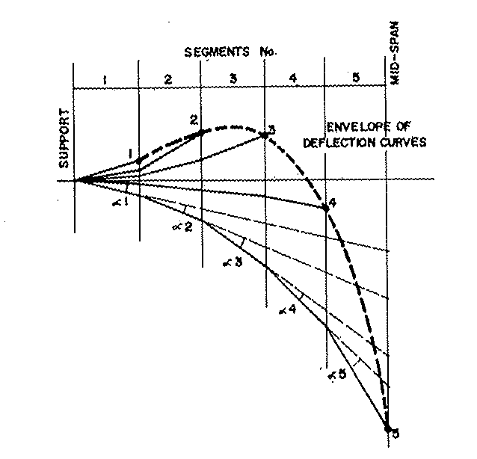
By changing the relative angular positions of the various segments by small angles, such as a1, a2, and so on, the cantilever should be assembled to its final length with a satisfactory longitudinal profile as shown in Fig. 3.9 for the simple case considered.

Figure 3.9 Deflection of a Typical Cantilever

It is interesting to compare the relative importance of deflections and camber for cast-in-situ and precast construction. Figure 3.10 shows values for an actual structure, where computations have been made for the two different methods. The calculation assumptions given in Fig.3.10 indicate that in most cases the difference would be even more significant if a- cast-in-situ cycle of less than one week were employed and if precast segments were stored for more than two weeks.
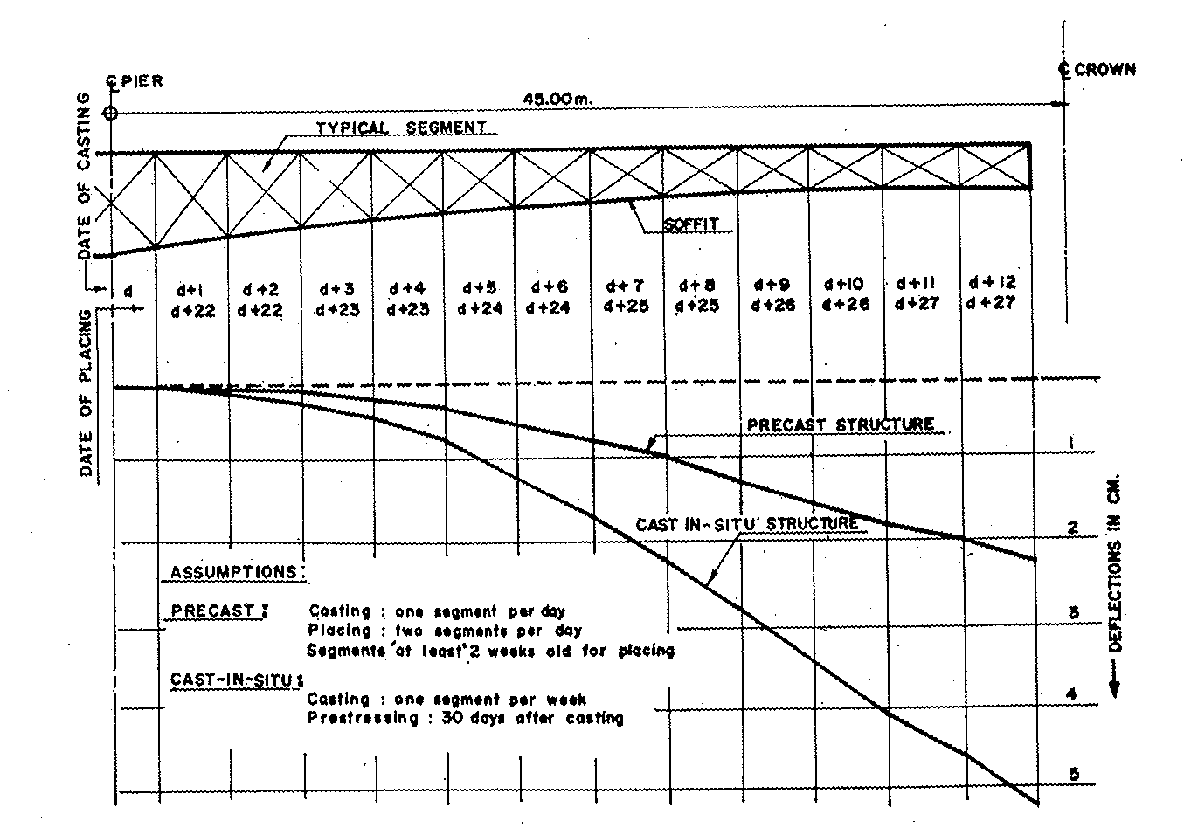
Figure 3.10 Comparison of deflection in Precast & in-situ structures

Serviceability Limit State of Cracking

Following the reasonable conditions for this purpose:
(i) The assessed surface crack width shall not in general exceed 0.3 mm.

(ii) When members are exposed to a particularly aggressive environment, such as the ‘very severe’ category (i.e., exposed to sea water and with abrasion), the assessed surface crack widths at points nearest the main reinforcement should not exceed 0.004 times the nominal àover to the main reinforcement.
In a ‘normal environment’ condition (i) will suffice, while in the ‘very severe category’ the more critical of conditions (i) and (ii) will govern. For this category, the minimum grade of concrete is 40 N/mm2 and the nominal cover is 60 mm. Or we can have 50 mm cover using grade 50 concrete. Using the latter, we should have the requirement that at points nearest the main reinforcement the crack width should not exceed 0.2 mm whilst it must not exceed 0.3 mm at any other position.
With large covers to the main bars it will generally be found that unless the bars are at fairly close centres it will be the 0.3 mm criteria that will govern the design.

The widths of flexural cracks at a particular point on the surface of a member depend primarily on three factors:

- The proximity to the point under consideration, of reinforcing bars perpendicular to the cracks,
- The proximity of the neutral axis to the point under consideration,
- The average surface strain at the point under consideration.

Referring to Fig 3.11 the surface crack width in reinforced concrete under flexure may be taken as equal to (3.3cε₁) for deformed bars or (3.8cε₁) for plain bars. If a’ < c, then substitute a’ for c.

Figure 3.11 Crack Control

The formulae give acceptably accurate results in most normal design circumstances, but it should be emphasized that cracking is a random phenomenon and that an absolute maximum crack width cannot be predicted. The formula is designed to give a width of crack which has an acceptably small chance of being exceeded. Thus an occasional crack slightly larger than the predicted width should not be considered as cause for concern. But if a significant number of the cracks in a structure exceed the calculated width, reasons other than the structural nature of the phenomenon should be sought to explain their presence. (In certain cases, the occurrence of cracks due to plastic shrinkage of setting concrete, much before any load comes on the structure, could be a possible confusing reason).

Control of Crack Width

1 Cracking and crack-width-prediction-and-control have been much in the limelight in receipt years. The problem - has engaged growing attention of researcher’s code- makers, designers and constructors, to such an extent that it almost selects itself as one of the most discussed topics of the last decade, among people dealing with concrete.

2. All this talk about crack-width-computation may lead one to believe -that the panacea- of all ills lies in accurate prediction of flexural crack width or shear crack-width. Nothing could be farther from truth. Computing crack width is an important design task but a designer with over reliance on crack width computation for crack controls may soon find it disappointing.

3. Cracking of concrete occurs due to tensile stresses. But the occurrence of such tensile stresses may be traced to various sources other than flexural tension. Had flexural stresses been the one and only reason for tensile stresses in concrete, ‘full’ prestressing would have easily solved the problem.

4. There are other kinds of tensile stresses. It is, therefore, to be expected that the concrete structure remains unimpressed by the most sophisticated prediction- of flexural crack width and may crack due to these other tensile stresses.

5. One of the commonest causes of cracking in structures is the lack of reinforcing at locations where significant tensile stresses occur under predictable or unpredictable combinations of effects: Another kind comprises avoidable ‘deficiencies in construction quality of concrete resulting in so-called plastic cracking’.

6. In concrete, seeds of most cracking distress are sown before hardening and application of loading. Deficiencies and consequent damages that have been done to concrete at birth or at a very young age cannot be undone after it matures, and is put into service. If visible cracking has not appearing already in the concrete when poorly made, it remains very vulnerable due to unhealed scars. Reinforcement does not help, and computations go haywire!

7. To guard against such cracking, one must understand one’s concrete better. It is a multiphase, inherently heterogeneous, complex material. In engineering use, we interpret the behavior of concrete at phenomenon level, which can be deemed as little better than pre-scientific. The status of knowledge on microstructure of concrete and .associated theories of crack propagation and fracture of concrete has grown fast in recent years. It is now clear that micro cracks, lying hidden from view, hold the ‘key to the cracking behavior of concrete ‘like all other properties pertaining to strength and deformation.

8. Micro cracks are minute flaws or discontinuities inherent to heterogeneous nature of concrete. They appear in concrete not yet loaded, or lightly loaded while lying in the forms, waiting to’ gain its mechanical strength, The cracks are too narrow to falsify the use of elastic theory or the assumption of a homogeneous isotropic material by the-structural designer. (Some micro cracks may also get healed partly or completely with the crystals precipitating during the continued hydration of cement. But this autogenously healing does not solve all problems.) They nevertheless create, through their geometry, zones of potential fracture. So it is but expected that any excessive micro-cracking that occurs before hardening of concrete may prove to be the major source of cracking distress in the service life of the structure.

9. Restraint to free deformation while concrete hardens (plastic shrinkage, plastic settlement, etc.) is the primary cause of random non-structural cracking. Cracking can occur in otherwise sound concrete when still fresh due to the tendency of concrete to contract, caused by loss moisture or change in temperature. Other reasons are differential settlement over obstructions, such as large pieces of aggregates or steel, separation of aggregates and matrix due to settlement of latter with local bleeding under coarse aggregate. Segregation and faulty compaction result in voids and honeycombs.

10. Even when deficient quality of construction induces excessive micro cracking which soon develops into visible cracks, these may lie undetected for long despite their early appearance. These are usually obscured at early age of concrete by water bleeding initially to the surface of concrete. All looks well until the curing is over or the concrete is put into service. Unfavorable ambient conditions soon magnify the damages for all to see and ponder over. But post-mortem analysis often ignores the original sin.

11. The tensile strength of concrete develops very slowly and the concrete obviously remains very vulnerable to cracking at a young age. Deficiencies in composition of concrete, placing and curing, etc., and more significantly the adverse environmental conditions (wind, heat and cold) are agents which magnify the distress. Even if visible cracking is not very evident, due to severe micro cracking, the tensile strength of the hardened concrete may be much smaller than anticipated and severe cracking distress under subsequent load- induced tensile stresses can occur.

- As mentioned earlier, cracking in concrete yet to harden, can be attributed basically to (1) temperature change, and (2) drying. shrinkage. The mechanism of cracking due to temperature change is simple enough. to appreciate. Cement liberates heat during. hydration. While temperature rises, the plastic concrete hardens as it cools. A temperature differential can thus be set up between the outer and inner portions of the concrete mass during this temperature change. This can .be aggravated by environmental conditions. Restraint to free deformation results, in tensile stress (not necessarily flexural).

- Similarly, drying shrinkage generates tensile stresses due to restraint of deformation. Drying is largest at the exposed surface which tends to shrink more than the interior, yielding a restraint to the deformation of interior layers.

- Conscious efforts to reduce these restraint stresses and the consequent risks of cracking in plastic concrete may involve some elementary care in making good concrete. For reducing the cracking caused by temperature change, the temperature in the interior of concrete must be kept down and there are many ways of doing it. The most obvious one is to strike at the grass-roots. Cement is the source of heat of hydration. So the less the cement, less is the temperature change. Of course, cement is also the primary source of strength. So an optimum quantity, just enough to gain the desired strength, should be used. Non-optimal use of cement may make the concrete costlier or even stronger than desired but never betted merely richer mix for the same target strength can in the limit be poorer in quality. lt has been reported from a survey of a number of mass concrete structures in USA that the only concretes free from cracking were the ‘leanest’. Perhaps temperature differences alone cannot explain the observed better cracking resistance of leaner mixes. Lower modulus of elasticity and lower drying shrinkage characteristics may also contribute equally.

- The above elementary rule of making better concrete with less cement may be too well-known to be restated. Yet it remains a fact of life that misconceived reliance on liberal• addition to cement content to compensate for lack of controls on construction quality continues. Accent should be on durability and bond more than on extra strength alone. This calls for coarser gradation, cleaner dust-free aggregates of good quality, tight water- cement ratio, casting in low-wind low-heat low-cold weather, with adequate curing. It is worse when people add extra cement hoping it will ‘take care’ of strength when the worker quietly adds more water arbitrarily to permit him an easier workability, locally. This in fact leads later to all sorts of non-load-induced random cracks that subsequently accentuate, which ultimately destroys the integrity of the structure.

16. A designer doing voluminous computations of crack- width should perhaps first ensure that the mix of the concrete going into the structure is properly designed arid followed because excess of cement alone can lead to ross of quality in respect of cracking behaviour.

17. Caution against using too finely ground cement few not so high grades of concrete is also called for. Modem high-strength catchments are ground much finer than earlier. They liberate heat of hydration much faster and increase the risk of setting up a thermal gradient in a thick member. So, where cracking behaviour is a critical consideration, use of a very finely ground high-strength cement may not be favoured.

18. For preventing excessive drying shrinkage of concrete, it is important to protect the concrete surface by continued curing. Members with large thickness, or those cast in adverse ambient condition, will require greater care. Premature exposure by removal of forms also can aggravate the risk. In control of drying shrinkage, the effect of water content and mix proportions is most important. Choosing the lowest water-cement ratio practicable is necessary from the viewpoint of cracking resistance also.

19. Settlement cracking’ also appears in concrete before hardening. This type of cracking can be seen in poorly laid concrete on upper surface of slab ‘following approximately the top reinforcing pattern. The obstruction to the downward movement of solid particles by the ‘It reinforcement grid is the obvious cause. The incompatibility of the concrete mix, placing, and compacting techniques with the reinforcement arrangement contribute to the distress. This can be controlled by slightly reverberating the concrete before its initial setting. Plastic shrinkage cracks (which start at top and descend downwards, sometimes following the obstruction-creating path of the reinforcement grid and sometimes appearing normal to wind direction) can be controlled by robust timely toweling. They are caused when the rate of surface evaporation is faster than the •rate of internal bleeding (rising upward of water in fresh concrete)

  - The assumption of uniform stress distribution over the total ‘effective’ compression flange width only brushes aside a considerable deviation of stresses at the flange-edges. But such inaccuracies do not spell any trouble nor do they signify any gross error. Gross errors occur when the designer fails to subjectively account for the possible significant impact of the inherent inaccuracies of his analysis. In spite of the large sophistication in the tools of mathematical analysis of a structure, •a ‘structure’ design can hardly live by computation alone. Unless design decisions are supplemented by subjective engineering judgment of the actual structural behaviour, the finest efforts may end in disaster. This lesson has been learnt the hard way many times in this century. All the brilliant mathematics of the first Tacoma -Narrows bridge design did not save it from the collapse due to aerodynamic instability. The small geometric inaccuracies ignored in analysis brought about startling disasters of mighty steel bridges. Added to this entire are the unavoidable differential temperature stresses even whose prediction is inaccurate.

Codal Provisions

Section Check criteria

The complete design of superstructure is to be checked for both service stage and ultimate stage as per codal provisions. The design should satisfy both conditions simultaneously. The design includes the considerations of strength, stiffness and stability. The design of superstructure is done either on elastic (working) strength basis or on load factored (ultimate) strength basis and also ensure the serviceability criteria (like limiting the flexural crack widths, deflections and vibrations).
(i) Permissible Stresses in Concrete
- As per Indian Road Congress (IRC:18)

(a) Permissible compressive stress in concrete during construction | = | 0.5 f_{cj} < 30 MPa
 |  | Where f_{c}j is concrete strength at the time of stressing of cables subject to maximum value of f_{ck}.
- Permissible tensile stress in concrete 0.1 of permissible temporary
during construction compressive stress of concrete

- Permissible compressive stress during 0.33 f_{ck}
service stage

(d) Permissible tensile stress during service stage No tension
- As per British Standards
(a) Service Limit State
Description | Stress unit (MPa)
 | Tension | Compress
(i) SLS1 (Comb 1) | No tension | 20.0 | 0.4 fck
(ii) SLS 3 (Comb 3) | 2.55 | 20.00 | 0.4 kg
(ii) Ultimate strength check
As per code IRC: 18 (Design Criteria for Prestressed Concrete Road Bridges, Post Tensioned Bridge), a PSC bridge shall be checked for failure conditions at an ultimate load of 1.25G + 2SG + 2.5Q under moderate condition and 1.5G + 2SG + 2.5Q under severe exposure conditions where G, SG and Q denotes permanent load, superimposed dead load and live load including impact factor respectively. For sections, where dead load causes effect opposite to those of live load, the section shall also be checked for adequacy for a load of G+SG+2.5Q. The shear calculation is only required in ultimate load condition.
The ultimate shear resistance of the concrete section alone shall be considered as both uncracked and cracked section in flexure and the lesser value of these two shall be taken.
The ultimate load factor to be considered in checking as per British Standard is already given in Table 3.1.

Prestressing Tendons

Prestressing tendons normally take the form of separate wires, wires spun together helically to form strands or bars. For pre-tensioned steel, wires, strands and occasionally bars are used singly to permit the concrete to bond directly to them. When post tensioning is used, it is common practice to group the separate tendon together so as to reduce the number of anchorages and ducts required to accommodate them. When grouped in this way, the tendons in each duct are usually termed a cable. The following types of cables/tendons are available.

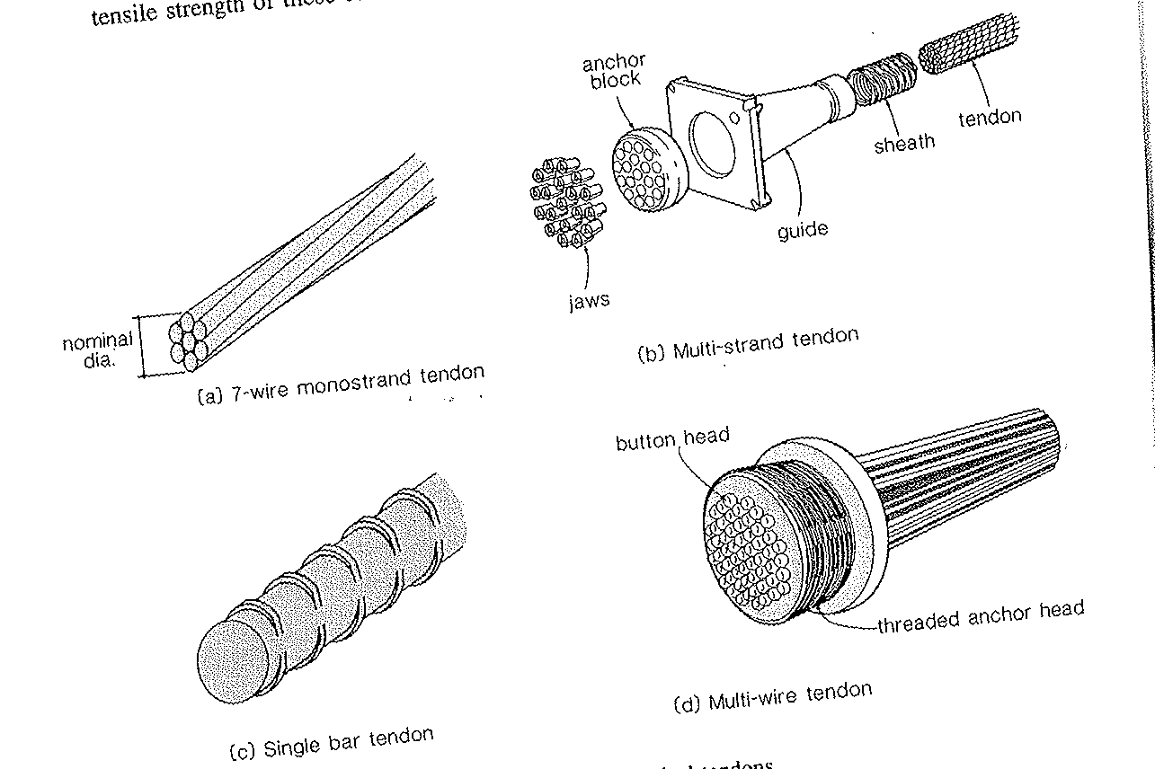
Figure 4.1 Different Types of Tendon

(i) 4K15 Tendons
It comprises of 4 nos of strand of 15.2 dia of wire and having following characteristics.
UTS of cable | 106.64 T
Maximum allowable force in cable after anchoring | 85.31T
Nominal steel area | 560mm²
Nominal weight of cable | 4.41 kg/m
Minimum recommended Sheathing diameter | 51mm

(ii) 7K13
It comprising of 7 strands of 12.7m dia of wire, in long span bridges and nuclear reactor etc. 7K13 system of anchorage is being used.

UTS of cable | 131T
Maximum allowable force in cable after anchoring | 105T
Nominal steel area | 691mm²
Nominal weight of cable | 5.425 kg/m
Minimum recommended Sheathing diameter | 51mm

(iii) 12 K13

12K13 anchorage system comprising of 12 strands of 12.7mm diameter developed specially to cater the needs of lower force range upto UTS 225T.
UTS of cable | 225 T
Maximum allowable force in cable after anchoring | 180T
Nominal steel area | 1184mm²
Nominal weight of cable | 9.3 kg/m
Minimum recommended Sheathing diameter | 75mm

(iii) 12K 15
UTS of cable | 319.104 T
Maximum allowable force in cable after anchoring | 255.28T
Nominal steel area | 1680mm2
Nominal weight of cable | 13.224 kg/m
Minimum recommended Sheathing diameter | 85mm

(iv) 19 K13
UTS of cable | 356 T
Maximum allowable force in cable after anchoring | 284.8T
Nominal steel area | 1875mm2
Nominal weight of cable | 14.73 kg/m
Minimum recommended Sheathing diameter | 85mm

- 19K15

UTS of cable | 506.7 T
Maximum allowable force in cable after anchoring | 405.4T
Nominal steel area | 2660mm2
Nominal weight of cable | 20.9 kg/m
Minimum recommended Sheathing diameter | 100mm

(vi) 27K 13

UTS of cable | 505.71 T
Maximum allowable force in cable after anchoring | 404.57T
Nominal steel area | 2665mm2
Nominal weight of cable | 20.925 kg/m
Minimum recommended Sheathing diameter | 100mm

(vii) 27k15
UTS of cable | 718 T
Maximum allowable force in cable after anchoring | 575T
Nominal steel area | 3780mm2
Nominal weight of cable | 30 kg/m
Minimum recommended Sheathing diameter | 110 mm

Sheathing Duct

The sheathing duct shall be either in mild steel or in HDPE. They shall be in as long length as practical from handling and transportation consideration without getting damaged.

(i) MS Sheathing Ducts

The material shall be cold rolled cold annealed (CRCA) mild steel intended for mechanised treatment and surface refining but not for quench hardening or tempering. The material shall be clean and free from rust and normally of bright metal finish. However, in case of use in aggressive environment galvanized or lead coated mild steel strips shall be adopted. The thickness of metal sheathing shall not be less than 0.3mm, 0.4mm & 0.5mm for sheathing ducts having internal diameter upto 50mm, 75mm & 90mm respectively.

- Corrugated HDPE Sheathing ducts

The material for the ducts shall be high density polyethylene with more than 2% carbon black to provide resistance to ultraviolet degradation. The ducts shall be connected on both sides. The ducts shall transit full tendon strength from the tendon to the surrounding concrete over a length not greater than 40 ducts diameter.

Specification for Sheathing Duct Joints

The sheathing ducts shall be of the spiral corrugated type. For major projects, the sheathing ducts should preferably be manufactured at the project site utilizing appropriate machines. With such an arrangement, long lengths of sheathing ducts may be used with consequent reduction in the number of joints and couplers.
Where sheathing ducts joints are unavoidable, such joints shall be made cement slurry tight by the use of corrugated threaded sleeve couplers which can be tightly screwed on to the outer side of the sheathing ducts. A heat-shrink coupler could also be used if suitable.
Typical detail of a sleeve coupler is shown in Fig 4.2. The length of the coupler should not be less than 150mm but should be increased up to 200mm wherever practicable. The joints between the ends of the coupler and the duct shall be sealed with adhesive sealing tape to prevent penetration of cement slurry during concreting. The couplers of adjacent ducts should be staggered wherever practicable. As far as possible, couplers should not be located in curved zones. The corrugated sleeve couplers are being conveniently manufactured using the sheath making machine with the next higher size of die set.
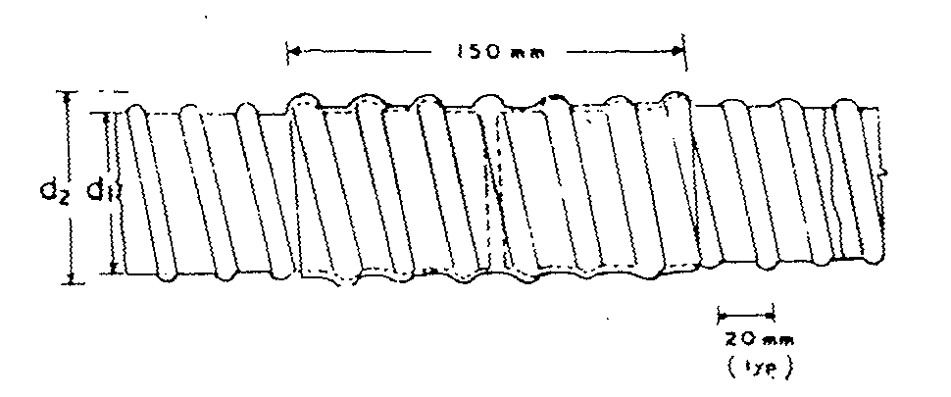
Fig 4.2 Details of Sleeve Coupler

The heat-shrink coupler shown in Fig. 4.3 is supplied in the form of bandage rolls which can be used for all diameters of sheathing ducts. The bandage is coated on the underside with a heat sensitive adhesive so that after heating the bandage material shrinks on to the sheathing duct and ensures of formation of a leak proof joint, without the need for extra taping or support in the form of corrugated sleeve couplers. The heating is affected by means of a soft gas flame.
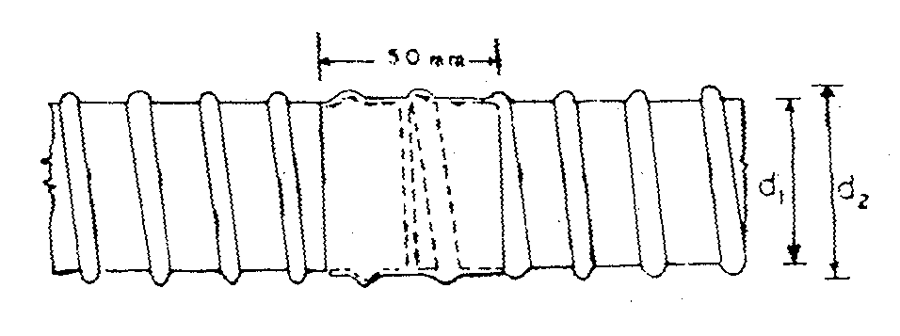
Fig 4.3 Details of Heat Shrink Coupler

Recommended Practice for Storage and Handling of Prestressing Material

(i). All prestressing steel, sheathing, anchorages and sleeves or couplings shall be protected during transportation, handling and storage. For wires upto 5mm dia, coils of about 1.5m dia, and for wires above 5mm dia, coils of about 2m dia without breaks and joints shall be obtained from the manufacturer.
(ii). Materials shall be stored in accordance with the provisions contained in relevant specifications. All efforts shall be made to store the materials in proper places so as to prevent their deterioration or intrusion by foreign matter and to ensure their satisfactory quality and fitness for the work. The storage space shall also permit easy inspection, removal and re-storage of the materials.
(iii). The prestressing steel, sheathing and other accessories shall be stored under cover and protected from rain or damp ground. These shall also be protected from the ambient atmosphere if it is likely to be aggressive. All prestressing steel shall be provided with temporary protection during storage such as coating of soluble oils, silica gel or vapour phase inhibiting materials of proven specifications.
(iv). Storage at site shall be kept to the absolute minimum,. All materials even though stored in approved godowns shall be subjected to acceptance test prior to their immediate use.

Recommended Practice for Prestressing Operations

Prestressing operation and grouting shall be entrusted to only specially trained and qualified personnel. All prestressing accessories shall be procured from authorized manufacturers with in-house testing facilities. Contractors shall also be required to engage specialised agencies who should also be entrusted with the total service contract for fabrication of cables, protection of cables during concreting, prestressing and grouting. Necessary certificates shall also be accorded by such specialized agencies that the work has been carried out in accordance with prescribed specifications. In exceptional cases where the client is convinced that the contractor of the bridge itself is well experienced and has qualified personnel and sufficient track record to substantiate his performance in the particular system of prestressing being adopted the prestressing and grouting operations could be entrusted to the contractor.

Anchorage
The anchorage will comprise of two components
(i) Anchorage Plate
It has twin function of guide and bearing plate component together and shall be embedded in the concrete at the time of casting. It is provided with tapered hole to accommodate the grip.
(ii) Grips
It will be standard 3 segmental grip of provider with circlips as usual for keeping 3 segments together
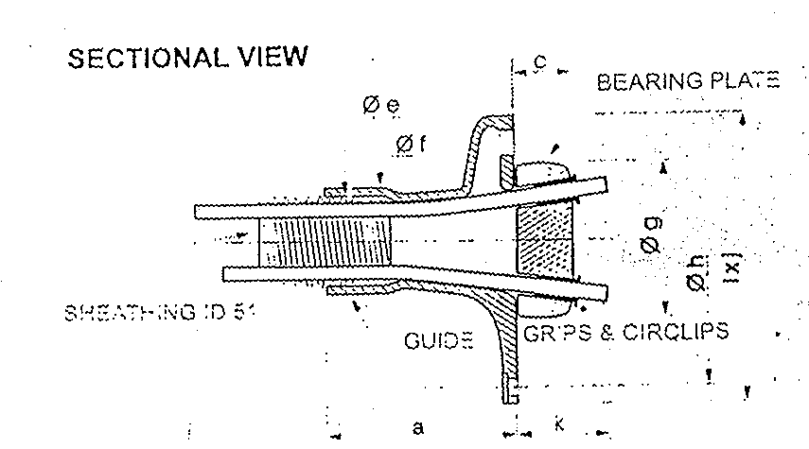
Figure 4.4 Anchorage Sectional View

End Block

End block shall be designed to distribute the concentrated prestressing force at the anchorage. It shall have sufficient area to accommodate anchorages at the jacking end & shall be enough wide as the narrowest flange of the beam. The design of reinforcement in the anchorage zone is of Paramount importance as high bursting and spalling stresses set up in concrete immediately in front of a prestressing anchorage at the time of tensioning the prestressing cable.
The prestressing force emanating from the anchorage travels into the concrete member initially in the shape of trajectories that set up stress eddies in three dimensions within a certain distance-generally taken equal to three-quarters to full depth of beam at anchorage face. The zone within this distance is sometimes referred to as the ‘lead-in- zone. The prestress force is assumed to come on the full effective section only from the end of the lead in zone.
The bursting forces F_{bst} in the end block should be assessed on the basis of the ultimate tensile strength, the bursting tensile force fast existing in an individual square end block loaded by a symmetrically placed square anchorage or bearing plate derived from table no 4.1.
Table:4.1- Design bursting forces in end block
Y_{P0}/Y₀ | 0.3 | 0.4 | 0.5 | 0.6 | 0.7
F_{bst}/P_{k} | 0.23 | 0.20 | 0.17 | 0.14 | 0.11

When 2Y₀ = is the side of end block
2 Y_{PO} = is the side of loaded area
P_{K} = Jacking force of tendon
F_{bst} = is the bursting tensile force

Concrete Grade
The concrete shall be in grade designated in Table 4.2, where the characteristic strength is defined as the strength of material below which not more than 5% of test result an expected to fall.

Table 4.2: Concrete Grade & respective Compressive Strength

Grade Designation | Specified characteristic compressive strength at 28 Days (MPa)
M15 | 15
M20 | 20
M25 | 25
M30 | 30
M35 | 35
M40 | 40
M45 | 45
M50 | 50
M55 | 55

TABLE 4.3:
A) FOR BRIDGGES IN PRESTRESSED CONCRETE OR THOSE WITH TOTAL LENGTH MORE THAN 60M OR THOSE THAT ARE BUILT WITH INNOVATE DESIGN/CONSTRUCTION
STRUCTURAL MEMBER | MINIMUM GRADE OF CONCRETE  CONDITIONS OF EXPOSURE  MODERATE SEVERE |  | MIN. CEMENT CONTENT FOR ALL EXPOSURE CONDITIONS  (kg/cu.m) | MAXIMUM WATER CEMENT RATIO  CONDITIONS OF EXPOSURE  MODERATE SEVERE
a) PCC members | M25 | M30 | 360 | 0.45 | 0.45
b) RCC members | M30 | M35 | 380 | 0.45 | 0.40
c) PSC members | M35 | M40 | 400 | 0.40 | 0.40

B) FOR BRIDGES OTHER THAN THOSE MENTIONED IN TABLE A, FOR CULVERTS AND OTHER INCIDENTAL CONSTRUCTION.
STRUCTURAL MEMBER | MINIMUM GRADE OF CONCRETE  CONDITIONS OF EXPOSURE  MODERATE SEVERE |  | MIN. CEMENT CONTENT (Kg./cu.m)  CONDITIONS OF EXPOSURE  MODERATE SEVERE |  | MAXIMUM WATER CEMENT RATIO CONDITIONS OF EXPOSURE  MODERATE SEVERE
a) PCC members | M15 | M20 | 250 | 310 | 0.50 | 0.45
b) RCC members | M20 | M25 | 310 | 360 | 0.45 | 0.40

Notes:- (1) Conditions of Exposure:
Severe-Marine environment: alternate wetting and drying due to sea spray, alternate wetting and drying combined with freezing; buried in soil (having corrosive effect): members in contact with water where the velocity of flow and the bed material are likely to cause erosion of concrete.
Moderate-conditions other than ‘severe’:

- The minimum cement content is based on 20 mm size aggregates. For larger size aggregates, it may be reduced suitably by not more than 10 percent. Similarly for smaller size aggregates, it may be suitably increased, but not more than 10 per cent.

