Comparison of Different Approaches of
Analysis in Reinforced Concrete Framed Buildings

A dissertation submitted in partial fulfillment
for the award of the degree of

Master of Engineering
In
Civil Engineering
(Structural Engineering)

Submitted by

Pankaj Kumar
(Roll No. 8488)

Under the guidance of
Mr. Alok Verma
Lecturer
Civil Engineering Department,
Delhi College of Engineering,
Delhi



Department of Civil & Environmental Engineering
Delhi College of Engineering
University of Delhi, Delhi
2008-2010

This is to declare that the major project titled “Comparison of Different Approaches of Analysis in Reinforced Concrete Framed Buildings” is the record of work done by me for the partial fulfillment of the requirements for the degree of Master of Engineering in Civil Engineering (Structural Engineering), Delhi College of Engineering.

This project has been carried out under the guidance and supervision of Mr. Alok Verma.

The matter embodied in this major project has not been submitted for the award of any other degree.

July 12, 2010

Pankaj Kumar
Enrolment No. DP287/04
Roll No. 8488

This is to certify that the above statements made by Mr. Pankaj Kumar, are correct to the best of my knowledge.

.

Alok Verma
Lecturer,
Civil Engineering Department,
Delhi College of Engineering

I wish to express my deep sense of gratitude and appreciation to Mr. Alok Verma, Lecturer, Department of Civil & Environmental Engineering, Delhi College of Engineering, Delhi for extending all help and words of encouragement while working on the project. Without their guidance this project would not have materialized.

I express my sincere gratitude to all other faculty members of Civil Engineering Department and the people from library of Delhi College of Engineering, Delhi for providing the relevant information when needed during the course of my this project work.

I also thanks my friends who made numerous & valuable contribution in the completion of this work. I feel indebted for their help and co-operation.

Pankaj Kumar

Abstract 5

Objectives of the Project 6

Literature Survey 7

Numerical Study 13

Comparison of the three approaches of analysis 21

Conclusions 70

Scope of further study 72

References 73

Reinforced concrete (RC) buildings are constructed first as a framed structure. After building frame is constructed the walls also known as infill walls are constructed. These infill walls are not usually taken in analyzing the structure. But these infill walls also give contribution to the overall stiffness of the building.

Reinforced concrete (RC) framed buildings with infill walls are usually analysed and designed as bare frames, without considering the strength and stiffness contribution of the infills. However, during earthquakes, these infill walls contribute to the response of the structure and the behavior of infilled framed building is different from the predicted for bare frame structures.

The effects of nonstructural masonry infills can modify the seismic behavior of framed buildings to a large extent. The panels can significantly increase the global stiffness and strength of the structure and consequently change the base shear imposed on the building in a seismic event.

Apart from the above consideration, it must be appreciated that pseudo static and dynamic approaches of analysis of RC framed are different, when all such aspects are combined. Different results are expected in different approaches.

In this study pseudo static and dynamic methods of analysis with/without consideration of stiffness of infill wall have been applied to atypical RC framed building to appreciate the variation in different approaches. Such variations have been determined for the same RC framed building considering all the seismic zone.

The various objectives of this project report are listed below:

- To study the various Codes and guidelines applicable to such buildings.

- To study the present state of art and state of practice for analyzing a building without considering the role of stiffness of infill wall with the help of STAAD PRO.

- To study the present state of art and state of practice for analyzing a building considering the role of stiffness of infill wall with the help of STAAD PRO.

- To analyse the building by Portal Method for pseudo static approach.

- To observe the variation of various parameters including

  - Base Shear in different seismic zones.

  - Top floor drift in longitudinal and transverse direction in different seismic zones.

  - Forces in various structural components.

- Plotting graph on above results.

- Concluding the result obtained on above analysis.

- To suggest the scope of further study.

Introduction

Reinforced concrete (RC) frames consist of horizontal elements (beams) and vertical elements (columns) connected by rigid joints. These structures are cast monolithically that is, beams and columns are cast in a single operation in order to act in unison. RC frames provide resistance to both gravity and lateral loads through bending in beams and columns.

In common practice reinforced concrete (RC) framed buildings with infill walls are usually analysed and designed without considering the strength and stiffness contribution of the infills. However, during earthquakes, these infill walls contribute to the response of the structure and the behavior of infilled framed building is different from the predicted for bare frame structures.

The RC framed building with unreinforced masonry walls are modeled as “Equivalent braced frame method” with infill walls replaced by “equivalent struts”. The strut area, Ae, was given by following expression:

Where 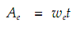

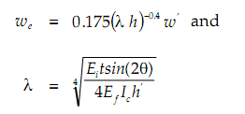
Where,

= the modulus of elasticity of the infill material,
= the modulus of elasticity of the frame material,
= the moment of inertia of column,
= the thickness of infill,
h’ = the height of infill,
= the diagonal length of infill panel,
= the slope of infill diagonal to the horizontal.

A simple and conservative expression of the width of equivalent strut was proposed as:

Where,

= the length of the infill diagonal.

The infilled frame in this model was idealized as an equivalent diagonally – braced framed with the diagonal compression struts pin-connected to the frame corners.

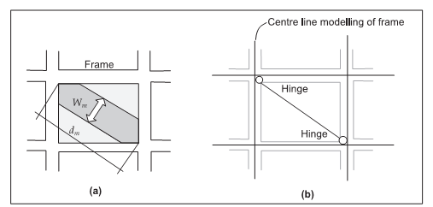
Idealisation of brick infill panel as equivalent diagonal strut

Analysis of Seismic Loads

The total design lateral force or design seismic base shear (V_{B} ) along any principal direction shall be determined by as per IS 1893-2002

V_{B} = A_{h *} W
Where,

A_{h} = Design horizontal seismic coefficient
W = Effective weight of the structure.

The design horizontal seismic coefficient A_{h} for a structure shall be determined by the following expression:

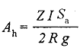
Where,

Z = Zone factor as given in table below,
I = Importance factor,
R = Response Reduction factor,
S_{a} / g = Average response acceleration coefficient for rock or soil sites as
given by the figure below.

Zone factor is classified as:

Seismic Zone | II | III | IV | V
Intensity | Low | Moderate | Severe | Very Severe
Z | 0.1 | 0.16 | 0.24 | 0.36

Figure giving Response Spectra for 5% damping

The code specifies two methods for calculating design seismic force and its distribution to different levels along the height of the structure. These methods are namely static and dynamic analysis.

Fundamental Natural Periods

(a) The approximate fundamental natural period of vibration in seconds, of moment resisting frame building without brick infill panels may be estimated by the empirical expression:

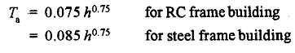

Where, h = Height of building, in m. This excludes the basement storeys, where basement walls are connected with the ground floor deck or fitted between the building columns. But, it includes the basement storeys, when they are not so connected.

(b) The approximate fundamental natural period of vibration in seconds, of all other buildings, including moment resisting frame building with brick infill panels, may be estimated by the empirical expression:

0.09 h
T_{a} =
Where,

h = Height of building, in meter
d = Base dimension of the building at the plinth level, in m, along the
considered direction of the lateral force.

Calculation of S_{a} / g for medium soil

1+ 15T, 0.00 ≤T 0.10
S_{a} / g = 2.5, 0.00 ≤T 0.10
1.36/T, 0.00 ≤T 0.10

Distribution of Design Force

Vertical Distribution of Base Shear to Different Floor Levels

The design base shear ( ) computed shall be distributed along the height of the building as per the following expression:

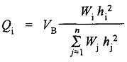
Where,

Q_{i} = Design lateral force at floor i,
W_{i} = Seismic weight of floor i,
h_{i} = Height of floor i,
n = Numbers of storeys.

The Pseudo Static Method of Analysis

This method is satisfactory for buildings up to 25 stories, hence is the most commonly used approximate method for analysing tall buildings. The following are the simplifying assumptions made in the portal method:

- A point of contra flexure occurs at the centre of each beam.

- A point of contra flexure occurs at the centre of each column.

- The total horizontal shear at each storey is distributed between the
columns of that storey in such a way that each interior column carries
twice the shear carried by each exterior column.

The above assumptions convert the indeterminate multi-storey frame to a determinate structure. The steps involved in the analysis of the frame are detailed below:

- The horizontal shears on each level are distributed between the columns of that floor according to assumption (3).

- The moment in each column is equal to the column shear multiplied by half the column height according to assumption (2).

- The girder moments are determined by applying moment equilibrium
equation to the joints: by noting that the sum of the girder moments at
any joint equals the sum of the column moments at that joint. These
calculations are easily made by starting at the upper left joint and
working joint by joint across to the right end.

- The shear in each girder is equal to its moment divided by half the
girder length. This is according to assumption (1).

- Finally, the column axial forces are determined by summing up the
beam shears and other axial forces at each joint. These calculations again are easily made by working from left to right and from the top floor down.

In this report it has been analysed an idealized four storeys RC framed structure with infilled brick masonry wall. The building consists of three panels each of 4 meters by 4 meters.

The building is first analysed without considering infill wall stiffness using STAAD PRO. In second analysis the stiffness of infill wall is taken into consideration. The stiffness of infill wall is calculated by equivalent strut method stated in this report. The third method if analysis is approximate method of analysis of which I have taken Portal Method.

The data used in the numerical study is given below:

1. Type of structure Multi-storeyed rigid joined plane frame
(Special RC moment resisting frame)

2. Number of storeys Four, (G + 3)

3. Floor height 3.2 m

4. Infill wall 250 mm thick

5. Imposed load 2 KN/m²

6. Size of columns 0.450 m X 0.250 m

7. Size of beams 0.400 m X 0.250 m

8. Depth of slab 150 mm

9. Specific weight of RCC 25 KN/m³

10. Specific weight of infill 22 KN/m³

11. Soil type Medium Soil

12. Seismic zone All four zone

13. Response spectra As per IS-1893 (part-1) 2002

Building in 3d view (when infill walls stiffness are not taken)

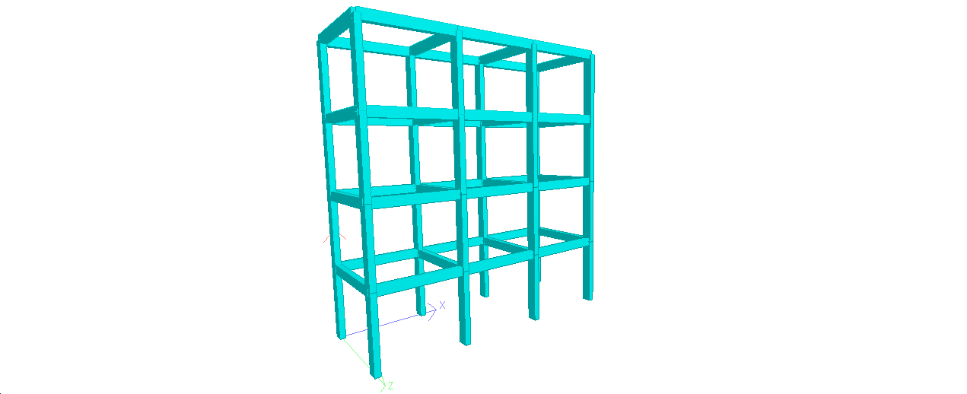

Building in 3D view (when infill walls are considered as strut)

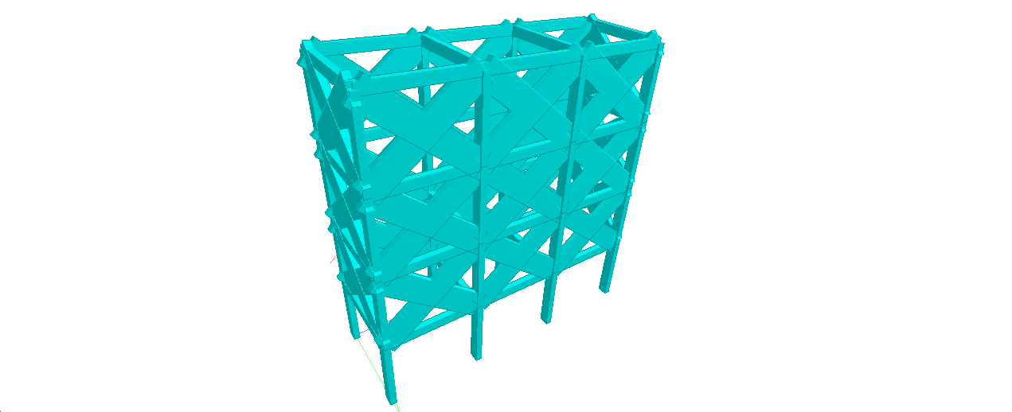

Plan of the building

ANALYSIS OF BUILDING BY PSEUDO STATIC METHOD

Here we use portal method of analysis

Calculation of base shears, time period, top floor Displacement, column reaction at different storeys:

Determination of base shear as per IS 1893(Part-1)2002

The total seismic base shear is given by

V_{B} = A_{h *} W

A_{h} = Design horizontal acceleration spectrum values and it is determined by following expression

CALCULATION OF BASE SHEAR WITHOUT INFILL WALLS
AS WELL AS WITH INFILL

For EQX
 | ZONE2 | ZONE3 | ZONE4 | ZONE5
Q1 | 17.8 | 28.5 | 42.7 | 64.1
Q2 | 82.5 | 131.9 | 197.9 | 296.8
Q3 | 160.1 | 256.2 | 384.3 | 576.5
Q4 | 69.6 | 111.3 | 167 | 250.5

For EQZ
 | ZONE2 | ZONE3 | ZONE4 | ZONE5
Q1 | 17.8 | 28.5 | 42.7 | 64.1
Q2 | 82.5 | 131.9 | 197.9 | 296.8
Q3 | 160.1 | 256.2 | 384.3 | 576.5
Q4 | 69.6 | 111.3 | 167 | 250.5
 | Q₁
V₄ 2V₄ 2V₄ V₄
Q₂

V₃ 2V₃ 2V₃ V₃
Q₃

V₂ 2V₂ 2V₂ V₂
Q₄

V₁ 2V₁ 2V₁ V₁

ALONG X DIRECTION |  |  |  |  |  |  |  |  |  |  | ALONG Z DIRECTION
V₄ = Q₄/6 |  |  |  |  |  |  |  |  |  |  | V₄ = Q₄/2
V₃ = (Q4+Q3)/6 |  |  |  |  |  |  |  |  |  |  | V₃= (Q₄+Q₃)/2
V₂ = (Q4+Q3+Q2)/6 |  |  |  |  |  |  |  |  |  |  | V₂ = (Q₄+Q₃+Q₂)/2
V₁ = (Q4+Q3+Q2+Q1)/6 |  |  |  |  |  |  |  |  |  |  | V₁ = (Q₄+Q₃+Q₂+Q₁)/2
SHEAR FORCE FOR |  |  |  |  |  |  |  |  |  |  | SHEAR FORCE FOR
INDIVIDUAL COLUMN IN X DIRN |  |  |  |  |  |  |  |  |  |  | INDIVIDUAL COLUMN IN Z DIRN
OUTER COLUMN |  |  |  |  |  |  |  |  |  |  |  | OUTER COLUMN / INNER COLUMN
V₄ = Q₄/12 |  |  |  |  |  |  |  |  |  |  | V₄ = Q₄/8
V₃ = (Q₄+Q₃)/12 |  |  |  |  |  |  |  |  |  |  |  | V₃ = (Q₄+Q₃)/8
V₂ = (Q₄+Q₃+Q₂)/12 |  |  |  |  |  |  |  |  |  |  |  | V₂ = (Q₄+Q₃+Q₂)/8
V₁ = (Q₄+Q₃+Q₂+Q₁)/12 |  |  |  |  |  |  |  |  |  |  | V₁ = (Q₄+Q₃+Q₂+Q₁)/8
INNER COLUMN
V₄ = Q₄/6
V₃ = (Q₄+Q₃)/6
V₂ = (Q₄+Q₃+Q₂)/6
V₁ = (Q₄+Q₃+Q₂+Q₁)/6

CALCULATION OF TOP FLOOR DISPLACEMENT

 | δ δ ' | δ'=θL'=QL²L'/2EI
L'
Q
 | δ | δ=QL³ /3EI
 | θ=QL²/2EI
L
 | Net drift = δ+δ'
 | ThenTotal drift = (Qa²/2EI)(H-a/3)

The top floor drift calculated by pseudo static approach are as follow:

 | ZONE 2 | ZONE 3 |  | ZONE 4 | ZONE 5
δ1
Along X | 2.375668 | 3.803738 |  | 5.698933 | 8.555073
Along z | 11.83152 | 18.94373 |  | 28.38236 | 42.60677

 | ZONE 2 | ZONE 3 | ZONE 4 | ZONE 5
δ2
Along X | 40.03935 | 64.01442 | 96.0459 | 144.0446
Along z | 199.4077 | 318.8106 | 478.3367 | 717.3842
 | ZONE 2 | ZONE 3 | ZONE 4 | ZONE 5
δ3
Along X | 157.3437 | 251.7892 | 377.6839 | 566.0835
Along z | 783.6177 | 1253.984 | 1880.976 | 2819.262

 | ZONE 2 | ZONE 3 | ZONE 4 | ZONE 5
δ4
Along X | 108.0917 | 172.8535 | 259.3579 | 389.0368
Along z | 538.3282 | 860.861 | 1291.678 | 1937.517

 | ZONE 2 | ZONE 3 | ZONE 4 | ZONE 5
δ net
Along X | 307.8504 | 492.4609 | 738.7866 | 1107.72
Along z | 1533.185 | 2452.599 | 3679.373 | 5516.77

MAXIMUM BASE SHEAR VS DIFFERENT APPROACHES ALONG X DIRECTION IN ALL SEISMIC ZONES

ZONE 2
DIFFERENT METHODS USED |  | BASE SHEAR (KN)
WITH OUT INFILL WALL STIFFNESS |  | 250.432
WITH INFILL WALL STIFFNESS |  | 357.580
PSEUDO STATIC APPROACH |  | 330.000
ZONE 3
DIFFERENT METHODS USED |  | BASE SHEAR (KN)
WITH OUT INFILL WALL STIFFNESS |  | 386.744
WITH INFILL WALL STIFFNESS |  | 386.732
PSEUDO STATIC APPROACH |  | 527.900

ZONE 4
DIFFERENT METHODS USED | BASE SHEAR (KN)
WITH OUT INFILL WALL STIFFNESS | 580.116
WITH INFILL WALL STIFFNESS | 580.100
PSEUDO STATIC APPROACH | 791.900

ZONE 5
DIFFERENT METHODS USED | BASE SHEAR (KN)
WITH OUT INFILL WALL STIFFNESS | 870.176
WITH INFILL WALL STIFFNESS | 870.152
PSEUDO STATIC APPROACH | 1187.9

GRAPHS OF MAXIMUM BASE SHEAR VS DIFFERENT APPROACHES ALONG X DIRECTION IN ALL SEISMIC ZONES

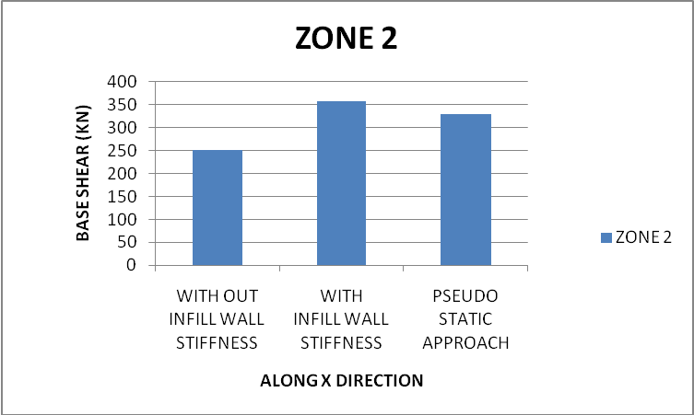

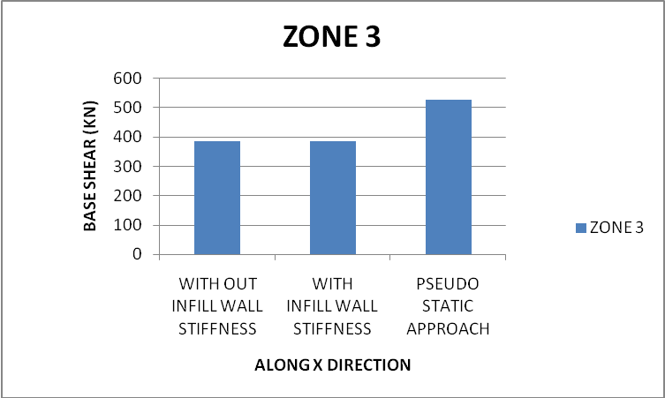

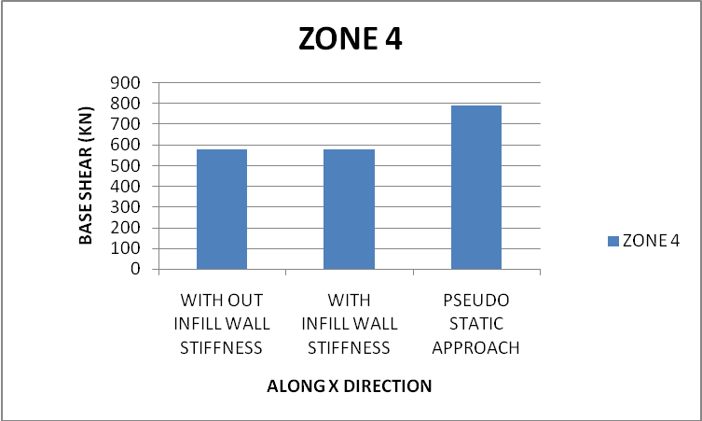

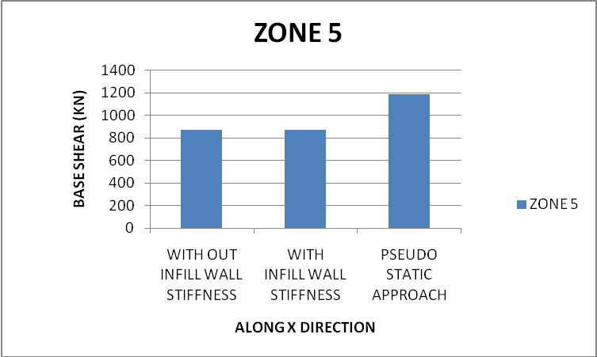

MAXIMUM BASE SHEAR VS DIFFERENT APPROACHES ALONG Z DIRECTION IN SEISMIC ZONES

ZONE 2
DIFFERENT METHODS USED | BASE SHEAR (KN)
WITH OUT INFILL WALL STIFFNESS | 432.394
WITH INFILL WALL STIFFNESS | 548.914
PSEUDO STATIC APPROACH | 330.000

ZONE 3
DIFFERENT METHODS USED | BASE SHEAR (KN)
WITH OUT INFILL WALL STIFFNESS | 513.112
WITH INFILL WALL STIFFNESS | 548.914
PSEUDO STATIC APPROACH | 527.900

ZONE 4
DIFFERENT METHODS USED | BASE SHEAR (KN)
WITH OUT INFILL WALL STIFFNESS | 769.668
WITH INFILL WALL STIFFNESS | 784.504
PSEUDO STATIC APPROACH | 791.900

ZONE 5
DIFFERENT METHODS USED | BASE SHEAR (KN)
WITH OUT INFILL WALL STIFFNESS | 1154.502
WITH INFILL WALL STIFFNESS | 1176.760
PSEUDO STATIC APPROACH | 1187.900

GRAPHS OF MAXIMUM BASE SHEAR VS DIFFERENT APPROACHES ALONG Z DIRECTION IN SEISMIC ZONES

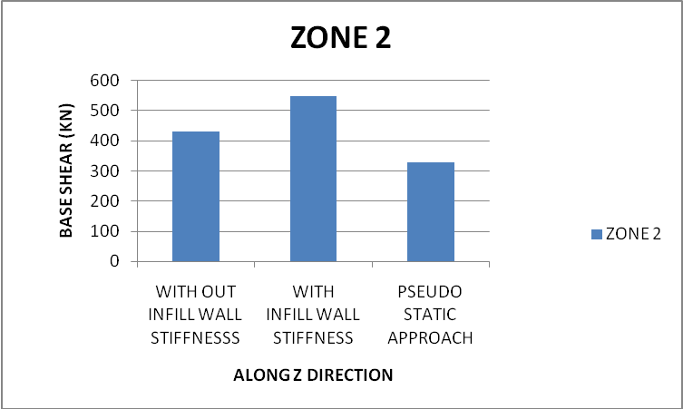

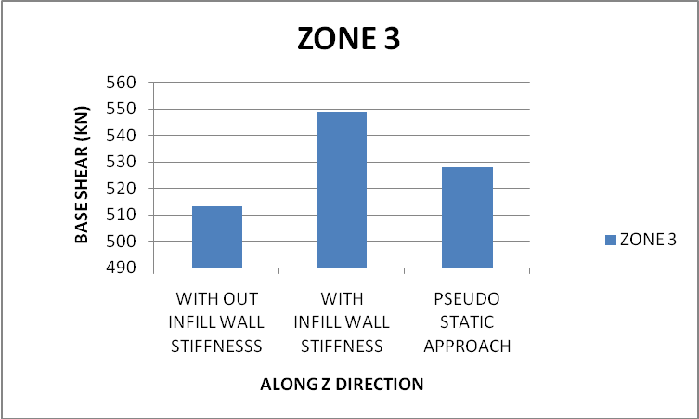

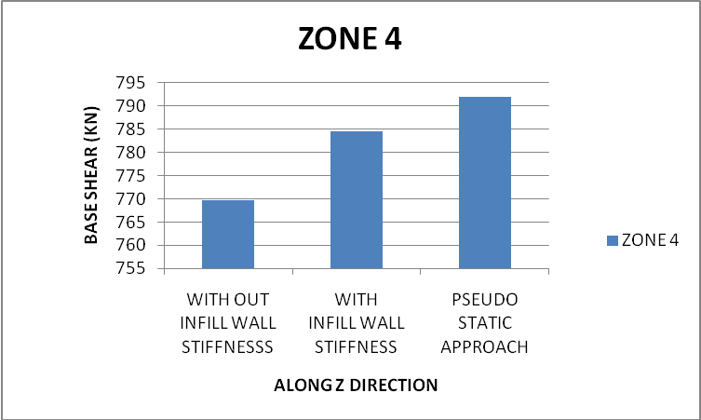

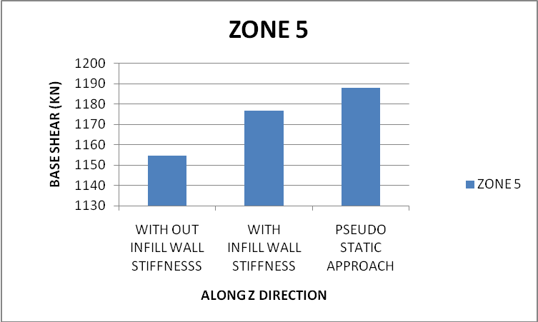

MAXIMUM TOP FLOOR DISPLACEMENT IN X DIRECTION VS DIFFERENT APPROACHES OF ANALYSIS IN ALL SEISMIC ZONES

ZONE 2
DIFFERENT METHODS USED | TOP FLOOR DISPLACEMENT (mm)
WITH OUT INFILL WALL STIFFNESS | 15.708
WITH INFILL WALL STIFFNESS | 9.543
PSEUDO STATIC APPROACH | 307.850

ZONE 3
DIFFERENT METHODS USED | TOP FLOOR DISPLACEMENT (mm)
WITH OUT INFILL WALL STIFFNESS | 24.258
WITH INFILL WALL STIFFNESS | 10.321
PSEUDO STATIC APPROACH | 492.460

ZONE 4
DIFFERENT METHODS USED | TOP FLOOR DISPLACEMENT (mm)
WITH OUT INFILL WALL STIFFNESS | 36.387
WITH INFILL WALL STIFFNESS | 15.482
PSEUDO STATIC APPROACH | 738.7866

ZONE 5
DIFFERENT METHODS USED | TOP FLOOR DISPLACEMENT (mm)
WITH OUT INFILL WALL STIFFNESS | 54.58
WITH INFILL WALL STIFFNESS | 23.222
PSEUDO STATIC APPROACH | 1107.72

GRAPH OF MAXIMUM TOP FLOOR DISPLACEMENT IN X DIRECTION VS DIFFERENT APPROACHES OF ANALYSIS IN ALL SEISMIC ZONES

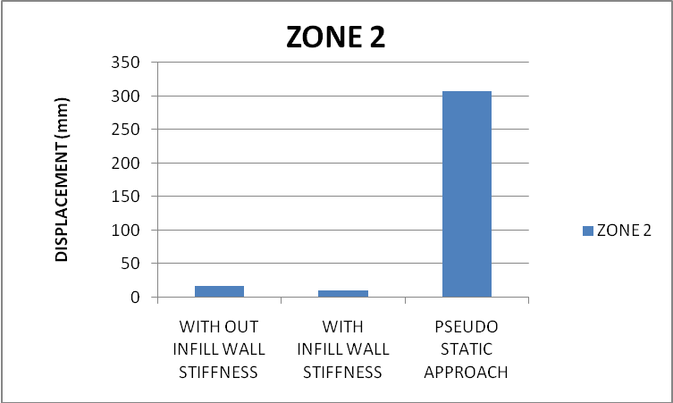

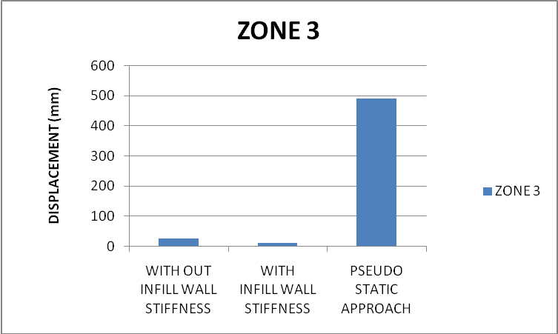

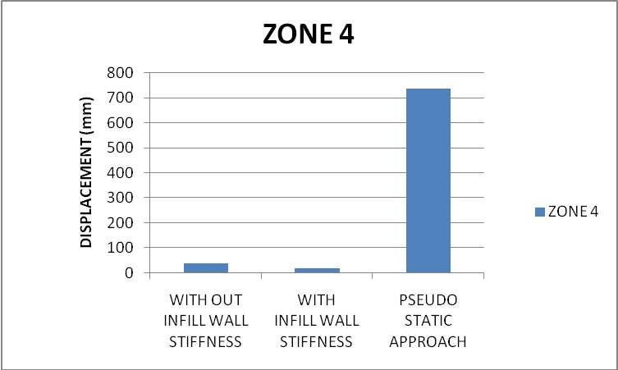

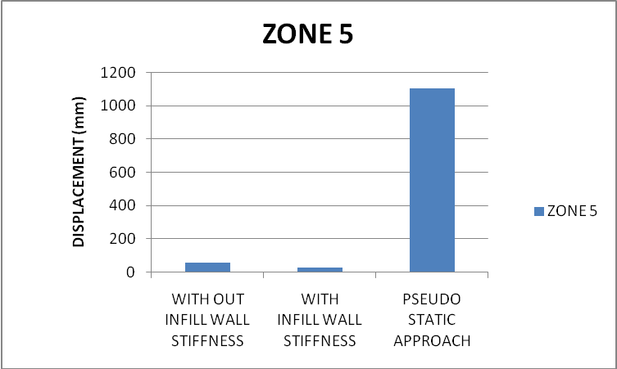

MAXIMUM TOP FLOOR DISPLACEMENT VS DIFFERENT APPROACHES OF ANALYSIS
ALONG Z DIRECTION

ZONE 2
DIFFERENT METHODS USED | TOP FLOOR DISPLACEMENT (mm)
WITH OUT INFILL WALL STIFFNESS | 10.553
WITH INFILL WALL STIFFNESS | 6.981
PSEUDO STATIC APPROACH | 1533.185

ZONE 3
DIFFERENT METHODS USED | TOP FLOOR DISPLACEMENT (mm)
WITH OUT INFILL WALL STIFFNESS | 12.523
WITH INFILL WALL STIFFNESS | 6.981
PSEUDO STATIC APPROACH | 2452.599

ZONE 4
DIFFERENT METHODS USED | TOP FLOOR DISPLACEMENT (mm)
WITH OUT INFILL WALL STIFFNESS | 18.785
WITH INFILL WALL STIFFNESS | 9.977
PSEUDO STATIC APPROACH | 3679.373

ZONE 5
DIFFERENT METHODS USED | TOP FLOOR DISPLACEMENT (mm)
WITH OUT INFILL WALL STIFFNESS | 28.177
WITH INFILL WALL STIFFNESS | 14.965
PSEUDO STATIC APPROACH | 5516.77

CORNER COLUMN AND INNER COLUMN REACTION OF ALL FOUR STOREYS VS DIFFERENT APPROACHES OF ANALYSIS IN ALL SEISMIC ZONES ALONG X DIRECTION

Ground floor columns

ZONE 2
COLUMN SPESIFICATION | WITHOUT INFILL  WALL STIFFNESS | WITH  INFILL  WALL STIFFNESS | PSEUDO STATIC  APPROACH
GROUND FLOOR CORNER COLUMN | 131.735 | 152.484 | 27.5
GROUND FLOOR INNER COLUMN | 127.525 | 43.948 | 55.0

ZONE 3
COLUMN SPESIFICATION | WITHOUT INFILL  WALL STIFFNESS | WITH  INFILL  WALL STIFFNESS | PSEUDO STATIC  APPROACH
GROUND FLOOR CORNER COLUMN | 156.327 | 152.484 | 43.99
GROUND FLOOR INNER COLUMN | 151.331 | 143.948 | 87.98

ZONE 4
COLUMN SPESIFICATION | WITHOUT INFILL  WALL STIFFNESS | WITH  INFILL  WALL STIFFNESS | PSEUDO STATIC  APPROACH
GROUND FLOOR CORNER COLUMN | 234.49 | 217.929 | 65.99
GROUND FLOOR INNER COLUMN | 226.996 | 205.73 | 131.98

ZONE 5
COLUMN SPESIFICATION | WITHOUT INFILL  WALL STIFFNESS | WITH  INFILL  WALL STIFFNESS | PSEUDO STATIC  APPROACH
GROUND FLOOR CORNER COLUMN | 351.736 | 326.894 | 98.99
GROUND FLOOR INNER COLUMN | 340.494 | 308.596 | 197.98

First floor columns

ZONE 2
COLUMN SPESIFICATION | WITHOUT INFILL  WALL STIFFNESS | WITH  INFILL  WALL STIFFNESS | PSEUDO STATIC  APPROACH
FIRST FLOOR CORNER COLUMN | 70.427 | 41.93 | 26.01
FIRST FLOOR INNER COLUMN | 68.157 | 39.846 | 52.03

ZONE 3
COLUMN SPESIFICATION | WITHOUT INFILL  WALL STIFFNESS | WITH INFILL  WALL STIFFNESS | PSEUDO STATIC  APPROACH
FIRST FLOOR CORNER COLUMN | 83.575 | 41.93 | 41.61
FIRST FLOOR INNER COLUMN | 80.881 | 39.846 | 83.23

ZONE 4
COLUMN SPESIFICATION | WITHOUT INFILL  WALL STIFFNESS | WITH  INFILL  WALL STIFFNESS | PSEUDO STATIC  APPROACH
FIRST FLOOR CORNER COLUMN | 125.362 | 59.926 | 62.43
FIRST FLOOR INNER COLUMN | 121.321 | 56.948 | 124.86

ZONE 5
COLUMN SPESIFICATION | WITHOUT INFILL  WALL STIFFNESS | WITH  INFILL  WALL STIFFNESS | PSEUDO STATIC  APPROACH
FIRST FLOOR CORNER COLUMN | 188.043 | 89.889 | 93.65
FIRST FLOOR INNER COLUMN | 181.982 | 85.422 | 187.3

Second floor columns

ZONE 2
COLUMN SPESIFICATION | WITHOUT INFILL  WALL STIFFNESS | WITH  INFILL  WALL STIFFNESS | PSEUDO STATIC  APPROACH
SECOND FLOOR CORNER COLUMN | 24.999 | 14.076 | 19.14
SECOND FLOOR INNER COLUMN | 24.161 | 13.424 | 38.28

ZONE 3
COLUMN SPESIFICATION | WITHOUT INFILL  WALL STIFFNESS | WITH  INFILL  WALL STIFFNESS | PSEUDO STATIC  APPROACH
SECOND FLOOR CORNER COLUMN | 29.665 | 14.076 | 30.62
SECOND FLOOR INNER COLUMN | 28.671 | 13.424 | 61.25

ZONE 4
COLUMN SPESIFICATION | WITHOUT INFILL  WALL STIFFNESS | WITH  INFILL  WALL STIFFNESS | PSEUDO STATIC  APPROACH
SECOND FLOOR CORNER COLUMN | 44.498 | 20.118 | 45.94
SECOND FLOOR INNER COLUMN | 43.007 | 19.186 | 91.88

ZONE 5
COLUMN SPESIFICATION | WITHOUT INFILL  WALL STIFFNESS | WITH  INFILL  WALL STIFFNESS | PSEUDO STATIC  APPROACH
SECOND FLOOR CORNER COLUMN | 66.747 | 30.177 | 68.91
SECOND FLOOR INNER COLUMN | 64.51 | 28.778 | 137.83

Third floor columns

ZONE 2
COLUMN SPESIFICATION | WITHOUT INFILL  WALL STIFFNESS | WITH  INFILL  WALL STIFFNESS | PSEUDO STATIC  APPROACH
THIRD FLOOR CORNER COLUMN | 3.811 | 2.101 | 5.8
THIRD FLOOR INNER COLUMN | 3.683 | 2.013 | 11.6

ZONE 3
COLUMN SPESIFICATION | WITHOUT INFILL  WALL STIFFNESS | WITH  INFILL  WALL STIFFNESS | PSEUDO STATIC  APPROACH
THIRD FLOOR CORNER COLUMN | 4.522 | 2.101 | 9.27
THIRD FLOOR INNER COLUMN | 4.37 | 2.013 | 18.55

ZONE 4
COLUMN SPESIFICATION | WITHOUT INFILL  WALL STIFFNESS | WITH  INFILL  WALL STIFFNESS | PSEUDO STATIC  APPROACH
THIRD FLOOR CORNER COLUMN | 6.783 | 3.003 | 13.91
THIRD FLOOR INNER COLUMN | 6.555 | 2.876 | 27.83

ZONE 5
COLUMN SPESIFICATION | WITHOUT INFILL  WALL STIFFNESS | WITH  INFILL  WALL STIFFNESS | PSEUDO STATIC  APPROACH
THIRD FLOOR CORNER COLUMN | 10.175 | 4.504 | 20.87
THIRD FLOOR INNER COLUMN | 9.832 | 4.315 | 41.75

GRAPH OF CORNER COLUMN AND INNER COLUMN REACTION OF ALL FOUR STOREYS VS DIFFERENT APPROACHES OF ANALYSIS IN ALL SEISMIC ZONES ALONG X DIRECTION

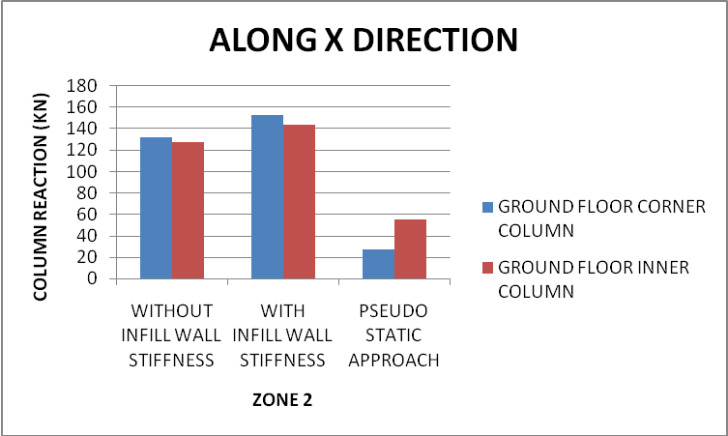

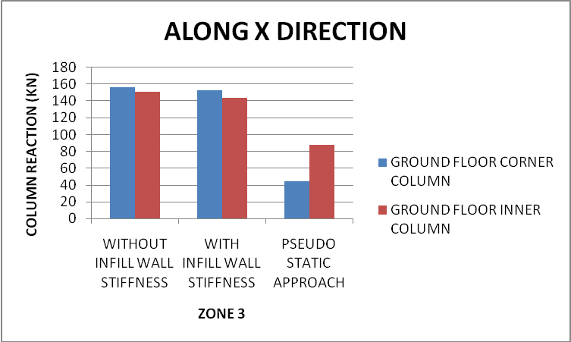

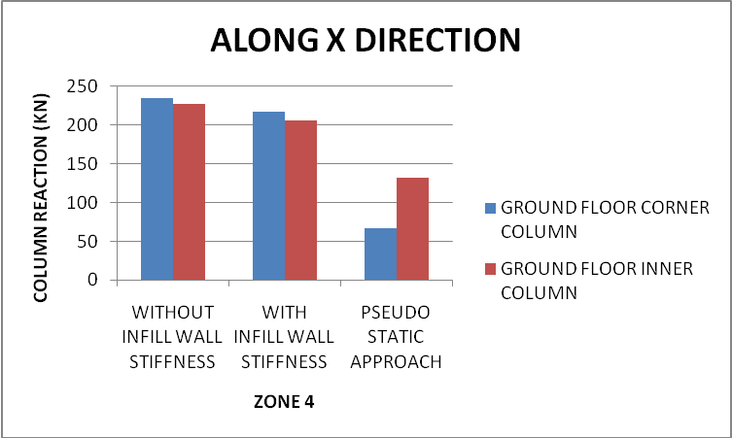

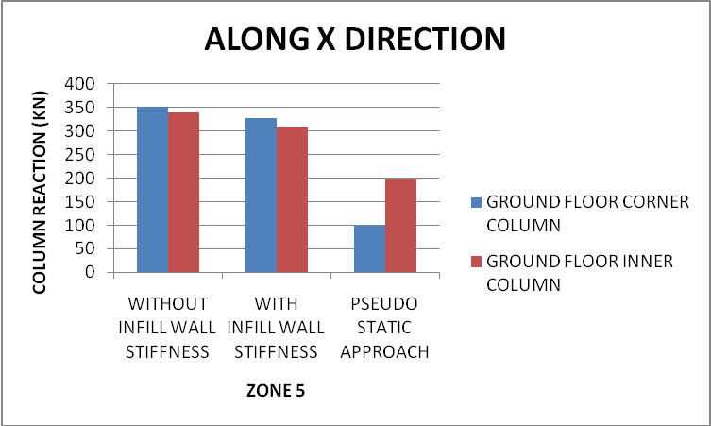

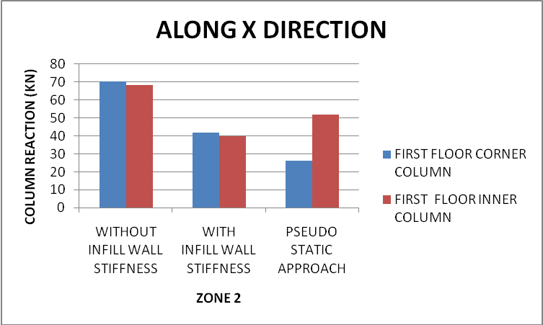

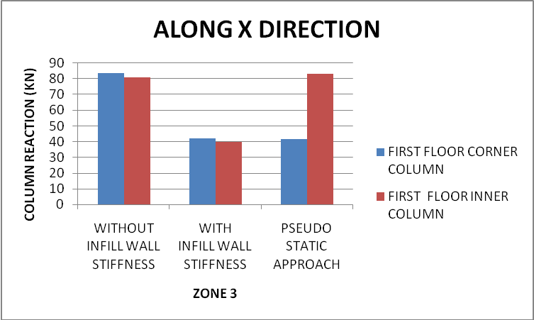

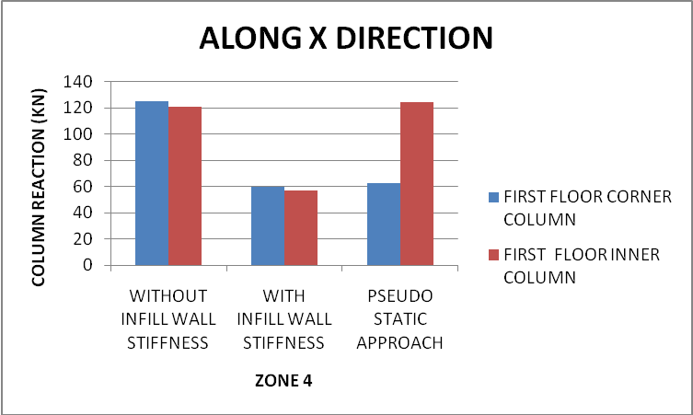

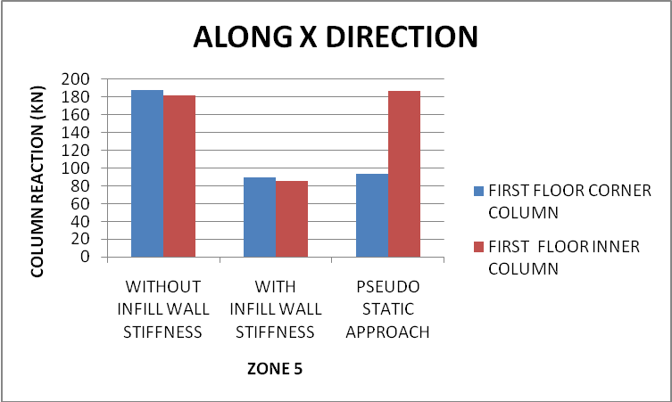

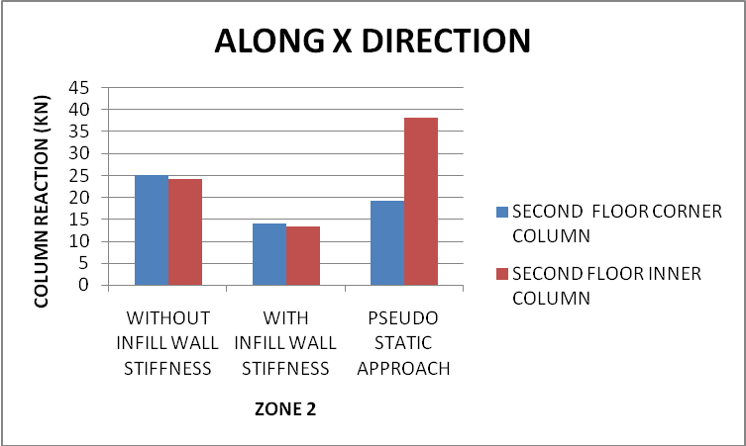

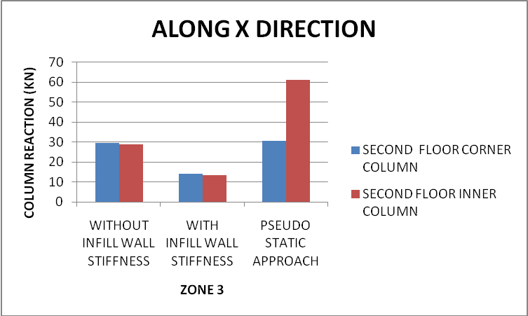

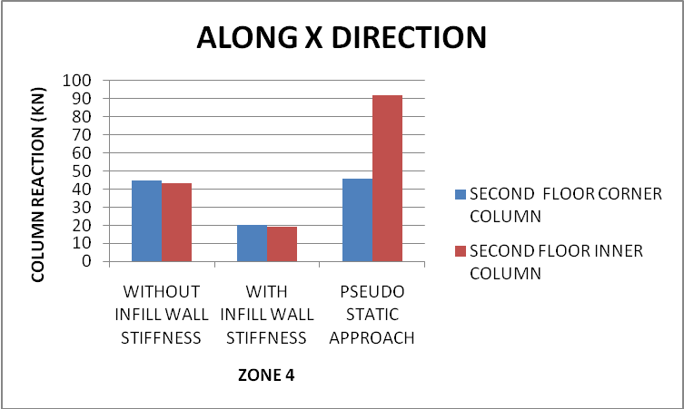

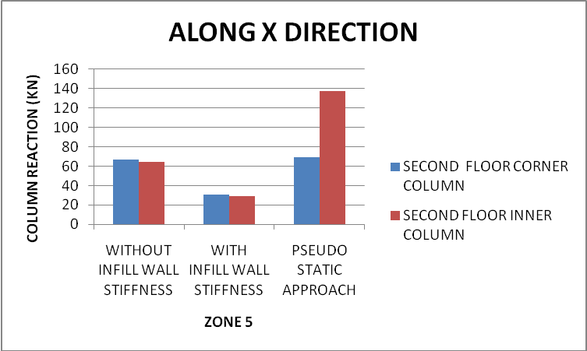

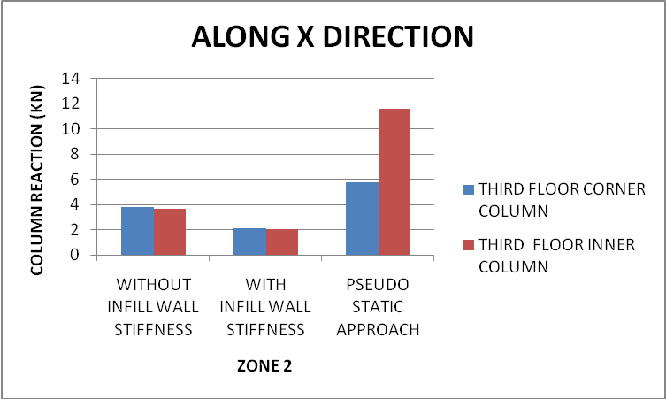

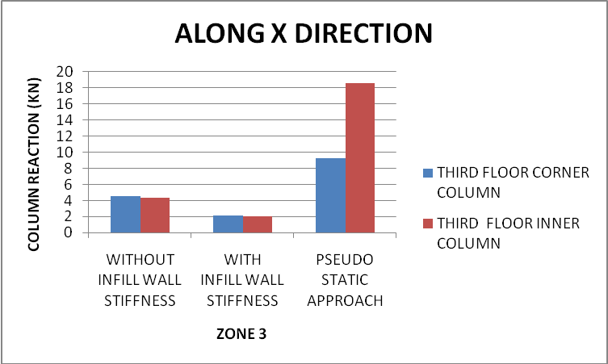

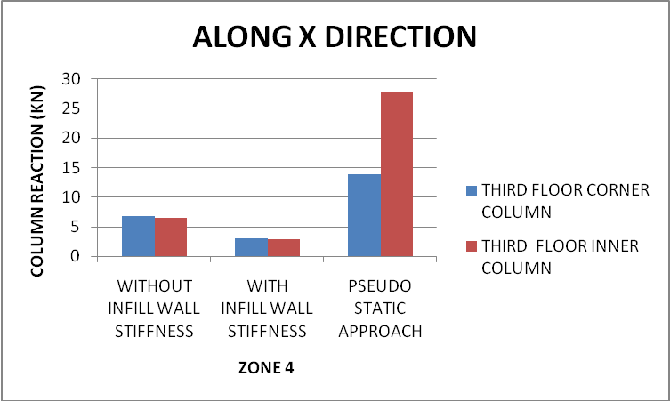

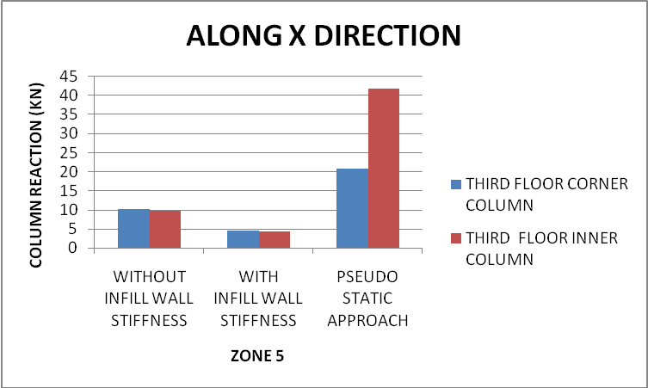

CORNER COLUMN AND INNER COLUMN REACTION OF ALL FOUR FLOORS VS DIFFERENT APPROACHES OF ANALYSIS IN ALL FOUR SEISMIC ZONES ALONG Z DIRECTION

Ground floor columns
ZONE 2
COLUMN SPESIFICATION | WITHOUT INFILL  WALL  STIFFNESS | WITH INFILL  WALL  STIFFNESS | PSEUDO STATIC  APPROACH
GROUND FLOOR CORNER COLUMN | 34.302 | 49.039 | 41.25
GROUND FLOOR INNER COLUMN | 34.302 | 49.039 | 41.25

ZONE 3
COLUMN SPESIFICATION | WITHOUT INFILL  WALL STIFFNESS | WITH INFILL  WALL STIFFNESS | PSEUDO STATIC  APPROACH
GROUND FLOOR CORNER COLUMN | 52.973 | 53.037 | 65.98
GROUND FLOOR INNER COLUMN | 52.973 | 53.037 | 65.98

ZONE 4
COLUMN SPESIFICATION | WITHOUT INFILL  WALL STIFFNESS | WITH INFILL  WALL STIFFNESS | PSEUDO STATIC  APPROACH
GROUND FLOOR CORNER COLUMN | 79.459 | 79.556 | 98.98
GROUND FLOOR INNER COLUMN | 79.459 | 79.556 | 98.98

ZONE 5
COLUMN SPESIFICATION | WITHOUT INFILL  WALL STIFFNESS | WITH INFILL  WALL STIFFNESS | PSEUDO STATIC  APPROACH
GROUND FLOOR CORNER COLUMN | 119.189 | 119.334 | 148.48
GROUND FLOOR INNER COLUMN | 119.189 | 119.334 | 148.48

First floor columns

ZONE 2
COLUMN SPESIFICATION | WITHOUT INFILL  WALL STIFFNESS | WITH INFILL  WALL STIFFNESS | PSEUDO STATIC  APPROACH
FIRST FLOOR CORNER COLUMN | 28.43 | 0.215 | 39.025
FIRST FLOOR INNER COLUMN | 28.43 | 0.215 | 39.025

ZONE 3
COLUMN SPESIFICATION | WITHOUT INFILL  WALL STIFFNESS | WITH INFILL  WALL STIFFNESS | PSEUDO STATIC  APPROACH
FIRST FLOOR CORNER COLUMN | 43.904 | 0.233 | 62.42
FIRST FLOOR INNER COLUMN | 43.904 | 0.233 | 62.42

ZONE 4
COLUMN SPESIFICATION | WITHOUT INFILL  WALL STIFFNESS | WITH INFILL  WALL STIFFNESS | PSEUDO STATIC  APPROACH
FIRST FLOOR CORNER COLUMN | 65.856 | 0.35 | 93.65
FIRST FLOOR INNER COLUMN | 65.856 | 0.35 | 93.65

ZONE 5
COLUMN SPESIFICATION | WITHOUT INFILL  WALL STIFFNESS | WITH INFILL  WALL STIFFNESS | PSEUDO STATIC  APPROACH
FIRST FLOOR CORNER COLUMN | 98.784 | 0.524 | 140.47
FIRST FLOOR INNER COLUMN | 98.784 | 0.524 | 140.47
Second floor columns

ZONE 2
COLUMN SPESIFICATION | WITHOUT INFILL  WALL STIFFNESS | WITH INFILL  WALL STIFFNESS | PSEUDO STATIC  APPROACH
SECOND FLOOR CORNER COLUMN | 17.834 | 0.112 | 28.71
SECOND FLOOR INNER COLUMN | 17.834 | 0.112 | 28.71

ZONE 3
COLUMN SPESIFICATION | WITHOUT INFILL  WALL STIFFNESS | WITH INFILL  WALL STIFFNESS | PSEUDO STATIC  APPROACH
SECOND FLOOR CORNER COLUMN | 27.541 | 0.121 | 45.93
SECOND FLOOR INNER COLUMN | 27.541 | 0.121 | 45.93

ZONE 4
COLUMN SPESIFICATION | WITHOUT INFILL  WALL STIFFNESS | WITH INFILL  WALL STIFFNESS | PSEUDO STATIC  APPROACH
SECOND FLOOR CORNER COLUMN | 41.312 | 0.182 | 68.91
SECOND FLOOR INNER COLUMN | 41.312 | 0.182 | 68.91

ZONE 5
COLUMN SPESIFICATION | WITHOUT INFILL  WALL STIFFNESS | WITH INFILL  WALL STIFFNESS | PSEUDO STATIC  APPROACH
SECOND FLOOR CORNER COLUMN | 61.968 | 0.272 | 103.37
SECOND FLOOR INNER COLUMN | 61.968 | 0.272 | 103.37

Third floor columns

ZONE 2
COLUMN SPESIFICATION | WITHOUT INFILL  WALL STIFFNESS | WITH INFILL  WALL STIFFNESS | PSEUDO STATIC  APPROACH
THIRD FLOOR CORNER COLUMN | 3.867 | 0.022 | 8.7
THIRD FLOOR INNER COLUMN | 3.867 | 0.022 | 8.7

ZONE 3
COLUMN SPESIFICATION | WITHOUT INFILL  WALL STIFFNESS | WITH INFILL  WALL STIFFNESS | PSEUDO STATIC  APPROACH
THIRD FLOOR CORNER COLUMN | 5.972 | 0.024 | 13.91
THIRD FLOOR INNER COLUMN | 5.972 | 0.024 | 13.91

ZONE 4
COLUMN SPESIFICATION | WITHOUT INFILL  WALL STIFFNESS | WITH INFILL  WALL STIFFNESS | PSEUDO STATIC  APPROACH
THIRD FLOOR CORNER COLUMN | 8.958 | 0.036 | 20.87
THIRD FLOOR INNER COLUMN | 8.958 | 0.036 | 20.87

ZONE 5
COLUMN SPESIFICATION | WITHOUT INFILL  WALL STIFFNESS | WITH INFILL  WALL STIFFNESS | PSEUDO STATIC  APPROACH
THIRD FLOOR CORNER COLUMN | 13.437 | 0.054 | 31.31
THIRD FLOOR INNER COLUMN | 13.437 | 0.054 | 31.31

GRAPH OF CORNER COLUMN AND INNER COLUMN REACTION OF GROUND FLOOR VS DIFFERENT APPROACHES OF ANALYSIS IN ALL SEISMIC ZONES ALONG X DIRECTION

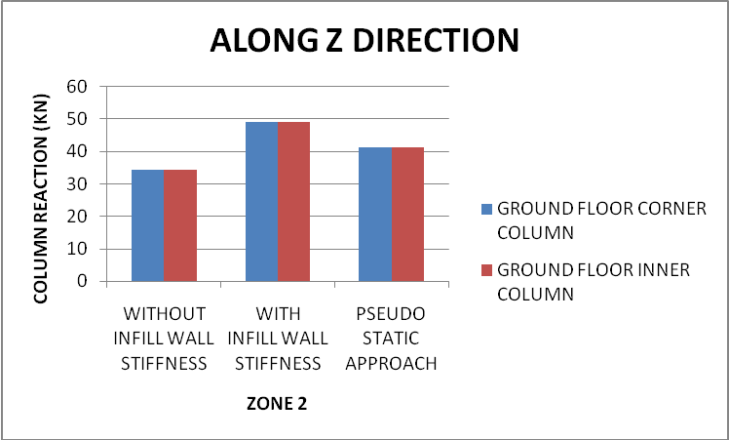

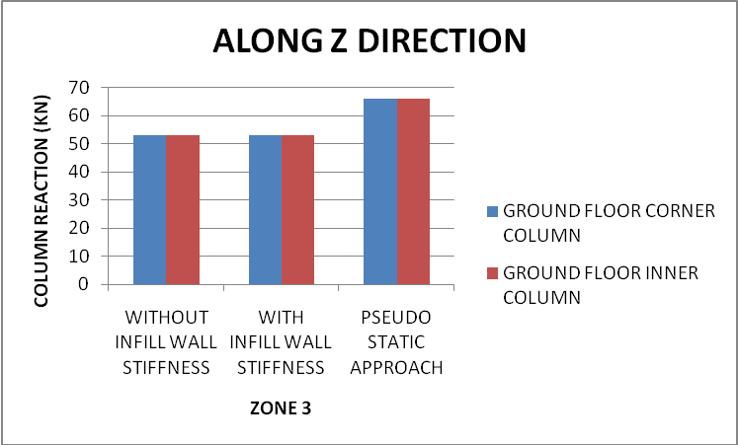

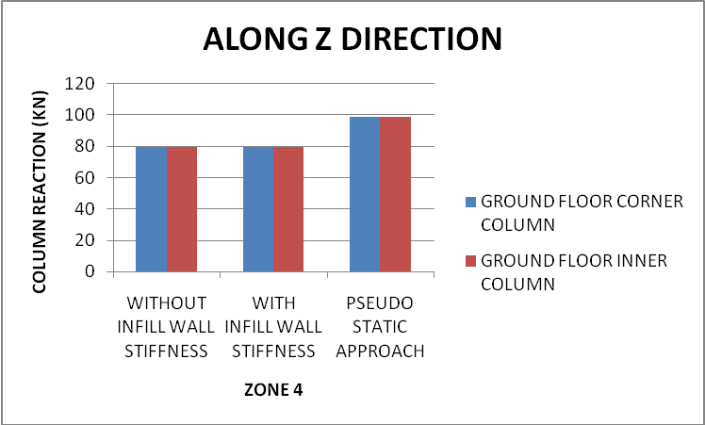

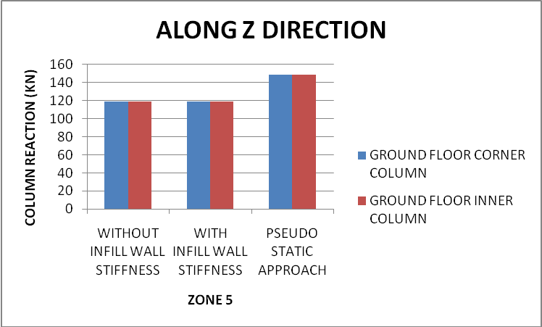

FUNDAMENTAL TIME PERIODS OF GIVEN STRUCTURE VS DIFFERENT APPROAVHES OF ANALYSIS

DIFFERENT METHODS USED | TIME PERIODS IN SECOND
WITH OUT INFILL WALL STIFFNESS | 1.11622
WITH INFILL WALL STIFFNESS | 0.84123
PSEUDO STATIC METHOD | 0.507538

GRAPH OF FUNDAMENTAL TIME PERIODS OF GIVEN STRUCTURE VS DIFFERENT APPROAVHES OF ANALYSIS

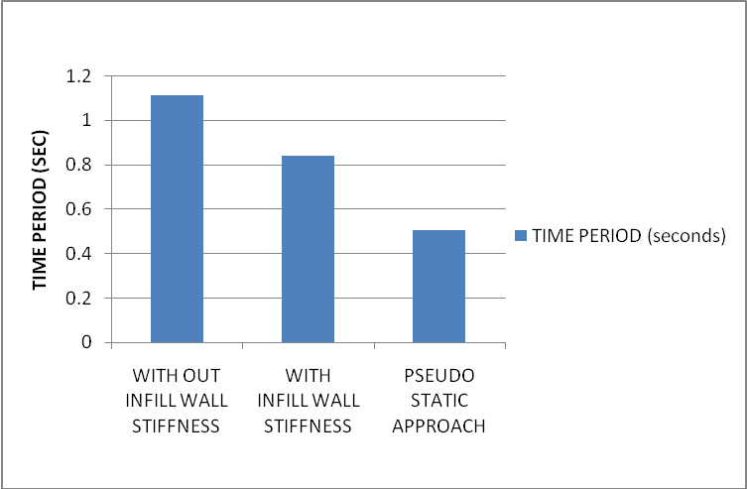

First three mode shapes are given below:

MODE SHAPES WITHOUT CONSIDERING INFILL WALL STIFFNESS

ZONE 2

ZONE 2
ZONE 2

ZONE 3

ZONE 3

ZONE 3

ZONE4

ZONE4ZONE4

ZONE5

ZONE5ZONE5

MODE SHAPES CONSIDERING INFILL WALL STIFFNESS:

ZONE2
ZONE2ZONE2
ZONE3ZONE3

ZONE3

ZONE4
ZONE4ZONE4

ZONE5
ZONE5ZONE5

From the results obtained, the following conclusions can be drawn:

1. The base shear calculated in X direction with considering the stiffness of infill walls is found to increase about 43 percent in seismic zone two while it is found to almost same value in seismic zone three, four and five as compare to the base shear, when it is calculated without stiffness of the infill walls.

2.The base shear calculated in X direction by pseudo static approach is found to increase about 32 percent in seismic zone two and 36 percent in seismic zone three, four, and five as compare to base shear when it is calculated without considering stiffness of infill walls.

3. The base shear calculated in Z direction with considering the stiffness of infill walls is found to increase about 27 percent in seismic zone two, while it is found to increase about 7 percent in zone three and about 2 percent each in zone four and five as compare to the base shear when it is calculated without stiffness of the infill walls.

4. The base shear calculated in Z direction by pseudo static method is found to decrease about 24 percent in seismic zone two and increase about 3 percent each in seismic zone three, four, and five as compare to base shear when it is calculated without considering stiffness of infill walls.

5. The top floor displacement calculated in X direction with considering the stiffness of infill walls is found to decrease about 39 percent in seismic zone two while it is found to decrease about 57 percent in seismic zone three, four and five as compare to the displacement when it is calculated without stiffness of the infill wall.

6. The top floor displacement calculated in X direction by pseudo static method is found to increase very much in all seismic zone, as compare to top floor displacement when it is calculated without considering stiffness of infill walls.

7. The top floor displacement calculated in Z direction with considering the stiffness of infill wall is found to decrease about 39 percent in seismic zone two, while it is found to decrease about 57 percent less in seismic zone three, four and five as compare to the displacement when it is calculated without stiffness of the infill wall.

8. The top floor displacement calculated in Z direction by pseudo static method is found to increase very much in all four seismic zones, as compare to top floor displacement when it is calculated without considering stiffness of infill walls.

9 .The fundamental time period of the building considering infill walls stiffness is found to decrease by one fourth, as compare to time period calculated when infill walls stiffness is not considered.

10. The fundamental time period of the building as calculated by pseudo static method of analysis is found to decrease about to half, as compare to time period calculated when infill walls stiffness is not considered.

There could be many permutations and computations of the said problem and each one would present a unique solution when analysed. The scope can be summarized as below.

  - The variation in forces can be compared for different height of the building.

  - The plan of the building can be unsymmetrical as against the symmetrical plan chosen in this report.

  - The orientation of the column can be changed to transverse direction.

Since infill walls are constructed by bricks. But scope is open for reinforced infill wall.

- IS 1893 : 2002: Criteria for Earthquake Resistant Design of Structures (Part 1) General Provisions And Buildings.

- IS 456 : 2000, Plain and Reinforced concrete – Code of Practice.

- IS 875 : 1987 (Part-1), Code of Practice for Design Loads ( Other than Earthquake) For Buildings and Structures. For Dead Load Calculation.

- IS 875 : 1987 (Part-2), Code of Practice for Design Loads ( Other than Earthquake) For Buildings and Structures. For Impose Load Calculation.

- Vazirani V.N.,Ratwani M.M.,Duggal S.K. , “Analysis of Structures” Vol-1, Page 392-423 Khanna Publication 2006.

- Shrikhande Manish, Aggarwal Pankaj, “Earthquake Resistant Design of Structures” Page 251-259

STADD INPUT FILE WHEN INFILL WALL STIFFNESS IS NOT CONSIDERED

STAAD SPACE
START JOB INFORMATION
ENGINEER DATE 19-Jun-10
END JOB INFORMATION
INPUT WIDTH 79
UNIT METER KN
JOINT COORDINATES
1 0 0 0; 2 4 0 0; 3 8 0 0; 4 12 0 0; 5 12 0 4; 6 8 0 4; 7 4 0 4; 8 0 0 4;
9 0 3.2 0; 10 4 3.2 0; 11 8 3.2 0; 12 12 3.2 0; 13 12 3.2 4; 14 8 3.2 4;
15 4 3.2 4; 16 0 3.2 4; 17 0 6.4 0; 18 4 6.4 0; 19 8 6.4 0; 20 12 6.4 0;
21 12 6.4 4; 22 8 6.4 4; 23 4 6.4 4; 24 0 6.4 4; 25 0 9.6 0; 26 4 9.6 0;
27 8 9.6 0; 28 12 9.6 0; 29 12 9.6 4; 30 8 9.6 4; 31 4 9.6 4; 32 0 9.6 4;
33 0 12.8 0; 34 4 12.8 0; 35 8 12.8 0; 36 12 12.8 0; 37 12 12.8 4; 38 8 12.8 4;
39 4 12.8 4; 40 0 12.8 4;
MEMBER INCIDENCES
11 1 9; 12 2 10; 13 3 11; 14 4 12; 15 5 13; 16 6 14; 17 7 15; 18 8 16;
101 9 10; 102 10 11; 103 11 12; 104 12 13; 105 13 14; 106 14 15; 107 15 16;
108 16 9; 109 10 15; 110 14 11; 111 9 17; 112 10 18; 113 11 19; 114 12 20;
115 13 21; 116 14 22; 117 15 23; 118 16 24; 201 17 18; 202 18 19; 203 19 20;
204 20 21; 205 21 22; 206 22 23; 207 23 24; 208 24 17; 209 18 23; 210 22 19;
211 17 25; 212 18 26; 213 19 27; 214 20 28; 215 21 29; 216 22 30; 217 23 31;
218 24 32; 301 25 26; 302 26 27; 303 27 28; 304 28 29; 305 29 30; 306 30 31;
307 31 32; 308 32 25; 309 26 31; 310 30 27; 311 25 33; 312 26 34; 313 27 35;
314 28 36; 315 29 37; 316 30 38; 317 31 39; 318 32 40; 401 33 34; 402 34 35;
403 35 36; 404 36 37; 405 37 38; 406 38 39; 407 39 40; 408 40 33; 409 34 39;
410 38 35;
DEFINE MATERIAL START
ISOTROPIC CONCRETE
E 2.5e+007
POISSON 0.17
DENSITY 25
ALPHA 5.5e-006
DAMP 0.05
END DEFINE MATERIAL
CONSTANTS
BETA 90 ALL
MATERIAL CONCRETE ALL
MEMBER PROPERTY INDIAN
11 TO 18 111 TO 118 211 TO 218 311 TO 318 PRIS YD 0.45 ZD 0.25
101 TO 110 201 TO 210 301 TO 310 401 TO 410 PRIS YD 0.25 ZD 0.4
SUPPORTS
1 TO 8 FIXED
SLAVE RIGID MASTER 10 JOINT 9 TO 16
SLAVE RIGID MASTER 18 JOINT 17 TO 24
SLAVE RIGID MASTER 26 JOINT 25 TO 32
SLAVE RIGID MASTER 34 JOINT 33 TO 40
DEFINE 1893 LOAD
ZONE 0.1 RF 5 I 1.5 SS 2 ST 1 DM 5 DT 2
JOINT WEIGHT
1 WEIGHT 6.75
2 WEIGHT 6.75
3 WEIGHT 6.75
4 WEIGHT 6.75
5 WEIGHT 6.75
6 WEIGHT 6.75
7 WEIGHT 6.75
8 WEIGHT 6.75
9 WEIGHT 189.947
10 WEIGHT 294.853
11 WEIGHT 294.853
12 WEIGHT 189.947
13 WEIGHT 189.947
14 WEIGHT 294.853
15 WEIGHT 294.853
16 WEIGHT 189.947
17 WEIGHT 229.735
18 WEIGHT 331.865
19 WEIGHT 331.865
20 WEIGHT 229.735
21 WEIGHT 229.735
22 WEIGHT 331.865
23 WEIGHT 331.865
24 WEIGHT 229.735
25 WEIGHT 190.58
26 WEIGHT 294.22
27 WEIGHT 294.22
28 WEIGHT 190.58
29 WEIGHT 190.58
30 WEIGHT 294.22
31 WEIGHT 294.22
32 WEIGHT 190.58
33 WEIGHT 42.461
34 WEIGHT 76.039
35 WEIGHT 76.039
36 WEIGHT 42.461
37 WEIGHT 42.461
38 WEIGHT 76.039
39 WEIGHT 76.039
40 WEIGHT 42.461
CUT OFF MODE SHAPE 10
LOAD 1 EQX
JOINT LOAD
*********************
1 FX 6.75 FZ 6.75
2 FX 6.75 FZ 6.75
3 FX 6.75 FZ 6.75
4 FX 6.75 FZ 6.75
5 FX 6.75 FZ 6.75
6 FX 6.75 FZ 6.75
7 FX 6.75 FZ 6.75
8 FX 6.75 FZ 6.75
9 FX 189.947 FZ 189.947
10 FX 294.853 FZ 294.853
11 FX 294.853 FZ 294.853
12 FX 189.947 FZ 189.947
13 FX 189.947 FZ 189.947
14 FX 294.853 FZ 294.853
15 FX 294.853 FZ 294.853
16 FX 189.947 FZ 189.947
17 FX 229.735 FZ 229.735
18 FX 331.865 FZ 331.865
19 FX 331.865 FZ 331.865
20 FX 229.735 FZ 229.735
21 FX 229.735 FZ 229.735
22 FX 331.865 FZ 331.865
23 FX 331.865 FZ 331.865
24 FX 229.735 FZ 229.735
25 FX 190.58 FZ 190.58
26 FX 294.22 FZ 294.22
27 FX 294.22 FZ 294.22
28 FX 190.58 FZ 190.58
29 FX 190.58 FZ 190.58
30 FX 294.22 FZ 294.22
31 FX 294.22 FZ 294.22
32 FX 190.58 FZ 190.58
33 FX 42.461 FZ 42.461
34 FX 76.039 FZ 76.039
35 FX 76.039 FZ 76.039
36 FX 42.461 FZ 42.461
37 FX 42.461 FZ 42.461
38 FX 76.039 FZ 76.039
39 FX 76.039 FZ 76.039
40 FX 42.461 FZ 42.461
***********************
SPECTRUM CQC 1893 X 0.036 ACC SCALE 1 DAMP 0.05
SOIL TYPE 2
LOAD 2 EQZ
SPECTRUM CQC 1893 Z 0.036 ACC SCALE 1 DAMP 0.05
SOIL TYPE 2
***************************************
LOAD 3 LOADTYPE Dead TITLE LOAD CASE 1
SELFWEIGHT Y -1
***********WALL LOAD*************
MEMBER LOAD
101 TO 118 201 TO 218 301 TO 310 UNI GY -16
FLOOR LOAD
YRANGE 0 12.8 FLOAD -3.75 XRANGE 0 12 ZRANGE 0 4 GY
*********************************************
LOAD 4 LOADTYPE Live TITLE LOAD CASE 2
FLOOR LOAD
YRANGE 0 9.6 FLOAD -2 XRANGE 0 12 ZRANGE 0 4 GY
*********************************
LOAD COMB 5 1.5*(DL++LL)
3 1.5 4 1.5
PERFORM ANALYSIS
FINISH

STADD INPUT FILE WHEN INFILL WALL STIFFNESS IS CONSIDERED AS STRUT

STAAD SPACE
START JOB INFORMATION
ENGINEER DATE 19-Jun-10
END JOB INFORMATION
INPUT WIDTH 79
UNIT METER KN
JOINT COORDINATES
1 0 0 0; 2 4 0 0; 3 8 0 0; 4 12 0 0; 5 12 0 4; 6 8 0 4; 7 4 0 4; 8 0 0 4;
9 0 3.2 0; 10 4 3.2 0; 11 8 3.2 0; 12 12 3.2 0; 13 12 3.2 4; 14 8 3.2 4;
15 4 3.2 4; 16 0 3.2 4; 17 0 6.4 0; 18 4 6.4 0; 19 8 6.4 0; 20 12 6.4 0;
21 12 6.4 4; 22 8 6.4 4; 23 4 6.4 4; 24 0 6.4 4; 25 0 9.6 0; 26 4 9.6 0;
27 8 9.6 0; 28 12 9.6 0; 29 12 9.6 4; 30 8 9.6 4; 31 4 9.6 4; 32 0 9.6 4;
33 0 12.8 0; 34 4 12.8 0; 35 8 12.8 0; 36 12 12.8 0; 37 12 12.8 4; 38 8 12.8 4;
39 4 12.8 4; 40 0 12.8 4;
MEMBER INCIDENCES
11 1 9; 12 2 10; 13 3 11; 14 4 12; 15 5 13; 16 6 14; 17 7 15; 18 8 16;
101 9 10; 102 10 11; 103 11 12; 104 12 13; 105 13 14; 106 14 15; 107 15 16;
108 16 9; 109 10 15; 110 14 11; 111 9 17; 112 10 18; 113 11 19; 114 12 20;
115 13 21; 116 14 22; 117 15 23; 118 16 24; 201 17 18; 202 18 19; 203 19 20;
204 20 21; 205 21 22; 206 22 23; 207 23 24; 208 24 17; 209 18 23; 210 22 19;
211 17 25; 212 18 26; 213 19 27; 214 20 28; 215 21 29; 216 22 30; 217 23 31;
218 24 32; 301 25 26; 302 26 27; 303 27 28; 304 28 29; 305 29 30; 306 30 31;
307 31 32; 308 32 25; 309 26 31; 310 30 27; 311 25 33; 312 26 34; 313 27 35;
314 28 36; 315 29 37; 316 30 38; 317 31 39; 318 32 40; 401 33 34; 402 34 35;
403 35 36; 404 36 37; 405 37 38; 406 38 39; 407 39 40; 408 40 33; 409 34 39;
410 38 35; 411 40 31; 412 39 32; 413 39 30; 414 38 31; 415 38 29; 416 37 30;
417 29 22; 418 30 21; 419 21 14; 420 22 13; 421 31 22; 422 30 23; 423 23 14;
424 22 15; 425 32 23; 426 31 24; 427 24 15; 428 23 16; 429 17 16; 430 24 9;
431 25 24; 432 32 17; 433 33 32; 434 40 25; 435 33 26; 436 34 25; 437 34 27;
438 35 26; 439 35 28; 440 36 27; 441 28 19; 442 27 20; 443 27 18; 444 26 19;
445 26 17; 446 25 18; 447 17 10; 448 18 9; 449 18 11; 450 19 10; 451 19 12;
452 20 11; 453 36 29; 454 37 28; 455 29 20; 456 28 21; 457 20 13; 458 21 12;
DEFINE MATERIAL START
ISOTROPIC CONCRETE
E 2.5e+007
POISSON 0.17
DENSITY 25
ALPHA 5.5e-006
DAMP 0.05
END DEFINE MATERIAL
CONSTANTS
BETA 90 MEMB 11 TO 18 101 TO 118 201 TO 218 301 TO 318 401 TO 410 440
MATERIAL CONCRETE ALL
MEMBER PROPERTY INDIAN
11 TO 18 111 TO 118 211 TO 218 311 TO 318 PRIS YD 0.45 ZD 0.25
101 TO 110 201 TO 210 301 TO 310 401 TO 410 PRIS YD 0.25 ZD 0.4
411 TO 458 PRIS YD 0.9899 ZD 0.25
SUPPORTS
1 TO 8 FIXED
*MEMBER COMPRESSION
*411 TO 458
MEMBER RELEASE
411 TO 458 START MX MY MZ
411 TO 458 END MX MY MZ
SLAVE RIGID MASTER 10 JOINT 9 TO 16
SLAVE RIGID MASTER 18 JOINT 17 TO 24
SLAVE RIGID MASTER 26 JOINT 25 TO 32
SLAVE RIGID MASTER 34 JOINT 33 TO 40
DEFINE 1893 LOAD
ZONE 0.1 RF 5 I 1.5 SS 2 ST 1 DM 5 DT 2
JOINT WEIGHT
1 WEIGHT 6.75
2 WEIGHT 6.75
3 WEIGHT 6.75
4 WEIGHT 6.75
5 WEIGHT 6.75
6 WEIGHT 6.75
7 WEIGHT 6.75
8 WEIGHT 6.75
9 WEIGHT 189.947
10 WEIGHT 294.853
11 WEIGHT 294.853
12 WEIGHT 189.947
13 WEIGHT 189.947
14 WEIGHT 294.853
15 WEIGHT 294.853
16 WEIGHT 189.947
17 WEIGHT 229.735
18 WEIGHT 331.865
19 WEIGHT 331.865
20 WEIGHT 229.735
21 WEIGHT 229.735
22 WEIGHT 331.865
23 WEIGHT 331.865
24 WEIGHT 229.735
25 WEIGHT 190.58
26 WEIGHT 294.22
27 WEIGHT 294.22
28 WEIGHT 190.58
29 WEIGHT 190.58
30 WEIGHT 294.22
31 WEIGHT 294.22
32 WEIGHT 190.58
33 WEIGHT 42.461
34 WEIGHT 76.039
35 WEIGHT 76.039
36 WEIGHT 42.461
37 WEIGHT 42.461
38 WEIGHT 76.039
39 WEIGHT 76.039
40 WEIGHT 42.461
CUT OFF MODE SHAPE 10
LOAD 1 EQX
JOINT LOAD
*********************
1 FX 6.75 FZ 6.75
2 FX 6.75 FZ 6.75
3 FX 6.75 FZ 6.75
4 FX 6.75 FZ 6.75
5 FX 6.75 FZ 6.75
6 FX 6.75 FZ 6.75
7 FX 6.75 FZ 6.75
8 FX 6.75 FZ 6.75
9 FX 189.947 FZ 189.947
10 FX 294.853 FZ 294.853
11 FX 294.853 FZ 294.853
12 FX 189.947 FZ 189.947
13 FX 189.947 FZ 189.947
14 FX 294.853 FZ 294.853
15 FX 294.853 FZ 294.853
16 FX 189.947 FZ 189.947
17 FX 229.735 FZ 229.735
18 FX 331.865 FZ 331.865
19 FX 331.865 FZ 331.865
20 FX 229.735 FZ 229.735
21 FX 229.735 FZ 229.735
22 FX 331.865 FZ 331.865
23 FX 331.865 FZ 331.865
24 FX 229.735 FZ 229.735
25 FX 190.58 FZ 190.58
26 FX 294.22 FZ 294.22
27 FX 294.22 FZ 294.22
28 FX 190.58 FZ 190.58
29 FX 190.58 FZ 190.58
30 FX 294.22 FZ 294.22
31 FX 294.22 FZ 294.22
32 FX 190.58 FZ 190.58
33 FX 42.461 FZ 42.461
34 FX 76.039 FZ 76.039
35 FX 76.039 FZ 76.039
36 FX 42.461 FZ 42.461
37 FX 42.461 FZ 42.461
38 FX 76.039 FZ 76.039
39 FX 76.039 FZ 76.039
40 FX 42.461 FZ 42.461
***********************
SPECTRUM CQC 1893 X 0.036 ACC SCALE 1 DAMP 0.05
SOIL TYPE 2
LOAD 2 EQZ
SPECTRUM CQC 1893 Z 0.036 ACC SCALE 1 DAMP 0.05
SOIL TYPE 2
***************************************
LOAD 3 LOADTYPE Dead TITLE LOAD CASE 1
SELFWEIGHT Y -1
***********WALL LOAD***25 MM THICK WALL*************
MEMBER LOAD
101 TO 118 201 TO 218 301 TO 310 UNI GY -16
***************FLOOR THICKNESS 150 MM*******
FLOOR LOAD
YRANGE 0 12.8 FLOAD -3.75 XRANGE 0 12 ZRANGE 0 4 GY
*********************************************
LOAD 4 LOADTYPE Live TITLE LOAD CASE 2
FLOOR LOAD
YRANGE 0 9.6 FLOAD -2 XRANGE 0 12 ZRANGE 0 4 GY
*********************************
LOAD COMB 5 1.5*(DL++LL)
3 1.5 4 1.5
PERFORM ANALYSIS
FINISH

