CHAPTER -3

MANAGEMENT OF BIO-MEDICAL WASTE
AT SIR GANGA RAM HOSPITAL

3.1 INTRODUCTION

Sir Ganga Ram hospital is located in Rajinder Nagar New Delhi. This hospital is one of the best private hospital in Delhi and having 567 beds and equipped with all medical facilities. This hospital is set up to provide quality health care services.

During the treatment of patients in Sir Ganga Ram hospital a wide variety of drugs including antibiotics, cytotoxics, corrosive chemicals and radio active substances are used, which are the main causes of hospital waste .The advent of disposables in hospital has brought in its unauthorized and illegal reuse and increase in the quantum of waste To meet the required standards and objectives on Bio-medical waste management a policy has been framed at Sir Ganga Ram Hospital which also provide a systematical management of all potentially infectious and hazardous wastes in accordance with the Bio Medical Waste (management and handling) Rules 1998. It is accepted that segregation is the responsibility of the generator of waste i.e. the doctor, nurse or para-medical personnel. Actually this job is always delegated to the sanitation staff.

3.2 BIO -MEDICAL WASTE GENERATION

Generated waste from each department of the hospital is segregated at the source. In other words we can say the waste is segregated at the point of generation. Waste segregation at the source might be achieved due to required number of bins in the hospital and due to required number of hospital staff. but, waste was segregated, ward wise at their collection point in the hospital and quantified in the two shifts. On the basis of quantification, attempts were made to evolve waste generation factor with existing occupancy, the number of patients admitted during study. To know the waste generation factor, the total quantity of waste generated is divided by total numbers of occupied beds. During the period of study the occupancy was 100%. Total average waste generation in Sir Ganga Ram Hospital from the various wards was 1760 kg/day (including general waste). The overall average waste generated per bed was found 3.10 kg/bed/day.
3.3 HOSPITAL STRUCTURE

There are 24 departments in the hospital as given below

1. Orthopedic
2. E.N.T
3. Gynecology and Obstetrics
4. Pathology
5. Pediatric
6. Neurology
7. Anesthesia
8. Speech therapy
9. Vascular surgery
10. Oncology
11. Neuron surgery
12. I.C.U
13. Gastroenterology
14. Cardiology
15. General surgery
16. Physiotherapy
17. Ultrasound
18. MAS
19. Homoeopathy
20. Cardiac surgery
21. Biochemistry
22. Auditor
23. Legal advisor
24. Administration

The numbers of beds are divided in five categories as shown in table 3.1

Table 3.1: Total number of beds at Sir Ganga Ram Hospital

Wards | No. of beds | ICU
General wards | 109 | 6
Day care | 42 | 2
Nursing home | 193 | 20
Semi nursing | 91 | 6
Semi payment | 132 | 8

3.4 SEGREGATION OF WASTE

For the segregation of different categories of waste by sorting at the point of generation has been considered as the key for the entire process. This study has been done on the process followed in the hospital. The procedure adopted in the hospital and responsibility of the staff is given in table 3.2.
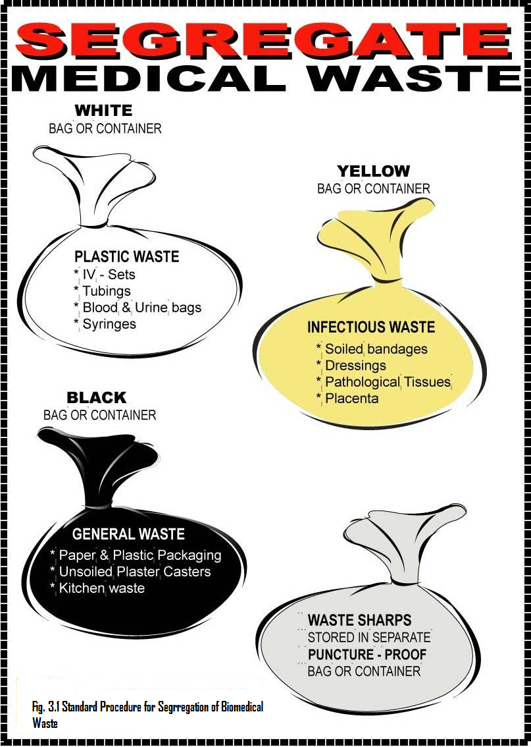
3.4.1 Standard Operation procedure (SOP) for Segregation

Segregation acts as the key of sound management of Bio-medical waste. It verifies that the quantities of waste needing special attention are considerably reduced and there fore more manageable. Various types of waste required separate treatment and therein lies the importance of segregation. The placement of containers in wards is shown in table 3.3. There is availability of four types of containers at each point foe appropriate collection of waste as given below:
- General waste
- Infected non-sharp waste
- Infected sharp waste In addition, a separate container for non- infected plastic may used. available
- Disposable, which may be recycled by authorized person

Table 3.2:Bio-medical waste Management by the hospital staff

No. | LOCATION | CONTAINER | RESPONSIBILITY
1.  2  3  4  5 | Wards  Treatment room and sluice room  Bathroom and  toilets bags  Nursing station  Laboratories and sample collection centers included blood banks etc  Operation theatres and ICUs | Color coded (yellow, blue,  Black) large size containers (100lit. capacity) lined with sluice room Polythene bags of appropriate color.  Only black colored bins lined by black polyethylene bags  Needle destroyer  Puncture proof container with 1 %  Sod. Hypochlorite solution.  Color-coded (yellow, blue, and black) large size bins(100ltr. capacity)  Color-coded (yellow, blue, and black) medium size containers lined with polythene bags of appropriate color.  Needle destroyer  Color-coded (yellow, blue, and black) large and medium size containers lined with polythene bags of appropriate color.  Needle destroyer  Puncture proof container with 1% sod. Hypo chloride solution. | Sister I/C  Replaced  : twice daily  Sister I/C should ensure:  Equipment is functional.  1. Puncture proof contains 1% sod. Hypo chloride solution, which should be changed at least once a day.  Officer in charge of the laboratory  Clinical and Para clinical staff.  Nursing staff, clinical and Para clinical staff.

Table 3.3: Types of containers in Various Wards.

S.NO. | Source  of wastes  in hospital | General waste  Containers  (black) | Infectious  waste  containers  (yellow) | Hazardous waste  containers  (blue) | Containers for sharps  (blue puncture proof)
1. | In front of OPD | Yes | Yes | Yes | Yes
2. | Inside OPD | Yes | Yes | Yes | Yes
3. | Surgery room (OT) | Yes | Yes | Yes | Yes
4. | Labors room | Yes | Yes | Yes | Yes
5. | Inside wards | Yes | Yes | Yes | Yes
6. | Emergency room | Yes | Yes | Yes | Yes
7. | Isolation room | Yes | Yes | Yes | Yes
8. | Dental care section | Yes | Yes | Yes | Yes
9. | Pharmaceutical | Yes | Yes | Yes | Yes
10. | section | Yes | Yes | Yes | Yes
11. | Medical registration | Yes | Yes | Yes | Yes
12. | Laboratory | Yes | Yes | Yes | Yes
13. | And radiology | Yes | Yes | Yes | Yes
14. | Kitchen | Yes | Yes | Yes | Yes
15. | Corridors & footpath General Admn Staff duty room | Yes | Yes | Yes | Yes

3.4.2 Color-coding of containers and waste components

3.4.2.1 Yellow Container Components

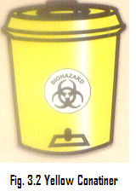
Yellow beg is used for infectious waste (Non-chlorinated), Infected non-sharp waste that may contain:

- Soiled bandages. Dressings · Soiled cotton · Gauze generated by cleaning spills · other soiled waste from treatment area. Blood bags etc.

- Human or animal tissue or body part ( yellow container may be used)

      - Blue Container Components
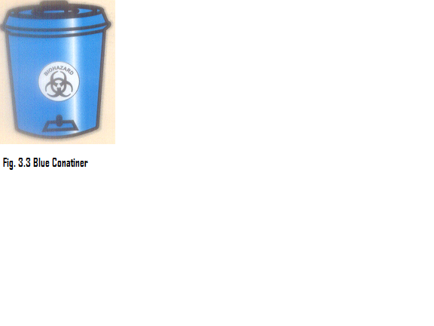

The disposable items like gloves, catheters IV sets/sharp waste (puncture-proof container with blue liner) The treatment used for Blue bag are micro waving, autoclaving, hydro calving and chemical treatment finally this will go to landfill or deep burial.
.
3.4.2.3 Black Container Components
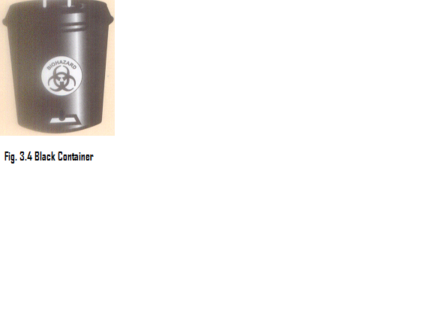

- Black container is used for non-infectious, non-hazardous (household waste)
- Municipal Solid waste includes kitchen, office, store wastes

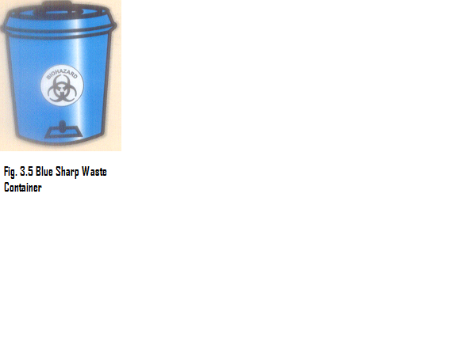

3.4.2.3 Sharp Waste Container

Sharp should always be placed in puncture-proof containers. Sharps include syringes and their attached needles, scalpel blades, piercing parts of catheters and any cutting or piercing articles; glass vials used slides and small pieces of broken glass.

3.5 Standard Operating Procedure used for the Disposal of Hazardous Waste

3.5.1 Sharps

Appropriate disposal of sharps is compulsory because they create the risk of blood-borne diseases from Bio-medical waste. All the sharps like Needles, syringes and other sharp instruments and objects are place in a puncture-proof plastic/metal container at the workstation. They should be autoclaved or chemically disinfected and then disposed and may also be transported to a central site for their treatment. Re use of containers if required should only be after cleaning and disinfecting by following procedure.

- Autoclave or boil for 20 minutes
- Aspirate hypochlorite solution
- Immerse in flat tray for 20 meters.
- Rinse with water several times

After use, syringe and needle filled with disinfectant, should be placed immediately in an appropriate receptacle sharp decontaminating unit nearby for this purpose. Needle should never be recapped, bent or mutilated by hand. Care should be taken that the needle should not be disconnected by hand from the syringe after use. By the use of needle destroyer it can be done easily and syringe can be disfigured. If a needle and syringe destroyer is not available then care should be taken that, the needle should be removed from the syringe with gloved hands and put into the puncture proof container. Before disposal the syringe, needle and other sharps must be pretreated by autoclaving.

3.6 Collection and Transportation

Total collection from Blue Bags is done in Puncture proof containers. This work is done by the contractor, it is the responsibility of the contractor to collect and transport this waste to the treatment/disposal plant and the collection procedure in the hospital is given below on the basis of study :

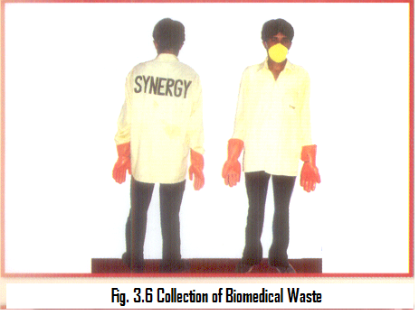

- Trolley: Starts at 7:00 a.m. and collects general and glass bottles from Operation Thearter., Blood Bank, Biochemistry lab., Maternity General Ward, MRI, Hematology Laboratory and ICU.
- Trolley Starts(9:a.m.) and collects the waste from 5th floor, MRI front, Casualty, CSSD, General OPD , 4th floor Block, 3rd and 5th floor.
- Trolley starts: (10:00 a.m.) and collects the waste from 3rd CD and 2nd CD, Labour Room, Pediatric Ward
- Trolley starts (11:00 a.m.): and collects the waste from Male General Ward Female General Ward Old Nursing Home F.F.
- Trolley starts (11:30 a.m.) and collects waste from Doctors Hostel, Maintenance, and Nurses Hostel Kitchen.
- The same process is repeated for the collection of waste at 3:00 P.m.

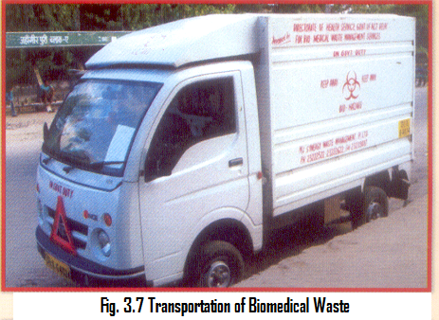
Agency collects the yellow bags from all Nursing Stations/Departments in Yellow Wheel Barrow Concerned Departments and Ward are advised to give yellow bags to the Yellow Wheel Barrow person and finally carried out by the closed container vehicle to the incinerator for treatment and disposal.

3.7 Duties and Responsibility of Hospital Staff

3.7.1 Responsibility of Medical Superintendent

It is the responsibility of Medical superintendents that the formulation and implementation of guidelines for hospital waste management and has to ensure that waste is handled without any harmful effect to human health and environment. As the "occupier", He is responsible for applying for grant of authorization to the prescribed authority i.e. Delhi Pollution Control Board.

3.7.2 Responsibility of Hospital Waste management committee

It is the responsibility of hospital waste management committee to circulate the required copies of Bio-Medical Waste handling rules and guidelines for implementation of these Bio-Medical Waste handling rules and guidelines in Clinical Departments. The responsibility of the individual professionals will be highlighted in these guidelines. To conduct "Awareness Programme": Clinical combined/grand round will be held for making the Faculty and the Residents aware of the ''Bio-medical Waste management &Handling Rules 1998". To conduct training programmers for Medical professionals, Nursing professionals and Sanitation professionals. To hold meeting of the Hospital Waste management Committee and formulate the detailed plan of action in regard to segregation, collection, storage and transport of waste from the entire patient care areas. To produce the items required in this regard and make them available in all patients care areas. Each Clinical Department (Unit), Lab Services, Blood Bank, Microbiology, Pathology will make one Faculty Member responsible for supervisioI1 of segregation of their area of activities. Floor wise one Nursing Sister (Dy. Nursing Supdt) will be responsible for supervision of segregation in the wards of each floor. In each and every of the same instruction of supervision will be followed and one Sister In charge will be responsible.

3.7.3 Responsibility of Officer In charge of Waste Management

Officer In charge of Waste Management plays very effective role. He will be in charge of implementation and will liaise with the heads of the Departments, Infection Control Officer, Chief Nursing Officer. He will also be the member of the Hospital Waste management Committee. For monitoring the programme from time to time at various levels is also the part of his responsibility. These are as generation, segregation, collection, storage, transportation and treatment including It is also his responsibility to circulate of all policy decisions and the hospital disposal. waste management manual. He will be responsible for accident reporting in Form ill to the prescribed authority.

3.7.4 Responsibility of Concerned Heads/In Charge of labs; Units/Departments.

Concerned Heads/In Charge of labs; Units/Departments will be responsible for the formulation and implementation of waste management procedures for their departments in conformity with the general guidelines issued by administration. It is also his responsibility to getting all staff, doctors, nurses paramedics and group-D staff, trained in bio-medical waste management and will liaise with the officer in charge of waste management for administrative support. For the departments, which generate radioactive waste, one out of the consultants should be designated as Radiation protections officer and he will be responsible for implementation of the necessary guidelines.

3.7.5 Responsibility of Chief Nursing officer

The Chief Nursing officer will designate one of the senior administrative level deputies and Sister In charge of Hospital waste Management, who will be responsible for close monitoring of the activity. She will conduct surprise rounds and will review and evaluate the various aspects of scientific hospital waste management at all levels from generation and segregation to final disposal. She will also attend the meeting of Hospital waste management committee on behalf of the Chief Nursing officer and co-ordinate the training of nurses on Hospital waste Management with administration.

3.7.6 Responsibility of Sanitation Officer

The sanitation officer will be responsible for the implementation, monitoring and evaluation of bio-medical waste management from collection and storage of hospital waste to its final disposal. He will attend the bio-medical waste Management Committee meetings and will ensure the training of the staff posted under him. He will carry out regular in service training and evaluation of the sanitation attendants. He will also provide feed back information of Officer in charge waste management in case of accidents and spills.

3.8 Waste Treatment

3 .8.1 Incinerator

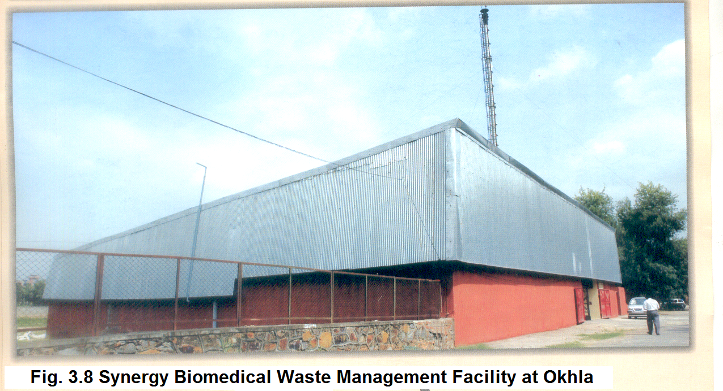
Sir Ganga Ram hospital is equipped with treatment facilities like incinerator, autoclave, and shredder to destruct completely the medical waste. However Sir Ganga Ram Hospital is equipped with diesel fired inbuilt Mild steel incinerator but it has not been in use for a few years. Hospital waste is transported to Synergic Waste Treatment Pvt Ltd (situated at Okhala ) for incineration treatment and disposal.
However the incinerator installed at Sir Ganga Ram hospital is presently not in working order but having following features:

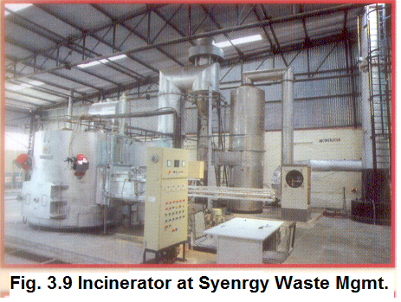
Primary Chamber: The primary chamber of incinerator is constructed with refractory and insulation bricks of IS-2042 standards. The top cover is constructed with refractory and insulation cast able of ACC. The requirement of air for volatilization is supplied through an air duct and introduce into the chamber. The primary chamber is fitted with a mono block burner, which has necessary instrumentation to function automatically. The temperature of primary chamber was maintained at 850 + 50 °C. The waste was fed through a door known as charging door and the ash was removed from the ash door.

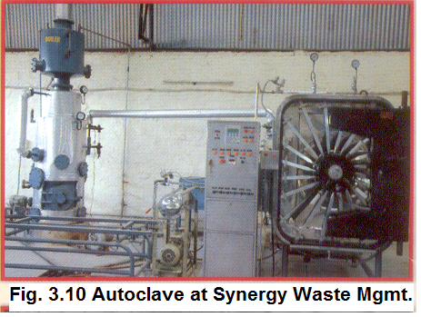
Secondary Chamber: The gases emitted from the primary chamber is relised through a duct wherein the combustion air was mixed and then passed on to a secondary chamber which is also constructed with refractory and insulation bricks.

Chimney: The size of chimney is 500 mm dia at top outlet and having vertical length of 30 m above ground. It is made up of M.S. Plate of size 8 mm and provided with suitable size angle flanges at 3 m interval. Each joint is provided with gasket with high tensile nut and washers etc. It is having plat form and ladder for monitoring of air emissions. The chimney is installed on solid RC.C. Foundation ofM-200 mix with high tensile foundation bolts. The incinerator is painted with heat resistant paint The major component like control panel, ill fan and fuel tank was skid mounted, which is reducing the associated site work and thus making the model plug and play type. The control panel was having electrical components of Siemens. All the units were completely refractory lined, pre-wired, pre-piped assembled and test fixed to ensure no short supplies and trouble free performance at site.
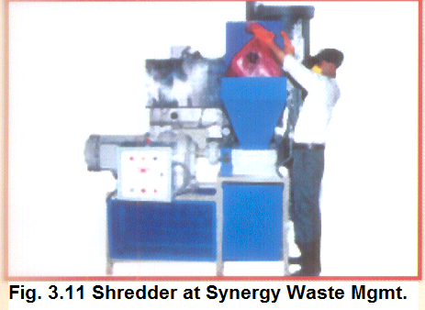
Safety Inter Locks Burner is having interlocks with respective chamber temperatures and features of auto on off with temperature signal. Incinerate able and autoclave able bio-medical waste generated by Sir Ganga Ram Hospital has been treating by Synergic Waste Management Pvt.Ltd. since the incinerator of Sir GangaRam Hospital is not in working order .

3.8.2 Autoclave

Autoclave of Sir Ganga Ram hospital is a per-vacuum autoclave with temperature more than 121°C and pressure of 15 psi per an autoclave residence time of 45 minutes cycle. They are doing the validation test as well as the routine test at regular intervals.

3.8.3 Shredder

Shredder is installed for shredding of sterilized i.e. autoclaved regulated medical waste in the packages before disposal. The shredder is designed for shredding of sterilized waste. The volume of packages of sterilized waste depends upon its type, composition as specified below:

- High infectious waste, gloves, blood bags, lab cultures, bio-technology waste · Isolated waste
- Disposable PVC/Plastic! Card board! Thermo Cole! All catheters · any other sterilized waste received from Autoclave

3.9 Collection and Disposal Of Wastewater

3.9.1 Effluent Treatment Plant

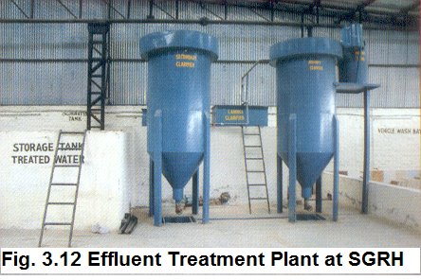
The waste water produced from the hospital activities is contaminated, which is produced by different wards treating patient with interact diseases and is particular problem during outbreaks of diarrhea diseases. Waste water produced from cleaning and disinfections operation is also included in this. In sir ganga ram hospital effluents treatment plant (ETP) is installed and the waste water generated in the hospital is discharged into the sewer after appropriate treatment. The ETP has been provided to treat the hospital effluent effectively and efficiently to render it harmless from infected materials and chemicals before it is recycled after treatment for various purposes. e.g. toilet flushing in S.S.R.B. and horticultural purposes. It has the capacity of treating 500m³ of effluent per day. The wastewater generated from many sources such as toilets and bathrooms, Kitchens and pantries, laboratories, laundries. The effluent streams are collected in a combine mode and treated accordingly. E.T.P is installed in the basement of Super specialty & Research block near the exit of the basement parking. E.T.P. is operated around the clock and has three operators and one supervisor and is monitored by Maintenance and Sanitation Department. The ETP has been supplied by Enhanced warp System (I) Pvt Ltd and has the units of Extended Aeration, Suspended growth process using fine bubble diffused aeration system. The sizes of various units are as under : in table 3.4.

Table 3.4 shows the sizes of various units with their volume

Name of the Units | Length (m) |  | Breath (m) |  | Depth (m) |  | Volume (cm³)
Equalization tank (E.Q.T) |  | 4.20 |  | 12.00 |  | 2.875 |  | 100.8 m³
Aeration tank |  | 12.20 |  | 9.00 |  | 3.80 |  | 329.4 m³
Chlorine contact tank (CCT) |  | 5.00 |  | 10.00 |  | 2.80 |  | 8.5 m³
Treated water tank (TWT) |  | 6.0 |  | 12.0 |  | 2.80 |  | 144 m³
Clarifier |  | 7.0 |  | 7.0 |  | 1.54 |  | 132.62 m³

3.9.2 Effluent Streams

Table 3.5 The various effluent/wastewater streams originating from the hospital are
As under:

Parameters | Domestic | Laundry | Kitchen | Boiler
Peak flow kl/day | 385 | 75 | 30 | 10
Oil & grease mg/L | 10-20 | 50-75 | 150-175 | <5
Suspended solids mg/L | 100-150 | 150-200 | 300-400 | 200-250
B.O.D. mg/L | 200-250 | 100-150 | 500-600 | 20-30
C.O.D.mg/L | 400-600 | 600-800 | 1000-1100 | 40-50

3.9.3 Main process Component: -

- Collection of raw waste water from old and new building by gravity in to the collection tank out side the E.T.P.
- Raw Influent from laundry comes directly into flocculation tank from flocculation tank it passes through tube settler for sedimentation process and finally collects in equalization tank for further aerobic treatment
- From outside collection tank, effluent pumps into the equalization tanks for further treatment.
- Aerobic Treatment in aeration tank through suspended growth process using diffused membrane aeration system.
- Secondary clarification of aerated mixed liquor in Hopper Bottom Secondary
- Clarifier.
- Chlorination for disinfections.
- Filtration and de-chlorination of excess chlorine using multi grade filter and activated carbon filter.
- Collection of treated water in treated water storage tank
- Reusing of treated water for flushing and gardening.
- Sludge Thickening through filter press and used as manures for plants

3.9.4 Treated wastewater characteristics

The sample of effluent was collected from outlet of ETP and analysed. The characteristics of treated wastewater are as follows:

1. Discharge BOD₃ at 27 ºC 16 mg / 1t
2. Suspended solids 22 mg / 1t
3. Oil and Grease < 1 mg / 1t
4. pH 7.7
5 Bio-Assay 90%survival of fish after 96 hrs in 100%
effluent

3.10 Bio-Medical Waste Management Plan

In Sir Ganga Ram hospital bio-medical waste management plan is maintained by the officials. There is a waste management team to develop a written waste management plan for the hospital. The plan indicates the duties and responsibilities of all members of staff, regarding handling of bio-medical waste, and establish lines of accountability. They are maintaininig the management plan up to date and controlling internal collection of waste containers and their transport collection of waste containers. Each head of department are responsible for the segregation, storage and disposal of waste generated in their departments accordingly.

3.11 Waste Minimization, Recycling and Reuse

Waste minimization actually support the waste producer. Amount for the purchase of goods as well as for waste treatment and disposal are reduced and the liabilities related with the disposal of hazardous waste are lessened. Careful segregation of waste material into different categories is done which helps to minimize the quantities of hazardous waste by actual hand separation In Sir Ganga Ram hospital. Recycling and reuse is implementing in Sir Ganga Ram hospital by selling waste to contractor.

